Dangers & Dwellers
  - Short rulebook
4–8 Stakeholders · 6 years · One shared treasury
Protect Geolie together. Win through your own goals. If Happiness, Wealth or Population reaches 0, everyone loses. Survive six years, then the highest personal medal wins: Gold > Silver > Bronze. Ties share the victory.

Set up
1. Choose roles. Each player or team takes a different Stakeholder and its Action deck. A team of 2–4 people shares one hand, one ability and one vote. Choose a Master to manage the Event deck.
2. Deal cards. Shuffle each Stakeholder’s Action deck separately. Draw 3 cards; place the rest face down. Keep at most 3 cards in hand.
3. Set the boards. Start Happiness, Wealth and Population at 50; all nine defence statistics at 0. Put 200 Geuros in the common treasury. Place the turn marker on year 1.
4. Prepare Events. Randomly select 3 Level I, 2 Level II and 1 Level III cards. Stack them face down to be drawn in this order:
Year | 1 | 2 | 3 | 4 | 5 | 6
Level | I | I | I | II | II | III

5. Choose who starts. Proceed clockwise. At the end of each year, the next Stakeholder clockwise becomes the starting player.

Read the boards
 Island health groups Happiness, Wealth and Population.
 | Statistic | Start | Range
 | Happiness | 50 | 0–100
 | Wealth | 50 | 0–100
 | Population | 50 | 0–100
 | Forecast | 0 | 0–10 per hazard
 | Mitigation | 0 | 0–10 per hazard
 | Response | 0 | 0–10 per hazard

Keep Geuros separate from Wealth. Each hazard has its own board:
 Floods  Landslides 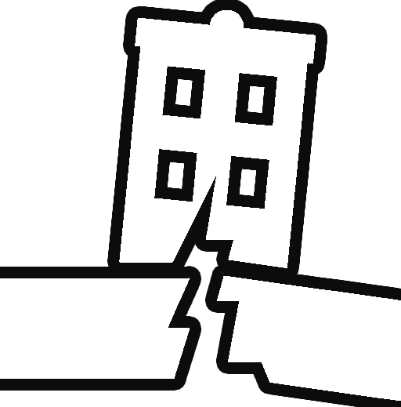 Earthquakes
Apply a card’s changes only to its printed statistics and hazard columns.

1 Decide and fund
Begin the year. Activate scheduled actions. In years 2–6, each Stakeholder draws 1 card. Keep at most 3; put any discarded cards on the bottom of your own deck. No draw in year 1.
Propose. Each Stakeholder, clockwise from the starter, proposes one card or passes. Discuss your options openly. The treasury is shared.
Vote. Each Stakeholder votes for one other player’s proposal, never their own. Select the top two cards. A tie affecting a slot gets a runoff; if still tied, choose the cheapest, then draw lots. Unanimous agreement can replace voting.
Fund. Pay the selected cards from the treasury. If funds are insufficient, prioritise the higher-voted card, then the next affordable proposal. Resolve price changes first. Immediate income can fund another selected card without adding a slot. Return unfunded proposals.
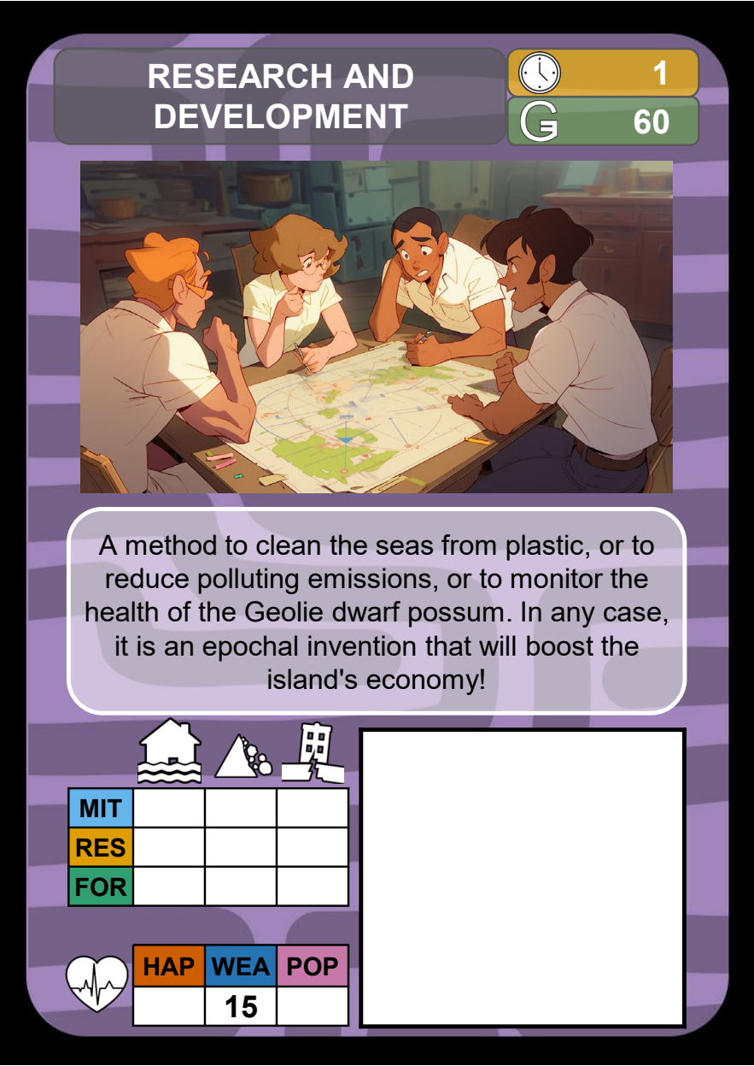
Cost and implementation time appear at the top of each Action card.
Implement. Time 0: now. Time 1: next year. Time 2: the year after that. Pay now; place delayed cards on the Timeline. Apply their effects once when they activate, without paying again or using a new slot. Actions due after year 6 do not activate.
Keep active cards visible and record temporary modifiers separately, preserving permanent values when bonuses expire. Follow the instructions on each card. All discarded cards go to the bottom of their owner’s deck; active and pending cards stay out of the deck.

2 Resolve the Event
Before revealing the Event, resolve any abilities due before the draw. Use the level scheduled for this year. Read the card and use the matching hazard board.

I Forecast
Compare Forecast with the FOR threshold. If it meets or exceeds the threshold, apply Yes; otherwise apply No. Resolve immediate effects and keep any protection to apply to the relevant loss.

II Mitigation
Calculate Magnitude − Mitigation. Find that column in Phase II: apply its Wealth change, after any protection, and carry the printed Damage value into Phase III.

III Response
Calculate Damage − Response. Find that column in Phase III: apply its Population and Happiness changes after protection and any timely rescue ability.
Use column 0 for a negative result and 10 for a result above 10. Apply Damage modifiers before subtracting Response. Read the result from the table even in column 0.
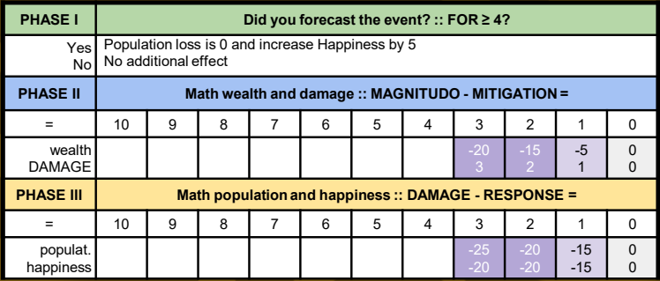
Read the column for your result, then apply that column’s effects.
Example — Flash Flood. With Forecast 4, Mitigation 1 and Response 1: the forecast prevents Population loss and adds 5 Happiness. Then 3 − 1 = 2 gives −15 Wealth and Damage 2; 2 − 1 = 1 gives −15 Happiness. Starting from 50 each, finish at Happiness 40, Wealth 35, Population 50.
Rounding. Halve losses, then round down to a multiple of 5: 15 becomes 5. Apply fixed reductions before halving. Never turn a reduced loss into a gain. Resolve protections and timely rescue before applying the loss.

Finish the year
Any health statistic at 0 means defeat. If alive, add the income printed beside current Wealth to the treasury, including in year 6. In years 1–5, remove expired effects and pass the starting-player marker clockwise. In year 6, check medals with temporary bonuses still active.

3 Abilities and victory

Use your Stakeholder ability
Follow its timing and discard cost. Put the discarded cards on the bottom of your deck. No vote or funded-action slot is needed. Use each ability at most once per turn, unless marked once per game.
A proposal is no longer in your hand. Before voting, you may withdraw it to pay an ability cost and make no proposal that year. Unfunded proposals return after funding and may pay for abilities used later.
Scientists — Cassandra. Before voting, discard 3 cards. The Master shows you the next 3 Event cards in random order for 10 seconds, covering their Level labels. If fewer remain, use those. The Master then shuffles them and returns them to the top, keeping the levels in their required order. Once per game.

Check medals after year 6
After collecting turn 6 income, check medals with that turn’s temporary bonuses still active. Earn the highest medal whose conditions you meet. All players tied for the highest earned medal win. If nobody earns a medal, record shared survival with no individual winner.
Stakeholder | Bronze | Silver | Gold
Citizenship | Happiness ≥ 35 | Happiness ≥ 40 | Happiness ≥ 45
Scientists | Forecast ≥ 4  in 1 hazard | Forecast ≥ 4  in 2 hazards | Forecast ≥ 4  in all 3
Local Government | Wealth ≥ 10 | Wealth ≥ 15 | Wealth ≥ 25
Mass Media | Population ≥ 40 | Population ≥ 50 | Population ≥ 60
Ministry of Finance | Treasury ≥ 250 | Treasury ≥ 300 | Treasury ≥ 350
Ministry of Infrastructure | Mitigation ≥ 3  in 1 hazard | Mitigation ≥ 3  in 2 hazards | Mitigation ≥ 3  in all 3
Civil Protection | Population ≥ 40  and Wealth ≥ 5 | Population ≥ 45  and Wealth ≥ 10 | Population ≥ 50  and Wealth ≥ 15
Firefighters | Response ≥ 5  in 1 hazard | Response ≥ 5  in 2 hazards | Response ≥ 5  in all 3

Treasury values are in Geuros. Meet both conditions where two are listed. Count each hazard board separately for Forecast, Mitigation and Response.

The full year
Activate → Draw → Propose → Vote → Fund → Event → Income
Event order: I, I, I, II, II, III across the six years.
Resolve temporary effects and final medals at the times stated above.

