Proceedings of the FOSS/GRASS Users Conference - Bangkok, Thailand, 12-14 September 2004

Title of Paper

John Smith*, Phisan Santitamnont**

* Department of Geography, University of Nowhere, Bluebell Street 77, 25623 London, England, tel. +661261882618, fax +661261882672, e-mail John.Smith@nowhere.edu
** Faculty of Survey Engineering, Chulalongkorn University, Patumwan, Bangkok, Thailand,
tel. +6622186661 fax +66-2-2186653 e-mail grass04_office@gisws.media.osaka-cu.ac.jp

1 Introduction

The Free/Libre and Open Source Software (FOSS) for Geoinformatics: GIS - GRASS Users Conference will be held in Bangkok, Thailand, 12-14 September 2004. An extended successor to a long series of GRASS-GIS Users Conferences (last held on September 2002 in Trento, Italy), the series will be in Asia for the first time. The conference joins GRASS developers and users worldwide to foster closer relations, and to share ideas for improving software and applications. (Unlike at closed-source software users meetings, anyone can turn findings of this meeting into new code and improved applications.) The Bangkok conference will cover all aspects of FOSS for Geoinformatics, in addition to GRASS itself. Thus the aim of the conference is twofold: (a) exchange of experiences between GRASS users and developers and (b) provide first-hand information on FOSS capabilities for developing national/local spatial data infrastructures, with emphasis on Asian countries. One unique aspect of the conference will be the INSTALLFEST. Bring your computer (or buy one in Bangkok), install GRASS and other Geoinformatics software, and begin to use it, all at the conference!

2 Location

The conference is being organized by the Faculty of Engineering, Chulalongkorn University, Thailand, with support from several other institutions. The Organizing Committee includes prominent experts in FOSS for Geoinformatics.

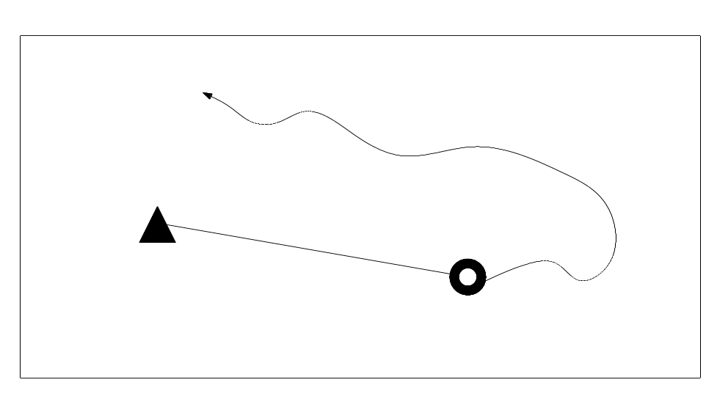
Figure 1: Path to final point

3 About Free/Libre and Open Source Software

Geoinformatics technologies help us to manage, assess and present spatial information on natural resources, environment and habitat. They provide valuable tools for national development planning, resource management and disaster mitigation. Many Geoinformatics techniques are now operational, while others are poised (because of breakthroughs in data availability or other reason) to provide vital support for sustainable development. Countries that urgently need such abilities are often those that also face severe technical and cost constraints to implementing them. In particular, the total cost of proprietary software is too high for many less wealthy countries. Several nations are therefore unable to build, maintain, and adequately benefit from geoinformatics technologies. Over the last decade, Free and Open Source Software (FOSS) has grown tremendously in scope and popularity. FOSS has gained the attention of the Geoinformatics community and created new opportunities for developing such capabilities. Attractive licensing terms, free availability, high quality, low management costs, and opportunities for anyone to join cooperative software development teams make FOSS systems highly desirable for capacity building in developing countries, especially regions with growing IT skills and manufacture such as Asia, and also to stimulate academic and commercial spin-offs, as well as international cooperation in developing and adaptation of such software for specific national/local needs.

 | Onions | Potatoes
Number | 25 | 50
Table 1: Vegetables

The conference registration fee has been kept low to encourage widespread participation. This is important in particular for applicants from less well-endowed countries, private individuals and students. Special efforts will be made during the conference to foster technology transfer to developing countries especially in the Southeast Asian region. Sponsors can provide funds to cover general conference expenses or provide much needed travel grants and support waiver of registration fee for deserving applicants. To become a sponsor or exhibitor contact either of the coordinators.

References

[1] Benciolini B., Ciolli M., Zatelli P. Grass conference organization. In Benciolini B., Ciolli M and Zatelli P., editors, Proceedings of the “Open Source GIS - GRASS users conference”, pages 2-98. International Grass Users, 2002.

[2] Ciolli M. An introduction to GRASS GIS. In Zatelli P., editor, Grass GIS, pages 5-99. International Grass Service, 2002.

