AUTONYMOUS.ME
Technical Specifications

Self-Sovereign Identity Protocol — Engineering Reference
Holochain · eIDAS 2.0 · OpenID4VP · W3C DID 1.0 · SD-JWT RFC 9901

Version 0.4-alpha · April 2026 · Status: Internal Draft
Audience: Core engineering team, external contributors, security auditors
License: Apache 2.0

1. Technology Stack
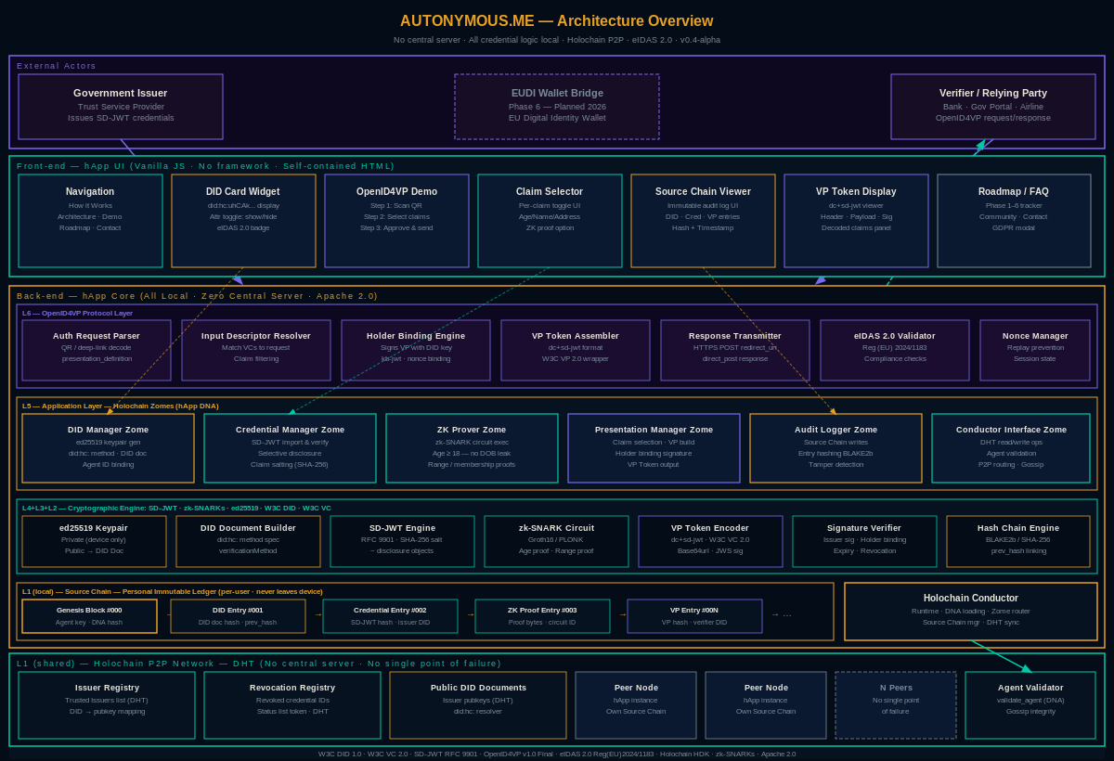
Figure 1 — Autonymous.me System Architecture (6 Layers)

1.1 Runtime and Network
Layer | Technology | Version | Purpose
P2P Runtime | Holochain | 0.3.x | DNA execution engine, Source Chain, DHT gossip
Zome Language | Rust (WASM) | 1.76+ | Core business logic compiled to WASM modules
Front-end | TypeScript + Svelte | 5.x | hApp UI, credential selector, Source Chain viewer
Conductor API | WebSocket (HDK) | 0.3 | Bridge between UI and Holochain Conductor
Protocol Layer | OpenID4VP v1.0 Final | — | Authorization request parsing, VP Token assembly

1.2 Cryptographic Libraries
Library | Algorithm | Usage
libsodium (via hdk::prelude) | Ed25519 | DID keypair generation, Source Chain signing, Holder Binding
snarkjs / bellman | Groth16 (zk-SNARK) | Age proof circuit — prove birth_year ≤ current_year - 18
sd-jwt-js (RFC 9901) | HMAC-SHA256 salt | Selective disclosure: per-claim salt commitment
jsonwebtoken | ES256 (P-256) | VP Token outer JWT, kb-jwt holder binding
argon2id | Memory-hard KDF | Encrypted key-store backup password derivation
AES-256-GCM | Symmetric | Local key-store encryption at rest

2. Holochain DNA Architecture

2.1 DNA Overview
The Autonymous.me hApp is packaged as a single Holochain DNA containing five Zomes. Each Zome is a WASM module compiled from Rust using the Holochain Development Kit (HDK).

Zome Name | WASM Module | Responsibilities
did_manager | did_manager.wasm | Keypair generation, DID Document creation and rotation, DHT publication
credential_manager | credential_manager.wasm | SD-JWT import, issuer signature verification, local credential store
zk_prover | zk_prover.wasm | Groth16 proof generation (age circuit), proof serialisation
presentation_manager | presentation_manager.wasm | OpenID4VP request parsing, claim selector, VP Token assembly
audit_logger | audit_logger.wasm | Source Chain Entry creation, hash-chain verification, timeline query

2.2 Source Chain Entry Schema
Every Source Chain Entry follows this structure. Entries are linked by prev_hash (SHA-256 of the prior entry's serialised bytes).

{
"entry_type": "DIDCreated" | "CredentialImported" | "ZKProofGenerated" | "VPPresented",
"timestamp": "<ISO-8601 UTC>",
"payload": { /* entry-type specific — see below */ },
"prev_hash": "<SHA-256 hex of previous entry>",
"signature": "<ed25519 sig of entry bytes using holder private key>"
}

2.2.1 DIDCreated Entry
{ "did": "did:hc:<agent_pub_key_base58>",
"pub_key": "<ed25519 public key base64url>",
"key_type": "Ed25519",
"created_at": "<ISO-8601>" }

2.2.2 CredentialImported Entry
{ "credential_id": "<sha256 of SD-JWT bytes>",
"issuer_did": "did:hc:<issuer_agent_key>",
"credential_type": ["VerifiableCredential", "AgeCredential"],
"claim_keys": ["birth_year", "nationality"], // no values stored
"valid_until": "<ISO-8601>",
"sd_jwt_hash": "<sha256 of full SD-JWT>" }

2.2.3 VPPresented Entry
{ "verifier_did": "did:web:verifier.example.com",
"presentation_id": "<uuid>",
"disclosed_claims": ["birth_year_range_proof"],
"nonce": "<32-byte hex>",
"state": "<opaque verifier state>",
"vp_token_hash": "<sha256 of VP Token>",
"presented_at": "<ISO-8601>" }

3. DID Method Specification — did:hc:

3.1 DID Syntax
did:hc:<agent-public-key>
Example: did:hc:uhCAkVzHvZ4QmS...
The method-specific identifier is the base58btc-encoded 32-byte ed25519 public key (Holochain AgentPubKey format).

3.2 DID Document Structure
{
"@context": ["https://www.w3.org/ns/did/v1"],
"id": "did:hc:uhCAkVzHvZ4QmS...",
"verificationMethod": [{
"id": "did:hc:uhCAkVzHvZ4QmS...#keys-1",
"type": "Ed25519VerificationKey2020",
"controller": "did:hc:uhCAkVzHvZ4QmS...",
"publicKeyMultibase": "z6Mkf5rGMoatr..."
}],
"authentication": ["did:hc:uhCAkVzHvZ4QmS...#keys-1"],
"service": [{
"id": "did:hc:uhCAkVzHvZ4QmS...#openid4vp",
"type": "OpenID4VPEndpoint",
"serviceEndpoint": "https://wallet.autonymous.me/present"
}]
}

3.3 CRUD Operations
Operation | Mechanism | Notes
Create | HDK create_entry() → DHT publish | Genesis block + DIDCreated Source Chain entry
Read (Resolve) | HDK get() on agent key hash | Any peer can resolve; no auth required
Update | create_entry() with key_rotation flag | Previous key marked superseded in new DID Document
Deactivate | create_entry() with deactivated: true | Revocation propagated via DHT gossip

4. SD-JWT Processing Pipeline

4.1 Issuance (by external issuer)
Each claim to be selectively disclosable is replaced by a salted hash disclosure. The SD-JWT has this structure:

<header>.<payload>.<signature>~<disclosure1>~<disclosure2>~...

Payload excerpt:
{ "iss": "did:hc:<issuer_key>",
"sub": "did:hc:<holder_key>",
"iat": 1714000000, "exp": 1745536000,
"_sd": ["hash1", "hash2"],
"_sd_alg": "sha-256" }

Each disclosure is a base64url-encoded JSON array: [salt, claim_name, claim_value].
Example disclosure (base64url-decoded): ["dX3z9Kq...", "birth_year", 1990]

4.2 Storage
- The full SD-JWT (header + payload + signature + all disclosures) is stored in the Holochain source chain as a CredentialImported entry
- Only the SD-JWT hash is stored in the entry payload; the full JWT bytes are in the Holochain private Entry (not shared on DHT)
- Claim values are NEVER stored in plaintext outside the SD-JWT

4.3 Selective Disclosure at Presentation Time
- User opens Claim Selector UI; the credential_manager Zome decodes the SD-JWT and lists claim names (no values)
- User selects claims to disclose; the Zome builds the VP Token including ONLY the selected disclosures
- Non-selected disclosures are omitted from the VP Token — they are not hashed, encrypted, or otherwise included
- A new Holder Binding JWT (kb-jwt) is generated: signed by the holder's private key, containing aud, iat, nonce, sd_hash

5. OpenID4VP Protocol Flow

5.1 Step-by-Step Sequence

Step | Actor | Action | Data
1 | Verifier | Generate Authorization Request | client_id, response_type=vp_token, presentation_definition, nonce, state, response_uri
2 | Verifier | Encode as QR code or deep link | openid4vp://?request_uri=https://...
3 | Holder hApp | Scan / receive request | Parse JWT, verify verifier DID signature
4 | Holder hApp | Resolve presentation_definition | Match input_descriptor against local credentials
5 | Holder hApp | Present Claim Selector UI | User picks claims to disclose
6 | Holder hApp | Generate zk proof (if required) | age_circuit.wasm → Groth16 proof bytes
7 | Holder hApp | Assemble VP Token | dc+sd-jwt with selected disclosures + kb-jwt + optional zk claim
8 | Holder hApp | POST to response_uri | Content-Type: application/x-www-form-urlencoded; vp_token=...&presentation_submission=...
9 | Verifier | Validate VP Token | Verify sd-jwt sig, holder binding, nonce, zk proof
10 | Verifier | Return result | HTTP 200 redirect_uri or error

5.2 VP Token Format
// dc+sd-jwt VP Token
<sd-jwt>~<selected-disclosures>~<kb-jwt>

// kb-jwt header
{ "alg": "EdDSA", "typ": "kb+jwt" }

// kb-jwt payload
{ "iat": 1714000000,
"aud": "did:web:verifier.example.com",
"nonce": "abc123def456...",
"sd_hash": "<sha256 of header.payload.sig~disclosures>" }

5.3 presentation_submission
{ "id": "<uuid>",
"definition_id": "age-proof-request",
"descriptor_map": [{
"id": "age_credential",
"format": "dc+sd-jwt",
"path": "$"
}] }

6. zk-SNARK Circuit Specification

6.1 Circuit: age_check
The age_check circuit proves that a private input birth_year satisfies the constraint: current_year - birth_year >= 18, without revealing birth_year.

// Circom 2.x circuit
pragma circom 2.1.4;

template AgeCheck() {
signal input birth_year; // private
signal input current_year; // public
signal input credential_hash; // public — binds proof to specific SD-JWT
signal output age_ok;

signal age;
age <== current_year - birth_year;
age_ok <== age >= 18 ? 1 : 0;
}

component main {public [current_year, credential_hash]} = AgeCheck();

6.2 Proving System
Parameter | Value
Proving system | Groth16
Curve | BN128 (alt-bn128)
Constraint count | ~150 R1CS constraints (age_check circuit)
Proving time (desktop) | < 2 s (snarkjs WASM)
Proof size | 192 bytes (3 × 64-byte G1/G2 points)
Verification time | < 50 ms
Trusted setup | Phase 1: Hermez ceremony (public). Phase 2: circuit-specific — ceremony to be published.

6.3 Proof Embedding in VP Token
The Groth16 proof is embedded as an additional SD-JWT claim with key zk_proof:
{
"zk_proof": {
"proof_type": "groth16",
"circuit": "age_check_v1",
"public_inputs": { "current_year": 2026, "credential_hash": "0xabc..." },
"proof": { "pi_a": "...", "pi_b": "...", "pi_c": "..." },
"vk_uri": "did:hc:<zkVerificationKey>"
}
}

7. Holochain DHT Data Models

7.1 Issuer Registry Entry
{
"entry_type": "IssuerRegistration",
"issuer_did": "did:hc:<issuer_key>",
"issuer_name": "National ID Authority FR",
"credential_types": ["AgeCredential", "AddressCredential"],
"signing_key": "<ed25519 public key base64url>",
"accreditation_proof": "<eIDAS trust service list pointer>",
"registered_at": "<ISO-8601>",
"status": "active"
}

7.2 Revocation Registry Entry
{
"entry_type": "RevocationEntry",
"credential_id": "<sha256 of SD-JWT>",
"issuer_did": "did:hc:<issuer_key>",
"revoked_at": "<ISO-8601>",
"reason": "keyCompromise | superseded | cessationOfOperation",
"issuer_signature": "<ed25519 sig of (credential_id + revoked_at)>"
}

7.3 Public DID Document (DHT)
DID Documents are published as Holochain Public Entries (visible to all peers). They contain only the public key and service endpoints — no personal data.

7.4 DHT Consistency Model
- Holochain uses an eventually-consistent DHT. Writes propagate via gossip within seconds on a well-connected network.
- Source Chain entries are locally final immediately (agent-centric consistency).
- Revocation checks: the credential_manager Zome queries the DHT for a RevocationEntry before accepting any credential for presentation. A network timeout returns credential_status: unknown (not revoked).

8. REST API Specification (Verifier-Facing)
Verifiers integrate via a thin REST shim that bridges HTTP to the Holochain Conductor WebSocket. All endpoints require HTTPS. No PII is ever stored server-side.

8.1 Initiate Authorization Request
POST /api/v1/openid4vp/request
Content-Type: application/json

{ "client_id": "did:web:verifier.example.com",
"presentation_definition": { ... },
"response_uri": "https://verifier.example.com/callback",
"state": "<opaque>",
"nonce": "<32-byte hex>" }

Response 201:
{ "request_uri": "https://wallet.autonymous.me/request/abc123",
"qr_code_svg": "<inline SVG>",
"deep_link": "openid4vp://?request_uri=https://..." }

8.2 Receive VP Token (Callback)
POST <response_uri>
Content-Type: application/x-www-form-urlencoded

Body: vp_token=<dc+sd-jwt>&presentation_submission=<JSON>

Response 200:
{ "verified": true,
"disclosed_claims": { "birth_year_range_proof": "age>=18" },
"presentation_id": "<uuid>",
"verifier_log_hash": "<sha256 of verification record>" }

8.3 Resolve DID
GET /api/v1/did/{did}

Response 200: W3C DID Document (JSON-LD)

8.4 Check Credential Status
GET /api/v1/credential/{credential_id}/status

Response 200: { "status": "active" | "revoked" | "unknown", "checked_at": "<ISO-8601>" }

9. Security Model

9.1 Threat Model
Threat | Attack Vector | Mitigation
Private key exfiltration | Malware reads key store file | AES-256-GCM encryption; key derived from Argon2id password (cost: 64 MB, 3 iterations)
Replay attack | Intercept VP Token and reuse | Nonce unique per session (32 bytes random); exp in kb-jwt (5-minute window)
Credential forgery | Fake SD-JWT with falsified claims | Issuer ed25519 signature verified against DHT Issuer Registry before storage
MITM on VP Token POST | Intercept direct_post payload | response_uri must be HTTPS; VP Token contains holder-bound kb-jwt — useless without private key
Revoked credential use | Ignore revocation DHT entry | credential_manager checks RevocationEntry on every presentation; fail-closed on network timeout (present as unknown status with user warning)
DHT Sybil attack | Flood DHT with fake peers | Holochain membrane proofs + agent validation rules; validator quorum required for DHT writes

9.2 Key Storage
- Private keys stored in OS keychain (macOS Keychain, Windows DPAPI) where available
- Fallback: AES-256-GCM encrypted file, key derived via Argon2id (m=65536, t=3, p=4)
- Private keys never transmitted, never serialised to logs, never included in Source Chain entries

9.3 Zero-Knowledge Proof Security
- Groth16 soundness: computationally binding under discrete log assumption on BN128
- Trusted setup ceremony artefacts published; phase 2 ceremony to involve >= 20 independent participants
- credential_hash public input binds proof to specific SD-JWT — proof not transferable to other credentials

10. Build, Test, and Deployment

10.1 Repository Structure
autonymous.me/
├── dna/ # Holochain DNA
│ ├── zomes/ # Rust WASM Zomes
│ │ ├── did_manager/
│ │ ├── credential_manager/
│ │ ├── zk_prover/
│ │ ├── presentation_manager/
│ │ └── audit_logger/
│ └── workdir/ # DNA manifest
├── ui/ # Svelte/TypeScript front-end
├── circuits/ # Circom zk-SNARK circuits
│ └── age_check/
├── sdk/ # Verifier integration SDK (TypeScript)
├── api/ # REST shim (Node.js/Express)
├── tests/ # Integration and unit tests
├── index.html # Standalone demo (no deps)
└── README.md

10.2 Build Pipeline
- Zomes: cargo build --target wasm32-unknown-unknown --release
- Circuits: circom age_check.circom --r1cs --wasm && snarkjs groth16 setup
- UI: npm run build (Vite bundler, TypeScript strict mode)
- hApp package: hc app pack ./workdir → autonymous.happ

10.3 Test Strategy
- Unit tests: Rust #[test] for each Zome function
- Integration tests: tryorama (Holochain test framework) — 2-agent scenarios for DHT propagation
- Protocol tests: automated OpenID4VP flow with mock verifier
- zk-SNARK tests: snarkjs witness generation + proof verification for edge cases (age = 18, age = 17, age = 100)

10.4 CI/CD
- GitHub Actions: build + test on every PR
- Security audit: cargo audit + npm audit on every push
- Release artefacts: autonymous.happ + SDK npm package + standalone HTML

11. Standards Compliance Matrix

Standard | Reference | Compliance | Notes
W3C DID 1.0 | w3.org/TR/did-core/ | Full | did:hc: method, resolver, CRUD operations
W3C VC Data Model 2.0 | w3.org/TR/vc-data-model-2.0/ | Full | SD-JWT encoding, credential subject, proof
SD-JWT RFC 9901 | rfc-editor.org/rfc/rfc9901 | Full | Issuance, selective disclosure, kb-jwt
OpenID4VP v1.0 Final | openid.net specs | Full | direct_post, presentation_definition, VP Token
eIDAS 2.0 — Reg. EU 2024/1183 | eur-lex.europa.eu | Compliant (pre-cert) | EUDI Wallet bridge planned Phase 6
FIDO2 / WebAuthn | w3.org/TR/webauthn-3/ | Partial | Hardware key binding — roadmap Phase 5

