AUTONYMOUS.ME
Functional Specifications

Self-Sovereign Identity Protocol
Holochain · eIDAS 2.0 · OpenID4VP · W3C DID/VC

Version 0.4-alpha · April 2026
Status: Internal Draft
License: Apache 2.0 · Non-Profit Community Governed

1. Executive Summary
Autonymous.me is an open-source, non-profit, community-governed protocol for self-sovereign identity (SSI). It enables individuals to prove who they are — age, address, professional credentials — to any compliant verifier without ever transmitting personal data to a server.

The current online identity ecosystem is broken by design. In 2025 alone, 3,322 data compromises were recorded in the United States — a new all-time high — affecting 278 million individuals and costing an average of USD 4.44 million per breach. At the root of this problem is a centralised model: every time a person proves their identity, they hand sensitive data to a private company that stores it, sells it, or eventually loses it.

Autonymous.me eliminates this model at the protocol level. Credentials live on the user’s device. Proofs are generated locally. No personal data is ever transmitted. Every action is logged immutably on the user’s own Holochain Source Chain — a personal, tamper-proof audit log they control.

The protocol is fully compliant with eIDAS 2.0 (Reg. EU 2024/1183), W3C DID 1.0, W3C VC 2.0, OpenID4VP v1.0 Final, and SD-JWT RFC 9901. It extends these standards with zero-knowledge proofs (zk-SNARKs) for privacy-preserving attribute disclosure.

2. Product Vision

2.1 Mission Statement
To give every person on earth the ability to prove who they are — selectively, privately, verifiably — without depending on any company, government database, or central server.

2.2 Core Principles
- Self-sovereignty: the user controls their identity at all times
- Minimal disclosure: only the specific claim required is shared, nothing more
- No central point of failure: no server, no database, no single entity can revoke access
- Open source and non-profit: Apache 2.0 licence, community governed
- Standards-first: eIDAS 2.0, W3C DID/VC, OpenID4VP — interoperable by design

2.3 Success Metrics
- Time-to-verify < 3 seconds for a standard age-gate proof
- Zero personal data transmitted to any server during any verification
- eIDAS 2.0 certification achieved by 2026
- 10,000 active wallets within 12 months of mobile launch

3. User Personas

3.1 The Privacy-Conscious Citizen (Primary)
Age 25–45. Aware of data breaches. Wants to prove their age or address online without uploading a passport scan to a website they distrust. Uses the Autonymous.me hApp on desktop or mobile. Technical level: consumer.

3.2 The Compliance Officer (Verifier)
Works at a regulated entity (bank, e-commerce, healthcare provider). Must perform KYC/AML checks. Wants a standards-compliant, auditable verification flow that does not store PII. Integrates Autonymous.me via the OpenID4VP REST API. Technical level: intermediate.

3.3 The Credential Issuer
A government agency or accredited institution (e.g. national ID authority, university, employer). Issues official SD-JWT credentials to citizens. Registers in the Holochain Issuer Registry DHT. Technical level: advanced.

3.4 The Open-Source Contributor
Developer or researcher. Builds Holochain Zomes, zk-SNARK circuits, or front-end integrations. Contributes via GitHub. Technical level: advanced.

4. Functional Requirements

4.1 DID Management
FR-DID-01
The system SHALL generate a W3C DID (did:hc: method) entirely on-device using an ed25519 keypair. No network call is required.
FR-DID-02
The system SHALL display the DID as a QR code and human-readable string in the Identity Card widget.
FR-DID-03
The system SHALL publish the DID Document (including public key and service endpoints) to the Holochain DHT for resolver access.
FR-DID-04
The system SHALL support key rotation: new keypair generated, old keys marked revoked in the Source Chain, DID Document updated on DHT.
FR-DID-05
The system SHALL allow the user to export an encrypted backup of their keypair (AES-256-GCM, password-derived key via Argon2id).

4.2 Credential Management
FR-CRED-01
The system SHALL accept SD-JWT credentials (RFC 9901) issued by any registered issuer.
FR-CRED-02
Credentials SHALL be stored exclusively on the user’s device in the hApp local store (Holochain Source Chain Entry).
FR-CRED-03
The system SHALL verify the issuer signature against the Issuer Registry before storing any credential.
FR-CRED-04
The system SHALL display credentials with human-readable claim labels, validity period, and issuer name.
FR-CRED-05
The system SHALL support revocation checks via the Holochain Revocation Registry DHT entry.

4.3 Selective Disclosure
FR-SD-01
The system SHALL present the user with a visual claim selector listing every disclosable claim for a given credential.
FR-SD-02
The system SHALL disclose only the claims explicitly selected by the user. All non-selected claims remain hidden even from cryptographic analysis (salted hash commitment).
FR-SD-03
The system SHALL generate a Holder Binding (kb-jwt) signed with the holder’s private key, binding the presentation to the current session nonce.
FR-SD-04
The system SHALL produce a VP Token in dc+sd-jwt format compliant with OpenID4VP v1.0 Final.

4.4 OpenID4VP Presentation Flow
FR-OID-01
The system SHALL parse OpenID4VP Authorization Requests received via QR code scan or deep link (openid4vp://).
FR-OID-02
The system SHALL resolve presentation_definition Input Descriptors to select the matching local credential(s).
FR-OID-03
The system SHALL validate the response_uri, nonce, and state parameters before generating any proof.
FR-OID-04
The system SHALL transmit the VP Token to the verifier’s response_uri via HTTP POST (direct_post mode). No redirect is used for sensitive data.
FR-OID-05
The system SHALL complete the full request-presentation-response cycle in under 3 seconds on a standard consumer device.
FR-OID-06
The system SHALL log each completed presentation to the user’s Source Chain with timestamp, verifier DID, disclosed claims, and session nonce.

4.5 Zero-Knowledge Proofs
FR-ZK-01
The system SHALL support age ≥ 18 proofs via zk-SNARK (Groth16) without revealing the actual date of birth.
FR-ZK-02
Proof generation SHALL complete in under 2 seconds on a standard desktop CPU.
FR-ZK-03
The system SHALL embed the zk proof in the VP Token as an additional claim (proof_type: groth16).
FR-ZK-04
The verifier SHALL be able to validate the zk proof using the published verification key from the Holochain DHT without receiving any raw biometric or date data.

4.6 Source Chain Audit Log
FR-SC-01
Every user action (DID creation, credential import, presentation) SHALL be recorded as an immutable Entry on the user’s Holochain Source Chain.
FR-SC-02
Each Entry SHALL be linked to its predecessor via prev_hash (SHA-256), forming a tamper-evident chain.
FR-SC-03
The Source Chain SHALL be viewable within the hApp in a chronological timeline UI.
FR-SC-04
The Source Chain SHALL never leave the user’s device unless the user explicitly exports it (encrypted).

4.7 Verifier Integration
FR-VER-01
The system SHALL expose a REST API endpoint for verifiers to initiate an OpenID4VP Authorization Request.
FR-VER-02
The system SHALL provide a JavaScript/TypeScript SDK and browser extension for web-based verifier integration.
FR-VER-03
Verification results returned to the verifier SHALL contain ONLY: presentation_submission, verified: true/false, disclosed claims as stated in the VP Token. No PII beyond what the user selected.

5. Use Cases

ID | Name | Description
UC-01 | Age Gate | User proves age ≥ 18 to an adult content site via zk proof. DOB never transmitted.
UC-02 | KYC Lite | User discloses name + address SD-JWT claims to a fintech app for account opening.
UC-03 | Academic Credential | University issues degree SD-JWT. Graduate shares it with employer via QR code.
UC-04 | Healthcare Access | Hospital verifies patient identity offline using cached DID + Source Chain entry.
UC-05 | EU Travel | Citizen presents eIDAS 2.0 EUDI Wallet bridge VP Token at EU border control kiosk.
UC-06 | Pseudonymous Login | User proves ‘I am a verified human’ to a social platform without revealing real identity.

6. Non-Functional Requirements

6.1 Performance
- DID generation: < 500 ms
- SD-JWT credential import and signature verification: < 1 s
- zk-SNARK proof generation (age ≥ 18): < 2 s on standard desktop CPU
- Full OpenID4VP round-trip (request to VP Token POST): < 3 s

6.2 Security
- All private keys stored in OS secure enclave or encrypted key store (AES-256-GCM)
- No private key ever transmitted over any network
- Replay prevention: nonce must be unique per session, validated before proof generation
- VP Token validity window: 5 minutes (configurable per verifier policy)
- Source Chain integrity verified on every read (SHA-256 hash chain)

6.3 Privacy
- Zero personal data stored on any server at any time
- No tracking cookies, analytics, or telemetry without explicit user opt-in
- GDPR Article 17 (right to erasure): user deletes hApp → all local data gone. No server copy exists.
- Selective disclosure enforced at the cryptographic level (SD-JWT salt commitment)

6.4 Availability and Resilience
- Credential verification works fully offline (local DID + local credential)
- Issuer Registry and Revocation Registry: eventually consistent via Holochain DHT gossip
- Loss of any peer node does not affect any other peer’s Source Chain or credentials

6.5 Accessibility
- hApp UI: WCAG 2.1 AA compliant
- QR code scanning: device camera or manual URL entry fallback
- Localisation: English and French at launch; i18n framework in place for additional languages

7. Architecture Overview
The following diagram illustrates the six-layer system architecture, covering both the user-facing front-end and the back-end Holochain stack.
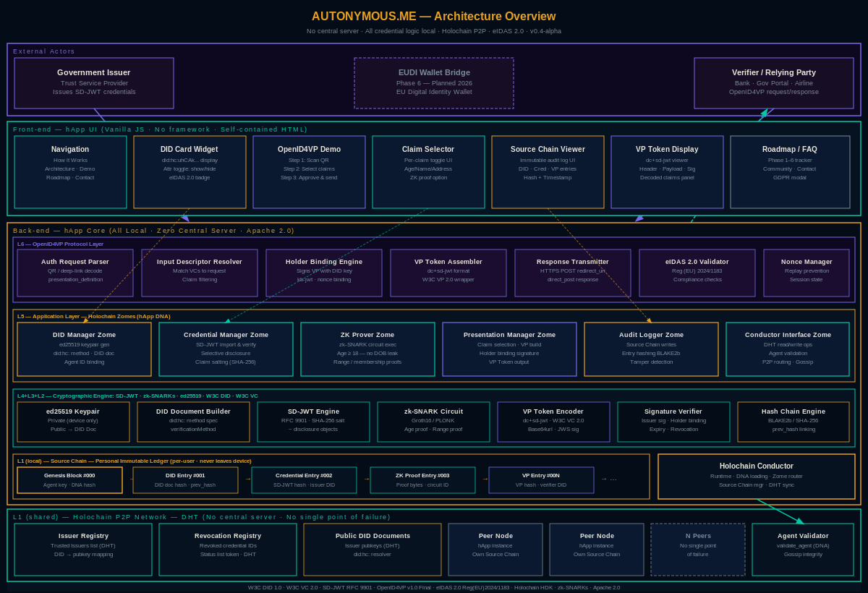
Figure 1 — Autonymous.me Full System Architecture (Front-end + Back-end)

7.1 Layer Summary

Layer | Component | Role
L6 | OpenID4VP Protocol Handler | Parses auth requests, assembles VP Token, posts to verifier
L5 | Holochain hApp Zomes | DID Manager, Credential Manager, ZK Prover, Audit Logger
L4 | Verifiable Credentials | SD-JWT engine, selective disclosure, claim salting
L3 | Zero-Knowledge Proofs | zk-SNARK circuit (Groth16), proof generation + verification
L2 | Decentralised Identifiers | ed25519 keypair, DID Document builder, signature verifier
L1 | Holochain Network | Source Chain, DHT, Gossip Protocol, Peer validation

8. Roadmap

Phase | Description | Status | Target
1 | Core protocol design (DID, zk circuits, SD-JWT schema) | ✅ Complete | Q1 2025
2 | Alpha wallet — key mgmt, credential import, Source Chain UI | ✅ Complete | Q2 2025
3 | OpenID4VP integration — full flow, dc+sd-jwt, holder binding | ✅ Complete | Q3 2025
4 | Issuer registry (DHT), REST API, browser extension | 🔄 In progress | Q1 2026
5 | Mobile app (iOS/Android), community governance v1 | 📋 Planned | Q3 2026
6 | eIDAS 2.0 production certification, EUDI Wallet bridge | 📋 Planned | 2027

9. Glossary

Term | Definition
DID | Decentralised Identifier — a globally unique, self-controlled identifier (W3C DID 1.0)
SD-JWT | Selective Disclosure JSON Web Token — allows hiding individual claims (RFC 9901)
VP Token | Verifiable Presentation Token — the signed payload sent to a verifier
OpenID4VP | OpenID for Verifiable Presentations — presentation protocol over OpenID Connect
zk-SNARK | Zero-Knowledge Succinct Non-Interactive Argument of Knowledge — privacy-preserving proof
Source Chain | Personal immutable ledger in Holochain; every user action recorded as a hash-linked Entry
DHT | Distributed Hash Table — Holochain’s shared, peer-validated data store
eIDAS 2.0 | EU Regulation 2024/1183 on electronic identification and trust services
Holder Binding | kb-jwt proving the presenter holds the private key corresponding to the credential subject
Groth16 | Efficient zk-SNARK proving system used for age proofs in Autonymous.me

