[](http://www.comsol.com/)

Chap1Ex2 SISO HeatEquation 2

|  |  |
| --- | --- |
| Date | Mar 24, 2015 6:37:56 AM |

Contents

1. Global

1.1. Definitions

2. Model 1

2.1. Definitions

2.2. Geometry 1

2.3. Coefficient Form PDE

2.4. Coefficient Form PDE 2

2.5. Mesh 1

3. Study 1

3.1. Stationary

3.2. Solver Configurations

4. Study 2

4.1. Time Dependent

4.2. Solver Configurations

5. Results

5.1. Data Sets

5.2. Derived Values

5.3. Tables

5.4. Plot Groups

1. Global

|  |  |
| --- | --- |
| Date | Aug 15, 2013 4:36:48 PM |

Global settings

|  |  |
| --- | --- |
| Name | Chap1Ex2 SISO HeatEquation 2.mph |
| Path | /Users/gilliam/Desktop/collect_15/research_15/geo_reg_mono_eugenio/Mono_1_15/Comsol_EX_GitHub/Chapter1/Chap1Ex2/Chap1Ex2_SISO_HeatEquation_2.mph |
| Program | COMSOL 5.0 (Build: 276) |

Used products

|  |
| --- |
| COMSOL Multiphysics |

* 1. Definitions
     1. Parameters 1

Parameters

| **Name** | **Expression** | **Value** | **Description** |
| --- | --- | --- | --- |
| L | 1 | 1.0000 |  |
| Ar | 1 | 1.0000 |  |
| alpha | 2 | 2.0000 |  |
| Md | 1 | 1.0000 |  |

1. Model 1

Component settings

|  |  |
| --- | --- |
| Unit system | SI |

* 1. Definitions
     1. Variables

#### Variables 1

Selection

|  |  |
| --- | --- |
| Geometric entity level | Entire model |

| **Name** | **Expression** | **Description** |
| --- | --- | --- |
| Gamma1 | real(1/C(PI1)) |  |
| Gamma2 | imag(1/C(PI1)) |  |
| Gamma3 | -C(PIt2)/C(PI2) |  |
| w3 | Md |  |
| w1 | Ar*sin(alpha*t) |  |
| w2 | Ar*cos(alpha*t) |  |
| Gamma | Gamma1*w1 + Gamma2*w2 + Gamma3*w3 |  |
| err | C(z) - w1 |  |
| Bin | 2 |  |
| Bd | 1 |  |

* + 1. Probes

#### Global Variable Probe 1

|  |  |
| --- | --- |
| Probe type | Global variable probe |

#### Global Variable Probe 2

|  |  |
| --- | --- |
| Probe type | Global variable probe |

#### Global Variable Probe 3

|  |  |
| --- | --- |
| Probe type | Global variable probe |

* + 1. Component Couplings

#### Average 1

|  |  |
| --- | --- |
| Coupling type | Average |
| Operator name | C |

Source selection

|  |  |
| --- | --- |
| Geometric entity level | Domain |
| Selection | Domain 1 |

* 1. Geometry 1

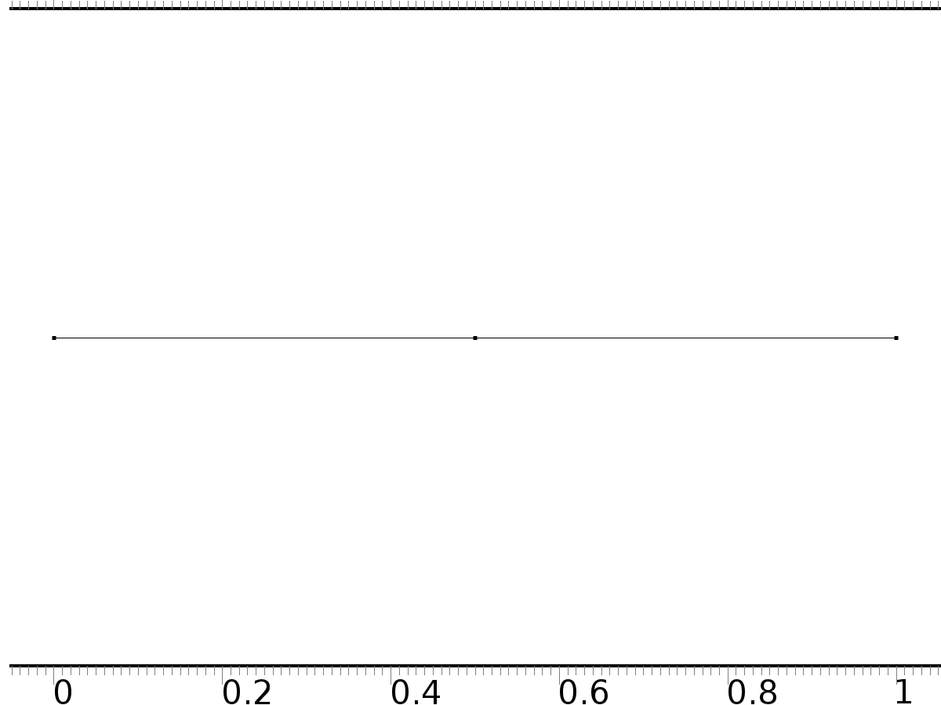

Geometry 1

Units

|  |  |
| --- | --- |
| Length unit | m |
| Angular unit | deg |

Geometry statistics

| **Description** | **Value** |
| --- | --- |
| Space dimension | 1 |
| Number of domains | 2 |
| Number of boundaries | 3 |

* + 1. Interval 1 (i1)

Interval

| **Description** | **Value** |
| --- | --- |
| Number of intervals | Many |
| Points | {0, 0.5, 1} |

* 1. Coefficient Form PDE

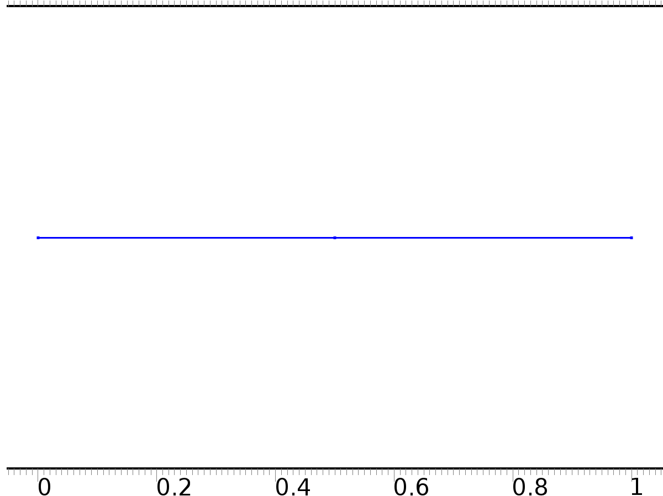

Coefficient Form PDE

Selection

|  |  |
| --- | --- |
| Geometric entity level | Domain |
| Selection | Domains 1–2 |

Settings

| **Description** | **Value** |
| --- | --- |
| Shape function type | Lagrange |
| Element order | Quadratic |
| Compute boundary fluxes | On |
| Apply smoothing to boundary fluxes | On |
| Value type when using splitting of complex variables | Complex |
| Dependent variable quantity | Dimensionless (1) |
| Source term quantity | None |
| Unit | m^ - 2 |

Used products

|  |
| --- |
| COMSOL Multiphysics |

Variables

| **Name** | **Expression** | **Unit** | **Description** | **Selection** |
| --- | --- | --- | --- | --- |
| c.nx | nx |  | Normal vector, x component | Boundaries 1–3 |
| c.ny | root.ny |  | Normal vector, y component | Boundaries 1–3 |
| c.nz | root.nz |  | Normal vector, z component | Boundaries 1–3 |
| c.nxmesh | root.nxmesh |  | Normal vector (mesh), x component | Boundaries 1–3 |
| c.nymesh | root.nymesh |  | Normal vector (mesh), y component | Boundaries 1–3 |
| c.nzmesh | root.nzmesh |  | Normal vector (mesh), z component | Boundaries 1–3 |

* + 1. Coefficient Form PDE 1



Coefficient Form PDE 1

Selection

|  |  |
| --- | --- |
| Geometric entity level | Domain |
| Selection | Domains 1–2 |

Equations







Settings

| **Description** | **Value** |
| --- | --- |
| Diffusion coefficient | {{1, 0, 0}, {0, 1, 0}, {0, 0, 1}} |
| Absorption coefficient | {{i*alpha, 0, 0}, {0, 0, 0}, {0, 0, 0}} |
| Source term | {0, 0, 0} |
| Mass coefficient | {{0, 0, 0}, {0, 0, 0}, {0, 0, 0}} |
| Damping or mass coefficient | {{0, 0, 0}, {0, 0, 0}, {0, 0, 0}} |
| Conservative flux convection coefficient | {{0, 0, 0}, {0, 0, 0}, {0, 0, 0}} |
| Convection coefficient | {{0, 0, 0}, {0, 0, 0}, {0, 0, 0}} |
| Conservative flux source | {0, 0, 0} |

#### Variables

| **Name** | **Expression** | **Unit** | **Description** | **Selection** |
| --- | --- | --- | --- | --- |
| domflux.PI1x | -d(PI1,x) | 1/m | Domain flux, x component | Domains 1–2 |
| domflux.PI2x | -d(PI2,x) | 1/m | Domain flux, x component | Domains 1–2 |
| domflux.PIt2x | -d(PIt2,x) | 1/m | Domain flux, x component | Domains 1–2 |

#### Shape functions

| **Name** | **Shape function** | **Unit** | **Description** | **Shape frame** | **Selection** |
| --- | --- | --- | --- | --- | --- |
| PI1 | Lagrange (Quadratic) | 1 | Dependent variable PI1 | Material | Domains 1–2 |
| PI2 | Lagrange (Quadratic) | 1 | Dependent variable PI2 | Material | Domains 1–2 |
| PIt2 | Lagrange (Quadratic) | 1 | Dependent variable PIt2 | Material | Domains 1–2 |

* + 1. Zero Flux 1

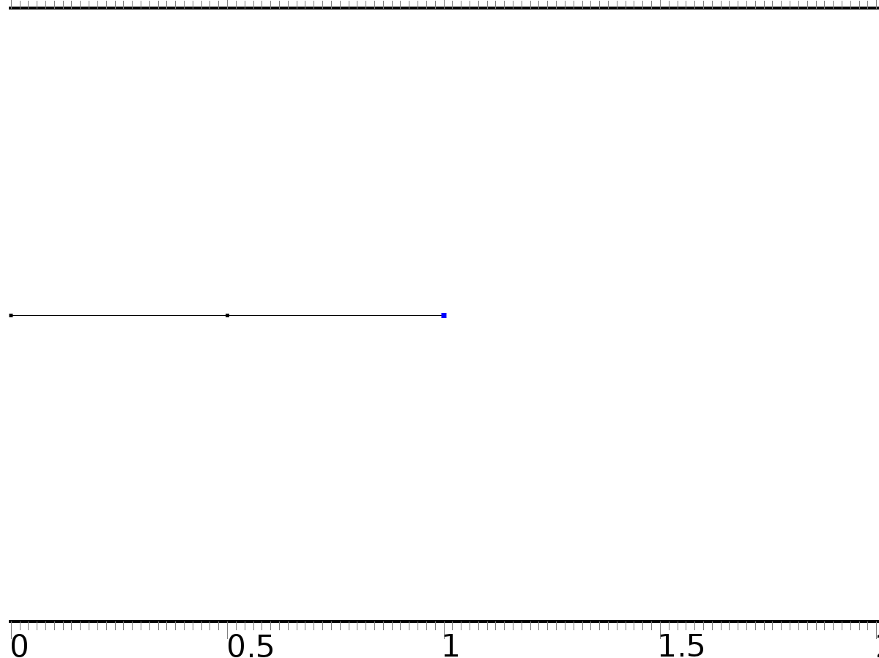

Zero Flux 1

Selection

|  |  |
| --- | --- |
| Geometric entity level | Boundary |
| Selection | Boundary 3 |

Equations







* + 1. Initial Values 1



Initial Values 1

Selection

|  |  |
| --- | --- |
| Geometric entity level | Domain |
| Selection | Domains 1–2 |

Settings

| **Description** | **Value** |
| --- | --- |
| Initial value for PI2 | 0 |
| Initial time derivative of PI2 | 0 |
| Initial value for PI1 | 0 |
| Initial time derivative of PI1 | 0 |
| Initial value for PIt2 | 0 |
| Initial time derivative of PIt2 | 0 |

* + 1. Source 1

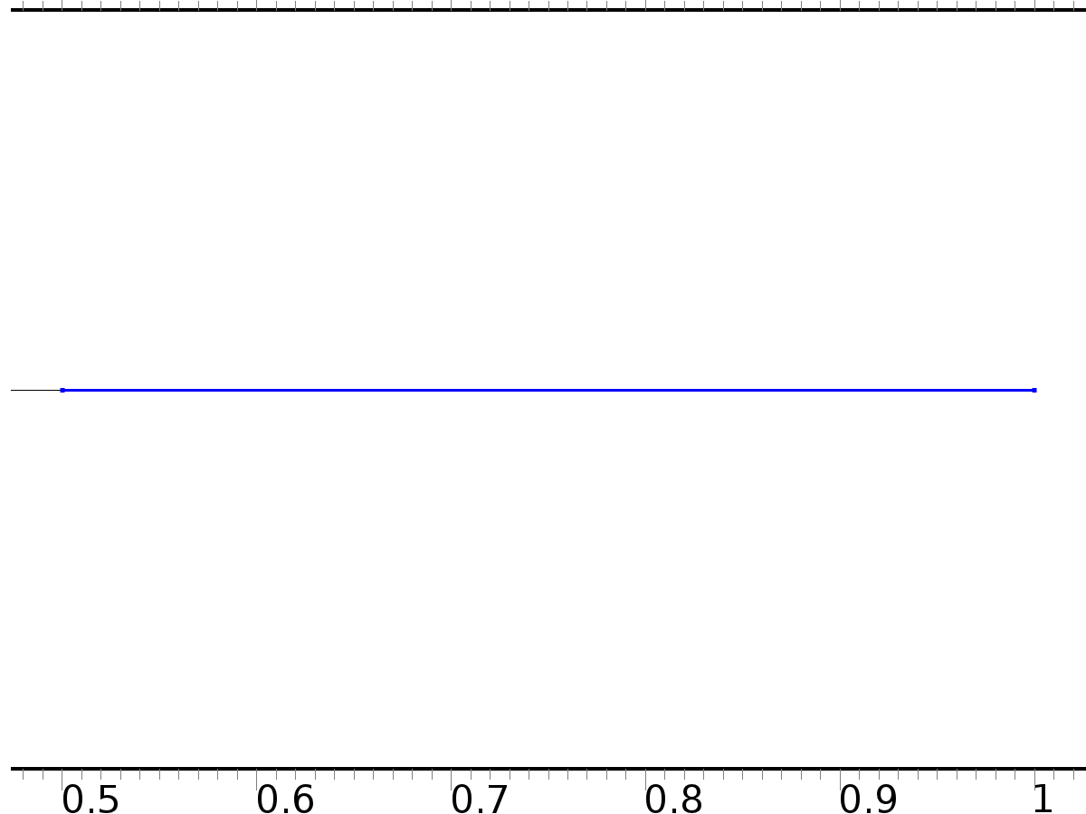

Source 1

Selection

|  |  |
| --- | --- |
| Geometric entity level | Domain |
| Selection | Domain 2 |

Settings

| **Description** | **Value** |
| --- | --- |
| Source term | {Bin, Bin, 0} |

#### Variables

| **Name** | **Expression** | **Unit** | **Description** | **Selection** |
| --- | --- | --- | --- | --- |
| c.f_PI1 | Bin | 1/m^2 | Source term | Domain 2 |
| c.f_PI2 | Bin | 1/m^2 | Source term | Domain 2 |
| c.f_PIt2 | 0 | 1/m^2 | Source term | Domain 2 |

* + 1. Source 2



Source 2

Selection

|  |  |
| --- | --- |
| Geometric entity level | Domain |
| Selection | Domains 1–2 |

Settings

| **Description** | **Value** |
| --- | --- |
| Source term | {0, 0, Bd} |

#### Variables

| **Name** | **Expression** | **Unit** | **Description** | **Selection** |
| --- | --- | --- | --- | --- |
| c.f_PI1 | 0 | 1/m^2 | Source term | Domains 1–2 |
| c.f_PI2 | 0 | 1/m^2 | Source term | Domains 1–2 |
| c.f_PIt2 | Bd | 1/m^2 | Source term | Domains 1–2 |

* + 1. Dirichlet Boundary Condition 1

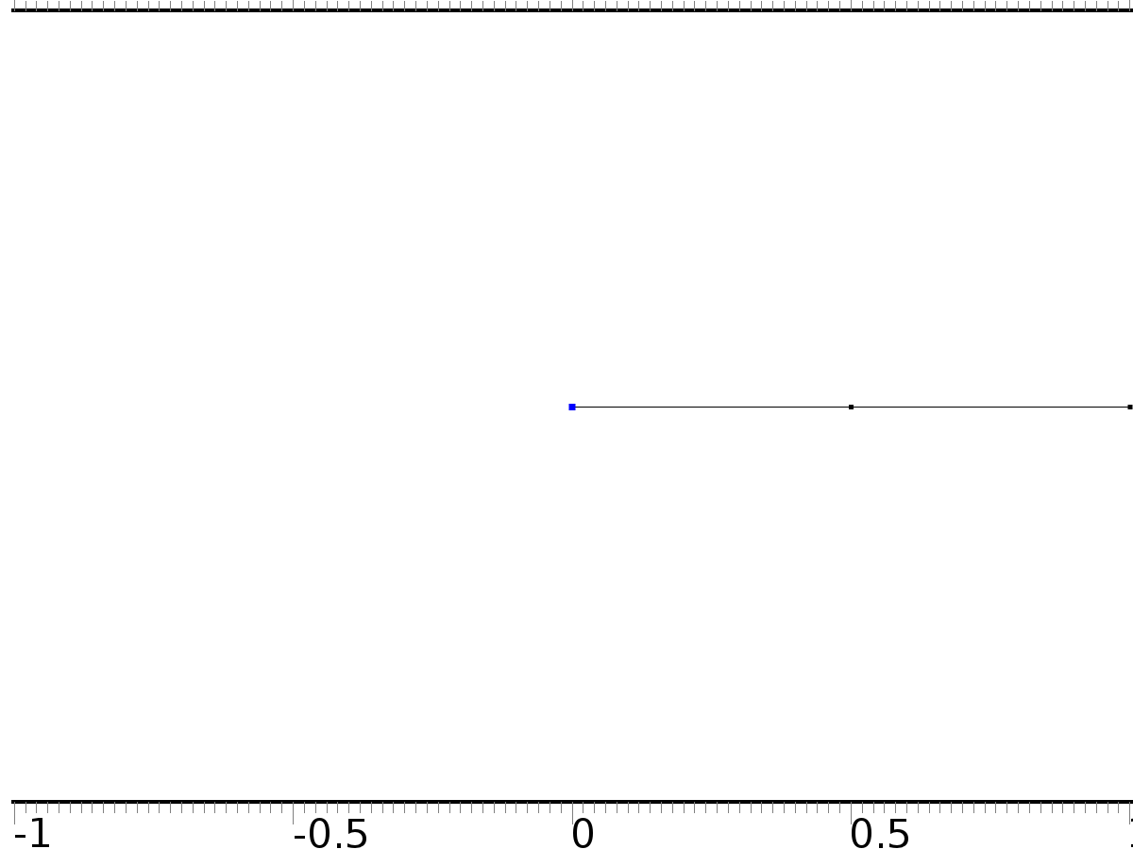

Dirichlet Boundary Condition 1

Selection

|  |  |
| --- | --- |
| Geometric entity level | Boundary |
| Selection | Boundary 1 |

Equations









Settings

| **Description** | **Value** |
| --- | --- |
| Value on boundary | {0, 0, 0} |
| Prescribed value of PI1 | On |
| Prescribed value of PI2 | On |
| Prescribed value of PIt2 | On |
| Apply reaction terms on | Individual dependent variables |
| Use weak constraints | Off |
| Constraint method | Elemental |

#### Shape functions

| **Constraint** | **Constraint force** | **Shape function** | **Selection** |
| --- | --- | --- | --- |
| -PI1 | -test(PI1) | Lagrange (Quadratic) | Boundary 1 |
| -PI2 | -test(PI2) | Lagrange (Quadratic) | Boundary 1 |
| -PIt2 | -test(PIt2) | Lagrange (Quadratic) | Boundary 1 |

* 1. Coefficient Form PDE 2



Coefficient Form PDE 2

Selection

|  |  |
| --- | --- |
| Geometric entity level | Domain |
| Selection | Domains 1–2 |

Settings

| **Description** | **Value** |
| --- | --- |
| Shape function type | Lagrange |
| Element order | Quadratic |
| Compute boundary fluxes | On |
| Apply smoothing to boundary fluxes | On |
| Value type when using splitting of complex variables | Complex |
| Dependent variable quantity | Dimensionless (1) |
| Source term quantity | None |
| Unit | m^ - 2 |

Used products

|  |
| --- |
| COMSOL Multiphysics |

Variables

| **Name** | **Expression** | **Unit** | **Description** | **Selection** |
| --- | --- | --- | --- | --- |
| c2.nx | nx |  | Normal vector, x component | Boundaries 1–3 |
| c2.ny | root.ny |  | Normal vector, y component | Boundaries 1–3 |
| c2.nz | root.nz |  | Normal vector, z component | Boundaries 1–3 |
| c2.nxmesh | root.nxmesh |  | Normal vector (mesh), x component | Boundaries 1–3 |
| c2.nymesh | root.nymesh |  | Normal vector (mesh), y component | Boundaries 1–3 |
| c2.nzmesh | root.nzmesh |  | Normal vector (mesh), z component | Boundaries 1–3 |

* + 1. Coefficient Form PDE 1



Coefficient Form PDE 1

Selection

|  |  |
| --- | --- |
| Geometric entity level | Domain |
| Selection | Domains 1–2 |

Equations





Settings

| **Description** | **Value** |
| --- | --- |
| Diffusion coefficient | 1 |
| Absorption coefficient | 0 |
| Source term | 0 |
| Mass coefficient | 0 |
| Damping or mass coefficient | 1 |
| Conservative flux convection coefficient | 0 |
| Convection coefficient | 0 |
| Conservative flux source | 0 |

#### Variables

| **Name** | **Expression** | **Unit** | **Description** | **Selection** |
| --- | --- | --- | --- | --- |
| domflux.zx | -d(z,x) | 1/m | Domain flux, x component | Domains 1–2 |

#### Shape functions

| **Name** | **Shape function** | **Unit** | **Description** | **Shape frame** | **Selection** |
| --- | --- | --- | --- | --- | --- |
| z | Lagrange (Quadratic) | 1 | Dependent variable z | Material | Domains 1–2 |

* + 1. Zero Flux 1



Zero Flux 1

Selection

|  |  |
| --- | --- |
| Geometric entity level | Boundary |
| Selection | Boundary 3 |

Equations





* + 1. Initial Values 1



Initial Values 1

Selection

|  |  |
| --- | --- |
| Geometric entity level | Domain |
| Selection | Domains 1–2 |

Settings

| **Description** | **Value** |
| --- | --- |
| Initial value for z | 4*cos(pi*x) |
| Initial time derivative of z | 0 |

* + 1. Source 1



Source 1

Selection

|  |  |
| --- | --- |
| Geometric entity level | Domain |
| Selection | Domain 2 |

Settings

| **Description** | **Value** |
| --- | --- |
| Source term | Bin*Gamma |

#### Variables

| **Name** | **Expression** | **Unit** | **Description** | **Selection** |
| --- | --- | --- | --- | --- |
| c2.f_z | Bin*Gamma | 1/m^2 | Source term | Domain 2 |

* + 1. Source 2



Source 2

Selection

|  |  |
| --- | --- |
| Geometric entity level | Domain |
| Selection | Domains 1–2 |

Settings

| **Description** | **Value** |
| --- | --- |
| Source term | Bd*w3 |

#### Variables

| **Name** | **Expression** | **Unit** | **Description** | **Selection** |
| --- | --- | --- | --- | --- |
| c2.f_z | Bd*w3 | 1/m^2 | Source term | Domains 1–2 |

* + 1. Dirichlet Boundary Condition 1



Dirichlet Boundary Condition 1

Selection

|  |  |
| --- | --- |
| Geometric entity level | Boundary |
| Selection | Boundary 1 |

Equations





Settings

| **Description** | **Value** |
| --- | --- |
| Value on boundary | 0 |
| Prescribed value of z | On |
| Apply reaction terms on | Individual dependent variables |
| Use weak constraints | Off |
| Constraint method | Elemental |

#### Shape functions

| **Constraint** | **Constraint force** | **Shape function** | **Selection** |
| --- | --- | --- | --- |
| -z | -test(z) | Lagrange (Quadratic) | Boundary 1 |

* 1. Mesh 1

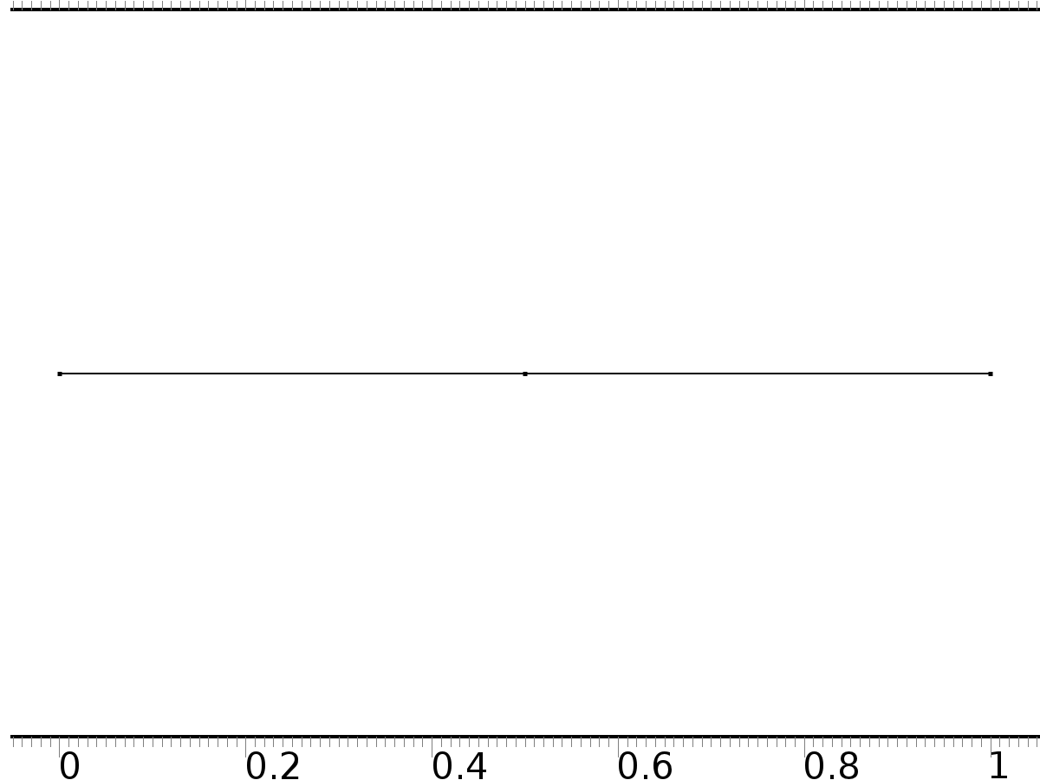

Mesh 1

* + 1. Size (size)

Settings

| **Description** | **Value** |
| --- | --- |
| Maximum element size | 0.037 |
| Minimum element size | 1.25E-4 |
| Curvature factor | 0.25 |
| Maximum element growth rate | 1.25 |
| Predefined size | Finer |

* + 1. Edge 1 (edg1)

Selection

|  |  |
| --- | --- |
| Geometric entity level | Remaining |

1. Study 1
   1. Stationary

Study settings

| **Description** | **Value** |
| --- | --- |
| Include geometric nonlinearity | Off |

Physics and variables selection

| **Physics interface** | **Discretization** |
| --- | --- |
| Coefficient Form PDE (c) | physics |

Mesh selection

| **Geometry** | **Mesh** |
| --- | --- |
| Geometry 1 (geom1) | mesh1 |

* 1. Solver Configurations
     1. Solver 1

#### Compile Equations: Stationary (st1)

Study and step

| **Description** | **Value** |
| --- | --- |
| Use study | Study 1 |
| Use study step | Stationary |

#### Dependent Variables 1 (v1)

General

| **Description** | **Value** |
| --- | --- |
| Defined by study step | Stationary |
| Constant |  |

Initial values of variables solved for

| **Description** | **Value** |
| --- | --- |
| Solution | Zero |

Values of variables not solved for

| **Description** | **Value** |
| --- | --- |
| Solution | Zero |

##### Dependent variable PI1 (mod1.PI1) (mod1_PI1)

General

| **Description** | **Value** |
| --- | --- |
| Field components | mod1.PI1 |
| Field name | mod1_X |

##### Dependent variable z (mod1.z) (mod1_z)

General

| **Description** | **Value** |
| --- | --- |
| Field components | mod1.z |
| Solve for this field | Off |

##### Dependent variable PI2 (mod1.PI2) (mod1_PI2)

General

| **Description** | **Value** |
| --- | --- |
| Field components | mod1.PI2 |

##### Dependent variable PIt2 (mod1.PIt2) (mod1_PIt2)

General

| **Description** | **Value** |
| --- | --- |
| Field components | mod1.PIt2 |
| Field name | mod1_PI3 |

#### Stationary Solver 1 (s1)

General

| **Description** | **Value** |
| --- | --- |
| Defined by study step | Stationary |
| Relative tolerance | 0.0000010 |

Log

| **Description** | **Value** |
| --- | --- |
| Constant |  |

##### Advanced (aDef)

General

| **Description** | **Value** |
| --- | --- |
| Allow complex-valued output from functions with real input | On |

##### Fully Coupled 1 (fc1)

General

| **Description** | **Value** |
| --- | --- |
| Linear solver | Direct |

1. Study 2
   1. Time Dependent

Study settings

| **Description** | **Value** |
| --- | --- |
| Include geometric nonlinearity | Off |

| **Times** | **Unit** |
| --- | --- |
| range(0,0.01,6) | s |

Physics and variables selection

| **Physics interface** | **Discretization** |
| --- | --- |
| Coefficient Form PDE 2 (c2) | physics |

Mesh selection

| **Geometry** | **Mesh** |
| --- | --- |
| Geometry 1 (geom1) | mesh1 |

* 1. Solver Configurations
     1. Solver 2

#### Compile Equations: Time Dependent (st1)

Study and step

| **Description** | **Value** |
| --- | --- |
| Use study | Study 2 |
| Use study step | Time Dependent |

#### Dependent Variables 1 (v1)

General

| **Description** | **Value** |
| --- | --- |
| Defined by study step | Time Dependent |
| Constant |  |

Initial values of variables solved for

| **Description** | **Value** |
| --- | --- |
| Solution | Zero |

Values of variables not solved for

| **Description** | **Value** |
| --- | --- |
| Method | Solution |
| Solution | Solver 1 |

##### Dependent variable z (mod1.z) (mod1_z)

General

| **Description** | **Value** |
| --- | --- |
| Field components | mod1.z |

##### Dependent variable PI1 (mod1.PI1) (mod1_PI1)

General

| **Description** | **Value** |
| --- | --- |
| Field components | mod1.PI1 |
| Solve for this field | Off |
| Field name | mod1_X |

##### Dependent variable PI2 (mod1.PI2) (mod1_PI2)

General

| **Description** | **Value** |
| --- | --- |
| Field components | mod1.PI2 |
| Solve for this field | Off |

##### Dependent variable PIt2 (mod1.PIt2) (mod1_PIt2)

General

| **Description** | **Value** |
| --- | --- |
| Field components | mod1.PIt2 |
| Solve for this field | Off |
| Field name | mod1_PI3 |

#### Time-Dependent Solver 1 (t1)

General

| **Description** | **Value** |
| --- | --- |
| Defined by study step | Time Dependent |
| Time | {0, 0.01, 0.02, 0.03, 0.04, 0.05, 0.06, 0.07, 0.08, 0.09, 0.1, 0.11, 0.12, 0.13, 0.14, 0.15, 0.16, 0.17, 0.18, 0.19, 0.2, 0.21, 0.22, 0.23, 0.24, 0.25, 0.26, 0.27, 0.28, 0.29, 0.3, 0.31, 0.32, 0.33, 0.34, 0.35000000000000003, 0.36, 0.37, 0.38, 0.39, 0.4, 0.41000000000000003, 0.42, 0.43, 0.44, 0.45, 0.46, 0.47000000000000003, 0.48, 0.49, 0.5, 0.51, 0.52, 0.53, 0.54, 0.55, 0.56, 0.5700000000000001, 0.58, 0.59, 0.6, 0.61, 0.62, 0.63, 0.64, 0.65, 0.66, 0.67, 0.68, 0.6900000000000001, 0.7000000000000001, 0.71, 0.72, 0.73, 0.74, 0.75, 0.76, 0.77, 0.78, 0.79, 0.8, 0.81, 0.8200000000000001, 0.8300000000000001, 0.84, 0.85, 0.86, 0.87, 0.88, 0.89, 0.9, 0.91, 0.92, 0.93, 0.9400000000000001, 0.9500000000000001, 0.96, 0.97, 0.98, 0.99, 1, 1.01, 1.02, 1.03, 1.04, 1.05, 1.06, 1.07, 1.08, 1.09, 1.1, 1.11, 1.12, 1.1300000000000001, 1.1400000000000001, 1.1500000000000001, 1.16, 1.17, 1.18, 1.19, 1.2, 1.21, 1.22, 1.23, 1.24, 1.25, 1.26, 1.27, 1.28, 1.29, 1.3, 1.31, 1.32, 1.33, 1.34, 1.35, 1.36, 1.37, 1.3800000000000001, 1.3900000000000001, 1.4000000000000001, 1.41, 1.42, 1.43, 1.44, 1.45, 1.46, 1.47, 1.48, 1.49, 1.5, 1.51, 1.52, 1.53, 1.54, 1.55, 1.56, 1.57, 1.58, 1.59, 1.6, 1.61, 1.62, 1.6300000000000001, 1.6400000000000001, 1.6500000000000001, 1.6600000000000001, 1.67, 1.68, 1.69, 1.7, 1.71, 1.72, 1.73, 1.74, 1.75, 1.76, 1.77, 1.78, 1.79, 1.8, 1.81, 1.82, 1.83, 1.84, 1.85, 1.86, 1.87, 1.8800000000000001, 1.8900000000000001, 1.9000000000000001, 1.9100000000000001, 1.92, 1.93, 1.94, 1.95, 1.96, 1.97, 1.98, 1.99, 2, 2.0100000000000002, 2.02, 2.0300000000000002, 2.04, 2.05, 2.06, 2.07, 2.08, 2.09, 2.1, 2.11, 2.12, 2.13, 2.14, 2.15, 2.16, 2.17, 2.18, 2.19, 2.2, 2.21, 2.22, 2.23, 2.24, 2.25, 2.2600000000000002, 2.27, 2.2800000000000002, 2.29, 2.3000000000000003, 2.31, 2.32, 2.33, 2.34, 2.35, 2.36, 2.37, 2.38, 2.39, 2.4, 2.41, 2.42, 2.43, 2.44, 2.45, 2.46, 2.47, 2.48, 2.49, 2.5, 2.5100000000000002, 2.52, 2.5300000000000002, 2.54, 2.5500000000000003, 2.56, 2.57, 2.58, 2.59, 2.6, 2.61, 2.62, 2.63, 2.64, 2.65, 2.66, 2.67, 2.68, 2.69, 2.7, 2.71, 2.72, 2.73, 2.74, 2.75, 2.7600000000000002, 2.77, 2.7800000000000002, 2.79, 2.8000000000000003, 2.81, 2.82, 2.83, 2.84, 2.85, 2.86, 2.87, 2.88, 2.89, 2.9, 2.91, 2.92, 2.93, 2.94, 2.95, 2.96, 2.97, 2.98, 2.99, 3, 3.0100000000000002, 3.02, 3.0300000000000002, 3.04, 3.0500000000000003, 3.06, 3.0700000000000003, 3.08, 3.09, 3.1, 3.11, 3.12, 3.13, 3.14, 3.15, 3.16, 3.17, 3.18, 3.19, 3.2, 3.21, 3.22, 3.23, 3.24, 3.25, 3.2600000000000002, 3.27, 3.2800000000000002, 3.29, 3.3000000000000003, 3.31, 3.3200000000000003, 3.33, 3.34, 3.35, 3.36, 3.37, 3.38, 3.39, 3.4, 3.41, 3.42, 3.43, 3.44, 3.45, 3.46, 3.47, 3.48, 3.49, 3.5, 3.5100000000000002, 3.52, 3.5300000000000002, 3.54, 3.5500000000000003, 3.56, 3.5700000000000003, 3.58, 3.59, 3.6, 3.61, 3.62, 3.63, 3.64, 3.65, 3.66, 3.67, 3.68, 3.69, 3.7, 3.71, 3.72, 3.73, 3.74, 3.75, 3.7600000000000002, 3.77, 3.7800000000000002, 3.79, 3.8000000000000003, 3.81, 3.8200000000000003, 3.83, 3.84, 3.85, 3.86, 3.87, 3.88, 3.89, 3.9, 3.91, 3.92, 3.93, 3.94, 3.95, 3.96, 3.97, 3.98, 3.99, 4, 4.01, 4.0200000000000005, 4.03, 4.04, 4.05, 4.0600000000000005, 4.07, 4.08, 4.09, 4.1, 4.11, 4.12, 4.13, 4.14, 4.15, 4.16, 4.17, 4.18, 4.19, 4.2, 4.21, 4.22, 4.23, 4.24, 4.25, 4.26, 4.2700000000000005, 4.28, 4.29, 4.3, 4.3100000000000005, 4.32, 4.33, 4.34, 4.3500000000000005, 4.36, 4.37, 4.38, 4.39, 4.4, 4.41, 4.42, 4.43, 4.44, 4.45, 4.46, 4.47, 4.48, 4.49, 4.5, 4.51, 4.5200000000000005, 4.53, 4.54, 4.55, 4.5600000000000005, 4.57, 4.58, 4.59, 4.6000000000000005, 4.61, 4.62, 4.63, 4.64, 4.65, 4.66, 4.67, 4.68, 4.69, 4.7, 4.71, 4.72, 4.73, 4.74, 4.75, 4.76, 4.7700000000000005, 4.78, 4.79, 4.8, 4.8100000000000005, 4.82, 4.83, 4.84, 4.8500000000000005, 4.86, 4.87, 4.88, 4.89, 4.9, 4.91, 4.92, 4.93, 4.94, 4.95, 4.96, 4.97, 4.98, 4.99, 5, 5.01, 5.0200000000000005, 5.03, 5.04, 5.05, 5.0600000000000005, 5.07, 5.08, 5.09, 5.1000000000000005, 5.11, 5.12, 5.13, 5.14, 5.15, 5.16, 5.17, 5.18, 5.19, 5.2, 5.21, 5.22, 5.23, 5.24, 5.25, 5.26, 5.2700000000000005, 5.28, 5.29, 5.3, 5.3100000000000005, 5.32, 5.33, 5.34, 5.3500000000000005, 5.36, 5.37, 5.38, 5.39, 5.4, 5.41, 5.42, 5.43, 5.44, 5.45, 5.46, 5.47, 5.48, 5.49, 5.5, 5.51, 5.5200000000000005, 5.53, 5.54, 5.55, 5.5600000000000005, 5.57, 5.58, 5.59, 5.6000000000000005, 5.61, 5.62, 5.63, 5.64, 5.65, 5.66, 5.67, 5.68, 5.69, 5.7, 5.71, 5.72, 5.73, 5.74, 5.75, 5.76, 5.7700000000000005, 5.78, 5.79, 5.8, 5.8100000000000005, 5.82, 5.83, 5.84, 5.8500000000000005, 5.86, 5.87, 5.88, 5.89, 5.9, 5.91, 5.92, 5.93, 5.94, 5.95, 5.96, 5.97, 5.98, 5.99, 6} |
| Relative tolerance | 0.00001 |

Absolute tolerance

| **Description** | **Value** |
| --- | --- |
| Tolerance | 0.0000010 |

Time stepping

| **Description** | **Value** |
| --- | --- |
| Initial step | 0.0010 |

Results while solving

| **Description** | **Value** |
| --- | --- |
| Probes | None |

Advanced

| **Description** | **Value** |
| --- | --- |
| Fraction of initial step for Backward Euler | 0.0010 |

Log

| **Description** | **Value** |
| --- | --- |
| Constant |  |

##### Fully Coupled 1 (fc1)

General

| **Description** | **Value** |
| --- | --- |
| Linear solver | Direct |

1. Results
   1. Data Sets
      1. Solution 1

Solution

| **Description** | **Value** |
| --- | --- |
| Solution | Solver 1 |
| Component | Save Point Geometry 1 |

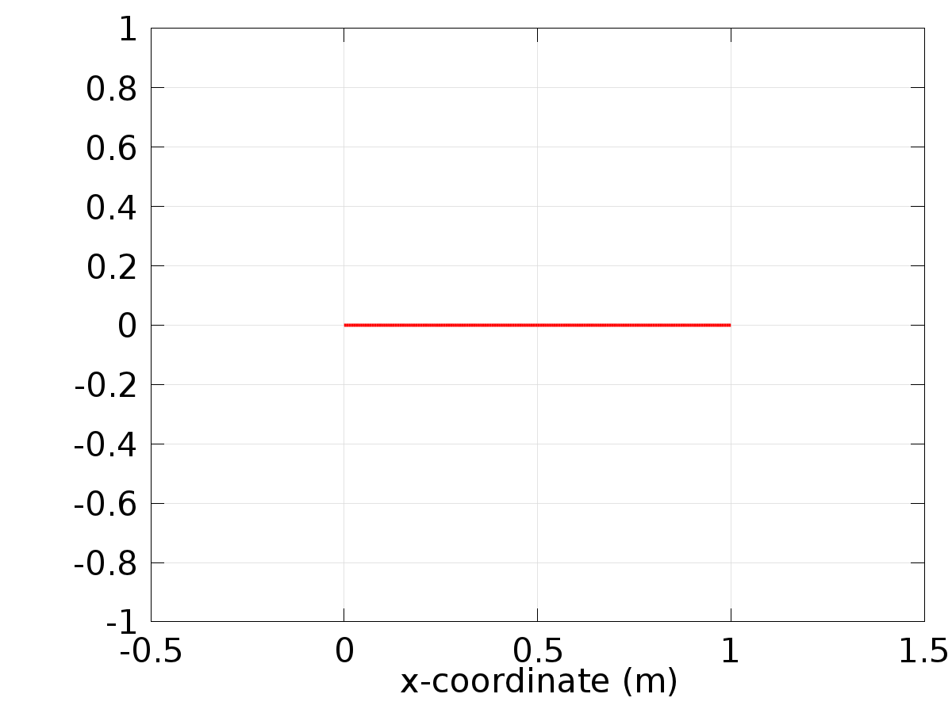

Data set: Solution 1

* + 1. Solution 2

Solution

| **Description** | **Value** |
| --- | --- |
| Solution | Solver 2 |
| Component | Save Point Geometry 1 |

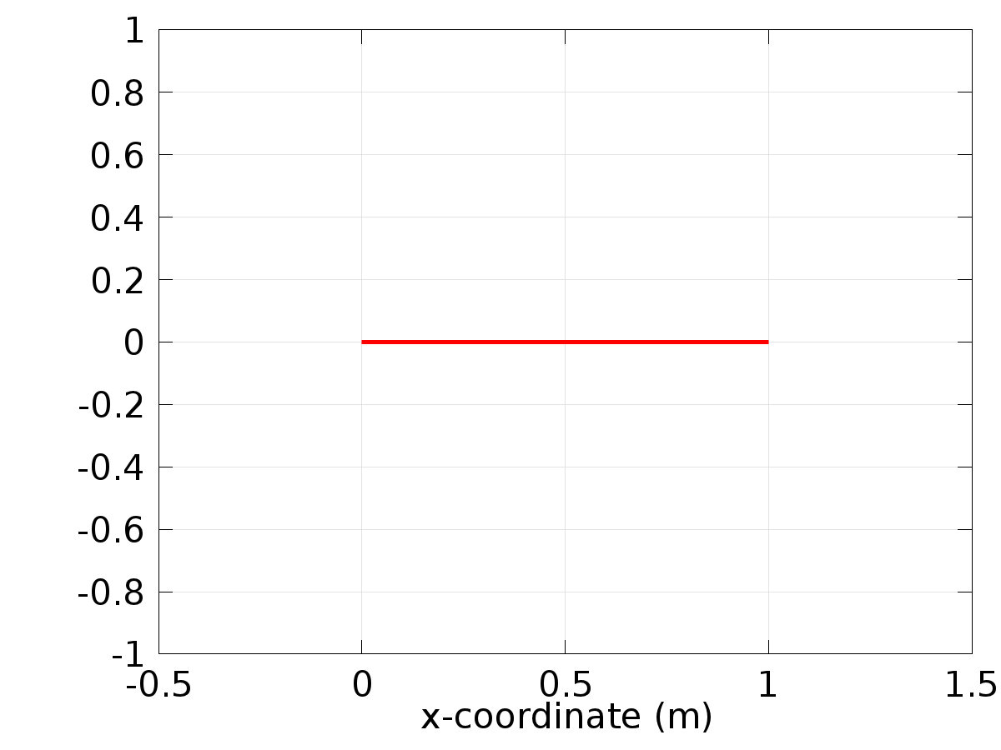

Data set: Solution 2

* + 1. Probe Solution 3

Solution

| **Description** | **Value** |
| --- | --- |
| Solution | Solver 2 |
| Component | Save Point Geometry 1 |



Data set: Probe Solution 3

* 1. Derived Values
     1. Global Variable Probe 1

Data

| **Description** | **Value** |
| --- | --- |
| Data set | Probe Solution 3 |

Expression

| **Description** | **Value** |
| --- | --- |
| Expression | Gamma1 |
| Unit | 1 |

* + 1. Global Variable Probe 2

Data

| **Description** | **Value** |
| --- | --- |
| Data set | Probe Solution 3 |

Expression

| **Description** | **Value** |
| --- | --- |
| Expression | Gamma2 |
| Unit | 1 |

* + 1. Global Variable Probe 3

Data

| **Description** | **Value** |
| --- | --- |
| Data set | Probe Solution 3 |

Expression

| **Description** | **Value** |
| --- | --- |
| Expression | Gamma3 |
| Unit | 1 |

* + 1. Point Evaluation 1

Selection

|  |  |
| --- | --- |
| Geometric entity level | Boundary |
| Selection | Boundary 2 |

Data

| **Description** | **Value** |
| --- | --- |
| Data set | Solution 2 |

Expression

| **Description** | **Value** |
| --- | --- |
| Expression | Gamma |

* 1. Tables
     1. Table 1

Global Evaluation 1 (C(X))

Table 1

| **Gamma3 (1)** |
| --- |
| -0.83333 |

* + 1. Table 2

Point Evaluation 1 (z)

Table 2

| **Dependent variable z (1), Point: 1** |
| --- |
| 0.0000 |

* + 1. Table 3

Point Evaluation 1 (z)

Table 3

| **Time** | **Gradient of z, x component (1/m), Point: 1** |
| --- | --- |
| 6.0000 | -1.4311 |

* + 1. Probe Table 4

Probe Table 4

| **(1), Global Variable Probe 1** | **(1), Global Variable Probe 2** | **(1), Global Variable Probe 3** |
| --- | --- | --- |
| 3.7960 | 3.5036 | -0.83333 |

* + 1. Table 5

Point Evaluation 1 (w1)

* + 1. Table 6

Point Evaluation 1 (w1)

Table 6

| **Time** | **w1, Point: 2** | **C(z) (1), Point: 2** | **w3, Point: 2** | **Gamma, Point: 2** |
| --- | --- | --- | --- | --- |
| 0.0000 | 0.0000 | 2.4915 | 1.0000 | 2.6703 |
| 0.010000 | 0.019999 | 1.4735 | 1.0000 | 2.7455 |
| 0.020000 | 0.039989 | 1.0022 | 1.0000 | 2.8193 |
| 0.030000 | 0.059964 | 0.67655 | 1.0000 | 2.8916 |
| 0.040000 | 0.079915 | 0.44275 | 1.0000 | 2.9625 |
| 0.050000 | 0.099833 | 0.27258 | 1.0000 | 3.0318 |
| 0.060000 | 0.11971 | 0.14834 | 1.0000 | 3.0995 |
| 0.070000 | 0.13954 | 0.058229 | 1.0000 | 3.1657 |
| 0.080000 | 0.15932 | -0.0059973 | 1.0000 | 3.2303 |
| 0.090000 | 0.17903 | -0.050308 | 1.0000 | 3.2933 |
| 0.10000 | 0.19867 | -0.079143 | 1.0000 | 3.3546 |
| 0.11000 | 0.21823 | -0.095874 | 1.0000 | 3.4143 |
| 0.12000 | 0.23770 | -0.10311 | 1.0000 | 3.4722 |
| 0.13000 | 0.25708 | -0.10287 | 1.0000 | 3.5284 |
| 0.14000 | 0.27636 | -0.096770 | 1.0000 | 3.5829 |
| 0.15000 | 0.29552 | -0.086068 | 1.0000 | 3.6356 |
| 0.16000 | 0.31457 | -0.071771 | 1.0000 | 3.6865 |
| 0.17000 | 0.33349 | -0.054680 | 1.0000 | 3.7357 |
| 0.18000 | 0.35227 | -0.035436 | 1.0000 | 3.7829 |
| 0.19000 | 0.37092 | -0.014549 | 1.0000 | 3.8284 |
| 0.20000 | 0.38942 | 0.0075720 | 1.0000 | 3.8720 |
| 0.21000 | 0.40776 | 0.030598 | 1.0000 | 3.9137 |
| 0.22000 | 0.42594 | 0.054268 | 1.0000 | 3.9535 |
| 0.23000 | 0.44395 | 0.078371 | 1.0000 | 3.9913 |
| 0.24000 | 0.46178 | 0.10274 | 1.0000 | 4.0273 |
| 0.25000 | 0.47943 | 0.12723 | 1.0000 | 4.0613 |
| 0.26000 | 0.49688 | 0.15175 | 1.0000 | 4.0933 |
| 0.27000 | 0.51414 | 0.17620 | 1.0000 | 4.1234 |
| 0.28000 | 0.53119 | 0.20051 | 1.0000 | 4.1515 |
| 0.29000 | 0.54802 | 0.22462 | 1.0000 | 4.1776 |
| 0.30000 | 0.56464 | 0.24850 | 1.0000 | 4.2017 |
| 0.31000 | 0.58104 | 0.27210 | 1.0000 | 4.2238 |
| 0.32000 | 0.59720 | 0.29538 | 1.0000 | 4.2439 |
| 0.33000 | 0.61312 | 0.31834 | 1.0000 | 4.2619 |
| 0.34000 | 0.62879 | 0.34094 | 1.0000 | 4.2779 |
| 0.35000 | 0.64422 | 0.36317 | 1.0000 | 4.2918 |
| 0.36000 | 0.65938 | 0.38502 | 1.0000 | 4.3037 |
| 0.37000 | 0.67429 | 0.40648 | 1.0000 | 4.3136 |
| 0.38000 | 0.68892 | 0.42753 | 1.0000 | 4.3214 |
| 0.39000 | 0.70328 | 0.44818 | 1.0000 | 4.3271 |
| 0.40000 | 0.71736 | 0.46841 | 1.0000 | 4.3307 |
| 0.41000 | 0.73115 | 0.48821 | 1.0000 | 4.3323 |
| 0.42000 | 0.74464 | 0.50759 | 1.0000 | 4.3319 |
| 0.43000 | 0.75784 | 0.52653 | 1.0000 | 4.3293 |
| 0.44000 | 0.77074 | 0.54503 | 1.0000 | 4.3247 |
| 0.45000 | 0.78333 | 0.56310 | 1.0000 | 4.3181 |
| 0.46000 | 0.79560 | 0.58072 | 1.0000 | 4.3093 |
| 0.47000 | 0.80756 | 0.59790 | 1.0000 | 4.2985 |
| 0.48000 | 0.81919 | 0.61463 | 1.0000 | 4.2857 |
| 0.49000 | 0.83050 | 0.63091 | 1.0000 | 4.2708 |
| 0.50000 | 0.84147 | 0.64674 | 1.0000 | 4.2539 |
| 0.51000 | 0.85211 | 0.66212 | 1.0000 | 4.2349 |
| 0.52000 | 0.86240 | 0.67704 | 1.0000 | 4.2139 |
| 0.53000 | 0.87236 | 0.69150 | 1.0000 | 4.1909 |
| 0.54000 | 0.88196 | 0.70551 | 1.0000 | 4.1659 |
| 0.55000 | 0.89121 | 0.71906 | 1.0000 | 4.1389 |
| 0.56000 | 0.90010 | 0.73215 | 1.0000 | 4.1099 |
| 0.57000 | 0.90863 | 0.74477 | 1.0000 | 4.0789 |
| 0.58000 | 0.91680 | 0.75694 | 1.0000 | 4.0460 |
| 0.59000 | 0.92461 | 0.76863 | 1.0000 | 4.0111 |
| 0.60000 | 0.93204 | 0.77987 | 1.0000 | 3.9742 |
| 0.61000 | 0.93910 | 0.79064 | 1.0000 | 3.9355 |
| 0.62000 | 0.94578 | 0.80094 | 1.0000 | 3.8948 |
| 0.63000 | 0.95209 | 0.81078 | 1.0000 | 3.8523 |
| 0.64000 | 0.95802 | 0.82015 | 1.0000 | 3.8078 |
| 0.65000 | 0.96356 | 0.82905 | 1.0000 | 3.7615 |
| 0.66000 | 0.96872 | 0.83748 | 1.0000 | 3.7134 |
| 0.67000 | 0.97348 | 0.84545 | 1.0000 | 3.6635 |
| 0.68000 | 0.97786 | 0.85295 | 1.0000 | 3.6117 |
| 0.69000 | 0.98185 | 0.85998 | 1.0000 | 3.5582 |
| 0.70000 | 0.98545 | 0.86655 | 1.0000 | 3.5029 |
| 0.71000 | 0.98865 | 0.87265 | 1.0000 | 3.4459 |
| 0.72000 | 0.99146 | 0.87829 | 1.0000 | 3.3872 |
| 0.73000 | 0.99387 | 0.88345 | 1.0000 | 3.3268 |
| 0.74000 | 0.99588 | 0.88816 | 1.0000 | 3.2647 |
| 0.75000 | 0.99749 | 0.89240 | 1.0000 | 3.2010 |
| 0.76000 | 0.99871 | 0.89617 | 1.0000 | 3.1356 |
| 0.77000 | 0.99953 | 0.89949 | 1.0000 | 3.0687 |
| 0.78000 | 0.99994 | 0.90234 | 1.0000 | 3.0002 |
| 0.79000 | 0.99996 | 0.90474 | 1.0000 | 2.9302 |
| 0.80000 | 0.99957 | 0.90667 | 1.0000 | 2.8587 |
| 0.81000 | 0.99879 | 0.90815 | 1.0000 | 2.7857 |
| 0.82000 | 0.99761 | 0.90918 | 1.0000 | 2.7113 |
| 0.83000 | 0.99602 | 0.90975 | 1.0000 | 2.6354 |
| 0.84000 | 0.99404 | 0.90988 | 1.0000 | 2.5582 |
| 0.85000 | 0.99166 | 0.90955 | 1.0000 | 2.4796 |
| 0.86000 | 0.98889 | 0.90877 | 1.0000 | 2.3996 |
| 0.87000 | 0.98572 | 0.90756 | 1.0000 | 2.3184 |
| 0.88000 | 0.98215 | 0.90590 | 1.0000 | 2.2359 |
| 0.89000 | 0.97820 | 0.90380 | 1.0000 | 2.1522 |
| 0.90000 | 0.97385 | 0.90126 | 1.0000 | 2.0673 |
| 0.91000 | 0.96911 | 0.89829 | 1.0000 | 1.9813 |
| 0.92000 | 0.96398 | 0.89489 | 1.0000 | 1.8941 |
| 0.93000 | 0.95847 | 0.89106 | 1.0000 | 1.8058 |
| 0.94000 | 0.95258 | 0.88681 | 1.0000 | 1.7165 |
| 0.95000 | 0.94630 | 0.88214 | 1.0000 | 1.6261 |
| 0.96000 | 0.93965 | 0.87705 | 1.0000 | 1.5348 |
| 0.97000 | 0.93262 | 0.87154 | 1.0000 | 1.4425 |
| 0.98000 | 0.92521 | 0.86563 | 1.0000 | 1.3493 |
| 0.99000 | 0.91744 | 0.85931 | 1.0000 | 1.2552 |
| 1.0000 | 0.90930 | 0.85258 | 1.0000 | 1.1603 |
| 1.0100 | 0.90079 | 0.84546 | 1.0000 | 1.0646 |
| 1.0200 | 0.89193 | 0.83795 | 1.0000 | 0.96814 |
| 1.0300 | 0.88271 | 0.83004 | 1.0000 | 0.87096 |
| 1.0400 | 0.87313 | 0.82175 | 1.0000 | 0.77309 |
| 1.0500 | 0.86321 | 0.81308 | 1.0000 | 0.67458 |
| 1.0600 | 0.85294 | 0.80403 | 1.0000 | 0.57547 |
| 1.0700 | 0.84233 | 0.79461 | 1.0000 | 0.47580 |
| 1.0800 | 0.83138 | 0.78483 | 1.0000 | 0.37560 |
| 1.0900 | 0.82010 | 0.77468 | 1.0000 | 0.27492 |
| 1.1000 | 0.80850 | 0.76418 | 1.0000 | 0.17380 |
| 1.1100 | 0.79657 | 0.75333 | 1.0000 | 0.072270 |
| 1.1200 | 0.78432 | 0.74213 | 1.0000 | -0.029619 |
| 1.1300 | 0.77175 | 0.73060 | 1.0000 | -0.13183 |
| 1.1400 | 0.75888 | 0.71873 | 1.0000 | -0.23432 |
| 1.1500 | 0.74571 | 0.70653 | 1.0000 | -0.33705 |
| 1.1600 | 0.73223 | 0.69401 | 1.0000 | -0.43998 |
| 1.1700 | 0.71846 | 0.68118 | 1.0000 | -0.54307 |
| 1.1800 | 0.70441 | 0.66803 | 1.0000 | -0.64627 |
| 1.1900 | 0.69007 | 0.65458 | 1.0000 | -0.74955 |
| 1.2000 | 0.67546 | 0.64083 | 1.0000 | -0.85286 |
| 1.2100 | 0.66058 | 0.62679 | 1.0000 | -0.95616 |
| 1.2200 | 0.64543 | 0.61247 | 1.0000 | -1.0594 |
| 1.2300 | 0.63003 | 0.59787 | 1.0000 | -1.1626 |
| 1.2400 | 0.61437 | 0.58300 | 1.0000 | -1.2656 |
| 1.2500 | 0.59847 | 0.56786 | 1.0000 | -1.3685 |
| 1.2600 | 0.58233 | 0.55246 | 1.0000 | -1.4711 |
| 1.2700 | 0.56596 | 0.53682 | 1.0000 | -1.5735 |
| 1.2800 | 0.54936 | 0.52092 | 1.0000 | -1.6756 |
| 1.2900 | 0.53253 | 0.50480 | 1.0000 | -1.7774 |
| 1.3000 | 0.51550 | 0.48844 | 1.0000 | -1.8787 |
| 1.3100 | 0.49826 | 0.47186 | 1.0000 | -1.9797 |
| 1.3200 | 0.48082 | 0.45506 | 1.0000 | -2.0802 |
| 1.3300 | 0.46319 | 0.43806 | 1.0000 | -2.1802 |
| 1.3400 | 0.44537 | 0.42085 | 1.0000 | -2.2797 |
| 1.3500 | 0.42738 | 0.40346 | 1.0000 | -2.3786 |
| 1.3600 | 0.40921 | 0.38587 | 1.0000 | -2.4768 |
| 1.3700 | 0.39088 | 0.36811 | 1.0000 | -2.5744 |
| 1.3800 | 0.37240 | 0.35018 | 1.0000 | -2.6714 |
| 1.3900 | 0.35376 | 0.33209 | 1.0000 | -2.7675 |
| 1.4000 | 0.33499 | 0.31384 | 1.0000 | -2.8629 |
| 1.4100 | 0.31608 | 0.29544 | 1.0000 | -2.9575 |
| 1.4200 | 0.29704 | 0.27691 | 1.0000 | -3.0513 |
| 1.4300 | 0.27789 | 0.25825 | 1.0000 | -3.1441 |
| 1.4400 | 0.25862 | 0.23946 | 1.0000 | -3.2361 |
| 1.4500 | 0.23925 | 0.22055 | 1.0000 | -3.3270 |
| 1.4600 | 0.21978 | 0.20154 | 1.0000 | -3.4170 |
| 1.4700 | 0.20023 | 0.18243 | 1.0000 | -3.5060 |
| 1.4800 | 0.18060 | 0.16323 | 1.0000 | -3.5938 |
| 1.4900 | 0.16089 | 0.14395 | 1.0000 | -3.6806 |
| 1.5000 | 0.14112 | 0.12459 | 1.0000 | -3.7662 |
| 1.5100 | 0.12129 | 0.10517 | 1.0000 | -3.8507 |
| 1.5200 | 0.10142 | 0.085688 | 1.0000 | -3.9339 |
| 1.5300 | 0.081502 | 0.066156 | 1.0000 | -4.0159 |
| 1.5400 | 0.061554 | 0.046582 | 1.0000 | -4.0967 |
| 1.5500 | 0.041581 | 0.026973 | 1.0000 | -4.1761 |
| 1.5600 | 0.021591 | 0.0073398 | 1.0000 | -4.2542 |
| 1.5700 | 0.0015927 | -0.012311 | 1.0000 | -4.3309 |
| 1.5800 | -0.018406 | -0.031971 | 1.0000 | -4.4063 |
| 1.5900 | -0.038398 | -0.051632 | 1.0000 | -4.4802 |
| 1.6000 | -0.058374 | -0.071286 | 1.0000 | -4.5526 |
| 1.6100 | -0.078327 | -0.090924 | 1.0000 | -4.6235 |
| 1.6200 | -0.098249 | -0.11054 | 1.0000 | -4.6930 |
| 1.6300 | -0.11813 | -0.13012 | 1.0000 | -4.7609 |
| 1.6400 | -0.13797 | -0.14966 | 1.0000 | -4.8272 |
| 1.6500 | -0.15775 | -0.16916 | 1.0000 | -4.8919 |
| 1.6600 | -0.17746 | -0.18860 | 1.0000 | -4.9550 |
| 1.6700 | -0.19711 | -0.20797 | 1.0000 | -5.0165 |
| 1.6800 | -0.21668 | -0.22727 | 1.0000 | -5.0762 |
| 1.6900 | -0.23616 | -0.24650 | 1.0000 | -5.1343 |
| 1.7000 | -0.25554 | -0.26563 | 1.0000 | -5.1907 |
| 1.7100 | -0.27482 | -0.28467 | 1.0000 | -5.2453 |
| 1.7200 | -0.29400 | -0.30360 | 1.0000 | -5.2982 |
| 1.7300 | -0.31305 | -0.32242 | 1.0000 | -5.3492 |
| 1.7400 | -0.33199 | -0.34113 | 1.0000 | -5.3985 |
| 1.7500 | -0.35078 | -0.35970 | 1.0000 | -5.4459 |
| 1.7600 | -0.36944 | -0.37814 | 1.0000 | -5.4915 |
| 1.7700 | -0.38795 | -0.39644 | 1.0000 | -5.5352 |
| 1.7800 | -0.40631 | -0.41459 | 1.0000 | -5.5771 |
| 1.7900 | -0.42450 | -0.43258 | 1.0000 | -5.6170 |
| 1.8000 | -0.44252 | -0.45040 | 1.0000 | -5.6551 |
| 1.8100 | -0.46037 | -0.46806 | 1.0000 | -5.6912 |
| 1.8200 | -0.47803 | -0.48553 | 1.0000 | -5.7253 |
| 1.8300 | -0.49550 | -0.50282 | 1.0000 | -5.7575 |
| 1.8400 | -0.51277 | -0.51991 | 1.0000 | -5.7878 |
| 1.8500 | -0.52984 | -0.53680 | 1.0000 | -5.8160 |
| 1.8600 | -0.54669 | -0.55349 | 1.0000 | -5.8423 |
| 1.8700 | -0.56333 | -0.56996 | 1.0000 | -5.8665 |
| 1.8800 | -0.57974 | -0.58621 | 1.0000 | -5.8888 |
| 1.8900 | -0.59592 | -0.60223 | 1.0000 | -5.9090 |
| 1.9000 | -0.61186 | -0.61802 | 1.0000 | -5.9272 |
| 1.9100 | -0.62755 | -0.63356 | 1.0000 | -5.9434 |
| 1.9200 | -0.64300 | -0.64886 | 1.0000 | -5.9575 |
| 1.9300 | -0.65819 | -0.66390 | 1.0000 | -5.9695 |
| 1.9400 | -0.67311 | -0.67869 | 1.0000 | -5.9795 |
| 1.9500 | -0.68777 | -0.69321 | 1.0000 | -5.9875 |
| 1.9600 | -0.70215 | -0.70746 | 1.0000 | -5.9934 |
| 1.9700 | -0.71625 | -0.72143 | 1.0000 | -5.9972 |
| 1.9800 | -0.73006 | -0.73511 | 1.0000 | -5.9990 |
| 1.9900 | -0.74358 | -0.74851 | 1.0000 | -5.9986 |
| 2.0000 | -0.75680 | -0.76161 | 1.0000 | -5.9963 |
| 2.0100 | -0.76972 | -0.77442 | 1.0000 | -5.9918 |
| 2.0200 | -0.78234 | -0.78691 | 1.0000 | -5.9853 |
| 2.0300 | -0.79464 | -0.79910 | 1.0000 | -5.9768 |
| 2.0400 | -0.80662 | -0.81098 | 1.0000 | -5.9661 |
| 2.0500 | -0.81828 | -0.82253 | 1.0000 | -5.9535 |
| 2.0600 | -0.82961 | -0.83376 | 1.0000 | -5.9388 |
| 2.0700 | -0.84061 | -0.84466 | 1.0000 | -5.9220 |
| 2.0800 | -0.85127 | -0.85522 | 1.0000 | -5.9032 |
| 2.0900 | -0.86160 | -0.86545 | 1.0000 | -5.8824 |
| 2.1000 | -0.87158 | -0.87533 | 1.0000 | -5.8595 |
| 2.1100 | -0.88121 | -0.88487 | 1.0000 | -5.8347 |
| 2.1200 | -0.89048 | -0.89406 | 1.0000 | -5.8078 |
| 2.1300 | -0.89941 | -0.90290 | 1.0000 | -5.7790 |
| 2.1400 | -0.90797 | -0.91137 | 1.0000 | -5.7481 |
| 2.1500 | -0.91617 | -0.91949 | 1.0000 | -5.7153 |
| 2.1600 | -0.92400 | -0.92724 | 1.0000 | -5.6806 |
| 2.1700 | -0.93146 | -0.93462 | 1.0000 | -5.6439 |
| 2.1800 | -0.93855 | -0.94164 | 1.0000 | -5.6053 |
| 2.1900 | -0.94527 | -0.94828 | 1.0000 | -5.5648 |
| 2.2000 | -0.95160 | -0.95454 | 1.0000 | -5.5224 |
| 2.2100 | -0.95756 | -0.96042 | 1.0000 | -5.4781 |
| 2.2200 | -0.96313 | -0.96593 | 1.0000 | -5.4319 |
| 2.2300 | -0.96832 | -0.97105 | 1.0000 | -5.3840 |
| 2.2400 | -0.97312 | -0.97578 | 1.0000 | -5.3342 |
| 2.2500 | -0.97753 | -0.98013 | 1.0000 | -5.2826 |
| 2.2600 | -0.98155 | -0.98408 | 1.0000 | -5.2292 |
| 2.2700 | -0.98518 | -0.98765 | 1.0000 | -5.1740 |
| 2.2800 | -0.98841 | -0.99082 | 1.0000 | -5.1172 |
| 2.2900 | -0.99125 | -0.99360 | 1.0000 | -5.0586 |
| 2.3000 | -0.99369 | -0.99598 | 1.0000 | -4.9983 |
| 2.3100 | -0.99574 | -0.99797 | 1.0000 | -4.9364 |
| 2.3200 | -0.99738 | -0.99956 | 1.0000 | -4.8728 |
| 2.3300 | -0.99863 | -1.0008 | 1.0000 | -4.8076 |
| 2.3400 | -0.99948 | -1.0016 | 1.0000 | -4.7408 |
| 2.3500 | -0.99992 | -1.0019 | 1.0000 | -4.6724 |
| 2.3600 | -0.99997 | -1.0019 | 1.0000 | -4.6025 |
| 2.3700 | -0.99962 | -1.0015 | 1.0000 | -4.5311 |
| 2.3800 | -0.99887 | -1.0007 | 1.0000 | -4.4583 |
| 2.3900 | -0.99772 | -0.99955 | 1.0000 | -4.3839 |
| 2.4000 | -0.99616 | -0.99795 | 1.0000 | -4.3082 |
| 2.4100 | -0.99422 | -0.99596 | 1.0000 | -4.2310 |
| 2.4200 | -0.99187 | -0.99357 | 1.0000 | -4.1525 |
| 2.4300 | -0.98913 | -0.99079 | 1.0000 | -4.0727 |
| 2.4400 | -0.98599 | -0.98761 | 1.0000 | -3.9916 |
| 2.4500 | -0.98245 | -0.98403 | 1.0000 | -3.9092 |
| 2.4600 | -0.97853 | -0.98007 | 1.0000 | -3.8256 |
| 2.4700 | -0.97421 | -0.97571 | 1.0000 | -3.7408 |
| 2.4800 | -0.96950 | -0.97097 | 1.0000 | -3.6548 |
| 2.4900 | -0.96441 | -0.96584 | 1.0000 | -3.5677 |
| 2.5000 | -0.95892 | -0.96032 | 1.0000 | -3.4795 |
| 2.5100 | -0.95306 | -0.95442 | 1.0000 | -3.3903 |
| 2.5200 | -0.94681 | -0.94814 | 1.0000 | -3.3000 |
| 2.5300 | -0.94019 | -0.94149 | 1.0000 | -3.2087 |
| 2.5400 | -0.93319 | -0.93445 | 1.0000 | -3.1165 |
| 2.5500 | -0.92581 | -0.92705 | 1.0000 | -3.0234 |
| 2.5600 | -0.91807 | -0.91927 | 1.0000 | -2.9294 |
| 2.5700 | -0.90996 | -0.91113 | 1.0000 | -2.8346 |
| 2.5800 | -0.90148 | -0.90263 | 1.0000 | -2.7389 |
| 2.5900 | -0.89265 | -0.89377 | 1.0000 | -2.6425 |
| 2.6000 | -0.88345 | -0.88455 | 1.0000 | -2.5454 |
| 2.6100 | -0.87391 | -0.87497 | 1.0000 | -2.4476 |
| 2.6200 | -0.86401 | -0.86505 | 1.0000 | -2.3491 |
| 2.6300 | -0.85377 | -0.85479 | 1.0000 | -2.2501 |
| 2.6400 | -0.84319 | -0.84418 | 1.0000 | -2.1504 |
| 2.6500 | -0.83227 | -0.83323 | 1.0000 | -2.0503 |
| 2.6600 | -0.82101 | -0.82196 | 1.0000 | -1.9496 |
| 2.6700 | -0.80943 | -0.81035 | 1.0000 | -1.8485 |
| 2.6800 | -0.79753 | -0.79842 | 1.0000 | -1.7470 |
| 2.6900 | -0.78530 | -0.78618 | 1.0000 | -1.6452 |
| 2.7000 | -0.77276 | -0.77362 | 1.0000 | -1.5430 |
| 2.7100 | -0.75992 | -0.76075 | 1.0000 | -1.4405 |
| 2.7200 | -0.74677 | -0.74758 | 1.0000 | -1.3378 |
| 2.7300 | -0.73332 | -0.73411 | 1.0000 | -1.2349 |
| 2.7400 | -0.71957 | -0.72035 | 1.0000 | -1.1318 |
| 2.7500 | -0.70554 | -0.70630 | 1.0000 | -1.0286 |
| 2.7600 | -0.69123 | -0.69196 | 1.0000 | -0.92534 |
| 2.7700 | -0.67664 | -0.67736 | 1.0000 | -0.82203 |
| 2.7800 | -0.66178 | -0.66248 | 1.0000 | -0.71873 |
| 2.7900 | -0.64665 | -0.64734 | 1.0000 | -0.61547 |
| 2.8000 | -0.63127 | -0.63193 | 1.0000 | -0.51230 |
| 2.8100 | -0.61563 | -0.61628 | 1.0000 | -0.40925 |
| 2.8200 | -0.59975 | -0.60038 | 1.0000 | -0.30638 |
| 2.8300 | -0.58362 | -0.58424 | 1.0000 | -0.20371 |
| 2.8400 | -0.56727 | -0.56787 | 1.0000 | -0.10130 |
| 2.8500 | -0.55069 | -0.55128 | 1.0000 | 8.1837E-4 |
| 2.8600 | -0.53388 | -0.53446 | 1.0000 | 0.10260 |
| 2.8700 | -0.51687 | -0.51743 | 1.0000 | 0.20401 |
| 2.8800 | -0.49964 | -0.50019 | 1.0000 | 0.30501 |
| 2.8900 | -0.48222 | -0.48275 | 1.0000 | 0.40555 |
| 2.9000 | -0.46460 | -0.46512 | 1.0000 | 0.50560 |
| 2.9100 | -0.44680 | -0.44731 | 1.0000 | 0.60511 |
| 2.9200 | -0.42882 | -0.42931 | 1.0000 | 0.70404 |
| 2.9300 | -0.41067 | -0.41115 | 1.0000 | 0.80236 |
| 2.9400 | -0.39235 | -0.39282 | 1.0000 | 0.90003 |
| 2.9500 | -0.37388 | -0.37434 | 1.0000 | 0.99700 |
| 2.9600 | -0.35525 | -0.35570 | 1.0000 | 1.0932 |
| 2.9700 | -0.33649 | -0.33693 | 1.0000 | 1.1887 |
| 2.9800 | -0.31759 | -0.31802 | 1.0000 | 1.2834 |
| 2.9900 | -0.29856 | -0.29898 | 1.0000 | 1.3772 |
| 3.0000 | -0.27942 | -0.27982 | 1.0000 | 1.4701 |
| 3.0100 | -0.26016 | -0.26055 | 1.0000 | 1.5621 |
| 3.0200 | -0.24080 | -0.24118 | 1.0000 | 1.6532 |
| 3.0300 | -0.22134 | -0.22172 | 1.0000 | 1.7432 |
| 3.0400 | -0.20179 | -0.20216 | 1.0000 | 1.8322 |
| 3.0500 | -0.18216 | -0.18252 | 1.0000 | 1.9202 |
| 3.0600 | -0.16246 | -0.16281 | 1.0000 | 2.0071 |
| 3.0700 | -0.14270 | -0.14304 | 1.0000 | 2.0928 |
| 3.0800 | -0.12287 | -0.12321 | 1.0000 | 2.1773 |
| 3.0900 | -0.10300 | -0.10333 | 1.0000 | 2.2607 |
| 3.1000 | -0.083089 | -0.083408 | 1.0000 | 2.3428 |
| 3.1100 | -0.063143 | -0.063455 | 1.0000 | 2.4236 |
| 3.1200 | -0.043172 | -0.043476 | 1.0000 | 2.5032 |
| 3.1300 | -0.023183 | -0.023480 | 1.0000 | 2.5814 |
| 3.1400 | -0.0031853 | -0.0034745 | 1.0000 | 2.6582 |
| 3.1500 | 0.016814 | 0.016532 | 1.0000 | 2.7336 |
| 3.1600 | 0.036806 | 0.036531 | 1.0000 | 2.8077 |
| 3.1700 | 0.056784 | 0.056516 | 1.0000 | 2.8802 |
| 3.1800 | 0.076739 | 0.076477 | 1.0000 | 2.9513 |
| 3.1900 | 0.096664 | 0.096408 | 1.0000 | 3.0208 |
| 3.2000 | 0.11655 | 0.11630 | 1.0000 | 3.0889 |
| 3.2100 | 0.13639 | 0.13614 | 1.0000 | 3.1553 |
| 3.2200 | 0.15617 | 0.15594 | 1.0000 | 3.2202 |
| 3.2300 | 0.17589 | 0.17566 | 1.0000 | 3.2834 |
| 3.2400 | 0.19555 | 0.19532 | 1.0000 | 3.3450 |
| 3.2500 | 0.21512 | 0.21490 | 1.0000 | 3.4049 |
| 3.2600 | 0.23461 | 0.23439 | 1.0000 | 3.4631 |
| 3.2700 | 0.25400 | 0.25379 | 1.0000 | 3.5196 |
| 3.2800 | 0.27329 | 0.27309 | 1.0000 | 3.5743 |
| 3.2900 | 0.29248 | 0.29228 | 1.0000 | 3.6273 |
| 3.3000 | 0.31154 | 0.31135 | 1.0000 | 3.6785 |
| 3.3100 | 0.33048 | 0.33029 | 1.0000 | 3.7280 |
| 3.3200 | 0.34929 | 0.34911 | 1.0000 | 3.7755 |
| 3.3300 | 0.36796 | 0.36778 | 1.0000 | 3.8213 |
| 3.3400 | 0.38648 | 0.38631 | 1.0000 | 3.8651 |
| 3.3500 | 0.40485 | 0.40468 | 1.0000 | 3.9071 |
| 3.3600 | 0.42306 | 0.42289 | 1.0000 | 3.9472 |
| 3.3700 | 0.44109 | 0.44093 | 1.0000 | 3.9854 |
| 3.3800 | 0.45895 | 0.45879 | 1.0000 | 4.0217 |
| 3.3900 | 0.47663 | 0.47647 | 1.0000 | 4.0560 |
| 3.4000 | 0.49411 | 0.49396 | 1.0000 | 4.0884 |
| 3.4100 | 0.51140 | 0.51125 | 1.0000 | 4.1188 |
| 3.4200 | 0.52848 | 0.52834 | 1.0000 | 4.1472 |
| 3.4300 | 0.54536 | 0.54521 | 1.0000 | 4.1736 |
| 3.4400 | 0.56201 | 0.56187 | 1.0000 | 4.1980 |
| 3.4500 | 0.57844 | 0.57830 | 1.0000 | 4.2204 |
| 3.4600 | 0.59464 | 0.59451 | 1.0000 | 4.2408 |
| 3.4700 | 0.61060 | 0.61047 | 1.0000 | 4.2592 |
| 3.4800 | 0.62631 | 0.62619 | 1.0000 | 4.2755 |
| 3.4900 | 0.64178 | 0.64166 | 1.0000 | 4.2898 |
| 3.5000 | 0.65699 | 0.65687 | 1.0000 | 4.3020 |
| 3.5100 | 0.67193 | 0.67182 | 1.0000 | 4.3121 |
| 3.5200 | 0.68661 | 0.68650 | 1.0000 | 4.3203 |
| 3.5300 | 0.70101 | 0.70090 | 1.0000 | 4.3263 |
| 3.5400 | 0.71513 | 0.71502 | 1.0000 | 4.3303 |
| 3.5500 | 0.72897 | 0.72886 | 1.0000 | 4.3322 |
| 3.5600 | 0.74251 | 0.74241 | 1.0000 | 4.3321 |
| 3.5700 | 0.75576 | 0.75566 | 1.0000 | 4.3299 |
| 3.5800 | 0.76871 | 0.76861 | 1.0000 | 4.3256 |
| 3.5900 | 0.78134 | 0.78125 | 1.0000 | 4.3193 |
| 3.6000 | 0.79367 | 0.79357 | 1.0000 | 4.3109 |
| 3.6100 | 0.80568 | 0.80558 | 1.0000 | 4.3004 |
| 3.6200 | 0.81736 | 0.81727 | 1.0000 | 4.2879 |
| 3.6300 | 0.82872 | 0.82863 | 1.0000 | 4.2733 |
| 3.6400 | 0.83975 | 0.83966 | 1.0000 | 4.2567 |
| 3.6500 | 0.85044 | 0.85035 | 1.0000 | 4.2381 |
| 3.6600 | 0.86079 | 0.86070 | 1.0000 | 4.2174 |
| 3.6700 | 0.87079 | 0.87071 | 1.0000 | 4.1947 |
| 3.6800 | 0.88045 | 0.88037 | 1.0000 | 4.1700 |
| 3.6900 | 0.88976 | 0.88968 | 1.0000 | 4.1433 |
| 3.7000 | 0.89871 | 0.89863 | 1.0000 | 4.1147 |
| 3.7100 | 0.90730 | 0.90722 | 1.0000 | 4.0840 |
| 3.7200 | 0.91553 | 0.91545 | 1.0000 | 4.0514 |
| 3.7300 | 0.92339 | 0.92332 | 1.0000 | 4.0168 |
| 3.7400 | 0.93088 | 0.93081 | 1.0000 | 3.9802 |
| 3.7500 | 0.93800 | 0.93793 | 1.0000 | 3.9418 |
| 3.7600 | 0.94474 | 0.94468 | 1.0000 | 3.9014 |
| 3.7700 | 0.95111 | 0.95104 | 1.0000 | 3.8592 |
| 3.7800 | 0.95710 | 0.95703 | 1.0000 | 3.8150 |
| 3.7900 | 0.96270 | 0.96264 | 1.0000 | 3.7690 |
| 3.8000 | 0.96792 | 0.96786 | 1.0000 | 3.7212 |
| 3.8100 | 0.97275 | 0.97269 | 1.0000 | 3.6715 |
| 3.8200 | 0.97719 | 0.97713 | 1.0000 | 3.6201 |
| 3.8300 | 0.98124 | 0.98118 | 1.0000 | 3.5668 |
| 3.8400 | 0.98490 | 0.98484 | 1.0000 | 3.5118 |
| 3.8500 | 0.98817 | 0.98811 | 1.0000 | 3.4551 |
| 3.8600 | 0.99104 | 0.99098 | 1.0000 | 3.3966 |
| 3.8700 | 0.99351 | 0.99345 | 1.0000 | 3.3365 |
| 3.8800 | 0.99559 | 0.99553 | 1.0000 | 3.2747 |
| 3.8900 | 0.99726 | 0.99721 | 1.0000 | 3.2112 |
| 3.9000 | 0.99854 | 0.99849 | 1.0000 | 3.1462 |
| 3.9100 | 0.99942 | 0.99937 | 1.0000 | 3.0795 |
| 3.9200 | 0.99990 | 0.99985 | 1.0000 | 3.0113 |
| 3.9300 | 0.99998 | 0.99993 | 1.0000 | 2.9415 |
| 3.9400 | 0.99966 | 0.99961 | 1.0000 | 2.8702 |
| 3.9500 | 0.99894 | 0.99889 | 1.0000 | 2.7974 |
| 3.9600 | 0.99782 | 0.99777 | 1.0000 | 2.7232 |
| 3.9700 | 0.99630 | 0.99625 | 1.0000 | 2.6476 |
| 3.9800 | 0.99439 | 0.99434 | 1.0000 | 2.5706 |
| 3.9900 | 0.99207 | 0.99202 | 1.0000 | 2.4922 |
| 4.0000 | 0.98936 | 0.98931 | 1.0000 | 2.4125 |
| 4.0100 | 0.98625 | 0.98620 | 1.0000 | 2.3314 |
| 4.0200 | 0.98275 | 0.98270 | 1.0000 | 2.2492 |
| 4.0300 | 0.97885 | 0.97881 | 1.0000 | 2.1656 |
| 4.0400 | 0.97457 | 0.97452 | 1.0000 | 2.0809 |
| 4.0500 | 0.96989 | 0.96984 | 1.0000 | 1.9950 |
| 4.0600 | 0.96483 | 0.96478 | 1.0000 | 1.9080 |
| 4.0700 | 0.95937 | 0.95933 | 1.0000 | 1.8199 |
| 4.0800 | 0.95354 | 0.95350 | 1.0000 | 1.7308 |
| 4.0900 | 0.94733 | 0.94728 | 1.0000 | 1.6406 |
| 4.1000 | 0.94073 | 0.94069 | 1.0000 | 1.5494 |
| 4.1100 | 0.93376 | 0.93372 | 1.0000 | 1.4572 |
| 4.1200 | 0.92642 | 0.92637 | 1.0000 | 1.3642 |
| 4.1300 | 0.91870 | 0.91866 | 1.0000 | 1.2702 |
| 4.1400 | 0.91062 | 0.91058 | 1.0000 | 1.1755 |
| 4.1500 | 0.90217 | 0.90213 | 1.0000 | 1.0799 |
| 4.1600 | 0.89336 | 0.89333 | 1.0000 | 0.98355 |
| 4.1700 | 0.88420 | 0.88416 | 1.0000 | 0.88648 |
| 4.1800 | 0.87468 | 0.87464 | 1.0000 | 0.78872 |
| 4.1900 | 0.86481 | 0.86478 | 1.0000 | 0.69031 |
| 4.2000 | 0.85460 | 0.85456 | 1.0000 | 0.59130 |
| 4.2100 | 0.84404 | 0.84401 | 1.0000 | 0.49171 |
| 4.2200 | 0.83315 | 0.83311 | 1.0000 | 0.39159 |
| 4.2300 | 0.82192 | 0.82189 | 1.0000 | 0.29099 |
| 4.2400 | 0.81037 | 0.81033 | 1.0000 | 0.18993 |
| 4.2500 | 0.79849 | 0.79845 | 1.0000 | 0.088465 |
| 4.2600 | 0.78629 | 0.78625 | 1.0000 | -0.013369 |
| 4.2700 | 0.77377 | 0.77374 | 1.0000 | -0.11553 |
| 4.2800 | 0.76095 | 0.76092 | 1.0000 | -0.21798 |
| 4.2900 | 0.74782 | 0.74779 | 1.0000 | -0.32068 |
| 4.3000 | 0.73440 | 0.73436 | 1.0000 | -0.42358 |
| 4.3100 | 0.72068 | 0.72064 | 1.0000 | -0.52664 |
| 4.3200 | 0.70667 | 0.70663 | 1.0000 | -0.62983 |
| 4.3300 | 0.69238 | 0.69234 | 1.0000 | -0.73310 |
| 4.3400 | 0.67781 | 0.67778 | 1.0000 | -0.83641 |
| 4.3500 | 0.66297 | 0.66294 | 1.0000 | -0.93971 |
| 4.3600 | 0.64786 | 0.64783 | 1.0000 | -1.0430 |
| 4.3700 | 0.63250 | 0.63247 | 1.0000 | -1.1462 |
| 4.3800 | 0.61688 | 0.61685 | 1.0000 | -1.2492 |
| 4.3900 | 0.60102 | 0.60099 | 1.0000 | -1.3521 |
| 4.4000 | 0.58492 | 0.58488 | 1.0000 | -1.4548 |
| 4.4100 | 0.56858 | 0.56855 | 1.0000 | -1.5572 |
| 4.4200 | 0.55201 | 0.55198 | 1.0000 | -1.6594 |
| 4.4300 | 0.53523 | 0.53520 | 1.0000 | -1.7612 |
| 4.4400 | 0.51823 | 0.51820 | 1.0000 | -1.8626 |
| 4.4500 | 0.50102 | 0.50099 | 1.0000 | -1.9637 |
| 4.4600 | 0.48361 | 0.48358 | 1.0000 | -2.0642 |
| 4.4700 | 0.46601 | 0.46598 | 1.0000 | -2.1643 |
| 4.4800 | 0.44822 | 0.44819 | 1.0000 | -2.2639 |
| 4.4900 | 0.43026 | 0.43023 | 1.0000 | -2.3629 |
| 4.5000 | 0.41212 | 0.41209 | 1.0000 | -2.4612 |
| 4.5100 | 0.39381 | 0.39379 | 1.0000 | -2.5589 |
| 4.5200 | 0.37535 | 0.37533 | 1.0000 | -2.6560 |
| 4.5300 | 0.35674 | 0.35671 | 1.0000 | -2.7523 |
| 4.5400 | 0.33799 | 0.33796 | 1.0000 | -2.8478 |
| 4.5500 | 0.31910 | 0.31907 | 1.0000 | -2.9425 |
| 4.5600 | 0.30008 | 0.30006 | 1.0000 | -3.0364 |
| 4.5700 | 0.28094 | 0.28092 | 1.0000 | -3.1294 |
| 4.5800 | 0.26169 | 0.26167 | 1.0000 | -3.2215 |
| 4.5900 | 0.24234 | 0.24232 | 1.0000 | -3.3126 |
| 4.6000 | 0.22289 | 0.22287 | 1.0000 | -3.4028 |
| 4.6100 | 0.20335 | 0.20333 | 1.0000 | -3.4919 |
| 4.6200 | 0.18373 | 0.18371 | 1.0000 | -3.5799 |
| 4.6300 | 0.16403 | 0.16401 | 1.0000 | -3.6669 |
| 4.6400 | 0.14427 | 0.14425 | 1.0000 | -3.7527 |
| 4.6500 | 0.12445 | 0.12443 | 1.0000 | -3.8373 |
| 4.6600 | 0.10459 | 0.10457 | 1.0000 | -3.9208 |
| 4.6700 | 0.084676 | 0.084657 | 1.0000 | -4.0030 |
| 4.6800 | 0.064733 | 0.064713 | 1.0000 | -4.0839 |
| 4.6900 | 0.044763 | 0.044744 | 1.0000 | -4.1635 |
| 4.7000 | 0.024775 | 0.024757 | 1.0000 | -4.2419 |
| 4.7100 | 0.0047779 | 0.0047599 | 1.0000 | -4.3188 |
| 4.7200 | -0.015221 | -0.015239 | 1.0000 | -4.3944 |
| 4.7300 | -0.035215 | -0.035232 | 1.0000 | -4.4685 |
| 4.7400 | -0.055194 | -0.055211 | 1.0000 | -4.5412 |
| 4.7500 | -0.075151 | -0.075167 | 1.0000 | -4.6123 |
| 4.7600 | -0.095078 | -0.095094 | 1.0000 | -4.6820 |
| 4.7700 | -0.11497 | -0.11498 | 1.0000 | -4.7502 |
| 4.7800 | -0.13481 | -0.13483 | 1.0000 | -4.8167 |
| 4.7900 | -0.15460 | -0.15461 | 1.0000 | -4.8817 |
| 4.8000 | -0.17433 | -0.17434 | 1.0000 | -4.9451 |
| 4.8100 | -0.19398 | -0.19400 | 1.0000 | -5.0068 |
| 4.8200 | -0.21356 | -0.21358 | 1.0000 | -5.0668 |
| 4.8300 | -0.23306 | -0.23307 | 1.0000 | -5.1252 |
| 4.8400 | -0.25246 | -0.25247 | 1.0000 | -5.1818 |
| 4.8500 | -0.27176 | -0.27177 | 1.0000 | -5.2367 |
| 4.8600 | -0.29095 | -0.29096 | 1.0000 | -5.2899 |
| 4.8700 | -0.31003 | -0.31004 | 1.0000 | -5.3412 |
| 4.8800 | -0.32898 | -0.32899 | 1.0000 | -5.3908 |
| 4.8900 | -0.34780 | -0.34781 | 1.0000 | -5.4385 |
| 4.9000 | -0.36648 | -0.36649 | 1.0000 | -5.4844 |
| 4.9100 | -0.38501 | -0.38502 | 1.0000 | -5.5284 |
| 4.9200 | -0.40339 | -0.40340 | 1.0000 | -5.5705 |
| 4.9300 | -0.42161 | -0.42162 | 1.0000 | -5.6108 |
| 4.9400 | -0.43966 | -0.43967 | 1.0000 | -5.6491 |
| 4.9500 | -0.45754 | -0.45755 | 1.0000 | -5.6855 |
| 4.9600 | -0.47523 | -0.47524 | 1.0000 | -5.7200 |
| 4.9700 | -0.49273 | -0.49274 | 1.0000 | -5.7525 |
| 4.9800 | -0.51003 | -0.51004 | 1.0000 | -5.7831 |
| 4.9900 | -0.52713 | -0.52714 | 1.0000 | -5.8117 |
| 5.0000 | -0.54402 | -0.54403 | 1.0000 | -5.8382 |
| 5.0100 | -0.56069 | -0.56070 | 1.0000 | -5.8628 |
| 5.0200 | -0.57714 | -0.57715 | 1.0000 | -5.8854 |
| 5.0300 | -0.59336 | -0.59336 | 1.0000 | -5.9059 |
| 5.0400 | -0.60934 | -0.60934 | 1.0000 | -5.9244 |
| 5.0500 | -0.62507 | -0.62508 | 1.0000 | -5.9409 |
| 5.0600 | -0.64056 | -0.64056 | 1.0000 | -5.9554 |
| 5.0700 | -0.65579 | -0.65579 | 1.0000 | -5.9677 |
| 5.0800 | -0.67075 | -0.67076 | 1.0000 | -5.9781 |
| 5.0900 | -0.68545 | -0.68545 | 1.0000 | -5.9864 |
| 5.1000 | -0.69987 | -0.69988 | 1.0000 | -5.9926 |
| 5.1100 | -0.71402 | -0.71402 | 1.0000 | -5.9967 |
| 5.1200 | -0.72788 | -0.72788 | 1.0000 | -5.9988 |
| 5.1300 | -0.74145 | -0.74145 | 1.0000 | -5.9988 |
| 5.1400 | -0.75472 | -0.75472 | 1.0000 | -5.9968 |
| 5.1500 | -0.76769 | -0.76769 | 1.0000 | -5.9927 |
| 5.1600 | -0.78035 | -0.78035 | 1.0000 | -5.9865 |
| 5.1700 | -0.79270 | -0.79270 | 1.0000 | -5.9783 |
| 5.1800 | -0.80473 | -0.80473 | 1.0000 | -5.9680 |
| 5.1900 | -0.81644 | -0.81644 | 1.0000 | -5.9556 |
| 5.2000 | -0.82783 | -0.82782 | 1.0000 | -5.9412 |
| 5.2100 | -0.83888 | -0.83888 | 1.0000 | -5.9248 |
| 5.2200 | -0.84960 | -0.84960 | 1.0000 | -5.9063 |
| 5.2300 | -0.85998 | -0.85997 | 1.0000 | -5.8858 |
| 5.2400 | -0.87001 | -0.87001 | 1.0000 | -5.8633 |
| 5.2500 | -0.87970 | -0.87969 | 1.0000 | -5.8387 |
| 5.2600 | -0.88903 | -0.88903 | 1.0000 | -5.8122 |
| 5.2700 | -0.89801 | -0.89800 | 1.0000 | -5.7837 |
| 5.2800 | -0.90663 | -0.90662 | 1.0000 | -5.7532 |
| 5.2900 | -0.91488 | -0.91488 | 1.0000 | -5.7207 |
| 5.3000 | -0.92278 | -0.92277 | 1.0000 | -5.6863 |
| 5.3100 | -0.93030 | -0.93029 | 1.0000 | -5.6499 |
| 5.3200 | -0.93745 | -0.93744 | 1.0000 | -5.6116 |
| 5.3300 | -0.94422 | -0.94422 | 1.0000 | -5.5714 |
| 5.3400 | -0.95062 | -0.95061 | 1.0000 | -5.5293 |
| 5.3500 | -0.95664 | -0.95663 | 1.0000 | -5.4853 |
| 5.3600 | -0.96227 | -0.96226 | 1.0000 | -5.4394 |
| 5.3700 | -0.96752 | -0.96751 | 1.0000 | -5.3917 |
| 5.3800 | -0.97238 | -0.97237 | 1.0000 | -5.3422 |
| 5.3900 | -0.97685 | -0.97685 | 1.0000 | -5.2909 |
| 5.4000 | -0.98094 | -0.98093 | 1.0000 | -5.2378 |
| 5.4100 | -0.98463 | -0.98462 | 1.0000 | -5.1829 |
| 5.4200 | -0.98792 | -0.98792 | 1.0000 | -5.1263 |
| 5.4300 | -0.99082 | -0.99082 | 1.0000 | -5.0680 |
| 5.4400 | -0.99333 | -0.99332 | 1.0000 | -5.0080 |
| 5.4500 | -0.99544 | -0.99543 | 1.0000 | -4.9463 |
| 5.4600 | -0.99715 | -0.99714 | 1.0000 | -4.8830 |
| 5.4700 | -0.99846 | -0.99845 | 1.0000 | -4.8181 |
| 5.4800 | -0.99937 | -0.99936 | 1.0000 | -4.7515 |
| 5.4900 | -0.99988 | -0.99987 | 1.0000 | -4.6834 |
| 5.5000 | -0.99999 | -0.99998 | 1.0000 | -4.6138 |
| 5.5100 | -0.99970 | -0.99969 | 1.0000 | -4.5426 |
| 5.5200 | -0.99901 | -0.99901 | 1.0000 | -4.4700 |
| 5.5300 | -0.99793 | -0.99792 | 1.0000 | -4.3959 |
| 5.5400 | -0.99644 | -0.99643 | 1.0000 | -4.3203 |
| 5.5500 | -0.99455 | -0.99454 | 1.0000 | -4.2434 |
| 5.5600 | -0.99227 | -0.99226 | 1.0000 | -4.1651 |
| 5.5700 | -0.98959 | -0.98958 | 1.0000 | -4.0855 |
| 5.5800 | -0.98651 | -0.98650 | 1.0000 | -4.0046 |
| 5.5900 | -0.98304 | -0.98303 | 1.0000 | -3.9224 |
| 5.6000 | -0.97918 | -0.97917 | 1.0000 | -3.8390 |
| 5.6100 | -0.97492 | -0.97491 | 1.0000 | -3.7544 |
| 5.6200 | -0.97028 | -0.97027 | 1.0000 | -3.6686 |
| 5.6300 | -0.96524 | -0.96523 | 1.0000 | -3.5817 |
| 5.6400 | -0.95982 | -0.95981 | 1.0000 | -3.4937 |
| 5.6500 | -0.95402 | -0.95401 | 1.0000 | -3.4046 |
| 5.6600 | -0.94783 | -0.94782 | 1.0000 | -3.3144 |
| 5.6700 | -0.94127 | -0.94126 | 1.0000 | -3.2233 |
| 5.6800 | -0.93433 | -0.93432 | 1.0000 | -3.1313 |
| 5.6900 | -0.92701 | -0.92700 | 1.0000 | -3.0383 |
| 5.7000 | -0.91933 | -0.91932 | 1.0000 | -2.9444 |
| 5.7100 | -0.91128 | -0.91127 | 1.0000 | -2.8497 |
| 5.7200 | -0.90286 | -0.90285 | 1.0000 | -2.7542 |
| 5.7300 | -0.89408 | -0.89407 | 1.0000 | -2.6579 |
| 5.7400 | -0.88494 | -0.88493 | 1.0000 | -2.5609 |
| 5.7500 | -0.87545 | -0.87544 | 1.0000 | -2.4632 |
| 5.7600 | -0.86561 | -0.86560 | 1.0000 | -2.3648 |
| 5.7700 | -0.85542 | -0.85541 | 1.0000 | -2.2659 |
| 5.7800 | -0.84490 | -0.84488 | 1.0000 | -2.1663 |
| 5.7900 | -0.83403 | -0.83402 | 1.0000 | -2.0663 |
| 5.8000 | -0.82283 | -0.82282 | 1.0000 | -1.9657 |
| 5.8100 | -0.81130 | -0.81129 | 1.0000 | -1.8647 |
| 5.8200 | -0.79944 | -0.79943 | 1.0000 | -1.7632 |
| 5.8300 | -0.78727 | -0.78726 | 1.0000 | -1.6614 |
| 5.8400 | -0.77478 | -0.77477 | 1.0000 | -1.5593 |
| 5.8500 | -0.76198 | -0.76197 | 1.0000 | -1.4569 |
| 5.8600 | -0.74888 | -0.74887 | 1.0000 | -1.3542 |
| 5.8700 | -0.73548 | -0.73546 | 1.0000 | -1.2513 |
| 5.8800 | -0.72178 | -0.72177 | 1.0000 | -1.1482 |
| 5.8900 | -0.70779 | -0.70778 | 1.0000 | -1.0451 |
| 5.9000 | -0.69353 | -0.69351 | 1.0000 | -0.94179 |
| 5.9100 | -0.67898 | -0.67896 | 1.0000 | -0.83849 |
| 5.9200 | -0.66416 | -0.66415 | 1.0000 | -0.73518 |
| 5.9300 | -0.64908 | -0.64906 | 1.0000 | -0.63191 |
| 5.9400 | -0.63373 | -0.63372 | 1.0000 | -0.52872 |
| 5.9500 | -0.61814 | -0.61812 | 1.0000 | -0.42565 |
| 5.9600 | -0.60229 | -0.60228 | 1.0000 | -0.32275 |
| 5.9700 | -0.58621 | -0.58619 | 1.0000 | -0.22005 |
| 5.9800 | -0.56989 | -0.56987 | 1.0000 | -0.11759 |
| 5.9900 | -0.55334 | -0.55333 | 1.0000 | -0.015424 |
| 6.0000 | -0.53657 | -0.53656 | 1.0000 | 0.086417 |

* 1. Plot Groups
     1. 1D Plot Group 1

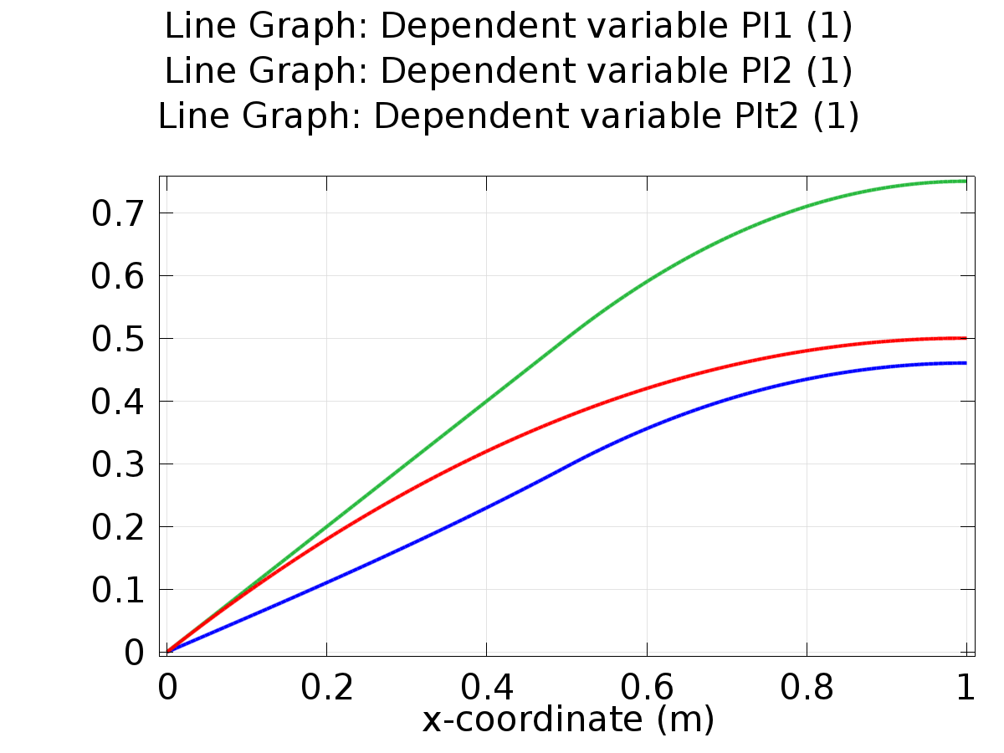

Line Graph: Dependent variable PI1 (1) Line Graph: Dependent variable PI2 (1) Line Graph: Dependent variable PIt2 (1)

* + 1. 1D Plot Group 2

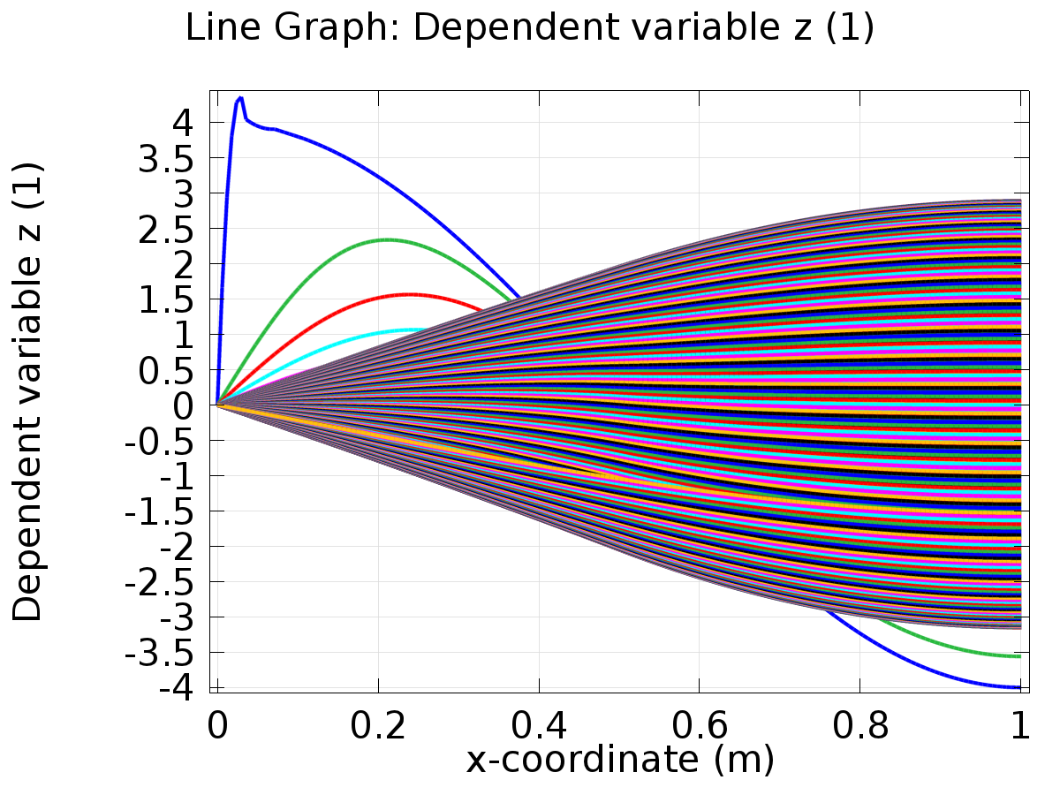

Line Graph: Dependent variable z (1)

* + 1. 1D Plot Group 3

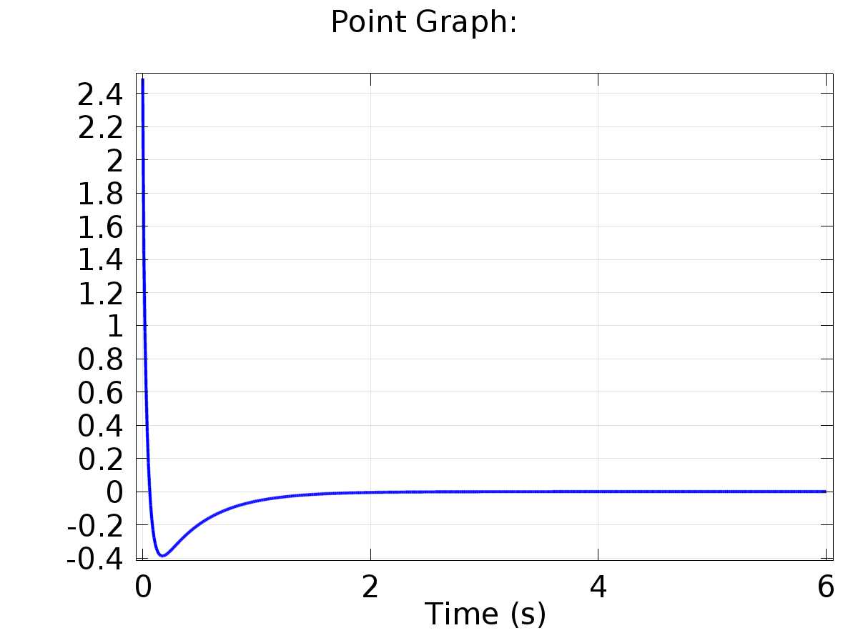

Point Graph:

* + 1. 1D Plot Group 4

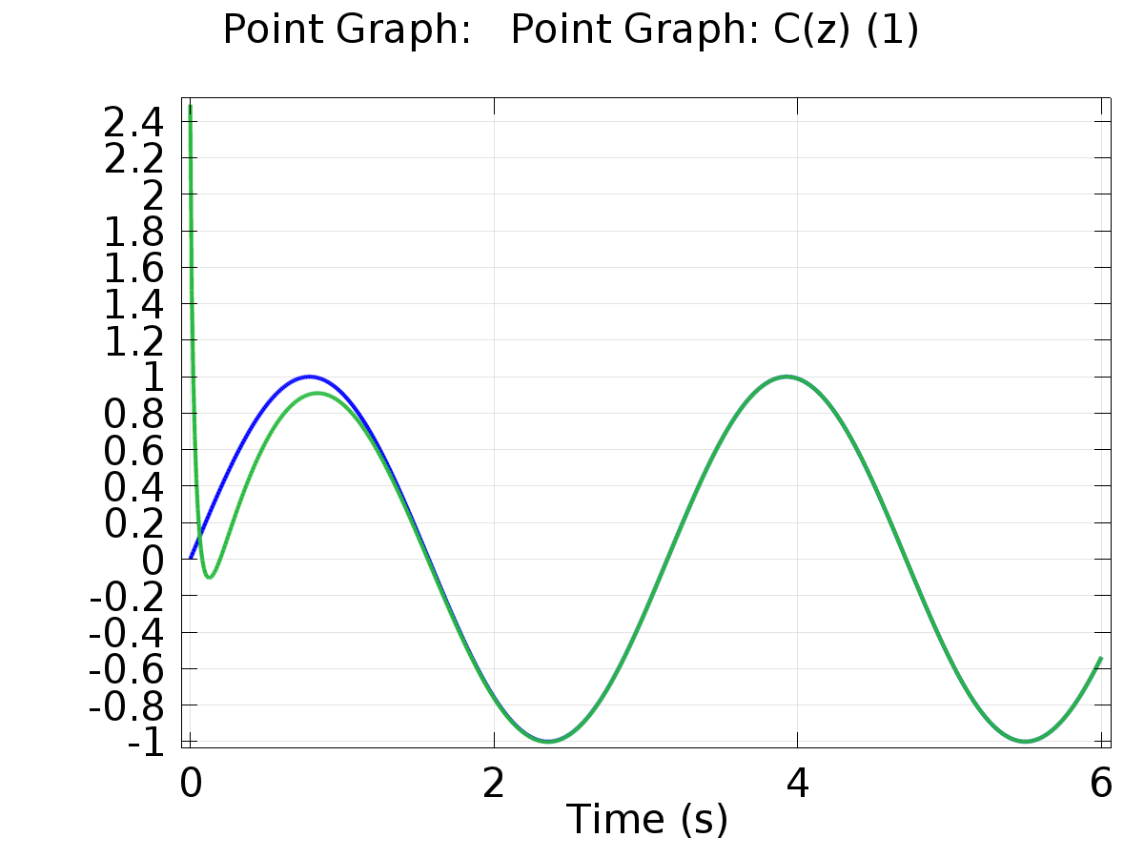

Point Graph: Point Graph: C(z) (1)

* + 1. Probe 1D Plot Group 5

