[](http://www.comsol.com/)

Chap1Ex3 SISO DampedWaveEquation

|  |  |
| --- | --- |
| Date | Nov 5, 2013 10:17:19 AM |

Contents

1. Global

1.1. Definitions

2. Model 1

2.1. Definitions

2.2. Geometry 1

2.3. Coefficient Form PDE

2.4. Coefficient Form PDE 2

2.5. Mesh 1

3. Study 1

3.1. Stationary

3.2. Solver Configurations

4. Study 2

4.1. Time Dependent

4.2. Solver Configurations

5. Results

5.1. Data Sets

5.2. Derived Values

5.3. Tables

5.4. Plot Groups

1. Global

|  |  |
| --- | --- |
| Date | Aug 15, 2013 4:36:48 PM |

Global settings

|  |  |
| --- | --- |
| Name | Chap1Ex3 SISO DampedWaveEquation.mph |
| Path | /Users/gilliam/Desktop/collect_15/research_15/geo_reg_mono_eugenio/Mono_1_15/Comsol_EX_GitHub/Chapter1/Chap1Ex3/Chap1Ex3_SISO_DampedWaveEquation.mph |
| Program | COMSOL 4.3b (Build: 189) |

Used products

|  |
| --- |
| COMSOL Multiphysics |

* 1. Definitions
     1. Parameters 1

Parameters

| **Name** | **Expression** | **Value** | **Description** |
| --- | --- | --- | --- |
| L | 1 | 1.0000 |  |
| Mr | 1 | 1.0000 |  |
| beta | 0.5 | 0.50000 |  |
| Ad | 0.25 | 0.25000 |  |
| gamma | 0.5 | 0.50000 |  |

1. Model 1

Component settings

|  |  |
| --- | --- |
| Unit system | SI |

* 1. Definitions
     1. Variables

#### Variables 1

Selection

|  |  |
| --- | --- |
| Geometric entity level | Entire model |

| **Name** | **Expression** | **Description** |
| --- | --- | --- |
| Gamma1 | real(1/C(PI1)) |  |
| rCPI2i | real(1/C(PI2)) |  |
| iCPI2i | imag(1/C(PI2)) |  |
| rCPIt2 | real(C(PIt2)) |  |
| iCPIt2 | imag(C(PIt2)) |  |
| Gamma2 | (-rCPI2i*rCPIt2 + iCPI2i*iCPIt2) |  |
| Gamma3 | (-rCPI2i*iCPIt2 - iCPI2i*rCPIt2) |  |
| w1 | Mr |  |
| w2 | Ad*sin(beta*t) |  |
| w3 | Ad*cos(beta*t) |  |
| Gamma | Gamma1*w1 + Gamma2*w2 + Gamma3*w3 |  |
| err | w1 - C(z) |  |
| Bin | 2 |  |
| Bd | 4 |  |

* + 1. Probes

#### Global Variable Probe 1

|  |  |
| --- | --- |
| Probe type | Global variable probe |

#### Global Variable Probe 2

|  |  |
| --- | --- |
| Probe type | Global variable probe |

#### Global Variable Probe 3

|  |  |
| --- | --- |
| Probe type | Global variable probe |

* + 1. Component Couplings

#### Average 1

|  |  |
| --- | --- |
| Coupling type | Average |
| Operator name | C |

Source selection

|  |  |
| --- | --- |
| Geometric entity level | Domain |
| Selection | Domains 2–3 |

* 1. Geometry 1

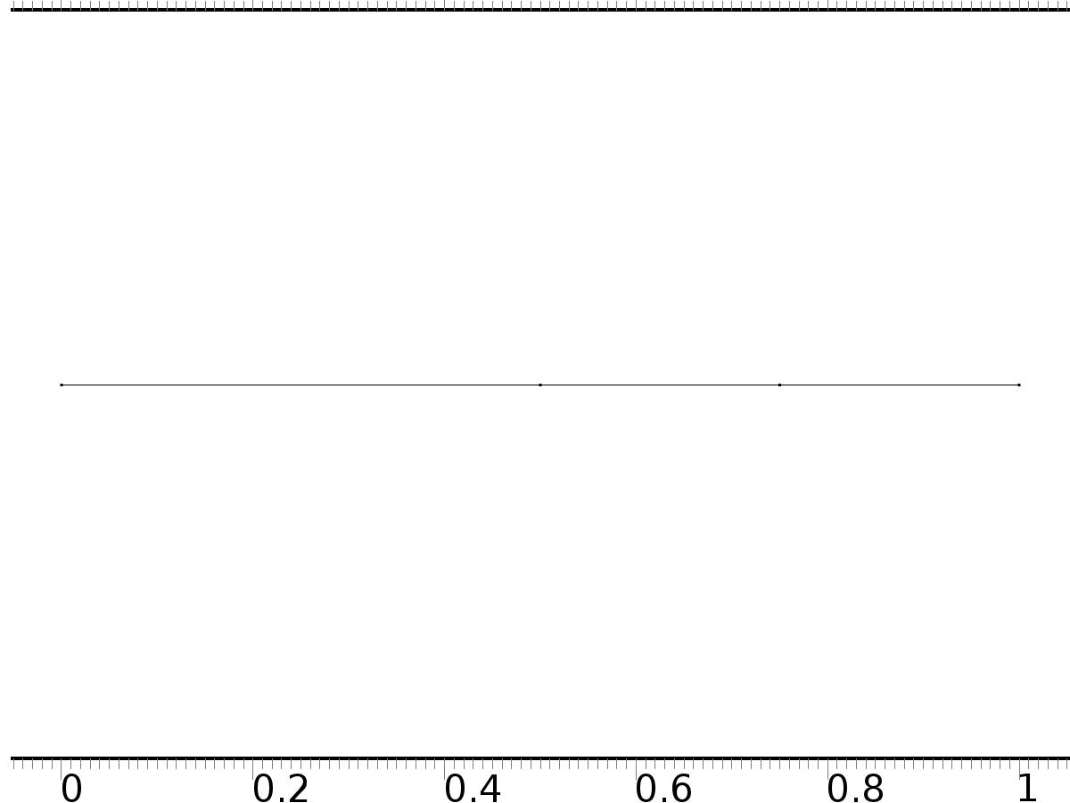

Geometry 1

Units

|  |  |
| --- | --- |
| Length unit | m |
| Angular unit | deg |

Geometry statistics

| **Description** | **Value** |
| --- | --- |
| Space dimension | 1 |
| Number of domains | 3 |
| Number of boundaries | 4 |

* + 1. Interval 1 (i1)

Interval

| **Description** | **Value** |
| --- | --- |
| Number of intervals | Many |
| Points | {0, 0.5, 0.75, 1} |

* 1. Coefficient Form PDE

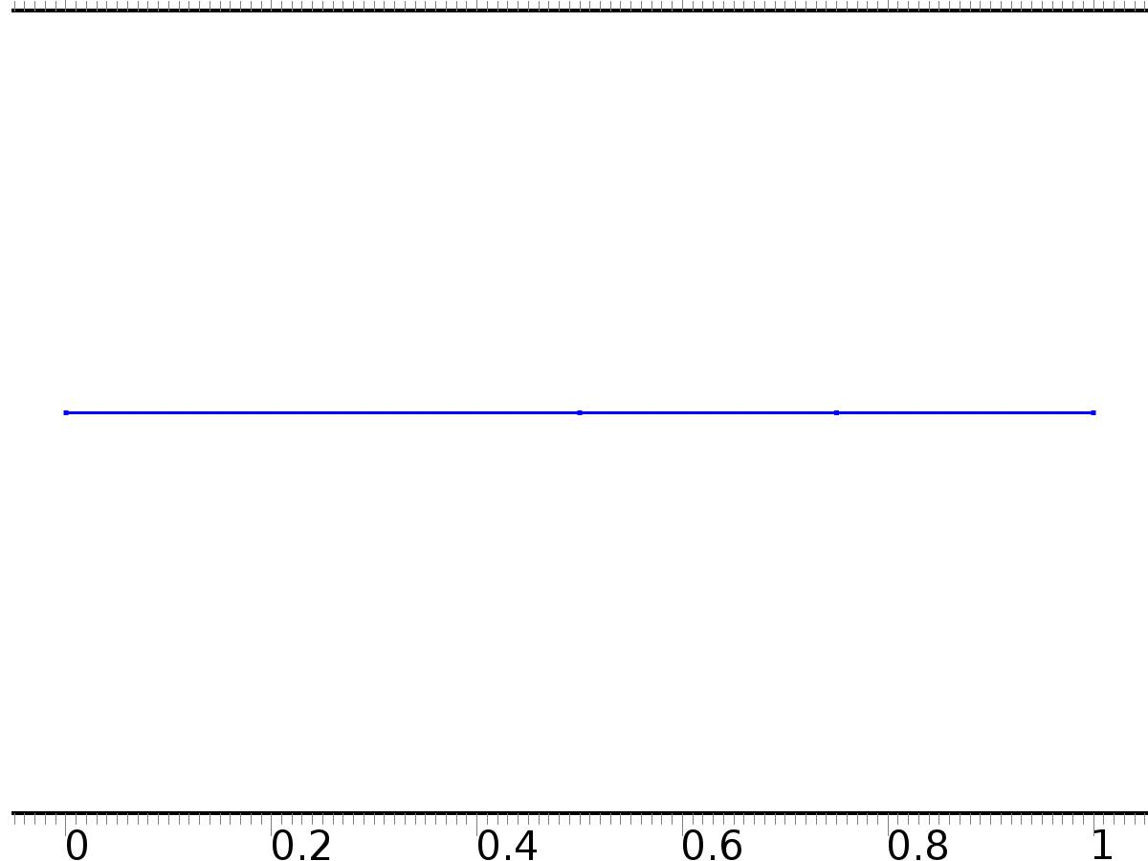

Coefficient Form PDE

Selection

|  |  |
| --- | --- |
| Geometric entity level | Domain |
| Selection | Domains 1–3 |

Settings

| **Description** | **Value** |
| --- | --- |
| Shape function type | Lagrange |
| Element order | Quadratic |
| Compute boundary fluxes | On |
| Apply smoothing to boundary fluxes | On |
| Value type when using splitting of complex variables | Complex |
| Dependent variable quantity | Dimensionless (1) |
| Source term quantity | None |
| Unit | m^ - 2 |

Used products

|  |
| --- |
| COMSOL Multiphysics |

Variables

| **Name** | **Expression** | **Unit** | **Description** | **Selection** |
| --- | --- | --- | --- | --- |
| c.nx | unx |  | Normal vector, x component | Boundary 1 |
| c.ny | 0 |  | Normal vector, y component | Boundary 1 |
| c.nz | 0 |  | Normal vector, z component | Boundary 1 |
| c.nx | dnx |  | Normal vector, x component | Boundary 4 |
| c.ny | 0 |  | Normal vector, y component | Boundary 4 |
| c.nz | 0 |  | Normal vector, z component | Boundary 4 |
| c.nx | nx |  | Normal vector, x component | Boundaries 2–3 |
| c.ny | 0 |  | Normal vector, y component | Boundaries 2–3 |
| c.nz | 0 |  | Normal vector, z component | Boundaries 2–3 |
| c.nxmesh | root.unxmesh |  | Normal vector (mesh), x component | Boundary 1 |
| c.nymesh | 0 |  | Normal vector (mesh), y component | Boundary 1 |
| c.nzmesh | 0 |  | Normal vector (mesh), z component | Boundary 1 |
| c.nxmesh | root.dnxmesh |  | Normal vector (mesh), x component | Boundary 4 |
| c.nymesh | 0 |  | Normal vector (mesh), y component | Boundary 4 |
| c.nzmesh | 0 |  | Normal vector (mesh), z component | Boundary 4 |
| c.nxmesh | root.nxmesh |  | Normal vector (mesh), x component | Boundaries 2–3 |
| c.nymesh | 0 |  | Normal vector (mesh), y component | Boundaries 2–3 |
| c.nzmesh | 0 |  | Normal vector (mesh), z component | Boundaries 2–3 |

* + 1. Coefficient Form PDE 1



Coefficient Form PDE 1

Selection

|  |  |
| --- | --- |
| Geometric entity level | Domain |
| Selection | Domains 1–3 |

Equations

Settings

| **Description** | **Value** |
| --- | --- |
| Diffusion coefficient | {{1, 0, 0}, {0, 1, 0}, {0, 0, 1}} |
| Absorption coefficient | {{0, 0, 0}, {0, i*2*gamma*beta - beta^2, 0}, {0, 0, i*2*gamma*beta - beta^2}} |
| Source term | {0, 0, 0} |
| Mass coefficient | {{0, 0, 0}, {0, 0, 0}, {0, 0, 0}} |
| Damping or mass coefficient | {{0, 0, 0}, {0, 0, 0}, {0, 0, 0}} |
| Conservative flux convection coefficient | {{0, 0, 0}, {0, 0, 0}, {0, 0, 0}} |
| Convection coefficient | {{0, 0, 0}, {0, 0, 0}, {0, 0, 0}} |
| Conservative flux source | {0, 0, 0} |

#### Variables

| **Name** | **Expression** | **Unit** | **Description** | **Selection** |
| --- | --- | --- | --- | --- |
| domflux.PI1x | -d(PI1,x) | 1/m | Domain flux, x component | Domains 1–3 |
| domflux.PI2x | -d(PI2,x) | 1/m | Domain flux, x component | Domains 1–3 |
| domflux.PIt2x | -d(PIt2,x) | 1/m | Domain flux, x component | Domains 1–3 |

#### Shape functions

| **Name** | **Shape function** | **Unit** | **Description** | **Shape frame** | **Selection** |
| --- | --- | --- | --- | --- | --- |
| PI1 | Lagrange (Quadratic) | 1 | Dependent variable PI1 | Material | Domains 1–3 |
| PI2 | Lagrange (Quadratic) | 1 | Dependent variable PI2 | Material | Domains 1–3 |
| PIt2 | Lagrange (Quadratic) | 1 | Dependent variable PIt2 | Material | Domains 1–3 |

* + 1. Zero Flux 1



Zero Flux 1

Selection

|  |  |
| --- | --- |
| Geometric entity level | Boundary |
| Selection | No boundaries |

Equations

* + 1. Initial Values 1



Initial Values 1

Selection

|  |  |
| --- | --- |
| Geometric entity level | Domain |
| Selection | Domains 1–3 |

Settings

| **Description** | **Value** |
| --- | --- |
| Initial value for PI2 | 0 |
| Initial time derivative of PI2 | 0 |
| Initial value for PI1 | 0 |
| Initial time derivative of PI1 | 0 |
| Initial value for PIt2 | 0 |
| Initial time derivative of PIt2 | 0 |

* + 1. Source 1

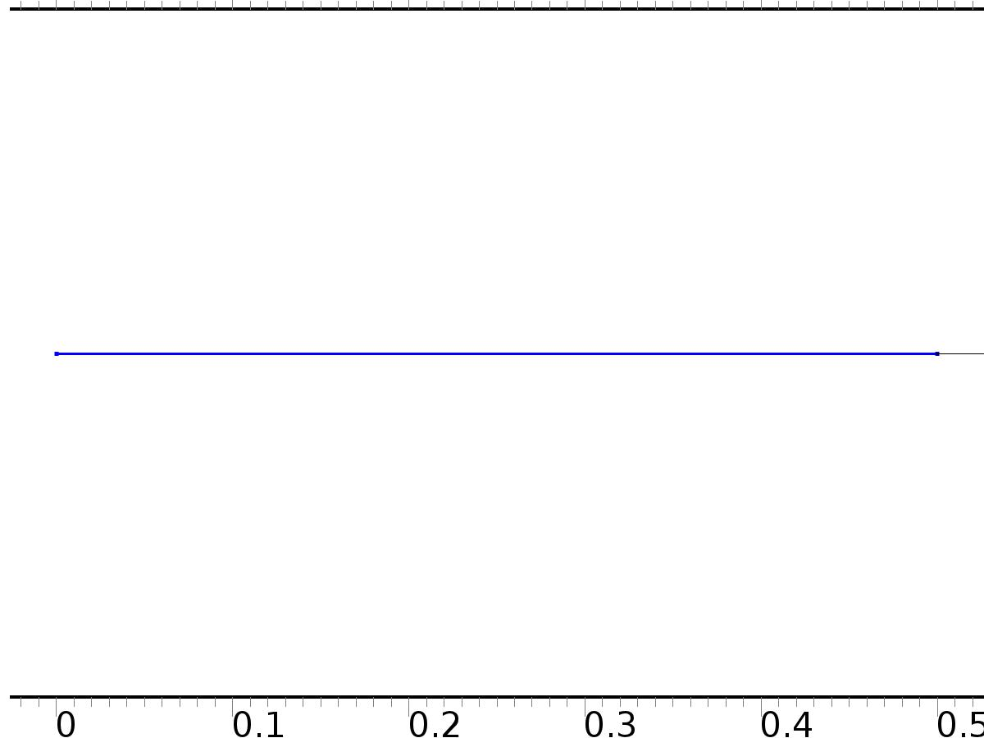

Source 1

Selection

|  |  |
| --- | --- |
| Geometric entity level | Domain |
| Selection | Domain 1 |

Settings

| **Description** | **Value** |
| --- | --- |
| Source term | {Bin, Bin, 0} |

#### Variables

| **Name** | **Expression** | **Unit** | **Description** | **Selection** |
| --- | --- | --- | --- | --- |
| c.f_PI1 | Bin | 1/m^2 | Source term | Domain 1 |
| c.f_PI2 | Bin | 1/m^2 | Source term | Domain 1 |
| c.f_PIt2 | 0 | 1/m^2 | Source term | Domain 1 |

* + 1. Source 2

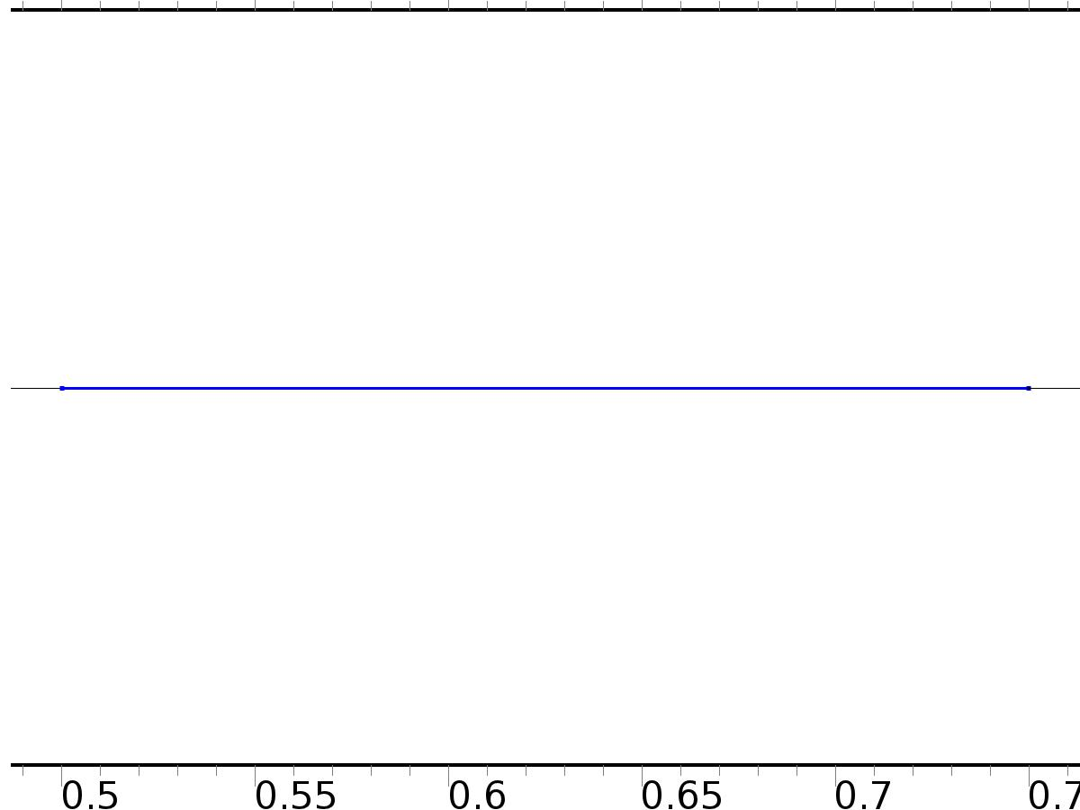

Source 2

Selection

|  |  |
| --- | --- |
| Geometric entity level | Domain |
| Selection | Domain 2 |

Settings

| **Description** | **Value** |
| --- | --- |
| Source term | {0, 0, Bd} |

#### Variables

| **Name** | **Expression** | **Unit** | **Description** | **Selection** |
| --- | --- | --- | --- | --- |
| c.f_PI1 | 0 | 1/m^2 | Source term | Domain 2 |
| c.f_PI2 | 0 | 1/m^2 | Source term | Domain 2 |
| c.f_PIt2 | Bd | 1/m^2 | Source term | Domain 2 |

* + 1. Dirichlet Boundary Condition 1

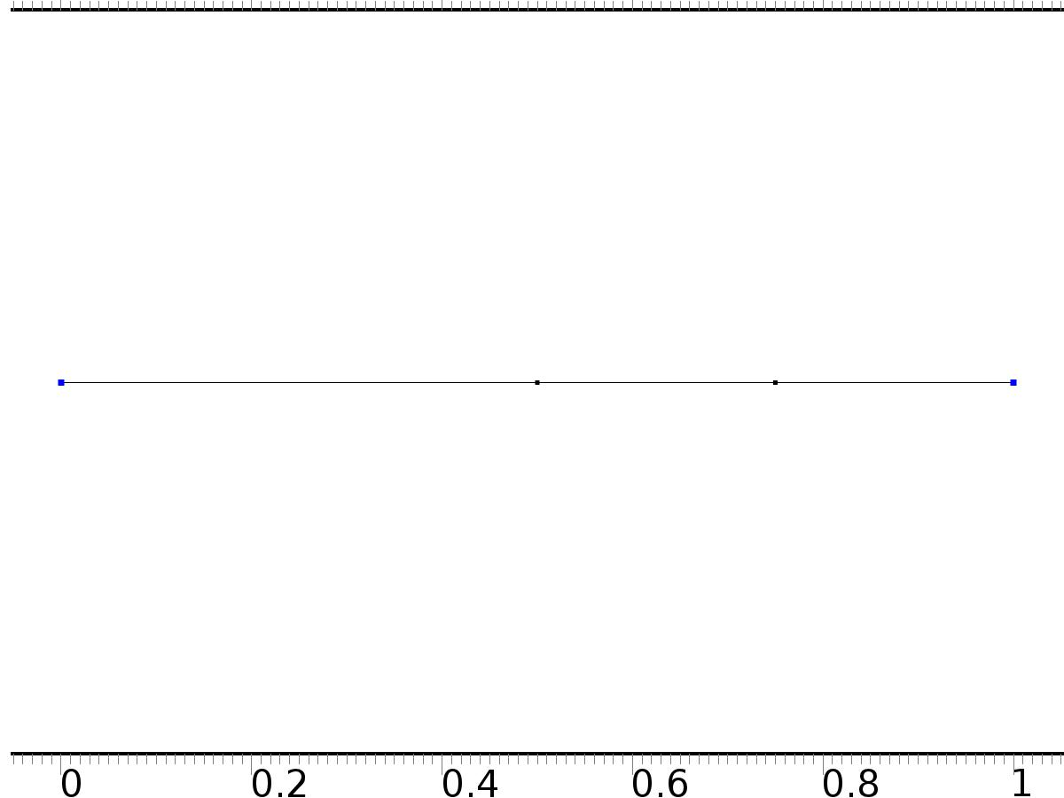

Dirichlet Boundary Condition 1

Selection

|  |  |
| --- | --- |
| Geometric entity level | Boundary |
| Selection | Boundaries 1, 4 |

Equations

Settings

| **Description** | **Value** |
| --- | --- |
| Value on boundary | {0, 0, 0} |
| Prescribed value of PI1 | On |
| Prescribed value of PI2 | On |
| Prescribed value of PIt2 | On |
| Apply reaction terms on | Individual dependent variables |
| Use weak constraints | Off |
| Constraint method | Elemental |

#### Shape functions

| **Constraint** | **Constraint force** | **Shape function** | **Selection** |
| --- | --- | --- | --- |
| -PI1 | -test(PI1) | Lagrange (Quadratic) | Boundaries 1, 4 |
| -PI2 | -test(PI2) | Lagrange (Quadratic) | Boundaries 1, 4 |
| -PIt2 | -test(PIt2) | Lagrange (Quadratic) | Boundaries 1, 4 |

* 1. Coefficient Form PDE 2



Coefficient Form PDE 2

Selection

|  |  |
| --- | --- |
| Geometric entity level | Domain |
| Selection | Domains 1–3 |

Settings

| **Description** | **Value** |
| --- | --- |
| Shape function type | Lagrange |
| Element order | Quadratic |
| Compute boundary fluxes | On |
| Apply smoothing to boundary fluxes | On |
| Value type when using splitting of complex variables | Complex |
| Dependent variable quantity | Dimensionless (1) |
| Source term quantity | None |
| Unit | m^ - 2 |

Used products

|  |
| --- |
| COMSOL Multiphysics |

Variables

| **Name** | **Expression** | **Unit** | **Description** | **Selection** |
| --- | --- | --- | --- | --- |
| c2.nx | unx |  | Normal vector, x component | Boundary 1 |
| c2.ny | 0 |  | Normal vector, y component | Boundary 1 |
| c2.nz | 0 |  | Normal vector, z component | Boundary 1 |
| c2.nx | dnx |  | Normal vector, x component | Boundary 4 |
| c2.ny | 0 |  | Normal vector, y component | Boundary 4 |
| c2.nz | 0 |  | Normal vector, z component | Boundary 4 |
| c2.nx | nx |  | Normal vector, x component | Boundaries 2–3 |
| c2.ny | 0 |  | Normal vector, y component | Boundaries 2–3 |
| c2.nz | 0 |  | Normal vector, z component | Boundaries 2–3 |
| c2.nxmesh | root.unxmesh |  | Normal vector (mesh), x component | Boundary 1 |
| c2.nymesh | 0 |  | Normal vector (mesh), y component | Boundary 1 |
| c2.nzmesh | 0 |  | Normal vector (mesh), z component | Boundary 1 |
| c2.nxmesh | root.dnxmesh |  | Normal vector (mesh), x component | Boundary 4 |
| c2.nymesh | 0 |  | Normal vector (mesh), y component | Boundary 4 |
| c2.nzmesh | 0 |  | Normal vector (mesh), z component | Boundary 4 |
| c2.nxmesh | root.nxmesh |  | Normal vector (mesh), x component | Boundaries 2–3 |
| c2.nymesh | 0 |  | Normal vector (mesh), y component | Boundaries 2–3 |
| c2.nzmesh | 0 |  | Normal vector (mesh), z component | Boundaries 2–3 |

* + 1. Coefficient Form PDE 1



Coefficient Form PDE 1

Selection

|  |  |
| --- | --- |
| Geometric entity level | Domain |
| Selection | Domains 1–3 |

Equations

Settings

| **Description** | **Value** |
| --- | --- |
| Diffusion coefficient | 1 |
| Absorption coefficient | 0 |
| Source term | 0 |
| Mass coefficient | 1 |
| Damping or mass coefficient | 2*gamma |
| Conservative flux convection coefficient | 0 |
| Convection coefficient | 0 |
| Conservative flux source | 0 |

#### Variables

| **Name** | **Expression** | **Unit** | **Description** | **Selection** |
| --- | --- | --- | --- | --- |
| domflux.zx | -d(z,x) | 1/m | Domain flux, x component | Domains 1–3 |

#### Shape functions

| **Name** | **Shape function** | **Unit** | **Description** | **Shape frame** | **Selection** |
| --- | --- | --- | --- | --- | --- |
| z | Lagrange (Quadratic) | 1 | Dependent variable z | Material | Domains 1–3 |

* + 1. Zero Flux 1



Zero Flux 1

Selection

|  |  |
| --- | --- |
| Geometric entity level | Boundary |
| Selection | No boundaries |

Equations

* + 1. Initial Values 1



Initial Values 1

Selection

|  |  |
| --- | --- |
| Geometric entity level | Domain |
| Selection | Domains 1–3 |

Settings

| **Description** | **Value** |
| --- | --- |
| Initial value for z | 16*(1 - x)^2*x^2 |
| Initial time derivative of z | 0.5*sin(pi*x)^2 |

* + 1. Source 1



Source 1

Selection

|  |  |
| --- | --- |
| Geometric entity level | Domain |
| Selection | Domain 1 |

Settings

| **Description** | **Value** |
| --- | --- |
| Source term | Bin*Gamma |

#### Variables

| **Name** | **Expression** | **Unit** | **Description** | **Selection** |
| --- | --- | --- | --- | --- |
| c2.f_z | Bin*Gamma | 1/m^2 | Source term | Domain 1 |

* + 1. Source 2



Source 2

Selection

|  |  |
| --- | --- |
| Geometric entity level | Domain |
| Selection | Domain 2 |

Settings

| **Description** | **Value** |
| --- | --- |
| Source term | Bd*w2 |

#### Variables

| **Name** | **Expression** | **Unit** | **Description** | **Selection** |
| --- | --- | --- | --- | --- |
| c2.f_z | Bd*w2 | 1/m^2 | Source term | Domain 2 |

* + 1. Dirichlet Boundary Condition 1



Dirichlet Boundary Condition 1

Selection

|  |  |
| --- | --- |
| Geometric entity level | Boundary |
| Selection | Boundaries 1, 4 |

Equations

Settings

| **Description** | **Value** |
| --- | --- |
| Value on boundary | 0 |
| Prescribed value of z | On |
| Apply reaction terms on | Individual dependent variables |
| Use weak constraints | Off |
| Constraint method | Elemental |

#### Shape functions

| **Constraint** | **Constraint force** | **Shape function** | **Selection** |
| --- | --- | --- | --- |
| -z | -test(z) | Lagrange (Quadratic) | Boundaries 1, 4 |

* 1. Mesh 1

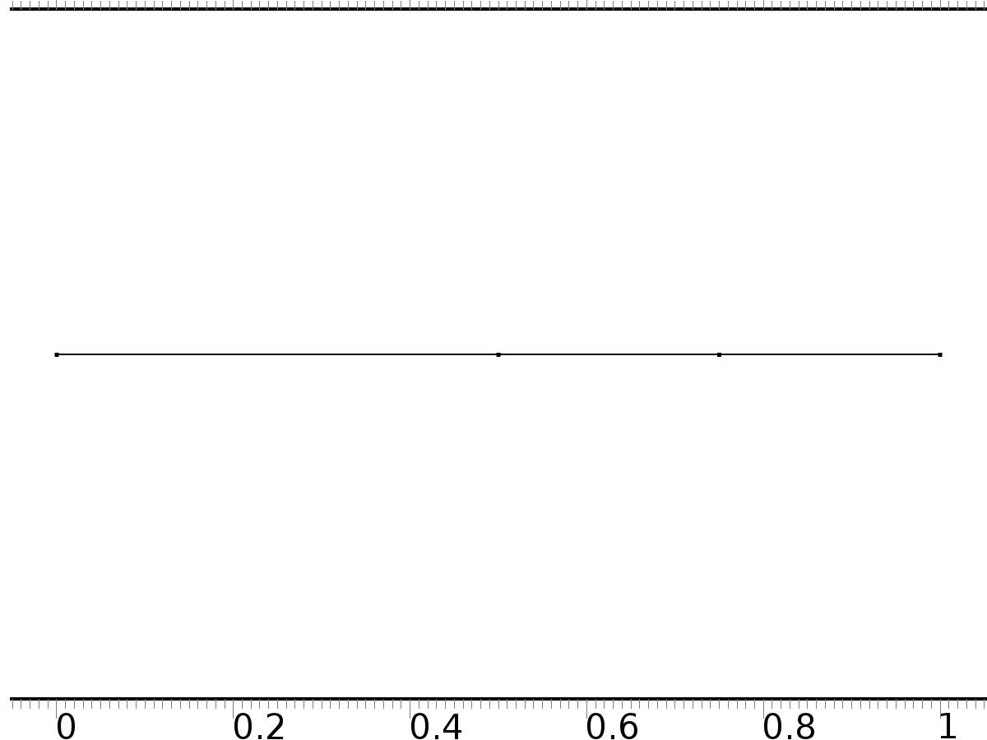

Mesh 1

* + 1. Size (size)

Settings

| **Description** | **Value** |
| --- | --- |
| Maximum element size | 0.037 |
| Minimum element size | 1.25E-4 |
| Curvature factor | 0.25 |
| Maximum element growth rate | 1.25 |
| Predefined size | Finer |

* + 1. Edge 1 (edg1)

Selection

|  |  |
| --- | --- |
| Geometric entity level | Remaining |

1. Study 1
   1. Stationary

Study settings

| **Description** | **Value** |
| --- | --- |
| Include geometric nonlinearity | Off |

Physics and variables selection

| **Physics interface** | **Discretization** |
| --- | --- |
| Coefficient Form PDE (c) | physics |

Mesh selection

| **Geometry** | **Mesh** |
| --- | --- |
| Geometry 1 (geom1) | mesh1 |

* 1. Solver Configurations
     1. Solver 1

#### Compile Equations: Stationary (st1)

Study and step

| **Description** | **Value** |
| --- | --- |
| Use study | Study 1 |
| Use study step | Stationary |

#### Dependent Variables 1 (v1)

General

| **Description** | **Value** |
| --- | --- |
| Defined by study step | Stationary |
| Constant |  |

Initial values of variables solved for

| **Description** | **Value** |
| --- | --- |
| Solution | Zero |

Values of variables not solved for

| **Description** | **Value** |
| --- | --- |
| Solution | Zero |

##### Dependent variable PI1 (mod1.PI1) (mod1_PI1)

General

| **Description** | **Value** |
| --- | --- |
| Field components | mod1.PI1 |
| Field name | mod1_X |

##### Dependent variable z (mod1.z) (mod1_z)

General

| **Description** | **Value** |
| --- | --- |
| Field components | mod1.z |
| Solve for this field | Off |

##### Dependent variable PI2 (mod1.PI2) (mod1_PI2)

General

| **Description** | **Value** |
| --- | --- |
| Field components | mod1.PI2 |

##### Dependent variable PIt2 (mod1.PIt2) (mod1_PIt2)

General

| **Description** | **Value** |
| --- | --- |
| Field components | mod1.PIt2 |
| Field name | mod1_PI3 |

#### Stationary Solver 1 (s1)

General

| **Description** | **Value** |
| --- | --- |
| Defined by study step | Stationary |
| Relative tolerance | 0.0000010 |

Log

| **Description** | **Value** |
| --- | --- |
| Constant |  |

##### Advanced (aDef)

General

| **Description** | **Value** |
| --- | --- |
| Allow complex-valued output from functions with real input | On |

##### Fully Coupled 1 (fc1)

General

| **Description** | **Value** |
| --- | --- |
| Linear solver | Direct |

1. Study 2
   1. Time Dependent

Study settings

| **Description** | **Value** |
| --- | --- |
| Include geometric nonlinearity | Off |

| **Times** | **Unit** |
| --- | --- |
| range(0,0.025,20) | s |

Physics and variables selection

| **Physics interface** | **Discretization** |
| --- | --- |
| Coefficient Form PDE 2 (c2) | physics |

Mesh selection

| **Geometry** | **Mesh** |
| --- | --- |
| Geometry 1 (geom1) | mesh1 |

* 1. Solver Configurations
     1. Solver 2

#### Compile Equations: Time Dependent (st1)

Study and step

| **Description** | **Value** |
| --- | --- |
| Use study | Study 2 |
| Use study step | Time Dependent |

#### Dependent Variables 1 (v1)

General

| **Description** | **Value** |
| --- | --- |
| Defined by study step | Time Dependent |
| Constant |  |

Initial values of variables solved for

| **Description** | **Value** |
| --- | --- |
| Solution | Zero |

Values of variables not solved for

| **Description** | **Value** |
| --- | --- |
| Method | Solution |
| Solution | Solver 1 |

##### Dependent variable z (mod1.z) (mod1_z)

General

| **Description** | **Value** |
| --- | --- |
| Field components | mod1.z |

##### Dependent variable PI1 (mod1.PI1) (mod1_PI1)

General

| **Description** | **Value** |
| --- | --- |
| Field components | mod1.PI1 |
| Solve for this field | Off |
| Field name | mod1_X |

##### Dependent variable PI2 (mod1.PI2) (mod1_PI2)

General

| **Description** | **Value** |
| --- | --- |
| Field components | mod1.PI2 |
| Solve for this field | Off |

##### Dependent variable PIt2 (mod1.PIt2) (mod1_PIt2)

General

| **Description** | **Value** |
| --- | --- |
| Field components | mod1.PIt2 |
| Solve for this field | Off |
| Field name | mod1_PI3 |

#### Time-Dependent Solver 1 (t1)

General

| **Description** | **Value** |
| --- | --- |
| Defined by study step | Time Dependent |
| Time | {0, 0.025, 0.05, 0.07500000000000001, 0.1, 0.125, 0.15000000000000002, 0.17500000000000002, 0.2, 0.225, 0.25, 0.275, 0.30000000000000004, 0.325, 0.35000000000000003, 0.375, 0.4, 0.42500000000000004, 0.45, 0.47500000000000003, 0.5, 0.525, 0.55, 0.5750000000000001, 0.6000000000000001, 0.625, 0.65, 0.675, 0.7000000000000001, 0.7250000000000001, 0.75, 0.775, 0.8, 0.8250000000000001, 0.8500000000000001, 0.875, 0.9, 0.925, 0.9500000000000001, 0.9750000000000001, 1, 1.0250000000000001, 1.05, 1.075, 1.1, 1.125, 1.1500000000000001, 1.175, 1.2000000000000002, 1.225, 1.25, 1.2750000000000001, 1.3, 1.3250000000000002, 1.35, 1.375, 1.4000000000000001, 1.425, 1.4500000000000002, 1.475, 1.5, 1.5250000000000001, 1.55, 1.5750000000000002, 1.6, 1.625, 1.6500000000000001, 1.675, 1.7000000000000002, 1.725, 1.75, 1.7750000000000001, 1.8, 1.8250000000000002, 1.85, 1.875, 1.9000000000000001, 1.925, 1.9500000000000002, 1.975, 2, 2.025, 2.0500000000000003, 2.075, 2.1, 2.125, 2.15, 2.1750000000000003, 2.2, 2.225, 2.25, 2.275, 2.3000000000000003, 2.325, 2.35, 2.375, 2.4000000000000004, 2.4250000000000003, 2.45, 2.475, 2.5, 2.5250000000000004, 2.5500000000000003, 2.575, 2.6, 2.625, 2.6500000000000004, 2.6750000000000003, 2.7, 2.725, 2.75, 2.7750000000000004, 2.8000000000000003, 2.825, 2.85, 2.875, 2.9000000000000004, 2.9250000000000003, 2.95, 2.975, 3, 3.0250000000000004, 3.0500000000000003, 3.075, 3.1, 3.125, 3.1500000000000004, 3.1750000000000003, 3.2, 3.225, 3.25, 3.2750000000000004, 3.3000000000000003, 3.325, 3.35, 3.375, 3.4000000000000004, 3.4250000000000003, 3.45, 3.475, 3.5, 3.5250000000000004, 3.5500000000000003, 3.575, 3.6, 3.625, 3.6500000000000004, 3.6750000000000003, 3.7, 3.725, 3.75, 3.7750000000000004, 3.8000000000000003, 3.825, 3.85, 3.875, 3.9000000000000004, 3.9250000000000003, 3.95, 3.975, 4, 4.025, 4.05, 4.075, 4.1000000000000005, 4.125, 4.15, 4.175, 4.2, 4.2250000000000005, 4.25, 4.275, 4.3, 4.325, 4.3500000000000005, 4.375, 4.4, 4.425, 4.45, 4.4750000000000005, 4.5, 4.525, 4.55, 4.575, 4.6000000000000005, 4.625, 4.65, 4.675, 4.7, 4.7250000000000005, 4.75, 4.775, 4.800000000000001, 4.825, 4.8500000000000005, 4.875, 4.9, 4.925000000000001, 4.95, 4.9750000000000005, 5, 5.025, 5.050000000000001, 5.075, 5.1000000000000005, 5.125, 5.15, 5.175000000000001, 5.2, 5.2250000000000005, 5.25, 5.275, 5.300000000000001, 5.325, 5.3500000000000005, 5.375, 5.4, 5.425000000000001, 5.45, 5.4750000000000005, 5.5, 5.525, 5.550000000000001, 5.575, 5.6000000000000005, 5.625, 5.65, 5.675000000000001, 5.7, 5.7250000000000005, 5.75, 5.775, 5.800000000000001, 5.825, 5.8500000000000005, 5.875, 5.9, 5.925000000000001, 5.95, 5.9750000000000005, 6, 6.025, 6.050000000000001, 6.075, 6.1000000000000005, 6.125, 6.15, 6.175000000000001, 6.2, 6.2250000000000005, 6.25, 6.275, 6.300000000000001, 6.325, 6.3500000000000005, 6.375, 6.4, 6.425000000000001, 6.45, 6.4750000000000005, 6.5, 6.525, 6.550000000000001, 6.575, 6.6000000000000005, 6.625, 6.65, 6.675000000000001, 6.7, 6.7250000000000005, 6.75, 6.775, 6.800000000000001, 6.825, 6.8500000000000005, 6.875, 6.9, 6.925000000000001, 6.95, 6.9750000000000005, 7, 7.025, 7.050000000000001, 7.075, 7.1000000000000005, 7.125, 7.15, 7.175000000000001, 7.2, 7.2250000000000005, 7.25, 7.275, 7.300000000000001, 7.325, 7.3500000000000005, 7.375, 7.4, 7.425000000000001, 7.45, 7.4750000000000005, 7.5, 7.525, 7.550000000000001, 7.575, 7.6000000000000005, 7.625, 7.65, 7.675000000000001, 7.7, 7.7250000000000005, 7.75, 7.775, 7.800000000000001, 7.825, 7.8500000000000005, 7.875, 7.9, 7.925000000000001, 7.95, 7.9750000000000005, 8, 8.025, 8.05, 8.075000000000001, 8.1, 8.125, 8.15, 8.175, 8.200000000000001, 8.225, 8.25, 8.275, 8.3, 8.325000000000001, 8.35, 8.375, 8.4, 8.425, 8.450000000000001, 8.475, 8.5, 8.525, 8.55, 8.575000000000001, 8.6, 8.625, 8.65, 8.675, 8.700000000000001, 8.725, 8.75, 8.775, 8.8, 8.825000000000001, 8.85, 8.875, 8.9, 8.925, 8.950000000000001, 8.975, 9, 9.025, 9.05, 9.075000000000001, 9.1, 9.125, 9.15, 9.175, 9.200000000000001, 9.225, 9.25, 9.275, 9.3, 9.325000000000001, 9.35, 9.375, 9.4, 9.425, 9.450000000000001, 9.475, 9.5, 9.525, 9.55, 9.575000000000001, 9.600000000000001, 9.625, 9.65, 9.675, 9.700000000000001, 9.725000000000001, 9.75, 9.775, 9.8, 9.825000000000001, 9.850000000000001, 9.875, 9.9, 9.925, 9.950000000000001, 9.975000000000001, 10, 10.025, 10.05, 10.075000000000001, 10.100000000000001, 10.125, 10.15, 10.175, 10.200000000000001, 10.225000000000001, 10.25, 10.275, 10.3, 10.325000000000001, 10.350000000000001, 10.375, 10.4, 10.425, 10.450000000000001, 10.475000000000001, 10.5, 10.525, 10.55, 10.575000000000001, 10.600000000000001, 10.625, 10.65, 10.675, 10.700000000000001, 10.725000000000001, 10.75, 10.775, 10.8, 10.825000000000001, 10.850000000000001, 10.875, 10.9, 10.925, 10.950000000000001, 10.975000000000001, 11, 11.025, 11.05, 11.075000000000001, 11.100000000000001, 11.125, 11.15, 11.175, 11.200000000000001, 11.225000000000001, 11.25, 11.275, 11.3, 11.325000000000001, 11.350000000000001, 11.375, 11.4, 11.425, 11.450000000000001, 11.475000000000001, 11.5, 11.525, 11.55, 11.575000000000001, 11.600000000000001, 11.625, 11.65, 11.675, 11.700000000000001, 11.725000000000001, 11.75, 11.775, 11.8, 11.825000000000001, 11.850000000000001, 11.875, 11.9, 11.925, 11.950000000000001, 11.975000000000001, 12, 12.025, 12.05, 12.075000000000001, 12.100000000000001, 12.125, 12.15, 12.175, 12.200000000000001, 12.225000000000001, 12.25, 12.275, 12.3, 12.325000000000001, 12.350000000000001, 12.375, 12.4, 12.425, 12.450000000000001, 12.475000000000001, 12.5, 12.525, 12.55, 12.575000000000001, 12.600000000000001, 12.625, 12.65, 12.675, 12.700000000000001, 12.725000000000001, 12.75, 12.775, 12.8, 12.825000000000001, 12.850000000000001, 12.875, 12.9, 12.925, 12.950000000000001, 12.975000000000001, 13, 13.025, 13.05, 13.075000000000001, 13.100000000000001, 13.125, 13.15, 13.175, 13.200000000000001, 13.225000000000001, 13.25, 13.275, 13.3, 13.325000000000001, 13.350000000000001, 13.375, 13.4, 13.425, 13.450000000000001, 13.475000000000001, 13.5, 13.525, 13.55, 13.575000000000001, 13.600000000000001, 13.625, 13.65, 13.675, 13.700000000000001, 13.725000000000001, 13.75, 13.775, 13.8, 13.825000000000001, 13.850000000000001, 13.875, 13.9, 13.925, 13.950000000000001, 13.975000000000001, 14, 14.025, 14.05, 14.075000000000001, 14.100000000000001, 14.125, 14.15, 14.175, 14.200000000000001, 14.225000000000001, 14.25, 14.275, 14.3, 14.325000000000001, 14.350000000000001, 14.375, 14.4, 14.425, 14.450000000000001, 14.475000000000001, 14.5, 14.525, 14.55, 14.575000000000001, 14.600000000000001, 14.625, 14.65, 14.675, 14.700000000000001, 14.725000000000001, 14.75, 14.775, 14.8, 14.825000000000001, 14.850000000000001, 14.875, 14.9, 14.925, 14.950000000000001, 14.975000000000001, 15, 15.025, 15.05, 15.075000000000001, 15.100000000000001, 15.125, 15.15, 15.175, 15.200000000000001, 15.225000000000001, 15.25, 15.275, 15.3, 15.325000000000001, 15.350000000000001, 15.375, 15.4, 15.425, 15.450000000000001, 15.475000000000001, 15.5, 15.525, 15.55, 15.575000000000001, 15.600000000000001, 15.625, 15.65, 15.675, 15.700000000000001, 15.725000000000001, 15.75, 15.775, 15.8, 15.825000000000001, 15.850000000000001, 15.875, 15.9, 15.925, 15.950000000000001, 15.975000000000001, 16, 16.025000000000002, 16.05, 16.075, 16.1, 16.125, 16.150000000000002, 16.175, 16.2, 16.225, 16.25, 16.275000000000002, 16.3, 16.325, 16.35, 16.375, 16.400000000000002, 16.425, 16.45, 16.475, 16.5, 16.525000000000002, 16.55, 16.575, 16.6, 16.625, 16.650000000000002, 16.675, 16.7, 16.725, 16.75, 16.775000000000002, 16.8, 16.825, 16.85, 16.875, 16.900000000000002, 16.925, 16.95, 16.975, 17, 17.025000000000002, 17.05, 17.075, 17.1, 17.125, 17.150000000000002, 17.175, 17.2, 17.225, 17.25, 17.275000000000002, 17.3, 17.325, 17.35, 17.375, 17.400000000000002, 17.425, 17.45, 17.475, 17.5, 17.525000000000002, 17.55, 17.575, 17.6, 17.625, 17.650000000000002, 17.675, 17.7, 17.725, 17.75, 17.775000000000002, 17.8, 17.825, 17.85, 17.875, 17.900000000000002, 17.925, 17.95, 17.975, 18, 18.025000000000002, 18.05, 18.075, 18.1, 18.125, 18.150000000000002, 18.175, 18.2, 18.225, 18.25, 18.275000000000002, 18.3, 18.325, 18.35, 18.375, 18.400000000000002, 18.425, 18.45, 18.475, 18.5, 18.525000000000002, 18.55, 18.575, 18.6, 18.625, 18.650000000000002, 18.675, 18.7, 18.725, 18.75, 18.775000000000002, 18.8, 18.825, 18.85, 18.875, 18.900000000000002, 18.925, 18.95, 18.975, 19, 19.025000000000002, 19.05, 19.075, 19.1, 19.125, 19.150000000000002, 19.175, 19.200000000000003, 19.225, 19.25, 19.275000000000002, 19.3, 19.325000000000003, 19.35, 19.375, 19.400000000000002, 19.425, 19.450000000000003, 19.475, 19.5, 19.525000000000002, 19.55, 19.575000000000003, 19.6, 19.625, 19.650000000000002, 19.675, 19.700000000000003, 19.725, 19.75, 19.775000000000002, 19.8, 19.825000000000003, 19.85, 19.875, 19.900000000000002, 19.925, 19.950000000000003, 19.975, 20} |
| Relative tolerance | 0.00001 |

Absolute tolerance

| **Description** | **Value** |
| --- | --- |
| Tolerance | 0.0000010 |

Time stepping

| **Description** | **Value** |
| --- | --- |
| Initial step | 0.0010 |

Results while solving

| **Description** | **Value** |
| --- | --- |
| Probes | None |

Advanced

| **Description** | **Value** |
| --- | --- |
| Fraction of initial step for Backward Euler | 0.0010 |

Log

| **Description** | **Value** |
| --- | --- |
| Constant |  |

##### Fully Coupled 1 (fc1)

General

| **Description** | **Value** |
| --- | --- |
| Linear solver | Direct |

1. Results
   1. Data Sets
      1. Solution 1

Solution

| **Description** | **Value** |
| --- | --- |
| Solution | Solver 1 |
| Component | Save Point Geometry 1 |

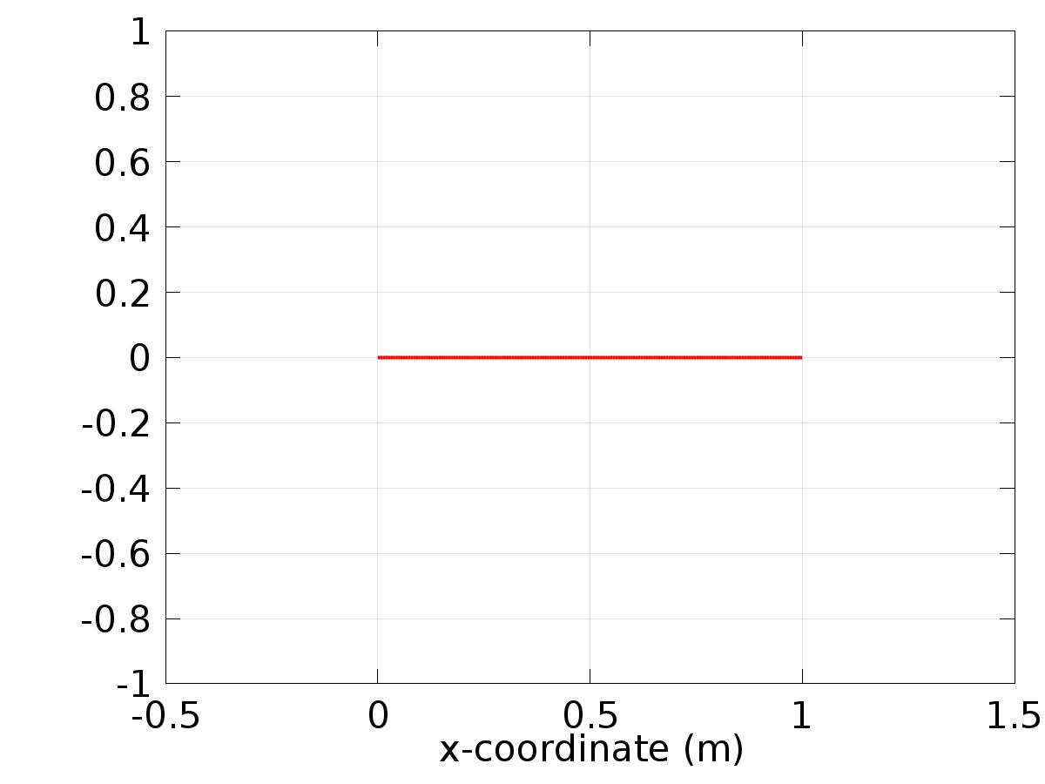

Data set: Solution 1

* + 1. Solution 2

Solution

| **Description** | **Value** |
| --- | --- |
| Solution | Solver 2 |
| Component | Save Point Geometry 1 |

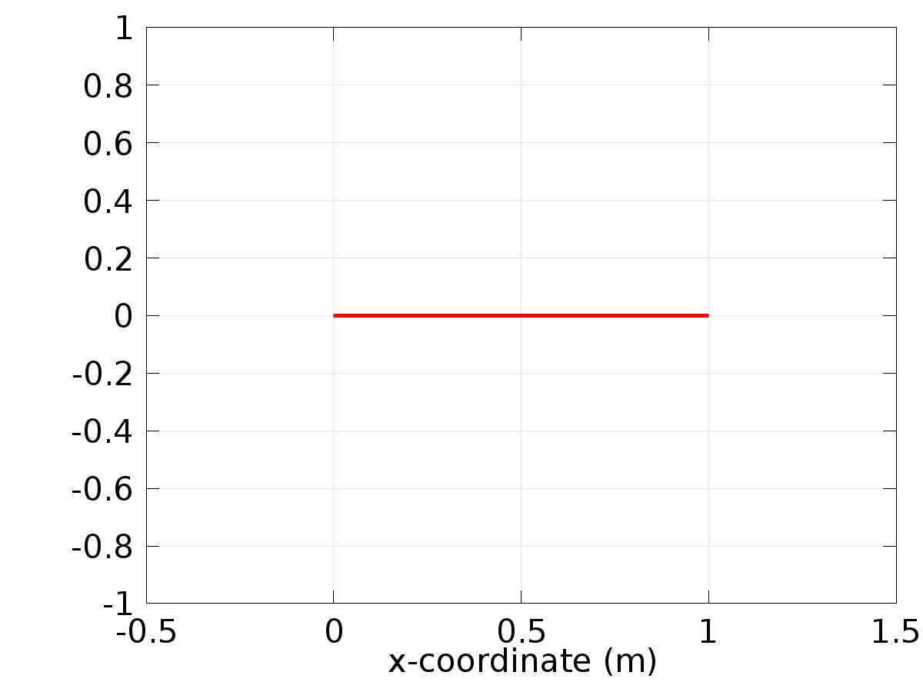

Data set: Solution 2

* + 1. Probe Solution 3

Solution

| **Description** | **Value** |
| --- | --- |
| Solution | Solver 2 |
| Component | Save Point Geometry 1 |



Data set: Probe Solution 3

* 1. Derived Values
     1. Global Variable Probe 1

Data

| **Description** | **Value** |
| --- | --- |
| Data set | Probe Solution 3 |

Expression

| **Description** | **Value** |
| --- | --- |
| Expression | Gamma1 |
| Unit | 1 |

* + 1. Global Variable Probe 2

Data

| **Description** | **Value** |
| --- | --- |
| Data set | Probe Solution 3 |

Expression

| **Description** | **Value** |
| --- | --- |
| Expression | Gamma2 |
| Unit | 1 |

* + 1. Global Variable Probe 3

Data

| **Description** | **Value** |
| --- | --- |
| Data set | Probe Solution 3 |

Expression

| **Description** | **Value** |
| --- | --- |
| Expression | Gamma3 |
| Unit | 1 |

* + 1. Point Evaluation 1

Selection

|  |  |
| --- | --- |
| Geometric entity level | Boundary |
| Selection | Boundary 2 |

Data

| **Description** | **Value** |
| --- | --- |
| Data set | Solution 2 |

Expression

| **Description** | **Value** |
| --- | --- |
| Expression | Gamma |

* 1. Tables
     1. Table 1

Global Evaluation 1 (C(X))

* + 1. Table 2

Point Evaluation 1 (z)

Table 2

| **Dependent variable z (1), Point: 1** |
| --- |
| 0.0000 |

* + 1. Table 3

Point Evaluation 1 (z)

Table 3

| **Time** | **Gradient of z, x component (1/m), Point: 1** |
| --- | --- |
| 30.000 | 11.798 |

* + 1. Probe Table 4

Probe Table 4

| **Gamma1 (1)** | **Gamma2 (1)** | **Gamma3 (1)** |
| --- | --- | --- |
| 16.000 | -2.1481 | -0.037285 |

* + 1. Table 5

Point Evaluation 1 (C(z))

Table 5

| **Time** | **C(z) (1), Point: 2** | **w1, Point: 2** | **w2, Point: 2** | **Gamma, Point: 2** |
| --- | --- | --- | --- | --- |
| 0.0000 | 0.53334 | 1.0000 | 0.0000 | 15.991 |
| 0.025000 | 0.53944 | 1.0000 | 0.0031249 | 15.984 |
| 0.050000 | 0.54498 | 1.0000 | 0.0062493 | 15.977 |
| 0.075000 | 0.54968 | 1.0000 | 0.0093728 | 15.971 |
| 0.10000 | 0.55342 | 1.0000 | 0.012495 | 15.964 |
| 0.12500 | 0.55618 | 1.0000 | 0.015615 | 15.957 |
| 0.15000 | 0.55804 | 1.0000 | 0.018732 | 15.950 |
| 0.17500 | 0.55919 | 1.0000 | 0.021847 | 15.944 |
| 0.20000 | 0.55990 | 1.0000 | 0.024958 | 15.937 |
| 0.22500 | 0.56050 | 1.0000 | 0.028066 | 15.930 |
| 0.25000 | 0.56143 | 1.0000 | 0.031169 | 15.924 |
| 0.27500 | 0.56314 | 1.0000 | 0.034267 | 15.917 |
| 0.30000 | 0.56613 | 1.0000 | 0.037360 | 15.911 |
| 0.32500 | 0.57099 | 1.0000 | 0.040446 | 15.904 |
| 0.35000 | 0.57827 | 1.0000 | 0.043527 | 15.897 |
| 0.37500 | 0.58861 | 1.0000 | 0.046601 | 15.891 |
| 0.40000 | 0.60262 | 1.0000 | 0.049667 | 15.884 |
| 0.42500 | 0.62099 | 1.0000 | 0.052726 | 15.878 |
| 0.45000 | 0.64426 | 1.0000 | 0.055777 | 15.871 |
| 0.47500 | 0.67313 | 1.0000 | 0.058818 | 15.865 |
| 0.50000 | 0.70837 | 1.0000 | 0.061851 | 15.858 |
| 0.52500 | 0.75016 | 1.0000 | 0.064874 | 15.852 |
| 0.55000 | 0.79788 | 1.0000 | 0.067887 | 15.845 |
| 0.57500 | 0.85064 | 1.0000 | 0.070889 | 15.839 |
| 0.60000 | 0.90764 | 1.0000 | 0.073880 | 15.832 |
| 0.62500 | 0.96797 | 1.0000 | 0.076860 | 15.826 |
| 0.65000 | 1.0308 | 1.0000 | 0.079827 | 15.820 |
| 0.67500 | 1.0953 | 1.0000 | 0.082782 | 15.813 |
| 0.70000 | 1.1606 | 1.0000 | 0.085724 | 15.807 |
| 0.72500 | 1.2260 | 1.0000 | 0.088653 | 15.801 |
| 0.75000 | 1.2905 | 1.0000 | 0.091568 | 15.795 |
| 0.77500 | 1.3533 | 1.0000 | 0.094469 | 15.788 |
| 0.80000 | 1.4135 | 1.0000 | 0.097355 | 15.782 |
| 0.82500 | 1.4702 | 1.0000 | 0.10023 | 15.776 |
| 0.85000 | 1.5225 | 1.0000 | 0.10308 | 15.770 |
| 0.87500 | 1.5694 | 1.0000 | 0.10592 | 15.764 |
| 0.90000 | 1.6098 | 1.0000 | 0.10874 | 15.758 |
| 0.92500 | 1.6427 | 1.0000 | 0.11155 | 15.752 |
| 0.95000 | 1.6673 | 1.0000 | 0.11433 | 15.746 |
| 0.97500 | 1.6822 | 1.0000 | 0.11710 | 15.740 |
| 1.0000 | 1.6858 | 1.0000 | 0.11986 | 15.734 |
| 1.0250 | 1.6782 | 1.0000 | 0.12259 | 15.729 |
| 1.0500 | 1.6603 | 1.0000 | 0.12530 | 15.723 |
| 1.0750 | 1.6335 | 1.0000 | 0.12800 | 15.717 |
| 1.1000 | 1.5994 | 1.0000 | 0.13067 | 15.711 |
| 1.1250 | 1.5593 | 1.0000 | 0.13333 | 15.706 |
| 1.1500 | 1.5144 | 1.0000 | 0.13596 | 15.700 |
| 1.1750 | 1.4659 | 1.0000 | 0.13857 | 15.695 |
| 1.2000 | 1.4148 | 1.0000 | 0.14116 | 15.689 |
| 1.2250 | 1.3620 | 1.0000 | 0.14373 | 15.684 |
| 1.2500 | 1.3085 | 1.0000 | 0.14627 | 15.678 |
| 1.2750 | 1.2549 | 1.0000 | 0.14880 | 15.673 |
| 1.3000 | 1.2021 | 1.0000 | 0.15130 | 15.668 |
| 1.3250 | 1.1507 | 1.0000 | 0.15377 | 15.662 |
| 1.3500 | 1.1013 | 1.0000 | 0.15622 | 15.657 |
| 1.3750 | 1.0545 | 1.0000 | 0.15865 | 15.652 |
| 1.4000 | 1.0109 | 1.0000 | 0.16105 | 15.647 |
| 1.4250 | 0.97080 | 1.0000 | 0.16343 | 15.642 |
| 1.4500 | 0.93465 | 1.0000 | 0.16578 | 15.637 |
| 1.4750 | 0.90305 | 1.0000 | 0.16811 | 15.632 |
| 1.5000 | 0.87639 | 1.0000 | 0.17041 | 15.627 |
| 1.5250 | 0.85467 | 1.0000 | 0.17268 | 15.622 |
| 1.5500 | 0.83758 | 1.0000 | 0.17493 | 15.618 |
| 1.5750 | 0.82458 | 1.0000 | 0.17715 | 15.613 |
| 1.6000 | 0.81511 | 1.0000 | 0.17934 | 15.608 |
| 1.6250 | 0.80870 | 1.0000 | 0.18150 | 15.604 |
| 1.6500 | 0.80483 | 1.0000 | 0.18364 | 15.599 |
| 1.6750 | 0.80303 | 1.0000 | 0.18574 | 15.595 |
| 1.7000 | 0.80290 | 1.0000 | 0.18782 | 15.590 |
| 1.7250 | 0.80404 | 1.0000 | 0.18987 | 15.586 |
| 1.7500 | 0.80610 | 1.0000 | 0.19189 | 15.582 |
| 1.7750 | 0.80875 | 1.0000 | 0.19387 | 15.578 |
| 1.8000 | 0.81175 | 1.0000 | 0.19583 | 15.574 |
| 1.8250 | 0.81486 | 1.0000 | 0.19776 | 15.569 |
| 1.8500 | 0.81787 | 1.0000 | 0.19966 | 15.566 |
| 1.8750 | 0.82064 | 1.0000 | 0.20152 | 15.562 |
| 1.9000 | 0.82313 | 1.0000 | 0.20335 | 15.558 |
| 1.9250 | 0.82522 | 1.0000 | 0.20516 | 15.554 |
| 1.9500 | 0.82694 | 1.0000 | 0.20693 | 15.550 |
| 1.9750 | 0.82841 | 1.0000 | 0.20866 | 15.547 |
| 2.0000 | 0.82973 | 1.0000 | 0.21037 | 15.543 |
| 2.0250 | 0.83089 | 1.0000 | 0.21204 | 15.540 |
| 2.0500 | 0.83188 | 1.0000 | 0.21368 | 15.536 |
| 2.0750 | 0.83258 | 1.0000 | 0.21528 | 15.533 |
| 2.1000 | 0.83296 | 1.0000 | 0.21686 | 15.530 |
| 2.1250 | 0.83299 | 1.0000 | 0.21839 | 15.526 |
| 2.1500 | 0.83270 | 1.0000 | 0.21990 | 15.523 |
| 2.1750 | 0.83216 | 1.0000 | 0.22137 | 15.520 |
| 2.2000 | 0.83147 | 1.0000 | 0.22280 | 15.517 |
| 2.2250 | 0.83078 | 1.0000 | 0.22420 | 15.514 |
| 2.2500 | 0.83017 | 1.0000 | 0.22557 | 15.511 |
| 2.2750 | 0.82988 | 1.0000 | 0.22690 | 15.509 |
| 2.3000 | 0.83009 | 1.0000 | 0.22819 | 15.506 |
| 2.3250 | 0.83099 | 1.0000 | 0.22945 | 15.503 |
| 2.3500 | 0.83279 | 1.0000 | 0.23067 | 15.501 |
| 2.3750 | 0.83577 | 1.0000 | 0.23186 | 15.498 |
| 2.4000 | 0.84016 | 1.0000 | 0.23301 | 15.496 |
| 2.4250 | 0.84611 | 1.0000 | 0.23412 | 15.494 |
| 2.4500 | 0.85392 | 1.0000 | 0.23520 | 15.492 |
| 2.4750 | 0.86394 | 1.0000 | 0.23624 | 15.489 |
| 2.5000 | 0.87639 | 1.0000 | 0.23725 | 15.487 |
| 2.5250 | 0.89130 | 1.0000 | 0.23821 | 15.485 |
| 2.5500 | 0.90848 | 1.0000 | 0.23914 | 15.484 |
| 2.5750 | 0.92764 | 1.0000 | 0.24003 | 15.482 |
| 2.6000 | 0.94849 | 1.0000 | 0.24089 | 15.480 |
| 2.6250 | 0.97069 | 1.0000 | 0.24171 | 15.478 |
| 2.6500 | 0.99398 | 1.0000 | 0.24249 | 15.477 |
| 2.6750 | 1.0180 | 1.0000 | 0.24323 | 15.475 |
| 2.7000 | 1.0425 | 1.0000 | 0.24393 | 15.474 |
| 2.7250 | 1.0671 | 1.0000 | 0.24460 | 15.473 |
| 2.7500 | 1.0916 | 1.0000 | 0.24522 | 15.471 |
| 2.7750 | 1.1156 | 1.0000 | 0.24581 | 15.470 |
| 2.8000 | 1.1387 | 1.0000 | 0.24636 | 15.469 |
| 2.8250 | 1.1607 | 1.0000 | 0.24687 | 15.468 |
| 2.8500 | 1.1813 | 1.0000 | 0.24735 | 15.467 |
| 2.8750 | 1.1998 | 1.0000 | 0.24778 | 15.467 |
| 2.9000 | 1.2160 | 1.0000 | 0.24818 | 15.466 |
| 2.9250 | 1.2298 | 1.0000 | 0.24854 | 15.465 |
| 2.9500 | 1.2404 | 1.0000 | 0.24885 | 15.465 |
| 2.9750 | 1.2474 | 1.0000 | 0.24913 | 15.464 |
| 3.0000 | 1.2503 | 1.0000 | 0.24937 | 15.464 |
| 3.0250 | 1.2490 | 1.0000 | 0.24958 | 15.463 |
| 3.0500 | 1.2440 | 1.0000 | 0.24974 | 15.463 |
| 3.0750 | 1.2356 | 1.0000 | 0.24986 | 15.463 |
| 3.1000 | 1.2245 | 1.0000 | 0.24995 | 15.463 |
| 3.1250 | 1.2110 | 1.0000 | 0.24999 | 15.463 |
| 3.1500 | 1.1957 | 1.0000 | 0.25000 | 15.463 |
| 3.1750 | 1.1789 | 1.0000 | 0.24997 | 15.463 |
| 3.2000 | 1.1610 | 1.0000 | 0.24989 | 15.463 |
| 3.2250 | 1.1424 | 1.0000 | 0.24978 | 15.464 |
| 3.2500 | 1.1234 | 1.0000 | 0.24963 | 15.464 |
| 3.2750 | 1.1042 | 1.0000 | 0.24944 | 15.465 |
| 3.3000 | 1.0852 | 1.0000 | 0.24922 | 15.465 |
| 3.3250 | 1.0666 | 1.0000 | 0.24895 | 15.466 |
| 3.3500 | 1.0486 | 1.0000 | 0.24864 | 15.467 |
| 3.3750 | 1.0315 | 1.0000 | 0.24830 | 15.468 |
| 3.4000 | 1.0154 | 1.0000 | 0.24792 | 15.469 |
| 3.4250 | 1.0005 | 1.0000 | 0.24749 | 15.470 |
| 3.4500 | 0.98697 | 1.0000 | 0.24703 | 15.471 |
| 3.4750 | 0.97507 | 1.0000 | 0.24653 | 15.472 |
| 3.5000 | 0.96493 | 1.0000 | 0.24600 | 15.473 |
| 3.5250 | 0.95654 | 1.0000 | 0.24542 | 15.475 |
| 3.5500 | 0.94979 | 1.0000 | 0.24481 | 15.476 |
| 3.5750 | 0.94453 | 1.0000 | 0.24415 | 15.478 |
| 3.6000 | 0.94056 | 1.0000 | 0.24346 | 15.479 |
| 3.6250 | 0.93768 | 1.0000 | 0.24273 | 15.481 |
| 3.6500 | 0.93574 | 1.0000 | 0.24197 | 15.483 |
| 3.6750 | 0.93456 | 1.0000 | 0.24116 | 15.484 |
| 3.7000 | 0.93400 | 1.0000 | 0.24032 | 15.486 |
| 3.7250 | 0.93391 | 1.0000 | 0.23944 | 15.488 |
| 3.7500 | 0.93417 | 1.0000 | 0.23852 | 15.490 |
| 3.7750 | 0.93467 | 1.0000 | 0.23757 | 15.493 |
| 3.8000 | 0.93529 | 1.0000 | 0.23658 | 15.495 |
| 3.8250 | 0.93595 | 1.0000 | 0.23555 | 15.497 |
| 3.8500 | 0.93660 | 1.0000 | 0.23448 | 15.500 |
| 3.8750 | 0.93720 | 1.0000 | 0.23338 | 15.502 |
| 3.9000 | 0.93767 | 1.0000 | 0.23224 | 15.505 |
| 3.9250 | 0.93801 | 1.0000 | 0.23107 | 15.507 |
| 3.9500 | 0.93822 | 1.0000 | 0.22985 | 15.510 |
| 3.9750 | 0.93835 | 1.0000 | 0.22861 | 15.513 |
| 4.0000 | 0.93844 | 1.0000 | 0.22732 | 15.516 |
| 4.0250 | 0.93848 | 1.0000 | 0.22601 | 15.519 |
| 4.0500 | 0.93845 | 1.0000 | 0.22465 | 15.522 |
| 4.0750 | 0.93833 | 1.0000 | 0.22326 | 15.525 |
| 4.1000 | 0.93809 | 1.0000 | 0.22184 | 15.528 |
| 4.1250 | 0.93772 | 1.0000 | 0.22038 | 15.531 |
| 4.1500 | 0.93724 | 1.0000 | 0.21889 | 15.534 |
| 4.1750 | 0.93668 | 1.0000 | 0.21736 | 15.538 |
| 4.2000 | 0.93606 | 1.0000 | 0.21580 | 15.541 |
| 4.2250 | 0.93542 | 1.0000 | 0.21421 | 15.545 |
| 4.2500 | 0.93485 | 1.0000 | 0.21258 | 15.548 |
| 4.2750 | 0.93439 | 1.0000 | 0.21092 | 15.552 |
| 4.3000 | 0.93410 | 1.0000 | 0.20922 | 15.556 |
| 4.3250 | 0.93406 | 1.0000 | 0.20750 | 15.559 |
| 4.3500 | 0.93439 | 1.0000 | 0.20574 | 15.563 |
| 4.3750 | 0.93516 | 1.0000 | 0.20395 | 15.567 |
| 4.4000 | 0.93643 | 1.0000 | 0.20212 | 15.571 |
| 4.4250 | 0.93830 | 1.0000 | 0.20027 | 15.575 |
| 4.4500 | 0.94088 | 1.0000 | 0.19838 | 15.580 |
| 4.4750 | 0.94430 | 1.0000 | 0.19647 | 15.584 |
| 4.5000 | 0.94864 | 1.0000 | 0.19452 | 15.588 |
| 4.5250 | 0.95392 | 1.0000 | 0.19254 | 15.592 |
| 4.5500 | 0.96007 | 1.0000 | 0.19053 | 15.597 |
| 4.5750 | 0.96698 | 1.0000 | 0.18849 | 15.601 |
| 4.6000 | 0.97456 | 1.0000 | 0.18643 | 15.606 |
| 4.6250 | 0.98271 | 1.0000 | 0.18433 | 15.610 |
| 4.6500 | 0.99129 | 1.0000 | 0.18220 | 15.615 |
| 4.6750 | 1.0002 | 1.0000 | 0.18005 | 15.620 |
| 4.7000 | 1.0093 | 1.0000 | 0.17787 | 15.624 |
| 4.7250 | 1.0186 | 1.0000 | 0.17566 | 15.629 |
| 4.7500 | 1.0278 | 1.0000 | 0.17342 | 15.634 |
| 4.7750 | 1.0369 | 1.0000 | 0.17116 | 15.639 |
| 4.8000 | 1.0458 | 1.0000 | 0.16887 | 15.644 |
| 4.8250 | 1.0543 | 1.0000 | 0.16655 | 15.649 |
| 4.8500 | 1.0622 | 1.0000 | 0.16420 | 15.654 |
| 4.8750 | 1.0695 | 1.0000 | 0.16184 | 15.659 |
| 4.9000 | 1.0760 | 1.0000 | 0.15944 | 15.665 |
| 4.9250 | 1.0817 | 1.0000 | 0.15702 | 15.670 |
| 4.9500 | 1.0861 | 1.0000 | 0.15458 | 15.675 |
| 4.9750 | 1.0893 | 1.0000 | 0.15211 | 15.681 |
| 5.0000 | 1.0909 | 1.0000 | 0.14962 | 15.686 |
| 5.0250 | 1.0910 | 1.0000 | 0.14710 | 15.692 |
| 5.0500 | 1.0897 | 1.0000 | 0.14456 | 15.697 |
| 5.0750 | 1.0872 | 1.0000 | 0.14200 | 15.703 |
| 5.1000 | 1.0836 | 1.0000 | 0.13942 | 15.708 |
| 5.1250 | 1.0792 | 1.0000 | 0.13682 | 15.714 |
| 5.1500 | 1.0740 | 1.0000 | 0.13419 | 15.720 |
| 5.1750 | 1.0682 | 1.0000 | 0.13154 | 15.725 |
| 5.2000 | 1.0620 | 1.0000 | 0.12888 | 15.731 |
| 5.2250 | 1.0555 | 1.0000 | 0.12619 | 15.737 |
| 5.2500 | 1.0487 | 1.0000 | 0.12348 | 15.743 |
| 5.2750 | 1.0419 | 1.0000 | 0.12075 | 15.749 |
| 5.3000 | 1.0351 | 1.0000 | 0.11801 | 15.755 |
| 5.3250 | 1.0284 | 1.0000 | 0.11524 | 15.761 |
| 5.3500 | 1.0219 | 1.0000 | 0.11246 | 15.767 |
| 5.3750 | 1.0156 | 1.0000 | 0.10966 | 15.773 |
| 5.4000 | 1.0097 | 1.0000 | 0.10684 | 15.779 |
| 5.4250 | 1.0042 | 1.0000 | 0.10401 | 15.785 |
| 5.4500 | 0.99919 | 1.0000 | 0.10116 | 15.791 |
| 5.4750 | 0.99474 | 1.0000 | 0.098296 | 15.797 |
| 5.5000 | 0.99090 | 1.0000 | 0.095415 | 15.804 |
| 5.5250 | 0.98769 | 1.0000 | 0.092519 | 15.810 |
| 5.5500 | 0.98507 | 1.0000 | 0.089609 | 15.816 |
| 5.5750 | 0.98298 | 1.0000 | 0.086685 | 15.823 |
| 5.6000 | 0.98135 | 1.0000 | 0.083747 | 15.829 |
| 5.6250 | 0.98012 | 1.0000 | 0.080796 | 15.835 |
| 5.6500 | 0.97924 | 1.0000 | 0.077833 | 15.842 |
| 5.6750 | 0.97863 | 1.0000 | 0.074857 | 15.848 |
| 5.7000 | 0.97824 | 1.0000 | 0.071870 | 15.855 |
| 5.7250 | 0.97804 | 1.0000 | 0.068871 | 15.861 |
| 5.7500 | 0.97796 | 1.0000 | 0.065861 | 15.868 |
| 5.7750 | 0.97797 | 1.0000 | 0.062842 | 15.874 |
| 5.8000 | 0.97803 | 1.0000 | 0.059812 | 15.881 |
| 5.8250 | 0.97811 | 1.0000 | 0.056773 | 15.887 |
| 5.8500 | 0.97820 | 1.0000 | 0.053726 | 15.894 |
| 5.8750 | 0.97826 | 1.0000 | 0.050670 | 15.900 |
| 5.9000 | 0.97828 | 1.0000 | 0.047606 | 15.907 |
| 5.9250 | 0.97824 | 1.0000 | 0.044534 | 15.914 |
| 5.9500 | 0.97817 | 1.0000 | 0.041456 | 15.920 |
| 5.9750 | 0.97808 | 1.0000 | 0.038371 | 15.927 |
| 6.0000 | 0.97796 | 1.0000 | 0.035280 | 15.933 |
| 6.0250 | 0.97783 | 1.0000 | 0.032184 | 15.940 |
| 6.0500 | 0.97768 | 1.0000 | 0.029082 | 15.947 |
| 6.0750 | 0.97749 | 1.0000 | 0.025976 | 15.953 |
| 6.1000 | 0.97726 | 1.0000 | 0.022866 | 15.960 |
| 6.1250 | 0.97698 | 1.0000 | 0.019753 | 15.967 |
| 6.1500 | 0.97667 | 1.0000 | 0.016636 | 15.974 |
| 6.1750 | 0.97632 | 1.0000 | 0.013517 | 15.980 |
| 6.2000 | 0.97594 | 1.0000 | 0.010395 | 15.987 |
| 6.2250 | 0.97557 | 1.0000 | 0.0072721 | 15.994 |
| 6.2500 | 0.97522 | 1.0000 | 0.0041480 | 16.000 |
| 6.2750 | 0.97491 | 1.0000 | 0.0010232 | 16.007 |
| 6.3000 | 0.97465 | 1.0000 | -0.0021018 | 16.014 |
| 6.3250 | 0.97450 | 1.0000 | -0.0052265 | 16.021 |
| 6.3500 | 0.97448 | 1.0000 | -0.0083503 | 16.027 |
| 6.3750 | 0.97462 | 1.0000 | -0.011473 | 16.034 |
| 6.4000 | 0.97495 | 1.0000 | -0.014594 | 16.041 |
| 6.4250 | 0.97550 | 1.0000 | -0.017712 | 16.047 |
| 6.4500 | 0.97631 | 1.0000 | -0.020828 | 16.054 |
| 6.4750 | 0.97744 | 1.0000 | -0.023940 | 16.061 |
| 6.5000 | 0.97892 | 1.0000 | -0.027049 | 16.067 |
| 6.5250 | 0.98075 | 1.0000 | -0.030153 | 16.074 |
| 6.5500 | 0.98291 | 1.0000 | -0.033253 | 16.081 |
| 6.5750 | 0.98538 | 1.0000 | -0.036348 | 16.087 |
| 6.6000 | 0.98813 | 1.0000 | -0.039436 | 16.094 |
| 6.6250 | 0.99110 | 1.0000 | -0.042519 | 16.101 |
| 6.6500 | 0.99423 | 1.0000 | -0.045595 | 16.107 |
| 6.6750 | 0.99753 | 1.0000 | -0.048664 | 16.114 |
| 6.7000 | 1.0009 | 1.0000 | -0.051725 | 16.120 |
| 6.7250 | 1.0044 | 1.0000 | -0.054779 | 16.127 |
| 6.7500 | 1.0078 | 1.0000 | -0.057823 | 16.133 |
| 6.7750 | 1.0113 | 1.0000 | -0.060859 | 16.140 |
| 6.8000 | 1.0147 | 1.0000 | -0.063885 | 16.146 |
| 6.8250 | 1.0180 | 1.0000 | -0.066901 | 16.153 |
| 6.8500 | 1.0210 | 1.0000 | -0.069907 | 16.159 |
| 6.8750 | 1.0239 | 1.0000 | -0.072902 | 16.166 |
| 6.9000 | 1.0265 | 1.0000 | -0.075885 | 16.172 |
| 6.9250 | 1.0287 | 1.0000 | -0.078857 | 16.178 |
| 6.9500 | 1.0306 | 1.0000 | -0.081816 | 16.185 |
| 6.9750 | 1.0320 | 1.0000 | -0.084763 | 16.191 |
| 7.0000 | 1.0328 | 1.0000 | -0.087696 | 16.197 |
| 7.0250 | 1.0331 | 1.0000 | -0.090615 | 16.203 |
| 7.0500 | 1.0328 | 1.0000 | -0.093521 | 16.210 |
| 7.0750 | 1.0321 | 1.0000 | -0.096411 | 16.216 |
| 7.1000 | 1.0310 | 1.0000 | -0.099287 | 16.222 |
| 7.1250 | 1.0295 | 1.0000 | -0.10215 | 16.228 |
| 7.1500 | 1.0278 | 1.0000 | -0.10499 | 16.234 |
| 7.1750 | 1.0258 | 1.0000 | -0.10782 | 16.240 |
| 7.2000 | 1.0237 | 1.0000 | -0.11063 | 16.246 |
| 7.2250 | 1.0214 | 1.0000 | -0.11342 | 16.252 |
| 7.2500 | 1.0190 | 1.0000 | -0.11620 | 16.258 |
| 7.2750 | 1.0166 | 1.0000 | -0.11896 | 16.264 |
| 7.3000 | 1.0142 | 1.0000 | -0.12170 | 16.270 |
| 7.3250 | 1.0118 | 1.0000 | -0.12442 | 16.275 |
| 7.3500 | 1.0094 | 1.0000 | -0.12712 | 16.281 |
| 7.3750 | 1.0072 | 1.0000 | -0.12980 | 16.287 |
| 7.4000 | 1.0050 | 1.0000 | -0.13246 | 16.292 |
| 7.4250 | 1.0030 | 1.0000 | -0.13510 | 16.298 |
| 7.4500 | 1.0012 | 1.0000 | -0.13772 | 16.304 |
| 7.4750 | 0.99951 | 1.0000 | -0.14031 | 16.309 |
| 7.5000 | 0.99808 | 1.0000 | -0.14289 | 16.315 |
| 7.5250 | 0.99686 | 1.0000 | -0.14544 | 16.320 |
| 7.5500 | 0.99587 | 1.0000 | -0.14797 | 16.325 |
| 7.5750 | 0.99507 | 1.0000 | -0.15048 | 16.331 |
| 7.6000 | 0.99442 | 1.0000 | -0.15296 | 16.336 |
| 7.6250 | 0.99392 | 1.0000 | -0.15542 | 16.341 |
| 7.6500 | 0.99354 | 1.0000 | -0.15786 | 16.346 |
| 7.6750 | 0.99326 | 1.0000 | -0.16027 | 16.351 |
| 7.7000 | 0.99307 | 1.0000 | -0.16266 | 16.356 |
| 7.7250 | 0.99293 | 1.0000 | -0.16502 | 16.361 |
| 7.7500 | 0.99284 | 1.0000 | -0.16735 | 16.366 |
| 7.7750 | 0.99278 | 1.0000 | -0.16966 | 16.371 |
| 7.8000 | 0.99274 | 1.0000 | -0.17194 | 16.376 |
| 7.8250 | 0.99273 | 1.0000 | -0.17420 | 16.381 |
| 7.8500 | 0.99270 | 1.0000 | -0.17642 | 16.386 |
| 7.8750 | 0.99267 | 1.0000 | -0.17862 | 16.390 |
| 7.9000 | 0.99259 | 1.0000 | -0.18080 | 16.395 |
| 7.9250 | 0.99251 | 1.0000 | -0.18294 | 16.399 |
| 7.9500 | 0.99243 | 1.0000 | -0.18506 | 16.404 |
| 7.9750 | 0.99234 | 1.0000 | -0.18714 | 16.408 |
| 8.0000 | 0.99225 | 1.0000 | -0.18920 | 16.413 |
| 8.0250 | 0.99213 | 1.0000 | -0.19123 | 16.417 |
| 8.0500 | 0.99199 | 1.0000 | -0.19323 | 16.421 |
| 8.0750 | 0.99186 | 1.0000 | -0.19519 | 16.425 |
| 8.1000 | 0.99171 | 1.0000 | -0.19713 | 16.429 |
| 8.1250 | 0.99157 | 1.0000 | -0.19904 | 16.433 |
| 8.1500 | 0.99141 | 1.0000 | -0.20091 | 16.437 |
| 8.1750 | 0.99122 | 1.0000 | -0.20276 | 16.441 |
| 8.2000 | 0.99101 | 1.0000 | -0.20457 | 16.445 |
| 8.2250 | 0.99083 | 1.0000 | -0.20635 | 16.449 |
| 8.2500 | 0.99065 | 1.0000 | -0.20810 | 16.452 |
| 8.2750 | 0.99048 | 1.0000 | -0.20981 | 16.456 |
| 8.3000 | 0.99033 | 1.0000 | -0.21150 | 16.459 |
| 8.3250 | 0.99021 | 1.0000 | -0.21315 | 16.463 |
| 8.3500 | 0.99015 | 1.0000 | -0.21476 | 16.466 |
| 8.3750 | 0.99016 | 1.0000 | -0.21634 | 16.469 |
| 8.4000 | 0.99024 | 1.0000 | -0.21789 | 16.473 |
| 8.4250 | 0.99038 | 1.0000 | -0.21941 | 16.476 |
| 8.4500 | 0.99062 | 1.0000 | -0.22089 | 16.479 |
| 8.4750 | 0.99098 | 1.0000 | -0.22234 | 16.482 |
| 8.5000 | 0.99150 | 1.0000 | -0.22375 | 16.485 |
| 8.5250 | 0.99213 | 1.0000 | -0.22512 | 16.488 |
| 8.5500 | 0.99289 | 1.0000 | -0.22647 | 16.490 |
| 8.5750 | 0.99378 | 1.0000 | -0.22777 | 16.493 |
| 8.6000 | 0.99477 | 1.0000 | -0.22904 | 16.496 |
| 8.6250 | 0.99584 | 1.0000 | -0.23028 | 16.498 |
| 8.6500 | 0.99699 | 1.0000 | -0.23147 | 16.501 |
| 8.6750 | 0.99819 | 1.0000 | -0.23264 | 16.503 |
| 8.7000 | 0.99945 | 1.0000 | -0.23376 | 16.505 |
| 8.7250 | 1.0007 | 1.0000 | -0.23485 | 16.508 |
| 8.7500 | 1.0020 | 1.0000 | -0.23591 | 16.510 |
| 8.7750 | 1.0033 | 1.0000 | -0.23692 | 16.512 |
| 8.8000 | 1.0046 | 1.0000 | -0.23790 | 16.514 |
| 8.8250 | 1.0059 | 1.0000 | -0.23884 | 16.516 |
| 8.8500 | 1.0070 | 1.0000 | -0.23975 | 16.518 |
| 8.8750 | 1.0081 | 1.0000 | -0.24061 | 16.519 |
| 8.9000 | 1.0092 | 1.0000 | -0.24144 | 16.521 |
| 8.9250 | 1.0101 | 1.0000 | -0.24223 | 16.523 |
| 8.9500 | 1.0108 | 1.0000 | -0.24299 | 16.524 |
| 8.9750 | 1.0114 | 1.0000 | -0.24370 | 16.526 |
| 9.0000 | 1.0118 | 1.0000 | -0.24438 | 16.527 |
| 9.0250 | 1.0120 | 1.0000 | -0.24502 | 16.528 |
| 9.0500 | 1.0119 | 1.0000 | -0.24562 | 16.529 |
| 9.0750 | 1.0118 | 1.0000 | -0.24619 | 16.530 |
| 9.1000 | 1.0114 | 1.0000 | -0.24671 | 16.531 |
| 9.1250 | 1.0110 | 1.0000 | -0.24720 | 16.532 |
| 9.1500 | 1.0104 | 1.0000 | -0.24764 | 16.533 |
| 9.1750 | 1.0097 | 1.0000 | -0.24805 | 16.534 |
| 9.2000 | 1.0090 | 1.0000 | -0.24842 | 16.535 |
| 9.2250 | 1.0082 | 1.0000 | -0.24875 | 16.535 |
| 9.2500 | 1.0074 | 1.0000 | -0.24905 | 16.536 |
| 9.2750 | 1.0065 | 1.0000 | -0.24930 | 16.536 |
| 9.3000 | 1.0057 | 1.0000 | -0.24951 | 16.537 |
| 9.3250 | 1.0048 | 1.0000 | -0.24969 | 16.537 |
| 9.3500 | 1.0039 | 1.0000 | -0.24983 | 16.537 |
| 9.3750 | 1.0031 | 1.0000 | -0.24992 | 16.537 |
| 9.4000 | 1.0023 | 1.0000 | -0.24998 | 16.537 |
| 9.4250 | 1.0016 | 1.0000 | -0.25000 | 16.537 |
| 9.4500 | 1.0009 | 1.0000 | -0.24998 | 16.537 |
| 9.4750 | 1.0003 | 1.0000 | -0.24992 | 16.537 |
| 9.5000 | 0.99979 | 1.0000 | -0.24982 | 16.536 |
| 9.5250 | 0.99933 | 1.0000 | -0.24969 | 16.536 |
| 9.5500 | 0.99895 | 1.0000 | -0.24951 | 16.535 |
| 9.5750 | 0.99864 | 1.0000 | -0.24930 | 16.535 |
| 9.6000 | 0.99839 | 1.0000 | -0.24904 | 16.534 |
| 9.6250 | 0.99818 | 1.0000 | -0.24875 | 16.533 |
| 9.6500 | 0.99804 | 1.0000 | -0.24842 | 16.533 |
| 9.6750 | 0.99793 | 1.0000 | -0.24805 | 16.532 |
| 9.7000 | 0.99782 | 1.0000 | -0.24764 | 16.531 |
| 9.7250 | 0.99774 | 1.0000 | -0.24719 | 16.530 |
| 9.7500 | 0.99768 | 1.0000 | -0.24670 | 16.528 |
| 9.7750 | 0.99764 | 1.0000 | -0.24618 | 16.527 |
| 9.8000 | 0.99763 | 1.0000 | -0.24561 | 16.526 |
| 9.8250 | 0.99761 | 1.0000 | -0.24501 | 16.524 |
| 9.8500 | 0.99758 | 1.0000 | -0.24437 | 16.523 |
| 9.8750 | 0.99753 | 1.0000 | -0.24369 | 16.521 |
| 9.9000 | 0.99747 | 1.0000 | -0.24298 | 16.520 |
| 9.9250 | 0.99743 | 1.0000 | -0.24222 | 16.518 |
| 9.9500 | 0.99739 | 1.0000 | -0.24143 | 16.516 |
| 9.9750 | 0.99735 | 1.0000 | -0.24060 | 16.514 |
| 10.000 | 0.99729 | 1.0000 | -0.23973 | 16.512 |
| 10.025 | 0.99723 | 1.0000 | -0.23883 | 16.510 |
| 10.050 | 0.99715 | 1.0000 | -0.23788 | 16.508 |
| 10.075 | 0.99708 | 1.0000 | -0.23690 | 16.506 |
| 10.100 | 0.99701 | 1.0000 | -0.23589 | 16.504 |
| 10.125 | 0.99694 | 1.0000 | -0.23483 | 16.501 |
| 10.150 | 0.99687 | 1.0000 | -0.23374 | 16.499 |
| 10.175 | 0.99678 | 1.0000 | -0.23262 | 16.496 |
| 10.200 | 0.99669 | 1.0000 | -0.23145 | 16.494 |
| 10.225 | 0.99658 | 1.0000 | -0.23025 | 16.491 |
| 10.250 | 0.99649 | 1.0000 | -0.22902 | 16.488 |
| 10.275 | 0.99641 | 1.0000 | -0.22775 | 16.485 |
| 10.300 | 0.99634 | 1.0000 | -0.22644 | 16.482 |
| 10.325 | 0.99629 | 1.0000 | -0.22510 | 16.479 |
| 10.350 | 0.99625 | 1.0000 | -0.22372 | 16.476 |
| 10.375 | 0.99622 | 1.0000 | -0.22231 | 16.473 |
| 10.400 | 0.99621 | 1.0000 | -0.22086 | 16.470 |
| 10.425 | 0.99625 | 1.0000 | -0.21938 | 16.467 |
| 10.450 | 0.99632 | 1.0000 | -0.21787 | 16.463 |
| 10.475 | 0.99645 | 1.0000 | -0.21632 | 16.460 |
| 10.500 | 0.99661 | 1.0000 | -0.21473 | 16.456 |
| 10.525 | 0.99683 | 1.0000 | -0.21312 | 16.453 |
| 10.550 | 0.99710 | 1.0000 | -0.21147 | 16.449 |
| 10.575 | 0.99740 | 1.0000 | -0.20978 | 16.446 |
| 10.600 | 0.99775 | 1.0000 | -0.20807 | 16.442 |
| 10.625 | 0.99814 | 1.0000 | -0.20632 | 16.438 |
| 10.650 | 0.99856 | 1.0000 | -0.20454 | 16.434 |
| 10.675 | 0.99902 | 1.0000 | -0.20272 | 16.430 |
| 10.700 | 0.99948 | 1.0000 | -0.20088 | 16.426 |
| 10.725 | 0.99994 | 1.0000 | -0.19900 | 16.422 |
| 10.750 | 1.0004 | 1.0000 | -0.19710 | 16.418 |
| 10.775 | 1.0009 | 1.0000 | -0.19516 | 16.413 |
| 10.800 | 1.0014 | 1.0000 | -0.19319 | 16.409 |
| 10.825 | 1.0019 | 1.0000 | -0.19119 | 16.405 |
| 10.850 | 1.0023 | 1.0000 | -0.18916 | 16.400 |
| 10.875 | 1.0028 | 1.0000 | -0.18711 | 16.396 |
| 10.900 | 1.0031 | 1.0000 | -0.18502 | 16.391 |
| 10.925 | 1.0035 | 1.0000 | -0.18290 | 16.387 |
| 10.950 | 1.0038 | 1.0000 | -0.18076 | 16.382 |
| 10.975 | 1.0041 | 1.0000 | -0.17859 | 16.377 |
| 11.000 | 1.0042 | 1.0000 | -0.17639 | 16.372 |
| 11.025 | 1.0043 | 1.0000 | -0.17416 | 16.367 |
| 11.050 | 1.0043 | 1.0000 | -0.17190 | 16.362 |
| 11.075 | 1.0043 | 1.0000 | -0.16962 | 16.358 |
| 11.100 | 1.0042 | 1.0000 | -0.16731 | 16.352 |
| 11.125 | 1.0040 | 1.0000 | -0.16497 | 16.347 |
| 11.150 | 1.0039 | 1.0000 | -0.16261 | 16.342 |
| 11.175 | 1.0036 | 1.0000 | -0.16023 | 16.337 |
| 11.200 | 1.0034 | 1.0000 | -0.15782 | 16.332 |
| 11.225 | 1.0031 | 1.0000 | -0.15538 | 16.326 |
| 11.250 | 1.0028 | 1.0000 | -0.15292 | 16.321 |
| 11.275 | 1.0025 | 1.0000 | -0.15044 | 16.316 |
| 11.300 | 1.0022 | 1.0000 | -0.14793 | 16.310 |
| 11.325 | 1.0019 | 1.0000 | -0.14540 | 16.305 |
| 11.350 | 1.0016 | 1.0000 | -0.14284 | 16.299 |
| 11.375 | 1.0013 | 1.0000 | -0.14027 | 16.294 |
| 11.400 | 1.0010 | 1.0000 | -0.13767 | 16.288 |
| 11.425 | 1.0008 | 1.0000 | -0.13505 | 16.282 |
| 11.450 | 1.0005 | 1.0000 | -0.13241 | 16.277 |
| 11.475 | 1.0003 | 1.0000 | -0.12975 | 16.271 |
| 11.500 | 1.0001 | 1.0000 | -0.12707 | 16.265 |
| 11.525 | 0.99993 | 1.0000 | -0.12437 | 16.259 |
| 11.550 | 0.99979 | 1.0000 | -0.12165 | 16.253 |
| 11.575 | 0.99967 | 1.0000 | -0.11891 | 16.247 |
| 11.600 | 0.99957 | 1.0000 | -0.11615 | 16.241 |
| 11.625 | 0.99949 | 1.0000 | -0.11337 | 16.235 |
| 11.650 | 0.99942 | 1.0000 | -0.11058 | 16.229 |
| 11.675 | 0.99937 | 1.0000 | -0.10777 | 16.223 |
| 11.700 | 0.99934 | 1.0000 | -0.10494 | 16.217 |
| 11.725 | 0.99930 | 1.0000 | -0.10210 | 16.211 |
| 11.750 | 0.99928 | 1.0000 | -0.099236 | 16.205 |
| 11.775 | 0.99926 | 1.0000 | -0.096360 | 16.198 |
| 11.800 | 0.99924 | 1.0000 | -0.093469 | 16.192 |
| 11.825 | 0.99922 | 1.0000 | -0.090564 | 16.186 |
| 11.850 | 0.99920 | 1.0000 | -0.087644 | 16.180 |
| 11.875 | 0.99918 | 1.0000 | -0.084710 | 16.173 |
| 11.900 | 0.99916 | 1.0000 | -0.081764 | 16.167 |
| 11.925 | 0.99914 | 1.0000 | -0.078804 | 16.160 |
| 11.950 | 0.99912 | 1.0000 | -0.075832 | 16.154 |
| 11.975 | 0.99910 | 1.0000 | -0.072849 | 16.148 |
| 12.000 | 0.99906 | 1.0000 | -0.069854 | 16.141 |
| 12.025 | 0.99902 | 1.0000 | -0.066848 | 16.135 |
| 12.050 | 0.99899 | 1.0000 | -0.063832 | 16.128 |
| 12.075 | 0.99896 | 1.0000 | -0.060805 | 16.122 |
| 12.100 | 0.99894 | 1.0000 | -0.057769 | 16.115 |
| 12.125 | 0.99891 | 1.0000 | -0.054725 | 16.108 |
| 12.150 | 0.99887 | 1.0000 | -0.051671 | 16.102 |
| 12.175 | 0.99882 | 1.0000 | -0.048610 | 16.095 |
| 12.200 | 0.99877 | 1.0000 | -0.045541 | 16.089 |
| 12.225 | 0.99873 | 1.0000 | -0.042464 | 16.082 |
| 12.250 | 0.99870 | 1.0000 | -0.039382 | 16.075 |
| 12.275 | 0.99867 | 1.0000 | -0.036293 | 16.069 |
| 12.300 | 0.99863 | 1.0000 | -0.033198 | 16.062 |
| 12.325 | 0.99860 | 1.0000 | -0.030098 | 16.055 |
| 12.350 | 0.99857 | 1.0000 | -0.026994 | 16.049 |
| 12.375 | 0.99855 | 1.0000 | -0.023885 | 16.042 |
| 12.400 | 0.99854 | 1.0000 | -0.020772 | 16.035 |
| 12.425 | 0.99855 | 1.0000 | -0.017657 | 16.029 |
| 12.450 | 0.99857 | 1.0000 | -0.014538 | 16.022 |
| 12.475 | 0.99861 | 1.0000 | -0.011417 | 16.015 |
| 12.500 | 0.99867 | 1.0000 | -0.0082948 | 16.009 |
| 12.525 | 0.99874 | 1.0000 | -0.0051710 | 16.002 |
| 12.550 | 0.99883 | 1.0000 | -0.0020463 | 15.995 |
| 12.575 | 0.99893 | 1.0000 | 0.0010787 | 15.988 |
| 12.600 | 0.99905 | 1.0000 | 0.0042035 | 15.982 |
| 12.625 | 0.99920 | 1.0000 | 0.0073276 | 15.975 |
| 12.650 | 0.99936 | 1.0000 | 0.010451 | 15.968 |
| 12.675 | 0.99952 | 1.0000 | 0.013572 | 15.962 |
| 12.700 | 0.99969 | 1.0000 | 0.016691 | 15.955 |
| 12.725 | 0.99985 | 1.0000 | 0.019808 | 15.948 |
| 12.750 | 1.0000 | 1.0000 | 0.022921 | 15.941 |
| 12.775 | 1.0002 | 1.0000 | 0.026031 | 15.935 |
| 12.800 | 1.0004 | 1.0000 | 0.029137 | 15.928 |
| 12.825 | 1.0006 | 1.0000 | 0.032239 | 15.922 |
| 12.850 | 1.0008 | 1.0000 | 0.035335 | 15.915 |
| 12.875 | 1.0009 | 1.0000 | 0.038426 | 15.908 |
| 12.900 | 1.0011 | 1.0000 | 0.041511 | 15.902 |
| 12.925 | 1.0012 | 1.0000 | 0.044589 | 15.895 |
| 12.950 | 1.0013 | 1.0000 | 0.047660 | 15.888 |
| 12.975 | 1.0014 | 1.0000 | 0.050724 | 15.882 |
| 13.000 | 1.0015 | 1.0000 | 0.053780 | 15.875 |
| 13.025 | 1.0016 | 1.0000 | 0.056828 | 15.869 |
| 13.050 | 1.0016 | 1.0000 | 0.059866 | 15.862 |
| 13.075 | 1.0016 | 1.0000 | 0.062896 | 15.856 |
| 13.100 | 1.0015 | 1.0000 | 0.065915 | 15.849 |
| 13.125 | 1.0015 | 1.0000 | 0.068924 | 15.843 |
| 13.150 | 1.0014 | 1.0000 | 0.071923 | 15.837 |
| 13.175 | 1.0014 | 1.0000 | 0.074910 | 15.830 |
| 13.200 | 1.0013 | 1.0000 | 0.077885 | 15.824 |
| 13.225 | 1.0012 | 1.0000 | 0.080849 | 15.818 |
| 13.250 | 1.0011 | 1.0000 | 0.083799 | 15.811 |
| 13.275 | 1.0010 | 1.0000 | 0.086737 | 15.805 |
| 13.300 | 1.0009 | 1.0000 | 0.089661 | 15.799 |
| 13.325 | 1.0008 | 1.0000 | 0.092571 | 15.792 |
| 13.350 | 1.0007 | 1.0000 | 0.095467 | 15.786 |
| 13.375 | 1.0006 | 1.0000 | 0.098347 | 15.780 |
| 13.400 | 1.0005 | 1.0000 | 0.10121 | 15.774 |
| 13.425 | 1.0003 | 1.0000 | 0.10406 | 15.768 |
| 13.450 | 1.0002 | 1.0000 | 0.10690 | 15.762 |
| 13.475 | 1.0002 | 1.0000 | 0.10971 | 15.756 |
| 13.500 | 1.0001 | 1.0000 | 0.11251 | 15.750 |
| 13.525 | 1.0000 | 1.0000 | 0.11529 | 15.744 |
| 13.550 | 1.00000 | 1.0000 | 0.11806 | 15.738 |
| 13.575 | 0.99995 | 1.0000 | 0.12080 | 15.732 |
| 13.600 | 0.99990 | 1.0000 | 0.12353 | 15.727 |
| 13.625 | 0.99986 | 1.0000 | 0.12624 | 15.721 |
| 13.650 | 0.99983 | 1.0000 | 0.12892 | 15.715 |
| 13.675 | 0.99982 | 1.0000 | 0.13159 | 15.709 |
| 13.700 | 0.99982 | 1.0000 | 0.13424 | 15.704 |
| 13.725 | 0.99981 | 1.0000 | 0.13686 | 15.698 |
| 13.750 | 0.99979 | 1.0000 | 0.13947 | 15.693 |
| 13.775 | 0.99977 | 1.0000 | 0.14205 | 15.687 |
| 13.800 | 0.99975 | 1.0000 | 0.14461 | 15.682 |
| 13.825 | 0.99975 | 1.0000 | 0.14715 | 15.676 |
| 13.850 | 0.99975 | 1.0000 | 0.14966 | 15.671 |
| 13.875 | 0.99974 | 1.0000 | 0.15215 | 15.666 |
| 13.900 | 0.99974 | 1.0000 | 0.15462 | 15.661 |
| 13.925 | 0.99973 | 1.0000 | 0.15707 | 15.655 |
| 13.950 | 0.99971 | 1.0000 | 0.15948 | 15.650 |
| 13.975 | 0.99968 | 1.0000 | 0.16188 | 15.645 |
| 14.000 | 0.99966 | 1.0000 | 0.16425 | 15.640 |
| 14.025 | 0.99966 | 1.0000 | 0.16659 | 15.635 |
| 14.050 | 0.99966 | 1.0000 | 0.16891 | 15.630 |
| 14.075 | 0.99966 | 1.0000 | 0.17120 | 15.625 |
| 14.100 | 0.99964 | 1.0000 | 0.17346 | 15.621 |
| 14.125 | 0.99961 | 1.0000 | 0.17570 | 15.616 |
| 14.150 | 0.99957 | 1.0000 | 0.17791 | 15.611 |
| 14.175 | 0.99955 | 1.0000 | 0.18009 | 15.607 |
| 14.200 | 0.99955 | 1.0000 | 0.18224 | 15.602 |
| 14.225 | 0.99955 | 1.0000 | 0.18437 | 15.598 |
| 14.250 | 0.99955 | 1.0000 | 0.18646 | 15.593 |
| 14.275 | 0.99952 | 1.0000 | 0.18853 | 15.589 |
| 14.300 | 0.99948 | 1.0000 | 0.19057 | 15.585 |
| 14.325 | 0.99945 | 1.0000 | 0.19258 | 15.580 |
| 14.350 | 0.99944 | 1.0000 | 0.19455 | 15.576 |
| 14.375 | 0.99945 | 1.0000 | 0.19650 | 15.572 |
| 14.400 | 0.99946 | 1.0000 | 0.19842 | 15.568 |
| 14.425 | 0.99947 | 1.0000 | 0.20030 | 15.564 |
| 14.450 | 0.99946 | 1.0000 | 0.20216 | 15.560 |
| 14.475 | 0.99945 | 1.0000 | 0.20398 | 15.556 |
| 14.500 | 0.99945 | 1.0000 | 0.20577 | 15.553 |
| 14.525 | 0.99948 | 1.0000 | 0.20753 | 15.549 |
| 14.550 | 0.99953 | 1.0000 | 0.20926 | 15.545 |
| 14.575 | 0.99959 | 1.0000 | 0.21095 | 15.542 |
| 14.600 | 0.99964 | 1.0000 | 0.21261 | 15.538 |
| 14.625 | 0.99968 | 1.0000 | 0.21424 | 15.535 |
| 14.650 | 0.99971 | 1.0000 | 0.21583 | 15.532 |
| 14.675 | 0.99976 | 1.0000 | 0.21739 | 15.528 |
| 14.700 | 0.99982 | 1.0000 | 0.21892 | 15.525 |
| 14.725 | 0.99990 | 1.0000 | 0.22041 | 15.522 |
| 14.750 | 0.99998 | 1.0000 | 0.22187 | 15.519 |
| 14.775 | 1.0001 | 1.0000 | 0.22329 | 15.516 |
| 14.800 | 1.0001 | 1.0000 | 0.22468 | 15.513 |
| 14.825 | 1.0002 | 1.0000 | 0.22603 | 15.510 |
| 14.850 | 1.0002 | 1.0000 | 0.22735 | 15.508 |
| 14.875 | 1.0003 | 1.0000 | 0.22863 | 15.505 |
| 14.900 | 1.0003 | 1.0000 | 0.22988 | 15.503 |
| 14.925 | 1.0004 | 1.0000 | 0.23109 | 15.500 |
| 14.950 | 1.0005 | 1.0000 | 0.23226 | 15.498 |
| 14.975 | 1.0005 | 1.0000 | 0.23340 | 15.495 |
| 15.000 | 1.0005 | 1.0000 | 0.23450 | 15.493 |
| 15.025 | 1.0005 | 1.0000 | 0.23556 | 15.491 |
| 15.050 | 1.0005 | 1.0000 | 0.23659 | 15.489 |
| 15.075 | 1.0005 | 1.0000 | 0.23758 | 15.487 |
| 15.100 | 1.0006 | 1.0000 | 0.23854 | 15.485 |
| 15.125 | 1.0006 | 1.0000 | 0.23945 | 15.483 |
| 15.150 | 1.0005 | 1.0000 | 0.24033 | 15.481 |
| 15.175 | 1.0005 | 1.0000 | 0.24118 | 15.479 |
| 15.200 | 1.0005 | 1.0000 | 0.24198 | 15.478 |
| 15.225 | 1.0004 | 1.0000 | 0.24275 | 15.476 |
| 15.250 | 1.0004 | 1.0000 | 0.24347 | 15.475 |
| 15.275 | 1.0004 | 1.0000 | 0.24416 | 15.474 |
| 15.300 | 1.0003 | 1.0000 | 0.24482 | 15.472 |
| 15.325 | 1.0003 | 1.0000 | 0.24543 | 15.471 |
| 15.350 | 1.0003 | 1.0000 | 0.24601 | 15.470 |
| 15.375 | 1.0002 | 1.0000 | 0.24654 | 15.469 |
| 15.400 | 1.0002 | 1.0000 | 0.24704 | 15.468 |
| 15.425 | 1.0001 | 1.0000 | 0.24750 | 15.467 |
| 15.450 | 1.0001 | 1.0000 | 0.24792 | 15.466 |
| 15.475 | 1.0001 | 1.0000 | 0.24831 | 15.466 |
| 15.500 | 1.0001 | 1.0000 | 0.24865 | 15.465 |
| 15.525 | 1.0001 | 1.0000 | 0.24895 | 15.464 |
| 15.550 | 1.0000 | 1.0000 | 0.24922 | 15.464 |
| 15.575 | 1.0000 | 1.0000 | 0.24945 | 15.464 |
| 15.600 | 0.99997 | 1.0000 | 0.24964 | 15.463 |
| 15.625 | 0.99995 | 1.0000 | 0.24978 | 15.463 |
| 15.650 | 0.99995 | 1.0000 | 0.24990 | 15.463 |
| 15.675 | 0.99996 | 1.0000 | 0.24997 | 15.463 |
| 15.700 | 0.99997 | 1.0000 | 0.25000 | 15.463 |
| 15.725 | 0.99996 | 1.0000 | 0.24999 | 15.463 |
| 15.750 | 0.99994 | 1.0000 | 0.24994 | 15.463 |
| 15.775 | 0.99992 | 1.0000 | 0.24986 | 15.464 |
| 15.800 | 0.99991 | 1.0000 | 0.24974 | 15.464 |
| 15.825 | 0.99991 | 1.0000 | 0.24957 | 15.464 |
| 15.850 | 0.99992 | 1.0000 | 0.24937 | 15.465 |
| 15.875 | 0.99994 | 1.0000 | 0.24913 | 15.466 |
| 15.900 | 0.99994 | 1.0000 | 0.24885 | 15.466 |
| 15.925 | 0.99992 | 1.0000 | 0.24853 | 15.467 |
| 15.950 | 0.99989 | 1.0000 | 0.24817 | 15.468 |
| 15.975 | 0.99987 | 1.0000 | 0.24777 | 15.469 |
| 16.000 | 0.99987 | 1.0000 | 0.24734 | 15.470 |
| 16.025 | 0.99989 | 1.0000 | 0.24687 | 15.471 |
| 16.050 | 0.99990 | 1.0000 | 0.24635 | 15.472 |
| 16.075 | 0.99990 | 1.0000 | 0.24580 | 15.474 |
| 16.100 | 0.99988 | 1.0000 | 0.24521 | 15.475 |
| 16.125 | 0.99985 | 1.0000 | 0.24458 | 15.477 |
| 16.150 | 0.99983 | 1.0000 | 0.24392 | 15.478 |
| 16.175 | 0.99982 | 1.0000 | 0.24321 | 15.480 |
| 16.200 | 0.99984 | 1.0000 | 0.24247 | 15.481 |
| 16.225 | 0.99985 | 1.0000 | 0.24169 | 15.483 |
| 16.250 | 0.99986 | 1.0000 | 0.24087 | 15.485 |
| 16.275 | 0.99983 | 1.0000 | 0.24002 | 15.487 |
| 16.300 | 0.99980 | 1.0000 | 0.23913 | 15.489 |
| 16.325 | 0.99977 | 1.0000 | 0.23820 | 15.491 |
| 16.350 | 0.99977 | 1.0000 | 0.23723 | 15.493 |
| 16.375 | 0.99979 | 1.0000 | 0.23622 | 15.496 |
| 16.400 | 0.99982 | 1.0000 | 0.23518 | 15.498 |
| 16.425 | 0.99983 | 1.0000 | 0.23410 | 15.500 |
| 16.450 | 0.99980 | 1.0000 | 0.23299 | 15.503 |
| 16.475 | 0.99977 | 1.0000 | 0.23184 | 15.505 |
| 16.500 | 0.99976 | 1.0000 | 0.23065 | 15.508 |
| 16.525 | 0.99978 | 1.0000 | 0.22943 | 15.511 |
| 16.550 | 0.99982 | 1.0000 | 0.22817 | 15.514 |
| 16.575 | 0.99986 | 1.0000 | 0.22687 | 15.517 |
| 16.600 | 0.99987 | 1.0000 | 0.22554 | 15.520 |
| 16.625 | 0.99987 | 1.0000 | 0.22418 | 15.523 |
| 16.650 | 0.99987 | 1.0000 | 0.22278 | 15.526 |
| 16.675 | 0.99988 | 1.0000 | 0.22134 | 15.529 |
| 16.700 | 0.99990 | 1.0000 | 0.21987 | 15.532 |
| 16.725 | 0.99995 | 1.0000 | 0.21837 | 15.535 |
| 16.750 | 0.99999 | 1.0000 | 0.21683 | 15.539 |
| 16.775 | 1.0000 | 1.0000 | 0.21526 | 15.542 |
| 16.800 | 1.0000 | 1.0000 | 0.21365 | 15.546 |
| 16.825 | 1.0000 | 1.0000 | 0.21201 | 15.550 |
| 16.850 | 1.0000 | 1.0000 | 0.21034 | 15.553 |
| 16.875 | 1.0001 | 1.0000 | 0.20863 | 15.557 |
| 16.900 | 1.0001 | 1.0000 | 0.20689 | 15.561 |
| 16.925 | 1.0002 | 1.0000 | 0.20512 | 15.565 |
| 16.950 | 1.0002 | 1.0000 | 0.20332 | 15.569 |
| 16.975 | 1.0002 | 1.0000 | 0.20149 | 15.573 |
| 17.000 | 1.0002 | 1.0000 | 0.19962 | 15.577 |
| 17.025 | 1.0002 | 1.0000 | 0.19772 | 15.581 |
| 17.050 | 1.0002 | 1.0000 | 0.19580 | 15.585 |
| 17.075 | 1.0002 | 1.0000 | 0.19384 | 15.590 |
| 17.100 | 1.0002 | 1.0000 | 0.19185 | 15.594 |
| 17.125 | 1.0002 | 1.0000 | 0.18983 | 15.598 |
| 17.150 | 1.0002 | 1.0000 | 0.18778 | 15.603 |
| 17.175 | 1.0002 | 1.0000 | 0.18571 | 15.607 |
| 17.200 | 1.0001 | 1.0000 | 0.18360 | 15.612 |
| 17.225 | 1.0002 | 1.0000 | 0.18146 | 15.617 |
| 17.250 | 1.0002 | 1.0000 | 0.17930 | 15.621 |
| 17.275 | 1.0002 | 1.0000 | 0.17711 | 15.626 |
| 17.300 | 1.0001 | 1.0000 | 0.17489 | 15.631 |
| 17.325 | 1.0001 | 1.0000 | 0.17264 | 15.636 |
| 17.350 | 1.0001 | 1.0000 | 0.17037 | 15.641 |
| 17.375 | 1.0001 | 1.0000 | 0.16807 | 15.646 |
| 17.400 | 1.0001 | 1.0000 | 0.16574 | 15.651 |
| 17.425 | 1.0001 | 1.0000 | 0.16339 | 15.656 |
| 17.450 | 1.0001 | 1.0000 | 0.16101 | 15.661 |
| 17.475 | 1.0001 | 1.0000 | 0.15861 | 15.667 |
| 17.500 | 1.0000 | 1.0000 | 0.15618 | 15.672 |
| 17.525 | 1.0000 | 1.0000 | 0.15373 | 15.677 |
| 17.550 | 0.99999 | 1.0000 | 0.15125 | 15.683 |
| 17.575 | 1.0000 | 1.0000 | 0.14875 | 15.688 |
| 17.600 | 1.0000 | 1.0000 | 0.14623 | 15.693 |
| 17.625 | 1.0000 | 1.0000 | 0.14368 | 15.699 |
| 17.650 | 1.0000 | 1.0000 | 0.14111 | 15.705 |
| 17.675 | 0.99999 | 1.0000 | 0.13852 | 15.710 |
| 17.700 | 0.99997 | 1.0000 | 0.13591 | 15.716 |
| 17.725 | 0.99997 | 1.0000 | 0.13328 | 15.722 |
| 17.750 | 0.99998 | 1.0000 | 0.13062 | 15.727 |
| 17.775 | 0.99999 | 1.0000 | 0.12795 | 15.733 |
| 17.800 | 1.0000 | 1.0000 | 0.12526 | 15.739 |
| 17.825 | 0.99999 | 1.0000 | 0.12254 | 15.745 |
| 17.850 | 0.99997 | 1.0000 | 0.11981 | 15.751 |
| 17.875 | 0.99995 | 1.0000 | 0.11706 | 15.757 |
| 17.900 | 0.99996 | 1.0000 | 0.11429 | 15.763 |
| 17.925 | 0.99998 | 1.0000 | 0.11150 | 15.769 |
| 17.950 | 0.99999 | 1.0000 | 0.10869 | 15.775 |
| 17.975 | 0.99999 | 1.0000 | 0.10587 | 15.781 |
| 18.000 | 0.99996 | 1.0000 | 0.10303 | 15.787 |
| 18.025 | 0.99994 | 1.0000 | 0.10017 | 15.793 |
| 18.050 | 0.99994 | 1.0000 | 0.097303 | 15.800 |
| 18.075 | 0.99996 | 1.0000 | 0.094417 | 15.806 |
| 18.100 | 0.99997 | 1.0000 | 0.091516 | 15.812 |
| 18.125 | 0.99997 | 1.0000 | 0.088601 | 15.818 |
| 18.150 | 0.99995 | 1.0000 | 0.085672 | 15.825 |
| 18.175 | 0.99993 | 1.0000 | 0.082730 | 15.831 |
| 18.200 | 0.99993 | 1.0000 | 0.079775 | 15.837 |
| 18.225 | 0.99993 | 1.0000 | 0.076807 | 15.844 |
| 18.250 | 0.99994 | 1.0000 | 0.073827 | 15.850 |
| 18.275 | 0.99994 | 1.0000 | 0.070836 | 15.857 |
| 18.300 | 0.99994 | 1.0000 | 0.067833 | 15.863 |
| 18.325 | 0.99993 | 1.0000 | 0.064820 | 15.870 |
| 18.350 | 0.99992 | 1.0000 | 0.061797 | 15.876 |
| 18.375 | 0.99992 | 1.0000 | 0.058764 | 15.883 |
| 18.400 | 0.99992 | 1.0000 | 0.055722 | 15.889 |
| 18.425 | 0.99992 | 1.0000 | 0.052672 | 15.896 |
| 18.450 | 0.99992 | 1.0000 | 0.049613 | 15.903 |
| 18.475 | 0.99992 | 1.0000 | 0.046546 | 15.909 |
| 18.500 | 0.99993 | 1.0000 | 0.043472 | 15.916 |
| 18.525 | 0.99993 | 1.0000 | 0.040392 | 15.922 |
| 18.550 | 0.99992 | 1.0000 | 0.037305 | 15.929 |
| 18.575 | 0.99993 | 1.0000 | 0.034212 | 15.936 |
| 18.600 | 0.99993 | 1.0000 | 0.031114 | 15.942 |
| 18.625 | 0.99995 | 1.0000 | 0.028011 | 15.949 |
| 18.650 | 0.99996 | 1.0000 | 0.024903 | 15.956 |
| 18.675 | 0.99996 | 1.0000 | 0.021792 | 15.962 |
| 18.700 | 0.99996 | 1.0000 | 0.018677 | 15.969 |
| 18.725 | 0.99997 | 1.0000 | 0.015559 | 15.976 |
| 18.750 | 0.99999 | 1.0000 | 0.012439 | 15.983 |
| 18.775 | 1.0000 | 1.0000 | 0.0093173 | 15.989 |
| 18.800 | 1.0000 | 1.0000 | 0.0061939 | 15.996 |
| 18.825 | 1.0000 | 1.0000 | 0.0030694 | 16.003 |
| 18.850 | 1.0000 | 1.0000 | -5.5510E-5 | 16.009 |
| 18.875 | 1.0000 | 1.0000 | -0.0031804 | 16.016 |
| 18.900 | 1.0001 | 1.0000 | -0.0063048 | 16.023 |
| 18.925 | 1.0001 | 1.0000 | -0.0094283 | 16.030 |
| 18.950 | 1.0001 | 1.0000 | -0.012550 | 16.036 |
| 18.975 | 1.0001 | 1.0000 | -0.015670 | 16.043 |
| 19.000 | 1.0000 | 1.0000 | -0.018788 | 16.050 |
| 19.025 | 1.0000 | 1.0000 | -0.021902 | 16.056 |
| 19.050 | 1.0001 | 1.0000 | -0.025014 | 16.063 |
| 19.075 | 1.0001 | 1.0000 | -0.028121 | 16.070 |
| 19.100 | 1.0001 | 1.0000 | -0.031224 | 16.076 |
| 19.125 | 1.0001 | 1.0000 | -0.034322 | 16.083 |
| 19.150 | 1.0000 | 1.0000 | -0.037414 | 16.090 |
| 19.175 | 1.0000 | 1.0000 | -0.040501 | 16.096 |
| 19.200 | 1.0001 | 1.0000 | -0.043582 | 16.103 |
| 19.225 | 1.0001 | 1.0000 | -0.046655 | 16.109 |
| 19.250 | 1.0001 | 1.0000 | -0.049722 | 16.116 |
| 19.275 | 1.0001 | 1.0000 | -0.052780 | 16.122 |
| 19.300 | 1.0000 | 1.0000 | -0.055831 | 16.129 |
| 19.325 | 1.0000 | 1.0000 | -0.058872 | 16.136 |
| 19.350 | 1.0000 | 1.0000 | -0.061905 | 16.142 |
| 19.375 | 1.0000 | 1.0000 | -0.064928 | 16.148 |
| 19.400 | 1.0001 | 1.0000 | -0.067940 | 16.155 |
| 19.425 | 1.0001 | 1.0000 | -0.070942 | 16.161 |
| 19.450 | 1.0000 | 1.0000 | -0.073933 | 16.168 |
| 19.475 | 1.0000 | 1.0000 | -0.076912 | 16.174 |
| 19.500 | 0.99999 | 1.0000 | -0.079880 | 16.180 |
| 19.525 | 0.99999 | 1.0000 | -0.082835 | 16.187 |
| 19.550 | 1.0000 | 1.0000 | -0.085777 | 16.193 |
| 19.575 | 1.0000 | 1.0000 | -0.088705 | 16.199 |
| 19.600 | 1.0000 | 1.0000 | -0.091620 | 16.205 |
| 19.625 | 1.0000 | 1.0000 | -0.094520 | 16.212 |
| 19.650 | 0.99999 | 1.0000 | -0.097406 | 16.218 |
| 19.675 | 0.99997 | 1.0000 | -0.10028 | 16.224 |
| 19.700 | 0.99997 | 1.0000 | -0.10313 | 16.230 |
| 19.725 | 1.00000 | 1.0000 | -0.10597 | 16.236 |
| 19.750 | 1.0000 | 1.0000 | -0.10879 | 16.242 |
| 19.775 | 1.0000 | 1.0000 | -0.11160 | 16.248 |
| 19.800 | 1.0000 | 1.0000 | -0.11438 | 16.254 |
| 19.825 | 0.99997 | 1.0000 | -0.11715 | 16.260 |
| 19.850 | 0.99996 | 1.0000 | -0.11991 | 16.266 |
| 19.875 | 0.99997 | 1.0000 | -0.12264 | 16.272 |
| 19.900 | 1.0000 | 1.0000 | -0.12535 | 16.277 |
| 19.925 | 1.0000 | 1.0000 | -0.12805 | 16.283 |
| 19.950 | 1.0000 | 1.0000 | -0.13072 | 16.289 |
| 19.975 | 0.99999 | 1.0000 | -0.13337 | 16.294 |
| 20.000 | 0.99996 | 1.0000 | -0.13601 | 16.300 |

* 1. Plot Groups
     1. 1D Plot Group 1

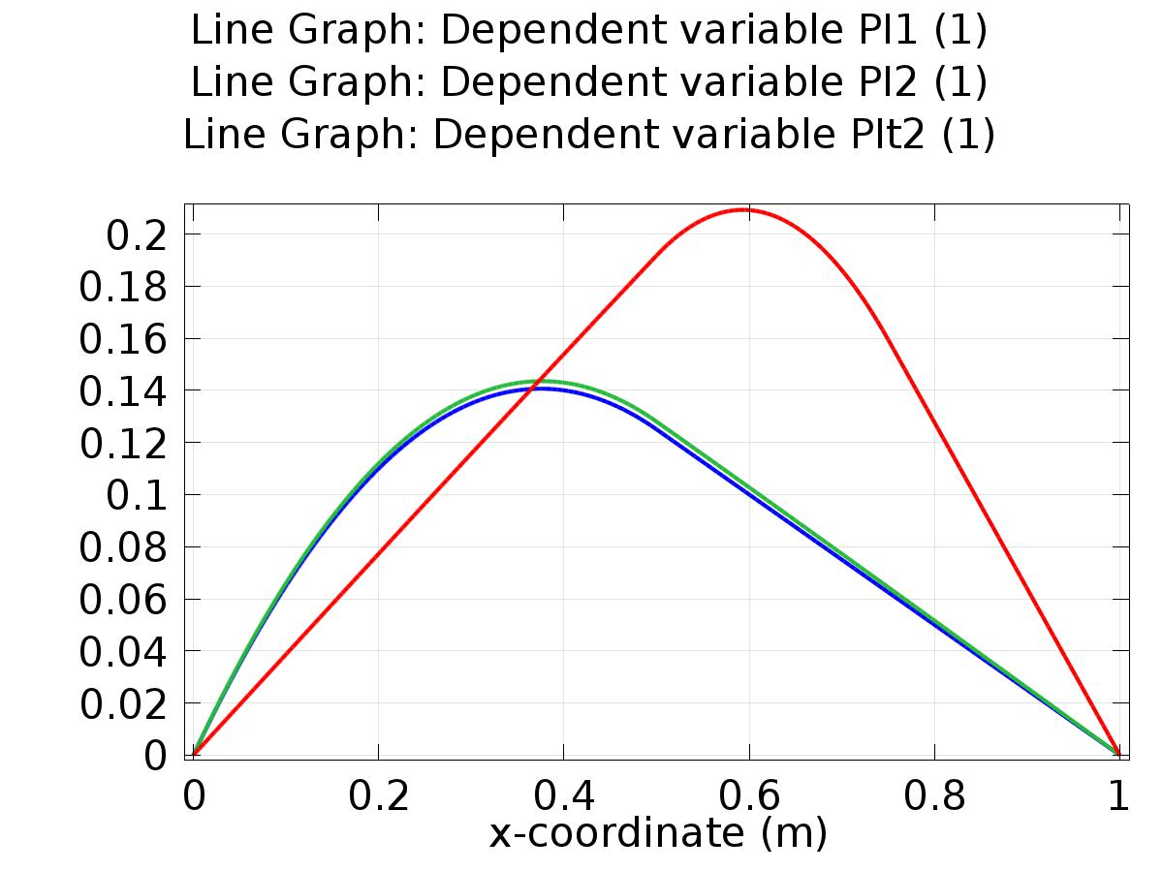

Line Graph: Dependent variable PI1 (1) Line Graph: Dependent variable PI2 (1) Line Graph: Dependent variable PIt2 (1)

* + 1. 1D Plot Group 2

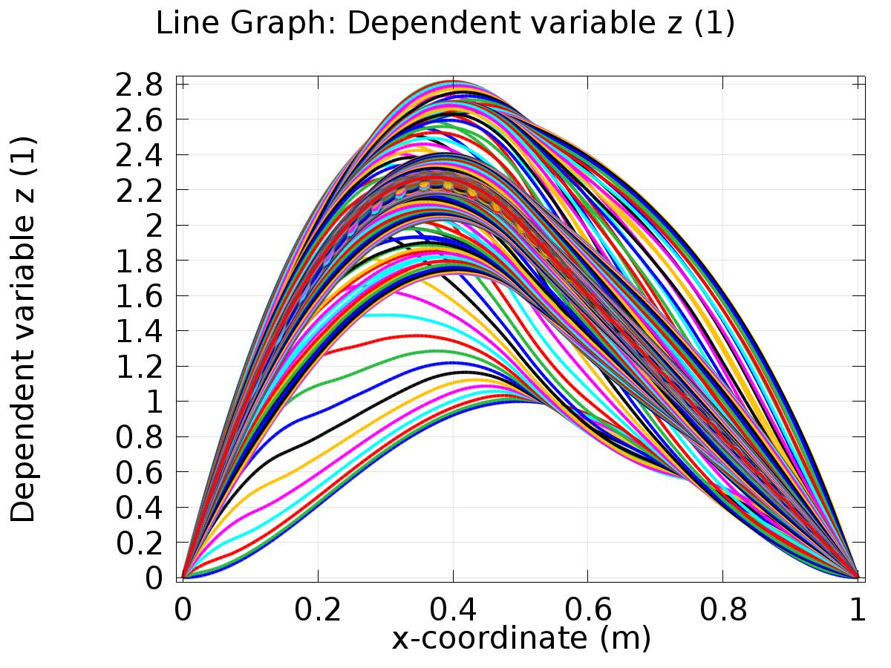

Line Graph: Dependent variable z (1)

* + 1. 1D Plot Group 3

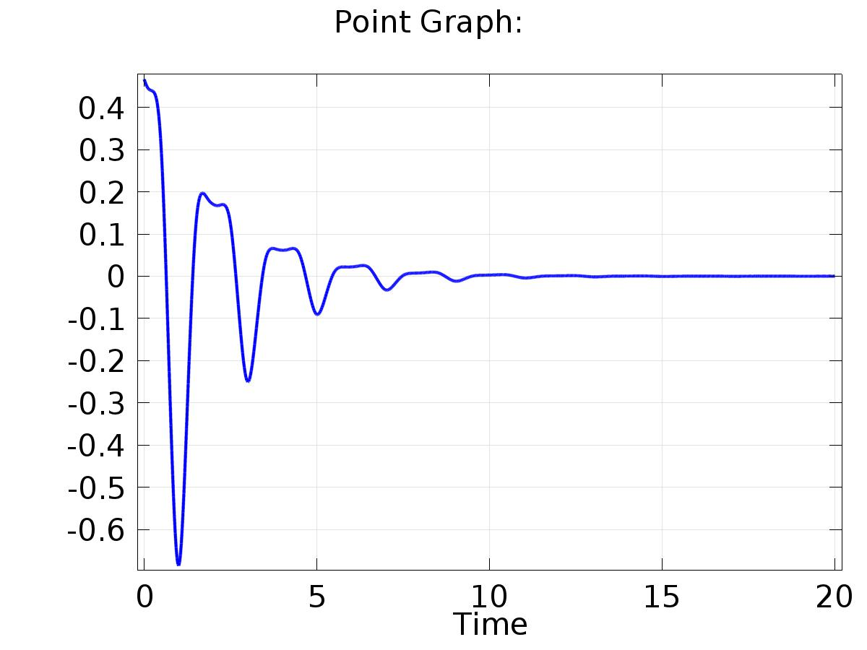

Point Graph:

* + 1. 1D Plot Group 4

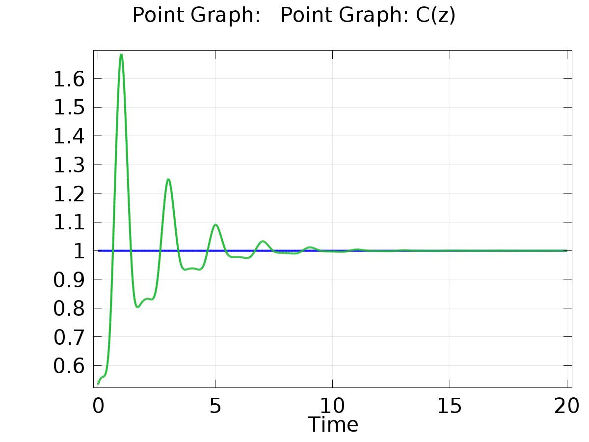

Point Graph: Point Graph: C(z)

* + 1. Probe 1D Plot Group 5

