[](http://www.comsol.com/)

David Bounded MIMO2 K0k1

|  |  |
| --- | --- |
| Date | Aug 10, 2013 2:32:18 PM |

Contents

1. Global Definitions

1.1. Parameters 1

2. Model 1 (mod1)

2.1. Definitions

2.2. Geometry 1

2.3. PDE (c)

2.4. PDE 2 (c2)

2.5. PDE 3 (c3)

2.6. PDE 4 (c4)

2.7. PDE 5 (c5)

2.8. PDE 6 (c6)

2.9. PDE 7 (c7)

2.10. PDE 8 (c8)

2.11. Mesh 1

3. Study 1

3.1. Stationary

3.2. Solver Configurations

4. Study 2

4.1. Stationary

4.2. Solver Configurations

5. Study 8

5.1. Time Dependent

5.2. Solver Configurations

6. Results

6.1. Data Sets

6.2. Derived Values

6.3. Tables

6.4. Plot Groups

1. Global Definitions
   1. Parameters 1

Parameters

| **Name** | **Expression** | **Value** | **Description** |
| --- | --- | --- | --- |
| L | 1.2 | 1.2000 |  |
| x1 | 0.2 | 0.20000 |  |
| x2 | 0.4 | 0.40000 |  |
| x3 | 0.6 | 0.60000 |  |
| x4 | 0.8 | 0.80000 |  |
| x5 | 1 | 1.0000 |  |
| nu | 0.025 | 0.025000 |  |
| alpha1 | 1 | 1.0000 |  |
| alpha2 | 2 | 2.0000 |  |
| beta | 0.5 | 0.50000 |  |
| Mr1 | 0.5 | 0.50000 |  |
| Mr2 | 0.25 | 0.25000 |  |
| Md | 1 | 1.0000 |  |
| Ar1 | 0.25 | 0.25000 |  |
| Ar2 | 0.5 | 0.50000 |  |
| Ad | 0.75 | 0.75000 |  |
| k0 | 1 | 1.0000 |  |
| k1 | 1 | 1.0000 |  |

1. Model 1 (mod1)
   1. Definitions
      1. Variables

#### Variables 1a

Selection

|  |  |
| --- | --- |
| Geometric entity level | Entire model |

| **Name** | **Expression** | **Description** |
| --- | --- | --- |
| G11 | C1(X1) |  |
| G12 | C1(X2) |  |
| G21 | C2(X1) |  |
| G22 | C2(X2) |  |
| DETG | G11*G22 - G12*G21 |  |
| g11 | G22/DETG |  |
| g12 | -G12/DETG |  |
| g21 | -G21/DETG |  |
| g22 | G11/DETG |  |

#### Variables 2a

Selection

|  |  |
| --- | --- |
| Geometric entity level | Entire model |

| **Name** | **Expression** | **Description** |
| --- | --- | --- |
| Gamma11 | g11 |  |
| Gamma12 | g21 |  |
| Gamma21 | g12 |  |
| Gamma22 | g22 |  |
| Gamma31 | g11*(0 - C1(PIt3)) + g12*(0 - C2(PIt3)) |  |
| Gamma32 | g21*(0 - C1(PIt3)) + g22*(0 - C2(PIt3)) |  |
| Gamma41 | g11*(1 - C1(PIt4)) + g12*(0 - C2(PIt4)) |  |
| Gamma42 | g21*(1 - C1(PIt4)) + g22*(0 - C2(PIt4)) |  |
| Gamma51 | g11*(0 - C1(PIt5)) + g12*(0 - C2(PIt5)) |  |
| Gamma52 | g21*(0 - C1(PIt5)) + g22*(0 - C2(PIt5)) |  |
| Gamma61 | g11*(0 - C1(PIt6)) + g12*(1 - C2(PIt6)) |  |
| Gamma62 | g21*(0 - C1(PIt6)) + g22*(1 - C2(PIt6)) |  |
| Gamma71 | g11*(0 - C1(PIt7)) + g12*(0 - C2(PIt7)) |  |
| Gamma72 | g21*(0 - C1(PIt7)) + g22*(0 - C2(PIt7)) |  |
| Gamma81 | g11*(0 - C1(PIt8)) + g12*(0 - C2(PIt8)) |  |
| Gamma82 | g21*(0 - C1(PIt8)) + g22*(0 - C2(PIt8)) |  |
| Gamma91 | g11*(0 - C1(PIt9)) + g12*(0 - C2(PIt9)) |  |
| Gamma92 | g21*(0 - C1(PIt9)) + g22*(0 - C2(PIt9)) |  |

#### Variables 3a

Selection

|  |  |
| --- | --- |
| Geometric entity level | Entire model |

| **Name** | **Expression** | **Description** |
| --- | --- | --- |
| w1 | Mr1 |  |
| w2 | Mr2 |  |
| w3 | Md |  |
| w4 | Ar1*cos(alpha1*t) |  |
| w5 | Ar1*sin(alpha1*t) |  |
| w6 | Ar2*cos(alpha2*t) |  |
| w7 | Ar2*sin(alpha2*t) |  |
| w8 | Ad*cos(beta*t) |  |
| w9 | Ad*sin(beta*t) |  |
| Gamma1 | Gamma11*w1 + Gamma21*w2 + Gamma31*w3 + Gamma41*w4 + Gamma51*w5 + Gamma61*w6 + Gamma71*w7 + Gamma81*w8 + Gamma91*w9 |  |
| Gamma2 | Gamma12*w1 + Gamma22*w2 + Gamma32*w3 + Gamma42*w4 + Gamma52*w5 + Gamma62*w6 + Gamma72*w7 + Gamma82*w8 + Gamma92*w9 |  |
| d | w3 + w8 |  |
| yr1 | w1 + w4 |  |
| yr2 | w2 + w6 |  |
| e1 | C1(z) - yr1 |  |
| e2 | C2(z) - yr2 |  |

* + 1. Model Couplings

#### Average 1

|  |  |
| --- | --- |
| Coupling type | Average |
| Operator name | C1 |

Source selection

|  |  |
| --- | --- |
| Geometric entity level | Domain |
| Selection | Domain 4 |

#### Average 2

|  |  |
| --- | --- |
| Coupling type | Average |
| Operator name | C2 |

Source selection

|  |  |
| --- | --- |
| Geometric entity level | Domain |
| Selection | Domain 8 |

* 1. Geometry 1

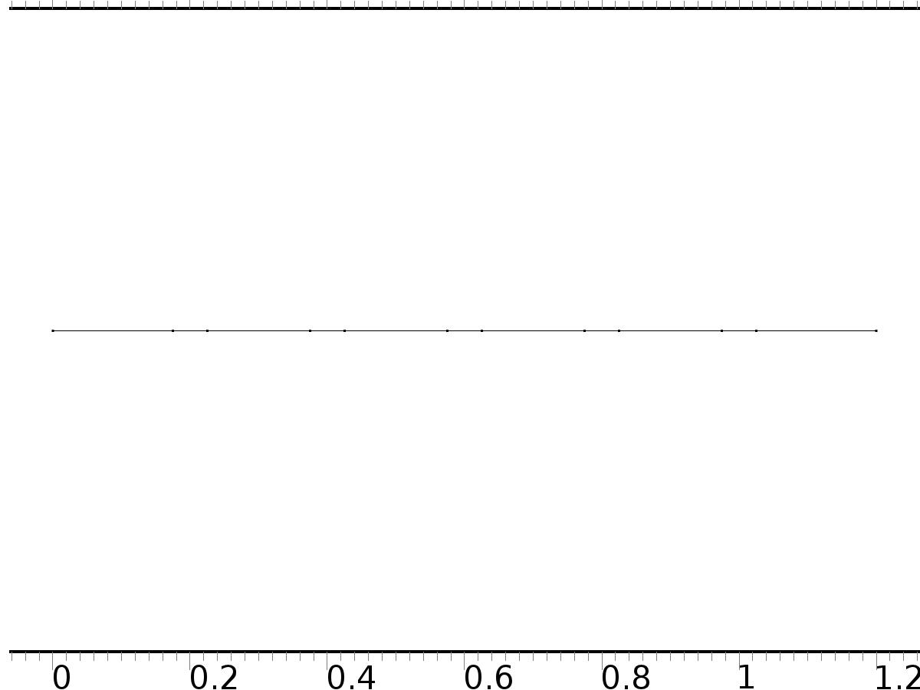

Geometry 1

Units

|  |  |
| --- | --- |
| Length unit | m |
| Angular unit | deg |

Geometry statistics

| **Description** | **Value** |
| --- | --- |
| Space dimension | 1 |
| Number of domains | 11 |
| Number of boundaries | 12 |

* + 1. Interval 1 (i1)

Interval

| **Description** | **Value** |
| --- | --- |
| Number of intervals | Many |
| Points | {0, 0.17500000000000002, 0.225, 0.375, 0.42500000000000004, 0.575, 0.625, 0.775, 0.8250000000000001, 0.975, 1.025, 1.2} |

* 1. PDE (c)

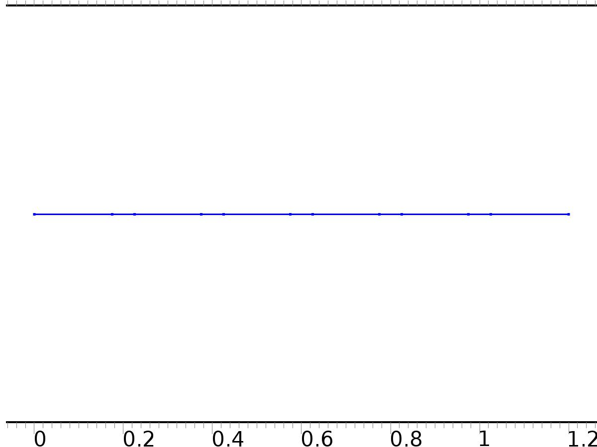

PDE

Selection

|  |  |
| --- | --- |
| Geometric entity level | Domain |
| Selection | Domains 1–11 |

Settings

| **Description** | **Value** |
| --- | --- |
| Shape function type | Lagrange |
| Element order | Quadratic |
| Value type when using splitting of complex variables | Complex |
| Compute boundary fluxes | Off |
| Dependent variable quantity | Dimensionless (1) |
| Source term quantity | None |
| Unit | m^ - 2 |

Variables

| **Name** | **Expression** | **Unit** | **Description** | **Selection** |
| --- | --- | --- | --- | --- |
| c.nx | unx |  | Normal vector, x component | Boundary 1 |
| c.ny | 0 |  | Normal vector, y component | Boundary 1 |
| c.nz | 0 |  | Normal vector, z component | Boundary 1 |
| c.nx | dnx |  | Normal vector, x component | Boundary 12 |
| c.ny | 0 |  | Normal vector, y component | Boundary 12 |
| c.nz | 0 |  | Normal vector, z component | Boundary 12 |
| c.nx | nx |  | Normal vector, x component | Boundaries 2–11 |
| c.ny | 0 |  | Normal vector, y component | Boundaries 2–11 |
| c.nz | 0 |  | Normal vector, z component | Boundaries 2–11 |
| c.nxmesh | root.unxmesh |  | Normal vector (mesh), x component | Boundary 1 |
| c.nymesh | 0 |  | Normal vector (mesh), y component | Boundary 1 |
| c.nzmesh | 0 |  | Normal vector (mesh), z component | Boundary 1 |
| c.nxmesh | root.dnxmesh |  | Normal vector (mesh), x component | Boundary 12 |
| c.nymesh | 0 |  | Normal vector (mesh), y component | Boundary 12 |
| c.nzmesh | 0 |  | Normal vector (mesh), z component | Boundary 12 |
| c.nxmesh | root.nxmesh |  | Normal vector (mesh), x component | Boundaries 2–11 |
| c.nymesh | 0 |  | Normal vector (mesh), y component | Boundaries 2–11 |
| c.nzmesh | 0 |  | Normal vector (mesh), z component | Boundaries 2–11 |

* + 1. Coefficient Form PDE 1



Coefficient Form PDE 1

Selection

|  |  |
| --- | --- |
| Geometric entity level | Domain |
| Selection | Domains 1–11 |

Equations

Settings

| **Description** | **Value** |
| --- | --- |
| Diffusion coefficient | {{1, 0}, {0, 1}} |
| Absorption coefficient | {{0, 0}, {0, 0}} |
| Source term | {0, 0} |
| Mass coefficient | {{0, 0}, {0, 0}} |
| Damping or mass coefficient | {{0, 0}, {0, 0}} |
| Conservative flux convection coefficient | {{0, 0}, {0, 0}} |
| Convection coefficient | {{0, 0}, {0, 0}} |
| Conservative flux source | {0, 0} |

#### Variables

| **Name** | **Expression** | **Unit** | **Description** | **Selection** |
| --- | --- | --- | --- | --- |
| domflux.X1x | -d(X1,x) | 1/m | Domain flux, x component | Domains 1–11 |
| domflux.X2x | -d(X2,x) | 1/m | Domain flux, x component | Domains 1–11 |

* + 1. Zero Flux 1



Zero Flux 1

Selection

|  |  |
| --- | --- |
| Geometric entity level | Boundary |
| Selection | No boundaries |

Equations

* + 1. Initial Values 1



Initial Values 1

Selection

|  |  |
| --- | --- |
| Geometric entity level | Domain |
| Selection | Domains 1–11 |

Settings

| **Description** | **Value** |
| --- | --- |
| Initial value for X1 | 0 |
| Initial value for X2 | 0 |
| Initial time derivative of X1 | 0 |
| Initial time derivative of X2 | 0 |

* + 1. Source 1

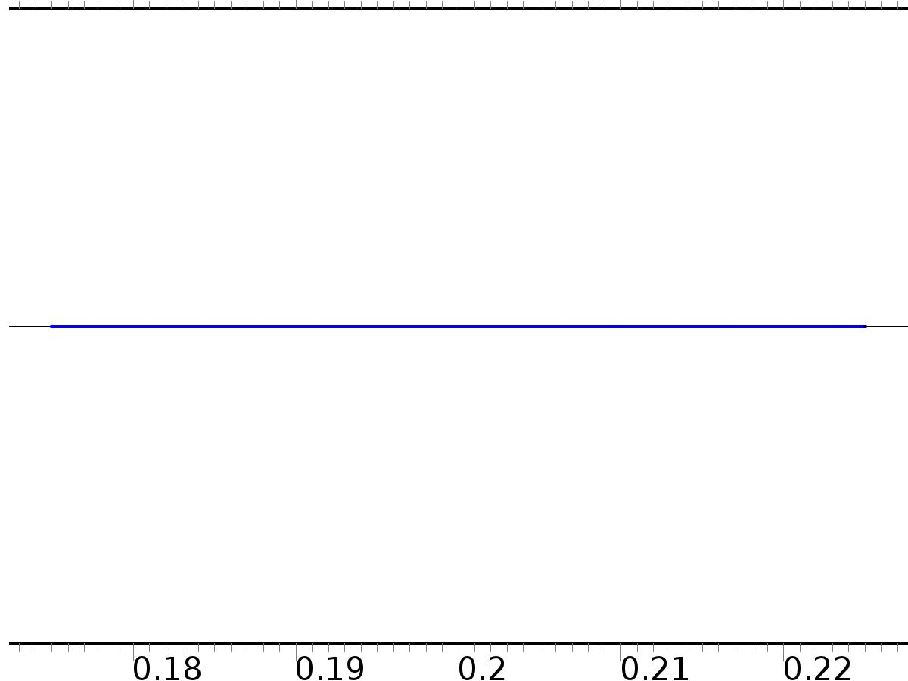

Source 1

Selection

|  |  |
| --- | --- |
| Geometric entity level | Domain |
| Selection | Domain 2 |

Settings

| **Description** | **Value** |
| --- | --- |
| Source term | {1, 0} |

#### Variables

| **Name** | **Expression** | **Unit** | **Description** | **Selection** |
| --- | --- | --- | --- | --- |
| c.f_X1 | 1 | 1/m^2 | Source term | Domain 2 |
| c.f_X2 | 0 | 1/m^2 | Source term | Domain 2 |

* + 1. Source 2

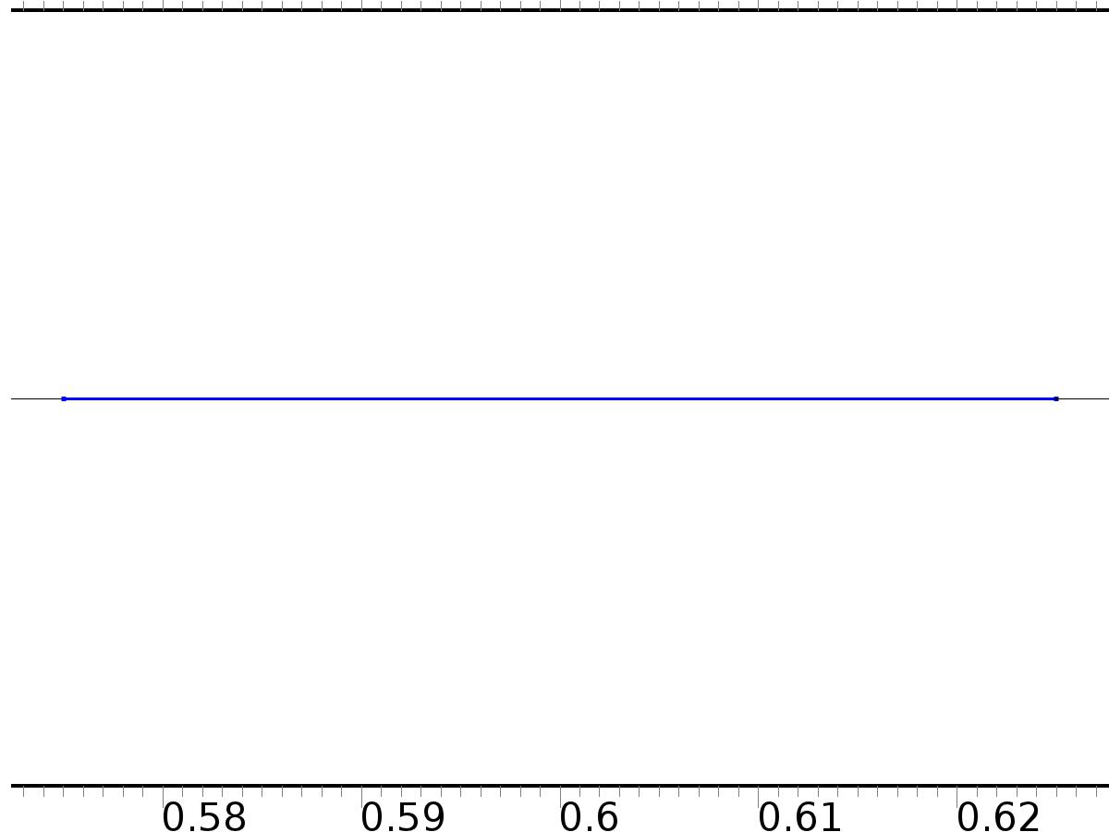

Source 2

Selection

|  |  |
| --- | --- |
| Geometric entity level | Domain |
| Selection | Domain 6 |

Settings

| **Description** | **Value** |
| --- | --- |
| Source term | {0, 1} |

#### Variables

| **Name** | **Expression** | **Unit** | **Description** | **Selection** |
| --- | --- | --- | --- | --- |
| c.f_X1 | 0 | 1/m^2 | Source term | Domain 6 |
| c.f_X2 | 1 | 1/m^2 | Source term | Domain 6 |

* + 1. Flux/Source 1

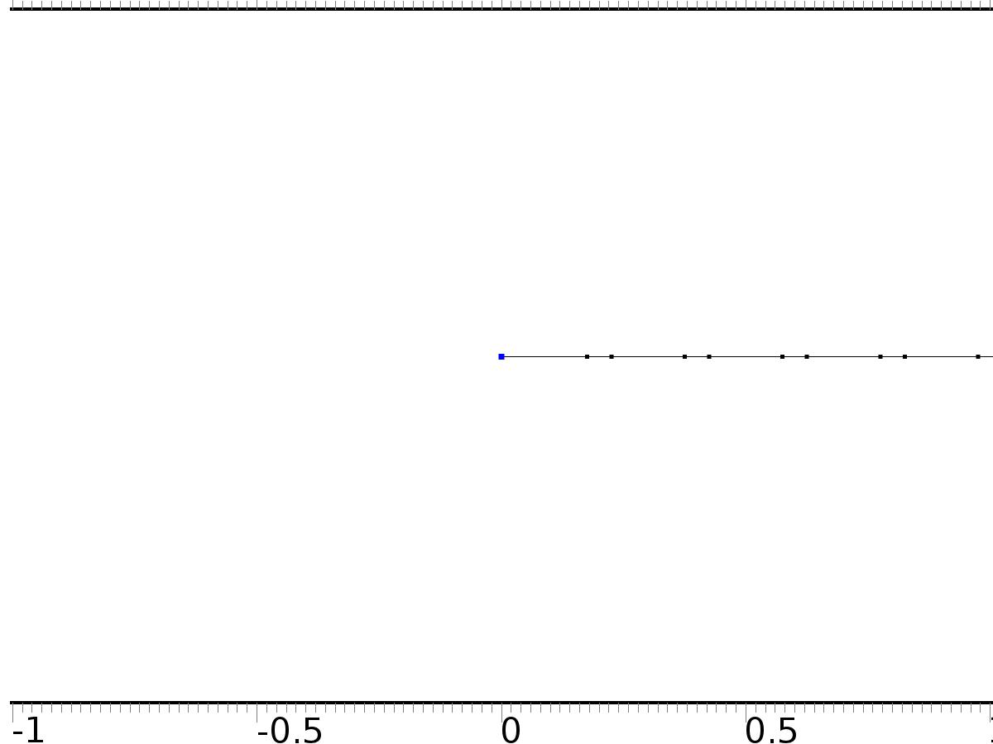

Flux/Source 1

Selection

|  |  |
| --- | --- |
| Geometric entity level | Boundary |
| Selection | Boundary 1 |

Equations

Settings

| **Description** | **Value** |
| --- | --- |
| Boundary flux/source | {0, 0} |
| Boundary absorption/impedance term | {{k0, 0}, {0, k0}} |

#### Variables

| **Name** | **Expression** | **Unit** | **Description** | **Selection** |
| --- | --- | --- | --- | --- |
| c.g_X1 | -k0*X1 | 1/m | Boundary flux/source | Boundary 1 |
| c.g_X2 | -k0*X2 | 1/m | Boundary flux/source | Boundary 1 |

* + 1. Flux/Source 2

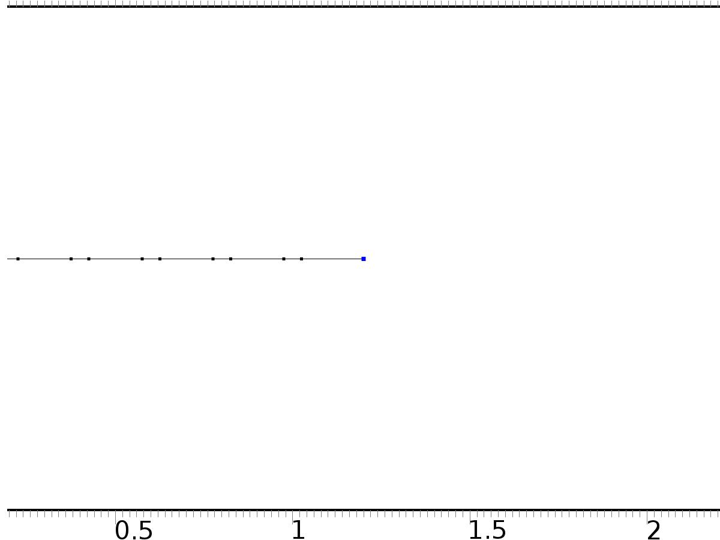

Flux/Source 2

Selection

|  |  |
| --- | --- |
| Geometric entity level | Boundary |
| Selection | Boundary 12 |

Equations

Settings

| **Description** | **Value** |
| --- | --- |
| Boundary flux/source | {0, 0} |
| Boundary absorption/impedance term | {{k1, 0}, {0, k1}} |

#### Variables

| **Name** | **Expression** | **Unit** | **Description** | **Selection** |
| --- | --- | --- | --- | --- |
| c.g_X1 | -k1*X1 | 1/m | Boundary flux/source | Boundary 12 |
| c.g_X2 | -k1*X2 | 1/m | Boundary flux/source | Boundary 12 |

* 1. PDE 2 (c2)



PDE 2

Selection

|  |  |
| --- | --- |
| Geometric entity level | Domain |
| Selection | Domains 1–11 |

Settings

| **Description** | **Value** |
| --- | --- |
| Shape function type | Lagrange |
| Element order | Quadratic |
| Value type when using splitting of complex variables | Complex |
| Compute boundary fluxes | Off |
| Dependent variable quantity | Dimensionless (1) |
| Source term quantity | None |
| Unit | m^ - 2 |

Variables

| **Name** | **Expression** | **Unit** | **Description** | **Selection** |
| --- | --- | --- | --- | --- |
| c2.nx | unx |  | Normal vector, x component | Boundary 1 |
| c2.ny | 0 |  | Normal vector, y component | Boundary 1 |
| c2.nz | 0 |  | Normal vector, z component | Boundary 1 |
| c2.nx | dnx |  | Normal vector, x component | Boundary 12 |
| c2.ny | 0 |  | Normal vector, y component | Boundary 12 |
| c2.nz | 0 |  | Normal vector, z component | Boundary 12 |
| c2.nx | nx |  | Normal vector, x component | Boundaries 2–11 |
| c2.ny | 0 |  | Normal vector, y component | Boundaries 2–11 |
| c2.nz | 0 |  | Normal vector, z component | Boundaries 2–11 |
| c2.nxmesh | root.unxmesh |  | Normal vector (mesh), x component | Boundary 1 |
| c2.nymesh | 0 |  | Normal vector (mesh), y component | Boundary 1 |
| c2.nzmesh | 0 |  | Normal vector (mesh), z component | Boundary 1 |
| c2.nxmesh | root.dnxmesh |  | Normal vector (mesh), x component | Boundary 12 |
| c2.nymesh | 0 |  | Normal vector (mesh), y component | Boundary 12 |
| c2.nzmesh | 0 |  | Normal vector (mesh), z component | Boundary 12 |
| c2.nxmesh | root.nxmesh |  | Normal vector (mesh), x component | Boundaries 2–11 |
| c2.nymesh | 0 |  | Normal vector (mesh), y component | Boundaries 2–11 |
| c2.nzmesh | 0 |  | Normal vector (mesh), z component | Boundaries 2–11 |

* + 1. Coefficient Form PDE 1



Coefficient Form PDE 1

Selection

|  |  |
| --- | --- |
| Geometric entity level | Domain |
| Selection | Domains 1–11 |

Equations

Settings

| **Description** | **Value** |
| --- | --- |
| Diffusion coefficient | 1 |
| Absorption coefficient | 0 |
| Source term | 0 |
| Mass coefficient | 0 |
| Damping or mass coefficient | 0 |
| Conservative flux convection coefficient | 0 |
| Convection coefficient | 0 |
| Conservative flux source | 0 |

#### Variables

| **Name** | **Expression** | **Unit** | **Description** | **Selection** |
| --- | --- | --- | --- | --- |
| domflux.PI1x | -d(PI1,x) | 1/m | Domain flux, x component | Domains 1–11 |

* + 1. Zero Flux 1



Zero Flux 1

Selection

|  |  |
| --- | --- |
| Geometric entity level | Boundary |
| Selection | No boundaries |

Equations

* + 1. Initial Values 1



Initial Values 1

Selection

|  |  |
| --- | --- |
| Geometric entity level | Domain |
| Selection | Domains 1–11 |

Settings

| **Description** | **Value** |
| --- | --- |
| Initial value for PI1 | 0 |
| Initial time derivative of PI1 | 0 |

* + 1. Source 1



Source 1

Selection

|  |  |
| --- | --- |
| Geometric entity level | Domain |
| Selection | Domain 2 |

Settings

| **Description** | **Value** |
| --- | --- |
| Source term | Gamma11 |

#### Variables

| **Name** | **Expression** | **Unit** | **Description** | **Selection** |
| --- | --- | --- | --- | --- |
| c2.f_PI1 | Gamma11 | 1/m^2 | Source term | Domain 2 |

* + 1. Source 2



Source 2

Selection

|  |  |
| --- | --- |
| Geometric entity level | Domain |
| Selection | Domain 6 |

Settings

| **Description** | **Value** |
| --- | --- |
| Source term | Gamma12 |

#### Variables

| **Name** | **Expression** | **Unit** | **Description** | **Selection** |
| --- | --- | --- | --- | --- |
| c2.f_PI1 | Gamma12 | 1/m^2 | Source term | Domain 6 |

* + 1. Flux/Source 1



Flux/Source 1

Selection

|  |  |
| --- | --- |
| Geometric entity level | Boundary |
| Selection | Boundary 1 |

Equations

Settings

| **Description** | **Value** |
| --- | --- |
| Boundary flux/source | 0 |
| Boundary absorption/impedance term | k0 |

#### Variables

| **Name** | **Expression** | **Unit** | **Description** | **Selection** |
| --- | --- | --- | --- | --- |
| c2.g_PI1 | -k0*PI1 | 1/m | Boundary flux/source | Boundary 1 |

* + 1. Flux/Source 2



Flux/Source 2

Selection

|  |  |
| --- | --- |
| Geometric entity level | Boundary |
| Selection | Boundary 12 |

Equations

Settings

| **Description** | **Value** |
| --- | --- |
| Boundary flux/source | 0 |
| Boundary absorption/impedance term | k1 |

#### Variables

| **Name** | **Expression** | **Unit** | **Description** | **Selection** |
| --- | --- | --- | --- | --- |
| c2.g_PI1 | -k1*PI1 | 1/m | Boundary flux/source | Boundary 12 |

* 1. PDE 3 (c3)



PDE 3

Selection

|  |  |
| --- | --- |
| Geometric entity level | Domain |
| Selection | Domains 1–11 |

Settings

| **Description** | **Value** |
| --- | --- |
| Shape function type | Lagrange |
| Element order | Quadratic |
| Value type when using splitting of complex variables | Complex |
| Compute boundary fluxes | Off |
| Dependent variable quantity | Dimensionless (1) |
| Source term quantity | None |
| Unit | m^ - 2 |

Variables

| **Name** | **Expression** | **Unit** | **Description** | **Selection** |
| --- | --- | --- | --- | --- |
| c3.nx | unx |  | Normal vector, x component | Boundary 1 |
| c3.ny | 0 |  | Normal vector, y component | Boundary 1 |
| c3.nz | 0 |  | Normal vector, z component | Boundary 1 |
| c3.nx | dnx |  | Normal vector, x component | Boundary 12 |
| c3.ny | 0 |  | Normal vector, y component | Boundary 12 |
| c3.nz | 0 |  | Normal vector, z component | Boundary 12 |
| c3.nx | nx |  | Normal vector, x component | Boundaries 2–11 |
| c3.ny | 0 |  | Normal vector, y component | Boundaries 2–11 |
| c3.nz | 0 |  | Normal vector, z component | Boundaries 2–11 |
| c3.nxmesh | root.unxmesh |  | Normal vector (mesh), x component | Boundary 1 |
| c3.nymesh | 0 |  | Normal vector (mesh), y component | Boundary 1 |
| c3.nzmesh | 0 |  | Normal vector (mesh), z component | Boundary 1 |
| c3.nxmesh | root.dnxmesh |  | Normal vector (mesh), x component | Boundary 12 |
| c3.nymesh | 0 |  | Normal vector (mesh), y component | Boundary 12 |
| c3.nzmesh | 0 |  | Normal vector (mesh), z component | Boundary 12 |
| c3.nxmesh | root.nxmesh |  | Normal vector (mesh), x component | Boundaries 2–11 |
| c3.nymesh | 0 |  | Normal vector (mesh), y component | Boundaries 2–11 |
| c3.nzmesh | 0 |  | Normal vector (mesh), z component | Boundaries 2–11 |

* + 1. Coefficient Form PDE 1



Coefficient Form PDE 1

Selection

|  |  |
| --- | --- |
| Geometric entity level | Domain |
| Selection | Domains 1–11 |

Equations

Settings

| **Description** | **Value** |
| --- | --- |
| Diffusion coefficient | 1 |
| Absorption coefficient | 0 |
| Source term | 0 |
| Mass coefficient | 0 |
| Damping or mass coefficient | 0 |
| Conservative flux convection coefficient | 0 |
| Convection coefficient | 0 |
| Conservative flux source | 0 |

#### Variables

| **Name** | **Expression** | **Unit** | **Description** | **Selection** |
| --- | --- | --- | --- | --- |
| domflux.PI2x | -d(PI2,x) | 1/m | Domain flux, x component | Domains 1–11 |

* + 1. Zero Flux 1



Zero Flux 1

Selection

|  |  |
| --- | --- |
| Geometric entity level | Boundary |
| Selection | No boundaries |

Equations

* + 1. Initial Values 1



Initial Values 1

Selection

|  |  |
| --- | --- |
| Geometric entity level | Domain |
| Selection | Domains 1–11 |

Settings

| **Description** | **Value** |
| --- | --- |
| Initial value for PI2 | 0 |
| Initial time derivative of PI2 | 0 |

* + 1. Source 1



Source 1

Selection

|  |  |
| --- | --- |
| Geometric entity level | Domain |
| Selection | Domain 2 |

Settings

| **Description** | **Value** |
| --- | --- |
| Source term | Gamma21 |

#### Variables

| **Name** | **Expression** | **Unit** | **Description** | **Selection** |
| --- | --- | --- | --- | --- |
| c3.f_PI2 | Gamma21 | 1/m^2 | Source term | Domain 2 |

* + 1. Source 2



Source 2

Selection

|  |  |
| --- | --- |
| Geometric entity level | Domain |
| Selection | Domain 6 |

Settings

| **Description** | **Value** |
| --- | --- |
| Source term | Gamma22 |

#### Variables

| **Name** | **Expression** | **Unit** | **Description** | **Selection** |
| --- | --- | --- | --- | --- |
| c3.f_PI2 | Gamma22 | 1/m^2 | Source term | Domain 6 |

* + 1. Flux/Source 1



Flux/Source 1

Selection

|  |  |
| --- | --- |
| Geometric entity level | Boundary |
| Selection | Boundary 1 |

Equations

Settings

| **Description** | **Value** |
| --- | --- |
| Boundary flux/source | 0 |
| Boundary absorption/impedance term | k0 |

#### Variables

| **Name** | **Expression** | **Unit** | **Description** | **Selection** |
| --- | --- | --- | --- | --- |
| c3.g_PI2 | -k0*PI2 | 1/m | Boundary flux/source | Boundary 1 |

* + 1. Flux/Source 2



Flux/Source 2

Selection

|  |  |
| --- | --- |
| Geometric entity level | Boundary |
| Selection | Boundary 12 |

Equations

Settings

| **Description** | **Value** |
| --- | --- |
| Boundary flux/source | 0 |
| Boundary absorption/impedance term | k1 |

#### Variables

| **Name** | **Expression** | **Unit** | **Description** | **Selection** |
| --- | --- | --- | --- | --- |
| c3.g_PI2 | -k1*PI2 | 1/m | Boundary flux/source | Boundary 12 |

* 1. PDE 4 (c4)



PDE 4

Selection

|  |  |
| --- | --- |
| Geometric entity level | Domain |
| Selection | Domains 1–11 |

Settings

| **Description** | **Value** |
| --- | --- |
| Shape function type | Lagrange |
| Element order | Quadratic |
| Value type when using splitting of complex variables | Complex |
| Compute boundary fluxes | Off |
| Dependent variable quantity | Dimensionless (1) |
| Source term quantity | None |
| Unit | m^ - 2 |

Variables

| **Name** | **Expression** | **Unit** | **Description** | **Selection** |
| --- | --- | --- | --- | --- |
| c4.nx | unx |  | Normal vector, x component | Boundary 1 |
| c4.ny | 0 |  | Normal vector, y component | Boundary 1 |
| c4.nz | 0 |  | Normal vector, z component | Boundary 1 |
| c4.nx | dnx |  | Normal vector, x component | Boundary 12 |
| c4.ny | 0 |  | Normal vector, y component | Boundary 12 |
| c4.nz | 0 |  | Normal vector, z component | Boundary 12 |
| c4.nx | nx |  | Normal vector, x component | Boundaries 2–11 |
| c4.ny | 0 |  | Normal vector, y component | Boundaries 2–11 |
| c4.nz | 0 |  | Normal vector, z component | Boundaries 2–11 |
| c4.nxmesh | root.unxmesh |  | Normal vector (mesh), x component | Boundary 1 |
| c4.nymesh | 0 |  | Normal vector (mesh), y component | Boundary 1 |
| c4.nzmesh | 0 |  | Normal vector (mesh), z component | Boundary 1 |
| c4.nxmesh | root.dnxmesh |  | Normal vector (mesh), x component | Boundary 12 |
| c4.nymesh | 0 |  | Normal vector (mesh), y component | Boundary 12 |
| c4.nzmesh | 0 |  | Normal vector (mesh), z component | Boundary 12 |
| c4.nxmesh | root.nxmesh |  | Normal vector (mesh), x component | Boundaries 2–11 |
| c4.nymesh | 0 |  | Normal vector (mesh), y component | Boundaries 2–11 |
| c4.nzmesh | 0 |  | Normal vector (mesh), z component | Boundaries 2–11 |

* + 1. Coefficient Form PDE 1



Coefficient Form PDE 1

Selection

|  |  |
| --- | --- |
| Geometric entity level | Domain |
| Selection | Domains 1–11 |

Equations

Settings

| **Description** | **Value** |
| --- | --- |
| Diffusion coefficient | {{1, 0}, {0, 1}} |
| Absorption coefficient | {{0, 0}, {0, 0}} |
| Source term | {0, 0} |
| Mass coefficient | {{0, 0}, {0, 0}} |
| Damping or mass coefficient | {{0, 0}, {0, 0}} |
| Conservative flux convection coefficient | {{0, 0}, {0, 0}} |
| Convection coefficient | {{0, 0}, {0, 0}} |
| Conservative flux source | {0, 0} |

#### Variables

| **Name** | **Expression** | **Unit** | **Description** | **Selection** |
| --- | --- | --- | --- | --- |
| domflux.PI3x | -d(PI3,x) | 1/m | Domain flux, x component | Domains 1–11 |
| domflux.PIt3x | -d(PIt3,x) | 1/m | Domain flux, x component | Domains 1–11 |

* + 1. Zero Flux 1



Zero Flux 1

Selection

|  |  |
| --- | --- |
| Geometric entity level | Boundary |
| Selection | No boundaries |

Equations

* + 1. Initial Values 1



Initial Values 1

Selection

|  |  |
| --- | --- |
| Geometric entity level | Domain |
| Selection | Domains 1–11 |

Settings

| **Description** | **Value** |
| --- | --- |
| Initial value for PI3 | 0 |
| Initial value for PIt3 | 0 |
| Initial time derivative of PI3 | 0 |
| Initial time derivative of PIt3 | 0 |

* + 1. Source 1



Source 1

Selection

|  |  |
| --- | --- |
| Geometric entity level | Domain |
| Selection | Domain 2 |

Settings

| **Description** | **Value** |
| --- | --- |
| Source term | {Gamma31, 0} |

#### Variables

| **Name** | **Expression** | **Unit** | **Description** | **Selection** |
| --- | --- | --- | --- | --- |
| c4.f_PI3 | Gamma31 | 1/m^2 | Source term | Domain 2 |
| c4.f_PIt3 | 0 | 1/m^2 | Source term | Domain 2 |

* + 1. Source 2



Source 2

Selection

|  |  |
| --- | --- |
| Geometric entity level | Domain |
| Selection | Domain 6 |

Settings

| **Description** | **Value** |
| --- | --- |
| Source term | {Gamma32, 0} |

#### Variables

| **Name** | **Expression** | **Unit** | **Description** | **Selection** |
| --- | --- | --- | --- | --- |
| c4.f_PI3 | Gamma32 | 1/m^2 | Source term | Domain 6 |
| c4.f_PIt3 | 0 | 1/m^2 | Source term | Domain 6 |

* + 1. Source 3

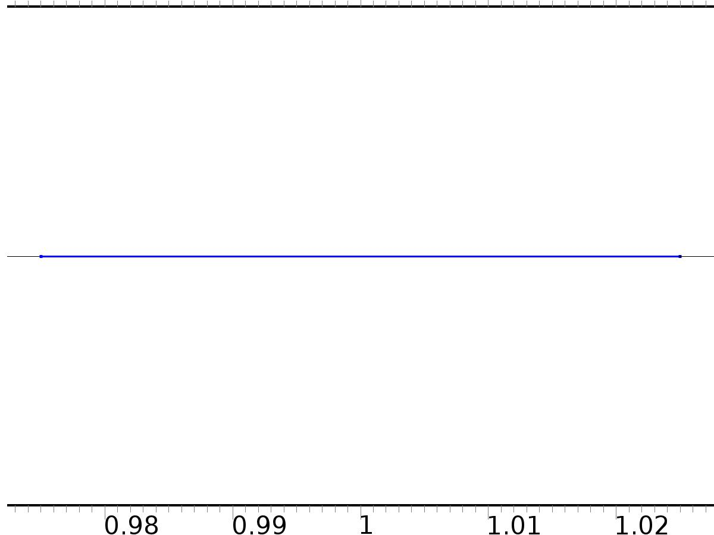

Source 3

Selection

|  |  |
| --- | --- |
| Geometric entity level | Domain |
| Selection | Domain 10 |

Settings

| **Description** | **Value** |
| --- | --- |
| Source term | {1, 1} |

#### Variables

| **Name** | **Expression** | **Unit** | **Description** | **Selection** |
| --- | --- | --- | --- | --- |
| c4.f_PI3 | 1 | 1/m^2 | Source term | Domain 10 |
| c4.f_PIt3 | 1 | 1/m^2 | Source term | Domain 10 |

* + 1. Flux/Source 1



Flux/Source 1

Selection

|  |  |
| --- | --- |
| Geometric entity level | Boundary |
| Selection | Boundary 1 |

Equations

Settings

| **Description** | **Value** |
| --- | --- |
| Boundary flux/source | {0, 0} |
| Boundary absorption/impedance term | {{k0, 0}, {0, k0}} |

#### Variables

| **Name** | **Expression** | **Unit** | **Description** | **Selection** |
| --- | --- | --- | --- | --- |
| c4.g_PI3 | -k0*PI3 | 1/m | Boundary flux/source | Boundary 1 |
| c4.g_PIt3 | -k0*PIt3 | 1/m | Boundary flux/source | Boundary 1 |

* + 1. Flux/Source 2



Flux/Source 2

Selection

|  |  |
| --- | --- |
| Geometric entity level | Boundary |
| Selection | Boundary 12 |

Equations

Settings

| **Description** | **Value** |
| --- | --- |
| Boundary flux/source | {0, 0} |
| Boundary absorption/impedance term | {{k1, 0}, {0, k1}} |

#### Variables

| **Name** | **Expression** | **Unit** | **Description** | **Selection** |
| --- | --- | --- | --- | --- |
| c4.g_PI3 | -k1*PI3 | 1/m | Boundary flux/source | Boundary 12 |
| c4.g_PIt3 | -k1*PIt3 | 1/m | Boundary flux/source | Boundary 12 |

* 1. PDE 5 (c5)



PDE 5

Selection

|  |  |
| --- | --- |
| Geometric entity level | Domain |
| Selection | Domains 1–11 |

Settings

| **Description** | **Value** |
| --- | --- |
| Shape function type | Lagrange |
| Element order | Quadratic |
| Value type when using splitting of complex variables | Complex |
| Compute boundary fluxes | Off |
| Dependent variable quantity | Dimensionless (1) |
| Source term quantity | None |
| Unit | m^ - 2 |

Variables

| **Name** | **Expression** | **Unit** | **Description** | **Selection** |
| --- | --- | --- | --- | --- |
| c5.nx | unx |  | Normal vector, x component | Boundary 1 |
| c5.ny | 0 |  | Normal vector, y component | Boundary 1 |
| c5.nz | 0 |  | Normal vector, z component | Boundary 1 |
| c5.nx | dnx |  | Normal vector, x component | Boundary 12 |
| c5.ny | 0 |  | Normal vector, y component | Boundary 12 |
| c5.nz | 0 |  | Normal vector, z component | Boundary 12 |
| c5.nx | nx |  | Normal vector, x component | Boundaries 2–11 |
| c5.ny | 0 |  | Normal vector, y component | Boundaries 2–11 |
| c5.nz | 0 |  | Normal vector, z component | Boundaries 2–11 |
| c5.nxmesh | root.unxmesh |  | Normal vector (mesh), x component | Boundary 1 |
| c5.nymesh | 0 |  | Normal vector (mesh), y component | Boundary 1 |
| c5.nzmesh | 0 |  | Normal vector (mesh), z component | Boundary 1 |
| c5.nxmesh | root.dnxmesh |  | Normal vector (mesh), x component | Boundary 12 |
| c5.nymesh | 0 |  | Normal vector (mesh), y component | Boundary 12 |
| c5.nzmesh | 0 |  | Normal vector (mesh), z component | Boundary 12 |
| c5.nxmesh | root.nxmesh |  | Normal vector (mesh), x component | Boundaries 2–11 |
| c5.nymesh | 0 |  | Normal vector (mesh), y component | Boundaries 2–11 |
| c5.nzmesh | 0 |  | Normal vector (mesh), z component | Boundaries 2–11 |

* + 1. Coefficient Form PDE 1



Coefficient Form PDE 1

Selection

|  |  |
| --- | --- |
| Geometric entity level | Domain |
| Selection | Domains 1–11 |

Equations

Settings

| **Description** | **Value** |
| --- | --- |
| Diffusion coefficient | {{1, 0, 0, 0}, {0, 1, 0, 0}, {0, 0, 1, 0}, {0, 0, 0, 1}} |
| Absorption coefficient | {{0, -alpha1, 0, -alpha1}, {alpha1, 0, alpha1, 0}, {0, 0, 0, 0}, {0, 0, 0, 0}} |
| Source term | {0, 0, 0, 0} |
| Mass coefficient | {{0, 0, 0, 0}, {0, 0, 0, 0}, {0, 0, 0, 0}, {0, 0, 0, 0}} |
| Damping or mass coefficient | {{0, 0, 0, 0}, {0, 0, 0, 0}, {0, 0, 0, 0}, {0, 0, 0, 0}} |
| Conservative flux convection coefficient | {{0, 0, 0, 0}, {0, 0, 0, 0}, {0, 0, 0, 0}, {0, 0, 0, 0}} |
| Convection coefficient | {{0, 0, 0, 0}, {0, 0, 0, 0}, {0, 0, 0, 0}, {0, 0, 0, 0}} |
| Conservative flux source | {0, 0, 0, 0} |

#### Variables

| **Name** | **Expression** | **Unit** | **Description** | **Selection** |
| --- | --- | --- | --- | --- |
| domflux.PI4x | -d(PI4,x) | 1/m | Domain flux, x component | Domains 1–11 |
| domflux.PI5x | -d(PI5,x) | 1/m | Domain flux, x component | Domains 1–11 |
| domflux.PIt4x | -d(PIt4,x) | 1/m | Domain flux, x component | Domains 1–11 |
| domflux.PIt5x | -d(PIt5,x) | 1/m | Domain flux, x component | Domains 1–11 |

* + 1. Zero Flux 1



Zero Flux 1

Selection

|  |  |
| --- | --- |
| Geometric entity level | Boundary |
| Selection | No boundaries |

Equations

* + 1. Initial Values 1



Initial Values 1

Selection

|  |  |
| --- | --- |
| Geometric entity level | Domain |
| Selection | Domains 1–11 |

Settings

| **Description** | **Value** |
| --- | --- |
| Initial value for PI4 | 0 |
| Initial value for PI5 | 0 |
| Initial value for PIt4 | 0 |
| Initial value for PIt5 | 0 |
| Initial time derivative of PI4 | 0 |
| Initial time derivative of PI5 | 0 |
| Initial time derivative of PIt4 | 0 |
| Initial time derivative of PIt5 | 0 |

* + 1. Source 1



Source 1

Selection

|  |  |
| --- | --- |
| Geometric entity level | Domain |
| Selection | Domain 2 |

Settings

| **Description** | **Value** |
| --- | --- |
| Source term | {Gamma41, Gamma51, 0, 0} |

#### Variables

| **Name** | **Expression** | **Unit** | **Description** | **Selection** |
| --- | --- | --- | --- | --- |
| c5.f_PI4 | Gamma41 | 1/m^2 | Source term | Domain 2 |
| c5.f_PI5 | Gamma51 | 1/m^2 | Source term | Domain 2 |
| c5.f_PIt4 | 0 | 1/m^2 | Source term | Domain 2 |
| c5.f_PIt5 | 0 | 1/m^2 | Source term | Domain 2 |

* + 1. Source 2



Source 2

Selection

|  |  |
| --- | --- |
| Geometric entity level | Domain |
| Selection | Domain 6 |

Settings

| **Description** | **Value** |
| --- | --- |
| Source term | {Gamma42, Gamma52, 0, 0} |

#### Variables

| **Name** | **Expression** | **Unit** | **Description** | **Selection** |
| --- | --- | --- | --- | --- |
| c5.f_PI4 | Gamma42 | 1/m^2 | Source term | Domain 6 |
| c5.f_PI5 | Gamma52 | 1/m^2 | Source term | Domain 6 |
| c5.f_PIt4 | 0 | 1/m^2 | Source term | Domain 6 |
| c5.f_PIt5 | 0 | 1/m^2 | Source term | Domain 6 |

* + 1. Flux/Source 1



Flux/Source 1

Selection

|  |  |
| --- | --- |
| Geometric entity level | Boundary |
| Selection | Boundary 1 |

Equations

Settings

| **Description** | **Value** |
| --- | --- |
| Boundary flux/source | {0, 0, 0, 0} |
| Boundary absorption/impedance term | {{k0, 0, 0, 0}, {0, k0, 0, 0}, {0, 0, k0, 0}, {0, 0, 0, k0}} |

#### Variables

| **Name** | **Expression** | **Unit** | **Description** | **Selection** |
| --- | --- | --- | --- | --- |
| c5.g_PI4 | -k0*PI4 | 1/m | Boundary flux/source | Boundary 1 |
| c5.g_PI5 | -k0*PI5 | 1/m | Boundary flux/source | Boundary 1 |
| c5.g_PIt4 | -k0*PIt4 | 1/m | Boundary flux/source | Boundary 1 |
| c5.g_PIt5 | -k0*PIt5 | 1/m | Boundary flux/source | Boundary 1 |

* + 1. Flux/Source 2



Flux/Source 2

Selection

|  |  |
| --- | --- |
| Geometric entity level | Boundary |
| Selection | Boundary 12 |

Equations

Settings

| **Description** | **Value** |
| --- | --- |
| Boundary flux/source | {0, 0, 0, 0} |
| Boundary absorption/impedance term | {{k1, 0, 0, 0}, {0, k1, 0, 0}, {0, 0, k1, 0}, {0, 0, 0, k1}} |

#### Variables

| **Name** | **Expression** | **Unit** | **Description** | **Selection** |
| --- | --- | --- | --- | --- |
| c5.g_PI4 | -k1*PI4 | 1/m | Boundary flux/source | Boundary 12 |
| c5.g_PI5 | -k1*PI5 | 1/m | Boundary flux/source | Boundary 12 |
| c5.g_PIt4 | -k1*PIt4 | 1/m | Boundary flux/source | Boundary 12 |
| c5.g_PIt5 | -k1*PIt5 | 1/m | Boundary flux/source | Boundary 12 |

* 1. PDE 6 (c6)



PDE 6

Selection

|  |  |
| --- | --- |
| Geometric entity level | Domain |
| Selection | Domains 1–11 |

Settings

| **Description** | **Value** |
| --- | --- |
| Shape function type | Lagrange |
| Element order | Quadratic |
| Value type when using splitting of complex variables | Complex |
| Compute boundary fluxes | Off |
| Dependent variable quantity | Dimensionless (1) |
| Source term quantity | None |
| Unit | m^ - 2 |

Variables

| **Name** | **Expression** | **Unit** | **Description** | **Selection** |
| --- | --- | --- | --- | --- |
| c6.nx | unx |  | Normal vector, x component | Boundary 1 |
| c6.ny | 0 |  | Normal vector, y component | Boundary 1 |
| c6.nz | 0 |  | Normal vector, z component | Boundary 1 |
| c6.nx | dnx |  | Normal vector, x component | Boundary 12 |
| c6.ny | 0 |  | Normal vector, y component | Boundary 12 |
| c6.nz | 0 |  | Normal vector, z component | Boundary 12 |
| c6.nx | nx |  | Normal vector, x component | Boundaries 2–11 |
| c6.ny | 0 |  | Normal vector, y component | Boundaries 2–11 |
| c6.nz | 0 |  | Normal vector, z component | Boundaries 2–11 |
| c6.nxmesh | root.unxmesh |  | Normal vector (mesh), x component | Boundary 1 |
| c6.nymesh | 0 |  | Normal vector (mesh), y component | Boundary 1 |
| c6.nzmesh | 0 |  | Normal vector (mesh), z component | Boundary 1 |
| c6.nxmesh | root.dnxmesh |  | Normal vector (mesh), x component | Boundary 12 |
| c6.nymesh | 0 |  | Normal vector (mesh), y component | Boundary 12 |
| c6.nzmesh | 0 |  | Normal vector (mesh), z component | Boundary 12 |
| c6.nxmesh | root.nxmesh |  | Normal vector (mesh), x component | Boundaries 2–11 |
| c6.nymesh | 0 |  | Normal vector (mesh), y component | Boundaries 2–11 |
| c6.nzmesh | 0 |  | Normal vector (mesh), z component | Boundaries 2–11 |

* + 1. Coefficient Form PDE 1



Coefficient Form PDE 1

Selection

|  |  |
| --- | --- |
| Geometric entity level | Domain |
| Selection | Domains 1–11 |

Equations

Settings

| **Description** | **Value** |
| --- | --- |
| Diffusion coefficient | {{1, 0, 0, 0}, {0, 1, 0, 0}, {0, 0, 1, 0}, {0, 0, 0, 1}} |
| Absorption coefficient | {{0, -alpha2, 0, -alpha2}, {alpha2, 0, alpha2, 0}, {0, 0, 0, 0}, {0, 0, 0, 0}} |
| Source term | {0, 0, 0, 0} |
| Mass coefficient | {{0, 0, 0, 0}, {0, 0, 0, 0}, {0, 0, 0, 0}, {0, 0, 0, 0}} |
| Damping or mass coefficient | {{0, 0, 0, 0}, {0, 0, 0, 0}, {0, 0, 0, 0}, {0, 0, 0, 0}} |
| Conservative flux convection coefficient | {{0, 0, 0, 0}, {0, 0, 0, 0}, {0, 0, 0, 0}, {0, 0, 0, 0}} |
| Convection coefficient | {{0, 0, 0, 0}, {0, 0, 0, 0}, {0, 0, 0, 0}, {0, 0, 0, 0}} |
| Conservative flux source | {0, 0, 0, 0} |

#### Variables

| **Name** | **Expression** | **Unit** | **Description** | **Selection** |
| --- | --- | --- | --- | --- |
| domflux.PI6x | -d(PI6,x) | 1/m | Domain flux, x component | Domains 1–11 |
| domflux.PI7x | -d(PI7,x) | 1/m | Domain flux, x component | Domains 1–11 |
| domflux.PIt6x | -d(PIt6,x) | 1/m | Domain flux, x component | Domains 1–11 |
| domflux.PIt7x | -d(PIt7,x) | 1/m | Domain flux, x component | Domains 1–11 |

* + 1. Zero Flux 1



Zero Flux 1

Selection

|  |  |
| --- | --- |
| Geometric entity level | Boundary |
| Selection | No boundaries |

Equations

* + 1. Initial Values 1



Initial Values 1

Selection

|  |  |
| --- | --- |
| Geometric entity level | Domain |
| Selection | Domains 1–11 |

Settings

| **Description** | **Value** |
| --- | --- |
| Initial value for PI6 | 0 |
| Initial value for PI7 | 0 |
| Initial value for PIt6 | 0 |
| Initial value for PIt7 | 0 |
| Initial time derivative of PI6 | 0 |
| Initial time derivative of PI7 | 0 |
| Initial time derivative of PIt6 | 0 |
| Initial time derivative of PIt7 | 0 |

* + 1. Source 1



Source 1

Selection

|  |  |
| --- | --- |
| Geometric entity level | Domain |
| Selection | Domain 2 |

Settings

| **Description** | **Value** |
| --- | --- |
| Source term | {Gamma61, Gamma71, 0, 0} |

#### Variables

| **Name** | **Expression** | **Unit** | **Description** | **Selection** |
| --- | --- | --- | --- | --- |
| c6.f_PI6 | Gamma61 | 1/m^2 | Source term | Domain 2 |
| c6.f_PI7 | Gamma71 | 1/m^2 | Source term | Domain 2 |
| c6.f_PIt6 | 0 | 1/m^2 | Source term | Domain 2 |
| c6.f_PIt7 | 0 | 1/m^2 | Source term | Domain 2 |

* + 1. Source 2



Source 2

Selection

|  |  |
| --- | --- |
| Geometric entity level | Domain |
| Selection | Domain 6 |

Settings

| **Description** | **Value** |
| --- | --- |
| Source term | {Gamma62, Gamma72, 0, 0} |

#### Variables

| **Name** | **Expression** | **Unit** | **Description** | **Selection** |
| --- | --- | --- | --- | --- |
| c6.f_PI6 | Gamma62 | 1/m^2 | Source term | Domain 6 |
| c6.f_PI7 | Gamma72 | 1/m^2 | Source term | Domain 6 |
| c6.f_PIt6 | 0 | 1/m^2 | Source term | Domain 6 |
| c6.f_PIt7 | 0 | 1/m^2 | Source term | Domain 6 |

* + 1. Flux/Source 1



Flux/Source 1

Selection

|  |  |
| --- | --- |
| Geometric entity level | Boundary |
| Selection | Boundary 1 |

Equations

Settings

| **Description** | **Value** |
| --- | --- |
| Boundary flux/source | {0, 0, 0, 0} |
| Boundary absorption/impedance term | {{k0, 0, 0, 0}, {0, k0, 0, 0}, {0, 0, k0, 0}, {0, 0, 0, k0}} |

#### Variables

| **Name** | **Expression** | **Unit** | **Description** | **Selection** |
| --- | --- | --- | --- | --- |
| c6.g_PI6 | -k0*PI6 | 1/m | Boundary flux/source | Boundary 1 |
| c6.g_PI7 | -k0*PI7 | 1/m | Boundary flux/source | Boundary 1 |
| c6.g_PIt6 | -k0*PIt6 | 1/m | Boundary flux/source | Boundary 1 |
| c6.g_PIt7 | -k0*PIt7 | 1/m | Boundary flux/source | Boundary 1 |

* + 1. Flux/Source 2



Flux/Source 2

Selection

|  |  |
| --- | --- |
| Geometric entity level | Boundary |
| Selection | Boundary 12 |

Equations

Settings

| **Description** | **Value** |
| --- | --- |
| Boundary flux/source | {0, 0, 0, 0} |
| Boundary absorption/impedance term | {{k1, 0, 0, 0}, {0, k1, 0, 0}, {0, 0, k1, 0}, {0, 0, 0, k1}} |

#### Variables

| **Name** | **Expression** | **Unit** | **Description** | **Selection** |
| --- | --- | --- | --- | --- |
| c6.g_PI6 | -k1*PI6 | 1/m | Boundary flux/source | Boundary 12 |
| c6.g_PI7 | -k1*PI7 | 1/m | Boundary flux/source | Boundary 12 |
| c6.g_PIt6 | -k1*PIt6 | 1/m | Boundary flux/source | Boundary 12 |
| c6.g_PIt7 | -k1*PIt7 | 1/m | Boundary flux/source | Boundary 12 |

* 1. PDE 7 (c7)



PDE 7

Selection

|  |  |
| --- | --- |
| Geometric entity level | Domain |
| Selection | Domains 1–11 |

Settings

| **Description** | **Value** |
| --- | --- |
| Shape function type | Lagrange |
| Element order | Quadratic |
| Value type when using splitting of complex variables | Complex |
| Compute boundary fluxes | Off |
| Dependent variable quantity | Dimensionless (1) |
| Source term quantity | None |
| Unit | m^ - 2 |

Variables

| **Name** | **Expression** | **Unit** | **Description** | **Selection** |
| --- | --- | --- | --- | --- |
| c7.nx | unx |  | Normal vector, x component | Boundary 1 |
| c7.ny | 0 |  | Normal vector, y component | Boundary 1 |
| c7.nz | 0 |  | Normal vector, z component | Boundary 1 |
| c7.nx | dnx |  | Normal vector, x component | Boundary 12 |
| c7.ny | 0 |  | Normal vector, y component | Boundary 12 |
| c7.nz | 0 |  | Normal vector, z component | Boundary 12 |
| c7.nx | nx |  | Normal vector, x component | Boundaries 2–11 |
| c7.ny | 0 |  | Normal vector, y component | Boundaries 2–11 |
| c7.nz | 0 |  | Normal vector, z component | Boundaries 2–11 |
| c7.nxmesh | root.unxmesh |  | Normal vector (mesh), x component | Boundary 1 |
| c7.nymesh | 0 |  | Normal vector (mesh), y component | Boundary 1 |
| c7.nzmesh | 0 |  | Normal vector (mesh), z component | Boundary 1 |
| c7.nxmesh | root.dnxmesh |  | Normal vector (mesh), x component | Boundary 12 |
| c7.nymesh | 0 |  | Normal vector (mesh), y component | Boundary 12 |
| c7.nzmesh | 0 |  | Normal vector (mesh), z component | Boundary 12 |
| c7.nxmesh | root.nxmesh |  | Normal vector (mesh), x component | Boundaries 2–11 |
| c7.nymesh | 0 |  | Normal vector (mesh), y component | Boundaries 2–11 |
| c7.nzmesh | 0 |  | Normal vector (mesh), z component | Boundaries 2–11 |

* + 1. Coefficient Form PDE 1



Coefficient Form PDE 1

Selection

|  |  |
| --- | --- |
| Geometric entity level | Domain |
| Selection | Domains 1–11 |

Equations

Settings

| **Description** | **Value** |
| --- | --- |
| Diffusion coefficient | {{1, 0, 0, 0}, {0, 1, 0, 0}, {0, 0, 1, 0}, {0, 0, 0, 1}} |
| Absorption coefficient | {{0, -beta, 0, -beta}, {beta, 0, beta, 0}, {0, 0, 0, 0}, {0, 0, 0, 0}} |
| Source term | {0, 0, 0, 0} |
| Mass coefficient | {{0, 0, 0, 0}, {0, 0, 0, 0}, {0, 0, 0, 0}, {0, 0, 0, 0}} |
| Damping or mass coefficient | {{0, 0, 0, 0}, {0, 0, 0, 0}, {0, 0, 0, 0}, {0, 0, 0, 0}} |
| Conservative flux convection coefficient | {{0, 0, 0, 0}, {0, 0, 0, 0}, {0, 0, 0, 0}, {0, 0, 0, 0}} |
| Convection coefficient | {{0, 0, 0, 0}, {0, 0, 0, 0}, {0, 0, 0, 0}, {0, 0, 0, 0}} |
| Conservative flux source | {0, 0, 0, 0} |

#### Variables

| **Name** | **Expression** | **Unit** | **Description** | **Selection** |
| --- | --- | --- | --- | --- |
| domflux.PI8x | -d(PI8,x) | 1/m | Domain flux, x component | Domains 1–11 |
| domflux.PI9x | -d(PI9,x) | 1/m | Domain flux, x component | Domains 1–11 |
| domflux.PIt8x | -d(PIt8,x) | 1/m | Domain flux, x component | Domains 1–11 |
| domflux.PIt9x | -d(PIt9,x) | 1/m | Domain flux, x component | Domains 1–11 |

* + 1. Zero Flux 1



Zero Flux 1

Selection

|  |  |
| --- | --- |
| Geometric entity level | Boundary |
| Selection | No boundaries |

Equations

* + 1. Initial Values 1



Initial Values 1

Selection

|  |  |
| --- | --- |
| Geometric entity level | Domain |
| Selection | Domains 1–11 |

Settings

| **Description** | **Value** |
| --- | --- |
| Initial value for PI8 | 0 |
| Initial value for PI9 | 0 |
| Initial value for PIt8 | 0 |
| Initial value for PIt9 | 0 |
| Initial time derivative of PI8 | 0 |
| Initial time derivative of PI9 | 0 |
| Initial time derivative of PIt8 | 0 |
| Initial time derivative of PIt9 | 0 |

* + 1. Source 1



Source 1

Selection

|  |  |
| --- | --- |
| Geometric entity level | Domain |
| Selection | Domain 2 |

Settings

| **Description** | **Value** |
| --- | --- |
| Source term | {Gamma81, Gamma91, 0, 0} |

#### Variables

| **Name** | **Expression** | **Unit** | **Description** | **Selection** |
| --- | --- | --- | --- | --- |
| c7.f_PI8 | Gamma81 | 1/m^2 | Source term | Domain 2 |
| c7.f_PI9 | Gamma91 | 1/m^2 | Source term | Domain 2 |
| c7.f_PIt8 | 0 | 1/m^2 | Source term | Domain 2 |
| c7.f_PIt9 | 0 | 1/m^2 | Source term | Domain 2 |

* + 1. Source 2



Source 2

Selection

|  |  |
| --- | --- |
| Geometric entity level | Domain |
| Selection | Domain 6 |

Settings

| **Description** | **Value** |
| --- | --- |
| Source term | {Gamma82, Gamma92, 0, 0} |

#### Variables

| **Name** | **Expression** | **Unit** | **Description** | **Selection** |
| --- | --- | --- | --- | --- |
| c7.f_PI8 | Gamma82 | 1/m^2 | Source term | Domain 6 |
| c7.f_PI9 | Gamma92 | 1/m^2 | Source term | Domain 6 |
| c7.f_PIt8 | 0 | 1/m^2 | Source term | Domain 6 |
| c7.f_PIt9 | 0 | 1/m^2 | Source term | Domain 6 |

* + 1. Source 3



Source 3

Selection

|  |  |
| --- | --- |
| Geometric entity level | Domain |
| Selection | Domain 10 |

Settings

| **Description** | **Value** |
| --- | --- |
| Source term | {1, 0, 1, 0} |

#### Variables

| **Name** | **Expression** | **Unit** | **Description** | **Selection** |
| --- | --- | --- | --- | --- |
| c7.f_PI8 | 1 | 1/m^2 | Source term | Domain 10 |
| c7.f_PI9 | 0 | 1/m^2 | Source term | Domain 10 |
| c7.f_PIt8 | 1 | 1/m^2 | Source term | Domain 10 |
| c7.f_PIt9 | 0 | 1/m^2 | Source term | Domain 10 |

* + 1. Flux/Source 1



Flux/Source 1

Selection

|  |  |
| --- | --- |
| Geometric entity level | Boundary |
| Selection | Boundary 1 |

Equations

Settings

| **Description** | **Value** |
| --- | --- |
| Boundary flux/source | {0, 0, 0, 0} |
| Boundary absorption/impedance term | {{k0, 0, 0, 0}, {0, k0, 0, 0}, {0, 0, k0, 0}, {0, 0, 0, k0}} |

#### Variables

| **Name** | **Expression** | **Unit** | **Description** | **Selection** |
| --- | --- | --- | --- | --- |
| c7.g_PI8 | -k0*PI8 | 1/m | Boundary flux/source | Boundary 1 |
| c7.g_PI9 | -k0*PI9 | 1/m | Boundary flux/source | Boundary 1 |
| c7.g_PIt8 | -k0*PIt8 | 1/m | Boundary flux/source | Boundary 1 |
| c7.g_PIt9 | -k0*PIt9 | 1/m | Boundary flux/source | Boundary 1 |

* + 1. Flux/Source 2



Flux/Source 2

Selection

|  |  |
| --- | --- |
| Geometric entity level | Boundary |
| Selection | Boundary 12 |

Equations

Settings

| **Description** | **Value** |
| --- | --- |
| Boundary flux/source | {0, 0, 0, 0} |
| Boundary absorption/impedance term | {{k1, 0, 0, 0}, {0, k1, 0, 0}, {0, 0, k1, 0}, {0, 0, 0, k1}} |

#### Variables

| **Name** | **Expression** | **Unit** | **Description** | **Selection** |
| --- | --- | --- | --- | --- |
| c7.g_PI8 | -k1*PI8 | 1/m | Boundary flux/source | Boundary 12 |
| c7.g_PI9 | -k1*PI9 | 1/m | Boundary flux/source | Boundary 12 |
| c7.g_PIt8 | -k1*PIt8 | 1/m | Boundary flux/source | Boundary 12 |
| c7.g_PIt9 | -k1*PIt9 | 1/m | Boundary flux/source | Boundary 12 |

* 1. PDE 8 (c8)



PDE 8

Selection

|  |  |
| --- | --- |
| Geometric entity level | Domain |
| Selection | Domains 1–11 |

Settings

| **Description** | **Value** |
| --- | --- |
| Shape function type | Lagrange |
| Element order | Quadratic |
| Value type when using splitting of complex variables | Complex |
| Compute boundary fluxes | Off |
| Dependent variable quantity | Dimensionless (1) |
| Source term quantity | None |
| Unit | m^ - 2 |

Variables

| **Name** | **Expression** | **Unit** | **Description** | **Selection** |
| --- | --- | --- | --- | --- |
| c8.nx | unx |  | Normal vector, x component | Boundary 1 |
| c8.ny | 0 |  | Normal vector, y component | Boundary 1 |
| c8.nz | 0 |  | Normal vector, z component | Boundary 1 |
| c8.nx | dnx |  | Normal vector, x component | Boundary 12 |
| c8.ny | 0 |  | Normal vector, y component | Boundary 12 |
| c8.nz | 0 |  | Normal vector, z component | Boundary 12 |
| c8.nx | nx |  | Normal vector, x component | Boundaries 2–11 |
| c8.ny | 0 |  | Normal vector, y component | Boundaries 2–11 |
| c8.nz | 0 |  | Normal vector, z component | Boundaries 2–11 |
| c8.nxmesh | root.unxmesh |  | Normal vector (mesh), x component | Boundary 1 |
| c8.nymesh | 0 |  | Normal vector (mesh), y component | Boundary 1 |
| c8.nzmesh | 0 |  | Normal vector (mesh), z component | Boundary 1 |
| c8.nxmesh | root.dnxmesh |  | Normal vector (mesh), x component | Boundary 12 |
| c8.nymesh | 0 |  | Normal vector (mesh), y component | Boundary 12 |
| c8.nzmesh | 0 |  | Normal vector (mesh), z component | Boundary 12 |
| c8.nxmesh | root.nxmesh |  | Normal vector (mesh), x component | Boundaries 2–11 |
| c8.nymesh | 0 |  | Normal vector (mesh), y component | Boundaries 2–11 |
| c8.nzmesh | 0 |  | Normal vector (mesh), z component | Boundaries 2–11 |

* + 1. Coefficient Form PDE 1



Coefficient Form PDE 1

Selection

|  |  |
| --- | --- |
| Geometric entity level | Domain |
| Selection | Domains 1–11 |

Equations

Settings

| **Description** | **Value** |
| --- | --- |
| Diffusion coefficient | 1 |
| Absorption coefficient | 0 |
| Source term | 0 |
| Mass coefficient | 0 |
| Damping or mass coefficient | 1 |
| Conservative flux convection coefficient | 0 |
| Convection coefficient | 0 |
| Conservative flux source | 0 |

#### Variables

| **Name** | **Expression** | **Unit** | **Description** | **Selection** |
| --- | --- | --- | --- | --- |
| domflux.zx | -d(z,x) | 1/m | Domain flux, x component | Domains 1–11 |

* + 1. Zero Flux 1



Zero Flux 1

Selection

|  |  |
| --- | --- |
| Geometric entity level | Boundary |
| Selection | No boundaries |

Equations

* + 1. Initial Values 1



Initial Values 1

Selection

|  |  |
| --- | --- |
| Geometric entity level | Domain |
| Selection | Domains 1–11 |

Settings

| **Description** | **Value** |
| --- | --- |
| Initial value for z | cos(pi*x/L) |
| Initial time derivative of z | 0 |

* + 1. Source 1



Source 1

Selection

|  |  |
| --- | --- |
| Geometric entity level | Domain |
| Selection | Domain 2 |

Settings

| **Description** | **Value** |
| --- | --- |
| Source term | Gamma1 |

#### Variables

| **Name** | **Expression** | **Unit** | **Description** | **Selection** |
| --- | --- | --- | --- | --- |
| c8.f_z | Gamma1 | 1/m^2 | Source term | Domain 2 |

* + 1. Source 2



Source 2

Selection

|  |  |
| --- | --- |
| Geometric entity level | Domain |
| Selection | Domain 6 |

Settings

| **Description** | **Value** |
| --- | --- |
| Source term | Gamma2 |

#### Variables

| **Name** | **Expression** | **Unit** | **Description** | **Selection** |
| --- | --- | --- | --- | --- |
| c8.f_z | Gamma2 | 1/m^2 | Source term | Domain 6 |

* + 1. Source 3



Source 3

Selection

|  |  |
| --- | --- |
| Geometric entity level | Domain |
| Selection | Domain 10 |

Settings

| **Description** | **Value** |
| --- | --- |
| Source term | d |

#### Variables

| **Name** | **Expression** | **Unit** | **Description** | **Selection** |
| --- | --- | --- | --- | --- |
| c8.f_z | d | 1/m^2 | Source term | Domain 10 |

* + 1. Flux/Source 1



Flux/Source 1

Selection

|  |  |
| --- | --- |
| Geometric entity level | Boundary |
| Selection | Boundary 1 |

Equations

Settings

| **Description** | **Value** |
| --- | --- |
| Boundary flux/source | 0 |
| Boundary absorption/impedance term | k0 |

#### Variables

| **Name** | **Expression** | **Unit** | **Description** | **Selection** |
| --- | --- | --- | --- | --- |
| c8.g_z | -k0*z | 1/m | Boundary flux/source | Boundary 1 |

* + 1. Flux/Source 2



Flux/Source 2

Selection

|  |  |
| --- | --- |
| Geometric entity level | Boundary |
| Selection | Boundary 12 |

Equations

Settings

| **Description** | **Value** |
| --- | --- |
| Boundary flux/source | 0 |
| Boundary absorption/impedance term | k1 |

#### Variables

| **Name** | **Expression** | **Unit** | **Description** | **Selection** |
| --- | --- | --- | --- | --- |
| c8.g_z | -k1*z | 1/m | Boundary flux/source | Boundary 12 |

* 1. Mesh 1

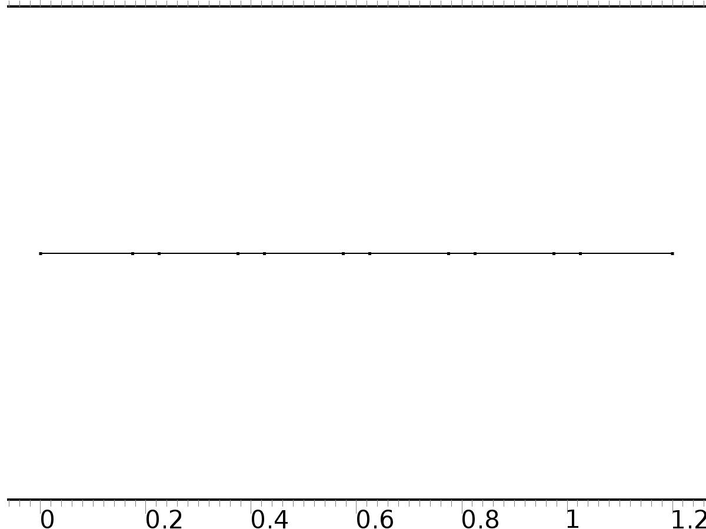

Mesh 1

* + 1. Size (size)

Settings

| **Description** | **Value** |
| --- | --- |
| Maximum element size | 0.024 |
| Minimum element size | 9.0E-5 |
| Curvature factor | 0.25 |
| Maximum element growth rate | 1.2 |
| Predefined size | Extra fine |

* + 1. Edge 1 (edg1)

Selection

|  |  |
| --- | --- |
| Geometric entity level | Remaining |

1. Study 1
   1. Stationary

Study settings

| **Description** | **Value** |
| --- | --- |
| Include geometric nonlinearity | Off |

Physics and variables selection

| **Physics interface** | **Discretization** |
| --- | --- |
| PDE (c) | physics |

Mesh selection

| **Geometry** | **Mesh** |
| --- | --- |
| Geometry 1 (geom1) | mesh1 |

* 1. Solver Configurations
     1. Solver 1

#### Compile Equations: Stationary (st1)

Study and step

| **Description** | **Value** |
| --- | --- |
| Use study | Study 1 |
| Use study step | Stationary |

#### Dependent Variables 1 (v1)

General

| **Description** | **Value** |
| --- | --- |
| Defined by study step | Stationary |
| Constant |  |

Initial values of variables solved for

| **Description** | **Value** |
| --- | --- |
| Solution | Zero |

Values of variables not solved for

| **Description** | **Value** |
| --- | --- |
| Solution | Zero |

##### mod1.PI9 (mod1_PI9)

General

| **Description** | **Value** |
| --- | --- |
| Field components | mod1.PI9 |
| Solve for this field | Off |

##### mod1.z (mod1_z)

General

| **Description** | **Value** |
| --- | --- |
| Field components | mod1.z |
| Solve for this field | Off |

##### mod1.PIt8 (mod1_PIt8)

General

| **Description** | **Value** |
| --- | --- |
| Field components | mod1.PIt8 |
| Solve for this field | Off |

##### mod1.PI1 (mod1_PI1)

General

| **Description** | **Value** |
| --- | --- |
| Field components | mod1.PI1 |
| Solve for this field | Off |

##### mod1.PIt7 (mod1_PIt7)

General

| **Description** | **Value** |
| --- | --- |
| Field components | mod1.PIt7 |
| Solve for this field | Off |

##### mod1.PI2 (mod1_PI2)

General

| **Description** | **Value** |
| --- | --- |
| Field components | mod1.PI2 |
| Solve for this field | Off |

##### mod1.PI3 (mod1_PI3)

General

| **Description** | **Value** |
| --- | --- |
| Field components | mod1.PI3 |
| Solve for this field | Off |

##### mod1.PIt9 (mod1_PIt9)

General

| **Description** | **Value** |
| --- | --- |
| Field components | mod1.PIt9 |
| Solve for this field | Off |

##### mod1.PI4 (mod1_PI4)

General

| **Description** | **Value** |
| --- | --- |
| Field components | mod1.PI4 |
| Solve for this field | Off |

##### mod1.X2 (mod1_X2)

General

| **Description** | **Value** |
| --- | --- |
| Field components | mod1.X2 |

##### mod1.PI5 (mod1_PI5)

General

| **Description** | **Value** |
| --- | --- |
| Field components | mod1.PI5 |
| Solve for this field | Off |

##### mod1.PIt4 (mod1_PIt4)

General

| **Description** | **Value** |
| --- | --- |
| Field components | mod1.PIt4 |
| Solve for this field | Off |

##### mod1.PIt3 (mod1_PIt3)

General

| **Description** | **Value** |
| --- | --- |
| Field components | mod1.PIt3 |
| Solve for this field | Off |

##### mod1.PI6 (mod1_PI6)

General

| **Description** | **Value** |
| --- | --- |
| Field components | mod1.PI6 |
| Solve for this field | Off |

##### mod1.PI7 (mod1_PI7)

General

| **Description** | **Value** |
| --- | --- |
| Field components | mod1.PI7 |
| Solve for this field | Off |

##### mod1.PIt6 (mod1_PIt6)

General

| **Description** | **Value** |
| --- | --- |
| Field components | mod1.PIt6 |
| Solve for this field | Off |

##### mod1.PI8 (mod1_PI8)

General

| **Description** | **Value** |
| --- | --- |
| Field components | mod1.PI8 |
| Solve for this field | Off |

##### mod1.X1 (mod1_X1)

General

| **Description** | **Value** |
| --- | --- |
| Field components | mod1.X1 |

##### mod1.PIt5 (mod1_PIt5)

General

| **Description** | **Value** |
| --- | --- |
| Field components | mod1.PIt5 |
| Solve for this field | Off |

#### Stationary Solver 1 (s1)

General

| **Description** | **Value** |
| --- | --- |
| Defined by study step | Stationary |
| Relative tolerance | 0.0010 |

Log

| **Description** | **Value** |
| --- | --- |
| Constant |  |

##### Fully Coupled 1 (fc1)

General

| **Description** | **Value** |
| --- | --- |
| Linear solver | Direct |

Method and termination

| **Description** | **Value** |
| --- | --- |
| Termination criterion | Solution |

1. Study 2
   1. Stationary

Study settings

| **Description** | **Value** |
| --- | --- |
| Include geometric nonlinearity | Off |

Physics and variables selection

| **Physics interface** | **Discretization** |
| --- | --- |
| PDE 2 (c2) | physics |
| PDE 3 (c3) | physics |
| PDE 4 (c4) | physics |
| PDE 5 (c5) | physics |
| PDE 6 (c6) | physics |
| PDE 7 (c7) | physics |

Mesh selection

| **Geometry** | **Mesh** |
| --- | --- |
| Geometry 1 (geom1) | mesh1 |

* 1. Solver Configurations
     1. Solver 2

#### Compile Equations: Stationary (st1)

Study and step

| **Description** | **Value** |
| --- | --- |
| Use study | Study 2 |
| Use study step | Stationary |

#### Dependent Variables 1 (v1)

General

| **Description** | **Value** |
| --- | --- |
| Defined by study step | Stationary |
| Constant |  |

Initial values of variables solved for

| **Description** | **Value** |
| --- | --- |
| Solution | Zero |

Values of variables not solved for

| **Description** | **Value** |
| --- | --- |
| Method | Solution |
| Solution | Solver 1 |

##### mod1.PI9 (mod1_PI9)

General

| **Description** | **Value** |
| --- | --- |
| Field components | mod1.PI9 |

##### mod1.PIt8 (mod1_PIt8)

General

| **Description** | **Value** |
| --- | --- |
| Field components | mod1.PIt8 |

##### mod1.PI1 (mod1_PI1)

General

| **Description** | **Value** |
| --- | --- |
| Field components | mod1.PI1 |

##### mod1.PIt7 (mod1_PIt7)

General

| **Description** | **Value** |
| --- | --- |
| Field components | mod1.PIt7 |

##### mod1.PI2 (mod1_PI2)

General

| **Description** | **Value** |
| --- | --- |
| Field components | mod1.PI2 |

##### mod1.PI3 (mod1_PI3)

General

| **Description** | **Value** |
| --- | --- |
| Field components | mod1.PI3 |

##### mod1.PIt9 (mod1_PIt9)

General

| **Description** | **Value** |
| --- | --- |
| Field components | mod1.PIt9 |

##### mod1.PI4 (mod1_PI4)

General

| **Description** | **Value** |
| --- | --- |
| Field components | mod1.PI4 |

##### mod1.X2 (mod1_X2)

General

| **Description** | **Value** |
| --- | --- |
| Field components | mod1.X2 |
| Solve for this field | Off |

##### mod1.PI5 (mod1_PI5)

General

| **Description** | **Value** |
| --- | --- |
| Field components | mod1.PI5 |

##### mod1.PIt4 (mod1_PIt4)

General

| **Description** | **Value** |
| --- | --- |
| Field components | mod1.PIt4 |

##### mod1.PIt3 (mod1_PIt3)

General

| **Description** | **Value** |
| --- | --- |
| Field components | mod1.PIt3 |

##### mod1.PI6 (mod1_PI6)

General

| **Description** | **Value** |
| --- | --- |
| Field components | mod1.PI6 |

##### mod1.PI7 (mod1_PI7)

General

| **Description** | **Value** |
| --- | --- |
| Field components | mod1.PI7 |

##### mod1.PIt6 (mod1_PIt6)

General

| **Description** | **Value** |
| --- | --- |
| Field components | mod1.PIt6 |

##### mod1.PI8 (mod1_PI8)

General

| **Description** | **Value** |
| --- | --- |
| Field components | mod1.PI8 |

##### mod1.X1 (mod1_X1)

General

| **Description** | **Value** |
| --- | --- |
| Field components | mod1.X1 |
| Solve for this field | Off |

##### mod1.PIt5 (mod1_PIt5)

General

| **Description** | **Value** |
| --- | --- |
| Field components | mod1.PIt5 |

##### mod1.z (mod1_z)

General

| **Description** | **Value** |
| --- | --- |
| Field components | mod1.z |
| Solve for this field | Off |

#### Stationary Solver 1 (s1)

General

| **Description** | **Value** |
| --- | --- |
| Defined by study step | Stationary |
| Relative tolerance | 0.0010 |

Log

| **Description** | **Value** |
| --- | --- |
| Constant |  |

##### Fully Coupled 1 (fc1)

General

| **Description** | **Value** |
| --- | --- |
| Linear solver | Direct |

Method and termination

| **Description** | **Value** |
| --- | --- |
| Termination criterion | Solution |

1. Study 8
   1. Time Dependent

Study settings

| **Description** | **Value** |
| --- | --- |
| Include geometric nonlinearity | Off |

| **Times** | **Unit** |
| --- | --- |
| range(0,0.01,10) | s |

Physics and variables selection

| **Physics interface** | **Discretization** |
| --- | --- |
| PDE 8 (c8) | physics |

Mesh selection

| **Geometry** | **Mesh** |
| --- | --- |
| Geometry 1 (geom1) | mesh1 |

* 1. Solver Configurations
     1. Solver 3

#### Compile Equations: Time Dependent (st1)

Study and step

| **Description** | **Value** |
| --- | --- |
| Use study | Study 3 |
| Use study step | Time Dependent |

#### Dependent Variables 1 (v1)

General

| **Description** | **Value** |
| --- | --- |
| Defined by study step | Time Dependent |
| Constant |  |

Initial values of variables solved for

| **Description** | **Value** |
| --- | --- |
| Solution | Zero |

Values of variables not solved for

| **Description** | **Value** |
| --- | --- |
| Method | Solution |
| Solution | Solver 2 |

##### mod1.PI9 (mod1_PI9)

General

| **Description** | **Value** |
| --- | --- |
| Field components | mod1.PI9 |
| Solve for this field | Off |

##### mod1.z (mod1_z)

General

| **Description** | **Value** |
| --- | --- |
| Field components | mod1.z |

##### mod1.PIt8 (mod1_PIt8)

General

| **Description** | **Value** |
| --- | --- |
| Field components | mod1.PIt8 |
| Solve for this field | Off |

##### mod1.PI1 (mod1_PI1)

General

| **Description** | **Value** |
| --- | --- |
| Field components | mod1.PI1 |
| Solve for this field | Off |

##### mod1.PIt7 (mod1_PIt7)

General

| **Description** | **Value** |
| --- | --- |
| Field components | mod1.PIt7 |
| Solve for this field | Off |

##### mod1.PI2 (mod1_PI2)

General

| **Description** | **Value** |
| --- | --- |
| Field components | mod1.PI2 |
| Solve for this field | Off |

##### mod1.PI3 (mod1_PI3)

General

| **Description** | **Value** |
| --- | --- |
| Field components | mod1.PI3 |
| Solve for this field | Off |

##### mod1.PIt9 (mod1_PIt9)

General

| **Description** | **Value** |
| --- | --- |
| Field components | mod1.PIt9 |
| Solve for this field | Off |

##### mod1.PI4 (mod1_PI4)

General

| **Description** | **Value** |
| --- | --- |
| Field components | mod1.PI4 |
| Solve for this field | Off |

##### mod1.X2 (mod1_X2)

General

| **Description** | **Value** |
| --- | --- |
| Field components | mod1.X2 |
| Solve for this field | Off |

##### mod1.PI5 (mod1_PI5)

General

| **Description** | **Value** |
| --- | --- |
| Field components | mod1.PI5 |
| Solve for this field | Off |

##### mod1.PIt4 (mod1_PIt4)

General

| **Description** | **Value** |
| --- | --- |
| Field components | mod1.PIt4 |
| Solve for this field | Off |

##### mod1.PIt3 (mod1_PIt3)

General

| **Description** | **Value** |
| --- | --- |
| Field components | mod1.PIt3 |
| Solve for this field | Off |

##### mod1.PI6 (mod1_PI6)

General

| **Description** | **Value** |
| --- | --- |
| Field components | mod1.PI6 |
| Solve for this field | Off |

##### mod1.PI7 (mod1_PI7)

General

| **Description** | **Value** |
| --- | --- |
| Field components | mod1.PI7 |
| Solve for this field | Off |

##### mod1.PIt6 (mod1_PIt6)

General

| **Description** | **Value** |
| --- | --- |
| Field components | mod1.PIt6 |
| Solve for this field | Off |

##### mod1.PI8 (mod1_PI8)

General

| **Description** | **Value** |
| --- | --- |
| Field components | mod1.PI8 |
| Solve for this field | Off |

##### mod1.X1 (mod1_X1)

General

| **Description** | **Value** |
| --- | --- |
| Field components | mod1.X1 |
| Solve for this field | Off |

##### mod1.PIt5 (mod1_PIt5)

General

| **Description** | **Value** |
| --- | --- |
| Field components | mod1.PIt5 |
| Solve for this field | Off |

#### Time-Dependent Solver 1 (t1)

General

| **Description** | **Value** |
| --- | --- |
| Defined by study step | Time Dependent |
| Time | {0, 0.01, 0.02, 0.03, 0.04, 0.05, 0.06, 0.07, 0.08, 0.09, 0.1, 0.11, 0.12, 0.13, 0.14, 0.15, 0.16, 0.17, 0.18, 0.19, 0.2, 0.21, 0.22, 0.23, 0.24, 0.25, 0.26, 0.27, 0.28, 0.29, 0.3, 0.31, 0.32, 0.33, 0.34, 0.35000000000000003, 0.36, 0.37, 0.38, 0.39, 0.4, 0.41000000000000003, 0.42, 0.43, 0.44, 0.45, 0.46, 0.47000000000000003, 0.48, 0.49, 0.5, 0.51, 0.52, 0.53, 0.54, 0.55, 0.56, 0.5700000000000001, 0.58, 0.59, 0.6, 0.61, 0.62, 0.63, 0.64, 0.65, 0.66, 0.67, 0.68, 0.6900000000000001, 0.7000000000000001, 0.71, 0.72, 0.73, 0.74, 0.75, 0.76, 0.77, 0.78, 0.79, 0.8, 0.81, 0.8200000000000001, 0.8300000000000001, 0.84, 0.85, 0.86, 0.87, 0.88, 0.89, 0.9, 0.91, 0.92, 0.93, 0.9400000000000001, 0.9500000000000001, 0.96, 0.97, 0.98, 0.99, 1, 1.01, 1.02, 1.03, 1.04, 1.05, 1.06, 1.07, 1.08, 1.09, 1.1, 1.11, 1.12, 1.1300000000000001, 1.1400000000000001, 1.1500000000000001, 1.16, 1.17, 1.18, 1.19, 1.2, 1.21, 1.22, 1.23, 1.24, 1.25, 1.26, 1.27, 1.28, 1.29, 1.3, 1.31, 1.32, 1.33, 1.34, 1.35, 1.36, 1.37, 1.3800000000000001, 1.3900000000000001, 1.4000000000000001, 1.41, 1.42, 1.43, 1.44, 1.45, 1.46, 1.47, 1.48, 1.49, 1.5, 1.51, 1.52, 1.53, 1.54, 1.55, 1.56, 1.57, 1.58, 1.59, 1.6, 1.61, 1.62, 1.6300000000000001, 1.6400000000000001, 1.6500000000000001, 1.6600000000000001, 1.67, 1.68, 1.69, 1.7, 1.71, 1.72, 1.73, 1.74, 1.75, 1.76, 1.77, 1.78, 1.79, 1.8, 1.81, 1.82, 1.83, 1.84, 1.85, 1.86, 1.87, 1.8800000000000001, 1.8900000000000001, 1.9000000000000001, 1.9100000000000001, 1.92, 1.93, 1.94, 1.95, 1.96, 1.97, 1.98, 1.99, 2, 2.0100000000000002, 2.02, 2.0300000000000002, 2.04, 2.05, 2.06, 2.07, 2.08, 2.09, 2.1, 2.11, 2.12, 2.13, 2.14, 2.15, 2.16, 2.17, 2.18, 2.19, 2.2, 2.21, 2.22, 2.23, 2.24, 2.25, 2.2600000000000002, 2.27, 2.2800000000000002, 2.29, 2.3000000000000003, 2.31, 2.32, 2.33, 2.34, 2.35, 2.36, 2.37, 2.38, 2.39, 2.4, 2.41, 2.42, 2.43, 2.44, 2.45, 2.46, 2.47, 2.48, 2.49, 2.5, 2.5100000000000002, 2.52, 2.5300000000000002, 2.54, 2.5500000000000003, 2.56, 2.57, 2.58, 2.59, 2.6, 2.61, 2.62, 2.63, 2.64, 2.65, 2.66, 2.67, 2.68, 2.69, 2.7, 2.71, 2.72, 2.73, 2.74, 2.75, 2.7600000000000002, 2.77, 2.7800000000000002, 2.79, 2.8000000000000003, 2.81, 2.82, 2.83, 2.84, 2.85, 2.86, 2.87, 2.88, 2.89, 2.9, 2.91, 2.92, 2.93, 2.94, 2.95, 2.96, 2.97, 2.98, 2.99, 3, 3.0100000000000002, 3.02, 3.0300000000000002, 3.04, 3.0500000000000003, 3.06, 3.0700000000000003, 3.08, 3.09, 3.1, 3.11, 3.12, 3.13, 3.14, 3.15, 3.16, 3.17, 3.18, 3.19, 3.2, 3.21, 3.22, 3.23, 3.24, 3.25, 3.2600000000000002, 3.27, 3.2800000000000002, 3.29, 3.3000000000000003, 3.31, 3.3200000000000003, 3.33, 3.34, 3.35, 3.36, 3.37, 3.38, 3.39, 3.4, 3.41, 3.42, 3.43, 3.44, 3.45, 3.46, 3.47, 3.48, 3.49, 3.5, 3.5100000000000002, 3.52, 3.5300000000000002, 3.54, 3.5500000000000003, 3.56, 3.5700000000000003, 3.58, 3.59, 3.6, 3.61, 3.62, 3.63, 3.64, 3.65, 3.66, 3.67, 3.68, 3.69, 3.7, 3.71, 3.72, 3.73, 3.74, 3.75, 3.7600000000000002, 3.77, 3.7800000000000002, 3.79, 3.8000000000000003, 3.81, 3.8200000000000003, 3.83, 3.84, 3.85, 3.86, 3.87, 3.88, 3.89, 3.9, 3.91, 3.92, 3.93, 3.94, 3.95, 3.96, 3.97, 3.98, 3.99, 4, 4.01, 4.0200000000000005, 4.03, 4.04, 4.05, 4.0600000000000005, 4.07, 4.08, 4.09, 4.1, 4.11, 4.12, 4.13, 4.14, 4.15, 4.16, 4.17, 4.18, 4.19, 4.2, 4.21, 4.22, 4.23, 4.24, 4.25, 4.26, 4.2700000000000005, 4.28, 4.29, 4.3, 4.3100000000000005, 4.32, 4.33, 4.34, 4.3500000000000005, 4.36, 4.37, 4.38, 4.39, 4.4, 4.41, 4.42, 4.43, 4.44, 4.45, 4.46, 4.47, 4.48, 4.49, 4.5, 4.51, 4.5200000000000005, 4.53, 4.54, 4.55, 4.5600000000000005, 4.57, 4.58, 4.59, 4.6000000000000005, 4.61, 4.62, 4.63, 4.64, 4.65, 4.66, 4.67, 4.68, 4.69, 4.7, 4.71, 4.72, 4.73, 4.74, 4.75, 4.76, 4.7700000000000005, 4.78, 4.79, 4.8, 4.8100000000000005, 4.82, 4.83, 4.84, 4.8500000000000005, 4.86, 4.87, 4.88, 4.89, 4.9, 4.91, 4.92, 4.93, 4.94, 4.95, 4.96, 4.97, 4.98, 4.99, 5, 5.01, 5.0200000000000005, 5.03, 5.04, 5.05, 5.0600000000000005, 5.07, 5.08, 5.09, 5.1000000000000005, 5.11, 5.12, 5.13, 5.14, 5.15, 5.16, 5.17, 5.18, 5.19, 5.2, 5.21, 5.22, 5.23, 5.24, 5.25, 5.26, 5.2700000000000005, 5.28, 5.29, 5.3, 5.3100000000000005, 5.32, 5.33, 5.34, 5.3500000000000005, 5.36, 5.37, 5.38, 5.39, 5.4, 5.41, 5.42, 5.43, 5.44, 5.45, 5.46, 5.47, 5.48, 5.49, 5.5, 5.51, 5.5200000000000005, 5.53, 5.54, 5.55, 5.5600000000000005, 5.57, 5.58, 5.59, 5.6000000000000005, 5.61, 5.62, 5.63, 5.64, 5.65, 5.66, 5.67, 5.68, 5.69, 5.7, 5.71, 5.72, 5.73, 5.74, 5.75, 5.76, 5.7700000000000005, 5.78, 5.79, 5.8, 5.8100000000000005, 5.82, 5.83, 5.84, 5.8500000000000005, 5.86, 5.87, 5.88, 5.89, 5.9, 5.91, 5.92, 5.93, 5.94, 5.95, 5.96, 5.97, 5.98, 5.99, 6, 6.01, 6.0200000000000005, 6.03, 6.04, 6.05, 6.0600000000000005, 6.07, 6.08, 6.09, 6.1000000000000005, 6.11, 6.12, 6.13, 6.140000000000001, 6.15, 6.16, 6.17, 6.18, 6.19, 6.2, 6.21, 6.22, 6.23, 6.24, 6.25, 6.26, 6.2700000000000005, 6.28, 6.29, 6.3, 6.3100000000000005, 6.32, 6.33, 6.34, 6.3500000000000005, 6.36, 6.37, 6.38, 6.390000000000001, 6.4, 6.41, 6.42, 6.43, 6.44, 6.45, 6.46, 6.47, 6.48, 6.49, 6.5, 6.51, 6.5200000000000005, 6.53, 6.54, 6.55, 6.5600000000000005, 6.57, 6.58, 6.59, 6.6000000000000005, 6.61, 6.62, 6.63, 6.640000000000001, 6.65, 6.66, 6.67, 6.68, 6.69, 6.7, 6.71, 6.72, 6.73, 6.74, 6.75, 6.76, 6.7700000000000005, 6.78, 6.79, 6.8, 6.8100000000000005, 6.82, 6.83, 6.84, 6.8500000000000005, 6.86, 6.87, 6.88, 6.890000000000001, 6.9, 6.91, 6.92, 6.93, 6.94, 6.95, 6.96, 6.97, 6.98, 6.99, 7, 7.01, 7.0200000000000005, 7.03, 7.04, 7.05, 7.0600000000000005, 7.07, 7.08, 7.09, 7.1000000000000005, 7.11, 7.12, 7.13, 7.140000000000001, 7.15, 7.16, 7.17, 7.18, 7.19, 7.2, 7.21, 7.22, 7.23, 7.24, 7.25, 7.26, 7.2700000000000005, 7.28, 7.29, 7.3, 7.3100000000000005, 7.32, 7.33, 7.34, 7.3500000000000005, 7.36, 7.37, 7.38, 7.390000000000001, 7.4, 7.41, 7.42, 7.43, 7.44, 7.45, 7.46, 7.47, 7.48, 7.49, 7.5, 7.51, 7.5200000000000005, 7.53, 7.54, 7.55, 7.5600000000000005, 7.57, 7.58, 7.59, 7.6000000000000005, 7.61, 7.62, 7.63, 7.640000000000001, 7.65, 7.66, 7.67, 7.68, 7.69, 7.7, 7.71, 7.72, 7.73, 7.74, 7.75, 7.76, 7.7700000000000005, 7.78, 7.79, 7.8, 7.8100000000000005, 7.82, 7.83, 7.84, 7.8500000000000005, 7.86, 7.87, 7.88, 7.890000000000001, 7.9, 7.91, 7.92, 7.930000000000001, 7.94, 7.95, 7.96, 7.97, 7.98, 7.99, 8, 8.01, 8.02, 8.03, 8.040000000000001, 8.05, 8.06, 8.07, 8.08, 8.09, 8.1, 8.11, 8.120000000000001, 8.13, 8.14, 8.15, 8.16, 8.17, 8.18, 8.19, 8.2, 8.21, 8.22, 8.23, 8.24, 8.25, 8.26, 8.27, 8.28, 8.290000000000001, 8.3, 8.31, 8.32, 8.33, 8.34, 8.35, 8.36, 8.370000000000001, 8.38, 8.39, 8.4, 8.41, 8.42, 8.43, 8.44, 8.45, 8.46, 8.47, 8.48, 8.49, 8.5, 8.51, 8.52, 8.53, 8.540000000000001, 8.55, 8.56, 8.57, 8.58, 8.59, 8.6, 8.61, 8.620000000000001, 8.63, 8.64, 8.65, 8.66, 8.67, 8.68, 8.69, 8.700000000000001, 8.71, 8.72, 8.73, 8.74, 8.75, 8.76, 8.77, 8.78, 8.790000000000001, 8.8, 8.81, 8.82, 8.83, 8.84, 8.85, 8.86, 8.870000000000001, 8.88, 8.89, 8.9, 8.91, 8.92, 8.93, 8.94, 8.950000000000001, 8.96, 8.97, 8.98, 8.99, 9, 9.01, 9.02, 9.03, 9.040000000000001, 9.05, 9.06, 9.07, 9.08, 9.09, 9.1, 9.11, 9.120000000000001, 9.13, 9.14, 9.15, 9.16, 9.17, 9.18, 9.19, 9.200000000000001, 9.21, 9.22, 9.23, 9.24, 9.25, 9.26, 9.27, 9.28, 9.290000000000001, 9.3, 9.31, 9.32, 9.33, 9.34, 9.35, 9.36, 9.370000000000001, 9.38, 9.39, 9.4, 9.41, 9.42, 9.43, 9.44, 9.450000000000001, 9.46, 9.47, 9.48, 9.49, 9.5, 9.51, 9.52, 9.53, 9.540000000000001, 9.55, 9.56, 9.57, 9.58, 9.59, 9.6, 9.61, 9.620000000000001, 9.63, 9.64, 9.65, 9.66, 9.67, 9.68, 9.69, 9.700000000000001, 9.71, 9.72, 9.73, 9.74, 9.75, 9.76, 9.77, 9.78, 9.790000000000001, 9.8, 9.81, 9.82, 9.83, 9.84, 9.85, 9.86, 9.870000000000001, 9.88, 9.89, 9.9, 9.91, 9.92, 9.93, 9.94, 9.950000000000001, 9.96, 9.97, 9.98, 9.99, 10} |
| Relative tolerance | 1.0E-4 |

Absolute tolerance

| **Description** | **Value** |
| --- | --- |
| Tolerance | 0.000010 |

Time stepping

| **Description** | **Value** |
| --- | --- |
| Initial step | 0.0010 |

Results while solving

| **Description** | **Value** |
| --- | --- |
| Probes | None |

Advanced

| **Description** | **Value** |
| --- | --- |
| Fraction of initial step for Backward Euler | 1.0 |

Log

| **Description** | **Value** |
| --- | --- |
| Constant |  |

##### Fully Coupled 1 (fc1)

General

| **Description** | **Value** |
| --- | --- |
| Linear solver | Direct |

1. Results
   1. Data Sets
      1. Solution 1

Solution

| **Description** | **Value** |
| --- | --- |
| Solution | Solver 1 |
| Component | Save Point Geometry 1 |

* + 1. Solution 2

Solution

| **Description** | **Value** |
| --- | --- |
| Solution | Solver 2 |
| Component | Save Point Geometry 1 |

* + 1. Solution 3

Solution

| **Description** | **Value** |
| --- | --- |
| Solution | Solver 3 |
| Component | Save Point Geometry 1 |

* 1. Derived Values
     1. Global Evaluation 1

Data

| **Description** | **Value** |
| --- | --- |
| Data set | Solution 3 |

Expression

| **Description** | **Value** |
| --- | --- |
| Expression | e1 |

* + 1. Global Evaluation 2

Data

| **Description** | **Value** |
| --- | --- |
| Data set | Solution 3 |

Expression

| **Description** | **Value** |
| --- | --- |
| Expression | C2(PI9) |
| Unit | 1 |
| Description | C2(PI9) |

* + 1. Point Evaluation 1

Selection

|  |  |
| --- | --- |
| Geometric entity level | Boundary |
| Selection | Boundary 2 |

Data

| **Description** | **Value** |
| --- | --- |
| Data set | Solution 3 |

Expression

| **Description** | **Value** |
| --- | --- |
| Expression | yr2 |

* + 1. Point Evaluation 2

Selection

|  |  |
| --- | --- |
| Geometric entity level | Boundary |
| Selection | Boundary 2 |

Data

| **Description** | **Value** |
| --- | --- |
| Data set | Solution 3 |

Expression

| **Description** | **Value** |
| --- | --- |
| Expression | yr2 |

* 1. Tables
     1. Table 1

Global Evaluation 1 (g11)

Table 1

| **DETG (1)** |
| --- |
| 3.3333E-5 |

* + 1. Table 2

Global Evaluation 2 (C1(PI1))

Table 2

| **C2(PI1) (1)** | **C1(PI1) (1)** |
| --- | --- |
| -2.0000 | -1.00000 |

* + 1. Table 3

Global Evaluation 2 (C1(PI1))

Table 3

| **C1(PI1)** | **C2(PI1) (1)** |
| --- | --- |
| 2.0000 | 1.0000 |

* + 1. Table 4

Global Evaluation 2 (C1(P1))

* + 1. Table 5

Global Evaluation 2 (C1(P1))

* + 1. Table 6

Global Evaluation 2 (C1(PI1))

Table 6

| **C2(PI7) (1)** | **C1(PI8) (1)** | **C2(PI8) (1)** | **C1(PI9) (1)** | **C2(PI9) (1)** |
| --- | --- | --- | --- | --- |
| 1.9269E-15 | -8.4144E-17 | -9.4834E-17 | -1.2565E-16 | -9.0429E-17 |

* + 1. Table 7

Global Evaluation 1 (Gamma1)

Table 7

| **Time** | **e1** |
| --- | --- |
| 0.0000 | -0.33928 |
| 0.10000 | -0.46922 |
| 0.20000 | -0.47912 |
| 0.30000 | -0.44382 |
| 0.40000 | -0.39650 |
| 0.50000 | -0.34910 |
| 0.60000 | -0.30546 |
| 0.70000 | -0.26659 |
| 0.80000 | -0.23241 |
| 0.90000 | -0.20251 |
| 1.0000 | -0.17642 |
| 1.1000 | -0.15367 |
| 1.2000 | -0.13386 |
| 1.3000 | -0.11660 |
| 1.4000 | -0.10157 |
| 1.5000 | -0.088471 |
| 1.6000 | -0.077060 |
| 1.7000 | -0.067116 |
| 1.8000 | -0.058452 |
| 1.9000 | -0.050907 |
| 2.0000 | -0.044339 |
| 2.1000 | -0.038622 |
| 2.2000 | -0.033640 |
| 2.3000 | -0.029296 |
| 2.4000 | -0.025518 |
| 2.5000 | -0.022238 |
| 2.6000 | -0.019370 |
| 2.7000 | -0.016860 |
| 2.8000 | -0.014694 |
| 2.9000 | -0.012816 |
| 3.0000 | -0.011134 |
| 3.1000 | -0.0096632 |
| 3.2000 | -0.0084527 |
| 3.3000 | -0.0073776 |
| 3.4000 | -0.0063964 |
| 3.5000 | -0.0055747 |
| 3.6000 | -0.0048671 |
| 3.7000 | -0.0042257 |
| 3.8000 | -0.0036857 |
| 3.9000 | -0.0032160 |
| 4.0000 | -0.0027964 |
| 4.1000 | -0.0024360 |
| 4.2000 | -0.0021207 |
| 4.3000 | -0.0018486 |
| 4.4000 | -0.0016116 |
| 4.5000 | -0.0014037 |
| 4.6000 | -0.0012233 |
| 4.7000 | -0.0010658 |
| 4.8000 | -9.2819E-4 |
| 4.9000 | -8.0843E-4 |
| 5.0000 | -7.0408E-4 |
| 5.1000 | -6.1271E-4 |
| 5.2000 | -5.3169E-4 |
| 5.3000 | -4.6013E-4 |
| 5.4000 | -3.9708E-4 |
| 5.5000 | -3.4312E-4 |
| 5.6000 | -2.9715E-4 |
| 5.7000 | -2.5921E-4 |
| 5.8000 | -2.2445E-4 |
| 5.9000 | -1.9610E-4 |
| 6.0000 | -1.6586E-4 |
| 6.1000 | -1.3552E-4 |
| 6.2000 | -1.0782E-4 |
| 6.3000 | -8.7747E-5 |
| 6.4000 | -7.5402E-5 |
| 6.5000 | -7.1932E-5 |
| 6.6000 | -6.9121E-5 |
| 6.7000 | -6.9697E-5 |
| 6.8000 | -6.3613E-5 |
| 6.9000 | -4.6379E-5 |
| 7.0000 | -2.7729E-5 |
| 7.1000 | -1.6846E-5 |
| 7.2000 | -1.6834E-5 |
| 7.3000 | -1.5391E-5 |
| 7.4000 | -1.2374E-5 |
| 7.5000 | -9.7433E-6 |
| 7.6000 | -6.8292E-6 |
| 7.7000 | -1.0261E-5 |
| 7.8000 | -1.3458E-5 |
| 7.9000 | -1.6027E-5 |
| 8.0000 | -1.3982E-5 |
| 8.1000 | -1.1001E-5 |
| 8.2000 | -2.1536E-6 |
| 8.3000 | 4.7580E-6 |
| 8.4000 | 1.0278E-5 |
| 8.5000 | 1.1868E-5 |
| 8.6000 | 1.1785E-5 |
| 8.7000 | 1.1468E-5 |
| 8.8000 | 1.0464E-5 |
| 8.9000 | 8.8924E-6 |
| 9.0000 | 7.1541E-6 |
| 9.1000 | 5.7311E-6 |
| 9.2000 | 5.9283E-6 |
| 9.3000 | 3.8457E-6 |
| 9.4000 | 3.5141E-6 |
| 9.5000 | 7.3906E-6 |
| 9.6000 | 1.3707E-5 |
| 9.7000 | 1.8745E-5 |
| 9.8000 | 1.8050E-5 |
| 9.9000 | 1.1396E-5 |
| 10.000 | 3.1596E-6 |
| 10.100 | -1.1392E-6 |
| 10.200 | 1.1839E-6 |
| 10.300 | 5.3378E-6 |
| 10.400 | 9.0579E-6 |
| 10.500 | 5.5278E-6 |
| 10.600 | 3.4731E-6 |
| 10.700 | -7.0240E-6 |
| 10.800 | -1.1194E-5 |
| 10.900 | -1.2924E-5 |
| 11.000 | -6.1014E-6 |
| 11.100 | -4.1941E-6 |
| 11.200 | 6.9151E-6 |
| 11.300 | 1.2857E-5 |
| 11.400 | 1.7307E-5 |
| 11.500 | 1.1428E-5 |
| 11.600 | 6.2242E-6 |
| 11.700 | 6.9766E-6 |
| 11.800 | 5.4959E-6 |
| 11.900 | 1.4815E-5 |
| 12.000 | 2.0559E-5 |
| 12.100 | 2.1926E-5 |
| 12.200 | 1.4757E-5 |
| 12.300 | 3.2954E-5 |
| 12.400 | 5.2341E-5 |
| 12.500 | 6.3226E-5 |
| 12.600 | 6.6640E-5 |
| 12.700 | 6.0293E-5 |
| 12.800 | 5.8500E-5 |
| 12.900 | 6.1530E-5 |
| 13.000 | 6.1672E-5 |
| 13.100 | 4.8184E-5 |
| 13.200 | 4.0854E-5 |
| 13.300 | 3.9826E-5 |
| 13.400 | 3.7021E-5 |
| 13.500 | 2.8063E-5 |
| 13.600 | 1.8955E-5 |
| 13.700 | 1.4570E-5 |
| 13.800 | 1.2979E-5 |
| 13.900 | 1.3998E-5 |
| 14.000 | 1.5009E-5 |
| 14.100 | 1.6513E-5 |
| 14.200 | 1.8101E-5 |
| 14.300 | 1.6156E-5 |
| 14.400 | 1.6156E-5 |
| 14.500 | 1.9479E-5 |
| 14.600 | 2.0893E-5 |
| 14.700 | 2.1009E-5 |
| 14.800 | 1.9209E-5 |
| 14.900 | 1.3066E-5 |
| 15.000 | 7.4941E-6 |
| 15.100 | 3.9002E-6 |
| 15.200 | -1.6709E-6 |
| 15.300 | -5.7233E-6 |
| 15.400 | -9.0839E-6 |
| 15.500 | -1.1009E-5 |
| 15.600 | -1.1413E-5 |
| 15.700 | -9.2755E-6 |
| 15.800 | -1.0488E-5 |
| 15.900 | -2.4823E-6 |
| 16.000 | 1.1898E-5 |
| 16.100 | 1.7647E-5 |
| 16.200 | 1.0598E-5 |
| 16.300 | 5.4856E-6 |
| 16.400 | 1.3326E-5 |
| 16.500 | 1.9863E-5 |
| 16.600 | 1.0621E-5 |
| 16.700 | 1.8941E-7 |
| 16.800 | -1.5811E-6 |
| 16.900 | 4.1951E-6 |
| 17.000 | 6.3915E-6 |
| 17.100 | 1.0429E-5 |
| 17.200 | 7.2615E-6 |
| 17.300 | 1.3980E-5 |
| 17.400 | 1.4750E-5 |
| 17.500 | -7.7038E-7 |
| 17.600 | -5.1372E-6 |
| 17.700 | 6.7903E-6 |
| 17.800 | 3.0192E-9 |
| 17.900 | -8.8993E-6 |
| 18.000 | 3.3628E-6 |
| 18.100 | -7.2457E-6 |
| 18.200 | -1.7653E-5 |
| 18.300 | -9.7522E-6 |
| 18.400 | -5.0262E-7 |
| 18.500 | -2.2197E-6 |
| 18.600 | -1.4779E-6 |
| 18.700 | -1.2607E-5 |
| 18.800 | -2.1372E-5 |
| 18.900 | -2.0168E-5 |
| 19.000 | -1.3397E-5 |
| 19.100 | -2.0607E-5 |
| 19.200 | -3.9444E-5 |
| 19.300 | -3.7579E-5 |
| 19.400 | -3.1146E-5 |
| 19.500 | -2.8858E-5 |
| 19.600 | -2.3200E-5 |
| 19.700 | -2.5783E-5 |
| 19.800 | -1.6344E-5 |
| 19.900 | -1.1233E-5 |
| 20.000 | -1.4994E-5 |

* + 1. Table 8

Global Evaluation 2 (C1(PI8))

Table 8

| **Time** | **C2(PI9) (1)** |
| --- | --- |
| 0.0000 | 5.4527E-17 |
| 0.10000 | 5.4527E-17 |
| 0.20000 | 5.4527E-17 |
| 0.30000 | 5.4527E-17 |
| 0.40000 | 5.4527E-17 |
| 0.50000 | 5.4527E-17 |
| 0.60000 | 5.4527E-17 |
| 0.70000 | 5.4527E-17 |
| 0.80000 | 5.4527E-17 |
| 0.90000 | 5.4527E-17 |
| 1.0000 | 5.4527E-17 |
| 1.1000 | 5.4527E-17 |
| 1.2000 | 5.4527E-17 |
| 1.3000 | 5.4527E-17 |
| 1.4000 | 5.4527E-17 |
| 1.5000 | 5.4527E-17 |
| 1.6000 | 5.4527E-17 |
| 1.7000 | 5.4527E-17 |
| 1.8000 | 5.4527E-17 |
| 1.9000 | 5.4527E-17 |
| 2.0000 | 5.4527E-17 |
| 2.1000 | 5.4527E-17 |
| 2.2000 | 5.4527E-17 |
| 2.3000 | 5.4527E-17 |
| 2.4000 | 5.4527E-17 |
| 2.5000 | 5.4527E-17 |
| 2.6000 | 5.4527E-17 |
| 2.7000 | 5.4527E-17 |
| 2.8000 | 5.4527E-17 |
| 2.9000 | 5.4527E-17 |
| 3.0000 | 5.4527E-17 |
| 3.1000 | 5.4527E-17 |
| 3.2000 | 5.4527E-17 |
| 3.3000 | 5.4527E-17 |
| 3.4000 | 5.4527E-17 |
| 3.5000 | 5.4527E-17 |
| 3.6000 | 5.4527E-17 |
| 3.7000 | 5.4527E-17 |
| 3.8000 | 5.4527E-17 |
| 3.9000 | 5.4527E-17 |
| 4.0000 | 5.4527E-17 |
| 4.1000 | 5.4527E-17 |
| 4.2000 | 5.4527E-17 |
| 4.3000 | 5.4527E-17 |
| 4.4000 | 5.4527E-17 |
| 4.5000 | 5.4527E-17 |
| 4.6000 | 5.4527E-17 |
| 4.7000 | 5.4527E-17 |
| 4.8000 | 5.4527E-17 |
| 4.9000 | 5.4527E-17 |
| 5.0000 | 5.4527E-17 |
| 5.1000 | 5.4527E-17 |
| 5.2000 | 5.4527E-17 |
| 5.3000 | 5.4527E-17 |
| 5.4000 | 5.4527E-17 |
| 5.5000 | 5.4527E-17 |
| 5.6000 | 5.4527E-17 |
| 5.7000 | 5.4527E-17 |
| 5.8000 | 5.4527E-17 |
| 5.9000 | 5.4527E-17 |
| 6.0000 | 5.4527E-17 |
| 6.1000 | 5.4527E-17 |
| 6.2000 | 5.4527E-17 |
| 6.3000 | 5.4527E-17 |
| 6.4000 | 5.4527E-17 |
| 6.5000 | 5.4527E-17 |
| 6.6000 | 5.4527E-17 |
| 6.7000 | 5.4527E-17 |
| 6.8000 | 5.4527E-17 |
| 6.9000 | 5.4527E-17 |
| 7.0000 | 5.4527E-17 |
| 7.1000 | 5.4527E-17 |
| 7.2000 | 5.4527E-17 |
| 7.3000 | 5.4527E-17 |
| 7.4000 | 5.4527E-17 |
| 7.5000 | 5.4527E-17 |
| 7.6000 | 5.4527E-17 |
| 7.7000 | 5.4527E-17 |
| 7.8000 | 5.4527E-17 |
| 7.9000 | 5.4527E-17 |
| 8.0000 | 5.4527E-17 |
| 8.1000 | 5.4527E-17 |
| 8.2000 | 5.4527E-17 |
| 8.3000 | 5.4527E-17 |
| 8.4000 | 5.4527E-17 |
| 8.5000 | 5.4527E-17 |
| 8.6000 | 5.4527E-17 |
| 8.7000 | 5.4527E-17 |
| 8.8000 | 5.4527E-17 |
| 8.9000 | 5.4527E-17 |
| 9.0000 | 5.4527E-17 |
| 9.1000 | 5.4527E-17 |
| 9.2000 | 5.4527E-17 |
| 9.3000 | 5.4527E-17 |
| 9.4000 | 5.4527E-17 |
| 9.5000 | 5.4527E-17 |
| 9.6000 | 5.4527E-17 |
| 9.7000 | 5.4527E-17 |
| 9.8000 | 5.4527E-17 |
| 9.9000 | 5.4527E-17 |
| 10.000 | 5.4527E-17 |
| 10.100 | 5.4527E-17 |
| 10.200 | 5.4527E-17 |
| 10.300 | 5.4527E-17 |
| 10.400 | 5.4527E-17 |
| 10.500 | 5.4527E-17 |
| 10.600 | 5.4527E-17 |
| 10.700 | 5.4527E-17 |
| 10.800 | 5.4527E-17 |
| 10.900 | 5.4527E-17 |
| 11.000 | 5.4527E-17 |
| 11.100 | 5.4527E-17 |
| 11.200 | 5.4527E-17 |
| 11.300 | 5.4527E-17 |
| 11.400 | 5.4527E-17 |
| 11.500 | 5.4527E-17 |
| 11.600 | 5.4527E-17 |
| 11.700 | 5.4527E-17 |
| 11.800 | 5.4527E-17 |
| 11.900 | 5.4527E-17 |
| 12.000 | 5.4527E-17 |
| 12.100 | 5.4527E-17 |
| 12.200 | 5.4527E-17 |
| 12.300 | 5.4527E-17 |
| 12.400 | 5.4527E-17 |
| 12.500 | 5.4527E-17 |
| 12.600 | 5.4527E-17 |
| 12.700 | 5.4527E-17 |
| 12.800 | 5.4527E-17 |
| 12.900 | 5.4527E-17 |
| 13.000 | 5.4527E-17 |
| 13.100 | 5.4527E-17 |
| 13.200 | 5.4527E-17 |
| 13.300 | 5.4527E-17 |
| 13.400 | 5.4527E-17 |
| 13.500 | 5.4527E-17 |
| 13.600 | 5.4527E-17 |
| 13.700 | 5.4527E-17 |
| 13.800 | 5.4527E-17 |
| 13.900 | 5.4527E-17 |
| 14.000 | 5.4527E-17 |
| 14.100 | 5.4527E-17 |
| 14.200 | 5.4527E-17 |
| 14.300 | 5.4527E-17 |
| 14.400 | 5.4527E-17 |
| 14.500 | 5.4527E-17 |
| 14.600 | 5.4527E-17 |
| 14.700 | 5.4527E-17 |
| 14.800 | 5.4527E-17 |
| 14.900 | 5.4527E-17 |
| 15.000 | 5.4527E-17 |
| 15.100 | 5.4527E-17 |
| 15.200 | 5.4527E-17 |
| 15.300 | 5.4527E-17 |
| 15.400 | 5.4527E-17 |
| 15.500 | 5.4527E-17 |
| 15.600 | 5.4527E-17 |
| 15.700 | 5.4527E-17 |
| 15.800 | 5.4527E-17 |
| 15.900 | 5.4527E-17 |
| 16.000 | 5.4527E-17 |
| 16.100 | 5.4527E-17 |
| 16.200 | 5.4527E-17 |
| 16.300 | 5.4527E-17 |
| 16.400 | 5.4527E-17 |
| 16.500 | 5.4527E-17 |
| 16.600 | 5.4527E-17 |
| 16.700 | 5.4527E-17 |
| 16.800 | 5.4527E-17 |
| 16.900 | 5.4527E-17 |
| 17.000 | 5.4527E-17 |
| 17.100 | 5.4527E-17 |
| 17.200 | 5.4527E-17 |
| 17.300 | 5.4527E-17 |
| 17.400 | 5.4527E-17 |
| 17.500 | 5.4527E-17 |
| 17.600 | 5.4527E-17 |
| 17.700 | 5.4527E-17 |
| 17.800 | 5.4527E-17 |
| 17.900 | 5.4527E-17 |
| 18.000 | 5.4527E-17 |
| 18.100 | 5.4527E-17 |
| 18.200 | 5.4527E-17 |
| 18.300 | 5.4527E-17 |
| 18.400 | 5.4527E-17 |
| 18.500 | 5.4527E-17 |
| 18.600 | 5.4527E-17 |
| 18.700 | 5.4527E-17 |
| 18.800 | 5.4527E-17 |
| 18.900 | 5.4527E-17 |
| 19.000 | 5.4527E-17 |
| 19.100 | 5.4527E-17 |
| 19.200 | 5.4527E-17 |
| 19.300 | 5.4527E-17 |
| 19.400 | 5.4527E-17 |
| 19.500 | 5.4527E-17 |
| 19.600 | 5.4527E-17 |
| 19.700 | 5.4527E-17 |
| 19.800 | 5.4527E-17 |
| 19.900 | 5.4527E-17 |
| 20.000 | 5.4527E-17 |

* + 1. Table 9

Point Evaluation 1 (C1(z))

Table 9

| **Time** | **yr2, Point: 2** |
| --- | --- |
| 0.0000 | 0.75000 |
| 0.10000 | 0.74003 |
| 0.20000 | 0.71053 |
| 0.30000 | 0.66267 |
| 0.40000 | 0.59835 |
| 0.50000 | 0.52015 |
| 0.60000 | 0.43118 |
| 0.70000 | 0.33498 |
| 0.80000 | 0.23540 |
| 0.90000 | 0.13640 |
| 1.0000 | 0.041927 |
| 1.1000 | -0.044251 |
| 1.2000 | -0.11870 |
| 1.3000 | -0.17844 |
| 1.4000 | -0.22111 |
| 1.5000 | -0.24500 |
| 1.6000 | -0.24915 |
| 1.7000 | -0.23340 |
| 1.8000 | -0.19838 |
| 1.9000 | -0.14548 |
| 2.0000 | -0.076822 |
| 2.1000 | 0.0048696 |
| 2.2000 | 0.096334 |
| 2.3000 | 0.19392 |
| 2.4000 | 0.29375 |
| 2.5000 | 0.39183 |
| 2.6000 | 0.48426 |
| 2.7000 | 0.56735 |
| 2.8000 | 0.63778 |
| 2.9000 | 0.69276 |
| 3.0000 | 0.73009 |
| 3.1000 | 0.74827 |
| 3.2000 | 0.74659 |
| 3.3000 | 0.72512 |
| 3.4000 | 0.68470 |
| 3.5000 | 0.62695 |
| 3.6000 | 0.55418 |
| 3.7000 | 0.46927 |
| 3.8000 | 0.37563 |
| 3.9000 | 0.27698 |
| 4.0000 | 0.17725 |
| 4.1000 | 0.080423 |
| 4.2000 | -0.0096443 |
| 4.3000 | -0.089360 |
| 4.4000 | -0.15555 |
| 4.5000 | -0.20557 |
| 4.6000 | -0.23742 |
| 4.7000 | -0.24985 |
| 4.8000 | -0.24234 |
| 4.9000 | -0.21521 |
| 5.0000 | -0.16954 |
| 5.1000 | -0.10713 |
| 5.2000 | -0.030492 |
| 5.3000 | 0.057331 |
| 5.4000 | 0.15284 |
| 5.5000 | 0.25221 |
| 5.6000 | 0.35150 |
| 5.7000 | 0.44675 |
| 5.8000 | 0.53414 |
| 5.9000 | 0.61022 |
| 6.0000 | 0.67193 |
| 6.1000 | 0.71682 |
| 6.2000 | 0.74310 |
| 6.3000 | 0.74972 |
| 6.4000 | 0.73642 |
| 6.5000 | 0.70372 |
| 6.6000 | 0.65294 |
| 6.7000 | 0.58610 |
| 6.8000 | 0.50585 |
| 6.9000 | 0.41541 |
| 7.0000 | 0.31837 |
| 7.1000 | 0.21860 |
| 7.2000 | 0.12009 |
| 7.3000 | 0.026758 |
| 7.4000 | -0.057676 |
| 7.5000 | -0.12984 |
| 7.6000 | -0.18687 |
| 7.7000 | -0.22648 |
| 7.8000 | -0.24709 |
| 7.9000 | -0.24788 |
| 8.0000 | -0.22883 |
| 8.1000 | -0.19069 |
| 8.2000 | -0.13497 |
| 8.3000 | -0.063914 |
| 8.4000 | 0.019661 |
| 8.5000 | 0.11242 |
| 8.6000 | 0.21066 |
| 8.7000 | 0.31047 |
| 8.8000 | 0.40787 |
| 8.9000 | 0.49898 |
| 9.0000 | 0.58016 |
| 9.1000 | 0.64818 |
| 9.2000 | 0.70032 |
| 9.3000 | 0.73451 |
| 9.4000 | 0.74939 |
| 9.5000 | 0.74435 |
| 9.6000 | 0.71961 |
| 9.7000 | 0.67615 |
| 9.8000 | 0.61569 |
| 9.9000 | 0.54066 |
| 10.000 | 0.45404 |
| 10.100 | 0.35929 |
| 10.200 | 0.26018 |
| 10.300 | 0.16066 |
| 10.400 | 0.064703 |
| 10.500 | -0.023865 |
| 10.600 | -0.10151 |
| 10.700 | -0.16515 |
| 10.800 | -0.21224 |
| 10.900 | -0.24089 |
| 11.000 | -0.24998 |
| 11.100 | -0.23913 |
| 11.200 | -0.20879 |
| 11.300 | -0.16015 |
| 11.400 | -0.095165 |
| 11.500 | -0.016417 |
| 11.600 | 0.072953 |
| 11.700 | 0.16938 |
| 11.800 | 0.26902 |
| 11.900 | 0.36791 |
| 12.000 | 0.46209 |
| 12.100 | 0.54782 |
| 12.200 | 0.62167 |
| 12.300 | 0.68071 |
| 12.400 | 0.72258 |
| 12.500 | 0.74560 |
| 12.600 | 0.74887 |
| 12.700 | 0.73225 |
| 12.800 | 0.69640 |
| 12.900 | 0.64276 |
| 13.000 | 0.57346 |
| 13.100 | 0.49126 |
| 13.200 | 0.39945 |
| 13.300 | 0.30168 |
| 13.400 | 0.20184 |
| 13.500 | 0.10393 |
| 13.600 | 0.011841 |
| 13.700 | -0.070754 |
| 13.800 | -0.14056 |
| 13.900 | -0.19480 |
| 14.000 | -0.23130 |
| 14.100 | -0.24862 |
| 14.200 | -0.24606 |
| 14.300 | -0.22372 |
| 14.400 | -0.18249 |
| 14.500 | -0.12403 |
| 14.600 | -0.050651 |
| 14.700 | 0.034712 |
| 14.800 | 0.12866 |
| 14.900 | 0.22744 |
| 15.000 | 0.32713 |
| 15.100 | 0.42373 |
| 15.200 | 0.51342 |
| 15.300 | 0.59260 |
| 15.400 | 0.65812 |
| 15.500 | 0.70737 |
| 15.600 | 0.73839 |
| 15.700 | 0.74994 |
| 15.800 | 0.74155 |
| 15.900 | 0.71357 |
| 16.000 | 0.66711 |
| 16.100 | 0.60402 |
| 16.200 | 0.52682 |
| 16.300 | 0.43858 |
| 16.400 | 0.34282 |
| 16.500 | 0.24336 |
| 16.600 | 0.14417 |
| 16.700 | 0.049194 |
| 16.800 | -0.037775 |
| 16.900 | -0.11327 |
| 17.000 | -0.17429 |
| 17.100 | -0.21838 |
| 17.200 | -0.24381 |
| 17.300 | -0.24955 |
| 17.400 | -0.23537 |
| 17.500 | -0.20185 |
| 17.600 | -0.15031 |
| 17.700 | -0.082807 |
| 17.800 | -0.0020396 |
| 17.900 | 0.088776 |
| 18.000 | 0.18602 |
| 18.100 | 0.28581 |
| 18.200 | 0.38418 |
| 18.300 | 0.47719 |
| 18.400 | 0.56115 |
| 18.500 | 0.63271 |
| 18.600 | 0.68900 |
| 18.700 | 0.72780 |
| 18.800 | 0.74755 |
| 18.900 | 0.74746 |
| 19.000 | 0.72754 |
| 19.100 | 0.68858 |
| 19.200 | 0.63213 |
| 19.300 | 0.56046 |
| 19.400 | 0.47640 |
| 19.500 | 0.38332 |
| 19.600 | 0.28493 |
| 19.700 | 0.18514 |
| 19.800 | 0.087935 |
| 19.900 | -0.0028063 |
| 20.000 | -0.083469 |

* + 1. Table 10

Global Evaluation 3 (z)

* + 1. Table 11

Point Evaluation 2 (C1(z))

Table 11

| **Time** | **yr2, Point: 2** |
| --- | --- |
| 0.0000 | 0.75000 |
| 0.10000 | 0.74003 |
| 0.20000 | 0.71053 |
| 0.30000 | 0.66267 |
| 0.40000 | 0.59835 |
| 0.50000 | 0.52015 |
| 0.60000 | 0.43118 |
| 0.70000 | 0.33498 |
| 0.80000 | 0.23540 |
| 0.90000 | 0.13640 |
| 1.0000 | 0.041927 |
| 1.1000 | -0.044251 |
| 1.2000 | -0.11870 |
| 1.3000 | -0.17844 |
| 1.4000 | -0.22111 |
| 1.5000 | -0.24500 |
| 1.6000 | -0.24915 |
| 1.7000 | -0.23340 |
| 1.8000 | -0.19838 |
| 1.9000 | -0.14548 |
| 2.0000 | -0.076822 |
| 2.1000 | 0.0048696 |
| 2.2000 | 0.096334 |
| 2.3000 | 0.19392 |
| 2.4000 | 0.29375 |
| 2.5000 | 0.39183 |
| 2.6000 | 0.48426 |
| 2.7000 | 0.56735 |
| 2.8000 | 0.63778 |
| 2.9000 | 0.69276 |
| 3.0000 | 0.73009 |
| 3.1000 | 0.74827 |
| 3.2000 | 0.74659 |
| 3.3000 | 0.72512 |
| 3.4000 | 0.68470 |
| 3.5000 | 0.62695 |
| 3.6000 | 0.55418 |
| 3.7000 | 0.46927 |
| 3.8000 | 0.37563 |
| 3.9000 | 0.27698 |
| 4.0000 | 0.17725 |
| 4.1000 | 0.080423 |
| 4.2000 | -0.0096443 |
| 4.3000 | -0.089360 |
| 4.4000 | -0.15555 |
| 4.5000 | -0.20557 |
| 4.6000 | -0.23742 |
| 4.7000 | -0.24985 |
| 4.8000 | -0.24234 |
| 4.9000 | -0.21521 |
| 5.0000 | -0.16954 |
| 5.1000 | -0.10713 |
| 5.2000 | -0.030492 |
| 5.3000 | 0.057331 |
| 5.4000 | 0.15284 |
| 5.5000 | 0.25221 |
| 5.6000 | 0.35150 |
| 5.7000 | 0.44675 |
| 5.8000 | 0.53414 |
| 5.9000 | 0.61022 |
| 6.0000 | 0.67193 |
| 6.1000 | 0.71682 |
| 6.2000 | 0.74310 |
| 6.3000 | 0.74972 |
| 6.4000 | 0.73642 |
| 6.5000 | 0.70372 |
| 6.6000 | 0.65294 |
| 6.7000 | 0.58610 |
| 6.8000 | 0.50585 |
| 6.9000 | 0.41541 |
| 7.0000 | 0.31837 |
| 7.1000 | 0.21860 |
| 7.2000 | 0.12009 |
| 7.3000 | 0.026758 |
| 7.4000 | -0.057676 |
| 7.5000 | -0.12984 |
| 7.6000 | -0.18687 |
| 7.7000 | -0.22648 |
| 7.8000 | -0.24709 |
| 7.9000 | -0.24788 |
| 8.0000 | -0.22883 |
| 8.1000 | -0.19069 |
| 8.2000 | -0.13497 |
| 8.3000 | -0.063914 |
| 8.4000 | 0.019661 |
| 8.5000 | 0.11242 |
| 8.6000 | 0.21066 |
| 8.7000 | 0.31047 |
| 8.8000 | 0.40787 |
| 8.9000 | 0.49898 |
| 9.0000 | 0.58016 |
| 9.1000 | 0.64818 |
| 9.2000 | 0.70032 |
| 9.3000 | 0.73451 |
| 9.4000 | 0.74939 |
| 9.5000 | 0.74435 |
| 9.6000 | 0.71961 |
| 9.7000 | 0.67615 |
| 9.8000 | 0.61569 |
| 9.9000 | 0.54066 |
| 10.000 | 0.45404 |
| 10.100 | 0.35929 |
| 10.200 | 0.26018 |
| 10.300 | 0.16066 |
| 10.400 | 0.064703 |
| 10.500 | -0.023865 |
| 10.600 | -0.10151 |
| 10.700 | -0.16515 |
| 10.800 | -0.21224 |
| 10.900 | -0.24089 |
| 11.000 | -0.24998 |
| 11.100 | -0.23913 |
| 11.200 | -0.20879 |
| 11.300 | -0.16015 |
| 11.400 | -0.095165 |
| 11.500 | -0.016417 |
| 11.600 | 0.072953 |
| 11.700 | 0.16938 |
| 11.800 | 0.26902 |
| 11.900 | 0.36791 |
| 12.000 | 0.46209 |
| 12.100 | 0.54782 |
| 12.200 | 0.62167 |
| 12.300 | 0.68071 |
| 12.400 | 0.72258 |
| 12.500 | 0.74560 |
| 12.600 | 0.74887 |
| 12.700 | 0.73225 |
| 12.800 | 0.69640 |
| 12.900 | 0.64276 |
| 13.000 | 0.57346 |
| 13.100 | 0.49126 |
| 13.200 | 0.39945 |
| 13.300 | 0.30168 |
| 13.400 | 0.20184 |
| 13.500 | 0.10393 |
| 13.600 | 0.011841 |
| 13.700 | -0.070754 |
| 13.800 | -0.14056 |
| 13.900 | -0.19480 |
| 14.000 | -0.23130 |
| 14.100 | -0.24862 |
| 14.200 | -0.24606 |
| 14.300 | -0.22372 |
| 14.400 | -0.18249 |
| 14.500 | -0.12403 |
| 14.600 | -0.050651 |
| 14.700 | 0.034712 |
| 14.800 | 0.12866 |
| 14.900 | 0.22744 |
| 15.000 | 0.32713 |
| 15.100 | 0.42373 |
| 15.200 | 0.51342 |
| 15.300 | 0.59260 |
| 15.400 | 0.65812 |
| 15.500 | 0.70737 |
| 15.600 | 0.73839 |
| 15.700 | 0.74994 |
| 15.800 | 0.74155 |
| 15.900 | 0.71357 |
| 16.000 | 0.66711 |
| 16.100 | 0.60402 |
| 16.200 | 0.52682 |
| 16.300 | 0.43858 |
| 16.400 | 0.34282 |
| 16.500 | 0.24336 |
| 16.600 | 0.14417 |
| 16.700 | 0.049194 |
| 16.800 | -0.037775 |
| 16.900 | -0.11327 |
| 17.000 | -0.17429 |
| 17.100 | -0.21838 |
| 17.200 | -0.24381 |
| 17.300 | -0.24955 |
| 17.400 | -0.23537 |
| 17.500 | -0.20185 |
| 17.600 | -0.15031 |
| 17.700 | -0.082807 |
| 17.800 | -0.0020396 |
| 17.900 | 0.088776 |
| 18.000 | 0.18602 |
| 18.100 | 0.28581 |
| 18.200 | 0.38418 |
| 18.300 | 0.47719 |
| 18.400 | 0.56115 |
| 18.500 | 0.63271 |
| 18.600 | 0.68900 |
| 18.700 | 0.72780 |
| 18.800 | 0.74755 |
| 18.900 | 0.74746 |
| 19.000 | 0.72754 |
| 19.100 | 0.68858 |
| 19.200 | 0.63213 |
| 19.300 | 0.56046 |
| 19.400 | 0.47640 |
| 19.500 | 0.38332 |
| 19.600 | 0.28493 |
| 19.700 | 0.18514 |
| 19.800 | 0.087935 |
| 19.900 | -0.0028063 |
| 20.000 | -0.083469 |

* + 1. Table 12

Global Evaluation 3 (z)

* 1. Plot Groups
     1. 1D Plot Group 1

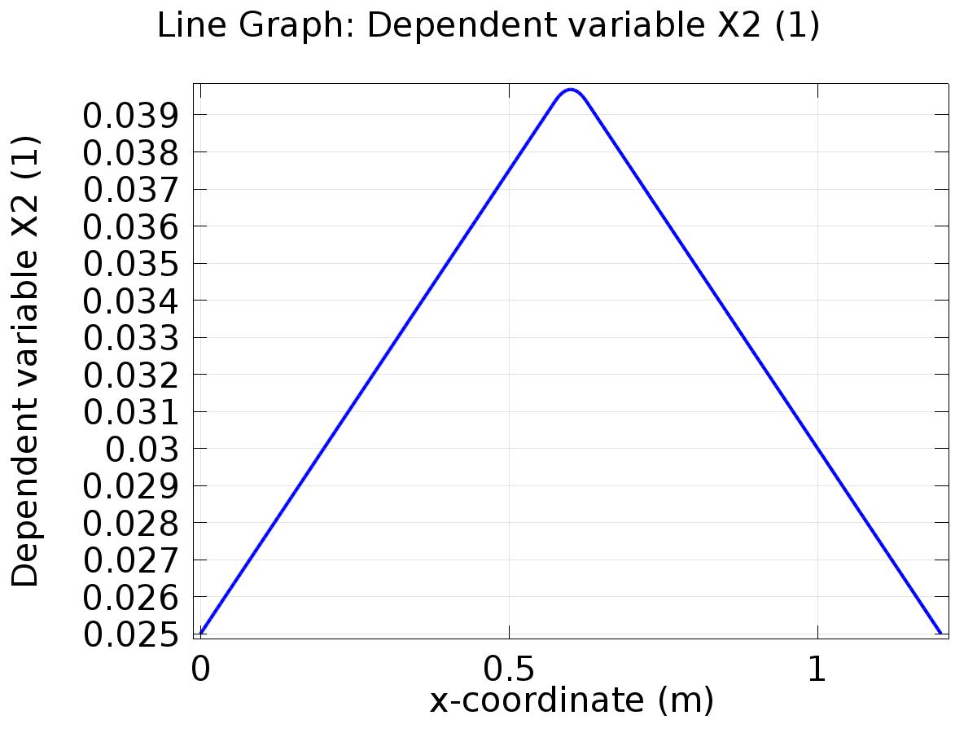

Line Graph: Dependent variable X2 (1)

* + 1. 1D Plot Group 2

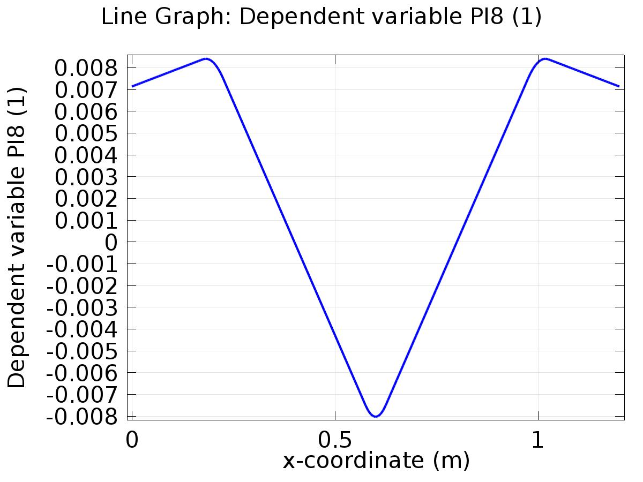

Line Graph: Dependent variable PI8 (1)

* + 1. 1D Plot Group 3

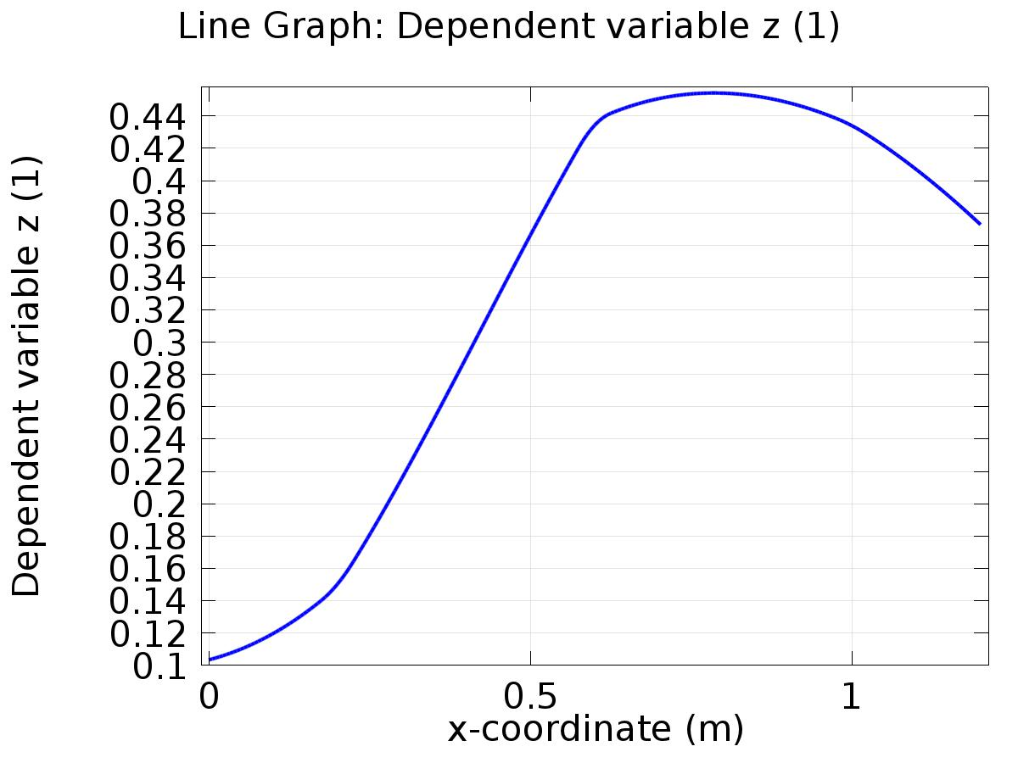

Line Graph: Dependent variable z (1)

* + 1. 1D Plot Group 4

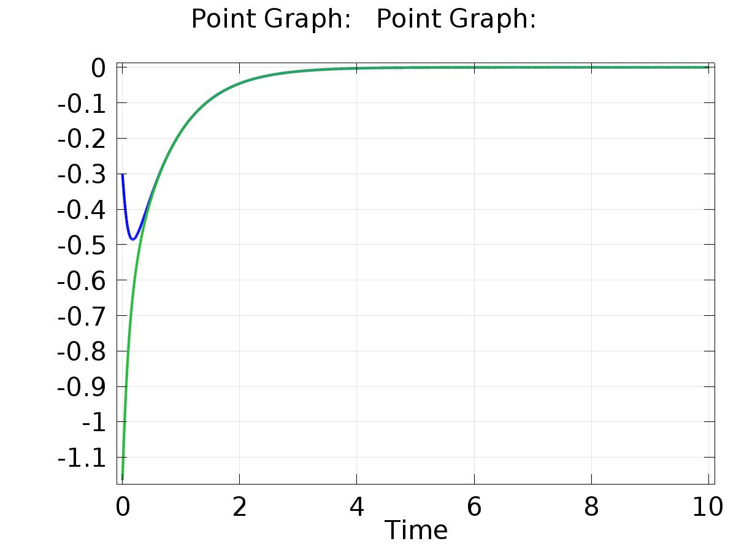

Point Graph: Point Graph:

* + 1. 1D Plot Group 5

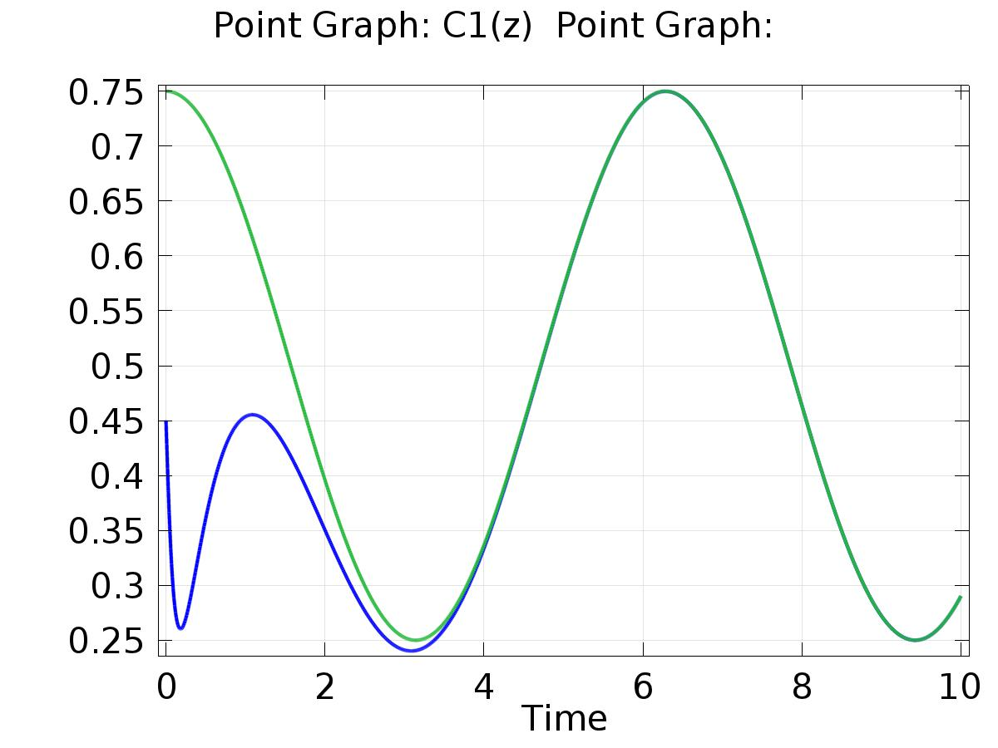

Point Graph: C1(z) (1) Point Graph:

* + 1. 1D Plot Group 6

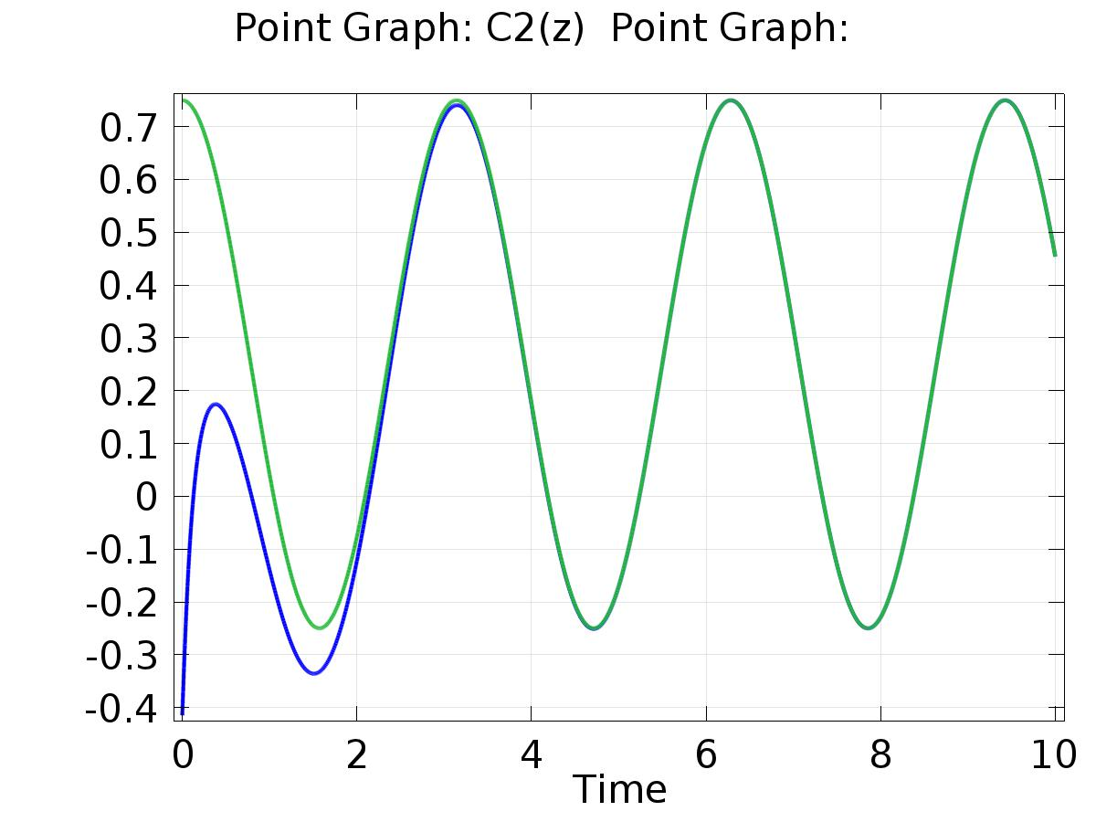

Point Graph: C2(z) (1) Point Graph: