[](http://www.comsol.com/)

CHAP2 ex2 SISO HeatEquation

|  |  |
| --- | --- |
| Date | Nov 5, 2013 1:24:25 PM |

Contents

1. Global

1.1. Definitions

2. Model 1

2.1. Definitions

2.2. Geometry 1

2.3. Coefficient Form PDE

2.4. Coefficient Form PDE 2

2.5. Mesh 1

3. Study 1

3.1. Stationary

3.2. Solver Configurations

4. Study 2

4.1. Time Dependent

4.2. Solver Configurations

5. Results

5.1. Data Sets

5.2. Derived Values

5.3. Tables

5.4. Plot Groups

1. Global

|  |  |
| --- | --- |
| Date | Aug 15, 2013 4:36:48 PM |

Global settings

|  |  |
| --- | --- |
| Name | CHAP2 ex2 SISO HeatEquation.mph |
| Path | /Users/gilliam/Desktop/collect_15/research_15/geo_reg_mono_eugenio/Mono_1_15/Comsol_EX_GitHub/Chapter2/Chap2Ex2/CHAP2_ex2_SISO_HeatEquation.mph |
| Program | COMSOL 4.3b (Build: 189) |

Used products

|  |
| --- |
| COMSOL Multiphysics |

* 1. Definitions
     1. Parameters 1

Parameters

| **Name** | **Expression** | **Value** | **Description** |
| --- | --- | --- | --- |
| L | 1 | 1.0000 |  |
| Ar | 1 | 1.0000 |  |
| alpha | 2 | 2.0000 |  |
| Md | 1 | 1.0000 |  |

1. Model 1

Component settings

|  |  |
| --- | --- |
| Unit system | SI |

* 1. Definitions
     1. Variables

#### Variables 1

Selection

|  |  |
| --- | --- |
| Geometric entity level | Entire model |

| **Name** | **Expression** | **Description** |
| --- | --- | --- |
| Gamma1 | real(1/C(PI1)) |  |
| Gamma2 | imag(1/C(PI1)) |  |
| Gamma3 | -C(PIt2)/C(PI2) |  |
| w3 | Md |  |
| w1 | Ar*sin(alpha*t) |  |
| w2 | Ar*cos(alpha*t) |  |
| Gamma | Gamma1*w1 + Gamma2*w2 + Gamma3*w3 |  |
| err | C(z) - w1 |  |
| Bin | 1 |  |
| Bd | 1 |  |

* + 1. Probes

#### Global Variable Probe 1

|  |  |
| --- | --- |
| Probe type | Global variable probe |

#### Global Variable Probe 2

|  |  |
| --- | --- |
| Probe type | Global variable probe |

#### Global Variable Probe 3

|  |  |
| --- | --- |
| Probe type | Global variable probe |

* + 1. Component Couplings

#### Average 1

|  |  |
| --- | --- |
| Coupling type | Average |
| Operator name | C |

Source selection

|  |  |
| --- | --- |
| Geometric entity level | Boundary |
| Selection | Boundary 2 |

* 1. Geometry 1

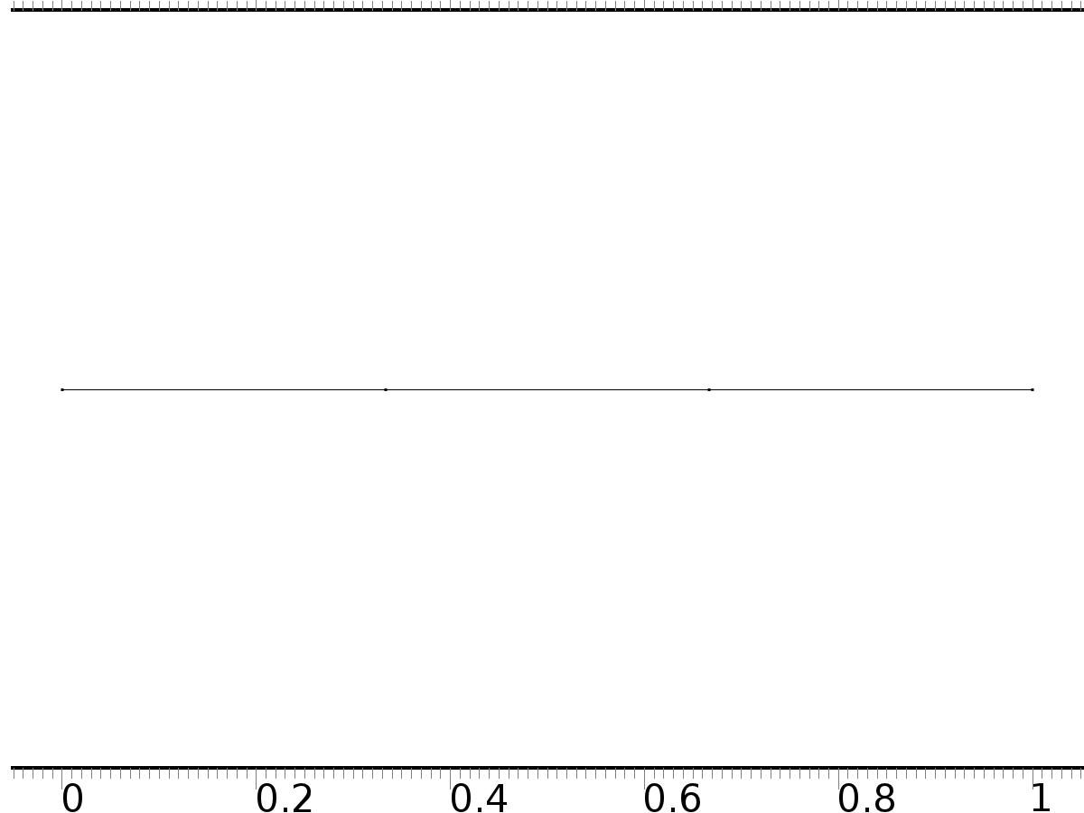

Geometry 1

Units

|  |  |
| --- | --- |
| Length unit | m |
| Angular unit | deg |

Geometry statistics

| **Description** | **Value** |
| --- | --- |
| Space dimension | 1 |
| Number of domains | 3 |
| Number of boundaries | 4 |

* + 1. Interval 1 (i1)

Interval

| **Description** | **Value** |
| --- | --- |
| Number of intervals | Many |
| Points | {0, 0.3333333333333333, 0.6666666666666666, 1} |

* 1. Coefficient Form PDE

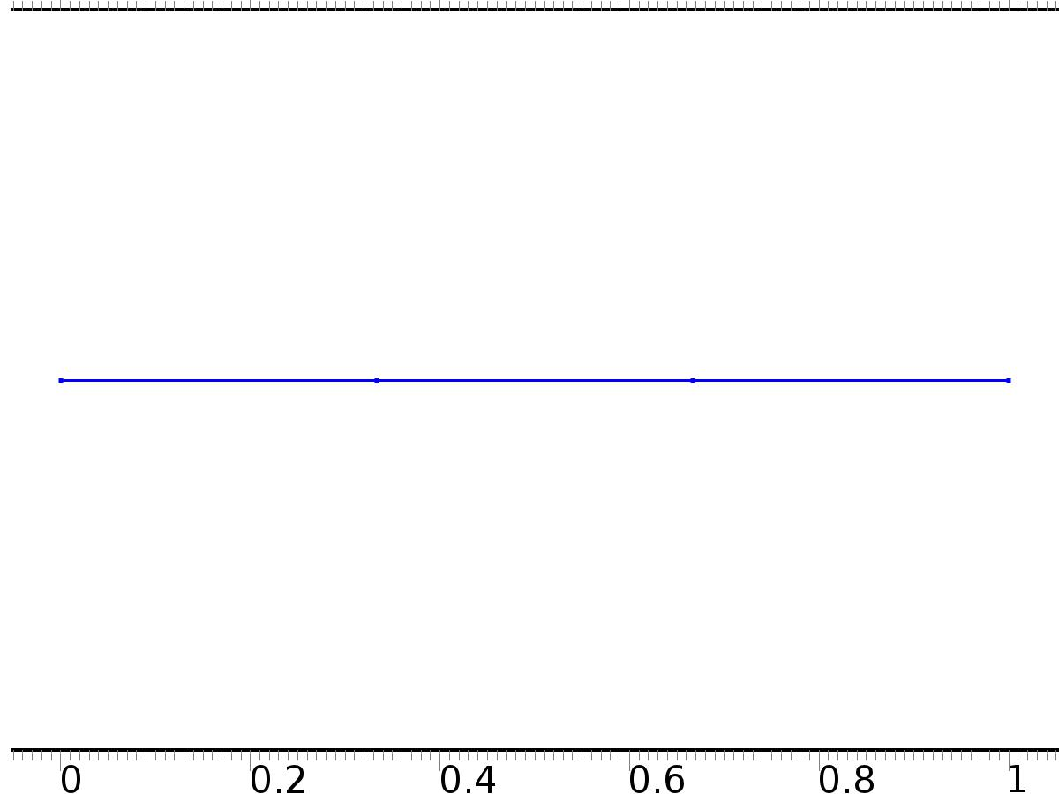

Coefficient Form PDE

Selection

|  |  |
| --- | --- |
| Geometric entity level | Domain |
| Selection | Domains 1–3 |

Settings

| **Description** | **Value** |
| --- | --- |
| Shape function type | Lagrange |
| Element order | Quadratic |
| Compute boundary fluxes | On |
| Apply smoothing to boundary fluxes | On |
| Value type when using splitting of complex variables | Complex |
| Dependent variable quantity | Dimensionless (1) |
| Source term quantity | None |
| Unit | m^ - 2 |

Used products

|  |
| --- |
| COMSOL Multiphysics |

Variables

| **Name** | **Expression** | **Unit** | **Description** | **Selection** |
| --- | --- | --- | --- | --- |
| c.nx | unx |  | Normal vector, x component | Boundary 1 |
| c.ny | 0 |  | Normal vector, y component | Boundary 1 |
| c.nz | 0 |  | Normal vector, z component | Boundary 1 |
| c.nx | dnx |  | Normal vector, x component | Boundary 4 |
| c.ny | 0 |  | Normal vector, y component | Boundary 4 |
| c.nz | 0 |  | Normal vector, z component | Boundary 4 |
| c.nx | nx |  | Normal vector, x component | Boundaries 2–3 |
| c.ny | 0 |  | Normal vector, y component | Boundaries 2–3 |
| c.nz | 0 |  | Normal vector, z component | Boundaries 2–3 |
| c.nxmesh | root.unxmesh |  | Normal vector (mesh), x component | Boundary 1 |
| c.nymesh | 0 |  | Normal vector (mesh), y component | Boundary 1 |
| c.nzmesh | 0 |  | Normal vector (mesh), z component | Boundary 1 |
| c.nxmesh | root.dnxmesh |  | Normal vector (mesh), x component | Boundary 4 |
| c.nymesh | 0 |  | Normal vector (mesh), y component | Boundary 4 |
| c.nzmesh | 0 |  | Normal vector (mesh), z component | Boundary 4 |
| c.nxmesh | root.nxmesh |  | Normal vector (mesh), x component | Boundaries 2–3 |
| c.nymesh | 0 |  | Normal vector (mesh), y component | Boundaries 2–3 |
| c.nzmesh | 0 |  | Normal vector (mesh), z component | Boundaries 2–3 |

* + 1. Coefficient Form PDE 1



Coefficient Form PDE 1

Selection

|  |  |
| --- | --- |
| Geometric entity level | Domain |
| Selection | Domains 1–3 |

Equations

Settings

| **Description** | **Value** |
| --- | --- |
| Diffusion coefficient | {{1, 0, 0}, {0, 1, 0}, {0, 0, 1}} |
| Absorption coefficient | {{i*alpha, 0, 0}, {0, 0, 0}, {0, 0, 0}} |
| Source term | {0, 0, 0} |
| Mass coefficient | {{0, 0, 0}, {0, 0, 0}, {0, 0, 0}} |
| Damping or mass coefficient | {{0, 0, 0}, {0, 0, 0}, {0, 0, 0}} |
| Conservative flux convection coefficient | {{0, 0, 0}, {0, 0, 0}, {0, 0, 0}} |
| Convection coefficient | {{0, 0, 0}, {0, 0, 0}, {0, 0, 0}} |
| Conservative flux source | {0, 0, 0} |

#### Variables

| **Name** | **Expression** | **Unit** | **Description** | **Selection** |
| --- | --- | --- | --- | --- |
| domflux.PI1x | -d(PI1,x) | 1/m | Domain flux, x component | Domains 1–3 |
| domflux.PI2x | -d(PI2,x) | 1/m | Domain flux, x component | Domains 1–3 |
| domflux.PIt2x | -d(PIt2,x) | 1/m | Domain flux, x component | Domains 1–3 |

#### Shape functions

| **Name** | **Shape function** | **Unit** | **Description** | **Shape frame** | **Selection** |
| --- | --- | --- | --- | --- | --- |
| PI1 | Lagrange (Quadratic) | 1 | Dependent variable PI1 | Material | Domains 1–3 |
| PI2 | Lagrange (Quadratic) | 1 | Dependent variable PI2 | Material | Domains 1–3 |
| PIt2 | Lagrange (Quadratic) | 1 | Dependent variable PIt2 | Material | Domains 1–3 |

* + 1. Zero Flux 1



Zero Flux 1

Selection

|  |  |
| --- | --- |
| Geometric entity level | Boundary |
| Selection | No boundaries |

Equations

* + 1. Initial Values 1



Initial Values 1

Selection

|  |  |
| --- | --- |
| Geometric entity level | Domain |
| Selection | Domains 1–3 |

Settings

| **Description** | **Value** |
| --- | --- |
| Initial value for PI2 | 0 |
| Initial time derivative of PI2 | 0 |
| Initial value for PI1 | 0 |
| Initial time derivative of PI1 | 0 |
| Initial value for PIt2 | 0 |
| Initial time derivative of PIt2 | 0 |

* + 1. Flux/Source 1

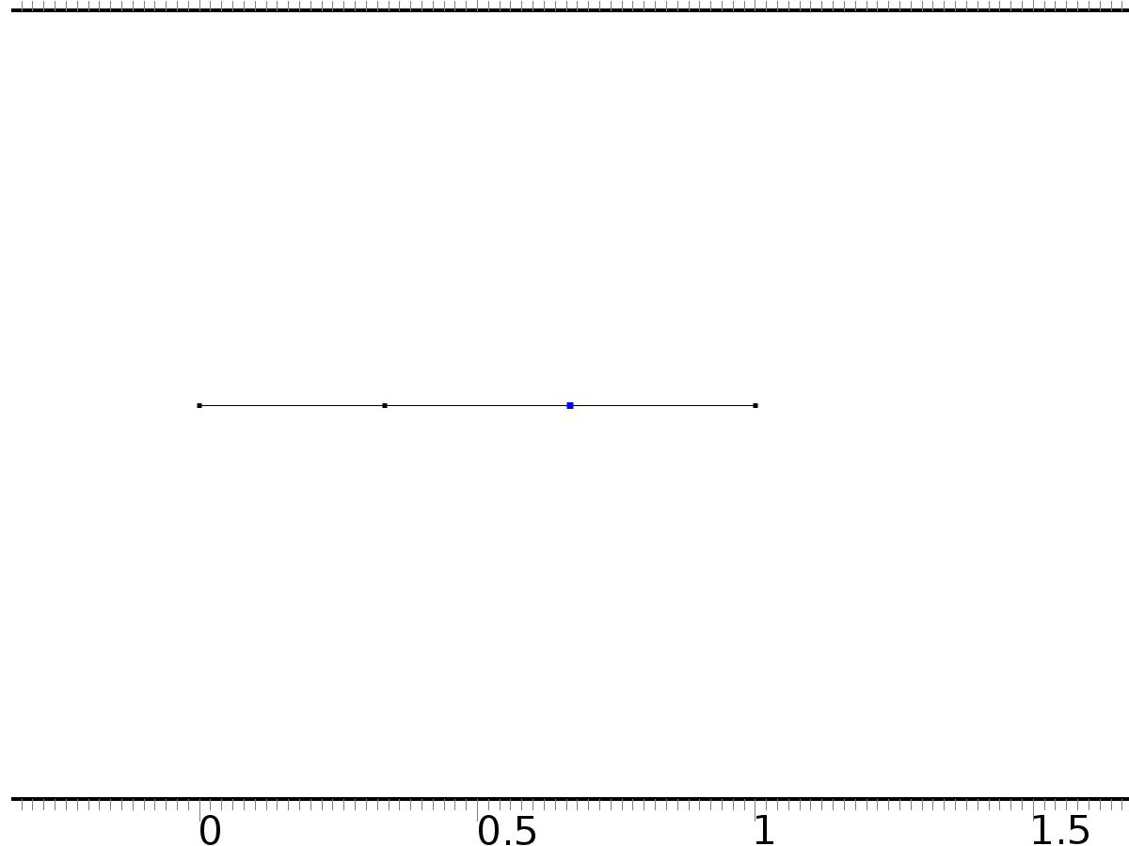

Flux/Source 1

Selection

|  |  |
| --- | --- |
| Geometric entity level | Boundary |
| Selection | Boundary 3 |

Equations

Settings

| **Description** | **Value** |
| --- | --- |
| Boundary flux/source | {Bin, Bin, 0} |
| Boundary absorption/impedance term | {{0, 0, 0}, {0, 0, 0}, {0, 0, 0}} |

#### Variables

| **Name** | **Expression** | **Unit** | **Description** | **Selection** |
| --- | --- | --- | --- | --- |
| c.g_PI1 | Bin | 1/m | Boundary flux/source | Boundary 3 |
| c.g_PI2 | Bin | 1/m | Boundary flux/source | Boundary 3 |
| c.g_PIt2 | 0 | 1/m | Boundary flux/source | Boundary 3 |

* + 1. Flux/Source 2

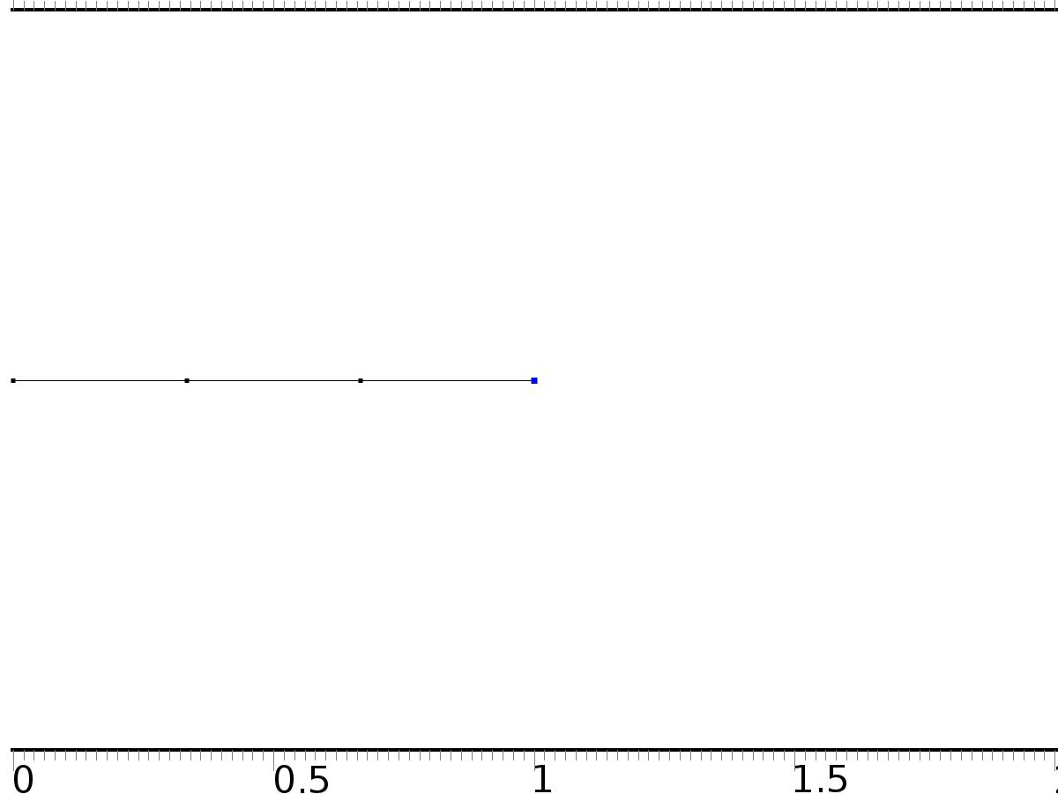

Flux/Source 2

Selection

|  |  |
| --- | --- |
| Geometric entity level | Boundary |
| Selection | Boundary 4 |

Equations

Settings

| **Description** | **Value** |
| --- | --- |
| Boundary flux/source | {0, 0, Bd} |
| Boundary absorption/impedance term | {{0, 0, 0}, {0, 0, 0}, {0, 0, 0}} |

#### Variables

| **Name** | **Expression** | **Unit** | **Description** | **Selection** |
| --- | --- | --- | --- | --- |
| c.g_PI1 | 0 | 1/m | Boundary flux/source | Boundary 4 |
| c.g_PI2 | 0 | 1/m | Boundary flux/source | Boundary 4 |
| c.g_PIt2 | Bd | 1/m | Boundary flux/source | Boundary 4 |

* + 1. Dirichlet Boundary Condition 1

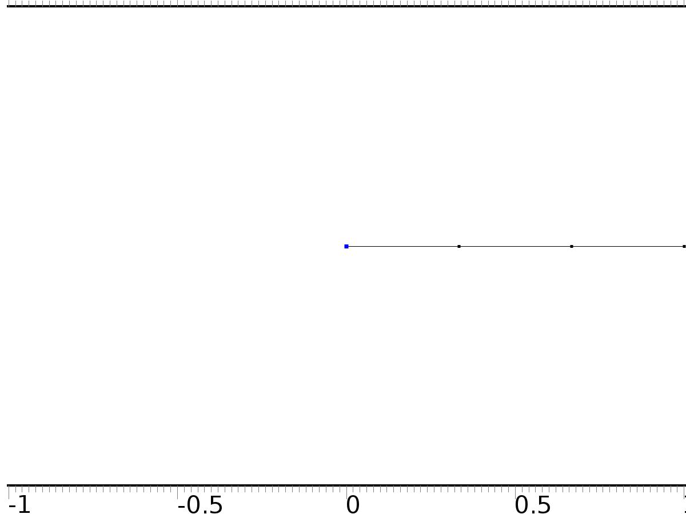

Dirichlet Boundary Condition 1

Selection

|  |  |
| --- | --- |
| Geometric entity level | Boundary |
| Selection | Boundary 1 |

Equations

Settings

| **Description** | **Value** |
| --- | --- |
| Value on boundary | {0, 0, 0} |
| Prescribed value of PI1 | On |
| Prescribed value of PI2 | On |
| Prescribed value of PIt2 | On |
| Apply reaction terms on | Individual dependent variables |
| Use weak constraints | Off |
| Constraint method | Elemental |

#### Shape functions

| **Constraint** | **Constraint force** | **Shape function** | **Selection** |
| --- | --- | --- | --- |
| -PI1 | -test(PI1) | Lagrange (Quadratic) | Boundary 1 |
| -PI2 | -test(PI2) | Lagrange (Quadratic) | Boundary 1 |
| -PIt2 | -test(PIt2) | Lagrange (Quadratic) | Boundary 1 |

* 1. Coefficient Form PDE 2



Coefficient Form PDE 2

Selection

|  |  |
| --- | --- |
| Geometric entity level | Domain |
| Selection | Domains 1–3 |

Settings

| **Description** | **Value** |
| --- | --- |
| Shape function type | Lagrange |
| Element order | Quadratic |
| Compute boundary fluxes | On |
| Apply smoothing to boundary fluxes | On |
| Value type when using splitting of complex variables | Complex |
| Dependent variable quantity | Dimensionless (1) |
| Source term quantity | None |
| Unit | m^ - 2 |

Used products

|  |
| --- |
| COMSOL Multiphysics |

Variables

| **Name** | **Expression** | **Unit** | **Description** | **Selection** |
| --- | --- | --- | --- | --- |
| c2.nx | unx |  | Normal vector, x component | Boundary 1 |
| c2.ny | 0 |  | Normal vector, y component | Boundary 1 |
| c2.nz | 0 |  | Normal vector, z component | Boundary 1 |
| c2.nx | dnx |  | Normal vector, x component | Boundary 4 |
| c2.ny | 0 |  | Normal vector, y component | Boundary 4 |
| c2.nz | 0 |  | Normal vector, z component | Boundary 4 |
| c2.nx | nx |  | Normal vector, x component | Boundaries 2–3 |
| c2.ny | 0 |  | Normal vector, y component | Boundaries 2–3 |
| c2.nz | 0 |  | Normal vector, z component | Boundaries 2–3 |
| c2.nxmesh | root.unxmesh |  | Normal vector (mesh), x component | Boundary 1 |
| c2.nymesh | 0 |  | Normal vector (mesh), y component | Boundary 1 |
| c2.nzmesh | 0 |  | Normal vector (mesh), z component | Boundary 1 |
| c2.nxmesh | root.dnxmesh |  | Normal vector (mesh), x component | Boundary 4 |
| c2.nymesh | 0 |  | Normal vector (mesh), y component | Boundary 4 |
| c2.nzmesh | 0 |  | Normal vector (mesh), z component | Boundary 4 |
| c2.nxmesh | root.nxmesh |  | Normal vector (mesh), x component | Boundaries 2–3 |
| c2.nymesh | 0 |  | Normal vector (mesh), y component | Boundaries 2–3 |
| c2.nzmesh | 0 |  | Normal vector (mesh), z component | Boundaries 2–3 |

* + 1. Coefficient Form PDE 1



Coefficient Form PDE 1

Selection

|  |  |
| --- | --- |
| Geometric entity level | Domain |
| Selection | Domains 1–3 |

Equations

Settings

| **Description** | **Value** |
| --- | --- |
| Diffusion coefficient | 1 |
| Absorption coefficient | 0 |
| Source term | 0 |
| Mass coefficient | 0 |
| Damping or mass coefficient | 1 |
| Conservative flux convection coefficient | 0 |
| Convection coefficient | 0 |
| Conservative flux source | 0 |

#### Variables

| **Name** | **Expression** | **Unit** | **Description** | **Selection** |
| --- | --- | --- | --- | --- |
| domflux.zx | -d(z,x) | 1/m | Domain flux, x component | Domains 1–3 |

#### Shape functions

| **Name** | **Shape function** | **Unit** | **Description** | **Shape frame** | **Selection** |
| --- | --- | --- | --- | --- | --- |
| z | Lagrange (Quadratic) | 1 | Dependent variable z | Material | Domains 1–3 |

* + 1. Zero Flux 1



Zero Flux 1

Selection

|  |  |
| --- | --- |
| Geometric entity level | Boundary |
| Selection | No boundaries |

Equations

* + 1. Initial Values 1



Initial Values 1

Selection

|  |  |
| --- | --- |
| Geometric entity level | Domain |
| Selection | Domains 1–3 |

Settings

| **Description** | **Value** |
| --- | --- |
| Initial value for z | 4*cos(pi*x) |
| Initial time derivative of z | 0 |

* + 1. Flux/Source 1



Flux/Source 1

Selection

|  |  |
| --- | --- |
| Geometric entity level | Boundary |
| Selection | Boundary 3 |

Equations

Settings

| **Description** | **Value** |
| --- | --- |
| Boundary flux/source | Bin*Gamma |
| Boundary absorption/impedance term | 0 |

#### Variables

| **Name** | **Expression** | **Unit** | **Description** | **Selection** |
| --- | --- | --- | --- | --- |
| c2.g_z | Bin*Gamma | 1/m | Boundary flux/source | Boundary 3 |

* + 1. Flux/Source 2



Flux/Source 2

Selection

|  |  |
| --- | --- |
| Geometric entity level | Boundary |
| Selection | Boundary 4 |

Equations

Settings

| **Description** | **Value** |
| --- | --- |
| Boundary flux/source | Bd*w3 |
| Boundary absorption/impedance term | 0 |

#### Variables

| **Name** | **Expression** | **Unit** | **Description** | **Selection** |
| --- | --- | --- | --- | --- |
| c2.g_z | Bd*w3 | 1/m | Boundary flux/source | Boundary 4 |

* + 1. Dirichlet Boundary Condition 1



Dirichlet Boundary Condition 1

Selection

|  |  |
| --- | --- |
| Geometric entity level | Boundary |
| Selection | Boundary 1 |

Equations

Settings

| **Description** | **Value** |
| --- | --- |
| Value on boundary | 0 |
| Prescribed value of z | On |
| Apply reaction terms on | Individual dependent variables |
| Use weak constraints | Off |
| Constraint method | Elemental |

#### Shape functions

| **Constraint** | **Constraint force** | **Shape function** | **Selection** |
| --- | --- | --- | --- |
| -z | -test(z) | Lagrange (Quadratic) | Boundary 1 |

* 1. Mesh 1

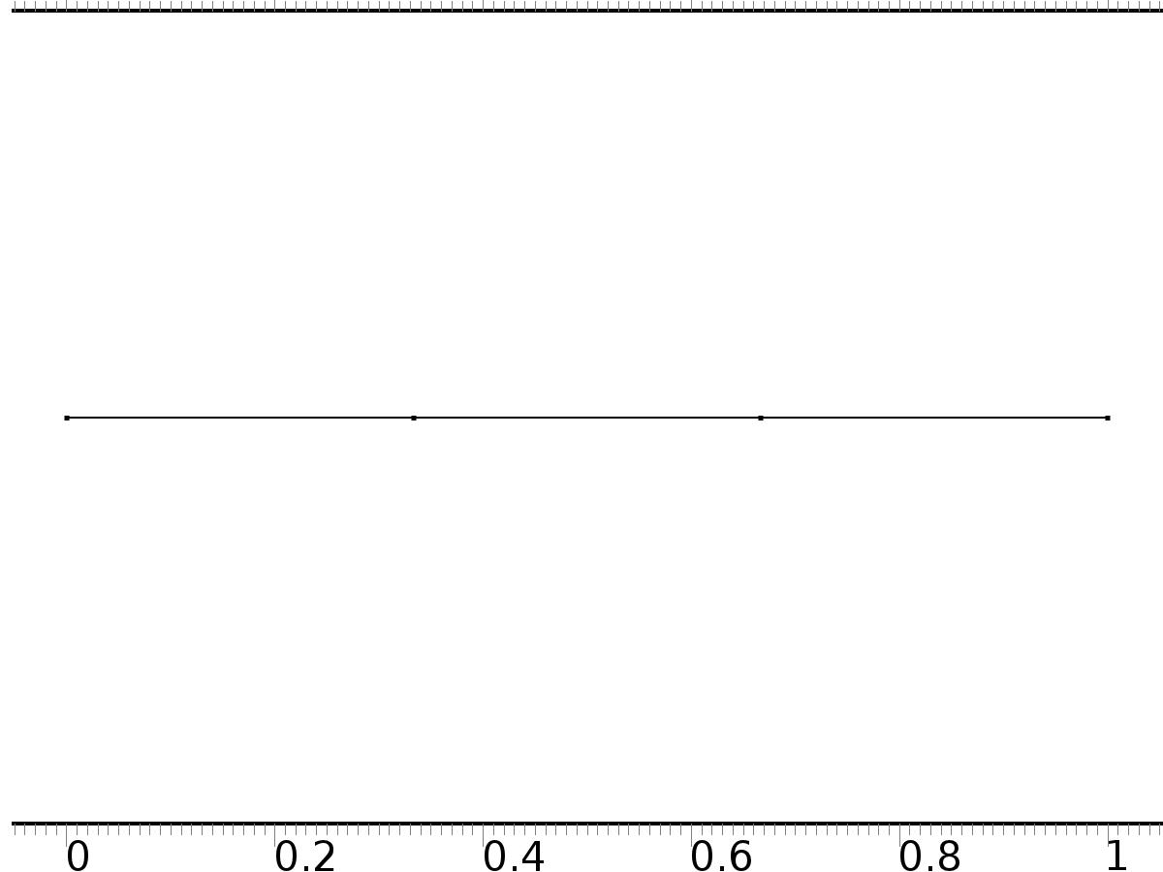

Mesh 1

* + 1. Size (size)

Settings

| **Description** | **Value** |
| --- | --- |
| Maximum element size | 0.037 |
| Minimum element size | 1.25E-4 |
| Curvature factor | 0.25 |
| Maximum element growth rate | 1.25 |
| Predefined size | Finer |

* + 1. Edge 1 (edg1)

Selection

|  |  |
| --- | --- |
| Geometric entity level | Remaining |

1. Study 1
   1. Stationary

Study settings

| **Description** | **Value** |
| --- | --- |
| Include geometric nonlinearity | Off |

Physics and variables selection

| **Physics interface** | **Discretization** |
| --- | --- |
| Coefficient Form PDE (c) | physics |

Mesh selection

| **Geometry** | **Mesh** |
| --- | --- |
| Geometry 1 (geom1) | mesh1 |

* 1. Solver Configurations
     1. Solver 1

#### Compile Equations: Stationary (st1)

Study and step

| **Description** | **Value** |
| --- | --- |
| Use study | Study 1 |
| Use study step | Stationary |

#### Dependent Variables 1 (v1)

General

| **Description** | **Value** |
| --- | --- |
| Defined by study step | Stationary |
| Constant |  |

Initial values of variables solved for

| **Description** | **Value** |
| --- | --- |
| Solution | Zero |

Values of variables not solved for

| **Description** | **Value** |
| --- | --- |
| Solution | Zero |

##### Dependent variable PI1 (mod1.PI1) (mod1_PI1)

General

| **Description** | **Value** |
| --- | --- |
| Field components | mod1.PI1 |
| Field name | mod1_X |

##### Dependent variable z (mod1.z) (mod1_z)

General

| **Description** | **Value** |
| --- | --- |
| Field components | mod1.z |
| Solve for this field | Off |

##### Dependent variable PI2 (mod1.PI2) (mod1_PI2)

General

| **Description** | **Value** |
| --- | --- |
| Field components | mod1.PI2 |

##### Dependent variable PIt2 (mod1.PIt2) (mod1_PIt2)

General

| **Description** | **Value** |
| --- | --- |
| Field components | mod1.PIt2 |
| Field name | mod1_PI3 |

#### Stationary Solver 1 (s1)

General

| **Description** | **Value** |
| --- | --- |
| Defined by study step | Stationary |
| Relative tolerance | 0.0000010 |

Log

| **Description** | **Value** |
| --- | --- |
| Constant |  |

##### Advanced (aDef)

General

| **Description** | **Value** |
| --- | --- |
| Allow complex-valued output from functions with real input | On |

##### Fully Coupled 1 (fc1)

General

| **Description** | **Value** |
| --- | --- |
| Linear solver | Direct |

1. Study 2
   1. Time Dependent

Study settings

| **Description** | **Value** |
| --- | --- |
| Include geometric nonlinearity | Off |

| **Times** | **Unit** |
| --- | --- |
| range(0,0.01,6) | s |

Physics and variables selection

| **Physics interface** | **Discretization** |
| --- | --- |
| Coefficient Form PDE 2 (c2) | physics |

Mesh selection

| **Geometry** | **Mesh** |
| --- | --- |
| Geometry 1 (geom1) | mesh1 |

* 1. Solver Configurations
     1. Solver 2

#### Compile Equations: Time Dependent (st1)

Study and step

| **Description** | **Value** |
| --- | --- |
| Use study | Study 2 |
| Use study step | Time Dependent |

#### Dependent Variables 1 (v1)

General

| **Description** | **Value** |
| --- | --- |
| Defined by study step | Time Dependent |
| Constant |  |

Initial values of variables solved for

| **Description** | **Value** |
| --- | --- |
| Solution | Zero |

Values of variables not solved for

| **Description** | **Value** |
| --- | --- |
| Method | Solution |
| Solution | Solver 1 |

##### Dependent variable z (mod1.z) (mod1_z)

General

| **Description** | **Value** |
| --- | --- |
| Field components | mod1.z |

##### Dependent variable PI1 (mod1.PI1) (mod1_PI1)

General

| **Description** | **Value** |
| --- | --- |
| Field components | mod1.PI1 |
| Solve for this field | Off |
| Field name | mod1_X |

##### Dependent variable PI2 (mod1.PI2) (mod1_PI2)

General

| **Description** | **Value** |
| --- | --- |
| Field components | mod1.PI2 |
| Solve for this field | Off |

##### Dependent variable PIt2 (mod1.PIt2) (mod1_PIt2)

General

| **Description** | **Value** |
| --- | --- |
| Field components | mod1.PIt2 |
| Solve for this field | Off |
| Field name | mod1_PI3 |

#### Time-Dependent Solver 1 (t1)

General

| **Description** | **Value** |
| --- | --- |
| Defined by study step | Time Dependent |
| Time | {0, 0.01, 0.02, 0.03, 0.04, 0.05, 0.06, 0.07, 0.08, 0.09, 0.1, 0.11, 0.12, 0.13, 0.14, 0.15, 0.16, 0.17, 0.18, 0.19, 0.2, 0.21, 0.22, 0.23, 0.24, 0.25, 0.26, 0.27, 0.28, 0.29, 0.3, 0.31, 0.32, 0.33, 0.34, 0.35000000000000003, 0.36, 0.37, 0.38, 0.39, 0.4, 0.41000000000000003, 0.42, 0.43, 0.44, 0.45, 0.46, 0.47000000000000003, 0.48, 0.49, 0.5, 0.51, 0.52, 0.53, 0.54, 0.55, 0.56, 0.5700000000000001, 0.58, 0.59, 0.6, 0.61, 0.62, 0.63, 0.64, 0.65, 0.66, 0.67, 0.68, 0.6900000000000001, 0.7000000000000001, 0.71, 0.72, 0.73, 0.74, 0.75, 0.76, 0.77, 0.78, 0.79, 0.8, 0.81, 0.8200000000000001, 0.8300000000000001, 0.84, 0.85, 0.86, 0.87, 0.88, 0.89, 0.9, 0.91, 0.92, 0.93, 0.9400000000000001, 0.9500000000000001, 0.96, 0.97, 0.98, 0.99, 1, 1.01, 1.02, 1.03, 1.04, 1.05, 1.06, 1.07, 1.08, 1.09, 1.1, 1.11, 1.12, 1.1300000000000001, 1.1400000000000001, 1.1500000000000001, 1.16, 1.17, 1.18, 1.19, 1.2, 1.21, 1.22, 1.23, 1.24, 1.25, 1.26, 1.27, 1.28, 1.29, 1.3, 1.31, 1.32, 1.33, 1.34, 1.35, 1.36, 1.37, 1.3800000000000001, 1.3900000000000001, 1.4000000000000001, 1.41, 1.42, 1.43, 1.44, 1.45, 1.46, 1.47, 1.48, 1.49, 1.5, 1.51, 1.52, 1.53, 1.54, 1.55, 1.56, 1.57, 1.58, 1.59, 1.6, 1.61, 1.62, 1.6300000000000001, 1.6400000000000001, 1.6500000000000001, 1.6600000000000001, 1.67, 1.68, 1.69, 1.7, 1.71, 1.72, 1.73, 1.74, 1.75, 1.76, 1.77, 1.78, 1.79, 1.8, 1.81, 1.82, 1.83, 1.84, 1.85, 1.86, 1.87, 1.8800000000000001, 1.8900000000000001, 1.9000000000000001, 1.9100000000000001, 1.92, 1.93, 1.94, 1.95, 1.96, 1.97, 1.98, 1.99, 2, 2.0100000000000002, 2.02, 2.0300000000000002, 2.04, 2.05, 2.06, 2.07, 2.08, 2.09, 2.1, 2.11, 2.12, 2.13, 2.14, 2.15, 2.16, 2.17, 2.18, 2.19, 2.2, 2.21, 2.22, 2.23, 2.24, 2.25, 2.2600000000000002, 2.27, 2.2800000000000002, 2.29, 2.3000000000000003, 2.31, 2.32, 2.33, 2.34, 2.35, 2.36, 2.37, 2.38, 2.39, 2.4, 2.41, 2.42, 2.43, 2.44, 2.45, 2.46, 2.47, 2.48, 2.49, 2.5, 2.5100000000000002, 2.52, 2.5300000000000002, 2.54, 2.5500000000000003, 2.56, 2.57, 2.58, 2.59, 2.6, 2.61, 2.62, 2.63, 2.64, 2.65, 2.66, 2.67, 2.68, 2.69, 2.7, 2.71, 2.72, 2.73, 2.74, 2.75, 2.7600000000000002, 2.77, 2.7800000000000002, 2.79, 2.8000000000000003, 2.81, 2.82, 2.83, 2.84, 2.85, 2.86, 2.87, 2.88, 2.89, 2.9, 2.91, 2.92, 2.93, 2.94, 2.95, 2.96, 2.97, 2.98, 2.99, 3, 3.0100000000000002, 3.02, 3.0300000000000002, 3.04, 3.0500000000000003, 3.06, 3.0700000000000003, 3.08, 3.09, 3.1, 3.11, 3.12, 3.13, 3.14, 3.15, 3.16, 3.17, 3.18, 3.19, 3.2, 3.21, 3.22, 3.23, 3.24, 3.25, 3.2600000000000002, 3.27, 3.2800000000000002, 3.29, 3.3000000000000003, 3.31, 3.3200000000000003, 3.33, 3.34, 3.35, 3.36, 3.37, 3.38, 3.39, 3.4, 3.41, 3.42, 3.43, 3.44, 3.45, 3.46, 3.47, 3.48, 3.49, 3.5, 3.5100000000000002, 3.52, 3.5300000000000002, 3.54, 3.5500000000000003, 3.56, 3.5700000000000003, 3.58, 3.59, 3.6, 3.61, 3.62, 3.63, 3.64, 3.65, 3.66, 3.67, 3.68, 3.69, 3.7, 3.71, 3.72, 3.73, 3.74, 3.75, 3.7600000000000002, 3.77, 3.7800000000000002, 3.79, 3.8000000000000003, 3.81, 3.8200000000000003, 3.83, 3.84, 3.85, 3.86, 3.87, 3.88, 3.89, 3.9, 3.91, 3.92, 3.93, 3.94, 3.95, 3.96, 3.97, 3.98, 3.99, 4, 4.01, 4.0200000000000005, 4.03, 4.04, 4.05, 4.0600000000000005, 4.07, 4.08, 4.09, 4.1, 4.11, 4.12, 4.13, 4.14, 4.15, 4.16, 4.17, 4.18, 4.19, 4.2, 4.21, 4.22, 4.23, 4.24, 4.25, 4.26, 4.2700000000000005, 4.28, 4.29, 4.3, 4.3100000000000005, 4.32, 4.33, 4.34, 4.3500000000000005, 4.36, 4.37, 4.38, 4.39, 4.4, 4.41, 4.42, 4.43, 4.44, 4.45, 4.46, 4.47, 4.48, 4.49, 4.5, 4.51, 4.5200000000000005, 4.53, 4.54, 4.55, 4.5600000000000005, 4.57, 4.58, 4.59, 4.6000000000000005, 4.61, 4.62, 4.63, 4.64, 4.65, 4.66, 4.67, 4.68, 4.69, 4.7, 4.71, 4.72, 4.73, 4.74, 4.75, 4.76, 4.7700000000000005, 4.78, 4.79, 4.8, 4.8100000000000005, 4.82, 4.83, 4.84, 4.8500000000000005, 4.86, 4.87, 4.88, 4.89, 4.9, 4.91, 4.92, 4.93, 4.94, 4.95, 4.96, 4.97, 4.98, 4.99, 5, 5.01, 5.0200000000000005, 5.03, 5.04, 5.05, 5.0600000000000005, 5.07, 5.08, 5.09, 5.1000000000000005, 5.11, 5.12, 5.13, 5.14, 5.15, 5.16, 5.17, 5.18, 5.19, 5.2, 5.21, 5.22, 5.23, 5.24, 5.25, 5.26, 5.2700000000000005, 5.28, 5.29, 5.3, 5.3100000000000005, 5.32, 5.33, 5.34, 5.3500000000000005, 5.36, 5.37, 5.38, 5.39, 5.4, 5.41, 5.42, 5.43, 5.44, 5.45, 5.46, 5.47, 5.48, 5.49, 5.5, 5.51, 5.5200000000000005, 5.53, 5.54, 5.55, 5.5600000000000005, 5.57, 5.58, 5.59, 5.6000000000000005, 5.61, 5.62, 5.63, 5.64, 5.65, 5.66, 5.67, 5.68, 5.69, 5.7, 5.71, 5.72, 5.73, 5.74, 5.75, 5.76, 5.7700000000000005, 5.78, 5.79, 5.8, 5.8100000000000005, 5.82, 5.83, 5.84, 5.8500000000000005, 5.86, 5.87, 5.88, 5.89, 5.9, 5.91, 5.92, 5.93, 5.94, 5.95, 5.96, 5.97, 5.98, 5.99, 6} |
| Relative tolerance | 0.00001 |

Absolute tolerance

| **Description** | **Value** |
| --- | --- |
| Tolerance | 0.0000010 |

Time stepping

| **Description** | **Value** |
| --- | --- |
| Initial step | 0.0010 |

Results while solving

| **Description** | **Value** |
| --- | --- |
| Probes | None |

Advanced

| **Description** | **Value** |
| --- | --- |
| Fraction of initial step for Backward Euler | 0.0010 |

Log

| **Description** | **Value** |
| --- | --- |
| Constant |  |

##### Fully Coupled 1 (fc1)

General

| **Description** | **Value** |
| --- | --- |
| Linear solver | Direct |

1. Results
   1. Data Sets
      1. Solution 1

Solution

| **Description** | **Value** |
| --- | --- |
| Solution | Solver 1 |
| Component | Save Point Geometry 1 |

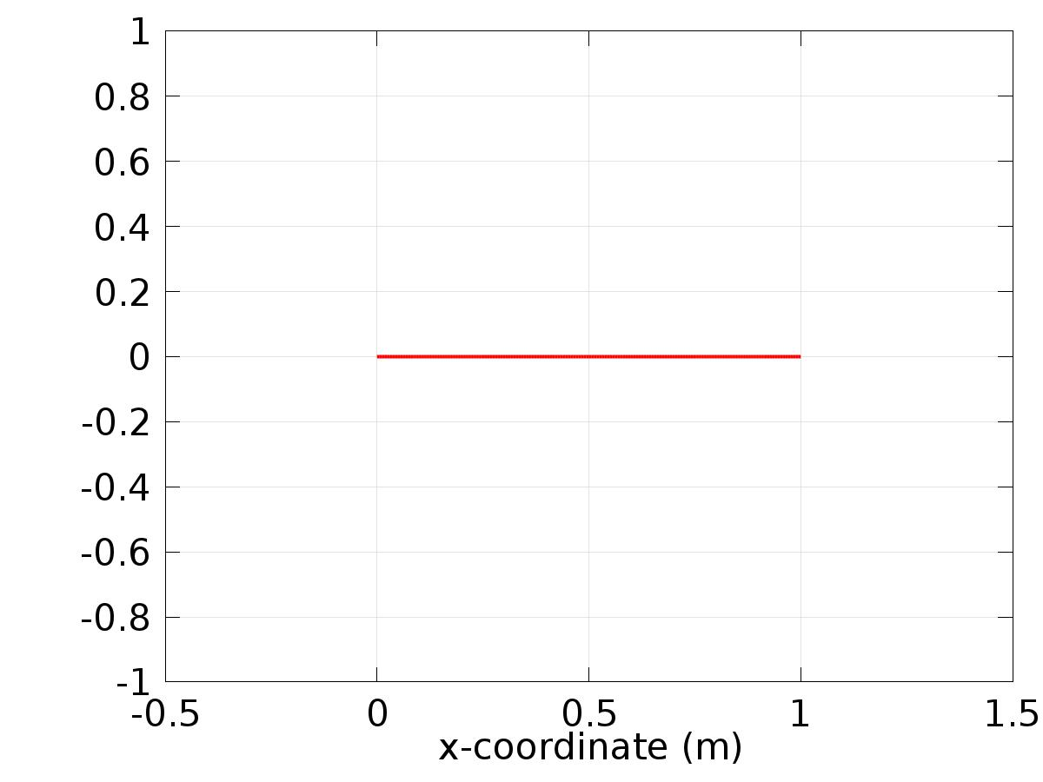

Data set: Solution 1

* + 1. Solution 2

Solution

| **Description** | **Value** |
| --- | --- |
| Solution | Solver 2 |
| Component | Save Point Geometry 1 |

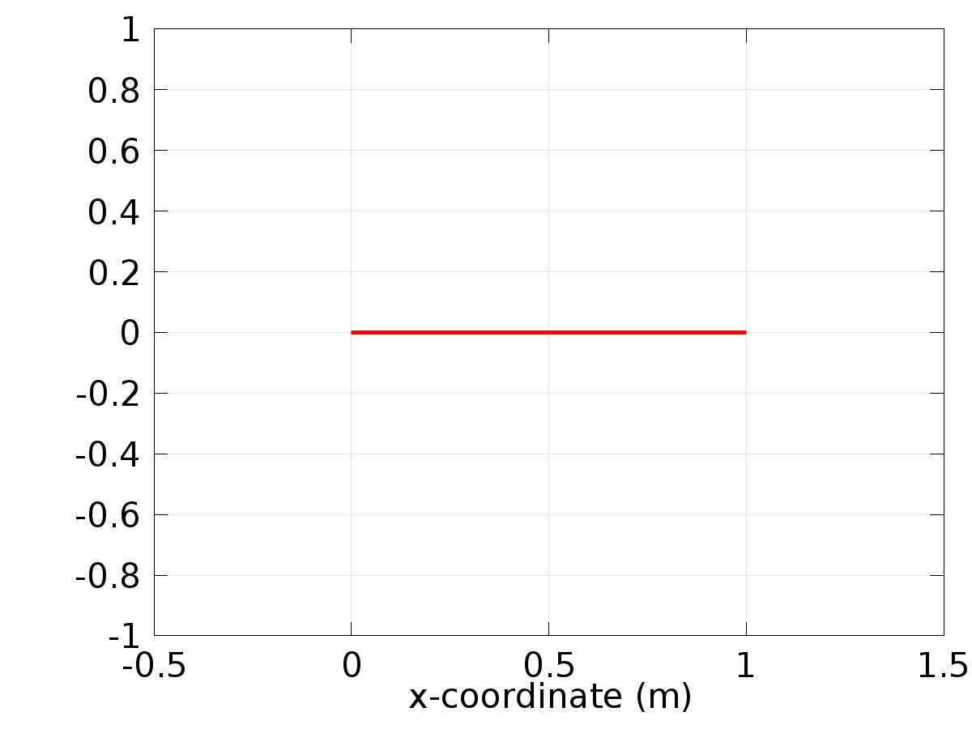

Data set: Solution 2

* + 1. Probe Solution 3

Solution

| **Description** | **Value** |
| --- | --- |
| Solution | Solver 1 |
| Component | Save Point Geometry 1 |

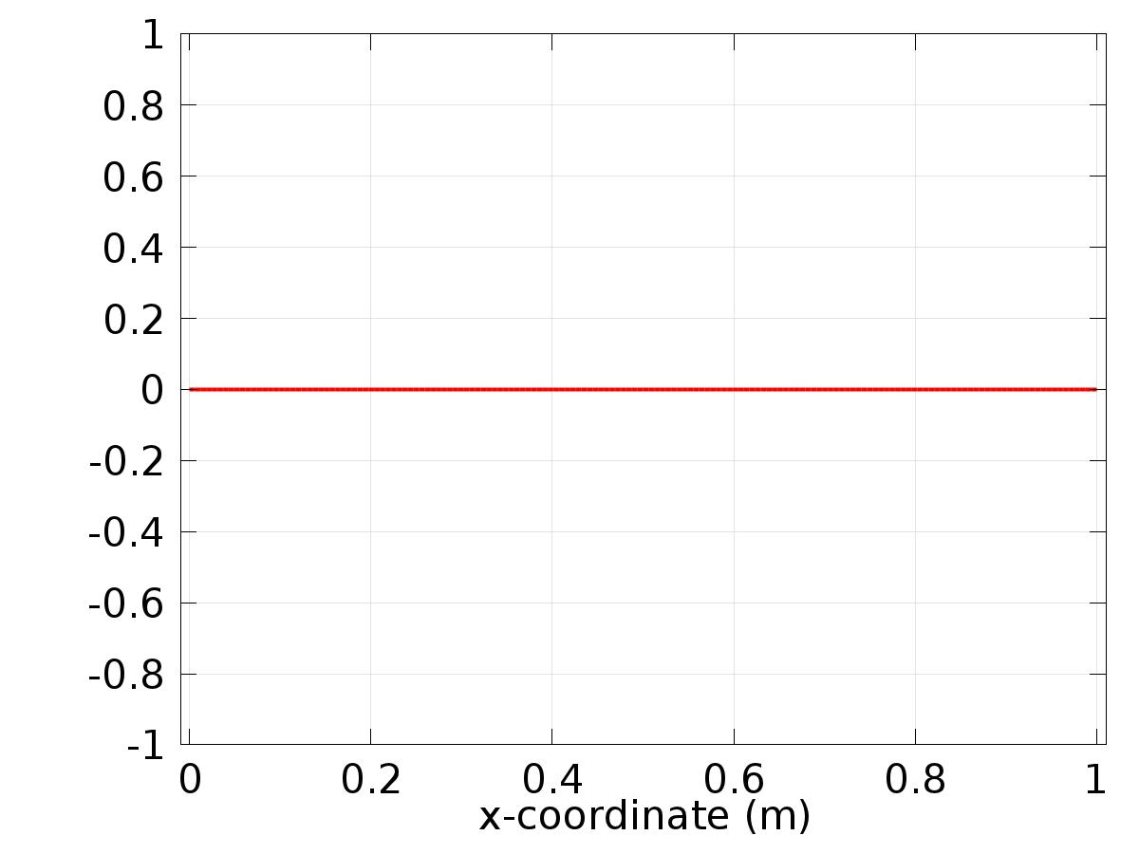

Data set: Probe Solution 3

* 1. Derived Values
     1. Global Variable Probe 1

Data

| **Description** | **Value** |
| --- | --- |
| Data set | Probe Solution 3 |

Expression

| **Description** | **Value** |
| --- | --- |
| Expression | Gamma1 |
| Unit | 1 |

* + 1. Global Variable Probe 2

Data

| **Description** | **Value** |
| --- | --- |
| Data set | Probe Solution 3 |

Expression

| **Description** | **Value** |
| --- | --- |
| Expression | Gamma2 |
| Unit | 1 |

* + 1. Global Variable Probe 3

Data

| **Description** | **Value** |
| --- | --- |
| Data set | Probe Solution 3 |

Expression

| **Description** | **Value** |
| --- | --- |
| Expression | Gamma3 |
| Unit | 1 |

* + 1. Point Evaluation 1

Selection

|  |  |
| --- | --- |
| Geometric entity level | Boundary |
| Selection | Boundary 3 |

Data

| **Description** | **Value** |
| --- | --- |
| Data set | Solution 2 |

Expression

| **Description** | **Value** |
| --- | --- |
| Expression | w1 |

* 1. Tables
     1. Table 1

Global Evaluation 1 (C(X))

Table 1

| **Gamma3 (1)** |
| --- |
| -1.00000 |

* + 1. Table 2

Point Evaluation 1 (z)

Table 2

| **Dependent variable z (1), Point: 1** |
| --- |
| 0.0000 |

* + 1. Table 3

Point Evaluation 1 (z)

Table 3

| **Time** | **Gradient of z, x component (1/m), Point: 1** |
| --- | --- |
| 6.0000 | -1.4311 |

* + 1. Probe Table 4

Probe Table 4

| **Gamma1 (1)** | **Gamma2 (1)** | **Gamma3 (1)** |
| --- | --- | --- |
| 2.8984 | 2.5545 | -1.00000 |

* + 1. Table 5

Point Evaluation 1 (C(z))

Table 5

| **Time** | **C(z) (1), Point: 3** | **w1, Point: 3** |
| --- | --- | --- |
| 0.0000 | 1.9998 | 0.0000 |
| 0.010000 | 1.7401 | 0.019999 |
| 0.020000 | 1.2875 | 0.039989 |
| 0.030000 | 0.88035 | 0.059964 |
| 0.040000 | 0.56451 | 0.079915 |
| 0.050000 | 0.32624 | 0.099833 |
| 0.060000 | 0.14800 | 0.11971 |
| 0.070000 | 0.015745 | 0.13954 |
| 0.080000 | -0.081091 | 0.15932 |
| 0.090000 | -0.15043 | 0.17903 |
| 0.10000 | -0.19827 | 0.19867 |
| 0.11000 | -0.22925 | 0.21823 |
| 0.12000 | -0.24695 | 0.23770 |
| 0.13000 | -0.25418 | 0.25708 |
| 0.14000 | -0.25318 | 0.27636 |
| 0.15000 | -0.24570 | 0.29552 |
| 0.16000 | -0.23314 | 0.31457 |
| 0.17000 | -0.21662 | 0.33349 |
| 0.18000 | -0.19704 | 0.35227 |
| 0.19000 | -0.17511 | 0.37092 |
| 0.20000 | -0.15139 | 0.38942 |
| 0.21000 | -0.12634 | 0.40776 |
| 0.22000 | -0.10033 | 0.42594 |
| 0.23000 | -0.073648 | 0.44395 |
| 0.24000 | -0.046529 | 0.46178 |
| 0.25000 | -0.019157 | 0.47943 |
| 0.26000 | 0.0083154 | 0.49688 |
| 0.27000 | 0.035770 | 0.51414 |
| 0.28000 | 0.063111 | 0.53119 |
| 0.29000 | 0.090261 | 0.54802 |
| 0.30000 | 0.11716 | 0.56464 |
| 0.31000 | 0.14375 | 0.58104 |
| 0.32000 | 0.17001 | 0.59720 |
| 0.33000 | 0.19589 | 0.61312 |
| 0.34000 | 0.22137 | 0.62879 |
| 0.35000 | 0.24644 | 0.64422 |
| 0.36000 | 0.27107 | 0.65938 |
| 0.37000 | 0.29525 | 0.67429 |
| 0.38000 | 0.31898 | 0.68892 |
| 0.39000 | 0.34223 | 0.70328 |
| 0.40000 | 0.36501 | 0.71736 |
| 0.41000 | 0.38731 | 0.73115 |
| 0.42000 | 0.40913 | 0.74464 |
| 0.43000 | 0.43046 | 0.75784 |
| 0.44000 | 0.45129 | 0.77074 |
| 0.45000 | 0.47163 | 0.78333 |
| 0.46000 | 0.49148 | 0.79560 |
| 0.47000 | 0.51083 | 0.80756 |
| 0.48000 | 0.52968 | 0.81919 |
| 0.49000 | 0.54803 | 0.83050 |
| 0.50000 | 0.56588 | 0.84147 |
| 0.51000 | 0.58322 | 0.85211 |
| 0.52000 | 0.60007 | 0.86240 |
| 0.53000 | 0.61641 | 0.87236 |
| 0.54000 | 0.63224 | 0.88196 |
| 0.55000 | 0.64757 | 0.89121 |
| 0.56000 | 0.66240 | 0.90010 |
| 0.57000 | 0.67673 | 0.90863 |
| 0.58000 | 0.69054 | 0.91680 |
| 0.59000 | 0.70386 | 0.92461 |
| 0.60000 | 0.71667 | 0.93204 |
| 0.61000 | 0.72898 | 0.93910 |
| 0.62000 | 0.74079 | 0.94578 |
| 0.63000 | 0.75209 | 0.95209 |
| 0.64000 | 0.76289 | 0.95802 |
| 0.65000 | 0.77318 | 0.96356 |
| 0.66000 | 0.78298 | 0.96872 |
| 0.67000 | 0.79228 | 0.97348 |
| 0.68000 | 0.80107 | 0.97786 |
| 0.69000 | 0.80937 | 0.98185 |
| 0.70000 | 0.81717 | 0.98545 |
| 0.71000 | 0.82447 | 0.98865 |
| 0.72000 | 0.83128 | 0.99146 |
| 0.73000 | 0.83760 | 0.99387 |
| 0.74000 | 0.84342 | 0.99588 |
| 0.75000 | 0.84875 | 0.99749 |
| 0.76000 | 0.85359 | 0.99871 |
| 0.77000 | 0.85794 | 0.99953 |
| 0.78000 | 0.86181 | 0.99994 |
| 0.79000 | 0.86519 | 0.99996 |
| 0.80000 | 0.86809 | 0.99957 |
| 0.81000 | 0.87051 | 0.99879 |
| 0.82000 | 0.87246 | 0.99761 |
| 0.83000 | 0.87392 | 0.99602 |
| 0.84000 | 0.87492 | 0.99404 |
| 0.85000 | 0.87545 | 0.99166 |
| 0.86000 | 0.87550 | 0.98889 |
| 0.87000 | 0.87510 | 0.98572 |
| 0.88000 | 0.87423 | 0.98215 |
| 0.89000 | 0.87290 | 0.97820 |
| 0.90000 | 0.87112 | 0.97385 |
| 0.91000 | 0.86888 | 0.96911 |
| 0.92000 | 0.86620 | 0.96398 |
| 0.93000 | 0.86307 | 0.95847 |
| 0.94000 | 0.85950 | 0.95258 |
| 0.95000 | 0.85550 | 0.94630 |
| 0.96000 | 0.85105 | 0.93965 |
| 0.97000 | 0.84618 | 0.93262 |
| 0.98000 | 0.84089 | 0.92521 |
| 0.99000 | 0.83517 | 0.91744 |
| 1.0000 | 0.82903 | 0.90930 |
| 1.0100 | 0.82248 | 0.90079 |
| 1.0200 | 0.81553 | 0.89193 |
| 1.0300 | 0.80817 | 0.88271 |
| 1.0400 | 0.80041 | 0.87313 |
| 1.0500 | 0.79226 | 0.86321 |
| 1.0600 | 0.78372 | 0.85294 |
| 1.0700 | 0.77480 | 0.84233 |
| 1.0800 | 0.76550 | 0.83138 |
| 1.0900 | 0.75582 | 0.82010 |
| 1.1000 | 0.74578 | 0.80850 |
| 1.1100 | 0.73538 | 0.79657 |
| 1.1200 | 0.72462 | 0.78432 |
| 1.1300 | 0.71351 | 0.77175 |
| 1.1400 | 0.70206 | 0.75888 |
| 1.1500 | 0.69027 | 0.74571 |
| 1.1600 | 0.67814 | 0.73223 |
| 1.1700 | 0.66570 | 0.71846 |
| 1.1800 | 0.65293 | 0.70441 |
| 1.1900 | 0.63985 | 0.69007 |
| 1.2000 | 0.62646 | 0.67546 |
| 1.2100 | 0.61277 | 0.66058 |
| 1.2200 | 0.59879 | 0.64543 |
| 1.2300 | 0.58452 | 0.63003 |
| 1.2400 | 0.56997 | 0.61437 |
| 1.2500 | 0.55515 | 0.59847 |
| 1.2600 | 0.54007 | 0.58233 |
| 1.2700 | 0.52472 | 0.56596 |
| 1.2800 | 0.50913 | 0.54936 |
| 1.2900 | 0.49329 | 0.53253 |
| 1.3000 | 0.47721 | 0.51550 |
| 1.3100 | 0.46090 | 0.49826 |
| 1.3200 | 0.44438 | 0.48082 |
| 1.3300 | 0.42763 | 0.46319 |
| 1.3400 | 0.41068 | 0.44537 |
| 1.3500 | 0.39353 | 0.42738 |
| 1.3600 | 0.37619 | 0.40921 |
| 1.3700 | 0.35867 | 0.39088 |
| 1.3800 | 0.34097 | 0.37240 |
| 1.3900 | 0.32310 | 0.35376 |
| 1.4000 | 0.30507 | 0.33499 |
| 1.4100 | 0.28689 | 0.31608 |
| 1.4200 | 0.26856 | 0.29704 |
| 1.4300 | 0.25010 | 0.27789 |
| 1.4400 | 0.23151 | 0.25862 |
| 1.4500 | 0.21280 | 0.23925 |
| 1.4600 | 0.19398 | 0.21978 |
| 1.4700 | 0.17506 | 0.20023 |
| 1.4800 | 0.15604 | 0.18060 |
| 1.4900 | 0.13693 | 0.16089 |
| 1.5000 | 0.11774 | 0.14112 |
| 1.5100 | 0.098485 | 0.12129 |
| 1.5200 | 0.079166 | 0.10142 |
| 1.5300 | 0.059792 | 0.081502 |
| 1.5400 | 0.040373 | 0.061554 |
| 1.5500 | 0.020916 | 0.041581 |
| 1.5600 | 0.0014296 | 0.021591 |
| 1.5700 | -0.018077 | 0.0015927 |
| 1.5800 | -0.037597 | -0.018406 |
| 1.5900 | -0.057121 | -0.038398 |
| 1.6000 | -0.076641 | -0.058374 |
| 1.6100 | -0.096149 | -0.078327 |
| 1.6200 | -0.11564 | -0.098249 |
| 1.6300 | -0.13509 | -0.11813 |
| 1.6400 | -0.15452 | -0.13797 |
| 1.6500 | -0.17389 | -0.15775 |
| 1.6600 | -0.19322 | -0.17746 |
| 1.6700 | -0.21248 | -0.19711 |
| 1.6800 | -0.23167 | -0.21668 |
| 1.6900 | -0.25078 | -0.23616 |
| 1.7000 | -0.26981 | -0.25554 |
| 1.7100 | -0.28875 | -0.27482 |
| 1.7200 | -0.30758 | -0.29400 |
| 1.7300 | -0.32631 | -0.31305 |
| 1.7400 | -0.34492 | -0.33199 |
| 1.7500 | -0.36340 | -0.35078 |
| 1.7600 | -0.38175 | -0.36944 |
| 1.7700 | -0.39996 | -0.38795 |
| 1.7800 | -0.41802 | -0.40631 |
| 1.7900 | -0.43593 | -0.42450 |
| 1.8000 | -0.45367 | -0.44252 |
| 1.8100 | -0.47125 | -0.46037 |
| 1.8200 | -0.48864 | -0.47803 |
| 1.8300 | -0.50585 | -0.49550 |
| 1.8400 | -0.52287 | -0.51277 |
| 1.8500 | -0.53969 | -0.52984 |
| 1.8600 | -0.55631 | -0.54669 |
| 1.8700 | -0.57271 | -0.56333 |
| 1.8800 | -0.58889 | -0.57974 |
| 1.8900 | -0.60485 | -0.59592 |
| 1.9000 | -0.62057 | -0.61186 |
| 1.9100 | -0.63605 | -0.62755 |
| 1.9200 | -0.65129 | -0.64300 |
| 1.9300 | -0.66628 | -0.65819 |
| 1.9400 | -0.68100 | -0.67311 |
| 1.9500 | -0.69547 | -0.68777 |
| 1.9600 | -0.70966 | -0.70215 |
| 1.9700 | -0.72358 | -0.71625 |
| 1.9800 | -0.73721 | -0.73006 |
| 1.9900 | -0.75056 | -0.74358 |
| 2.0000 | -0.76361 | -0.75680 |
| 2.0100 | -0.77636 | -0.76972 |
| 2.0200 | -0.78881 | -0.78234 |
| 2.0300 | -0.80096 | -0.79464 |
| 2.0400 | -0.81278 | -0.80662 |
| 2.0500 | -0.82429 | -0.81828 |
| 2.0600 | -0.83548 | -0.82961 |
| 2.0700 | -0.84633 | -0.84061 |
| 2.0800 | -0.85686 | -0.85127 |
| 2.0900 | -0.86705 | -0.86160 |
| 2.1000 | -0.87689 | -0.87158 |
| 2.1100 | -0.88639 | -0.88121 |
| 2.1200 | -0.89554 | -0.89048 |
| 2.1300 | -0.90434 | -0.89941 |
| 2.1400 | -0.91278 | -0.90797 |
| 2.1500 | -0.92086 | -0.91617 |
| 2.1600 | -0.92858 | -0.92400 |
| 2.1700 | -0.93593 | -0.93146 |
| 2.1800 | -0.94291 | -0.93855 |
| 2.1900 | -0.94952 | -0.94527 |
| 2.2000 | -0.95575 | -0.95160 |
| 2.2100 | -0.96161 | -0.95756 |
| 2.2200 | -0.96708 | -0.96313 |
| 2.2300 | -0.97217 | -0.96832 |
| 2.2400 | -0.97688 | -0.97312 |
| 2.2500 | -0.98120 | -0.97753 |
| 2.2600 | -0.98513 | -0.98155 |
| 2.2700 | -0.98867 | -0.98518 |
| 2.2800 | -0.99182 | -0.98841 |
| 2.2900 | -0.99457 | -0.99125 |
| 2.3000 | -0.99693 | -0.99369 |
| 2.3100 | -0.99889 | -0.99574 |
| 2.3200 | -1.0005 | -0.99738 |
| 2.3300 | -1.0016 | -0.99863 |
| 2.3400 | -1.0024 | -0.99948 |
| 2.3500 | -1.0028 | -0.99992 |
| 2.3600 | -1.0028 | -0.99997 |
| 2.3700 | -1.0023 | -0.99962 |
| 2.3800 | -1.0015 | -0.99887 |
| 2.3900 | -1.0003 | -0.99772 |
| 2.4000 | -0.99869 | -0.99616 |
| 2.4100 | -0.99668 | -0.99422 |
| 2.4200 | -0.99427 | -0.99187 |
| 2.4300 | -0.99147 | -0.98913 |
| 2.4400 | -0.98827 | -0.98599 |
| 2.4500 | -0.98468 | -0.98245 |
| 2.4600 | -0.98070 | -0.97853 |
| 2.4700 | -0.97632 | -0.97421 |
| 2.4800 | -0.97156 | -0.96950 |
| 2.4900 | -0.96642 | -0.96441 |
| 2.5000 | -0.96089 | -0.95892 |
| 2.5100 | -0.95498 | -0.95306 |
| 2.5200 | -0.94868 | -0.94681 |
| 2.5300 | -0.94201 | -0.94019 |
| 2.5400 | -0.93497 | -0.93319 |
| 2.5500 | -0.92755 | -0.92581 |
| 2.5600 | -0.91976 | -0.91807 |
| 2.5700 | -0.91161 | -0.90996 |
| 2.5800 | -0.90309 | -0.90148 |
| 2.5900 | -0.89422 | -0.89265 |
| 2.6000 | -0.88499 | -0.88345 |
| 2.6100 | -0.87540 | -0.87391 |
| 2.6200 | -0.86547 | -0.86401 |
| 2.6300 | -0.85519 | -0.85377 |
| 2.6400 | -0.84457 | -0.84319 |
| 2.6500 | -0.83362 | -0.83227 |
| 2.6600 | -0.82233 | -0.82101 |
| 2.6700 | -0.81072 | -0.80943 |
| 2.6800 | -0.79878 | -0.79753 |
| 2.6900 | -0.78653 | -0.78530 |
| 2.7000 | -0.77396 | -0.77276 |
| 2.7100 | -0.76108 | -0.75992 |
| 2.7200 | -0.74790 | -0.74677 |
| 2.7300 | -0.73442 | -0.73332 |
| 2.7400 | -0.72065 | -0.71957 |
| 2.7500 | -0.70659 | -0.70554 |
| 2.7600 | -0.69225 | -0.69123 |
| 2.7700 | -0.67764 | -0.67664 |
| 2.7800 | -0.66275 | -0.66178 |
| 2.7900 | -0.64760 | -0.64665 |
| 2.8000 | -0.63220 | -0.63127 |
| 2.8100 | -0.61654 | -0.61563 |
| 2.8200 | -0.60063 | -0.59975 |
| 2.8300 | -0.58449 | -0.58362 |
| 2.8400 | -0.56811 | -0.56727 |
| 2.8500 | -0.55151 | -0.55069 |
| 2.8600 | -0.53468 | -0.53388 |
| 2.8700 | -0.51765 | -0.51687 |
| 2.8800 | -0.50040 | -0.49964 |
| 2.8900 | -0.48296 | -0.48222 |
| 2.9000 | -0.46533 | -0.46460 |
| 2.9100 | -0.44751 | -0.44680 |
| 2.9200 | -0.42951 | -0.42882 |
| 2.9300 | -0.41134 | -0.41067 |
| 2.9400 | -0.39300 | -0.39235 |
| 2.9500 | -0.37452 | -0.37388 |
| 2.9600 | -0.35588 | -0.35525 |
| 2.9700 | -0.33710 | -0.33649 |
| 2.9800 | -0.31818 | -0.31759 |
| 2.9900 | -0.29914 | -0.29856 |
| 3.0000 | -0.27998 | -0.27942 |
| 3.0100 | -0.26071 | -0.26016 |
| 3.0200 | -0.24133 | -0.24080 |
| 3.0300 | -0.22186 | -0.22134 |
| 3.0400 | -0.20230 | -0.20179 |
| 3.0500 | -0.18266 | -0.18216 |
| 3.0600 | -0.16295 | -0.16246 |
| 3.0700 | -0.14317 | -0.14270 |
| 3.0800 | -0.12334 | -0.12287 |
| 3.0900 | -0.10345 | -0.10300 |
| 3.1000 | -0.083529 | -0.083089 |
| 3.1100 | -0.063572 | -0.063143 |
| 3.1200 | -0.043591 | -0.043172 |
| 3.1300 | -0.023592 | -0.023183 |
| 3.1400 | -0.0035836 | -0.0031853 |
| 3.1500 | 0.016425 | 0.016814 |
| 3.1600 | 0.036427 | 0.036806 |
| 3.1700 | 0.056414 | 0.056784 |
| 3.1800 | 0.076378 | 0.076739 |
| 3.1900 | 0.096312 | 0.096664 |
| 3.2000 | 0.11621 | 0.11655 |
| 3.2100 | 0.13605 | 0.13639 |
| 3.2200 | 0.15585 | 0.15617 |
| 3.2300 | 0.17558 | 0.17589 |
| 3.2400 | 0.19524 | 0.19555 |
| 3.2500 | 0.21482 | 0.21512 |
| 3.2600 | 0.23431 | 0.23461 |
| 3.2700 | 0.25371 | 0.25400 |
| 3.2800 | 0.27301 | 0.27329 |
| 3.2900 | 0.29220 | 0.29248 |
| 3.3000 | 0.31127 | 0.31154 |
| 3.3100 | 0.33022 | 0.33048 |
| 3.3200 | 0.34904 | 0.34929 |
| 3.3300 | 0.36771 | 0.36796 |
| 3.3400 | 0.38624 | 0.38648 |
| 3.3500 | 0.40461 | 0.40485 |
| 3.3600 | 0.42282 | 0.42306 |
| 3.3700 | 0.44087 | 0.44109 |
| 3.3800 | 0.45873 | 0.45895 |
| 3.3900 | 0.47641 | 0.47663 |
| 3.4000 | 0.49390 | 0.49411 |
| 3.4100 | 0.51120 | 0.51140 |
| 3.4200 | 0.52829 | 0.52848 |
| 3.4300 | 0.54516 | 0.54536 |
| 3.4400 | 0.56182 | 0.56201 |
| 3.4500 | 0.57825 | 0.57844 |
| 3.4600 | 0.59446 | 0.59464 |
| 3.4700 | 0.61042 | 0.61060 |
| 3.4800 | 0.62614 | 0.62631 |
| 3.4900 | 0.64161 | 0.64178 |
| 3.5000 | 0.65682 | 0.65699 |
| 3.5100 | 0.67177 | 0.67193 |
| 3.5200 | 0.68645 | 0.68661 |
| 3.5300 | 0.70086 | 0.70101 |
| 3.5400 | 0.71498 | 0.71513 |
| 3.5500 | 0.72882 | 0.72897 |
| 3.5600 | 0.74237 | 0.74251 |
| 3.5700 | 0.75562 | 0.75576 |
| 3.5800 | 0.76857 | 0.76871 |
| 3.5900 | 0.78121 | 0.78134 |
| 3.6000 | 0.79354 | 0.79367 |
| 3.6100 | 0.80555 | 0.80568 |
| 3.6200 | 0.81724 | 0.81736 |
| 3.6300 | 0.82860 | 0.82872 |
| 3.6400 | 0.83963 | 0.83975 |
| 3.6500 | 0.85032 | 0.85044 |
| 3.6600 | 0.86067 | 0.86079 |
| 3.6700 | 0.87068 | 0.87079 |
| 3.6800 | 0.88034 | 0.88045 |
| 3.6900 | 0.88965 | 0.88976 |
| 3.7000 | 0.89860 | 0.89871 |
| 3.7100 | 0.90720 | 0.90730 |
| 3.7200 | 0.91543 | 0.91553 |
| 3.7300 | 0.92329 | 0.92339 |
| 3.7400 | 0.93078 | 0.93088 |
| 3.7500 | 0.93791 | 0.93800 |
| 3.7600 | 0.94465 | 0.94474 |
| 3.7700 | 0.95102 | 0.95111 |
| 3.7800 | 0.95701 | 0.95710 |
| 3.7900 | 0.96261 | 0.96270 |
| 3.8000 | 0.96783 | 0.96792 |
| 3.8100 | 0.97267 | 0.97275 |
| 3.8200 | 0.97711 | 0.97719 |
| 3.8300 | 0.98116 | 0.98124 |
| 3.8400 | 0.98482 | 0.98490 |
| 3.8500 | 0.98809 | 0.98817 |
| 3.8600 | 0.99096 | 0.99104 |
| 3.8700 | 0.99344 | 0.99351 |
| 3.8800 | 0.99551 | 0.99559 |
| 3.8900 | 0.99719 | 0.99726 |
| 3.9000 | 0.99847 | 0.99854 |
| 3.9100 | 0.99935 | 0.99942 |
| 3.9200 | 0.99983 | 0.99990 |
| 3.9300 | 0.99991 | 0.99998 |
| 3.9400 | 0.99960 | 0.99966 |
| 3.9500 | 0.99888 | 0.99894 |
| 3.9600 | 0.99776 | 0.99782 |
| 3.9700 | 0.99624 | 0.99630 |
| 3.9800 | 0.99432 | 0.99439 |
| 3.9900 | 0.99201 | 0.99207 |
| 4.0000 | 0.98930 | 0.98936 |
| 4.0100 | 0.98619 | 0.98625 |
| 4.0200 | 0.98269 | 0.98275 |
| 4.0300 | 0.97880 | 0.97885 |
| 4.0400 | 0.97451 | 0.97457 |
| 4.0500 | 0.96983 | 0.96989 |
| 4.0600 | 0.96477 | 0.96483 |
| 4.0700 | 0.95932 | 0.95937 |
| 4.0800 | 0.95349 | 0.95354 |
| 4.0900 | 0.94727 | 0.94733 |
| 4.1000 | 0.94068 | 0.94073 |
| 4.1100 | 0.93371 | 0.93376 |
| 4.1200 | 0.92637 | 0.92642 |
| 4.1300 | 0.91865 | 0.91870 |
| 4.1400 | 0.91057 | 0.91062 |
| 4.1500 | 0.90212 | 0.90217 |
| 4.1600 | 0.89332 | 0.89336 |
| 4.1700 | 0.88415 | 0.88420 |
| 4.1800 | 0.87464 | 0.87468 |
| 4.1900 | 0.86477 | 0.86481 |
| 4.2000 | 0.85455 | 0.85460 |
| 4.2100 | 0.84400 | 0.84404 |
| 4.2200 | 0.83311 | 0.83315 |
| 4.2300 | 0.82188 | 0.82192 |
| 4.2400 | 0.81032 | 0.81037 |
| 4.2500 | 0.79844 | 0.79849 |
| 4.2600 | 0.78625 | 0.78629 |
| 4.2700 | 0.77373 | 0.77377 |
| 4.2800 | 0.76091 | 0.76095 |
| 4.2900 | 0.74778 | 0.74782 |
| 4.3000 | 0.73436 | 0.73440 |
| 4.3100 | 0.72064 | 0.72068 |
| 4.3200 | 0.70663 | 0.70667 |
| 4.3300 | 0.69234 | 0.69238 |
| 4.3400 | 0.67777 | 0.67781 |
| 4.3500 | 0.66293 | 0.66297 |
| 4.3600 | 0.64783 | 0.64786 |
| 4.3700 | 0.63246 | 0.63250 |
| 4.3800 | 0.61685 | 0.61688 |
| 4.3900 | 0.60099 | 0.60102 |
| 4.4000 | 0.58488 | 0.58492 |
| 4.4100 | 0.56854 | 0.56858 |
| 4.4200 | 0.55198 | 0.55201 |
| 4.4300 | 0.53519 | 0.53523 |
| 4.4400 | 0.51819 | 0.51823 |
| 4.4500 | 0.50099 | 0.50102 |
| 4.4600 | 0.48358 | 0.48361 |
| 4.4700 | 0.46598 | 0.46601 |
| 4.4800 | 0.44819 | 0.44822 |
| 4.4900 | 0.43023 | 0.43026 |
| 4.5000 | 0.41209 | 0.41212 |
| 4.5100 | 0.39378 | 0.39381 |
| 4.5200 | 0.37532 | 0.37535 |
| 4.5300 | 0.35671 | 0.35674 |
| 4.5400 | 0.33796 | 0.33799 |
| 4.5500 | 0.31907 | 0.31910 |
| 4.5600 | 0.30005 | 0.30008 |
| 4.5700 | 0.28092 | 0.28094 |
| 4.5800 | 0.26167 | 0.26169 |
| 4.5900 | 0.24231 | 0.24234 |
| 4.6000 | 0.22286 | 0.22289 |
| 4.6100 | 0.20332 | 0.20335 |
| 4.6200 | 0.18370 | 0.18373 |
| 4.6300 | 0.16401 | 0.16403 |
| 4.6400 | 0.14425 | 0.14427 |
| 4.6500 | 0.12443 | 0.12445 |
| 4.6600 | 0.10456 | 0.10459 |
| 4.6700 | 0.084652 | 0.084676 |
| 4.6800 | 0.064709 | 0.064733 |
| 4.6900 | 0.044739 | 0.044763 |
| 4.7000 | 0.024752 | 0.024775 |
| 4.7100 | 0.0047552 | 0.0047779 |
| 4.7200 | -0.015244 | -0.015221 |
| 4.7300 | -0.035237 | -0.035215 |
| 4.7400 | -0.055215 | -0.055194 |
| 4.7500 | -0.075172 | -0.075151 |
| 4.7600 | -0.095099 | -0.095078 |
| 4.7700 | -0.11499 | -0.11497 |
| 4.7800 | -0.13483 | -0.13481 |
| 4.7900 | -0.15462 | -0.15460 |
| 4.8000 | -0.17435 | -0.17433 |
| 4.8100 | -0.19400 | -0.19398 |
| 4.8200 | -0.21358 | -0.21356 |
| 4.8300 | -0.23308 | -0.23306 |
| 4.8400 | -0.25248 | -0.25246 |
| 4.8500 | -0.27178 | -0.27176 |
| 4.8600 | -0.29097 | -0.29095 |
| 4.8700 | -0.31004 | -0.31003 |
| 4.8800 | -0.32899 | -0.32898 |
| 4.8900 | -0.34781 | -0.34780 |
| 4.9000 | -0.36649 | -0.36648 |
| 4.9100 | -0.38503 | -0.38501 |
| 4.9200 | -0.40341 | -0.40339 |
| 4.9300 | -0.42163 | -0.42161 |
| 4.9400 | -0.43967 | -0.43966 |
| 4.9500 | -0.45755 | -0.45754 |
| 4.9600 | -0.47524 | -0.47523 |
| 4.9700 | -0.49274 | -0.49273 |
| 4.9800 | -0.51004 | -0.51003 |
| 4.9900 | -0.52714 | -0.52713 |
| 5.0000 | -0.54403 | -0.54402 |
| 5.0100 | -0.56070 | -0.56069 |
| 5.0200 | -0.57715 | -0.57714 |
| 5.0300 | -0.59337 | -0.59336 |
| 5.0400 | -0.60934 | -0.60934 |
| 5.0500 | -0.62508 | -0.62507 |
| 5.0600 | -0.64056 | -0.64056 |
| 5.0700 | -0.65579 | -0.65579 |
| 5.0800 | -0.67076 | -0.67075 |
| 5.0900 | -0.68546 | -0.68545 |
| 5.1000 | -0.69988 | -0.69987 |
| 5.1100 | -0.71403 | -0.71402 |
| 5.1200 | -0.72788 | -0.72788 |
| 5.1300 | -0.74145 | -0.74145 |
| 5.1400 | -0.75472 | -0.75472 |
| 5.1500 | -0.76769 | -0.76769 |
| 5.1600 | -0.78035 | -0.78035 |
| 5.1700 | -0.79270 | -0.79270 |
| 5.1800 | -0.80473 | -0.80473 |
| 5.1900 | -0.81645 | -0.81644 |
| 5.2000 | -0.82783 | -0.82783 |
| 5.2100 | -0.83888 | -0.83888 |
| 5.2200 | -0.84960 | -0.84960 |
| 5.2300 | -0.85998 | -0.85998 |
| 5.2400 | -0.87001 | -0.87001 |
| 5.2500 | -0.87970 | -0.87970 |
| 5.2600 | -0.88903 | -0.88903 |
| 5.2700 | -0.89801 | -0.89801 |
| 5.2800 | -0.90663 | -0.90663 |
| 5.2900 | -0.91488 | -0.91488 |
| 5.3000 | -0.92277 | -0.92278 |
| 5.3100 | -0.93030 | -0.93030 |
| 5.3200 | -0.93745 | -0.93745 |
| 5.3300 | -0.94422 | -0.94422 |
| 5.3400 | -0.95062 | -0.95062 |
| 5.3500 | -0.95663 | -0.95664 |
| 5.3600 | -0.96227 | -0.96227 |
| 5.3700 | -0.96751 | -0.96752 |
| 5.3800 | -0.97238 | -0.97238 |
| 5.3900 | -0.97685 | -0.97685 |
| 5.4000 | -0.98093 | -0.98094 |
| 5.4100 | -0.98462 | -0.98463 |
| 5.4200 | -0.98792 | -0.98792 |
| 5.4300 | -0.99082 | -0.99082 |
| 5.4400 | -0.99332 | -0.99333 |
| 5.4500 | -0.99543 | -0.99544 |
| 5.4600 | -0.99714 | -0.99715 |
| 5.4700 | -0.99845 | -0.99846 |
| 5.4800 | -0.99936 | -0.99937 |
| 5.4900 | -0.99987 | -0.99988 |
| 5.5000 | -0.99998 | -0.99999 |
| 5.5100 | -0.99969 | -0.99970 |
| 5.5200 | -0.99901 | -0.99901 |
| 5.5300 | -0.99792 | -0.99793 |
| 5.5400 | -0.99643 | -0.99644 |
| 5.5500 | -0.99454 | -0.99455 |
| 5.5600 | -0.99226 | -0.99227 |
| 5.5700 | -0.98958 | -0.98959 |
| 5.5800 | -0.98650 | -0.98651 |
| 5.5900 | -0.98303 | -0.98304 |
| 5.6000 | -0.97917 | -0.97918 |
| 5.6100 | -0.97491 | -0.97492 |
| 5.6200 | -0.97027 | -0.97028 |
| 5.6300 | -0.96523 | -0.96524 |
| 5.6400 | -0.95981 | -0.95982 |
| 5.6500 | -0.95401 | -0.95402 |
| 5.6600 | -0.94782 | -0.94783 |
| 5.6700 | -0.94126 | -0.94127 |
| 5.6800 | -0.93432 | -0.93433 |
| 5.6900 | -0.92700 | -0.92701 |
| 5.7000 | -0.91932 | -0.91933 |
| 5.7100 | -0.91126 | -0.91128 |
| 5.7200 | -0.90284 | -0.90286 |
| 5.7300 | -0.89407 | -0.89408 |
| 5.7400 | -0.88493 | -0.88494 |
| 5.7500 | -0.87544 | -0.87545 |
| 5.7600 | -0.86560 | -0.86561 |
| 5.7700 | -0.85541 | -0.85542 |
| 5.7800 | -0.84488 | -0.84490 |
| 5.7900 | -0.83401 | -0.83403 |
| 5.8000 | -0.82281 | -0.82283 |
| 5.8100 | -0.81128 | -0.81130 |
| 5.8200 | -0.79943 | -0.79944 |
| 5.8300 | -0.78726 | -0.78727 |
| 5.8400 | -0.77477 | -0.77478 |
| 5.8500 | -0.76197 | -0.76198 |
| 5.8600 | -0.74886 | -0.74888 |
| 5.8700 | -0.73546 | -0.73548 |
| 5.8800 | -0.72176 | -0.72178 |
| 5.8900 | -0.70778 | -0.70779 |
| 5.9000 | -0.69351 | -0.69353 |
| 5.9100 | -0.67896 | -0.67898 |
| 5.9200 | -0.66414 | -0.66416 |
| 5.9300 | -0.64906 | -0.64908 |
| 5.9400 | -0.63372 | -0.63373 |
| 5.9500 | -0.61812 | -0.61814 |
| 5.9600 | -0.60228 | -0.60229 |
| 5.9700 | -0.58619 | -0.58621 |
| 5.9800 | -0.56987 | -0.56989 |
| 5.9900 | -0.55333 | -0.55334 |
| 6.0000 | -0.53656 | -0.53657 |

* 1. Plot Groups
     1. 1D Plot Group 1

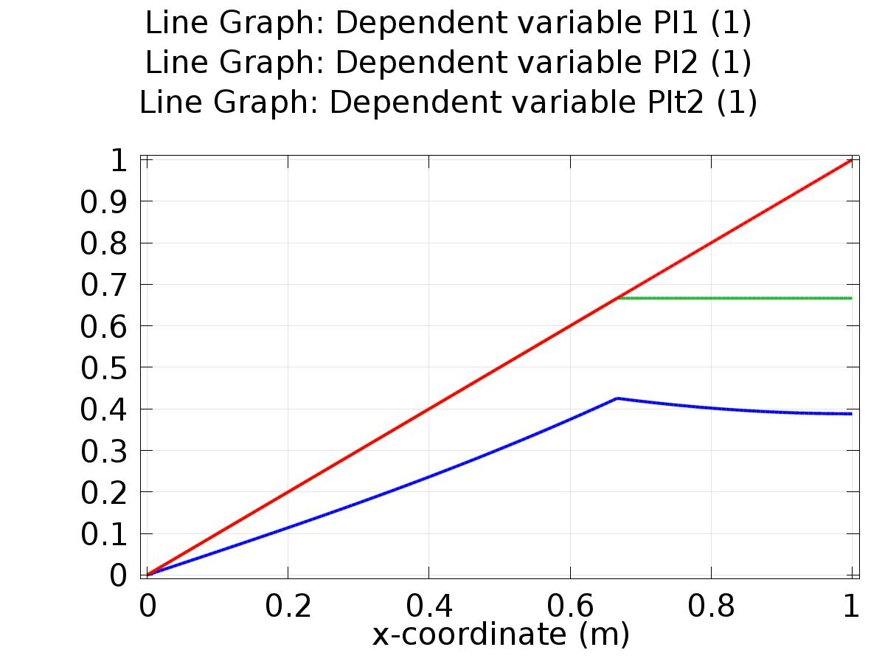

Line Graph: Dependent variable PI1 (1) Line Graph: Dependent variable PI2 (1) Line Graph: Dependent variable PIt2 (1)

* + 1. 1D Plot Group 2

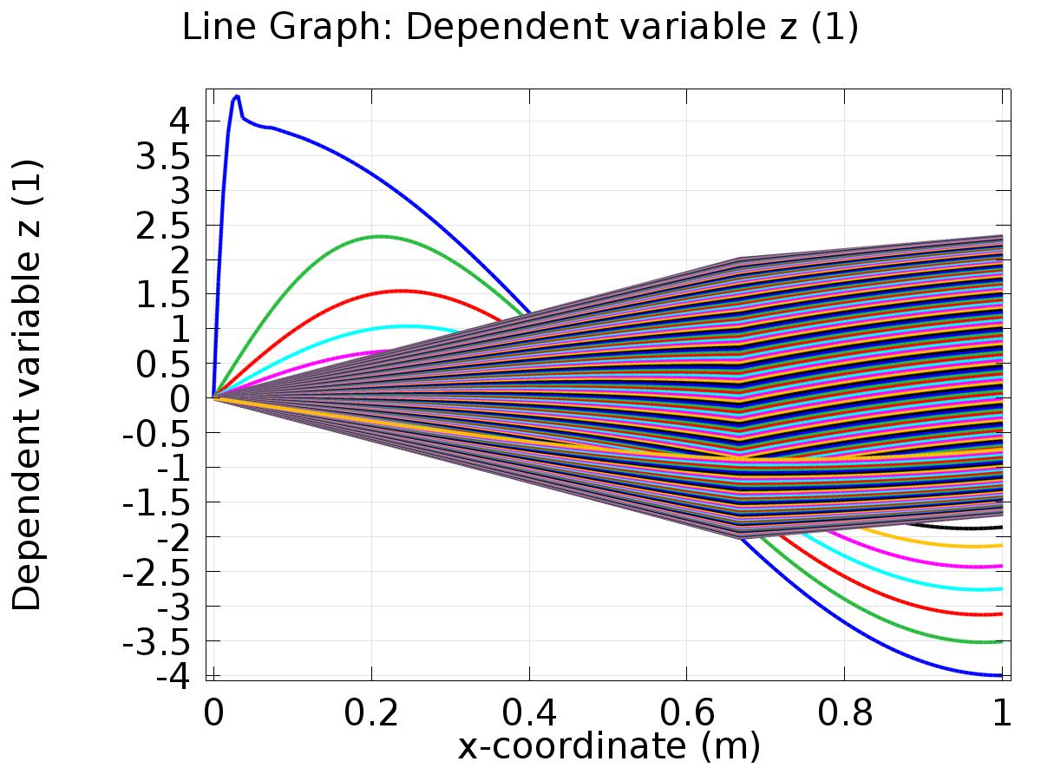

Line Graph: Dependent variable z (1)

* + 1. 1D Plot Group 3

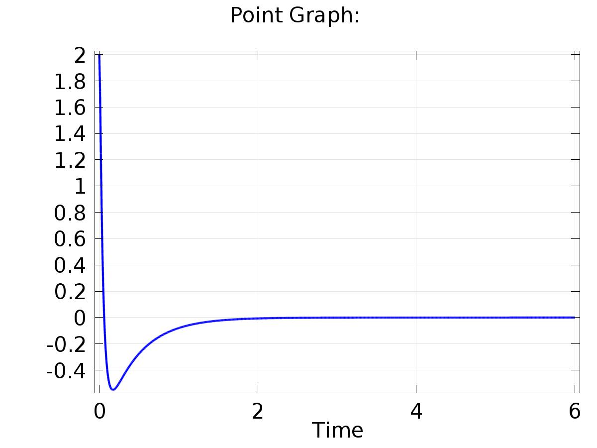

Point Graph:

* + 1. 1D Plot Group 4

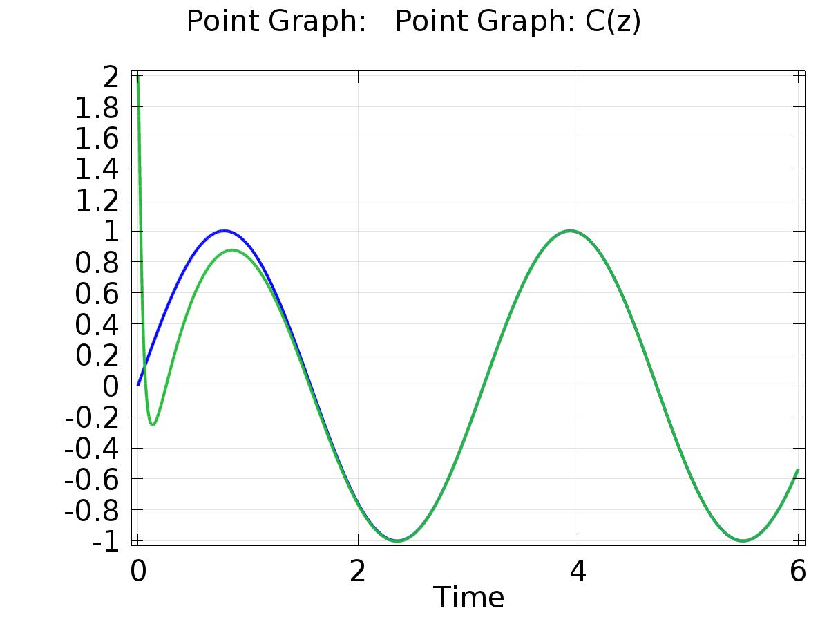

Point Graph: Point Graph: C(z)

* + 1. Probe 1D Plot Group 5

