[](http://www.comsol.com/)

Chap2Ex3 SISO HeatEquation triangle

|  |  |
| --- | --- |
| Date | Nov 5, 2013 2:28:19 PM |

Contents

1. Global

1.1. Definitions

2. Model 1

2.1. Definitions

2.2. Geometry 1

2.3. Coefficient Form PDE

2.4. Coefficient Form PDE 3

2.5. Coefficient Form PDE 2

2.6. Mesh 1

3. Study 1

3.1. Stationary

3.2. Solver Configurations

4. Study 2

4.1. Parametric Sweep

4.2. Stationary

4.3. Solver Configurations

5. Study 3

5.1. Time Dependent

5.2. Solver Configurations

6. Results

6.1. Data Sets

6.2. Derived Values

6.3. Tables

6.4. Plot Groups

1. Global

|  |  |
| --- | --- |
| Date | Aug 15, 2013 4:36:48 PM |

Global settings

|  |  |
| --- | --- |
| Name | Chap2Ex3 SISO HeatEquation triangle.mph |
| Path | /Users/gilliam/Desktop/collect_15/research_15/geo_reg_mono_eugenio/Mono_1_15/Comsol_EX_GitHub/Chapter2/Chap2Ex3/Chap2Ex3_SISO_HeatEquation_triangle.mph |
| Program | COMSOL 4.3b (Build: 189) |

Used products

|  |
| --- |
| COMSOL Multiphysics |

* 1. Definitions
     1. Parameters 1

Parameters

| **Name** | **Expression** | **Value** | **Description** |
| --- | --- | --- | --- |
| L | 1 | 1.0000 |  |
| n | 1 | 1.0000 |  |
| Mr | 0.5 | 0.50000 |  |

* + 1. Functions

#### Analytic 1

|  |  |
| --- | --- |
| Function name | alpha |
| Function type | Analytic |

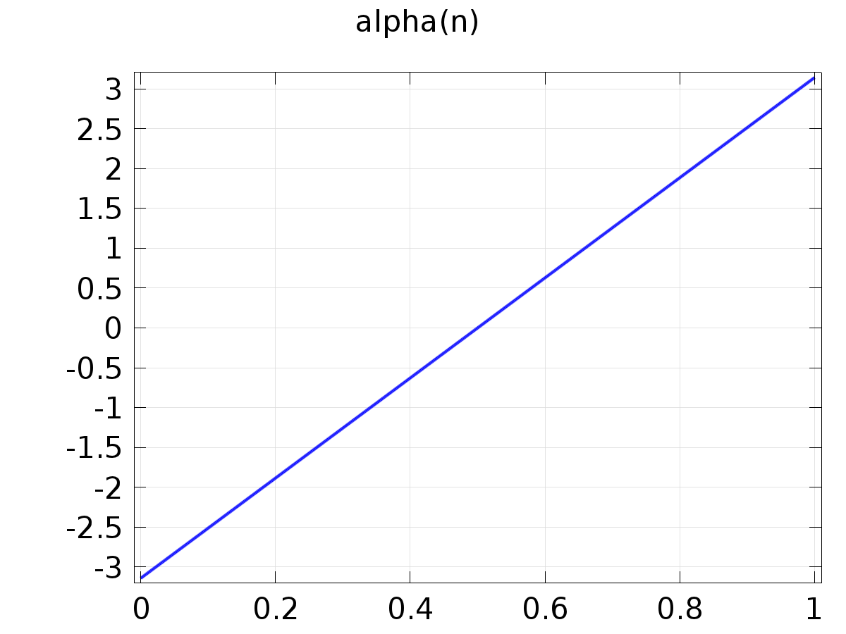

Analytic 1

Definition

| **Description** | **Value** |
| --- | --- |
| Expression | (2*n - 1)*pi |
| Arguments | n |

#### Analytic 2

|  |  |
| --- | --- |
| Function name | Ar |
| Function type | Analytic |

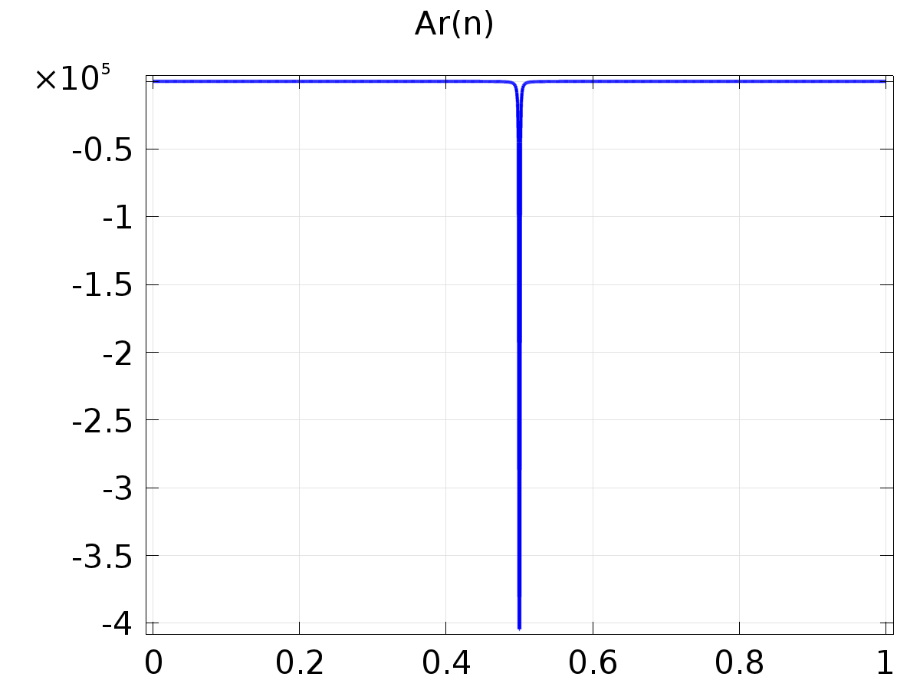

Analytic 2

Definition

| **Description** | **Value** |
| --- | --- |
| Expression | -4/(alpha(n))^2 |
| Arguments | n |

#### Analytic 3

|  |  |
| --- | --- |
| Function name | w1 |
| Function type | Analytic |

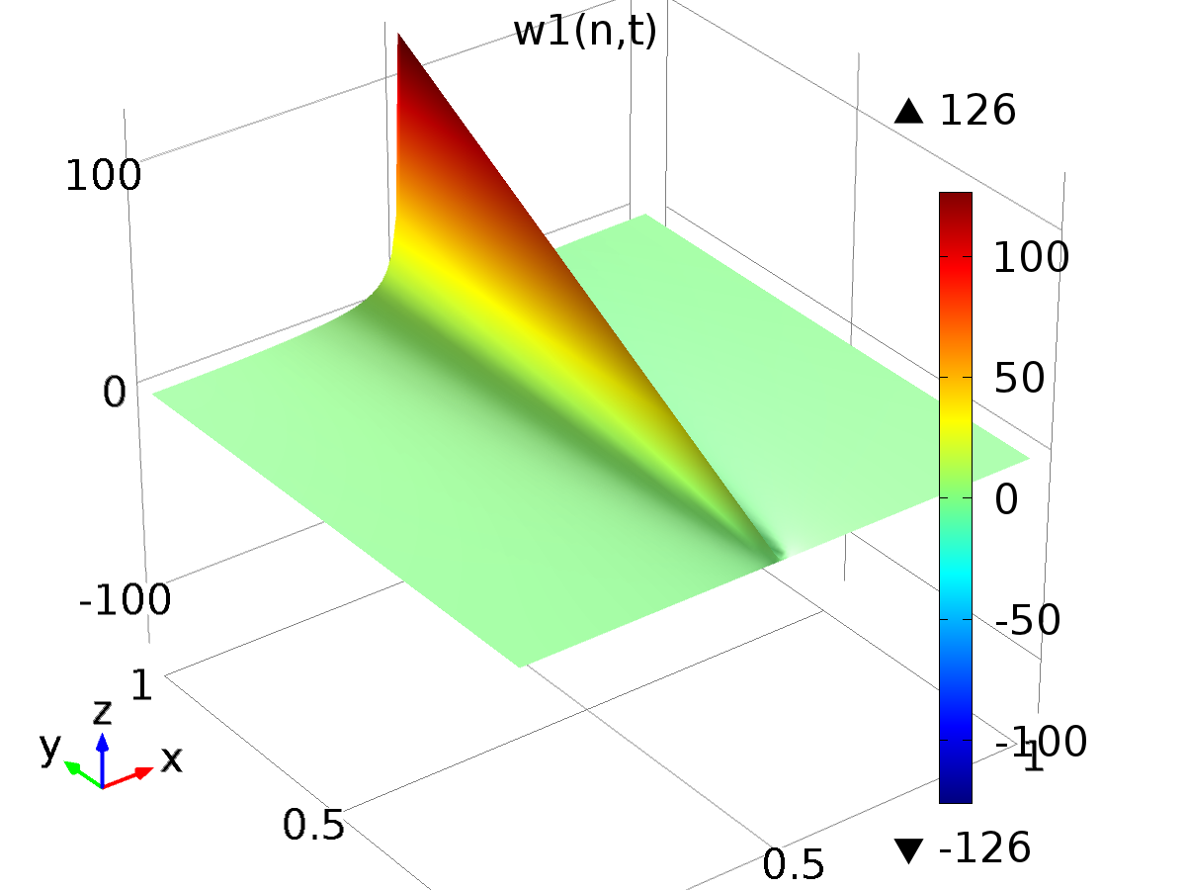

Analytic 3

Definition

| **Description** | **Value** |
| --- | --- |
| Expression | Ar(n)*sin(alpha(n)*t) |
| Arguments | {n, t} |

#### Analytic 4

|  |  |
| --- | --- |
| Function name | w2 |
| Function type | Analytic |

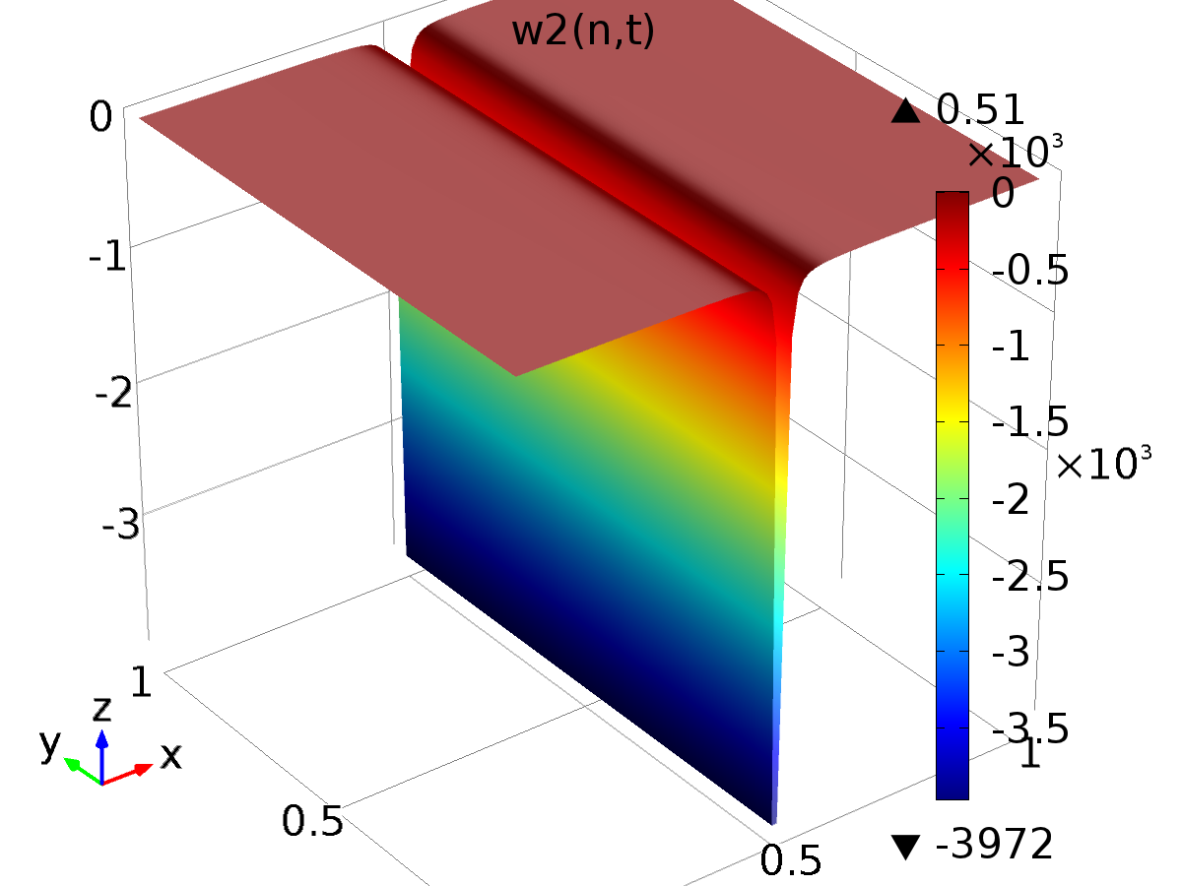

Analytic 4

Definition

| **Description** | **Value** |
| --- | --- |
| Expression | Ar(n)*cos(alpha(n)*t) |
| Arguments | {n, t} |

1. Model 1

Component settings

|  |  |
| --- | --- |
| Unit system | SI |

* 1. Definitions
     1. Variables

#### Variables 1

Selection

|  |  |
| --- | --- |
| Geometric entity level | Entire model |

| **Name** | **Expression** | **Description** |
| --- | --- | --- |
| Gamma_0 | 1/C(PI0) |  |
| Gamman1 | -imag(1/C(PIn)) |  |
| Gamman2 | real(1/C(PIn)) |  |
| w0 | Mr |  |
| err | z - yr |  |
| Bin | 1 |  |

#### Variables 2a

Selection

|  |  |
| --- | --- |
| Geometric entity level | Entire model |

| **Name** | **Expression** | **Description** |
| --- | --- | --- |
| Gamma0 | 0.7999999999995465 |  |
| Gamma1_1 | -3.578884033818498 |  |
| Gamma1_2 | -7.813779578590128 |  |
| Gamma1_3 | -3.5284284923251277 |  |
| Gamma1_4 | 14.140996171403312 |  |
| Gamma1_5 | 48.87024978552352 |  |
| Gamma1_6 | 102.73509656527025 |  |
| Gamma1_7 | 175.85080589651474 |  |
| Gamma1_8 | 266.0729078794366 |  |
| Gamma1_9 | 368.7705852239943 |  |
| Gamma1_10 | 476.68411711136275 |  |
| Gamma2_1 | -0.5237897928365126 |  |
| Gamma2_2 | -10.748473681363208 |  |
| Gamma2_3 | -29.26498761403147 |  |
| Gamma2_4 | -52.291678667480035 |  |
| Gamma2_5 | -74.37075898328712 |  |
| Gamma2_6 | -88.63189796536476 |  |
| Gamma2_7 | -87.14238416709397 |  |
| Gamma2_8 | -61.334211650437695 |  |
| Gamma2_9 | -2.4962647692501783 |  |
| Gamma2_10 | 97.68086477635816 |  |
| Gamma | Gamma0*w0 + Gamma1_1*w1(1, t) + Gamma2_1*w2(1, t) + Gamma1_2*w1(2, t) + Gamma2_2*w2(2, t) + Gamma1_3*w1(3, t) + Gamma2_3*w2(3, t) + Gamma1_4*w1(4, t) + Gamma2_4*w2(4, t) + Gamma1_5*w1(5, t) + Gamma2_5*w2(5, t) + Gamma1_6*w1(6, t) + Gamma2_6*w2(6, t) + Gamma1_7*w1(7, t) + Gamma2_7*w2(7, t) + Gamma1_8*w1(8, t) + Gamma2_8*w2(8, t) + Gamma1_9*w1(9, t) + Gamma2_9*w2(9, t) + Gamma1_10*w1(10, t) + Gamma2_10*w2(10, t) |  |
| yr | w0 + w2(1, t) + w2(2, t) + w2(3, t) + w2(4, t) + w2(5, t) + w2(6, t) + w2(7, t) + w2(8, t) + w2(9, t) + w2(10, t) |  |

* + 1. Component Couplings

#### Average 1

|  |  |
| --- | --- |
| Coupling type | Average |
| Operator name | C |

Source selection

|  |  |
| --- | --- |
| Geometric entity level | Boundary |
| Selection | Boundary 2 |

* 1. Geometry 1

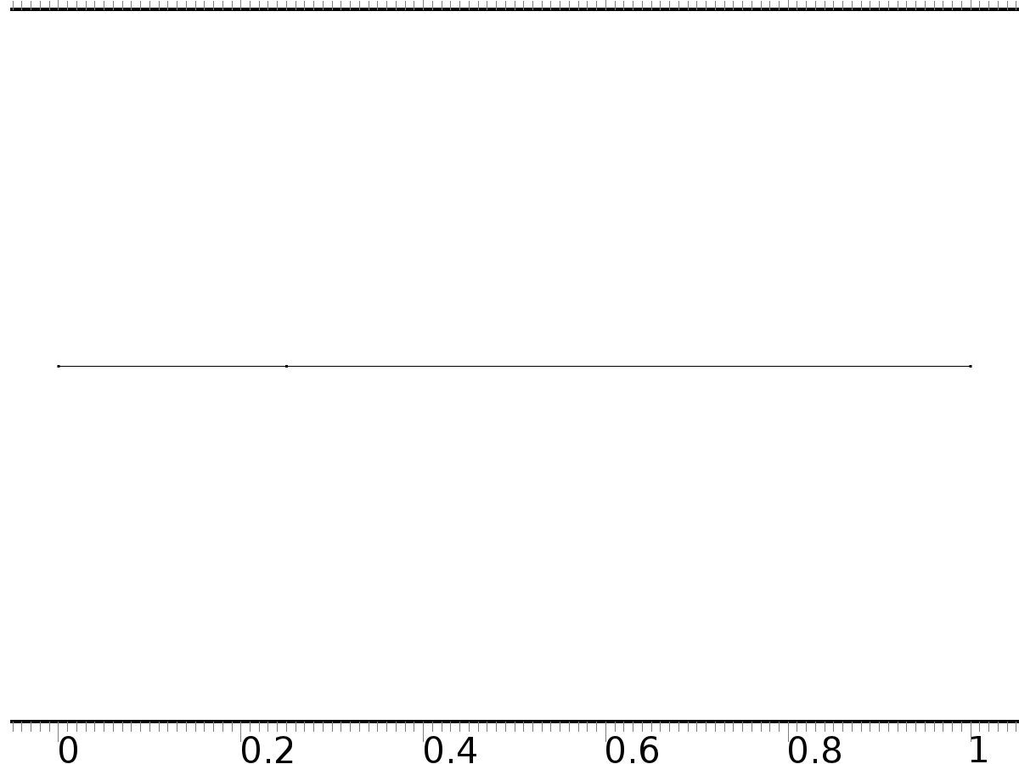

Geometry 1

Units

|  |  |
| --- | --- |
| Length unit | m |
| Angular unit | deg |

Geometry statistics

| **Description** | **Value** |
| --- | --- |
| Space dimension | 1 |
| Number of domains | 2 |
| Number of boundaries | 3 |

* + 1. Interval 1 (i1)

Interval

| **Description** | **Value** |
| --- | --- |
| Number of intervals | Many |
| Points | {0, 0.25, 1} |

* 1. Coefficient Form PDE

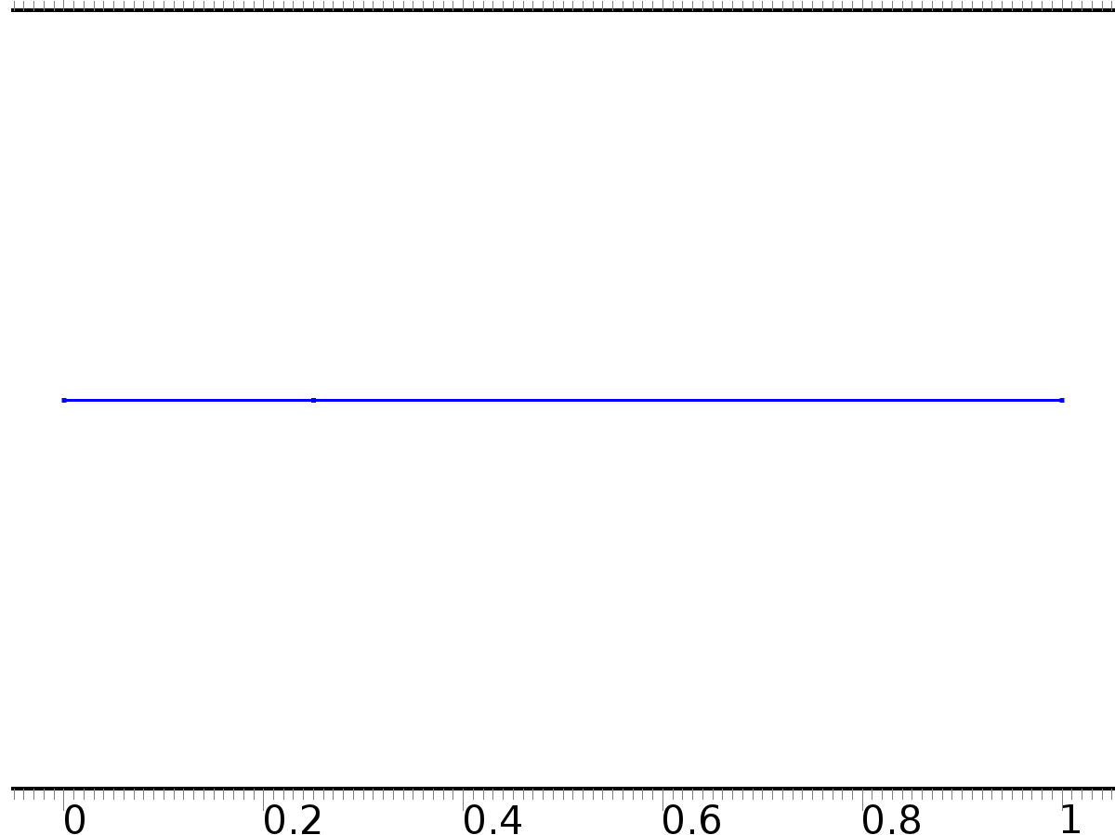

Coefficient Form PDE

Selection

|  |  |
| --- | --- |
| Geometric entity level | Domain |
| Selection | Domains 1–2 |

Settings

| **Description** | **Value** |
| --- | --- |
| Shape function type | Lagrange |
| Element order | Quadratic |
| Compute boundary fluxes | On |
| Apply smoothing to boundary fluxes | On |
| Value type when using splitting of complex variables | Complex |
| Dependent variable quantity | Dimensionless (1) |
| Source term quantity | None |
| Unit | m^ - 2 |

Used products

|  |
| --- |
| COMSOL Multiphysics |

Variables

| **Name** | **Expression** | **Unit** | **Description** | **Selection** |
| --- | --- | --- | --- | --- |
| c.nx | unx |  | Normal vector, x component | Boundary 1 |
| c.ny | 0 |  | Normal vector, y component | Boundary 1 |
| c.nz | 0 |  | Normal vector, z component | Boundary 1 |
| c.nx | dnx |  | Normal vector, x component | Boundary 3 |
| c.ny | 0 |  | Normal vector, y component | Boundary 3 |
| c.nz | 0 |  | Normal vector, z component | Boundary 3 |
| c.nx | nx |  | Normal vector, x component | Boundary 2 |
| c.ny | 0 |  | Normal vector, y component | Boundary 2 |
| c.nz | 0 |  | Normal vector, z component | Boundary 2 |
| c.nxmesh | root.unxmesh |  | Normal vector (mesh), x component | Boundary 1 |
| c.nymesh | 0 |  | Normal vector (mesh), y component | Boundary 1 |
| c.nzmesh | 0 |  | Normal vector (mesh), z component | Boundary 1 |
| c.nxmesh | root.dnxmesh |  | Normal vector (mesh), x component | Boundary 3 |
| c.nymesh | 0 |  | Normal vector (mesh), y component | Boundary 3 |
| c.nzmesh | 0 |  | Normal vector (mesh), z component | Boundary 3 |
| c.nxmesh | root.nxmesh |  | Normal vector (mesh), x component | Boundary 2 |
| c.nymesh | 0 |  | Normal vector (mesh), y component | Boundary 2 |
| c.nzmesh | 0 |  | Normal vector (mesh), z component | Boundary 2 |

* + 1. Coefficient Form PDE 1



Coefficient Form PDE 1

Selection

|  |  |
| --- | --- |
| Geometric entity level | Domain |
| Selection | Domains 1–2 |

Equations





Settings

| **Description** | **Value** |
| --- | --- |
| Diffusion coefficient | 1 |
| Absorption coefficient | 0 |
| Source term | 0 |
| Mass coefficient | 0 |
| Damping or mass coefficient | 0 |
| Conservative flux convection coefficient | 0 |
| Convection coefficient | 0 |
| Conservative flux source | 0 |

#### Variables

| **Name** | **Expression** | **Unit** | **Description** | **Selection** |
| --- | --- | --- | --- | --- |
| domflux.PI0x | -d(PI0,x) | 1/m | Domain flux, x component | Domains 1–2 |

#### Shape functions

| **Name** | **Shape function** | **Unit** | **Description** | **Shape frame** | **Selection** |
| --- | --- | --- | --- | --- | --- |
| PI0 | Lagrange (Quadratic) | 1 | Dependent variable PI0 | Material | Domains 1–2 |

* + 1. Zero Flux 1



Zero Flux 1

Selection

|  |  |
| --- | --- |
| Geometric entity level | Boundary |
| Selection | No boundaries |

Equations





* + 1. Initial Values 1



Initial Values 1

Selection

|  |  |
| --- | --- |
| Geometric entity level | Domain |
| Selection | Domains 1–2 |

Settings

| **Description** | **Value** |
| --- | --- |
| Initial value for PI0 | 0 |
| Initial time derivative of PI0 | 0 |

* + 1. Flux/Source 1

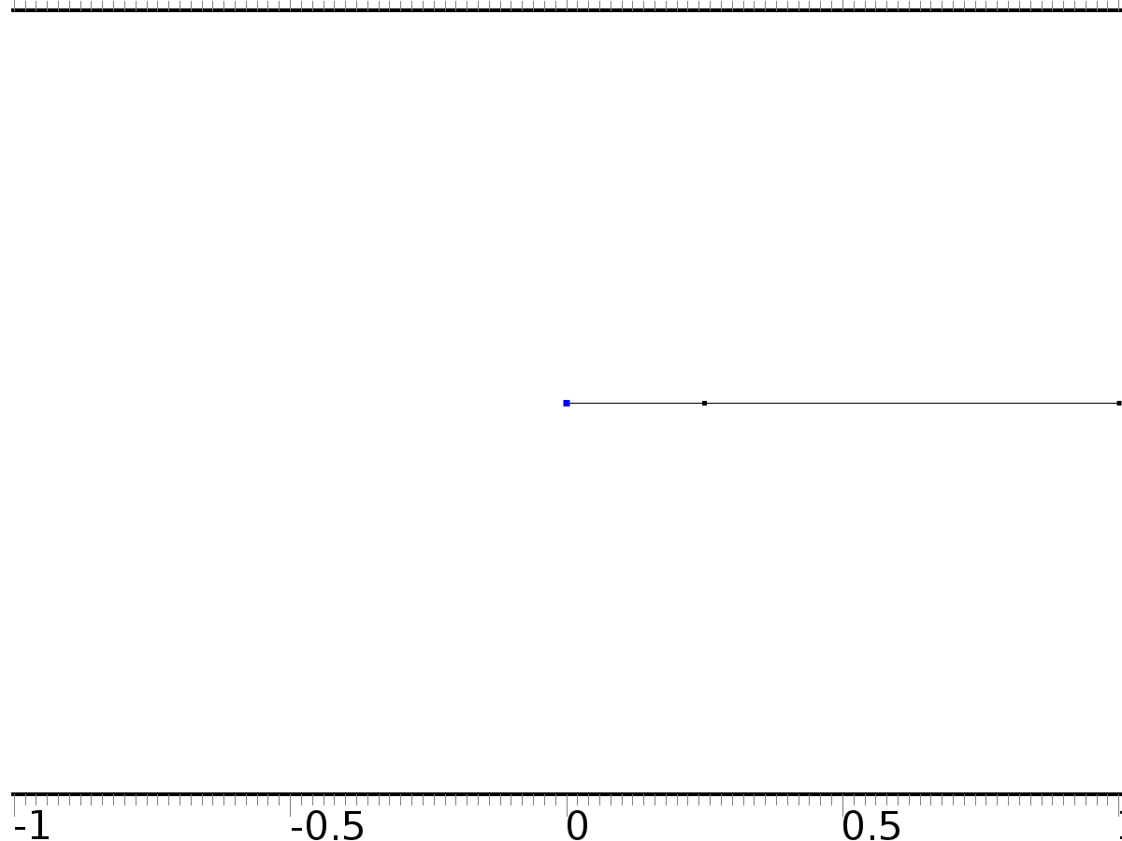

Flux/Source 1

Selection

|  |  |
| --- | --- |
| Geometric entity level | Boundary |
| Selection | Boundary 1 |

Equations





Settings

| **Description** | **Value** |
| --- | --- |
| Boundary flux/source | 0 |
| Boundary absorption/impedance term | 1 |

#### Variables

| **Name** | **Expression** | **Unit** | **Description** | **Selection** |
| --- | --- | --- | --- | --- |
| c.g_PI0 | -PI0 | 1/m | Boundary flux/source | Boundary 1 |

* + 1. Flux/Source 2

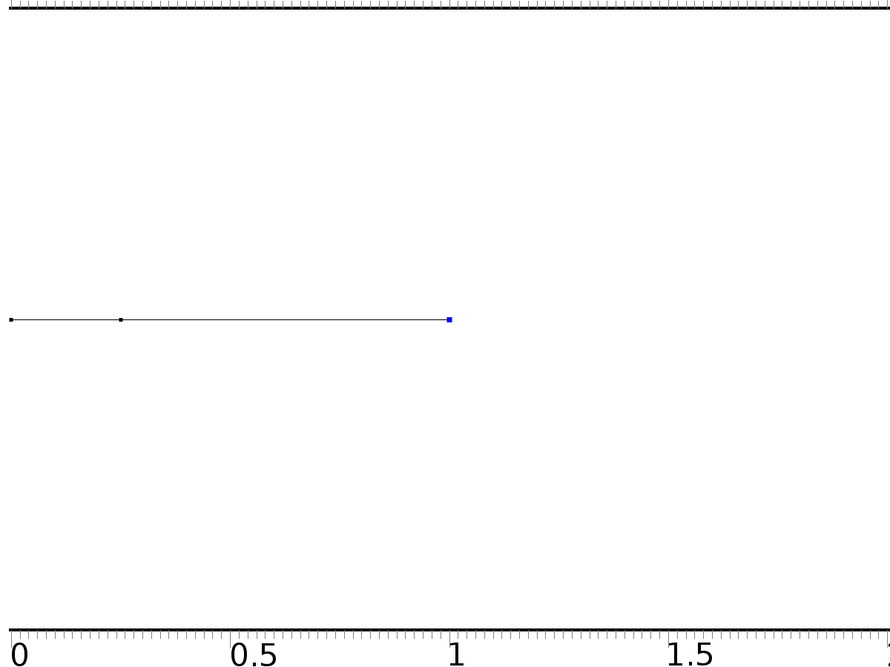

Flux/Source 2

Selection

|  |  |
| --- | --- |
| Geometric entity level | Boundary |
| Selection | Boundary 3 |

Equations





Settings

| **Description** | **Value** |
| --- | --- |
| Boundary flux/source | Bin |
| Boundary absorption/impedance term | 0 |

#### Variables

| **Name** | **Expression** | **Unit** | **Description** | **Selection** |
| --- | --- | --- | --- | --- |
| c.g_PI0 | Bin | 1/m | Boundary flux/source | Boundary 3 |

* 1. Coefficient Form PDE 3



Coefficient Form PDE 3

Selection

|  |  |
| --- | --- |
| Geometric entity level | Domain |
| Selection | Domains 1–2 |

Settings

| **Description** | **Value** |
| --- | --- |
| Shape function type | Lagrange |
| Element order | Quadratic |
| Compute boundary fluxes | On |
| Apply smoothing to boundary fluxes | On |
| Value type when using splitting of complex variables | Complex |
| Dependent variable quantity | Dimensionless (1) |
| Source term quantity | None |
| Unit | m^ - 2 |

Used products

|  |
| --- |
| COMSOL Multiphysics |

Variables

| **Name** | **Expression** | **Unit** | **Description** | **Selection** |
| --- | --- | --- | --- | --- |
| c2.nx | unx |  | Normal vector, x component | Boundary 1 |
| c2.ny | 0 |  | Normal vector, y component | Boundary 1 |
| c2.nz | 0 |  | Normal vector, z component | Boundary 1 |
| c2.nx | dnx |  | Normal vector, x component | Boundary 3 |
| c2.ny | 0 |  | Normal vector, y component | Boundary 3 |
| c2.nz | 0 |  | Normal vector, z component | Boundary 3 |
| c2.nx | nx |  | Normal vector, x component | Boundary 2 |
| c2.ny | 0 |  | Normal vector, y component | Boundary 2 |
| c2.nz | 0 |  | Normal vector, z component | Boundary 2 |
| c2.nxmesh | root.unxmesh |  | Normal vector (mesh), x component | Boundary 1 |
| c2.nymesh | 0 |  | Normal vector (mesh), y component | Boundary 1 |
| c2.nzmesh | 0 |  | Normal vector (mesh), z component | Boundary 1 |
| c2.nxmesh | root.dnxmesh |  | Normal vector (mesh), x component | Boundary 3 |
| c2.nymesh | 0 |  | Normal vector (mesh), y component | Boundary 3 |
| c2.nzmesh | 0 |  | Normal vector (mesh), z component | Boundary 3 |
| c2.nxmesh | root.nxmesh |  | Normal vector (mesh), x component | Boundary 2 |
| c2.nymesh | 0 |  | Normal vector (mesh), y component | Boundary 2 |
| c2.nzmesh | 0 |  | Normal vector (mesh), z component | Boundary 2 |

* + 1. Coefficient Form PDE 1



Coefficient Form PDE 1

Selection

|  |  |
| --- | --- |
| Geometric entity level | Domain |
| Selection | Domains 1–2 |

Equations





Settings

| **Description** | **Value** |
| --- | --- |
| Diffusion coefficient | 1 |
| Absorption coefficient | i*alpha(n) |
| Source term | 0 |
| Mass coefficient | 0 |
| Damping or mass coefficient | 0 |
| Conservative flux convection coefficient | 0 |
| Convection coefficient | 0 |
| Conservative flux source | 0 |

#### Variables

| **Name** | **Expression** | **Unit** | **Description** | **Selection** |
| --- | --- | --- | --- | --- |
| domflux.PInx | -d(PIn,x) | 1/m | Domain flux, x component | Domains 1–2 |

#### Shape functions

| **Name** | **Shape function** | **Unit** | **Description** | **Shape frame** | **Selection** |
| --- | --- | --- | --- | --- | --- |
| PIn | Lagrange (Quadratic) | 1 | Dependent variable PIn | Material | Domains 1–2 |

* + 1. Zero Flux 1



Zero Flux 1

Selection

|  |  |
| --- | --- |
| Geometric entity level | Boundary |
| Selection | No boundaries |

Equations





* + 1. Initial Values 1



Initial Values 1

Selection

|  |  |
| --- | --- |
| Geometric entity level | Domain |
| Selection | Domains 1–2 |

Settings

| **Description** | **Value** |
| --- | --- |
| Initial value for PIn | 0 |
| Initial time derivative of PIn | 0 |

* + 1. Flux/Source 1



Flux/Source 1

Selection

|  |  |
| --- | --- |
| Geometric entity level | Boundary |
| Selection | Boundary 1 |

Equations





Settings

| **Description** | **Value** |
| --- | --- |
| Boundary flux/source | 0 |
| Boundary absorption/impedance term | 1 |

#### Variables

| **Name** | **Expression** | **Unit** | **Description** | **Selection** |
| --- | --- | --- | --- | --- |
| c2.g_PIn | -PIn | 1/m | Boundary flux/source | Boundary 1 |

* + 1. Flux/Source 2



Flux/Source 2

Selection

|  |  |
| --- | --- |
| Geometric entity level | Boundary |
| Selection | Boundary 3 |

Equations





Settings

| **Description** | **Value** |
| --- | --- |
| Boundary flux/source | Bin |
| Boundary absorption/impedance term | 0 |

#### Variables

| **Name** | **Expression** | **Unit** | **Description** | **Selection** |
| --- | --- | --- | --- | --- |
| c2.g_PIn | Bin | 1/m | Boundary flux/source | Boundary 3 |

* 1. Coefficient Form PDE 2



Coefficient Form PDE 2

Selection

|  |  |
| --- | --- |
| Geometric entity level | Domain |
| Selection | Domains 1–2 |

Settings

| **Description** | **Value** |
| --- | --- |
| Shape function type | Lagrange |
| Element order | Quadratic |
| Compute boundary fluxes | On |
| Apply smoothing to boundary fluxes | On |
| Value type when using splitting of complex variables | Complex |
| Dependent variable quantity | Dimensionless (1) |
| Source term quantity | None |
| Unit | m^ - 2 |

Used products

|  |
| --- |
| COMSOL Multiphysics |

Variables

| **Name** | **Expression** | **Unit** | **Description** | **Selection** |
| --- | --- | --- | --- | --- |
| c3.nx | unx |  | Normal vector, x component | Boundary 1 |
| c3.ny | 0 |  | Normal vector, y component | Boundary 1 |
| c3.nz | 0 |  | Normal vector, z component | Boundary 1 |
| c3.nx | dnx |  | Normal vector, x component | Boundary 3 |
| c3.ny | 0 |  | Normal vector, y component | Boundary 3 |
| c3.nz | 0 |  | Normal vector, z component | Boundary 3 |
| c3.nx | nx |  | Normal vector, x component | Boundary 2 |
| c3.ny | 0 |  | Normal vector, y component | Boundary 2 |
| c3.nz | 0 |  | Normal vector, z component | Boundary 2 |
| c3.nxmesh | root.unxmesh |  | Normal vector (mesh), x component | Boundary 1 |
| c3.nymesh | 0 |  | Normal vector (mesh), y component | Boundary 1 |
| c3.nzmesh | 0 |  | Normal vector (mesh), z component | Boundary 1 |
| c3.nxmesh | root.dnxmesh |  | Normal vector (mesh), x component | Boundary 3 |
| c3.nymesh | 0 |  | Normal vector (mesh), y component | Boundary 3 |
| c3.nzmesh | 0 |  | Normal vector (mesh), z component | Boundary 3 |
| c3.nxmesh | root.nxmesh |  | Normal vector (mesh), x component | Boundary 2 |
| c3.nymesh | 0 |  | Normal vector (mesh), y component | Boundary 2 |
| c3.nzmesh | 0 |  | Normal vector (mesh), z component | Boundary 2 |

* + 1. Coefficient Form PDE 1



Coefficient Form PDE 1

Selection

|  |  |
| --- | --- |
| Geometric entity level | Domain |
| Selection | Domains 1–2 |

Equations





Settings

| **Description** | **Value** |
| --- | --- |
| Diffusion coefficient | 1 |
| Absorption coefficient | 0 |
| Source term | 0 |
| Mass coefficient | 0 |
| Damping or mass coefficient | 1 |
| Conservative flux convection coefficient | 0 |
| Convection coefficient | 0 |
| Conservative flux source | 0 |

#### Variables

| **Name** | **Expression** | **Unit** | **Description** | **Selection** |
| --- | --- | --- | --- | --- |
| domflux.zx | -d(z,x) | 1/m | Domain flux, x component | Domains 1–2 |

#### Shape functions

| **Name** | **Shape function** | **Unit** | **Description** | **Shape frame** | **Selection** |
| --- | --- | --- | --- | --- | --- |
| z | Lagrange (Quadratic) | 1 | Dependent variable z | Material | Domains 1–2 |

* + 1. Zero Flux 1



Zero Flux 1

Selection

|  |  |
| --- | --- |
| Geometric entity level | Boundary |
| Selection | No boundaries |

Equations





* + 1. Initial Values 1



Initial Values 1

Selection

|  |  |
| --- | --- |
| Geometric entity level | Domain |
| Selection | Domains 1–2 |

Settings

| **Description** | **Value** |
| --- | --- |
| Initial value for z | cos(pi*x) |
| Initial time derivative of z | 0 |

* + 1. Flux/Source 1



Flux/Source 1

Selection

|  |  |
| --- | --- |
| Geometric entity level | Boundary |
| Selection | Boundary 1 |

Equations





Settings

| **Description** | **Value** |
| --- | --- |
| Boundary flux/source | 0 |
| Boundary absorption/impedance term | 1 |

#### Variables

| **Name** | **Expression** | **Unit** | **Description** | **Selection** |
| --- | --- | --- | --- | --- |
| c3.g_z | -z | 1/m | Boundary flux/source | Boundary 1 |

* + 1. Flux/Source 2



Flux/Source 2

Selection

|  |  |
| --- | --- |
| Geometric entity level | Boundary |
| Selection | Boundary 3 |

Equations





Settings

| **Description** | **Value** |
| --- | --- |
| Boundary flux/source | Bin*Gamma |
| Boundary absorption/impedance term | 0 |

#### Variables

| **Name** | **Expression** | **Unit** | **Description** | **Selection** |
| --- | --- | --- | --- | --- |
| c3.g_z | Bin*Gamma | 1/m | Boundary flux/source | Boundary 3 |

* 1. Mesh 1

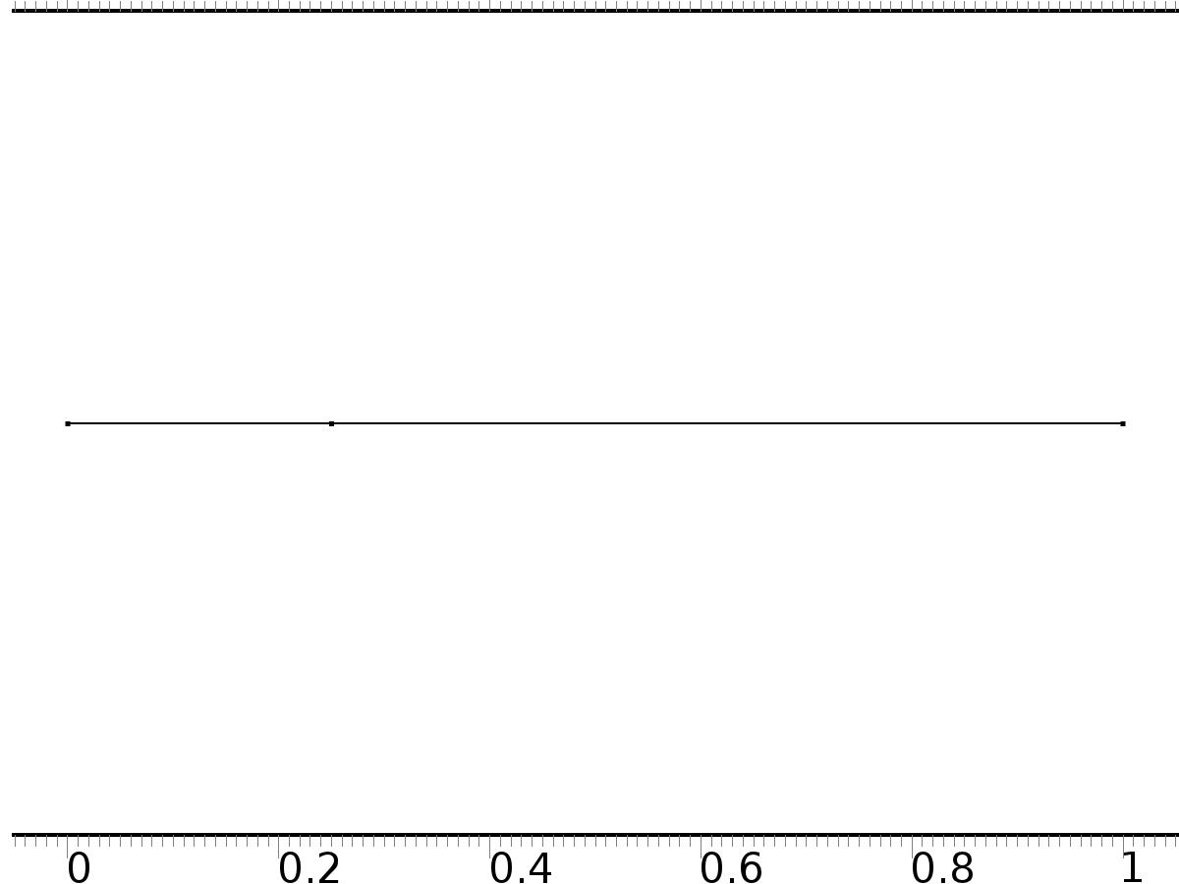

Mesh 1

* + 1. Size (size)

Settings

| **Description** | **Value** |
| --- | --- |
| Maximum element size | 0.037 |
| Minimum element size | 1.25E-4 |
| Curvature factor | 0.25 |
| Maximum element growth rate | 1.25 |
| Predefined size | Finer |

* + 1. Edge 1 (edg1)

Selection

|  |  |
| --- | --- |
| Geometric entity level | Remaining |

1. Study 1
   1. Stationary

Study settings

| **Description** | **Value** |
| --- | --- |
| Include geometric nonlinearity | Off |

Physics and variables selection

| **Physics interface** | **Discretization** |
| --- | --- |
| Coefficient Form PDE (c) | physics |

Mesh selection

| **Geometry** | **Mesh** |
| --- | --- |
| Geometry 1 (geom1) | mesh1 |

* 1. Solver Configurations
     1. Solver 1

#### Compile Equations: Stationary (st1)

Study and step

| **Description** | **Value** |
| --- | --- |
| Use study | Study 1 |
| Use study step | Stationary |

#### Dependent Variables 1 (v1)

General

| **Description** | **Value** |
| --- | --- |
| Defined by study step | Stationary |
| Constant |  |

Initial values of variables solved for

| **Description** | **Value** |
| --- | --- |
| Solution | Zero |

Values of variables not solved for

| **Description** | **Value** |
| --- | --- |
| Solution | Zero |

##### Dependent variable PI0 (mod1.PI0) (mod1_PI0)

General

| **Description** | **Value** |
| --- | --- |
| Field components | mod1.PI0 |
| Field name | mod1_X |

##### Dependent variable z (mod1.z) (mod1_z)

General

| **Description** | **Value** |
| --- | --- |
| Field components | mod1.z |
| Solve for this field | Off |

##### Dependent variable PIn (mod1.PIn) (mod1_PIn)

General

| **Description** | **Value** |
| --- | --- |
| Field components | mod1.PIn |
| Solve for this field | Off |

#### Stationary Solver 1 (s1)

General

| **Description** | **Value** |
| --- | --- |
| Defined by study step | Stationary |
| Relative tolerance | 0.0000010 |

Log

| **Description** | **Value** |
| --- | --- |
| Constant |  |

##### Advanced (aDef)

General

| **Description** | **Value** |
| --- | --- |
| Allow complex-valued output from functions with real input | On |

##### Fully Coupled 1 (fc1)

General

| **Description** | **Value** |
| --- | --- |
| Linear solver | Direct |

1. Study 2
   1. Parametric Sweep

| **Parameter name** | **Parameter value list** |
| --- | --- |
| n | 1,2,3,4,5,6,7,8,9,10 |

* 1. Stationary

Study settings

| **Description** | **Value** |
| --- | --- |
| Include geometric nonlinearity | Off |

Physics and variables selection

| **Physics interface** | **Discretization** |
| --- | --- |
| Coefficient Form PDE 3 (c3) | physics |

Mesh selection

| **Geometry** | **Mesh** |
| --- | --- |
| Geometry 1 (geom1) | mesh1 |

* 1. Solver Configurations
     1. Solver 2

#### Compile Equations: Stationary (st1)

Study and step

| **Description** | **Value** |
| --- | --- |
| Use study | Study 2 |
| Use study step | Stationary |

#### Dependent Variables 1 (v1)

General

| **Description** | **Value** |
| --- | --- |
| Defined by study step | Stationary |
| Constant |  |

Initial values of variables solved for

| **Description** | **Value** |
| --- | --- |
| Solution | Zero |

Values of variables not solved for

| **Description** | **Value** |
| --- | --- |
| Solution | Solver 1 |

##### Dependent variable PIn (mod1.PIn) (mod1_PIn)

General

| **Description** | **Value** |
| --- | --- |
| Field components | mod1.PIn |

##### Dependent variable PI0 (mod1.PI0) (mod1_PI0)

General

| **Description** | **Value** |
| --- | --- |
| Field components | mod1.PI0 |
| Solve for this field | Off |
| Field name | mod1_PI1 |

##### Dependent variable z (mod1.z) (mod1_z)

General

| **Description** | **Value** |
| --- | --- |
| Field components | mod1.z |
| Solve for this field | Off |

#### Stationary Solver 1 (s1)

General

| **Description** | **Value** |
| --- | --- |
| Defined by study step | Stationary |
| Relative tolerance | 0.0000010 |

Log

| **Description** | **Value** |
| --- | --- |
| Constant |  |

##### Parametric 1 (p1)

General

| **Description** | **Value** |
| --- | --- |
| Defined by study step | Parametric Sweep |
| Parameter value list | 1, 2, 3, 4, 5, 6, 7, 8, 9, 10 |

##### Fully Coupled 1 (fc1)

General

| **Description** | **Value** |
| --- | --- |
| Linear solver | Direct |

1. Study 3
   1. Time Dependent

Study settings

| **Description** | **Value** |
| --- | --- |
| Include geometric nonlinearity | Off |

| **Times** | **Unit** |
| --- | --- |
| range(0,0.1,8) | s |

Physics and variables selection

| **Physics interface** | **Discretization** |
| --- | --- |
| Coefficient Form PDE 2 (c2) | physics |

Mesh selection

| **Geometry** | **Mesh** |
| --- | --- |
| Geometry 1 (geom1) | mesh1 |

* 1. Solver Configurations
     1. Solver 3

#### Compile Equations: Time Dependent (st1)

Study and step

| **Description** | **Value** |
| --- | --- |
| Use study | Study 3 |
| Use study step | Time Dependent |

#### Dependent Variables 1 (v1)

General

| **Description** | **Value** |
| --- | --- |
| Defined by study step | Time Dependent |
| Constant |  |

Initial values of variables solved for

| **Description** | **Value** |
| --- | --- |
| Solution | Zero |

Values of variables not solved for

| **Description** | **Value** |
| --- | --- |
| Solution | Zero |

##### Dependent variable PIn (mod1.PIn) (mod1_PIn)

General

| **Description** | **Value** |
| --- | --- |
| Field components | mod1.PIn |
| Solve for this field | Off |

##### Dependent variable PI0 (mod1.PI0) (mod1_PI0)

General

| **Description** | **Value** |
| --- | --- |
| Field components | mod1.PI0 |
| Solve for this field | Off |

##### Dependent variable z (mod1.z) (mod1_z)

General

| **Description** | **Value** |
| --- | --- |
| Field components | mod1.z |

#### Time-Dependent Solver 1 (t1)

General

| **Description** | **Value** |
| --- | --- |
| Defined by study step | Time Dependent |
| Time | {0, 0.1, 0.2, 0.30000000000000004, 0.4, 0.5, 0.6000000000000001, 0.7000000000000001, 0.8, 0.9, 1, 1.1, 1.2000000000000002, 1.3, 1.4000000000000001, 1.5, 1.6, 1.7000000000000002, 1.8, 1.9000000000000001, 2, 2.1, 2.2, 2.3000000000000003, 2.4000000000000004, 2.5, 2.6, 2.7, 2.8000000000000003, 2.9000000000000004, 3, 3.1, 3.2, 3.3000000000000003, 3.4000000000000004, 3.5, 3.6, 3.7, 3.8000000000000003, 3.9000000000000004, 4, 4.1000000000000005, 4.2, 4.3, 4.4, 4.5, 4.6000000000000005, 4.7, 4.800000000000001, 4.9, 5, 5.1000000000000005, 5.2, 5.300000000000001, 5.4, 5.5, 5.6000000000000005, 5.7, 5.800000000000001, 5.9, 6, 6.1000000000000005, 6.2, 6.300000000000001, 6.4, 6.5, 6.6000000000000005, 6.7, 6.800000000000001, 6.9, 7, 7.1000000000000005, 7.2, 7.300000000000001, 7.4, 7.5, 7.6000000000000005, 7.7, 7.800000000000001, 7.9, 8} |
| Relative tolerance | 0.00001 |

Absolute tolerance

| **Description** | **Value** |
| --- | --- |
| Tolerance | 0.0010 |

Time stepping

| **Description** | **Value** |
| --- | --- |
| Initial step | 0.0010 |

Advanced

| **Description** | **Value** |
| --- | --- |
| Fraction of initial step for Backward Euler | 0.0010 |

Log

| **Description** | **Value** |
| --- | --- |
| Constant |  |

##### Fully Coupled 1 (fc1)

General

| **Description** | **Value** |
| --- | --- |
| Linear solver | Direct |

1. Results
   1. Data Sets
      1. Solution 1

Solution

| **Description** | **Value** |
| --- | --- |
| Solution | Solver 1 |
| Component | Save Point Geometry 1 |

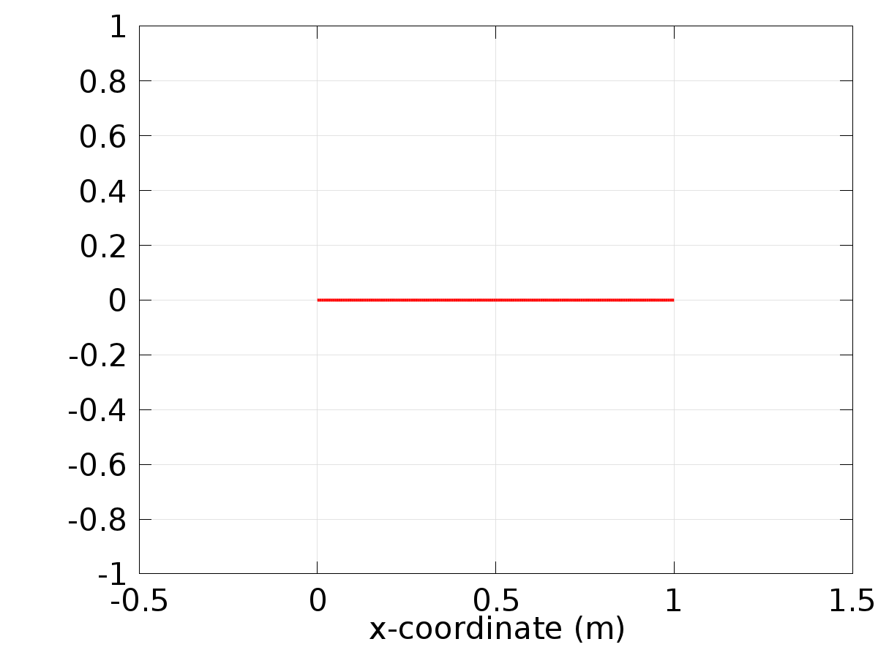

Data set: Solution 1

* + 1. Solution 2

Solution

| **Description** | **Value** |
| --- | --- |
| Solution | Solver 2 |
| Component | Save Point Geometry 1 |

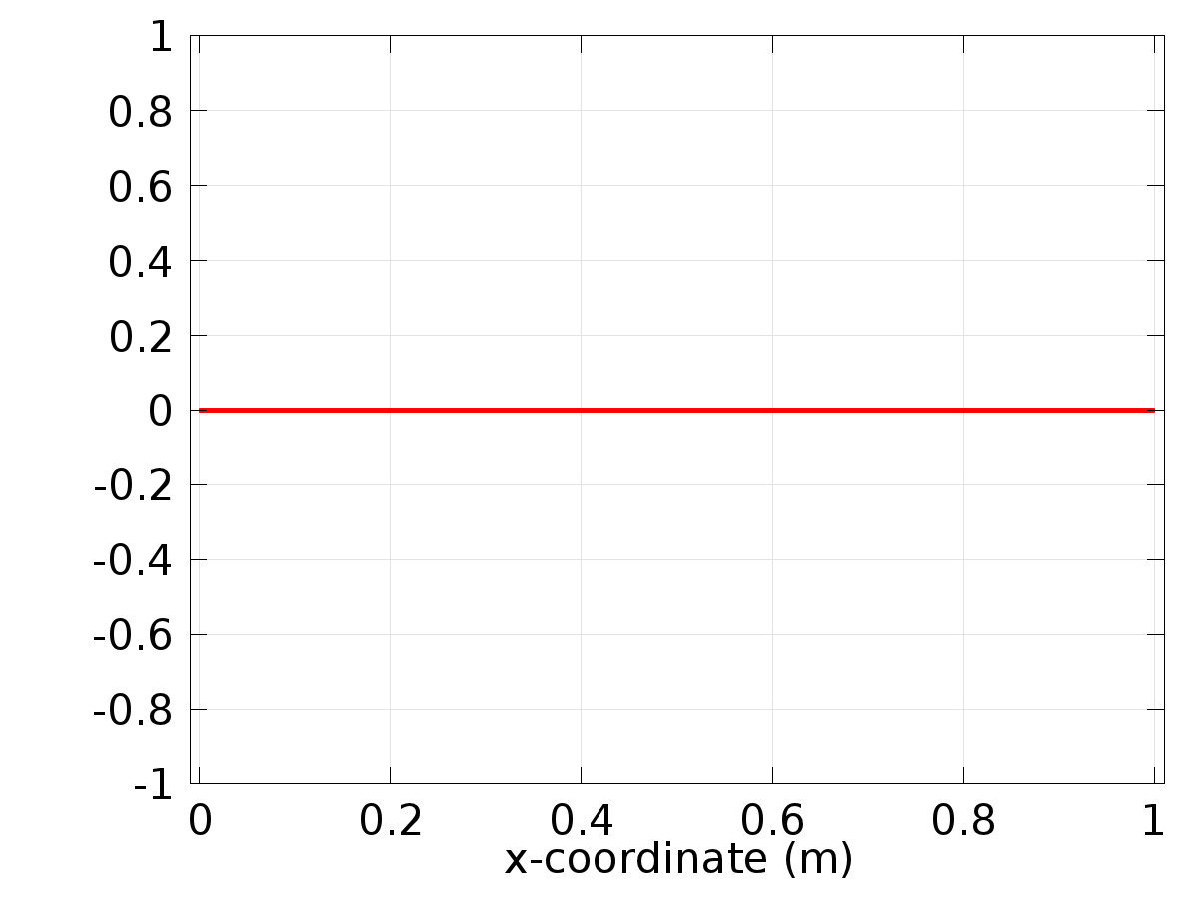

Data set: Solution 2

* + 1. Solution 3

Solution

| **Description** | **Value** |
| --- | --- |
| Solution | Solver 3 |
| Component | Save Point Geometry 1 |

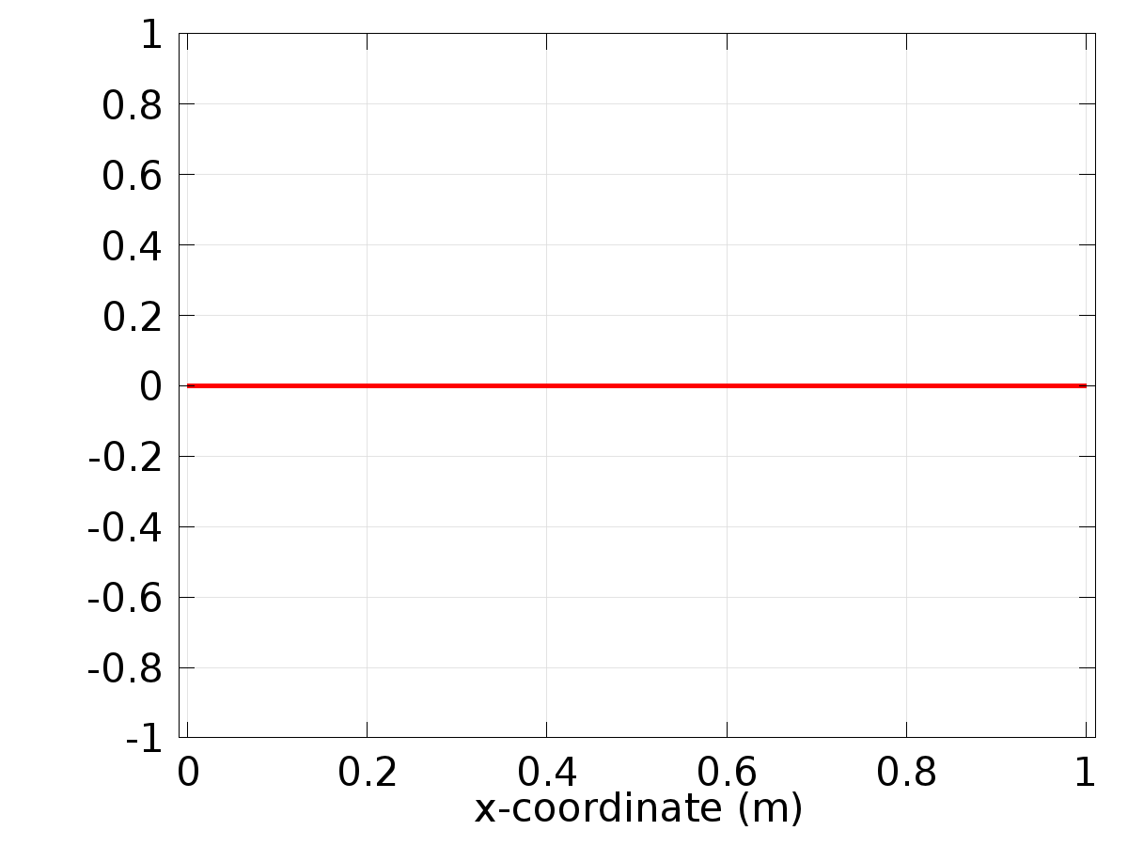

Data set: Solution 3

* 1. Derived Values
     1. Global Evaluation 4

Data

| **Description** | **Value** |
| --- | --- |
| Data set | Solution 1 |

Expression

| **Description** | **Value** |
| --- | --- |
| Expression | Gamma_0 |
| Description | Gamma_0 |

* + 1. Global Evaluation 5

Data

| **Description** | **Value** |
| --- | --- |
| Data set | Solution 2 |

Expression

| **Description** | **Value** |
| --- | --- |
| Expression | Gamman1 |
| Unit | 1 |

* + 1. Global Evaluation 6

Data

| **Description** | **Value** |
| --- | --- |
| Data set | Solution 2 |

Expression

| **Description** | **Value** |
| --- | --- |
| Expression | Gamman2 |
| Description | Gamman2 |

* + 1. Point Evaluation 1

Selection

|  |  |
| --- | --- |
| Geometric entity level | Boundary |
| Selection | Boundary 2 |

Data

| **Description** | **Value** |
| --- | --- |
| Data set | Solution 3 |

Expression

| **Description** | **Value** |
| --- | --- |
| Expression | Gamma |

* 1. Tables
     1. Table 1

Global Evaluation 4 (Gamma0)

Table 1

| **Gamma_0** |
| --- |
| 0.80000 |

* + 1. Table 2

Global Evaluation 5 (Gamman1)

Table 2

| **n** | **Gamman1 (1)** |
| --- | --- |
| 1.0000 | -3.5789 |
| 2.0000 | -7.8138 |
| 3.0000 | -3.5284 |
| 4.0000 | 14.141 |
| 5.0000 | 48.870 |
| 6.0000 | 102.74 |
| 7.0000 | 175.85 |
| 8.0000 | 266.07 |
| 9.0000 | 368.77 |
| 10.000 | 476.68 |

* + 1. Table 3

Global Evaluation 6 (Gamman2)

* + 1. Table 4

Point Evaluation 1 (C(z))

Table 4

| **Time** | **C(z) (1), Point: 2** | **yr, Point: 2** | **Gamma, Point: 2** |
| --- | --- | --- | --- |
| 0.0000 | 0.70700 | 0.010124 | 2.8855 |
| 0.10000 | 0.19881 | 0.10041 | 1.9013 |
| 0.20000 | 0.10305 | 0.20011 | 1.7357 |
| 0.30000 | 0.15130 | 0.30004 | 1.7267 |
| 0.40000 | 0.24396 | 0.40002 | 1.7720 |
| 0.50000 | 0.34979 | 0.50000 | 1.8479 |
| 0.60000 | 0.45924 | 0.59998 | 1.9521 |
| 0.70000 | 0.57009 | 0.69996 | 2.0997 |
| 0.80000 | 0.67985 | 0.79989 | 2.3548 |
| 0.90000 | 0.78797 | 0.89959 | 3.1596 |
| 1.0000 | 0.88643 | 0.98988 | -2.0855 |
| 1.1000 | 0.80368 | 0.89959 | -1.1013 |
| 1.2000 | 0.71067 | 0.79989 | -0.93569 |
| 1.3000 | 0.61671 | 0.69996 | -0.92675 |
| 1.4000 | 0.52252 | 0.59998 | -0.97202 |
| 1.5000 | 0.42829 | 0.50000 | -1.0479 |
| 1.6000 | 0.33372 | 0.40002 | -1.1521 |
| 1.7000 | 0.23828 | 0.30004 | -1.2997 |
| 1.8000 | 0.14268 | 0.20011 | -1.5548 |
| 1.9000 | 0.047132 | 0.10041 | -2.3596 |
| 2.0000 | -0.039369 | 0.010124 | 2.8855 |
| 2.1000 | 0.054422 | 0.10041 | 1.9013 |
| 2.2000 | 0.15743 | 0.20011 | 1.7357 |
| 2.3000 | 0.26041 | 0.30004 | 1.7267 |
| 2.4000 | 0.36321 | 0.40002 | 1.7720 |
| 2.5000 | 0.46582 | 0.50000 | 1.8479 |
| 2.6000 | 0.56824 | 0.59998 | 1.9521 |
| 2.7000 | 0.67048 | 0.69996 | 2.0997 |
| 2.8000 | 0.77251 | 0.79989 | 2.3548 |
| 2.9000 | 0.87416 | 0.89959 | 3.1596 |
| 3.0000 | 0.96630 | 0.98988 | -2.0855 |
| 3.1000 | 0.87773 | 0.89959 | -1.1013 |
| 3.2000 | 0.77956 | 0.79989 | -0.93569 |
| 3.3000 | 0.68107 | 0.69996 | -0.92675 |
| 3.4000 | 0.58245 | 0.59998 | -0.97202 |
| 3.5000 | 0.48371 | 0.50000 | -1.0479 |
| 3.6000 | 0.38489 | 0.40002 | -1.1521 |
| 3.7000 | 0.28600 | 0.30004 | -1.2997 |
| 3.8000 | 0.18707 | 0.20011 | -1.5548 |
| 3.9000 | 0.088305 | 0.10041 | -2.3596 |
| 4.0000 | -0.0011508 | 0.010124 | 2.8855 |
| 4.1000 | 0.089908 | 0.10041 | 1.9013 |
| 4.2000 | 0.19038 | 0.20011 | 1.7357 |
| 4.3000 | 0.29101 | 0.30004 | 1.7267 |
| 4.4000 | 0.39163 | 0.40002 | 1.7720 |
| 4.5000 | 0.49221 | 0.50000 | 1.8479 |
| 4.6000 | 0.59275 | 0.59998 | 1.9521 |
| 4.7000 | 0.69324 | 0.69996 | 2.0997 |
| 4.8000 | 0.79365 | 0.79989 | 2.3548 |
| 4.9000 | 0.89379 | 0.89959 | 3.1596 |
| 5.0000 | 0.98452 | 0.98988 | -2.0855 |
| 5.1000 | 0.89465 | 0.89959 | -1.1013 |
| 5.2000 | 0.79528 | 0.79989 | -0.93569 |
| 5.3000 | 0.69567 | 0.69996 | -0.92675 |
| 5.4000 | 0.59600 | 0.59998 | -0.97202 |
| 5.5000 | 0.49630 | 0.50000 | -1.0479 |
| 5.6000 | 0.39658 | 0.40002 | -1.1521 |
| 5.7000 | 0.29686 | 0.30004 | -1.2997 |
| 5.8000 | 0.19716 | 0.20011 | -1.5548 |
| 5.9000 | 0.097668 | 0.10041 | -2.3596 |
| 6.0000 | 0.0075439 | 0.010124 | 2.8855 |
| 6.1000 | 0.097982 | 0.10041 | 1.9013 |
| 6.2000 | 0.19788 | 0.20011 | 1.7357 |
| 6.3000 | 0.29798 | 0.30004 | 1.7267 |
| 6.4000 | 0.39810 | 0.40002 | 1.7720 |
| 6.5000 | 0.49822 | 0.50000 | 1.8479 |
| 6.6000 | 0.59833 | 0.59998 | 1.9521 |
| 6.7000 | 0.69842 | 0.69996 | 2.0997 |
| 6.8000 | 0.79846 | 0.79989 | 2.3548 |
| 6.9000 | 0.89826 | 0.89959 | 3.1596 |
| 7.0000 | 0.98867 | 0.98988 | -2.0855 |
| 7.1000 | 0.89850 | 0.89959 | -1.1013 |
| 7.2000 | 0.79886 | 0.79989 | -0.93569 |
| 7.3000 | 0.69899 | 0.69996 | -0.92675 |
| 7.4000 | 0.59909 | 0.59998 | -0.97202 |
| 7.5000 | 0.49917 | 0.50000 | -1.0479 |
| 7.6000 | 0.39924 | 0.40002 | -1.1521 |
| 7.7000 | 0.29933 | 0.30004 | -1.2997 |
| 7.8000 | 0.19945 | 0.20011 | -1.5548 |
| 7.9000 | 0.099799 | 0.10041 | -2.3596 |
| 8.0000 | 0.0095223 | 0.010124 | 2.8855 |

* 1. Plot Groups
     1. 1D Plot Group 8

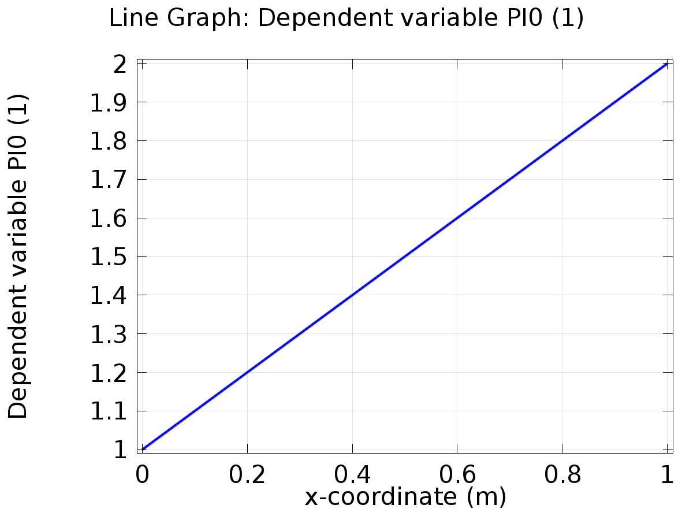

Line Graph: Dependent variable PI0 (1)

* + 1. 1D Plot Group 9

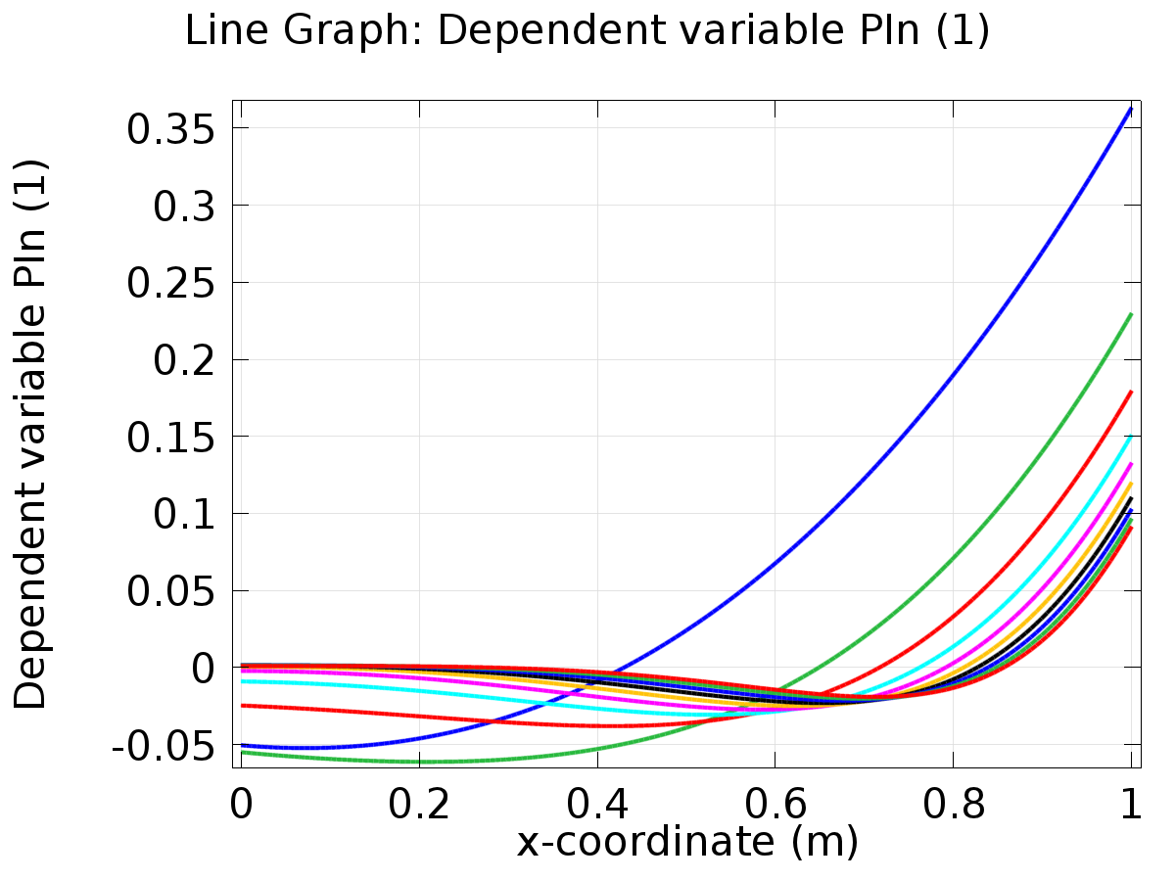

Line Graph: Dependent variable PIn (1)

* + 1. 1D Plot Group 10

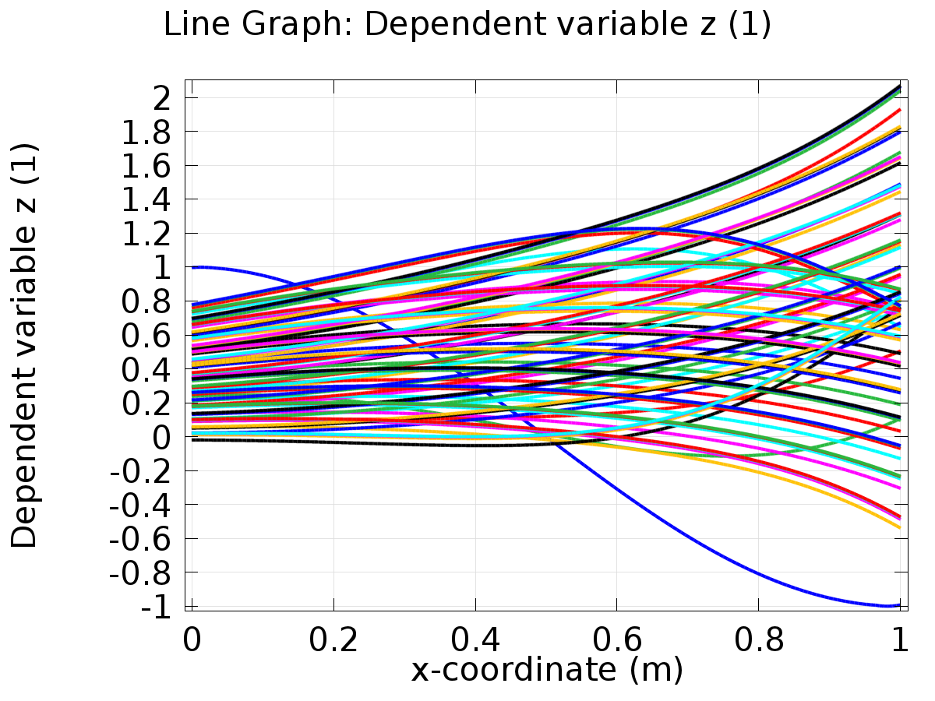

Line Graph: Dependent variable z (1)

* + 1. 1D Plot Group 11

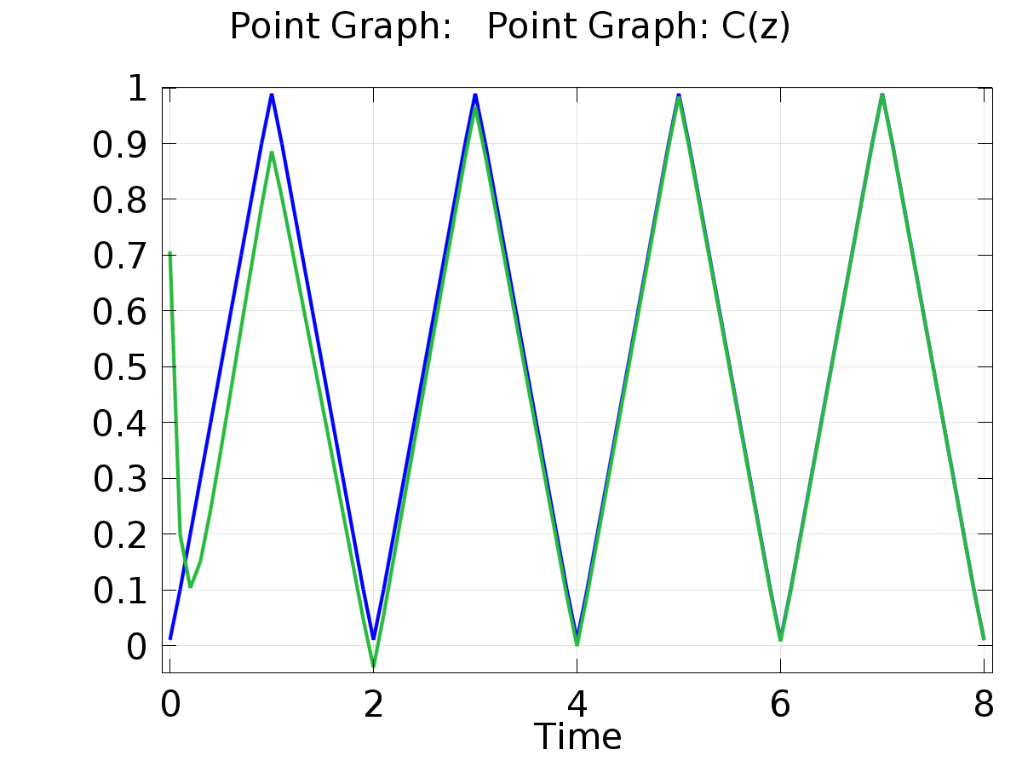

Point Graph: Point Graph: C(z)

* + 1. 1D Plot Group 12

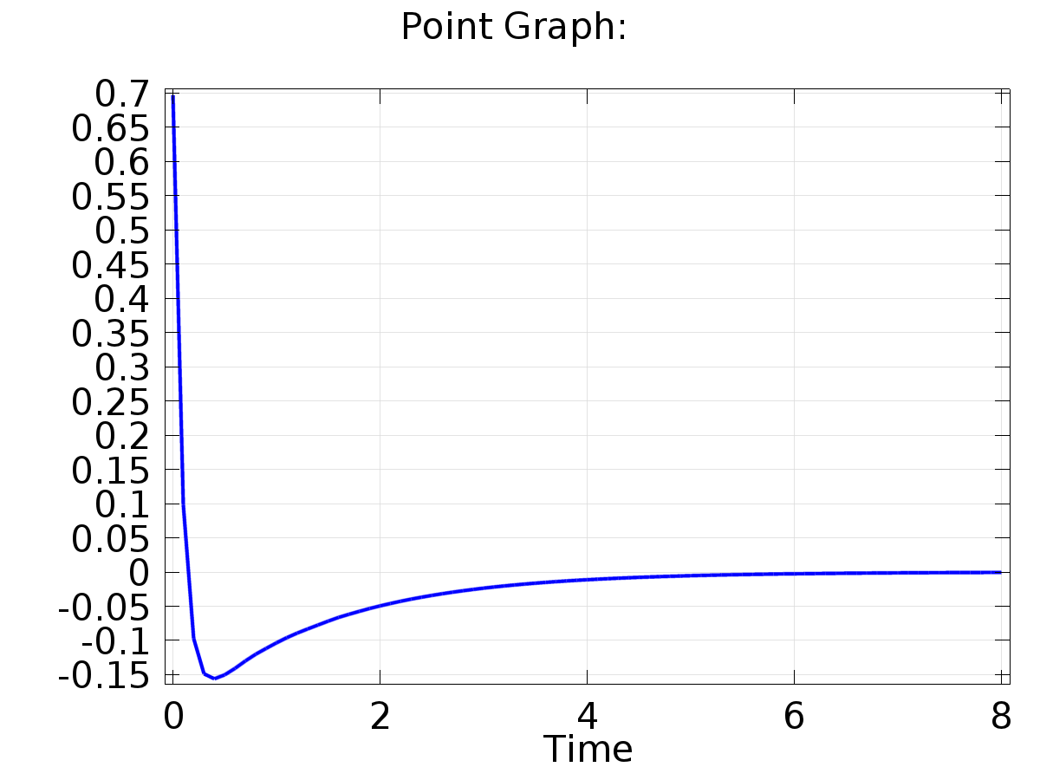

Point Graph: