[](http://www.comsol.com/)

Chap2Ex4 SISO DampedWaveEquation

|  |  |
| --- | --- |
| Date | Sep 6, 2013 3:00:15 PM |

Contents

1. Global

1.1. Definitions

2. Model 1

2.1. Definitions

2.2. Geometry 1

2.3. Coefficient Form PDE

2.4. Coefficient Form PDE 2

2.5. Mesh 1

3. Study 1

3.1. Stationary

3.2. Solver Configurations

4. Study 2

4.1. Time Dependent

4.2. Solver Configurations

5. Results

5.1. Data Sets

5.2. Derived Values

5.3. Tables

5.4. Plot Groups

1. Global

|  |  |
| --- | --- |
| Date | Aug 15, 2013 4:36:48 PM |

Global settings

|  |  |
| --- | --- |
| Name | Chap2Ex4 SISO DampedWaveEquation.mph |
| Path | /Users/gilliam/Desktop/collect_15/research_15/geo_reg_mono_eugenio/Mono_1_15/Comsol_EX_GitHub/Chapter2/Chap2Ex4/Chap2Ex4_SISO_DampedWaveEquation.mph |
| Program | COMSOL 4.3b (Build: 189) |

Used products

|  |
| --- |
| COMSOL Multiphysics |

* 1. Definitions
     1. Parameters 1

Parameters

| **Name** | **Expression** | **Value** | **Description** |
| --- | --- | --- | --- |
| L | 1 | 1.0000 |  |
| Mr | 1 | 1.0000 |  |
| beta | 0.5 | 0.50000 |  |
| Ad | 0.25 | 0.25000 |  |
| gamma | 0.5 | 0.50000 |  |
| k1 | 1 | 1.0000 |  |

1. Model 1

Component settings

|  |  |
| --- | --- |
| Unit system | SI |

* 1. Definitions
     1. Variables

#### Variables 1

Selection

|  |  |
| --- | --- |
| Geometric entity level | Entire model |

| **Name** | **Expression** | **Description** |
| --- | --- | --- |
| Gamma1 | real(1/C(PI1)) |  |
| rCPI2i | real(1/C(PI2)) |  |
| iCPI2i | imag(1/C(PI2)) |  |
| rCPIt2 | real(C(PIt2)) |  |
| iCPIt2 | imag(C(PIt2)) |  |
| Gamma2 | (-rCPI2i*rCPIt2 + iCPI2i*iCPIt2) |  |
| Gamma3 | (-rCPI2i*iCPIt2 - iCPI2i*rCPIt2) |  |
| w1 | Mr |  |
| w2 | Ad*sin(beta*t) |  |
| w3 | Ad*cos(beta*t) |  |
| Gamma | Gamma1*w1 + Gamma2*w2 + Gamma3*w3 |  |
| err | w1 - C(z) |  |
| Bin | -1 |  |
| Bd | -1 |  |

* + 1. Probes

#### Global Variable Probe 1

|  |  |
| --- | --- |
| Probe type | Global variable probe |

#### Global Variable Probe 2

|  |  |
| --- | --- |
| Probe type | Global variable probe |

#### Global Variable Probe 3

|  |  |
| --- | --- |
| Probe type | Global variable probe |

* + 1. Component Couplings

#### Average 1

|  |  |
| --- | --- |
| Coupling type | Average |
| Operator name | C |

Source selection

|  |  |
| --- | --- |
| Geometric entity level | Boundary |
| Selection | Boundary 3 |

* 1. Geometry 1

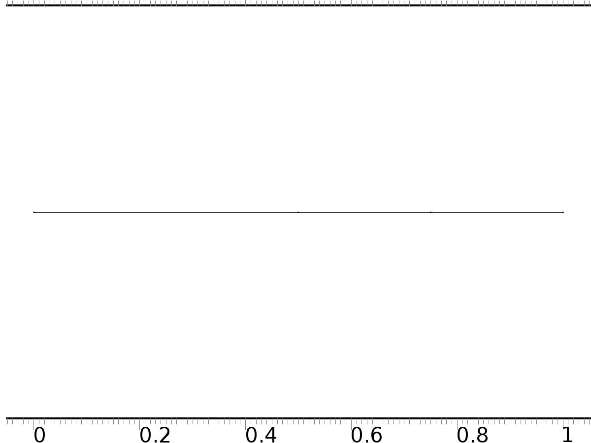

Geometry 1

Units

|  |  |
| --- | --- |
| Length unit | m |
| Angular unit | deg |

Geometry statistics

| **Description** | **Value** |
| --- | --- |
| Space dimension | 1 |
| Number of domains | 3 |
| Number of boundaries | 4 |

* + 1. Interval 1 (i1)

Interval

| **Description** | **Value** |
| --- | --- |
| Number of intervals | Many |
| Points | {0, 0.5, 0.75, 1} |

* 1. Coefficient Form PDE

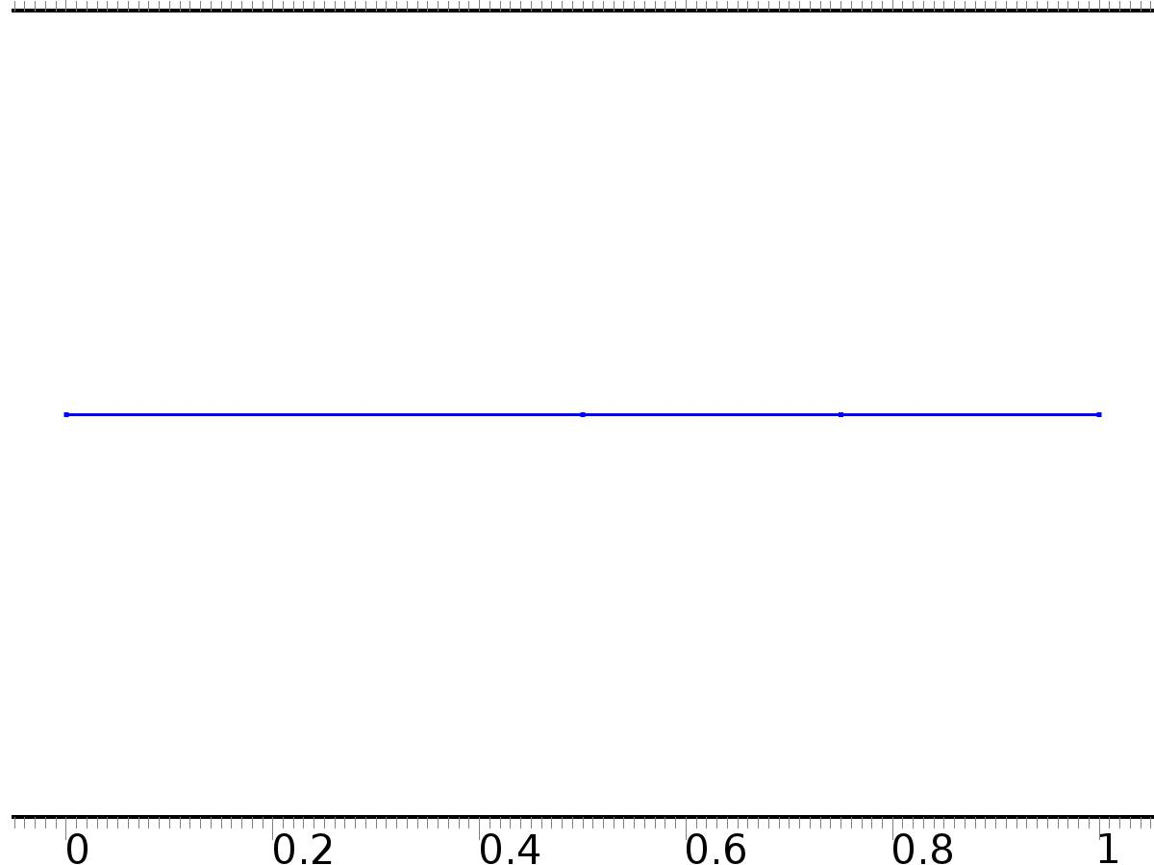

Coefficient Form PDE

Selection

|  |  |
| --- | --- |
| Geometric entity level | Domain |
| Selection | Domains 1–3 |

Settings

| **Description** | **Value** |
| --- | --- |
| Shape function type | Lagrange |
| Element order | Quadratic |
| Compute boundary fluxes | On |
| Apply smoothing to boundary fluxes | On |
| Value type when using splitting of complex variables | Complex |
| Dependent variable quantity | Dimensionless (1) |
| Source term quantity | None |
| Unit | m^ - 2 |

Used products

|  |
| --- |
| COMSOL Multiphysics |

Variables

| **Name** | **Expression** | **Unit** | **Description** | **Selection** |
| --- | --- | --- | --- | --- |
| c.nx | unx |  | Normal vector, x component | Boundary 1 |
| c.ny | 0 |  | Normal vector, y component | Boundary 1 |
| c.nz | 0 |  | Normal vector, z component | Boundary 1 |
| c.nx | dnx |  | Normal vector, x component | Boundary 4 |
| c.ny | 0 |  | Normal vector, y component | Boundary 4 |
| c.nz | 0 |  | Normal vector, z component | Boundary 4 |
| c.nx | nx |  | Normal vector, x component | Boundaries 2–3 |
| c.ny | 0 |  | Normal vector, y component | Boundaries 2–3 |
| c.nz | 0 |  | Normal vector, z component | Boundaries 2–3 |
| c.nxmesh | root.unxmesh |  | Normal vector (mesh), x component | Boundary 1 |
| c.nymesh | 0 |  | Normal vector (mesh), y component | Boundary 1 |
| c.nzmesh | 0 |  | Normal vector (mesh), z component | Boundary 1 |
| c.nxmesh | root.dnxmesh |  | Normal vector (mesh), x component | Boundary 4 |
| c.nymesh | 0 |  | Normal vector (mesh), y component | Boundary 4 |
| c.nzmesh | 0 |  | Normal vector (mesh), z component | Boundary 4 |
| c.nxmesh | root.nxmesh |  | Normal vector (mesh), x component | Boundaries 2–3 |
| c.nymesh | 0 |  | Normal vector (mesh), y component | Boundaries 2–3 |
| c.nzmesh | 0 |  | Normal vector (mesh), z component | Boundaries 2–3 |

* + 1. Coefficient Form PDE 1



Coefficient Form PDE 1

Selection

|  |  |
| --- | --- |
| Geometric entity level | Domain |
| Selection | Domains 1–3 |

Equations

Settings

| **Description** | **Value** |
| --- | --- |
| Diffusion coefficient | {{1, 0, 0}, {0, 1, 0}, {0, 0, 1}} |
| Absorption coefficient | {{0, 0, 0}, {0, i*2*gamma*beta - beta^2, 0}, {0, 0, i*2*gamma*beta - beta^2}} |
| Source term | {0, 0, 0} |
| Mass coefficient | {{0, 0, 0}, {0, 0, 0}, {0, 0, 0}} |
| Damping or mass coefficient | {{0, 0, 0}, {0, 0, 0}, {0, 0, 0}} |
| Conservative flux convection coefficient | {{0, 0, 0}, {0, 0, 0}, {0, 0, 0}} |
| Convection coefficient | {{0, 0, 0}, {0, 0, 0}, {0, 0, 0}} |
| Conservative flux source | {0, 0, 0} |

#### Variables

| **Name** | **Expression** | **Unit** | **Description** | **Selection** |
| --- | --- | --- | --- | --- |
| domflux.PI1x | -d(PI1,x) | 1/m | Domain flux, x component | Domains 1–3 |
| domflux.PI2x | -d(PI2,x) | 1/m | Domain flux, x component | Domains 1–3 |
| domflux.PIt2x | -d(PIt2,x) | 1/m | Domain flux, x component | Domains 1–3 |

#### Shape functions

| **Name** | **Shape function** | **Unit** | **Description** | **Shape frame** | **Selection** |
| --- | --- | --- | --- | --- | --- |
| PI1 | Lagrange (Quadratic) | 1 | Dependent variable PI1 | Material | Domains 1–3 |
| PI2 | Lagrange (Quadratic) | 1 | Dependent variable PI2 | Material | Domains 1–3 |
| PIt2 | Lagrange (Quadratic) | 1 | Dependent variable PIt2 | Material | Domains 1–3 |

* + 1. Zero Flux 1



Zero Flux 1

Selection

|  |  |
| --- | --- |
| Geometric entity level | Boundary |
| Selection | No boundaries |

Equations

* + 1. Initial Values 1



Initial Values 1

Selection

|  |  |
| --- | --- |
| Geometric entity level | Domain |
| Selection | Domains 1–3 |

Settings

| **Description** | **Value** |
| --- | --- |
| Initial value for PI2 | 0 |
| Initial time derivative of PI2 | 0 |
| Initial value for PI1 | 0 |
| Initial time derivative of PI1 | 0 |
| Initial value for PIt2 | 0 |
| Initial time derivative of PIt2 | 0 |

* + 1. Flux/Source 1

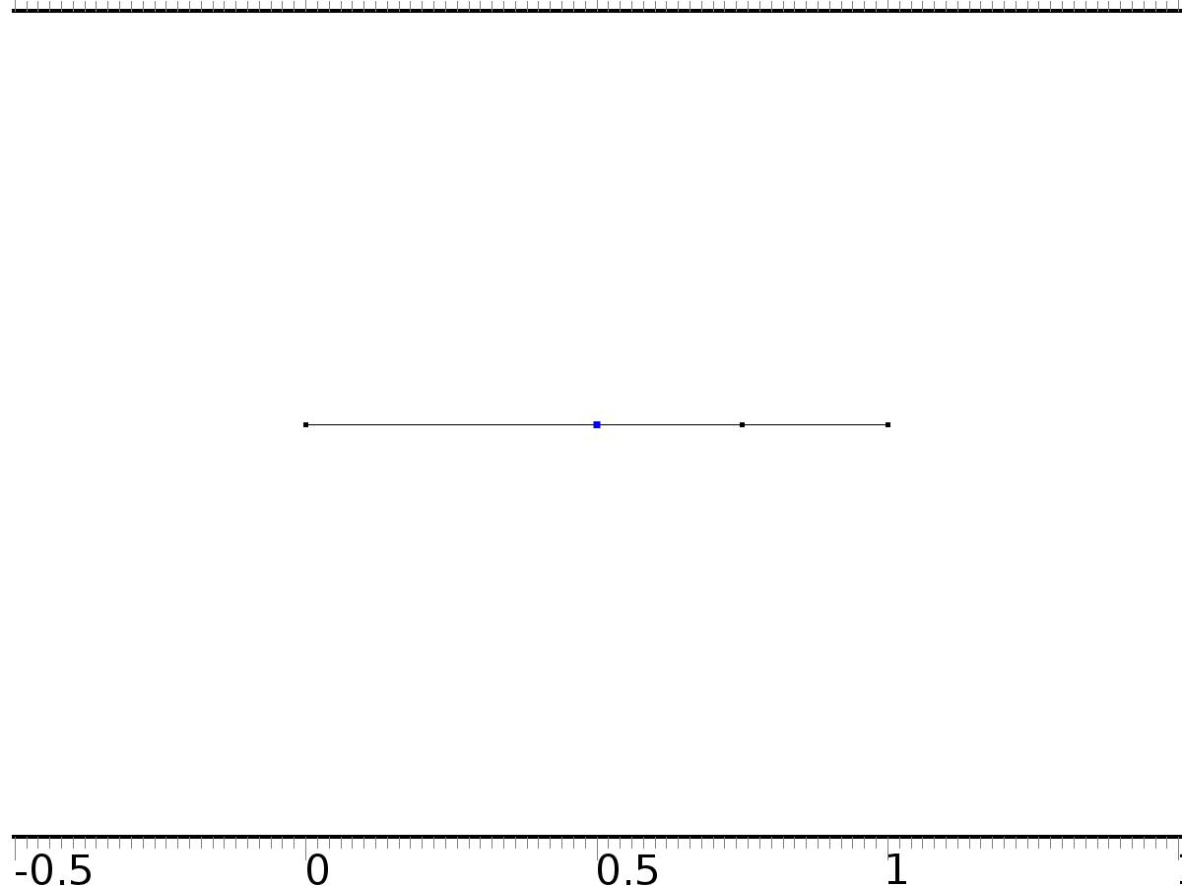

Flux/Source 1

Selection

|  |  |
| --- | --- |
| Geometric entity level | Boundary |
| Selection | Boundary 2 |

Equations

Settings

| **Description** | **Value** |
| --- | --- |
| Boundary flux/source | {Bin, Bin, 0} |
| Boundary absorption/impedance term | {{0, 0, 0}, {0, 0, 0}, {0, 0, 0}} |

#### Variables

| **Name** | **Expression** | **Unit** | **Description** | **Selection** |
| --- | --- | --- | --- | --- |
| c.g_PI1 | Bin | 1/m | Boundary flux/source | Boundary 2 |
| c.g_PI2 | Bin | 1/m | Boundary flux/source | Boundary 2 |
| c.g_PIt2 | 0 | 1/m | Boundary flux/source | Boundary 2 |

* + 1. Dirichlet Boundary Condition 2

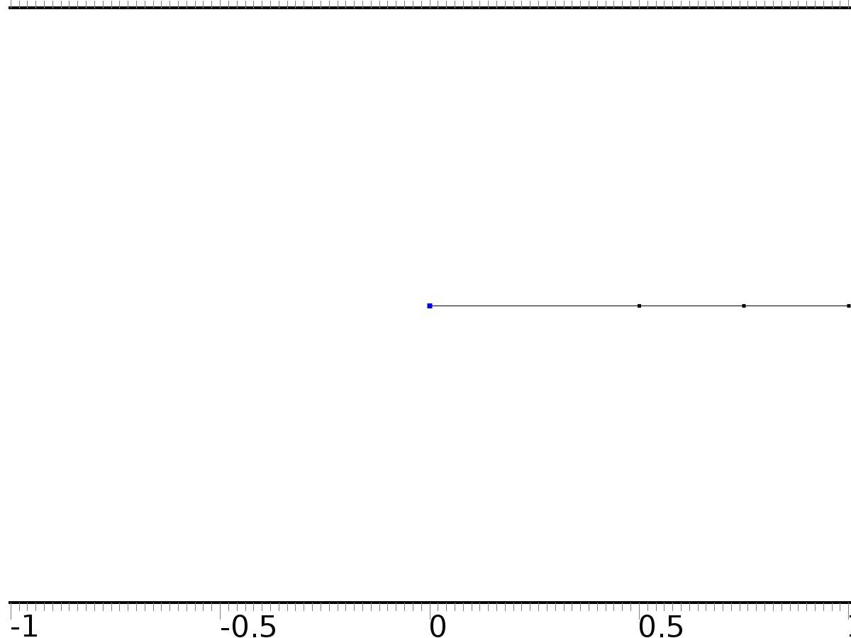

Dirichlet Boundary Condition 2

Selection

|  |  |
| --- | --- |
| Geometric entity level | Boundary |
| Selection | Boundary 1 |

Equations

Settings

| **Description** | **Value** |
| --- | --- |
| Value on boundary | {0, 0, 0} |
| Prescribed value of PI1 | On |
| Prescribed value of PI2 | On |
| Prescribed value of PIt2 | On |
| Apply reaction terms on | Individual dependent variables |
| Use weak constraints | Off |
| Constraint method | Elemental |

#### Shape functions

| **Constraint** | **Constraint force** | **Shape function** | **Selection** |
| --- | --- | --- | --- |
| -PI1 | -test(PI1) | Lagrange (Quadratic) | Boundary 1 |
| -PI2 | -test(PI2) | Lagrange (Quadratic) | Boundary 1 |
| -PIt2 | -test(PIt2) | Lagrange (Quadratic) | Boundary 1 |

* + 1. Flux/Source 2

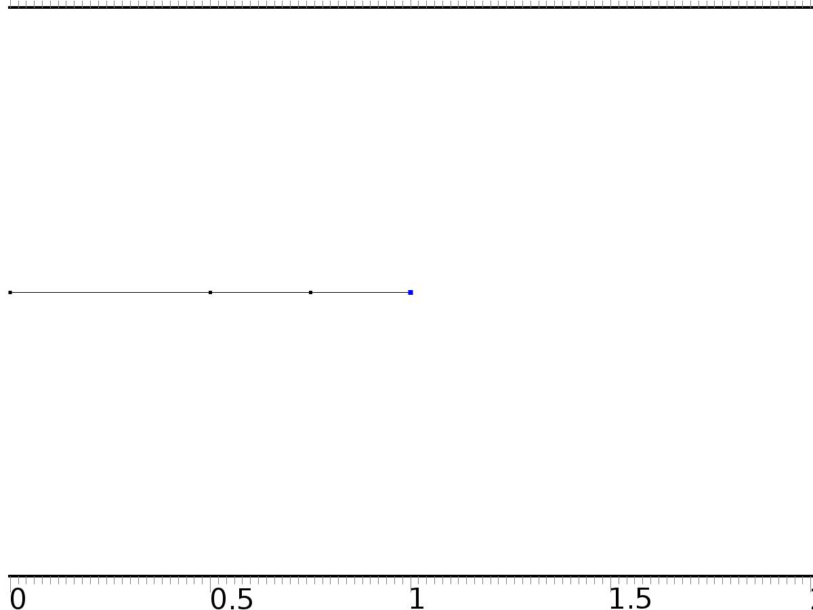

Flux/Source 2

Selection

|  |  |
| --- | --- |
| Geometric entity level | Boundary |
| Selection | Boundary 4 |

Equations

Settings

| **Description** | **Value** |
| --- | --- |
| Boundary flux/source | {0, 0, Bd} |
| Boundary absorption/impedance term | {{k1, 0, 0}, {0, k1, 0}, {0, 0, k1}} |

#### Variables

| **Name** | **Expression** | **Unit** | **Description** | **Selection** |
| --- | --- | --- | --- | --- |
| c.g_PI1 | -k1*PI1 | 1/m | Boundary flux/source | Boundary 4 |
| c.g_PI2 | -k1*PI2 | 1/m | Boundary flux/source | Boundary 4 |
| c.g_PIt2 | Bd-k1*PIt2 | 1/m | Boundary flux/source | Boundary 4 |

* 1. Coefficient Form PDE 2



Coefficient Form PDE 2

Selection

|  |  |
| --- | --- |
| Geometric entity level | Domain |
| Selection | Domains 1–3 |

Settings

| **Description** | **Value** |
| --- | --- |
| Shape function type | Lagrange |
| Element order | Quadratic |
| Compute boundary fluxes | On |
| Apply smoothing to boundary fluxes | On |
| Value type when using splitting of complex variables | Complex |
| Dependent variable quantity | Dimensionless (1) |
| Source term quantity | None |
| Unit | m^ - 2 |

Used products

|  |
| --- |
| COMSOL Multiphysics |

Variables

| **Name** | **Expression** | **Unit** | **Description** | **Selection** |
| --- | --- | --- | --- | --- |
| c2.nx | unx |  | Normal vector, x component | Boundary 1 |
| c2.ny | 0 |  | Normal vector, y component | Boundary 1 |
| c2.nz | 0 |  | Normal vector, z component | Boundary 1 |
| c2.nx | dnx |  | Normal vector, x component | Boundary 4 |
| c2.ny | 0 |  | Normal vector, y component | Boundary 4 |
| c2.nz | 0 |  | Normal vector, z component | Boundary 4 |
| c2.nx | nx |  | Normal vector, x component | Boundaries 2–3 |
| c2.ny | 0 |  | Normal vector, y component | Boundaries 2–3 |
| c2.nz | 0 |  | Normal vector, z component | Boundaries 2–3 |
| c2.nxmesh | root.unxmesh |  | Normal vector (mesh), x component | Boundary 1 |
| c2.nymesh | 0 |  | Normal vector (mesh), y component | Boundary 1 |
| c2.nzmesh | 0 |  | Normal vector (mesh), z component | Boundary 1 |
| c2.nxmesh | root.dnxmesh |  | Normal vector (mesh), x component | Boundary 4 |
| c2.nymesh | 0 |  | Normal vector (mesh), y component | Boundary 4 |
| c2.nzmesh | 0 |  | Normal vector (mesh), z component | Boundary 4 |
| c2.nxmesh | root.nxmesh |  | Normal vector (mesh), x component | Boundaries 2–3 |
| c2.nymesh | 0 |  | Normal vector (mesh), y component | Boundaries 2–3 |
| c2.nzmesh | 0 |  | Normal vector (mesh), z component | Boundaries 2–3 |

* + 1. Coefficient Form PDE 1



Coefficient Form PDE 1

Selection

|  |  |
| --- | --- |
| Geometric entity level | Domain |
| Selection | Domains 1–3 |

Equations

Settings

| **Description** | **Value** |
| --- | --- |
| Diffusion coefficient | 1 |
| Absorption coefficient | 0 |
| Source term | 0 |
| Mass coefficient | 1 |
| Damping or mass coefficient | 2*gamma |
| Conservative flux convection coefficient | 0 |
| Convection coefficient | 0 |
| Conservative flux source | 0 |

#### Variables

| **Name** | **Expression** | **Unit** | **Description** | **Selection** |
| --- | --- | --- | --- | --- |
| domflux.zx | -d(z,x) | 1/m | Domain flux, x component | Domains 1–3 |

#### Shape functions

| **Name** | **Shape function** | **Unit** | **Description** | **Shape frame** | **Selection** |
| --- | --- | --- | --- | --- | --- |
| z | Lagrange (Quadratic) | 1 | Dependent variable z | Material | Domains 1–3 |

* + 1. Zero Flux 1



Zero Flux 1

Selection

|  |  |
| --- | --- |
| Geometric entity level | Boundary |
| Selection | No boundaries |

Equations

* + 1. Initial Values 1



Initial Values 1

Selection

|  |  |
| --- | --- |
| Geometric entity level | Domain |
| Selection | Domains 1–3 |

Settings

| **Description** | **Value** |
| --- | --- |
| Initial value for z | 16*(1 - x)^2*x^2 |
| Initial time derivative of z | 0.5*sin(pi*x)^2 |

* + 1. Flux/Source 1



Flux/Source 1

Selection

|  |  |
| --- | --- |
| Geometric entity level | Boundary |
| Selection | Boundary 2 |

Equations

Settings

| **Description** | **Value** |
| --- | --- |
| Boundary flux/source | Bin*Gamma |
| Boundary absorption/impedance term | 0 |

#### Variables

| **Name** | **Expression** | **Unit** | **Description** | **Selection** |
| --- | --- | --- | --- | --- |
| c2.g_z | Bin*Gamma | 1/m | Boundary flux/source | Boundary 2 |

* + 1. Dirichlet Boundary Condition 2



Dirichlet Boundary Condition 2

Selection

|  |  |
| --- | --- |
| Geometric entity level | Boundary |
| Selection | Boundary 1 |

Equations

Settings

| **Description** | **Value** |
| --- | --- |
| Value on boundary | 0 |
| Prescribed value of z | On |
| Apply reaction terms on | Individual dependent variables |
| Use weak constraints | Off |
| Constraint method | Elemental |

#### Shape functions

| **Constraint** | **Constraint force** | **Shape function** | **Selection** |
| --- | --- | --- | --- |
| -z | -test(z) | Lagrange (Quadratic) | Boundary 1 |

* + 1. Flux/Source 2



Flux/Source 2

Selection

|  |  |
| --- | --- |
| Geometric entity level | Boundary |
| Selection | Boundary 4 |

Equations

Settings

| **Description** | **Value** |
| --- | --- |
| Boundary flux/source | Bd*w2 |
| Boundary absorption/impedance term | k1 |

#### Variables

| **Name** | **Expression** | **Unit** | **Description** | **Selection** |
| --- | --- | --- | --- | --- |
| c2.g_z | Bd*w2-k1*z | 1/m | Boundary flux/source | Boundary 4 |

* 1. Mesh 1

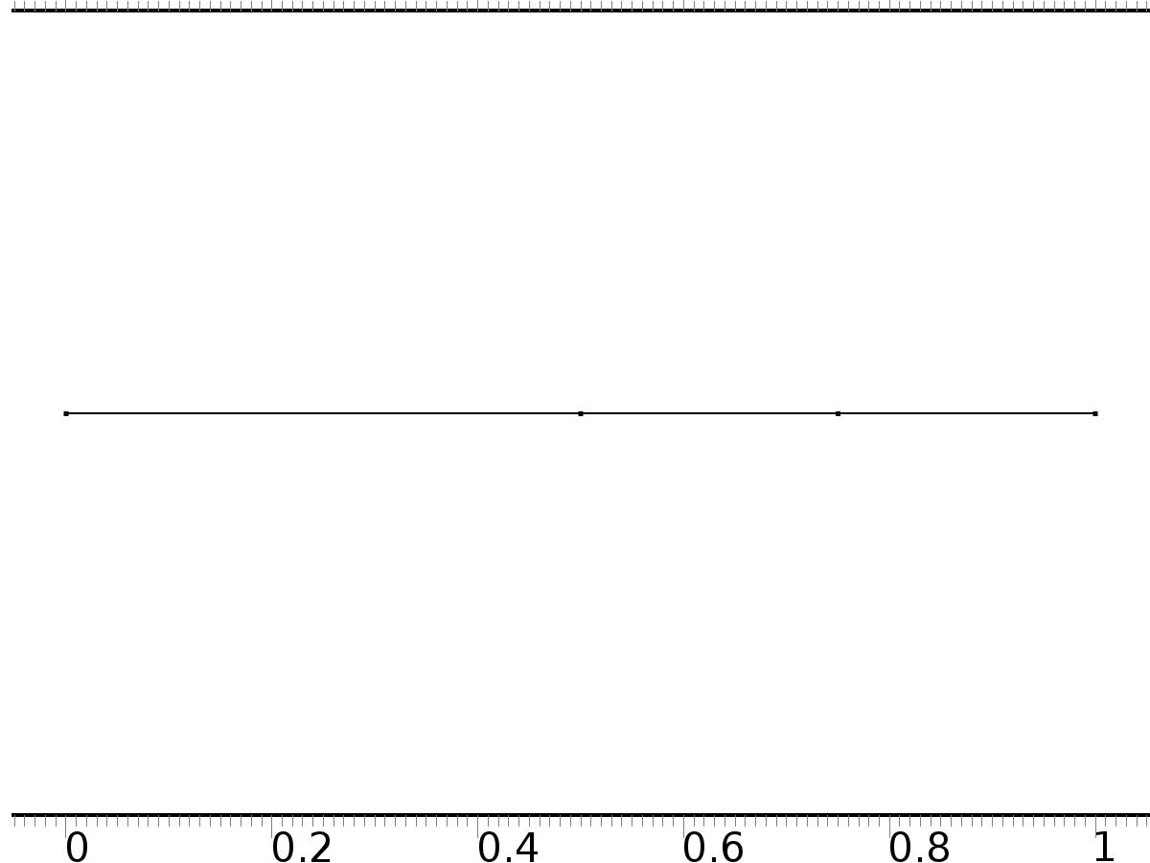

Mesh 1

* + 1. Size (size)

Settings

| **Description** | **Value** |
| --- | --- |
| Maximum element size | 0.037 |
| Minimum element size | 1.25E-4 |
| Curvature factor | 0.25 |
| Maximum element growth rate | 1.25 |
| Predefined size | Finer |

* + 1. Edge 1 (edg1)

Selection

|  |  |
| --- | --- |
| Geometric entity level | Remaining |

1. Study 1
   1. Stationary

Study settings

| **Description** | **Value** |
| --- | --- |
| Include geometric nonlinearity | Off |

Physics and variables selection

| **Physics interface** | **Discretization** |
| --- | --- |
| Coefficient Form PDE (c) | physics |

Mesh selection

| **Geometry** | **Mesh** |
| --- | --- |
| Geometry 1 (geom1) | mesh1 |

* 1. Solver Configurations
     1. Solver 1

#### Compile Equations: Stationary (st1)

Study and step

| **Description** | **Value** |
| --- | --- |
| Use study | Study 1 |
| Use study step | Stationary |

#### Dependent Variables 1 (v1)

General

| **Description** | **Value** |
| --- | --- |
| Defined by study step | Stationary |
| Constant |  |

Initial values of variables solved for

| **Description** | **Value** |
| --- | --- |
| Solution | Zero |

Values of variables not solved for

| **Description** | **Value** |
| --- | --- |
| Solution | Zero |

##### Dependent variable PI1 (mod1.PI1) (mod1_PI1)

General

| **Description** | **Value** |
| --- | --- |
| Field components | mod1.PI1 |
| Field name | mod1_X |

##### Dependent variable z (mod1.z) (mod1_z)

General

| **Description** | **Value** |
| --- | --- |
| Field components | mod1.z |
| Solve for this field | Off |

##### Dependent variable PI2 (mod1.PI2) (mod1_PI2)

General

| **Description** | **Value** |
| --- | --- |
| Field components | mod1.PI2 |

##### Dependent variable PIt2 (mod1.PIt2) (mod1_PIt2)

General

| **Description** | **Value** |
| --- | --- |
| Field components | mod1.PIt2 |
| Field name | mod1_PI3 |

#### Stationary Solver 1 (s1)

General

| **Description** | **Value** |
| --- | --- |
| Defined by study step | Stationary |
| Relative tolerance | 0.0000010 |

Log

| **Description** | **Value** |
| --- | --- |
| Constant |  |

##### Advanced (aDef)

General

| **Description** | **Value** |
| --- | --- |
| Allow complex-valued output from functions with real input | On |

##### Fully Coupled 1 (fc1)

General

| **Description** | **Value** |
| --- | --- |
| Linear solver | Direct |

1. Study 2
   1. Time Dependent

Study settings

| **Description** | **Value** |
| --- | --- |
| Include geometric nonlinearity | Off |

| **Times** | **Unit** |
| --- | --- |
| range(0,0.1,30) | s |

Physics and variables selection

| **Physics interface** | **Discretization** |
| --- | --- |
| Coefficient Form PDE 2 (c2) | physics |

Mesh selection

| **Geometry** | **Mesh** |
| --- | --- |
| Geometry 1 (geom1) | mesh1 |

* 1. Solver Configurations
     1. Solver 2

#### Compile Equations: Time Dependent (st1)

Study and step

| **Description** | **Value** |
| --- | --- |
| Use study | Study 2 |
| Use study step | Time Dependent |

#### Dependent Variables 1 (v1)

General

| **Description** | **Value** |
| --- | --- |
| Defined by study step | Time Dependent |
| Constant |  |

Initial values of variables solved for

| **Description** | **Value** |
| --- | --- |
| Solution | Zero |

Values of variables not solved for

| **Description** | **Value** |
| --- | --- |
| Method | Solution |
| Solution | Solver 1 |

##### Dependent variable z (mod1.z) (mod1_z)

General

| **Description** | **Value** |
| --- | --- |
| Field components | mod1.z |

##### Dependent variable PI1 (mod1.PI1) (mod1_PI1)

General

| **Description** | **Value** |
| --- | --- |
| Field components | mod1.PI1 |
| Solve for this field | Off |
| Field name | mod1_X |

##### Dependent variable PI2 (mod1.PI2) (mod1_PI2)

General

| **Description** | **Value** |
| --- | --- |
| Field components | mod1.PI2 |
| Solve for this field | Off |

##### Dependent variable PIt2 (mod1.PIt2) (mod1_PIt2)

General

| **Description** | **Value** |
| --- | --- |
| Field components | mod1.PIt2 |
| Solve for this field | Off |
| Field name | mod1_PI3 |

#### Time-Dependent Solver 1 (t1)

General

| **Description** | **Value** |
| --- | --- |
| Defined by study step | Time Dependent |
| Time | {0, 0.1, 0.2, 0.30000000000000004, 0.4, 0.5, 0.6000000000000001, 0.7000000000000001, 0.8, 0.9, 1, 1.1, 1.2000000000000002, 1.3, 1.4000000000000001, 1.5, 1.6, 1.7000000000000002, 1.8, 1.9000000000000001, 2, 2.1, 2.2, 2.3000000000000003, 2.4000000000000004, 2.5, 2.6, 2.7, 2.8000000000000003, 2.9000000000000004, 3, 3.1, 3.2, 3.3000000000000003, 3.4000000000000004, 3.5, 3.6, 3.7, 3.8000000000000003, 3.9000000000000004, 4, 4.1000000000000005, 4.2, 4.3, 4.4, 4.5, 4.6000000000000005, 4.7, 4.800000000000001, 4.9, 5, 5.1000000000000005, 5.2, 5.300000000000001, 5.4, 5.5, 5.6000000000000005, 5.7, 5.800000000000001, 5.9, 6, 6.1000000000000005, 6.2, 6.300000000000001, 6.4, 6.5, 6.6000000000000005, 6.7, 6.800000000000001, 6.9, 7, 7.1000000000000005, 7.2, 7.300000000000001, 7.4, 7.5, 7.6000000000000005, 7.7, 7.800000000000001, 7.9, 8, 8.1, 8.200000000000001, 8.3, 8.4, 8.5, 8.6, 8.700000000000001, 8.8, 8.9, 9, 9.1, 9.200000000000001, 9.3, 9.4, 9.5, 9.600000000000001, 9.700000000000001, 9.8, 9.9, 10, 10.100000000000001, 10.200000000000001, 10.3, 10.4, 10.5, 10.600000000000001, 10.700000000000001, 10.8, 10.9, 11, 11.100000000000001, 11.200000000000001, 11.3, 11.4, 11.5, 11.600000000000001, 11.700000000000001, 11.8, 11.9, 12, 12.100000000000001, 12.200000000000001, 12.3, 12.4, 12.5, 12.600000000000001, 12.700000000000001, 12.8, 12.9, 13, 13.100000000000001, 13.200000000000001, 13.3, 13.4, 13.5, 13.600000000000001, 13.700000000000001, 13.8, 13.9, 14, 14.100000000000001, 14.200000000000001, 14.3, 14.4, 14.5, 14.600000000000001, 14.700000000000001, 14.8, 14.9, 15, 15.100000000000001, 15.200000000000001, 15.3, 15.4, 15.5, 15.600000000000001, 15.700000000000001, 15.8, 15.9, 16, 16.1, 16.2, 16.3, 16.400000000000002, 16.5, 16.6, 16.7, 16.8, 16.900000000000002, 17, 17.1, 17.2, 17.3, 17.400000000000002, 17.5, 17.6, 17.7, 17.8, 17.900000000000002, 18, 18.1, 18.2, 18.3, 18.400000000000002, 18.5, 18.6, 18.7, 18.8, 18.900000000000002, 19, 19.1, 19.200000000000003, 19.3, 19.400000000000002, 19.5, 19.6, 19.700000000000003, 19.8, 19.900000000000002, 20, 20.1, 20.200000000000003, 20.3, 20.400000000000002, 20.5, 20.6, 20.700000000000003, 20.8, 20.900000000000002, 21, 21.1, 21.200000000000003, 21.3, 21.400000000000002, 21.5, 21.6, 21.700000000000003, 21.8, 21.900000000000002, 22, 22.1, 22.200000000000003, 22.3, 22.400000000000002, 22.5, 22.6, 22.700000000000003, 22.8, 22.900000000000002, 23, 23.1, 23.200000000000003, 23.3, 23.400000000000002, 23.5, 23.6, 23.700000000000003, 23.8, 23.900000000000002, 24, 24.1, 24.200000000000003, 24.3, 24.400000000000002, 24.5, 24.6, 24.700000000000003, 24.8, 24.900000000000002, 25, 25.1, 25.200000000000003, 25.3, 25.400000000000002, 25.5, 25.6, 25.700000000000003, 25.8, 25.900000000000002, 26, 26.1, 26.200000000000003, 26.3, 26.400000000000002, 26.5, 26.6, 26.700000000000003, 26.8, 26.900000000000002, 27, 27.1, 27.200000000000003, 27.3, 27.400000000000002, 27.5, 27.6, 27.700000000000003, 27.8, 27.900000000000002, 28, 28.1, 28.200000000000003, 28.3, 28.400000000000002, 28.5, 28.6, 28.700000000000003, 28.8, 28.900000000000002, 29, 29.1, 29.200000000000003, 29.3, 29.400000000000002, 29.5, 29.6, 29.700000000000003, 29.8, 29.900000000000002, 30} |
| Relative tolerance | 0.000001 |

Absolute tolerance

| **Description** | **Value** |
| --- | --- |
| Tolerance | 0.0000010 |

Time stepping

| **Description** | **Value** |
| --- | --- |
| Initial step | 0.0010 |
| Maximum BDF order | 2 |

Results while solving

| **Description** | **Value** |
| --- | --- |
| Probes | None |

Advanced

| **Description** | **Value** |
| --- | --- |
| Fraction of initial step for Backward Euler | 0.0010 |

Log

| **Description** | **Value** |
| --- | --- |
| Constant |  |

##### Fully Coupled 1 (fc1)

General

| **Description** | **Value** |
| --- | --- |
| Linear solver | Direct |

1. Results
   1. Data Sets
      1. Solution 1

Solution

| **Description** | **Value** |
| --- | --- |
| Solution | Solver 1 |
| Component | Save Point Geometry 1 |

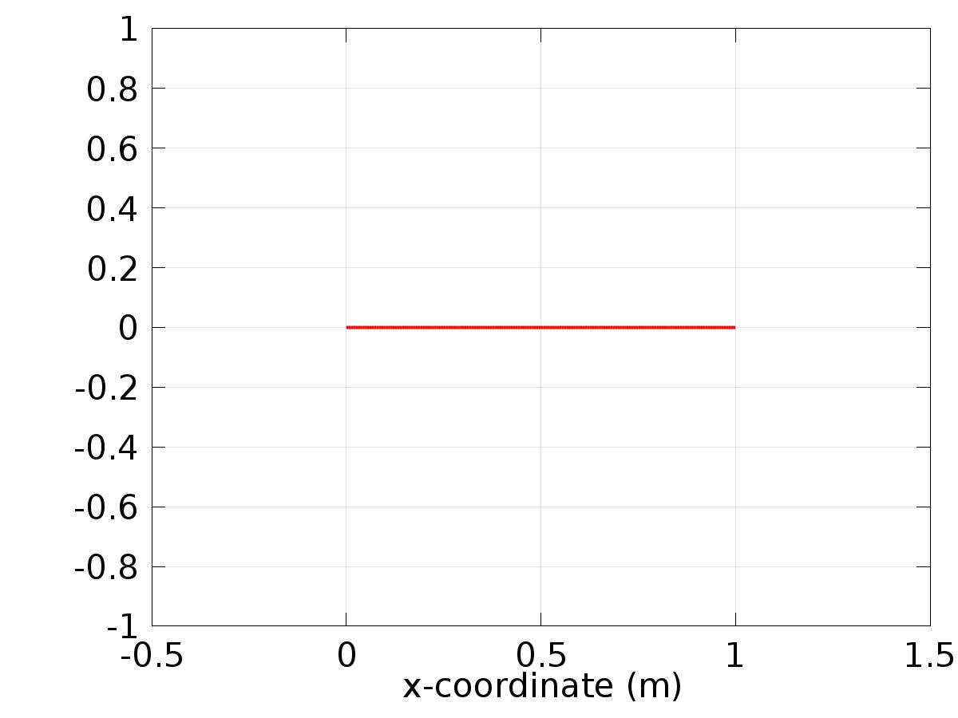

Data set: Solution 1

* + 1. Solution 2

Solution

| **Description** | **Value** |
| --- | --- |
| Solution | Solver 2 |
| Component | Save Point Geometry 1 |

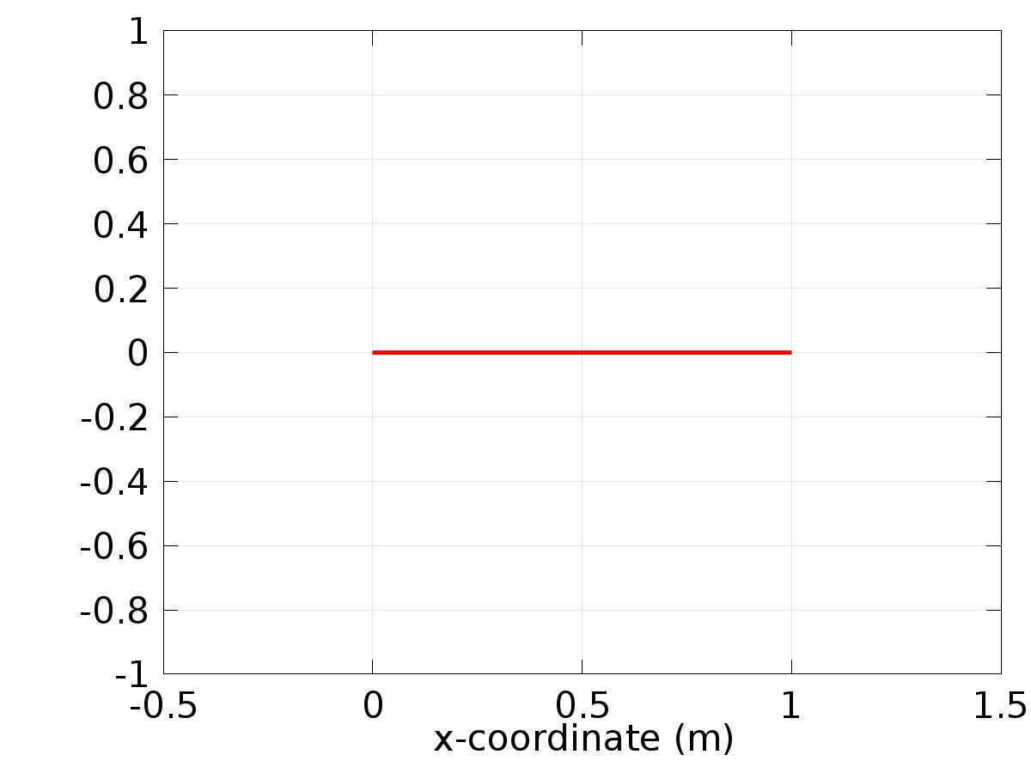

Data set: Solution 2

* + 1. Probe Solution 3

Solution

| **Description** | **Value** |
| --- | --- |
| Solution | Solver 1 |
| Component | Save Point Geometry 1 |

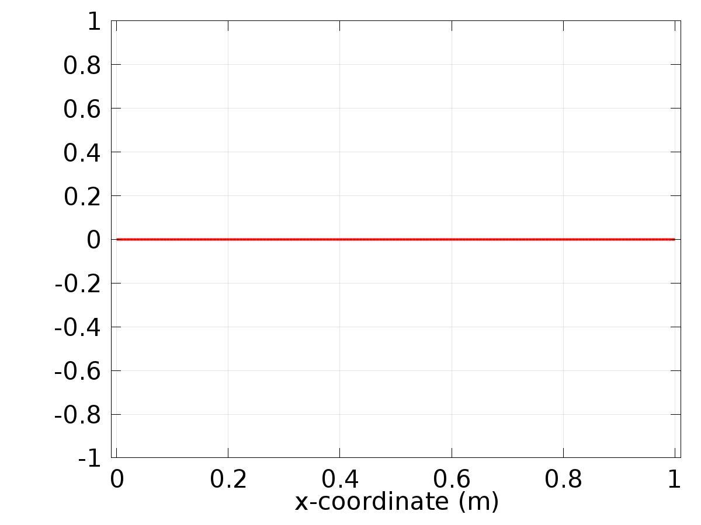

Data set: Probe Solution 3

* 1. Derived Values
     1. Global Variable Probe 1

Data

| **Description** | **Value** |
| --- | --- |
| Data set | Probe Solution 3 |

Expression

| **Description** | **Value** |
| --- | --- |
| Expression | Gamma1 |
| Unit | 1 |

* + 1. Global Variable Probe 2

Data

| **Description** | **Value** |
| --- | --- |
| Data set | Probe Solution 3 |

Expression

| **Description** | **Value** |
| --- | --- |
| Expression | Gamma2 |
| Unit | 1 |

* + 1. Global Variable Probe 3

Data

| **Description** | **Value** |
| --- | --- |
| Data set | Probe Solution 3 |

Expression

| **Description** | **Value** |
| --- | --- |
| Expression | Gamma3 |
| Unit | 1 |

* 1. Tables
     1. Table 1

Global Evaluation 1 (C(X))

Table 1

| **Gamma1 (1)** | **Gamma2 (1)** | **Gamma3 (1)** |
| --- | --- | --- |
| 16.000 | -2.1481 | -0.037285 |

* + 1. Table 2

Point Evaluation 1 (z)

Table 2

| **Dependent variable z (1), Point: 1** |
| --- |
| 0.0000 |

* + 1. Table 3

Point Evaluation 1 (z)

Table 3

| **Time** | **Gradient of z, x component (1/m), Point: 1** |
| --- | --- |
| 30.000 | 11.798 |

* + 1. Probe Table 4

Probe Table 4

| **Gamma1 (1)** | **Gamma2 (1)** | **Gamma3 (1)** |
| --- | --- | --- |
| -3.2000 | -1.1927 | -0.015259 |

* 1. Plot Groups
     1. 1D Plot Group 1

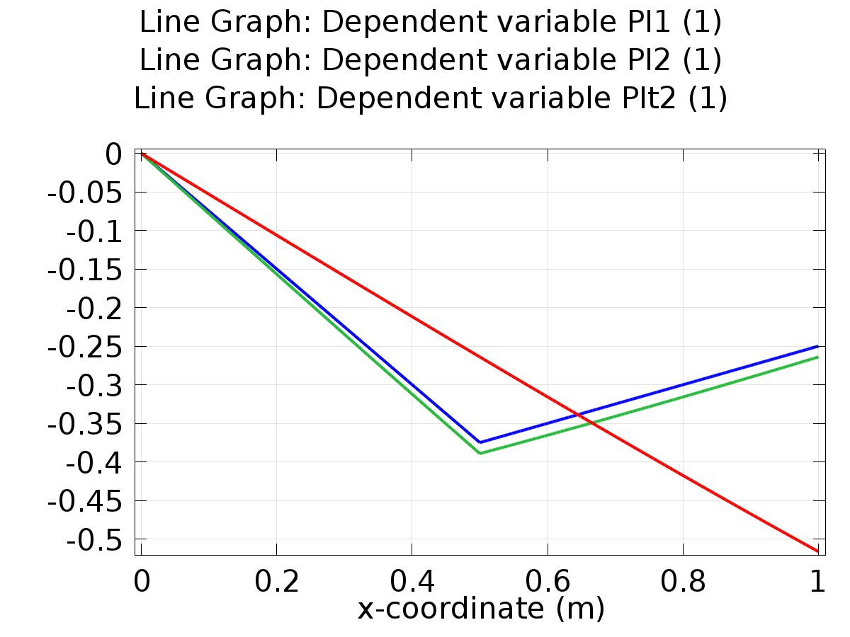

Line Graph: Dependent variable PI1 (1) Line Graph: Dependent variable PI2 (1) Line Graph: Dependent variable PIt2 (1)

* + 1. 1D Plot Group 2

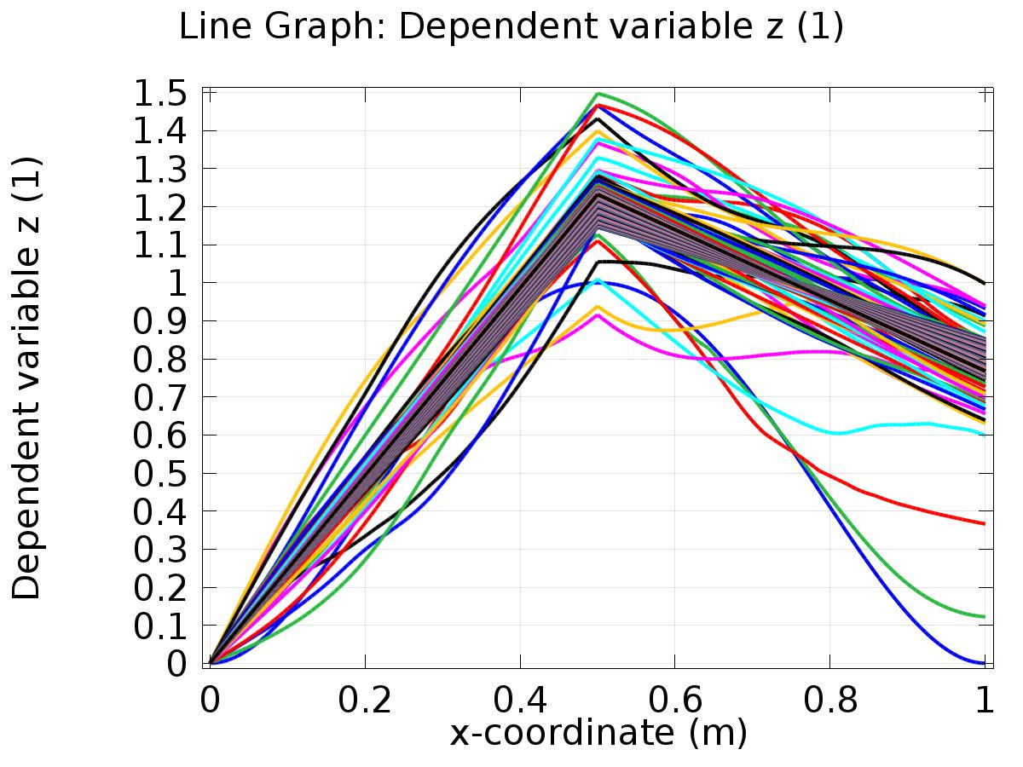

Line Graph: Dependent variable z (1)

* + 1. 1D Plot Group 3

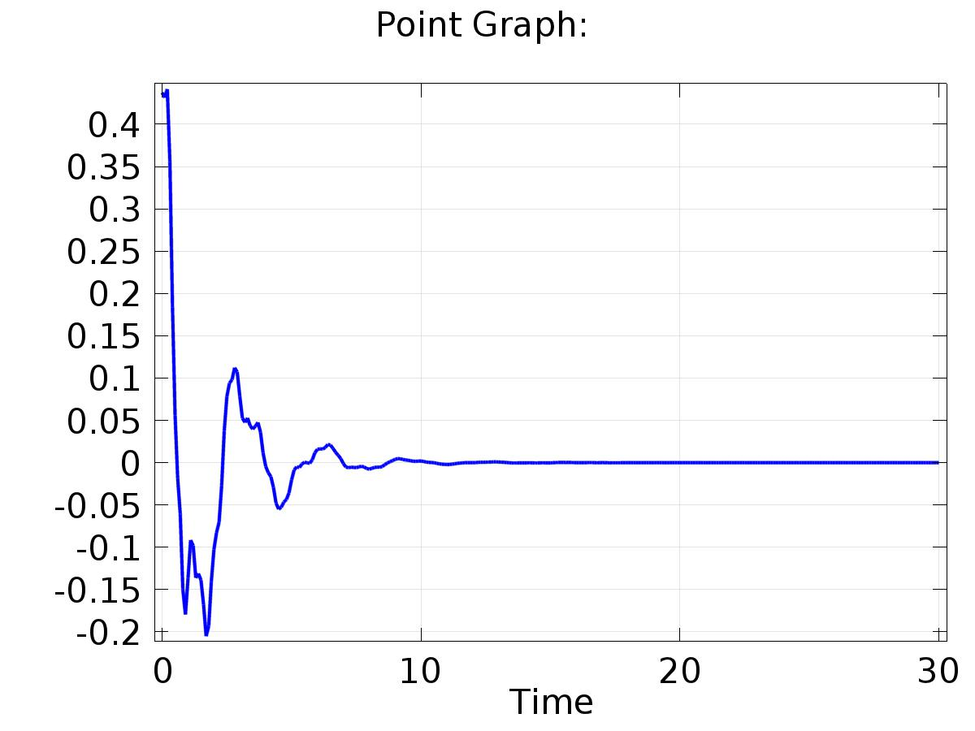

Point Graph:

* + 1. 1D Plot Group 4

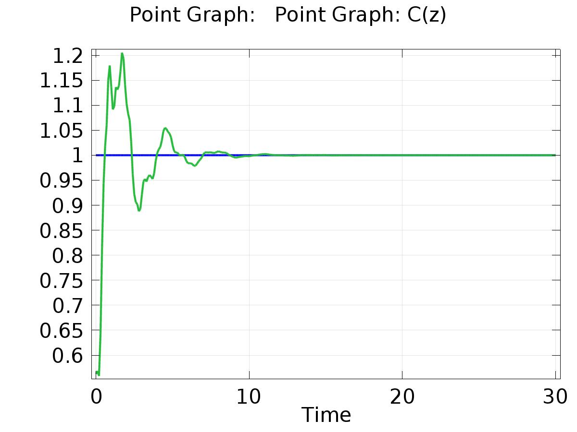

Point Graph: Point Graph: C(z)

* + 1. Probe 1D Plot Group 5

