[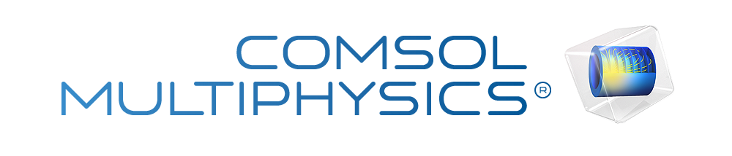](http://www.comsol.com/)

CHAP2 DG ex2 5 MIMO HeatEquation

|  |  |
| --- | --- |
| Date | Nov 5, 2013 3:11:09 PM |

Contents

1. Global

1.1. Definitions

2. Model 1

2.1. Definitions

2.2. Geometry 1

2.3. PDE

2.4. PDE 2

2.5. PDE 3

2.6. PDE 4

2.7. PDE 5

2.8. PDE 6

2.9. PDE 7

2.10. PDE 8

2.11. Mesh 1

3. Study 1

3.1. Stationary

3.2. Solver Configurations

4. Study 2

4.1. Stationary

4.2. Solver Configurations

5. Study 3

5.1. Time Dependent

5.2. Solver Configurations

6. Results

6.1. Data Sets

6.2. Derived Values

6.3. Tables

6.4. Plot Groups

1. Global

|  |  |
| --- | --- |
| Date | Jul 27, 2013 8:42:49 AM |

Global settings

|  |  |
| --- | --- |
| Name | CHAP2 DG ex2 5 MIMO HeatEquation.mph |
| Path | /Users/gilliam/Desktop/collect_15/research_15/geo_reg_mono_eugenio/Mono_1_15/Comsol_EX_GitHub/Chapter2/Chap2Ex5/CHAP2_DG_ex2_5_MIMO_HeatEquation.mph |
| Program | COMSOL 4.3b (Build: 189) |

Used products

|  |
| --- |
| COMSOL Multiphysics |

* 1. Definitions
     1. Parameters 1

Parameters

| **Name** | **Expression** | **Value** | **Description** |
| --- | --- | --- | --- |
| L | 1.2 | 1.2000 |  |
| x1 | 0.2 | 0.20000 |  |
| x2 | 0.4 | 0.40000 |  |
| x3 | 0.6 | 0.60000 |  |
| x4 | 0.8 | 0.80000 |  |
| x5 | 1 | 1.0000 |  |
| alpha1 | 1 | 1.0000 |  |
| alpha2 | 2 | 2.0000 |  |
| beta | 0.5 | 0.50000 |  |
| Mr1 | 0.5 | 0.50000 |  |
| Mr2 | 0.25 | 0.25000 |  |
| Md | 1 | 1.0000 |  |
| Ar1 | 0.25 | 0.25000 |  |
| Ar2 | 0.5 | 0.50000 |  |
| Ad | 0.75 | 0.75000 |  |
| k0 | 1 | 1.0000 |  |
| k1 | 1 | 1.0000 |  |

1. Model 1

Component settings

|  |  |
| --- | --- |
| Unit system | SI |

* 1. Definitions
     1. Variables

#### Variables 1a

Selection

|  |  |
| --- | --- |
| Geometric entity level | Entire model |

| **Name** | **Expression** | **Description** |
| --- | --- | --- |
| G11 | C1(X1) |  |
| G12 | C1(X2) |  |
| G21 | C2(X1) |  |
| G22 | C2(X2) |  |
| DETG | G11*G22 - G12*G21 |  |
| g11 | G22/DETG |  |
| g12 | -G12/DETG |  |
| g21 | -G21/DETG |  |
| g22 | G11/DETG |  |

#### Variables 2a

Selection

|  |  |
| --- | --- |
| Geometric entity level | Entire model |

| **Name** | **Expression** | **Description** |
| --- | --- | --- |
| Gamma11 | g11 |  |
| Gamma12 | g21 |  |
| Gamma21 | g12 |  |
| Gamma22 | g22 |  |
| Gamma31 | g11*(0 - C1(PIt3)) + g12*(0 - C2(PIt3)) |  |
| Gamma32 | g21*(0 - C1(PIt3)) + g22*(0 - C2(PIt3)) |  |
| Gamma41 | g11*(1 - C1(PIt4)) + g12*(0 - C2(PIt4)) |  |
| Gamma42 | g21*(1 - C1(PIt4)) + g22*(0 - C2(PIt4)) |  |
| Gamma51 | g11*(0 - C1(PIt5)) + g12*(0 - C2(PIt5)) |  |
| Gamma52 | g21*(0 - C1(PIt5)) + g22*(0 - C2(PIt5)) |  |
| Gamma61 | g11*(0 - C1(PIt6)) + g12*(1 - C2(PIt6)) |  |
| Gamma62 | g21*(0 - C1(PIt6)) + g22*(1 - C2(PIt6)) |  |
| Gamma71 | g11*(0 - C1(PIt7)) + g12*(0 - C2(PIt7)) |  |
| Gamma72 | g21*(0 - C1(PIt7)) + g22*(0 - C2(PIt7)) |  |
| Gamma81 | g11*(0 - C1(PIt8)) + g12*(0 - C2(PIt8)) |  |
| Gamma82 | g21*(0 - C1(PIt8)) + g22*(0 - C2(PIt8)) |  |
| Gamma91 | g11*(0 - C1(PIt9)) + g12*(0 - C2(PIt9)) |  |
| Gamma92 | g21*(0 - C1(PIt9)) + g22*(0 - C2(PIt9)) |  |

#### Variables 3a

Selection

|  |  |
| --- | --- |
| Geometric entity level | Entire model |

| **Name** | **Expression** | **Description** |
| --- | --- | --- |
| w1 | Mr1 |  |
| w2 | Mr2 |  |
| w3 | Md |  |
| w4 | Ar1*cos(alpha1*t) |  |
| w5 | Ar1*sin(alpha1*t) |  |
| w6 | Ar2*cos(alpha2*t) |  |
| w7 | Ar2*sin(alpha2*t) |  |
| w8 | Ad*cos(beta*t) |  |
| w9 | Ad*sin(beta*t) |  |
| Gamma1 | Gamma11*w1 + Gamma21*w2 + Gamma31*w3 + Gamma41*w4 + Gamma51*w5 + Gamma61*w6 + Gamma71*w7 + Gamma81*w8 + Gamma91*w9 |  |
| Gamma2 | Gamma12*w1 + Gamma22*w2 + Gamma32*w3 + Gamma42*w4 + Gamma52*w5 + Gamma62*w6 + Gamma72*w7 + Gamma82*w8 + Gamma92*w9 |  |
| d | w3 + w8 |  |
| yr1 | w1 + w4 |  |
| yr2 | w2 + w6 |  |
| e1 | C1(z) - yr1 |  |
| e2 | C2(z) - yr2 |  |
| Bin1 | -1 |  |
| Bin2 | -1 |  |
| Bd | -1 |  |

* + 1. Probes

#### Global Variable Probe 1

|  |  |
| --- | --- |
| Probe type | Global variable probe |

#### Global Variable Probe 2

|  |  |
| --- | --- |
| Probe type | Global variable probe |

#### Global Variable Probe 3

|  |  |
| --- | --- |
| Probe type | Global variable probe |

#### Global Variable Probe 4

|  |  |
| --- | --- |
| Probe type | Global variable probe |

#### Global Variable Probe 5

|  |  |
| --- | --- |
| Probe type | Global variable probe |

#### Global Variable Probe 6

|  |  |
| --- | --- |
| Probe type | Global variable probe |

#### Global Variable Probe 7

|  |  |
| --- | --- |
| Probe type | Global variable probe |

#### Global Variable Probe 8

|  |  |
| --- | --- |
| Probe type | Global variable probe |

#### Global Variable Probe 9

|  |  |
| --- | --- |
| Probe type | Global variable probe |

#### Global Variable Probe 10

|  |  |
| --- | --- |
| Probe type | Global variable probe |

#### Global Variable Probe 11

|  |  |
| --- | --- |
| Probe type | Global variable probe |

#### Global Variable Probe 12

|  |  |
| --- | --- |
| Probe type | Global variable probe |

#### Global Variable Probe 13

|  |  |
| --- | --- |
| Probe type | Global variable probe |

#### Global Variable Probe 14

|  |  |
| --- | --- |
| Probe type | Global variable probe |

#### Global Variable Probe 15

|  |  |
| --- | --- |
| Probe type | Global variable probe |

#### Global Variable Probe 16

|  |  |
| --- | --- |
| Probe type | Global variable probe |

#### Global Variable Probe 17

|  |  |
| --- | --- |
| Probe type | Global variable probe |

#### Global Variable Probe 18

|  |  |
| --- | --- |
| Probe type | Global variable probe |

* + 1. Component Couplings

#### Average 1

|  |  |
| --- | --- |
| Coupling type | Average |
| Operator name | C1 |

Source selection

|  |  |
| --- | --- |
| Geometric entity level | Boundary |
| Selection | Boundary 3 |

#### Average 2

|  |  |
| --- | --- |
| Coupling type | Average |
| Operator name | C2 |

Source selection

|  |  |
| --- | --- |
| Geometric entity level | Boundary |
| Selection | Boundary 5 |

* 1. Geometry 1

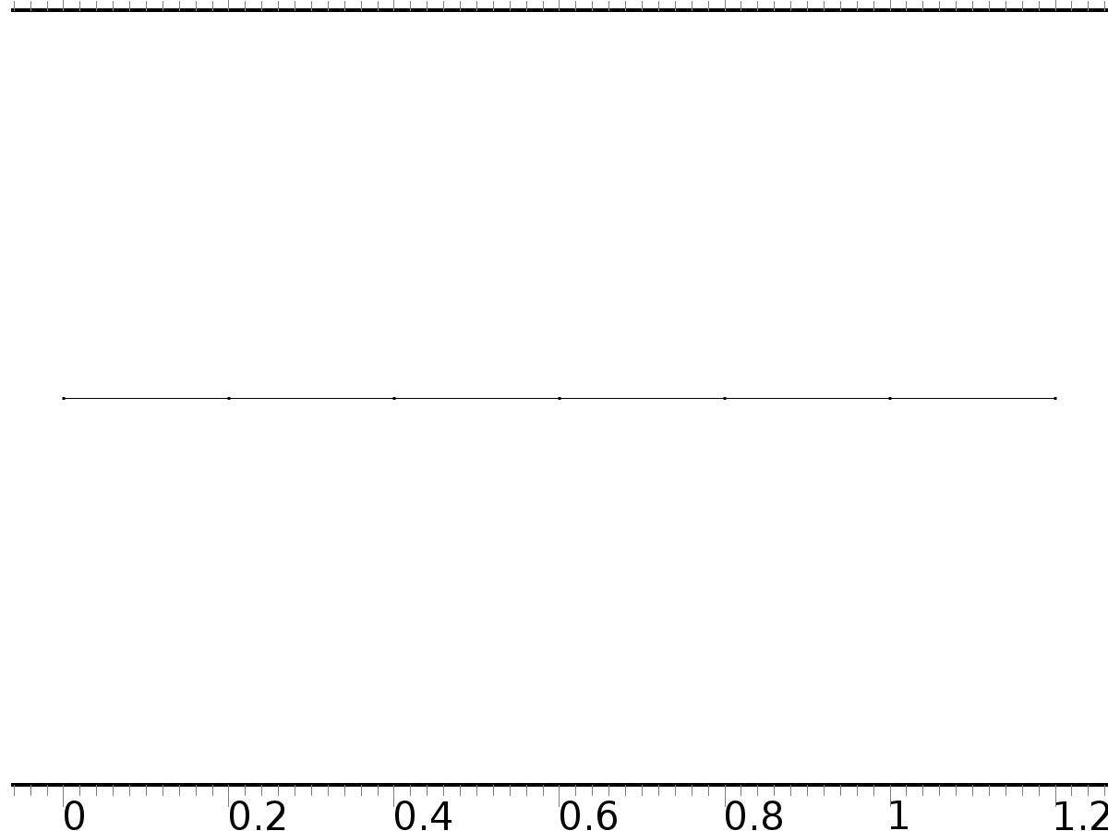

Geometry 1

Units

|  |  |
| --- | --- |
| Length unit | m |
| Angular unit | deg |

Geometry statistics

| **Description** | **Value** |
| --- | --- |
| Space dimension | 1 |
| Number of domains | 6 |
| Number of boundaries | 7 |

* + 1. Interval 1 (i1)

Interval

| **Description** | **Value** |
| --- | --- |
| Number of intervals | Many |
| Points | {0, 0.2, 0.4, 0.6, 0.8, 1, 1.2} |

* 1. PDE

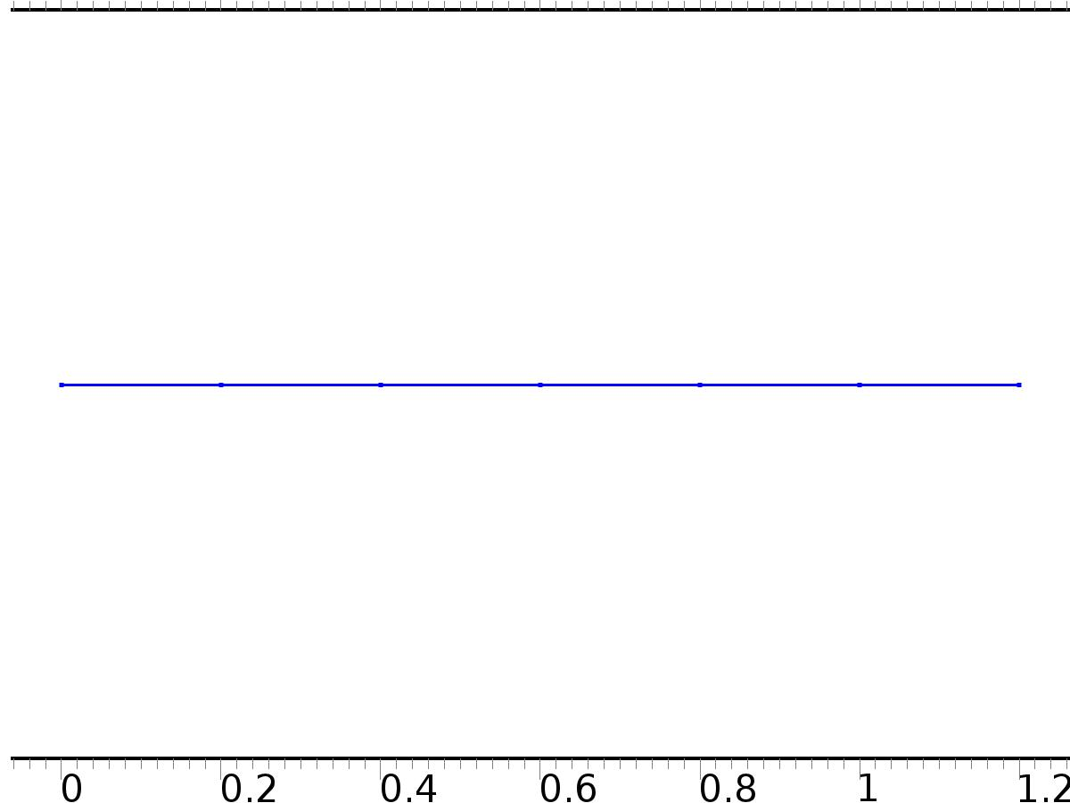

PDE

Selection

|  |  |
| --- | --- |
| Geometric entity level | Domain |
| Selection | Domains 1–6 |

Settings

| **Description** | **Value** |
| --- | --- |
| Shape function type | Lagrange |
| Element order | Quadratic |
| Value type when using splitting of complex variables | Complex |
| Compute boundary fluxes | Off |
| Dependent variable quantity | Dimensionless (1) |
| Source term quantity | None |
| Unit | m^ - 2 |

Used products

|  |
| --- |
| COMSOL Multiphysics |

Variables

| **Name** | **Expression** | **Unit** | **Description** | **Selection** |
| --- | --- | --- | --- | --- |
| c.nx | unx |  | Normal vector, x component | Boundary 1 |
| c.ny | 0 |  | Normal vector, y component | Boundary 1 |
| c.nz | 0 |  | Normal vector, z component | Boundary 1 |
| c.nx | dnx |  | Normal vector, x component | Boundary 7 |
| c.ny | 0 |  | Normal vector, y component | Boundary 7 |
| c.nz | 0 |  | Normal vector, z component | Boundary 7 |
| c.nx | nx |  | Normal vector, x component | Boundaries 2–6 |
| c.ny | 0 |  | Normal vector, y component | Boundaries 2–6 |
| c.nz | 0 |  | Normal vector, z component | Boundaries 2–6 |
| c.nxmesh | root.unxmesh |  | Normal vector (mesh), x component | Boundary 1 |
| c.nymesh | 0 |  | Normal vector (mesh), y component | Boundary 1 |
| c.nzmesh | 0 |  | Normal vector (mesh), z component | Boundary 1 |
| c.nxmesh | root.dnxmesh |  | Normal vector (mesh), x component | Boundary 7 |
| c.nymesh | 0 |  | Normal vector (mesh), y component | Boundary 7 |
| c.nzmesh | 0 |  | Normal vector (mesh), z component | Boundary 7 |
| c.nxmesh | root.nxmesh |  | Normal vector (mesh), x component | Boundaries 2–6 |
| c.nymesh | 0 |  | Normal vector (mesh), y component | Boundaries 2–6 |
| c.nzmesh | 0 |  | Normal vector (mesh), z component | Boundaries 2–6 |

* + 1. Coefficient Form PDE 1



Coefficient Form PDE 1

Selection

|  |  |
| --- | --- |
| Geometric entity level | Domain |
| Selection | Domains 1–6 |

Equations

Settings

| **Description** | **Value** |
| --- | --- |
| Diffusion coefficient | {{1, 0}, {0, 1}} |
| Absorption coefficient | {{0, 0}, {0, 0}} |
| Source term | {0, 0} |
| Mass coefficient | {{0, 0}, {0, 0}} |
| Damping or mass coefficient | {{0, 0}, {0, 0}} |
| Conservative flux convection coefficient | {{0, 0}, {0, 0}} |
| Convection coefficient | {{0, 0}, {0, 0}} |
| Conservative flux source | {0, 0} |

#### Variables

| **Name** | **Expression** | **Unit** | **Description** | **Selection** |
| --- | --- | --- | --- | --- |
| domflux.X1x | -d(X1,x) | 1/m | Domain flux, x component | Domains 1–6 |
| domflux.X2x | -d(X2,x) | 1/m | Domain flux, x component | Domains 1–6 |

#### Shape functions

| **Name** | **Shape function** | **Unit** | **Description** | **Shape frame** | **Selection** |
| --- | --- | --- | --- | --- | --- |
| X1 | Lagrange (Quadratic) | 1 | Dependent variable X1 | Material | Domains 1–6 |
| X2 | Lagrange (Quadratic) | 1 | Dependent variable X2 | Material | Domains 1–6 |

* + 1. Zero Flux 1



Zero Flux 1

Selection

|  |  |
| --- | --- |
| Geometric entity level | Boundary |
| Selection | No boundaries |

Equations

* + 1. Initial Values 1



Initial Values 1

Selection

|  |  |
| --- | --- |
| Geometric entity level | Domain |
| Selection | Domains 1–6 |

Settings

| **Description** | **Value** |
| --- | --- |
| Initial value for X1 | 0 |
| Initial value for X2 | 0 |
| Initial time derivative of X1 | 0 |
| Initial time derivative of X2 | 0 |

* + 1. Flux/Source 1

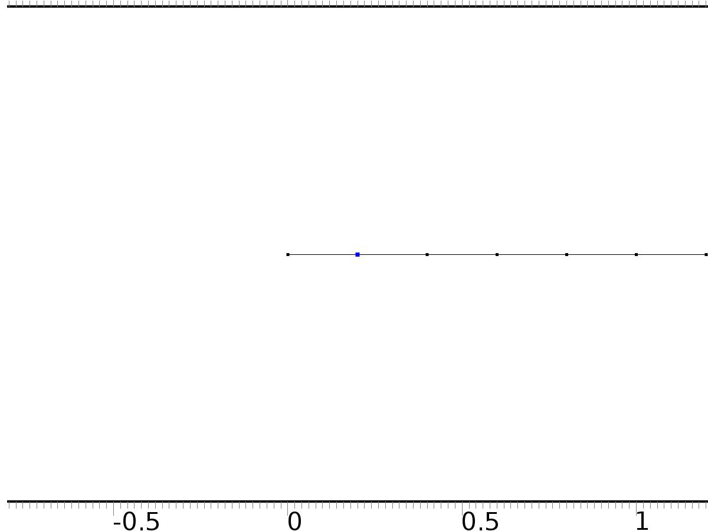

Flux/Source 1

Selection

|  |  |
| --- | --- |
| Geometric entity level | Boundary |
| Selection | Boundary 2 |

Equations

Settings

| **Description** | **Value** |
| --- | --- |
| Boundary flux/source | {Bin1, 0} |
| Boundary absorption/impedance term | {{0, 0}, {0, 0}} |

#### Variables

| **Name** | **Expression** | **Unit** | **Description** | **Selection** |
| --- | --- | --- | --- | --- |
| c.g_X1 | Bin1 | 1/m | Boundary flux/source | Boundary 2 |
| c.g_X2 | 0 | 1/m | Boundary flux/source | Boundary 2 |

* + 1. Flux/Source 2

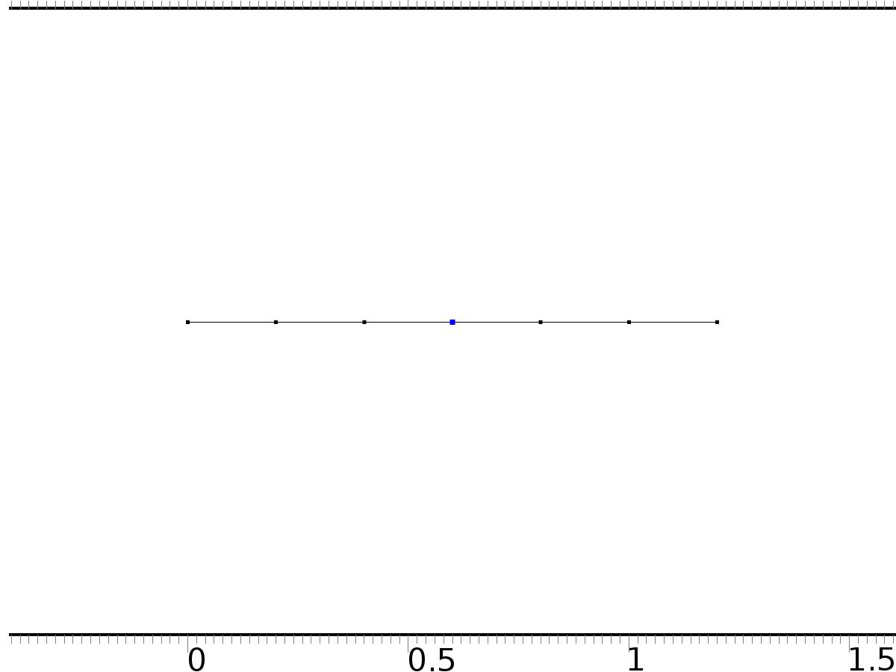

Flux/Source 2

Selection

|  |  |
| --- | --- |
| Geometric entity level | Boundary |
| Selection | Boundary 4 |

Equations

Settings

| **Description** | **Value** |
| --- | --- |
| Boundary flux/source | {0, Bin2} |
| Boundary absorption/impedance term | {{0, 0}, {0, 0}} |

#### Variables

| **Name** | **Expression** | **Unit** | **Description** | **Selection** |
| --- | --- | --- | --- | --- |
| c.g_X1 | 0 | 1/m | Boundary flux/source | Boundary 4 |
| c.g_X2 | Bin2 | 1/m | Boundary flux/source | Boundary 4 |

* + 1. Flux/Source 3

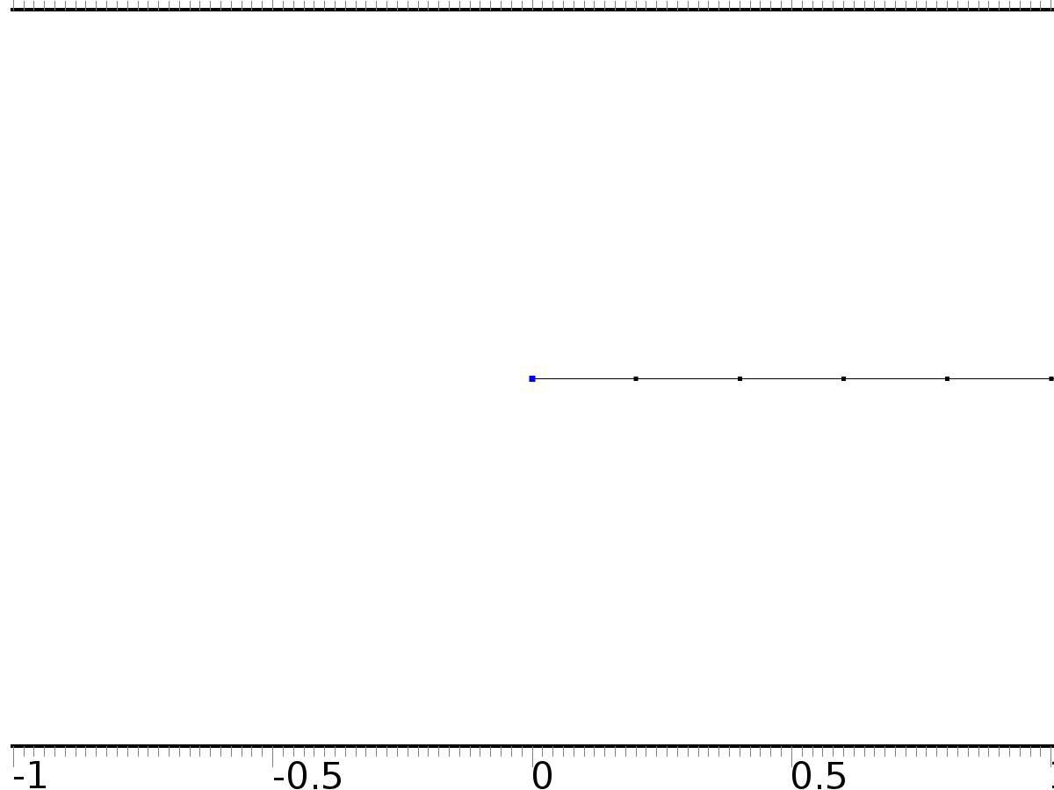

Flux/Source 3

Selection

|  |  |
| --- | --- |
| Geometric entity level | Boundary |
| Selection | Boundary 1 |

Equations

Settings

| **Description** | **Value** |
| --- | --- |
| Boundary flux/source | {0, 0} |
| Boundary absorption/impedance term | {{k0, 0}, {0, k0}} |

#### Variables

| **Name** | **Expression** | **Unit** | **Description** | **Selection** |
| --- | --- | --- | --- | --- |
| c.g_X1 | -k0*X1 | 1/m | Boundary flux/source | Boundary 1 |
| c.g_X2 | -k0*X2 | 1/m | Boundary flux/source | Boundary 1 |

* + 1. Flux/Source 4

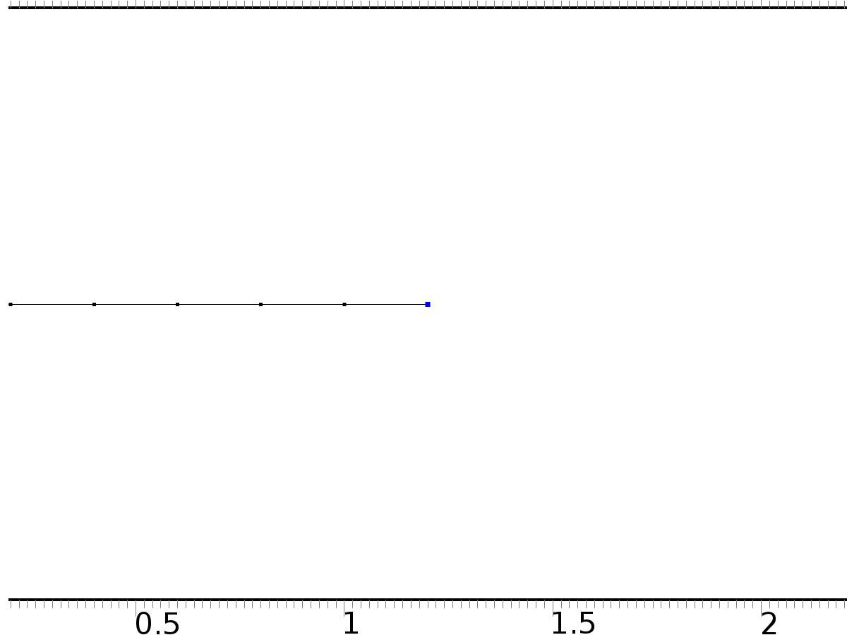

Flux/Source 4

Selection

|  |  |
| --- | --- |
| Geometric entity level | Boundary |
| Selection | Boundary 7 |

Equations

Settings

| **Description** | **Value** |
| --- | --- |
| Boundary flux/source | {0, 0} |
| Boundary absorption/impedance term | {{k1, 0}, {0, k1}} |

#### Variables

| **Name** | **Expression** | **Unit** | **Description** | **Selection** |
| --- | --- | --- | --- | --- |
| c.g_X1 | -k1*X1 | 1/m | Boundary flux/source | Boundary 7 |
| c.g_X2 | -k1*X2 | 1/m | Boundary flux/source | Boundary 7 |

* 1. PDE 2



PDE 2

Selection

|  |  |
| --- | --- |
| Geometric entity level | Domain |
| Selection | Domains 1–6 |

Settings

| **Description** | **Value** |
| --- | --- |
| Shape function type | Lagrange |
| Element order | Quadratic |
| Value type when using splitting of complex variables | Complex |
| Compute boundary fluxes | Off |
| Dependent variable quantity | Dimensionless (1) |
| Source term quantity | None |
| Unit | m^ - 2 |

Used products

|  |
| --- |
| COMSOL Multiphysics |

Variables

| **Name** | **Expression** | **Unit** | **Description** | **Selection** |
| --- | --- | --- | --- | --- |
| c2.nx | unx |  | Normal vector, x component | Boundary 1 |
| c2.ny | 0 |  | Normal vector, y component | Boundary 1 |
| c2.nz | 0 |  | Normal vector, z component | Boundary 1 |
| c2.nx | dnx |  | Normal vector, x component | Boundary 7 |
| c2.ny | 0 |  | Normal vector, y component | Boundary 7 |
| c2.nz | 0 |  | Normal vector, z component | Boundary 7 |
| c2.nx | nx |  | Normal vector, x component | Boundaries 2–6 |
| c2.ny | 0 |  | Normal vector, y component | Boundaries 2–6 |
| c2.nz | 0 |  | Normal vector, z component | Boundaries 2–6 |
| c2.nxmesh | root.unxmesh |  | Normal vector (mesh), x component | Boundary 1 |
| c2.nymesh | 0 |  | Normal vector (mesh), y component | Boundary 1 |
| c2.nzmesh | 0 |  | Normal vector (mesh), z component | Boundary 1 |
| c2.nxmesh | root.dnxmesh |  | Normal vector (mesh), x component | Boundary 7 |
| c2.nymesh | 0 |  | Normal vector (mesh), y component | Boundary 7 |
| c2.nzmesh | 0 |  | Normal vector (mesh), z component | Boundary 7 |
| c2.nxmesh | root.nxmesh |  | Normal vector (mesh), x component | Boundaries 2–6 |
| c2.nymesh | 0 |  | Normal vector (mesh), y component | Boundaries 2–6 |
| c2.nzmesh | 0 |  | Normal vector (mesh), z component | Boundaries 2–6 |

* + 1. Coefficient Form PDE 1



Coefficient Form PDE 1

Selection

|  |  |
| --- | --- |
| Geometric entity level | Domain |
| Selection | Domains 1–6 |

Equations

Settings

| **Description** | **Value** |
| --- | --- |
| Diffusion coefficient | 1 |
| Absorption coefficient | 0 |
| Source term | 0 |
| Mass coefficient | 0 |
| Damping or mass coefficient | 0 |
| Conservative flux convection coefficient | 0 |
| Convection coefficient | 0 |
| Conservative flux source | 0 |

#### Variables

| **Name** | **Expression** | **Unit** | **Description** | **Selection** |
| --- | --- | --- | --- | --- |
| domflux.PI1x | -d(PI1,x) | 1/m | Domain flux, x component | Domains 1–6 |

#### Shape functions

| **Name** | **Shape function** | **Unit** | **Description** | **Shape frame** | **Selection** |
| --- | --- | --- | --- | --- | --- |
| PI1 | Lagrange (Quadratic) | 1 | Dependent variable PI1 | Material | Domains 1–6 |

* + 1. Zero Flux 1



Zero Flux 1

Selection

|  |  |
| --- | --- |
| Geometric entity level | Boundary |
| Selection | No boundaries |

Equations

* + 1. Initial Values 1



Initial Values 1

Selection

|  |  |
| --- | --- |
| Geometric entity level | Domain |
| Selection | Domains 1–6 |

Settings

| **Description** | **Value** |
| --- | --- |
| Initial value for PI1 | 0 |
| Initial time derivative of PI1 | 0 |

* + 1. Flux/Source 1



Flux/Source 1

Selection

|  |  |
| --- | --- |
| Geometric entity level | Boundary |
| Selection | Boundary 2 |

Equations

Settings

| **Description** | **Value** |
| --- | --- |
| Boundary flux/source | Bin1*Gamma11 |
| Boundary absorption/impedance term | 0 |

#### Variables

| **Name** | **Expression** | **Unit** | **Description** | **Selection** |
| --- | --- | --- | --- | --- |
| c2.g_PI1 | Bin1*Gamma11 | 1/m | Boundary flux/source | Boundary 2 |

* + 1. Flux/Source 2



Flux/Source 2

Selection

|  |  |
| --- | --- |
| Geometric entity level | Boundary |
| Selection | Boundary 4 |

Equations

Settings

| **Description** | **Value** |
| --- | --- |
| Boundary flux/source | Bin2*Gamma12 |
| Boundary absorption/impedance term | 0 |

#### Variables

| **Name** | **Expression** | **Unit** | **Description** | **Selection** |
| --- | --- | --- | --- | --- |
| c2.g_PI1 | Bin2*Gamma12 | 1/m | Boundary flux/source | Boundary 4 |

* + 1. Flux/Source 3



Flux/Source 3

Selection

|  |  |
| --- | --- |
| Geometric entity level | Boundary |
| Selection | Boundary 1 |

Equations

Settings

| **Description** | **Value** |
| --- | --- |
| Boundary flux/source | 0 |
| Boundary absorption/impedance term | k0 |

#### Variables

| **Name** | **Expression** | **Unit** | **Description** | **Selection** |
| --- | --- | --- | --- | --- |
| c2.g_PI1 | -k0*PI1 | 1/m | Boundary flux/source | Boundary 1 |

* + 1. Flux/Source 4



Flux/Source 4

Selection

|  |  |
| --- | --- |
| Geometric entity level | Boundary |
| Selection | Boundary 7 |

Equations

Settings

| **Description** | **Value** |
| --- | --- |
| Boundary flux/source | 0 |
| Boundary absorption/impedance term | k1 |

#### Variables

| **Name** | **Expression** | **Unit** | **Description** | **Selection** |
| --- | --- | --- | --- | --- |
| c2.g_PI1 | -k1*PI1 | 1/m | Boundary flux/source | Boundary 7 |

* 1. PDE 3



PDE 3

Selection

|  |  |
| --- | --- |
| Geometric entity level | Domain |
| Selection | Domains 1–6 |

Settings

| **Description** | **Value** |
| --- | --- |
| Shape function type | Lagrange |
| Element order | Quadratic |
| Value type when using splitting of complex variables | Complex |
| Compute boundary fluxes | Off |
| Dependent variable quantity | Dimensionless (1) |
| Source term quantity | None |
| Unit | m^ - 2 |

Used products

|  |
| --- |
| COMSOL Multiphysics |

Variables

| **Name** | **Expression** | **Unit** | **Description** | **Selection** |
| --- | --- | --- | --- | --- |
| c3.nx | unx |  | Normal vector, x component | Boundary 1 |
| c3.ny | 0 |  | Normal vector, y component | Boundary 1 |
| c3.nz | 0 |  | Normal vector, z component | Boundary 1 |
| c3.nx | dnx |  | Normal vector, x component | Boundary 7 |
| c3.ny | 0 |  | Normal vector, y component | Boundary 7 |
| c3.nz | 0 |  | Normal vector, z component | Boundary 7 |
| c3.nx | nx |  | Normal vector, x component | Boundaries 2–6 |
| c3.ny | 0 |  | Normal vector, y component | Boundaries 2–6 |
| c3.nz | 0 |  | Normal vector, z component | Boundaries 2–6 |
| c3.nxmesh | root.unxmesh |  | Normal vector (mesh), x component | Boundary 1 |
| c3.nymesh | 0 |  | Normal vector (mesh), y component | Boundary 1 |
| c3.nzmesh | 0 |  | Normal vector (mesh), z component | Boundary 1 |
| c3.nxmesh | root.dnxmesh |  | Normal vector (mesh), x component | Boundary 7 |
| c3.nymesh | 0 |  | Normal vector (mesh), y component | Boundary 7 |
| c3.nzmesh | 0 |  | Normal vector (mesh), z component | Boundary 7 |
| c3.nxmesh | root.nxmesh |  | Normal vector (mesh), x component | Boundaries 2–6 |
| c3.nymesh | 0 |  | Normal vector (mesh), y component | Boundaries 2–6 |
| c3.nzmesh | 0 |  | Normal vector (mesh), z component | Boundaries 2–6 |

* + 1. Coefficient Form PDE 1



Coefficient Form PDE 1

Selection

|  |  |
| --- | --- |
| Geometric entity level | Domain |
| Selection | Domains 1–6 |

Equations

Settings

| **Description** | **Value** |
| --- | --- |
| Diffusion coefficient | 1 |
| Absorption coefficient | 0 |
| Source term | 0 |
| Mass coefficient | 0 |
| Damping or mass coefficient | 0 |
| Conservative flux convection coefficient | 0 |
| Convection coefficient | 0 |
| Conservative flux source | 0 |

#### Variables

| **Name** | **Expression** | **Unit** | **Description** | **Selection** |
| --- | --- | --- | --- | --- |
| domflux.PI2x | -d(PI2,x) | 1/m | Domain flux, x component | Domains 1–6 |

#### Shape functions

| **Name** | **Shape function** | **Unit** | **Description** | **Shape frame** | **Selection** |
| --- | --- | --- | --- | --- | --- |
| PI2 | Lagrange (Quadratic) | 1 | Dependent variable PI2 | Material | Domains 1–6 |

* + 1. Zero Flux 1



Zero Flux 1

Selection

|  |  |
| --- | --- |
| Geometric entity level | Boundary |
| Selection | No boundaries |

Equations

* + 1. Initial Values 1



Initial Values 1

Selection

|  |  |
| --- | --- |
| Geometric entity level | Domain |
| Selection | Domains 1–6 |

Settings

| **Description** | **Value** |
| --- | --- |
| Initial value for PI2 | 0 |
| Initial time derivative of PI2 | 0 |

* + 1. Flux/Source 1



Flux/Source 1

Selection

|  |  |
| --- | --- |
| Geometric entity level | Boundary |
| Selection | Boundary 2 |

Equations

Settings

| **Description** | **Value** |
| --- | --- |
| Boundary flux/source | Bin1*Gamma21 |
| Boundary absorption/impedance term | 0 |

#### Variables

| **Name** | **Expression** | **Unit** | **Description** | **Selection** |
| --- | --- | --- | --- | --- |
| c3.g_PI2 | Bin1*Gamma21 | 1/m | Boundary flux/source | Boundary 2 |

* + 1. Flux/Source 2



Flux/Source 2

Selection

|  |  |
| --- | --- |
| Geometric entity level | Boundary |
| Selection | Boundary 4 |

Equations

Settings

| **Description** | **Value** |
| --- | --- |
| Boundary flux/source | Bin2*Gamma22 |
| Boundary absorption/impedance term | 0 |

#### Variables

| **Name** | **Expression** | **Unit** | **Description** | **Selection** |
| --- | --- | --- | --- | --- |
| c3.g_PI2 | Bin2*Gamma22 | 1/m | Boundary flux/source | Boundary 4 |

* + 1. Flux/Source 3



Flux/Source 3

Selection

|  |  |
| --- | --- |
| Geometric entity level | Boundary |
| Selection | Boundary 1 |

Equations

Settings

| **Description** | **Value** |
| --- | --- |
| Boundary flux/source | 0 |
| Boundary absorption/impedance term | k0 |

#### Variables

| **Name** | **Expression** | **Unit** | **Description** | **Selection** |
| --- | --- | --- | --- | --- |
| c3.g_PI2 | -k0*PI2 | 1/m | Boundary flux/source | Boundary 1 |

* + 1. Flux/Source 4



Flux/Source 4

Selection

|  |  |
| --- | --- |
| Geometric entity level | Boundary |
| Selection | Boundary 7 |

Equations

Settings

| **Description** | **Value** |
| --- | --- |
| Boundary flux/source | 0 |
| Boundary absorption/impedance term | k1 |

#### Variables

| **Name** | **Expression** | **Unit** | **Description** | **Selection** |
| --- | --- | --- | --- | --- |
| c3.g_PI2 | -k1*PI2 | 1/m | Boundary flux/source | Boundary 7 |

* 1. PDE 4



PDE 4

Selection

|  |  |
| --- | --- |
| Geometric entity level | Domain |
| Selection | Domains 1–6 |

Settings

| **Description** | **Value** |
| --- | --- |
| Shape function type | Lagrange |
| Element order | Quadratic |
| Value type when using splitting of complex variables | Complex |
| Compute boundary fluxes | Off |
| Dependent variable quantity | Dimensionless (1) |
| Source term quantity | None |
| Unit | m^ - 2 |

Used products

|  |
| --- |
| COMSOL Multiphysics |

Variables

| **Name** | **Expression** | **Unit** | **Description** | **Selection** |
| --- | --- | --- | --- | --- |
| c4.nx | unx |  | Normal vector, x component | Boundary 1 |
| c4.ny | 0 |  | Normal vector, y component | Boundary 1 |
| c4.nz | 0 |  | Normal vector, z component | Boundary 1 |
| c4.nx | dnx |  | Normal vector, x component | Boundary 7 |
| c4.ny | 0 |  | Normal vector, y component | Boundary 7 |
| c4.nz | 0 |  | Normal vector, z component | Boundary 7 |
| c4.nx | nx |  | Normal vector, x component | Boundaries 2–6 |
| c4.ny | 0 |  | Normal vector, y component | Boundaries 2–6 |
| c4.nz | 0 |  | Normal vector, z component | Boundaries 2–6 |
| c4.nxmesh | root.unxmesh |  | Normal vector (mesh), x component | Boundary 1 |
| c4.nymesh | 0 |  | Normal vector (mesh), y component | Boundary 1 |
| c4.nzmesh | 0 |  | Normal vector (mesh), z component | Boundary 1 |
| c4.nxmesh | root.dnxmesh |  | Normal vector (mesh), x component | Boundary 7 |
| c4.nymesh | 0 |  | Normal vector (mesh), y component | Boundary 7 |
| c4.nzmesh | 0 |  | Normal vector (mesh), z component | Boundary 7 |
| c4.nxmesh | root.nxmesh |  | Normal vector (mesh), x component | Boundaries 2–6 |
| c4.nymesh | 0 |  | Normal vector (mesh), y component | Boundaries 2–6 |
| c4.nzmesh | 0 |  | Normal vector (mesh), z component | Boundaries 2–6 |

* + 1. Coefficient Form PDE 1



Coefficient Form PDE 1

Selection

|  |  |
| --- | --- |
| Geometric entity level | Domain |
| Selection | Domains 1–6 |

Equations

Settings

| **Description** | **Value** |
| --- | --- |
| Diffusion coefficient | {{1, 0}, {0, 1}} |
| Absorption coefficient | {{0, 0}, {0, 0}} |
| Source term | {0, 0} |
| Mass coefficient | {{0, 0}, {0, 0}} |
| Damping or mass coefficient | {{0, 0}, {0, 0}} |
| Conservative flux convection coefficient | {{0, 0}, {0, 0}} |
| Convection coefficient | {{0, 0}, {0, 0}} |
| Conservative flux source | {0, 0} |

#### Variables

| **Name** | **Expression** | **Unit** | **Description** | **Selection** |
| --- | --- | --- | --- | --- |
| domflux.PI3x | -d(PI3,x) | 1/m | Domain flux, x component | Domains 1–6 |
| domflux.PIt3x | -d(PIt3,x) | 1/m | Domain flux, x component | Domains 1–6 |

#### Shape functions

| **Name** | **Shape function** | **Unit** | **Description** | **Shape frame** | **Selection** |
| --- | --- | --- | --- | --- | --- |
| PI3 | Lagrange (Quadratic) | 1 | Dependent variable PI3 | Material | Domains 1–6 |
| PIt3 | Lagrange (Quadratic) | 1 | Dependent variable PIt3 | Material | Domains 1–6 |

* + 1. Zero Flux 1



Zero Flux 1

Selection

|  |  |
| --- | --- |
| Geometric entity level | Boundary |
| Selection | No boundaries |

Equations

* + 1. Initial Values 1



Initial Values 1

Selection

|  |  |
| --- | --- |
| Geometric entity level | Domain |
| Selection | Domains 1–6 |

Settings

| **Description** | **Value** |
| --- | --- |
| Initial value for PI3 | 0 |
| Initial value for PIt3 | 0 |
| Initial time derivative of PI3 | 0 |
| Initial time derivative of PIt3 | 0 |

* + 1. Flux/Source 1



Flux/Source 1

Selection

|  |  |
| --- | --- |
| Geometric entity level | Boundary |
| Selection | Boundary 2 |

Equations

Settings

| **Description** | **Value** |
| --- | --- |
| Boundary flux/source | {Bin1*Gamma31, 0} |
| Boundary absorption/impedance term | {{0, 0}, {0, 0}} |

#### Variables

| **Name** | **Expression** | **Unit** | **Description** | **Selection** |
| --- | --- | --- | --- | --- |
| c4.g_PI3 | Bin1*Gamma31 | 1/m | Boundary flux/source | Boundary 2 |
| c4.g_PIt3 | 0 | 1/m | Boundary flux/source | Boundary 2 |

* + 1. Flux/Source 2



Flux/Source 2

Selection

|  |  |
| --- | --- |
| Geometric entity level | Boundary |
| Selection | Boundary 4 |

Equations

Settings

| **Description** | **Value** |
| --- | --- |
| Boundary flux/source | {Bin2*Gamma32, 0} |
| Boundary absorption/impedance term | {{0, 0}, {0, 0}} |

#### Variables

| **Name** | **Expression** | **Unit** | **Description** | **Selection** |
| --- | --- | --- | --- | --- |
| c4.g_PI3 | Bin2*Gamma32 | 1/m | Boundary flux/source | Boundary 4 |
| c4.g_PIt3 | 0 | 1/m | Boundary flux/source | Boundary 4 |

* + 1. Flux/Source 3

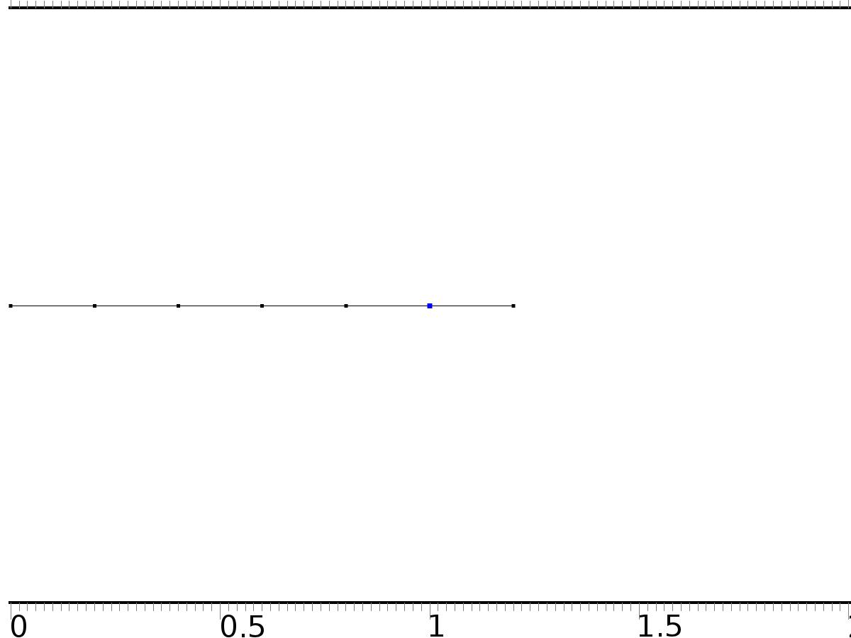

Flux/Source 3

Selection

|  |  |
| --- | --- |
| Geometric entity level | Boundary |
| Selection | Boundary 6 |

Equations

Settings

| **Description** | **Value** |
| --- | --- |
| Boundary flux/source | {Bd, Bd} |
| Boundary absorption/impedance term | {{0, 0}, {0, 0}} |

#### Variables

| **Name** | **Expression** | **Unit** | **Description** | **Selection** |
| --- | --- | --- | --- | --- |
| c4.g_PI3 | Bd | 1/m | Boundary flux/source | Boundary 6 |
| c4.g_PIt3 | Bd | 1/m | Boundary flux/source | Boundary 6 |

* + 1. Flux/Source 4



Flux/Source 4

Selection

|  |  |
| --- | --- |
| Geometric entity level | Boundary |
| Selection | Boundary 1 |

Equations

Settings

| **Description** | **Value** |
| --- | --- |
| Boundary flux/source | {0, 0} |
| Boundary absorption/impedance term | {{k0, 0}, {0, k0}} |

#### Variables

| **Name** | **Expression** | **Unit** | **Description** | **Selection** |
| --- | --- | --- | --- | --- |
| c4.g_PI3 | -k0*PI3 | 1/m | Boundary flux/source | Boundary 1 |
| c4.g_PIt3 | -k0*PIt3 | 1/m | Boundary flux/source | Boundary 1 |

* + 1. Flux/Source 5



Flux/Source 5

Selection

|  |  |
| --- | --- |
| Geometric entity level | Boundary |
| Selection | Boundary 7 |

Equations

Settings

| **Description** | **Value** |
| --- | --- |
| Boundary flux/source | {0, 0} |
| Boundary absorption/impedance term | {{k1, 0}, {0, k1}} |

#### Variables

| **Name** | **Expression** | **Unit** | **Description** | **Selection** |
| --- | --- | --- | --- | --- |
| c4.g_PI3 | -k1*PI3 | 1/m | Boundary flux/source | Boundary 7 |
| c4.g_PIt3 | -k1*PIt3 | 1/m | Boundary flux/source | Boundary 7 |

* 1. PDE 5



PDE 5

Selection

|  |  |
| --- | --- |
| Geometric entity level | Domain |
| Selection | Domains 1–6 |

Settings

| **Description** | **Value** |
| --- | --- |
| Shape function type | Lagrange |
| Element order | Quadratic |
| Value type when using splitting of complex variables | Complex |
| Compute boundary fluxes | Off |
| Dependent variable quantity | Dimensionless (1) |
| Source term quantity | None |
| Unit | m^ - 2 |

Used products

|  |
| --- |
| COMSOL Multiphysics |

Variables

| **Name** | **Expression** | **Unit** | **Description** | **Selection** |
| --- | --- | --- | --- | --- |
| c5.nx | unx |  | Normal vector, x component | Boundary 1 |
| c5.ny | 0 |  | Normal vector, y component | Boundary 1 |
| c5.nz | 0 |  | Normal vector, z component | Boundary 1 |
| c5.nx | dnx |  | Normal vector, x component | Boundary 7 |
| c5.ny | 0 |  | Normal vector, y component | Boundary 7 |
| c5.nz | 0 |  | Normal vector, z component | Boundary 7 |
| c5.nx | nx |  | Normal vector, x component | Boundaries 2–6 |
| c5.ny | 0 |  | Normal vector, y component | Boundaries 2–6 |
| c5.nz | 0 |  | Normal vector, z component | Boundaries 2–6 |
| c5.nxmesh | root.unxmesh |  | Normal vector (mesh), x component | Boundary 1 |
| c5.nymesh | 0 |  | Normal vector (mesh), y component | Boundary 1 |
| c5.nzmesh | 0 |  | Normal vector (mesh), z component | Boundary 1 |
| c5.nxmesh | root.dnxmesh |  | Normal vector (mesh), x component | Boundary 7 |
| c5.nymesh | 0 |  | Normal vector (mesh), y component | Boundary 7 |
| c5.nzmesh | 0 |  | Normal vector (mesh), z component | Boundary 7 |
| c5.nxmesh | root.nxmesh |  | Normal vector (mesh), x component | Boundaries 2–6 |
| c5.nymesh | 0 |  | Normal vector (mesh), y component | Boundaries 2–6 |
| c5.nzmesh | 0 |  | Normal vector (mesh), z component | Boundaries 2–6 |

* + 1. Coefficient Form PDE 1



Coefficient Form PDE 1

Selection

|  |  |
| --- | --- |
| Geometric entity level | Domain |
| Selection | Domains 1–6 |

Equations

Settings

| **Description** | **Value** |
| --- | --- |
| Diffusion coefficient | {{1, 0, 0, 0}, {0, 1, 0, 0}, {0, 0, 1, 0}, {0, 0, 0, 1}} |
| Absorption coefficient | {{0, -alpha1, 0, -alpha1}, {alpha1, 0, alpha1, 0}, {0, 0, 0, 0}, {0, 0, 0, 0}} |
| Source term | {0, 0, 0, 0} |
| Mass coefficient | {{0, 0, 0, 0}, {0, 0, 0, 0}, {0, 0, 0, 0}, {0, 0, 0, 0}} |
| Damping or mass coefficient | {{0, 0, 0, 0}, {0, 0, 0, 0}, {0, 0, 0, 0}, {0, 0, 0, 0}} |
| Conservative flux convection coefficient | {{0, 0, 0, 0}, {0, 0, 0, 0}, {0, 0, 0, 0}, {0, 0, 0, 0}} |
| Convection coefficient | {{0, 0, 0, 0}, {0, 0, 0, 0}, {0, 0, 0, 0}, {0, 0, 0, 0}} |
| Conservative flux source | {0, 0, 0, 0} |

#### Variables

| **Name** | **Expression** | **Unit** | **Description** | **Selection** |
| --- | --- | --- | --- | --- |
| domflux.PI4x | -d(PI4,x) | 1/m | Domain flux, x component | Domains 1–6 |
| domflux.PI5x | -d(PI5,x) | 1/m | Domain flux, x component | Domains 1–6 |
| domflux.PIt4x | -d(PIt4,x) | 1/m | Domain flux, x component | Domains 1–6 |
| domflux.PIt5x | -d(PIt5,x) | 1/m | Domain flux, x component | Domains 1–6 |

#### Shape functions

| **Name** | **Shape function** | **Unit** | **Description** | **Shape frame** | **Selection** |
| --- | --- | --- | --- | --- | --- |
| PI4 | Lagrange (Quadratic) | 1 | Dependent variable PI4 | Material | Domains 1–6 |
| PI5 | Lagrange (Quadratic) | 1 | Dependent variable PI5 | Material | Domains 1–6 |
| PIt4 | Lagrange (Quadratic) | 1 | Dependent variable PIt4 | Material | Domains 1–6 |
| PIt5 | Lagrange (Quadratic) | 1 | Dependent variable PIt5 | Material | Domains 1–6 |

* + 1. Zero Flux 1



Zero Flux 1

Selection

|  |  |
| --- | --- |
| Geometric entity level | Boundary |
| Selection | No boundaries |

Equations

* + 1. Initial Values 1



Initial Values 1

Selection

|  |  |
| --- | --- |
| Geometric entity level | Domain |
| Selection | Domains 1–6 |

Settings

| **Description** | **Value** |
| --- | --- |
| Initial value for PI4 | 0 |
| Initial value for PI5 | 0 |
| Initial value for PIt4 | 0 |
| Initial value for PIt5 | 0 |
| Initial time derivative of PI4 | 0 |
| Initial time derivative of PI5 | 0 |
| Initial time derivative of PIt4 | 0 |
| Initial time derivative of PIt5 | 0 |

* + 1. Flux/Source 1



Flux/Source 1

Selection

|  |  |
| --- | --- |
| Geometric entity level | Boundary |
| Selection | Boundary 2 |

Equations

Settings

| **Description** | **Value** |
| --- | --- |
| Boundary flux/source | {Bin1*Gamma41, Bin1*Gamma51, 0, 0} |
| Boundary absorption/impedance term | {{0, 0, 0, 0}, {0, 0, 0, 0}, {0, 0, 0, 0}, {0, 0, 0, 0}} |

#### Variables

| **Name** | **Expression** | **Unit** | **Description** | **Selection** |
| --- | --- | --- | --- | --- |
| c5.g_PI4 | Bin1*Gamma41 | 1/m | Boundary flux/source | Boundary 2 |
| c5.g_PI5 | Bin1*Gamma51 | 1/m | Boundary flux/source | Boundary 2 |
| c5.g_PIt4 | 0 | 1/m | Boundary flux/source | Boundary 2 |
| c5.g_PIt5 | 0 | 1/m | Boundary flux/source | Boundary 2 |

* + 1. Flux/Source 2



Flux/Source 2

Selection

|  |  |
| --- | --- |
| Geometric entity level | Boundary |
| Selection | Boundary 4 |

Equations

Settings

| **Description** | **Value** |
| --- | --- |
| Boundary flux/source | {Bin2*Gamma42, Bin2*Gamma52, 0, 0} |
| Boundary absorption/impedance term | {{0, 0, 0, 0}, {0, 0, 0, 0}, {0, 0, 0, 0}, {0, 0, 0, 0}} |

#### Variables

| **Name** | **Expression** | **Unit** | **Description** | **Selection** |
| --- | --- | --- | --- | --- |
| c5.g_PI4 | Bin2*Gamma42 | 1/m | Boundary flux/source | Boundary 4 |
| c5.g_PI5 | Bin2*Gamma52 | 1/m | Boundary flux/source | Boundary 4 |
| c5.g_PIt4 | 0 | 1/m | Boundary flux/source | Boundary 4 |
| c5.g_PIt5 | 0 | 1/m | Boundary flux/source | Boundary 4 |

* + 1. Flux/Source 3



Flux/Source 3

Selection

|  |  |
| --- | --- |
| Geometric entity level | Boundary |
| Selection | Boundary 1 |

Equations

Settings

| **Description** | **Value** |
| --- | --- |
| Boundary flux/source | {0, 0, 0, 0} |
| Boundary absorption/impedance term | {{k0, 0, 0, 0}, {0, k0, 0, 0}, {0, 0, k0, 0}, {0, 0, 0, k0}} |

#### Variables

| **Name** | **Expression** | **Unit** | **Description** | **Selection** |
| --- | --- | --- | --- | --- |
| c5.g_PI4 | -k0*PI4 | 1/m | Boundary flux/source | Boundary 1 |
| c5.g_PI5 | -k0*PI5 | 1/m | Boundary flux/source | Boundary 1 |
| c5.g_PIt4 | -k0*PIt4 | 1/m | Boundary flux/source | Boundary 1 |
| c5.g_PIt5 | -k0*PIt5 | 1/m | Boundary flux/source | Boundary 1 |

* + 1. Flux/Source 4



Flux/Source 4

Selection

|  |  |
| --- | --- |
| Geometric entity level | Boundary |
| Selection | Boundary 7 |

Equations

Settings

| **Description** | **Value** |
| --- | --- |
| Boundary flux/source | {0, 0, 0, 0} |
| Boundary absorption/impedance term | {{k1, 0, 0, 0}, {0, k1, 0, 0}, {0, 0, k1, 0}, {0, 0, 0, k1}} |

#### Variables

| **Name** | **Expression** | **Unit** | **Description** | **Selection** |
| --- | --- | --- | --- | --- |
| c5.g_PI4 | -k1*PI4 | 1/m | Boundary flux/source | Boundary 7 |
| c5.g_PI5 | -k1*PI5 | 1/m | Boundary flux/source | Boundary 7 |
| c5.g_PIt4 | -k1*PIt4 | 1/m | Boundary flux/source | Boundary 7 |
| c5.g_PIt5 | -k1*PIt5 | 1/m | Boundary flux/source | Boundary 7 |

* 1. PDE 6



PDE 6

Selection

|  |  |
| --- | --- |
| Geometric entity level | Domain |
| Selection | Domains 1–6 |

Settings

| **Description** | **Value** |
| --- | --- |
| Shape function type | Lagrange |
| Element order | Quadratic |
| Value type when using splitting of complex variables | Complex |
| Compute boundary fluxes | Off |
| Dependent variable quantity | Dimensionless (1) |
| Source term quantity | None |
| Unit | m^ - 2 |

Used products

|  |
| --- |
| COMSOL Multiphysics |

Variables

| **Name** | **Expression** | **Unit** | **Description** | **Selection** |
| --- | --- | --- | --- | --- |
| c6.nx | unx |  | Normal vector, x component | Boundary 1 |
| c6.ny | 0 |  | Normal vector, y component | Boundary 1 |
| c6.nz | 0 |  | Normal vector, z component | Boundary 1 |
| c6.nx | dnx |  | Normal vector, x component | Boundary 7 |
| c6.ny | 0 |  | Normal vector, y component | Boundary 7 |
| c6.nz | 0 |  | Normal vector, z component | Boundary 7 |
| c6.nx | nx |  | Normal vector, x component | Boundaries 2–6 |
| c6.ny | 0 |  | Normal vector, y component | Boundaries 2–6 |
| c6.nz | 0 |  | Normal vector, z component | Boundaries 2–6 |
| c6.nxmesh | root.unxmesh |  | Normal vector (mesh), x component | Boundary 1 |
| c6.nymesh | 0 |  | Normal vector (mesh), y component | Boundary 1 |
| c6.nzmesh | 0 |  | Normal vector (mesh), z component | Boundary 1 |
| c6.nxmesh | root.dnxmesh |  | Normal vector (mesh), x component | Boundary 7 |
| c6.nymesh | 0 |  | Normal vector (mesh), y component | Boundary 7 |
| c6.nzmesh | 0 |  | Normal vector (mesh), z component | Boundary 7 |
| c6.nxmesh | root.nxmesh |  | Normal vector (mesh), x component | Boundaries 2–6 |
| c6.nymesh | 0 |  | Normal vector (mesh), y component | Boundaries 2–6 |
| c6.nzmesh | 0 |  | Normal vector (mesh), z component | Boundaries 2–6 |

* + 1. Coefficient Form PDE 1



Coefficient Form PDE 1

Selection

|  |  |
| --- | --- |
| Geometric entity level | Domain |
| Selection | Domains 1–6 |

Equations

Settings

| **Description** | **Value** |
| --- | --- |
| Diffusion coefficient | {{1, 0, 0, 0}, {0, 1, 0, 0}, {0, 0, 1, 0}, {0, 0, 0, 1}} |
| Absorption coefficient | {{0, -alpha2, 0, -alpha2}, {alpha2, 0, alpha2, 0}, {0, 0, 0, 0}, {0, 0, 0, 0}} |
| Source term | {0, 0, 0, 0} |
| Mass coefficient | {{0, 0, 0, 0}, {0, 0, 0, 0}, {0, 0, 0, 0}, {0, 0, 0, 0}} |
| Damping or mass coefficient | {{0, 0, 0, 0}, {0, 0, 0, 0}, {0, 0, 0, 0}, {0, 0, 0, 0}} |
| Conservative flux convection coefficient | {{0, 0, 0, 0}, {0, 0, 0, 0}, {0, 0, 0, 0}, {0, 0, 0, 0}} |
| Convection coefficient | {{0, 0, 0, 0}, {0, 0, 0, 0}, {0, 0, 0, 0}, {0, 0, 0, 0}} |
| Conservative flux source | {0, 0, 0, 0} |

#### Variables

| **Name** | **Expression** | **Unit** | **Description** | **Selection** |
| --- | --- | --- | --- | --- |
| domflux.PI6x | -d(PI6,x) | 1/m | Domain flux, x component | Domains 1–6 |
| domflux.PI7x | -d(PI7,x) | 1/m | Domain flux, x component | Domains 1–6 |
| domflux.PIt6x | -d(PIt6,x) | 1/m | Domain flux, x component | Domains 1–6 |
| domflux.PIt7x | -d(PIt7,x) | 1/m | Domain flux, x component | Domains 1–6 |

#### Shape functions

| **Name** | **Shape function** | **Unit** | **Description** | **Shape frame** | **Selection** |
| --- | --- | --- | --- | --- | --- |
| PI6 | Lagrange (Quadratic) | 1 | Dependent variable PI6 | Material | Domains 1–6 |
| PI7 | Lagrange (Quadratic) | 1 | Dependent variable PI7 | Material | Domains 1–6 |
| PIt6 | Lagrange (Quadratic) | 1 | Dependent variable PIt6 | Material | Domains 1–6 |
| PIt7 | Lagrange (Quadratic) | 1 | Dependent variable PIt7 | Material | Domains 1–6 |

* + 1. Zero Flux 1



Zero Flux 1

Selection

|  |  |
| --- | --- |
| Geometric entity level | Boundary |
| Selection | No boundaries |

Equations

* + 1. Initial Values 1



Initial Values 1

Selection

|  |  |
| --- | --- |
| Geometric entity level | Domain |
| Selection | Domains 1–6 |

Settings

| **Description** | **Value** |
| --- | --- |
| Initial value for PI6 | 0 |
| Initial value for PI7 | 0 |
| Initial value for PIt6 | 0 |
| Initial value for PIt7 | 0 |
| Initial time derivative of PI6 | 0 |
| Initial time derivative of PI7 | 0 |
| Initial time derivative of PIt6 | 0 |
| Initial time derivative of PIt7 | 0 |

* + 1. Flux/Source 1



Flux/Source 1

Selection

|  |  |
| --- | --- |
| Geometric entity level | Boundary |
| Selection | Boundary 2 |

Equations

Settings

| **Description** | **Value** |
| --- | --- |
| Boundary flux/source | {Bin1*Gamma61, Bin1*Gamma71, 0, 0} |
| Boundary absorption/impedance term | {{0, 0, 0, 0}, {0, 0, 0, 0}, {0, 0, 0, 0}, {0, 0, 0, 0}} |

#### Variables

| **Name** | **Expression** | **Unit** | **Description** | **Selection** |
| --- | --- | --- | --- | --- |
| c6.g_PI6 | Bin1*Gamma61 | 1/m | Boundary flux/source | Boundary 2 |
| c6.g_PI7 | Bin1*Gamma71 | 1/m | Boundary flux/source | Boundary 2 |
| c6.g_PIt6 | 0 | 1/m | Boundary flux/source | Boundary 2 |
| c6.g_PIt7 | 0 | 1/m | Boundary flux/source | Boundary 2 |

* + 1. Flux/Source 2



Flux/Source 2

Selection

|  |  |
| --- | --- |
| Geometric entity level | Boundary |
| Selection | Boundary 4 |

Equations

Settings

| **Description** | **Value** |
| --- | --- |
| Boundary flux/source | {Bin2*Gamma62, Bin2*Gamma72, 0, 0} |
| Boundary absorption/impedance term | {{0, 0, 0, 0}, {0, 0, 0, 0}, {0, 0, 0, 0}, {0, 0, 0, 0}} |

#### Variables

| **Name** | **Expression** | **Unit** | **Description** | **Selection** |
| --- | --- | --- | --- | --- |
| c6.g_PI6 | Bin2*Gamma62 | 1/m | Boundary flux/source | Boundary 4 |
| c6.g_PI7 | Bin2*Gamma72 | 1/m | Boundary flux/source | Boundary 4 |
| c6.g_PIt6 | 0 | 1/m | Boundary flux/source | Boundary 4 |
| c6.g_PIt7 | 0 | 1/m | Boundary flux/source | Boundary 4 |

* + 1. Flux/Source 3



Flux/Source 3

Selection

|  |  |
| --- | --- |
| Geometric entity level | Boundary |
| Selection | Boundary 1 |

Equations

Settings

| **Description** | **Value** |
| --- | --- |
| Boundary flux/source | {0, 0, 0, 0} |
| Boundary absorption/impedance term | {{k0, 0, 0, 0}, {0, k0, 0, 0}, {0, 0, k0, 0}, {0, 0, 0, k0}} |

#### Variables

| **Name** | **Expression** | **Unit** | **Description** | **Selection** |
| --- | --- | --- | --- | --- |
| c6.g_PI6 | -k0*PI6 | 1/m | Boundary flux/source | Boundary 1 |
| c6.g_PI7 | -k0*PI7 | 1/m | Boundary flux/source | Boundary 1 |
| c6.g_PIt6 | -k0*PIt6 | 1/m | Boundary flux/source | Boundary 1 |
| c6.g_PIt7 | -k0*PIt7 | 1/m | Boundary flux/source | Boundary 1 |

* + 1. Flux/Source 4



Flux/Source 4

Selection

|  |  |
| --- | --- |
| Geometric entity level | Boundary |
| Selection | Boundary 7 |

Equations

Settings

| **Description** | **Value** |
| --- | --- |
| Boundary flux/source | {0, 0, 0, 0} |
| Boundary absorption/impedance term | {{k1, 0, 0, 0}, {0, k1, 0, 0}, {0, 0, k1, 0}, {0, 0, 0, k1}} |

#### Variables

| **Name** | **Expression** | **Unit** | **Description** | **Selection** |
| --- | --- | --- | --- | --- |
| c6.g_PI6 | -k1*PI6 | 1/m | Boundary flux/source | Boundary 7 |
| c6.g_PI7 | -k1*PI7 | 1/m | Boundary flux/source | Boundary 7 |
| c6.g_PIt6 | -k1*PIt6 | 1/m | Boundary flux/source | Boundary 7 |
| c6.g_PIt7 | -k1*PIt7 | 1/m | Boundary flux/source | Boundary 7 |

* 1. PDE 7



PDE 7

Selection

|  |  |
| --- | --- |
| Geometric entity level | Domain |
| Selection | Domains 1–6 |

Settings

| **Description** | **Value** |
| --- | --- |
| Shape function type | Lagrange |
| Element order | Quadratic |
| Value type when using splitting of complex variables | Complex |
| Compute boundary fluxes | Off |
| Dependent variable quantity | Dimensionless (1) |
| Source term quantity | None |
| Unit | m^ - 2 |

Used products

|  |
| --- |
| COMSOL Multiphysics |

Variables

| **Name** | **Expression** | **Unit** | **Description** | **Selection** |
| --- | --- | --- | --- | --- |
| c7.nx | unx |  | Normal vector, x component | Boundary 1 |
| c7.ny | 0 |  | Normal vector, y component | Boundary 1 |
| c7.nz | 0 |  | Normal vector, z component | Boundary 1 |
| c7.nx | dnx |  | Normal vector, x component | Boundary 7 |
| c7.ny | 0 |  | Normal vector, y component | Boundary 7 |
| c7.nz | 0 |  | Normal vector, z component | Boundary 7 |
| c7.nx | nx |  | Normal vector, x component | Boundaries 2–6 |
| c7.ny | 0 |  | Normal vector, y component | Boundaries 2–6 |
| c7.nz | 0 |  | Normal vector, z component | Boundaries 2–6 |
| c7.nxmesh | root.unxmesh |  | Normal vector (mesh), x component | Boundary 1 |
| c7.nymesh | 0 |  | Normal vector (mesh), y component | Boundary 1 |
| c7.nzmesh | 0 |  | Normal vector (mesh), z component | Boundary 1 |
| c7.nxmesh | root.dnxmesh |  | Normal vector (mesh), x component | Boundary 7 |
| c7.nymesh | 0 |  | Normal vector (mesh), y component | Boundary 7 |
| c7.nzmesh | 0 |  | Normal vector (mesh), z component | Boundary 7 |
| c7.nxmesh | root.nxmesh |  | Normal vector (mesh), x component | Boundaries 2–6 |
| c7.nymesh | 0 |  | Normal vector (mesh), y component | Boundaries 2–6 |
| c7.nzmesh | 0 |  | Normal vector (mesh), z component | Boundaries 2–6 |

* + 1. Coefficient Form PDE 1



Coefficient Form PDE 1

Selection

|  |  |
| --- | --- |
| Geometric entity level | Domain |
| Selection | Domains 1–6 |

Equations

Settings

| **Description** | **Value** |
| --- | --- |
| Diffusion coefficient | {{1, 0, 0, 0}, {0, 1, 0, 0}, {0, 0, 1, 0}, {0, 0, 0, 1}} |
| Absorption coefficient | {{0, -beta, 0, -beta}, {beta, 0, beta, 0}, {0, 0, 0, 0}, {0, 0, 0, 0}} |
| Source term | {0, 0, 0, 0} |
| Mass coefficient | {{0, 0, 0, 0}, {0, 0, 0, 0}, {0, 0, 0, 0}, {0, 0, 0, 0}} |
| Damping or mass coefficient | {{0, 0, 0, 0}, {0, 0, 0, 0}, {0, 0, 0, 0}, {0, 0, 0, 0}} |
| Conservative flux convection coefficient | {{0, 0, 0, 0}, {0, 0, 0, 0}, {0, 0, 0, 0}, {0, 0, 0, 0}} |
| Convection coefficient | {{0, 0, 0, 0}, {0, 0, 0, 0}, {0, 0, 0, 0}, {0, 0, 0, 0}} |
| Conservative flux source | {0, 0, 0, 0} |

#### Variables

| **Name** | **Expression** | **Unit** | **Description** | **Selection** |
| --- | --- | --- | --- | --- |
| domflux.PI8x | -d(PI8,x) | 1/m | Domain flux, x component | Domains 1–6 |
| domflux.PI9x | -d(PI9,x) | 1/m | Domain flux, x component | Domains 1–6 |
| domflux.PIt8x | -d(PIt8,x) | 1/m | Domain flux, x component | Domains 1–6 |
| domflux.PIt9x | -d(PIt9,x) | 1/m | Domain flux, x component | Domains 1–6 |

#### Shape functions

| **Name** | **Shape function** | **Unit** | **Description** | **Shape frame** | **Selection** |
| --- | --- | --- | --- | --- | --- |
| PI8 | Lagrange (Quadratic) | 1 | Dependent variable PI8 | Material | Domains 1–6 |
| PI9 | Lagrange (Quadratic) | 1 | Dependent variable PI9 | Material | Domains 1–6 |
| PIt8 | Lagrange (Quadratic) | 1 | Dependent variable PIt8 | Material | Domains 1–6 |
| PIt9 | Lagrange (Quadratic) | 1 | Dependent variable PIt9 | Material | Domains 1–6 |

* + 1. Zero Flux 1



Zero Flux 1

Selection

|  |  |
| --- | --- |
| Geometric entity level | Boundary |
| Selection | No boundaries |

Equations

* + 1. Initial Values 1



Initial Values 1

Selection

|  |  |
| --- | --- |
| Geometric entity level | Domain |
| Selection | Domains 1–6 |

Settings

| **Description** | **Value** |
| --- | --- |
| Initial value for PI8 | 0 |
| Initial value for PI9 | 0 |
| Initial value for PIt8 | 0 |
| Initial value for PIt9 | 0 |
| Initial time derivative of PI8 | 0 |
| Initial time derivative of PI9 | 0 |
| Initial time derivative of PIt8 | 0 |
| Initial time derivative of PIt9 | 0 |

* + 1. Flux/Source 1



Flux/Source 1

Selection

|  |  |
| --- | --- |
| Geometric entity level | Boundary |
| Selection | Boundary 2 |

Equations

Settings

| **Description** | **Value** |
| --- | --- |
| Boundary flux/source | {Bin1*Gamma81, Bin1*Gamma91, 0, 0} |
| Boundary absorption/impedance term | {{0, 0, 0, 0}, {0, 0, 0, 0}, {0, 0, 0, 0}, {0, 0, 0, 0}} |

#### Variables

| **Name** | **Expression** | **Unit** | **Description** | **Selection** |
| --- | --- | --- | --- | --- |
| c7.g_PI8 | Bin1*Gamma81 | 1/m | Boundary flux/source | Boundary 2 |
| c7.g_PI9 | Bin1*Gamma91 | 1/m | Boundary flux/source | Boundary 2 |
| c7.g_PIt8 | 0 | 1/m | Boundary flux/source | Boundary 2 |
| c7.g_PIt9 | 0 | 1/m | Boundary flux/source | Boundary 2 |

* + 1. Flux/Source 2



Flux/Source 2

Selection

|  |  |
| --- | --- |
| Geometric entity level | Boundary |
| Selection | Boundary 4 |

Equations

Settings

| **Description** | **Value** |
| --- | --- |
| Boundary flux/source | {Bin2*Gamma82, Bin2*Gamma92, 0, 0} |
| Boundary absorption/impedance term | {{0, 0, 0, 0}, {0, 0, 0, 0}, {0, 0, 0, 0}, {0, 0, 0, 0}} |

#### Variables

| **Name** | **Expression** | **Unit** | **Description** | **Selection** |
| --- | --- | --- | --- | --- |
| c7.g_PI8 | Bin2*Gamma82 | 1/m | Boundary flux/source | Boundary 4 |
| c7.g_PI9 | Bin2*Gamma92 | 1/m | Boundary flux/source | Boundary 4 |
| c7.g_PIt8 | 0 | 1/m | Boundary flux/source | Boundary 4 |
| c7.g_PIt9 | 0 | 1/m | Boundary flux/source | Boundary 4 |

* + 1. Flux/Source 3



Flux/Source 3

Selection

|  |  |
| --- | --- |
| Geometric entity level | Boundary |
| Selection | Boundary 6 |

Equations

Settings

| **Description** | **Value** |
| --- | --- |
| Boundary flux/source | {Bd, 0, Bd, 0} |
| Boundary absorption/impedance term | {{0, 0, 0, 0}, {0, 0, 0, 0}, {0, 0, 0, 0}, {0, 0, 0, 0}} |

#### Variables

| **Name** | **Expression** | **Unit** | **Description** | **Selection** |
| --- | --- | --- | --- | --- |
| c7.g_PI8 | Bd | 1/m | Boundary flux/source | Boundary 6 |
| c7.g_PI9 | 0 | 1/m | Boundary flux/source | Boundary 6 |
| c7.g_PIt8 | Bd | 1/m | Boundary flux/source | Boundary 6 |
| c7.g_PIt9 | 0 | 1/m | Boundary flux/source | Boundary 6 |

* + 1. Flux/Source 4



Flux/Source 4

Selection

|  |  |
| --- | --- |
| Geometric entity level | Boundary |
| Selection | Boundary 1 |

Equations

Settings

| **Description** | **Value** |
| --- | --- |
| Boundary flux/source | {0, 0, 0, 0} |
| Boundary absorption/impedance term | {{k0, 0, 0, 0}, {0, k0, 0, 0}, {0, 0, k0, 0}, {0, 0, 0, k0}} |

#### Variables

| **Name** | **Expression** | **Unit** | **Description** | **Selection** |
| --- | --- | --- | --- | --- |
| c7.g_PI8 | -k0*PI8 | 1/m | Boundary flux/source | Boundary 1 |
| c7.g_PI9 | -k0*PI9 | 1/m | Boundary flux/source | Boundary 1 |
| c7.g_PIt8 | -k0*PIt8 | 1/m | Boundary flux/source | Boundary 1 |
| c7.g_PIt9 | -k0*PIt9 | 1/m | Boundary flux/source | Boundary 1 |

* + 1. Flux/Source 5



Flux/Source 5

Selection

|  |  |
| --- | --- |
| Geometric entity level | Boundary |
| Selection | Boundary 7 |

Equations

Settings

| **Description** | **Value** |
| --- | --- |
| Boundary flux/source | {0, 0, 0, 0} |
| Boundary absorption/impedance term | {{k1, 0, 0, 0}, {0, k1, 0, 0}, {0, 0, k1, 0}, {0, 0, 0, k1}} |

#### Variables

| **Name** | **Expression** | **Unit** | **Description** | **Selection** |
| --- | --- | --- | --- | --- |
| c7.g_PI8 | -k1*PI8 | 1/m | Boundary flux/source | Boundary 7 |
| c7.g_PI9 | -k1*PI9 | 1/m | Boundary flux/source | Boundary 7 |
| c7.g_PIt8 | -k1*PIt8 | 1/m | Boundary flux/source | Boundary 7 |
| c7.g_PIt9 | -k1*PIt9 | 1/m | Boundary flux/source | Boundary 7 |

* 1. PDE 8



PDE 8

Selection

|  |  |
| --- | --- |
| Geometric entity level | Domain |
| Selection | Domains 1–6 |

Settings

| **Description** | **Value** |
| --- | --- |
| Shape function type | Lagrange |
| Element order | Quadratic |
| Value type when using splitting of complex variables | Complex |
| Compute boundary fluxes | Off |
| Dependent variable quantity | Dimensionless (1) |
| Source term quantity | None |
| Unit | m^ - 2 |

Used products

|  |
| --- |
| COMSOL Multiphysics |

Variables

| **Name** | **Expression** | **Unit** | **Description** | **Selection** |
| --- | --- | --- | --- | --- |
| c8.nx | unx |  | Normal vector, x component | Boundary 1 |
| c8.ny | 0 |  | Normal vector, y component | Boundary 1 |
| c8.nz | 0 |  | Normal vector, z component | Boundary 1 |
| c8.nx | dnx |  | Normal vector, x component | Boundary 7 |
| c8.ny | 0 |  | Normal vector, y component | Boundary 7 |
| c8.nz | 0 |  | Normal vector, z component | Boundary 7 |
| c8.nx | nx |  | Normal vector, x component | Boundaries 2–6 |
| c8.ny | 0 |  | Normal vector, y component | Boundaries 2–6 |
| c8.nz | 0 |  | Normal vector, z component | Boundaries 2–6 |
| c8.nxmesh | root.unxmesh |  | Normal vector (mesh), x component | Boundary 1 |
| c8.nymesh | 0 |  | Normal vector (mesh), y component | Boundary 1 |
| c8.nzmesh | 0 |  | Normal vector (mesh), z component | Boundary 1 |
| c8.nxmesh | root.dnxmesh |  | Normal vector (mesh), x component | Boundary 7 |
| c8.nymesh | 0 |  | Normal vector (mesh), y component | Boundary 7 |
| c8.nzmesh | 0 |  | Normal vector (mesh), z component | Boundary 7 |
| c8.nxmesh | root.nxmesh |  | Normal vector (mesh), x component | Boundaries 2–6 |
| c8.nymesh | 0 |  | Normal vector (mesh), y component | Boundaries 2–6 |
| c8.nzmesh | 0 |  | Normal vector (mesh), z component | Boundaries 2–6 |

* + 1. Coefficient Form PDE 1



Coefficient Form PDE 1

Selection

|  |  |
| --- | --- |
| Geometric entity level | Domain |
| Selection | Domains 1–6 |

Equations

Settings

| **Description** | **Value** |
| --- | --- |
| Diffusion coefficient | 1 |
| Absorption coefficient | 0 |
| Source term | 0 |
| Mass coefficient | 0 |
| Damping or mass coefficient | 1 |
| Conservative flux convection coefficient | 0 |
| Convection coefficient | 0 |
| Conservative flux source | 0 |

#### Variables

| **Name** | **Expression** | **Unit** | **Description** | **Selection** |
| --- | --- | --- | --- | --- |
| domflux.zx | -d(z,x) | 1/m | Domain flux, x component | Domains 1–6 |

#### Shape functions

| **Name** | **Shape function** | **Unit** | **Description** | **Shape frame** | **Selection** |
| --- | --- | --- | --- | --- | --- |
| z | Lagrange (Quadratic) | 1 | Dependent variable z | Material | Domains 1–6 |

* + 1. Zero Flux 1



Zero Flux 1

Selection

|  |  |
| --- | --- |
| Geometric entity level | Boundary |
| Selection | No boundaries |

Equations

* + 1. Initial Values 1



Initial Values 1

Selection

|  |  |
| --- | --- |
| Geometric entity level | Domain |
| Selection | Domains 1–6 |

Settings

| **Description** | **Value** |
| --- | --- |
| Initial value for z | cos(pi*x/L) |
| Initial time derivative of z | 0 |

* + 1. Flux/Source 1



Flux/Source 1

Selection

|  |  |
| --- | --- |
| Geometric entity level | Boundary |
| Selection | Boundary 2 |

Equations

Settings

| **Description** | **Value** |
| --- | --- |
| Boundary flux/source | Bin1*Gamma1 |
| Boundary absorption/impedance term | 0 |

#### Variables

| **Name** | **Expression** | **Unit** | **Description** | **Selection** |
| --- | --- | --- | --- | --- |
| c8.g_z | Bin1*Gamma1 | 1/m | Boundary flux/source | Boundary 2 |

* + 1. Flux/Source 2



Flux/Source 2

Selection

|  |  |
| --- | --- |
| Geometric entity level | Boundary |
| Selection | Boundary 4 |

Equations

Settings

| **Description** | **Value** |
| --- | --- |
| Boundary flux/source | Bin2*Gamma2 |
| Boundary absorption/impedance term | 0 |

#### Variables

| **Name** | **Expression** | **Unit** | **Description** | **Selection** |
| --- | --- | --- | --- | --- |
| c8.g_z | Bin2*Gamma2 | 1/m | Boundary flux/source | Boundary 4 |

* + 1. Flux/Source 3



Flux/Source 3

Selection

|  |  |
| --- | --- |
| Geometric entity level | Boundary |
| Selection | Boundary 6 |

Equations

Settings

| **Description** | **Value** |
| --- | --- |
| Boundary flux/source | Bd*d |
| Boundary absorption/impedance term | 0 |

#### Variables

| **Name** | **Expression** | **Unit** | **Description** | **Selection** |
| --- | --- | --- | --- | --- |
| c8.g_z | Bd*d | 1/m | Boundary flux/source | Boundary 6 |

* + 1. Flux/Source 4



Flux/Source 4

Selection

|  |  |
| --- | --- |
| Geometric entity level | Boundary |
| Selection | Boundary 1 |

Equations

Settings

| **Description** | **Value** |
| --- | --- |
| Boundary flux/source | 0 |
| Boundary absorption/impedance term | k0 |

#### Variables

| **Name** | **Expression** | **Unit** | **Description** | **Selection** |
| --- | --- | --- | --- | --- |
| c8.g_z | -k0*z | 1/m | Boundary flux/source | Boundary 1 |

* + 1. Flux/Source 5



Flux/Source 5

Selection

|  |  |
| --- | --- |
| Geometric entity level | Boundary |
| Selection | Boundary 7 |

Equations

Settings

| **Description** | **Value** |
| --- | --- |
| Boundary flux/source | 0 |
| Boundary absorption/impedance term | k1 |

#### Variables

| **Name** | **Expression** | **Unit** | **Description** | **Selection** |
| --- | --- | --- | --- | --- |
| c8.g_z | -k1*z | 1/m | Boundary flux/source | Boundary 7 |

* 1. Mesh 1

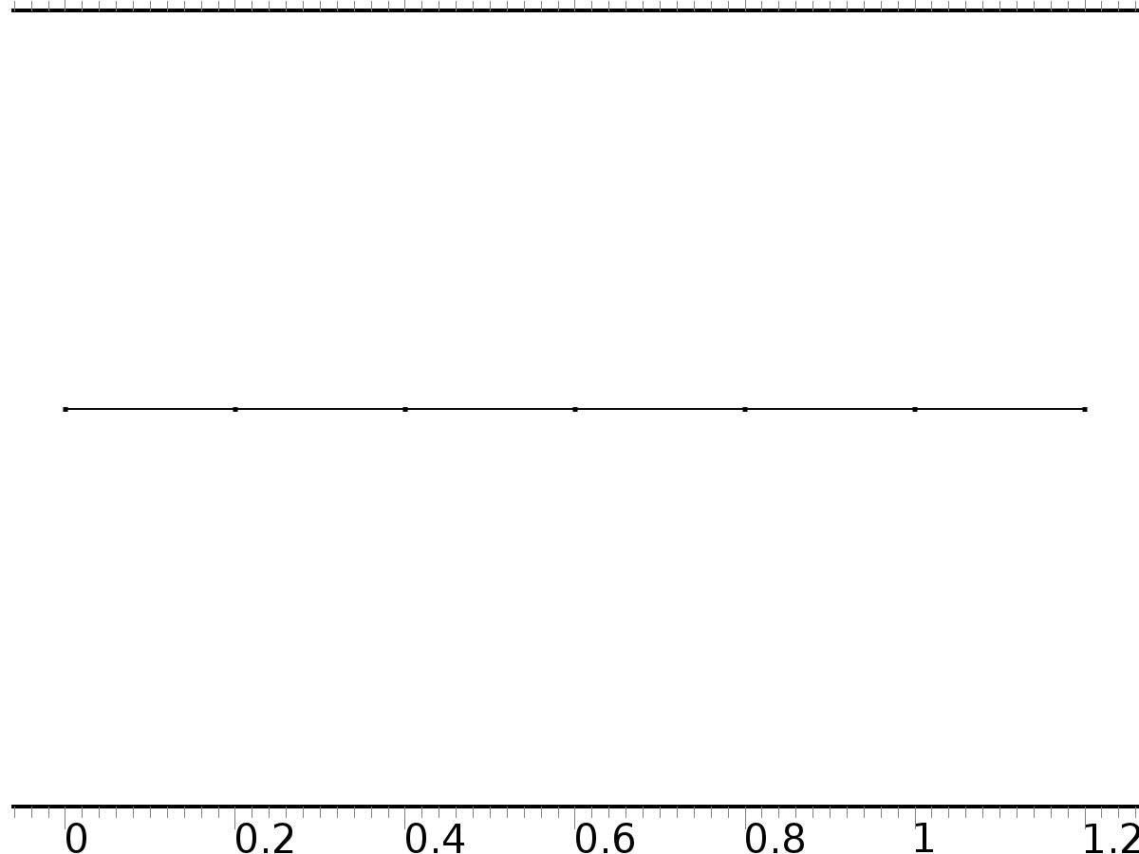

Mesh 1

* + 1. Size (size)

Settings

| **Description** | **Value** |
| --- | --- |
| Maximum element size | 0.024 |
| Minimum element size | 9.0E-5 |
| Curvature factor | 0.25 |
| Maximum element growth rate | 1.2 |
| Predefined size | Extra fine |

* + 1. Edge 1 (edg1)

Selection

|  |  |
| --- | --- |
| Geometric entity level | Remaining |

1. Study 1
   1. Stationary

Study settings

| **Description** | **Value** |
| --- | --- |
| Include geometric nonlinearity | Off |

Physics and variables selection

| **Physics interface** | **Discretization** |
| --- | --- |
| PDE (c) | physics |

Mesh selection

| **Geometry** | **Mesh** |
| --- | --- |
| Geometry 1 (geom1) | mesh1 |

* 1. Solver Configurations
     1. Solver 1

#### Compile Equations: Stationary (st1)

Study and step

| **Description** | **Value** |
| --- | --- |
| Use study | Study 1 |
| Use study step | Stationary |

#### Dependent Variables 1 (v1)

General

| **Description** | **Value** |
| --- | --- |
| Defined by study step | Stationary |
| Constant |  |

Initial values of variables solved for

| **Description** | **Value** |
| --- | --- |
| Solution | Zero |

Values of variables not solved for

| **Description** | **Value** |
| --- | --- |
| Solution | Zero |

##### mod1.PI9 (mod1_PI9)

General

| **Description** | **Value** |
| --- | --- |
| Field components | mod1.PI9 |
| Solve for this field | Off |

##### mod1.z (mod1_z)

General

| **Description** | **Value** |
| --- | --- |
| Field components | mod1.z |
| Solve for this field | Off |

##### mod1.PIt8 (mod1_PIt8)

General

| **Description** | **Value** |
| --- | --- |
| Field components | mod1.PIt8 |
| Solve for this field | Off |

##### mod1.PI1 (mod1_PI1)

General

| **Description** | **Value** |
| --- | --- |
| Field components | mod1.PI1 |
| Solve for this field | Off |

##### mod1.PIt7 (mod1_PIt7)

General

| **Description** | **Value** |
| --- | --- |
| Field components | mod1.PIt7 |
| Solve for this field | Off |

##### mod1.PI2 (mod1_PI2)

General

| **Description** | **Value** |
| --- | --- |
| Field components | mod1.PI2 |
| Solve for this field | Off |

##### mod1.PI3 (mod1_PI3)

General

| **Description** | **Value** |
| --- | --- |
| Field components | mod1.PI3 |
| Solve for this field | Off |

##### mod1.PIt9 (mod1_PIt9)

General

| **Description** | **Value** |
| --- | --- |
| Field components | mod1.PIt9 |
| Solve for this field | Off |

##### mod1.PI4 (mod1_PI4)

General

| **Description** | **Value** |
| --- | --- |
| Field components | mod1.PI4 |
| Solve for this field | Off |

##### mod1.X2 (mod1_X2)

General

| **Description** | **Value** |
| --- | --- |
| Field components | mod1.X2 |

##### mod1.PI5 (mod1_PI5)

General

| **Description** | **Value** |
| --- | --- |
| Field components | mod1.PI5 |
| Solve for this field | Off |

##### mod1.PIt4 (mod1_PIt4)

General

| **Description** | **Value** |
| --- | --- |
| Field components | mod1.PIt4 |
| Solve for this field | Off |

##### mod1.PIt3 (mod1_PIt3)

General

| **Description** | **Value** |
| --- | --- |
| Field components | mod1.PIt3 |
| Solve for this field | Off |

##### mod1.PI6 (mod1_PI6)

General

| **Description** | **Value** |
| --- | --- |
| Field components | mod1.PI6 |
| Solve for this field | Off |

##### mod1.PI7 (mod1_PI7)

General

| **Description** | **Value** |
| --- | --- |
| Field components | mod1.PI7 |
| Solve for this field | Off |

##### mod1.PIt6 (mod1_PIt6)

General

| **Description** | **Value** |
| --- | --- |
| Field components | mod1.PIt6 |
| Solve for this field | Off |

##### mod1.PI8 (mod1_PI8)

General

| **Description** | **Value** |
| --- | --- |
| Field components | mod1.PI8 |
| Solve for this field | Off |

##### mod1.X1 (mod1_X1)

General

| **Description** | **Value** |
| --- | --- |
| Field components | mod1.X1 |

##### mod1.PIt5 (mod1_PIt5)

General

| **Description** | **Value** |
| --- | --- |
| Field components | mod1.PIt5 |
| Solve for this field | Off |

#### Stationary Solver 1 (s1)

General

| **Description** | **Value** |
| --- | --- |
| Defined by study step | Stationary |
| Relative tolerance | 0.0010 |

Log

| **Description** | **Value** |
| --- | --- |
| Constant |  |

##### Fully Coupled 1 (fc1)

General

| **Description** | **Value** |
| --- | --- |
| Linear solver | Direct |

Method and termination

| **Description** | **Value** |
| --- | --- |
| Termination criterion | Solution |

1. Study 2
   1. Stationary

Study settings

| **Description** | **Value** |
| --- | --- |
| Include geometric nonlinearity | Off |

Physics and variables selection

| **Physics interface** | **Discretization** |
| --- | --- |
| PDE 2 (c2) | physics |
| PDE 3 (c3) | physics |
| PDE 4 (c4) | physics |
| PDE 5 (c5) | physics |
| PDE 6 (c6) | physics |
| PDE 7 (c7) | physics |

Mesh selection

| **Geometry** | **Mesh** |
| --- | --- |
| Geometry 1 (geom1) | mesh1 |

* 1. Solver Configurations
     1. Solver 2

#### Compile Equations: Stationary (st1)

Study and step

| **Description** | **Value** |
| --- | --- |
| Use study | Study 2 |
| Use study step | Stationary |

#### Dependent Variables 1 (v1)

General

| **Description** | **Value** |
| --- | --- |
| Defined by study step | Stationary |
| Constant |  |

Initial values of variables solved for

| **Description** | **Value** |
| --- | --- |
| Solution | Zero |

Values of variables not solved for

| **Description** | **Value** |
| --- | --- |
| Method | Solution |
| Solution | Solver 1 |

##### mod1.PI9 (mod1_PI9)

General

| **Description** | **Value** |
| --- | --- |
| Field components | mod1.PI9 |

##### mod1.PIt8 (mod1_PIt8)

General

| **Description** | **Value** |
| --- | --- |
| Field components | mod1.PIt8 |

##### mod1.PI1 (mod1_PI1)

General

| **Description** | **Value** |
| --- | --- |
| Field components | mod1.PI1 |

##### mod1.PIt7 (mod1_PIt7)

General

| **Description** | **Value** |
| --- | --- |
| Field components | mod1.PIt7 |

##### mod1.PI2 (mod1_PI2)

General

| **Description** | **Value** |
| --- | --- |
| Field components | mod1.PI2 |

##### mod1.PI3 (mod1_PI3)

General

| **Description** | **Value** |
| --- | --- |
| Field components | mod1.PI3 |

##### mod1.PIt9 (mod1_PIt9)

General

| **Description** | **Value** |
| --- | --- |
| Field components | mod1.PIt9 |

##### mod1.PI4 (mod1_PI4)

General

| **Description** | **Value** |
| --- | --- |
| Field components | mod1.PI4 |

##### mod1.X2 (mod1_X2)

General

| **Description** | **Value** |
| --- | --- |
| Field components | mod1.X2 |
| Solve for this field | Off |

##### mod1.PI5 (mod1_PI5)

General

| **Description** | **Value** |
| --- | --- |
| Field components | mod1.PI5 |

##### mod1.PIt4 (mod1_PIt4)

General

| **Description** | **Value** |
| --- | --- |
| Field components | mod1.PIt4 |

##### mod1.PIt3 (mod1_PIt3)

General

| **Description** | **Value** |
| --- | --- |
| Field components | mod1.PIt3 |

##### mod1.PI6 (mod1_PI6)

General

| **Description** | **Value** |
| --- | --- |
| Field components | mod1.PI6 |

##### mod1.PI7 (mod1_PI7)

General

| **Description** | **Value** |
| --- | --- |
| Field components | mod1.PI7 |

##### mod1.PIt6 (mod1_PIt6)

General

| **Description** | **Value** |
| --- | --- |
| Field components | mod1.PIt6 |

##### mod1.PI8 (mod1_PI8)

General

| **Description** | **Value** |
| --- | --- |
| Field components | mod1.PI8 |

##### mod1.X1 (mod1_X1)

General

| **Description** | **Value** |
| --- | --- |
| Field components | mod1.X1 |
| Solve for this field | Off |

##### mod1.PIt5 (mod1_PIt5)

General

| **Description** | **Value** |
| --- | --- |
| Field components | mod1.PIt5 |

##### mod1.z (mod1_z)

General

| **Description** | **Value** |
| --- | --- |
| Field components | mod1.z |
| Solve for this field | Off |

#### Stationary Solver 1 (s1)

General

| **Description** | **Value** |
| --- | --- |
| Defined by study step | Stationary |
| Relative tolerance | 0.0010 |

Log

| **Description** | **Value** |
| --- | --- |
| Constant |  |

##### Fully Coupled 1 (fc1)

General

| **Description** | **Value** |
| --- | --- |
| Linear solver | Direct |

Method and termination

| **Description** | **Value** |
| --- | --- |
| Termination criterion | Solution |

1. Study 3
   1. Time Dependent

Study settings

| **Description** | **Value** |
| --- | --- |
| Include geometric nonlinearity | Off |

| **Times** | **Unit** |
| --- | --- |
| range(0,0.01,10) | s |

Physics and variables selection

| **Physics interface** | **Discretization** |
| --- | --- |
| PDE 8 (c8) | physics |

Mesh selection

| **Geometry** | **Mesh** |
| --- | --- |
| Geometry 1 (geom1) | mesh1 |

* 1. Solver Configurations
     1. Solver 3

#### Compile Equations: Time Dependent (st1)

Study and step

| **Description** | **Value** |
| --- | --- |
| Use study | Study 3 |
| Use study step | Time Dependent |

#### Dependent Variables 1 (v1)

General

| **Description** | **Value** |
| --- | --- |
| Defined by study step | Time Dependent |
| Constant |  |

Initial values of variables solved for

| **Description** | **Value** |
| --- | --- |
| Solution | Zero |

Values of variables not solved for

| **Description** | **Value** |
| --- | --- |
| Method | Solution |
| Solution | Solver 2 |

##### mod1.PI9 (mod1_PI9)

General

| **Description** | **Value** |
| --- | --- |
| Field components | mod1.PI9 |
| Solve for this field | Off |

##### mod1.z (mod1_z)

General

| **Description** | **Value** |
| --- | --- |
| Field components | mod1.z |

##### mod1.PIt8 (mod1_PIt8)

General

| **Description** | **Value** |
| --- | --- |
| Field components | mod1.PIt8 |
| Solve for this field | Off |

##### mod1.PI1 (mod1_PI1)

General

| **Description** | **Value** |
| --- | --- |
| Field components | mod1.PI1 |
| Solve for this field | Off |

##### mod1.PIt7 (mod1_PIt7)

General

| **Description** | **Value** |
| --- | --- |
| Field components | mod1.PIt7 |
| Solve for this field | Off |

##### mod1.PI2 (mod1_PI2)

General

| **Description** | **Value** |
| --- | --- |
| Field components | mod1.PI2 |
| Solve for this field | Off |

##### mod1.PI3 (mod1_PI3)

General

| **Description** | **Value** |
| --- | --- |
| Field components | mod1.PI3 |
| Solve for this field | Off |

##### mod1.PIt9 (mod1_PIt9)

General

| **Description** | **Value** |
| --- | --- |
| Field components | mod1.PIt9 |
| Solve for this field | Off |

##### mod1.PI4 (mod1_PI4)

General

| **Description** | **Value** |
| --- | --- |
| Field components | mod1.PI4 |
| Solve for this field | Off |

##### mod1.X2 (mod1_X2)

General

| **Description** | **Value** |
| --- | --- |
| Field components | mod1.X2 |
| Solve for this field | Off |

##### mod1.PI5 (mod1_PI5)

General

| **Description** | **Value** |
| --- | --- |
| Field components | mod1.PI5 |
| Solve for this field | Off |

##### mod1.PIt4 (mod1_PIt4)

General

| **Description** | **Value** |
| --- | --- |
| Field components | mod1.PIt4 |
| Solve for this field | Off |

##### mod1.PIt3 (mod1_PIt3)

General

| **Description** | **Value** |
| --- | --- |
| Field components | mod1.PIt3 |
| Solve for this field | Off |

##### mod1.PI6 (mod1_PI6)

General

| **Description** | **Value** |
| --- | --- |
| Field components | mod1.PI6 |
| Solve for this field | Off |

##### mod1.PI7 (mod1_PI7)

General

| **Description** | **Value** |
| --- | --- |
| Field components | mod1.PI7 |
| Solve for this field | Off |

##### mod1.PIt6 (mod1_PIt6)

General

| **Description** | **Value** |
| --- | --- |
| Field components | mod1.PIt6 |
| Solve for this field | Off |

##### mod1.PI8 (mod1_PI8)

General

| **Description** | **Value** |
| --- | --- |
| Field components | mod1.PI8 |
| Solve for this field | Off |

##### mod1.X1 (mod1_X1)

General

| **Description** | **Value** |
| --- | --- |
| Field components | mod1.X1 |
| Solve for this field | Off |

##### mod1.PIt5 (mod1_PIt5)

General

| **Description** | **Value** |
| --- | --- |
| Field components | mod1.PIt5 |
| Solve for this field | Off |

#### Time-Dependent Solver 1 (t1)

General

| **Description** | **Value** |
| --- | --- |
| Defined by study step | Time Dependent |
| Time | {0, 0.01, 0.02, 0.03, 0.04, 0.05, 0.06, 0.07, 0.08, 0.09, 0.1, 0.11, 0.12, 0.13, 0.14, 0.15, 0.16, 0.17, 0.18, 0.19, 0.2, 0.21, 0.22, 0.23, 0.24, 0.25, 0.26, 0.27, 0.28, 0.29, 0.3, 0.31, 0.32, 0.33, 0.34, 0.35000000000000003, 0.36, 0.37, 0.38, 0.39, 0.4, 0.41000000000000003, 0.42, 0.43, 0.44, 0.45, 0.46, 0.47000000000000003, 0.48, 0.49, 0.5, 0.51, 0.52, 0.53, 0.54, 0.55, 0.56, 0.5700000000000001, 0.58, 0.59, 0.6, 0.61, 0.62, 0.63, 0.64, 0.65, 0.66, 0.67, 0.68, 0.6900000000000001, 0.7000000000000001, 0.71, 0.72, 0.73, 0.74, 0.75, 0.76, 0.77, 0.78, 0.79, 0.8, 0.81, 0.8200000000000001, 0.8300000000000001, 0.84, 0.85, 0.86, 0.87, 0.88, 0.89, 0.9, 0.91, 0.92, 0.93, 0.9400000000000001, 0.9500000000000001, 0.96, 0.97, 0.98, 0.99, 1, 1.01, 1.02, 1.03, 1.04, 1.05, 1.06, 1.07, 1.08, 1.09, 1.1, 1.11, 1.12, 1.1300000000000001, 1.1400000000000001, 1.1500000000000001, 1.16, 1.17, 1.18, 1.19, 1.2, 1.21, 1.22, 1.23, 1.24, 1.25, 1.26, 1.27, 1.28, 1.29, 1.3, 1.31, 1.32, 1.33, 1.34, 1.35, 1.36, 1.37, 1.3800000000000001, 1.3900000000000001, 1.4000000000000001, 1.41, 1.42, 1.43, 1.44, 1.45, 1.46, 1.47, 1.48, 1.49, 1.5, 1.51, 1.52, 1.53, 1.54, 1.55, 1.56, 1.57, 1.58, 1.59, 1.6, 1.61, 1.62, 1.6300000000000001, 1.6400000000000001, 1.6500000000000001, 1.6600000000000001, 1.67, 1.68, 1.69, 1.7, 1.71, 1.72, 1.73, 1.74, 1.75, 1.76, 1.77, 1.78, 1.79, 1.8, 1.81, 1.82, 1.83, 1.84, 1.85, 1.86, 1.87, 1.8800000000000001, 1.8900000000000001, 1.9000000000000001, 1.9100000000000001, 1.92, 1.93, 1.94, 1.95, 1.96, 1.97, 1.98, 1.99, 2, 2.0100000000000002, 2.02, 2.0300000000000002, 2.04, 2.05, 2.06, 2.07, 2.08, 2.09, 2.1, 2.11, 2.12, 2.13, 2.14, 2.15, 2.16, 2.17, 2.18, 2.19, 2.2, 2.21, 2.22, 2.23, 2.24, 2.25, 2.2600000000000002, 2.27, 2.2800000000000002, 2.29, 2.3000000000000003, 2.31, 2.32, 2.33, 2.34, 2.35, 2.36, 2.37, 2.38, 2.39, 2.4, 2.41, 2.42, 2.43, 2.44, 2.45, 2.46, 2.47, 2.48, 2.49, 2.5, 2.5100000000000002, 2.52, 2.5300000000000002, 2.54, 2.5500000000000003, 2.56, 2.57, 2.58, 2.59, 2.6, 2.61, 2.62, 2.63, 2.64, 2.65, 2.66, 2.67, 2.68, 2.69, 2.7, 2.71, 2.72, 2.73, 2.74, 2.75, 2.7600000000000002, 2.77, 2.7800000000000002, 2.79, 2.8000000000000003, 2.81, 2.82, 2.83, 2.84, 2.85, 2.86, 2.87, 2.88, 2.89, 2.9, 2.91, 2.92, 2.93, 2.94, 2.95, 2.96, 2.97, 2.98, 2.99, 3, 3.0100000000000002, 3.02, 3.0300000000000002, 3.04, 3.0500000000000003, 3.06, 3.0700000000000003, 3.08, 3.09, 3.1, 3.11, 3.12, 3.13, 3.14, 3.15, 3.16, 3.17, 3.18, 3.19, 3.2, 3.21, 3.22, 3.23, 3.24, 3.25, 3.2600000000000002, 3.27, 3.2800000000000002, 3.29, 3.3000000000000003, 3.31, 3.3200000000000003, 3.33, 3.34, 3.35, 3.36, 3.37, 3.38, 3.39, 3.4, 3.41, 3.42, 3.43, 3.44, 3.45, 3.46, 3.47, 3.48, 3.49, 3.5, 3.5100000000000002, 3.52, 3.5300000000000002, 3.54, 3.5500000000000003, 3.56, 3.5700000000000003, 3.58, 3.59, 3.6, 3.61, 3.62, 3.63, 3.64, 3.65, 3.66, 3.67, 3.68, 3.69, 3.7, 3.71, 3.72, 3.73, 3.74, 3.75, 3.7600000000000002, 3.77, 3.7800000000000002, 3.79, 3.8000000000000003, 3.81, 3.8200000000000003, 3.83, 3.84, 3.85, 3.86, 3.87, 3.88, 3.89, 3.9, 3.91, 3.92, 3.93, 3.94, 3.95, 3.96, 3.97, 3.98, 3.99, 4, 4.01, 4.0200000000000005, 4.03, 4.04, 4.05, 4.0600000000000005, 4.07, 4.08, 4.09, 4.1, 4.11, 4.12, 4.13, 4.14, 4.15, 4.16, 4.17, 4.18, 4.19, 4.2, 4.21, 4.22, 4.23, 4.24, 4.25, 4.26, 4.2700000000000005, 4.28, 4.29, 4.3, 4.3100000000000005, 4.32, 4.33, 4.34, 4.3500000000000005, 4.36, 4.37, 4.38, 4.39, 4.4, 4.41, 4.42, 4.43, 4.44, 4.45, 4.46, 4.47, 4.48, 4.49, 4.5, 4.51, 4.5200000000000005, 4.53, 4.54, 4.55, 4.5600000000000005, 4.57, 4.58, 4.59, 4.6000000000000005, 4.61, 4.62, 4.63, 4.64, 4.65, 4.66, 4.67, 4.68, 4.69, 4.7, 4.71, 4.72, 4.73, 4.74, 4.75, 4.76, 4.7700000000000005, 4.78, 4.79, 4.8, 4.8100000000000005, 4.82, 4.83, 4.84, 4.8500000000000005, 4.86, 4.87, 4.88, 4.89, 4.9, 4.91, 4.92, 4.93, 4.94, 4.95, 4.96, 4.97, 4.98, 4.99, 5, 5.01, 5.0200000000000005, 5.03, 5.04, 5.05, 5.0600000000000005, 5.07, 5.08, 5.09, 5.1000000000000005, 5.11, 5.12, 5.13, 5.14, 5.15, 5.16, 5.17, 5.18, 5.19, 5.2, 5.21, 5.22, 5.23, 5.24, 5.25, 5.26, 5.2700000000000005, 5.28, 5.29, 5.3, 5.3100000000000005, 5.32, 5.33, 5.34, 5.3500000000000005, 5.36, 5.37, 5.38, 5.39, 5.4, 5.41, 5.42, 5.43, 5.44, 5.45, 5.46, 5.47, 5.48, 5.49, 5.5, 5.51, 5.5200000000000005, 5.53, 5.54, 5.55, 5.5600000000000005, 5.57, 5.58, 5.59, 5.6000000000000005, 5.61, 5.62, 5.63, 5.64, 5.65, 5.66, 5.67, 5.68, 5.69, 5.7, 5.71, 5.72, 5.73, 5.74, 5.75, 5.76, 5.7700000000000005, 5.78, 5.79, 5.8, 5.8100000000000005, 5.82, 5.83, 5.84, 5.8500000000000005, 5.86, 5.87, 5.88, 5.89, 5.9, 5.91, 5.92, 5.93, 5.94, 5.95, 5.96, 5.97, 5.98, 5.99, 6, 6.01, 6.0200000000000005, 6.03, 6.04, 6.05, 6.0600000000000005, 6.07, 6.08, 6.09, 6.1000000000000005, 6.11, 6.12, 6.13, 6.140000000000001, 6.15, 6.16, 6.17, 6.18, 6.19, 6.2, 6.21, 6.22, 6.23, 6.24, 6.25, 6.26, 6.2700000000000005, 6.28, 6.29, 6.3, 6.3100000000000005, 6.32, 6.33, 6.34, 6.3500000000000005, 6.36, 6.37, 6.38, 6.390000000000001, 6.4, 6.41, 6.42, 6.43, 6.44, 6.45, 6.46, 6.47, 6.48, 6.49, 6.5, 6.51, 6.5200000000000005, 6.53, 6.54, 6.55, 6.5600000000000005, 6.57, 6.58, 6.59, 6.6000000000000005, 6.61, 6.62, 6.63, 6.640000000000001, 6.65, 6.66, 6.67, 6.68, 6.69, 6.7, 6.71, 6.72, 6.73, 6.74, 6.75, 6.76, 6.7700000000000005, 6.78, 6.79, 6.8, 6.8100000000000005, 6.82, 6.83, 6.84, 6.8500000000000005, 6.86, 6.87, 6.88, 6.890000000000001, 6.9, 6.91, 6.92, 6.93, 6.94, 6.95, 6.96, 6.97, 6.98, 6.99, 7, 7.01, 7.0200000000000005, 7.03, 7.04, 7.05, 7.0600000000000005, 7.07, 7.08, 7.09, 7.1000000000000005, 7.11, 7.12, 7.13, 7.140000000000001, 7.15, 7.16, 7.17, 7.18, 7.19, 7.2, 7.21, 7.22, 7.23, 7.24, 7.25, 7.26, 7.2700000000000005, 7.28, 7.29, 7.3, 7.3100000000000005, 7.32, 7.33, 7.34, 7.3500000000000005, 7.36, 7.37, 7.38, 7.390000000000001, 7.4, 7.41, 7.42, 7.43, 7.44, 7.45, 7.46, 7.47, 7.48, 7.49, 7.5, 7.51, 7.5200000000000005, 7.53, 7.54, 7.55, 7.5600000000000005, 7.57, 7.58, 7.59, 7.6000000000000005, 7.61, 7.62, 7.63, 7.640000000000001, 7.65, 7.66, 7.67, 7.68, 7.69, 7.7, 7.71, 7.72, 7.73, 7.74, 7.75, 7.76, 7.7700000000000005, 7.78, 7.79, 7.8, 7.8100000000000005, 7.82, 7.83, 7.84, 7.8500000000000005, 7.86, 7.87, 7.88, 7.890000000000001, 7.9, 7.91, 7.92, 7.930000000000001, 7.94, 7.95, 7.96, 7.97, 7.98, 7.99, 8, 8.01, 8.02, 8.03, 8.040000000000001, 8.05, 8.06, 8.07, 8.08, 8.09, 8.1, 8.11, 8.120000000000001, 8.13, 8.14, 8.15, 8.16, 8.17, 8.18, 8.19, 8.2, 8.21, 8.22, 8.23, 8.24, 8.25, 8.26, 8.27, 8.28, 8.290000000000001, 8.3, 8.31, 8.32, 8.33, 8.34, 8.35, 8.36, 8.370000000000001, 8.38, 8.39, 8.4, 8.41, 8.42, 8.43, 8.44, 8.45, 8.46, 8.47, 8.48, 8.49, 8.5, 8.51, 8.52, 8.53, 8.540000000000001, 8.55, 8.56, 8.57, 8.58, 8.59, 8.6, 8.61, 8.620000000000001, 8.63, 8.64, 8.65, 8.66, 8.67, 8.68, 8.69, 8.700000000000001, 8.71, 8.72, 8.73, 8.74, 8.75, 8.76, 8.77, 8.78, 8.790000000000001, 8.8, 8.81, 8.82, 8.83, 8.84, 8.85, 8.86, 8.870000000000001, 8.88, 8.89, 8.9, 8.91, 8.92, 8.93, 8.94, 8.950000000000001, 8.96, 8.97, 8.98, 8.99, 9, 9.01, 9.02, 9.03, 9.040000000000001, 9.05, 9.06, 9.07, 9.08, 9.09, 9.1, 9.11, 9.120000000000001, 9.13, 9.14, 9.15, 9.16, 9.17, 9.18, 9.19, 9.200000000000001, 9.21, 9.22, 9.23, 9.24, 9.25, 9.26, 9.27, 9.28, 9.290000000000001, 9.3, 9.31, 9.32, 9.33, 9.34, 9.35, 9.36, 9.370000000000001, 9.38, 9.39, 9.4, 9.41, 9.42, 9.43, 9.44, 9.450000000000001, 9.46, 9.47, 9.48, 9.49, 9.5, 9.51, 9.52, 9.53, 9.540000000000001, 9.55, 9.56, 9.57, 9.58, 9.59, 9.6, 9.61, 9.620000000000001, 9.63, 9.64, 9.65, 9.66, 9.67, 9.68, 9.69, 9.700000000000001, 9.71, 9.72, 9.73, 9.74, 9.75, 9.76, 9.77, 9.78, 9.790000000000001, 9.8, 9.81, 9.82, 9.83, 9.84, 9.85, 9.86, 9.870000000000001, 9.88, 9.89, 9.9, 9.91, 9.92, 9.93, 9.94, 9.950000000000001, 9.96, 9.97, 9.98, 9.99, 10} |
| Relative tolerance | 1.0E-4 |

Absolute tolerance

| **Description** | **Value** |
| --- | --- |
| Tolerance | 0.000010 |

Time stepping

| **Description** | **Value** |
| --- | --- |
| Initial step | 0.0010 |

Results while solving

| **Description** | **Value** |
| --- | --- |
| Probes | None |

Advanced

| **Description** | **Value** |
| --- | --- |
| Fraction of initial step for Backward Euler | 1.0 |

Log

| **Description** | **Value** |
| --- | --- |
| Constant |  |

##### Fully Coupled 1 (fc1)

General

| **Description** | **Value** |
| --- | --- |
| Linear solver | Direct |

1. Results
   1. Data Sets
      1. Solution 1

Solution

| **Description** | **Value** |
| --- | --- |
| Solution | Solver 1 |
| Component | Save Point Geometry 1 |

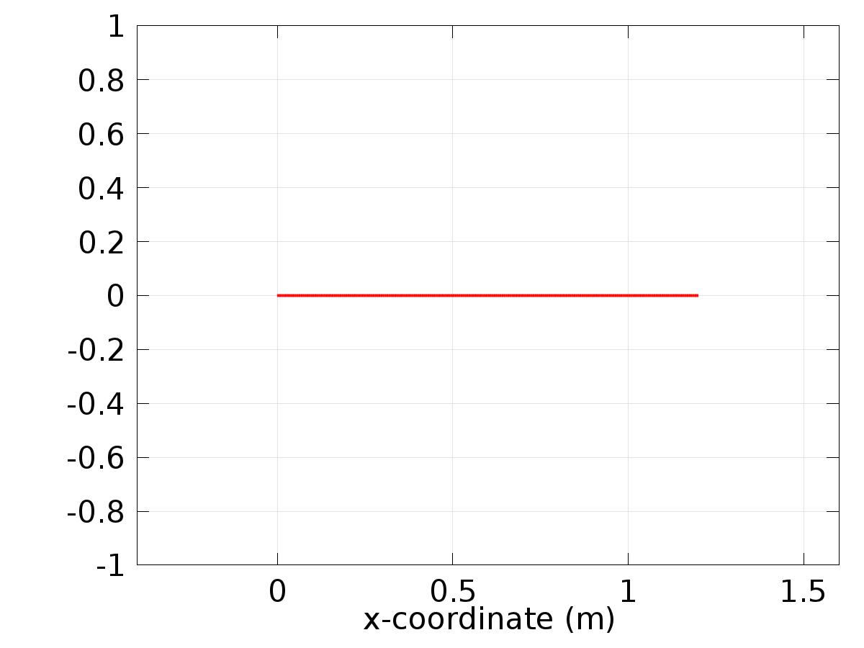

Data set: Solution 1

* + 1. Solution 2

Solution

| **Description** | **Value** |
| --- | --- |
| Solution | Solver 2 |
| Component | Save Point Geometry 1 |



Data set: Solution 2

* + 1. Solution 3

Solution

| **Description** | **Value** |
| --- | --- |
| Solution | Solver 3 |
| Component | Save Point Geometry 1 |

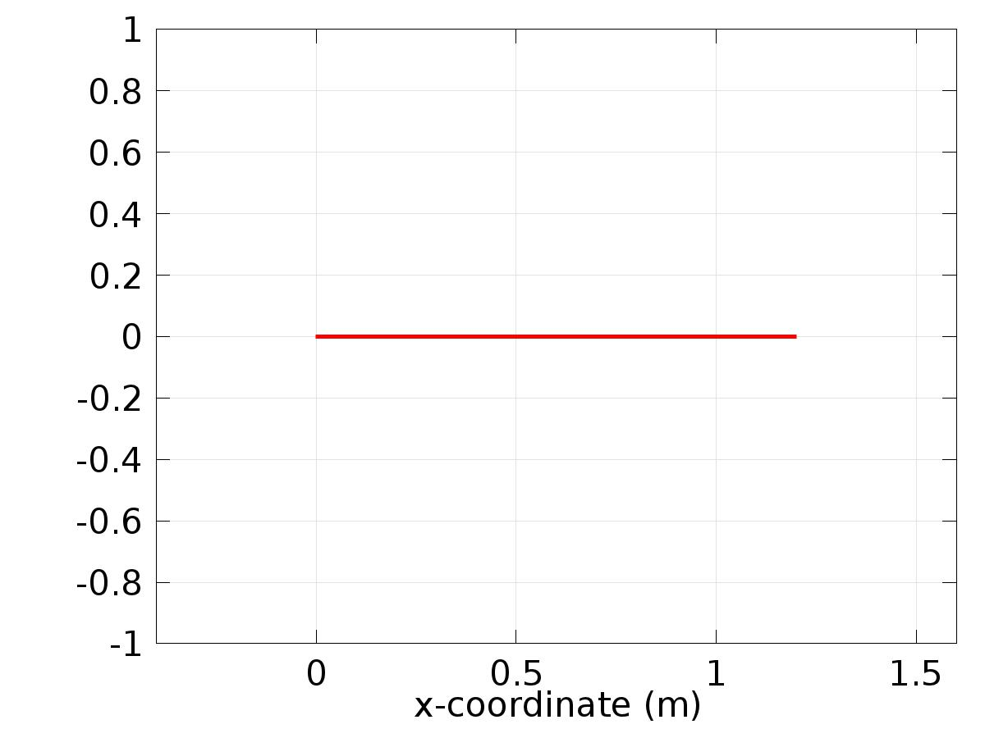

Data set: Solution 3

* + 1. Probe Solution 4

Solution

| **Description** | **Value** |
| --- | --- |
| Solution | Solver 3 |
| Component | Save Point Geometry 1 |



Data set: Probe Solution 4

* 1. Derived Values
     1. Global Evaluation 1

Data

| **Description** | **Value** |
| --- | --- |
| Data set | Solution 3 |

Expression

| **Description** | **Value** |
| --- | --- |
| Expression | e1 |

* + 1. Global Evaluation 2

Data

| **Description** | **Value** |
| --- | --- |
| Data set | Solution 3 |

Expression

| **Description** | **Value** |
| --- | --- |
| Expression | C2(PI9) |
| Unit | 1 |
| Description | C2(PI9) |

* + 1. Point Evaluation 1

Selection

|  |  |
| --- | --- |
| Geometric entity level | Boundary |
| Selection | No boundaries |

Data

| **Description** | **Value** |
| --- | --- |
| Data set | Solution 3 |

Expression

| **Description** | **Value** |
| --- | --- |
| Expression | yr2 |

* + 1. Point Evaluation 2

Selection

|  |  |
| --- | --- |
| Geometric entity level | Boundary |
| Selection | No boundaries |

Data

| **Description** | **Value** |
| --- | --- |
| Data set | Solution 3 |

Expression

| **Description** | **Value** |
| --- | --- |
| Expression | yr2 |

* + 1. Global Variable Probe 1

Data

| **Description** | **Value** |
| --- | --- |
| Data set | Probe Solution 4 |

Expression

| **Description** | **Value** |
| --- | --- |
| Expression | Gamma11 |
| Unit | 1 |

* + 1. Global Variable Probe 2

Data

| **Description** | **Value** |
| --- | --- |
| Data set | Probe Solution 4 |

Expression

| **Description** | **Value** |
| --- | --- |
| Expression | Gamma12 |
| Unit | 1 |

* + 1. Global Variable Probe 3

Data

| **Description** | **Value** |
| --- | --- |
| Data set | Probe Solution 4 |

Expression

| **Description** | **Value** |
| --- | --- |
| Expression | Gamma21 |
| Unit | 1 |

* + 1. Global Variable Probe 4

Data

| **Description** | **Value** |
| --- | --- |
| Data set | Probe Solution 4 |

Expression

| **Description** | **Value** |
| --- | --- |
| Expression | Gamma22 |
| Unit | 1 |

* + 1. Global Variable Probe 5

Data

| **Description** | **Value** |
| --- | --- |
| Data set | Probe Solution 4 |

Expression

| **Description** | **Value** |
| --- | --- |
| Expression | Gamma31 |
| Unit | 1 |

* + 1. Global Variable Probe 6

Data

| **Description** | **Value** |
| --- | --- |
| Data set | Probe Solution 4 |

Expression

| **Description** | **Value** |
| --- | --- |
| Expression | Gamma32 |
| Unit | 1 |

* + 1. Global Variable Probe 7

Data

| **Description** | **Value** |
| --- | --- |
| Data set | Probe Solution 4 |

Expression

| **Description** | **Value** |
| --- | --- |
| Expression | Gamma41 |
| Unit | 1 |

* + 1. Global Variable Probe 8

Data

| **Description** | **Value** |
| --- | --- |
| Data set | Probe Solution 4 |

Expression

| **Description** | **Value** |
| --- | --- |
| Expression | Gamma42 |
| Unit | 1 |

* + 1. Global Variable Probe 9

Data

| **Description** | **Value** |
| --- | --- |
| Data set | Probe Solution 4 |

Expression

| **Description** | **Value** |
| --- | --- |
| Expression | Gamma51 |
| Unit | 1 |

* + 1. Global Variable Probe 10

Data

| **Description** | **Value** |
| --- | --- |
| Data set | Probe Solution 4 |

Expression

| **Description** | **Value** |
| --- | --- |
| Expression | Gamma52 |
| Unit | 1 |

* + 1. Global Variable Probe 11

Data

| **Description** | **Value** |
| --- | --- |
| Data set | Probe Solution 4 |

Expression

| **Description** | **Value** |
| --- | --- |
| Expression | Gamma61 |
| Unit | 1 |

* + 1. Global Variable Probe 12

Data

| **Description** | **Value** |
| --- | --- |
| Data set | Probe Solution 4 |

Expression

| **Description** | **Value** |
| --- | --- |
| Expression | Gamma62 |
| Unit | 1 |

* + 1. Global Variable Probe 13

Data

| **Description** | **Value** |
| --- | --- |
| Data set | Probe Solution 4 |

Expression

| **Description** | **Value** |
| --- | --- |
| Expression | Gamma71 |
| Unit | 1 |

* + 1. Global Variable Probe 14

Data

| **Description** | **Value** |
| --- | --- |
| Data set | Probe Solution 4 |

Expression

| **Description** | **Value** |
| --- | --- |
| Expression | Gamma72 |
| Unit | 1 |

* + 1. Global Variable Probe 15

Data

| **Description** | **Value** |
| --- | --- |
| Data set | Probe Solution 4 |

Expression

| **Description** | **Value** |
| --- | --- |
| Expression | Gamma81 |
| Unit | 1 |

* + 1. Global Variable Probe 16

Data

| **Description** | **Value** |
| --- | --- |
| Data set | Probe Solution 4 |

Expression

| **Description** | **Value** |
| --- | --- |
| Expression | Gamma82 |
| Unit | 1 |

* + 1. Global Variable Probe 17

Data

| **Description** | **Value** |
| --- | --- |
| Data set | Probe Solution 4 |

Expression

| **Description** | **Value** |
| --- | --- |
| Expression | Gamma91 |
| Unit | 1 |

* + 1. Global Variable Probe 18

Data

| **Description** | **Value** |
| --- | --- |
| Data set | Probe Solution 4 |

Expression

| **Description** | **Value** |
| --- | --- |
| Expression | Gamma92 |
| Unit | 1 |

* + 1. Point Evaluation 3

Selection

|  |  |
| --- | --- |
| Geometric entity level | Boundary |
| Selection | Boundary 3 |

Data

| **Description** | **Value** |
| --- | --- |
| Data set | Solution 3 |

Expression

| **Description** | **Value** |
| --- | --- |
| Expression | yr2 |

* 1. Tables
     1. Table 1

Global Evaluation 1 (g11)

Table 1

| **DETG (1)** |
| --- |
| 3.3333E-5 |

* + 1. Table 2

Global Evaluation 2 (C1(PI1))

Table 2

| **C2(PI1) (1)** | **C1(PI1) (1)** |
| --- | --- |
| -2.0000 | -1.00000 |

* + 1. Table 3

Global Evaluation 2 (C1(PI1))

Table 3

| **C1(PI1)** | **C2(PI1) (1)** |
| --- | --- |
| 2.0000 | 1.0000 |

* + 1. Table 4

Global Evaluation 2 (C1(P1))

* + 1. Table 5

Global Evaluation 2 (C1(P1))

* + 1. Table 6

Global Evaluation 2 (C1(PI1))

Table 6

| **C2(PI7) (1)** | **C1(PI8) (1)** | **C2(PI8) (1)** | **C1(PI9) (1)** | **C2(PI9) (1)** |
| --- | --- | --- | --- | --- |
| 1.9269E-15 | -8.4144E-17 | -9.4834E-17 | -1.2565E-16 | -9.0429E-17 |

* + 1. Table 7

Global Evaluation 1 (Gamma1)

Table 7

| **Time** | **e1** |
| --- | --- |
| 0.0000 | -0.30075 |
| 0.10000 | -0.39953 |
| 0.20000 | -0.41663 |
| 0.30000 | -0.38934 |
| 0.40000 | -0.34906 |
| 0.50000 | -0.30778 |
| 0.60000 | -0.26948 |
| 0.70000 | -0.23524 |
| 0.80000 | -0.20510 |
| 0.90000 | -0.17872 |
| 1.0000 | -0.15570 |
| 1.1000 | -0.13563 |
| 1.2000 | -0.11814 |
| 1.3000 | -0.10291 |
| 1.4000 | -0.089636 |
| 1.5000 | -0.078076 |
| 1.6000 | -0.068006 |
| 1.7000 | -0.059234 |
| 1.8000 | -0.051594 |
| 1.9000 | -0.044940 |
| 2.0000 | -0.039148 |
| 2.1000 | -0.034104 |
| 2.2000 | -0.029709 |
| 2.3000 | -0.025878 |
| 2.4000 | -0.022543 |
| 2.5000 | -0.019638 |
| 2.6000 | -0.017105 |
| 2.7000 | -0.014897 |
| 2.8000 | -0.012973 |
| 2.9000 | -0.011284 |
| 3.0000 | -0.0098186 |
| 3.1000 | -0.0085529 |
| 3.2000 | -0.0074503 |
| 3.3000 | -0.0065050 |
| 3.4000 | -0.0056858 |
| 3.5000 | -0.0049603 |
| 3.6000 | -0.0043172 |
| 3.7000 | -0.0037713 |
| 3.8000 | -0.0033006 |
| 3.9000 | -0.0028819 |
| 4.0000 | -0.0025149 |
| 4.1000 | -0.0021945 |
| 4.2000 | -0.0019146 |
| 4.3000 | -0.0016702 |
| 4.4000 | -0.0014573 |
| 4.5000 | -0.0012714 |
| 4.6000 | -0.0011080 |
| 4.7000 | -9.6479E-4 |
| 4.8000 | -8.4010E-4 |
| 4.9000 | -7.3133E-4 |
| 5.0000 | -6.3318E-4 |
| 5.1000 | -5.4511E-4 |
| 5.2000 | -4.7106E-4 |
| 5.3000 | -4.0832E-4 |
| 5.4000 | -3.5205E-4 |
| 5.5000 | -3.0312E-4 |
| 5.6000 | -2.6351E-4 |
| 5.7000 | -2.3101E-4 |
| 5.8000 | -1.9692E-4 |
| 5.9000 | -1.6989E-4 |
| 6.0000 | -1.4762E-4 |
| 6.1000 | -1.2705E-4 |
| 6.2000 | -1.0849E-4 |
| 6.3000 | -9.3267E-5 |
| 6.4000 | -8.0346E-5 |
| 6.5000 | -6.6684E-5 |
| 6.6000 | -4.9712E-5 |
| 6.7000 | -3.0983E-5 |
| 6.8000 | -1.9951E-5 |
| 6.9000 | -1.8753E-5 |
| 7.0000 | -2.1253E-5 |
| 7.1000 | -8.5597E-6 |
| 7.2000 | 2.7829E-5 |
| 7.3000 | 5.3504E-5 |
| 7.4000 | 5.2159E-5 |
| 7.5000 | 2.6987E-5 |
| 7.6000 | 1.8851E-5 |
| 7.7000 | 5.2454E-5 |
| 7.8000 | 7.0242E-5 |
| 7.9000 | 4.5064E-5 |
| 8.0000 | 5.3177E-6 |
| 8.1000 | -4.1447E-6 |
| 8.2000 | 2.2823E-5 |
| 8.3000 | 3.1151E-5 |
| 8.4000 | 2.2311E-6 |
| 8.5000 | -2.7749E-5 |
| 8.6000 | -1.5966E-5 |
| 8.7000 | 2.0708E-7 |
| 8.8000 | -7.3099E-6 |
| 8.9000 | -1.3104E-5 |
| 9.0000 | -2.6178E-6 |
| 9.1000 | -1.2355E-6 |
| 9.2000 | -8.3397E-6 |
| 9.3000 | -5.4245E-6 |
| 9.4000 | -3.5993E-7 |
| 9.5000 | -3.7019E-6 |
| 9.6000 | -5.2960E-6 |
| 9.7000 | -1.1621E-6 |
| 9.8000 | -7.0767E-7 |
| 9.9000 | -3.2670E-6 |
| 10.000 | -1.9753E-6 |
| 10.100 | 3.8942E-7 |
| 10.200 | -1.0949E-6 |
| 10.300 | -2.0179E-6 |
| 10.400 | 1.2962E-8 |
| 10.500 | 4.7099E-7 |
| 10.600 | -1.3721E-6 |
| 10.700 | -6.7561E-7 |
| 10.800 | 9.2655E-7 |
| 10.900 | -1.4089E-7 |
| 11.000 | -9.9425E-7 |
| 11.100 | 6.6047E-7 |
| 11.200 | 7.5009E-7 |
| 11.300 | -7.0018E-7 |
| 11.400 | -1.7974E-7 |
| 11.500 | 8.0317E-7 |
| 11.600 | -3.3820E-7 |
| 11.700 | -8.0525E-7 |
| 11.800 | 2.0196E-7 |
| 11.900 | 3.5938E-8 |
| 12.000 | -8.5229E-7 |
| 12.100 | -3.5647E-7 |
| 12.200 | 8.2617E-8 |
| 12.300 | -5.4402E-7 |
| 12.400 | -6.9594E-7 |
| 12.500 | -1.7126E-7 |
| 12.600 | -2.8431E-7 |
| 12.700 | -6.3496E-7 |
| 12.800 | -3.6841E-7 |
| 12.900 | -9.2299E-8 |
| 13.000 | -2.6400E-7 |
| 13.100 | -2.9412E-7 |
| 13.200 | 2.0856E-8 |
| 13.300 | 1.1810E-7 |
| 13.400 | -8.9706E-9 |
| 13.500 | 1.0575E-7 |
| 13.600 | 4.1348E-7 |
| 13.700 | 7.9062E-7 |
| 13.800 | 9.6008E-7 |
| 13.900 | 7.9197E-7 |
| 14.000 | 1.5979E-6 |
| 14.100 | 4.3562E-6 |
| 14.200 | 8.1942E-6 |
| 14.300 | 1.2221E-5 |
| 14.400 | 1.2921E-5 |
| 14.500 | 1.1259E-5 |
| 14.600 | 1.1863E-5 |
| 14.700 | 1.4362E-5 |
| 14.800 | 1.2788E-5 |
| 14.900 | 1.3196E-5 |
| 15.000 | 1.7684E-5 |
| 15.100 | 2.0449E-5 |
| 15.200 | 2.3920E-5 |
| 15.300 | 2.7009E-5 |
| 15.400 | 2.8676E-5 |
| 15.500 | 2.8341E-5 |
| 15.600 | 2.7415E-5 |
| 15.700 | 2.3727E-5 |
| 15.800 | 1.6205E-5 |
| 15.900 | 1.0188E-5 |
| 16.000 | 8.1044E-6 |
| 16.100 | 1.6598E-5 |
| 16.200 | 2.3161E-5 |
| 16.300 | 1.9942E-5 |
| 16.400 | 1.5401E-5 |
| 16.500 | 2.0235E-5 |
| 16.600 | 2.9227E-5 |
| 16.700 | 3.0762E-5 |
| 16.800 | 2.4365E-5 |
| 16.900 | 1.9204E-5 |
| 17.000 | 1.8035E-5 |
| 17.100 | 1.7036E-5 |
| 17.200 | 1.4722E-5 |
| 17.300 | 1.2978E-5 |
| 17.400 | 1.2553E-5 |
| 17.500 | 1.2294E-5 |
| 17.600 | 1.1609E-5 |
| 17.700 | 1.1021E-5 |
| 17.800 | 1.0822E-5 |
| 17.900 | 1.0651E-5 |
| 18.000 | 1.0218E-5 |
| 18.100 | 9.6374E-6 |
| 18.200 | 9.0592E-6 |
| 18.300 | 8.4204E-6 |
| 18.400 | 7.5813E-6 |
| 18.500 | 6.5153E-6 |
| 18.600 | 4.9466E-6 |
| 18.700 | 1.8905E-6 |
| 18.800 | -1.4943E-6 |
| 18.900 | -4.8153E-6 |
| 19.000 | -1.0795E-5 |
| 19.100 | -1.4956E-5 |
| 19.200 | -1.8579E-5 |
| 19.300 | -2.4334E-5 |
| 19.400 | -2.8254E-5 |
| 19.500 | -3.3033E-5 |
| 19.600 | -3.9229E-5 |
| 19.700 | -4.5992E-5 |
| 19.800 | -4.8765E-5 |
| 19.900 | -4.4379E-5 |
| 20.000 | -3.5541E-5 |

* + 1. Table 8

Global Evaluation 2 (C1(PI8))

Table 8

| **Time** | **C2(PI9) (1)** |
| --- | --- |
| 0.0000 | -8.4672E-15 |
| 0.10000 | -8.4672E-15 |
| 0.20000 | -8.4672E-15 |
| 0.30000 | -8.4672E-15 |
| 0.40000 | -8.4672E-15 |
| 0.50000 | -8.4672E-15 |
| 0.60000 | -8.4672E-15 |
| 0.70000 | -8.4672E-15 |
| 0.80000 | -8.4672E-15 |
| 0.90000 | -8.4672E-15 |
| 1.0000 | -8.4672E-15 |
| 1.1000 | -8.4672E-15 |
| 1.2000 | -8.4672E-15 |
| 1.3000 | -8.4672E-15 |
| 1.4000 | -8.4672E-15 |
| 1.5000 | -8.4672E-15 |
| 1.6000 | -8.4672E-15 |
| 1.7000 | -8.4672E-15 |
| 1.8000 | -8.4672E-15 |
| 1.9000 | -8.4672E-15 |
| 2.0000 | -8.4672E-15 |
| 2.1000 | -8.4672E-15 |
| 2.2000 | -8.4672E-15 |
| 2.3000 | -8.4672E-15 |
| 2.4000 | -8.4672E-15 |
| 2.5000 | -8.4672E-15 |
| 2.6000 | -8.4672E-15 |
| 2.7000 | -8.4672E-15 |
| 2.8000 | -8.4672E-15 |
| 2.9000 | -8.4672E-15 |
| 3.0000 | -8.4672E-15 |
| 3.1000 | -8.4672E-15 |
| 3.2000 | -8.4672E-15 |
| 3.3000 | -8.4672E-15 |
| 3.4000 | -8.4672E-15 |
| 3.5000 | -8.4672E-15 |
| 3.6000 | -8.4672E-15 |
| 3.7000 | -8.4672E-15 |
| 3.8000 | -8.4672E-15 |
| 3.9000 | -8.4672E-15 |
| 4.0000 | -8.4672E-15 |
| 4.1000 | -8.4672E-15 |
| 4.2000 | -8.4672E-15 |
| 4.3000 | -8.4672E-15 |
| 4.4000 | -8.4672E-15 |
| 4.5000 | -8.4672E-15 |
| 4.6000 | -8.4672E-15 |
| 4.7000 | -8.4672E-15 |
| 4.8000 | -8.4672E-15 |
| 4.9000 | -8.4672E-15 |
| 5.0000 | -8.4672E-15 |
| 5.1000 | -8.4672E-15 |
| 5.2000 | -8.4672E-15 |
| 5.3000 | -8.4672E-15 |
| 5.4000 | -8.4672E-15 |
| 5.5000 | -8.4672E-15 |
| 5.6000 | -8.4672E-15 |
| 5.7000 | -8.4672E-15 |
| 5.8000 | -8.4672E-15 |
| 5.9000 | -8.4672E-15 |
| 6.0000 | -8.4672E-15 |
| 6.1000 | -8.4672E-15 |
| 6.2000 | -8.4672E-15 |
| 6.3000 | -8.4672E-15 |
| 6.4000 | -8.4672E-15 |
| 6.5000 | -8.4672E-15 |
| 6.6000 | -8.4672E-15 |
| 6.7000 | -8.4672E-15 |
| 6.8000 | -8.4672E-15 |
| 6.9000 | -8.4672E-15 |
| 7.0000 | -8.4672E-15 |
| 7.1000 | -8.4672E-15 |
| 7.2000 | -8.4672E-15 |
| 7.3000 | -8.4672E-15 |
| 7.4000 | -8.4672E-15 |
| 7.5000 | -8.4672E-15 |
| 7.6000 | -8.4672E-15 |
| 7.7000 | -8.4672E-15 |
| 7.8000 | -8.4672E-15 |
| 7.9000 | -8.4672E-15 |
| 8.0000 | -8.4672E-15 |
| 8.1000 | -8.4672E-15 |
| 8.2000 | -8.4672E-15 |
| 8.3000 | -8.4672E-15 |
| 8.4000 | -8.4672E-15 |
| 8.5000 | -8.4672E-15 |
| 8.6000 | -8.4672E-15 |
| 8.7000 | -8.4672E-15 |
| 8.8000 | -8.4672E-15 |
| 8.9000 | -8.4672E-15 |
| 9.0000 | -8.4672E-15 |
| 9.1000 | -8.4672E-15 |
| 9.2000 | -8.4672E-15 |
| 9.3000 | -8.4672E-15 |
| 9.4000 | -8.4672E-15 |
| 9.5000 | -8.4672E-15 |
| 9.6000 | -8.4672E-15 |
| 9.7000 | -8.4672E-15 |
| 9.8000 | -8.4672E-15 |
| 9.9000 | -8.4672E-15 |
| 10.000 | -8.4672E-15 |
| 10.100 | -8.4672E-15 |
| 10.200 | -8.4672E-15 |
| 10.300 | -8.4672E-15 |
| 10.400 | -8.4672E-15 |
| 10.500 | -8.4672E-15 |
| 10.600 | -8.4672E-15 |
| 10.700 | -8.4672E-15 |
| 10.800 | -8.4672E-15 |
| 10.900 | -8.4672E-15 |
| 11.000 | -8.4672E-15 |
| 11.100 | -8.4672E-15 |
| 11.200 | -8.4672E-15 |
| 11.300 | -8.4672E-15 |
| 11.400 | -8.4672E-15 |
| 11.500 | -8.4672E-15 |
| 11.600 | -8.4672E-15 |
| 11.700 | -8.4672E-15 |
| 11.800 | -8.4672E-15 |
| 11.900 | -8.4672E-15 |
| 12.000 | -8.4672E-15 |
| 12.100 | -8.4672E-15 |
| 12.200 | -8.4672E-15 |
| 12.300 | -8.4672E-15 |
| 12.400 | -8.4672E-15 |
| 12.500 | -8.4672E-15 |
| 12.600 | -8.4672E-15 |
| 12.700 | -8.4672E-15 |
| 12.800 | -8.4672E-15 |
| 12.900 | -8.4672E-15 |
| 13.000 | -8.4672E-15 |
| 13.100 | -8.4672E-15 |
| 13.200 | -8.4672E-15 |
| 13.300 | -8.4672E-15 |
| 13.400 | -8.4672E-15 |
| 13.500 | -8.4672E-15 |
| 13.600 | -8.4672E-15 |
| 13.700 | -8.4672E-15 |
| 13.800 | -8.4672E-15 |
| 13.900 | -8.4672E-15 |
| 14.000 | -8.4672E-15 |
| 14.100 | -8.4672E-15 |
| 14.200 | -8.4672E-15 |
| 14.300 | -8.4672E-15 |
| 14.400 | -8.4672E-15 |
| 14.500 | -8.4672E-15 |
| 14.600 | -8.4672E-15 |
| 14.700 | -8.4672E-15 |
| 14.800 | -8.4672E-15 |
| 14.900 | -8.4672E-15 |
| 15.000 | -8.4672E-15 |
| 15.100 | -8.4672E-15 |
| 15.200 | -8.4672E-15 |
| 15.300 | -8.4672E-15 |
| 15.400 | -8.4672E-15 |
| 15.500 | -8.4672E-15 |
| 15.600 | -8.4672E-15 |
| 15.700 | -8.4672E-15 |
| 15.800 | -8.4672E-15 |
| 15.900 | -8.4672E-15 |
| 16.000 | -8.4672E-15 |
| 16.100 | -8.4672E-15 |
| 16.200 | -8.4672E-15 |
| 16.300 | -8.4672E-15 |
| 16.400 | -8.4672E-15 |
| 16.500 | -8.4672E-15 |
| 16.600 | -8.4672E-15 |
| 16.700 | -8.4672E-15 |
| 16.800 | -8.4672E-15 |
| 16.900 | -8.4672E-15 |
| 17.000 | -8.4672E-15 |
| 17.100 | -8.4672E-15 |
| 17.200 | -8.4672E-15 |
| 17.300 | -8.4672E-15 |
| 17.400 | -8.4672E-15 |
| 17.500 | -8.4672E-15 |
| 17.600 | -8.4672E-15 |
| 17.700 | -8.4672E-15 |
| 17.800 | -8.4672E-15 |
| 17.900 | -8.4672E-15 |
| 18.000 | -8.4672E-15 |
| 18.100 | -8.4672E-15 |
| 18.200 | -8.4672E-15 |
| 18.300 | -8.4672E-15 |
| 18.400 | -8.4672E-15 |
| 18.500 | -8.4672E-15 |
| 18.600 | -8.4672E-15 |
| 18.700 | -8.4672E-15 |
| 18.800 | -8.4672E-15 |
| 18.900 | -8.4672E-15 |
| 19.000 | -8.4672E-15 |
| 19.100 | -8.4672E-15 |
| 19.200 | -8.4672E-15 |
| 19.300 | -8.4672E-15 |
| 19.400 | -8.4672E-15 |
| 19.500 | -8.4672E-15 |
| 19.600 | -8.4672E-15 |
| 19.700 | -8.4672E-15 |
| 19.800 | -8.4672E-15 |
| 19.900 | -8.4672E-15 |
| 20.000 | -8.4672E-15 |

* + 1. Table 9

Point Evaluation 1 (C1(z))

Table 9

| **Time** | **yr2** |
| --- | --- |
| 0.0000 | 0.0000 |
| 0.10000 | 0.0000 |
| 0.20000 | 0.0000 |
| 0.30000 | 0.0000 |
| 0.40000 | 0.0000 |
| 0.50000 | 0.0000 |
| 0.60000 | 0.0000 |
| 0.70000 | 0.0000 |
| 0.80000 | 0.0000 |
| 0.90000 | 0.0000 |
| 1.0000 | 0.0000 |
| 1.1000 | 0.0000 |
| 1.2000 | 0.0000 |
| 1.3000 | 0.0000 |
| 1.4000 | 0.0000 |
| 1.5000 | 0.0000 |
| 1.6000 | 0.0000 |
| 1.7000 | 0.0000 |
| 1.8000 | 0.0000 |
| 1.9000 | 0.0000 |
| 2.0000 | 0.0000 |
| 2.1000 | 0.0000 |
| 2.2000 | 0.0000 |
| 2.3000 | 0.0000 |
| 2.4000 | 0.0000 |
| 2.5000 | 0.0000 |
| 2.6000 | 0.0000 |
| 2.7000 | 0.0000 |
| 2.8000 | 0.0000 |
| 2.9000 | 0.0000 |
| 3.0000 | 0.0000 |
| 3.1000 | 0.0000 |
| 3.2000 | 0.0000 |
| 3.3000 | 0.0000 |
| 3.4000 | 0.0000 |
| 3.5000 | 0.0000 |
| 3.6000 | 0.0000 |
| 3.7000 | 0.0000 |
| 3.8000 | 0.0000 |
| 3.9000 | 0.0000 |
| 4.0000 | 0.0000 |
| 4.1000 | 0.0000 |
| 4.2000 | 0.0000 |
| 4.3000 | 0.0000 |
| 4.4000 | 0.0000 |
| 4.5000 | 0.0000 |
| 4.6000 | 0.0000 |
| 4.7000 | 0.0000 |
| 4.8000 | 0.0000 |
| 4.9000 | 0.0000 |
| 5.0000 | 0.0000 |
| 5.1000 | 0.0000 |
| 5.2000 | 0.0000 |
| 5.3000 | 0.0000 |
| 5.4000 | 0.0000 |
| 5.5000 | 0.0000 |
| 5.6000 | 0.0000 |
| 5.7000 | 0.0000 |
| 5.8000 | 0.0000 |
| 5.9000 | 0.0000 |
| 6.0000 | 0.0000 |
| 6.1000 | 0.0000 |
| 6.2000 | 0.0000 |
| 6.3000 | 0.0000 |
| 6.4000 | 0.0000 |
| 6.5000 | 0.0000 |
| 6.6000 | 0.0000 |
| 6.7000 | 0.0000 |
| 6.8000 | 0.0000 |
| 6.9000 | 0.0000 |
| 7.0000 | 0.0000 |
| 7.1000 | 0.0000 |
| 7.2000 | 0.0000 |
| 7.3000 | 0.0000 |
| 7.4000 | 0.0000 |
| 7.5000 | 0.0000 |
| 7.6000 | 0.0000 |
| 7.7000 | 0.0000 |
| 7.8000 | 0.0000 |
| 7.9000 | 0.0000 |
| 8.0000 | 0.0000 |
| 8.1000 | 0.0000 |
| 8.2000 | 0.0000 |
| 8.3000 | 0.0000 |
| 8.4000 | 0.0000 |
| 8.5000 | 0.0000 |
| 8.6000 | 0.0000 |
| 8.7000 | 0.0000 |
| 8.8000 | 0.0000 |
| 8.9000 | 0.0000 |
| 9.0000 | 0.0000 |
| 9.1000 | 0.0000 |
| 9.2000 | 0.0000 |
| 9.3000 | 0.0000 |
| 9.4000 | 0.0000 |
| 9.5000 | 0.0000 |
| 9.6000 | 0.0000 |
| 9.7000 | 0.0000 |
| 9.8000 | 0.0000 |
| 9.9000 | 0.0000 |
| 10.000 | 0.0000 |
| 10.100 | 0.0000 |
| 10.200 | 0.0000 |
| 10.300 | 0.0000 |
| 10.400 | 0.0000 |
| 10.500 | 0.0000 |
| 10.600 | 0.0000 |
| 10.700 | 0.0000 |
| 10.800 | 0.0000 |
| 10.900 | 0.0000 |
| 11.000 | 0.0000 |
| 11.100 | 0.0000 |
| 11.200 | 0.0000 |
| 11.300 | 0.0000 |
| 11.400 | 0.0000 |
| 11.500 | 0.0000 |
| 11.600 | 0.0000 |
| 11.700 | 0.0000 |
| 11.800 | 0.0000 |
| 11.900 | 0.0000 |
| 12.000 | 0.0000 |
| 12.100 | 0.0000 |
| 12.200 | 0.0000 |
| 12.300 | 0.0000 |
| 12.400 | 0.0000 |
| 12.500 | 0.0000 |
| 12.600 | 0.0000 |
| 12.700 | 0.0000 |
| 12.800 | 0.0000 |
| 12.900 | 0.0000 |
| 13.000 | 0.0000 |
| 13.100 | 0.0000 |
| 13.200 | 0.0000 |
| 13.300 | 0.0000 |
| 13.400 | 0.0000 |
| 13.500 | 0.0000 |
| 13.600 | 0.0000 |
| 13.700 | 0.0000 |
| 13.800 | 0.0000 |
| 13.900 | 0.0000 |
| 14.000 | 0.0000 |
| 14.100 | 0.0000 |
| 14.200 | 0.0000 |
| 14.300 | 0.0000 |
| 14.400 | 0.0000 |
| 14.500 | 0.0000 |
| 14.600 | 0.0000 |
| 14.700 | 0.0000 |
| 14.800 | 0.0000 |
| 14.900 | 0.0000 |
| 15.000 | 0.0000 |
| 15.100 | 0.0000 |
| 15.200 | 0.0000 |
| 15.300 | 0.0000 |
| 15.400 | 0.0000 |
| 15.500 | 0.0000 |
| 15.600 | 0.0000 |
| 15.700 | 0.0000 |
| 15.800 | 0.0000 |
| 15.900 | 0.0000 |
| 16.000 | 0.0000 |
| 16.100 | 0.0000 |
| 16.200 | 0.0000 |
| 16.300 | 0.0000 |
| 16.400 | 0.0000 |
| 16.500 | 0.0000 |
| 16.600 | 0.0000 |
| 16.700 | 0.0000 |
| 16.800 | 0.0000 |
| 16.900 | 0.0000 |
| 17.000 | 0.0000 |
| 17.100 | 0.0000 |
| 17.200 | 0.0000 |
| 17.300 | 0.0000 |
| 17.400 | 0.0000 |
| 17.500 | 0.0000 |
| 17.600 | 0.0000 |
| 17.700 | 0.0000 |
| 17.800 | 0.0000 |
| 17.900 | 0.0000 |
| 18.000 | 0.0000 |
| 18.100 | 0.0000 |
| 18.200 | 0.0000 |
| 18.300 | 0.0000 |
| 18.400 | 0.0000 |
| 18.500 | 0.0000 |
| 18.600 | 0.0000 |
| 18.700 | 0.0000 |
| 18.800 | 0.0000 |
| 18.900 | 0.0000 |
| 19.000 | 0.0000 |
| 19.100 | 0.0000 |
| 19.200 | 0.0000 |
| 19.300 | 0.0000 |
| 19.400 | 0.0000 |
| 19.500 | 0.0000 |
| 19.600 | 0.0000 |
| 19.700 | 0.0000 |
| 19.800 | 0.0000 |
| 19.900 | 0.0000 |
| 20.000 | 0.0000 |

* + 1. Table 10

Global Evaluation 3 (z)

* + 1. Table 11

Point Evaluation 2 (C1(z))

Table 11

| **Time** | **yr2** |
| --- | --- |
| 0.0000 | 0.0000 |
| 0.10000 | 0.0000 |
| 0.20000 | 0.0000 |
| 0.30000 | 0.0000 |
| 0.40000 | 0.0000 |
| 0.50000 | 0.0000 |
| 0.60000 | 0.0000 |
| 0.70000 | 0.0000 |
| 0.80000 | 0.0000 |
| 0.90000 | 0.0000 |
| 1.0000 | 0.0000 |
| 1.1000 | 0.0000 |
| 1.2000 | 0.0000 |
| 1.3000 | 0.0000 |
| 1.4000 | 0.0000 |
| 1.5000 | 0.0000 |
| 1.6000 | 0.0000 |
| 1.7000 | 0.0000 |
| 1.8000 | 0.0000 |
| 1.9000 | 0.0000 |
| 2.0000 | 0.0000 |
| 2.1000 | 0.0000 |
| 2.2000 | 0.0000 |
| 2.3000 | 0.0000 |
| 2.4000 | 0.0000 |
| 2.5000 | 0.0000 |
| 2.6000 | 0.0000 |
| 2.7000 | 0.0000 |
| 2.8000 | 0.0000 |
| 2.9000 | 0.0000 |
| 3.0000 | 0.0000 |
| 3.1000 | 0.0000 |
| 3.2000 | 0.0000 |
| 3.3000 | 0.0000 |
| 3.4000 | 0.0000 |
| 3.5000 | 0.0000 |
| 3.6000 | 0.0000 |
| 3.7000 | 0.0000 |
| 3.8000 | 0.0000 |
| 3.9000 | 0.0000 |
| 4.0000 | 0.0000 |
| 4.1000 | 0.0000 |
| 4.2000 | 0.0000 |
| 4.3000 | 0.0000 |
| 4.4000 | 0.0000 |
| 4.5000 | 0.0000 |
| 4.6000 | 0.0000 |
| 4.7000 | 0.0000 |
| 4.8000 | 0.0000 |
| 4.9000 | 0.0000 |
| 5.0000 | 0.0000 |
| 5.1000 | 0.0000 |
| 5.2000 | 0.0000 |
| 5.3000 | 0.0000 |
| 5.4000 | 0.0000 |
| 5.5000 | 0.0000 |
| 5.6000 | 0.0000 |
| 5.7000 | 0.0000 |
| 5.8000 | 0.0000 |
| 5.9000 | 0.0000 |
| 6.0000 | 0.0000 |
| 6.1000 | 0.0000 |
| 6.2000 | 0.0000 |
| 6.3000 | 0.0000 |
| 6.4000 | 0.0000 |
| 6.5000 | 0.0000 |
| 6.6000 | 0.0000 |
| 6.7000 | 0.0000 |
| 6.8000 | 0.0000 |
| 6.9000 | 0.0000 |
| 7.0000 | 0.0000 |
| 7.1000 | 0.0000 |
| 7.2000 | 0.0000 |
| 7.3000 | 0.0000 |
| 7.4000 | 0.0000 |
| 7.5000 | 0.0000 |
| 7.6000 | 0.0000 |
| 7.7000 | 0.0000 |
| 7.8000 | 0.0000 |
| 7.9000 | 0.0000 |
| 8.0000 | 0.0000 |
| 8.1000 | 0.0000 |
| 8.2000 | 0.0000 |
| 8.3000 | 0.0000 |
| 8.4000 | 0.0000 |
| 8.5000 | 0.0000 |
| 8.6000 | 0.0000 |
| 8.7000 | 0.0000 |
| 8.8000 | 0.0000 |
| 8.9000 | 0.0000 |
| 9.0000 | 0.0000 |
| 9.1000 | 0.0000 |
| 9.2000 | 0.0000 |
| 9.3000 | 0.0000 |
| 9.4000 | 0.0000 |
| 9.5000 | 0.0000 |
| 9.6000 | 0.0000 |
| 9.7000 | 0.0000 |
| 9.8000 | 0.0000 |
| 9.9000 | 0.0000 |
| 10.000 | 0.0000 |
| 10.100 | 0.0000 |
| 10.200 | 0.0000 |
| 10.300 | 0.0000 |
| 10.400 | 0.0000 |
| 10.500 | 0.0000 |
| 10.600 | 0.0000 |
| 10.700 | 0.0000 |
| 10.800 | 0.0000 |
| 10.900 | 0.0000 |
| 11.000 | 0.0000 |
| 11.100 | 0.0000 |
| 11.200 | 0.0000 |
| 11.300 | 0.0000 |
| 11.400 | 0.0000 |
| 11.500 | 0.0000 |
| 11.600 | 0.0000 |
| 11.700 | 0.0000 |
| 11.800 | 0.0000 |
| 11.900 | 0.0000 |
| 12.000 | 0.0000 |
| 12.100 | 0.0000 |
| 12.200 | 0.0000 |
| 12.300 | 0.0000 |
| 12.400 | 0.0000 |
| 12.500 | 0.0000 |
| 12.600 | 0.0000 |
| 12.700 | 0.0000 |
| 12.800 | 0.0000 |
| 12.900 | 0.0000 |
| 13.000 | 0.0000 |
| 13.100 | 0.0000 |
| 13.200 | 0.0000 |
| 13.300 | 0.0000 |
| 13.400 | 0.0000 |
| 13.500 | 0.0000 |
| 13.600 | 0.0000 |
| 13.700 | 0.0000 |
| 13.800 | 0.0000 |
| 13.900 | 0.0000 |
| 14.000 | 0.0000 |
| 14.100 | 0.0000 |
| 14.200 | 0.0000 |
| 14.300 | 0.0000 |
| 14.400 | 0.0000 |
| 14.500 | 0.0000 |
| 14.600 | 0.0000 |
| 14.700 | 0.0000 |
| 14.800 | 0.0000 |
| 14.900 | 0.0000 |
| 15.000 | 0.0000 |
| 15.100 | 0.0000 |
| 15.200 | 0.0000 |
| 15.300 | 0.0000 |
| 15.400 | 0.0000 |
| 15.500 | 0.0000 |
| 15.600 | 0.0000 |
| 15.700 | 0.0000 |
| 15.800 | 0.0000 |
| 15.900 | 0.0000 |
| 16.000 | 0.0000 |
| 16.100 | 0.0000 |
| 16.200 | 0.0000 |
| 16.300 | 0.0000 |
| 16.400 | 0.0000 |
| 16.500 | 0.0000 |
| 16.600 | 0.0000 |
| 16.700 | 0.0000 |
| 16.800 | 0.0000 |
| 16.900 | 0.0000 |
| 17.000 | 0.0000 |
| 17.100 | 0.0000 |
| 17.200 | 0.0000 |
| 17.300 | 0.0000 |
| 17.400 | 0.0000 |
| 17.500 | 0.0000 |
| 17.600 | 0.0000 |
| 17.700 | 0.0000 |
| 17.800 | 0.0000 |
| 17.900 | 0.0000 |
| 18.000 | 0.0000 |
| 18.100 | 0.0000 |
| 18.200 | 0.0000 |
| 18.300 | 0.0000 |
| 18.400 | 0.0000 |
| 18.500 | 0.0000 |
| 18.600 | 0.0000 |
| 18.700 | 0.0000 |
| 18.800 | 0.0000 |
| 18.900 | 0.0000 |
| 19.000 | 0.0000 |
| 19.100 | 0.0000 |
| 19.200 | 0.0000 |
| 19.300 | 0.0000 |
| 19.400 | 0.0000 |
| 19.500 | 0.0000 |
| 19.600 | 0.0000 |
| 19.700 | 0.0000 |
| 19.800 | 0.0000 |
| 19.900 | 0.0000 |
| 20.000 | 0.0000 |

* + 1. Table 12

Global Evaluation 3 (z)

* + 1. Probe Table 13
    2. Table 14

Point Evaluation 3 (C1(z))

Table 14

| **Time** | **C1(z) (1), Point: 3** | **yr1, Point: 3** | **C2(z) (1), Point: 3** | **yr2, Point: 3** |
| --- | --- | --- | --- | --- |
| 0.0000 | 0.47077 | 0.75000 | -0.39498 | 0.75000 |
| 0.010000 | 0.46125 | 0.74999 | -0.33729 | 0.74990 |
| 0.020000 | 0.45087 | 0.74995 | -0.28116 | 0.74960 |
| 0.030000 | 0.43874 | 0.74989 | -0.22955 | 0.74910 |
| 0.040000 | 0.42571 | 0.74980 | -0.18300 | 0.74840 |
| 0.050000 | 0.41260 | 0.74969 | -0.14128 | 0.74750 |
| 0.060000 | 0.39999 | 0.74955 | -0.10388 | 0.74640 |
| 0.070000 | 0.38819 | 0.74939 | -0.070319 | 0.74511 |
| 0.080000 | 0.37742 | 0.74920 | -0.040101 | 0.74361 |
| 0.090000 | 0.36775 | 0.74899 | -0.012823 | 0.74192 |
| 0.10000 | 0.35922 | 0.74875 | 0.011866 | 0.74003 |
| 0.11000 | 0.35181 | 0.74849 | 0.034262 | 0.73795 |
| 0.12000 | 0.34546 | 0.74820 | 0.054610 | 0.73567 |
| 0.13000 | 0.34012 | 0.74789 | 0.073117 | 0.73319 |
| 0.14000 | 0.33571 | 0.74755 | 0.089963 | 0.73053 |
| 0.15000 | 0.33217 | 0.74719 | 0.10531 | 0.72767 |
| 0.16000 | 0.32942 | 0.74681 | 0.11928 | 0.72462 |
| 0.17000 | 0.32740 | 0.74640 | 0.13200 | 0.72138 |
| 0.18000 | 0.32603 | 0.74596 | 0.14356 | 0.71795 |
| 0.19000 | 0.32525 | 0.74550 | 0.15407 | 0.71433 |
| 0.20000 | 0.32501 | 0.74502 | 0.16360 | 0.71053 |
| 0.21000 | 0.32525 | 0.74451 | 0.17223 | 0.70654 |
| 0.22000 | 0.32591 | 0.74397 | 0.18001 | 0.70238 |
| 0.23000 | 0.32695 | 0.74342 | 0.18701 | 0.69803 |
| 0.24000 | 0.32832 | 0.74283 | 0.19328 | 0.69350 |
| 0.25000 | 0.33000 | 0.74223 | 0.19886 | 0.68879 |
| 0.26000 | 0.33193 | 0.74160 | 0.20381 | 0.68391 |
| 0.27000 | 0.33409 | 0.74094 | 0.20815 | 0.67885 |
| 0.28000 | 0.33645 | 0.74026 | 0.21193 | 0.67363 |
| 0.29000 | 0.33898 | 0.73956 | 0.21518 | 0.66823 |
| 0.30000 | 0.34166 | 0.73883 | 0.21792 | 0.66267 |
| 0.31000 | 0.34446 | 0.73808 | 0.22019 | 0.65694 |
| 0.32000 | 0.34737 | 0.73731 | 0.22201 | 0.65105 |
| 0.33000 | 0.35036 | 0.73651 | 0.22341 | 0.64500 |
| 0.34000 | 0.35342 | 0.73569 | 0.22439 | 0.63879 |
| 0.35000 | 0.35654 | 0.73484 | 0.22499 | 0.63242 |
| 0.36000 | 0.35969 | 0.73397 | 0.22522 | 0.62590 |
| 0.37000 | 0.36288 | 0.73308 | 0.22510 | 0.61923 |
| 0.38000 | 0.36609 | 0.73217 | 0.22465 | 0.61242 |
| 0.39000 | 0.36931 | 0.73123 | 0.22387 | 0.60546 |
| 0.40000 | 0.37252 | 0.73027 | 0.22278 | 0.59835 |
| 0.41000 | 0.37573 | 0.72928 | 0.22140 | 0.59111 |
| 0.42000 | 0.37893 | 0.72827 | 0.21974 | 0.58373 |
| 0.43000 | 0.38211 | 0.72724 | 0.21780 | 0.57622 |
| 0.44000 | 0.38526 | 0.72619 | 0.21560 | 0.56858 |
| 0.45000 | 0.38838 | 0.72511 | 0.21315 | 0.56080 |
| 0.46000 | 0.39146 | 0.72401 | 0.21046 | 0.55291 |
| 0.47000 | 0.39450 | 0.72289 | 0.20754 | 0.54489 |
| 0.48000 | 0.39751 | 0.72175 | 0.20439 | 0.53676 |
| 0.49000 | 0.40046 | 0.72058 | 0.20102 | 0.52851 |
| 0.50000 | 0.40337 | 0.71940 | 0.19744 | 0.52015 |
| 0.51000 | 0.40623 | 0.71819 | 0.19367 | 0.51168 |
| 0.52000 | 0.40904 | 0.71695 | 0.18970 | 0.50311 |
| 0.53000 | 0.41179 | 0.71570 | 0.18554 | 0.49444 |
| 0.54000 | 0.41448 | 0.71443 | 0.18120 | 0.48566 |
| 0.55000 | 0.41712 | 0.71313 | 0.17669 | 0.47680 |
| 0.56000 | 0.41970 | 0.71181 | 0.17202 | 0.46784 |
| 0.57000 | 0.42222 | 0.71048 | 0.16718 | 0.45880 |
| 0.58000 | 0.42468 | 0.70912 | 0.16218 | 0.44967 |
| 0.59000 | 0.42708 | 0.70774 | 0.15704 | 0.44046 |
| 0.60000 | 0.42941 | 0.70633 | 0.15175 | 0.43118 |
| 0.61000 | 0.43169 | 0.70491 | 0.14633 | 0.42182 |
| 0.62000 | 0.43390 | 0.70347 | 0.14077 | 0.41240 |
| 0.63000 | 0.43605 | 0.70201 | 0.13509 | 0.40291 |
| 0.64000 | 0.43814 | 0.70052 | 0.12929 | 0.39336 |
| 0.65000 | 0.44017 | 0.69902 | 0.12337 | 0.38375 |
| 0.66000 | 0.44214 | 0.69750 | 0.11734 | 0.37409 |
| 0.67000 | 0.44404 | 0.69596 | 0.11120 | 0.36438 |
| 0.68000 | 0.44588 | 0.69439 | 0.10497 | 0.35462 |
| 0.69000 | 0.44766 | 0.69281 | 0.098636 | 0.34482 |
| 0.70000 | 0.44938 | 0.69121 | 0.092218 | 0.33498 |
| 0.71000 | 0.45104 | 0.68959 | 0.085714 | 0.32511 |
| 0.72000 | 0.45264 | 0.68795 | 0.079131 | 0.31521 |
| 0.73000 | 0.45418 | 0.68629 | 0.072472 | 0.30528 |
| 0.74000 | 0.45566 | 0.68462 | 0.065744 | 0.29534 |
| 0.75000 | 0.45708 | 0.68292 | 0.058952 | 0.28537 |
| 0.76000 | 0.45844 | 0.68121 | 0.052099 | 0.27539 |
| 0.77000 | 0.45974 | 0.67948 | 0.045190 | 0.26540 |
| 0.78000 | 0.46099 | 0.67773 | 0.038231 | 0.25540 |
| 0.79000 | 0.46217 | 0.67596 | 0.031226 | 0.24540 |
| 0.80000 | 0.46331 | 0.67418 | 0.024181 | 0.23540 |
| 0.81000 | 0.46438 | 0.67237 | 0.017099 | 0.22541 |
| 0.82000 | 0.46540 | 0.67056 | 0.0099860 | 0.21543 |
| 0.83000 | 0.46637 | 0.66872 | 0.0028461 | 0.20546 |
| 0.84000 | 0.46728 | 0.66687 | -0.0043159 | 0.19551 |
| 0.85000 | 0.46814 | 0.66500 | -0.011495 | 0.18558 |
| 0.86000 | 0.46894 | 0.66311 | -0.018687 | 0.17567 |
| 0.87000 | 0.46970 | 0.66121 | -0.025888 | 0.16580 |
| 0.88000 | 0.47040 | 0.65929 | -0.033092 | 0.15596 |
| 0.89000 | 0.47105 | 0.65735 | -0.040295 | 0.14616 |
| 0.90000 | 0.47164 | 0.65540 | -0.047492 | 0.13640 |
| 0.91000 | 0.47219 | 0.65344 | -0.054680 | 0.12668 |
| 0.92000 | 0.47269 | 0.65146 | -0.061854 | 0.11702 |
| 0.93000 | 0.47314 | 0.64946 | -0.069009 | 0.10741 |
| 0.94000 | 0.47355 | 0.64745 | -0.076141 | 0.097850 |
| 0.95000 | 0.47390 | 0.64542 | -0.083246 | 0.088355 |
| 0.96000 | 0.47421 | 0.64338 | -0.090320 | 0.078925 |
| 0.97000 | 0.47447 | 0.64132 | -0.097357 | 0.069564 |
| 0.98000 | 0.47469 | 0.63926 | -0.10435 | 0.060274 |
| 0.99000 | 0.47486 | 0.63717 | -0.11131 | 0.051061 |
| 1.0000 | 0.47498 | 0.63508 | -0.11821 | 0.041927 |
| 1.0100 | 0.47507 | 0.63297 | -0.12507 | 0.032876 |
| 1.0200 | 0.47511 | 0.63084 | -0.13186 | 0.023912 |
| 1.0300 | 0.47510 | 0.62870 | -0.13860 | 0.015038 |
| 1.0400 | 0.47506 | 0.62656 | -0.14527 | 0.0062589 |
| 1.0500 | 0.47497 | 0.62439 | -0.15187 | -0.0024231 |
| 1.0600 | 0.47485 | 0.62222 | -0.15840 | -0.011004 |
| 1.0700 | 0.47468 | 0.62003 | -0.16485 | -0.019481 |
| 1.0800 | 0.47447 | 0.61783 | -0.17123 | -0.027850 |
| 1.0900 | 0.47423 | 0.61562 | -0.17752 | -0.036107 |
| 1.1000 | 0.47394 | 0.61340 | -0.18372 | -0.044251 |
| 1.1100 | 0.47362 | 0.61117 | -0.18983 | -0.052276 |
| 1.1200 | 0.47326 | 0.60892 | -0.19585 | -0.060181 |
| 1.1300 | 0.47287 | 0.60666 | -0.20177 | -0.067961 |
| 1.1400 | 0.47244 | 0.60440 | -0.20759 | -0.075615 |
| 1.1500 | 0.47197 | 0.60212 | -0.21330 | -0.083138 |
| 1.1600 | 0.47147 | 0.59983 | -0.21891 | -0.090528 |
| 1.1700 | 0.47093 | 0.59754 | -0.22440 | -0.097782 |
| 1.1800 | 0.47036 | 0.59523 | -0.22978 | -0.10490 |
| 1.1900 | 0.46975 | 0.59291 | -0.23504 | -0.11187 |
| 1.2000 | 0.46912 | 0.59059 | -0.24018 | -0.11870 |
| 1.2100 | 0.46845 | 0.58825 | -0.24519 | -0.12538 |
| 1.2200 | 0.46775 | 0.58591 | -0.25008 | -0.13191 |
| 1.2300 | 0.46702 | 0.58356 | -0.25483 | -0.13829 |
| 1.2400 | 0.46625 | 0.58120 | -0.25946 | -0.14451 |
| 1.2500 | 0.46546 | 0.57883 | -0.26395 | -0.15057 |
| 1.2600 | 0.46464 | 0.57645 | -0.26830 | -0.15648 |
| 1.2700 | 0.46379 | 0.57407 | -0.27250 | -0.16222 |
| 1.2800 | 0.46291 | 0.57168 | -0.27657 | -0.16779 |
| 1.2900 | 0.46200 | 0.56928 | -0.28049 | -0.17320 |
| 1.3000 | 0.46107 | 0.56687 | -0.28425 | -0.17844 |
| 1.3100 | 0.46011 | 0.56446 | -0.28787 | -0.18351 |
| 1.3200 | 0.45912 | 0.56204 | -0.29134 | -0.18841 |
| 1.3300 | 0.45811 | 0.55962 | -0.29465 | -0.19313 |
| 1.3400 | 0.45707 | 0.55719 | -0.29780 | -0.19767 |
| 1.3500 | 0.45600 | 0.55475 | -0.30079 | -0.20204 |
| 1.3600 | 0.45492 | 0.55231 | -0.30361 | -0.20622 |
| 1.3700 | 0.45380 | 0.54986 | -0.30628 | -0.21022 |
| 1.3800 | 0.45267 | 0.54741 | -0.30878 | -0.21404 |
| 1.3900 | 0.45151 | 0.54495 | -0.31111 | -0.21767 |
| 1.4000 | 0.45033 | 0.54249 | -0.31327 | -0.22111 |
| 1.4100 | 0.44913 | 0.54003 | -0.31526 | -0.22437 |
| 1.4200 | 0.44791 | 0.53756 | -0.31708 | -0.22743 |
| 1.4300 | 0.44666 | 0.53508 | -0.31873 | -0.23031 |
| 1.4400 | 0.44540 | 0.53261 | -0.32020 | -0.23299 |
| 1.4500 | 0.44411 | 0.53013 | -0.32149 | -0.23548 |
| 1.4600 | 0.44281 | 0.52764 | -0.32261 | -0.23777 |
| 1.4700 | 0.44149 | 0.52516 | -0.32354 | -0.23987 |
| 1.4800 | 0.44015 | 0.52267 | -0.32430 | -0.24178 |
| 1.4900 | 0.43879 | 0.52018 | -0.32487 | -0.24349 |
| 1.5000 | 0.43741 | 0.51768 | -0.32527 | -0.24500 |
| 1.5100 | 0.43602 | 0.51519 | -0.32548 | -0.24631 |
| 1.5200 | 0.43461 | 0.51269 | -0.32551 | -0.24742 |
| 1.5300 | 0.43318 | 0.51020 | -0.32535 | -0.24834 |
| 1.5400 | 0.43174 | 0.50770 | -0.32501 | -0.24905 |
| 1.5500 | 0.43028 | 0.50520 | -0.32448 | -0.24957 |
| 1.5600 | 0.42881 | 0.50270 | -0.32377 | -0.24988 |
| 1.5700 | 0.42732 | 0.50020 | -0.32287 | -0.25000 |
| 1.5800 | 0.42582 | 0.49770 | -0.32179 | -0.24992 |
| 1.5900 | 0.42431 | 0.49520 | -0.32052 | -0.24963 |
| 1.6000 | 0.42278 | 0.49270 | -0.31906 | -0.24915 |
| 1.6100 | 0.42124 | 0.49020 | -0.31742 | -0.24846 |
| 1.6200 | 0.41969 | 0.48770 | -0.31559 | -0.24758 |
| 1.6300 | 0.41813 | 0.48521 | -0.31358 | -0.24650 |
| 1.6400 | 0.41655 | 0.48271 | -0.31138 | -0.24522 |
| 1.6500 | 0.41497 | 0.48022 | -0.30899 | -0.24374 |
| 1.6600 | 0.41337 | 0.47773 | -0.30642 | -0.24206 |
| 1.6700 | 0.41176 | 0.47524 | -0.30367 | -0.24019 |
| 1.6800 | 0.41015 | 0.47275 | -0.30073 | -0.23812 |
| 1.6900 | 0.40852 | 0.47027 | -0.29760 | -0.23586 |
| 1.7000 | 0.40689 | 0.46779 | -0.29430 | -0.23340 |
| 1.7100 | 0.40525 | 0.46531 | -0.29081 | -0.23075 |
| 1.7200 | 0.40360 | 0.46284 | -0.28714 | -0.22790 |
| 1.7300 | 0.40194 | 0.46037 | -0.28329 | -0.22487 |
| 1.7400 | 0.40027 | 0.45790 | -0.27927 | -0.22164 |
| 1.7500 | 0.39860 | 0.45544 | -0.27506 | -0.21823 |
| 1.7600 | 0.39692 | 0.45298 | -0.27068 | -0.21463 |
| 1.7700 | 0.39524 | 0.45053 | -0.26612 | -0.21084 |
| 1.7800 | 0.39355 | 0.44808 | -0.26139 | -0.20687 |
| 1.7900 | 0.39186 | 0.44564 | -0.25649 | -0.20271 |
| 1.8000 | 0.39016 | 0.44320 | -0.25141 | -0.19838 |
| 1.8100 | 0.38845 | 0.44077 | -0.24617 | -0.19386 |
| 1.8200 | 0.38674 | 0.43834 | -0.24076 | -0.18917 |
| 1.8300 | 0.38503 | 0.43592 | -0.23518 | -0.18430 |
| 1.8400 | 0.38332 | 0.43351 | -0.22944 | -0.17926 |
| 1.8500 | 0.38160 | 0.43110 | -0.22354 | -0.17405 |
| 1.8600 | 0.37988 | 0.42870 | -0.21748 | -0.16867 |
| 1.8700 | 0.37816 | 0.42631 | -0.21126 | -0.16312 |
| 1.8800 | 0.37643 | 0.42392 | -0.20488 | -0.15740 |
| 1.8900 | 0.37470 | 0.42155 | -0.19835 | -0.15152 |
| 1.9000 | 0.37297 | 0.41918 | -0.19167 | -0.14548 |
| 1.9100 | 0.37125 | 0.41682 | -0.18484 | -0.13929 |
| 1.9200 | 0.36952 | 0.41446 | -0.17786 | -0.13293 |
| 1.9300 | 0.36779 | 0.41212 | -0.17074 | -0.12643 |
| 1.9400 | 0.36606 | 0.40978 | -0.16347 | -0.11977 |
| 1.9500 | 0.36433 | 0.40745 | -0.15607 | -0.11297 |
| 1.9600 | 0.36261 | 0.40514 | -0.14853 | -0.10602 |
| 1.9700 | 0.36088 | 0.40283 | -0.14085 | -0.098924 |
| 1.9800 | 0.35916 | 0.40053 | -0.13304 | -0.091692 |
| 1.9900 | 0.35744 | 0.39824 | -0.12511 | -0.084324 |
| 2.0000 | 0.35572 | 0.39596 | -0.11705 | -0.076822 |
| 2.0100 | 0.35400 | 0.39370 | -0.10886 | -0.069189 |
| 2.0200 | 0.35229 | 0.39144 | -0.10056 | -0.061428 |
| 2.0300 | 0.35058 | 0.38919 | -0.092135 | -0.053543 |
| 2.0400 | 0.34888 | 0.38696 | -0.083599 | -0.045537 |
| 2.0500 | 0.34717 | 0.38473 | -0.074952 | -0.037412 |
| 2.0600 | 0.34548 | 0.38252 | -0.066198 | -0.029172 |
| 2.0700 | 0.34378 | 0.38032 | -0.057339 | -0.020821 |
| 2.0800 | 0.34210 | 0.37813 | -0.048379 | -0.012361 |
| 2.0900 | 0.34041 | 0.37595 | -0.039321 | -0.0037966 |
| 2.1000 | 0.33874 | 0.37379 | -0.030169 | 0.0048696 |
| 2.1100 | 0.33706 | 0.37164 | -0.020925 | 0.013634 |
| 2.1200 | 0.33540 | 0.36950 | -0.011593 | 0.022493 |
| 2.1300 | 0.33374 | 0.36737 | -0.0021759 | 0.031442 |
| 2.1400 | 0.33209 | 0.36526 | 0.0073218 | 0.040479 |
| 2.1500 | 0.33045 | 0.36316 | 0.016897 | 0.049600 |
| 2.1600 | 0.32881 | 0.36108 | 0.026546 | 0.058802 |
| 2.1700 | 0.32718 | 0.35900 | 0.036266 | 0.068079 |
| 2.1800 | 0.32556 | 0.35695 | 0.046052 | 0.077430 |
| 2.1900 | 0.32395 | 0.35490 | 0.055901 | 0.086849 |
| 2.2000 | 0.32234 | 0.35287 | 0.065810 | 0.096334 |
| 2.2100 | 0.32075 | 0.35086 | 0.075774 | 0.10588 |
| 2.2200 | 0.31916 | 0.34886 | 0.085791 | 0.11548 |
| 2.2300 | 0.31759 | 0.34688 | 0.095856 | 0.12514 |
| 2.2400 | 0.31602 | 0.34491 | 0.10596 | 0.13485 |
| 2.2500 | 0.31446 | 0.34296 | 0.11611 | 0.14460 |
| 2.2600 | 0.31292 | 0.34102 | 0.12630 | 0.15440 |
| 2.2700 | 0.31138 | 0.33910 | 0.13652 | 0.16423 |
| 2.2800 | 0.30986 | 0.33719 | 0.14677 | 0.17410 |
| 2.2900 | 0.30834 | 0.33530 | 0.15704 | 0.18400 |
| 2.3000 | 0.30684 | 0.33343 | 0.16734 | 0.19392 |
| 2.3100 | 0.30535 | 0.33158 | 0.17765 | 0.20387 |
| 2.3200 | 0.30387 | 0.32974 | 0.18797 | 0.21384 |
| 2.3300 | 0.30240 | 0.32791 | 0.19831 | 0.22382 |
| 2.3400 | 0.30095 | 0.32611 | 0.20865 | 0.23381 |
| 2.3500 | 0.29950 | 0.32432 | 0.21899 | 0.24381 |
| 2.3600 | 0.29808 | 0.32255 | 0.22933 | 0.25381 |
| 2.3700 | 0.29666 | 0.32080 | 0.23967 | 0.26380 |
| 2.3800 | 0.29526 | 0.31907 | 0.24999 | 0.27380 |
| 2.3900 | 0.29387 | 0.31735 | 0.26030 | 0.28378 |
| 2.4000 | 0.29249 | 0.31565 | 0.27059 | 0.29375 |
| 2.4100 | 0.29113 | 0.31397 | 0.28086 | 0.30370 |
| 2.4200 | 0.28978 | 0.31231 | 0.29111 | 0.31363 |
| 2.4300 | 0.28845 | 0.31067 | 0.30132 | 0.32354 |
| 2.4400 | 0.28713 | 0.30905 | 0.31150 | 0.33341 |
| 2.4500 | 0.28583 | 0.30744 | 0.32164 | 0.34326 |
| 2.4600 | 0.28454 | 0.30586 | 0.33175 | 0.35306 |
| 2.4700 | 0.28327 | 0.30429 | 0.34180 | 0.36283 |
| 2.4800 | 0.28201 | 0.30275 | 0.35181 | 0.37254 |
| 2.4900 | 0.28077 | 0.30122 | 0.36176 | 0.38221 |
| 2.5000 | 0.27954 | 0.29971 | 0.37166 | 0.39183 |
| 2.5100 | 0.27833 | 0.29823 | 0.38150 | 0.40139 |
| 2.5200 | 0.27714 | 0.29676 | 0.39127 | 0.41089 |
| 2.5300 | 0.27596 | 0.29532 | 0.40097 | 0.42033 |
| 2.5400 | 0.27480 | 0.29389 | 0.41061 | 0.42969 |
| 2.5500 | 0.27366 | 0.29249 | 0.42016 | 0.43899 |
| 2.5600 | 0.27253 | 0.29110 | 0.42964 | 0.44821 |
| 2.5700 | 0.27143 | 0.28974 | 0.43904 | 0.45735 |
| 2.5800 | 0.27034 | 0.28840 | 0.44834 | 0.46641 |
| 2.5900 | 0.26926 | 0.28708 | 0.45756 | 0.47538 |
| 2.6000 | 0.26821 | 0.28578 | 0.46669 | 0.48426 |
| 2.6100 | 0.26717 | 0.28450 | 0.47572 | 0.49305 |
| 2.6200 | 0.26615 | 0.28324 | 0.48464 | 0.50174 |
| 2.6300 | 0.26515 | 0.28201 | 0.49347 | 0.51032 |
| 2.6400 | 0.26417 | 0.28080 | 0.50218 | 0.51881 |
| 2.6500 | 0.26321 | 0.27960 | 0.51079 | 0.52719 |
| 2.6600 | 0.26226 | 0.27844 | 0.51928 | 0.53545 |
| 2.6700 | 0.26134 | 0.27729 | 0.52765 | 0.54361 |
| 2.6800 | 0.26043 | 0.27616 | 0.53591 | 0.55164 |
| 2.6900 | 0.25955 | 0.27506 | 0.54404 | 0.55956 |
| 2.7000 | 0.25868 | 0.27398 | 0.55204 | 0.56735 |
| 2.7100 | 0.25783 | 0.27292 | 0.55992 | 0.57501 |
| 2.7200 | 0.25700 | 0.27189 | 0.56766 | 0.58254 |
| 2.7300 | 0.25620 | 0.27088 | 0.57526 | 0.58994 |
| 2.7400 | 0.25541 | 0.26989 | 0.58273 | 0.59721 |
| 2.7500 | 0.25464 | 0.26892 | 0.59005 | 0.60433 |
| 2.7600 | 0.25389 | 0.26798 | 0.59723 | 0.61132 |
| 2.7700 | 0.25317 | 0.26706 | 0.60426 | 0.61816 |
| 2.7800 | 0.25246 | 0.26617 | 0.61115 | 0.62485 |
| 2.7900 | 0.25178 | 0.26529 | 0.61788 | 0.63139 |
| 2.8000 | 0.25111 | 0.26444 | 0.62445 | 0.63778 |
| 2.8100 | 0.25047 | 0.26362 | 0.63087 | 0.64402 |
| 2.8200 | 0.24985 | 0.26282 | 0.63713 | 0.65009 |
| 2.8300 | 0.24925 | 0.26204 | 0.64322 | 0.65601 |
| 2.8400 | 0.24867 | 0.26128 | 0.64915 | 0.66177 |
| 2.8500 | 0.24811 | 0.26055 | 0.65491 | 0.66736 |
| 2.8600 | 0.24758 | 0.25985 | 0.66051 | 0.67278 |
| 2.8700 | 0.24706 | 0.25916 | 0.66593 | 0.67803 |
| 2.8800 | 0.24657 | 0.25851 | 0.67118 | 0.68312 |
| 2.8900 | 0.24610 | 0.25787 | 0.67625 | 0.68803 |
| 2.9000 | 0.24565 | 0.25726 | 0.68115 | 0.69276 |
| 2.9100 | 0.24522 | 0.25667 | 0.68586 | 0.69732 |
| 2.9200 | 0.24482 | 0.25611 | 0.69040 | 0.70170 |
| 2.9300 | 0.24444 | 0.25558 | 0.69475 | 0.70589 |
| 2.9400 | 0.24408 | 0.25506 | 0.69892 | 0.70991 |
| 2.9500 | 0.24374 | 0.25457 | 0.70290 | 0.71374 |
| 2.9600 | 0.24342 | 0.25411 | 0.70669 | 0.71738 |
| 2.9700 | 0.24313 | 0.25367 | 0.71030 | 0.72084 |
| 2.9800 | 0.24286 | 0.25326 | 0.71371 | 0.72411 |
| 2.9900 | 0.24261 | 0.25287 | 0.71694 | 0.72720 |
| 3.0000 | 0.24239 | 0.25250 | 0.71997 | 0.73009 |
| 3.0100 | 0.24219 | 0.25216 | 0.72280 | 0.73278 |
| 3.0200 | 0.24201 | 0.25185 | 0.72545 | 0.73529 |
| 3.0300 | 0.24185 | 0.25156 | 0.72789 | 0.73760 |
| 3.0400 | 0.24172 | 0.25129 | 0.73014 | 0.73971 |
| 3.0500 | 0.24161 | 0.25105 | 0.73219 | 0.74163 |
| 3.0600 | 0.24152 | 0.25083 | 0.73404 | 0.74336 |
| 3.0700 | 0.24146 | 0.25064 | 0.73570 | 0.74488 |
| 3.0800 | 0.24142 | 0.25047 | 0.73715 | 0.74621 |
| 3.0900 | 0.24140 | 0.25033 | 0.73840 | 0.74734 |
| 3.1000 | 0.24141 | 0.25022 | 0.73946 | 0.74827 |
| 3.1100 | 0.24144 | 0.25012 | 0.74031 | 0.74900 |
| 3.1200 | 0.24149 | 0.25006 | 0.74096 | 0.74953 |
| 3.1300 | 0.24156 | 0.25002 | 0.74141 | 0.74987 |
| 3.1400 | 0.24166 | 0.25000 | 0.74166 | 0.75000 |
| 3.1500 | 0.24179 | 0.25001 | 0.74170 | 0.74993 |
| 3.1600 | 0.24193 | 0.25004 | 0.74155 | 0.74966 |
| 3.1700 | 0.24210 | 0.25010 | 0.74119 | 0.74919 |
| 3.1800 | 0.24230 | 0.25018 | 0.74063 | 0.74853 |
| 3.1900 | 0.24251 | 0.25029 | 0.73987 | 0.74766 |
| 3.2000 | 0.24275 | 0.25043 | 0.73891 | 0.74659 |
| 3.2100 | 0.24302 | 0.25058 | 0.73775 | 0.74533 |
| 3.2200 | 0.24330 | 0.25077 | 0.73639 | 0.74386 |
| 3.2300 | 0.24361 | 0.25098 | 0.73484 | 0.74220 |
| 3.2400 | 0.24395 | 0.25121 | 0.73308 | 0.74035 |
| 3.2500 | 0.24430 | 0.25147 | 0.73113 | 0.73829 |
| 3.2600 | 0.24469 | 0.25175 | 0.72898 | 0.73605 |
| 3.2700 | 0.24509 | 0.25206 | 0.72663 | 0.73360 |
| 3.2800 | 0.24552 | 0.25239 | 0.72409 | 0.73097 |
| 3.2900 | 0.24597 | 0.25275 | 0.72135 | 0.72814 |
| 3.3000 | 0.24644 | 0.25313 | 0.71843 | 0.72512 |
| 3.3100 | 0.24694 | 0.25354 | 0.71531 | 0.72191 |
| 3.3200 | 0.24746 | 0.25397 | 0.71200 | 0.71851 |
| 3.3300 | 0.24801 | 0.25442 | 0.70850 | 0.71492 |
| 3.3400 | 0.24858 | 0.25490 | 0.70482 | 0.71115 |
| 3.3500 | 0.24917 | 0.25541 | 0.70095 | 0.70719 |
| 3.3600 | 0.24978 | 0.25594 | 0.69689 | 0.70305 |
| 3.3700 | 0.25042 | 0.25649 | 0.69266 | 0.69873 |
| 3.3800 | 0.25108 | 0.25707 | 0.68824 | 0.69423 |
| 3.3900 | 0.25177 | 0.25767 | 0.68364 | 0.68955 |
| 3.4000 | 0.25248 | 0.25830 | 0.67887 | 0.68470 |
| 3.4100 | 0.25321 | 0.25895 | 0.67392 | 0.67967 |
| 3.4200 | 0.25396 | 0.25963 | 0.66880 | 0.67447 |
| 3.4300 | 0.25474 | 0.26033 | 0.66351 | 0.66910 |
| 3.4400 | 0.25554 | 0.26105 | 0.65805 | 0.66356 |
| 3.4500 | 0.25636 | 0.26180 | 0.65242 | 0.65786 |
| 3.4600 | 0.25720 | 0.26257 | 0.64663 | 0.65200 |
| 3.4700 | 0.25807 | 0.26336 | 0.64068 | 0.64597 |
| 3.4800 | 0.25896 | 0.26418 | 0.63456 | 0.63979 |
| 3.4900 | 0.25988 | 0.26502 | 0.62830 | 0.63345 |
| 3.5000 | 0.26081 | 0.26589 | 0.62187 | 0.62695 |
| 3.5100 | 0.26177 | 0.26677 | 0.61530 | 0.62031 |
| 3.5200 | 0.26275 | 0.26769 | 0.60857 | 0.61351 |
| 3.5300 | 0.26375 | 0.26862 | 0.60170 | 0.60658 |
| 3.5400 | 0.26478 | 0.26958 | 0.59469 | 0.59949 |
| 3.5500 | 0.26583 | 0.27056 | 0.58753 | 0.59227 |
| 3.5600 | 0.26689 | 0.27157 | 0.58024 | 0.58492 |
| 3.5700 | 0.26799 | 0.27259 | 0.57281 | 0.57742 |
| 3.5800 | 0.26910 | 0.27364 | 0.56525 | 0.56980 |
| 3.5900 | 0.27023 | 0.27472 | 0.55756 | 0.56205 |
| 3.6000 | 0.27139 | 0.27581 | 0.54975 | 0.55418 |
| 3.6100 | 0.27257 | 0.27693 | 0.54181 | 0.54618 |
| 3.6200 | 0.27377 | 0.27807 | 0.53376 | 0.53806 |
| 3.6300 | 0.27499 | 0.27923 | 0.52559 | 0.52983 |
| 3.6400 | 0.27623 | 0.28041 | 0.51730 | 0.52149 |
| 3.6500 | 0.27749 | 0.28162 | 0.50891 | 0.51304 |
| 3.6600 | 0.27878 | 0.28285 | 0.50041 | 0.50448 |
| 3.6700 | 0.28008 | 0.28410 | 0.49181 | 0.49582 |
| 3.6800 | 0.28141 | 0.28537 | 0.48310 | 0.48707 |
| 3.6900 | 0.28276 | 0.28666 | 0.47431 | 0.47822 |
| 3.7000 | 0.28412 | 0.28797 | 0.46542 | 0.46927 |
| 3.7100 | 0.28551 | 0.28931 | 0.45644 | 0.46024 |
| 3.7200 | 0.28692 | 0.29067 | 0.44738 | 0.45113 |
| 3.7300 | 0.28835 | 0.29204 | 0.43823 | 0.44193 |
| 3.7400 | 0.28980 | 0.29344 | 0.42901 | 0.43266 |
| 3.7500 | 0.29126 | 0.29486 | 0.41972 | 0.42332 |
| 3.7600 | 0.29275 | 0.29630 | 0.41035 | 0.41390 |
| 3.7700 | 0.29426 | 0.29776 | 0.40092 | 0.40442 |
| 3.7800 | 0.29579 | 0.29924 | 0.39143 | 0.39488 |
| 3.7900 | 0.29734 | 0.30074 | 0.38188 | 0.38528 |
| 3.8000 | 0.29890 | 0.30226 | 0.37227 | 0.37563 |
| 3.8100 | 0.30049 | 0.30380 | 0.36261 | 0.36593 |
| 3.8200 | 0.30209 | 0.30536 | 0.35291 | 0.35618 |
| 3.8300 | 0.30372 | 0.30694 | 0.34316 | 0.34638 |
| 3.8400 | 0.30536 | 0.30853 | 0.33337 | 0.33655 |
| 3.8500 | 0.30702 | 0.31015 | 0.32355 | 0.32669 |
| 3.8600 | 0.30870 | 0.31179 | 0.31370 | 0.31679 |
| 3.8700 | 0.31039 | 0.31344 | 0.30382 | 0.30687 |
| 3.8800 | 0.31211 | 0.31511 | 0.29391 | 0.29692 |
| 3.8900 | 0.31384 | 0.31681 | 0.28399 | 0.28696 |
| 3.9000 | 0.31559 | 0.31852 | 0.27405 | 0.27698 |
| 3.9100 | 0.31736 | 0.32025 | 0.26410 | 0.26699 |
| 3.9200 | 0.31915 | 0.32199 | 0.25414 | 0.25699 |
| 3.9300 | 0.32095 | 0.32376 | 0.24418 | 0.24699 |
| 3.9400 | 0.32277 | 0.32554 | 0.23422 | 0.23699 |
| 3.9500 | 0.32461 | 0.32734 | 0.22427 | 0.22700 |
| 3.9600 | 0.32646 | 0.32915 | 0.21432 | 0.21701 |
| 3.9700 | 0.32833 | 0.33099 | 0.20439 | 0.20704 |
| 3.9800 | 0.33022 | 0.33284 | 0.19447 | 0.19709 |
| 3.9900 | 0.33212 | 0.33471 | 0.18457 | 0.18716 |
| 4.0000 | 0.33404 | 0.33659 | 0.17470 | 0.17725 |
| 4.0100 | 0.33598 | 0.33849 | 0.16486 | 0.16737 |
| 4.0200 | 0.33793 | 0.34041 | 0.15505 | 0.15753 |
| 4.0300 | 0.33989 | 0.34234 | 0.14527 | 0.14772 |
| 4.0400 | 0.34187 | 0.34429 | 0.13554 | 0.13795 |
| 4.0500 | 0.34387 | 0.34625 | 0.12585 | 0.12823 |
| 4.0600 | 0.34588 | 0.34823 | 0.11621 | 0.11855 |
| 4.0700 | 0.34791 | 0.35022 | 0.10662 | 0.10893 |
| 4.0800 | 0.34995 | 0.35223 | 0.097085 | 0.099368 |
| 4.0900 | 0.35201 | 0.35426 | 0.087611 | 0.089863 |
| 4.1000 | 0.35407 | 0.35629 | 0.078202 | 0.080423 |
| 4.1100 | 0.35616 | 0.35835 | 0.068859 | 0.071050 |
| 4.1200 | 0.35825 | 0.36041 | 0.059588 | 0.061749 |
| 4.1300 | 0.36037 | 0.36249 | 0.050392 | 0.052523 |
| 4.1400 | 0.36249 | 0.36459 | 0.041275 | 0.043376 |
| 4.1500 | 0.36463 | 0.36670 | 0.032239 | 0.034312 |
| 4.1600 | 0.36678 | 0.36882 | 0.023290 | 0.025334 |
| 4.1700 | 0.36894 | 0.37095 | 0.014430 | 0.016445 |
| 4.1800 | 0.37111 | 0.37310 | 0.0056627 | 0.0076508 |
| 4.1900 | 0.37330 | 0.37526 | -0.0030078 | -0.0010470 |
| 4.2000 | 0.37550 | 0.37743 | -0.011578 | -0.0096443 |
| 4.2100 | 0.37771 | 0.37962 | -0.020045 | -0.018138 |
| 4.2200 | 0.37994 | 0.38182 | -0.028405 | -0.026524 |
| 4.2300 | 0.38217 | 0.38403 | -0.036655 | -0.034800 |
| 4.2400 | 0.38442 | 0.38625 | -0.044791 | -0.042961 |
| 4.2500 | 0.38667 | 0.38848 | -0.052810 | -0.051006 |
| 4.2600 | 0.38894 | 0.39072 | -0.060710 | -0.058930 |
| 4.2700 | 0.39122 | 0.39298 | -0.068486 | -0.066731 |
| 4.2800 | 0.39351 | 0.39524 | -0.076135 | -0.074405 |
| 4.2900 | 0.39581 | 0.39751 | -0.083656 | -0.081949 |
| 4.3000 | 0.39812 | 0.39980 | -0.091044 | -0.089360 |
| 4.3100 | 0.40043 | 0.40210 | -0.098296 | -0.096636 |
| 4.3200 | 0.40276 | 0.40440 | -0.10541 | -0.10377 |
| 4.3300 | 0.40510 | 0.40672 | -0.11238 | -0.11077 |
| 4.3400 | 0.40745 | 0.40904 | -0.11921 | -0.11762 |
| 4.3500 | 0.40980 | 0.41137 | -0.12589 | -0.12432 |
| 4.3600 | 0.41216 | 0.41371 | -0.13243 | -0.13088 |
| 4.3700 | 0.41454 | 0.41607 | -0.13881 | -0.13728 |
| 4.3800 | 0.41692 | 0.41842 | -0.14503 | -0.14353 |
| 4.3900 | 0.41930 | 0.42079 | -0.15110 | -0.14962 |
| 4.4000 | 0.42170 | 0.42317 | -0.15701 | -0.15555 |
| 4.4100 | 0.42410 | 0.42555 | -0.16276 | -0.16131 |
| 4.4200 | 0.42651 | 0.42794 | -0.16834 | -0.16692 |
| 4.4300 | 0.42893 | 0.43034 | -0.17376 | -0.17235 |
| 4.4400 | 0.43135 | 0.43274 | -0.17901 | -0.17762 |
| 4.4500 | 0.43378 | 0.43515 | -0.18408 | -0.18272 |
| 4.4600 | 0.43622 | 0.43757 | -0.18899 | -0.18764 |
| 4.4700 | 0.43866 | 0.43999 | -0.19372 | -0.19239 |
| 4.4800 | 0.44111 | 0.44242 | -0.19827 | -0.19696 |
| 4.4900 | 0.44356 | 0.44486 | -0.20265 | -0.20135 |
| 4.5000 | 0.44602 | 0.44730 | -0.20684 | -0.20557 |
| 4.5100 | 0.44849 | 0.44975 | -0.21085 | -0.20959 |
| 4.5200 | 0.45096 | 0.45220 | -0.21468 | -0.21344 |
| 4.5300 | 0.45343 | 0.45466 | -0.21832 | -0.21710 |
| 4.5400 | 0.45591 | 0.45712 | -0.22178 | -0.22058 |
| 4.5500 | 0.45839 | 0.45958 | -0.22505 | -0.22386 |
| 4.5600 | 0.46087 | 0.46205 | -0.22813 | -0.22696 |
| 4.5700 | 0.46336 | 0.46452 | -0.23102 | -0.22986 |
| 4.5800 | 0.46586 | 0.46700 | -0.23372 | -0.23258 |
| 4.5900 | 0.46835 | 0.46948 | -0.23622 | -0.23510 |
| 4.6000 | 0.47085 | 0.47196 | -0.23853 | -0.23742 |
| 4.6100 | 0.47335 | 0.47445 | -0.24065 | -0.23955 |
| 4.6200 | 0.47585 | 0.47694 | -0.24257 | -0.24149 |
| 4.6300 | 0.47836 | 0.47943 | -0.24429 | -0.24323 |
| 4.6400 | 0.48087 | 0.48192 | -0.24582 | -0.24477 |
| 4.6500 | 0.48338 | 0.48441 | -0.24715 | -0.24611 |
| 4.6600 | 0.48589 | 0.48691 | -0.24828 | -0.24726 |
| 4.6700 | 0.48840 | 0.48941 | -0.24921 | -0.24820 |
| 4.6800 | 0.49091 | 0.49190 | -0.24994 | -0.24895 |
| 4.6900 | 0.49342 | 0.49440 | -0.25048 | -0.24950 |
| 4.7000 | 0.49593 | 0.49690 | -0.25081 | -0.24985 |
| 4.7100 | 0.49845 | 0.49940 | -0.25095 | -0.24999 |
| 4.7200 | 0.50096 | 0.50190 | -0.25088 | -0.24994 |
| 4.7300 | 0.50347 | 0.50440 | -0.25061 | -0.24969 |
| 4.7400 | 0.50599 | 0.50690 | -0.25015 | -0.24924 |
| 4.7500 | 0.50850 | 0.50940 | -0.24948 | -0.24859 |
| 4.7600 | 0.51101 | 0.51190 | -0.24862 | -0.24773 |
| 4.7700 | 0.51352 | 0.51439 | -0.24756 | -0.24668 |
| 4.7800 | 0.51602 | 0.51689 | -0.24630 | -0.24544 |
| 4.7900 | 0.51853 | 0.51938 | -0.24484 | -0.24399 |
| 4.8000 | 0.52103 | 0.52187 | -0.24318 | -0.24234 |
| 4.8100 | 0.52353 | 0.52436 | -0.24133 | -0.24050 |
| 4.8200 | 0.52603 | 0.52685 | -0.23928 | -0.23846 |
| 4.8300 | 0.52853 | 0.52934 | -0.23703 | -0.23623 |
| 4.8400 | 0.53102 | 0.53182 | -0.23460 | -0.23380 |
| 4.8500 | 0.53351 | 0.53429 | -0.23196 | -0.23118 |
| 4.8600 | 0.53599 | 0.53677 | -0.22914 | -0.22837 |
| 4.8700 | 0.53848 | 0.53924 | -0.22612 | -0.22536 |
| 4.8800 | 0.54095 | 0.54171 | -0.22292 | -0.22217 |
| 4.8900 | 0.54343 | 0.54417 | -0.21952 | -0.21878 |
| 4.9000 | 0.54590 | 0.54663 | -0.21594 | -0.21521 |
| 4.9100 | 0.54836 | 0.54908 | -0.21217 | -0.21146 |
| 4.9200 | 0.55082 | 0.55153 | -0.20822 | -0.20751 |
| 4.9300 | 0.55327 | 0.55397 | -0.20409 | -0.20339 |
| 4.9400 | 0.55572 | 0.55641 | -0.19977 | -0.19908 |
| 4.9500 | 0.55816 | 0.55885 | -0.19527 | -0.19460 |
| 4.9600 | 0.56060 | 0.56127 | -0.19060 | -0.18993 |
| 4.9700 | 0.56303 | 0.56369 | -0.18575 | -0.18509 |
| 4.9800 | 0.56545 | 0.56611 | -0.18073 | -0.18008 |
| 4.9900 | 0.56787 | 0.56851 | -0.17553 | -0.17489 |
| 5.0000 | 0.57028 | 0.57092 | -0.17017 | -0.16954 |
| 5.0100 | 0.57268 | 0.57331 | -0.16464 | -0.16401 |
| 5.0200 | 0.57508 | 0.57570 | -0.15894 | -0.15832 |
| 5.0300 | 0.57746 | 0.57807 | -0.15308 | -0.15247 |
| 5.0400 | 0.57984 | 0.58045 | -0.14705 | -0.14646 |
| 5.0500 | 0.58221 | 0.58281 | -0.14087 | -0.14028 |
| 5.0600 | 0.58458 | 0.58516 | -0.13454 | -0.13396 |
| 5.0700 | 0.58693 | 0.58751 | -0.12805 | -0.12747 |
| 5.0800 | 0.58928 | 0.58985 | -0.12141 | -0.12084 |
| 5.0900 | 0.59161 | 0.59218 | -0.11462 | -0.11406 |
| 5.1000 | 0.59394 | 0.59449 | -0.10768 | -0.10713 |
| 5.1100 | 0.59626 | 0.59680 | -0.10060 | -0.10006 |
| 5.1200 | 0.59857 | 0.59910 | -0.093387 | -0.092853 |
| 5.1300 | 0.60086 | 0.60139 | -0.086033 | -0.085507 |
| 5.1400 | 0.60315 | 0.60367 | -0.078544 | -0.078025 |
| 5.1500 | 0.60543 | 0.60594 | -0.070925 | -0.070413 |
| 5.1600 | 0.60769 | 0.60820 | -0.063177 | -0.062673 |
| 5.1700 | 0.60995 | 0.61045 | -0.055304 | -0.054807 |
| 5.1800 | 0.61219 | 0.61269 | -0.047310 | -0.046820 |
| 5.1900 | 0.61443 | 0.61491 | -0.039197 | -0.038714 |
| 5.2000 | 0.61665 | 0.61713 | -0.030969 | -0.030492 |
| 5.2100 | 0.61886 | 0.61933 | -0.022629 | -0.022158 |
| 5.2200 | 0.62105 | 0.62152 | -0.014179 | -0.013716 |
| 5.2300 | 0.62324 | 0.62370 | -0.0056245 | -0.0051675 |
| 5.2400 | 0.62541 | 0.62587 | 0.0030322 | 0.0034827 |
| 5.2500 | 0.62757 | 0.62802 | 0.011787 | 0.012232 |
| 5.2600 | 0.62972 | 0.63016 | 0.020638 | 0.021075 |
| 5.2700 | 0.63185 | 0.63229 | 0.029579 | 0.030011 |
| 5.2800 | 0.63397 | 0.63440 | 0.038609 | 0.039034 |
| 5.2900 | 0.63608 | 0.63651 | 0.047722 | 0.048142 |
| 5.3000 | 0.63818 | 0.63859 | 0.056917 | 0.057331 |
| 5.3100 | 0.64025 | 0.64067 | 0.066188 | 0.066597 |
| 5.3200 | 0.64232 | 0.64273 | 0.075533 | 0.075936 |
| 5.3300 | 0.64437 | 0.64477 | 0.084947 | 0.085344 |
| 5.3400 | 0.64641 | 0.64680 | 0.094427 | 0.094819 |
| 5.3500 | 0.64843 | 0.64882 | 0.10397 | 0.10436 |
| 5.3600 | 0.65044 | 0.65082 | 0.11357 | 0.11395 |
| 5.3700 | 0.65243 | 0.65281 | 0.12322 | 0.12360 |
| 5.3800 | 0.65440 | 0.65478 | 0.13293 | 0.13330 |
| 5.3900 | 0.65636 | 0.65673 | 0.14268 | 0.14305 |
| 5.4000 | 0.65831 | 0.65867 | 0.15248 | 0.15284 |
| 5.4100 | 0.66024 | 0.66060 | 0.16231 | 0.16266 |
| 5.4200 | 0.66215 | 0.66251 | 0.17218 | 0.17253 |
| 5.4300 | 0.66405 | 0.66440 | 0.18208 | 0.18242 |
| 5.4400 | 0.66593 | 0.66627 | 0.19200 | 0.19234 |
| 5.4500 | 0.66779 | 0.66813 | 0.20195 | 0.20229 |
| 5.4600 | 0.66964 | 0.66997 | 0.21192 | 0.21225 |
| 5.4700 | 0.67147 | 0.67180 | 0.22190 | 0.22223 |
| 5.4800 | 0.67328 | 0.67360 | 0.23189 | 0.23222 |
| 5.4900 | 0.67507 | 0.67539 | 0.24190 | 0.24221 |
| 5.5000 | 0.67685 | 0.67717 | 0.25190 | 0.25221 |
| 5.5100 | 0.67861 | 0.67892 | 0.26190 | 0.26221 |
| 5.5200 | 0.68035 | 0.68066 | 0.27190 | 0.27221 |
| 5.5300 | 0.68208 | 0.68238 | 0.28189 | 0.28219 |
| 5.5400 | 0.68378 | 0.68408 | 0.29187 | 0.29216 |
| 5.5500 | 0.68547 | 0.68576 | 0.30183 | 0.30212 |
| 5.5600 | 0.68714 | 0.68743 | 0.31176 | 0.31205 |
| 5.5700 | 0.68878 | 0.68907 | 0.32168 | 0.32196 |
| 5.5800 | 0.69041 | 0.69070 | 0.33156 | 0.33184 |
| 5.5900 | 0.69203 | 0.69230 | 0.34141 | 0.34169 |
| 5.6000 | 0.69362 | 0.69389 | 0.35123 | 0.35150 |
| 5.6100 | 0.69519 | 0.69546 | 0.36100 | 0.36127 |
| 5.6200 | 0.69674 | 0.69701 | 0.37073 | 0.37100 |
| 5.6300 | 0.69828 | 0.69854 | 0.38042 | 0.38068 |
| 5.6400 | 0.69979 | 0.70005 | 0.39005 | 0.39030 |
| 5.6500 | 0.70128 | 0.70154 | 0.39962 | 0.39987 |
| 5.6600 | 0.70275 | 0.70301 | 0.40913 | 0.40938 |
| 5.6700 | 0.70421 | 0.70445 | 0.41858 | 0.41883 |
| 5.6800 | 0.70564 | 0.70588 | 0.42796 | 0.42821 |
| 5.6900 | 0.70705 | 0.70729 | 0.43727 | 0.43751 |
| 5.7000 | 0.70844 | 0.70868 | 0.44651 | 0.44675 |
| 5.7100 | 0.70981 | 0.71004 | 0.45566 | 0.45590 |
| 5.7200 | 0.71116 | 0.71139 | 0.46474 | 0.46497 |
| 5.7300 | 0.71249 | 0.71271 | 0.47373 | 0.47395 |
| 5.7400 | 0.71379 | 0.71402 | 0.48263 | 0.48285 |
| 5.7500 | 0.71508 | 0.71530 | 0.49143 | 0.49165 |
| 5.7600 | 0.71634 | 0.71656 | 0.50014 | 0.50036 |
| 5.7700 | 0.71758 | 0.71780 | 0.50875 | 0.50896 |
| 5.7800 | 0.71880 | 0.71901 | 0.51725 | 0.51747 |
| 5.7900 | 0.72000 | 0.72021 | 0.52565 | 0.52586 |
| 5.8000 | 0.72117 | 0.72138 | 0.53394 | 0.53414 |
| 5.8100 | 0.72233 | 0.72253 | 0.54211 | 0.54232 |
| 5.8200 | 0.72346 | 0.72366 | 0.55017 | 0.55037 |
| 5.8300 | 0.72457 | 0.72476 | 0.55810 | 0.55830 |
| 5.8400 | 0.72565 | 0.72585 | 0.56592 | 0.56611 |
| 5.8500 | 0.72671 | 0.72691 | 0.57360 | 0.57380 |
| 5.8600 | 0.72776 | 0.72795 | 0.58116 | 0.58135 |
| 5.8700 | 0.72877 | 0.72896 | 0.58858 | 0.58877 |
| 5.8800 | 0.72977 | 0.72995 | 0.59587 | 0.59606 |
| 5.8900 | 0.73074 | 0.73092 | 0.60302 | 0.60321 |
| 5.9000 | 0.73169 | 0.73187 | 0.61003 | 0.61022 |
| 5.9100 | 0.73261 | 0.73279 | 0.61689 | 0.61708 |
| 5.9200 | 0.73352 | 0.73369 | 0.62361 | 0.62379 |
| 5.9300 | 0.73440 | 0.73457 | 0.63018 | 0.63036 |
| 5.9400 | 0.73525 | 0.73542 | 0.63660 | 0.63678 |
| 5.9500 | 0.73608 | 0.73625 | 0.64286 | 0.64304 |
| 5.9600 | 0.73689 | 0.73706 | 0.64896 | 0.64914 |
| 5.9700 | 0.73768 | 0.73784 | 0.65490 | 0.65508 |
| 5.9800 | 0.73844 | 0.73860 | 0.66069 | 0.66086 |
| 5.9900 | 0.73917 | 0.73933 | 0.66630 | 0.66648 |
| 6.0000 | 0.73988 | 0.74004 | 0.67175 | 0.67193 |
| 6.0100 | 0.74057 | 0.74073 | 0.67703 | 0.67721 |
| 6.0200 | 0.74124 | 0.74139 | 0.68214 | 0.68232 |
| 6.0300 | 0.74188 | 0.74203 | 0.68708 | 0.68726 |
| 6.0400 | 0.74249 | 0.74264 | 0.69184 | 0.69202 |
| 6.0500 | 0.74309 | 0.74323 | 0.69643 | 0.69660 |
| 6.0600 | 0.74365 | 0.74380 | 0.70084 | 0.70101 |
| 6.0700 | 0.74420 | 0.74434 | 0.70506 | 0.70524 |
| 6.0800 | 0.74471 | 0.74486 | 0.70911 | 0.70928 |
| 6.0900 | 0.74521 | 0.74535 | 0.71297 | 0.71314 |
| 6.1000 | 0.74568 | 0.74582 | 0.71664 | 0.71682 |
| 6.1100 | 0.74612 | 0.74626 | 0.72013 | 0.72031 |
| 6.1200 | 0.74654 | 0.74668 | 0.72343 | 0.72361 |
| 6.1300 | 0.74694 | 0.74707 | 0.72655 | 0.72672 |
| 6.1400 | 0.74731 | 0.74744 | 0.72947 | 0.72964 |
| 6.1500 | 0.74765 | 0.74779 | 0.73220 | 0.73237 |
| 6.1600 | 0.74798 | 0.74811 | 0.73474 | 0.73490 |
| 6.1700 | 0.74827 | 0.74840 | 0.73708 | 0.73724 |
| 6.1800 | 0.74854 | 0.74867 | 0.73922 | 0.73939 |
| 6.1900 | 0.74879 | 0.74892 | 0.74117 | 0.74134 |
| 6.2000 | 0.74901 | 0.74914 | 0.74293 | 0.74310 |
| 6.2100 | 0.74921 | 0.74933 | 0.74448 | 0.74465 |
| 6.2200 | 0.74938 | 0.74950 | 0.74584 | 0.74601 |
| 6.2300 | 0.74953 | 0.74965 | 0.74700 | 0.74717 |
| 6.2400 | 0.74965 | 0.74977 | 0.74797 | 0.74814 |
| 6.2500 | 0.74974 | 0.74986 | 0.74873 | 0.74890 |
| 6.2600 | 0.74981 | 0.74993 | 0.74930 | 0.74946 |
| 6.2700 | 0.74986 | 0.74998 | 0.74966 | 0.74983 |
| 6.2800 | 0.74988 | 0.75000 | 0.74983 | 0.74999 |
| 6.2900 | 0.74988 | 0.74999 | 0.74980 | 0.74995 |
| 6.3000 | 0.74985 | 0.74996 | 0.74957 | 0.74972 |
| 6.3100 | 0.74980 | 0.74991 | 0.74913 | 0.74928 |
| 6.3200 | 0.74972 | 0.74983 | 0.74850 | 0.74865 |
| 6.3300 | 0.74961 | 0.74973 | 0.74766 | 0.74781 |
| 6.3400 | 0.74949 | 0.74960 | 0.74663 | 0.74678 |
| 6.3500 | 0.74933 | 0.74944 | 0.74540 | 0.74554 |
| 6.3600 | 0.74915 | 0.74926 | 0.74397 | 0.74411 |
| 6.3700 | 0.74895 | 0.74906 | 0.74234 | 0.74248 |
| 6.3800 | 0.74872 | 0.74883 | 0.74052 | 0.74066 |
| 6.3900 | 0.74847 | 0.74858 | 0.73850 | 0.73863 |
| 6.4000 | 0.74819 | 0.74830 | 0.73629 | 0.73642 |
| 6.4100 | 0.74789 | 0.74799 | 0.73388 | 0.73400 |
| 6.4200 | 0.74756 | 0.74766 | 0.73128 | 0.73140 |
| 6.4300 | 0.74721 | 0.74731 | 0.72849 | 0.72860 |
| 6.4400 | 0.74684 | 0.74693 | 0.72551 | 0.72561 |
| 6.4500 | 0.74643 | 0.74653 | 0.72233 | 0.72243 |
| 6.4600 | 0.74601 | 0.74610 | 0.71896 | 0.71906 |
| 6.4700 | 0.74556 | 0.74565 | 0.71541 | 0.71550 |
| 6.4800 | 0.74508 | 0.74517 | 0.71167 | 0.71176 |
| 6.4900 | 0.74458 | 0.74467 | 0.70774 | 0.70783 |
| 6.5000 | 0.74406 | 0.74415 | 0.70363 | 0.70372 |
| 6.5100 | 0.74351 | 0.74360 | 0.69934 | 0.69943 |
| 6.5200 | 0.74294 | 0.74302 | 0.69487 | 0.69496 |
| 6.5300 | 0.74234 | 0.74242 | 0.69022 | 0.69031 |
| 6.5400 | 0.74172 | 0.74180 | 0.68540 | 0.68548 |
| 6.5500 | 0.74107 | 0.74115 | 0.68040 | 0.68048 |
| 6.5600 | 0.74040 | 0.74048 | 0.67523 | 0.67531 |
| 6.5700 | 0.73971 | 0.73979 | 0.66989 | 0.66997 |
| 6.5800 | 0.73899 | 0.73907 | 0.66438 | 0.66446 |
| 6.5900 | 0.73825 | 0.73833 | 0.65870 | 0.65878 |
| 6.6000 | 0.73748 | 0.73756 | 0.65286 | 0.65294 |
| 6.6100 | 0.73669 | 0.73677 | 0.64686 | 0.64694 |
| 6.6200 | 0.73588 | 0.73595 | 0.64070 | 0.64078 |
| 6.6300 | 0.73504 | 0.73512 | 0.63438 | 0.63447 |
| 6.6400 | 0.73418 | 0.73425 | 0.62791 | 0.62800 |
| 6.6500 | 0.73329 | 0.73337 | 0.62129 | 0.62137 |
| 6.6600 | 0.73239 | 0.73246 | 0.61452 | 0.61461 |
| 6.6700 | 0.73146 | 0.73153 | 0.60760 | 0.60769 |
| 6.6800 | 0.73050 | 0.73057 | 0.60054 | 0.60063 |
| 6.6900 | 0.72952 | 0.72960 | 0.59334 | 0.59343 |
| 6.7000 | 0.72852 | 0.72860 | 0.58601 | 0.58610 |
| 6.7100 | 0.72750 | 0.72757 | 0.57854 | 0.57863 |
| 6.7200 | 0.72646 | 0.72653 | 0.57094 | 0.57102 |
| 6.7300 | 0.72539 | 0.72546 | 0.56321 | 0.56329 |
| 6.7400 | 0.72430 | 0.72437 | 0.55535 | 0.55544 |
| 6.7500 | 0.72318 | 0.72325 | 0.54737 | 0.54746 |
| 6.7600 | 0.72205 | 0.72212 | 0.53927 | 0.53936 |
| 6.7700 | 0.72089 | 0.72096 | 0.53106 | 0.53115 |
| 6.7800 | 0.71971 | 0.71978 | 0.52273 | 0.52283 |
| 6.7900 | 0.71851 | 0.71857 | 0.51429 | 0.51439 |
| 6.8000 | 0.71728 | 0.71735 | 0.50575 | 0.50585 |
| 6.8100 | 0.71603 | 0.71610 | 0.49711 | 0.49721 |
| 6.8200 | 0.71477 | 0.71484 | 0.48837 | 0.48847 |
| 6.8300 | 0.71348 | 0.71355 | 0.47953 | 0.47963 |
| 6.8400 | 0.71217 | 0.71224 | 0.47060 | 0.47070 |
| 6.8500 | 0.71083 | 0.71090 | 0.46159 | 0.46169 |
| 6.8600 | 0.70948 | 0.70955 | 0.45249 | 0.45259 |
| 6.8700 | 0.70811 | 0.70818 | 0.44330 | 0.44340 |
| 6.8800 | 0.70671 | 0.70678 | 0.43404 | 0.43414 |
| 6.8900 | 0.70530 | 0.70537 | 0.42471 | 0.42481 |
| 6.9000 | 0.70386 | 0.70393 | 0.41530 | 0.41541 |
| 6.9100 | 0.70240 | 0.70248 | 0.40583 | 0.40594 |
| 6.9200 | 0.70093 | 0.70100 | 0.39630 | 0.39641 |
| 6.9300 | 0.69943 | 0.69950 | 0.38671 | 0.38682 |
| 6.9400 | 0.69791 | 0.69799 | 0.37706 | 0.37717 |
| 6.9500 | 0.69637 | 0.69645 | 0.36737 | 0.36747 |
| 6.9600 | 0.69482 | 0.69489 | 0.35763 | 0.35773 |
| 6.9700 | 0.69324 | 0.69332 | 0.34784 | 0.34795 |
| 6.9800 | 0.69165 | 0.69172 | 0.33802 | 0.33812 |
| 6.9900 | 0.69003 | 0.69011 | 0.32816 | 0.32826 |
| 7.0000 | 0.68840 | 0.68848 | 0.31827 | 0.31837 |
| 7.0100 | 0.68675 | 0.68682 | 0.30835 | 0.30845 |
| 7.0200 | 0.68507 | 0.68515 | 0.29840 | 0.29851 |
| 7.0300 | 0.68339 | 0.68346 | 0.28844 | 0.28855 |
| 7.0400 | 0.68168 | 0.68176 | 0.27847 | 0.27857 |
| 7.0500 | 0.67995 | 0.68003 | 0.26848 | 0.26858 |
| 7.0600 | 0.67821 | 0.67829 | 0.25848 | 0.25858 |
| 7.0700 | 0.67645 | 0.67653 | 0.24848 | 0.24858 |
| 7.0800 | 0.67467 | 0.67475 | 0.23848 | 0.23858 |
| 7.0900 | 0.67287 | 0.67295 | 0.22849 | 0.22859 |
| 7.1000 | 0.67106 | 0.67114 | 0.21851 | 0.21860 |
| 7.1100 | 0.66922 | 0.66931 | 0.20853 | 0.20863 |
| 7.1200 | 0.66738 | 0.66746 | 0.19858 | 0.19867 |
| 7.1300 | 0.66551 | 0.66559 | 0.18864 | 0.18874 |
| 7.1400 | 0.66363 | 0.66371 | 0.17873 | 0.17883 |
| 7.1500 | 0.66173 | 0.66181 | 0.16885 | 0.16894 |
| 7.1600 | 0.65982 | 0.65990 | 0.15900 | 0.15909 |
| 7.1700 | 0.65789 | 0.65797 | 0.14919 | 0.14928 |
| 7.1800 | 0.65595 | 0.65603 | 0.13941 | 0.13950 |
| 7.1900 | 0.65399 | 0.65406 | 0.12968 | 0.12977 |
| 7.2000 | 0.65201 | 0.65209 | 0.12000 | 0.12009 |
| 7.2100 | 0.65002 | 0.65010 | 0.11038 | 0.11046 |
| 7.2200 | 0.64801 | 0.64809 | 0.10080 | 0.10089 |
| 7.2300 | 0.64599 | 0.64607 | 0.091290 | 0.091373 |
| 7.2400 | 0.64396 | 0.64403 | 0.081841 | 0.081922 |
| 7.2500 | 0.64191 | 0.64198 | 0.072459 | 0.072538 |
| 7.2600 | 0.63984 | 0.63992 | 0.063148 | 0.063225 |
| 7.2700 | 0.63777 | 0.63784 | 0.053911 | 0.053987 |
| 7.2800 | 0.63567 | 0.63574 | 0.044753 | 0.044827 |
| 7.2900 | 0.63357 | 0.63364 | 0.035677 | 0.035750 |
| 7.3000 | 0.63145 | 0.63152 | 0.026686 | 0.026758 |
| 7.3100 | 0.62932 | 0.62939 | 0.017784 | 0.017855 |
| 7.3200 | 0.62718 | 0.62724 | 0.0089758 | 0.0090451 |
| 7.3300 | 0.62502 | 0.62508 | 2.6341E-4 | 3.3164E-4 |
| 7.3400 | 0.62285 | 0.62291 | -0.0083493 | -0.0082819 |
| 7.3500 | 0.62067 | 0.62073 | -0.016859 | -0.016792 |
| 7.3600 | 0.61847 | 0.61853 | -0.025262 | -0.025196 |
| 7.3700 | 0.61626 | 0.61633 | -0.033555 | -0.033489 |
| 7.3800 | 0.61405 | 0.61411 | -0.041734 | -0.041669 |
| 7.3900 | 0.61182 | 0.61188 | -0.049796 | -0.049733 |
| 7.4000 | 0.60958 | 0.60964 | -0.057738 | -0.057676 |
| 7.4100 | 0.60733 | 0.60738 | -0.065558 | -0.065497 |
| 7.4200 | 0.60506 | 0.60512 | -0.073251 | -0.073191 |
| 7.4300 | 0.60279 | 0.60285 | -0.080815 | -0.080756 |
| 7.4400 | 0.60051 | 0.60056 | -0.088246 | -0.088189 |
| 7.4500 | 0.59821 | 0.59827 | -0.095542 | -0.095486 |
| 7.4600 | 0.59591 | 0.59597 | -0.10270 | -0.10265 |
| 7.4700 | 0.59360 | 0.59365 | -0.10972 | -0.10966 |
| 7.4800 | 0.59128 | 0.59133 | -0.11659 | -0.11654 |
| 7.4900 | 0.58895 | 0.58900 | -0.12332 | -0.12327 |
| 7.5000 | 0.58661 | 0.58666 | -0.12989 | -0.12984 |
| 7.5100 | 0.58426 | 0.58431 | -0.13632 | -0.13627 |
| 7.5200 | 0.58190 | 0.58195 | -0.14259 | -0.14254 |
| 7.5300 | 0.57954 | 0.57959 | -0.14870 | -0.14866 |
| 7.5400 | 0.57717 | 0.57721 | -0.15466 | -0.15461 |
| 7.5500 | 0.57479 | 0.57483 | -0.16045 | -0.16041 |
| 7.5600 | 0.57240 | 0.57244 | -0.16608 | -0.16604 |
| 7.5700 | 0.57000 | 0.57005 | -0.17154 | -0.17150 |
| 7.5800 | 0.56760 | 0.56764 | -0.17683 | -0.17679 |
| 7.5900 | 0.56519 | 0.56523 | -0.18195 | -0.18192 |
| 7.6000 | 0.56278 | 0.56281 | -0.18690 | -0.18687 |
| 7.6100 | 0.56035 | 0.56039 | -0.19168 | -0.19164 |
| 7.6200 | 0.55793 | 0.55796 | -0.19628 | -0.19624 |
| 7.6300 | 0.55549 | 0.55553 | -0.20070 | -0.20067 |
| 7.6400 | 0.55305 | 0.55309 | -0.20494 | -0.20491 |
| 7.6500 | 0.55061 | 0.55064 | -0.20899 | -0.20897 |
| 7.6600 | 0.54816 | 0.54819 | -0.21287 | -0.21284 |
| 7.6700 | 0.54571 | 0.54574 | -0.21656 | -0.21653 |
| 7.6800 | 0.54325 | 0.54328 | -0.22006 | -0.22003 |
| 7.6900 | 0.54078 | 0.54081 | -0.22337 | -0.22335 |
| 7.7000 | 0.53832 | 0.53834 | -0.22650 | -0.22648 |
| 7.7100 | 0.53585 | 0.53587 | -0.22943 | -0.22941 |
| 7.7200 | 0.53337 | 0.53340 | -0.23218 | -0.23216 |
| 7.7300 | 0.53089 | 0.53092 | -0.23473 | -0.23471 |
| 7.7400 | 0.52841 | 0.52843 | -0.23709 | -0.23706 |
| 7.7500 | 0.52593 | 0.52595 | -0.23925 | -0.23923 |
| 7.7600 | 0.52344 | 0.52346 | -0.24121 | -0.24119 |
| 7.7700 | 0.52095 | 0.52097 | -0.24298 | -0.24296 |
| 7.7800 | 0.51846 | 0.51848 | -0.24456 | -0.24454 |
| 7.7900 | 0.51597 | 0.51598 | -0.24593 | -0.24591 |
| 7.8000 | 0.51347 | 0.51349 | -0.24711 | -0.24709 |
| 7.8100 | 0.51097 | 0.51099 | -0.24808 | -0.24807 |
| 7.8200 | 0.50848 | 0.50849 | -0.24886 | -0.24885 |
| 7.8300 | 0.50598 | 0.50599 | -0.24944 | -0.24942 |
| 7.8400 | 0.50348 | 0.50350 | -0.24982 | -0.24980 |
| 7.8500 | 0.50098 | 0.50100 | -0.25000 | -0.24998 |
| 7.8600 | 0.49848 | 0.49850 | -0.24998 | -0.24996 |
| 7.8700 | 0.49598 | 0.49600 | -0.24976 | -0.24974 |
| 7.8800 | 0.49348 | 0.49350 | -0.24934 | -0.24932 |
| 7.8900 | 0.49098 | 0.49100 | -0.24872 | -0.24870 |
| 7.9000 | 0.48848 | 0.48850 | -0.24790 | -0.24788 |
| 7.9100 | 0.48599 | 0.48600 | -0.24688 | -0.24687 |
| 7.9200 | 0.48349 | 0.48351 | -0.24566 | -0.24565 |
| 7.9300 | 0.48100 | 0.48101 | -0.24424 | -0.24423 |
| 7.9400 | 0.47850 | 0.47852 | -0.24263 | -0.24262 |
| 7.9500 | 0.47601 | 0.47603 | -0.24082 | -0.24081 |
| 7.9600 | 0.47353 | 0.47355 | -0.23881 | -0.23880 |
| 7.9700 | 0.47104 | 0.47106 | -0.23661 | -0.23660 |
| 7.9800 | 0.46856 | 0.46858 | -0.23421 | -0.23420 |
| 7.9900 | 0.46608 | 0.46610 | -0.23162 | -0.23161 |
| 8.0000 | 0.46361 | 0.46362 | -0.22883 | -0.22883 |
| 8.0100 | 0.46114 | 0.46115 | -0.22586 | -0.22586 |
| 8.0200 | 0.45867 | 0.45869 | -0.22269 | -0.22269 |
| 8.0300 | 0.45621 | 0.45622 | -0.21933 | -0.21934 |
| 8.0400 | 0.45375 | 0.45376 | -0.21579 | -0.21579 |
| 8.0500 | 0.45129 | 0.45131 | -0.21206 | -0.21207 |
| 8.0600 | 0.44885 | 0.44886 | -0.20815 | -0.20815 |
| 8.0700 | 0.44640 | 0.44641 | -0.20405 | -0.20406 |
| 8.0800 | 0.44396 | 0.44398 | -0.19977 | -0.19978 |
| 8.0900 | 0.44153 | 0.44154 | -0.19531 | -0.19532 |
| 8.1000 | 0.43911 | 0.43911 | -0.19068 | -0.19069 |
| 8.1100 | 0.43668 | 0.43669 | -0.18587 | -0.18587 |
| 8.1200 | 0.43427 | 0.43428 | -0.18088 | -0.18089 |
| 8.1300 | 0.43186 | 0.43187 | -0.17572 | -0.17573 |
| 8.1400 | 0.42946 | 0.42947 | -0.17040 | -0.17040 |
| 8.1500 | 0.42707 | 0.42707 | -0.16490 | -0.16490 |
| 8.1600 | 0.42468 | 0.42468 | -0.15923 | -0.15924 |
| 8.1700 | 0.42230 | 0.42230 | -0.15341 | -0.15341 |
| 8.1800 | 0.41993 | 0.41993 | -0.14742 | -0.14742 |
| 8.1900 | 0.41757 | 0.41757 | -0.14127 | -0.14128 |
| 8.2000 | 0.41521 | 0.41521 | -0.13497 | -0.13497 |
| 8.2100 | 0.41287 | 0.41286 | -0.12851 | -0.12852 |
| 8.2200 | 0.41053 | 0.41052 | -0.12190 | -0.12191 |
| 8.2300 | 0.40820 | 0.40820 | -0.11514 | -0.11515 |
| 8.2400 | 0.40588 | 0.40587 | -0.10824 | -0.10825 |
| 8.2500 | 0.40357 | 0.40356 | -0.10119 | -0.10120 |
| 8.2600 | 0.40127 | 0.40126 | -0.094005 | -0.094011 |
| 8.2700 | 0.39897 | 0.39897 | -0.086680 | -0.086686 |
| 8.2800 | 0.39669 | 0.39669 | -0.079220 | -0.079226 |
| 8.2900 | 0.39442 | 0.39442 | -0.071628 | -0.071634 |
| 8.3000 | 0.39216 | 0.39216 | -0.063907 | -0.063914 |
| 8.3100 | 0.38991 | 0.38991 | -0.056061 | -0.056068 |
| 8.3200 | 0.38767 | 0.38767 | -0.048093 | -0.048100 |
| 8.3300 | 0.38544 | 0.38544 | -0.040005 | -0.040013 |
| 8.3400 | 0.38323 | 0.38322 | -0.031802 | -0.031809 |
| 8.3500 | 0.38102 | 0.38102 | -0.023486 | -0.023493 |
| 8.3600 | 0.37883 | 0.37883 | -0.015061 | -0.015067 |
| 8.3700 | 0.37665 | 0.37664 | -0.0065293 | -0.0065358 |
| 8.3800 | 0.37448 | 0.37448 | 0.0021053 | 0.0020983 |
| 8.3900 | 0.37232 | 0.37232 | 0.010839 | 0.010832 |
| 8.4000 | 0.37018 | 0.37018 | 0.019668 | 0.019661 |
| 8.4100 | 0.36805 | 0.36805 | 0.028590 | 0.028582 |
| 8.4200 | 0.36593 | 0.36593 | 0.037600 | 0.037592 |
| 8.4300 | 0.36383 | 0.36383 | 0.046695 | 0.046686 |
| 8.4400 | 0.36174 | 0.36174 | 0.055871 | 0.055862 |
| 8.4500 | 0.35966 | 0.35966 | 0.065125 | 0.065116 |
| 8.4600 | 0.35760 | 0.35760 | 0.074452 | 0.074443 |
| 8.4700 | 0.35555 | 0.35555 | 0.083850 | 0.083841 |
| 8.4800 | 0.35352 | 0.35352 | 0.093314 | 0.093306 |
| 8.4900 | 0.35150 | 0.35150 | 0.10284 | 0.10283 |
| 8.5000 | 0.34950 | 0.34950 | 0.11243 | 0.11242 |
| 8.5100 | 0.34751 | 0.34751 | 0.12207 | 0.12206 |
| 8.5200 | 0.34553 | 0.34553 | 0.13176 | 0.13175 |
| 8.5300 | 0.34358 | 0.34358 | 0.14150 | 0.14149 |
| 8.5400 | 0.34163 | 0.34163 | 0.15128 | 0.15127 |
| 8.5500 | 0.33971 | 0.33971 | 0.16111 | 0.16110 |
| 8.5600 | 0.33780 | 0.33780 | 0.17096 | 0.17095 |
| 8.5700 | 0.33590 | 0.33590 | 0.18085 | 0.18084 |
| 8.5800 | 0.33403 | 0.33403 | 0.19077 | 0.19076 |
| 8.5900 | 0.33216 | 0.33216 | 0.20071 | 0.20070 |
| 8.6000 | 0.33032 | 0.33032 | 0.21067 | 0.21066 |
| 8.6100 | 0.32849 | 0.32849 | 0.22065 | 0.22064 |
| 8.6200 | 0.32668 | 0.32668 | 0.23063 | 0.23063 |
| 8.6300 | 0.32489 | 0.32489 | 0.24063 | 0.24062 |
| 8.6400 | 0.32312 | 0.32311 | 0.25063 | 0.25062 |
| 8.6500 | 0.32136 | 0.32136 | 0.26063 | 0.26062 |
| 8.6600 | 0.31962 | 0.31962 | 0.27062 | 0.27061 |
| 8.6700 | 0.31790 | 0.31789 | 0.28061 | 0.28060 |
| 8.6800 | 0.31619 | 0.31619 | 0.29058 | 0.29058 |
| 8.6900 | 0.31451 | 0.31451 | 0.30054 | 0.30053 |
| 8.7000 | 0.31284 | 0.31284 | 0.31048 | 0.31047 |
| 8.7100 | 0.31119 | 0.31119 | 0.32039 | 0.32039 |
| 8.7200 | 0.30957 | 0.30956 | 0.33028 | 0.33027 |
| 8.7300 | 0.30796 | 0.30795 | 0.34013 | 0.34012 |
| 8.7400 | 0.30637 | 0.30636 | 0.34995 | 0.34994 |
| 8.7500 | 0.30479 | 0.30479 | 0.35973 | 0.35972 |
| 8.7600 | 0.30324 | 0.30324 | 0.36946 | 0.36945 |
| 8.7700 | 0.30171 | 0.30170 | 0.37915 | 0.37914 |
| 8.7800 | 0.30020 | 0.30019 | 0.38878 | 0.38877 |
| 8.7900 | 0.29871 | 0.29870 | 0.39836 | 0.39835 |
| 8.8000 | 0.29723 | 0.29723 | 0.40788 | 0.40787 |
| 8.8100 | 0.29578 | 0.29577 | 0.41734 | 0.41733 |
| 8.8200 | 0.29435 | 0.29434 | 0.42672 | 0.42672 |
| 8.8300 | 0.29294 | 0.29293 | 0.43604 | 0.43604 |
| 8.8400 | 0.29155 | 0.29154 | 0.44529 | 0.44528 |
| 8.8500 | 0.29018 | 0.29017 | 0.45445 | 0.45445 |
| 8.8600 | 0.28883 | 0.28882 | 0.46354 | 0.46353 |
| 8.8700 | 0.28750 | 0.28750 | 0.47254 | 0.47253 |
| 8.8800 | 0.28620 | 0.28619 | 0.48145 | 0.48144 |
| 8.8900 | 0.28491 | 0.28490 | 0.49026 | 0.49026 |
| 8.9000 | 0.28365 | 0.28364 | 0.49898 | 0.49898 |
| 8.9100 | 0.28241 | 0.28240 | 0.50761 | 0.50760 |
| 8.9200 | 0.28119 | 0.28118 | 0.51612 | 0.51612 |
| 8.9300 | 0.27999 | 0.27998 | 0.52454 | 0.52453 |
| 8.9400 | 0.27881 | 0.27881 | 0.53284 | 0.53283 |
| 8.9500 | 0.27766 | 0.27765 | 0.54103 | 0.54102 |
| 8.9600 | 0.27653 | 0.27652 | 0.54910 | 0.54909 |
| 8.9700 | 0.27542 | 0.27541 | 0.55705 | 0.55705 |
| 8.9800 | 0.27433 | 0.27432 | 0.56488 | 0.56488 |
| 8.9900 | 0.27326 | 0.27326 | 0.57259 | 0.57258 |
| 9.0000 | 0.27222 | 0.27222 | 0.58016 | 0.58016 |
| 9.0100 | 0.27120 | 0.27120 | 0.58761 | 0.58760 |
| 9.0200 | 0.27021 | 0.27020 | 0.59491 | 0.59491 |
| 9.0300 | 0.26923 | 0.26923 | 0.60209 | 0.60208 |
| 9.0400 | 0.26828 | 0.26828 | 0.60911 | 0.60911 |
| 9.0500 | 0.26736 | 0.26735 | 0.61600 | 0.61600 |
| 9.0600 | 0.26645 | 0.26645 | 0.62274 | 0.62274 |
| 9.0700 | 0.26557 | 0.26557 | 0.62933 | 0.62933 |
| 9.0800 | 0.26472 | 0.26471 | 0.63577 | 0.63576 |
| 9.0900 | 0.26388 | 0.26388 | 0.64205 | 0.64205 |
| 9.1000 | 0.26307 | 0.26307 | 0.64818 | 0.64818 |
| 9.1100 | 0.26229 | 0.26228 | 0.65415 | 0.65414 |
| 9.1200 | 0.26153 | 0.26152 | 0.65995 | 0.65995 |
| 9.1300 | 0.26079 | 0.26078 | 0.66559 | 0.66559 |
| 9.1400 | 0.26007 | 0.26007 | 0.67107 | 0.67107 |
| 9.1500 | 0.25938 | 0.25938 | 0.67638 | 0.67638 |
| 9.1600 | 0.25872 | 0.25871 | 0.68151 | 0.68152 |
| 9.1700 | 0.25807 | 0.25807 | 0.68648 | 0.68648 |
| 9.1800 | 0.25746 | 0.25745 | 0.69127 | 0.69127 |
| 9.1900 | 0.25686 | 0.25686 | 0.69588 | 0.69588 |
| 9.2000 | 0.25629 | 0.25629 | 0.70032 | 0.70032 |
| 9.2100 | 0.25575 | 0.25574 | 0.70457 | 0.70458 |
| 9.2200 | 0.25523 | 0.25522 | 0.70865 | 0.70865 |
| 9.2300 | 0.25473 | 0.25473 | 0.71254 | 0.71254 |
| 9.2400 | 0.25426 | 0.25426 | 0.71624 | 0.71624 |
| 9.2500 | 0.25381 | 0.25381 | 0.71976 | 0.71976 |
| 9.2600 | 0.25339 | 0.25339 | 0.72309 | 0.72309 |
| 9.2700 | 0.25299 | 0.25299 | 0.72623 | 0.72623 |
| 9.2800 | 0.25262 | 0.25262 | 0.72918 | 0.72919 |
| 9.2900 | 0.25227 | 0.25227 | 0.73194 | 0.73194 |
| 9.3000 | 0.25195 | 0.25194 | 0.73450 | 0.73451 |
| 9.3100 | 0.25165 | 0.25164 | 0.73688 | 0.73688 |
| 9.3200 | 0.25137 | 0.25137 | 0.73905 | 0.73906 |
| 9.3300 | 0.25112 | 0.25112 | 0.74104 | 0.74104 |
| 9.3400 | 0.25090 | 0.25090 | 0.74282 | 0.74283 |
| 9.3500 | 0.25070 | 0.25070 | 0.74441 | 0.74442 |
| 9.3600 | 0.25053 | 0.25052 | 0.74580 | 0.74581 |
| 9.3700 | 0.25038 | 0.25037 | 0.74699 | 0.74700 |
| 9.3800 | 0.25025 | 0.25025 | 0.74799 | 0.74800 |
| 9.3900 | 0.25015 | 0.25015 | 0.74878 | 0.74879 |
| 9.4000 | 0.25008 | 0.25008 | 0.74938 | 0.74939 |
| 9.4100 | 0.25003 | 0.25003 | 0.74977 | 0.74978 |
| 9.4200 | 0.25000 | 0.25000 | 0.74997 | 0.74998 |
| 9.4300 | 0.25000 | 0.25000 | 0.74996 | 0.74997 |
| 9.4400 | 0.25003 | 0.25003 | 0.74976 | 0.74977 |
| 9.4500 | 0.25008 | 0.25008 | 0.74935 | 0.74936 |
| 9.4600 | 0.25015 | 0.25016 | 0.74875 | 0.74876 |
| 9.4700 | 0.25025 | 0.25026 | 0.74794 | 0.74796 |
| 9.4800 | 0.25038 | 0.25038 | 0.74694 | 0.74695 |
| 9.4900 | 0.25053 | 0.25053 | 0.74574 | 0.74575 |
| 9.5000 | 0.25071 | 0.25071 | 0.74434 | 0.74435 |
| 9.5100 | 0.25091 | 0.25091 | 0.74274 | 0.74275 |
| 9.5200 | 0.25113 | 0.25113 | 0.74094 | 0.74096 |
| 9.5300 | 0.25138 | 0.25138 | 0.73895 | 0.73897 |
| 9.5400 | 0.25166 | 0.25166 | 0.73677 | 0.73678 |
| 9.5500 | 0.25195 | 0.25196 | 0.73438 | 0.73440 |
| 9.5600 | 0.25228 | 0.25228 | 0.73181 | 0.73183 |
| 9.5700 | 0.25263 | 0.25263 | 0.72904 | 0.72906 |
| 9.5800 | 0.25300 | 0.25301 | 0.72608 | 0.72610 |
| 9.5900 | 0.25340 | 0.25340 | 0.72293 | 0.72295 |
| 9.6000 | 0.25382 | 0.25383 | 0.71959 | 0.71961 |
| 9.6100 | 0.25427 | 0.25428 | 0.71607 | 0.71608 |
| 9.6200 | 0.25474 | 0.25475 | 0.71235 | 0.71237 |
| 9.6300 | 0.25524 | 0.25525 | 0.70845 | 0.70847 |
| 9.6400 | 0.25576 | 0.25577 | 0.70437 | 0.70439 |
| 9.6500 | 0.25631 | 0.25631 | 0.70011 | 0.70013 |
| 9.6600 | 0.25688 | 0.25688 | 0.69566 | 0.69568 |
| 9.6700 | 0.25747 | 0.25748 | 0.69104 | 0.69106 |
| 9.6800 | 0.25809 | 0.25810 | 0.68624 | 0.68626 |
| 9.6900 | 0.25874 | 0.25874 | 0.68127 | 0.68129 |
| 9.7000 | 0.25940 | 0.25941 | 0.67612 | 0.67615 |
| 9.7100 | 0.26009 | 0.26010 | 0.67081 | 0.67083 |
| 9.7200 | 0.26081 | 0.26082 | 0.66532 | 0.66535 |
| 9.7300 | 0.26155 | 0.26155 | 0.65967 | 0.65970 |
| 9.7400 | 0.26231 | 0.26232 | 0.65386 | 0.65388 |
| 9.7500 | 0.26310 | 0.26311 | 0.64788 | 0.64791 |
| 9.7600 | 0.26391 | 0.26392 | 0.64175 | 0.64177 |
| 9.7700 | 0.26474 | 0.26475 | 0.63546 | 0.63548 |
| 9.7800 | 0.26560 | 0.26561 | 0.62901 | 0.62904 |
| 9.7900 | 0.26648 | 0.26649 | 0.62241 | 0.62244 |
| 9.8000 | 0.26738 | 0.26739 | 0.61567 | 0.61569 |
| 9.8100 | 0.26831 | 0.26832 | 0.60878 | 0.60880 |
| 9.8200 | 0.26926 | 0.26927 | 0.60174 | 0.60176 |
| 9.8300 | 0.27024 | 0.27025 | 0.59456 | 0.59459 |
| 9.8400 | 0.27123 | 0.27124 | 0.58725 | 0.58727 |
| 9.8500 | 0.27225 | 0.27226 | 0.57980 | 0.57982 |
| 9.8600 | 0.27330 | 0.27331 | 0.57222 | 0.57224 |
| 9.8700 | 0.27436 | 0.27437 | 0.56451 | 0.56453 |
| 9.8800 | 0.27545 | 0.27546 | 0.55667 | 0.55670 |
| 9.8900 | 0.27656 | 0.27657 | 0.54871 | 0.54874 |
| 9.9000 | 0.27769 | 0.27770 | 0.54063 | 0.54066 |
| 9.9100 | 0.27885 | 0.27886 | 0.53244 | 0.53247 |
| 9.9200 | 0.28002 | 0.28003 | 0.52413 | 0.52416 |
| 9.9300 | 0.28122 | 0.28123 | 0.51572 | 0.51574 |
| 9.9400 | 0.28244 | 0.28245 | 0.50719 | 0.50722 |
| 9.9500 | 0.28368 | 0.28370 | 0.49857 | 0.49859 |
| 9.9600 | 0.28495 | 0.28496 | 0.48984 | 0.48987 |
| 9.9700 | 0.28623 | 0.28625 | 0.48102 | 0.48105 |
| 9.9800 | 0.28754 | 0.28755 | 0.47210 | 0.47213 |
| 9.9900 | 0.28887 | 0.28888 | 0.46310 | 0.46313 |
| 10.000 | 0.29022 | 0.29023 | 0.45401 | 0.45404 |

* 1. Plot Groups
     1. 1D Plot Group 1

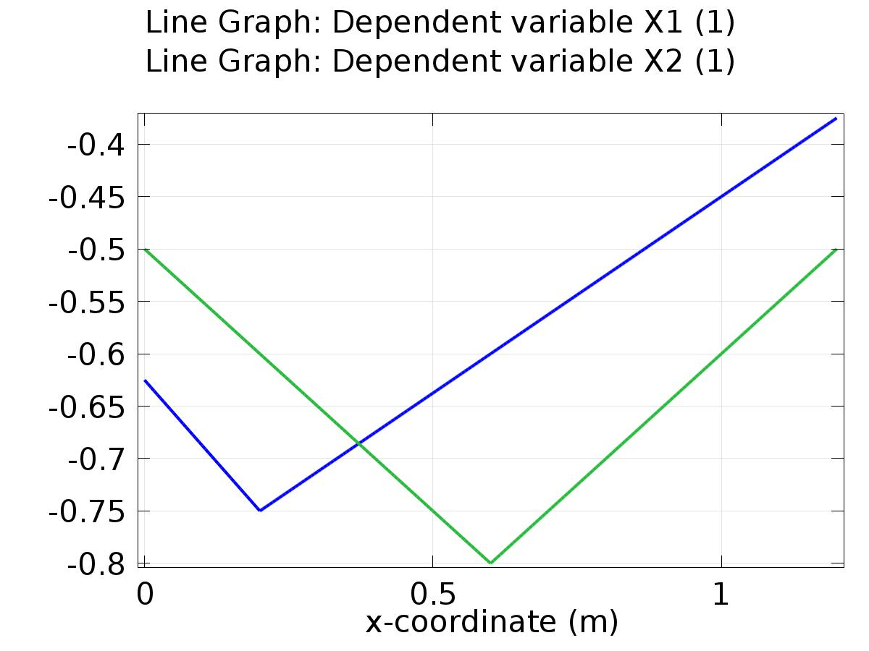

Line Graph: Dependent variable X1 (1) Line Graph: Dependent variable X2 (1)

* + 1. 1D Plot Group 2

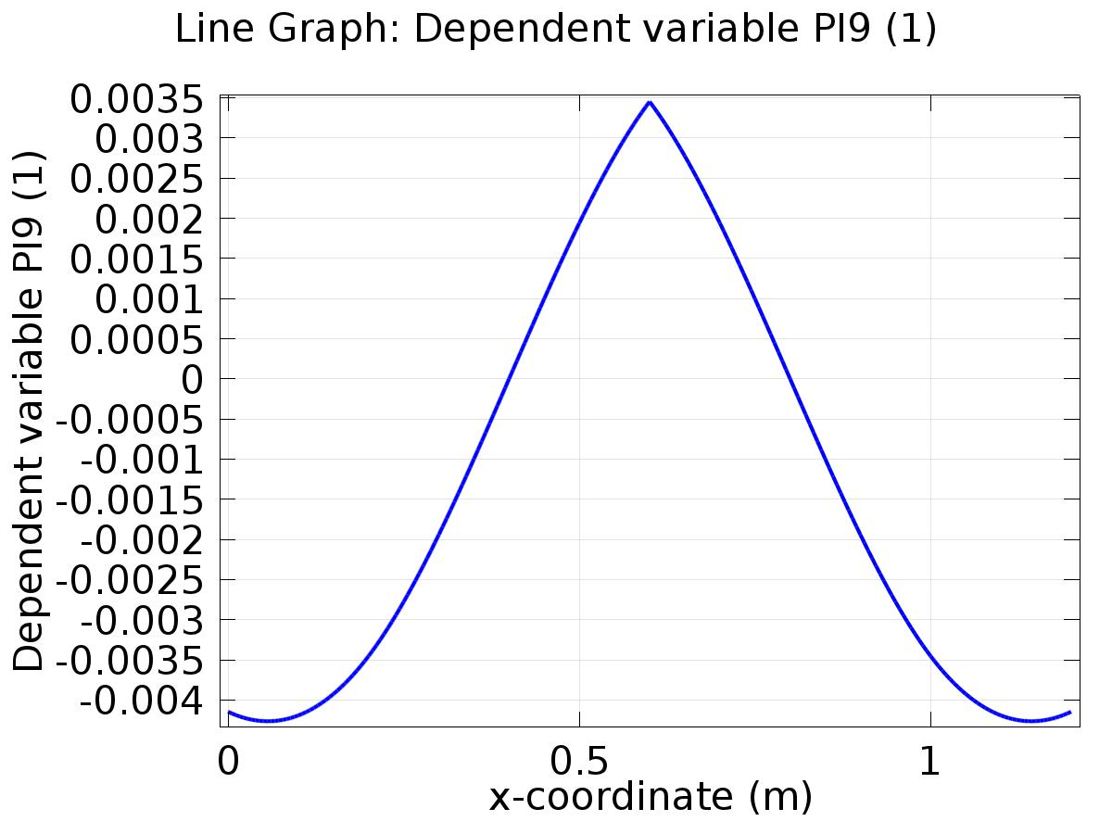

Line Graph: Dependent variable PI9 (1)

* + 1. 1D Plot Group 3

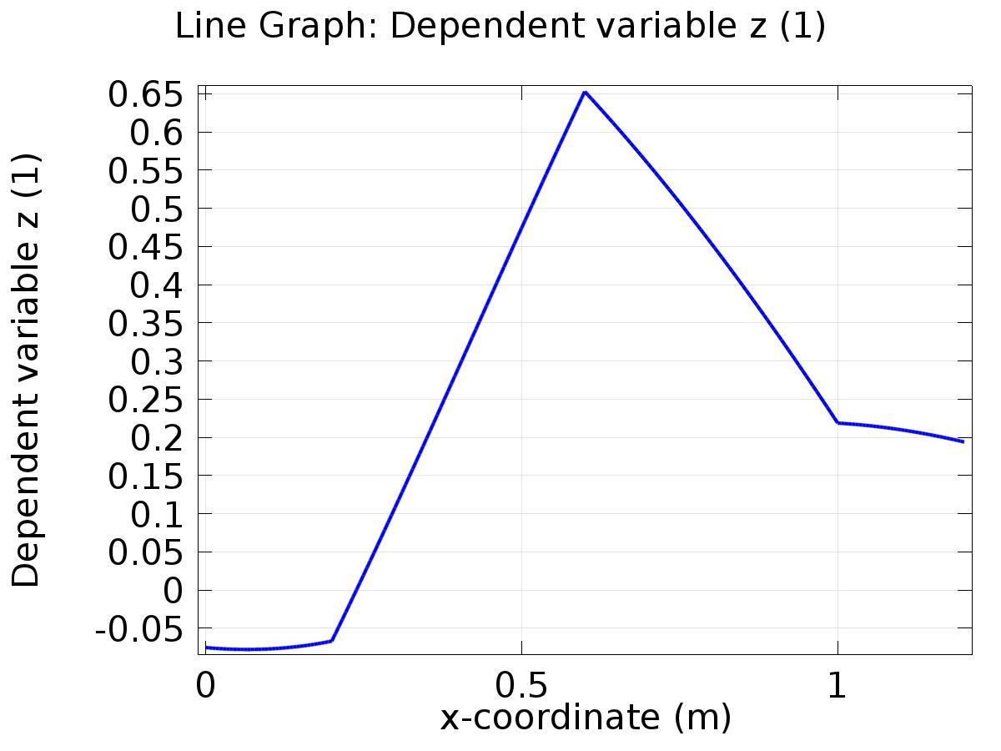

Line Graph: Dependent variable z (1)

* + 1. 1D Plot Group 4

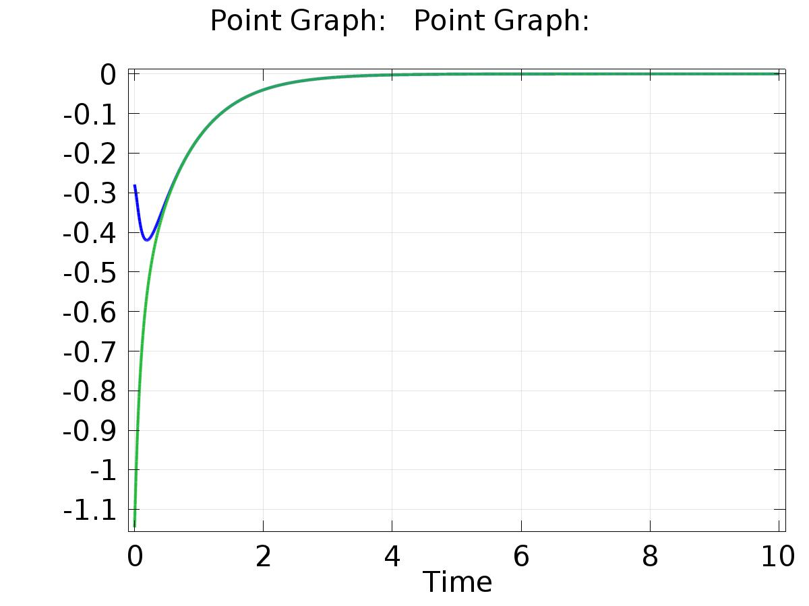

Point Graph: Point Graph:

* + 1. 1D Plot Group 5

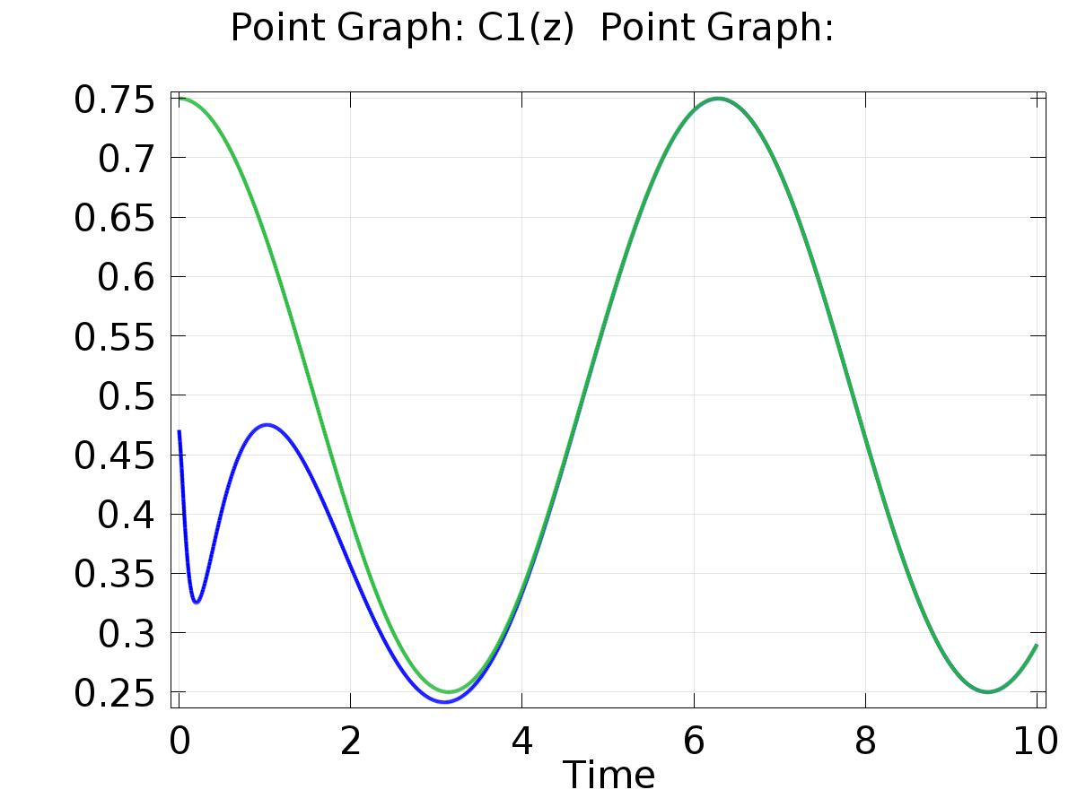

Point Graph: C1(z) (1) Point Graph:

* + 1. 1D Plot Group 6

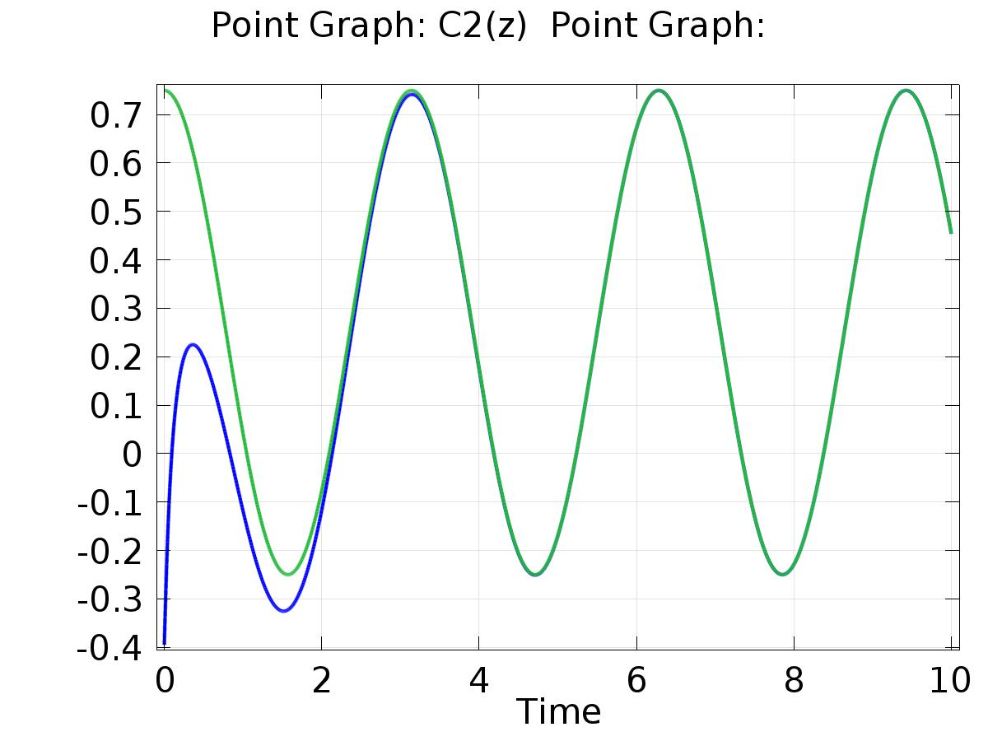

Point Graph: C2(z) Point Graph:

* + 1. Probe 1D Plot Group 7

