[](http://www.comsol.com/)

Chap3 Ex1 CoupledWaveEq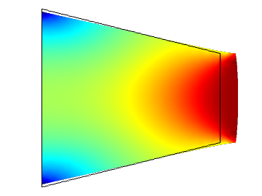

Date

Aug 5, 2013 4:36:39 PM

Contents

1. Global Definitions

1.1. Parameters 1

2. Model 1 (mod1)

2.1. Definitions

2.2. Geometry 1

2.3. PDE (c)

2.4. PDE 2 (c2)

2.5. PDE 3 (c3)

2.6. Mesh 1

3. Study 1

3.1. Stationary

4. Study 2

4.1. Stationary

5. Study 3

5.1. Time Dependent

6. Results

6.1. Data Sets

6.2. Derived Values

6.3. Tables

6.4. Plot Groups

1. Global Definitions
   1. Parameters 1

Parameters

| **Name** | **Expression** | **Value** | **Description** |
| --- | --- | --- | --- |
| Mr | 1 | 1.0000 | Signal Amplitude |
| alpha | 1 | 1.0000 | Signal Period: 2 pi/alpha |
| beta | 1 | 1.0000 | Damping |
| M | 0.1 | 0.10000 | Collocated Mass |

1. Model 1 (mod1)
   1. Definitions
      1. Variables

#### Variables 1

Selection

|  |  |
| --- | --- |
| Geometric entity level | Entire model |

| **Name** | **Expression** | **Description** |
| --- | --- | --- |
| a | x^2 + 1 | Spring Stiffness |
| G | C(Xx) |  |
| Gamma1 | (1 - C(PIt1x))/G |  |
| Gamma2 | (0 - C(PIt2x))/G |  |
| w1 | Mr*sin(alpha*t) |  |
| w2 | Mr*cos(alpha*t) |  |
| u | Gamma1*w1 + Gamma2*w2 |  |
| yr | w1 |  |
| e | C(qx) - yr |  |

* + 1. Model Couplings

#### Integration 1

|  |  |
| --- | --- |
| Coupling type | Integration |
| Operator name | C |

* 1. Geometry 1

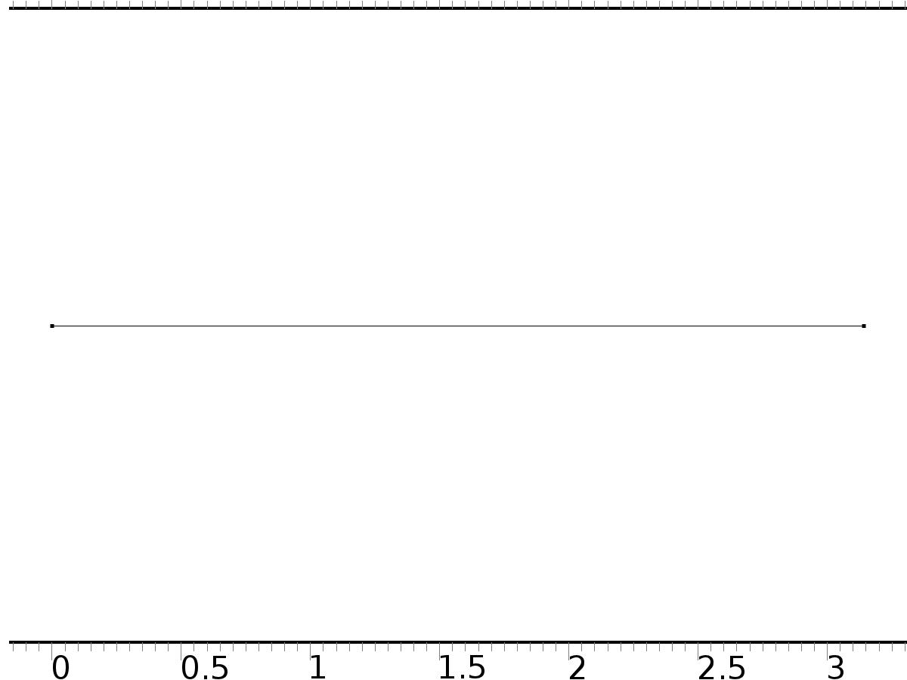

Geometry 1

Units

|  |  |
| --- | --- |
| Length unit | m |
| Angular unit | deg |

* 1. PDE (c)

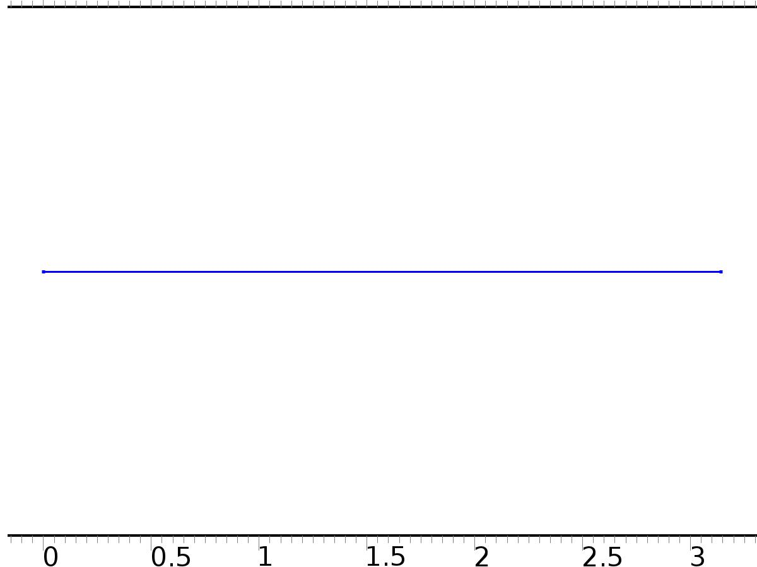

Unit Input

Features

|  |
| --- |
| Coefficient Form PDE 1 |
| Zero Flux 1 |
| Initial Values 1 |
| Dirichlet Homogeneous BC |
| Bin*1 |

* 1. PDE 2 (c2)



Regulator Equations

Features

|  |
| --- |
| Coefficient Form PDE 1 |
| Zero Flux 1 |
| Initial Values 1 |
| Dirichlet Homogeneous BC |
| Bin*(beta*S*PI(0)+Gamma) |

* 1. PDE 3 (c3)



Closed Loop System

Features

|  |
| --- |
| Coefficient Form PDE 1 |
| Zero Flux 1 |
| Initial Values 1 |
| Dirichlet Homogeneous BC |
| -a*qx=-M*qtt-beta*qt+u |

* 1. Mesh 1

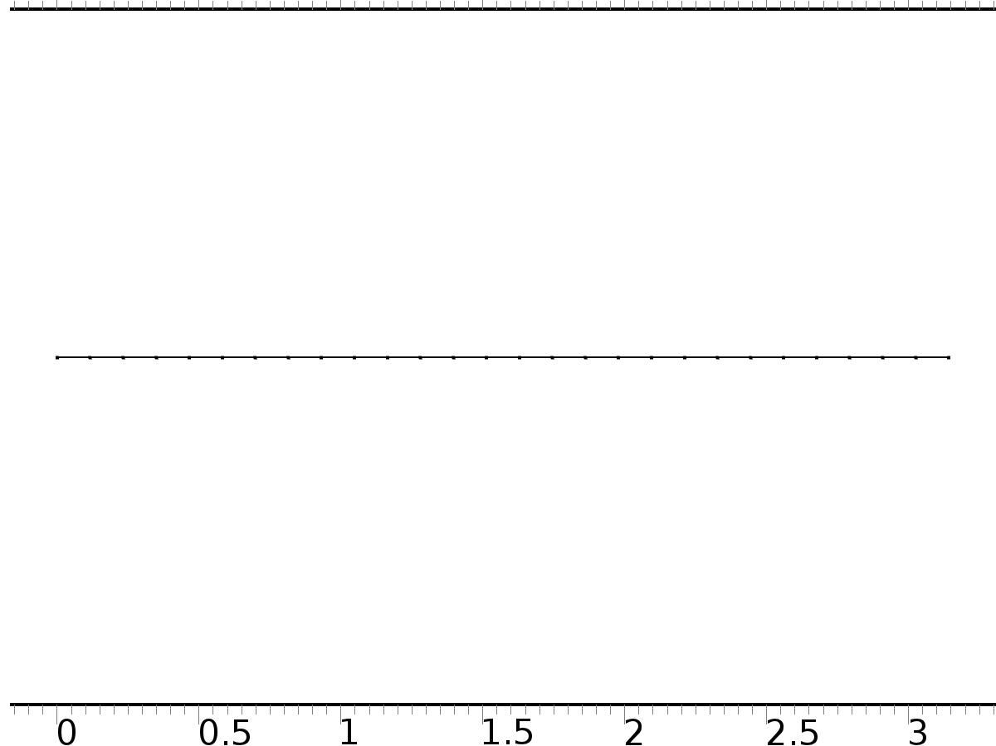

Mesh 1

1. Study 1
   1. Stationary

Study settings

| **Description** | **Value** |
| --- | --- |
| Include geometric nonlinearity | Off |

Physics and variables selection

| **Physics interface** | **Discretization** |
| --- | --- |
| Unit Input (c) | physics |

Mesh selection

| **Geometry** | **Mesh** |
| --- | --- |
| Geometry 1 (geom1) | mesh1 |

1. Study 2
   1. Stationary

Study settings

| **Description** | **Value** |
| --- | --- |
| Include geometric nonlinearity | Off |

Physics and variables selection

| **Physics interface** | **Discretization** |
| --- | --- |
| Regulator Equations (c2) | physics |

Mesh selection

| **Geometry** | **Mesh** |
| --- | --- |
| Geometry 1 (geom1) | mesh1 |

1. Study 3
   1. Time Dependent

Study settings

| **Description** | **Value** |
| --- | --- |
| Include geometric nonlinearity | Off |

| **Times** | **Unit** |
| --- | --- |
| range(0,0.01,6*pi) | s |

Physics and variables selection

| **Physics interface** | **Discretization** |
| --- | --- |
| Closed Loop System (c3) | physics |

Mesh selection

| **Geometry** | **Mesh** |
| --- | --- |
| Geometry 1 (geom1) | mesh1 |

1. Results
   1. Data Sets
      1. Solution 1

Solution

| **Description** | **Value** |
| --- | --- |
| Solution | Solver 1 |
| Component | Save Point Geometry 1 |

* + 1. Solution 2

Solution

| **Description** | **Value** |
| --- | --- |
| Solution | Solver 2 |
| Component | Save Point Geometry 1 |

* + 1. Solution 3

Solution

| **Description** | **Value** |
| --- | --- |
| Solution | Solver 3 |
| Component | Save Point Geometry 1 |

* 1. Derived Values
     1. Global Evaluation 1

Data

| **Description** | **Value** |
| --- | --- |
| Data set | Solution 2 |

Expression

| **Description** | **Value** |
| --- | --- |
| Expression | Gamma1 |
| Unit | 1 |

* + 1. Point Evaluation 1

Selection

|  |  |
| --- | --- |
| Geometric entity level | Boundary |
| Selection | Boundary 1 |

Data

| **Description** | **Value** |
| --- | --- |
| Data set | Solution 2 |

Expression

| **Description** | **Value** |
| --- | --- |
| Expression | Gamma2 |
| Unit | 1 |

* + 1. Point Evaluation 2

Selection

|  |  |
| --- | --- |
| Geometric entity level | Boundary |
| Selection | Boundary 1 |

Data

| **Description** | **Value** |
| --- | --- |
| Data set | Solution 3 |

Expression

| **Description** | **Value** |
| --- | --- |
| Expression | Gamma |

* 1. Tables
     1. Table 1

Global Evaluation 1 (Gamma1)

Table 1

| **Gamma1 (1)** | **Gamma1 (1)** |
| --- | --- |
| -2.4815 | -2.0072 |

* + 1. Table 2

Point Evaluation 1 (C(zx))

Table 2

| **Gamma1 (1), Point: 1** | **Gamma2 (1), Point: 1** | **Gamma2 (1), Point: 1** |
| --- | --- | --- |
| -2.0072 | -0.62575 | -0.62575 |

* + 1. Table 3

Point Evaluation 2 (zx)

* 1. Plot Groups
     1. 1D Plot Group 1

Line Graph: Gradient of X, x component (1/m)

* + 1. 1D Plot Group 2

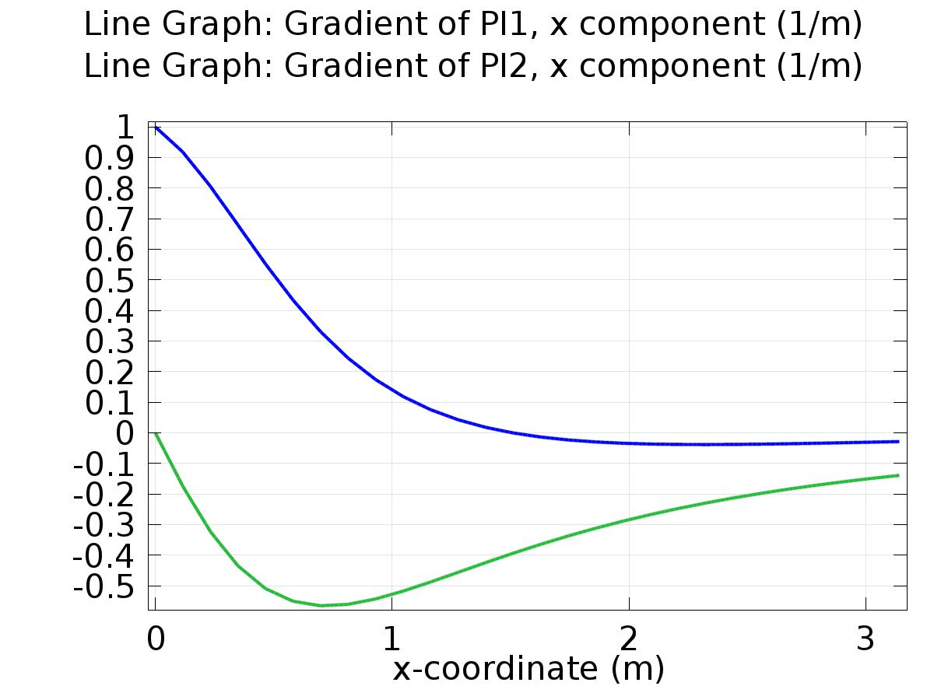

Line Graph: Gradient of PI1, x component (1/m) Line Graph: Gradient of PI2, x component (1/m)

* + 1. 1D Plot Group 3

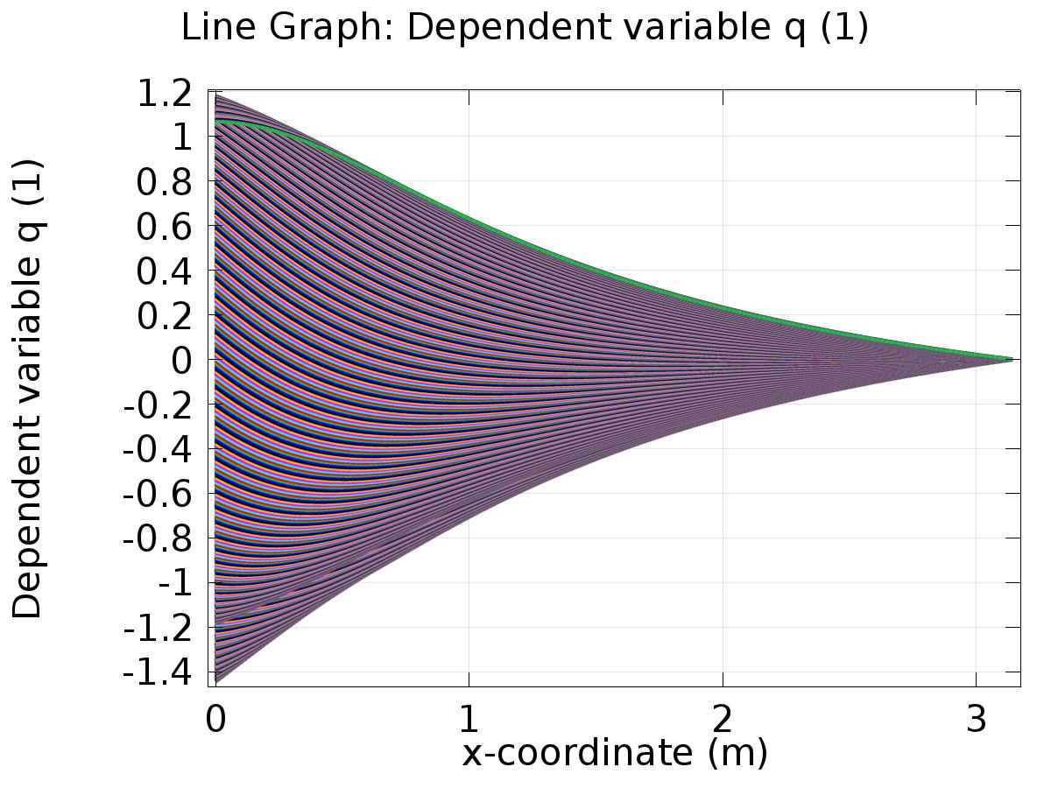

Line Graph: Dependent variable q (1)

* + 1. 1D Plot Group 4

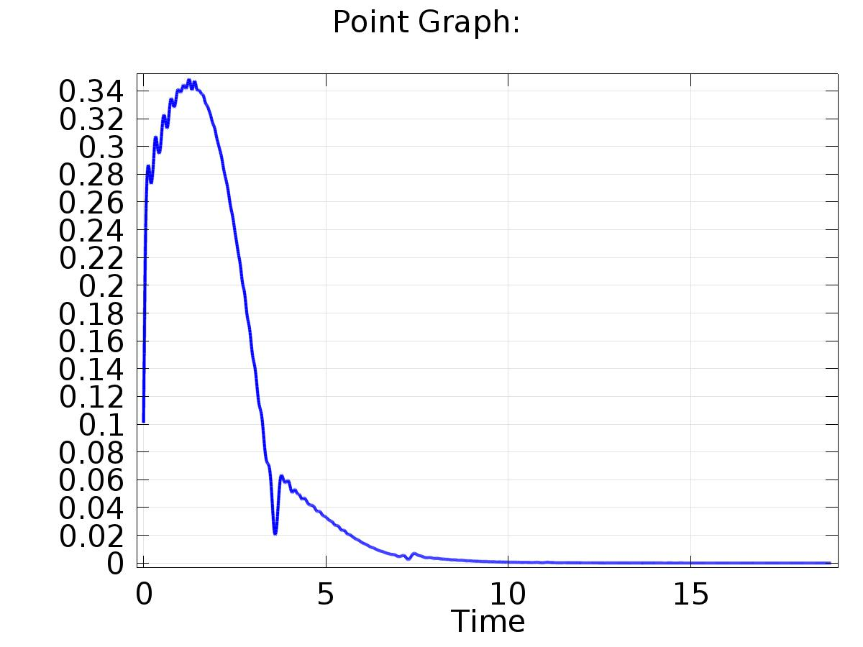

Point Graph:

* + 1. 1D Plot Group 5

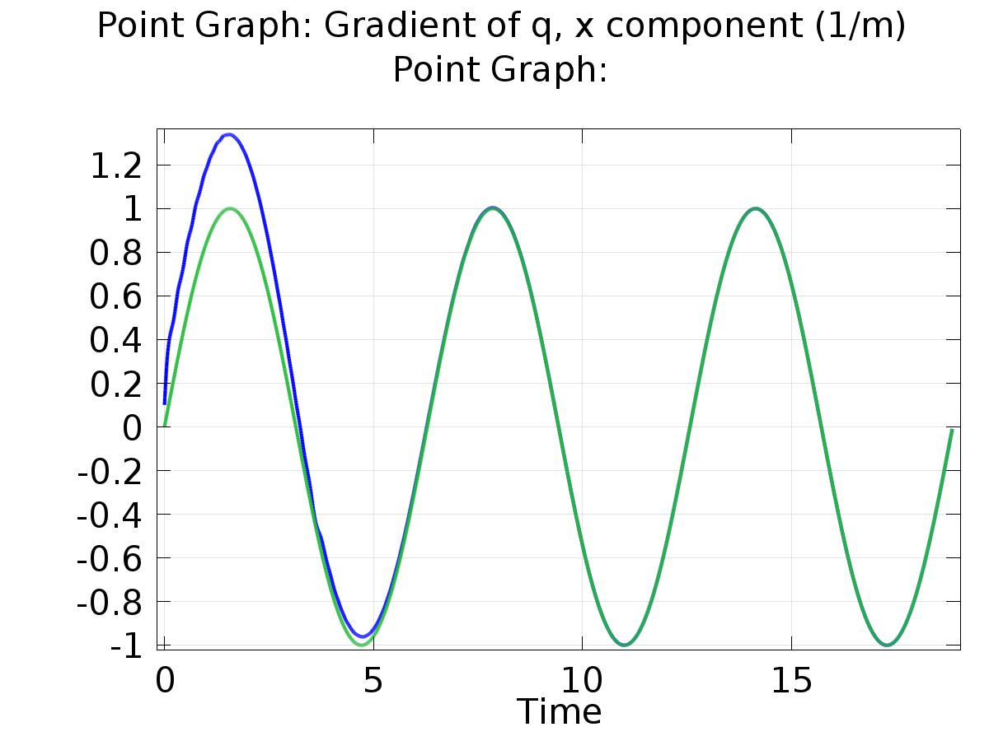

Point Graph: Gradient of q, x component (1/m) Point Graph:

* + 1. 1D Plot Group 1

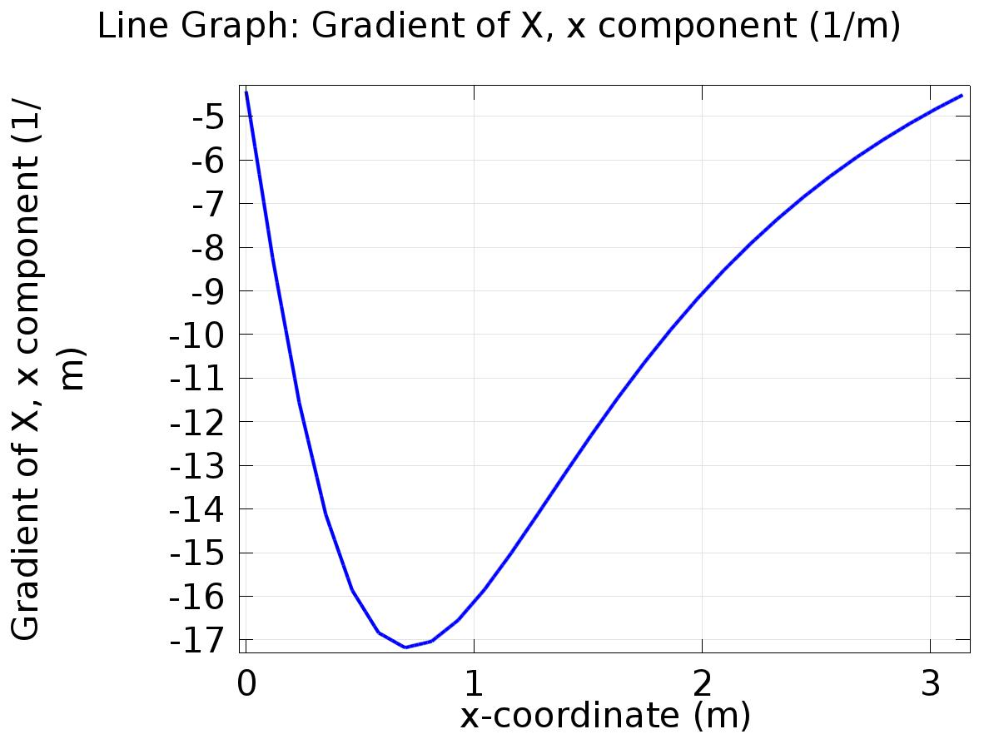

Line Graph: Gradient of X, x component (1/m)