[](http://www.comsol.com/)

Ch3 Ex 3 clamped plate

|  |  |
| --- | --- |
| Date | Dec 27, 2013 6:09:50 AM |

Contents

1. Global

1.1. Definitions

2. Model 1

2.1. Definitions

2.2. Geometry 1

2.3. Unit Input1

2.4. Unit Input2

2.5. Regulator Eqs

2.6. Close Loop System

2.7. Mesh 1

3. Study 1

3.1. Stationary

3.2. Solver Configurations

4. Study 2

4.1. Stationary

4.2. Solver Configurations

5. Study 3

5.1. Time Dependent

5.2. Solver Configurations

6. Results

6.1. Data Sets

6.2. Derived Values

6.3. Tables

6.4. Plot Groups

1. Global

|  |  |
| --- | --- |
| Date | Sep 5, 2013 5:01:11 PM |

Global settings

|  |  |
| --- | --- |
| Name | Ex3 3 clamped plate.mph |
| Path | /Users/gilliam/Desktop/collect_15/research_15/geo_reg_mono_eugenio/Mono_1_15/Comsol_EX_GitHub/Chapter3/Chap3Ex3_Vibrations_2D_plate/Ex3_3_clamped_plate.mph |
| Program | COMSOL 4.4 (Build: 150) |

Used products

|  |
| --- |
| COMSOL Multiphysics |

* 1. Definitions
     1. Parameters 1

Parameters

| **Name** | **Expression** | **Value** | **Description** |
| --- | --- | --- | --- |
| R | 2 | 2.0000 | plate radius |
| EI | 1 | 1.0000 | stiffness coefficient |
| rho | 1 | 1.0000 | density |
| delta | 1 | 1.0000 | damping coefficient |
| Md | 1 | 1.0000 | laod constant |
| beta | pi | 3.1416 | frequency |
| theta | 5 | 5.0000 | mesh par1 |
| n | 360/theta | 72.000 | mesh par2 |
| hr | 2*pi*R/n | 0.17453 | mesh par3 |
| n_dis | floor((R/3)/hr) + 1 | 4.0000 | mesh par4 |

1. Model 1

Component settings

|  |  |
| --- | --- |
| Unit system | None |

* 1. Definitions
     1. Variables

#### Variables 1a

Selection

|  |  |
| --- | --- |
| Geometric entity level | Entire model |

| **Name** | **Expression** | **Description** |
| --- | --- | --- |
| r | sqrt(x^2 + y^2) |  |
| G11 | C1(X1) |  |
| G12 | C1(X2) |  |
| G21 | C2(X1) |  |
| G22 | C2(X2) |  |
| DET | G11*G22 - G12*G21 |  |
| g11 | G22/DET |  |
| g12 | -G12/DET |  |
| g21 | -G21/DET |  |
| g22 | G11/DET |  |
| Gamma11 | g11*(0 - C1(PIt1)) + g12*(0 - C2(PIt1)) |  |
| Gamma21 | g21*(0 - C1(PIt1)) + g22*(0 - C2(PIt1)) |  |
| Gamma12 | g11*(0 - C1(PIt2)) + g12*(0 - C2(PIt2)) |  |
| Gamma22 | g21*(0 - C1(PIt2)) + g22*(0 - C2(PIt2)) |  |
| Bd1 | sin(4*pi*r/R) |  |
| Bd2 | cos(4*pi*r/R) |  |
| w1 | Md*sin(beta*t) |  |
| w2 | Md*cos(beta*t) |  |
| d | Bd1*w1 + Bd2*w2 |  |
| u1 | Gamma11*w1 + Gamma12*w2 |  |
| u2 | Gamma21*w1 + Gamma22*w2 |  |

#### Variables 2a

Selection

|  |  |
| --- | --- |
| Geometric entity level | Domain |
| Selection | Domains 1–4, 6–8, 11–18, 20 |

| **Name** | **Expression** | **Description** |
| --- | --- | --- |
| Bin | 0 |  |

#### Variables 3a

Selection

|  |  |
| --- | --- |
| Geometric entity level | Domain |
| Selection | Domains 5, 19 |

| **Name** | **Expression** | **Description** |
| --- | --- | --- |
| sr | 3/R*(r - R/3) |  |
| Bin | -1 + 2*sr |  |

#### Variables 4a

Selection

|  |  |
| --- | --- |
| Geometric entity level | Domain |
| Selection | Domains 9–10 |

| **Name** | **Expression** | **Description** |
| --- | --- | --- |
| sr | 3/R*(r - 2*R/3) |  |
| Bin | -1 + 2*sr |  |

* + 1. Probes

#### Global Variable Probe 1

|  |  |
| --- | --- |
| Probe type | Global variable probe |

#### Global Variable Probe 2

|  |  |
| --- | --- |
| Probe type | Global variable probe |

#### Global Variable Probe 3

|  |  |
| --- | --- |
| Probe type | Global variable probe |

#### Global Variable Probe 4

|  |  |
| --- | --- |
| Probe type | Global variable probe |

* + 1. Component Couplings

#### Average 1

|  |  |
| --- | --- |
| Coupling type | Average |
| Operator name | C1 |

Source selection

|  |  |
| --- | --- |
| Geometric entity level | Point |
| Selection | Point 13 |

#### Average 2

|  |  |
| --- | --- |
| Coupling type | Average |
| Operator name | C2 |

Source selection

|  |  |
| --- | --- |
| Geometric entity level | Boundary |
| Selection | Boundaries 24, 26, 33 |

* + 1. Coordinate Systems

#### Boundary System 1

|  |  |
| --- | --- |
| Coordinate system type | Boundary system |
| Tag | sys1 |

Coordinate names

| **First (t1)** | **Second (n)** | **Third (to)** |
| --- | --- | --- |
| t1 | n | to |

Settings

| **Description** | **Value** |
| --- | --- |
| Create first tangent direction from | Global Cartesian |

* 1. Geometry 1

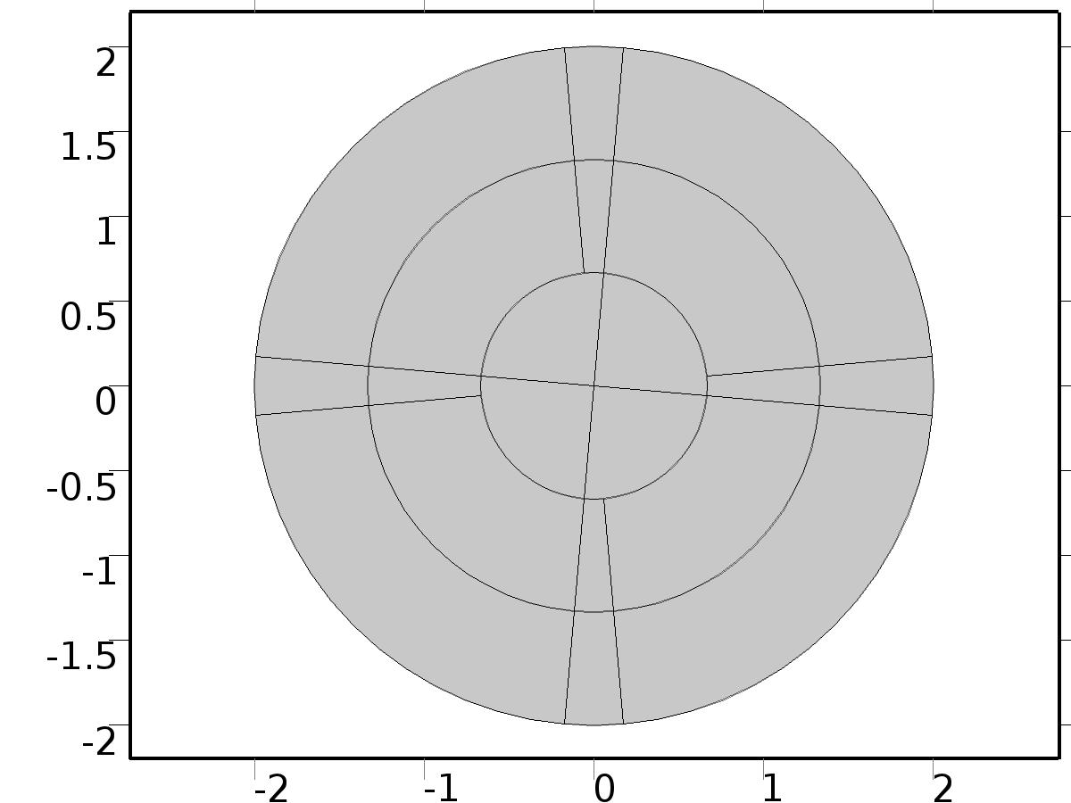

Geometry 1

Units

|  |  |
| --- | --- |
| Length unit | m |
| Angular unit | deg |

Geometry statistics

| **Description** | **Value** |
| --- | --- |
| Space dimension | 2 |
| Number of domains | 20 |
| Number of boundaries | 44 |
| Number of vertices | 25 |

* + 1. Circle 1 (c1)

Position

| **Description** | **Value** |
| --- | --- |
| Position | {0, 0} |
| Layers |  |

Size and shape

| **Description** | **Value** |
| --- | --- |
| Radius | R |

* + 1. Point 1 (pt1)

Point

| **Description** | **Value** |
| --- | --- |
| Point coordinate | {0, 0} |

* + 1. Circle 2 (c2)

Position

| **Description** | **Value** |
| --- | --- |
| Position | {0, 0} |
| Layers |  |

Size and shape

| **Description** | **Value** |
| --- | --- |
| Radius | 1/3*R |

* + 1. Circle 3 (c3)

Position

| **Description** | **Value** |
| --- | --- |
| Position | {0, 0} |
| Layers |  |

Size and shape

| **Description** | **Value** |
| --- | --- |
| Radius | 2/3*R |

* + 1. Polygon 1 (pol1)

Object type

| **Description** | **Value** |
| --- | --- |
| Type | Open curve |

Coordinates

| **Description** | **Value** |
| --- | --- |
| x | {-2, 2} |
| y | {0, 0} |

* + 1. Rotate 1 (rot1)

Settings

| **Description** | **Value** |
| --- | --- |
| Rotation | 5 |
| Point on axis of rotation | {0, 0} |

* + 1. Polygon 2 (pol2)

Object type

| **Description** | **Value** |
| --- | --- |
| Type | Open curve |

Coordinates

| **Description** | **Value** |
| --- | --- |
| x | {-2, 2} |
| y | {0, 0} |

* + 1. Rotate 2 (rot2)

Settings

| **Description** | **Value** |
| --- | --- |
| Rotation | -5 |
| Point on axis of rotation | {0, 0} |

* + 1. Polygon 3 (pol3)

Object type

| **Description** | **Value** |
| --- | --- |
| Type | Open curve |

Coordinates

| **Description** | **Value** |
| --- | --- |
| x | {0, 0} |
| y | {-2, 2} |

* + 1. Rotate 4 (rot4)

Settings

| **Description** | **Value** |
| --- | --- |
| Rotation | 5 |
| Point on axis of rotation | {0, 0} |

* + 1. Polygon 4 (pol4)

Object type

| **Description** | **Value** |
| --- | --- |
| Type | Open curve |

Coordinates

| **Description** | **Value** |
| --- | --- |
| x | {0, 0} |
| y | {-2, 2} |

* + 1. Rotate 3 (rot3)

Settings

| **Description** | **Value** |
| --- | --- |
| Rotation | -5 |
| Point on axis of rotation | {0, 0} |

* + 1. Union 2 (uni2)

Compose

| **Description** | **Value** |
| --- | --- |
| Keep interior boundaries | Off |

* + 1. Union 3 (uni3)

Compose

| **Description** | **Value** |
| --- | --- |
| Keep interior boundaries | Off |

* + 1. Union 4 (uni4)

Compose

| **Description** | **Value** |
| --- | --- |
| Keep interior boundaries | Off |

* + 1. Union 5 (uni5)

Compose

| **Description** | **Value** |
| --- | --- |
| Keep interior boundaries | Off |

* 1. Unit Input1

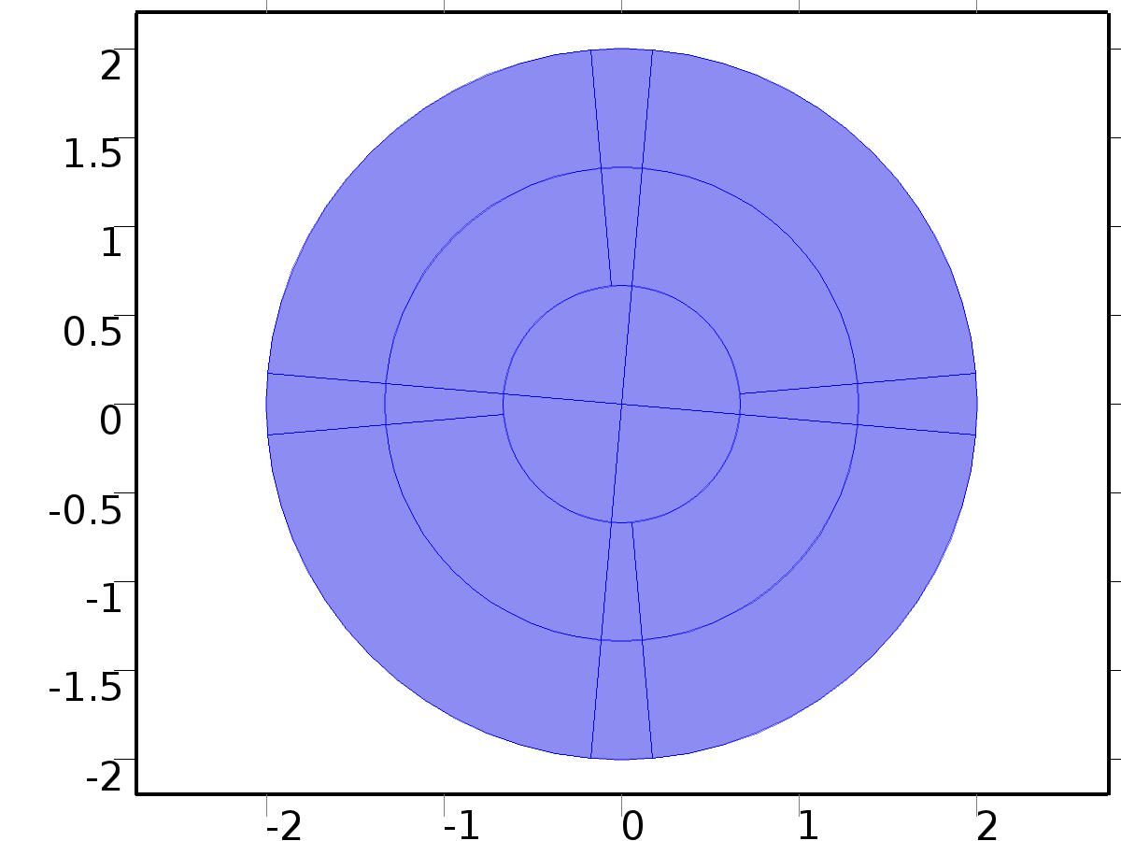

Unit Input1

Selection

|  |  |
| --- | --- |
| Geometric entity level | Domain |
| Selection | Domains 1–20 |

Settings

| **Description** | **Value** |
| --- | --- |
| Shape function type | Lagrange |
| Element order | Quadratic |
| Compute boundary fluxes | On |
| Apply smoothing to boundary fluxes | On |
| Value type when using splitting of complex variables | Complex |
| Dependent variable quantity | Dimensionless (1) |
| Source term quantity | None |
| Unit | m^ - 2 |

Used products

|  |
| --- |
| COMSOL Multiphysics |

Variables

| **Name** | **Expression** | **Unit** | **Description** | **Selection** |
| --- | --- | --- | --- | --- |
| X1.nx | nx |  | Normal vector, x component | Boundaries 1–44 |
| X1.ny | ny |  | Normal vector, y component | Boundaries 1–44 |
| X1.nz | root.nz |  | Normal vector, z component | Boundaries 1–44 |
| X1.nxmesh | root.nxmesh |  | Normal vector (mesh), x component | Boundaries 1–44 |
| X1.nymesh | root.nymesh |  | Normal vector (mesh), y component | Boundaries 1–44 |
| X1.nzmesh | root.nzmesh |  | Normal vector (mesh), z component | Boundaries 1–44 |

* + 1. Coefficient Form PDE 1



Coefficient Form PDE 1

Selection

|  |  |
| --- | --- |
| Geometric entity level | Domain |
| Selection | Domains 1–20 |

Equations

Settings

| **Description** | **Value** |
| --- | --- |
| Diffusion coefficient | {{{{1, 0}, {0, 1}}, {{0, 0}, {0, 0}}}, {{{0, 0}, {0, 0}}, {{EI, 0}, {0, EI}}}} |
| Absorption coefficient | {{0, -rho*beta^2}, {-1, 0}} |
| Source term | {0, 0} |
| Mass coefficient | {{0, 0}, {0, 0}} |
| Damping or mass coefficient | {{0, 0}, {0, 0}} |
| Conservative flux convection coefficient | {{{0, 0}, {0, 0}}, {{0, 0}, {0, 0}}} |
| Convection coefficient | {{{0, 0}, {0, 0}}, {{0, 0}, {0, 0}}} |
| Conservative flux source | {{0, 0}, {0, 0}} |

#### Variables

| **Name** | **Expression** | **Unit** | **Description** | **Selection** |
| --- | --- | --- | --- | --- |
| domflux.X1x | -d(X1,x) |  | Domain flux, x component | Domains 1–20 |
| domflux.X1y | -d(X1,y) |  | Domain flux, y component | Domains 1–20 |
| domflux.Xa1x | -EI*d(Xa1,x) |  | Domain flux, x component | Domains 1–20 |
| domflux.Xa1y | -EI*d(Xa1,y) |  | Domain flux, y component | Domains 1–20 |

#### Shape functions

| **Name** | **Shape function** | **Unit** | **Description** | **Shape frame** | **Selection** |
| --- | --- | --- | --- | --- | --- |
| X1 | Lagrange (Quadratic) |  | Dependent variable X1 | Material | Domains 1–20 |
| Xa1 | Lagrange (Quadratic) |  | Dependent variable Xa1 | Material | Domains 1–20 |

* + 1. Zero Flux 1



Zero Flux 1

Selection

|  |  |
| --- | --- |
| Geometric entity level | Boundary |
| Selection | No boundaries |

Equations

* + 1. Initial Values 1



Initial Values 1

Selection

|  |  |
| --- | --- |
| Geometric entity level | Domain |
| Selection | Domains 1–20 |

Settings

| **Description** | **Value** |
| --- | --- |
| Initial value for X1 | 0 |
| Initial time derivative of X1 | 0 |
| Initial value for Xa1 | 0 |
| Initial time derivative of Xa1 | 0 |

* + 1. Dirichlet Boundary Condition 1

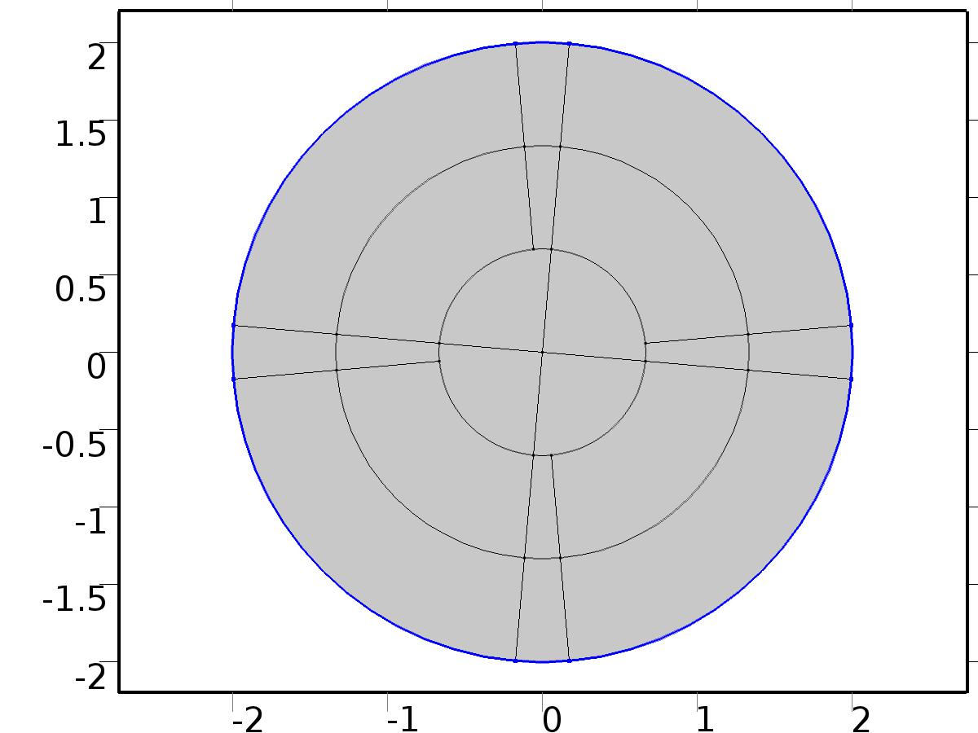

Dirichlet Boundary Condition 1

Selection

|  |  |
| --- | --- |
| Geometric entity level | Boundary |
| Selection | Boundaries 21–23, 30–31, 40–41, 44 |

Equations

Settings

| **Description** | **Value** |
| --- | --- |
| Value on boundary | {0, 0} |
| Prescribed value of X1 | On |
| Prescribed value of Xa1 | On |
| Apply reaction terms on | Individual dependent variables |
| Use weak constraints | Off |
| Constraint method | Elemental |

#### Shape functions

| **Constraint** | **Constraint force** | **Shape function** | **Selection** |
| --- | --- | --- | --- |
| -X1 | -test(X1) | Lagrange (Quadratic) | Boundaries 21–23, 30–31, 40–41, 44 |
| -Xa1 | -test(Xa1) | Lagrange (Quadratic) | Boundaries 21–23, 30–31, 40–41, 44 |

* + 1. Bin1

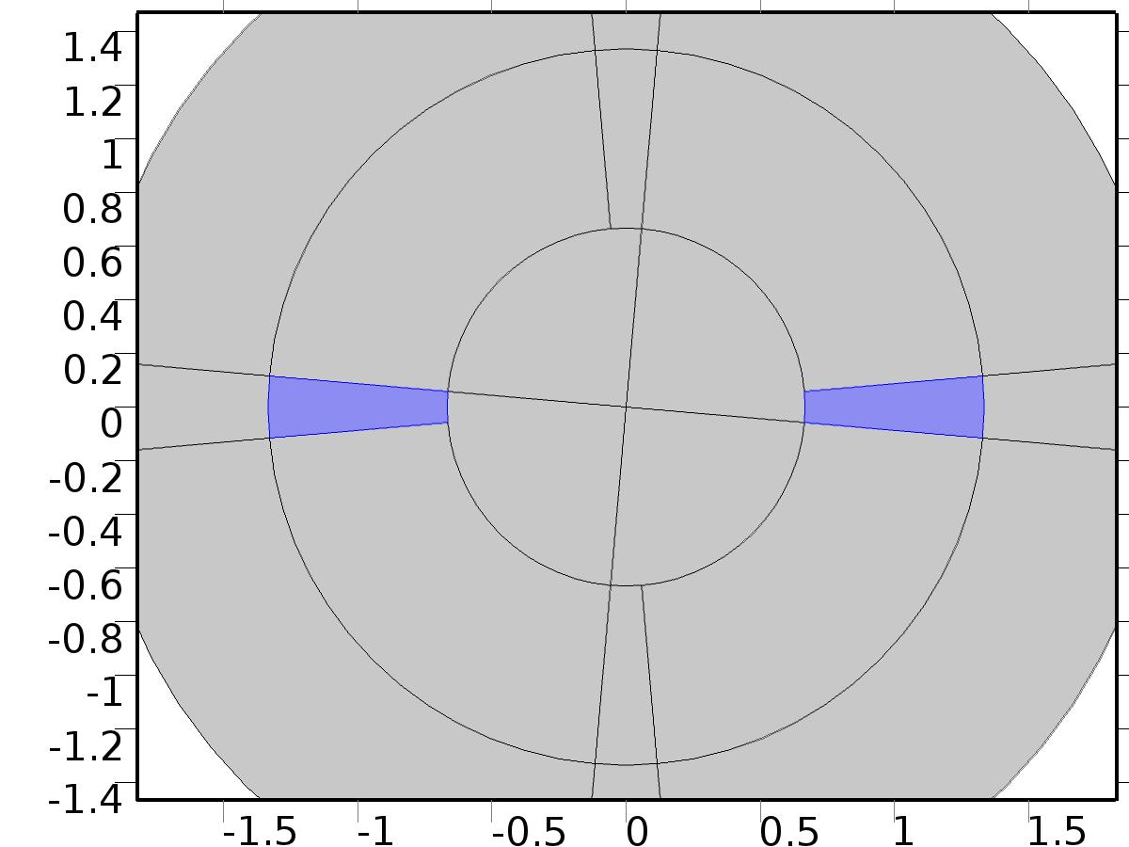

Bin1

Selection

|  |  |
| --- | --- |
| Geometric entity level | Domain |
| Selection | Domains 5, 19 |

Settings

| **Description** | **Value** |
| --- | --- |
| Source term | {0, Bin} |

#### Variables

| **Name** | **Expression** | **Unit** | **Description** | **Selection** |
| --- | --- | --- | --- | --- |
| X1.f_X1 | 0 |  | Source term | Domains 5, 19 |
| X1.f_Xa1 | Bin |  | Source term | Domains 5, 19 |

* 1. Unit Input2



Unit Input2

Selection

|  |  |
| --- | --- |
| Geometric entity level | Domain |
| Selection | Domains 1–20 |

Settings

| **Description** | **Value** |
| --- | --- |
| Shape function type | Lagrange |
| Element order | Quadratic |
| Compute boundary fluxes | On |
| Apply smoothing to boundary fluxes | On |
| Value type when using splitting of complex variables | Complex |
| Dependent variable quantity | Dimensionless (1) |
| Source term quantity | None |
| Unit | m^ - 2 |

Used products

|  |
| --- |
| COMSOL Multiphysics |

Variables

| **Name** | **Expression** | **Unit** | **Description** | **Selection** |
| --- | --- | --- | --- | --- |
| X2.nx | nx |  | Normal vector, x component | Boundaries 1–44 |
| X2.ny | ny |  | Normal vector, y component | Boundaries 1–44 |
| X2.nz | root.nz |  | Normal vector, z component | Boundaries 1–44 |
| X2.nxmesh | root.nxmesh |  | Normal vector (mesh), x component | Boundaries 1–44 |
| X2.nymesh | root.nymesh |  | Normal vector (mesh), y component | Boundaries 1–44 |
| X2.nzmesh | root.nzmesh |  | Normal vector (mesh), z component | Boundaries 1–44 |

* + 1. Coefficient Form PDE 1



Coefficient Form PDE 1

Selection

|  |  |
| --- | --- |
| Geometric entity level | Domain |
| Selection | Domains 1–20 |

Equations

Settings

| **Description** | **Value** |
| --- | --- |
| Diffusion coefficient | {{{{1, 0}, {0, 1}}, {{0, 0}, {0, 0}}}, {{{0, 0}, {0, 0}}, {{EI, 0}, {0, EI}}}} |
| Absorption coefficient | {{0, -rho*beta^2}, {-1, 0}} |
| Source term | {0, 0} |
| Mass coefficient | {{0, 0}, {0, 0}} |
| Damping or mass coefficient | {{0, 0}, {0, 0}} |
| Conservative flux convection coefficient | {{{0, 0}, {0, 0}}, {{0, 0}, {0, 0}}} |
| Convection coefficient | {{{0, 0}, {0, 0}}, {{0, 0}, {0, 0}}} |
| Conservative flux source | {{0, 0}, {0, 0}} |

#### Variables

| **Name** | **Expression** | **Unit** | **Description** | **Selection** |
| --- | --- | --- | --- | --- |
| domflux.X2x | -d(X2,x) |  | Domain flux, x component | Domains 1–20 |
| domflux.X2y | -d(X2,y) |  | Domain flux, y component | Domains 1–20 |
| domflux.Xa2x | -EI*d(Xa2,x) |  | Domain flux, x component | Domains 1–20 |
| domflux.Xa2y | -EI*d(Xa2,y) |  | Domain flux, y component | Domains 1–20 |

#### Shape functions

| **Name** | **Shape function** | **Unit** | **Description** | **Shape frame** | **Selection** |
| --- | --- | --- | --- | --- | --- |
| X2 | Lagrange (Quadratic) |  | Dependent variable X2 | Material | Domains 1–20 |
| Xa2 | Lagrange (Quadratic) |  | Dependent variable Xa2 | Material | Domains 1–20 |

* + 1. Zero Flux 1



Zero Flux 1

Selection

|  |  |
| --- | --- |
| Geometric entity level | Boundary |
| Selection | No boundaries |

Equations

* + 1. Initial Values 1



Initial Values 1

Selection

|  |  |
| --- | --- |
| Geometric entity level | Domain |
| Selection | Domains 1–20 |

Settings

| **Description** | **Value** |
| --- | --- |
| Initial value for X2 | 0 |
| Initial time derivative of X2 | 0 |
| Initial value for Xa2 | 0 |
| Initial time derivative of Xa2 | 0 |

* + 1. Dirichlet Boundary Condition 1



Dirichlet Boundary Condition 1

Selection

|  |  |
| --- | --- |
| Geometric entity level | Boundary |
| Selection | Boundaries 21–23, 30–31, 40–41, 44 |

Equations

Settings

| **Description** | **Value** |
| --- | --- |
| Value on boundary | {0, 0} |
| Prescribed value of X2 | On |
| Prescribed value of Xa2 | On |
| Apply reaction terms on | Individual dependent variables |
| Use weak constraints | Off |
| Constraint method | Elemental |

#### Shape functions

| **Constraint** | **Constraint force** | **Shape function** | **Selection** |
| --- | --- | --- | --- |
| -X2 | -test(X2) | Lagrange (Quadratic) | Boundaries 21–23, 30–31, 40–41, 44 |
| -Xa2 | -test(Xa2) | Lagrange (Quadratic) | Boundaries 21–23, 30–31, 40–41, 44 |

* + 1. Bin2

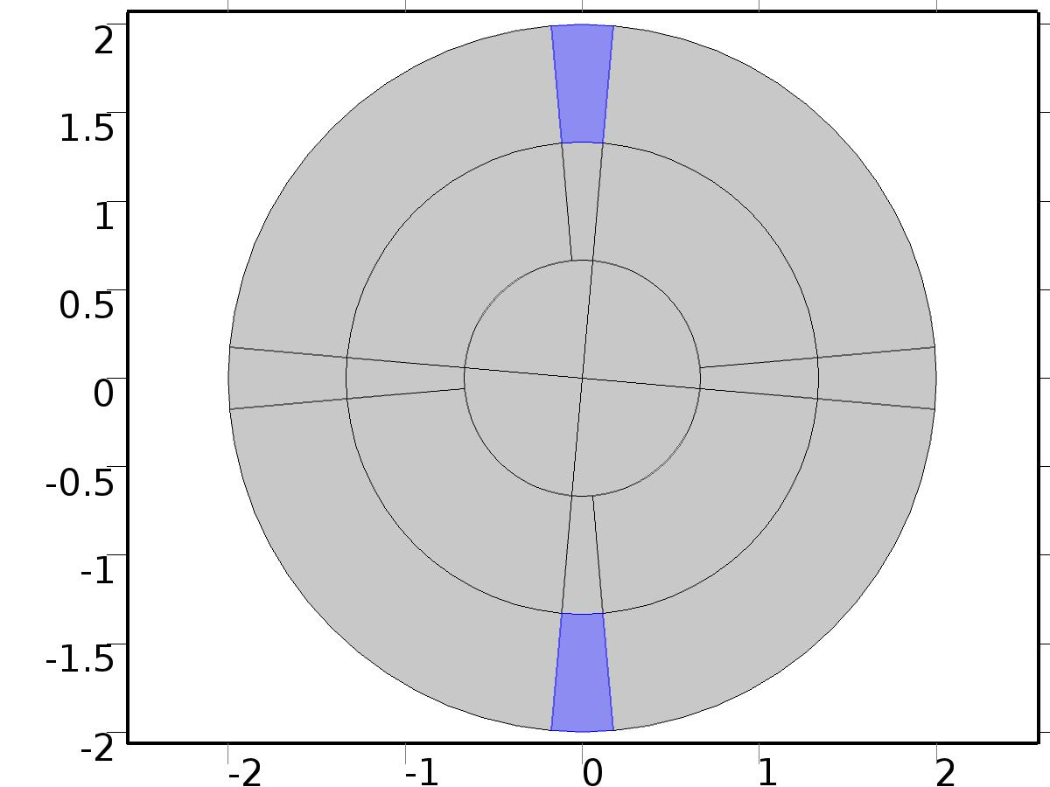

Bin2

Selection

|  |  |
| --- | --- |
| Geometric entity level | Domain |
| Selection | Domains 9–10 |

Settings

| **Description** | **Value** |
| --- | --- |
| Source term | {0, Bin} |

#### Variables

| **Name** | **Expression** | **Unit** | **Description** | **Selection** |
| --- | --- | --- | --- | --- |
| X2.f_X2 | 0 |  | Source term | Domains 9–10 |
| X2.f_Xa2 | Bin |  | Source term | Domains 9–10 |

* 1. Regulator Eqs



Regulator Eqs

Selection

|  |  |
| --- | --- |
| Geometric entity level | Domain |
| Selection | Domains 1–20 |

Settings

| **Description** | **Value** |
| --- | --- |
| Shape function type | Lagrange |
| Element order | Quadratic |
| Compute boundary fluxes | On |
| Apply smoothing to boundary fluxes | On |
| Value type when using splitting of complex variables | Complex |
| Dependent variable quantity | Dimensionless (1) |
| Source term quantity | None |
| Unit | m^ - 2 |

Used products

|  |
| --- |
| COMSOL Multiphysics |

Variables

| **Name** | **Expression** | **Unit** | **Description** | **Selection** |
| --- | --- | --- | --- | --- |
| PI.nx | nx |  | Normal vector, x component | Boundaries 1–44 |
| PI.ny | ny |  | Normal vector, y component | Boundaries 1–44 |
| PI.nz | root.nz |  | Normal vector, z component | Boundaries 1–44 |
| PI.nxmesh | root.nxmesh |  | Normal vector (mesh), x component | Boundaries 1–44 |
| PI.nymesh | root.nymesh |  | Normal vector (mesh), y component | Boundaries 1–44 |
| PI.nzmesh | root.nzmesh |  | Normal vector (mesh), z component | Boundaries 1–44 |

* + 1. Coefficient Form PDE 1



Coefficient Form PDE 1

Selection

|  |  |
| --- | --- |
| Geometric entity level | Domain |
| Selection | Domains 1–20 |

Equations

Settings

| **Description** | **Value** |
| --- | --- |
| Diffusion coefficient | {{{{1, 0}, {0, 1}}, {{0, 0}, {0, 0}}, {{0, 0}, {0, 0}}, {{0, 0}, {0, 0}}, {{0, 0}, {0, 0}}, {{0, 0}, {0, 0}}, {{0, 0}, {0, 0}}, {{0, 0}, {0, 0}}}, {{{0, 0}, {0, 0}}, {{EI, 0}, {0, EI}}, {{0, 0}, {0, 0}}, {{0, 0}, {0, 0}}, {{0, 0}, {0, 0}}, {{0, 0}, {0, 0}}, {{0, 0}, {0, 0}}, {{0, 0}, {0, 0}}}, {{{0, 0}, {0, 0}}, {{0, 0}, {0, 0}}, {{1, 0}, {0, 1}}, {{0, 0}, {0, 0}}, {{0, 0}, {0, 0}}, {{0, 0}, {0, 0}}, {{0, 0}, {0, 0}}, {{0, 0}, {0, 0}}}, {{{0, 0}, {0, 0}}, {{0, 0}, {0, 0}}, {{0, 0}, {0, 0}}, {{EI, 0}, {0, EI}}, {{0, 0}, {0, 0}}, {{0, 0}, {0, 0}}, {{0, 0}, {0, 0}}, {{0, 0}, {0, 0}}}, {{{0, 0}, {0, 0}}, {{0, 0}, {0, 0}}, {{0, 0}, {0, 0}}, {{0, 0}, {0, 0}}, {{1, 0}, {0, 1}}, {{0, 0}, {0, 0}}, {{0, 0}, {0, 0}}, {{0, 0}, {0, 0}}}, {{{0, 0}, {0, 0}}, {{0, 0}, {0, 0}}, {{0, 0}, {0, 0}}, {{0, 0}, {0, 0}}, {{0, 0}, {0, 0}}, {{EI, 0}, {0, EI}}, {{0, 0}, {0, 0}}, {{0, 0}, {0, 0}}}, {{{0, 0}, {0, 0}}, {{0, 0}, {0, 0}}, {{0, 0}, {0, 0}}, {{0, 0}, {0, 0}}, {{0, 0}, {0, 0}}, {{0, 0}, {0, 0}}, {{1, 0}, {0, 1}}, {{0, 0}, {0, 0}}}, {{{0, 0}, {0, 0}}, {{0, 0}, {0, 0}}, {{0, 0}, {0, 0}}, {{0, 0}, {0, 0}}, {{0, 0}, {0, 0}}, {{0, 0}, {0, 0}}, {{0, 0}, {0, 0}}, {{EI, 0}, {0, EI}}}} |
| Absorption coefficient | {{0, -rho*beta^2, 0, 0, 0, 0, 0, 0}, {-1, 0, 0, 0, 0, delta*beta, 0, delta*beta}, {0, 0, 0, -rho*beta^2, 0, 0, 0, 0}, {0, 0, -1, 0, 0, 0, 0, 0}, {0, 0, 0, 0, 0, -rho*beta^2, 0, 0}, {0, -delta*beta, 0, -delta*beta, -1, 0, 0, 0}, {0, 0, 0, 0, 0, 0, 0, -rho*beta^2}, {0, 0, 0, 0, 0, 0, -1, 0}} |
| Source term | {0, Bd1, 0, Bd1, 0, Bd2, 0, Bd2} |
| Mass coefficient | {{0, 0, 0, 0, 0, 0, 0, 0}, {0, 0, 0, 0, 0, 0, 0, 0}, {0, 0, 0, 0, 0, 0, 0, 0}, {0, 0, 0, 0, 0, 0, 0, 0}, {0, 0, 0, 0, 0, 0, 0, 0}, {0, 0, 0, 0, 0, 0, 0, 0}, {0, 0, 0, 0, 0, 0, 0, 0}, {0, 0, 0, 0, 0, 0, 0, 0}} |
| Damping or mass coefficient | {{0, 0, 0, 0, 0, 0, 0, 0}, {0, 0, 0, 0, 0, 0, 0, 0}, {0, 0, 0, 0, 0, 0, 0, 0}, {0, 0, 0, 0, 0, 0, 0, 0}, {0, 0, 0, 0, 0, 0, 0, 0}, {0, 0, 0, 0, 0, 0, 0, 0}, {0, 0, 0, 0, 0, 0, 0, 0}, {0, 0, 0, 0, 0, 0, 0, 0}} |
| Conservative flux convection coefficient | {{{0, 0}, {0, 0}, {0, 0}, {0, 0}, {0, 0}, {0, 0}, {0, 0}, {0, 0}}, {{0, 0}, {0, 0}, {0, 0}, {0, 0}, {0, 0}, {0, 0}, {0, 0}, {0, 0}}, {{0, 0}, {0, 0}, {0, 0}, {0, 0}, {0, 0}, {0, 0}, {0, 0}, {0, 0}}, {{0, 0}, {0, 0}, {0, 0}, {0, 0}, {0, 0}, {0, 0}, {0, 0}, {0, 0}}, {{0, 0}, {0, 0}, {0, 0}, {0, 0}, {0, 0}, {0, 0}, {0, 0}, {0, 0}}, {{0, 0}, {0, 0}, {0, 0}, {0, 0}, {0, 0}, {0, 0}, {0, 0}, {0, 0}}, {{0, 0}, {0, 0}, {0, 0}, {0, 0}, {0, 0}, {0, 0}, {0, 0}, {0, 0}}, {{0, 0}, {0, 0}, {0, 0}, {0, 0}, {0, 0}, {0, 0}, {0, 0}, {0, 0}}} |
| Convection coefficient | {{{0, 0}, {0, 0}, {0, 0}, {0, 0}, {0, 0}, {0, 0}, {0, 0}, {0, 0}}, {{0, 0}, {0, 0}, {0, 0}, {0, 0}, {0, 0}, {0, 0}, {0, 0}, {0, 0}}, {{0, 0}, {0, 0}, {0, 0}, {0, 0}, {0, 0}, {0, 0}, {0, 0}, {0, 0}}, {{0, 0}, {0, 0}, {0, 0}, {0, 0}, {0, 0}, {0, 0}, {0, 0}, {0, 0}}, {{0, 0}, {0, 0}, {0, 0}, {0, 0}, {0, 0}, {0, 0}, {0, 0}, {0, 0}}, {{0, 0}, {0, 0}, {0, 0}, {0, 0}, {0, 0}, {0, 0}, {0, 0}, {0, 0}}, {{0, 0}, {0, 0}, {0, 0}, {0, 0}, {0, 0}, {0, 0}, {0, 0}, {0, 0}}, {{0, 0}, {0, 0}, {0, 0}, {0, 0}, {0, 0}, {0, 0}, {0, 0}, {0, 0}}} |
| Conservative flux source | {{0, 0}, {0, 0}, {0, 0}, {0, 0}, {0, 0}, {0, 0}, {0, 0}, {0, 0}} |

#### Variables

| **Name** | **Expression** | **Unit** | **Description** | **Selection** |
| --- | --- | --- | --- | --- |
| domflux.PI1x | -d(PI1,x) |  | Domain flux, x component | Domains 1–20 |
| domflux.PI1y | -d(PI1,y) |  | Domain flux, y component | Domains 1–20 |
| domflux.PIa1x | -EI*d(PIa1,x) |  | Domain flux, x component | Domains 1–20 |
| domflux.PIa1y | -EI*d(PIa1,y) |  | Domain flux, y component | Domains 1–20 |
| domflux.PIt1x | -d(PIt1,x) |  | Domain flux, x component | Domains 1–20 |
| domflux.PIt1y | -d(PIt1,y) |  | Domain flux, y component | Domains 1–20 |
| domflux.PIta1x | -EI*d(PIta1,x) |  | Domain flux, x component | Domains 1–20 |
| domflux.PIta1y | -EI*d(PIta1,y) |  | Domain flux, y component | Domains 1–20 |
| domflux.PI2x | -d(PI2,x) |  | Domain flux, x component | Domains 1–20 |
| domflux.PI2y | -d(PI2,y) |  | Domain flux, y component | Domains 1–20 |
| domflux.PIa2x | -EI*d(PIa2,x) |  | Domain flux, x component | Domains 1–20 |
| domflux.PIa2y | -EI*d(PIa2,y) |  | Domain flux, y component | Domains 1–20 |
| domflux.PIt2x | -d(PIt2,x) |  | Domain flux, x component | Domains 1–20 |
| domflux.PIt2y | -d(PIt2,y) |  | Domain flux, y component | Domains 1–20 |
| domflux.PIta2x | -EI*d(PIta2,x) |  | Domain flux, x component | Domains 1–20 |
| domflux.PIta2y | -EI*d(PIta2,y) |  | Domain flux, y component | Domains 1–20 |

#### Shape functions

| **Name** | **Shape function** | **Unit** | **Description** | **Shape frame** | **Selection** |
| --- | --- | --- | --- | --- | --- |
| PI1 | Lagrange (Quadratic) |  | Dependent variable PI1 | Material | Domains 1–20 |
| PIa1 | Lagrange (Quadratic) |  | Dependent variable PIa1 | Material | Domains 1–20 |
| PIt1 | Lagrange (Quadratic) |  | Dependent variable PIt1 | Material | Domains 1–20 |
| PIta1 | Lagrange (Quadratic) |  | Dependent variable PIta1 | Material | Domains 1–20 |
| PI2 | Lagrange (Quadratic) |  | Dependent variable PI2 | Material | Domains 1–20 |
| PIa2 | Lagrange (Quadratic) |  | Dependent variable PIa2 | Material | Domains 1–20 |
| PIt2 | Lagrange (Quadratic) |  | Dependent variable PIt2 | Material | Domains 1–20 |
| PIta2 | Lagrange (Quadratic) |  | Dependent variable PIta2 | Material | Domains 1–20 |

* + 1. Zero Flux 1



Zero Flux 1

Selection

|  |  |
| --- | --- |
| Geometric entity level | Boundary |
| Selection | No boundaries |

Equations

* + 1. Initial Values 1



Initial Values 1

Selection

|  |  |
| --- | --- |
| Geometric entity level | Domain |
| Selection | Domains 1–20 |

Settings

| **Description** | **Value** |
| --- | --- |
| Initial value for PI1 | 0 |
| Initial time derivative of PI1 | 0 |
| Initial value for PIt1 | 0 |
| Initial time derivative of PIt1 | 0 |
| Initial value for PI2 | 0 |
| Initial time derivative of PI2 | 0 |
| Initial value for PIt2 | 0 |
| Initial time derivative of PIt2 | 0 |
| Initial value for PIa1 | 0 |
| Initial time derivative of PIa1 | 0 |
| Initial value for PIta1 | 0 |
| Initial time derivative of PIta1 | 0 |
| Initial value for PIa2 | 0 |
| Initial time derivative of PIa2 | 0 |
| Initial value for PIta2 | 0 |
| Initial time derivative of PIta2 | 0 |

* + 1. Dirichlet Boundary Condition 1



Dirichlet Boundary Condition 1

Selection

|  |  |
| --- | --- |
| Geometric entity level | Boundary |
| Selection | Boundaries 21–23, 30–31, 40–41, 44 |

Equations

Settings

| **Description** | **Value** |
| --- | --- |
| Value on boundary | {0, 0, 0, 0, 0, 0, 0, 0} |
| Prescribed value of PI1 | On |
| Prescribed value of PIa1 | On |
| Prescribed value of PIt1 | On |
| Prescribed value of PIta1 | On |
| Prescribed value of PI2 | On |
| Prescribed value of PIa2 | On |
| Prescribed value of PIt2 | On |
| Prescribed value of PIta2 | On |
| Apply reaction terms on | Individual dependent variables |
| Use weak constraints | Off |
| Constraint method | Elemental |

#### Shape functions

| **Constraint** | **Constraint force** | **Shape function** | **Selection** |
| --- | --- | --- | --- |
| -PI1 | -test(PI1) | Lagrange (Quadratic) | Boundaries 21–23, 30–31, 40–41, 44 |
| -PIa1 | -test(PIa1) | Lagrange (Quadratic) | Boundaries 21–23, 30–31, 40–41, 44 |
| -PIt1 | -test(PIt1) | Lagrange (Quadratic) | Boundaries 21–23, 30–31, 40–41, 44 |
| -PIta1 | -test(PIta1) | Lagrange (Quadratic) | Boundaries 21–23, 30–31, 40–41, 44 |
| -PI2 | -test(PI2) | Lagrange (Quadratic) | Boundaries 21–23, 30–31, 40–41, 44 |
| -PIa2 | -test(PIa2) | Lagrange (Quadratic) | Boundaries 21–23, 30–31, 40–41, 44 |
| -PIt2 | -test(PIt2) | Lagrange (Quadratic) | Boundaries 21–23, 30–31, 40–41, 44 |
| -PIta2 | -test(PIta2) | Lagrange (Quadratic) | Boundaries 21–23, 30–31, 40–41, 44 |

* + 1. Bin1



Bin1

Selection

|  |  |
| --- | --- |
| Geometric entity level | Domain |
| Selection | Domains 5, 19 |

Settings

| **Description** | **Value** |
| --- | --- |
| Source term | {0, Bin*Gamma11, 0, 0, 0, Bin*Gamma12, 0, 0} |

#### Variables

| **Name** | **Expression** | **Unit** | **Description** | **Selection** |
| --- | --- | --- | --- | --- |
| PI.f_PI1 | 0 |  | Source term | Domains 5, 19 |
| PI.f_PIa1 | Bin*Gamma11 |  | Source term | Domains 5, 19 |
| PI.f_PIt1 | 0 |  | Source term | Domains 5, 19 |
| PI.f_PIta1 | 0 |  | Source term | Domains 5, 19 |
| PI.f_PI2 | 0 |  | Source term | Domains 5, 19 |
| PI.f_PIa2 | Bin*Gamma12 |  | Source term | Domains 5, 19 |
| PI.f_PIt2 | 0 |  | Source term | Domains 5, 19 |
| PI.f_PIta2 | 0 |  | Source term | Domains 5, 19 |

* + 1. Bin2



Bin2

Selection

|  |  |
| --- | --- |
| Geometric entity level | Domain |
| Selection | Domains 9–10 |

Settings

| **Description** | **Value** |
| --- | --- |
| Source term | {0, Bin*Gamma21, 0, 0, 0, Bin*Gamma22, 0, 0} |

#### Variables

| **Name** | **Expression** | **Unit** | **Description** | **Selection** |
| --- | --- | --- | --- | --- |
| PI.f_PI1 | 0 |  | Source term | Domains 9–10 |
| PI.f_PIa1 | Bin*Gamma21 |  | Source term | Domains 9–10 |
| PI.f_PIt1 | 0 |  | Source term | Domains 9–10 |
| PI.f_PIta1 | 0 |  | Source term | Domains 9–10 |
| PI.f_PI2 | 0 |  | Source term | Domains 9–10 |
| PI.f_PIa2 | Bin*Gamma22 |  | Source term | Domains 9–10 |
| PI.f_PIt2 | 0 |  | Source term | Domains 9–10 |
| PI.f_PIta2 | 0 |  | Source term | Domains 9–10 |

* 1. Close Loop System



Close Loop System

Selection

|  |  |
| --- | --- |
| Geometric entity level | Domain |
| Selection | Domains 1–20 |

Settings

| **Description** | **Value** |
| --- | --- |
| Shape function type | Lagrange |
| Element order | Quadratic |
| Compute boundary fluxes | On |
| Apply smoothing to boundary fluxes | On |
| Value type when using splitting of complex variables | Complex |
| Dependent variable quantity | Dimensionless (1) |
| Source term quantity | None |
| Unit | m^ - 2 |

Used products

|  |
| --- |
| COMSOL Multiphysics |

Variables

| **Name** | **Expression** | **Unit** | **Description** | **Selection** |
| --- | --- | --- | --- | --- |
| q.nx | nx |  | Normal vector, x component | Boundaries 1–44 |
| q.ny | ny |  | Normal vector, y component | Boundaries 1–44 |
| q.nz | root.nz |  | Normal vector, z component | Boundaries 1–44 |
| q.nxmesh | root.nxmesh |  | Normal vector (mesh), x component | Boundaries 1–44 |
| q.nymesh | root.nymesh |  | Normal vector (mesh), y component | Boundaries 1–44 |
| q.nzmesh | root.nzmesh |  | Normal vector (mesh), z component | Boundaries 1–44 |

* + 1. Coefficient Form PDE 1



Coefficient Form PDE 1

Selection

|  |  |
| --- | --- |
| Geometric entity level | Domain |
| Selection | Domains 1–20 |

Equations

Settings

| **Description** | **Value** |
| --- | --- |
| Diffusion coefficient | {{{{1, 0}, {0, 1}}, {{0, 0}, {0, 0}}}, {{{0, 0}, {0, 0}}, {{EI, 0}, {0, EI}}}} |
| Absorption coefficient | {{0, 0}, {-1, 0}} |
| Source term | {0, d} |
| Mass coefficient | {{0, rho}, {0, 0}} |
| Damping or mass coefficient | {{0, 0}, {0, delta}} |
| Conservative flux convection coefficient | {{{0, 0}, {0, 0}}, {{0, 0}, {0, 0}}} |
| Convection coefficient | {{{0, 0}, {0, 0}}, {{0, 0}, {0, 0}}} |
| Conservative flux source | {{0, 0}, {0, 0}} |

#### Variables

| **Name** | **Expression** | **Unit** | **Description** | **Selection** |
| --- | --- | --- | --- | --- |
| domflux.qx | -d(q,x) |  | Domain flux, x component | Domains 1–20 |
| domflux.qy | -d(q,y) |  | Domain flux, y component | Domains 1–20 |
| domflux.qax | -EI*d(qa,x) |  | Domain flux, x component | Domains 1–20 |
| domflux.qay | -EI*d(qa,y) |  | Domain flux, y component | Domains 1–20 |

#### Shape functions

| **Name** | **Shape function** | **Unit** | **Description** | **Shape frame** | **Selection** |
| --- | --- | --- | --- | --- | --- |
| q | Lagrange (Quadratic) |  | Dependent variable q | Material | Domains 1–20 |
| qa | Lagrange (Quadratic) |  | Dependent variable qa | Material | Domains 1–20 |

* + 1. Zero Flux 1



Zero Flux 1

Selection

|  |  |
| --- | --- |
| Geometric entity level | Boundary |
| Selection | No boundaries |

Equations

* + 1. Initial Values 1



Initial Values 1

Selection

|  |  |
| --- | --- |
| Geometric entity level | Domain |
| Selection | Domains 1–20 |

Settings

| **Description** | **Value** |
| --- | --- |
| Initial value for q | 0 |
| Initial time derivative of q | 0 |
| Initial value for qa | 0 |
| Initial time derivative of qa | 0 |

* + 1. Dirichlet Boundary Condition 1



Dirichlet Boundary Condition 1

Selection

|  |  |
| --- | --- |
| Geometric entity level | Boundary |
| Selection | Boundaries 21–23, 30–31, 40–41, 44 |

Equations

Settings

| **Description** | **Value** |
| --- | --- |
| Value on boundary | {0, 0} |
| Prescribed value of q | On |
| Prescribed value of qa | On |
| Apply reaction terms on | Individual dependent variables |
| Use weak constraints | Off |
| Constraint method | Elemental |

#### Shape functions

| **Constraint** | **Constraint force** | **Shape function** | **Selection** |
| --- | --- | --- | --- |
| -q | -test(q) | Lagrange (Quadratic) | Boundaries 21–23, 30–31, 40–41, 44 |
| -qa | -test(qa) | Lagrange (Quadratic) | Boundaries 21–23, 30–31, 40–41, 44 |

* + 1. Bin1



Bin1

Selection

|  |  |
| --- | --- |
| Geometric entity level | Domain |
| Selection | Domains 5, 19 |

Settings

| **Description** | **Value** |
| --- | --- |
| Source term | {0, Bin*u1} |

#### Variables

| **Name** | **Expression** | **Unit** | **Description** | **Selection** |
| --- | --- | --- | --- | --- |
| q.f_q | 0 |  | Source term | Domains 5, 19 |
| q.f_qa | Bin*u1 |  | Source term | Domains 5, 19 |

* + 1. Bin2



Bin2

Selection

|  |  |
| --- | --- |
| Geometric entity level | Domain |
| Selection | Domains 9–10 |

Settings

| **Description** | **Value** |
| --- | --- |
| Source term | {0, Bin*u2} |

#### Variables

| **Name** | **Expression** | **Unit** | **Description** | **Selection** |
| --- | --- | --- | --- | --- |
| q.f_q | 0 |  | Source term | Domains 9–10 |
| q.f_qa | Bin*u2 |  | Source term | Domains 9–10 |

* 1. Mesh 1

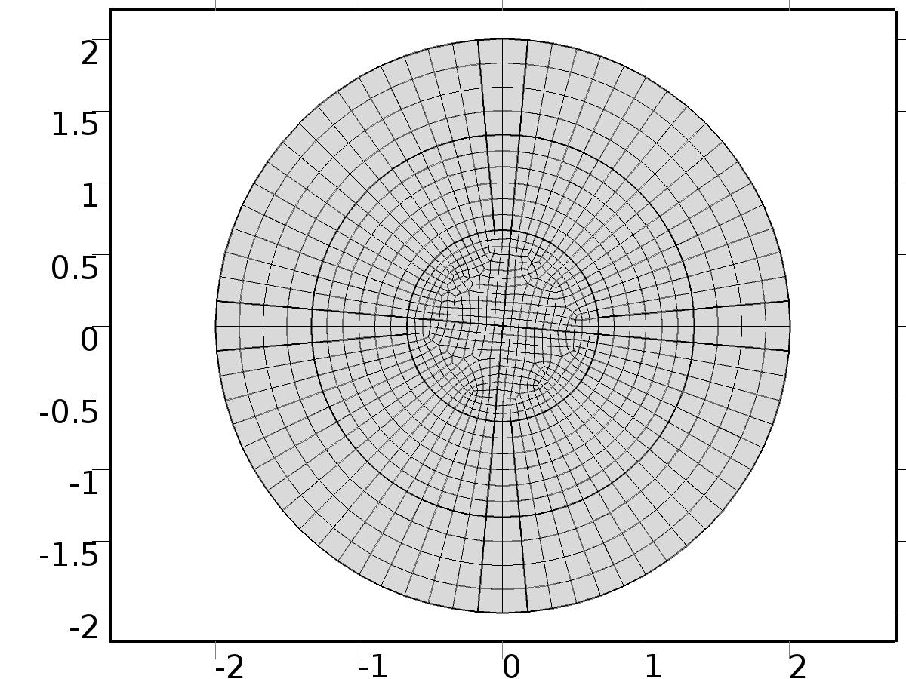

Mesh 1

* + 1. Size (size)

Settings

| **Description** | **Value** |
| --- | --- |
| Maximum element size | hr |
| Minimum element size | 6.0E-4 |
| Curvature factor | 0.3 |
| Maximum element growth rate | 1.3 |
| Custom element size | Custom |

* + 1. Distribution 1 (dis7)

Selection

|  |  |
| --- | --- |
| Geometric entity level | Boundary |
| Selection | Boundaries 1–2, 6–7, 15–16, 19–20 |

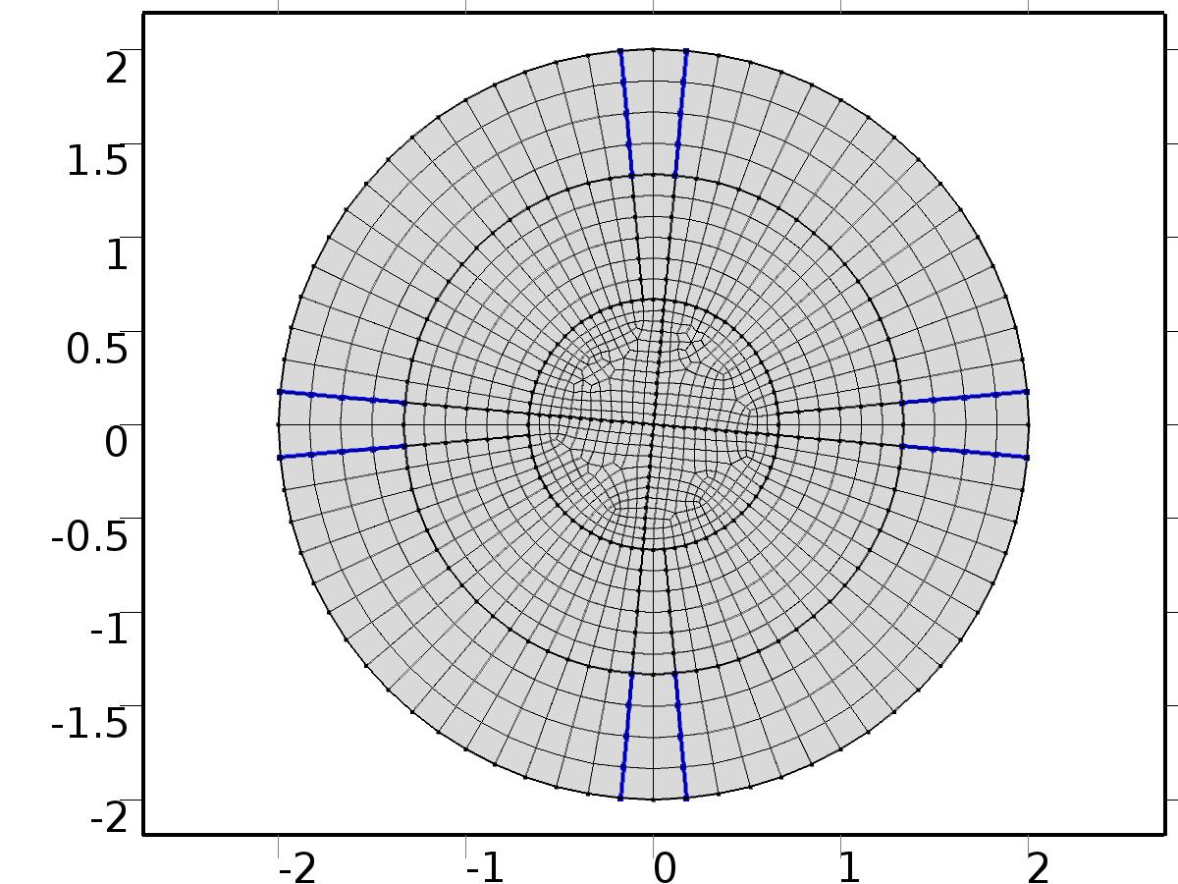

Distribution 1

Settings

| **Description** | **Value** |
| --- | --- |
| Distribution properties | Predefined distribution type |
| Number of elements | n_dis |

* + 1. Distribution 2 (dis2)

Selection

|  |  |
| --- | --- |
| Geometric entity level | Boundary |
| Selection | Boundaries 3–4, 8–9, 13–14, 17–18 |

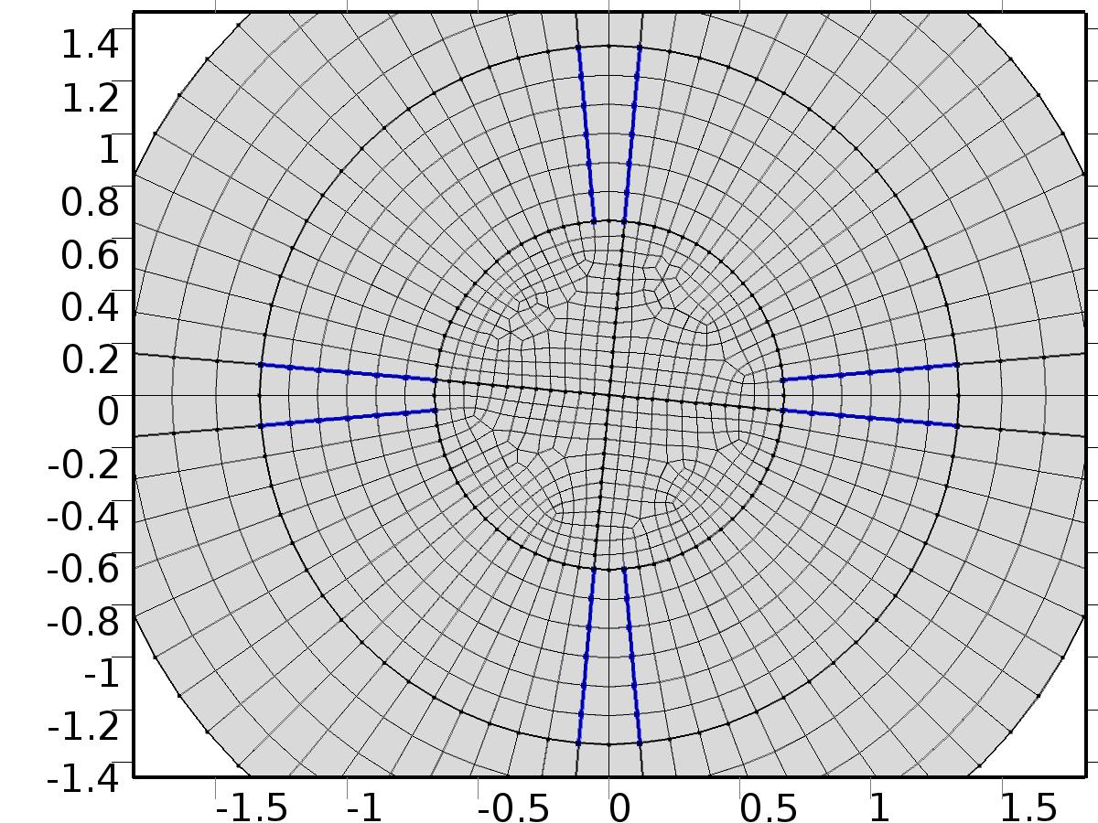

Distribution 2

Settings

| **Description** | **Value** |
| --- | --- |
| Distribution properties | Predefined distribution type |
| Number of elements | 1.5*n_dis |

* + 1. Distribution 3 (dis3)

Selection

|  |  |
| --- | --- |
| Geometric entity level | Boundary |
| Selection | Boundaries 5, 10–12 |

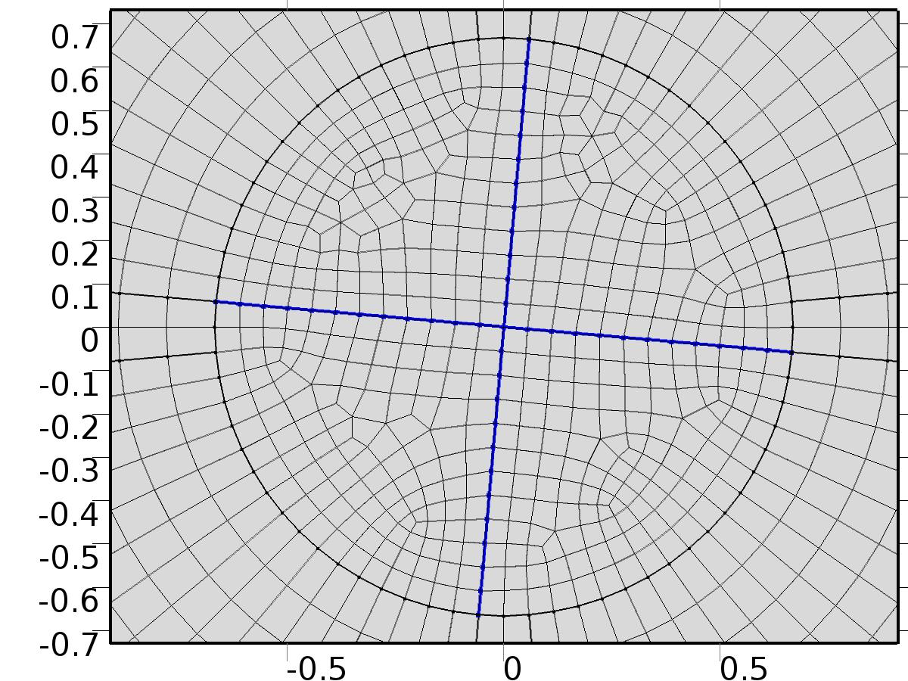

Distribution 3

Settings

| **Description** | **Value** |
| --- | --- |
| Number of elements | 3*n_dis |

* + 1. Mapped 1 (map1)

Selection

|  |  |
| --- | --- |
| Geometric entity level | Domain |
| Selection | Domains 1–6, 9–12, 15–20 |

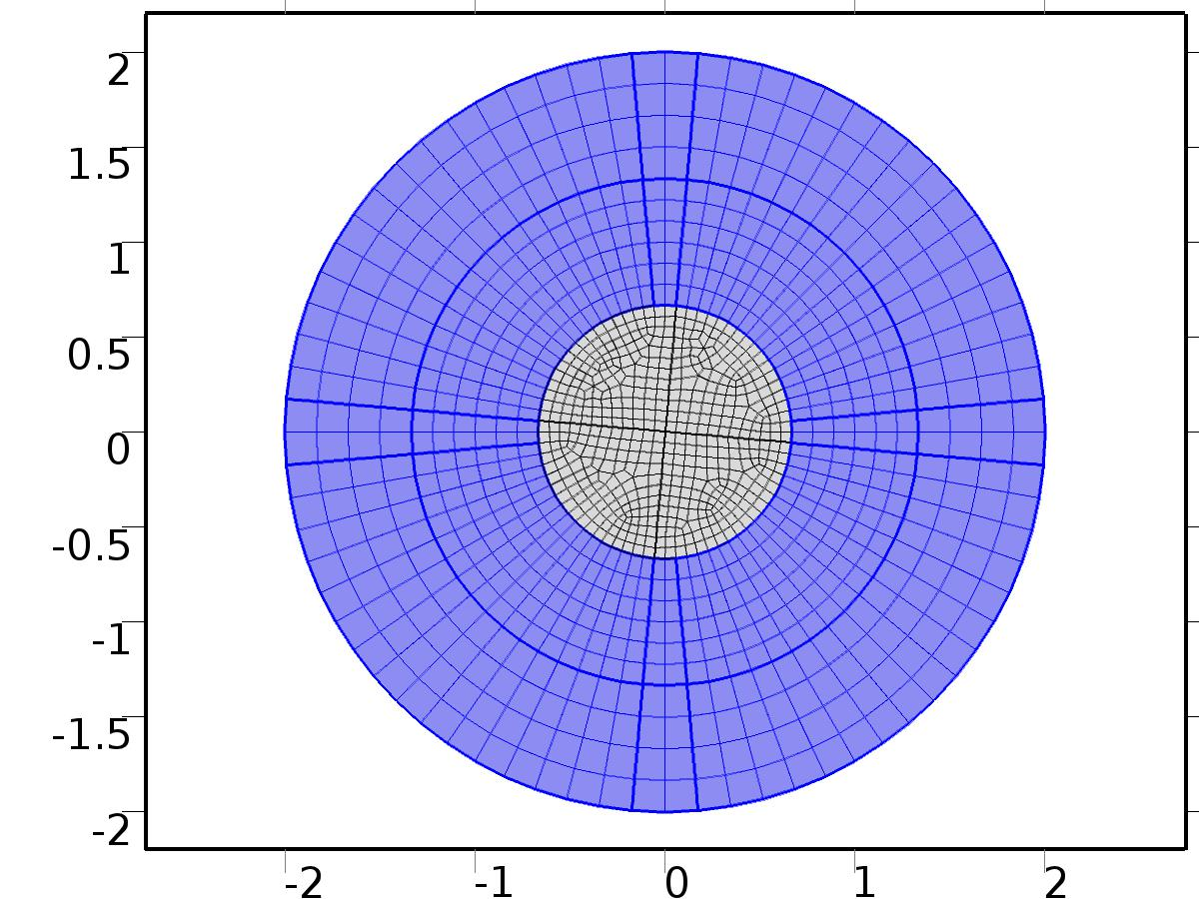

Mapped 1

* + 1. Free Quad 1 (fq1)

Selection

|  |  |
| --- | --- |
| Geometric entity level | Remaining |

1. Study 1
   1. Stationary

Study settings

| **Description** | **Value** |
| --- | --- |
| Include geometric nonlinearity | Off |

Physics and variables selection

| **Physics interface** | **Discretization** |
| --- | --- |
| Unit Input1 (c2) | physics |
| Unit Input2 (phys1) | physics |

Mesh selection

| **Geometry** | **Mesh** |
| --- | --- |
| Geometry 1 (geom1) | mesh1 |

* 1. Solver Configurations
     1. Solver 1

#### Compile Equations: Stationary (st1)

Study and step

| **Description** | **Value** |
| --- | --- |
| Use study | Study 1 |
| Use study step | Stationary |

#### Dependent Variables 1 (v1)

General

| **Description** | **Value** |
| --- | --- |
| Defined by study step | Stationary |
| Constant |  |

Initial values of variables solved for

| **Description** | **Value** |
| --- | --- |
| Solution | Zero |

Values of variables not solved for

| **Description** | **Value** |
| --- | --- |
| Solution | Zero |

##### Dependent variable q (mod1.q) (mod1_q)

General

| **Description** | **Value** |
| --- | --- |
| Field components | mod1.q |
| Solve for this field | Off |
| Field name | mod1_u |

##### Dependent variable qa (mod1.qa) (mod1_qa)

General

| **Description** | **Value** |
| --- | --- |
| Field components | mod1.qa |
| Solve for this field | Off |
| Field name | mod1_w |

##### Dependent variable Xa1 (mod1.Xa1) (mod1_Xa1)

General

| **Description** | **Value** |
| --- | --- |
| Field components | mod1.Xa1 |
| Field name | mod1_X1_u |

##### Dependent variable X1 (mod1.X1) (mod1_X1)

General

| **Description** | **Value** |
| --- | --- |
| Field components | mod1.X1 |
| Field name | mod1_X1_w |

##### Dependent variable Xa2 (mod1.Xa2) (mod1_Xa2)

General

| **Description** | **Value** |
| --- | --- |
| Field components | mod1.Xa2 |
| Field name | mod1_X2_w |

##### Dependent variable X2 (mod1.X2) (mod1_X2)

General

| **Description** | **Value** |
| --- | --- |
| Field components | mod1.X2 |
| Field name | mod1_X2_u |

##### Dependent variable PIa1 (mod1.PIa1) (mod1_PIa1)

General

| **Description** | **Value** |
| --- | --- |
| Field components | mod1.PIa1 |
| Solve for this field | Off |
| Field name | mod1_Z1_w |

##### Dependent variable PI1 (mod1.PI1) (mod1_PI1)

General

| **Description** | **Value** |
| --- | --- |
| Field components | mod1.PI1 |
| Solve for this field | Off |
| Field name | mod1_Z1_u |

##### Dependent variable PIt2 (mod1.PIt2) (mod1_PIt2)

General

| **Description** | **Value** |
| --- | --- |
| Field components | mod1.PIt2 |
| Solve for this field | Off |
| Field name | mod1_Zt2_u |

##### Dependent variable PIa2 (mod1.PIa2) (mod1_PIa2)

General

| **Description** | **Value** |
| --- | --- |
| Field components | mod1.PIa2 |
| Solve for this field | Off |
| Field name | mod1_Z2_w |

##### Dependent variable PIta2 (mod1.PIta2) (mod1_PIta2)

General

| **Description** | **Value** |
| --- | --- |
| Field components | mod1.PIta2 |
| Solve for this field | Off |
| Field name | mod1_Zt2_w |

##### Dependent variable PI2 (mod1.PI2) (mod1_PI2)

General

| **Description** | **Value** |
| --- | --- |
| Field components | mod1.PI2 |
| Solve for this field | Off |
| Field name | mod1_Z2_u |

##### Dependent variable PIta1 (mod1.PIta1) (mod1_PIta1)

General

| **Description** | **Value** |
| --- | --- |
| Field components | mod1.PIta1 |
| Solve for this field | Off |
| Field name | mod1_Zt1_w |

##### Dependent variable PIt1 (mod1.PIt1) (mod1_PIt1)

General

| **Description** | **Value** |
| --- | --- |
| Field components | mod1.PIt1 |
| Solve for this field | Off |
| Field name | mod1_Zt1_u |

#### Stationary Solver 1 (s1)

General

| **Description** | **Value** |
| --- | --- |
| Defined by study step | Stationary |
| Relative tolerance | 0.000000010 |

Log

| **Description** | **Value** |
| --- | --- |
| Constant |  |

##### Fully Coupled 1 (fc1)

General

| **Description** | **Value** |
| --- | --- |
| Linear solver | Direct |

1. Study 2
   1. Stationary

Study settings

| **Description** | **Value** |
| --- | --- |
| Include geometric nonlinearity | Off |

Physics and variables selection

| **Physics interface** | **Discretization** |
| --- | --- |
| Regulator Eqs (phys2) | physics |

Mesh selection

| **Geometry** | **Mesh** |
| --- | --- |
| Geometry 1 (geom1) | mesh1 |

* 1. Solver Configurations
     1. Solver 2

#### Compile Equations: Stationary (st1)

Study and step

| **Description** | **Value** |
| --- | --- |
| Use study | Study 2 |
| Use study step | Stationary |

#### Dependent Variables 1 (v1)

General

| **Description** | **Value** |
| --- | --- |
| Defined by study step | Stationary |
| Constant |  |

Initial values of variables solved for

| **Description** | **Value** |
| --- | --- |
| Solution | Zero |

Values of variables not solved for

| **Description** | **Value** |
| --- | --- |
| Method | Solution |
| Solution | Solver 1 |

##### Dependent variable PIa1 (mod1.PIa1) (mod1_PIa1)

General

| **Description** | **Value** |
| --- | --- |
| Field components | mod1.PIa1 |
| Field name | mod1_Z1_w |

##### Dependent variable q (mod1.q) (mod1_q)

General

| **Description** | **Value** |
| --- | --- |
| Field components | mod1.q |
| Solve for this field | Off |
| Field name | mod1_u |

##### Dependent variable qa (mod1.qa) (mod1_qa)

General

| **Description** | **Value** |
| --- | --- |
| Field components | mod1.qa |
| Solve for this field | Off |
| Field name | mod1_w |

##### Dependent variable PI1 (mod1.PI1) (mod1_PI1)

General

| **Description** | **Value** |
| --- | --- |
| Field components | mod1.PI1 |
| Field name | mod1_Z1_u |

##### Dependent variable Xa2 (mod1.Xa2) (mod1_Xa2)

General

| **Description** | **Value** |
| --- | --- |
| Field components | mod1.Xa2 |
| Solve for this field | Off |
| Field name | mod1_X2_w |

##### Dependent variable X2 (mod1.X2) (mod1_X2)

General

| **Description** | **Value** |
| --- | --- |
| Field components | mod1.X2 |
| Solve for this field | Off |
| Field name | mod1_X2_u |

##### Dependent variable PIt2 (mod1.PIt2) (mod1_PIt2)

General

| **Description** | **Value** |
| --- | --- |
| Field components | mod1.PIt2 |
| Field name | mod1_Zt2_u |

##### Dependent variable X1 (mod1.X1) (mod1_X1)

General

| **Description** | **Value** |
| --- | --- |
| Field components | mod1.X1 |
| Solve for this field | Off |
| Field name | mod1_X1_w |

##### Dependent variable PIa2 (mod1.PIa2) (mod1_PIa2)

General

| **Description** | **Value** |
| --- | --- |
| Field components | mod1.PIa2 |
| Field name | mod1_Z2_w |

##### Dependent variable PIta2 (mod1.PIta2) (mod1_PIta2)

General

| **Description** | **Value** |
| --- | --- |
| Field components | mod1.PIta2 |
| Field name | mod1_Zt2_w |

##### Dependent variable PI2 (mod1.PI2) (mod1_PI2)

General

| **Description** | **Value** |
| --- | --- |
| Field components | mod1.PI2 |
| Field name | mod1_Z2_u |

##### Dependent variable PIta1 (mod1.PIta1) (mod1_PIta1)

General

| **Description** | **Value** |
| --- | --- |
| Field components | mod1.PIta1 |
| Field name | mod1_Zt1_w |

##### Dependent variable Xa1 (mod1.Xa1) (mod1_Xa1)

General

| **Description** | **Value** |
| --- | --- |
| Field components | mod1.Xa1 |
| Solve for this field | Off |
| Field name | mod1_X1_u |

##### Dependent variable PIt1 (mod1.PIt1) (mod1_PIt1)

General

| **Description** | **Value** |
| --- | --- |
| Field components | mod1.PIt1 |
| Field name | mod1_Zt1_u |

#### Stationary Solver 1 (s1)

General

| **Description** | **Value** |
| --- | --- |
| Defined by study step | Stationary |
| Relative tolerance | 0.000000010 |

Log

| **Description** | **Value** |
| --- | --- |
| Constant |  |

##### Fully Coupled 1 (fc1)

General

| **Description** | **Value** |
| --- | --- |
| Linear solver | Direct |

1. Study 3
   1. Time Dependent

Study settings

| **Description** | **Value** |
| --- | --- |
| Include geometric nonlinearity | Off |

| **Times** | **Unit** |
| --- | --- |
| range(0,0.025,15) | s |

Physics and variables selection

| **Physics interface** | **Discretization** |
| --- | --- |
| Close Loop System (c) | physics |

Mesh selection

| **Geometry** | **Mesh** |
| --- | --- |
| Geometry 1 (geom1) | mesh1 |

* 1. Solver Configurations
     1. Solver 3

#### Compile Equations: Time Dependent (st1)

Study and step

| **Description** | **Value** |
| --- | --- |
| Use study | Study 3 |
| Use study step | Time Dependent |

#### Dependent Variables 1 (v1)

General

| **Description** | **Value** |
| --- | --- |
| Defined by study step | Time Dependent |
| Constant |  |

Initial values of variables solved for

| **Description** | **Value** |
| --- | --- |
| Solution | Zero |

Values of variables not solved for

| **Description** | **Value** |
| --- | --- |
| Method | Solution |
| Solution | Solver 2 |

##### Dependent variable PIa1 (mod1.PIa1) (mod1_PIa1)

General

| **Description** | **Value** |
| --- | --- |
| Field components | mod1.PIa1 |
| Solve for this field | Off |
| Field name | mod1_PI1_w |

##### Dependent variable PIt1 (mod1.PIt1) (mod1_PIt1)

General

| **Description** | **Value** |
| --- | --- |
| Field components | mod1.PIt1 |
| Solve for this field | Off |
| Field name | mod1_PIt1_u |

##### Dependent variable q (mod1.q) (mod1_q)

General

| **Description** | **Value** |
| --- | --- |
| Field components | mod1.q |
| Field name | mod1_u |

##### Dependent variable qa (mod1.qa) (mod1_qa)

General

| **Description** | **Value** |
| --- | --- |
| Field components | mod1.qa |
| Field name | mod1_w |

##### Dependent variable PIta1 (mod1.PIta1) (mod1_PIta1)

General

| **Description** | **Value** |
| --- | --- |
| Field components | mod1.PIta1 |
| Solve for this field | Off |
| Field name | mod1_PIt1_w |

##### Dependent variable Xa2 (mod1.Xa2) (mod1_Xa2)

General

| **Description** | **Value** |
| --- | --- |
| Field components | mod1.Xa2 |
| Solve for this field | Off |
| Field name | mod1_X2_w |

##### Dependent variable PIa2 (mod1.PIa2) (mod1_PIa2)

General

| **Description** | **Value** |
| --- | --- |
| Field components | mod1.PIa2 |
| Solve for this field | Off |
| Field name | mod1_PI2_w |

##### Dependent variable X2 (mod1.X2) (mod1_X2)

General

| **Description** | **Value** |
| --- | --- |
| Field components | mod1.X2 |
| Solve for this field | Off |
| Field name | mod1_X2_u |

##### Dependent variable Xa1 (mod1.Xa1) (mod1_Xa1)

General

| **Description** | **Value** |
| --- | --- |
| Field components | mod1.Xa1 |
| Solve for this field | Off |
| Field name | mod1_X1_w |

##### Dependent variable PI1 (mod1.PI1) (mod1_PI1)

General

| **Description** | **Value** |
| --- | --- |
| Field components | mod1.PI1 |
| Solve for this field | Off |
| Field name | mod1_PI1_u |

##### Dependent variable X1 (mod1.X1) (mod1_X1)

General

| **Description** | **Value** |
| --- | --- |
| Field components | mod1.X1 |
| Solve for this field | Off |
| Field name | mod1_X1_u |

##### Dependent variable PIt2 (mod1.PIt2) (mod1_PIt2)

General

| **Description** | **Value** |
| --- | --- |
| Field components | mod1.PIt2 |
| Solve for this field | Off |
| Field name | mod1_PIt2_u |

##### Dependent variable PIta2 (mod1.PIta2) (mod1_PIta2)

General

| **Description** | **Value** |
| --- | --- |
| Field components | mod1.PIta2 |
| Solve for this field | Off |
| Field name | mod1_PIt2_w |

##### Dependent variable PI2 (mod1.PI2) (mod1_PI2)

General

| **Description** | **Value** |
| --- | --- |
| Field components | mod1.PI2 |
| Solve for this field | Off |
| Field name | mod1_PI2_u |

#### Time-Dependent Solver 1 (t1)

General

| **Description** | **Value** |
| --- | --- |
| Defined by study step | Time Dependent |
| Time | {0, 0.025, 0.05, 0.07500000000000001, 0.1, 0.125, 0.15000000000000002, 0.17500000000000002, 0.2, 0.225, 0.25, 0.275, 0.30000000000000004, 0.325, 0.35000000000000003, 0.375, 0.4, 0.42500000000000004, 0.45, 0.47500000000000003, 0.5, 0.525, 0.55, 0.5750000000000001, 0.6000000000000001, 0.625, 0.65, 0.675, 0.7000000000000001, 0.7250000000000001, 0.75, 0.775, 0.8, 0.8250000000000001, 0.8500000000000001, 0.875, 0.9, 0.925, 0.9500000000000001, 0.9750000000000001, 1, 1.0250000000000001, 1.05, 1.075, 1.1, 1.125, 1.1500000000000001, 1.175, 1.2000000000000002, 1.225, 1.25, 1.2750000000000001, 1.3, 1.3250000000000002, 1.35, 1.375, 1.4000000000000001, 1.425, 1.4500000000000002, 1.475, 1.5, 1.5250000000000001, 1.55, 1.5750000000000002, 1.6, 1.625, 1.6500000000000001, 1.675, 1.7000000000000002, 1.725, 1.75, 1.7750000000000001, 1.8, 1.8250000000000002, 1.85, 1.875, 1.9000000000000001, 1.925, 1.9500000000000002, 1.975, 2, 2.025, 2.0500000000000003, 2.075, 2.1, 2.125, 2.15, 2.1750000000000003, 2.2, 2.225, 2.25, 2.275, 2.3000000000000003, 2.325, 2.35, 2.375, 2.4000000000000004, 2.4250000000000003, 2.45, 2.475, 2.5, 2.5250000000000004, 2.5500000000000003, 2.575, 2.6, 2.625, 2.6500000000000004, 2.6750000000000003, 2.7, 2.725, 2.75, 2.7750000000000004, 2.8000000000000003, 2.825, 2.85, 2.875, 2.9000000000000004, 2.9250000000000003, 2.95, 2.975, 3, 3.0250000000000004, 3.0500000000000003, 3.075, 3.1, 3.125, 3.1500000000000004, 3.1750000000000003, 3.2, 3.225, 3.25, 3.2750000000000004, 3.3000000000000003, 3.325, 3.35, 3.375, 3.4000000000000004, 3.4250000000000003, 3.45, 3.475, 3.5, 3.5250000000000004, 3.5500000000000003, 3.575, 3.6, 3.625, 3.6500000000000004, 3.6750000000000003, 3.7, 3.725, 3.75, 3.7750000000000004, 3.8000000000000003, 3.825, 3.85, 3.875, 3.9000000000000004, 3.9250000000000003, 3.95, 3.975, 4, 4.025, 4.05, 4.075, 4.1000000000000005, 4.125, 4.15, 4.175, 4.2, 4.2250000000000005, 4.25, 4.275, 4.3, 4.325, 4.3500000000000005, 4.375, 4.4, 4.425, 4.45, 4.4750000000000005, 4.5, 4.525, 4.55, 4.575, 4.6000000000000005, 4.625, 4.65, 4.675, 4.7, 4.7250000000000005, 4.75, 4.775, 4.800000000000001, 4.825, 4.8500000000000005, 4.875, 4.9, 4.925000000000001, 4.95, 4.9750000000000005, 5, 5.025, 5.050000000000001, 5.075, 5.1000000000000005, 5.125, 5.15, 5.175000000000001, 5.2, 5.2250000000000005, 5.25, 5.275, 5.300000000000001, 5.325, 5.3500000000000005, 5.375, 5.4, 5.425000000000001, 5.45, 5.4750000000000005, 5.5, 5.525, 5.550000000000001, 5.575, 5.6000000000000005, 5.625, 5.65, 5.675000000000001, 5.7, 5.7250000000000005, 5.75, 5.775, 5.800000000000001, 5.825, 5.8500000000000005, 5.875, 5.9, 5.925000000000001, 5.95, 5.9750000000000005, 6, 6.025, 6.050000000000001, 6.075, 6.1000000000000005, 6.125, 6.15, 6.175000000000001, 6.2, 6.2250000000000005, 6.25, 6.275, 6.300000000000001, 6.325, 6.3500000000000005, 6.375, 6.4, 6.425000000000001, 6.45, 6.4750000000000005, 6.5, 6.525, 6.550000000000001, 6.575, 6.6000000000000005, 6.625, 6.65, 6.675000000000001, 6.7, 6.7250000000000005, 6.75, 6.775, 6.800000000000001, 6.825, 6.8500000000000005, 6.875, 6.9, 6.925000000000001, 6.95, 6.9750000000000005, 7, 7.025, 7.050000000000001, 7.075, 7.1000000000000005, 7.125, 7.15, 7.175000000000001, 7.2, 7.2250000000000005, 7.25, 7.275, 7.300000000000001, 7.325, 7.3500000000000005, 7.375, 7.4, 7.425000000000001, 7.45, 7.4750000000000005, 7.5, 7.525, 7.550000000000001, 7.575, 7.6000000000000005, 7.625, 7.65, 7.675000000000001, 7.7, 7.7250000000000005, 7.75, 7.775, 7.800000000000001, 7.825, 7.8500000000000005, 7.875, 7.9, 7.925000000000001, 7.95, 7.9750000000000005, 8, 8.025, 8.05, 8.075000000000001, 8.1, 8.125, 8.15, 8.175, 8.200000000000001, 8.225, 8.25, 8.275, 8.3, 8.325000000000001, 8.35, 8.375, 8.4, 8.425, 8.450000000000001, 8.475, 8.5, 8.525, 8.55, 8.575000000000001, 8.6, 8.625, 8.65, 8.675, 8.700000000000001, 8.725, 8.75, 8.775, 8.8, 8.825000000000001, 8.85, 8.875, 8.9, 8.925, 8.950000000000001, 8.975, 9, 9.025, 9.05, 9.075000000000001, 9.1, 9.125, 9.15, 9.175, 9.200000000000001, 9.225, 9.25, 9.275, 9.3, 9.325000000000001, 9.35, 9.375, 9.4, 9.425, 9.450000000000001, 9.475, 9.5, 9.525, 9.55, 9.575000000000001, 9.600000000000001, 9.625, 9.65, 9.675, 9.700000000000001, 9.725000000000001, 9.75, 9.775, 9.8, 9.825000000000001, 9.850000000000001, 9.875, 9.9, 9.925, 9.950000000000001, 9.975000000000001, 10, 10.025, 10.05, 10.075000000000001, 10.100000000000001, 10.125, 10.15, 10.175, 10.200000000000001, 10.225000000000001, 10.25, 10.275, 10.3, 10.325000000000001, 10.350000000000001, 10.375, 10.4, 10.425, 10.450000000000001, 10.475000000000001, 10.5, 10.525, 10.55, 10.575000000000001, 10.600000000000001, 10.625, 10.65, 10.675, 10.700000000000001, 10.725000000000001, 10.75, 10.775, 10.8, 10.825000000000001, 10.850000000000001, 10.875, 10.9, 10.925, 10.950000000000001, 10.975000000000001, 11, 11.025, 11.05, 11.075000000000001, 11.100000000000001, 11.125, 11.15, 11.175, 11.200000000000001, 11.225000000000001, 11.25, 11.275, 11.3, 11.325000000000001, 11.350000000000001, 11.375, 11.4, 11.425, 11.450000000000001, 11.475000000000001, 11.5, 11.525, 11.55, 11.575000000000001, 11.600000000000001, 11.625, 11.65, 11.675, 11.700000000000001, 11.725000000000001, 11.75, 11.775, 11.8, 11.825000000000001, 11.850000000000001, 11.875, 11.9, 11.925, 11.950000000000001, 11.975000000000001, 12, 12.025, 12.05, 12.075000000000001, 12.100000000000001, 12.125, 12.15, 12.175, 12.200000000000001, 12.225000000000001, 12.25, 12.275, 12.3, 12.325000000000001, 12.350000000000001, 12.375, 12.4, 12.425, 12.450000000000001, 12.475000000000001, 12.5, 12.525, 12.55, 12.575000000000001, 12.600000000000001, 12.625, 12.65, 12.675, 12.700000000000001, 12.725000000000001, 12.75, 12.775, 12.8, 12.825000000000001, 12.850000000000001, 12.875, 12.9, 12.925, 12.950000000000001, 12.975000000000001, 13, 13.025, 13.05, 13.075000000000001, 13.100000000000001, 13.125, 13.15, 13.175, 13.200000000000001, 13.225000000000001, 13.25, 13.275, 13.3, 13.325000000000001, 13.350000000000001, 13.375, 13.4, 13.425, 13.450000000000001, 13.475000000000001, 13.5, 13.525, 13.55, 13.575000000000001, 13.600000000000001, 13.625, 13.65, 13.675, 13.700000000000001, 13.725000000000001, 13.75, 13.775, 13.8, 13.825000000000001, 13.850000000000001, 13.875, 13.9, 13.925, 13.950000000000001, 13.975000000000001, 14, 14.025, 14.05, 14.075000000000001, 14.100000000000001, 14.125, 14.15, 14.175, 14.200000000000001, 14.225000000000001, 14.25, 14.275, 14.3, 14.325000000000001, 14.350000000000001, 14.375, 14.4, 14.425, 14.450000000000001, 14.475000000000001, 14.5, 14.525, 14.55, 14.575000000000001, 14.600000000000001, 14.625, 14.65, 14.675, 14.700000000000001, 14.725000000000001, 14.75, 14.775, 14.8, 14.825000000000001, 14.850000000000001, 14.875, 14.9, 14.925, 14.950000000000001, 14.975000000000001, 15} |
| Relative tolerance | 0.00001 |

Absolute tolerance

| **Description** | **Value** |
| --- | --- |
| Tolerance | 0.0000010 |

Time stepping

| **Description** | **Value** |
| --- | --- |
| Initial step | 0.0010 |

Results while solving

| **Description** | **Value** |
| --- | --- |
| Probes | None |

Advanced

| **Description** | **Value** |
| --- | --- |
| Fraction of initial step for Backward Euler | 0.0010 |

Log

| **Description** | **Value** |
| --- | --- |
| Constant |  |

##### Fully Coupled 1 (fc1)

General

| **Description** | **Value** |
| --- | --- |
| Linear solver | Direct |

1. Results
   1. Data Sets
      1. Solution 1

Solution

| **Description** | **Value** |
| --- | --- |
| Solution | Solver 1 |
| Component | Save Point Geometry 1 |

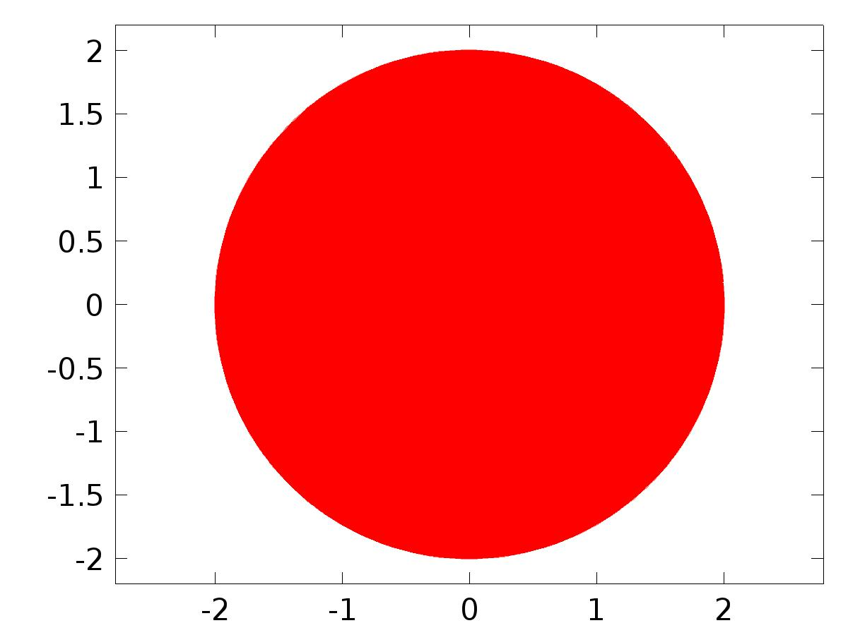

Data set: Solution 1

* + 1. Solution 2

Solution

| **Description** | **Value** |
| --- | --- |
| Solution | Solver 2 |
| Component | Save Point Geometry 1 |



Data set: Solution 2

* + 1. Probe Solution 3

Solution

| **Description** | **Value** |
| --- | --- |
| Solution | Solver 3 |
| Component | Save Point Geometry 1 |



Data set: Probe Solution 3

* + 1. Solution 4

Solution

| **Description** | **Value** |
| --- | --- |
| Solution | Solver 3 |
| Component | Save Point Geometry 1 |



Data set: Solution 4

* 1. Derived Values
     1. Global Variable Probe 1

Data

| **Description** | **Value** |
| --- | --- |
| Data set | Probe Solution 3 |

Expression

| **Description** | **Value** |
| --- | --- |
| Expression | Gamma11 |

* + 1. Global Variable Probe 2

Data

| **Description** | **Value** |
| --- | --- |
| Data set | Probe Solution 3 |

Expression

| **Description** | **Value** |
| --- | --- |
| Expression | Gamma12 |

* + 1. Global Variable Probe 3

Data

| **Description** | **Value** |
| --- | --- |
| Data set | Probe Solution 3 |

Expression

| **Description** | **Value** |
| --- | --- |
| Expression | Gamma21 |

* + 1. Global Variable Probe 4

Data

| **Description** | **Value** |
| --- | --- |
| Data set | Probe Solution 3 |

Expression

| **Description** | **Value** |
| --- | --- |
| Expression | Gamma22 |

* + 1. Global Evaluation 5

Data

| **Description** | **Value** |
| --- | --- |
| Data set | Solution 4 |

Expression

| **Description** | **Value** |
| --- | --- |
| Expression | u2 |

* 1. Tables
     1. Probe Table 1

Probe Table 1

| **, Global Variable Probe 1** | **, Global Variable Probe 2** | **, Global Variable Probe 3** | **, Global Variable Probe 4** |
| --- | --- | --- | --- |
| 1.4451 | -7.2625 | -0.80521 | -13.910 |

* + 1. Table 2

Global Evaluation 5 (g11)

Table 2

| **g22** |
| --- |
| -73.886 |

* + 1. Table 3

Point Evaluation 1 (C1(w))

Table 3

| **Time** | **C1(w), Point: 4** | **C2(w), Point: 4** | **f, Point: 4** | **Gamma1, Point: 4** | **Gamma2, Point: 4** |
| --- | --- | --- | --- | --- | --- |
| 0.0000 | 2.9969E-10 | 6.1912E-13 | -0.50000 | -7.2630 | -13.910 |
| 0.025000 | 1.2269E-4 | -5.1643E-5 | -0.43051 | -7.1273 | -13.930 |
| 0.050000 | -3.2572E-5 | -1.1628E-4 | -0.35837 | -6.9477 | -13.864 |
| 0.075000 | -5.9801E-4 | -1.4302E-4 | -0.28402 | -6.7253 | -13.713 |
| 0.10000 | -0.0012507 | -1.6731E-4 | -0.20791 | -6.4614 | -13.478 |
| 0.12500 | -0.0017471 | -2.0568E-4 | -0.13053 | -6.1577 | -13.159 |
| 0.15000 | -0.0020102 | -2.4644E-4 | -0.052336 | -5.8160 | -12.759 |
| 0.17500 | -0.0020579 | -2.7431E-4 | 0.026177 | -5.4385 | -12.281 |
| 0.20000 | -0.0019315 | -2.8607E-4 | 0.10453 | -5.0274 | -11.727 |
| 0.22500 | -0.0016870 | -2.8618E-4 | 0.18224 | -4.5853 | -11.100 |
| 0.25000 | -0.0013856 | -2.7975E-4 | 0.25882 | -4.1150 | -10.405 |
| 0.27500 | -0.0010819 | -2.7069E-4 | 0.33381 | -3.6193 | -9.6463 |
| 0.30000 | -8.1024E-4 | -2.6052E-4 | 0.40674 | -3.1013 | -8.8277 |
| 0.32500 | -5.7786E-4 | -2.4914E-4 | 0.47716 | -2.5641 | -7.9548 |
| 0.35000 | -3.9222E-4 | -2.3745E-4 | 0.54464 | -2.0112 | -7.0328 |
| 0.37500 | -2.5406E-4 | -2.2510E-4 | 0.60876 | -1.4458 | -6.0674 |
| 0.40000 | -1.5512E-4 | -2.1068E-4 | 0.66913 | -0.87156 | -5.0646 |
| 0.42500 | -8.2543E-5 | -1.9398E-4 | 0.72537 | -0.29192 | -4.0307 |
| 0.45000 | -2.7875E-5 | -1.7503E-4 | 0.77715 | 0.28952 | -2.9718 |
| 0.47500 | 1.4970E-5 | -1.5360E-4 | 0.82413 | 0.86917 | -1.8946 |
| 0.50000 | 5.1615E-5 | -1.2983E-4 | 0.86603 | 1.4435 | -0.80580 |
| 0.52500 | 8.5047E-5 | -1.0409E-4 | 0.90259 | 2.0089 | 0.28802 |
| 0.55000 | 1.1774E-4 | -7.6935E-5 | 0.93358 | 2.5619 | 1.3801 |
| 0.57500 | 1.5031E-4 | -4.8828E-5 | 0.95882 | 3.0991 | 2.4636 |
| 0.60000 | 1.8282E-4 | -2.0237E-5 | 0.97815 | 3.6172 | 3.5319 |
| 0.62500 | 2.1507E-4 | 8.3377E-6 | 0.99144 | 4.1130 | 4.5785 |
| 0.65000 | 2.4651E-4 | 3.6447E-5 | 0.99863 | 4.5835 | 5.5968 |
| 0.67500 | 2.7662E-4 | 6.3691E-5 | 0.99966 | 5.0256 | 6.5807 |
| 0.70000 | 3.0501E-4 | 8.9737E-5 | 0.99452 | 5.4369 | 7.5239 |
| 0.72500 | 3.3154E-4 | 1.1435E-4 | 0.98325 | 5.8145 | 8.4208 |
| 0.75000 | 3.5636E-4 | 1.3742E-4 | 0.96593 | 6.1564 | 9.2658 |
| 0.77500 | 3.8010E-4 | 1.5892E-4 | 0.94264 | 6.4603 | 10.054 |
| 0.80000 | 4.0352E-4 | 1.7893E-4 | 0.91355 | 6.7243 | 10.779 |
| 0.82500 | 4.2717E-4 | 1.9750E-4 | 0.87882 | 6.9469 | 11.439 |
| 0.85000 | 4.5126E-4 | 2.1466E-4 | 0.83867 | 7.1267 | 12.028 |
| 0.87500 | 4.7553E-4 | 2.3042E-4 | 0.79335 | 7.2625 | 12.542 |
| 0.90000 | 4.9953E-4 | 2.4479E-4 | 0.74314 | 7.3535 | 12.980 |
| 0.92500 | 5.2301E-4 | 2.5780E-4 | 0.68835 | 7.3993 | 13.337 |
| 0.95000 | 5.4574E-4 | 2.6951E-4 | 0.62932 | 7.3993 | 13.612 |
| 0.97500 | 5.6773E-4 | 2.8002E-4 | 0.56641 | 7.3538 | 13.803 |
| 1.0000 | 5.8894E-4 | 2.8941E-4 | 0.50000 | 7.2630 | 13.910 |
| 1.0250 | 6.0949E-4 | 2.9778E-4 | 0.43051 | 7.1273 | 13.930 |
| 1.0500 | 6.2960E-4 | 3.0529E-4 | 0.35837 | 6.9477 | 13.864 |
| 1.0750 | 6.4930E-4 | 3.1206E-4 | 0.28402 | 6.7253 | 13.713 |
| 1.1000 | 6.6837E-4 | 3.1817E-4 | 0.20791 | 6.4614 | 13.478 |
| 1.1250 | 6.8654E-4 | 3.2366E-4 | 0.13053 | 6.1577 | 13.159 |
| 1.1500 | 7.0342E-4 | 3.2857E-4 | 0.052336 | 5.8160 | 12.759 |
| 1.1750 | 7.1853E-4 | 3.3291E-4 | -0.026177 | 5.4385 | 12.281 |
| 1.2000 | 7.3151E-4 | 3.3670E-4 | -0.10453 | 5.0274 | 11.727 |
| 1.2250 | 7.4230E-4 | 3.3996E-4 | -0.18224 | 4.5853 | 11.100 |
| 1.2500 | 7.5104E-4 | 3.4272E-4 | -0.25882 | 4.1150 | 10.405 |
| 1.2750 | 7.5800E-4 | 3.4499E-4 | -0.33381 | 3.6193 | 9.6463 |
| 1.3000 | 7.6354E-4 | 3.4680E-4 | -0.40674 | 3.1013 | 8.8277 |
| 1.3250 | 7.6796E-4 | 3.4819E-4 | -0.47716 | 2.5641 | 7.9548 |
| 1.3500 | 7.7124E-4 | 3.4915E-4 | -0.54464 | 2.0112 | 7.0328 |
| 1.3750 | 7.7344E-4 | 3.4970E-4 | -0.60876 | 1.4458 | 6.0674 |
| 1.4000 | 7.7447E-4 | 3.4983E-4 | -0.66913 | 0.87156 | 5.0646 |
| 1.4250 | 7.7442E-4 | 3.4956E-4 | -0.72537 | 0.29192 | 4.0307 |
| 1.4500 | 7.7329E-4 | 3.4888E-4 | -0.77715 | -0.28952 | 2.9718 |
| 1.4750 | 7.7116E-4 | 3.4783E-4 | -0.82413 | -0.86917 | 1.8946 |
| 1.5000 | 7.6808E-4 | 3.4642E-4 | -0.86603 | -1.4435 | 0.80580 |
| 1.5250 | 7.6408E-4 | 3.4466E-4 | -0.90259 | -2.0089 | -0.28802 |
| 1.5500 | 7.5916E-4 | 3.4255E-4 | -0.93358 | -2.5619 | -1.3801 |
| 1.5750 | 7.5335E-4 | 3.4009E-4 | -0.95882 | -3.0991 | -2.4636 |
| 1.6000 | 7.4669E-4 | 3.3728E-4 | -0.97815 | -3.6172 | -3.5319 |
| 1.6250 | 7.3925E-4 | 3.3413E-4 | -0.99144 | -4.1130 | -4.5785 |
| 1.6500 | 7.3113E-4 | 3.3067E-4 | -0.99863 | -4.5835 | -5.5968 |
| 1.6750 | 7.2236E-4 | 3.2690E-4 | -0.99966 | -5.0256 | -6.5807 |
| 1.7000 | 7.1302E-4 | 3.2285E-4 | -0.99452 | -5.4369 | -7.5239 |
| 1.7250 | 7.0312E-4 | 3.1854E-4 | -0.98325 | -5.8145 | -8.4208 |
| 1.7500 | 6.9270E-4 | 3.1397E-4 | -0.96593 | -6.1564 | -9.2658 |
| 1.7750 | 6.8177E-4 | 3.0915E-4 | -0.94264 | -6.4603 | -10.054 |
| 1.8000 | 6.7037E-4 | 3.0409E-4 | -0.91355 | -6.7243 | -10.779 |
| 1.8250 | 6.5852E-4 | 2.9881E-4 | -0.87882 | -6.9469 | -11.439 |
| 1.8500 | 6.4625E-4 | 2.9332E-4 | -0.83867 | -7.1267 | -12.028 |
| 1.8750 | 6.3359E-4 | 2.8763E-4 | -0.79335 | -7.2625 | -12.542 |
| 1.9000 | 6.2059E-4 | 2.8178E-4 | -0.74314 | -7.3535 | -12.980 |
| 1.9250 | 6.0728E-4 | 2.7577E-4 | -0.68835 | -7.3993 | -13.337 |
| 1.9500 | 5.9369E-4 | 2.6961E-4 | -0.62932 | -7.3993 | -13.612 |
| 1.9750 | 5.7984E-4 | 2.6333E-4 | -0.56641 | -7.3538 | -13.803 |
| 2.0000 | 5.6575E-4 | 2.5692E-4 | -0.50000 | -7.2630 | -13.910 |
| 2.0250 | 5.5145E-4 | 2.5039E-4 | -0.43051 | -7.1273 | -13.930 |
| 2.0500 | 5.3695E-4 | 2.4378E-4 | -0.35837 | -6.9477 | -13.864 |
| 2.0750 | 5.2225E-4 | 2.3708E-4 | -0.28402 | -6.7253 | -13.713 |
| 2.1000 | 5.0738E-4 | 2.3030E-4 | -0.20791 | -6.4614 | -13.478 |
| 2.1250 | 4.9236E-4 | 2.2347E-4 | -0.13053 | -6.1577 | -13.159 |
| 2.1500 | 4.7720E-4 | 2.1659E-4 | -0.052336 | -5.8160 | -12.759 |
| 2.1750 | 4.6196E-4 | 2.0967E-4 | 0.026177 | -5.4385 | -12.281 |
| 2.2000 | 4.4669E-4 | 2.0274E-4 | 0.10453 | -5.0274 | -11.727 |
| 2.2250 | 4.3144E-4 | 1.9580E-4 | 0.18224 | -4.5853 | -11.100 |
| 2.2500 | 4.1616E-4 | 1.8886E-4 | 0.25882 | -4.1150 | -10.405 |
| 2.2750 | 4.0091E-4 | 1.8192E-4 | 0.33381 | -3.6193 | -9.6463 |
| 2.3000 | 3.8571E-4 | 1.7500E-4 | 0.40674 | -3.1013 | -8.8277 |
| 2.3250 | 3.7054E-4 | 1.6809E-4 | 0.47716 | -2.5641 | -7.9548 |
| 2.3500 | 3.5542E-4 | 1.6121E-4 | 0.54464 | -2.0112 | -7.0328 |
| 2.3750 | 3.4033E-4 | 1.5435E-4 | 0.60876 | -1.4458 | -6.0674 |
| 2.4000 | 3.2532E-4 | 1.4754E-4 | 0.66913 | -0.87156 | -5.0646 |
| 2.4250 | 3.1038E-4 | 1.4078E-4 | 0.72537 | -0.29192 | -4.0307 |
| 2.4500 | 2.9554E-4 | 1.3408E-4 | 0.77715 | 0.28952 | -2.9718 |
| 2.4750 | 2.8082E-4 | 1.2745E-4 | 0.82413 | 0.86917 | -1.8946 |
| 2.5000 | 2.6627E-4 | 1.2089E-4 | 0.86603 | 1.4435 | -0.80580 |
| 2.5250 | 2.5192E-4 | 1.1441E-4 | 0.90259 | 2.0089 | 0.28802 |
| 2.5500 | 2.3775E-4 | 1.0802E-4 | 0.93358 | 2.5619 | 1.3801 |
| 2.5750 | 2.2379E-4 | 1.0171E-4 | 0.95882 | 3.0991 | 2.4636 |
| 2.6000 | 2.1007E-4 | 9.5503E-5 | 0.97815 | 3.6172 | 3.5319 |
| 2.6250 | 1.9659E-4 | 8.9393E-5 | 0.99144 | 4.1130 | 4.5785 |
| 2.6500 | 1.8336E-4 | 8.3385E-5 | 0.99863 | 4.5835 | 5.5968 |
| 2.6750 | 1.7036E-4 | 7.7483E-5 | 0.99966 | 5.0256 | 6.5807 |
| 2.7000 | 1.5763E-4 | 7.1694E-5 | 0.99452 | 5.4369 | 7.5239 |
| 2.7250 | 1.4517E-4 | 6.6024E-5 | 0.98325 | 5.8145 | 8.4208 |
| 2.7500 | 1.3298E-4 | 6.0478E-5 | 0.96593 | 6.1564 | 9.2658 |
| 2.7750 | 1.2107E-4 | 5.5054E-5 | 0.94264 | 6.4603 | 10.054 |
| 2.8000 | 1.0946E-4 | 4.9759E-5 | 0.91355 | 6.7243 | 10.779 |
| 2.8250 | 9.8143E-5 | 4.4595E-5 | 0.87882 | 6.9469 | 11.439 |
| 2.8500 | 8.7122E-5 | 3.9565E-5 | 0.83867 | 7.1267 | 12.028 |
| 2.8750 | 7.6398E-5 | 3.4670E-5 | 0.79335 | 7.2625 | 12.542 |
| 2.9000 | 6.5971E-5 | 2.9913E-5 | 0.74314 | 7.3535 | 12.980 |
| 2.9250 | 5.5846E-5 | 2.5294E-5 | 0.68835 | 7.3993 | 13.337 |
| 2.9500 | 4.6022E-5 | 2.0815E-5 | 0.62932 | 7.3993 | 13.612 |
| 2.9750 | 3.6497E-5 | 1.6475E-5 | 0.56641 | 7.3538 | 13.803 |
| 3.0000 | 2.7278E-5 | 1.2276E-5 | 0.50000 | 7.2630 | 13.910 |
| 3.0250 | 1.8367E-5 | 8.2205E-6 | 0.43051 | 7.1273 | 13.930 |
| 3.0500 | 9.7711E-6 | 4.3081E-6 | 0.35837 | 6.9477 | 13.864 |
| 3.0750 | 1.4855E-6 | 5.3743E-7 | 0.28402 | 6.7253 | 13.713 |
| 3.1000 | -6.4859E-6 | -3.0918E-6 | 0.20791 | 6.4614 | 13.478 |
| 3.1250 | -1.4140E-5 | -6.5803E-6 | 0.13053 | 6.1577 | 13.159 |
| 3.1500 | -2.1484E-5 | -9.9282E-6 | 0.052336 | 5.8160 | 12.759 |
| 3.1750 | -2.8521E-5 | -1.3137E-5 | -0.026177 | 5.4385 | 12.281 |
| 3.2000 | -3.5259E-5 | -1.6207E-5 | -0.10453 | 5.0274 | 11.727 |
| 3.2250 | -4.1696E-5 | -1.9140E-5 | -0.18224 | 4.5853 | 11.100 |
| 3.2500 | -4.7840E-5 | -2.1939E-5 | -0.25882 | 4.1150 | 10.405 |
| 3.2750 | -5.3696E-5 | -2.4606E-5 | -0.33381 | 3.6193 | 9.6463 |
| 3.3000 | -5.9268E-5 | -2.7141E-5 | -0.40674 | 3.1013 | 8.8277 |
| 3.3250 | -6.4560E-5 | -2.9546E-5 | -0.47716 | 2.5641 | 7.9548 |
| 3.3500 | -6.9576E-5 | -3.1824E-5 | -0.54464 | 2.0112 | 7.0328 |
| 3.3750 | -7.4322E-5 | -3.3977E-5 | -0.60876 | 1.4458 | 6.0674 |
| 3.4000 | -7.8802E-5 | -3.6007E-5 | -0.66913 | 0.87156 | 5.0646 |
| 3.4250 | -8.3020E-5 | -3.7917E-5 | -0.72537 | 0.29192 | 4.0307 |
| 3.4500 | -8.6982E-5 | -3.9710E-5 | -0.77715 | -0.28952 | 2.9718 |
| 3.4750 | -9.0694E-5 | -4.1386E-5 | -0.82413 | -0.86917 | 1.8946 |
| 3.5000 | -9.4160E-5 | -4.2949E-5 | -0.86603 | -1.4435 | 0.80580 |
| 3.5250 | -9.7386E-5 | -4.4401E-5 | -0.90259 | -2.0089 | -0.28802 |
| 3.5500 | -1.0038E-4 | -4.5747E-5 | -0.93358 | -2.5619 | -1.3801 |
| 3.5750 | -1.0314E-4 | -4.6987E-5 | -0.95882 | -3.0991 | -2.4636 |
| 3.6000 | -1.0567E-4 | -4.8126E-5 | -0.97815 | -3.6172 | -3.5319 |
| 3.6250 | -1.0799E-4 | -4.9165E-5 | -0.99144 | -4.1130 | -4.5785 |
| 3.6500 | -1.1010E-4 | -5.0107E-5 | -0.99863 | -4.5835 | -5.5968 |
| 3.6750 | -1.1200E-4 | -5.0955E-5 | -0.99966 | -5.0256 | -6.5807 |
| 3.7000 | -1.1370E-4 | -5.1713E-5 | -0.99452 | -5.4369 | -7.5239 |
| 3.7250 | -1.1521E-4 | -5.2383E-5 | -0.98325 | -5.8145 | -8.4208 |
| 3.7500 | -1.1654E-4 | -5.2969E-5 | -0.96593 | -6.1564 | -9.2658 |
| 3.7750 | -1.1769E-4 | -5.3471E-5 | -0.94264 | -6.4603 | -10.054 |
| 3.8000 | -1.1867E-4 | -5.3894E-5 | -0.91355 | -6.7243 | -10.779 |
| 3.8250 | -1.1948E-4 | -5.4241E-5 | -0.87882 | -6.9469 | -11.439 |
| 3.8500 | -1.2013E-4 | -5.4513E-5 | -0.83867 | -7.1267 | -12.028 |
| 3.8750 | -1.2062E-4 | -5.4713E-5 | -0.79335 | -7.2625 | -12.542 |
| 3.9000 | -1.2095E-4 | -5.4845E-5 | -0.74314 | -7.3535 | -12.980 |
| 3.9250 | -1.2114E-4 | -5.4909E-5 | -0.68835 | -7.3993 | -13.337 |
| 3.9500 | -1.2119E-4 | -5.4909E-5 | -0.62932 | -7.3993 | -13.612 |
| 3.9750 | -1.2109E-4 | -5.4846E-5 | -0.56641 | -7.3538 | -13.803 |
| 4.0000 | -1.2086E-4 | -5.4724E-5 | -0.50000 | -7.2630 | -13.910 |
| 4.0250 | -1.2051E-4 | -5.4544E-5 | -0.43051 | -7.1273 | -13.930 |
| 4.0500 | -1.2003E-4 | -5.4309E-5 | -0.35837 | -6.9477 | -13.864 |
| 4.0750 | -1.1943E-4 | -5.4021E-5 | -0.28402 | -6.7253 | -13.713 |
| 4.1000 | -1.1871E-4 | -5.3682E-5 | -0.20791 | -6.4614 | -13.478 |
| 4.1250 | -1.1789E-4 | -5.3294E-5 | -0.13053 | -6.1577 | -13.159 |
| 4.1500 | -1.1696E-4 | -5.2860E-5 | -0.052336 | -5.8160 | -12.759 |
| 4.1750 | -1.1593E-4 | -5.2381E-5 | 0.026177 | -5.4385 | -12.281 |
| 4.2000 | -1.1481E-4 | -5.1858E-5 | 0.10453 | -5.0274 | -11.727 |
| 4.2250 | -1.1359E-4 | -5.1295E-5 | 0.18224 | -4.5853 | -11.100 |
| 4.2500 | -1.1228E-4 | -5.0691E-5 | 0.25882 | -4.1150 | -10.405 |
| 4.2750 | -1.1088E-4 | -5.0050E-5 | 0.33381 | -3.6193 | -9.6463 |
| 4.3000 | -1.0940E-4 | -4.9373E-5 | 0.40674 | -3.1013 | -8.8277 |
| 4.3250 | -1.0785E-4 | -4.8661E-5 | 0.47716 | -2.5641 | -7.9548 |
| 4.3500 | -1.0621E-4 | -4.7916E-5 | 0.54464 | -2.0112 | -7.0328 |
| 4.3750 | -1.0450E-4 | -4.7140E-5 | 0.60876 | -1.4458 | -6.0674 |
| 4.4000 | -1.0273E-4 | -4.6334E-5 | 0.66913 | -0.87156 | -5.0646 |
| 4.4250 | -1.0088E-4 | -4.5498E-5 | 0.72537 | -0.29192 | -4.0307 |
| 4.4500 | -9.8973E-5 | -4.4636E-5 | 0.77715 | 0.28952 | -2.9718 |
| 4.4750 | -9.7004E-5 | -4.3748E-5 | 0.82413 | 0.86917 | -1.8946 |
| 4.5000 | -9.4977E-5 | -4.2836E-5 | 0.86603 | 1.4435 | -0.80580 |
| 4.5250 | -9.2896E-5 | -4.1901E-5 | 0.90259 | 2.0089 | 0.28802 |
| 4.5500 | -9.0764E-5 | -4.0944E-5 | 0.93358 | 2.5619 | 1.3801 |
| 4.5750 | -8.8585E-5 | -3.9967E-5 | 0.95882 | 3.0991 | 2.4636 |
| 4.6000 | -8.6361E-5 | -3.8971E-5 | 0.97815 | 3.6172 | 3.5319 |
| 4.6250 | -8.4097E-5 | -3.7957E-5 | 0.99144 | 4.1130 | 4.5785 |
| 4.6500 | -8.1795E-5 | -3.6928E-5 | 0.99863 | 4.5835 | 5.5968 |
| 4.6750 | -7.9457E-5 | -3.5883E-5 | 0.99966 | 5.0256 | 6.5807 |
| 4.7000 | -7.7088E-5 | -3.4825E-5 | 0.99452 | 5.4369 | 7.5239 |
| 4.7250 | -7.4689E-5 | -3.3754E-5 | 0.98325 | 5.8145 | 8.4208 |
| 4.7500 | -7.2265E-5 | -3.2672E-5 | 0.96593 | 6.1564 | 9.2658 |
| 4.7750 | -6.9817E-5 | -3.1580E-5 | 0.94264 | 6.4603 | 10.054 |
| 4.8000 | -6.7349E-5 | -3.0480E-5 | 0.91355 | 6.7243 | 10.779 |
| 4.8250 | -6.4865E-5 | -2.9373E-5 | 0.87882 | 6.9469 | 11.439 |
| 4.8500 | -6.2366E-5 | -2.8260E-5 | 0.83867 | 7.1267 | 12.028 |
| 4.8750 | -5.9857E-5 | -2.7142E-5 | 0.79335 | 7.2625 | 12.542 |
| 4.9000 | -5.7341E-5 | -2.6021E-5 | 0.74314 | 7.3535 | 12.980 |
| 4.9250 | -5.4820E-5 | -2.4898E-5 | 0.68835 | 7.3993 | 13.337 |
| 4.9500 | -5.2300E-5 | -2.3775E-5 | 0.62932 | 7.3993 | 13.612 |
| 4.9750 | -4.9782E-5 | -2.2653E-5 | 0.56641 | 7.3538 | 13.803 |
| 5.0000 | -4.7269E-5 | -2.1533E-5 | 0.50000 | 7.2630 | 13.910 |
| 5.0250 | -4.4767E-5 | -2.0417E-5 | 0.43051 | 7.1273 | 13.930 |
| 5.0500 | -4.2277E-5 | -1.9306E-5 | 0.35837 | 6.9477 | 13.864 |
| 5.0750 | -3.9803E-5 | -1.8201E-5 | 0.28402 | 6.7253 | 13.713 |
| 5.1000 | -3.7348E-5 | -1.7104E-5 | 0.20791 | 6.4614 | 13.478 |
| 5.1250 | -3.4916E-5 | -1.6015E-5 | 0.13053 | 6.1577 | 13.159 |
| 5.1500 | -3.2509E-5 | -1.4938E-5 | 0.052336 | 5.8160 | 12.759 |
| 5.1750 | -3.0130E-5 | -1.3871E-5 | -0.026177 | 5.4385 | 12.281 |
| 5.2000 | -2.7783E-5 | -1.2818E-5 | -0.10453 | 5.0274 | 11.727 |
| 5.2250 | -2.5470E-5 | -1.1780E-5 | -0.18224 | 4.5853 | 11.100 |
| 5.2500 | -2.3194E-5 | -1.0756E-5 | -0.25882 | 4.1150 | 10.405 |
| 5.2750 | -2.0959E-5 | -9.7499E-6 | -0.33381 | 3.6193 | 9.6463 |
| 5.3000 | -1.8766E-5 | -8.7614E-6 | -0.40674 | 3.1013 | 8.8277 |
| 5.3250 | -1.6619E-5 | -7.7919E-6 | -0.47716 | 2.5641 | 7.9548 |
| 5.3500 | -1.4519E-5 | -6.8427E-6 | -0.54464 | 2.0112 | 7.0328 |
| 5.3750 | -1.2471E-5 | -5.9149E-6 | -0.60876 | 1.4458 | 6.0674 |
| 5.4000 | -1.0475E-5 | -5.0097E-6 | -0.66913 | 0.87156 | 5.0646 |
| 5.4250 | -8.5347E-6 | -4.1278E-6 | -0.72537 | 0.29192 | 4.0307 |
| 5.4500 | -6.6514E-6 | -3.2703E-6 | -0.77715 | -0.28952 | 2.9718 |
| 5.4750 | -4.8273E-6 | -2.4380E-6 | -0.82413 | -0.86917 | 1.8946 |
| 5.5000 | -3.0644E-6 | -1.6318E-6 | -0.86603 | -1.4435 | 0.80580 |
| 5.5250 | -1.3642E-6 | -8.5259E-7 | -0.90259 | -2.0089 | -0.28802 |
| 5.5500 | 2.7171E-7 | -1.0109E-7 | -0.93358 | -2.5619 | -1.3801 |
| 5.5750 | 1.8422E-6 | 6.2218E-7 | -0.95882 | -3.0991 | -2.4636 |
| 5.6000 | 3.3463E-6 | 1.3167E-6 | -0.97815 | -3.6172 | -3.5319 |
| 5.6250 | 4.7832E-6 | 1.9820E-6 | -0.99144 | -4.1130 | -4.5785 |
| 5.6500 | 6.1519E-6 | 2.6175E-6 | -0.99863 | -4.5835 | -5.5968 |
| 5.6750 | 7.4519E-6 | 3.2228E-6 | -0.99966 | -5.0256 | -6.5807 |
| 5.7000 | 8.6827E-6 | 3.7977E-6 | -0.99452 | -5.4369 | -7.5239 |
| 5.7250 | 9.8443E-6 | 4.3420E-6 | -0.98325 | -5.8145 | -8.4208 |
| 5.7500 | 1.0937E-5 | 4.8557E-6 | -0.96593 | -6.1564 | -9.2658 |
| 5.7750 | 1.1960E-5 | 5.3387E-6 | -0.94264 | -6.4603 | -10.054 |
| 5.8000 | 1.2915E-5 | 5.7911E-6 | -0.91355 | -6.7243 | -10.779 |
| 5.8250 | 1.3801E-5 | 6.2128E-6 | -0.87882 | -6.9469 | -11.439 |
| 5.8500 | 1.4619E-5 | 6.6040E-6 | -0.83867 | -7.1267 | -12.028 |
| 5.8750 | 1.5371E-5 | 6.9652E-6 | -0.79335 | -7.2625 | -12.542 |
| 5.9000 | 1.6057E-5 | 7.2966E-6 | -0.74314 | -7.3535 | -12.980 |
| 5.9250 | 1.6679E-5 | 7.5988E-6 | -0.68835 | -7.3993 | -13.337 |
| 5.9500 | 1.7237E-5 | 7.8721E-6 | -0.62932 | -7.3993 | -13.612 |
| 5.9750 | 1.7734E-5 | 8.1171E-6 | -0.56641 | -7.3538 | -13.803 |
| 6.0000 | 1.8171E-5 | 8.3345E-6 | -0.50000 | -7.2630 | -13.910 |
| 6.0250 | 1.8549E-5 | 8.5249E-6 | -0.43051 | -7.1273 | -13.930 |
| 6.0500 | 1.8872E-5 | 8.6892E-6 | -0.35837 | -6.9477 | -13.864 |
| 6.0750 | 1.9140E-5 | 8.8283E-6 | -0.28402 | -6.7253 | -13.713 |
| 6.1000 | 1.9357E-5 | 8.9429E-6 | -0.20791 | -6.4614 | -13.478 |
| 6.1250 | 1.9524E-5 | 9.0339E-6 | -0.13053 | -6.1577 | -13.159 |
| 6.1500 | 1.9644E-5 | 9.1024E-6 | -0.052336 | -5.8160 | -12.759 |
| 6.1750 | 1.9719E-5 | 9.1494E-6 | 0.026177 | -5.4385 | -12.281 |
| 6.2000 | 1.9751E-5 | 9.1759E-6 | 0.10453 | -5.0274 | -11.727 |
| 6.2250 | 1.9744E-5 | 9.1831E-6 | 0.18224 | -4.5853 | -11.100 |
| 6.2500 | 1.9700E-5 | 9.1720E-6 | 0.25882 | -4.1150 | -10.405 |
| 6.2750 | 1.9622E-5 | 9.1438E-6 | 0.33381 | -3.6193 | -9.6463 |
| 6.3000 | 1.9511E-5 | 9.0996E-6 | 0.40674 | -3.1013 | -8.8277 |
| 6.3250 | 1.9371E-5 | 9.0406E-6 | 0.47716 | -2.5641 | -7.9548 |
| 6.3500 | 1.9205E-5 | 8.9679E-6 | 0.54464 | -2.0112 | -7.0328 |
| 6.3750 | 1.9014E-5 | 8.8828E-6 | 0.60876 | -1.4458 | -6.0674 |
| 6.4000 | 1.8802E-5 | 8.7865E-6 | 0.66913 | -0.87156 | -5.0646 |
| 6.4250 | 1.8572E-5 | 8.6800E-6 | 0.72537 | -0.29192 | -4.0307 |
| 6.4500 | 1.8324E-5 | 8.5645E-6 | 0.77715 | 0.28952 | -2.9718 |
| 6.4750 | 1.8063E-5 | 8.4410E-6 | 0.82413 | 0.86917 | -1.8946 |
| 6.5000 | 1.7791E-5 | 8.3109E-6 | 0.86603 | 1.4435 | -0.80580 |
| 6.5250 | 1.7509E-5 | 8.1751E-6 | 0.90259 | 2.0089 | 0.28802 |
| 6.5500 | 1.7220E-5 | 8.0348E-6 | 0.93358 | 2.5619 | 1.3801 |
| 6.5750 | 1.6927E-5 | 7.8907E-6 | 0.95882 | 3.0991 | 2.4636 |
| 6.6000 | 1.6630E-5 | 7.7440E-6 | 0.97815 | 3.6172 | 3.5319 |
| 6.6250 | 1.6332E-5 | 7.5955E-6 | 0.99144 | 4.1130 | 4.5785 |
| 6.6500 | 1.6035E-5 | 7.4462E-6 | 0.99863 | 4.5835 | 5.5968 |
| 6.6750 | 1.5740E-5 | 7.2968E-6 | 0.99966 | 5.0256 | 6.5807 |
| 6.7000 | 1.5449E-5 | 7.1481E-6 | 0.99452 | 5.4369 | 7.5239 |
| 6.7250 | 1.5163E-5 | 7.0008E-6 | 0.98325 | 5.8145 | 8.4208 |
| 6.7500 | 1.4883E-5 | 6.8556E-6 | 0.96593 | 6.1564 | 9.2658 |
| 6.7750 | 1.4610E-5 | 6.7129E-6 | 0.94264 | 6.4603 | 10.054 |
| 6.8000 | 1.4346E-5 | 6.5735E-6 | 0.91355 | 6.7243 | 10.779 |
| 6.8250 | 1.4090E-5 | 6.4376E-6 | 0.87882 | 6.9469 | 11.439 |
| 6.8500 | 1.3844E-5 | 6.3058E-6 | 0.83867 | 7.1267 | 12.028 |
| 6.8750 | 1.3607E-5 | 6.1783E-6 | 0.79335 | 7.2625 | 12.542 |
| 6.9000 | 1.3381E-5 | 6.0554E-6 | 0.74314 | 7.3535 | 12.980 |
| 6.9250 | 1.3165E-5 | 5.9373E-6 | 0.68835 | 7.3993 | 13.337 |
| 6.9500 | 1.2960E-5 | 5.8241E-6 | 0.62932 | 7.3993 | 13.612 |
| 6.9750 | 1.2765E-5 | 5.7159E-6 | 0.56641 | 7.3538 | 13.803 |
| 7.0000 | 1.2580E-5 | 5.6128E-6 | 0.50000 | 7.2630 | 13.910 |
| 7.0250 | 1.2404E-5 | 5.5146E-6 | 0.43051 | 7.1273 | 13.930 |
| 7.0500 | 1.2238E-5 | 5.4212E-6 | 0.35837 | 6.9477 | 13.864 |
| 7.0750 | 1.2081E-5 | 5.3326E-6 | 0.28402 | 6.7253 | 13.713 |
| 7.1000 | 1.1931E-5 | 5.2484E-6 | 0.20791 | 6.4614 | 13.478 |
| 7.1250 | 1.1788E-5 | 5.1685E-6 | 0.13053 | 6.1577 | 13.159 |
| 7.1500 | 1.1652E-5 | 5.0925E-6 | 0.052336 | 5.8160 | 12.759 |
| 7.1750 | 1.1521E-5 | 5.0201E-6 | -0.026177 | 5.4385 | 12.281 |
| 7.2000 | 1.1394E-5 | 4.9509E-6 | -0.10453 | 5.0274 | 11.727 |
| 7.2250 | 1.1271E-5 | 4.8844E-6 | -0.18224 | 4.5853 | 11.100 |
| 7.2500 | 1.1149E-5 | 4.8202E-6 | -0.25882 | 4.1150 | 10.405 |
| 7.2750 | 1.1028E-5 | 4.7580E-6 | -0.33381 | 3.6193 | 9.6463 |
| 7.3000 | 1.0907E-5 | 4.6970E-6 | -0.40674 | 3.1013 | 8.8277 |
| 7.3250 | 1.0785E-5 | 4.6370E-6 | -0.47716 | 2.5641 | 7.9548 |
| 7.3500 | 1.0659E-5 | 4.5772E-6 | -0.54464 | 2.0112 | 7.0328 |
| 7.3750 | 1.0530E-5 | 4.5171E-6 | -0.60876 | 1.4458 | 6.0674 |
| 7.4000 | 1.0395E-5 | 4.4563E-6 | -0.66913 | 0.87156 | 5.0646 |
| 7.4250 | 1.0254E-5 | 4.3943E-6 | -0.72537 | 0.29192 | 4.0307 |
| 7.4500 | 1.0106E-5 | 4.3305E-6 | -0.77715 | -0.28952 | 2.9718 |
| 7.4750 | 9.9488E-6 | 4.2643E-6 | -0.82413 | -0.86917 | 1.8946 |
| 7.5000 | 9.7822E-6 | 4.1954E-6 | -0.86603 | -1.4435 | 0.80580 |
| 7.5250 | 9.6051E-6 | 4.1230E-6 | -0.90259 | -2.0089 | -0.28802 |
| 7.5500 | 9.4165E-6 | 4.0470E-6 | -0.93358 | -2.5619 | -1.3801 |
| 7.5750 | 9.2157E-6 | 3.9668E-6 | -0.95882 | -3.0991 | -2.4636 |
| 7.6000 | 9.0019E-6 | 3.8820E-6 | -0.97815 | -3.6172 | -3.5319 |
| 7.6250 | 8.7745E-6 | 3.7922E-6 | -0.99144 | -4.1130 | -4.5785 |
| 7.6500 | 8.5328E-6 | 3.6972E-6 | -0.99863 | -4.5835 | -5.5968 |
| 7.6750 | 8.2765E-6 | 3.5966E-6 | -0.99966 | -5.0256 | -6.5807 |
| 7.7000 | 8.0053E-6 | 3.4902E-6 | -0.99452 | -5.4369 | -7.5239 |
| 7.7250 | 7.7190E-6 | 3.3778E-6 | -0.98325 | -5.8145 | -8.4208 |
| 7.7500 | 7.4175E-6 | 3.2593E-6 | -0.96593 | -6.1564 | -9.2658 |
| 7.7750 | 7.1008E-6 | 3.1345E-6 | -0.94264 | -6.4603 | -10.054 |
| 7.8000 | 6.7690E-6 | 3.0034E-6 | -0.91355 | -6.7243 | -10.779 |
| 7.8250 | 6.4223E-6 | 2.8660E-6 | -0.87882 | -6.9469 | -11.439 |
| 7.8500 | 6.0613E-6 | 2.7224E-6 | -0.83867 | -7.1267 | -12.028 |
| 7.8750 | 5.6864E-6 | 2.5726E-6 | -0.79335 | -7.2625 | -12.542 |
| 7.9000 | 5.2983E-6 | 2.4169E-6 | -0.74314 | -7.3535 | -12.980 |
| 7.9250 | 4.8976E-6 | 2.2554E-6 | -0.68835 | -7.3993 | -13.337 |
| 7.9500 | 4.4852E-6 | 2.0884E-6 | -0.62932 | -7.3993 | -13.612 |
| 7.9750 | 4.0620E-6 | 1.9162E-6 | -0.56641 | -7.3538 | -13.803 |
| 8.0000 | 3.6292E-6 | 1.7391E-6 | -0.50000 | -7.2630 | -13.910 |
| 8.0250 | 3.1878E-6 | 1.5575E-6 | -0.43051 | -7.1273 | -13.930 |
| 8.0500 | 2.7392E-6 | 1.3720E-6 | -0.35837 | -6.9477 | -13.864 |
| 8.0750 | 2.2845E-6 | 1.1830E-6 | -0.28402 | -6.7253 | -13.713 |
| 8.1000 | 1.8253E-6 | 9.9095E-7 | -0.20791 | -6.4614 | -13.478 |
| 8.1250 | 1.3628E-6 | 7.9647E-7 | -0.13053 | -6.1577 | -13.159 |
| 8.1500 | 8.9876E-7 | 6.0016E-7 | -0.052336 | -5.8160 | -12.759 |
| 8.1750 | 4.3467E-7 | 4.0264E-7 | 0.026177 | -5.4385 | -12.281 |
| 8.2000 | -2.7825E-8 | 2.0459E-7 | 0.10453 | -5.0274 | -11.727 |
| 8.2250 | -4.8715E-7 | 6.6279E-9 | 0.18224 | -4.5853 | -11.100 |
| 8.2500 | -9.4166E-7 | -1.9055E-7 | 0.25882 | -4.1150 | -10.405 |
| 8.2750 | -1.3897E-6 | -3.8625E-7 | 0.33381 | -3.6193 | -9.6463 |
| 8.3000 | -1.8296E-6 | -5.7975E-7 | 0.40674 | -3.1013 | -8.8277 |
| 8.3250 | -2.2596E-6 | -7.7033E-7 | 0.47716 | -2.5641 | -7.9548 |
| 8.3500 | -2.6781E-6 | -9.5727E-7 | 0.54464 | -2.0112 | -7.0328 |
| 8.3750 | -3.0836E-6 | -1.1399E-6 | 0.60876 | -1.4458 | -6.0674 |
| 8.4000 | -3.4745E-6 | -1.3175E-6 | 0.66913 | -0.87156 | -5.0646 |
| 8.4250 | -3.8494E-6 | -1.4893E-6 | 0.72537 | -0.29192 | -4.0307 |
| 8.4500 | -4.2066E-6 | -1.6549E-6 | 0.77715 | 0.28952 | -2.9718 |
| 8.4750 | -4.5449E-6 | -1.8133E-6 | 0.82413 | 0.86917 | -1.8946 |
| 8.5000 | -4.8629E-6 | -1.9641E-6 | 0.86603 | 1.4435 | -0.80580 |
| 8.5250 | -5.1595E-6 | -2.1067E-6 | 0.90259 | 2.0089 | 0.28802 |
| 8.5500 | -5.4335E-6 | -2.2404E-6 | 0.93358 | 2.5619 | 1.3801 |
| 8.5750 | -5.6840E-6 | -2.3649E-6 | 0.95882 | 3.0991 | 2.4636 |
| 8.6000 | -5.9100E-6 | -2.4796E-6 | 0.97815 | 3.6172 | 3.5319 |
| 8.6250 | -6.1106E-6 | -2.5840E-6 | 0.99144 | 4.1130 | 4.5785 |
| 8.6500 | -6.2853E-6 | -2.6778E-6 | 0.99863 | 4.5835 | 5.5968 |
| 8.6750 | -6.4335E-6 | -2.7606E-6 | 0.99966 | 5.0256 | 6.5807 |
| 8.7000 | -6.5548E-6 | -2.8323E-6 | 0.99452 | 5.4369 | 7.5239 |
| 8.7250 | -6.6489E-6 | -2.8924E-6 | 0.98325 | 5.8145 | 8.4208 |
| 8.7500 | -6.7156E-6 | -2.9409E-6 | 0.96593 | 6.1564 | 9.2658 |
| 8.7750 | -6.7550E-6 | -2.9777E-6 | 0.94264 | 6.4603 | 10.054 |
| 8.8000 | -6.7671E-6 | -3.0026E-6 | 0.91355 | 6.7243 | 10.779 |
| 8.8250 | -6.7522E-6 | -3.0156E-6 | 0.87882 | 6.9469 | 11.439 |
| 8.8500 | -6.7106E-6 | -3.0169E-6 | 0.83867 | 7.1267 | 12.028 |
| 8.8750 | -6.6431E-6 | -3.0066E-6 | 0.79335 | 7.2625 | 12.542 |
| 8.9000 | -6.5501E-6 | -2.9847E-6 | 0.74314 | 7.3535 | 12.980 |
| 8.9250 | -6.4325E-6 | -2.9516E-6 | 0.68835 | 7.3993 | 13.337 |
| 8.9500 | -6.2912E-6 | -2.9075E-6 | 0.62932 | 7.3993 | 13.612 |
| 8.9750 | -6.1272E-6 | -2.8528E-6 | 0.56641 | 7.3538 | 13.803 |
| 9.0000 | -5.9416E-6 | -2.7879E-6 | 0.50000 | 7.2630 | 13.910 |
| 9.0250 | -5.7358E-6 | -2.7132E-6 | 0.43051 | 7.1273 | 13.930 |
| 9.0500 | -5.5110E-6 | -2.6292E-6 | 0.35837 | 6.9477 | 13.864 |
| 9.0750 | -5.2688E-6 | -2.5365E-6 | 0.28402 | 6.7253 | 13.713 |
| 9.1000 | -5.0105E-6 | -2.4357E-6 | 0.20791 | 6.4614 | 13.478 |
| 9.1250 | -4.7379E-6 | -2.3273E-6 | 0.13053 | 6.1577 | 13.159 |
| 9.1500 | -4.4526E-6 | -2.2121E-6 | 0.052336 | 5.8160 | 12.759 |
| 9.1750 | -4.1564E-6 | -2.0907E-6 | -0.026177 | 5.4385 | 12.281 |
| 9.2000 | -3.8510E-6 | -1.9639E-6 | -0.10453 | 5.0274 | 11.727 |
| 9.2250 | -3.5382E-6 | -1.8324E-6 | -0.18224 | 4.5853 | 11.100 |
| 9.2500 | -3.2199E-6 | -1.6970E-6 | -0.25882 | 4.1150 | 10.405 |
| 9.2750 | -2.8978E-6 | -1.5584E-6 | -0.33381 | 3.6193 | 9.6463 |
| 9.3000 | -2.5740E-6 | -1.4176E-6 | -0.40674 | 3.1013 | 8.8277 |
| 9.3250 | -2.2503E-6 | -1.2752E-6 | -0.47716 | 2.5641 | 7.9548 |
| 9.3500 | -1.9285E-6 | -1.1321E-6 | -0.54464 | 2.0112 | 7.0328 |
| 9.3750 | -1.6103E-6 | -9.8914E-7 | -0.60876 | 1.4458 | 6.0674 |
| 9.4000 | -1.2976E-6 | -8.4704E-7 | -0.66913 | 0.87156 | 5.0646 |
| 9.4250 | -9.9216E-7 | -7.0661E-7 | -0.72537 | 0.29192 | 4.0307 |
| 9.4500 | -6.9559E-7 | -5.6863E-7 | -0.77715 | -0.28952 | 2.9718 |
| 9.4750 | -4.0954E-7 | -4.3387E-7 | -0.82413 | -0.86917 | 1.8946 |
| 9.5000 | -1.3553E-7 | -3.0304E-7 | -0.86603 | -1.4435 | 0.80580 |
| 9.5250 | 1.2501E-7 | -1.7682E-7 | -0.90259 | -2.0089 | -0.28802 |
| 9.5500 | 3.7073E-7 | -5.5889E-8 | -0.93358 | -2.5619 | -1.3801 |
| 9.5750 | 6.0040E-7 | 5.9137E-8 | -0.95882 | -3.0991 | -2.4636 |
| 9.6000 | 8.1280E-7 | 1.6765E-7 | -0.97815 | -3.6172 | -3.5319 |
| 9.6250 | 1.0069E-6 | 2.6912E-7 | -0.99144 | -4.1130 | -4.5785 |
| 9.6500 | 1.1819E-6 | 3.6304E-7 | -0.99863 | -4.5835 | -5.5968 |
| 9.6750 | 1.3369E-6 | 4.4898E-7 | -0.99966 | -5.0256 | -6.5807 |
| 9.7000 | 1.4712E-6 | 5.2653E-7 | -0.99452 | -5.4369 | -7.5239 |
| 9.7250 | 1.5845E-6 | 5.9538E-7 | -0.98325 | -5.8145 | -8.4208 |
| 9.7500 | 1.6762E-6 | 6.5520E-7 | -0.96593 | -6.1564 | -9.2658 |
| 9.7750 | 1.7461E-6 | 7.0578E-7 | -0.94264 | -6.4603 | -10.054 |
| 9.8000 | 1.7940E-6 | 7.4696E-7 | -0.91355 | -6.7243 | -10.779 |
| 9.8250 | 1.8201E-6 | 7.7861E-7 | -0.87882 | -6.9469 | -11.439 |
| 9.8500 | 1.8245E-6 | 8.0071E-7 | -0.83867 | -7.1267 | -12.028 |
| 9.8750 | 1.8075E-6 | 8.1326E-7 | -0.79335 | -7.2625 | -12.542 |
| 9.9000 | 1.7694E-6 | 8.1631E-7 | -0.74314 | -7.3535 | -12.980 |
| 9.9250 | 1.7109E-6 | 8.1001E-7 | -0.68835 | -7.3993 | -13.337 |
| 9.9500 | 1.6326E-6 | 7.9453E-7 | -0.62932 | -7.3993 | -13.612 |
| 9.9750 | 1.5354E-6 | 7.7013E-7 | -0.56641 | -7.3538 | -13.803 |
| 10.000 | 1.4201E-6 | 7.3710E-7 | -0.50000 | -7.2630 | -13.910 |

* + 1. Table 4

Global Evaluation 5 (C1(q))

Table 4

| **Time (s)** | **C1(q)** | **C2(q)** | **u1** | **u2** |
| --- | --- | --- | --- | --- |
| 0.0000 | 6.7404E-10 | 1.5481E-11 | -7.2625 | -13.910 |
| 0.025000 | 1.2603E-4 | -5.1312E-5 | -7.1267 | -13.930 |
| 0.050000 | -2.4185E-5 | -1.1608E-4 | -6.9470 | -13.864 |
| 0.075000 | -5.8946E-4 | -1.4233E-4 | -6.7245 | -13.713 |
| 0.10000 | -0.0012447 | -1.6623E-4 | -6.4605 | -13.478 |
| 0.12500 | -0.0017433 | -2.0504E-4 | -6.1567 | -13.159 |
| 0.15000 | -0.0020104 | -2.4596E-4 | -5.8149 | -12.759 |
| 0.17500 | -0.0020604 | -2.7427E-4 | -5.4372 | -12.281 |
| 0.20000 | -0.0019360 | -2.8637E-4 | -5.0261 | -11.726 |
| 0.22500 | -0.0016923 | -2.8633E-4 | -4.5839 | -11.100 |
| 0.25000 | -0.0013887 | -2.7950E-4 | -4.1135 | -10.405 |
| 0.27500 | -0.0010777 | -2.6970E-4 | -3.6177 | -9.6459 |
| 0.30000 | -7.9525E-4 | -2.5894E-4 | -3.0997 | -8.8273 |
| 0.32500 | -5.6007E-4 | -2.4795E-4 | -2.5625 | -7.9543 |
| 0.35000 | -3.7668E-4 | -2.3661E-4 | -2.0095 | -7.0323 |
| 0.37500 | -2.4061E-4 | -2.2429E-4 | -1.4441 | -6.0669 |
| 0.40000 | -1.4275E-4 | -2.1029E-4 | -0.86985 | -5.0641 |
| 0.42500 | -7.3239E-5 | -1.9413E-4 | -0.29021 | -4.0301 |
| 0.45000 | -2.2316E-5 | -1.7539E-4 | 0.29123 | -2.9712 |
| 0.47500 | 1.7655E-5 | -1.5409E-4 | 0.87086 | -1.8941 |
| 0.50000 | 5.2305E-5 | -1.3033E-4 | 1.4451 | -0.80521 |
| 0.52500 | 8.5117E-5 | -1.0449E-4 | 2.0105 | 0.28861 |
| 0.55000 | 1.1782E-4 | -7.7074E-5 | 2.5634 | 1.3807 |
| 0.57500 | 1.5073E-4 | -4.8650E-5 | 3.1006 | 2.4642 |
| 0.60000 | 1.8337E-4 | -1.9805E-5 | 3.6186 | 3.5325 |
| 0.62500 | 2.1516E-4 | 8.9271E-6 | 4.1144 | 4.5791 |
| 0.65000 | 2.4559E-4 | 3.7082E-5 | 4.5847 | 5.5974 |
| 0.67500 | 2.7437E-4 | 6.4296E-5 | 5.0268 | 6.5812 |
| 0.70000 | 3.0144E-4 | 9.0298E-5 | 5.4379 | 7.5245 |
| 0.72500 | 3.2699E-4 | 1.1489E-4 | 5.8155 | 8.4213 |
| 0.75000 | 3.5134E-4 | 1.3796E-4 | 6.1572 | 9.2662 |
| 0.77500 | 3.7485E-4 | 1.5944E-4 | 6.4610 | 10.054 |
| 0.80000 | 3.9792E-4 | 1.7933E-4 | 6.7249 | 10.780 |
| 0.82500 | 4.2083E-4 | 1.9764E-4 | 6.9474 | 11.439 |
| 0.85000 | 4.4379E-4 | 2.1442E-4 | 7.1270 | 12.028 |
| 0.87500 | 4.6686E-4 | 2.2974E-4 | 7.2627 | 12.543 |
| 0.90000 | 4.9005E-4 | 2.4365E-4 | 7.3536 | 12.980 |
| 0.92500 | 5.1324E-4 | 2.5625E-4 | 7.3992 | 13.337 |
| 0.95000 | 5.3629E-4 | 2.6762E-4 | 7.3992 | 13.612 |
| 0.97500 | 5.5900E-4 | 2.7784E-4 | 7.3535 | 13.804 |
| 1.0000 | 5.8116E-4 | 2.8701E-4 | 7.2625 | 13.910 |
| 1.0250 | 6.0257E-4 | 2.9520E-4 | 7.1267 | 13.930 |
| 1.0500 | 6.2303E-4 | 3.0250E-4 | 6.9470 | 13.864 |
| 1.0750 | 6.4239E-4 | 3.0899E-4 | 6.7245 | 13.713 |
| 1.1000 | 6.6050E-4 | 3.1473E-4 | 6.4605 | 13.478 |
| 1.1250 | 6.7726E-4 | 3.1980E-4 | 6.1567 | 13.159 |
| 1.1500 | 6.9260E-4 | 3.2426E-4 | 5.8149 | 12.759 |
| 1.1750 | 7.0647E-4 | 3.2815E-4 | 5.4372 | 12.281 |
| 1.2000 | 7.1882E-4 | 3.3152E-4 | 5.0261 | 11.726 |
| 1.2250 | 7.2966E-4 | 3.3440E-4 | 4.5839 | 11.100 |
| 1.2500 | 7.3898E-4 | 3.3684E-4 | 4.1135 | 10.405 |
| 1.2750 | 7.4678E-4 | 3.3884E-4 | 3.6177 | 9.6459 |
| 1.3000 | 7.5311E-4 | 3.4044E-4 | 3.0997 | 8.8273 |
| 1.3250 | 7.5800E-4 | 3.4164E-4 | 2.5625 | 7.9543 |
| 1.3500 | 7.6150E-4 | 3.4246E-4 | 2.0095 | 7.0323 |
| 1.3750 | 7.6367E-4 | 3.4290E-4 | 1.4441 | 6.0669 |
| 1.4000 | 7.6457E-4 | 3.4298E-4 | 0.86985 | 5.0641 |
| 1.4250 | 7.6425E-4 | 3.4269E-4 | 0.29021 | 4.0301 |
| 1.4500 | 7.6280E-4 | 3.4203E-4 | -0.29123 | 2.9712 |
| 1.4750 | 7.6028E-4 | 3.4102E-4 | -0.87086 | 1.8941 |
| 1.5000 | 7.5675E-4 | 3.3966E-4 | -1.4451 | 0.80521 |
| 1.5250 | 7.5228E-4 | 3.3794E-4 | -2.0105 | -0.28861 |
| 1.5500 | 7.4693E-4 | 3.3589E-4 | -2.5634 | -1.3807 |
| 1.5750 | 7.4077E-4 | 3.3349E-4 | -3.1006 | -2.4642 |
| 1.6000 | 7.3385E-4 | 3.3076E-4 | -3.6186 | -3.5325 |
| 1.6250 | 7.2622E-4 | 3.2771E-4 | -4.1144 | -4.5791 |
| 1.6500 | 7.1793E-4 | 3.2434E-4 | -4.5847 | -5.5974 |
| 1.6750 | 7.0903E-4 | 3.2067E-4 | -5.0268 | -6.5812 |
| 1.7000 | 6.9956E-4 | 3.1671E-4 | -5.4379 | -7.5245 |
| 1.7250 | 6.8956E-4 | 3.1247E-4 | -5.8155 | -8.4213 |
| 1.7500 | 6.7907E-4 | 3.0796E-4 | -6.1572 | -9.2662 |
| 1.7750 | 6.6812E-4 | 3.0321E-4 | -6.4610 | -10.054 |
| 1.8000 | 6.5674E-4 | 2.9821E-4 | -6.7249 | -10.780 |
| 1.8250 | 6.4496E-4 | 2.9300E-4 | -6.9474 | -11.439 |
| 1.8500 | 6.3281E-4 | 2.8758E-4 | -7.1270 | -12.028 |
| 1.8750 | 6.2031E-4 | 2.8197E-4 | -7.2627 | -12.543 |
| 1.9000 | 6.0749E-4 | 2.7618E-4 | -7.3536 | -12.980 |
| 1.9250 | 5.9438E-4 | 2.7023E-4 | -7.3992 | -13.337 |
| 1.9500 | 5.8099E-4 | 2.6414E-4 | -7.3992 | -13.612 |
| 1.9750 | 5.6735E-4 | 2.5792E-4 | -7.3535 | -13.804 |
| 2.0000 | 5.5348E-4 | 2.5158E-4 | -7.2625 | -13.910 |
| 2.0250 | 5.3941E-4 | 2.4514E-4 | -7.1267 | -13.930 |
| 2.0500 | 5.2514E-4 | 2.3860E-4 | -6.9470 | -13.864 |
| 2.0750 | 5.1072E-4 | 2.3200E-4 | -6.7245 | -13.713 |
| 2.1000 | 4.9615E-4 | 2.2532E-4 | -6.4605 | -13.478 |
| 2.1250 | 4.8146E-4 | 2.1860E-4 | -6.1567 | -13.159 |
| 2.1500 | 4.6667E-4 | 2.1183E-4 | -5.8149 | -12.759 |
| 2.1750 | 4.5180E-4 | 2.0503E-4 | -5.4372 | -12.281 |
| 2.2000 | 4.3687E-4 | 1.9822E-4 | -5.0261 | -11.726 |
| 2.2250 | 4.2190E-4 | 1.9139E-4 | -4.5839 | -11.100 |
| 2.2500 | 4.0690E-4 | 1.8456E-4 | -4.1135 | -10.405 |
| 2.2750 | 3.9190E-4 | 1.7773E-4 | -3.6177 | -9.6459 |
| 2.3000 | 3.7692E-4 | 1.7092E-4 | -3.0997 | -8.8273 |
| 2.3250 | 3.6198E-4 | 1.6414E-4 | -2.5625 | -7.9543 |
| 2.3500 | 3.4709E-4 | 1.5739E-4 | -2.0095 | -7.0323 |
| 2.3750 | 3.3228E-4 | 1.5067E-4 | -1.4441 | -6.0669 |
| 2.4000 | 3.1756E-4 | 1.4400E-4 | -0.86985 | -5.0641 |
| 2.4250 | 3.0295E-4 | 1.3739E-4 | -0.29021 | -4.0301 |
| 2.4500 | 2.8847E-4 | 1.3083E-4 | 0.29123 | -2.9712 |
| 2.4750 | 2.7413E-4 | 1.2434E-4 | 0.87086 | -1.8941 |
| 2.5000 | 2.5995E-4 | 1.1792E-4 | 1.4451 | -0.80521 |
| 2.5250 | 2.4595E-4 | 1.1157E-4 | 2.0105 | 0.28861 |
| 2.5500 | 2.3212E-4 | 1.0531E-4 | 2.5634 | 1.3807 |
| 2.5750 | 2.1849E-4 | 9.9139E-5 | 3.1006 | 2.4642 |
| 2.6000 | 2.0507E-4 | 9.3055E-5 | 3.6186 | 3.5325 |
| 2.6250 | 1.9186E-4 | 8.7067E-5 | 4.1144 | 4.5791 |
| 2.6500 | 1.7886E-4 | 8.1177E-5 | 4.5847 | 5.5974 |
| 2.6750 | 1.6610E-4 | 7.5390E-5 | 5.0268 | 6.5812 |
| 2.7000 | 1.5359E-4 | 6.9711E-5 | 5.4379 | 7.5245 |
| 2.7250 | 1.4132E-4 | 6.4143E-5 | 5.8155 | 8.4213 |
| 2.7500 | 1.2931E-4 | 5.8691E-5 | 6.1572 | 9.2662 |
| 2.7750 | 1.1757E-4 | 5.3358E-5 | 6.4610 | 10.054 |
| 2.8000 | 1.0611E-4 | 4.8149E-5 | 6.7249 | 10.780 |
| 2.8250 | 9.4923E-5 | 4.3066E-5 | 6.9474 | 11.439 |
| 2.8500 | 8.4022E-5 | 3.8110E-5 | 7.1270 | 12.028 |
| 2.8750 | 7.3403E-5 | 3.3283E-5 | 7.2627 | 12.543 |
| 2.9000 | 6.3062E-5 | 2.8584E-5 | 7.3536 | 12.980 |
| 2.9250 | 5.2993E-5 | 2.4011E-5 | 7.3992 | 13.337 |
| 2.9500 | 4.3200E-5 | 1.9567E-5 | 7.3992 | 13.612 |
| 2.9750 | 3.3686E-5 | 1.5253E-5 | 7.3535 | 13.804 |
| 3.0000 | 2.4453E-5 | 1.1070E-5 | 7.2625 | 13.910 |
| 3.0250 | 1.5511E-5 | 7.0217E-6 | 7.1267 | 13.930 |
| 3.0500 | 6.8698E-6 | 3.1102E-6 | 6.9470 | 13.864 |
| 3.0750 | -1.4561E-6 | -6.6181E-7 | 6.7245 | 13.713 |
| 3.1000 | -9.4579E-6 | -4.2929E-6 | 6.4605 | 13.478 |
| 3.1250 | -1.7138E-5 | -7.7853E-6 | 6.1567 | 13.159 |
| 3.1500 | -2.4501E-5 | -1.1141E-5 | 5.8149 | 12.759 |
| 3.1750 | -3.1563E-5 | -1.4364E-5 | 5.4372 | 12.281 |
| 3.2000 | -3.8346E-5 | -1.7458E-5 | 5.0261 | 11.726 |
| 3.2250 | -4.4852E-5 | -2.0423E-5 | 4.5839 | 11.100 |
| 3.2500 | -5.1099E-5 | -2.3258E-5 | 4.1135 | 10.405 |
| 3.2750 | -5.7069E-5 | -2.5961E-5 | 3.6177 | 9.6459 |
| 3.3000 | -6.2753E-5 | -2.8527E-5 | 3.0997 | 8.8273 |
| 3.3250 | -6.8148E-5 | -3.0961E-5 | 2.5625 | 7.9543 |
| 3.3500 | -7.3244E-5 | -3.3265E-5 | 2.0095 | 7.0323 |
| 3.3750 | -7.8067E-5 | -3.5446E-5 | 1.4441 | 6.0669 |
| 3.4000 | -8.2632E-5 | -3.7511E-5 | 0.86985 | 5.0641 |
| 3.4250 | -8.6947E-5 | -3.9461E-5 | 0.29021 | 4.0301 |
| 3.4500 | -9.1025E-5 | -4.1297E-5 | -0.29123 | 2.9712 |
| 3.4750 | -9.4840E-5 | -4.3013E-5 | -0.87086 | 1.8941 |
| 3.5000 | -9.8384E-5 | -4.4608E-5 | -1.4451 | 0.80521 |
| 3.5250 | -1.0163E-4 | -4.6081E-5 | -2.0105 | -0.28861 |
| 3.5500 | -1.0461E-4 | -4.7440E-5 | -2.5634 | -1.3807 |
| 3.5750 | -1.0735E-4 | -4.8693E-5 | -3.1006 | -2.4642 |
| 3.6000 | -1.0988E-4 | -4.9845E-5 | -3.6186 | -3.5325 |
| 3.6250 | -1.1222E-4 | -5.0897E-5 | -4.1144 | -4.5791 |
| 3.6500 | -1.1436E-4 | -5.1848E-5 | -4.5847 | -5.5974 |
| 3.6750 | -1.1626E-4 | -5.2699E-5 | -5.0268 | -6.5812 |
| 3.7000 | -1.1791E-4 | -5.3450E-5 | -5.4379 | -7.5245 |
| 3.7250 | -1.1932E-4 | -5.4104E-5 | -5.8155 | -8.4213 |
| 3.7500 | -1.2053E-4 | -5.4663E-5 | -6.1572 | -9.2662 |
| 3.7750 | -1.2158E-4 | -5.5132E-5 | -6.4610 | -10.054 |
| 3.8000 | -1.2245E-4 | -5.5515E-5 | -6.7249 | -10.780 |
| 3.8250 | -1.2312E-4 | -5.5816E-5 | -6.9474 | -11.439 |
| 3.8500 | -1.2357E-4 | -5.6037E-5 | -7.1270 | -12.028 |
| 3.8750 | -1.2386E-4 | -5.6175E-5 | -7.2627 | -12.543 |
| 3.9000 | -1.2399E-4 | -5.6230E-5 | -7.3536 | -12.980 |
| 3.9250 | -1.2397E-4 | -5.6214E-5 | -7.3992 | -13.337 |
| 3.9500 | -1.2379E-4 | -5.6134E-5 | -7.3992 | -13.612 |
| 3.9750 | -1.2344E-4 | -5.5992E-5 | -7.3535 | -13.804 |
| 4.0000 | -1.2295E-4 | -5.5779E-5 | -7.2625 | -13.910 |
| 4.0250 | -1.2234E-4 | -5.5494E-5 | -7.1267 | -13.930 |
| 4.0500 | -1.2161E-4 | -5.5144E-5 | -6.9470 | -13.864 |
| 4.0750 | -1.2074E-4 | -5.4741E-5 | -6.7245 | -13.713 |
| 4.1000 | -1.1974E-4 | -5.4292E-5 | -6.4605 | -13.478 |
| 4.1250 | -1.1861E-4 | -5.3792E-5 | -6.1567 | -13.159 |
| 4.1500 | -1.1737E-4 | -5.3233E-5 | -5.8149 | -12.759 |
| 4.1750 | -1.1604E-4 | -5.2617E-5 | -5.4372 | -12.281 |
| 4.2000 | -1.1460E-4 | -5.1954E-5 | -5.0261 | -11.726 |
| 4.2250 | -1.1304E-4 | -5.1258E-5 | -4.5839 | -11.100 |
| 4.2500 | -1.1139E-4 | -5.0527E-5 | -4.1135 | -10.405 |
| 4.2750 | -1.0967E-4 | -4.9755E-5 | -3.6177 | -9.6459 |
| 4.3000 | -1.0789E-4 | -4.8938E-5 | -3.0997 | -8.8273 |
| 4.3250 | -1.0604E-4 | -4.8082E-5 | -2.5625 | -7.9543 |
| 4.3500 | -1.0409E-4 | -4.7200E-5 | -2.0095 | -7.0323 |
| 4.3750 | -1.0205E-4 | -4.6298E-5 | -1.4441 | -6.0669 |
| 4.4000 | -9.9969E-5 | -4.5366E-5 | -0.86985 | -5.0641 |
| 4.4250 | -9.7874E-5 | -4.4401E-5 | -0.29021 | -4.0301 |
| 4.4500 | -9.5733E-5 | -4.3409E-5 | 0.29123 | -2.9712 |
| 4.4750 | -9.3517E-5 | -4.2404E-5 | 0.87086 | -1.8941 |
| 4.5000 | -9.1235E-5 | -4.1385E-5 | 1.4451 | -0.80521 |
| 4.5250 | -8.8922E-5 | -4.0349E-5 | 2.0105 | 0.28861 |
| 4.5500 | -8.6597E-5 | -3.9293E-5 | 2.5634 | 1.3807 |
| 4.5750 | -8.4256E-5 | -3.8221E-5 | 3.1006 | 2.4642 |
| 4.6000 | -8.1888E-5 | -3.7140E-5 | 3.6186 | 3.5325 |
| 4.6250 | -7.9494E-5 | -3.6052E-5 | 4.1144 | 4.5791 |
| 4.6500 | -7.7082E-5 | -3.4958E-5 | 4.5847 | 5.5974 |
| 4.6750 | -7.4664E-5 | -3.3859E-5 | 5.0268 | 6.5812 |
| 4.7000 | -7.2242E-5 | -3.2755E-5 | 5.4379 | 7.5245 |
| 4.7250 | -6.9817E-5 | -3.1650E-5 | 5.8155 | 8.4213 |
| 4.7500 | -6.7386E-5 | -3.0544E-5 | 6.1572 | 9.2662 |
| 4.7750 | -6.4953E-5 | -2.9439E-5 | 6.4610 | 10.054 |
| 4.8000 | -6.2516E-5 | -2.8334E-5 | 6.7249 | 10.780 |
| 4.8250 | -6.0085E-5 | -2.7233E-5 | 6.9474 | 11.439 |
| 4.8500 | -5.7666E-5 | -2.6134E-5 | 7.1270 | 12.028 |
| 4.8750 | -5.5255E-5 | -2.5042E-5 | 7.2627 | 12.543 |
| 4.9000 | -5.2833E-5 | -2.3954E-5 | 7.3536 | 12.980 |
| 4.9250 | -5.0401E-5 | -2.2872E-5 | 7.3992 | 13.337 |
| 4.9500 | -4.7983E-5 | -2.1795E-5 | 7.3992 | 13.612 |
| 4.9750 | -4.5602E-5 | -2.0726E-5 | 7.3535 | 13.804 |
| 5.0000 | -4.3260E-5 | -1.9668E-5 | 7.2625 | 13.910 |
| 5.0250 | -4.0951E-5 | -1.8624E-5 | 7.1267 | 13.930 |
| 5.0500 | -3.8671E-5 | -1.7593E-5 | 6.9470 | 13.864 |
| 5.0750 | -3.6421E-5 | -1.6573E-5 | 6.7245 | 13.713 |
| 5.1000 | -3.4205E-5 | -1.5566E-5 | 6.4605 | 13.478 |
| 5.1250 | -3.2021E-5 | -1.4572E-5 | 6.1567 | 13.159 |
| 5.1500 | -2.9871E-5 | -1.3593E-5 | 5.8149 | 12.759 |
| 5.1750 | -2.7757E-5 | -1.2631E-5 | 5.4372 | 12.281 |
| 5.2000 | -2.5683E-5 | -1.1686E-5 | 5.0261 | 11.726 |
| 5.2250 | -2.3652E-5 | -1.0760E-5 | 4.5839 | 11.100 |
| 5.2500 | -2.1664E-5 | -9.8533E-6 | 4.1135 | 10.405 |
| 5.2750 | -1.9718E-5 | -8.9658E-6 | 3.6177 | 9.6459 |
| 5.3000 | -1.7810E-5 | -8.0957E-6 | 3.0997 | 8.8273 |
| 5.3250 | -1.5934E-5 | -7.2408E-6 | 2.5625 | 7.9543 |
| 5.3500 | -1.4094E-5 | -6.4026E-6 | 2.0095 | 7.0323 |
| 5.3750 | -1.2306E-5 | -5.5864E-6 | 1.4441 | 6.0669 |
| 5.4000 | -1.0586E-5 | -4.7972E-6 | 0.86985 | 5.0641 |
| 5.4250 | -8.9310E-6 | -4.0359E-6 | 0.29021 | 4.0301 |
| 5.4500 | -7.3317E-6 | -3.3008E-6 | -0.29123 | 2.9712 |
| 5.4750 | -5.7732E-6 | -2.5893E-6 | -0.87086 | 1.8941 |
| 5.5000 | -4.2540E-6 | -1.9016E-6 | -1.4451 | 0.80521 |
| 5.5250 | -2.7849E-6 | -1.2396E-6 | -2.0105 | -0.28861 |
| 5.5500 | -1.3667E-6 | -6.0230E-7 | -2.5634 | -1.3807 |
| 5.5750 | 1.8435E-8 | 1.5951E-8 | -3.1006 | -2.4642 |
| 5.6000 | 1.3818E-6 | 6.1926E-7 | -3.6186 | -3.5325 |
| 5.6250 | 2.7065E-6 | 1.2048E-6 | -4.1144 | -4.5791 |
| 5.6500 | 3.9635E-6 | 1.7658E-6 | -4.5847 | -5.5974 |
| 5.6750 | 5.1427E-6 | 2.2990E-6 | -5.0268 | -6.5812 |
| 5.7000 | 6.2608E-6 | 2.8085E-6 | -5.4379 | -7.5245 |
| 5.7250 | 7.3375E-6 | 3.2994E-6 | -5.8155 | -8.4213 |
| 5.7500 | 8.3763E-6 | 3.7723E-6 | -6.1572 | -9.2662 |
| 5.7750 | 9.3642E-6 | 4.2234E-6 | -6.4610 | -10.054 |
| 5.8000 | 1.0291E-5 | 4.6500E-6 | -6.7249 | -10.780 |
| 5.8250 | 1.1165E-5 | 5.0542E-6 | -6.9474 | -11.439 |
| 5.8500 | 1.2004E-5 | 5.4404E-6 | -7.1270 | -12.028 |
| 5.8750 | 1.2806E-5 | 5.8070E-6 | -7.2627 | -12.543 |
| 5.9000 | 1.3547E-5 | 6.1484E-6 | -7.3536 | -12.980 |
| 5.9250 | 1.4231E-5 | 6.4665E-6 | -7.3992 | -13.337 |
| 5.9500 | 1.4886E-5 | 6.7687E-6 | -7.3992 | -13.612 |
| 5.9750 | 1.5519E-5 | 7.0560E-6 | -7.3535 | -13.804 |
| 6.0000 | 1.6120E-5 | 7.3254E-6 | -7.2625 | -13.910 |
| 6.0250 | 1.6666E-5 | 7.5720E-6 | -7.1267 | -13.930 |
| 6.0500 | 1.7164E-5 | 7.7977E-6 | -6.9470 | -13.864 |
| 6.0750 | 1.7600E-5 | 7.9999E-6 | -6.7245 | -13.713 |
| 6.1000 | 1.8024E-5 | 8.1898E-6 | -6.4605 | -13.478 |
| 6.1250 | 1.8443E-5 | 8.3700E-6 | -6.1567 | -13.159 |
| 6.1500 | 1.8807E-5 | 8.5299E-6 | -5.8149 | -12.759 |
| 6.1750 | 1.9105E-5 | 8.6671E-6 | -5.4372 | -12.281 |
| 6.2000 | 1.9359E-5 | 8.7862E-6 | -5.0261 | -11.726 |
| 6.2250 | 1.9588E-5 | 8.8913E-6 | -4.5839 | -11.100 |
| 6.2500 | 1.9796E-5 | 8.9832E-6 | -4.1135 | -10.405 |
| 6.2750 | 1.9989E-5 | 9.0637E-6 | -3.6177 | -9.6459 |
| 6.3000 | 2.0146E-5 | 9.1287E-6 | -3.0997 | -8.8273 |
| 6.3250 | 2.0253E-5 | 9.1749E-6 | -2.5625 | -7.9543 |
| 6.3500 | 2.0309E-5 | 9.2024E-6 | -2.0095 | -7.0323 |
| 6.3750 | 2.0344E-5 | 9.2193E-6 | -1.4441 | -6.0669 |
| 6.4000 | 2.0366E-5 | 9.2290E-6 | -0.86985 | -5.0641 |
| 6.4250 | 2.0368E-5 | 9.2310E-6 | -0.29021 | -4.0301 |
| 6.4500 | 2.0337E-5 | 9.2222E-6 | 0.29123 | -2.9712 |
| 6.4750 | 2.0272E-5 | 9.2001E-6 | 0.87086 | -1.8941 |
| 6.5000 | 2.0188E-5 | 9.1659E-6 | 1.4451 | -0.80521 |
| 6.5250 | 2.0091E-5 | 9.1211E-6 | 2.0105 | 0.28861 |
| 6.5500 | 1.9976E-5 | 9.0662E-6 | 2.5634 | 1.3807 |
| 6.5750 | 1.9841E-5 | 9.0014E-6 | 3.1006 | 2.4642 |
| 6.6000 | 1.9681E-5 | 8.9269E-6 | 3.6186 | 3.5325 |
| 6.6250 | 1.9499E-5 | 8.8435E-6 | 4.1144 | 4.5791 |
| 6.6500 | 1.9299E-5 | 8.7524E-6 | 4.5847 | 5.5974 |
| 6.6750 | 1.9086E-5 | 8.6544E-6 | 5.0268 | 6.5812 |
| 6.7000 | 1.8859E-5 | 8.5493E-6 | 5.4379 | 7.5245 |
| 6.7250 | 1.8615E-5 | 8.4364E-6 | 5.8155 | 8.4213 |
| 6.7500 | 1.8351E-5 | 8.3159E-6 | 6.1572 | 9.2662 |
| 6.7750 | 1.8074E-5 | 8.1893E-6 | 6.4610 | 10.054 |
| 6.8000 | 1.7788E-5 | 8.0580E-6 | 6.7249 | 10.780 |
| 6.8250 | 1.7491E-5 | 7.9217E-6 | 6.9474 | 11.439 |
| 6.8500 | 1.7179E-5 | 7.7797E-6 | 7.1270 | 12.028 |
| 6.8750 | 1.6852E-5 | 7.6323E-6 | 7.2627 | 12.543 |
| 6.9000 | 1.6517E-5 | 7.4806E-6 | 7.3536 | 12.980 |
| 6.9250 | 1.6173E-5 | 7.3254E-6 | 7.3992 | 13.337 |
| 6.9500 | 1.5818E-5 | 7.1664E-6 | 7.3992 | 13.612 |
| 6.9750 | 1.5455E-5 | 7.0031E-6 | 7.3535 | 13.804 |
| 7.0000 | 1.5085E-5 | 6.8365E-6 | 7.2625 | 13.910 |
| 7.0250 | 1.4709E-5 | 6.6675E-6 | 7.1267 | 13.930 |
| 7.0500 | 1.4328E-5 | 6.4964E-6 | 6.9470 | 13.864 |
| 7.0750 | 1.3942E-5 | 6.3225E-6 | 6.7245 | 13.713 |
| 7.1000 | 1.3554E-5 | 6.1462E-6 | 6.4605 | 13.478 |
| 7.1250 | 1.3160E-5 | 5.9686E-6 | 6.1567 | 13.159 |
| 7.1500 | 1.2762E-5 | 5.7901E-6 | 5.8149 | 12.759 |
| 7.1750 | 1.2364E-5 | 5.6102E-6 | 5.4372 | 12.281 |
| 7.2000 | 1.1967E-5 | 5.4289E-6 | 5.0261 | 11.726 |
| 7.2250 | 1.1567E-5 | 5.2468E-6 | 4.5839 | 11.100 |
| 7.2500 | 1.1161E-5 | 5.0644E-6 | 4.1135 | 10.405 |
| 7.2750 | 1.0754E-5 | 4.8811E-6 | 3.6177 | 9.6459 |
| 7.3000 | 1.0349E-5 | 4.6964E-6 | 3.0997 | 8.8273 |
| 7.3250 | 9.9427E-6 | 4.5107E-6 | 2.5625 | 7.9543 |
| 7.3500 | 9.5303E-6 | 4.3257E-6 | 2.0095 | 7.0323 |
| 7.3750 | 9.1184E-6 | 4.1422E-6 | 1.4441 | 6.0669 |
| 7.4000 | 8.7144E-6 | 3.9594E-6 | 0.86985 | 5.0641 |
| 7.4250 | 8.3154E-6 | 3.7767E-6 | 0.29021 | 4.0301 |
| 7.4500 | 7.9133E-6 | 3.5950E-6 | -0.29123 | 2.9712 |
| 7.4750 | 7.5102E-6 | 3.4154E-6 | -0.87086 | 1.8941 |
| 7.5000 | 7.1153E-6 | 3.2376E-6 | -1.4451 | 0.80521 |
| 7.5250 | 6.7271E-6 | 3.0603E-6 | -2.0105 | -0.28861 |
| 7.5500 | 6.3379E-6 | 2.8838E-6 | -2.5634 | -1.3807 |
| 7.5750 | 5.9465E-6 | 2.7085E-6 | -3.1006 | -2.4642 |
| 7.6000 | 5.5540E-6 | 2.5320E-6 | -3.6186 | -3.5325 |
| 7.6250 | 5.1550E-6 | 2.3501E-6 | -4.1144 | -4.5791 |
| 7.6500 | 4.7427E-6 | 2.1619E-6 | -4.5847 | -5.5974 |
| 7.6750 | 4.3243E-6 | 1.9729E-6 | -5.0268 | -6.5812 |
| 7.7000 | 3.9186E-6 | 1.7902E-6 | -5.4379 | -7.5245 |
| 7.7250 | 3.5370E-6 | 1.6158E-6 | -5.8155 | -8.4213 |
| 7.7500 | 3.1754E-6 | 1.4470E-6 | -6.1572 | -9.2662 |
| 7.7750 | 2.8242E-6 | 1.2821E-6 | -6.4610 | -10.054 |
| 7.8000 | 2.4774E-6 | 1.1207E-6 | -6.7249 | -10.780 |
| 7.8250 | 2.1348E-6 | 9.6366E-7 | -6.9474 | -11.439 |
| 7.8500 | 1.7991E-6 | 8.1081E-7 | -7.1270 | -12.028 |
| 7.8750 | 1.4728E-6 | 6.6233E-7 | -7.2627 | -12.543 |
| 7.9000 | 1.1571E-6 | 5.1851E-7 | -7.3536 | -12.980 |
| 7.9250 | 8.5069E-7 | 3.7934E-7 | -7.3992 | -13.337 |
| 7.9500 | 5.5212E-7 | 2.4462E-7 | -7.3992 | -13.612 |
| 7.9750 | 2.6214E-7 | 1.1430E-7 | -7.3535 | -13.804 |
| 8.0000 | -1.7657E-8 | -1.1597E-8 | -7.2625 | -13.910 |
| 8.0250 | -2.8629E-7 | -1.3309E-7 | -7.1267 | -13.930 |
| 8.0500 | -5.4432E-7 | -2.5028E-7 | -6.9470 | -13.864 |
| 8.0750 | -7.9283E-7 | -3.6278E-7 | -6.7245 | -13.713 |
| 8.1000 | -1.0329E-6 | -4.7068E-7 | -6.4605 | -13.478 |
| 8.1250 | -1.2648E-6 | -5.7423E-7 | -6.1567 | -13.159 |
| 8.1500 | -1.4869E-6 | -6.7350E-7 | -5.8149 | -12.759 |
| 8.1750 | -1.6973E-6 | -7.6864E-7 | -5.4372 | -12.281 |
| 8.2000 | -1.8957E-6 | -8.5941E-7 | -5.0261 | -11.726 |
| 8.2250 | -2.0829E-6 | -9.4565E-7 | -4.5839 | -11.100 |
| 8.2500 | -2.2618E-6 | -1.0271E-6 | -4.1135 | -10.405 |
| 8.2750 | -2.4337E-6 | -1.1041E-6 | -3.6177 | -9.6459 |
| 8.3000 | -2.5995E-6 | -1.1771E-6 | -3.0997 | -8.8273 |
| 8.3250 | -2.7561E-6 | -1.2468E-6 | -2.5625 | -7.9543 |
| 8.3500 | -2.9024E-6 | -1.3127E-6 | -2.0095 | -7.0323 |
| 8.3750 | -3.0357E-6 | -1.3747E-6 | -1.4441 | -6.0669 |
| 8.4000 | -3.1588E-6 | -1.4322E-6 | -0.86985 | -5.0641 |
| 8.4250 | -3.2734E-6 | -1.4848E-6 | -0.29021 | -4.0301 |
| 8.4500 | -3.3825E-6 | -1.5333E-6 | 0.29123 | -2.9712 |
| 8.4750 | -3.4851E-6 | -1.5782E-6 | 0.87086 | -1.8941 |
| 8.5000 | -3.5798E-6 | -1.6207E-6 | 1.4451 | -0.80521 |
| 8.5250 | -3.6649E-6 | -1.6601E-6 | 2.0105 | 0.28861 |
| 8.5500 | -3.7399E-6 | -1.6962E-6 | 2.5634 | 1.3807 |
| 8.5750 | -3.8070E-6 | -1.7276E-6 | 3.1006 | 2.4642 |
| 8.6000 | -3.8670E-6 | -1.7549E-6 | 3.6186 | 3.5325 |
| 8.6250 | -3.9220E-6 | -1.7782E-6 | 4.1144 | 4.5791 |
| 8.6500 | -3.9697E-6 | -1.7991E-6 | 4.5847 | 5.5974 |
| 8.6750 | -4.0100E-6 | -1.8178E-6 | 5.0268 | 6.5812 |
| 8.7000 | -4.0420E-6 | -1.8344E-6 | 5.4379 | 7.5245 |
| 8.7250 | -4.0678E-6 | -1.8481E-6 | 5.8155 | 8.4213 |
| 8.7500 | -4.0891E-6 | -1.8576E-6 | 6.1572 | 9.2662 |
| 8.7750 | -4.1057E-6 | -1.8634E-6 | 6.4610 | 10.054 |
| 8.8000 | -4.1165E-6 | -1.8661E-6 | 6.7249 | 10.780 |
| 8.8250 | -4.1185E-6 | -1.8671E-6 | 6.9474 | 11.439 |
| 8.8500 | -4.1134E-6 | -1.8666E-6 | 7.1270 | 12.028 |
| 8.8750 | -4.1021E-6 | -1.8646E-6 | 7.2627 | 12.543 |
| 8.9000 | -4.0896E-6 | -1.8597E-6 | 7.3536 | 12.980 |
| 8.9250 | -4.0750E-6 | -1.8519E-6 | 7.3992 | 13.337 |
| 8.9500 | -4.0579E-6 | -1.8408E-6 | 7.3992 | 13.612 |
| 8.9750 | -4.0339E-6 | -1.8277E-6 | 7.3535 | 13.804 |
| 9.0000 | -4.0003E-6 | -1.8135E-6 | 7.2625 | 13.910 |
| 9.0250 | -3.9597E-6 | -1.7985E-6 | 7.1267 | 13.930 |
| 9.0500 | -3.9157E-6 | -1.7822E-6 | 6.9470 | 13.864 |
| 9.0750 | -3.8749E-6 | -1.7634E-6 | 6.7245 | 13.713 |
| 9.1000 | -3.8347E-6 | -1.7423E-6 | 6.4605 | 13.478 |
| 9.1250 | -3.7934E-6 | -1.7189E-6 | 6.1567 | 13.159 |
| 9.1500 | -3.7427E-6 | -1.6948E-6 | 5.8149 | 12.759 |
| 9.1750 | -3.6842E-6 | -1.6700E-6 | 5.4372 | 12.281 |
| 9.2000 | -3.6182E-6 | -1.6449E-6 | 5.0261 | 11.726 |
| 9.2250 | -3.5531E-6 | -1.6182E-6 | 4.5839 | 11.100 |
| 9.2500 | -3.4921E-6 | -1.5898E-6 | 4.1135 | 10.405 |
| 9.2750 | -3.4354E-6 | -1.5594E-6 | 3.6177 | 9.6459 |
| 9.3000 | -3.3763E-6 | -1.5284E-6 | 3.0997 | 8.8273 |
| 9.3250 | -3.3094E-6 | -1.4973E-6 | 2.5625 | 7.9543 |
| 9.3500 | -3.2348E-6 | -1.4662E-6 | 2.0095 | 7.0323 |
| 9.3750 | -3.1572E-6 | -1.4343E-6 | 1.4441 | 6.0669 |
| 9.4000 | -3.0811E-6 | -1.4012E-6 | 0.86985 | 5.0641 |
| 9.4250 | -3.0084E-6 | -1.3671E-6 | 0.29021 | 4.0301 |
| 9.4500 | -2.9362E-6 | -1.3327E-6 | -0.29123 | 2.9712 |
| 9.4750 | -2.8623E-6 | -1.2984E-6 | -0.87086 | 1.8941 |
| 9.5000 | -2.7851E-6 | -1.2641E-6 | -1.4451 | 0.80521 |
| 9.5250 | -2.7053E-6 | -1.2296E-6 | -2.0105 | -0.28861 |
| 9.5500 | -2.6240E-6 | -1.1945E-6 | -2.5634 | -1.3807 |
| 9.5750 | -2.5429E-6 | -1.1590E-6 | -3.1006 | -2.4642 |
| 9.6000 | -2.4621E-6 | -1.1233E-6 | -3.6186 | -3.5325 |
| 9.6250 | -2.3824E-6 | -1.0877E-6 | -4.1144 | -4.5791 |
| 9.6500 | -2.3043E-6 | -1.0523E-6 | -4.5847 | -5.5974 |
| 9.6750 | -2.2279E-6 | -1.0172E-6 | -5.0268 | -6.5812 |
| 9.7000 | -2.1532E-6 | -9.8243E-7 | -5.4379 | -7.5245 |
| 9.7250 | -2.0795E-6 | -9.4799E-7 | -5.8155 | -8.4213 |
| 9.7500 | -2.0062E-6 | -9.1395E-7 | -6.1572 | -9.2662 |
| 9.7750 | -1.9333E-6 | -8.8024E-7 | -6.4610 | -10.054 |
| 9.8000 | -1.8613E-6 | -8.4680E-7 | -6.7249 | -10.780 |
| 9.8250 | -1.7906E-6 | -8.1374E-7 | -6.9474 | -11.439 |
| 9.8500 | -1.7216E-6 | -7.8118E-7 | -7.1270 | -12.028 |
| 9.8750 | -1.6544E-6 | -7.4929E-7 | -7.2627 | -12.543 |
| 9.9000 | -1.5885E-6 | -7.1816E-7 | -7.3536 | -12.980 |
| 9.9250 | -1.5240E-6 | -6.8776E-7 | -7.3992 | -13.337 |
| 9.9500 | -1.4608E-6 | -6.5800E-7 | -7.3992 | -13.612 |
| 9.9750 | -1.3990E-6 | -6.2886E-7 | -7.3535 | -13.804 |
| 10.000 | -1.3387E-6 | -6.0033E-7 | -7.2625 | -13.910 |
| 10.025 | -1.2799E-6 | -5.7243E-7 | -7.1267 | -13.930 |
| 10.050 | -1.2221E-6 | -5.4524E-7 | -6.9470 | -13.864 |
| 10.075 | -1.1656E-6 | -5.1876E-7 | -6.7245 | -13.713 |
| 10.100 | -1.1104E-6 | -4.9301E-7 | -6.4605 | -13.478 |
| 10.125 | -1.0566E-6 | -4.6796E-7 | -6.1567 | -13.159 |
| 10.150 | -1.0041E-6 | -4.4359E-7 | -5.8149 | -12.759 |
| 10.175 | -9.5301E-7 | -4.1985E-7 | -5.4372 | -12.281 |
| 10.200 | -9.0296E-7 | -3.9673E-7 | -5.0261 | -11.726 |
| 10.225 | -8.5397E-7 | -3.7417E-7 | -4.5839 | -11.100 |
| 10.250 | -8.0596E-7 | -3.5217E-7 | -4.1135 | -10.405 |
| 10.275 | -7.5888E-7 | -3.3074E-7 | -3.6177 | -9.6459 |
| 10.300 | -7.1280E-7 | -3.0985E-7 | -3.0997 | -8.8273 |
| 10.325 | -6.6770E-7 | -2.8949E-7 | -2.5625 | -7.9543 |
| 10.350 | -6.2346E-7 | -2.6962E-7 | -2.0095 | -7.0323 |
| 10.375 | -5.8009E-7 | -2.5019E-7 | -1.4441 | -6.0669 |
| 10.400 | -5.3749E-7 | -2.3116E-7 | -0.86985 | -5.0641 |
| 10.425 | -4.9550E-7 | -2.1252E-7 | -0.29021 | -4.0301 |
| 10.450 | -4.5413E-7 | -1.9423E-7 | 0.29123 | -2.9712 |
| 10.475 | -4.1330E-7 | -1.7627E-7 | 0.87086 | -1.8941 |
| 10.500 | -3.7295E-7 | -1.5864E-7 | 1.4451 | -0.80521 |
| 10.525 | -3.3316E-7 | -1.4130E-7 | 2.0105 | 0.28861 |
| 10.550 | -2.9389E-7 | -1.2422E-7 | 2.5634 | 1.3807 |
| 10.575 | -2.5507E-7 | -1.0740E-7 | 3.1006 | 2.4642 |
| 10.600 | -2.1668E-7 | -9.0791E-8 | 3.6186 | 3.5325 |
| 10.625 | -1.7864E-7 | -7.4390E-8 | 4.1144 | 4.5791 |
| 10.650 | -1.4085E-7 | -5.8178E-8 | 4.5847 | 5.5974 |
| 10.675 | -1.0339E-7 | -4.2137E-8 | 5.0268 | 6.5812 |
| 10.700 | -6.6205E-8 | -2.6262E-8 | 5.4379 | 7.5245 |
| 10.725 | -2.9324E-8 | -1.0548E-8 | 5.8155 | 8.4213 |
| 10.750 | 7.2016E-9 | 5.0152E-9 | 6.1572 | 9.2662 |
| 10.775 | 4.3401E-8 | 2.0427E-8 | 6.4610 | 10.054 |
| 10.800 | 7.9290E-8 | 3.5688E-8 | 6.7249 | 10.780 |
| 10.825 | 1.1482E-7 | 5.0804E-8 | 6.9474 | 11.439 |
| 10.850 | 1.5003E-7 | 6.5769E-8 | 7.1270 | 12.028 |
| 10.875 | 1.8489E-7 | 8.0577E-8 | 7.2627 | 12.543 |
| 10.900 | 2.1933E-7 | 9.5224E-8 | 7.3536 | 12.980 |
| 10.925 | 2.5334E-7 | 1.0969E-7 | 7.3992 | 13.337 |
| 10.950 | 2.8686E-7 | 1.2397E-7 | 7.3992 | 13.612 |
| 10.975 | 3.1982E-7 | 1.3805E-7 | 7.3535 | 13.804 |
| 11.000 | 3.5219E-7 | 1.5190E-7 | 7.2625 | 13.910 |
| 11.025 | 3.8393E-7 | 1.6551E-7 | 7.1267 | 13.930 |
| 11.050 | 4.1497E-7 | 1.7886E-7 | 6.9470 | 13.864 |
| 11.075 | 4.4527E-7 | 1.9192E-7 | 6.7245 | 13.713 |
| 11.100 | 4.7477E-7 | 2.0468E-7 | 6.4605 | 13.478 |
| 11.125 | 5.0338E-7 | 2.1710E-7 | 6.1567 | 13.159 |
| 11.150 | 5.3105E-7 | 2.2917E-7 | 5.8149 | 12.759 |
| 11.175 | 5.5772E-7 | 2.4085E-7 | 5.4372 | 12.281 |
| 11.200 | 5.8329E-7 | 2.5211E-7 | 5.0261 | 11.726 |
| 11.225 | 6.0773E-7 | 2.6293E-7 | 4.5839 | 11.100 |
| 11.250 | 6.3096E-7 | 2.7329E-7 | 4.1135 | 10.405 |
| 11.275 | 6.5291E-7 | 2.8314E-7 | 3.6177 | 9.6459 |
| 11.300 | 6.7354E-7 | 2.9247E-7 | 3.0997 | 8.8273 |
| 11.325 | 6.9277E-7 | 3.0125E-7 | 2.5625 | 7.9543 |
| 11.350 | 7.1055E-7 | 3.0945E-7 | 2.0095 | 7.0323 |
| 11.375 | 7.2682E-7 | 3.1704E-7 | 1.4441 | 6.0669 |
| 11.400 | 7.4153E-7 | 3.2400E-7 | 0.86985 | 5.0641 |
| 11.425 | 7.5463E-7 | 3.3031E-7 | 0.29021 | 4.0301 |
| 11.450 | 7.6608E-7 | 3.3595E-7 | -0.29123 | 2.9712 |
| 11.475 | 7.7585E-7 | 3.4089E-7 | -0.87086 | 1.8941 |
| 11.500 | 7.8389E-7 | 3.4512E-7 | -1.4451 | 0.80521 |
| 11.525 | 7.9020E-7 | 3.4863E-7 | -2.0105 | -0.28861 |
| 11.550 | 7.9474E-7 | 3.5139E-7 | -2.5634 | -1.3807 |
| 11.575 | 7.9749E-7 | 3.5341E-7 | -3.1006 | -2.4642 |
| 11.600 | 7.9847E-7 | 3.5466E-7 | -3.6186 | -3.5325 |
| 11.625 | 7.9766E-7 | 3.5515E-7 | -4.1144 | -4.5791 |
| 11.650 | 7.9505E-7 | 3.5487E-7 | -4.5847 | -5.5974 |
| 11.675 | 7.9069E-7 | 3.5383E-7 | -5.0268 | -6.5812 |
| 11.700 | 7.8457E-7 | 3.5202E-7 | -5.4379 | -7.5245 |
| 11.725 | 7.7672E-7 | 3.4945E-7 | -5.8155 | -8.4213 |
| 11.750 | 7.6720E-7 | 3.4614E-7 | -6.1572 | -9.2662 |
| 11.775 | 7.5602E-7 | 3.4209E-7 | -6.4610 | -10.054 |
| 11.800 | 7.4324E-7 | 3.3731E-7 | -6.7249 | -10.780 |
| 11.825 | 7.2891E-7 | 3.3184E-7 | -6.9474 | -11.439 |
| 11.850 | 7.1310E-7 | 3.2568E-7 | -7.1270 | -12.028 |
| 11.875 | 6.9587E-7 | 3.1887E-7 | -7.2627 | -12.543 |
| 11.900 | 6.7729E-7 | 3.1142E-7 | -7.3536 | -12.980 |
| 11.925 | 6.5745E-7 | 3.0338E-7 | -7.3992 | -13.337 |
| 11.950 | 6.3642E-7 | 2.9476E-7 | -7.3992 | -13.612 |
| 11.975 | 6.1430E-7 | 2.8561E-7 | -7.3535 | -13.804 |
| 12.000 | 5.9118E-7 | 2.7597E-7 | -7.2625 | -13.910 |
| 12.025 | 5.6716E-7 | 2.6587E-7 | -7.1267 | -13.930 |
| 12.050 | 5.4234E-7 | 2.5535E-7 | -6.9470 | -13.864 |
| 12.075 | 5.1682E-7 | 2.4446E-7 | -6.7245 | -13.713 |
| 12.100 | 4.9070E-7 | 2.3324E-7 | -6.4605 | -13.478 |
| 12.125 | 4.6412E-7 | 2.2173E-7 | -6.1567 | -13.159 |
| 12.150 | 4.3716E-7 | 2.0999E-7 | -5.8149 | -12.759 |
| 12.175 | 4.0994E-7 | 1.9806E-7 | -5.4372 | -12.281 |
| 12.200 | 3.8258E-7 | 1.8599E-7 | -5.0261 | -11.726 |
| 12.225 | 3.5518E-7 | 1.7382E-7 | -4.5839 | -11.100 |
| 12.250 | 3.2787E-7 | 1.6162E-7 | -4.1135 | -10.405 |
| 12.275 | 3.0074E-7 | 1.4942E-7 | -3.6177 | -9.6459 |
| 12.300 | 2.7390E-7 | 1.3727E-7 | -3.0997 | -8.8273 |
| 12.325 | 2.4747E-7 | 1.2522E-7 | -2.5625 | -7.9543 |
| 12.350 | 2.2154E-7 | 1.1332E-7 | -2.0095 | -7.0323 |
| 12.375 | 1.9621E-7 | 1.0162E-7 | -1.4441 | -6.0669 |
| 12.400 | 1.7157E-7 | 9.0155E-8 | -0.86985 | -5.0641 |
| 12.425 | 1.4773E-7 | 7.8971E-8 | -0.29021 | -4.0301 |
| 12.450 | 1.2476E-7 | 6.8108E-8 | 0.29123 | -2.9712 |
| 12.475 | 1.0274E-7 | 5.7606E-8 | 0.87086 | -1.8941 |
| 12.500 | 8.1745E-8 | 4.7502E-8 | 1.4451 | -0.80521 |
| 12.525 | 6.1844E-8 | 3.7829E-8 | 2.0105 | 0.28861 |
| 12.550 | 4.3097E-8 | 2.8620E-8 | 2.5634 | 1.3807 |
| 12.575 | 2.5561E-8 | 1.9903E-8 | 3.1006 | 2.4642 |
| 12.600 | 9.2781E-9 | 1.1704E-8 | 3.6186 | 3.5325 |
| 12.625 | -5.7086E-9 | 4.0464E-9 | 4.1144 | 4.5791 |
| 12.650 | -1.9367E-8 | -3.0501E-9 | 4.5847 | 5.5974 |
| 12.675 | -3.1676E-8 | -9.5689E-9 | 5.0268 | 6.5812 |
| 12.700 | -4.2616E-8 | -1.5497E-8 | 5.4379 | 7.5245 |
| 12.725 | -5.2179E-8 | -2.0824E-8 | 5.8155 | 8.4213 |
| 12.750 | -6.0365E-8 | -2.5544E-8 | 6.1572 | 9.2662 |
| 12.775 | -6.7181E-8 | -2.9654E-8 | 6.4610 | 10.054 |
| 12.800 | -7.2640E-8 | -3.3153E-8 | 6.7249 | 10.780 |
| 12.825 | -7.6766E-8 | -3.6047E-8 | 6.9474 | 11.439 |
| 12.850 | -7.9587E-8 | -3.8341E-8 | 7.1270 | 12.028 |
| 12.875 | -8.1141E-8 | -4.0047E-8 | 7.2627 | 12.543 |
| 12.900 | -8.1471E-8 | -4.1177E-8 | 7.3536 | 12.980 |
| 12.925 | -8.0627E-8 | -4.1749E-8 | 7.3992 | 13.337 |
| 12.950 | -7.8666E-8 | -4.1782E-8 | 7.3992 | 13.612 |
| 12.975 | -7.5651E-8 | -4.1300E-8 | 7.3535 | 13.804 |
| 13.000 | -7.1648E-8 | -4.0326E-8 | 7.2625 | 13.910 |
| 13.025 | -6.6730E-8 | -3.8890E-8 | 7.1267 | 13.930 |
| 13.050 | -6.0976E-8 | -3.7020E-8 | 6.9470 | 13.864 |
| 13.075 | -5.4465E-8 | -3.4750E-8 | 6.7245 | 13.713 |
| 13.100 | -4.7283E-8 | -3.2114E-8 | 6.4605 | 13.478 |
| 13.125 | -3.9519E-8 | -2.9147E-8 | 6.1567 | 13.159 |
| 13.150 | -3.1261E-8 | -2.5888E-8 | 5.8149 | 12.759 |
| 13.175 | -2.2603E-8 | -2.2375E-8 | 5.4372 | 12.281 |
| 13.200 | -1.3638E-8 | -1.8647E-8 | 5.0261 | 11.726 |
| 13.225 | -4.4589E-9 | -1.4746E-8 | 4.5839 | 11.100 |
| 13.250 | 4.8391E-9 | -1.0713E-8 | 4.1135 | 10.405 |
| 13.275 | 1.4162E-8 | -6.5884E-9 | 3.6177 | 9.6459 |
| 13.300 | 2.3418E-8 | -2.4142E-9 | 3.0997 | 8.8273 |
| 13.325 | 3.2516E-8 | 1.7687E-9 | 2.5625 | 7.9543 |
| 13.350 | 4.1367E-8 | 5.9195E-9 | 2.0095 | 7.0323 |
| 13.375 | 4.9885E-8 | 9.9984E-9 | 1.4441 | 6.0669 |
| 13.400 | 5.7987E-8 | 1.3967E-8 | 0.86985 | 5.0641 |
| 13.425 | 6.5593E-8 | 1.7786E-8 | 0.29021 | 4.0301 |
| 13.450 | 7.2631E-8 | 2.1421E-8 | -0.29123 | 2.9712 |
| 13.475 | 7.9028E-8 | 2.4837E-8 | -0.87086 | 1.8941 |
| 13.500 | 8.4721E-8 | 2.8002E-8 | -1.4451 | 0.80521 |
| 13.525 | 8.9650E-8 | 3.0884E-8 | -2.0105 | -0.28861 |
| 13.550 | 9.3762E-8 | 3.3455E-8 | -2.5634 | -1.3807 |
| 13.575 | 9.7009E-8 | 3.5691E-8 | -3.1006 | -2.4642 |
| 13.600 | 9.9350E-8 | 3.7566E-8 | -3.6186 | -3.5325 |
| 13.625 | 1.0075E-7 | 3.9062E-8 | -4.1144 | -4.5791 |
| 13.650 | 1.0119E-7 | 4.0161E-8 | -4.5847 | -5.5974 |
| 13.675 | 1.0063E-7 | 4.0846E-8 | -5.0268 | -6.5812 |
| 13.700 | 9.9083E-8 | 4.1108E-8 | -5.4379 | -7.5245 |
| 13.725 | 9.6525E-8 | 4.0938E-8 | -5.8155 | -8.4213 |
| 13.750 | 9.2963E-8 | 4.0330E-8 | -6.1572 | -9.2662 |
| 13.775 | 8.8406E-8 | 3.9281E-8 | -6.4610 | -10.054 |
| 13.800 | 8.2870E-8 | 3.7793E-8 | -6.7249 | -10.780 |
| 13.825 | 7.6377E-8 | 3.5870E-8 | -6.9474 | -11.439 |
| 13.850 | 6.8957E-8 | 3.3519E-8 | -7.1270 | -12.028 |
| 13.875 | 6.0647E-8 | 3.0751E-8 | -7.2627 | -12.543 |
| 13.900 | 5.1489E-8 | 2.7578E-8 | -7.3536 | -12.980 |
| 13.925 | 4.1533E-8 | 2.4017E-8 | -7.3992 | -13.337 |
| 13.950 | 3.0834E-8 | 2.0087E-8 | -7.3992 | -13.612 |
| 13.975 | 1.9451E-8 | 1.5809E-8 | -7.3535 | -13.804 |
| 14.000 | 7.4496E-9 | 1.1208E-8 | -7.2625 | -13.910 |
| 14.025 | -5.0997E-9 | 6.3099E-9 | -7.1267 | -13.930 |
| 14.050 | -1.8123E-8 | 1.1436E-9 | -6.9470 | -13.864 |
| 14.075 | -3.1543E-8 | -4.2602E-9 | -6.7245 | -13.713 |
| 14.100 | -4.5278E-8 | -9.8689E-9 | -6.4605 | -13.478 |
| 14.125 | -5.9244E-8 | -1.5649E-8 | -6.1567 | -13.159 |
| 14.150 | -7.3357E-8 | -2.1564E-8 | -5.8149 | -12.759 |
| 14.175 | -8.7528E-8 | -2.7577E-8 | -5.4372 | -12.281 |
| 14.200 | -1.0167E-7 | -3.3652E-8 | -5.0261 | -11.726 |
| 14.225 | -1.1569E-7 | -3.9751E-8 | -4.5839 | -11.100 |
| 14.250 | -1.2951E-7 | -4.5833E-8 | -4.1135 | -10.405 |
| 14.275 | -1.4303E-7 | -5.1862E-8 | -3.6177 | -9.6459 |
| 14.300 | -1.5617E-7 | -5.7798E-8 | -3.0997 | -8.8273 |
| 14.325 | -1.6884E-7 | -6.3602E-8 | -2.5625 | -7.9543 |
| 14.350 | -1.8097E-7 | -6.9238E-8 | -2.0095 | -7.0323 |
| 14.375 | -1.9246E-7 | -7.4668E-8 | -1.4441 | -6.0669 |
| 14.400 | -2.0325E-7 | -7.9856E-8 | -0.86985 | -5.0641 |
| 14.425 | -2.1327E-7 | -8.4767E-8 | -0.29021 | -4.0301 |
| 14.450 | -2.2244E-7 | -8.9370E-8 | 0.29123 | -2.9712 |
| 14.475 | -2.3070E-7 | -9.3632E-8 | 0.87086 | -1.8941 |
| 14.500 | -2.3800E-7 | -9.7524E-8 | 1.4451 | -0.80521 |
| 14.525 | -2.4428E-7 | -1.0102E-7 | 2.0105 | 0.28861 |
| 14.550 | -2.4949E-7 | -1.0409E-7 | 2.5634 | 1.3807 |
| 14.575 | -2.5361E-7 | -1.0672E-7 | 3.1006 | 2.4642 |
| 14.600 | -2.5658E-7 | -1.0888E-7 | 3.6186 | 3.5325 |
| 14.625 | -2.5839E-7 | -1.1056E-7 | 4.1144 | 4.5791 |
| 14.650 | -2.5902E-7 | -1.1175E-7 | 4.5847 | 5.5974 |
| 14.675 | -2.5845E-7 | -1.1243E-7 | 5.0268 | 6.5812 |
| 14.700 | -2.5668E-7 | -1.1259E-7 | 5.4379 | 7.5245 |
| 14.725 | -2.5371E-7 | -1.1223E-7 | 5.8155 | 8.4213 |
| 14.750 | -2.4955E-7 | -1.1135E-7 | 6.1572 | 9.2662 |
| 14.775 | -2.4421E-7 | -1.0995E-7 | 6.4610 | 10.054 |
| 14.800 | -2.3772E-7 | -1.0803E-7 | 6.7249 | 10.780 |
| 14.825 | -2.3011E-7 | -1.0560E-7 | 6.9474 | 11.439 |
| 14.850 | -2.2142E-7 | -1.0267E-7 | 7.1270 | 12.028 |
| 14.875 | -2.1168E-7 | -9.9257E-8 | 7.2627 | 12.543 |
| 14.900 | -2.0096E-7 | -9.5373E-8 | 7.3536 | 12.980 |
| 14.925 | -1.8930E-7 | -9.1039E-8 | 7.3992 | 13.337 |
| 14.950 | -1.7677E-7 | -8.6277E-8 | 7.3992 | 13.612 |
| 14.975 | -1.6343E-7 | -8.1112E-8 | 7.3535 | 13.804 |
| 15.000 | -1.4936E-7 | -7.5572E-8 | 7.2625 | 13.910 |

* 1. Plot Groups
     1. 2D Plot Group 1

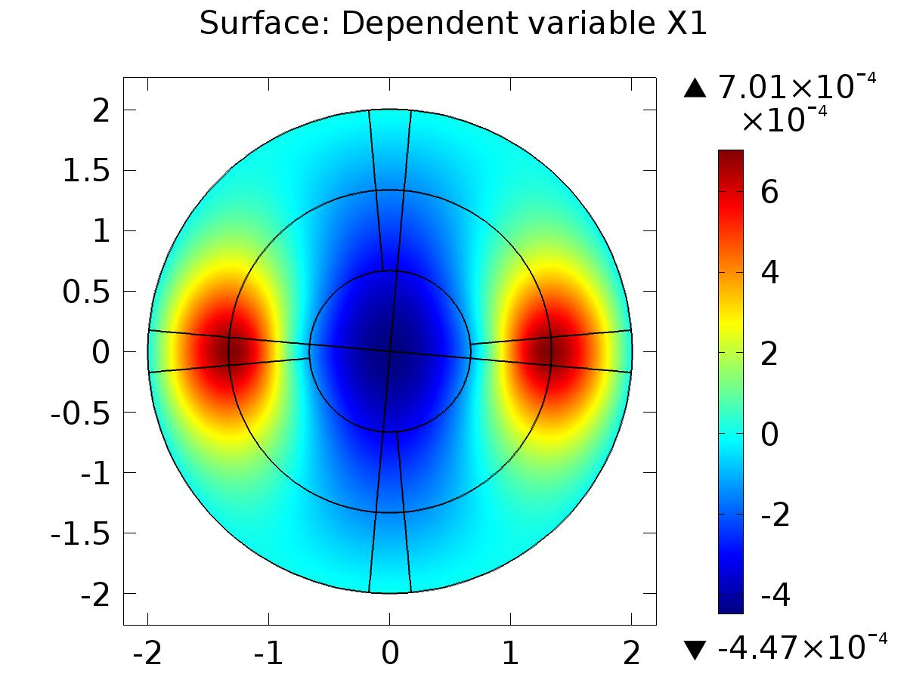

Surface: Dependent variable X1

* + 1. 2D Plot Group 2

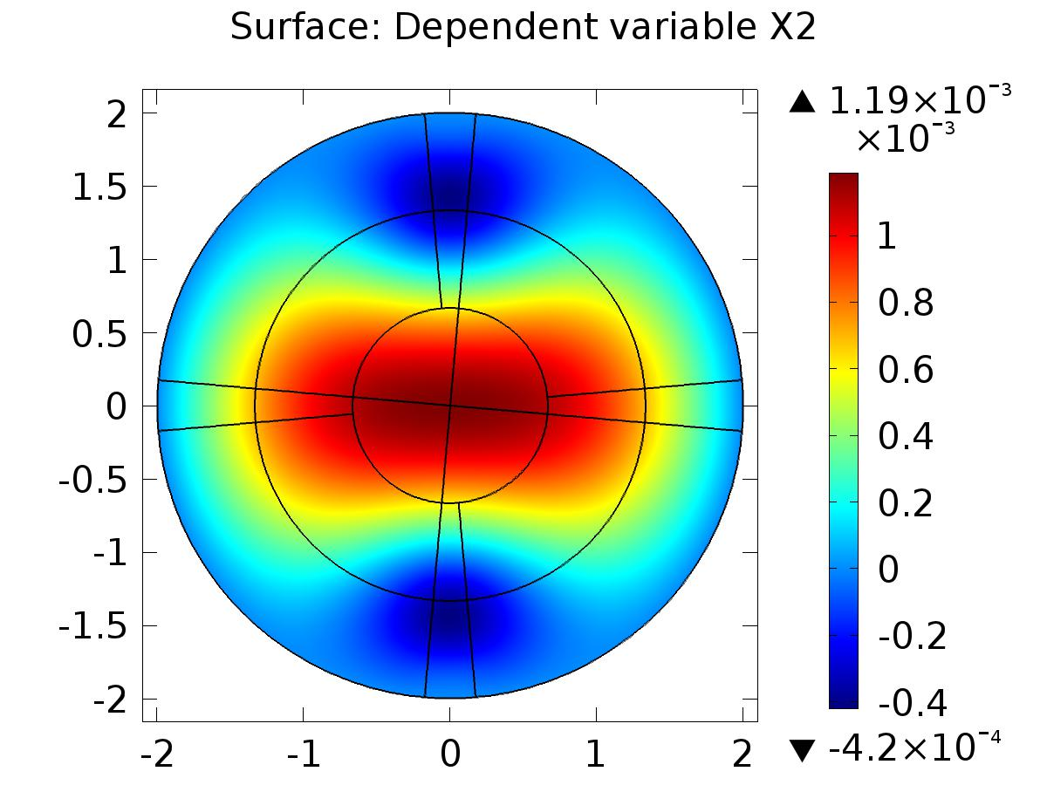

Surface: Dependent variable X2

* + 1. 2D Plot Group 3

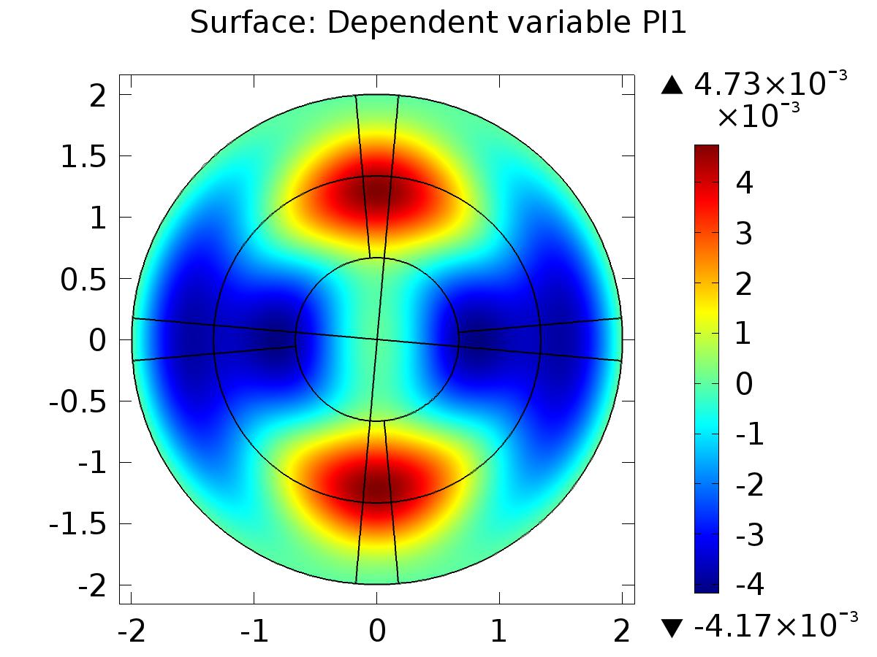

Surface: Dependent variable PI1

* + 1. 2D Plot Group 5

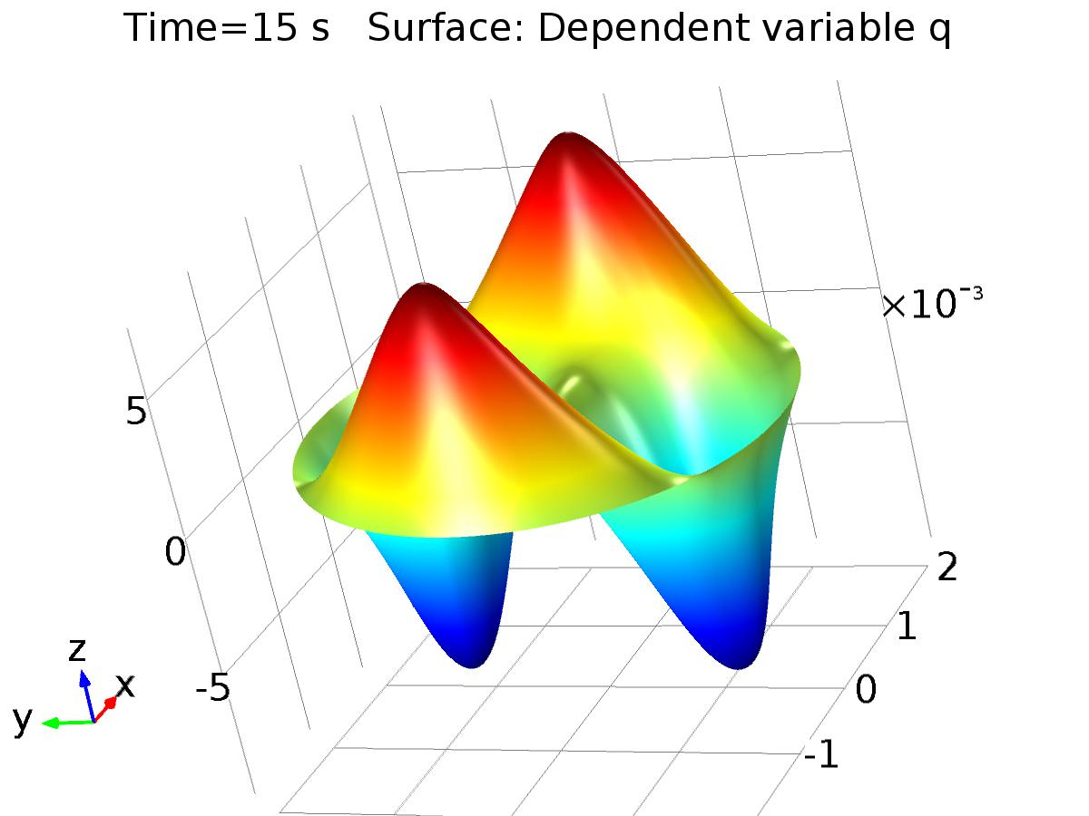

Time=15 s Surface: Dependent variable q

* + 1. 1D Plot Group 6

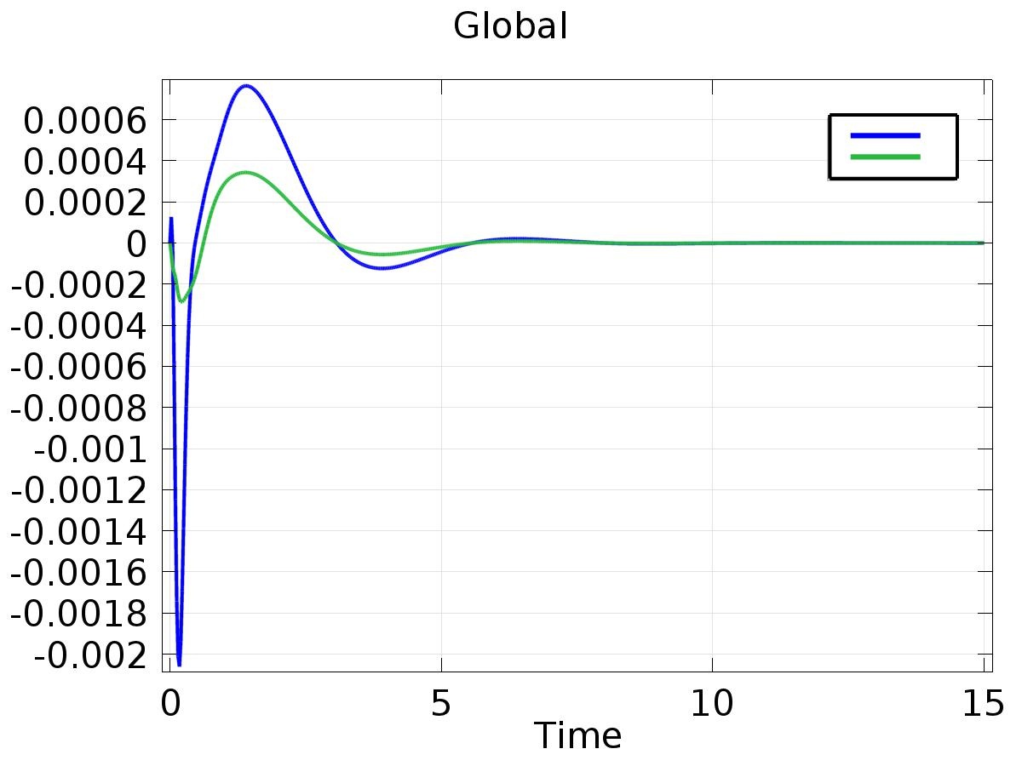

Global

* + 1. Probe Plot Group 7

