[](http://www.comsol.com/)

EX3 5 2D Heat MIMO

|  |  |
| --- | --- |
| Date | Nov 21, 2013 7:48:30 AM |

Contents

1. Global

1.1. Definitions

2. Model 1

2.1. Definitions

2.2. Geometry 1

2.3. NavierStokes

2.4. Temperature 1

2.5. Temperature 2

2.6. Temperature 3

2.7. Temperature 4

2.8. Temperature 5

2.9. Temperature 6

2.10. Temperature CLS

2.11. Mesh 1

3. Study 1

3.1. Stationary

3.2. Solver Configurations

4. Study 2

4.1. Stationary

4.2. Solver Configurations

5. Study 3

5.1. Parametric Sweep

5.2. Stationary

5.3. Solver Configurations

6. Study 4

6.1. Time Dependent

6.2. Solver Configurations

7. Results

7.1. Data Sets

7.2. Derived Values

7.3. Tables

7.4. Plot Groups

1. Global

|  |  |
| --- | --- |
| Date | Nov 2, 2013 5:46:39 AM |

Global settings

|  |  |
| --- | --- |
| Name | EX3 5 2D Heat MIMO.mph |
| Path | /Users/gilliam/Desktop/collect_15/research_15/geo_reg_mono_eugenio/Mono_1_15/Comsol_EX_GitHub/Chapter3/Chap3Ex5_2D_room_Heat_MIMO/EX3_5_2D_Heat_MIMO.mph |
| Program | COMSOL 4.3b (Build: 189) |

Used products

|  |
| --- |
| COMSOL Multiphysics |

* 1. Definitions
     1. Parameters 1

Parameters

| **Name** | **Expression** | **Value** | **Description** |
| --- | --- | --- | --- |
| H | 2.[m] | 2.0000 m |  |
| L | 4[m] | 4.0000 m |  |
| D | 0.2[m] | 0.20000 m |  |
| mesh_size | D/8 | 0.025000 m |  |
| rho | 1[kg/m^3] | 1.0000 kg/m³ |  |
| mu | 0.001[Pa*s] | 0.0010000 Pa·s |  |
| K | 0.001[W/(m*K)] | 0.0010000 W/(m·K) |  |
| cp | 1[J/(kg*K)] | 1.0000 J/(kg·K) |  |
| h1 | 0.01 [W/(m^2*K)] | 0.010000 W/(m²·K) |  |
| h2 | 0.02 [W/(m^2*K)] | 0.020000 W/(m²·K) |  |
| Tr | 25[K] | 25.000 K |  |
| Mr1 | 22[K] | 22.000 K |  |
| Ar1 | 3[K] | 3.0000 K |  |
| Md1 | 5[K] | 5.0000 K |  |
| Ad1 | 10[K] | 10.000 K |  |
| Mr2 | 18[K] | 18.000 K |  |
| Ar2 | 1[K] | 1.0000 K |  |
| Md2 | 8 [K] | 8.0000 K |  |
| Ad2 | 5[K] | 5.0000 K |  |
| alpha0 | 0 | 0.0000 |  |
| alpha1 | 2*pi/day | 7.2722E-5 1/s |  |
| hour | 3600[s] | 3600.0 s |  |
| day | 24*hour | 86400 s |  |
| k | 0 | 0.0000 |  |
| l | 1 | 1.0000 |  |

* + 1. Functions

#### Analytic 1

|  |  |
| --- | --- |
| Function name | alpha |
| Function type | Analytic |

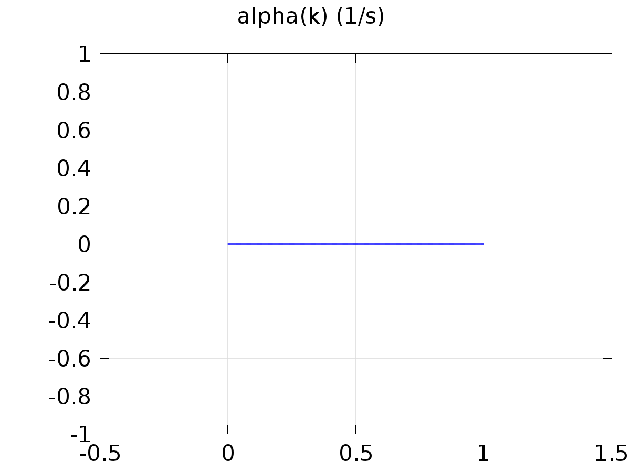

Analytic 1

Definition

| **Description** | **Value** |
| --- | --- |
| Expression | alpha0*((k==0) + (k==1)) + alpha1*((k==2) + (k==3)) |
| Arguments | k |

Units

| **Description** | **Value** |
| --- | --- |
| Function | 1/s |

#### Analytic 2

|  |  |
| --- | --- |
| Function name | yc1 |
| Function type | Analytic |

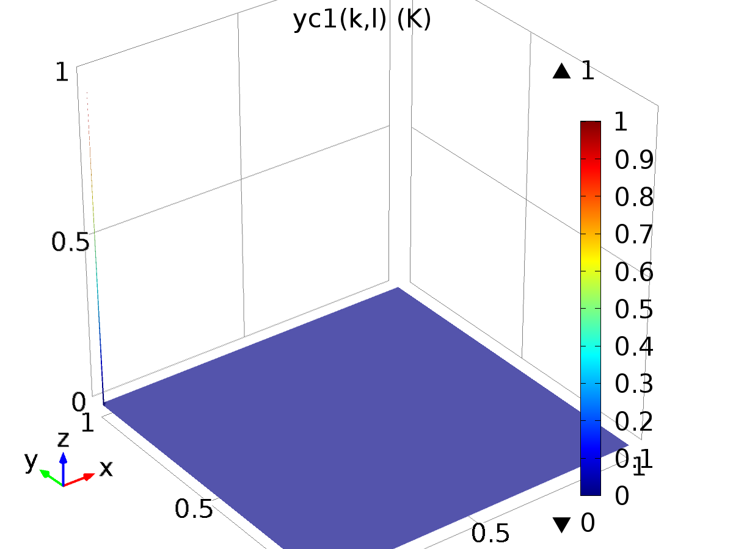

Analytic 2

Definition

| **Description** | **Value** |
| --- | --- |
| Expression | (k==0)*(l==1) |
| Arguments | {k, l} |

Units

| **Description** | **Value** |
| --- | --- |
| Function | K |

#### Analytic 5

|  |  |
| --- | --- |
| Function name | yc2 |
| Function type | Analytic |

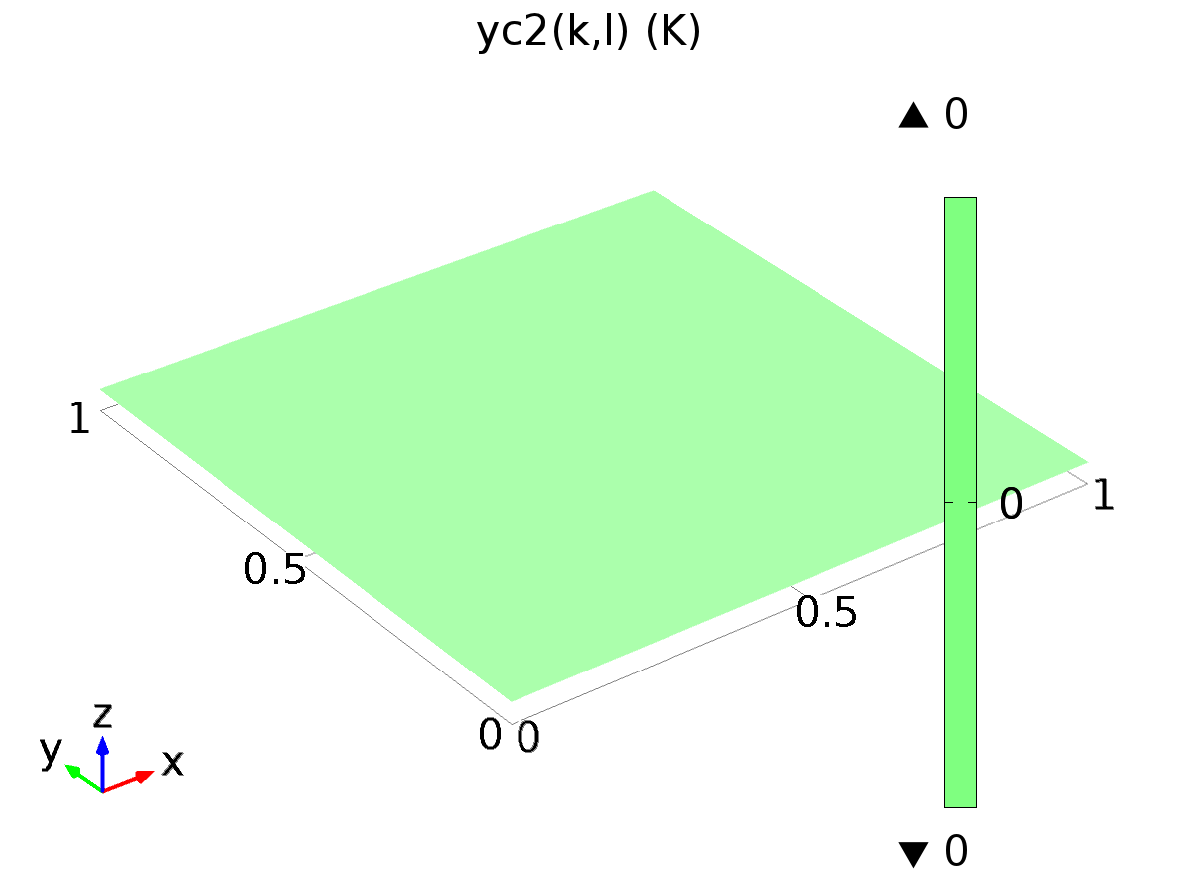

Analytic 5

Definition

| **Description** | **Value** |
| --- | --- |
| Expression | (k==0)*(l==2) |
| Arguments | {k, l} |

Units

| **Description** | **Value** |
| --- | --- |
| Function | K |

#### Analytic 3

|  |  |
| --- | --- |
| Function name | dc1 |
| Function type | Analytic |

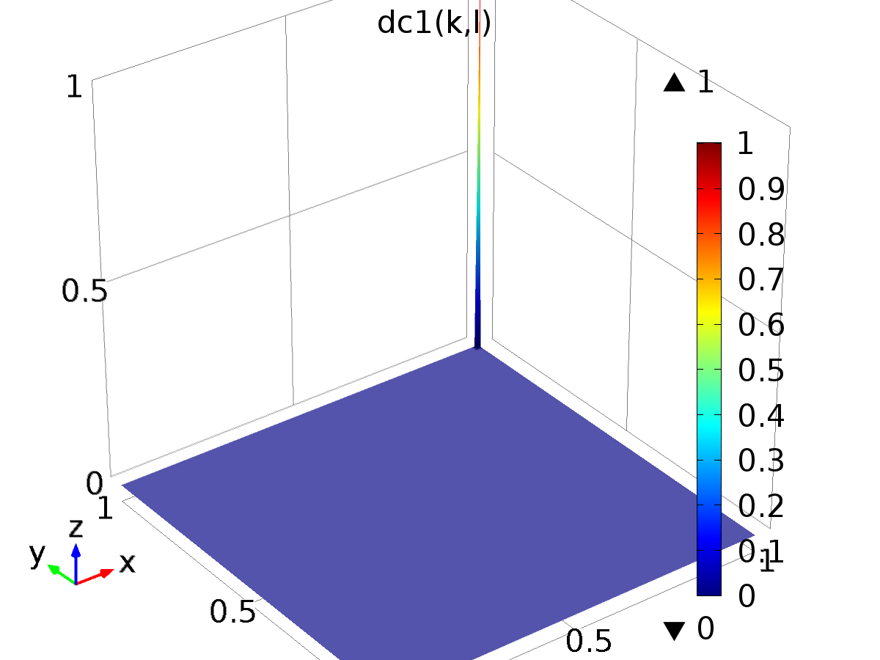

Analytic 3

Definition

| **Description** | **Value** |
| --- | --- |
| Expression | (k==1)*(l==1) |
| Arguments | {k, l} |

#### Analytic 4

|  |  |
| --- | --- |
| Function name | dc2 |
| Function type | Analytic |

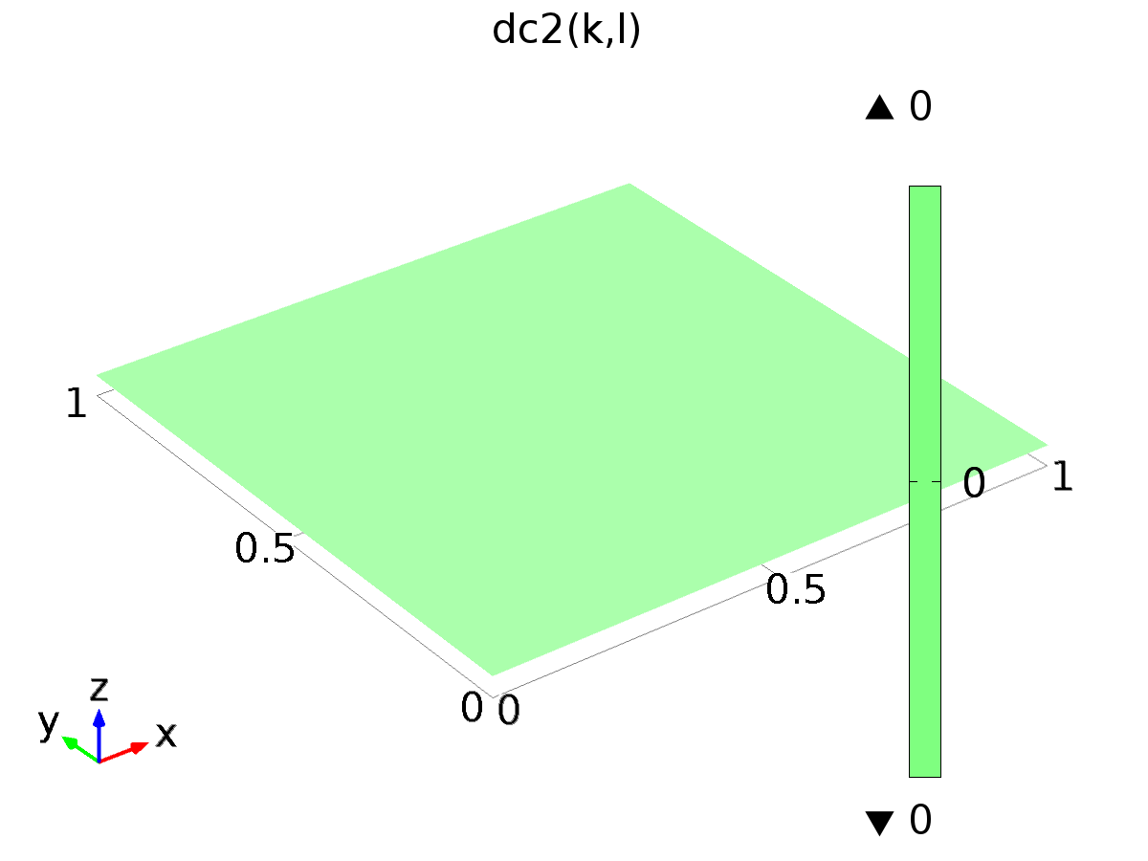

Analytic 4

Definition

| **Description** | **Value** |
| --- | --- |
| Expression | (k==1)*(l==2) |
| Arguments | {k, l} |

#### Analytic 6

|  |  |
| --- | --- |
| Function name | ys1 |
| Function type | Analytic |

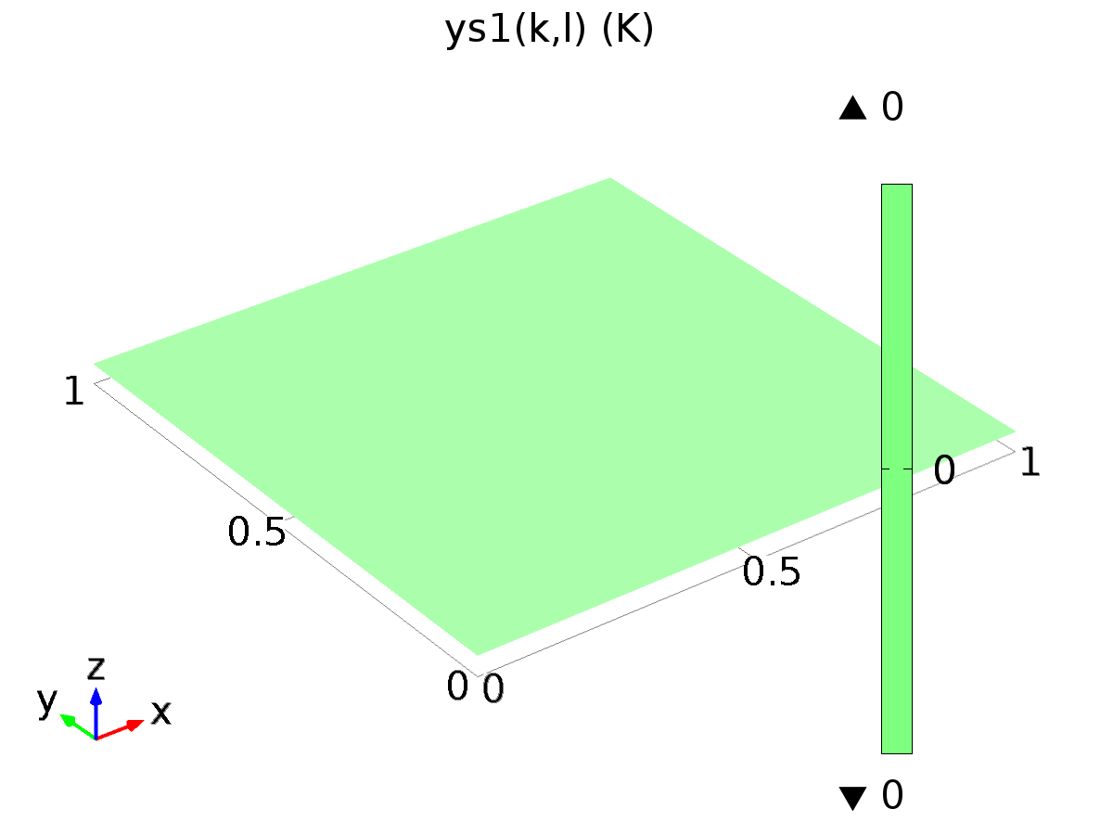

Analytic 6

Definition

| **Description** | **Value** |
| --- | --- |
| Expression | (k==2)*(l==1) |
| Arguments | {k, l} |

Units

| **Description** | **Value** |
| --- | --- |
| Function | K |

#### Analytic 7

|  |  |
| --- | --- |
| Function name | ys2 |
| Function type | Analytic |

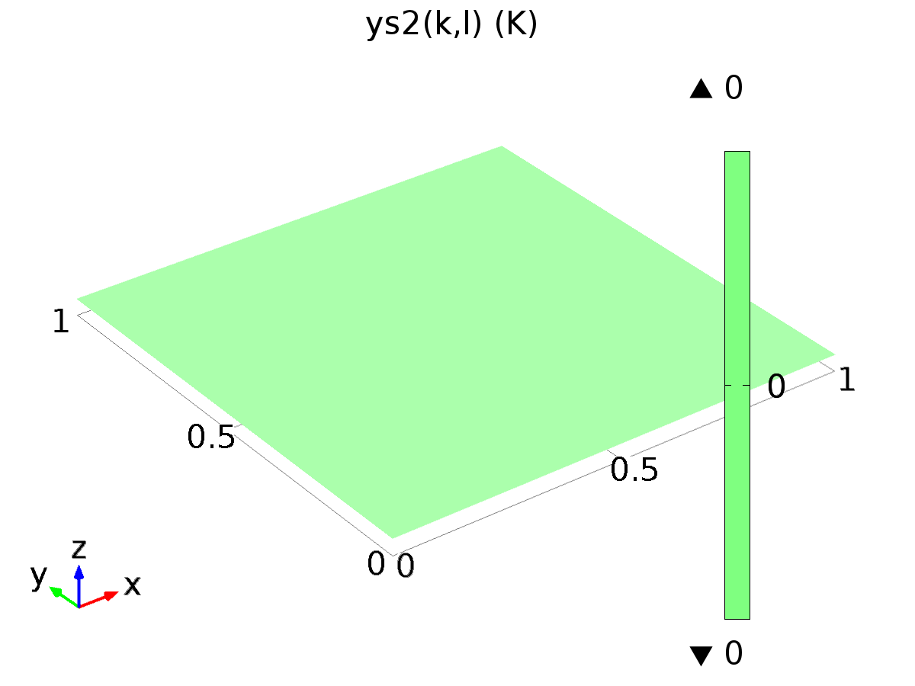

Analytic 7

Definition

| **Description** | **Value** |
| --- | --- |
| Expression | (k==2)*(l==2) |
| Arguments | {k, l} |

Units

| **Description** | **Value** |
| --- | --- |
| Function | K |

#### Analytic 8

|  |  |
| --- | --- |
| Function name | ds1 |
| Function type | Analytic |

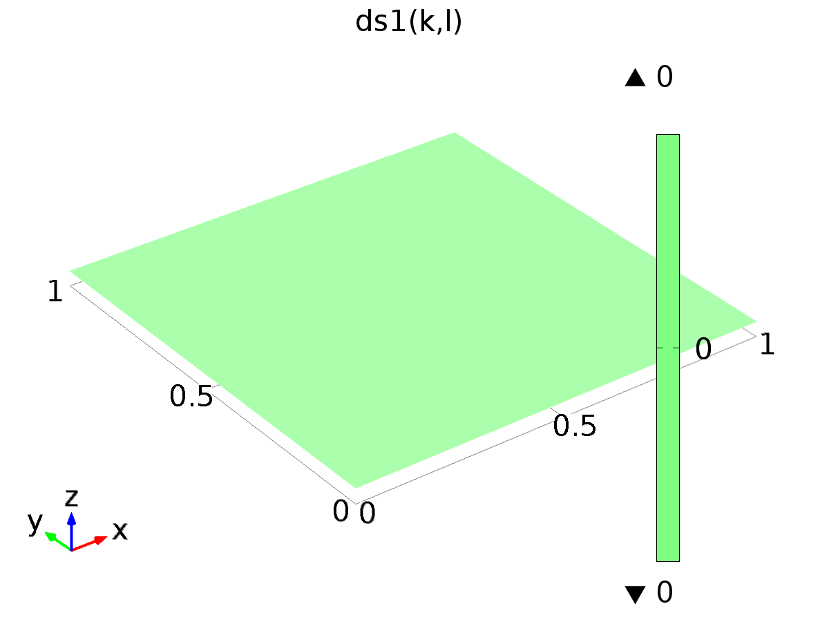

Analytic 8

Definition

| **Description** | **Value** |
| --- | --- |
| Expression | (k==3)*(l==1) |
| Arguments | {k, l} |

#### Analytic 9

|  |  |
| --- | --- |
| Function name | ds2 |
| Function type | Analytic |

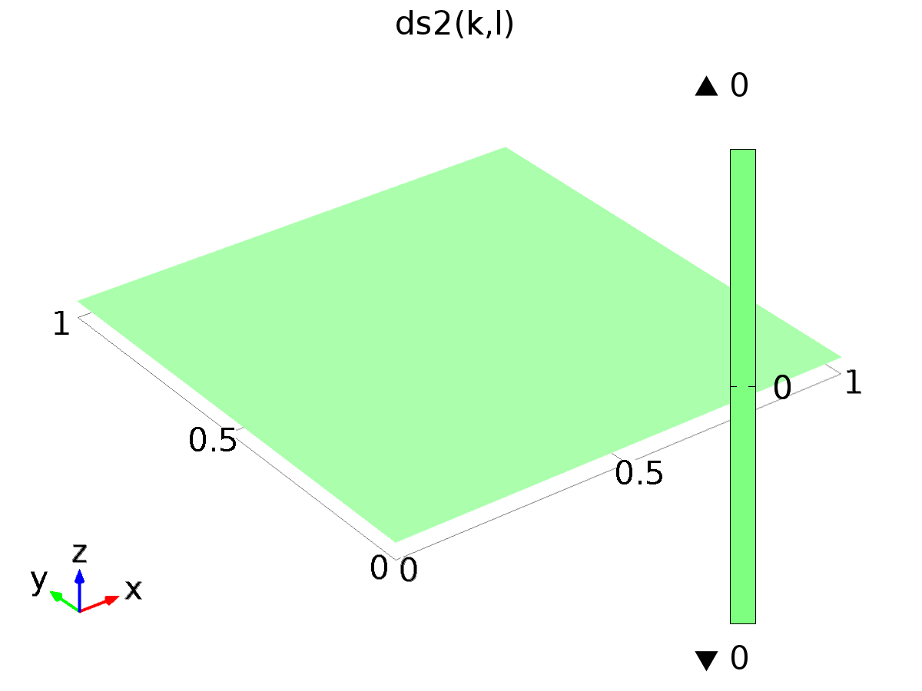

Analytic 9

Definition

| **Description** | **Value** |
| --- | --- |
| Expression | (k==3)*(l==2) |
| Arguments | {k, l} |

1. Model 1

Component settings

|  |  |
| --- | --- |
| Unit system | SI |

* 1. Definitions
     1. Variables

#### Variables 1a

Selection

|  |  |
| --- | --- |
| Geometric entity level | Entire model |

| **Name** | **Expression** | **Description** |
| --- | --- | --- |
| G11 | C1(X1) |  |
| G12 | C1(X2) |  |
| G21 | C2(X1) |  |
| G22 | C2(X2) |  |
| DET | G11*G22 - G12*G21 |  |
| g11 | G22/DET |  |
| g12 | -G12/DET |  |
| g21 | -G21/DET |  |
| g22 | G11/DET |  |
| gammac1 | g11*(yc1(k, l) - C1(Zt1)) + g12*(yc2(k, l) - C2(Zt1)) |  |
| gammac2 | g21*(yc1(k, l) - C1(Zt1)) + g22*(yc2(k, l) - C2(Zt1)) |  |
| gammas1 | g11*(ys1(k, l) - C1(Zt2)) + g12*(ys2(k, l) - C2(Zt2)) |  |
| gammas2 | g21*(ys1(k, l) - C1(Zt2)) + g22*(ys2(k, l) - C2(Zt2)) |  |

#### Variables 2

Selection

|  |  |
| --- | --- |
| Geometric entity level | Entire model |

| **Name** | **Expression** | **Description** |
| --- | --- | --- |
| Gamma1_Mr1 | -0.9127793196318487 |  |
| Gamma1_Mr2 | 2.2107583600662375 |  |
| Gamma1_Md1 | -0.06280274138554237 |  |
| Gamma1_Md2 | -0.23517601181732228 |  |
| Gamma1c_Ar1 | -0.008750275578560208 |  |
| Gamma1c_Ar2 | 0.010460112721401557 |  |
| Gamma1c_Ad1 | 3.8512844027351615E-4 |  |
| Gamma1c_Ad2 | 4.339696188966127E-4 |  |
| Gamma2_Mr1 | 0.02518435695877158 |  |
| Gamma2_Mr2 | -0.02797741005094198 |  |
| Gamma2_Md1 | 7.932961945868911E-4 |  |
| Gamma2_Md2 | 0.0019997579248721537 |  |
| Gamma2c_Ar1 | 4.984698522194511E-4 |  |
| Gamma2c_Ar2 | -1.8266440880033015E-4 |  |
| Gamma2c_Ad1 | -3.41693873285137E-6 |  |
| Gamma2c_Ad2 | 1.6633786001884846E-6 |  |
| Gamma1s_Ar1 | -0.9127905901352015 |  |
| Gamma1s_Ar2 | 2.210800208284132 |  |
| Gamma1s_Ad1 | -0.06279880816853603 |  |
| Gamma1s_Ad2 | -0.23517617807079028 |  |
| Gamma2s_Ar1 | 0.02518243187989135 |  |
| Gamma2s_Ar2 | -0.027977771998862717 |  |
| Gamma2s_Ad1 | 7.932576237539687E-4 |  |
| Gamma2s_Ad2 | 0.0019997839032156756 |  |

#### Variables 3

Selection

|  |  |
| --- | --- |
| Geometric entity level | Entire model |

| **Name** | **Expression** | **Description** |
| --- | --- | --- |
| Gamma1_const | Gamma1_Mr1*Mr1 + Gamma1_Mr2*Mr2 +Gamma1_Md1*Md1 +Gamma1_Md2*Md2 |  |
| Gamma1_cos | (Gamma1c_Ar1*Ar1 + Gamma1c_Ar2*Ar2 + Gamma1c_Ad1*Ad1 + Gamma1c_Ad2*Ad2)*cos(alpha1*t) |  |
| Gamma1_sin | (Gamma1s_Ar1*Ar1 + Gamma1s_Ar2*Ar2 + Gamma1s_Ad1*Ad1 + Gamma1s_Ad2*Ad2)*sin(alpha1*t) |  |
| Gamma1 | Gamma1_const + Gamma1_cos + Gamma1_sin |  |
| Gamma2_const | Gamma2_Mr1*Mr1 + Gamma2_Mr2*Mr2 +Gamma2_Md1*Md1 +Gamma2_Md2*Md2 |  |
| Gamma2_cos | (Gamma2c_Ar1*Ar1 + Gamma2c_Ar2*Ar2 + Gamma2c_Ad1*Ad1 + Gamma2c_Ad2*Ad2)*cos(alpha1*t) |  |
| Gamma2_sin | (Gamma2s_Ar1*Ar1 + Gamma2s_Ar2*Ar2 + Gamma2s_Ad1*Ad1 + Gamma2s_Ad2*Ad2)*sin(alpha1*t) |  |
| Gamma2 | Gamma2_const + Gamma2_cos + Gamma2_sin |  |
| d1 | Md1 + Ad1*sin(alpha1*t) |  |
| d2 | Md2 + Ad2*sin(alpha1*t) |  |
| yr1 | Mr1 + Ar1*sin(alpha1*t) |  |
| yr2 | Mr2 + Ar2*sin(alpha1*t) |  |
| e1 | C1(T) - yr1 |  |
| e2 | C2(T) - yr2 |  |

* + 1. Probes

#### Global Variable Probe 5

|  |  |
| --- | --- |
| Probe type | Global variable probe |

#### Global Variable Probe 6

|  |  |
| --- | --- |
| Probe type | Global variable probe |

#### Global Variable Probe 7

|  |  |
| --- | --- |
| Probe type | Global variable probe |

#### Global Variable Probe 8

|  |  |
| --- | --- |
| Probe type | Global variable probe |

* + 1. Component Couplings

#### Average 1

|  |  |
| --- | --- |
| Coupling type | Average |
| Operator name | C1 |

Source selection

|  |  |
| --- | --- |
| Geometric entity level | Boundary |
| Selection | Boundary 28 |

#### Average 2

|  |  |
| --- | --- |
| Coupling type | Average |
| Operator name | C2 |

Source selection

|  |  |
| --- | --- |
| Geometric entity level | Boundary |
| Selection | Boundaries 10, 12, 15, 23, 30, 37, 46, 49, 51 |

* + 1. Coordinate Systems

#### Boundary System 1

|  |  |
| --- | --- |
| Coordinate system type | Boundary system |
| Tag | sys1 |

Coordinate names

| **First (t1)** | **Second (n)** | **Third (to)** |
| --- | --- | --- |
| t1 | n | to |

Settings

| **Description** | **Value** |
| --- | --- |
| Create first tangent direction from | Global Cartesian |

* 1. Geometry 1

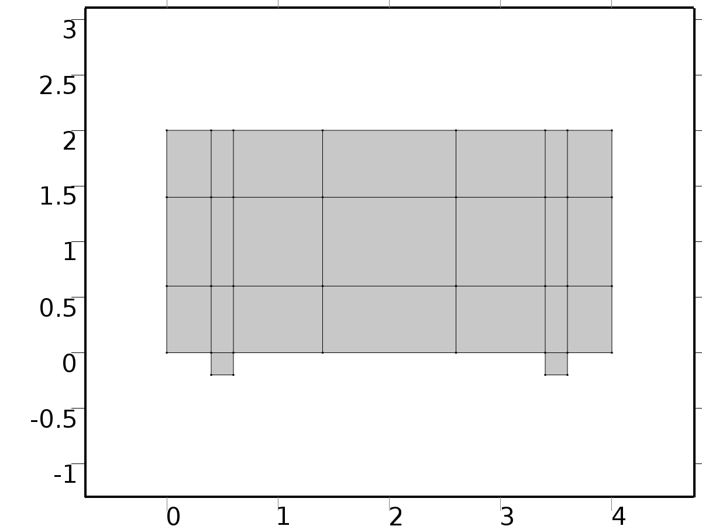

Geometry 1

Units

|  |  |
| --- | --- |
| Length unit | m |
| Angular unit | deg |

Geometry statistics

| **Description** | **Value** |
| --- | --- |
| Space dimension | 2 |
| Number of domains | 23 |
| Number of boundaries | 58 |
| Number of vertices | 36 |

* + 1. Rectangle 2 (r2)

Position

| **Description** | **Value** |
| --- | --- |
| Position | {0, 0} |
| Layers |  |

Size

| **Description** | **Value** |
| --- | --- |
| Width | L |
| Height | H |

* + 1. Rectangle 1 (r1)

Position

| **Description** | **Value** |
| --- | --- |
| Position | {L - 3*D, -D} |
| Layers |  |

Size

| **Description** | **Value** |
| --- | --- |
| Width | D |
| Height | H + D |

* + 1. Rectangle 3 (r3)

Position

| **Description** | **Value** |
| --- | --- |
| Position | {2*D, -D} |
| Layers |  |

Size

| **Description** | **Value** |
| --- | --- |
| Width | D |
| Height | H + D |

* + 1. Rectangle 4 (r4)

Position

| **Description** | **Value** |
| --- | --- |
| Position | {0, 3*D} |
| Layers |  |

Size

| **Description** | **Value** |
| --- | --- |
| Width | L |
| Height | 4*D |

* + 1. Rectangle 5 (r5)

Position

| **Description** | **Value** |
| --- | --- |
| Position | {7*D, 0} |
| Layers |  |

Size

| **Description** | **Value** |
| --- | --- |
| Width | 6*D |
| Height | H |

* 1. NavierStokes

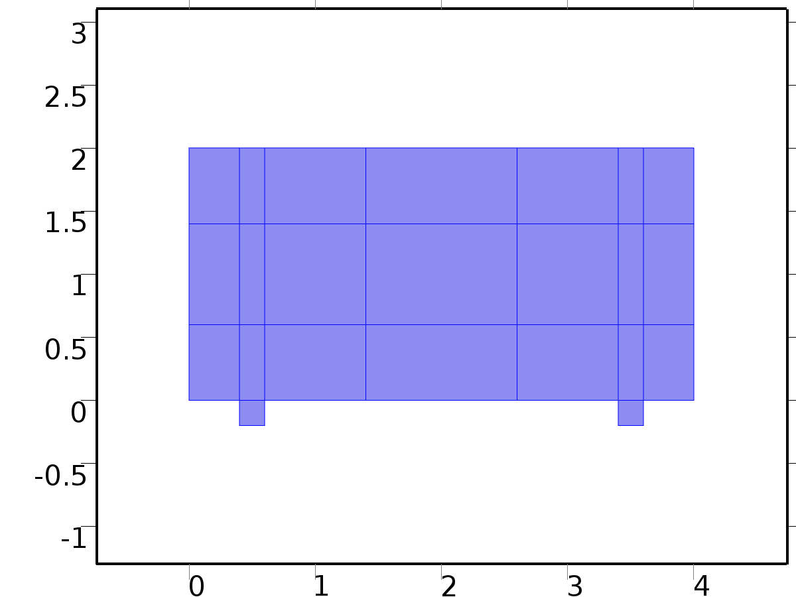

NavierStokes

Selection

|  |  |
| --- | --- |
| Geometric entity level | Domain |
| Selection | Domains 1–23 |

Equations









Settings

| **Description** | **Value** |
| --- | --- |
| Discretization of fluids | P1 + P1 |
| Value type when using splitting of complex variables | {Real, Real, Real, Real, Real, Real, Real, Real, Real, Real, Real} |
| Isotropic diffusion | Off |
| Compressibility | Incompressible flow |
| Channel thickness | 1 |
| Turbulence model type | None |
| Reference pressure level | 1[atm] |
| Use pseudo time stepping for stationary equation form | Off |
| Local CFL number | 1.3^min(niterCMP, 9) + if(niterCMP>=25, 9*1.3^min(niterCMP - 25, 9), 0) + if(niterCMP>=45, 90*1.3^min(niterCMP - 45, 9), 0) |
| Streamline diffusion | On |
| Crosswind diffusion | On |

Used products

|  |
| --- |
| COMSOL Multiphysics |

Variables

| **Name** | **Expression** | **Unit** | **Description** | **Selection** |
| --- | --- | --- | --- | --- |
| NS.dz | 1 | m | Thickness | Domains 1–23 |
| NS.pref | 1[atm] | Pa | Reference pressure level | Domains 1–23 |
| NS.pA | p+NS.pref | Pa | Absolute pressure | Domains 1–23 |
| NS.nx | nx | 1 | Normal vector, x component | Boundaries 4, 6, 10–15, 18, 20–23, 25, 27–30, 32, 34–37, 41–46, 49, 51–54 |
| NS.ny | ny | 1 | Normal vector, y component | Boundaries 4, 6, 10–15, 18, 20–23, 25, 27–30, 32, 34–37, 41–46, 49, 51–54 |
| NS.nz | 0 | 1 | Normal vector, z component | Boundaries 4, 6, 10–15, 18, 20–23, 25, 27–30, 32, 34–37, 41–46, 49, 51–54 |
| NS.nx | dnx | 1 | Normal vector, x component | Boundaries 1–3, 5, 7–9, 16–17, 19, 24, 26, 31, 33, 38–40, 47–48, 50, 55–58 |
| NS.ny | dny | 1 | Normal vector, y component | Boundaries 1–3, 5, 7–9, 16–17, 19, 24, 26, 31, 33, 38–40, 47–48, 50, 55–58 |
| NS.nz | 0 | 1 | Normal vector, z component | Boundaries 1–3, 5, 7–9, 16–17, 19, 24, 26, 31, 33, 38–40, 47–48, 50, 55–58 |
| NS.nxmesh | root.nxmesh | 1 | Normal vector, x component | Boundaries 4, 6, 10–15, 18, 20–23, 25, 27–30, 32, 34–37, 41–46, 49, 51–54 |
| NS.nymesh | root.nymesh | 1 | Normal vector, y component | Boundaries 4, 6, 10–15, 18, 20–23, 25, 27–30, 32, 34–37, 41–46, 49, 51–54 |
| NS.nzmesh | 0 | 1 | Normal vector, z component | Boundaries 4, 6, 10–15, 18, 20–23, 25, 27–30, 32, 34–37, 41–46, 49, 51–54 |
| NS.nxmesh | root.dnxmesh | 1 | Normal vector, x component | Boundaries 1–3, 5, 7–9, 16–17, 19, 24, 26, 31, 33, 38–40, 47–48, 50, 55–58 |
| NS.nymesh | root.dnymesh | 1 | Normal vector, y component | Boundaries 1–3, 5, 7–9, 16–17, 19, 24, 26, 31, 33, 38–40, 47–48, 50, 55–58 |
| NS.nzmesh | 0 | 1 | Normal vector, z component | Boundaries 1–3, 5, 7–9, 16–17, 19, 24, 26, 31, 33, 38–40, 47–48, 50, 55–58 |

* + 1. Fluid Properties 1



Fluid Properties 1

Selection

|  |  |
| --- | --- |
| Geometric entity level | Domain |
| Selection | Domains 1–23 |

Equations







Settings

| **Description** | **Value** |
| --- | --- |
| Density | User defined |
| Density | rho |
| Dynamic viscosity | User defined |
| Dynamic viscosity | mu |

#### Variables

| **Name** | **Expression** | **Unit** | **Description** | **Selection** |
| --- | --- | --- | --- | --- |
| NS.rho | rho | kg/m^3 | Density | Domains 1–23 |
| NS.mu | mu | Pa*s | Dynamic viscosity | Domains 1–23 |
| NS.sr | sqrt(0.5*(4*ux^2+2*(uy+vx)^2+4*vy^2)+eps) | 1/s | Shear rate | Domains 1–23 |
| NS.divu | ux+vy | 1/s | Divergence of velocity field | Domains 1–23 |
| NS.Fx | 0 | N/m^3 | Volume force, x component | Domains 1–23 |
| NS.Fy | 0 | N/m^3 | Volume force, y component | Domains 1–23 |
| NS.Fz | 0 | N/m^3 | Volume force, z component | Domains 1–23 |
| NS.U | sqrt(u^2+v^2) | m/s | Velocity magnitude | Domains 1–23 |
| NS.vorticityx | 0 | 1/s | Vorticity field, x component | Domains 1–23 |
| NS.vorticityy | 0 | 1/s | Vorticity field, y component | Domains 1–23 |
| NS.vorticityz | vx-uy | 1/s | Vorticity field, z component | Domains 1–23 |
| NS.vort_magn | sqrt(NS.vorticityx^2+NS.vorticityy^2+NS.vorticityz^2) | 1/s | Vorticity magnitude | Domains 1–23 |
| NS.cellRe | 0.25*NS.rho*sqrt(emetric(u,v)/emetric2)/NS.mu | 1 | Cell Reynolds number | Domains 1–23 |
| NS.nu | NS.mu/NS.rho | m^2/s | Kinematic viscosity | Domains 1–23 |
| NS.betaT | 0 | 1/Pa | Isothermal compressibility coefficient | Domains 1–23 |
| NS.mu_eff | NS.mu+NS.muT | Pa*s | Dynamic viscosity | Domains 1–23 |
| NS.muT | 0 | Pa*s | Turbulent dynamic viscosity | Domains 1–23 |
| NS.T_stressx | NS.K_stressx-p*NS.nxmesh | N/m^2 | Total stress, x component | Boundaries 1–58 |
| NS.T_stressy | NS.K_stressy-p*NS.nymesh | N/m^2 | Total stress, y component | Boundaries 1–58 |
| NS.T_stressz | NS.K_stressz-p*NS.nzmesh | N/m^2 | Total stress, z component | Boundaries 1–58 |
| NS.K_stressx | NS.mu_eff*(2*ux*NS.nxmesh+(uy+vx)*NS.nymesh) | N/m^2 | Viscous stress, x component | Boundaries 1–58 |
| NS.K_stressy | NS.mu_eff*((vx+uy)*NS.nxmesh+2*vy*NS.nymesh) | N/m^2 | Viscous stress, y component | Boundaries 1–58 |
| NS.K_stressz | 0 | N/m^2 | Viscous stress, z component | Boundaries 1–58 |
| NS.K_stress_tensorxx | 2*NS.mu_eff*ux | N/m^2 | Viscous stress tensor, xx component | Domains 1–23 |
| NS.K_stress_tensoryx | NS.mu_eff*(vx+uy) | N/m^2 | Viscous stress tensor, yx component | Domains 1–23 |
| NS.K_stress_tensorzx | 0 | N/m^2 | Viscous stress tensor, zx component | Domains 1–23 |
| NS.K_stress_tensorxy | NS.mu_eff*(uy+vx) | N/m^2 | Viscous stress tensor, xy component | Domains 1–23 |
| NS.K_stress_tensoryy | 2*NS.mu_eff*vy | N/m^2 | Viscous stress tensor, yy component | Domains 1–23 |
| NS.K_stress_tensorzy | 0 | N/m^2 | Viscous stress tensor, zy component | Domains 1–23 |
| NS.K_stress_tensorxz | 0 | N/m^2 | Viscous stress tensor, xz component | Domains 1–23 |
| NS.K_stress_tensoryz | 0 | N/m^2 | Viscous stress tensor, yz component | Domains 1–23 |
| NS.K_stress_tensorzz | 0 | N/m^2 | Viscous stress tensor, zz component | Domains 1–23 |
| NS.K_stress_tensor_testxx | 2*NS.mu_eff*test(ux) | N/m^2 | Viscous stress tensor test, xx component | Domains 1–23 |
| NS.K_stress_tensor_testyx | NS.mu_eff*(test(vx)+test(uy)) | N/m^2 | Viscous stress tensor test, yx component | Domains 1–23 |
| NS.K_stress_tensor_testzx | 0 | N/m^2 | Viscous stress tensor test, zx component | Domains 1–23 |
| NS.K_stress_tensor_testxy | NS.mu_eff*(test(uy)+test(vx)) | N/m^2 | Viscous stress tensor test, xy component | Domains 1–23 |
| NS.K_stress_tensor_testyy | 2*NS.mu_eff*test(vy) | N/m^2 | Viscous stress tensor test, yy component | Domains 1–23 |
| NS.K_stress_tensor_testzy | 0 | N/m^2 | Viscous stress tensor test, zy component | Domains 1–23 |
| NS.K_stress_tensor_testxz | 0 | N/m^2 | Viscous stress tensor test, xz component | Domains 1–23 |
| NS.K_stress_tensor_testyz | 0 | N/m^2 | Viscous stress tensor test, yz component | Domains 1–23 |
| NS.K_stress_tensor_testzz | 0 | N/m^2 | Viscous stress tensor test, zz component | Domains 1–23 |
| NS.upwind_helpx | u | m/s | Upwind term, x component | Domains 1–23 |
| NS.upwind_helpy | v | m/s | Upwind term, y component | Domains 1–23 |
| NS.upwind_helpz | 0 | m/s | Upwind term, z component | Domains 1–23 |
| NS.tau_vdxx | 2*NS.mu*ux | Pa | Strain rate, xx component | Domains 1–23 |
| NS.tau_vdyx | NS.mu*(vx+uy) | Pa | Strain rate, yx component | Domains 1–23 |
| NS.tau_vdzx | 0 | Pa | Strain rate, zx component | Domains 1–23 |
| NS.tau_vdxy | NS.mu*(uy+vx) | Pa | Strain rate, xy component | Domains 1–23 |
| NS.tau_vdyy | 2*NS.mu*vy | Pa | Strain rate, yy component | Domains 1–23 |
| NS.tau_vdzy | 0 | Pa | Strain rate, zy component | Domains 1–23 |
| NS.tau_vdxz | 0 | Pa | Strain rate, xz component | Domains 1–23 |
| NS.tau_vdyz | 0 | Pa | Strain rate, yz component | Domains 1–23 |
| NS.tau_vdzz | 0 | Pa | Strain rate, zz component | Domains 1–23 |
| NS.Qvd | NS.tau_vdxx*ux+NS.tau_vdxy*uy+NS.tau_vdyx*vx+NS.tau_vdyy*vy | W/m^3 | Viscous dissipation | Domains 1–23 |
| NS.res_u | px+NS.rho*u*ux+NS.rho*v*uy-(d(2*ux,x)+d(uy+vx,y))*NS.mu-NS.Fx | N/m^3 | Equation residual | Domains 1–23 |
| NS.res_v | NS.rho*u*vx+py+NS.rho*v*vy-(d(vx+uy,x)+d(2*vy,y))*NS.mu-NS.Fy | N/m^3 | Equation residual | Domains 1–23 |
| NS.res_p | NS.rho*NS.divu | kg/(m^3*s) | Pressure equation residual | Domains 1–23 |

#### Shape functions

| **Name** | **Shape function** | **Unit** | **Description** | **Shape frame** | **Selection** |
| --- | --- | --- | --- | --- | --- |
| u | Lagrange (Linear) | m/s | Velocity field, x component | Material | Domains 1–23 |
| v | Lagrange (Linear) | m/s | Velocity field, y component | Material | Domains 1–23 |
| p | Lagrange (Linear) | Pa | Pressure | Material | Domains 1–23 |

#### Weak expressions

| **Weak expression** | **Integration frame** | **Selection** |
| --- | --- | --- |
| (p-NS.K_stress_tensorxx)*test(ux)-NS.K_stress_tensorxy*test(uy)-NS.K_stress_tensoryx*test(vx)+(p-NS.K_stress_tensoryy)*test(vy) | Material | Domains 1–23 |
| NS.Fx*test(u)+NS.Fy*test(v) | Material | Domains 1–23 |
| NS.rho*(-(ux*u+uy*v)*test(u)-(vx*u+vy*v)*test(v)) | Material | Domains 1–23 |
| -NS.rho*NS.divu*test(p) | Material | Domains 1–23 |
| NS.streamlinens | Material | Domains 1–23 |
| NS.crosswindns | Material | Domains 1–23 |

* + 1. Wall 1

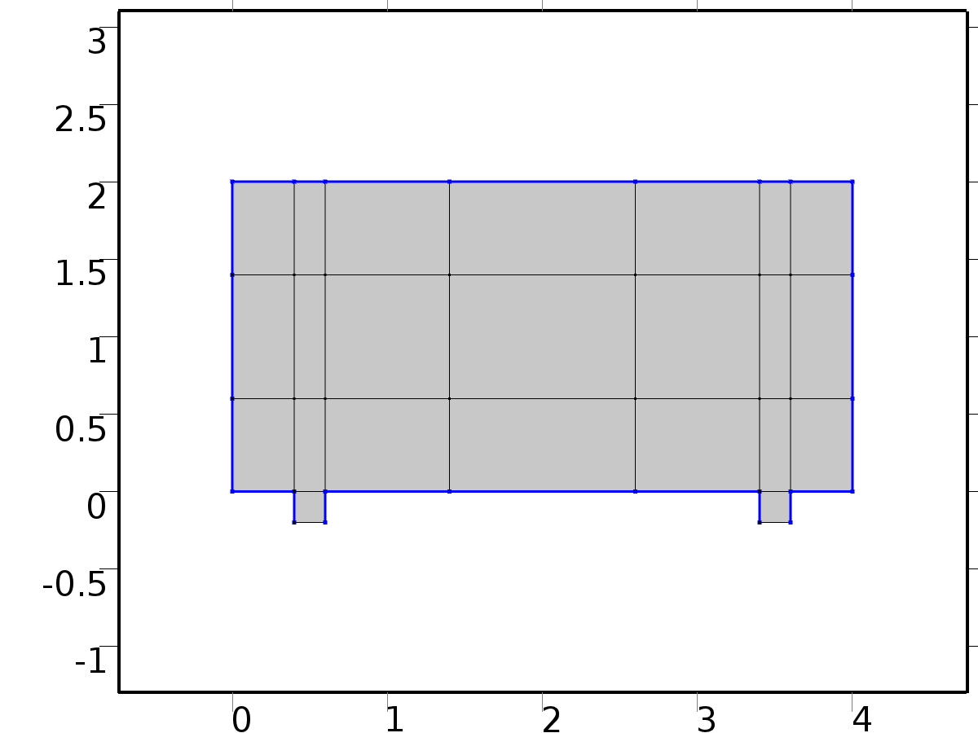

Wall 1

Selection

|  |  |
| --- | --- |
| Geometric entity level | Boundary |
| Selection | Boundaries 1–3, 5, 7–8, 16–17, 19, 24, 26, 31, 33, 38–39, 47–48, 50, 55–58 |

Equations



Settings

| **Description** | **Value** |
| --- | --- |
| Boundary condition | No slip |
| Apply reaction terms on | Individual dependent variables |
| Use weak constraints | Off |
| Constraint method | Elemental |

#### Variables

| **Name** | **Expression** | **Unit** | **Description** | **Selection** |
| --- | --- | --- | --- | --- |
| NS.ubndx | 0 | m/s | Velocity at boundary, x component | Boundaries 1–3, 5, 7–8, 16–17, 19, 24, 26, 31, 33, 38–39, 47–48, 50, 55–58 |
| NS.ubndy | 0 | m/s | Velocity at boundary, y component | Boundaries 1–3, 5, 7–8, 16–17, 19, 24, 26, 31, 33, 38–39, 47–48, 50, 55–58 |
| NS.ubndz | 0 | m/s | Velocity at boundary, z component | Boundaries 1–3, 5, 7–8, 16–17, 19, 24, 26, 31, 33, 38–39, 47–48, 50, 55–58 |

#### Shape functions

| **Constraint** | **Constraint force** | **Shape function** | **Selection** |
| --- | --- | --- | --- |
| -u+NS.ubndx | test(-u) | Lagrange (Linear) | Boundaries 1–3, 5, 7–8, 16–17, 19, 24, 26, 31, 33, 38–39, 47–48, 50, 55–58 |
| -v+NS.ubndy | test(-v) | Lagrange (Linear) | Boundaries 1–3, 5, 7–8, 16–17, 19, 24, 26, 31, 33, 38–39, 47–48, 50, 55–58 |
| NS.ubndz | 0 |  | Boundaries 1–3, 5, 7–8, 16–17, 19, 24, 26, 31, 33, 38–39, 47–48, 50, 55–58 |

* + 1. Initial Values 1



Initial Values 1

Selection

|  |  |
| --- | --- |
| Geometric entity level | Domain |
| Selection | Domains 1–23 |

Settings

| **Description** | **Value** |
| --- | --- |
| Velocity field | {0, 0, 0} |
| Pressure | 0 |
| Turbulent kinetic energy | spf.kinit |
| Turbulent dissipation rate | spf.epinit |
| Specific dissipation rate | spf.omInit |
| Reciprocal wall distance | spf.G0 |
| Undamped turbulent kinematic viscosity | spf.nutildeinit |

* + 1. Inlet 1

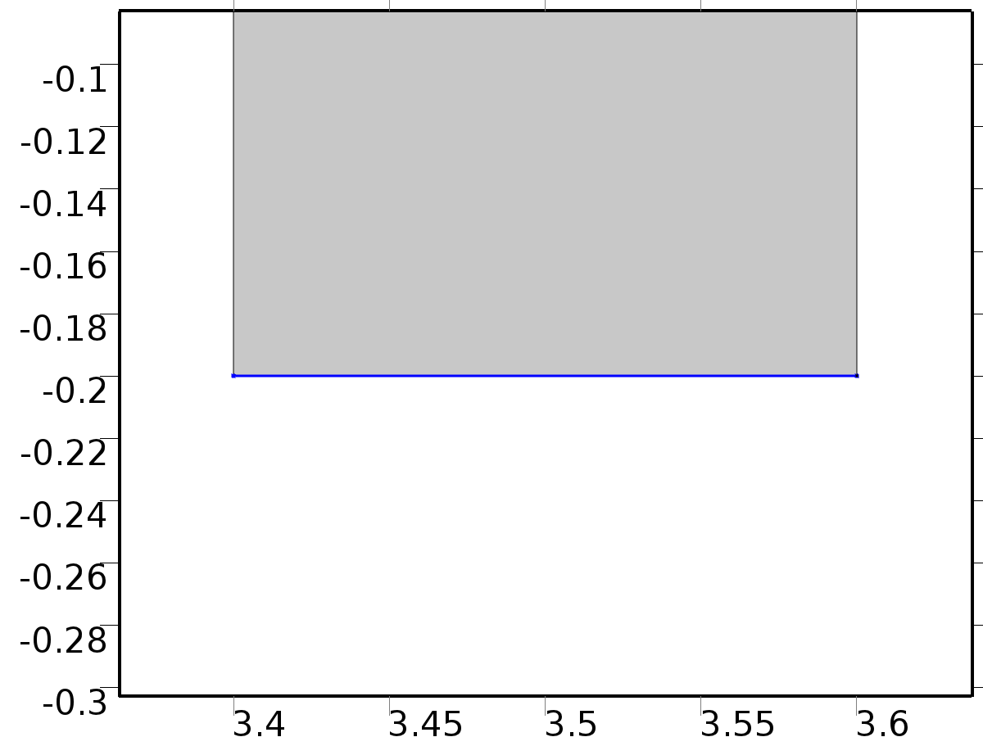

Inlet 1

Selection

|  |  |
| --- | --- |
| Geometric entity level | Boundary |
| Selection | Boundary 40 |

Equations



Settings

| **Description** | **Value** |
| --- | --- |
| Apply reaction terms on | All physics (symmetric) |
| Use weak constraints | Off |
| Boundary condition | Velocity |
| Velocity field componentwise | Normal inflow velocity |
| Normal stress | 0.5 |
| Normal inflow velocity | s*(1 - s) |
| Turbulent intensity | 0.05 |
| Turbulence length scale | 0.01[m] |
| Turbulent kinetic energy | 0.005[m^2/s^2] |
| Turbulent dissipation rate | 0.005[m^2/s^3] |
| Specific dissipation rate | 20[1/s] |
| Undamped turbulent kinematic viscosity | 3*spf.nu |
| Constraint method | Elemental |

#### Variables

| **Name** | **Expression** | **Unit** | **Description** | **Selection** |
| --- | --- | --- | --- | --- |
| NS.ubndx | -nojac(NS.nxmesh)*NS.U0in | m/s | Velocity at boundary, x component | Boundary 40 |
| NS.ubndy | -nojac(NS.nymesh)*NS.U0in | m/s | Velocity at boundary, y component | Boundary 40 |
| NS.ubndz | -nojac(NS.nzmesh)*NS.U0in | m/s | Velocity at boundary, z component | Boundary 40 |
| NS.U0in | s*(1-s) | m/s | Normal inflow velocity | Boundary 40 |

#### Shape functions

| **Constraint** | **Constraint force** | **Shape function** | **Selection** |
| --- | --- | --- | --- |
| -u+NS.ubndx | test(-u+NS.ubndx) | Lagrange (Linear) | Boundary 40 |
| -v+NS.ubndy | test(-v+NS.ubndy) | Lagrange (Linear) | Boundary 40 |
| NS.ubndz | test(NS.ubndz) |  | Boundary 40 |

* + 1. Outlet 1

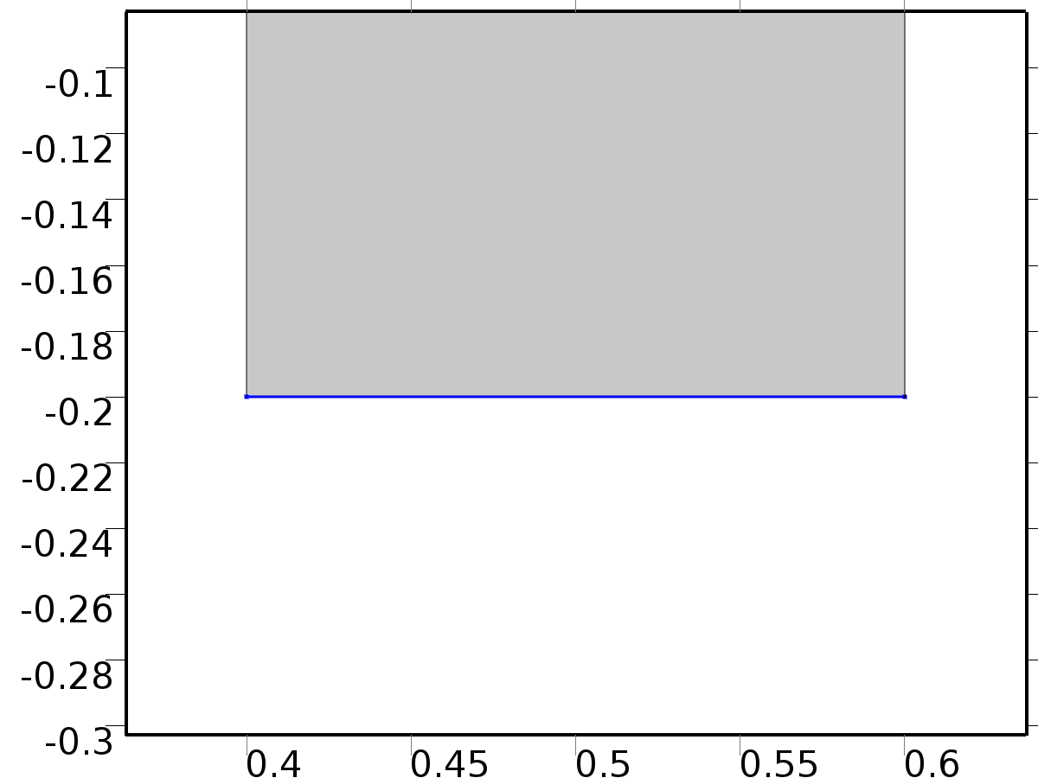

Outlet 1

Selection

|  |  |
| --- | --- |
| Geometric entity level | Boundary |
| Selection | Boundary 9 |

Equations



Settings

| **Description** | **Value** |
| --- | --- |
| Use weak constraints | Off |
| Boundary condition | Normal stress |
| Normal stress | 0 |
| Constraint method | Elemental |

#### Variables

| **Name** | **Expression** | **Unit** | **Description** | **Selection** |
| --- | --- | --- | --- | --- |
| NS.f0 | 0 | N/m^2 | Normal stress | Boundary 9 |

#### Weak expressions

| **Weak expression** | **Integration frame** | **Selection** |
| --- | --- | --- |
| -NS.f0*(test(u)*NS.nxmesh+test(v)*NS.nymesh) | Material | Boundary 9 |

* 1. Temperature 1



Temperature 1

Selection

|  |  |
| --- | --- |
| Geometric entity level | Domain |
| Selection | Domains 1–23 |

Equations





Settings

| **Description** | **Value** |
| --- | --- |
| Temperature | Linear |
| Compute boundary fluxes | On |
| Apply smoothing to boundary fluxes | On |
| Value type when using splitting of complex variables | Real |
| Thickness | 1[m] |
| Streamline diffusion | On |
| Crosswind diffusion | On |
| Lower gradient limit | (0.01[K])/ht.helem |
| Isotropic diffusion | Off |

Used products

|  |
| --- |
| COMSOL Multiphysics |

Variables

| **Name** | **Expression** | **Unit** | **Description** | **Selection** |
| --- | --- | --- | --- | --- |
| X1.q0 | 0 | W/m^2 | Inward heat flux | Boundaries 1–58 |
| X1.Tu | X1 | K | Temperature | Boundaries 1–58 |
| X1.Td | X1 | K | Temperature | Boundaries 1–58 |
| X1.opaqueLayer | 1 |  | Thin layer opacity | Boundaries 1–58 |
| X1.dz | 1[m] | m | Thickness | Domains 1–23 |
| X1.Tvar | X1 | K | Temperature | Domains 1–23 |
| X1.d | X1.dz | m | Thickness | Domains 1–23 |
| X1.Pc | 1 | 1 | Cross sectional perimeter | Domains 1–23 |
| X1.nx | nx | 1 | Normal vector, x component | Boundaries 4, 6, 10–15, 18, 20–23, 25, 27–30, 32, 34–37, 41–46, 49, 51–54 |
| X1.ny | ny | 1 | Normal vector, y component | Boundaries 4, 6, 10–15, 18, 20–23, 25, 27–30, 32, 34–37, 41–46, 49, 51–54 |
| X1.nz | 0 | 1 | Normal vector, z component | Boundaries 4, 6, 10–15, 18, 20–23, 25, 27–30, 32, 34–37, 41–46, 49, 51–54 |
| X1.nx | dnx | 1 | Normal vector, x component | Boundaries 1–3, 5, 7–9, 16–17, 19, 24, 26, 31, 33, 38–40, 47–48, 50, 55–58 |
| X1.ny | dny | 1 | Normal vector, y component | Boundaries 1–3, 5, 7–9, 16–17, 19, 24, 26, 31, 33, 38–40, 47–48, 50, 55–58 |
| X1.nz | 0 | 1 | Normal vector, z component | Boundaries 1–3, 5, 7–9, 16–17, 19, 24, 26, 31, 33, 38–40, 47–48, 50, 55–58 |
| X1.nxmesh | root.nxmesh | 1 | Normal vector (mesh), x component | Boundaries 4, 6, 10–15, 18, 20–23, 25, 27–30, 32, 34–37, 41–46, 49, 51–54 |
| X1.nymesh | root.nymesh | 1 | Normal vector (mesh), y component | Boundaries 4, 6, 10–15, 18, 20–23, 25, 27–30, 32, 34–37, 41–46, 49, 51–54 |
| X1.nzmesh | 0 | 1 | Normal vector (mesh), z component | Boundaries 4, 6, 10–15, 18, 20–23, 25, 27–30, 32, 34–37, 41–46, 49, 51–54 |
| X1.nxmesh | root.dnxmesh | 1 | Normal vector (mesh), x component | Boundaries 1–3, 5, 7–9, 16–17, 19, 24, 26, 31, 33, 38–40, 47–48, 50, 55–58 |
| X1.nymesh | root.dnymesh | 1 | Normal vector (mesh), y component | Boundaries 1–3, 5, 7–9, 16–17, 19, 24, 26, 31, 33, 38–40, 47–48, 50, 55–58 |
| X1.nzmesh | 0 | 1 | Normal vector (mesh), z component | Boundaries 1–3, 5, 7–9, 16–17, 19, 24, 26, 31, 33, 38–40, 47–48, 50, 55–58 |
| X1.dnx | dnx | 1 | Normal vector down direction, x component | Boundaries 1–58 |
| X1.dny | dny | 1 | Normal vector down direction, y component | Boundaries 1–58 |
| X1.dnz | 0 | 1 | Normal vector down direction, z component | Boundaries 1–58 |
| X1.unx | unx | 1 | Normal vector up direction, x component | Boundaries 1–58 |
| X1.uny | uny | 1 | Normal vector up direction, y component | Boundaries 1–58 |
| X1.unz | 0 | 1 | Normal vector up direction, z component | Boundaries 1–58 |
| X1.dEiInt | X1.intDom(d(X1.rho*X1.Ei,t)*X1.varIntSpa) | W | Total accumulated heat rate | Global |
| X1.dEi0Int | X1.intDom(d(X1.rho*X1.Ei0,t)*X1.varIntSpa) | W | Total accumulated energy rate | Global |
| X1.ntfluxInt | X1.intExtBnd(X1.ntflux*X1.varIntSpa) | W | Total net heat rate | Global |
| X1.ntefluxInt | X1.intExtBnd(X1.nteflux*X1.varIntSpa) | W | Total net energy rate | Global |
| X1.QInt | X1.intDom(X1.Qtot*X1.varIntSpa)-X1.intIntBnd((X1.ndflux_u+X1.ndflux_d)*X1.varIntSpa) | W | Total heat source | Global |
| X1.WnsInt | 0 | W | Total work source | Global |
| X1.WInt | 0 | W | Total work source | Global |

* + 1. Heat Transfer in Fluids 1



Heat Transfer in Fluids 1

Selection

|  |  |
| --- | --- |
| Geometric entity level | Domain |
| Selection | Domains 1–23 |

Equations



Settings

| **Description** | **Value** |
| --- | --- |
| Fluid type | Gas/Liquid |
| Thermal conductivity | User defined |
| Thermal conductivity | {{K, 0, 0}, {0, K, 0}, {0, 0, K}} |
| Density | User defined |
| Density | rho |
| Heat capacity at constant pressure | User defined |
| Heat capacity at constant pressure | cp |
| Ratio of specific heats | User defined |
| Ratio of specific heats | 1 |
| Equivalent conductivity for convection | Off |

#### Variables

| **Name** | **Expression** | **Unit** | **Description** | **Selection** |
| --- | --- | --- | --- | --- |
| domflux.X1x | -X1.k_effxx*X1x-X1.k_effxy*X1y | W/m^2 | Domain flux, x component | Domains 1–23 |
| domflux.X1y | -X1.k_effyx*X1x-X1.k_effyy*X1y | W/m^2 | Domain flux, y component | Domains 1–23 |
| X1.WnsInt | X1.fluid1.intDom(X1.pA*(d(X1.ux,x)+d(X1.uy,y))*X1.fluid1.varIntSpa) | W | Total work source | Global |
| X1.kxx | K | W/(m*K) | Thermal conductivity, xx component | Domains 1–23 |
| X1.kyx | 0 | W/(m*K) | Thermal conductivity, yx component | Domains 1–23 |
| X1.kzx | 0 | W/(m*K) | Thermal conductivity, zx component | Domains 1–23 |
| X1.kxy | 0 | W/(m*K) | Thermal conductivity, xy component | Domains 1–23 |
| X1.kyy | K | W/(m*K) | Thermal conductivity, yy component | Domains 1–23 |
| X1.kzy | 0 | W/(m*K) | Thermal conductivity, zy component | Domains 1–23 |
| X1.kxz | 0 | W/(m*K) | Thermal conductivity, xz component | Domains 1–23 |
| X1.kyz | 0 | W/(m*K) | Thermal conductivity, yz component | Domains 1–23 |
| X1.kzz | K | W/(m*K) | Thermal conductivity, zz component | Domains 1–23 |
| X1.rho | material.rho | kg/m^3 | Density | Domains 1–23 |
| X1.Cp | cp | J/(kg*K) | Heat capacity at constant pressure | Domains 1–23 |
| X1.gamma | 1 | 1 | Ratio of specific heats | Domains 1–23 |
| X1.fluid1.pRef | model.input.pRef | Pa | Reference pressure level | Domains 1–23 |
| X1.T | model.input.minput_temperature | K | Temperature | Domains 1–23 |
| X1.alphap | -d(X1.rho,X1)/(X1.rho+eps) | 1/K | Isobaric compressibility coefficient | Domains 1–23 |
| X1.pA | model.input.minput_pressure | Pa | Absolute pressure | Domains 1–23 |
| X1.gradTmag | sqrt(X1.gradTx^2+X1.gradTy^2+X1.gradTz^2) | K/m | Temperature gradient magnitude | Domains 1–23 |
| X1.kmean | 0.5*(X1.k_effxx+X1.k_effyy) | W/(m*K) | Mean effective thermal conductivity | Domains 1–23 |
| X1.Q | 0 | W/m^3 | Heat source | Domains 1–23 |
| X1.qs | 0 | W/(m^3*K) | Production/absorption coefficient | Domains 1–23 |
| X1.Qmet | 0 | W/m^3 | Metabolic heat source | Domains 1–23 |
| X1.Qtot | 0 | W/m^3 | Total heat source | Domains 1–23 |
| X1.rhoInt | subst(X1.rho,root.mod1.X1.fluid1.minput_pressure,X1.pA) | kg/m^3 | Density for integration | Domains 1–23 |
| X1.CpInt | subst(X1.Cp,root.mod1.X1.fluid1.minput_pressure,X1.pA) | J/(kg*K) | Specific heat capacity for integration | Domains 1–23 |
| X1.gammaInt | subst(X1.gamma,root.mod1.X1.fluid1.minput_pressure,X1.pA) | 1 | Ratio of specific heats for integration | Domains 1–23 |
| X1.TRef | 298.15[K] | K | Reference temperature | Domains 1–23 |
| X1.pRef | X1.fluid1.pRef | Pa | Reference pressure level | Domains 1–23 |
| X1.HRef | 0 | J/kg | Reference enthalpy | Domains 1–23 |
| X1.DeltaH | integrate((1+X1*d(X1.rhoInt,X1)/X1.rhoInt)/X1.rhoInt,X1.pA,X1.pRef,X1.pA)+integrate(subst(X1.CpInt,X1.pA,X1.pRef),X1,X1.TRef,X1) | J/kg | Sensible enthalpy | Domains 1–23 |
| X1.H | X1.HRef+X1.DeltaH | J/kg | Enthalpy | Domains 1–23 |
| X1.H0 | X1.H+0.5*(X1.ux^2+X1.uy^2+X1.uz^2) | J/kg | Total enthalpy | Domains 1–23 |
| X1.Ei | X1.H-X1.pA/X1.rho | J/kg | Internal energy | Domains 1–23 |
| X1.Ei0 | X1.Ei+0.5*(X1.ux^2+X1.uy^2+X1.uz^2) | J/kg | Total internal energy | Domains 1–23 |
| X1.Qbtot | 0 | W/m^2 | Total boundary heat source | Boundaries 1–58 |
| X1.k_effxx | X1.kxx | W/(m*K) | Effective thermal conductivity, xx component | Domains 1–23 |
| X1.k_effyx | X1.kyx | W/(m*K) | Effective thermal conductivity, yx component | Domains 1–23 |
| X1.k_effzx | 0 | W/(m*K) | Effective thermal conductivity, zx component | Domains 1–23 |
| X1.k_effxy | X1.kxy | W/(m*K) | Effective thermal conductivity, xy component | Domains 1–23 |
| X1.k_effyy | X1.kyy | W/(m*K) | Effective thermal conductivity, yy component | Domains 1–23 |
| X1.k_effzy | 0 | W/(m*K) | Effective thermal conductivity, zy component | Domains 1–23 |
| X1.k_effxz | 0 | W/(m*K) | Effective thermal conductivity, xz component | Domains 1–23 |
| X1.k_effyz | 0 | W/(m*K) | Effective thermal conductivity, yz component | Domains 1–23 |
| X1.k_effzz | 0 | W/(m*K) | Effective thermal conductivity, zz component | Domains 1–23 |
| X1.C_eff | X1.rho*X1.Cp | J/(m^3*K) | Effective volumetric heat capacity | Domains 1–23 |
| X1.ux | model.input.minput_velocity1 | m/s | Velocity field, x component | Domains 1–23 |
| X1.uy | model.input.minput_velocity2 | m/s | Velocity field, y component | Domains 1–23 |
| X1.uz | model.input.minput_velocity3 | m/s | Velocity field, z component | Domains 1–23 |
| X1.gradTx | X1x | K/m | Temperature gradient, x component | Domains 1–23 |
| X1.gradTy | X1y | K/m | Temperature gradient, y component | Domains 1–23 |
| X1.gradTz | 0 | K/m | Temperature gradient, z component | Domains 1–23 |
| X1.Qltot | 0 | W/m | Total line heat source | Points 1–36 |
| X1.alphaTdxx | X1.k_effxx/X1.C_eff | m^2/s | Thermal diffusivity, xx component | Domains 1–23 |
| X1.alphaTdyx | X1.k_effyx/X1.C_eff | m^2/s | Thermal diffusivity, yx component | Domains 1–23 |
| X1.alphaTdzx | X1.k_effzx/X1.C_eff | m^2/s | Thermal diffusivity, zx component | Domains 1–23 |
| X1.alphaTdxy | X1.k_effxy/X1.C_eff | m^2/s | Thermal diffusivity, xy component | Domains 1–23 |
| X1.alphaTdyy | X1.k_effyy/X1.C_eff | m^2/s | Thermal diffusivity, yy component | Domains 1–23 |
| X1.alphaTdzy | X1.k_effzy/X1.C_eff | m^2/s | Thermal diffusivity, zy component | Domains 1–23 |
| X1.alphaTdxz | X1.k_effxz/X1.C_eff | m^2/s | Thermal diffusivity, xz component | Domains 1–23 |
| X1.alphaTdyz | X1.k_effyz/X1.C_eff | m^2/s | Thermal diffusivity, yz component | Domains 1–23 |
| X1.alphaTdzz | X1.k_effzz/X1.C_eff | m^2/s | Thermal diffusivity, zz component | Domains 1–23 |
| X1.alphaTdMean | X1.kmean/X1.C_eff | m^2/s | Mean thermal diffusivity | Domains 1–23 |
| X1.dfluxx | -X1.k_effxx*X1x-X1.k_effxy*X1y | W/m^2 | Conductive heat flux, x component | Domains 1–23 |
| X1.dfluxy | -X1.k_effyx*X1x-X1.k_effyy*X1y | W/m^2 | Conductive heat flux, y component | Domains 1–23 |
| X1.dfluxz | -X1.k_effzx*X1x-X1.k_effzy*X1y | W/m^2 | Conductive heat flux, z component | Domains 1–23 |
| X1.dfluxMag | sqrt(X1.dfluxx^2+X1.dfluxy^2+X1.dfluxz^2) | W/m^2 | Conductive heat flux magnitude | Domains 1–23 |
| X1.trlfluxx | 0 | W/m^2 | Translational heat flux, x component | Domains 1–23 |
| X1.trlfluxy | 0 | W/m^2 | Translational heat flux, y component | Domains 1–23 |
| X1.trlfluxz | 0 | W/m^2 | Translational heat flux, z component | Domains 1–23 |
| X1.trlfluxMag | sqrt(X1.trlfluxx^2+X1.trlfluxy^2+X1.trlfluxz^2) | W/m^2 | Translational heat flux magnitude | Domains 1–23 |
| X1.cfluxx | X1.rho*X1.ux*X1.Ei | W/m^2 | Convective heat flux, x component | Domains 1–23 |
| X1.cfluxy | X1.rho*X1.uy*X1.Ei | W/m^2 | Convective heat flux, y component | Domains 1–23 |
| X1.cfluxz | X1.rho*X1.uz*X1.Ei | W/m^2 | Convective heat flux, z component | Domains 1–23 |
| X1.cfluxMag | sqrt(X1.cfluxx^2+X1.cfluxy^2+X1.cfluxz^2) | W/m^2 | Convective heat flux magnitude | Domains 1–23 |
| X1.tfluxx | X1.dfluxx+X1.trlfluxx+X1.cfluxx | W/m^2 | Total heat flux, x component | Domains 1–23 |
| X1.tfluxy | X1.dfluxy+X1.trlfluxy+X1.cfluxy | W/m^2 | Total heat flux, y component | Domains 1–23 |
| X1.tfluxz | X1.dfluxz+X1.trlfluxz+X1.cfluxz | W/m^2 | Total heat flux, z component | Domains 1–23 |
| X1.tfluxMag | sqrt(X1.tfluxx^2+X1.tfluxy^2+X1.tfluxz^2) | W/m^2 | Total heat flux magnitude | Domains 1–23 |
| X1.tefluxx | X1.dfluxx+X1.rho*X1.ux*X1.H0 | W/m^2 | Total energy flux, x component | Domains 1–23 |
| X1.tefluxy | X1.dfluxy+X1.rho*X1.uy*X1.H0 | W/m^2 | Total energy flux, y component | Domains 1–23 |
| X1.tefluxz | X1.dfluxz+X1.rho*X1.uz*X1.H0 | W/m^2 | Total energy flux, z component | Domains 1–23 |
| X1.tefluxMag | sqrt(X1.tefluxx^2+X1.tefluxy^2+X1.tefluxz^2) | W/m^2 | Total energy flux magnitude | Domains 1–23 |
| X1.rflux | 0 | W/m^2 | Radiative heat flux | Boundaries 1–58 |
| X1.chflux | 0 | W/m^2 | Boundary convective heat flux | Boundaries 1–58 |
| X1.ntrlflux | mean(X1.trlfluxx)*X1.nx+mean(X1.trlfluxy)*X1.ny+mean(X1.trlfluxz)*X1.nz | W/m^2 | Normal translational heat flux | Boundaries 1–58 |
| X1.ntrlflux_u | up(X1.trlfluxx)*X1.unx+up(X1.trlfluxy)*X1.uny+up(X1.trlfluxz)*X1.unz | W/m^2 | Internal normal translational heat flux, upside | Boundaries 4, 6, 10–15, 18, 20–23, 25, 27–30, 32, 34–37, 41–46, 49, 51–54 |
| X1.ntrlflux_d | down(X1.trlfluxx)*X1.dnx+down(X1.trlfluxy)*X1.dny+down(X1.trlfluxz)*X1.dnz | W/m^2 | Internal normal translational heat flux, downside | Boundaries 4, 6, 10–15, 18, 20–23, 25, 27–30, 32, 34–37, 41–46, 49, 51–54 |
| X1.ncflux | mean(X1.cfluxx)*X1.nx+mean(X1.cfluxy)*X1.ny+mean(X1.cfluxz)*X1.nz | W/m^2 | Normal convective heat flux | Boundaries 1–58 |
| X1.ncflux_u | up(X1.cfluxx)*X1.unx+up(X1.cfluxy)*X1.uny+up(X1.cfluxz)*X1.unz | W/m^2 | Internal normal convective heat flux, upside | Boundaries 4, 6, 10–15, 18, 20–23, 25, 27–30, 32, 34–37, 41–46, 49, 51–54 |
| X1.ncflux_d | down(X1.cfluxx)*X1.dnx+down(X1.cfluxy)*X1.dny+down(X1.cfluxz)*X1.dnz | W/m^2 | Internal normal convective heat flux, downside | Boundaries 4, 6, 10–15, 18, 20–23, 25, 27–30, 32, 34–37, 41–46, 49, 51–54 |
| X1.ndflux | -dflux_spatial(X1) | W/m^2 | Normal conductive heat flux | Boundaries 1–3, 5, 7–9, 16–17, 19, 24, 26, 31, 33, 38–40, 47–48, 50, 55–58 |
| X1.ndflux | 0.5*(uflux_spatial(X1)-dflux_spatial(X1)) | W/m^2 | Normal conductive heat flux | Boundaries 4, 6, 10–15, 18, 20–23, 25, 27–30, 32, 34–37, 41–46, 49, 51–54 |
| X1.ndflux_u | -uflux_spatial(X1) | W/m^2 | Internal normal conductive heat flux, upside | Boundaries 4, 6, 10–15, 18, 20–23, 25, 27–30, 32, 34–37, 41–46, 49, 51–54 |
| X1.ndflux_d | -dflux_spatial(X1) | W/m^2 | Internal normal conductive heat flux, downside | Boundaries 4, 6, 10–15, 18, 20–23, 25, 27–30, 32, 34–37, 41–46, 49, 51–54 |
| X1.ntflux | X1.ndflux+X1.ntrlflux+X1.ncflux | W/m^2 | Normal total heat flux | Boundaries 1–58 |
| X1.ntflux_u | X1.ndflux_u+X1.ntrlflux_u+X1.ncflux_u | W/m^2 | Internal normal total flux, upside | Boundaries 4, 6, 10–15, 18, 20–23, 25, 27–30, 32, 34–37, 41–46, 49, 51–54 |
| X1.ntflux_d | X1.ndflux_d+X1.ntrlflux_d+X1.ncflux_d | W/m^2 | Internal normal total flux, downside | Boundaries 4, 6, 10–15, 18, 20–23, 25, 27–30, 32, 34–37, 41–46, 49, 51–54 |
| X1.nteflux | mean(X1.tefluxx)*X1.nx+mean(X1.tefluxy)*X1.ny+mean(X1.tefluxz)*X1.nz-mean(X1.dfluxx)*X1.nx-mean(X1.dfluxy)*X1.ny-mean(X1.dfluxz)*X1.nz+X1.ndflux | W/m^2 | Normal total energy flux | Boundaries 1–58 |
| X1.nteflux_u | up(X1.tefluxx)*X1.unx+up(X1.tefluxy)*X1.uny+up(X1.tefluxz)*X1.unz-up(X1.dfluxx)*X1.unx-up(X1.dfluxy)*X1.uny-up(X1.dfluxz)*X1.unz+X1.ndflux_u | W/m^2 | Internal normal total energy flux, upside | Boundaries 4, 6, 10–15, 18, 20–23, 25, 27–30, 32, 34–37, 41–46, 49, 51–54 |
| X1.nteflux_d | down(X1.tefluxx)*X1.dnx+down(X1.tefluxy)*X1.dny+down(X1.tefluxz)*X1.dnz-down(X1.dfluxx)*X1.dnx-down(X1.dfluxy)*X1.dny-down(X1.dfluxz)*X1.dnz+X1.ndflux_d | W/m^2 | Internal normal total energy flux, downside | Boundaries 4, 6, 10–15, 18, 20–23, 25, 27–30, 32, 34–37, 41–46, 49, 51–54 |
| X1.q0_u | 0 | W/m^2 | Out-of-plane heat flux, upside | Domains 1–23 |
| X1.q0_d | 0 | W/m^2 | Out-of-plane heat flux, downside | Domains 1–23 |
| X1.rflux_u | 0 | W/m^2 | Radiative out-of-plane heat flux, upside | Domains 1–23 |
| X1.rflux_d | 0 | W/m^2 | Radiative out-of-plane heat flux, downside | Domains 1–23 |
| X1.chflux_u | 0 | W/m^2 | Convective out-of-plane heat flux, upside | Domains 1–23 |
| X1.chflux_d | 0 | W/m^2 | Convective out-of-plane heat flux, downside | Domains 1–23 |
| X1.tflux_u | X1.chflux_u+X1.q0_u+X1.rflux_u | W/m^2 | Total out-of-plane heat flux, upside | Domains 1–23 |
| X1.tflux_d | X1.chflux_d+X1.q0_d+X1.rflux_d | W/m^2 | Total out-of-plane heat flux, downside | Domains 1–23 |
| X1.fluid1.dEiInt | X1.fluid1.intDom(d(X1.rho*X1.Ei,t)*X1.fluid1.varIntSpa) | W | Total accumulated heat rate | Global |
| X1.fluid1.dEi0Int | X1.fluid1.intDom(d(X1.rho*X1.Ei0,t)*X1.fluid1.varIntSpa) | W | Total accumulated energy rate | Global |
| X1.fluid1.ntfluxInt | X1.fluid1.intExtBnd(X1.ntflux*X1.fluid1.varIntSpa)+X1.fluid1.intExtBndUp(X1.ntflux_u*X1.fluid1.varIntSpa)+X1.fluid1.intExtBndDown(X1.ntflux_d*X1.fluid1.varIntSpa) | W | Total net heat rate | Global |
| X1.fluid1.ntefluxInt | X1.fluid1.intExtBnd(X1.nteflux*X1.fluid1.varIntSpa)+X1.fluid1.intExtBndUp(X1.nteflux_u*X1.fluid1.varIntSpa)+X1.fluid1.intExtBndDown(X1.nteflux_d*X1.fluid1.varIntSpa) | W | Total net energy rate | Global |
| X1.fluid1.QInt | X1.fluid1.intDom(X1.Qtot*X1.fluid1.varIntSpa)-X1.fluid1.intIntBnd((X1.ndflux_u+X1.ndflux_d)*X1.fluid1.varIntSpa) | W | Total heat source | Global |
| X1.fluid1.WnsInt | X1.fluid1.intDom(X1.pA*(d(X1.ux,x)+d(X1.uy,y))*X1.fluid1.varIntSpa) | W | Total work source | Global |
| X1.fluid1.WInt | 0 | W | Total work source | Global |
| X1.c_s | sqrt(X1.gamma/max(subst(d(X1.rhoInt,X1.pA),X1.pA,model.input.minput_pressure),eps)) | m/s | Speed of sound | Domains 1–23 |
| X1.Ma | sqrt(model.input.minput_velocity1^2+model.input.minput_velocity2^2+model.input.minput_velocity3^2)/X1.c_s | 1 | Mach number | Domains 1–23 |
| X1.cellPe | 0.5*X1.rho*X1.Cp*h*sqrt(X1.ux^2+X1.uy^2+X1.uz^2)/X1.kmean | 1 | Cell Péclet number | Domains 1–23 |
| X1.helem | h | m | Element size | Domains 1–23 |
| X1.res_T | X1.d*(-X1.k_effxx*X1xx-X1.k_effxy*X1xy-X1.k_effyx*X1yx-X1.k_effyy*X1yy-(X1.qs+X1.qs_oop)*X1+X1.rho*X1.Cp*(X1.ux*X1x+X1.uy*X1y)-X1.Q-X1.Qoop) | W/m^3 | Equation residual | Domains 1–23 |

#### Shape functions

| **Name** | **Shape function** | **Unit** | **Description** | **Shape frame** | **Selection** |
| --- | --- | --- | --- | --- | --- |
| X1 | Lagrange (Linear) | K | Temperature | Material | Domains 1–23 |

#### Weak expressions

| **Weak expression** | **Integration frame** | **Selection** |
| --- | --- | --- |
| (-(X1.k_effxx*X1x+X1.k_effxy*X1y)*test(X1x)-(X1.k_effyx*X1x+X1.k_effyy*X1y)*test(X1y))*X1.d | Material | Domains 1–23 |
| -X1.rho*X1.Cp*(X1.ux*X1x+X1.uy*X1y)*test(X1)*X1.d | Material | Domains 1–23 |
| X1.crosswind | Material | Domains 1–23 |
| X1.streamline | Material | Domains 1–23 |

* + 1. Thermal Insulation 1

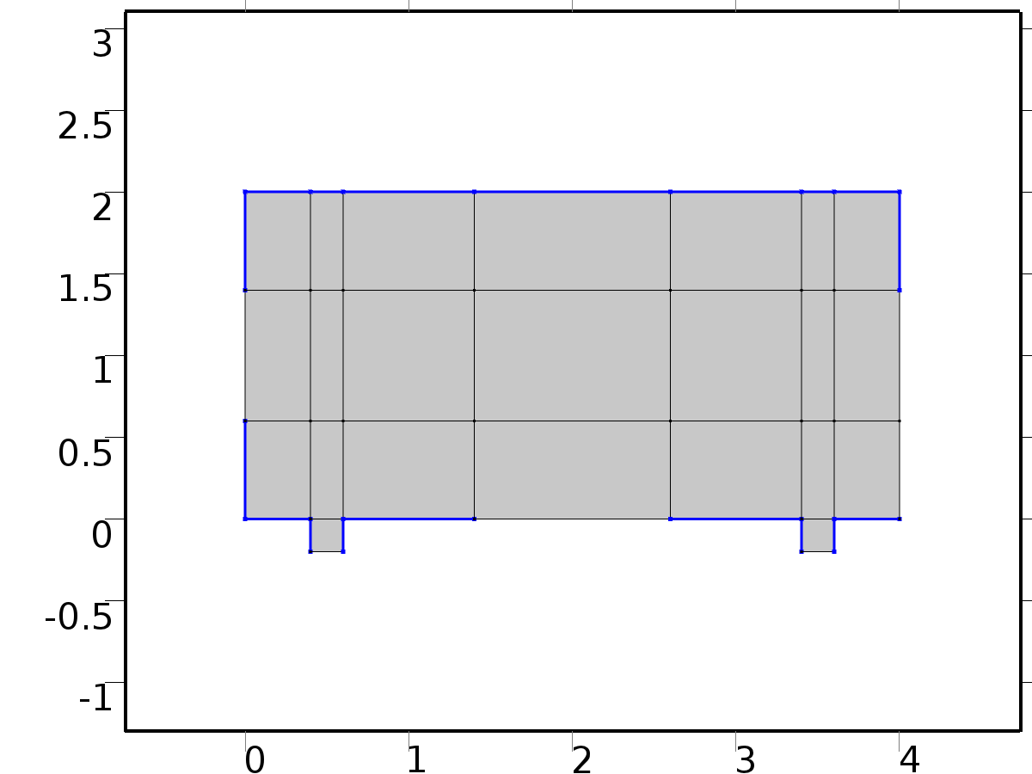

Thermal Insulation 1

Selection

|  |  |
| --- | --- |
| Geometric entity level | Boundary |
| Selection | Boundaries 1–2, 5, 7–8, 16–17, 19, 24, 31, 33, 38–39, 47–48, 50, 55, 58 |

Equations



#### Variables

| **Name** | **Expression** | **Unit** | **Description** | **Selection** |
| --- | --- | --- | --- | --- |
| X1.ins1.ntfluxInt | X1.ins1.intExtBnd(X1.ntflux*X1.ins1.varIntSpa) | W | Total net heat rate | Global |
| X1.ins1.ntefluxInt | X1.ins1.intExtBnd(X1.nteflux*X1.ins1.varIntSpa) | W | Total net energy rate | Global |
| X1.ins1.ntfluxInt_u | X1.ins1.intIntBnd(X1.ntflux_u*X1.ins1.varIntSpa) | W | Total net heat rate, upside | Global |
| X1.ins1.ntefluxInt_u | X1.ins1.intIntBnd(X1.nteflux_u*X1.ins1.varIntSpa) | W | Total net energy rate, upside | Global |
| X1.ins1.ntfluxInt_d | X1.ins1.intIntBnd(X1.ntflux_d*X1.ins1.varIntSpa) | W | Total net heat rate, downside | Global |
| X1.ins1.ntefluxInt_d | X1.ins1.intIntBnd(X1.nteflux_d*X1.ins1.varIntSpa) | W | Total net energy rate, downside | Global |
| X1.ins1.Tave | if(X1.ins1.intBnd(X1.ins1.varIntSpa*X1.rho*X1.Cp*(X1.ux*X1.nx+X1.uy*X1.ny+X1.uz*X1.nz))==0,X1.ins1.intBnd(X1.ins1.varIntSpa*X1)/X1.ins1.intBnd(X1.ins1.varIntSpa),X1.ins1.intBnd(X1.ins1.varIntSpa*X1.rho*X1.Cp*X1*(X1.ux*X1.nx+X1.uy*X1.ny+X1.uz*X1.nz))/X1.ins1.intBnd(X1.ins1.varIntSpa*X1.rho*X1.Cp*(X1.ux*X1.nx+X1.uy*X1.ny+X1.uz*X1.nz))) | K | Weighted average temperature | Global |

* + 1. Initial Values 1



Initial Values 1

Selection

|  |  |
| --- | --- |
| Geometric entity level | Domain |
| Selection | Domains 1–23 |

#### Variables

| **Name** | **Expression** | **Unit** | **Description** | **Selection** |
| --- | --- | --- | --- | --- |
| X1.Tinit | 0 | K | Temperature | Domains 1–23 |

* + 1. Outflow 1



Outflow 1

Selection

|  |  |
| --- | --- |
| Geometric entity level | Boundary |
| Selection | Boundary 9 |

Equations



#### Variables

| **Name** | **Expression** | **Unit** | **Description** | **Selection** |
| --- | --- | --- | --- | --- |
| X1.ofl1.ntfluxInt | X1.ofl1.intExtBnd(X1.ntflux*X1.ofl1.varIntSpa) | W | Total net heat rate | Global |
| X1.ofl1.ntefluxInt | X1.ofl1.intExtBnd(X1.nteflux*X1.ofl1.varIntSpa) | W | Total net energy rate | Global |
| X1.ofl1.ntfluxInt_u | X1.ofl1.intIntBnd(X1.ntflux_u*X1.ofl1.varIntSpa) | W | Total net heat rate, upside | Global |
| X1.ofl1.ntefluxInt_u | X1.ofl1.intIntBnd(X1.nteflux_u*X1.ofl1.varIntSpa) | W | Total net energy rate, upside | Global |
| X1.ofl1.ntfluxInt_d | X1.ofl1.intIntBnd(X1.ntflux_d*X1.ofl1.varIntSpa) | W | Total net heat rate, downside | Global |
| X1.ofl1.ntefluxInt_d | X1.ofl1.intIntBnd(X1.nteflux_d*X1.ofl1.varIntSpa) | W | Total net energy rate, downside | Global |
| X1.ofl1.Tave | if(X1.ofl1.intBnd(X1.ofl1.varIntSpa*X1.rho*X1.Cp*(X1.ux*X1.nx+X1.uy*X1.ny+X1.uz*X1.nz))==0,X1.ofl1.intBnd(X1.ofl1.varIntSpa*X1)/X1.ofl1.intBnd(X1.ofl1.varIntSpa),X1.ofl1.intBnd(X1.ofl1.varIntSpa*X1.rho*X1.Cp*X1*(X1.ux*X1.nx+X1.uy*X1.ny+X1.uz*X1.nz))/X1.ofl1.intBnd(X1.ofl1.varIntSpa*X1.rho*X1.Cp*(X1.ux*X1.nx+X1.uy*X1.ny+X1.uz*X1.nz))) | K | Weighted average temperature | Global |

* + 1. Temperature Bin1



Temperature Bin1

Selection

|  |  |
| --- | --- |
| Geometric entity level | Boundary |
| Selection | Boundary 40 |

Equations



Settings

| **Description** | **Value** |
| --- | --- |
| Temperature | 1 |
|  | Classic constraints |
| Apply reaction terms on | All physics (symmetric) |
| Use weak constraints | Off |
| Constraint method | Elemental |

#### Variables

| **Name** | **Expression** | **Unit** | **Description** | **Selection** |
| --- | --- | --- | --- | --- |
| X1.Tvar | X1 | K | Temperature | Boundary 40 |
| X1.T0 | 1 | K | Temperature | Boundary 40 |
| X1.temp1.ntfluxInt | X1.temp1.intExtBnd(X1.ntflux*X1.temp1.varIntSpa) | W | Total net heat rate | Global |
| X1.temp1.ntefluxInt | X1.temp1.intExtBnd(X1.nteflux*X1.temp1.varIntSpa) | W | Total net energy rate | Global |
| X1.temp1.ntfluxInt_u | X1.temp1.intIntBnd(X1.ntflux_u*X1.temp1.varIntSpa) | W | Total net heat rate, upside | Global |
| X1.temp1.ntefluxInt_u | X1.temp1.intIntBnd(X1.nteflux_u*X1.temp1.varIntSpa) | W | Total net energy rate, upside | Global |
| X1.temp1.ntfluxInt_d | X1.temp1.intIntBnd(X1.ntflux_d*X1.temp1.varIntSpa) | W | Total net heat rate, downside | Global |
| X1.temp1.ntefluxInt_d | X1.temp1.intIntBnd(X1.nteflux_d*X1.temp1.varIntSpa) | W | Total net energy rate, downside | Global |
| X1.temp1.Tave | if(X1.temp1.intBnd(X1.temp1.varIntSpa*X1.rho*X1.Cp*(X1.ux*X1.nx+X1.uy*X1.ny+X1.uz*X1.nz))==0,X1.temp1.intBnd(X1.temp1.varIntSpa*X1)/X1.temp1.intBnd(X1.temp1.varIntSpa),X1.temp1.intBnd(X1.temp1.varIntSpa*X1.rho*X1.Cp*X1*(X1.ux*X1.nx+X1.uy*X1.ny+X1.uz*X1.nz))/X1.temp1.intBnd(X1.temp1.varIntSpa*X1.rho*X1.Cp*(X1.ux*X1.nx+X1.uy*X1.ny+X1.uz*X1.nz))) | K | Weighted average temperature | Global |

#### Shape functions

| **Constraint** | **Constraint force** | **Shape function** | **Selection** |
| --- | --- | --- | --- |
| X1.T0-X1.Tvar | test(X1.T0-X1.Tvar) | Lagrange (Linear) | Boundary 40 |

* + 1. Heat Flux Bin2

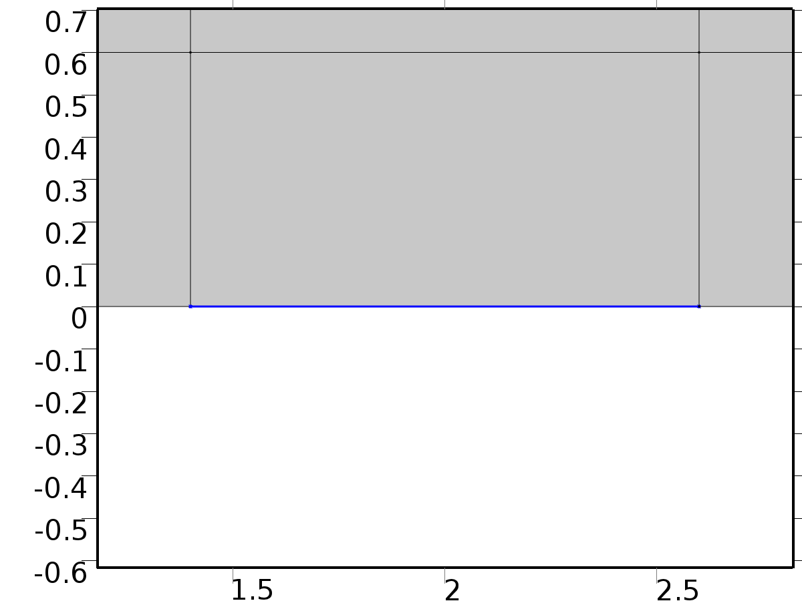

Heat Flux Bin2

Selection

|  |  |
| --- | --- |
| Geometric entity level | Boundary |
| Selection | Boundary 26 |

Equations



Settings

| **Description** | **Value** |
| --- | --- |
| Heat flux | General inward heat flux |
| Inward heat flux | 0 |
| Overall heat transfer rate | 0*ht.d/1[m] |

#### Variables

| **Name** | **Expression** | **Unit** | **Description** | **Selection** |
| --- | --- | --- | --- | --- |
| X1.q0 | X1.hf1.q0 | W/m^2 | Inward heat flux | Boundary 26 |
| X1.Tvar | X1.Tu | K | Temperature | Boundary 26 |
| X1.hf1.q0 | 0 | W/m^2 | Inward heat flux | Boundary 26 |
| X1.hf1.ntfluxInt | X1.hf1.intExtBnd(X1.ntflux*X1.hf1.varIntSpa) | W | Total net heat rate | Global |
| X1.hf1.ntefluxInt | X1.hf1.intExtBnd(X1.nteflux*X1.hf1.varIntSpa) | W | Total net energy rate | Global |
| X1.hf1.ntfluxInt_u | X1.hf1.intIntBnd(X1.ntflux_u*X1.hf1.varIntSpa) | W | Total net heat rate, upside | Global |
| X1.hf1.ntefluxInt_u | X1.hf1.intIntBnd(X1.nteflux_u*X1.hf1.varIntSpa) | W | Total net energy rate, upside | Global |
| X1.hf1.ntfluxInt_d | X1.hf1.intIntBnd(X1.ntflux_d*X1.hf1.varIntSpa) | W | Total net heat rate, downside | Global |
| X1.hf1.ntefluxInt_d | X1.hf1.intIntBnd(X1.nteflux_d*X1.hf1.varIntSpa) | W | Total net energy rate, downside | Global |
| X1.hf1.Tave | if(X1.hf1.intBnd(X1.hf1.varIntSpa*X1.rho*X1.Cp*(X1.ux*X1.nx+X1.uy*X1.ny+X1.uz*X1.nz))==0,X1.hf1.intBnd(X1.hf1.varIntSpa*X1)/X1.hf1.intBnd(X1.hf1.varIntSpa),X1.hf1.intBnd(X1.hf1.varIntSpa*X1.rho*X1.Cp*X1*(X1.ux*X1.nx+X1.uy*X1.ny+X1.uz*X1.nz))/X1.hf1.intBnd(X1.hf1.varIntSpa*X1.rho*X1.Cp*(X1.ux*X1.nx+X1.uy*X1.ny+X1.uz*X1.nz))) | K | Weighted average temperature | Global |

#### Weak expressions

| **Weak expression** | **Integration frame** | **Selection** |
| --- | --- | --- |
| X1.hf1.q0*test(X1.Tvar)*X1.d | Material | Boundary 26 |

* + 1. Heat Flux Bd1

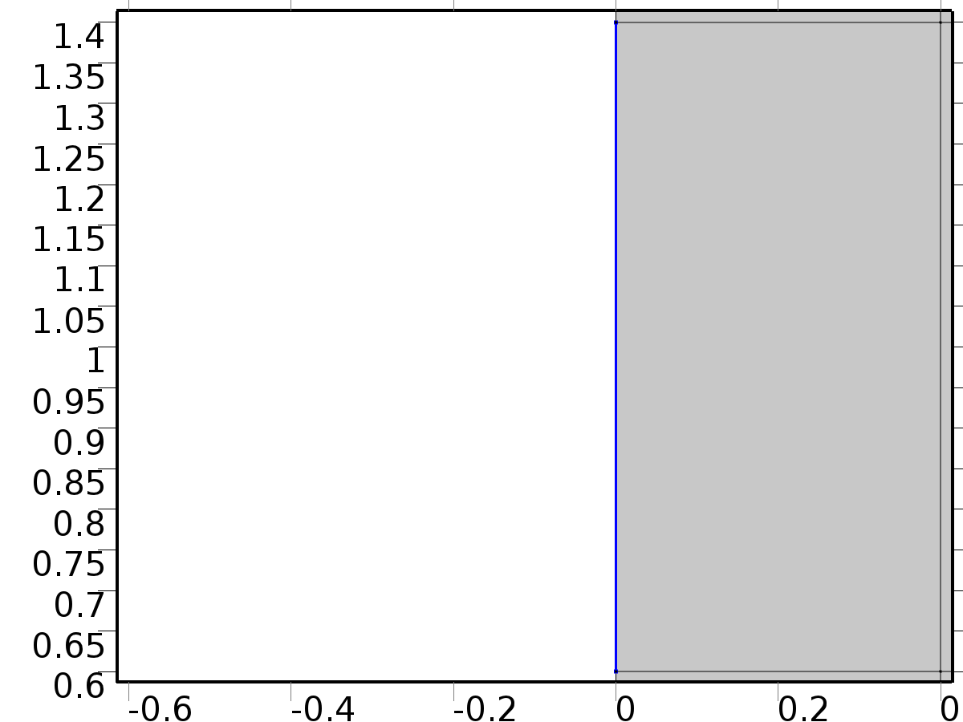

Heat Flux Bd1

Selection

|  |  |
| --- | --- |
| Geometric entity level | Boundary |
| Selection | Boundary 3 |

Equations



Settings

| **Description** | **Value** |
| --- | --- |
| Heat flux | Convective heat flux |
| Heat transfer coefficient | h1 |
| External temperature | 0 |
| Overall heat transfer rate | 0*ht.d/1[m] |
| Heat transfer coefficient | User defined |

#### Variables

| **Name** | **Expression** | **Unit** | **Description** | **Selection** |
| --- | --- | --- | --- | --- |
| X1.q0 | X1.hf2.q0 | W/m^2 | Inward heat flux | Boundary 3 |
| X1.Tvar | X1.Tu | K | Temperature | Boundary 3 |
| X1.hf2.h | h1 | W/(m^2*K) | Heat transfer coefficient | Boundary 3 |
| X1.hf2.Text | 0 | K | External temperature | Boundary 3 |
| X1.hf2.q0 | X1.hf2.h*(X1.hf2.Text-X1.Tvar) | W/m^2 | Boundary convective heat flux | Boundary 3 |
| X1.hf2.ntfluxInt | X1.hf2.intExtBnd(X1.ntflux*X1.hf2.varIntSpa) | W | Total net heat rate | Global |
| X1.hf2.ntefluxInt | X1.hf2.intExtBnd(X1.nteflux*X1.hf2.varIntSpa) | W | Total net energy rate | Global |
| X1.hf2.ntfluxInt_u | X1.hf2.intIntBnd(X1.ntflux_u*X1.hf2.varIntSpa) | W | Total net heat rate, upside | Global |
| X1.hf2.ntefluxInt_u | X1.hf2.intIntBnd(X1.nteflux_u*X1.hf2.varIntSpa) | W | Total net energy rate, upside | Global |
| X1.hf2.ntfluxInt_d | X1.hf2.intIntBnd(X1.ntflux_d*X1.hf2.varIntSpa) | W | Total net heat rate, downside | Global |
| X1.hf2.ntefluxInt_d | X1.hf2.intIntBnd(X1.nteflux_d*X1.hf2.varIntSpa) | W | Total net energy rate, downside | Global |
| X1.hf2.Tave | if(X1.hf2.intBnd(X1.hf2.varIntSpa*X1.rho*X1.Cp*(X1.ux*X1.nx+X1.uy*X1.ny+X1.uz*X1.nz))==0,X1.hf2.intBnd(X1.hf2.varIntSpa*X1)/X1.hf2.intBnd(X1.hf2.varIntSpa),X1.hf2.intBnd(X1.hf2.varIntSpa*X1.rho*X1.Cp*X1*(X1.ux*X1.nx+X1.uy*X1.ny+X1.uz*X1.nz))/X1.hf2.intBnd(X1.hf2.varIntSpa*X1.rho*X1.Cp*(X1.ux*X1.nx+X1.uy*X1.ny+X1.uz*X1.nz))) | K | Weighted average temperature | Global |

#### Weak expressions

| **Weak expression** | **Integration frame** | **Selection** |
| --- | --- | --- |
| X1.hf2.q0*test(X1.Tvar)*X1.d | Material | Boundary 3 |

* + 1. Heat Flux Bd2

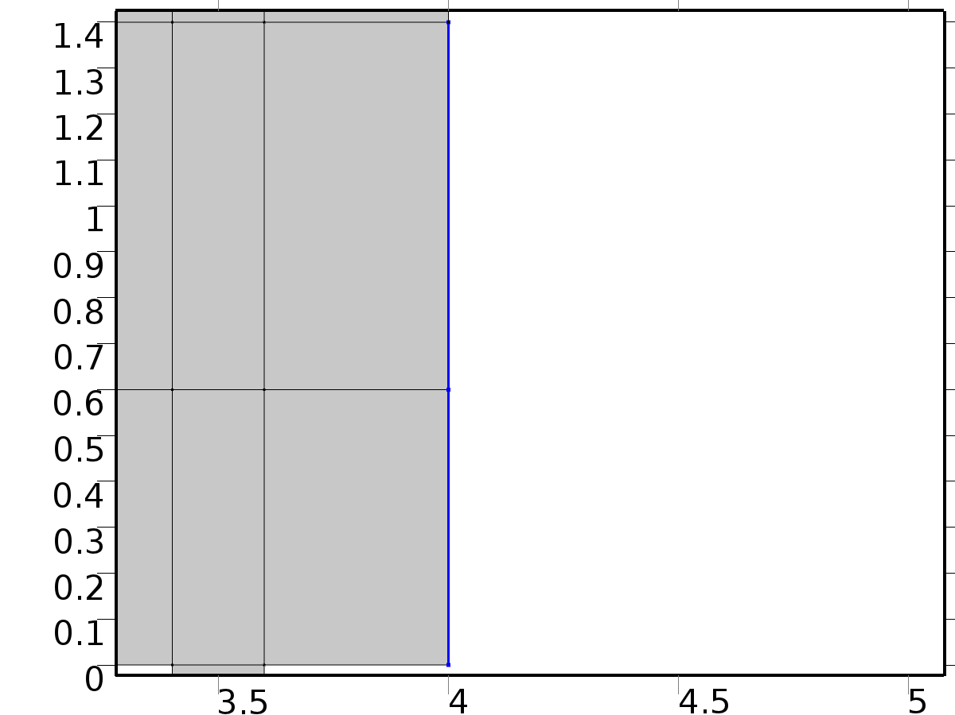

Heat Flux Bd2

Selection

|  |  |
| --- | --- |
| Geometric entity level | Boundary |
| Selection | Boundaries 56–57 |

Equations



Settings

| **Description** | **Value** |
| --- | --- |
| Heat flux | Convective heat flux |
| Heat transfer coefficient | h2 |
| External temperature | 0 |
| Overall heat transfer rate | 0*ht.d/1[m] |
| Heat transfer coefficient | User defined |

#### Variables

| **Name** | **Expression** | **Unit** | **Description** | **Selection** |
| --- | --- | --- | --- | --- |
| X1.q0 | X1.hf3.q0 | W/m^2 | Inward heat flux | Boundaries 56–57 |
| X1.Tvar | X1.Tu | K | Temperature | Boundaries 56–57 |
| X1.hf3.h | h2 | W/(m^2*K) | Heat transfer coefficient | Boundaries 56–57 |
| X1.hf3.Text | 0 | K | External temperature | Boundaries 56–57 |
| X1.hf3.q0 | X1.hf3.h*(X1.hf3.Text-X1.Tvar) | W/m^2 | Boundary convective heat flux | Boundaries 56–57 |
| X1.hf3.ntfluxInt | X1.hf3.intExtBnd(X1.ntflux*X1.hf3.varIntSpa) | W | Total net heat rate | Global |
| X1.hf3.ntefluxInt | X1.hf3.intExtBnd(X1.nteflux*X1.hf3.varIntSpa) | W | Total net energy rate | Global |
| X1.hf3.ntfluxInt_u | X1.hf3.intIntBnd(X1.ntflux_u*X1.hf3.varIntSpa) | W | Total net heat rate, upside | Global |
| X1.hf3.ntefluxInt_u | X1.hf3.intIntBnd(X1.nteflux_u*X1.hf3.varIntSpa) | W | Total net energy rate, upside | Global |
| X1.hf3.ntfluxInt_d | X1.hf3.intIntBnd(X1.ntflux_d*X1.hf3.varIntSpa) | W | Total net heat rate, downside | Global |
| X1.hf3.ntefluxInt_d | X1.hf3.intIntBnd(X1.nteflux_d*X1.hf3.varIntSpa) | W | Total net energy rate, downside | Global |
| X1.hf3.Tave | if(X1.hf3.intBnd(X1.hf3.varIntSpa*X1.rho*X1.Cp*(X1.ux*X1.nx+X1.uy*X1.ny+X1.uz*X1.nz))==0,X1.hf3.intBnd(X1.hf3.varIntSpa*X1)/X1.hf3.intBnd(X1.hf3.varIntSpa),X1.hf3.intBnd(X1.hf3.varIntSpa*X1.rho*X1.Cp*X1*(X1.ux*X1.nx+X1.uy*X1.ny+X1.uz*X1.nz))/X1.hf3.intBnd(X1.hf3.varIntSpa*X1.rho*X1.Cp*(X1.ux*X1.nx+X1.uy*X1.ny+X1.uz*X1.nz))) | K | Weighted average temperature | Global |

#### Weak expressions

| **Weak expression** | **Integration frame** | **Selection** |
| --- | --- | --- |
| X1.hf3.q0*test(X1.Tvar)*X1.d | Material | Boundaries 56–57 |

* 1. Temperature 2



Temperature 2

Selection

|  |  |
| --- | --- |
| Geometric entity level | Domain |
| Selection | Domains 1–23 |

Equations





Settings

| **Description** | **Value** |
| --- | --- |
| Temperature | Linear |
| Compute boundary fluxes | On |
| Apply smoothing to boundary fluxes | On |
| Value type when using splitting of complex variables | Real |
| Thickness | 1[m] |
| Streamline diffusion | On |
| Crosswind diffusion | On |
| Lower gradient limit | (0.01[K])/ht2.helem |
| Isotropic diffusion | Off |

Used products

|  |
| --- |
| COMSOL Multiphysics |

Variables

| **Name** | **Expression** | **Unit** | **Description** | **Selection** |
| --- | --- | --- | --- | --- |
| X2.q0 | 0 | W/m^2 | Inward heat flux | Boundaries 1–58 |
| X2.Tu | X2 | K | Temperature | Boundaries 1–58 |
| X2.Td | X2 | K | Temperature | Boundaries 1–58 |
| X2.opaqueLayer | 1 |  | Thin layer opacity | Boundaries 1–58 |
| X2.dz | 1[m] | m | Thickness | Domains 1–23 |
| X2.Tvar | X2 | K | Temperature | Domains 1–23 |
| X2.d | X2.dz | m | Thickness | Domains 1–23 |
| X2.Pc | 1 | 1 | Cross sectional perimeter | Domains 1–23 |
| X2.nx | nx | 1 | Normal vector, x component | Boundaries 4, 6, 10–15, 18, 20–23, 25, 27–30, 32, 34–37, 41–46, 49, 51–54 |
| X2.ny | ny | 1 | Normal vector, y component | Boundaries 4, 6, 10–15, 18, 20–23, 25, 27–30, 32, 34–37, 41–46, 49, 51–54 |
| X2.nz | 0 | 1 | Normal vector, z component | Boundaries 4, 6, 10–15, 18, 20–23, 25, 27–30, 32, 34–37, 41–46, 49, 51–54 |
| X2.nx | dnx | 1 | Normal vector, x component | Boundaries 1–3, 5, 7–9, 16–17, 19, 24, 26, 31, 33, 38–40, 47–48, 50, 55–58 |
| X2.ny | dny | 1 | Normal vector, y component | Boundaries 1–3, 5, 7–9, 16–17, 19, 24, 26, 31, 33, 38–40, 47–48, 50, 55–58 |
| X2.nz | 0 | 1 | Normal vector, z component | Boundaries 1–3, 5, 7–9, 16–17, 19, 24, 26, 31, 33, 38–40, 47–48, 50, 55–58 |
| X2.nxmesh | root.nxmesh | 1 | Normal vector (mesh), x component | Boundaries 4, 6, 10–15, 18, 20–23, 25, 27–30, 32, 34–37, 41–46, 49, 51–54 |
| X2.nymesh | root.nymesh | 1 | Normal vector (mesh), y component | Boundaries 4, 6, 10–15, 18, 20–23, 25, 27–30, 32, 34–37, 41–46, 49, 51–54 |
| X2.nzmesh | 0 | 1 | Normal vector (mesh), z component | Boundaries 4, 6, 10–15, 18, 20–23, 25, 27–30, 32, 34–37, 41–46, 49, 51–54 |
| X2.nxmesh | root.dnxmesh | 1 | Normal vector (mesh), x component | Boundaries 1–3, 5, 7–9, 16–17, 19, 24, 26, 31, 33, 38–40, 47–48, 50, 55–58 |
| X2.nymesh | root.dnymesh | 1 | Normal vector (mesh), y component | Boundaries 1–3, 5, 7–9, 16–17, 19, 24, 26, 31, 33, 38–40, 47–48, 50, 55–58 |
| X2.nzmesh | 0 | 1 | Normal vector (mesh), z component | Boundaries 1–3, 5, 7–9, 16–17, 19, 24, 26, 31, 33, 38–40, 47–48, 50, 55–58 |
| X2.dnx | dnx | 1 | Normal vector down direction, x component | Boundaries 1–58 |
| X2.dny | dny | 1 | Normal vector down direction, y component | Boundaries 1–58 |
| X2.dnz | 0 | 1 | Normal vector down direction, z component | Boundaries 1–58 |
| X2.unx | unx | 1 | Normal vector up direction, x component | Boundaries 1–58 |
| X2.uny | uny | 1 | Normal vector up direction, y component | Boundaries 1–58 |
| X2.unz | 0 | 1 | Normal vector up direction, z component | Boundaries 1–58 |
| X2.dEiInt | X2.intDom(d(X2.rho*X2.Ei,t)*X2.varIntSpa) | W | Total accumulated heat rate | Global |
| X2.dEi0Int | X2.intDom(d(X2.rho*X2.Ei0,t)*X2.varIntSpa) | W | Total accumulated energy rate | Global |
| X2.ntfluxInt | X2.intExtBnd(X2.ntflux*X2.varIntSpa) | W | Total net heat rate | Global |
| X2.ntefluxInt | X2.intExtBnd(X2.nteflux*X2.varIntSpa) | W | Total net energy rate | Global |
| X2.QInt | X2.intDom(X2.Qtot*X2.varIntSpa)-X2.intIntBnd((X2.ndflux_u+X2.ndflux_d)*X2.varIntSpa) | W | Total heat source | Global |
| X2.WnsInt | 0 | W | Total work source | Global |
| X2.WInt | 0 | W | Total work source | Global |

* + 1. Heat Transfer in Fluids 1



Heat Transfer in Fluids 1

Selection

|  |  |
| --- | --- |
| Geometric entity level | Domain |
| Selection | Domains 1–23 |

Equations



Settings

| **Description** | **Value** |
| --- | --- |
| Fluid type | Gas/Liquid |
| Thermal conductivity | User defined |
| Thermal conductivity | {{K, 0, 0}, {0, K, 0}, {0, 0, K}} |
| Density | User defined |
| Density | rho |
| Heat capacity at constant pressure | User defined |
| Heat capacity at constant pressure | cp |
| Ratio of specific heats | User defined |
| Ratio of specific heats | 1 |
| Equivalent conductivity for convection | Off |

#### Variables

| **Name** | **Expression** | **Unit** | **Description** | **Selection** |
| --- | --- | --- | --- | --- |
| domflux.X2x | -X2.k_effxx*X2x-X2.k_effxy*X2y | W/m^2 | Domain flux, x component | Domains 1–23 |
| domflux.X2y | -X2.k_effyx*X2x-X2.k_effyy*X2y | W/m^2 | Domain flux, y component | Domains 1–23 |
| X2.WnsInt | X2.fluid1.intDom(X2.pA*(d(X2.ux,x)+d(X2.uy,y))*X2.fluid1.varIntSpa) | W | Total work source | Global |
| X2.kxx | K | W/(m*K) | Thermal conductivity, xx component | Domains 1–23 |
| X2.kyx | 0 | W/(m*K) | Thermal conductivity, yx component | Domains 1–23 |
| X2.kzx | 0 | W/(m*K) | Thermal conductivity, zx component | Domains 1–23 |
| X2.kxy | 0 | W/(m*K) | Thermal conductivity, xy component | Domains 1–23 |
| X2.kyy | K | W/(m*K) | Thermal conductivity, yy component | Domains 1–23 |
| X2.kzy | 0 | W/(m*K) | Thermal conductivity, zy component | Domains 1–23 |
| X2.kxz | 0 | W/(m*K) | Thermal conductivity, xz component | Domains 1–23 |
| X2.kyz | 0 | W/(m*K) | Thermal conductivity, yz component | Domains 1–23 |
| X2.kzz | K | W/(m*K) | Thermal conductivity, zz component | Domains 1–23 |
| X2.rho | material.rho | kg/m^3 | Density | Domains 1–23 |
| X2.Cp | cp | J/(kg*K) | Heat capacity at constant pressure | Domains 1–23 |
| X2.gamma | 1 | 1 | Ratio of specific heats | Domains 1–23 |
| X2.fluid1.pRef | model.input.pRef | Pa | Reference pressure level | Domains 1–23 |
| X2.T | model.input.minput_temperature | K | Temperature | Domains 1–23 |
| X2.alphap | -d(X2.rho,X2)/(X2.rho+eps) | 1/K | Isobaric compressibility coefficient | Domains 1–23 |
| X2.pA | model.input.minput_pressure | Pa | Absolute pressure | Domains 1–23 |
| X2.gradTmag | sqrt(X2.gradTx^2+X2.gradTy^2+X2.gradTz^2) | K/m | Temperature gradient magnitude | Domains 1–23 |
| X2.kmean | 0.5*(X2.k_effxx+X2.k_effyy) | W/(m*K) | Mean effective thermal conductivity | Domains 1–23 |
| X2.Q | 0 | W/m^3 | Heat source | Domains 1–23 |
| X2.qs | 0 | W/(m^3*K) | Production/absorption coefficient | Domains 1–23 |
| X2.Qmet | 0 | W/m^3 | Metabolic heat source | Domains 1–23 |
| X2.Qtot | 0 | W/m^3 | Total heat source | Domains 1–23 |
| X2.rhoInt | subst(X2.rho,root.mod1.X2.fluid1.minput_pressure,X2.pA) | kg/m^3 | Density for integration | Domains 1–23 |
| X2.CpInt | subst(X2.Cp,root.mod1.X2.fluid1.minput_pressure,X2.pA) | J/(kg*K) | Specific heat capacity for integration | Domains 1–23 |
| X2.gammaInt | subst(X2.gamma,root.mod1.X2.fluid1.minput_pressure,X2.pA) | 1 | Ratio of specific heats for integration | Domains 1–23 |
| X2.TRef | 298.15[K] | K | Reference temperature | Domains 1–23 |
| X2.pRef | X2.fluid1.pRef | Pa | Reference pressure level | Domains 1–23 |
| X2.HRef | 0 | J/kg | Reference enthalpy | Domains 1–23 |
| X2.DeltaH | integrate((1+X2*d(X2.rhoInt,X2)/X2.rhoInt)/X2.rhoInt,X2.pA,X2.pRef,X2.pA)+integrate(subst(X2.CpInt,X2.pA,X2.pRef),X2,X2.TRef,X2) | J/kg | Sensible enthalpy | Domains 1–23 |
| X2.H | X2.HRef+X2.DeltaH | J/kg | Enthalpy | Domains 1–23 |
| X2.H0 | X2.H+0.5*(X2.ux^2+X2.uy^2+X2.uz^2) | J/kg | Total enthalpy | Domains 1–23 |
| X2.Ei | X2.H-X2.pA/X2.rho | J/kg | Internal energy | Domains 1–23 |
| X2.Ei0 | X2.Ei+0.5*(X2.ux^2+X2.uy^2+X2.uz^2) | J/kg | Total internal energy | Domains 1–23 |
| X2.Qbtot | 0 | W/m^2 | Total boundary heat source | Boundaries 1–58 |
| X2.k_effxx | X2.kxx | W/(m*K) | Effective thermal conductivity, xx component | Domains 1–23 |
| X2.k_effyx | X2.kyx | W/(m*K) | Effective thermal conductivity, yx component | Domains 1–23 |
| X2.k_effzx | 0 | W/(m*K) | Effective thermal conductivity, zx component | Domains 1–23 |
| X2.k_effxy | X2.kxy | W/(m*K) | Effective thermal conductivity, xy component | Domains 1–23 |
| X2.k_effyy | X2.kyy | W/(m*K) | Effective thermal conductivity, yy component | Domains 1–23 |
| X2.k_effzy | 0 | W/(m*K) | Effective thermal conductivity, zy component | Domains 1–23 |
| X2.k_effxz | 0 | W/(m*K) | Effective thermal conductivity, xz component | Domains 1–23 |
| X2.k_effyz | 0 | W/(m*K) | Effective thermal conductivity, yz component | Domains 1–23 |
| X2.k_effzz | 0 | W/(m*K) | Effective thermal conductivity, zz component | Domains 1–23 |
| X2.C_eff | X2.rho*X2.Cp | J/(m^3*K) | Effective volumetric heat capacity | Domains 1–23 |
| X2.ux | model.input.minput_velocity1 | m/s | Velocity field, x component | Domains 1–23 |
| X2.uy | model.input.minput_velocity2 | m/s | Velocity field, y component | Domains 1–23 |
| X2.uz | model.input.minput_velocity3 | m/s | Velocity field, z component | Domains 1–23 |
| X2.gradTx | X2x | K/m | Temperature gradient, x component | Domains 1–23 |
| X2.gradTy | X2y | K/m | Temperature gradient, y component | Domains 1–23 |
| X2.gradTz | 0 | K/m | Temperature gradient, z component | Domains 1–23 |
| X2.Qltot | 0 | W/m | Total line heat source | Points 1–36 |
| X2.alphaTdxx | X2.k_effxx/X2.C_eff | m^2/s | Thermal diffusivity, xx component | Domains 1–23 |
| X2.alphaTdyx | X2.k_effyx/X2.C_eff | m^2/s | Thermal diffusivity, yx component | Domains 1–23 |
| X2.alphaTdzx | X2.k_effzx/X2.C_eff | m^2/s | Thermal diffusivity, zx component | Domains 1–23 |
| X2.alphaTdxy | X2.k_effxy/X2.C_eff | m^2/s | Thermal diffusivity, xy component | Domains 1–23 |
| X2.alphaTdyy | X2.k_effyy/X2.C_eff | m^2/s | Thermal diffusivity, yy component | Domains 1–23 |
| X2.alphaTdzy | X2.k_effzy/X2.C_eff | m^2/s | Thermal diffusivity, zy component | Domains 1–23 |
| X2.alphaTdxz | X2.k_effxz/X2.C_eff | m^2/s | Thermal diffusivity, xz component | Domains 1–23 |
| X2.alphaTdyz | X2.k_effyz/X2.C_eff | m^2/s | Thermal diffusivity, yz component | Domains 1–23 |
| X2.alphaTdzz | X2.k_effzz/X2.C_eff | m^2/s | Thermal diffusivity, zz component | Domains 1–23 |
| X2.alphaTdMean | X2.kmean/X2.C_eff | m^2/s | Mean thermal diffusivity | Domains 1–23 |
| X2.dfluxx | -X2.k_effxx*X2x-X2.k_effxy*X2y | W/m^2 | Conductive heat flux, x component | Domains 1–23 |
| X2.dfluxy | -X2.k_effyx*X2x-X2.k_effyy*X2y | W/m^2 | Conductive heat flux, y component | Domains 1–23 |
| X2.dfluxz | -X2.k_effzx*X2x-X2.k_effzy*X2y | W/m^2 | Conductive heat flux, z component | Domains 1–23 |
| X2.dfluxMag | sqrt(X2.dfluxx^2+X2.dfluxy^2+X2.dfluxz^2) | W/m^2 | Conductive heat flux magnitude | Domains 1–23 |
| X2.trlfluxx | 0 | W/m^2 | Translational heat flux, x component | Domains 1–23 |
| X2.trlfluxy | 0 | W/m^2 | Translational heat flux, y component | Domains 1–23 |
| X2.trlfluxz | 0 | W/m^2 | Translational heat flux, z component | Domains 1–23 |
| X2.trlfluxMag | sqrt(X2.trlfluxx^2+X2.trlfluxy^2+X2.trlfluxz^2) | W/m^2 | Translational heat flux magnitude | Domains 1–23 |
| X2.cfluxx | X2.rho*X2.ux*X2.Ei | W/m^2 | Convective heat flux, x component | Domains 1–23 |
| X2.cfluxy | X2.rho*X2.uy*X2.Ei | W/m^2 | Convective heat flux, y component | Domains 1–23 |
| X2.cfluxz | X2.rho*X2.uz*X2.Ei | W/m^2 | Convective heat flux, z component | Domains 1–23 |
| X2.cfluxMag | sqrt(X2.cfluxx^2+X2.cfluxy^2+X2.cfluxz^2) | W/m^2 | Convective heat flux magnitude | Domains 1–23 |
| X2.tfluxx | X2.dfluxx+X2.trlfluxx+X2.cfluxx | W/m^2 | Total heat flux, x component | Domains 1–23 |
| X2.tfluxy | X2.dfluxy+X2.trlfluxy+X2.cfluxy | W/m^2 | Total heat flux, y component | Domains 1–23 |
| X2.tfluxz | X2.dfluxz+X2.trlfluxz+X2.cfluxz | W/m^2 | Total heat flux, z component | Domains 1–23 |
| X2.tfluxMag | sqrt(X2.tfluxx^2+X2.tfluxy^2+X2.tfluxz^2) | W/m^2 | Total heat flux magnitude | Domains 1–23 |
| X2.tefluxx | X2.dfluxx+X2.rho*X2.ux*X2.H0 | W/m^2 | Total energy flux, x component | Domains 1–23 |
| X2.tefluxy | X2.dfluxy+X2.rho*X2.uy*X2.H0 | W/m^2 | Total energy flux, y component | Domains 1–23 |
| X2.tefluxz | X2.dfluxz+X2.rho*X2.uz*X2.H0 | W/m^2 | Total energy flux, z component | Domains 1–23 |
| X2.tefluxMag | sqrt(X2.tefluxx^2+X2.tefluxy^2+X2.tefluxz^2) | W/m^2 | Total energy flux magnitude | Domains 1–23 |
| X2.rflux | 0 | W/m^2 | Radiative heat flux | Boundaries 1–58 |
| X2.chflux | 0 | W/m^2 | Boundary convective heat flux | Boundaries 1–58 |
| X2.ntrlflux | mean(X2.trlfluxx)*X2.nx+mean(X2.trlfluxy)*X2.ny+mean(X2.trlfluxz)*X2.nz | W/m^2 | Normal translational heat flux | Boundaries 1–58 |
| X2.ntrlflux_u | up(X2.trlfluxx)*X2.unx+up(X2.trlfluxy)*X2.uny+up(X2.trlfluxz)*X2.unz | W/m^2 | Internal normal translational heat flux, upside | Boundaries 4, 6, 10–15, 18, 20–23, 25, 27–30, 32, 34–37, 41–46, 49, 51–54 |
| X2.ntrlflux_d | down(X2.trlfluxx)*X2.dnx+down(X2.trlfluxy)*X2.dny+down(X2.trlfluxz)*X2.dnz | W/m^2 | Internal normal translational heat flux, downside | Boundaries 4, 6, 10–15, 18, 20–23, 25, 27–30, 32, 34–37, 41–46, 49, 51–54 |
| X2.ncflux | mean(X2.cfluxx)*X2.nx+mean(X2.cfluxy)*X2.ny+mean(X2.cfluxz)*X2.nz | W/m^2 | Normal convective heat flux | Boundaries 1–58 |
| X2.ncflux_u | up(X2.cfluxx)*X2.unx+up(X2.cfluxy)*X2.uny+up(X2.cfluxz)*X2.unz | W/m^2 | Internal normal convective heat flux, upside | Boundaries 4, 6, 10–15, 18, 20–23, 25, 27–30, 32, 34–37, 41–46, 49, 51–54 |
| X2.ncflux_d | down(X2.cfluxx)*X2.dnx+down(X2.cfluxy)*X2.dny+down(X2.cfluxz)*X2.dnz | W/m^2 | Internal normal convective heat flux, downside | Boundaries 4, 6, 10–15, 18, 20–23, 25, 27–30, 32, 34–37, 41–46, 49, 51–54 |
| X2.ndflux | -dflux_spatial(X2) | W/m^2 | Normal conductive heat flux | Boundaries 1–3, 5, 7–9, 16–17, 19, 24, 26, 31, 33, 38–40, 47–48, 50, 55–58 |
| X2.ndflux | 0.5*(uflux_spatial(X2)-dflux_spatial(X2)) | W/m^2 | Normal conductive heat flux | Boundaries 4, 6, 10–15, 18, 20–23, 25, 27–30, 32, 34–37, 41–46, 49, 51–54 |
| X2.ndflux_u | -uflux_spatial(X2) | W/m^2 | Internal normal conductive heat flux, upside | Boundaries 4, 6, 10–15, 18, 20–23, 25, 27–30, 32, 34–37, 41–46, 49, 51–54 |
| X2.ndflux_d | -dflux_spatial(X2) | W/m^2 | Internal normal conductive heat flux, downside | Boundaries 4, 6, 10–15, 18, 20–23, 25, 27–30, 32, 34–37, 41–46, 49, 51–54 |
| X2.ntflux | X2.ndflux+X2.ntrlflux+X2.ncflux | W/m^2 | Normal total heat flux | Boundaries 1–58 |
| X2.ntflux_u | X2.ndflux_u+X2.ntrlflux_u+X2.ncflux_u | W/m^2 | Internal normal total flux, upside | Boundaries 4, 6, 10–15, 18, 20–23, 25, 27–30, 32, 34–37, 41–46, 49, 51–54 |
| X2.ntflux_d | X2.ndflux_d+X2.ntrlflux_d+X2.ncflux_d | W/m^2 | Internal normal total flux, downside | Boundaries 4, 6, 10–15, 18, 20–23, 25, 27–30, 32, 34–37, 41–46, 49, 51–54 |
| X2.nteflux | mean(X2.tefluxx)*X2.nx+mean(X2.tefluxy)*X2.ny+mean(X2.tefluxz)*X2.nz-mean(X2.dfluxx)*X2.nx-mean(X2.dfluxy)*X2.ny-mean(X2.dfluxz)*X2.nz+X2.ndflux | W/m^2 | Normal total energy flux | Boundaries 1–58 |
| X2.nteflux_u | up(X2.tefluxx)*X2.unx+up(X2.tefluxy)*X2.uny+up(X2.tefluxz)*X2.unz-up(X2.dfluxx)*X2.unx-up(X2.dfluxy)*X2.uny-up(X2.dfluxz)*X2.unz+X2.ndflux_u | W/m^2 | Internal normal total energy flux, upside | Boundaries 4, 6, 10–15, 18, 20–23, 25, 27–30, 32, 34–37, 41–46, 49, 51–54 |
| X2.nteflux_d | down(X2.tefluxx)*X2.dnx+down(X2.tefluxy)*X2.dny+down(X2.tefluxz)*X2.dnz-down(X2.dfluxx)*X2.dnx-down(X2.dfluxy)*X2.dny-down(X2.dfluxz)*X2.dnz+X2.ndflux_d | W/m^2 | Internal normal total energy flux, downside | Boundaries 4, 6, 10–15, 18, 20–23, 25, 27–30, 32, 34–37, 41–46, 49, 51–54 |
| X2.q0_u | 0 | W/m^2 | Out-of-plane heat flux, upside | Domains 1–23 |
| X2.q0_d | 0 | W/m^2 | Out-of-plane heat flux, downside | Domains 1–23 |
| X2.rflux_u | 0 | W/m^2 | Radiative out-of-plane heat flux, upside | Domains 1–23 |
| X2.rflux_d | 0 | W/m^2 | Radiative out-of-plane heat flux, downside | Domains 1–23 |
| X2.chflux_u | 0 | W/m^2 | Convective out-of-plane heat flux, upside | Domains 1–23 |
| X2.chflux_d | 0 | W/m^2 | Convective out-of-plane heat flux, downside | Domains 1–23 |
| X2.tflux_u | X2.chflux_u+X2.q0_u+X2.rflux_u | W/m^2 | Total out-of-plane heat flux, upside | Domains 1–23 |
| X2.tflux_d | X2.chflux_d+X2.q0_d+X2.rflux_d | W/m^2 | Total out-of-plane heat flux, downside | Domains 1–23 |
| X2.fluid1.dEiInt | X2.fluid1.intDom(d(X2.rho*X2.Ei,t)*X2.fluid1.varIntSpa) | W | Total accumulated heat rate | Global |
| X2.fluid1.dEi0Int | X2.fluid1.intDom(d(X2.rho*X2.Ei0,t)*X2.fluid1.varIntSpa) | W | Total accumulated energy rate | Global |
| X2.fluid1.ntfluxInt | X2.fluid1.intExtBnd(X2.ntflux*X2.fluid1.varIntSpa)+X2.fluid1.intExtBndUp(X2.ntflux_u*X2.fluid1.varIntSpa)+X2.fluid1.intExtBndDown(X2.ntflux_d*X2.fluid1.varIntSpa) | W | Total net heat rate | Global |
| X2.fluid1.ntefluxInt | X2.fluid1.intExtBnd(X2.nteflux*X2.fluid1.varIntSpa)+X2.fluid1.intExtBndUp(X2.nteflux_u*X2.fluid1.varIntSpa)+X2.fluid1.intExtBndDown(X2.nteflux_d*X2.fluid1.varIntSpa) | W | Total net energy rate | Global |
| X2.fluid1.QInt | X2.fluid1.intDom(X2.Qtot*X2.fluid1.varIntSpa)-X2.fluid1.intIntBnd((X2.ndflux_u+X2.ndflux_d)*X2.fluid1.varIntSpa) | W | Total heat source | Global |
| X2.fluid1.WnsInt | X2.fluid1.intDom(X2.pA*(d(X2.ux,x)+d(X2.uy,y))*X2.fluid1.varIntSpa) | W | Total work source | Global |
| X2.fluid1.WInt | 0 | W | Total work source | Global |
| X2.c_s | sqrt(X2.gamma/max(subst(d(X2.rhoInt,X2.pA),X2.pA,model.input.minput_pressure),eps)) | m/s | Speed of sound | Domains 1–23 |
| X2.Ma | sqrt(model.input.minput_velocity1^2+model.input.minput_velocity2^2+model.input.minput_velocity3^2)/X2.c_s | 1 | Mach number | Domains 1–23 |
| X2.cellPe | 0.5*X2.rho*X2.Cp*h*sqrt(X2.ux^2+X2.uy^2+X2.uz^2)/X2.kmean | 1 | Cell Péclet number | Domains 1–23 |
| X2.helem | h | m | Element size | Domains 1–23 |
| X2.res_T | X2.d*(-X2.k_effxx*X2xx-X2.k_effxy*X2xy-X2.k_effyx*X2yx-X2.k_effyy*X2yy-(X2.qs+X2.qs_oop)*X2+X2.rho*X2.Cp*(X2.ux*X2x+X2.uy*X2y)-X2.Q-X2.Qoop) | W/m^3 | Equation residual | Domains 1–23 |

#### Shape functions

| **Name** | **Shape function** | **Unit** | **Description** | **Shape frame** | **Selection** |
| --- | --- | --- | --- | --- | --- |
| X2 | Lagrange (Linear) | K | Temperature | Material | Domains 1–23 |

#### Weak expressions

| **Weak expression** | **Integration frame** | **Selection** |
| --- | --- | --- |
| (-(X2.k_effxx*X2x+X2.k_effxy*X2y)*test(X2x)-(X2.k_effyx*X2x+X2.k_effyy*X2y)*test(X2y))*X2.d | Material | Domains 1–23 |
| -X2.rho*X2.Cp*(X2.ux*X2x+X2.uy*X2y)*test(X2)*X2.d | Material | Domains 1–23 |
| X2.crosswind | Material | Domains 1–23 |
| X2.streamline | Material | Domains 1–23 |

* + 1. Thermal Insulation 1



Thermal Insulation 1

Selection

|  |  |
| --- | --- |
| Geometric entity level | Boundary |
| Selection | Boundaries 1–2, 5, 7–8, 16–17, 19, 24, 31, 33, 38–39, 47–48, 50, 55, 58 |

Equations



#### Variables

| **Name** | **Expression** | **Unit** | **Description** | **Selection** |
| --- | --- | --- | --- | --- |
| X2.ins1.ntfluxInt | X2.ins1.intExtBnd(X2.ntflux*X2.ins1.varIntSpa) | W | Total net heat rate | Global |
| X2.ins1.ntefluxInt | X2.ins1.intExtBnd(X2.nteflux*X2.ins1.varIntSpa) | W | Total net energy rate | Global |
| X2.ins1.ntfluxInt_u | X2.ins1.intIntBnd(X2.ntflux_u*X2.ins1.varIntSpa) | W | Total net heat rate, upside | Global |
| X2.ins1.ntefluxInt_u | X2.ins1.intIntBnd(X2.nteflux_u*X2.ins1.varIntSpa) | W | Total net energy rate, upside | Global |
| X2.ins1.ntfluxInt_d | X2.ins1.intIntBnd(X2.ntflux_d*X2.ins1.varIntSpa) | W | Total net heat rate, downside | Global |
| X2.ins1.ntefluxInt_d | X2.ins1.intIntBnd(X2.nteflux_d*X2.ins1.varIntSpa) | W | Total net energy rate, downside | Global |
| X2.ins1.Tave | if(X2.ins1.intBnd(X2.ins1.varIntSpa*X2.rho*X2.Cp*(X2.ux*X2.nx+X2.uy*X2.ny+X2.uz*X2.nz))==0,X2.ins1.intBnd(X2.ins1.varIntSpa*X2)/X2.ins1.intBnd(X2.ins1.varIntSpa),X2.ins1.intBnd(X2.ins1.varIntSpa*X2.rho*X2.Cp*X2*(X2.ux*X2.nx+X2.uy*X2.ny+X2.uz*X2.nz))/X2.ins1.intBnd(X2.ins1.varIntSpa*X2.rho*X2.Cp*(X2.ux*X2.nx+X2.uy*X2.ny+X2.uz*X2.nz))) | K | Weighted average temperature | Global |

* + 1. Initial Values 1



Initial Values 1

Selection

|  |  |
| --- | --- |
| Geometric entity level | Domain |
| Selection | Domains 1–23 |

#### Variables

| **Name** | **Expression** | **Unit** | **Description** | **Selection** |
| --- | --- | --- | --- | --- |
| X2.Tinit | 0 | K | Temperature | Domains 1–23 |

* + 1. Outflow 1



Outflow 1

Selection

|  |  |
| --- | --- |
| Geometric entity level | Boundary |
| Selection | Boundary 9 |

Equations



#### Variables

| **Name** | **Expression** | **Unit** | **Description** | **Selection** |
| --- | --- | --- | --- | --- |
| X2.ofl1.ntfluxInt | X2.ofl1.intExtBnd(X2.ntflux*X2.ofl1.varIntSpa) | W | Total net heat rate | Global |
| X2.ofl1.ntefluxInt | X2.ofl1.intExtBnd(X2.nteflux*X2.ofl1.varIntSpa) | W | Total net energy rate | Global |
| X2.ofl1.ntfluxInt_u | X2.ofl1.intIntBnd(X2.ntflux_u*X2.ofl1.varIntSpa) | W | Total net heat rate, upside | Global |
| X2.ofl1.ntefluxInt_u | X2.ofl1.intIntBnd(X2.nteflux_u*X2.ofl1.varIntSpa) | W | Total net energy rate, upside | Global |
| X2.ofl1.ntfluxInt_d | X2.ofl1.intIntBnd(X2.ntflux_d*X2.ofl1.varIntSpa) | W | Total net heat rate, downside | Global |
| X2.ofl1.ntefluxInt_d | X2.ofl1.intIntBnd(X2.nteflux_d*X2.ofl1.varIntSpa) | W | Total net energy rate, downside | Global |
| X2.ofl1.Tave | if(X2.ofl1.intBnd(X2.ofl1.varIntSpa*X2.rho*X2.Cp*(X2.ux*X2.nx+X2.uy*X2.ny+X2.uz*X2.nz))==0,X2.ofl1.intBnd(X2.ofl1.varIntSpa*X2)/X2.ofl1.intBnd(X2.ofl1.varIntSpa),X2.ofl1.intBnd(X2.ofl1.varIntSpa*X2.rho*X2.Cp*X2*(X2.ux*X2.nx+X2.uy*X2.ny+X2.uz*X2.nz))/X2.ofl1.intBnd(X2.ofl1.varIntSpa*X2.rho*X2.Cp*(X2.ux*X2.nx+X2.uy*X2.ny+X2.uz*X2.nz))) | K | Weighted average temperature | Global |

* + 1. Temperature Bin1



Temperature Bin1

Selection

|  |  |
| --- | --- |
| Geometric entity level | Boundary |
| Selection | Boundary 40 |

Equations



Settings

| **Description** | **Value** |
| --- | --- |
| Temperature | 0 |
|  | Classic constraints |
| Apply reaction terms on | All physics (symmetric) |
| Use weak constraints | Off |
| Constraint method | Elemental |

#### Variables

| **Name** | **Expression** | **Unit** | **Description** | **Selection** |
| --- | --- | --- | --- | --- |
| X2.Tvar | X2 | K | Temperature | Boundary 40 |
| X2.T0 | 0 | K | Temperature | Boundary 40 |
| X2.temp1.ntfluxInt | X2.temp1.intExtBnd(X2.ntflux*X2.temp1.varIntSpa) | W | Total net heat rate | Global |
| X2.temp1.ntefluxInt | X2.temp1.intExtBnd(X2.nteflux*X2.temp1.varIntSpa) | W | Total net energy rate | Global |
| X2.temp1.ntfluxInt_u | X2.temp1.intIntBnd(X2.ntflux_u*X2.temp1.varIntSpa) | W | Total net heat rate, upside | Global |
| X2.temp1.ntefluxInt_u | X2.temp1.intIntBnd(X2.nteflux_u*X2.temp1.varIntSpa) | W | Total net energy rate, upside | Global |
| X2.temp1.ntfluxInt_d | X2.temp1.intIntBnd(X2.ntflux_d*X2.temp1.varIntSpa) | W | Total net heat rate, downside | Global |
| X2.temp1.ntefluxInt_d | X2.temp1.intIntBnd(X2.nteflux_d*X2.temp1.varIntSpa) | W | Total net energy rate, downside | Global |
| X2.temp1.Tave | if(X2.temp1.intBnd(X2.temp1.varIntSpa*X2.rho*X2.Cp*(X2.ux*X2.nx+X2.uy*X2.ny+X2.uz*X2.nz))==0,X2.temp1.intBnd(X2.temp1.varIntSpa*X2)/X2.temp1.intBnd(X2.temp1.varIntSpa),X2.temp1.intBnd(X2.temp1.varIntSpa*X2.rho*X2.Cp*X2*(X2.ux*X2.nx+X2.uy*X2.ny+X2.uz*X2.nz))/X2.temp1.intBnd(X2.temp1.varIntSpa*X2.rho*X2.Cp*(X2.ux*X2.nx+X2.uy*X2.ny+X2.uz*X2.nz))) | K | Weighted average temperature | Global |

#### Shape functions

| **Constraint** | **Constraint force** | **Shape function** | **Selection** |
| --- | --- | --- | --- |
| X2.T0-X2.Tvar | test(X2.T0-X2.Tvar) | Lagrange (Linear) | Boundary 40 |

* + 1. Heat Flux Bin2



Heat Flux Bin2

Selection

|  |  |
| --- | --- |
| Geometric entity level | Boundary |
| Selection | Boundary 26 |

Equations



Settings

| **Description** | **Value** |
| --- | --- |
| Heat flux | General inward heat flux |
| Inward heat flux | 1 |
| Overall heat transfer rate | 0*ht2.d/1[m] |

#### Variables

| **Name** | **Expression** | **Unit** | **Description** | **Selection** |
| --- | --- | --- | --- | --- |
| X2.q0 | X2.hf1.q0 | W/m^2 | Inward heat flux | Boundary 26 |
| X2.Tvar | X2.Tu | K | Temperature | Boundary 26 |
| X2.hf1.q0 | 1 | W/m^2 | Inward heat flux | Boundary 26 |
| X2.hf1.ntfluxInt | X2.hf1.intExtBnd(X2.ntflux*X2.hf1.varIntSpa) | W | Total net heat rate | Global |
| X2.hf1.ntefluxInt | X2.hf1.intExtBnd(X2.nteflux*X2.hf1.varIntSpa) | W | Total net energy rate | Global |
| X2.hf1.ntfluxInt_u | X2.hf1.intIntBnd(X2.ntflux_u*X2.hf1.varIntSpa) | W | Total net heat rate, upside | Global |
| X2.hf1.ntefluxInt_u | X2.hf1.intIntBnd(X2.nteflux_u*X2.hf1.varIntSpa) | W | Total net energy rate, upside | Global |
| X2.hf1.ntfluxInt_d | X2.hf1.intIntBnd(X2.ntflux_d*X2.hf1.varIntSpa) | W | Total net heat rate, downside | Global |
| X2.hf1.ntefluxInt_d | X2.hf1.intIntBnd(X2.nteflux_d*X2.hf1.varIntSpa) | W | Total net energy rate, downside | Global |
| X2.hf1.Tave | if(X2.hf1.intBnd(X2.hf1.varIntSpa*X2.rho*X2.Cp*(X2.ux*X2.nx+X2.uy*X2.ny+X2.uz*X2.nz))==0,X2.hf1.intBnd(X2.hf1.varIntSpa*X2)/X2.hf1.intBnd(X2.hf1.varIntSpa),X2.hf1.intBnd(X2.hf1.varIntSpa*X2.rho*X2.Cp*X2*(X2.ux*X2.nx+X2.uy*X2.ny+X2.uz*X2.nz))/X2.hf1.intBnd(X2.hf1.varIntSpa*X2.rho*X2.Cp*(X2.ux*X2.nx+X2.uy*X2.ny+X2.uz*X2.nz))) | K | Weighted average temperature | Global |

#### Weak expressions

| **Weak expression** | **Integration frame** | **Selection** |
| --- | --- | --- |
| X2.hf1.q0*test(X2.Tvar)*X2.d | Material | Boundary 26 |

* + 1. Heat Flux Bd1



Heat Flux Bd1

Selection

|  |  |
| --- | --- |
| Geometric entity level | Boundary |
| Selection | Boundary 3 |

Equations



Settings

| **Description** | **Value** |
| --- | --- |
| Heat flux | Convective heat flux |
| Heat transfer coefficient | h1 |
| External temperature | 0 |
| Overall heat transfer rate | 0*ht2.d/1[m] |
| Heat transfer coefficient | User defined |

#### Variables

| **Name** | **Expression** | **Unit** | **Description** | **Selection** |
| --- | --- | --- | --- | --- |
| X2.q0 | X2.hf2.q0 | W/m^2 | Inward heat flux | Boundary 3 |
| X2.Tvar | X2.Tu | K | Temperature | Boundary 3 |
| X2.hf2.h | h1 | W/(m^2*K) | Heat transfer coefficient | Boundary 3 |
| X2.hf2.Text | 0 | K | External temperature | Boundary 3 |
| X2.hf2.q0 | X2.hf2.h*(X2.hf2.Text-X2.Tvar) | W/m^2 | Boundary convective heat flux | Boundary 3 |
| X2.hf2.ntfluxInt | X2.hf2.intExtBnd(X2.ntflux*X2.hf2.varIntSpa) | W | Total net heat rate | Global |
| X2.hf2.ntefluxInt | X2.hf2.intExtBnd(X2.nteflux*X2.hf2.varIntSpa) | W | Total net energy rate | Global |
| X2.hf2.ntfluxInt_u | X2.hf2.intIntBnd(X2.ntflux_u*X2.hf2.varIntSpa) | W | Total net heat rate, upside | Global |
| X2.hf2.ntefluxInt_u | X2.hf2.intIntBnd(X2.nteflux_u*X2.hf2.varIntSpa) | W | Total net energy rate, upside | Global |
| X2.hf2.ntfluxInt_d | X2.hf2.intIntBnd(X2.ntflux_d*X2.hf2.varIntSpa) | W | Total net heat rate, downside | Global |
| X2.hf2.ntefluxInt_d | X2.hf2.intIntBnd(X2.nteflux_d*X2.hf2.varIntSpa) | W | Total net energy rate, downside | Global |
| X2.hf2.Tave | if(X2.hf2.intBnd(X2.hf2.varIntSpa*X2.rho*X2.Cp*(X2.ux*X2.nx+X2.uy*X2.ny+X2.uz*X2.nz))==0,X2.hf2.intBnd(X2.hf2.varIntSpa*X2)/X2.hf2.intBnd(X2.hf2.varIntSpa),X2.hf2.intBnd(X2.hf2.varIntSpa*X2.rho*X2.Cp*X2*(X2.ux*X2.nx+X2.uy*X2.ny+X2.uz*X2.nz))/X2.hf2.intBnd(X2.hf2.varIntSpa*X2.rho*X2.Cp*(X2.ux*X2.nx+X2.uy*X2.ny+X2.uz*X2.nz))) | K | Weighted average temperature | Global |

#### Weak expressions

| **Weak expression** | **Integration frame** | **Selection** |
| --- | --- | --- |
| X2.hf2.q0*test(X2.Tvar)*X2.d | Material | Boundary 3 |

* + 1. Heat Flux Bd2



Heat Flux Bd2

Selection

|  |  |
| --- | --- |
| Geometric entity level | Boundary |
| Selection | Boundaries 56–57 |

Equations



Settings

| **Description** | **Value** |
| --- | --- |
| Heat flux | Convective heat flux |
| Heat transfer coefficient | h2 |
| External temperature | 0 |
| Overall heat transfer rate | 0*ht2.d/1[m] |
| Heat transfer coefficient | User defined |

#### Variables

| **Name** | **Expression** | **Unit** | **Description** | **Selection** |
| --- | --- | --- | --- | --- |
| X2.q0 | X2.hf3.q0 | W/m^2 | Inward heat flux | Boundaries 56–57 |
| X2.Tvar | X2.Tu | K | Temperature | Boundaries 56–57 |
| X2.hf3.h | h2 | W/(m^2*K) | Heat transfer coefficient | Boundaries 56–57 |
| X2.hf3.Text | 0 | K | External temperature | Boundaries 56–57 |
| X2.hf3.q0 | X2.hf3.h*(X2.hf3.Text-X2.Tvar) | W/m^2 | Boundary convective heat flux | Boundaries 56–57 |
| X2.hf3.ntfluxInt | X2.hf3.intExtBnd(X2.ntflux*X2.hf3.varIntSpa) | W | Total net heat rate | Global |
| X2.hf3.ntefluxInt | X2.hf3.intExtBnd(X2.nteflux*X2.hf3.varIntSpa) | W | Total net energy rate | Global |
| X2.hf3.ntfluxInt_u | X2.hf3.intIntBnd(X2.ntflux_u*X2.hf3.varIntSpa) | W | Total net heat rate, upside | Global |
| X2.hf3.ntefluxInt_u | X2.hf3.intIntBnd(X2.nteflux_u*X2.hf3.varIntSpa) | W | Total net energy rate, upside | Global |
| X2.hf3.ntfluxInt_d | X2.hf3.intIntBnd(X2.ntflux_d*X2.hf3.varIntSpa) | W | Total net heat rate, downside | Global |
| X2.hf3.ntefluxInt_d | X2.hf3.intIntBnd(X2.nteflux_d*X2.hf3.varIntSpa) | W | Total net energy rate, downside | Global |
| X2.hf3.Tave | if(X2.hf3.intBnd(X2.hf3.varIntSpa*X2.rho*X2.Cp*(X2.ux*X2.nx+X2.uy*X2.ny+X2.uz*X2.nz))==0,X2.hf3.intBnd(X2.hf3.varIntSpa*X2)/X2.hf3.intBnd(X2.hf3.varIntSpa),X2.hf3.intBnd(X2.hf3.varIntSpa*X2.rho*X2.Cp*X2*(X2.ux*X2.nx+X2.uy*X2.ny+X2.uz*X2.nz))/X2.hf3.intBnd(X2.hf3.varIntSpa*X2.rho*X2.Cp*(X2.ux*X2.nx+X2.uy*X2.ny+X2.uz*X2.nz))) | K | Weighted average temperature | Global |

#### Weak expressions

| **Weak expression** | **Integration frame** | **Selection** |
| --- | --- | --- |
| X2.hf3.q0*test(X2.Tvar)*X2.d | Material | Boundaries 56–57 |

* 1. Temperature 3



Temperature 3

Selection

|  |  |
| --- | --- |
| Geometric entity level | Domain |
| Selection | Domains 1–23 |

Equations





Settings

| **Description** | **Value** |
| --- | --- |
| Temperature | Linear |
| Compute boundary fluxes | On |
| Apply smoothing to boundary fluxes | On |
| Value type when using splitting of complex variables | Real |
| Thickness | 1[m] |
| Streamline diffusion | On |
| Crosswind diffusion | On |
| Lower gradient limit | (0.01[K])/ht.helem |
| Isotropic diffusion | Off |

Used products

|  |
| --- |
| COMSOL Multiphysics |

Variables

| **Name** | **Expression** | **Unit** | **Description** | **Selection** |
| --- | --- | --- | --- | --- |
| Z1.q0 | 0 | W/m^2 | Inward heat flux | Boundaries 1–58 |
| Z1.Tu | Z1 | K | Temperature | Boundaries 1–58 |
| Z1.Td | Z1 | K | Temperature | Boundaries 1–58 |
| Z1.opaqueLayer | 1 |  | Thin layer opacity | Boundaries 1–58 |
| Z1.dz | 1[m] | m | Thickness | Domains 1–23 |
| Z1.Tvar | Z1 | K | Temperature | Domains 1–23 |
| Z1.d | Z1.dz | m | Thickness | Domains 1–23 |
| Z1.Pc | 1 | 1 | Cross sectional perimeter | Domains 1–23 |
| Z1.nx | nx | 1 | Normal vector, x component | Boundaries 4, 6, 10–15, 18, 20–23, 25, 27–30, 32, 34–37, 41–46, 49, 51–54 |
| Z1.ny | ny | 1 | Normal vector, y component | Boundaries 4, 6, 10–15, 18, 20–23, 25, 27–30, 32, 34–37, 41–46, 49, 51–54 |
| Z1.nz | 0 | 1 | Normal vector, z component | Boundaries 4, 6, 10–15, 18, 20–23, 25, 27–30, 32, 34–37, 41–46, 49, 51–54 |
| Z1.nx | dnx | 1 | Normal vector, x component | Boundaries 1–3, 5, 7–9, 16–17, 19, 24, 26, 31, 33, 38–40, 47–48, 50, 55–58 |
| Z1.ny | dny | 1 | Normal vector, y component | Boundaries 1–3, 5, 7–9, 16–17, 19, 24, 26, 31, 33, 38–40, 47–48, 50, 55–58 |
| Z1.nz | 0 | 1 | Normal vector, z component | Boundaries 1–3, 5, 7–9, 16–17, 19, 24, 26, 31, 33, 38–40, 47–48, 50, 55–58 |
| Z1.nxmesh | root.nxmesh | 1 | Normal vector (mesh), x component | Boundaries 4, 6, 10–15, 18, 20–23, 25, 27–30, 32, 34–37, 41–46, 49, 51–54 |
| Z1.nymesh | root.nymesh | 1 | Normal vector (mesh), y component | Boundaries 4, 6, 10–15, 18, 20–23, 25, 27–30, 32, 34–37, 41–46, 49, 51–54 |
| Z1.nzmesh | 0 | 1 | Normal vector (mesh), z component | Boundaries 4, 6, 10–15, 18, 20–23, 25, 27–30, 32, 34–37, 41–46, 49, 51–54 |
| Z1.nxmesh | root.dnxmesh | 1 | Normal vector (mesh), x component | Boundaries 1–3, 5, 7–9, 16–17, 19, 24, 26, 31, 33, 38–40, 47–48, 50, 55–58 |
| Z1.nymesh | root.dnymesh | 1 | Normal vector (mesh), y component | Boundaries 1–3, 5, 7–9, 16–17, 19, 24, 26, 31, 33, 38–40, 47–48, 50, 55–58 |
| Z1.nzmesh | 0 | 1 | Normal vector (mesh), z component | Boundaries 1–3, 5, 7–9, 16–17, 19, 24, 26, 31, 33, 38–40, 47–48, 50, 55–58 |
| Z1.dnx | dnx | 1 | Normal vector down direction, x component | Boundaries 1–58 |
| Z1.dny | dny | 1 | Normal vector down direction, y component | Boundaries 1–58 |
| Z1.dnz | 0 | 1 | Normal vector down direction, z component | Boundaries 1–58 |
| Z1.unx | unx | 1 | Normal vector up direction, x component | Boundaries 1–58 |
| Z1.uny | uny | 1 | Normal vector up direction, y component | Boundaries 1–58 |
| Z1.unz | 0 | 1 | Normal vector up direction, z component | Boundaries 1–58 |
| Z1.dEiInt | Z1.intDom(d(Z1.rho*Z1.Ei,t)*Z1.varIntSpa) | W | Total accumulated heat rate | Global |
| Z1.dEi0Int | Z1.intDom(d(Z1.rho*Z1.Ei0,t)*Z1.varIntSpa) | W | Total accumulated energy rate | Global |
| Z1.ntfluxInt | Z1.intExtBnd(Z1.ntflux*Z1.varIntSpa) | W | Total net heat rate | Global |
| Z1.ntefluxInt | Z1.intExtBnd(Z1.nteflux*Z1.varIntSpa) | W | Total net energy rate | Global |
| Z1.QInt | Z1.intDom(Z1.Qtot*Z1.varIntSpa)-Z1.intIntBnd((Z1.ndflux_u+Z1.ndflux_d)*Z1.varIntSpa) | W | Total heat source | Global |
| Z1.WnsInt | 0 | W | Total work source | Global |
| Z1.WInt | 0 | W | Total work source | Global |

* + 1. Heat Transfer in Fluids 1



Heat Transfer in Fluids 1

Selection

|  |  |
| --- | --- |
| Geometric entity level | Domain |
| Selection | Domains 1–23 |

Equations



Settings

| **Description** | **Value** |
| --- | --- |
| Fluid type | Gas/Liquid |
| Thermal conductivity | User defined |
| Thermal conductivity | {{K, 0, 0}, {0, K, 0}, {0, 0, K}} |
| Density | User defined |
| Density | rho |
| Heat capacity at constant pressure | User defined |
| Heat capacity at constant pressure | cp |
| Ratio of specific heats | User defined |
| Ratio of specific heats | 1 |
| Equivalent conductivity for convection | Off |

#### Variables

| **Name** | **Expression** | **Unit** | **Description** | **Selection** |
| --- | --- | --- | --- | --- |
| domflux.Z1x | -Z1.k_effxx*Z1x-Z1.k_effxy*Z1y | W/m^2 | Domain flux, x component | Domains 1–23 |
| domflux.Z1y | -Z1.k_effyx*Z1x-Z1.k_effyy*Z1y | W/m^2 | Domain flux, y component | Domains 1–23 |
| Z1.WnsInt | Z1.fluid1.intDom(Z1.pA*(d(Z1.ux,x)+d(Z1.uy,y))*Z1.fluid1.varIntSpa) | W | Total work source | Global |
| Z1.Q | 0 | W/m^3 | Heat source | Domains 1–23 |
| Z1.Qtot | 0 | W/m^3 | Total heat source | Domains 1–23 |
| Z1.kxx | K | W/(m*K) | Thermal conductivity, xx component | Domains 1–23 |
| Z1.kyx | 0 | W/(m*K) | Thermal conductivity, yx component | Domains 1–23 |
| Z1.kzx | 0 | W/(m*K) | Thermal conductivity, zx component | Domains 1–23 |
| Z1.kxy | 0 | W/(m*K) | Thermal conductivity, xy component | Domains 1–23 |
| Z1.kyy | K | W/(m*K) | Thermal conductivity, yy component | Domains 1–23 |
| Z1.kzy | 0 | W/(m*K) | Thermal conductivity, zy component | Domains 1–23 |
| Z1.kxz | 0 | W/(m*K) | Thermal conductivity, xz component | Domains 1–23 |
| Z1.kyz | 0 | W/(m*K) | Thermal conductivity, yz component | Domains 1–23 |
| Z1.kzz | K | W/(m*K) | Thermal conductivity, zz component | Domains 1–23 |
| Z1.rho | material.rho | kg/m^3 | Density | Domains 1–23 |
| Z1.Cp | cp | J/(kg*K) | Heat capacity at constant pressure | Domains 1–23 |
| Z1.gamma | 1 | 1 | Ratio of specific heats | Domains 1–23 |
| Z1.fluid1.pRef | model.input.pRef | Pa | Reference pressure level | Domains 1–23 |
| Z1.T | model.input.minput_temperature | K | Temperature | Domains 1–23 |
| Z1.alphap | -d(Z1.rho,Z1)/(Z1.rho+eps) | 1/K | Isobaric compressibility coefficient | Domains 1–23 |
| Z1.pA | model.input.minput_pressure | Pa | Absolute pressure | Domains 1–23 |
| Z1.gradTmag | sqrt(Z1.gradTx^2+Z1.gradTy^2+Z1.gradTz^2) | K/m | Temperature gradient magnitude | Domains 1–23 |
| Z1.kmean | 0.5*(Z1.k_effxx+Z1.k_effyy) | W/(m*K) | Mean effective thermal conductivity | Domains 1–23 |
| Z1.qs | 0 | W/(m^3*K) | Production/absorption coefficient | Domains 1–23 |
| Z1.Qmet | 0 | W/m^3 | Metabolic heat source | Domains 1–23 |
| Z1.rhoInt | subst(Z1.rho,root.mod1.Z1.fluid1.minput_pressure,Z1.pA) | kg/m^3 | Density for integration | Domains 1–23 |
| Z1.CpInt | subst(Z1.Cp,root.mod1.Z1.fluid1.minput_pressure,Z1.pA) | J/(kg*K) | Specific heat capacity for integration | Domains 1–23 |
| Z1.gammaInt | subst(Z1.gamma,root.mod1.Z1.fluid1.minput_pressure,Z1.pA) | 1 | Ratio of specific heats for integration | Domains 1–23 |
| Z1.TRef | 298.15[K] | K | Reference temperature | Domains 1–23 |
| Z1.pRef | Z1.fluid1.pRef | Pa | Reference pressure level | Domains 1–23 |
| Z1.HRef | 0 | J/kg | Reference enthalpy | Domains 1–23 |
| Z1.DeltaH | integrate((1+Z1*d(Z1.rhoInt,Z1)/Z1.rhoInt)/Z1.rhoInt,Z1.pA,Z1.pRef,Z1.pA)+integrate(subst(Z1.CpInt,Z1.pA,Z1.pRef),Z1,Z1.TRef,Z1) | J/kg | Sensible enthalpy | Domains 1–23 |
| Z1.H | Z1.HRef+Z1.DeltaH | J/kg | Enthalpy | Domains 1–23 |
| Z1.H0 | Z1.H+0.5*(Z1.ux^2+Z1.uy^2+Z1.uz^2) | J/kg | Total enthalpy | Domains 1–23 |
| Z1.Ei | Z1.H-Z1.pA/Z1.rho | J/kg | Internal energy | Domains 1–23 |
| Z1.Ei0 | Z1.Ei+0.5*(Z1.ux^2+Z1.uy^2+Z1.uz^2) | J/kg | Total internal energy | Domains 1–23 |
| Z1.Qbtot | 0 | W/m^2 | Total boundary heat source | Boundaries 1–58 |
| Z1.k_effxx | Z1.kxx | W/(m*K) | Effective thermal conductivity, xx component | Domains 1–23 |
| Z1.k_effyx | Z1.kyx | W/(m*K) | Effective thermal conductivity, yx component | Domains 1–23 |
| Z1.k_effzx | 0 | W/(m*K) | Effective thermal conductivity, zx component | Domains 1–23 |
| Z1.k_effxy | Z1.kxy | W/(m*K) | Effective thermal conductivity, xy component | Domains 1–23 |
| Z1.k_effyy | Z1.kyy | W/(m*K) | Effective thermal conductivity, yy component | Domains 1–23 |
| Z1.k_effzy | 0 | W/(m*K) | Effective thermal conductivity, zy component | Domains 1–23 |
| Z1.k_effxz | 0 | W/(m*K) | Effective thermal conductivity, xz component | Domains 1–23 |
| Z1.k_effyz | 0 | W/(m*K) | Effective thermal conductivity, yz component | Domains 1–23 |
| Z1.k_effzz | 0 | W/(m*K) | Effective thermal conductivity, zz component | Domains 1–23 |
| Z1.C_eff | Z1.rho*Z1.Cp | J/(m^3*K) | Effective volumetric heat capacity | Domains 1–23 |
| Z1.ux | model.input.minput_velocity1 | m/s | Velocity field, x component | Domains 1–23 |
| Z1.uy | model.input.minput_velocity2 | m/s | Velocity field, y component | Domains 1–23 |
| Z1.uz | model.input.minput_velocity3 | m/s | Velocity field, z component | Domains 1–23 |
| Z1.gradTx | Z1x | K/m | Temperature gradient, x component | Domains 1–23 |
| Z1.gradTy | Z1y | K/m | Temperature gradient, y component | Domains 1–23 |
| Z1.gradTz | 0 | K/m | Temperature gradient, z component | Domains 1–23 |
| Z1.Qltot | 0 | W/m | Total line heat source | Points 1–36 |
| Z1.alphaTdxx | Z1.k_effxx/Z1.C_eff | m^2/s | Thermal diffusivity, xx component | Domains 1–23 |
| Z1.alphaTdyx | Z1.k_effyx/Z1.C_eff | m^2/s | Thermal diffusivity, yx component | Domains 1–23 |
| Z1.alphaTdzx | Z1.k_effzx/Z1.C_eff | m^2/s | Thermal diffusivity, zx component | Domains 1–23 |
| Z1.alphaTdxy | Z1.k_effxy/Z1.C_eff | m^2/s | Thermal diffusivity, xy component | Domains 1–23 |
| Z1.alphaTdyy | Z1.k_effyy/Z1.C_eff | m^2/s | Thermal diffusivity, yy component | Domains 1–23 |
| Z1.alphaTdzy | Z1.k_effzy/Z1.C_eff | m^2/s | Thermal diffusivity, zy component | Domains 1–23 |
| Z1.alphaTdxz | Z1.k_effxz/Z1.C_eff | m^2/s | Thermal diffusivity, xz component | Domains 1–23 |
| Z1.alphaTdyz | Z1.k_effyz/Z1.C_eff | m^2/s | Thermal diffusivity, yz component | Domains 1–23 |
| Z1.alphaTdzz | Z1.k_effzz/Z1.C_eff | m^2/s | Thermal diffusivity, zz component | Domains 1–23 |
| Z1.alphaTdMean | Z1.kmean/Z1.C_eff | m^2/s | Mean thermal diffusivity | Domains 1–23 |
| Z1.dfluxx | -Z1.k_effxx*Z1x-Z1.k_effxy*Z1y | W/m^2 | Conductive heat flux, x component | Domains 1–23 |
| Z1.dfluxy | -Z1.k_effyx*Z1x-Z1.k_effyy*Z1y | W/m^2 | Conductive heat flux, y component | Domains 1–23 |
| Z1.dfluxz | -Z1.k_effzx*Z1x-Z1.k_effzy*Z1y | W/m^2 | Conductive heat flux, z component | Domains 1–23 |
| Z1.dfluxMag | sqrt(Z1.dfluxx^2+Z1.dfluxy^2+Z1.dfluxz^2) | W/m^2 | Conductive heat flux magnitude | Domains 1–23 |
| Z1.trlfluxx | 0 | W/m^2 | Translational heat flux, x component | Domains 1–23 |
| Z1.trlfluxy | 0 | W/m^2 | Translational heat flux, y component | Domains 1–23 |
| Z1.trlfluxz | 0 | W/m^2 | Translational heat flux, z component | Domains 1–23 |
| Z1.trlfluxMag | sqrt(Z1.trlfluxx^2+Z1.trlfluxy^2+Z1.trlfluxz^2) | W/m^2 | Translational heat flux magnitude | Domains 1–23 |
| Z1.cfluxx | Z1.rho*Z1.ux*Z1.Ei | W/m^2 | Convective heat flux, x component | Domains 1–23 |
| Z1.cfluxy | Z1.rho*Z1.uy*Z1.Ei | W/m^2 | Convective heat flux, y component | Domains 1–23 |
| Z1.cfluxz | Z1.rho*Z1.uz*Z1.Ei | W/m^2 | Convective heat flux, z component | Domains 1–23 |
| Z1.cfluxMag | sqrt(Z1.cfluxx^2+Z1.cfluxy^2+Z1.cfluxz^2) | W/m^2 | Convective heat flux magnitude | Domains 1–23 |
| Z1.tfluxx | Z1.dfluxx+Z1.trlfluxx+Z1.cfluxx | W/m^2 | Total heat flux, x component | Domains 1–23 |
| Z1.tfluxy | Z1.dfluxy+Z1.trlfluxy+Z1.cfluxy | W/m^2 | Total heat flux, y component | Domains 1–23 |
| Z1.tfluxz | Z1.dfluxz+Z1.trlfluxz+Z1.cfluxz | W/m^2 | Total heat flux, z component | Domains 1–23 |
| Z1.tfluxMag | sqrt(Z1.tfluxx^2+Z1.tfluxy^2+Z1.tfluxz^2) | W/m^2 | Total heat flux magnitude | Domains 1–23 |
| Z1.tefluxx | Z1.dfluxx+Z1.rho*Z1.ux*Z1.H0 | W/m^2 | Total energy flux, x component | Domains 1–23 |
| Z1.tefluxy | Z1.dfluxy+Z1.rho*Z1.uy*Z1.H0 | W/m^2 | Total energy flux, y component | Domains 1–23 |
| Z1.tefluxz | Z1.dfluxz+Z1.rho*Z1.uz*Z1.H0 | W/m^2 | Total energy flux, z component | Domains 1–23 |
| Z1.tefluxMag | sqrt(Z1.tefluxx^2+Z1.tefluxy^2+Z1.tefluxz^2) | W/m^2 | Total energy flux magnitude | Domains 1–23 |
| Z1.rflux | 0 | W/m^2 | Radiative heat flux | Boundaries 1–58 |
| Z1.chflux | 0 | W/m^2 | Boundary convective heat flux | Boundaries 1–58 |
| Z1.ntrlflux | mean(Z1.trlfluxx)*Z1.nx+mean(Z1.trlfluxy)*Z1.ny+mean(Z1.trlfluxz)*Z1.nz | W/m^2 | Normal translational heat flux | Boundaries 1–58 |
| Z1.ntrlflux_u | up(Z1.trlfluxx)*Z1.unx+up(Z1.trlfluxy)*Z1.uny+up(Z1.trlfluxz)*Z1.unz | W/m^2 | Internal normal translational heat flux, upside | Boundaries 4, 6, 10–15, 18, 20–23, 25, 27–30, 32, 34–37, 41–46, 49, 51–54 |
| Z1.ntrlflux_d | down(Z1.trlfluxx)*Z1.dnx+down(Z1.trlfluxy)*Z1.dny+down(Z1.trlfluxz)*Z1.dnz | W/m^2 | Internal normal translational heat flux, downside | Boundaries 4, 6, 10–15, 18, 20–23, 25, 27–30, 32, 34–37, 41–46, 49, 51–54 |
| Z1.ncflux | mean(Z1.cfluxx)*Z1.nx+mean(Z1.cfluxy)*Z1.ny+mean(Z1.cfluxz)*Z1.nz | W/m^2 | Normal convective heat flux | Boundaries 1–58 |
| Z1.ncflux_u | up(Z1.cfluxx)*Z1.unx+up(Z1.cfluxy)*Z1.uny+up(Z1.cfluxz)*Z1.unz | W/m^2 | Internal normal convective heat flux, upside | Boundaries 4, 6, 10–15, 18, 20–23, 25, 27–30, 32, 34–37, 41–46, 49, 51–54 |
| Z1.ncflux_d | down(Z1.cfluxx)*Z1.dnx+down(Z1.cfluxy)*Z1.dny+down(Z1.cfluxz)*Z1.dnz | W/m^2 | Internal normal convective heat flux, downside | Boundaries 4, 6, 10–15, 18, 20–23, 25, 27–30, 32, 34–37, 41–46, 49, 51–54 |
| Z1.ndflux | -dflux_spatial(Z1) | W/m^2 | Normal conductive heat flux | Boundaries 1–3, 5, 7–9, 16–17, 19, 24, 26, 31, 33, 38–40, 47–48, 50, 55–58 |
| Z1.ndflux | 0.5*(uflux_spatial(Z1)-dflux_spatial(Z1)) | W/m^2 | Normal conductive heat flux | Boundaries 4, 6, 10–15, 18, 20–23, 25, 27–30, 32, 34–37, 41–46, 49, 51–54 |
| Z1.ndflux_u | -uflux_spatial(Z1) | W/m^2 | Internal normal conductive heat flux, upside | Boundaries 4, 6, 10–15, 18, 20–23, 25, 27–30, 32, 34–37, 41–46, 49, 51–54 |
| Z1.ndflux_d | -dflux_spatial(Z1) | W/m^2 | Internal normal conductive heat flux, downside | Boundaries 4, 6, 10–15, 18, 20–23, 25, 27–30, 32, 34–37, 41–46, 49, 51–54 |
| Z1.ntflux | Z1.ndflux+Z1.ntrlflux+Z1.ncflux | W/m^2 | Normal total heat flux | Boundaries 1–58 |
| Z1.ntflux_u | Z1.ndflux_u+Z1.ntrlflux_u+Z1.ncflux_u | W/m^2 | Internal normal total flux, upside | Boundaries 4, 6, 10–15, 18, 20–23, 25, 27–30, 32, 34–37, 41–46, 49, 51–54 |
| Z1.ntflux_d | Z1.ndflux_d+Z1.ntrlflux_d+Z1.ncflux_d | W/m^2 | Internal normal total flux, downside | Boundaries 4, 6, 10–15, 18, 20–23, 25, 27–30, 32, 34–37, 41–46, 49, 51–54 |
| Z1.nteflux | mean(Z1.tefluxx)*Z1.nx+mean(Z1.tefluxy)*Z1.ny+mean(Z1.tefluxz)*Z1.nz-mean(Z1.dfluxx)*Z1.nx-mean(Z1.dfluxy)*Z1.ny-mean(Z1.dfluxz)*Z1.nz+Z1.ndflux | W/m^2 | Normal total energy flux | Boundaries 1–58 |
| Z1.nteflux_u | up(Z1.tefluxx)*Z1.unx+up(Z1.tefluxy)*Z1.uny+up(Z1.tefluxz)*Z1.unz-up(Z1.dfluxx)*Z1.unx-up(Z1.dfluxy)*Z1.uny-up(Z1.dfluxz)*Z1.unz+Z1.ndflux_u | W/m^2 | Internal normal total energy flux, upside | Boundaries 4, 6, 10–15, 18, 20–23, 25, 27–30, 32, 34–37, 41–46, 49, 51–54 |
| Z1.nteflux_d | down(Z1.tefluxx)*Z1.dnx+down(Z1.tefluxy)*Z1.dny+down(Z1.tefluxz)*Z1.dnz-down(Z1.dfluxx)*Z1.dnx-down(Z1.dfluxy)*Z1.dny-down(Z1.dfluxz)*Z1.dnz+Z1.ndflux_d | W/m^2 | Internal normal total energy flux, downside | Boundaries 4, 6, 10–15, 18, 20–23, 25, 27–30, 32, 34–37, 41–46, 49, 51–54 |
| Z1.q0_u | 0 | W/m^2 | Out-of-plane heat flux, upside | Domains 1–23 |
| Z1.q0_d | 0 | W/m^2 | Out-of-plane heat flux, downside | Domains 1–23 |
| Z1.rflux_u | 0 | W/m^2 | Radiative out-of-plane heat flux, upside | Domains 1–23 |
| Z1.rflux_d | 0 | W/m^2 | Radiative out-of-plane heat flux, downside | Domains 1–23 |
| Z1.chflux_u | 0 | W/m^2 | Convective out-of-plane heat flux, upside | Domains 1–23 |
| Z1.chflux_d | 0 | W/m^2 | Convective out-of-plane heat flux, downside | Domains 1–23 |
| Z1.tflux_u | Z1.chflux_u+Z1.q0_u+Z1.rflux_u | W/m^2 | Total out-of-plane heat flux, upside | Domains 1–23 |
| Z1.tflux_d | Z1.chflux_d+Z1.q0_d+Z1.rflux_d | W/m^2 | Total out-of-plane heat flux, downside | Domains 1–23 |
| Z1.fluid1.dEiInt | Z1.fluid1.intDom(d(Z1.rho*Z1.Ei,t)*Z1.fluid1.varIntSpa) | W | Total accumulated heat rate | Global |
| Z1.fluid1.dEi0Int | Z1.fluid1.intDom(d(Z1.rho*Z1.Ei0,t)*Z1.fluid1.varIntSpa) | W | Total accumulated energy rate | Global |
| Z1.fluid1.ntfluxInt | Z1.fluid1.intExtBnd(Z1.ntflux*Z1.fluid1.varIntSpa)+Z1.fluid1.intExtBndUp(Z1.ntflux_u*Z1.fluid1.varIntSpa)+Z1.fluid1.intExtBndDown(Z1.ntflux_d*Z1.fluid1.varIntSpa) | W | Total net heat rate | Global |
| Z1.fluid1.ntefluxInt | Z1.fluid1.intExtBnd(Z1.nteflux*Z1.fluid1.varIntSpa)+Z1.fluid1.intExtBndUp(Z1.nteflux_u*Z1.fluid1.varIntSpa)+Z1.fluid1.intExtBndDown(Z1.nteflux_d*Z1.fluid1.varIntSpa) | W | Total net energy rate | Global |
| Z1.fluid1.QInt | Z1.fluid1.intDom(Z1.Qtot*Z1.fluid1.varIntSpa)-Z1.fluid1.intIntBnd((Z1.ndflux_u+Z1.ndflux_d)*Z1.fluid1.varIntSpa) | W | Total heat source | Global |
| Z1.fluid1.WnsInt | Z1.fluid1.intDom(Z1.pA*(d(Z1.ux,x)+d(Z1.uy,y))*Z1.fluid1.varIntSpa) | W | Total work source | Global |
| Z1.fluid1.WInt | 0 | W | Total work source | Global |
| Z1.c_s | sqrt(Z1.gamma/max(subst(d(Z1.rhoInt,Z1.pA),Z1.pA,model.input.minput_pressure),eps)) | m/s | Speed of sound | Domains 1–23 |
| Z1.Ma | sqrt(model.input.minput_velocity1^2+model.input.minput_velocity2^2+model.input.minput_velocity3^2)/Z1.c_s | 1 | Mach number | Domains 1–23 |
| Z1.cellPe | 0.5*Z1.rho*Z1.Cp*h*sqrt(Z1.ux^2+Z1.uy^2+Z1.uz^2)/Z1.kmean | 1 | Cell Péclet number | Domains 1–23 |
| Z1.helem | h | m | Element size | Domains 1–23 |
| Z1.res_T | Z1.d*(-Z1.k_effxx*Z1xx-Z1.k_effxy*Z1xy-Z1.k_effyx*Z1yx-Z1.k_effyy*Z1yy-(Z1.qs+Z1.qs_oop)*Z1+Z1.rho*Z1.Cp*(Z1.ux*Z1x+Z1.uy*Z1y)-Z1.Q-Z1.Qoop) | W/m^3 | Equation residual | Domains 1–23 |

#### Shape functions

| **Name** | **Shape function** | **Unit** | **Description** | **Shape frame** | **Selection** |
| --- | --- | --- | --- | --- | --- |
| Z1 | Lagrange (Linear) | K | Temperature | Material | Domains 1–23 |

#### Weak expressions

| **Weak expression** | **Integration frame** | **Selection** |
| --- | --- | --- |
| (-(Z1.k_effxx*Z1x+Z1.k_effxy*Z1y)*test(Z1x)-(Z1.k_effyx*Z1x+Z1.k_effyy*Z1y)*test(Z1y))*Z1.d | Material | Domains 1–23 |
| -Z1.rho*Z1.Cp*(Z1.ux*Z1x+Z1.uy*Z1y)*test(Z1)*Z1.d | Material | Domains 1–23 |
| Z1.crosswind | Material | Domains 1–23 |
| Z1.streamline | Material | Domains 1–23 |

* + 1. Thermal Insulation 1



Thermal Insulation 1

Selection

|  |  |
| --- | --- |
| Geometric entity level | Boundary |
| Selection | Boundaries 1–2, 5, 7–8, 16–17, 19, 24, 31, 33, 38–39, 47–48, 50, 55, 58 |

Equations



#### Variables

| **Name** | **Expression** | **Unit** | **Description** | **Selection** |
| --- | --- | --- | --- | --- |
| Z1.ins1.ntfluxInt | Z1.ins1.intExtBnd(Z1.ntflux*Z1.ins1.varIntSpa) | W | Total net heat rate | Global |
| Z1.ins1.ntefluxInt | Z1.ins1.intExtBnd(Z1.nteflux*Z1.ins1.varIntSpa) | W | Total net energy rate | Global |
| Z1.ins1.ntfluxInt_u | Z1.ins1.intIntBnd(Z1.ntflux_u*Z1.ins1.varIntSpa) | W | Total net heat rate, upside | Global |
| Z1.ins1.ntefluxInt_u | Z1.ins1.intIntBnd(Z1.nteflux_u*Z1.ins1.varIntSpa) | W | Total net energy rate, upside | Global |
| Z1.ins1.ntfluxInt_d | Z1.ins1.intIntBnd(Z1.ntflux_d*Z1.ins1.varIntSpa) | W | Total net heat rate, downside | Global |
| Z1.ins1.ntefluxInt_d | Z1.ins1.intIntBnd(Z1.nteflux_d*Z1.ins1.varIntSpa) | W | Total net energy rate, downside | Global |
| Z1.ins1.Tave | if(Z1.ins1.intBnd(Z1.ins1.varIntSpa*Z1.rho*Z1.Cp*(Z1.ux*Z1.nx+Z1.uy*Z1.ny+Z1.uz*Z1.nz))==0,Z1.ins1.intBnd(Z1.ins1.varIntSpa*Z1)/Z1.ins1.intBnd(Z1.ins1.varIntSpa),Z1.ins1.intBnd(Z1.ins1.varIntSpa*Z1.rho*Z1.Cp*Z1*(Z1.ux*Z1.nx+Z1.uy*Z1.ny+Z1.uz*Z1.nz))/Z1.ins1.intBnd(Z1.ins1.varIntSpa*Z1.rho*Z1.Cp*(Z1.ux*Z1.nx+Z1.uy*Z1.ny+Z1.uz*Z1.nz))) | K | Weighted average temperature | Global |

* + 1. Initial Values 1



Initial Values 1

Selection

|  |  |
| --- | --- |
| Geometric entity level | Domain |
| Selection | Domains 1–23 |

#### Variables

| **Name** | **Expression** | **Unit** | **Description** | **Selection** |
| --- | --- | --- | --- | --- |
| Z1.Tinit | 0 | K | Temperature | Domains 1–23 |

* + 1. Outflow 1



Outflow 1

Selection

|  |  |
| --- | --- |
| Geometric entity level | Boundary |
| Selection | Boundary 9 |

Equations



#### Variables

| **Name** | **Expression** | **Unit** | **Description** | **Selection** |
| --- | --- | --- | --- | --- |
| Z1.ofl1.ntfluxInt | Z1.ofl1.intExtBnd(Z1.ntflux*Z1.ofl1.varIntSpa) | W | Total net heat rate | Global |
| Z1.ofl1.ntefluxInt | Z1.ofl1.intExtBnd(Z1.nteflux*Z1.ofl1.varIntSpa) | W | Total net energy rate | Global |
| Z1.ofl1.ntfluxInt_u | Z1.ofl1.intIntBnd(Z1.ntflux_u*Z1.ofl1.varIntSpa) | W | Total net heat rate, upside | Global |
| Z1.ofl1.ntefluxInt_u | Z1.ofl1.intIntBnd(Z1.nteflux_u*Z1.ofl1.varIntSpa) | W | Total net energy rate, upside | Global |
| Z1.ofl1.ntfluxInt_d | Z1.ofl1.intIntBnd(Z1.ntflux_d*Z1.ofl1.varIntSpa) | W | Total net heat rate, downside | Global |
| Z1.ofl1.ntefluxInt_d | Z1.ofl1.intIntBnd(Z1.nteflux_d*Z1.ofl1.varIntSpa) | W | Total net energy rate, downside | Global |
| Z1.ofl1.Tave | if(Z1.ofl1.intBnd(Z1.ofl1.varIntSpa*Z1.rho*Z1.Cp*(Z1.ux*Z1.nx+Z1.uy*Z1.ny+Z1.uz*Z1.nz))==0,Z1.ofl1.intBnd(Z1.ofl1.varIntSpa*Z1)/Z1.ofl1.intBnd(Z1.ofl1.varIntSpa),Z1.ofl1.intBnd(Z1.ofl1.varIntSpa*Z1.rho*Z1.Cp*Z1*(Z1.ux*Z1.nx+Z1.uy*Z1.ny+Z1.uz*Z1.nz))/Z1.ofl1.intBnd(Z1.ofl1.varIntSpa*Z1.rho*Z1.Cp*(Z1.ux*Z1.nx+Z1.uy*Z1.ny+Z1.uz*Z1.nz))) | K | Weighted average temperature | Global |

* + 1. Temperature Bin1



Temperature Bin1

Selection

|  |  |
| --- | --- |
| Geometric entity level | Boundary |
| Selection | Boundary 40 |

Equations



Settings

| **Description** | **Value** |
| --- | --- |
| Temperature | gammac1 |
|  | Classic constraints |
| Apply reaction terms on | All physics (symmetric) |
| Use weak constraints | Off |
| Constraint method | Elemental |

#### Variables

| **Name** | **Expression** | **Unit** | **Description** | **Selection** |
| --- | --- | --- | --- | --- |
| Z1.Tvar | Z1 | K | Temperature | Boundary 40 |
| Z1.T0 | gammac1 | K | Temperature | Boundary 40 |
| Z1.temp1.ntfluxInt | Z1.temp1.intExtBnd(Z1.ntflux*Z1.temp1.varIntSpa) | W | Total net heat rate | Global |
| Z1.temp1.ntefluxInt | Z1.temp1.intExtBnd(Z1.nteflux*Z1.temp1.varIntSpa) | W | Total net energy rate | Global |
| Z1.temp1.ntfluxInt_u | Z1.temp1.intIntBnd(Z1.ntflux_u*Z1.temp1.varIntSpa) | W | Total net heat rate, upside | Global |
| Z1.temp1.ntefluxInt_u | Z1.temp1.intIntBnd(Z1.nteflux_u*Z1.temp1.varIntSpa) | W | Total net energy rate, upside | Global |
| Z1.temp1.ntfluxInt_d | Z1.temp1.intIntBnd(Z1.ntflux_d*Z1.temp1.varIntSpa) | W | Total net heat rate, downside | Global |
| Z1.temp1.ntefluxInt_d | Z1.temp1.intIntBnd(Z1.nteflux_d*Z1.temp1.varIntSpa) | W | Total net energy rate, downside | Global |
| Z1.temp1.Tave | if(Z1.temp1.intBnd(Z1.temp1.varIntSpa*Z1.rho*Z1.Cp*(Z1.ux*Z1.nx+Z1.uy*Z1.ny+Z1.uz*Z1.nz))==0,Z1.temp1.intBnd(Z1.temp1.varIntSpa*Z1)/Z1.temp1.intBnd(Z1.temp1.varIntSpa),Z1.temp1.intBnd(Z1.temp1.varIntSpa*Z1.rho*Z1.Cp*Z1*(Z1.ux*Z1.nx+Z1.uy*Z1.ny+Z1.uz*Z1.nz))/Z1.temp1.intBnd(Z1.temp1.varIntSpa*Z1.rho*Z1.Cp*(Z1.ux*Z1.nx+Z1.uy*Z1.ny+Z1.uz*Z1.nz))) | K | Weighted average temperature | Global |

#### Shape functions

| **Constraint** | **Constraint force** | **Shape function** | **Selection** |
| --- | --- | --- | --- |
| Z1.T0-Z1.Tvar | test(Z1.T0-Z1.Tvar) | Lagrange (Linear) | Boundary 40 |

* + 1. Heat Flux Bin2



Heat Flux Bin2

Selection

|  |  |
| --- | --- |
| Geometric entity level | Boundary |
| Selection | Boundary 26 |

Equations



Settings

| **Description** | **Value** |
| --- | --- |
| Heat flux | General inward heat flux |
| Inward heat flux | gammac2 |
| Overall heat transfer rate | 0*phys1.d/1[m] |

#### Variables

| **Name** | **Expression** | **Unit** | **Description** | **Selection** |
| --- | --- | --- | --- | --- |
| Z1.q0 | Z1.hf1.q0 | W/m^2 | Inward heat flux | Boundary 26 |
| Z1.Tvar | Z1.Tu | K | Temperature | Boundary 26 |
| Z1.hf1.q0 | gammac2 | W/m^2 | Inward heat flux | Boundary 26 |
| Z1.hf1.ntfluxInt | Z1.hf1.intExtBnd(Z1.ntflux*Z1.hf1.varIntSpa) | W | Total net heat rate | Global |
| Z1.hf1.ntefluxInt | Z1.hf1.intExtBnd(Z1.nteflux*Z1.hf1.varIntSpa) | W | Total net energy rate | Global |
| Z1.hf1.ntfluxInt_u | Z1.hf1.intIntBnd(Z1.ntflux_u*Z1.hf1.varIntSpa) | W | Total net heat rate, upside | Global |
| Z1.hf1.ntefluxInt_u | Z1.hf1.intIntBnd(Z1.nteflux_u*Z1.hf1.varIntSpa) | W | Total net energy rate, upside | Global |
| Z1.hf1.ntfluxInt_d | Z1.hf1.intIntBnd(Z1.ntflux_d*Z1.hf1.varIntSpa) | W | Total net heat rate, downside | Global |
| Z1.hf1.ntefluxInt_d | Z1.hf1.intIntBnd(Z1.nteflux_d*Z1.hf1.varIntSpa) | W | Total net energy rate, downside | Global |
| Z1.hf1.Tave | if(Z1.hf1.intBnd(Z1.hf1.varIntSpa*Z1.rho*Z1.Cp*(Z1.ux*Z1.nx+Z1.uy*Z1.ny+Z1.uz*Z1.nz))==0,Z1.hf1.intBnd(Z1.hf1.varIntSpa*Z1)/Z1.hf1.intBnd(Z1.hf1.varIntSpa),Z1.hf1.intBnd(Z1.hf1.varIntSpa*Z1.rho*Z1.Cp*Z1*(Z1.ux*Z1.nx+Z1.uy*Z1.ny+Z1.uz*Z1.nz))/Z1.hf1.intBnd(Z1.hf1.varIntSpa*Z1.rho*Z1.Cp*(Z1.ux*Z1.nx+Z1.uy*Z1.ny+Z1.uz*Z1.nz))) | K | Weighted average temperature | Global |

#### Weak expressions

| **Weak expression** | **Integration frame** | **Selection** |
| --- | --- | --- |
| Z1.hf1.q0*test(Z1.Tvar)*Z1.d | Material | Boundary 26 |

* + 1. Heat Flux Bd1



Heat Flux Bd1

Selection

|  |  |
| --- | --- |
| Geometric entity level | Boundary |
| Selection | Boundary 3 |

Equations



Settings

| **Description** | **Value** |
| --- | --- |
| Heat flux | Convective heat flux |
| Heat transfer coefficient | h1 |
| External temperature | dc1(k, l) |
| Overall heat transfer rate | 0*phys1.d/1[m] |
| Heat transfer coefficient | User defined |

#### Variables

| **Name** | **Expression** | **Unit** | **Description** | **Selection** |
| --- | --- | --- | --- | --- |
| Z1.q0 | Z1.hf2.q0 | W/m^2 | Inward heat flux | Boundary 3 |
| Z1.Tvar | Z1.Tu | K | Temperature | Boundary 3 |
| Z1.hf2.h | h1 | W/(m^2*K) | Heat transfer coefficient | Boundary 3 |
| Z1.hf2.Text | dc1(k,l) | K | External temperature | Boundary 3 |
| Z1.hf2.q0 | Z1.hf2.h*(Z1.hf2.Text-Z1.Tvar) | W/m^2 | Boundary convective heat flux | Boundary 3 |
| Z1.hf2.ntfluxInt | Z1.hf2.intExtBnd(Z1.ntflux*Z1.hf2.varIntSpa) | W | Total net heat rate | Global |
| Z1.hf2.ntefluxInt | Z1.hf2.intExtBnd(Z1.nteflux*Z1.hf2.varIntSpa) | W | Total net energy rate | Global |
| Z1.hf2.ntfluxInt_u | Z1.hf2.intIntBnd(Z1.ntflux_u*Z1.hf2.varIntSpa) | W | Total net heat rate, upside | Global |
| Z1.hf2.ntefluxInt_u | Z1.hf2.intIntBnd(Z1.nteflux_u*Z1.hf2.varIntSpa) | W | Total net energy rate, upside | Global |
| Z1.hf2.ntfluxInt_d | Z1.hf2.intIntBnd(Z1.ntflux_d*Z1.hf2.varIntSpa) | W | Total net heat rate, downside | Global |
| Z1.hf2.ntefluxInt_d | Z1.hf2.intIntBnd(Z1.nteflux_d*Z1.hf2.varIntSpa) | W | Total net energy rate, downside | Global |
| Z1.hf2.Tave | if(Z1.hf2.intBnd(Z1.hf2.varIntSpa*Z1.rho*Z1.Cp*(Z1.ux*Z1.nx+Z1.uy*Z1.ny+Z1.uz*Z1.nz))==0,Z1.hf2.intBnd(Z1.hf2.varIntSpa*Z1)/Z1.hf2.intBnd(Z1.hf2.varIntSpa),Z1.hf2.intBnd(Z1.hf2.varIntSpa*Z1.rho*Z1.Cp*Z1*(Z1.ux*Z1.nx+Z1.uy*Z1.ny+Z1.uz*Z1.nz))/Z1.hf2.intBnd(Z1.hf2.varIntSpa*Z1.rho*Z1.Cp*(Z1.ux*Z1.nx+Z1.uy*Z1.ny+Z1.uz*Z1.nz))) | K | Weighted average temperature | Global |

#### Weak expressions

| **Weak expression** | **Integration frame** | **Selection** |
| --- | --- | --- |
| Z1.hf2.q0*test(Z1.Tvar)*Z1.d | Material | Boundary 3 |

* + 1. Heat Flux Bd2



Heat Flux Bd2

Selection

|  |  |
| --- | --- |
| Geometric entity level | Boundary |
| Selection | Boundaries 56–57 |

Equations



Settings

| **Description** | **Value** |
| --- | --- |
| Heat flux | Convective heat flux |
| Heat transfer coefficient | h2 |
| External temperature | dc2(k, l) |
| Overall heat transfer rate | 0*phys1.d/1[m] |
| Heat transfer coefficient | User defined |

#### Variables

| **Name** | **Expression** | **Unit** | **Description** | **Selection** |
| --- | --- | --- | --- | --- |
| Z1.q0 | Z1.hf3.q0 | W/m^2 | Inward heat flux | Boundaries 56–57 |
| Z1.Tvar | Z1.Tu | K | Temperature | Boundaries 56–57 |
| Z1.hf3.h | h2 | W/(m^2*K) | Heat transfer coefficient | Boundaries 56–57 |
| Z1.hf3.Text | dc2(k,l) | K | External temperature | Boundaries 56–57 |
| Z1.hf3.q0 | Z1.hf3.h*(Z1.hf3.Text-Z1.Tvar) | W/m^2 | Boundary convective heat flux | Boundaries 56–57 |
| Z1.hf3.ntfluxInt | Z1.hf3.intExtBnd(Z1.ntflux*Z1.hf3.varIntSpa) | W | Total net heat rate | Global |
| Z1.hf3.ntefluxInt | Z1.hf3.intExtBnd(Z1.nteflux*Z1.hf3.varIntSpa) | W | Total net energy rate | Global |
| Z1.hf3.ntfluxInt_u | Z1.hf3.intIntBnd(Z1.ntflux_u*Z1.hf3.varIntSpa) | W | Total net heat rate, upside | Global |
| Z1.hf3.ntefluxInt_u | Z1.hf3.intIntBnd(Z1.nteflux_u*Z1.hf3.varIntSpa) | W | Total net energy rate, upside | Global |
| Z1.hf3.ntfluxInt_d | Z1.hf3.intIntBnd(Z1.ntflux_d*Z1.hf3.varIntSpa) | W | Total net heat rate, downside | Global |
| Z1.hf3.ntefluxInt_d | Z1.hf3.intIntBnd(Z1.nteflux_d*Z1.hf3.varIntSpa) | W | Total net energy rate, downside | Global |
| Z1.hf3.Tave | if(Z1.hf3.intBnd(Z1.hf3.varIntSpa*Z1.rho*Z1.Cp*(Z1.ux*Z1.nx+Z1.uy*Z1.ny+Z1.uz*Z1.nz))==0,Z1.hf3.intBnd(Z1.hf3.varIntSpa*Z1)/Z1.hf3.intBnd(Z1.hf3.varIntSpa),Z1.hf3.intBnd(Z1.hf3.varIntSpa*Z1.rho*Z1.Cp*Z1*(Z1.ux*Z1.nx+Z1.uy*Z1.ny+Z1.uz*Z1.nz))/Z1.hf3.intBnd(Z1.hf3.varIntSpa*Z1.rho*Z1.Cp*(Z1.ux*Z1.nx+Z1.uy*Z1.ny+Z1.uz*Z1.nz))) | K | Weighted average temperature | Global |

#### Weak expressions

| **Weak expression** | **Integration frame** | **Selection** |
| --- | --- | --- |
| Z1.hf3.q0*test(Z1.Tvar)*Z1.d | Material | Boundaries 56–57 |

* + 1. Heat Source 1



Heat Source 1

Selection

|  |  |
| --- | --- |
| Geometric entity level | Domain |
| Selection | Domains 1–23 |

Equations



Settings

| **Description** | **Value** |
| --- | --- |
| Heat source | General source |
| Overall heat transfer rate | 0*phys1.d/1[m] |
| Heat source | User defined |
| Heat source | -alpha(k)*rho*cp*Z2 |

#### Variables

| **Name** | **Expression** | **Unit** | **Description** | **Selection** |
| --- | --- | --- | --- | --- |
| Z1.Q | Z1.hs1.Q | W/m^3 | Heat source | Domains 1–23 |
| Z1.Qtot | Z1.hs1.Q | W/m^3 | Total heat source | Domains 1–23 |
| Z1.hs1.Q | -alpha(k)*rho*cp*Z2 | W/m^3 | Heat source | Domains 1–23 |

#### Weak expressions

| **Weak expression** | **Integration frame** | **Selection** |
| --- | --- | --- |
| Z1.hs1.Q*test(Z1)*Z1.d | Material | Domains 1–23 |

* 1. Temperature 4



Temperature 4

Selection

|  |  |
| --- | --- |
| Geometric entity level | Domain |
| Selection | Domains 1–23 |

Equations





Settings

| **Description** | **Value** |
| --- | --- |
| Temperature | Linear |
| Compute boundary fluxes | On |
| Apply smoothing to boundary fluxes | On |
| Value type when using splitting of complex variables | Real |
| Thickness | 1[m] |
| Streamline diffusion | On |
| Crosswind diffusion | On |
| Lower gradient limit | (0.01[K])/ht2.helem |
| Isotropic diffusion | Off |

Used products

|  |
| --- |
| COMSOL Multiphysics |

Variables

| **Name** | **Expression** | **Unit** | **Description** | **Selection** |
| --- | --- | --- | --- | --- |
| Zt1.q0 | 0 | W/m^2 | Inward heat flux | Boundaries 1–58 |
| Zt1.Tu | Zt1 | K | Temperature | Boundaries 1–58 |
| Zt1.Td | Zt1 | K | Temperature | Boundaries 1–58 |
| Zt1.opaqueLayer | 1 |  | Thin layer opacity | Boundaries 1–58 |
| Zt1.dz | 1[m] | m | Thickness | Domains 1–23 |
| Zt1.Tvar | Zt1 | K | Temperature | Domains 1–23 |
| Zt1.d | Zt1.dz | m | Thickness | Domains 1–23 |
| Zt1.Pc | 1 | 1 | Cross sectional perimeter | Domains 1–23 |
| Zt1.nx | nx | 1 | Normal vector, x component | Boundaries 4, 6, 10–15, 18, 20–23, 25, 27–30, 32, 34–37, 41–46, 49, 51–54 |
| Zt1.ny | ny | 1 | Normal vector, y component | Boundaries 4, 6, 10–15, 18, 20–23, 25, 27–30, 32, 34–37, 41–46, 49, 51–54 |
| Zt1.nz | 0 | 1 | Normal vector, z component | Boundaries 4, 6, 10–15, 18, 20–23, 25, 27–30, 32, 34–37, 41–46, 49, 51–54 |
| Zt1.nx | dnx | 1 | Normal vector, x component | Boundaries 1–3, 5, 7–9, 16–17, 19, 24, 26, 31, 33, 38–40, 47–48, 50, 55–58 |
| Zt1.ny | dny | 1 | Normal vector, y component | Boundaries 1–3, 5, 7–9, 16–17, 19, 24, 26, 31, 33, 38–40, 47–48, 50, 55–58 |
| Zt1.nz | 0 | 1 | Normal vector, z component | Boundaries 1–3, 5, 7–9, 16–17, 19, 24, 26, 31, 33, 38–40, 47–48, 50, 55–58 |
| Zt1.nxmesh | root.nxmesh | 1 | Normal vector (mesh), x component | Boundaries 4, 6, 10–15, 18, 20–23, 25, 27–30, 32, 34–37, 41–46, 49, 51–54 |
| Zt1.nymesh | root.nymesh | 1 | Normal vector (mesh), y component | Boundaries 4, 6, 10–15, 18, 20–23, 25, 27–30, 32, 34–37, 41–46, 49, 51–54 |
| Zt1.nzmesh | 0 | 1 | Normal vector (mesh), z component | Boundaries 4, 6, 10–15, 18, 20–23, 25, 27–30, 32, 34–37, 41–46, 49, 51–54 |
| Zt1.nxmesh | root.dnxmesh | 1 | Normal vector (mesh), x component | Boundaries 1–3, 5, 7–9, 16–17, 19, 24, 26, 31, 33, 38–40, 47–48, 50, 55–58 |
| Zt1.nymesh | root.dnymesh | 1 | Normal vector (mesh), y component | Boundaries 1–3, 5, 7–9, 16–17, 19, 24, 26, 31, 33, 38–40, 47–48, 50, 55–58 |
| Zt1.nzmesh | 0 | 1 | Normal vector (mesh), z component | Boundaries 1–3, 5, 7–9, 16–17, 19, 24, 26, 31, 33, 38–40, 47–48, 50, 55–58 |
| Zt1.dnx | dnx | 1 | Normal vector down direction, x component | Boundaries 1–58 |
| Zt1.dny | dny | 1 | Normal vector down direction, y component | Boundaries 1–58 |
| Zt1.dnz | 0 | 1 | Normal vector down direction, z component | Boundaries 1–58 |
| Zt1.unx | unx | 1 | Normal vector up direction, x component | Boundaries 1–58 |
| Zt1.uny | uny | 1 | Normal vector up direction, y component | Boundaries 1–58 |
| Zt1.unz | 0 | 1 | Normal vector up direction, z component | Boundaries 1–58 |
| Zt1.dEiInt | Zt1.intDom(d(Zt1.rho*Zt1.Ei,t)*Zt1.varIntSpa) | W | Total accumulated heat rate | Global |
| Zt1.dEi0Int | Zt1.intDom(d(Zt1.rho*Zt1.Ei0,t)*Zt1.varIntSpa) | W | Total accumulated energy rate | Global |
| Zt1.ntfluxInt | Zt1.intExtBnd(Zt1.ntflux*Zt1.varIntSpa) | W | Total net heat rate | Global |
| Zt1.ntefluxInt | Zt1.intExtBnd(Zt1.nteflux*Zt1.varIntSpa) | W | Total net energy rate | Global |
| Zt1.QInt | Zt1.intDom(Zt1.Qtot*Zt1.varIntSpa)-Zt1.intIntBnd((Zt1.ndflux_u+Zt1.ndflux_d)*Zt1.varIntSpa) | W | Total heat source | Global |
| Zt1.WnsInt | 0 | W | Total work source | Global |
| Zt1.WInt | 0 | W | Total work source | Global |

* + 1. Heat Transfer in Fluids 1



Heat Transfer in Fluids 1

Selection

|  |  |
| --- | --- |
| Geometric entity level | Domain |
| Selection | Domains 1–23 |

Equations



Settings

| **Description** | **Value** |
| --- | --- |
| Fluid type | Gas/Liquid |
| Thermal conductivity | User defined |
| Thermal conductivity | {{K, 0, 0}, {0, K, 0}, {0, 0, K}} |
| Density | User defined |
| Density | rho |
| Heat capacity at constant pressure | User defined |
| Heat capacity at constant pressure | cp |
| Ratio of specific heats | User defined |
| Ratio of specific heats | 1 |
| Equivalent conductivity for convection | Off |

#### Variables

| **Name** | **Expression** | **Unit** | **Description** | **Selection** |
| --- | --- | --- | --- | --- |
| domflux.Zt1x | -Zt1.k_effxx*Zt1x-Zt1.k_effxy*Zt1y | W/m^2 | Domain flux, x component | Domains 1–23 |
| domflux.Zt1y | -Zt1.k_effyx*Zt1x-Zt1.k_effyy*Zt1y | W/m^2 | Domain flux, y component | Domains 1–23 |
| Zt1.WnsInt | Zt1.fluid1.intDom(Zt1.pA*(d(Zt1.ux,x)+d(Zt1.uy,y))*Zt1.fluid1.varIntSpa) | W | Total work source | Global |
| Zt1.Q | 0 | W/m^3 | Heat source | Domains 1–23 |
| Zt1.Qtot | 0 | W/m^3 | Total heat source | Domains 1–23 |
| Zt1.kxx | K | W/(m*K) | Thermal conductivity, xx component | Domains 1–23 |
| Zt1.kyx | 0 | W/(m*K) | Thermal conductivity, yx component | Domains 1–23 |
| Zt1.kzx | 0 | W/(m*K) | Thermal conductivity, zx component | Domains 1–23 |
| Zt1.kxy | 0 | W/(m*K) | Thermal conductivity, xy component | Domains 1–23 |
| Zt1.kyy | K | W/(m*K) | Thermal conductivity, yy component | Domains 1–23 |
| Zt1.kzy | 0 | W/(m*K) | Thermal conductivity, zy component | Domains 1–23 |
| Zt1.kxz | 0 | W/(m*K) | Thermal conductivity, xz component | Domains 1–23 |
| Zt1.kyz | 0 | W/(m*K) | Thermal conductivity, yz component | Domains 1–23 |
| Zt1.kzz | K | W/(m*K) | Thermal conductivity, zz component | Domains 1–23 |
| Zt1.rho | material.rho | kg/m^3 | Density | Domains 1–23 |
| Zt1.Cp | cp | J/(kg*K) | Heat capacity at constant pressure | Domains 1–23 |
| Zt1.gamma | 1 | 1 | Ratio of specific heats | Domains 1–23 |
| Zt1.fluid1.pRef | model.input.pRef | Pa | Reference pressure level | Domains 1–23 |
| Zt1.T | model.input.minput_temperature | K | Temperature | Domains 1–23 |
| Zt1.alphap | -d(Zt1.rho,Zt1)/(Zt1.rho+eps) | 1/K | Isobaric compressibility coefficient | Domains 1–23 |
| Zt1.pA | model.input.minput_pressure | Pa | Absolute pressure | Domains 1–23 |
| Zt1.gradTmag | sqrt(Zt1.gradTx^2+Zt1.gradTy^2+Zt1.gradTz^2) | K/m | Temperature gradient magnitude | Domains 1–23 |
| Zt1.kmean | 0.5*(Zt1.k_effxx+Zt1.k_effyy) | W/(m*K) | Mean effective thermal conductivity | Domains 1–23 |
| Zt1.qs | 0 | W/(m^3*K) | Production/absorption coefficient | Domains 1–23 |
| Zt1.Qmet | 0 | W/m^3 | Metabolic heat source | Domains 1–23 |
| Zt1.rhoInt | subst(Zt1.rho,root.mod1.Zt1.fluid1.minput_pressure,Zt1.pA) | kg/m^3 | Density for integration | Domains 1–23 |
| Zt1.CpInt | subst(Zt1.Cp,root.mod1.Zt1.fluid1.minput_pressure,Zt1.pA) | J/(kg*K) | Specific heat capacity for integration | Domains 1–23 |
| Zt1.gammaInt | subst(Zt1.gamma,root.mod1.Zt1.fluid1.minput_pressure,Zt1.pA) | 1 | Ratio of specific heats for integration | Domains 1–23 |
| Zt1.TRef | 298.15[K] | K | Reference temperature | Domains 1–23 |
| Zt1.pRef | Zt1.fluid1.pRef | Pa | Reference pressure level | Domains 1–23 |
| Zt1.HRef | 0 | J/kg | Reference enthalpy | Domains 1–23 |
| Zt1.DeltaH | integrate((1+Zt1*d(Zt1.rhoInt,Zt1)/Zt1.rhoInt)/Zt1.rhoInt,Zt1.pA,Zt1.pRef,Zt1.pA)+integrate(subst(Zt1.CpInt,Zt1.pA,Zt1.pRef),Zt1,Zt1.TRef,Zt1) | J/kg | Sensible enthalpy | Domains 1–23 |
| Zt1.H | Zt1.HRef+Zt1.DeltaH | J/kg | Enthalpy | Domains 1–23 |
| Zt1.H0 | Zt1.H+0.5*(Zt1.ux^2+Zt1.uy^2+Zt1.uz^2) | J/kg | Total enthalpy | Domains 1–23 |
| Zt1.Ei | Zt1.H-Zt1.pA/Zt1.rho | J/kg | Internal energy | Domains 1–23 |
| Zt1.Ei0 | Zt1.Ei+0.5*(Zt1.ux^2+Zt1.uy^2+Zt1.uz^2) | J/kg | Total internal energy | Domains 1–23 |
| Zt1.Qbtot | 0 | W/m^2 | Total boundary heat source | Boundaries 1–58 |
| Zt1.k_effxx | Zt1.kxx | W/(m*K) | Effective thermal conductivity, xx component | Domains 1–23 |
| Zt1.k_effyx | Zt1.kyx | W/(m*K) | Effective thermal conductivity, yx component | Domains 1–23 |
| Zt1.k_effzx | 0 | W/(m*K) | Effective thermal conductivity, zx component | Domains 1–23 |
| Zt1.k_effxy | Zt1.kxy | W/(m*K) | Effective thermal conductivity, xy component | Domains 1–23 |
| Zt1.k_effyy | Zt1.kyy | W/(m*K) | Effective thermal conductivity, yy component | Domains 1–23 |
| Zt1.k_effzy | 0 | W/(m*K) | Effective thermal conductivity, zy component | Domains 1–23 |
| Zt1.k_effxz | 0 | W/(m*K) | Effective thermal conductivity, xz component | Domains 1–23 |
| Zt1.k_effyz | 0 | W/(m*K) | Effective thermal conductivity, yz component | Domains 1–23 |
| Zt1.k_effzz | 0 | W/(m*K) | Effective thermal conductivity, zz component | Domains 1–23 |
| Zt1.C_eff | Zt1.rho*Zt1.Cp | J/(m^3*K) | Effective volumetric heat capacity | Domains 1–23 |
| Zt1.ux | model.input.minput_velocity1 | m/s | Velocity field, x component | Domains 1–23 |
| Zt1.uy | model.input.minput_velocity2 | m/s | Velocity field, y component | Domains 1–23 |
| Zt1.uz | model.input.minput_velocity3 | m/s | Velocity field, z component | Domains 1–23 |
| Zt1.gradTx | Zt1x | K/m | Temperature gradient, x component | Domains 1–23 |
| Zt1.gradTy | Zt1y | K/m | Temperature gradient, y component | Domains 1–23 |
| Zt1.gradTz | 0 | K/m | Temperature gradient, z component | Domains 1–23 |
| Zt1.Qltot | 0 | W/m | Total line heat source | Points 1–36 |
| Zt1.alphaTdxx | Zt1.k_effxx/Zt1.C_eff | m^2/s | Thermal diffusivity, xx component | Domains 1–23 |
| Zt1.alphaTdyx | Zt1.k_effyx/Zt1.C_eff | m^2/s | Thermal diffusivity, yx component | Domains 1–23 |
| Zt1.alphaTdzx | Zt1.k_effzx/Zt1.C_eff | m^2/s | Thermal diffusivity, zx component | Domains 1–23 |
| Zt1.alphaTdxy | Zt1.k_effxy/Zt1.C_eff | m^2/s | Thermal diffusivity, xy component | Domains 1–23 |
| Zt1.alphaTdyy | Zt1.k_effyy/Zt1.C_eff | m^2/s | Thermal diffusivity, yy component | Domains 1–23 |
| Zt1.alphaTdzy | Zt1.k_effzy/Zt1.C_eff | m^2/s | Thermal diffusivity, zy component | Domains 1–23 |
| Zt1.alphaTdxz | Zt1.k_effxz/Zt1.C_eff | m^2/s | Thermal diffusivity, xz component | Domains 1–23 |
| Zt1.alphaTdyz | Zt1.k_effyz/Zt1.C_eff | m^2/s | Thermal diffusivity, yz component | Domains 1–23 |
| Zt1.alphaTdzz | Zt1.k_effzz/Zt1.C_eff | m^2/s | Thermal diffusivity, zz component | Domains 1–23 |
| Zt1.alphaTdMean | Zt1.kmean/Zt1.C_eff | m^2/s | Mean thermal diffusivity | Domains 1–23 |
| Zt1.dfluxx | -Zt1.k_effxx*Zt1x-Zt1.k_effxy*Zt1y | W/m^2 | Conductive heat flux, x component | Domains 1–23 |
| Zt1.dfluxy | -Zt1.k_effyx*Zt1x-Zt1.k_effyy*Zt1y | W/m^2 | Conductive heat flux, y component | Domains 1–23 |
| Zt1.dfluxz | -Zt1.k_effzx*Zt1x-Zt1.k_effzy*Zt1y | W/m^2 | Conductive heat flux, z component | Domains 1–23 |
| Zt1.dfluxMag | sqrt(Zt1.dfluxx^2+Zt1.dfluxy^2+Zt1.dfluxz^2) | W/m^2 | Conductive heat flux magnitude | Domains 1–23 |
| Zt1.trlfluxx | 0 | W/m^2 | Translational heat flux, x component | Domains 1–23 |
| Zt1.trlfluxy | 0 | W/m^2 | Translational heat flux, y component | Domains 1–23 |
| Zt1.trlfluxz | 0 | W/m^2 | Translational heat flux, z component | Domains 1–23 |
| Zt1.trlfluxMag | sqrt(Zt1.trlfluxx^2+Zt1.trlfluxy^2+Zt1.trlfluxz^2) | W/m^2 | Translational heat flux magnitude | Domains 1–23 |
| Zt1.cfluxx | Zt1.rho*Zt1.ux*Zt1.Ei | W/m^2 | Convective heat flux, x component | Domains 1–23 |
| Zt1.cfluxy | Zt1.rho*Zt1.uy*Zt1.Ei | W/m^2 | Convective heat flux, y component | Domains 1–23 |
| Zt1.cfluxz | Zt1.rho*Zt1.uz*Zt1.Ei | W/m^2 | Convective heat flux, z component | Domains 1–23 |
| Zt1.cfluxMag | sqrt(Zt1.cfluxx^2+Zt1.cfluxy^2+Zt1.cfluxz^2) | W/m^2 | Convective heat flux magnitude | Domains 1–23 |
| Zt1.tfluxx | Zt1.dfluxx+Zt1.trlfluxx+Zt1.cfluxx | W/m^2 | Total heat flux, x component | Domains 1–23 |
| Zt1.tfluxy | Zt1.dfluxy+Zt1.trlfluxy+Zt1.cfluxy | W/m^2 | Total heat flux, y component | Domains 1–23 |
| Zt1.tfluxz | Zt1.dfluxz+Zt1.trlfluxz+Zt1.cfluxz | W/m^2 | Total heat flux, z component | Domains 1–23 |
| Zt1.tfluxMag | sqrt(Zt1.tfluxx^2+Zt1.tfluxy^2+Zt1.tfluxz^2) | W/m^2 | Total heat flux magnitude | Domains 1–23 |
| Zt1.tefluxx | Zt1.dfluxx+Zt1.rho*Zt1.ux*Zt1.H0 | W/m^2 | Total energy flux, x component | Domains 1–23 |
| Zt1.tefluxy | Zt1.dfluxy+Zt1.rho*Zt1.uy*Zt1.H0 | W/m^2 | Total energy flux, y component | Domains 1–23 |
| Zt1.tefluxz | Zt1.dfluxz+Zt1.rho*Zt1.uz*Zt1.H0 | W/m^2 | Total energy flux, z component | Domains 1–23 |
| Zt1.tefluxMag | sqrt(Zt1.tefluxx^2+Zt1.tefluxy^2+Zt1.tefluxz^2) | W/m^2 | Total energy flux magnitude | Domains 1–23 |
| Zt1.rflux | 0 | W/m^2 | Radiative heat flux | Boundaries 1–58 |
| Zt1.chflux | 0 | W/m^2 | Boundary convective heat flux | Boundaries 1–58 |
| Zt1.ntrlflux | mean(Zt1.trlfluxx)*Zt1.nx+mean(Zt1.trlfluxy)*Zt1.ny+mean(Zt1.trlfluxz)*Zt1.nz | W/m^2 | Normal translational heat flux | Boundaries 1–58 |
| Zt1.ntrlflux_u | up(Zt1.trlfluxx)*Zt1.unx+up(Zt1.trlfluxy)*Zt1.uny+up(Zt1.trlfluxz)*Zt1.unz | W/m^2 | Internal normal translational heat flux, upside | Boundaries 4, 6, 10–15, 18, 20–23, 25, 27–30, 32, 34–37, 41–46, 49, 51–54 |
| Zt1.ntrlflux_d | down(Zt1.trlfluxx)*Zt1.dnx+down(Zt1.trlfluxy)*Zt1.dny+down(Zt1.trlfluxz)*Zt1.dnz | W/m^2 | Internal normal translational heat flux, downside | Boundaries 4, 6, 10–15, 18, 20–23, 25, 27–30, 32, 34–37, 41–46, 49, 51–54 |
| Zt1.ncflux | mean(Zt1.cfluxx)*Zt1.nx+mean(Zt1.cfluxy)*Zt1.ny+mean(Zt1.cfluxz)*Zt1.nz | W/m^2 | Normal convective heat flux | Boundaries 1–58 |
| Zt1.ncflux_u | up(Zt1.cfluxx)*Zt1.unx+up(Zt1.cfluxy)*Zt1.uny+up(Zt1.cfluxz)*Zt1.unz | W/m^2 | Internal normal convective heat flux, upside | Boundaries 4, 6, 10–15, 18, 20–23, 25, 27–30, 32, 34–37, 41–46, 49, 51–54 |
| Zt1.ncflux_d | down(Zt1.cfluxx)*Zt1.dnx+down(Zt1.cfluxy)*Zt1.dny+down(Zt1.cfluxz)*Zt1.dnz | W/m^2 | Internal normal convective heat flux, downside | Boundaries 4, 6, 10–15, 18, 20–23, 25, 27–30, 32, 34–37, 41–46, 49, 51–54 |
| Zt1.ndflux | -dflux_spatial(Zt1) | W/m^2 | Normal conductive heat flux | Boundaries 1–3, 5, 7–9, 16–17, 19, 24, 26, 31, 33, 38–40, 47–48, 50, 55–58 |
| Zt1.ndflux | 0.5*(uflux_spatial(Zt1)-dflux_spatial(Zt1)) | W/m^2 | Normal conductive heat flux | Boundaries 4, 6, 10–15, 18, 20–23, 25, 27–30, 32, 34–37, 41–46, 49, 51–54 |
| Zt1.ndflux_u | -uflux_spatial(Zt1) | W/m^2 | Internal normal conductive heat flux, upside | Boundaries 4, 6, 10–15, 18, 20–23, 25, 27–30, 32, 34–37, 41–46, 49, 51–54 |
| Zt1.ndflux_d | -dflux_spatial(Zt1) | W/m^2 | Internal normal conductive heat flux, downside | Boundaries 4, 6, 10–15, 18, 20–23, 25, 27–30, 32, 34–37, 41–46, 49, 51–54 |
| Zt1.ntflux | Zt1.ndflux+Zt1.ntrlflux+Zt1.ncflux | W/m^2 | Normal total heat flux | Boundaries 1–58 |
| Zt1.ntflux_u | Zt1.ndflux_u+Zt1.ntrlflux_u+Zt1.ncflux_u | W/m^2 | Internal normal total flux, upside | Boundaries 4, 6, 10–15, 18, 20–23, 25, 27–30, 32, 34–37, 41–46, 49, 51–54 |
| Zt1.ntflux_d | Zt1.ndflux_d+Zt1.ntrlflux_d+Zt1.ncflux_d | W/m^2 | Internal normal total flux, downside | Boundaries 4, 6, 10–15, 18, 20–23, 25, 27–30, 32, 34–37, 41–46, 49, 51–54 |
| Zt1.nteflux | mean(Zt1.tefluxx)*Zt1.nx+mean(Zt1.tefluxy)*Zt1.ny+mean(Zt1.tefluxz)*Zt1.nz-mean(Zt1.dfluxx)*Zt1.nx-mean(Zt1.dfluxy)*Zt1.ny-mean(Zt1.dfluxz)*Zt1.nz+Zt1.ndflux | W/m^2 | Normal total energy flux | Boundaries 1–58 |
| Zt1.nteflux_u | up(Zt1.tefluxx)*Zt1.unx+up(Zt1.tefluxy)*Zt1.uny+up(Zt1.tefluxz)*Zt1.unz-up(Zt1.dfluxx)*Zt1.unx-up(Zt1.dfluxy)*Zt1.uny-up(Zt1.dfluxz)*Zt1.unz+Zt1.ndflux_u | W/m^2 | Internal normal total energy flux, upside | Boundaries 4, 6, 10–15, 18, 20–23, 25, 27–30, 32, 34–37, 41–46, 49, 51–54 |
| Zt1.nteflux_d | down(Zt1.tefluxx)*Zt1.dnx+down(Zt1.tefluxy)*Zt1.dny+down(Zt1.tefluxz)*Zt1.dnz-down(Zt1.dfluxx)*Zt1.dnx-down(Zt1.dfluxy)*Zt1.dny-down(Zt1.dfluxz)*Zt1.dnz+Zt1.ndflux_d | W/m^2 | Internal normal total energy flux, downside | Boundaries 4, 6, 10–15, 18, 20–23, 25, 27–30, 32, 34–37, 41–46, 49, 51–54 |
| Zt1.q0_u | 0 | W/m^2 | Out-of-plane heat flux, upside | Domains 1–23 |
| Zt1.q0_d | 0 | W/m^2 | Out-of-plane heat flux, downside | Domains 1–23 |
| Zt1.rflux_u | 0 | W/m^2 | Radiative out-of-plane heat flux, upside | Domains 1–23 |
| Zt1.rflux_d | 0 | W/m^2 | Radiative out-of-plane heat flux, downside | Domains 1–23 |
| Zt1.chflux_u | 0 | W/m^2 | Convective out-of-plane heat flux, upside | Domains 1–23 |
| Zt1.chflux_d | 0 | W/m^2 | Convective out-of-plane heat flux, downside | Domains 1–23 |
| Zt1.tflux_u | Zt1.chflux_u+Zt1.q0_u+Zt1.rflux_u | W/m^2 | Total out-of-plane heat flux, upside | Domains 1–23 |
| Zt1.tflux_d | Zt1.chflux_d+Zt1.q0_d+Zt1.rflux_d | W/m^2 | Total out-of-plane heat flux, downside | Domains 1–23 |
| Zt1.fluid1.dEiInt | Zt1.fluid1.intDom(d(Zt1.rho*Zt1.Ei,t)*Zt1.fluid1.varIntSpa) | W | Total accumulated heat rate | Global |
| Zt1.fluid1.dEi0Int | Zt1.fluid1.intDom(d(Zt1.rho*Zt1.Ei0,t)*Zt1.fluid1.varIntSpa) | W | Total accumulated energy rate | Global |
| Zt1.fluid1.ntfluxInt | Zt1.fluid1.intExtBnd(Zt1.ntflux*Zt1.fluid1.varIntSpa)+Zt1.fluid1.intExtBndUp(Zt1.ntflux_u*Zt1.fluid1.varIntSpa)+Zt1.fluid1.intExtBndDown(Zt1.ntflux_d*Zt1.fluid1.varIntSpa) | W | Total net heat rate | Global |
| Zt1.fluid1.ntefluxInt | Zt1.fluid1.intExtBnd(Zt1.nteflux*Zt1.fluid1.varIntSpa)+Zt1.fluid1.intExtBndUp(Zt1.nteflux_u*Zt1.fluid1.varIntSpa)+Zt1.fluid1.intExtBndDown(Zt1.nteflux_d*Zt1.fluid1.varIntSpa) | W | Total net energy rate | Global |
| Zt1.fluid1.QInt | Zt1.fluid1.intDom(Zt1.Qtot*Zt1.fluid1.varIntSpa)-Zt1.fluid1.intIntBnd((Zt1.ndflux_u+Zt1.ndflux_d)*Zt1.fluid1.varIntSpa) | W | Total heat source | Global |
| Zt1.fluid1.WnsInt | Zt1.fluid1.intDom(Zt1.pA*(d(Zt1.ux,x)+d(Zt1.uy,y))*Zt1.fluid1.varIntSpa) | W | Total work source | Global |
| Zt1.fluid1.WInt | 0 | W | Total work source | Global |
| Zt1.c_s | sqrt(Zt1.gamma/max(subst(d(Zt1.rhoInt,Zt1.pA),Zt1.pA,model.input.minput_pressure),eps)) | m/s | Speed of sound | Domains 1–23 |
| Zt1.Ma | sqrt(model.input.minput_velocity1^2+model.input.minput_velocity2^2+model.input.minput_velocity3^2)/Zt1.c_s | 1 | Mach number | Domains 1–23 |
| Zt1.cellPe | 0.5*Zt1.rho*Zt1.Cp*h*sqrt(Zt1.ux^2+Zt1.uy^2+Zt1.uz^2)/Zt1.kmean | 1 | Cell Péclet number | Domains 1–23 |
| Zt1.helem | h | m | Element size | Domains 1–23 |
| Zt1.res_T | Zt1.d*(-Zt1.k_effxx*Zt1xx-Zt1.k_effxy*Zt1xy-Zt1.k_effyx*Zt1yx-Zt1.k_effyy*Zt1yy-(Zt1.qs+Zt1.qs_oop)*Zt1+Zt1.rho*Zt1.Cp*(Zt1.ux*Zt1x+Zt1.uy*Zt1y)-Zt1.Q-Zt1.Qoop) | W/m^3 | Equation residual | Domains 1–23 |

#### Shape functions

| **Name** | **Shape function** | **Unit** | **Description** | **Shape frame** | **Selection** |
| --- | --- | --- | --- | --- | --- |
| Zt1 | Lagrange (Linear) | K | Temperature | Material | Domains 1–23 |

#### Weak expressions

| **Weak expression** | **Integration frame** | **Selection** |
| --- | --- | --- |
| (-(Zt1.k_effxx*Zt1x+Zt1.k_effxy*Zt1y)*test(Zt1x)-(Zt1.k_effyx*Zt1x+Zt1.k_effyy*Zt1y)*test(Zt1y))*Zt1.d | Material | Domains 1–23 |
| -Zt1.rho*Zt1.Cp*(Zt1.ux*Zt1x+Zt1.uy*Zt1y)*test(Zt1)*Zt1.d | Material | Domains 1–23 |
| Zt1.crosswind | Material | Domains 1–23 |
| Zt1.streamline | Material | Domains 1–23 |

* + 1. Thermal Insulation 1



Thermal Insulation 1

Selection

|  |  |
| --- | --- |
| Geometric entity level | Boundary |
| Selection | Boundaries 1–2, 5, 7–8, 16–17, 19, 24, 31, 33, 38–39, 47–48, 50, 55, 58 |

Equations



#### Variables

| **Name** | **Expression** | **Unit** | **Description** | **Selection** |
| --- | --- | --- | --- | --- |
| Zt1.ins1.ntfluxInt | Zt1.ins1.intExtBnd(Zt1.ntflux*Zt1.ins1.varIntSpa) | W | Total net heat rate | Global |
| Zt1.ins1.ntefluxInt | Zt1.ins1.intExtBnd(Zt1.nteflux*Zt1.ins1.varIntSpa) | W | Total net energy rate | Global |
| Zt1.ins1.ntfluxInt_u | Zt1.ins1.intIntBnd(Zt1.ntflux_u*Zt1.ins1.varIntSpa) | W | Total net heat rate, upside | Global |
| Zt1.ins1.ntefluxInt_u | Zt1.ins1.intIntBnd(Zt1.nteflux_u*Zt1.ins1.varIntSpa) | W | Total net energy rate, upside | Global |
| Zt1.ins1.ntfluxInt_d | Zt1.ins1.intIntBnd(Zt1.ntflux_d*Zt1.ins1.varIntSpa) | W | Total net heat rate, downside | Global |
| Zt1.ins1.ntefluxInt_d | Zt1.ins1.intIntBnd(Zt1.nteflux_d*Zt1.ins1.varIntSpa) | W | Total net energy rate, downside | Global |
| Zt1.ins1.Tave | if(Zt1.ins1.intBnd(Zt1.ins1.varIntSpa*Zt1.rho*Zt1.Cp*(Zt1.ux*Zt1.nx+Zt1.uy*Zt1.ny+Zt1.uz*Zt1.nz))==0,Zt1.ins1.intBnd(Zt1.ins1.varIntSpa*Zt1)/Zt1.ins1.intBnd(Zt1.ins1.varIntSpa),Zt1.ins1.intBnd(Zt1.ins1.varIntSpa*Zt1.rho*Zt1.Cp*Zt1*(Zt1.ux*Zt1.nx+Zt1.uy*Zt1.ny+Zt1.uz*Zt1.nz))/Zt1.ins1.intBnd(Zt1.ins1.varIntSpa*Zt1.rho*Zt1.Cp*(Zt1.ux*Zt1.nx+Zt1.uy*Zt1.ny+Zt1.uz*Zt1.nz))) | K | Weighted average temperature | Global |

* + 1. Initial Values 1



Initial Values 1

Selection

|  |  |
| --- | --- |
| Geometric entity level | Domain |
| Selection | Domains 1–23 |

#### Variables

| **Name** | **Expression** | **Unit** | **Description** | **Selection** |
| --- | --- | --- | --- | --- |
| Zt1.Tinit | 0 | K | Temperature | Domains 1–23 |

* + 1. Outflow 1



Outflow 1

Selection

|  |  |
| --- | --- |
| Geometric entity level | Boundary |
| Selection | Boundary 9 |

Equations



#### Variables

| **Name** | **Expression** | **Unit** | **Description** | **Selection** |
| --- | --- | --- | --- | --- |
| Zt1.ofl1.ntfluxInt | Zt1.ofl1.intExtBnd(Zt1.ntflux*Zt1.ofl1.varIntSpa) | W | Total net heat rate | Global |
| Zt1.ofl1.ntefluxInt | Zt1.ofl1.intExtBnd(Zt1.nteflux*Zt1.ofl1.varIntSpa) | W | Total net energy rate | Global |
| Zt1.ofl1.ntfluxInt_u | Zt1.ofl1.intIntBnd(Zt1.ntflux_u*Zt1.ofl1.varIntSpa) | W | Total net heat rate, upside | Global |
| Zt1.ofl1.ntefluxInt_u | Zt1.ofl1.intIntBnd(Zt1.nteflux_u*Zt1.ofl1.varIntSpa) | W | Total net energy rate, upside | Global |
| Zt1.ofl1.ntfluxInt_d | Zt1.ofl1.intIntBnd(Zt1.ntflux_d*Zt1.ofl1.varIntSpa) | W | Total net heat rate, downside | Global |
| Zt1.ofl1.ntefluxInt_d | Zt1.ofl1.intIntBnd(Zt1.nteflux_d*Zt1.ofl1.varIntSpa) | W | Total net energy rate, downside | Global |
| Zt1.ofl1.Tave | if(Zt1.ofl1.intBnd(Zt1.ofl1.varIntSpa*Zt1.rho*Zt1.Cp*(Zt1.ux*Zt1.nx+Zt1.uy*Zt1.ny+Zt1.uz*Zt1.nz))==0,Zt1.ofl1.intBnd(Zt1.ofl1.varIntSpa*Zt1)/Zt1.ofl1.intBnd(Zt1.ofl1.varIntSpa),Zt1.ofl1.intBnd(Zt1.ofl1.varIntSpa*Zt1.rho*Zt1.Cp*Zt1*(Zt1.ux*Zt1.nx+Zt1.uy*Zt1.ny+Zt1.uz*Zt1.nz))/Zt1.ofl1.intBnd(Zt1.ofl1.varIntSpa*Zt1.rho*Zt1.Cp*(Zt1.ux*Zt1.nx+Zt1.uy*Zt1.ny+Zt1.uz*Zt1.nz))) | K | Weighted average temperature | Global |

* + 1. Temperature Bin1



Temperature Bin1

Selection

|  |  |
| --- | --- |
| Geometric entity level | Boundary |
| Selection | Boundary 40 |

Equations



Settings

| **Description** | **Value** |
| --- | --- |
| Temperature | 0 |
|  | Classic constraints |
| Apply reaction terms on | All physics (symmetric) |
| Use weak constraints | Off |
| Constraint method | Elemental |

#### Variables

| **Name** | **Expression** | **Unit** | **Description** | **Selection** |
| --- | --- | --- | --- | --- |
| Zt1.Tvar | Zt1 | K | Temperature | Boundary 40 |
| Zt1.T0 | 0 | K | Temperature | Boundary 40 |
| Zt1.temp1.ntfluxInt | Zt1.temp1.intExtBnd(Zt1.ntflux*Zt1.temp1.varIntSpa) | W | Total net heat rate | Global |
| Zt1.temp1.ntefluxInt | Zt1.temp1.intExtBnd(Zt1.nteflux*Zt1.temp1.varIntSpa) | W | Total net energy rate | Global |
| Zt1.temp1.ntfluxInt_u | Zt1.temp1.intIntBnd(Zt1.ntflux_u*Zt1.temp1.varIntSpa) | W | Total net heat rate, upside | Global |
| Zt1.temp1.ntefluxInt_u | Zt1.temp1.intIntBnd(Zt1.nteflux_u*Zt1.temp1.varIntSpa) | W | Total net energy rate, upside | Global |
| Zt1.temp1.ntfluxInt_d | Zt1.temp1.intIntBnd(Zt1.ntflux_d*Zt1.temp1.varIntSpa) | W | Total net heat rate, downside | Global |
| Zt1.temp1.ntefluxInt_d | Zt1.temp1.intIntBnd(Zt1.nteflux_d*Zt1.temp1.varIntSpa) | W | Total net energy rate, downside | Global |
| Zt1.temp1.Tave | if(Zt1.temp1.intBnd(Zt1.temp1.varIntSpa*Zt1.rho*Zt1.Cp*(Zt1.ux*Zt1.nx+Zt1.uy*Zt1.ny+Zt1.uz*Zt1.nz))==0,Zt1.temp1.intBnd(Zt1.temp1.varIntSpa*Zt1)/Zt1.temp1.intBnd(Zt1.temp1.varIntSpa),Zt1.temp1.intBnd(Zt1.temp1.varIntSpa*Zt1.rho*Zt1.Cp*Zt1*(Zt1.ux*Zt1.nx+Zt1.uy*Zt1.ny+Zt1.uz*Zt1.nz))/Zt1.temp1.intBnd(Zt1.temp1.varIntSpa*Zt1.rho*Zt1.Cp*(Zt1.ux*Zt1.nx+Zt1.uy*Zt1.ny+Zt1.uz*Zt1.nz))) | K | Weighted average temperature | Global |

#### Shape functions

| **Constraint** | **Constraint force** | **Shape function** | **Selection** |
| --- | --- | --- | --- |
| Zt1.T0-Zt1.Tvar | test(Zt1.T0-Zt1.Tvar) | Lagrange (Linear) | Boundary 40 |

* + 1. Heat Flux Bin2



Heat Flux Bin2

Selection

|  |  |
| --- | --- |
| Geometric entity level | Boundary |
| Selection | Boundary 26 |

Equations



Settings

| **Description** | **Value** |
| --- | --- |
| Heat flux | General inward heat flux |
| Inward heat flux | 0 |
| Overall heat transfer rate | 0*phys2.d/1[m] |

#### Variables

| **Name** | **Expression** | **Unit** | **Description** | **Selection** |
| --- | --- | --- | --- | --- |
| Zt1.q0 | Zt1.hf1.q0 | W/m^2 | Inward heat flux | Boundary 26 |
| Zt1.Tvar | Zt1.Tu | K | Temperature | Boundary 26 |
| Zt1.hf1.q0 | 0 | W/m^2 | Inward heat flux | Boundary 26 |
| Zt1.hf1.ntfluxInt | Zt1.hf1.intExtBnd(Zt1.ntflux*Zt1.hf1.varIntSpa) | W | Total net heat rate | Global |
| Zt1.hf1.ntefluxInt | Zt1.hf1.intExtBnd(Zt1.nteflux*Zt1.hf1.varIntSpa) | W | Total net energy rate | Global |
| Zt1.hf1.ntfluxInt_u | Zt1.hf1.intIntBnd(Zt1.ntflux_u*Zt1.hf1.varIntSpa) | W | Total net heat rate, upside | Global |
| Zt1.hf1.ntefluxInt_u | Zt1.hf1.intIntBnd(Zt1.nteflux_u*Zt1.hf1.varIntSpa) | W | Total net energy rate, upside | Global |
| Zt1.hf1.ntfluxInt_d | Zt1.hf1.intIntBnd(Zt1.ntflux_d*Zt1.hf1.varIntSpa) | W | Total net heat rate, downside | Global |
| Zt1.hf1.ntefluxInt_d | Zt1.hf1.intIntBnd(Zt1.nteflux_d*Zt1.hf1.varIntSpa) | W | Total net energy rate, downside | Global |
| Zt1.hf1.Tave | if(Zt1.hf1.intBnd(Zt1.hf1.varIntSpa*Zt1.rho*Zt1.Cp*(Zt1.ux*Zt1.nx+Zt1.uy*Zt1.ny+Zt1.uz*Zt1.nz))==0,Zt1.hf1.intBnd(Zt1.hf1.varIntSpa*Zt1)/Zt1.hf1.intBnd(Zt1.hf1.varIntSpa),Zt1.hf1.intBnd(Zt1.hf1.varIntSpa*Zt1.rho*Zt1.Cp*Zt1*(Zt1.ux*Zt1.nx+Zt1.uy*Zt1.ny+Zt1.uz*Zt1.nz))/Zt1.hf1.intBnd(Zt1.hf1.varIntSpa*Zt1.rho*Zt1.Cp*(Zt1.ux*Zt1.nx+Zt1.uy*Zt1.ny+Zt1.uz*Zt1.nz))) | K | Weighted average temperature | Global |

#### Weak expressions

| **Weak expression** | **Integration frame** | **Selection** |
| --- | --- | --- |
| Zt1.hf1.q0*test(Zt1.Tvar)*Zt1.d | Material | Boundary 26 |

* + 1. Heat Flux Bd1



Heat Flux Bd1

Selection

|  |  |
| --- | --- |
| Geometric entity level | Boundary |
| Selection | Boundary 3 |

Equations



Settings

| **Description** | **Value** |
| --- | --- |
| Heat flux | Convective heat flux |
| Heat transfer coefficient | h1 |
| External temperature | dc1(k, l) |
| Overall heat transfer rate | 0*phys2.d/1[m] |
| Heat transfer coefficient | User defined |

#### Variables

| **Name** | **Expression** | **Unit** | **Description** | **Selection** |
| --- | --- | --- | --- | --- |
| Zt1.q0 | Zt1.hf2.q0 | W/m^2 | Inward heat flux | Boundary 3 |
| Zt1.Tvar | Zt1.Tu | K | Temperature | Boundary 3 |
| Zt1.hf2.h | h1 | W/(m^2*K) | Heat transfer coefficient | Boundary 3 |
| Zt1.hf2.Text | dc1(k,l) | K | External temperature | Boundary 3 |
| Zt1.hf2.q0 | Zt1.hf2.h*(Zt1.hf2.Text-Zt1.Tvar) | W/m^2 | Boundary convective heat flux | Boundary 3 |
| Zt1.hf2.ntfluxInt | Zt1.hf2.intExtBnd(Zt1.ntflux*Zt1.hf2.varIntSpa) | W | Total net heat rate | Global |
| Zt1.hf2.ntefluxInt | Zt1.hf2.intExtBnd(Zt1.nteflux*Zt1.hf2.varIntSpa) | W | Total net energy rate | Global |
| Zt1.hf2.ntfluxInt_u | Zt1.hf2.intIntBnd(Zt1.ntflux_u*Zt1.hf2.varIntSpa) | W | Total net heat rate, upside | Global |
| Zt1.hf2.ntefluxInt_u | Zt1.hf2.intIntBnd(Zt1.nteflux_u*Zt1.hf2.varIntSpa) | W | Total net energy rate, upside | Global |
| Zt1.hf2.ntfluxInt_d | Zt1.hf2.intIntBnd(Zt1.ntflux_d*Zt1.hf2.varIntSpa) | W | Total net heat rate, downside | Global |
| Zt1.hf2.ntefluxInt_d | Zt1.hf2.intIntBnd(Zt1.nteflux_d*Zt1.hf2.varIntSpa) | W | Total net energy rate, downside | Global |
| Zt1.hf2.Tave | if(Zt1.hf2.intBnd(Zt1.hf2.varIntSpa*Zt1.rho*Zt1.Cp*(Zt1.ux*Zt1.nx+Zt1.uy*Zt1.ny+Zt1.uz*Zt1.nz))==0,Zt1.hf2.intBnd(Zt1.hf2.varIntSpa*Zt1)/Zt1.hf2.intBnd(Zt1.hf2.varIntSpa),Zt1.hf2.intBnd(Zt1.hf2.varIntSpa*Zt1.rho*Zt1.Cp*Zt1*(Zt1.ux*Zt1.nx+Zt1.uy*Zt1.ny+Zt1.uz*Zt1.nz))/Zt1.hf2.intBnd(Zt1.hf2.varIntSpa*Zt1.rho*Zt1.Cp*(Zt1.ux*Zt1.nx+Zt1.uy*Zt1.ny+Zt1.uz*Zt1.nz))) | K | Weighted average temperature | Global |

#### Weak expressions

| **Weak expression** | **Integration frame** | **Selection** |
| --- | --- | --- |
| Zt1.hf2.q0*test(Zt1.Tvar)*Zt1.d | Material | Boundary 3 |

* + 1. Heat Flux Bd2



Heat Flux Bd2

Selection

|  |  |
| --- | --- |
| Geometric entity level | Boundary |
| Selection | Boundaries 56–57 |

Equations



Settings

| **Description** | **Value** |
| --- | --- |
| Heat flux | Convective heat flux |
| Heat transfer coefficient | h2 |
| External temperature | dc2(k, l) |
| Overall heat transfer rate | 0*phys2.d/1[m] |
| Heat transfer coefficient | User defined |

#### Variables

| **Name** | **Expression** | **Unit** | **Description** | **Selection** |
| --- | --- | --- | --- | --- |
| Zt1.q0 | Zt1.hf3.q0 | W/m^2 | Inward heat flux | Boundaries 56–57 |
| Zt1.Tvar | Zt1.Tu | K | Temperature | Boundaries 56–57 |
| Zt1.hf3.h | h2 | W/(m^2*K) | Heat transfer coefficient | Boundaries 56–57 |
| Zt1.hf3.Text | dc2(k,l) | K | External temperature | Boundaries 56–57 |
| Zt1.hf3.q0 | Zt1.hf3.h*(Zt1.hf3.Text-Zt1.Tvar) | W/m^2 | Boundary convective heat flux | Boundaries 56–57 |
| Zt1.hf3.ntfluxInt | Zt1.hf3.intExtBnd(Zt1.ntflux*Zt1.hf3.varIntSpa) | W | Total net heat rate | Global |
| Zt1.hf3.ntefluxInt | Zt1.hf3.intExtBnd(Zt1.nteflux*Zt1.hf3.varIntSpa) | W | Total net energy rate | Global |
| Zt1.hf3.ntfluxInt_u | Zt1.hf3.intIntBnd(Zt1.ntflux_u*Zt1.hf3.varIntSpa) | W | Total net heat rate, upside | Global |
| Zt1.hf3.ntefluxInt_u | Zt1.hf3.intIntBnd(Zt1.nteflux_u*Zt1.hf3.varIntSpa) | W | Total net energy rate, upside | Global |
| Zt1.hf3.ntfluxInt_d | Zt1.hf3.intIntBnd(Zt1.ntflux_d*Zt1.hf3.varIntSpa) | W | Total net heat rate, downside | Global |
| Zt1.hf3.ntefluxInt_d | Zt1.hf3.intIntBnd(Zt1.nteflux_d*Zt1.hf3.varIntSpa) | W | Total net energy rate, downside | Global |
| Zt1.hf3.Tave | if(Zt1.hf3.intBnd(Zt1.hf3.varIntSpa*Zt1.rho*Zt1.Cp*(Zt1.ux*Zt1.nx+Zt1.uy*Zt1.ny+Zt1.uz*Zt1.nz))==0,Zt1.hf3.intBnd(Zt1.hf3.varIntSpa*Zt1)/Zt1.hf3.intBnd(Zt1.hf3.varIntSpa),Zt1.hf3.intBnd(Zt1.hf3.varIntSpa*Zt1.rho*Zt1.Cp*Zt1*(Zt1.ux*Zt1.nx+Zt1.uy*Zt1.ny+Zt1.uz*Zt1.nz))/Zt1.hf3.intBnd(Zt1.hf3.varIntSpa*Zt1.rho*Zt1.Cp*(Zt1.ux*Zt1.nx+Zt1.uy*Zt1.ny+Zt1.uz*Zt1.nz))) | K | Weighted average temperature | Global |

#### Weak expressions

| **Weak expression** | **Integration frame** | **Selection** |
| --- | --- | --- |
| Zt1.hf3.q0*test(Zt1.Tvar)*Zt1.d | Material | Boundaries 56–57 |

* + 1. Heat Source 1



Heat Source 1

Selection

|  |  |
| --- | --- |
| Geometric entity level | Domain |
| Selection | Domains 1–23 |

Equations



Settings

| **Description** | **Value** |
| --- | --- |
| Heat source | General source |
| Overall heat transfer rate | 0*phys2.d/1[m] |
| Heat source | User defined |
| Heat source | -alpha(k)*rho*cp*Z2 |

#### Variables

| **Name** | **Expression** | **Unit** | **Description** | **Selection** |
| --- | --- | --- | --- | --- |
| Zt1.Q | Zt1.hs1.Q | W/m^3 | Heat source | Domains 1–23 |
| Zt1.Qtot | Zt1.hs1.Q | W/m^3 | Total heat source | Domains 1–23 |
| Zt1.hs1.Q | -alpha(k)*rho*cp*Z2 | W/m^3 | Heat source | Domains 1–23 |

#### Weak expressions

| **Weak expression** | **Integration frame** | **Selection** |
| --- | --- | --- |
| Zt1.hs1.Q*test(Zt1)*Zt1.d | Material | Domains 1–23 |

* 1. Temperature 5



Temperature 5

Selection

|  |  |
| --- | --- |
| Geometric entity level | Domain |
| Selection | Domains 1–23 |

Equations





Settings

| **Description** | **Value** |
| --- | --- |
| Temperature | Linear |
| Compute boundary fluxes | On |
| Apply smoothing to boundary fluxes | On |
| Value type when using splitting of complex variables | Real |
| Thickness | 1[m] |
| Streamline diffusion | On |
| Crosswind diffusion | On |
| Lower gradient limit | (0.01[K])/ht.helem |
| Isotropic diffusion | Off |

Used products

|  |
| --- |
| COMSOL Multiphysics |

Variables

| **Name** | **Expression** | **Unit** | **Description** | **Selection** |
| --- | --- | --- | --- | --- |
| Z2.q0 | 0 | W/m^2 | Inward heat flux | Boundaries 1–58 |
| Z2.Tu | Z2 | K | Temperature | Boundaries 1–58 |
| Z2.Td | Z2 | K | Temperature | Boundaries 1–58 |
| Z2.opaqueLayer | 1 |  | Thin layer opacity | Boundaries 1–58 |
| Z2.dz | 1[m] | m | Thickness | Domains 1–23 |
| Z2.Tvar | Z2 | K | Temperature | Domains 1–23 |
| Z2.d | Z2.dz | m | Thickness | Domains 1–23 |
| Z2.Pc | 1 | 1 | Cross sectional perimeter | Domains 1–23 |
| Z2.nx | nx | 1 | Normal vector, x component | Boundaries 4, 6, 10–15, 18, 20–23, 25, 27–30, 32, 34–37, 41–46, 49, 51–54 |
| Z2.ny | ny | 1 | Normal vector, y component | Boundaries 4, 6, 10–15, 18, 20–23, 25, 27–30, 32, 34–37, 41–46, 49, 51–54 |
| Z2.nz | 0 | 1 | Normal vector, z component | Boundaries 4, 6, 10–15, 18, 20–23, 25, 27–30, 32, 34–37, 41–46, 49, 51–54 |
| Z2.nx | dnx | 1 | Normal vector, x component | Boundaries 1–3, 5, 7–9, 16–17, 19, 24, 26, 31, 33, 38–40, 47–48, 50, 55–58 |
| Z2.ny | dny | 1 | Normal vector, y component | Boundaries 1–3, 5, 7–9, 16–17, 19, 24, 26, 31, 33, 38–40, 47–48, 50, 55–58 |
| Z2.nz | 0 | 1 | Normal vector, z component | Boundaries 1–3, 5, 7–9, 16–17, 19, 24, 26, 31, 33, 38–40, 47–48, 50, 55–58 |
| Z2.nxmesh | root.nxmesh | 1 | Normal vector (mesh), x component | Boundaries 4, 6, 10–15, 18, 20–23, 25, 27–30, 32, 34–37, 41–46, 49, 51–54 |
| Z2.nymesh | root.nymesh | 1 | Normal vector (mesh), y component | Boundaries 4, 6, 10–15, 18, 20–23, 25, 27–30, 32, 34–37, 41–46, 49, 51–54 |
| Z2.nzmesh | 0 | 1 | Normal vector (mesh), z component | Boundaries 4, 6, 10–15, 18, 20–23, 25, 27–30, 32, 34–37, 41–46, 49, 51–54 |
| Z2.nxmesh | root.dnxmesh | 1 | Normal vector (mesh), x component | Boundaries 1–3, 5, 7–9, 16–17, 19, 24, 26, 31, 33, 38–40, 47–48, 50, 55–58 |
| Z2.nymesh | root.dnymesh | 1 | Normal vector (mesh), y component | Boundaries 1–3, 5, 7–9, 16–17, 19, 24, 26, 31, 33, 38–40, 47–48, 50, 55–58 |
| Z2.nzmesh | 0 | 1 | Normal vector (mesh), z component | Boundaries 1–3, 5, 7–9, 16–17, 19, 24, 26, 31, 33, 38–40, 47–48, 50, 55–58 |
| Z2.dnx | dnx | 1 | Normal vector down direction, x component | Boundaries 1–58 |
| Z2.dny | dny | 1 | Normal vector down direction, y component | Boundaries 1–58 |
| Z2.dnz | 0 | 1 | Normal vector down direction, z component | Boundaries 1–58 |
| Z2.unx | unx | 1 | Normal vector up direction, x component | Boundaries 1–58 |
| Z2.uny | uny | 1 | Normal vector up direction, y component | Boundaries 1–58 |
| Z2.unz | 0 | 1 | Normal vector up direction, z component | Boundaries 1–58 |
| Z2.dEiInt | Z2.intDom(d(Z2.rho*Z2.Ei,t)*Z2.varIntSpa) | W | Total accumulated heat rate | Global |
| Z2.dEi0Int | Z2.intDom(d(Z2.rho*Z2.Ei0,t)*Z2.varIntSpa) | W | Total accumulated energy rate | Global |
| Z2.ntfluxInt | Z2.intExtBnd(Z2.ntflux*Z2.varIntSpa) | W | Total net heat rate | Global |
| Z2.ntefluxInt | Z2.intExtBnd(Z2.nteflux*Z2.varIntSpa) | W | Total net energy rate | Global |
| Z2.QInt | Z2.intDom(Z2.Qtot*Z2.varIntSpa)-Z2.intIntBnd((Z2.ndflux_u+Z2.ndflux_d)*Z2.varIntSpa) | W | Total heat source | Global |
| Z2.WnsInt | 0 | W | Total work source | Global |
| Z2.WInt | 0 | W | Total work source | Global |

* + 1. Heat Transfer in Fluids 1



Heat Transfer in Fluids 1

Selection

|  |  |
| --- | --- |
| Geometric entity level | Domain |
| Selection | Domains 1–23 |

Equations



Settings

| **Description** | **Value** |
| --- | --- |
| Fluid type | Gas/Liquid |
| Thermal conductivity | User defined |
| Thermal conductivity | {{K, 0, 0}, {0, K, 0}, {0, 0, K}} |
| Density | User defined |
| Density | rho |
| Heat capacity at constant pressure | User defined |
| Heat capacity at constant pressure | cp |
| Ratio of specific heats | User defined |
| Ratio of specific heats | 1 |
| Equivalent conductivity for convection | Off |

#### Variables

| **Name** | **Expression** | **Unit** | **Description** | **Selection** |
| --- | --- | --- | --- | --- |
| domflux.Z2x | -Z2.k_effxx*Z2x-Z2.k_effxy*Z2y | W/m^2 | Domain flux, x component | Domains 1–23 |
| domflux.Z2y | -Z2.k_effyx*Z2x-Z2.k_effyy*Z2y | W/m^2 | Domain flux, y component | Domains 1–23 |
| Z2.WnsInt | Z2.fluid1.intDom(Z2.pA*(d(Z2.ux,x)+d(Z2.uy,y))*Z2.fluid1.varIntSpa) | W | Total work source | Global |
| Z2.Q | 0 | W/m^3 | Heat source | Domains 1–23 |
| Z2.Qtot | 0 | W/m^3 | Total heat source | Domains 1–23 |
| Z2.kxx | K | W/(m*K) | Thermal conductivity, xx component | Domains 1–23 |
| Z2.kyx | 0 | W/(m*K) | Thermal conductivity, yx component | Domains 1–23 |
| Z2.kzx | 0 | W/(m*K) | Thermal conductivity, zx component | Domains 1–23 |
| Z2.kxy | 0 | W/(m*K) | Thermal conductivity, xy component | Domains 1–23 |
| Z2.kyy | K | W/(m*K) | Thermal conductivity, yy component | Domains 1–23 |
| Z2.kzy | 0 | W/(m*K) | Thermal conductivity, zy component | Domains 1–23 |
| Z2.kxz | 0 | W/(m*K) | Thermal conductivity, xz component | Domains 1–23 |
| Z2.kyz | 0 | W/(m*K) | Thermal conductivity, yz component | Domains 1–23 |
| Z2.kzz | K | W/(m*K) | Thermal conductivity, zz component | Domains 1–23 |
| Z2.rho | material.rho | kg/m^3 | Density | Domains 1–23 |
| Z2.Cp | cp | J/(kg*K) | Heat capacity at constant pressure | Domains 1–23 |
| Z2.gamma | 1 | 1 | Ratio of specific heats | Domains 1–23 |
| Z2.fluid1.pRef | model.input.pRef | Pa | Reference pressure level | Domains 1–23 |
| Z2.T | model.input.minput_temperature | K | Temperature | Domains 1–23 |
| Z2.alphap | -d(Z2.rho,Z2)/(Z2.rho+eps) | 1/K | Isobaric compressibility coefficient | Domains 1–23 |
| Z2.pA | model.input.minput_pressure | Pa | Absolute pressure | Domains 1–23 |
| Z2.gradTmag | sqrt(Z2.gradTx^2+Z2.gradTy^2+Z2.gradTz^2) | K/m | Temperature gradient magnitude | Domains 1–23 |
| Z2.kmean | 0.5*(Z2.k_effxx+Z2.k_effyy) | W/(m*K) | Mean effective thermal conductivity | Domains 1–23 |
| Z2.qs | 0 | W/(m^3*K) | Production/absorption coefficient | Domains 1–23 |
| Z2.Qmet | 0 | W/m^3 | Metabolic heat source | Domains 1–23 |
| Z2.rhoInt | subst(Z2.rho,root.mod1.Z2.fluid1.minput_pressure,Z2.pA) | kg/m^3 | Density for integration | Domains 1–23 |
| Z2.CpInt | subst(Z2.Cp,root.mod1.Z2.fluid1.minput_pressure,Z2.pA) | J/(kg*K) | Specific heat capacity for integration | Domains 1–23 |
| Z2.gammaInt | subst(Z2.gamma,root.mod1.Z2.fluid1.minput_pressure,Z2.pA) | 1 | Ratio of specific heats for integration | Domains 1–23 |
| Z2.TRef | 298.15[K] | K | Reference temperature | Domains 1–23 |
| Z2.pRef | Z2.fluid1.pRef | Pa | Reference pressure level | Domains 1–23 |
| Z2.HRef | 0 | J/kg | Reference enthalpy | Domains 1–23 |
| Z2.DeltaH | integrate((1+Z2*d(Z2.rhoInt,Z2)/Z2.rhoInt)/Z2.rhoInt,Z2.pA,Z2.pRef,Z2.pA)+integrate(subst(Z2.CpInt,Z2.pA,Z2.pRef),Z2,Z2.TRef,Z2) | J/kg | Sensible enthalpy | Domains 1–23 |
| Z2.H | Z2.HRef+Z2.DeltaH | J/kg | Enthalpy | Domains 1–23 |
| Z2.H0 | Z2.H+0.5*(Z2.ux^2+Z2.uy^2+Z2.uz^2) | J/kg | Total enthalpy | Domains 1–23 |
| Z2.Ei | Z2.H-Z2.pA/Z2.rho | J/kg | Internal energy | Domains 1–23 |
| Z2.Ei0 | Z2.Ei+0.5*(Z2.ux^2+Z2.uy^2+Z2.uz^2) | J/kg | Total internal energy | Domains 1–23 |
| Z2.Qbtot | 0 | W/m^2 | Total boundary heat source | Boundaries 1–58 |
| Z2.k_effxx | Z2.kxx | W/(m*K) | Effective thermal conductivity, xx component | Domains 1–23 |
| Z2.k_effyx | Z2.kyx | W/(m*K) | Effective thermal conductivity, yx component | Domains 1–23 |
| Z2.k_effzx | 0 | W/(m*K) | Effective thermal conductivity, zx component | Domains 1–23 |
| Z2.k_effxy | Z2.kxy | W/(m*K) | Effective thermal conductivity, xy component | Domains 1–23 |
| Z2.k_effyy | Z2.kyy | W/(m*K) | Effective thermal conductivity, yy component | Domains 1–23 |
| Z2.k_effzy | 0 | W/(m*K) | Effective thermal conductivity, zy component | Domains 1–23 |
| Z2.k_effxz | 0 | W/(m*K) | Effective thermal conductivity, xz component | Domains 1–23 |
| Z2.k_effyz | 0 | W/(m*K) | Effective thermal conductivity, yz component | Domains 1–23 |
| Z2.k_effzz | 0 | W/(m*K) | Effective thermal conductivity, zz component | Domains 1–23 |
| Z2.C_eff | Z2.rho*Z2.Cp | J/(m^3*K) | Effective volumetric heat capacity | Domains 1–23 |
| Z2.ux | model.input.minput_velocity1 | m/s | Velocity field, x component | Domains 1–23 |
| Z2.uy | model.input.minput_velocity2 | m/s | Velocity field, y component | Domains 1–23 |
| Z2.uz | model.input.minput_velocity3 | m/s | Velocity field, z component | Domains 1–23 |
| Z2.gradTx | Z2x | K/m | Temperature gradient, x component | Domains 1–23 |
| Z2.gradTy | Z2y | K/m | Temperature gradient, y component | Domains 1–23 |
| Z2.gradTz | 0 | K/m | Temperature gradient, z component | Domains 1–23 |
| Z2.Qltot | 0 | W/m | Total line heat source | Points 1–36 |
| Z2.alphaTdxx | Z2.k_effxx/Z2.C_eff | m^2/s | Thermal diffusivity, xx component | Domains 1–23 |
| Z2.alphaTdyx | Z2.k_effyx/Z2.C_eff | m^2/s | Thermal diffusivity, yx component | Domains 1–23 |
| Z2.alphaTdzx | Z2.k_effzx/Z2.C_eff | m^2/s | Thermal diffusivity, zx component | Domains 1–23 |
| Z2.alphaTdxy | Z2.k_effxy/Z2.C_eff | m^2/s | Thermal diffusivity, xy component | Domains 1–23 |
| Z2.alphaTdyy | Z2.k_effyy/Z2.C_eff | m^2/s | Thermal diffusivity, yy component | Domains 1–23 |
| Z2.alphaTdzy | Z2.k_effzy/Z2.C_eff | m^2/s | Thermal diffusivity, zy component | Domains 1–23 |
| Z2.alphaTdxz | Z2.k_effxz/Z2.C_eff | m^2/s | Thermal diffusivity, xz component | Domains 1–23 |
| Z2.alphaTdyz | Z2.k_effyz/Z2.C_eff | m^2/s | Thermal diffusivity, yz component | Domains 1–23 |
| Z2.alphaTdzz | Z2.k_effzz/Z2.C_eff | m^2/s | Thermal diffusivity, zz component | Domains 1–23 |
| Z2.alphaTdMean | Z2.kmean/Z2.C_eff | m^2/s | Mean thermal diffusivity | Domains 1–23 |
| Z2.dfluxx | -Z2.k_effxx*Z2x-Z2.k_effxy*Z2y | W/m^2 | Conductive heat flux, x component | Domains 1–23 |
| Z2.dfluxy | -Z2.k_effyx*Z2x-Z2.k_effyy*Z2y | W/m^2 | Conductive heat flux, y component | Domains 1–23 |
| Z2.dfluxz | -Z2.k_effzx*Z2x-Z2.k_effzy*Z2y | W/m^2 | Conductive heat flux, z component | Domains 1–23 |
| Z2.dfluxMag | sqrt(Z2.dfluxx^2+Z2.dfluxy^2+Z2.dfluxz^2) | W/m^2 | Conductive heat flux magnitude | Domains 1–23 |
| Z2.trlfluxx | 0 | W/m^2 | Translational heat flux, x component | Domains 1–23 |
| Z2.trlfluxy | 0 | W/m^2 | Translational heat flux, y component | Domains 1–23 |
| Z2.trlfluxz | 0 | W/m^2 | Translational heat flux, z component | Domains 1–23 |
| Z2.trlfluxMag | sqrt(Z2.trlfluxx^2+Z2.trlfluxy^2+Z2.trlfluxz^2) | W/m^2 | Translational heat flux magnitude | Domains 1–23 |
| Z2.cfluxx | Z2.rho*Z2.ux*Z2.Ei | W/m^2 | Convective heat flux, x component | Domains 1–23 |
| Z2.cfluxy | Z2.rho*Z2.uy*Z2.Ei | W/m^2 | Convective heat flux, y component | Domains 1–23 |
| Z2.cfluxz | Z2.rho*Z2.uz*Z2.Ei | W/m^2 | Convective heat flux, z component | Domains 1–23 |
| Z2.cfluxMag | sqrt(Z2.cfluxx^2+Z2.cfluxy^2+Z2.cfluxz^2) | W/m^2 | Convective heat flux magnitude | Domains 1–23 |
| Z2.tfluxx | Z2.dfluxx+Z2.trlfluxx+Z2.cfluxx | W/m^2 | Total heat flux, x component | Domains 1–23 |
| Z2.tfluxy | Z2.dfluxy+Z2.trlfluxy+Z2.cfluxy | W/m^2 | Total heat flux, y component | Domains 1–23 |
| Z2.tfluxz | Z2.dfluxz+Z2.trlfluxz+Z2.cfluxz | W/m^2 | Total heat flux, z component | Domains 1–23 |
| Z2.tfluxMag | sqrt(Z2.tfluxx^2+Z2.tfluxy^2+Z2.tfluxz^2) | W/m^2 | Total heat flux magnitude | Domains 1–23 |
| Z2.tefluxx | Z2.dfluxx+Z2.rho*Z2.ux*Z2.H0 | W/m^2 | Total energy flux, x component | Domains 1–23 |
| Z2.tefluxy | Z2.dfluxy+Z2.rho*Z2.uy*Z2.H0 | W/m^2 | Total energy flux, y component | Domains 1–23 |
| Z2.tefluxz | Z2.dfluxz+Z2.rho*Z2.uz*Z2.H0 | W/m^2 | Total energy flux, z component | Domains 1–23 |
| Z2.tefluxMag | sqrt(Z2.tefluxx^2+Z2.tefluxy^2+Z2.tefluxz^2) | W/m^2 | Total energy flux magnitude | Domains 1–23 |
| Z2.rflux | 0 | W/m^2 | Radiative heat flux | Boundaries 1–58 |
| Z2.chflux | 0 | W/m^2 | Boundary convective heat flux | Boundaries 1–58 |
| Z2.ntrlflux | mean(Z2.trlfluxx)*Z2.nx+mean(Z2.trlfluxy)*Z2.ny+mean(Z2.trlfluxz)*Z2.nz | W/m^2 | Normal translational heat flux | Boundaries 1–58 |
| Z2.ntrlflux_u | up(Z2.trlfluxx)*Z2.unx+up(Z2.trlfluxy)*Z2.uny+up(Z2.trlfluxz)*Z2.unz | W/m^2 | Internal normal translational heat flux, upside | Boundaries 4, 6, 10–15, 18, 20–23, 25, 27–30, 32, 34–37, 41–46, 49, 51–54 |
| Z2.ntrlflux_d | down(Z2.trlfluxx)*Z2.dnx+down(Z2.trlfluxy)*Z2.dny+down(Z2.trlfluxz)*Z2.dnz | W/m^2 | Internal normal translational heat flux, downside | Boundaries 4, 6, 10–15, 18, 20–23, 25, 27–30, 32, 34–37, 41–46, 49, 51–54 |
| Z2.ncflux | mean(Z2.cfluxx)*Z2.nx+mean(Z2.cfluxy)*Z2.ny+mean(Z2.cfluxz)*Z2.nz | W/m^2 | Normal convective heat flux | Boundaries 1–58 |
| Z2.ncflux_u | up(Z2.cfluxx)*Z2.unx+up(Z2.cfluxy)*Z2.uny+up(Z2.cfluxz)*Z2.unz | W/m^2 | Internal normal convective heat flux, upside | Boundaries 4, 6, 10–15, 18, 20–23, 25, 27–30, 32, 34–37, 41–46, 49, 51–54 |
| Z2.ncflux_d | down(Z2.cfluxx)*Z2.dnx+down(Z2.cfluxy)*Z2.dny+down(Z2.cfluxz)*Z2.dnz | W/m^2 | Internal normal convective heat flux, downside | Boundaries 4, 6, 10–15, 18, 20–23, 25, 27–30, 32, 34–37, 41–46, 49, 51–54 |
| Z2.ndflux | -dflux_spatial(Z2) | W/m^2 | Normal conductive heat flux | Boundaries 1–3, 5, 7–9, 16–17, 19, 24, 26, 31, 33, 38–40, 47–48, 50, 55–58 |
| Z2.ndflux | 0.5*(uflux_spatial(Z2)-dflux_spatial(Z2)) | W/m^2 | Normal conductive heat flux | Boundaries 4, 6, 10–15, 18, 20–23, 25, 27–30, 32, 34–37, 41–46, 49, 51–54 |
| Z2.ndflux_u | -uflux_spatial(Z2) | W/m^2 | Internal normal conductive heat flux, upside | Boundaries 4, 6, 10–15, 18, 20–23, 25, 27–30, 32, 34–37, 41–46, 49, 51–54 |
| Z2.ndflux_d | -dflux_spatial(Z2) | W/m^2 | Internal normal conductive heat flux, downside | Boundaries 4, 6, 10–15, 18, 20–23, 25, 27–30, 32, 34–37, 41–46, 49, 51–54 |
| Z2.ntflux | Z2.ndflux+Z2.ntrlflux+Z2.ncflux | W/m^2 | Normal total heat flux | Boundaries 1–58 |
| Z2.ntflux_u | Z2.ndflux_u+Z2.ntrlflux_u+Z2.ncflux_u | W/m^2 | Internal normal total flux, upside | Boundaries 4, 6, 10–15, 18, 20–23, 25, 27–30, 32, 34–37, 41–46, 49, 51–54 |
| Z2.ntflux_d | Z2.ndflux_d+Z2.ntrlflux_d+Z2.ncflux_d | W/m^2 | Internal normal total flux, downside | Boundaries 4, 6, 10–15, 18, 20–23, 25, 27–30, 32, 34–37, 41–46, 49, 51–54 |
| Z2.nteflux | mean(Z2.tefluxx)*Z2.nx+mean(Z2.tefluxy)*Z2.ny+mean(Z2.tefluxz)*Z2.nz-mean(Z2.dfluxx)*Z2.nx-mean(Z2.dfluxy)*Z2.ny-mean(Z2.dfluxz)*Z2.nz+Z2.ndflux | W/m^2 | Normal total energy flux | Boundaries 1–58 |
| Z2.nteflux_u | up(Z2.tefluxx)*Z2.unx+up(Z2.tefluxy)*Z2.uny+up(Z2.tefluxz)*Z2.unz-up(Z2.dfluxx)*Z2.unx-up(Z2.dfluxy)*Z2.uny-up(Z2.dfluxz)*Z2.unz+Z2.ndflux_u | W/m^2 | Internal normal total energy flux, upside | Boundaries 4, 6, 10–15, 18, 20–23, 25, 27–30, 32, 34–37, 41–46, 49, 51–54 |
| Z2.nteflux_d | down(Z2.tefluxx)*Z2.dnx+down(Z2.tefluxy)*Z2.dny+down(Z2.tefluxz)*Z2.dnz-down(Z2.dfluxx)*Z2.dnx-down(Z2.dfluxy)*Z2.dny-down(Z2.dfluxz)*Z2.dnz+Z2.ndflux_d | W/m^2 | Internal normal total energy flux, downside | Boundaries 4, 6, 10–15, 18, 20–23, 25, 27–30, 32, 34–37, 41–46, 49, 51–54 |
| Z2.q0_u | 0 | W/m^2 | Out-of-plane heat flux, upside | Domains 1–23 |
| Z2.q0_d | 0 | W/m^2 | Out-of-plane heat flux, downside | Domains 1–23 |
| Z2.rflux_u | 0 | W/m^2 | Radiative out-of-plane heat flux, upside | Domains 1–23 |
| Z2.rflux_d | 0 | W/m^2 | Radiative out-of-plane heat flux, downside | Domains 1–23 |
| Z2.chflux_u | 0 | W/m^2 | Convective out-of-plane heat flux, upside | Domains 1–23 |
| Z2.chflux_d | 0 | W/m^2 | Convective out-of-plane heat flux, downside | Domains 1–23 |
| Z2.tflux_u | Z2.chflux_u+Z2.q0_u+Z2.rflux_u | W/m^2 | Total out-of-plane heat flux, upside | Domains 1–23 |
| Z2.tflux_d | Z2.chflux_d+Z2.q0_d+Z2.rflux_d | W/m^2 | Total out-of-plane heat flux, downside | Domains 1–23 |
| Z2.fluid1.dEiInt | Z2.fluid1.intDom(d(Z2.rho*Z2.Ei,t)*Z2.fluid1.varIntSpa) | W | Total accumulated heat rate | Global |
| Z2.fluid1.dEi0Int | Z2.fluid1.intDom(d(Z2.rho*Z2.Ei0,t)*Z2.fluid1.varIntSpa) | W | Total accumulated energy rate | Global |
| Z2.fluid1.ntfluxInt | Z2.fluid1.intExtBnd(Z2.ntflux*Z2.fluid1.varIntSpa)+Z2.fluid1.intExtBndUp(Z2.ntflux_u*Z2.fluid1.varIntSpa)+Z2.fluid1.intExtBndDown(Z2.ntflux_d*Z2.fluid1.varIntSpa) | W | Total net heat rate | Global |
| Z2.fluid1.ntefluxInt | Z2.fluid1.intExtBnd(Z2.nteflux*Z2.fluid1.varIntSpa)+Z2.fluid1.intExtBndUp(Z2.nteflux_u*Z2.fluid1.varIntSpa)+Z2.fluid1.intExtBndDown(Z2.nteflux_d*Z2.fluid1.varIntSpa) | W | Total net energy rate | Global |
| Z2.fluid1.QInt | Z2.fluid1.intDom(Z2.Qtot*Z2.fluid1.varIntSpa)-Z2.fluid1.intIntBnd((Z2.ndflux_u+Z2.ndflux_d)*Z2.fluid1.varIntSpa) | W | Total heat source | Global |
| Z2.fluid1.WnsInt | Z2.fluid1.intDom(Z2.pA*(d(Z2.ux,x)+d(Z2.uy,y))*Z2.fluid1.varIntSpa) | W | Total work source | Global |
| Z2.fluid1.WInt | 0 | W | Total work source | Global |
| Z2.c_s | sqrt(Z2.gamma/max(subst(d(Z2.rhoInt,Z2.pA),Z2.pA,model.input.minput_pressure),eps)) | m/s | Speed of sound | Domains 1–23 |
| Z2.Ma | sqrt(model.input.minput_velocity1^2+model.input.minput_velocity2^2+model.input.minput_velocity3^2)/Z2.c_s | 1 | Mach number | Domains 1–23 |
| Z2.cellPe | 0.5*Z2.rho*Z2.Cp*h*sqrt(Z2.ux^2+Z2.uy^2+Z2.uz^2)/Z2.kmean | 1 | Cell Péclet number | Domains 1–23 |
| Z2.helem | h | m | Element size | Domains 1–23 |
| Z2.res_T | Z2.d*(-Z2.k_effxx*Z2xx-Z2.k_effxy*Z2xy-Z2.k_effyx*Z2yx-Z2.k_effyy*Z2yy-(Z2.qs+Z2.qs_oop)*Z2+Z2.rho*Z2.Cp*(Z2.ux*Z2x+Z2.uy*Z2y)-Z2.Q-Z2.Qoop) | W/m^3 | Equation residual | Domains 1–23 |

#### Shape functions

| **Name** | **Shape function** | **Unit** | **Description** | **Shape frame** | **Selection** |
| --- | --- | --- | --- | --- | --- |
| Z2 | Lagrange (Linear) | K | Temperature | Material | Domains 1–23 |

#### Weak expressions

| **Weak expression** | **Integration frame** | **Selection** |
| --- | --- | --- |
| (-(Z2.k_effxx*Z2x+Z2.k_effxy*Z2y)*test(Z2x)-(Z2.k_effyx*Z2x+Z2.k_effyy*Z2y)*test(Z2y))*Z2.d | Material | Domains 1–23 |
| -Z2.rho*Z2.Cp*(Z2.ux*Z2x+Z2.uy*Z2y)*test(Z2)*Z2.d | Material | Domains 1–23 |
| Z2.crosswind | Material | Domains 1–23 |
| Z2.streamline | Material | Domains 1–23 |

* + 1. Thermal Insulation 1



Thermal Insulation 1

Selection

|  |  |
| --- | --- |
| Geometric entity level | Boundary |
| Selection | Boundaries 1–2, 5, 7–8, 16–17, 19, 24, 31, 33, 38–39, 47–48, 50, 55, 58 |

Equations



#### Variables

| **Name** | **Expression** | **Unit** | **Description** | **Selection** |
| --- | --- | --- | --- | --- |
| Z2.ins1.ntfluxInt | Z2.ins1.intExtBnd(Z2.ntflux*Z2.ins1.varIntSpa) | W | Total net heat rate | Global |
| Z2.ins1.ntefluxInt | Z2.ins1.intExtBnd(Z2.nteflux*Z2.ins1.varIntSpa) | W | Total net energy rate | Global |
| Z2.ins1.ntfluxInt_u | Z2.ins1.intIntBnd(Z2.ntflux_u*Z2.ins1.varIntSpa) | W | Total net heat rate, upside | Global |
| Z2.ins1.ntefluxInt_u | Z2.ins1.intIntBnd(Z2.nteflux_u*Z2.ins1.varIntSpa) | W | Total net energy rate, upside | Global |
| Z2.ins1.ntfluxInt_d | Z2.ins1.intIntBnd(Z2.ntflux_d*Z2.ins1.varIntSpa) | W | Total net heat rate, downside | Global |
| Z2.ins1.ntefluxInt_d | Z2.ins1.intIntBnd(Z2.nteflux_d*Z2.ins1.varIntSpa) | W | Total net energy rate, downside | Global |
| Z2.ins1.Tave | if(Z2.ins1.intBnd(Z2.ins1.varIntSpa*Z2.rho*Z2.Cp*(Z2.ux*Z2.nx+Z2.uy*Z2.ny+Z2.uz*Z2.nz))==0,Z2.ins1.intBnd(Z2.ins1.varIntSpa*Z2)/Z2.ins1.intBnd(Z2.ins1.varIntSpa),Z2.ins1.intBnd(Z2.ins1.varIntSpa*Z2.rho*Z2.Cp*Z2*(Z2.ux*Z2.nx+Z2.uy*Z2.ny+Z2.uz*Z2.nz))/Z2.ins1.intBnd(Z2.ins1.varIntSpa*Z2.rho*Z2.Cp*(Z2.ux*Z2.nx+Z2.uy*Z2.ny+Z2.uz*Z2.nz))) | K | Weighted average temperature | Global |

* + 1. Initial Values 1



Initial Values 1

Selection

|  |  |
| --- | --- |
| Geometric entity level | Domain |
| Selection | Domains 1–23 |

#### Variables

| **Name** | **Expression** | **Unit** | **Description** | **Selection** |
| --- | --- | --- | --- | --- |
| Z2.Tinit | 0 | K | Temperature | Domains 1–23 |

* + 1. Outflow 1



Outflow 1

Selection

|  |  |
| --- | --- |
| Geometric entity level | Boundary |
| Selection | Boundary 9 |

Equations



#### Variables

| **Name** | **Expression** | **Unit** | **Description** | **Selection** |
| --- | --- | --- | --- | --- |
| Z2.ofl1.ntfluxInt | Z2.ofl1.intExtBnd(Z2.ntflux*Z2.ofl1.varIntSpa) | W | Total net heat rate | Global |
| Z2.ofl1.ntefluxInt | Z2.ofl1.intExtBnd(Z2.nteflux*Z2.ofl1.varIntSpa) | W | Total net energy rate | Global |
| Z2.ofl1.ntfluxInt_u | Z2.ofl1.intIntBnd(Z2.ntflux_u*Z2.ofl1.varIntSpa) | W | Total net heat rate, upside | Global |
| Z2.ofl1.ntefluxInt_u | Z2.ofl1.intIntBnd(Z2.nteflux_u*Z2.ofl1.varIntSpa) | W | Total net energy rate, upside | Global |
| Z2.ofl1.ntfluxInt_d | Z2.ofl1.intIntBnd(Z2.ntflux_d*Z2.ofl1.varIntSpa) | W | Total net heat rate, downside | Global |
| Z2.ofl1.ntefluxInt_d | Z2.ofl1.intIntBnd(Z2.nteflux_d*Z2.ofl1.varIntSpa) | W | Total net energy rate, downside | Global |
| Z2.ofl1.Tave | if(Z2.ofl1.intBnd(Z2.ofl1.varIntSpa*Z2.rho*Z2.Cp*(Z2.ux*Z2.nx+Z2.uy*Z2.ny+Z2.uz*Z2.nz))==0,Z2.ofl1.intBnd(Z2.ofl1.varIntSpa*Z2)/Z2.ofl1.intBnd(Z2.ofl1.varIntSpa),Z2.ofl1.intBnd(Z2.ofl1.varIntSpa*Z2.rho*Z2.Cp*Z2*(Z2.ux*Z2.nx+Z2.uy*Z2.ny+Z2.uz*Z2.nz))/Z2.ofl1.intBnd(Z2.ofl1.varIntSpa*Z2.rho*Z2.Cp*(Z2.ux*Z2.nx+Z2.uy*Z2.ny+Z2.uz*Z2.nz))) | K | Weighted average temperature | Global |

* + 1. Temperature Bin1



Temperature Bin1

Selection

|  |  |
| --- | --- |
| Geometric entity level | Boundary |
| Selection | Boundary 40 |

Equations



Settings

| **Description** | **Value** |
| --- | --- |
| Temperature | gammas1 |
|  | Classic constraints |
| Apply reaction terms on | All physics (symmetric) |
| Use weak constraints | Off |
| Constraint method | Elemental |

#### Variables

| **Name** | **Expression** | **Unit** | **Description** | **Selection** |
| --- | --- | --- | --- | --- |
| Z2.Tvar | Z2 | K | Temperature | Boundary 40 |
| Z2.T0 | gammas1 | K | Temperature | Boundary 40 |
| Z2.temp1.ntfluxInt | Z2.temp1.intExtBnd(Z2.ntflux*Z2.temp1.varIntSpa) | W | Total net heat rate | Global |
| Z2.temp1.ntefluxInt | Z2.temp1.intExtBnd(Z2.nteflux*Z2.temp1.varIntSpa) | W | Total net energy rate | Global |
| Z2.temp1.ntfluxInt_u | Z2.temp1.intIntBnd(Z2.ntflux_u*Z2.temp1.varIntSpa) | W | Total net heat rate, upside | Global |
| Z2.temp1.ntefluxInt_u | Z2.temp1.intIntBnd(Z2.nteflux_u*Z2.temp1.varIntSpa) | W | Total net energy rate, upside | Global |
| Z2.temp1.ntfluxInt_d | Z2.temp1.intIntBnd(Z2.ntflux_d*Z2.temp1.varIntSpa) | W | Total net heat rate, downside | Global |
| Z2.temp1.ntefluxInt_d | Z2.temp1.intIntBnd(Z2.nteflux_d*Z2.temp1.varIntSpa) | W | Total net energy rate, downside | Global |
| Z2.temp1.Tave | if(Z2.temp1.intBnd(Z2.temp1.varIntSpa*Z2.rho*Z2.Cp*(Z2.ux*Z2.nx+Z2.uy*Z2.ny+Z2.uz*Z2.nz))==0,Z2.temp1.intBnd(Z2.temp1.varIntSpa*Z2)/Z2.temp1.intBnd(Z2.temp1.varIntSpa),Z2.temp1.intBnd(Z2.temp1.varIntSpa*Z2.rho*Z2.Cp*Z2*(Z2.ux*Z2.nx+Z2.uy*Z2.ny+Z2.uz*Z2.nz))/Z2.temp1.intBnd(Z2.temp1.varIntSpa*Z2.rho*Z2.Cp*(Z2.ux*Z2.nx+Z2.uy*Z2.ny+Z2.uz*Z2.nz))) | K | Weighted average temperature | Global |

#### Shape functions

| **Constraint** | **Constraint force** | **Shape function** | **Selection** |
| --- | --- | --- | --- |
| Z2.T0-Z2.Tvar | test(Z2.T0-Z2.Tvar) | Lagrange (Linear) | Boundary 40 |

* + 1. Heat Flux Bin2



Heat Flux Bin2

Selection

|  |  |
| --- | --- |
| Geometric entity level | Boundary |
| Selection | Boundary 26 |

Equations



Settings

| **Description** | **Value** |
| --- | --- |
| Heat flux | General inward heat flux |
| Inward heat flux | gammas2 |
| Overall heat transfer rate | 0*phys3.d/1[m] |

#### Variables

| **Name** | **Expression** | **Unit** | **Description** | **Selection** |
| --- | --- | --- | --- | --- |
| Z2.q0 | Z2.hf1.q0 | W/m^2 | Inward heat flux | Boundary 26 |
| Z2.Tvar | Z2.Tu | K | Temperature | Boundary 26 |
| Z2.hf1.q0 | gammas2 | W/m^2 | Inward heat flux | Boundary 26 |
| Z2.hf1.ntfluxInt | Z2.hf1.intExtBnd(Z2.ntflux*Z2.hf1.varIntSpa) | W | Total net heat rate | Global |
| Z2.hf1.ntefluxInt | Z2.hf1.intExtBnd(Z2.nteflux*Z2.hf1.varIntSpa) | W | Total net energy rate | Global |
| Z2.hf1.ntfluxInt_u | Z2.hf1.intIntBnd(Z2.ntflux_u*Z2.hf1.varIntSpa) | W | Total net heat rate, upside | Global |
| Z2.hf1.ntefluxInt_u | Z2.hf1.intIntBnd(Z2.nteflux_u*Z2.hf1.varIntSpa) | W | Total net energy rate, upside | Global |
| Z2.hf1.ntfluxInt_d | Z2.hf1.intIntBnd(Z2.ntflux_d*Z2.hf1.varIntSpa) | W | Total net heat rate, downside | Global |
| Z2.hf1.ntefluxInt_d | Z2.hf1.intIntBnd(Z2.nteflux_d*Z2.hf1.varIntSpa) | W | Total net energy rate, downside | Global |
| Z2.hf1.Tave | if(Z2.hf1.intBnd(Z2.hf1.varIntSpa*Z2.rho*Z2.Cp*(Z2.ux*Z2.nx+Z2.uy*Z2.ny+Z2.uz*Z2.nz))==0,Z2.hf1.intBnd(Z2.hf1.varIntSpa*Z2)/Z2.hf1.intBnd(Z2.hf1.varIntSpa),Z2.hf1.intBnd(Z2.hf1.varIntSpa*Z2.rho*Z2.Cp*Z2*(Z2.ux*Z2.nx+Z2.uy*Z2.ny+Z2.uz*Z2.nz))/Z2.hf1.intBnd(Z2.hf1.varIntSpa*Z2.rho*Z2.Cp*(Z2.ux*Z2.nx+Z2.uy*Z2.ny+Z2.uz*Z2.nz))) | K | Weighted average temperature | Global |

#### Weak expressions

| **Weak expression** | **Integration frame** | **Selection** |
| --- | --- | --- |
| Z2.hf1.q0*test(Z2.Tvar)*Z2.d | Material | Boundary 26 |

* + 1. Heat Flux Bd1



Heat Flux Bd1

Selection

|  |  |
| --- | --- |
| Geometric entity level | Boundary |
| Selection | Boundary 3 |

Equations



Settings

| **Description** | **Value** |
| --- | --- |
| Heat flux | Convective heat flux |
| Heat transfer coefficient | h1 |
| External temperature | ds1(k, l) |
| Overall heat transfer rate | 0*phys3.d/1[m] |
| Heat transfer coefficient | User defined |

#### Variables

| **Name** | **Expression** | **Unit** | **Description** | **Selection** |
| --- | --- | --- | --- | --- |
| Z2.q0 | Z2.hf2.q0 | W/m^2 | Inward heat flux | Boundary 3 |
| Z2.Tvar | Z2.Tu | K | Temperature | Boundary 3 |
| Z2.hf2.h | h1 | W/(m^2*K) | Heat transfer coefficient | Boundary 3 |
| Z2.hf2.Text | ds1(k,l) | K | External temperature | Boundary 3 |
| Z2.hf2.q0 | Z2.hf2.h*(Z2.hf2.Text-Z2.Tvar) | W/m^2 | Boundary convective heat flux | Boundary 3 |
| Z2.hf2.ntfluxInt | Z2.hf2.intExtBnd(Z2.ntflux*Z2.hf2.varIntSpa) | W | Total net heat rate | Global |
| Z2.hf2.ntefluxInt | Z2.hf2.intExtBnd(Z2.nteflux*Z2.hf2.varIntSpa) | W | Total net energy rate | Global |
| Z2.hf2.ntfluxInt_u | Z2.hf2.intIntBnd(Z2.ntflux_u*Z2.hf2.varIntSpa) | W | Total net heat rate, upside | Global |
| Z2.hf2.ntefluxInt_u | Z2.hf2.intIntBnd(Z2.nteflux_u*Z2.hf2.varIntSpa) | W | Total net energy rate, upside | Global |
| Z2.hf2.ntfluxInt_d | Z2.hf2.intIntBnd(Z2.ntflux_d*Z2.hf2.varIntSpa) | W | Total net heat rate, downside | Global |
| Z2.hf2.ntefluxInt_d | Z2.hf2.intIntBnd(Z2.nteflux_d*Z2.hf2.varIntSpa) | W | Total net energy rate, downside | Global |
| Z2.hf2.Tave | if(Z2.hf2.intBnd(Z2.hf2.varIntSpa*Z2.rho*Z2.Cp*(Z2.ux*Z2.nx+Z2.uy*Z2.ny+Z2.uz*Z2.nz))==0,Z2.hf2.intBnd(Z2.hf2.varIntSpa*Z2)/Z2.hf2.intBnd(Z2.hf2.varIntSpa),Z2.hf2.intBnd(Z2.hf2.varIntSpa*Z2.rho*Z2.Cp*Z2*(Z2.ux*Z2.nx+Z2.uy*Z2.ny+Z2.uz*Z2.nz))/Z2.hf2.intBnd(Z2.hf2.varIntSpa*Z2.rho*Z2.Cp*(Z2.ux*Z2.nx+Z2.uy*Z2.ny+Z2.uz*Z2.nz))) | K | Weighted average temperature | Global |

#### Weak expressions

| **Weak expression** | **Integration frame** | **Selection** |
| --- | --- | --- |
| Z2.hf2.q0*test(Z2.Tvar)*Z2.d | Material | Boundary 3 |

* + 1. Heat Flux Bd2



Heat Flux Bd2

Selection

|  |  |
| --- | --- |
| Geometric entity level | Boundary |
| Selection | Boundaries 56–57 |

Equations



Settings

| **Description** | **Value** |
| --- | --- |
| Heat flux | Convective heat flux |
| Heat transfer coefficient | h2 |
| External temperature | ds2(k, l) |
| Overall heat transfer rate | 0*phys3.d/1[m] |
| Heat transfer coefficient | User defined |

#### Variables

| **Name** | **Expression** | **Unit** | **Description** | **Selection** |
| --- | --- | --- | --- | --- |
| Z2.q0 | Z2.hf3.q0 | W/m^2 | Inward heat flux | Boundaries 56–57 |
| Z2.Tvar | Z2.Tu | K | Temperature | Boundaries 56–57 |
| Z2.hf3.h | h2 | W/(m^2*K) | Heat transfer coefficient | Boundaries 56–57 |
| Z2.hf3.Text | ds2(k,l) | K | External temperature | Boundaries 56–57 |
| Z2.hf3.q0 | Z2.hf3.h*(Z2.hf3.Text-Z2.Tvar) | W/m^2 | Boundary convective heat flux | Boundaries 56–57 |
| Z2.hf3.ntfluxInt | Z2.hf3.intExtBnd(Z2.ntflux*Z2.hf3.varIntSpa) | W | Total net heat rate | Global |
| Z2.hf3.ntefluxInt | Z2.hf3.intExtBnd(Z2.nteflux*Z2.hf3.varIntSpa) | W | Total net energy rate | Global |
| Z2.hf3.ntfluxInt_u | Z2.hf3.intIntBnd(Z2.ntflux_u*Z2.hf3.varIntSpa) | W | Total net heat rate, upside | Global |
| Z2.hf3.ntefluxInt_u | Z2.hf3.intIntBnd(Z2.nteflux_u*Z2.hf3.varIntSpa) | W | Total net energy rate, upside | Global |
| Z2.hf3.ntfluxInt_d | Z2.hf3.intIntBnd(Z2.ntflux_d*Z2.hf3.varIntSpa) | W | Total net heat rate, downside | Global |
| Z2.hf3.ntefluxInt_d | Z2.hf3.intIntBnd(Z2.nteflux_d*Z2.hf3.varIntSpa) | W | Total net energy rate, downside | Global |
| Z2.hf3.Tave | if(Z2.hf3.intBnd(Z2.hf3.varIntSpa*Z2.rho*Z2.Cp*(Z2.ux*Z2.nx+Z2.uy*Z2.ny+Z2.uz*Z2.nz))==0,Z2.hf3.intBnd(Z2.hf3.varIntSpa*Z2)/Z2.hf3.intBnd(Z2.hf3.varIntSpa),Z2.hf3.intBnd(Z2.hf3.varIntSpa*Z2.rho*Z2.Cp*Z2*(Z2.ux*Z2.nx+Z2.uy*Z2.ny+Z2.uz*Z2.nz))/Z2.hf3.intBnd(Z2.hf3.varIntSpa*Z2.rho*Z2.Cp*(Z2.ux*Z2.nx+Z2.uy*Z2.ny+Z2.uz*Z2.nz))) | K | Weighted average temperature | Global |

#### Weak expressions

| **Weak expression** | **Integration frame** | **Selection** |
| --- | --- | --- |
| Z2.hf3.q0*test(Z2.Tvar)*Z2.d | Material | Boundaries 56–57 |

* + 1. Heat Source 1



Heat Source 1

Selection

|  |  |
| --- | --- |
| Geometric entity level | Domain |
| Selection | Domains 1–23 |

Equations



Settings

| **Description** | **Value** |
| --- | --- |
| Heat source | General source |
| Overall heat transfer rate | 0*phys3.d/1[m] |
| Heat source | User defined |
| Heat source | alpha(k)*rho*cp*Z1 |

#### Variables

| **Name** | **Expression** | **Unit** | **Description** | **Selection** |
| --- | --- | --- | --- | --- |
| Z2.Q | Z2.hs1.Q | W/m^3 | Heat source | Domains 1–23 |
| Z2.Qtot | Z2.hs1.Q | W/m^3 | Total heat source | Domains 1–23 |
| Z2.hs1.Q | alpha(k)*rho*cp*Z1 | W/m^3 | Heat source | Domains 1–23 |

#### Weak expressions

| **Weak expression** | **Integration frame** | **Selection** |
| --- | --- | --- |
| Z2.hs1.Q*test(Z2)*Z2.d | Material | Domains 1–23 |

* 1. Temperature 6



Temperature 6

Selection

|  |  |
| --- | --- |
| Geometric entity level | Domain |
| Selection | Domains 1–23 |

Equations





Settings

| **Description** | **Value** |
| --- | --- |
| Temperature | Linear |
| Compute boundary fluxes | On |
| Apply smoothing to boundary fluxes | On |
| Value type when using splitting of complex variables | Real |
| Thickness | 1[m] |
| Streamline diffusion | On |
| Crosswind diffusion | On |
| Lower gradient limit | (0.01[K])/ht2.helem |
| Isotropic diffusion | Off |

Used products

|  |
| --- |
| COMSOL Multiphysics |

Variables

| **Name** | **Expression** | **Unit** | **Description** | **Selection** |
| --- | --- | --- | --- | --- |
| Zt2.q0 | 0 | W/m^2 | Inward heat flux | Boundaries 1–58 |
| Zt2.Tu | Zt2 | K | Temperature | Boundaries 1–58 |
| Zt2.Td | Zt2 | K | Temperature | Boundaries 1–58 |
| Zt2.opaqueLayer | 1 |  | Thin layer opacity | Boundaries 1–58 |
| Zt2.dz | 1[m] | m | Thickness | Domains 1–23 |
| Zt2.Tvar | Zt2 | K | Temperature | Domains 1–23 |
| Zt2.d | Zt2.dz | m | Thickness | Domains 1–23 |
| Zt2.Pc | 1 | 1 | Cross sectional perimeter | Domains 1–23 |
| Zt2.nx | nx | 1 | Normal vector, x component | Boundaries 4, 6, 10–15, 18, 20–23, 25, 27–30, 32, 34–37, 41–46, 49, 51–54 |
| Zt2.ny | ny | 1 | Normal vector, y component | Boundaries 4, 6, 10–15, 18, 20–23, 25, 27–30, 32, 34–37, 41–46, 49, 51–54 |
| Zt2.nz | 0 | 1 | Normal vector, z component | Boundaries 4, 6, 10–15, 18, 20–23, 25, 27–30, 32, 34–37, 41–46, 49, 51–54 |
| Zt2.nx | dnx | 1 | Normal vector, x component | Boundaries 1–3, 5, 7–9, 16–17, 19, 24, 26, 31, 33, 38–40, 47–48, 50, 55–58 |
| Zt2.ny | dny | 1 | Normal vector, y component | Boundaries 1–3, 5, 7–9, 16–17, 19, 24, 26, 31, 33, 38–40, 47–48, 50, 55–58 |
| Zt2.nz | 0 | 1 | Normal vector, z component | Boundaries 1–3, 5, 7–9, 16–17, 19, 24, 26, 31, 33, 38–40, 47–48, 50, 55–58 |
| Zt2.nxmesh | root.nxmesh | 1 | Normal vector (mesh), x component | Boundaries 4, 6, 10–15, 18, 20–23, 25, 27–30, 32, 34–37, 41–46, 49, 51–54 |
| Zt2.nymesh | root.nymesh | 1 | Normal vector (mesh), y component | Boundaries 4, 6, 10–15, 18, 20–23, 25, 27–30, 32, 34–37, 41–46, 49, 51–54 |
| Zt2.nzmesh | 0 | 1 | Normal vector (mesh), z component | Boundaries 4, 6, 10–15, 18, 20–23, 25, 27–30, 32, 34–37, 41–46, 49, 51–54 |
| Zt2.nxmesh | root.dnxmesh | 1 | Normal vector (mesh), x component | Boundaries 1–3, 5, 7–9, 16–17, 19, 24, 26, 31, 33, 38–40, 47–48, 50, 55–58 |
| Zt2.nymesh | root.dnymesh | 1 | Normal vector (mesh), y component | Boundaries 1–3, 5, 7–9, 16–17, 19, 24, 26, 31, 33, 38–40, 47–48, 50, 55–58 |
| Zt2.nzmesh | 0 | 1 | Normal vector (mesh), z component | Boundaries 1–3, 5, 7–9, 16–17, 19, 24, 26, 31, 33, 38–40, 47–48, 50, 55–58 |
| Zt2.dnx | dnx | 1 | Normal vector down direction, x component | Boundaries 1–58 |
| Zt2.dny | dny | 1 | Normal vector down direction, y component | Boundaries 1–58 |
| Zt2.dnz | 0 | 1 | Normal vector down direction, z component | Boundaries 1–58 |
| Zt2.unx | unx | 1 | Normal vector up direction, x component | Boundaries 1–58 |
| Zt2.uny | uny | 1 | Normal vector up direction, y component | Boundaries 1–58 |
| Zt2.unz | 0 | 1 | Normal vector up direction, z component | Boundaries 1–58 |
| Zt2.dEiInt | Zt2.intDom(d(Zt2.rho*Zt2.Ei,t)*Zt2.varIntSpa) | W | Total accumulated heat rate | Global |
| Zt2.dEi0Int | Zt2.intDom(d(Zt2.rho*Zt2.Ei0,t)*Zt2.varIntSpa) | W | Total accumulated energy rate | Global |
| Zt2.ntfluxInt | Zt2.intExtBnd(Zt2.ntflux*Zt2.varIntSpa) | W | Total net heat rate | Global |
| Zt2.ntefluxInt | Zt2.intExtBnd(Zt2.nteflux*Zt2.varIntSpa) | W | Total net energy rate | Global |
| Zt2.QInt | Zt2.intDom(Zt2.Qtot*Zt2.varIntSpa)-Zt2.intIntBnd((Zt2.ndflux_u+Zt2.ndflux_d)*Zt2.varIntSpa) | W | Total heat source | Global |
| Zt2.WnsInt | 0 | W | Total work source | Global |
| Zt2.WInt | 0 | W | Total work source | Global |

* + 1. Heat Transfer in Fluids 1



Heat Transfer in Fluids 1

Selection

|  |  |
| --- | --- |
| Geometric entity level | Domain |
| Selection | Domains 1–23 |

Equations



Settings

| **Description** | **Value** |
| --- | --- |
| Fluid type | Gas/Liquid |
| Thermal conductivity | User defined |
| Thermal conductivity | {{K, 0, 0}, {0, K, 0}, {0, 0, K}} |
| Density | User defined |
| Density | rho |
| Heat capacity at constant pressure | User defined |
| Heat capacity at constant pressure | cp |
| Ratio of specific heats | User defined |
| Ratio of specific heats | 1 |
| Equivalent conductivity for convection | Off |

#### Variables

| **Name** | **Expression** | **Unit** | **Description** | **Selection** |
| --- | --- | --- | --- | --- |
| domflux.Zt2x | -Zt2.k_effxx*Zt2x-Zt2.k_effxy*Zt2y | W/m^2 | Domain flux, x component | Domains 1–23 |
| domflux.Zt2y | -Zt2.k_effyx*Zt2x-Zt2.k_effyy*Zt2y | W/m^2 | Domain flux, y component | Domains 1–23 |
| Zt2.WnsInt | Zt2.fluid1.intDom(Zt2.pA*(d(Zt2.ux,x)+d(Zt2.uy,y))*Zt2.fluid1.varIntSpa) | W | Total work source | Global |
| Zt2.Q | 0 | W/m^3 | Heat source | Domains 1–23 |
| Zt2.Qtot | 0 | W/m^3 | Total heat source | Domains 1–23 |
| Zt2.kxx | K | W/(m*K) | Thermal conductivity, xx component | Domains 1–23 |
| Zt2.kyx | 0 | W/(m*K) | Thermal conductivity, yx component | Domains 1–23 |
| Zt2.kzx | 0 | W/(m*K) | Thermal conductivity, zx component | Domains 1–23 |
| Zt2.kxy | 0 | W/(m*K) | Thermal conductivity, xy component | Domains 1–23 |
| Zt2.kyy | K | W/(m*K) | Thermal conductivity, yy component | Domains 1–23 |
| Zt2.kzy | 0 | W/(m*K) | Thermal conductivity, zy component | Domains 1–23 |
| Zt2.kxz | 0 | W/(m*K) | Thermal conductivity, xz component | Domains 1–23 |
| Zt2.kyz | 0 | W/(m*K) | Thermal conductivity, yz component | Domains 1–23 |
| Zt2.kzz | K | W/(m*K) | Thermal conductivity, zz component | Domains 1–23 |
| Zt2.rho | material.rho | kg/m^3 | Density | Domains 1–23 |
| Zt2.Cp | cp | J/(kg*K) | Heat capacity at constant pressure | Domains 1–23 |
| Zt2.gamma | 1 | 1 | Ratio of specific heats | Domains 1–23 |
| Zt2.fluid1.pRef | model.input.pRef | Pa | Reference pressure level | Domains 1–23 |
| Zt2.T | model.input.minput_temperature | K | Temperature | Domains 1–23 |
| Zt2.alphap | -d(Zt2.rho,Zt2)/(Zt2.rho+eps) | 1/K | Isobaric compressibility coefficient | Domains 1–23 |
| Zt2.pA | model.input.minput_pressure | Pa | Absolute pressure | Domains 1–23 |
| Zt2.gradTmag | sqrt(Zt2.gradTx^2+Zt2.gradTy^2+Zt2.gradTz^2) | K/m | Temperature gradient magnitude | Domains 1–23 |
| Zt2.kmean | 0.5*(Zt2.k_effxx+Zt2.k_effyy) | W/(m*K) | Mean effective thermal conductivity | Domains 1–23 |
| Zt2.qs | 0 | W/(m^3*K) | Production/absorption coefficient | Domains 1–23 |
| Zt2.Qmet | 0 | W/m^3 | Metabolic heat source | Domains 1–23 |
| Zt2.rhoInt | subst(Zt2.rho,root.mod1.Zt2.fluid1.minput_pressure,Zt2.pA) | kg/m^3 | Density for integration | Domains 1–23 |
| Zt2.CpInt | subst(Zt2.Cp,root.mod1.Zt2.fluid1.minput_pressure,Zt2.pA) | J/(kg*K) | Specific heat capacity for integration | Domains 1–23 |
| Zt2.gammaInt | subst(Zt2.gamma,root.mod1.Zt2.fluid1.minput_pressure,Zt2.pA) | 1 | Ratio of specific heats for integration | Domains 1–23 |
| Zt2.TRef | 298.15[K] | K | Reference temperature | Domains 1–23 |
| Zt2.pRef | Zt2.fluid1.pRef | Pa | Reference pressure level | Domains 1–23 |
| Zt2.HRef | 0 | J/kg | Reference enthalpy | Domains 1–23 |
| Zt2.DeltaH | integrate((1+Zt2*d(Zt2.rhoInt,Zt2)/Zt2.rhoInt)/Zt2.rhoInt,Zt2.pA,Zt2.pRef,Zt2.pA)+integrate(subst(Zt2.CpInt,Zt2.pA,Zt2.pRef),Zt2,Zt2.TRef,Zt2) | J/kg | Sensible enthalpy | Domains 1–23 |
| Zt2.H | Zt2.HRef+Zt2.DeltaH | J/kg | Enthalpy | Domains 1–23 |
| Zt2.H0 | Zt2.H+0.5*(Zt2.ux^2+Zt2.uy^2+Zt2.uz^2) | J/kg | Total enthalpy | Domains 1–23 |
| Zt2.Ei | Zt2.H-Zt2.pA/Zt2.rho | J/kg | Internal energy | Domains 1–23 |
| Zt2.Ei0 | Zt2.Ei+0.5*(Zt2.ux^2+Zt2.uy^2+Zt2.uz^2) | J/kg | Total internal energy | Domains 1–23 |
| Zt2.Qbtot | 0 | W/m^2 | Total boundary heat source | Boundaries 1–58 |
| Zt2.k_effxx | Zt2.kxx | W/(m*K) | Effective thermal conductivity, xx component | Domains 1–23 |
| Zt2.k_effyx | Zt2.kyx | W/(m*K) | Effective thermal conductivity, yx component | Domains 1–23 |
| Zt2.k_effzx | 0 | W/(m*K) | Effective thermal conductivity, zx component | Domains 1–23 |
| Zt2.k_effxy | Zt2.kxy | W/(m*K) | Effective thermal conductivity, xy component | Domains 1–23 |
| Zt2.k_effyy | Zt2.kyy | W/(m*K) | Effective thermal conductivity, yy component | Domains 1–23 |
| Zt2.k_effzy | 0 | W/(m*K) | Effective thermal conductivity, zy component | Domains 1–23 |
| Zt2.k_effxz | 0 | W/(m*K) | Effective thermal conductivity, xz component | Domains 1–23 |
| Zt2.k_effyz | 0 | W/(m*K) | Effective thermal conductivity, yz component | Domains 1–23 |
| Zt2.k_effzz | 0 | W/(m*K) | Effective thermal conductivity, zz component | Domains 1–23 |
| Zt2.C_eff | Zt2.rho*Zt2.Cp | J/(m^3*K) | Effective volumetric heat capacity | Domains 1–23 |
| Zt2.ux | model.input.minput_velocity1 | m/s | Velocity field, x component | Domains 1–23 |
| Zt2.uy | model.input.minput_velocity2 | m/s | Velocity field, y component | Domains 1–23 |
| Zt2.uz | model.input.minput_velocity3 | m/s | Velocity field, z component | Domains 1–23 |
| Zt2.gradTx | Zt2x | K/m | Temperature gradient, x component | Domains 1–23 |
| Zt2.gradTy | Zt2y | K/m | Temperature gradient, y component | Domains 1–23 |
| Zt2.gradTz | 0 | K/m | Temperature gradient, z component | Domains 1–23 |
| Zt2.Qltot | 0 | W/m | Total line heat source | Points 1–36 |
| Zt2.alphaTdxx | Zt2.k_effxx/Zt2.C_eff | m^2/s | Thermal diffusivity, xx component | Domains 1–23 |
| Zt2.alphaTdyx | Zt2.k_effyx/Zt2.C_eff | m^2/s | Thermal diffusivity, yx component | Domains 1–23 |
| Zt2.alphaTdzx | Zt2.k_effzx/Zt2.C_eff | m^2/s | Thermal diffusivity, zx component | Domains 1–23 |
| Zt2.alphaTdxy | Zt2.k_effxy/Zt2.C_eff | m^2/s | Thermal diffusivity, xy component | Domains 1–23 |
| Zt2.alphaTdyy | Zt2.k_effyy/Zt2.C_eff | m^2/s | Thermal diffusivity, yy component | Domains 1–23 |
| Zt2.alphaTdzy | Zt2.k_effzy/Zt2.C_eff | m^2/s | Thermal diffusivity, zy component | Domains 1–23 |
| Zt2.alphaTdxz | Zt2.k_effxz/Zt2.C_eff | m^2/s | Thermal diffusivity, xz component | Domains 1–23 |
| Zt2.alphaTdyz | Zt2.k_effyz/Zt2.C_eff | m^2/s | Thermal diffusivity, yz component | Domains 1–23 |
| Zt2.alphaTdzz | Zt2.k_effzz/Zt2.C_eff | m^2/s | Thermal diffusivity, zz component | Domains 1–23 |
| Zt2.alphaTdMean | Zt2.kmean/Zt2.C_eff | m^2/s | Mean thermal diffusivity | Domains 1–23 |
| Zt2.dfluxx | -Zt2.k_effxx*Zt2x-Zt2.k_effxy*Zt2y | W/m^2 | Conductive heat flux, x component | Domains 1–23 |
| Zt2.dfluxy | -Zt2.k_effyx*Zt2x-Zt2.k_effyy*Zt2y | W/m^2 | Conductive heat flux, y component | Domains 1–23 |
| Zt2.dfluxz | -Zt2.k_effzx*Zt2x-Zt2.k_effzy*Zt2y | W/m^2 | Conductive heat flux, z component | Domains 1–23 |
| Zt2.dfluxMag | sqrt(Zt2.dfluxx^2+Zt2.dfluxy^2+Zt2.dfluxz^2) | W/m^2 | Conductive heat flux magnitude | Domains 1–23 |
| Zt2.trlfluxx | 0 | W/m^2 | Translational heat flux, x component | Domains 1–23 |
| Zt2.trlfluxy | 0 | W/m^2 | Translational heat flux, y component | Domains 1–23 |
| Zt2.trlfluxz | 0 | W/m^2 | Translational heat flux, z component | Domains 1–23 |
| Zt2.trlfluxMag | sqrt(Zt2.trlfluxx^2+Zt2.trlfluxy^2+Zt2.trlfluxz^2) | W/m^2 | Translational heat flux magnitude | Domains 1–23 |
| Zt2.cfluxx | Zt2.rho*Zt2.ux*Zt2.Ei | W/m^2 | Convective heat flux, x component | Domains 1–23 |
| Zt2.cfluxy | Zt2.rho*Zt2.uy*Zt2.Ei | W/m^2 | Convective heat flux, y component | Domains 1–23 |
| Zt2.cfluxz | Zt2.rho*Zt2.uz*Zt2.Ei | W/m^2 | Convective heat flux, z component | Domains 1–23 |
| Zt2.cfluxMag | sqrt(Zt2.cfluxx^2+Zt2.cfluxy^2+Zt2.cfluxz^2) | W/m^2 | Convective heat flux magnitude | Domains 1–23 |
| Zt2.tfluxx | Zt2.dfluxx+Zt2.trlfluxx+Zt2.cfluxx | W/m^2 | Total heat flux, x component | Domains 1–23 |
| Zt2.tfluxy | Zt2.dfluxy+Zt2.trlfluxy+Zt2.cfluxy | W/m^2 | Total heat flux, y component | Domains 1–23 |
| Zt2.tfluxz | Zt2.dfluxz+Zt2.trlfluxz+Zt2.cfluxz | W/m^2 | Total heat flux, z component | Domains 1–23 |
| Zt2.tfluxMag | sqrt(Zt2.tfluxx^2+Zt2.tfluxy^2+Zt2.tfluxz^2) | W/m^2 | Total heat flux magnitude | Domains 1–23 |
| Zt2.tefluxx | Zt2.dfluxx+Zt2.rho*Zt2.ux*Zt2.H0 | W/m^2 | Total energy flux, x component | Domains 1–23 |
| Zt2.tefluxy | Zt2.dfluxy+Zt2.rho*Zt2.uy*Zt2.H0 | W/m^2 | Total energy flux, y component | Domains 1–23 |
| Zt2.tefluxz | Zt2.dfluxz+Zt2.rho*Zt2.uz*Zt2.H0 | W/m^2 | Total energy flux, z component | Domains 1–23 |
| Zt2.tefluxMag | sqrt(Zt2.tefluxx^2+Zt2.tefluxy^2+Zt2.tefluxz^2) | W/m^2 | Total energy flux magnitude | Domains 1–23 |
| Zt2.rflux | 0 | W/m^2 | Radiative heat flux | Boundaries 1–58 |
| Zt2.chflux | 0 | W/m^2 | Boundary convective heat flux | Boundaries 1–58 |
| Zt2.ntrlflux | mean(Zt2.trlfluxx)*Zt2.nx+mean(Zt2.trlfluxy)*Zt2.ny+mean(Zt2.trlfluxz)*Zt2.nz | W/m^2 | Normal translational heat flux | Boundaries 1–58 |
| Zt2.ntrlflux_u | up(Zt2.trlfluxx)*Zt2.unx+up(Zt2.trlfluxy)*Zt2.uny+up(Zt2.trlfluxz)*Zt2.unz | W/m^2 | Internal normal translational heat flux, upside | Boundaries 4, 6, 10–15, 18, 20–23, 25, 27–30, 32, 34–37, 41–46, 49, 51–54 |
| Zt2.ntrlflux_d | down(Zt2.trlfluxx)*Zt2.dnx+down(Zt2.trlfluxy)*Zt2.dny+down(Zt2.trlfluxz)*Zt2.dnz | W/m^2 | Internal normal translational heat flux, downside | Boundaries 4, 6, 10–15, 18, 20–23, 25, 27–30, 32, 34–37, 41–46, 49, 51–54 |
| Zt2.ncflux | mean(Zt2.cfluxx)*Zt2.nx+mean(Zt2.cfluxy)*Zt2.ny+mean(Zt2.cfluxz)*Zt2.nz | W/m^2 | Normal convective heat flux | Boundaries 1–58 |
| Zt2.ncflux_u | up(Zt2.cfluxx)*Zt2.unx+up(Zt2.cfluxy)*Zt2.uny+up(Zt2.cfluxz)*Zt2.unz | W/m^2 | Internal normal convective heat flux, upside | Boundaries 4, 6, 10–15, 18, 20–23, 25, 27–30, 32, 34–37, 41–46, 49, 51–54 |
| Zt2.ncflux_d | down(Zt2.cfluxx)*Zt2.dnx+down(Zt2.cfluxy)*Zt2.dny+down(Zt2.cfluxz)*Zt2.dnz | W/m^2 | Internal normal convective heat flux, downside | Boundaries 4, 6, 10–15, 18, 20–23, 25, 27–30, 32, 34–37, 41–46, 49, 51–54 |
| Zt2.ndflux | -dflux_spatial(Zt2) | W/m^2 | Normal conductive heat flux | Boundaries 1–3, 5, 7–9, 16–17, 19, 24, 26, 31, 33, 38–40, 47–48, 50, 55–58 |
| Zt2.ndflux | 0.5*(uflux_spatial(Zt2)-dflux_spatial(Zt2)) | W/m^2 | Normal conductive heat flux | Boundaries 4, 6, 10–15, 18, 20–23, 25, 27–30, 32, 34–37, 41–46, 49, 51–54 |
| Zt2.ndflux_u | -uflux_spatial(Zt2) | W/m^2 | Internal normal conductive heat flux, upside | Boundaries 4, 6, 10–15, 18, 20–23, 25, 27–30, 32, 34–37, 41–46, 49, 51–54 |
| Zt2.ndflux_d | -dflux_spatial(Zt2) | W/m^2 | Internal normal conductive heat flux, downside | Boundaries 4, 6, 10–15, 18, 20–23, 25, 27–30, 32, 34–37, 41–46, 49, 51–54 |
| Zt2.ntflux | Zt2.ndflux+Zt2.ntrlflux+Zt2.ncflux | W/m^2 | Normal total heat flux | Boundaries 1–58 |
| Zt2.ntflux_u | Zt2.ndflux_u+Zt2.ntrlflux_u+Zt2.ncflux_u | W/m^2 | Internal normal total flux, upside | Boundaries 4, 6, 10–15, 18, 20–23, 25, 27–30, 32, 34–37, 41–46, 49, 51–54 |
| Zt2.ntflux_d | Zt2.ndflux_d+Zt2.ntrlflux_d+Zt2.ncflux_d | W/m^2 | Internal normal total flux, downside | Boundaries 4, 6, 10–15, 18, 20–23, 25, 27–30, 32, 34–37, 41–46, 49, 51–54 |
| Zt2.nteflux | mean(Zt2.tefluxx)*Zt2.nx+mean(Zt2.tefluxy)*Zt2.ny+mean(Zt2.tefluxz)*Zt2.nz-mean(Zt2.dfluxx)*Zt2.nx-mean(Zt2.dfluxy)*Zt2.ny-mean(Zt2.dfluxz)*Zt2.nz+Zt2.ndflux | W/m^2 | Normal total energy flux | Boundaries 1–58 |
| Zt2.nteflux_u | up(Zt2.tefluxx)*Zt2.unx+up(Zt2.tefluxy)*Zt2.uny+up(Zt2.tefluxz)*Zt2.unz-up(Zt2.dfluxx)*Zt2.unx-up(Zt2.dfluxy)*Zt2.uny-up(Zt2.dfluxz)*Zt2.unz+Zt2.ndflux_u | W/m^2 | Internal normal total energy flux, upside | Boundaries 4, 6, 10–15, 18, 20–23, 25, 27–30, 32, 34–37, 41–46, 49, 51–54 |
| Zt2.nteflux_d | down(Zt2.tefluxx)*Zt2.dnx+down(Zt2.tefluxy)*Zt2.dny+down(Zt2.tefluxz)*Zt2.dnz-down(Zt2.dfluxx)*Zt2.dnx-down(Zt2.dfluxy)*Zt2.dny-down(Zt2.dfluxz)*Zt2.dnz+Zt2.ndflux_d | W/m^2 | Internal normal total energy flux, downside | Boundaries 4, 6, 10–15, 18, 20–23, 25, 27–30, 32, 34–37, 41–46, 49, 51–54 |
| Zt2.q0_u | 0 | W/m^2 | Out-of-plane heat flux, upside | Domains 1–23 |
| Zt2.q0_d | 0 | W/m^2 | Out-of-plane heat flux, downside | Domains 1–23 |
| Zt2.rflux_u | 0 | W/m^2 | Radiative out-of-plane heat flux, upside | Domains 1–23 |
| Zt2.rflux_d | 0 | W/m^2 | Radiative out-of-plane heat flux, downside | Domains 1–23 |
| Zt2.chflux_u | 0 | W/m^2 | Convective out-of-plane heat flux, upside | Domains 1–23 |
| Zt2.chflux_d | 0 | W/m^2 | Convective out-of-plane heat flux, downside | Domains 1–23 |
| Zt2.tflux_u | Zt2.chflux_u+Zt2.q0_u+Zt2.rflux_u | W/m^2 | Total out-of-plane heat flux, upside | Domains 1–23 |
| Zt2.tflux_d | Zt2.chflux_d+Zt2.q0_d+Zt2.rflux_d | W/m^2 | Total out-of-plane heat flux, downside | Domains 1–23 |
| Zt2.fluid1.dEiInt | Zt2.fluid1.intDom(d(Zt2.rho*Zt2.Ei,t)*Zt2.fluid1.varIntSpa) | W | Total accumulated heat rate | Global |
| Zt2.fluid1.dEi0Int | Zt2.fluid1.intDom(d(Zt2.rho*Zt2.Ei0,t)*Zt2.fluid1.varIntSpa) | W | Total accumulated energy rate | Global |
| Zt2.fluid1.ntfluxInt | Zt2.fluid1.intExtBnd(Zt2.ntflux*Zt2.fluid1.varIntSpa)+Zt2.fluid1.intExtBndUp(Zt2.ntflux_u*Zt2.fluid1.varIntSpa)+Zt2.fluid1.intExtBndDown(Zt2.ntflux_d*Zt2.fluid1.varIntSpa) | W | Total net heat rate | Global |
| Zt2.fluid1.ntefluxInt | Zt2.fluid1.intExtBnd(Zt2.nteflux*Zt2.fluid1.varIntSpa)+Zt2.fluid1.intExtBndUp(Zt2.nteflux_u*Zt2.fluid1.varIntSpa)+Zt2.fluid1.intExtBndDown(Zt2.nteflux_d*Zt2.fluid1.varIntSpa) | W | Total net energy rate | Global |
| Zt2.fluid1.QInt | Zt2.fluid1.intDom(Zt2.Qtot*Zt2.fluid1.varIntSpa)-Zt2.fluid1.intIntBnd((Zt2.ndflux_u+Zt2.ndflux_d)*Zt2.fluid1.varIntSpa) | W | Total heat source | Global |
| Zt2.fluid1.WnsInt | Zt2.fluid1.intDom(Zt2.pA*(d(Zt2.ux,x)+d(Zt2.uy,y))*Zt2.fluid1.varIntSpa) | W | Total work source | Global |
| Zt2.fluid1.WInt | 0 | W | Total work source | Global |
| Zt2.c_s | sqrt(Zt2.gamma/max(subst(d(Zt2.rhoInt,Zt2.pA),Zt2.pA,model.input.minput_pressure),eps)) | m/s | Speed of sound | Domains 1–23 |
| Zt2.Ma | sqrt(model.input.minput_velocity1^2+model.input.minput_velocity2^2+model.input.minput_velocity3^2)/Zt2.c_s | 1 | Mach number | Domains 1–23 |
| Zt2.cellPe | 0.5*Zt2.rho*Zt2.Cp*h*sqrt(Zt2.ux^2+Zt2.uy^2+Zt2.uz^2)/Zt2.kmean | 1 | Cell Péclet number | Domains 1–23 |
| Zt2.helem | h | m | Element size | Domains 1–23 |
| Zt2.res_T | Zt2.d*(-Zt2.k_effxx*Zt2xx-Zt2.k_effxy*Zt2xy-Zt2.k_effyx*Zt2yx-Zt2.k_effyy*Zt2yy-(Zt2.qs+Zt2.qs_oop)*Zt2+Zt2.rho*Zt2.Cp*(Zt2.ux*Zt2x+Zt2.uy*Zt2y)-Zt2.Q-Zt2.Qoop) | W/m^3 | Equation residual | Domains 1–23 |

#### Shape functions

| **Name** | **Shape function** | **Unit** | **Description** | **Shape frame** | **Selection** |
| --- | --- | --- | --- | --- | --- |
| Zt2 | Lagrange (Linear) | K | Temperature | Material | Domains 1–23 |

#### Weak expressions

| **Weak expression** | **Integration frame** | **Selection** |
| --- | --- | --- |
| (-(Zt2.k_effxx*Zt2x+Zt2.k_effxy*Zt2y)*test(Zt2x)-(Zt2.k_effyx*Zt2x+Zt2.k_effyy*Zt2y)*test(Zt2y))*Zt2.d | Material | Domains 1–23 |
| -Zt2.rho*Zt2.Cp*(Zt2.ux*Zt2x+Zt2.uy*Zt2y)*test(Zt2)*Zt2.d | Material | Domains 1–23 |
| Zt2.crosswind | Material | Domains 1–23 |
| Zt2.streamline | Material | Domains 1–23 |

* + 1. Thermal Insulation 1



Thermal Insulation 1

Selection

|  |  |
| --- | --- |
| Geometric entity level | Boundary |
| Selection | Boundaries 1–2, 5, 7–8, 16–17, 19, 24, 31, 33, 38–39, 47–48, 50, 55, 58 |

Equations



#### Variables

| **Name** | **Expression** | **Unit** | **Description** | **Selection** |
| --- | --- | --- | --- | --- |
| Zt2.ins1.ntfluxInt | Zt2.ins1.intExtBnd(Zt2.ntflux*Zt2.ins1.varIntSpa) | W | Total net heat rate | Global |
| Zt2.ins1.ntefluxInt | Zt2.ins1.intExtBnd(Zt2.nteflux*Zt2.ins1.varIntSpa) | W | Total net energy rate | Global |
| Zt2.ins1.ntfluxInt_u | Zt2.ins1.intIntBnd(Zt2.ntflux_u*Zt2.ins1.varIntSpa) | W | Total net heat rate, upside | Global |
| Zt2.ins1.ntefluxInt_u | Zt2.ins1.intIntBnd(Zt2.nteflux_u*Zt2.ins1.varIntSpa) | W | Total net energy rate, upside | Global |
| Zt2.ins1.ntfluxInt_d | Zt2.ins1.intIntBnd(Zt2.ntflux_d*Zt2.ins1.varIntSpa) | W | Total net heat rate, downside | Global |
| Zt2.ins1.ntefluxInt_d | Zt2.ins1.intIntBnd(Zt2.nteflux_d*Zt2.ins1.varIntSpa) | W | Total net energy rate, downside | Global |
| Zt2.ins1.Tave | if(Zt2.ins1.intBnd(Zt2.ins1.varIntSpa*Zt2.rho*Zt2.Cp*(Zt2.ux*Zt2.nx+Zt2.uy*Zt2.ny+Zt2.uz*Zt2.nz))==0,Zt2.ins1.intBnd(Zt2.ins1.varIntSpa*Zt2)/Zt2.ins1.intBnd(Zt2.ins1.varIntSpa),Zt2.ins1.intBnd(Zt2.ins1.varIntSpa*Zt2.rho*Zt2.Cp*Zt2*(Zt2.ux*Zt2.nx+Zt2.uy*Zt2.ny+Zt2.uz*Zt2.nz))/Zt2.ins1.intBnd(Zt2.ins1.varIntSpa*Zt2.rho*Zt2.Cp*(Zt2.ux*Zt2.nx+Zt2.uy*Zt2.ny+Zt2.uz*Zt2.nz))) | K | Weighted average temperature | Global |

* + 1. Initial Values 1



Initial Values 1

Selection

|  |  |
| --- | --- |
| Geometric entity level | Domain |
| Selection | Domains 1–23 |

#### Variables

| **Name** | **Expression** | **Unit** | **Description** | **Selection** |
| --- | --- | --- | --- | --- |
| Zt2.Tinit | 0 | K | Temperature | Domains 1–23 |

* + 1. Outflow 1



Outflow 1

Selection

|  |  |
| --- | --- |
| Geometric entity level | Boundary |
| Selection | Boundary 9 |

Equations



#### Variables

| **Name** | **Expression** | **Unit** | **Description** | **Selection** |
| --- | --- | --- | --- | --- |
| Zt2.ofl1.ntfluxInt | Zt2.ofl1.intExtBnd(Zt2.ntflux*Zt2.ofl1.varIntSpa) | W | Total net heat rate | Global |
| Zt2.ofl1.ntefluxInt | Zt2.ofl1.intExtBnd(Zt2.nteflux*Zt2.ofl1.varIntSpa) | W | Total net energy rate | Global |
| Zt2.ofl1.ntfluxInt_u | Zt2.ofl1.intIntBnd(Zt2.ntflux_u*Zt2.ofl1.varIntSpa) | W | Total net heat rate, upside | Global |
| Zt2.ofl1.ntefluxInt_u | Zt2.ofl1.intIntBnd(Zt2.nteflux_u*Zt2.ofl1.varIntSpa) | W | Total net energy rate, upside | Global |
| Zt2.ofl1.ntfluxInt_d | Zt2.ofl1.intIntBnd(Zt2.ntflux_d*Zt2.ofl1.varIntSpa) | W | Total net heat rate, downside | Global |
| Zt2.ofl1.ntefluxInt_d | Zt2.ofl1.intIntBnd(Zt2.nteflux_d*Zt2.ofl1.varIntSpa) | W | Total net energy rate, downside | Global |
| Zt2.ofl1.Tave | if(Zt2.ofl1.intBnd(Zt2.ofl1.varIntSpa*Zt2.rho*Zt2.Cp*(Zt2.ux*Zt2.nx+Zt2.uy*Zt2.ny+Zt2.uz*Zt2.nz))==0,Zt2.ofl1.intBnd(Zt2.ofl1.varIntSpa*Zt2)/Zt2.ofl1.intBnd(Zt2.ofl1.varIntSpa),Zt2.ofl1.intBnd(Zt2.ofl1.varIntSpa*Zt2.rho*Zt2.Cp*Zt2*(Zt2.ux*Zt2.nx+Zt2.uy*Zt2.ny+Zt2.uz*Zt2.nz))/Zt2.ofl1.intBnd(Zt2.ofl1.varIntSpa*Zt2.rho*Zt2.Cp*(Zt2.ux*Zt2.nx+Zt2.uy*Zt2.ny+Zt2.uz*Zt2.nz))) | K | Weighted average temperature | Global |

* + 1. Temperature Bin1



Temperature Bin1

Selection

|  |  |
| --- | --- |
| Geometric entity level | Boundary |
| Selection | Boundary 40 |

Equations



Settings

| **Description** | **Value** |
| --- | --- |
| Temperature | 0 |
|  | Classic constraints |
| Apply reaction terms on | All physics (symmetric) |
| Use weak constraints | Off |
| Constraint method | Elemental |

#### Variables

| **Name** | **Expression** | **Unit** | **Description** | **Selection** |
| --- | --- | --- | --- | --- |
| Zt2.Tvar | Zt2 | K | Temperature | Boundary 40 |
| Zt2.T0 | 0 | K | Temperature | Boundary 40 |
| Zt2.temp1.ntfluxInt | Zt2.temp1.intExtBnd(Zt2.ntflux*Zt2.temp1.varIntSpa) | W | Total net heat rate | Global |
| Zt2.temp1.ntefluxInt | Zt2.temp1.intExtBnd(Zt2.nteflux*Zt2.temp1.varIntSpa) | W | Total net energy rate | Global |
| Zt2.temp1.ntfluxInt_u | Zt2.temp1.intIntBnd(Zt2.ntflux_u*Zt2.temp1.varIntSpa) | W | Total net heat rate, upside | Global |
| Zt2.temp1.ntefluxInt_u | Zt2.temp1.intIntBnd(Zt2.nteflux_u*Zt2.temp1.varIntSpa) | W | Total net energy rate, upside | Global |
| Zt2.temp1.ntfluxInt_d | Zt2.temp1.intIntBnd(Zt2.ntflux_d*Zt2.temp1.varIntSpa) | W | Total net heat rate, downside | Global |
| Zt2.temp1.ntefluxInt_d | Zt2.temp1.intIntBnd(Zt2.nteflux_d*Zt2.temp1.varIntSpa) | W | Total net energy rate, downside | Global |
| Zt2.temp1.Tave | if(Zt2.temp1.intBnd(Zt2.temp1.varIntSpa*Zt2.rho*Zt2.Cp*(Zt2.ux*Zt2.nx+Zt2.uy*Zt2.ny+Zt2.uz*Zt2.nz))==0,Zt2.temp1.intBnd(Zt2.temp1.varIntSpa*Zt2)/Zt2.temp1.intBnd(Zt2.temp1.varIntSpa),Zt2.temp1.intBnd(Zt2.temp1.varIntSpa*Zt2.rho*Zt2.Cp*Zt2*(Zt2.ux*Zt2.nx+Zt2.uy*Zt2.ny+Zt2.uz*Zt2.nz))/Zt2.temp1.intBnd(Zt2.temp1.varIntSpa*Zt2.rho*Zt2.Cp*(Zt2.ux*Zt2.nx+Zt2.uy*Zt2.ny+Zt2.uz*Zt2.nz))) | K | Weighted average temperature | Global |

#### Shape functions

| **Constraint** | **Constraint force** | **Shape function** | **Selection** |
| --- | --- | --- | --- |
| Zt2.T0-Zt2.Tvar | test(Zt2.T0-Zt2.Tvar) | Lagrange (Linear) | Boundary 40 |

* + 1. Heat Flux Bin2



Heat Flux Bin2

Selection

|  |  |
| --- | --- |
| Geometric entity level | Boundary |
| Selection | Boundary 26 |

Equations



Settings

| **Description** | **Value** |
| --- | --- |
| Heat flux | General inward heat flux |
| Inward heat flux | 0 |
| Overall heat transfer rate | 0*phys4.d/1[m] |

#### Variables

| **Name** | **Expression** | **Unit** | **Description** | **Selection** |
| --- | --- | --- | --- | --- |
| Zt2.q0 | Zt2.hf1.q0 | W/m^2 | Inward heat flux | Boundary 26 |
| Zt2.Tvar | Zt2.Tu | K | Temperature | Boundary 26 |
| Zt2.hf1.q0 | 0 | W/m^2 | Inward heat flux | Boundary 26 |
| Zt2.hf1.ntfluxInt | Zt2.hf1.intExtBnd(Zt2.ntflux*Zt2.hf1.varIntSpa) | W | Total net heat rate | Global |
| Zt2.hf1.ntefluxInt | Zt2.hf1.intExtBnd(Zt2.nteflux*Zt2.hf1.varIntSpa) | W | Total net energy rate | Global |
| Zt2.hf1.ntfluxInt_u | Zt2.hf1.intIntBnd(Zt2.ntflux_u*Zt2.hf1.varIntSpa) | W | Total net heat rate, upside | Global |
| Zt2.hf1.ntefluxInt_u | Zt2.hf1.intIntBnd(Zt2.nteflux_u*Zt2.hf1.varIntSpa) | W | Total net energy rate, upside | Global |
| Zt2.hf1.ntfluxInt_d | Zt2.hf1.intIntBnd(Zt2.ntflux_d*Zt2.hf1.varIntSpa) | W | Total net heat rate, downside | Global |
| Zt2.hf1.ntefluxInt_d | Zt2.hf1.intIntBnd(Zt2.nteflux_d*Zt2.hf1.varIntSpa) | W | Total net energy rate, downside | Global |
| Zt2.hf1.Tave | if(Zt2.hf1.intBnd(Zt2.hf1.varIntSpa*Zt2.rho*Zt2.Cp*(Zt2.ux*Zt2.nx+Zt2.uy*Zt2.ny+Zt2.uz*Zt2.nz))==0,Zt2.hf1.intBnd(Zt2.hf1.varIntSpa*Zt2)/Zt2.hf1.intBnd(Zt2.hf1.varIntSpa),Zt2.hf1.intBnd(Zt2.hf1.varIntSpa*Zt2.rho*Zt2.Cp*Zt2*(Zt2.ux*Zt2.nx+Zt2.uy*Zt2.ny+Zt2.uz*Zt2.nz))/Zt2.hf1.intBnd(Zt2.hf1.varIntSpa*Zt2.rho*Zt2.Cp*(Zt2.ux*Zt2.nx+Zt2.uy*Zt2.ny+Zt2.uz*Zt2.nz))) | K | Weighted average temperature | Global |

#### Weak expressions

| **Weak expression** | **Integration frame** | **Selection** |
| --- | --- | --- |
| Zt2.hf1.q0*test(Zt2.Tvar)*Zt2.d | Material | Boundary 26 |

* + 1. Heat Flux Bd1



Heat Flux Bd1

Selection

|  |  |
| --- | --- |
| Geometric entity level | Boundary |
| Selection | Boundary 3 |

Equations



Settings

| **Description** | **Value** |
| --- | --- |
| Heat flux | Convective heat flux |
| Heat transfer coefficient | h1 |
| External temperature | ds1(k, l) |
| Overall heat transfer rate | 0*phys4.d/1[m] |
| Heat transfer coefficient | User defined |

#### Variables

| **Name** | **Expression** | **Unit** | **Description** | **Selection** |
| --- | --- | --- | --- | --- |
| Zt2.q0 | Zt2.hf2.q0 | W/m^2 | Inward heat flux | Boundary 3 |
| Zt2.Tvar | Zt2.Tu | K | Temperature | Boundary 3 |
| Zt2.hf2.h | h1 | W/(m^2*K) | Heat transfer coefficient | Boundary 3 |
| Zt2.hf2.Text | ds1(k,l) | K | External temperature | Boundary 3 |
| Zt2.hf2.q0 | Zt2.hf2.h*(Zt2.hf2.Text-Zt2.Tvar) | W/m^2 | Boundary convective heat flux | Boundary 3 |
| Zt2.hf2.ntfluxInt | Zt2.hf2.intExtBnd(Zt2.ntflux*Zt2.hf2.varIntSpa) | W | Total net heat rate | Global |
| Zt2.hf2.ntefluxInt | Zt2.hf2.intExtBnd(Zt2.nteflux*Zt2.hf2.varIntSpa) | W | Total net energy rate | Global |
| Zt2.hf2.ntfluxInt_u | Zt2.hf2.intIntBnd(Zt2.ntflux_u*Zt2.hf2.varIntSpa) | W | Total net heat rate, upside | Global |
| Zt2.hf2.ntefluxInt_u | Zt2.hf2.intIntBnd(Zt2.nteflux_u*Zt2.hf2.varIntSpa) | W | Total net energy rate, upside | Global |
| Zt2.hf2.ntfluxInt_d | Zt2.hf2.intIntBnd(Zt2.ntflux_d*Zt2.hf2.varIntSpa) | W | Total net heat rate, downside | Global |
| Zt2.hf2.ntefluxInt_d | Zt2.hf2.intIntBnd(Zt2.nteflux_d*Zt2.hf2.varIntSpa) | W | Total net energy rate, downside | Global |
| Zt2.hf2.Tave | if(Zt2.hf2.intBnd(Zt2.hf2.varIntSpa*Zt2.rho*Zt2.Cp*(Zt2.ux*Zt2.nx+Zt2.uy*Zt2.ny+Zt2.uz*Zt2.nz))==0,Zt2.hf2.intBnd(Zt2.hf2.varIntSpa*Zt2)/Zt2.hf2.intBnd(Zt2.hf2.varIntSpa),Zt2.hf2.intBnd(Zt2.hf2.varIntSpa*Zt2.rho*Zt2.Cp*Zt2*(Zt2.ux*Zt2.nx+Zt2.uy*Zt2.ny+Zt2.uz*Zt2.nz))/Zt2.hf2.intBnd(Zt2.hf2.varIntSpa*Zt2.rho*Zt2.Cp*(Zt2.ux*Zt2.nx+Zt2.uy*Zt2.ny+Zt2.uz*Zt2.nz))) | K | Weighted average temperature | Global |

#### Weak expressions

| **Weak expression** | **Integration frame** | **Selection** |
| --- | --- | --- |
| Zt2.hf2.q0*test(Zt2.Tvar)*Zt2.d | Material | Boundary 3 |

* + 1. Heat Flux Bd2



Heat Flux Bd2

Selection

|  |  |
| --- | --- |
| Geometric entity level | Boundary |
| Selection | Boundaries 56–57 |

Equations



Settings

| **Description** | **Value** |
| --- | --- |
| Heat flux | Convective heat flux |
| Heat transfer coefficient | h2 |
| External temperature | ds2(k, l) |
| Overall heat transfer rate | 0*phys4.d/1[m] |
| Heat transfer coefficient | User defined |

#### Variables

| **Name** | **Expression** | **Unit** | **Description** | **Selection** |
| --- | --- | --- | --- | --- |
| Zt2.q0 | Zt2.hf3.q0 | W/m^2 | Inward heat flux | Boundaries 56–57 |
| Zt2.Tvar | Zt2.Tu | K | Temperature | Boundaries 56–57 |
| Zt2.hf3.h | h2 | W/(m^2*K) | Heat transfer coefficient | Boundaries 56–57 |
| Zt2.hf3.Text | ds2(k,l) | K | External temperature | Boundaries 56–57 |
| Zt2.hf3.q0 | Zt2.hf3.h*(Zt2.hf3.Text-Zt2.Tvar) | W/m^2 | Boundary convective heat flux | Boundaries 56–57 |
| Zt2.hf3.ntfluxInt | Zt2.hf3.intExtBnd(Zt2.ntflux*Zt2.hf3.varIntSpa) | W | Total net heat rate | Global |
| Zt2.hf3.ntefluxInt | Zt2.hf3.intExtBnd(Zt2.nteflux*Zt2.hf3.varIntSpa) | W | Total net energy rate | Global |
| Zt2.hf3.ntfluxInt_u | Zt2.hf3.intIntBnd(Zt2.ntflux_u*Zt2.hf3.varIntSpa) | W | Total net heat rate, upside | Global |
| Zt2.hf3.ntefluxInt_u | Zt2.hf3.intIntBnd(Zt2.nteflux_u*Zt2.hf3.varIntSpa) | W | Total net energy rate, upside | Global |
| Zt2.hf3.ntfluxInt_d | Zt2.hf3.intIntBnd(Zt2.ntflux_d*Zt2.hf3.varIntSpa) | W | Total net heat rate, downside | Global |
| Zt2.hf3.ntefluxInt_d | Zt2.hf3.intIntBnd(Zt2.nteflux_d*Zt2.hf3.varIntSpa) | W | Total net energy rate, downside | Global |
| Zt2.hf3.Tave | if(Zt2.hf3.intBnd(Zt2.hf3.varIntSpa*Zt2.rho*Zt2.Cp*(Zt2.ux*Zt2.nx+Zt2.uy*Zt2.ny+Zt2.uz*Zt2.nz))==0,Zt2.hf3.intBnd(Zt2.hf3.varIntSpa*Zt2)/Zt2.hf3.intBnd(Zt2.hf3.varIntSpa),Zt2.hf3.intBnd(Zt2.hf3.varIntSpa*Zt2.rho*Zt2.Cp*Zt2*(Zt2.ux*Zt2.nx+Zt2.uy*Zt2.ny+Zt2.uz*Zt2.nz))/Zt2.hf3.intBnd(Zt2.hf3.varIntSpa*Zt2.rho*Zt2.Cp*(Zt2.ux*Zt2.nx+Zt2.uy*Zt2.ny+Zt2.uz*Zt2.nz))) | K | Weighted average temperature | Global |

#### Weak expressions

| **Weak expression** | **Integration frame** | **Selection** |
| --- | --- | --- |
| Zt2.hf3.q0*test(Zt2.Tvar)*Zt2.d | Material | Boundaries 56–57 |

* + 1. Heat Source 1



Heat Source 1

Selection

|  |  |
| --- | --- |
| Geometric entity level | Domain |
| Selection | Domains 1–23 |

Equations



Settings

| **Description** | **Value** |
| --- | --- |
| Heat source | General source |
| Overall heat transfer rate | 0*phys4.d/1[m] |
| Heat source | User defined |
| Heat source | alpha(k)*rho*cp*Z1 |

#### Variables

| **Name** | **Expression** | **Unit** | **Description** | **Selection** |
| --- | --- | --- | --- | --- |
| Zt2.Q | Zt2.hs1.Q | W/m^3 | Heat source | Domains 1–23 |
| Zt2.Qtot | Zt2.hs1.Q | W/m^3 | Total heat source | Domains 1–23 |
| Zt2.hs1.Q | alpha(k)*rho*cp*Z1 | W/m^3 | Heat source | Domains 1–23 |

#### Weak expressions

| **Weak expression** | **Integration frame** | **Selection** |
| --- | --- | --- |
| Zt2.hs1.Q*test(Zt2)*Zt2.d | Material | Domains 1–23 |

* 1. Temperature CLS



Temperature CLS

Selection

|  |  |
| --- | --- |
| Geometric entity level | Domain |
| Selection | Domains 1–23 |

Equations





Settings

| **Description** | **Value** |
| --- | --- |
| Temperature | Linear |
| Compute boundary fluxes | On |
| Apply smoothing to boundary fluxes | On |
| Value type when using splitting of complex variables | Real |
| Thickness | 1[m] |
| Streamline diffusion | On |
| Crosswind diffusion | On |
| Lower gradient limit | (0.01[K])/ht.helem |
| Isotropic diffusion | Off |

Used products

|  |
| --- |
| COMSOL Multiphysics |

Variables

| **Name** | **Expression** | **Unit** | **Description** | **Selection** |
| --- | --- | --- | --- | --- |
| T.q0 | 0 | W/m^2 | Inward heat flux | Boundaries 1–58 |
| T.Tu | T | K | Temperature | Boundaries 1–58 |
| T.Td | T | K | Temperature | Boundaries 1–58 |
| T.opaqueLayer | 1 |  | Thin layer opacity | Boundaries 1–58 |
| T.dz | 1[m] | m | Thickness | Domains 1–23 |
| T.Tvar | T | K | Temperature | Domains 1–23 |
| T.d | T.dz | m | Thickness | Domains 1–23 |
| T.Pc | 1 | 1 | Cross sectional perimeter | Domains 1–23 |
| T.nx | nx | 1 | Normal vector, x component | Boundaries 4, 6, 10–15, 18, 20–23, 25, 27–30, 32, 34–37, 41–46, 49, 51–54 |
| T.ny | ny | 1 | Normal vector, y component | Boundaries 4, 6, 10–15, 18, 20–23, 25, 27–30, 32, 34–37, 41–46, 49, 51–54 |
| T.nz | 0 | 1 | Normal vector, z component | Boundaries 4, 6, 10–15, 18, 20–23, 25, 27–30, 32, 34–37, 41–46, 49, 51–54 |
| T.nx | dnx | 1 | Normal vector, x component | Boundaries 1–3, 5, 7–9, 16–17, 19, 24, 26, 31, 33, 38–40, 47–48, 50, 55–58 |
| T.ny | dny | 1 | Normal vector, y component | Boundaries 1–3, 5, 7–9, 16–17, 19, 24, 26, 31, 33, 38–40, 47–48, 50, 55–58 |
| T.nz | 0 | 1 | Normal vector, z component | Boundaries 1–3, 5, 7–9, 16–17, 19, 24, 26, 31, 33, 38–40, 47–48, 50, 55–58 |
| T.nxmesh | root.nxmesh | 1 | Normal vector (mesh), x component | Boundaries 4, 6, 10–15, 18, 20–23, 25, 27–30, 32, 34–37, 41–46, 49, 51–54 |
| T.nymesh | root.nymesh | 1 | Normal vector (mesh), y component | Boundaries 4, 6, 10–15, 18, 20–23, 25, 27–30, 32, 34–37, 41–46, 49, 51–54 |
| T.nzmesh | 0 | 1 | Normal vector (mesh), z component | Boundaries 4, 6, 10–15, 18, 20–23, 25, 27–30, 32, 34–37, 41–46, 49, 51–54 |
| T.nxmesh | root.dnxmesh | 1 | Normal vector (mesh), x component | Boundaries 1–3, 5, 7–9, 16–17, 19, 24, 26, 31, 33, 38–40, 47–48, 50, 55–58 |
| T.nymesh | root.dnymesh | 1 | Normal vector (mesh), y component | Boundaries 1–3, 5, 7–9, 16–17, 19, 24, 26, 31, 33, 38–40, 47–48, 50, 55–58 |
| T.nzmesh | 0 | 1 | Normal vector (mesh), z component | Boundaries 1–3, 5, 7–9, 16–17, 19, 24, 26, 31, 33, 38–40, 47–48, 50, 55–58 |
| T.dnx | dnx | 1 | Normal vector down direction, x component | Boundaries 1–58 |
| T.dny | dny | 1 | Normal vector down direction, y component | Boundaries 1–58 |
| T.dnz | 0 | 1 | Normal vector down direction, z component | Boundaries 1–58 |
| T.unx | unx | 1 | Normal vector up direction, x component | Boundaries 1–58 |
| T.uny | uny | 1 | Normal vector up direction, y component | Boundaries 1–58 |
| T.unz | 0 | 1 | Normal vector up direction, z component | Boundaries 1–58 |
| T.dEiInt | T.intDom(d(T.rho*T.Ei,t)*T.varIntSpa) | W | Total accumulated heat rate | Global |
| T.dEi0Int | T.intDom(d(T.rho*T.Ei0,t)*T.varIntSpa) | W | Total accumulated energy rate | Global |
| T.ntfluxInt | T.intExtBnd(T.ntflux*T.varIntSpa) | W | Total net heat rate | Global |
| T.ntefluxInt | T.intExtBnd(T.nteflux*T.varIntSpa) | W | Total net energy rate | Global |
| T.QInt | T.intDom(T.Qtot*T.varIntSpa)-T.intIntBnd((T.ndflux_u+T.ndflux_d)*T.varIntSpa) | W | Total heat source | Global |
| T.WnsInt | 0 | W | Total work source | Global |
| T.WInt | 0 | W | Total work source | Global |

* + 1. Heat Transfer in Fluids 1



Heat Transfer in Fluids 1

Selection

|  |  |
| --- | --- |
| Geometric entity level | Domain |
| Selection | Domains 1–23 |

Equations



Settings

| **Description** | **Value** |
| --- | --- |
| Fluid type | Gas/Liquid |
| Thermal conductivity | User defined |
| Thermal conductivity | {{K, 0, 0}, {0, K, 0}, {0, 0, K}} |
| Density | User defined |
| Density | rho |
| Heat capacity at constant pressure | User defined |
| Heat capacity at constant pressure | cp |
| Ratio of specific heats | User defined |
| Ratio of specific heats | 1 |
| Equivalent conductivity for convection | Off |

#### Variables

| **Name** | **Expression** | **Unit** | **Description** | **Selection** |
| --- | --- | --- | --- | --- |
| domflux.Tx | -T.k_effxx*Tx-T.k_effxy*Ty | W/m^2 | Domain flux, x component | Domains 1–23 |
| domflux.Ty | -T.k_effyx*Tx-T.k_effyy*Ty | W/m^2 | Domain flux, y component | Domains 1–23 |
| T.WnsInt | T.fluid1.intDom(T.pA*(d(T.ux,x)+d(T.uy,y))*T.fluid1.varIntSpa) | W | Total work source | Global |
| T.kxx | K | W/(m*K) | Thermal conductivity, xx component | Domains 1–23 |
| T.kyx | 0 | W/(m*K) | Thermal conductivity, yx component | Domains 1–23 |
| T.kzx | 0 | W/(m*K) | Thermal conductivity, zx component | Domains 1–23 |
| T.kxy | 0 | W/(m*K) | Thermal conductivity, xy component | Domains 1–23 |
| T.kyy | K | W/(m*K) | Thermal conductivity, yy component | Domains 1–23 |
| T.kzy | 0 | W/(m*K) | Thermal conductivity, zy component | Domains 1–23 |
| T.kxz | 0 | W/(m*K) | Thermal conductivity, xz component | Domains 1–23 |
| T.kyz | 0 | W/(m*K) | Thermal conductivity, yz component | Domains 1–23 |
| T.kzz | K | W/(m*K) | Thermal conductivity, zz component | Domains 1–23 |
| T.rho | material.rho | kg/m^3 | Density | Domains 1–23 |
| T.Cp | cp | J/(kg*K) | Heat capacity at constant pressure | Domains 1–23 |
| T.gamma | 1 | 1 | Ratio of specific heats | Domains 1–23 |
| T.fluid1.pRef | model.input.pRef | Pa | Reference pressure level | Domains 1–23 |
| T.T | model.input.minput_temperature | K | Temperature | Domains 1–23 |
| T.alphap | -d(T.rho,T)/(T.rho+eps) | 1/K | Isobaric compressibility coefficient | Domains 1–23 |
| T.pA | model.input.minput_pressure | Pa | Absolute pressure | Domains 1–23 |
| T.gradTmag | sqrt(T.gradTx^2+T.gradTy^2+T.gradTz^2) | K/m | Temperature gradient magnitude | Domains 1–23 |
| T.kmean | 0.5*(T.k_effxx+T.k_effyy) | W/(m*K) | Mean effective thermal conductivity | Domains 1–23 |
| T.Q | 0 | W/m^3 | Heat source | Domains 1–23 |
| T.qs | 0 | W/(m^3*K) | Production/absorption coefficient | Domains 1–23 |
| T.Qmet | 0 | W/m^3 | Metabolic heat source | Domains 1–23 |
| T.Qtot | 0 | W/m^3 | Total heat source | Domains 1–23 |
| T.rhoInt | subst(T.rho,root.mod1.T.fluid1.minput_pressure,T.pA) | kg/m^3 | Density for integration | Domains 1–23 |
| T.CpInt | subst(T.Cp,root.mod1.T.fluid1.minput_pressure,T.pA) | J/(kg*K) | Specific heat capacity for integration | Domains 1–23 |
| T.gammaInt | subst(T.gamma,root.mod1.T.fluid1.minput_pressure,T.pA) | 1 | Ratio of specific heats for integration | Domains 1–23 |
| T.TRef | 298.15[K] | K | Reference temperature | Domains 1–23 |
| T.pRef | T.fluid1.pRef | Pa | Reference pressure level | Domains 1–23 |
| T.HRef | 0 | J/kg | Reference enthalpy | Domains 1–23 |
| T.DeltaH | integrate((1+T*d(T.rhoInt,T)/T.rhoInt)/T.rhoInt,T.pA,T.pRef,T.pA)+integrate(subst(T.CpInt,T.pA,T.pRef),T,T.TRef,T) | J/kg | Sensible enthalpy | Domains 1–23 |
| T.H | T.HRef+T.DeltaH | J/kg | Enthalpy | Domains 1–23 |
| T.H0 | T.H+0.5*(T.ux^2+T.uy^2+T.uz^2) | J/kg | Total enthalpy | Domains 1–23 |
| T.Ei | T.H-T.pA/T.rho | J/kg | Internal energy | Domains 1–23 |
| T.Ei0 | T.Ei+0.5*(T.ux^2+T.uy^2+T.uz^2) | J/kg | Total internal energy | Domains 1–23 |
| T.Qbtot | 0 | W/m^2 | Total boundary heat source | Boundaries 1–58 |
| T.k_effxx | T.kxx | W/(m*K) | Effective thermal conductivity, xx component | Domains 1–23 |
| T.k_effyx | T.kyx | W/(m*K) | Effective thermal conductivity, yx component | Domains 1–23 |
| T.k_effzx | 0 | W/(m*K) | Effective thermal conductivity, zx component | Domains 1–23 |
| T.k_effxy | T.kxy | W/(m*K) | Effective thermal conductivity, xy component | Domains 1–23 |
| T.k_effyy | T.kyy | W/(m*K) | Effective thermal conductivity, yy component | Domains 1–23 |
| T.k_effzy | 0 | W/(m*K) | Effective thermal conductivity, zy component | Domains 1–23 |
| T.k_effxz | 0 | W/(m*K) | Effective thermal conductivity, xz component | Domains 1–23 |
| T.k_effyz | 0 | W/(m*K) | Effective thermal conductivity, yz component | Domains 1–23 |
| T.k_effzz | 0 | W/(m*K) | Effective thermal conductivity, zz component | Domains 1–23 |
| T.C_eff | T.rho*T.Cp | J/(m^3*K) | Effective volumetric heat capacity | Domains 1–23 |
| T.ux | model.input.minput_velocity1 | m/s | Velocity field, x component | Domains 1–23 |
| T.uy | model.input.minput_velocity2 | m/s | Velocity field, y component | Domains 1–23 |
| T.uz | model.input.minput_velocity3 | m/s | Velocity field, z component | Domains 1–23 |
| T.gradTx | Tx | K/m | Temperature gradient, x component | Domains 1–23 |
| T.gradTy | Ty | K/m | Temperature gradient, y component | Domains 1–23 |
| T.gradTz | 0 | K/m | Temperature gradient, z component | Domains 1–23 |
| T.Qltot | 0 | W/m | Total line heat source | Points 1–36 |
| T.alphaTdxx | T.k_effxx/T.C_eff | m^2/s | Thermal diffusivity, xx component | Domains 1–23 |
| T.alphaTdyx | T.k_effyx/T.C_eff | m^2/s | Thermal diffusivity, yx component | Domains 1–23 |
| T.alphaTdzx | T.k_effzx/T.C_eff | m^2/s | Thermal diffusivity, zx component | Domains 1–23 |
| T.alphaTdxy | T.k_effxy/T.C_eff | m^2/s | Thermal diffusivity, xy component | Domains 1–23 |
| T.alphaTdyy | T.k_effyy/T.C_eff | m^2/s | Thermal diffusivity, yy component | Domains 1–23 |
| T.alphaTdzy | T.k_effzy/T.C_eff | m^2/s | Thermal diffusivity, zy component | Domains 1–23 |
| T.alphaTdxz | T.k_effxz/T.C_eff | m^2/s | Thermal diffusivity, xz component | Domains 1–23 |
| T.alphaTdyz | T.k_effyz/T.C_eff | m^2/s | Thermal diffusivity, yz component | Domains 1–23 |
| T.alphaTdzz | T.k_effzz/T.C_eff | m^2/s | Thermal diffusivity, zz component | Domains 1–23 |
| T.alphaTdMean | T.kmean/T.C_eff | m^2/s | Mean thermal diffusivity | Domains 1–23 |
| T.dfluxx | -T.k_effxx*Tx-T.k_effxy*Ty | W/m^2 | Conductive heat flux, x component | Domains 1–23 |
| T.dfluxy | -T.k_effyx*Tx-T.k_effyy*Ty | W/m^2 | Conductive heat flux, y component | Domains 1–23 |
| T.dfluxz | -T.k_effzx*Tx-T.k_effzy*Ty | W/m^2 | Conductive heat flux, z component | Domains 1–23 |
| T.dfluxMag | sqrt(T.dfluxx^2+T.dfluxy^2+T.dfluxz^2) | W/m^2 | Conductive heat flux magnitude | Domains 1–23 |
| T.trlfluxx | 0 | W/m^2 | Translational heat flux, x component | Domains 1–23 |
| T.trlfluxy | 0 | W/m^2 | Translational heat flux, y component | Domains 1–23 |
| T.trlfluxz | 0 | W/m^2 | Translational heat flux, z component | Domains 1–23 |
| T.trlfluxMag | sqrt(T.trlfluxx^2+T.trlfluxy^2+T.trlfluxz^2) | W/m^2 | Translational heat flux magnitude | Domains 1–23 |
| T.cfluxx | T.rho*T.ux*T.Ei | W/m^2 | Convective heat flux, x component | Domains 1–23 |
| T.cfluxy | T.rho*T.uy*T.Ei | W/m^2 | Convective heat flux, y component | Domains 1–23 |
| T.cfluxz | T.rho*T.uz*T.Ei | W/m^2 | Convective heat flux, z component | Domains 1–23 |
| T.cfluxMag | sqrt(T.cfluxx^2+T.cfluxy^2+T.cfluxz^2) | W/m^2 | Convective heat flux magnitude | Domains 1–23 |
| T.tfluxx | T.dfluxx+T.trlfluxx+T.cfluxx | W/m^2 | Total heat flux, x component | Domains 1–23 |
| T.tfluxy | T.dfluxy+T.trlfluxy+T.cfluxy | W/m^2 | Total heat flux, y component | Domains 1–23 |
| T.tfluxz | T.dfluxz+T.trlfluxz+T.cfluxz | W/m^2 | Total heat flux, z component | Domains 1–23 |
| T.tfluxMag | sqrt(T.tfluxx^2+T.tfluxy^2+T.tfluxz^2) | W/m^2 | Total heat flux magnitude | Domains 1–23 |
| T.tefluxx | T.dfluxx+T.rho*T.ux*T.H0 | W/m^2 | Total energy flux, x component | Domains 1–23 |
| T.tefluxy | T.dfluxy+T.rho*T.uy*T.H0 | W/m^2 | Total energy flux, y component | Domains 1–23 |
| T.tefluxz | T.dfluxz+T.rho*T.uz*T.H0 | W/m^2 | Total energy flux, z component | Domains 1–23 |
| T.tefluxMag | sqrt(T.tefluxx^2+T.tefluxy^2+T.tefluxz^2) | W/m^2 | Total energy flux magnitude | Domains 1–23 |
| T.rflux | 0 | W/m^2 | Radiative heat flux | Boundaries 1–58 |
| T.chflux | 0 | W/m^2 | Boundary convective heat flux | Boundaries 1–58 |
| T.ntrlflux | mean(T.trlfluxx)*T.nx+mean(T.trlfluxy)*T.ny+mean(T.trlfluxz)*T.nz | W/m^2 | Normal translational heat flux | Boundaries 1–58 |
| T.ntrlflux_u | up(T.trlfluxx)*T.unx+up(T.trlfluxy)*T.uny+up(T.trlfluxz)*T.unz | W/m^2 | Internal normal translational heat flux, upside | Boundaries 4, 6, 10–15, 18, 20–23, 25, 27–30, 32, 34–37, 41–46, 49, 51–54 |
| T.ntrlflux_d | down(T.trlfluxx)*T.dnx+down(T.trlfluxy)*T.dny+down(T.trlfluxz)*T.dnz | W/m^2 | Internal normal translational heat flux, downside | Boundaries 4, 6, 10–15, 18, 20–23, 25, 27–30, 32, 34–37, 41–46, 49, 51–54 |
| T.ncflux | mean(T.cfluxx)*T.nx+mean(T.cfluxy)*T.ny+mean(T.cfluxz)*T.nz | W/m^2 | Normal convective heat flux | Boundaries 1–58 |
| T.ncflux_u | up(T.cfluxx)*T.unx+up(T.cfluxy)*T.uny+up(T.cfluxz)*T.unz | W/m^2 | Internal normal convective heat flux, upside | Boundaries 4, 6, 10–15, 18, 20–23, 25, 27–30, 32, 34–37, 41–46, 49, 51–54 |
| T.ncflux_d | down(T.cfluxx)*T.dnx+down(T.cfluxy)*T.dny+down(T.cfluxz)*T.dnz | W/m^2 | Internal normal convective heat flux, downside | Boundaries 4, 6, 10–15, 18, 20–23, 25, 27–30, 32, 34–37, 41–46, 49, 51–54 |
| T.ndflux | -dflux_spatial(T) | W/m^2 | Normal conductive heat flux | Boundaries 1–3, 5, 7–9, 16–17, 19, 24, 26, 31, 33, 38–40, 47–48, 50, 55–58 |
| T.ndflux | 0.5*(uflux_spatial(T)-dflux_spatial(T)) | W/m^2 | Normal conductive heat flux | Boundaries 4, 6, 10–15, 18, 20–23, 25, 27–30, 32, 34–37, 41–46, 49, 51–54 |
| T.ndflux_u | -uflux_spatial(T) | W/m^2 | Internal normal conductive heat flux, upside | Boundaries 4, 6, 10–15, 18, 20–23, 25, 27–30, 32, 34–37, 41–46, 49, 51–54 |
| T.ndflux_d | -dflux_spatial(T) | W/m^2 | Internal normal conductive heat flux, downside | Boundaries 4, 6, 10–15, 18, 20–23, 25, 27–30, 32, 34–37, 41–46, 49, 51–54 |
| T.ntflux | T.ndflux+T.ntrlflux+T.ncflux | W/m^2 | Normal total heat flux | Boundaries 1–58 |
| T.ntflux_u | T.ndflux_u+T.ntrlflux_u+T.ncflux_u | W/m^2 | Internal normal total flux, upside | Boundaries 4, 6, 10–15, 18, 20–23, 25, 27–30, 32, 34–37, 41–46, 49, 51–54 |
| T.ntflux_d | T.ndflux_d+T.ntrlflux_d+T.ncflux_d | W/m^2 | Internal normal total flux, downside | Boundaries 4, 6, 10–15, 18, 20–23, 25, 27–30, 32, 34–37, 41–46, 49, 51–54 |
| T.nteflux | mean(T.tefluxx)*T.nx+mean(T.tefluxy)*T.ny+mean(T.tefluxz)*T.nz-mean(T.dfluxx)*T.nx-mean(T.dfluxy)*T.ny-mean(T.dfluxz)*T.nz+T.ndflux | W/m^2 | Normal total energy flux | Boundaries 1–58 |
| T.nteflux_u | up(T.tefluxx)*T.unx+up(T.tefluxy)*T.uny+up(T.tefluxz)*T.unz-up(T.dfluxx)*T.unx-up(T.dfluxy)*T.uny-up(T.dfluxz)*T.unz+T.ndflux_u | W/m^2 | Internal normal total energy flux, upside | Boundaries 4, 6, 10–15, 18, 20–23, 25, 27–30, 32, 34–37, 41–46, 49, 51–54 |
| T.nteflux_d | down(T.tefluxx)*T.dnx+down(T.tefluxy)*T.dny+down(T.tefluxz)*T.dnz-down(T.dfluxx)*T.dnx-down(T.dfluxy)*T.dny-down(T.dfluxz)*T.dnz+T.ndflux_d | W/m^2 | Internal normal total energy flux, downside | Boundaries 4, 6, 10–15, 18, 20–23, 25, 27–30, 32, 34–37, 41–46, 49, 51–54 |
| T.q0_u | 0 | W/m^2 | Out-of-plane heat flux, upside | Domains 1–23 |
| T.q0_d | 0 | W/m^2 | Out-of-plane heat flux, downside | Domains 1–23 |
| T.rflux_u | 0 | W/m^2 | Radiative out-of-plane heat flux, upside | Domains 1–23 |
| T.rflux_d | 0 | W/m^2 | Radiative out-of-plane heat flux, downside | Domains 1–23 |
| T.chflux_u | 0 | W/m^2 | Convective out-of-plane heat flux, upside | Domains 1–23 |
| T.chflux_d | 0 | W/m^2 | Convective out-of-plane heat flux, downside | Domains 1–23 |
| T.tflux_u | T.chflux_u+T.q0_u+T.rflux_u | W/m^2 | Total out-of-plane heat flux, upside | Domains 1–23 |
| T.tflux_d | T.chflux_d+T.q0_d+T.rflux_d | W/m^2 | Total out-of-plane heat flux, downside | Domains 1–23 |
| T.fluid1.dEiInt | T.fluid1.intDom(d(T.rho*T.Ei,t)*T.fluid1.varIntSpa) | W | Total accumulated heat rate | Global |
| T.fluid1.dEi0Int | T.fluid1.intDom(d(T.rho*T.Ei0,t)*T.fluid1.varIntSpa) | W | Total accumulated energy rate | Global |
| T.fluid1.ntfluxInt | T.fluid1.intExtBnd(T.ntflux*T.fluid1.varIntSpa)+T.fluid1.intExtBndUp(T.ntflux_u*T.fluid1.varIntSpa)+T.fluid1.intExtBndDown(T.ntflux_d*T.fluid1.varIntSpa) | W | Total net heat rate | Global |
| T.fluid1.ntefluxInt | T.fluid1.intExtBnd(T.nteflux*T.fluid1.varIntSpa)+T.fluid1.intExtBndUp(T.nteflux_u*T.fluid1.varIntSpa)+T.fluid1.intExtBndDown(T.nteflux_d*T.fluid1.varIntSpa) | W | Total net energy rate | Global |
| T.fluid1.QInt | T.fluid1.intDom(T.Qtot*T.fluid1.varIntSpa)-T.fluid1.intIntBnd((T.ndflux_u+T.ndflux_d)*T.fluid1.varIntSpa) | W | Total heat source | Global |
| T.fluid1.WnsInt | T.fluid1.intDom(T.pA*(d(T.ux,x)+d(T.uy,y))*T.fluid1.varIntSpa) | W | Total work source | Global |
| T.fluid1.WInt | 0 | W | Total work source | Global |
| T.c_s | sqrt(T.gamma/max(subst(d(T.rhoInt,T.pA),T.pA,model.input.minput_pressure),eps)) | m/s | Speed of sound | Domains 1–23 |
| T.Ma | sqrt(model.input.minput_velocity1^2+model.input.minput_velocity2^2+model.input.minput_velocity3^2)/T.c_s | 1 | Mach number | Domains 1–23 |
| T.cellPe | 0.5*T.rho*T.Cp*h*sqrt(T.ux^2+T.uy^2+T.uz^2)/T.kmean | 1 | Cell Péclet number | Domains 1–23 |
| T.helem | h | m | Element size | Domains 1–23 |
| T.res_T | T.d*(-T.k_effxx*Txx-T.k_effxy*Txy-T.k_effyx*Tyx-T.k_effyy*Tyy-(T.qs+T.qs_oop)*T+T.rho*T.Cp*(T.ux*Tx+T.uy*Ty)-T.Q-T.Qoop) | W/m^3 | Equation residual | Domains 1–23 |

#### Shape functions

| **Name** | **Shape function** | **Unit** | **Description** | **Shape frame** | **Selection** |
| --- | --- | --- | --- | --- | --- |
| T | Lagrange (Linear) | K | Temperature | Material | Domains 1–23 |

#### Weak expressions

| **Weak expression** | **Integration frame** | **Selection** |
| --- | --- | --- |
| (-(T.k_effxx*Tx+T.k_effxy*Ty)*test(Tx)-(T.k_effyx*Tx+T.k_effyy*Ty)*test(Ty))*T.d | Material | Domains 1–23 |
| -T.rho*T.Cp*(T.ux*Tx+T.uy*Ty)*test(T)*T.d | Material | Domains 1–23 |
| T.crosswind | Material | Domains 1–23 |
| T.streamline | Material | Domains 1–23 |

* + 1. Thermal Insulation 1



Thermal Insulation 1

Selection

|  |  |
| --- | --- |
| Geometric entity level | Boundary |
| Selection | Boundaries 1–2, 5, 7–8, 16–17, 19, 24, 31, 33, 38–39, 47–48, 50, 55, 58 |

Equations



#### Variables

| **Name** | **Expression** | **Unit** | **Description** | **Selection** |
| --- | --- | --- | --- | --- |
| T.ins1.ntfluxInt | T.ins1.intExtBnd(T.ntflux*T.ins1.varIntSpa) | W | Total net heat rate | Global |
| T.ins1.ntefluxInt | T.ins1.intExtBnd(T.nteflux*T.ins1.varIntSpa) | W | Total net energy rate | Global |
| T.ins1.ntfluxInt_u | T.ins1.intIntBnd(T.ntflux_u*T.ins1.varIntSpa) | W | Total net heat rate, upside | Global |
| T.ins1.ntefluxInt_u | T.ins1.intIntBnd(T.nteflux_u*T.ins1.varIntSpa) | W | Total net energy rate, upside | Global |
| T.ins1.ntfluxInt_d | T.ins1.intIntBnd(T.ntflux_d*T.ins1.varIntSpa) | W | Total net heat rate, downside | Global |
| T.ins1.ntefluxInt_d | T.ins1.intIntBnd(T.nteflux_d*T.ins1.varIntSpa) | W | Total net energy rate, downside | Global |
| T.ins1.Tave | if(T.ins1.intBnd(T.ins1.varIntSpa*T.rho*T.Cp*(T.ux*T.nx+T.uy*T.ny+T.uz*T.nz))==0,T.ins1.intBnd(T.ins1.varIntSpa*T)/T.ins1.intBnd(T.ins1.varIntSpa),T.ins1.intBnd(T.ins1.varIntSpa*T.rho*T.Cp*T*(T.ux*T.nx+T.uy*T.ny+T.uz*T.nz))/T.ins1.intBnd(T.ins1.varIntSpa*T.rho*T.Cp*(T.ux*T.nx+T.uy*T.ny+T.uz*T.nz))) | K | Weighted average temperature | Global |

* + 1. Initial Values 1



Initial Values 1

Selection

|  |  |
| --- | --- |
| Geometric entity level | Domain |
| Selection | Domains 1–23 |

#### Variables

| **Name** | **Expression** | **Unit** | **Description** | **Selection** |
| --- | --- | --- | --- | --- |
| T.Tinit | Mr2 | K | Temperature | Domains 1–23 |

* + 1. Outflow 1



Outflow 1

Selection

|  |  |
| --- | --- |
| Geometric entity level | Boundary |
| Selection | Boundary 9 |

Equations



#### Variables

| **Name** | **Expression** | **Unit** | **Description** | **Selection** |
| --- | --- | --- | --- | --- |
| T.ofl1.ntfluxInt | T.ofl1.intExtBnd(T.ntflux*T.ofl1.varIntSpa) | W | Total net heat rate | Global |
| T.ofl1.ntefluxInt | T.ofl1.intExtBnd(T.nteflux*T.ofl1.varIntSpa) | W | Total net energy rate | Global |
| T.ofl1.ntfluxInt_u | T.ofl1.intIntBnd(T.ntflux_u*T.ofl1.varIntSpa) | W | Total net heat rate, upside | Global |
| T.ofl1.ntefluxInt_u | T.ofl1.intIntBnd(T.nteflux_u*T.ofl1.varIntSpa) | W | Total net energy rate, upside | Global |
| T.ofl1.ntfluxInt_d | T.ofl1.intIntBnd(T.ntflux_d*T.ofl1.varIntSpa) | W | Total net heat rate, downside | Global |
| T.ofl1.ntefluxInt_d | T.ofl1.intIntBnd(T.nteflux_d*T.ofl1.varIntSpa) | W | Total net energy rate, downside | Global |
| T.ofl1.Tave | if(T.ofl1.intBnd(T.ofl1.varIntSpa*T.rho*T.Cp*(T.ux*T.nx+T.uy*T.ny+T.uz*T.nz))==0,T.ofl1.intBnd(T.ofl1.varIntSpa*T)/T.ofl1.intBnd(T.ofl1.varIntSpa),T.ofl1.intBnd(T.ofl1.varIntSpa*T.rho*T.Cp*T*(T.ux*T.nx+T.uy*T.ny+T.uz*T.nz))/T.ofl1.intBnd(T.ofl1.varIntSpa*T.rho*T.Cp*(T.ux*T.nx+T.uy*T.ny+T.uz*T.nz))) | K | Weighted average temperature | Global |

* + 1. Temperature Bin1



Temperature Bin1

Selection

|  |  |
| --- | --- |
| Geometric entity level | Boundary |
| Selection | Boundary 40 |

Equations



Settings

| **Description** | **Value** |
| --- | --- |
| Temperature | Gamma1 |
|  | Classic constraints |
| Apply reaction terms on | All physics (symmetric) |
| Use weak constraints | Off |
| Constraint method | Elemental |

#### Variables

| **Name** | **Expression** | **Unit** | **Description** | **Selection** |
| --- | --- | --- | --- | --- |
| T.Tvar | T | K | Temperature | Boundary 40 |
| T.T0 | Gamma1 | K | Temperature | Boundary 40 |
| T.temp1.ntfluxInt | T.temp1.intExtBnd(T.ntflux*T.temp1.varIntSpa) | W | Total net heat rate | Global |
| T.temp1.ntefluxInt | T.temp1.intExtBnd(T.nteflux*T.temp1.varIntSpa) | W | Total net energy rate | Global |
| T.temp1.ntfluxInt_u | T.temp1.intIntBnd(T.ntflux_u*T.temp1.varIntSpa) | W | Total net heat rate, upside | Global |
| T.temp1.ntefluxInt_u | T.temp1.intIntBnd(T.nteflux_u*T.temp1.varIntSpa) | W | Total net energy rate, upside | Global |
| T.temp1.ntfluxInt_d | T.temp1.intIntBnd(T.ntflux_d*T.temp1.varIntSpa) | W | Total net heat rate, downside | Global |
| T.temp1.ntefluxInt_d | T.temp1.intIntBnd(T.nteflux_d*T.temp1.varIntSpa) | W | Total net energy rate, downside | Global |
| T.temp1.Tave | if(T.temp1.intBnd(T.temp1.varIntSpa*T.rho*T.Cp*(T.ux*T.nx+T.uy*T.ny+T.uz*T.nz))==0,T.temp1.intBnd(T.temp1.varIntSpa*T)/T.temp1.intBnd(T.temp1.varIntSpa),T.temp1.intBnd(T.temp1.varIntSpa*T.rho*T.Cp*T*(T.ux*T.nx+T.uy*T.ny+T.uz*T.nz))/T.temp1.intBnd(T.temp1.varIntSpa*T.rho*T.Cp*(T.ux*T.nx+T.uy*T.ny+T.uz*T.nz))) | K | Weighted average temperature | Global |

#### Shape functions

| **Constraint** | **Constraint force** | **Shape function** | **Selection** |
| --- | --- | --- | --- |
| T.T0-T.Tvar | test(T.T0-T.Tvar) | Lagrange (Linear) | Boundary 40 |

* + 1. Heat Flux Bin2



Heat Flux Bin2

Selection

|  |  |
| --- | --- |
| Geometric entity level | Boundary |
| Selection | Boundary 26 |

Equations



Settings

| **Description** | **Value** |
| --- | --- |
| Heat flux | General inward heat flux |
| Inward heat flux | Gamma2 |
| Overall heat transfer rate | 0*phys5.d/1[m] |

#### Variables

| **Name** | **Expression** | **Unit** | **Description** | **Selection** |
| --- | --- | --- | --- | --- |
| T.q0 | T.hf1.q0 | W/m^2 | Inward heat flux | Boundary 26 |
| T.Tvar | T.Tu | K | Temperature | Boundary 26 |
| T.hf1.q0 | Gamma2 | W/m^2 | Inward heat flux | Boundary 26 |
| T.hf1.ntfluxInt | T.hf1.intExtBnd(T.ntflux*T.hf1.varIntSpa) | W | Total net heat rate | Global |
| T.hf1.ntefluxInt | T.hf1.intExtBnd(T.nteflux*T.hf1.varIntSpa) | W | Total net energy rate | Global |
| T.hf1.ntfluxInt_u | T.hf1.intIntBnd(T.ntflux_u*T.hf1.varIntSpa) | W | Total net heat rate, upside | Global |
| T.hf1.ntefluxInt_u | T.hf1.intIntBnd(T.nteflux_u*T.hf1.varIntSpa) | W | Total net energy rate, upside | Global |
| T.hf1.ntfluxInt_d | T.hf1.intIntBnd(T.ntflux_d*T.hf1.varIntSpa) | W | Total net heat rate, downside | Global |
| T.hf1.ntefluxInt_d | T.hf1.intIntBnd(T.nteflux_d*T.hf1.varIntSpa) | W | Total net energy rate, downside | Global |
| T.hf1.Tave | if(T.hf1.intBnd(T.hf1.varIntSpa*T.rho*T.Cp*(T.ux*T.nx+T.uy*T.ny+T.uz*T.nz))==0,T.hf1.intBnd(T.hf1.varIntSpa*T)/T.hf1.intBnd(T.hf1.varIntSpa),T.hf1.intBnd(T.hf1.varIntSpa*T.rho*T.Cp*T*(T.ux*T.nx+T.uy*T.ny+T.uz*T.nz))/T.hf1.intBnd(T.hf1.varIntSpa*T.rho*T.Cp*(T.ux*T.nx+T.uy*T.ny+T.uz*T.nz))) | K | Weighted average temperature | Global |

#### Weak expressions

| **Weak expression** | **Integration frame** | **Selection** |
| --- | --- | --- |
| T.hf1.q0*test(T.Tvar)*T.d | Material | Boundary 26 |

* + 1. Heat Flux Bd1



Heat Flux Bd1

Selection

|  |  |
| --- | --- |
| Geometric entity level | Boundary |
| Selection | Boundary 3 |

Equations



Settings

| **Description** | **Value** |
| --- | --- |
| Heat flux | Convective heat flux |
| Heat transfer coefficient | h1 |
| External temperature | d1 |
| Overall heat transfer rate | 0*phys5.d/1[m] |
| Heat transfer coefficient | User defined |

#### Variables

| **Name** | **Expression** | **Unit** | **Description** | **Selection** |
| --- | --- | --- | --- | --- |
| T.q0 | T.hf2.q0 | W/m^2 | Inward heat flux | Boundary 3 |
| T.Tvar | T.Tu | K | Temperature | Boundary 3 |
| T.hf2.h | h1 | W/(m^2*K) | Heat transfer coefficient | Boundary 3 |
| T.hf2.Text | d1 | K | External temperature | Boundary 3 |
| T.hf2.q0 | T.hf2.h*(T.hf2.Text-T.Tvar) | W/m^2 | Boundary convective heat flux | Boundary 3 |
| T.hf2.ntfluxInt | T.hf2.intExtBnd(T.ntflux*T.hf2.varIntSpa) | W | Total net heat rate | Global |
| T.hf2.ntefluxInt | T.hf2.intExtBnd(T.nteflux*T.hf2.varIntSpa) | W | Total net energy rate | Global |
| T.hf2.ntfluxInt_u | T.hf2.intIntBnd(T.ntflux_u*T.hf2.varIntSpa) | W | Total net heat rate, upside | Global |
| T.hf2.ntefluxInt_u | T.hf2.intIntBnd(T.nteflux_u*T.hf2.varIntSpa) | W | Total net energy rate, upside | Global |
| T.hf2.ntfluxInt_d | T.hf2.intIntBnd(T.ntflux_d*T.hf2.varIntSpa) | W | Total net heat rate, downside | Global |
| T.hf2.ntefluxInt_d | T.hf2.intIntBnd(T.nteflux_d*T.hf2.varIntSpa) | W | Total net energy rate, downside | Global |
| T.hf2.Tave | if(T.hf2.intBnd(T.hf2.varIntSpa*T.rho*T.Cp*(T.ux*T.nx+T.uy*T.ny+T.uz*T.nz))==0,T.hf2.intBnd(T.hf2.varIntSpa*T)/T.hf2.intBnd(T.hf2.varIntSpa),T.hf2.intBnd(T.hf2.varIntSpa*T.rho*T.Cp*T*(T.ux*T.nx+T.uy*T.ny+T.uz*T.nz))/T.hf2.intBnd(T.hf2.varIntSpa*T.rho*T.Cp*(T.ux*T.nx+T.uy*T.ny+T.uz*T.nz))) | K | Weighted average temperature | Global |

#### Weak expressions

| **Weak expression** | **Integration frame** | **Selection** |
| --- | --- | --- |
| T.hf2.q0*test(T.Tvar)*T.d | Material | Boundary 3 |

* + 1. Heat Flux Bd2



Heat Flux Bd2

Selection

|  |  |
| --- | --- |
| Geometric entity level | Boundary |
| Selection | Boundaries 56–57 |

Equations



Settings

| **Description** | **Value** |
| --- | --- |
| Heat flux | Convective heat flux |
| Heat transfer coefficient | h2 |
| External temperature | d2 |
| Overall heat transfer rate | 0*phys5.d/1[m] |
| Heat transfer coefficient | User defined |

#### Variables

| **Name** | **Expression** | **Unit** | **Description** | **Selection** |
| --- | --- | --- | --- | --- |
| T.q0 | T.hf3.q0 | W/m^2 | Inward heat flux | Boundaries 56–57 |
| T.Tvar | T.Tu | K | Temperature | Boundaries 56–57 |
| T.hf3.h | h2 | W/(m^2*K) | Heat transfer coefficient | Boundaries 56–57 |
| T.hf3.Text | d2 | K | External temperature | Boundaries 56–57 |
| T.hf3.q0 | T.hf3.h*(T.hf3.Text-T.Tvar) | W/m^2 | Boundary convective heat flux | Boundaries 56–57 |
| T.hf3.ntfluxInt | T.hf3.intExtBnd(T.ntflux*T.hf3.varIntSpa) | W | Total net heat rate | Global |
| T.hf3.ntefluxInt | T.hf3.intExtBnd(T.nteflux*T.hf3.varIntSpa) | W | Total net energy rate | Global |
| T.hf3.ntfluxInt_u | T.hf3.intIntBnd(T.ntflux_u*T.hf3.varIntSpa) | W | Total net heat rate, upside | Global |
| T.hf3.ntefluxInt_u | T.hf3.intIntBnd(T.nteflux_u*T.hf3.varIntSpa) | W | Total net energy rate, upside | Global |
| T.hf3.ntfluxInt_d | T.hf3.intIntBnd(T.ntflux_d*T.hf3.varIntSpa) | W | Total net heat rate, downside | Global |
| T.hf3.ntefluxInt_d | T.hf3.intIntBnd(T.nteflux_d*T.hf3.varIntSpa) | W | Total net energy rate, downside | Global |
| T.hf3.Tave | if(T.hf3.intBnd(T.hf3.varIntSpa*T.rho*T.Cp*(T.ux*T.nx+T.uy*T.ny+T.uz*T.nz))==0,T.hf3.intBnd(T.hf3.varIntSpa*T)/T.hf3.intBnd(T.hf3.varIntSpa),T.hf3.intBnd(T.hf3.varIntSpa*T.rho*T.Cp*T*(T.ux*T.nx+T.uy*T.ny+T.uz*T.nz))/T.hf3.intBnd(T.hf3.varIntSpa*T.rho*T.Cp*(T.ux*T.nx+T.uy*T.ny+T.uz*T.nz))) | K | Weighted average temperature | Global |

#### Weak expressions

| **Weak expression** | **Integration frame** | **Selection** |
| --- | --- | --- |
| T.hf3.q0*test(T.Tvar)*T.d | Material | Boundaries 56–57 |

* 1. Mesh 1

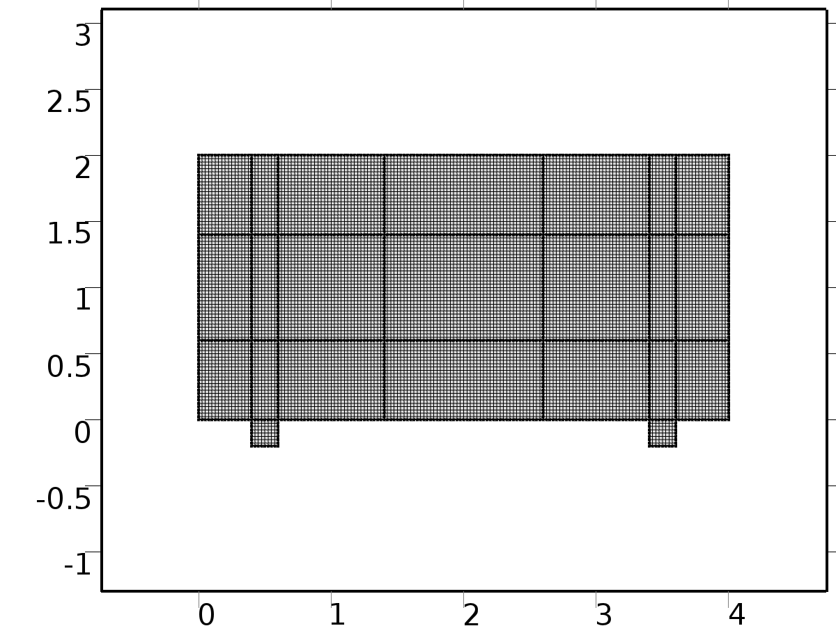

Mesh 1

* + 1. Size (size)

Settings

| **Description** | **Value** |
| --- | --- |
| Maximum element size | mesh_size |
| Minimum element size | mesh_size |
| Curvature factor | 0.3 |
| Maximum element growth rate | 1.3 |
| Custom element size | Custom |

* + 1. Edge 1 (edg1)

Selection

|  |  |
| --- | --- |
| Geometric entity level | Domain |
| Selection | Geometry geom1 |

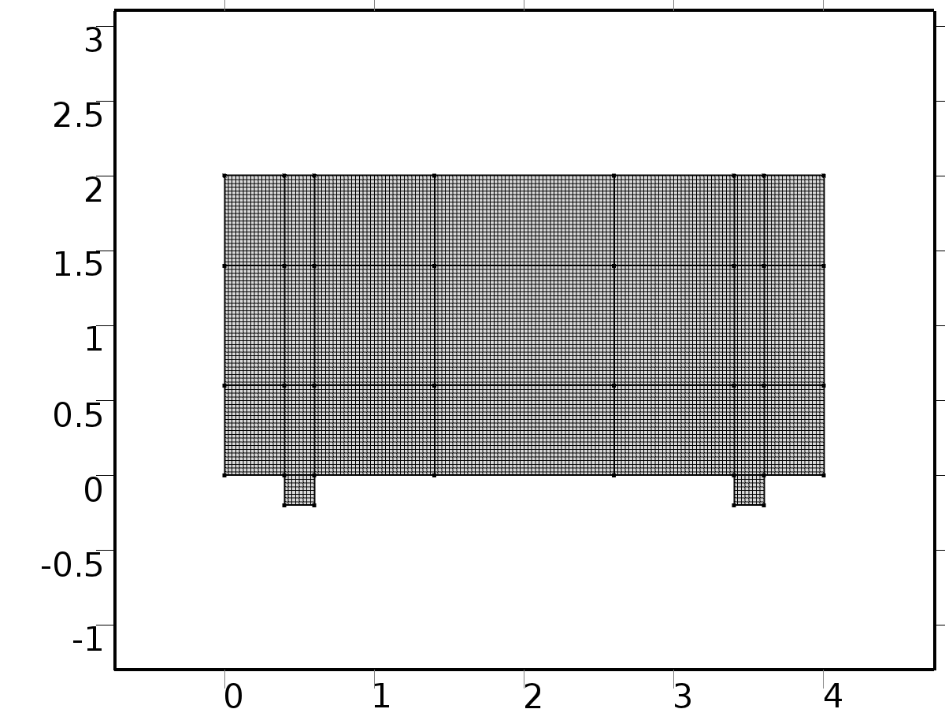

Edge 1

* + 1. Mapped 1 (map1)

Selection

|  |  |
| --- | --- |
| Geometric entity level | Remaining |

1. Study 1
   1. Stationary

Study settings

| **Description** | **Value** |
| --- | --- |
| Include geometric nonlinearity | Off |

Physics and variables selection

| **Physics interface** | **Discretization** |
| --- | --- |
| NavierStokes (spf) | physics |

Mesh selection

| **Geometry** | **Mesh** |
| --- | --- |
| Geometry 1 (geom1) | mesh1 |

* 1. Solver Configurations
     1. Solver 1

#### Compile Equations: Stationary (st1)

Study and step

| **Description** | **Value** |
| --- | --- |
| Use study | Study 1 |
| Use study step | Stationary |

#### Dependent Variables 1 (v1)

General

| **Description** | **Value** |
| --- | --- |
| Defined by study step | Stationary |
| Constant |  |

Initial values of variables solved for

| **Description** | **Value** |
| --- | --- |
| Solution | Zero |

Values of variables not solved for

| **Description** | **Value** |
| --- | --- |
| Solution | Zero |

##### Velocity field (mod1.u) (mod1_u)

General

| **Description** | **Value** |
| --- | --- |
| Field components | {mod1.u, mod1.v} |

##### Pressure (mod1.p) (mod1_p)

General

| **Description** | **Value** |
| --- | --- |
| Field components | mod1.p |

##### Temperature (mod1.X1) (mod1_X1)

General

| **Description** | **Value** |
| --- | --- |
| Field components | mod1.X1 |
| Solve for this field | Off |
| Field name | mod1_T |

##### Temperature (mod1.X2) (mod1_X2)

General

| **Description** | **Value** |
| --- | --- |
| Field components | mod1.X2 |
| Solve for this field | Off |
| Field name | mod1_T |

##### Temperature (mod1.Z1) (mod1_Z1)

General

| **Description** | **Value** |
| --- | --- |
| Field components | mod1.Z1 |
| Solve for this field | Off |
| Field name | mod1_T |

##### Temperature (mod1.Zt1) (mod1_Zt1)

General

| **Description** | **Value** |
| --- | --- |
| Field components | mod1.Zt1 |
| Solve for this field | Off |
| Field name | mod1_T |

##### Temperature (mod1.Z2) (mod1_Z2)

General

| **Description** | **Value** |
| --- | --- |
| Field components | mod1.Z2 |
| Solve for this field | Off |
| Field name | mod1_T |

##### Temperature (mod1.Zt2) (mod1_Zt2)

General

| **Description** | **Value** |
| --- | --- |
| Field components | mod1.Zt2 |
| Solve for this field | Off |
| Field name | mod1_T |

##### Temperature (mod1.T) (mod1_T)

General

| **Description** | **Value** |
| --- | --- |
| Field components | mod1.T |
| Solve for this field | Off |

#### Stationary Solver 1 (s1)

General

| **Description** | **Value** |
| --- | --- |
| Defined by study step | Stationary |
| Relative tolerance | 0.0010 |

Log

| **Description** | **Value** |
| --- | --- |
| Constant |  |

##### Fully Coupled 1 (fc1)

General

| **Description** | **Value** |
| --- | --- |
| Linear solver | Direct 1 |

Method and termination

| **Description** | **Value** |
| --- | --- |
| Initial damping factor | 0.01 |
| Minimum damping factor | 1.0E-6 |

##### Direct 1 (d1)

General

| **Description** | **Value** |
| --- | --- |
| Solver | PARDISO |

1. Study 2
   1. Stationary

Study settings

| **Description** | **Value** |
| --- | --- |
| Include geometric nonlinearity | Off |

Physics and variables selection

| **Physics interface** | **Discretization** |
| --- | --- |
| Temperature 1 (ht) | physics |
| Temperature 2 (ht2) | physics |

Mesh selection

| **Geometry** | **Mesh** |
| --- | --- |
| Geometry 1 (geom1) | mesh1 |

* 1. Solver Configurations
     1. Solver 2

#### Compile Equations: Stationary (st1)

Study and step

| **Description** | **Value** |
| --- | --- |
| Use study | Study 2 |
| Use study step | Stationary |

#### Dependent Variables 1 (v1)

General

| **Description** | **Value** |
| --- | --- |
| Defined by study step | Stationary |
| Constant |  |

Initial values of variables solved for

| **Description** | **Value** |
| --- | --- |
| Solution | Zero |

Values of variables not solved for

| **Description** | **Value** |
| --- | --- |
| Method | Solution |
| Solution | Solver 1 |

##### Velocity field (mod1.u) (mod1_u)

General

| **Description** | **Value** |
| --- | --- |
| Field components | {mod1.u, mod1.v} |
| Solve for this field | Off |

##### Pressure (mod1.p) (mod1_p)

General

| **Description** | **Value** |
| --- | --- |
| Field components | mod1.p |
| Solve for this field | Off |

##### Temperature (mod1.Z1) (mod1_Z1)

General

| **Description** | **Value** |
| --- | --- |
| Field components | mod1.Z1 |
| Solve for this field | Off |

##### Temperature (mod1.Zt1) (mod1_Zt1)

General

| **Description** | **Value** |
| --- | --- |
| Field components | mod1.Zt1 |
| Solve for this field | Off |

##### Temperature (mod1.X2) (mod1_X2)

General

| **Description** | **Value** |
| --- | --- |
| Field components | mod1.X2 |

##### Temperature (mod1.X1) (mod1_X1)

General

| **Description** | **Value** |
| --- | --- |
| Field components | mod1.X1 |

##### Temperature (mod1.Z2) (mod1_Z2)

General

| **Description** | **Value** |
| --- | --- |
| Field components | mod1.Z2 |
| Solve for this field | Off |
| Field name | mod1_T |

##### Temperature (mod1.Zt2) (mod1_Zt2)

General

| **Description** | **Value** |
| --- | --- |
| Field components | mod1.Zt2 |
| Solve for this field | Off |
| Field name | mod1_T |

##### Temperature (mod1.T) (mod1_T)

General

| **Description** | **Value** |
| --- | --- |
| Field components | mod1.T |
| Solve for this field | Off |

#### Stationary Solver 1 (s1)

General

| **Description** | **Value** |
| --- | --- |
| Defined by study step | Stationary |
| Relative tolerance | 0.00000010 |

Log

| **Description** | **Value** |
| --- | --- |
| Constant |  |

##### Fully Coupled 1 (fc1)

General

| **Description** | **Value** |
| --- | --- |
| Linear solver | Direct 1 |

Method and termination

| **Description** | **Value** |
| --- | --- |
| Initial damping factor | 0.01 |
| Minimum damping factor | 1.0E-6 |
| Maximum number of iterations | 50 |

##### Direct 1 (d1)

General

| **Description** | **Value** |
| --- | --- |
| Solver | PARDISO |

1. Study 3
   1. Parametric Sweep

| **Parameter name** | **Parameter value list** |
| --- | --- |
| k | 0,1,2,3 |
| l | 1,2 |

* 1. Stationary

Study settings

| **Description** | **Value** |
| --- | --- |
| Include geometric nonlinearity | Off |

Physics and variables selection

| **Physics interface** | **Discretization** |
| --- | --- |
| Temperature 3 (phys1) | physics |
| Temperature 4 (phys2) | physics |
| Temperature 5 (phys3) | physics |
| Temperature 6 (phys4) | physics |

Mesh selection

| **Geometry** | **Mesh** |
| --- | --- |
| Geometry 1 (geom1) | mesh1 |

* 1. Solver Configurations
     1. Solver 3

#### Compile Equations: Stationary (st1)

Study and step

| **Description** | **Value** |
| --- | --- |
| Use study | Study 3 |
| Use study step | Stationary |

#### Dependent Variables 1 (v1)

General

| **Description** | **Value** |
| --- | --- |
| Defined by study step | Stationary |
| Constant |  |

Initial values of variables solved for

| **Description** | **Value** |
| --- | --- |
| Solution | Zero |

Values of variables not solved for

| **Description** | **Value** |
| --- | --- |
| Method | Solution |
| Solution | Solver 2 |

##### Velocity field (mod1.u) (mod1_u)

General

| **Description** | **Value** |
| --- | --- |
| Field components | {mod1.u, mod1.v} |
| Solve for this field | Off |

##### Pressure (mod1.p) (mod1_p)

General

| **Description** | **Value** |
| --- | --- |
| Field components | mod1.p |
| Solve for this field | Off |

##### Temperature (mod1.Z1) (mod1_Z1)

General

| **Description** | **Value** |
| --- | --- |
| Field components | mod1.Z1 |

##### Temperature (mod1.Zt1) (mod1_Zt1)

General

| **Description** | **Value** |
| --- | --- |
| Field components | mod1.Zt1 |

##### Temperature (mod1.X2) (mod1_X2)

General

| **Description** | **Value** |
| --- | --- |
| Field components | mod1.X2 |
| Solve for this field | Off |

##### Temperature (mod1.X1) (mod1_X1)

General

| **Description** | **Value** |
| --- | --- |
| Field components | mod1.X1 |
| Solve for this field | Off |

##### Temperature (mod1.Z2) (mod1_Z2)

General

| **Description** | **Value** |
| --- | --- |
| Field components | mod1.Z2 |
| Field name | mod1_T |

##### Temperature (mod1.Zt2) (mod1_Zt2)

General

| **Description** | **Value** |
| --- | --- |
| Field components | mod1.Zt2 |
| Field name | mod1_T |

##### Temperature (mod1.T) (mod1_T)

General

| **Description** | **Value** |
| --- | --- |
| Field components | mod1.T |
| Solve for this field | Off |

#### Stationary Solver 1 (s1)

General

| **Description** | **Value** |
| --- | --- |
| Defined by study step | Stationary |
| Relative tolerance | 0.00000010 |

Log

| **Description** | **Value** |
| --- | --- |
| Constant |  |

##### Fully Coupled 1 (fc1)

General

| **Description** | **Value** |
| --- | --- |
| Linear solver | Direct 1 |

Method and termination

| **Description** | **Value** |
| --- | --- |
| Initial damping factor | 0.01 |
| Minimum damping factor | 1.0E-6 |
| Maximum number of iterations | 50 |

##### Direct 1 (d1)

General

| **Description** | **Value** |
| --- | --- |
| Solver | PARDISO |

##### Parametric 1 (p1)

General

| **Description** | **Value** |
| --- | --- |
| Defined by study step | Parametric Sweep |
| Sweep type | All combinations |
| Parameter value list | {0, 1, 2, 3, 1, 2} |
| Run continuation for | No parameter |

1. Study 4
   1. Time Dependent

Study settings

| **Description** | **Value** |
| --- | --- |
| Include geometric nonlinearity | Off |

| **Times** | **Unit** |
| --- | --- |
| range(0,hour/4,2*day) | s |

Physics and variables selection

| **Physics interface** | **Discretization** |
| --- | --- |
| Temperature CLS (phys5) | physics |

Mesh selection

| **Geometry** | **Mesh** |
| --- | --- |
| Geometry 1 (geom1) | mesh1 |

* 1. Solver Configurations
     1. Solver 4

#### Compile Equations: Time Dependent (st1)

Study and step

| **Description** | **Value** |
| --- | --- |
| Use study | Study 4 |
| Use study step | Time Dependent |

#### Dependent Variables 1 (v1)

General

| **Description** | **Value** |
| --- | --- |
| Defined by study step | Time Dependent |
| Constant |  |

Initial values of variables solved for

| **Description** | **Value** |
| --- | --- |
| Solution | Zero |

Values of variables not solved for

| **Description** | **Value** |
| --- | --- |
| Method | Solution |
| Solution | Solver 2 |

##### Velocity field (mod1.u) (mod1_u)

General

| **Description** | **Value** |
| --- | --- |
| Field components | {mod1.u, mod1.v} |
| Solve for this field | Off |

##### Temperature (mod1.T) (mod1_T)

General

| **Description** | **Value** |
| --- | --- |
| Field components | mod1.T |

##### Pressure (mod1.p) (mod1_p)

General

| **Description** | **Value** |
| --- | --- |
| Field components | mod1.p |
| Solve for this field | Off |

##### Temperature (mod1.Z1) (mod1_Z1)

General

| **Description** | **Value** |
| --- | --- |
| Field components | mod1.Z1 |
| Solve for this field | Off |

##### Temperature (mod1.Zt1) (mod1_Zt1)

General

| **Description** | **Value** |
| --- | --- |
| Field components | mod1.Zt1 |
| Solve for this field | Off |

##### Temperature (mod1.Zt2) (mod1_Zt2)

General

| **Description** | **Value** |
| --- | --- |
| Field components | mod1.Zt2 |
| Solve for this field | Off |

##### Temperature (mod1.Z2) (mod1_Z2)

General

| **Description** | **Value** |
| --- | --- |
| Field components | mod1.Z2 |
| Solve for this field | Off |

##### Temperature (mod1.X2) (mod1_X2)

General

| **Description** | **Value** |
| --- | --- |
| Field components | mod1.X2 |
| Solve for this field | Off |

##### Temperature (mod1.X1) (mod1_X1)

General

| **Description** | **Value** |
| --- | --- |
| Field components | mod1.X1 |
| Solve for this field | Off |

#### Time-Dependent Solver 1 (t1)

General

| **Description** | **Value** |
| --- | --- |
| Defined by study step | Time Dependent |
| Time | {0, 900, 1800, 2700, 3600, 4500, 5400, 6300, 7200, 8100, 9000, 9900, 10800, 11700, 12600, 13500, 14400, 15300, 16200, 17100, 18000, 18900, 19800, 20700, 21600, 22500, 23400, 24300, 25200, 26100, 27000, 27900, 28800, 29700, 30600, 31500, 32400, 33300, 34200, 35100, 36000, 36900, 37800, 38700, 39600, 40500, 41400, 42300, 43200, 44100, 45000, 45900, 46800, 47700, 48600, 49500, 50400, 51300, 52200, 53100, 54000, 54900, 55800, 56700, 57600, 58500, 59400, 60300, 61200, 62100, 63000, 63900, 64800, 65700, 66600, 67500, 68400, 69300, 70200, 71100, 72000, 72900, 73800, 74700, 75600, 76500, 77400, 78300, 79200, 80100, 81000, 81900, 82800, 83700, 84600, 85500, 86400, 87300, 88200, 89100, 90000, 90900, 91800, 92700, 93600, 94500, 95400, 96300, 97200, 98100, 99000, 99900, 100800, 101700, 102600, 103500, 104400, 105300, 106200, 107100, 108000, 108900, 109800, 110700, 111600, 112500, 113400, 114300, 115200, 116100, 117000, 117900, 118800, 119700, 120600, 121500, 122400, 123300, 124200, 125100, 126000, 126900, 127800, 128700, 129600, 130500, 131400, 132300, 133200, 134100, 135000, 135900, 136800, 137700, 138600, 139500, 140400, 141300, 142200, 143100, 144000, 144900, 145800, 146700, 147600, 148500, 149400, 150300, 151200, 152100, 153000, 153900, 154800, 155700, 156600, 157500, 158400, 159300, 160200, 161100, 162000, 162900, 163800, 164700, 165600, 166500, 167400, 168300, 169200, 170100, 171000, 171900, 172800} |
| Relative tolerance | 0.0000001 |

Absolute tolerance

| **Description** | **Value** |
| --- | --- |
| Tolerance | 0.0010 |

Time stepping

| **Description** | **Value** |
| --- | --- |
| Initial step | 0.0010 |
| Maximum BDF order | 2 |

Results while solving

| **Description** | **Value** |
| --- | --- |
| Probes | None |

Advanced

| **Description** | **Value** |
| --- | --- |
| Fraction of initial step for Backward Euler | 0.0010 |

Log

| **Description** | **Value** |
| --- | --- |
| Constant |  |

##### Fully Coupled 1 (fc1)

General

| **Description** | **Value** |
| --- | --- |
| Linear solver | Direct 1 |

Method and termination

| **Description** | **Value** |
| --- | --- |
| Damping factor | 0.9 |
| Jacobian update | Once per time step |
| Maximum number of iterations | 5 |

##### Direct 1 (d1)

General

| **Description** | **Value** |
| --- | --- |
| Solver | PARDISO |

1. Results
   1. Data Sets
      1. Solution 1

Solution

| **Description** | **Value** |
| --- | --- |
| Solution | Solver 1 |
| Component | Save Point Geometry 1 |

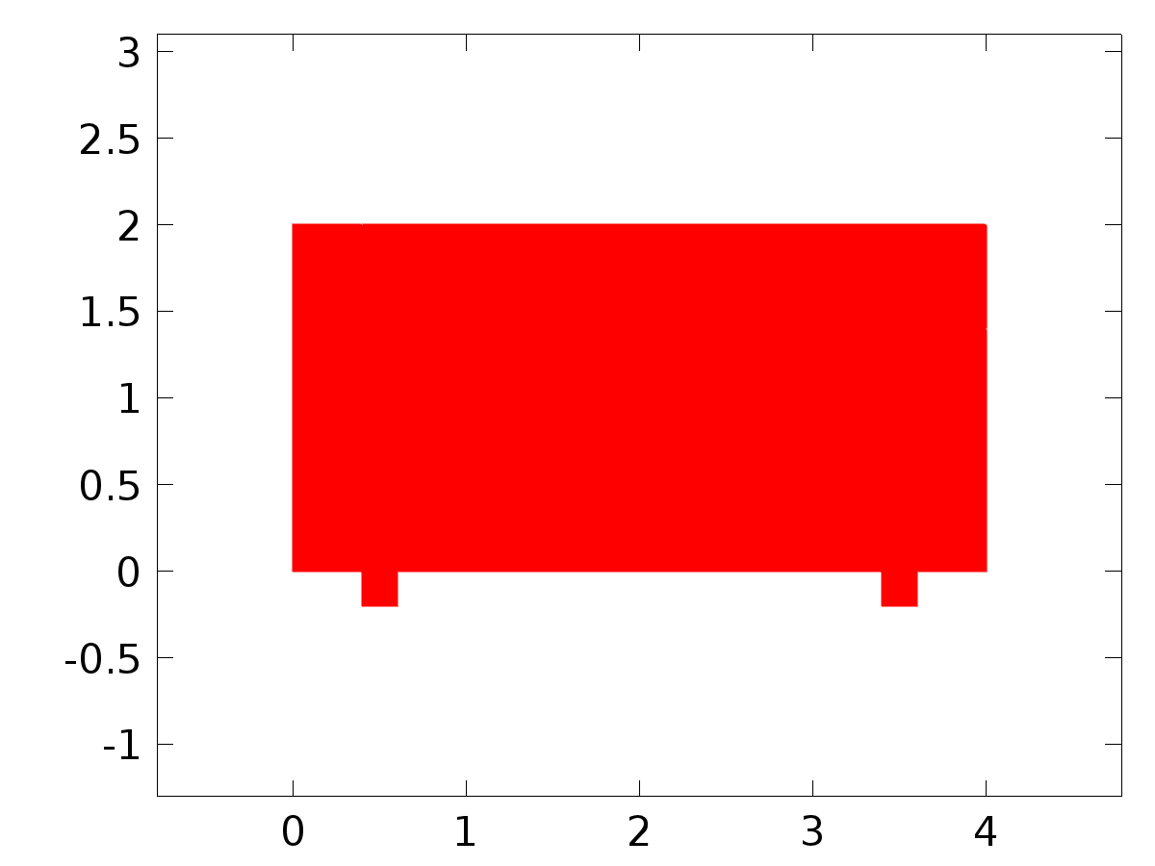

Data set: Solution 1

* + 1. Probe Solution 2

Solution

| **Description** | **Value** |
| --- | --- |
| Solution | Solver 4 |
| Component | Save Point Geometry 1 |

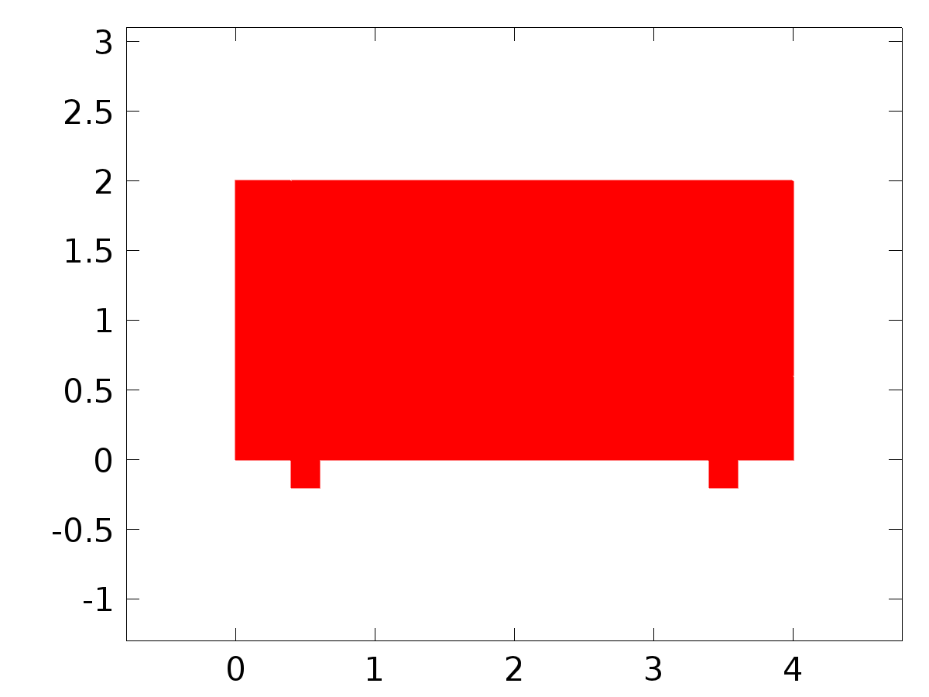

Data set: Probe Solution 2

* + 1. Solution 3

Solution

| **Description** | **Value** |
| --- | --- |
| Solution | Solver 2 |
| Component | Save Point Geometry 1 |



Data set: Solution 3

* + 1. Solution 4

Solution

| **Description** | **Value** |
| --- | --- |
| Solution | Solver 3 |
| Component | Save Point Geometry 1 |



Data set: Solution 4

* + 1. Solution 5

Solution

| **Description** | **Value** |
| --- | --- |
| Solution | Solver 4 |
| Component | Save Point Geometry 1 |



Data set: Solution 5

* 1. Derived Values
     1. Global Variable Probe 1

Data

| **Description** | **Value** |
| --- | --- |
| Data set | Probe Solution 2 |

Expression

| **Description** | **Value** |
| --- | --- |
| Expression | C1(Z1) |
| Unit | K |
| Description | C1(Z1) |

* + 1. Global Variable Probe 2

Data

| **Description** | **Value** |
| --- | --- |
| Data set | Probe Solution 2 |

Expression

| **Description** | **Value** |
| --- | --- |
| Expression | C2(Z1) |
| Unit | K |
| Description | C2(Z1) |

* + 1. Global Variable Probe 3

Data

| **Description** | **Value** |
| --- | --- |
| Data set | Probe Solution 2 |

Expression

| **Description** | **Value** |
| --- | --- |
| Expression | C1(Z2) |
| Unit | K |
| Description | C1(Z2) |

* + 1. Global Variable Probe 4

Data

| **Description** | **Value** |
| --- | --- |
| Data set | Probe Solution 2 |

Expression

| **Description** | **Value** |
| --- | --- |
| Expression | C2(Z2) |
| Unit | K |
| Description | C2(Z2) |

* + 1. Global Variable Probe 5

Data

| **Description** | **Value** |
| --- | --- |
| Data set | Probe Solution 2 |

Expression

| **Description** | **Value** |
| --- | --- |
| Expression | gammac1 |
| Unit | 1 |

* + 1. Global Variable Probe 6

Data

| **Description** | **Value** |
| --- | --- |
| Data set | Probe Solution 2 |

Expression

| **Description** | **Value** |
| --- | --- |
| Expression | gammac2 |
| Unit | 1 |

* + 1. Global Variable Probe 7

Data

| **Description** | **Value** |
| --- | --- |
| Data set | Probe Solution 2 |

Expression

| **Description** | **Value** |
| --- | --- |
| Expression | gammas1 |
| Unit | 1 |

* + 1. Global Variable Probe 8

Data

| **Description** | **Value** |
| --- | --- |
| Data set | Probe Solution 2 |

Expression

| **Description** | **Value** |
| --- | --- |
| Expression | gammas2 |
| Unit | 1 |

* + 1. Global Variable Probe 9

Data

| **Description** | **Value** |
| --- | --- |
| Data set | Probe Solution 2 |

Expression

| **Description** | **Value** |
| --- | --- |
| Expression | alpha(k) |
| Unit | 1/kg |
| Description | alpha(k) |

* + 1. Global Variable Probe 10

Data

| **Description** | **Value** |
| --- | --- |
| Data set | Probe Solution 2 |

Expression

| **Description** | **Value** |
| --- | --- |
| Expression | yc1(k, l) |
| Unit | K |
| Description | yc1(k, l) |

* + 1. Global Variable Probe 11

Data

| **Description** | **Value** |
| --- | --- |
| Data set | Probe Solution 2 |

Expression

| **Description** | **Value** |
| --- | --- |
| Expression | yc2(k, l) |
| Unit | K |
| Description | yc2(k, l) |

* + 1. Global Variable Probe 12

Data

| **Description** | **Value** |
| --- | --- |
| Data set | Probe Solution 2 |

Expression

| **Description** | **Value** |
| --- | --- |
| Expression | ys1(k, l) |
| Unit | K |
| Description | ys1(k, l) |

* + 1. Global Variable Probe 13

Data

| **Description** | **Value** |
| --- | --- |
| Data set | Probe Solution 2 |

Expression

| **Description** | **Value** |
| --- | --- |
| Expression | ys2(k, l) |
| Unit | K |
| Description | ys2(k, l) |

* + 1. Global Variable Probe 14

Data

| **Description** | **Value** |
| --- | --- |
| Data set | Probe Solution 2 |

Expression

| **Description** | **Value** |
| --- | --- |
| Expression | dc1(k, l) |
| Description | dc1(k, l) |

* + 1. Global Variable Probe 15

Data

| **Description** | **Value** |
| --- | --- |
| Data set | Probe Solution 2 |

Expression

| **Description** | **Value** |
| --- | --- |
| Expression | dc2(k, l) |
| Description | dc2(k, l) |

* + 1. Global Variable Probe 16

Data

| **Description** | **Value** |
| --- | --- |
| Data set | Probe Solution 2 |

Expression

| **Description** | **Value** |
| --- | --- |
| Expression | ds1(k, l) |
| Description | ds1(k, l) |

* + 1. Global Variable Probe 17

Data

| **Description** | **Value** |
| --- | --- |
| Data set | Probe Solution 2 |

Expression

| **Description** | **Value** |
| --- | --- |
| Expression | ds2(k, l) |
| Description | ds2(k, l) |

* + 1. Point Evaluation 1

Selection

|  |  |
| --- | --- |
| Geometric entity level | Point |
| Selection | Point 17 |

Data

| **Description** | **Value** |
| --- | --- |
| Data set | Solution 5 |

Expression

| **Description** | **Value** |
| --- | --- |
| Expression | Gamma2 |
| Unit | K |

* + 1. Point Evaluation 2

Selection

|  |  |
| --- | --- |
| Geometric entity level | Point |
| Selection | Point 16 |

Data

| **Description** | **Value** |
| --- | --- |
| Data set | Solution 5 |

Expression

| **Description** | **Value** |
| --- | --- |
| Expression | C1(T) |
| Unit | K |
| Description | C1(T) |

* 1. Tables
     1. Probe Table 1
     2. Table 2

Global Evaluation 5 (C2(Z1))

Table 2

| **C2(Z1) (K)** |
| --- |
| 1.0003 |

* + 1. Table 3

Point Evaluation 1 (C1(T))

Table 3

| **Time** | **C1(T) (K), Point: 17** | **yr1 (K), Point: 17** | **C2(T) (K), Point: 17** | **yr2 (K), Point: 17** | **d1 (K), Point: 17** | **d2 (K), Point: 17** | **Gamma1 (K), Point: 17** | **Gamma2 (K), Point: 17** |
| --- | --- | --- | --- | --- | --- | --- | --- | --- |
| 0.0000 | 18.000 | 22.000 | 18.000 | 18.000 | 5.0000 | 15.000 | 15.860 | 0.085709 |
| 900.00 | 21.968 | 22.196 | 17.999 | 18.065 | 5.6540 | 15.196 | 15.739 | 0.089729 |
| 1800.0 | 22.389 | 22.392 | 18.130 | 18.131 | 6.3053 | 15.392 | 15.617 | 0.093725 |
| 2700.0 | 22.586 | 22.585 | 18.195 | 18.195 | 6.9509 | 15.585 | 15.497 | 0.097683 |
| 3600.0 | 22.776 | 22.776 | 18.259 | 18.259 | 7.5882 | 15.776 | 15.379 | 0.10158 |
| 4500.0 | 22.962 | 22.964 | 18.321 | 18.321 | 8.2144 | 15.964 | 15.263 | 0.10541 |
| 5400.0 | 23.146 | 23.148 | 18.382 | 18.383 | 8.8268 | 16.148 | 15.149 | 0.10915 |
| 6300.0 | 23.323 | 23.327 | 18.441 | 18.442 | 9.4229 | 16.327 | 15.038 | 0.11278 |
| 7200.0 | 23.496 | 23.500 | 18.499 | 18.500 | 10.000 | 16.500 | 14.931 | 0.11629 |
| 8100.0 | 23.663 | 23.667 | 18.554 | 18.556 | 10.556 | 16.667 | 14.828 | 0.11966 |
| 9000.0 | 23.823 | 23.826 | 18.608 | 18.609 | 11.088 | 16.826 | 14.729 | 0.12288 |
| 9900.0 | 23.974 | 23.978 | 18.658 | 18.659 | 11.593 | 16.978 | 14.636 | 0.12594 |
| 10800 | 24.118 | 24.121 | 18.706 | 18.707 | 12.071 | 17.121 | 14.547 | 0.12882 |
| 11700 | 24.254 | 24.256 | 18.751 | 18.752 | 12.518 | 17.256 | 14.465 | 0.13151 |
| 12600 | 24.377 | 24.380 | 18.792 | 18.793 | 12.934 | 17.380 | 14.388 | 0.13400 |
| 13500 | 24.492 | 24.494 | 18.830 | 18.831 | 13.315 | 17.494 | 14.318 | 0.13628 |
| 14400 | 24.596 | 24.598 | 18.865 | 18.866 | 13.660 | 17.598 | 14.254 | 0.13833 |
| 15300 | 24.689 | 24.691 | 18.896 | 18.897 | 13.969 | 17.691 | 14.197 | 0.14015 |
| 16200 | 24.769 | 24.772 | 18.923 | 18.924 | 14.239 | 17.772 | 14.147 | 0.14174 |
| 17100 | 24.839 | 24.841 | 18.946 | 18.947 | 14.469 | 17.841 | 14.105 | 0.14308 |
| 18000 | 24.896 | 24.898 | 18.965 | 18.966 | 14.659 | 17.898 | 14.070 | 0.14416 |
| 18900 | 24.941 | 24.942 | 18.980 | 18.981 | 14.808 | 17.942 | 14.043 | 0.14500 |
| 19800 | 24.973 | 24.974 | 18.991 | 18.991 | 14.914 | 17.974 | 14.024 | 0.14557 |
| 20700 | 24.993 | 24.994 | 18.997 | 18.998 | 14.979 | 17.994 | 14.013 | 0.14588 |
| 21600 | 24.999 | 25.000 | 18.999 | 19.000 | 15.000 | 18.000 | 14.010 | 0.14593 |
| 22500 | 24.993 | 24.994 | 18.997 | 18.998 | 14.979 | 17.994 | 14.014 | 0.14571 |
| 23400 | 24.974 | 24.974 | 18.991 | 18.991 | 14.914 | 17.974 | 14.027 | 0.14523 |
| 24300 | 24.942 | 24.942 | 18.981 | 18.981 | 14.808 | 17.942 | 14.048 | 0.14449 |
| 25200 | 24.899 | 24.898 | 18.966 | 18.966 | 14.659 | 17.898 | 14.076 | 0.14350 |
| 26100 | 24.843 | 24.841 | 18.947 | 18.947 | 14.469 | 17.841 | 14.112 | 0.14225 |
| 27000 | 24.775 | 24.772 | 18.925 | 18.924 | 14.239 | 17.772 | 14.156 | 0.14075 |
| 27900 | 24.694 | 24.691 | 18.898 | 18.897 | 13.969 | 17.691 | 14.206 | 0.13902 |
| 28800 | 24.601 | 24.598 | 18.867 | 18.866 | 13.660 | 17.598 | 14.264 | 0.13705 |
| 29700 | 24.496 | 24.494 | 18.832 | 18.831 | 13.315 | 17.494 | 14.329 | 0.13485 |
| 30600 | 24.382 | 24.380 | 18.794 | 18.793 | 12.934 | 17.380 | 14.401 | 0.13244 |
| 31500 | 24.260 | 24.256 | 18.753 | 18.752 | 12.518 | 17.256 | 14.479 | 0.12982 |
| 32400 | 24.126 | 24.121 | 18.709 | 18.707 | 12.071 | 17.121 | 14.562 | 0.12701 |
| 33300 | 23.982 | 23.978 | 18.661 | 18.659 | 11.593 | 16.978 | 14.652 | 0.12401 |
| 34200 | 23.827 | 23.826 | 18.609 | 18.609 | 11.088 | 16.826 | 14.746 | 0.12085 |
| 35100 | 23.670 | 23.667 | 18.557 | 18.556 | 10.556 | 16.667 | 14.846 | 0.11753 |
| 36000 | 23.505 | 23.500 | 18.502 | 18.500 | 10.000 | 16.500 | 14.950 | 0.11406 |
| 36900 | 23.332 | 23.327 | 18.444 | 18.442 | 9.4229 | 16.327 | 15.057 | 0.11048 |
| 37800 | 23.152 | 23.148 | 18.384 | 18.383 | 8.8268 | 16.148 | 15.168 | 0.10678 |
| 38700 | 22.966 | 22.964 | 18.322 | 18.321 | 8.2144 | 15.964 | 15.283 | 0.10298 |
| 39600 | 22.781 | 22.776 | 18.260 | 18.259 | 7.5882 | 15.776 | 15.399 | 0.099103 |
| 40500 | 22.591 | 22.585 | 18.197 | 18.195 | 6.9509 | 15.585 | 15.518 | 0.095165 |
| 41400 | 22.396 | 22.392 | 18.132 | 18.131 | 6.3053 | 15.392 | 15.638 | 0.091180 |
| 42300 | 22.198 | 22.196 | 18.066 | 18.065 | 5.6540 | 15.196 | 15.760 | 0.087167 |
| 43200 | 22.004 | 22.000 | 18.001 | 18.000 | 5.0000 | 15.000 | 15.881 | 0.083142 |
| 44100 | 21.809 | 21.804 | 17.936 | 17.935 | 4.3460 | 14.804 | 16.003 | 0.079122 |
| 45000 | 21.612 | 21.608 | 17.871 | 17.869 | 3.6947 | 14.608 | 16.124 | 0.075125 |
| 45900 | 21.419 | 21.415 | 17.806 | 17.805 | 3.0491 | 14.415 | 16.244 | 0.071168 |
| 46800 | 21.232 | 21.224 | 17.744 | 17.741 | 2.4118 | 14.224 | 16.363 | 0.067268 |
| 47700 | 21.045 | 21.036 | 17.681 | 17.679 | 1.7856 | 14.036 | 16.479 | 0.063441 |
| 48600 | 20.859 | 20.852 | 17.619 | 17.617 | 1.1732 | 13.852 | 16.593 | 0.059704 |
| 49500 | 20.683 | 20.673 | 17.561 | 17.558 | 0.57711 | 13.673 | 16.704 | 0.056073 |
| 50400 | 20.514 | 20.500 | 17.504 | 17.500 | 2.6645E-15 | 13.500 | 16.811 | 0.052563 |
| 51300 | 20.346 | 20.333 | 17.448 | 17.444 | -0.55570 | 13.333 | 16.914 | 0.049190 |
| 52200 | 20.182 | 20.174 | 17.393 | 17.391 | -1.0876 | 13.174 | 17.012 | 0.045967 |
| 53100 | 20.034 | 20.022 | 17.344 | 17.341 | -1.5935 | 13.022 | 17.106 | 0.042910 |
| 54000 | 19.887 | 19.879 | 17.295 | 17.293 | -2.0711 | 12.879 | 17.194 | 0.040030 |
| 54900 | 19.755 | 19.744 | 17.251 | 17.248 | -2.5184 | 12.744 | 17.277 | 0.037340 |
| 55800 | 19.628 | 19.620 | 17.208 | 17.207 | -2.9335 | 12.620 | 17.354 | 0.034852 |
| 56700 | 19.516 | 19.506 | 17.171 | 17.169 | -3.3147 | 12.506 | 17.424 | 0.032576 |
| 57600 | 19.408 | 19.402 | 17.135 | 17.134 | -3.6603 | 12.402 | 17.488 | 0.030522 |
| 58500 | 19.319 | 19.309 | 17.106 | 17.103 | -3.9687 | 12.309 | 17.545 | 0.028699 |
| 59400 | 19.237 | 19.228 | 17.078 | 17.076 | -4.2388 | 12.228 | 17.594 | 0.027114 |
| 60300 | 19.167 | 19.159 | 17.055 | 17.053 | -4.4693 | 12.159 | 17.637 | 0.025775 |
| 61200 | 19.111 | 19.102 | 17.036 | 17.034 | -4.6593 | 12.102 | 17.671 | 0.024687 |
| 62100 | 19.066 | 19.058 | 17.021 | 17.019 | -4.8079 | 12.058 | 17.698 | 0.023855 |
| 63000 | 19.032 | 19.026 | 17.010 | 17.009 | -4.9144 | 12.026 | 17.717 | 0.023282 |
| 63900 | 19.016 | 19.006 | 17.004 | 17.002 | -4.9786 | 12.006 | 17.729 | 0.022972 |
| 64800 | 19.006 | 19.000 | 17.001 | 17.000 | -5.0000 | 12.000 | 17.732 | 0.022924 |
| 65700 | 19.011 | 19.006 | 17.003 | 17.002 | -4.9786 | 12.006 | 17.727 | 0.023139 |
| 66600 | 19.029 | 19.026 | 17.009 | 17.009 | -4.9144 | 12.026 | 17.715 | 0.023618 |
| 67500 | 19.060 | 19.058 | 17.019 | 17.019 | -4.8079 | 12.058 | 17.694 | 0.024356 |
| 68400 | 19.103 | 19.102 | 17.034 | 17.034 | -4.6593 | 12.102 | 17.666 | 0.025352 |
| 69300 | 19.159 | 19.159 | 17.052 | 17.053 | -4.4693 | 12.159 | 17.630 | 0.026600 |
| 70200 | 19.228 | 19.228 | 17.075 | 17.076 | -4.2388 | 12.228 | 17.586 | 0.028097 |
| 71100 | 19.309 | 19.309 | 17.102 | 17.103 | -3.9687 | 12.309 | 17.535 | 0.029834 |
| 72000 | 19.403 | 19.402 | 17.133 | 17.134 | -3.6603 | 12.402 | 17.477 | 0.031805 |
| 72900 | 19.505 | 19.506 | 17.167 | 17.169 | -3.3147 | 12.506 | 17.412 | 0.034002 |
| 73800 | 19.617 | 19.620 | 17.205 | 17.207 | -2.9335 | 12.620 | 17.341 | 0.036414 |
| 74700 | 19.740 | 19.744 | 17.246 | 17.248 | -2.5184 | 12.744 | 17.263 | 0.039032 |
| 75600 | 19.873 | 19.879 | 17.290 | 17.293 | -2.0711 | 12.879 | 17.179 | 0.041845 |
| 76500 | 20.018 | 20.022 | 17.339 | 17.341 | -1.5935 | 13.022 | 17.090 | 0.044840 |
| 77400 | 20.174 | 20.174 | 17.390 | 17.391 | -1.0876 | 13.174 | 16.995 | 0.048004 |
| 78300 | 20.330 | 20.333 | 17.443 | 17.444 | -0.55570 | 13.333 | 16.896 | 0.051324 |
| 79200 | 20.495 | 20.500 | 17.498 | 17.500 | -4.4409E-15 | 13.500 | 16.792 | 0.054786 |
| 80100 | 20.667 | 20.673 | 17.555 | 17.558 | 0.57711 | 13.673 | 16.684 | 0.058375 |
| 81000 | 20.847 | 20.852 | 17.615 | 17.617 | 1.1732 | 13.852 | 16.573 | 0.062076 |
| 81900 | 21.035 | 21.036 | 17.678 | 17.679 | 1.7856 | 14.036 | 16.459 | 0.065872 |
| 82800 | 21.221 | 21.224 | 17.740 | 17.741 | 2.4118 | 14.224 | 16.342 | 0.069747 |
| 83700 | 21.410 | 21.415 | 17.803 | 17.805 | 3.0491 | 14.415 | 16.223 | 0.073686 |
| 84600 | 21.603 | 21.608 | 17.868 | 17.869 | 3.6947 | 14.608 | 16.103 | 0.077670 |
| 85500 | 21.801 | 21.804 | 17.934 | 17.935 | 4.3460 | 14.804 | 15.982 | 0.081684 |
| 86400 | 21.998 | 22.000 | 17.999 | 18.000 | 5.0000 | 15.000 | 15.860 | 0.085709 |
| 87300 | 22.192 | 22.196 | 18.064 | 18.065 | 5.6540 | 15.196 | 15.739 | 0.089729 |
| 88200 | 22.387 | 22.392 | 18.129 | 18.131 | 6.3053 | 15.392 | 15.617 | 0.093725 |
| 89100 | 22.583 | 22.585 | 18.194 | 18.195 | 6.9509 | 15.585 | 15.497 | 0.097683 |
| 90000 | 22.773 | 22.776 | 18.258 | 18.259 | 7.5882 | 15.776 | 15.379 | 0.10158 |
| 90900 | 22.960 | 22.964 | 18.320 | 18.321 | 8.2144 | 15.964 | 15.263 | 0.10541 |
| 91800 | 23.145 | 23.148 | 18.382 | 18.383 | 8.8268 | 16.148 | 15.149 | 0.10915 |
| 92700 | 23.320 | 23.327 | 18.440 | 18.442 | 9.4229 | 16.327 | 15.038 | 0.11278 |
| 93600 | 23.494 | 23.500 | 18.498 | 18.500 | 10.000 | 16.500 | 14.931 | 0.11629 |
| 94500 | 23.659 | 23.667 | 18.553 | 18.556 | 10.556 | 16.667 | 14.828 | 0.11966 |
| 95400 | 23.817 | 23.826 | 18.605 | 18.609 | 11.088 | 16.826 | 14.729 | 0.12288 |
| 96300 | 23.974 | 23.978 | 18.658 | 18.659 | 11.593 | 16.978 | 14.636 | 0.12594 |
| 97200 | 24.117 | 24.121 | 18.706 | 18.707 | 12.071 | 17.121 | 14.547 | 0.12882 |
| 98100 | 24.253 | 24.256 | 18.751 | 18.752 | 12.518 | 17.256 | 14.465 | 0.13151 |
| 99000 | 24.378 | 24.380 | 18.793 | 18.793 | 12.934 | 17.380 | 14.388 | 0.13400 |
| 99900 | 24.493 | 24.494 | 18.831 | 18.831 | 13.315 | 17.494 | 14.318 | 0.13628 |
| 1.0080E5 | 24.597 | 24.598 | 18.866 | 18.866 | 13.660 | 17.598 | 14.254 | 0.13833 |
| 1.0170E5 | 24.689 | 24.691 | 18.896 | 18.897 | 13.969 | 17.691 | 14.197 | 0.14015 |
| 1.0260E5 | 24.770 | 24.772 | 18.923 | 18.924 | 14.239 | 17.772 | 14.147 | 0.14174 |
| 1.0350E5 | 24.840 | 24.841 | 18.946 | 18.947 | 14.469 | 17.841 | 14.105 | 0.14308 |
| 1.0440E5 | 24.897 | 24.898 | 18.965 | 18.966 | 14.659 | 17.898 | 14.070 | 0.14416 |
| 1.0530E5 | 24.941 | 24.942 | 18.980 | 18.981 | 14.808 | 17.942 | 14.043 | 0.14500 |
| 1.0620E5 | 24.973 | 24.974 | 18.991 | 18.991 | 14.914 | 17.974 | 14.024 | 0.14557 |
| 1.0710E5 | 24.992 | 24.994 | 18.997 | 18.998 | 14.979 | 17.994 | 14.013 | 0.14588 |
| 1.0800E5 | 24.999 | 25.000 | 18.999 | 19.000 | 15.000 | 18.000 | 14.010 | 0.14593 |
| 1.0890E5 | 24.992 | 24.994 | 18.997 | 18.998 | 14.979 | 17.994 | 14.014 | 0.14571 |
| 1.0980E5 | 24.973 | 24.974 | 18.991 | 18.991 | 14.914 | 17.974 | 14.027 | 0.14523 |
| 1.1070E5 | 24.942 | 24.942 | 18.980 | 18.981 | 14.808 | 17.942 | 14.048 | 0.14449 |
| 1.1160E5 | 24.898 | 24.898 | 18.966 | 18.966 | 14.659 | 17.898 | 14.076 | 0.14350 |
| 1.1250E5 | 24.842 | 24.841 | 18.947 | 18.947 | 14.469 | 17.841 | 14.112 | 0.14225 |
| 1.1340E5 | 24.773 | 24.772 | 18.924 | 18.924 | 14.239 | 17.772 | 14.156 | 0.14075 |
| 1.1430E5 | 24.691 | 24.691 | 18.897 | 18.897 | 13.969 | 17.691 | 14.206 | 0.13902 |
| 1.1520E5 | 24.599 | 24.598 | 18.866 | 18.866 | 13.660 | 17.598 | 14.264 | 0.13705 |
| 1.1610E5 | 24.497 | 24.494 | 18.832 | 18.831 | 13.315 | 17.494 | 14.329 | 0.13485 |
| 1.1700E5 | 24.383 | 24.380 | 18.794 | 18.793 | 12.934 | 17.380 | 14.401 | 0.13244 |
| 1.1790E5 | 24.259 | 24.256 | 18.753 | 18.752 | 12.518 | 17.256 | 14.479 | 0.12982 |
| 1.1880E5 | 24.122 | 24.121 | 18.707 | 18.707 | 12.071 | 17.121 | 14.562 | 0.12701 |
| 1.1970E5 | 23.981 | 23.978 | 18.660 | 18.659 | 11.593 | 16.978 | 14.652 | 0.12401 |
| 1.2060E5 | 23.831 | 23.826 | 18.610 | 18.609 | 11.088 | 16.826 | 14.746 | 0.12085 |
| 1.2150E5 | 23.672 | 23.667 | 18.557 | 18.556 | 10.556 | 16.667 | 14.846 | 0.11753 |
| 1.2240E5 | 23.504 | 23.500 | 18.501 | 18.500 | 10.0000 | 16.500 | 14.950 | 0.11406 |
| 1.2330E5 | 23.328 | 23.327 | 18.443 | 18.442 | 9.4229 | 16.327 | 15.057 | 0.11048 |
| 1.2420E5 | 23.152 | 23.148 | 18.384 | 18.383 | 8.8268 | 16.148 | 15.168 | 0.10678 |
| 1.2510E5 | 22.970 | 22.964 | 18.323 | 18.321 | 8.2144 | 15.964 | 15.283 | 0.10298 |
| 1.2600E5 | 22.782 | 22.776 | 18.261 | 18.259 | 7.5882 | 15.776 | 15.399 | 0.099103 |
| 1.2690E5 | 22.588 | 22.585 | 18.196 | 18.195 | 6.9509 | 15.585 | 15.518 | 0.095165 |
| 1.2780E5 | 22.395 | 22.392 | 18.132 | 18.131 | 6.3053 | 15.392 | 15.638 | 0.091180 |
| 1.2870E5 | 22.201 | 22.196 | 18.067 | 18.065 | 5.6540 | 15.196 | 15.760 | 0.087167 |
| 1.2960E5 | 22.005 | 22.000 | 18.002 | 18.000 | 5.0000 | 15.000 | 15.881 | 0.083142 |
| 1.3050E5 | 21.806 | 21.804 | 17.935 | 17.935 | 4.3460 | 14.804 | 16.003 | 0.079122 |
| 1.3140E5 | 21.612 | 21.608 | 17.870 | 17.869 | 3.6947 | 14.608 | 16.124 | 0.075125 |
| 1.3230E5 | 21.419 | 21.415 | 17.806 | 17.805 | 3.0491 | 14.415 | 16.244 | 0.071168 |
| 1.3320E5 | 21.227 | 21.224 | 17.742 | 17.741 | 2.4118 | 14.224 | 16.363 | 0.067268 |
| 1.3410E5 | 21.040 | 21.036 | 17.680 | 17.679 | 1.7856 | 14.036 | 16.479 | 0.063441 |
| 1.3500E5 | 20.863 | 20.852 | 17.620 | 17.617 | 1.1732 | 13.852 | 16.593 | 0.059704 |
| 1.3590E5 | 20.685 | 20.673 | 17.561 | 17.558 | 0.57711 | 13.673 | 16.704 | 0.056073 |
| 1.3680E5 | 20.507 | 20.500 | 17.502 | 17.500 | 7.9936E-15 | 13.500 | 16.811 | 0.052563 |
| 1.3770E5 | 20.344 | 20.333 | 17.447 | 17.444 | -0.55570 | 13.333 | 16.914 | 0.049190 |
| 1.3860E5 | 20.186 | 20.174 | 17.395 | 17.391 | -1.0876 | 13.174 | 17.012 | 0.045967 |
| 1.3950E5 | 20.028 | 20.022 | 17.342 | 17.341 | -1.5935 | 13.022 | 17.106 | 0.042910 |
| 1.4040E5 | 19.890 | 19.879 | 17.296 | 17.293 | -2.0711 | 12.879 | 17.194 | 0.040030 |
| 1.4130E5 | 19.752 | 19.744 | 17.250 | 17.248 | -2.5184 | 12.744 | 17.277 | 0.037340 |
| 1.4220E5 | 19.631 | 19.620 | 17.209 | 17.207 | -2.9335 | 12.620 | 17.354 | 0.034852 |
| 1.4310E5 | 19.512 | 19.506 | 17.170 | 17.169 | -3.3147 | 12.506 | 17.424 | 0.032576 |
| 1.4400E5 | 19.412 | 19.402 | 17.137 | 17.134 | -3.6603 | 12.402 | 17.488 | 0.030522 |
| 1.4490E5 | 19.318 | 19.309 | 17.105 | 17.103 | -3.9687 | 12.309 | 17.545 | 0.028699 |
| 1.4580E5 | 19.236 | 19.228 | 17.078 | 17.076 | -4.2388 | 12.228 | 17.594 | 0.027114 |
| 1.4670E5 | 19.169 | 19.159 | 17.056 | 17.053 | -4.4693 | 12.159 | 17.637 | 0.025775 |
| 1.4760E5 | 19.110 | 19.102 | 17.036 | 17.034 | -4.6593 | 12.102 | 17.671 | 0.024687 |
| 1.4850E5 | 19.066 | 19.058 | 17.021 | 17.019 | -4.8079 | 12.058 | 17.698 | 0.023855 |
| 1.4940E5 | 19.031 | 19.026 | 17.010 | 17.009 | -4.9144 | 12.026 | 17.717 | 0.023282 |
| 1.5030E5 | 19.011 | 19.006 | 17.003 | 17.002 | -4.9786 | 12.006 | 17.729 | 0.022972 |
| 1.5120E5 | 19.004 | 19.000 | 17.000 | 17.000 | -5.0000 | 12.000 | 17.732 | 0.022924 |
| 1.5210E5 | 19.009 | 19.006 | 17.002 | 17.002 | -4.9786 | 12.006 | 17.727 | 0.023139 |
| 1.5300E5 | 19.027 | 19.026 | 17.008 | 17.009 | -4.9144 | 12.026 | 17.715 | 0.023618 |
| 1.5390E5 | 19.058 | 19.058 | 17.019 | 17.019 | -4.8079 | 12.058 | 17.694 | 0.024356 |
| 1.5480E5 | 19.103 | 19.102 | 17.033 | 17.034 | -4.6593 | 12.102 | 17.666 | 0.025352 |
| 1.5570E5 | 19.160 | 19.159 | 17.052 | 17.053 | -4.4693 | 12.159 | 17.630 | 0.026600 |
| 1.5660E5 | 19.229 | 19.228 | 17.076 | 17.076 | -4.2388 | 12.228 | 17.586 | 0.028097 |
| 1.5750E5 | 19.310 | 19.309 | 17.102 | 17.103 | -3.9687 | 12.309 | 17.535 | 0.029834 |
| 1.5840E5 | 19.400 | 19.402 | 17.132 | 17.134 | -3.6603 | 12.402 | 17.477 | 0.031805 |
| 1.5930E5 | 19.502 | 19.506 | 17.166 | 17.169 | -3.3147 | 12.506 | 17.412 | 0.034002 |
| 1.6020E5 | 19.615 | 19.620 | 17.204 | 17.207 | -2.9335 | 12.620 | 17.341 | 0.036414 |
| 1.6110E5 | 19.740 | 19.744 | 17.246 | 17.248 | -2.5184 | 12.744 | 17.263 | 0.039032 |
| 1.6200E5 | 19.877 | 19.879 | 17.291 | 17.293 | -2.0711 | 12.879 | 17.179 | 0.041845 |
| 1.6290E5 | 20.021 | 20.022 | 17.339 | 17.341 | -1.5935 | 13.022 | 17.090 | 0.044840 |
| 1.6380E5 | 20.169 | 20.174 | 17.389 | 17.391 | -1.0876 | 13.174 | 16.995 | 0.048004 |
| 1.6470E5 | 20.327 | 20.333 | 17.441 | 17.444 | -0.55570 | 13.333 | 16.896 | 0.051324 |
| 1.6560E5 | 20.493 | 20.500 | 17.497 | 17.500 | 8.8818E-16 | 13.500 | 16.792 | 0.054786 |
| 1.6650E5 | 20.668 | 20.673 | 17.555 | 17.558 | 0.57711 | 13.673 | 16.684 | 0.058375 |
| 1.6740E5 | 20.851 | 20.852 | 17.617 | 17.617 | 1.1732 | 13.852 | 16.573 | 0.062076 |
| 1.6830E5 | 21.032 | 21.036 | 17.677 | 17.679 | 1.7856 | 14.036 | 16.459 | 0.065872 |
| 1.6920E5 | 21.218 | 21.224 | 17.739 | 17.741 | 2.4118 | 14.224 | 16.342 | 0.069747 |
| 1.7010E5 | 21.409 | 21.415 | 17.803 | 17.805 | 3.0491 | 14.415 | 16.223 | 0.073686 |
| 1.7100E5 | 21.605 | 21.608 | 17.868 | 17.869 | 3.6947 | 14.608 | 16.103 | 0.077670 |
| 1.7190E5 | 21.802 | 21.804 | 17.934 | 17.935 | 4.3460 | 14.804 | 15.982 | 0.081684 |
| 1.7280E5 | 21.996 | 22.000 | 17.999 | 18.000 | 5.0000 | 15.000 | 15.860 | 0.085709 |

* 1. Plot Groups
     1. Probe 1D Plot Group 11

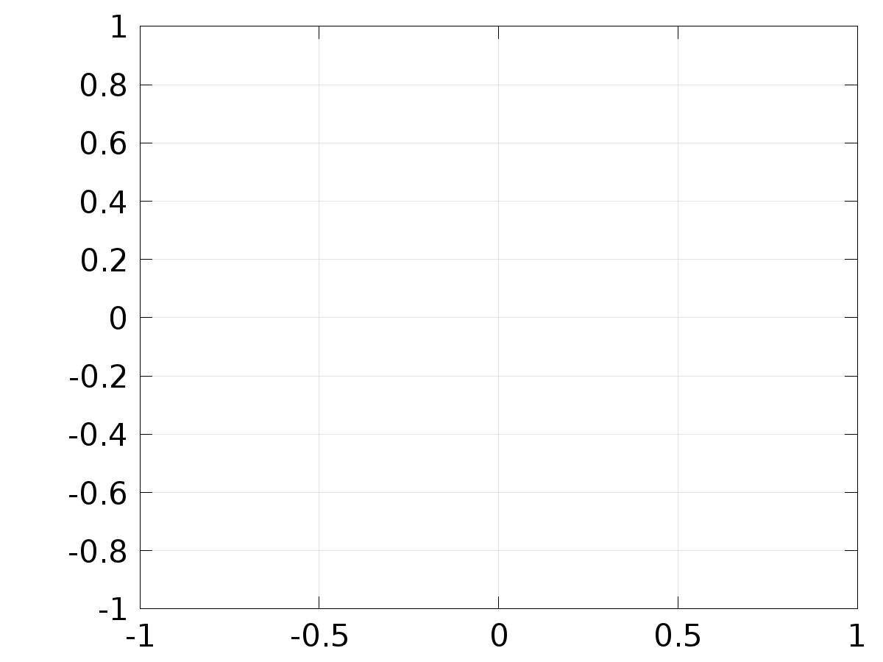

* + 1. Velocity (spf)

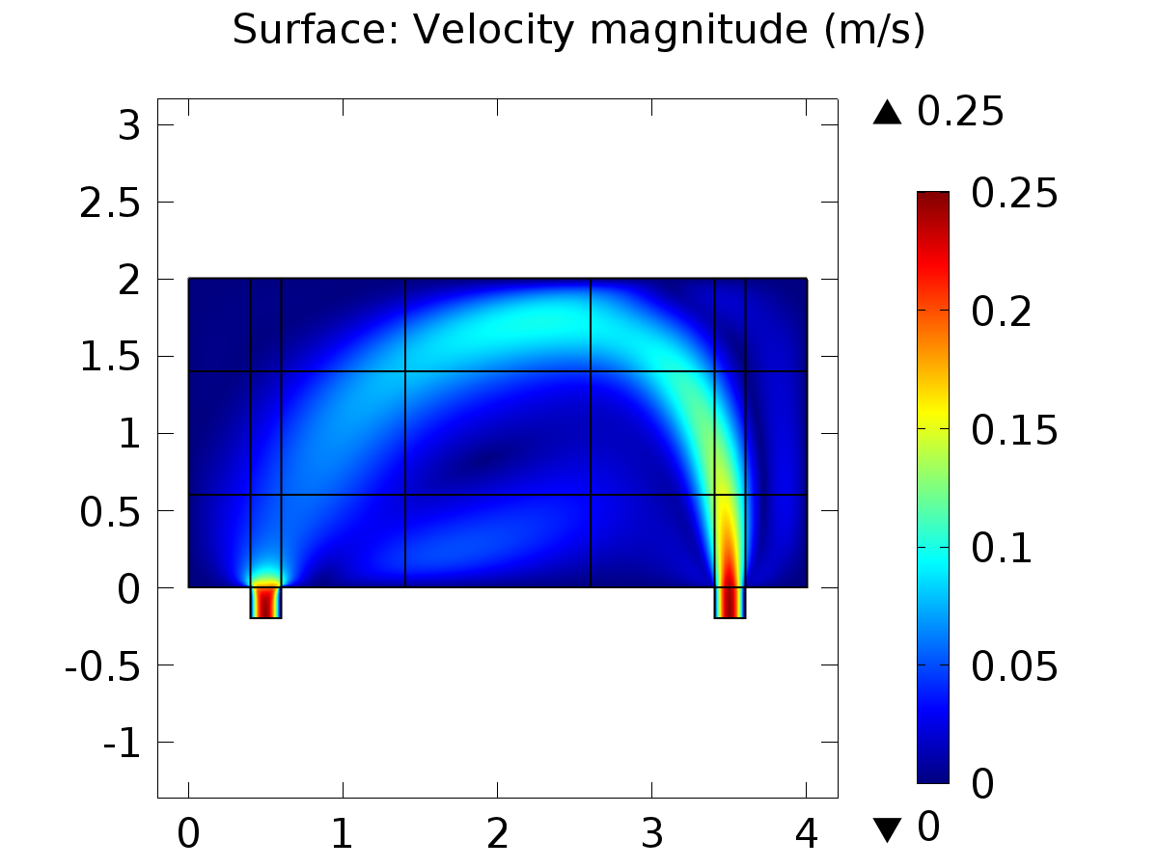

Surface: Velocity magnitude (m/s)

* + 1. Pressure (spf)

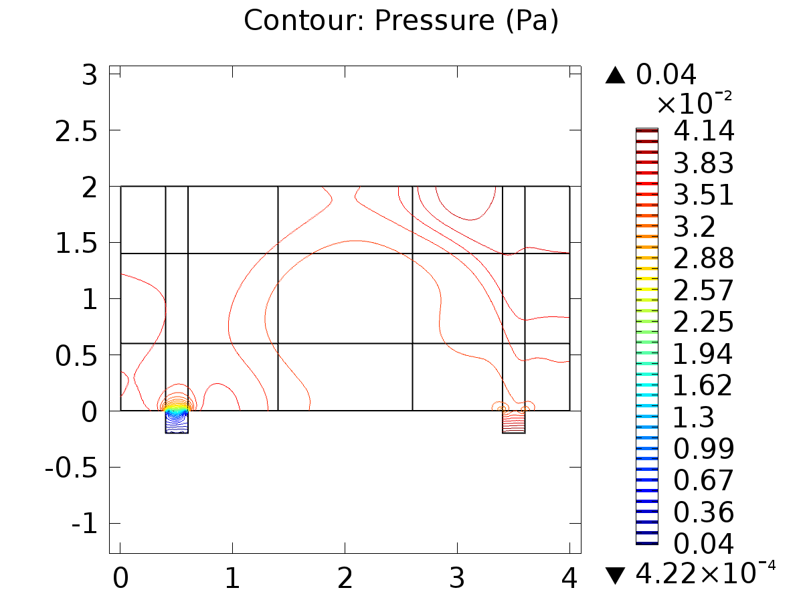

Contour: Pressure (Pa)

* + 1. Temperature (ht)

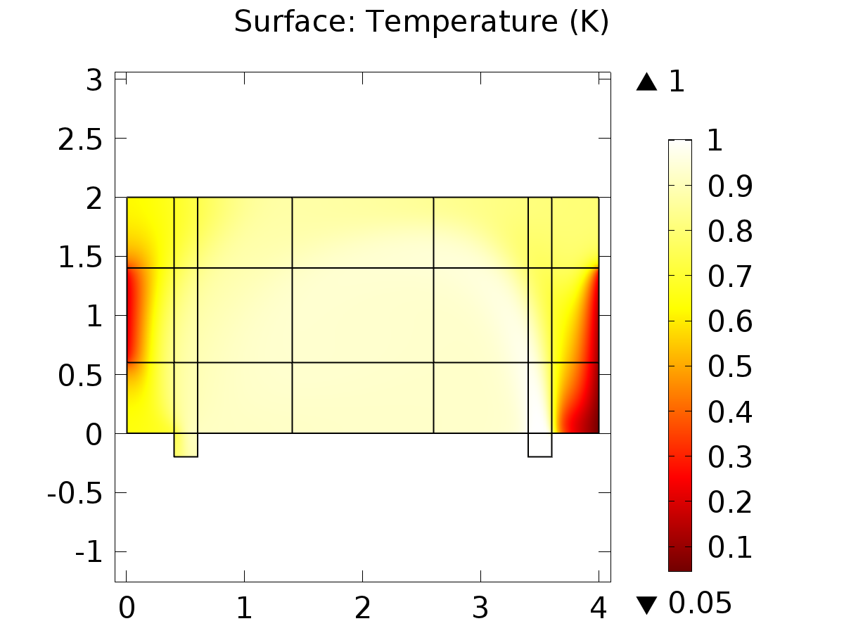

Surface: Temperature (K)

* + 1. Isothermal Contours (ht)

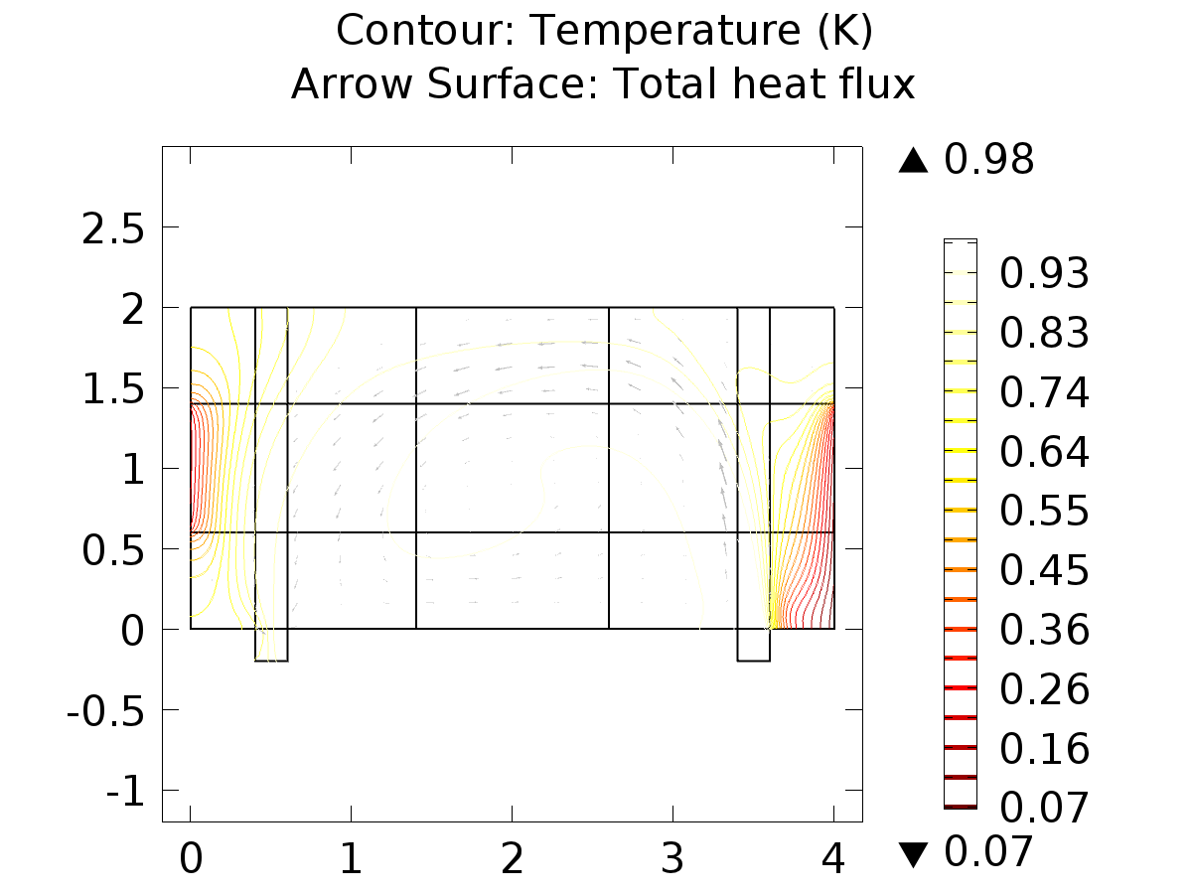

Contour: Temperature (K) Arrow Surface: Total heat flux

* + 1. Temperature (ht2)

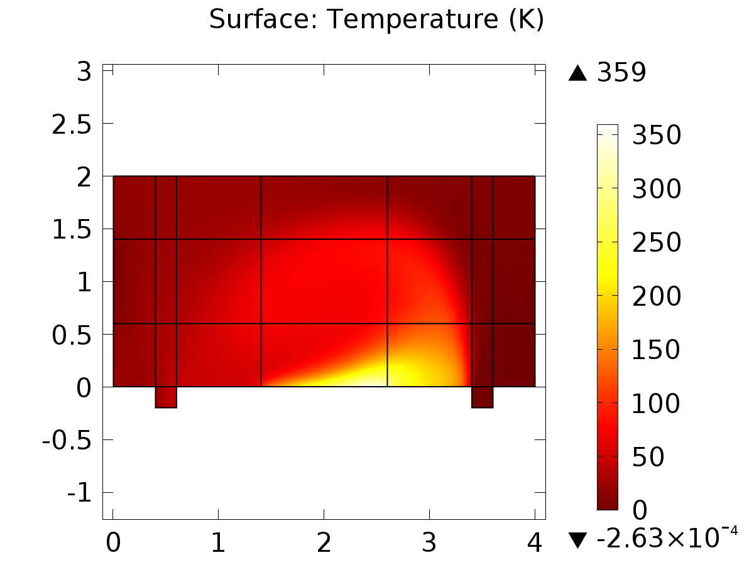

Surface: Temperature (K)

* + 1. Isothermal Contours (ht2)

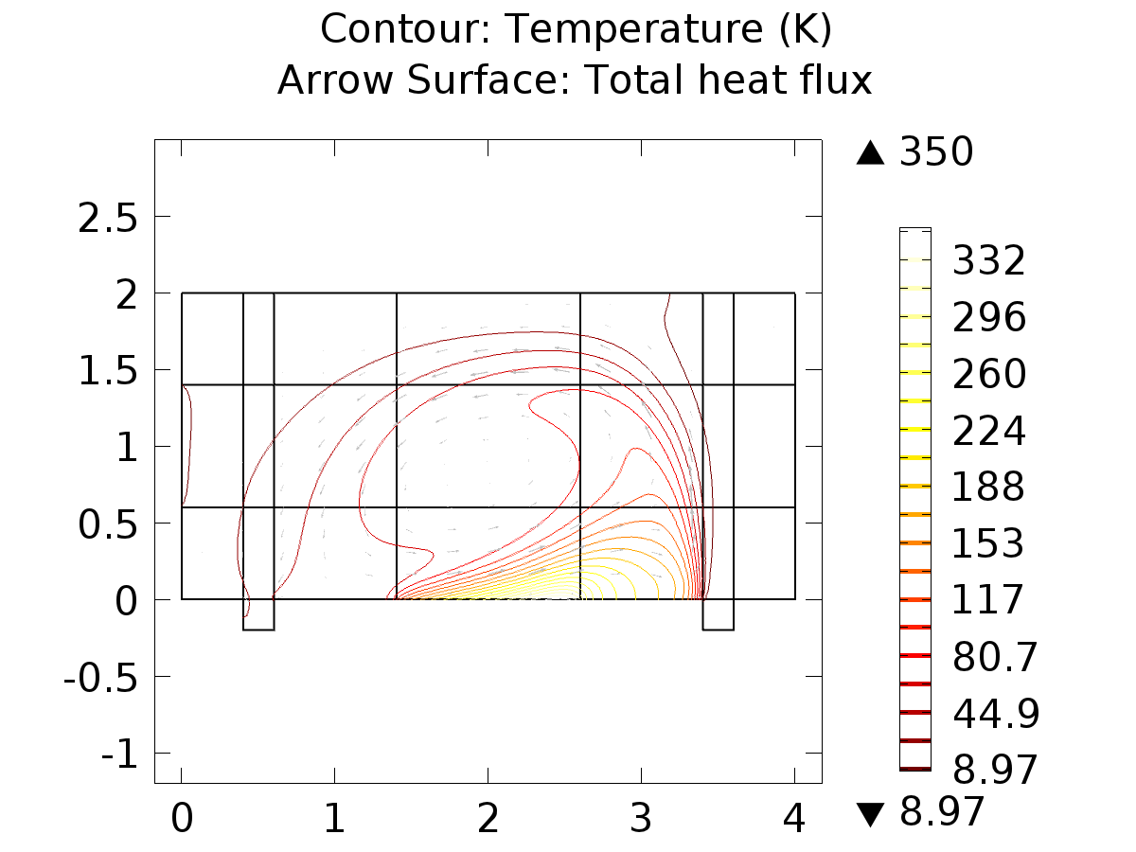

Contour: Temperature (K) Arrow Surface: Total heat flux

* + 1. Temperature (phys1)

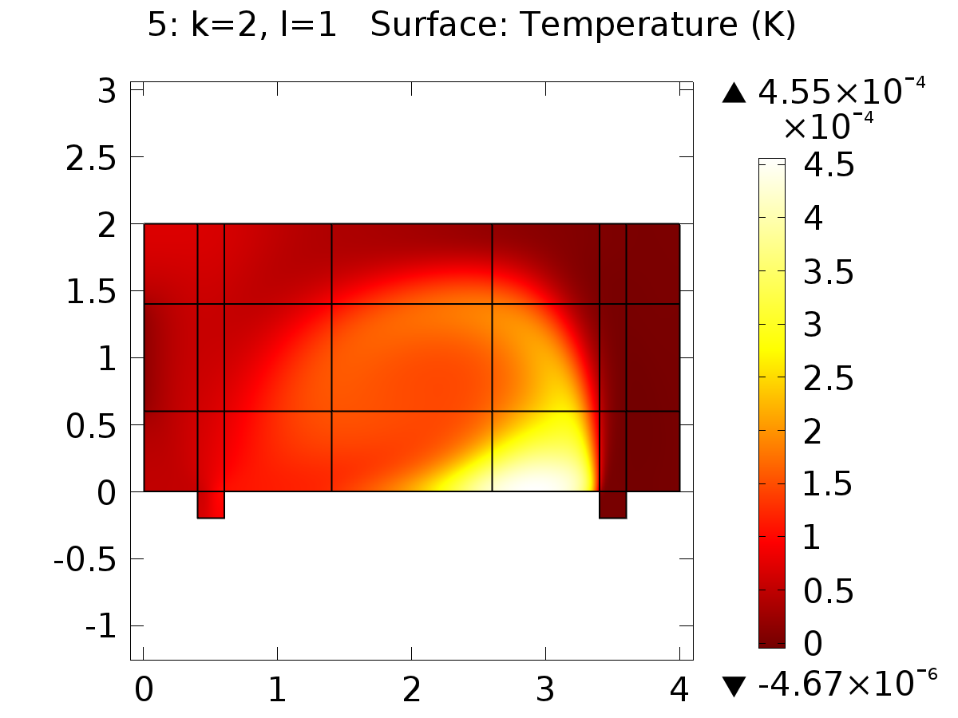

5: k=2, l=1 Surface: Temperature (K)

* + 1. Isothermal Contours (phys1)

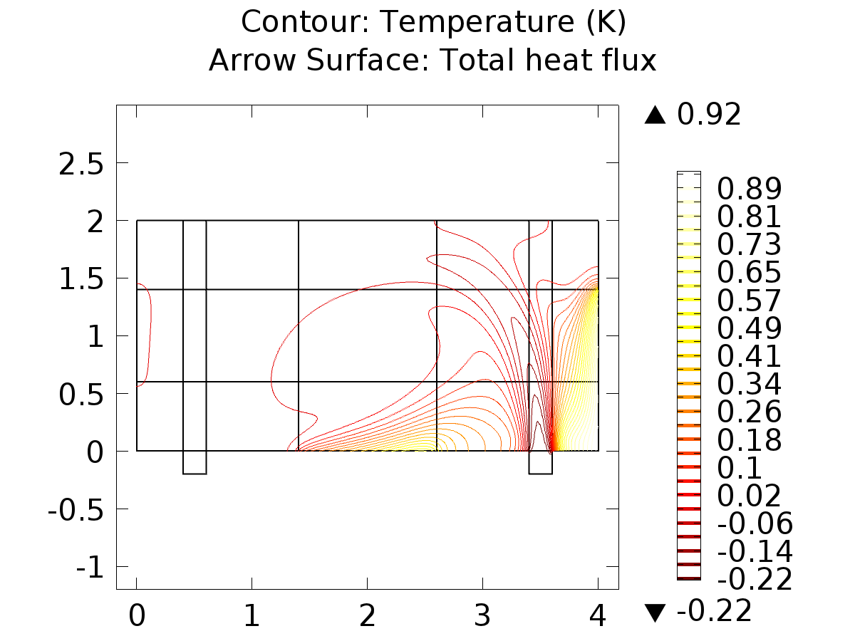

Contour: Temperature (K) Arrow Surface: Total heat flux

* + 1. Temperature (phys1) 1

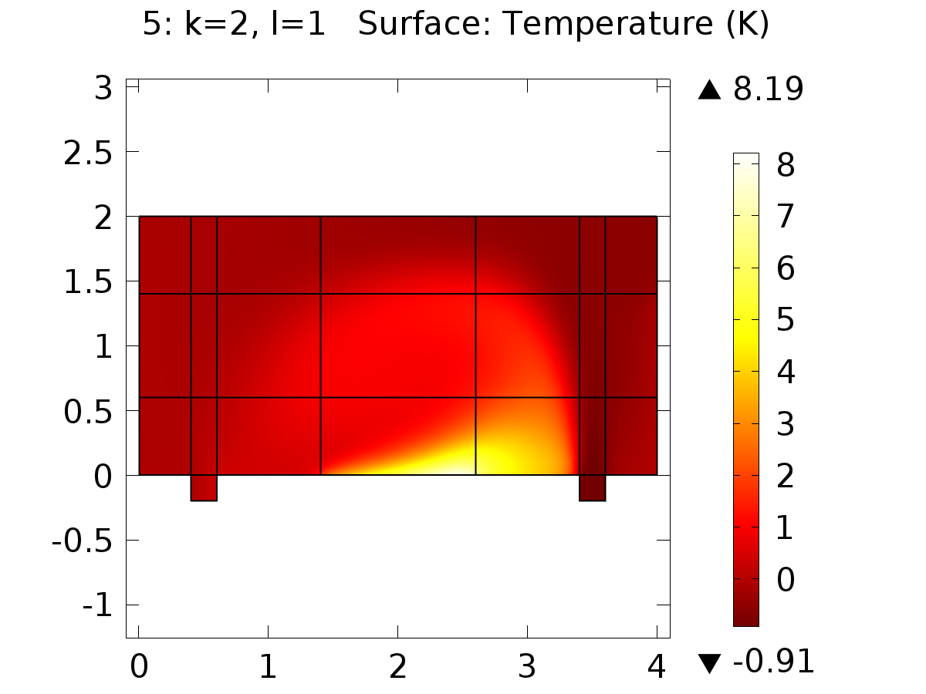

5: k=2, l=1 Surface: Temperature (K)

* + 1. Temperature (phys5)

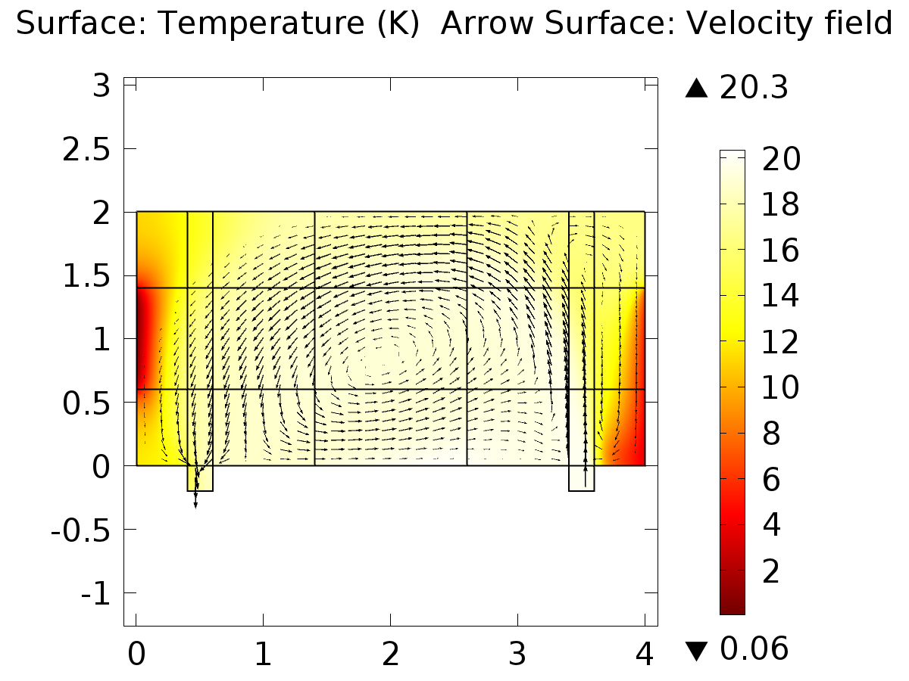

Surface: Temperature (K) Arrow Surface: Velocity field

* + 1. Isothermal Contours (phys5)

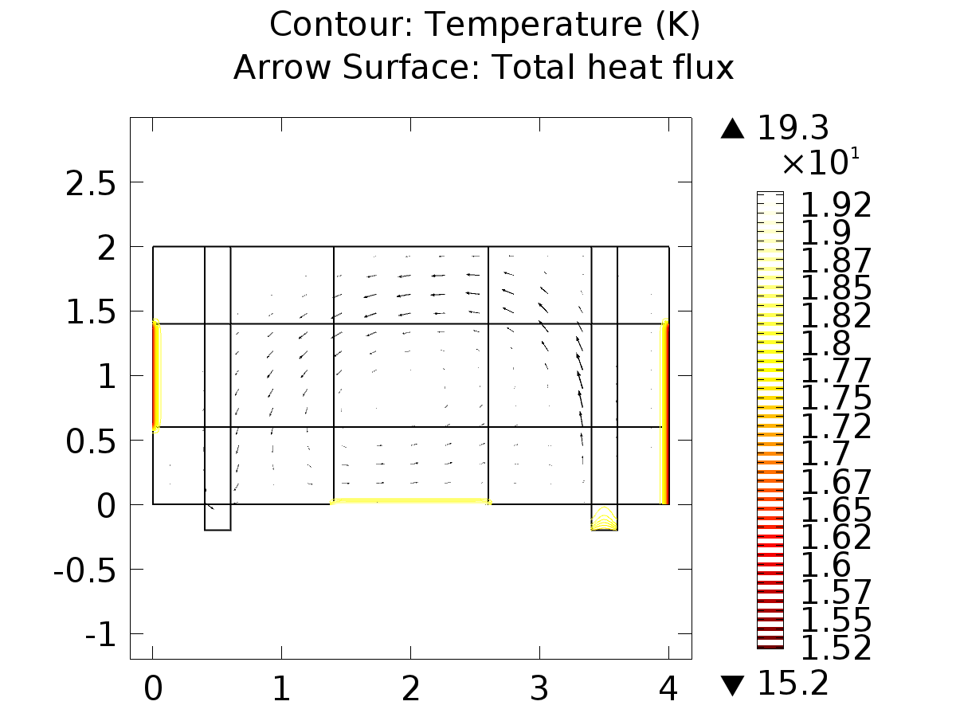

Contour: Temperature (K) Arrow Surface: Total heat flux

* + 1. 1D Plot Group 23

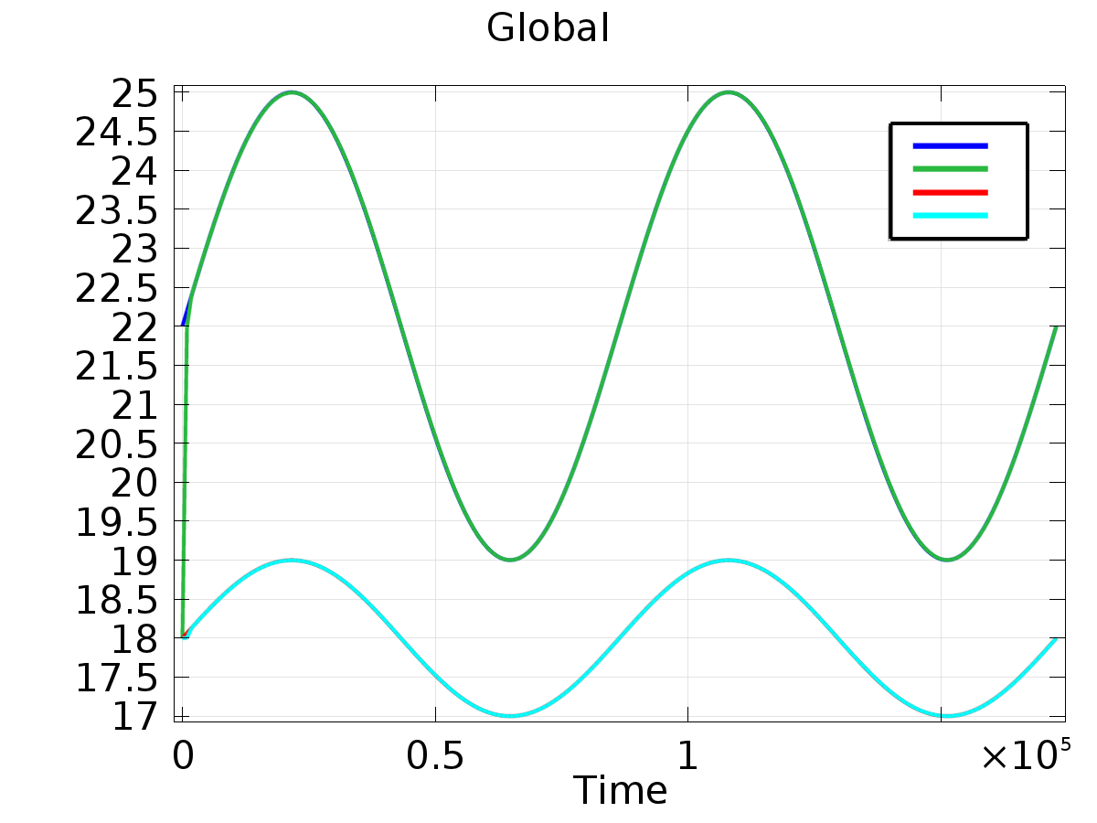

Global

* + 1. 1D Plot Group 24

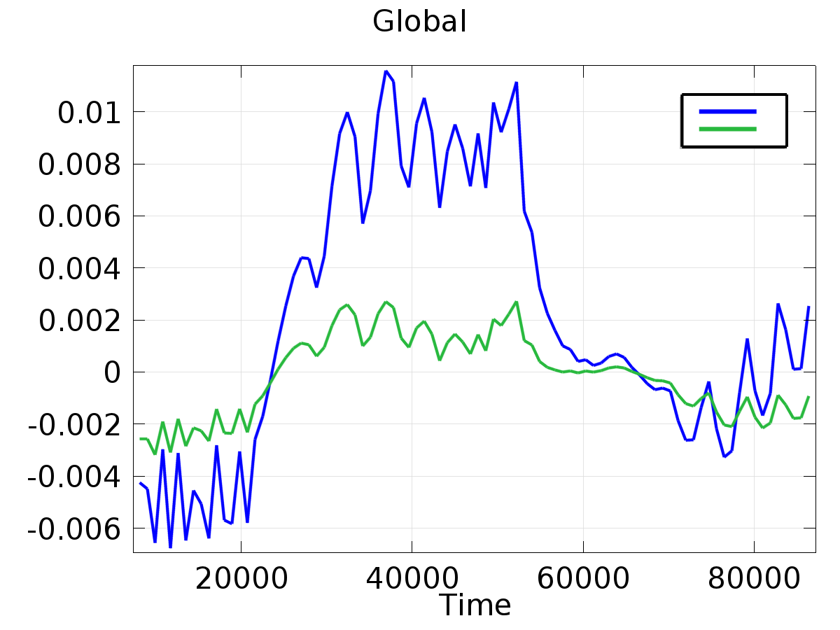

Global