[](http://www.comsol.com/)

IncommensuratePeriodicSignals

|  |  |
| --- | --- |
| Date | Feb 4, 2014 5:29:26 AM |

Contents

1. Global

1.1. Definitions

2. Plant

2.1. Definitions

2.2. Geometry 2

2.3. Unit Input

2.4. Regulator Eqs

2.5. Closed Loop System

2.6. Mesh 2

3. Study 1

3.1. Parametric Sweep

3.2. Stationary

3.3. Solver Configurations

4. Study 2

4.1. Parametric Sweep

4.2. Stationary

4.3. Solver Configurations

5. Study 3

5.1. Time Dependent

5.2. Solver Configurations

6. Results

6.1. Data Sets

6.2. Derived Values

6.3. Tables

6.4. Plot Groups

1. Global

|  |  |
| --- | --- |
| Date | Nov 7, 2013 4:24:39 PM |

Global settings

|  |  |
| --- | --- |
| Name | IncommensuratePeriodicSignals.mph |
| Path | /Users/gilliam/Desktop/collect_15/research_15/geo_reg_mono_eugenio/Mono_1_15/Comsol_EX_GitHub/Chapter3/Chap3Ex7_FourierSeries/Chap3Ex7_incommensurateFourierSeries/IncommensuratePeriodicSignals.mph |
| Program | COMSOL 4.4 (Build: 150) |

Used products

|  |
| --- |
| COMSOL Multiphysics |

* 1. Definitions
     1. Parameters 1

Parameters

| **Name** | **Expression** | **Value** | **Description** |
| --- | --- | --- | --- |
| c | 0.1 | 0.10000 |  |
| n | 1 | 1.0000 |  |
| n_in | 3 | 3.0000 |  |
| n_out | n_in | 3.0000 |  |
| n_d | 1 | 1.0000 |  |
| l | 1 | 1.0000 | Function Index |
| lmax | n_out + n_d | 4.0000 |  |
| k | 0 | 0.0000 | coefficient index |
| kmax | 20 | 20.000 |  |

* + 1. Functions

#### P(l)

|  |  |
| --- | --- |
| Function name | P |
| Function type | Analytic |

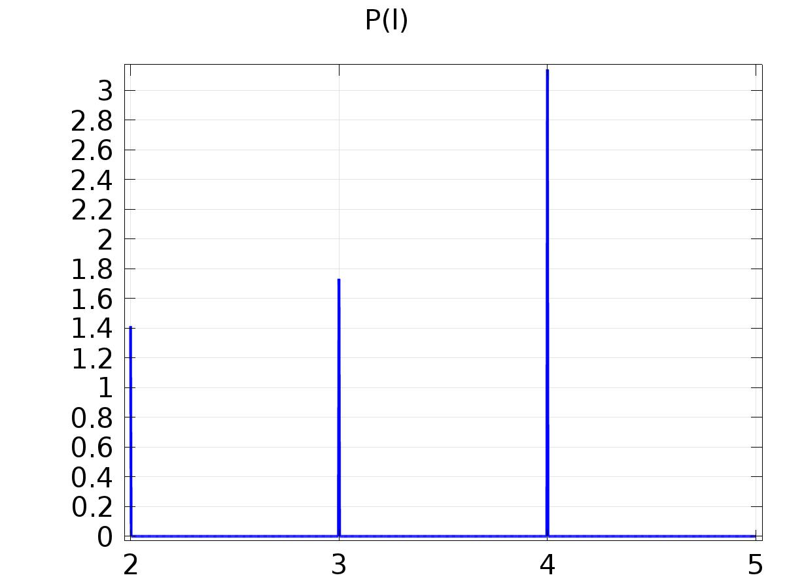

P(l)

Definition

| **Description** | **Value** |
| --- | --- |
| Expression | pi*((l==1) + (l==4)) + sqrt(2)*(l==2) + sqrt(3)*(l==3) |
| Arguments | l |

#### alpha_lk=pi/P(l)*k

|  |  |
| --- | --- |
| Function name | alpha |
| Function type | Analytic |

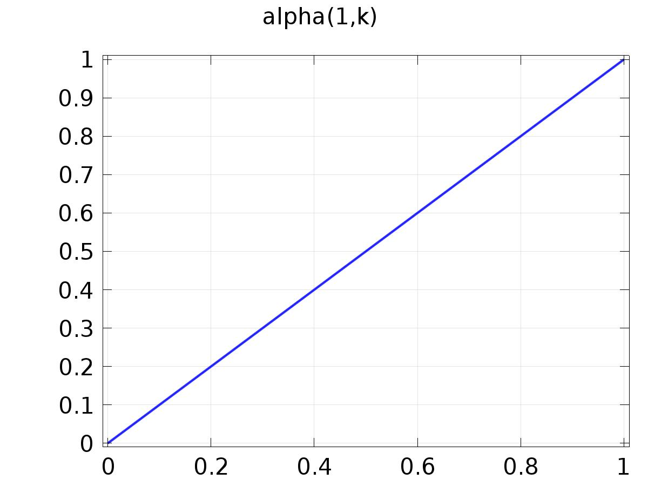

alpha_lk=pi/P(l)*k

Definition

| **Description** | **Value** |
| --- | --- |
| Expression | pi/P(l)*k |
| Arguments | {l, k} |

#### Cos(alpha_lk*t)

|  |  |
| --- | --- |
| Function name | FourierCos |
| Function type | Analytic |

Definition

| **Description** | **Value** |
| --- | --- |
| Expression | cos( alpha(l, k) * t ) |
| Arguments | {l, k, t} |

#### Sin(alpha_lk*t)

|  |  |
| --- | --- |
| Function name | FourierSin |
| Function type | Analytic |

Definition

| **Description** | **Value** |
| --- | --- |
| Expression | sin( alpha(l, k) * t ) |
| Arguments | {l, k, t} |

#### Cos Output Q_lk1

|  |  |
| --- | --- |
| Function name | Q1 |
| Function type | Analytic |

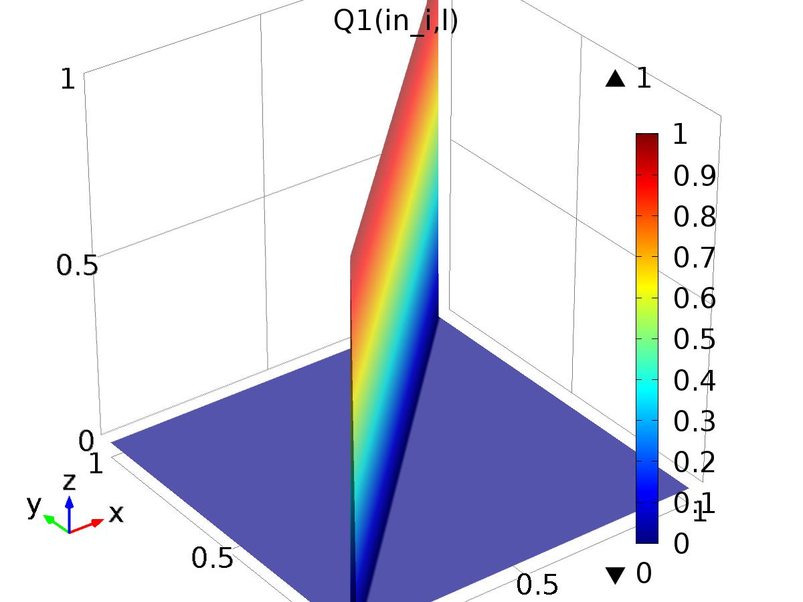

Cos Output Q_lk1

Definition

| **Description** | **Value** |
| --- | --- |
| Expression | (in_i==l) |
| Arguments | {in_i, l} |

#### Sin Output Q_lk2

|  |  |
| --- | --- |
| Function name | Q2 |
| Function type | Analytic |

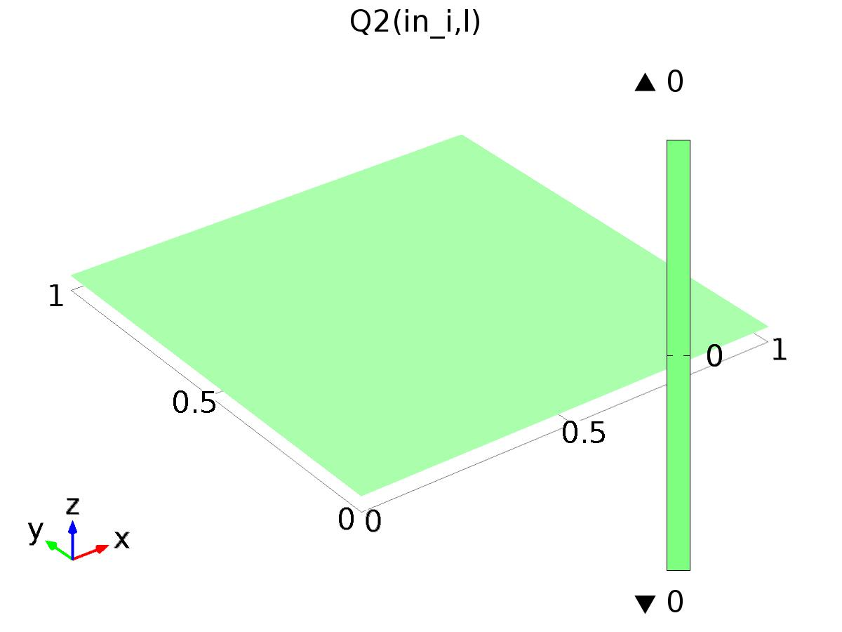

Sin Output Q_lk2

Definition

| **Description** | **Value** |
| --- | --- |
| Expression | 0 |
| Arguments | {in_i, l} |

#### Cos Disturbance P_lk1

|  |  |
| --- | --- |
| Function name | P1 |
| Function type | Analytic |

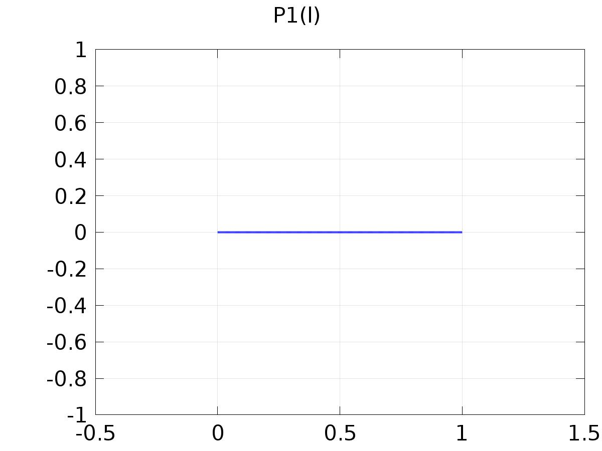

Cos Disturbance P_lk1

Definition

| **Description** | **Value** |
| --- | --- |
| Expression | (l==n_out + 1) |
| Arguments | l |

#### Sin Disturbance P_lk2

|  |  |
| --- | --- |
| Function name | P2 |
| Function type | Analytic |

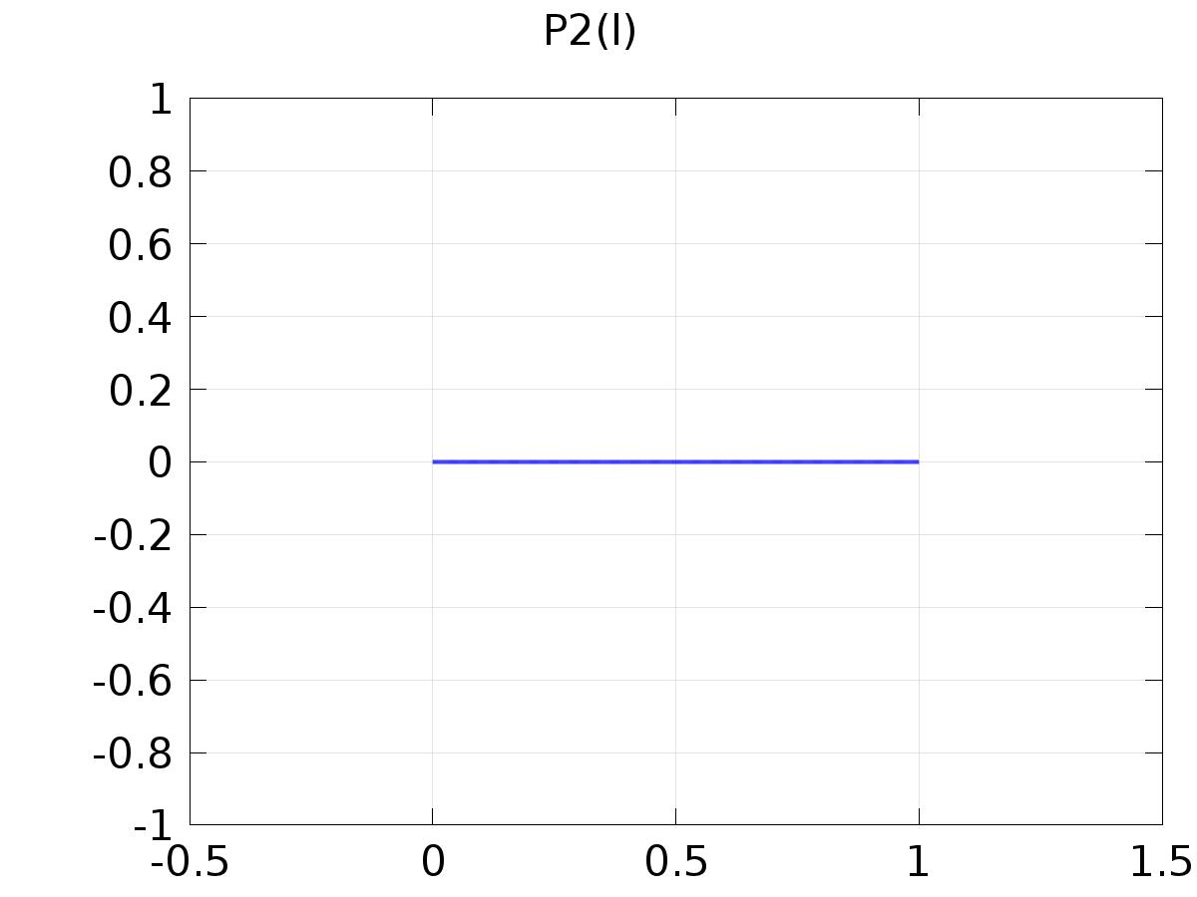

Sin Disturbance P_lk2

Definition

| **Description** | **Value** |
| --- | --- |
| Expression | 0 |
| Arguments | l |

#### delta_input

|  |  |
| --- | --- |
| Function name | delta |
| Function type | Analytic |

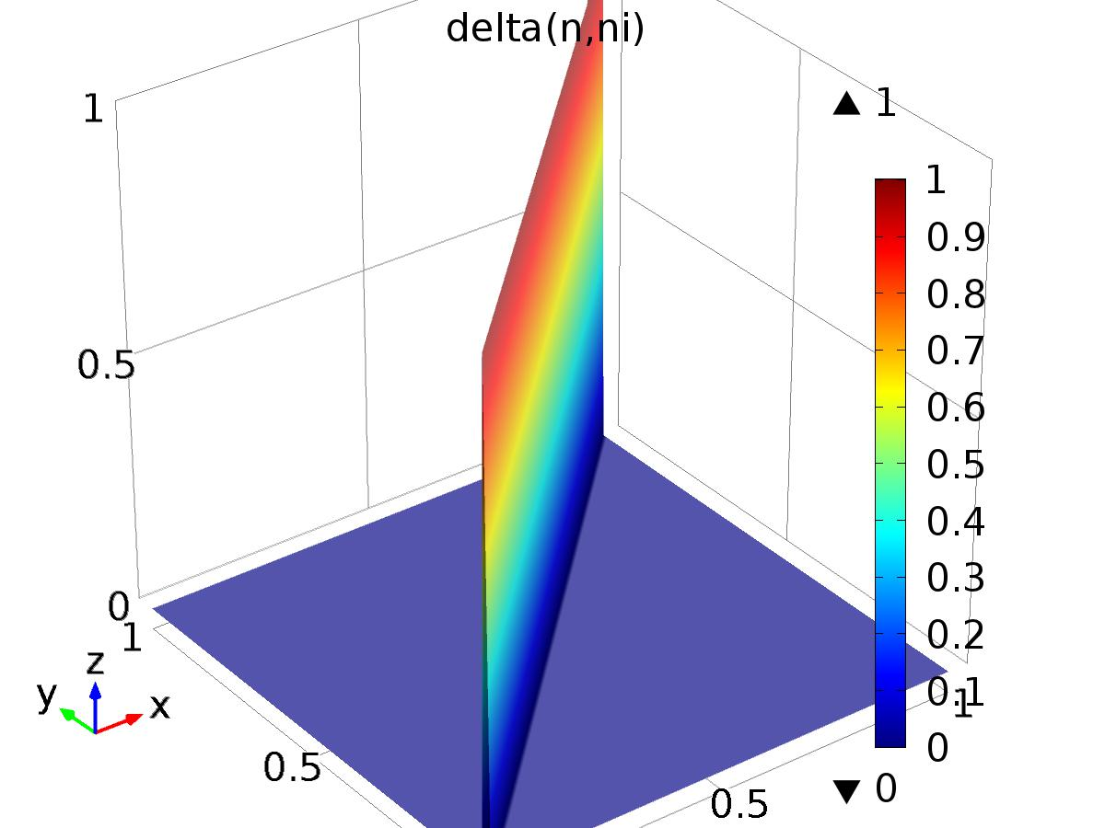

delta_input

Definition

| **Description** | **Value** |
| --- | --- |
| Expression | (ni==n) |
| Arguments | {n, ni} |

#### yr1

|  |  |
| --- | --- |
| Function name | yr1 |
| Function type | Analytic |

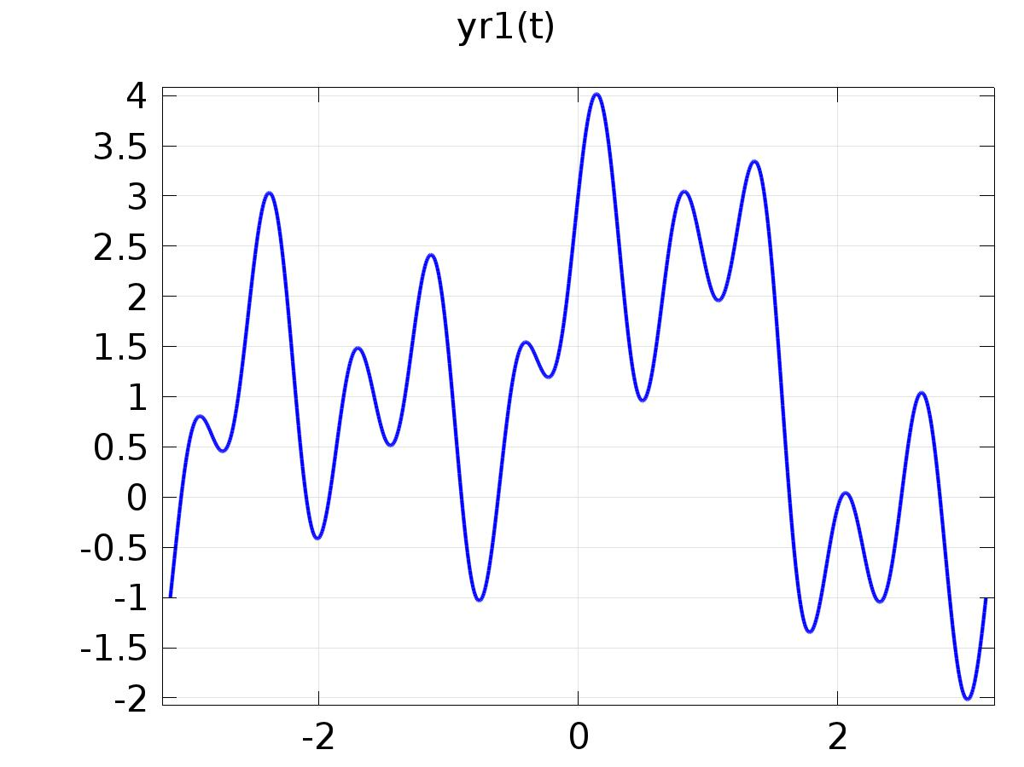

yr1

Definition

| **Description** | **Value** |
| --- | --- |
| Expression | 1 + cos(t) + sin(2*t) + cos(5*t) + sin(10*t) |
| Arguments | t |

#### yr2

|  |  |
| --- | --- |
| Function name | yr2 |
| Function type | Piecewise |

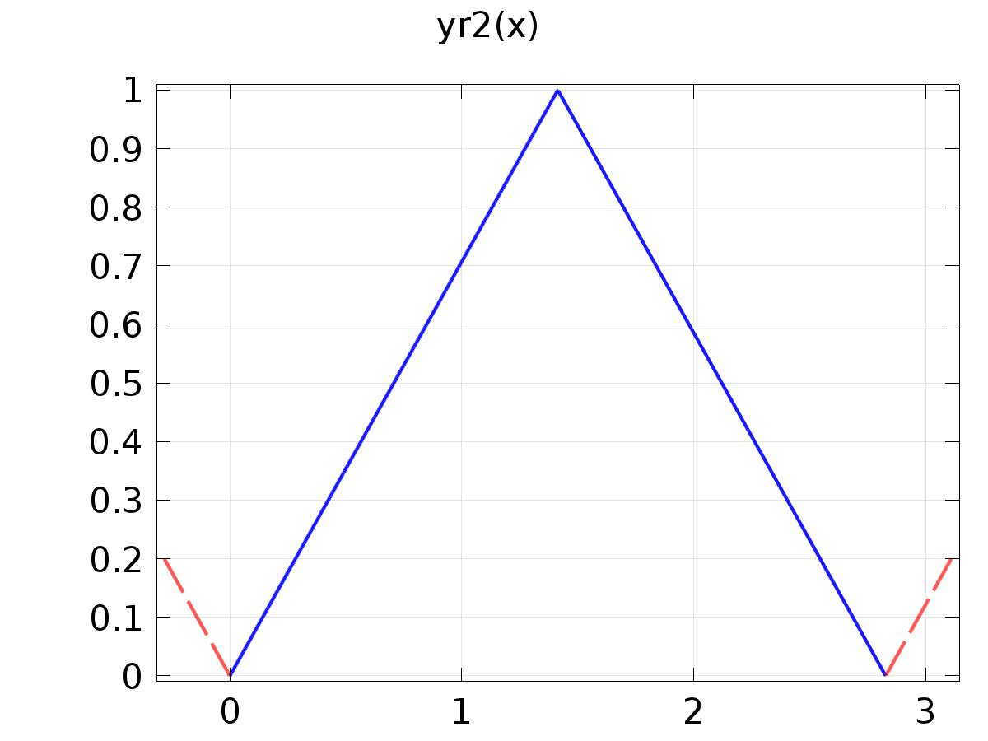

yr2

Definition

| **Description** | **Value** |
| --- | --- |
| Argument | x |
| Extrapolation | Periodic |
| Smoothing | No smoothing |

Definition

| **Start** | **End** | **Function** |
| --- | --- | --- |
| 0 | sqrt(2) | x/sqrt(2) |
| sqrt(2) | 2*sqrt(2) | (2-x/sqrt(2)) |

#### yr3

|  |  |
| --- | --- |
| Function name | yr3 |
| Function type | Piecewise |

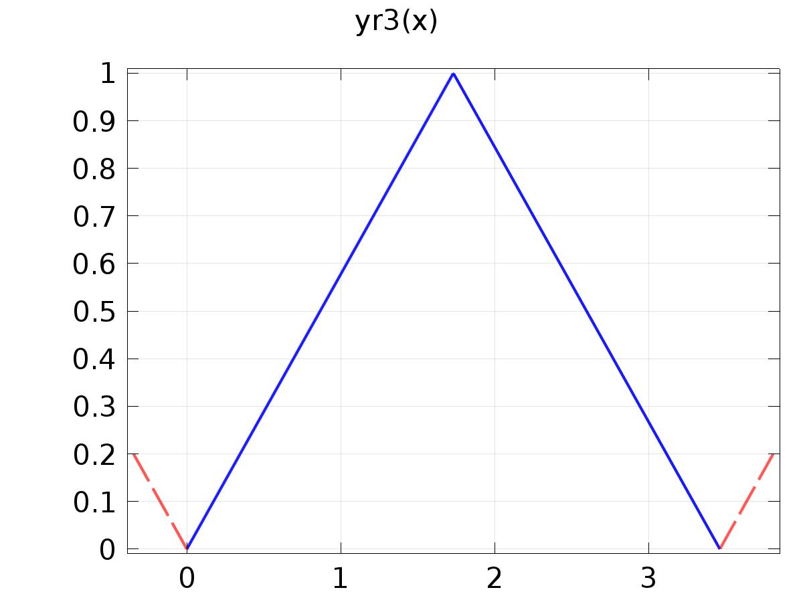

yr3

Definition

| **Description** | **Value** |
| --- | --- |
| Argument | x |
| Extrapolation | Periodic |
| Smoothing | No smoothing |

Definition

| **Start** | **End** | **Function** |
| --- | --- | --- |
| 0 | sqrt(3) | (x/sqrt(3)) |
| sqrt(3) | 2*sqrt(3) | (2-x/sqrt(3)) |

#### d1

|  |  |
| --- | --- |
| Function name | d1 |
| Function type | Analytic |

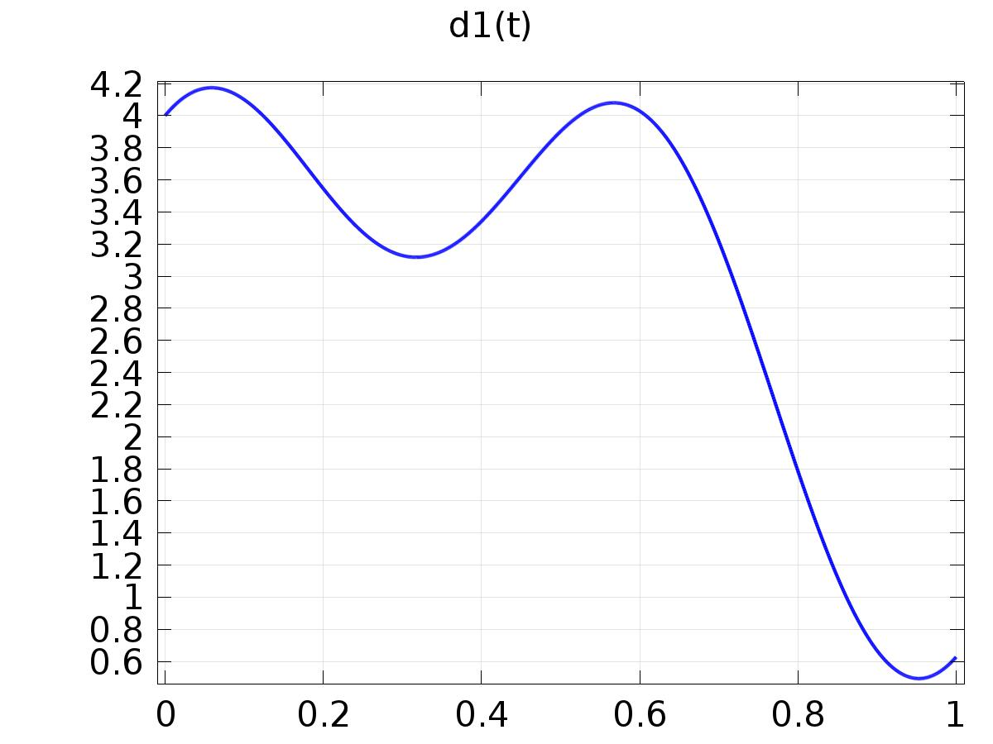

d1

Definition

| **Description** | **Value** |
| --- | --- |
| Expression | 2 + sin(t) + cos(2*t) + sin(5*t) + cos(10*t) |
| Arguments | t |

1. Plant

Component settings

|  |  |
| --- | --- |
| Unit system | None |

* 1. Definitions
     1. Variables

#### Gamma

Selection

|  |  |
| --- | --- |
| Geometric entity level | Entire model |

| **Name** | **Expression** | **Description** |
| --- | --- | --- |
| Gamma11 | 0 + (-2.59551446923744E+00)*(Q1(1, l) - C1(PIt1)) + (1.61132805650271E+00)*(Q1(2, l) - C2(PIt1)) + (1.13278596347482E+00)*(Q1(3, l) - C3(PIt1)) |  |
| Gamma12 | 0 + (-2.59551446923744E+00)*(Q2(1, l) - C1(PIt2)) + (1.61132805650271E+00)*(Q2(2, l) - C2(PIt2)) + (1.13278596347482E+00)*(Q2(3, l) - C3(PIt2)) |  |
| Gamma21 | 0 + (-8.45090233310403E+02)*(Q1(1, l) - C1(PIt1)) + (1.70618227648515E+02)*(Q1(2, l) - C2(PIt1)) + (8.58287466141936E+02)*(Q1(3, l) - C3(PIt1)) |  |
| Gamma22 | 0 + (-8.45090233310403E+02)*(Q2(1, l) - C1(PIt2)) + (1.70618227648515E+02)*(Q2(2, l) - C2(PIt2)) + (8.58287466141936E+02)*(Q2(3, l) - C3(PIt2)) |  |
| Gamma31 | 0 + (2.01080507896101E+02)*(Q1(1, l) - C1(PIt1)) + (-4.07833107239756E+01)*(Q1(2, l) - C2(PIt1)) + (-2.00927620030446E+02)*(Q1(3, l) - C3(PIt1)) |  |
| Gamma32 | 0 + (2.01080507896101E+02)*(Q2(1, l) - C1(PIt2)) + (-4.07833107239756E+01)*(Q2(2, l) - C2(PIt2)) + (-2.00927620030446E+02)*(Q2(3, l) - C3(PIt2)) |  |

#### u(t)

Selection

|  |  |
| --- | --- |
| Geometric entity level | Entire model |

| **Name** | **Expression** | **Description** |
| --- | --- | --- |
| u1 | 0 + (-2.59551446923744e+00)*FourierCos(1, 0, t) + (-1.98179718450793e+00)*FourierCos(1, 1, t) + (2.32152459432247e+00)*FourierSin(1, 1, t) + (-4.32328433081556e+00)*FourierCos(1, 2, t) + (-1.82085017634358e-01)*FourierSin(1, 2, t) + (1.05007375496959e+01)*FourierCos(1, 5, t) + (5.47178449056662e+00)*FourierSin(1, 5, t) + (2.26559626709095e+01)*FourierCos(1, 10, t) + (2.56453002889368e+01)*FourierSin(1, 10, t) + (8.05664028251355e-01)*FourierCos(2, 0, t) + (2.92496792481706e-01)*FourierCos(2, 1, t) + (1.26051337432406e+00)*FourierSin(2, 1, t) + (6.31021985783925e-01)*FourierCos(2, 3, t) + (-1.86085296581970e-01)*FourierSin(2, 3, t) + (2.35696375915398e-01)*FourierCos(2, 5, t) + (-6.59699776969679e-01)*FourierSin(2, 5, t) + (-3.10845504400551e-01)*FourierCos(2, 7, t) + (-7.74202923944069e-01)*FourierSin(2, 7, t) + (-8.65892067071395e-01)*FourierCos(2, 9, t) + (-5.60612786534354e-01)*FourierSin(2, 9, t) + (-1.29310297909516e+00)*FourierCos(2, 11, t) + (-4.04369952791776e-02)*FourierSin(2, 11, t) + (-1.45993555443933e+00)*FourierCos(2, 13, t) + (7.25599413154245e-01)*FourierSin(2, 13, t) + (-1.25305818313511e+00)*FourierCos(2, 15, t) + (1.62896557681932e+00)*FourierSin(2, 15, t) + (-5.96002329552422e-01)*FourierCos(2, 17, t) + (2.51637898364076e+00)*FourierSin(2, 17, t) + (5.34233934648090e-01)*FourierCos(2, 19, t) + (3.20015762928143e+00)*FourierSin(2, 19, t) + (5.66392981737410e-01)*FourierCos(3, 0, t) + (-2.98175759397726e-01)*FourierCos(3, 1, t) + (5.58338802310101e-01)*FourierSin(3, 1, t) + (8.79889285314007e-02)*FourierCos(3, 3, t) + (1.95883267896880e-01)*FourierSin(3, 3, t) + (9.92897017960147e-02)*FourierCos(3, 5, t) + (1.00817700060222e-01)*FourierSin(3, 5, t) + (9.94068232496211e-02)*FourierCos(3, 7, t) + (4.85205194740910e-02)*FourierSin(3, 7, t) + (9.56263324937565e-02)*FourierCos(3, 9, t) + (1.42918800448928e-02)*FourierSin(3, 9, t) + (8.87319080750952e-02)*FourierCos(3, 11, t) + (-1.06984048109847e-02)*FourierSin(3, 11, t) + (7.95494436209931e-02)*FourierCos(3, 13, t) + (-2.91928005967719e-02)*FourierSin(3, 13, t) + (6.98544141151200e-02)*FourierCos(3, 15, t) + (-4.18977987445431e-02)*FourierSin(3, 15, t) + (6.28191607103400e-02)*FourierCos(3, 17, t) + (-4.99211381579125e-02)*FourierSin(3, 17, t) + (6.23307502301081e-02)*FourierCos(3, 19, t) + (-5.70143364906539e-02)*FourierSin(3, 19, t) + (-2.97199101480283e-01)*FourierCos(4, 0, t) + (-2.77791464124732e-02)*FourierCos(4, 1, t) + (-1.59892247712227e-01)*FourierSin(4, 1, t) + (-1.91514010327423e-01)*FourierCos(4, 2, t) + (4.39777391451778e-02)*FourierSin(4, 2, t) + (5.00684975592518e-02)*FourierCos(4, 5, t) + (-2.93130142826418e-01)*FourierSin(4, 5, t) + (-1.68746416972405e-01)*FourierCos(4, 10, t) + (-2.03700681810645e-01)*FourierSin(4, 10, t) |  |
| u2 | 0 + (-8.45090233310403e+02)*FourierCos(1, 0, t) + (-5.64984080679567e+02)*FourierCos(1, 1, t) + (7.90119635025302e+02)*FourierSin(1, 1, t) + (-1.35720890358867e+03)*FourierCos(1, 2, t) + (2.49797804558629e+02)*FourierSin(1, 2, t) + (1.62326065401272e-12)*FourierCos(1, 3, t) + (1.15763515265120e-12)*FourierSin(1, 3, t) + (1.37946208893939e-12)*FourierCos(1, 4, t) + (4.78433232809886e+03)*FourierCos(1, 5, t) + (-4.78234151019571e+01)*FourierSin(1, 5, t) + (1.56962912106255e-12)*FourierCos(1, 6, t) + (8.76701347282281e-12)*FourierCos(1, 7, t) + (4.20394897370668e-12)*FourierSin(1, 7, t) + (7.09665152224598e-12)*FourierCos(1, 8, t) + (-1.10762378530899e-11)*FourierSin(1, 8, t) + (3.82370752051047e-12)*FourierCos(1, 9, t) + (-4.86756003819413e-12)*FourierSin(1, 9, t) + (1.67409991726546e+04)*FourierCos(1, 10, t) + (4.68032318607339e+03)*FourierSin(1, 10, t) + (3.45347807495207e-12)*FourierCos(1, 11, t) + (-1.30720371167302e-11)*FourierSin(1, 11, t) + (3.43306460783202e-12)*FourierCos(1, 12, t) + (1.94970371074629e-12)*FourierSin(1, 12, t) + (5.92358306194079e-12)*FourierCos(1, 13, t) + (-2.22331125395069e-11)*FourierSin(1, 13, t) + (9.77747013619494e-12)*FourierCos(1, 14, t) + (-2.10562099374827e-11)*FourierSin(1, 14, t) + (-1.61049781740793e-11)*FourierCos(1, 15, t) + (-4.87000045588916e-11)*FourierSin(1, 15, t) + (-2.12702353245953e-11)*FourierCos(1, 16, t) + (-8.91502432165417e-12)*FourierSin(1, 16, t) + (-7.06398558148464e-12)*FourierCos(1, 17, t) + (-7.43916126639806e-11)*FourierSin(1, 17, t) + (-6.63169790510773e-11)*FourierCos(1, 18, t) + (-4.54364670065161e-11)*FourierSin(1, 18, t) + (-1.03588051344508e-10)*FourierCos(1, 19, t) + (-5.89922851199890e-11)*FourierSin(1, 19, t) + (-1.23421506658978e-10)*FourierCos(1, 20, t) + (-4.04479484305874e-11)*FourierSin(1, 20, t) + (8.53091138242575e+01)*FourierCos(2, 0, t) + (-6.04298453570478e+01)*FourierCos(2, 1, t) + (6.75022468996802e+01)*FourierSin(2, 1, t) + (-1.26487812795906e+00)*FourierCos(2, 3, t) + (1.92449879091040e+01)*FourierSin(2, 3, t) + (4.52262612775012e+00)*FourierCos(2, 5, t) + (7.97450019275364e+00)*FourierSin(2, 5, t) + (5.77362095126201e+00)*FourierCos(2, 7, t) + (2.96203592071541e+00)*FourierSin(2, 7, t) + (5.60243950660890e+00)*FourierCos(2, 9, t) + (-1.49025099817586e-01)*FourierSin(2, 9, t) + (4.79705213715676e+00)*FourierCos(2, 11, t) + (-2.33746673261398e+00)*FourierSin(2, 11, t) + (3.63686949746387e+00)*FourierCos(2, 13, t) + (-3.92566442686686e+00)*FourierSin(2, 13, t) + (2.25651408478182e+00)*FourierCos(2, 15, t) + (-5.05398744092188e+00)*FourierSin(2, 15, t) + (7.31235436347351e-01)*FourierCos(2, 17, t) + (-5.80150843232030e+00)*FourierSin(2, 17, t) + (-9.03728354189954e-01)*FourierCos(2, 19, t) + (-6.22110336627342e+00)*FourierSin(2, 19, t) + (4.29143733070968e+02)*FourierCos(3, 0, t) + (2.61142979082648e+01)*FourierCos(3, 1, t) + (5.35046864044429e+02)*FourierSin(3, 1, t) + (2.52374514974685e+02)*FourierCos(3, 3, t) + (-2.82464765184788e+01)*FourierSin(3, 3, t) + (1.13218787524766e+02)*FourierCos(3, 5, t) + (-1.98481103519602e+02)*FourierSin(3, 5, t) + (2.84501064594639e-12)*FourierCos(3, 6, t) + (-7.61605441796473e+01)*FourierCos(3, 7, t) + (-2.34693119480833e+02)*FourierSin(3, 7, t) + (-4.14973748106952e-12)*FourierCos(3, 8, t) + (1.90096610769074e-12)*FourierSin(3, 8, t) + (-2.55837538313344e+02)*FourierCos(3, 9, t) + (-1.50808138076770e+02)*FourierSin(3, 9, t) + (1.40672982084914e-12)*FourierCos(3, 10, t) + (-3.73613715413199e+02)*FourierCos(3, 11, t) + (3.75640770348268e+01)*FourierSin(3, 11, t) + (-2.69489885074191e-11)*FourierCos(3, 12, t) + (-2.12535446901352e-11)*FourierSin(3, 12, t) + (-3.82155321200989e+02)*FourierCos(3, 13, t) + (2.97718519130801e+02)*FourierSin(3, 13, t) + (-7.14317098376854e-11)*FourierCos(3, 14, t) + (2.81478424617625e-11)*FourierSin(3, 14, t) + (-2.46396611433804e+02)*FourierCos(3, 15, t) + (5.78809470895328e+02)*FourierSin(3, 15, t) + (-5.32422413729309e-11)*FourierCos(3, 16, t) + (1.76341635766916e-11)*FourierSin(3, 16, t) + (4.95782573690984e+01)*FourierCos(3, 17, t) + (8.15717825462561e+02)*FourierSin(3, 17, t) + (-2.36627616192818e-10)*FourierCos(3, 18, t) + (-1.99225678061584e-10)*FourierSin(3, 18, t) + (4.97932130331204e+02)*FourierCos(3, 19, t) + (9.35378767152554e+02)*FourierSin(3, 19, t) + (2.92478022799921e-10)*FourierCos(3, 20, t) + (-2.13456900721350e-10)*FourierSin(3, 20, t) + (-3.57630920960182e+02)*FourierCos(4, 0, t) + (-6.18381820264982e+01)*FourierCos(4, 1, t) + (-1.79949754712728e+02)*FourierSin(4, 1, t) + (-1.85020778233262e+02)*FourierCos(4, 2, t) + (1.25182246604057e+02)*FourierSin(4, 2, t) + (-2.88868893393916e+02)*FourierCos(4, 5, t) + (-2.43905376799948e+02)*FourierSin(4, 5, t) + (-2.65739682131376e+02)*FourierCos(4, 10, t) + (4.26173861953177e+02)*FourierSin(4, 10, t) + (-1.56340468633391e-12)*FourierCos(4, 18, t) + (1.31599216373267e-12)*FourierSin(4, 18, t) + (-1.07465982187281e-12)*FourierSin(4, 19, t) + (2.36700919171540e-12)*FourierSin(4, 20, t) |  |
| u3 | 0 + (2.01080507896101e+02)*FourierCos(1, 0, t) + (1.19795072440878e+02)*FourierCos(1, 1, t) + (-2.03732897287245e+02)*FourierSin(1, 1, t) + (3.32748329164280e+02)*FourierCos(1, 2, t) + (-1.14408459051426e+02)*FourierSin(1, 2, t) + (-1.33693869744193e+03)*FourierCos(1, 5, t) + (3.11139362243943e+02)*FourierSin(1, 5, t) + (-2.87190470530658e-12)*FourierCos(1, 7, t) + (-1.28631923430785e-12)*FourierCos(1, 8, t) + (3.84708639124261e-12)*FourierSin(1, 8, t) + (1.78363832390219e-12)*FourierSin(1, 9, t) + (-5.56383049671737e+03)*FourierCos(1, 10, t) + (-6.51618128755924e+01)*FourierSin(1, 10, t) + (4.40106799080103e-12)*FourierSin(1, 11, t) + (-1.26685070342833e-12)*FourierCos(1, 12, t) + (7.72314622612562e-12)*FourierSin(1, 13, t) + (-1.21169909457712e-12)*FourierCos(1, 14, t) + (7.81175402454163e-12)*FourierSin(1, 14, t) + (1.00539579632671e-11)*FourierCos(1, 15, t) + (1.45720135793529e-11)*FourierSin(1, 15, t) + (8.01540963604660e-12)*FourierCos(1, 16, t) + (9.94664815191311e-12)*FourierCos(1, 17, t) + (2.45071546747355e-11)*FourierSin(1, 17, t) + (2.74418920669685e-11)*FourierCos(1, 18, t) + (8.70408782768652e-12)*FourierSin(1, 18, t) + (4.21162924874642e-11)*FourierCos(1, 19, t) + (9.49631006819157e-12)*FourierSin(1, 19, t) + (4.75396877474389e-11)*FourierCos(1, 20, t) + (-2.03916553619878e+01)*FourierCos(2, 0, t) + (1.26513275525797e+01)*FourierCos(2, 1, t) + (-1.95832395629359e+01)*FourierSin(2, 1, t) + (-9.82482290379790e-01)*FourierCos(2, 3, t) + (-5.69387307689074e+00)*FourierSin(2, 3, t) + (-2.10955269874184e+00)*FourierCos(2, 5, t) + (-2.11882852965989e+00)*FourierSin(2, 5, t) + (-2.21616407077888e+00)*FourierCos(2, 7, t) + (-4.20729194064142e-01)*FourierSin(2, 7, t) + (-1.94439069107991e+00)*FourierCos(2, 9, t) + (6.54330426513419e-01)*FourierSin(2, 9, t) + (-1.48009832510548e+00)*FourierCos(2, 11, t) + (1.40254479501556e+00)*FourierSin(2, 11, t) + (-8.99117172840138e-01)*FourierCos(2, 13, t) + (1.92073122593017e+00)*FourierSin(2, 13, t) + (-2.43750277359762e-01)*FourierCos(2, 15, t) + (2.25046678434183e+00)*FourierSin(2, 15, t) + (4.59855570491352e-01)*FourierCos(2, 17, t) + (2.41506143377968e+00)*FourierSin(2, 17, t) + (1.19903079495736e+00)*FourierCos(2, 19, t) + (2.42887383805545e+00)*FourierSin(2, 19, t) + (-1.00463810015223e+02)*FourierCos(3, 0, t) + (-2.59760190865684e+01)*FourierCos(3, 1, t) + (-1.30448102808418e+02)*FourierSin(3, 1, t) + (-6.90611633893963e+01)*FourierCos(3, 3, t) + (2.49589482191027e+01)*FourierSin(3, 3, t) + (-1.80735234748723e+01)*FourierCos(3, 5, t) + (6.96766602901707e+01)*FourierSin(3, 5, t) + (4.64572988723147e+01)*FourierCos(3, 7, t) + (6.85346976990224e+01)*FourierSin(3, 7, t) + (1.18509118558403e-12)*FourierCos(3, 8, t) + (-1.03371361294733e-12)*FourierSin(3, 8, t) + (1.01756847063573e+02)*FourierCos(3, 9, t) + (2.49425643375250e+01)*FourierSin(3, 9, t) + (1.27165134745188e+02)*FourierCos(3, 11, t) + (-5.36330774414830e+01)*FourierSin(3, 11, t) + (1.19914252505129e-11)*FourierCos(3, 12, t) + (4.60083814706483e-12)*FourierSin(3, 12, t) + (1.04902215976713e+02)*FourierCos(3, 13, t) + (-1.51572261396764e+02)*FourierSin(3, 13, t) + (2.30582245990258e-11)*FourierCos(3, 14, t) + (-1.86747619234689e-11)*FourierSin(3, 14, t) + (2.35289815939098e+01)*FourierCos(3, 15, t) + (-2.45555260882661e+02)*FourierSin(3, 15, t) + (1.80412463032751e-11)*FourierCos(3, 16, t) + (-1.31015996823670e-11)*FourierSin(3, 16, t) + (-1.19039915182684e+02)*FourierCos(3, 17, t) + (-3.06822830368874e+02)*FourierSin(3, 17, t) + (1.16662470892167e-10)*FourierCos(3, 18, t) + (4.78783129449822e-11)*FourierSin(3, 18, t) + (-3.13623081399757e+02)*FourierCos(3, 19, t) + (-3.04387662219053e+02)*FourierSin(3, 19, t) + (-8.87794185079242e-11)*FourierCos(3, 20, t) + (1.22148341638515e-10)*FourierSin(3, 20, t) + (8.32608457166568e+01)*FourierCos(4, 0, t) + (1.87666287965693e+01)*FourierCos(4, 1, t) + (4.12837038791935e+01)*FourierSin(4, 1, t) + (4.07828756311670e+01)*FourierCos(4, 2, t) + (-3.84329570501724e+01)*FourierSin(4, 2, t) + (9.62300688649653e+01)*FourierCos(4, 5, t) + (4.89611640671674e+01)*FourierSin(4, 5, t) + (4.57299452838419e+01)*FourierCos(4, 10, t) + (-1.54444865438819e+02)*FourierSin(4, 10, t) |  |

* + 1. Probes

#### C1(Xj)

|  |  |
| --- | --- |
| Probe type | Global variable probe |

#### C2(Xj)

|  |  |
| --- | --- |
| Probe type | Global variable probe |

#### C3(Xj)

|  |  |
| --- | --- |
| Probe type | Global variable probe |

#### Gamma_lk11

|  |  |
| --- | --- |
| Probe type | Global variable probe |

#### Gamma_lk12

|  |  |
| --- | --- |
| Probe type | Global variable probe |

#### Gamma_lk21

|  |  |
| --- | --- |
| Probe type | Global variable probe |

#### Gamma_lk22

|  |  |
| --- | --- |
| Probe type | Global variable probe |

#### Gamma_lk31

|  |  |
| --- | --- |
| Probe type | Global variable probe |

#### Gamma_lk32

|  |  |
| --- | --- |
| Probe type | Global variable probe |

* + 1. Component Couplings

#### Average 1

|  |  |
| --- | --- |
| Coupling type | Average |
| Operator name | C1 |

Source selection

|  |  |
| --- | --- |
| Geometric entity level | Boundary |
| Selection | Boundary 5 |

#### Average 2

|  |  |
| --- | --- |
| Coupling type | Average |
| Operator name | C2 |

Source selection

|  |  |
| --- | --- |
| Geometric entity level | Boundary |
| Selection | Boundary 4 |

#### Average 3

|  |  |
| --- | --- |
| Coupling type | Average |
| Operator name | C3 |

Source selection

|  |  |
| --- | --- |
| Geometric entity level | Boundary |
| Selection | Boundary 6 |

* + 1. Coordinate Systems

#### Boundary System 1

|  |  |
| --- | --- |
| Coordinate system type | Boundary system |
| Tag | sys1 |

Coordinate names

| **First (t1)** | **Second (n)** | **Third (to)** |
| --- | --- | --- |
| t1 | n | to |

Settings

| **Description** | **Value** |
| --- | --- |
| Create first tangent direction from | Global Cartesian |

* 1. Geometry 2

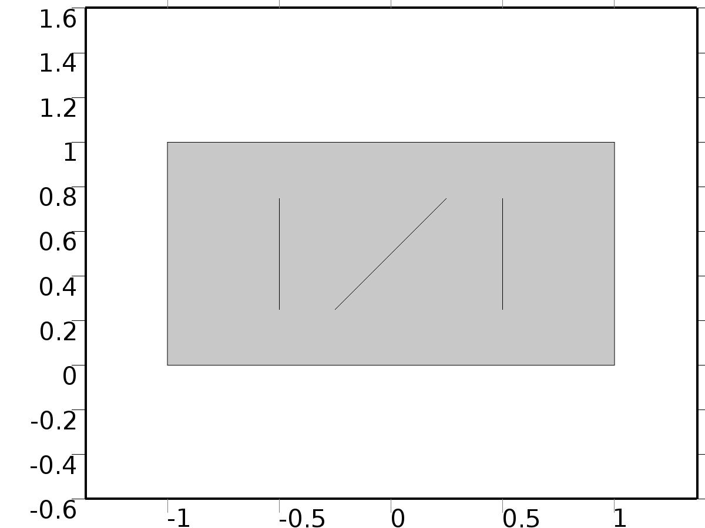

Geometry 2

Units

|  |  |
| --- | --- |
| Length unit | m |
| Angular unit | deg |

Geometry statistics

| **Description** | **Value** |
| --- | --- |
| Space dimension | 2 |
| Number of domains | 1 |
| Number of boundaries | 7 |
| Number of vertices | 10 |

* + 1. Rectangle 1 (r1)

Position

| **Description** | **Value** |
| --- | --- |
| Position | {-1, 0} |
| Layers |  |

Size

| **Description** | **Value** |
| --- | --- |
| Width | 2 |
| Height | 1 |

* + 1. Polygon 1 (pol1)

Object type

| **Description** | **Value** |
| --- | --- |
| Type | Open curve |

Coordinates

| **Description** | **Value** |
| --- | --- |
| x | {-0.25, 0.25} |
| y | {0.25, 0.75} |

* + 1. Polygon 2 (pol2)

Object type

| **Description** | **Value** |
| --- | --- |
| Type | Open curve |

Coordinates

| **Description** | **Value** |
| --- | --- |
| x | {0.5, 0.5} |
| y | {0.25, 0.75} |

* + 1. Polygon 3 (pol3)

Object type

| **Description** | **Value** |
| --- | --- |
| Type | Open curve |

Coordinates

| **Description** | **Value** |
| --- | --- |
| x | {-0.5, -0.5} |
| y | {0.25, 0.75} |

* 1. Unit Input

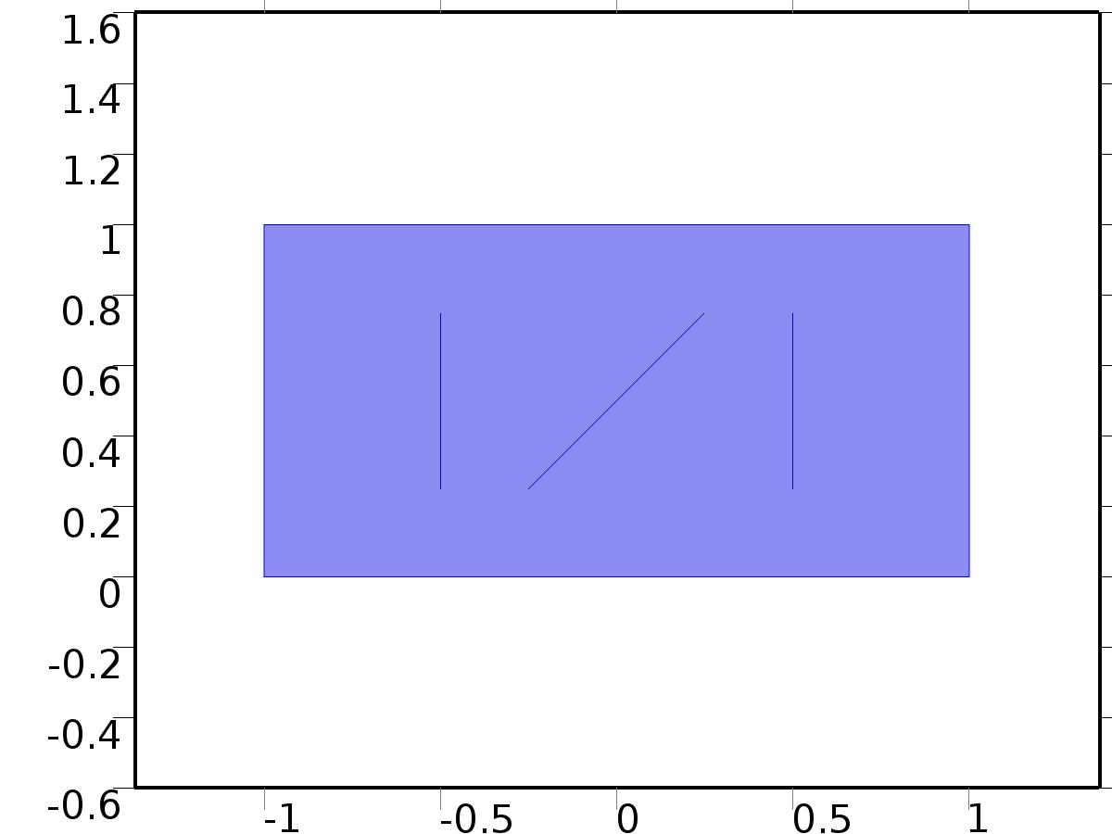

Unit Input

Selection

|  |  |
| --- | --- |
| Geometric entity level | Domain |
| Selection | Domain 1 |

Settings

| **Description** | **Value** |
| --- | --- |
| Shape function type | Lagrange |
| Element order | Quadratic |
| Compute boundary fluxes | On |
| Apply smoothing to boundary fluxes | On |
| Value type when using splitting of complex variables | Complex |
| Dependent variable quantity | Dimensionless (1) |
| Source term quantity | None |
| Unit | m^ - 2 |

Used products

|  |
| --- |
| COMSOL Multiphysics |

Variables

| **Name** | **Expression** | **Unit** | **Description** | **Selection** |
| --- | --- | --- | --- | --- |
| X.nx | nx |  | Normal vector, x component | Boundaries 1–7 |
| X.ny | ny |  | Normal vector, y component | Boundaries 1–7 |
| X.nz | root.nz |  | Normal vector, z component | Boundaries 1–7 |
| X.nxmesh | root.nxmesh |  | Normal vector (mesh), x component | Boundaries 1–7 |
| X.nymesh | root.nymesh |  | Normal vector (mesh), y component | Boundaries 1–7 |
| X.nzmesh | root.nzmesh |  | Normal vector (mesh), z component | Boundaries 1–7 |

* + 1. Coefficient Form PDE 1



Coefficient Form PDE 1

Selection

|  |  |
| --- | --- |
| Geometric entity level | Domain |
| Selection | Domain 1 |

Equations

Settings

| **Description** | **Value** |
| --- | --- |
| Diffusion coefficient | {{c, 0}, {0, c}} |
| Absorption coefficient | 0 |
| Source term | 0 |
| Mass coefficient | 0 |
| Damping or mass coefficient | 0 |
| Conservative flux convection coefficient | {0, 0} |
| Convection coefficient | {0, 0} |
| Conservative flux source | {0, 0} |

#### Variables

| **Name** | **Expression** | **Unit** | **Description** | **Selection** |
| --- | --- | --- | --- | --- |
| domflux.Xx | -c*d(X,x) |  | Domain flux, x component | Domain 1 |
| domflux.Xy | -c*d(X,y) |  | Domain flux, y component | Domain 1 |

#### Shape functions

| **Name** | **Shape function** | **Unit** | **Description** | **Shape frame** | **Selection** |
| --- | --- | --- | --- | --- | --- |
| X | Lagrange (Quadratic) |  | Dependent variable X | Material | Domain 1 |

* + 1. Zero Flux 1



Zero Flux 1

Selection

|  |  |
| --- | --- |
| Geometric entity level | Boundary |
| Selection | No boundaries |

Equations

* + 1. Initial Values 1



Initial Values 1

Selection

|  |  |
| --- | --- |
| Geometric entity level | Domain |
| Selection | Domain 1 |

Settings

| **Description** | **Value** |
| --- | --- |
| Initial value for X | 0 |
| Initial time derivative of X | 0 |

* + 1. Bin1*delta(n,1)

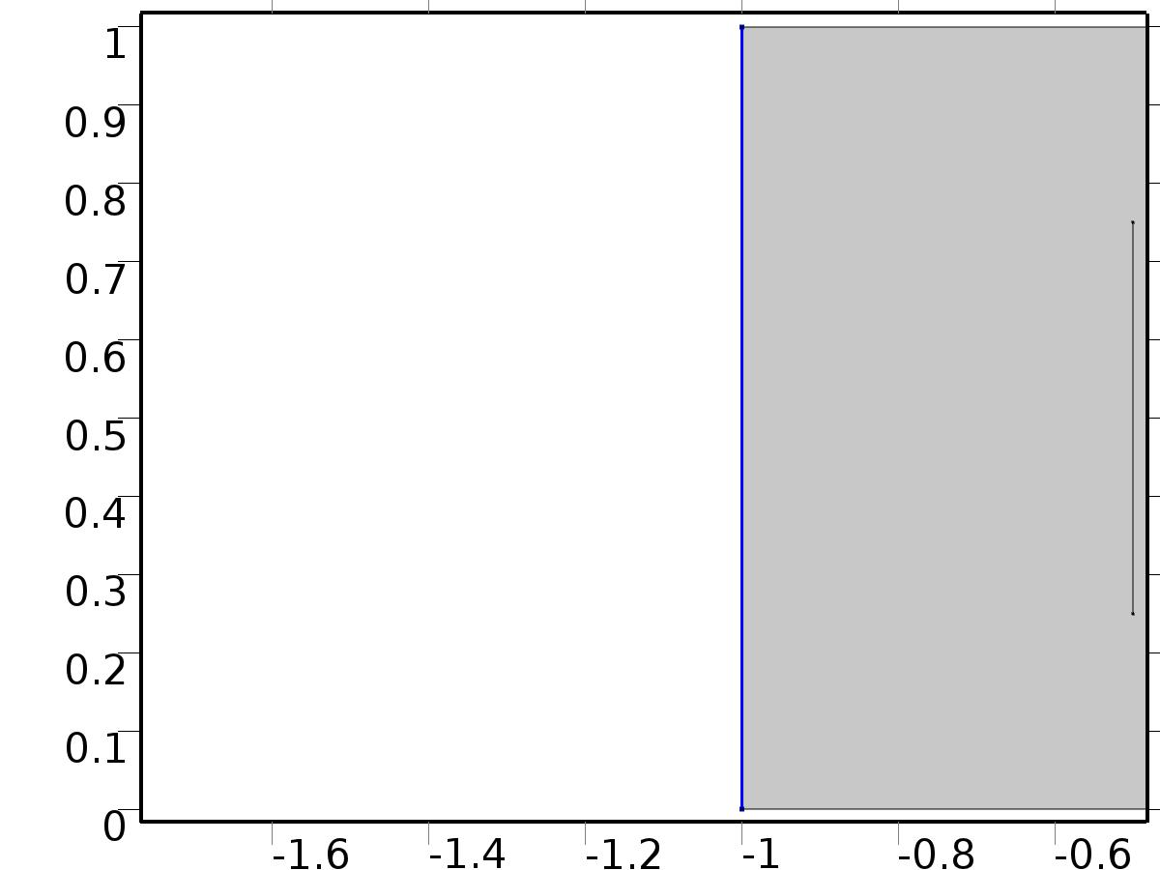

Bin1*delta(n,1)

Selection

|  |  |
| --- | --- |
| Geometric entity level | Boundary |
| Selection | Boundary 1 |

Equations

Settings

| **Description** | **Value** |
| --- | --- |
| Boundary flux/source | delta(n, 1) |
| Boundary absorption/impedance term | 0 |

#### Variables

| **Name** | **Expression** | **Unit** | **Description** | **Selection** |
| --- | --- | --- | --- | --- |
| X.g_X | delta(n,1) |  | Boundary flux/source | Boundary 1 |

* + 1. Bin2*delta(n,2)

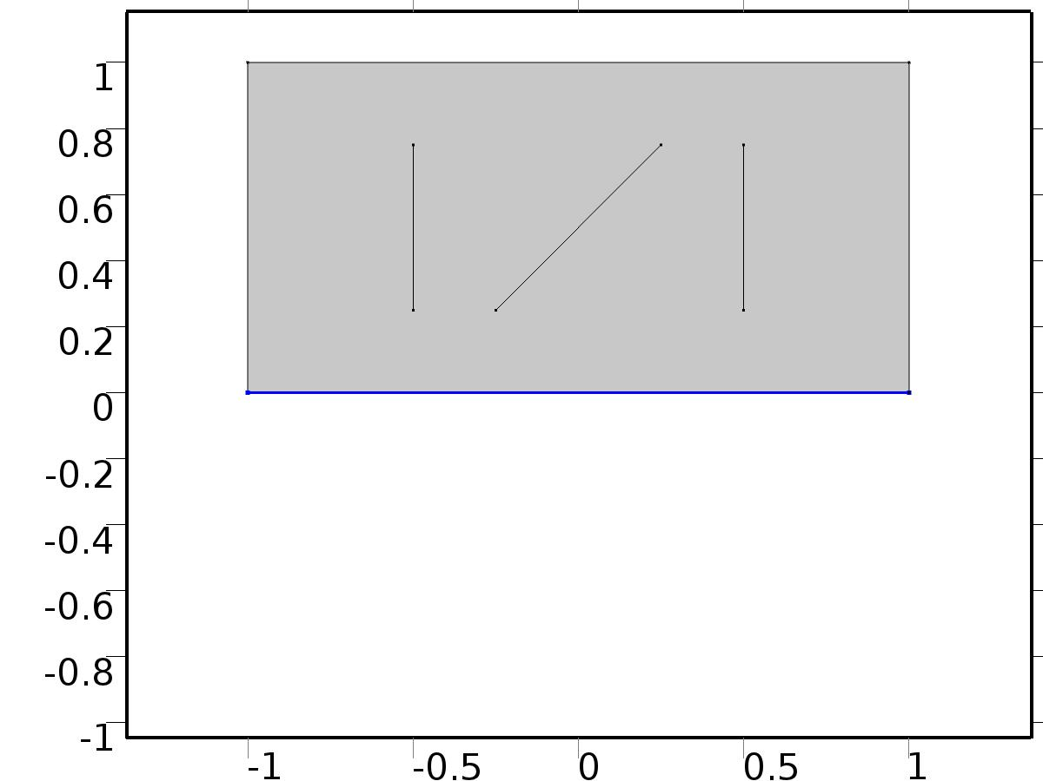

Bin2*delta(n,2)

Selection

|  |  |
| --- | --- |
| Geometric entity level | Boundary |
| Selection | Boundary 2 |

Equations

Settings

| **Description** | **Value** |
| --- | --- |
| Boundary flux/source | delta(n, 2) |
| Boundary absorption/impedance term | 5 |

#### Variables

| **Name** | **Expression** | **Unit** | **Description** | **Selection** |
| --- | --- | --- | --- | --- |
| X.g_X | delta(n,2)-5*X |  | Boundary flux/source | Boundary 2 |

* + 1. Bin3*delta(n,3)

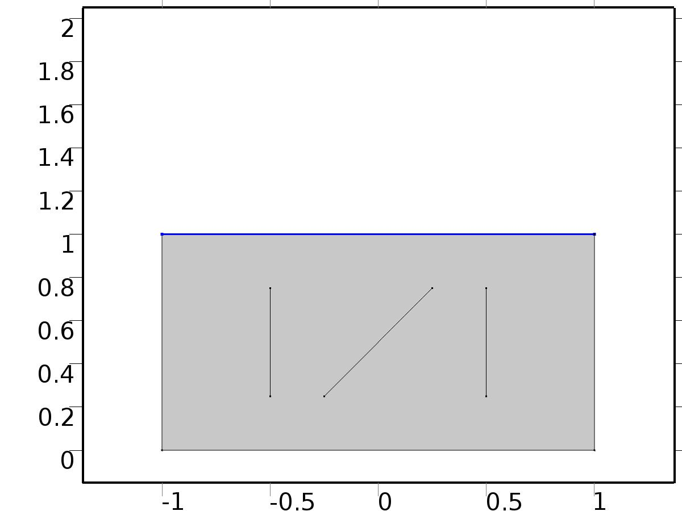

Bin3*delta(n,3)

Selection

|  |  |
| --- | --- |
| Geometric entity level | Boundary |
| Selection | Boundary 3 |

Equations

Settings

| **Description** | **Value** |
| --- | --- |
| Boundary flux/source | delta(n, 3) |
| Boundary absorption/impedance term | 1 |

#### Variables

| **Name** | **Expression** | **Unit** | **Description** | **Selection** |
| --- | --- | --- | --- | --- |
| X.g_X | delta(n,3)-X |  | Boundary flux/source | Boundary 3 |

* + 1. Bd*0

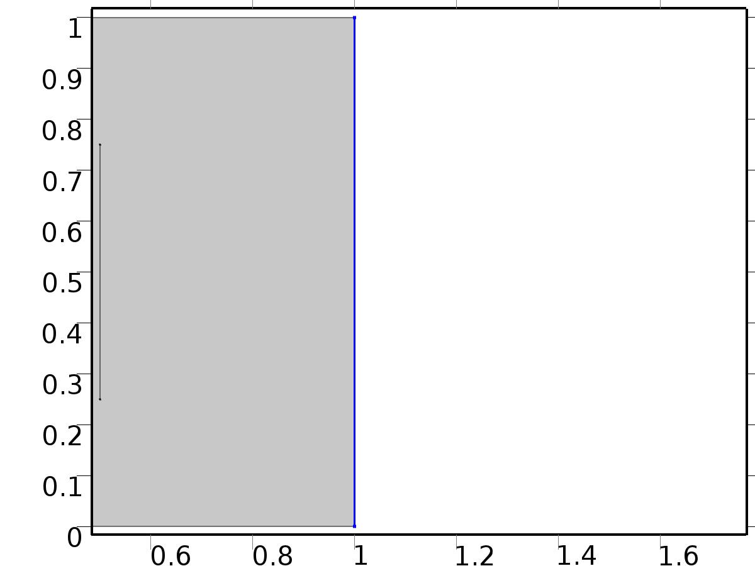

Bd*0

Selection

|  |  |
| --- | --- |
| Geometric entity level | Boundary |
| Selection | Boundary 7 |

Equations

Settings

| **Description** | **Value** |
| --- | --- |
| Value on boundary | 0 |
| Prescribed value of X | On |
| Apply reaction terms on | Individual dependent variables |
| Use weak constraints | Off |
| Constraint method | Elemental |

#### Shape functions

| **Constraint** | **Constraint force** | **Shape function** | **Selection** |
| --- | --- | --- | --- |
| -X | -test(X) | Lagrange (Quadratic) | Boundary 7 |

* 1. Regulator Eqs



Regulator Eqs

Selection

|  |  |
| --- | --- |
| Geometric entity level | Domain |
| Selection | Domain 1 |

Settings

| **Description** | **Value** |
| --- | --- |
| Shape function type | Lagrange |
| Element order | Quadratic |
| Compute boundary fluxes | On |
| Apply smoothing to boundary fluxes | On |
| Value type when using splitting of complex variables | Complex |
| Dependent variable quantity | Dimensionless (1) |
| Source term quantity | None |
| Unit | m^ - 2 |

Used products

|  |
| --- |
| COMSOL Multiphysics |

Variables

| **Name** | **Expression** | **Unit** | **Description** | **Selection** |
| --- | --- | --- | --- | --- |
| PI.nx | nx |  | Normal vector, x component | Boundaries 1–7 |
| PI.ny | ny |  | Normal vector, y component | Boundaries 1–7 |
| PI.nz | root.nz |  | Normal vector, z component | Boundaries 1–7 |
| PI.nxmesh | root.nxmesh |  | Normal vector (mesh), x component | Boundaries 1–7 |
| PI.nymesh | root.nymesh |  | Normal vector (mesh), y component | Boundaries 1–7 |
| PI.nzmesh | root.nzmesh |  | Normal vector (mesh), z component | Boundaries 1–7 |

* + 1. Coefficient Form PDE 1



Coefficient Form PDE 1

Selection

|  |  |
| --- | --- |
| Geometric entity level | Domain |
| Selection | Domain 1 |

Equations

Settings

| **Description** | **Value** |
| --- | --- |
| Diffusion coefficient | {{{{c, 0}, {0, c}}, {{0, 0}, {0, 0}}, {{0, 0}, {0, 0}}, {{0, 0}, {0, 0}}}, {{{0, 0}, {0, 0}}, {{c, 0}, {0, c}}, {{0, 0}, {0, 0}}, {{0, 0}, {0, 0}}}, {{{0, 0}, {0, 0}}, {{0, 0}, {0, 0}}, {{c, 0}, {0, c}}, {{0, 0}, {0, 0}}}, {{{0, 0}, {0, 0}}, {{0, 0}, {0, 0}}, {{0, 0}, {0, 0}}, {{c, 0}, {0, c}}}} |
| Absorption coefficient | {{0, 0, -alpha(l, k), -alpha(l, k)}, {0, 0, 0, 0}, {alpha(l, k), alpha(l, k), 0, 0}, {0, 0, 0, 0}} |
| Source term | {0, 0, 0, 0} |
| Mass coefficient | {{0, 0, 0, 0}, {0, 0, 0, 0}, {0, 0, 0, 0}, {0, 0, 0, 0}} |
| Damping or mass coefficient | {{0, 0, 0, 0}, {0, 0, 0, 0}, {0, 0, 0, 0}, {0, 0, 0, 0}} |
| Conservative flux convection coefficient | {{{0, 0}, {0, 0}, {0, 0}, {0, 0}}, {{0, 0}, {0, 0}, {0, 0}, {0, 0}}, {{0, 0}, {0, 0}, {0, 0}, {0, 0}}, {{0, 0}, {0, 0}, {0, 0}, {0, 0}}} |
| Convection coefficient | {{{0, 0}, {0, 0}, {0, 0}, {0, 0}}, {{0, 0}, {0, 0}, {0, 0}, {0, 0}}, {{0, 0}, {0, 0}, {0, 0}, {0, 0}}, {{0, 0}, {0, 0}, {0, 0}, {0, 0}}} |
| Conservative flux source | {{0, 0}, {0, 0}, {0, 0}, {0, 0}} |

#### Variables

| **Name** | **Expression** | **Unit** | **Description** | **Selection** |
| --- | --- | --- | --- | --- |
| domflux.PI1x | -c*d(PI1,x) |  | Domain flux, x component | Domain 1 |
| domflux.PI1y | -c*d(PI1,y) |  | Domain flux, y component | Domain 1 |
| domflux.PIt1x | -c*d(PIt1,x) |  | Domain flux, x component | Domain 1 |
| domflux.PIt1y | -c*d(PIt1,y) |  | Domain flux, y component | Domain 1 |
| domflux.PI2x | -c*d(PI2,x) |  | Domain flux, x component | Domain 1 |
| domflux.PI2y | -c*d(PI2,y) |  | Domain flux, y component | Domain 1 |
| domflux.PIt2x | -c*d(PIt2,x) |  | Domain flux, x component | Domain 1 |
| domflux.PIt2y | -c*d(PIt2,y) |  | Domain flux, y component | Domain 1 |

#### Shape functions

| **Name** | **Shape function** | **Unit** | **Description** | **Shape frame** | **Selection** |
| --- | --- | --- | --- | --- | --- |
| PI1 | Lagrange (Quadratic) |  | Dependent variable PI1 | Material | Domain 1 |
| PIt1 | Lagrange (Quadratic) |  | Dependent variable PIt1 | Material | Domain 1 |
| PI2 | Lagrange (Quadratic) |  | Dependent variable PI2 | Material | Domain 1 |
| PIt2 | Lagrange (Quadratic) |  | Dependent variable PIt2 | Material | Domain 1 |

* + 1. Zero Flux 1



Zero Flux 1

Selection

|  |  |
| --- | --- |
| Geometric entity level | Boundary |
| Selection | No boundaries |

Equations

* + 1. Initial Values 1



Initial Values 1

Selection

|  |  |
| --- | --- |
| Geometric entity level | Domain |
| Selection | Domain 1 |

Settings

| **Description** | **Value** |
| --- | --- |
| Initial value for PI1 | 0 |
| Initial value for PIt1 | 0 |
| Initial value for PI2 | 0 |
| Initial value for PIt2 | 0 |
| Initial time derivative of PI1 | 0 |
| Initial time derivative of PIt1 | 0 |
| Initial time derivative of PI2 | 0 |
| Initial time derivative of PIt2 | 0 |

* + 1. Bin1*Gamma1



Bin1*Gamma1

Selection

|  |  |
| --- | --- |
| Geometric entity level | Boundary |
| Selection | Boundary 1 |

Equations

Settings

| **Description** | **Value** |
| --- | --- |
| Boundary flux/source | {Gamma11, 0, Gamma12, 0} |
| Boundary absorption/impedance term | {{0, 0, 0, 0}, {0, 0, 0, 0}, {0, 0, 0, 0}, {0, 0, 0, 0}} |

#### Variables

| **Name** | **Expression** | **Unit** | **Description** | **Selection** |
| --- | --- | --- | --- | --- |
| PI.g_PI1 | Gamma11 |  | Boundary flux/source | Boundary 1 |
| PI.g_PIt1 | 0 |  | Boundary flux/source | Boundary 1 |
| PI.g_PI2 | Gamma12 |  | Boundary flux/source | Boundary 1 |
| PI.g_PIt2 | 0 |  | Boundary flux/source | Boundary 1 |

* + 1. Bin2*Gamma2



Bin2*Gamma2

Selection

|  |  |
| --- | --- |
| Geometric entity level | Boundary |
| Selection | Boundary 2 |

Equations

Settings

| **Description** | **Value** |
| --- | --- |
| Boundary flux/source | {Gamma21, 0, Gamma22, 0} |
| Boundary absorption/impedance term | {{5, 0, 0, 0}, {0, 5, 0, 0}, {0, 0, 5, 0}, {0, 0, 0, 5}} |

#### Variables

| **Name** | **Expression** | **Unit** | **Description** | **Selection** |
| --- | --- | --- | --- | --- |
| PI.g_PI1 | Gamma21-5*PI1 |  | Boundary flux/source | Boundary 2 |
| PI.g_PIt1 | -5*PIt1 |  | Boundary flux/source | Boundary 2 |
| PI.g_PI2 | Gamma22-5*PI2 |  | Boundary flux/source | Boundary 2 |
| PI.g_PIt2 | -5*PIt2 |  | Boundary flux/source | Boundary 2 |

* + 1. Bin3*Gamma3



Bin3*Gamma3

Selection

|  |  |
| --- | --- |
| Geometric entity level | Boundary |
| Selection | Boundary 3 |

Equations

Settings

| **Description** | **Value** |
| --- | --- |
| Boundary flux/source | {Gamma31, 0, Gamma32, 0} |
| Boundary absorption/impedance term | {{1, 0, 0, 0}, {0, 1, 0, 0}, {0, 0, 1, 0}, {0, 0, 0, 1}} |

#### Variables

| **Name** | **Expression** | **Unit** | **Description** | **Selection** |
| --- | --- | --- | --- | --- |
| PI.g_PI1 | Gamma31-PI1 |  | Boundary flux/source | Boundary 3 |
| PI.g_PIt1 | -PIt1 |  | Boundary flux/source | Boundary 3 |
| PI.g_PI2 | Gamma32-PI2 |  | Boundary flux/source | Boundary 3 |
| PI.g_PIt2 | -PIt2 |  | Boundary flux/source | Boundary 3 |

* + 1. Bd*P



Bd*P

Selection

|  |  |
| --- | --- |
| Geometric entity level | Boundary |
| Selection | Boundary 7 |

Equations

Settings

| **Description** | **Value** |
| --- | --- |
| Value on boundary | {P1(l), P1(l), P2(l), P2(l)} |
| Prescribed value of PI1 | On |
| Prescribed value of PIt1 | On |
| Prescribed value of PI2 | On |
| Prescribed value of PIt2 | On |
| Apply reaction terms on | Individual dependent variables |
| Use weak constraints | Off |
| Constraint method | Elemental |

#### Shape functions

| **Constraint** | **Constraint force** | **Shape function** | **Selection** |
| --- | --- | --- | --- |
| P1(l)-PI1 | -test(PI1) | Lagrange (Quadratic) | Boundary 7 |
| P1(l)-PIt1 | -test(PIt1) | Lagrange (Quadratic) | Boundary 7 |
| P2(l)-PI2 | -test(PI2) | Lagrange (Quadratic) | Boundary 7 |
| P2(l)-PIt2 | -test(PIt2) | Lagrange (Quadratic) | Boundary 7 |

* 1. Closed Loop System



Closed Loop System

Selection

|  |  |
| --- | --- |
| Geometric entity level | Domain |
| Selection | Domain 1 |

Settings

| **Description** | **Value** |
| --- | --- |
| Shape function type | Lagrange |
| Element order | Quadratic |
| Compute boundary fluxes | On |
| Apply smoothing to boundary fluxes | On |
| Value type when using splitting of complex variables | Complex |
| Dependent variable quantity | Dimensionless (1) |
| Source term quantity | None |
| Unit | m^ - 2 |

Used products

|  |
| --- |
| COMSOL Multiphysics |

Variables

| **Name** | **Expression** | **Unit** | **Description** | **Selection** |
| --- | --- | --- | --- | --- |
| z.nx | nx |  | Normal vector, x component | Boundaries 1–7 |
| z.ny | ny |  | Normal vector, y component | Boundaries 1–7 |
| z.nz | root.nz |  | Normal vector, z component | Boundaries 1–7 |
| z.nxmesh | root.nxmesh |  | Normal vector (mesh), x component | Boundaries 1–7 |
| z.nymesh | root.nymesh |  | Normal vector (mesh), y component | Boundaries 1–7 |
| z.nzmesh | root.nzmesh |  | Normal vector (mesh), z component | Boundaries 1–7 |

* + 1. Coefficient Form PDE 1



Coefficient Form PDE 1

Selection

|  |  |
| --- | --- |
| Geometric entity level | Domain |
| Selection | Domain 1 |

Equations

Settings

| **Description** | **Value** |
| --- | --- |
| Diffusion coefficient | {{c, 0}, {0, c}} |
| Absorption coefficient | 0 |
| Source term | 0 |
| Mass coefficient | 0 |
| Damping or mass coefficient | 1 |
| Conservative flux convection coefficient | {0, 0} |
| Convection coefficient | {0, 0} |
| Conservative flux source | {0, 0} |

#### Variables

| **Name** | **Expression** | **Unit** | **Description** | **Selection** |
| --- | --- | --- | --- | --- |
| domflux.zx | -c*d(z,x) |  | Domain flux, x component | Domain 1 |
| domflux.zy | -c*d(z,y) |  | Domain flux, y component | Domain 1 |

#### Shape functions

| **Name** | **Shape function** | **Unit** | **Description** | **Shape frame** | **Selection** |
| --- | --- | --- | --- | --- | --- |
| z | Lagrange (Quadratic) |  | Dependent variable z | Material | Domain 1 |

* + 1. Zero Flux 1



Zero Flux 1

Selection

|  |  |
| --- | --- |
| Geometric entity level | Boundary |
| Selection | No boundaries |

Equations

* + 1. Initial Values 1



Initial Values 1

Selection

|  |  |
| --- | --- |
| Geometric entity level | Domain |
| Selection | Domain 1 |

Settings

| **Description** | **Value** |
| --- | --- |
| Initial value for z | 1 |
| Initial time derivative of z | 0 |

* + 1. Bin1*u1



Bin1*u1

Selection

|  |  |
| --- | --- |
| Geometric entity level | Boundary |
| Selection | Boundary 1 |

Equations

Settings

| **Description** | **Value** |
| --- | --- |
| Boundary flux/source | u1 |
| Boundary absorption/impedance term | 0 |

#### Variables

| **Name** | **Expression** | **Unit** | **Description** | **Selection** |
| --- | --- | --- | --- | --- |
| z.g_z | u1 |  | Boundary flux/source | Boundary 1 |

* + 1. Bin2*u2



Bin2*u2

Selection

|  |  |
| --- | --- |
| Geometric entity level | Boundary |
| Selection | Boundary 2 |

Equations

Settings

| **Description** | **Value** |
| --- | --- |
| Boundary flux/source | u2 |
| Boundary absorption/impedance term | 5 |

#### Variables

| **Name** | **Expression** | **Unit** | **Description** | **Selection** |
| --- | --- | --- | --- | --- |
| z.g_z | u2-5*z |  | Boundary flux/source | Boundary 2 |

* + 1. Bin3*u3



Bin3*u3

Selection

|  |  |
| --- | --- |
| Geometric entity level | Boundary |
| Selection | Boundary 3 |

Equations

Settings

| **Description** | **Value** |
| --- | --- |
| Boundary flux/source | u3 |
| Boundary absorption/impedance term | 1 |

#### Variables

| **Name** | **Expression** | **Unit** | **Description** | **Selection** |
| --- | --- | --- | --- | --- |
| z.g_z | u3-z |  | Boundary flux/source | Boundary 3 |

* + 1. Bd*d1(t)



Bd*d1(t)

Selection

|  |  |
| --- | --- |
| Geometric entity level | Boundary |
| Selection | Boundary 7 |

Equations

Settings

| **Description** | **Value** |
| --- | --- |
| Value on boundary | d1(t) |
| Prescribed value of z | On |
| Apply reaction terms on | Individual dependent variables |
| Use weak constraints | Off |
| Constraint method | Elemental |

#### Shape functions

| **Constraint** | **Constraint force** | **Shape function** | **Selection** |
| --- | --- | --- | --- |
| d1(t)-z | -test(z) | Lagrange (Quadratic) | Boundary 7 |

* 1. Mesh 2

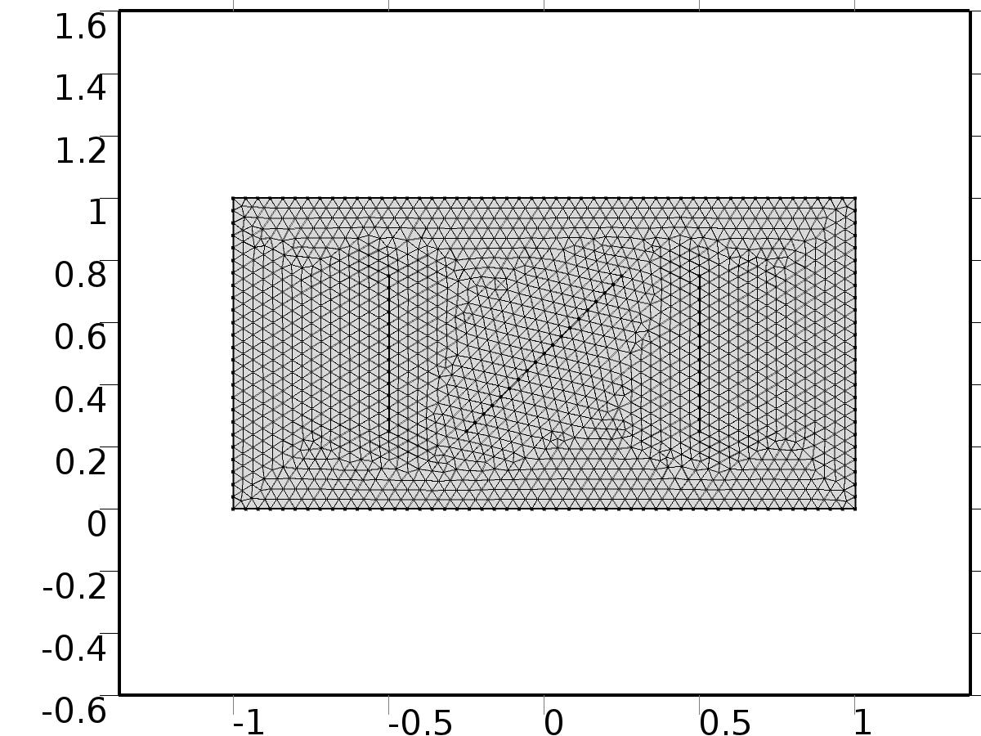

Mesh 2

* + 1. Size (size)

Settings

| **Description** | **Value** |
| --- | --- |
| Maximum element size | 0.04 |
| Minimum element size | 1.5E-4 |
| Curvature factor | 0.25 |
| Maximum element growth rate | 1.2 |
| Predefined size | Extra fine |

* + 1. Free Triangular 1 (ftri1)

Selection

|  |  |
| --- | --- |
| Geometric entity level | Remaining |

1. Study 1
   1. Parametric Sweep

| **Parameter name** | **Parameter value list** |
| --- | --- |
| n | range(1,1,n_in) |

* 1. Stationary

Study settings

| **Description** | **Value** |
| --- | --- |
| Include geometric nonlinearity | Off |

Physics and variables selection

| **Physics interface** | **Discretization** |
| --- | --- |
| Unit Input (c) | physics |

Mesh selection

| **Geometry** | **Mesh** |
| --- | --- |
| Geometry 2 (geom2) | mesh2 |

* 1. Solver Configurations
     1. Solver 4

#### Compile Equations: Stationary (st1)

Study and step

| **Description** | **Value** |
| --- | --- |
| Use study | Study 1 |
| Use study step | Stationary |

#### Dependent Variables 1 (v1)

General

| **Description** | **Value** |
| --- | --- |
| Defined by study step | Stationary |
| Constant |  |

Initial values of variables solved for

| **Description** | **Value** |
| --- | --- |
| Solution | Zero |

Values of variables not solved for

| **Description** | **Value** |
| --- | --- |
| Solution | Zero |

##### Dependent variable PIt1 (mod2.PIt1) (mod2_PIt1)

General

| **Description** | **Value** |
| --- | --- |
| Field components | mod2.PIt1 |
| Solve for this field | Off |

##### Dependent variable PI1 (mod2.PI1) (mod2_PI1)

General

| **Description** | **Value** |
| --- | --- |
| Field components | mod2.PI1 |
| Solve for this field | Off |

##### Dependent variable z (mod2.z) (mod2_z)

General

| **Description** | **Value** |
| --- | --- |
| Field components | mod2.z |
| Solve for this field | Off |

##### Dependent variable PI2 (mod2.PI2) (mod2_PI2)

General

| **Description** | **Value** |
| --- | --- |
| Field components | mod2.PI2 |
| Solve for this field | Off |

##### Dependent variable X (mod2.X) (mod2_X)

General

| **Description** | **Value** |
| --- | --- |
| Field components | mod2.X |

##### Dependent variable PIt2 (mod2.PIt2) (mod2_PIt2)

General

| **Description** | **Value** |
| --- | --- |
| Field components | mod2.PIt2 |
| Solve for this field | Off |

#### Stationary Solver 1 (s1)

General

| **Description** | **Value** |
| --- | --- |
| Defined by study step | Stationary |
| Relative tolerance | 0.000010 |

Log

| **Description** | **Value** |
| --- | --- |
| Constant |  |

##### Parametric 1 (p1)

General

| **Description** | **Value** |
| --- | --- |
| Defined by study step | Parametric Sweep |
| Parameter value list | range(1, 1, n_in) |
| Run continuation for | No parameter |

Results while solving

| **Description** | **Value** |
| --- | --- |
| Probes | Manual |
| Probes | {C1(Xj), C2(Xj), C3(Xj)} |

##### Fully Coupled 1 (fc1)

General

| **Description** | **Value** |
| --- | --- |
| Linear solver | Direct |

1. Study 2
   1. Parametric Sweep

| **Parameter name** | **Parameter value list** |
| --- | --- |
| l | range(1,1,lmax) |
| k | range(0,1,kmax) |

* 1. Stationary

Study settings

| **Description** | **Value** |
| --- | --- |
| Include geometric nonlinearity | Off |

Physics and variables selection

| **Physics interface** | **Discretization** |
| --- | --- |
| Regulator Eqs (c2) | physics |

Mesh selection

| **Geometry** | **Mesh** |
| --- | --- |
| Geometry 2 (geom2) | mesh2 |

* 1. Solver Configurations
     1. Solver 5

#### Compile Equations: Stationary (st1)

Study and step

| **Description** | **Value** |
| --- | --- |
| Use study | Study 2 |
| Use study step | Stationary |

#### Dependent Variables 1 (v1)

General

| **Description** | **Value** |
| --- | --- |
| Defined by study step | Stationary |
| Constant |  |

Initial values of variables solved for

| **Description** | **Value** |
| --- | --- |
| Solution | Zero |

Values of variables not solved for

| **Description** | **Value** |
| --- | --- |
| Solution | Zero |

##### Dependent variable PIt1 (mod2.PIt1) (mod2_PIt1)

General

| **Description** | **Value** |
| --- | --- |
| Field components | mod2.PIt1 |

##### Dependent variable PI1 (mod2.PI1) (mod2_PI1)

General

| **Description** | **Value** |
| --- | --- |
| Field components | mod2.PI1 |

##### Dependent variable z (mod2.z) (mod2_z)

General

| **Description** | **Value** |
| --- | --- |
| Field components | mod2.z |
| Solve for this field | Off |

##### Dependent variable PI2 (mod2.PI2) (mod2_PI2)

General

| **Description** | **Value** |
| --- | --- |
| Field components | mod2.PI2 |

##### Dependent variable X (mod2.X) (mod2_X)

General

| **Description** | **Value** |
| --- | --- |
| Field components | mod2.X |
| Solve for this field | Off |

##### Dependent variable PIt2 (mod2.PIt2) (mod2_PIt2)

General

| **Description** | **Value** |
| --- | --- |
| Field components | mod2.PIt2 |

#### Stationary Solver 1 (s1)

General

| **Description** | **Value** |
| --- | --- |
| Defined by study step | Stationary |

Results while solving

| **Description** | **Value** |
| --- | --- |
| Probes | None |

Log

| **Description** | **Value** |
| --- | --- |
| Constant |  |

##### Parametric 1 (p1)

General

| **Description** | **Value** |
| --- | --- |
| Defined by study step | Parametric Sweep |
| Sweep type | All combinations |
| Parameter value list | {range(1, 1, lmax), range(0, 1, kmax)} |
| Run continuation for | No parameter |

Results while solving

| **Description** | **Value** |
| --- | --- |
| Probes | Manual |
| Probes | {Gamma_lk11, Gamma_lk12, Gamma_lk21, Gamma_lk22, Gamma_lk31, Gamma_lk32} |

##### Fully Coupled 1 (fc1)

General

| **Description** | **Value** |
| --- | --- |
| Linear solver | Direct |

1. Study 3
   1. Time Dependent

Study settings

| **Description** | **Value** |
| --- | --- |
| Include geometric nonlinearity | Off |

| **Times** | **Unit** |
| --- | --- |
| range(0,0.0125,14) | s |

Physics and variables selection

| **Physics interface** | **Discretization** |
| --- | --- |
| Closed Loop System (phys1) | physics |

Mesh selection

| **Geometry** | **Mesh** |
| --- | --- |
| Geometry 2 (geom2) | mesh2 |

* 1. Solver Configurations
     1. Solver 3

#### Compile Equations: Time Dependent (st1)

Study and step

| **Description** | **Value** |
| --- | --- |
| Use study | Study 3 |
| Use study step | Time Dependent |

#### Dependent Variables 1 (v1)

General

| **Description** | **Value** |
| --- | --- |
| Defined by study step | Time Dependent |
| Constant |  |

Initial values of variables solved for

| **Description** | **Value** |
| --- | --- |
| Solution | Zero |

Values of variables not solved for

| **Description** | **Value** |
| --- | --- |
| Solution | Zero |

##### Dependent variable PIt1 (mod2.PIt1) (mod2_PIt1)

General

| **Description** | **Value** |
| --- | --- |
| Field components | mod2.PIt1 |
| Solve for this field | Off |

##### Dependent variable PI1 (mod2.PI1) (mod2_PI1)

General

| **Description** | **Value** |
| --- | --- |
| Field components | mod2.PI1 |
| Solve for this field | Off |

##### Dependent variable z (mod2.z) (mod2_z)

General

| **Description** | **Value** |
| --- | --- |
| Field components | mod2.z |

##### Dependent variable PI2 (mod2.PI2) (mod2_PI2)

General

| **Description** | **Value** |
| --- | --- |
| Field components | mod2.PI2 |
| Solve for this field | Off |

##### Dependent variable X (mod2.X) (mod2_X)

General

| **Description** | **Value** |
| --- | --- |
| Field components | mod2.X |
| Solve for this field | Off |

##### Dependent variable PIt2 (mod2.PIt2) (mod2_PIt2)

General

| **Description** | **Value** |
| --- | --- |
| Field components | mod2.PIt2 |
| Solve for this field | Off |

#### Time-Dependent Solver 1 (t1)

General

| **Description** | **Value** |
| --- | --- |
| Defined by study step | Time Dependent |
| Time | {0, 0.0125, 0.025, 0.037500000000000006, 0.05, 0.0625, 0.07500000000000001, 0.08750000000000001, 0.1, 0.1125, 0.125, 0.1375, 0.15000000000000002, 0.1625, 0.17500000000000002, 0.1875, 0.2, 0.21250000000000002, 0.225, 0.23750000000000002, 0.25, 0.2625, 0.275, 0.28750000000000003, 0.30000000000000004, 0.3125, 0.325, 0.3375, 0.35000000000000003, 0.36250000000000004, 0.375, 0.3875, 0.4, 0.41250000000000003, 0.42500000000000004, 0.4375, 0.45, 0.4625, 0.47500000000000003, 0.48750000000000004, 0.5, 0.5125000000000001, 0.525, 0.5375, 0.55, 0.5625, 0.5750000000000001, 0.5875, 0.6000000000000001, 0.6125, 0.625, 0.6375000000000001, 0.65, 0.6625000000000001, 0.675, 0.6875, 0.7000000000000001, 0.7125, 0.7250000000000001, 0.7375, 0.75, 0.7625000000000001, 0.775, 0.7875000000000001, 0.8, 0.8125, 0.8250000000000001, 0.8375, 0.8500000000000001, 0.8625, 0.875, 0.8875000000000001, 0.9, 0.9125000000000001, 0.925, 0.9375, 0.9500000000000001, 0.9625, 0.9750000000000001, 0.9875, 1, 1.0125, 1.0250000000000001, 1.0375, 1.05, 1.0625, 1.075, 1.0875000000000001, 1.1, 1.1125, 1.125, 1.1375, 1.1500000000000001, 1.1625, 1.175, 1.1875, 1.2000000000000002, 1.2125000000000001, 1.225, 1.2375, 1.25, 1.2625000000000002, 1.2750000000000001, 1.2875, 1.3, 1.3125, 1.3250000000000002, 1.3375000000000001, 1.35, 1.3625, 1.375, 1.3875000000000002, 1.4000000000000001, 1.4125, 1.425, 1.4375, 1.4500000000000002, 1.4625000000000001, 1.475, 1.4875, 1.5, 1.5125000000000002, 1.5250000000000001, 1.5375, 1.55, 1.5625, 1.5750000000000002, 1.5875000000000001, 1.6, 1.6125, 1.625, 1.6375000000000002, 1.6500000000000001, 1.6625, 1.675, 1.6875, 1.7000000000000002, 1.7125000000000001, 1.725, 1.7375, 1.75, 1.7625000000000002, 1.7750000000000001, 1.7875, 1.8, 1.8125, 1.8250000000000002, 1.8375000000000001, 1.85, 1.8625, 1.875, 1.8875000000000002, 1.9000000000000001, 1.9125, 1.925, 1.9375, 1.9500000000000002, 1.9625000000000001, 1.975, 1.9875, 2, 2.0125, 2.025, 2.0375, 2.0500000000000003, 2.0625, 2.075, 2.0875, 2.1, 2.1125000000000003, 2.125, 2.1375, 2.15, 2.1625, 2.1750000000000003, 2.1875, 2.2, 2.2125, 2.225, 2.2375000000000003, 2.25, 2.2625, 2.275, 2.2875, 2.3000000000000003, 2.3125, 2.325, 2.3375, 2.35, 2.3625000000000003, 2.375, 2.3875, 2.4000000000000004, 2.4125, 2.4250000000000003, 2.4375, 2.45, 2.4625000000000004, 2.475, 2.4875000000000003, 2.5, 2.5125, 2.5250000000000004, 2.5375, 2.5500000000000003, 2.5625, 2.575, 2.5875000000000004, 2.6, 2.6125000000000003, 2.625, 2.6375, 2.6500000000000004, 2.6625, 2.6750000000000003, 2.6875, 2.7, 2.7125000000000004, 2.725, 2.7375000000000003, 2.75, 2.7625, 2.7750000000000004, 2.7875, 2.8000000000000003, 2.8125, 2.825, 2.8375000000000004, 2.85, 2.8625000000000003, 2.875, 2.8875, 2.9000000000000004, 2.9125, 2.9250000000000003, 2.9375, 2.95, 2.9625000000000004, 2.975, 2.9875000000000003, 3, 3.0125, 3.0250000000000004, 3.0375, 3.0500000000000003, 3.0625, 3.075, 3.0875000000000004, 3.1, 3.1125000000000003, 3.125, 3.1375, 3.1500000000000004, 3.1625, 3.1750000000000003, 3.1875, 3.2, 3.2125000000000004, 3.225, 3.2375000000000003, 3.25, 3.2625, 3.2750000000000004, 3.2875, 3.3000000000000003, 3.3125, 3.325, 3.3375000000000004, 3.35, 3.3625000000000003, 3.375, 3.3875, 3.4000000000000004, 3.4125, 3.4250000000000003, 3.4375, 3.45, 3.4625000000000004, 3.475, 3.4875000000000003, 3.5, 3.5125, 3.5250000000000004, 3.5375, 3.5500000000000003, 3.5625, 3.575, 3.5875000000000004, 3.6, 3.6125000000000003, 3.625, 3.6375, 3.6500000000000004, 3.6625, 3.6750000000000003, 3.6875, 3.7, 3.7125000000000004, 3.725, 3.7375000000000003, 3.75, 3.7625, 3.7750000000000004, 3.7875, 3.8000000000000003, 3.8125, 3.825, 3.8375000000000004, 3.85, 3.8625000000000003, 3.875, 3.8875, 3.9000000000000004, 3.9125, 3.9250000000000003, 3.9375, 3.95, 3.9625000000000004, 3.975, 3.9875000000000003, 4, 4.0125, 4.025, 4.0375000000000005, 4.05, 4.0625, 4.075, 4.0875, 4.1000000000000005, 4.1125, 4.125, 4.1375, 4.15, 4.1625000000000005, 4.175, 4.1875, 4.2, 4.2125, 4.2250000000000005, 4.2375, 4.25, 4.2625, 4.275, 4.2875000000000005, 4.3, 4.3125, 4.325, 4.3375, 4.3500000000000005, 4.3625, 4.375, 4.3875, 4.4, 4.4125000000000005, 4.425, 4.4375, 4.45, 4.4625, 4.4750000000000005, 4.4875, 4.5, 4.5125, 4.525, 4.5375000000000005, 4.55, 4.5625, 4.575, 4.5875, 4.6000000000000005, 4.6125, 4.625, 4.6375, 4.65, 4.6625000000000005, 4.675, 4.6875, 4.7, 4.7125, 4.7250000000000005, 4.7375, 4.75, 4.7625, 4.775, 4.7875000000000005, 4.800000000000001, 4.8125, 4.825, 4.8375, 4.8500000000000005, 4.862500000000001, 4.875, 4.8875, 4.9, 4.9125000000000005, 4.925000000000001, 4.9375, 4.95, 4.9625, 4.9750000000000005, 4.987500000000001, 5, 5.0125, 5.025, 5.0375000000000005, 5.050000000000001, 5.0625, 5.075, 5.0875, 5.1000000000000005, 5.112500000000001, 5.125, 5.1375, 5.15, 5.1625000000000005, 5.175000000000001, 5.1875, 5.2, 5.2125, 5.2250000000000005, 5.237500000000001, 5.25, 5.2625, 5.275, 5.2875000000000005, 5.300000000000001, 5.3125, 5.325, 5.3375, 5.3500000000000005, 5.362500000000001, 5.375, 5.3875, 5.4, 5.4125000000000005, 5.425000000000001, 5.4375, 5.45, 5.4625, 5.4750000000000005, 5.487500000000001, 5.5, 5.5125, 5.525, 5.5375000000000005, 5.550000000000001, 5.5625, 5.575, 5.5875, 5.6000000000000005, 5.612500000000001, 5.625, 5.6375, 5.65, 5.6625000000000005, 5.675000000000001, 5.6875, 5.7, 5.7125, 5.7250000000000005, 5.737500000000001, 5.75, 5.7625, 5.775, 5.7875000000000005, 5.800000000000001, 5.8125, 5.825, 5.8375, 5.8500000000000005, 5.862500000000001, 5.875, 5.8875, 5.9, 5.9125000000000005, 5.925000000000001, 5.9375, 5.95, 5.9625, 5.9750000000000005, 5.987500000000001, 6, 6.0125, 6.025, 6.0375000000000005, 6.050000000000001, 6.0625, 6.075, 6.0875, 6.1000000000000005, 6.112500000000001, 6.125, 6.1375, 6.15, 6.1625000000000005, 6.175000000000001, 6.1875, 6.2, 6.2125, 6.2250000000000005, 6.237500000000001, 6.25, 6.2625, 6.275, 6.2875000000000005, 6.300000000000001, 6.3125, 6.325, 6.3375, 6.3500000000000005, 6.362500000000001, 6.375, 6.3875, 6.4, 6.4125000000000005, 6.425000000000001, 6.4375, 6.45, 6.4625, 6.4750000000000005, 6.487500000000001, 6.5, 6.5125, 6.525, 6.5375000000000005, 6.550000000000001, 6.5625, 6.575, 6.5875, 6.6000000000000005, 6.612500000000001, 6.625, 6.6375, 6.65, 6.6625000000000005, 6.675000000000001, 6.6875, 6.7, 6.7125, 6.7250000000000005, 6.737500000000001, 6.75, 6.7625, 6.775, 6.7875000000000005, 6.800000000000001, 6.8125, 6.825, 6.8375, 6.8500000000000005, 6.862500000000001, 6.875, 6.8875, 6.9, 6.9125000000000005, 6.925000000000001, 6.9375, 6.95, 6.9625, 6.9750000000000005, 6.987500000000001, 7, 7.0125, 7.025, 7.0375000000000005, 7.050000000000001, 7.0625, 7.075, 7.0875, 7.1000000000000005, 7.112500000000001, 7.125, 7.1375, 7.15, 7.1625000000000005, 7.175000000000001, 7.1875, 7.2, 7.2125, 7.2250000000000005, 7.237500000000001, 7.25, 7.2625, 7.275, 7.2875000000000005, 7.300000000000001, 7.3125, 7.325, 7.3375, 7.3500000000000005, 7.362500000000001, 7.375, 7.3875, 7.4, 7.4125000000000005, 7.425000000000001, 7.4375, 7.45, 7.4625, 7.4750000000000005, 7.487500000000001, 7.5, 7.5125, 7.525, 7.5375000000000005, 7.550000000000001, 7.5625, 7.575, 7.5875, 7.6000000000000005, 7.612500000000001, 7.625, 7.6375, 7.65, 7.6625000000000005, 7.675000000000001, 7.6875, 7.7, 7.7125, 7.7250000000000005, 7.737500000000001, 7.75, 7.7625, 7.775, 7.7875000000000005, 7.800000000000001, 7.8125, 7.825, 7.8375, 7.8500000000000005, 7.862500000000001, 7.875, 7.8875, 7.9, 7.9125000000000005, 7.925000000000001, 7.9375, 7.95, 7.9625, 7.9750000000000005, 7.987500000000001, 8, 8.012500000000001, 8.025, 8.0375, 8.05, 8.0625, 8.075000000000001, 8.0875, 8.1, 8.1125, 8.125, 8.137500000000001, 8.15, 8.1625, 8.175, 8.1875, 8.200000000000001, 8.2125, 8.225, 8.2375, 8.25, 8.262500000000001, 8.275, 8.2875, 8.3, 8.3125, 8.325000000000001, 8.3375, 8.35, 8.3625, 8.375, 8.387500000000001, 8.4, 8.4125, 8.425, 8.4375, 8.450000000000001, 8.4625, 8.475, 8.4875, 8.5, 8.512500000000001, 8.525, 8.5375, 8.55, 8.5625, 8.575000000000001, 8.5875, 8.6, 8.6125, 8.625, 8.637500000000001, 8.65, 8.6625, 8.675, 8.6875, 8.700000000000001, 8.7125, 8.725, 8.7375, 8.75, 8.762500000000001, 8.775, 8.7875, 8.8, 8.8125, 8.825000000000001, 8.8375, 8.85, 8.8625, 8.875, 8.887500000000001, 8.9, 8.9125, 8.925, 8.9375, 8.950000000000001, 8.9625, 8.975, 8.9875, 9, 9.012500000000001, 9.025, 9.0375, 9.05, 9.0625, 9.075000000000001, 9.0875, 9.1, 9.1125, 9.125, 9.137500000000001, 9.15, 9.1625, 9.175, 9.1875, 9.200000000000001, 9.2125, 9.225, 9.2375, 9.25, 9.262500000000001, 9.275, 9.2875, 9.3, 9.3125, 9.325000000000001, 9.3375, 9.35, 9.3625, 9.375, 9.387500000000001, 9.4, 9.4125, 9.425, 9.4375, 9.450000000000001, 9.4625, 9.475, 9.4875, 9.5, 9.512500000000001, 9.525, 9.5375, 9.55, 9.5625, 9.575000000000001, 9.5875, 9.600000000000001, 9.6125, 9.625, 9.637500000000001, 9.65, 9.662500000000001, 9.675, 9.6875, 9.700000000000001, 9.7125, 9.725000000000001, 9.7375, 9.75, 9.762500000000001, 9.775, 9.787500000000001, 9.8, 9.8125, 9.825000000000001, 9.8375, 9.850000000000001, 9.8625, 9.875, 9.887500000000001, 9.9, 9.912500000000001, 9.925, 9.9375, 9.950000000000001, 9.9625, 9.975000000000001, 9.9875, 10, 10.012500000000001, 10.025, 10.037500000000001, 10.05, 10.0625, 10.075000000000001, 10.0875, 10.100000000000001, 10.1125, 10.125, 10.137500000000001, 10.15, 10.162500000000001, 10.175, 10.1875, 10.200000000000001, 10.2125, 10.225000000000001, 10.2375, 10.25, 10.262500000000001, 10.275, 10.287500000000001, 10.3, 10.3125, 10.325000000000001, 10.3375, 10.350000000000001, 10.3625, 10.375, 10.387500000000001, 10.4, 10.412500000000001, 10.425, 10.4375, 10.450000000000001, 10.4625, 10.475000000000001, 10.4875, 10.5, 10.512500000000001, 10.525, 10.537500000000001, 10.55, 10.5625, 10.575000000000001, 10.5875, 10.600000000000001, 10.6125, 10.625, 10.637500000000001, 10.65, 10.662500000000001, 10.675, 10.6875, 10.700000000000001, 10.7125, 10.725000000000001, 10.7375, 10.75, 10.762500000000001, 10.775, 10.787500000000001, 10.8, 10.8125, 10.825000000000001, 10.8375, 10.850000000000001, 10.8625, 10.875, 10.887500000000001, 10.9, 10.912500000000001, 10.925, 10.9375, 10.950000000000001, 10.9625, 10.975000000000001, 10.9875, 11, 11.012500000000001, 11.025, 11.037500000000001, 11.05, 11.0625, 11.075000000000001, 11.0875, 11.100000000000001, 11.1125, 11.125, 11.137500000000001, 11.15, 11.162500000000001, 11.175, 11.1875, 11.200000000000001, 11.2125, 11.225000000000001, 11.2375, 11.25, 11.262500000000001, 11.275, 11.287500000000001, 11.3, 11.3125, 11.325000000000001, 11.3375, 11.350000000000001, 11.3625, 11.375, 11.387500000000001, 11.4, 11.412500000000001, 11.425, 11.4375, 11.450000000000001, 11.4625, 11.475000000000001, 11.4875, 11.5, 11.512500000000001, 11.525, 11.537500000000001, 11.55, 11.5625, 11.575000000000001, 11.5875, 11.600000000000001, 11.6125, 11.625, 11.637500000000001, 11.65, 11.662500000000001, 11.675, 11.6875, 11.700000000000001, 11.7125, 11.725000000000001, 11.7375, 11.75, 11.762500000000001, 11.775, 11.787500000000001, 11.8, 11.8125, 11.825000000000001, 11.8375, 11.850000000000001, 11.8625, 11.875, 11.887500000000001, 11.9, 11.912500000000001, 11.925, 11.9375, 11.950000000000001, 11.9625, 11.975000000000001, 11.9875, 12, 12.012500000000001, 12.025, 12.037500000000001, 12.05, 12.0625, 12.075000000000001, 12.0875, 12.100000000000001, 12.1125, 12.125, 12.137500000000001, 12.15, 12.162500000000001, 12.175, 12.1875, 12.200000000000001, 12.2125, 12.225000000000001, 12.2375, 12.25, 12.262500000000001, 12.275, 12.287500000000001, 12.3, 12.3125, 12.325000000000001, 12.3375, 12.350000000000001, 12.3625, 12.375, 12.387500000000001, 12.4, 12.412500000000001, 12.425, 12.4375, 12.450000000000001, 12.4625, 12.475000000000001, 12.4875, 12.5, 12.512500000000001, 12.525, 12.537500000000001, 12.55, 12.5625, 12.575000000000001, 12.5875, 12.600000000000001, 12.6125, 12.625, 12.637500000000001, 12.65, 12.662500000000001, 12.675, 12.6875, 12.700000000000001, 12.7125, 12.725000000000001, 12.7375, 12.75, 12.762500000000001, 12.775, 12.787500000000001, 12.8, 12.8125, 12.825000000000001, 12.8375, 12.850000000000001, 12.8625, 12.875, 12.887500000000001, 12.9, 12.912500000000001, 12.925, 12.9375, 12.950000000000001, 12.9625, 12.975000000000001, 12.9875, 13, 13.012500000000001, 13.025, 13.037500000000001, 13.05, 13.0625, 13.075000000000001, 13.0875, 13.100000000000001, 13.1125, 13.125, 13.137500000000001, 13.15, 13.162500000000001, 13.175, 13.1875, 13.200000000000001, 13.2125, 13.225000000000001, 13.2375, 13.25, 13.262500000000001, 13.275, 13.287500000000001, 13.3, 13.3125, 13.325000000000001, 13.3375, 13.350000000000001, 13.3625, 13.375, 13.387500000000001, 13.4, 13.412500000000001, 13.425, 13.4375, 13.450000000000001, 13.4625, 13.475000000000001, 13.4875, 13.5, 13.512500000000001, 13.525, 13.537500000000001, 13.55, 13.5625, 13.575000000000001, 13.5875, 13.600000000000001, 13.6125, 13.625, 13.637500000000001, 13.65, 13.662500000000001, 13.675, 13.6875, 13.700000000000001, 13.7125, 13.725000000000001, 13.7375, 13.75, 13.762500000000001, 13.775, 13.787500000000001, 13.8, 13.8125, 13.825000000000001, 13.8375, 13.850000000000001, 13.8625, 13.875, 13.887500000000001, 13.9, 13.912500000000001, 13.925, 13.9375, 13.950000000000001, 13.9625, 13.975000000000001, 13.9875, 14} |
| Relative tolerance | 0.00001 |

Absolute tolerance

| **Description** | **Value** |
| --- | --- |
| Tolerance | 0.000010 |

Time stepping

| **Description** | **Value** |
| --- | --- |
| Initial step | 0.0010 |

Results while solving

| **Description** | **Value** |
| --- | --- |
| Probes | None |

Advanced

| **Description** | **Value** |
| --- | --- |
| Fraction of initial step for Backward Euler | 0.0010 |

Log

| **Description** | **Value** |
| --- | --- |
| Constant |  |

##### Fully Coupled 1 (fc1)

General

| **Description** | **Value** |
| --- | --- |
| Linear solver | Direct |

1. Results
   1. Data Sets
      1. Solution 1

Solution

| **Description** | **Value** |
| --- | --- |
| Solution | Solver 4 |
| Component | Save Point Geometry 2 |

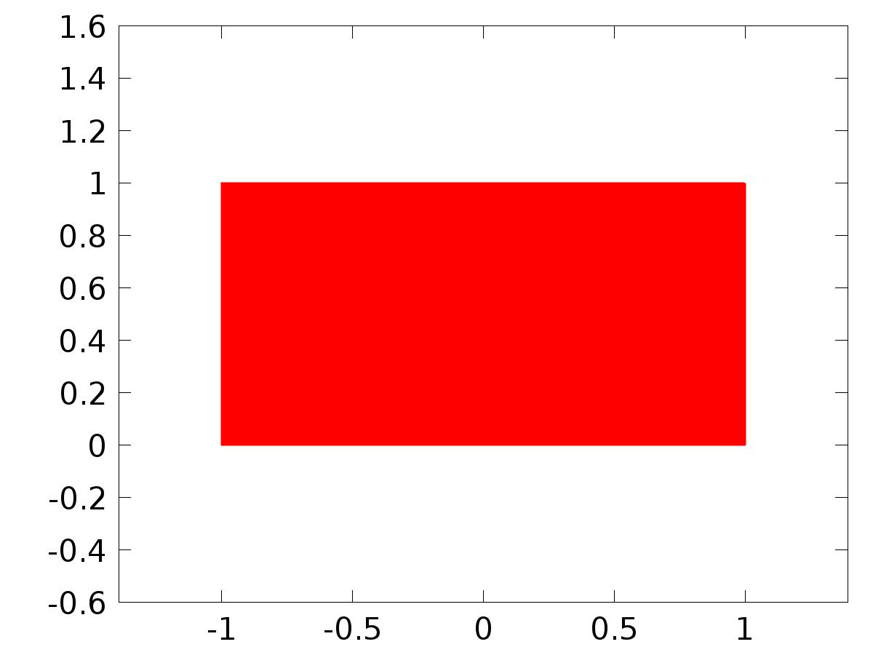

Data set: Solution 1

* + 1. Probe Solution 2

Solution

| **Description** | **Value** |
| --- | --- |
| Solution | Solver 3 |
| Component | Save Point Geometry 2 |



Data set: Probe Solution 2

* + 1. Solution 4

Solution

| **Description** | **Value** |
| --- | --- |
| Solution | Solver 3 |
| Component | Save Point Geometry 2 |



Data set: Solution 4

* + 1. Solution 5

Solution

| **Description** | **Value** |
| --- | --- |
| Solution | Solver 5 |
| Component | Save Point Geometry 2 |



Data set: Solution 5

* 1. Derived Values
     1. C1(Xj)

Data

| **Description** | **Value** |
| --- | --- |
| Data set | Probe Solution 2 |

Expression

| **Description** | **Value** |
| --- | --- |
| Expression | C1(X) |
| Description | C1(X) |

* + 1. C2(Xj)

Data

| **Description** | **Value** |
| --- | --- |
| Data set | Probe Solution 2 |

Expression

| **Description** | **Value** |
| --- | --- |
| Expression | C2(X) |
| Description | C2(X) |

* + 1. C3(Xj)

Data

| **Description** | **Value** |
| --- | --- |
| Data set | Probe Solution 2 |

Expression

| **Description** | **Value** |
| --- | --- |
| Expression | C3(X) |
| Description | C3(X) |

* + 1. Gamma_lk11

Data

| **Description** | **Value** |
| --- | --- |
| Data set | Probe Solution 2 |

Expression

| **Description** | **Value** |
| --- | --- |
| Expression | Gamma11 |

* + 1. Gamma_lk12

Data

| **Description** | **Value** |
| --- | --- |
| Data set | Probe Solution 2 |

Expression

| **Description** | **Value** |
| --- | --- |
| Expression | Gamma12 |

* + 1. Gamma_lk21

Data

| **Description** | **Value** |
| --- | --- |
| Data set | Probe Solution 2 |

Expression

| **Description** | **Value** |
| --- | --- |
| Expression | Gamma21 |

* + 1. Gamma_lk22

Data

| **Description** | **Value** |
| --- | --- |
| Data set | Probe Solution 2 |

Expression

| **Description** | **Value** |
| --- | --- |
| Expression | Gamma22 |

* + 1. Gamma_lk31

Data

| **Description** | **Value** |
| --- | --- |
| Data set | Probe Solution 2 |

Expression

| **Description** | **Value** |
| --- | --- |
| Expression | Gamma31 |

* + 1. Gamma_lk32

Data

| **Description** | **Value** |
| --- | --- |
| Data set | Probe Solution 2 |

Expression

| **Description** | **Value** |
| --- | --- |
| Expression | Gamma32 |

* + 1. Global Evaluation 10

Data

| **Description** | **Value** |
| --- | --- |
| Data set | Solution 4 |

Expression

| **Description** | **Value** |
| --- | --- |
| Expression | yr1 |
| Description | yr1 |

* 1. Tables
     1. Probe Table 1

Probe Table 1

| **l** | **k** | **, Gamma_lk11** | **, Gamma_lk12** | **, Gamma_lk21** | **, Gamma_lk22** | **, Gamma_lk31** | **, Gamma_lk32** |
| --- | --- | --- | --- | --- | --- | --- | --- |
| 1.0000 | -2.5955 | 0.0000 | -845.09 | 0.0000 | 201.08 | 0.0000 |
| 1.0000 | -1.9818 | 2.3215 | -564.98 | 790.12 | 119.80 | -203.73 |
| 1.0000 | -0.18209 | 4.3233 | 249.80 | 1357.2 | -114.41 | -332.75 |
| 1.0000 | 2.6708 | 5.7054 | 1520.3 | 1502.7 | -472.55 | -320.51 |
| 1.0000 | 6.3389 | 6.1846 | 3103.7 | 1071.6 | -904.63 | -116.50 |
| 1.0000 | 10.501 | 5.4718 | 4784.3 | -47.823 | -1336.9 | 311.14 |
| 1.0000 | 14.806 | 3.2911 | 6290.7 | -1935.5 | -1675.9 | 977.93 |
| 1.0000 | 18.893 | -0.56068 | 7329.8 | -4626.6 | -1819.2 | 1880.9 |
| 1.0000 | 22.364 | -6.1837 | 7604.1 | -8085.7 | -1663.6 | 2991.2 |
| 1.0000 | 24.775 | -13.579 | 6816.6 | -12193 | -1109.4 | 4249.4 |
| 1.0000 | 25.645 | -22.656 | 4680.3 | -16741 | -65.162 | 5563.8 |
| 1.0000 | 24.480 | -33.228 | 933.59 | -21438 | 1546.3 | 6811.8 |
| 1.0000 | 20.781 | -45.011 | -4642.7 | -25909 | 3780.8 | 7841.1 |
| 1.0000 | 14.070 | -57.619 | -12207 | -29702 | 6665.5 | 8472.6 |
| 1.0000 | 3.9003 | -70.565 | -21838 | -32294 | 10192 | 8504.7 |
| 1.0000 | -10.125 | -83.253 | -33519 | -33104 | 14311 | 7718.4 |
| 1.0000 | -28.335 | -94.991 | -47121 | -31506 | 18924 | 5883.8 |
| 1.0000 | -50.975 | -104.99 | -62389 | -26841 | 23879 | 2768.1 |
| 1.0000 | -78.190 | -112.35 | -78927 | -18444 | 28968 | -1855.7 |
| 1.0000 | -110.01 | -116.13 | -96191 | -5659.0 | 33921 | -8198.6 |
| 1.0000 | -146.32 | -115.28 | -1.1348E5 | 12133 | 38408 | -16445 |
| 2.0000 | 1.6113 | 0.0000 | 170.62 | 0.0000 | -40.783 | 0.0000 |
| 2.0000 | -0.72171 | -3.1102 | 149.10 | -166.56 | -31.216 | 48.320 |
| 2.0000 | -6.7953 | -2.6740 | 104.07 | -323.65 | -9.5037 | 95.316 |
| 2.0000 | -14.013 | 4.1323 | 28.089 | -427.37 | 21.818 | 126.44 |
| 2.0000 | -18.278 | 18.724 | -103.71 | -480.88 | 69.385 | 137.89 |
| 2.0000 | -14.539 | 40.694 | -278.98 | -491.91 | 130.13 | 130.70 |
| 2.0000 | 2.4954 | 67.372 | -481.58 | -453.76 | 198.21 | 102.60 |
| 2.0000 | 37.582 | 93.603 | -698.05 | -358.12 | 267.94 | 50.867 |
| 2.0000 | 94.081 | 111.77 | -915.30 | -198.40 | 333.46 | -26.561 |
| 2.0000 | 173.06 | 112.04 | -1119.7 | 29.784 | 388.60 | -130.77 |
| 2.0000 | 272.40 | 82.941 | -1296.9 | 328.57 | 426.95 | -261.83 |
| 2.0000 | 386.06 | 12.073 | -1432.2 | 697.86 | 441.89 | -418.74 |
| 2.0000 | 503.40 | -112.81 | -1510.4 | 1135.4 | 426.75 | -599.45 |
| 2.0000 | 608.78 | -302.57 | -1516.5 | 1637.0 | 374.92 | -800.93 |
| 2.0000 | 681.44 | -565.21 | -1435.6 | 2196.3 | 279.91 | -1019.2 |
| 2.0000 | 695.65 | -904.35 | -1252.7 | 2805.8 | 135.32 | -1249.4 |
| 2.0000 | 621.34 | -1317.5 | -953.10 | 3456.1 | -65.146 | -1485.9 |
| 2.0000 | 425.00 | -1794.4 | -521.43 | 4136.9 | -327.91 | -1722.1 |
| 2.0000 | 71.134 | -2315.5 | 58.556 | 4836.4 | -659.73 | -1950.8 |
| 2.0000 | -475.86 | -2850.5 | 804.98 | 5541.3 | -1068.0 | -2163.5 |
| 2.0000 | -1249.4 | -3357.2 | 1739.0 | 6236.1 | -1561.3 | -2349.9 |
| 3.0000 | 1.1328 | 0.0000 | 858.29 | 0.0000 | -200.93 | 0.0000 |
| 3.0000 | 0.73572 | -1.3776 | -64.434 | -1320.2 | 64.093 | 321.87 |
| 3.0000 | -0.39003 | -2.8428 | -2542.4 | -1400.3 | 754.07 | 227.91 |
| 3.0000 | -1.9539 | -4.3499 | -5604.4 | 627.26 | 1533.6 | -554.25 |
| 3.0000 | -3.8262 | -5.5401 | -7670.1 | 5227.4 | 1856.3 | -2113.5 |
| 3.0000 | -6.1247 | -6.2189 | -6983.9 | 12243 | 1114.9 | -4298.0 |
| 3.0000 | -8.8748 | -6.3436 | -1832.3 | 20617 | -1245.4 | -6626.9 |
| 3.0000 | -12.019 | -5.8663 | 9208.0 | 28375 | -5616.8 | -8286.0 |
| 3.0000 | -15.467 | -4.7241 | 26926 | 32708 | -12093 | -8173.2 |
| 3.0000 | -19.112 | -2.8564 | 51132 | 30140 | -20337 | -4985.0 |
| 3.0000 | -22.831 | -0.22051 | 80343 | 16799 | -29465 | 2652.9 |
| 3.0000 | -26.491 | 3.1941 | 1.1154E5 | -11215 | -37966 | 16012 |
| 3.0000 | -29.969 | 7.3535 | 1.4003E5 | -57364 | -43666 | 36056 |
| 3.0000 | -33.171 | 12.173 | 1.5936E5 | -1.2415E5 | -43743 | 63204 |
| 3.0000 | -36.077 | 17.524 | 1.6144E5 | -2.1252E5 | -34811 | 97091 |
| 3.0000 | -38.781 | 23.260 | 1.3679E5 | -3.2133E5 | -13062 | 1.3632E5 |
| 3.0000 | -41.537 | 29.276 | 74875 | -4.4674E5 | 25520 | 1.7826E5 |
| 3.0000 | -44.795 | 35.598 | -35353 | -5.8167E5 | 84885 | 2.1879E5 |
| 3.0000 | -49.196 | 42.522 | -2.0481E5 | -7.1541E5 | 1.6858E5 | 2.5222E5 |
| 3.0000 | -55.520 | 50.784 | -4.4352E5 | -8.3317E5 | 2.7935E5 | 2.7113E5 |
| 3.0000 | -64.552 | 61.761 | -7.5974E5 | -9.1582E5 | 4.1874E5 | 2.6630E5 |
| 4.0000 | -0.14860 | 0.0000 | -178.82 | 0.0000 | 41.630 | 0.0000 |
| 4.0000 | -0.15989 | 0.027779 | -179.95 | 61.838 | 41.284 | -18.767 |
| 4.0000 | -0.19151 | 0.043978 | -185.02 | 125.18 | 40.783 | -38.433 |
| 4.0000 | -0.23527 | 0.037546 | -197.70 | 188.27 | 41.494 | -59.010 |
| 4.0000 | -0.27491 | 0.0032212 | -219.16 | 244.82 | 44.480 | -78.976 |
| 4.0000 | -0.29313 | -0.050068 | -243.91 | 288.87 | 48.961 | -96.230 |
| 4.0000 | -0.28571 | -0.10413 | -263.72 | 321.17 | 52.762 | -110.17 |
| 4.0000 | -0.26129 | -0.14670 | -274.60 | 347.33 | 54.340 | -121.89 |
| 4.0000 | -0.23013 | -0.17559 | -277.15 | 372.25 | 53.432 | -132.71 |
| 4.0000 | -0.19841 | -0.19349 | -273.56 | 398.30 | 50.409 | -143.45 |
| 4.0000 | -0.16875 | -0.20370 | -265.74 | 426.17 | 45.730 | -154.44 |
| 4.0000 | -0.14187 | -0.20876 | -254.97 | 455.82 | 39.747 | -165.80 |
| 4.0000 | -0.11775 | -0.21036 | -242.03 | 486.99 | 32.701 | -177.51 |
| 4.0000 | -0.096115 | -0.20955 | -227.40 | 519.39 | 24.747 | -189.52 |
| 4.0000 | -0.076648 | -0.20702 | -211.33 | 552.77 | 15.990 | -201.80 |
| 4.0000 | -0.059074 | -0.20319 | -194.03 | 586.94 | 6.4976 | -214.29 |
| 4.0000 | -0.043166 | -0.19836 | -175.58 | 621.74 | -3.6803 | -226.95 |
| 4.0000 | -0.028743 | -0.19273 | -156.08 | 657.05 | -14.508 | -239.76 |
| 4.0000 | -0.015658 | -0.18644 | -135.58 | 692.77 | -25.957 | -252.69 |
| 4.0000 | -0.0037912 | -0.17962 | -114.13 | 728.83 | -38.004 | -265.71 |
| 4.0000 | 0.0069582 | -0.17235 | -91.757 | 765.16 | -50.631 | -278.82 |

* + 1. Probe Table 2
    2. Probe Table 3
    3. Table 4

Global Evaluation 10 (u(t))

Table 4

| **Time (s)** | **C1(z)** | **C2(z)** | **C3(z)** |
| --- | --- | --- | --- |
| 0.0000 | 1.0000 | 1.0000 | 1.0000 |
| 0.012500 | 1.0000 | 1.0000 | 1.0000 |
| 0.025000 | 1.0114 | 1.0114 | 1.0116 |
| 0.037500 | 1.1555 | 1.1555 | 1.1558 |
| 0.050000 | 1.6205 | 1.6205 | 1.6208 |
| 0.062500 | 2.4630 | 2.4629 | 2.4632 |
| 0.075000 | 3.6219 | 3.6222 | 3.6222 |
| 0.087500 | 4.9963 | 4.9975 | 4.9967 |
| 0.10000 | 6.4893 | 6.4931 | 6.4902 |
| 0.11250 | 8.0234 | 8.0327 | 8.0250 |
| 0.12500 | 9.5413 | 9.5607 | 9.5441 |
| 0.13750 | 11.004 | 11.039 | 11.008 |
| 0.15000 | 12.385 | 12.445 | 12.392 |
| 0.16250 | 13.669 | 13.763 | 13.681 |
| 0.17500 | 14.848 | 14.986 | 14.867 |
| 0.18750 | 15.918 | 16.113 | 15.946 |
| 0.20000 | 16.880 | 17.142 | 16.920 |
| 0.21250 | 17.736 | 18.077 | 17.791 |
| 0.22500 | 18.491 | 18.923 | 18.564 |
| 0.23750 | 19.149 | 19.682 | 19.245 |
| 0.25000 | 19.717 | 20.360 | 19.838 |
| 0.26250 | 20.201 | 20.963 | 20.349 |
| 0.27500 | 20.607 | 21.496 | 20.785 |
| 0.28750 | 20.942 | 21.964 | 21.151 |
| 0.30000 | 21.214 | 22.372 | 21.453 |
| 0.31250 | 21.427 | 22.725 | 21.695 |
| 0.32500 | 21.589 | 23.028 | 21.884 |
| 0.33750 | 21.706 | 23.284 | 22.024 |
| 0.35000 | 21.783 | 23.498 | 22.120 |
| 0.36250 | 21.826 | 23.672 | 22.176 |
| 0.37500 | 21.841 | 23.811 | 22.195 |
| 0.38750 | 21.832 | 23.917 | 22.181 |
| 0.40000 | 21.804 | 23.992 | 22.139 |
| 0.41250 | 21.762 | 24.041 | 22.070 |
| 0.42500 | 21.708 | 24.065 | 21.978 |
| 0.43750 | 21.646 | 24.066 | 21.865 |
| 0.45000 | 21.580 | 24.048 | 21.733 |
| 0.46250 | 21.512 | 24.011 | 21.584 |
| 0.47500 | 21.444 | 23.957 | 21.421 |
| 0.48750 | 21.378 | 23.889 | 21.245 |
| 0.50000 | 21.316 | 23.808 | 21.058 |
| 0.51250 | 21.259 | 23.714 | 20.861 |
| 0.52500 | 21.207 | 23.609 | 20.656 |
| 0.53750 | 21.161 | 23.494 | 20.443 |
| 0.55000 | 21.121 | 23.371 | 20.225 |
| 0.56250 | 21.086 | 23.239 | 20.002 |
| 0.57500 | 21.057 | 23.101 | 19.775 |
| 0.58750 | 21.032 | 22.957 | 19.545 |
| 0.60000 | 21.010 | 22.808 | 19.313 |
| 0.61250 | 20.991 | 22.654 | 19.078 |
| 0.62500 | 20.973 | 22.496 | 18.843 |
| 0.63750 | 20.955 | 22.334 | 18.606 |
| 0.65000 | 20.935 | 22.170 | 18.370 |
| 0.66250 | 20.912 | 22.003 | 18.133 |
| 0.67500 | 20.885 | 21.834 | 17.897 |
| 0.68750 | 20.851 | 21.662 | 17.662 |
| 0.70000 | 20.810 | 21.490 | 17.428 |
| 0.71250 | 20.760 | 21.316 | 17.195 |
| 0.72500 | 20.700 | 21.141 | 16.964 |
| 0.73750 | 20.628 | 20.966 | 16.735 |
| 0.75000 | 20.545 | 20.790 | 16.509 |
| 0.76250 | 20.450 | 20.615 | 16.285 |
| 0.77500 | 20.341 | 20.440 | 16.063 |
| 0.78750 | 20.219 | 20.265 | 15.844 |
| 0.80000 | 20.083 | 20.090 | 15.627 |
| 0.81250 | 19.933 | 19.916 | 15.413 |
| 0.82500 | 19.771 | 19.742 | 15.202 |
| 0.83750 | 19.596 | 19.568 | 14.993 |
| 0.85000 | 19.409 | 19.396 | 14.788 |
| 0.86250 | 19.212 | 19.224 | 14.585 |
| 0.87500 | 19.005 | 19.054 | 14.385 |
| 0.88750 | 18.789 | 18.884 | 14.188 |
| 0.90000 | 18.567 | 18.716 | 13.994 |
| 0.91250 | 18.339 | 18.549 | 13.803 |
| 0.92500 | 18.107 | 18.384 | 13.615 |
| 0.93750 | 17.873 | 18.219 | 13.430 |
| 0.95000 | 17.639 | 18.056 | 13.248 |
| 0.96250 | 17.406 | 17.894 | 13.069 |
| 0.97500 | 17.177 | 17.733 | 12.893 |
| 0.98750 | 16.952 | 17.574 | 12.720 |
| 1.0000 | 16.734 | 17.416 | 12.550 |
| 1.0125 | 16.524 | 17.259 | 12.382 |
| 1.0250 | 16.322 | 17.104 | 12.217 |
| 1.0375 | 16.132 | 16.950 | 12.055 |
| 1.0500 | 15.953 | 16.798 | 11.895 |
| 1.0625 | 15.786 | 16.648 | 11.738 |
| 1.0750 | 15.632 | 16.499 | 11.584 |
| 1.0875 | 15.491 | 16.351 | 11.433 |
| 1.1000 | 15.364 | 16.204 | 11.284 |
| 1.1125 | 15.251 | 16.059 | 11.138 |
| 1.1250 | 15.151 | 15.915 | 10.995 |
| 1.1375 | 15.063 | 15.772 | 10.854 |
| 1.1500 | 14.988 | 15.631 | 10.715 |
| 1.1625 | 14.923 | 15.491 | 10.579 |
| 1.1750 | 14.869 | 15.353 | 10.445 |
| 1.1875 | 14.822 | 15.217 | 10.313 |
| 1.2000 | 14.783 | 15.082 | 10.183 |
| 1.2125 | 14.749 | 14.949 | 10.056 |
| 1.2250 | 14.719 | 14.817 | 9.9307 |
| 1.2375 | 14.691 | 14.686 | 9.8077 |
| 1.2500 | 14.662 | 14.556 | 9.6869 |
| 1.2625 | 14.632 | 14.427 | 9.5683 |
| 1.2750 | 14.597 | 14.299 | 9.4520 |
| 1.2875 | 14.556 | 14.172 | 9.3377 |
| 1.3000 | 14.508 | 14.047 | 9.2255 |
| 1.3125 | 14.450 | 13.924 | 9.1152 |
| 1.3250 | 14.381 | 13.803 | 9.0067 |
| 1.3375 | 14.299 | 13.684 | 8.9000 |
| 1.3500 | 14.203 | 13.566 | 8.7949 |
| 1.3625 | 14.092 | 13.449 | 8.6916 |
| 1.3750 | 13.964 | 13.332 | 8.5898 |
| 1.3875 | 13.820 | 13.215 | 8.4898 |
| 1.4000 | 13.659 | 13.096 | 8.3915 |
| 1.4125 | 13.480 | 12.976 | 8.2949 |
| 1.4250 | 13.283 | 12.854 | 8.2001 |
| 1.4375 | 13.070 | 12.730 | 8.1072 |
| 1.4500 | 12.839 | 12.605 | 8.0160 |
| 1.4625 | 12.593 | 12.479 | 7.9266 |
| 1.4750 | 12.332 | 12.353 | 7.8387 |
| 1.4875 | 12.057 | 12.227 | 7.7523 |
| 1.5000 | 11.770 | 12.103 | 7.6673 |
| 1.5125 | 11.472 | 11.980 | 7.5834 |
| 1.5250 | 11.166 | 11.860 | 7.5008 |
| 1.5375 | 10.853 | 11.740 | 7.4192 |
| 1.5500 | 10.534 | 11.623 | 7.3388 |
| 1.5625 | 10.214 | 11.506 | 7.2597 |
| 1.5750 | 9.8927 | 11.391 | 7.1819 |
| 1.5875 | 9.5732 | 11.276 | 7.1057 |
| 1.6000 | 9.2577 | 11.162 | 7.0311 |
| 1.6125 | 8.9483 | 11.048 | 6.9581 |
| 1.6250 | 8.6470 | 10.935 | 6.8868 |
| 1.6375 | 8.3558 | 10.824 | 6.8171 |
| 1.6500 | 8.0766 | 10.713 | 6.7487 |
| 1.6625 | 7.8110 | 10.604 | 6.6813 |
| 1.6750 | 7.5606 | 10.496 | 6.6146 |
| 1.6875 | 7.3266 | 10.389 | 6.5481 |
| 1.7000 | 7.1102 | 10.283 | 6.4815 |
| 1.7125 | 6.9123 | 10.178 | 6.4143 |
| 1.7250 | 6.7334 | 10.074 | 6.3462 |
| 1.7375 | 6.5739 | 9.9710 | 6.2771 |
| 1.7500 | 6.4339 | 9.8684 | 6.2070 |
| 1.7625 | 6.3133 | 9.7666 | 6.1359 |
| 1.7750 | 6.2117 | 9.6656 | 6.0642 |
| 1.7875 | 6.1284 | 9.5656 | 5.9922 |
| 1.8000 | 6.0627 | 9.4667 | 5.9201 |
| 1.8125 | 6.0134 | 9.3688 | 5.8484 |
| 1.8250 | 5.9792 | 9.2720 | 5.7776 |
| 1.8375 | 5.9587 | 9.1762 | 5.7077 |
| 1.8500 | 5.9503 | 9.0813 | 5.6391 |
| 1.8625 | 5.9523 | 8.9871 | 5.5717 |
| 1.8750 | 5.9628 | 8.8936 | 5.5057 |
| 1.8875 | 5.9799 | 8.8007 | 5.4409 |
| 1.9000 | 6.0018 | 8.7086 | 5.3771 |
| 1.9125 | 6.0264 | 8.6172 | 5.3142 |
| 1.9250 | 6.0518 | 8.5266 | 5.2520 |
| 1.9375 | 6.0762 | 8.4369 | 5.1904 |
| 1.9500 | 6.0977 | 8.3482 | 5.1293 |
| 1.9625 | 6.1147 | 8.2605 | 5.0688 |
| 1.9750 | 6.1257 | 8.1736 | 5.0087 |
| 1.9875 | 6.1292 | 8.0876 | 4.9493 |
| 2.0000 | 6.1240 | 8.0023 | 4.8905 |
| 2.0125 | 6.1091 | 7.9176 | 4.8326 |
| 2.0250 | 6.0836 | 7.8336 | 4.7755 |
| 2.0375 | 6.0470 | 7.7501 | 4.7192 |
| 2.0500 | 5.9989 | 7.6673 | 4.6638 |
| 2.0625 | 5.9391 | 7.5852 | 4.6093 |
| 2.0750 | 5.8679 | 7.5039 | 4.5555 |
| 2.0875 | 5.7853 | 7.4235 | 4.5024 |
| 2.1000 | 5.6922 | 7.3439 | 4.4498 |
| 2.1125 | 5.5890 | 7.2652 | 4.3978 |
| 2.1250 | 5.4770 | 7.1872 | 4.3462 |
| 2.1375 | 5.3571 | 7.1099 | 4.2951 |
| 2.1500 | 5.2306 | 7.0332 | 4.2444 |
| 2.1625 | 5.0991 | 6.9570 | 4.1943 |
| 2.1750 | 4.9639 | 6.8813 | 4.1447 |
| 2.1875 | 4.8268 | 6.8062 | 4.0958 |
| 2.2000 | 4.6894 | 6.7318 | 4.0475 |
| 2.2125 | 4.5534 | 6.6580 | 3.9999 |
| 2.2250 | 4.4205 | 6.5850 | 3.9529 |
| 2.2375 | 4.2924 | 6.5128 | 3.9066 |
| 2.2500 | 4.1707 | 6.4414 | 3.8609 |
| 2.2625 | 4.0569 | 6.3707 | 3.8157 |
| 2.2750 | 3.9524 | 6.3006 | 3.7710 |
| 2.2875 | 3.8585 | 6.2311 | 3.7266 |
| 2.3000 | 3.7763 | 6.1620 | 3.6827 |
| 2.3125 | 3.7067 | 6.0934 | 3.6391 |
| 2.3250 | 3.6504 | 6.0252 | 3.5959 |
| 2.3375 | 3.6079 | 5.9576 | 3.5532 |
| 2.3500 | 3.5796 | 5.8906 | 3.5108 |
| 2.3625 | 3.5654 | 5.8243 | 3.4690 |
| 2.3750 | 3.5652 | 5.7587 | 3.4278 |
| 2.3875 | 3.5786 | 5.6939 | 3.3871 |
| 2.4000 | 3.6049 | 5.6298 | 3.3469 |
| 2.4125 | 3.6434 | 5.5662 | 3.3072 |
| 2.4250 | 3.6928 | 5.5032 | 3.2680 |
| 2.4375 | 3.7520 | 5.4405 | 3.2293 |
| 2.4500 | 3.8196 | 5.3782 | 3.1909 |
| 2.4625 | 3.8939 | 5.3163 | 3.1528 |
| 2.4750 | 3.9732 | 5.2547 | 3.1150 |
| 2.4875 | 4.0557 | 5.1937 | 3.0775 |
| 2.5000 | 4.1396 | 5.1334 | 3.0403 |
| 2.5125 | 4.2228 | 5.0738 | 3.0035 |
| 2.5250 | 4.3034 | 5.0149 | 2.9670 |
| 2.5375 | 4.3795 | 4.9567 | 2.9309 |
| 2.5500 | 4.4491 | 4.8991 | 2.8954 |
| 2.5625 | 4.5104 | 4.8420 | 2.8602 |
| 2.5750 | 4.5618 | 4.7852 | 2.8255 |
| 2.5875 | 4.6015 | 4.7286 | 2.7913 |
| 2.6000 | 4.6281 | 4.6721 | 2.7574 |
| 2.6125 | 4.6405 | 4.6160 | 2.7239 |
| 2.6250 | 4.6374 | 4.5603 | 2.6906 |
| 2.6375 | 4.6181 | 4.5051 | 2.6576 |
| 2.6500 | 4.5820 | 4.4508 | 2.6248 |
| 2.6625 | 4.5286 | 4.3973 | 2.5922 |
| 2.6750 | 4.4579 | 4.3446 | 2.5599 |
| 2.6875 | 4.3699 | 4.2927 | 2.5279 |
| 2.7000 | 4.2651 | 4.2411 | 2.4962 |
| 2.7125 | 4.1440 | 4.1897 | 2.4648 |
| 2.7250 | 4.0076 | 4.1382 | 2.4338 |
| 2.7375 | 3.8570 | 4.0865 | 2.4033 |
| 2.7500 | 3.6934 | 4.0346 | 2.3731 |
| 2.7625 | 3.5184 | 3.9828 | 2.3433 |
| 2.7750 | 3.3337 | 3.9317 | 2.3137 |
| 2.7875 | 3.1411 | 3.8820 | 2.2845 |
| 2.8000 | 2.9425 | 3.8343 | 2.2555 |
| 2.8125 | 2.7401 | 3.7894 | 2.2266 |
| 2.8250 | 2.5360 | 3.7477 | 2.1979 |
| 2.8375 | 2.3324 | 3.7095 | 2.1694 |
| 2.8500 | 2.1313 | 3.6748 | 2.1410 |
| 2.8625 | 1.9351 | 3.6431 | 2.1129 |
| 2.8750 | 1.7457 | 3.6138 | 2.0851 |
| 2.8875 | 1.5652 | 3.5862 | 2.0575 |
| 2.9000 | 1.3955 | 3.5597 | 2.0303 |
| 2.9125 | 1.2383 | 3.5334 | 2.0035 |
| 2.9250 | 1.0952 | 3.5071 | 1.9771 |
| 2.9375 | 0.96760 | 3.4806 | 1.9509 |
| 2.9500 | 0.85667 | 3.4537 | 1.9250 |
| 2.9625 | 0.76338 | 3.4268 | 1.8993 |
| 2.9750 | 0.68844 | 3.4001 | 1.8738 |
| 2.9875 | 0.63235 | 3.3738 | 1.8484 |
| 3.0000 | 0.59531 | 3.3482 | 1.8230 |
| 3.0125 | 0.57729 | 3.3233 | 1.7978 |
| 3.0250 | 0.57801 | 3.2991 | 1.7727 |
| 3.0375 | 0.59695 | 3.2756 | 1.7477 |
| 3.0500 | 0.63332 | 3.2524 | 1.7230 |
| 3.0625 | 0.68614 | 3.2294 | 1.6987 |
| 3.0750 | 0.75420 | 3.2065 | 1.6746 |
| 3.0875 | 0.83612 | 3.1836 | 1.6509 |
| 3.1000 | 0.93035 | 3.1609 | 1.6276 |
| 3.1125 | 1.0352 | 3.1383 | 1.6046 |
| 3.1250 | 1.1488 | 3.1160 | 1.5818 |
| 3.1375 | 1.2694 | 3.0942 | 1.5591 |
| 3.1500 | 1.3950 | 3.0729 | 1.5365 |
| 3.1625 | 1.5235 | 3.0522 | 1.5139 |
| 3.1750 | 1.6531 | 3.0319 | 1.4912 |
| 3.1875 | 1.7818 | 3.0120 | 1.4686 |
| 3.2000 | 1.9078 | 2.9924 | 1.4461 |
| 3.2125 | 2.0292 | 2.9729 | 1.4237 |
| 3.2250 | 2.1445 | 2.9535 | 1.4015 |
| 3.2375 | 2.2521 | 2.9342 | 1.3797 |
| 3.2500 | 2.3507 | 2.9151 | 1.3583 |
| 3.2625 | 2.4391 | 2.8963 | 1.3373 |
| 3.2750 | 2.5164 | 2.8778 | 1.3168 |
| 3.2875 | 2.5818 | 2.8598 | 1.2966 |
| 3.3000 | 2.6348 | 2.8422 | 1.2765 |
| 3.3125 | 2.6752 | 2.8250 | 1.2566 |
| 3.3250 | 2.7028 | 2.8082 | 1.2365 |
| 3.3375 | 2.7179 | 2.7916 | 1.2161 |
| 3.3500 | 2.7209 | 2.7752 | 1.1955 |
| 3.3625 | 2.7124 | 2.7589 | 1.1746 |
| 3.3750 | 2.6932 | 2.7427 | 1.1535 |
| 3.3875 | 2.6643 | 2.7266 | 1.1326 |
| 3.4000 | 2.6271 | 2.7108 | 1.1121 |
| 3.4125 | 2.5827 | 2.6952 | 1.0924 |
| 3.4250 | 2.5326 | 2.6800 | 1.0739 |
| 3.4375 | 2.4785 | 2.6653 | 1.0570 |
| 3.4500 | 2.4219 | 2.6509 | 1.0420 |
| 3.4625 | 2.3645 | 2.6368 | 1.0291 |
| 3.4750 | 2.3080 | 2.6231 | 1.0184 |
| 3.4875 | 2.2541 | 2.6094 | 1.0099 |
| 3.5000 | 2.2043 | 2.5959 | 1.0034 |
| 3.5125 | 2.1604 | 2.5825 | 0.99847 |
| 3.5250 | 2.1236 | 2.5691 | 0.99485 |
| 3.5375 | 2.0954 | 2.5559 | 0.99212 |
| 3.5500 | 2.0769 | 2.5430 | 0.98987 |
| 3.5625 | 2.0691 | 2.5303 | 0.98778 |
| 3.5750 | 2.0729 | 2.5180 | 0.98557 |
| 3.5875 | 2.0888 | 2.5061 | 0.98310 |
| 3.6000 | 2.1173 | 2.4946 | 0.98030 |
| 3.6125 | 2.1586 | 2.4833 | 0.97722 |
| 3.6250 | 2.2125 | 2.4721 | 0.97395 |
| 3.6375 | 2.2788 | 2.4611 | 0.97065 |
| 3.6500 | 2.3569 | 2.4501 | 0.96747 |
| 3.6625 | 2.4461 | 2.4392 | 0.96453 |
| 3.6750 | 2.5455 | 2.4284 | 0.96193 |
| 3.6875 | 2.6538 | 2.4177 | 0.95971 |
| 3.7000 | 2.7697 | 2.4074 | 0.95784 |
| 3.7125 | 2.8918 | 2.3974 | 0.95626 |
| 3.7250 | 3.0183 | 2.3877 | 0.95488 |
| 3.7375 | 3.1475 | 2.3783 | 0.95359 |
| 3.7500 | 3.2775 | 2.3693 | 0.95230 |
| 3.7625 | 3.4064 | 2.3604 | 0.95095 |
| 3.7750 | 3.5322 | 2.3515 | 0.94951 |
| 3.7875 | 3.6531 | 2.3428 | 0.94799 |
| 3.8000 | 3.7670 | 2.3340 | 0.94643 |
| 3.8125 | 3.8721 | 2.3252 | 0.94491 |
| 3.8250 | 3.9667 | 2.3166 | 0.94350 |
| 3.8375 | 4.0489 | 2.3083 | 0.94227 |
| 3.8500 | 4.1174 | 2.3003 | 0.94127 |
| 3.8625 | 4.1707 | 2.2926 | 0.94051 |
| 3.8750 | 4.2077 | 2.2853 | 0.93999 |
| 3.8875 | 4.2274 | 2.2783 | 0.93966 |
| 3.9000 | 4.2290 | 2.2714 | 0.93947 |
| 3.9125 | 4.2122 | 2.2646 | 0.93936 |
| 3.9250 | 4.1766 | 2.2578 | 0.93926 |
| 3.9375 | 4.1222 | 2.2510 | 0.93914 |
| 3.9500 | 4.0494 | 2.2441 | 0.93899 |
| 3.9625 | 3.9585 | 2.2373 | 0.93881 |
| 3.9750 | 3.8505 | 2.2306 | 0.93863 |
| 3.9875 | 3.7261 | 2.2243 | 0.93849 |
| 4.0000 | 3.5868 | 2.2185 | 0.93845 |
| 4.0125 | 3.4338 | 2.2131 | 0.93855 |
| 4.0250 | 3.2688 | 2.2080 | 0.93884 |
| 4.0375 | 3.0936 | 2.2032 | 0.93932 |
| 4.0500 | 2.9101 | 2.1984 | 0.93999 |
| 4.0625 | 2.7204 | 2.1935 | 0.94081 |
| 4.0750 | 2.5264 | 2.1883 | 0.94173 |
| 4.0875 | 2.3305 | 2.1829 | 0.94269 |
| 4.1000 | 2.1349 | 2.1774 | 0.94366 |
| 4.1125 | 1.9416 | 2.1719 | 0.94459 |
| 4.1250 | 1.7528 | 2.1669 | 0.94546 |
| 4.1375 | 1.5707 | 2.1625 | 0.94631 |
| 4.1500 | 1.3972 | 2.1590 | 0.94719 |
| 4.1625 | 1.2343 | 2.1562 | 0.94814 |
| 4.1750 | 1.0834 | 2.1539 | 0.94920 |
| 4.1875 | 0.94630 | 2.1517 | 0.95041 |
| 4.2000 | 0.82415 | 2.1487 | 0.95177 |
| 4.2125 | 0.71808 | 2.1443 | 0.95331 |
| 4.2250 | 0.62897 | 2.1377 | 0.95500 |
| 4.2375 | 0.55744 | 2.1285 | 0.95680 |
| 4.2500 | 0.50385 | 2.1162 | 0.95865 |
| 4.2625 | 0.46834 | 2.1011 | 0.96052 |
| 4.2750 | 0.45087 | 2.0834 | 0.96246 |
| 4.2875 | 0.45098 | 2.0638 | 0.96435 |
| 4.3000 | 0.46797 | 2.0426 | 0.96611 |
| 4.3125 | 0.50107 | 2.0209 | 0.96782 |
| 4.3250 | 0.54926 | 1.9992 | 0.96955 |
| 4.3375 | 0.61135 | 1.9783 | 0.97143 |
| 4.3500 | 0.68578 | 1.9581 | 0.97338 |
| 4.3625 | 0.77095 | 1.9385 | 0.97542 |
| 4.3750 | 0.86518 | 1.9196 | 0.97763 |
| 4.3875 | 0.96665 | 1.9010 | 0.98002 |
| 4.4000 | 1.0734 | 1.8824 | 0.98253 |
| 4.4125 | 1.1836 | 1.8637 | 0.98514 |
| 4.4250 | 1.2953 | 1.8447 | 0.98783 |
| 4.4375 | 1.4064 | 1.8253 | 0.99052 |
| 4.4500 | 1.5152 | 1.8059 | 0.99320 |
| 4.4625 | 1.6199 | 1.7864 | 0.99582 |
| 4.4750 | 1.7188 | 1.7672 | 0.99839 |
| 4.4875 | 1.8103 | 1.7483 | 1.0009 |
| 4.5000 | 1.8930 | 1.7299 | 1.0034 |
| 4.5125 | 1.9657 | 1.7117 | 1.0060 |
| 4.5250 | 2.0273 | 1.6939 | 1.0087 |
| 4.5375 | 2.0771 | 1.6761 | 1.0114 |
| 4.5500 | 2.1144 | 1.6583 | 1.0144 |
| 4.5625 | 2.1389 | 1.6404 | 1.0175 |
| 4.5750 | 2.1504 | 1.6223 | 1.0207 |
| 4.5875 | 2.1490 | 1.6042 | 1.0240 |
| 4.6000 | 2.1349 | 1.5860 | 1.0274 |
| 4.6125 | 2.1089 | 1.5680 | 1.0307 |
| 4.6250 | 2.0716 | 1.5502 | 1.0341 |
| 4.6375 | 2.0239 | 1.5327 | 1.0373 |
| 4.6500 | 1.9670 | 1.5155 | 1.0405 |
| 4.6625 | 1.9022 | 1.4985 | 1.0436 |
| 4.6750 | 1.8310 | 1.4816 | 1.0467 |
| 4.6875 | 1.7548 | 1.4647 | 1.0499 |
| 4.7000 | 1.6753 | 1.4478 | 1.0531 |
| 4.7125 | 1.5941 | 1.4309 | 1.0565 |
| 4.7250 | 1.5131 | 1.4138 | 1.0601 |
| 4.7375 | 1.4338 | 1.3967 | 1.0638 |
| 4.7500 | 1.3580 | 1.3798 | 1.0677 |
| 4.7625 | 1.2874 | 1.3629 | 1.0717 |
| 4.7750 | 1.2233 | 1.3463 | 1.0757 |
| 4.7875 | 1.1674 | 1.3300 | 1.0797 |
| 4.8000 | 1.1208 | 1.3138 | 1.0836 |
| 4.8125 | 1.0846 | 1.2978 | 1.0874 |
| 4.8250 | 1.0599 | 1.2818 | 1.0910 |
| 4.8375 | 1.0475 | 1.2658 | 1.0946 |
| 4.8500 | 1.0477 | 1.2497 | 1.0981 |
| 4.8625 | 1.0610 | 1.2336 | 1.1017 |
| 4.8750 | 1.0874 | 1.2174 | 1.1055 |
| 4.8875 | 1.1268 | 1.2013 | 1.1094 |
| 4.9000 | 1.1789 | 1.1854 | 1.1135 |
| 4.9125 | 1.2429 | 1.1696 | 1.1179 |
| 4.9250 | 1.3180 | 1.1540 | 1.1225 |
| 4.9375 | 1.4033 | 1.1387 | 1.1272 |
| 4.9500 | 1.4975 | 1.1235 | 1.1318 |
| 4.9625 | 1.5992 | 1.1083 | 1.1364 |
| 4.9750 | 1.7068 | 1.0931 | 1.1408 |
| 4.9875 | 1.8186 | 1.0779 | 1.1450 |
| 5.0000 | 1.9329 | 1.0625 | 1.1489 |
| 5.0125 | 2.0477 | 1.0471 | 1.1527 |
| 5.0250 | 2.1612 | 1.0317 | 1.1564 |
| 5.0375 | 2.2714 | 1.0165 | 1.1601 |
| 5.0500 | 2.3764 | 1.0014 | 1.1641 |
| 5.0625 | 2.4743 | 0.98653 | 1.1684 |
| 5.0750 | 2.5633 | 0.97191 | 1.1733 |
| 5.0875 | 2.6417 | 0.95746 | 1.1786 |
| 5.1000 | 2.7078 | 0.94310 | 1.1843 |
| 5.1125 | 2.7602 | 0.92874 | 1.1902 |
| 5.1250 | 2.7977 | 0.91429 | 1.1961 |
| 5.1375 | 2.8192 | 0.89972 | 1.2015 |
| 5.1500 | 2.8238 | 0.88505 | 1.2061 |
| 5.1625 | 2.8110 | 0.87034 | 1.2095 |
| 5.1750 | 2.7803 | 0.85568 | 1.2114 |
| 5.1875 | 2.7317 | 0.84117 | 1.2113 |
| 5.2000 | 2.6652 | 0.82687 | 1.2093 |
| 5.2125 | 2.5813 | 0.81281 | 1.2052 |
| 5.2250 | 2.4807 | 0.79897 | 1.1992 |
| 5.2375 | 2.3641 | 0.78525 | 1.1915 |
| 5.2500 | 2.2327 | 0.77156 | 1.1825 |
| 5.2625 | 2.0879 | 0.75781 | 1.1725 |
| 5.2750 | 1.9310 | 0.74393 | 1.1620 |
| 5.2875 | 1.7640 | 0.72991 | 1.1513 |
| 5.3000 | 1.5885 | 0.71581 | 1.1408 |
| 5.3125 | 1.4066 | 0.70173 | 1.1305 |
| 5.3250 | 1.2203 | 0.68778 | 1.1207 |
| 5.3375 | 1.0318 | 0.67405 | 1.1114 |
| 5.3500 | 0.84321 | 0.66059 | 1.1025 |
| 5.3625 | 0.65682 | 0.64738 | 1.0938 |
| 5.3750 | 0.47476 | 0.63434 | 1.0851 |
| 5.3875 | 0.29917 | 0.62132 | 1.0765 |
| 5.4000 | 0.13207 | 0.60820 | 1.0677 |
| 5.4125 | -0.024602 | 0.59488 | 1.0587 |
| 5.4250 | -0.16908 | 0.58132 | 1.0494 |
| 5.4375 | -0.29974 | 0.56759 | 1.0399 |
| 5.4500 | -0.41517 | 0.55381 | 1.0304 |
| 5.4625 | -0.51415 | 0.54017 | 1.0208 |
| 5.4750 | -0.59569 | 0.52684 | 1.0113 |
| 5.4875 | -0.65906 | 0.51393 | 1.0019 |
| 5.5000 | -0.70374 | 0.50146 | 0.99272 |
| 5.5125 | -0.72949 | 0.48930 | 0.98376 |
| 5.5250 | -0.73631 | 0.47723 | 0.97498 |
| 5.5375 | -0.72445 | 0.46497 | 0.96631 |
| 5.5500 | -0.69442 | 0.45226 | 0.95769 |
| 5.5625 | -0.64694 | 0.43893 | 0.94904 |
| 5.5750 | -0.58299 | 0.42501 | 0.94030 |
| 5.5875 | -0.50372 | 0.41074 | 0.93143 |
| 5.6000 | -0.41050 | 0.39660 | 0.92243 |
| 5.6125 | -0.30485 | 0.38323 | 0.91332 |
| 5.6250 | -0.18845 | 0.37138 | 0.90415 |
| 5.6375 | -0.063063 | 0.36175 | 0.89499 |
| 5.6500 | 0.069416 | 0.35490 | 0.88590 |
| 5.6625 | 0.20706 | 0.35113 | 0.87691 |
| 5.6750 | 0.34791 | 0.35047 | 0.86807 |
| 5.6875 | 0.49000 | 0.35262 | 0.85938 |
| 5.7000 | 0.63142 | 0.35703 | 0.85081 |
| 5.7125 | 0.77031 | 0.36299 | 0.84231 |
| 5.7250 | 0.90490 | 0.36978 | 0.83385 |
| 5.7375 | 1.0335 | 0.37673 | 0.82535 |
| 5.7500 | 1.1547 | 0.38336 | 0.81678 |
| 5.7625 | 1.2671 | 0.38941 | 0.80812 |
| 5.7750 | 1.3696 | 0.39484 | 0.79935 |
| 5.7875 | 1.4611 | 0.39982 | 0.79051 |
| 5.8000 | 1.5410 | 0.40458 | 0.78164 |
| 5.8125 | 1.6088 | 0.40943 | 0.77278 |
| 5.8250 | 1.6640 | 0.41457 | 0.76398 |
| 5.8375 | 1.7068 | 0.42014 | 0.75527 |
| 5.8500 | 1.7373 | 0.42612 | 0.74669 |
| 5.8625 | 1.7558 | 0.43240 | 0.73823 |
| 5.8750 | 1.7629 | 0.43881 | 0.72986 |
| 5.8875 | 1.7596 | 0.44515 | 0.72156 |
| 5.9000 | 1.7467 | 0.45130 | 0.71327 |
| 5.9125 | 1.7256 | 0.45718 | 0.70495 |
| 5.9250 | 1.6975 | 0.46282 | 0.69656 |
| 5.9375 | 1.6639 | 0.46833 | 0.68808 |
| 5.9500 | 1.6263 | 0.47386 | 0.67952 |
| 5.9625 | 1.5865 | 0.47953 | 0.67089 |
| 5.9750 | 1.5459 | 0.48544 | 0.66224 |
| 5.9875 | 1.5065 | 0.49163 | 0.65360 |
| 6.0000 | 1.4698 | 0.49803 | 0.64503 |
| 6.0125 | 1.4374 | 0.50457 | 0.63654 |
| 6.0250 | 1.4110 | 0.51111 | 0.62818 |
| 6.0375 | 1.3919 | 0.51756 | 0.61992 |
| 6.0500 | 1.3816 | 0.52383 | 0.61174 |
| 6.0625 | 1.3812 | 0.52993 | 0.60362 |
| 6.0750 | 1.3917 | 0.53590 | 0.59550 |
| 6.0875 | 1.4139 | 0.54185 | 0.58734 |
| 6.1000 | 1.4486 | 0.54788 | 0.57910 |
| 6.1125 | 1.4960 | 0.55407 | 0.57078 |
| 6.1250 | 1.5564 | 0.56047 | 0.56238 |
| 6.1375 | 1.6297 | 0.56706 | 0.55391 |
| 6.1500 | 1.7157 | 0.57378 | 0.54543 |
| 6.1625 | 1.8137 | 0.58056 | 0.53696 |
| 6.1750 | 1.9232 | 0.58728 | 0.52856 |
| 6.1875 | 2.0431 | 0.59389 | 0.52026 |
| 6.2000 | 2.1723 | 0.60035 | 0.51208 |
| 6.2125 | 2.3094 | 0.60670 | 0.50400 |
| 6.2250 | 2.4529 | 0.61300 | 0.49600 |
| 6.2375 | 2.6012 | 0.61933 | 0.48805 |
| 6.2500 | 2.7524 | 0.62578 | 0.48009 |
| 6.2625 | 2.9048 | 0.63240 | 0.47208 |
| 6.2750 | 3.0564 | 0.63918 | 0.46399 |
| 6.2875 | 3.2053 | 0.64611 | 0.45580 |
| 6.3000 | 3.3494 | 0.65310 | 0.44751 |
| 6.3125 | 3.4869 | 0.66007 | 0.43917 |
| 6.3250 | 3.6158 | 0.66695 | 0.43080 |
| 6.3375 | 3.7344 | 0.67371 | 0.42246 |
| 6.3500 | 3.8410 | 0.68036 | 0.41420 |
| 6.3625 | 3.9340 | 0.68695 | 0.40606 |
| 6.3750 | 4.0120 | 0.69355 | 0.39804 |
| 6.3875 | 4.0739 | 0.70024 | 0.39014 |
| 6.4000 | 4.1186 | 0.70707 | 0.38233 |
| 6.4125 | 4.1454 | 0.71407 | 0.37456 |
| 6.4250 | 4.1538 | 0.72121 | 0.36677 |
| 6.4375 | 4.1435 | 0.72843 | 0.35892 |
| 6.4500 | 4.1145 | 0.73564 | 0.35095 |
| 6.4625 | 4.0670 | 0.74278 | 0.34285 |
| 6.4750 | 4.0014 | 0.74979 | 0.33465 |
| 6.4875 | 3.9186 | 0.75667 | 0.32636 |
| 6.5000 | 3.8194 | 0.76347 | 0.31805 |
| 6.5125 | 3.7052 | 0.77026 | 0.30979 |
| 6.5250 | 3.5772 | 0.77713 | 0.30164 |
| 6.5375 | 3.4371 | 0.78415 | 0.29363 |
| 6.5500 | 3.2866 | 0.79135 | 0.28579 |
| 6.5625 | 3.1276 | 0.79872 | 0.27810 |
| 6.5750 | 2.9621 | 0.80619 | 0.27052 |
| 6.5875 | 2.7923 | 0.81368 | 0.26297 |
| 6.6000 | 2.6202 | 0.82108 | 0.25539 |
| 6.6125 | 2.4481 | 0.82834 | 0.24769 |
| 6.6250 | 2.2781 | 0.83543 | 0.23982 |
| 6.6375 | 2.1123 | 0.84239 | 0.23176 |
| 6.6500 | 1.9529 | 0.84929 | 0.22352 |
| 6.6625 | 1.8018 | 0.85624 | 0.21517 |
| 6.6750 | 1.6609 | 0.86335 | 0.20679 |
| 6.6875 | 1.5319 | 0.87067 | 0.19849 |
| 6.7000 | 1.4162 | 0.87822 | 0.19036 |
| 6.7125 | 1.3152 | 0.88594 | 0.18249 |
| 6.7250 | 1.2299 | 0.89373 | 0.17489 |
| 6.7375 | 1.1614 | 0.90147 | 0.16756 |
| 6.7500 | 1.1101 | 0.90903 | 0.16040 |
| 6.7625 | 1.0764 | 0.91637 | 0.15330 |
| 6.7750 | 1.0605 | 0.92349 | 0.14609 |
| 6.7875 | 1.0623 | 0.93047 | 0.13863 |
| 6.8000 | 1.0813 | 0.93744 | 0.13077 |
| 6.8125 | 1.1170 | 0.94455 | 0.12247 |
| 6.8250 | 1.1685 | 0.95193 | 0.11374 |
| 6.8375 | 1.2347 | 0.95961 | 0.10471 |
| 6.8500 | 1.3144 | 0.96756 | 0.095601 |
| 6.8625 | 1.4062 | 0.97566 | 0.086743 |
| 6.8750 | 1.5084 | 0.98373 | 0.078513 |
| 6.8875 | 1.6194 | 0.99159 | 0.071318 |
| 6.9000 | 1.7372 | 0.99912 | 0.065547 |
| 6.9125 | 1.8601 | 1.0063 | 0.061525 |
| 6.9250 | 1.9860 | 1.0131 | 0.059476 |
| 6.9375 | 2.1130 | 1.0199 | 0.059497 |
| 6.9500 | 2.2391 | 1.0269 | 0.061548 |
| 6.9625 | 2.3624 | 1.0343 | 0.065455 |
| 6.9750 | 2.4812 | 1.0424 | 0.070930 |
| 6.9875 | 2.5937 | 1.0511 | 0.077608 |
| 7.0000 | 2.6983 | 1.0602 | 0.085090 |
| 7.0125 | 2.7937 | 1.0694 | 0.092981 |
| 7.0250 | 2.8785 | 1.0779 | 0.10094 |
| 7.0375 | 2.9517 | 1.0851 | 0.10870 |
| 7.0500 | 3.0125 | 1.0902 | 0.11609 |
| 7.0625 | 3.0603 | 1.0927 | 0.12306 |
| 7.0750 | 3.0946 | 1.0922 | 0.12963 |
| 7.0875 | 3.1153 | 1.0886 | 0.13590 |
| 7.1000 | 3.1225 | 1.0822 | 0.14201 |
| 7.1125 | 3.1164 | 1.0735 | 0.14811 |
| 7.1250 | 3.0975 | 1.0632 | 0.15434 |
| 7.1375 | 3.0667 | 1.0520 | 0.16078 |
| 7.1500 | 3.0247 | 1.0406 | 0.16749 |
| 7.1625 | 2.9727 | 1.0295 | 0.17446 |
| 7.1750 | 2.9121 | 1.0190 | 0.18162 |
| 7.1875 | 2.8441 | 1.0092 | 0.18889 |
| 7.2000 | 2.7704 | 0.99990 | 0.19617 |
| 7.2125 | 2.6925 | 0.99091 | 0.20337 |
| 7.2250 | 2.6121 | 0.98195 | 0.21042 |
| 7.2375 | 2.5310 | 0.97276 | 0.21728 |
| 7.2500 | 2.4508 | 0.96321 | 0.22396 |
| 7.2625 | 2.3733 | 0.95329 | 0.23051 |
| 7.2750 | 2.3000 | 0.94310 | 0.23700 |
| 7.2875 | 2.2325 | 0.93281 | 0.24351 |
| 7.3000 | 2.1723 | 0.92261 | 0.25012 |
| 7.3125 | 2.1205 | 0.91264 | 0.25687 |
| 7.3250 | 2.0784 | 0.90297 | 0.26379 |
| 7.3375 | 2.0470 | 0.89360 | 0.27088 |
| 7.3500 | 2.0269 | 0.88444 | 0.27810 |
| 7.3625 | 2.0187 | 0.87533 | 0.28539 |
| 7.3750 | 2.0227 | 0.86613 | 0.29267 |
| 7.3875 | 2.0391 | 0.85673 | 0.29987 |
| 7.4000 | 2.0676 | 0.84711 | 0.30696 |
| 7.4125 | 2.1080 | 0.83731 | 0.31394 |
| 7.4250 | 2.1596 | 0.82740 | 0.32079 |
| 7.4375 | 2.2217 | 0.81751 | 0.32755 |
| 7.4500 | 2.2931 | 0.80773 | 0.33426 |
| 7.4625 | 2.3727 | 0.79814 | 0.34097 |
| 7.4750 | 2.4591 | 0.78875 | 0.34775 |
| 7.4875 | 2.5508 | 0.77952 | 0.35462 |
| 7.5000 | 2.6459 | 0.77035 | 0.36161 |
| 7.5125 | 2.7429 | 0.76113 | 0.36869 |
| 7.5250 | 2.8397 | 0.75178 | 0.37586 |
| 7.5375 | 2.9345 | 0.74225 | 0.38305 |
| 7.5500 | 3.0253 | 0.73253 | 0.39020 |
| 7.5625 | 3.1102 | 0.72268 | 0.39728 |
| 7.5750 | 3.1873 | 0.71278 | 0.40423 |
| 7.5875 | 3.2548 | 0.70294 | 0.41108 |
| 7.6000 | 3.3110 | 0.69328 | 0.41785 |
| 7.6125 | 3.3544 | 0.68377 | 0.42452 |
| 7.6250 | 3.3833 | 0.67442 | 0.43117 |
| 7.6375 | 3.3967 | 0.66520 | 0.43787 |
| 7.6500 | 3.3935 | 0.65599 | 0.44464 |
| 7.6625 | 3.3727 | 0.64671 | 0.45151 |
| 7.6750 | 3.3338 | 0.63731 | 0.45850 |
| 7.6875 | 3.2764 | 0.62778 | 0.46561 |
| 7.7000 | 3.2003 | 0.61813 | 0.47280 |
| 7.7125 | 3.1057 | 0.60844 | 0.48001 |
| 7.7250 | 2.9930 | 0.59880 | 0.48722 |
| 7.7375 | 2.8628 | 0.58925 | 0.49436 |
| 7.7500 | 2.7159 | 0.57984 | 0.50139 |
| 7.7625 | 2.5534 | 0.57059 | 0.50833 |
| 7.7750 | 2.3768 | 0.56142 | 0.51517 |
| 7.7875 | 2.1874 | 0.55227 | 0.52193 |
| 7.8000 | 1.9870 | 0.54306 | 0.52867 |
| 7.8125 | 1.7775 | 0.53371 | 0.53541 |
| 7.8250 | 1.5609 | 0.52420 | 0.54221 |
| 7.8375 | 1.3392 | 0.51456 | 0.54910 |
| 7.8500 | 1.1145 | 0.50485 | 0.55608 |
| 7.8625 | 0.88919 | 0.49515 | 0.56316 |
| 7.8750 | 0.66537 | 0.48554 | 0.57031 |
| 7.8875 | 0.44525 | 0.47609 | 0.57749 |
| 7.9000 | 0.23098 | 0.46682 | 0.58466 |
| 7.9125 | 0.024611 | 0.45767 | 0.59177 |
| 7.9250 | -0.17192 | 0.44859 | 0.59880 |
| 7.9375 | -0.35682 | 0.43947 | 0.60572 |
| 7.9500 | -0.52845 | 0.43024 | 0.61254 |
| 7.9625 | -0.68537 | 0.42085 | 0.61930 |
| 7.9750 | -0.82630 | 0.41131 | 0.62604 |
| 7.9875 | -0.95024 | 0.40168 | 0.63281 |
| 8.0000 | -1.0564 | 0.39203 | 0.63968 |
| 8.0125 | -1.1442 | 0.38249 | 0.64666 |
| 8.0250 | -1.2134 | 0.37310 | 0.65377 |
| 8.0375 | -1.2639 | 0.36391 | 0.66099 |
| 8.0500 | -1.2960 | 0.35488 | 0.66827 |
| 8.0625 | -1.3102 | 0.34594 | 0.67558 |
| 8.0750 | -1.3071 | 0.33700 | 0.68285 |
| 8.0875 | -1.2877 | 0.32794 | 0.69004 |
| 8.1000 | -1.2532 | 0.31870 | 0.69712 |
| 8.1125 | -1.2048 | 0.30926 | 0.70408 |
| 8.1250 | -1.1440 | 0.29967 | 0.71093 |
| 8.1375 | -1.0725 | 0.29003 | 0.71771 |
| 8.1500 | -0.99212 | 0.28045 | 0.72449 |
| 8.1625 | -0.90459 | 0.27104 | 0.73132 |
| 8.1750 | -0.81187 | 0.26186 | 0.73824 |
| 8.1875 | -0.71590 | 0.25290 | 0.74529 |
| 8.2000 | -0.61860 | 0.24409 | 0.75246 |
| 8.2125 | -0.52190 | 0.23530 | 0.75974 |
| 8.2250 | -0.42763 | 0.22638 | 0.76708 |
| 8.2375 | -0.33754 | 0.21722 | 0.77441 |
| 8.2500 | -0.25325 | 0.20778 | 0.78170 |
| 8.2625 | -0.17627 | 0.19808 | 0.78889 |
| 8.2750 | -0.10792 | 0.18826 | 0.79593 |
| 8.2875 | -0.049347 | 0.17846 | 0.80282 |
| 8.3000 | -0.0015108 | 0.16889 | 0.80958 |
| 8.3125 | 0.034858 | 0.15967 | 0.81625 |
| 8.3250 | 0.059255 | 0.15087 | 0.82293 |
| 8.3375 | 0.071405 | 0.14241 | 0.82970 |
| 8.3500 | 0.071258 | 0.13409 | 0.83662 |
| 8.3625 | 0.059000 | 0.12565 | 0.84375 |
| 8.3750 | 0.035035 | 0.11681 | 0.85108 |
| 8.3875 | -2.4645E-5 | 0.10735 | 0.85859 |
| 8.4000 | -0.045336 | 0.097240 | 0.86620 |
| 8.4125 | -0.099884 | 0.086663 | 0.87382 |
| 8.4250 | -0.16249 | 0.076010 | 0.88134 |
| 8.4375 | -0.23178 | 0.065903 | 0.88867 |
| 8.4500 | -0.30631 | 0.057060 | 0.89575 |
| 8.4625 | -0.38450 | 0.050190 | 0.90254 |
| 8.4750 | -0.46471 | 0.045916 | 0.90910 |
| 8.4875 | -0.54522 | 0.044649 | 0.91555 |
| 8.5000 | -0.62433 | 0.046471 | 0.92199 |
| 8.5125 | -0.70035 | 0.051167 | 0.92859 |
| 8.5250 | -0.77163 | 0.058259 | 0.93550 |
| 8.5375 | -0.83656 | 0.067092 | 0.94282 |
| 8.5500 | -0.89366 | 0.076916 | 0.95059 |
| 8.5625 | -0.94161 | 0.086999 | 0.95870 |
| 8.5750 | -0.97914 | 0.096845 | 0.96705 |
| 8.5875 | -1.0052 | 0.10612 | 0.97534 |
| 8.6000 | -1.0190 | 0.11470 | 0.98321 |
| 8.6125 | -1.0199 | 0.12267 | 0.99026 |
| 8.6250 | -1.0073 | 0.13035 | 0.99614 |
| 8.6375 | -0.98114 | 0.13797 | 1.0005 |
| 8.6500 | -0.94136 | 0.14580 | 1.0029 |
| 8.6625 | -0.88818 | 0.15405 | 1.0034 |
| 8.6750 | -0.82214 | 0.16269 | 1.0019 |
| 8.6875 | -0.74396 | 0.17163 | 0.99829 |
| 8.7000 | -0.65452 | 0.18075 | 0.99300 |
| 8.7125 | -0.55497 | 0.18984 | 0.98629 |
| 8.7250 | -0.44665 | 0.19873 | 0.97852 |
| 8.7375 | -0.33100 | 0.20736 | 0.97015 |
| 8.7500 | -0.20967 | 0.21572 | 0.96151 |
| 8.7625 | -0.084441 | 0.22385 | 0.95293 |
| 8.7750 | 0.042877 | 0.23194 | 0.94465 |
| 8.7875 | 0.17037 | 0.24010 | 0.93680 |
| 8.8000 | 0.29608 | 0.24845 | 0.92939 |
| 8.8125 | 0.41805 | 0.25704 | 0.92236 |
| 8.8250 | 0.53436 | 0.26583 | 0.91560 |
| 8.8375 | 0.64312 | 0.27476 | 0.90894 |
| 8.8500 | 0.74256 | 0.28372 | 0.90226 |
| 8.8625 | 0.83100 | 0.29261 | 0.89544 |
| 8.8750 | 0.90686 | 0.30131 | 0.88835 |
| 8.8875 | 0.96877 | 0.30981 | 0.88100 |
| 8.9000 | 1.0156 | 0.31819 | 0.87345 |
| 8.9125 | 1.0462 | 0.32650 | 0.86575 |
| 8.9250 | 1.0600 | 0.33486 | 0.85800 |
| 8.9375 | 1.0564 | 0.34337 | 0.85032 |
| 8.9500 | 1.0350 | 0.35203 | 0.84275 |
| 8.9625 | 0.99599 | 0.36093 | 0.83542 |
| 8.9750 | 0.93944 | 0.36999 | 0.82832 |
| 8.9875 | 0.86581 | 0.37908 | 0.82139 |
| 9.0000 | 0.77584 | 0.38811 | 0.81458 |
| 9.0125 | 0.67050 | 0.39704 | 0.80782 |
| 9.0250 | 0.55091 | 0.40576 | 0.80099 |
| 9.0375 | 0.41848 | 0.41431 | 0.79403 |
| 9.0500 | 0.27484 | 0.42279 | 0.78694 |
| 9.0625 | 0.12167 | 0.43122 | 0.77966 |
| 9.0750 | -0.039093 | 0.43973 | 0.77223 |
| 9.0875 | -0.20544 | 0.44837 | 0.76471 |
| 9.1000 | -0.37528 | 0.45716 | 0.75715 |
| 9.1125 | -0.54646 | 0.46608 | 0.74962 |
| 9.1250 | -0.71679 | 0.47507 | 0.74219 |
| 9.1375 | -0.88410 | 0.48402 | 0.73487 |
| 9.1500 | -1.0462 | 0.49289 | 0.72770 |
| 9.1625 | -1.2011 | 0.50163 | 0.72066 |
| 9.1750 | -1.3468 | 0.51022 | 0.71370 |
| 9.1875 | -1.4815 | 0.51872 | 0.70677 |
| 9.2000 | -1.6033 | 0.52720 | 0.69982 |
| 9.2125 | -1.7109 | 0.53573 | 0.69278 |
| 9.2250 | -1.8030 | 0.54435 | 0.68560 |
| 9.2375 | -1.8783 | 0.55313 | 0.67831 |
| 9.2500 | -1.9360 | 0.56203 | 0.67090 |
| 9.2625 | -1.9755 | 0.57100 | 0.66341 |
| 9.2750 | -1.9964 | 0.57998 | 0.65590 |
| 9.2875 | -1.9985 | 0.58889 | 0.64844 |
| 9.3000 | -1.9819 | 0.59767 | 0.64106 |
| 9.3125 | -1.9471 | 0.60629 | 0.63378 |
| 9.3250 | -1.8946 | 0.61481 | 0.62664 |
| 9.3375 | -1.8252 | 0.62327 | 0.61959 |
| 9.3500 | -1.7402 | 0.63174 | 0.61258 |
| 9.3625 | -1.6406 | 0.64035 | 0.60560 |
| 9.3750 | -1.5279 | 0.64911 | 0.59860 |
| 9.3875 | -1.4038 | 0.65804 | 0.59151 |
| 9.4000 | -1.2700 | 0.66706 | 0.58431 |
| 9.4125 | -1.1283 | 0.67614 | 0.57703 |
| 9.4250 | -0.98057 | 0.68517 | 0.56965 |
| 9.4375 | -0.82885 | 0.69404 | 0.56221 |
| 9.4500 | -0.67507 | 0.70275 | 0.55477 |
| 9.4625 | -0.52119 | 0.71129 | 0.54736 |
| 9.4750 | -0.36911 | 0.71973 | 0.54003 |
| 9.4875 | -0.22068 | 0.72817 | 0.53279 |
| 9.5000 | -0.077615 | 0.73670 | 0.52564 |
| 9.5125 | 0.058467 | 0.74540 | 0.51856 |
| 9.5250 | 0.18613 | 0.75429 | 0.51153 |
| 9.5375 | 0.30409 | 0.76335 | 0.50450 |
| 9.5500 | 0.41128 | 0.77249 | 0.49742 |
| 9.5625 | 0.50682 | 0.78159 | 0.49028 |
| 9.5750 | 0.59005 | 0.79055 | 0.48304 |
| 9.5875 | 0.66055 | 0.79928 | 0.47571 |
| 9.6000 | 0.71810 | 0.80779 | 0.46829 |
| 9.6125 | 0.76274 | 0.81614 | 0.46083 |
| 9.6250 | 0.79473 | 0.82444 | 0.45337 |
| 9.6375 | 0.81456 | 0.83284 | 0.44595 |
| 9.6500 | 0.82293 | 0.84146 | 0.43861 |
| 9.6625 | 0.82074 | 0.85037 | 0.43136 |
| 9.6750 | 0.80906 | 0.85954 | 0.42421 |
| 9.6875 | 0.78915 | 0.86886 | 0.41714 |
| 9.7000 | 0.76238 | 0.87818 | 0.41011 |
| 9.7125 | 0.73025 | 0.88729 | 0.40306 |
| 9.7250 | 0.69435 | 0.89603 | 0.39594 |
| 9.7375 | 0.65637 | 0.90438 | 0.38875 |
| 9.7500 | 0.61795 | 0.91237 | 0.38143 |
| 9.7625 | 0.58079 | 0.92021 | 0.37398 |
| 9.7750 | 0.54665 | 0.92821 | 0.36652 |
| 9.7875 | 0.51708 | 0.93662 | 0.35905 |
| 9.8000 | 0.49355 | 0.94561 | 0.35154 |
| 9.8125 | 0.47757 | 0.95531 | 0.34415 |
| 9.8250 | 0.47040 | 0.96559 | 0.33689 |
| 9.8375 | 0.47311 | 0.97599 | 0.32973 |
| 9.8500 | 0.48674 | 0.98602 | 0.32276 |
| 9.8625 | 0.51202 | 0.99492 | 0.31593 |
| 9.8750 | 0.54931 | 1.0018 | 0.30903 |
| 9.8875 | 0.59910 | 1.0062 | 0.30214 |
| 9.9000 | 0.66138 | 1.0075 | 0.29515 |
| 9.9125 | 0.73601 | 1.0057 | 0.28798 |
| 9.9250 | 0.82264 | 1.0009 | 0.28064 |
| 9.9375 | 0.92057 | 0.99347 | 0.27303 |
| 9.9500 | 1.0291 | 0.98423 | 0.26533 |
| 9.9625 | 1.1472 | 0.97387 | 0.25754 |
| 9.9750 | 1.2736 | 0.96309 | 0.24973 |
| 9.9875 | 1.4070 | 0.95260 | 0.24210 |
| 10.000 | 1.5459 | 0.94263 | 0.23458 |
| 10.013 | 1.6883 | 0.93329 | 0.22719 |
| 10.025 | 1.8328 | 0.92467 | 0.22007 |
| 10.038 | 1.9774 | 0.91649 | 0.21315 |
| 10.050 | 2.1200 | 0.90833 | 0.20622 |
| 10.063 | 2.2586 | 0.89991 | 0.19919 |
| 10.075 | 2.3914 | 0.89110 | 0.19202 |
| 10.088 | 2.5165 | 0.88202 | 0.18481 |
| 10.100 | 2.6321 | 0.87267 | 0.17745 |
| 10.113 | 2.7364 | 0.86325 | 0.17000 |
| 10.125 | 2.8279 | 0.85387 | 0.16245 |
| 10.138 | 2.9046 | 0.84441 | 0.15461 |
| 10.150 | 2.9657 | 0.83526 | 0.14685 |
| 10.163 | 3.0101 | 0.82665 | 0.13944 |
| 10.175 | 3.0366 | 0.81801 | 0.13203 |
| 10.188 | 3.0448 | 0.80945 | 0.12490 |
| 10.200 | 3.0342 | 0.80084 | 0.11802 |
| 10.213 | 3.0046 | 0.79205 | 0.11132 |
| 10.225 | 2.9562 | 0.78299 | 0.10466 |
| 10.238 | 2.8892 | 0.77365 | 0.097863 |
| 10.250 | 2.8043 | 0.76420 | 0.090853 |
| 10.263 | 2.7025 | 0.75487 | 0.083594 |
| 10.275 | 2.5847 | 0.74555 | 0.075849 |
| 10.288 | 2.4522 | 0.73652 | 0.067764 |
| 10.300 | 2.3066 | 0.72773 | 0.059384 |
| 10.313 | 2.1494 | 0.71905 | 0.050860 |
| 10.325 | 1.9826 | 0.71050 | 0.042544 |
| 10.338 | 1.8080 | 0.70194 | 0.034767 |
| 10.350 | 1.6278 | 0.69325 | 0.027943 |
| 10.363 | 1.4440 | 0.68443 | 0.022508 |
| 10.375 | 1.2589 | 0.67542 | 0.018735 |
| 10.388 | 1.0747 | 0.66627 | 0.016901 |
| 10.400 | 0.89343 | 0.65706 | 0.017113 |
| 10.413 | 0.71737 | 0.64789 | 0.019377 |
| 10.425 | 0.54853 | 0.63885 | 0.023539 |
| 10.438 | 0.38881 | 0.62995 | 0.029300 |
| 10.450 | 0.24002 | 0.62119 | 0.036311 |
| 10.463 | 0.10386 | 0.61256 | 0.044221 |
| 10.475 | -0.018287 | 0.60395 | 0.052581 |
| 10.488 | -0.12516 | 0.59525 | 0.061027 |
| 10.500 | -0.21568 | 0.58646 | 0.069342 |
| 10.513 | -0.28914 | 0.57749 | 0.077253 |
| 10.525 | -0.34489 | 0.56843 | 0.084778 |
| 10.538 | -0.38270 | 0.55931 | 0.091877 |
| 10.550 | -0.40251 | 0.55021 | 0.098657 |
| 10.563 | -0.40452 | 0.54124 | 0.10528 |
| 10.575 | -0.38922 | 0.53242 | 0.11187 |
| 10.588 | -0.35730 | 0.52376 | 0.11857 |
| 10.600 | -0.30969 | 0.51522 | 0.12549 |
| 10.613 | -0.24752 | 0.50673 | 0.13269 |
| 10.625 | -0.17213 | 0.49822 | 0.14015 |
| 10.638 | -0.085021 | 0.48957 | 0.14780 |
| 10.650 | 0.012189 | 0.48078 | 0.15558 |
| 10.663 | 0.11772 | 0.47184 | 0.16337 |
| 10.675 | 0.22973 | 0.46280 | 0.17107 |
| 10.688 | 0.34634 | 0.45375 | 0.17864 |
| 10.700 | 0.46557 | 0.44477 | 0.18600 |
| 10.713 | 0.58550 | 0.43591 | 0.19315 |
| 10.725 | 0.70423 | 0.42721 | 0.20016 |
| 10.738 | 0.81989 | 0.41864 | 0.20708 |
| 10.750 | 0.93072 | 0.41012 | 0.21396 |
| 10.763 | 1.0351 | 0.40158 | 0.22092 |
| 10.775 | 1.1315 | 0.39291 | 0.22796 |
| 10.788 | 1.2185 | 0.38411 | 0.23519 |
| 10.800 | 1.2952 | 0.37517 | 0.24257 |
| 10.813 | 1.3604 | 0.36611 | 0.25008 |
| 10.825 | 1.4133 | 0.35698 | 0.25763 |
| 10.838 | 1.4536 | 0.34790 | 0.26519 |
| 10.850 | 1.4809 | 0.33891 | 0.27265 |
| 10.863 | 1.4951 | 0.33008 | 0.27999 |
| 10.875 | 1.4964 | 0.32142 | 0.28720 |
| 10.888 | 1.4851 | 0.31286 | 0.29427 |
| 10.900 | 1.4621 | 0.30432 | 0.30124 |
| 10.913 | 1.4279 | 0.29570 | 0.30816 |
| 10.925 | 1.3838 | 0.28691 | 0.31509 |
| 10.938 | 1.3308 | 0.27792 | 0.32208 |
| 10.950 | 1.2703 | 0.26877 | 0.32916 |
| 10.963 | 1.2037 | 0.25952 | 0.33636 |
| 10.975 | 1.1327 | 0.25029 | 0.34368 |
| 10.988 | 1.0588 | 0.24120 | 0.35107 |
| 11.000 | 0.98390 | 0.23232 | 0.35851 |
| 11.013 | 0.90957 | 0.22368 | 0.36595 |
| 11.025 | 0.83755 | 0.21521 | 0.37333 |
| 11.038 | 0.76952 | 0.20681 | 0.38061 |
| 11.050 | 0.70708 | 0.19834 | 0.38780 |
| 11.063 | 0.65173 | 0.18967 | 0.39488 |
| 11.075 | 0.60485 | 0.18071 | 0.40187 |
| 11.088 | 0.56768 | 0.17148 | 0.40883 |
| 11.100 | 0.54128 | 0.16205 | 0.41579 |
| 11.113 | 0.52653 | 0.15260 | 0.42280 |
| 11.125 | 0.52412 | 0.14332 | 0.42991 |
| 11.138 | 0.53449 | 0.13434 | 0.43711 |
| 11.150 | 0.55788 | 0.12574 | 0.44439 |
| 11.163 | 0.59433 | 0.11752 | 0.45175 |
| 11.175 | 0.64358 | 0.10947 | 0.45915 |
| 11.188 | 0.70518 | 0.10136 | 0.46651 |
| 11.200 | 0.77846 | 0.092906 | 0.47384 |
| 11.213 | 0.86253 | 0.083893 | 0.48110 |
| 11.225 | 0.95626 | 0.074197 | 0.48824 |
| 11.238 | 1.0584 | 0.063956 | 0.49529 |
| 11.250 | 1.1674 | 0.053528 | 0.50229 |
| 11.263 | 1.2818 | 0.043430 | 0.50924 |
| 11.275 | 1.3997 | 0.034379 | 0.51620 |
| 11.288 | 1.5194 | 0.027156 | 0.52325 |
| 11.300 | 1.6389 | 0.022388 | 0.53038 |
| 11.313 | 1.7564 | 0.020505 | 0.53760 |
| 11.325 | 1.8698 | 0.021688 | 0.54488 |
| 11.338 | 1.9773 | 0.025841 | 0.55223 |
| 11.350 | 2.0770 | 0.032586 | 0.55965 |
| 11.363 | 2.1671 | 0.041260 | 0.56705 |
| 11.375 | 2.2460 | 0.051151 | 0.57441 |
| 11.388 | 2.3121 | 0.061517 | 0.58166 |
| 11.400 | 2.3639 | 0.071698 | 0.58874 |
| 11.413 | 2.4004 | 0.081431 | 0.59579 |
| 11.425 | 2.4206 | 0.090531 | 0.60280 |
| 11.438 | 2.4236 | 0.098950 | 0.60970 |
| 11.450 | 2.4089 | 0.10699 | 0.61666 |
| 11.463 | 2.3764 | 0.11496 | 0.62374 |
| 11.475 | 2.3258 | 0.12307 | 0.63091 |
| 11.488 | 2.2576 | 0.13153 | 0.63820 |
| 11.500 | 2.1720 | 0.14041 | 0.64561 |
| 11.513 | 2.0699 | 0.14964 | 0.65309 |
| 11.525 | 1.9522 | 0.15907 | 0.66060 |
| 11.538 | 1.8201 | 0.16853 | 0.66811 |
| 11.550 | 1.6749 | 0.17782 | 0.67552 |
| 11.563 | 1.5183 | 0.18686 | 0.68283 |
| 11.575 | 1.3520 | 0.19561 | 0.69002 |
| 11.588 | 1.1780 | 0.20412 | 0.69709 |
| 11.600 | 0.99809 | 0.21253 | 0.70407 |
| 11.613 | 0.81457 | 0.22098 | 0.71104 |
| 11.625 | 0.62954 | 0.22957 | 0.71804 |
| 11.638 | 0.44520 | 0.23838 | 0.72511 |
| 11.650 | 0.26372 | 0.24740 | 0.73228 |
| 11.663 | 0.087297 | 0.25658 | 0.73959 |
| 11.675 | -0.081990 | 0.26580 | 0.74702 |
| 11.688 | -0.24216 | 0.27491 | 0.75451 |
| 11.700 | -0.39137 | 0.28383 | 0.76198 |
| 11.713 | -0.52785 | 0.29257 | 0.76941 |
| 11.725 | -0.65005 | 0.30114 | 0.77673 |
| 11.738 | -0.75660 | 0.30961 | 0.78392 |
| 11.750 | -0.84640 | 0.31805 | 0.79093 |
| 11.763 | -0.91847 | 0.32662 | 0.79786 |
| 11.775 | -0.97224 | 0.33530 | 0.80465 |
| 11.788 | -1.0072 | 0.34420 | 0.81144 |
| 11.800 | -1.0232 | 0.35326 | 0.81831 |
| 11.813 | -1.0205 | 0.36234 | 0.82525 |
| 11.825 | -0.99917 | 0.37144 | 0.83242 |
| 11.838 | -0.95997 | 0.38037 | 0.83976 |
| 11.850 | -0.90365 | 0.38918 | 0.84729 |
| 11.863 | -0.83126 | 0.39783 | 0.85493 |
| 11.875 | -0.74406 | 0.40636 | 0.86256 |
| 11.888 | -0.64345 | 0.41487 | 0.87011 |
| 11.900 | -0.53101 | 0.42342 | 0.87748 |
| 11.913 | -0.40847 | 0.43208 | 0.88459 |
| 11.925 | -0.27762 | 0.44089 | 0.89144 |
| 11.938 | -0.14037 | 0.44981 | 0.89805 |
| 11.950 | 0.0013461 | 0.45882 | 0.90453 |
| 11.963 | 0.14558 | 0.46784 | 0.91101 |
| 11.975 | 0.29035 | 0.47675 | 0.91762 |
| 11.988 | 0.43377 | 0.48552 | 0.92452 |
| 12.000 | 0.57404 | 0.49416 | 0.93185 |
| 12.013 | 0.70939 | 0.50267 | 0.93962 |
| 12.025 | 0.83821 | 0.51110 | 0.94777 |
| 12.038 | 0.95910 | 0.51958 | 0.95620 |
| 12.050 | 1.0707 | 0.52817 | 0.96462 |
| 12.063 | 1.1720 | 0.53687 | 0.97268 |
| 12.075 | 1.2621 | 0.54574 | 0.98002 |
| 12.088 | 1.3403 | 0.55472 | 0.98624 |
| 12.100 | 1.4061 | 0.56371 | 0.99092 |
| 12.113 | 1.4595 | 0.57266 | 0.99381 |
| 12.125 | 1.5003 | 0.58151 | 0.99470 |
| 12.138 | 1.5289 | 0.59019 | 0.99350 |
| 12.150 | 1.5457 | 0.59874 | 0.99032 |
| 12.163 | 1.5515 | 0.60723 | 0.98538 |
| 12.175 | 1.5470 | 0.61572 | 0.97896 |
| 12.188 | 1.5335 | 0.62429 | 0.97143 |
| 12.200 | 1.5120 | 0.63300 | 0.96320 |
| 12.213 | 1.4840 | 0.64189 | 0.95469 |
| 12.225 | 1.4511 | 0.65096 | 0.94626 |
| 12.238 | 1.4147 | 0.66006 | 0.93807 |
| 12.250 | 1.3766 | 0.66909 | 0.93025 |
| 12.263 | 1.3383 | 0.67800 | 0.92288 |
| 12.275 | 1.3017 | 0.68677 | 0.91593 |
| 12.288 | 1.2684 | 0.69536 | 0.90924 |
| 12.300 | 1.2399 | 0.70384 | 0.90271 |
| 12.313 | 1.2179 | 0.71226 | 0.89610 |
| 12.325 | 1.2037 | 0.72080 | 0.88939 |
| 12.338 | 1.1986 | 0.72946 | 0.88239 |
| 12.350 | 1.2038 | 0.73834 | 0.87516 |
| 12.363 | 1.2202 | 0.74740 | 0.86767 |
| 12.375 | 1.2485 | 0.75650 | 0.85995 |
| 12.388 | 1.2894 | 0.76558 | 0.85213 |
| 12.400 | 1.3431 | 0.77455 | 0.84435 |
| 12.413 | 1.4097 | 0.78324 | 0.83661 |
| 12.425 | 1.4892 | 0.79179 | 0.82915 |
| 12.438 | 1.5811 | 0.80008 | 0.82181 |
| 12.450 | 1.6848 | 0.80822 | 0.81458 |
| 12.463 | 1.7995 | 0.81640 | 0.80746 |
| 12.475 | 1.9245 | 0.82496 | 0.80057 |
| 12.488 | 2.0581 | 0.83367 | 0.79354 |
| 12.500 | 2.1992 | 0.84266 | 0.78640 |
| 12.513 | 2.3459 | 0.85173 | 0.77900 |
| 12.525 | 2.4971 | 0.86110 | 0.77169 |
| 12.538 | 2.6503 | 0.87002 | 0.76394 |
| 12.550 | 2.8043 | 0.87893 | 0.75638 |
| 12.563 | 2.9565 | 0.88718 | 0.74851 |
| 12.575 | 3.1055 | 0.89526 | 0.74089 |
| 12.588 | 3.2486 | 0.90276 | 0.73298 |
| 12.600 | 3.3850 | 0.91077 | 0.72568 |
| 12.613 | 3.5116 | 0.91856 | 0.71797 |
| 12.625 | 3.6278 | 0.92753 | 0.71102 |
| 12.638 | 3.7308 | 0.93651 | 0.70348 |
| 12.650 | 3.8208 | 0.94709 | 0.69701 |
| 12.663 | 3.8954 | 0.95806 | 0.69063 |
| 12.675 | 3.9538 | 0.96895 | 0.68438 |
| 12.688 | 3.9943 | 0.97854 | 0.67766 |
| 12.700 | 4.0168 | 0.98648 | 0.67088 |
| 12.713 | 4.0207 | 0.99208 | 0.66404 |
| 12.725 | 4.0049 | 0.99376 | 0.65606 |
| 12.738 | 3.9708 | 0.99287 | 0.64859 |
| 12.750 | 3.9176 | 0.98813 | 0.64028 |
| 12.763 | 3.8478 | 0.98207 | 0.63339 |
| 12.775 | 3.7602 | 0.97305 | 0.62565 |
| 12.788 | 3.6567 | 0.96288 | 0.61817 |
| 12.800 | 3.5388 | 0.95243 | 0.61108 |
| 12.813 | 3.4077 | 0.94194 | 0.60396 |
| 12.825 | 3.2650 | 0.93198 | 0.59694 |
| 12.838 | 3.1124 | 0.92249 | 0.58968 |
| 12.850 | 2.9519 | 0.91362 | 0.58236 |
| 12.863 | 2.7857 | 0.90519 | 0.57493 |
| 12.875 | 2.6160 | 0.89699 | 0.56749 |
| 12.888 | 2.4448 | 0.88875 | 0.56001 |
| 12.900 | 2.2741 | 0.88006 | 0.55235 |
| 12.913 | 2.1066 | 0.87122 | 0.54494 |
| 12.925 | 1.9437 | 0.86165 | 0.53717 |
| 12.938 | 1.7880 | 0.85198 | 0.52960 |
| 12.950 | 1.6409 | 0.84205 | 0.52189 |
| 12.963 | 1.5048 | 0.83244 | 0.51447 |
| 12.975 | 1.3813 | 0.82333 | 0.50738 |
| 12.988 | 1.2714 | 0.81434 | 0.50015 |
| 13.000 | 1.1766 | 0.80560 | 0.49295 |
| 13.013 | 1.0981 | 0.79725 | 0.48598 |
| 13.025 | 1.0365 | 0.78886 | 0.47892 |
| 13.038 | 0.99239 | 0.78033 | 0.47176 |
| 13.050 | 0.96602 | 0.77164 | 0.46456 |
| 13.063 | 0.95743 | 0.76276 | 0.45732 |
| 13.075 | 0.96641 | 0.75374 | 0.45003 |
| 13.088 | 0.99250 | 0.74467 | 0.44277 |
| 13.100 | 1.0350 | 0.73570 | 0.43557 |
| 13.113 | 1.0930 | 0.72693 | 0.42849 |
| 13.125 | 1.1654 | 0.71840 | 0.42155 |
| 13.138 | 1.2508 | 0.71009 | 0.41474 |
| 13.150 | 1.3477 | 0.70193 | 0.40805 |
| 13.163 | 1.4545 | 0.69379 | 0.40141 |
| 13.175 | 1.5693 | 0.68558 | 0.39478 |
| 13.188 | 1.6904 | 0.67721 | 0.38810 |
| 13.200 | 1.8158 | 0.66865 | 0.38133 |
| 13.213 | 1.9435 | 0.65994 | 0.37444 |
| 13.225 | 2.0716 | 0.65114 | 0.36743 |
| 13.238 | 2.1982 | 0.64233 | 0.36030 |
| 13.250 | 2.3213 | 0.63358 | 0.35308 |
| 13.263 | 2.4393 | 0.62499 | 0.34587 |
| 13.275 | 2.5504 | 0.61659 | 0.33873 |
| 13.288 | 2.6532 | 0.60830 | 0.33167 |
| 13.300 | 2.7462 | 0.60001 | 0.32468 |
| 13.313 | 2.8282 | 0.59166 | 0.31779 |
| 13.325 | 2.8983 | 0.58315 | 0.31094 |
| 13.338 | 2.9557 | 0.57449 | 0.30417 |
| 13.350 | 2.9998 | 0.56559 | 0.29728 |
| 13.363 | 3.0304 | 0.55663 | 0.29038 |
| 13.375 | 3.0473 | 0.54762 | 0.28333 |
| 13.388 | 3.0507 | 0.53864 | 0.27610 |
| 13.400 | 3.0409 | 0.52977 | 0.26872 |
| 13.413 | 3.0186 | 0.52106 | 0.26124 |
| 13.425 | 2.9845 | 0.51239 | 0.25363 |
| 13.438 | 2.9397 | 0.50389 | 0.24613 |
| 13.450 | 2.8855 | 0.49542 | 0.23875 |
| 13.463 | 2.8229 | 0.48681 | 0.23145 |
| 13.475 | 2.7536 | 0.47806 | 0.22431 |
| 13.488 | 2.6789 | 0.46903 | 0.21719 |
| 13.500 | 2.6004 | 0.45967 | 0.20999 |
| 13.513 | 2.5203 | 0.45050 | 0.20308 |
| 13.525 | 2.4403 | 0.44177 | 0.19653 |
| 13.538 | 2.3618 | 0.43305 | 0.18978 |
| 13.550 | 2.2862 | 0.42426 | 0.18266 |
| 13.563 | 2.2155 | 0.41570 | 0.17544 |
| 13.575 | 2.1511 | 0.40720 | 0.16799 |
| 13.588 | 2.0942 | 0.39858 | 0.16028 |
| 13.600 | 2.0461 | 0.38979 | 0.15240 |
| 13.613 | 2.0080 | 0.38083 | 0.14452 |
| 13.625 | 1.9807 | 0.37167 | 0.13674 |
| 13.638 | 1.9650 | 0.36241 | 0.12920 |
| 13.650 | 1.9613 | 0.35306 | 0.12193 |
| 13.663 | 1.9699 | 0.34370 | 0.11487 |
| 13.675 | 1.9908 | 0.33447 | 0.10805 |
| 13.688 | 2.0239 | 0.32552 | 0.10142 |
| 13.700 | 2.0686 | 0.31670 | 0.094692 |
| 13.713 | 2.1243 | 0.30797 | 0.087726 |
| 13.725 | 2.1901 | 0.29936 | 0.080486 |
| 13.738 | 2.2649 | 0.29072 | 0.072840 |
| 13.750 | 2.3475 | 0.28194 | 0.064758 |
| 13.763 | 2.4362 | 0.27284 | 0.056223 |
| 13.775 | 2.5296 | 0.26360 | 0.047570 |
| 13.788 | 2.6259 | 0.25422 | 0.039044 |
| 13.800 | 2.7235 | 0.24497 | 0.031151 |
| 13.813 | 2.8201 | 0.23559 | 0.023940 |
| 13.825 | 2.9141 | 0.22649 | 0.018107 |
| 13.838 | 3.0034 | 0.21760 | 0.013909 |
| 13.850 | 3.0864 | 0.20912 | 0.011834 |
| 13.863 | 3.1609 | 0.20062 | 0.011700 |
| 13.875 | 3.2251 | 0.19204 | 0.013572 |
| 13.888 | 3.2777 | 0.18359 | 0.017673 |
| 13.900 | 3.3167 | 0.17459 | 0.023167 |
| 13.913 | 3.3410 | 0.16555 | 0.030217 |
| 13.925 | 3.3491 | 0.15595 | 0.037844 |
| 13.938 | 3.3405 | 0.14666 | 0.046366 |
| 13.950 | 3.3135 | 0.13685 | 0.054391 |
| 13.963 | 3.2692 | 0.12822 | 0.063164 |
| 13.975 | 3.2051 | 0.11887 | 0.070496 |
| 13.988 | 3.1226 | 0.11019 | 0.077666 |
| 14.000 | 3.0222 | 0.10225 | 0.084890 |

* 1. Plot Groups
     1. Probe 1D Plot Group 8

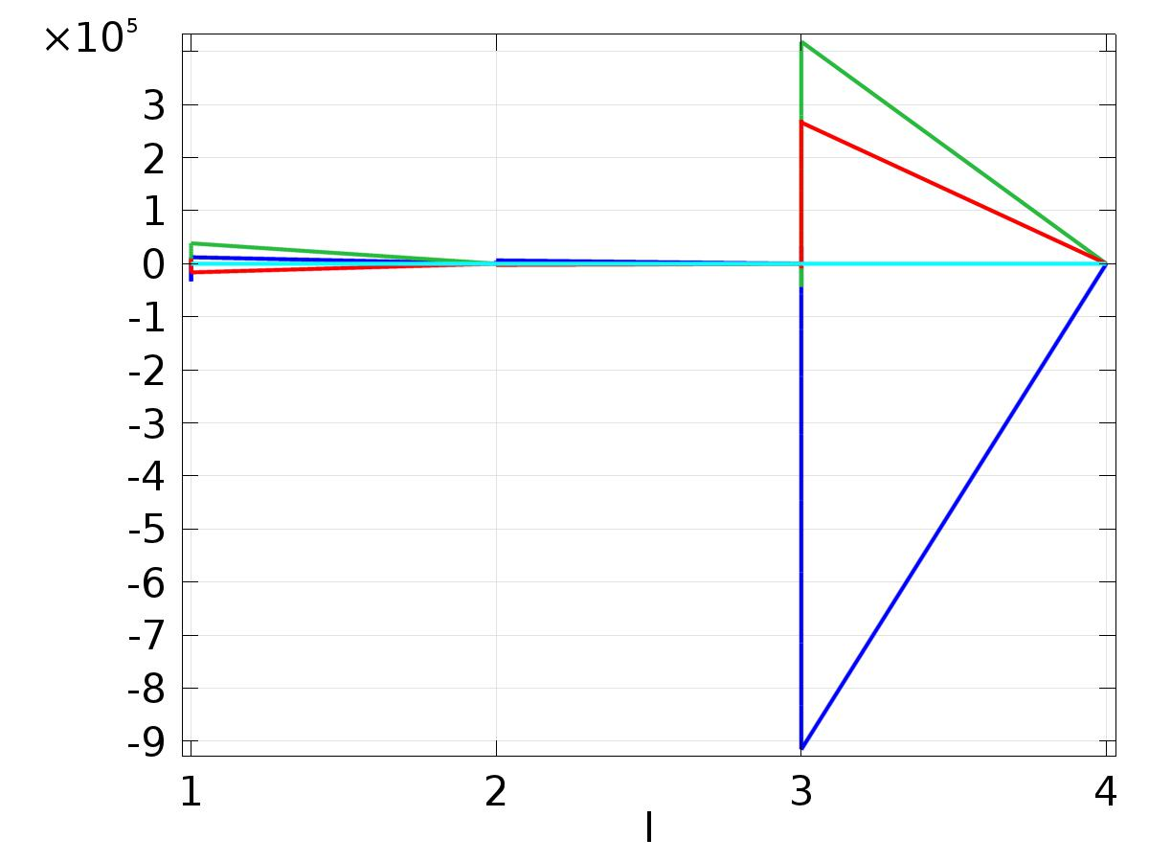

* + 1. Probe 1D Plot Group 9

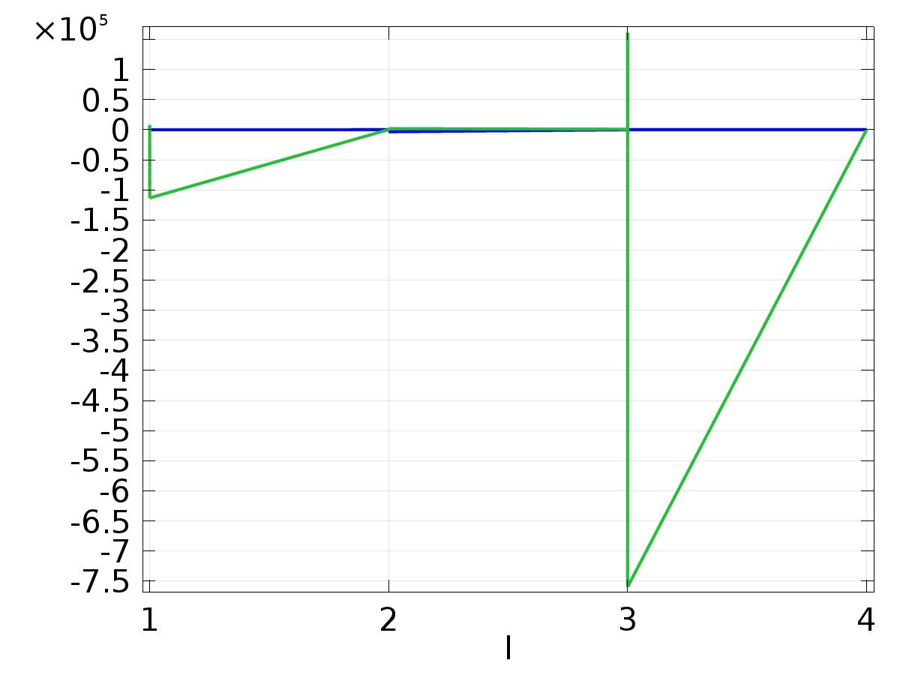

* + 1. 1D Plot Group 13

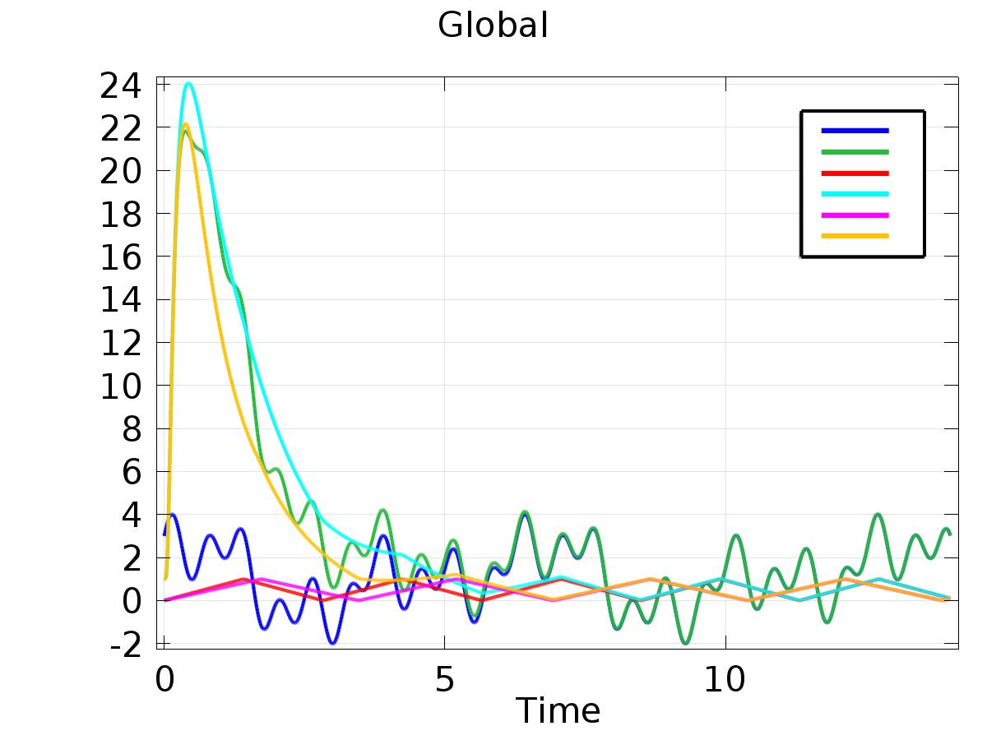

Global

* + 1. 1D Plot Group 14

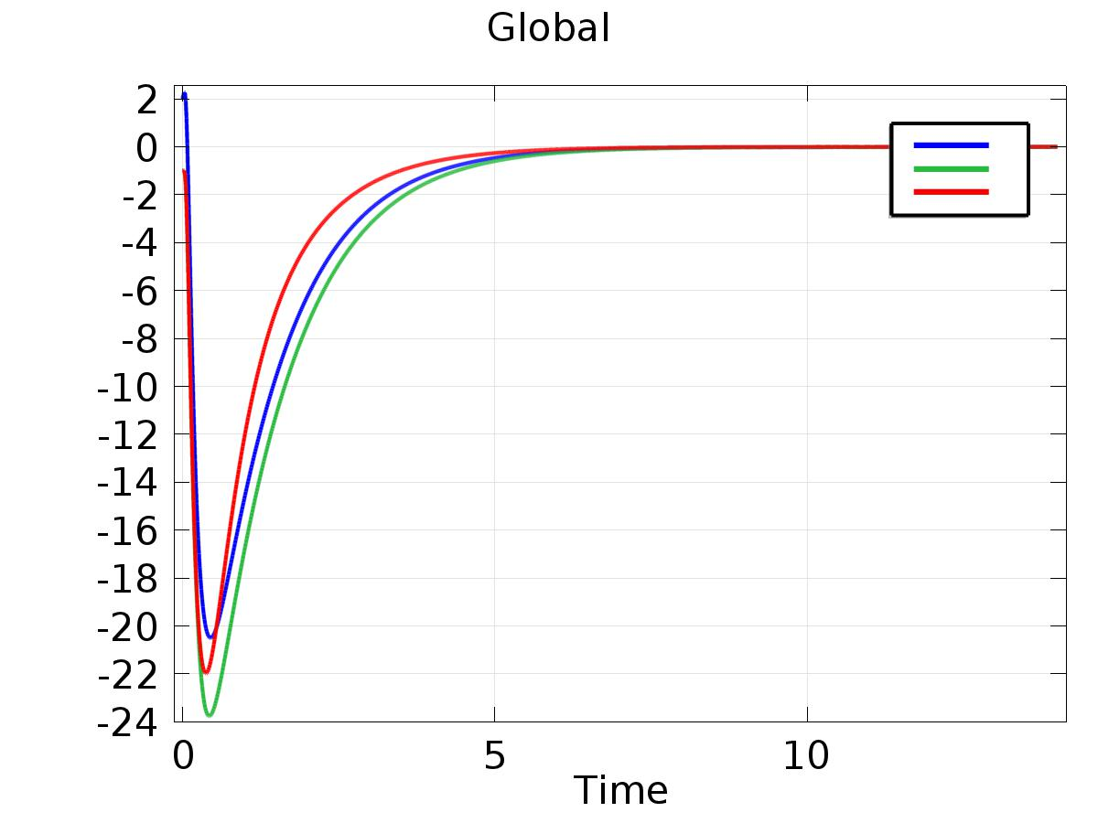

Global