[](http://www.comsol.com/)

GenSignalFourierDec shift time

|  |  |
| --- | --- |
| Date | Dec 2, 2013 10:58:16 AM |

Contents

1. Global

1.1. Definitions

2. Fourier Series Coefficient Evaluation

2.1. Definitions

2.2. Geometry 1

2.3. Mesh 1

3. Plant

3.1. Definitions

3.2. Geometry 2

3.3. Unit Input

3.4. Regulator Eqs

3.5. Closed Loop System

3.6. Mesh 2

4. Study 1

4.1. Parametric Sweep

4.2. Stationary

4.3. Solver Configurations

5. Study 2

5.1. Parametric Sweep

5.2. Stationary

5.3. Solver Configurations

6. Study 3

6.1. Time Dependent

6.2. Solver Configurations

7. Results

7.1. Data Sets

7.2. Derived Values

7.3. Tables

7.4. Plot Groups

1. Global

|  |  |
| --- | --- |
| Date | Nov 7, 2013 4:24:39 PM |

Global settings

|  |  |
| --- | --- |
| Name | GenSignalFourierDec shift time.mph |
| Path | /Users/gilliam/Desktop/collect_15/research_15/geo_reg_mono_eugenio/Mono_1_15/Comsol_EX_GitHub/Chapter3/Chap3Ex7_FourierSeries/shift_time/GenSignalFourierDec_shift_time.mph |
| Program | COMSOL 4.3b (Build: 189) |

Used products

|  |
| --- |
| COMSOL Multiphysics |

* 1. Definitions
     1. Parameters 1

Parameters

| **Name** | **Expression** | **Value** | **Description** |
| --- | --- | --- | --- |
| t0 | -1 | -1.0000 |  |
| t1 | 1 | 1.0000 |  |
| p | (t1 - t0)/2 | 1.0000 | half period |
| p2 | 2*p | 2.0000 | period |
| l | 1 | 1.0000 | Function Index |
| lmax | 4 | 4.0000 |  |
| k | 0 | 0.0000 | coefficient index |
| kmax | 20 | 20.000 |  |
| m | 1 | 1.0000 | cos or sin index |
| c | 1. | 1.0000 |  |
| n | 1 | 1.0000 |  |

* + 1. Variables

#### FourierCoefficients Ar

Selection

|  |  |
| --- | --- |
| Geometric entity level | Entire model |

| **Name** | **Expression** | **Description** |
| --- | --- | --- |
| Ar | mod1.C(Ar) |  |

* + 1. Functions

#### alpha(k)=pi*k/p

|  |  |
| --- | --- |
| Function name | alpha |
| Function type | Analytic |

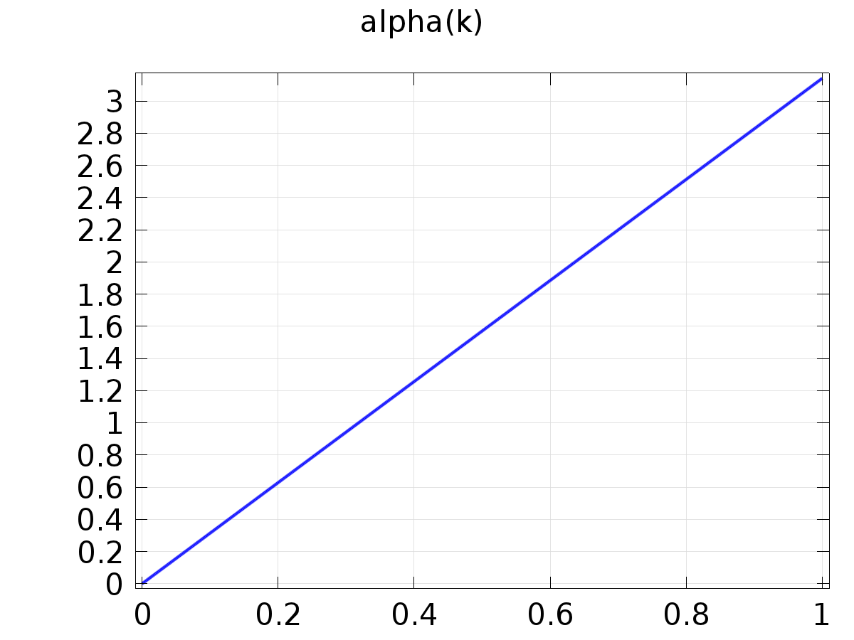

alpha(k)=pi*k/p

Definition

| **Description** | **Value** |
| --- | --- |
| Expression | pi/p*k |
| Arguments | k |

#### Cos(alpha(k)*(t-t0))

|  |  |
| --- | --- |
| Function name | FourierCos |
| Function type | Analytic |

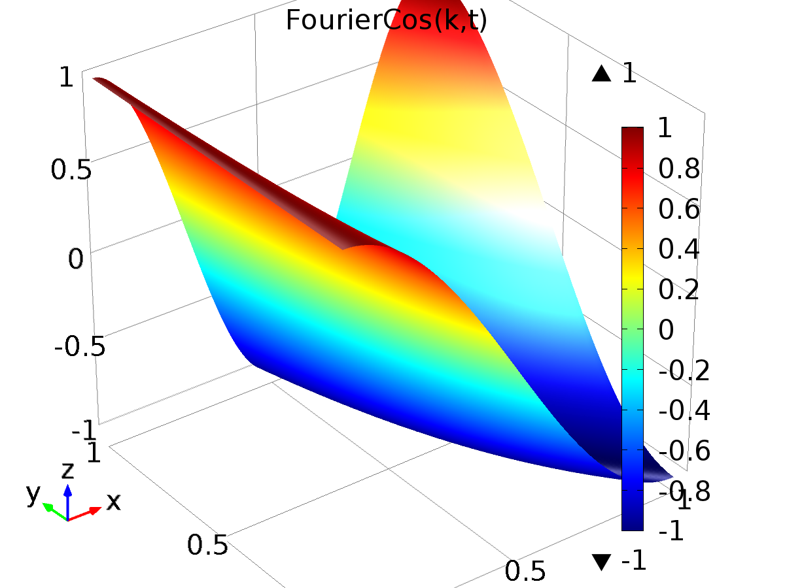

Cos(alpha(k)*(t-t0))

Definition

| **Description** | **Value** |
| --- | --- |
| Expression | cos(alpha(k)*(t - t0)) |
| Arguments | {k, t} |

#### Sin(alpha(k)*(t-t0))

|  |  |
| --- | --- |
| Function name | FourierSin |
| Function type | Analytic |

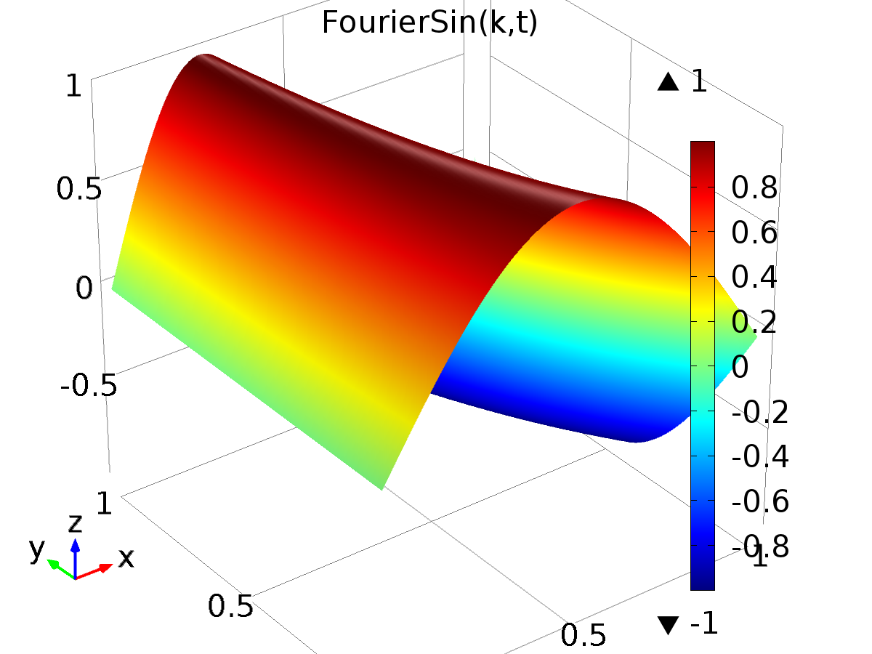

Sin(alpha(k)*(t-t0))

Definition

| **Description** | **Value** |
| --- | --- |
| Expression | sin(alpha(k)*(t - t0)) |
| Arguments | {k, t} |

#### Functions to decompose f(l,t)

|  |  |
| --- | --- |
| Function name | f |
| Function type | Analytic |

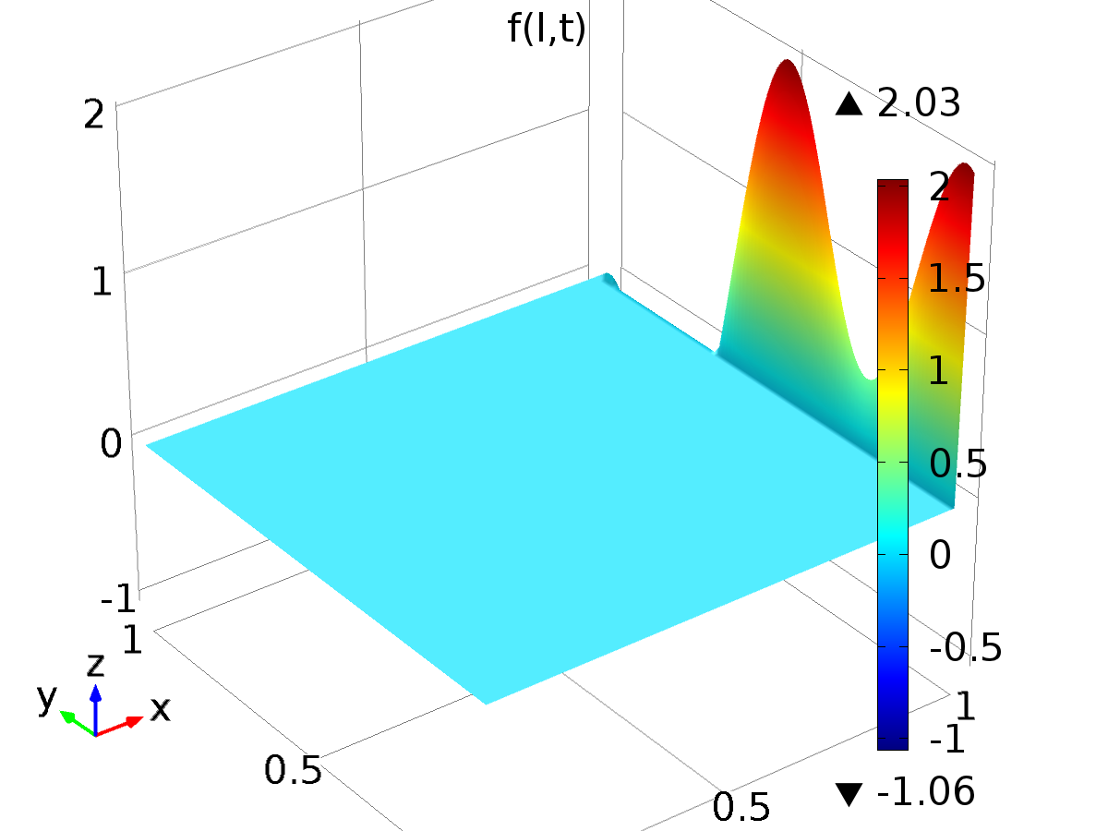

Functions to decompose f(l,t)

Definition

| **Description** | **Value** |
| --- | --- |
| Expression | (l==1)*(sin(pi/p*t) + cos(pi/p*t) + cos(pi/p*4*t)) + (l==2)*pw1(t) - (l==3)*pw2(t) + (l==4)*cos(pi/p*7*t) |
| Arguments | {l, t} |

#### Piecewise 1

|  |  |
| --- | --- |
| Function name | pw1 |
| Function type | Piecewise |

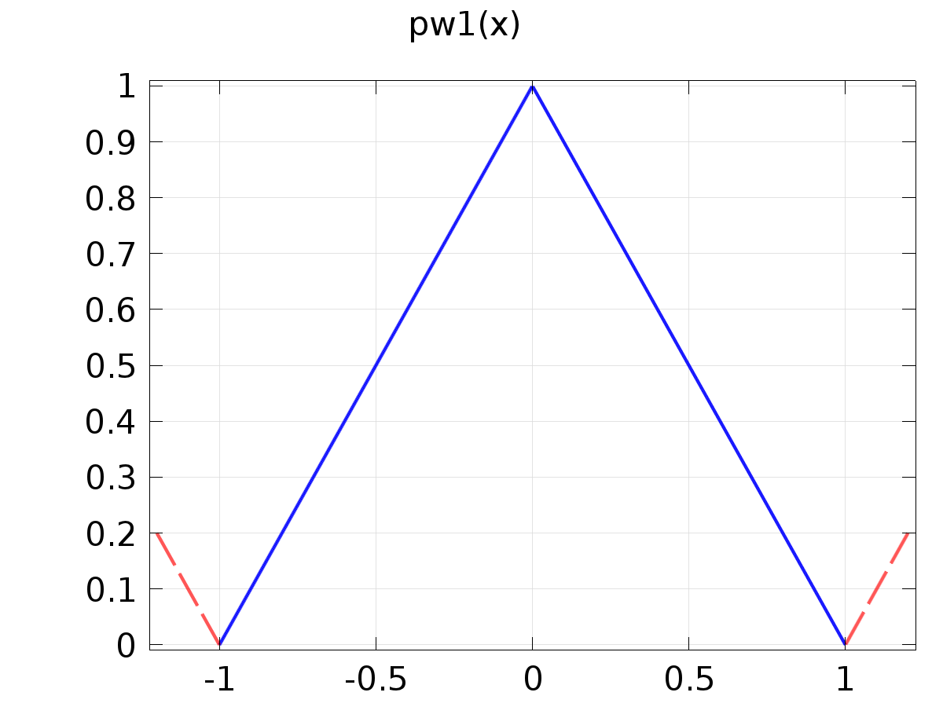

Piecewise 1

Definition

| **Description** | **Value** |
| --- | --- |
| Argument | x |
| Extrapolation | Periodic |
| Smoothing | No smoothing |

Definition

| **Start** | **End** | **Function** |
| --- | --- | --- |
| t0 | t0+p | (x-t0)/p |
| t0+p | t0+2*p | 2-(x-t0)/p |

#### Piecewise 2

|  |  |
| --- | --- |
| Function name | pw2 |
| Function type | Piecewise |

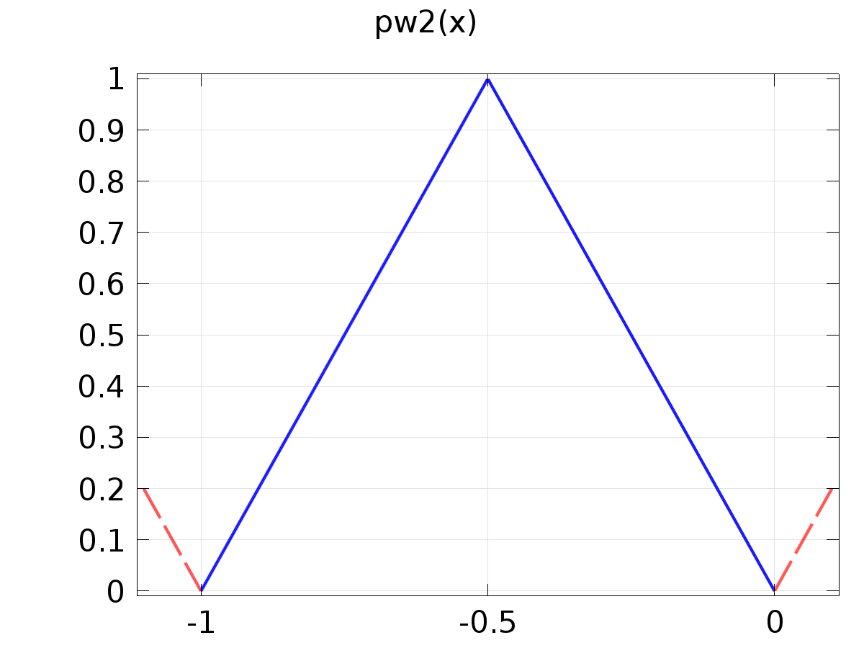

Piecewise 2

Definition

| **Description** | **Value** |
| --- | --- |
| Argument | x |
| Extrapolation | Periodic |
| Smoothing | No smoothing |

Definition

| **Start** | **End** | **Function** |
| --- | --- | --- |
| t0 | t0+p/2 | (x-t0)/(p/2) |
| t0+p/2 | t0+p | 2-(x-t0)/(p/2) |

#### Cos Output

|  |  |
| --- | --- |
| Function name | Qc |
| Function type | Analytic |

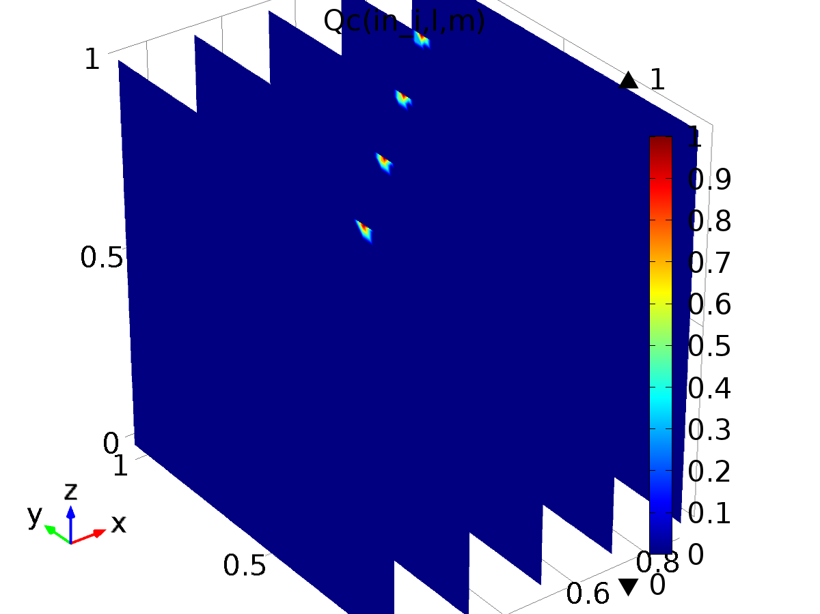

Cos Output

Definition

| **Description** | **Value** |
| --- | --- |
| Expression | (in_i==l)*(m==1) |
| Arguments | {in_i, l, m} |

#### Sin Output

|  |  |
| --- | --- |
| Function name | Qs |
| Function type | Analytic |

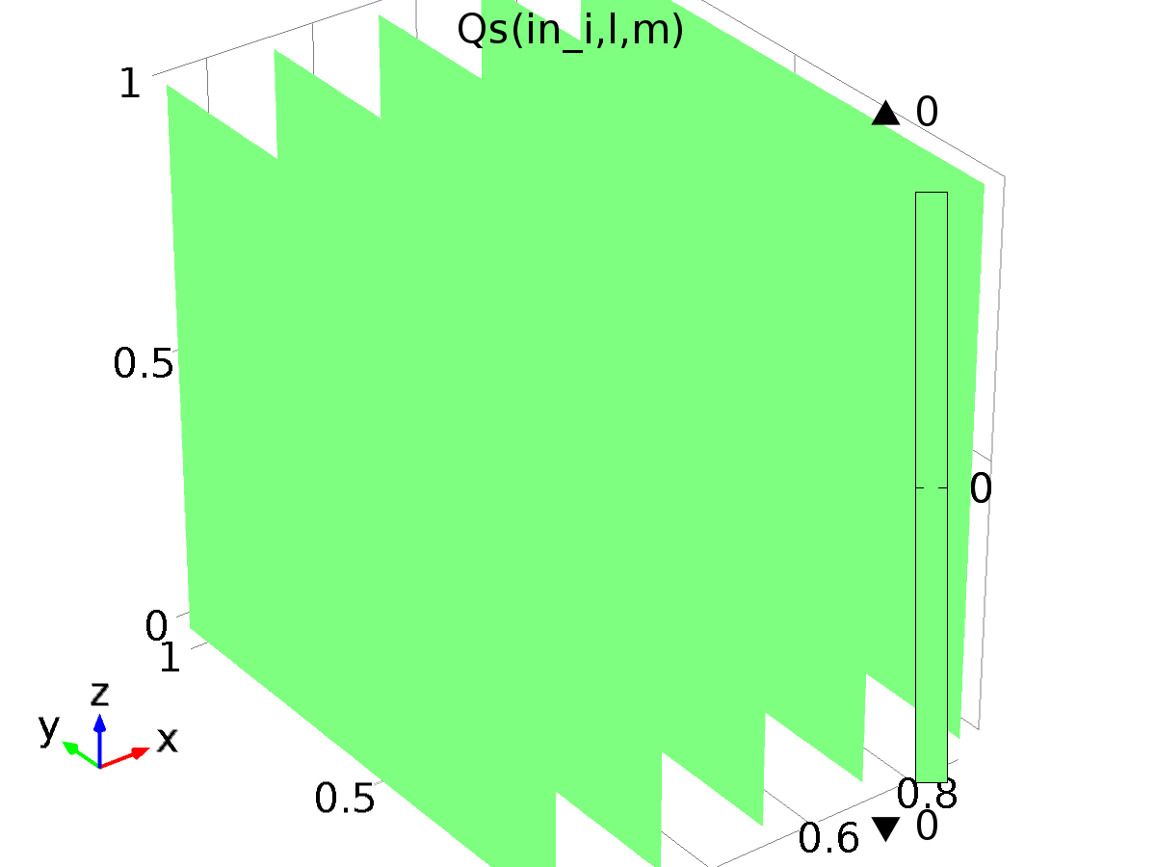

Sin Output

Definition

| **Description** | **Value** |
| --- | --- |
| Expression | (in_i==l)*(m==2) |
| Arguments | {in_i, l, m} |

#### Cos Disturbance

|  |  |
| --- | --- |
| Function name | Pc |
| Function type | Analytic |

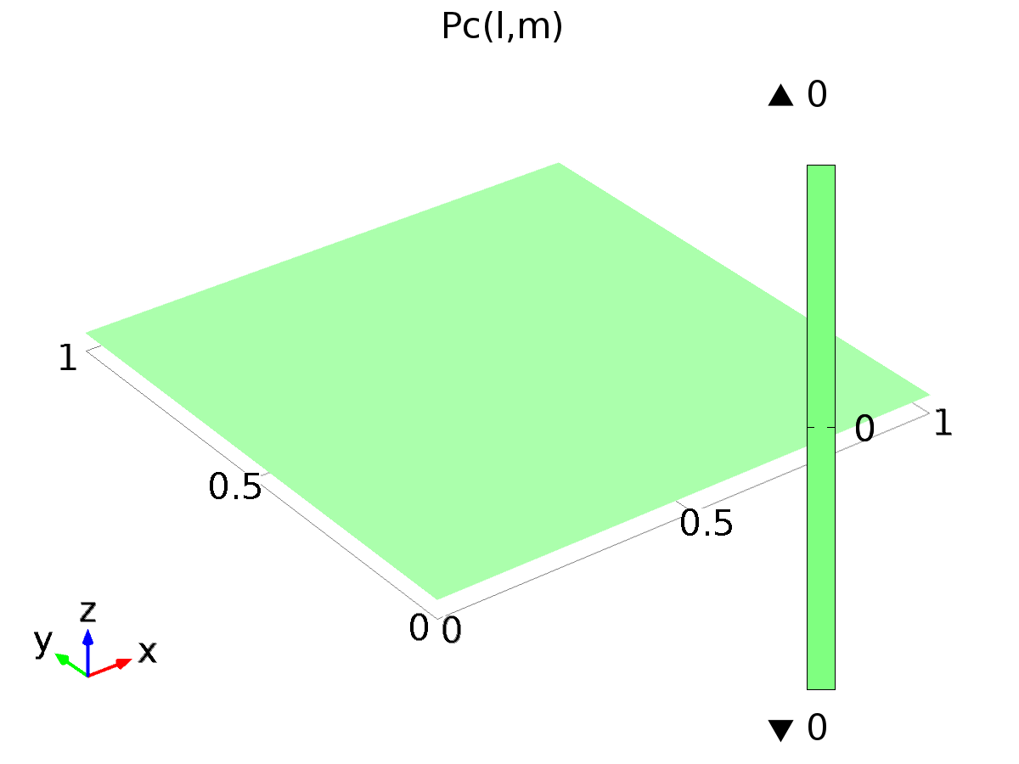

Cos Disturbance

Definition

| **Description** | **Value** |
| --- | --- |
| Expression | (l==4)*(m==1) |
| Arguments | {l, m} |

#### Sin Disturbance

|  |  |
| --- | --- |
| Function name | Ps |
| Function type | Analytic |

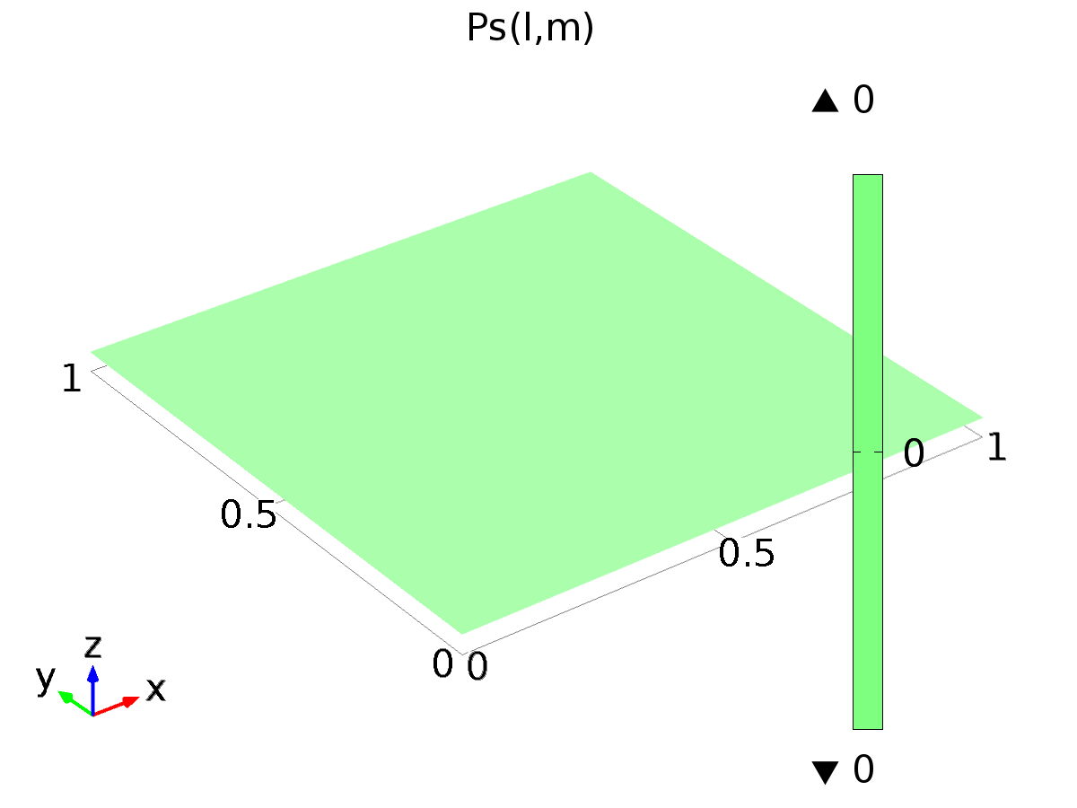

Sin Disturbance

Definition

| **Description** | **Value** |
| --- | --- |
| Expression | (l==4)*(m==2) |
| Arguments | {l, m} |

#### delta_input

|  |  |
| --- | --- |
| Function name | delta |
| Function type | Analytic |

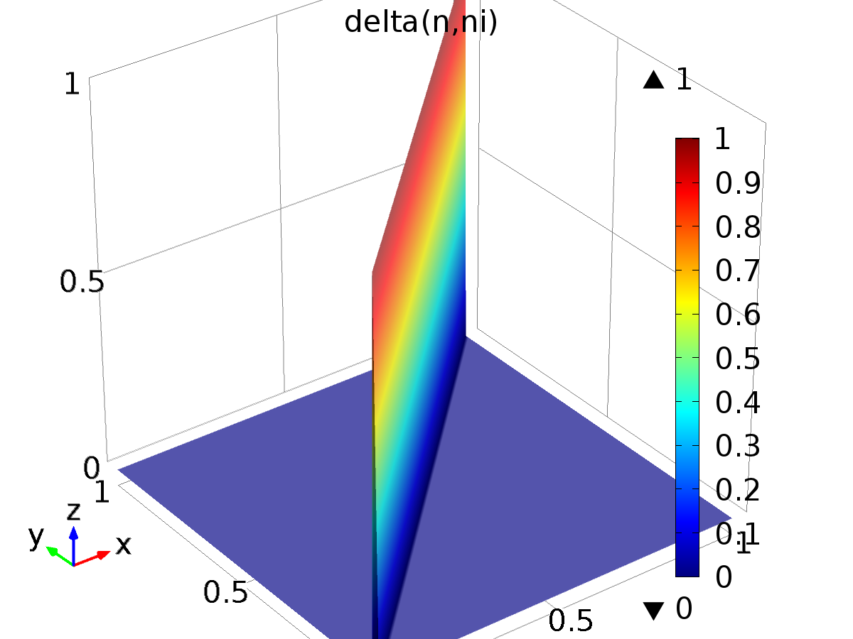

delta_input

Definition

| **Description** | **Value** |
| --- | --- |
| Expression | (ni==n) |
| Arguments | {n, ni} |

1. Fourier Series Coefficient Evaluation

Component settings

|  |  |
| --- | --- |
| Unit system | None |

* 1. Definitions
     1. Variables

#### Variables 1a

Selection

|  |  |
| --- | --- |
| Geometric entity level | Entire model |

| **Name** | **Expression** | **Description** |
| --- | --- | --- |
| ak | (0.5 + 0.5*(k>0))*int(f(l, x)*FourierCos(k, x))/p |  |
| bk | int(f(l, x)*FourierSin(k, x))/p |  |
| Ar | ak*(m==1) + bk*(m==2) |  |

* + 1. Component Couplings

#### Integration 1

|  |  |
| --- | --- |
| Coupling type | Integration |
| Operator name | int |

Source selection

|  |  |
| --- | --- |
| Geometric entity level | Domain |
| Selection | Domain 1 |

Advanced

| **Description** | **Value** |
| --- | --- |
| Integration order | 10 |

#### Integration 2

|  |  |
| --- | --- |
| Coupling type | Integration |
| Operator name | C |

Source selection

|  |  |
| --- | --- |
| Geometric entity level | Boundary |
| Selection | Boundary 2 |

* 1. Geometry 1

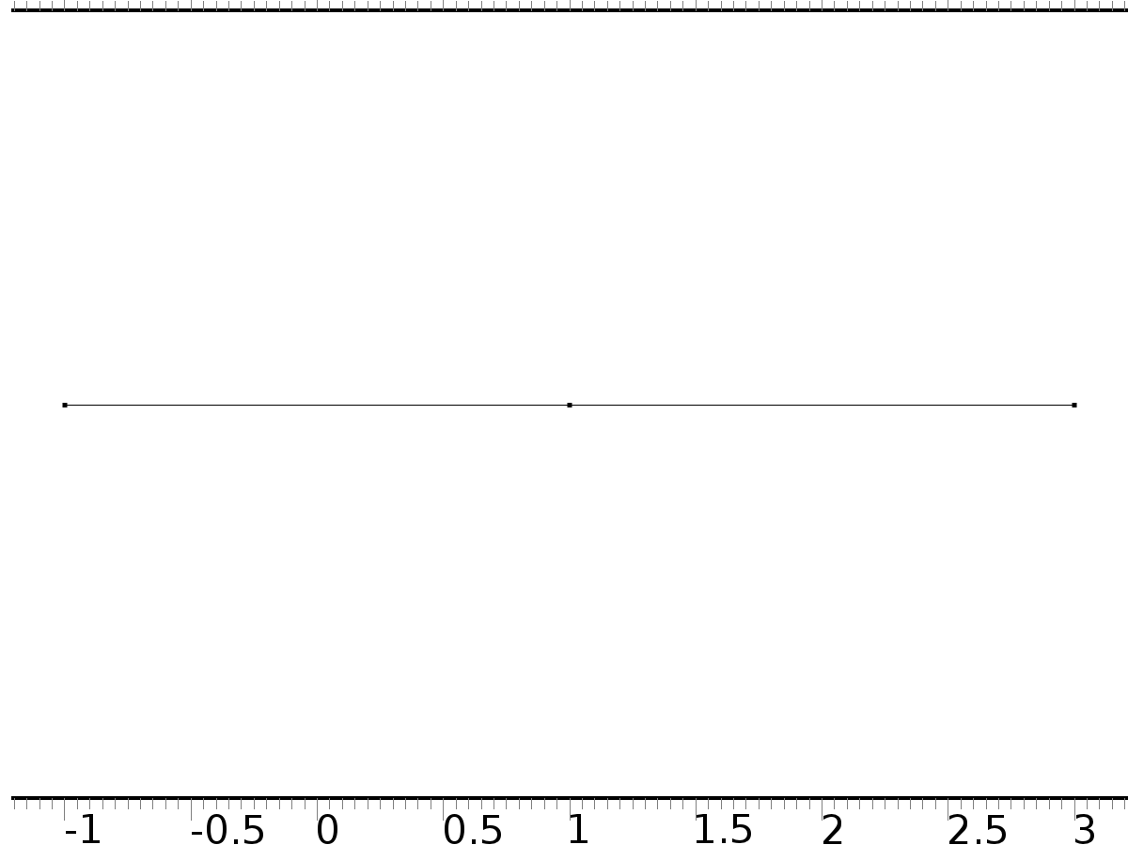

Geometry 1

Units

|  |  |
| --- | --- |
| Length unit | m |
| Angular unit | deg |

Geometry statistics

| **Description** | **Value** |
| --- | --- |
| Space dimension | 1 |
| Number of domains | 2 |
| Number of boundaries | 3 |

* + 1. Interval 1 (i1)

Interval

| **Description** | **Value** |
| --- | --- |
| Number of intervals | Many |
| Points | {-1, 1, 3} |

* 1. Mesh 1

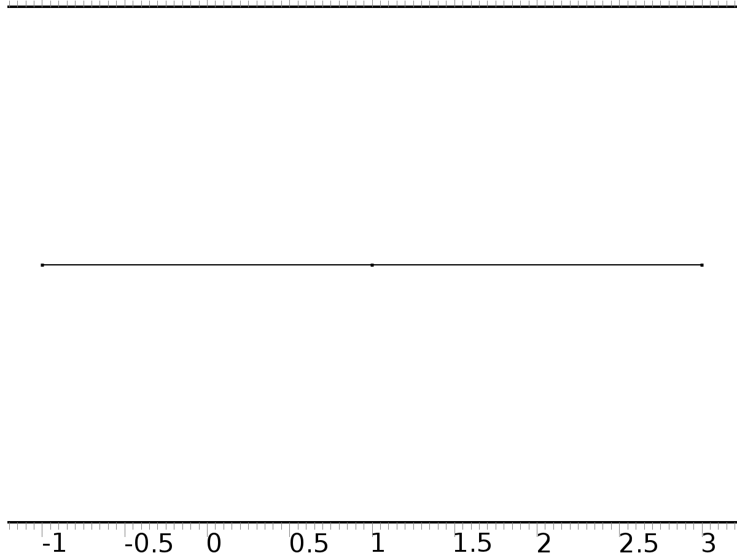

Mesh 1

* + 1. Size (size)

Settings

| **Description** | **Value** |
| --- | --- |
| Maximum element size | 0.02 |
| Minimum element size | 4.0E-5 |
| Curvature factor | 0.2 |
| Predefined size | Extremely fine |
| Custom element size | Custom |

* + 1. Edge 1 (auto_f1)

Selection

|  |  |
| --- | --- |
| Geometric entity level | Remaining |

1. Plant

Component settings

|  |  |
| --- | --- |
| Unit system | None |

* 1. Definitions
     1. Variables

#### Variables 8

Selection

|  |  |
| --- | --- |
| Geometric entity level | Entire model |

| **Name** | **Expression** | **Description** |
| --- | --- | --- |
| gammac1 | 0 + (-2.12225603430783E+01)*(Qc(1, l, m) - C1(PIt1)) + (1.08490674860336E+01)*(Qc(2, l, m) - C2(PIt1)) + (1.28187412465730E+01)*(Qc(3, l, m) - C3(PIt1)) |  |
| gammas1 | 0 + (-2.12225603430783E+01)*(Qs(1, l, m) - C1(PIt2)) + (1.08490674860336E+01)*(Qs(2, l, m) - C2(PIt2)) + (1.28187412465730E+01)*(Qs(3, l, m) - C3(PIt2)) |  |
| gammac2 | 0 + (-6.82852027162154E+02)*(Qc(1, l, m) - C1(PIt1)) + (1.78230557934565E+02)*(Qc(2, l, m) - C2(PIt1)) + (7.00068437381171E+02)*(Qc(3, l, m) - C3(PIt1)) |  |
| gammas2 | 0 + (-6.82852027162154E+02)*(Qs(1, l, m) - C1(PIt2)) + (1.78230557934565E+02)*(Qs(2, l, m) - C2(PIt2)) + (7.00068437381171E+02)*(Qs(3, l, m) - C3(PIt2)) |  |
| gammac3 | 0 + (3.14317057640532E+02)*(Qc(1, l, m) - C1(PIt1)) + (-8.31466297715868E+01)*(Qc(2, l, m) - C2(PIt1)) + (-3.14527079459246E+02)*(Qc(3, l, m) - C3(PIt1)) |  |
| gammas3 | 0 + (3.14317057640532E+02)*(Qs(1, l, m) - C1(PIt2)) + (-8.31466297715868E+01)*(Qs(2, l, m) - C2(PIt2)) + (-3.14527079459246E+02)*(Qs(3, l, m) - C3(PIt2)) |  |

#### Variables 2

Selection

|  |  |
| --- | --- |
| Geometric entity level | Entire model |

| **Name** | **Expression** | **Description** |
| --- | --- | --- |
| yr1 | f(1, t) |  |
| yr2 | f(2, t) |  |
| yr3 | f(3, t) |  |
| d | f(4, t) |  |
| e1 | yr1 - C1(z) |  |
| e2 | yr2 - C2(z) |  |
| e3 | yr3 - C3(z) |  |
| Gamma1 | 0 + (-9.84836880269699e-01)*FourierCos(0, t) + (2.36668936814558e+01)*FourierCos(1, t) + (4.78730476219788e+00)*FourierCos(2, t) + (-3.12199331728079e-01)*FourierCos(3, t) + (-1.01960651006490e+01)*FourierCos(4, t) + (-1.90187762751172e-03)*FourierCos(5, t) + (1.60158911274629e-01)*FourierCos(6, t) + (3.39242081498771e+00)*FourierCos(7, t) + (1.11684792273678e-01)*FourierCos(9, t) + (-2.21599382986135e-01)*FourierCos(10, t) + (1.24156175825918e-01)*FourierCos(11, t) + (1.28185043401861e-01)*FourierCos(13, t) + (-3.21384775227724e-01)*FourierCos(14, t) + (1.27688144871866e-01)*FourierCos(15, t) + (1.24440598591710e-01)*FourierCos(17, t) + (-3.33345850270724e-01)*FourierCos(18, t) + (1.19274923575571e-01)*FourierCos(19, t) + (1.49148562823287e+01)*FourierSin(1, t) + (-2.78926538955952e+00)*FourierSin(2, t) + (5.62338561545371e-01)*FourierSin(3, t) + (2.83058296622464e+01)*FourierSin(4, t) + (3.16778510399684e-01)*FourierSin(5, t) + (-9.15618393544930e-01)*FourierSin(6, t) + (-1.13421295657111e+00)*FourierSin(7, t) + (1.35871262490363e-01)*FourierSin(9, t) + (-5.47561848344011e-01)*FourierSin(10, t) + (8.77714588683018e-02)*FourierSin(11, t) + (5.06245992810102e-02)*FourierSin(13, t) + (-4.09685740824323e-01)*FourierSin(14, t) + (2.02271284784617e-02)*FourierSin(15, t) + (-5.51426223607200e-03)*FourierSin(17, t) + (-3.38718806593250e-01)*FourierSin(18, t) + (-2.77302727799293e-02)*FourierSin(19, t) |  |
| Gamma2 | 0 + (-2.60918939723303e+02)*FourierCos(0, t) + (8.69719364638670e+02)*FourierCos(1, t) + (1.94394971083813e+02)*FourierCos(2, t) + (-6.75998899654306e+00)*FourierCos(3, t) + (1.45111682467543e+02)*FourierCos(4, t) + (-1.62244106609067e+00)*FourierCos(5, t) + (-5.28643114561147e+01)*FourierCos(6, t) + (1.02776785248501e+02)*FourierCos(7, t) + (3.61791482492866e-01)*FourierCos(9, t) + (-6.41003524775477e+01)*FourierCos(10, t) + (6.30347280208191e-01)*FourierCos(11, t) + (7.52605846711531e-01)*FourierCos(13, t) + (-5.80120021733721e+01)*FourierCos(14, t) + (7.90920361376327e-01)*FourierCos(15, t) + (7.82151838818575e-01)*FourierCos(17, t) + (-4.53148660627646e+01)*FourierCos(18, t) + (7.53554353043220e-01)*FourierCos(19, t) + (3.37593135236954e+02)*FourierSin(1, t) + (-2.53990091660815e+02)*FourierSin(2, t) + (6.37065582661353e+00)*FourierSin(3, t) + (1.01263439656479e+03)*FourierSin(4, t) + (3.83373981356797e+00)*FourierSin(5, t) + (-5.09633707685592e+01)*FourierSin(6, t) + (-3.35321309745844e+02)*FourierSin(7, t) + (2.17767974866056e+00)*FourierSin(9, t) + (8.51566138850990e+00)*FourierSin(10, t) + (1.82314570253791e+00)*FourierSin(11, t) + (1.58609487642724e+00)*FourierSin(13, t) + (4.41574007594449e+01)*FourierSin(14, t) + (1.40727931328249e+00)*FourierSin(15, t) + (1.25178442292087e+00)*FourierSin(17, t) + (6.65995550817569e+01)*FourierSin(18, t) + (1.10374894369984e+00)*FourierSin(19, t) |  |
| Gamma3 | 0 + (1.15690224843830e+02)*FourierCos(0, t) + (-4.16821328383182e+02)*FourierCos(1, t) + (-7.25486653846163e+01)*FourierCos(2, t) + (2.78495534913829e+00)*FourierCos(3, t) + (-1.94848647336575e+02)*FourierCos(4, t) + (3.84756816620221e-01)*FourierCos(5, t) + (3.67021902033684e+01)*FourierCos(6, t) + (-5.61620845581760e+00)*FourierCos(7, t) + (-5.51309306204343e-01)*FourierCos(9, t) + (3.83837001389187e+01)*FourierCos(10, t) + (-6.80100968059141e-01)*FourierCos(11, t) + (-7.35627235682883e-01)*FourierCos(13, t) + (3.14278754051413e+01)*FourierCos(14, t) + (-7.44445163981638e-01)*FourierCos(15, t) + (-7.23765291608696e-01)*FourierCos(17, t) + (2.09924358609376e+01)*FourierCos(18, t) + (-6.89141314455642e-01)*FourierCos(19, t) + (-1.24417359459781e+02)*FourierSin(1, t) + (1.32026756264229e+02)*FourierSin(2, t) + (-3.81117674993349e+00)*FourierSin(3, t) + (-5.09666097199607e+02)*FourierSin(4, t) + (-2.28009028907001e+00)*FourierSin(5, t) + (2.01344869087331e+01)*FourierSin(6, t) + (2.08237255814990e+02)*FourierSin(7, t) + (-1.27561567591110e+00)*FourierSin(9, t) + (-1.57179197624535e+01)*FourierSin(10, t) + (-1.06319509864119e+00)*FourierSin(11, t) + (-9.25837235517292e-01)*FourierSin(13, t) + (-3.85304728136221e+01)*FourierSin(14, t) + (-8.26631662115626e-01)*FourierSin(15, t) + (-7.41655088553933e-01)*FourierSin(17, t) + (-5.30587731646654e+01)*FourierSin(18, t) + (-6.58440307288104e-01)*FourierSin(19, t) |  |

* + 1. Probes

#### C1(Xj)

|  |  |
| --- | --- |
| Probe type | Global variable probe |

#### C2(Xj)

|  |  |
| --- | --- |
| Probe type | Global variable probe |

#### C3(Xj)

|  |  |
| --- | --- |
| Probe type | Global variable probe |

#### gammac1*Ar

|  |  |
| --- | --- |
| Probe type | Global variable probe |

#### gammas1*Ar

|  |  |
| --- | --- |
| Probe type | Global variable probe |

#### gammac2*Ar

|  |  |
| --- | --- |
| Probe type | Global variable probe |

#### gammas2*Ar

|  |  |
| --- | --- |
| Probe type | Global variable probe |

#### gammac3*Ar

|  |  |
| --- | --- |
| Probe type | Global variable probe |

#### gammas3*Ar

|  |  |
| --- | --- |
| Probe type | Global variable probe |

* + 1. Component Couplings

#### Average 1

|  |  |
| --- | --- |
| Coupling type | Average |
| Operator name | C1 |

Source selection

|  |  |
| --- | --- |
| Geometric entity level | Boundary |
| Selection | Boundary 5 |

#### Average 2

|  |  |
| --- | --- |
| Coupling type | Average |
| Operator name | C2 |

Source selection

|  |  |
| --- | --- |
| Geometric entity level | Boundary |
| Selection | Boundary 4 |

#### Average 3

|  |  |
| --- | --- |
| Coupling type | Average |
| Operator name | C3 |

Source selection

|  |  |
| --- | --- |
| Geometric entity level | Boundary |
| Selection | Boundary 6 |

* + 1. Coordinate Systems

#### Boundary System 1

|  |  |
| --- | --- |
| Coordinate system type | Boundary system |
| Tag | sys1 |

Coordinate names

| **First (t1)** | **Second (n)** | **Third (to)** |
| --- | --- | --- |
| t1 | n | to |

Settings

| **Description** | **Value** |
| --- | --- |
| Create first tangent direction from | Global Cartesian |

* 1. Geometry 2

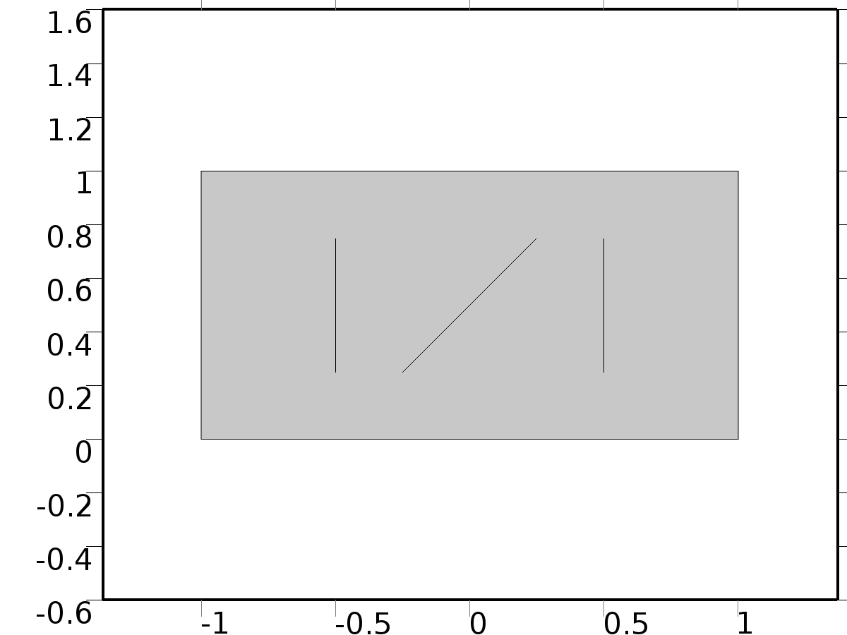

Geometry 2

Units

|  |  |
| --- | --- |
| Length unit | m |
| Angular unit | deg |

Geometry statistics

| **Description** | **Value** |
| --- | --- |
| Space dimension | 2 |
| Number of domains | 1 |
| Number of boundaries | 7 |
| Number of vertices | 10 |

* + 1. Rectangle 1 (r1)

Position

| **Description** | **Value** |
| --- | --- |
| Position | {-1, 0} |
| Layers |  |

Size

| **Description** | **Value** |
| --- | --- |
| Width | 2 |
| Height | 1 |

* + 1. Polygon 1 (pol1)

Object type

| **Description** | **Value** |
| --- | --- |
| Type | Open curve |

Coordinates

| **Description** | **Value** |
| --- | --- |
| x | {-0.25, 0.25} |
| y | {0.25, 0.75} |

* + 1. Polygon 2 (pol2)

Object type

| **Description** | **Value** |
| --- | --- |
| Type | Open curve |

Coordinates

| **Description** | **Value** |
| --- | --- |
| x | {0.5, 0.5} |
| y | {0.25, 0.75} |

* + 1. Polygon 3 (pol3)

Object type

| **Description** | **Value** |
| --- | --- |
| Type | Open curve |

Coordinates

| **Description** | **Value** |
| --- | --- |
| x | {-0.5, -0.5} |
| y | {0.25, 0.75} |

* 1. Unit Input

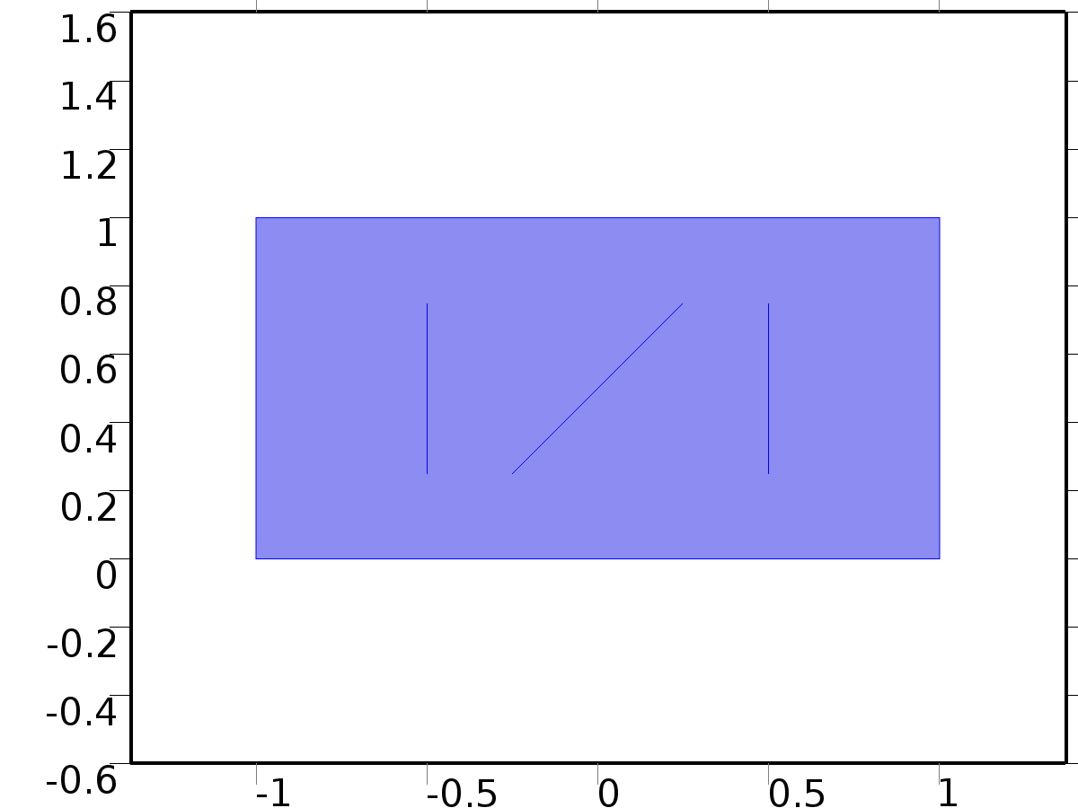

Unit Input

Selection

|  |  |
| --- | --- |
| Geometric entity level | Domain |
| Selection | Domain 1 |

Settings

| **Description** | **Value** |
| --- | --- |
| Shape function type | Lagrange |
| Element order | Quadratic |
| Compute boundary fluxes | On |
| Apply smoothing to boundary fluxes | On |
| Value type when using splitting of complex variables | Complex |
| Dependent variable quantity | Dimensionless (1) |
| Source term quantity | None |
| Unit | m^ - 2 |

Used products

|  |
| --- |
| COMSOL Multiphysics |

Variables

| **Name** | **Expression** | **Unit** | **Description** | **Selection** |
| --- | --- | --- | --- | --- |
| X.nx | nx |  | Normal vector, x component | Boundaries 1–7 |
| X.ny | ny |  | Normal vector, y component | Boundaries 1–7 |
| X.nz | root.nz |  | Normal vector, z component | Boundaries 1–7 |
| X.nxmesh | root.nxmesh |  | Normal vector (mesh), x component | Boundaries 1–7 |
| X.nymesh | root.nymesh |  | Normal vector (mesh), y component | Boundaries 1–7 |
| X.nzmesh | root.nzmesh |  | Normal vector (mesh), z component | Boundaries 1–7 |

* + 1. Coefficient Form PDE 1



Coefficient Form PDE 1

Selection

|  |  |
| --- | --- |
| Geometric entity level | Domain |
| Selection | Domain 1 |

Equations





Settings

| **Description** | **Value** |
| --- | --- |
| Diffusion coefficient | {{c, 0}, {0, c}} |
| Absorption coefficient | 0 |
| Source term | 0 |
| Mass coefficient | 0 |
| Damping or mass coefficient | 0 |
| Conservative flux convection coefficient | {0, 0} |
| Convection coefficient | {0, 0} |
| Conservative flux source | {0, 0} |

#### Variables

| **Name** | **Expression** | **Unit** | **Description** | **Selection** |
| --- | --- | --- | --- | --- |
| domflux.Xx | -c*d(X,x) |  | Domain flux, x component | Domain 1 |
| domflux.Xy | -c*d(X,y) |  | Domain flux, y component | Domain 1 |

#### Shape functions

| **Name** | **Shape function** | **Unit** | **Description** | **Shape frame** | **Selection** |
| --- | --- | --- | --- | --- | --- |
| X | Lagrange (Quadratic) |  | Dependent variable X | Material | Domain 1 |

* + 1. Zero Flux 1



Zero Flux 1

Selection

|  |  |
| --- | --- |
| Geometric entity level | Boundary |
| Selection | No boundaries |

Equations





* + 1. Initial Values 1



Initial Values 1

Selection

|  |  |
| --- | --- |
| Geometric entity level | Domain |
| Selection | Domain 1 |

Settings

| **Description** | **Value** |
| --- | --- |
| Initial value for X | 0 |
| Initial time derivative of X | 0 |

* + 1. Bin1*delta(n,1)

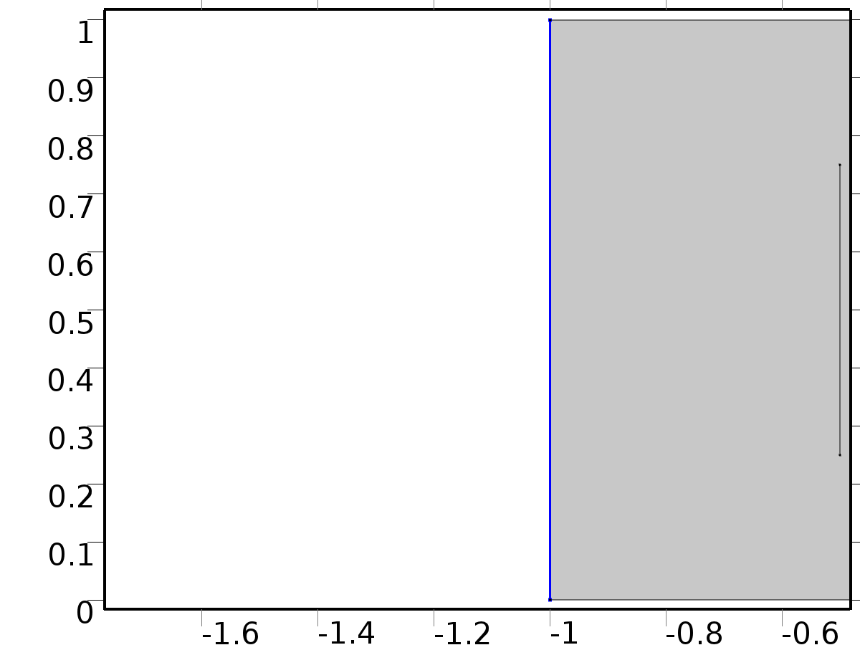

Bin1*delta(n,1)

Selection

|  |  |
| --- | --- |
| Geometric entity level | Boundary |
| Selection | Boundary 1 |

Equations





Settings

| **Description** | **Value** |
| --- | --- |
| Boundary flux/source | delta(n, 1) |
| Boundary absorption/impedance term | 0 |

#### Variables

| **Name** | **Expression** | **Unit** | **Description** | **Selection** |
| --- | --- | --- | --- | --- |
| X.g_X | delta(n,1) |  | Boundary flux/source | Boundary 1 |

* + 1. Bin2*delta(n,2)

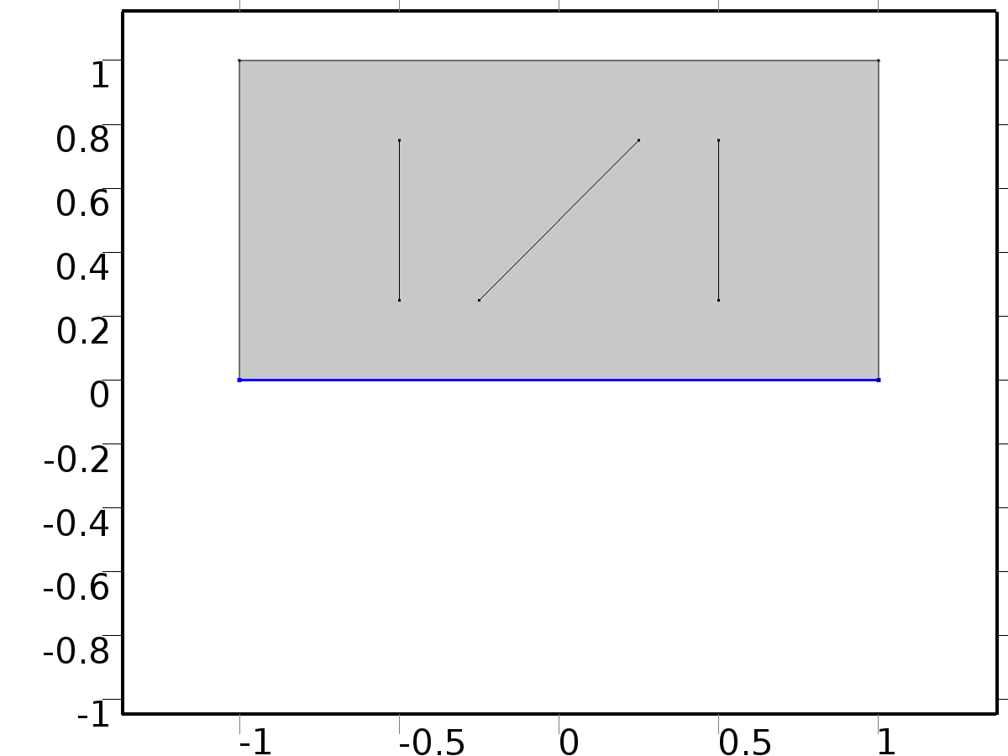

Bin2*delta(n,2)

Selection

|  |  |
| --- | --- |
| Geometric entity level | Boundary |
| Selection | Boundary 2 |

Equations





Settings

| **Description** | **Value** |
| --- | --- |
| Boundary flux/source | delta(n, 2) |
| Boundary absorption/impedance term | 5 |

#### Variables

| **Name** | **Expression** | **Unit** | **Description** | **Selection** |
| --- | --- | --- | --- | --- |
| X.g_X | delta(n,2)-5*X |  | Boundary flux/source | Boundary 2 |

* + 1. Bin3*delta(n,3)

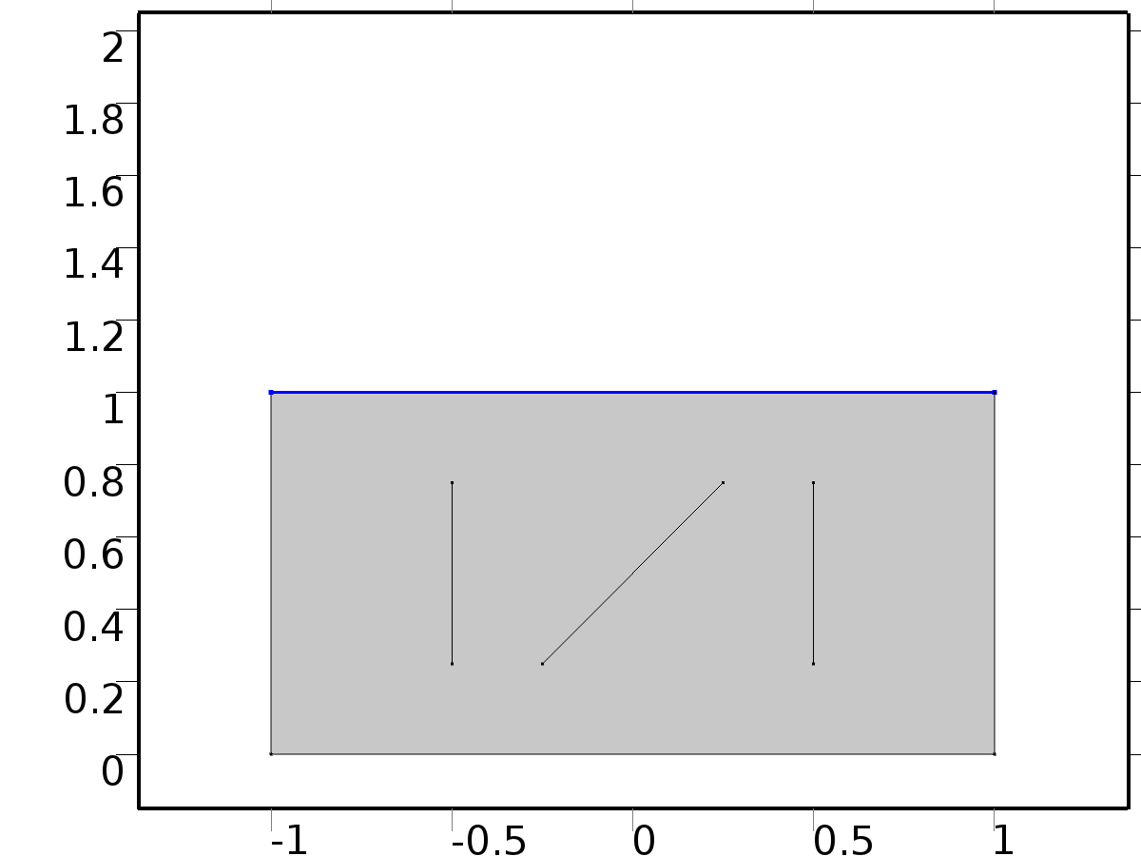

Bin3*delta(n,3)

Selection

|  |  |
| --- | --- |
| Geometric entity level | Boundary |
| Selection | Boundary 3 |

Equations





Settings

| **Description** | **Value** |
| --- | --- |
| Boundary flux/source | delta(n, 3) |
| Boundary absorption/impedance term | 1 |

#### Variables

| **Name** | **Expression** | **Unit** | **Description** | **Selection** |
| --- | --- | --- | --- | --- |
| X.g_X | delta(n,3)-X |  | Boundary flux/source | Boundary 3 |

* + 1. Bd*0

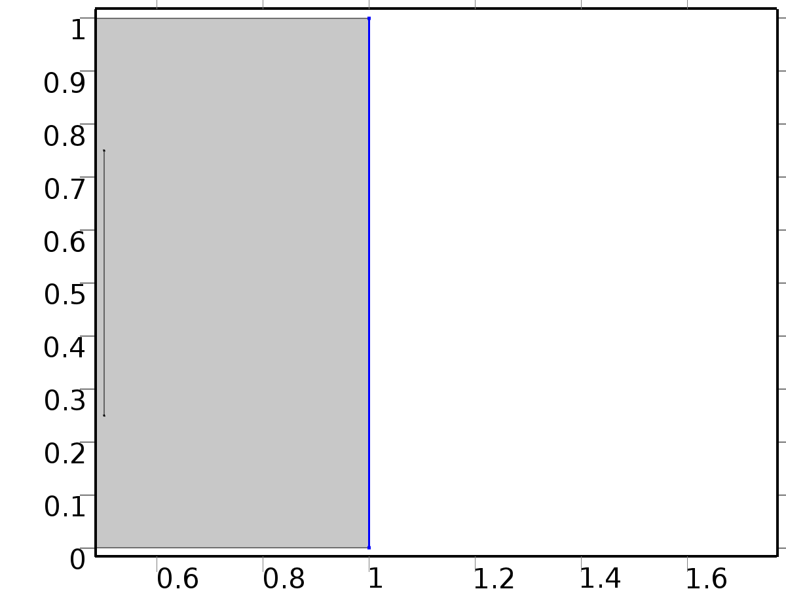

Bd*0

Selection

|  |  |
| --- | --- |
| Geometric entity level | Boundary |
| Selection | Boundary 7 |

Equations





Settings

| **Description** | **Value** |
| --- | --- |
| Value on boundary | 0 |
| Prescribed value of X | On |
| Apply reaction terms on | Individual dependent variables |
| Use weak constraints | Off |
| Constraint method | Elemental |

#### Shape functions

| **Constraint** | **Constraint force** | **Shape function** | **Selection** |
| --- | --- | --- | --- |
| -X | -test(X) | Lagrange (Quadratic) | Boundary 7 |

* 1. Regulator Eqs



Regulator Eqs

Selection

|  |  |
| --- | --- |
| Geometric entity level | Domain |
| Selection | Domain 1 |

Settings

| **Description** | **Value** |
| --- | --- |
| Shape function type | Lagrange |
| Element order | Quadratic |
| Compute boundary fluxes | On |
| Apply smoothing to boundary fluxes | On |
| Value type when using splitting of complex variables | Complex |
| Dependent variable quantity | Dimensionless (1) |
| Source term quantity | None |
| Unit | m^ - 2 |

Used products

|  |
| --- |
| COMSOL Multiphysics |

Variables

| **Name** | **Expression** | **Unit** | **Description** | **Selection** |
| --- | --- | --- | --- | --- |
| PI.nx | nx |  | Normal vector, x component | Boundaries 1–7 |
| PI.ny | ny |  | Normal vector, y component | Boundaries 1–7 |
| PI.nz | root.nz |  | Normal vector, z component | Boundaries 1–7 |
| PI.nxmesh | root.nxmesh |  | Normal vector (mesh), x component | Boundaries 1–7 |
| PI.nymesh | root.nymesh |  | Normal vector (mesh), y component | Boundaries 1–7 |
| PI.nzmesh | root.nzmesh |  | Normal vector (mesh), z component | Boundaries 1–7 |

* + 1. Coefficient Form PDE 1



Coefficient Form PDE 1

Selection

|  |  |
| --- | --- |
| Geometric entity level | Domain |
| Selection | Domain 1 |

Equations







Settings

| **Description** | **Value** |
| --- | --- |
| Diffusion coefficient | {{{{c, 0}, {0, c}}, {{0, 0}, {0, 0}}, {{0, 0}, {0, 0}}, {{0, 0}, {0, 0}}}, {{{0, 0}, {0, 0}}, {{c, 0}, {0, c}}, {{0, 0}, {0, 0}}, {{0, 0}, {0, 0}}}, {{{0, 0}, {0, 0}}, {{0, 0}, {0, 0}}, {{c, 0}, {0, c}}, {{0, 0}, {0, 0}}}, {{{0, 0}, {0, 0}}, {{0, 0}, {0, 0}}, {{0, 0}, {0, 0}}, {{c, 0}, {0, c}}}} |
| Absorption coefficient | {{0, 0, -alpha(k), -alpha(k)}, {0, 0, 0, 0}, {alpha(k), alpha(k), 0, 0}, {0, 0, 0, 0}} |
| Source term | {0, 0, 0, 0} |
| Mass coefficient | {{0, 0, 0, 0}, {0, 0, 0, 0}, {0, 0, 0, 0}, {0, 0, 0, 0}} |
| Damping or mass coefficient | {{0, 0, 0, 0}, {0, 0, 0, 0}, {0, 0, 0, 0}, {0, 0, 0, 0}} |
| Conservative flux convection coefficient | {{{0, 0}, {0, 0}, {0, 0}, {0, 0}}, {{0, 0}, {0, 0}, {0, 0}, {0, 0}}, {{0, 0}, {0, 0}, {0, 0}, {0, 0}}, {{0, 0}, {0, 0}, {0, 0}, {0, 0}}} |
| Convection coefficient | {{{0, 0}, {0, 0}, {0, 0}, {0, 0}}, {{0, 0}, {0, 0}, {0, 0}, {0, 0}}, {{0, 0}, {0, 0}, {0, 0}, {0, 0}}, {{0, 0}, {0, 0}, {0, 0}, {0, 0}}} |
| Conservative flux source | {{0, 0}, {0, 0}, {0, 0}, {0, 0}} |

#### Variables

| **Name** | **Expression** | **Unit** | **Description** | **Selection** |
| --- | --- | --- | --- | --- |
| domflux.PI1x | -c*d(PI1,x) |  | Domain flux, x component | Domain 1 |
| domflux.PI1y | -c*d(PI1,y) |  | Domain flux, y component | Domain 1 |
| domflux.PIt1x | -c*d(PIt1,x) |  | Domain flux, x component | Domain 1 |
| domflux.PIt1y | -c*d(PIt1,y) |  | Domain flux, y component | Domain 1 |
| domflux.PI2x | -c*d(PI2,x) |  | Domain flux, x component | Domain 1 |
| domflux.PI2y | -c*d(PI2,y) |  | Domain flux, y component | Domain 1 |
| domflux.PIt2x | -c*d(PIt2,x) |  | Domain flux, x component | Domain 1 |
| domflux.PIt2y | -c*d(PIt2,y) |  | Domain flux, y component | Domain 1 |

#### Shape functions

| **Name** | **Shape function** | **Unit** | **Description** | **Shape frame** | **Selection** |
| --- | --- | --- | --- | --- | --- |
| PI1 | Lagrange (Quadratic) |  | Dependent variable PI1 | Material | Domain 1 |
| PIt1 | Lagrange (Quadratic) |  | Dependent variable PIt1 | Material | Domain 1 |
| PI2 | Lagrange (Quadratic) |  | Dependent variable PI2 | Material | Domain 1 |
| PIt2 | Lagrange (Quadratic) |  | Dependent variable PIt2 | Material | Domain 1 |

* + 1. Zero Flux 1



Zero Flux 1

Selection

|  |  |
| --- | --- |
| Geometric entity level | Boundary |
| Selection | No boundaries |

Equations







* + 1. Initial Values 1



Initial Values 1

Selection

|  |  |
| --- | --- |
| Geometric entity level | Domain |
| Selection | Domain 1 |

Settings

| **Description** | **Value** |
| --- | --- |
| Initial value for PI1 | 0 |
| Initial value for PIt1 | 0 |
| Initial value for PI2 | 0 |
| Initial value for PIt2 | 0 |
| Initial time derivative of PI1 | 0 |
| Initial time derivative of PIt1 | 0 |
| Initial time derivative of PI2 | 0 |
| Initial time derivative of PIt2 | 0 |

* + 1. Bin1*gamma1



Bin1*gamma1

Selection

|  |  |
| --- | --- |
| Geometric entity level | Boundary |
| Selection | Boundary 1 |

Equations







Settings

| **Description** | **Value** |
| --- | --- |
| Boundary flux/source | {gammac1, 0, gammas1, 0} |
| Boundary absorption/impedance term | {{0, 0, 0, 0}, {0, 0, 0, 0}, {0, 0, 0, 0}, {0, 0, 0, 0}} |

#### Variables

| **Name** | **Expression** | **Unit** | **Description** | **Selection** |
| --- | --- | --- | --- | --- |
| PI.g_PI1 | gammac1 |  | Boundary flux/source | Boundary 1 |
| PI.g_PIt1 | 0 |  | Boundary flux/source | Boundary 1 |
| PI.g_PI2 | gammas1 |  | Boundary flux/source | Boundary 1 |
| PI.g_PIt2 | 0 |  | Boundary flux/source | Boundary 1 |

* + 1. Bin2*gamma2



Bin2*gamma2

Selection

|  |  |
| --- | --- |
| Geometric entity level | Boundary |
| Selection | Boundary 2 |

Equations







Settings

| **Description** | **Value** |
| --- | --- |
| Boundary flux/source | {gammac2, 0, gammas2, 0} |
| Boundary absorption/impedance term | {{5, 0, 0, 0}, {0, 5, 0, 0}, {0, 0, 5, 0}, {0, 0, 0, 5}} |

#### Variables

| **Name** | **Expression** | **Unit** | **Description** | **Selection** |
| --- | --- | --- | --- | --- |
| PI.g_PI1 | gammac2-5*PI1 |  | Boundary flux/source | Boundary 2 |
| PI.g_PIt1 | -5*PIt1 |  | Boundary flux/source | Boundary 2 |
| PI.g_PI2 | gammas2-5*PI2 |  | Boundary flux/source | Boundary 2 |
| PI.g_PIt2 | -5*PIt2 |  | Boundary flux/source | Boundary 2 |

* + 1. Bin3*gamma3



Bin3*gamma3

Selection

|  |  |
| --- | --- |
| Geometric entity level | Boundary |
| Selection | Boundary 3 |

Equations







Settings

| **Description** | **Value** |
| --- | --- |
| Boundary flux/source | {gammac3, 0, gammas3, 0} |
| Boundary absorption/impedance term | {{1, 0, 0, 0}, {0, 1, 0, 0}, {0, 0, 1, 0}, {0, 0, 0, 1}} |

#### Variables

| **Name** | **Expression** | **Unit** | **Description** | **Selection** |
| --- | --- | --- | --- | --- |
| PI.g_PI1 | gammac3-PI1 |  | Boundary flux/source | Boundary 3 |
| PI.g_PIt1 | -PIt1 |  | Boundary flux/source | Boundary 3 |
| PI.g_PI2 | gammas3-PI2 |  | Boundary flux/source | Boundary 3 |
| PI.g_PIt2 | -PIt2 |  | Boundary flux/source | Boundary 3 |

* + 1. Bd*P



Bd*P

Selection

|  |  |
| --- | --- |
| Geometric entity level | Boundary |
| Selection | Boundary 7 |

Equations









Settings

| **Description** | **Value** |
| --- | --- |
| Value on boundary | {Pc(l, m), Pc(l, m), Ps(l, m), Ps(l, m)} |
| Prescribed value of PI1 | On |
| Prescribed value of PIt1 | On |
| Prescribed value of PI2 | On |
| Prescribed value of PIt2 | On |
| Apply reaction terms on | Individual dependent variables |
| Use weak constraints | Off |
| Constraint method | Elemental |

#### Shape functions

| **Constraint** | **Constraint force** | **Shape function** | **Selection** |
| --- | --- | --- | --- |
| Pc(l,m)-PI1 | -test(PI1) | Lagrange (Quadratic) | Boundary 7 |
| Pc(l,m)-PIt1 | -test(PIt1) | Lagrange (Quadratic) | Boundary 7 |
| Ps(l,m)-PI2 | -test(PI2) | Lagrange (Quadratic) | Boundary 7 |
| Ps(l,m)-PIt2 | -test(PIt2) | Lagrange (Quadratic) | Boundary 7 |

* 1. Closed Loop System



Closed Loop System

Selection

|  |  |
| --- | --- |
| Geometric entity level | Domain |
| Selection | Domain 1 |

Settings

| **Description** | **Value** |
| --- | --- |
| Shape function type | Lagrange |
| Element order | Quadratic |
| Compute boundary fluxes | On |
| Apply smoothing to boundary fluxes | On |
| Value type when using splitting of complex variables | Complex |
| Dependent variable quantity | Dimensionless (1) |
| Source term quantity | None |
| Unit | m^ - 2 |

Used products

|  |
| --- |
| COMSOL Multiphysics |

Variables

| **Name** | **Expression** | **Unit** | **Description** | **Selection** |
| --- | --- | --- | --- | --- |
| z.nx | nx |  | Normal vector, x component | Boundaries 1–7 |
| z.ny | ny |  | Normal vector, y component | Boundaries 1–7 |
| z.nz | root.nz |  | Normal vector, z component | Boundaries 1–7 |
| z.nxmesh | root.nxmesh |  | Normal vector (mesh), x component | Boundaries 1–7 |
| z.nymesh | root.nymesh |  | Normal vector (mesh), y component | Boundaries 1–7 |
| z.nzmesh | root.nzmesh |  | Normal vector (mesh), z component | Boundaries 1–7 |

* + 1. Coefficient Form PDE 1



Coefficient Form PDE 1

Selection

|  |  |
| --- | --- |
| Geometric entity level | Domain |
| Selection | Domain 1 |

Equations





Settings

| **Description** | **Value** |
| --- | --- |
| Diffusion coefficient | {{c, 0}, {0, c}} |
| Absorption coefficient | 0 |
| Source term | 0 |
| Mass coefficient | 0 |
| Damping or mass coefficient | 1 |
| Conservative flux convection coefficient | {0, 0} |
| Convection coefficient | {0, 0} |
| Conservative flux source | {0, 0} |

#### Variables

| **Name** | **Expression** | **Unit** | **Description** | **Selection** |
| --- | --- | --- | --- | --- |
| domflux.zx | -c*d(z,x) |  | Domain flux, x component | Domain 1 |
| domflux.zy | -c*d(z,y) |  | Domain flux, y component | Domain 1 |

#### Shape functions

| **Name** | **Shape function** | **Unit** | **Description** | **Shape frame** | **Selection** |
| --- | --- | --- | --- | --- | --- |
| z | Lagrange (Quadratic) |  | Dependent variable z | Material | Domain 1 |

* + 1. Zero Flux 1



Zero Flux 1

Selection

|  |  |
| --- | --- |
| Geometric entity level | Boundary |
| Selection | No boundaries |

Equations





* + 1. Initial Values 1



Initial Values 1

Selection

|  |  |
| --- | --- |
| Geometric entity level | Domain |
| Selection | Domain 1 |

Settings

| **Description** | **Value** |
| --- | --- |
| Initial value for z | 0 |
| Initial time derivative of z | 0 |

* + 1. Bin1*Gamma1



Bin1*Gamma1

Selection

|  |  |
| --- | --- |
| Geometric entity level | Boundary |
| Selection | Boundary 1 |

Equations





Settings

| **Description** | **Value** |
| --- | --- |
| Boundary flux/source | Gamma1 |
| Boundary absorption/impedance term | 0 |

#### Variables

| **Name** | **Expression** | **Unit** | **Description** | **Selection** |
| --- | --- | --- | --- | --- |
| z.g_z | Gamma1 |  | Boundary flux/source | Boundary 1 |

* + 1. Bin2*Gamma2



Bin2*Gamma2

Selection

|  |  |
| --- | --- |
| Geometric entity level | Boundary |
| Selection | Boundary 2 |

Equations





Settings

| **Description** | **Value** |
| --- | --- |
| Boundary flux/source | Gamma2 |
| Boundary absorption/impedance term | 5 |

#### Variables

| **Name** | **Expression** | **Unit** | **Description** | **Selection** |
| --- | --- | --- | --- | --- |
| z.g_z | Gamma2-5*z |  | Boundary flux/source | Boundary 2 |

* + 1. Bin3*Gamma3



Bin3*Gamma3

Selection

|  |  |
| --- | --- |
| Geometric entity level | Boundary |
| Selection | Boundary 3 |

Equations





Settings

| **Description** | **Value** |
| --- | --- |
| Boundary flux/source | Gamma3 |
| Boundary absorption/impedance term | 1 |

#### Variables

| **Name** | **Expression** | **Unit** | **Description** | **Selection** |
| --- | --- | --- | --- | --- |
| z.g_z | Gamma3-z |  | Boundary flux/source | Boundary 3 |

* + 1. Bd*d



Bd*d

Selection

|  |  |
| --- | --- |
| Geometric entity level | Boundary |
| Selection | Boundary 7 |

Equations





Settings

| **Description** | **Value** |
| --- | --- |
| Value on boundary | d |
| Prescribed value of z | On |
| Apply reaction terms on | Individual dependent variables |
| Use weak constraints | Off |
| Constraint method | Elemental |

#### Shape functions

| **Constraint** | **Constraint force** | **Shape function** | **Selection** |
| --- | --- | --- | --- |
| d-z | -test(z) | Lagrange (Quadratic) | Boundary 7 |

* 1. Mesh 2

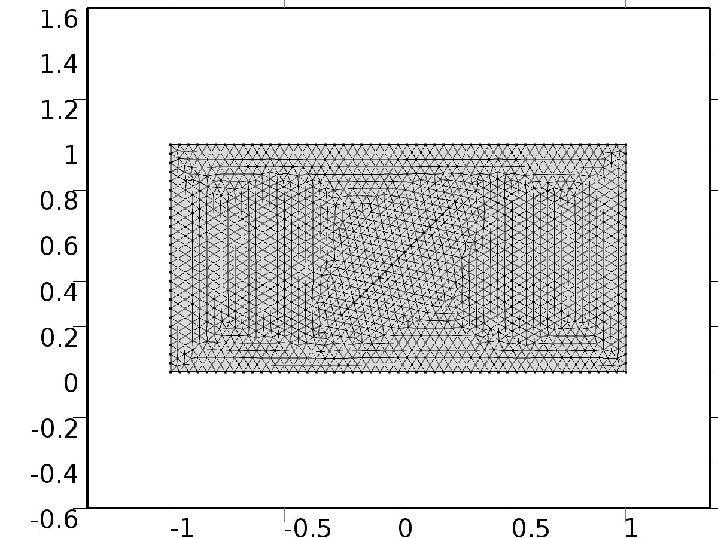

Mesh 2

* + 1. Size (size)

Settings

| **Description** | **Value** |
| --- | --- |
| Maximum element size | 0.04 |
| Minimum element size | 1.5E-4 |
| Curvature factor | 0.25 |
| Maximum element growth rate | 1.2 |
| Predefined size | Extra fine |

* + 1. Free Triangular 1 (ftri1)

Selection

|  |  |
| --- | --- |
| Geometric entity level | Remaining |

1. Study 1
   1. Parametric Sweep

| **Parameter name** | **Parameter value list** |
| --- | --- |
| n | 1,2,3 |

* 1. Stationary

Study settings

| **Description** | **Value** |
| --- | --- |
| Include geometric nonlinearity | Off |

Physics and variables selection

| **Physics interface** | **Discretization** |
| --- | --- |
| Unit Input (c) | physics |

Mesh selection

| **Geometry** | **Mesh** |
| --- | --- |
| Geometry 1 (geom1) | mesh1 |
| Geometry 2 (geom2) | mesh2 |

* 1. Solver Configurations
     1. Solver 1

#### Compile Equations: Stationary (st1)

Study and step

| **Description** | **Value** |
| --- | --- |
| Use study | Study 1 |
| Use study step | Stationary |

#### Dependent Variables 1 (v1)

General

| **Description** | **Value** |
| --- | --- |
| Defined by study step | Stationary |
| Constant |  |

Initial values of variables solved for

| **Description** | **Value** |
| --- | --- |
| Solution | Zero |

Values of variables not solved for

| **Description** | **Value** |
| --- | --- |
| Solution | Zero |

##### Dependent variable X (mod2.X) (mod2_X)

General

| **Description** | **Value** |
| --- | --- |
| Field components | mod2.X |

##### Dependent variable PIt1 (mod2.PIt1) (mod2_PIt1)

General

| **Description** | **Value** |
| --- | --- |
| Field components | mod2.PIt1 |
| Solve for this field | Off |

##### Dependent variable PI1 (mod2.PI1) (mod2_PI1)

General

| **Description** | **Value** |
| --- | --- |
| Field components | mod2.PI1 |
| Solve for this field | Off |

##### Dependent variable PI2 (mod2.PI2) (mod2_PI2)

General

| **Description** | **Value** |
| --- | --- |
| Field components | mod2.PI2 |
| Solve for this field | Off |

##### Dependent variable PIt2 (mod2.PIt2) (mod2_PIt2)

General

| **Description** | **Value** |
| --- | --- |
| Field components | mod2.PIt2 |
| Solve for this field | Off |

##### Dependent variable z (mod2.z) (mod2_z)

General

| **Description** | **Value** |
| --- | --- |
| Field components | mod2.z |
| Solve for this field | Off |

#### Stationary Solver 1 (s1)

General

| **Description** | **Value** |
| --- | --- |
| Defined by study step | Stationary |
| Relative tolerance | 0.000010 |

Log

| **Description** | **Value** |
| --- | --- |
| Constant |  |

##### Fully Coupled 1 (fc1)

General

| **Description** | **Value** |
| --- | --- |
| Linear solver | Direct |

##### Parametric 1 (p1)

General

| **Description** | **Value** |
| --- | --- |
| Defined by study step | Parametric Sweep |
| Parameter value list | 1, 2, 3 |

Results while solving

| **Description** | **Value** |
| --- | --- |
| Probes | Manual |
| Probes | {C1(Xj), C2(Xj), C3(Xj)} |

1. Study 2
   1. Parametric Sweep

| **Parameter name** | **Parameter value list** |
| --- | --- |
| k | range(0,1,kmax) |
| m | 1,2 |
| l | range(1,1,lmax) |

* 1. Stationary

Study settings

| **Description** | **Value** |
| --- | --- |
| Include geometric nonlinearity | Off |

Physics and variables selection

| **Physics interface** | **Discretization** |
| --- | --- |
| Regulator Eqs (c2) | physics |

Mesh selection

| **Geometry** | **Mesh** |
| --- | --- |
| Geometry 1 (geom1) | mesh1 |
| Geometry 2 (geom2) | mesh2 |

* 1. Solver Configurations
     1. Solver 2

#### Compile Equations: Stationary (st1)

Study and step

| **Description** | **Value** |
| --- | --- |
| Use study | Study 2 |
| Use study step | Stationary |

#### Dependent Variables 1 (v1)

General

| **Description** | **Value** |
| --- | --- |
| Defined by study step | Stationary |
| Constant |  |

Initial values of variables solved for

| **Description** | **Value** |
| --- | --- |
| Solution | Zero |

Values of variables not solved for

| **Description** | **Value** |
| --- | --- |
| Method | Solution |
| Solution | Solver 1 |

##### Dependent variable PIt1 (mod2.PIt1) (mod2_PIt1)

General

| **Description** | **Value** |
| --- | --- |
| Field components | mod2.PIt1 |

##### Dependent variable PI1 (mod2.PI1) (mod2_PI1)

General

| **Description** | **Value** |
| --- | --- |
| Field components | mod2.PI1 |

##### Dependent variable PI2 (mod2.PI2) (mod2_PI2)

General

| **Description** | **Value** |
| --- | --- |
| Field components | mod2.PI2 |

##### Dependent variable X (mod2.X) (mod2_X)

General

| **Description** | **Value** |
| --- | --- |
| Field components | mod2.X |
| Solve for this field | Off |

##### Dependent variable PIt2 (mod2.PIt2) (mod2_PIt2)

General

| **Description** | **Value** |
| --- | --- |
| Field components | mod2.PIt2 |

##### Dependent variable z (mod2.z) (mod2_z)

General

| **Description** | **Value** |
| --- | --- |
| Field components | mod2.z |
| Solve for this field | Off |

#### Stationary Solver 1 (s1)

General

| **Description** | **Value** |
| --- | --- |
| Defined by study step | Stationary |
| Relative tolerance | 0.00010 |

Log

| **Description** | **Value** |
| --- | --- |
| Constant |  |

##### Fully Coupled 1 (fc1)

General

| **Description** | **Value** |
| --- | --- |
| Linear solver | Direct |

##### Parametric 1 (p1)

General

| **Description** | **Value** |
| --- | --- |
| Defined by study step | Parametric Sweep |
| Sweep type | All combinations |
| Parameter value list | {range(0, 1, kmax), 1, 2, range(1, 1, lmax)} |
| Run continuation for | No parameter |

Results while solving

| **Description** | **Value** |
| --- | --- |
| Probes | Manual |
| Probes | {gammac1*Ar, gammas1*Ar, gammac2*Ar, gammas2*Ar, gammac3*Ar, gammas3*Ar} |

1. Study 3
   1. Time Dependent

Study settings

| **Description** | **Value** |
| --- | --- |
| Include geometric nonlinearity | Off |

| **Times** | **Unit** |
| --- | --- |
| range(0,p/40,4*p2) | s |

Physics and variables selection

| **Physics interface** | **Discretization** |
| --- | --- |
| Closed Loop System (phys1) | physics |

Mesh selection

| **Geometry** | **Mesh** |
| --- | --- |
| Geometry 1 (geom1) | mesh1 |
| Geometry 2 (geom2) | mesh2 |

* 1. Solver Configurations
     1. Solver 3

#### Compile Equations: Time Dependent (st1)

Study and step

| **Description** | **Value** |
| --- | --- |
| Use study | Study 3 |
| Use study step | Time Dependent |

#### Dependent Variables 1 (v1)

General

| **Description** | **Value** |
| --- | --- |
| Defined by study step | Time Dependent |
| Constant |  |

Initial values of variables solved for

| **Description** | **Value** |
| --- | --- |
| Solution | Zero |

Values of variables not solved for

| **Description** | **Value** |
| --- | --- |
| Method | Solution |
| Solution | Solver 2 |

##### Dependent variable PIt1 (mod2.PIt1) (mod2_PIt1)

General

| **Description** | **Value** |
| --- | --- |
| Field components | mod2.PIt1 |
| Solve for this field | Off |

##### Dependent variable PI1 (mod2.PI1) (mod2_PI1)

General

| **Description** | **Value** |
| --- | --- |
| Field components | mod2.PI1 |
| Solve for this field | Off |

##### Dependent variable z (mod2.z) (mod2_z)

General

| **Description** | **Value** |
| --- | --- |
| Field components | mod2.z |

##### Dependent variable PI2 (mod2.PI2) (mod2_PI2)

General

| **Description** | **Value** |
| --- | --- |
| Field components | mod2.PI2 |
| Solve for this field | Off |

##### Dependent variable X (mod2.X) (mod2_X)

General

| **Description** | **Value** |
| --- | --- |
| Field components | mod2.X |
| Solve for this field | Off |

##### Dependent variable PIt2 (mod2.PIt2) (mod2_PIt2)

General

| **Description** | **Value** |
| --- | --- |
| Field components | mod2.PIt2 |
| Solve for this field | Off |

#### Time-Dependent Solver 1 (t1)

General

| **Description** | **Value** |
| --- | --- |
| Defined by study step | Time Dependent |
| Time | {0, 0.025, 0.05, 0.07500000000000001, 0.1, 0.125, 0.15000000000000002, 0.17500000000000002, 0.2, 0.225, 0.25, 0.275, 0.30000000000000004, 0.325, 0.35000000000000003, 0.375, 0.4, 0.42500000000000004, 0.45, 0.47500000000000003, 0.5, 0.525, 0.55, 0.5750000000000001, 0.6000000000000001, 0.625, 0.65, 0.675, 0.7000000000000001, 0.7250000000000001, 0.75, 0.775, 0.8, 0.8250000000000001, 0.8500000000000001, 0.875, 0.9, 0.925, 0.9500000000000001, 0.9750000000000001, 1, 1.0250000000000001, 1.05, 1.075, 1.1, 1.125, 1.1500000000000001, 1.175, 1.2000000000000002, 1.225, 1.25, 1.2750000000000001, 1.3, 1.3250000000000002, 1.35, 1.375, 1.4000000000000001, 1.425, 1.4500000000000002, 1.475, 1.5, 1.5250000000000001, 1.55, 1.5750000000000002, 1.6, 1.625, 1.6500000000000001, 1.675, 1.7000000000000002, 1.725, 1.75, 1.7750000000000001, 1.8, 1.8250000000000002, 1.85, 1.875, 1.9000000000000001, 1.925, 1.9500000000000002, 1.975, 2, 2.025, 2.0500000000000003, 2.075, 2.1, 2.125, 2.15, 2.1750000000000003, 2.2, 2.225, 2.25, 2.275, 2.3000000000000003, 2.325, 2.35, 2.375, 2.4000000000000004, 2.4250000000000003, 2.45, 2.475, 2.5, 2.5250000000000004, 2.5500000000000003, 2.575, 2.6, 2.625, 2.6500000000000004, 2.6750000000000003, 2.7, 2.725, 2.75, 2.7750000000000004, 2.8000000000000003, 2.825, 2.85, 2.875, 2.9000000000000004, 2.9250000000000003, 2.95, 2.975, 3, 3.0250000000000004, 3.0500000000000003, 3.075, 3.1, 3.125, 3.1500000000000004, 3.1750000000000003, 3.2, 3.225, 3.25, 3.2750000000000004, 3.3000000000000003, 3.325, 3.35, 3.375, 3.4000000000000004, 3.4250000000000003, 3.45, 3.475, 3.5, 3.5250000000000004, 3.5500000000000003, 3.575, 3.6, 3.625, 3.6500000000000004, 3.6750000000000003, 3.7, 3.725, 3.75, 3.7750000000000004, 3.8000000000000003, 3.825, 3.85, 3.875, 3.9000000000000004, 3.9250000000000003, 3.95, 3.975, 4, 4.025, 4.05, 4.075, 4.1000000000000005, 4.125, 4.15, 4.175, 4.2, 4.2250000000000005, 4.25, 4.275, 4.3, 4.325, 4.3500000000000005, 4.375, 4.4, 4.425, 4.45, 4.4750000000000005, 4.5, 4.525, 4.55, 4.575, 4.6000000000000005, 4.625, 4.65, 4.675, 4.7, 4.7250000000000005, 4.75, 4.775, 4.800000000000001, 4.825, 4.8500000000000005, 4.875, 4.9, 4.925000000000001, 4.95, 4.9750000000000005, 5, 5.025, 5.050000000000001, 5.075, 5.1000000000000005, 5.125, 5.15, 5.175000000000001, 5.2, 5.2250000000000005, 5.25, 5.275, 5.300000000000001, 5.325, 5.3500000000000005, 5.375, 5.4, 5.425000000000001, 5.45, 5.4750000000000005, 5.5, 5.525, 5.550000000000001, 5.575, 5.6000000000000005, 5.625, 5.65, 5.675000000000001, 5.7, 5.7250000000000005, 5.75, 5.775, 5.800000000000001, 5.825, 5.8500000000000005, 5.875, 5.9, 5.925000000000001, 5.95, 5.9750000000000005, 6, 6.025, 6.050000000000001, 6.075, 6.1000000000000005, 6.125, 6.15, 6.175000000000001, 6.2, 6.2250000000000005, 6.25, 6.275, 6.300000000000001, 6.325, 6.3500000000000005, 6.375, 6.4, 6.425000000000001, 6.45, 6.4750000000000005, 6.5, 6.525, 6.550000000000001, 6.575, 6.6000000000000005, 6.625, 6.65, 6.675000000000001, 6.7, 6.7250000000000005, 6.75, 6.775, 6.800000000000001, 6.825, 6.8500000000000005, 6.875, 6.9, 6.925000000000001, 6.95, 6.9750000000000005, 7, 7.025, 7.050000000000001, 7.075, 7.1000000000000005, 7.125, 7.15, 7.175000000000001, 7.2, 7.2250000000000005, 7.25, 7.275, 7.300000000000001, 7.325, 7.3500000000000005, 7.375, 7.4, 7.425000000000001, 7.45, 7.4750000000000005, 7.5, 7.525, 7.550000000000001, 7.575, 7.6000000000000005, 7.625, 7.65, 7.675000000000001, 7.7, 7.7250000000000005, 7.75, 7.775, 7.800000000000001, 7.825, 7.8500000000000005, 7.875, 7.9, 7.925000000000001, 7.95, 7.9750000000000005, 8} |
| Relative tolerance | 0.00001 |

Absolute tolerance

| **Description** | **Value** |
| --- | --- |
| Tolerance | 0.00010 |

Time stepping

| **Description** | **Value** |
| --- | --- |
| Initial step | 0.0010 |

Results while solving

| **Description** | **Value** |
| --- | --- |
| Probes | None |

Advanced

| **Description** | **Value** |
| --- | --- |
| Fraction of initial step for Backward Euler | 0.0010 |

Log

| **Description** | **Value** |
| --- | --- |
| Constant |  |

##### Fully Coupled 1 (fc1)

General

| **Description** | **Value** |
| --- | --- |
| Linear solver | Direct |

1. Results
   1. Data Sets
      1. Solution 1

Solution

| **Description** | **Value** |
| --- | --- |
| Solution | Solver 1 |
| Component | Save Point Geometry 2 |

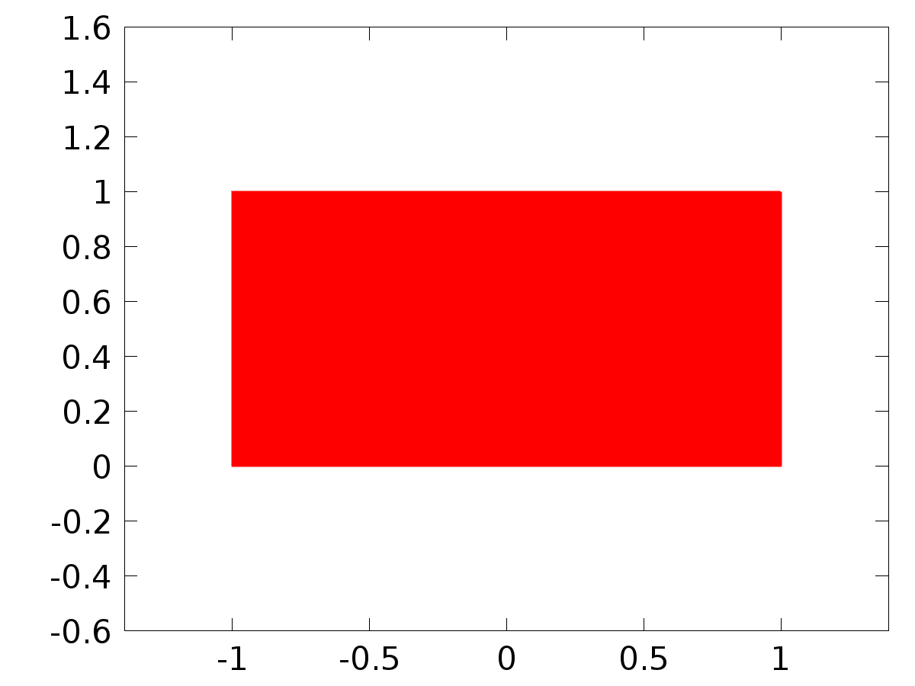

Data set: Solution 1

* + 1. Probe Solution 2

Solution

| **Description** | **Value** |
| --- | --- |
| Solution | Solver 3 |
| Component | Save Point Geometry 2 |



Data set: Probe Solution 2

* + 1. Solution 3

Solution

| **Description** | **Value** |
| --- | --- |
| Solution | Solver 2 |
| Component | Save Point Geometry 2 |



Data set: Solution 3

* + 1. Solution 4

Solution

| **Description** | **Value** |
| --- | --- |
| Solution | Solver 3 |
| Component | Save Point Geometry 2 |



Data set: Solution 4

* 1. Derived Values
     1. gammac1*Ar

Data

| **Description** | **Value** |
| --- | --- |
| Data set | Probe Solution 2 |

Expression

| **Description** | **Value** |
| --- | --- |
| Expression | gammac1*Ar |
| Description | gammac1*Ar |

* + 1. gammas1*Ar

Data

| **Description** | **Value** |
| --- | --- |
| Data set | Probe Solution 2 |

Expression

| **Description** | **Value** |
| --- | --- |
| Expression | gammas1*Ar |
| Description | gammas1*Ar |

* + 1. C1(Xj)

Data

| **Description** | **Value** |
| --- | --- |
| Data set | Probe Solution 2 |

Expression

| **Description** | **Value** |
| --- | --- |
| Expression | C1(X) |
| Description | C1(X) |

* + 1. C2(Xj)

Data

| **Description** | **Value** |
| --- | --- |
| Data set | Probe Solution 2 |

Expression

| **Description** | **Value** |
| --- | --- |
| Expression | C2(X) |
| Description | C2(X) |

* + 1. C3(Xj)

Data

| **Description** | **Value** |
| --- | --- |
| Data set | Probe Solution 2 |

Expression

| **Description** | **Value** |
| --- | --- |
| Expression | C3(X) |
| Description | C3(X) |

* + 1. gammac2*Ar

Data

| **Description** | **Value** |
| --- | --- |
| Data set | Probe Solution 2 |

Expression

| **Description** | **Value** |
| --- | --- |
| Expression | gammac2*Ar |
| Description | gammac2*Ar |

* + 1. gammas2*Ar

Data

| **Description** | **Value** |
| --- | --- |
| Data set | Probe Solution 2 |

Expression

| **Description** | **Value** |
| --- | --- |
| Expression | gammas2*Ar |
| Description | gammas2*Ar |

* + 1. gammac3*Ar

Data

| **Description** | **Value** |
| --- | --- |
| Data set | Probe Solution 2 |

Expression

| **Description** | **Value** |
| --- | --- |
| Expression | gammac3*Ar |
| Description | gammac3*Ar |

* + 1. gammas3*Ar

Data

| **Description** | **Value** |
| --- | --- |
| Data set | Probe Solution 2 |

Expression

| **Description** | **Value** |
| --- | --- |
| Expression | gammas3*Ar |
| Description | gammas3*Ar |

* + 1. Point Evaluation 1

Selection

|  |  |
| --- | --- |
| Geometric entity level | Point |
| Selection | Point 5 |

Data

| **Description** | **Value** |
| --- | --- |
| Data set | Solution 4 |

Expression

| **Description** | **Value** |
| --- | --- |
| Expression | C1(T) |
| Description | C1(T) |

* + 1. Global Evaluation 10

Data

| **Description** | **Value** |
| --- | --- |
| Data set | Solution 4 |

Expression

| **Description** | **Value** |
| --- | --- |
| Expression | d |

* 1. Tables
     1. Probe Table 1

Probe Table 1

| **k** | **m** | **l** | **gammac1*Ar, gammac1*Ar** | **gammas1*Ar, gammas1*Ar** | **gammac2*Ar, gammac2*Ar** | **gammas2*Ar, gammas2*Ar** | **gammac3*Ar, gammac3*Ar** | **gammas3*Ar, gammas3*Ar** |
| --- | --- | --- | --- | --- | --- | --- | --- | --- |
| 0.0000 | 1.1309E-15 | 0.0000 | 3.6388E-14 | 0.0000 | -1.6749E-14 | 0.0000 |
| 0.0000 | 5.4245 | 0.0000 | 89.115 | 0.0000 | -41.573 | 0.0000 |
| 0.0000 | -6.4094 | 0.0000 | -350.03 | 0.0000 | 157.26 | 0.0000 |
| 0.0000 | -1.5058E-16 | 0.0000 | -1.1728E-14 | 0.0000 | 5.1949E-15 | 0.0000 |
| 0.0000 | 0.0000 | 0.0000 | 0.0000 | 0.0000 | 0.0000 | 0.0000 |
| 0.0000 | 0.0000 | 0.0000 | 0.0000 | 0.0000 | 0.0000 | 0.0000 |
| 0.0000 | 0.0000 | 0.0000 | 0.0000 | 0.0000 | 0.0000 | 0.0000 |
| 0.0000 | 0.0000 | 0.0000 | 0.0000 | 0.0000 | 0.0000 | 0.0000 |
| 1.0000 | 20.531 | -7.3550 | 629.59 | -311.10 | -281.26 | 168.30 |
| 1.0000 | -4.2194 | 1.7385 | -70.969 | 19.096 | 32.741 | -11.459 |
| 1.0000 | 7.5198E-16 | -2.0628E-16 | 3.8573E-14 | -1.9455E-14 | -1.6778E-14 | 1.0246E-14 |
| 1.0000 | -1.5163E-16 | 1.3252E-17 | -1.1612E-14 | 2.7190E-15 | 5.0936E-15 | -1.6727E-15 |
| 1.0000 | 7.3550 | 20.531 | 311.10 | 629.59 | -168.30 | -281.26 |
| 1.0000 | 3.1919E-16 | 7.7468E-16 | 3.5060E-15 | 1.3030E-14 | -2.1039E-15 | -6.0112E-15 |
| 1.0000 | -1.3031E-16 | -4.7502E-16 | -1.2290E-14 | -2.4367E-14 | 6.4723E-15 | 1.0599E-14 |
| 1.0000 | -8.3117E-18 | -9.5104E-17 | -1.7054E-15 | -7.2832E-15 | 1.0491E-15 | 3.1947E-15 |
| 2.0000 | 1.2769E-15 | -1.0097E-15 | 3.2583E-14 | -4.1431E-14 | -1.2664E-14 | 2.2149E-14 |
| 2.0000 | -1.1520E-16 | 1.0739E-16 | -2.0980E-15 | 1.1931E-15 | 9.3280E-16 | -7.1515E-16 |
| 2.0000 | 4.7873 | -2.7893 | 194.39 | -253.99 | -72.549 | 132.03 |
| 2.0000 | -1.9185E-16 | 3.2659E-17 | -1.3963E-14 | 6.7769E-15 | 5.9368E-15 | -4.1708E-15 |
| 2.0000 | -1.7449E-16 | -2.2065E-16 | -7.1595E-15 | -5.6305E-15 | 3.8275E-15 | 2.1885E-15 |
| 2.0000 | 2.6237E-16 | 2.8145E-16 | 2.9150E-15 | 5.1256E-15 | -1.7472E-15 | -2.2790E-15 |
| 2.0000 | -9.9873E-16 | -1.7142E-15 | -9.0944E-14 | -6.9605E-14 | 4.7274E-14 | 2.5977E-14 |
| 2.0000 | -6.2627E-19 | -3.6790E-18 | -1.2996E-16 | -2.6775E-16 | 7.9979E-17 | 1.1384E-16 |
| 3.0000 | 1.0213E-16 | -1.4707E-16 | 1.4343E-15 | -5.7178E-15 | -1.5485E-16 | 2.9893E-15 |
| 3.0000 | -0.31220 | 0.56234 | -6.7600 | 6.3707 | 2.7850 | -3.8112 |
| 3.0000 | -2.8298E-16 | 2.7620E-16 | -5.5957E-15 | 2.3645E-14 | 3.5447E-16 | -1.1993E-14 |
| 3.0000 | -4.1488E-16 | 1.0139E-16 | -2.7707E-14 | 2.1450E-14 | 1.1104E-14 | -1.3211E-14 |
| 3.0000 | -1.0002E-15 | -6.9455E-16 | -3.8886E-14 | -9.7543E-15 | 2.0330E-14 | 1.0531E-15 |
| 3.0000 | 2.8102E-16 | 1.5602E-16 | 3.1837E-15 | 3.3782E-15 | -1.9046E-15 | -1.3917E-15 |
| 3.0000 | -3.2042E-16 | -3.2828E-16 | -2.7430E-14 | -6.4916E-15 | 1.3913E-14 | 4.1122E-16 |
| 3.0000 | 1.3087E-18 | 5.3551E-18 | 2.7687E-16 | 3.5763E-16 | -1.7052E-16 | -1.4332E-16 |
| 4.0000 | -10.196 | 28.306 | 145.11 | 1012.6 | -194.85 | -509.67 |
| 4.0000 | -9.0371E-17 | 3.7280E-16 | -2.9499E-15 | 4.3442E-15 | 1.0400E-15 | -2.5921E-15 |
| 4.0000 | -2.2430E-17 | 3.5019E-17 | 4.1737E-16 | 2.7286E-15 | -5.4371E-16 | -1.3276E-15 |
| 4.0000 | -4.3195E-16 | 1.3243E-16 | -2.5507E-14 | 2.8816E-14 | 9.2264E-15 | -1.7766E-14 |
| 4.0000 | 1.6772E-14 | 6.0416E-15 | 6.0003E-13 | -8.5985E-14 | -3.0200E-13 | 1.1546E-13 |
| 4.0000 | 4.0157E-16 | 9.7345E-17 | 4.6794E-15 | 3.1775E-15 | -2.7921E-15 | -1.1202E-15 |
| 4.0000 | 8.1340E-17 | 5.2100E-17 | 6.3379E-15 | -9.6946E-16 | -3.0837E-15 | 1.2629E-15 |
| 4.0000 | -8.5032E-18 | -2.7735E-17 | -1.8502E-15 | -1.6377E-15 | 1.1407E-15 | 5.9240E-16 |
| 5.0000 | -4.2008E-17 | 3.6068E-16 | 6.1430E-15 | 1.1406E-14 | -4.8326E-15 | -5.3753E-15 |
| 5.0000 | -0.0019019 | 0.31678 | -1.6224 | 3.8337 | 0.38476 | -2.2801 |
| 5.0000 | -1.3268E-16 | 3.5100E-16 | 1.2933E-14 | 2.3849E-14 | -1.0128E-14 | -1.0801E-14 |
| 5.0000 | 5.4953E-17 | -1.9486E-17 | 2.7552E-15 | -4.4037E-15 | -8.3011E-16 | 2.7193E-15 |
| 5.0000 | 3.3140E-16 | 3.8599E-17 | 1.0480E-14 | -5.6444E-15 | -4.9390E-15 | 4.4403E-15 |
| 5.0000 | 7.1535E-17 | 4.2948E-19 | 8.6574E-16 | 3.6638E-16 | -5.1489E-16 | -8.6886E-17 |
| 5.0000 | 3.1819E-16 | 1.2028E-16 | 2.1620E-14 | -1.1724E-14 | -9.7916E-15 | 9.1812E-15 |
| 5.0000 | -2.0040E-16 | -5.6514E-16 | -4.5288E-14 | -2.8335E-14 | 2.7965E-14 | 8.5369E-15 |
| 6.0000 | 2.7259E-16 | 3.1531E-15 | 8.6849E-14 | 8.2898E-14 | -6.0547E-14 | -3.4437E-14 |
| 6.0000 | -2.8391E-17 | -1.4252E-16 | 4.1830E-16 | -1.8111E-15 | 1.6515E-17 | 1.0731E-15 |
| 6.0000 | 0.16016 | -0.91562 | -52.864 | -50.963 | 36.702 | 20.134 |
| 6.0000 | -2.6682E-18 | 1.0332E-18 | -1.0841E-16 | 2.4524E-16 | 2.2403E-17 | -1.5177E-16 |
| 6.0000 | -2.3769E-16 | 2.0548E-17 | -6.2489E-15 | 6.5468E-15 | 2.5959E-15 | -4.5641E-15 |
| 6.0000 | 8.6688E-16 | -1.7269E-16 | 1.1016E-14 | 2.5443E-15 | -6.5274E-15 | 1.0045E-16 |
| 6.0000 | -1.8913E-15 | -3.3083E-16 | -1.0527E-13 | 1.0920E-13 | 4.1590E-14 | -7.5812E-14 |
| 6.0000 | -1.3251E-16 | -3.4220E-16 | -3.1452E-14 | -1.3904E-14 | 1.9464E-14 | 2.8731E-15 |
| 7.0000 | 1.6687E-15 | 6.1578E-15 | 2.3010E-13 | 1.2074E-13 | -1.5147E-13 | -3.6529E-14 |
| 7.0000 | 0.080759 | 0.20416 | -0.20967 | 2.7590 | -0.27932 | -1.6283 |
| 7.0000 | 3.8397E-18 | -7.9502E-16 | -6.0303E-14 | -3.2643E-14 | 3.9529E-14 | 9.1975E-15 |
| 7.0000 | 3.3117 | -1.3384 | 102.99 | -338.08 | -5.3369 | 209.87 |
| 7.0000 | 6.5431E-16 | -1.7731E-16 | 1.2829E-14 | -2.4449E-14 | -3.8815E-15 | 1.6095E-14 |
| 7.0000 | 1.5058E-15 | -5.9564E-16 | 2.0349E-14 | 1.5464E-15 | -1.2009E-14 | 2.0601E-15 |
| 7.0000 | -1.5716E-15 | -7.5904E-18 | -6.4529E-14 | 1.1921E-13 | 1.8182E-14 | -7.8142E-14 |
| 7.0000 | -1.2581E-15 | -3.1130E-15 | -3.1780E-13 | -9.6808E-14 | 1.9727E-13 | 5.0167E-15 |
| 8.0000 | -8.3846E-17 | -1.8652E-16 | -8.7443E-15 | -2.1181E-15 | 5.5467E-15 | -4.2385E-17 |
| 8.0000 | 5.2337E-16 | 8.7470E-16 | 6.9243E-16 | 1.2759E-14 | -2.3182E-15 | -7.5004E-15 |
| 8.0000 | 1.7997E-17 | 1.2418E-16 | 1.1387E-14 | 3.0054E-15 | -7.1937E-15 | 5.5047E-17 |
| 8.0000 | -3.3284E-16 | 1.3505E-16 | -7.3377E-15 | 3.6885E-14 | -1.6326E-15 | -2.2991E-14 |
| 8.0000 | 4.2896E-15 | -1.9283E-15 | 4.8712E-14 | -2.0110E-13 | 9.7479E-16 | 1.2756E-13 |
| 8.0000 | -1.4961E-16 | 8.9521E-17 | -2.1824E-15 | 1.1844E-16 | 1.2829E-15 | -3.9652E-16 |
| 8.0000 | 1.5221E-15 | -2.2060E-16 | 3.6838E-14 | -1.3957E-13 | 6.7473E-16 | 8.8176E-14 |
| 8.0000 | -1.9595E-16 | -4.8293E-16 | -5.3517E-14 | -1.0647E-14 | 3.3359E-14 | -2.3688E-15 |
| 9.0000 | -1.4879E-15 | -2.3615E-15 | -1.3302E-13 | -2.9965E-15 | 8.1955E-14 | -1.8321E-14 |
| 9.0000 | 0.11168 | 0.13587 | 0.36179 | 2.1777 | -0.55131 | -1.2756 |
| 9.0000 | -4.0607E-16 | -1.4474E-15 | -1.5260E-13 | -7.5848E-15 | 9.3695E-14 | -2.0167E-14 |
| 9.0000 | 3.0437E-17 | -1.1961E-17 | 4.2298E-16 | -3.6013E-15 | 3.3079E-16 | 2.2569E-15 |
| 9.0000 | 4.5722E-15 | -2.8809E-15 | 5.8018E-15 | -2.5755E-13 | 3.5472E-14 | 1.5868E-13 |
| 9.0000 | -1.0884E-16 | 8.9467E-17 | -1.7445E-15 | 2.8982E-16 | 1.0219E-15 | -4.4164E-16 |
| 9.0000 | -9.1390E-16 | 2.5640E-16 | -4.7892E-15 | 9.6353E-14 | -1.2734E-14 | -5.9161E-14 |
| 9.0000 | 7.1099E-17 | 1.8093E-16 | 2.1408E-14 | 2.5144E-15 | -1.3416E-14 | 1.9663E-15 |
| 10.000 | 2.5682E-15 | 3.1371E-15 | 2.0670E-13 | -3.4433E-14 | -1.2408E-13 | 5.3036E-14 |
| 10.000 | -8.3189E-16 | -7.6692E-16 | -3.6270E-15 | -1.3803E-14 | 4.3730E-15 | 8.0627E-15 |
| 10.000 | -0.22160 | -0.54756 | -64.100 | 8.5157 | 38.384 | -15.718 |
| 10.000 | 1.1048E-17 | -4.0548E-18 | 7.6989E-17 | -1.3794E-15 | 1.7744E-16 | 8.7036E-16 |
| 10.000 | 1.0764E-14 | -8.8119E-15 | -1.1815E-13 | -7.0922E-13 | 1.8197E-13 | 4.2572E-13 |
| 10.000 | -4.7739E-16 | 5.1783E-16 | -8.5920E-15 | 2.2577E-15 | 5.0189E-15 | -2.7221E-15 |
| 10.000 | -3.9099E-15 | 1.5824E-15 | 6.0807E-14 | 4.5771E-13 | -1.1224E-13 | -2.7408E-13 |
| 10.000 | 2.5343E-17 | 6.9051E-17 | 8.6212E-15 | 4.8118E-16 | -5.4398E-15 | 1.1090E-15 |
| 11.000 | 4.5194E-15 | 4.4294E-15 | 3.3534E-13 | -1.1413E-13 | -1.9625E-13 | 1.2387E-13 |
| 11.000 | 0.12416 | 0.087771 | 0.63035 | 1.8231 | -0.68010 | -1.0632 |
| 11.000 | -1.0534E-15 | -2.0340E-15 | -2.5736E-13 | 7.6827E-14 | 1.5047E-13 | -9.0453E-14 |
| 11.000 | -1.6224E-15 | 5.3460E-16 | -2.3717E-15 | 2.1208E-13 | -3.3013E-14 | -1.3493E-13 |
| 11.000 | -1.0851E-14 | 1.1072E-14 | 2.7960E-13 | 8.2153E-13 | -3.0347E-13 | -4.8078E-13 |
| 11.000 | 1.2100E-15 | -1.7117E-15 | 2.5135E-14 | -8.6902E-15 | -1.4658E-14 | 9.3761E-15 |
| 11.000 | -8.0316E-17 | 4.1594E-17 | 3.0337E-15 | 1.0162E-14 | -3.5717E-15 | -5.9415E-15 |
| 11.000 | -9.9991E-17 | -3.0345E-16 | -3.9666E-14 | -4.4359E-16 | 2.5236E-14 | -6.1747E-15 |
| 12.000 | 1.3751E-14 | 1.1089E-14 | 9.5292E-13 | -4.8321E-13 | -5.4331E-13 | 4.5799E-13 |
| 12.000 | -4.0008E-15 | -2.1488E-15 | -2.2221E-14 | -5.3415E-14 | 2.2539E-14 | 3.1141E-14 |
| 12.000 | 2.4483E-15 | 3.9525E-15 | 5.2871E-13 | -2.4073E-13 | -3.0175E-13 | 2.4058E-13 |
| 12.000 | -7.8557E-16 | 2.2174E-16 | 1.9989E-15 | 1.0701E-13 | -1.8602E-14 | -6.8742E-14 |
| 12.000 | -1.1409E-14 | 1.4148E-14 | 4.9719E-13 | 9.8049E-13 | -4.7124E-13 | -5.5903E-13 |
| 12.000 | -1.6024E-15 | 2.9835E-15 | -3.9833E-14 | 1.6571E-14 | 2.3223E-14 | -1.6808E-14 |
| 12.000 | 4.8094E-15 | -2.9791E-15 | -2.9292E-13 | -6.4333E-13 | 2.9274E-13 | 3.6717E-13 |
| 12.000 | 1.2067E-16 | 4.2751E-16 | 5.8235E-14 | -1.0878E-15 | -3.7409E-14 | 1.0123E-14 |
| 13.000 | 2.4524E-14 | 1.6528E-14 | 1.5990E-12 | -1.0747E-12 | -8.8671E-13 | 9.4850E-13 |
| 13.000 | 0.12819 | 0.050625 | 0.75261 | 1.5861 | -0.73563 | -0.92584 |
| 13.000 | 5.1675E-15 | 7.2941E-15 | 1.0122E-12 | -6.1568E-13 | -5.6336E-13 | 5.6536E-13 |
| 13.000 | 1.3542E-16 | -3.0766E-17 | -6.8880E-16 | -1.9183E-14 | 3.5324E-15 | 1.2458E-14 |
| 13.000 | -4.5422E-15 | 6.7393E-15 | 2.9533E-13 | 4.3941E-13 | -2.6066E-13 | -2.4368E-13 |
| 13.000 | -1.4215E-15 | 3.5992E-15 | -4.4535E-14 | 2.1132E-14 | 2.5996E-14 | -2.0655E-14 |
| 13.000 | 6.0940E-15 | -4.3173E-15 | -5.1437E-13 | -8.4565E-13 | 4.7234E-13 | 4.7066E-13 |
| 13.000 | 2.3340E-16 | 1.0274E-15 | 1.4553E-13 | -5.2254E-15 | -9.4507E-14 | 2.6797E-14 |
| 14.000 | -4.9910E-15 | -2.8367E-15 | -3.0734E-13 | 2.5802E-13 | 1.6534E-13 | -2.1807E-13 |
| 14.000 | -1.3625E-15 | -3.6880E-16 | -8.2758E-15 | -1.5837E-14 | 7.9051E-15 | 9.2688E-15 |
| 14.000 | -0.32138 | -0.40969 | -58.012 | 44.157 | 31.428 | -38.530 |
| 14.000 | -6.1208E-16 | 1.0173E-16 | 3.8530E-15 | 9.0157E-14 | -1.6928E-14 | -5.9241E-14 |
| 14.000 | -7.4804E-15 | 1.3161E-14 | 6.8042E-13 | 8.1045E-13 | -5.7506E-13 | -4.3601E-13 |
| 14.000 | -6.1662E-16 | 2.2780E-15 | -2.6480E-14 | 1.3837E-14 | 1.5497E-14 | -1.3217E-14 |
| 14.000 | -8.7569E-16 | 6.8695E-16 | 9.4385E-14 | 1.2400E-13 | -8.2358E-14 | -6.7176E-14 |
| 14.000 | 8.4779E-17 | 5.1007E-16 | 7.5131E-14 | -3.2109E-15 | -4.9367E-14 | 1.4106E-14 |
| 15.000 | -7.1519E-15 | -3.4382E-15 | -4.1632E-13 | 4.2204E-13 | 2.1646E-13 | -3.4655E-13 |
| 15.000 | 0.12769 | 0.020227 | 0.79092 | 1.4073 | -0.74445 | -0.82663 |
| 15.000 | 2.9223E-15 | 3.4461E-15 | 4.9070E-13 | -4.5043E-13 | -2.5801E-13 | 3.7994E-13 |
| 15.000 | -1.3285E-15 | 1.3439E-16 | 8.4667E-15 | 2.0377E-13 | -3.7919E-14 | -1.3555E-13 |
| 15.000 | -1.6785E-14 | 3.4915E-14 | 2.0603E-12 | 2.0324E-12 | -1.6918E-12 | -1.0567E-12 |
| 15.000 | 8.3162E-16 | -5.2498E-15 | 5.7859E-14 | -3.2518E-14 | -3.3986E-14 | 3.0607E-14 |
| 15.000 | -3.0340E-15 | 2.5729E-15 | 3.9657E-13 | 4.3202E-13 | -3.3451E-13 | -2.2716E-13 |
| 15.000 | 2.7568E-17 | 2.7251E-16 | 4.1799E-14 | -1.7368E-15 | -2.7805E-14 | 7.7782E-15 |
| 16.000 | -7.9406E-15 | -3.2177E-15 | -4.3607E-13 | 5.2340E-13 | 2.1790E-13 | -4.2105E-13 |
| 16.000 | -1.2870E-16 | -6.9877E-18 | -8.0530E-16 | -1.3528E-15 | 7.5055E-16 | 7.9806E-16 |
| 16.000 | 3.0761E-16 | 3.4153E-16 | 4.8253E-14 | -5.2275E-14 | -2.4518E-14 | 4.3043E-14 |
| 16.000 | 7.5981E-16 | -2.5569E-17 | -4.2287E-15 | -1.2166E-13 | 2.1974E-14 | 8.1938E-14 |
| 16.000 | 8.4781E-15 | -2.0922E-14 | -1.3791E-12 | -1.1490E-12 | 1.1094E-12 | 5.7414E-13 |
| 16.000 | 6.2919E-17 | -1.1589E-15 | 1.2181E-14 | -7.2511E-15 | -7.1859E-15 | 6.7581E-15 |
| 16.000 | 1.0429E-15 | -9.3930E-16 | -1.5962E-13 | -1.4734E-13 | 1.3143E-13 | 7.4865E-14 |
| 16.000 | -1.6129E-17 | -4.7931E-16 | -7.6748E-14 | 2.6676E-15 | 5.1688E-14 | -1.3862E-14 |
| 17.000 | -1.9113E-14 | -6.4534E-15 | -9.8504E-13 | 1.3860E-12 | 4.6905E-13 | -1.0978E-12 |
| 17.000 | 0.12444 | -0.0055143 | 0.78215 | 1.2518 | -0.72377 | -0.74166 |
| 17.000 | -2.5729E-15 | -2.7224E-15 | -3.7678E-13 | 4.7628E-13 | 1.8376E-13 | -3.8506E-13 |
| 17.000 | -7.9021E-16 | -2.7642E-17 | 3.2649E-15 | 1.3248E-13 | -2.2896E-14 | -9.0310E-14 |
| 17.000 | -1.4618E-14 | 4.3294E-14 | 3.1396E-12 | 2.2312E-12 | -2.4866E-12 | -1.0625E-12 |
| 17.000 | -1.4319E-16 | -3.2314E-15 | 3.2505E-14 | -2.0310E-14 | -1.9259E-14 | 1.8794E-14 |
| 17.000 | 2.7584E-16 | -2.6069E-16 | -4.8257E-14 | -3.8176E-14 | 3.9015E-14 | 1.8619E-14 |
| 17.000 | 1.7386E-17 | -4.9702E-16 | -8.3328E-14 | 2.0536E-15 | 5.6803E-14 | -1.4401E-14 |
| 18.000 | -5.7311E-15 | -1.5760E-15 | -2.7466E-13 | 4.5217E-13 | 1.2296E-13 | -3.5368E-13 |
| 18.000 | -2.4063E-15 | 3.3538E-16 | -1.5159E-14 | -2.3206E-14 | 1.3944E-14 | 1.3803E-14 |
| 18.000 | -0.33335 | -0.33872 | -45.315 | 66.600 | 20.992 | -53.059 |
| 18.000 | 2.9385E-16 | 3.0466E-17 | -6.8380E-16 | -5.1746E-14 | 8.4891E-15 | 3.5683E-14 |
| 18.000 | 9.3614E-15 | -3.4043E-14 | -2.6859E-12 | -1.6315E-12 | 2.1009E-12 | 7.3041E-13 |
| 18.000 | 1.7274E-15 | 1.2394E-14 | -1.1953E-13 | 7.8079E-14 | 7.1092E-14 | -7.1819E-14 |
| 18.000 | 3.4405E-16 | -3.3859E-16 | -6.7647E-14 | -4.6027E-14 | 5.3893E-14 | 2.1323E-14 |
| 18.000 | 5.8881E-17 | -5.6792E-16 | -1.0001E-13 | 1.3216E-15 | 6.8964E-14 | -1.6407E-14 |
| 19.000 | 6.1522E-14 | 1.3234E-14 | 2.7042E-12 | -5.2363E-12 | -1.1131E-12 | 4.0524E-12 |
| 19.000 | 0.11927 | -0.027730 | 0.75355 | 1.1037 | -0.68914 | -0.65844 |
| 19.000 | 1.1805E-14 | 1.1564E-14 | 1.4733E-12 | -2.5258E-12 | -6.3742E-13 | 1.9874E-12 |
| 19.000 | -2.6526E-15 | -4.5538E-16 | 1.0268E-15 | 4.9213E-13 | -7.6491E-14 | -3.4301E-13 |
| 19.000 | 2.8938E-15 | -1.3453E-14 | -1.1450E-12 | -5.9134E-13 | 8.8615E-13 | 2.4340E-13 |
| 19.000 | -2.0390E-15 | -8.7701E-15 | 8.1157E-14 | -5.5408E-14 | -4.8414E-14 | 5.0672E-14 |
| 19.000 | -1.1941E-14 | 1.2189E-14 | 2.6080E-12 | 1.5212E-12 | -2.0521E-12 | -6.5817E-13 |
| 19.000 | 4.1512E-16 | -2.4181E-15 | -4.4863E-13 | 9.3606E-16 | 3.1269E-13 | -6.9730E-14 |
| 20.000 | -2.1941E-14 | -3.4331E-15 | -8.6712E-13 | 2.0011E-12 | 3.1528E-13 | -1.5340E-12 |
| 20.000 | 2.3947E-15 | -7.7850E-16 | 1.5215E-14 | 2.1275E-14 | -1.3830E-14 | -1.2713E-14 |
| 20.000 | 8.2211E-16 | 7.7726E-16 | 9.2591E-14 | -1.8706E-13 | -3.6355E-14 | 1.4557E-13 |
| 20.000 | 5.1708E-16 | 1.2329E-16 | 7.6491E-16 | -1.0134E-13 | 1.4978E-14 | 7.1329E-14 |
| 20.000 | 7.0434E-15 | -4.5016E-14 | -4.1055E-12 | -1.7790E-12 | 3.1473E-12 | 6.4683E-13 |
| 20.000 | 1.0610E-15 | 3.2636E-15 | -2.8995E-14 | 2.0735E-14 | 1.7326E-14 | -1.8848E-14 |
| 20.000 | 1.7581E-16 | -1.8595E-16 | -4.2312E-14 | -2.0943E-14 | 3.2926E-14 | 8.2232E-15 |
| 20.000 | 4.1186E-16 | -1.7273E-15 | -3.3854E-13 | -2.5552E-15 | 2.3828E-13 | -5.0036E-14 |

* + 1. Probe Table 2
    2. Probe Table 3
    3. Table 4

Point Evaluation 1 (C1(T))

* + 1. Table 5

Global Evaluation 10 (C1(z))

Table 5

| **Time** | **C1(z)** | **yr1** | **C2(z)** | **yr2** | **C3(z)** | **yr3** | **e1** | **e2** | **e3** | **d** |
| --- | --- | --- | --- | --- | --- | --- | --- | --- | --- | --- |
| -1.0000 | -2.0692E-10 | -2.2204E-16 | 5.7533E-11 | 0.0000 | -4.6581E-10 | 0.0000 | 2.0692E-10 | -5.7533E-11 | 4.6581E-10 | -1.0000 |
| -0.97500 | 0.98682 | -0.12432 | 1.0291 | 0.025000 | 0.95331 | -0.050000 | -1.1111 | -1.0041 | -1.0033 | -0.85264 |
| -0.95000 | 2.5784 | -0.33511 | 2.9159 | 0.050000 | 2.3707 | -0.10000 | -2.9135 | -2.8659 | -2.4707 | -0.45399 |
| -0.92500 | 3.5023 | -0.61803 | 4.2910 | 0.075000 | 3.1254 | -0.15000 | -4.1203 | -4.2160 | -3.2754 | 0.078459 |
| -0.90000 | 3.7880 | -0.95106 | 5.0799 | 0.10000 | 3.3691 | -0.20000 | -4.7391 | -4.9799 | -3.5691 | 0.58779 |
| -0.87500 | 3.6361 | -1.3066 | 5.4355 | 0.12500 | 3.3087 | -0.25000 | -4.9427 | -5.3105 | -3.5587 | 0.92388 |
| -0.85000 | 3.2311 | -1.6540 | 5.5071 | 0.15000 | 3.0842 | -0.30000 | -4.8851 | -5.3571 | -3.3842 | 0.98769 |
| -0.82500 | 2.7138 | -1.9629 | 5.4011 | 0.17500 | 2.7873 | -0.35000 | -4.6768 | -5.2261 | -3.1373 | 0.76041 |
| -0.80000 | 2.1845 | -2.2058 | 5.1902 | 0.20000 | 2.4711 | -0.40000 | -4.3903 | -4.9902 | -2.8711 | 0.30902 |
| -0.77500 | 1.7099 | -2.3609 | 4.9251 | 0.22500 | 2.1567 | -0.45000 | -4.0708 | -4.7001 | -2.6067 | -0.23345 |
| -0.75000 | 1.3305 | -2.4142 | 4.6375 | 0.25000 | 1.8519 | -0.50000 | -3.7448 | -4.3875 | -2.3519 | -0.70711 |
| -0.72500 | 1.0661 | -2.3609 | 4.3446 | 0.27500 | 1.5662 | -0.55000 | -3.4270 | -4.0696 | -2.1162 | -0.97237 |
| -0.70000 | 0.92039 | -2.2058 | 4.0570 | 0.30000 | 1.3061 | -0.60000 | -3.1262 | -3.7570 | -1.9061 | -0.95106 |
| -0.67500 | 0.88373 | -1.9629 | 3.7829 | 0.32500 | 1.0672 | -0.65000 | -2.8467 | -3.4579 | -1.7172 | -0.64945 |
| -0.65000 | 0.93526 | -1.6540 | 3.5269 | 0.35000 | 0.84357 | -0.70000 | -2.5893 | -3.1769 | -1.5436 | -0.15643 |
| -0.62500 | 1.0467 | -1.3066 | 3.2887 | 0.37500 | 0.63767 | -0.75000 | -2.3533 | -2.9137 | -1.3877 | 0.38268 |
| -0.60000 | 1.1870 | -0.95106 | 3.0679 | 0.40000 | 0.45371 | -0.80000 | -2.1381 | -2.6679 | -1.2537 | 0.80902 |
| -0.57500 | 1.3248 | -0.61803 | 2.8660 | 0.42500 | 0.28436 | -0.85000 | -1.9428 | -2.4410 | -1.1344 | 0.99692 |
| -0.55000 | 1.4310 | -0.33511 | 2.6833 | 0.45000 | 0.11914 | -0.90000 | -1.7661 | -2.2333 | -1.0191 | 0.89101 |
| -0.52500 | 1.4810 | -0.12432 | 2.5171 | 0.47500 | -0.033156 | -0.95000 | -1.6053 | -2.0421 | -0.91684 | 0.52250 |
| -0.50000 | 1.4589 | 1.1102E-16 | 2.3649 | 0.50000 | -0.14507 | -1.0000 | -1.4589 | -1.8649 | -0.85493 | -4.2863E-16 |
| -0.47500 | 1.3588 | 0.032598 | 2.2274 | 0.52500 | -0.20109 | -0.95000 | -1.3262 | -1.7024 | -0.74891 | -0.52250 |
| -0.45000 | 1.1836 | -0.022237 | 2.1047 | 0.55000 | -0.21820 | -0.90000 | -1.2058 | -1.5547 | -0.68180 | -0.89101 |
| -0.42500 | 0.94565 | -0.15114 | 1.9946 | 0.57500 | -0.22617 | -0.85000 | -1.0968 | -1.4196 | -0.62383 | -0.99692 |
| -0.40000 | 0.66485 | -0.33302 | 1.8952 | 0.60000 | -0.23681 | -0.80000 | -0.99788 | -1.2952 | -0.56319 | -0.80902 |
| -0.37500 | 0.36692 | -0.54120 | 1.8064 | 0.62500 | -0.24220 | -0.75000 | -0.90812 | -1.1814 | -0.50780 | -0.38268 |
| -0.35000 | 0.080644 | -0.74603 | 1.7286 | 0.65000 | -0.23672 | -0.70000 | -0.82668 | -1.0786 | -0.46328 | 0.15643 |
| -0.32500 | -0.16519 | -0.91793 | 1.6598 | 0.67500 | -0.22656 | -0.65000 | -0.75274 | -0.98484 | -0.42344 | 0.64945 |
| -0.30000 | -0.34474 | -1.0302 | 1.5980 | 0.70000 | -0.21696 | -0.60000 | -0.68551 | -0.89802 | -0.38304 | 0.95106 |
| -0.27500 | -0.43765 | -1.0620 | 1.5437 | 0.72500 | -0.20382 | -0.55000 | -0.62436 | -0.81869 | -0.34618 | 0.97237 |
| -0.25000 | -0.43124 | -1.00000 | 1.4976 | 0.75000 | -0.18329 | -0.50000 | -0.56876 | -0.74756 | -0.31671 | 0.70711 |
| -0.22500 | -0.32189 | -0.84010 | 1.4577 | 0.77500 | -0.15981 | -0.45000 | -0.51821 | -0.68271 | -0.29019 | 0.23345 |
| -0.20000 | -0.11559 | -0.58779 | 1.4220 | 0.80000 | -0.13782 | -0.40000 | -0.47220 | -0.62201 | -0.26218 | -0.30902 |
| -0.17500 | 0.17263 | -0.25764 | 1.3915 | 0.82500 | -0.11342 | -0.35000 | -0.43027 | -0.56654 | -0.23658 | -0.76041 |
| -0.15000 | 0.52011 | 0.12800 | 1.3678 | 0.85000 | -0.082293 | -0.30000 | -0.39211 | -0.51782 | -0.21771 | -0.98769 |
| -0.12500 | 0.89860 | 0.54120 | 1.3484 | 0.87500 | -0.049335 | -0.25000 | -0.35741 | -0.47340 | -0.20067 | -0.92388 |
| -0.10000 | 1.2769 | 0.95106 | 1.3303 | 0.90000 | -0.020381 | -0.20000 | -0.32580 | -0.43031 | -0.17962 | -0.58779 |
| -0.075000 | 1.6237 | 1.3267 | 1.3160 | 0.92500 | 0.010539 | -0.15000 | -0.29696 | -0.39103 | -0.16054 | -0.078459 |
| -0.050000 | 1.9109 | 1.6403 | 1.3094 | 0.95000 | 0.051939 | -0.100000 | -0.27066 | -0.35944 | -0.15194 | 0.45399 |
| -0.025000 | 2.1163 | 1.8695 | 1.3050 | 0.97500 | 0.092782 | -0.050000 | -0.24674 | -0.32995 | -0.14278 | 0.85264 |
| 0.0000 | 2.2250 | 2.0000 | 1.2879 | 1.0000 | 0.10411 | 0.0000 | -0.22499 | -0.28795 | -0.10411 | 1.0000 |
| 0.025000 | 2.2316 | 2.0264 | 1.2501 | 0.97500 | 0.069714 | -0.050000 | -0.20515 | -0.27507 | -0.11971 | 0.85264 |
| 0.050000 | 2.1401 | 1.9531 | 1.1991 | 0.95000 | 0.0055106 | -0.10000 | -0.18699 | -0.24909 | -0.10551 | 0.45399 |
| 0.075000 | 1.9640 | 1.7936 | 1.1492 | 0.92500 | -0.059703 | -0.15000 | -0.17045 | -0.22425 | -0.090297 | -0.078459 |
| 0.10000 | 1.7245 | 1.5691 | 1.1058 | 0.90000 | -0.11501 | -0.20000 | -0.15542 | -0.20578 | -0.084994 | -0.58779 |
| 0.12500 | 1.4483 | 1.3066 | 1.0643 | 0.87500 | -0.16914 | -0.25000 | -0.14175 | -0.18930 | -0.080858 | -0.92388 |
| 0.15000 | 1.1652 | 1.0360 | 1.0217 | 0.85000 | -0.22840 | -0.30000 | -0.12925 | -0.17172 | -0.071597 | -0.98769 |
| 0.17500 | 0.90518 | 0.78735 | 0.98047 | 0.82500 | -0.28723 | -0.35000 | -0.11782 | -0.15547 | -0.062772 | -0.76041 |
| 0.20000 | 0.69522 | 0.58779 | 0.94252 | 0.80000 | -0.34090 | -0.40000 | -0.10743 | -0.14252 | -0.059097 | -0.30902 |
| 0.22500 | 0.55679 | 0.45880 | 0.90587 | 0.77500 | -0.39398 | -0.45000 | -0.097994 | -0.13087 | -0.056015 | 0.23345 |
| 0.25000 | 0.50358 | 0.41421 | 0.86873 | 0.75000 | -0.45074 | -0.50000 | -0.089366 | -0.11873 | -0.049258 | 0.70711 |
| 0.27500 | 0.54026 | 0.45880 | 0.83254 | 0.72500 | -0.50711 | -0.55000 | -0.081464 | -0.10754 | -0.042894 | 0.97237 |
| 0.30000 | 0.66206 | 0.58779 | 0.79861 | 0.70000 | -0.55896 | -0.60000 | -0.074272 | -0.098612 | -0.041044 | 0.95106 |
| 0.32500 | 0.85510 | 0.78735 | 0.76557 | 0.67500 | -0.61049 | -0.65000 | -0.067748 | -0.090575 | -0.039510 | 0.64945 |
| 0.35000 | 1.0976 | 1.0360 | 0.73193 | 0.65000 | -0.66649 | -0.70000 | -0.061635 | -0.081935 | -0.033511 | 0.15643 |
| 0.37500 | 1.3620 | 1.3066 | 0.69839 | 0.62500 | -0.72253 | -0.75000 | -0.055429 | -0.073386 | -0.027469 | -0.38268 |
| 0.40000 | 1.6195 | 1.5691 | 0.66725 | 0.60000 | -0.77171 | -0.80000 | -0.050422 | -0.067254 | -0.028289 | -0.80902 |
| 0.42500 | 1.8397 | 1.7936 | 0.63698 | 0.57500 | -0.82093 | -0.85000 | -0.046125 | -0.061978 | -0.029070 | -0.99692 |
| 0.45000 | 1.9955 | 1.9531 | 0.60633 | 0.55000 | -0.87895 | -0.90000 | -0.042359 | -0.056330 | -0.021054 | -0.89101 |
| 0.47500 | 2.0652 | 2.0264 | 0.57597 | 0.52500 | -0.93511 | -0.95000 | -0.038720 | -0.050974 | -0.014894 | -0.52250 |
| 0.50000 | 2.0353 | 2.0000 | 0.54699 | 0.50000 | -0.96037 | -1.0000 | -0.035341 | -0.046992 | -0.039632 | -4.2863E-16 |
| 0.52500 | 1.9019 | 1.8695 | 0.51850 | 0.47500 | -0.93855 | -0.95000 | -0.032364 | -0.043498 | -0.011448 | 0.52250 |
| 0.55000 | 1.6704 | 1.6403 | 0.48982 | 0.45000 | -0.88546 | -0.90000 | -0.030123 | -0.039819 | -0.014539 | 0.89101 |
| 0.57500 | 1.3550 | 1.3267 | 0.46166 | 0.42500 | -0.83026 | -0.85000 | -0.028271 | -0.036662 | -0.019741 | 0.99692 |
| 0.60000 | 0.97733 | 0.95106 | 0.43448 | 0.40000 | -0.78434 | -0.80000 | -0.026277 | -0.034479 | -0.015658 | 0.80902 |
| 0.62500 | 0.56558 | 0.54120 | 0.40745 | 0.37500 | -0.73879 | -0.75000 | -0.024388 | -0.032449 | -0.011214 | 0.38268 |
| 0.65000 | 0.15060 | 0.12800 | 0.37948 | 0.35000 | -0.68745 | -0.70000 | -0.022602 | -0.029483 | -0.012545 | -0.15643 |
| 0.67500 | -0.23675 | -0.25764 | 0.35167 | 0.32500 | -0.63595 | -0.65000 | -0.020894 | -0.026673 | -0.014054 | -0.64945 |
| 0.70000 | -0.56840 | -0.58779 | 0.32532 | 0.30000 | -0.58888 | -0.60000 | -0.019388 | -0.025317 | -0.011122 | -0.95106 |
| 0.72500 | -0.82230 | -0.84010 | 0.29890 | 0.27500 | -0.54198 | -0.55000 | -0.017802 | -0.023903 | -0.0080234 | -0.97237 |
| 0.75000 | -0.98379 | -1.00000 | 0.27115 | 0.25000 | -0.49095 | -0.50000 | -0.016206 | -0.021151 | -0.0090514 | -0.70711 |
| 0.77500 | -1.0473 | -1.0620 | 0.24357 | 0.22500 | -0.43983 | -0.45000 | -0.014729 | -0.018572 | -0.010174 | -0.23345 |
| 0.80000 | -1.0170 | -1.0302 | 0.21756 | 0.20000 | -0.39285 | -0.40000 | -0.013231 | -0.017557 | -0.0071486 | 0.30902 |
| 0.82500 | -0.90606 | -0.91793 | 0.19164 | 0.17500 | -0.34571 | -0.35000 | -0.011862 | -0.016642 | -0.0042855 | 0.76041 |
| 0.85000 | -0.73535 | -0.74603 | 0.16400 | 0.15000 | -0.29387 | -0.30000 | -0.010686 | -0.014001 | -0.0061284 | 0.98769 |
| 0.87500 | -0.53144 | -0.54120 | 0.13673 | 0.12500 | -0.24198 | -0.25000 | -0.0097585 | -0.011733 | -0.0080160 | 0.92388 |
| 0.90000 | -0.32403 | -0.33302 | 0.11232 | 0.100000 | -0.19575 | -0.20000 | -0.0089972 | -0.012317 | -0.0042487 | 0.58779 |
| 0.92500 | -0.14298 | -0.15114 | 0.087622 | 0.075000 | -0.14924 | -0.15000 | -0.0081559 | -0.012622 | -7.6488E-4 | 0.078459 |
| 0.95000 | -0.014856 | -0.022237 | 0.058622 | 0.050000 | -0.093639 | -0.100000 | -0.0073804 | -0.0086224 | -0.0063606 | -0.45399 |
| 0.97500 | 0.039227 | 0.032598 | 0.030643 | 0.025000 | -0.039969 | -0.050000 | -0.0066284 | -0.0056428 | -0.010031 | -0.85264 |
| 1.0000 | 0.0058945 | 1.1102E-16 | 0.018051 | 0.0000 | -0.017078 | 0.0000 | -0.0058945 | -0.018051 | 0.017078 | -1.0000 |
| 1.0250 | -0.11927 | -0.12432 | 0.028695 | 0.025000 | -0.041019 | -0.050000 | -0.0050484 | -0.0036948 | -0.0089809 | -0.85264 |
| 1.0500 | -0.33095 | -0.33511 | 0.054677 | 0.050000 | -0.095804 | -0.10000 | -0.0041560 | -0.0046773 | -0.0041956 | -0.45399 |
| 1.0750 | -0.61449 | -0.61803 | 0.081833 | 0.075000 | -0.15213 | -0.15000 | -0.0035384 | -0.0068325 | 0.0021254 | 0.078459 |
| 1.1000 | -0.94808 | -0.95106 | 0.10470 | 0.10000 | -0.19945 | -0.20000 | -0.0029729 | -0.0046961 | -5.4790E-4 | 0.58779 |
| 1.1250 | -1.3038 | -1.3066 | 0.12744 | 0.12500 | -0.24545 | -0.25000 | -0.0027946 | -0.0024367 | -0.0045490 | 0.92388 |
| 1.1500 | -1.6516 | -1.6540 | 0.15249 | 0.15000 | -0.29736 | -0.30000 | -0.0024180 | -0.0024861 | -0.0026352 | 0.98769 |
| 1.1750 | -1.9604 | -1.9629 | 0.17854 | 0.17500 | -0.34963 | -0.35000 | -0.0024952 | -0.0035444 | -3.7384E-4 | 0.76041 |
| 1.2000 | -2.2034 | -2.2058 | 0.20258 | 0.20000 | -0.39776 | -0.40000 | -0.0024021 | -0.0025816 | -0.0022423 | 0.30902 |
| 1.2250 | -2.3586 | -2.3609 | 0.22663 | 0.22500 | -0.44580 | -0.45000 | -0.0023287 | -0.0016291 | -0.0041993 | -0.23345 |
| 1.2500 | -2.4118 | -2.4142 | 0.25245 | 0.25000 | -0.49783 | -0.50000 | -0.0024408 | -0.0024472 | -0.0021738 | -0.70711 |
| 1.2750 | -2.3586 | -2.3609 | 0.27808 | 0.27500 | -0.55011 | -0.55000 | -0.0022845 | -0.0030795 | 1.1062E-4 | -0.97237 |
| 1.3000 | -2.2043 | -2.2058 | 0.30178 | 0.30000 | -0.59878 | -0.60000 | -0.0015613 | -0.0017821 | -0.0012215 | -0.95106 |
| 1.3250 | -1.9622 | -1.9629 | 0.32526 | 0.32500 | -0.64751 | -0.65000 | -6.8868E-4 | -2.5836E-4 | -0.0024935 | -0.64945 |
| 1.3500 | -1.6538 | -1.6540 | 0.35027 | 0.35000 | -0.70039 | -0.70000 | -1.6957E-4 | -2.6590E-4 | 3.8984E-4 | -0.15643 |
| 1.3750 | -1.3067 | -1.3066 | 0.37551 | 0.37500 | -0.75291 | -0.75000 | 1.3074E-4 | -5.0573E-4 | 0.0029066 | 0.38268 |
| 1.4000 | -0.95167 | -0.95106 | 0.39944 | 0.40000 | -0.79981 | -0.80000 | 6.0971E-4 | 5.5680E-4 | -1.9499E-4 | 0.80902 |
| 1.4250 | -0.61892 | -0.61803 | 0.42357 | 0.42500 | -0.84697 | -0.85000 | 8.9064E-4 | 0.0014264 | -0.0030265 | 0.99692 |
| 1.4500 | -0.33612 | -0.33511 | 0.44892 | 0.45000 | -0.90306 | -0.90000 | 0.0010183 | 0.0010818 | 0.0030586 | 0.89101 |
| 1.4750 | -0.12525 | -0.12432 | 0.47449 | 0.47500 | -0.95704 | -0.95000 | 9.2990E-4 | 5.1099E-4 | 0.0070402 | 0.52250 |
| 1.5000 | -7.4766E-4 | -2.2204E-16 | 0.49913 | 0.50000 | -0.98021 | -1.0000 | 7.4766E-4 | 8.6644E-4 | -0.019789 | -4.9048E-16 |
| 1.5250 | 0.031784 | 0.032598 | 0.52354 | 0.52500 | -0.95689 | -0.95000 | 8.1442E-4 | 0.0014576 | 0.0068875 | -0.52250 |
| 1.5500 | -0.023017 | -0.022237 | 0.54908 | 0.55000 | -0.90274 | -0.90000 | 7.7995E-4 | 9.2283E-4 | 0.0027417 | -0.89101 |
| 1.5750 | -0.15186 | -0.15114 | 0.57464 | 0.57500 | -0.84666 | -0.85000 | 7.2172E-4 | 3.5868E-4 | -0.0033351 | -0.99692 |
| 1.6000 | -0.33373 | -0.33302 | 0.59912 | 0.60000 | -0.79967 | -0.80000 | 7.0849E-4 | 8.7762E-4 | -3.2927E-4 | -0.80902 |
| 1.6250 | -0.54190 | -0.54120 | 0.62360 | 0.62500 | -0.75309 | -0.75000 | 7.0572E-4 | 0.0013988 | 0.0030912 | -0.38268 |
| 1.6500 | -0.74668 | -0.74603 | 0.64923 | 0.65000 | -0.70070 | -0.70000 | 6.5086E-4 | 7.6972E-4 | 7.0332E-4 | 0.15643 |
| 1.6750 | -0.91849 | -0.91793 | 0.67488 | 0.67500 | -0.64814 | -0.65000 | 5.6385E-4 | 1.1847E-4 | -0.0018621 | 0.64945 |
| 1.7000 | -1.0308 | -1.0302 | 0.69931 | 0.70000 | -0.60017 | -0.60000 | 5.1238E-4 | 6.8926E-4 | 1.7016E-4 | 0.95106 |
| 1.7250 | -1.0625 | -1.0620 | 0.72372 | 0.72500 | -0.55229 | -0.55000 | 4.9998E-4 | 0.0012793 | 0.0022908 | 0.97237 |
| 1.7500 | -1.0005 | -1.0000 | 0.74948 | 0.75000 | -0.50028 | -0.50000 | 4.6809E-4 | 5.1790E-4 | 2.7589E-4 | 0.70711 |
| 1.7750 | -0.84050 | -0.84010 | 0.77525 | 0.77500 | -0.44823 | -0.45000 | 4.0225E-4 | -2.4584E-4 | -0.0017661 | 0.23345 |
| 1.8000 | -0.58814 | -0.58779 | 0.79943 | 0.80000 | -0.40033 | -0.40000 | 3.5597E-4 | 5.7058E-4 | 3.2569E-4 | -0.30902 |
| 1.8250 | -0.25800 | -0.25764 | 0.82362 | 0.82500 | -0.35239 | -0.35000 | 3.5270E-4 | 0.0013776 | 0.0023921 | -0.76041 |
| 1.8500 | 0.12766 | 0.12800 | 0.84977 | 0.85000 | -0.29988 | -0.30000 | 3.3958E-4 | 2.3305E-4 | -1.1794E-4 | -0.98769 |
| 1.8750 | 0.54092 | 0.54120 | 0.87586 | 0.87500 | -0.24749 | -0.25000 | 2.7845E-4 | -8.6212E-4 | -0.0025109 | -0.92388 |
| 1.9000 | 0.95084 | 0.95106 | 0.89930 | 0.90000 | -0.20086 | -0.20000 | 2.1879E-4 | 7.0273E-4 | 8.6395E-4 | -0.58779 |
| 1.9250 | 1.3265 | 1.3267 | 0.92290 | 0.92500 | -0.15388 | -0.15000 | 2.2019E-4 | 0.0021037 | 0.0038754 | -0.078459 |
| 1.9500 | 1.6400 | 1.6403 | 0.95087 | 0.95000 | -0.097856 | -0.100000 | 2.4807E-4 | -8.6511E-4 | -0.0021436 | 0.45399 |
| 1.9750 | 1.8693 | 1.8695 | 0.97791 | 0.97500 | -0.043707 | -0.050000 | 2.2236E-4 | -0.0029097 | -0.0062934 | 0.85264 |
| 2.0000 | 1.9999 | 2.0000 | 0.98967 | 1.0000 | -0.020263 | 0.0000 | 1.4760E-4 | 0.010328 | 0.020263 | 1.0000 |
| 2.0250 | 2.0263 | 2.0264 | 0.97803 | 0.97500 | -0.043632 | -0.050000 | 1.1106E-4 | -0.0030274 | -0.0063682 | 0.85264 |
| 2.0500 | 1.9530 | 1.9531 | 0.95098 | 0.95000 | -0.097796 | -0.10000 | 1.4624E-4 | -9.8470E-4 | -0.0022040 | 0.45399 |
| 2.0750 | 1.7934 | 1.7936 | 0.92297 | 0.92500 | -0.15387 | -0.15000 | 1.8054E-4 | 0.0020334 | 0.0038666 | -0.078459 |
| 2.1000 | 1.5689 | 1.5691 | 0.89941 | 0.90000 | -0.20084 | -0.20000 | 1.5016E-4 | 5.9462E-4 | 8.3655E-4 | -0.58779 |
| 2.1250 | 1.3065 | 1.3066 | 0.87609 | 0.87500 | -0.24738 | -0.25000 | 9.5200E-5 | -0.0010913 | -0.0026202 | -0.92388 |
| 2.1500 | 1.0359 | 1.0360 | 0.85008 | 0.85000 | -0.29973 | -0.30000 | 8.5867E-5 | -7.5894E-5 | -2.7354E-4 | -0.98769 |
| 2.1750 | 0.78724 | 0.78735 | 0.82393 | 0.82500 | -0.35225 | -0.35000 | 1.0912E-4 | 0.0010670 | 0.0022520 | -0.76041 |
| 2.2000 | 0.58768 | 0.58779 | 0.79976 | 0.80000 | -0.40018 | -0.40000 | 1.0072E-4 | 2.3814E-4 | 1.8335E-4 | -0.30902 |
| 2.2250 | 0.45874 | 0.45880 | 0.77568 | 0.77500 | -0.44803 | -0.45000 | 5.8426E-5 | -6.7508E-4 | -0.0019699 | 0.23345 |
| 2.2500 | 0.41417 | 0.41421 | 0.75000 | 0.75000 | -0.50002 | -0.50000 | 4.1842E-5 | -3.3013E-6 | 1.6677E-5 | 0.70711 |
| 2.2750 | 0.45873 | 0.45880 | 0.72426 | 0.72500 | -0.55203 | -0.55000 | 6.5574E-5 | 7.3910E-4 | 0.0020347 | 0.97237 |
| 2.3000 | 0.58771 | 0.58779 | 0.69986 | 0.70000 | -0.59992 | -0.60000 | 7.4454E-5 | 1.3628E-4 | -7.8480E-5 | 0.95106 |
| 2.3250 | 0.78731 | 0.78735 | 0.67552 | 0.67500 | -0.64784 | -0.65000 | 4.5280E-5 | -5.2139E-4 | -0.0021595 | 0.64945 |
| 2.3500 | 1.0358 | 1.0360 | 0.64981 | 0.65000 | -0.70055 | -0.70000 | 1.8821E-4 | 1.9479E-4 | 5.5335E-4 | 0.15643 |
| 2.3750 | 1.3055 | 1.3066 | 0.62341 | 0.62500 | -0.75367 | -0.75000 | 0.0010229 | 0.0015910 | 0.0036710 | -0.38268 |
| 2.4000 | 1.5678 | 1.5691 | 0.59868 | 0.60000 | -0.80029 | -0.80000 | 0.0012476 | 0.0013159 | 2.9202E-4 | -0.80902 |
| 2.4250 | 1.7925 | 1.7936 | 0.57435 | 0.57500 | -0.84706 | -0.85000 | 0.0010810 | 6.4822E-4 | -0.0029396 | -0.99692 |
| 2.4500 | 1.9526 | 1.9531 | 0.54933 | 0.55000 | -0.90264 | -0.90000 | 5.8329E-4 | 6.7178E-4 | 0.0026433 | -0.89101 |
| 2.4750 | 2.0260 | 2.0264 | 0.52402 | 0.52500 | -0.95668 | -0.95000 | 4.0665E-4 | 9.7854E-4 | 0.0066803 | -0.52250 |
| 2.5000 | 1.9997 | 2.0000 | 0.49965 | 0.50000 | -0.97998 | -1.0000 | 3.0575E-4 | 3.4985E-4 | -0.020022 | -3.9195E-15 |
| 2.5250 | 1.8688 | 1.8695 | 0.47475 | 0.47500 | -0.95699 | -0.95000 | 6.9112E-4 | 2.4920E-4 | 0.0069914 | 0.52250 |
| 2.5500 | 1.6392 | 1.6403 | 0.44882 | 0.45000 | -0.90320 | -0.90000 | 0.0010823 | 0.0011751 | 0.0032003 | 0.89101 |
| 2.5750 | 1.3250 | 1.3267 | 0.42270 | 0.42500 | -0.84772 | -0.85000 | 0.0016910 | 0.0023036 | -0.0022767 | 0.99692 |
| 2.6000 | 0.94911 | 0.95106 | 0.39796 | 0.40000 | -0.80088 | -0.80000 | 0.0019434 | 0.0020352 | 8.7591E-4 | 0.80902 |
| 2.6250 | 0.53907 | 0.54120 | 0.37328 | 0.37500 | -0.75434 | -0.75000 | 0.0021244 | 0.0017214 | 0.0043446 | 0.38268 |
| 2.6500 | 0.12603 | 0.12800 | 0.34782 | 0.35000 | -0.70175 | -0.70000 | 0.0019714 | 0.0021817 | 0.0017491 | -0.15643 |
| 2.6750 | -0.25922 | -0.25764 | 0.32263 | 0.32500 | -0.64886 | -0.65000 | 0.0015808 | 0.0023654 | -0.0011418 | -0.64945 |
| 2.7000 | -0.58911 | -0.58779 | 0.29853 | 0.30000 | -0.60073 | -0.60000 | 0.0013268 | 0.0014723 | 7.2574E-4 | -0.95106 |
| 2.7250 | -0.84141 | -0.84010 | 0.27415 | 0.27500 | -0.55286 | -0.55000 | 0.0013137 | 8.5109E-4 | 0.0028632 | -0.97237 |
| 2.7500 | -1.0012 | -1.00000 | 0.24848 | 0.25000 | -0.50080 | -0.50000 | 0.0012454 | 0.0015236 | 8.0048E-4 | -0.70711 |
| 2.7750 | -1.0630 | -1.0620 | 0.22306 | 0.22500 | -0.44856 | -0.45000 | 9.6824E-4 | 0.0019373 | -0.0014363 | -0.23345 |
| 2.8000 | -1.0310 | -1.0302 | 0.19918 | 0.20000 | -0.40053 | -0.40000 | 7.4126E-4 | 8.1531E-4 | 5.2606E-4 | 0.30902 |
| 2.8250 | -0.91857 | -0.91793 | 0.17511 | 0.17500 | -0.35254 | -0.35000 | 6.4802E-4 | -1.1473E-4 | 0.0025443 | 0.76041 |
| 2.8500 | -0.74655 | -0.74603 | 0.14913 | 0.15000 | -0.29994 | -0.30000 | 5.1370E-4 | 8.6701E-4 | -5.9338E-5 | 0.98769 |
| 2.8750 | -0.54150 | -0.54120 | 0.12332 | 0.12500 | -0.24744 | -0.25000 | 3.0800E-4 | 0.0016752 | -0.0025603 | 0.92388 |
| 2.9000 | -0.33296 | -0.33302 | 0.10035 | 0.100000 | -0.20052 | -0.20000 | -6.7132E-5 | -3.4685E-4 | 5.2245E-4 | 0.58779 |
| 2.9250 | -0.15085 | -0.15114 | 0.076999 | 0.075000 | -0.15338 | -0.15000 | -2.8540E-4 | -0.0019991 | 0.0033771 | 0.078459 |
| 2.9500 | -0.021882 | -0.022237 | 0.049101 | 0.050000 | -0.097323 | -0.100000 | -3.5494E-4 | 8.9931E-4 | -0.0026766 | -0.45399 |
| 2.9750 | 0.033103 | 0.032598 | 0.022261 | 0.025000 | -0.043108 | -0.050000 | -5.0513E-4 | 0.0027390 | -0.0068921 | -0.85264 |
| 3.0000 | 6.4442E-4 | 3.3307E-16 | 0.010755 | 0.0000 | -0.019657 | 0.0000 | -6.4442E-4 | -0.010755 | 0.019657 | -1.0000 |
| 3.0250 | -0.12356 | -0.12432 | 0.022611 | 0.025000 | -0.043018 | -0.050000 | -7.5759E-4 | 0.0023886 | -0.0069816 | -0.85264 |
| 3.0500 | -0.33416 | -0.33511 | 0.049843 | 0.050000 | -0.097000 | -0.100000 | -9.4373E-4 | 1.5682E-4 | -0.0030001 | -0.45399 |
| 3.0750 | -0.61692 | -0.61803 | 0.078007 | 0.075000 | -0.15291 | -0.15000 | -0.0011051 | -0.0030067 | 0.0029101 | 0.078459 |
| 3.1000 | -0.94993 | -0.95106 | 0.10163 | 0.10000 | -0.19992 | -0.20000 | -0.0011288 | -0.0016281 | -8.2795E-5 | 0.58779 |
| 3.1250 | -1.3056 | -1.3066 | 0.12486 | 0.12500 | -0.24672 | -0.25000 | -9.6327E-4 | 1.3567E-4 | -0.0032829 | 0.92388 |
| 3.1500 | -1.6534 | -1.6540 | 0.15055 | 0.15000 | -0.29951 | -0.30000 | -5.6864E-4 | -5.4631E-4 | -4.9026E-4 | 0.98769 |
| 3.1750 | -1.9629 | -1.9629 | 0.17619 | 0.17500 | -0.35250 | -0.35000 | -5.8225E-5 | -0.0011939 | 0.0024970 | 0.76041 |
| 3.2000 | -2.2063 | -2.2058 | 0.19981 | 0.20000 | -0.40084 | -0.40000 | 4.7795E-4 | 1.8645E-4 | 8.3968E-4 | 0.30902 |
| 3.2250 | -2.3617 | -2.3609 | 0.22357 | 0.22500 | -0.44890 | -0.45000 | 8.0350E-4 | 0.0014324 | -0.0011029 | -0.23345 |
| 3.2500 | -2.4154 | -2.4142 | 0.24886 | 0.25000 | -0.50112 | -0.50000 | 0.0011642 | 0.0011425 | 0.0011229 | -0.70711 |
| 3.2750 | -2.3625 | -2.3609 | 0.27412 | 0.27500 | -0.55340 | -0.55000 | 0.0015742 | 8.7740E-4 | 0.0033990 | -0.97237 |
| 3.3000 | -2.2077 | -2.2058 | 0.29814 | 0.30000 | -0.60145 | -0.60000 | 0.0018852 | 0.0018606 | 0.0014482 | -0.95106 |
| 3.3250 | -1.9651 | -1.9629 | 0.32220 | 0.32500 | -0.64952 | -0.65000 | 0.0021384 | 0.0028047 | -4.8011E-4 | -0.64945 |
| 3.3500 | -1.6561 | -1.6540 | 0.34772 | 0.35000 | -0.70191 | -0.70000 | 0.0021193 | 0.0022776 | 0.0019090 | -0.15643 |
| 3.3750 | -1.3087 | -1.3066 | 0.37324 | 0.37500 | -0.75421 | -0.75000 | 0.0021287 | 0.0017571 | 0.0042148 | 0.38268 |
| 3.4000 | -0.95351 | -0.95106 | 0.39735 | 0.40000 | -0.80106 | -0.80000 | 0.0024514 | 0.0026540 | 0.0010596 | 0.80902 |
| 3.4250 | -0.62046 | -0.61803 | 0.42178 | 0.42500 | -0.84797 | -0.85000 | 0.0024348 | 0.0032154 | -0.0020287 | 0.99692 |
| 3.4500 | -0.33733 | -0.33511 | 0.44747 | 0.45000 | -0.90377 | -0.90000 | 0.0022262 | 0.0025291 | 0.0037664 | 0.89101 |
| 3.4750 | -0.12633 | -0.12432 | 0.47319 | 0.47500 | -0.95772 | -0.95000 | 0.0020127 | 0.0018113 | 0.0077214 | 0.52250 |
| 3.5000 | -0.0020154 | -4.4409E-16 | 0.49768 | 0.50000 | -0.98115 | -1.0000 | 0.0020154 | 0.0023213 | -0.018850 | 8.3295E-15 |
| 3.5250 | 0.030591 | 0.032598 | 0.52218 | 0.52500 | -0.95777 | -0.95000 | 0.0020073 | 0.0028224 | 0.0077722 | -0.52250 |
| 3.5500 | -0.024144 | -0.022237 | 0.54779 | 0.55000 | -0.90356 | -0.90000 | 0.0019069 | 0.0022124 | 0.0035604 | -0.89101 |
| 3.5750 | -0.15298 | -0.15114 | 0.57336 | 0.57500 | -0.84748 | -0.85000 | 0.0018397 | 0.0016373 | -0.0025244 | -0.99692 |
| 3.6000 | -0.33487 | -0.33302 | 0.59782 | 0.60000 | -0.80047 | -0.80000 | 0.0018460 | 0.0021802 | 4.7031E-4 | -0.80902 |
| 3.6250 | -0.54296 | -0.54120 | 0.62238 | 0.62500 | -0.75379 | -0.75000 | 0.0017630 | 0.0026249 | 0.0037860 | -0.38268 |
| 3.6500 | -0.74750 | -0.74603 | 0.64825 | 0.65000 | -0.70118 | -0.70000 | 0.0014642 | 0.0017495 | 0.0011814 | 0.15643 |
| 3.6750 | -0.91909 | -0.91793 | 0.67413 | 0.67500 | -0.64846 | -0.65000 | 0.0011633 | 8.6987E-4 | -0.0015432 | 0.64945 |
| 3.7000 | -1.0312 | -1.0302 | 0.69876 | 0.70000 | -0.60037 | -0.60000 | 9.2579E-4 | 0.0012369 | 3.6600E-4 | 0.95106 |
| 3.7250 | -1.0628 | -1.0620 | 0.72335 | 0.72500 | -0.55239 | -0.55000 | 7.5698E-4 | 0.0016513 | 0.0023852 | 0.97237 |
| 3.7500 | -1.0006 | -1.0000 | 0.74924 | 0.75000 | -0.50031 | -0.50000 | 6.1545E-4 | 7.6151E-4 | 3.0938E-4 | 0.70711 |
| 3.7750 | -0.84059 | -0.84010 | 0.77508 | 0.77500 | -0.44824 | -0.45000 | 4.8719E-4 | -8.1038E-5 | -0.0017621 | 0.23345 |
| 3.8000 | -0.58814 | -0.58779 | 0.79937 | 0.80000 | -0.40025 | -0.40000 | 3.5716E-4 | 6.2969E-4 | 2.5296E-4 | -0.30902 |
| 3.8250 | -0.25787 | -0.25764 | 0.82372 | 0.82500 | -0.35216 | -0.35000 | 2.2146E-4 | 0.0012849 | 0.0021631 | -0.76041 |
| 3.8500 | 0.12845 | 0.12800 | 0.85053 | 0.85000 | -0.29908 | -0.30000 | -4.5112E-4 | -5.2984E-4 | -9.2251E-4 | -0.98769 |
| 3.8750 | 0.54177 | 0.54120 | 0.87670 | 0.87500 | -0.24674 | -0.25000 | -5.6896E-4 | -0.0016984 | -0.0032567 | -0.92388 |
| 3.9000 | 0.95196 | 0.95106 | 0.90040 | 0.90000 | -0.19995 | -0.20000 | -9.0311E-4 | -4.0084E-4 | -5.3714E-5 | -0.58779 |
| 3.9250 | 1.3267 | 1.3267 | 0.92316 | 0.92500 | -0.15387 | -0.15000 | -1.7025E-5 | 0.0018433 | 0.0038707 | -0.078459 |
| 3.9500 | 1.6407 | 1.6403 | 0.95158 | 0.95000 | -0.097493 | -0.100000 | -4.3422E-4 | -0.0015765 | -0.0025072 | 0.45399 |
| 3.9750 | 1.8701 | 1.8695 | 0.97885 | 0.97500 | -0.043193 | -0.050000 | -6.1394E-4 | -0.0038476 | -0.0068071 | 0.85264 |
| 4.0000 | 2.0003 | 2.0000 | 0.99027 | 1.0000 | -0.019959 | 0.0000 | -3.1075E-4 | 0.0097269 | 0.019959 | 1.0000 |
| 4.0250 | 2.0270 | 2.0264 | 0.97880 | 0.97500 | -0.043062 | -0.050000 | -5.5934E-4 | -0.0038033 | -0.0069378 | 0.85264 |
| 4.0500 | 1.9537 | 1.9531 | 0.95174 | 0.95000 | -0.097278 | -0.10000 | -5.5687E-4 | -0.0017383 | -0.0027224 | 0.45399 |
| 4.0750 | 1.7938 | 1.7936 | 0.92333 | 0.92500 | -0.15383 | -0.15000 | -1.7015E-4 | 0.0016697 | 0.0038278 | -0.078459 |
| 4.1000 | 1.5686 | 1.5691 | 0.89906 | 0.90000 | -0.20147 | -0.20000 | 5.2599E-4 | 9.4285E-4 | 0.0014712 | -0.58779 |
| 4.1250 | 1.3055 | 1.3066 | 0.87518 | 0.87500 | -0.24841 | -0.25000 | 0.0010229 | -1.7668E-4 | -0.0015941 | -0.92388 |
| 4.1500 | 1.0347 | 1.0360 | 0.84887 | 0.85000 | -0.30084 | -0.30000 | 0.0012743 | 0.0011300 | 8.4489E-4 | -0.98769 |
| 4.1750 | 0.78595 | 0.78735 | 0.82259 | 0.82500 | -0.35335 | -0.35000 | 0.0014006 | 0.0024076 | 0.0033468 | -0.76041 |
| 4.2000 | 0.58629 | 0.58779 | 0.79829 | 0.80000 | -0.40129 | -0.40000 | 0.0014951 | 0.0017107 | 0.0012932 | -0.30902 |
| 4.2250 | 0.45734 | 0.45880 | 0.77417 | 0.77500 | -0.44907 | -0.45000 | 0.0014531 | 8.2549E-4 | -9.2535E-4 | 0.23345 |
| 4.2500 | 0.41282 | 0.41421 | 0.74852 | 0.75000 | -0.50099 | -0.50000 | 0.0013915 | 0.0014783 | 9.8765E-4 | 0.70711 |
| 4.2750 | 0.45725 | 0.45880 | 0.72262 | 0.72500 | -0.55315 | -0.55000 | 0.0015499 | 0.0023825 | 0.0031480 | 0.97237 |
| 4.3000 | 0.58573 | 0.58779 | 0.69771 | 0.70000 | -0.60145 | -0.60000 | 0.0020551 | 0.0022921 | 0.0014503 | 0.95106 |
| 4.3250 | 0.78511 | 0.78735 | 0.67310 | 0.67500 | -0.64948 | -0.65000 | 0.0022462 | 0.0019028 | -5.1603E-4 | 0.64945 |
| 4.3500 | 1.0338 | 1.0360 | 0.64758 | 0.65000 | -0.70189 | -0.70000 | 0.0021737 | 0.0024212 | 0.0018856 | 0.15643 |
| 4.3750 | 1.3042 | 1.3066 | 0.62177 | 0.62500 | -0.75442 | -0.75000 | 0.0023988 | 0.0032258 | 0.0044152 | -0.38268 |
| 4.4000 | 1.5664 | 1.5691 | 0.59695 | 0.60000 | -0.80120 | -0.80000 | 0.0027229 | 0.0030490 | 0.0012035 | -0.80902 |
| 4.4250 | 1.7911 | 1.7936 | 0.57266 | 0.57500 | -0.84790 | -0.85000 | 0.0024989 | 0.0023387 | -0.0021038 | -0.99692 |
| 4.4500 | 1.9513 | 1.9531 | 0.54782 | 0.55000 | -0.90335 | -0.90000 | 0.0018227 | 0.0021848 | 0.0033492 | -0.89101 |
| 4.4750 | 2.0249 | 2.0264 | 0.52266 | 0.52500 | -0.95732 | -0.95000 | 0.0015083 | 0.0023444 | 0.0073170 | -0.52250 |
| 4.5000 | 1.9982 | 2.0000 | 0.49786 | 0.50000 | -0.98106 | -1.0000 | 0.0018352 | 0.0021399 | -0.018943 | 1.4714E-15 |
| 4.5250 | 1.8674 | 1.8695 | 0.47310 | 0.47500 | -0.95781 | -0.95000 | 0.0020736 | 0.0019002 | 0.0078098 | 0.52250 |
| 4.5500 | 1.6386 | 1.6403 | 0.44800 | 0.45000 | -0.90322 | -0.90000 | 0.0016316 | 0.0019968 | 0.0032219 | 0.89101 |
| 4.5750 | 1.3257 | 1.3267 | 0.42317 | 0.42500 | -0.84669 | -0.85000 | 9.9090E-4 | 0.0018298 | -0.0033139 | 0.99692 |
| 4.6000 | 0.95020 | 0.95106 | 0.39889 | 0.40000 | -0.79969 | -0.80000 | 8.5719E-4 | 0.0011071 | -3.0646E-4 | 0.80902 |
| 4.6250 | 0.54032 | 0.54120 | 0.37443 | 0.37500 | -0.75321 | -0.75000 | 8.7597E-4 | 5.6780E-4 | 0.0032074 | 0.38268 |
| 4.6500 | 0.12717 | 0.12800 | 0.34893 | 0.35000 | -0.70085 | -0.70000 | 8.2849E-4 | 0.0010712 | 8.4691E-4 | -0.15643 |
| 4.6750 | -0.25766 | -0.25764 | 0.32419 | 0.32500 | -0.64751 | -0.65000 | 2.0042E-5 | 8.0871E-4 | -0.0024922 | -0.64945 |
| 4.7000 | -0.58804 | -0.58779 | 0.29964 | 0.30000 | -0.59991 | -0.60000 | 2.5313E-4 | 3.6370E-4 | -9.2926E-5 | -0.95106 |
| 4.7250 | -0.84167 | -0.84010 | 0.27402 | 0.27500 | -0.55343 | -0.55000 | 0.0015727 | 9.8206E-4 | 0.0034262 | -0.97237 |
| 4.7500 | -1.0023 | -1.00000 | 0.24762 | 0.25000 | -0.50216 | -0.50000 | 0.0023265 | 0.0023804 | 0.0021601 | -0.70711 |
| 4.7750 | -1.0643 | -1.0620 | 0.22201 | 0.22500 | -0.45005 | -0.45000 | 0.0023141 | 0.0029932 | 5.3647E-5 | -0.23345 |
| 4.8000 | -1.0318 | -1.0302 | 0.19860 | 0.20000 | -0.40141 | -0.40000 | 0.0015799 | 0.0014023 | 0.0014134 | 0.30902 |
| 4.8250 | -0.91920 | -0.91793 | 0.17469 | 0.17500 | -0.35318 | -0.35000 | 0.0012699 | 3.0772E-4 | 0.0031834 | 0.76041 |
| 4.8500 | -0.74715 | -0.74603 | 0.14870 | 0.15000 | -0.30054 | -0.30000 | 0.0011130 | 0.0013046 | 5.3949E-4 | 0.98769 |
| 4.8750 | -0.54214 | -0.54120 | 0.12280 | 0.12500 | -0.24803 | -0.25000 | 9.4726E-4 | 0.0022011 | -0.0019654 | 0.92388 |
| 4.9000 | -0.33419 | -0.33302 | 0.099164 | 0.100000 | -0.20162 | -0.20000 | 0.0011670 | 8.3572E-4 | 0.0016153 | 0.58779 |
| 4.9250 | -0.15237 | -0.15114 | 0.075491 | 0.075000 | -0.15466 | -0.15000 | 0.0012344 | -4.9126E-4 | 0.0046571 | 0.078459 |
| 4.9500 | -0.023632 | -0.022237 | 0.047305 | 0.050000 | -0.098737 | -0.100000 | 0.0013947 | 0.0026952 | -0.0012634 | -0.45399 |
| 4.9750 | 0.031044 | 0.032598 | 0.020101 | 0.025000 | -0.044728 | -0.050000 | 0.0015547 | 0.0048994 | -0.0052717 | -0.85264 |
| 5.0000 | -0.0016823 | 6.6613E-16 | 0.0082459 | 0.0000 | -0.021413 | 0.0000 | 0.0016823 | -0.0082459 | 0.021413 | -1.0000 |
| 5.0250 | -0.12595 | -0.12432 | 0.019947 | 0.025000 | -0.044721 | -0.050000 | 0.0016322 | 0.0050528 | -0.0052789 | -0.85264 |
| 5.0500 | -0.33677 | -0.33511 | 0.046925 | 0.050000 | -0.098872 | -0.10000 | 0.0016660 | 0.0030755 | -0.0011282 | -0.45399 |
| 5.0750 | -0.62018 | -0.61803 | 0.074393 | 0.075000 | -0.15541 | -0.15000 | 0.0021547 | 6.0651E-4 | 0.0054075 | 0.078459 |
| 5.1000 | -0.95343 | -0.95106 | 0.097787 | 0.10000 | -0.20256 | -0.20000 | 0.0023699 | 0.0022135 | 0.0025616 | 0.58779 |
| 5.1250 | -1.3089 | -1.3066 | 0.12122 | 0.12500 | -0.24910 | -0.25000 | 0.0023306 | 0.0037791 | -9.0114E-4 | 0.92388 |
| 5.1500 | -1.6555 | -1.6540 | 0.14810 | 0.15000 | -0.30056 | -0.30000 | 0.0014478 | 0.0019000 | 5.5520E-4 | 0.98769 |
| 5.1750 | -1.9628 | -1.9629 | 0.17580 | 0.17500 | -0.35155 | -0.35000 | -1.6224E-4 | -7.9711E-4 | 0.0015509 | 0.76041 |
| 5.2000 | -2.2037 | -2.2058 | 0.20195 | 0.20000 | -0.39778 | -0.40000 | -0.0021525 | -0.0019482 | -0.0022246 | 0.30902 |
| 5.2250 | -2.3590 | -2.3609 | 0.22596 | 0.22500 | -0.44615 | -0.45000 | -0.0019423 | -9.5566E-4 | -0.0038534 | -0.23345 |
| 5.2500 | -2.4144 | -2.4142 | 0.24968 | 0.25000 | -0.50044 | -0.50000 | 1.4131E-4 | 3.1873E-4 | 4.4004E-4 | -0.70711 |
| 5.2750 | -2.3612 | -2.3609 | 0.27533 | 0.27500 | -0.55239 | -0.55000 | 2.4606E-4 | -3.2748E-4 | 0.0023925 | -0.97237 |
| 5.3000 | -2.2071 | -2.2058 | 0.29871 | 0.30000 | -0.60110 | -0.60000 | 0.0012487 | 0.0012891 | 0.0011018 | -0.95106 |
| 5.3250 | -1.9644 | -1.9629 | 0.32282 | 0.32500 | -0.64907 | -0.65000 | 0.0014695 | 0.0021826 | -9.2793E-4 | -0.64945 |
| 5.3500 | -1.6560 | -1.6540 | 0.34777 | 0.35000 | -0.70191 | -0.70000 | 0.0020138 | 0.0022270 | 0.0019102 | -0.15643 |
| 5.3750 | -1.3084 | -1.3066 | 0.37354 | 0.37500 | -0.75406 | -0.75000 | 0.0018072 | 0.0014582 | 0.0040582 | 0.38268 |
| 5.4000 | -0.95404 | -0.95106 | 0.39682 | 0.40000 | -0.80169 | -0.80000 | 0.0029837 | 0.0031792 | 0.0016884 | 0.80902 |
| 5.4250 | -0.62140 | -0.61803 | 0.42085 | 0.42500 | -0.84898 | -0.85000 | 0.0033719 | 0.0041485 | -0.0010181 | 0.99692 |
| 5.4500 | -0.33832 | -0.33511 | 0.44650 | 0.45000 | -0.90469 | -0.90000 | 0.0032150 | 0.0035041 | 0.0046920 | 0.89101 |
| 5.4750 | -0.12678 | -0.12432 | 0.47272 | 0.47500 | -0.95790 | -0.95000 | 0.0024557 | 0.0022844 | 0.0079048 | 0.52250 |
| 5.5000 | -0.0020813 | -2.4425E-15 | 0.49758 | 0.50000 | -0.98096 | -1.0000 | 0.0020813 | 0.0024247 | -0.019039 | 2.9385E-15 |
| 5.5250 | 0.030860 | 0.032598 | 0.52241 | 0.52500 | -0.95735 | -0.95000 | 0.0017381 | 0.0025935 | 0.0073486 | -0.52250 |
| 5.5500 | -0.023789 | -0.022237 | 0.54813 | 0.55000 | -0.90322 | -0.90000 | 0.0015519 | 0.0018675 | 0.0032151 | -0.89101 |
| 5.5750 | -0.15230 | -0.15114 | 0.57403 | 0.57500 | -0.84680 | -0.85000 | 0.0011643 | 9.7193E-4 | -0.0032020 | -0.99692 |
| 5.6000 | -0.33387 | -0.33302 | 0.59878 | 0.60000 | -0.79941 | -0.80000 | 8.4512E-4 | 0.0012191 | -5.8971E-4 | -0.80902 |
| 5.6250 | -0.54126 | -0.54120 | 0.62397 | 0.62500 | -0.75195 | -0.75000 | 6.1074E-5 | 0.0010338 | 0.0019509 | -0.38268 |
| 5.6500 | -0.74531 | -0.74603 | 0.65032 | 0.65000 | -0.69898 | -0.70000 | -7.2443E-4 | -3.1515E-4 | -0.0010156 | 0.15643 |
| 5.6750 | -0.91609 | -0.91793 | 0.67704 | 0.67500 | -0.64560 | -0.65000 | -0.0018377 | -0.0020368 | -0.0044047 | 0.64945 |
| 5.7000 | -1.0282 | -1.0302 | 0.70173 | 0.70000 | -0.59767 | -0.60000 | -0.0020898 | -0.0017321 | -0.0023273 | 0.95106 |
| 5.7250 | -1.0604 | -1.0620 | 0.72572 | 0.72500 | -0.55056 | -0.55000 | -0.0015707 | -7.1953E-4 | 5.6245E-4 | 0.97237 |
| 5.7500 | -0.99870 | -1.0000 | 0.75125 | 0.75000 | -0.49895 | -0.50000 | -0.0012965 | -0.0012480 | -0.0010493 | 0.70711 |
| 5.7750 | -0.83895 | -0.84010 | 0.77685 | 0.77500 | -0.44711 | -0.45000 | -0.0011472 | -0.0018483 | -0.0028879 | 0.23345 |
| 5.8000 | -0.58701 | -0.58779 | 0.80065 | 0.80000 | -0.39949 | -0.40000 | -7.7339E-4 | -6.4855E-4 | -5.1229E-4 | -0.30902 |
| 5.8250 | -0.25687 | -0.25764 | 0.82487 | 0.82500 | -0.35153 | -0.35000 | -7.7344E-4 | 1.2969E-4 | 0.0015315 | -0.76041 |
| 5.8500 | 0.12889 | 0.12800 | 0.85113 | 0.85000 | -0.29900 | -0.30000 | -8.9324E-4 | -0.0011348 | -9.9518E-4 | -0.98769 |
| 5.8750 | 0.54296 | 0.54120 | 0.87810 | 0.87500 | -0.24569 | -0.25000 | -0.0017629 | -0.0030988 | -0.0043091 | -0.92388 |
| 5.9000 | 0.95361 | 0.95106 | 0.90230 | 0.90000 | -0.19826 | -0.20000 | -0.0025573 | -0.0023032 | -0.0017402 | -0.58779 |
| 5.9250 | 1.3330 | 1.3267 | 0.92981 | 0.92500 | -0.14816 | -0.15000 | -0.0062661 | -0.0048095 | -0.0018427 | -0.078459 |
| 5.9500 | 1.6493 | 1.6403 | 0.96083 | 0.95000 | -0.089633 | -0.100000 | -0.0090472 | -0.010826 | -0.010367 | 0.45399 |
| 5.9750 | 1.8767 | 1.8695 | 0.98598 | 0.97500 | -0.037396 | -0.050000 | -0.0071436 | -0.010978 | -0.012604 | 0.85264 |
| 6.0000 | 2.0073 | 2.0000 | 0.99783 | 1.0000 | -0.015012 | 0.0000 | -0.0072791 | 0.0021680 | 0.015012 | 1.0000 |
| 6.0250 | 2.0387 | 2.0264 | 0.99198 | 0.97500 | -0.034174 | -0.050000 | -0.012228 | -0.016977 | -0.015826 | 0.85264 |
| 6.0500 | 1.9647 | 1.9531 | 0.96443 | 0.95000 | -0.089467 | -0.10000 | -0.011608 | -0.014434 | -0.010533 | 0.45399 |
| 6.0750 | 1.8070 | 1.7936 | 0.93886 | 0.92500 | -0.14485 | -0.15000 | -0.013412 | -0.013864 | -0.0051494 | -0.078459 |
| 6.1000 | 1.5806 | 1.5691 | 0.91320 | 0.90000 | -0.19344 | -0.20000 | -0.011461 | -0.013198 | -0.0065560 | -0.58779 |
| 6.1250 | 1.3173 | 1.3066 | 0.88913 | 0.87500 | -0.24069 | -0.25000 | -0.010718 | -0.014127 | -0.0093098 | -0.92388 |
| 6.1500 | 1.0457 | 1.0360 | 0.86199 | 0.85000 | -0.29378 | -0.30000 | -0.0096830 | -0.011987 | -0.0062169 | -0.98769 |
| 6.1750 | 0.79623 | 0.78735 | 0.83502 | 0.82500 | -0.34691 | -0.35000 | -0.0088740 | -0.010023 | -0.0030905 | -0.76041 |
| 6.2000 | 0.59588 | 0.58779 | 0.81003 | 0.80000 | -0.39546 | -0.40000 | -0.0080973 | -0.010029 | -0.0045418 | -0.30902 |
| 6.2250 | 0.46584 | 0.45880 | 0.78496 | 0.77500 | -0.44442 | -0.45000 | -0.0070424 | -0.0099643 | -0.0055809 | 0.23345 |
| 6.2500 | 0.42029 | 0.41421 | 0.75820 | 0.75000 | -0.49699 | -0.50000 | -0.0060807 | -0.0082031 | -0.0030063 | 0.70711 |
| 6.2750 | 0.46335 | 0.45880 | 0.73130 | 0.72500 | -0.55073 | -0.55000 | -0.0045494 | -0.0063021 | 7.2947E-4 | 0.97237 |
| 6.3000 | 0.59113 | 0.58779 | 0.70565 | 0.70000 | -0.59931 | -0.60000 | -0.0033449 | -0.0056451 | -6.8631E-4 | 0.95106 |
| 6.3250 | 0.79039 | 0.78735 | 0.68071 | 0.67500 | -0.64693 | -0.65000 | -0.0030397 | -0.0057117 | -0.0030670 | 0.64945 |
| 6.3500 | 1.0393 | 1.0360 | 0.65518 | 0.65000 | -0.69879 | -0.70000 | -0.0033551 | -0.0051827 | -0.0012130 | 0.15643 |
| 6.3750 | 1.3099 | 1.3066 | 0.62931 | 0.62500 | -0.75109 | -0.75000 | -0.0032882 | -0.0043149 | 0.0010881 | -0.38268 |
| 6.4000 | 1.5716 | 1.5691 | 0.60386 | 0.60000 | -0.79828 | -0.80000 | -0.0024856 | -0.0038581 | -0.0017214 | -0.80902 |
| 6.4250 | 1.7955 | 1.7936 | 0.57860 | 0.57500 | -0.84563 | -0.85000 | -0.0018905 | -0.0036047 | -0.0043724 | -0.99692 |
| 6.4500 | 1.9550 | 1.9531 | 0.55286 | 0.55000 | -0.90152 | -0.90000 | -0.0018238 | -0.0028577 | 0.0015244 | -0.89101 |
| 6.4750 | 2.0285 | 2.0264 | 0.52749 | 0.52500 | -0.95534 | -0.95000 | -0.0020726 | -0.0024856 | 0.0053430 | -0.52250 |
| 6.5000 | 2.0018 | 2.0000 | 0.50266 | 0.50000 | -0.97889 | -1.0000 | -0.0018316 | -0.0026565 | -0.021106 | -7.3485E-15 |
| 6.5250 | 1.8711 | 1.8695 | 0.47787 | 0.47500 | -0.95559 | -0.95000 | -0.0016341 | -0.0028681 | 0.0055920 | 0.52250 |
| 6.5500 | 1.6418 | 1.6403 | 0.45218 | 0.45000 | -0.90150 | -0.90000 | -0.0015384 | -0.0021760 | 0.0015008 | 0.89101 |
| 6.5750 | 1.3281 | 1.3267 | 0.42641 | 0.42500 | -0.84558 | -0.85000 | -0.0013488 | -0.0014069 | -0.0044245 | 0.99692 |
| 6.6000 | 0.95200 | 0.95106 | 0.40147 | 0.40000 | -0.79888 | -0.80000 | -9.4813E-4 | -0.0014688 | -0.0011221 | 0.80902 |
| 6.6250 | 0.54177 | 0.54120 | 0.37655 | 0.37500 | -0.75255 | -0.75000 | -5.7864E-4 | -0.0015516 | 0.0025495 | 0.38268 |
| 6.6500 | 0.12825 | 0.12800 | 0.35059 | 0.35000 | -0.70041 | -0.70000 | -2.5434E-4 | -5.8812E-4 | 4.1054E-4 | -0.15643 |
| 6.6750 | -0.25759 | -0.25764 | 0.32477 | 0.32500 | -0.64804 | -0.65000 | -4.9367E-5 | 2.3313E-4 | -0.0019629 | -0.64945 |
| 6.7000 | -0.58770 | -0.58779 | 0.30039 | 0.30000 | -0.59998 | -0.60000 | -8.4251E-5 | -3.9318E-4 | -2.3103E-5 | -0.95106 |
| 6.7250 | -0.83936 | -0.84010 | 0.27665 | 0.27500 | -0.55142 | -0.55000 | -7.4280E-4 | -0.0016476 | 0.0014229 | -0.97237 |
| 6.7500 | -0.99880 | -1.00000 | 0.25134 | 0.25000 | -0.49902 | -0.50000 | -0.0012003 | -0.0013404 | -9.8128E-4 | -0.70711 |
| 6.7750 | -1.0616 | -1.0620 | 0.22484 | 0.22500 | -0.44784 | -0.45000 | -4.2039E-4 | 1.6100E-4 | -0.0021616 | -0.23345 |
| 6.8000 | -1.0302 | -1.0302 | 0.20031 | 0.20000 | -0.40030 | -0.40000 | -3.9976E-5 | -3.1239E-4 | 2.9772E-4 | 0.30902 |
| 6.8250 | -0.91801 | -0.91793 | 0.17600 | 0.17500 | -0.35242 | -0.35000 | 8.1305E-5 | -9.9952E-4 | 0.0024164 | 0.76041 |
| 6.8500 | -0.74673 | -0.74603 | 0.14922 | 0.15000 | -0.30041 | -0.30000 | 6.9403E-4 | 7.8180E-4 | 4.1295E-4 | 0.98769 |
| 6.8750 | -0.54185 | -0.54120 | 0.12320 | 0.12500 | -0.24797 | -0.25000 | 6.5603E-4 | 0.0017964 | -0.0020285 | 0.92388 |
| 6.9000 | -0.33347 | -0.33302 | 0.10003 | 0.100000 | -0.20116 | -0.20000 | 4.4679E-4 | -3.4931E-5 | 0.0011603 | 0.58779 |
| 6.9250 | -0.15128 | -0.15114 | 0.076747 | 0.075000 | -0.15393 | -0.15000 | 1.4098E-4 | -0.0017472 | 0.0039347 | 0.078459 |
| 6.9500 | -0.022317 | -0.022237 | 0.048796 | 0.050000 | -0.097776 | -0.100000 | 7.9955E-5 | 0.0012041 | -0.0022238 | -0.45399 |
| 6.9750 | 0.032607 | 0.032598 | 0.021779 | 0.025000 | -0.043305 | -0.050000 | -8.7037E-6 | 0.0032208 | -0.0066945 | -0.85264 |
| 7.0000 | 3.4389E-4 | 8.8818E-16 | 0.010568 | 0.0000 | -0.020003 | 0.0000 | -3.4389E-4 | -0.010568 | 0.020003 | -1.0000 |

* + 1. Evaluation 2D

Interactive 2D values

Evaluation 2D

| **x** | **y** | **Value** |
| --- | --- | --- |
| 0.92703 | 0.38243 | 0.021931 |
| 0.85135 | 0.35270 | 0.041396 |
| 0.70000 | 0.29054 | 0.069896 |
| 0.28108 | 0.19324 | 0.11173 |
| -0.097297 | 0.21757 | 0.15087 |
| -0.37297 | 0.60405 | 0.32628 |
| -0.55946 | 0.88784 | 0.46462 |

* 1. Plot Groups
     1. 2D Plot Group 1

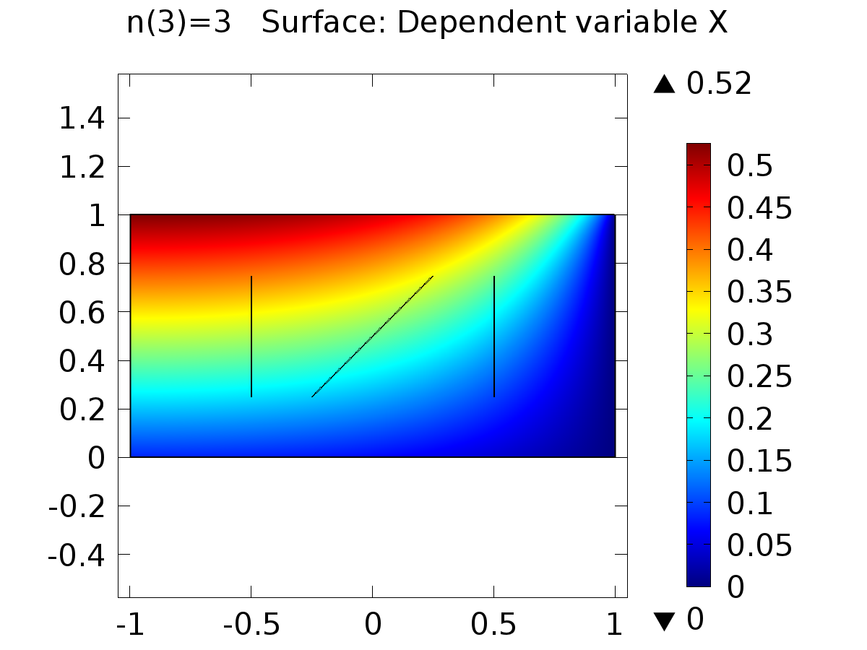

n(3)=3 Surface: Dependent variable X

* + 1. 2D Plot Group 3

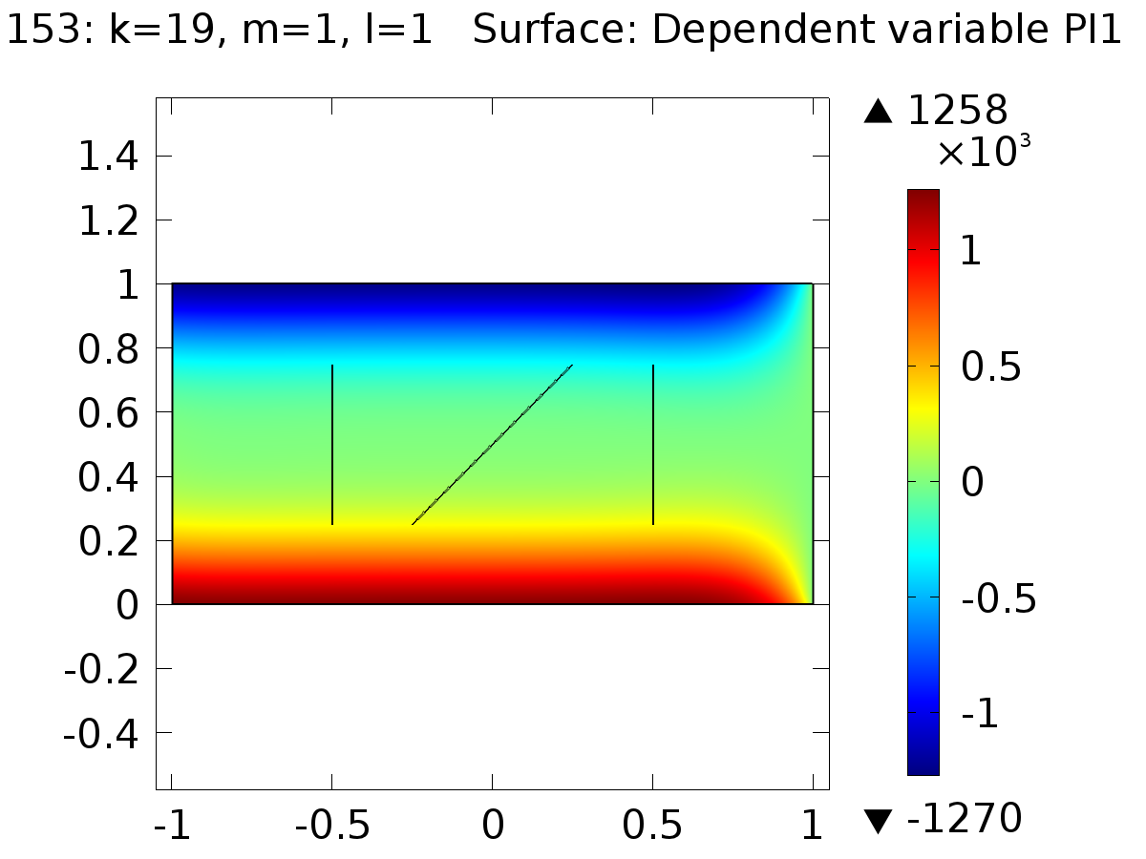

153: k=19, m=1, l=1 Surface: Dependent variable PI1

* + 1. 2D Plot Group 4

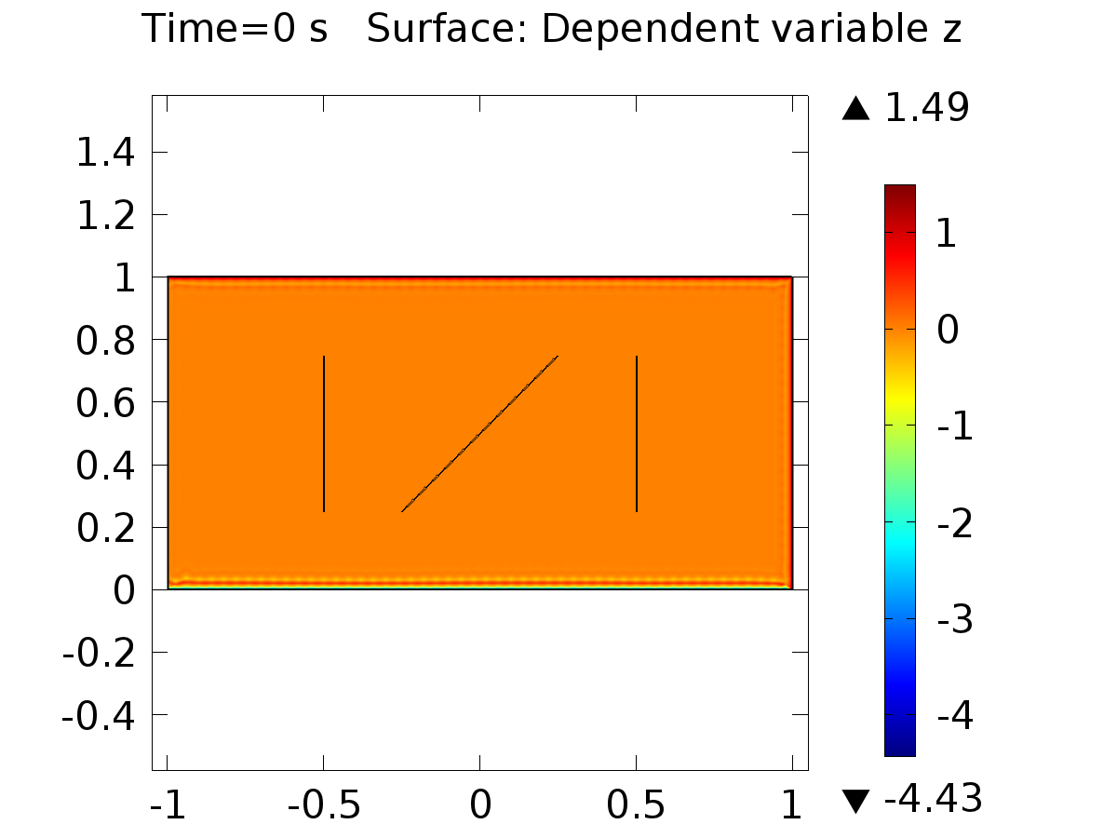

Time=0 s Surface: Dependent variable z

* + 1. 1D Plot Group 6

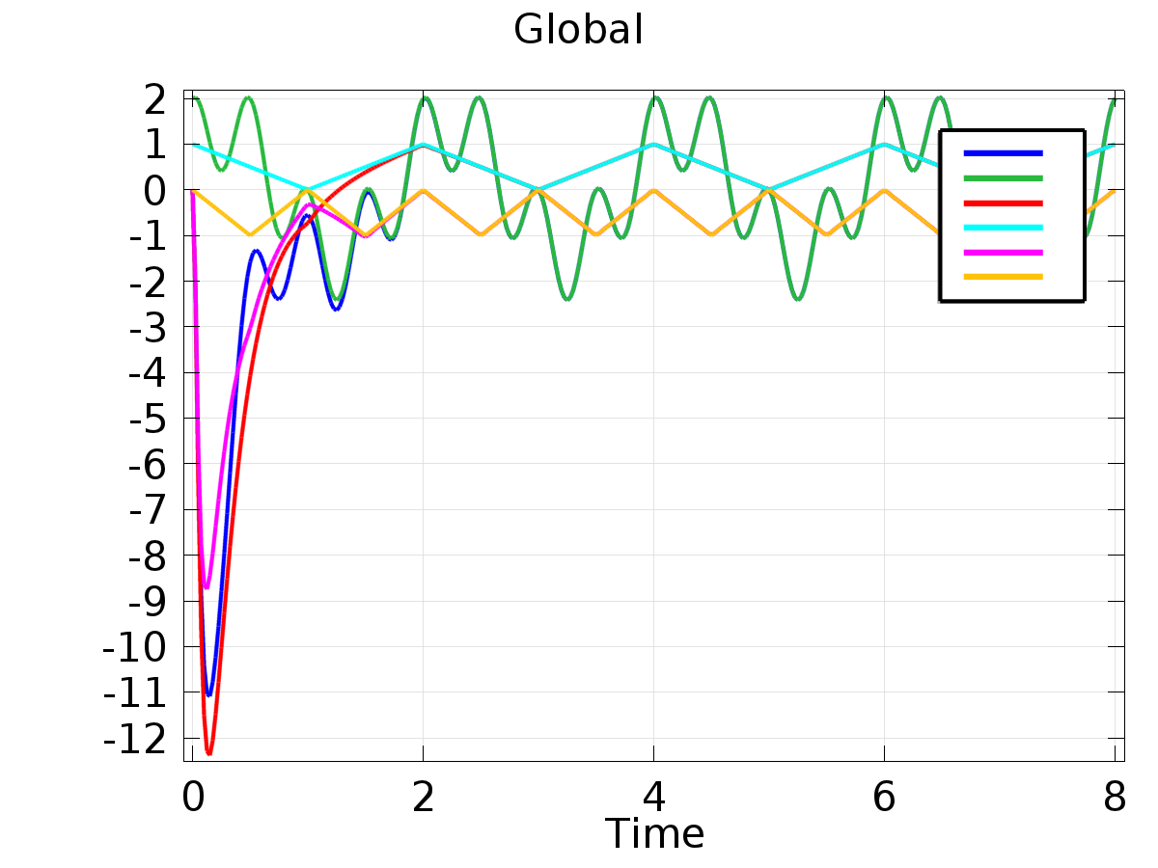

Global

* + 1. 1D Plot Group 7

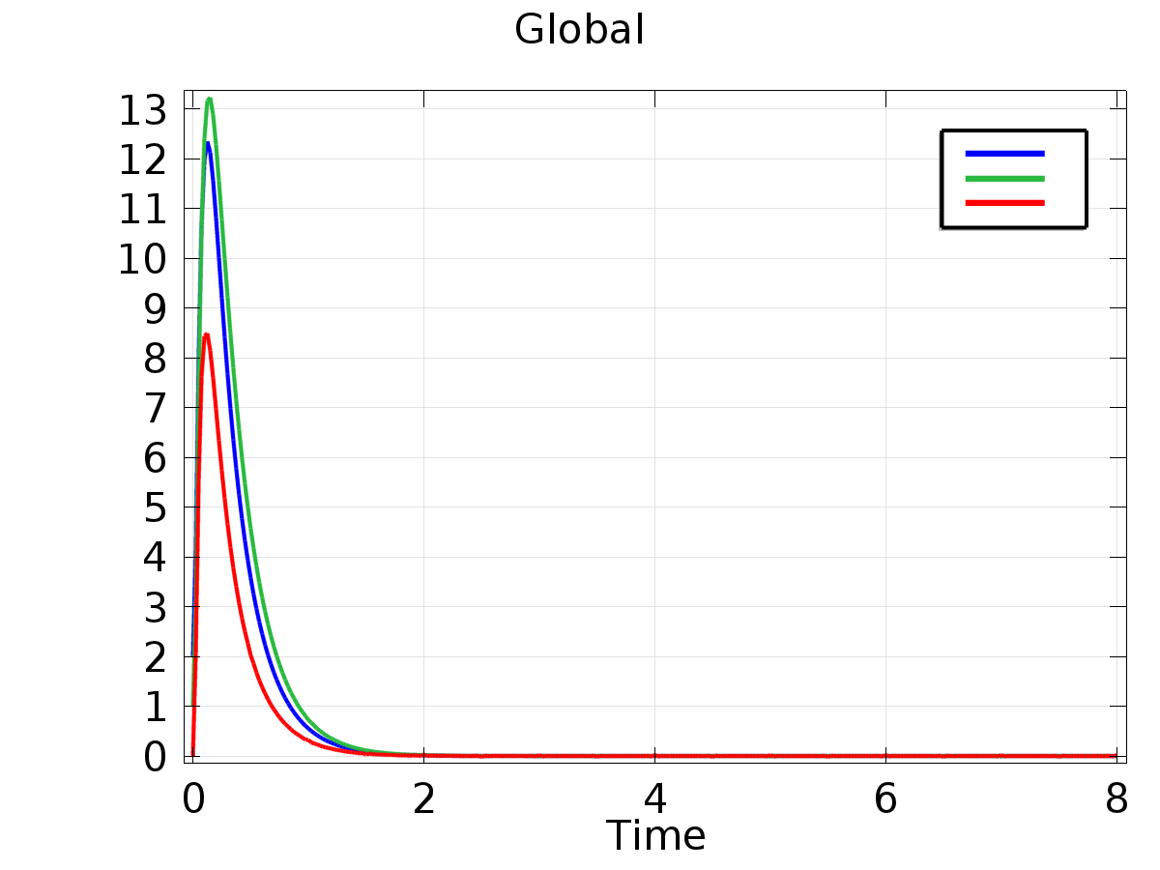

Global

* + 1. Probe 1D Plot Group 8

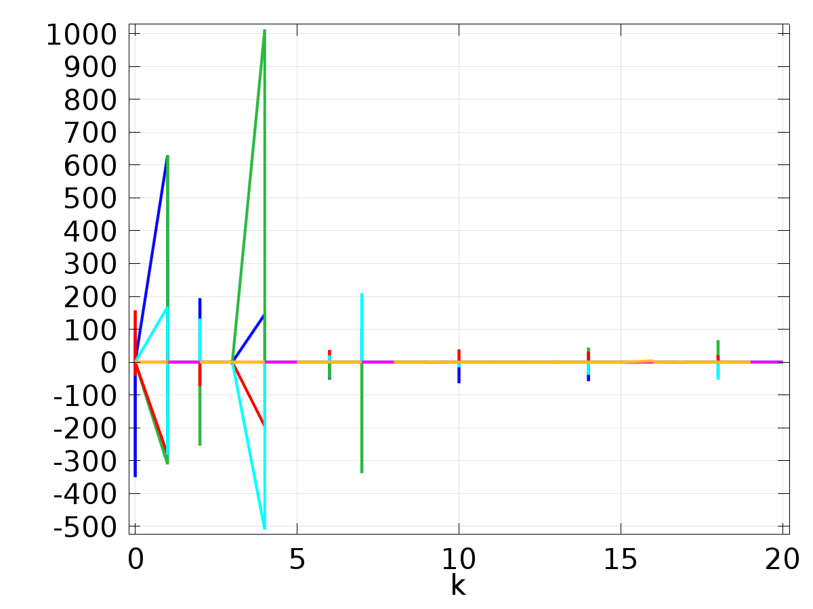

* + 1. Probe 1D Plot Group 9

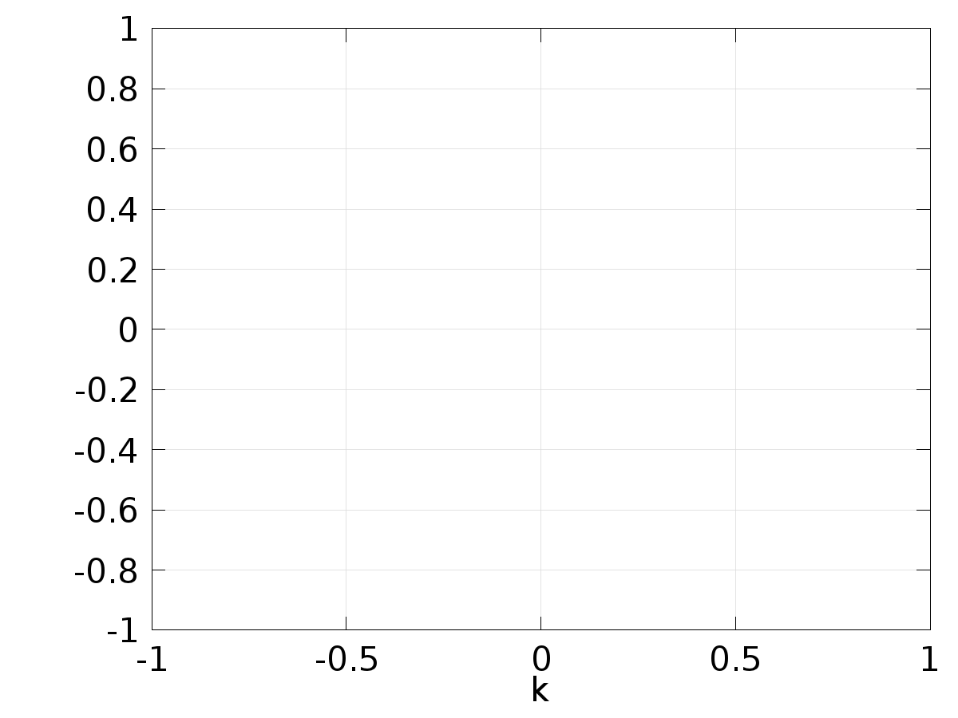

* + 1. 2D Plot Group 10

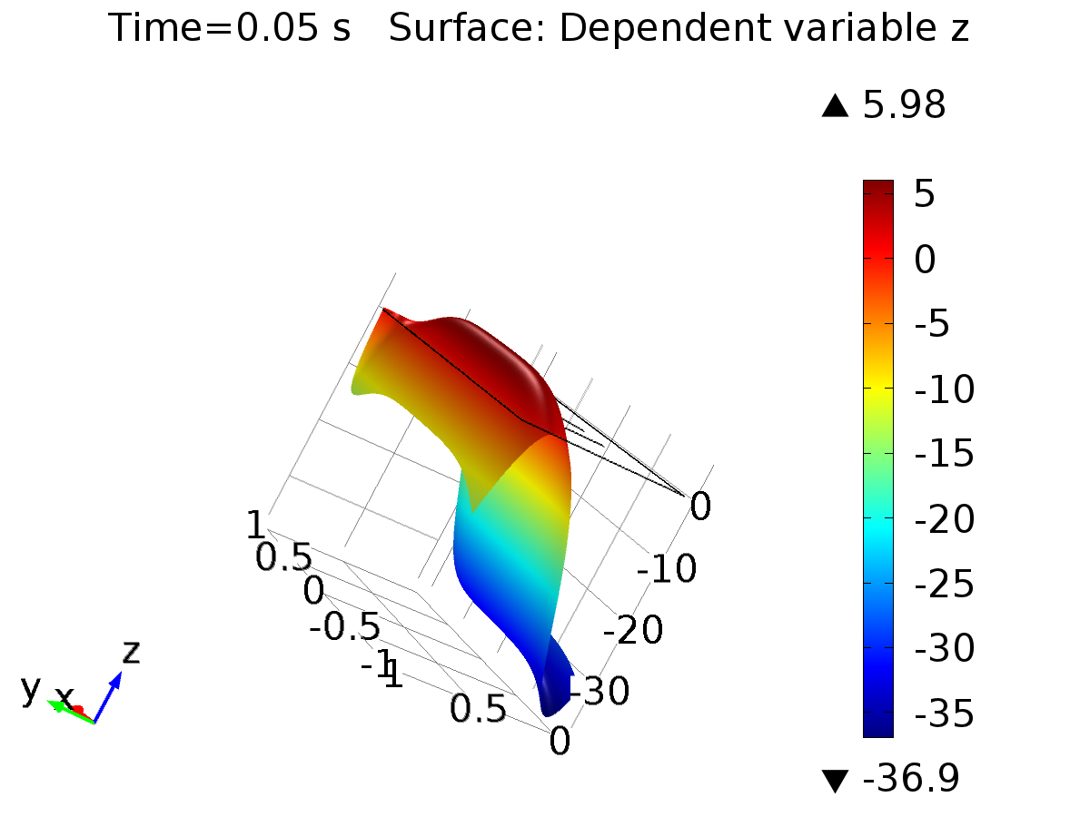

Time=0.05 s Surface: Dependent variable z

* + 1. 2D Plot Group 11

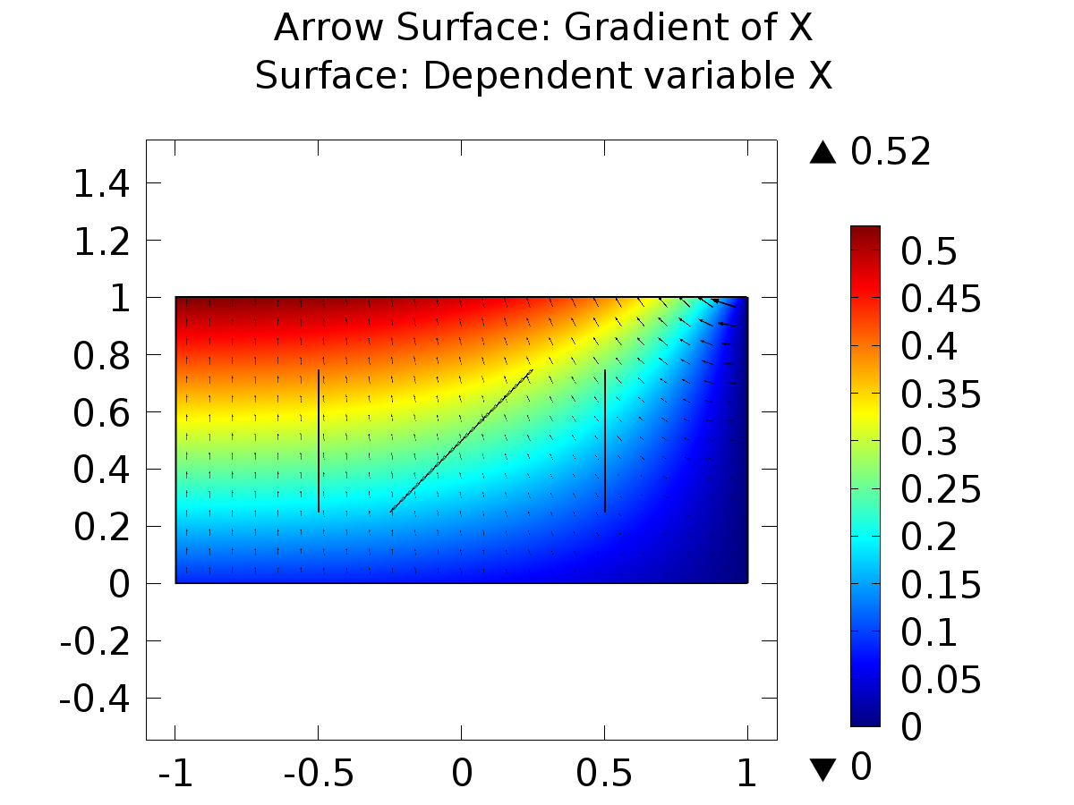

Arrow Surface: Gradient of X Surface: Dependent variable X