[](http://www.comsol.com/)

Ex3 8 heat 2d BC zdi

|  |  |
| --- | --- |
| Date | Dec 7, 2013 4:21:28 PM |

Contents

1. Global

1.1. Definitions

2. Component 1

2.1. Definitions

2.2. Geometry 1

2.3. Coefficient Form PDE

2.4. Coefficient Form PDE 2

2.5. Mesh 1

3. Study 1

3.1. Time Dependent

3.2. Solver Configurations

4. Results

4.1. Data Sets

4.2. Tables

4.3. Plot Groups

1. Global

|  |  |
| --- | --- |
| Date | Dec 6, 2013 11:23:39 AM |

Global settings

|  |  |
| --- | --- |
| Name | Ex3 8 heat 2d BC zdi.mph |
| Path | /Users/gilliam/Desktop/collect_15/research_15/geo_reg_mono_eugenio/Mono_1_15/Comsol_EX_GitHub/Chapter3/Chap3Ex8_9_2D_ZDI_Control/Ex3_8_BC_zdi/Ex3_8_heat_2d_BC_zdi.mph |
| Program | COMSOL 4.4 (Build: 150) |

Used products

|  |
| --- |
| COMSOL Multiphysics |

* 1. Definitions
     1. Parameters 1

Parameters

| **Name** | **Expression** | **Value** | **Description** |
| --- | --- | --- | --- |
| L | 2 | 2.0000 |  |
| H | 1 | 1.0000 |  |
| c | 0.1 | 0.10000 |  |
| Mr1 | 1 | 1.0000 |  |
| Mr2 | 2 | 2.0000 |  |
| Ar1 | 1 | 1.0000 |  |
| Ar2 | 2 | 2.0000 |  |
| K1 | 2 | 2.0000 |  |
| K2 | 5 | 5.0000 |  |
| Kd | 1 | 1.0000 |  |

1. Component 1

Component settings

|  |  |
| --- | --- |
| Unit system | None |

* 1. Definitions
     1. Variables

#### Variables 1

Selection

|  |  |
| --- | --- |
| Geometric entity level | Entire model |

| **Name** | **Expression** | **Description** |
| --- | --- | --- |
| yr1 | Ar1 + Mr1*cos(1/4* (x - t) ) |  |
| yr2 | Ar2 + Mr2*sin( .75*(x + t) ) |  |
| d | bump(y, H)*sin(t) |  |
| e1 | C1((yr1 - z)^2) |  |
| e2 | C2((yr2 - z)^2) |  |

* + 1. Functions

#### Analytic 1

|  |  |
| --- | --- |
| Function name | bump |
| Function type | Analytic |

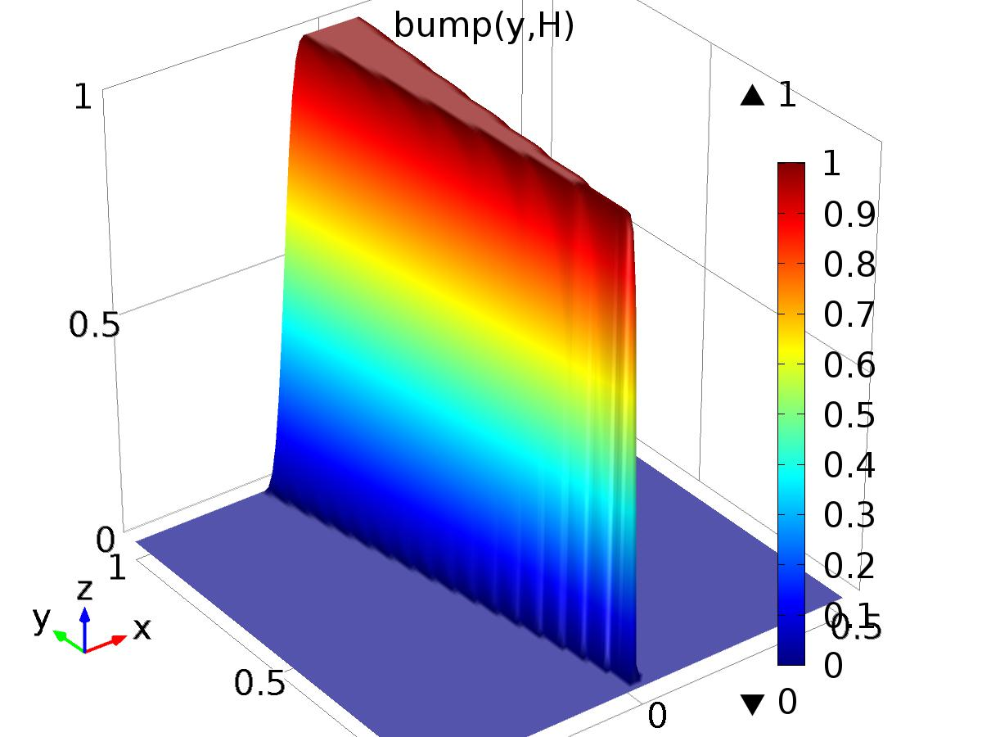

Analytic 1

Definition

| **Description** | **Value** |
| --- | --- |
| Expression | flc2hs(-y + H/8, H/16)*flc2hs(y + H/8, H/16) |
| Arguments | {y, H} |

* + 1. Component Couplings

#### Integration 1

|  |  |
| --- | --- |
| Coupling type | Integration |
| Operator name | C1 |

Source selection

|  |  |
| --- | --- |
| Geometric entity level | Boundary |
| Selection | Boundary 2 |

#### Integration 2

|  |  |
| --- | --- |
| Coupling type | Integration |
| Operator name | C2 |

Source selection

|  |  |
| --- | --- |
| Geometric entity level | Boundary |
| Selection | Boundary 3 |

* + 1. Coordinate Systems

#### Boundary System 1

|  |  |
| --- | --- |
| Coordinate system type | Boundary system |
| Tag | sys1 |

Coordinate names

| **First (t1)** | **Second (n)** | **Third (to)** |
| --- | --- | --- |
| t1 | n | to |

Settings

| **Description** | **Value** |
| --- | --- |
| Create first tangent direction from | Global Cartesian |

* 1. Geometry 1

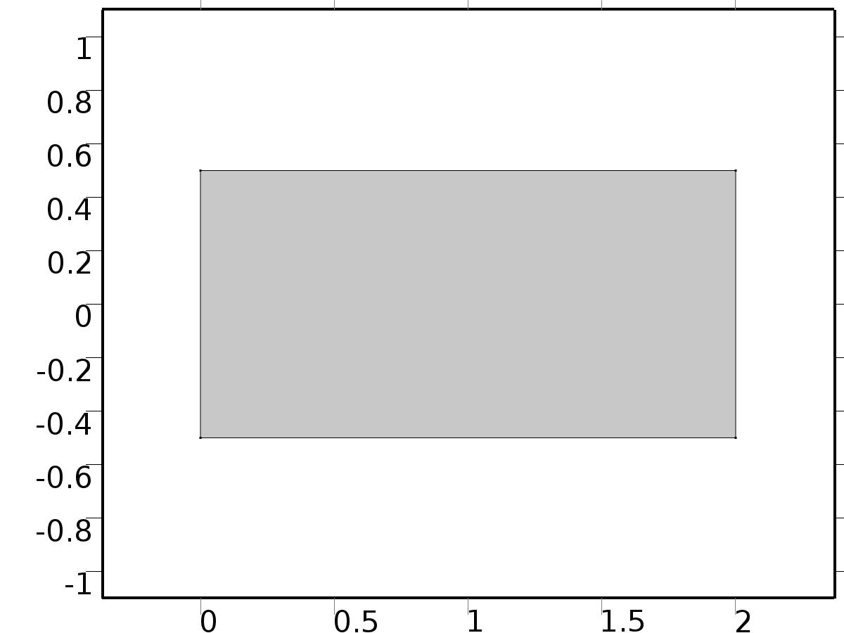

Geometry 1

Units

|  |  |
| --- | --- |
| Length unit | m |
| Angular unit | deg |

Geometry statistics

| **Description** | **Value** |
| --- | --- |
| Space dimension | 2 |
| Number of domains | 1 |
| Number of boundaries | 4 |
| Number of vertices | 4 |

* + 1. Rectangle 1 (r1)

Position

| **Description** | **Value** |
| --- | --- |
| Position | {0, -H/2} |
| Layers |  |

Size

| **Description** | **Value** |
| --- | --- |
| Width | L |
| Height | H |

* 1. Coefficient Form PDE

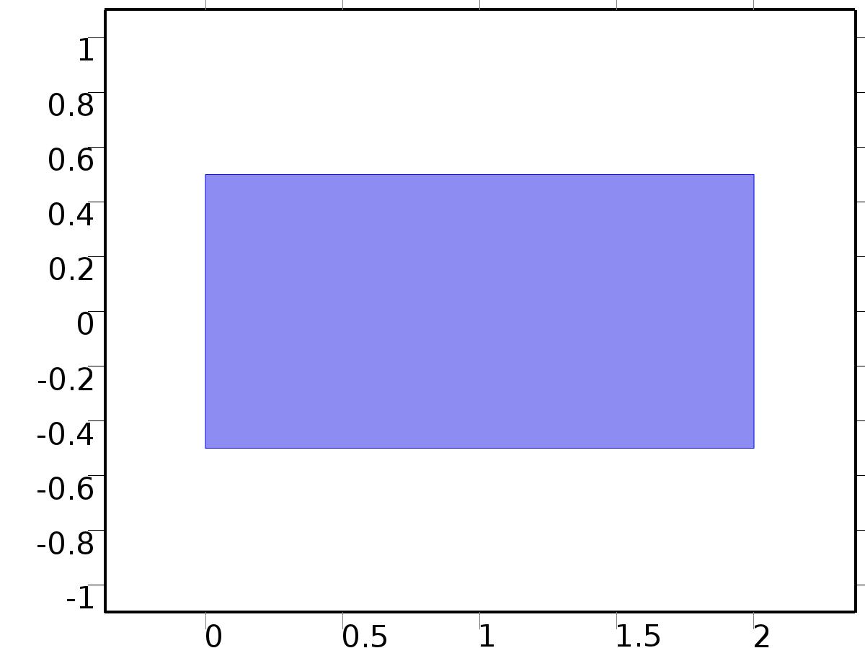

Coefficient Form PDE

Selection

|  |  |
| --- | --- |
| Geometric entity level | Domain |
| Selection | Domain 1 |

Settings

| **Description** | **Value** |
| --- | --- |
| Shape function type | Lagrange |
| Element order | Quadratic |
| Compute boundary fluxes | On |
| Apply smoothing to boundary fluxes | On |
| Value type when using splitting of complex variables | Complex |
| Dependent variable quantity | Dimensionless (1) |
| Source term quantity | None |
| Unit | m^ - 2 |

Used products

|  |
| --- |
| COMSOL Multiphysics |

Variables

| **Name** | **Expression** | **Unit** | **Description** | **Selection** |
| --- | --- | --- | --- | --- |
| c.nx | nx |  | Normal vector, x component | Boundaries 1–4 |
| c.ny | ny |  | Normal vector, y component | Boundaries 1–4 |
| c.nz | root.nz |  | Normal vector, z component | Boundaries 1–4 |
| c.nxmesh | root.nxmesh |  | Normal vector (mesh), x component | Boundaries 1–4 |
| c.nymesh | root.nymesh |  | Normal vector (mesh), y component | Boundaries 1–4 |
| c.nzmesh | root.nzmesh |  | Normal vector (mesh), z component | Boundaries 1–4 |

* + 1. Coefficient Form PDE 1



Coefficient Form PDE 1

Selection

|  |  |
| --- | --- |
| Geometric entity level | Domain |
| Selection | Domain 1 |

Equations

Settings

| **Description** | **Value** |
| --- | --- |
| Diffusion coefficient | {{c, 0}, {0, c}} |
| Absorption coefficient | 0 |
| Source term | 0 |
| Mass coefficient | 0 |
| Damping or mass coefficient | 1 |
| Conservative flux convection coefficient | {0, 0} |
| Convection coefficient | {0, 0} |
| Conservative flux source | {0, 0} |

#### Variables

| **Name** | **Expression** | **Unit** | **Description** | **Selection** |
| --- | --- | --- | --- | --- |
| domflux.Xx | -c*d(X,x) |  | Domain flux, x component | Domain 1 |
| domflux.Xy | -c*d(X,y) |  | Domain flux, y component | Domain 1 |

#### Shape functions

| **Name** | **Shape function** | **Unit** | **Description** | **Shape frame** | **Selection** |
| --- | --- | --- | --- | --- | --- |
| X | Lagrange (Quadratic) |  | Dependent variable X | Material | Domain 1 |

* + 1. Zero Flux 1

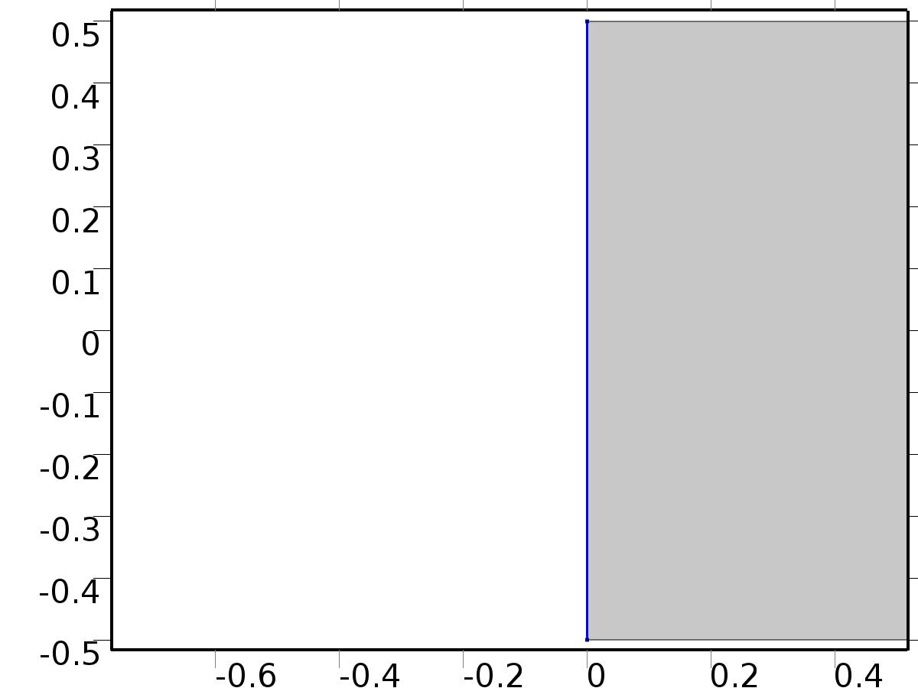

Zero Flux 1

Selection

|  |  |
| --- | --- |
| Geometric entity level | Boundary |
| Selection | Boundary 1 |

Equations

* + 1. Initial Values 1



Initial Values 1

Selection

|  |  |
| --- | --- |
| Geometric entity level | Domain |
| Selection | Domain 1 |

Settings

| **Description** | **Value** |
| --- | --- |
| Initial value for X | 0 |
| Initial time derivative of X | 0 |

* + 1. Constraint 1

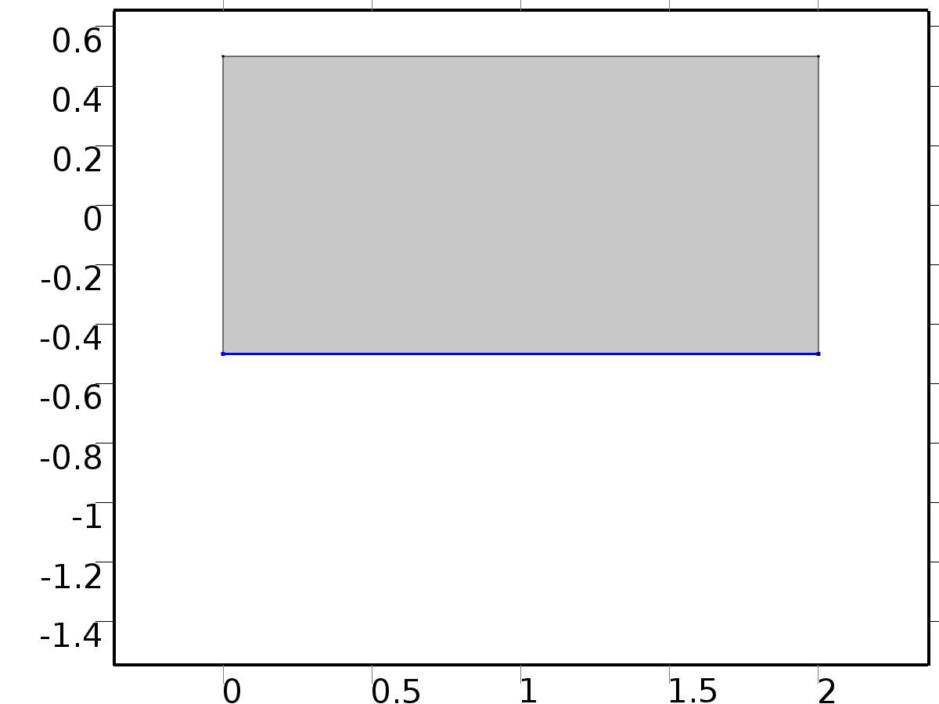

Constraint 1

Selection

|  |  |
| --- | --- |
| Geometric entity level | Boundary |
| Selection | Boundary 2 |

Equations

Settings

| **Description** | **Value** |
| --- | --- |
| Bidirectional constraint, R = 0 | X - yr1 |
| Apply reaction terms on | Individual dependent variables |
| Use weak constraints | On |

#### Variables

| **Name** | **Expression** | **Unit** | **Description** | **Selection** |
| --- | --- | --- | --- | --- |
| c.R_X | X-yr1 |  | Bidirectional constraint, R = 0 | Boundary 2 |

#### Shape functions

| **Name** | **Shape function** | **Unit** | **Description** | **Shape frame** | **Selection** |
| --- | --- | --- | --- | --- | --- |
| X_lm | Lagrange (Quadratic) |  | Lagrange multiplier for dependent variable x | Material | Boundary 2 |

#### Weak expressions

| **Weak expression** | **Integration frame** | **Selection** |
| --- | --- | --- |
| (X-yr1)*test(-X_lm) | Material | Boundary 2 |
| test(X)*X_lm | Material | Boundary 2 |

* + 1. Constraint 2

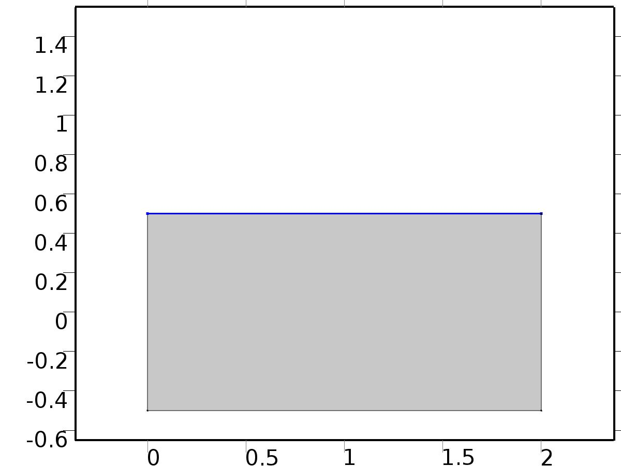

Constraint 2

Selection

|  |  |
| --- | --- |
| Geometric entity level | Boundary |
| Selection | Boundary 3 |

Equations

Settings

| **Description** | **Value** |
| --- | --- |
| Bidirectional constraint, R = 0 | X - yr2 |
| Apply reaction terms on | Individual dependent variables |
| Use weak constraints | On |

#### Variables

| **Name** | **Expression** | **Unit** | **Description** | **Selection** |
| --- | --- | --- | --- | --- |
| c.R_X | X-yr2 |  | Bidirectional constraint, R = 0 | Boundary 3 |

#### Shape functions

| **Name** | **Shape function** | **Unit** | **Description** | **Shape frame** | **Selection** |
| --- | --- | --- | --- | --- | --- |
| X_lm | Lagrange (Quadratic) |  | Lagrange multiplier for dependent variable x | Material | Boundary 3 |

#### Weak expressions

| **Weak expression** | **Integration frame** | **Selection** |
| --- | --- | --- |
| (X-yr2)*test(-X_lm) | Material | Boundary 3 |
| test(X)*X_lm | Material | Boundary 3 |

* + 1. Flux/Source 1

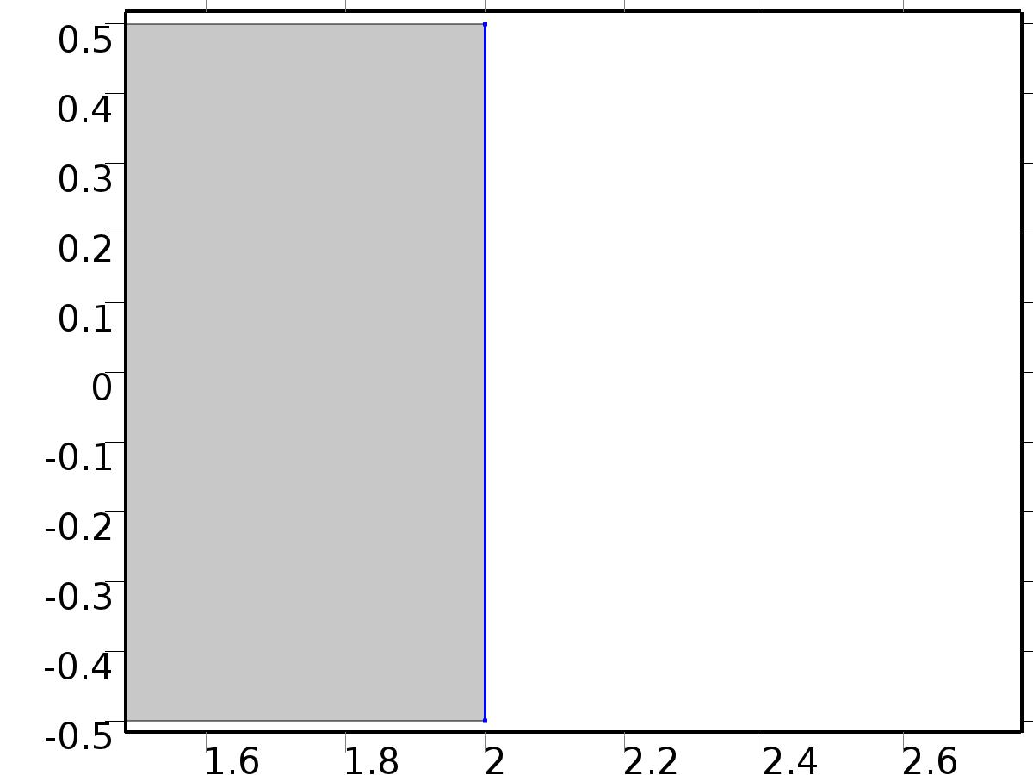

Flux/Source 1

Selection

|  |  |
| --- | --- |
| Geometric entity level | Boundary |
| Selection | Boundary 4 |

Equations

Settings

| **Description** | **Value** |
| --- | --- |
| Boundary flux/source | d |
| Boundary absorption/impedance term | Kd |

#### Variables

| **Name** | **Expression** | **Unit** | **Description** | **Selection** |
| --- | --- | --- | --- | --- |
| c.g_X | d-Kd*X |  | Boundary flux/source | Boundary 4 |

* 1. Coefficient Form PDE 2



Coefficient Form PDE 2

Selection

|  |  |
| --- | --- |
| Geometric entity level | Domain |
| Selection | Domain 1 |

Settings

| **Description** | **Value** |
| --- | --- |
| Shape function type | Lagrange |
| Element order | Quadratic |
| Compute boundary fluxes | On |
| Apply smoothing to boundary fluxes | On |
| Value type when using splitting of complex variables | Complex |
| Dependent variable quantity | Dimensionless (1) |
| Source term quantity | None |
| Unit | m^ - 2 |

Used products

|  |
| --- |
| COMSOL Multiphysics |

Variables

| **Name** | **Expression** | **Unit** | **Description** | **Selection** |
| --- | --- | --- | --- | --- |
| c2.nx | nx |  | Normal vector, x component | Boundaries 1–4 |
| c2.ny | ny |  | Normal vector, y component | Boundaries 1–4 |
| c2.nz | root.nz |  | Normal vector, z component | Boundaries 1–4 |
| c2.nxmesh | root.nxmesh |  | Normal vector (mesh), x component | Boundaries 1–4 |
| c2.nymesh | root.nymesh |  | Normal vector (mesh), y component | Boundaries 1–4 |
| c2.nzmesh | root.nzmesh |  | Normal vector (mesh), z component | Boundaries 1–4 |

* + 1. Coefficient Form PDE 1



Coefficient Form PDE 1

Selection

|  |  |
| --- | --- |
| Geometric entity level | Domain |
| Selection | Domain 1 |

Equations

Settings

| **Description** | **Value** |
| --- | --- |
| Diffusion coefficient | {{c, 0}, {0, c}} |
| Absorption coefficient | 0 |
| Source term | 0 |
| Mass coefficient | 0 |
| Damping or mass coefficient | 1 |
| Conservative flux convection coefficient | {0, 0} |
| Convection coefficient | {0, 0} |
| Conservative flux source | {0, 0} |

#### Variables

| **Name** | **Expression** | **Unit** | **Description** | **Selection** |
| --- | --- | --- | --- | --- |
| domflux.zx | -c*d(z,x) |  | Domain flux, x component | Domain 1 |
| domflux.zy | -c*d(z,y) |  | Domain flux, y component | Domain 1 |

#### Shape functions

| **Name** | **Shape function** | **Unit** | **Description** | **Shape frame** | **Selection** |
| --- | --- | --- | --- | --- | --- |
| z | Lagrange (Quadratic) |  | Dependent variable z | Material | Domain 1 |

* + 1. Zero Flux 1



Zero Flux 1

Selection

|  |  |
| --- | --- |
| Geometric entity level | Boundary |
| Selection | Boundary 1 |

Equations

* + 1. Initial Values 1



Initial Values 1

Selection

|  |  |
| --- | --- |
| Geometric entity level | Domain |
| Selection | Domain 1 |

Settings

| **Description** | **Value** |
| --- | --- |
| Initial value for z | x*y |
| Initial time derivative of z | 0 |

* + 1. Flux/Source 1



Flux/Source 1

Selection

|  |  |
| --- | --- |
| Geometric entity level | Boundary |
| Selection | Boundary 2 |

Equations

Settings

| **Description** | **Value** |
| --- | --- |
| Boundary flux/source | X_lm*flc2hs(t - 0.1, 0.1) |
| Boundary absorption/impedance term | 0 |

#### Variables

| **Name** | **Expression** | **Unit** | **Description** | **Selection** |
| --- | --- | --- | --- | --- |
| c2.g_z | X_lm*flc2hs(-0.1+t,0.1) |  | Boundary flux/source | Boundary 2 |

* + 1. Flux/Source 2



Flux/Source 2

Selection

|  |  |
| --- | --- |
| Geometric entity level | Boundary |
| Selection | Boundary 3 |

Equations

Settings

| **Description** | **Value** |
| --- | --- |
| Boundary flux/source | X_lm*flc2hs(t - 0.1, 0.1) |
| Boundary absorption/impedance term | 0 |

#### Variables

| **Name** | **Expression** | **Unit** | **Description** | **Selection** |
| --- | --- | --- | --- | --- |
| c2.g_z | X_lm*flc2hs(-0.1+t,0.1) |  | Boundary flux/source | Boundary 3 |

* + 1. Flux/Source 3



Flux/Source 3

Selection

|  |  |
| --- | --- |
| Geometric entity level | Boundary |
| Selection | Boundary 4 |

Equations

Settings

| **Description** | **Value** |
| --- | --- |
| Boundary flux/source | d*flc2hs(t - 0.1, 0.1) |
| Boundary absorption/impedance term | Kd |

#### Variables

| **Name** | **Expression** | **Unit** | **Description** | **Selection** |
| --- | --- | --- | --- | --- |
| c2.g_z | d*flc2hs(-0.1+t,0.1)-Kd*z |  | Boundary flux/source | Boundary 4 |

* 1. Mesh 1

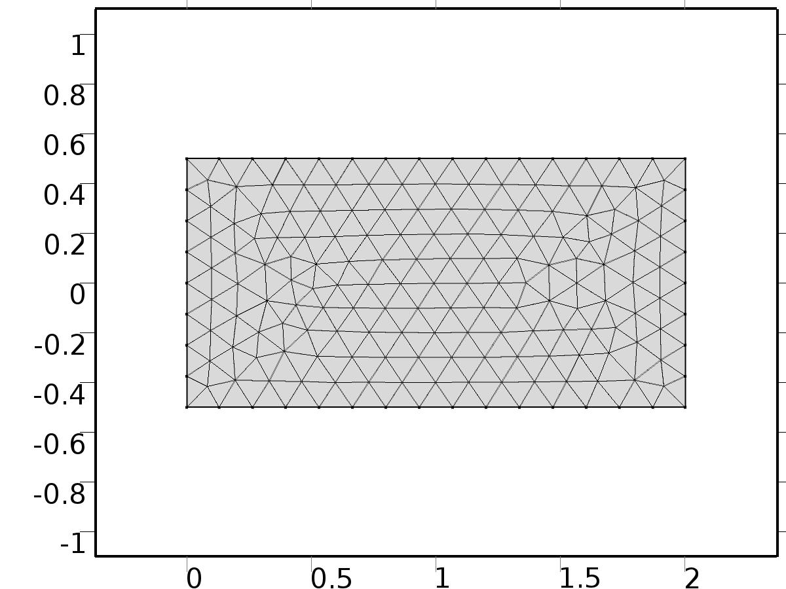

Mesh 1

* + 1. Size (size)

Settings

| **Description** | **Value** |
| --- | --- |
| Maximum element size | 0.134 |
| Minimum element size | 6.0E-4 |
| Curvature factor | 0.3 |
| Maximum element growth rate | 1.3 |

* + 1. Free Triangular 1 (ftri1)

Selection

|  |  |
| --- | --- |
| Geometric entity level | Remaining |

1. Study 1
   1. Time Dependent

Study settings

| **Description** | **Value** |
| --- | --- |
| Include geometric nonlinearity | Off |

| **Times** | **Unit** |
| --- | --- |
| range(-20,0.1,100) | s |

Physics and variables selection

| **Physics interface** | **Discretization** |
| --- | --- |
| Coefficient Form PDE (c) | physics |
| Coefficient Form PDE 2 (c2) | physics |

Mesh selection

| **Geometry** | **Mesh** |
| --- | --- |
| Geometry 1 (geom1) | mesh1 |

* 1. Solver Configurations
     1. Solver 1

#### Compile Equations: Time Dependent (st1)

Study and step

| **Description** | **Value** |
| --- | --- |
| Use study | Study 1 |
| Use study step | Time Dependent |

#### Dependent Variables 1 (v1)

General

| **Description** | **Value** |
| --- | --- |
| Defined by study step | Time Dependent |
| Constant |  |

Initial values of variables solved for

| **Description** | **Value** |
| --- | --- |
| Solution | Zero |

Values of variables not solved for

| **Description** | **Value** |
| --- | --- |
| Solution | Zero |

##### Lagrange multiplier for dependent variable x (comp1.X_lm) (comp1_X_lm)

General

| **Description** | **Value** |
| --- | --- |
| Field components | comp1.X_lm |

##### Dependent variable z (comp1.z) (comp1_z)

General

| **Description** | **Value** |
| --- | --- |
| Field components | comp1.z |

##### Dependent variable X (comp1.X) (comp1_X)

General

| **Description** | **Value** |
| --- | --- |
| Field components | comp1.X |

#### Time-Dependent Solver 1 (t1)

General

| **Description** | **Value** |
| --- | --- |
| Defined by study step | Time Dependent |
| Time | {-20, -19.9, -19.8, -19.7, -19.6, -19.5, -19.4, -19.3, -19.2, -19.1, -19, -18.9, -18.8, -18.7, -18.6, -18.5, -18.4, -18.3, -18.2, -18.1, -18, -17.9, -17.8, -17.7, -17.6, -17.5, -17.4, -17.3, -17.2, -17.1, -17, -16.9, -16.8, -16.7, -16.6, -16.5, -16.4, -16.3, -16.2, -16.1, -16, -15.899999999999999, -15.8, -15.7, -15.6, -15.5, -15.399999999999999, -15.3, -15.2, -15.1, -15, -14.899999999999999, -14.8, -14.7, -14.6, -14.5, -14.399999999999999, -14.3, -14.2, -14.1, -14, -13.899999999999999, -13.8, -13.7, -13.6, -13.5, -13.399999999999999, -13.3, -13.2, -13.1, -13, -12.899999999999999, -12.8, -12.7, -12.6, -12.5, -12.399999999999999, -12.3, -12.2, -12.1, -12, -11.9, -11.799999999999999, -11.7, -11.6, -11.5, -11.4, -11.299999999999999, -11.2, -11.1, -11, -10.9, -10.799999999999999, -10.7, -10.6, -10.5, -10.399999999999999, -10.299999999999999, -10.2, -10.1, -10, -9.899999999999999, -9.799999999999999, -9.7, -9.6, -9.5, -9.399999999999999, -9.299999999999999, -9.2, -9.1, -9, -8.899999999999999, -8.799999999999999, -8.7, -8.6, -8.5, -8.399999999999999, -8.299999999999999, -8.2, -8.1, -8, -7.899999999999999, -7.799999999999999, -7.699999999999999, -7.6, -7.5, -7.399999999999999, -7.299999999999999, -7.199999999999999, -7.1, -7, -6.899999999999999, -6.799999999999999, -6.699999999999999, -6.6, -6.5, -6.399999999999999, -6.299999999999999, -6.199999999999999, -6.1, -6, -5.899999999999999, -5.799999999999999, -5.699999999999999, -5.6, -5.5, -5.399999999999999, -5.299999999999999, -5.199999999999999, -5.1, -5, -4.899999999999999, -4.799999999999999, -4.699999999999999, -4.6, -4.5, -4.399999999999999, -4.299999999999999, -4.199999999999999, -4.1, -4, -3.8999999999999986, -3.8000000000000007, -3.6999999999999993, -3.599999999999998, -3.5, -3.3999999999999986, -3.3000000000000007, -3.1999999999999993, -3.099999999999998, -3, -2.8999999999999986, -2.8000000000000007, -2.6999999999999993, -2.599999999999998, -2.5, -2.3999999999999986, -2.3000000000000007, -2.1999999999999993, -2.099999999999998, -2, -1.8999999999999986, -1.8000000000000007, -1.6999999999999993, -1.5999999999999979, -1.5, -1.3999999999999986, -1.3000000000000007, -1.1999999999999993, -1.0999999999999979, -1, -0.8999999999999986, -0.7999999999999972, -0.6999999999999993, -0.5999999999999979, -0.5, -0.3999999999999986, -0.29999999999999716, -0.1999999999999993, -0.09999999999999787, 0, 0.10000000000000142, 0.20000000000000284, 0.3000000000000007, 0.40000000000000213, 0.5, 0.6000000000000014, 0.7000000000000028, 0.8000000000000007, 0.9000000000000021, 1, 1.1000000000000014, 1.2000000000000028, 1.3000000000000007, 1.4000000000000021, 1.5, 1.6000000000000014, 1.7000000000000028, 1.8000000000000007, 1.9000000000000021, 2, 2.1000000000000014, 2.200000000000003, 2.3000000000000007, 2.400000000000002, 2.5, 2.6000000000000014, 2.700000000000003, 2.8000000000000007, 2.900000000000002, 3, 3.1000000000000014, 3.200000000000003, 3.3000000000000007, 3.400000000000002, 3.5, 3.6000000000000014, 3.700000000000003, 3.8000000000000007, 3.900000000000002, 4, 4.100000000000001, 4.200000000000003, 4.300000000000001, 4.400000000000002, 4.5, 4.600000000000001, 4.700000000000003, 4.800000000000001, 4.900000000000002, 5, 5.100000000000001, 5.200000000000003, 5.300000000000001, 5.400000000000002, 5.5, 5.600000000000001, 5.700000000000003, 5.800000000000001, 5.900000000000002, 6, 6.100000000000001, 6.200000000000003, 6.300000000000001, 6.400000000000002, 6.5, 6.600000000000001, 6.700000000000003, 6.800000000000001, 6.900000000000002, 7, 7.100000000000001, 7.200000000000003, 7.300000000000001, 7.400000000000002, 7.5, 7.600000000000001, 7.700000000000003, 7.800000000000001, 7.900000000000002, 8, 8.100000000000001, 8.200000000000003, 8.3, 8.400000000000002, 8.5, 8.600000000000001, 8.700000000000003, 8.8, 8.900000000000002, 9, 9.100000000000001, 9.200000000000003, 9.3, 9.400000000000002, 9.5, 9.600000000000001, 9.700000000000003, 9.8, 9.900000000000002, 10, 10.100000000000001, 10.200000000000003, 10.3, 10.400000000000002, 10.5, 10.600000000000001, 10.700000000000003, 10.8, 10.900000000000002, 11, 11.100000000000001, 11.200000000000003, 11.3, 11.400000000000002, 11.5, 11.600000000000001, 11.700000000000003, 11.8, 11.900000000000002, 12, 12.100000000000001, 12.200000000000003, 12.300000000000004, 12.399999999999999, 12.5, 12.600000000000001, 12.700000000000003, 12.800000000000004, 12.899999999999999, 13, 13.100000000000001, 13.200000000000003, 13.300000000000004, 13.399999999999999, 13.5, 13.600000000000001, 13.700000000000003, 13.800000000000004, 13.899999999999999, 14, 14.100000000000001, 14.200000000000003, 14.300000000000004, 14.399999999999999, 14.5, 14.600000000000001, 14.700000000000003, 14.800000000000004, 14.899999999999999, 15, 15.100000000000001, 15.200000000000003, 15.300000000000004, 15.399999999999999, 15.5, 15.600000000000001, 15.700000000000003, 15.800000000000004, 15.899999999999999, 16, 16.1, 16.200000000000003, 16.300000000000004, 16.4, 16.5, 16.6, 16.700000000000003, 16.800000000000004, 16.9, 17, 17.1, 17.200000000000003, 17.300000000000004, 17.4, 17.5, 17.6, 17.700000000000003, 17.800000000000004, 17.9, 18, 18.1, 18.200000000000003, 18.300000000000004, 18.400000000000006, 18.5, 18.6, 18.700000000000003, 18.800000000000004, 18.900000000000006, 19, 19.1, 19.200000000000003, 19.300000000000004, 19.400000000000006, 19.5, 19.6, 19.700000000000003, 19.800000000000004, 19.900000000000006, 20, 20.1, 20.200000000000003, 20.300000000000004, 20.400000000000006, 20.5, 20.6, 20.700000000000003, 20.800000000000004, 20.900000000000006, 21, 21.1, 21.200000000000003, 21.300000000000004, 21.400000000000006, 21.5, 21.6, 21.700000000000003, 21.800000000000004, 21.900000000000006, 22, 22.1, 22.200000000000003, 22.300000000000004, 22.400000000000006, 22.5, 22.6, 22.700000000000003, 22.800000000000004, 22.900000000000006, 23, 23.1, 23.200000000000003, 23.300000000000004, 23.400000000000006, 23.5, 23.6, 23.700000000000003, 23.800000000000004, 23.900000000000006, 24, 24.1, 24.200000000000003, 24.300000000000004, 24.400000000000006, 24.5, 24.6, 24.700000000000003, 24.800000000000004, 24.900000000000006, 25, 25.1, 25.200000000000003, 25.300000000000004, 25.400000000000006, 25.5, 25.6, 25.700000000000003, 25.800000000000004, 25.900000000000006, 26, 26.1, 26.200000000000003, 26.300000000000004, 26.400000000000006, 26.5, 26.6, 26.700000000000003, 26.800000000000004, 26.900000000000006, 27, 27.1, 27.200000000000003, 27.300000000000004, 27.400000000000006, 27.5, 27.6, 27.700000000000003, 27.800000000000004, 27.900000000000006, 28, 28.1, 28.200000000000003, 28.300000000000004, 28.400000000000006, 28.5, 28.6, 28.700000000000003, 28.800000000000004, 28.900000000000006, 29, 29.1, 29.200000000000003, 29.300000000000004, 29.400000000000006, 29.5, 29.6, 29.700000000000003, 29.800000000000004, 29.900000000000006, 30, 30.1, 30.200000000000003, 30.300000000000004, 30.400000000000006, 30.5, 30.6, 30.700000000000003, 30.800000000000004, 30.900000000000006, 31, 31.1, 31.200000000000003, 31.300000000000004, 31.400000000000006, 31.5, 31.6, 31.700000000000003, 31.800000000000004, 31.900000000000006, 32, 32.1, 32.2, 32.300000000000004, 32.400000000000006, 32.5, 32.6, 32.7, 32.800000000000004, 32.900000000000006, 33, 33.1, 33.2, 33.300000000000004, 33.400000000000006, 33.5, 33.6, 33.7, 33.800000000000004, 33.900000000000006, 34, 34.1, 34.2, 34.300000000000004, 34.400000000000006, 34.5, 34.6, 34.7, 34.800000000000004, 34.900000000000006, 35, 35.1, 35.2, 35.300000000000004, 35.400000000000006, 35.5, 35.6, 35.7, 35.800000000000004, 35.900000000000006, 36, 36.1, 36.2, 36.300000000000004, 36.400000000000006, 36.5, 36.6, 36.7, 36.800000000000004, 36.900000000000006, 37, 37.1, 37.2, 37.300000000000004, 37.400000000000006, 37.5, 37.6, 37.7, 37.800000000000004, 37.900000000000006, 38, 38.1, 38.2, 38.300000000000004, 38.400000000000006, 38.5, 38.6, 38.7, 38.800000000000004, 38.900000000000006, 39, 39.1, 39.2, 39.300000000000004, 39.400000000000006, 39.5, 39.6, 39.7, 39.800000000000004, 39.900000000000006, 40, 40.1, 40.2, 40.300000000000004, 40.400000000000006, 40.5, 40.6, 40.7, 40.800000000000004, 40.900000000000006, 41, 41.1, 41.2, 41.300000000000004, 41.400000000000006, 41.5, 41.6, 41.7, 41.800000000000004, 41.900000000000006, 42, 42.1, 42.2, 42.300000000000004, 42.400000000000006, 42.5, 42.6, 42.7, 42.800000000000004, 42.900000000000006, 43, 43.1, 43.2, 43.300000000000004, 43.400000000000006, 43.5, 43.6, 43.7, 43.800000000000004, 43.900000000000006, 44, 44.10000000000001, 44.2, 44.3, 44.400000000000006, 44.5, 44.60000000000001, 44.7, 44.8, 44.900000000000006, 45, 45.10000000000001, 45.2, 45.3, 45.400000000000006, 45.5, 45.60000000000001, 45.7, 45.8, 45.900000000000006, 46, 46.10000000000001, 46.2, 46.3, 46.400000000000006, 46.5, 46.60000000000001, 46.7, 46.8, 46.900000000000006, 47, 47.10000000000001, 47.2, 47.3, 47.400000000000006, 47.5, 47.60000000000001, 47.7, 47.8, 47.900000000000006, 48, 48.10000000000001, 48.2, 48.3, 48.400000000000006, 48.5, 48.60000000000001, 48.7, 48.8, 48.900000000000006, 49, 49.10000000000001, 49.2, 49.3, 49.400000000000006, 49.5, 49.60000000000001, 49.7, 49.8, 49.900000000000006, 50, 50.10000000000001, 50.2, 50.3, 50.400000000000006, 50.5, 50.60000000000001, 50.7, 50.8, 50.900000000000006, 51, 51.10000000000001, 51.2, 51.3, 51.400000000000006, 51.5, 51.60000000000001, 51.7, 51.8, 51.900000000000006, 52, 52.10000000000001, 52.2, 52.3, 52.400000000000006, 52.5, 52.60000000000001, 52.7, 52.8, 52.900000000000006, 53, 53.10000000000001, 53.2, 53.3, 53.400000000000006, 53.5, 53.60000000000001, 53.7, 53.8, 53.900000000000006, 54, 54.10000000000001, 54.2, 54.3, 54.400000000000006, 54.5, 54.60000000000001, 54.7, 54.8, 54.900000000000006, 55, 55.10000000000001, 55.2, 55.3, 55.400000000000006, 55.5, 55.60000000000001, 55.7, 55.8, 55.900000000000006, 56, 56.10000000000001, 56.2, 56.3, 56.400000000000006, 56.5, 56.60000000000001, 56.7, 56.80000000000001, 56.900000000000006, 57, 57.10000000000001, 57.2, 57.30000000000001, 57.400000000000006, 57.5, 57.60000000000001, 57.7, 57.80000000000001, 57.900000000000006, 58, 58.10000000000001, 58.2, 58.30000000000001, 58.400000000000006, 58.5, 58.60000000000001, 58.7, 58.80000000000001, 58.900000000000006, 59, 59.10000000000001, 59.2, 59.30000000000001, 59.400000000000006, 59.5, 59.60000000000001, 59.7, 59.80000000000001, 59.900000000000006, 60, 60.10000000000001, 60.2, 60.30000000000001, 60.400000000000006, 60.5, 60.60000000000001, 60.7, 60.80000000000001, 60.900000000000006, 61, 61.10000000000001, 61.2, 61.30000000000001, 61.400000000000006, 61.5, 61.60000000000001, 61.7, 61.80000000000001, 61.900000000000006, 62, 62.10000000000001, 62.2, 62.30000000000001, 62.400000000000006, 62.5, 62.60000000000001, 62.7, 62.80000000000001, 62.900000000000006, 63, 63.10000000000001, 63.2, 63.30000000000001, 63.400000000000006, 63.5, 63.60000000000001, 63.7, 63.80000000000001, 63.900000000000006, 64, 64.10000000000001, 64.2, 64.30000000000001, 64.4, 64.5, 64.60000000000001, 64.7, 64.80000000000001, 64.9, 65, 65.10000000000001, 65.2, 65.30000000000001, 65.4, 65.5, 65.60000000000001, 65.7, 65.80000000000001, 65.9, 66, 66.10000000000001, 66.2, 66.30000000000001, 66.4, 66.5, 66.60000000000001, 66.7, 66.80000000000001, 66.9, 67, 67.10000000000001, 67.2, 67.30000000000001, 67.4, 67.5, 67.60000000000001, 67.7, 67.80000000000001, 67.9, 68, 68.10000000000001, 68.2, 68.30000000000001, 68.4, 68.5, 68.60000000000001, 68.7, 68.80000000000001, 68.9, 69, 69.10000000000001, 69.2, 69.30000000000001, 69.4, 69.5, 69.60000000000001, 69.7, 69.80000000000001, 69.9, 70, 70.10000000000001, 70.2, 70.30000000000001, 70.4, 70.5, 70.60000000000001, 70.7, 70.80000000000001, 70.9, 71, 71.10000000000001, 71.2, 71.30000000000001, 71.4, 71.5, 71.60000000000001, 71.7, 71.80000000000001, 71.9, 72, 72.10000000000001, 72.2, 72.30000000000001, 72.4, 72.5, 72.60000000000001, 72.7, 72.80000000000001, 72.9, 73, 73.10000000000001, 73.2, 73.30000000000001, 73.4, 73.5, 73.60000000000001, 73.7, 73.80000000000001, 73.9, 74, 74.10000000000001, 74.2, 74.30000000000001, 74.4, 74.5, 74.60000000000001, 74.7, 74.80000000000001, 74.9, 75, 75.10000000000001, 75.2, 75.30000000000001, 75.4, 75.5, 75.60000000000001, 75.7, 75.80000000000001, 75.9, 76, 76.10000000000001, 76.2, 76.30000000000001, 76.4, 76.5, 76.60000000000001, 76.7, 76.80000000000001, 76.9, 77, 77.10000000000001, 77.2, 77.30000000000001, 77.4, 77.5, 77.60000000000001, 77.7, 77.80000000000001, 77.9, 78, 78.10000000000001, 78.2, 78.30000000000001, 78.4, 78.5, 78.60000000000001, 78.7, 78.80000000000001, 78.9, 79, 79.10000000000001, 79.2, 79.30000000000001, 79.4, 79.5, 79.60000000000001, 79.7, 79.80000000000001, 79.9, 80, 80.10000000000001, 80.2, 80.30000000000001, 80.4, 80.5, 80.60000000000001, 80.7, 80.80000000000001, 80.9, 81, 81.10000000000001, 81.2, 81.30000000000001, 81.4, 81.5, 81.60000000000001, 81.7, 81.80000000000001, 81.9, 82, 82.10000000000001, 82.2, 82.30000000000001, 82.4, 82.5, 82.60000000000001, 82.7, 82.80000000000001, 82.9, 83, 83.10000000000001, 83.2, 83.30000000000001, 83.4, 83.5, 83.60000000000001, 83.7, 83.80000000000001, 83.9, 84, 84.10000000000001, 84.2, 84.30000000000001, 84.4, 84.5, 84.60000000000001, 84.7, 84.80000000000001, 84.9, 85, 85.10000000000001, 85.2, 85.30000000000001, 85.4, 85.5, 85.60000000000001, 85.7, 85.80000000000001, 85.9, 86, 86.10000000000001, 86.2, 86.30000000000001, 86.4, 86.5, 86.60000000000001, 86.7, 86.80000000000001, 86.9, 87, 87.10000000000001, 87.2, 87.30000000000001, 87.4, 87.5, 87.60000000000001, 87.7, 87.80000000000001, 87.9, 88, 88.10000000000001, 88.2, 88.30000000000001, 88.4, 88.5, 88.60000000000001, 88.7, 88.80000000000001, 88.9, 89, 89.10000000000001, 89.2, 89.30000000000001, 89.4, 89.5, 89.60000000000001, 89.7, 89.80000000000001, 89.9, 90, 90.10000000000001, 90.2, 90.30000000000001, 90.4, 90.5, 90.60000000000001, 90.7, 90.80000000000001, 90.9, 91, 91.10000000000001, 91.2, 91.30000000000001, 91.4, 91.5, 91.60000000000001, 91.7, 91.80000000000001, 91.9, 92, 92.10000000000001, 92.2, 92.30000000000001, 92.4, 92.5, 92.60000000000001, 92.7, 92.80000000000001, 92.9, 93, 93.10000000000001, 93.2, 93.30000000000001, 93.4, 93.5, 93.60000000000001, 93.7, 93.80000000000001, 93.9, 94, 94.10000000000001, 94.2, 94.30000000000001, 94.4, 94.5, 94.60000000000001, 94.7, 94.80000000000001, 94.9, 95, 95.10000000000001, 95.2, 95.30000000000001, 95.4, 95.5, 95.60000000000001, 95.7, 95.80000000000001, 95.9, 96, 96.10000000000001, 96.2, 96.30000000000001, 96.4, 96.5, 96.60000000000001, 96.7, 96.80000000000001, 96.9, 97, 97.10000000000001, 97.2, 97.30000000000001, 97.4, 97.5, 97.60000000000001, 97.7, 97.80000000000001, 97.9, 98, 98.10000000000001, 98.2, 98.30000000000001, 98.4, 98.5, 98.60000000000001, 98.7, 98.80000000000001, 98.9, 99, 99.10000000000001, 99.2, 99.30000000000001, 99.4, 99.5, 99.60000000000001, 99.7, 99.80000000000001, 99.9, 100} |
| Relative tolerance | 0.00001 |

Log

| **Description** | **Value** |
| --- | --- |
| Constant |  |

##### Fully Coupled 1 (fc1)

General

| **Description** | **Value** |
| --- | --- |
| Linear solver | Direct |

1. Results
   1. Data Sets
      1. Solution 1

Solution

| **Description** | **Value** |
| --- | --- |
| Solution | Solver 1 |
| Component | Save Point Geometry 1 |

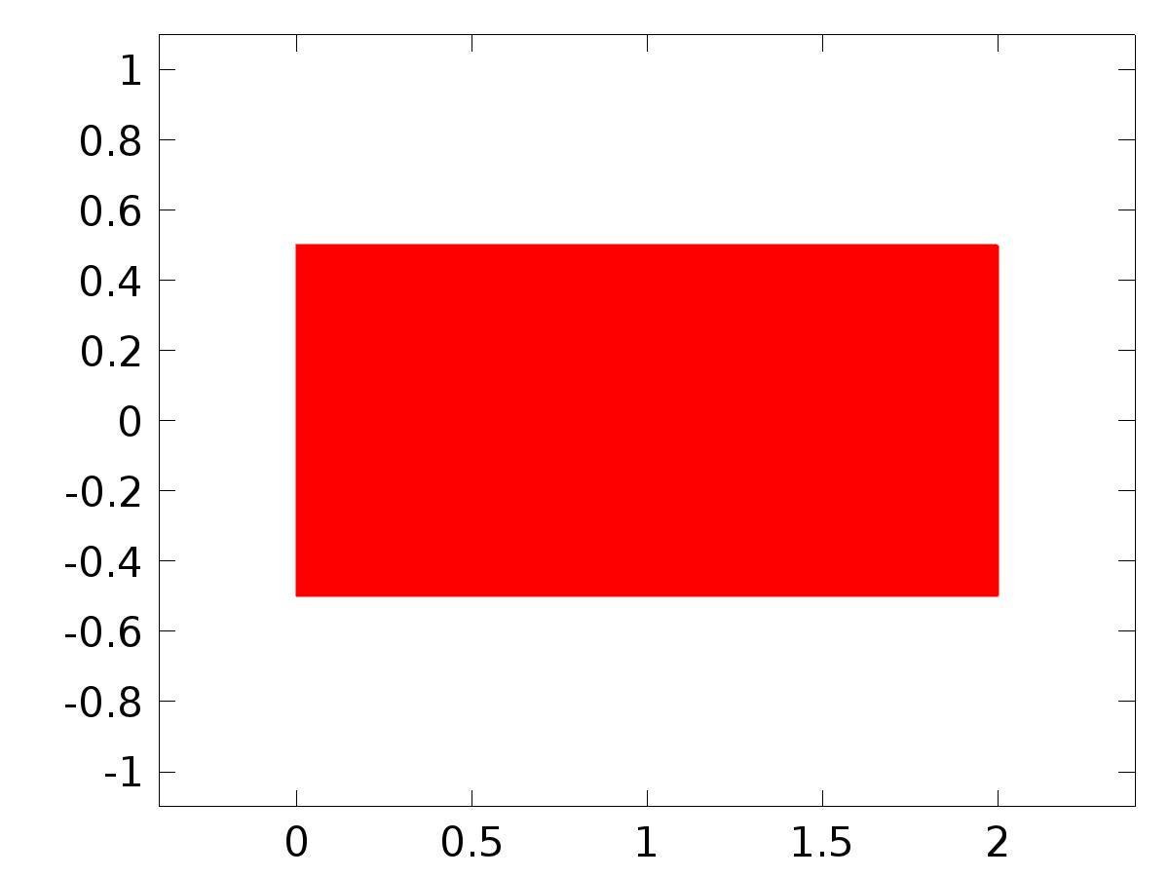

Data set: Solution 1

* 1. Tables
     1. Table 1

Global Evaluation 1 (z)

* 1. Plot Groups
     1. 2D Plot Group 1

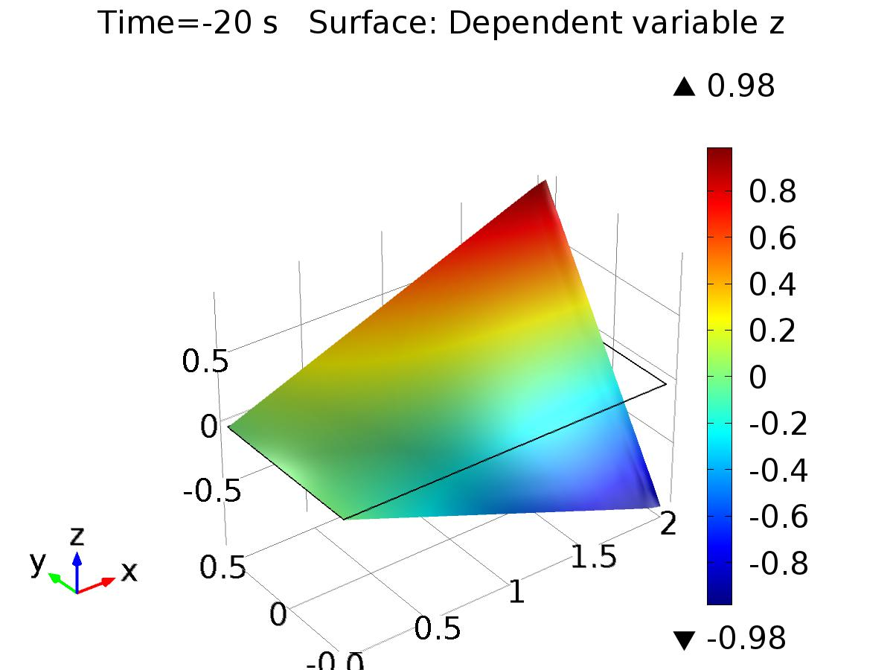

Time=-20 s Surface: Dependent variable z

* + 1. 1D Plot Group 2

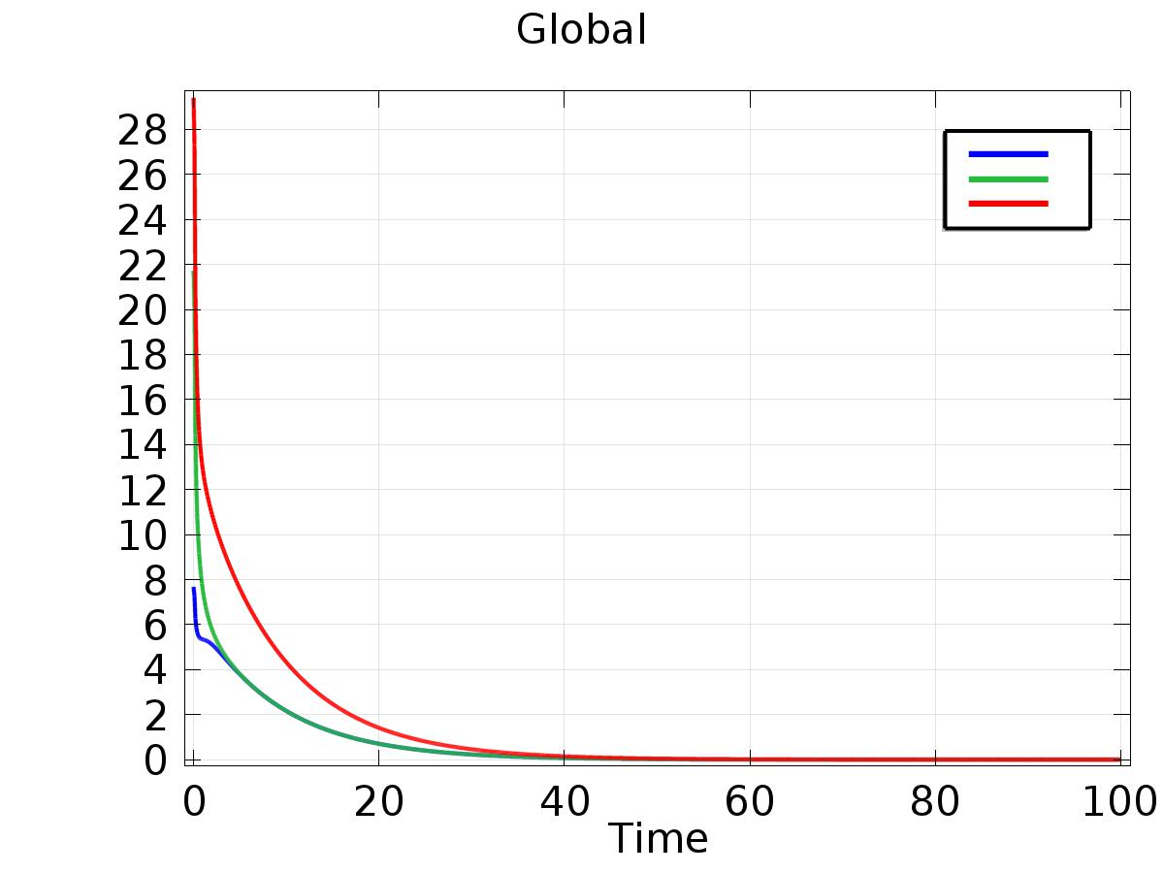

Global