[](http://www.comsol.com/)

Ex3 9 interior control

|  |  |
| --- | --- |
| Date | Dec 9, 2013 3:05:50 PM |

Contents

1. Global

1.1. Definitions

2. Model 1

2.1. Definitions

2.2. Geometry 1

2.3. To find Bin(x,t)

2.4. Close loop system

2.5. Mesh 1

3. Study 1

3.1. Time Dependent

3.2. Solver Configurations

4. Results

4.1. Data Sets

4.2. Derived Values

4.3. Tables

4.4. Plot Groups

1. Global

|  |  |
| --- | --- |
| Date | Nov 6, 2013 6:22:22 PM |

Global settings

|  |  |
| --- | --- |
| Name | Ex3 9 interior control.mph |
| Path | /Users/gilliam/Desktop/collect_15/research_15/geo_reg_mono_eugenio/Mono_1_15/Comsol_EX_GitHub/Chapter3/Chap3Ex8_9_2D_ZDI_Control/Ex3_9_Interior_zdi/Ex3_9_interior_control.mph |
| Program | COMSOL 4.4 (Build: 150) |

Used products

|  |
| --- |
| COMSOL Multiphysics |

* 1. Definitions
     1. Parameters 1

Parameters

| **Name** | **Expression** | **Value** | **Description** |
| --- | --- | --- | --- |
| L | 1 | 1.0000 |  |
| Mr | 1 | 1.0000 |  |
| Ar | 0.5*0 + 1 | 1.0000 |  |
| a | 10 | 10.000 |  |
| c | 1 | 1.0000 |  |
| alpha | pi | 3.1416 |  |

1. Model 1

Component settings

|  |  |
| --- | --- |
| Unit system | None |

* 1. Definitions
     1. Variables

#### Variables 1

Selection

|  |  |
| --- | --- |
| Geometric entity level | Boundary |
| Selection | Boundaries 4–7 |

| **Name** | **Expression** | **Description** |
| --- | --- | --- |
| yr | Mr + Ar*(4*s*(1 - s))^2*cos(alpha*t) + 0*sin(3*pi*s)*cos(alpha*t) |  |

#### Variables 2

Selection

|  |  |
| --- | --- |
| Geometric entity level | Entire model |

| **Name** | **Expression** | **Description** |
| --- | --- | --- |
| e | sqrt( C((z - yr)^2) ) |  |

* + 1. Component Couplings

#### Integration 1

|  |  |
| --- | --- |
| Coupling type | Integration |
| Operator name | C |

Source selection

|  |  |
| --- | --- |
| Geometric entity level | Boundary |
| Selection | Boundaries 4–7 |

* + 1. Coordinate Systems

#### Boundary System 1

|  |  |
| --- | --- |
| Coordinate system type | Boundary system |
| Tag | sys1 |

Coordinate names

| **First (t1)** | **Second (n)** | **Third (to)** |
| --- | --- | --- |
| t1 | n | to |

Settings

| **Description** | **Value** |
| --- | --- |
| Create first tangent direction from | Global Cartesian |

* 1. Geometry 1

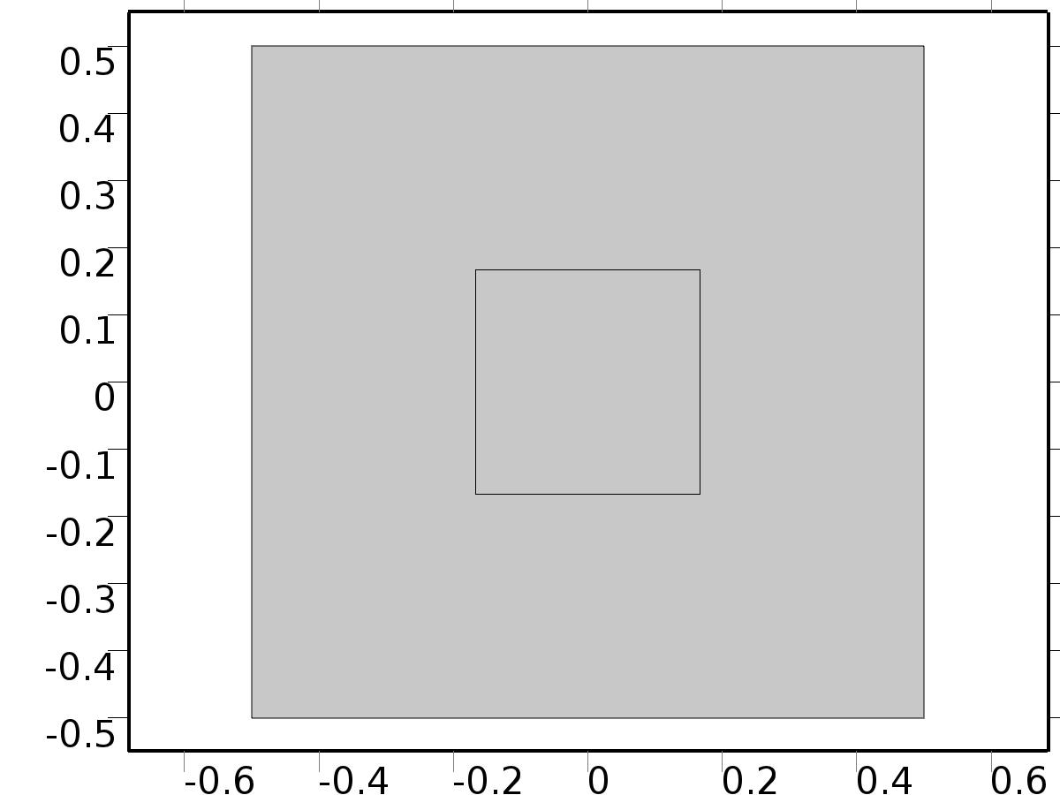

Geometry 1

Units

|  |  |
| --- | --- |
| Length unit | m |
| Angular unit | deg |

Geometry statistics

| **Description** | **Value** |
| --- | --- |
| Space dimension | 2 |
| Number of domains | 2 |
| Number of boundaries | 8 |
| Number of vertices | 8 |

* + 1. Rectangle 1 (r1)

Position

| **Description** | **Value** |
| --- | --- |
| Position | {0, 0} |
| Base | Center |
| Layers |  |

Size

| **Description** | **Value** |
| --- | --- |
| Width | L |
| Height | L |

* + 1. Rectangle 2 (r2)

Position

| **Description** | **Value** |
| --- | --- |
| Position | {0, 0} |
| Base | Center |
| Layers |  |

Size

| **Description** | **Value** |
| --- | --- |
| Width | L/3 |
| Height | L/3 |

* 1. To find Bin(x,t)

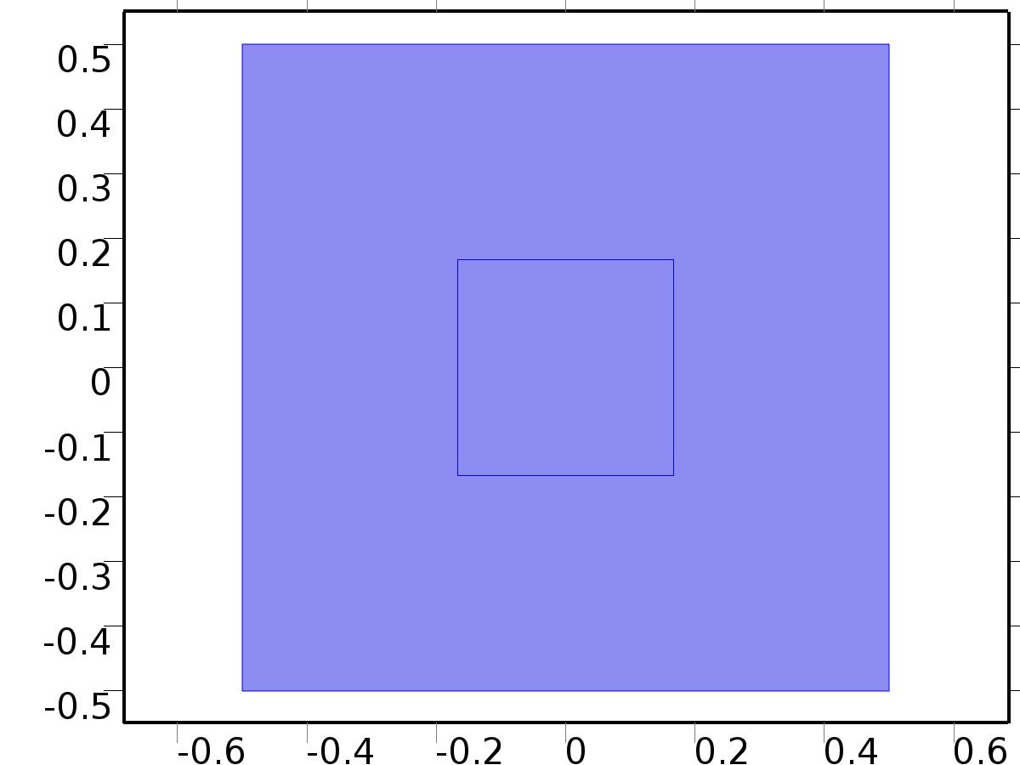

To find Bin(x,t)

Selection

|  |  |
| --- | --- |
| Geometric entity level | Domain |
| Selection | Domains 1–2 |

Settings

| **Description** | **Value** |
| --- | --- |
| Shape function type | Lagrange |
| Element order | Quadratic |
| Compute boundary fluxes | On |
| Apply smoothing to boundary fluxes | On |
| Value type when using splitting of complex variables | Complex |
| Dependent variable quantity | Dimensionless (1) |
| Source term quantity | None |
| Unit | m^ - 2 |

Used products

|  |
| --- |
| COMSOL Multiphysics |

Variables

| **Name** | **Expression** | **Unit** | **Description** | **Selection** |
| --- | --- | --- | --- | --- |
| X.nx | nx |  | Normal vector, x component | Boundaries 1–8 |
| X.ny | ny |  | Normal vector, y component | Boundaries 1–8 |
| X.nz | root.nz |  | Normal vector, z component | Boundaries 1–8 |
| X.nxmesh | root.nxmesh |  | Normal vector (mesh), x component | Boundaries 1–8 |
| X.nymesh | root.nymesh |  | Normal vector (mesh), y component | Boundaries 1–8 |
| X.nzmesh | root.nzmesh |  | Normal vector (mesh), z component | Boundaries 1–8 |

* + 1. Coefficient Form PDE 1



Coefficient Form PDE 1

Selection

|  |  |
| --- | --- |
| Geometric entity level | Domain |
| Selection | Domains 1–2 |

Equations

Settings

| **Description** | **Value** |
| --- | --- |
| Diffusion coefficient | {{c, 0}, {0, c}} |
| Absorption coefficient | 0 |
| Source term | 0 |
| Mass coefficient | 0 |
| Damping or mass coefficient | a |
| Conservative flux convection coefficient | {0, 0} |
| Convection coefficient | {0, 0} |
| Conservative flux source | {0, 0} |

#### Variables

| **Name** | **Expression** | **Unit** | **Description** | **Selection** |
| --- | --- | --- | --- | --- |
| domflux.Xx | -c*d(X,x) |  | Domain flux, x component | Domains 1–2 |
| domflux.Xy | -c*d(X,y) |  | Domain flux, y component | Domains 1–2 |

#### Shape functions

| **Name** | **Shape function** | **Unit** | **Description** | **Shape frame** | **Selection** |
| --- | --- | --- | --- | --- | --- |
| X | Lagrange (Quadratic) |  | Dependent variable X | Material | Domains 1–2 |

* + 1. Zero Flux 1



Zero Flux 1

Selection

|  |  |
| --- | --- |
| Geometric entity level | Boundary |
| Selection | No boundaries |

Equations

* + 1. Initial Values 1



Initial Values 1

Selection

|  |  |
| --- | --- |
| Geometric entity level | Domain |
| Selection | Domains 1–2 |

Settings

| **Description** | **Value** |
| --- | --- |
| Initial value for X | 0 |
| Initial time derivative of X | 0 |

* + 1. Constraint 1

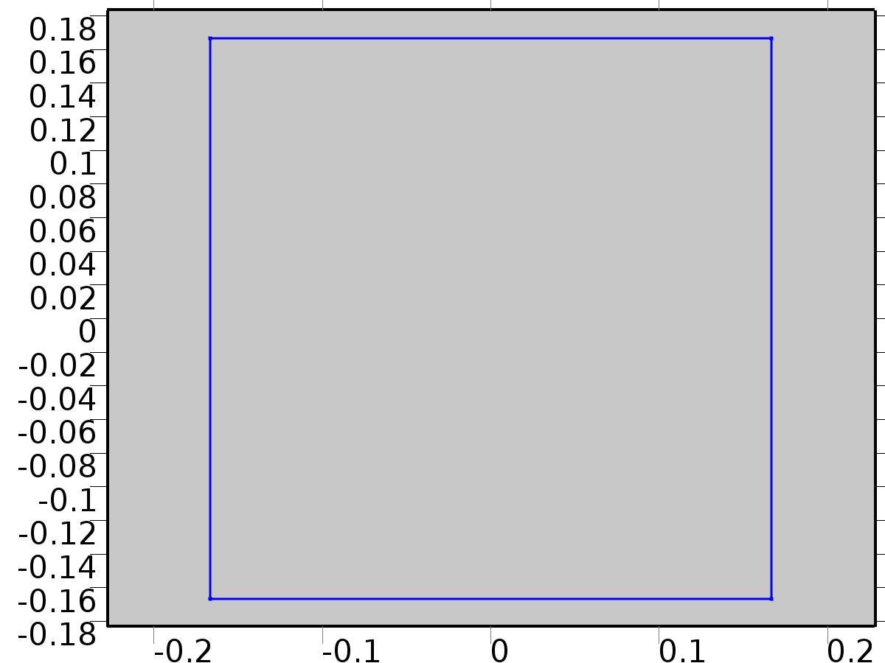

Constraint 1

Selection

|  |  |
| --- | --- |
| Geometric entity level | Boundary |
| Selection | Boundaries 4–7 |

Equations

Settings

| **Description** | **Value** |
| --- | --- |
| Bidirectional constraint, R = 0 | X - yr |
| Apply reaction terms on | Individual dependent variables |
| Use weak constraints | On |

#### Variables

| **Name** | **Expression** | **Unit** | **Description** | **Selection** |
| --- | --- | --- | --- | --- |
| X.R_X | X-yr |  | Bidirectional constraint, R = 0 | Boundaries 4–7 |

#### Shape functions

| **Name** | **Shape function** | **Unit** | **Description** | **Shape frame** | **Selection** |
| --- | --- | --- | --- | --- | --- |
| X_lm | Lagrange (Quadratic) |  | Lagrange multiplier for dependent variable x | Material | Boundaries 4–7 |

#### Weak expressions

| **Weak expression** | **Integration frame** | **Selection** |
| --- | --- | --- |
| (X-yr)*test(-X_lm) | Material | Boundaries 4–7 |
| test(X)*X_lm | Material | Boundaries 4–7 |

* + 1. Flux/Source 1

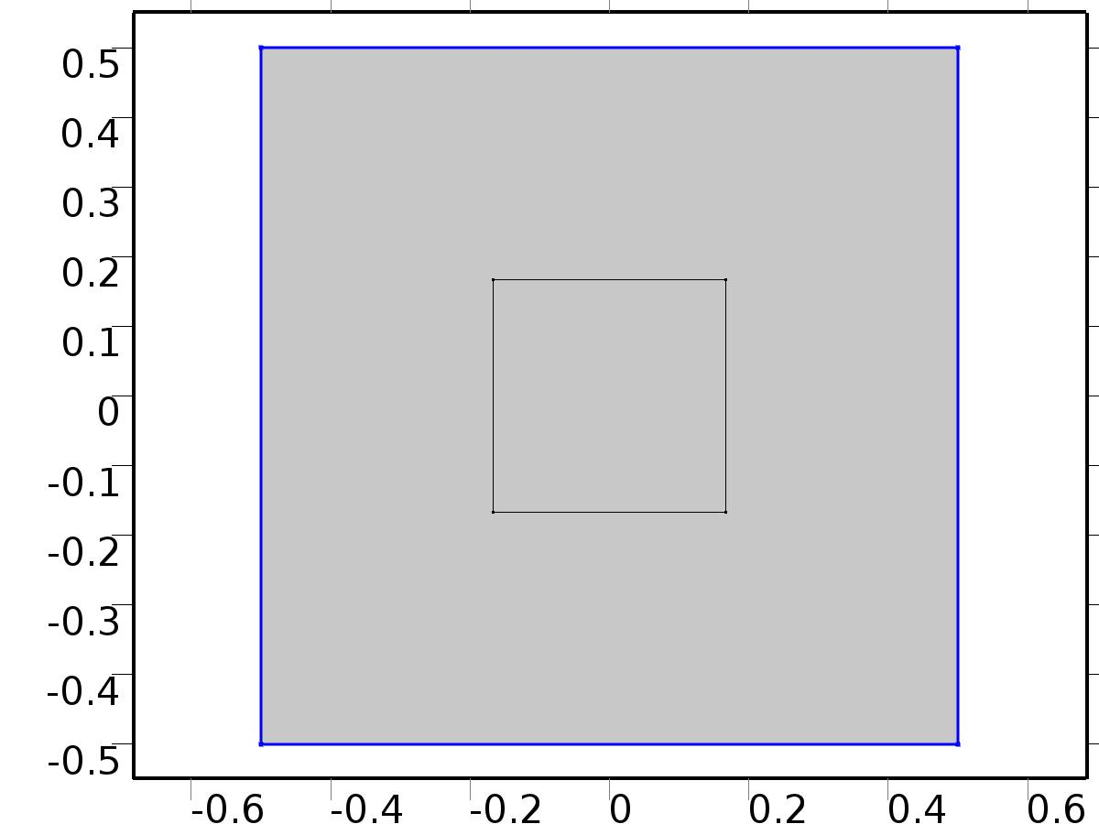

Flux/Source 1

Selection

|  |  |
| --- | --- |
| Geometric entity level | Boundary |
| Selection | Boundaries 1–3, 8 |

Equations

Settings

| **Description** | **Value** |
| --- | --- |
| Boundary flux/source | 1 |
| Boundary absorption/impedance term | 1 |

#### Variables

| **Name** | **Expression** | **Unit** | **Description** | **Selection** |
| --- | --- | --- | --- | --- |
| X.g_X | 1-X |  | Boundary flux/source | Boundaries 1–3, 8 |

* 1. Close loop system



Close loop system

Selection

|  |  |
| --- | --- |
| Geometric entity level | Domain |
| Selection | Domains 1–2 |

Settings

| **Description** | **Value** |
| --- | --- |
| Shape function type | Lagrange |
| Element order | Quadratic |
| Compute boundary fluxes | On |
| Apply smoothing to boundary fluxes | On |
| Value type when using splitting of complex variables | Complex |
| Dependent variable quantity | Dimensionless (1) |
| Source term quantity | None |
| Unit | m^ - 2 |

Used products

|  |
| --- |
| COMSOL Multiphysics |

Variables

| **Name** | **Expression** | **Unit** | **Description** | **Selection** |
| --- | --- | --- | --- | --- |
| z.nx | nx |  | Normal vector, x component | Boundaries 1–8 |
| z.ny | ny |  | Normal vector, y component | Boundaries 1–8 |
| z.nz | root.nz |  | Normal vector, z component | Boundaries 1–8 |
| z.nxmesh | root.nxmesh |  | Normal vector (mesh), x component | Boundaries 1–8 |
| z.nymesh | root.nymesh |  | Normal vector (mesh), y component | Boundaries 1–8 |
| z.nzmesh | root.nzmesh |  | Normal vector (mesh), z component | Boundaries 1–8 |

* + 1. Coefficient Form PDE 1



Coefficient Form PDE 1

Selection

|  |  |
| --- | --- |
| Geometric entity level | Domain |
| Selection | Domains 1–2 |

Equations

Settings

| **Description** | **Value** |
| --- | --- |
| Diffusion coefficient | {{c, 0}, {0, c}} |
| Absorption coefficient | 0 |
| Source term | 0 |
| Mass coefficient | 0 |
| Damping or mass coefficient | a |
| Conservative flux convection coefficient | {0, 0} |
| Convection coefficient | {0, 0} |
| Conservative flux source | {0, 0} |

#### Variables

| **Name** | **Expression** | **Unit** | **Description** | **Selection** |
| --- | --- | --- | --- | --- |
| domflux.zx | -c*d(z,x) |  | Domain flux, x component | Domains 1–2 |
| domflux.zy | -c*d(z,y) |  | Domain flux, y component | Domains 1–2 |

#### Shape functions

| **Name** | **Shape function** | **Unit** | **Description** | **Shape frame** | **Selection** |
| --- | --- | --- | --- | --- | --- |
| z | Lagrange (Quadratic) |  | Dependent variable z | Material | Domains 1–2 |

* + 1. Zero Flux 1



Zero Flux 1

Selection

|  |  |
| --- | --- |
| Geometric entity level | Boundary |
| Selection | No boundaries |

Equations

* + 1. Initial Values 1



Initial Values 1

Selection

|  |  |
| --- | --- |
| Geometric entity level | Domain |
| Selection | Domains 1–2 |

Settings

| **Description** | **Value** |
| --- | --- |
| Initial value for z | 100*(.5^2 - x^2)*(.5^2 - y^2)*0 |
| Initial time derivative of z | 0 |

* + 1. Input Bin(x,t)



Input Bin(x,t)

Selection

|  |  |
| --- | --- |
| Geometric entity level | Boundary |
| Selection | Boundaries 4–7 |

Equations

Settings

| **Description** | **Value** |
| --- | --- |
| Boundary flux/source | X_lm*flc2hs(t - 0.1, 0.1) |
| Boundary absorption/impedance term | 0 |

#### Variables

| **Name** | **Expression** | **Unit** | **Description** | **Selection** |
| --- | --- | --- | --- | --- |
| z.g_z | X_lm*flc2hs(-0.1+t,0.1) |  | Boundary flux/source | Boundaries 4–7 |

* + 1. Flux/Source 2



Flux/Source 2

Selection

|  |  |
| --- | --- |
| Geometric entity level | Boundary |
| Selection | Boundaries 1–3, 8 |

Equations

Settings

| **Description** | **Value** |
| --- | --- |
| Boundary flux/source | 1 |
| Boundary absorption/impedance term | 1 |

#### Variables

| **Name** | **Expression** | **Unit** | **Description** | **Selection** |
| --- | --- | --- | --- | --- |
| z.g_z | 1-z |  | Boundary flux/source | Boundaries 1–3, 8 |

* 1. Mesh 1

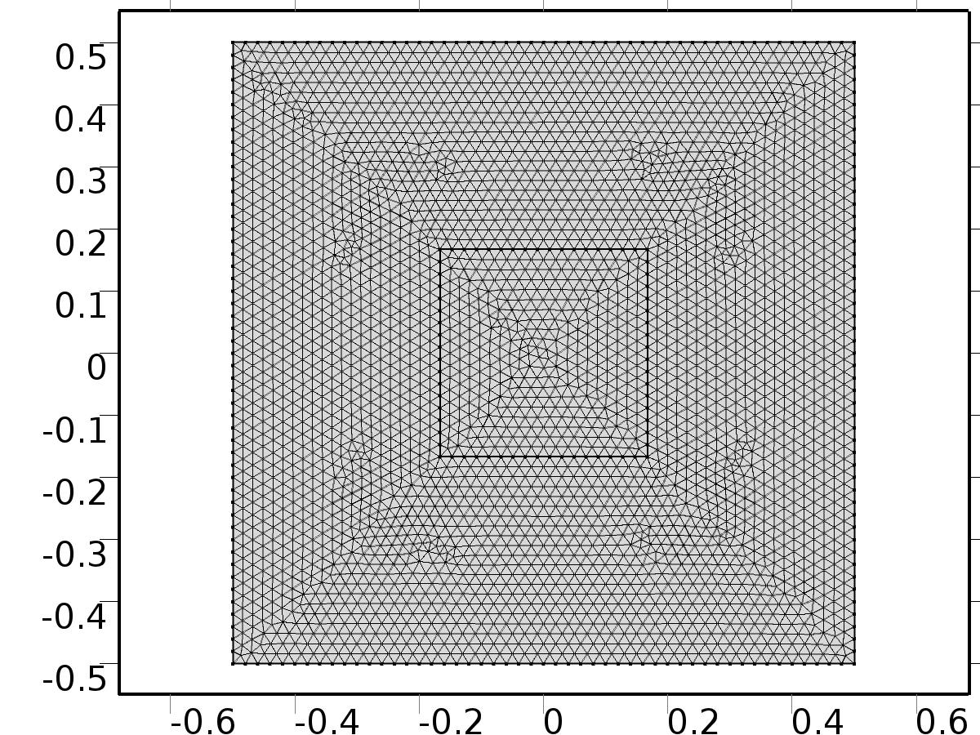

Mesh 1

* + 1. Size (size)

Settings

| **Description** | **Value** |
| --- | --- |
| Maximum element size | 0.02 |
| Minimum element size | 7.5E-5 |
| Curvature factor | 0.25 |
| Maximum element growth rate | 1.2 |
| Predefined size | Extra fine |

* + 1. Free Triangular 1 (ftri1)

Selection

|  |  |
| --- | --- |
| Geometric entity level | Remaining |

1. Study 1
   1. Time Dependent

Study settings

| **Description** | **Value** |
| --- | --- |
| Include geometric nonlinearity | Off |

| **Times** | **Unit** |
| --- | --- |
| range(-4,0.1,20) | s |

Physics and variables selection

| **Physics interface** | **Discretization** |
| --- | --- |
| To find Bin(x,t) (c) | physics |
| Close loop system (c2) | physics |

Mesh selection

| **Geometry** | **Mesh** |
| --- | --- |
| Geometry 1 (geom1) | mesh1 |

* 1. Solver Configurations
     1. Solver 1

#### Compile Equations: Time Dependent (st1)

Study and step

| **Description** | **Value** |
| --- | --- |
| Use study | Study 1 |
| Use study step | Time Dependent |

#### Dependent Variables 1 (v1)

General

| **Description** | **Value** |
| --- | --- |
| Defined by study step | Time Dependent |
| Constant |  |

Initial values of variables solved for

| **Description** | **Value** |
| --- | --- |
| Solution | Zero |

Values of variables not solved for

| **Description** | **Value** |
| --- | --- |
| Solution | Zero |

##### Lagrange multiplier for dependent variable x (mod1.X_lm) (mod1_X_lm)

General

| **Description** | **Value** |
| --- | --- |
| Field components | mod1.X_lm |

##### Dependent variable z (mod1.z) (mod1_z)

General

| **Description** | **Value** |
| --- | --- |
| Field components | mod1.z |

##### Dependent variable X (mod1.X) (mod1_X)

General

| **Description** | **Value** |
| --- | --- |
| Field components | mod1.X |

#### Time-Dependent Solver 1 (t1)

General

| **Description** | **Value** |
| --- | --- |
| Defined by study step | Time Dependent |
| Time | {-4, -3.9, -3.8, -3.7, -3.6, -3.5, -3.4, -3.3, -3.2, -3.1, -3, -2.9, -2.8, -2.7, -2.5999999999999996, -2.5, -2.4, -2.3, -2.2, -2.0999999999999996, -2, -1.9, -1.7999999999999998, -1.6999999999999997, -1.5999999999999996, -1.5, -1.4, -1.2999999999999998, -1.1999999999999997, -1.0999999999999996, -1, -0.8999999999999999, -0.7999999999999998, -0.6999999999999997, -0.5999999999999996, -0.5, -0.3999999999999999, -0.2999999999999998, -0.19999999999999973, -0.09999999999999964, 0, 0.10000000000000053, 0.20000000000000018, 0.2999999999999998, 0.40000000000000036, 0.5, 0.6000000000000005, 0.7000000000000002, 0.8000000000000007, 0.9000000000000004, 1, 1.1000000000000005, 1.2000000000000002, 1.3000000000000007, 1.4000000000000004, 1.5, 1.6000000000000005, 1.7000000000000002, 1.8000000000000007, 1.9000000000000004, 2, 2.1000000000000005, 2.2, 2.3000000000000007, 2.4000000000000004, 2.5, 2.6000000000000005, 2.7, 2.8000000000000007, 2.9000000000000004, 3, 3.1000000000000005, 3.2, 3.3000000000000007, 3.4000000000000004, 3.5, 3.6000000000000005, 3.7, 3.8000000000000007, 3.9000000000000004, 4, 4.1, 4.200000000000001, 4.300000000000001, 4.4, 4.5, 4.6, 4.700000000000001, 4.800000000000001, 4.9, 5, 5.1, 5.200000000000001, 5.300000000000001, 5.4, 5.5, 5.600000000000001, 5.700000000000001, 5.800000000000001, 5.9, 6, 6.100000000000001, 6.200000000000001, 6.300000000000001, 6.4, 6.5, 6.600000000000001, 6.700000000000001, 6.800000000000001, 6.9, 7, 7.100000000000001, 7.200000000000001, 7.300000000000001, 7.4, 7.5, 7.600000000000001, 7.700000000000001, 7.800000000000001, 7.9, 8, 8.100000000000001, 8.200000000000001, 8.3, 8.4, 8.5, 8.600000000000001, 8.700000000000001, 8.8, 8.9, 9, 9.100000000000001, 9.200000000000001, 9.3, 9.4, 9.5, 9.600000000000001, 9.700000000000001, 9.8, 9.9, 10, 10.100000000000001, 10.200000000000001, 10.3, 10.4, 10.5, 10.600000000000001, 10.700000000000001, 10.8, 10.9, 11, 11.100000000000001, 11.200000000000001, 11.3, 11.4, 11.5, 11.600000000000001, 11.700000000000001, 11.8, 11.9, 12, 12.100000000000001, 12.2, 12.3, 12.400000000000002, 12.5, 12.600000000000001, 12.7, 12.8, 12.900000000000002, 13, 13.100000000000001, 13.2, 13.3, 13.400000000000002, 13.5, 13.600000000000001, 13.7, 13.8, 13.900000000000002, 14, 14.100000000000001, 14.2, 14.3, 14.400000000000002, 14.5, 14.600000000000001, 14.7, 14.8, 14.900000000000002, 15, 15.100000000000001, 15.200000000000003, 15.3, 15.400000000000002, 15.5, 15.600000000000001, 15.700000000000003, 15.8, 15.900000000000002, 16, 16.1, 16.200000000000003, 16.3, 16.400000000000002, 16.5, 16.6, 16.700000000000003, 16.8, 16.900000000000002, 17, 17.1, 17.200000000000003, 17.3, 17.400000000000002, 17.5, 17.6, 17.700000000000003, 17.8, 17.900000000000002, 18, 18.1, 18.200000000000003, 18.3, 18.400000000000002, 18.5, 18.6, 18.700000000000003, 18.8, 18.900000000000002, 19, 19.1, 19.200000000000003, 19.3, 19.400000000000002, 19.5, 19.6, 19.700000000000003, 19.8, 19.900000000000002, 20} |
| Relative tolerance | 0.0001 |

Absolute tolerance

| **Description** | **Value** |
| --- | --- |
| Tolerance | 0.0010 |

Time stepping

| **Description** | **Value** |
| --- | --- |
| Initial step | 0.0010 |

Advanced

| **Description** | **Value** |
| --- | --- |
| Fraction of initial step for Backward Euler | 0.0010 |

Log

| **Description** | **Value** |
| --- | --- |
| Constant |  |

##### Fully Coupled 1 (fc1)

General

| **Description** | **Value** |
| --- | --- |
| Linear solver | Direct |

1. Results
   1. Data Sets
      1. Solution 1

Solution

| **Description** | **Value** |
| --- | --- |
| Solution | Solver 1 |
| Component | Save Point Geometry 1 |

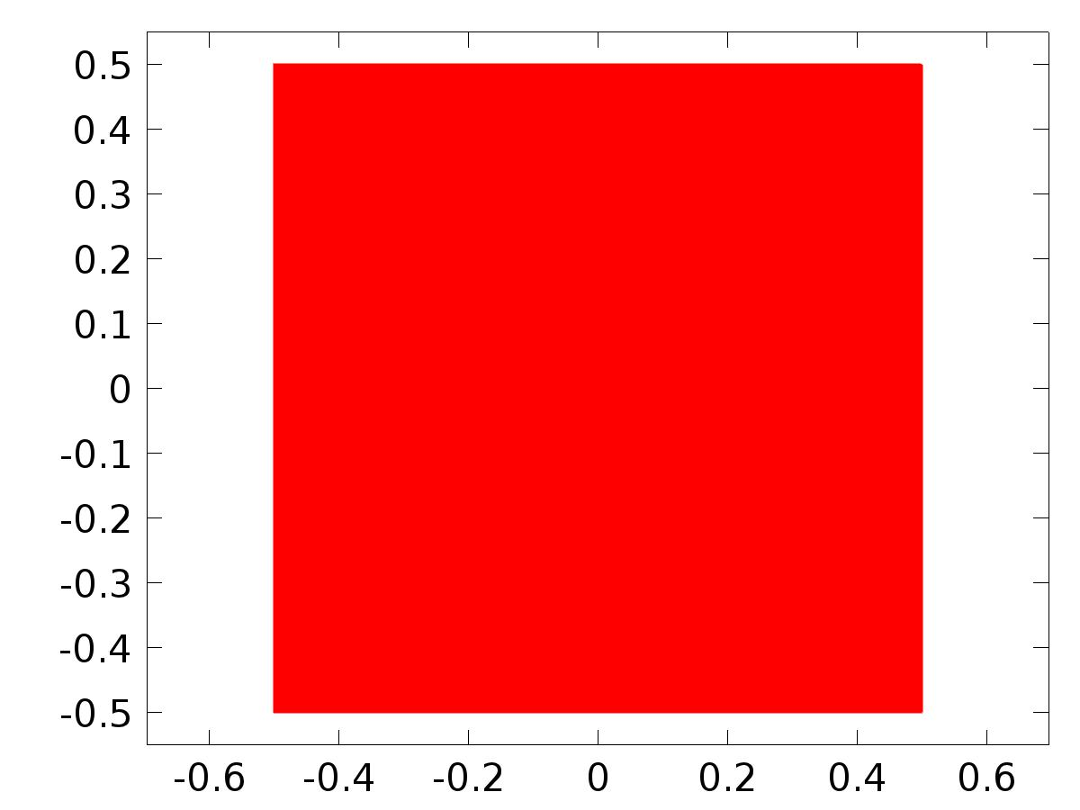

Data set: Solution 1

* 1. Derived Values
     1. Point Evaluation 1

Selection

|  |  |
| --- | --- |
| Geometric entity level | Point |
| Selection | Point 4 |

Data

| **Description** | **Value** |
| --- | --- |
| Data set | Solution 1 |

Expression

| **Description** | **Value** |
| --- | --- |
| Expression | e |

* 1. Tables
     1. Table 1

Point Evaluation 1 (C(z))

Table 1

| **Time (s)** | **C(z), Point: 4** | **e, Point: 4** |
| --- | --- | --- |
| -4.0000 | -2.9153E-22 | 1.8159 |
| -3.9000 | 0.0014128 | 1.7810 |
| -3.8000 | 0.014274 | 1.6730 |
| -3.7000 | 0.038093 | 1.5031 |
| -3.6000 | 0.068501 | 1.2922 |
| -3.5000 | 0.10261 | 1.0659 |
| -3.4000 | 0.13858 | 0.85266 |
| -3.3000 | 0.17528 | 0.68118 |
| -3.2000 | 0.21198 | 0.57092 |
| -3.1000 | 0.24823 | 0.51732 |
| -3.0000 | 0.28377 | 0.49352 |
| -2.9000 | 0.31844 | 0.47797 |
| -2.8000 | 0.35215 | 0.47559 |
| -2.7000 | 0.38485 | 0.51438 |
| -2.6000 | 0.41654 | 0.61530 |
| -2.5000 | 0.44722 | 0.76742 |
| -2.4000 | 0.47690 | 0.94098 |
| -2.3000 | 0.50561 | 1.1056 |
| -2.2000 | 0.53337 | 1.2361 |
| -2.1000 | 0.56021 | 1.3139 |
| -2.0000 | 0.58615 | 1.3271 |
| -1.9000 | 0.61122 | 1.2716 |
| -1.8000 | 0.63545 | 1.1510 |
| -1.7000 | 0.65887 | 0.97630 |
| -1.6000 | 0.68151 | 0.76566 |
| -1.5000 | 0.70339 | 0.54556 |
| -1.4000 | 0.72453 | 0.35798 |
| -1.3000 | 0.74497 | 0.27617 |
| -1.2000 | 0.76471 | 0.32280 |
| -1.1000 | 0.78380 | 0.39567 |
| -1.0000 | 0.80224 | 0.42929 |
| -0.90000 | 0.82007 | 0.40571 |
| -0.80000 | 0.83730 | 0.33040 |
| -0.70000 | 0.85395 | 0.24006 |
| -0.60000 | 0.87004 | 0.24357 |
| -0.50000 | 0.88559 | 0.38777 |
| -0.40000 | 0.90062 | 0.57919 |
| -0.30000 | 0.91514 | 0.76272 |
| -0.20000 | 0.92918 | 0.90966 |
| -0.100000 | 0.94274 | 1.0013 |
| 0.0000 | 0.95720 | 1.0235 |
| 0.10000 | 0.99929 | 0.91129 |
| 0.20000 | 1.0370 | 0.75593 |
| 0.30000 | 0.97816 | 0.66990 |
| 0.40000 | 0.84998 | 0.60905 |
| 0.50000 | 0.68089 | 0.56511 |
| 0.60000 | 0.49982 | 0.53158 |
| 0.70000 | 0.33278 | 0.50456 |
| 0.80000 | 0.20173 | 0.48179 |
| 0.90000 | 0.12365 | 0.46194 |
| 1.0000 | 0.10943 | 0.44411 |
| 1.1000 | 0.16316 | 0.42771 |
| 1.2000 | 0.28186 | 0.41239 |
| 1.3000 | 0.45587 | 0.39794 |
| 1.4000 | 0.66996 | 0.38420 |
| 1.5000 | 0.90486 | 0.37108 |
| 1.6000 | 1.1392 | 0.35848 |
| 1.7000 | 1.3514 | 0.34635 |
| 1.8000 | 1.5222 | 0.33466 |
| 1.9000 | 1.6362 | 0.32339 |
| 2.0000 | 1.6836 | 0.31252 |
| 2.1000 | 1.6609 | 0.30202 |
| 2.2000 | 1.5716 | 0.29188 |
| 2.3000 | 1.4256 | 0.28208 |
| 2.4000 | 1.2383 | 0.27261 |
| 2.5000 | 1.0291 | 0.26347 |
| 2.6000 | 0.81959 | 0.25462 |
| 2.7000 | 0.63119 | 0.24610 |
| 2.8000 | 0.48344 | 0.23781 |
| 2.9000 | 0.39161 | 0.22987 |
| 3.0000 | 0.36570 | 0.22216 |
| 3.1000 | 0.40915 | 0.21467 |
| 3.2000 | 0.51850 | 0.20744 |
| 3.3000 | 0.68386 | 0.20048 |
| 3.4000 | 0.88987 | 0.19375 |
| 3.5000 | 1.1171 | 0.18724 |
| 3.6000 | 1.3441 | 0.18096 |
| 3.7000 | 1.5494 | 0.17486 |
| 3.8000 | 1.7135 | 0.16902 |
| 3.9000 | 1.8211 | 0.16330 |
| 4.0000 | 1.8622 | 0.15786 |
| 4.1000 | 1.8335 | 0.15257 |
| 4.2000 | 1.7384 | 0.14745 |
| 4.3000 | 1.5868 | 0.14250 |
| 4.4000 | 1.3941 | 0.13771 |
| 4.5000 | 1.1797 | 0.13309 |
| 4.6000 | 0.96507 | 0.12862 |
| 4.7000 | 0.77182 | 0.12431 |
| 4.8000 | 0.61932 | 0.12013 |
| 4.9000 | 0.52297 | 0.11610 |
| 5.0000 | 0.49267 | 0.11220 |
| 5.1000 | 0.53185 | 0.10841 |
| 5.2000 | 0.63707 | 0.10476 |
| 5.3000 | 0.79843 | 0.10126 |
| 5.4000 | 1.0006 | 0.097882 |
| 5.5000 | 1.2241 | 0.094577 |
| 5.6000 | 1.4475 | 0.091407 |
| 5.7000 | 1.6493 | 0.088352 |
| 5.8000 | 1.8100 | 0.085397 |
| 5.9000 | 1.9143 | 0.082534 |
| 6.0000 | 1.9523 | 0.079762 |
| 6.1000 | 1.9206 | 0.077079 |
| 6.2000 | 1.8226 | 0.074500 |
| 6.3000 | 1.6682 | 0.072015 |
| 6.4000 | 1.4727 | 0.069599 |
| 6.5000 | 1.2557 | 0.067254 |
| 6.6000 | 1.0386 | 0.064986 |
| 6.7000 | 0.84284 | 0.062798 |
| 6.8000 | 0.68796 | 0.060688 |
| 6.9000 | 0.58930 | 0.058654 |
| 7.0000 | 0.55679 | 0.056669 |
| 7.1000 | 0.59379 | 0.054764 |
| 7.2000 | 0.69691 | 0.052933 |
| 7.3000 | 0.85628 | 0.051162 |
| 7.4000 | 1.0565 | 0.049449 |
| 7.5000 | 1.2782 | 0.047789 |
| 7.6000 | 1.4997 | 0.046185 |
| 7.7000 | 1.6998 | 0.044636 |
| 7.8000 | 1.8588 | 0.043139 |
| 7.9000 | 1.9615 | 0.041693 |
| 8.0000 | 1.9979 | 0.040296 |
| 8.1000 | 1.9647 | 0.038945 |
| 8.2000 | 1.8652 | 0.037639 |
| 8.3000 | 1.7093 | 0.036376 |
| 8.4000 | 1.5125 | 0.035154 |
| 8.5000 | 1.2941 | 0.033972 |
| 8.6000 | 1.0757 | 0.032829 |
| 8.7000 | 0.87872 | 0.031725 |
| 8.8000 | 0.72263 | 0.030660 |
| 8.9000 | 0.62281 | 0.029631 |
| 9.0000 | 0.58916 | 0.028636 |
| 9.1000 | 0.62507 | 0.027673 |
| 9.2000 | 0.72715 | 0.026743 |
| 9.3000 | 0.88551 | 0.025845 |
| 9.4000 | 1.0847 | 0.024977 |
| 9.5000 | 1.3055 | 0.024139 |
| 9.6000 | 1.5261 | 0.023331 |
| 9.7000 | 1.7253 | 0.022550 |
| 9.8000 | 1.8835 | 0.021793 |
| 9.9000 | 1.9853 | 0.021062 |
| 10.000 | 2.0209 | 0.020357 |
| 10.100 | 1.9869 | 0.019675 |
| 10.200 | 1.8867 | 0.019016 |
| 10.300 | 1.7301 | 0.018376 |
| 10.400 | 1.5326 | 0.017756 |
| 10.500 | 1.3135 | 0.017161 |
| 10.600 | 1.0944 | 0.016584 |
| 10.700 | 0.89685 | 0.016027 |
| 10.800 | 0.74015 | 0.015488 |
| 10.900 | 0.63974 | 0.014970 |
| 11.000 | 0.60552 | 0.014466 |
| 11.100 | 0.64089 | 0.013979 |
| 11.200 | 0.74244 | 0.013508 |
| 11.300 | 0.90028 | 0.013055 |
| 11.400 | 1.0990 | 0.012619 |
| 11.500 | 1.3193 | 0.012196 |
| 11.600 | 1.5395 | 0.011787 |
| 11.700 | 1.7382 | 0.011393 |
| 11.800 | 1.8959 | 0.011012 |
| 11.900 | 1.9974 | 0.010642 |
| 12.000 | 2.0326 | 0.010284 |
| 12.100 | 1.9982 | 0.0099402 |
| 12.200 | 1.8975 | 0.0096082 |
| 12.300 | 1.7406 | 0.0092862 |
| 12.400 | 1.5427 | 0.0089732 |
| 12.500 | 1.3233 | 0.0086690 |
| 12.600 | 1.1039 | 0.0083782 |
| 12.700 | 0.90600 | 0.0080964 |
| 12.800 | 0.74900 | 0.0078234 |
| 12.900 | 0.64830 | 0.0075600 |
| 13.000 | 0.61379 | 0.0073078 |
| 13.100 | 0.64887 | 0.0070630 |
| 13.200 | 0.75015 | 0.0068241 |
| 13.300 | 0.90774 | 0.0065936 |
| 13.400 | 1.1062 | 0.0063722 |
| 13.500 | 1.3262 | 0.0061600 |
| 13.600 | 1.5462 | 0.0059549 |
| 13.700 | 1.7447 | 0.0057558 |
| 13.800 | 1.9022 | 0.0055643 |
| 13.900 | 2.0034 | 0.0053795 |
| 14.000 | 2.0384 | 0.0051994 |
| 14.100 | 2.0038 | 0.0050214 |
| 14.200 | 1.9030 | 0.0048541 |
| 14.300 | 1.7459 | 0.0046923 |
| 14.400 | 1.5478 | 0.0045350 |
| 14.500 | 1.3283 | 0.0043818 |
| 14.600 | 1.1087 | 0.0042331 |
| 14.700 | 0.91063 | 0.0040907 |
| 14.800 | 0.75347 | 0.0039528 |
| 14.900 | 0.65262 | 0.0038188 |
| 15.000 | 0.61796 | 0.0036895 |
| 15.100 | 0.65291 | 0.0035666 |
| 15.200 | 0.75405 | 0.0034492 |
| 15.300 | 0.91151 | 0.0033316 |
| 15.400 | 1.1099 | 0.0032185 |
| 15.500 | 1.3297 | 0.0031105 |
| 15.600 | 1.5496 | 0.0030076 |
| 15.700 | 1.7480 | 0.0029081 |
| 15.800 | 1.9054 | 0.0028120 |
| 15.900 | 2.0065 | 0.0027199 |
| 16.000 | 2.0414 | 0.0026308 |
| 16.100 | 2.0067 | 0.0025430 |
| 16.200 | 1.9058 | 0.0024546 |
| 16.300 | 1.7486 | 0.0023705 |
| 16.400 | 1.5504 | 0.0022913 |
| 16.500 | 1.3308 | 0.0022143 |
| 16.600 | 1.1111 | 0.0021394 |
| 16.700 | 0.91297 | 0.0020672 |
| 16.800 | 0.75573 | 0.0019988 |
| 16.900 | 0.65480 | 0.0019313 |
| 17.000 | 0.62007 | 0.0018651 |
| 17.100 | 0.65495 | 0.0018009 |
| 17.200 | 0.75603 | 0.0017403 |
| 17.300 | 0.91341 | 0.0016848 |
| 17.400 | 1.1117 | 0.0016266 |
| 17.500 | 1.3315 | 0.0015712 |
| 17.600 | 1.5513 | 0.0015194 |
| 17.700 | 1.7496 | 0.0014707 |
| 17.800 | 1.9070 | 0.0014230 |
| 17.900 | 2.0081 | 0.0013765 |
| 18.000 | 2.0429 | 0.0013328 |
| 18.100 | 2.0082 | 0.0012897 |
| 18.200 | 1.9072 | 0.0012463 |
| 18.300 | 1.7499 | 0.0012015 |
| 18.400 | 1.5517 | 0.0011573 |
| 18.500 | 1.3320 | 0.0011185 |
| 18.600 | 1.1123 | 0.0010812 |
| 18.700 | 0.91415 | 0.0010452 |
| 18.800 | 0.75687 | 0.0010111 |
| 18.900 | 0.65590 | 9.8053E-4 |
| 19.000 | 0.62114 | 9.4731E-4 |
| 19.100 | 0.65598 | 9.1345E-4 |
| 19.200 | 0.75702 | 8.8005E-4 |
| 19.300 | 0.91438 | 8.4878E-4 |
| 19.400 | 1.1126 | 8.2121E-4 |
| 19.500 | 1.3324 | 7.9410E-4 |
| 19.600 | 1.5522 | 7.6827E-4 |
| 19.700 | 1.7505 | 7.4555E-4 |
| 19.800 | 1.9078 | 7.2469E-4 |
| 19.900 | 2.0088 | 7.0302E-4 |
| 20.000 | 2.0437 | 6.7911E-4 |

* 1. Plot Groups
     1. 2D Plot Group 1

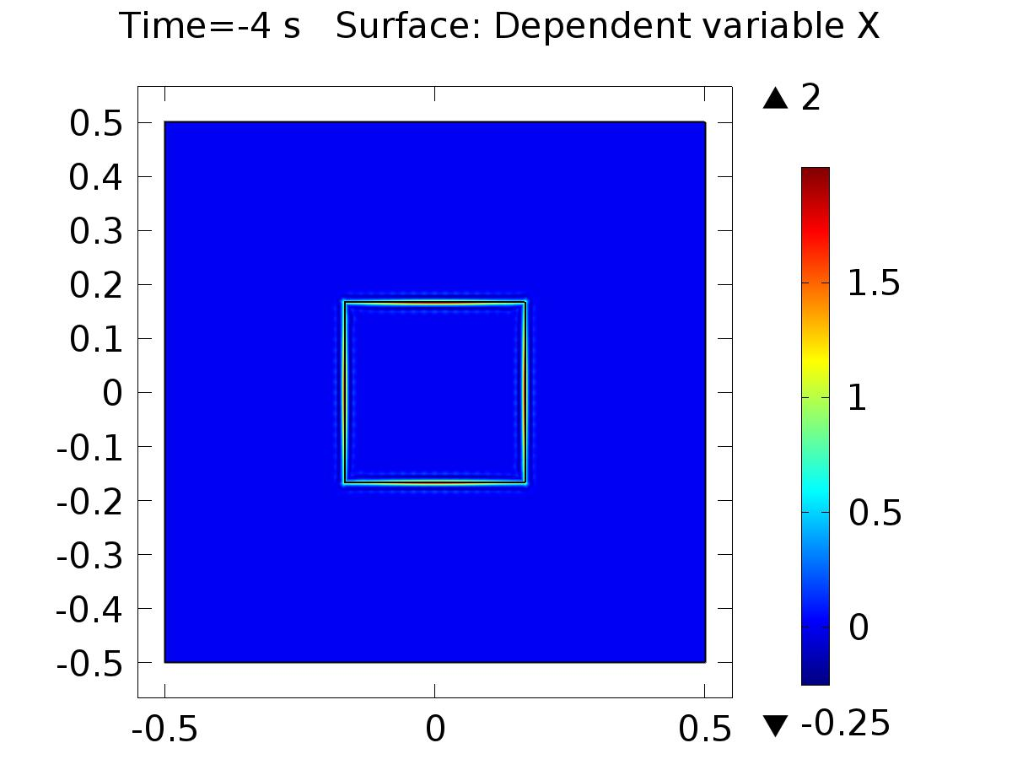

Time=-4 s Surface: Dependent variable X

* + 1. 2D Plot Group 2

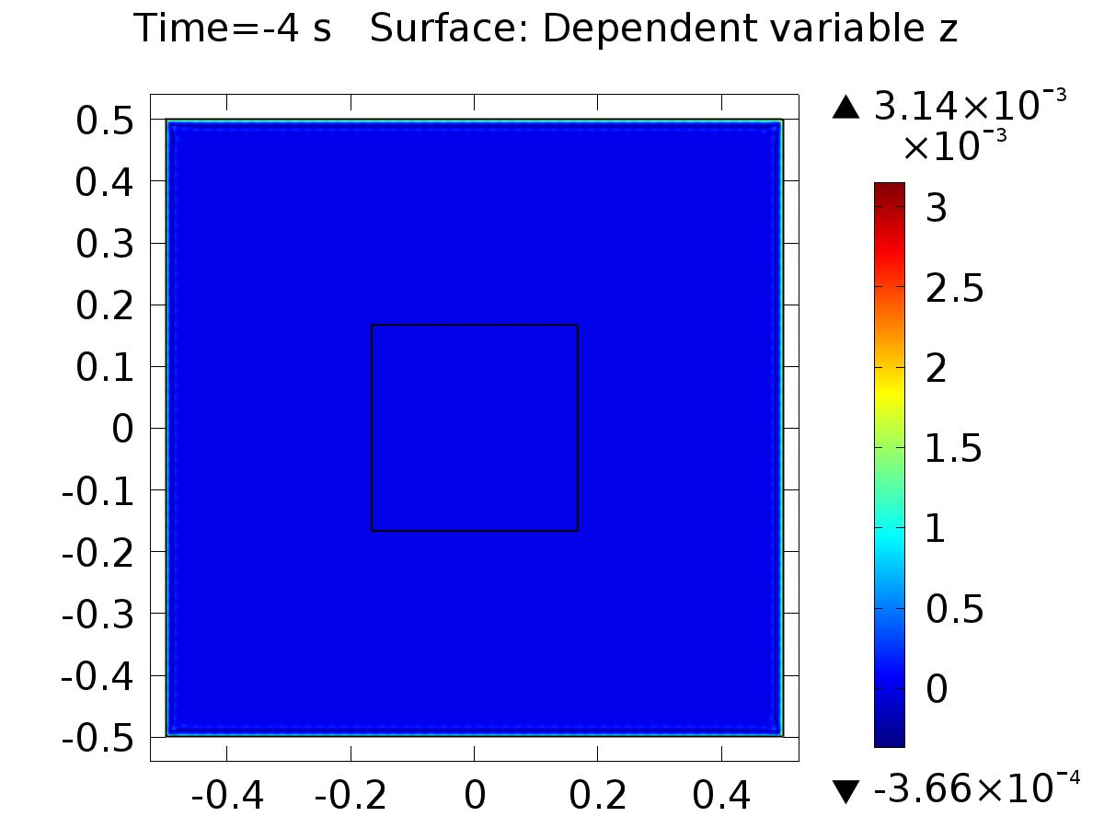

Time=-4 s Surface: Dependent variable z

* + 1. 1D Plot Group 3

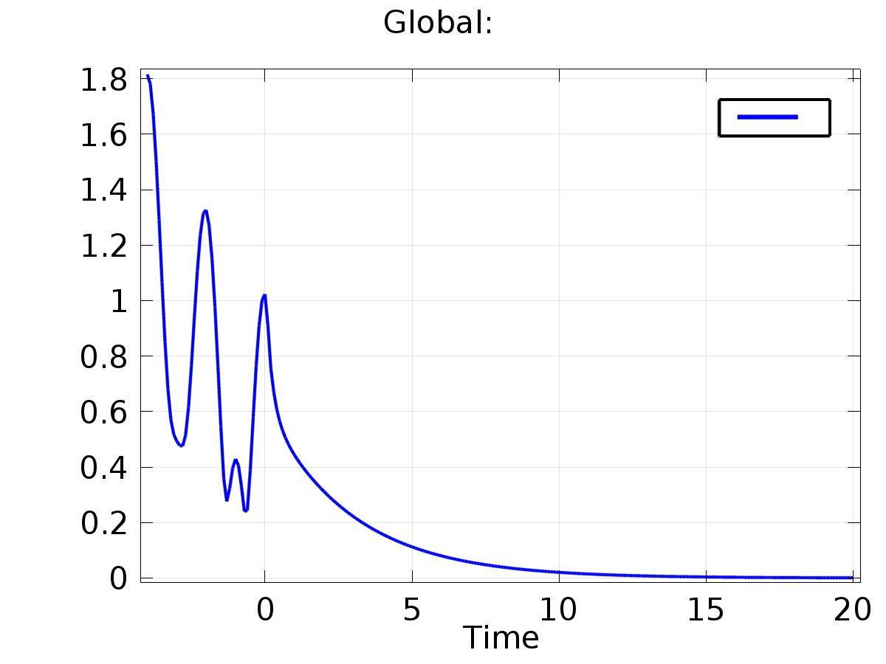

Global:

* + 1. 2D Plot Group 4

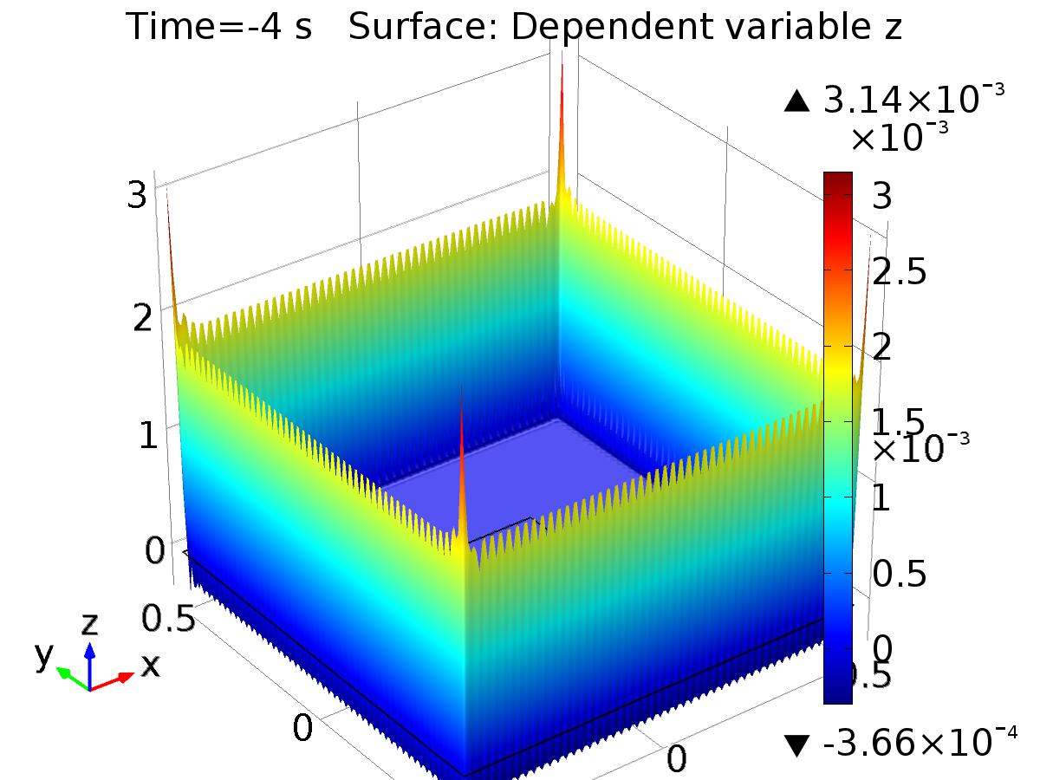

Time=-4 s Surface: Dependent variable z

* + 1. 1D Plot Group 5

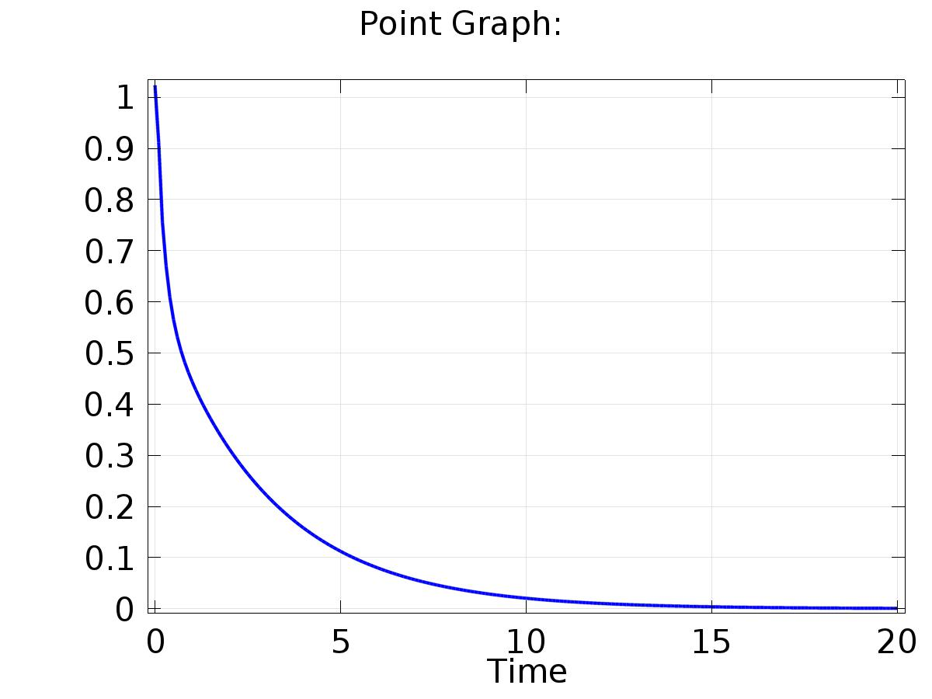

Point Graph:

* + 1. 2D Plot Group 6

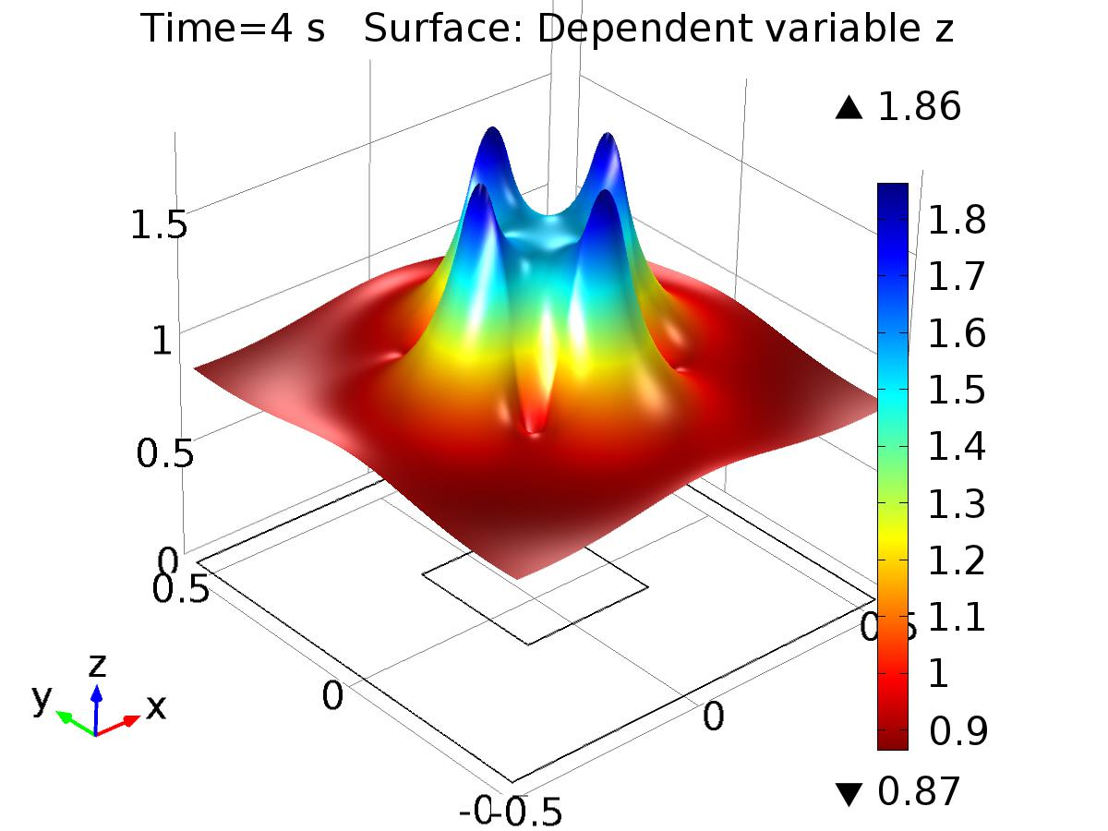

Time=4 s Surface: Dependent variable z

* + 1. 2D Plot Group 7

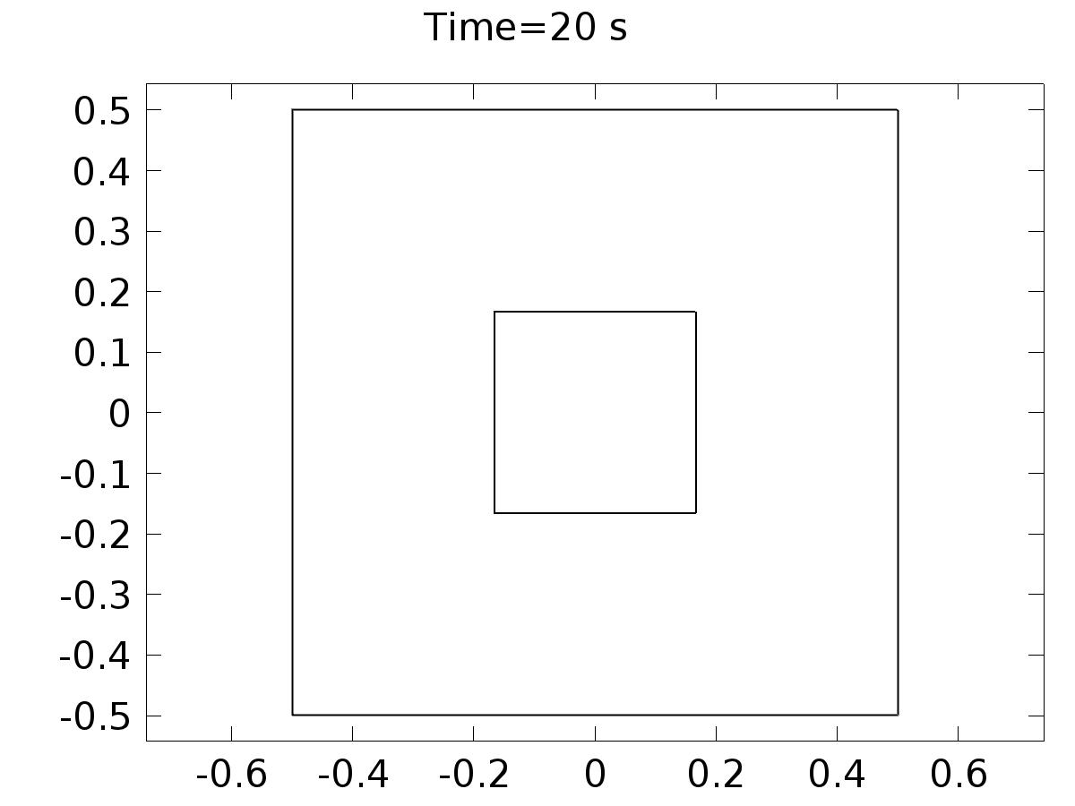

Time=20 s