[](http://www.comsol.com/)

IncommensuratePeriodicSignals

|  |  |
| --- | --- |
| Date | Dec 13, 2013 9:56:27 AM |

Contents

1. Global

1.1. Definitions

2. Plant

2.1. Definitions

2.2. Geometry 2

2.3. Unit Input

2.4. Regulator Eqs

2.5. Closed Loop System

2.6. Mesh 2

3. Study 1

3.1. Parametric Sweep

3.2. Stationary

3.3. Solver Configurations

4. Study 2

4.1. Parametric Sweep

4.2. Stationary

4.3. Solver Configurations

5. Study 3

5.1. Time Dependent

5.2. Solver Configurations

6. Results

6.1. Data Sets

6.2. Derived Values

6.3. Tables

6.4. Plot Groups

1. Global

|  |  |
| --- | --- |
| Date | Nov 7, 2013 4:24:39 PM |

Global settings

|  |  |
| --- | --- |
| Name | IncommensuratePeriodicSignals.mph |
| Path | /Users/gilliam/Desktop/collect_15/research_15/geo_reg_mono_eugenio/Mono_1_15/Comsol_EX_GitHub/Chapter3/IncommensuratePeriodSignals/IncommensuratePeriodicSignals.mph |
| Program | COMSOL 4.4 (Build: 150) |

Used products

|  |
| --- |
| COMSOL Multiphysics |

* 1. Definitions
     1. Parameters 1

Parameters

| **Name** | **Expression** | **Value** | **Description** |
| --- | --- | --- | --- |
| l | 1 | 1.0000 | Function Index |
| lmax | 4 | 4.0000 |  |
| k | 0 | 0.0000 | coefficient index |
| kmax | 20 | 20.000 |  |
| c | 0.1 | 0.10000 |  |
| n | 1 | 1.0000 |  |
| nmax | 3 | 3.0000 |  |

* + 1. Functions

#### p(l)

|  |  |
| --- | --- |
| Function name | p |
| Function type | Analytic |

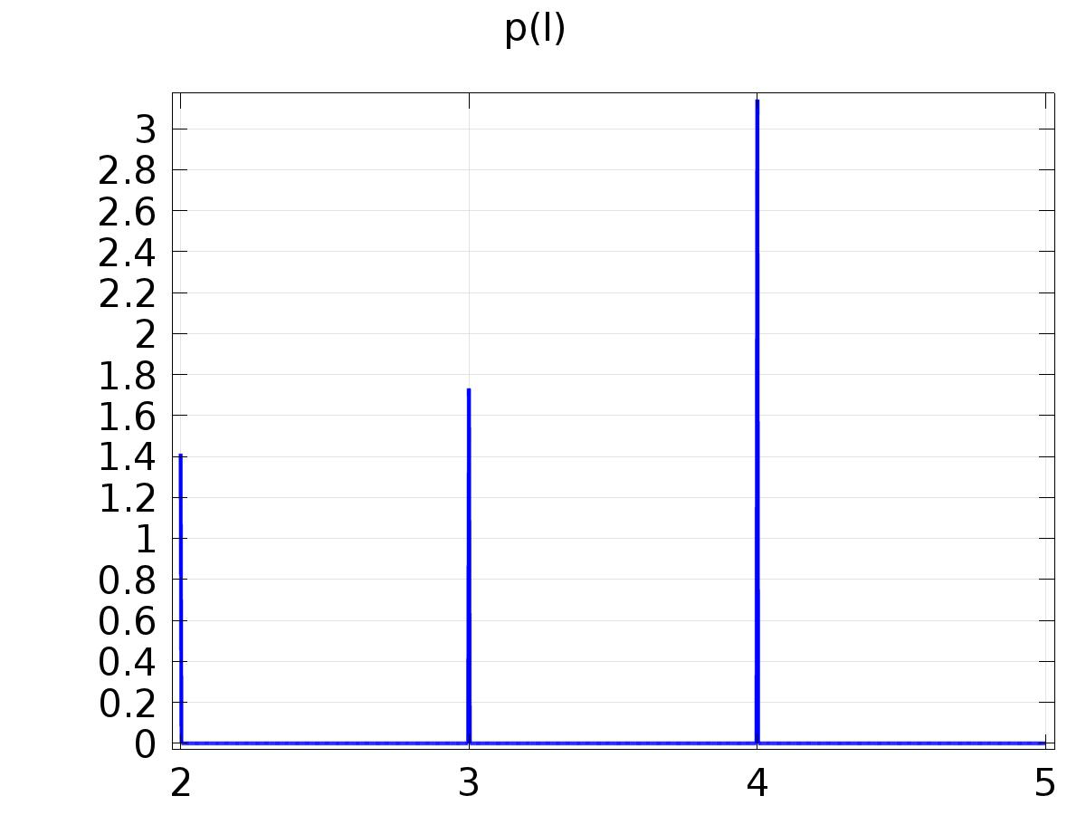

p(l)

Definition

| **Description** | **Value** |
| --- | --- |
| Expression | pi*((l==1) + (l==4)) + sqrt(2)*(l==2) + sqrt(3)*(l==3) |
| Arguments | l |

#### alpha(k,l)=pi/p(l)*k

|  |  |
| --- | --- |
| Function name | alpha |
| Function type | Analytic |

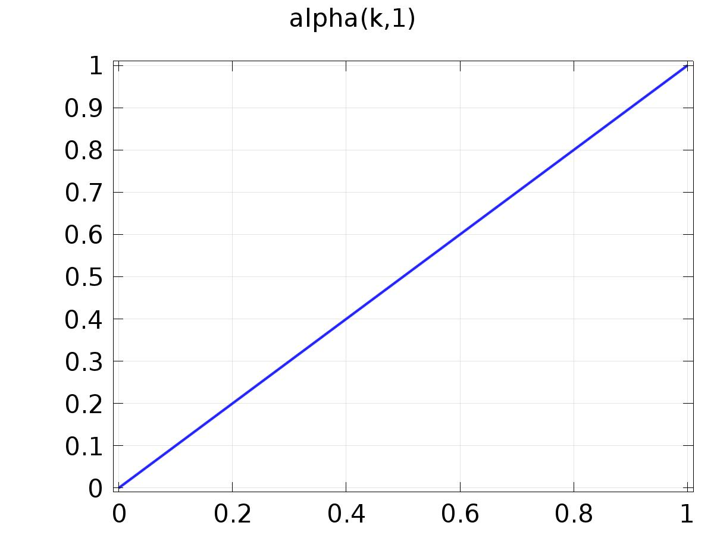

alpha(k,l)=pi/p(l)*k

Definition

| **Description** | **Value** |
| --- | --- |
| Expression | pi/p(l)*k |
| Arguments | {k, l} |

#### Cos(alpha(k)*t)

|  |  |
| --- | --- |
| Function name | FourierCos |
| Function type | Analytic |

Definition

| **Description** | **Value** |
| --- | --- |
| Expression | cos( alpha(k, l) * t ) |
| Arguments | {k, l, t} |

#### Sin(alpha(k)*t)

|  |  |
| --- | --- |
| Function name | FourierSin |
| Function type | Analytic |

Definition

| **Description** | **Value** |
| --- | --- |
| Expression | sin( alpha(k, l) * t ) |
| Arguments | {k, l, t} |

#### Cos Output

|  |  |
| --- | --- |
| Function name | Qc |
| Function type | Analytic |

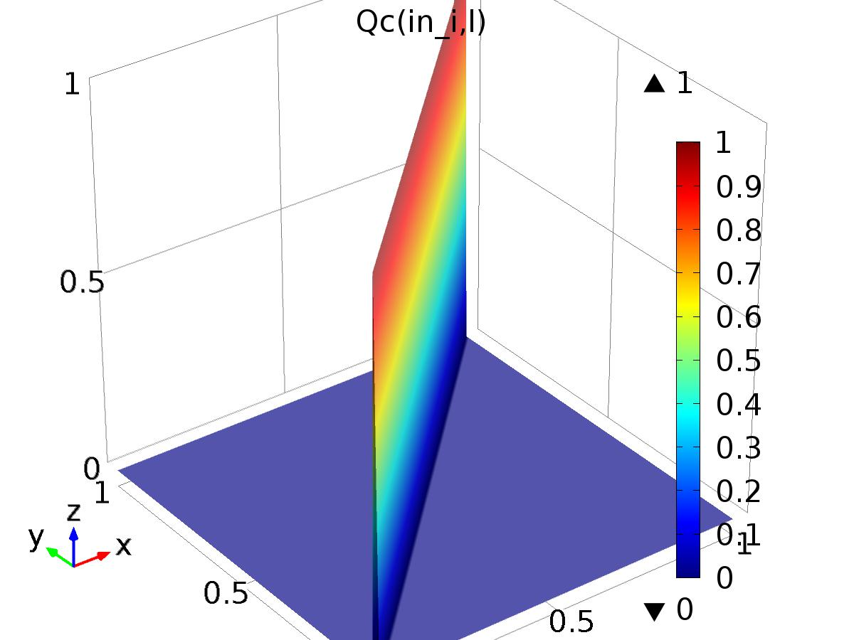

Cos Output

Definition

| **Description** | **Value** |
| --- | --- |
| Expression | (in_i==l) |
| Arguments | {in_i, l} |

#### Sin Output

|  |  |
| --- | --- |
| Function name | Qs |
| Function type | Analytic |

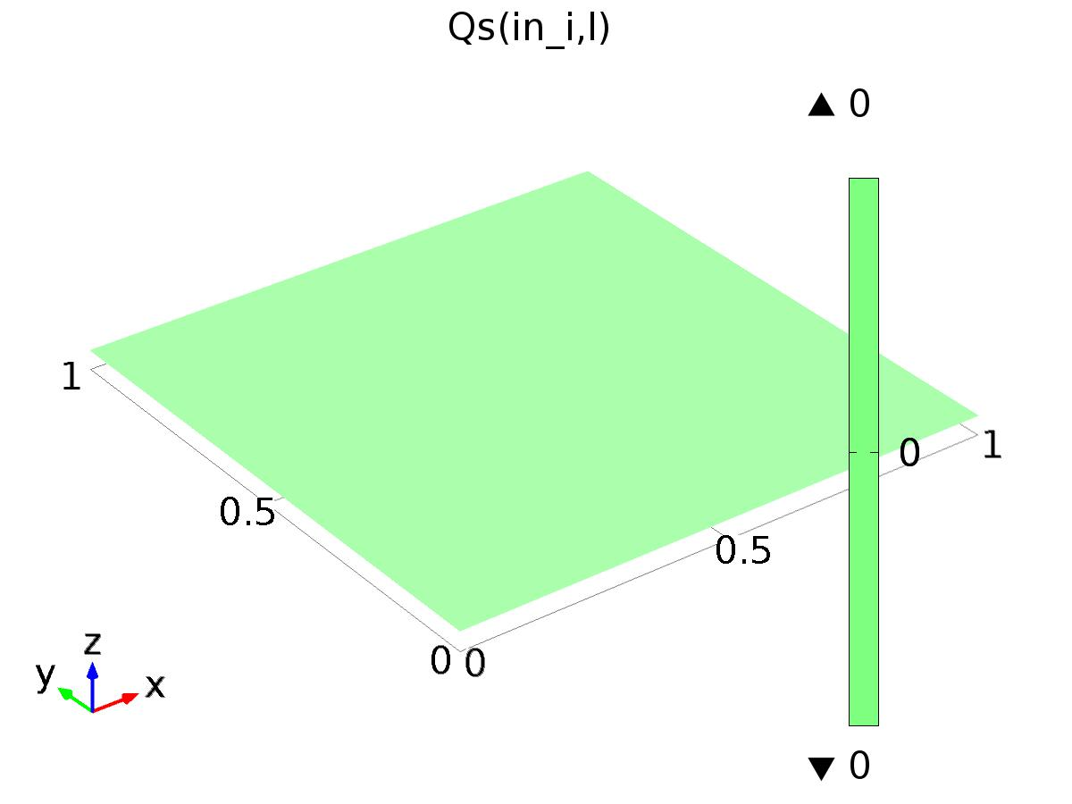

Sin Output

Definition

| **Description** | **Value** |
| --- | --- |
| Expression | 0 |
| Arguments | {in_i, l} |

#### Cos Disturbance

|  |  |
| --- | --- |
| Function name | Pc |
| Function type | Analytic |

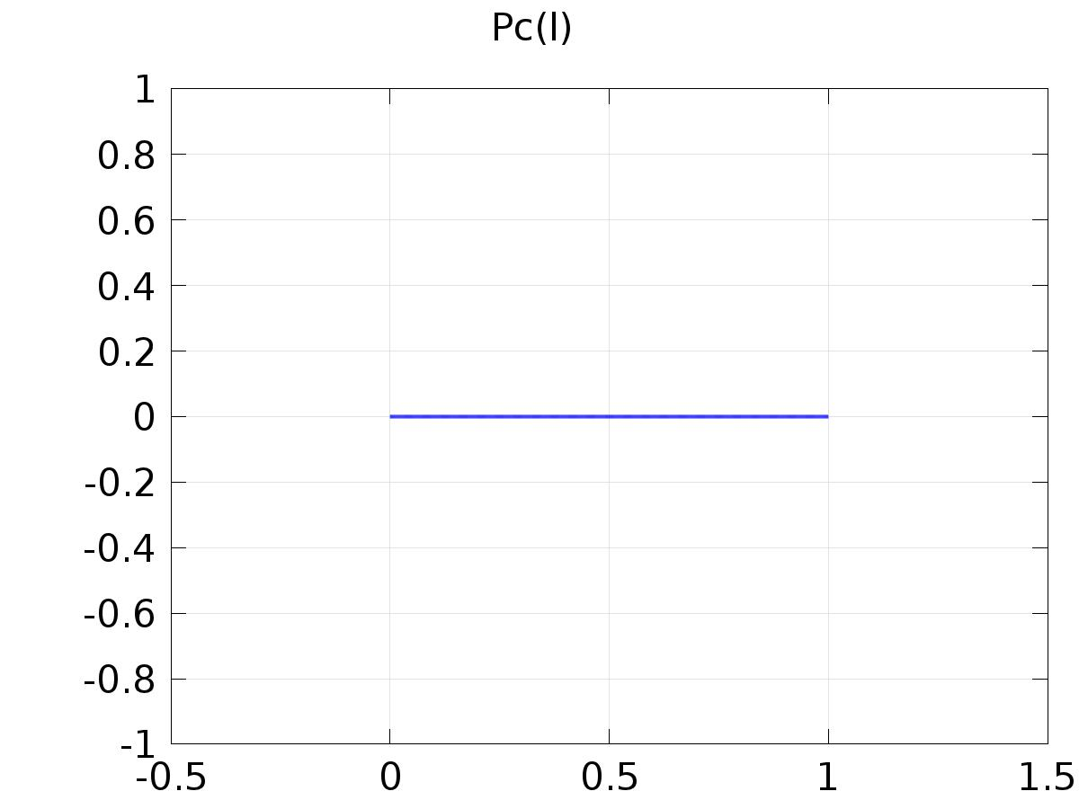

Cos Disturbance

Definition

| **Description** | **Value** |
| --- | --- |
| Expression | (l==nmax + 1) |
| Arguments | l |

#### Sin Disturbance

|  |  |
| --- | --- |
| Function name | Ps |
| Function type | Analytic |

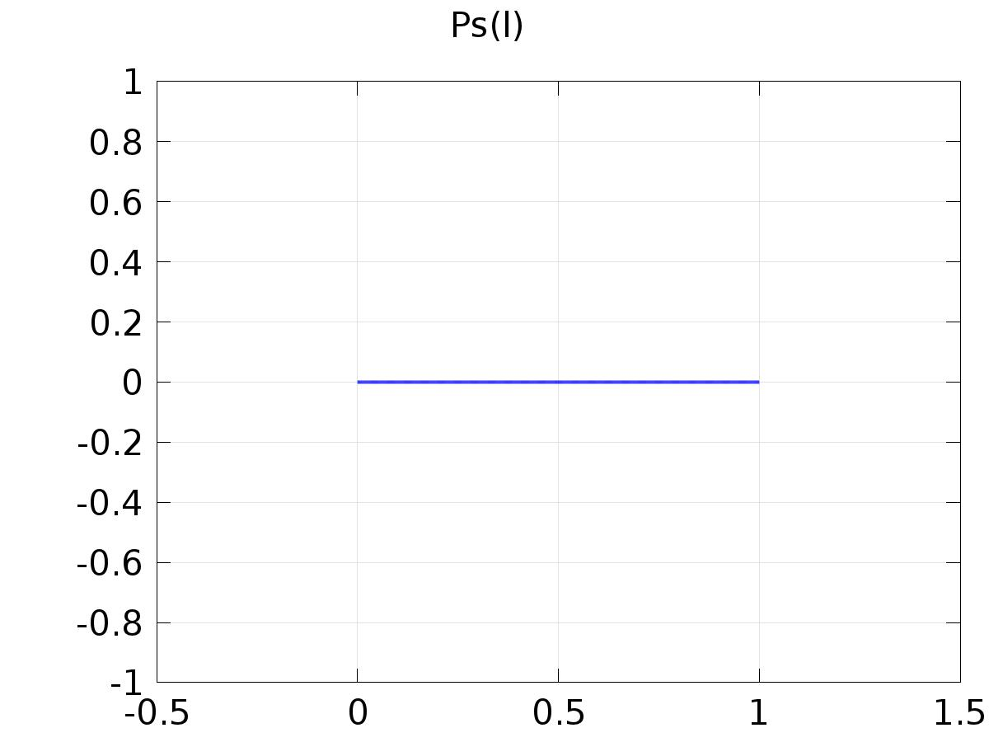

Sin Disturbance

Definition

| **Description** | **Value** |
| --- | --- |
| Expression | 0 |
| Arguments | l |

#### delta_input

|  |  |
| --- | --- |
| Function name | delta |
| Function type | Analytic |

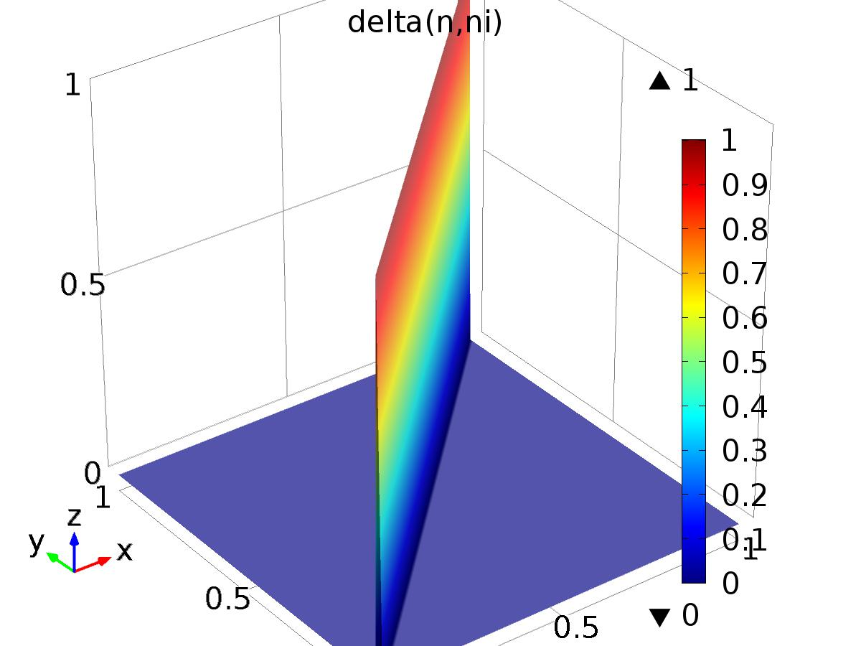

delta_input

Definition

| **Description** | **Value** |
| --- | --- |
| Expression | (ni==n) |
| Arguments | {n, ni} |

#### yr1

|  |  |
| --- | --- |
| Function name | yr1 |
| Function type | Analytic |

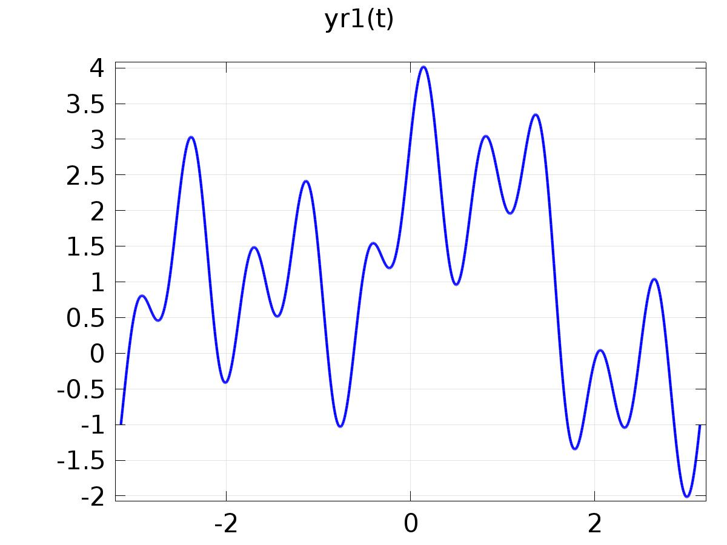

yr1

Definition

| **Description** | **Value** |
| --- | --- |
| Expression | 1 + cos(t) + sin(2*t) + cos(5*t) + sin(10*t) |
| Arguments | t |

#### yr2

|  |  |
| --- | --- |
| Function name | yr2 |
| Function type | Piecewise |

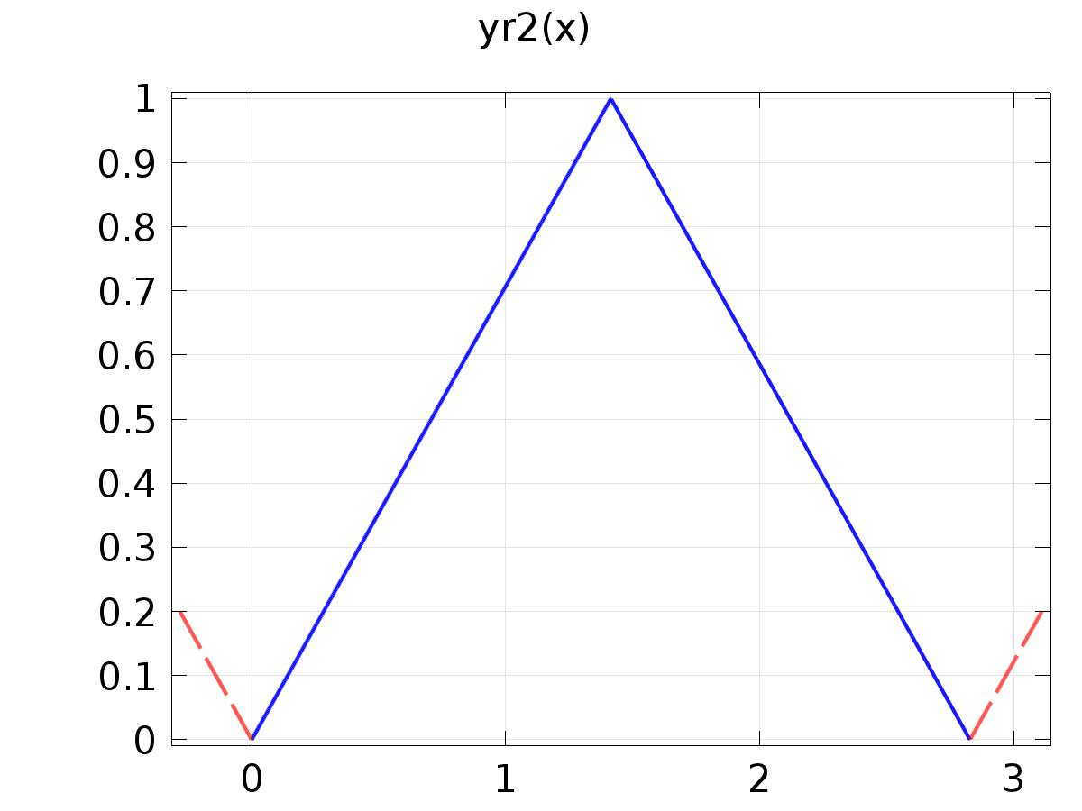

yr2

Definition

| **Description** | **Value** |
| --- | --- |
| Argument | x |
| Extrapolation | Periodic |
| Smoothing | No smoothing |

Definition

| **Start** | **End** | **Function** |
| --- | --- | --- |
| 0 | sqrt(2) | x/sqrt(2) |
| sqrt(2) | 2*sqrt(2) | (2-x/sqrt(2)) |

#### yr3

|  |  |
| --- | --- |
| Function name | yr3 |
| Function type | Piecewise |

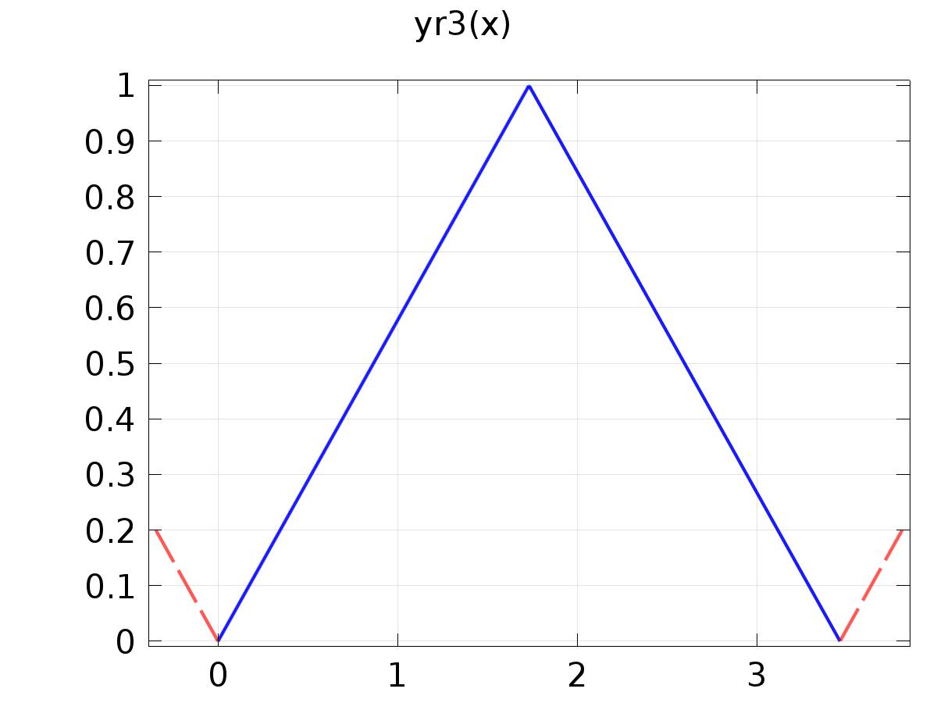

yr3

Definition

| **Description** | **Value** |
| --- | --- |
| Argument | x |
| Extrapolation | Periodic |
| Smoothing | No smoothing |

Definition

| **Start** | **End** | **Function** |
| --- | --- | --- |
| 0 | sqrt(3) | (x/sqrt(3)) |
| sqrt(3) | 2*sqrt(3) | (2-x/sqrt(3)) |

#### d1

|  |  |
| --- | --- |
| Function name | d1 |
| Function type | Analytic |

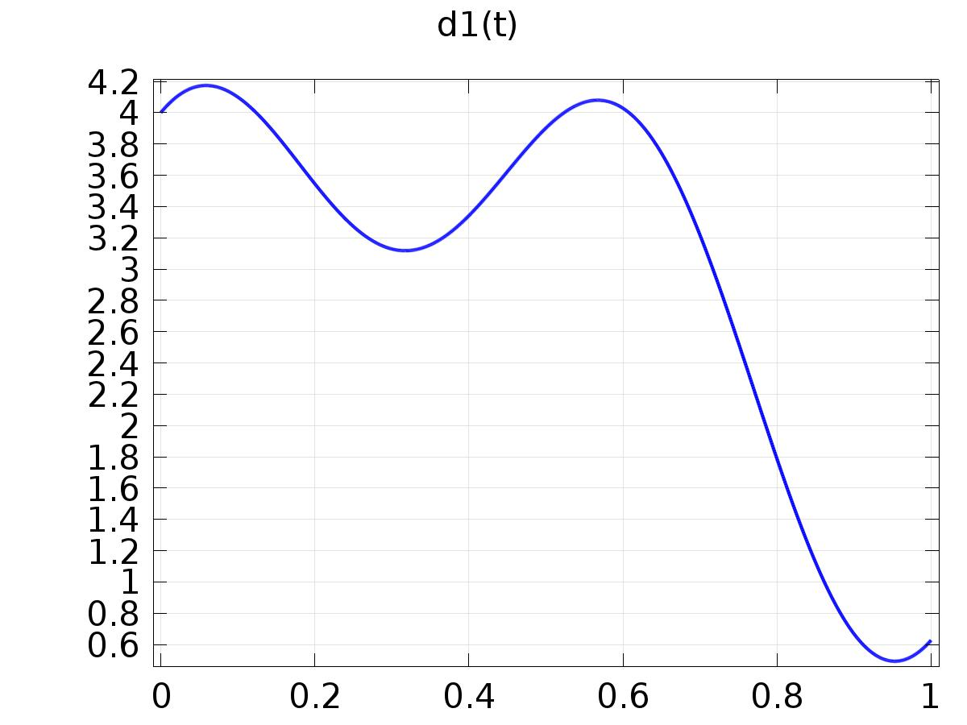

d1

Definition

| **Description** | **Value** |
| --- | --- |
| Expression | 2 + sin(t) + cos(2*t) + sin(5*t) + cos(10*t) |
| Arguments | t |

1. Plant

Component settings

|  |  |
| --- | --- |
| Unit system | None |

* 1. Definitions
     1. Variables

#### Variables 1

Selection

|  |  |
| --- | --- |
| Geometric entity level | Entire model |

| **Name** | **Expression** | **Description** |
| --- | --- | --- |
| gammac1 | 0 + (-2.59551446923730E+00)*(Qc(1, l) - C1(PIt1)) + (1.61132805650268E+00)*(Qc(2, l) - C2(PIt1)) + (1.13278596347468E+00)*(Qc(3, l) - C3(PIt1)) |  |
| gammas1 | 0 + (-2.59551446923730E+00)*(Qs(1, l) - C1(PIt2)) + (1.61132805650268E+00)*(Qs(2, l) - C2(PIt2)) + (1.13278596347468E+00)*(Qs(3, l) - C3(PIt2)) |  |
| gammac2 | 0 + (-8.45090233310356E+02)*(Qc(1, l) - C1(PIt1)) + (1.70618227648506E+02)*(Qc(2, l) - C2(PIt1)) + (8.58287466141889E+02)*(Qc(3, l) - C3(PIt1)) |  |
| gammas2 | 0 + (-8.45090233310356E+02)*(Qs(1, l) - C1(PIt2)) + (1.70618227648506E+02)*(Qs(2, l) - C2(PIt2)) + (8.58287466141889E+02)*(Qs(3, l) - C3(PIt2)) |  |
| gammac3 | 0 + (2.01080507896090E+02)*(Qc(1, l) - C1(PIt1)) + (-4.07833107239734E+01)*(Qc(2, l) - C2(PIt1)) + (-2.00927620030435E+02)*(Qc(3, l) - C3(PIt1)) |  |
| gammas3 | 0 + (2.01080507896090E+02)*(Qs(1, l) - C1(PIt2)) + (-4.07833107239734E+01)*(Qs(2, l) - C2(PIt2)) + (-2.00927620030435E+02)*(Qs(3, l) - C3(PIt2)) |  |

#### Variables2

Selection

|  |  |
| --- | --- |
| Geometric entity level | Entire model |

| **Name** | **Expression** | **Description** |
| --- | --- | --- |
| Gamma1 | 0 + (1.00000000000000e+00)*((-2.59551446923730e+00)*FourierCos(0, 1, t) + (0.00000000000000e+00)*FourierSin(0, 1, t)) + (5.00000000000000e-01)*((1.61132805650268e+00)*FourierCos(0, 2, t) + (0.00000000000000e+00)*FourierSin(0, 2, t)) + (5.00000000000000e-01)*((1.13278596347468e+00)*FourierCos(0, 3, t) + (0.00000000000000e+00)*FourierSin(0, 3, t)) + (2.00000000000000e+00)*((-1.48599550740109e-01)*FourierCos(0, 4, t) + (0.00000000000000e+00)*FourierSin(0, 4, t)) + (1.00000000000000e+00)*((-1.98179718450950e+00)*FourierCos(1, 1, t) + (2.32152459432168e+00)*FourierSin(1, 1, t)) + (-4.05284734569351e-01)*((-7.21706907593931e-01)*FourierCos(1, 2, t) + (-3.11019208671557e+00)*FourierSin(1, 2, t)) + (-4.05284734569351e-01)*((7.35719196815019e-01)*FourierCos(1, 3, t) + (-1.37764577514522e+00)*FourierSin(1, 3, t)) + (1.00000000000000e+00)*((-1.59892247712335e-01)*FourierSin(1, 4, t) - (2.77791464122668e-02)*FourierCos(1, 4, t)) + (1.00000000000000e+00)*((-1.82085017636808e-01)*FourierSin(2, 1, t) - (4.32328433081463e+00)*FourierCos(2, 1, t)) + (1.00000000000000e+00)*((-1.91514010327971e-01)*FourierCos(2, 4, t) + (4.39777391450038e-02)*FourierSin(2, 4, t)) + (-4.50316371743722e-02)*((-1.40128590781868e+01)*FourierCos(3, 2, t) + (4.13232358979140e+00)*FourierSin(3, 2, t)) + (-4.50316371743723e-02)*((-1.95393581169397e+00)*FourierCos(3, 3, t) + (-4.34990331658713e+00)*FourierSin(3, 3, t)) + (1.00000000000000e+00)*((1.05007375497253e+01)*FourierCos(5, 1, t) + (5.47178449059707e+00)*FourierSin(5, 1, t)) + (-1.62113893827740e-02)*((-1.45389374314107e+01)*FourierCos(5, 2, t) + (4.06935988887001e+01)*FourierSin(5, 2, t)) + (-1.62113893827740e-02)*((-6.12468798702028e+00)*FourierCos(5, 3, t) + (-6.21894260118518e+00)*FourierSin(5, 3, t)) + (1.00000000000000e+00)*((-2.93130142829456e-01)*FourierSin(5, 4, t) - (-5.00684975598062e-02)*FourierCos(5, 4, t)) + (-8.27111703202759e-03)*((3.75820464398692e+01)*FourierCos(7, 2, t) + (9.36031881712024e+01)*FourierSin(7, 2, t)) + (-8.27111703202759e-03)*((-1.20185487478057e+01)*FourierCos(7, 3, t) + (-5.86625956998807e+00)*FourierSin(7, 3, t)) + (-5.00351524159706e-03)*((1.73056746157418e+02)*FourierCos(9, 2, t) + (1.12043785107360e+02)*FourierSin(9, 2, t)) + (-5.00351524159694e-03)*((-1.91118299526574e+01)*FourierCos(9, 3, t) + (-2.85636783953532e+00)*FourierSin(9, 3, t)) + (1.00000000000000e+00)*((2.56453002889127e+01)*FourierSin(10, 1, t) - (-2.26559626720477e+01)*FourierCos(10, 1, t)) + (1.00000000000000e+00)*((-1.68746416984141e-01)*FourierCos(10, 4, t) + (-2.03700681790707e-01)*FourierSin(10, 4, t)) + (-3.34946061627554e-03)*((3.86063049300244e+02)*FourierCos(11, 2, t) + (1.20726886836016e+01)*FourierSin(11, 2, t)) + (-3.34946061627563e-03)*((-2.64914020703191e+01)*FourierCos(11, 3, t) + (3.19406796372732e+00)*FourierSin(11, 3, t)) + (-2.39813452407915e-03)*((6.08779674241333e+02)*FourierCos(13, 2, t) + (-3.02568269521876e+02)*FourierSin(13, 2, t)) + (-2.39813452407873e-03)*((-3.31713849305702e+01)*FourierCos(13, 3, t) + (1.21731288071096e+01)*FourierSin(13, 3, t)) + (-1.80126548697489e-03)*((6.95654356496986e+02)*FourierCos(15, 2, t) + (-9.04345077558385e+02)*FourierSin(15, 2, t)) + (-1.80126548697472e-03)*((-3.87807431294268e+01)*FourierCos(15, 3, t) + (2.32602017662284e+01)*FourierSin(15, 3, t)) + (-1.40236932376910e-03)*((4.24996696698233e+02)*FourierCos(17, 2, t) + (-1.79437680267041e+03)*FourierSin(17, 2, t)) + (-1.40236932376938e-03)*((-4.47950197571845e+01)*FourierCos(17, 3, t) + (3.55977110652020e+01)*FourierSin(17, 3, t)) + (-1.12267239492865e-03)*((-4.75859151681389e+02)*FourierCos(19, 2, t) + (-2.85048215675136e+03)*FourierSin(19, 2, t)) + (-1.12267239492944e-03)*((-5.55199819596892e+01)*FourierCos(19, 3, t) + (5.07844836499971e+01)*FourierSin(19, 3, t)) |  |
| Gamma2 | 0 + (1.00000000000000e+00)*((-8.45090233310356e+02)*FourierCos(0, 1, t) + (0.00000000000000e+00)*FourierSin(0, 1, t)) + (5.00000000000000e-01)*((1.70618227648506e+02)*FourierCos(0, 2, t) + (0.00000000000000e+00)*FourierSin(0, 2, t)) + (5.00000000000000e-01)*((8.58287466141889e+02)*FourierCos(0, 3, t) + (0.00000000000000e+00)*FourierSin(0, 3, t)) + (2.00000000000000e+00)*((-1.78815460480066e+02)*FourierCos(0, 4, t) + (0.00000000000000e+00)*FourierSin(0, 4, t)) + (1.00000000000000e+00)*((-5.64984080680173e+02)*FourierCos(1, 1, t) + (7.90119635025239e+02)*FourierSin(1, 1, t)) + (-4.05284734569351e-01)*((1.49104666923398e+02)*FourierCos(1, 2, t) + (-1.66555118271094e+02)*FourierSin(1, 2, t)) + (-4.05284734569351e-01)*((-6.44344473916899e+01)*FourierCos(1, 3, t) + (-1.32017522104179e+03)*FourierSin(1, 3, t)) + (1.00000000000000e+00)*((-1.79949754712813e+02)*FourierSin(1, 4, t) - (6.18381820264074e+01)*FourierCos(1, 4, t)) + (1.00000000000000e+00)*((2.49797804559059e+02)*FourierSin(2, 1, t) - (1.35720890358924e+03)*FourierCos(2, 1, t)) + (1.00000000000000e+00)*((-1.85020778233453e+02)*FourierCos(2, 4, t) + (1.25182246604169e+02)*FourierSin(2, 4, t)) + (-4.50316371743722e-02)*((2.80886551574749e+01)*FourierCos(3, 2, t) + (-4.27365939083865e+02)*FourierSin(3, 2, t)) + (-4.50316371743723e-02)*((-5.60438240340228e+03)*FourierCos(3, 3, t) + (6.27258485234503e+02)*FourierSin(3, 3, t)) + (1.00000000000000e+00)*((4.78433232812361e+03)*FourierCos(5, 1, t) + (-4.78234151519282e+01)*FourierSin(5, 1, t)) + (-1.62113893827740e-02)*((-2.78978317149224e+02)*FourierCos(5, 2, t) + (-4.91907263728907e+02)*FourierSin(5, 2, t)) + (-1.62113893827740e-02)*((-6.98390402214663e+03)*FourierCos(5, 3, t) + (1.22433123304378e+04)*FourierSin(5, 3, t)) + (1.00000000000000e+00)*((-2.43905376798789e+02)*FourierSin(5, 4, t) - (2.88868893397612e+02)*FourierCos(5, 4, t)) + (-8.27111703202759e-03)*((-6.98046095648664e+02)*FourierCos(7, 2, t) + (-3.58118003474906e+02)*FourierSin(7, 2, t)) + (-8.27111703202759e-03)*((9.20801191529050e+03)*FourierCos(7, 3, t) + (2.83750209976815e+04)*FourierSin(7, 3, t)) + (-5.00351524159706e-03)*((-1.11970069625591e+03)*FourierCos(9, 2, t) + (2.97840805090345e+01)*FourierSin(9, 2, t)) + (-5.00351524159694e-03)*((5.11315596947740e+04)*FourierCos(9, 3, t) + (3.01404374279099e+04)*FourierSin(9, 3, t)) + (1.00000000000000e+00)*((4.68032318525715e+03)*FourierSin(10, 1, t) - (-1.67409991724967e+04)*FourierCos(10, 1, t)) + (1.00000000000000e+00)*((-2.65739682106368e+02)*FourierCos(10, 4, t) + (4.26173861956586e+02)*FourierSin(10, 4, t)) + (-3.34946061627554e-03)*((-1.43218645579069e+03)*FourierCos(11, 2, t) + (6.97863622399498e+02)*FourierSin(11, 2, t)) + (-3.34946061627563e-03)*((1.11544441956991e+05)*FourierCos(11, 3, t) + (-1.12149630088038e+04)*FourierSin(11, 3, t)) + (-2.39813452407915e-03)*((-1.51654107909989e+03)*FourierCos(13, 2, t) + (1.63696587869237e+03)*FourierSin(13, 2, t)) + (-2.39813452407873e-03)*((1.59355247794173e+05)*FourierCos(13, 3, t) + (-1.24145879137101e+05)*FourierSin(13, 3, t)) + (-1.80126548697489e-03)*((-1.25273825633163e+03)*FourierCos(15, 2, t) + (2.80579818208618e+03)*FourierSin(15, 2, t)) + (-1.80126548697472e-03)*((1.36790836335147e+05)*FourierCos(15, 3, t) + (-3.21334903060794e+05)*FourierSin(15, 3, t)) + (-1.40236932376910e-03)*((-5.21428696315037e+02)*FourierCos(17, 2, t) + (4.13693346162530e+03)*FourierSin(17, 2, t)) + (-1.40236932376938e-03)*((-3.53532091970854e+04)*FourierCos(17, 3, t) + (-5.81671185179982e+05)*FourierSin(17, 3, t)) + (-1.12267239492865e-03)*((8.04979553300596e+02)*FourierCos(19, 2, t) + (5.54133500418218e+03)*FourierSin(19, 2, t)) + (-1.12267239492944e-03)*((-4.43523980898842e+05)*FourierCos(19, 3, t) + (-8.33171613521039e+05)*FourierSin(19, 3, t)) |  |
| Gamma3 | 0 + (1.00000000000000e+00)*((2.01080507896090e+02)*FourierCos(0, 1, t) + (0.00000000000000e+00)*FourierSin(0, 1, t)) + (5.00000000000000e-01)*((-4.07833107239734e+01)*FourierCos(0, 2, t) + (0.00000000000000e+00)*FourierSin(0, 2, t)) + (5.00000000000000e-01)*((-2.00927620030435e+02)*FourierCos(0, 3, t) + (0.00000000000000e+00)*FourierSin(0, 3, t)) + (2.00000000000000e+00)*((4.16304228583226e+01)*FourierCos(0, 4, t) + (0.00000000000000e+00)*FourierSin(0, 4, t)) + (1.00000000000000e+00)*((1.19795072441033e+02)*FourierCos(1, 1, t) + (-2.03732897287242e+02)*FourierSin(1, 1, t)) + (-4.05284734569351e-01)*((-3.12158995231792e+01)*FourierCos(1, 2, t) + (4.83197068444820e+01)*FourierSin(1, 2, t)) + (-4.05284734569351e-01)*((6.40932580749277e+01)*FourierCos(1, 3, t) + (3.21867792398266e+02)*FourierSin(1, 3, t)) + (1.00000000000000e+00)*((4.12837038792169e+01)*FourierSin(1, 4, t) - (-1.87666287965487e+01)*FourierCos(1, 4, t)) + (1.00000000000000e+00)*((-1.14408459051544e+02)*FourierSin(2, 1, t) - (-3.32748329164425e+02)*FourierCos(2, 1, t)) + (1.00000000000000e+00)*((4.07828756312134e+01)*FourierCos(2, 4, t) + (-3.84329570502077e+01)*FourierSin(2, 4, t)) + (-4.50316371743722e-02)*((2.18176009604063e+01)*FourierCos(3, 2, t) + (1.26441618254942e+02)*FourierSin(3, 2, t)) + (-4.50316371743723e-02)*((1.53361431480465e+03)*FourierCos(3, 3, t) + (-5.54253626699468e+02)*FourierSin(3, 3, t)) + (1.00000000000000e+00)*((-1.33693869744594e+03)*FourierCos(5, 1, t) + (3.11139362259455e+02)*FourierSin(5, 1, t)) + (-1.62113893827740e-02)*((1.30127816265484e+02)*FourierCos(5, 2, t) + (1.30699996125038e+02)*FourierSin(5, 2, t)) + (-1.62113893827740e-02)*((1.11486579248834e+03)*FourierCos(5, 3, t) + (-4.29800670661194e+03)*FourierSin(5, 3, t)) + (1.00000000000000e+00)*((4.89611640666218e+01)*FourierSin(5, 4, t) - (-9.62300688659423e+01)*FourierCos(5, 4, t)) + (-8.27111703202759e-03)*((2.67940117616614e+02)*FourierCos(7, 2, t) + (5.08672760368479e+01)*FourierSin(7, 2, t)) + (-8.27111703202759e-03)*((-5.61681072722399e+03)*FourierCos(7, 3, t) + (-8.28602683603497e+03)*FourierSin(7, 3, t)) + (-5.00351524159706e-03)*((3.88604929671883e+02)*FourierCos(9, 2, t) + (-1.30774144681138e+02)*FourierSin(9, 2, t)) + (-5.00351524159694e-03)*((-2.03370714648524e+04)*FourierCos(9, 3, t) + (-4.98500816574800e+03)*FourierSin(9, 3, t)) + (1.00000000000000e+00)*((-6.51618126352842e+01)*FourierSin(10, 1, t) - (5.56383049660505e+03)*FourierCos(10, 1, t)) + (1.00000000000000e+00)*((4.57299452758330e+01)*FourierCos(10, 4, t) + (-1.54444865437923e+02)*FourierSin(10, 4, t)) + (-3.34946061627554e-03)*((4.41891544108210e+02)*FourierCos(11, 2, t) + (-4.18737507227139e+02)*FourierSin(11, 2, t)) + (-3.34946061627563e-03)*((-3.79658545918623e+04)*FourierCos(11, 3, t) + (1.60124520126261e+04)*FourierSin(11, 3, t)) + (-2.39813452407915e-03)*((3.74923581875843e+02)*FourierCos(13, 2, t) + (-8.00927218523851e+02)*FourierSin(13, 2, t)) + (-2.39813452407873e-03)*((-4.37432575231748e+04)*FourierCos(13, 3, t) + (6.32042363609625e+04)*FourierSin(13, 3, t)) + (-1.80126548697489e-03)*((1.35321705640511e+02)*FourierCos(15, 2, t) + (-1.24938095384331e+03)*FourierSin(15, 2, t)) + (-1.80126548697472e-03)*((-1.30624731124355e+04)*FourierCos(15, 3, t) + (1.36323747211256e+05)*FourierSin(15, 3, t)) + (-1.40236932376910e-03)*((-3.27913277369669e+02)*FourierCos(17, 2, t) + (-1.72212945235048e+03)*FourierSin(17, 2, t)) + (-1.40236932376938e-03)*((8.48848536644867e+04)*FourierCos(17, 3, t) + (2.18788892318388e+05)*FourierSin(17, 3, t)) + (-1.12267239492865e-03)*((-1.06801489973578e+03)*FourierCos(19, 2, t) + (-2.16347533561791e+03)*FourierSin(19, 2, t)) + (-1.12267239492944e-03)*((2.79354051174866e+05)*FourierCos(19, 3, t) + (2.71127770716450e+05)*FourierSin(19, 3, t)) |  |

* + 1. Probes

#### C1(Xj)

|  |  |
| --- | --- |
| Probe type | Global variable probe |

#### C2(Xj)

|  |  |
| --- | --- |
| Probe type | Global variable probe |

#### C3(Xj)

|  |  |
| --- | --- |
| Probe type | Global variable probe |

#### gammac1

|  |  |
| --- | --- |
| Probe type | Global variable probe |

#### gammas1

|  |  |
| --- | --- |
| Probe type | Global variable probe |

#### gammac2

|  |  |
| --- | --- |
| Probe type | Global variable probe |

#### gammas2

|  |  |
| --- | --- |
| Probe type | Global variable probe |

#### gammac3

|  |  |
| --- | --- |
| Probe type | Global variable probe |

#### gammas3

|  |  |
| --- | --- |
| Probe type | Global variable probe |

* + 1. Component Couplings

#### Average 1

|  |  |
| --- | --- |
| Coupling type | Average |
| Operator name | C1 |

Source selection

|  |  |
| --- | --- |
| Geometric entity level | Boundary |
| Selection | Boundary 5 |

#### Average 2

|  |  |
| --- | --- |
| Coupling type | Average |
| Operator name | C2 |

Source selection

|  |  |
| --- | --- |
| Geometric entity level | Boundary |
| Selection | Boundary 4 |

#### Average 3

|  |  |
| --- | --- |
| Coupling type | Average |
| Operator name | C3 |

Source selection

|  |  |
| --- | --- |
| Geometric entity level | Boundary |
| Selection | Boundary 6 |

* + 1. Coordinate Systems

#### Boundary System 1

|  |  |
| --- | --- |
| Coordinate system type | Boundary system |
| Tag | sys1 |

Coordinate names

| **First (t1)** | **Second (n)** | **Third (to)** |
| --- | --- | --- |
| t1 | n | to |

Settings

| **Description** | **Value** |
| --- | --- |
| Create first tangent direction from | Global Cartesian |

* 1. Geometry 2

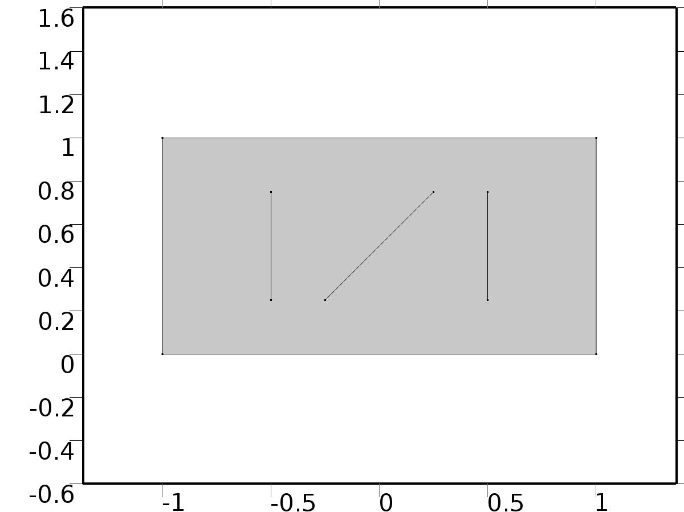

Geometry 2

Units

|  |  |
| --- | --- |
| Length unit | m |
| Angular unit | deg |

Geometry statistics

| **Description** | **Value** |
| --- | --- |
| Space dimension | 2 |
| Number of domains | 1 |
| Number of boundaries | 7 |
| Number of vertices | 10 |

* + 1. Rectangle 1 (r1)

Position

| **Description** | **Value** |
| --- | --- |
| Position | {-1, 0} |
| Layers |  |

Size

| **Description** | **Value** |
| --- | --- |
| Width | 2 |
| Height | 1 |

* + 1. Polygon 1 (pol1)

Object type

| **Description** | **Value** |
| --- | --- |
| Type | Open curve |

Coordinates

| **Description** | **Value** |
| --- | --- |
| x | {-0.25, 0.25} |
| y | {0.25, 0.75} |

* + 1. Polygon 2 (pol2)

Object type

| **Description** | **Value** |
| --- | --- |
| Type | Open curve |

Coordinates

| **Description** | **Value** |
| --- | --- |
| x | {0.5, 0.5} |
| y | {0.25, 0.75} |

* + 1. Polygon 3 (pol3)

Object type

| **Description** | **Value** |
| --- | --- |
| Type | Open curve |

Coordinates

| **Description** | **Value** |
| --- | --- |
| x | {-0.5, -0.5} |
| y | {0.25, 0.75} |

* 1. Unit Input

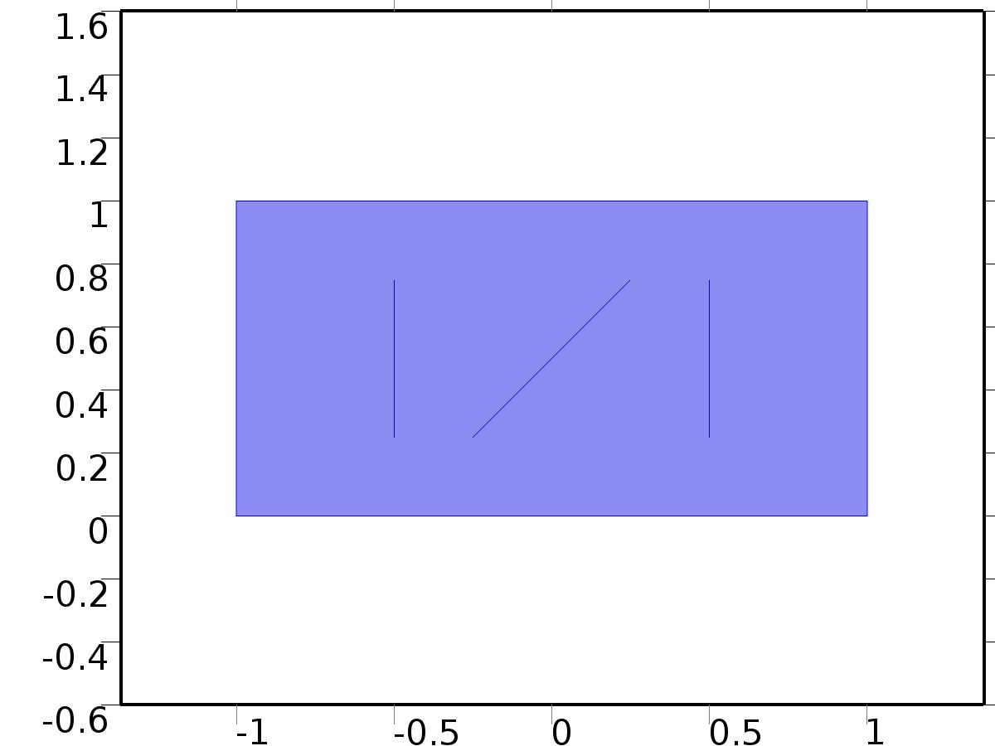

Unit Input

Selection

|  |  |
| --- | --- |
| Geometric entity level | Domain |
| Selection | Domain 1 |

Settings

| **Description** | **Value** |
| --- | --- |
| Shape function type | Lagrange |
| Element order | Quadratic |
| Compute boundary fluxes | On |
| Apply smoothing to boundary fluxes | On |
| Value type when using splitting of complex variables | Complex |
| Dependent variable quantity | Dimensionless (1) |
| Source term quantity | None |
| Unit | m^ - 2 |

Used products

|  |
| --- |
| COMSOL Multiphysics |

Variables

| **Name** | **Expression** | **Unit** | **Description** | **Selection** |
| --- | --- | --- | --- | --- |
| X.nx | dnx |  | Normal vector, x component | Boundaries 1–3, 7 |
| X.ny | dny |  | Normal vector, y component | Boundaries 1–3, 7 |
| X.nz | 0 |  | Normal vector, z component | Boundaries 1–3, 7 |
| X.nx | nx |  | Normal vector, x component | Boundaries 4–6 |
| X.ny | ny |  | Normal vector, y component | Boundaries 4–6 |
| X.nz | 0 |  | Normal vector, z component | Boundaries 4–6 |
| X.nxmesh | root.dnxmesh |  | Normal vector (mesh), x component | Boundaries 1–3, 7 |
| X.nymesh | root.dnymesh |  | Normal vector (mesh), y component | Boundaries 1–3, 7 |
| X.nzmesh | 0 |  | Normal vector (mesh), z component | Boundaries 1–3, 7 |
| X.nxmesh | root.nxmesh |  | Normal vector (mesh), x component | Boundaries 4–6 |
| X.nymesh | root.nymesh |  | Normal vector (mesh), y component | Boundaries 4–6 |
| X.nzmesh | 0 |  | Normal vector (mesh), z component | Boundaries 4–6 |

* + 1. Coefficient Form PDE 1



Coefficient Form PDE 1

Selection

|  |  |
| --- | --- |
| Geometric entity level | Domain |
| Selection | Domain 1 |

Equations

Settings

| **Description** | **Value** |
| --- | --- |
| Diffusion coefficient | {{c, 0}, {0, c}} |
| Absorption coefficient | 0 |
| Source term | 0 |
| Mass coefficient | 0 |
| Damping or mass coefficient | 0 |
| Conservative flux convection coefficient | {0, 0} |
| Convection coefficient | {0, 0} |
| Conservative flux source | {0, 0} |

#### Variables

| **Name** | **Expression** | **Unit** | **Description** | **Selection** |
| --- | --- | --- | --- | --- |
| domflux.Xx | -c*d(X,x) |  | Domain flux, x component | Domain 1 |
| domflux.Xy | -c*d(X,y) |  | Domain flux, y component | Domain 1 |

#### Shape functions

| **Name** | **Shape function** | **Unit** | **Description** | **Shape frame** | **Selection** |
| --- | --- | --- | --- | --- | --- |
| X | Lagrange (Quadratic) |  | Dependent variable X | Material | Domain 1 |

* + 1. Zero Flux 1

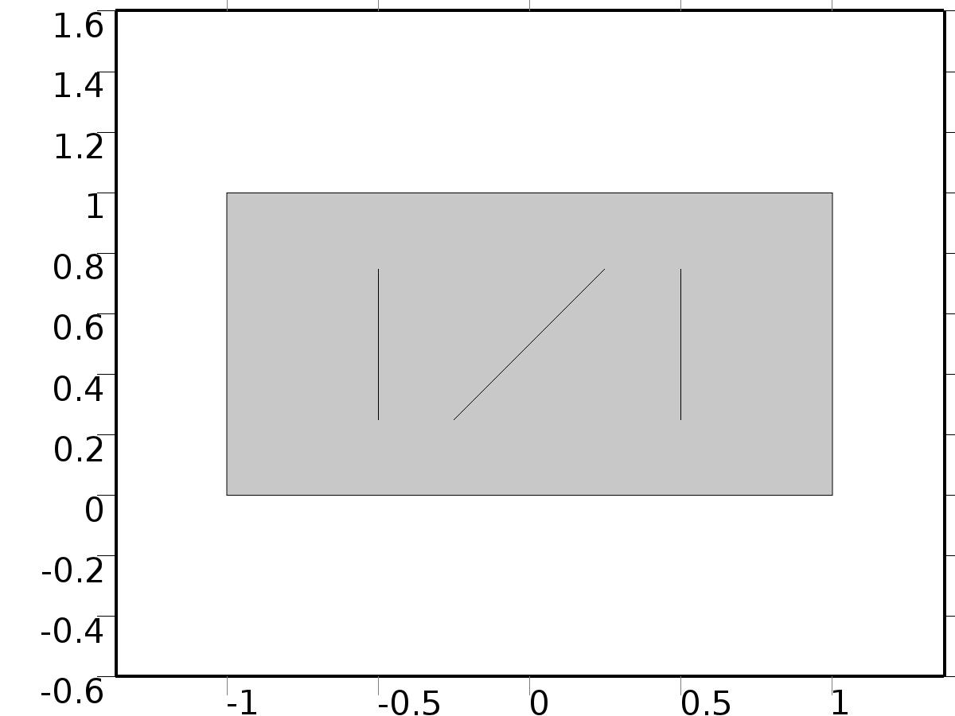

Zero Flux 1

Selection

|  |  |
| --- | --- |
| Geometric entity level | Boundary |
| Selection | No boundaries |

Equations

* + 1. Initial Values 1



Initial Values 1

Selection

|  |  |
| --- | --- |
| Geometric entity level | Domain |
| Selection | Domain 1 |

Settings

| **Description** | **Value** |
| --- | --- |
| Initial value for X | 0 |
| Initial time derivative of X | 0 |

* + 1. Bin1*delta(n,1)

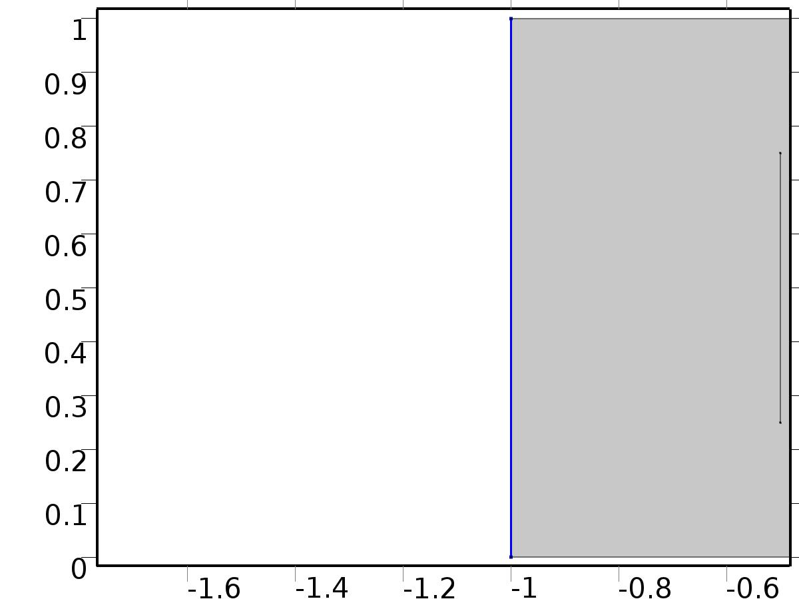

Bin1*delta(n,1)

Selection

|  |  |
| --- | --- |
| Geometric entity level | Boundary |
| Selection | Boundary 1 |

Equations

Settings

| **Description** | **Value** |
| --- | --- |
| Boundary flux/source | delta(n, 1) |
| Boundary absorption/impedance term | 0 |

#### Variables

| **Name** | **Expression** | **Unit** | **Description** | **Selection** |
| --- | --- | --- | --- | --- |
| X.g_X | delta(n,1) |  | Boundary flux/source | Boundary 1 |

* + 1. Bin2*delta(n,2)

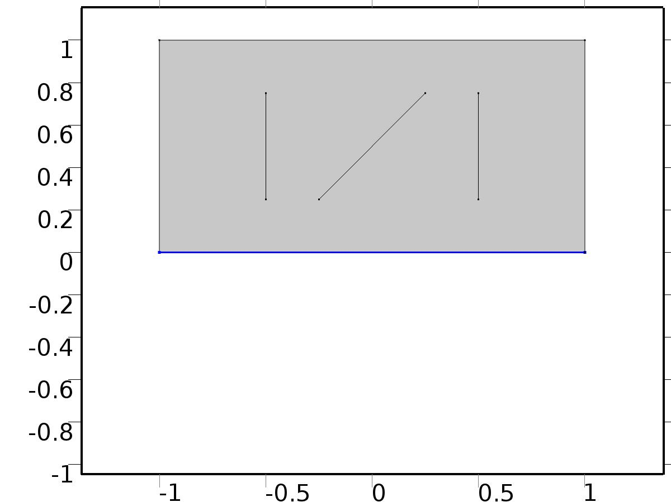

Bin2*delta(n,2)

Selection

|  |  |
| --- | --- |
| Geometric entity level | Boundary |
| Selection | Boundary 2 |

Equations

Settings

| **Description** | **Value** |
| --- | --- |
| Boundary flux/source | delta(n, 2) |
| Boundary absorption/impedance term | 5 |

#### Variables

| **Name** | **Expression** | **Unit** | **Description** | **Selection** |
| --- | --- | --- | --- | --- |
| X.g_X | delta(n,2)-5*X |  | Boundary flux/source | Boundary 2 |

* + 1. Bin3*delta(n,3)

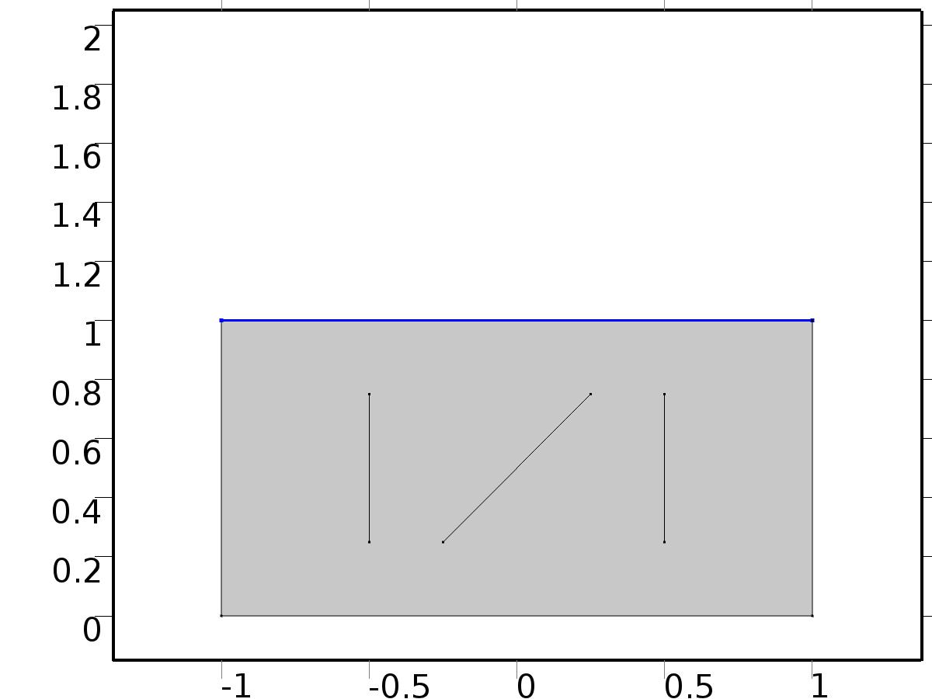

Bin3*delta(n,3)

Selection

|  |  |
| --- | --- |
| Geometric entity level | Boundary |
| Selection | Boundary 3 |

Equations

Settings

| **Description** | **Value** |
| --- | --- |
| Boundary flux/source | delta(n, 3) |
| Boundary absorption/impedance term | 1 |

#### Variables

| **Name** | **Expression** | **Unit** | **Description** | **Selection** |
| --- | --- | --- | --- | --- |
| X.g_X | delta(n,3)-X |  | Boundary flux/source | Boundary 3 |

* + 1. Bd*0

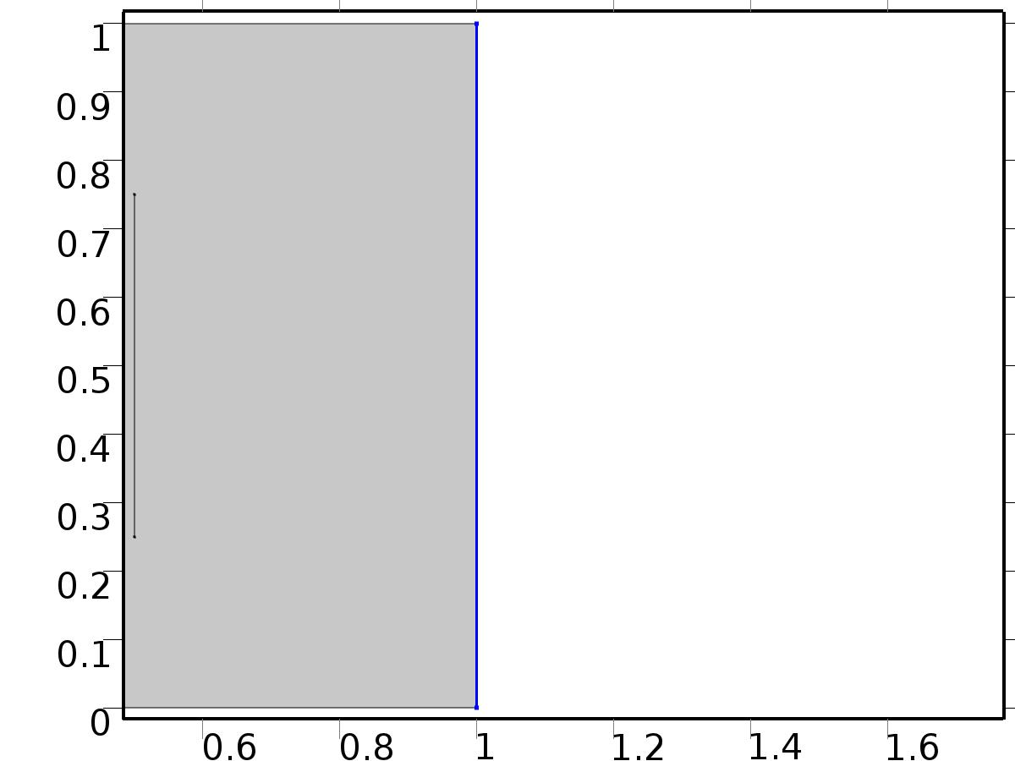

Bd*0

Selection

|  |  |
| --- | --- |
| Geometric entity level | Boundary |
| Selection | Boundary 7 |

Equations

Settings

| **Description** | **Value** |
| --- | --- |
| Value on boundary | 0 |
| Prescribed value of X | On |
| Apply reaction terms on | Individual dependent variables |
| Use weak constraints | Off |
| Constraint method | Elemental |

#### Shape functions

| **Constraint** | **Constraint force** | **Shape function** | **Selection** |
| --- | --- | --- | --- |
| -X | -test(X) | Lagrange (Quadratic) | Boundary 7 |

* 1. Regulator Eqs



Regulator Eqs

Selection

|  |  |
| --- | --- |
| Geometric entity level | Domain |
| Selection | Domain 1 |

Settings

| **Description** | **Value** |
| --- | --- |
| Shape function type | Lagrange |
| Element order | Quadratic |
| Compute boundary fluxes | On |
| Apply smoothing to boundary fluxes | On |
| Value type when using splitting of complex variables | Complex |
| Dependent variable quantity | Dimensionless (1) |
| Source term quantity | None |
| Unit | m^ - 2 |

Used products

|  |
| --- |
| COMSOL Multiphysics |

Variables

| **Name** | **Expression** | **Unit** | **Description** | **Selection** |
| --- | --- | --- | --- | --- |
| PI.nx | dnx |  | Normal vector, x component | Boundaries 1–3, 7 |
| PI.ny | dny |  | Normal vector, y component | Boundaries 1–3, 7 |
| PI.nz | 0 |  | Normal vector, z component | Boundaries 1–3, 7 |
| PI.nx | nx |  | Normal vector, x component | Boundaries 4–6 |
| PI.ny | ny |  | Normal vector, y component | Boundaries 4–6 |
| PI.nz | 0 |  | Normal vector, z component | Boundaries 4–6 |
| PI.nxmesh | root.dnxmesh |  | Normal vector (mesh), x component | Boundaries 1–3, 7 |
| PI.nymesh | root.dnymesh |  | Normal vector (mesh), y component | Boundaries 1–3, 7 |
| PI.nzmesh | 0 |  | Normal vector (mesh), z component | Boundaries 1–3, 7 |
| PI.nxmesh | root.nxmesh |  | Normal vector (mesh), x component | Boundaries 4–6 |
| PI.nymesh | root.nymesh |  | Normal vector (mesh), y component | Boundaries 4–6 |
| PI.nzmesh | 0 |  | Normal vector (mesh), z component | Boundaries 4–6 |

* + 1. Coefficient Form PDE 1



Coefficient Form PDE 1

Selection

|  |  |
| --- | --- |
| Geometric entity level | Domain |
| Selection | Domain 1 |

Equations

Settings

| **Description** | **Value** |
| --- | --- |
| Diffusion coefficient | {{{{c, 0}, {0, c}}, {{0, 0}, {0, 0}}, {{0, 0}, {0, 0}}, {{0, 0}, {0, 0}}}, {{{0, 0}, {0, 0}}, {{c, 0}, {0, c}}, {{0, 0}, {0, 0}}, {{0, 0}, {0, 0}}}, {{{0, 0}, {0, 0}}, {{0, 0}, {0, 0}}, {{c, 0}, {0, c}}, {{0, 0}, {0, 0}}}, {{{0, 0}, {0, 0}}, {{0, 0}, {0, 0}}, {{0, 0}, {0, 0}}, {{c, 0}, {0, c}}}} |
| Absorption coefficient | {{0, 0, -alpha(k, l), -alpha(k, l)}, {0, 0, 0, 0}, {alpha(k, l), alpha(k, l), 0, 0}, {0, 0, 0, 0}} |
| Source term | {0, 0, 0, 0} |
| Mass coefficient | {{0, 0, 0, 0}, {0, 0, 0, 0}, {0, 0, 0, 0}, {0, 0, 0, 0}} |
| Damping or mass coefficient | {{0, 0, 0, 0}, {0, 0, 0, 0}, {0, 0, 0, 0}, {0, 0, 0, 0}} |
| Conservative flux convection coefficient | {{{0, 0}, {0, 0}, {0, 0}, {0, 0}}, {{0, 0}, {0, 0}, {0, 0}, {0, 0}}, {{0, 0}, {0, 0}, {0, 0}, {0, 0}}, {{0, 0}, {0, 0}, {0, 0}, {0, 0}}} |
| Convection coefficient | {{{0, 0}, {0, 0}, {0, 0}, {0, 0}}, {{0, 0}, {0, 0}, {0, 0}, {0, 0}}, {{0, 0}, {0, 0}, {0, 0}, {0, 0}}, {{0, 0}, {0, 0}, {0, 0}, {0, 0}}} |
| Conservative flux source | {{0, 0}, {0, 0}, {0, 0}, {0, 0}} |

#### Variables

| **Name** | **Expression** | **Unit** | **Description** | **Selection** |
| --- | --- | --- | --- | --- |
| domflux.PI1x | -c*d(PI1,x) |  | Domain flux, x component | Domain 1 |
| domflux.PI1y | -c*d(PI1,y) |  | Domain flux, y component | Domain 1 |
| domflux.PIt1x | -c*d(PIt1,x) |  | Domain flux, x component | Domain 1 |
| domflux.PIt1y | -c*d(PIt1,y) |  | Domain flux, y component | Domain 1 |
| domflux.PI2x | -c*d(PI2,x) |  | Domain flux, x component | Domain 1 |
| domflux.PI2y | -c*d(PI2,y) |  | Domain flux, y component | Domain 1 |
| domflux.PIt2x | -c*d(PIt2,x) |  | Domain flux, x component | Domain 1 |
| domflux.PIt2y | -c*d(PIt2,y) |  | Domain flux, y component | Domain 1 |

#### Shape functions

| **Name** | **Shape function** | **Unit** | **Description** | **Shape frame** | **Selection** |
| --- | --- | --- | --- | --- | --- |
| PI1 | Lagrange (Quadratic) |  | Dependent variable PI1 | Material | Domain 1 |
| PIt1 | Lagrange (Quadratic) |  | Dependent variable PIt1 | Material | Domain 1 |
| PI2 | Lagrange (Quadratic) |  | Dependent variable PI2 | Material | Domain 1 |
| PIt2 | Lagrange (Quadratic) |  | Dependent variable PIt2 | Material | Domain 1 |

* + 1. Zero Flux 1



Zero Flux 1

Selection

|  |  |
| --- | --- |
| Geometric entity level | Boundary |
| Selection | No boundaries |

Equations

* + 1. Initial Values 1



Initial Values 1

Selection

|  |  |
| --- | --- |
| Geometric entity level | Domain |
| Selection | Domain 1 |

Settings

| **Description** | **Value** |
| --- | --- |
| Initial value for PI1 | 0 |
| Initial value for PIt1 | 0 |
| Initial value for PI2 | 0 |
| Initial value for PIt2 | 0 |
| Initial time derivative of PI1 | 0 |
| Initial time derivative of PIt1 | 0 |
| Initial time derivative of PI2 | 0 |
| Initial time derivative of PIt2 | 0 |

* + 1. Bin1*gamma1



Bin1*gamma1

Selection

|  |  |
| --- | --- |
| Geometric entity level | Boundary |
| Selection | Boundary 1 |

Equations

Settings

| **Description** | **Value** |
| --- | --- |
| Boundary flux/source | {gammac1, 0, gammas1, 0} |
| Boundary absorption/impedance term | {{0, 0, 0, 0}, {0, 0, 0, 0}, {0, 0, 0, 0}, {0, 0, 0, 0}} |

#### Variables

| **Name** | **Expression** | **Unit** | **Description** | **Selection** |
| --- | --- | --- | --- | --- |
| PI.g_PI1 | gammac1 |  | Boundary flux/source | Boundary 1 |
| PI.g_PIt1 | 0 |  | Boundary flux/source | Boundary 1 |
| PI.g_PI2 | gammas1 |  | Boundary flux/source | Boundary 1 |
| PI.g_PIt2 | 0 |  | Boundary flux/source | Boundary 1 |

* + 1. Bin2*gamma2



Bin2*gamma2

Selection

|  |  |
| --- | --- |
| Geometric entity level | Boundary |
| Selection | Boundary 2 |

Equations

Settings

| **Description** | **Value** |
| --- | --- |
| Boundary flux/source | {gammac2, 0, gammas2, 0} |
| Boundary absorption/impedance term | {{5, 0, 0, 0}, {0, 5, 0, 0}, {0, 0, 5, 0}, {0, 0, 0, 5}} |

#### Variables

| **Name** | **Expression** | **Unit** | **Description** | **Selection** |
| --- | --- | --- | --- | --- |
| PI.g_PI1 | gammac2-5*PI1 |  | Boundary flux/source | Boundary 2 |
| PI.g_PIt1 | -5*PIt1 |  | Boundary flux/source | Boundary 2 |
| PI.g_PI2 | gammas2-5*PI2 |  | Boundary flux/source | Boundary 2 |
| PI.g_PIt2 | -5*PIt2 |  | Boundary flux/source | Boundary 2 |

* + 1. Bin3*gamma3



Bin3*gamma3

Selection

|  |  |
| --- | --- |
| Geometric entity level | Boundary |
| Selection | Boundary 3 |

Equations

Settings

| **Description** | **Value** |
| --- | --- |
| Boundary flux/source | {gammac3, 0, gammas3, 0} |
| Boundary absorption/impedance term | {{1, 0, 0, 0}, {0, 1, 0, 0}, {0, 0, 1, 0}, {0, 0, 0, 1}} |

#### Variables

| **Name** | **Expression** | **Unit** | **Description** | **Selection** |
| --- | --- | --- | --- | --- |
| PI.g_PI1 | gammac3-PI1 |  | Boundary flux/source | Boundary 3 |
| PI.g_PIt1 | -PIt1 |  | Boundary flux/source | Boundary 3 |
| PI.g_PI2 | gammas3-PI2 |  | Boundary flux/source | Boundary 3 |
| PI.g_PIt2 | -PIt2 |  | Boundary flux/source | Boundary 3 |

* + 1. Bd*P



Bd*P

Selection

|  |  |
| --- | --- |
| Geometric entity level | Boundary |
| Selection | Boundary 7 |

Equations

Settings

| **Description** | **Value** |
| --- | --- |
| Value on boundary | {Pc(l), Pc(l), Ps(l), Ps(l)} |
| Prescribed value of PI1 | On |
| Prescribed value of PIt1 | On |
| Prescribed value of PI2 | On |
| Prescribed value of PIt2 | On |
| Apply reaction terms on | Individual dependent variables |
| Use weak constraints | Off |
| Constraint method | Elemental |

#### Shape functions

| **Constraint** | **Constraint force** | **Shape function** | **Selection** |
| --- | --- | --- | --- |
| Pc(l)-PI1 | -test(PI1) | Lagrange (Quadratic) | Boundary 7 |
| Pc(l)-PIt1 | -test(PIt1) | Lagrange (Quadratic) | Boundary 7 |
| Ps(l)-PI2 | -test(PI2) | Lagrange (Quadratic) | Boundary 7 |
| Ps(l)-PIt2 | -test(PIt2) | Lagrange (Quadratic) | Boundary 7 |

* 1. Closed Loop System



Closed Loop System

Selection

|  |  |
| --- | --- |
| Geometric entity level | Domain |
| Selection | Domain 1 |

Settings

| **Description** | **Value** |
| --- | --- |
| Shape function type | Lagrange |
| Element order | Quadratic |
| Compute boundary fluxes | On |
| Apply smoothing to boundary fluxes | On |
| Value type when using splitting of complex variables | Complex |
| Dependent variable quantity | Dimensionless (1) |
| Source term quantity | None |
| Unit | m^ - 2 |

Used products

|  |
| --- |
| COMSOL Multiphysics |

Variables

| **Name** | **Expression** | **Unit** | **Description** | **Selection** |
| --- | --- | --- | --- | --- |
| z.nx | dnx |  | Normal vector, x component | Boundaries 1–3, 7 |
| z.ny | dny |  | Normal vector, y component | Boundaries 1–3, 7 |
| z.nz | 0 |  | Normal vector, z component | Boundaries 1–3, 7 |
| z.nx | nx |  | Normal vector, x component | Boundaries 4–6 |
| z.ny | ny |  | Normal vector, y component | Boundaries 4–6 |
| z.nz | 0 |  | Normal vector, z component | Boundaries 4–6 |
| z.nxmesh | root.dnxmesh |  | Normal vector (mesh), x component | Boundaries 1–3, 7 |
| z.nymesh | root.dnymesh |  | Normal vector (mesh), y component | Boundaries 1–3, 7 |
| z.nzmesh | 0 |  | Normal vector (mesh), z component | Boundaries 1–3, 7 |
| z.nxmesh | root.nxmesh |  | Normal vector (mesh), x component | Boundaries 4–6 |
| z.nymesh | root.nymesh |  | Normal vector (mesh), y component | Boundaries 4–6 |
| z.nzmesh | 0 |  | Normal vector (mesh), z component | Boundaries 4–6 |

* + 1. Coefficient Form PDE 1



Coefficient Form PDE 1

Selection

|  |  |
| --- | --- |
| Geometric entity level | Domain |
| Selection | Domain 1 |

Equations

Settings

| **Description** | **Value** |
| --- | --- |
| Diffusion coefficient | {{c, 0}, {0, c}} |
| Absorption coefficient | 0 |
| Source term | 0 |
| Mass coefficient | 0 |
| Damping or mass coefficient | 1 |
| Conservative flux convection coefficient | {0, 0} |
| Convection coefficient | {0, 0} |
| Conservative flux source | {0, 0} |

#### Variables

| **Name** | **Expression** | **Unit** | **Description** | **Selection** |
| --- | --- | --- | --- | --- |
| domflux.zx | -c*d(z,x) |  | Domain flux, x component | Domain 1 |
| domflux.zy | -c*d(z,y) |  | Domain flux, y component | Domain 1 |

#### Shape functions

| **Name** | **Shape function** | **Unit** | **Description** | **Shape frame** | **Selection** |
| --- | --- | --- | --- | --- | --- |
| z | Lagrange (Quadratic) |  | Dependent variable z | Material | Domain 1 |

* + 1. Zero Flux 1



Zero Flux 1

Selection

|  |  |
| --- | --- |
| Geometric entity level | Boundary |
| Selection | No boundaries |

Equations

* + 1. Initial Values 1



Initial Values 1

Selection

|  |  |
| --- | --- |
| Geometric entity level | Domain |
| Selection | Domain 1 |

Settings

| **Description** | **Value** |
| --- | --- |
| Initial value for z | 1 |
| Initial time derivative of z | 0 |

* + 1. Bin1*Gamma1



Bin1*Gamma1

Selection

|  |  |
| --- | --- |
| Geometric entity level | Boundary |
| Selection | Boundary 1 |

Equations

Settings

| **Description** | **Value** |
| --- | --- |
| Boundary flux/source | Gamma1 |
| Boundary absorption/impedance term | 0 |

#### Variables

| **Name** | **Expression** | **Unit** | **Description** | **Selection** |
| --- | --- | --- | --- | --- |
| z.g_z | Gamma1 |  | Boundary flux/source | Boundary 1 |

* + 1. Bin2*Gamma2



Bin2*Gamma2

Selection

|  |  |
| --- | --- |
| Geometric entity level | Boundary |
| Selection | Boundary 2 |

Equations

Settings

| **Description** | **Value** |
| --- | --- |
| Boundary flux/source | Gamma2 |
| Boundary absorption/impedance term | 5 |

#### Variables

| **Name** | **Expression** | **Unit** | **Description** | **Selection** |
| --- | --- | --- | --- | --- |
| z.g_z | Gamma2-5*z |  | Boundary flux/source | Boundary 2 |

* + 1. Bin3*Gamma3



Bin3*Gamma3

Selection

|  |  |
| --- | --- |
| Geometric entity level | Boundary |
| Selection | Boundary 3 |

Equations

Settings

| **Description** | **Value** |
| --- | --- |
| Boundary flux/source | Gamma3 |
| Boundary absorption/impedance term | 1 |

#### Variables

| **Name** | **Expression** | **Unit** | **Description** | **Selection** |
| --- | --- | --- | --- | --- |
| z.g_z | Gamma3-z |  | Boundary flux/source | Boundary 3 |

* + 1. Bd*d1(t)



Bd*d1(t)

Selection

|  |  |
| --- | --- |
| Geometric entity level | Boundary |
| Selection | Boundary 7 |

Equations

Settings

| **Description** | **Value** |
| --- | --- |
| Value on boundary | d1(t) |
| Prescribed value of z | On |
| Apply reaction terms on | Individual dependent variables |
| Use weak constraints | Off |
| Constraint method | Elemental |

#### Shape functions

| **Constraint** | **Constraint force** | **Shape function** | **Selection** |
| --- | --- | --- | --- |
| d1(t)-z | -test(z) | Lagrange (Quadratic) | Boundary 7 |

* 1. Mesh 2

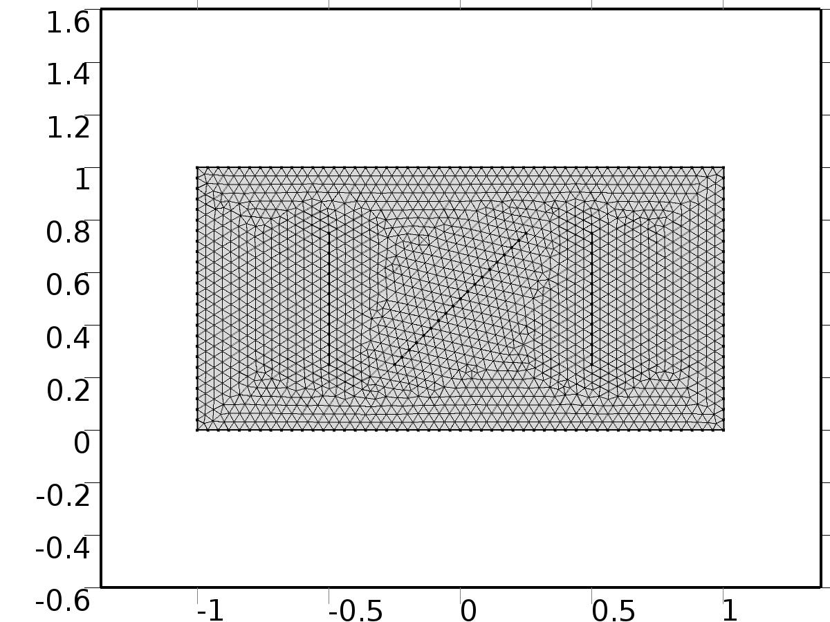

Mesh 2

* + 1. Size (size)

Settings

| **Description** | **Value** |
| --- | --- |
| Maximum element size | 0.04 |
| Minimum element size | 1.5E-4 |
| Curvature factor | 0.25 |
| Maximum element growth rate | 1.2 |
| Predefined size | Extra fine |

* + 1. Free Triangular 1 (ftri1)

Selection

|  |  |
| --- | --- |
| Geometric entity level | Remaining |

1. Study 1
   1. Parametric Sweep

| **Parameter name** | **Parameter value list** |
| --- | --- |
| n | range(1,1,nmax) |

* 1. Stationary

Study settings

| **Description** | **Value** |
| --- | --- |
| Include geometric nonlinearity | Off |

Physics and variables selection

| **Physics interface** | **Discretization** |
| --- | --- |
| Unit Input (c) | physics |

Mesh selection

| **Geometry** | **Mesh** |
| --- | --- |
| Geometry 2 (geom2) | mesh2 |

* 1. Solver Configurations
     1. Solver 4

#### Compile Equations: Stationary (st1)

Study and step

| **Description** | **Value** |
| --- | --- |
| Use study | Study 1 |
| Use study step | Stationary |

#### Dependent Variables 1 (v1)

General

| **Description** | **Value** |
| --- | --- |
| Defined by study step | Stationary |
| Constant |  |

Initial values of variables solved for

| **Description** | **Value** |
| --- | --- |
| Solution | Zero |

Values of variables not solved for

| **Description** | **Value** |
| --- | --- |
| Solution | Zero |

##### Dependent variable PIt1 (mod2.PIt1) (mod2_PIt1)

General

| **Description** | **Value** |
| --- | --- |
| Field components | mod2.PIt1 |
| Solve for this field | Off |

##### Dependent variable PI1 (mod2.PI1) (mod2_PI1)

General

| **Description** | **Value** |
| --- | --- |
| Field components | mod2.PI1 |
| Solve for this field | Off |

##### Dependent variable z (mod2.z) (mod2_z)

General

| **Description** | **Value** |
| --- | --- |
| Field components | mod2.z |
| Solve for this field | Off |

##### Dependent variable PI2 (mod2.PI2) (mod2_PI2)

General

| **Description** | **Value** |
| --- | --- |
| Field components | mod2.PI2 |
| Solve for this field | Off |

##### Dependent variable X (mod2.X) (mod2_X)

General

| **Description** | **Value** |
| --- | --- |
| Field components | mod2.X |

##### Dependent variable PIt2 (mod2.PIt2) (mod2_PIt2)

General

| **Description** | **Value** |
| --- | --- |
| Field components | mod2.PIt2 |
| Solve for this field | Off |

#### Stationary Solver 1 (s1)

General

| **Description** | **Value** |
| --- | --- |
| Defined by study step | Stationary |
| Relative tolerance | 0.000010 |

Log

| **Description** | **Value** |
| --- | --- |
| Constant |  |

##### Parametric 1 (p1)

General

| **Description** | **Value** |
| --- | --- |
| Defined by study step | Parametric Sweep |
| Parameter value list | range(1, 1, nmax) |
| Run continuation for | No parameter |

Results while solving

| **Description** | **Value** |
| --- | --- |
| Probes | Manual |
| Probes | {C1(Xj), C2(Xj), C3(Xj)} |

##### Fully Coupled 1 (fc1)

General

| **Description** | **Value** |
| --- | --- |
| Linear solver | Direct |

1. Study 2
   1. Parametric Sweep

| **Parameter name** | **Parameter value list** |
| --- | --- |
| k | range(0,1,kmax) |
| l | range(1,1,lmax) |

* 1. Stationary

Study settings

| **Description** | **Value** |
| --- | --- |
| Include geometric nonlinearity | Off |

Physics and variables selection

| **Physics interface** | **Discretization** |
| --- | --- |
| Regulator Eqs (c2) | physics |

Mesh selection

| **Geometry** | **Mesh** |
| --- | --- |
| Geometry 2 (geom2) | mesh2 |

* 1. Solver Configurations
     1. Solver 5

#### Compile Equations: Stationary (st1)

Study and step

| **Description** | **Value** |
| --- | --- |
| Use study | Study 2 |
| Use study step | Stationary |

#### Dependent Variables 1 (v1)

General

| **Description** | **Value** |
| --- | --- |
| Defined by study step | Stationary |
| Constant |  |

Initial values of variables solved for

| **Description** | **Value** |
| --- | --- |
| Solution | Zero |

Values of variables not solved for

| **Description** | **Value** |
| --- | --- |
| Solution | Zero |

##### Dependent variable PIt1 (mod2.PIt1) (mod2_PIt1)

General

| **Description** | **Value** |
| --- | --- |
| Field components | mod2.PIt1 |

##### Dependent variable PI1 (mod2.PI1) (mod2_PI1)

General

| **Description** | **Value** |
| --- | --- |
| Field components | mod2.PI1 |

##### Dependent variable z (mod2.z) (mod2_z)

General

| **Description** | **Value** |
| --- | --- |
| Field components | mod2.z |
| Solve for this field | Off |

##### Dependent variable PI2 (mod2.PI2) (mod2_PI2)

General

| **Description** | **Value** |
| --- | --- |
| Field components | mod2.PI2 |

##### Dependent variable X (mod2.X) (mod2_X)

General

| **Description** | **Value** |
| --- | --- |
| Field components | mod2.X |
| Solve for this field | Off |

##### Dependent variable PIt2 (mod2.PIt2) (mod2_PIt2)

General

| **Description** | **Value** |
| --- | --- |
| Field components | mod2.PIt2 |

#### Stationary Solver 1 (s1)

General

| **Description** | **Value** |
| --- | --- |
| Defined by study step | Stationary |
| Relative tolerance | 0.000010 |

Log

| **Description** | **Value** |
| --- | --- |
| Constant |  |

##### Parametric 1 (p1)

General

| **Description** | **Value** |
| --- | --- |
| Defined by study step | Parametric Sweep |
| Sweep type | All combinations |
| Parameter value list | {range(0, 1, kmax), range(1, 1, lmax)} |
| Run continuation for | No parameter |

Results while solving

| **Description** | **Value** |
| --- | --- |
| Probes | Manual |
| Probes | {gammac1, gammas1, gammac2, gammas2, gammac3, gammas3} |

##### Fully Coupled 1 (fc1)

General

| **Description** | **Value** |
| --- | --- |
| Linear solver | Direct |

1. Study 3
   1. Time Dependent

Study settings

| **Description** | **Value** |
| --- | --- |
| Include geometric nonlinearity | Off |

| **Times** | **Unit** |
| --- | --- |
| range(0,0.0125,14) | s |

Physics and variables selection

| **Physics interface** | **Discretization** |
| --- | --- |
| Closed Loop System (phys1) | physics |

Mesh selection

| **Geometry** | **Mesh** |
| --- | --- |
| Geometry 2 (geom2) | mesh2 |

* 1. Solver Configurations
     1. Solver 3

#### Compile Equations: Time Dependent (st1)

Study and step

| **Description** | **Value** |
| --- | --- |
| Use study | Study 3 |
| Use study step | Time Dependent |

#### Dependent Variables 1 (v1)

General

| **Description** | **Value** |
| --- | --- |
| Defined by study step | Time Dependent |
| Constant |  |

Initial values of variables solved for

| **Description** | **Value** |
| --- | --- |
| Solution | Zero |

Values of variables not solved for

| **Description** | **Value** |
| --- | --- |
| Solution | Zero |

##### Dependent variable PIt1 (mod2.PIt1) (mod2_PIt1)

General

| **Description** | **Value** |
| --- | --- |
| Field components | mod2.PIt1 |
| Solve for this field | Off |

##### Dependent variable PI1 (mod2.PI1) (mod2_PI1)

General

| **Description** | **Value** |
| --- | --- |
| Field components | mod2.PI1 |
| Solve for this field | Off |

##### Dependent variable z (mod2.z) (mod2_z)

General

| **Description** | **Value** |
| --- | --- |
| Field components | mod2.z |

##### Dependent variable PI2 (mod2.PI2) (mod2_PI2)

General

| **Description** | **Value** |
| --- | --- |
| Field components | mod2.PI2 |
| Solve for this field | Off |

##### Dependent variable X (mod2.X) (mod2_X)

General

| **Description** | **Value** |
| --- | --- |
| Field components | mod2.X |
| Solve for this field | Off |

##### Dependent variable PIt2 (mod2.PIt2) (mod2_PIt2)

General

| **Description** | **Value** |
| --- | --- |
| Field components | mod2.PIt2 |
| Solve for this field | Off |

#### Time-Dependent Solver 1 (t1)

General

| **Description** | **Value** |
| --- | --- |
| Defined by study step | Time Dependent |
| Time | {0, 0.0125, 0.025, 0.037500000000000006, 0.05, 0.0625, 0.07500000000000001, 0.08750000000000001, 0.1, 0.1125, 0.125, 0.1375, 0.15000000000000002, 0.1625, 0.17500000000000002, 0.1875, 0.2, 0.21250000000000002, 0.225, 0.23750000000000002, 0.25, 0.2625, 0.275, 0.28750000000000003, 0.30000000000000004, 0.3125, 0.325, 0.3375, 0.35000000000000003, 0.36250000000000004, 0.375, 0.3875, 0.4, 0.41250000000000003, 0.42500000000000004, 0.4375, 0.45, 0.4625, 0.47500000000000003, 0.48750000000000004, 0.5, 0.5125000000000001, 0.525, 0.5375, 0.55, 0.5625, 0.5750000000000001, 0.5875, 0.6000000000000001, 0.6125, 0.625, 0.6375000000000001, 0.65, 0.6625000000000001, 0.675, 0.6875, 0.7000000000000001, 0.7125, 0.7250000000000001, 0.7375, 0.75, 0.7625000000000001, 0.775, 0.7875000000000001, 0.8, 0.8125, 0.8250000000000001, 0.8375, 0.8500000000000001, 0.8625, 0.875, 0.8875000000000001, 0.9, 0.9125000000000001, 0.925, 0.9375, 0.9500000000000001, 0.9625, 0.9750000000000001, 0.9875, 1, 1.0125, 1.0250000000000001, 1.0375, 1.05, 1.0625, 1.075, 1.0875000000000001, 1.1, 1.1125, 1.125, 1.1375, 1.1500000000000001, 1.1625, 1.175, 1.1875, 1.2000000000000002, 1.2125000000000001, 1.225, 1.2375, 1.25, 1.2625000000000002, 1.2750000000000001, 1.2875, 1.3, 1.3125, 1.3250000000000002, 1.3375000000000001, 1.35, 1.3625, 1.375, 1.3875000000000002, 1.4000000000000001, 1.4125, 1.425, 1.4375, 1.4500000000000002, 1.4625000000000001, 1.475, 1.4875, 1.5, 1.5125000000000002, 1.5250000000000001, 1.5375, 1.55, 1.5625, 1.5750000000000002, 1.5875000000000001, 1.6, 1.6125, 1.625, 1.6375000000000002, 1.6500000000000001, 1.6625, 1.675, 1.6875, 1.7000000000000002, 1.7125000000000001, 1.725, 1.7375, 1.75, 1.7625000000000002, 1.7750000000000001, 1.7875, 1.8, 1.8125, 1.8250000000000002, 1.8375000000000001, 1.85, 1.8625, 1.875, 1.8875000000000002, 1.9000000000000001, 1.9125, 1.925, 1.9375, 1.9500000000000002, 1.9625000000000001, 1.975, 1.9875, 2, 2.0125, 2.025, 2.0375, 2.0500000000000003, 2.0625, 2.075, 2.0875, 2.1, 2.1125000000000003, 2.125, 2.1375, 2.15, 2.1625, 2.1750000000000003, 2.1875, 2.2, 2.2125, 2.225, 2.2375000000000003, 2.25, 2.2625, 2.275, 2.2875, 2.3000000000000003, 2.3125, 2.325, 2.3375, 2.35, 2.3625000000000003, 2.375, 2.3875, 2.4000000000000004, 2.4125, 2.4250000000000003, 2.4375, 2.45, 2.4625000000000004, 2.475, 2.4875000000000003, 2.5, 2.5125, 2.5250000000000004, 2.5375, 2.5500000000000003, 2.5625, 2.575, 2.5875000000000004, 2.6, 2.6125000000000003, 2.625, 2.6375, 2.6500000000000004, 2.6625, 2.6750000000000003, 2.6875, 2.7, 2.7125000000000004, 2.725, 2.7375000000000003, 2.75, 2.7625, 2.7750000000000004, 2.7875, 2.8000000000000003, 2.8125, 2.825, 2.8375000000000004, 2.85, 2.8625000000000003, 2.875, 2.8875, 2.9000000000000004, 2.9125, 2.9250000000000003, 2.9375, 2.95, 2.9625000000000004, 2.975, 2.9875000000000003, 3, 3.0125, 3.0250000000000004, 3.0375, 3.0500000000000003, 3.0625, 3.075, 3.0875000000000004, 3.1, 3.1125000000000003, 3.125, 3.1375, 3.1500000000000004, 3.1625, 3.1750000000000003, 3.1875, 3.2, 3.2125000000000004, 3.225, 3.2375000000000003, 3.25, 3.2625, 3.2750000000000004, 3.2875, 3.3000000000000003, 3.3125, 3.325, 3.3375000000000004, 3.35, 3.3625000000000003, 3.375, 3.3875, 3.4000000000000004, 3.4125, 3.4250000000000003, 3.4375, 3.45, 3.4625000000000004, 3.475, 3.4875000000000003, 3.5, 3.5125, 3.5250000000000004, 3.5375, 3.5500000000000003, 3.5625, 3.575, 3.5875000000000004, 3.6, 3.6125000000000003, 3.625, 3.6375, 3.6500000000000004, 3.6625, 3.6750000000000003, 3.6875, 3.7, 3.7125000000000004, 3.725, 3.7375000000000003, 3.75, 3.7625, 3.7750000000000004, 3.7875, 3.8000000000000003, 3.8125, 3.825, 3.8375000000000004, 3.85, 3.8625000000000003, 3.875, 3.8875, 3.9000000000000004, 3.9125, 3.9250000000000003, 3.9375, 3.95, 3.9625000000000004, 3.975, 3.9875000000000003, 4, 4.0125, 4.025, 4.0375000000000005, 4.05, 4.0625, 4.075, 4.0875, 4.1000000000000005, 4.1125, 4.125, 4.1375, 4.15, 4.1625000000000005, 4.175, 4.1875, 4.2, 4.2125, 4.2250000000000005, 4.2375, 4.25, 4.2625, 4.275, 4.2875000000000005, 4.3, 4.3125, 4.325, 4.3375, 4.3500000000000005, 4.3625, 4.375, 4.3875, 4.4, 4.4125000000000005, 4.425, 4.4375, 4.45, 4.4625, 4.4750000000000005, 4.4875, 4.5, 4.5125, 4.525, 4.5375000000000005, 4.55, 4.5625, 4.575, 4.5875, 4.6000000000000005, 4.6125, 4.625, 4.6375, 4.65, 4.6625000000000005, 4.675, 4.6875, 4.7, 4.7125, 4.7250000000000005, 4.7375, 4.75, 4.7625, 4.775, 4.7875000000000005, 4.800000000000001, 4.8125, 4.825, 4.8375, 4.8500000000000005, 4.862500000000001, 4.875, 4.8875, 4.9, 4.9125000000000005, 4.925000000000001, 4.9375, 4.95, 4.9625, 4.9750000000000005, 4.987500000000001, 5, 5.0125, 5.025, 5.0375000000000005, 5.050000000000001, 5.0625, 5.075, 5.0875, 5.1000000000000005, 5.112500000000001, 5.125, 5.1375, 5.15, 5.1625000000000005, 5.175000000000001, 5.1875, 5.2, 5.2125, 5.2250000000000005, 5.237500000000001, 5.25, 5.2625, 5.275, 5.2875000000000005, 5.300000000000001, 5.3125, 5.325, 5.3375, 5.3500000000000005, 5.362500000000001, 5.375, 5.3875, 5.4, 5.4125000000000005, 5.425000000000001, 5.4375, 5.45, 5.4625, 5.4750000000000005, 5.487500000000001, 5.5, 5.5125, 5.525, 5.5375000000000005, 5.550000000000001, 5.5625, 5.575, 5.5875, 5.6000000000000005, 5.612500000000001, 5.625, 5.6375, 5.65, 5.6625000000000005, 5.675000000000001, 5.6875, 5.7, 5.7125, 5.7250000000000005, 5.737500000000001, 5.75, 5.7625, 5.775, 5.7875000000000005, 5.800000000000001, 5.8125, 5.825, 5.8375, 5.8500000000000005, 5.862500000000001, 5.875, 5.8875, 5.9, 5.9125000000000005, 5.925000000000001, 5.9375, 5.95, 5.9625, 5.9750000000000005, 5.987500000000001, 6, 6.0125, 6.025, 6.0375000000000005, 6.050000000000001, 6.0625, 6.075, 6.0875, 6.1000000000000005, 6.112500000000001, 6.125, 6.1375, 6.15, 6.1625000000000005, 6.175000000000001, 6.1875, 6.2, 6.2125, 6.2250000000000005, 6.237500000000001, 6.25, 6.2625, 6.275, 6.2875000000000005, 6.300000000000001, 6.3125, 6.325, 6.3375, 6.3500000000000005, 6.362500000000001, 6.375, 6.3875, 6.4, 6.4125000000000005, 6.425000000000001, 6.4375, 6.45, 6.4625, 6.4750000000000005, 6.487500000000001, 6.5, 6.5125, 6.525, 6.5375000000000005, 6.550000000000001, 6.5625, 6.575, 6.5875, 6.6000000000000005, 6.612500000000001, 6.625, 6.6375, 6.65, 6.6625000000000005, 6.675000000000001, 6.6875, 6.7, 6.7125, 6.7250000000000005, 6.737500000000001, 6.75, 6.7625, 6.775, 6.7875000000000005, 6.800000000000001, 6.8125, 6.825, 6.8375, 6.8500000000000005, 6.862500000000001, 6.875, 6.8875, 6.9, 6.9125000000000005, 6.925000000000001, 6.9375, 6.95, 6.9625, 6.9750000000000005, 6.987500000000001, 7, 7.0125, 7.025, 7.0375000000000005, 7.050000000000001, 7.0625, 7.075, 7.0875, 7.1000000000000005, 7.112500000000001, 7.125, 7.1375, 7.15, 7.1625000000000005, 7.175000000000001, 7.1875, 7.2, 7.2125, 7.2250000000000005, 7.237500000000001, 7.25, 7.2625, 7.275, 7.2875000000000005, 7.300000000000001, 7.3125, 7.325, 7.3375, 7.3500000000000005, 7.362500000000001, 7.375, 7.3875, 7.4, 7.4125000000000005, 7.425000000000001, 7.4375, 7.45, 7.4625, 7.4750000000000005, 7.487500000000001, 7.5, 7.5125, 7.525, 7.5375000000000005, 7.550000000000001, 7.5625, 7.575, 7.5875, 7.6000000000000005, 7.612500000000001, 7.625, 7.6375, 7.65, 7.6625000000000005, 7.675000000000001, 7.6875, 7.7, 7.7125, 7.7250000000000005, 7.737500000000001, 7.75, 7.7625, 7.775, 7.7875000000000005, 7.800000000000001, 7.8125, 7.825, 7.8375, 7.8500000000000005, 7.862500000000001, 7.875, 7.8875, 7.9, 7.9125000000000005, 7.925000000000001, 7.9375, 7.95, 7.9625, 7.9750000000000005, 7.987500000000001, 8, 8.012500000000001, 8.025, 8.0375, 8.05, 8.0625, 8.075000000000001, 8.0875, 8.1, 8.1125, 8.125, 8.137500000000001, 8.15, 8.1625, 8.175, 8.1875, 8.200000000000001, 8.2125, 8.225, 8.2375, 8.25, 8.262500000000001, 8.275, 8.2875, 8.3, 8.3125, 8.325000000000001, 8.3375, 8.35, 8.3625, 8.375, 8.387500000000001, 8.4, 8.4125, 8.425, 8.4375, 8.450000000000001, 8.4625, 8.475, 8.4875, 8.5, 8.512500000000001, 8.525, 8.5375, 8.55, 8.5625, 8.575000000000001, 8.5875, 8.6, 8.6125, 8.625, 8.637500000000001, 8.65, 8.6625, 8.675, 8.6875, 8.700000000000001, 8.7125, 8.725, 8.7375, 8.75, 8.762500000000001, 8.775, 8.7875, 8.8, 8.8125, 8.825000000000001, 8.8375, 8.85, 8.8625, 8.875, 8.887500000000001, 8.9, 8.9125, 8.925, 8.9375, 8.950000000000001, 8.9625, 8.975, 8.9875, 9, 9.012500000000001, 9.025, 9.0375, 9.05, 9.0625, 9.075000000000001, 9.0875, 9.1, 9.1125, 9.125, 9.137500000000001, 9.15, 9.1625, 9.175, 9.1875, 9.200000000000001, 9.2125, 9.225, 9.2375, 9.25, 9.262500000000001, 9.275, 9.2875, 9.3, 9.3125, 9.325000000000001, 9.3375, 9.35, 9.3625, 9.375, 9.387500000000001, 9.4, 9.4125, 9.425, 9.4375, 9.450000000000001, 9.4625, 9.475, 9.4875, 9.5, 9.512500000000001, 9.525, 9.5375, 9.55, 9.5625, 9.575000000000001, 9.5875, 9.600000000000001, 9.6125, 9.625, 9.637500000000001, 9.65, 9.662500000000001, 9.675, 9.6875, 9.700000000000001, 9.7125, 9.725000000000001, 9.7375, 9.75, 9.762500000000001, 9.775, 9.787500000000001, 9.8, 9.8125, 9.825000000000001, 9.8375, 9.850000000000001, 9.8625, 9.875, 9.887500000000001, 9.9, 9.912500000000001, 9.925, 9.9375, 9.950000000000001, 9.9625, 9.975000000000001, 9.9875, 10, 10.012500000000001, 10.025, 10.037500000000001, 10.05, 10.0625, 10.075000000000001, 10.0875, 10.100000000000001, 10.1125, 10.125, 10.137500000000001, 10.15, 10.162500000000001, 10.175, 10.1875, 10.200000000000001, 10.2125, 10.225000000000001, 10.2375, 10.25, 10.262500000000001, 10.275, 10.287500000000001, 10.3, 10.3125, 10.325000000000001, 10.3375, 10.350000000000001, 10.3625, 10.375, 10.387500000000001, 10.4, 10.412500000000001, 10.425, 10.4375, 10.450000000000001, 10.4625, 10.475000000000001, 10.4875, 10.5, 10.512500000000001, 10.525, 10.537500000000001, 10.55, 10.5625, 10.575000000000001, 10.5875, 10.600000000000001, 10.6125, 10.625, 10.637500000000001, 10.65, 10.662500000000001, 10.675, 10.6875, 10.700000000000001, 10.7125, 10.725000000000001, 10.7375, 10.75, 10.762500000000001, 10.775, 10.787500000000001, 10.8, 10.8125, 10.825000000000001, 10.8375, 10.850000000000001, 10.8625, 10.875, 10.887500000000001, 10.9, 10.912500000000001, 10.925, 10.9375, 10.950000000000001, 10.9625, 10.975000000000001, 10.9875, 11, 11.012500000000001, 11.025, 11.037500000000001, 11.05, 11.0625, 11.075000000000001, 11.0875, 11.100000000000001, 11.1125, 11.125, 11.137500000000001, 11.15, 11.162500000000001, 11.175, 11.1875, 11.200000000000001, 11.2125, 11.225000000000001, 11.2375, 11.25, 11.262500000000001, 11.275, 11.287500000000001, 11.3, 11.3125, 11.325000000000001, 11.3375, 11.350000000000001, 11.3625, 11.375, 11.387500000000001, 11.4, 11.412500000000001, 11.425, 11.4375, 11.450000000000001, 11.4625, 11.475000000000001, 11.4875, 11.5, 11.512500000000001, 11.525, 11.537500000000001, 11.55, 11.5625, 11.575000000000001, 11.5875, 11.600000000000001, 11.6125, 11.625, 11.637500000000001, 11.65, 11.662500000000001, 11.675, 11.6875, 11.700000000000001, 11.7125, 11.725000000000001, 11.7375, 11.75, 11.762500000000001, 11.775, 11.787500000000001, 11.8, 11.8125, 11.825000000000001, 11.8375, 11.850000000000001, 11.8625, 11.875, 11.887500000000001, 11.9, 11.912500000000001, 11.925, 11.9375, 11.950000000000001, 11.9625, 11.975000000000001, 11.9875, 12, 12.012500000000001, 12.025, 12.037500000000001, 12.05, 12.0625, 12.075000000000001, 12.0875, 12.100000000000001, 12.1125, 12.125, 12.137500000000001, 12.15, 12.162500000000001, 12.175, 12.1875, 12.200000000000001, 12.2125, 12.225000000000001, 12.2375, 12.25, 12.262500000000001, 12.275, 12.287500000000001, 12.3, 12.3125, 12.325000000000001, 12.3375, 12.350000000000001, 12.3625, 12.375, 12.387500000000001, 12.4, 12.412500000000001, 12.425, 12.4375, 12.450000000000001, 12.4625, 12.475000000000001, 12.4875, 12.5, 12.512500000000001, 12.525, 12.537500000000001, 12.55, 12.5625, 12.575000000000001, 12.5875, 12.600000000000001, 12.6125, 12.625, 12.637500000000001, 12.65, 12.662500000000001, 12.675, 12.6875, 12.700000000000001, 12.7125, 12.725000000000001, 12.7375, 12.75, 12.762500000000001, 12.775, 12.787500000000001, 12.8, 12.8125, 12.825000000000001, 12.8375, 12.850000000000001, 12.8625, 12.875, 12.887500000000001, 12.9, 12.912500000000001, 12.925, 12.9375, 12.950000000000001, 12.9625, 12.975000000000001, 12.9875, 13, 13.012500000000001, 13.025, 13.037500000000001, 13.05, 13.0625, 13.075000000000001, 13.0875, 13.100000000000001, 13.1125, 13.125, 13.137500000000001, 13.15, 13.162500000000001, 13.175, 13.1875, 13.200000000000001, 13.2125, 13.225000000000001, 13.2375, 13.25, 13.262500000000001, 13.275, 13.287500000000001, 13.3, 13.3125, 13.325000000000001, 13.3375, 13.350000000000001, 13.3625, 13.375, 13.387500000000001, 13.4, 13.412500000000001, 13.425, 13.4375, 13.450000000000001, 13.4625, 13.475000000000001, 13.4875, 13.5, 13.512500000000001, 13.525, 13.537500000000001, 13.55, 13.5625, 13.575000000000001, 13.5875, 13.600000000000001, 13.6125, 13.625, 13.637500000000001, 13.65, 13.662500000000001, 13.675, 13.6875, 13.700000000000001, 13.7125, 13.725000000000001, 13.7375, 13.75, 13.762500000000001, 13.775, 13.787500000000001, 13.8, 13.8125, 13.825000000000001, 13.8375, 13.850000000000001, 13.8625, 13.875, 13.887500000000001, 13.9, 13.912500000000001, 13.925, 13.9375, 13.950000000000001, 13.9625, 13.975000000000001, 13.9875, 14} |
| Relative tolerance | 0.00001 |

Absolute tolerance

| **Description** | **Value** |
| --- | --- |
| Tolerance | 0.000010 |

Time stepping

| **Description** | **Value** |
| --- | --- |
| Initial step | 0.0010 |

Results while solving

| **Description** | **Value** |
| --- | --- |
| Probes | None |

Advanced

| **Description** | **Value** |
| --- | --- |
| Fraction of initial step for Backward Euler | 0.0010 |

Log

| **Description** | **Value** |
| --- | --- |
| Constant |  |

##### Fully Coupled 1 (fc1)

General

| **Description** | **Value** |
| --- | --- |
| Linear solver | Direct |

1. Results
   1. Data Sets
      1. Solution 1

Solution

| **Description** | **Value** |
| --- | --- |
| Solution | Solver 4 |
| Component | Save Point Geometry 2 |

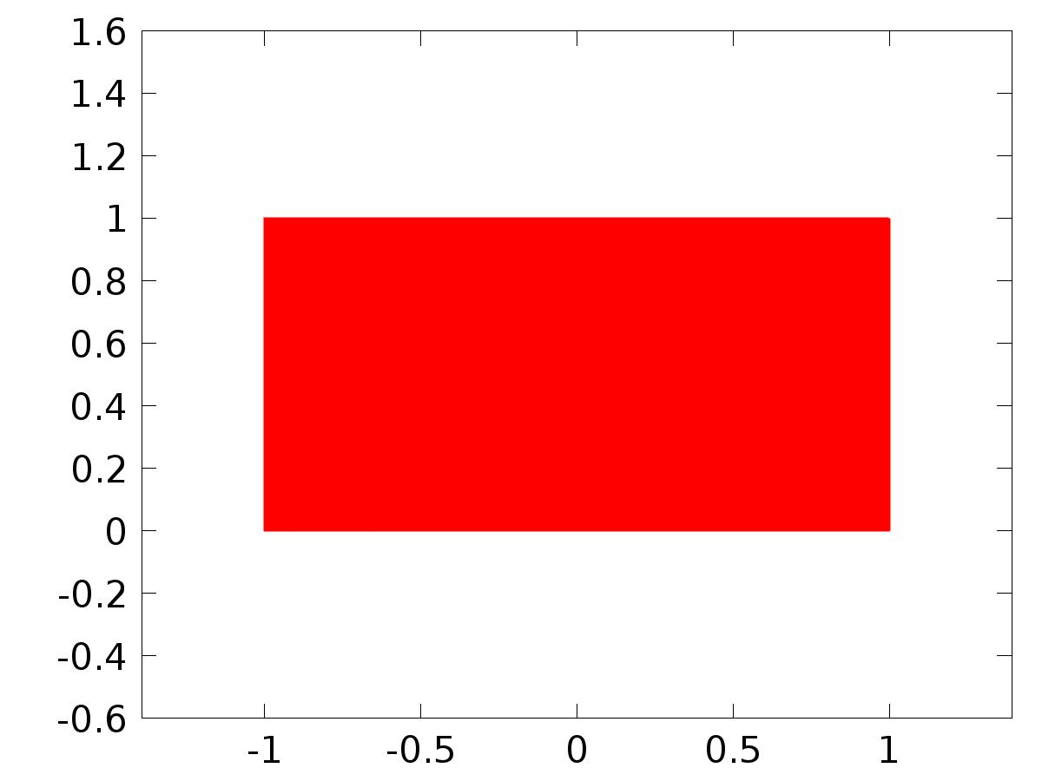

Data set: Solution 1

* + 1. Probe Solution 2

Solution

| **Description** | **Value** |
| --- | --- |
| Solution | Solver 3 |
| Component | Save Point Geometry 2 |



Data set: Probe Solution 2

* + 1. Solution 3

Solution

| **Description** | **Value** |
| --- | --- |
| Solution | Solver 5 |
| Component | Save Point Geometry 2 |



Data set: Solution 3

* + 1. Solution 4

Solution

| **Description** | **Value** |
| --- | --- |
| Solution | Solver 3 |
| Component | Save Point Geometry 2 |



Data set: Solution 4

* 1. Derived Values
     1. C1(Xj)

Data

| **Description** | **Value** |
| --- | --- |
| Data set | Probe Solution 2 |

Expression

| **Description** | **Value** |
| --- | --- |
| Expression | C1(X) |
| Description | C1(X) |

* + 1. C2(Xj)

Data

| **Description** | **Value** |
| --- | --- |
| Data set | Probe Solution 2 |

Expression

| **Description** | **Value** |
| --- | --- |
| Expression | C2(X) |
| Description | C2(X) |

* + 1. C3(Xj)

Data

| **Description** | **Value** |
| --- | --- |
| Data set | Probe Solution 2 |

Expression

| **Description** | **Value** |
| --- | --- |
| Expression | C3(X) |
| Description | C3(X) |

* + 1. gammac1

Data

| **Description** | **Value** |
| --- | --- |
| Data set | Probe Solution 2 |

Expression

| **Description** | **Value** |
| --- | --- |
| Expression | gammac1 |

* + 1. gammas1

Data

| **Description** | **Value** |
| --- | --- |
| Data set | Probe Solution 2 |

Expression

| **Description** | **Value** |
| --- | --- |
| Expression | gammas1 |

* + 1. gammac2

Data

| **Description** | **Value** |
| --- | --- |
| Data set | Probe Solution 2 |

Expression

| **Description** | **Value** |
| --- | --- |
| Expression | gammac2 |

* + 1. gammas2

Data

| **Description** | **Value** |
| --- | --- |
| Data set | Probe Solution 2 |

Expression

| **Description** | **Value** |
| --- | --- |
| Expression | gammas2 |

* + 1. gammac3

Data

| **Description** | **Value** |
| --- | --- |
| Data set | Probe Solution 2 |

Expression

| **Description** | **Value** |
| --- | --- |
| Expression | gammac3 |

* + 1. gammas3

Data

| **Description** | **Value** |
| --- | --- |
| Data set | Probe Solution 2 |

Expression

| **Description** | **Value** |
| --- | --- |
| Expression | gammas3 |

* 1. Tables
     1. Probe Table 1
     2. Probe Table 2
     3. Probe Table 3
  2. Plot Groups
     1. Probe 1D Plot Group 8

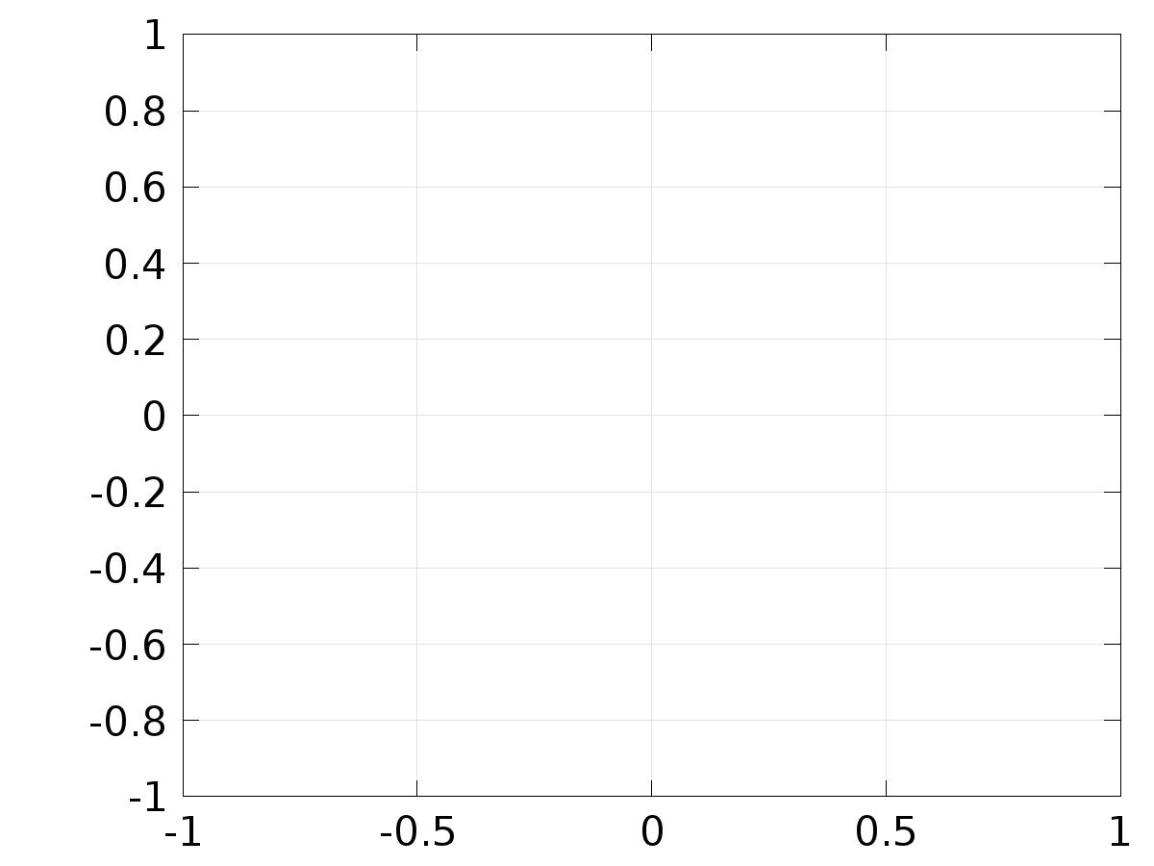

* + 1. Probe 1D Plot Group 9



* + 1. 2D Plot Group 10

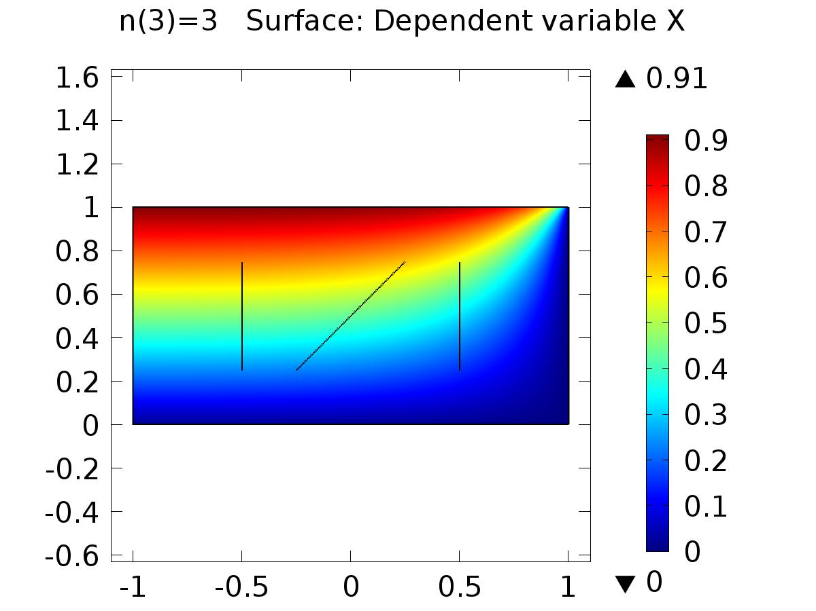

n(3)=3 Surface: Dependent variable X

* + 1. 2D Plot Group 11

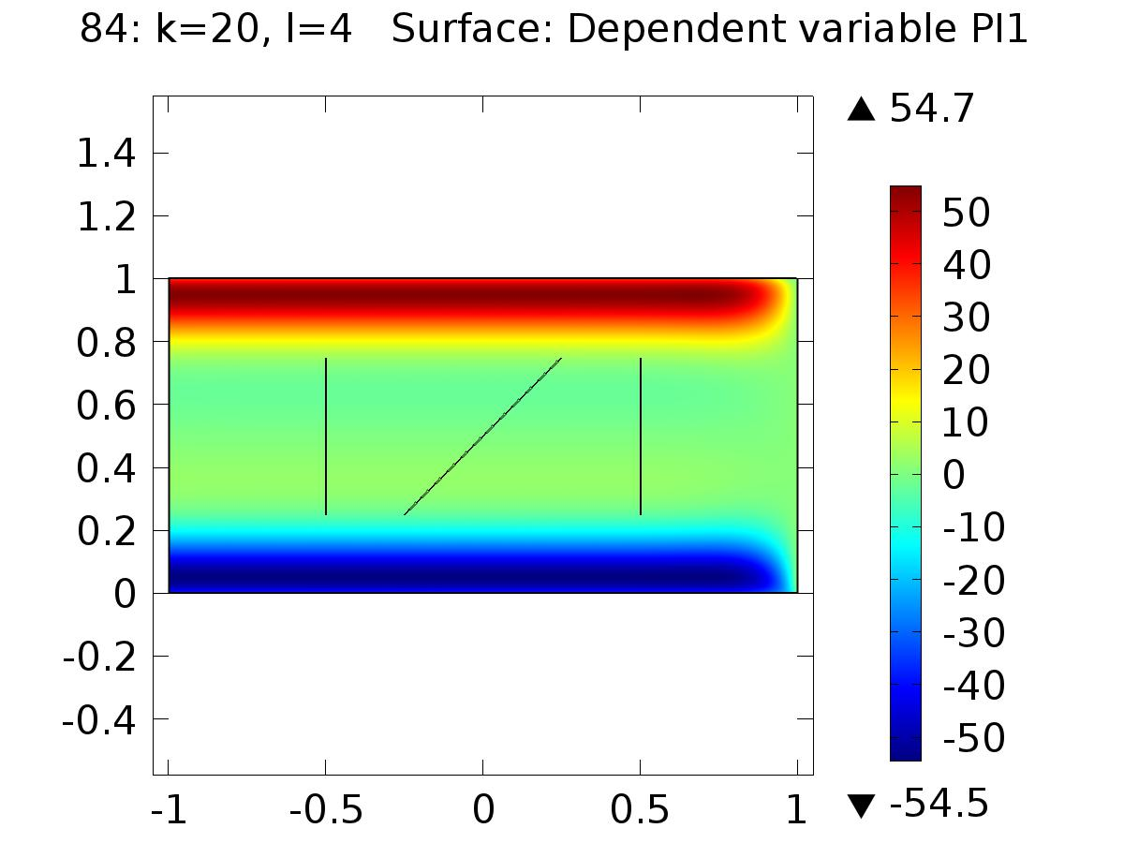

84: k=20, l=4 Surface: Dependent variable PI1

* + 1. 2D Plot Group 12

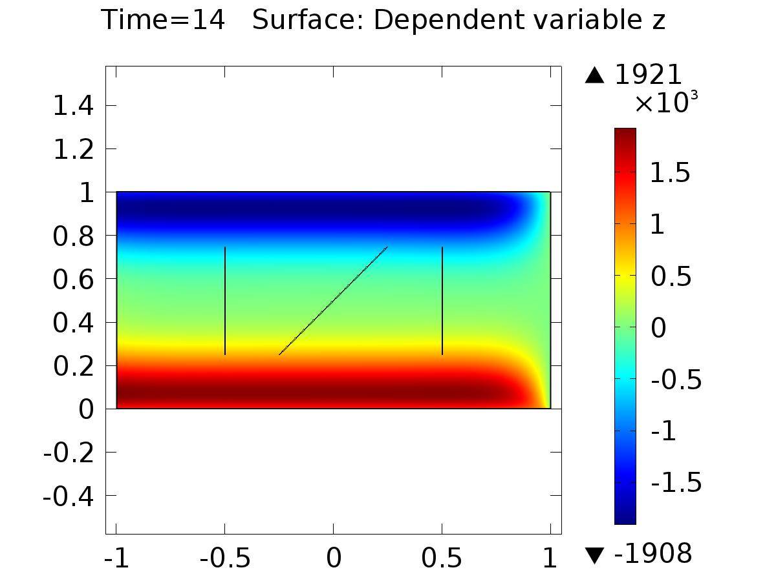

Time=14 Surface: Dependent variable z

* + 1. 1D Plot Group 13

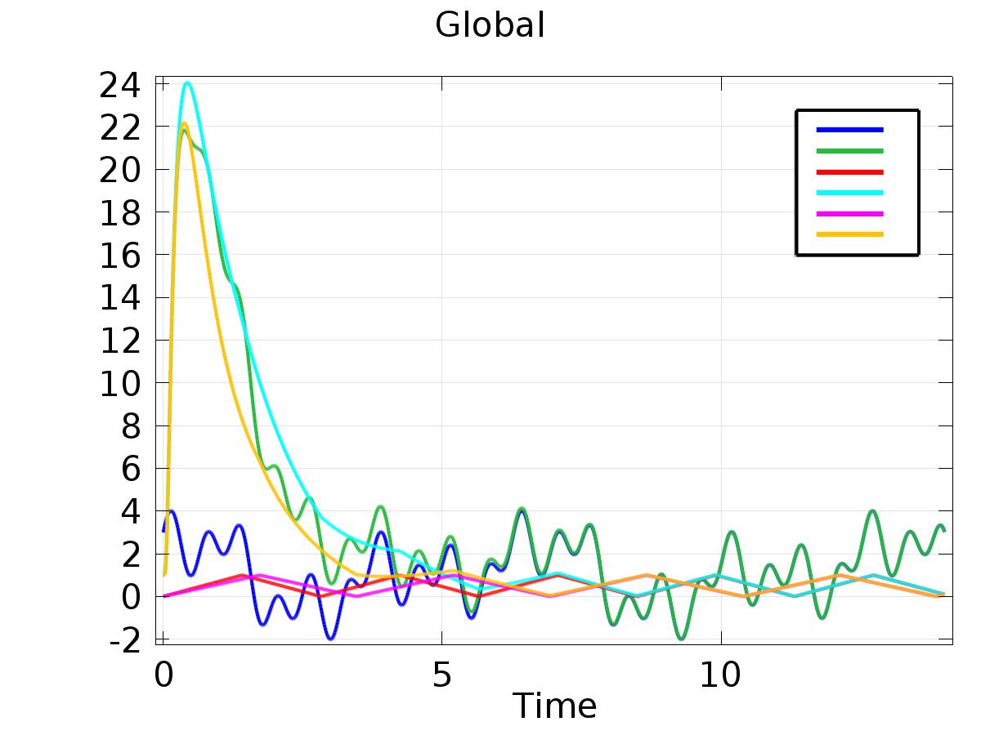

Global

* + 1. 1D Plot Group 14

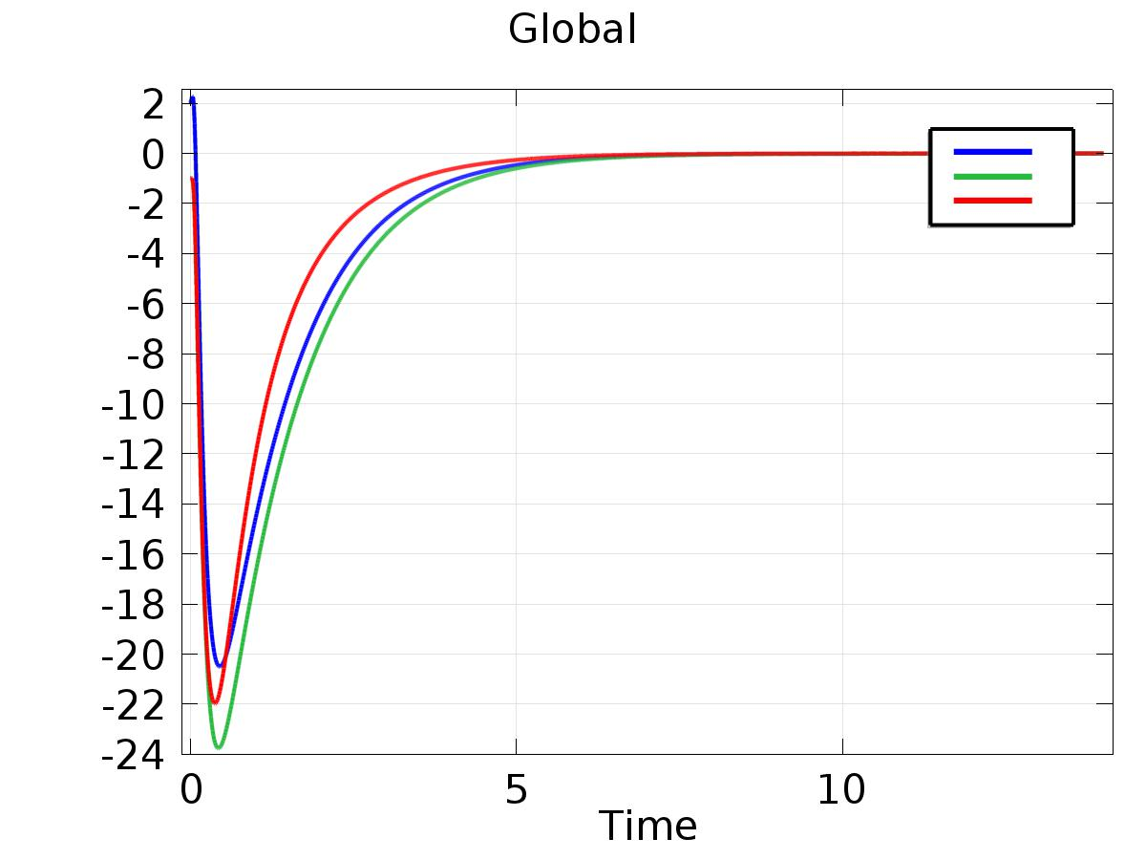

Global