[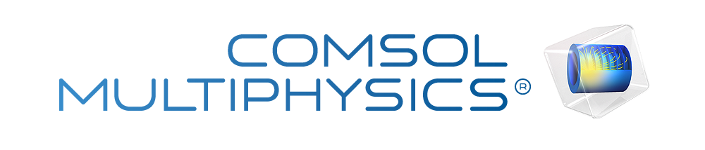](http://www.comsol.com/)

Ch4 Ex4 1-Chafee-Infante

|  |  |
| --- | --- |
| Date | Mar 25, 2014 9:17:35 AM |

Contents

1. Global

1.1. Definitions

2. Component 1

2.1. Definitions

2.2. Geometry 1

2.3. Unit Input

2.4. Invariant Manifold

2.5. Close Loop System

2.6. Mesh 1

3. Study 1

3.1. Stationary

3.2. Solver Configurations

4. Study 2

4.1. Stationary

4.2. Solver Configurations

5. Study 3

5.1. Time Dependent

5.2. Solver Configurations

6. Results

6.1. Data Sets

6.2. Derived Values

6.3. Tables

6.4. Plot Groups

1. Global

|  |  |
| --- | --- |
| Date | Feb 28, 2014 9:01:46 AM |

Global settings

|  |  |
| --- | --- |
| Name | Ch4 Ex4 1-Chafee-Infante.mph |
| Path | /Users/gilliam/Desktop/collect_15/research_15/geo_reg_mono_eugenio/Mono_1_15/Comsol_EX_GitHub/Chapter4/Example4.1/Ch4_Ex4_1-Chafee-Infante.mph |
| Program | COMSOL 4.4 (Build: 150) |

Used products

|  |
| --- |
| COMSOL Multiphysics |

* 1. Definitions
     1. Parameters 1

Parameters

| **Name** | **Expression** | **Value** | **Description** |
| --- | --- | --- | --- |
| L | 1 | 1.0000 |  |
| M | .75 | 0.75000 |  |
| x0 | .75 | 0.75000 |  |
| dx0 | .02 | 0.020000 |  |
| x1 | .25 | 0.25000 |  |
| k0 | 1 | 1.0000 |  |
| k1 | 2 | 2.0000 |  |

1. Component 1

Component settings

|  |  |
| --- | --- |
| Unit system | None |

* 1. Definitions
     1. Variables

#### Variables 1a

Selection

|  |  |
| --- | --- |
| Geometric entity level | Entire model |

| **Name** | **Expression** | **Description** |
| --- | --- | --- |
| G | C(X) |  |
| gamma | (M - C(PIT))/G |  |
| u | gamma |  |
| e | C(z) - M |  |

* + 1. Component Couplings

#### Integration 1

|  |  |
| --- | --- |
| Coupling type | Integration |
| Operator name | C |

Source selection

|  |  |
| --- | --- |
| Geometric entity level | Boundary |
| Selection | Boundary 2 |

* 1. Geometry 1

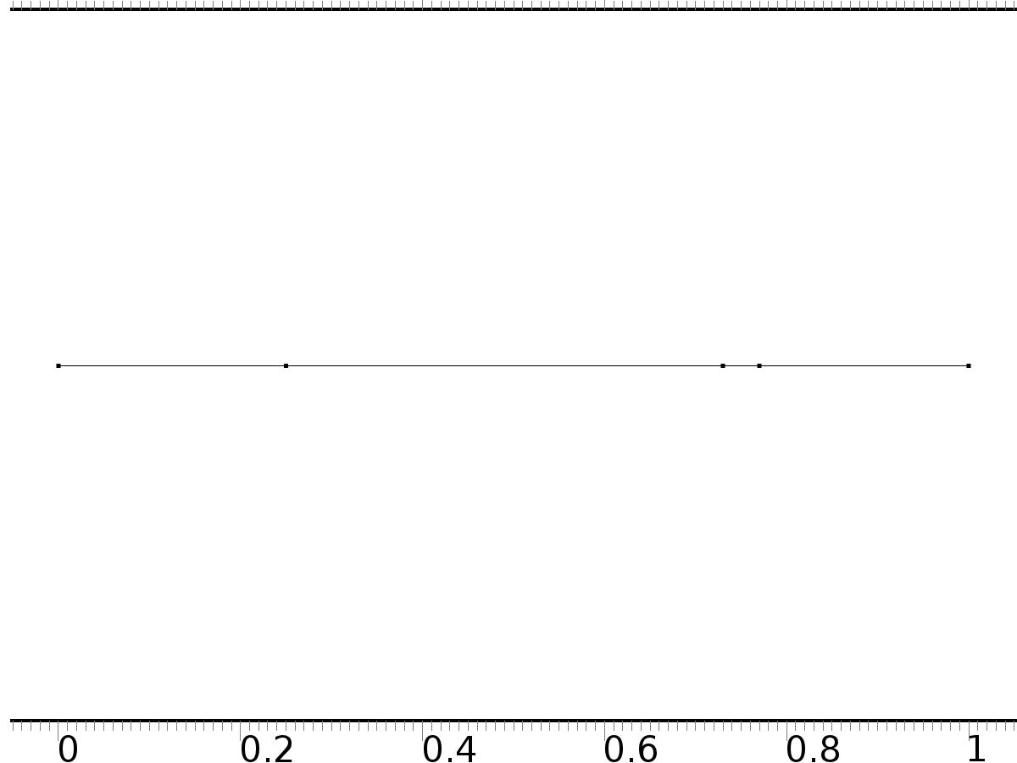

Geometry 1

Units

|  |  |
| --- | --- |
| Length unit | m |
| Angular unit | deg |

Geometry statistics

| **Description** | **Value** |
| --- | --- |
| Space dimension | 1 |
| Number of domains | 4 |
| Number of boundaries | 5 |

* + 1. Interval 1 (i1)

Interval

| **Description** | **Value** |
| --- | --- |
| Number of intervals | Many |
| Points | {0, 0.25, 0.73, 0.77, 1} |

* 1. Unit Input

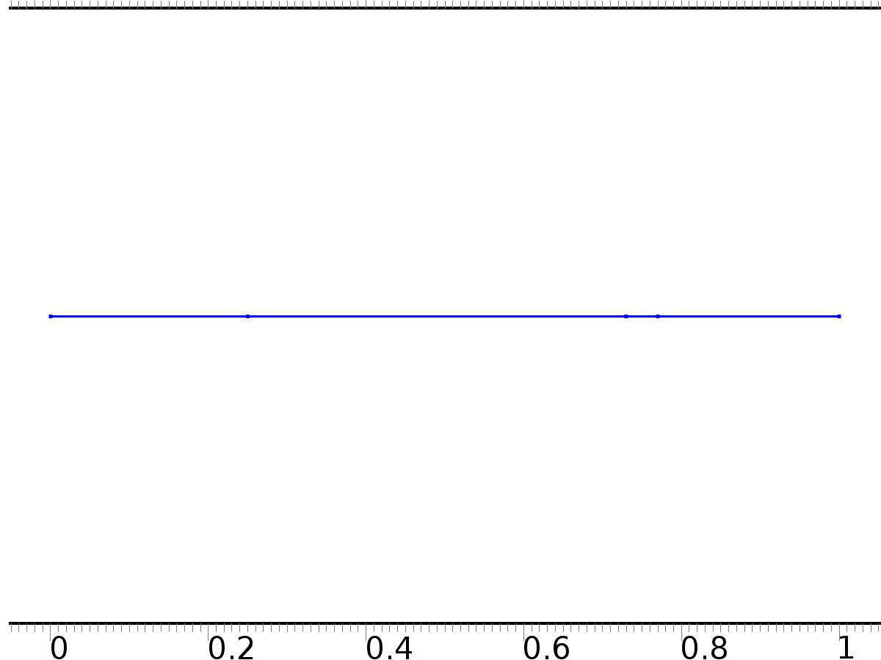

Unit Input

Selection

|  |  |
| --- | --- |
| Geometric entity level | Domain |
| Selection | Domains 1–4 |

Settings

| **Description** | **Value** |
| --- | --- |
| Shape function type | Lagrange |
| Element order | Quadratic |
| Compute boundary fluxes | On |
| Apply smoothing to boundary fluxes | On |
| Value type when using splitting of complex variables | Complex |
| Dependent variable quantity | Dimensionless (1) |
| Source term quantity | None |
| Unit | m^ - 2 |

Used products

|  |
| --- |
| COMSOL Multiphysics |

Variables

| **Name** | **Expression** | **Unit** | **Description** | **Selection** |
| --- | --- | --- | --- | --- |
| X.nx | nx |  | Normal vector, x component | Boundaries 1–5 |
| X.ny | root.ny |  | Normal vector, y component | Boundaries 1–5 |
| X.nz | root.nz |  | Normal vector, z component | Boundaries 1–5 |
| X.nxmesh | root.nxmesh |  | Normal vector (mesh), x component | Boundaries 1–5 |
| X.nymesh | root.nymesh |  | Normal vector (mesh), y component | Boundaries 1–5 |
| X.nzmesh | root.nzmesh |  | Normal vector (mesh), z component | Boundaries 1–5 |

* + 1. Coefficient Form PDE 1



Coefficient Form PDE 1

Selection

|  |  |
| --- | --- |
| Geometric entity level | Domain |
| Selection | Domains 1–4 |

Equations

Settings

| **Description** | **Value** |
| --- | --- |
| Diffusion coefficient | 1 |
| Absorption coefficient | 0 |
| Source term | 0 |
| Mass coefficient | 0 |
| Damping or mass coefficient | 0 |
| Conservative flux convection coefficient | 0 |
| Convection coefficient | 0 |
| Conservative flux source | 0 |

#### Variables

| **Name** | **Expression** | **Unit** | **Description** | **Selection** |
| --- | --- | --- | --- | --- |
| domflux.Xx | -d(X,x) |  | Domain flux, x component | Domains 1–4 |

#### Shape functions

| **Name** | **Shape function** | **Unit** | **Description** | **Shape frame** | **Selection** |
| --- | --- | --- | --- | --- | --- |
| X | Lagrange (Quadratic) |  | Dependent variable X | Material | Domains 1–4 |

* + 1. Zero Flux

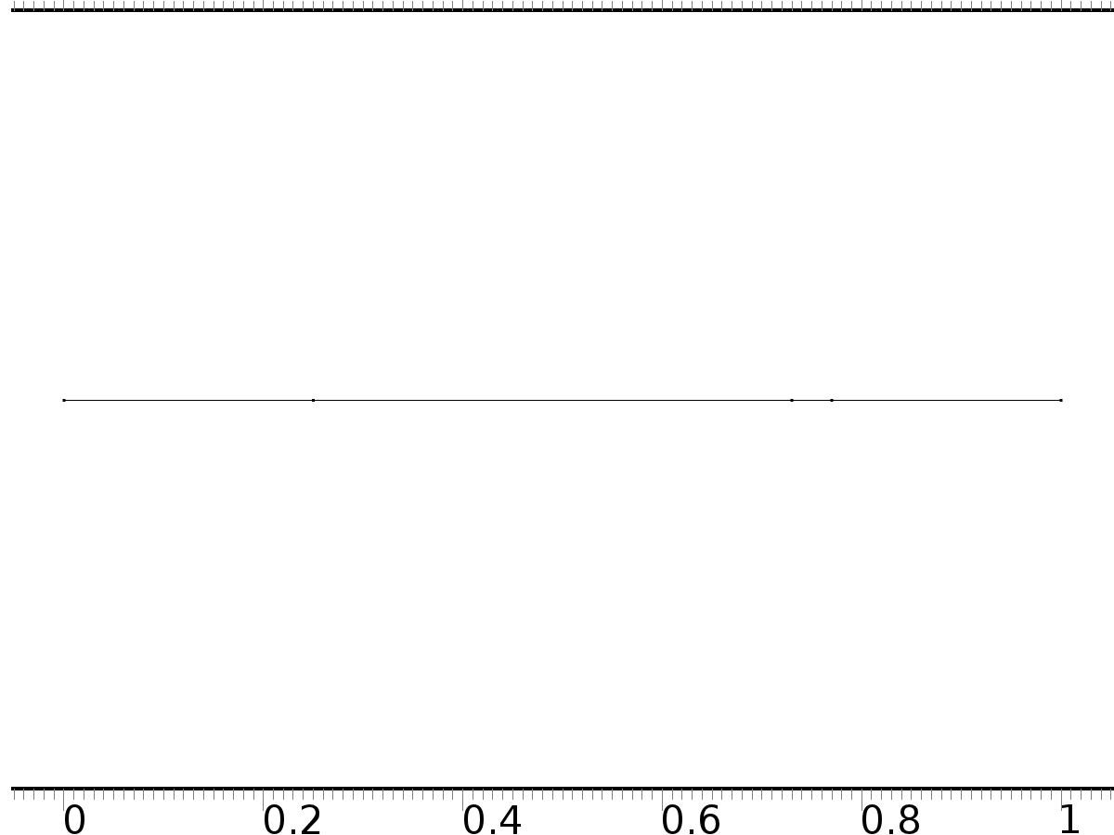

Zero Flux

Selection

|  |  |
| --- | --- |
| Geometric entity level | Boundary |
| Selection | No boundaries |

Equations

* + 1. Initial Values 1



Initial Values 1

Selection

|  |  |
| --- | --- |
| Geometric entity level | Domain |
| Selection | Domains 1–4 |

Settings

| **Description** | **Value** |
| --- | --- |
| Initial value for X | 0 |
| Initial time derivative of X | 0 |

* + 1. Bin*1

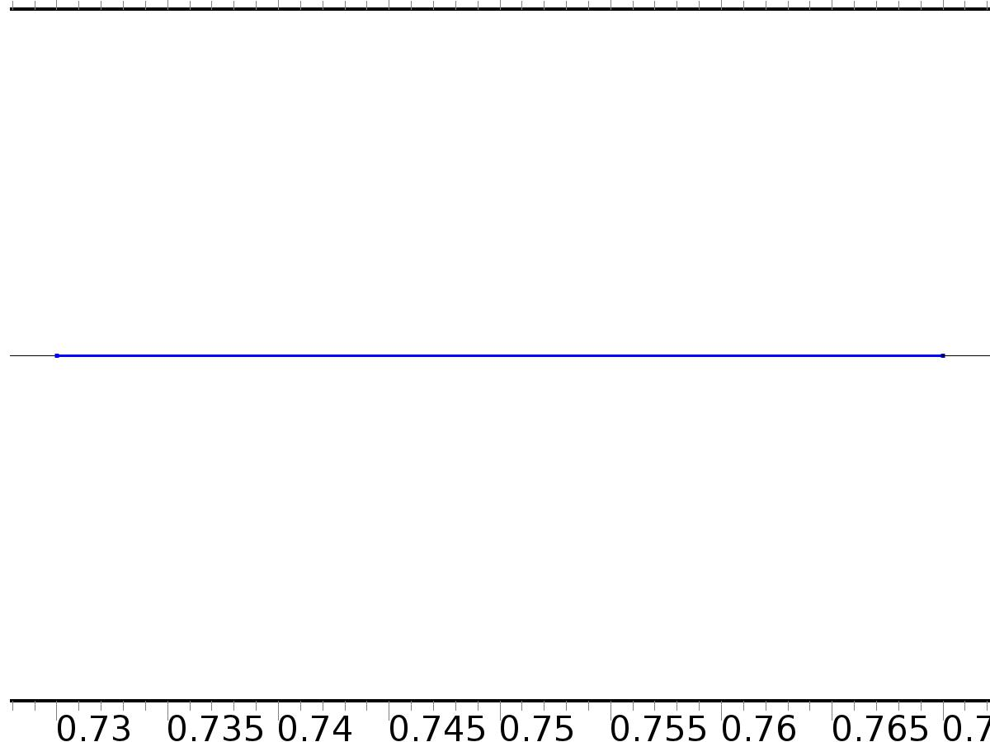

Bin*1

Selection

|  |  |
| --- | --- |
| Geometric entity level | Domain |
| Selection | Domain 3 |

Settings

| **Description** | **Value** |
| --- | --- |
| Source term | 1 |

#### Variables

| **Name** | **Expression** | **Unit** | **Description** | **Selection** |
| --- | --- | --- | --- | --- |
| X.f_X | 1 |  | Source term | Domain 3 |

* + 1. Robin x=0

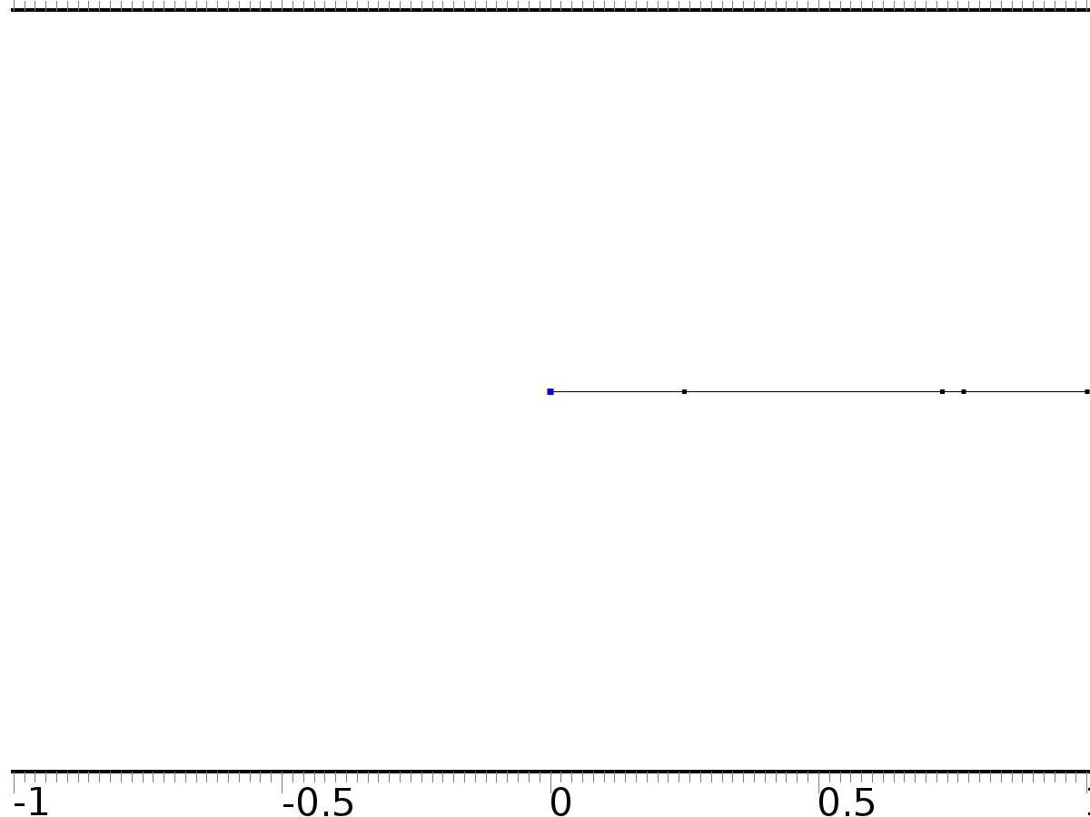

Robin x=0

Selection

|  |  |
| --- | --- |
| Geometric entity level | Boundary |
| Selection | Boundary 1 |

Equations

Settings

| **Description** | **Value** |
| --- | --- |
| Boundary flux/source | 0 |
| Boundary absorption/impedance term | k0 |

#### Variables

| **Name** | **Expression** | **Unit** | **Description** | **Selection** |
| --- | --- | --- | --- | --- |
| X.g_X | -k0*X |  | Boundary flux/source | Boundary 1 |

* + 1. Robin x=L

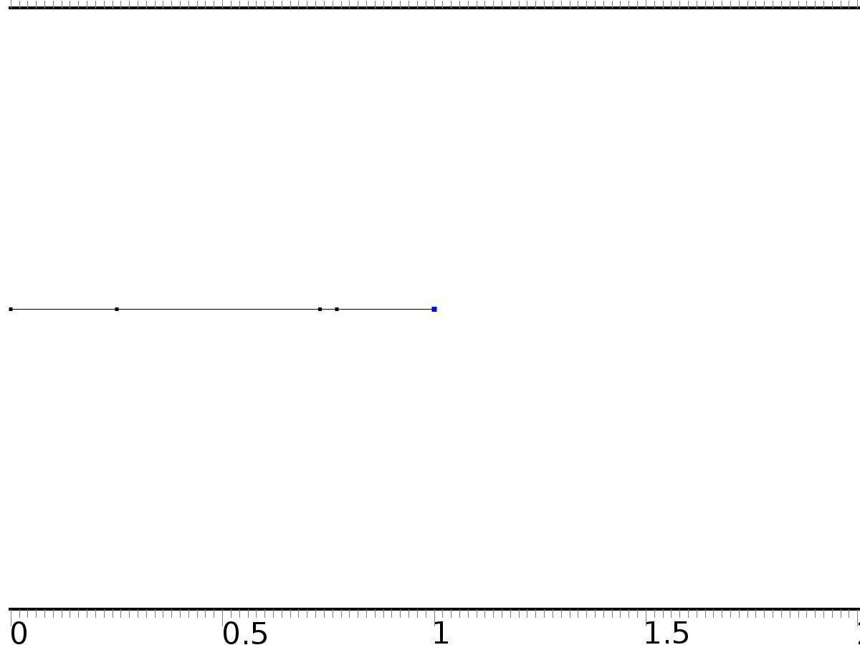

Robin x=L

Selection

|  |  |
| --- | --- |
| Geometric entity level | Boundary |
| Selection | Boundary 5 |

Equations

Settings

| **Description** | **Value** |
| --- | --- |
| Boundary flux/source | 0 |
| Boundary absorption/impedance term | k1 |

#### Variables

| **Name** | **Expression** | **Unit** | **Description** | **Selection** |
| --- | --- | --- | --- | --- |
| X.g_X | -k1*X |  | Boundary flux/source | Boundary 5 |

* 1. Invariant Manifold



Invariant Manifold

Selection

|  |  |
| --- | --- |
| Geometric entity level | Domain |
| Selection | Domains 1–4 |

Settings

| **Description** | **Value** |
| --- | --- |
| Shape function type | Lagrange |
| Element order | Quadratic |
| Compute boundary fluxes | On |
| Apply smoothing to boundary fluxes | On |
| Value type when using splitting of complex variables | Complex |
| Dependent variable quantity | Dimensionless (1) |
| Source term quantity | None |
| Unit | m^ - 2 |

Used products

|  |
| --- |
| COMSOL Multiphysics |

Variables

| **Name** | **Expression** | **Unit** | **Description** | **Selection** |
| --- | --- | --- | --- | --- |
| PI.nx | nx |  | Normal vector, x component | Boundaries 1–5 |
| PI.ny | root.ny |  | Normal vector, y component | Boundaries 1–5 |
| PI.nz | root.nz |  | Normal vector, z component | Boundaries 1–5 |
| PI.nxmesh | root.nxmesh |  | Normal vector (mesh), x component | Boundaries 1–5 |
| PI.nymesh | root.nymesh |  | Normal vector (mesh), y component | Boundaries 1–5 |
| PI.nzmesh | root.nzmesh |  | Normal vector (mesh), z component | Boundaries 1–5 |

* + 1. Coefficient Form PDE 1



Coefficient Form PDE 1

Selection

|  |  |
| --- | --- |
| Geometric entity level | Domain |
| Selection | Domains 1–4 |

Equations

Settings

| **Description** | **Value** |
| --- | --- |
| Diffusion coefficient | {{1, 0}, {0, 1}} |
| Absorption coefficient | {{0, 0}, {0, 0}} |
| Source term | {PI - PI^3, PI - PI^3} |
| Mass coefficient | {{0, 0}, {0, 0}} |
| Damping or mass coefficient | {{0, 0}, {0, 0}} |
| Conservative flux convection coefficient | {{0, 0}, {0, 0}} |
| Convection coefficient | {{0, 0}, {0, 0}} |
| Conservative flux source | {0, 0} |

#### Variables

| **Name** | **Expression** | **Unit** | **Description** | **Selection** |
| --- | --- | --- | --- | --- |
| domflux.PIx | -d(PI,x) |  | Domain flux, x component | Domains 1–4 |
| domflux.PITx | -d(PIT,x) |  | Domain flux, x component | Domains 1–4 |

#### Shape functions

| **Name** | **Shape function** | **Unit** | **Description** | **Shape frame** | **Selection** |
| --- | --- | --- | --- | --- | --- |
| PI | Lagrange (Quadratic) |  | Dependent variable PI | Material | Domains 1–4 |
| PIT | Lagrange (Quadratic) |  | Dependent variable PIT | Material | Domains 1–4 |

* + 1. Zero Flux



Zero Flux

Selection

|  |  |
| --- | --- |
| Geometric entity level | Boundary |
| Selection | No boundaries |

Equations

* + 1. Initial Values 1



Initial Values 1

Selection

|  |  |
| --- | --- |
| Geometric entity level | Domain |
| Selection | Domains 1–4 |

Settings

| **Description** | **Value** |
| --- | --- |
| Initial value for PI | 0 |
| Initial time derivative of PI | 0 |
| Initial value for PIT | 0 |
| Initial time derivative of PIT | 0 |

* + 1. Bin*gamma



Bin*gamma

Selection

|  |  |
| --- | --- |
| Geometric entity level | Domain |
| Selection | Domain 3 |

Settings

| **Description** | **Value** |
| --- | --- |
| Source term | {gamma, 0} |

#### Variables

| **Name** | **Expression** | **Unit** | **Description** | **Selection** |
| --- | --- | --- | --- | --- |
| PI.f_PI | gamma |  | Source term | Domain 3 |
| PI.f_PIT | 0 |  | Source term | Domain 3 |

* + 1. Robin x=0



Robin x=0

Selection

|  |  |
| --- | --- |
| Geometric entity level | Boundary |
| Selection | Boundary 1 |

Equations

Settings

| **Description** | **Value** |
| --- | --- |
| Boundary flux/source | {0, 0} |
| Boundary absorption/impedance term | {{k0, 0}, {0, k0}} |

#### Variables

| **Name** | **Expression** | **Unit** | **Description** | **Selection** |
| --- | --- | --- | --- | --- |
| PI.g_PI | -k0*PI |  | Boundary flux/source | Boundary 1 |
| PI.g_PIT | -k0*PIT |  | Boundary flux/source | Boundary 1 |

* + 1. Robin x=L



Robin x=L

Selection

|  |  |
| --- | --- |
| Geometric entity level | Boundary |
| Selection | Boundary 5 |

Equations

Settings

| **Description** | **Value** |
| --- | --- |
| Boundary flux/source | {0, 0} |
| Boundary absorption/impedance term | {{k1, 0}, {0, k1}} |

#### Variables

| **Name** | **Expression** | **Unit** | **Description** | **Selection** |
| --- | --- | --- | --- | --- |
| PI.g_PI | -k1*PI |  | Boundary flux/source | Boundary 5 |
| PI.g_PIT | -k1*PIT |  | Boundary flux/source | Boundary 5 |

* 1. Close Loop System



Close Loop System

Selection

|  |  |
| --- | --- |
| Geometric entity level | Domain |
| Selection | Domains 1–4 |

Settings

| **Description** | **Value** |
| --- | --- |
| Shape function type | Lagrange |
| Element order | Quadratic |
| Compute boundary fluxes | On |
| Apply smoothing to boundary fluxes | On |
| Value type when using splitting of complex variables | Complex |
| Dependent variable quantity | Dimensionless (1) |
| Source term quantity | None |
| Unit | m^ - 2 |

Used products

|  |
| --- |
| COMSOL Multiphysics |

Variables

| **Name** | **Expression** | **Unit** | **Description** | **Selection** |
| --- | --- | --- | --- | --- |
| z.nx | nx |  | Normal vector, x component | Boundaries 1–5 |
| z.ny | root.ny |  | Normal vector, y component | Boundaries 1–5 |
| z.nz | root.nz |  | Normal vector, z component | Boundaries 1–5 |
| z.nxmesh | root.nxmesh |  | Normal vector (mesh), x component | Boundaries 1–5 |
| z.nymesh | root.nymesh |  | Normal vector (mesh), y component | Boundaries 1–5 |
| z.nzmesh | root.nzmesh |  | Normal vector (mesh), z component | Boundaries 1–5 |

* + 1. Coefficient Form PDE 1



Coefficient Form PDE 1

Selection

|  |  |
| --- | --- |
| Geometric entity level | Domain |
| Selection | Domains 1–4 |

Equations

Settings

| **Description** | **Value** |
| --- | --- |
| Diffusion coefficient | 1 |
| Absorption coefficient | 0 |
| Source term | z - z^3 |
| Mass coefficient | 0 |
| Damping or mass coefficient | 1 |
| Conservative flux convection coefficient | 0 |
| Convection coefficient | 0 |
| Conservative flux source | 0 |

#### Variables

| **Name** | **Expression** | **Unit** | **Description** | **Selection** |
| --- | --- | --- | --- | --- |
| domflux.zx | -d(z,x) |  | Domain flux, x component | Domains 1–4 |

#### Shape functions

| **Name** | **Shape function** | **Unit** | **Description** | **Shape frame** | **Selection** |
| --- | --- | --- | --- | --- | --- |
| z | Lagrange (Quadratic) |  | Dependent variable z | Material | Domains 1–4 |

* + 1. Zero Flux



Zero Flux

Selection

|  |  |
| --- | --- |
| Geometric entity level | Boundary |
| Selection | No boundaries |

Equations

* + 1. Initial Values 1



Initial Values 1

Selection

|  |  |
| --- | --- |
| Geometric entity level | Domain |
| Selection | Domains 1–4 |

Settings

| **Description** | **Value** |
| --- | --- |
| Initial value for z | .5*cos(pi*x) |
| Initial time derivative of z | 0 |

* + 1. Bin*u



Bin*u

Selection

|  |  |
| --- | --- |
| Geometric entity level | Domain |
| Selection | Domain 3 |

Settings

| **Description** | **Value** |
| --- | --- |
| Source term | u |

#### Variables

| **Name** | **Expression** | **Unit** | **Description** | **Selection** |
| --- | --- | --- | --- | --- |
| z.f_z | u |  | Source term | Domain 3 |

* + 1. Robin x=0



Robin x=0

Selection

|  |  |
| --- | --- |
| Geometric entity level | Boundary |
| Selection | Boundary 1 |

Equations

Settings

| **Description** | **Value** |
| --- | --- |
| Boundary flux/source | 0 |
| Boundary absorption/impedance term | k0 |

#### Variables

| **Name** | **Expression** | **Unit** | **Description** | **Selection** |
| --- | --- | --- | --- | --- |
| z.g_z | -k0*z |  | Boundary flux/source | Boundary 1 |

* + 1. Robin x=L



Robin x=L

Selection

|  |  |
| --- | --- |
| Geometric entity level | Boundary |
| Selection | Boundary 5 |

Equations

Settings

| **Description** | **Value** |
| --- | --- |
| Boundary flux/source | 0 |
| Boundary absorption/impedance term | k1 |

#### Variables

| **Name** | **Expression** | **Unit** | **Description** | **Selection** |
| --- | --- | --- | --- | --- |
| z.g_z | -k1*z |  | Boundary flux/source | Boundary 5 |

* 1. Mesh 1

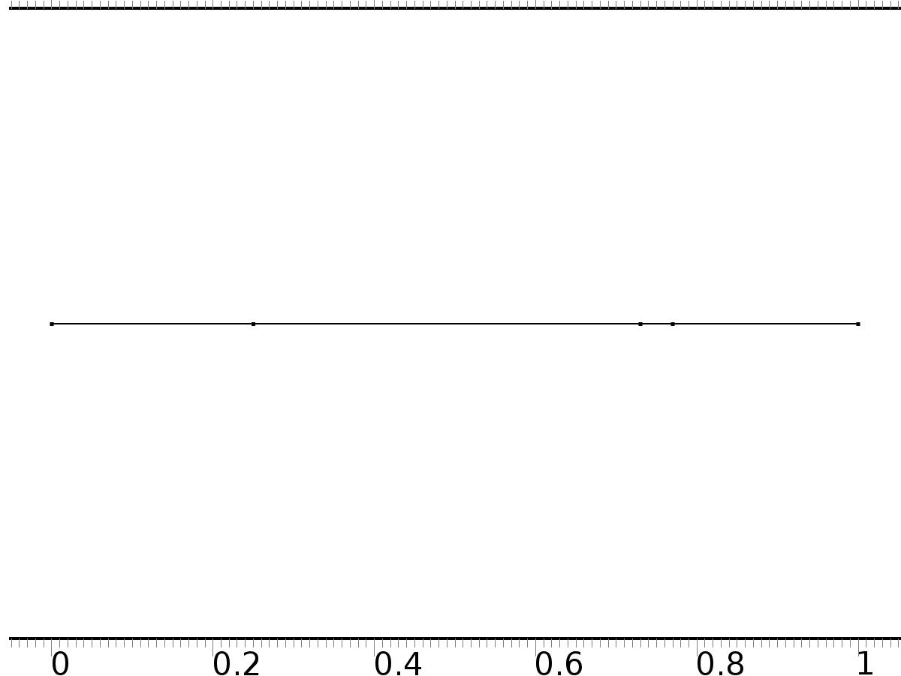

Mesh 1

* + 1. Size (size)

Settings

| **Description** | **Value** |
| --- | --- |
| Maximum element size | 0.02 |
| Minimum element size | 7.5E-5 |
| Curvature factor | 0.25 |
| Maximum element growth rate | 1.2 |
| Predefined size | Extra fine |

* + 1. Edge 1 (edg1)

Selection

|  |  |
| --- | --- |
| Geometric entity level | Remaining |

1. Study 1
   1. Stationary

Study settings

| **Description** | **Value** |
| --- | --- |
| Include geometric nonlinearity | Off |

Physics and variables selection

| **Physics interface** | **Discretization** |
| --- | --- |
| Unit Input (c) | physics |

Mesh selection

| **Geometry** | **Mesh** |
| --- | --- |
| Geometry 1 (geom1) | mesh1 |

* 1. Solver Configurations
     1. Solver 1

#### Compile Equations: Stationary (st1)

Study and step

| **Description** | **Value** |
| --- | --- |
| Use study | Study 1 |
| Use study step | Stationary |

#### Dependent Variables 1 (v1)

General

| **Description** | **Value** |
| --- | --- |
| Defined by study step | Stationary |
| Constant |  |

Initial values of variables solved for

| **Description** | **Value** |
| --- | --- |
| Solution | Zero |

Values of variables not solved for

| **Description** | **Value** |
| --- | --- |
| Solution | Zero |

##### Dependent variable PI (comp1.PI) (comp1_PI)

General

| **Description** | **Value** |
| --- | --- |
| Field components | comp1.PI |
| Solve for this field | Off |

##### Dependent variable z (comp1.z) (comp1_z)

General

| **Description** | **Value** |
| --- | --- |
| Field components | comp1.z |
| Solve for this field | Off |

##### Dependent variable PIT (comp1.PIT) (comp1_PIT)

General

| **Description** | **Value** |
| --- | --- |
| Field components | comp1.PIT |
| Solve for this field | Off |

##### Dependent variable X (comp1.X) (comp1_X)

General

| **Description** | **Value** |
| --- | --- |
| Field components | comp1.X |

#### Stationary Solver 1 (s1)

General

| **Description** | **Value** |
| --- | --- |
| Defined by study step | Stationary |
| Relative tolerance | 0.000010 |

Log

| **Description** | **Value** |
| --- | --- |
| Constant |  |

##### Fully Coupled 1 (fc1)

General

| **Description** | **Value** |
| --- | --- |
| Linear solver | Direct |

1. Study 2
   1. Stationary

Study settings

| **Description** | **Value** |
| --- | --- |
| Include geometric nonlinearity | Off |

Physics and variables selection

| **Physics interface** | **Discretization** |
| --- | --- |
| Invariant Manifold (c2) | physics |

Mesh selection

| **Geometry** | **Mesh** |
| --- | --- |
| Geometry 1 (geom1) | mesh1 |

* 1. Solver Configurations
     1. Solver 2

#### Compile Equations: Stationary (st1)

Study and step

| **Description** | **Value** |
| --- | --- |
| Use study | Study 2 |
| Use study step | Stationary |

#### Dependent Variables 1 (v1)

General

| **Description** | **Value** |
| --- | --- |
| Defined by study step | Stationary |
| Constant |  |

Initial values of variables solved for

| **Description** | **Value** |
| --- | --- |
| Solution | Zero |

Values of variables not solved for

| **Description** | **Value** |
| --- | --- |
| Method | Solution |
| Solution | Solver 1 |

##### Dependent variable PI (comp1.PI) (comp1_PI)

General

| **Description** | **Value** |
| --- | --- |
| Field components | comp1.PI |

##### Dependent variable z (comp1.z) (comp1_z)

General

| **Description** | **Value** |
| --- | --- |
| Field components | comp1.z |
| Solve for this field | Off |

##### Dependent variable PIT (comp1.PIT) (comp1_PIT)

General

| **Description** | **Value** |
| --- | --- |
| Field components | comp1.PIT |

##### Dependent variable X (comp1.X) (comp1_X)

General

| **Description** | **Value** |
| --- | --- |
| Field components | comp1.X |
| Solve for this field | Off |

#### Stationary Solver 1 (s1)

General

| **Description** | **Value** |
| --- | --- |
| Defined by study step | Stationary |
| Relative tolerance | 0.000010 |

Log

| **Description** | **Value** |
| --- | --- |
| Constant |  |

##### Fully Coupled 1 (fc1)

General

| **Description** | **Value** |
| --- | --- |
| Linear solver | Direct |

1. Study 3
   1. Time Dependent

Study settings

| **Description** | **Value** |
| --- | --- |
| Include geometric nonlinearity | Off |

| **Times** | **Unit** |
| --- | --- |
| range(0,0.01,6) | s |

Physics and variables selection

| **Physics interface** | **Discretization** |
| --- | --- |
| Close Loop System (c3) | physics |

Mesh selection

| **Geometry** | **Mesh** |
| --- | --- |
| Geometry 1 (geom1) | mesh1 |

* 1. Solver Configurations
     1. Solver 3

#### Compile Equations: Time Dependent (st1)

Study and step

| **Description** | **Value** |
| --- | --- |
| Use study | Study 3 |
| Use study step | Time Dependent |

#### Dependent Variables 1 (v1)

General

| **Description** | **Value** |
| --- | --- |
| Defined by study step | Time Dependent |
| Constant |  |

Initial values of variables solved for

| **Description** | **Value** |
| --- | --- |
| Solution | Zero |

Values of variables not solved for

| **Description** | **Value** |
| --- | --- |
| Method | Solution |
| Solution | Solver 2 |

##### Dependent variable PI (comp1.PI) (comp1_PI)

General

| **Description** | **Value** |
| --- | --- |
| Field components | comp1.PI |
| Solve for this field | Off |

##### Dependent variable z (comp1.z) (comp1_z)

General

| **Description** | **Value** |
| --- | --- |
| Field components | comp1.z |

##### Dependent variable PIT (comp1.PIT) (comp1_PIT)

General

| **Description** | **Value** |
| --- | --- |
| Field components | comp1.PIT |
| Solve for this field | Off |

##### Dependent variable X (comp1.X) (comp1_X)

General

| **Description** | **Value** |
| --- | --- |
| Field components | comp1.X |
| Solve for this field | Off |

#### Time-Dependent Solver 1 (t1)

General

| **Description** | **Value** |
| --- | --- |
| Defined by study step | Time Dependent |
| Time | {0, 0.01, 0.02, 0.03, 0.04, 0.05, 0.06, 0.07, 0.08, 0.09, 0.1, 0.11, 0.12, 0.13, 0.14, 0.15, 0.16, 0.17, 0.18, 0.19, 0.2, 0.21, 0.22, 0.23, 0.24, 0.25, 0.26, 0.27, 0.28, 0.29, 0.3, 0.31, 0.32, 0.33, 0.34, 0.35000000000000003, 0.36, 0.37, 0.38, 0.39, 0.4, 0.41000000000000003, 0.42, 0.43, 0.44, 0.45, 0.46, 0.47000000000000003, 0.48, 0.49, 0.5, 0.51, 0.52, 0.53, 0.54, 0.55, 0.56, 0.5700000000000001, 0.58, 0.59, 0.6, 0.61, 0.62, 0.63, 0.64, 0.65, 0.66, 0.67, 0.68, 0.6900000000000001, 0.7000000000000001, 0.71, 0.72, 0.73, 0.74, 0.75, 0.76, 0.77, 0.78, 0.79, 0.8, 0.81, 0.8200000000000001, 0.8300000000000001, 0.84, 0.85, 0.86, 0.87, 0.88, 0.89, 0.9, 0.91, 0.92, 0.93, 0.9400000000000001, 0.9500000000000001, 0.96, 0.97, 0.98, 0.99, 1, 1.01, 1.02, 1.03, 1.04, 1.05, 1.06, 1.07, 1.08, 1.09, 1.1, 1.11, 1.12, 1.1300000000000001, 1.1400000000000001, 1.1500000000000001, 1.16, 1.17, 1.18, 1.19, 1.2, 1.21, 1.22, 1.23, 1.24, 1.25, 1.26, 1.27, 1.28, 1.29, 1.3, 1.31, 1.32, 1.33, 1.34, 1.35, 1.36, 1.37, 1.3800000000000001, 1.3900000000000001, 1.4000000000000001, 1.41, 1.42, 1.43, 1.44, 1.45, 1.46, 1.47, 1.48, 1.49, 1.5, 1.51, 1.52, 1.53, 1.54, 1.55, 1.56, 1.57, 1.58, 1.59, 1.6, 1.61, 1.62, 1.6300000000000001, 1.6400000000000001, 1.6500000000000001, 1.6600000000000001, 1.67, 1.68, 1.69, 1.7, 1.71, 1.72, 1.73, 1.74, 1.75, 1.76, 1.77, 1.78, 1.79, 1.8, 1.81, 1.82, 1.83, 1.84, 1.85, 1.86, 1.87, 1.8800000000000001, 1.8900000000000001, 1.9000000000000001, 1.9100000000000001, 1.92, 1.93, 1.94, 1.95, 1.96, 1.97, 1.98, 1.99, 2, 2.0100000000000002, 2.02, 2.0300000000000002, 2.04, 2.05, 2.06, 2.07, 2.08, 2.09, 2.1, 2.11, 2.12, 2.13, 2.14, 2.15, 2.16, 2.17, 2.18, 2.19, 2.2, 2.21, 2.22, 2.23, 2.24, 2.25, 2.2600000000000002, 2.27, 2.2800000000000002, 2.29, 2.3000000000000003, 2.31, 2.32, 2.33, 2.34, 2.35, 2.36, 2.37, 2.38, 2.39, 2.4, 2.41, 2.42, 2.43, 2.44, 2.45, 2.46, 2.47, 2.48, 2.49, 2.5, 2.5100000000000002, 2.52, 2.5300000000000002, 2.54, 2.5500000000000003, 2.56, 2.57, 2.58, 2.59, 2.6, 2.61, 2.62, 2.63, 2.64, 2.65, 2.66, 2.67, 2.68, 2.69, 2.7, 2.71, 2.72, 2.73, 2.74, 2.75, 2.7600000000000002, 2.77, 2.7800000000000002, 2.79, 2.8000000000000003, 2.81, 2.82, 2.83, 2.84, 2.85, 2.86, 2.87, 2.88, 2.89, 2.9, 2.91, 2.92, 2.93, 2.94, 2.95, 2.96, 2.97, 2.98, 2.99, 3, 3.0100000000000002, 3.02, 3.0300000000000002, 3.04, 3.0500000000000003, 3.06, 3.0700000000000003, 3.08, 3.09, 3.1, 3.11, 3.12, 3.13, 3.14, 3.15, 3.16, 3.17, 3.18, 3.19, 3.2, 3.21, 3.22, 3.23, 3.24, 3.25, 3.2600000000000002, 3.27, 3.2800000000000002, 3.29, 3.3000000000000003, 3.31, 3.3200000000000003, 3.33, 3.34, 3.35, 3.36, 3.37, 3.38, 3.39, 3.4, 3.41, 3.42, 3.43, 3.44, 3.45, 3.46, 3.47, 3.48, 3.49, 3.5, 3.5100000000000002, 3.52, 3.5300000000000002, 3.54, 3.5500000000000003, 3.56, 3.5700000000000003, 3.58, 3.59, 3.6, 3.61, 3.62, 3.63, 3.64, 3.65, 3.66, 3.67, 3.68, 3.69, 3.7, 3.71, 3.72, 3.73, 3.74, 3.75, 3.7600000000000002, 3.77, 3.7800000000000002, 3.79, 3.8000000000000003, 3.81, 3.8200000000000003, 3.83, 3.84, 3.85, 3.86, 3.87, 3.88, 3.89, 3.9, 3.91, 3.92, 3.93, 3.94, 3.95, 3.96, 3.97, 3.98, 3.99, 4, 4.01, 4.0200000000000005, 4.03, 4.04, 4.05, 4.0600000000000005, 4.07, 4.08, 4.09, 4.1, 4.11, 4.12, 4.13, 4.14, 4.15, 4.16, 4.17, 4.18, 4.19, 4.2, 4.21, 4.22, 4.23, 4.24, 4.25, 4.26, 4.2700000000000005, 4.28, 4.29, 4.3, 4.3100000000000005, 4.32, 4.33, 4.34, 4.3500000000000005, 4.36, 4.37, 4.38, 4.39, 4.4, 4.41, 4.42, 4.43, 4.44, 4.45, 4.46, 4.47, 4.48, 4.49, 4.5, 4.51, 4.5200000000000005, 4.53, 4.54, 4.55, 4.5600000000000005, 4.57, 4.58, 4.59, 4.6000000000000005, 4.61, 4.62, 4.63, 4.64, 4.65, 4.66, 4.67, 4.68, 4.69, 4.7, 4.71, 4.72, 4.73, 4.74, 4.75, 4.76, 4.7700000000000005, 4.78, 4.79, 4.8, 4.8100000000000005, 4.82, 4.83, 4.84, 4.8500000000000005, 4.86, 4.87, 4.88, 4.89, 4.9, 4.91, 4.92, 4.93, 4.94, 4.95, 4.96, 4.97, 4.98, 4.99, 5, 5.01, 5.0200000000000005, 5.03, 5.04, 5.05, 5.0600000000000005, 5.07, 5.08, 5.09, 5.1000000000000005, 5.11, 5.12, 5.13, 5.14, 5.15, 5.16, 5.17, 5.18, 5.19, 5.2, 5.21, 5.22, 5.23, 5.24, 5.25, 5.26, 5.2700000000000005, 5.28, 5.29, 5.3, 5.3100000000000005, 5.32, 5.33, 5.34, 5.3500000000000005, 5.36, 5.37, 5.38, 5.39, 5.4, 5.41, 5.42, 5.43, 5.44, 5.45, 5.46, 5.47, 5.48, 5.49, 5.5, 5.51, 5.5200000000000005, 5.53, 5.54, 5.55, 5.5600000000000005, 5.57, 5.58, 5.59, 5.6000000000000005, 5.61, 5.62, 5.63, 5.64, 5.65, 5.66, 5.67, 5.68, 5.69, 5.7, 5.71, 5.72, 5.73, 5.74, 5.75, 5.76, 5.7700000000000005, 5.78, 5.79, 5.8, 5.8100000000000005, 5.82, 5.83, 5.84, 5.8500000000000005, 5.86, 5.87, 5.88, 5.89, 5.9, 5.91, 5.92, 5.93, 5.94, 5.95, 5.96, 5.97, 5.98, 5.99, 6} |
| Relative tolerance | 0.0001 |

Log

| **Description** | **Value** |
| --- | --- |
| Constant |  |

##### Fully Coupled 1 (fc1)

General

| **Description** | **Value** |
| --- | --- |
| Linear solver | Direct |

1. Results
   1. Data Sets
      1. Solution 1

Solution

| **Description** | **Value** |
| --- | --- |
| Solution | Solver 1 |
| Component | Save Point Geometry 1 |

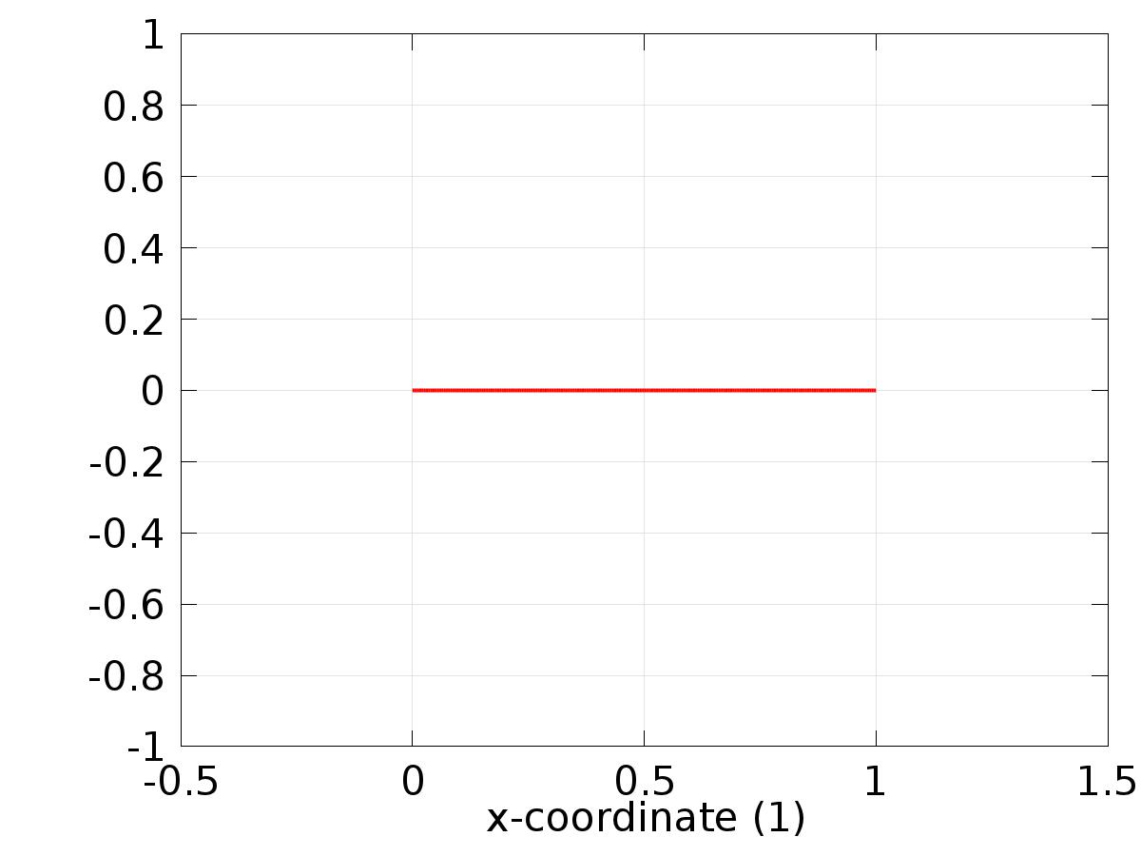

Data set: Solution 1

* + 1. Solution 2

Solution

| **Description** | **Value** |
| --- | --- |
| Solution | Solver 2 |
| Component | Save Point Geometry 1 |



Data set: Solution 2

* + 1. Solution 3

Solution

| **Description** | **Value** |
| --- | --- |
| Solution | Solver 3 |
| Component | Save Point Geometry 1 |

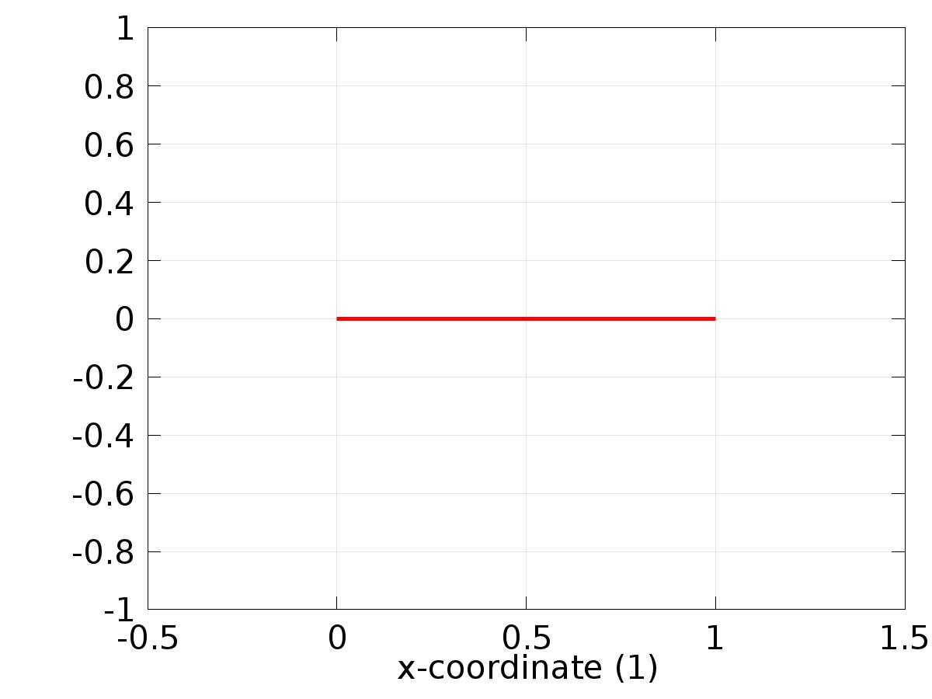

Data set: Solution 3

* 1. Derived Values
     1. Global Evaluation 1

Data

| **Description** | **Value** |
| --- | --- |
| Data set | Solution 2 |

Expression

| **Description** | **Value** |
| --- | --- |
| Expression | gamma |

* 1. Tables
     1. Table 1

Global Evaluation 1 (C(X))

Table 1

| **gamma** |
| --- |
| 37.441 |

* 1. Plot Groups
     1. 1D Plot Group 1

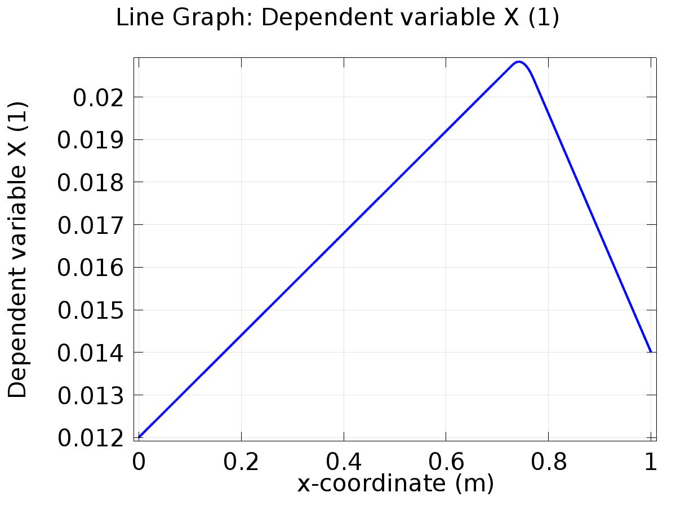

Line Graph: Dependent variable X (1)

* + 1. 1D Plot Group 2

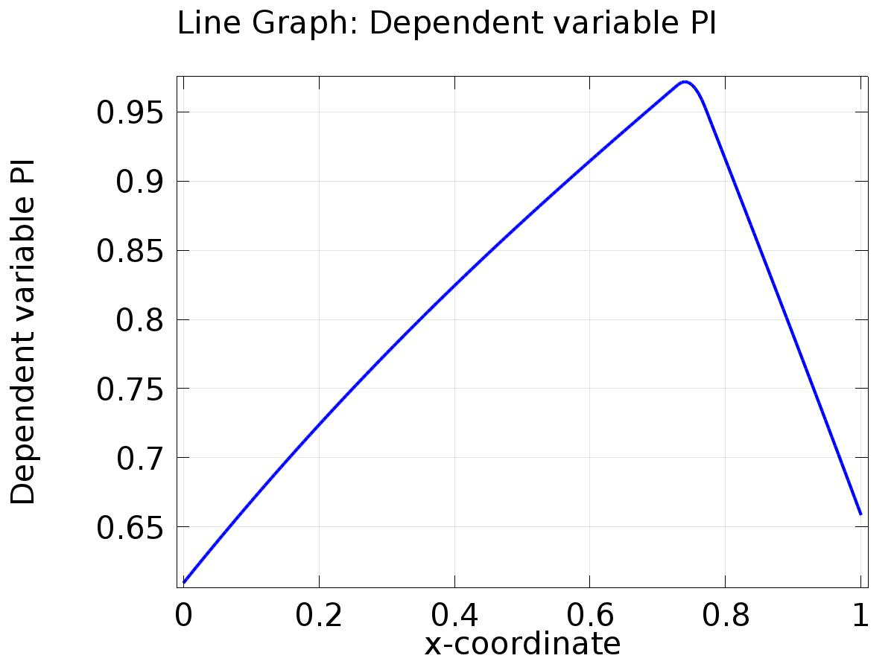

Line Graph: Dependent variable PI

* + 1. 1D Plot Group 3

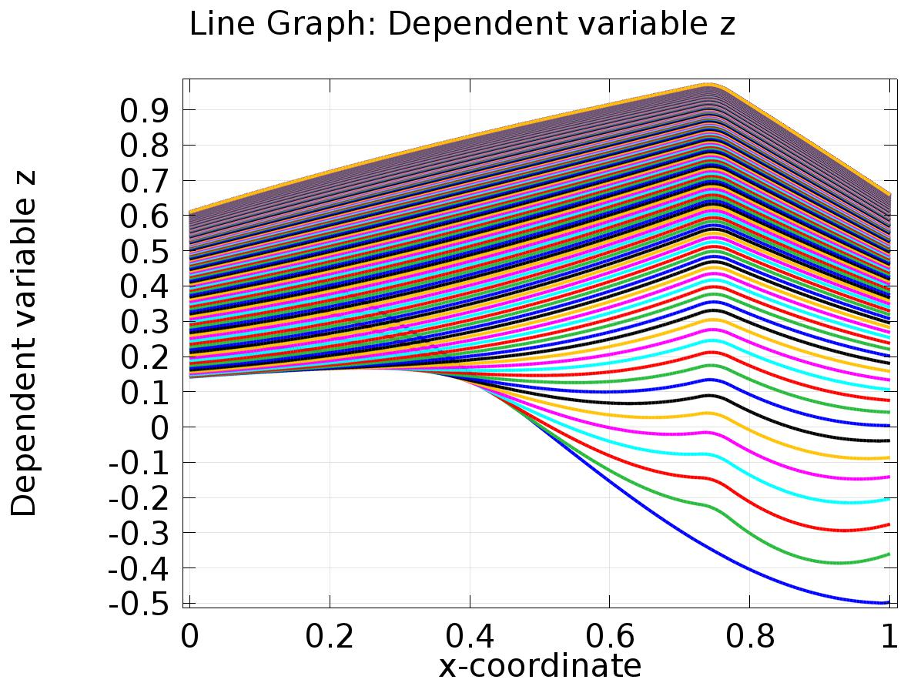

Line Graph: Dependent variable z

* + 1. 1D Plot Group 4

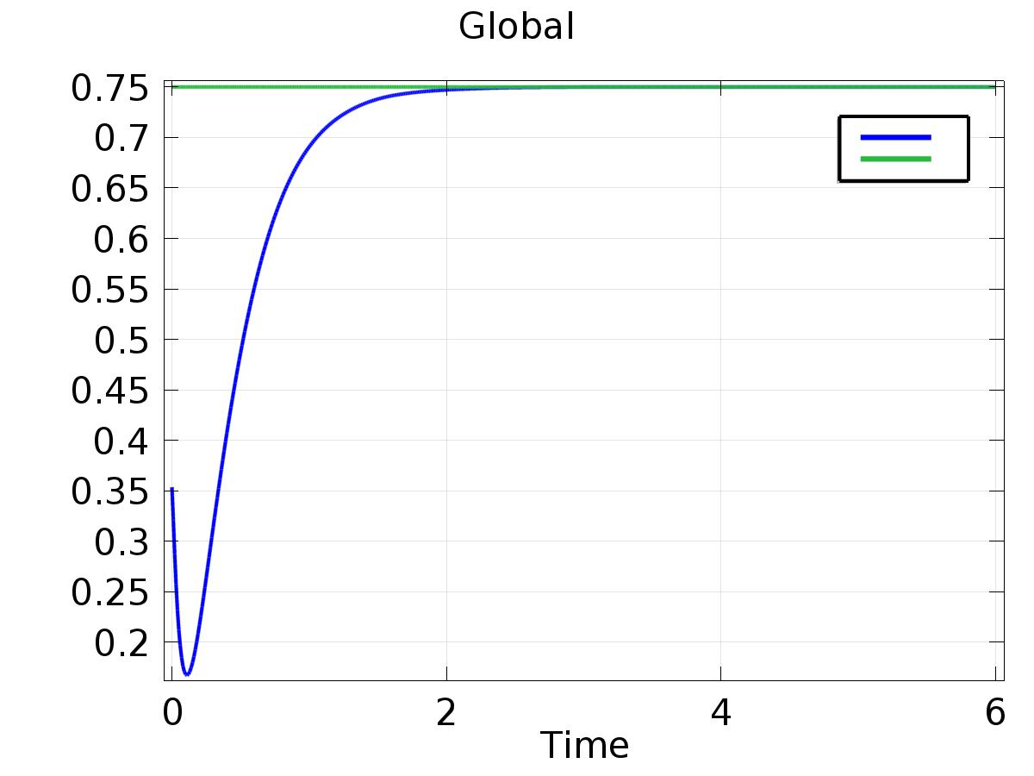

Global

* + 1. 1D Plot Group 5

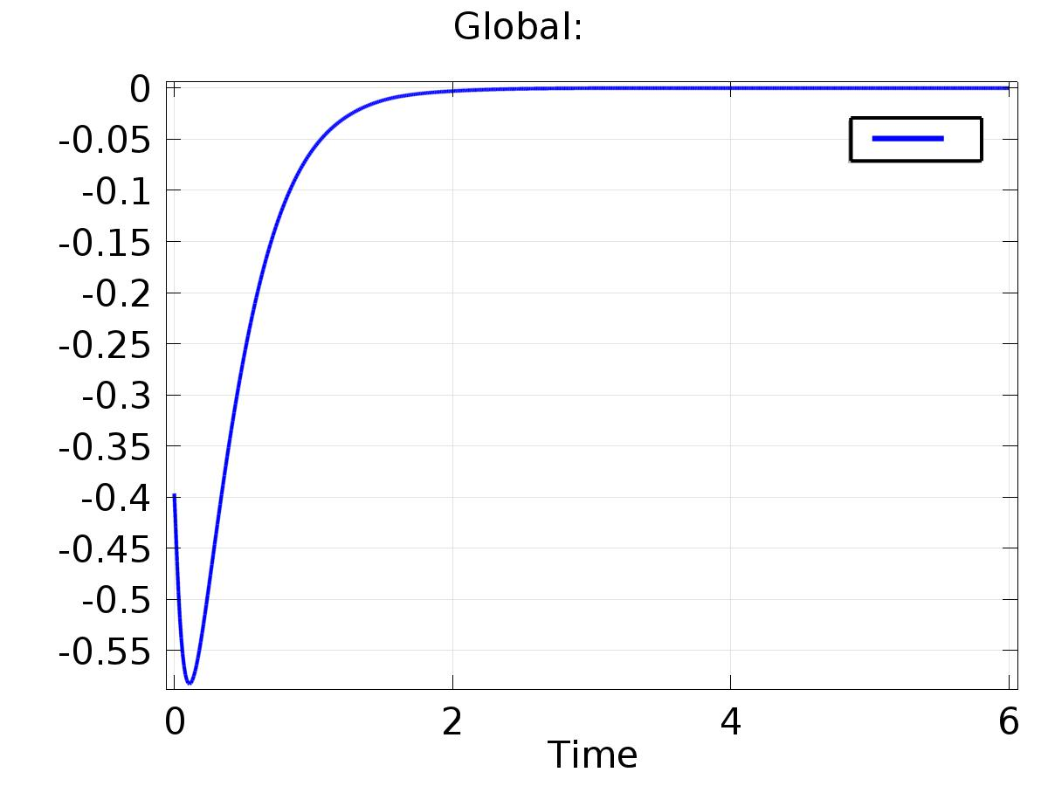

Global: