[](http://www.comsol.com/)

Ch4 Ex4.2 MIMO SetPoint Burger

|  |  |
| --- | --- |
| Date | Mar 30, 2014 10:22:50 AM |

Contents

1. Global

1.1. Definitions

2. Component 1

2.1. Definitions

2.2. Geometry 1

2.3. Unit Input

2.4. Regulator Equation

2.5. Closed Loop System

2.6. Mesh 1

3. Study 1

3.1. Stationary

3.2. Solver Configurations

4. Study 2

4.1. Stationary

4.2. Solver Configurations

5. Study 3

5.1. Time Dependent

5.2. Solver Configurations

6. Results

6.1. Data Sets

6.2. Derived Values

6.3. Tables

6.4. Plot Groups

1. Global

|  |  |
| --- | --- |
| Date | Mar 22, 2014 11:48:15 AM |

Global settings

|  |  |
| --- | --- |
| Name | Ch4 Ex4.2 MIMO SetPoint Burger.mph |
| Path | /Users/gilliam/Desktop/collect_15/research_15/geo_reg_mono_eugenio/Mono_1_15/Comsol_EX_GitHub/Chapter4/Example4.2/Ch4_Ex4.2_MIMO_SetPoint_Burger.mph |
| Program | COMSOL 4.4 (Build: 150) |

Used products

|  |
| --- |
| COMSOL Multiphysics |

* 1. Definitions
     1. Parameters 1

Parameters

| **Name** | **Expression** | **Value** | **Description** |
| --- | --- | --- | --- |
| L | 1 | 1.0000 |  |
| x0 | L/4 | 0.25000 |  |
| x1 | L/2 | 0.50000 |  |
| x2 | 3/4*L | 0.75000 |  |
| c | 0.2 | 0.20000 |  |
| yr1 | 0.5 | 0.50000 |  |
| yr2 | 0.75 | 0.75000 |  |
| d | 0.35 | 0.35000 |  |

1. Component 1

Component settings

|  |  |
| --- | --- |
| Unit system | None |

* 1. Definitions
     1. Variables

#### Variables 1a

Selection

|  |  |
| --- | --- |
| Geometric entity level | Entire model |

| **Name** | **Expression** | **Description** |
| --- | --- | --- |
| G11 | C1(X1) |  |
| G12 | C1(X2) |  |
| G21 | C2(X1) |  |
| G22 | C2(X2) |  |
| Det | G11*G22 - G12*G21 |  |
| g11 | G22/Det |  |
| g12 | -G12/Det |  |
| g21 | -G21/Det |  |
| g22 | G11/Det |  |
| Fz0 | -z0*z0x |  |
| gamma1 | g11*(yr1 - C1(zt0)) + g12*(yr2 - C2(zt0)) |  |
| gamma2 | g21*(yr1 - C1(zt0)) + g22*(yr2 - C2(zt0)) |  |
| Fz | -z*zx |  |
| u1 | gamma1 |  |
| u2 | gamma2 |  |
| e1 | yr1 - C1(z) |  |
| e2 | yr2 - C2(z) |  |

* + 1. Component Couplings

#### Integration 1

|  |  |
| --- | --- |
| Coupling type | Integration |
| Operator name | C1 |

Source selection

|  |  |
| --- | --- |
| Geometric entity level | Boundary |
| Selection | Boundary 2 |

#### Integration 2

|  |  |
| --- | --- |
| Coupling type | Integration |
| Operator name | C2 |

Source selection

|  |  |
| --- | --- |
| Geometric entity level | Boundary |
| Selection | Boundary 4 |

* 1. Geometry 1

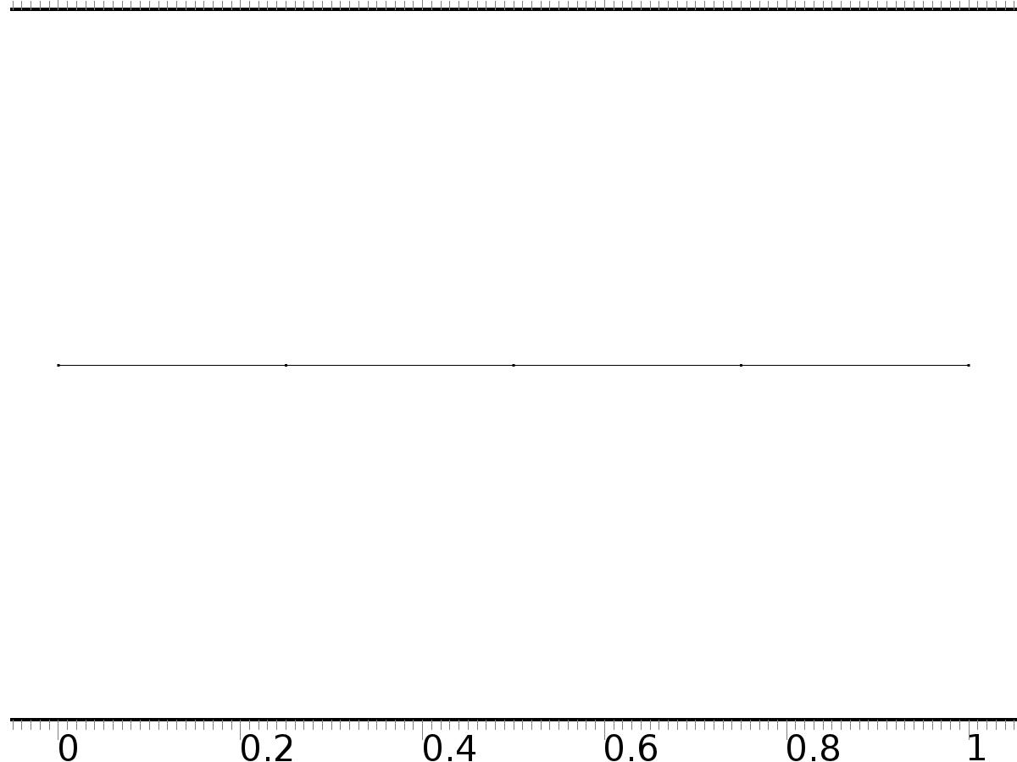

Geometry 1

Units

|  |  |
| --- | --- |
| Length unit | m |
| Angular unit | deg |

Geometry statistics

| **Description** | **Value** |
| --- | --- |
| Space dimension | 1 |
| Number of domains | 4 |
| Number of boundaries | 5 |

* + 1. Interval 1 (i1)

Interval

| **Description** | **Value** |
| --- | --- |
| Number of intervals | Many |
| Points | {0, 0.25, 0.5, 0.75, 1} |

* 1. Unit Input

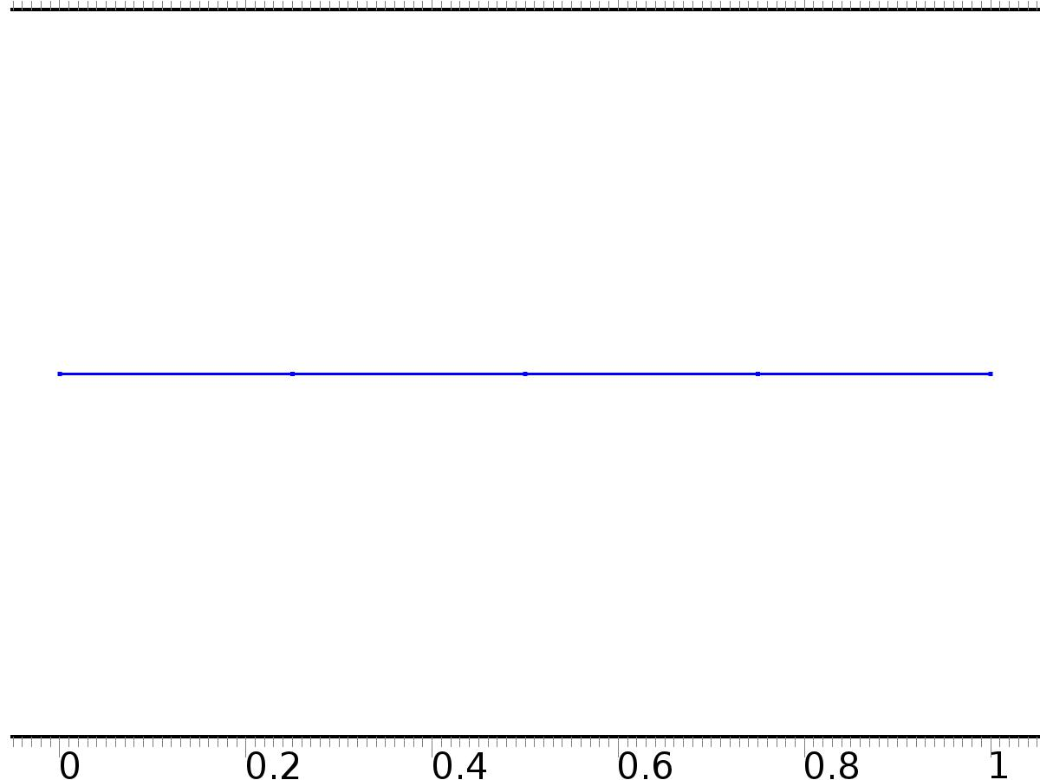

Unit Input

Selection

|  |  |
| --- | --- |
| Geometric entity level | Domain |
| Selection | Domains 1–4 |

Settings

| **Description** | **Value** |
| --- | --- |
| Shape function type | Lagrange |
| Element order | Quadratic |
| Compute boundary fluxes | On |
| Apply smoothing to boundary fluxes | On |
| Value type when using splitting of complex variables | Complex |
| Dependent variable quantity | Dimensionless (1) |
| Source term quantity | None |
| Unit | m^ - 2 |

Used products

|  |
| --- |
| COMSOL Multiphysics |

Variables

| **Name** | **Expression** | **Unit** | **Description** | **Selection** |
| --- | --- | --- | --- | --- |
| X.nx | nx |  | Normal vector, x component | Boundaries 1–5 |
| X.ny | root.ny |  | Normal vector, y component | Boundaries 1–5 |
| X.nz | root.nz |  | Normal vector, z component | Boundaries 1–5 |
| X.nxmesh | root.nxmesh |  | Normal vector (mesh), x component | Boundaries 1–5 |
| X.nymesh | root.nymesh |  | Normal vector (mesh), y component | Boundaries 1–5 |
| X.nzmesh | root.nzmesh |  | Normal vector (mesh), z component | Boundaries 1–5 |

* + 1. Coefficient Form PDE 1



Coefficient Form PDE 1

Selection

|  |  |
| --- | --- |
| Geometric entity level | Domain |
| Selection | Domains 1–4 |

Equations

Settings

| **Description** | **Value** |
| --- | --- |
| Diffusion coefficient | {{c, 0}, {0, c}} |
| Absorption coefficient | {{0, 0}, {0, 0}} |
| Source term | {0, 0} |
| Mass coefficient | {{0, 0}, {0, 0}} |
| Damping or mass coefficient | {{0, 0}, {0, 0}} |
| Conservative flux convection coefficient | {{0, 0}, {0, 0}} |
| Convection coefficient | {{0, 0}, {0, 0}} |
| Conservative flux source | {0, 0} |

#### Variables

| **Name** | **Expression** | **Unit** | **Description** | **Selection** |
| --- | --- | --- | --- | --- |
| domflux.X1x | -c*d(X1,x) |  | Domain flux, x component | Domains 1–4 |
| domflux.X2x | -c*d(X2,x) |  | Domain flux, x component | Domains 1–4 |

#### Shape functions

| **Name** | **Shape function** | **Unit** | **Description** | **Shape frame** | **Selection** |
| --- | --- | --- | --- | --- | --- |
| X1 | Lagrange (Quadratic) |  | Dependent variable X1 | Material | Domains 1–4 |
| X2 | Lagrange (Quadratic) |  | Dependent variable X2 | Material | Domains 1–4 |

* + 1. Zero Flux 1



Zero Flux 1

Selection

|  |  |
| --- | --- |
| Geometric entity level | Boundary |
| Selection | No boundaries |

Equations

* + 1. Initial Values 1



Initial Values 1

Selection

|  |  |
| --- | --- |
| Geometric entity level | Domain |
| Selection | Domains 1–4 |

Settings

| **Description** | **Value** |
| --- | --- |
| Initial value for X2 | 0 |
| Initial time derivative of X2 | 0 |
| Initial value for X1 | 0 |
| Initial time derivative of X1 | 0 |

* + 1. Bd*0

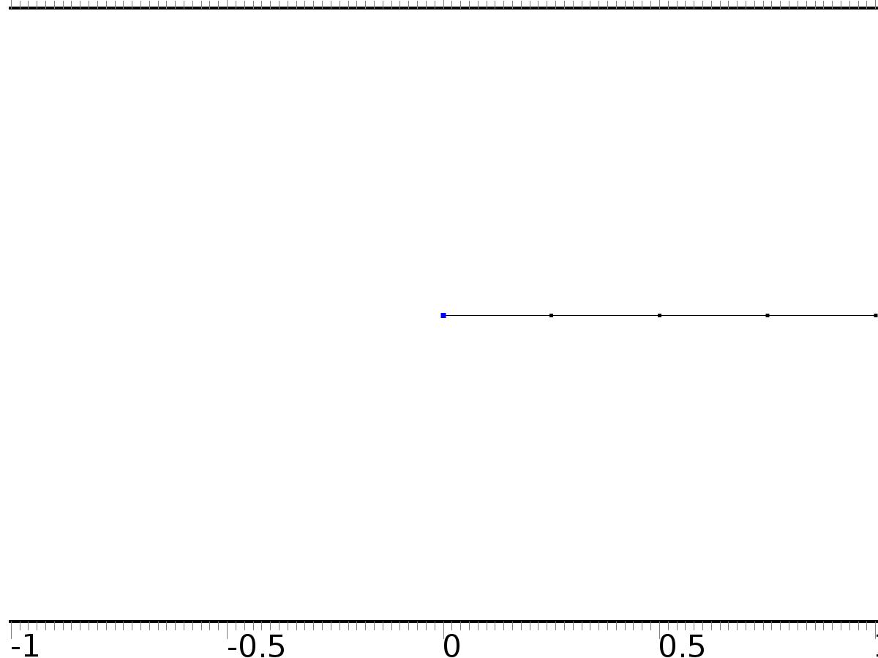

Bd*0

Selection

|  |  |
| --- | --- |
| Geometric entity level | Boundary |
| Selection | Boundary 1 |

Equations

Settings

| **Description** | **Value** |
| --- | --- |
| Value on boundary | {0, 0} |
| Prescribed value of X1 | On |
| Prescribed value of X2 | On |
| Apply reaction terms on | Individual dependent variables |
| Use weak constraints | Off |
| Constraint method | Elemental |

#### Shape functions

| **Constraint** | **Constraint force** | **Shape function** | **Selection** |
| --- | --- | --- | --- |
| -X1 | -test(X1) | Lagrange (Quadratic) | Boundary 1 |
| -X2 | -test(X2) | Lagrange (Quadratic) | Boundary 1 |

* + 1. Bin1*[1,0]

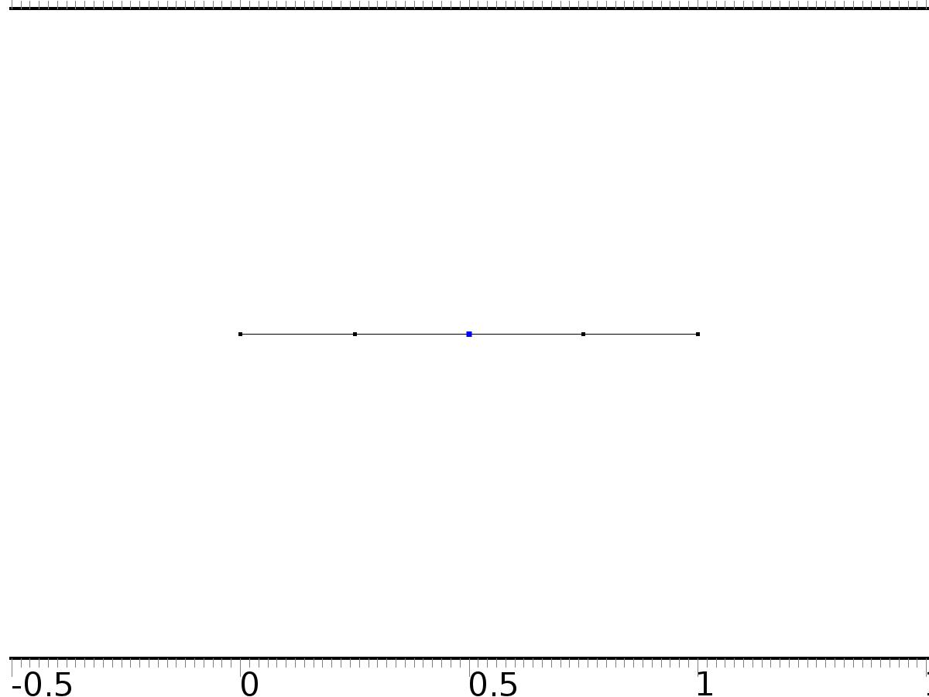

Bin1*[1,0]

Selection

|  |  |
| --- | --- |
| Geometric entity level | Boundary |
| Selection | Boundary 3 |

Equations

Settings

| **Description** | **Value** |
| --- | --- |
| Boundary flux/source | {1, 0} |
| Boundary absorption/impedance term | {{0, 0}, {0, 0}} |

#### Variables

| **Name** | **Expression** | **Unit** | **Description** | **Selection** |
| --- | --- | --- | --- | --- |
| X.g_X1 | 1 |  | Boundary flux/source | Boundary 3 |
| X.g_X2 | 0 |  | Boundary flux/source | Boundary 3 |

* + 1. Bin2*[0,1]

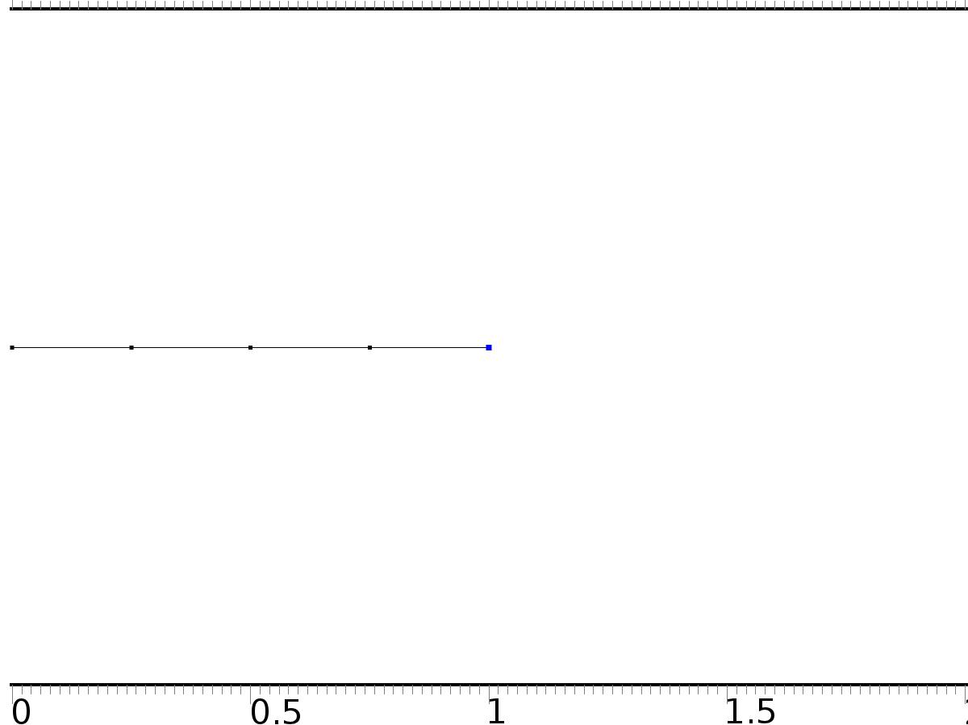

Bin2*[0,1]

Selection

|  |  |
| --- | --- |
| Geometric entity level | Boundary |
| Selection | Boundary 5 |

Equations

Settings

| **Description** | **Value** |
| --- | --- |
| Boundary flux/source | {0, 1} |
| Boundary absorption/impedance term | {{0, 0}, {0, 0}} |

#### Variables

| **Name** | **Expression** | **Unit** | **Description** | **Selection** |
| --- | --- | --- | --- | --- |
| X.g_X1 | 0 |  | Boundary flux/source | Boundary 5 |
| X.g_X2 | 1 |  | Boundary flux/source | Boundary 5 |

* 1. Regulator Equation



Regulator Equation

Selection

|  |  |
| --- | --- |
| Geometric entity level | Domain |
| Selection | Domains 1–4 |

Settings

| **Description** | **Value** |
| --- | --- |
| Shape function type | Lagrange |
| Element order | Quadratic |
| Compute boundary fluxes | On |
| Apply smoothing to boundary fluxes | On |
| Value type when using splitting of complex variables | Complex |
| Dependent variable quantity | Dimensionless (1) |
| Source term quantity | None |
| Unit | m^ - 2 |

Used products

|  |
| --- |
| COMSOL Multiphysics |

Variables

| **Name** | **Expression** | **Unit** | **Description** | **Selection** |
| --- | --- | --- | --- | --- |
| z0.nx | nx |  | Normal vector, x component | Boundaries 1–5 |
| z0.ny | root.ny |  | Normal vector, y component | Boundaries 1–5 |
| z0.nz | root.nz |  | Normal vector, z component | Boundaries 1–5 |
| z0.nxmesh | root.nxmesh |  | Normal vector (mesh), x component | Boundaries 1–5 |
| z0.nymesh | root.nymesh |  | Normal vector (mesh), y component | Boundaries 1–5 |
| z0.nzmesh | root.nzmesh |  | Normal vector (mesh), z component | Boundaries 1–5 |

* + 1. Coefficient Form PDE 1



Coefficient Form PDE 1

Selection

|  |  |
| --- | --- |
| Geometric entity level | Domain |
| Selection | Domains 1–4 |

Equations

Settings

| **Description** | **Value** |
| --- | --- |
| Diffusion coefficient | {{c, 0}, {0, c}} |
| Absorption coefficient | {{0, 0}, {0, 0}} |
| Source term | {Fz0, Fz0} |
| Mass coefficient | {{0, 0}, {0, 0}} |
| Damping or mass coefficient | {{0, 0}, {0, 0}} |
| Conservative flux convection coefficient | {{0, 0}, {0, 0}} |
| Convection coefficient | {{0, 0}, {0, 0}} |
| Conservative flux source | {0, 0} |

#### Variables

| **Name** | **Expression** | **Unit** | **Description** | **Selection** |
| --- | --- | --- | --- | --- |
| domflux.z0x | -c*d(z0,x) |  | Domain flux, x component | Domains 1–4 |
| domflux.zt0x | -c*d(zt0,x) |  | Domain flux, x component | Domains 1–4 |

#### Shape functions

| **Name** | **Shape function** | **Unit** | **Description** | **Shape frame** | **Selection** |
| --- | --- | --- | --- | --- | --- |
| z0 | Lagrange (Quadratic) |  | Dependent variable z0 | Material | Domains 1–4 |
| zt0 | Lagrange (Quadratic) |  | Dependent variable zt0 | Material | Domains 1–4 |

* + 1. Zero Flux 1



Zero Flux 1

Selection

|  |  |
| --- | --- |
| Geometric entity level | Boundary |
| Selection | No boundaries |

Equations

* + 1. Initial Values 1



Initial Values 1

Selection

|  |  |
| --- | --- |
| Geometric entity level | Domain |
| Selection | Domains 1–4 |

Settings

| **Description** | **Value** |
| --- | --- |
| Initial value for zt0 | 0 |
| Initial time derivative of zt0 | 0 |
| Initial value for z0 | 0 |
| Initial time derivative of z0 | 0 |

* + 1. Bd*[d,d]



Bd*[d,d]

Selection

|  |  |
| --- | --- |
| Geometric entity level | Boundary |
| Selection | Boundary 1 |

Equations

Settings

| **Description** | **Value** |
| --- | --- |
| Value on boundary | {d, d} |
| Prescribed value of z0 | On |
| Prescribed value of zt0 | On |
| Apply reaction terms on | Individual dependent variables |
| Use weak constraints | Off |
| Constraint method | Elemental |

#### Shape functions

| **Constraint** | **Constraint force** | **Shape function** | **Selection** |
| --- | --- | --- | --- |
| d-z0 | -test(z0) | Lagrange (Quadratic) | Boundary 1 |
| d-zt0 | -test(zt0) | Lagrange (Quadratic) | Boundary 1 |

* + 1. Bin1*[gamma1,0]



Bin1*[gamma1,0]

Selection

|  |  |
| --- | --- |
| Geometric entity level | Boundary |
| Selection | Boundary 3 |

Equations

Settings

| **Description** | **Value** |
| --- | --- |
| Boundary flux/source | {gamma1, 0} |
| Boundary absorption/impedance term | {{0, 0}, {0, 0}} |

#### Variables

| **Name** | **Expression** | **Unit** | **Description** | **Selection** |
| --- | --- | --- | --- | --- |
| z0.g_z0 | gamma1 |  | Boundary flux/source | Boundary 3 |
| z0.g_zt0 | 0 |  | Boundary flux/source | Boundary 3 |

* + 1. Bin2*[gamma2,0]



Bin2*[gamma2,0]

Selection

|  |  |
| --- | --- |
| Geometric entity level | Boundary |
| Selection | Boundary 5 |

Equations

Settings

| **Description** | **Value** |
| --- | --- |
| Boundary flux/source | {gamma2, 0} |
| Boundary absorption/impedance term | {{0, 0}, {0, 0}} |

#### Variables

| **Name** | **Expression** | **Unit** | **Description** | **Selection** |
| --- | --- | --- | --- | --- |
| z0.g_z0 | gamma2 |  | Boundary flux/source | Boundary 5 |
| z0.g_zt0 | 0 |  | Boundary flux/source | Boundary 5 |

* 1. Closed Loop System



Closed Loop System

Selection

|  |  |
| --- | --- |
| Geometric entity level | Domain |
| Selection | Domains 1–4 |

Settings

| **Description** | **Value** |
| --- | --- |
| Shape function type | Lagrange |
| Element order | Quadratic |
| Compute boundary fluxes | On |
| Apply smoothing to boundary fluxes | On |
| Value type when using splitting of complex variables | Complex |
| Dependent variable quantity | Dimensionless (1) |
| Source term quantity | None |
| Unit | m^ - 2 |

Used products

|  |
| --- |
| COMSOL Multiphysics |

Variables

| **Name** | **Expression** | **Unit** | **Description** | **Selection** |
| --- | --- | --- | --- | --- |
| z.nx | nx |  | Normal vector, x component | Boundaries 1–5 |
| z.ny | root.ny |  | Normal vector, y component | Boundaries 1–5 |
| z.nz | root.nz |  | Normal vector, z component | Boundaries 1–5 |
| z.nxmesh | root.nxmesh |  | Normal vector (mesh), x component | Boundaries 1–5 |
| z.nymesh | root.nymesh |  | Normal vector (mesh), y component | Boundaries 1–5 |
| z.nzmesh | root.nzmesh |  | Normal vector (mesh), z component | Boundaries 1–5 |

* + 1. Coefficient Form PDE 1



Coefficient Form PDE 1

Selection

|  |  |
| --- | --- |
| Geometric entity level | Domain |
| Selection | Domains 1–4 |

Equations

Settings

| **Description** | **Value** |
| --- | --- |
| Diffusion coefficient | c |
| Absorption coefficient | 0 |
| Source term | Fz |
| Mass coefficient | 0 |
| Damping or mass coefficient | 1 |
| Conservative flux convection coefficient | 0 |
| Convection coefficient | 0 |
| Conservative flux source | 0 |

#### Variables

| **Name** | **Expression** | **Unit** | **Description** | **Selection** |
| --- | --- | --- | --- | --- |
| domflux.zx | -c*d(z,x) |  | Domain flux, x component | Domains 1–4 |

#### Shape functions

| **Name** | **Shape function** | **Unit** | **Description** | **Shape frame** | **Selection** |
| --- | --- | --- | --- | --- | --- |
| z | Lagrange (Quadratic) |  | Dependent variable z | Material | Domains 1–4 |

* + 1. Zero Flux 1



Zero Flux 1

Selection

|  |  |
| --- | --- |
| Geometric entity level | Boundary |
| Selection | No boundaries |

Equations

* + 1. Initial Values 1



Initial Values 1

Selection

|  |  |
| --- | --- |
| Geometric entity level | Domain |
| Selection | Domains 1–4 |

Settings

| **Description** | **Value** |
| --- | --- |
| Initial value for z | 0 |
| Initial time derivative of z | 0 |

* + 1. Bd*d



Bd*d

Selection

|  |  |
| --- | --- |
| Geometric entity level | Boundary |
| Selection | Boundary 1 |

Equations

Settings

| **Description** | **Value** |
| --- | --- |
| Value on boundary | d |
| Prescribed value of z | On |
| Apply reaction terms on | Individual dependent variables |
| Use weak constraints | Off |
| Constraint method | Elemental |

#### Shape functions

| **Constraint** | **Constraint force** | **Shape function** | **Selection** |
| --- | --- | --- | --- |
| d-z | -test(z) | Lagrange (Quadratic) | Boundary 1 |

* + 1. Bin1*u1



Bin1*u1

Selection

|  |  |
| --- | --- |
| Geometric entity level | Boundary |
| Selection | Boundary 3 |

Equations

Settings

| **Description** | **Value** |
| --- | --- |
| Boundary flux/source | u1 |
| Boundary absorption/impedance term | 0 |

#### Variables

| **Name** | **Expression** | **Unit** | **Description** | **Selection** |
| --- | --- | --- | --- | --- |
| z.g_z | u1 |  | Boundary flux/source | Boundary 3 |

* + 1. Bin2*u2



Bin2*u2

Selection

|  |  |
| --- | --- |
| Geometric entity level | Boundary |
| Selection | Boundary 5 |

Equations

Settings

| **Description** | **Value** |
| --- | --- |
| Boundary flux/source | u2 |
| Boundary absorption/impedance term | 0 |

#### Variables

| **Name** | **Expression** | **Unit** | **Description** | **Selection** |
| --- | --- | --- | --- | --- |
| z.g_z | u2 |  | Boundary flux/source | Boundary 5 |

* 1. Mesh 1

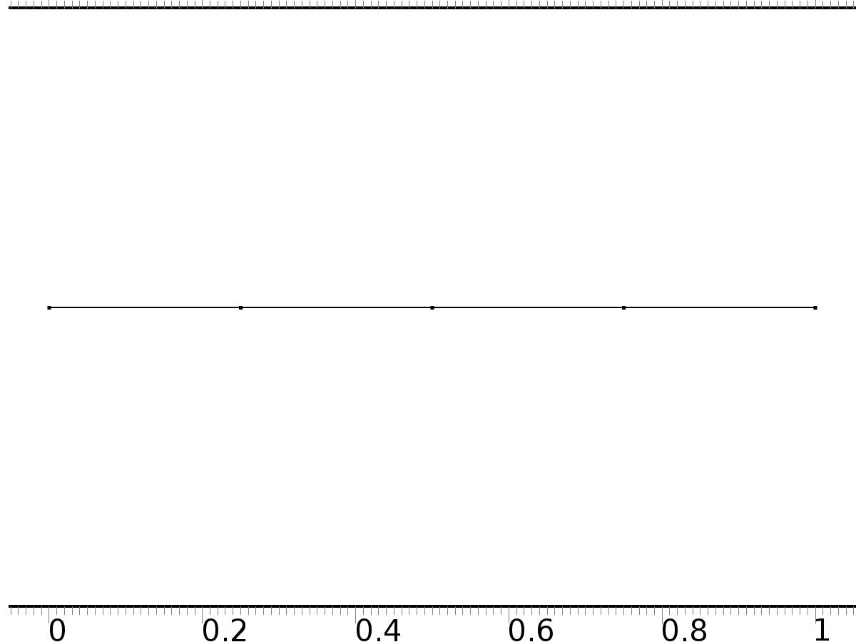

Mesh 1

* + 1. Size (size)

Settings

| **Description** | **Value** |
| --- | --- |
| Maximum element size | 0.02 |
| Minimum element size | 7.5E-5 |
| Curvature factor | 0.25 |
| Maximum element growth rate | 1.2 |
| Predefined size | Extra fine |

* + 1. Edge 1 (edg1)

Selection

|  |  |
| --- | --- |
| Geometric entity level | Remaining |

1. Study 1
   1. Stationary

Study settings

| **Description** | **Value** |
| --- | --- |
| Include geometric nonlinearity | Off |

Physics and variables selection

| **Physics interface** | **Discretization** |
| --- | --- |
| Unit Input (c) | physics |

Mesh selection

| **Geometry** | **Mesh** |
| --- | --- |
| Geometry 1 (geom1) | mesh1 |

* 1. Solver Configurations
     1. Solver 1

#### Compile Equations: Stationary (st1)

Study and step

| **Description** | **Value** |
| --- | --- |
| Use study | Study 1 |
| Use study step | Stationary |

#### Dependent Variables 1 (v1)

General

| **Description** | **Value** |
| --- | --- |
| Defined by study step | Stationary |
| Constant |  |

Initial values of variables solved for

| **Description** | **Value** |
| --- | --- |
| Solution | Zero |

Values of variables not solved for

| **Description** | **Value** |
| --- | --- |
| Solution | Zero |

##### Dependent variable zt0 (comp1.zt0) (comp1_zt0)

General

| **Description** | **Value** |
| --- | --- |
| Field components | comp1.zt0 |
| Solve for this field | Off |

##### Dependent variable z (comp1.z) (comp1_z)

General

| **Description** | **Value** |
| --- | --- |
| Field components | comp1.z |
| Solve for this field | Off |

##### Dependent variable z0 (comp1.z0) (comp1_z0)

General

| **Description** | **Value** |
| --- | --- |
| Field components | comp1.z0 |
| Solve for this field | Off |

##### Dependent variable X1 (comp1.X1) (comp1_X1)

General

| **Description** | **Value** |
| --- | --- |
| Field components | comp1.X1 |
| Field name | comp1_X |

##### Dependent variable X2 (comp1.X2) (comp1_X2)

General

| **Description** | **Value** |
| --- | --- |
| Field components | comp1.X2 |

#### Stationary Solver 1 (s1)

General

| **Description** | **Value** |
| --- | --- |
| Defined by study step | Stationary |
| Relative tolerance | 0.0000010 |

Log

| **Description** | **Value** |
| --- | --- |
| Constant |  |

##### Fully Coupled 1 (fc1)

General

| **Description** | **Value** |
| --- | --- |
| Linear solver | Direct |

1. Study 2
   1. Stationary

Study settings

| **Description** | **Value** |
| --- | --- |
| Include geometric nonlinearity | Off |

Physics and variables selection

| **Physics interface** | **Discretization** |
| --- | --- |
| Regulator Equation (c2) | physics |

Mesh selection

| **Geometry** | **Mesh** |
| --- | --- |
| Geometry 1 (geom1) | mesh1 |

* 1. Solver Configurations
     1. Solver 2

#### Compile Equations: Stationary (st1)

Study and step

| **Description** | **Value** |
| --- | --- |
| Use study | Study 2 |
| Use study step | Stationary |

#### Dependent Variables 1 (v1)

General

| **Description** | **Value** |
| --- | --- |
| Defined by study step | Stationary |
| Constant |  |

Initial values of variables solved for

| **Description** | **Value** |
| --- | --- |
| Solution | Zero |

Values of variables not solved for

| **Description** | **Value** |
| --- | --- |
| Method | Solution |
| Solution | Solver 1 |

##### Dependent variable zt0 (comp1.zt0) (comp1_zt0)

General

| **Description** | **Value** |
| --- | --- |
| Field components | comp1.zt0 |

##### Dependent variable z (comp1.z) (comp1_z)

General

| **Description** | **Value** |
| --- | --- |
| Field components | comp1.z |
| Solve for this field | Off |

##### Dependent variable z0 (comp1.z0) (comp1_z0)

General

| **Description** | **Value** |
| --- | --- |
| Field components | comp1.z0 |

##### Dependent variable X1 (comp1.X1) (comp1_X1)

General

| **Description** | **Value** |
| --- | --- |
| Field components | comp1.X1 |
| Solve for this field | Off |
| Field name | comp1_X |

##### Dependent variable X2 (comp1.X2) (comp1_X2)

General

| **Description** | **Value** |
| --- | --- |
| Field components | comp1.X2 |
| Solve for this field | Off |

#### Stationary Solver 1 (s1)

General

| **Description** | **Value** |
| --- | --- |
| Defined by study step | Stationary |
| Relative tolerance | 0.0000010 |

Log

| **Description** | **Value** |
| --- | --- |
| Constant |  |

##### Fully Coupled 1 (fc1)

General

| **Description** | **Value** |
| --- | --- |
| Linear solver | Direct |

1. Study 3
   1. Time Dependent

Study settings

| **Description** | **Value** |
| --- | --- |
| Include geometric nonlinearity | Off |

| **Times** | **Unit** |
| --- | --- |
| range(0,0.01,10) | s |

Physics and variables selection

| **Physics interface** | **Discretization** |
| --- | --- |
| Closed Loop System (phys2) | physics |

Mesh selection

| **Geometry** | **Mesh** |
| --- | --- |
| Geometry 1 (geom1) | mesh1 |

* 1. Solver Configurations
     1. Solver 3

#### Compile Equations: Time Dependent (st1)

Study and step

| **Description** | **Value** |
| --- | --- |
| Use study | Study 3 |
| Use study step | Time Dependent |

#### Dependent Variables 1 (v1)

General

| **Description** | **Value** |
| --- | --- |
| Defined by study step | Time Dependent |
| Constant |  |

Initial values of variables solved for

| **Description** | **Value** |
| --- | --- |
| Solution | Zero |

Values of variables not solved for

| **Description** | **Value** |
| --- | --- |
| Method | Solution |
| Solution | Solver 2 |

##### Dependent variable zt0 (comp1.zt0) (comp1_zt0)

General

| **Description** | **Value** |
| --- | --- |
| Field components | comp1.zt0 |
| Solve for this field | Off |

##### Dependent variable z0 (comp1.z0) (comp1_z0)

General

| **Description** | **Value** |
| --- | --- |
| Field components | comp1.z0 |
| Solve for this field | Off |

##### Dependent variable X1 (comp1.X1) (comp1_X1)

General

| **Description** | **Value** |
| --- | --- |
| Field components | comp1.X1 |
| Solve for this field | Off |
| Field name | comp1_X |

##### Dependent variable z (comp1.z) (comp1_z)

General

| **Description** | **Value** |
| --- | --- |
| Field components | comp1.z |
| Field name | comp1_u2 |

##### Dependent variable X2 (comp1.X2) (comp1_X2)

General

| **Description** | **Value** |
| --- | --- |
| Field components | comp1.X2 |
| Solve for this field | Off |

#### Time-Dependent Solver 1 (t1)

General

| **Description** | **Value** |
| --- | --- |
| Defined by study step | Time Dependent |
| Time | {0, 0.01, 0.02, 0.03, 0.04, 0.05, 0.06, 0.07, 0.08, 0.09, 0.1, 0.11, 0.12, 0.13, 0.14, 0.15, 0.16, 0.17, 0.18, 0.19, 0.2, 0.21, 0.22, 0.23, 0.24, 0.25, 0.26, 0.27, 0.28, 0.29, 0.3, 0.31, 0.32, 0.33, 0.34, 0.35000000000000003, 0.36, 0.37, 0.38, 0.39, 0.4, 0.41000000000000003, 0.42, 0.43, 0.44, 0.45, 0.46, 0.47000000000000003, 0.48, 0.49, 0.5, 0.51, 0.52, 0.53, 0.54, 0.55, 0.56, 0.5700000000000001, 0.58, 0.59, 0.6, 0.61, 0.62, 0.63, 0.64, 0.65, 0.66, 0.67, 0.68, 0.6900000000000001, 0.7000000000000001, 0.71, 0.72, 0.73, 0.74, 0.75, 0.76, 0.77, 0.78, 0.79, 0.8, 0.81, 0.8200000000000001, 0.8300000000000001, 0.84, 0.85, 0.86, 0.87, 0.88, 0.89, 0.9, 0.91, 0.92, 0.93, 0.9400000000000001, 0.9500000000000001, 0.96, 0.97, 0.98, 0.99, 1, 1.01, 1.02, 1.03, 1.04, 1.05, 1.06, 1.07, 1.08, 1.09, 1.1, 1.11, 1.12, 1.1300000000000001, 1.1400000000000001, 1.1500000000000001, 1.16, 1.17, 1.18, 1.19, 1.2, 1.21, 1.22, 1.23, 1.24, 1.25, 1.26, 1.27, 1.28, 1.29, 1.3, 1.31, 1.32, 1.33, 1.34, 1.35, 1.36, 1.37, 1.3800000000000001, 1.3900000000000001, 1.4000000000000001, 1.41, 1.42, 1.43, 1.44, 1.45, 1.46, 1.47, 1.48, 1.49, 1.5, 1.51, 1.52, 1.53, 1.54, 1.55, 1.56, 1.57, 1.58, 1.59, 1.6, 1.61, 1.62, 1.6300000000000001, 1.6400000000000001, 1.6500000000000001, 1.6600000000000001, 1.67, 1.68, 1.69, 1.7, 1.71, 1.72, 1.73, 1.74, 1.75, 1.76, 1.77, 1.78, 1.79, 1.8, 1.81, 1.82, 1.83, 1.84, 1.85, 1.86, 1.87, 1.8800000000000001, 1.8900000000000001, 1.9000000000000001, 1.9100000000000001, 1.92, 1.93, 1.94, 1.95, 1.96, 1.97, 1.98, 1.99, 2, 2.0100000000000002, 2.02, 2.0300000000000002, 2.04, 2.05, 2.06, 2.07, 2.08, 2.09, 2.1, 2.11, 2.12, 2.13, 2.14, 2.15, 2.16, 2.17, 2.18, 2.19, 2.2, 2.21, 2.22, 2.23, 2.24, 2.25, 2.2600000000000002, 2.27, 2.2800000000000002, 2.29, 2.3000000000000003, 2.31, 2.32, 2.33, 2.34, 2.35, 2.36, 2.37, 2.38, 2.39, 2.4, 2.41, 2.42, 2.43, 2.44, 2.45, 2.46, 2.47, 2.48, 2.49, 2.5, 2.5100000000000002, 2.52, 2.5300000000000002, 2.54, 2.5500000000000003, 2.56, 2.57, 2.58, 2.59, 2.6, 2.61, 2.62, 2.63, 2.64, 2.65, 2.66, 2.67, 2.68, 2.69, 2.7, 2.71, 2.72, 2.73, 2.74, 2.75, 2.7600000000000002, 2.77, 2.7800000000000002, 2.79, 2.8000000000000003, 2.81, 2.82, 2.83, 2.84, 2.85, 2.86, 2.87, 2.88, 2.89, 2.9, 2.91, 2.92, 2.93, 2.94, 2.95, 2.96, 2.97, 2.98, 2.99, 3, 3.0100000000000002, 3.02, 3.0300000000000002, 3.04, 3.0500000000000003, 3.06, 3.0700000000000003, 3.08, 3.09, 3.1, 3.11, 3.12, 3.13, 3.14, 3.15, 3.16, 3.17, 3.18, 3.19, 3.2, 3.21, 3.22, 3.23, 3.24, 3.25, 3.2600000000000002, 3.27, 3.2800000000000002, 3.29, 3.3000000000000003, 3.31, 3.3200000000000003, 3.33, 3.34, 3.35, 3.36, 3.37, 3.38, 3.39, 3.4, 3.41, 3.42, 3.43, 3.44, 3.45, 3.46, 3.47, 3.48, 3.49, 3.5, 3.5100000000000002, 3.52, 3.5300000000000002, 3.54, 3.5500000000000003, 3.56, 3.5700000000000003, 3.58, 3.59, 3.6, 3.61, 3.62, 3.63, 3.64, 3.65, 3.66, 3.67, 3.68, 3.69, 3.7, 3.71, 3.72, 3.73, 3.74, 3.75, 3.7600000000000002, 3.77, 3.7800000000000002, 3.79, 3.8000000000000003, 3.81, 3.8200000000000003, 3.83, 3.84, 3.85, 3.86, 3.87, 3.88, 3.89, 3.9, 3.91, 3.92, 3.93, 3.94, 3.95, 3.96, 3.97, 3.98, 3.99, 4, 4.01, 4.0200000000000005, 4.03, 4.04, 4.05, 4.0600000000000005, 4.07, 4.08, 4.09, 4.1, 4.11, 4.12, 4.13, 4.14, 4.15, 4.16, 4.17, 4.18, 4.19, 4.2, 4.21, 4.22, 4.23, 4.24, 4.25, 4.26, 4.2700000000000005, 4.28, 4.29, 4.3, 4.3100000000000005, 4.32, 4.33, 4.34, 4.3500000000000005, 4.36, 4.37, 4.38, 4.39, 4.4, 4.41, 4.42, 4.43, 4.44, 4.45, 4.46, 4.47, 4.48, 4.49, 4.5, 4.51, 4.5200000000000005, 4.53, 4.54, 4.55, 4.5600000000000005, 4.57, 4.58, 4.59, 4.6000000000000005, 4.61, 4.62, 4.63, 4.64, 4.65, 4.66, 4.67, 4.68, 4.69, 4.7, 4.71, 4.72, 4.73, 4.74, 4.75, 4.76, 4.7700000000000005, 4.78, 4.79, 4.8, 4.8100000000000005, 4.82, 4.83, 4.84, 4.8500000000000005, 4.86, 4.87, 4.88, 4.89, 4.9, 4.91, 4.92, 4.93, 4.94, 4.95, 4.96, 4.97, 4.98, 4.99, 5, 5.01, 5.0200000000000005, 5.03, 5.04, 5.05, 5.0600000000000005, 5.07, 5.08, 5.09, 5.1000000000000005, 5.11, 5.12, 5.13, 5.14, 5.15, 5.16, 5.17, 5.18, 5.19, 5.2, 5.21, 5.22, 5.23, 5.24, 5.25, 5.26, 5.2700000000000005, 5.28, 5.29, 5.3, 5.3100000000000005, 5.32, 5.33, 5.34, 5.3500000000000005, 5.36, 5.37, 5.38, 5.39, 5.4, 5.41, 5.42, 5.43, 5.44, 5.45, 5.46, 5.47, 5.48, 5.49, 5.5, 5.51, 5.5200000000000005, 5.53, 5.54, 5.55, 5.5600000000000005, 5.57, 5.58, 5.59, 5.6000000000000005, 5.61, 5.62, 5.63, 5.64, 5.65, 5.66, 5.67, 5.68, 5.69, 5.7, 5.71, 5.72, 5.73, 5.74, 5.75, 5.76, 5.7700000000000005, 5.78, 5.79, 5.8, 5.8100000000000005, 5.82, 5.83, 5.84, 5.8500000000000005, 5.86, 5.87, 5.88, 5.89, 5.9, 5.91, 5.92, 5.93, 5.94, 5.95, 5.96, 5.97, 5.98, 5.99, 6, 6.01, 6.0200000000000005, 6.03, 6.04, 6.05, 6.0600000000000005, 6.07, 6.08, 6.09, 6.1000000000000005, 6.11, 6.12, 6.13, 6.140000000000001, 6.15, 6.16, 6.17, 6.18, 6.19, 6.2, 6.21, 6.22, 6.23, 6.24, 6.25, 6.26, 6.2700000000000005, 6.28, 6.29, 6.3, 6.3100000000000005, 6.32, 6.33, 6.34, 6.3500000000000005, 6.36, 6.37, 6.38, 6.390000000000001, 6.4, 6.41, 6.42, 6.43, 6.44, 6.45, 6.46, 6.47, 6.48, 6.49, 6.5, 6.51, 6.5200000000000005, 6.53, 6.54, 6.55, 6.5600000000000005, 6.57, 6.58, 6.59, 6.6000000000000005, 6.61, 6.62, 6.63, 6.640000000000001, 6.65, 6.66, 6.67, 6.68, 6.69, 6.7, 6.71, 6.72, 6.73, 6.74, 6.75, 6.76, 6.7700000000000005, 6.78, 6.79, 6.8, 6.8100000000000005, 6.82, 6.83, 6.84, 6.8500000000000005, 6.86, 6.87, 6.88, 6.890000000000001, 6.9, 6.91, 6.92, 6.93, 6.94, 6.95, 6.96, 6.97, 6.98, 6.99, 7, 7.01, 7.0200000000000005, 7.03, 7.04, 7.05, 7.0600000000000005, 7.07, 7.08, 7.09, 7.1000000000000005, 7.11, 7.12, 7.13, 7.140000000000001, 7.15, 7.16, 7.17, 7.18, 7.19, 7.2, 7.21, 7.22, 7.23, 7.24, 7.25, 7.26, 7.2700000000000005, 7.28, 7.29, 7.3, 7.3100000000000005, 7.32, 7.33, 7.34, 7.3500000000000005, 7.36, 7.37, 7.38, 7.390000000000001, 7.4, 7.41, 7.42, 7.43, 7.44, 7.45, 7.46, 7.47, 7.48, 7.49, 7.5, 7.51, 7.5200000000000005, 7.53, 7.54, 7.55, 7.5600000000000005, 7.57, 7.58, 7.59, 7.6000000000000005, 7.61, 7.62, 7.63, 7.640000000000001, 7.65, 7.66, 7.67, 7.68, 7.69, 7.7, 7.71, 7.72, 7.73, 7.74, 7.75, 7.76, 7.7700000000000005, 7.78, 7.79, 7.8, 7.8100000000000005, 7.82, 7.83, 7.84, 7.8500000000000005, 7.86, 7.87, 7.88, 7.890000000000001, 7.9, 7.91, 7.92, 7.930000000000001, 7.94, 7.95, 7.96, 7.97, 7.98, 7.99, 8, 8.01, 8.02, 8.03, 8.040000000000001, 8.05, 8.06, 8.07, 8.08, 8.09, 8.1, 8.11, 8.120000000000001, 8.13, 8.14, 8.15, 8.16, 8.17, 8.18, 8.19, 8.2, 8.21, 8.22, 8.23, 8.24, 8.25, 8.26, 8.27, 8.28, 8.290000000000001, 8.3, 8.31, 8.32, 8.33, 8.34, 8.35, 8.36, 8.370000000000001, 8.38, 8.39, 8.4, 8.41, 8.42, 8.43, 8.44, 8.45, 8.46, 8.47, 8.48, 8.49, 8.5, 8.51, 8.52, 8.53, 8.540000000000001, 8.55, 8.56, 8.57, 8.58, 8.59, 8.6, 8.61, 8.620000000000001, 8.63, 8.64, 8.65, 8.66, 8.67, 8.68, 8.69, 8.700000000000001, 8.71, 8.72, 8.73, 8.74, 8.75, 8.76, 8.77, 8.78, 8.790000000000001, 8.8, 8.81, 8.82, 8.83, 8.84, 8.85, 8.86, 8.870000000000001, 8.88, 8.89, 8.9, 8.91, 8.92, 8.93, 8.94, 8.950000000000001, 8.96, 8.97, 8.98, 8.99, 9, 9.01, 9.02, 9.03, 9.040000000000001, 9.05, 9.06, 9.07, 9.08, 9.09, 9.1, 9.11, 9.120000000000001, 9.13, 9.14, 9.15, 9.16, 9.17, 9.18, 9.19, 9.200000000000001, 9.21, 9.22, 9.23, 9.24, 9.25, 9.26, 9.27, 9.28, 9.290000000000001, 9.3, 9.31, 9.32, 9.33, 9.34, 9.35, 9.36, 9.370000000000001, 9.38, 9.39, 9.4, 9.41, 9.42, 9.43, 9.44, 9.450000000000001, 9.46, 9.47, 9.48, 9.49, 9.5, 9.51, 9.52, 9.53, 9.540000000000001, 9.55, 9.56, 9.57, 9.58, 9.59, 9.6, 9.61, 9.620000000000001, 9.63, 9.64, 9.65, 9.66, 9.67, 9.68, 9.69, 9.700000000000001, 9.71, 9.72, 9.73, 9.74, 9.75, 9.76, 9.77, 9.78, 9.790000000000001, 9.8, 9.81, 9.82, 9.83, 9.84, 9.85, 9.86, 9.870000000000001, 9.88, 9.89, 9.9, 9.91, 9.92, 9.93, 9.94, 9.950000000000001, 9.96, 9.97, 9.98, 9.99, 10} |
| Relative tolerance | 0.0001 |

Absolute tolerance

| **Description** | **Value** |
| --- | --- |
| Tolerance | 0.000010 |

Time stepping

| **Description** | **Value** |
| --- | --- |
| Initial step | 0.0010 |

Advanced

| **Description** | **Value** |
| --- | --- |
| Fraction of initial step for Backward Euler | 0.0010 |

Log

| **Description** | **Value** |
| --- | --- |
| Constant |  |

##### Fully Coupled 1 (fc1)

General

| **Description** | **Value** |
| --- | --- |
| Linear solver | Direct |

1. Results
   1. Data Sets
      1. Solution 1

Solution

| **Description** | **Value** |
| --- | --- |
| Solution | Solver 1 |
| Component | Save Point Geometry 1 |

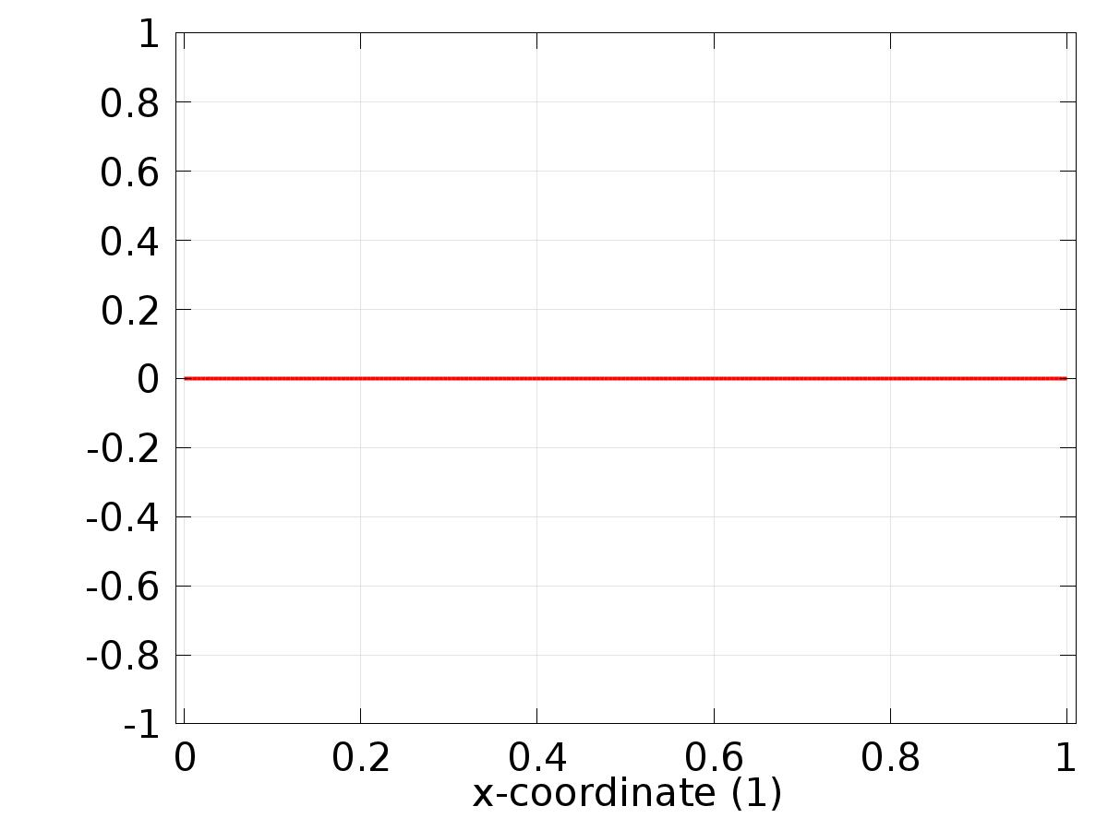

Data set: Solution 1

* + 1. Solution 2

Solution

| **Description** | **Value** |
| --- | --- |
| Solution | Solver 2 |
| Component | Save Point Geometry 1 |



Data set: Solution 2

* + 1. Solution 3

Solution

| **Description** | **Value** |
| --- | --- |
| Solution | Solver 3 |
| Component | Save Point Geometry 1 |

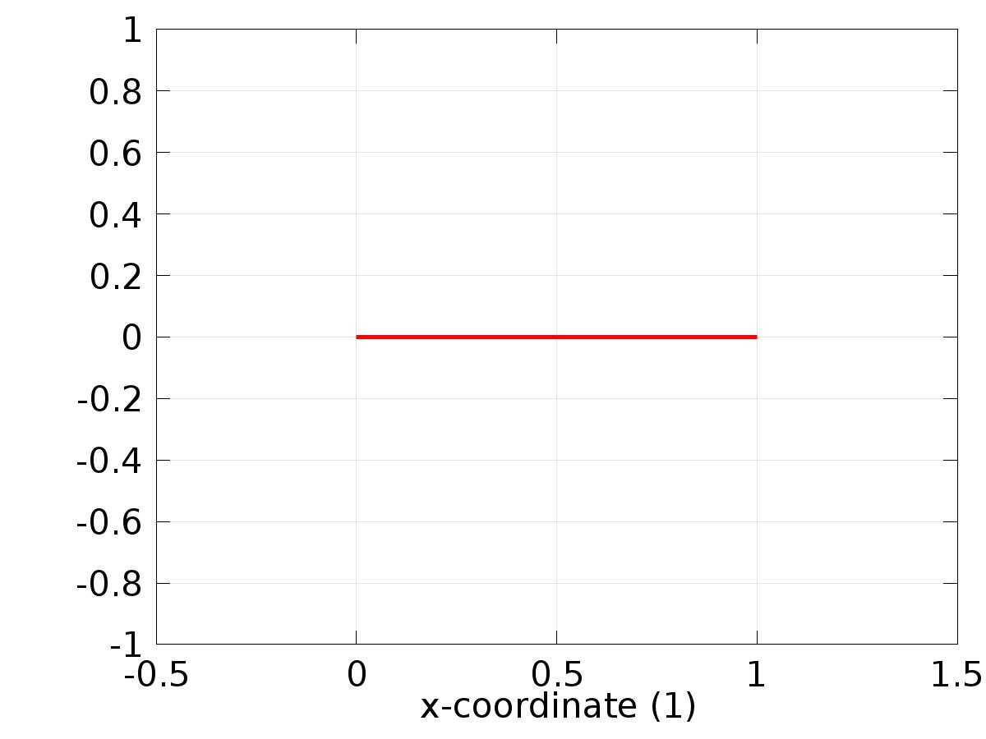

Data set: Solution 3

* 1. Derived Values
     1. Global Evaluation 1

Data

| **Description** | **Value** |
| --- | --- |
| Data set | Solution 3 |

Expression

| **Description** | **Value** |
| --- | --- |
| Expression | e2 |

* 1. Tables
     1. Table 1

Global Evaluation 1 (C1(z))

Table 1

| **Time (s)** | **C1(z)** | **C2(z)** | **e1** | **e2** |
| --- | --- | --- | --- | --- |
| 0.0000 | 1.2485E-13 | -1.1535E-15 | 0.50000 | 0.75000 |
| 0.010000 | 2.9014E-5 | 3.7778E-7 | 0.49997 | 0.75000 |
| 0.020000 | 0.0019921 | 4.5633E-5 | 0.49801 | 0.74995 |
| 0.030000 | 0.0089034 | 2.7825E-4 | 0.49110 | 0.74972 |
| 0.040000 | 0.019599 | 7.5386E-4 | 0.48040 | 0.74925 |
| 0.050000 | 0.032208 | 0.0014447 | 0.46779 | 0.74856 |
| 0.060000 | 0.045537 | 0.0023050 | 0.45446 | 0.74769 |
| 0.070000 | 0.058936 | 0.0032950 | 0.44106 | 0.74670 |
| 0.080000 | 0.072071 | 0.0043860 | 0.42793 | 0.74561 |
| 0.090000 | 0.084780 | 0.0055598 | 0.41522 | 0.74444 |
| 0.10000 | 0.096993 | 0.0068074 | 0.40301 | 0.74319 |
| 0.11000 | 0.10868 | 0.0081261 | 0.39132 | 0.74187 |
| 0.12000 | 0.11985 | 0.0095171 | 0.38015 | 0.74048 |
| 0.13000 | 0.13052 | 0.010984 | 0.36948 | 0.73902 |
| 0.14000 | 0.14072 | 0.012532 | 0.35928 | 0.73747 |
| 0.15000 | 0.15045 | 0.014164 | 0.34955 | 0.73584 |
| 0.16000 | 0.15976 | 0.015886 | 0.34024 | 0.73411 |
| 0.17000 | 0.16865 | 0.017700 | 0.33135 | 0.73230 |
| 0.18000 | 0.17717 | 0.019610 | 0.32283 | 0.73039 |
| 0.19000 | 0.18533 | 0.021615 | 0.31467 | 0.72838 |
| 0.20000 | 0.19314 | 0.023718 | 0.30686 | 0.72628 |
| 0.21000 | 0.20063 | 0.025917 | 0.29937 | 0.72408 |
| 0.22000 | 0.20782 | 0.028212 | 0.29218 | 0.72179 |
| 0.23000 | 0.21472 | 0.030602 | 0.28528 | 0.71940 |
| 0.24000 | 0.22135 | 0.033085 | 0.27865 | 0.71691 |
| 0.25000 | 0.22772 | 0.035659 | 0.27228 | 0.71434 |
| 0.26000 | 0.23385 | 0.038321 | 0.26615 | 0.71168 |
| 0.27000 | 0.23974 | 0.041069 | 0.26026 | 0.70893 |
| 0.28000 | 0.24541 | 0.043901 | 0.25459 | 0.70610 |
| 0.29000 | 0.25088 | 0.046814 | 0.24912 | 0.70319 |
| 0.30000 | 0.25614 | 0.049806 | 0.24386 | 0.70019 |
| 0.31000 | 0.26122 | 0.052873 | 0.23878 | 0.69713 |
| 0.32000 | 0.26612 | 0.056013 | 0.23388 | 0.69399 |
| 0.33000 | 0.27084 | 0.059223 | 0.22916 | 0.69078 |
| 0.34000 | 0.27540 | 0.062501 | 0.22460 | 0.68750 |
| 0.35000 | 0.27981 | 0.065844 | 0.22019 | 0.68416 |
| 0.36000 | 0.28407 | 0.069250 | 0.21593 | 0.68075 |
| 0.37000 | 0.28819 | 0.072715 | 0.21181 | 0.67728 |
| 0.38000 | 0.29217 | 0.076238 | 0.20783 | 0.67376 |
| 0.39000 | 0.29602 | 0.079816 | 0.20398 | 0.67018 |
| 0.40000 | 0.29975 | 0.083447 | 0.20025 | 0.66655 |
| 0.41000 | 0.30336 | 0.087129 | 0.19664 | 0.66287 |
| 0.42000 | 0.30686 | 0.090859 | 0.19314 | 0.65914 |
| 0.43000 | 0.31025 | 0.094637 | 0.18975 | 0.65536 |
| 0.44000 | 0.31354 | 0.098458 | 0.18646 | 0.65154 |
| 0.45000 | 0.31674 | 0.10232 | 0.18326 | 0.64768 |
| 0.46000 | 0.31983 | 0.10623 | 0.18017 | 0.64377 |
| 0.47000 | 0.32284 | 0.11017 | 0.17716 | 0.63983 |
| 0.48000 | 0.32576 | 0.11415 | 0.17424 | 0.63585 |
| 0.49000 | 0.32860 | 0.11817 | 0.17140 | 0.63183 |
| 0.50000 | 0.33137 | 0.12222 | 0.16863 | 0.62778 |
| 0.51000 | 0.33405 | 0.12630 | 0.16595 | 0.62370 |
| 0.52000 | 0.33667 | 0.13042 | 0.16333 | 0.61958 |
| 0.53000 | 0.33921 | 0.13456 | 0.16079 | 0.61544 |
| 0.54000 | 0.34169 | 0.13873 | 0.15831 | 0.61127 |
| 0.55000 | 0.34411 | 0.14292 | 0.15589 | 0.60708 |
| 0.56000 | 0.34646 | 0.14714 | 0.15354 | 0.60286 |
| 0.57000 | 0.34875 | 0.15139 | 0.15125 | 0.59861 |
| 0.58000 | 0.35099 | 0.15565 | 0.14901 | 0.59435 |
| 0.59000 | 0.35318 | 0.15993 | 0.14682 | 0.59007 |
| 0.60000 | 0.35531 | 0.16424 | 0.14469 | 0.58576 |
| 0.61000 | 0.35740 | 0.16856 | 0.14260 | 0.58144 |
| 0.62000 | 0.35944 | 0.17290 | 0.14056 | 0.57710 |
| 0.63000 | 0.36143 | 0.17725 | 0.13857 | 0.57275 |
| 0.64000 | 0.36338 | 0.18162 | 0.13662 | 0.56838 |
| 0.65000 | 0.36528 | 0.18600 | 0.13472 | 0.56400 |
| 0.66000 | 0.36714 | 0.19039 | 0.13286 | 0.55961 |
| 0.67000 | 0.36897 | 0.19479 | 0.13103 | 0.55521 |
| 0.68000 | 0.37076 | 0.19920 | 0.12924 | 0.55080 |
| 0.69000 | 0.37251 | 0.20362 | 0.12749 | 0.54638 |
| 0.70000 | 0.37422 | 0.20805 | 0.12578 | 0.54195 |
| 0.71000 | 0.37591 | 0.21249 | 0.12409 | 0.53751 |
| 0.72000 | 0.37756 | 0.21693 | 0.12244 | 0.53307 |
| 0.73000 | 0.37918 | 0.22137 | 0.12082 | 0.52863 |
| 0.74000 | 0.38077 | 0.22582 | 0.11923 | 0.52418 |
| 0.75000 | 0.38233 | 0.23027 | 0.11767 | 0.51973 |
| 0.76000 | 0.38386 | 0.23472 | 0.11614 | 0.51528 |
| 0.77000 | 0.38537 | 0.23917 | 0.11463 | 0.51083 |
| 0.78000 | 0.38685 | 0.24362 | 0.11315 | 0.50638 |
| 0.79000 | 0.38830 | 0.24807 | 0.11170 | 0.50193 |
| 0.80000 | 0.38973 | 0.25252 | 0.11027 | 0.49748 |
| 0.81000 | 0.39114 | 0.25696 | 0.10886 | 0.49304 |
| 0.82000 | 0.39253 | 0.26140 | 0.10747 | 0.48860 |
| 0.83000 | 0.39389 | 0.26584 | 0.10611 | 0.48416 |
| 0.84000 | 0.39523 | 0.27027 | 0.10477 | 0.47973 |
| 0.85000 | 0.39655 | 0.27470 | 0.10345 | 0.47530 |
| 0.86000 | 0.39785 | 0.27912 | 0.10215 | 0.47088 |
| 0.87000 | 0.39913 | 0.28353 | 0.10087 | 0.46647 |
| 0.88000 | 0.40039 | 0.28793 | 0.099606 | 0.46207 |
| 0.89000 | 0.40164 | 0.29232 | 0.098362 | 0.45768 |
| 0.90000 | 0.40286 | 0.29670 | 0.097136 | 0.45330 |
| 0.91000 | 0.40407 | 0.30108 | 0.095927 | 0.44892 |
| 0.92000 | 0.40527 | 0.30544 | 0.094735 | 0.44456 |
| 0.93000 | 0.40644 | 0.30979 | 0.093559 | 0.44021 |
| 0.94000 | 0.40760 | 0.31412 | 0.092399 | 0.43588 |
| 0.95000 | 0.40875 | 0.31845 | 0.091255 | 0.43155 |
| 0.96000 | 0.40987 | 0.32276 | 0.090125 | 0.42724 |
| 0.97000 | 0.41099 | 0.32705 | 0.089011 | 0.42295 |
| 0.98000 | 0.41209 | 0.33133 | 0.087910 | 0.41867 |
| 0.99000 | 0.41318 | 0.33560 | 0.086824 | 0.41440 |
| 1.0000 | 0.41425 | 0.33985 | 0.085751 | 0.41015 |
| 1.0100 | 0.41531 | 0.34408 | 0.084692 | 0.40592 |
| 1.0200 | 0.41635 | 0.34830 | 0.083645 | 0.40170 |
| 1.0300 | 0.41739 | 0.35249 | 0.082612 | 0.39751 |
| 1.0400 | 0.41841 | 0.35667 | 0.081590 | 0.39333 |
| 1.0500 | 0.41942 | 0.36083 | 0.080581 | 0.38917 |
| 1.0600 | 0.42042 | 0.36497 | 0.079584 | 0.38503 |
| 1.0700 | 0.42140 | 0.36909 | 0.078599 | 0.38091 |
| 1.0800 | 0.42238 | 0.37320 | 0.077625 | 0.37680 |
| 1.0900 | 0.42334 | 0.37728 | 0.076662 | 0.37272 |
| 1.1000 | 0.42429 | 0.38134 | 0.075711 | 0.36866 |
| 1.1100 | 0.42523 | 0.38537 | 0.074770 | 0.36463 |
| 1.1200 | 0.42616 | 0.38939 | 0.073839 | 0.36061 |
| 1.1300 | 0.42708 | 0.39338 | 0.072920 | 0.35662 |
| 1.1400 | 0.42799 | 0.39735 | 0.072010 | 0.35265 |
| 1.1500 | 0.42889 | 0.40130 | 0.071111 | 0.34870 |
| 1.1600 | 0.42978 | 0.40523 | 0.070222 | 0.34477 |
| 1.1700 | 0.43066 | 0.40913 | 0.069342 | 0.34087 |
| 1.1800 | 0.43153 | 0.41300 | 0.068473 | 0.33700 |
| 1.1900 | 0.43239 | 0.41686 | 0.067612 | 0.33314 |
| 1.2000 | 0.43324 | 0.42069 | 0.066761 | 0.32931 |
| 1.2100 | 0.43408 | 0.42449 | 0.065920 | 0.32551 |
| 1.2200 | 0.43491 | 0.42827 | 0.065087 | 0.32173 |
| 1.2300 | 0.43574 | 0.43202 | 0.064264 | 0.31798 |
| 1.2400 | 0.43655 | 0.43574 | 0.063450 | 0.31426 |
| 1.2500 | 0.43736 | 0.43944 | 0.062644 | 0.31056 |
| 1.2600 | 0.43815 | 0.44312 | 0.061847 | 0.30688 |
| 1.2700 | 0.43894 | 0.44676 | 0.061059 | 0.30324 |
| 1.2800 | 0.43972 | 0.45038 | 0.060279 | 0.29962 |
| 1.2900 | 0.44049 | 0.45398 | 0.059507 | 0.29602 |
| 1.3000 | 0.44126 | 0.45754 | 0.058744 | 0.29246 |
| 1.3100 | 0.44201 | 0.46108 | 0.057990 | 0.28892 |
| 1.3200 | 0.44276 | 0.46459 | 0.057243 | 0.28541 |
| 1.3300 | 0.44350 | 0.46808 | 0.056505 | 0.28192 |
| 1.3400 | 0.44423 | 0.47153 | 0.055774 | 0.27847 |
| 1.3500 | 0.44495 | 0.47496 | 0.055052 | 0.27504 |
| 1.3600 | 0.44566 | 0.47836 | 0.054337 | 0.27164 |
| 1.3700 | 0.44637 | 0.48173 | 0.053630 | 0.26827 |
| 1.3800 | 0.44707 | 0.48507 | 0.052931 | 0.26493 |
| 1.3900 | 0.44776 | 0.48839 | 0.052239 | 0.26161 |
| 1.4000 | 0.44845 | 0.49167 | 0.051555 | 0.25833 |
| 1.4100 | 0.44912 | 0.49493 | 0.050878 | 0.25507 |
| 1.4200 | 0.44979 | 0.49816 | 0.050209 | 0.25184 |
| 1.4300 | 0.45045 | 0.50136 | 0.049547 | 0.24864 |
| 1.4400 | 0.45111 | 0.50453 | 0.048893 | 0.24547 |
| 1.4500 | 0.45175 | 0.50767 | 0.048246 | 0.24233 |
| 1.4600 | 0.45239 | 0.51078 | 0.047605 | 0.23922 |
| 1.4700 | 0.45303 | 0.51387 | 0.046972 | 0.23613 |
| 1.4800 | 0.45365 | 0.51692 | 0.046346 | 0.23308 |
| 1.4900 | 0.45427 | 0.51995 | 0.045727 | 0.23005 |
| 1.5000 | 0.45489 | 0.52295 | 0.045114 | 0.22705 |
| 1.5100 | 0.45549 | 0.52592 | 0.044508 | 0.22408 |
| 1.5200 | 0.45609 | 0.52886 | 0.043909 | 0.22114 |
| 1.5300 | 0.45668 | 0.53177 | 0.043316 | 0.21823 |
| 1.5400 | 0.45727 | 0.53465 | 0.042731 | 0.21535 |
| 1.5500 | 0.45785 | 0.53750 | 0.042152 | 0.21250 |
| 1.5600 | 0.45842 | 0.54033 | 0.041580 | 0.20967 |
| 1.5700 | 0.45899 | 0.54312 | 0.041014 | 0.20688 |
| 1.5800 | 0.45954 | 0.54589 | 0.040455 | 0.20411 |
| 1.5900 | 0.46010 | 0.54863 | 0.039902 | 0.20137 |
| 1.6000 | 0.46064 | 0.55134 | 0.039356 | 0.19866 |
| 1.6100 | 0.46118 | 0.55402 | 0.038816 | 0.19598 |
| 1.6200 | 0.46172 | 0.55667 | 0.038282 | 0.19333 |
| 1.6300 | 0.46225 | 0.55930 | 0.037754 | 0.19070 |
| 1.6400 | 0.46277 | 0.56189 | 0.037232 | 0.18811 |
| 1.6500 | 0.46328 | 0.56446 | 0.036717 | 0.18554 |
| 1.6600 | 0.46379 | 0.56700 | 0.036207 | 0.18300 |
| 1.6700 | 0.46430 | 0.56951 | 0.035703 | 0.18049 |
| 1.6800 | 0.46479 | 0.57200 | 0.035206 | 0.17800 |
| 1.6900 | 0.46529 | 0.57446 | 0.034714 | 0.17554 |
| 1.7000 | 0.46577 | 0.57689 | 0.034228 | 0.17311 |
| 1.7100 | 0.46625 | 0.57929 | 0.033748 | 0.17071 |
| 1.7200 | 0.46673 | 0.58166 | 0.033274 | 0.16834 |
| 1.7300 | 0.46719 | 0.58401 | 0.032805 | 0.16599 |
| 1.7400 | 0.46766 | 0.58633 | 0.032343 | 0.16367 |
| 1.7500 | 0.46811 | 0.58863 | 0.031885 | 0.16137 |
| 1.7600 | 0.46857 | 0.59089 | 0.031434 | 0.15911 |
| 1.7700 | 0.46901 | 0.59313 | 0.030987 | 0.15687 |
| 1.7800 | 0.46945 | 0.59535 | 0.030547 | 0.15465 |
| 1.7900 | 0.46989 | 0.59754 | 0.030111 | 0.15246 |
| 1.8000 | 0.47032 | 0.59970 | 0.029681 | 0.15030 |
| 1.8100 | 0.47074 | 0.60184 | 0.029256 | 0.14816 |
| 1.8200 | 0.47116 | 0.60395 | 0.028837 | 0.14605 |
| 1.8300 | 0.47158 | 0.60603 | 0.028423 | 0.14397 |
| 1.8400 | 0.47199 | 0.60809 | 0.028014 | 0.14191 |
| 1.8500 | 0.47239 | 0.61013 | 0.027610 | 0.13987 |
| 1.8600 | 0.47279 | 0.61214 | 0.027211 | 0.13786 |
| 1.8700 | 0.47318 | 0.61412 | 0.026818 | 0.13588 |
| 1.8800 | 0.47357 | 0.61609 | 0.026429 | 0.13391 |
| 1.8900 | 0.47395 | 0.61802 | 0.026046 | 0.13198 |
| 1.9000 | 0.47433 | 0.61993 | 0.025667 | 0.13007 |
| 1.9100 | 0.47471 | 0.62182 | 0.025293 | 0.12818 |
| 1.9200 | 0.47508 | 0.62369 | 0.024924 | 0.12631 |
| 1.9300 | 0.47544 | 0.62553 | 0.024560 | 0.12447 |
| 1.9400 | 0.47580 | 0.62735 | 0.024200 | 0.12265 |
| 1.9500 | 0.47615 | 0.62914 | 0.023845 | 0.12086 |
| 1.9600 | 0.47651 | 0.63091 | 0.023495 | 0.11909 |
| 1.9700 | 0.47685 | 0.63266 | 0.023149 | 0.11734 |
| 1.9800 | 0.47719 | 0.63439 | 0.022808 | 0.11561 |
| 1.9900 | 0.47753 | 0.63609 | 0.022472 | 0.11391 |
| 2.0000 | 0.47786 | 0.63777 | 0.022140 | 0.11223 |
| 2.0100 | 0.47819 | 0.63943 | 0.021812 | 0.11057 |
| 2.0200 | 0.47851 | 0.64107 | 0.021489 | 0.10893 |
| 2.0300 | 0.47883 | 0.64268 | 0.021170 | 0.10732 |
| 2.0400 | 0.47914 | 0.64428 | 0.020855 | 0.10572 |
| 2.0500 | 0.47946 | 0.64585 | 0.020545 | 0.10415 |
| 2.0600 | 0.47976 | 0.64740 | 0.020238 | 0.10260 |
| 2.0700 | 0.48006 | 0.64894 | 0.019936 | 0.10106 |
| 2.0800 | 0.48036 | 0.65045 | 0.019638 | 0.099552 |
| 2.0900 | 0.48066 | 0.65194 | 0.019344 | 0.098062 |
| 2.1000 | 0.48095 | 0.65341 | 0.019054 | 0.096591 |
| 2.1100 | 0.48123 | 0.65486 | 0.018768 | 0.095140 |
| 2.1200 | 0.48151 | 0.65629 | 0.018486 | 0.093709 |
| 2.1300 | 0.48179 | 0.65770 | 0.018208 | 0.092298 |
| 2.1400 | 0.48207 | 0.65909 | 0.017934 | 0.090906 |
| 2.1500 | 0.48234 | 0.66047 | 0.017663 | 0.089532 |
| 2.1600 | 0.48260 | 0.66182 | 0.017396 | 0.088178 |
| 2.1700 | 0.48287 | 0.66316 | 0.017133 | 0.086843 |
| 2.1800 | 0.48313 | 0.66447 | 0.016874 | 0.085526 |
| 2.1900 | 0.48338 | 0.66577 | 0.016618 | 0.084227 |
| 2.2000 | 0.48363 | 0.66705 | 0.016365 | 0.082947 |
| 2.2100 | 0.48388 | 0.66832 | 0.016117 | 0.081684 |
| 2.2200 | 0.48413 | 0.66956 | 0.015871 | 0.080439 |
| 2.2300 | 0.48437 | 0.67079 | 0.015630 | 0.079212 |
| 2.2400 | 0.48461 | 0.67200 | 0.015391 | 0.078001 |
| 2.2500 | 0.48484 | 0.67319 | 0.015156 | 0.076808 |
| 2.2600 | 0.48508 | 0.67437 | 0.014925 | 0.075632 |
| 2.2700 | 0.48530 | 0.67553 | 0.014696 | 0.074472 |
| 2.2800 | 0.48553 | 0.67667 | 0.014471 | 0.073329 |
| 2.2900 | 0.48575 | 0.67780 | 0.014249 | 0.072202 |
| 2.3000 | 0.48597 | 0.67891 | 0.014030 | 0.071092 |
| 2.3100 | 0.48619 | 0.68000 | 0.013815 | 0.069997 |
| 2.3200 | 0.48640 | 0.68108 | 0.013602 | 0.068918 |
| 2.3300 | 0.48661 | 0.68215 | 0.013393 | 0.067854 |
| 2.3400 | 0.48681 | 0.68319 | 0.013186 | 0.066806 |
| 2.3500 | 0.48702 | 0.68423 | 0.012983 | 0.065773 |
| 2.3600 | 0.48722 | 0.68525 | 0.012782 | 0.064755 |
| 2.3700 | 0.48742 | 0.68625 | 0.012585 | 0.063752 |
| 2.3800 | 0.48761 | 0.68724 | 0.012390 | 0.062763 |
| 2.3900 | 0.48780 | 0.68821 | 0.012198 | 0.061789 |
| 2.4000 | 0.48799 | 0.68917 | 0.012009 | 0.060828 |
| 2.4100 | 0.48818 | 0.69012 | 0.011823 | 0.059882 |
| 2.4200 | 0.48836 | 0.69105 | 0.011639 | 0.058950 |
| 2.4300 | 0.48854 | 0.69197 | 0.011458 | 0.058032 |
| 2.4400 | 0.48872 | 0.69287 | 0.011280 | 0.057127 |
| 2.4500 | 0.48890 | 0.69377 | 0.011104 | 0.056235 |
| 2.4600 | 0.48907 | 0.69464 | 0.010931 | 0.055357 |
| 2.4700 | 0.48924 | 0.69551 | 0.010760 | 0.054491 |
| 2.4800 | 0.48941 | 0.69636 | 0.010592 | 0.053639 |
| 2.4900 | 0.48957 | 0.69720 | 0.010427 | 0.052799 |
| 2.5000 | 0.48974 | 0.69803 | 0.010264 | 0.051971 |
| 2.5100 | 0.48990 | 0.69884 | 0.010103 | 0.051156 |
| 2.5200 | 0.49005 | 0.69965 | 0.0099450 | 0.050353 |
| 2.5300 | 0.49021 | 0.70044 | 0.0097891 | 0.049563 |
| 2.5400 | 0.49036 | 0.70122 | 0.0096356 | 0.048783 |
| 2.5500 | 0.49052 | 0.70198 | 0.0094843 | 0.048016 |
| 2.5600 | 0.49066 | 0.70274 | 0.0093353 | 0.047260 |
| 2.5700 | 0.49081 | 0.70348 | 0.0091886 | 0.046516 |
| 2.5800 | 0.49096 | 0.70422 | 0.0090440 | 0.045782 |
| 2.5900 | 0.49110 | 0.70494 | 0.0089016 | 0.045060 |
| 2.6000 | 0.49124 | 0.70565 | 0.0087614 | 0.044349 |
| 2.6100 | 0.49138 | 0.70635 | 0.0086233 | 0.043648 |
| 2.6200 | 0.49151 | 0.70704 | 0.0084873 | 0.042958 |
| 2.6300 | 0.49165 | 0.70772 | 0.0083533 | 0.042279 |
| 2.6400 | 0.49178 | 0.70839 | 0.0082214 | 0.041610 |
| 2.6500 | 0.49191 | 0.70905 | 0.0080915 | 0.040951 |
| 2.6600 | 0.49204 | 0.70970 | 0.0079635 | 0.040302 |
| 2.6700 | 0.49216 | 0.71034 | 0.0078375 | 0.039663 |
| 2.6800 | 0.49229 | 0.71097 | 0.0077134 | 0.039033 |
| 2.6900 | 0.49241 | 0.71159 | 0.0075912 | 0.038414 |
| 2.7000 | 0.49253 | 0.71220 | 0.0074709 | 0.037804 |
| 2.7100 | 0.49265 | 0.71280 | 0.0073524 | 0.037203 |
| 2.7200 | 0.49276 | 0.71339 | 0.0072357 | 0.036611 |
| 2.7300 | 0.49288 | 0.71397 | 0.0071208 | 0.036029 |
| 2.7400 | 0.49299 | 0.71455 | 0.0070077 | 0.035455 |
| 2.7500 | 0.49310 | 0.71511 | 0.0068963 | 0.034890 |
| 2.7600 | 0.49321 | 0.71567 | 0.0067866 | 0.034334 |
| 2.7700 | 0.49332 | 0.71621 | 0.0066786 | 0.033787 |
| 2.7800 | 0.49343 | 0.71675 | 0.0065723 | 0.033248 |
| 2.7900 | 0.49353 | 0.71728 | 0.0064676 | 0.032717 |
| 2.8000 | 0.49364 | 0.71781 | 0.0063646 | 0.032195 |
| 2.8100 | 0.49374 | 0.71832 | 0.0062631 | 0.031681 |
| 2.8200 | 0.49384 | 0.71883 | 0.0061632 | 0.031174 |
| 2.8300 | 0.49394 | 0.71932 | 0.0060648 | 0.030676 |
| 2.8400 | 0.49403 | 0.71982 | 0.0059680 | 0.030185 |
| 2.8500 | 0.49413 | 0.72030 | 0.0058727 | 0.029702 |
| 2.8600 | 0.49422 | 0.72077 | 0.0057788 | 0.029226 |
| 2.8700 | 0.49431 | 0.72124 | 0.0056864 | 0.028758 |
| 2.8800 | 0.49440 | 0.72170 | 0.0055955 | 0.028297 |
| 2.8900 | 0.49449 | 0.72216 | 0.0055059 | 0.027843 |
| 2.9000 | 0.49458 | 0.72260 | 0.0054178 | 0.027397 |
| 2.9100 | 0.49467 | 0.72304 | 0.0053310 | 0.026957 |
| 2.9200 | 0.49475 | 0.72348 | 0.0052456 | 0.026525 |
| 2.9300 | 0.49484 | 0.72390 | 0.0051615 | 0.026099 |
| 2.9400 | 0.49492 | 0.72432 | 0.0050788 | 0.025679 |
| 2.9500 | 0.49500 | 0.72473 | 0.0049973 | 0.025267 |
| 2.9600 | 0.49508 | 0.72514 | 0.0049171 | 0.024861 |
| 2.9700 | 0.49516 | 0.72554 | 0.0048382 | 0.024461 |
| 2.9800 | 0.49524 | 0.72593 | 0.0047605 | 0.024067 |
| 2.9900 | 0.49532 | 0.72632 | 0.0046840 | 0.023680 |
| 3.0000 | 0.49539 | 0.72670 | 0.0046087 | 0.023299 |
| 3.0100 | 0.49547 | 0.72708 | 0.0045346 | 0.022923 |
| 3.0200 | 0.49554 | 0.72745 | 0.0044617 | 0.022554 |
| 3.0300 | 0.49561 | 0.72781 | 0.0043899 | 0.022190 |
| 3.0400 | 0.49568 | 0.72817 | 0.0043193 | 0.021833 |
| 3.0500 | 0.49575 | 0.72852 | 0.0042497 | 0.021481 |
| 3.0600 | 0.49582 | 0.72887 | 0.0041813 | 0.021134 |
| 3.0700 | 0.49589 | 0.72921 | 0.0041139 | 0.020793 |
| 3.0800 | 0.49595 | 0.72954 | 0.0040476 | 0.020457 |
| 3.0900 | 0.49602 | 0.72987 | 0.0039823 | 0.020127 |
| 3.1000 | 0.49608 | 0.73020 | 0.0039181 | 0.019802 |
| 3.1100 | 0.49615 | 0.73052 | 0.0038549 | 0.019482 |
| 3.1200 | 0.49621 | 0.73083 | 0.0037927 | 0.019167 |
| 3.1300 | 0.49627 | 0.73114 | 0.0037315 | 0.018857 |
| 3.1400 | 0.49633 | 0.73145 | 0.0036712 | 0.018552 |
| 3.1500 | 0.49639 | 0.73175 | 0.0036119 | 0.018252 |
| 3.1600 | 0.49645 | 0.73204 | 0.0035536 | 0.017957 |
| 3.1700 | 0.49650 | 0.73233 | 0.0034961 | 0.017666 |
| 3.1800 | 0.49656 | 0.73262 | 0.0034396 | 0.017380 |
| 3.1900 | 0.49662 | 0.73290 | 0.0033840 | 0.017099 |
| 3.2000 | 0.49667 | 0.73318 | 0.0033293 | 0.016822 |
| 3.2100 | 0.49672 | 0.73345 | 0.0032754 | 0.016550 |
| 3.2200 | 0.49678 | 0.73372 | 0.0032224 | 0.016281 |
| 3.2300 | 0.49683 | 0.73398 | 0.0031702 | 0.016018 |
| 3.2400 | 0.49688 | 0.73424 | 0.0031189 | 0.015758 |
| 3.2500 | 0.49693 | 0.73450 | 0.0030684 | 0.015502 |
| 3.2600 | 0.49698 | 0.73475 | 0.0030186 | 0.015251 |
| 3.2700 | 0.49703 | 0.73500 | 0.0029697 | 0.015004 |
| 3.2800 | 0.49708 | 0.73524 | 0.0029216 | 0.014760 |
| 3.2900 | 0.49713 | 0.73548 | 0.0028742 | 0.014521 |
| 3.3000 | 0.49717 | 0.73572 | 0.0028276 | 0.014285 |
| 3.3100 | 0.49722 | 0.73595 | 0.0027817 | 0.014053 |
| 3.3200 | 0.49726 | 0.73618 | 0.0027366 | 0.013825 |
| 3.3300 | 0.49731 | 0.73640 | 0.0026922 | 0.013600 |
| 3.3400 | 0.49735 | 0.73662 | 0.0026484 | 0.013379 |
| 3.3500 | 0.49739 | 0.73684 | 0.0026054 | 0.013162 |
| 3.3600 | 0.49744 | 0.73705 | 0.0025631 | 0.012948 |
| 3.3700 | 0.49748 | 0.73726 | 0.0025215 | 0.012737 |
| 3.3800 | 0.49752 | 0.73747 | 0.0024805 | 0.012530 |
| 3.3900 | 0.49756 | 0.73767 | 0.0024402 | 0.012326 |
| 3.4000 | 0.49760 | 0.73787 | 0.0024005 | 0.012126 |
| 3.4100 | 0.49764 | 0.73807 | 0.0023614 | 0.011928 |
| 3.4200 | 0.49768 | 0.73827 | 0.0023230 | 0.011734 |
| 3.4300 | 0.49771 | 0.73846 | 0.0022852 | 0.011543 |
| 3.4400 | 0.49775 | 0.73865 | 0.0022480 | 0.011355 |
| 3.4500 | 0.49779 | 0.73883 | 0.0022114 | 0.011170 |
| 3.4600 | 0.49782 | 0.73901 | 0.0021754 | 0.010988 |
| 3.4700 | 0.49786 | 0.73919 | 0.0021399 | 0.010809 |
| 3.4800 | 0.49789 | 0.73937 | 0.0021051 | 0.010632 |
| 3.4900 | 0.49793 | 0.73954 | 0.0020708 | 0.010459 |
| 3.5000 | 0.49796 | 0.73971 | 0.0020370 | 0.010288 |
| 3.5100 | 0.49800 | 0.73988 | 0.0020038 | 0.010120 |
| 3.5200 | 0.49803 | 0.74004 | 0.0019712 | 0.0099552 |
| 3.5300 | 0.49806 | 0.74021 | 0.0019390 | 0.0097927 |
| 3.5400 | 0.49809 | 0.74037 | 0.0019074 | 0.0096329 |
| 3.5500 | 0.49812 | 0.74052 | 0.0018763 | 0.0094757 |
| 3.5600 | 0.49815 | 0.74068 | 0.0018457 | 0.0093210 |
| 3.5700 | 0.49818 | 0.74083 | 0.0018156 | 0.0091688 |
| 3.5800 | 0.49821 | 0.74098 | 0.0017859 | 0.0090191 |
| 3.5900 | 0.49824 | 0.74113 | 0.0017568 | 0.0088718 |
| 3.6000 | 0.49827 | 0.74127 | 0.0017281 | 0.0087269 |
| 3.6100 | 0.49830 | 0.74142 | 0.0016999 | 0.0085844 |
| 3.6200 | 0.49833 | 0.74156 | 0.0016722 | 0.0084442 |
| 3.6300 | 0.49836 | 0.74169 | 0.0016449 | 0.0083062 |
| 3.6400 | 0.49838 | 0.74183 | 0.0016180 | 0.0081705 |
| 3.6500 | 0.49841 | 0.74196 | 0.0015916 | 0.0080371 |
| 3.6600 | 0.49843 | 0.74209 | 0.0015656 | 0.0079058 |
| 3.6700 | 0.49846 | 0.74222 | 0.0015401 | 0.0077766 |
| 3.6800 | 0.49849 | 0.74235 | 0.0015149 | 0.0076496 |
| 3.6900 | 0.49851 | 0.74248 | 0.0014902 | 0.0075246 |
| 3.7000 | 0.49853 | 0.74260 | 0.0014659 | 0.0074017 |
| 3.7100 | 0.49856 | 0.74272 | 0.0014419 | 0.0072808 |
| 3.7200 | 0.49858 | 0.74284 | 0.0014184 | 0.0071619 |
| 3.7300 | 0.49860 | 0.74295 | 0.0013952 | 0.0070450 |
| 3.7400 | 0.49863 | 0.74307 | 0.0013725 | 0.0069300 |
| 3.7500 | 0.49865 | 0.74318 | 0.0013501 | 0.0068169 |
| 3.7600 | 0.49867 | 0.74329 | 0.0013281 | 0.0067057 |
| 3.7700 | 0.49869 | 0.74340 | 0.0013064 | 0.0065963 |
| 3.7800 | 0.49871 | 0.74351 | 0.0012851 | 0.0064886 |
| 3.7900 | 0.49874 | 0.74362 | 0.0012641 | 0.0063826 |
| 3.8000 | 0.49876 | 0.74372 | 0.0012435 | 0.0062784 |
| 3.8100 | 0.49878 | 0.74382 | 0.0012232 | 0.0061759 |
| 3.8200 | 0.49880 | 0.74392 | 0.0012032 | 0.0060750 |
| 3.8300 | 0.49882 | 0.74402 | 0.0011836 | 0.0059758 |
| 3.8400 | 0.49884 | 0.74412 | 0.0011643 | 0.0058782 |
| 3.8500 | 0.49885 | 0.74422 | 0.0011453 | 0.0057823 |
| 3.8600 | 0.49887 | 0.74431 | 0.0011266 | 0.0056879 |
| 3.8700 | 0.49889 | 0.74440 | 0.0011082 | 0.0055950 |
| 3.8800 | 0.49891 | 0.74450 | 0.0010901 | 0.0055037 |
| 3.8900 | 0.49893 | 0.74459 | 0.0010724 | 0.0054138 |
| 3.9000 | 0.49895 | 0.74467 | 0.0010549 | 0.0053254 |
| 3.9100 | 0.49896 | 0.74476 | 0.0010377 | 0.0052385 |
| 3.9200 | 0.49898 | 0.74485 | 0.0010207 | 0.0051530 |
| 3.9300 | 0.49900 | 0.74493 | 0.0010041 | 0.0050688 |
| 3.9400 | 0.49901 | 0.74501 | 9.8772E-4 | 0.0049861 |
| 3.9500 | 0.49903 | 0.74510 | 9.7161E-4 | 0.0049046 |
| 3.9600 | 0.49904 | 0.74518 | 9.5575E-4 | 0.0048245 |
| 3.9700 | 0.49906 | 0.74525 | 9.4016E-4 | 0.0047457 |
| 3.9800 | 0.49908 | 0.74533 | 9.2481E-4 | 0.0046682 |
| 3.9900 | 0.49909 | 0.74541 | 9.0971E-4 | 0.0045919 |
| 4.0000 | 0.49911 | 0.74548 | 8.9485E-4 | 0.0045168 |
| 4.0100 | 0.49912 | 0.74556 | 8.8023E-4 | 0.0044429 |
| 4.0200 | 0.49913 | 0.74563 | 8.6585E-4 | 0.0043702 |
| 4.0300 | 0.49915 | 0.74570 | 8.5169E-4 | 0.0042987 |
| 4.0400 | 0.49916 | 0.74577 | 8.3775E-4 | 0.0042282 |
| 4.0500 | 0.49918 | 0.74584 | 8.2403E-4 | 0.0041589 |
| 4.0600 | 0.49919 | 0.74591 | 8.1060E-4 | 0.0040911 |
| 4.0700 | 0.49920 | 0.74598 | 7.9740E-4 | 0.0040243 |
| 4.0800 | 0.49922 | 0.74604 | 7.8441E-4 | 0.0039587 |
| 4.0900 | 0.49923 | 0.74611 | 7.7164E-4 | 0.0038942 |
| 4.1000 | 0.49924 | 0.74617 | 7.5907E-4 | 0.0038307 |
| 4.1100 | 0.49925 | 0.74623 | 7.4672E-4 | 0.0037682 |
| 4.1200 | 0.49927 | 0.74629 | 7.3456E-4 | 0.0037068 |
| 4.1300 | 0.49928 | 0.74635 | 7.2261E-4 | 0.0036464 |
| 4.1400 | 0.49929 | 0.74641 | 7.1085E-4 | 0.0035870 |
| 4.1500 | 0.49930 | 0.74647 | 6.9928E-4 | 0.0035286 |
| 4.1600 | 0.49931 | 0.74653 | 6.8790E-4 | 0.0034711 |
| 4.1700 | 0.49932 | 0.74659 | 6.7671E-4 | 0.0034146 |
| 4.1800 | 0.49933 | 0.74664 | 6.6570E-4 | 0.0033590 |
| 4.1900 | 0.49935 | 0.74670 | 6.5487E-4 | 0.0033042 |
| 4.2000 | 0.49936 | 0.74675 | 6.4421E-4 | 0.0032504 |
| 4.2100 | 0.49937 | 0.74680 | 6.3373E-4 | 0.0031975 |
| 4.2200 | 0.49938 | 0.74685 | 6.2342E-4 | 0.0031454 |
| 4.2300 | 0.49939 | 0.74691 | 6.1327E-4 | 0.0030942 |
| 4.2400 | 0.49940 | 0.74696 | 6.0328E-4 | 0.0030438 |
| 4.2500 | 0.49941 | 0.74701 | 5.9346E-4 | 0.0029942 |
| 4.2600 | 0.49942 | 0.74705 | 5.8379E-4 | 0.0029453 |
| 4.2700 | 0.49943 | 0.74710 | 5.7427E-4 | 0.0028973 |
| 4.2800 | 0.49944 | 0.74715 | 5.6490E-4 | 0.0028501 |
| 4.2900 | 0.49944 | 0.74720 | 5.5568E-4 | 0.0028035 |
| 4.3000 | 0.49945 | 0.74724 | 5.4661E-4 | 0.0027577 |
| 4.3100 | 0.49946 | 0.74729 | 5.3767E-4 | 0.0027127 |
| 4.3200 | 0.49947 | 0.74733 | 5.2888E-4 | 0.0026683 |
| 4.3300 | 0.49948 | 0.74738 | 5.2021E-4 | 0.0026246 |
| 4.3400 | 0.49949 | 0.74742 | 5.1175E-4 | 0.0025819 |
| 4.3500 | 0.49950 | 0.74746 | 5.0343E-4 | 0.0025399 |
| 4.3600 | 0.49950 | 0.74750 | 4.9524E-4 | 0.0024986 |
| 4.3700 | 0.49951 | 0.74754 | 4.8719E-4 | 0.0024580 |
| 4.3800 | 0.49952 | 0.74758 | 4.7927E-4 | 0.0024181 |
| 4.3900 | 0.49953 | 0.74762 | 4.7148E-4 | 0.0023788 |
| 4.4000 | 0.49954 | 0.74766 | 4.6381E-4 | 0.0023401 |
| 4.4100 | 0.49954 | 0.74770 | 4.5627E-4 | 0.0023021 |
| 4.4200 | 0.49955 | 0.74774 | 4.4885E-4 | 0.0022647 |
| 4.4300 | 0.49956 | 0.74777 | 4.4156E-4 | 0.0022279 |
| 4.4400 | 0.49957 | 0.74781 | 4.3438E-4 | 0.0021917 |
| 4.4500 | 0.49957 | 0.74784 | 4.2732E-4 | 0.0021560 |
| 4.4600 | 0.49958 | 0.74788 | 4.2037E-4 | 0.0021210 |
| 4.4700 | 0.49959 | 0.74791 | 4.1353E-4 | 0.0020865 |
| 4.4800 | 0.49959 | 0.74795 | 4.0681E-4 | 0.0020526 |
| 4.4900 | 0.49960 | 0.74798 | 4.0019E-4 | 0.0020193 |
| 4.5000 | 0.49961 | 0.74801 | 3.9368E-4 | 0.0019864 |
| 4.5100 | 0.49961 | 0.74805 | 3.8727E-4 | 0.0019541 |
| 4.5200 | 0.49962 | 0.74808 | 3.8096E-4 | 0.0019223 |
| 4.5300 | 0.49963 | 0.74811 | 3.7476E-4 | 0.0018910 |
| 4.5400 | 0.49963 | 0.74814 | 3.6865E-4 | 0.0018602 |
| 4.5500 | 0.49964 | 0.74817 | 3.6263E-4 | 0.0018299 |
| 4.5600 | 0.49964 | 0.74820 | 3.5672E-4 | 0.0018000 |
| 4.5700 | 0.49965 | 0.74823 | 3.5089E-4 | 0.0017706 |
| 4.5800 | 0.49965 | 0.74826 | 3.4515E-4 | 0.0017417 |
| 4.5900 | 0.49966 | 0.74829 | 3.3951E-4 | 0.0017132 |
| 4.6000 | 0.49967 | 0.74831 | 3.3395E-4 | 0.0016851 |
| 4.6100 | 0.49967 | 0.74834 | 3.2847E-4 | 0.0016575 |
| 4.6200 | 0.49968 | 0.74837 | 3.2312E-4 | 0.0016305 |
| 4.6300 | 0.49968 | 0.74840 | 3.1786E-4 | 0.0016040 |
| 4.6400 | 0.49969 | 0.74842 | 3.1268E-4 | 0.0015779 |
| 4.6500 | 0.49969 | 0.74845 | 3.0759E-4 | 0.0015522 |
| 4.6600 | 0.49970 | 0.74847 | 3.0258E-4 | 0.0015270 |
| 4.6700 | 0.49970 | 0.74850 | 2.9765E-4 | 0.0015021 |
| 4.6800 | 0.49971 | 0.74852 | 2.9280E-4 | 0.0014777 |
| 4.6900 | 0.49971 | 0.74855 | 2.8803E-4 | 0.0014537 |
| 4.7000 | 0.49972 | 0.74857 | 2.8334E-4 | 0.0014300 |
| 4.7100 | 0.49972 | 0.74859 | 2.7873E-4 | 0.0014067 |
| 4.7200 | 0.49973 | 0.74862 | 2.7419E-4 | 0.0013838 |
| 4.7300 | 0.49973 | 0.74864 | 2.6972E-4 | 0.0013613 |
| 4.7400 | 0.49973 | 0.74866 | 2.6532E-4 | 0.0013392 |
| 4.7500 | 0.49974 | 0.74868 | 2.6100E-4 | 0.0013174 |
| 4.7600 | 0.49974 | 0.74870 | 2.5675E-4 | 0.0012959 |
| 4.7700 | 0.49975 | 0.74873 | 2.5256E-4 | 0.0012748 |
| 4.7800 | 0.49975 | 0.74875 | 2.4844E-4 | 0.0012540 |
| 4.7900 | 0.49976 | 0.74877 | 2.4439E-4 | 0.0012336 |
| 4.8000 | 0.49976 | 0.74879 | 2.4041E-4 | 0.0012135 |
| 4.8100 | 0.49976 | 0.74881 | 2.3648E-4 | 0.0011937 |
| 4.8200 | 0.49977 | 0.74883 | 2.3262E-4 | 0.0011742 |
| 4.8300 | 0.49977 | 0.74884 | 2.2882E-4 | 0.0011550 |
| 4.8400 | 0.49977 | 0.74886 | 2.2508E-4 | 0.0011362 |
| 4.8500 | 0.49978 | 0.74888 | 2.2140E-4 | 0.0011176 |
| 4.8600 | 0.49978 | 0.74890 | 2.1778E-4 | 0.0010993 |
| 4.8700 | 0.49979 | 0.74892 | 2.1422E-4 | 0.0010813 |
| 4.8800 | 0.49979 | 0.74894 | 2.1071E-4 | 0.0010636 |
| 4.8900 | 0.49979 | 0.74895 | 2.0726E-4 | 0.0010461 |
| 4.9000 | 0.49980 | 0.74897 | 2.0388E-4 | 0.0010291 |
| 4.9100 | 0.49980 | 0.74899 | 2.0055E-4 | 0.0010123 |
| 4.9200 | 0.49980 | 0.74900 | 1.9728E-4 | 9.9578E-4 |
| 4.9300 | 0.49981 | 0.74902 | 1.9407E-4 | 9.7954E-4 |
| 4.9400 | 0.49981 | 0.74904 | 1.9090E-4 | 9.6357E-4 |
| 4.9500 | 0.49981 | 0.74905 | 1.8779E-4 | 9.4786E-4 |
| 4.9600 | 0.49982 | 0.74907 | 1.8473E-4 | 9.3241E-4 |
| 4.9700 | 0.49982 | 0.74908 | 1.8172E-4 | 9.1720E-4 |
| 4.9800 | 0.49982 | 0.74910 | 1.7876E-4 | 9.0225E-4 |
| 4.9900 | 0.49982 | 0.74911 | 1.7585E-4 | 8.8754E-4 |
| 5.0000 | 0.49983 | 0.74913 | 1.7298E-4 | 8.7307E-4 |
| 5.0100 | 0.49983 | 0.74914 | 1.7017E-4 | 8.5884E-4 |
| 5.0200 | 0.49983 | 0.74916 | 1.6739E-4 | 8.4483E-4 |
| 5.0300 | 0.49984 | 0.74917 | 1.6467E-4 | 8.3106E-4 |
| 5.0400 | 0.49984 | 0.74918 | 1.6198E-4 | 8.1751E-4 |
| 5.0500 | 0.49984 | 0.74920 | 1.5934E-4 | 8.0417E-4 |
| 5.0600 | 0.49984 | 0.74921 | 1.5675E-4 | 7.9105E-4 |
| 5.0700 | 0.49985 | 0.74922 | 1.5419E-4 | 7.7815E-4 |
| 5.0800 | 0.49985 | 0.74923 | 1.5168E-4 | 7.6545E-4 |
| 5.0900 | 0.49985 | 0.74925 | 1.4920E-4 | 7.5295E-4 |
| 5.1000 | 0.49985 | 0.74926 | 1.4677E-4 | 7.4066E-4 |
| 5.1100 | 0.49986 | 0.74927 | 1.4437E-4 | 7.2856E-4 |
| 5.1200 | 0.49986 | 0.74928 | 1.4201E-4 | 7.1665E-4 |
| 5.1300 | 0.49986 | 0.74930 | 1.3969E-4 | 7.0493E-4 |
| 5.1400 | 0.49986 | 0.74931 | 1.3741E-4 | 6.9339E-4 |
| 5.1500 | 0.49986 | 0.74932 | 1.3516E-4 | 6.8203E-4 |
| 5.1600 | 0.49987 | 0.74933 | 1.3294E-4 | 6.7085E-4 |
| 5.1700 | 0.49987 | 0.74934 | 1.3076E-4 | 6.5985E-4 |
| 5.1800 | 0.49987 | 0.74935 | 1.2863E-4 | 6.4910E-4 |
| 5.1900 | 0.49987 | 0.74936 | 1.2654E-4 | 6.3853E-4 |
| 5.2000 | 0.49988 | 0.74937 | 1.2448E-4 | 6.2813E-4 |
| 5.2100 | 0.49988 | 0.74938 | 1.2246E-4 | 6.1791E-4 |
| 5.2200 | 0.49988 | 0.74939 | 1.2047E-4 | 6.0785E-4 |
| 5.2300 | 0.49988 | 0.74940 | 1.1851E-4 | 5.9796E-4 |
| 5.2400 | 0.49988 | 0.74941 | 1.1659E-4 | 5.8823E-4 |
| 5.2500 | 0.49989 | 0.74942 | 1.1469E-4 | 5.7867E-4 |
| 5.2600 | 0.49989 | 0.74943 | 1.1283E-4 | 5.6926E-4 |
| 5.2700 | 0.49989 | 0.74944 | 1.1100E-4 | 5.6000E-4 |
| 5.2800 | 0.49989 | 0.74945 | 1.0920E-4 | 5.5090E-4 |
| 5.2900 | 0.49989 | 0.74946 | 1.0743E-4 | 5.4195E-4 |
| 5.3000 | 0.49989 | 0.74947 | 1.0568E-4 | 5.3314E-4 |
| 5.3100 | 0.49990 | 0.74948 | 1.0397E-4 | 5.2447E-4 |
| 5.3200 | 0.49990 | 0.74948 | 1.0228E-4 | 5.1595E-4 |
| 5.3300 | 0.49990 | 0.74949 | 1.0062E-4 | 5.0756E-4 |
| 5.3400 | 0.49990 | 0.74950 | 9.8986E-5 | 4.9931E-4 |
| 5.3500 | 0.49990 | 0.74951 | 9.7378E-5 | 4.9119E-4 |
| 5.3600 | 0.49990 | 0.74952 | 9.5795E-5 | 4.8320E-4 |
| 5.3700 | 0.49991 | 0.74952 | 9.4237E-5 | 4.7534E-4 |
| 5.3800 | 0.49991 | 0.74953 | 9.2704E-5 | 4.6759E-4 |
| 5.3900 | 0.49991 | 0.74954 | 9.1194E-5 | 4.5998E-4 |
| 5.4000 | 0.49991 | 0.74955 | 8.9707E-5 | 4.5247E-4 |
| 5.4100 | 0.49991 | 0.74955 | 8.8243E-5 | 4.4509E-4 |
| 5.4200 | 0.49991 | 0.74956 | 8.6801E-5 | 4.3781E-4 |
| 5.4300 | 0.49991 | 0.74957 | 8.5379E-5 | 4.3065E-4 |
| 5.4400 | 0.49992 | 0.74958 | 8.3979E-5 | 4.2359E-4 |
| 5.4500 | 0.49992 | 0.74958 | 8.2602E-5 | 4.1664E-4 |
| 5.4600 | 0.49992 | 0.74959 | 8.1262E-5 | 4.0989E-4 |
| 5.4700 | 0.49992 | 0.74960 | 7.9945E-5 | 4.0324E-4 |
| 5.4800 | 0.49992 | 0.74960 | 7.8650E-5 | 3.9671E-4 |
| 5.4900 | 0.49992 | 0.74961 | 7.7376E-5 | 3.9028E-4 |
| 5.5000 | 0.49992 | 0.74962 | 7.6122E-5 | 3.8396E-4 |
| 5.5100 | 0.49993 | 0.74962 | 7.4890E-5 | 3.7774E-4 |
| 5.5200 | 0.49993 | 0.74963 | 7.3677E-5 | 3.7163E-4 |
| 5.5300 | 0.49993 | 0.74963 | 7.2485E-5 | 3.6562E-4 |
| 5.5400 | 0.49993 | 0.74964 | 7.1312E-5 | 3.5970E-4 |
| 5.5500 | 0.49993 | 0.74965 | 7.0158E-5 | 3.5388E-4 |
| 5.5600 | 0.49993 | 0.74965 | 6.9022E-5 | 3.4816E-4 |
| 5.5700 | 0.49993 | 0.74966 | 6.7905E-5 | 3.4253E-4 |
| 5.5800 | 0.49993 | 0.74966 | 6.6806E-5 | 3.3699E-4 |
| 5.5900 | 0.49993 | 0.74967 | 6.5725E-5 | 3.3154E-4 |
| 5.6000 | 0.49994 | 0.74967 | 6.4661E-5 | 3.2618E-4 |
| 5.6100 | 0.49994 | 0.74968 | 6.3614E-5 | 3.2090E-4 |
| 5.6200 | 0.49994 | 0.74968 | 6.2583E-5 | 3.1571E-4 |
| 5.6300 | 0.49994 | 0.74969 | 6.1569E-5 | 3.1060E-4 |
| 5.6400 | 0.49994 | 0.74969 | 6.0571E-5 | 3.0556E-4 |
| 5.6500 | 0.49994 | 0.74970 | 5.9588E-5 | 3.0061E-4 |
| 5.6600 | 0.49994 | 0.74970 | 5.8620E-5 | 2.9573E-4 |
| 5.6700 | 0.49994 | 0.74971 | 5.7667E-5 | 2.9093E-4 |
| 5.6800 | 0.49994 | 0.74971 | 5.6729E-5 | 2.8620E-4 |
| 5.6900 | 0.49994 | 0.74972 | 5.5804E-5 | 2.8154E-4 |
| 5.7000 | 0.49995 | 0.74972 | 5.4894E-5 | 2.7694E-4 |
| 5.7100 | 0.49995 | 0.74973 | 5.3996E-5 | 2.7242E-4 |
| 5.7200 | 0.49995 | 0.74973 | 5.3112E-5 | 2.6796E-4 |
| 5.7300 | 0.49995 | 0.74974 | 5.2242E-5 | 2.6357E-4 |
| 5.7400 | 0.49995 | 0.74974 | 5.1396E-5 | 2.5930E-4 |
| 5.7500 | 0.49995 | 0.74974 | 5.0563E-5 | 2.5511E-4 |
| 5.7600 | 0.49995 | 0.74975 | 4.9743E-5 | 2.5098E-4 |
| 5.7700 | 0.49995 | 0.74975 | 4.8937E-5 | 2.4692E-4 |
| 5.7800 | 0.49995 | 0.74976 | 4.8144E-5 | 2.4293E-4 |
| 5.7900 | 0.49995 | 0.74976 | 4.7364E-5 | 2.3900E-4 |
| 5.8000 | 0.49995 | 0.74976 | 4.6596E-5 | 2.3514E-4 |
| 5.8100 | 0.49995 | 0.74977 | 4.5841E-5 | 2.3133E-4 |
| 5.8200 | 0.49995 | 0.74977 | 4.5098E-5 | 2.2759E-4 |
| 5.8300 | 0.49996 | 0.74978 | 4.4367E-5 | 2.2391E-4 |
| 5.8400 | 0.49996 | 0.74978 | 4.3648E-5 | 2.2029E-4 |
| 5.8500 | 0.49996 | 0.74978 | 4.2941E-5 | 2.1673E-4 |
| 5.8600 | 0.49996 | 0.74979 | 4.2244E-5 | 2.1322E-4 |
| 5.8700 | 0.49996 | 0.74979 | 4.1559E-5 | 2.0977E-4 |
| 5.8800 | 0.49996 | 0.74979 | 4.0885E-5 | 2.0637E-4 |
| 5.8900 | 0.49996 | 0.74980 | 4.0222E-5 | 2.0303E-4 |
| 5.9000 | 0.49996 | 0.74980 | 3.9569E-5 | 1.9974E-4 |
| 5.9100 | 0.49996 | 0.74980 | 3.8926E-5 | 1.9650E-4 |
| 5.9200 | 0.49996 | 0.74981 | 3.8294E-5 | 1.9331E-4 |
| 5.9300 | 0.49996 | 0.74981 | 3.7671E-5 | 1.9018E-4 |
| 5.9400 | 0.49996 | 0.74981 | 3.7058E-5 | 1.8709E-4 |
| 5.9500 | 0.49996 | 0.74982 | 3.6455E-5 | 1.8404E-4 |
| 5.9600 | 0.49996 | 0.74982 | 3.5861E-5 | 1.8105E-4 |
| 5.9700 | 0.49996 | 0.74982 | 3.5276E-5 | 1.7810E-4 |
| 5.9800 | 0.49997 | 0.74982 | 3.4700E-5 | 1.7519E-4 |
| 5.9900 | 0.49997 | 0.74983 | 3.4133E-5 | 1.7232E-4 |
| 6.0000 | 0.49997 | 0.74983 | 3.3574E-5 | 1.6950E-4 |
| 6.0100 | 0.49997 | 0.74983 | 3.3025E-5 | 1.6673E-4 |
| 6.0200 | 0.49997 | 0.74984 | 3.2488E-5 | 1.6402E-4 |
| 6.0300 | 0.49997 | 0.74984 | 3.1959E-5 | 1.6135E-4 |
| 6.0400 | 0.49997 | 0.74984 | 3.1440E-5 | 1.5873E-4 |
| 6.0500 | 0.49997 | 0.74984 | 3.0928E-5 | 1.5615E-4 |
| 6.0600 | 0.49997 | 0.74985 | 3.0425E-5 | 1.5361E-4 |
| 6.0700 | 0.49997 | 0.74985 | 2.9930E-5 | 1.5111E-4 |
| 6.0800 | 0.49997 | 0.74985 | 2.9443E-5 | 1.4865E-4 |
| 6.0900 | 0.49997 | 0.74985 | 2.8964E-5 | 1.4623E-4 |
| 6.1000 | 0.49997 | 0.74986 | 2.8493E-5 | 1.4385E-4 |
| 6.1100 | 0.49997 | 0.74986 | 2.8029E-5 | 1.4151E-4 |
| 6.1200 | 0.49997 | 0.74986 | 2.7572E-5 | 1.3921E-4 |
| 6.1300 | 0.49997 | 0.74986 | 2.7124E-5 | 1.3694E-4 |
| 6.1400 | 0.49997 | 0.74987 | 2.6682E-5 | 1.3471E-4 |
| 6.1500 | 0.49997 | 0.74987 | 2.6247E-5 | 1.3252E-4 |
| 6.1600 | 0.49997 | 0.74987 | 2.5820E-5 | 1.3036E-4 |
| 6.1700 | 0.49997 | 0.74987 | 2.5399E-5 | 1.2823E-4 |
| 6.1800 | 0.49998 | 0.74987 | 2.4985E-5 | 1.2614E-4 |
| 6.1900 | 0.49998 | 0.74988 | 2.4577E-5 | 1.2408E-4 |
| 6.2000 | 0.49998 | 0.74988 | 2.4176E-5 | 1.2205E-4 |
| 6.2100 | 0.49998 | 0.74988 | 2.3782E-5 | 1.2006E-4 |
| 6.2200 | 0.49998 | 0.74988 | 2.3393E-5 | 1.1810E-4 |
| 6.2300 | 0.49998 | 0.74988 | 2.3011E-5 | 1.1617E-4 |
| 6.2400 | 0.49998 | 0.74989 | 2.2635E-5 | 1.1427E-4 |
| 6.2500 | 0.49998 | 0.74989 | 2.2265E-5 | 1.1240E-4 |
| 6.2600 | 0.49998 | 0.74989 | 2.1900E-5 | 1.1055E-4 |
| 6.2700 | 0.49998 | 0.74989 | 2.1541E-5 | 1.0874E-4 |
| 6.2800 | 0.49998 | 0.74989 | 2.1188E-5 | 1.0696E-4 |
| 6.2900 | 0.49998 | 0.74989 | 2.0840E-5 | 1.0520E-4 |
| 6.3000 | 0.49998 | 0.74990 | 2.0501E-5 | 1.0349E-4 |
| 6.3100 | 0.49998 | 0.74990 | 2.0168E-5 | 1.0180E-4 |
| 6.3200 | 0.49998 | 0.74990 | 1.9841E-5 | 1.0014E-4 |
| 6.3300 | 0.49998 | 0.74990 | 1.9519E-5 | 9.8513E-5 |
| 6.3400 | 0.49998 | 0.74990 | 1.9203E-5 | 9.6910E-5 |
| 6.3500 | 0.49998 | 0.74990 | 1.8892E-5 | 9.5334E-5 |
| 6.3600 | 0.49998 | 0.74991 | 1.8586E-5 | 9.3785E-5 |
| 6.3700 | 0.49998 | 0.74991 | 1.8286E-5 | 9.2263E-5 |
| 6.3800 | 0.49998 | 0.74991 | 1.7991E-5 | 9.0767E-5 |
| 6.3900 | 0.49998 | 0.74991 | 1.7701E-5 | 8.9296E-5 |
| 6.4000 | 0.49998 | 0.74991 | 1.7416E-5 | 8.7851E-5 |
| 6.4100 | 0.49998 | 0.74991 | 1.7137E-5 | 8.6431E-5 |
| 6.4200 | 0.49998 | 0.74991 | 1.6862E-5 | 8.5035E-5 |
| 6.4300 | 0.49998 | 0.74992 | 1.6592E-5 | 8.3664E-5 |
| 6.4400 | 0.49998 | 0.74992 | 1.6327E-5 | 8.2317E-5 |
| 6.4500 | 0.49998 | 0.74992 | 1.6066E-5 | 8.0994E-5 |
| 6.4600 | 0.49998 | 0.74992 | 1.5811E-5 | 7.9695E-5 |
| 6.4700 | 0.49998 | 0.74992 | 1.5560E-5 | 7.8418E-5 |
| 6.4800 | 0.49998 | 0.74992 | 1.5313E-5 | 7.7164E-5 |
| 6.4900 | 0.49998 | 0.74992 | 1.5071E-5 | 7.5933E-5 |
| 6.5000 | 0.49999 | 0.74993 | 1.4834E-5 | 7.4724E-5 |
| 6.5100 | 0.49999 | 0.74993 | 1.4600E-5 | 7.3537E-5 |
| 6.5200 | 0.49999 | 0.74993 | 1.4371E-5 | 7.2372E-5 |
| 6.5300 | 0.49999 | 0.74993 | 1.4147E-5 | 7.1228E-5 |
| 6.5400 | 0.49999 | 0.74993 | 1.3926E-5 | 7.0105E-5 |
| 6.5500 | 0.49999 | 0.74993 | 1.3710E-5 | 6.9002E-5 |
| 6.5600 | 0.49999 | 0.74993 | 1.3498E-5 | 6.7921E-5 |
| 6.5700 | 0.49999 | 0.74993 | 1.3290E-5 | 6.6859E-5 |
| 6.5800 | 0.49999 | 0.74993 | 1.3085E-5 | 6.5817E-5 |
| 6.5900 | 0.49999 | 0.74994 | 1.2885E-5 | 6.4795E-5 |
| 6.6000 | 0.49999 | 0.74994 | 1.2689E-5 | 6.3792E-5 |
| 6.6100 | 0.49999 | 0.74994 | 1.2496E-5 | 6.2808E-5 |
| 6.6200 | 0.49999 | 0.74994 | 1.2307E-5 | 6.1843E-5 |
| 6.6300 | 0.49999 | 0.74994 | 1.2122E-5 | 6.0896E-5 |
| 6.6400 | 0.49999 | 0.74994 | 1.1940E-5 | 5.9967E-5 |
| 6.6500 | 0.49999 | 0.74994 | 1.1762E-5 | 5.9057E-5 |
| 6.6600 | 0.49999 | 0.74994 | 1.1587E-5 | 5.8164E-5 |
| 6.6700 | 0.49999 | 0.74994 | 1.1416E-5 | 5.7288E-5 |
| 6.6800 | 0.49999 | 0.74994 | 1.1248E-5 | 5.6429E-5 |
| 6.6900 | 0.49999 | 0.74994 | 1.1083E-5 | 5.5587E-5 |
| 6.7000 | 0.49999 | 0.74995 | 1.0922E-5 | 5.4761E-5 |
| 6.7100 | 0.49999 | 0.74995 | 1.0763E-5 | 5.3951E-5 |
| 6.7200 | 0.49999 | 0.74995 | 1.0608E-5 | 5.3157E-5 |
| 6.7300 | 0.49999 | 0.74995 | 1.0456E-5 | 5.2379E-5 |
| 6.7400 | 0.49999 | 0.74995 | 1.0307E-5 | 5.1615E-5 |
| 6.7500 | 0.49999 | 0.74995 | 1.0161E-5 | 5.0867E-5 |
| 6.7600 | 0.49999 | 0.74995 | 1.0017E-5 | 5.0133E-5 |
| 6.7700 | 0.49999 | 0.74995 | 9.8768E-6 | 4.9413E-5 |
| 6.7800 | 0.49999 | 0.74995 | 9.7389E-6 | 4.8708E-5 |
| 6.7900 | 0.49999 | 0.74995 | 9.6037E-6 | 4.8015E-5 |
| 6.8000 | 0.49999 | 0.74995 | 9.4711E-6 | 4.7336E-5 |
| 6.8100 | 0.49999 | 0.74995 | 9.3409E-6 | 4.6670E-5 |
| 6.8200 | 0.49999 | 0.74995 | 9.2132E-6 | 4.6017E-5 |
| 6.8300 | 0.49999 | 0.74995 | 9.0879E-6 | 4.5376E-5 |
| 6.8400 | 0.49999 | 0.74996 | 8.9648E-6 | 4.4746E-5 |
| 6.8500 | 0.49999 | 0.74996 | 8.8453E-6 | 4.4135E-5 |
| 6.8600 | 0.49999 | 0.74996 | 8.7330E-6 | 4.3558E-5 |
| 6.8700 | 0.49999 | 0.74996 | 8.6233E-6 | 4.2994E-5 |
| 6.8800 | 0.49999 | 0.74996 | 8.5162E-6 | 4.2444E-5 |
| 6.8900 | 0.49999 | 0.74996 | 8.4116E-6 | 4.1907E-5 |
| 6.9000 | 0.49999 | 0.74996 | 8.3095E-6 | 4.1382E-5 |
| 6.9100 | 0.49999 | 0.74996 | 8.2098E-6 | 4.0870E-5 |
| 6.9200 | 0.49999 | 0.74996 | 8.1125E-6 | 4.0370E-5 |
| 6.9300 | 0.49999 | 0.74996 | 8.0175E-6 | 3.9882E-5 |
| 6.9400 | 0.49999 | 0.74996 | 7.9248E-6 | 3.9406E-5 |
| 6.9500 | 0.49999 | 0.74996 | 7.8343E-6 | 3.8941E-5 |
| 6.9600 | 0.49999 | 0.74996 | 7.7460E-6 | 3.8487E-5 |
| 6.9700 | 0.49999 | 0.74996 | 7.6597E-6 | 3.8045E-5 |
| 6.9800 | 0.49999 | 0.74996 | 7.5755E-6 | 3.7612E-5 |
| 6.9900 | 0.49999 | 0.74996 | 7.4933E-6 | 3.7190E-5 |
| 7.0000 | 0.49999 | 0.74996 | 7.4130E-6 | 3.6779E-5 |
| 7.0100 | 0.49999 | 0.74996 | 7.3345E-6 | 3.6376E-5 |
| 7.0200 | 0.49999 | 0.74996 | 7.2578E-6 | 3.5984E-5 |
| 7.0300 | 0.49999 | 0.74996 | 7.1829E-6 | 3.5600E-5 |
| 7.0400 | 0.49999 | 0.74996 | 7.1096E-6 | 3.5225E-5 |
| 7.0500 | 0.49999 | 0.74997 | 7.0379E-6 | 3.4858E-5 |
| 7.0600 | 0.49999 | 0.74997 | 6.9677E-6 | 3.4500E-5 |
| 7.0700 | 0.49999 | 0.74997 | 6.8990E-6 | 3.4149E-5 |
| 7.0800 | 0.49999 | 0.74997 | 6.8317E-6 | 3.3806E-5 |
| 7.0900 | 0.49999 | 0.74997 | 6.7657E-6 | 3.3470E-5 |
| 7.1000 | 0.49999 | 0.74997 | 6.7009E-6 | 3.3140E-5 |
| 7.1100 | 0.49999 | 0.74997 | 6.6373E-6 | 3.2817E-5 |
| 7.1200 | 0.49999 | 0.74997 | 6.5748E-6 | 3.2500E-5 |
| 7.1300 | 0.49999 | 0.74997 | 6.5133E-6 | 3.2189E-5 |
| 7.1400 | 0.49999 | 0.74997 | 6.4527E-6 | 3.1883E-5 |
| 7.1500 | 0.49999 | 0.74997 | 6.3929E-6 | 3.1581E-5 |
| 7.1600 | 0.49999 | 0.74997 | 6.3339E-6 | 3.1284E-5 |
| 7.1700 | 0.49999 | 0.74997 | 6.2757E-6 | 3.0991E-5 |
| 7.1800 | 0.49999 | 0.74997 | 6.2179E-6 | 3.0701E-5 |
| 7.1900 | 0.49999 | 0.74997 | 6.1607E-6 | 3.0415E-5 |
| 7.2000 | 0.49999 | 0.74997 | 6.1040E-6 | 3.0131E-5 |
| 7.2100 | 0.49999 | 0.74997 | 6.0475E-6 | 2.9850E-5 |
| 7.2200 | 0.49999 | 0.74997 | 5.9912E-6 | 2.9570E-5 |
| 7.2300 | 0.49999 | 0.74997 | 5.9351E-6 | 2.9292E-5 |
| 7.2400 | 0.49999 | 0.74997 | 5.8791E-6 | 2.9014E-5 |
| 7.2500 | 0.49999 | 0.74997 | 5.8229E-6 | 2.8737E-5 |
| 7.2600 | 0.49999 | 0.74997 | 5.7666E-6 | 2.8460E-5 |
| 7.2700 | 0.49999 | 0.74997 | 5.7100E-6 | 2.8182E-5 |
| 7.2800 | 0.49999 | 0.74997 | 5.6530E-6 | 2.7903E-5 |
| 7.2900 | 0.49999 | 0.74997 | 5.5956E-6 | 2.7622E-5 |
| 7.3000 | 0.49999 | 0.74997 | 5.5375E-6 | 2.7338E-5 |
| 7.3100 | 0.49999 | 0.74997 | 5.4787E-6 | 2.7052E-5 |
| 7.3200 | 0.49999 | 0.74997 | 5.4191E-6 | 2.6763E-5 |
| 7.3300 | 0.49999 | 0.74997 | 5.3586E-6 | 2.6469E-5 |
| 7.3400 | 0.49999 | 0.74997 | 5.2969E-6 | 2.6171E-5 |
| 7.3500 | 0.49999 | 0.74997 | 5.2341E-6 | 2.5868E-5 |
| 7.3600 | 0.49999 | 0.74997 | 5.1700E-6 | 2.5559E-5 |
| 7.3700 | 0.49999 | 0.74997 | 5.1044E-6 | 2.5243E-5 |
| 7.3800 | 0.49999 | 0.74998 | 5.0373E-6 | 2.4921E-5 |
| 7.3900 | 0.50000 | 0.74998 | 4.9684E-6 | 2.4591E-5 |
| 7.4000 | 0.50000 | 0.74998 | 4.8977E-6 | 2.4252E-5 |
| 7.4100 | 0.50000 | 0.74998 | 4.8348E-6 | 2.3951E-5 |
| 7.4200 | 0.50000 | 0.74998 | 4.7978E-6 | 2.3776E-5 |
| 7.4300 | 0.50000 | 0.74998 | 4.7615E-6 | 2.3605E-5 |
| 7.4400 | 0.50000 | 0.74998 | 4.7259E-6 | 2.3438E-5 |
| 7.4500 | 0.50000 | 0.74998 | 4.6911E-6 | 2.3274E-5 |
| 7.4600 | 0.50000 | 0.74998 | 4.6568E-6 | 2.3114E-5 |
| 7.4700 | 0.50000 | 0.74998 | 4.6233E-6 | 2.2958E-5 |
| 7.4800 | 0.50000 | 0.74998 | 4.5903E-6 | 2.2804E-5 |
| 7.4900 | 0.50000 | 0.74998 | 4.5579E-6 | 2.2654E-5 |
| 7.5000 | 0.50000 | 0.74998 | 4.5261E-6 | 2.2507E-5 |
| 7.5100 | 0.50000 | 0.74998 | 4.4948E-6 | 2.2363E-5 |
| 7.5200 | 0.50000 | 0.74998 | 4.4640E-6 | 2.2222E-5 |
| 7.5300 | 0.50000 | 0.74998 | 4.4338E-6 | 2.2083E-5 |
| 7.5400 | 0.50000 | 0.74998 | 4.4040E-6 | 2.1946E-5 |
| 7.5500 | 0.50000 | 0.74998 | 4.3746E-6 | 2.1813E-5 |
| 7.5600 | 0.50000 | 0.74998 | 4.3457E-6 | 2.1681E-5 |
| 7.5700 | 0.50000 | 0.74998 | 4.3172E-6 | 2.1551E-5 |
| 7.5800 | 0.50000 | 0.74998 | 4.2890E-6 | 2.1423E-5 |
| 7.5900 | 0.50000 | 0.74998 | 4.2612E-6 | 2.1298E-5 |
| 7.6000 | 0.50000 | 0.74998 | 4.2337E-6 | 2.1173E-5 |
| 7.6100 | 0.50000 | 0.74998 | 4.2066E-6 | 2.1050E-5 |
| 7.6200 | 0.50000 | 0.74998 | 4.1797E-6 | 2.0929E-5 |
| 7.6300 | 0.50000 | 0.74998 | 4.1530E-6 | 2.0809E-5 |
| 7.6400 | 0.50000 | 0.74998 | 4.1266E-6 | 2.0689E-5 |
| 7.6500 | 0.50000 | 0.74998 | 4.1004E-6 | 2.0571E-5 |
| 7.6600 | 0.50000 | 0.74998 | 4.0744E-6 | 2.0453E-5 |
| 7.6700 | 0.50000 | 0.74998 | 4.0485E-6 | 2.0336E-5 |
| 7.6800 | 0.50000 | 0.74998 | 4.0227E-6 | 2.0220E-5 |
| 7.6900 | 0.50000 | 0.74998 | 3.9971E-6 | 2.0103E-5 |
| 7.7000 | 0.50000 | 0.74998 | 3.9715E-6 | 1.9987E-5 |
| 7.7100 | 0.50000 | 0.74998 | 3.9459E-6 | 1.9870E-5 |
| 7.7200 | 0.50000 | 0.74998 | 3.9204E-6 | 1.9754E-5 |
| 7.7300 | 0.50000 | 0.74998 | 3.8949E-6 | 1.9637E-5 |
| 7.7400 | 0.50000 | 0.74998 | 3.8693E-6 | 1.9519E-5 |
| 7.7500 | 0.50000 | 0.74998 | 3.8437E-6 | 1.9400E-5 |
| 7.7600 | 0.50000 | 0.74998 | 3.8180E-6 | 1.9281E-5 |
| 7.7700 | 0.50000 | 0.74998 | 3.7921E-6 | 1.9160E-5 |
| 7.7800 | 0.50000 | 0.74998 | 3.7661E-6 | 1.9039E-5 |
| 7.7900 | 0.50000 | 0.74998 | 3.7400E-6 | 1.8915E-5 |
| 7.8000 | 0.50000 | 0.74998 | 3.7136E-6 | 1.8790E-5 |
| 7.8100 | 0.50000 | 0.74998 | 3.6870E-6 | 1.8663E-5 |
| 7.8200 | 0.50000 | 0.74998 | 3.6601E-6 | 1.8534E-5 |
| 7.8300 | 0.50000 | 0.74998 | 3.6330E-6 | 1.8403E-5 |
| 7.8400 | 0.50000 | 0.74998 | 3.6055E-6 | 1.8269E-5 |
| 7.8500 | 0.50000 | 0.74998 | 3.5776E-6 | 1.8133E-5 |
| 7.8600 | 0.50000 | 0.74998 | 3.5494E-6 | 1.7994E-5 |
| 7.8700 | 0.50000 | 0.74998 | 3.5207E-6 | 1.7852E-5 |
| 7.8800 | 0.50000 | 0.74998 | 3.4916E-6 | 1.7706E-5 |
| 7.8900 | 0.50000 | 0.74998 | 3.4620E-6 | 1.7557E-5 |
| 7.9000 | 0.50000 | 0.74998 | 3.4319E-6 | 1.7404E-5 |
| 7.9100 | 0.50000 | 0.74998 | 3.4012E-6 | 1.7247E-5 |
| 7.9200 | 0.50000 | 0.74998 | 3.3700E-6 | 1.7087E-5 |
| 7.9300 | 0.50000 | 0.74998 | 3.3381E-6 | 1.6921E-5 |
| 7.9400 | 0.50000 | 0.74998 | 3.3055E-6 | 1.6751E-5 |
| 7.9500 | 0.50000 | 0.74998 | 3.2723E-6 | 1.6577E-5 |
| 7.9600 | 0.50000 | 0.74998 | 3.2383E-6 | 1.6397E-5 |
| 7.9700 | 0.50000 | 0.74998 | 3.2062E-6 | 1.6231E-5 |
| 7.9800 | 0.50000 | 0.74998 | 3.1797E-6 | 1.6106E-5 |
| 7.9900 | 0.50000 | 0.74998 | 3.1532E-6 | 1.5981E-5 |
| 8.0000 | 0.50000 | 0.74998 | 3.1266E-6 | 1.5855E-5 |
| 8.0100 | 0.50000 | 0.74998 | 3.0999E-6 | 1.5729E-5 |
| 8.0200 | 0.50000 | 0.74998 | 3.0731E-6 | 1.5603E-5 |
| 8.0300 | 0.50000 | 0.74998 | 3.0462E-6 | 1.5475E-5 |
| 8.0400 | 0.50000 | 0.74998 | 3.0193E-6 | 1.5347E-5 |
| 8.0500 | 0.50000 | 0.74998 | 2.9923E-6 | 1.5219E-5 |
| 8.0600 | 0.50000 | 0.74998 | 2.9652E-6 | 1.5090E-5 |
| 8.0700 | 0.50000 | 0.74999 | 2.9380E-6 | 1.4961E-5 |
| 8.0800 | 0.50000 | 0.74999 | 2.9107E-6 | 1.4831E-5 |
| 8.0900 | 0.50000 | 0.74999 | 2.8834E-6 | 1.4700E-5 |
| 8.1000 | 0.50000 | 0.74999 | 2.8559E-6 | 1.4568E-5 |
| 8.1100 | 0.50000 | 0.74999 | 2.8284E-6 | 1.4436E-5 |
| 8.1200 | 0.50000 | 0.74999 | 2.8008E-6 | 1.4304E-5 |
| 8.1300 | 0.50000 | 0.74999 | 2.7731E-6 | 1.4171E-5 |
| 8.1400 | 0.50000 | 0.74999 | 2.7454E-6 | 1.4037E-5 |
| 8.1500 | 0.50000 | 0.74999 | 2.7175E-6 | 1.3902E-5 |
| 8.1600 | 0.50000 | 0.74999 | 2.6896E-6 | 1.3767E-5 |
| 8.1700 | 0.50000 | 0.74999 | 2.6616E-6 | 1.3631E-5 |
| 8.1800 | 0.50000 | 0.74999 | 2.6335E-6 | 1.3495E-5 |
| 8.1900 | 0.50000 | 0.74999 | 2.6054E-6 | 1.3358E-5 |
| 8.2000 | 0.50000 | 0.74999 | 2.5772E-6 | 1.3221E-5 |
| 8.2100 | 0.50000 | 0.74999 | 2.5490E-6 | 1.3082E-5 |
| 8.2200 | 0.50000 | 0.74999 | 2.5206E-6 | 1.2944E-5 |
| 8.2300 | 0.50000 | 0.74999 | 2.4923E-6 | 1.2804E-5 |
| 8.2400 | 0.50000 | 0.74999 | 2.4639E-6 | 1.2665E-5 |
| 8.2500 | 0.50000 | 0.74999 | 2.4354E-6 | 1.2524E-5 |
| 8.2600 | 0.50000 | 0.74999 | 2.4069E-6 | 1.2383E-5 |
| 8.2700 | 0.50000 | 0.74999 | 2.3784E-6 | 1.2242E-5 |
| 8.2800 | 0.50000 | 0.74999 | 2.3498E-6 | 1.2100E-5 |
| 8.2900 | 0.50000 | 0.74999 | 2.3213E-6 | 1.1958E-5 |
| 8.3000 | 0.50000 | 0.74999 | 2.2927E-6 | 1.1815E-5 |
| 8.3100 | 0.50000 | 0.74999 | 2.2641E-6 | 1.1672E-5 |
| 8.3200 | 0.50000 | 0.74999 | 2.2355E-6 | 1.1529E-5 |
| 8.3300 | 0.50000 | 0.74999 | 2.2070E-6 | 1.1385E-5 |
| 8.3400 | 0.50000 | 0.74999 | 2.1784E-6 | 1.1241E-5 |
| 8.3500 | 0.50000 | 0.74999 | 2.1499E-6 | 1.1097E-5 |
| 8.3600 | 0.50000 | 0.74999 | 2.1214E-6 | 1.0952E-5 |
| 8.3700 | 0.50000 | 0.74999 | 2.0930E-6 | 1.0808E-5 |
| 8.3800 | 0.50000 | 0.74999 | 2.0646E-6 | 1.0663E-5 |
| 8.3900 | 0.50000 | 0.74999 | 2.0363E-6 | 1.0518E-5 |
| 8.4000 | 0.50000 | 0.74999 | 2.0081E-6 | 1.0373E-5 |
| 8.4100 | 0.50000 | 0.74999 | 1.9799E-6 | 1.0228E-5 |
| 8.4200 | 0.50000 | 0.74999 | 1.9518E-6 | 1.0083E-5 |
| 8.4300 | 0.50000 | 0.74999 | 1.9239E-6 | 9.9379E-6 |
| 8.4400 | 0.50000 | 0.74999 | 1.8961E-6 | 9.7931E-6 |
| 8.4500 | 0.50000 | 0.74999 | 1.8684E-6 | 9.6484E-6 |
| 8.4600 | 0.50000 | 0.74999 | 1.8408E-6 | 9.5039E-6 |
| 8.4700 | 0.50000 | 0.74999 | 1.8134E-6 | 9.3597E-6 |
| 8.4800 | 0.50000 | 0.74999 | 1.7862E-6 | 9.2159E-6 |
| 8.4900 | 0.50000 | 0.74999 | 1.7592E-6 | 9.0724E-6 |
| 8.5000 | 0.50000 | 0.74999 | 1.7323E-6 | 8.9293E-6 |
| 8.5100 | 0.50000 | 0.74999 | 1.7057E-6 | 8.7868E-6 |
| 8.5200 | 0.50000 | 0.74999 | 1.6793E-6 | 8.6448E-6 |
| 8.5300 | 0.50000 | 0.74999 | 1.6520E-6 | 8.5003E-6 |
| 8.5400 | 0.50000 | 0.74999 | 1.6227E-6 | 8.3501E-6 |
| 8.5500 | 0.50000 | 0.74999 | 1.5935E-6 | 8.2001E-6 |
| 8.5600 | 0.50000 | 0.74999 | 1.5644E-6 | 8.0503E-6 |
| 8.5700 | 0.50000 | 0.74999 | 1.5353E-6 | 7.9008E-6 |
| 8.5800 | 0.50000 | 0.74999 | 1.5063E-6 | 7.7515E-6 |
| 8.5900 | 0.50000 | 0.74999 | 1.4774E-6 | 7.6026E-6 |
| 8.6000 | 0.50000 | 0.74999 | 1.4486E-6 | 7.4541E-6 |
| 8.6100 | 0.50000 | 0.74999 | 1.4199E-6 | 7.3061E-6 |
| 8.6200 | 0.50000 | 0.74999 | 1.3913E-6 | 7.1586E-6 |
| 8.6300 | 0.50000 | 0.74999 | 1.3629E-6 | 7.0117E-6 |
| 8.6400 | 0.50000 | 0.74999 | 1.3346E-6 | 6.8654E-6 |
| 8.6500 | 0.50000 | 0.74999 | 1.3065E-6 | 6.7199E-6 |
| 8.6600 | 0.50000 | 0.74999 | 1.2786E-6 | 6.5751E-6 |
| 8.6700 | 0.50000 | 0.74999 | 1.2508E-6 | 6.4311E-6 |
| 8.6800 | 0.50000 | 0.74999 | 1.2232E-6 | 6.2881E-6 |
| 8.6900 | 0.50000 | 0.74999 | 1.1959E-6 | 6.1461E-6 |
| 8.7000 | 0.50000 | 0.74999 | 1.1687E-6 | 6.0050E-6 |
| 8.7100 | 0.50000 | 0.74999 | 1.1418E-6 | 5.8652E-6 |
| 8.7200 | 0.50000 | 0.74999 | 1.1151E-6 | 5.7265E-6 |
| 8.7300 | 0.50000 | 0.74999 | 1.0888E-6 | 5.5890E-6 |
| 8.7400 | 0.50000 | 0.74999 | 1.0626E-6 | 5.4529E-6 |
| 8.7500 | 0.50000 | 0.74999 | 1.0368E-6 | 5.3183E-6 |
| 8.7600 | 0.50000 | 0.74999 | 1.0113E-6 | 5.1851E-6 |
| 8.7700 | 0.50000 | 0.74999 | 9.8608E-7 | 5.0535E-6 |
| 8.7800 | 0.50000 | 0.75000 | 9.6121E-7 | 4.9236E-6 |
| 8.7900 | 0.50000 | 0.75000 | 9.3669E-7 | 4.7954E-6 |
| 8.8000 | 0.50000 | 0.75000 | 9.1254E-7 | 4.6690E-6 |
| 8.8100 | 0.50000 | 0.75000 | 8.8877E-7 | 4.5446E-6 |
| 8.8200 | 0.50000 | 0.75000 | 8.6541E-7 | 4.4221E-6 |
| 8.8300 | 0.50000 | 0.75000 | 8.4245E-7 | 4.3017E-6 |
| 8.8400 | 0.50000 | 0.75000 | 8.1993E-7 | 4.1835E-6 |
| 8.8500 | 0.50000 | 0.75000 | 7.9786E-7 | 4.0676E-6 |
| 8.8600 | 0.50000 | 0.75000 | 7.7625E-7 | 3.9541E-6 |
| 8.8700 | 0.50000 | 0.75000 | 7.5513E-7 | 3.8430E-6 |
| 8.8800 | 0.50000 | 0.75000 | 7.3451E-7 | 3.7344E-6 |
| 8.8900 | 0.50000 | 0.75000 | 7.1441E-7 | 3.6285E-6 |
| 8.9000 | 0.50000 | 0.75000 | 6.9485E-7 | 3.5254E-6 |
| 8.9100 | 0.50000 | 0.75000 | 6.7584E-7 | 3.4251E-6 |
| 8.9200 | 0.50000 | 0.75000 | 6.5741E-7 | 3.3277E-6 |
| 8.9300 | 0.50000 | 0.75000 | 6.3957E-7 | 3.2334E-6 |
| 8.9400 | 0.50000 | 0.75000 | 6.2235E-7 | 3.1423E-6 |
| 8.9500 | 0.50000 | 0.75000 | 6.0576E-7 | 3.0544E-6 |
| 8.9600 | 0.50000 | 0.75000 | 5.8983E-7 | 2.9699E-6 |
| 8.9700 | 0.50000 | 0.75000 | 5.7457E-7 | 2.8889E-6 |
| 8.9800 | 0.50000 | 0.75000 | 5.6000E-7 | 2.8114E-6 |
| 8.9900 | 0.50000 | 0.75000 | 5.4615E-7 | 2.7377E-6 |
| 9.0000 | 0.50000 | 0.75000 | 5.3303E-7 | 2.6678E-6 |
| 9.0100 | 0.50000 | 0.75000 | 5.2067E-7 | 2.6018E-6 |
| 9.0200 | 0.50000 | 0.75000 | 5.0909E-7 | 2.5398E-6 |
| 9.0300 | 0.50000 | 0.75000 | 4.9831E-7 | 2.4820E-6 |
| 9.0400 | 0.50000 | 0.75000 | 4.8835E-7 | 2.4285E-6 |
| 9.0500 | 0.50000 | 0.75000 | 4.7924E-7 | 2.3793E-6 |
| 9.0600 | 0.50000 | 0.75000 | 4.7099E-7 | 2.3347E-6 |
| 9.0700 | 0.50000 | 0.75000 | 4.6364E-7 | 2.2948E-6 |
| 9.0800 | 0.50000 | 0.75000 | 4.5719E-7 | 2.2595E-6 |
| 9.0900 | 0.50000 | 0.75000 | 4.4653E-7 | 2.2020E-6 |
| 9.1000 | 0.50000 | 0.75000 | 4.2805E-7 | 2.1032E-6 |
| 9.1100 | 0.50000 | 0.75000 | 4.0965E-7 | 2.0049E-6 |
| 9.1200 | 0.50000 | 0.75000 | 3.9134E-7 | 1.9069E-6 |
| 9.1300 | 0.50000 | 0.75000 | 3.7311E-7 | 1.8094E-6 |
| 9.1400 | 0.50000 | 0.75000 | 3.5496E-7 | 1.7122E-6 |
| 9.1500 | 0.50000 | 0.75000 | 3.3690E-7 | 1.6154E-6 |
| 9.1600 | 0.50000 | 0.75000 | 3.1891E-7 | 1.5190E-6 |
| 9.1700 | 0.50000 | 0.75000 | 3.0099E-7 | 1.4230E-6 |
| 9.1800 | 0.50000 | 0.75000 | 2.8315E-7 | 1.3273E-6 |
| 9.1900 | 0.50000 | 0.75000 | 2.6539E-7 | 1.2320E-6 |
| 9.2000 | 0.50000 | 0.75000 | 2.4769E-7 | 1.1371E-6 |
| 9.2100 | 0.50000 | 0.75000 | 2.3006E-7 | 1.0425E-6 |
| 9.2200 | 0.50000 | 0.75000 | 2.1249E-7 | 9.4820E-7 |
| 9.2300 | 0.50000 | 0.75000 | 1.9500E-7 | 8.5426E-7 |
| 9.2400 | 0.50000 | 0.75000 | 1.7756E-7 | 7.6064E-7 |
| 9.2500 | 0.50000 | 0.75000 | 1.6018E-7 | 6.6733E-7 |
| 9.2600 | 0.50000 | 0.75000 | 1.4286E-7 | 5.7433E-7 |
| 9.2700 | 0.50000 | 0.75000 | 1.2560E-7 | 4.8162E-7 |
| 9.2800 | 0.50000 | 0.75000 | 1.0838E-7 | 3.8919E-7 |
| 9.2900 | 0.50000 | 0.75000 | 9.1223E-8 | 2.9705E-7 |
| 9.3000 | 0.50000 | 0.75000 | 7.4111E-8 | 2.0517E-7 |
| 9.3100 | 0.50000 | 0.75000 | 5.7045E-8 | 1.1355E-7 |
| 9.3200 | 0.50000 | 0.75000 | 4.0023E-8 | 2.2176E-8 |
| 9.3300 | 0.50000 | 0.75000 | 2.3043E-8 | -6.8956E-8 |
| 9.3400 | 0.50000 | 0.75000 | 6.1013E-9 | -1.5986E-7 |
| 9.3500 | 0.50000 | 0.75000 | -1.0804E-8 | -2.5054E-7 |
| 9.3600 | 0.50000 | 0.75000 | -2.7675E-8 | -3.4101E-7 |
| 9.3700 | 0.50000 | 0.75000 | -4.4515E-8 | -4.3129E-7 |
| 9.3800 | 0.50000 | 0.75000 | -6.1326E-8 | -5.2137E-7 |
| 9.3900 | 0.50000 | 0.75000 | -7.8111E-8 | -6.1128E-7 |
| 9.4000 | 0.50000 | 0.75000 | -9.4873E-8 | -7.0101E-7 |
| 9.4100 | 0.50000 | 0.75000 | -1.1161E-7 | -7.9060E-7 |
| 9.4200 | 0.50000 | 0.75000 | -1.2834E-7 | -8.8003E-7 |
| 9.4300 | 0.50000 | 0.75000 | -1.4505E-7 | -9.6933E-7 |
| 9.4400 | 0.50000 | 0.75000 | -1.6174E-7 | -1.0585E-6 |
| 9.4500 | 0.50000 | 0.75000 | -1.7843E-7 | -1.1476E-6 |
| 9.4600 | 0.50000 | 0.75000 | -1.9511E-7 | -1.2365E-6 |
| 9.4700 | 0.50000 | 0.75000 | -2.1178E-7 | -1.3254E-6 |
| 9.4800 | 0.50000 | 0.75000 | -2.2846E-7 | -1.4142E-6 |
| 9.4900 | 0.50000 | 0.75000 | -2.4514E-7 | -1.5030E-6 |
| 9.5000 | 0.50000 | 0.75000 | -2.6182E-7 | -1.5917E-6 |
| 9.5100 | 0.50000 | 0.75000 | -2.7852E-7 | -1.6803E-6 |
| 9.5200 | 0.50000 | 0.75000 | -2.9522E-7 | -1.7689E-6 |
| 9.5300 | 0.50000 | 0.75000 | -3.1194E-7 | -1.8576E-6 |
| 9.5400 | 0.50000 | 0.75000 | -3.2868E-7 | -1.9462E-6 |
| 9.5500 | 0.50000 | 0.75000 | -3.4544E-7 | -2.0348E-6 |
| 9.5600 | 0.50000 | 0.75000 | -3.6222E-7 | -2.1234E-6 |
| 9.5700 | 0.50000 | 0.75000 | -3.7903E-7 | -2.2121E-6 |
| 9.5800 | 0.50000 | 0.75000 | -3.9587E-7 | -2.3009E-6 |
| 9.5900 | 0.50000 | 0.75000 | -4.1275E-7 | -2.3897E-6 |
| 9.6000 | 0.50000 | 0.75000 | -4.2967E-7 | -2.4786E-6 |
| 9.6100 | 0.50000 | 0.75000 | -4.4662E-7 | -2.5676E-6 |
| 9.6200 | 0.50000 | 0.75000 | -4.6362E-7 | -2.6567E-6 |
| 9.6300 | 0.50000 | 0.75000 | -4.8068E-7 | -2.7459E-6 |
| 9.6400 | 0.50000 | 0.75000 | -4.9778E-7 | -2.8353E-6 |
| 9.6500 | 0.50000 | 0.75000 | -5.1494E-7 | -2.9248E-6 |
| 9.6600 | 0.50000 | 0.75000 | -5.3216E-7 | -3.0145E-6 |
| 9.6700 | 0.50000 | 0.75000 | -5.4944E-7 | -3.1044E-6 |
| 9.6800 | 0.50000 | 0.75000 | -5.6679E-7 | -3.1945E-6 |
| 9.6900 | 0.50000 | 0.75000 | -5.8420E-7 | -3.2848E-6 |
| 9.7000 | 0.50000 | 0.75000 | -6.0170E-7 | -3.3753E-6 |
| 9.7100 | 0.50000 | 0.75000 | -6.1927E-7 | -3.4661E-6 |
| 9.7200 | 0.50000 | 0.75000 | -6.3692E-7 | -3.5571E-6 |
| 9.7300 | 0.50000 | 0.75000 | -6.5466E-7 | -3.6485E-6 |
| 9.7400 | 0.50000 | 0.75000 | -6.7249E-7 | -3.7401E-6 |
| 9.7500 | 0.50000 | 0.75000 | -6.9042E-7 | -3.8320E-6 |
| 9.7600 | 0.50000 | 0.75000 | -7.0844E-7 | -3.9243E-6 |
| 9.7700 | 0.50000 | 0.75000 | -7.2656E-7 | -4.0169E-6 |
| 9.7800 | 0.50000 | 0.75000 | -7.4479E-7 | -4.1098E-6 |
| 9.7900 | 0.50000 | 0.75000 | -7.6313E-7 | -4.2032E-6 |
| 9.8000 | 0.50000 | 0.75000 | -7.8159E-7 | -4.2969E-6 |
| 9.8100 | 0.50000 | 0.75000 | -8.0016E-7 | -4.3911E-6 |
| 9.8200 | 0.50000 | 0.75000 | -8.1885E-7 | -4.4857E-6 |
| 9.8300 | 0.50000 | 0.75000 | -8.3768E-7 | -4.5807E-6 |
| 9.8400 | 0.50000 | 0.75000 | -8.5663E-7 | -4.6763E-6 |
| 9.8500 | 0.50000 | 0.75000 | -8.7572E-7 | -4.7723E-6 |
| 9.8600 | 0.50000 | 0.75000 | -8.9495E-7 | -4.8688E-6 |
| 9.8700 | 0.50000 | 0.75000 | -9.1433E-7 | -4.9658E-6 |
| 9.8800 | 0.50000 | 0.75001 | -9.3385E-7 | -5.0634E-6 |
| 9.8900 | 0.50000 | 0.75001 | -9.5353E-7 | -5.1615E-6 |
| 9.9000 | 0.50000 | 0.75001 | -9.7336E-7 | -5.2602E-6 |
| 9.9100 | 0.50000 | 0.75001 | -9.9336E-7 | -5.3595E-6 |
| 9.9200 | 0.50000 | 0.75001 | -1.0135E-6 | -5.4594E-6 |
| 9.9300 | 0.50000 | 0.75001 | -1.0339E-6 | -5.5600E-6 |
| 9.9400 | 0.50000 | 0.75001 | -1.0544E-6 | -5.6612E-6 |
| 9.9500 | 0.50000 | 0.75001 | -1.0751E-6 | -5.7631E-6 |
| 9.9600 | 0.50000 | 0.75001 | -1.0960E-6 | -5.8657E-6 |
| 9.9700 | 0.50000 | 0.75001 | -1.1170E-6 | -5.9691E-6 |
| 9.9800 | 0.50000 | 0.75001 | -1.1383E-6 | -6.0731E-6 |
| 9.9900 | 0.50000 | 0.75001 | -1.1598E-6 | -6.1779E-6 |
| 10.000 | 0.50000 | 0.75001 | -1.1814E-6 | -6.2835E-6 |

* 1. Plot Groups
     1. 1D Plot Group 1

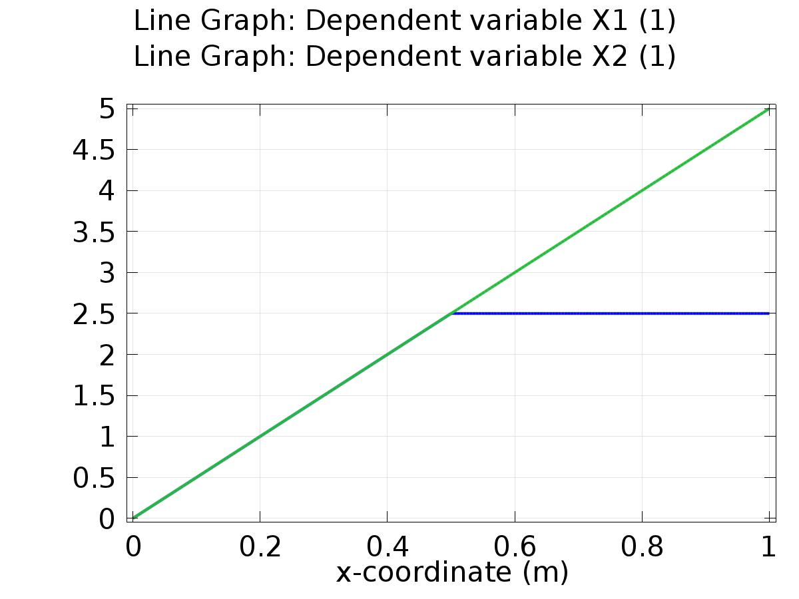

Line Graph: Dependent variable X1 (1) Line Graph: Dependent variable X2 (1)

* + 1. 1D Plot Group 2

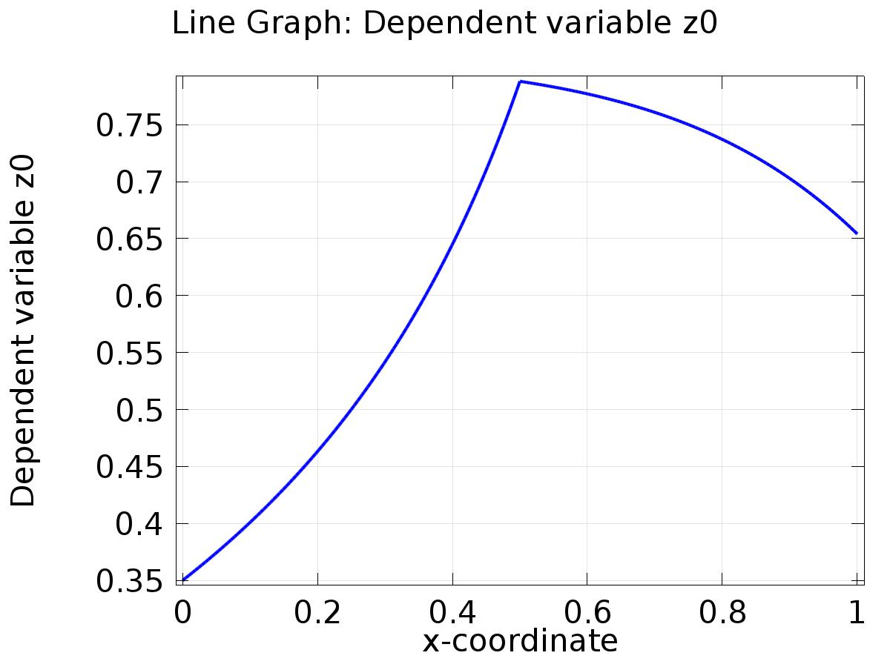

Line Graph: Dependent variable z0

* + 1. 1D Plot Group 3

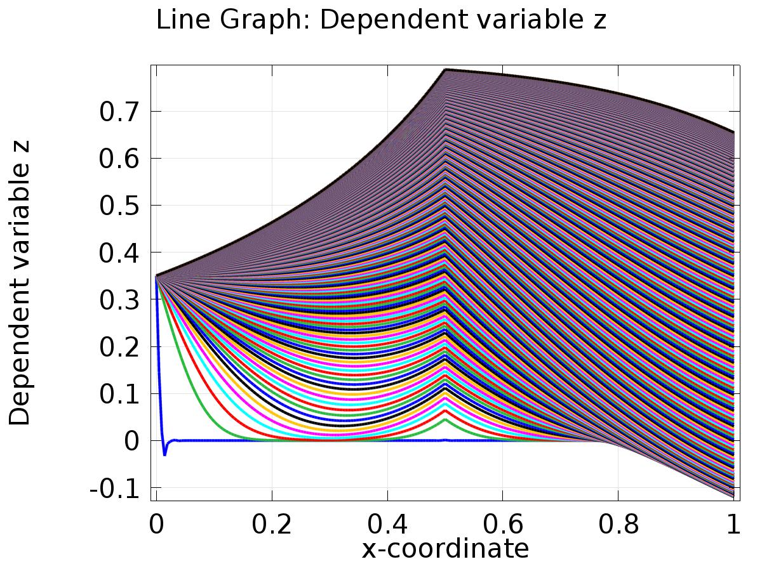

Line Graph: Dependent variable z

* + 1. 1D Plot Group 4

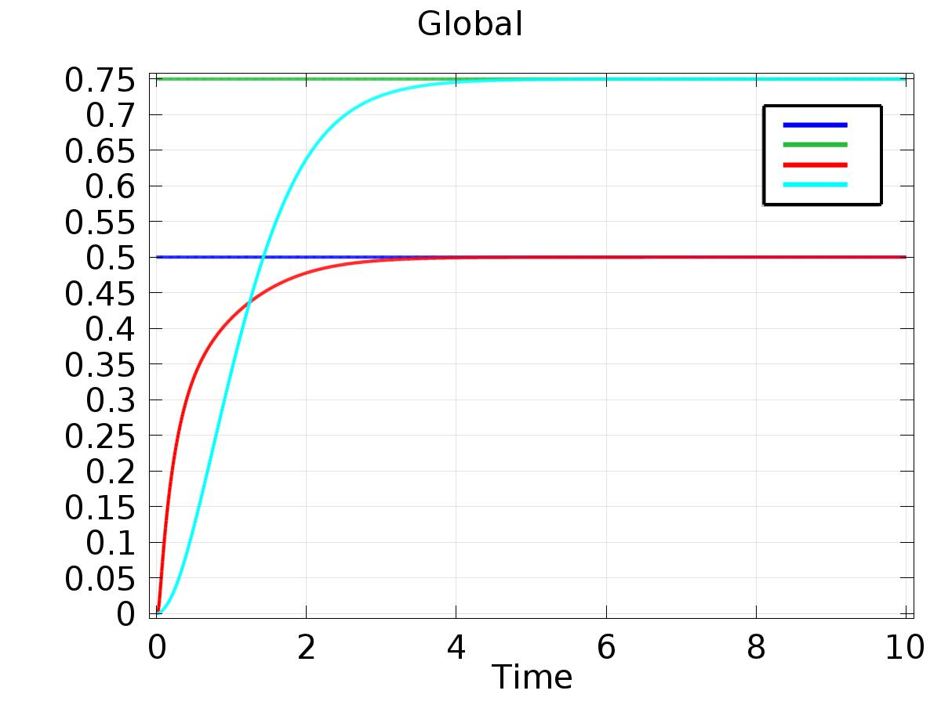

Global

* + 1. 1D Plot Group 5

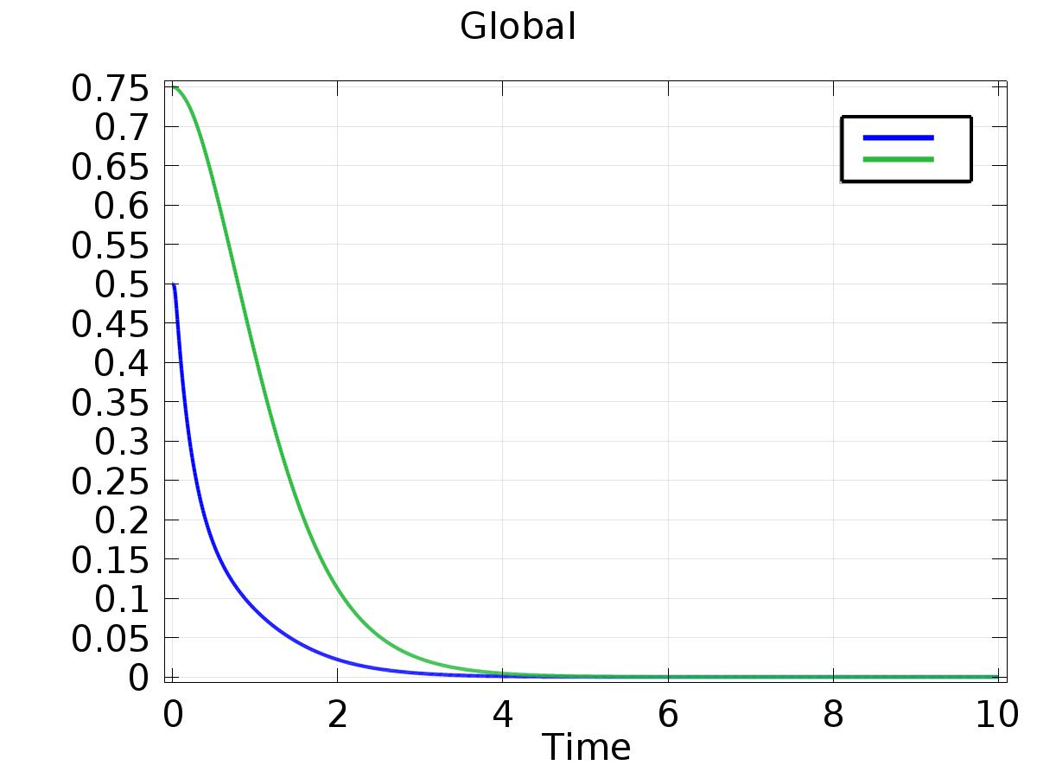

Global