[](http://www.comsol.com/)

Ch4 Ex4.3 Chafee Infante Eqn

|  |  |
| --- | --- |
| Date | Mar 25, 2014 2:16:19 PM |

Contents

1. Global

1.1. Definitions

2. Component 1

2.1. Definitions

2.2. Geometry 1

2.3. Unit Input

2.4. Initial Solution

2.5. Regulator Equation

2.6. Closed Loop System

2.7. Mesh 1

3. Study 1

3.1. Stationary

3.2. Solver Configurations

4. Study 2

4.1. Stationary

4.2. Solver Configurations

5. Study 3

5.1. Time Dependent

5.2. Solver Configurations

6. Results

6.1. Data Sets

6.2. Derived Values

6.3. Tables

6.4. Plot Groups

1. Global

|  |  |
| --- | --- |
| Date | Mar 22, 2014 11:48:15 AM |

Global settings

|  |  |
| --- | --- |
| Name | Ch4 Ex4.3 Chafee Infante Eqn.mph |
| Path | /Users/gilliam/Desktop/collect_15/research_15/geo_reg_mono_eugenio/Mono_1_15/Comsol_EX_GitHub/Chapter4/Example4.3/Ch4_Ex4.3_Chafee_Infante_Eqn.mph |
| Program | COMSOL 4.4 (Build: 150) |

Used products

|  |
| --- |
| COMSOL Multiphysics |

* 1. Definitions
     1. Parameters 1

Parameters

| **Name** | **Expression** | **Value** | **Description** |
| --- | --- | --- | --- |
| L | 1 | 1.0000 |  |
| x0 | L/4 | 0.25000 |  |
| x1 | L/2 | 0.50000 |  |
| x2 | 3/4*L | 0.75000 |  |
| alpha | 10 | 10.000 |  |
| lambda | 10 | 10.000 |  |
| beta | 0.1 | 0.10000 |  |

1. Component 1

Component settings

|  |  |
| --- | --- |
| Unit system | None |

* 1. Definitions
     1. Variables

#### Variables 1a

Selection

|  |  |
| --- | --- |
| Geometric entity level | Entire model |

| **Name** | **Expression** | **Description** |
| --- | --- | --- |
| G11 | C1(X1) |  |
| G12 | C1(X2) |  |
| G21 | C2(X1) |  |
| G22 | C2(X2) |  |
| Det | G11*G22 - G12*G21 |  |
| g11 | G22/Det |  |
| g12 | -G12/Det |  |
| g21 | -G21/Det |  |
| g22 | G11/Det |  |
| Fz0 | -lambda*(z0^3 - z0) |  |
| gamma10 | g11*(yr10 - C1(zt0)) + g12*(yr20 - C2(zt0)) |  |
| gamma20 | g21*(yr10 - C1(zt0)) + g22*(yr20 - C2(zt0)) |  |
| d0 | 0.75 |  |
| yr10 | 1 |  |
| yr20 | 0.5 |  |
| Fz1 | -lambda*(z1^3 - z1) |  |
| gamma1 | g11*(yr1 - C1(zt1)) + g12*(yr2 - C2(zt1)) |  |
| gamma2 | g21*(yr1 - C1(zt1)) + g22*(yr2 - C2(zt1)) |  |
| d | d0 + 0.25*flc2hs(t - 50, 1) - 0.25*flc2hs(t - 100, 1) |  |
| yr1 | yr10 - 0.25*flc2hs(t - 25, 1) + 0.5*flc2hs(t - 75, 1) - 0.25*flc2hs(t - 125, 1) |  |
| yr2 | yr20 - 0.25*flc2hs(t - 40, 1) + 0.5*flc2hs(t - 90, 1) - 0.25*flc2hs(t - 140, 1) |  |
| Fz | -lambda*(z^3 - z) |  |
| u1 | gamma1 |  |
| u2 | gamma2 |  |
| e1 | yr1 - C1(z) |  |
| e2 | yr2 - C2(z) |  |

* + 1. Component Couplings

#### Integration 1

|  |  |
| --- | --- |
| Coupling type | Integration |
| Operator name | C1 |

Source selection

|  |  |
| --- | --- |
| Geometric entity level | Boundary |
| Selection | Boundary 2 |

#### Integration 2

|  |  |
| --- | --- |
| Coupling type | Integration |
| Operator name | C2 |

Source selection

|  |  |
| --- | --- |
| Geometric entity level | Boundary |
| Selection | Boundary 4 |

* 1. Geometry 1

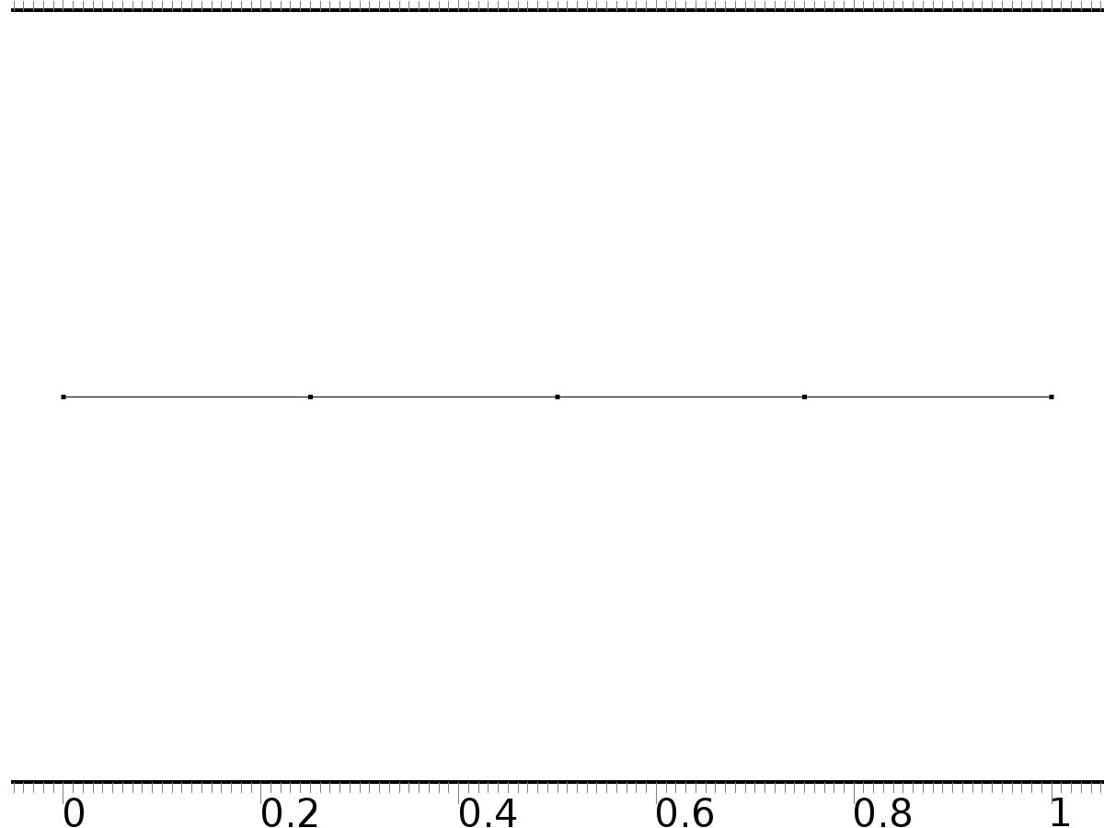

Geometry 1

Units

|  |  |
| --- | --- |
| Length unit | m |
| Angular unit | deg |

Geometry statistics

| **Description** | **Value** |
| --- | --- |
| Space dimension | 1 |
| Number of domains | 4 |
| Number of boundaries | 5 |

* + 1. Interval 1 (i1)

Interval

| **Description** | **Value** |
| --- | --- |
| Number of intervals | Many |
| Points | {0, 0.25, 0.5, 0.75, 1} |

* 1. Unit Input

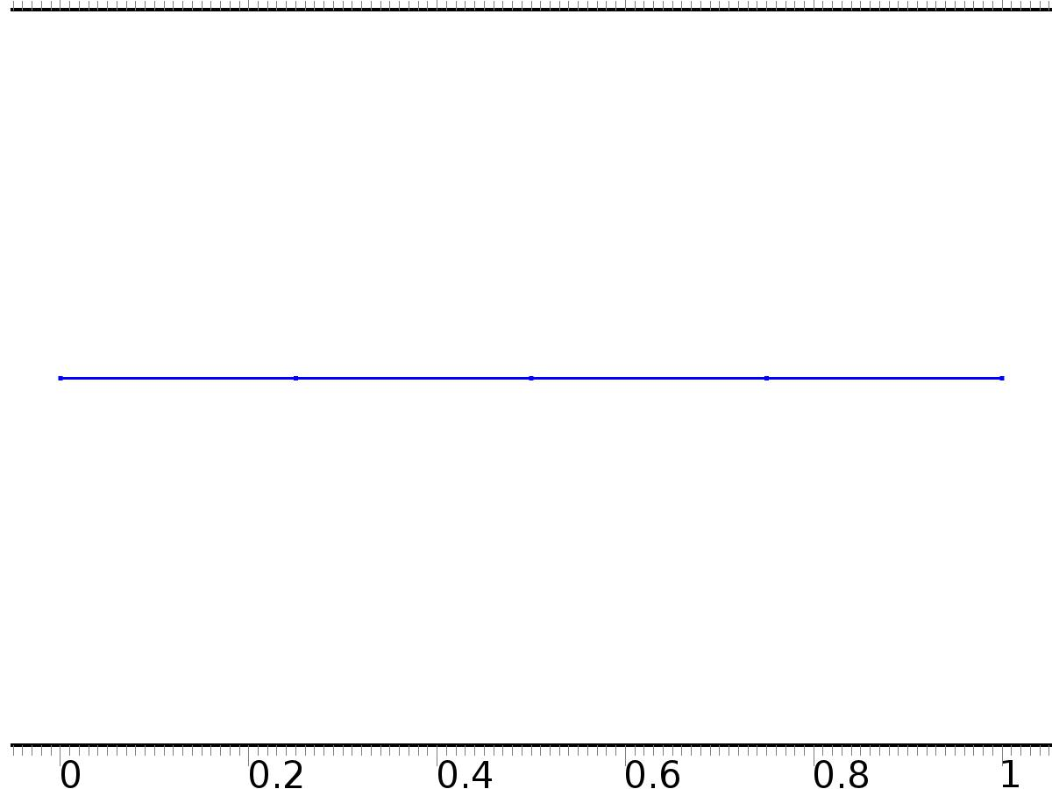

Unit Input

Selection

|  |  |
| --- | --- |
| Geometric entity level | Domain |
| Selection | Domains 1–4 |

Settings

| **Description** | **Value** |
| --- | --- |
| Shape function type | Lagrange |
| Element order | Quadratic |
| Compute boundary fluxes | On |
| Apply smoothing to boundary fluxes | On |
| Value type when using splitting of complex variables | Complex |
| Dependent variable quantity | Dimensionless (1) |
| Source term quantity | None |
| Unit | m^ - 2 |

Used products

|  |
| --- |
| COMSOL Multiphysics |

Variables

| **Name** | **Expression** | **Unit** | **Description** | **Selection** |
| --- | --- | --- | --- | --- |
| X.nx | nx |  | Normal vector, x component | Boundaries 1–5 |
| X.ny | root.ny |  | Normal vector, y component | Boundaries 1–5 |
| X.nz | root.nz |  | Normal vector, z component | Boundaries 1–5 |
| X.nxmesh | root.nxmesh |  | Normal vector (mesh), x component | Boundaries 1–5 |
| X.nymesh | root.nymesh |  | Normal vector (mesh), y component | Boundaries 1–5 |
| X.nzmesh | root.nzmesh |  | Normal vector (mesh), z component | Boundaries 1–5 |

* + 1. Coefficient Form PDE 1



Coefficient Form PDE 1

Selection

|  |  |
| --- | --- |
| Geometric entity level | Domain |
| Selection | Domains 1–4 |

Equations

Settings

| **Description** | **Value** |
| --- | --- |
| Diffusion coefficient | {{1, 0}, {0, 1}} |
| Absorption coefficient | {{0, 0}, {0, 0}} |
| Source term | {0, 0} |
| Mass coefficient | {{0, 0}, {0, 0}} |
| Damping or mass coefficient | {{0, 0}, {0, 0}} |
| Conservative flux convection coefficient | {{0, 0}, {0, 0}} |
| Convection coefficient | {{0, 0}, {0, 0}} |
| Conservative flux source | {0, 0} |

#### Variables

| **Name** | **Expression** | **Unit** | **Description** | **Selection** |
| --- | --- | --- | --- | --- |
| domflux.X1x | -d(X1,x) |  | Domain flux, x component | Domains 1–4 |
| domflux.X2x | -d(X2,x) |  | Domain flux, x component | Domains 1–4 |

#### Shape functions

| **Name** | **Shape function** | **Unit** | **Description** | **Shape frame** | **Selection** |
| --- | --- | --- | --- | --- | --- |
| X1 | Lagrange (Quadratic) |  | Dependent variable X1 | Material | Domains 1–4 |
| X2 | Lagrange (Quadratic) |  | Dependent variable X2 | Material | Domains 1–4 |

* + 1. Zero Flux 1

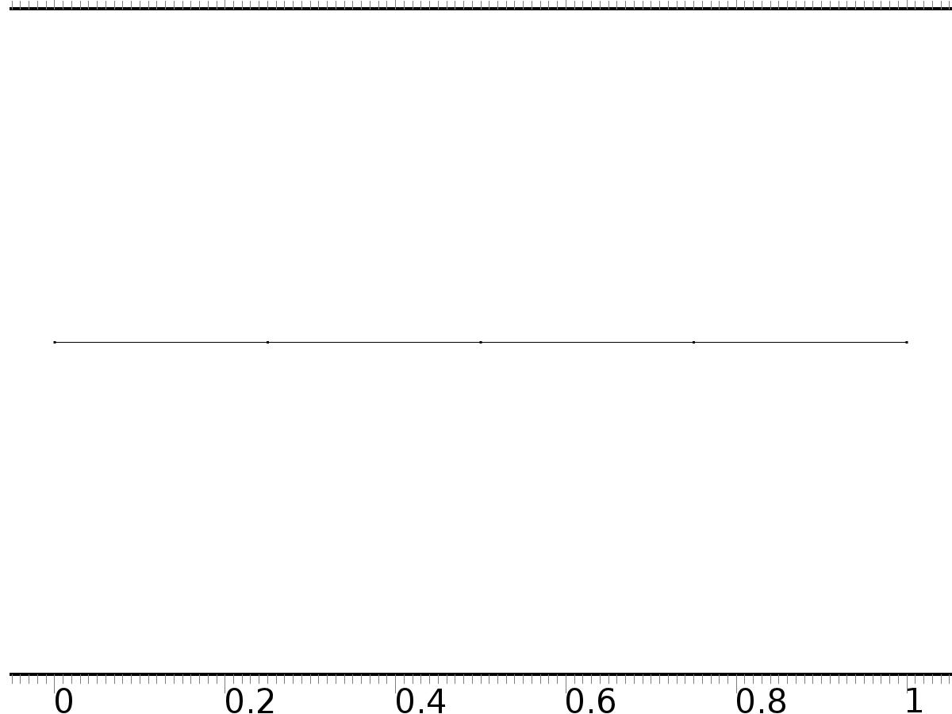

Zero Flux 1

Selection

|  |  |
| --- | --- |
| Geometric entity level | Boundary |
| Selection | No boundaries |

Equations

* + 1. Initial Values 1



Initial Values 1

Selection

|  |  |
| --- | --- |
| Geometric entity level | Domain |
| Selection | Domains 1–4 |

Settings

| **Description** | **Value** |
| --- | --- |
| Initial value for X2 | 0 |
| Initial time derivative of X2 | 0 |
| Initial value for X1 | 0 |
| Initial time derivative of X1 | 0 |

* + 1. Bd*0

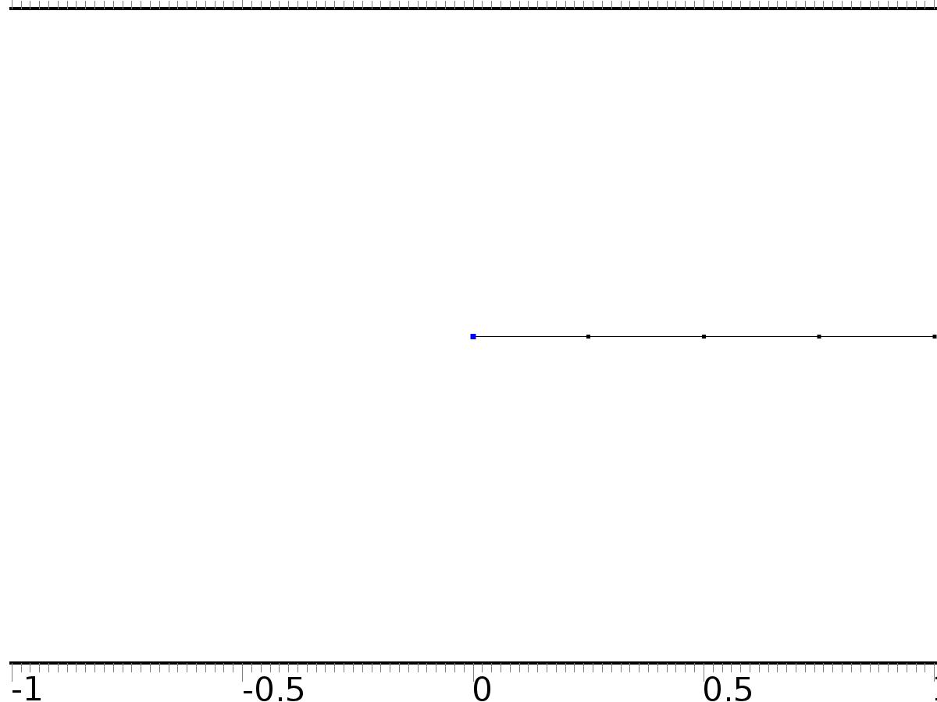

Bd*0

Selection

|  |  |
| --- | --- |
| Geometric entity level | Boundary |
| Selection | Boundary 1 |

Equations

Settings

| **Description** | **Value** |
| --- | --- |
| Value on boundary | {0, 0} |
| Prescribed value of X1 | On |
| Prescribed value of X2 | On |
| Apply reaction terms on | Individual dependent variables |
| Use weak constraints | Off |
| Constraint method | Elemental |

#### Shape functions

| **Constraint** | **Constraint force** | **Shape function** | **Selection** |
| --- | --- | --- | --- |
| -X1 | -test(X1) | Lagrange (Quadratic) | Boundary 1 |
| -X2 | -test(X2) | Lagrange (Quadratic) | Boundary 1 |

* + 1. Bin1*[1,0]

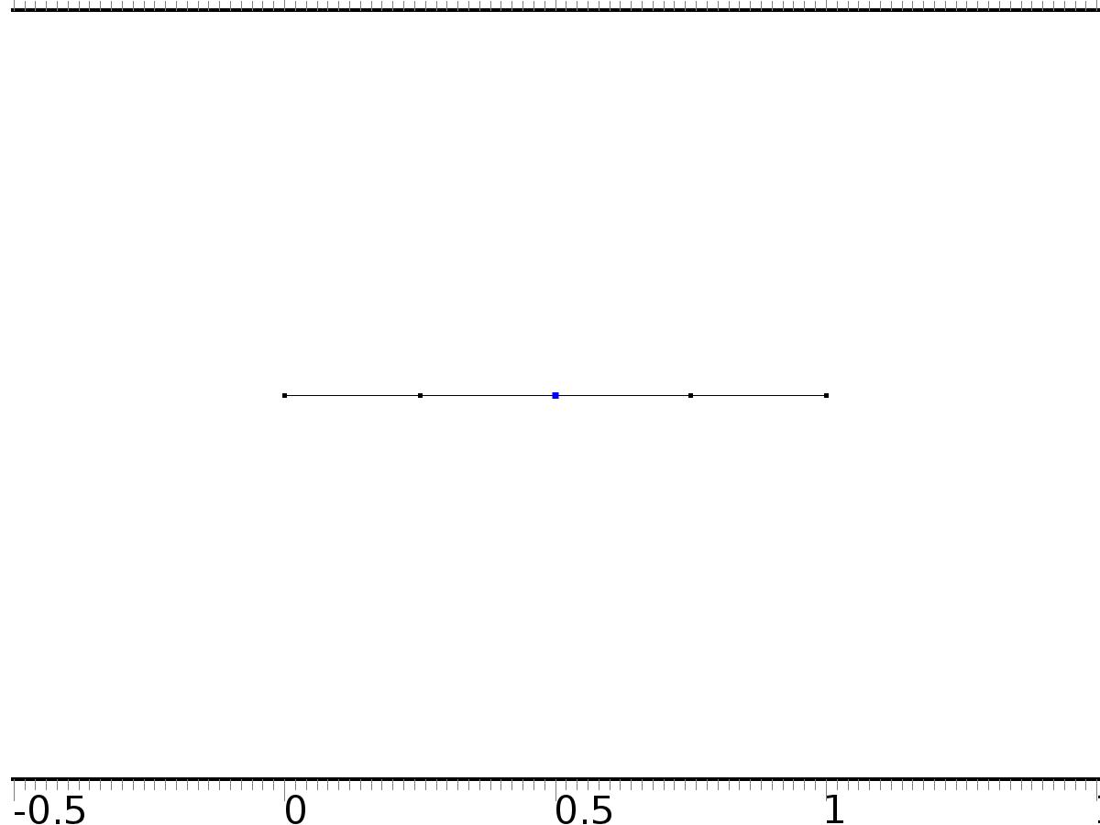

Bin1*[1,0]

Selection

|  |  |
| --- | --- |
| Geometric entity level | Boundary |
| Selection | Boundary 3 |

Equations

Settings

| **Description** | **Value** |
| --- | --- |
| Boundary flux/source | {1, 0} |
| Boundary absorption/impedance term | {{0, 0}, {0, 0}} |

#### Variables

| **Name** | **Expression** | **Unit** | **Description** | **Selection** |
| --- | --- | --- | --- | --- |
| X.g_X1 | 1 |  | Boundary flux/source | Boundary 3 |
| X.g_X2 | 0 |  | Boundary flux/source | Boundary 3 |

* + 1. Bin2*[0,1]

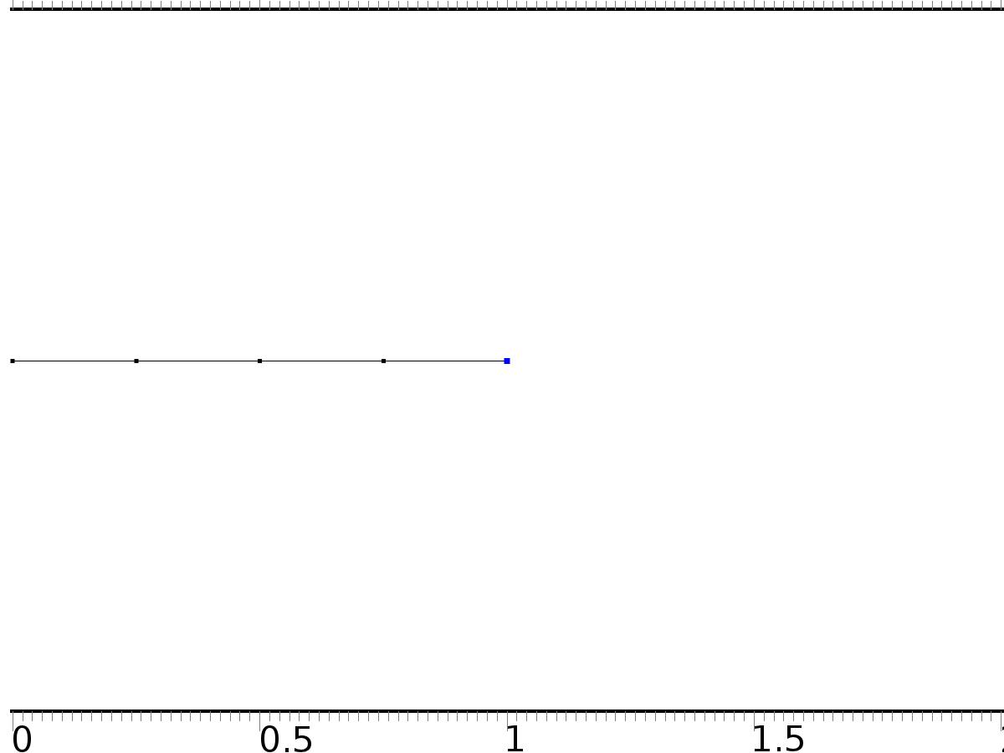

Bin2*[0,1]

Selection

|  |  |
| --- | --- |
| Geometric entity level | Boundary |
| Selection | Boundary 5 |

Equations

Settings

| **Description** | **Value** |
| --- | --- |
| Boundary flux/source | {0, 1} |
| Boundary absorption/impedance term | {{alpha, 0}, {0, alpha}} |

#### Variables

| **Name** | **Expression** | **Unit** | **Description** | **Selection** |
| --- | --- | --- | --- | --- |
| X.g_X1 | -alpha*X1 |  | Boundary flux/source | Boundary 5 |
| X.g_X2 | 1-alpha*X2 |  | Boundary flux/source | Boundary 5 |

* 1. Initial Solution



Initial Solution

Selection

|  |  |
| --- | --- |
| Geometric entity level | Domain |
| Selection | Domains 1–4 |

Settings

| **Description** | **Value** |
| --- | --- |
| Shape function type | Lagrange |
| Element order | Quadratic |
| Compute boundary fluxes | On |
| Apply smoothing to boundary fluxes | On |
| Value type when using splitting of complex variables | Complex |
| Dependent variable quantity | Dimensionless (1) |
| Source term quantity | None |
| Unit | m^ - 2 |

Used products

|  |
| --- |
| COMSOL Multiphysics |

Variables

| **Name** | **Expression** | **Unit** | **Description** | **Selection** |
| --- | --- | --- | --- | --- |
| z0.nx | nx |  | Normal vector, x component | Boundaries 1–5 |
| z0.ny | root.ny |  | Normal vector, y component | Boundaries 1–5 |
| z0.nz | root.nz |  | Normal vector, z component | Boundaries 1–5 |
| z0.nxmesh | root.nxmesh |  | Normal vector (mesh), x component | Boundaries 1–5 |
| z0.nymesh | root.nymesh |  | Normal vector (mesh), y component | Boundaries 1–5 |
| z0.nzmesh | root.nzmesh |  | Normal vector (mesh), z component | Boundaries 1–5 |

* + 1. Coefficient Form PDE 1



Coefficient Form PDE 1

Selection

|  |  |
| --- | --- |
| Geometric entity level | Domain |
| Selection | Domains 1–4 |

Equations

Settings

| **Description** | **Value** |
| --- | --- |
| Diffusion coefficient | {{1, 0}, {0, 1}} |
| Absorption coefficient | {{0, 0}, {0, 0}} |
| Source term | {Fz0, Fz0} |
| Mass coefficient | {{0, 0}, {0, 0}} |
| Damping or mass coefficient | {{0, 0}, {0, 0}} |
| Conservative flux convection coefficient | {{0, 0}, {0, 0}} |
| Convection coefficient | {{0, 0}, {0, 0}} |
| Conservative flux source | {0, 0} |

#### Variables

| **Name** | **Expression** | **Unit** | **Description** | **Selection** |
| --- | --- | --- | --- | --- |
| domflux.z0x | -d(z0,x) |  | Domain flux, x component | Domains 1–4 |
| domflux.zt0x | -d(zt0,x) |  | Domain flux, x component | Domains 1–4 |

#### Shape functions

| **Name** | **Shape function** | **Unit** | **Description** | **Shape frame** | **Selection** |
| --- | --- | --- | --- | --- | --- |
| z0 | Lagrange (Quadratic) |  | Dependent variable z0 | Material | Domains 1–4 |
| zt0 | Lagrange (Quadratic) |  | Dependent variable zt0 | Material | Domains 1–4 |

* + 1. Zero Flux 1



Zero Flux 1

Selection

|  |  |
| --- | --- |
| Geometric entity level | Boundary |
| Selection | No boundaries |

Equations

* + 1. Initial Values 1



Initial Values 1

Selection

|  |  |
| --- | --- |
| Geometric entity level | Domain |
| Selection | Domains 1–4 |

Settings

| **Description** | **Value** |
| --- | --- |
| Initial value for zt0 | 0 |
| Initial time derivative of zt0 | 0 |
| Initial value for z0 | 0 |
| Initial time derivative of z0 | 0 |

* + 1. Bd*[d0,d0]



Bd*[d0,d0]

Selection

|  |  |
| --- | --- |
| Geometric entity level | Boundary |
| Selection | Boundary 1 |

Equations

Settings

| **Description** | **Value** |
| --- | --- |
| Value on boundary | {d0, d0} |
| Prescribed value of z0 | On |
| Prescribed value of zt0 | On |
| Apply reaction terms on | Individual dependent variables |
| Use weak constraints | Off |
| Constraint method | Elemental |

#### Shape functions

| **Constraint** | **Constraint force** | **Shape function** | **Selection** |
| --- | --- | --- | --- |
| d0-z0 | -test(z0) | Lagrange (Quadratic) | Boundary 1 |
| d0-zt0 | -test(zt0) | Lagrange (Quadratic) | Boundary 1 |

* + 1. Bin1*[gamma10,0]



Bin1*[gamma10,0]

Selection

|  |  |
| --- | --- |
| Geometric entity level | Boundary |
| Selection | Boundary 3 |

Equations

Settings

| **Description** | **Value** |
| --- | --- |
| Boundary flux/source | {gamma10, 0} |
| Boundary absorption/impedance term | {{0, 0}, {0, 0}} |

#### Variables

| **Name** | **Expression** | **Unit** | **Description** | **Selection** |
| --- | --- | --- | --- | --- |
| z0.g_z0 | gamma10 |  | Boundary flux/source | Boundary 3 |
| z0.g_zt0 | 0 |  | Boundary flux/source | Boundary 3 |

* + 1. Bin2*[gamma20,0]



Bin2*[gamma20,0]

Selection

|  |  |
| --- | --- |
| Geometric entity level | Boundary |
| Selection | Boundary 5 |

Equations

Settings

| **Description** | **Value** |
| --- | --- |
| Boundary flux/source | {gamma20, 0} |
| Boundary absorption/impedance term | {{alpha, 0}, {0, alpha}} |

#### Variables

| **Name** | **Expression** | **Unit** | **Description** | **Selection** |
| --- | --- | --- | --- | --- |
| z0.g_z0 | gamma20-alpha*z0 |  | Boundary flux/source | Boundary 5 |
| z0.g_zt0 | -alpha*zt0 |  | Boundary flux/source | Boundary 5 |

* 1. Regulator Equation



Regulator Equation

Selection

|  |  |
| --- | --- |
| Geometric entity level | Domain |
| Selection | Domains 1–4 |

Settings

| **Description** | **Value** |
| --- | --- |
| Shape function type | Lagrange |
| Element order | Quadratic |
| Compute boundary fluxes | On |
| Apply smoothing to boundary fluxes | On |
| Value type when using splitting of complex variables | Complex |
| Dependent variable quantity | Dimensionless (1) |
| Source term quantity | None |
| Unit | m^ - 2 |

Used products

|  |
| --- |
| COMSOL Multiphysics |

Variables

| **Name** | **Expression** | **Unit** | **Description** | **Selection** |
| --- | --- | --- | --- | --- |
| z1.nx | nx |  | Normal vector, x component | Boundaries 1–5 |
| z1.ny | root.ny |  | Normal vector, y component | Boundaries 1–5 |
| z1.nz | root.nz |  | Normal vector, z component | Boundaries 1–5 |
| z1.nxmesh | root.nxmesh |  | Normal vector (mesh), x component | Boundaries 1–5 |
| z1.nymesh | root.nymesh |  | Normal vector (mesh), y component | Boundaries 1–5 |
| z1.nzmesh | root.nzmesh |  | Normal vector (mesh), z component | Boundaries 1–5 |

* + 1. Coefficient Form PDE 1



Coefficient Form PDE 1

Selection

|  |  |
| --- | --- |
| Geometric entity level | Domain |
| Selection | Domains 1–4 |

Equations

Settings

| **Description** | **Value** |
| --- | --- |
| Diffusion coefficient | {{1, 0}, {0, 1}} |
| Absorption coefficient | {{0, 0}, {0, 0}} |
| Source term | {Fz1, Fz1} |
| Mass coefficient | {{0, 0}, {0, 0}} |
| Damping or mass coefficient | {{1, (1 - beta)}, {0, 0}} |
| Conservative flux convection coefficient | {{0, 0}, {0, 0}} |
| Convection coefficient | {{0, 0}, {0, 0}} |
| Conservative flux source | {0, 0} |

#### Variables

| **Name** | **Expression** | **Unit** | **Description** | **Selection** |
| --- | --- | --- | --- | --- |
| domflux.z1x | -d(z1,x) |  | Domain flux, x component | Domains 1–4 |
| domflux.zt1x | -d(zt1,x) |  | Domain flux, x component | Domains 1–4 |

#### Shape functions

| **Name** | **Shape function** | **Unit** | **Description** | **Shape frame** | **Selection** |
| --- | --- | --- | --- | --- | --- |
| z1 | Lagrange (Quadratic) |  | Dependent variable z1 | Material | Domains 1–4 |
| zt1 | Lagrange (Quadratic) |  | Dependent variable zt1 | Material | Domains 1–4 |

* + 1. Zero Flux 1



Zero Flux 1

Selection

|  |  |
| --- | --- |
| Geometric entity level | Boundary |
| Selection | No boundaries |

Equations

* + 1. Initial Values: z0



Initial Values: z0

Selection

|  |  |
| --- | --- |
| Geometric entity level | Domain |
| Selection | Domains 1–4 |

Settings

| **Description** | **Value** |
| --- | --- |
| Initial value for z1 | z0 |
| Initial time derivative of z1 | 0 |
| Initial value for zt1 | 0 |
| Initial time derivative of zt1 | 0 |

* + 1. Bd*[d, d]



Bd*[d, d]

Selection

|  |  |
| --- | --- |
| Geometric entity level | Boundary |
| Selection | Boundary 1 |

Equations

Settings

| **Description** | **Value** |
| --- | --- |
| Value on boundary | {d, d} |
| Prescribed value of z1 | On |
| Prescribed value of zt1 | On |
| Apply reaction terms on | Individual dependent variables |
| Use weak constraints | Off |
| Constraint method | Elemental |

#### Shape functions

| **Constraint** | **Constraint force** | **Shape function** | **Selection** |
| --- | --- | --- | --- |
| d-z1 | -test(z1) | Lagrange (Quadratic) | Boundary 1 |
| d-zt1 | -test(zt1) | Lagrange (Quadratic) | Boundary 1 |

* + 1. Bin1*[gamma1,0]



Bin1*[gamma1,0]

Selection

|  |  |
| --- | --- |
| Geometric entity level | Boundary |
| Selection | Boundary 3 |

Equations

Settings

| **Description** | **Value** |
| --- | --- |
| Boundary flux/source | {gamma1, 0} |
| Boundary absorption/impedance term | {{0, 0}, {0, 0}} |

#### Variables

| **Name** | **Expression** | **Unit** | **Description** | **Selection** |
| --- | --- | --- | --- | --- |
| z1.g_z1 | gamma1 |  | Boundary flux/source | Boundary 3 |
| z1.g_zt1 | 0 |  | Boundary flux/source | Boundary 3 |

* + 1. Bin2*[gamma2,0]



Bin2*[gamma2,0]

Selection

|  |  |
| --- | --- |
| Geometric entity level | Boundary |
| Selection | Boundary 5 |

Equations

Settings

| **Description** | **Value** |
| --- | --- |
| Boundary flux/source | {gamma2, 0} |
| Boundary absorption/impedance term | {{alpha, 0}, {0, alpha}} |

#### Variables

| **Name** | **Expression** | **Unit** | **Description** | **Selection** |
| --- | --- | --- | --- | --- |
| z1.g_z1 | gamma2-alpha*z1 |  | Boundary flux/source | Boundary 5 |
| z1.g_zt1 | -alpha*zt1 |  | Boundary flux/source | Boundary 5 |

* 1. Closed Loop System



Closed Loop System

Selection

|  |  |
| --- | --- |
| Geometric entity level | Domain |
| Selection | Domains 1–4 |

Settings

| **Description** | **Value** |
| --- | --- |
| Shape function type | Lagrange |
| Element order | Quadratic |
| Compute boundary fluxes | On |
| Apply smoothing to boundary fluxes | On |
| Value type when using splitting of complex variables | Complex |
| Dependent variable quantity | Dimensionless (1) |
| Source term quantity | None |
| Unit | m^ - 2 |

Used products

|  |
| --- |
| COMSOL Multiphysics |

Variables

| **Name** | **Expression** | **Unit** | **Description** | **Selection** |
| --- | --- | --- | --- | --- |
| z.nx | nx |  | Normal vector, x component | Boundaries 1–5 |
| z.ny | root.ny |  | Normal vector, y component | Boundaries 1–5 |
| z.nz | root.nz |  | Normal vector, z component | Boundaries 1–5 |
| z.nxmesh | root.nxmesh |  | Normal vector (mesh), x component | Boundaries 1–5 |
| z.nymesh | root.nymesh |  | Normal vector (mesh), y component | Boundaries 1–5 |
| z.nzmesh | root.nzmesh |  | Normal vector (mesh), z component | Boundaries 1–5 |

* + 1. Coefficient Form PDE 1



Coefficient Form PDE 1

Selection

|  |  |
| --- | --- |
| Geometric entity level | Domain |
| Selection | Domains 1–4 |

Equations

Settings

| **Description** | **Value** |
| --- | --- |
| Diffusion coefficient | 1 |
| Absorption coefficient | 0 |
| Source term | Fz |
| Mass coefficient | 0 |
| Damping or mass coefficient | 1 |
| Conservative flux convection coefficient | 0 |
| Convection coefficient | 0 |
| Conservative flux source | 0 |

#### Variables

| **Name** | **Expression** | **Unit** | **Description** | **Selection** |
| --- | --- | --- | --- | --- |
| domflux.zx | -d(z,x) |  | Domain flux, x component | Domains 1–4 |

#### Shape functions

| **Name** | **Shape function** | **Unit** | **Description** | **Shape frame** | **Selection** |
| --- | --- | --- | --- | --- | --- |
| z | Lagrange (Quadratic) |  | Dependent variable z | Material | Domains 1–4 |

* + 1. Zero Flux 1



Zero Flux 1

Selection

|  |  |
| --- | --- |
| Geometric entity level | Boundary |
| Selection | No boundaries |

Equations

* + 1. Initial Values 1



Initial Values 1

Selection

|  |  |
| --- | --- |
| Geometric entity level | Domain |
| Selection | Domains 1–4 |

Settings

| **Description** | **Value** |
| --- | --- |
| Initial value for z | cos(x) |
| Initial time derivative of z | 0 |

* + 1. Bd*d



Bd*d

Selection

|  |  |
| --- | --- |
| Geometric entity level | Boundary |
| Selection | Boundary 1 |

Equations

Settings

| **Description** | **Value** |
| --- | --- |
| Value on boundary | d |
| Prescribed value of z | On |
| Apply reaction terms on | Individual dependent variables |
| Use weak constraints | Off |
| Constraint method | Elemental |

#### Shape functions

| **Constraint** | **Constraint force** | **Shape function** | **Selection** |
| --- | --- | --- | --- |
| d-z | -test(z) | Lagrange (Quadratic) | Boundary 1 |

* + 1. Bin1*u1



Bin1*u1

Selection

|  |  |
| --- | --- |
| Geometric entity level | Boundary |
| Selection | Boundary 3 |

Equations

Settings

| **Description** | **Value** |
| --- | --- |
| Boundary flux/source | u1 |
| Boundary absorption/impedance term | 0 |

#### Variables

| **Name** | **Expression** | **Unit** | **Description** | **Selection** |
| --- | --- | --- | --- | --- |
| z.g_z | u1 |  | Boundary flux/source | Boundary 3 |

* + 1. Bin2*u2



Bin2*u2

Selection

|  |  |
| --- | --- |
| Geometric entity level | Boundary |
| Selection | Boundary 5 |

Equations

Settings

| **Description** | **Value** |
| --- | --- |
| Boundary flux/source | u2 |
| Boundary absorption/impedance term | alpha |

#### Variables

| **Name** | **Expression** | **Unit** | **Description** | **Selection** |
| --- | --- | --- | --- | --- |
| z.g_z | u2-alpha*z |  | Boundary flux/source | Boundary 5 |

* 1. Mesh 1

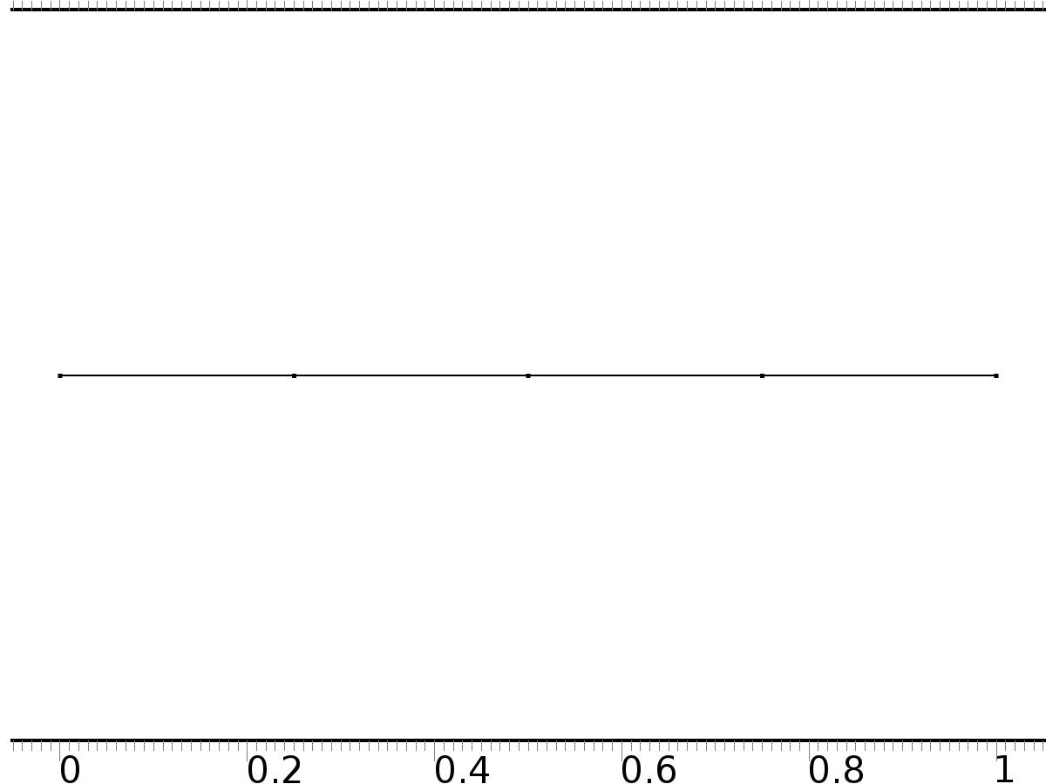

Mesh 1

* + 1. Size (size)

Settings

| **Description** | **Value** |
| --- | --- |
| Maximum element size | 0.067 |
| Minimum element size | 3.0E-4 |
| Curvature factor | 0.3 |
| Maximum element growth rate | 1.3 |

* + 1. Edge 1 (edg1)

Selection

|  |  |
| --- | --- |
| Geometric entity level | Remaining |

1. Study 1
   1. Stationary

Study settings

| **Description** | **Value** |
| --- | --- |
| Include geometric nonlinearity | Off |

Physics and variables selection

| **Physics interface** | **Discretization** |
| --- | --- |
| Unit Input (c) | physics |

Mesh selection

| **Geometry** | **Mesh** |
| --- | --- |
| Geometry 1 (geom1) | mesh1 |

* 1. Solver Configurations
     1. Solver 1

#### Compile Equations: Stationary (st1)

Study and step

| **Description** | **Value** |
| --- | --- |
| Use study | Study 1 |
| Use study step | Stationary |

#### Dependent Variables 1 (v1)

General

| **Description** | **Value** |
| --- | --- |
| Defined by study step | Stationary |
| Constant |  |

Initial values of variables solved for

| **Description** | **Value** |
| --- | --- |
| Solution | Zero |

Values of variables not solved for

| **Description** | **Value** |
| --- | --- |
| Solution | Zero |

##### Dependent variable zt1 (comp1.zt1) (comp1_zt1)

General

| **Description** | **Value** |
| --- | --- |
| Field components | comp1.zt1 |
| Solve for this field | Off |

##### Dependent variable zt0 (comp1.zt0) (comp1_zt0)

General

| **Description** | **Value** |
| --- | --- |
| Field components | comp1.zt0 |
| Solve for this field | Off |

##### Dependent variable z (comp1.z) (comp1_z)

General

| **Description** | **Value** |
| --- | --- |
| Field components | comp1.z |
| Solve for this field | Off |

##### Dependent variable z0 (comp1.z0) (comp1_z0)

General

| **Description** | **Value** |
| --- | --- |
| Field components | comp1.z0 |
| Solve for this field | Off |

##### Dependent variable z1 (comp1.z1) (comp1_z1)

General

| **Description** | **Value** |
| --- | --- |
| Field components | comp1.z1 |
| Solve for this field | Off |

##### Dependent variable X1 (comp1.X1) (comp1_X1)

General

| **Description** | **Value** |
| --- | --- |
| Field components | comp1.X1 |
| Field name | comp1_X |

##### Dependent variable X2 (comp1.X2) (comp1_X2)

General

| **Description** | **Value** |
| --- | --- |
| Field components | comp1.X2 |

#### Stationary Solver 1 (s1)

General

| **Description** | **Value** |
| --- | --- |
| Defined by study step | Stationary |
| Relative tolerance | 0.0000010 |

Log

| **Description** | **Value** |
| --- | --- |
| Constant |  |

##### Fully Coupled 1 (fc1)

General

| **Description** | **Value** |
| --- | --- |
| Linear solver | Direct |

1. Study 2
   1. Stationary

Study settings

| **Description** | **Value** |
| --- | --- |
| Include geometric nonlinearity | Off |

Physics and variables selection

| **Physics interface** | **Discretization** |
| --- | --- |
| Initial Solution (c2) | physics |

Mesh selection

| **Geometry** | **Mesh** |
| --- | --- |
| Geometry 1 (geom1) | mesh1 |

* 1. Solver Configurations
     1. Solver 2

#### Compile Equations: Stationary (st1)

Study and step

| **Description** | **Value** |
| --- | --- |
| Use study | Study 2 |
| Use study step | Stationary |

#### Dependent Variables 1 (v1)

General

| **Description** | **Value** |
| --- | --- |
| Defined by study step | Stationary |
| Constant |  |

Initial values of variables solved for

| **Description** | **Value** |
| --- | --- |
| Solution | Zero |

Values of variables not solved for

| **Description** | **Value** |
| --- | --- |
| Method | Solution |
| Solution | Solver 1 |

##### Dependent variable zt1 (comp1.zt1) (comp1_zt1)

General

| **Description** | **Value** |
| --- | --- |
| Field components | comp1.zt1 |
| Solve for this field | Off |

##### Dependent variable zt0 (comp1.zt0) (comp1_zt0)

General

| **Description** | **Value** |
| --- | --- |
| Field components | comp1.zt0 |

##### Dependent variable z (comp1.z) (comp1_z)

General

| **Description** | **Value** |
| --- | --- |
| Field components | comp1.z |
| Solve for this field | Off |

##### Dependent variable z0 (comp1.z0) (comp1_z0)

General

| **Description** | **Value** |
| --- | --- |
| Field components | comp1.z0 |

##### Dependent variable z1 (comp1.z1) (comp1_z1)

General

| **Description** | **Value** |
| --- | --- |
| Field components | comp1.z1 |
| Solve for this field | Off |

##### Dependent variable X1 (comp1.X1) (comp1_X1)

General

| **Description** | **Value** |
| --- | --- |
| Field components | comp1.X1 |
| Solve for this field | Off |
| Field name | comp1_X |

##### Dependent variable X2 (comp1.X2) (comp1_X2)

General

| **Description** | **Value** |
| --- | --- |
| Field components | comp1.X2 |
| Solve for this field | Off |

#### Stationary Solver 1 (s1)

General

| **Description** | **Value** |
| --- | --- |
| Defined by study step | Stationary |
| Relative tolerance | 0.0000010 |

Log

| **Description** | **Value** |
| --- | --- |
| Constant |  |

##### Fully Coupled 1 (fc1)

General

| **Description** | **Value** |
| --- | --- |
| Linear solver | Direct |

1. Study 3
   1. Time Dependent

Study settings

| **Description** | **Value** |
| --- | --- |
| Include geometric nonlinearity | Off |

| **Times** | **Unit** |
| --- | --- |
| range(0,0.5,150) | s |

Physics and variables selection

| **Physics interface** | **Discretization** |
| --- | --- |
| Regulator Equation (phys1) | physics |
| Closed Loop System (phys2) | physics |

Mesh selection

| **Geometry** | **Mesh** |
| --- | --- |
| Geometry 1 (geom1) | mesh1 |

* 1. Solver Configurations
     1. Solver 3

#### Compile Equations: Time Dependent (st1)

Study and step

| **Description** | **Value** |
| --- | --- |
| Use study | Study 3 |
| Use study step | Time Dependent |

#### Dependent Variables 1 (v1)

General

| **Description** | **Value** |
| --- | --- |
| Defined by study step | Time Dependent |
| Constant |  |

Initial values of variables solved for

| **Description** | **Value** |
| --- | --- |
| Solution | Zero |

Values of variables not solved for

| **Description** | **Value** |
| --- | --- |
| Method | Solution |
| Solution | Solver 2 |

##### Dependent variable zt1 (comp1.zt1) (comp1_zt1)

General

| **Description** | **Value** |
| --- | --- |
| Field components | comp1.zt1 |

##### Dependent variable zt0 (comp1.zt0) (comp1_zt0)

General

| **Description** | **Value** |
| --- | --- |
| Field components | comp1.zt0 |
| Solve for this field | Off |

##### Dependent variable z0 (comp1.z0) (comp1_z0)

General

| **Description** | **Value** |
| --- | --- |
| Field components | comp1.z0 |
| Solve for this field | Off |

##### Dependent variable z1 (comp1.z1) (comp1_z1)

General

| **Description** | **Value** |
| --- | --- |
| Field components | comp1.z1 |

##### Dependent variable X1 (comp1.X1) (comp1_X1)

General

| **Description** | **Value** |
| --- | --- |
| Field components | comp1.X1 |
| Solve for this field | Off |
| Field name | comp1_X |

##### Dependent variable z (comp1.z) (comp1_z)

General

| **Description** | **Value** |
| --- | --- |
| Field components | comp1.z |
| Field name | comp1_u2 |

##### Dependent variable X2 (comp1.X2) (comp1_X2)

General

| **Description** | **Value** |
| --- | --- |
| Field components | comp1.X2 |
| Solve for this field | Off |

#### Time-Dependent Solver 1 (t1)

General

| **Description** | **Value** |
| --- | --- |
| Defined by study step | Time Dependent |
| Time | {0, 0.5, 1, 1.5, 2, 2.5, 3, 3.5, 4, 4.5, 5, 5.5, 6, 6.5, 7, 7.5, 8, 8.5, 9, 9.5, 10, 10.5, 11, 11.5, 12, 12.5, 13, 13.5, 14, 14.5, 15, 15.5, 16, 16.5, 17, 17.5, 18, 18.5, 19, 19.5, 20, 20.5, 21, 21.5, 22, 22.5, 23, 23.5, 24, 24.5, 25, 25.5, 26, 26.5, 27, 27.5, 28, 28.5, 29, 29.5, 30, 30.5, 31, 31.5, 32, 32.5, 33, 33.5, 34, 34.5, 35, 35.5, 36, 36.5, 37, 37.5, 38, 38.5, 39, 39.5, 40, 40.5, 41, 41.5, 42, 42.5, 43, 43.5, 44, 44.5, 45, 45.5, 46, 46.5, 47, 47.5, 48, 48.5, 49, 49.5, 50, 50.5, 51, 51.5, 52, 52.5, 53, 53.5, 54, 54.5, 55, 55.5, 56, 56.5, 57, 57.5, 58, 58.5, 59, 59.5, 60, 60.5, 61, 61.5, 62, 62.5, 63, 63.5, 64, 64.5, 65, 65.5, 66, 66.5, 67, 67.5, 68, 68.5, 69, 69.5, 70, 70.5, 71, 71.5, 72, 72.5, 73, 73.5, 74, 74.5, 75, 75.5, 76, 76.5, 77, 77.5, 78, 78.5, 79, 79.5, 80, 80.5, 81, 81.5, 82, 82.5, 83, 83.5, 84, 84.5, 85, 85.5, 86, 86.5, 87, 87.5, 88, 88.5, 89, 89.5, 90, 90.5, 91, 91.5, 92, 92.5, 93, 93.5, 94, 94.5, 95, 95.5, 96, 96.5, 97, 97.5, 98, 98.5, 99, 99.5, 100, 100.5, 101, 101.5, 102, 102.5, 103, 103.5, 104, 104.5, 105, 105.5, 106, 106.5, 107, 107.5, 108, 108.5, 109, 109.5, 110, 110.5, 111, 111.5, 112, 112.5, 113, 113.5, 114, 114.5, 115, 115.5, 116, 116.5, 117, 117.5, 118, 118.5, 119, 119.5, 120, 120.5, 121, 121.5, 122, 122.5, 123, 123.5, 124, 124.5, 125, 125.5, 126, 126.5, 127, 127.5, 128, 128.5, 129, 129.5, 130, 130.5, 131, 131.5, 132, 132.5, 133, 133.5, 134, 134.5, 135, 135.5, 136, 136.5, 137, 137.5, 138, 138.5, 139, 139.5, 140, 140.5, 141, 141.5, 142, 142.5, 143, 143.5, 144, 144.5, 145, 145.5, 146, 146.5, 147, 147.5, 148, 148.5, 149, 149.5, 150} |
| Relative tolerance | 0.0001 |

Absolute tolerance

| **Description** | **Value** |
| --- | --- |
| Tolerance | 0.000010 |

Time stepping

| **Description** | **Value** |
| --- | --- |
| Initial step | 0.0010 |

Advanced

| **Description** | **Value** |
| --- | --- |
| Fraction of initial step for Backward Euler | 0.0010 |

Log

| **Description** | **Value** |
| --- | --- |
| Constant |  |

##### Fully Coupled 1 (fc1)

General

| **Description** | **Value** |
| --- | --- |
| Linear solver | Direct |

1. Results
   1. Data Sets
      1. Solution 1

Solution

| **Description** | **Value** |
| --- | --- |
| Solution | Solver 1 |
| Component | Save Point Geometry 1 |

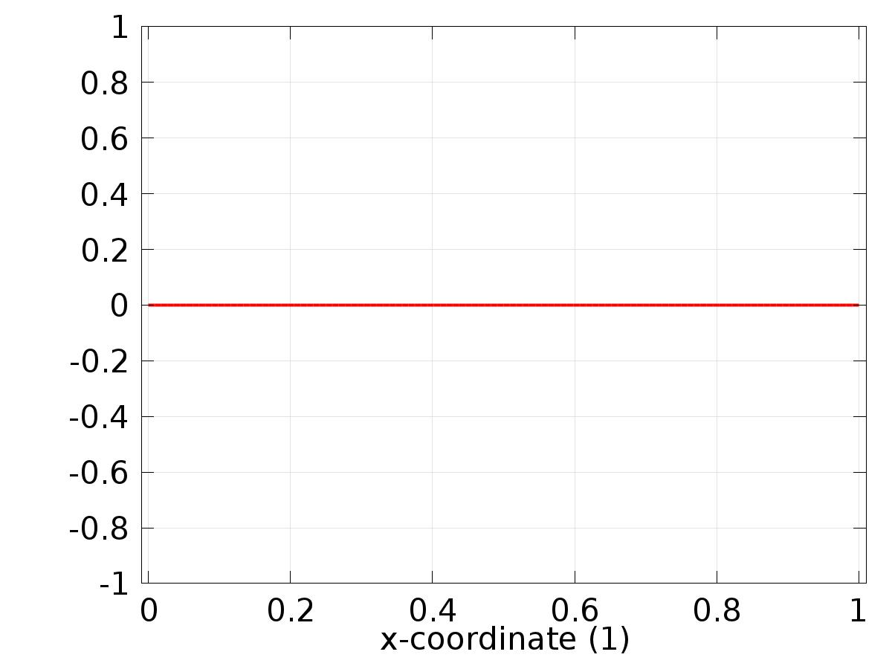

Data set: Solution 1

* + 1. Solution 2

Solution

| **Description** | **Value** |
| --- | --- |
| Solution | Solver 2 |
| Component | Save Point Geometry 1 |



Data set: Solution 2

* + 1. Solution 3

Solution

| **Description** | **Value** |
| --- | --- |
| Solution | Solver 3 |
| Component | Save Point Geometry 1 |

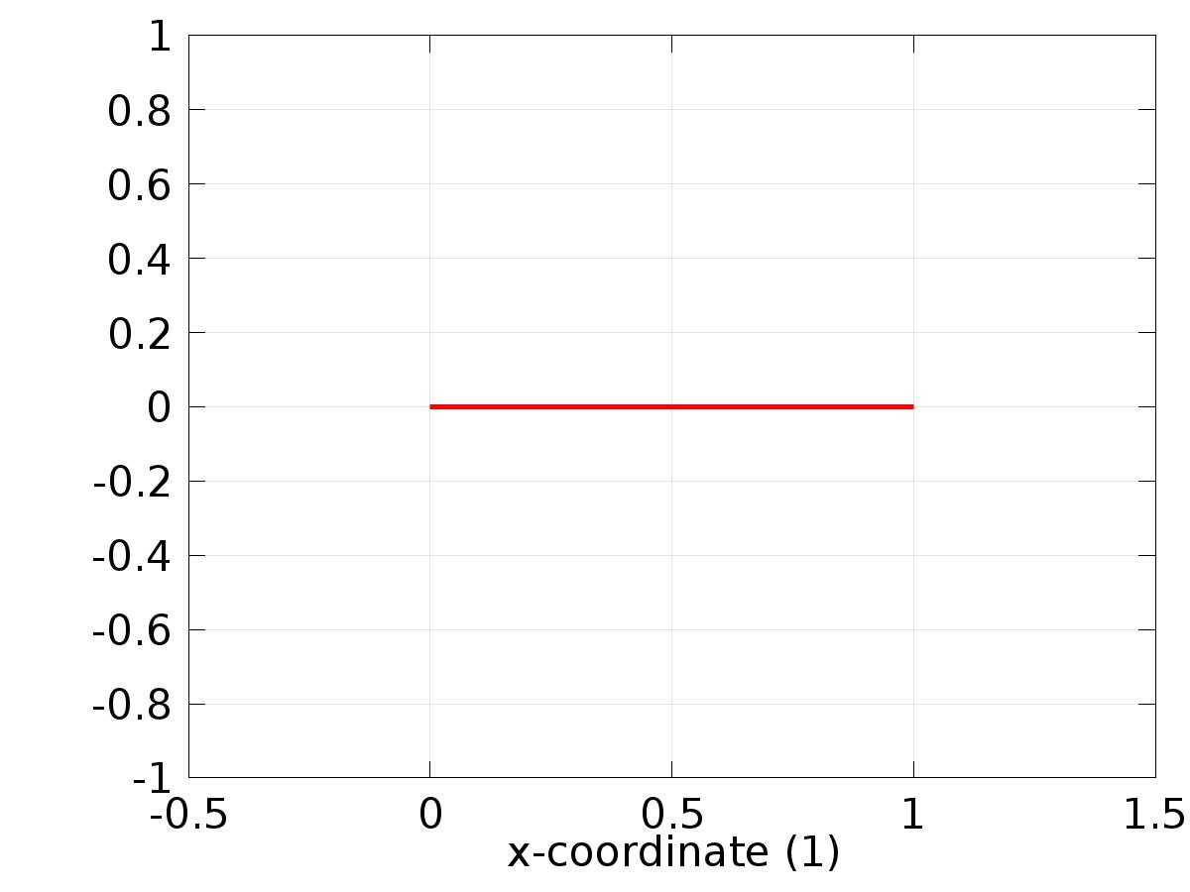

Data set: Solution 3

* 1. Derived Values
     1. Global Evaluation 1

Data

| **Description** | **Value** |
| --- | --- |
| Data set | Solution 3 |

Expression

| **Description** | **Value** |
| --- | --- |
| Expression | d |

* 1. Tables
     1. Table 1

Global Evaluation 1 (C1(z))

Table 1

| **Time (s)** | **C1(z)** | **yr1** | **C2(z)** | **yr2** | **u1** | **u2** | **e1** | **e2** | **d** |
| --- | --- | --- | --- | --- | --- | --- | --- | --- | --- |
| 0.0000 | 0.96880 | 1.0000 | 0.73249 | 0.50000 | 93.785 | -149.96 | 0.031199 | -0.23249 | 0.75000 |
| 0.50000 | 1.0000 | 1.0000 | 0.50003 | 0.50000 | 4.8184 | -7.4478 | -6.4185E-6 | -2.7168E-5 | 0.75000 |
| 1.0000 | 1.0000 | 1.0000 | 0.50000 | 0.50000 | 4.8184 | -7.4482 | -4.0948E-8 | -1.8677E-7 | 0.75000 |
| 1.5000 | 1.0000 | 1.0000 | 0.50000 | 0.50000 | 4.8184 | -7.4482 | -4.4170E-9 | -2.0147E-8 | 0.75000 |
| 2.0000 | 1.0000 | 1.0000 | 0.50000 | 0.50000 | 4.8184 | -7.4482 | -1.7687E-9 | -8.0676E-9 | 0.75000 |
| 2.5000 | 1.0000 | 1.0000 | 0.50000 | 0.50000 | 4.8184 | -7.4482 | -2.5932E-10 | -1.1828E-9 | 0.75000 |
| 3.0000 | 1.0000 | 1.0000 | 0.50000 | 0.50000 | 4.8184 | -7.4482 | -1.7630E-10 | -8.0417E-10 | 0.75000 |
| 3.5000 | 1.0000 | 1.0000 | 0.50000 | 0.50000 | 4.8184 | -7.4482 | -9.3280E-11 | -4.2551E-10 | 0.75000 |
| 4.0000 | 1.0000 | 1.0000 | 0.50000 | 0.50000 | 4.8184 | -7.4482 | -1.0263E-11 | -4.6856E-11 | 0.75000 |
| 4.5000 | 1.0000 | 1.0000 | 0.50000 | 0.50000 | 4.8184 | -7.4482 | -7.9656E-12 | -3.6378E-11 | 0.75000 |
| 5.0000 | 1.0000 | 1.0000 | 0.50000 | 0.50000 | 4.8184 | -7.4482 | -6.6440E-12 | -3.0349E-11 | 0.75000 |
| 5.5000 | 1.0000 | 1.0000 | 0.50000 | 0.50000 | 4.8184 | -7.4482 | -5.3222E-12 | -2.4320E-11 | 0.75000 |
| 6.0000 | 1.0000 | 1.0000 | 0.50000 | 0.50000 | 4.8184 | -7.4482 | -4.0001E-12 | -1.8290E-11 | 0.75000 |
| 6.5000 | 1.0000 | 1.0000 | 0.50000 | 0.50000 | 4.8184 | -7.4482 | -2.6783E-12 | -1.2261E-11 | 0.75000 |
| 7.0000 | 1.0000 | 1.0000 | 0.50000 | 0.50000 | 4.8184 | -7.4482 | -1.3565E-12 | -6.2316E-12 | 0.75000 |
| 7.5000 | 1.0000 | 1.0000 | 0.50000 | 0.50000 | 4.8184 | -7.4482 | -1.3478E-13 | -6.5870E-13 | 0.75000 |
| 8.0000 | 1.0000 | 1.0000 | 0.50000 | 0.50000 | 4.8184 | -7.4482 | -1.2412E-13 | -6.1029E-13 | 0.75000 |
| 8.5000 | 1.0000 | 1.0000 | 0.50000 | 0.50000 | 4.8184 | -7.4482 | -1.1346E-13 | -5.6188E-13 | 0.75000 |
| 9.0000 | 1.0000 | 1.0000 | 0.50000 | 0.50000 | 4.8184 | -7.4482 | -1.0281E-13 | -5.1337E-13 | 0.75000 |
| 9.5000 | 1.0000 | 1.0000 | 0.50000 | 0.50000 | 4.8184 | -7.4482 | -9.2371E-14 | -4.6507E-13 | 0.75000 |
| 10.000 | 1.0000 | 1.0000 | 0.50000 | 0.50000 | 4.8184 | -7.4482 | -8.1490E-14 | -4.1656E-13 | 0.75000 |
| 10.500 | 1.0000 | 1.0000 | 0.50000 | 0.50000 | 4.8184 | -7.4482 | -7.1054E-14 | -3.6826E-13 | 0.75000 |
| 11.000 | 1.0000 | 1.0000 | 0.50000 | 0.50000 | 4.8184 | -7.4482 | -6.0396E-14 | -3.1974E-13 | 0.75000 |
| 11.500 | 1.0000 | 1.0000 | 0.50000 | 0.50000 | 4.8184 | -7.4482 | -4.9738E-14 | -2.7145E-13 | 0.75000 |
| 12.000 | 1.0000 | 1.0000 | 0.50000 | 0.50000 | 4.8184 | -7.4482 | -3.9080E-14 | -2.2293E-13 | 0.75000 |
| 12.500 | 1.0000 | 1.0000 | 0.50000 | 0.50000 | 4.8184 | -7.4482 | -2.8644E-14 | -1.7453E-13 | 0.75000 |
| 13.000 | 1.0000 | 1.0000 | 0.50000 | 0.50000 | 4.8184 | -7.4482 | -1.7986E-14 | -1.2612E-13 | 0.75000 |
| 13.500 | 1.0000 | 1.0000 | 0.50000 | 0.50000 | 4.8184 | -7.4482 | -7.3275E-15 | -7.7605E-14 | 0.75000 |
| 14.000 | 1.00000 | 1.0000 | 0.50000 | 0.50000 | 4.8184 | -7.4482 | 3.2196E-15 | -2.9310E-14 | 0.75000 |
| 14.500 | 1.00000 | 1.0000 | 0.50000 | 0.50000 | 4.8184 | -7.4482 | 1.1213E-14 | 7.1054E-15 | 0.75000 |
| 15.000 | 1.00000 | 1.0000 | 0.50000 | 0.50000 | 4.8184 | -7.4482 | 1.1324E-14 | 7.9381E-15 | 0.75000 |
| 15.500 | 1.00000 | 1.0000 | 0.50000 | 0.50000 | 4.8184 | -7.4482 | 1.1768E-14 | 8.7708E-15 | 0.75000 |
| 16.000 | 1.00000 | 1.0000 | 0.50000 | 0.50000 | 4.8184 | -7.4482 | 1.1990E-14 | 9.5479E-15 | 0.75000 |
| 16.500 | 1.00000 | 1.0000 | 0.50000 | 0.50000 | 4.8184 | -7.4482 | 1.2101E-14 | 1.0381E-14 | 0.75000 |
| 17.000 | 1.00000 | 1.0000 | 0.50000 | 0.50000 | 4.8184 | -7.4482 | 1.2323E-14 | 1.1269E-14 | 0.75000 |
| 17.500 | 1.00000 | 1.0000 | 0.50000 | 0.50000 | 4.8184 | -7.4482 | 1.2546E-14 | 1.1990E-14 | 0.75000 |
| 18.000 | 1.00000 | 1.0000 | 0.50000 | 0.50000 | 4.8184 | -7.4482 | 1.2657E-14 | 1.2546E-14 | 0.75000 |
| 18.500 | 1.00000 | 1.0000 | 0.50000 | 0.50000 | 4.8184 | -7.4482 | 1.2657E-14 | 1.2546E-14 | 0.75000 |
| 19.000 | 1.00000 | 1.0000 | 0.50000 | 0.50000 | 4.8184 | -7.4482 | 1.2879E-14 | 1.2546E-14 | 0.75000 |
| 19.500 | 1.00000 | 1.0000 | 0.50000 | 0.50000 | 4.8184 | -7.4482 | 1.2879E-14 | 1.2546E-14 | 0.75000 |
| 20.000 | 1.00000 | 1.0000 | 0.50000 | 0.50000 | 4.8184 | -7.4482 | 1.2879E-14 | 1.2546E-14 | 0.75000 |
| 20.500 | 1.00000 | 1.0000 | 0.50000 | 0.50000 | 4.8184 | -7.4482 | 1.2657E-14 | 1.2490E-14 | 0.75000 |
| 21.000 | 1.00000 | 1.0000 | 0.50000 | 0.50000 | 4.8184 | -7.4482 | 1.2657E-14 | 1.2490E-14 | 0.75000 |
| 21.500 | 1.00000 | 1.0000 | 0.50000 | 0.50000 | 4.8184 | -7.4482 | 1.2546E-14 | 1.2379E-14 | 0.75000 |
| 22.000 | 1.00000 | 1.0000 | 0.50000 | 0.50000 | 4.8184 | -7.4482 | 1.2546E-14 | 1.2268E-14 | 0.75000 |
| 22.500 | 1.00000 | 1.0000 | 0.50000 | 0.50000 | 4.8184 | -7.4482 | 1.2323E-14 | 1.2268E-14 | 0.75000 |
| 23.000 | 1.00000 | 1.0000 | 0.50000 | 0.50000 | 4.8184 | -7.4482 | 1.2323E-14 | 1.2212E-14 | 0.75000 |
| 23.500 | 1.00000 | 1.0000 | 0.50000 | 0.50000 | 4.8184 | -7.4482 | 1.2323E-14 | 1.2212E-14 | 0.75000 |
| 24.000 | 1.00000 | 1.0000 | 0.50000 | 0.50000 | 4.8184 | -7.4482 | 1.8764E-7 | -8.0280E-8 | 0.75000 |
| 24.500 | 0.97577 | 0.97412 | 0.50126 | 0.50000 | 3.6583 | -6.3676 | -0.0016480 | -0.0012624 | 0.75000 |
| 25.000 | 0.87770 | 0.87500 | 0.50203 | 0.50000 | 0.56165 | -2.8385 | -0.0026983 | -0.0020321 | 0.75000 |
| 25.500 | 0.77728 | 0.77588 | 0.50104 | 0.50000 | -1.3257 | 0.21164 | -0.0013975 | -0.0010358 | 0.75000 |
| 26.000 | 0.74999 | 0.75000 | 0.49999 | 0.50000 | -1.6201 | 0.88202 | 1.1375E-5 | 7.0204E-6 | 0.75000 |
| 26.500 | 0.75000 | 0.75000 | 0.50000 | 0.50000 | -1.6207 | 0.88264 | -7.3826E-10 | -9.5779E-10 | 0.75000 |
| 27.000 | 0.75000 | 0.75000 | 0.50000 | 0.50000 | -1.6207 | 0.88264 | -8.0396E-12 | -1.1192E-11 | 0.75000 |
| 27.500 | 0.75000 | 0.75000 | 0.50000 | 0.50000 | -1.6207 | 0.88264 | 2.9954E-13 | 3.5472E-13 | 0.75000 |
| 28.000 | 0.75000 | 0.75000 | 0.50000 | 0.50000 | -1.6207 | 0.88264 | 1.1235E-13 | 1.3417E-13 | 0.75000 |
| 28.500 | 0.75000 | 0.75000 | 0.50000 | 0.50000 | -1.6207 | 0.88264 | 2.7756E-15 | 5.1070E-15 | 0.75000 |
| 29.000 | 0.75000 | 0.75000 | 0.50000 | 0.50000 | -1.6207 | 0.88264 | 7.7716E-16 | 2.6645E-15 | 0.75000 |
| 29.500 | 0.75000 | 0.75000 | 0.50000 | 0.50000 | -1.6207 | 0.88264 | -1.2212E-15 | 2.2204E-16 | 0.75000 |
| 30.000 | 0.75000 | 0.75000 | 0.50000 | 0.50000 | -1.6207 | 0.88264 | -3.1086E-15 | -2.1094E-15 | 0.75000 |
| 30.500 | 0.75000 | 0.75000 | 0.50000 | 0.50000 | -1.6207 | 0.88264 | -4.8850E-15 | -4.3299E-15 | 0.75000 |
| 31.000 | 0.75000 | 0.75000 | 0.50000 | 0.50000 | -1.6207 | 0.88264 | -4.8850E-15 | -4.3299E-15 | 0.75000 |
| 31.500 | 0.75000 | 0.75000 | 0.50000 | 0.50000 | -1.6207 | 0.88264 | -4.8850E-15 | -4.3299E-15 | 0.75000 |
| 32.000 | 0.75000 | 0.75000 | 0.50000 | 0.50000 | -1.6207 | 0.88264 | -4.8850E-15 | -4.3299E-15 | 0.75000 |
| 32.500 | 0.75000 | 0.75000 | 0.50000 | 0.50000 | -1.6207 | 0.88264 | -4.8850E-15 | -4.3299E-15 | 0.75000 |
| 33.000 | 0.75000 | 0.75000 | 0.50000 | 0.50000 | -1.6207 | 0.88264 | -4.8850E-15 | -4.3299E-15 | 0.75000 |
| 33.500 | 0.75000 | 0.75000 | 0.50000 | 0.50000 | -1.6207 | 0.88264 | -4.8850E-15 | -4.3299E-15 | 0.75000 |
| 34.000 | 0.75000 | 0.75000 | 0.50000 | 0.50000 | -1.6207 | 0.88264 | -4.8850E-15 | -4.3299E-15 | 0.75000 |
| 34.500 | 0.75000 | 0.75000 | 0.50000 | 0.50000 | -1.6207 | 0.88264 | -4.8850E-15 | -4.3299E-15 | 0.75000 |
| 35.000 | 0.75000 | 0.75000 | 0.50000 | 0.50000 | -1.6207 | 0.88264 | -4.8850E-15 | -4.3299E-15 | 0.75000 |
| 35.500 | 0.75000 | 0.75000 | 0.50000 | 0.50000 | -1.6207 | 0.88264 | -4.8850E-15 | -4.2188E-15 | 0.75000 |
| 36.000 | 0.75000 | 0.75000 | 0.50000 | 0.50000 | -1.6207 | 0.88264 | -4.7740E-15 | -4.1078E-15 | 0.75000 |
| 36.500 | 0.75000 | 0.75000 | 0.50000 | 0.50000 | -1.6207 | 0.88264 | -4.7740E-15 | -4.1078E-15 | 0.75000 |
| 37.000 | 0.75000 | 0.75000 | 0.50000 | 0.50000 | -1.6207 | 0.88264 | -4.7740E-15 | -3.9968E-15 | 0.75000 |
| 37.500 | 0.75000 | 0.75000 | 0.50000 | 0.50000 | -1.6207 | 0.88264 | -4.8850E-15 | -4.1078E-15 | 0.75000 |
| 38.000 | 0.75000 | 0.75000 | 0.50000 | 0.50000 | -1.6207 | 0.88264 | -4.9960E-15 | -4.1078E-15 | 0.75000 |
| 38.500 | 0.75000 | 0.75000 | 0.50000 | 0.50000 | -1.6207 | 0.88264 | -4.9960E-15 | -3.9968E-15 | 0.75000 |
| 39.000 | 0.75000 | 0.75000 | 0.50000 | 0.50000 | -1.6207 | 0.88262 | -5.4778E-8 | 8.9153E-7 | 0.75000 |
| 39.500 | 0.75038 | 0.75000 | 0.47514 | 0.47412 | -1.5187 | 0.26167 | -3.7712E-4 | -0.0010233 | 0.75000 |
| 40.000 | 0.75069 | 0.75000 | 0.37681 | 0.37500 | -1.1172 | -1.5844 | -6.8546E-4 | -0.0018063 | 0.75000 |
| 40.500 | 0.75040 | 0.75000 | 0.27689 | 0.27588 | -0.70304 | -3.0811 | -3.9528E-4 | -0.0010126 | 0.75000 |
| 41.000 | 0.75000 | 0.75000 | 0.25000 | 0.25000 | -0.58899 | -3.3631 | -2.4915E-7 | -1.3507E-7 | 0.75000 |
| 41.500 | 0.75000 | 0.75000 | 0.25000 | 0.25000 | -0.58897 | -3.3632 | -5.0602E-11 | -5.8436E-11 | 0.75000 |
| 42.000 | 0.75000 | 0.75000 | 0.25000 | 0.25000 | -0.58897 | -3.3632 | -3.7917E-12 | -4.5520E-12 | 0.75000 |
| 42.500 | 0.75000 | 0.75000 | 0.25000 | 0.25000 | -0.58897 | -3.3632 | -6.1584E-13 | -7.3747E-13 | 0.75000 |
| 43.000 | 0.75000 | 0.75000 | 0.25000 | 0.25000 | -0.58897 | -3.3632 | -3.9746E-14 | -4.5575E-14 | 0.75000 |
| 43.500 | 0.75000 | 0.75000 | 0.25000 | 0.25000 | -0.58897 | -3.3632 | -2.3093E-14 | -2.5535E-14 | 0.75000 |
| 44.000 | 0.75000 | 0.75000 | 0.25000 | 0.25000 | -0.58897 | -3.3632 | -6.3283E-15 | -5.4956E-15 | 0.75000 |
| 44.500 | 0.75000 | 0.75000 | 0.25000 | 0.25000 | -0.58897 | -3.3632 | -3.5527E-15 | -1.9429E-15 | 0.75000 |
| 45.000 | 0.75000 | 0.75000 | 0.25000 | 0.25000 | -0.58897 | -3.3632 | -3.5527E-15 | -1.9429E-15 | 0.75000 |
| 45.500 | 0.75000 | 0.75000 | 0.25000 | 0.25000 | -0.58897 | -3.3632 | -3.5527E-15 | -1.9429E-15 | 0.75000 |
| 46.000 | 0.75000 | 0.75000 | 0.25000 | 0.25000 | -0.58897 | -3.3632 | -3.5527E-15 | -1.9429E-15 | 0.75000 |
| 46.500 | 0.75000 | 0.75000 | 0.25000 | 0.25000 | -0.58897 | -3.3632 | -3.5527E-15 | -1.9429E-15 | 0.75000 |
| 47.000 | 0.75000 | 0.75000 | 0.25000 | 0.25000 | -0.58897 | -3.3632 | -3.5527E-15 | -1.9429E-15 | 0.75000 |
| 47.500 | 0.75000 | 0.75000 | 0.25000 | 0.25000 | -0.58897 | -3.3632 | -3.5527E-15 | -1.9984E-15 | 0.75000 |
| 48.000 | 0.75000 | 0.75000 | 0.25000 | 0.25000 | -0.58897 | -3.3632 | -3.5527E-15 | -2.0539E-15 | 0.75000 |
| 48.500 | 0.75000 | 0.75000 | 0.25000 | 0.25000 | -0.58897 | -3.3632 | -3.6637E-15 | -2.1094E-15 | 0.75000 |
| 49.000 | 0.75000 | 0.75000 | 0.25000 | 0.25000 | -0.58931 | -3.3627 | -4.0494E-7 | -4.0421E-7 | 0.75000 |
| 49.500 | 0.75025 | 0.75000 | 0.25025 | 0.25000 | -0.79916 | -3.0477 | -2.4997E-4 | -2.5081E-4 | 0.77588 |
| 50.000 | 0.75045 | 0.75000 | 0.25045 | 0.25000 | -1.5118 | -1.8834 | -4.4788E-4 | -4.5160E-4 | 0.87500 |
| 50.500 | 0.75025 | 0.75000 | 0.25026 | 0.25000 | -2.1403 | -0.76108 | -2.5226E-4 | -2.5552E-4 | 0.97412 |
| 51.000 | 0.75000 | 0.75000 | 0.25000 | 0.25000 | -2.2807 | -0.47887 | 1.2598E-6 | 1.2080E-6 | 1.0000 |
| 51.500 | 0.75000 | 0.75000 | 0.25000 | 0.25000 | -2.2808 | -0.47880 | -1.7349E-9 | -2.1151E-9 | 1.0000 |
| 52.000 | 0.75000 | 0.75000 | 0.25000 | 0.25000 | -2.2808 | -0.47880 | 1.6077E-11 | 1.9088E-11 | 1.0000 |
| 52.500 | 0.75000 | 0.75000 | 0.25000 | 0.25000 | -2.2808 | -0.47880 | 5.4527E-12 | 6.5214E-12 | 1.0000 |
| 53.000 | 0.75000 | 0.75000 | 0.25000 | 0.25000 | -2.2808 | -0.47880 | 7.3719E-14 | 9.2398E-14 | 1.0000 |
| 53.500 | 0.75000 | 0.75000 | 0.25000 | 0.25000 | -2.2808 | -0.47880 | 4.9072E-14 | 6.2672E-14 | 1.0000 |
| 54.000 | 0.75000 | 0.75000 | 0.25000 | 0.25000 | -2.2808 | -0.47880 | 2.4536E-14 | 3.2918E-14 | 1.0000 |
| 54.500 | 0.75000 | 0.75000 | 0.25000 | 0.25000 | -2.2808 | -0.47880 | 0.0000 | 3.1641E-15 | 1.0000 |
| 55.000 | 0.75000 | 0.75000 | 0.25000 | 0.25000 | -2.2808 | -0.47880 | -8.1046E-15 | -6.5503E-15 | 1.0000 |
| 55.500 | 0.75000 | 0.75000 | 0.25000 | 0.25000 | -2.2808 | -0.47880 | -7.9936E-15 | -6.5503E-15 | 1.0000 |
| 56.000 | 0.75000 | 0.75000 | 0.25000 | 0.25000 | -2.2808 | -0.47880 | -7.9936E-15 | -6.5503E-15 | 1.0000 |
| 56.500 | 0.75000 | 0.75000 | 0.25000 | 0.25000 | -2.2808 | -0.47880 | -7.9936E-15 | -6.5503E-15 | 1.0000 |
| 57.000 | 0.75000 | 0.75000 | 0.25000 | 0.25000 | -2.2808 | -0.47880 | -7.9936E-15 | -6.5503E-15 | 1.0000 |
| 57.500 | 0.75000 | 0.75000 | 0.25000 | 0.25000 | -2.2808 | -0.47880 | -7.9936E-15 | -6.6058E-15 | 1.0000 |
| 58.000 | 0.75000 | 0.75000 | 0.25000 | 0.25000 | -2.2808 | -0.47880 | -7.9936E-15 | -6.6058E-15 | 1.0000 |
| 58.500 | 0.75000 | 0.75000 | 0.25000 | 0.25000 | -2.2808 | -0.47880 | -7.9936E-15 | -6.6058E-15 | 1.0000 |
| 59.000 | 0.75000 | 0.75000 | 0.25000 | 0.25000 | -2.2808 | -0.47880 | -8.1046E-15 | -6.6058E-15 | 1.0000 |
| 59.500 | 0.75000 | 0.75000 | 0.25000 | 0.25000 | -2.2808 | -0.47880 | -8.1046E-15 | -6.6613E-15 | 1.0000 |
| 60.000 | 0.75000 | 0.75000 | 0.25000 | 0.25000 | -2.2808 | -0.47880 | -8.1046E-15 | -6.6613E-15 | 1.0000 |
| 60.500 | 0.75000 | 0.75000 | 0.25000 | 0.25000 | -2.2808 | -0.47880 | -8.1046E-15 | -6.7168E-15 | 1.0000 |
| 61.000 | 0.75000 | 0.75000 | 0.25000 | 0.25000 | -2.2808 | -0.47880 | -8.1046E-15 | -6.7724E-15 | 1.0000 |
| 61.500 | 0.75000 | 0.75000 | 0.25000 | 0.25000 | -2.2808 | -0.47880 | -8.1046E-15 | -6.8279E-15 | 1.0000 |
| 62.000 | 0.75000 | 0.75000 | 0.25000 | 0.25000 | -2.2808 | -0.47880 | -8.2157E-15 | -6.8279E-15 | 1.0000 |
| 62.500 | 0.75000 | 0.75000 | 0.25000 | 0.25000 | -2.2808 | -0.47880 | -8.2157E-15 | -6.8834E-15 | 1.0000 |
| 63.000 | 0.75000 | 0.75000 | 0.25000 | 0.25000 | -2.2808 | -0.47880 | -8.2157E-15 | -6.9389E-15 | 1.0000 |
| 63.500 | 0.75000 | 0.75000 | 0.25000 | 0.25000 | -2.2808 | -0.47880 | -8.3267E-15 | -6.9389E-15 | 1.0000 |
| 64.000 | 0.75000 | 0.75000 | 0.25000 | 0.25000 | -2.2808 | -0.47880 | -8.3267E-15 | -6.9389E-15 | 1.0000 |
| 64.500 | 0.75000 | 0.75000 | 0.25000 | 0.25000 | -2.2808 | -0.47880 | -8.3267E-15 | -6.9944E-15 | 1.0000 |
| 65.000 | 0.75000 | 0.75000 | 0.25000 | 0.25000 | -2.2808 | -0.47880 | -8.4377E-15 | -7.0499E-15 | 1.0000 |
| 65.500 | 0.75000 | 0.75000 | 0.25000 | 0.25000 | -2.2808 | -0.47880 | -8.3267E-15 | -7.0499E-15 | 1.0000 |
| 66.000 | 0.75000 | 0.75000 | 0.25000 | 0.25000 | -2.2808 | -0.47880 | -8.2157E-15 | -6.9944E-15 | 1.0000 |
| 66.500 | 0.75000 | 0.75000 | 0.25000 | 0.25000 | -2.2808 | -0.47880 | -8.2157E-15 | -6.9389E-15 | 1.0000 |
| 67.000 | 0.75000 | 0.75000 | 0.25000 | 0.25000 | -2.2808 | -0.47880 | -8.1046E-15 | -6.9389E-15 | 1.0000 |
| 67.500 | 0.75000 | 0.75000 | 0.25000 | 0.25000 | -2.2808 | -0.47880 | -8.1046E-15 | -6.9389E-15 | 1.0000 |
| 68.000 | 0.75000 | 0.75000 | 0.25000 | 0.25000 | -2.2808 | -0.47880 | -7.9936E-15 | -6.8834E-15 | 1.0000 |
| 68.500 | 0.75000 | 0.75000 | 0.25000 | 0.25000 | -2.2808 | -0.47880 | -7.9936E-15 | -6.8279E-15 | 1.0000 |
| 69.000 | 0.75000 | 0.75000 | 0.25000 | 0.25000 | -2.2808 | -0.47880 | -7.8826E-15 | -6.8279E-15 | 1.0000 |
| 69.500 | 0.75000 | 0.75000 | 0.25000 | 0.25000 | -2.2808 | -0.47880 | -7.8826E-15 | -6.7168E-15 | 1.0000 |
| 70.000 | 0.75000 | 0.75000 | 0.25000 | 0.25000 | -2.2808 | -0.47880 | -7.9936E-15 | -6.6613E-15 | 1.0000 |
| 70.500 | 0.75000 | 0.75000 | 0.25000 | 0.25000 | -2.2808 | -0.47880 | -7.9936E-15 | -6.6058E-15 | 1.0000 |
| 71.000 | 0.75000 | 0.75000 | 0.25000 | 0.25000 | -2.2808 | -0.47880 | -7.8826E-15 | -6.5503E-15 | 1.0000 |
| 71.500 | 0.75000 | 0.75000 | 0.25000 | 0.25000 | -2.2808 | -0.47880 | -7.7716E-15 | -6.4948E-15 | 1.0000 |
| 72.000 | 0.75000 | 0.75000 | 0.25000 | 0.25000 | -2.2808 | -0.47880 | -7.7716E-15 | -6.3283E-15 | 1.0000 |
| 72.500 | 0.75000 | 0.75000 | 0.25000 | 0.25000 | -2.2808 | -0.47880 | -7.6605E-15 | -6.2172E-15 | 1.0000 |
| 73.000 | 0.75000 | 0.75000 | 0.25000 | 0.25000 | -2.2808 | -0.47880 | -7.6605E-15 | -6.0507E-15 | 1.0000 |
| 73.500 | 0.75000 | 0.75000 | 0.25000 | 0.25000 | -2.2808 | -0.47880 | -7.6605E-15 | -5.9952E-15 | 1.0000 |
| 74.000 | 0.75000 | 0.75000 | 0.25000 | 0.25000 | -2.2808 | -0.47884 | -6.0978E-7 | 2.2190E-7 | 1.0000 |
| 74.500 | 0.79894 | 0.80176 | 0.24795 | 0.25000 | -1.3902 | -2.2469 | 0.0028161 | 0.0020475 | 1.0000 |
| 75.000 | 0.99415 | 1.0000 | 0.24554 | 0.25000 | 3.1382 | -9.3826 | 0.0058515 | 0.0044562 | 1.0000 |
| 75.500 | 1.1941 | 1.1982 | 0.24663 | 0.25000 | 13.620 | -19.400 | 0.0041677 | 0.0033702 | 1.0000 |
| 76.000 | 1.2500 | 1.2500 | 0.25000 | 0.25000 | 18.469 | -22.835 | 1.5892E-6 | -2.0171E-7 | 1.0000 |
| 76.500 | 1.2500 | 1.2500 | 0.25000 | 0.25000 | 18.469 | -22.835 | -3.7401E-10 | -3.4904E-10 | 1.0000 |
| 77.000 | 1.2500 | 1.2500 | 0.25000 | 0.25000 | 18.469 | -22.835 | 7.9432E-12 | 8.8552E-12 | 1.0000 |
| 77.500 | 1.2500 | 1.2500 | 0.25000 | 0.25000 | 18.469 | -22.835 | 2.6905E-12 | 2.9932E-12 | 1.0000 |
| 78.000 | 1.2500 | 1.2500 | 0.25000 | 0.25000 | 18.469 | -22.835 | 2.0250E-13 | 2.1663E-13 | 1.0000 |
| 78.500 | 1.2500 | 1.2500 | 0.25000 | 0.25000 | 18.469 | -22.835 | 1.4677E-13 | 1.5443E-13 | 1.0000 |
| 79.000 | 1.2500 | 1.2500 | 0.25000 | 0.25000 | 18.469 | -22.835 | 9.1260E-14 | 9.2260E-14 | 1.0000 |
| 79.500 | 1.2500 | 1.2500 | 0.25000 | 0.25000 | 18.469 | -22.835 | 5.1514E-14 | 4.7851E-14 | 1.0000 |
| 80.000 | 1.2500 | 1.2500 | 0.25000 | 0.25000 | 18.469 | -22.835 | 5.1292E-14 | 4.7823E-14 | 1.0000 |
| 80.500 | 1.2500 | 1.2500 | 0.25000 | 0.25000 | 18.469 | -22.835 | 5.1070E-14 | 4.7823E-14 | 1.0000 |
| 81.000 | 1.2500 | 1.2500 | 0.25000 | 0.25000 | 18.469 | -22.835 | 5.0626E-14 | 4.7823E-14 | 1.0000 |
| 81.500 | 1.2500 | 1.2500 | 0.25000 | 0.25000 | 18.469 | -22.835 | 5.0404E-14 | 4.7823E-14 | 1.0000 |
| 82.000 | 1.2500 | 1.2500 | 0.25000 | 0.25000 | 18.469 | -22.835 | 5.0404E-14 | 4.7767E-14 | 1.0000 |
| 82.500 | 1.2500 | 1.2500 | 0.25000 | 0.25000 | 18.469 | -22.835 | 5.0182E-14 | 4.7767E-14 | 1.0000 |
| 83.000 | 1.2500 | 1.2500 | 0.25000 | 0.25000 | 18.469 | -22.835 | 5.0404E-14 | 4.7767E-14 | 1.0000 |
| 83.500 | 1.2500 | 1.2500 | 0.25000 | 0.25000 | 18.469 | -22.835 | 5.0404E-14 | 4.7767E-14 | 1.0000 |
| 84.000 | 1.2500 | 1.2500 | 0.25000 | 0.25000 | 18.469 | -22.835 | 5.0626E-14 | 4.7767E-14 | 1.0000 |
| 84.500 | 1.2500 | 1.2500 | 0.25000 | 0.25000 | 18.469 | -22.835 | 5.1070E-14 | 4.7767E-14 | 1.0000 |
| 85.000 | 1.2500 | 1.2500 | 0.25000 | 0.25000 | 18.469 | -22.835 | 5.1070E-14 | 4.7767E-14 | 1.0000 |
| 85.500 | 1.2500 | 1.2500 | 0.25000 | 0.25000 | 18.469 | -22.835 | 5.0848E-14 | 4.7767E-14 | 1.0000 |
| 86.000 | 1.2500 | 1.2500 | 0.25000 | 0.25000 | 18.469 | -22.835 | 5.0848E-14 | 4.7712E-14 | 1.0000 |
| 86.500 | 1.2500 | 1.2500 | 0.25000 | 0.25000 | 18.469 | -22.835 | 5.0626E-14 | 4.7712E-14 | 1.0000 |
| 87.000 | 1.2500 | 1.2500 | 0.25000 | 0.25000 | 18.469 | -22.835 | 5.0626E-14 | 4.7684E-14 | 1.0000 |
| 87.500 | 1.2500 | 1.2500 | 0.25000 | 0.25000 | 18.469 | -22.835 | 5.0404E-14 | 4.7684E-14 | 1.0000 |
| 88.000 | 1.2500 | 1.2500 | 0.25000 | 0.25000 | 18.469 | -22.835 | 5.0404E-14 | 4.7684E-14 | 1.0000 |
| 88.500 | 1.2500 | 1.2500 | 0.25000 | 0.25000 | 18.469 | -22.835 | 5.0404E-14 | 4.7629E-14 | 1.0000 |
| 89.000 | 1.2500 | 1.2500 | 0.25000 | 0.25000 | 18.469 | -22.835 | 3.3809E-8 | -9.0285E-7 | 1.0000 |
| 89.500 | 1.2493 | 1.2500 | 0.29972 | 0.30176 | 18.244 | -20.940 | 7.2798E-4 | 0.0020359 | 1.0000 |
| 90.000 | 1.2486 | 1.2500 | 0.49630 | 0.50000 | 17.632 | -15.437 | 0.0013668 | 0.0037024 | 1.0000 |
| 90.500 | 1.2492 | 1.2500 | 0.69606 | 0.69824 | 17.163 | -10.852 | 8.2636E-4 | 0.0021794 | 1.0000 |
| 91.000 | 1.2500 | 1.2500 | 0.75001 | 0.75000 | 17.109 | -9.8303 | -5.7365E-7 | -5.0815E-6 | 1.0000 |
| 91.500 | 1.2500 | 1.2500 | 0.75000 | 0.75000 | 17.108 | -9.8294 | 2.2996E-10 | 2.6780E-10 | 1.0000 |
| 92.000 | 1.2500 | 1.2500 | 0.75000 | 0.75000 | 17.108 | -9.8294 | 6.5388E-12 | 7.5765E-12 | 1.0000 |
| 92.500 | 1.2500 | 1.2500 | 0.75000 | 0.75000 | 17.108 | -9.8294 | 2.4134E-12 | 2.7862E-12 | 1.0000 |
| 93.000 | 1.2500 | 1.2500 | 0.75000 | 0.75000 | 17.108 | -9.8294 | 1.0059E-13 | 1.0059E-13 | 1.0000 |
| 93.500 | 1.2500 | 1.2500 | 0.75000 | 0.75000 | 17.108 | -9.8294 | 8.4599E-14 | 8.2490E-14 | 1.0000 |
| 94.000 | 1.2500 | 1.2500 | 0.75000 | 0.75000 | 17.108 | -9.8294 | 6.8612E-14 | 6.4393E-14 | 1.0000 |
| 94.500 | 1.2500 | 1.2500 | 0.75000 | 0.75000 | 17.108 | -9.8294 | 5.2625E-14 | 4.6185E-14 | 1.0000 |
| 95.000 | 1.2500 | 1.2500 | 0.75000 | 0.75000 | 17.108 | -9.8294 | 5.2403E-14 | 4.5963E-14 | 1.0000 |
| 95.500 | 1.2500 | 1.2500 | 0.75000 | 0.75000 | 17.108 | -9.8294 | 5.2625E-14 | 4.5963E-14 | 1.0000 |
| 96.000 | 1.2500 | 1.2500 | 0.75000 | 0.75000 | 17.108 | -9.8294 | 5.2847E-14 | 4.6074E-14 | 1.0000 |
| 96.500 | 1.2500 | 1.2500 | 0.75000 | 0.75000 | 17.108 | -9.8294 | 5.3069E-14 | 4.6074E-14 | 1.0000 |
| 97.000 | 1.2500 | 1.2500 | 0.75000 | 0.75000 | 17.108 | -9.8294 | 5.3069E-14 | 4.6074E-14 | 1.0000 |
| 97.500 | 1.2500 | 1.2500 | 0.75000 | 0.75000 | 17.108 | -9.8294 | 5.3069E-14 | 4.6074E-14 | 1.0000 |
| 98.000 | 1.2500 | 1.2500 | 0.75000 | 0.75000 | 17.108 | -9.8294 | 5.3291E-14 | 4.5963E-14 | 1.0000 |
| 98.500 | 1.2500 | 1.2500 | 0.75000 | 0.75000 | 17.108 | -9.8294 | 5.1958E-14 | 4.5075E-14 | 1.0000 |
| 99.000 | 1.2500 | 1.2500 | 0.75000 | 0.75000 | 17.109 | -9.8296 | 6.6502E-8 | 6.9929E-8 | 1.0000 |
| 99.500 | 1.2497 | 1.2500 | 0.74968 | 0.75000 | 17.791 | -10.117 | 3.0021E-4 | 3.1554E-4 | 0.97412 |
| 100.00 | 1.2494 | 1.2500 | 0.74937 | 0.75000 | 20.681 | -11.226 | 5.9748E-4 | 6.3196E-4 | 0.87500 |
| 100.50 | 1.2496 | 1.2500 | 0.74960 | 0.75000 | 24.010 | -12.367 | 3.7881E-4 | 4.0325E-4 | 0.77588 |
| 101.00 | 1.2500 | 1.2500 | 0.75000 | 0.75000 | 24.986 | -12.670 | 7.1547E-7 | 7.9905E-7 | 0.75000 |
| 101.50 | 1.2500 | 1.2500 | 0.75000 | 0.75000 | 24.987 | -12.670 | -9.7897E-8 | -1.1444E-7 | 0.75000 |
| 102.00 | 1.2500 | 1.2500 | 0.75000 | 0.75000 | 24.987 | -12.670 | -2.0290E-9 | -2.3619E-9 | 0.75000 |
| 102.50 | 1.2500 | 1.2500 | 0.75000 | 0.75000 | 24.987 | -12.670 | -2.6900E-11 | -3.0885E-11 | 0.75000 |
| 103.00 | 1.2500 | 1.2500 | 0.75000 | 0.75000 | 24.987 | -12.670 | -7.0079E-12 | -8.0510E-12 | 0.75000 |
| 103.50 | 1.2500 | 1.2500 | 0.75000 | 0.75000 | 24.987 | -12.670 | 8.4066E-13 | 9.5601E-13 | 0.75000 |
| 104.00 | 1.2500 | 1.2500 | 0.75000 | 0.75000 | 24.987 | -12.670 | 6.2195E-13 | 7.0077E-13 | 0.75000 |
| 104.50 | 1.2500 | 1.2500 | 0.75000 | 0.75000 | 24.987 | -12.670 | 4.0323E-13 | 4.4564E-13 | 0.75000 |
| 105.00 | 1.2500 | 1.2500 | 0.75000 | 0.75000 | 24.987 | -12.670 | 1.8452E-13 | 1.9051E-13 | 0.75000 |
| 105.50 | 1.2500 | 1.2500 | 0.75000 | 0.75000 | 24.987 | -12.670 | 8.8818E-14 | 7.8715E-14 | 0.75000 |
| 106.00 | 1.2500 | 1.2500 | 0.75000 | 0.75000 | 24.987 | -12.670 | 8.7264E-14 | 7.6938E-14 | 0.75000 |
| 106.50 | 1.2500 | 1.2500 | 0.75000 | 0.75000 | 24.987 | -12.670 | 8.5709E-14 | 7.5273E-14 | 0.75000 |
| 107.00 | 1.2500 | 1.2500 | 0.75000 | 0.75000 | 24.987 | -12.670 | 8.4155E-14 | 7.3608E-14 | 0.75000 |
| 107.50 | 1.2500 | 1.2500 | 0.75000 | 0.75000 | 24.987 | -12.670 | 8.2823E-14 | 7.1831E-14 | 0.75000 |
| 108.00 | 1.2500 | 1.2500 | 0.75000 | 0.75000 | 24.987 | -12.670 | 8.1268E-14 | 7.0055E-14 | 0.75000 |
| 108.50 | 1.2500 | 1.2500 | 0.75000 | 0.75000 | 24.987 | -12.670 | 7.9714E-14 | 6.8390E-14 | 0.75000 |
| 109.00 | 1.2500 | 1.2500 | 0.75000 | 0.75000 | 24.987 | -12.670 | 7.8160E-14 | 6.6724E-14 | 0.75000 |
| 109.50 | 1.2500 | 1.2500 | 0.75000 | 0.75000 | 24.987 | -12.670 | 7.7494E-14 | 6.5947E-14 | 0.75000 |
| 110.00 | 1.2500 | 1.2500 | 0.75000 | 0.75000 | 24.987 | -12.670 | 7.7494E-14 | 6.5947E-14 | 0.75000 |
| 110.50 | 1.2500 | 1.2500 | 0.75000 | 0.75000 | 24.987 | -12.670 | 7.7494E-14 | 6.6058E-14 | 0.75000 |
| 111.00 | 1.2500 | 1.2500 | 0.75000 | 0.75000 | 24.987 | -12.670 | 7.7272E-14 | 6.6058E-14 | 0.75000 |
| 111.50 | 1.2500 | 1.2500 | 0.75000 | 0.75000 | 24.987 | -12.670 | 7.7272E-14 | 6.6169E-14 | 0.75000 |
| 112.00 | 1.2500 | 1.2500 | 0.75000 | 0.75000 | 24.987 | -12.670 | 7.7272E-14 | 6.6169E-14 | 0.75000 |
| 112.50 | 1.2500 | 1.2500 | 0.75000 | 0.75000 | 24.987 | -12.670 | 7.7272E-14 | 6.6280E-14 | 0.75000 |
| 113.00 | 1.2500 | 1.2500 | 0.75000 | 0.75000 | 24.987 | -12.670 | 7.7272E-14 | 6.6280E-14 | 0.75000 |
| 113.50 | 1.2500 | 1.2500 | 0.75000 | 0.75000 | 24.987 | -12.670 | 7.7049E-14 | 6.6280E-14 | 0.75000 |
| 114.00 | 1.2500 | 1.2500 | 0.75000 | 0.75000 | 24.987 | -12.670 | 7.7049E-14 | 6.6280E-14 | 0.75000 |
| 114.50 | 1.2500 | 1.2500 | 0.75000 | 0.75000 | 24.987 | -12.670 | 7.7049E-14 | 6.6391E-14 | 0.75000 |
| 115.00 | 1.2500 | 1.2500 | 0.75000 | 0.75000 | 24.987 | -12.670 | 7.7049E-14 | 6.6502E-14 | 0.75000 |
| 115.50 | 1.2500 | 1.2500 | 0.75000 | 0.75000 | 24.987 | -12.670 | 7.7049E-14 | 6.6502E-14 | 0.75000 |
| 116.00 | 1.2500 | 1.2500 | 0.75000 | 0.75000 | 24.987 | -12.670 | 7.6827E-14 | 6.6613E-14 | 0.75000 |
| 116.50 | 1.2500 | 1.2500 | 0.75000 | 0.75000 | 24.987 | -12.670 | 7.6827E-14 | 6.6613E-14 | 0.75000 |
| 117.00 | 1.2500 | 1.2500 | 0.75000 | 0.75000 | 24.987 | -12.670 | 7.6827E-14 | 6.6724E-14 | 0.75000 |
| 117.50 | 1.2500 | 1.2500 | 0.75000 | 0.75000 | 24.987 | -12.670 | 7.7049E-14 | 6.6724E-14 | 0.75000 |
| 118.00 | 1.2500 | 1.2500 | 0.75000 | 0.75000 | 24.987 | -12.670 | 7.7272E-14 | 6.6835E-14 | 0.75000 |
| 118.50 | 1.2500 | 1.2500 | 0.75000 | 0.75000 | 24.987 | -12.670 | 7.7494E-14 | 6.6835E-14 | 0.75000 |
| 119.00 | 1.2500 | 1.2500 | 0.75000 | 0.75000 | 24.987 | -12.670 | 7.7716E-14 | 6.6835E-14 | 0.75000 |
| 119.50 | 1.2500 | 1.2500 | 0.75000 | 0.75000 | 24.987 | -12.670 | 7.7938E-14 | 6.6835E-14 | 0.75000 |
| 120.00 | 1.2500 | 1.2500 | 0.75000 | 0.75000 | 24.987 | -12.670 | 7.7938E-14 | 6.6835E-14 | 0.75000 |
| 120.50 | 1.2500 | 1.2500 | 0.75000 | 0.75000 | 24.987 | -12.670 | 7.8160E-14 | 6.6946E-14 | 0.75000 |
| 121.00 | 1.2500 | 1.2500 | 0.75000 | 0.75000 | 24.987 | -12.670 | 7.8382E-14 | 6.6946E-14 | 0.75000 |
| 121.50 | 1.2500 | 1.2500 | 0.75000 | 0.75000 | 24.987 | -12.670 | 7.8382E-14 | 6.6946E-14 | 0.75000 |
| 122.00 | 1.2500 | 1.2500 | 0.75000 | 0.75000 | 24.987 | -12.670 | 7.8382E-14 | 6.6835E-14 | 0.75000 |
| 122.50 | 1.2500 | 1.2500 | 0.75000 | 0.75000 | 24.987 | -12.670 | 7.8382E-14 | 6.6835E-14 | 0.75000 |
| 123.00 | 1.2500 | 1.2500 | 0.75000 | 0.75000 | 24.987 | -12.670 | 7.8160E-14 | 6.6724E-14 | 0.75000 |
| 123.50 | 1.2500 | 1.2500 | 0.75000 | 0.75000 | 24.987 | -12.670 | 7.6827E-14 | 6.5725E-14 | 0.75000 |
| 124.00 | 1.2500 | 1.2500 | 0.75000 | 0.75000 | 24.986 | -12.670 | 2.7872E-6 | -7.4835E-7 | 0.75000 |
| 124.50 | 1.2263 | 1.2241 | 0.75182 | 0.75000 | 21.235 | -11.308 | -0.0021854 | -0.0018223 | 0.75000 |
| 125.00 | 1.1285 | 1.1250 | 0.75283 | 0.75000 | 11.021 | -6.8115 | -0.0034840 | -0.0028350 | 0.75000 |
| 125.50 | 1.0276 | 1.0259 | 0.75139 | 0.75000 | 5.0183 | -2.9095 | -0.0017581 | -0.0013939 | 0.75000 |
| 126.00 | 0.99999 | 1.0000 | 0.74999 | 0.75000 | 3.9808 | -2.0305 | 6.1190E-6 | 5.5528E-6 | 0.75000 |
| 126.50 | 1.00000 | 1.0000 | 0.75000 | 0.75000 | 3.9804 | -2.0301 | 2.7407E-10 | 3.2895E-10 | 0.75000 |
| 127.00 | 1.00000 | 1.0000 | 0.75000 | 0.75000 | 3.9804 | -2.0301 | 1.6680E-12 | 2.1185E-12 | 0.75000 |
| 127.50 | 1.0000 | 1.0000 | 0.75000 | 0.75000 | 3.9804 | -2.0301 | -1.6565E-13 | -1.9706E-13 | 0.75000 |
| 128.00 | 1.0000 | 1.0000 | 0.75000 | 0.75000 | 3.9804 | -2.0301 | -6.1284E-14 | -7.5162E-14 | 0.75000 |
| 128.50 | 1.00000 | 1.0000 | 0.75000 | 0.75000 | 3.9804 | -2.0301 | 8.7708E-15 | 6.6613E-15 | 0.75000 |
| 129.00 | 1.00000 | 1.0000 | 0.75000 | 0.75000 | 3.9804 | -2.0301 | 9.6589E-15 | 7.5495E-15 | 0.75000 |
| 129.50 | 1.00000 | 1.0000 | 0.75000 | 0.75000 | 3.9804 | -2.0301 | 1.0436E-14 | 8.5487E-15 | 0.75000 |
| 130.00 | 1.00000 | 1.0000 | 0.75000 | 0.75000 | 3.9804 | -2.0301 | 1.1324E-14 | 9.3259E-15 | 0.75000 |
| 130.50 | 1.00000 | 1.0000 | 0.75000 | 0.75000 | 3.9804 | -2.0301 | 1.2323E-14 | 1.0325E-14 | 0.75000 |
| 131.00 | 1.00000 | 1.0000 | 0.75000 | 0.75000 | 3.9804 | -2.0301 | 1.2323E-14 | 1.0436E-14 | 0.75000 |
| 131.50 | 1.00000 | 1.0000 | 0.75000 | 0.75000 | 3.9804 | -2.0301 | 1.2323E-14 | 1.0547E-14 | 0.75000 |
| 132.00 | 1.00000 | 1.0000 | 0.75000 | 0.75000 | 3.9804 | -2.0301 | 1.2323E-14 | 1.0547E-14 | 0.75000 |
| 132.50 | 1.00000 | 1.0000 | 0.75000 | 0.75000 | 3.9804 | -2.0301 | 1.2323E-14 | 1.0547E-14 | 0.75000 |
| 133.00 | 1.00000 | 1.0000 | 0.75000 | 0.75000 | 3.9804 | -2.0301 | 1.2323E-14 | 1.0547E-14 | 0.75000 |
| 133.50 | 1.00000 | 1.0000 | 0.75000 | 0.75000 | 3.9804 | -2.0301 | 1.2323E-14 | 1.0658E-14 | 0.75000 |
| 134.00 | 1.00000 | 1.0000 | 0.75000 | 0.75000 | 3.9804 | -2.0301 | 1.2323E-14 | 1.0658E-14 | 0.75000 |
| 134.50 | 1.00000 | 1.0000 | 0.75000 | 0.75000 | 3.9804 | -2.0301 | 1.2323E-14 | 1.0769E-14 | 0.75000 |
| 135.00 | 1.00000 | 1.0000 | 0.75000 | 0.75000 | 3.9804 | -2.0301 | 1.2323E-14 | 1.0769E-14 | 0.75000 |
| 135.50 | 1.00000 | 1.0000 | 0.75000 | 0.75000 | 3.9804 | -2.0301 | 1.2323E-14 | 1.0658E-14 | 0.75000 |
| 136.00 | 1.00000 | 1.0000 | 0.75000 | 0.75000 | 3.9804 | -2.0301 | 1.2323E-14 | 1.0547E-14 | 0.75000 |
| 136.50 | 1.00000 | 1.0000 | 0.75000 | 0.75000 | 3.9804 | -2.0301 | 1.2101E-14 | 1.0547E-14 | 0.75000 |
| 137.00 | 1.00000 | 1.0000 | 0.75000 | 0.75000 | 3.9804 | -2.0301 | 1.2101E-14 | 1.0547E-14 | 0.75000 |
| 137.50 | 1.00000 | 1.0000 | 0.75000 | 0.75000 | 3.9804 | -2.0301 | 1.2101E-14 | 1.0547E-14 | 0.75000 |
| 138.00 | 1.00000 | 1.0000 | 0.75000 | 0.75000 | 3.9804 | -2.0301 | 1.2101E-14 | 1.0547E-14 | 0.75000 |
| 138.50 | 1.00000 | 1.0000 | 0.75000 | 0.75000 | 3.9804 | -2.0301 | 1.2101E-14 | 1.0547E-14 | 0.75000 |
| 139.00 | 1.0000 | 1.0000 | 0.75000 | 0.75000 | 3.9804 | -2.0301 | -7.8871E-8 | 3.7558E-6 | 0.75000 |
| 139.50 | 1.0004 | 1.0000 | 0.72519 | 0.72412 | 4.0755 | -2.7992 | -3.8558E-4 | -0.0010705 | 0.75000 |
| 140.00 | 1.0007 | 1.0000 | 0.62688 | 0.62500 | 4.4091 | -5.1431 | -7.0098E-4 | -0.0018823 | 0.75000 |
| 140.50 | 1.0004 | 1.0000 | 0.52693 | 0.52588 | 4.7366 | -7.0663 | -4.0434E-4 | -0.0010522 | 0.75000 |
| 141.00 | 1.0000 | 1.0000 | 0.50000 | 0.50000 | 4.8184 | -7.4481 | -7.7579E-8 | 1.4182E-6 | 0.75000 |
| 141.50 | 1.00000 | 1.0000 | 0.50000 | 0.50000 | 4.8184 | -7.4482 | 3.4667E-10 | 7.3478E-10 | 0.75000 |
| 142.00 | 1.0000 | 1.0000 | 0.50000 | 0.50000 | 4.8184 | -7.4482 | -2.1174E-11 | -2.5315E-11 | 0.75000 |
| 142.50 | 1.0000 | 1.0000 | 0.50000 | 0.50000 | 4.8184 | -7.4482 | -2.1860E-12 | -2.6337E-12 | 0.75000 |
| 143.00 | 1.0000 | 1.0000 | 0.50000 | 0.50000 | 4.8184 | -7.4482 | -4.8650E-13 | -5.9708E-13 | 0.75000 |
| 143.50 | 1.0000 | 1.0000 | 0.50000 | 0.50000 | 4.8184 | -7.4482 | -2.3026E-13 | -2.8388E-13 | 0.75000 |
| 144.00 | 1.00000 | 1.0000 | 0.50000 | 0.50000 | 4.8184 | -7.4482 | 8.7708E-15 | 7.9381E-15 | 0.75000 |
| 144.50 | 1.00000 | 1.0000 | 0.50000 | 0.50000 | 4.8184 | -7.4482 | 9.4369E-15 | 8.7153E-15 | 0.75000 |
| 145.00 | 1.00000 | 1.0000 | 0.50000 | 0.50000 | 4.8184 | -7.4482 | 1.0103E-14 | 9.4369E-15 | 0.75000 |
| 145.50 | 1.00000 | 1.0000 | 0.50000 | 0.50000 | 4.8184 | -7.4482 | 1.0769E-14 | 1.0214E-14 | 0.75000 |
| 146.00 | 1.00000 | 1.0000 | 0.50000 | 0.50000 | 4.8184 | -7.4482 | 1.1324E-14 | 1.0991E-14 | 0.75000 |
| 146.50 | 1.00000 | 1.0000 | 0.50000 | 0.50000 | 4.8184 | -7.4482 | 1.2101E-14 | 1.1713E-14 | 0.75000 |
| 147.00 | 1.00000 | 1.0000 | 0.50000 | 0.50000 | 4.8184 | -7.4482 | 1.2546E-14 | 1.2212E-14 | 0.75000 |
| 147.50 | 1.00000 | 1.0000 | 0.50000 | 0.50000 | 4.8184 | -7.4482 | 1.2546E-14 | 1.2101E-14 | 0.75000 |
| 148.00 | 1.00000 | 1.0000 | 0.50000 | 0.50000 | 4.8184 | -7.4482 | 1.2546E-14 | 1.2101E-14 | 0.75000 |
| 148.50 | 1.00000 | 1.0000 | 0.50000 | 0.50000 | 4.8184 | -7.4482 | 1.2546E-14 | 1.2101E-14 | 0.75000 |
| 149.00 | 1.00000 | 1.0000 | 0.50000 | 0.50000 | 4.8184 | -7.4482 | 1.2546E-14 | 1.2101E-14 | 0.75000 |
| 149.50 | 1.00000 | 1.0000 | 0.50000 | 0.50000 | 4.8184 | -7.4482 | 1.2546E-14 | 1.1990E-14 | 0.75000 |
| 150.00 | 1.00000 | 1.0000 | 0.50000 | 0.50000 | 4.8184 | -7.4482 | 1.2546E-14 | 1.1990E-14 | 0.75000 |

* 1. Plot Groups
     1. 1D Plot Group 1

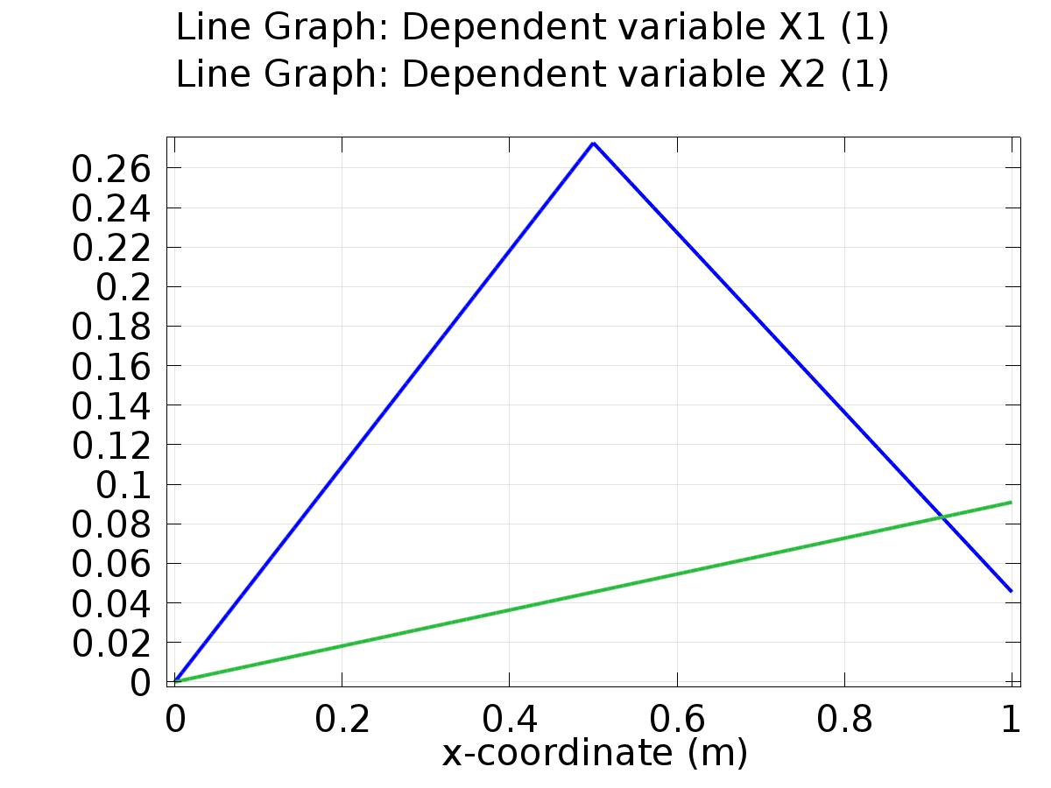

Line Graph: Dependent variable X1 (1) Line Graph: Dependent variable X2 (1)

* + 1. 1D Plot Group 2

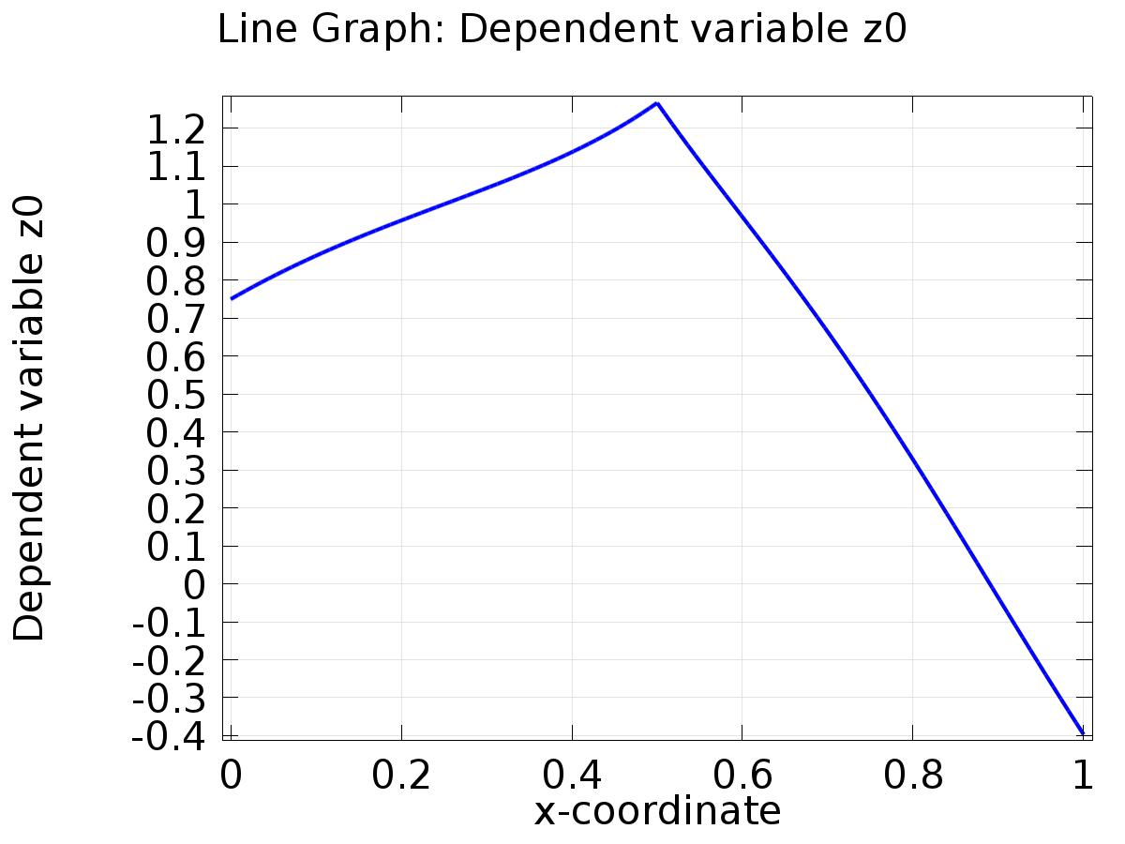

Line Graph: Dependent variable z0

* + 1. 1D Plot Group 3

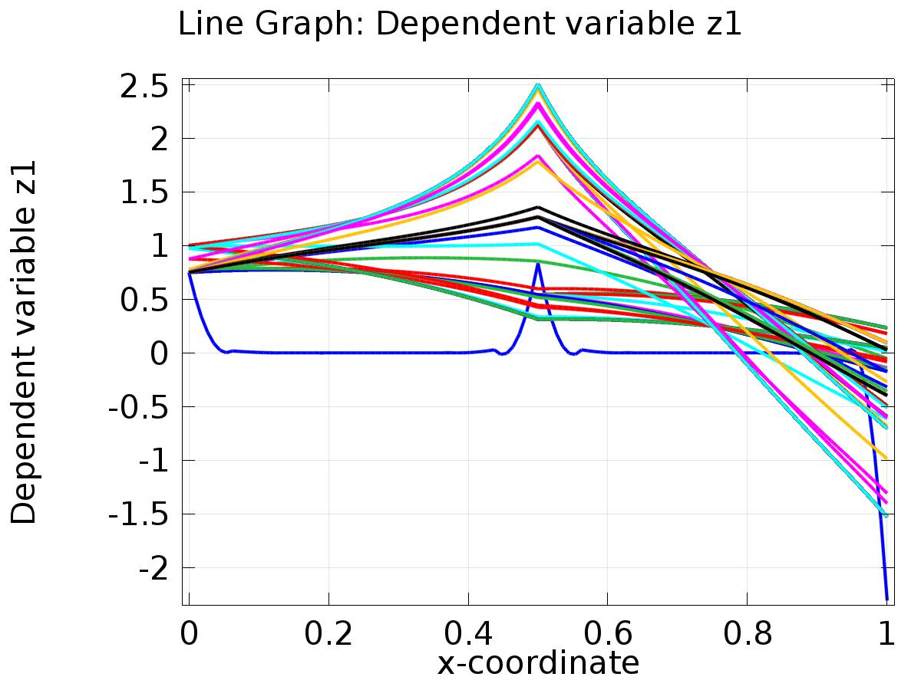

Line Graph: Dependent variable z1

* + 1. 1D Plot Group 4

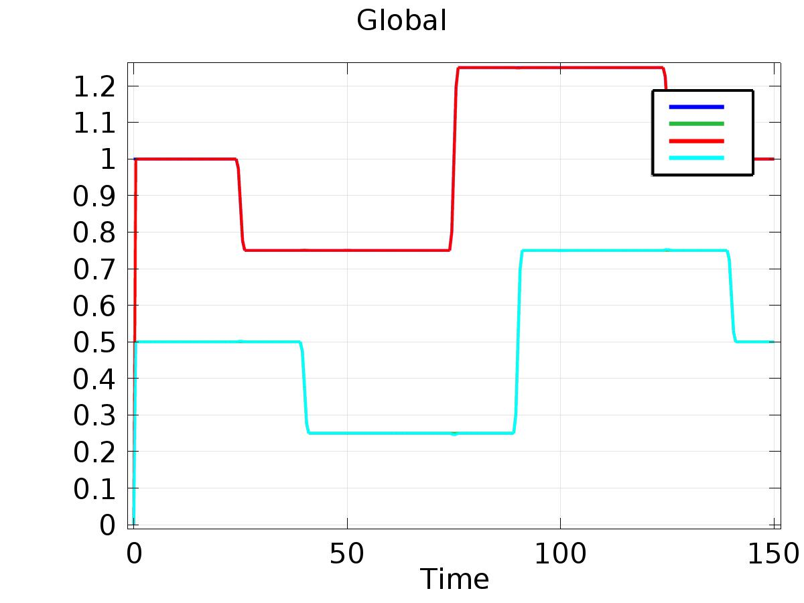

Global

* + 1. 1D Plot Group 5

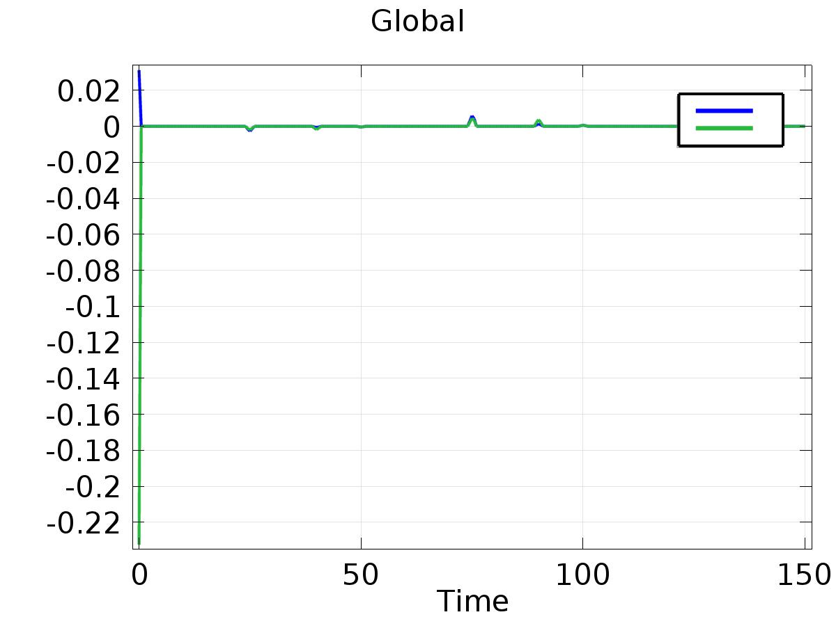

Global