[](http://www.comsol.com/)

Ch4 Ex4.5 NLFourierSeries Burger exportdata

|  |  |
| --- | --- |
| Date | Apr 27, 2014 4:40:49 PM |

Contents

1. Global

1.1. Definitions

2. Model 1

2.1. Definitions

2.2. Geometry 1

2.3. Unit input

2.4. Regulator Equation PI0

2.5. Regulator Equation PI1

2.6. Regulator Equation PI2

2.7. Regulator Equation PI3

2.8. Regulator Equation PI4

2.9. Regulator Equation PI5

2.10. Closed Loop System

2.11. Mesh 1

3. Study 1

3.1. Stationary

3.2. Solver Configurations

4. Study 2

4.1. Stationary

4.2. Solver Configurations

5. Study 3

5.1. Time Dependent

5.2. Solver Configurations

6. Results

6.1. Data Sets

6.2. Derived Values

6.3. Tables

6.4. Plot Groups

1. Global

|  |  |
| --- | --- |
| Date | Oct 14, 2013 11:45:18 AM |

Global settings

|  |  |
| --- | --- |
| Name | Ch4 Ex4.5 NLFourierSeries Burger exportdata.mph |
| Path | /Users/gilliam/Desktop/collect_15/research_15/geo_reg_mono_eugenio/Mono_1_15/Comsol_EX_GitHub/Chapter4/Example4.5/Ch4_Ex4.5_NLFourierSeries_Burger_exportdata.mph |
| Program | COMSOL 4.4 (Build: 150) |

Used products

|  |
| --- |
| COMSOL Multiphysics |

* 1. Definitions
     1. Parameters 1

Parameters

| **Name** | **Expression** | **Value** | **Description** |
| --- | --- | --- | --- |
| L | 1 | 1.0000 |  |
| x0 | 0.5 | 0.50000 |  |
| M1 | 0.5 | 0.50000 |  |
| A1 | 0.25 | 0.25000 |  |
| alpha | pi | 3.1416 |  |
| alpha1 | 2*alpha | 6.2832 |  |
| M2 | 0.75 | 0.75000 |  |
| A2 | 1. | 1.0000 |  |
| alpha2 | alpha | 3.1416 |  |
| N | 5 | 5.0000 |  |

1. Model 1

Component settings

|  |  |
| --- | --- |
| Unit system | None |

* 1. Definitions
     1. Variables

#### Variables 1

Selection

|  |  |
| --- | --- |
| Geometric entity level | Entire model |

| **Name** | **Expression** | **Description** |
| --- | --- | --- |
| f_a0 | -0.5*d(0.5*a0*a0 + a1*a1 + a2*a2 + a3*a3 + a4*a4 + a5*a5 + b1*b1 + b2*b2 + b3*b3 + b4*b4 + b5*b5, x) |  |
| f_a1 | -0.5*d(a0*a1 + 0.5*a1*a2 + 0.5*a2*a1 + 0.5*a2*a3 + 0.5*a3*a2 + 0.5*a3*a4 + 0.5*a4*a3 + 0.5*a4*a5 + 0.5*a5*a4 + 0.5*b1*b2 + 0.5*b2*b1 + 0.5*b2*b3 + 0.5*b3*b2 + 0.5*b3*b4 + 0.5*b4*b3 + 0.5*b4*b5 + 0.5*b5*b4, x)*(N>0) |  |
| f_b1 | -0.5*d(a0*b1 + a1*b2 - a2*b1 + a2*b3 - a3*b2 + a3*b4 - a4*b3 + a4*b5 - a5*b4, x)*(N>0) |  |
| f_a2 | -0.5*d(a0*a2 + 0.5*a1*a1 + 0.5*a1*a3 + 0.5*a2*a4 + 0.5*a3*a1 + 0.5*a3*a5 + 0.5*a4*a2 + 0.5*a5*a3 - 0.5*b1*b1 + 0.5*b1*b3 + 0.5*b2*b4 + 0.5*b3*b1 + 0.5*b3*b5 + 0.5*b4*b2 + 0.5*b5*b3, x)*(N>1) |  |
| f_b2 | -0.5*d(a0*b2 + a1*b1 + a1*b3 + a2*b4 - a3*b1 + a3*b5 - a4*b2 - a5*b3, x)*(N>1) |  |
| f_a3 | -0.5*d(a0*a3 + 0.5*a1*a2 + 0.5*a1*a4 + 0.5*a2*a1 + 0.5*a2*a5 + 0.5*a4*a1 + 0.5*a5*a2 - 0.5*b1*b2 + 0.5*b1*b4 - 0.5*b2*b1 + 0.5*b2*b5 + 0.5*b4*b1 + 0.5*b5*b2, x)*(N>2) |  |
| f_b3 | -0.5*d(a0*b3 + a1*b2 + a1*b4 + a2*b1 + a2*b5 - a4*b1 - a5*b2, x)*(N>2) |  |
| f_a4 | -0.5*d(a0*a4 + 0.5*a1*a3 + 0.5*a1*a5 + 0.5*a2*a2 + 0.5*a3*a1 + 0.5*a5*a1 - 0.5*b1*b3 + 0.5*b1*b5 - 0.5*b2*b2 - 0.5*b3*b1 + 0.5*b5*b1, x)*(N>3) |  |
| f_b4 | -0.5*d(a0*b4 + a1*b3 + a1*b5 + a2*b2 + a3*b1 - a5*b1, x)*(N>3) |  |
| f_a5 | -0.5*d(a0*a5 + 0.5*a1*a4 + 0.5*a2*a3 + 0.5*a3*a2 + 0.5*a4*a1 - 0.5*b1*b4 - 0.5*b2*b3 - 0.5*b3*b2 - 0.5*b4*b1, x)*(N>4) |  |
| f_b5 | -0.5*d(a0*b5 + a1*b4 + a2*b3 + a3*b2 + a4*b1, x)*(N>4) |  |
| d_a0 | 2*M2 |  |
| d_a1 | 0*(N>0) |  |
| d_b1 | A2*(N>0) |  |
| d_a2 | 0*(N>1) |  |
| d_b2 | 0*(N>1) |  |
| d_a3 | 0*(N>2) |  |
| d_b3 | 0*(N>2) |  |
| d_a4 | 0*(N>3) |  |
| d_b4 | 0*(N>3) |  |
| d_a5 | 0*(N>4) |  |
| d_b5 | 0*(N>4) |  |
| d | M2 + A2*sin(alpha2*t) |  |
| Gamma_a0 | (2*M1 - C(at0))/G |  |
| Gamma_a1 | (0 - C(at1))/G*(N>0) |  |
| Gamma_b1 | (0 - C(bt1))/G*(N>0) |  |
| Gamma_a2 | (0 - C(at2))/G*(N>1) |  |
| Gamma_b2 | (A1 - C(bt2))/G*(N>1) |  |
| Gamma_a3 | (0 - C(at3))/G*(N>2) |  |
| Gamma_b3 | (0 - C(bt3))/G*(N>2) |  |
| Gamma_a4 | (0 - C(at4))/G*(N>3) |  |
| Gamma_b4 | (0 - C(bt4))/G*(N>3) |  |
| Gamma_a5 | (0 - C(at5))/G*(N>4) |  |
| Gamma_b5 | (0 - C(bt5))/G*(N>4) |  |
| yr | M1 + A1*sin(alpha1*t) |  |
| u | 0.5*Gamma_a0 + Gamma_a1*cos(alpha*1*t) + Gamma_b1*sin(alpha*1*t) + Gamma_a2*cos(alpha*2*t) + Gamma_b2*sin(alpha*2*t) + Gamma_a3*cos(alpha*3*t) + Gamma_b3*sin(alpha*3*t) + Gamma_a4*cos(alpha*4*t) + Gamma_b4*sin(alpha*4*t) + Gamma_a5*cos(alpha*5*t) + Gamma_b5*sin(alpha*5*t) |  |

#### Variables 2

Selection

|  |  |
| --- | --- |
| Geometric entity level | Entire model |

| **Name** | **Expression** | **Description** |
| --- | --- | --- |
| G | C(X) |  |
| e | yr - C(z) |  |

* + 1. Component Couplings

#### Integration 1

|  |  |
| --- | --- |
| Coupling type | Integration |
| Operator name | C |

Source selection

|  |  |
| --- | --- |
| Geometric entity level | Boundary |
| Selection | Boundary 2 |

* 1. Geometry 1

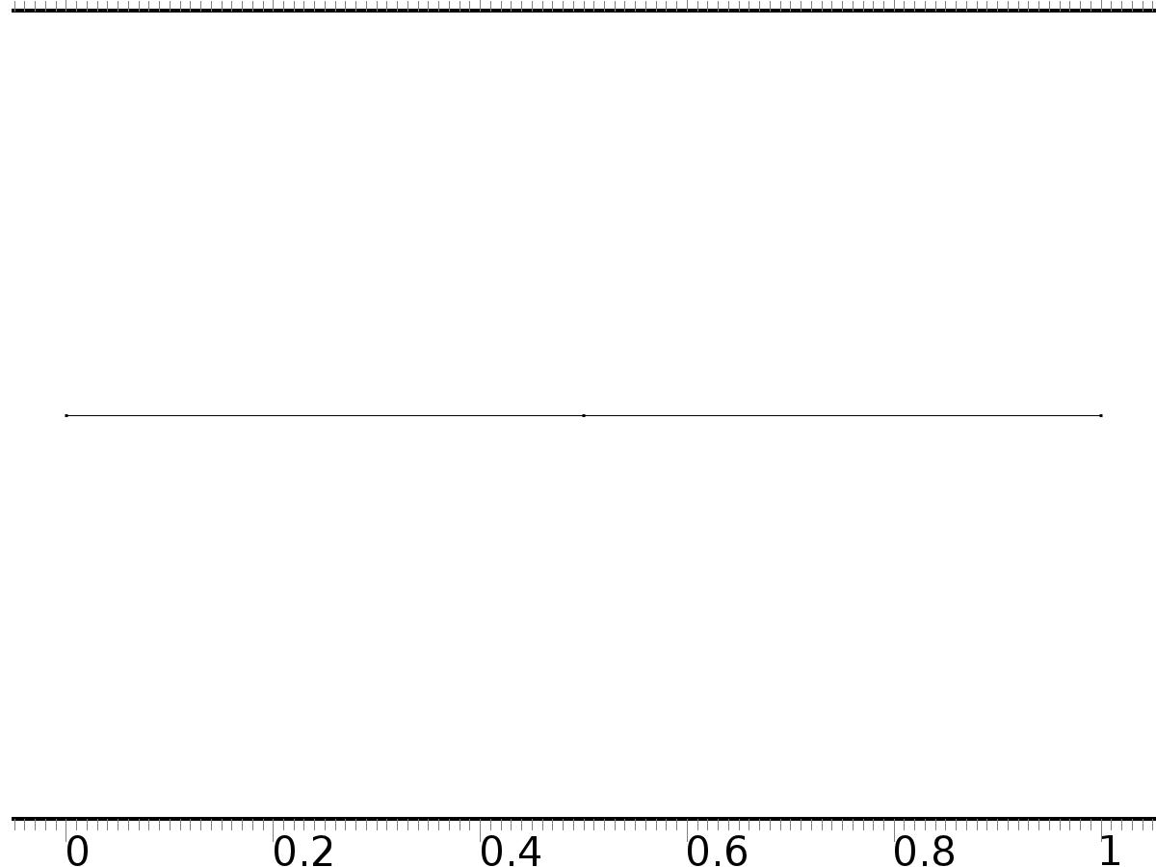

Geometry 1

Units

|  |  |
| --- | --- |
| Length unit | m |
| Angular unit | deg |

Geometry statistics

| **Description** | **Value** |
| --- | --- |
| Space dimension | 1 |
| Number of domains | 2 |
| Number of boundaries | 3 |

* + 1. Interval 1 (i1)

Interval

| **Description** | **Value** |
| --- | --- |
| Number of intervals | Many |
| Points | {0, 0.5, 1} |

* 1. Unit input

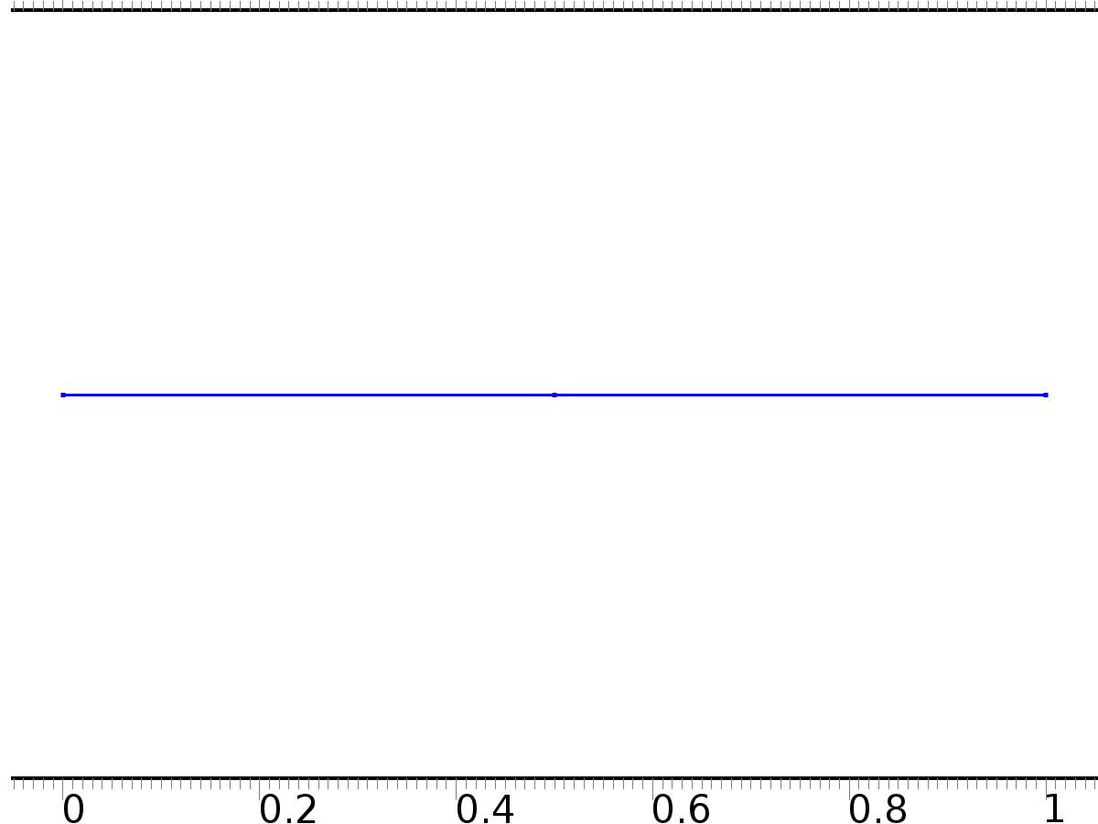

Unit input

Selection

|  |  |
| --- | --- |
| Geometric entity level | Domain |
| Selection | Domains 1–2 |

Settings

| **Description** | **Value** |
| --- | --- |
| Shape function type | Lagrange |
| Element order | Quadratic |
| Compute boundary fluxes | On |
| Apply smoothing to boundary fluxes | On |
| Value type when using splitting of complex variables | Complex |
| Dependent variable quantity | Dimensionless (1) |
| Source term quantity | None |
| Unit | m^ - 2 |

Used products

|  |
| --- |
| COMSOL Multiphysics |

Variables

| **Name** | **Expression** | **Unit** | **Description** | **Selection** |
| --- | --- | --- | --- | --- |
| X.nx | nx |  | Normal vector, x component | Boundaries 1–3 |
| X.ny | root.ny |  | Normal vector, y component | Boundaries 1–3 |
| X.nz | root.nz |  | Normal vector, z component | Boundaries 1–3 |
| X.nxmesh | root.nxmesh |  | Normal vector (mesh), x component | Boundaries 1–3 |
| X.nymesh | root.nymesh |  | Normal vector (mesh), y component | Boundaries 1–3 |
| X.nzmesh | root.nzmesh |  | Normal vector (mesh), z component | Boundaries 1–3 |

* + 1. Coefficient Form PDE 1



Coefficient Form PDE 1

Selection

|  |  |
| --- | --- |
| Geometric entity level | Domain |
| Selection | Domains 1–2 |

Equations

Settings

| **Description** | **Value** |
| --- | --- |
| Diffusion coefficient | 1 |
| Absorption coefficient | 0 |
| Source term | 0 |
| Mass coefficient | 0 |
| Damping or mass coefficient | 0 |
| Conservative flux convection coefficient | 0 |
| Convection coefficient | 0 |
| Conservative flux source | 0 |

#### Variables

| **Name** | **Expression** | **Unit** | **Description** | **Selection** |
| --- | --- | --- | --- | --- |
| domflux.Xx | -d(X,x) |  | Domain flux, x component | Domains 1–2 |

#### Shape functions

| **Name** | **Shape function** | **Unit** | **Description** | **Shape frame** | **Selection** |
| --- | --- | --- | --- | --- | --- |
| X | Lagrange (Quadratic) |  | Dependent variable X | Material | Domains 1–2 |

* + 1. Zero Flux 1



Zero Flux 1

Selection

|  |  |
| --- | --- |
| Geometric entity level | Boundary |
| Selection | No boundaries |

Equations

* + 1. Initial Values 1



Initial Values 1

Selection

|  |  |
| --- | --- |
| Geometric entity level | Domain |
| Selection | Domains 1–2 |

Settings

| **Description** | **Value** |
| --- | --- |
| Initial value for X | 0 |
| Initial time derivative of X | 0 |

* + 1. Bd*0

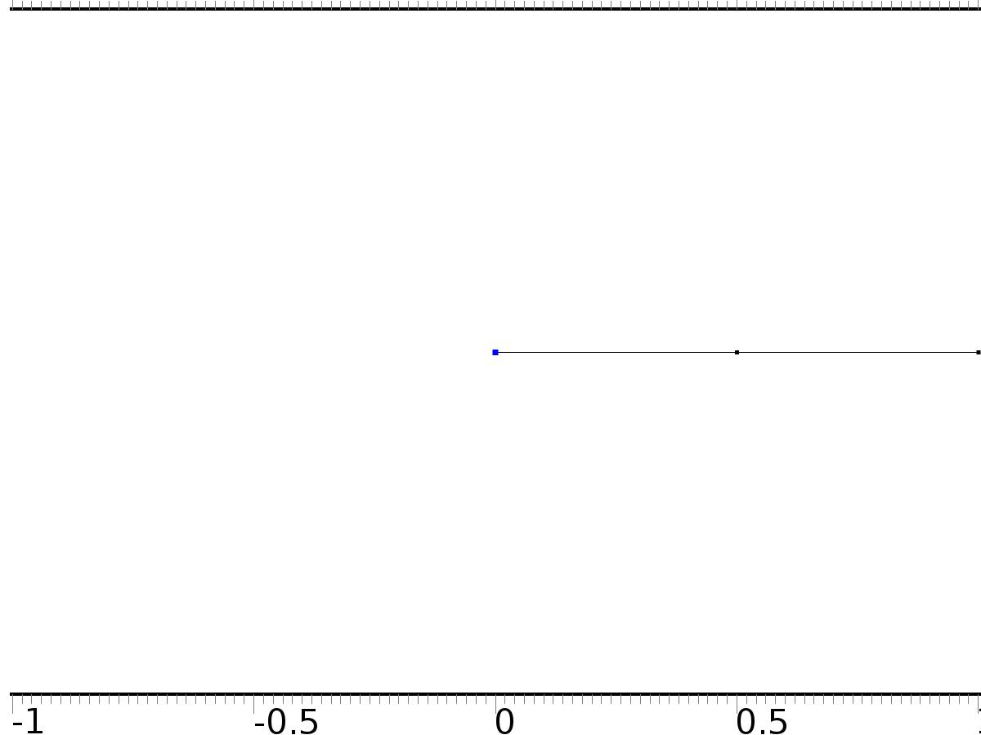

Bd*0

Selection

|  |  |
| --- | --- |
| Geometric entity level | Boundary |
| Selection | Boundary 1 |

Equations

Settings

| **Description** | **Value** |
| --- | --- |
| Value on boundary | 0 |
| Prescribed value of X | On |
| Apply reaction terms on | Individual dependent variables |
| Use weak constraints | Off |
| Constraint method | Elemental |

#### Shape functions

| **Constraint** | **Constraint force** | **Shape function** | **Selection** |
| --- | --- | --- | --- |
| -X | -test(X) | Lagrange (Quadratic) | Boundary 1 |

* + 1. Bin*1

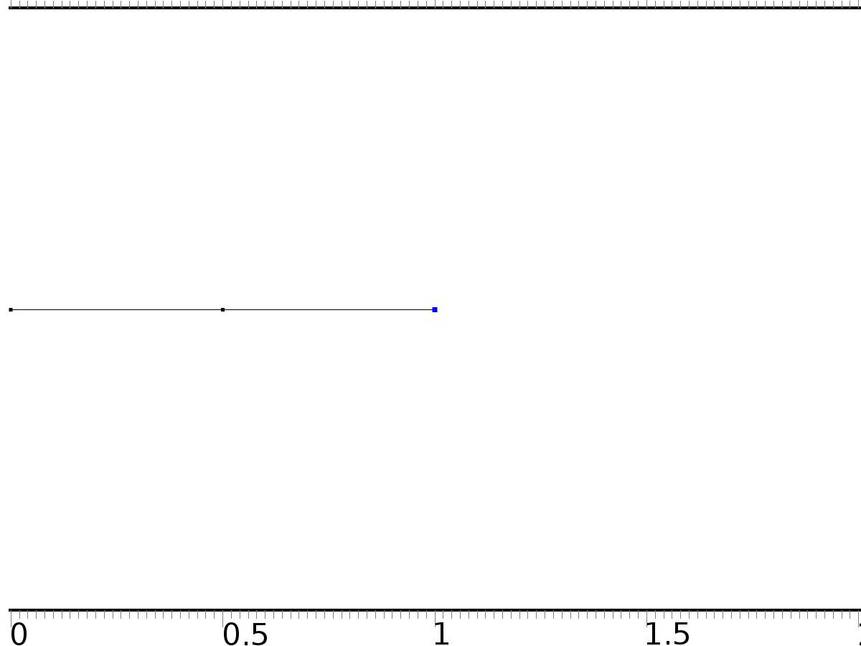

Bin*1

Selection

|  |  |
| --- | --- |
| Geometric entity level | Boundary |
| Selection | Boundary 3 |

Equations

Settings

| **Description** | **Value** |
| --- | --- |
| Boundary flux/source | 1 |
| Boundary absorption/impedance term | 0 |

#### Variables

| **Name** | **Expression** | **Unit** | **Description** | **Selection** |
| --- | --- | --- | --- | --- |
| X.g_X | 1 |  | Boundary flux/source | Boundary 3 |

* 1. Regulator Equation PI0



Regulator Equation PI0

Selection

|  |  |
| --- | --- |
| Geometric entity level | Domain |
| Selection | Domains 1–2 |

Settings

| **Description** | **Value** |
| --- | --- |
| Shape function type | Lagrange |
| Element order | Quadratic |
| Compute boundary fluxes | On |
| Apply smoothing to boundary fluxes | On |
| Value type when using splitting of complex variables | Complex |
| Dependent variable quantity | Dimensionless (1) |
| Source term quantity | None |
| Unit | m^ - 2 |

Used products

|  |
| --- |
| COMSOL Multiphysics |

Variables

| **Name** | **Expression** | **Unit** | **Description** | **Selection** |
| --- | --- | --- | --- | --- |
| A0.nx | nx |  | Normal vector, x component | Boundaries 1–3 |
| A0.ny | root.ny |  | Normal vector, y component | Boundaries 1–3 |
| A0.nz | root.nz |  | Normal vector, z component | Boundaries 1–3 |
| A0.nxmesh | root.nxmesh |  | Normal vector (mesh), x component | Boundaries 1–3 |
| A0.nymesh | root.nymesh |  | Normal vector (mesh), y component | Boundaries 1–3 |
| A0.nzmesh | root.nzmesh |  | Normal vector (mesh), z component | Boundaries 1–3 |

* + 1. Coefficient Form PDE 1



Coefficient Form PDE 1

Selection

|  |  |
| --- | --- |
| Geometric entity level | Domain |
| Selection | Domains 1–2 |

Equations

Settings

| **Description** | **Value** |
| --- | --- |
| Diffusion coefficient | {{1, 0}, {0, 1}} |
| Absorption coefficient | {{0, 0}, {0, 0}} |
| Source term | {f_a0, f_a0} |
| Mass coefficient | {{0, 0}, {0, 0}} |
| Damping or mass coefficient | {{0, 0}, {0, 0}} |
| Conservative flux convection coefficient | {{0, 0}, {0, 0}} |
| Convection coefficient | {{0, 0}, {0, 0}} |
| Conservative flux source | {0, 0} |

#### Variables

| **Name** | **Expression** | **Unit** | **Description** | **Selection** |
| --- | --- | --- | --- | --- |
| domflux.a0x | -d(a0,x) |  | Domain flux, x component | Domains 1–2 |
| domflux.at0x | -d(at0,x) |  | Domain flux, x component | Domains 1–2 |

#### Shape functions

| **Name** | **Shape function** | **Unit** | **Description** | **Shape frame** | **Selection** |
| --- | --- | --- | --- | --- | --- |
| a0 | Lagrange (Quadratic) |  | Dependent variable a0 | Material | Domains 1–2 |
| at0 | Lagrange (Quadratic) |  | Dependent variable at0 | Material | Domains 1–2 |

* + 1. Zero Flux 1



Zero Flux 1

Selection

|  |  |
| --- | --- |
| Geometric entity level | Boundary |
| Selection | No boundaries |

Equations

* + 1. Initial Values 1



Initial Values 1

Selection

|  |  |
| --- | --- |
| Geometric entity level | Domain |
| Selection | Domains 1–2 |

Settings

| **Description** | **Value** |
| --- | --- |
| Initial value for a0 | 0 |
| Initial time derivative of a0 | 0 |
| Initial value for at0 | 0 |
| Initial time derivative of at0 | 0 |

* + 1. Bd*d0



Bd*d0

Selection

|  |  |
| --- | --- |
| Geometric entity level | Boundary |
| Selection | Boundary 1 |

Equations

Settings

| **Description** | **Value** |
| --- | --- |
| Value on boundary | {d_a0, d_a0} |
| Prescribed value of a0 | On |
| Prescribed value of at0 | On |
| Apply reaction terms on | Individual dependent variables |
| Use weak constraints | Off |
| Constraint method | Elemental |

#### Shape functions

| **Constraint** | **Constraint force** | **Shape function** | **Selection** |
| --- | --- | --- | --- |
| d_a0-a0 | -test(a0) | Lagrange (Quadratic) | Boundary 1 |
| d_a0-at0 | -test(at0) | Lagrange (Quadratic) | Boundary 1 |

* + 1. Bin*Gamma0



Bin*Gamma0

Selection

|  |  |
| --- | --- |
| Geometric entity level | Boundary |
| Selection | Boundary 3 |

Equations

Settings

| **Description** | **Value** |
| --- | --- |
| Boundary flux/source | {Gamma_a0, 0} |
| Boundary absorption/impedance term | {{0, 0}, {0, 0}} |

#### Variables

| **Name** | **Expression** | **Unit** | **Description** | **Selection** |
| --- | --- | --- | --- | --- |
| A0.g_a0 | Gamma_a0 |  | Boundary flux/source | Boundary 3 |
| A0.g_at0 | 0 |  | Boundary flux/source | Boundary 3 |

* 1. Regulator Equation PI1



Regulator Equation PI1

Selection

|  |  |
| --- | --- |
| Geometric entity level | Domain |
| Selection | Domains 1–2 |

Settings

| **Description** | **Value** |
| --- | --- |
| Shape function type | Lagrange |
| Element order | Quadratic |
| Compute boundary fluxes | On |
| Apply smoothing to boundary fluxes | On |
| Value type when using splitting of complex variables | Complex |
| Dependent variable quantity | Dimensionless (1) |
| Source term quantity | None |
| Unit | m^ - 2 |

Used products

|  |
| --- |
| COMSOL Multiphysics |

Variables

| **Name** | **Expression** | **Unit** | **Description** | **Selection** |
| --- | --- | --- | --- | --- |
| A1.nx | nx |  | Normal vector, x component | Boundaries 1–3 |
| A1.ny | root.ny |  | Normal vector, y component | Boundaries 1–3 |
| A1.nz | root.nz |  | Normal vector, z component | Boundaries 1–3 |
| A1.nxmesh | root.nxmesh |  | Normal vector (mesh), x component | Boundaries 1–3 |
| A1.nymesh | root.nymesh |  | Normal vector (mesh), y component | Boundaries 1–3 |
| A1.nzmesh | root.nzmesh |  | Normal vector (mesh), z component | Boundaries 1–3 |

* + 1. Coefficient Form PDE 1



Coefficient Form PDE 1

Selection

|  |  |
| --- | --- |
| Geometric entity level | Domain |
| Selection | Domains 1–2 |

Equations

Settings

| **Description** | **Value** |
| --- | --- |
| Diffusion coefficient | {{1, 0, 0, 0}, {0, 1, 0, 0}, {0, 0, 1, 0}, {0, 0, 0, 1}} |
| Absorption coefficient | {{0, -alpha, 0, -alpha}, {alpha, 0, alpha, 0}, {0, 0, 0, 0}, {0, 0, 0, 0}} |
| Source term | {f_a1, f_b1, f_a1, f_b1} |
| Mass coefficient | {{0, 0, 0, 0}, {0, 0, 0, 0}, {0, 0, 0, 0}, {0, 0, 0, 0}} |
| Damping or mass coefficient | {{0, 0, 0, 0}, {0, 0, 0, 0}, {0, 0, 0, 0}, {0, 0, 0, 0}} |
| Conservative flux convection coefficient | {{0, 0, 0, 0}, {0, 0, 0, 0}, {0, 0, 0, 0}, {0, 0, 0, 0}} |
| Convection coefficient | {{0, 0, 0, 0}, {0, 0, 0, 0}, {0, 0, 0, 0}, {0, 0, 0, 0}} |
| Conservative flux source | {0, 0, 0, 0} |

#### Variables

| **Name** | **Expression** | **Unit** | **Description** | **Selection** |
| --- | --- | --- | --- | --- |
| domflux.a1x | -d(a1,x) |  | Domain flux, x component | Domains 1–2 |
| domflux.b1x | -d(b1,x) |  | Domain flux, x component | Domains 1–2 |
| domflux.at1x | -d(at1,x) |  | Domain flux, x component | Domains 1–2 |
| domflux.bt1x | -d(bt1,x) |  | Domain flux, x component | Domains 1–2 |

#### Shape functions

| **Name** | **Shape function** | **Unit** | **Description** | **Shape frame** | **Selection** |
| --- | --- | --- | --- | --- | --- |
| a1 | Lagrange (Quadratic) |  | Dependent variable a1 | Material | Domains 1–2 |
| b1 | Lagrange (Quadratic) |  | Dependent variable b1 | Material | Domains 1–2 |
| at1 | Lagrange (Quadratic) |  | Dependent variable at1 | Material | Domains 1–2 |
| bt1 | Lagrange (Quadratic) |  | Dependent variable bt1 | Material | Domains 1–2 |

* + 1. Zero Flux 1



Zero Flux 1

Selection

|  |  |
| --- | --- |
| Geometric entity level | Boundary |
| Selection | No boundaries |

Equations

* + 1. Initial Values 1



Initial Values 1

Selection

|  |  |
| --- | --- |
| Geometric entity level | Domain |
| Selection | Domains 1–2 |

Settings

| **Description** | **Value** |
| --- | --- |
| Initial value for a1 | 0 |
| Initial value for b1 | 0 |
| Initial value for at1 | 0 |
| Initial value for bt1 | 0 |
| Initial time derivative of a1 | 0 |
| Initial time derivative of b1 | 0 |
| Initial time derivative of at1 | 0 |
| Initial time derivative of bt1 | 0 |

* + 1. Bd*d1



Bd*d1

Selection

|  |  |
| --- | --- |
| Geometric entity level | Boundary |
| Selection | Boundary 1 |

Equations

Settings

| **Description** | **Value** |
| --- | --- |
| Value on boundary | {d_a1, d_b1, d_a1, d_b1} |
| Prescribed value of a1 | On |
| Prescribed value of b1 | On |
| Prescribed value of at1 | On |
| Prescribed value of bt1 | On |
| Apply reaction terms on | Individual dependent variables |
| Use weak constraints | Off |
| Constraint method | Elemental |

#### Shape functions

| **Constraint** | **Constraint force** | **Shape function** | **Selection** |
| --- | --- | --- | --- |
| d_a1-a1 | -test(a1) | Lagrange (Quadratic) | Boundary 1 |
| d_b1-b1 | -test(b1) | Lagrange (Quadratic) | Boundary 1 |
| d_a1-at1 | -test(at1) | Lagrange (Quadratic) | Boundary 1 |
| d_b1-bt1 | -test(bt1) | Lagrange (Quadratic) | Boundary 1 |

* + 1. Bin*Gamma1



Bin*Gamma1

Selection

|  |  |
| --- | --- |
| Geometric entity level | Boundary |
| Selection | Boundary 3 |

Equations

Settings

| **Description** | **Value** |
| --- | --- |
| Boundary flux/source | {Gamma_a1, Gamma_b1, 0, 0} |
| Boundary absorption/impedance term | {{0, 0, 0, 0}, {0, 0, 0, 0}, {0, 0, 0, 0}, {0, 0, 0, 0}} |

#### Variables

| **Name** | **Expression** | **Unit** | **Description** | **Selection** |
| --- | --- | --- | --- | --- |
| A1.g_a1 | Gamma_a1 |  | Boundary flux/source | Boundary 3 |
| A1.g_b1 | Gamma_b1 |  | Boundary flux/source | Boundary 3 |
| A1.g_at1 | 0 |  | Boundary flux/source | Boundary 3 |
| A1.g_bt1 | 0 |  | Boundary flux/source | Boundary 3 |

* 1. Regulator Equation PI2



Regulator Equation PI2

Selection

|  |  |
| --- | --- |
| Geometric entity level | Domain |
| Selection | Domains 1–2 |

Settings

| **Description** | **Value** |
| --- | --- |
| Shape function type | Lagrange |
| Element order | Quadratic |
| Compute boundary fluxes | On |
| Apply smoothing to boundary fluxes | On |
| Value type when using splitting of complex variables | Complex |
| Dependent variable quantity | Dimensionless (1) |
| Source term quantity | None |
| Unit | m^ - 2 |

Used products

|  |
| --- |
| COMSOL Multiphysics |

Variables

| **Name** | **Expression** | **Unit** | **Description** | **Selection** |
| --- | --- | --- | --- | --- |
| A2.nx | nx |  | Normal vector, x component | Boundaries 1–3 |
| A2.ny | root.ny |  | Normal vector, y component | Boundaries 1–3 |
| A2.nz | root.nz |  | Normal vector, z component | Boundaries 1–3 |
| A2.nxmesh | root.nxmesh |  | Normal vector (mesh), x component | Boundaries 1–3 |
| A2.nymesh | root.nymesh |  | Normal vector (mesh), y component | Boundaries 1–3 |
| A2.nzmesh | root.nzmesh |  | Normal vector (mesh), z component | Boundaries 1–3 |

* + 1. Coefficient Form PDE 1



Coefficient Form PDE 1

Selection

|  |  |
| --- | --- |
| Geometric entity level | Domain |
| Selection | Domains 1–2 |

Equations

Settings

| **Description** | **Value** |
| --- | --- |
| Diffusion coefficient | {{1, 0, 0, 0}, {0, 1, 0, 0}, {0, 0, 1, 0}, {0, 0, 0, 1}} |
| Absorption coefficient | {{0, -2*alpha, 0, -2*alpha}, {2*alpha, 0, 2*alpha, 0}, {0, 0, 0, 0}, {0, 0, 0, 0}} |
| Source term | {f_a2, f_b2, f_a2, f_b2} |
| Mass coefficient | {{0, 0, 0, 0}, {0, 0, 0, 0}, {0, 0, 0, 0}, {0, 0, 0, 0}} |
| Damping or mass coefficient | {{0, 0, 0, 0}, {0, 0, 0, 0}, {0, 0, 0, 0}, {0, 0, 0, 0}} |
| Conservative flux convection coefficient | {{0, 0, 0, 0}, {0, 0, 0, 0}, {0, 0, 0, 0}, {0, 0, 0, 0}} |
| Convection coefficient | {{0, 0, 0, 0}, {0, 0, 0, 0}, {0, 0, 0, 0}, {0, 0, 0, 0}} |
| Conservative flux source | {0, 0, 0, 0} |

#### Variables

| **Name** | **Expression** | **Unit** | **Description** | **Selection** |
| --- | --- | --- | --- | --- |
| domflux.a2x | -d(a2,x) |  | Domain flux, x component | Domains 1–2 |
| domflux.b2x | -d(b2,x) |  | Domain flux, x component | Domains 1–2 |
| domflux.at2x | -d(at2,x) |  | Domain flux, x component | Domains 1–2 |
| domflux.bt2x | -d(bt2,x) |  | Domain flux, x component | Domains 1–2 |

#### Shape functions

| **Name** | **Shape function** | **Unit** | **Description** | **Shape frame** | **Selection** |
| --- | --- | --- | --- | --- | --- |
| a2 | Lagrange (Quadratic) |  | Dependent variable a2 | Material | Domains 1–2 |
| b2 | Lagrange (Quadratic) |  | Dependent variable b2 | Material | Domains 1–2 |
| at2 | Lagrange (Quadratic) |  | Dependent variable at2 | Material | Domains 1–2 |
| bt2 | Lagrange (Quadratic) |  | Dependent variable bt2 | Material | Domains 1–2 |

* + 1. Zero Flux 1



Zero Flux 1

Selection

|  |  |
| --- | --- |
| Geometric entity level | Boundary |
| Selection | No boundaries |

Equations

* + 1. Initial Values 1



Initial Values 1

Selection

|  |  |
| --- | --- |
| Geometric entity level | Domain |
| Selection | Domains 1–2 |

Settings

| **Description** | **Value** |
| --- | --- |
| Initial value for a2 | 0 |
| Initial value for b2 | 0 |
| Initial value for at2 | 0 |
| Initial value for bt2 | 0 |
| Initial time derivative of a2 | 0 |
| Initial time derivative of b2 | 0 |
| Initial time derivative of at2 | 0 |
| Initial time derivative of bt2 | 0 |

* + 1. Bd*d2



Bd*d2

Selection

|  |  |
| --- | --- |
| Geometric entity level | Boundary |
| Selection | Boundary 1 |

Equations

Settings

| **Description** | **Value** |
| --- | --- |
| Value on boundary | {d_a2, d_b2, d_a2, d_b2} |
| Prescribed value of a2 | On |
| Prescribed value of b2 | On |
| Prescribed value of at2 | On |
| Prescribed value of bt2 | On |
| Apply reaction terms on | Individual dependent variables |
| Use weak constraints | Off |
| Constraint method | Elemental |

#### Shape functions

| **Constraint** | **Constraint force** | **Shape function** | **Selection** |
| --- | --- | --- | --- |
| d_a2-a2 | -test(a2) | Lagrange (Quadratic) | Boundary 1 |
| d_b2-b2 | -test(b2) | Lagrange (Quadratic) | Boundary 1 |
| d_a2-at2 | -test(at2) | Lagrange (Quadratic) | Boundary 1 |
| d_b2-bt2 | -test(bt2) | Lagrange (Quadratic) | Boundary 1 |

* + 1. Bin*Gamma2



Bin*Gamma2

Selection

|  |  |
| --- | --- |
| Geometric entity level | Boundary |
| Selection | Boundary 3 |

Equations

Settings

| **Description** | **Value** |
| --- | --- |
| Boundary flux/source | {Gamma_a2, Gamma_b2, 0, 0} |
| Boundary absorption/impedance term | {{0, 0, 0, 0}, {0, 0, 0, 0}, {0, 0, 0, 0}, {0, 0, 0, 0}} |

#### Variables

| **Name** | **Expression** | **Unit** | **Description** | **Selection** |
| --- | --- | --- | --- | --- |
| A2.g_a2 | Gamma_a2 |  | Boundary flux/source | Boundary 3 |
| A2.g_b2 | Gamma_b2 |  | Boundary flux/source | Boundary 3 |
| A2.g_at2 | 0 |  | Boundary flux/source | Boundary 3 |
| A2.g_bt2 | 0 |  | Boundary flux/source | Boundary 3 |

* 1. Regulator Equation PI3



Regulator Equation PI3

Selection

|  |  |
| --- | --- |
| Geometric entity level | Domain |
| Selection | Domains 1–2 |

Settings

| **Description** | **Value** |
| --- | --- |
| Shape function type | Lagrange |
| Element order | Quadratic |
| Compute boundary fluxes | On |
| Apply smoothing to boundary fluxes | On |
| Value type when using splitting of complex variables | Complex |
| Dependent variable quantity | Dimensionless (1) |
| Source term quantity | None |
| Unit | m^ - 2 |

Used products

|  |
| --- |
| COMSOL Multiphysics |

Variables

| **Name** | **Expression** | **Unit** | **Description** | **Selection** |
| --- | --- | --- | --- | --- |
| A3.nx | nx |  | Normal vector, x component | Boundaries 1–3 |
| A3.ny | root.ny |  | Normal vector, y component | Boundaries 1–3 |
| A3.nz | root.nz |  | Normal vector, z component | Boundaries 1–3 |
| A3.nxmesh | root.nxmesh |  | Normal vector (mesh), x component | Boundaries 1–3 |
| A3.nymesh | root.nymesh |  | Normal vector (mesh), y component | Boundaries 1–3 |
| A3.nzmesh | root.nzmesh |  | Normal vector (mesh), z component | Boundaries 1–3 |

* + 1. Coefficient Form PDE 1



Coefficient Form PDE 1

Selection

|  |  |
| --- | --- |
| Geometric entity level | Domain |
| Selection | Domains 1–2 |

Equations

Settings

| **Description** | **Value** |
| --- | --- |
| Diffusion coefficient | {{1, 0, 0, 0}, {0, 1, 0, 0}, {0, 0, 1, 0}, {0, 0, 0, 1}} |
| Absorption coefficient | {{0, -3*alpha, 0, -3*alpha}, {3*alpha, 0, 3*alpha, 0}, {0, 0, 0, 0}, {0, 0, 0, 0}} |
| Source term | {f_a3, f_b3, f_a3, f_b3} |
| Mass coefficient | {{0, 0, 0, 0}, {0, 0, 0, 0}, {0, 0, 0, 0}, {0, 0, 0, 0}} |
| Damping or mass coefficient | {{0, 0, 0, 0}, {0, 0, 0, 0}, {0, 0, 0, 0}, {0, 0, 0, 0}} |
| Conservative flux convection coefficient | {{0, 0, 0, 0}, {0, 0, 0, 0}, {0, 0, 0, 0}, {0, 0, 0, 0}} |
| Convection coefficient | {{0, 0, 0, 0}, {0, 0, 0, 0}, {0, 0, 0, 0}, {0, 0, 0, 0}} |
| Conservative flux source | {0, 0, 0, 0} |

#### Variables

| **Name** | **Expression** | **Unit** | **Description** | **Selection** |
| --- | --- | --- | --- | --- |
| domflux.a3x | -d(a3,x) |  | Domain flux, x component | Domains 1–2 |
| domflux.b3x | -d(b3,x) |  | Domain flux, x component | Domains 1–2 |
| domflux.at3x | -d(at3,x) |  | Domain flux, x component | Domains 1–2 |
| domflux.bt3x | -d(bt3,x) |  | Domain flux, x component | Domains 1–2 |

#### Shape functions

| **Name** | **Shape function** | **Unit** | **Description** | **Shape frame** | **Selection** |
| --- | --- | --- | --- | --- | --- |
| a3 | Lagrange (Quadratic) |  | Dependent variable a3 | Material | Domains 1–2 |
| b3 | Lagrange (Quadratic) |  | Dependent variable b3 | Material | Domains 1–2 |
| at3 | Lagrange (Quadratic) |  | Dependent variable at3 | Material | Domains 1–2 |
| bt3 | Lagrange (Quadratic) |  | Dependent variable bt3 | Material | Domains 1–2 |

* + 1. Zero Flux 1



Zero Flux 1

Selection

|  |  |
| --- | --- |
| Geometric entity level | Boundary |
| Selection | No boundaries |

Equations

* + 1. Initial Values 1



Initial Values 1

Selection

|  |  |
| --- | --- |
| Geometric entity level | Domain |
| Selection | Domains 1–2 |

Settings

| **Description** | **Value** |
| --- | --- |
| Initial value for a3 | 0 |
| Initial value for b3 | 0 |
| Initial value for at3 | 0 |
| Initial value for bt3 | 0 |
| Initial time derivative of a3 | 0 |
| Initial time derivative of b3 | 0 |
| Initial time derivative of at3 | 0 |
| Initial time derivative of bt3 | 0 |

* + 1. Bd*d3



Bd*d3

Selection

|  |  |
| --- | --- |
| Geometric entity level | Boundary |
| Selection | Boundary 1 |

Equations

Settings

| **Description** | **Value** |
| --- | --- |
| Value on boundary | {d_a3, d_b3, d_a3, d_b3} |
| Prescribed value of a3 | On |
| Prescribed value of b3 | On |
| Prescribed value of at3 | On |
| Prescribed value of bt3 | On |
| Apply reaction terms on | Individual dependent variables |
| Use weak constraints | Off |
| Constraint method | Elemental |

#### Shape functions

| **Constraint** | **Constraint force** | **Shape function** | **Selection** |
| --- | --- | --- | --- |
| d_a3-a3 | -test(a3) | Lagrange (Quadratic) | Boundary 1 |
| d_b3-b3 | -test(b3) | Lagrange (Quadratic) | Boundary 1 |
| d_a3-at3 | -test(at3) | Lagrange (Quadratic) | Boundary 1 |
| d_b3-bt3 | -test(bt3) | Lagrange (Quadratic) | Boundary 1 |

* + 1. Bin*Gamma3



Bin*Gamma3

Selection

|  |  |
| --- | --- |
| Geometric entity level | Boundary |
| Selection | Boundary 3 |

Equations

Settings

| **Description** | **Value** |
| --- | --- |
| Boundary flux/source | {Gamma_a3, Gamma_b3, 0, 0} |
| Boundary absorption/impedance term | {{0, 0, 0, 0}, {0, 0, 0, 0}, {0, 0, 0, 0}, {0, 0, 0, 0}} |

#### Variables

| **Name** | **Expression** | **Unit** | **Description** | **Selection** |
| --- | --- | --- | --- | --- |
| A3.g_a3 | Gamma_a3 |  | Boundary flux/source | Boundary 3 |
| A3.g_b3 | Gamma_b3 |  | Boundary flux/source | Boundary 3 |
| A3.g_at3 | 0 |  | Boundary flux/source | Boundary 3 |
| A3.g_bt3 | 0 |  | Boundary flux/source | Boundary 3 |

* 1. Regulator Equation PI4



Regulator Equation PI4

Selection

|  |  |
| --- | --- |
| Geometric entity level | Domain |
| Selection | Domains 1–2 |

Settings

| **Description** | **Value** |
| --- | --- |
| Shape function type | Lagrange |
| Element order | Quadratic |
| Compute boundary fluxes | On |
| Apply smoothing to boundary fluxes | On |
| Value type when using splitting of complex variables | Complex |
| Dependent variable quantity | Dimensionless (1) |
| Source term quantity | None |
| Unit | m^ - 2 |

Used products

|  |
| --- |
| COMSOL Multiphysics |

Variables

| **Name** | **Expression** | **Unit** | **Description** | **Selection** |
| --- | --- | --- | --- | --- |
| A4.nx | nx |  | Normal vector, x component | Boundaries 1–3 |
| A4.ny | root.ny |  | Normal vector, y component | Boundaries 1–3 |
| A4.nz | root.nz |  | Normal vector, z component | Boundaries 1–3 |
| A4.nxmesh | root.nxmesh |  | Normal vector (mesh), x component | Boundaries 1–3 |
| A4.nymesh | root.nymesh |  | Normal vector (mesh), y component | Boundaries 1–3 |
| A4.nzmesh | root.nzmesh |  | Normal vector (mesh), z component | Boundaries 1–3 |

* + 1. Coefficient Form PDE 1



Coefficient Form PDE 1

Selection

|  |  |
| --- | --- |
| Geometric entity level | Domain |
| Selection | Domains 1–2 |

Equations

Settings

| **Description** | **Value** |
| --- | --- |
| Diffusion coefficient | {{1, 0, 0, 0}, {0, 1, 0, 0}, {0, 0, 1, 0}, {0, 0, 0, 1}} |
| Absorption coefficient | {{0, -4*alpha, 0, -4*alpha}, {4*alpha, 0, 4*alpha, 0}, {0, 0, 0, 0}, {0, 0, 0, 0}} |
| Source term | {f_a4, f_b4, f_a4, f_b4} |
| Mass coefficient | {{0, 0, 0, 0}, {0, 0, 0, 0}, {0, 0, 0, 0}, {0, 0, 0, 0}} |
| Damping or mass coefficient | {{0, 0, 0, 0}, {0, 0, 0, 0}, {0, 0, 0, 0}, {0, 0, 0, 0}} |
| Conservative flux convection coefficient | {{0, 0, 0, 0}, {0, 0, 0, 0}, {0, 0, 0, 0}, {0, 0, 0, 0}} |
| Convection coefficient | {{0, 0, 0, 0}, {0, 0, 0, 0}, {0, 0, 0, 0}, {0, 0, 0, 0}} |
| Conservative flux source | {0, 0, 0, 0} |

#### Variables

| **Name** | **Expression** | **Unit** | **Description** | **Selection** |
| --- | --- | --- | --- | --- |
| domflux.a4x | -d(a4,x) |  | Domain flux, x component | Domains 1–2 |
| domflux.b4x | -d(b4,x) |  | Domain flux, x component | Domains 1–2 |
| domflux.at4x | -d(at4,x) |  | Domain flux, x component | Domains 1–2 |
| domflux.bt4x | -d(bt4,x) |  | Domain flux, x component | Domains 1–2 |

#### Shape functions

| **Name** | **Shape function** | **Unit** | **Description** | **Shape frame** | **Selection** |
| --- | --- | --- | --- | --- | --- |
| a4 | Lagrange (Quadratic) |  | Dependent variable a4 | Material | Domains 1–2 |
| b4 | Lagrange (Quadratic) |  | Dependent variable b4 | Material | Domains 1–2 |
| at4 | Lagrange (Quadratic) |  | Dependent variable at4 | Material | Domains 1–2 |
| bt4 | Lagrange (Quadratic) |  | Dependent variable bt4 | Material | Domains 1–2 |

* + 1. Zero Flux 1



Zero Flux 1

Selection

|  |  |
| --- | --- |
| Geometric entity level | Boundary |
| Selection | No boundaries |

Equations

* + 1. Initial Values 1



Initial Values 1

Selection

|  |  |
| --- | --- |
| Geometric entity level | Domain |
| Selection | Domains 1–2 |

Settings

| **Description** | **Value** |
| --- | --- |
| Initial value for a4 | 0 |
| Initial value for b4 | 0 |
| Initial value for at4 | 0 |
| Initial value for bt4 | 0 |
| Initial time derivative of a4 | 0 |
| Initial time derivative of b4 | 0 |
| Initial time derivative of at4 | 0 |
| Initial time derivative of bt4 | 0 |

* + 1. Bd*d4



Bd*d4

Selection

|  |  |
| --- | --- |
| Geometric entity level | Boundary |
| Selection | Boundary 1 |

Equations

Settings

| **Description** | **Value** |
| --- | --- |
| Value on boundary | {d_a4, d_b4, d_a4, d_b4} |
| Prescribed value of a4 | On |
| Prescribed value of b4 | On |
| Prescribed value of at4 | On |
| Prescribed value of bt4 | On |
| Apply reaction terms on | Individual dependent variables |
| Use weak constraints | Off |
| Constraint method | Elemental |

#### Shape functions

| **Constraint** | **Constraint force** | **Shape function** | **Selection** |
| --- | --- | --- | --- |
| d_a4-a4 | -test(a4) | Lagrange (Quadratic) | Boundary 1 |
| d_b4-b4 | -test(b4) | Lagrange (Quadratic) | Boundary 1 |
| d_a4-at4 | -test(at4) | Lagrange (Quadratic) | Boundary 1 |
| d_b4-bt4 | -test(bt4) | Lagrange (Quadratic) | Boundary 1 |

* + 1. Bin*Gamma4



Bin*Gamma4

Selection

|  |  |
| --- | --- |
| Geometric entity level | Boundary |
| Selection | Boundary 3 |

Equations

Settings

| **Description** | **Value** |
| --- | --- |
| Boundary flux/source | {Gamma_a4, Gamma_b4, 0, 0} |
| Boundary absorption/impedance term | {{0, 0, 0, 0}, {0, 0, 0, 0}, {0, 0, 0, 0}, {0, 0, 0, 0}} |

#### Variables

| **Name** | **Expression** | **Unit** | **Description** | **Selection** |
| --- | --- | --- | --- | --- |
| A4.g_a4 | Gamma_a4 |  | Boundary flux/source | Boundary 3 |
| A4.g_b4 | Gamma_b4 |  | Boundary flux/source | Boundary 3 |
| A4.g_at4 | 0 |  | Boundary flux/source | Boundary 3 |
| A4.g_bt4 | 0 |  | Boundary flux/source | Boundary 3 |

* 1. Regulator Equation PI5



Regulator Equation PI5

Selection

|  |  |
| --- | --- |
| Geometric entity level | Domain |
| Selection | Domains 1–2 |

Settings

| **Description** | **Value** |
| --- | --- |
| Shape function type | Lagrange |
| Element order | Quadratic |
| Compute boundary fluxes | On |
| Apply smoothing to boundary fluxes | On |
| Value type when using splitting of complex variables | Complex |
| Dependent variable quantity | Dimensionless (1) |
| Source term quantity | None |
| Unit | m^ - 2 |

Used products

|  |
| --- |
| COMSOL Multiphysics |

Variables

| **Name** | **Expression** | **Unit** | **Description** | **Selection** |
| --- | --- | --- | --- | --- |
| A5.nx | nx |  | Normal vector, x component | Boundaries 1–3 |
| A5.ny | root.ny |  | Normal vector, y component | Boundaries 1–3 |
| A5.nz | root.nz |  | Normal vector, z component | Boundaries 1–3 |
| A5.nxmesh | root.nxmesh |  | Normal vector (mesh), x component | Boundaries 1–3 |
| A5.nymesh | root.nymesh |  | Normal vector (mesh), y component | Boundaries 1–3 |
| A5.nzmesh | root.nzmesh |  | Normal vector (mesh), z component | Boundaries 1–3 |

* + 1. Coefficient Form PDE 1



Coefficient Form PDE 1

Selection

|  |  |
| --- | --- |
| Geometric entity level | Domain |
| Selection | Domains 1–2 |

Equations

Settings

| **Description** | **Value** |
| --- | --- |
| Diffusion coefficient | {{1, 0, 0, 0}, {0, 1, 0, 0}, {0, 0, 1, 0}, {0, 0, 0, 1}} |
| Absorption coefficient | {{0, -5*alpha, 0, -5*alpha}, {5*alpha, 0, 5*alpha, 0}, {0, 0, 0, 0}, {0, 0, 0, 0}} |
| Source term | {f_a5, f_b5, f_a5, f_b5} |
| Mass coefficient | {{0, 0, 0, 0}, {0, 0, 0, 0}, {0, 0, 0, 0}, {0, 0, 0, 0}} |
| Damping or mass coefficient | {{0, 0, 0, 0}, {0, 0, 0, 0}, {0, 0, 0, 0}, {0, 0, 0, 0}} |
| Conservative flux convection coefficient | {{0, 0, 0, 0}, {0, 0, 0, 0}, {0, 0, 0, 0}, {0, 0, 0, 0}} |
| Convection coefficient | {{0, 0, 0, 0}, {0, 0, 0, 0}, {0, 0, 0, 0}, {0, 0, 0, 0}} |
| Conservative flux source | {0, 0, 0, 0} |

#### Variables

| **Name** | **Expression** | **Unit** | **Description** | **Selection** |
| --- | --- | --- | --- | --- |
| domflux.a5x | -d(a5,x) |  | Domain flux, x component | Domains 1–2 |
| domflux.b5x | -d(b5,x) |  | Domain flux, x component | Domains 1–2 |
| domflux.at5x | -d(at5,x) |  | Domain flux, x component | Domains 1–2 |
| domflux.bt5x | -d(bt5,x) |  | Domain flux, x component | Domains 1–2 |

#### Shape functions

| **Name** | **Shape function** | **Unit** | **Description** | **Shape frame** | **Selection** |
| --- | --- | --- | --- | --- | --- |
| a5 | Lagrange (Quadratic) |  | Dependent variable a5 | Material | Domains 1–2 |
| b5 | Lagrange (Quadratic) |  | Dependent variable b5 | Material | Domains 1–2 |
| at5 | Lagrange (Quadratic) |  | Dependent variable at5 | Material | Domains 1–2 |
| bt5 | Lagrange (Quadratic) |  | Dependent variable bt5 | Material | Domains 1–2 |

* + 1. Zero Flux 1



Zero Flux 1

Selection

|  |  |
| --- | --- |
| Geometric entity level | Boundary |
| Selection | No boundaries |

Equations

* + 1. Initial Values 1



Initial Values 1

Selection

|  |  |
| --- | --- |
| Geometric entity level | Domain |
| Selection | Domains 1–2 |

Settings

| **Description** | **Value** |
| --- | --- |
| Initial value for a5 | 0 |
| Initial value for b5 | 0 |
| Initial value for at5 | 0 |
| Initial value for bt5 | 0 |
| Initial time derivative of a5 | 0 |
| Initial time derivative of b5 | 0 |
| Initial time derivative of at5 | 0 |
| Initial time derivative of bt5 | 0 |

* + 1. Bd*d5



Bd*d5

Selection

|  |  |
| --- | --- |
| Geometric entity level | Boundary |
| Selection | Boundary 1 |

Equations

Settings

| **Description** | **Value** |
| --- | --- |
| Value on boundary | {d_a5, d_b5, d_a5, d_b5} |
| Prescribed value of a5 | On |
| Prescribed value of b5 | On |
| Prescribed value of at5 | On |
| Prescribed value of bt5 | On |
| Apply reaction terms on | Individual dependent variables |
| Use weak constraints | Off |
| Constraint method | Elemental |

#### Shape functions

| **Constraint** | **Constraint force** | **Shape function** | **Selection** |
| --- | --- | --- | --- |
| d_a5-a5 | -test(a5) | Lagrange (Quadratic) | Boundary 1 |
| d_b5-b5 | -test(b5) | Lagrange (Quadratic) | Boundary 1 |
| d_a5-at5 | -test(at5) | Lagrange (Quadratic) | Boundary 1 |
| d_b5-bt5 | -test(bt5) | Lagrange (Quadratic) | Boundary 1 |

* + 1. Bin*Gamma5



Bin*Gamma5

Selection

|  |  |
| --- | --- |
| Geometric entity level | Boundary |
| Selection | Boundary 3 |

Equations

Settings

| **Description** | **Value** |
| --- | --- |
| Boundary flux/source | {Gamma_a5, Gamma_b5, 0, 0} |
| Boundary absorption/impedance term | {{0, 0, 0, 0}, {0, 0, 0, 0}, {0, 0, 0, 0}, {0, 0, 0, 0}} |

#### Variables

| **Name** | **Expression** | **Unit** | **Description** | **Selection** |
| --- | --- | --- | --- | --- |
| A5.g_a5 | Gamma_a5 |  | Boundary flux/source | Boundary 3 |
| A5.g_b5 | Gamma_b5 |  | Boundary flux/source | Boundary 3 |
| A5.g_at5 | 0 |  | Boundary flux/source | Boundary 3 |
| A5.g_bt5 | 0 |  | Boundary flux/source | Boundary 3 |

* 1. Closed Loop System



Closed Loop System

Selection

|  |  |
| --- | --- |
| Geometric entity level | Domain |
| Selection | Domains 1–2 |

Settings

| **Description** | **Value** |
| --- | --- |
| Shape function type | Lagrange |
| Element order | Quadratic |
| Compute boundary fluxes | On |
| Apply smoothing to boundary fluxes | On |
| Value type when using splitting of complex variables | Complex |
| Dependent variable quantity | Dimensionless (1) |
| Source term quantity | None |
| Unit | m^ - 2 |

Used products

|  |
| --- |
| COMSOL Multiphysics |

Variables

| **Name** | **Expression** | **Unit** | **Description** | **Selection** |
| --- | --- | --- | --- | --- |
| z.nx | nx |  | Normal vector, x component | Boundaries 1–3 |
| z.ny | root.ny |  | Normal vector, y component | Boundaries 1–3 |
| z.nz | root.nz |  | Normal vector, z component | Boundaries 1–3 |
| z.nxmesh | root.nxmesh |  | Normal vector (mesh), x component | Boundaries 1–3 |
| z.nymesh | root.nymesh |  | Normal vector (mesh), y component | Boundaries 1–3 |
| z.nzmesh | root.nzmesh |  | Normal vector (mesh), z component | Boundaries 1–3 |

* + 1. Coefficient Form PDE 1



Coefficient Form PDE 1

Selection

|  |  |
| --- | --- |
| Geometric entity level | Domain |
| Selection | Domains 1–2 |

Equations

Settings

| **Description** | **Value** |
| --- | --- |
| Diffusion coefficient | 1 |
| Absorption coefficient | 0 |
| Source term | -z*zx |
| Mass coefficient | 0 |
| Damping or mass coefficient | 1 |
| Conservative flux convection coefficient | 0 |
| Convection coefficient | 0 |
| Conservative flux source | 0 |

#### Variables

| **Name** | **Expression** | **Unit** | **Description** | **Selection** |
| --- | --- | --- | --- | --- |
| domflux.zx | -d(z,x) |  | Domain flux, x component | Domains 1–2 |

#### Shape functions

| **Name** | **Shape function** | **Unit** | **Description** | **Shape frame** | **Selection** |
| --- | --- | --- | --- | --- | --- |
| z | Lagrange (Quadratic) |  | Dependent variable z | Material | Domains 1–2 |

* + 1. Zero Flux 1



Zero Flux 1

Selection

|  |  |
| --- | --- |
| Geometric entity level | Boundary |
| Selection | No boundaries |

Equations

* + 1. Initial Values 1



Initial Values 1

Selection

|  |  |
| --- | --- |
| Geometric entity level | Domain |
| Selection | Domains 1–2 |

Settings

| **Description** | **Value** |
| --- | --- |
| Initial value for z | M2 |
| Initial time derivative of z | 0 |

* + 1. Bd*d



Bd*d

Selection

|  |  |
| --- | --- |
| Geometric entity level | Boundary |
| Selection | Boundary 1 |

Equations

Settings

| **Description** | **Value** |
| --- | --- |
| Value on boundary | d |
| Prescribed value of z | On |
| Apply reaction terms on | Individual dependent variables |
| Use weak constraints | Off |
| Constraint method | Elemental |

#### Shape functions

| **Constraint** | **Constraint force** | **Shape function** | **Selection** |
| --- | --- | --- | --- |
| d-z | -test(z) | Lagrange (Quadratic) | Boundary 1 |

* + 1. Bin*u



Bin*u

Selection

|  |  |
| --- | --- |
| Geometric entity level | Boundary |
| Selection | Boundary 3 |

Equations

Settings

| **Description** | **Value** |
| --- | --- |
| Boundary flux/source | u |
| Boundary absorption/impedance term | 0 |

#### Variables

| **Name** | **Expression** | **Unit** | **Description** | **Selection** |
| --- | --- | --- | --- | --- |
| z.g_z | u |  | Boundary flux/source | Boundary 3 |

* 1. Mesh 1

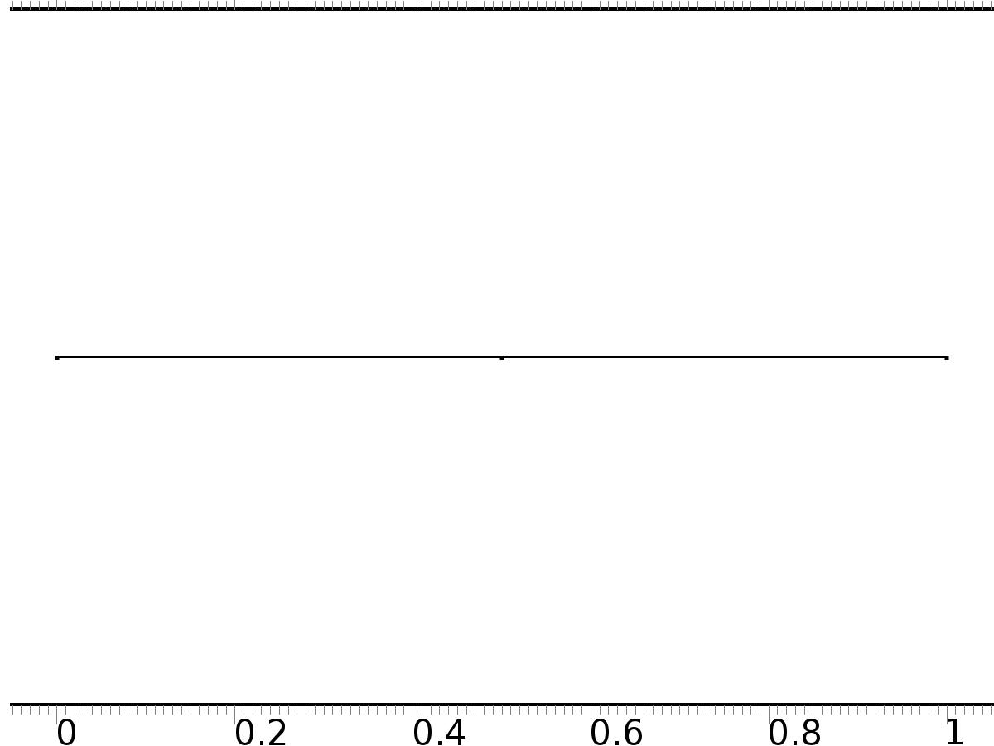

Mesh 1

* + 1. Size (size)

Settings

| **Description** | **Value** |
| --- | --- |
| Maximum element size | 0.067 |
| Minimum element size | 3.0E-4 |
| Curvature factor | 0.3 |
| Maximum element growth rate | 1.3 |

* + 1. Edge 1 (edg1)

Selection

|  |  |
| --- | --- |
| Geometric entity level | Remaining |

1. Study 1
   1. Stationary

Study settings

| **Description** | **Value** |
| --- | --- |
| Include geometric nonlinearity | Off |

Physics and variables selection

| **Physics interface** | **Discretization** |
| --- | --- |
| Unit input (c) | physics |

Mesh selection

| **Geometry** | **Mesh** |
| --- | --- |
| Geometry 1 (geom1) | mesh1 |

* 1. Solver Configurations
     1. Solver 1

#### Compile Equations: Stationary (st1)

Study and step

| **Description** | **Value** |
| --- | --- |
| Use study | Study 1 |
| Use study step | Stationary |

#### Dependent Variables 1 (v1)

General

| **Description** | **Value** |
| --- | --- |
| Defined by study step | Stationary |
| Constant |  |

Initial values of variables solved for

| **Description** | **Value** |
| --- | --- |
| Solution | Zero |

Values of variables not solved for

| **Description** | **Value** |
| --- | --- |
| Solution | Zero |

##### Dependent variable bt3 (mod1.bt3) (mod1_bt3)

General

| **Description** | **Value** |
| --- | --- |
| Field components | mod1.bt3 |
| Solve for this field | Off |

##### Dependent variable bt2 (mod1.bt2) (mod1_bt2)

General

| **Description** | **Value** |
| --- | --- |
| Field components | mod1.bt2 |
| Solve for this field | Off |

##### Dependent variable at3 (mod1.at3) (mod1_at3)

General

| **Description** | **Value** |
| --- | --- |
| Field components | mod1.at3 |
| Solve for this field | Off |

##### Dependent variable b2 (mod1.b2) (mod1_b2)

General

| **Description** | **Value** |
| --- | --- |
| Field components | mod1.b2 |
| Solve for this field | Off |

##### Dependent variable a3 (mod1.a3) (mod1_a3)

General

| **Description** | **Value** |
| --- | --- |
| Field components | mod1.a3 |
| Solve for this field | Off |

##### Dependent variable b3 (mod1.b3) (mod1_b3)

General

| **Description** | **Value** |
| --- | --- |
| Field components | mod1.b3 |
| Solve for this field | Off |

##### Dependent variable z (mod1.z) (mod1_z)

General

| **Description** | **Value** |
| --- | --- |
| Field components | mod1.z |
| Solve for this field | Off |

##### Dependent variable X (mod1.X) (mod1_X)

General

| **Description** | **Value** |
| --- | --- |
| Field components | mod1.X |

##### Dependent variable a1 (mod1.a1) (mod1_a1)

General

| **Description** | **Value** |
| --- | --- |
| Field components | mod1.a1 |
| Solve for this field | Off |

##### Dependent variable a2 (mod1.a2) (mod1_a2)

General

| **Description** | **Value** |
| --- | --- |
| Field components | mod1.a2 |
| Solve for this field | Off |

##### Dependent variable b1 (mod1.b1) (mod1_b1)

General

| **Description** | **Value** |
| --- | --- |
| Field components | mod1.b1 |
| Solve for this field | Off |

##### Dependent variable a0 (mod1.a0) (mod1_a0)

General

| **Description** | **Value** |
| --- | --- |
| Field components | mod1.a0 |
| Solve for this field | Off |

##### Dependent variable at2 (mod1.at2) (mod1_at2)

General

| **Description** | **Value** |
| --- | --- |
| Field components | mod1.at2 |
| Solve for this field | Off |

##### Dependent variable at1 (mod1.at1) (mod1_at1)

General

| **Description** | **Value** |
| --- | --- |
| Field components | mod1.at1 |
| Solve for this field | Off |

##### Dependent variable at0 (mod1.at0) (mod1_at0)

General

| **Description** | **Value** |
| --- | --- |
| Field components | mod1.at0 |
| Solve for this field | Off |

##### Dependent variable bt1 (mod1.bt1) (mod1_bt1)

General

| **Description** | **Value** |
| --- | --- |
| Field components | mod1.bt1 |
| Solve for this field | Off |

##### Dependent variable bt4 (mod1.bt4) (mod1_bt4)

General

| **Description** | **Value** |
| --- | --- |
| Field components | mod1.bt4 |
| Solve for this field | Off |

##### Dependent variable at4 (mod1.at4) (mod1_at4)

General

| **Description** | **Value** |
| --- | --- |
| Field components | mod1.at4 |
| Solve for this field | Off |

##### Dependent variable a4 (mod1.a4) (mod1_a4)

General

| **Description** | **Value** |
| --- | --- |
| Field components | mod1.a4 |
| Solve for this field | Off |

##### Dependent variable b4 (mod1.b4) (mod1_b4)

General

| **Description** | **Value** |
| --- | --- |
| Field components | mod1.b4 |
| Solve for this field | Off |

##### Dependent variable bt5 (mod1.bt5) (mod1_bt5)

General

| **Description** | **Value** |
| --- | --- |
| Field components | mod1.bt5 |
| Solve for this field | Off |

##### Dependent variable at5 (mod1.at5) (mod1_at5)

General

| **Description** | **Value** |
| --- | --- |
| Field components | mod1.at5 |
| Solve for this field | Off |

##### Dependent variable a5 (mod1.a5) (mod1_a5)

General

| **Description** | **Value** |
| --- | --- |
| Field components | mod1.a5 |
| Solve for this field | Off |

##### Dependent variable b5 (mod1.b5) (mod1_b5)

General

| **Description** | **Value** |
| --- | --- |
| Field components | mod1.b5 |
| Solve for this field | Off |

#### Stationary Solver 1 (s1)

General

| **Description** | **Value** |
| --- | --- |
| Defined by study step | Stationary |
| Relative tolerance | 0.000010 |

Log

| **Description** | **Value** |
| --- | --- |
| Constant |  |

##### Fully Coupled 1 (fc1)

General

| **Description** | **Value** |
| --- | --- |
| Linear solver | Direct |

1. Study 2
   1. Stationary

Study settings

| **Description** | **Value** |
| --- | --- |
| Include geometric nonlinearity | Off |

Physics and variables selection

| **Physics interface** | **Discretization** |
| --- | --- |
| Regulator Equation PI0 (c2) | physics |
| Regulator Equation PI1 (c3) | physics |
| Regulator Equation PI2 (c4) | physics |
| Regulator Equation PI3 (c6) | physics |
| Regulator Equation PI4 (phys1) | physics |
| Regulator Equation PI5 (c7) | physics |

Mesh selection

| **Geometry** | **Mesh** |
| --- | --- |
| Geometry 1 (geom1) | mesh1 |

* 1. Solver Configurations
     1. Solver 2

#### Compile Equations: Stationary (st1)

Study and step

| **Description** | **Value** |
| --- | --- |
| Use study | Study 2 |
| Use study step | Stationary |

#### Dependent Variables 1 (v1)

General

| **Description** | **Value** |
| --- | --- |
| Defined by study step | Stationary |
| Constant |  |

Initial values of variables solved for

| **Description** | **Value** |
| --- | --- |
| Solution | Zero |

Values of variables not solved for

| **Description** | **Value** |
| --- | --- |
| Method | Solution |
| Solution | Solver 1 |

##### Dependent variable bt5 (mod1.bt5) (mod1_bt5)

General

| **Description** | **Value** |
| --- | --- |
| Field components | mod1.bt5 |

##### Dependent variable bt4 (mod1.bt4) (mod1_bt4)

General

| **Description** | **Value** |
| --- | --- |
| Field components | mod1.bt4 |

##### Dependent variable bt3 (mod1.bt3) (mod1_bt3)

General

| **Description** | **Value** |
| --- | --- |
| Field components | mod1.bt3 |

##### Dependent variable bt2 (mod1.bt2) (mod1_bt2)

General

| **Description** | **Value** |
| --- | --- |
| Field components | mod1.bt2 |

##### Dependent variable at5 (mod1.at5) (mod1_at5)

General

| **Description** | **Value** |
| --- | --- |
| Field components | mod1.at5 |

##### Dependent variable at3 (mod1.at3) (mod1_at3)

General

| **Description** | **Value** |
| --- | --- |
| Field components | mod1.at3 |

##### Dependent variable at4 (mod1.at4) (mod1_at4)

General

| **Description** | **Value** |
| --- | --- |
| Field components | mod1.at4 |

##### Dependent variable a5 (mod1.a5) (mod1_a5)

General

| **Description** | **Value** |
| --- | --- |
| Field components | mod1.a5 |

##### Dependent variable b2 (mod1.b2) (mod1_b2)

General

| **Description** | **Value** |
| --- | --- |
| Field components | mod1.b2 |

##### Dependent variable a3 (mod1.a3) (mod1_a3)

General

| **Description** | **Value** |
| --- | --- |
| Field components | mod1.a3 |

##### Dependent variable a4 (mod1.a4) (mod1_a4)

General

| **Description** | **Value** |
| --- | --- |
| Field components | mod1.a4 |

##### Dependent variable b3 (mod1.b3) (mod1_b3)

General

| **Description** | **Value** |
| --- | --- |
| Field components | mod1.b3 |

##### Dependent variable z (mod1.z) (mod1_z)

General

| **Description** | **Value** |
| --- | --- |
| Field components | mod1.z |
| Solve for this field | Off |

##### Dependent variable b4 (mod1.b4) (mod1_b4)

General

| **Description** | **Value** |
| --- | --- |
| Field components | mod1.b4 |

##### Dependent variable X (mod1.X) (mod1_X)

General

| **Description** | **Value** |
| --- | --- |
| Field components | mod1.X |
| Solve for this field | Off |

##### Dependent variable a1 (mod1.a1) (mod1_a1)

General

| **Description** | **Value** |
| --- | --- |
| Field components | mod1.a1 |

##### Dependent variable b5 (mod1.b5) (mod1_b5)

General

| **Description** | **Value** |
| --- | --- |
| Field components | mod1.b5 |

##### Dependent variable a2 (mod1.a2) (mod1_a2)

General

| **Description** | **Value** |
| --- | --- |
| Field components | mod1.a2 |

##### Dependent variable b1 (mod1.b1) (mod1_b1)

General

| **Description** | **Value** |
| --- | --- |
| Field components | mod1.b1 |

##### Dependent variable a0 (mod1.a0) (mod1_a0)

General

| **Description** | **Value** |
| --- | --- |
| Field components | mod1.a0 |

##### Dependent variable at2 (mod1.at2) (mod1_at2)

General

| **Description** | **Value** |
| --- | --- |
| Field components | mod1.at2 |

##### Dependent variable at1 (mod1.at1) (mod1_at1)

General

| **Description** | **Value** |
| --- | --- |
| Field components | mod1.at1 |

##### Dependent variable at0 (mod1.at0) (mod1_at0)

General

| **Description** | **Value** |
| --- | --- |
| Field components | mod1.at0 |

##### Dependent variable bt1 (mod1.bt1) (mod1_bt1)

General

| **Description** | **Value** |
| --- | --- |
| Field components | mod1.bt1 |

#### Stationary Solver 1 (s1)

General

| **Description** | **Value** |
| --- | --- |
| Defined by study step | Stationary |

Log

| **Description** | **Value** |
| --- | --- |
| Constant |  |

##### Fully Coupled 1 (fc1)

General

| **Description** | **Value** |
| --- | --- |
| Linear solver | Direct |

1. Study 3
   1. Time Dependent

Study settings

| **Description** | **Value** |
| --- | --- |
| Include geometric nonlinearity | Off |

| **Times** | **Unit** |
| --- | --- |
| range(0,0.1,10) | s |

Physics and variables selection

| **Physics interface** | **Discretization** |
| --- | --- |
| Closed Loop System (c5) | physics |

Mesh selection

| **Geometry** | **Mesh** |
| --- | --- |
| Geometry 1 (geom1) | mesh1 |

* 1. Solver Configurations
     1. Solver 3

#### Compile Equations: Time Dependent (st1)

Study and step

| **Description** | **Value** |
| --- | --- |
| Use study | Study 3 |
| Use study step | Time Dependent |

#### Dependent Variables 1 (v1)

General

| **Description** | **Value** |
| --- | --- |
| Defined by study step | Time Dependent |
| Constant |  |

Initial values of variables solved for

| **Description** | **Value** |
| --- | --- |
| Solution | Zero |

Values of variables not solved for

| **Description** | **Value** |
| --- | --- |
| Method | Solution |
| Solution | Solver 2 |

##### Dependent variable bt5 (mod1.bt5) (mod1_bt5)

General

| **Description** | **Value** |
| --- | --- |
| Field components | mod1.bt5 |
| Solve for this field | Off |

##### Dependent variable bt4 (mod1.bt4) (mod1_bt4)

General

| **Description** | **Value** |
| --- | --- |
| Field components | mod1.bt4 |
| Solve for this field | Off |

##### Dependent variable bt3 (mod1.bt3) (mod1_bt3)

General

| **Description** | **Value** |
| --- | --- |
| Field components | mod1.bt3 |
| Solve for this field | Off |

##### Dependent variable bt2 (mod1.bt2) (mod1_bt2)

General

| **Description** | **Value** |
| --- | --- |
| Field components | mod1.bt2 |
| Solve for this field | Off |

##### Dependent variable at5 (mod1.at5) (mod1_at5)

General

| **Description** | **Value** |
| --- | --- |
| Field components | mod1.at5 |
| Solve for this field | Off |

##### Dependent variable at3 (mod1.at3) (mod1_at3)

General

| **Description** | **Value** |
| --- | --- |
| Field components | mod1.at3 |
| Solve for this field | Off |

##### Dependent variable at4 (mod1.at4) (mod1_at4)

General

| **Description** | **Value** |
| --- | --- |
| Field components | mod1.at4 |
| Solve for this field | Off |

##### Dependent variable a5 (mod1.a5) (mod1_a5)

General

| **Description** | **Value** |
| --- | --- |
| Field components | mod1.a5 |
| Solve for this field | Off |

##### Dependent variable b2 (mod1.b2) (mod1_b2)

General

| **Description** | **Value** |
| --- | --- |
| Field components | mod1.b2 |
| Solve for this field | Off |

##### Dependent variable a3 (mod1.a3) (mod1_a3)

General

| **Description** | **Value** |
| --- | --- |
| Field components | mod1.a3 |
| Solve for this field | Off |

##### Dependent variable a4 (mod1.a4) (mod1_a4)

General

| **Description** | **Value** |
| --- | --- |
| Field components | mod1.a4 |
| Solve for this field | Off |

##### Dependent variable b3 (mod1.b3) (mod1_b3)

General

| **Description** | **Value** |
| --- | --- |
| Field components | mod1.b3 |
| Solve for this field | Off |

##### Dependent variable z (mod1.z) (mod1_z)

General

| **Description** | **Value** |
| --- | --- |
| Field components | mod1.z |

##### Dependent variable b4 (mod1.b4) (mod1_b4)

General

| **Description** | **Value** |
| --- | --- |
| Field components | mod1.b4 |
| Solve for this field | Off |

##### Dependent variable X (mod1.X) (mod1_X)

General

| **Description** | **Value** |
| --- | --- |
| Field components | mod1.X |
| Solve for this field | Off |

##### Dependent variable a1 (mod1.a1) (mod1_a1)

General

| **Description** | **Value** |
| --- | --- |
| Field components | mod1.a1 |
| Solve for this field | Off |

##### Dependent variable b5 (mod1.b5) (mod1_b5)

General

| **Description** | **Value** |
| --- | --- |
| Field components | mod1.b5 |
| Solve for this field | Off |

##### Dependent variable a2 (mod1.a2) (mod1_a2)

General

| **Description** | **Value** |
| --- | --- |
| Field components | mod1.a2 |
| Solve for this field | Off |

##### Dependent variable b1 (mod1.b1) (mod1_b1)

General

| **Description** | **Value** |
| --- | --- |
| Field components | mod1.b1 |
| Solve for this field | Off |

##### Dependent variable a0 (mod1.a0) (mod1_a0)

General

| **Description** | **Value** |
| --- | --- |
| Field components | mod1.a0 |
| Solve for this field | Off |

##### Dependent variable at2 (mod1.at2) (mod1_at2)

General

| **Description** | **Value** |
| --- | --- |
| Field components | mod1.at2 |
| Solve for this field | Off |

##### Dependent variable at1 (mod1.at1) (mod1_at1)

General

| **Description** | **Value** |
| --- | --- |
| Field components | mod1.at1 |
| Solve for this field | Off |

##### Dependent variable at0 (mod1.at0) (mod1_at0)

General

| **Description** | **Value** |
| --- | --- |
| Field components | mod1.at0 |
| Solve for this field | Off |

##### Dependent variable bt1 (mod1.bt1) (mod1_bt1)

General

| **Description** | **Value** |
| --- | --- |
| Field components | mod1.bt1 |
| Solve for this field | Off |

#### Time-Dependent Solver 1 (t1)

General

| **Description** | **Value** |
| --- | --- |
| Defined by study step | Time Dependent |
| Time | {0, 0.1, 0.2, 0.30000000000000004, 0.4, 0.5, 0.6000000000000001, 0.7000000000000001, 0.8, 0.9, 1, 1.1, 1.2000000000000002, 1.3, 1.4000000000000001, 1.5, 1.6, 1.7000000000000002, 1.8, 1.9000000000000001, 2, 2.1, 2.2, 2.3000000000000003, 2.4000000000000004, 2.5, 2.6, 2.7, 2.8000000000000003, 2.9000000000000004, 3, 3.1, 3.2, 3.3000000000000003, 3.4000000000000004, 3.5, 3.6, 3.7, 3.8000000000000003, 3.9000000000000004, 4, 4.1000000000000005, 4.2, 4.3, 4.4, 4.5, 4.6000000000000005, 4.7, 4.800000000000001, 4.9, 5, 5.1000000000000005, 5.2, 5.300000000000001, 5.4, 5.5, 5.6000000000000005, 5.7, 5.800000000000001, 5.9, 6, 6.1000000000000005, 6.2, 6.300000000000001, 6.4, 6.5, 6.6000000000000005, 6.7, 6.800000000000001, 6.9, 7, 7.1000000000000005, 7.2, 7.300000000000001, 7.4, 7.5, 7.6000000000000005, 7.7, 7.800000000000001, 7.9, 8, 8.1, 8.200000000000001, 8.3, 8.4, 8.5, 8.6, 8.700000000000001, 8.8, 8.9, 9, 9.1, 9.200000000000001, 9.3, 9.4, 9.5, 9.600000000000001, 9.700000000000001, 9.8, 9.9, 10} |
| Relative tolerance | 0.0001 |

Absolute tolerance

| **Description** | **Value** |
| --- | --- |
| Tolerance | 0.000010 |

Time stepping

| **Description** | **Value** |
| --- | --- |
| Initial step | 0.0010 |

Advanced

| **Description** | **Value** |
| --- | --- |
| Fraction of initial step for Backward Euler | 0.0010 |

Log

| **Description** | **Value** |
| --- | --- |
| Constant |  |

##### Fully Coupled 1 (fc1)

General

| **Description** | **Value** |
| --- | --- |
| Linear solver | Direct |

1. Results
   1. Data Sets
      1. Solution 1

Solution

| **Description** | **Value** |
| --- | --- |
| Solution | Solver 1 |
| Component | Save Point Geometry 1 |

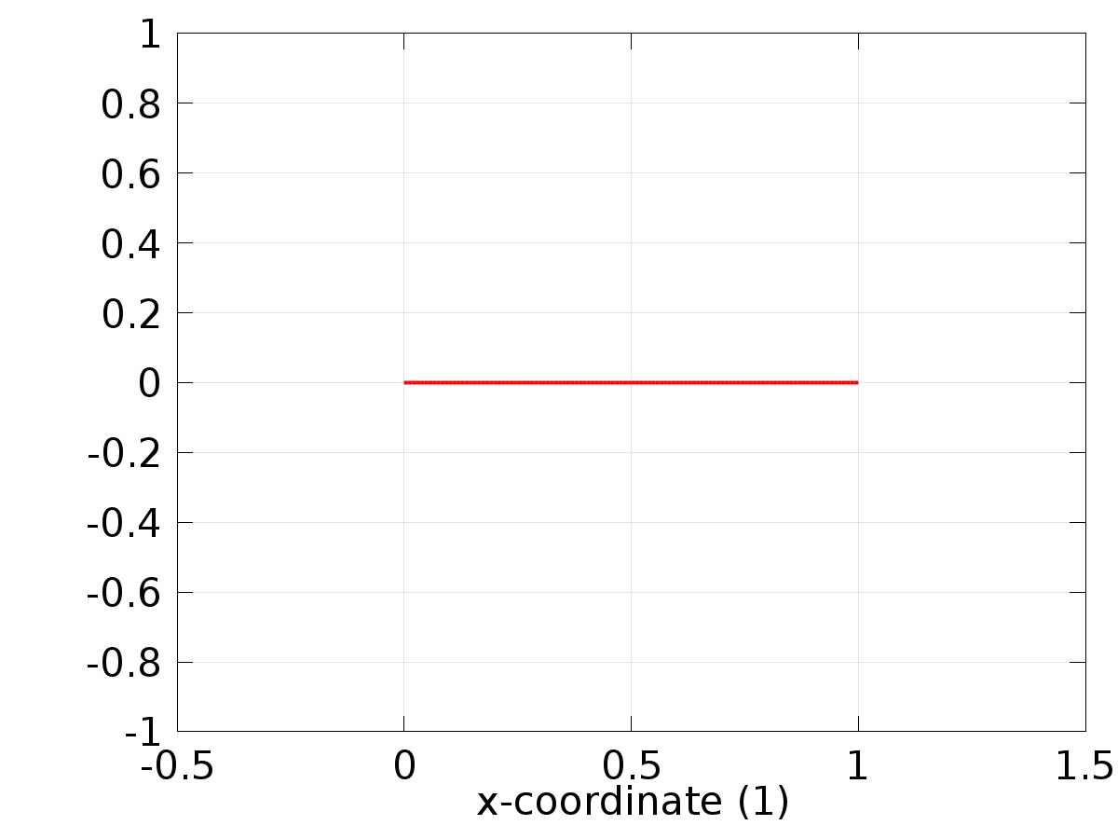

Data set: Solution 1

* + 1. Solution 2

Solution

| **Description** | **Value** |
| --- | --- |
| Solution | Solver 2 |
| Component | Save Point Geometry 1 |

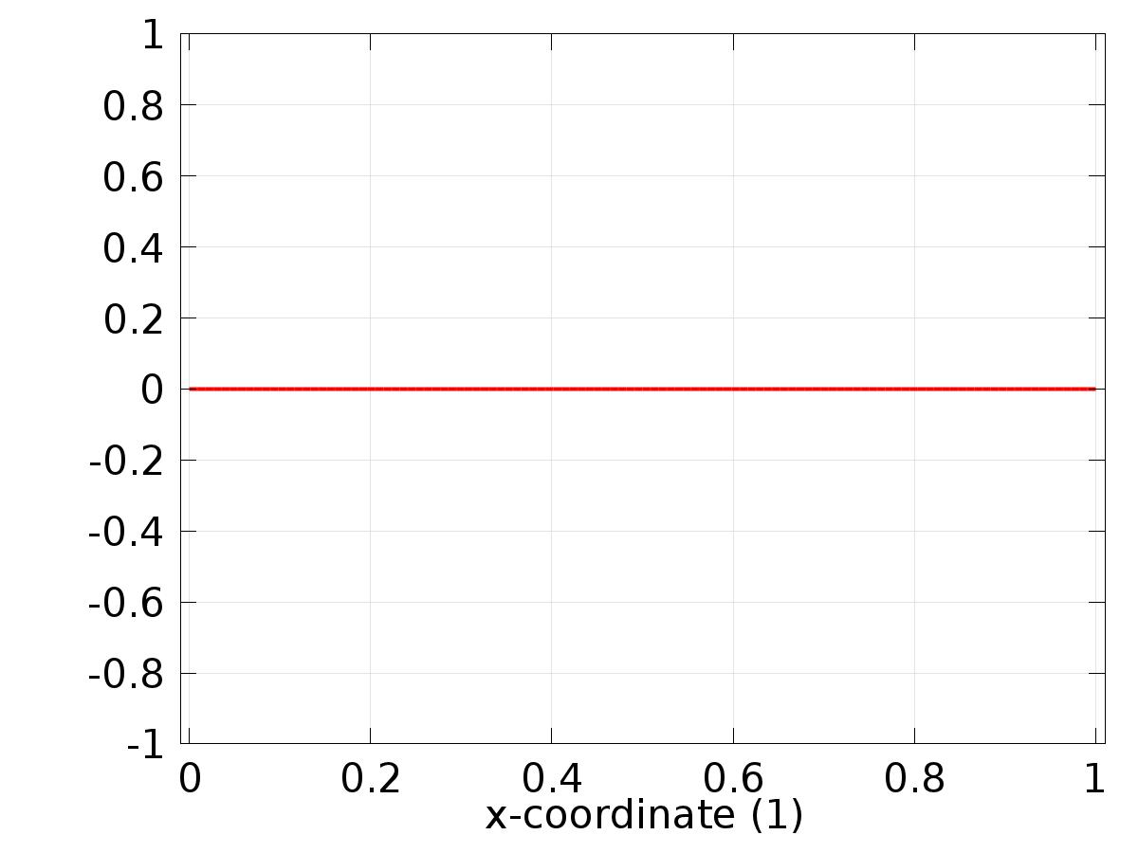

Data set: Solution 2

* + 1. Solution 3

Solution

| **Description** | **Value** |
| --- | --- |
| Solution | Solver 3 |
| Component | Save Point Geometry 1 |

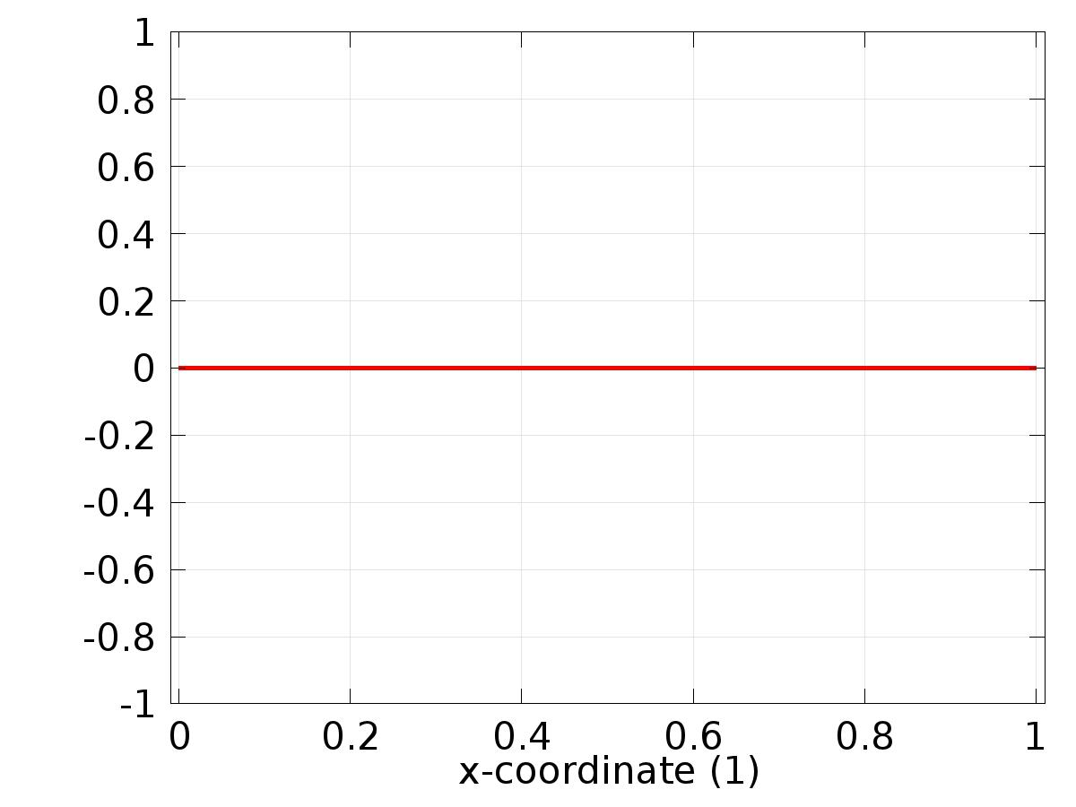

Data set: Solution 3

* 1. Derived Values
     1. Global Evaluation 1

Data

| **Description** | **Value** |
| --- | --- |
| Data set | Solution 3 |

Expression

| **Description** | **Value** |
| --- | --- |
| Expression | d |

* 1. Tables
     1. Table 1

Global Evaluation 1 (Gamma_a0)

Table 1

| **Gamma_a0 (1)** | **Gamma_a1 (1)** | **Gamma_b1 (1)** | **Gamma_a2 (1)** | **Gamma_b2 (1)** |
| --- | --- | --- | --- | --- |
| 1.4437 | 0.28111 | 0.79129 | -0.085978 | 0.029103 |

* + 1. Table 2

Point Evaluation 1 (yr)

* + 1. Table 3

Global Evaluation 1 (C(z))

Table 3

| **Time (s)** | **C(z)** | **yr** | **e** | **d** |
| --- | --- | --- | --- | --- |
| 0.0000 | 0.75000 | 0.50000 | -0.25000 | 0.75000 |
| 0.10000 | 0.79069 | 0.64695 | -0.14375 | 1.0590 |
| 0.20000 | 0.84367 | 0.73776 | -0.10590 | 1.3378 |
| 0.30000 | 0.82779 | 0.73776 | -0.090027 | 1.5590 |
| 0.40000 | 0.73413 | 0.64695 | -0.087186 | 1.7011 |
| 0.50000 | 0.59275 | 0.50000 | -0.092753 | 1.7500 |
| 0.60000 | 0.45463 | 0.35305 | -0.10158 | 1.7011 |
| 0.70000 | 0.37066 | 0.26224 | -0.10843 | 1.5590 |
| 0.80000 | 0.37034 | 0.26224 | -0.10811 | 1.3378 |
| 0.90000 | 0.44891 | 0.35305 | -0.095858 | 1.0590 |
| 1.0000 | 0.57425 | 0.50000 | -0.074247 | 0.75000 |
| 1.1000 | 0.69817 | 0.64695 | -0.051219 | 0.44098 |
| 1.2000 | 0.76955 | 0.73776 | -0.031790 | 0.16221 |
| 1.3000 | 0.75621 | 0.73776 | -0.018448 | -0.059017 |
| 1.4000 | 0.65841 | 0.64695 | -0.011459 | -0.20106 |
| 1.5000 | 0.50755 | 0.50000 | -0.0075469 | -0.25000 |
| 1.6000 | 0.35769 | 0.35305 | -0.0046361 | -0.20106 |
| 1.7000 | 0.26571 | 0.26224 | -0.0034722 | -0.059017 |
| 1.8000 | 0.26513 | 0.26224 | -0.0028915 | 0.16221 |
| 1.9000 | 0.35474 | 0.35305 | -0.0016844 | 0.44098 |
| 2.0000 | 0.50115 | 0.50000 | -0.0011512 | 0.75000 |
| 2.1000 | 0.64808 | 0.64695 | -0.0011357 | 1.0590 |
| 2.2000 | 0.73856 | 0.73776 | -7.9475E-4 | 1.3378 |
| 2.3000 | 0.73818 | 0.73776 | -4.1279E-4 | 1.5590 |
| 2.4000 | 0.64754 | 0.64695 | -5.9334E-4 | 1.7011 |
| 2.5000 | 0.50094 | 0.50000 | -9.3640E-4 | 1.7500 |
| 2.6000 | 0.35376 | 0.35305 | -7.0643E-4 | 1.7011 |
| 2.7000 | 0.26272 | 0.26224 | -4.8000E-4 | 1.5590 |
| 2.8000 | 0.26325 | 0.26224 | -0.0010094 | 1.3378 |
| 2.9000 | 0.35390 | 0.35305 | -8.4245E-4 | 1.0590 |
| 3.0000 | 0.50023 | 0.50000 | -2.2586E-4 | 0.75000 |
| 3.1000 | 0.64757 | 0.64695 | -6.1994E-4 | 0.44098 |
| 3.2000 | 0.73820 | 0.73776 | -4.4020E-4 | 0.16221 |
| 3.3000 | 0.73761 | 0.73776 | 1.5431E-4 | -0.059017 |
| 3.4000 | 0.64714 | 0.64695 | -1.9539E-4 | -0.20106 |
| 3.5000 | 0.50030 | 0.50000 | -3.0217E-4 | -0.25000 |
| 3.6000 | 0.35275 | 0.35305 | 3.0087E-4 | -0.20106 |
| 3.7000 | 0.26221 | 0.26224 | 2.8591E-5 | -0.059017 |
| 3.8000 | 0.26256 | 0.26224 | -3.2465E-4 | 0.16221 |
| 3.9000 | 0.35291 | 0.35305 | 1.4739E-4 | 0.44098 |
| 4.0000 | 0.49982 | 0.50000 | 1.8039E-4 | 0.75000 |
| 4.1000 | 0.64716 | 0.64695 | -2.1095E-4 | 1.0590 |
| 4.2000 | 0.73782 | 0.73776 | -5.5936E-5 | 1.3378 |
| 4.3000 | 0.73754 | 0.73776 | 2.2745E-4 | 1.5590 |
| 4.4000 | 0.64687 | 0.64695 | 7.4143E-5 | 1.7011 |
| 4.5000 | 0.50021 | 0.50000 | -2.0789E-4 | 1.7500 |
| 4.6000 | 0.35297 | 0.35305 | 8.6958E-5 | 1.7011 |
| 4.7000 | 0.26188 | 0.26224 | 3.5675E-4 | 1.5590 |
| 4.8000 | 0.26240 | 0.26224 | -1.5922E-4 | 1.3378 |
| 4.9000 | 0.35312 | 0.35305 | -6.6960E-5 | 1.0590 |
| 5.0000 | 0.49962 | 0.50000 | 3.7948E-4 | 0.75000 |
| 5.1000 | 0.64709 | 0.64695 | -1.4312E-4 | 0.44098 |
| 5.2000 | 0.73791 | 0.73776 | -1.4946E-4 | 0.16221 |
| 5.3000 | 0.73738 | 0.73776 | 3.8507E-4 | -0.059017 |
| 5.4000 | 0.64698 | 0.64695 | -3.0726E-5 | -0.20106 |
| 5.5000 | 0.50024 | 0.50000 | -2.3751E-4 | -0.25000 |
| 5.6000 | 0.35274 | 0.35305 | 3.1733E-4 | -0.20106 |
| 5.7000 | 0.26218 | 0.26224 | 5.4803E-5 | -0.059017 |
| 5.8000 | 0.26255 | 0.26224 | -3.1068E-4 | 0.16221 |
| 5.9000 | 0.35289 | 0.35305 | 1.6055E-4 | 0.44098 |
| 6.0000 | 0.49983 | 0.50000 | 1.6832E-4 | 0.75000 |
| 6.1000 | 0.64716 | 0.64695 | -2.1315E-4 | 1.0590 |
| 6.2000 | 0.73782 | 0.73776 | -5.6605E-5 | 1.3378 |
| 6.3000 | 0.73755 | 0.73776 | 2.1070E-4 | 1.5590 |
| 6.4000 | 0.64684 | 0.64695 | 1.0813E-4 | 1.7011 |
| 6.5000 | 0.50017 | 0.50000 | -1.6540E-4 | 1.7500 |
| 6.6000 | 0.35293 | 0.35305 | 1.2049E-4 | 1.7011 |
| 6.7000 | 0.26184 | 0.26224 | 4.0071E-4 | 1.5590 |
| 6.8000 | 0.26237 | 0.26224 | -1.3124E-4 | 1.3378 |
| 6.9000 | 0.35309 | 0.35305 | -3.3175E-5 | 1.0590 |
| 7.0000 | 0.49959 | 0.50000 | 4.1336E-4 | 0.75000 |
| 7.1000 | 0.64710 | 0.64695 | -1.4890E-4 | 0.44098 |
| 7.2000 | 0.73790 | 0.73776 | -1.3296E-4 | 0.16221 |
| 7.3000 | 0.73743 | 0.73776 | 3.3393E-4 | -0.059017 |
| 7.4000 | 0.64709 | 0.64695 | -1.4551E-4 | -0.20106 |
| 7.5000 | 0.50032 | 0.50000 | -3.1910E-4 | -0.25000 |
| 7.6000 | 0.35271 | 0.35305 | 3.4860E-4 | -0.20106 |
| 7.7000 | 0.26215 | 0.26224 | 8.3747E-5 | -0.059017 |
| 7.8000 | 0.26252 | 0.26224 | -2.7998E-4 | 0.16221 |
| 7.9000 | 0.35287 | 0.35305 | 1.8078E-4 | 0.44098 |
| 8.0000 | 0.49982 | 0.50000 | 1.7843E-4 | 0.75000 |
| 8.1000 | 0.64716 | 0.64695 | -2.1569E-4 | 1.0590 |
| 8.2000 | 0.73787 | 0.73776 | -1.0682E-4 | 1.3378 |
| 8.3000 | 0.73762 | 0.73776 | 1.4686E-4 | 1.5590 |
| 8.4000 | 0.64690 | 0.64695 | 5.0948E-5 | 1.7011 |
| 8.5000 | 0.50025 | 0.50000 | -2.4692E-4 | 1.7500 |
| 8.6000 | 0.35304 | 0.35305 | 9.5830E-6 | 1.7011 |
| 8.7000 | 0.26199 | 0.26224 | 2.4400E-4 | 1.5590 |
| 8.8000 | 0.26257 | 0.26224 | -3.3199E-4 | 1.3378 |
| 8.9000 | 0.35326 | 0.35305 | -2.0693E-4 | 1.0590 |
| 9.0000 | 0.49973 | 0.50000 | 2.7399E-4 | 0.75000 |
| 9.1000 | 0.64718 | 0.64695 | -2.3299E-4 | 0.44098 |
| 9.2000 | 0.73798 | 0.73776 | -2.1192E-4 | 0.16221 |
| 9.3000 | 0.73742 | 0.73776 | 3.4887E-4 | -0.059017 |
| 9.4000 | 0.64709 | 0.64695 | -1.4748E-4 | -0.20106 |
| 9.5000 | 0.50026 | 0.50000 | -2.5848E-4 | -0.25000 |
| 9.6000 | 0.35267 | 0.35305 | 3.8584E-4 | -0.20106 |
| 9.7000 | 0.26213 | 0.26224 | 1.0931E-4 | -0.059017 |
| 9.8000 | 0.26253 | 0.26224 | -2.9561E-4 | 0.16221 |
| 9.9000 | 0.35290 | 0.35305 | 1.5195E-4 | 0.44098 |
| 10.000 | 0.49982 | 0.50000 | 1.8224E-4 | 0.75000 |

* 1. Plot Groups
     1. 1D Plot Group 1

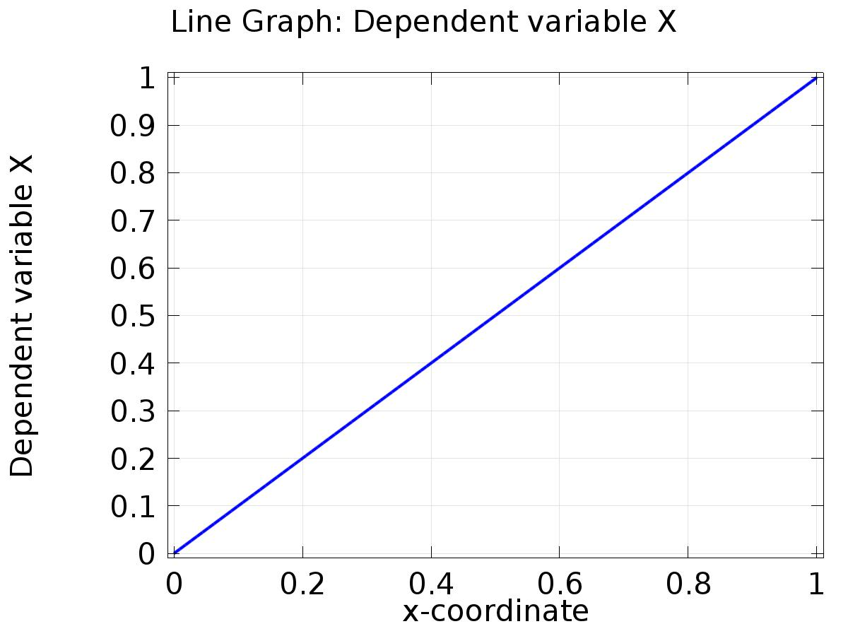

Line Graph: Dependent variable X

* + 1. 1D Plot Group 2

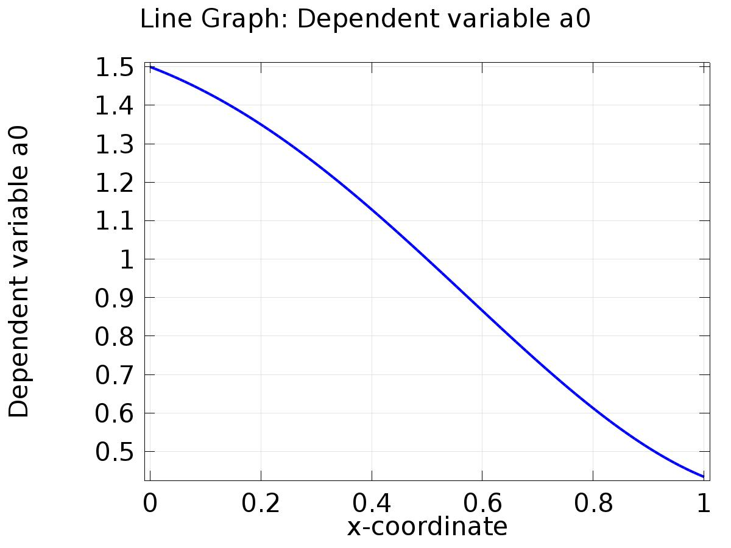

Line Graph: Dependent variable a0

* + 1. 1D Plot Group 3

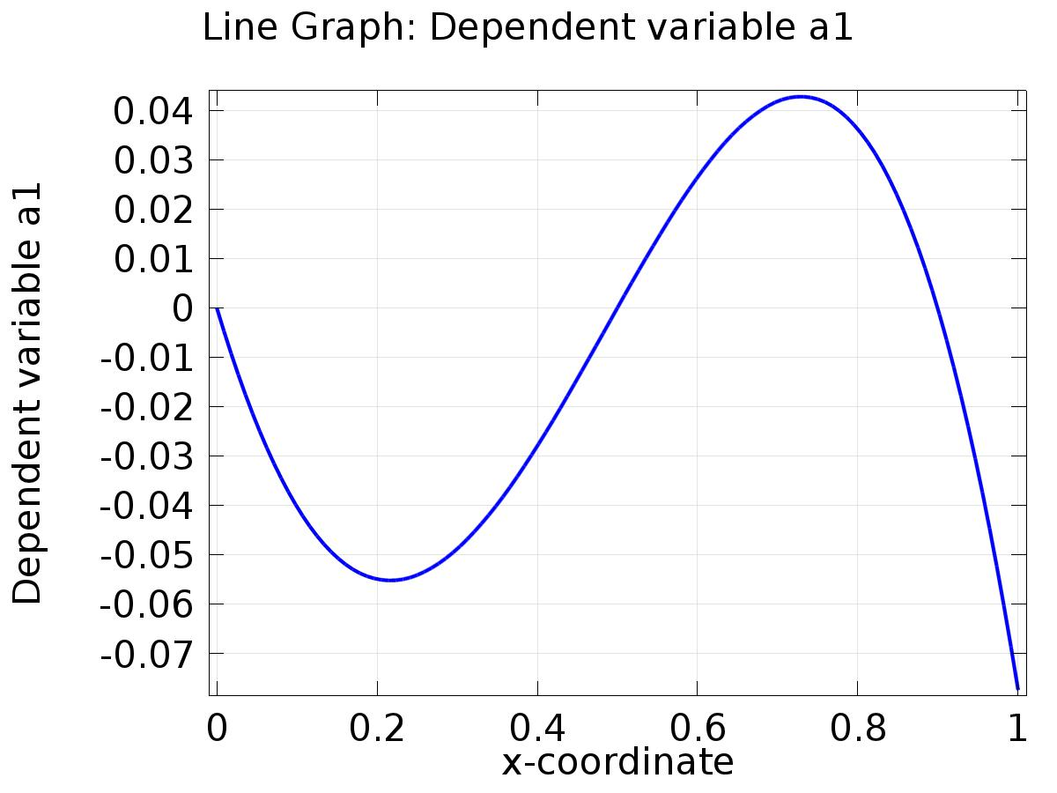

Line Graph: Dependent variable a1

* + 1. 1D Plot Group 4

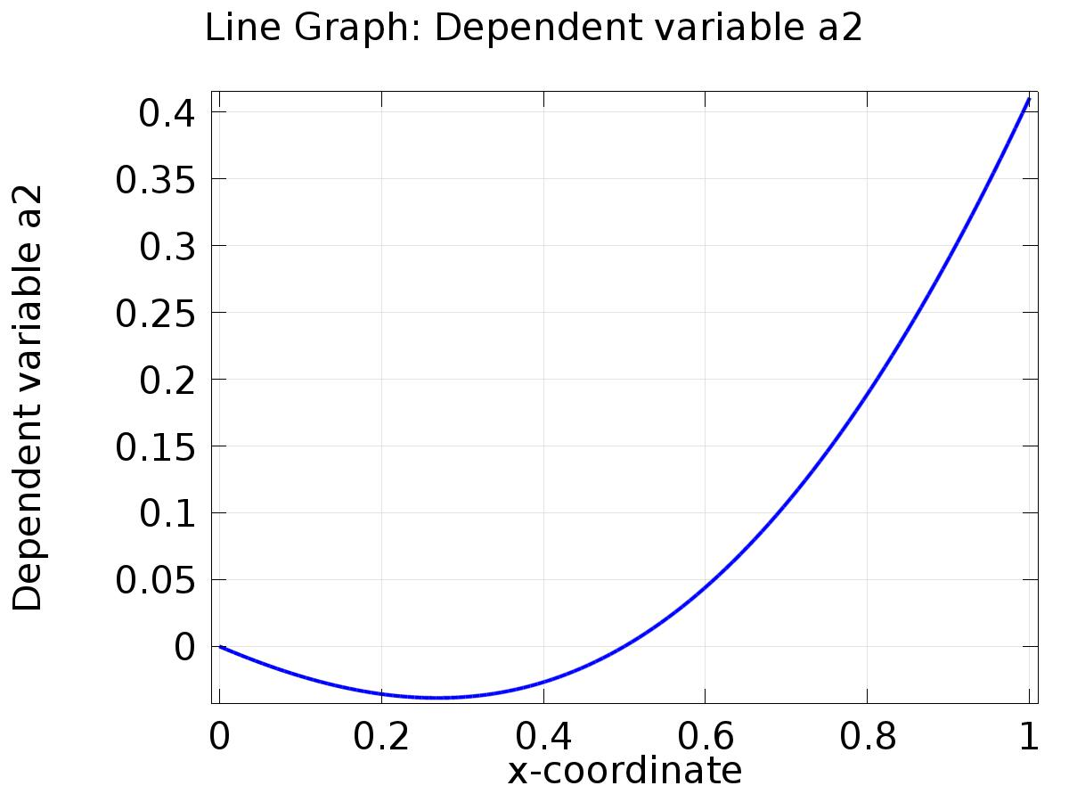

Line Graph: Dependent variable a2

* + 1. 1D Plot Group 5

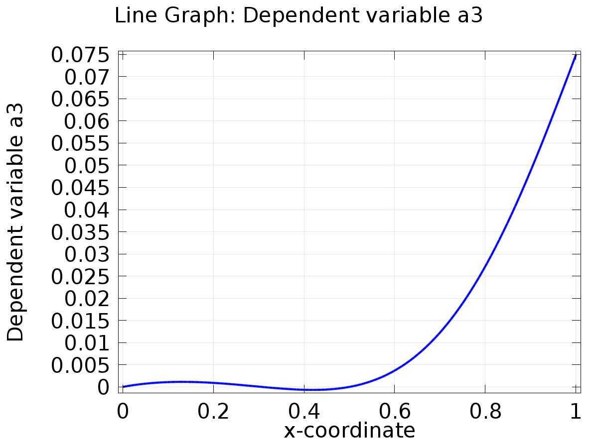

Line Graph: Dependent variable a3

* + 1. 1D Plot Group 6

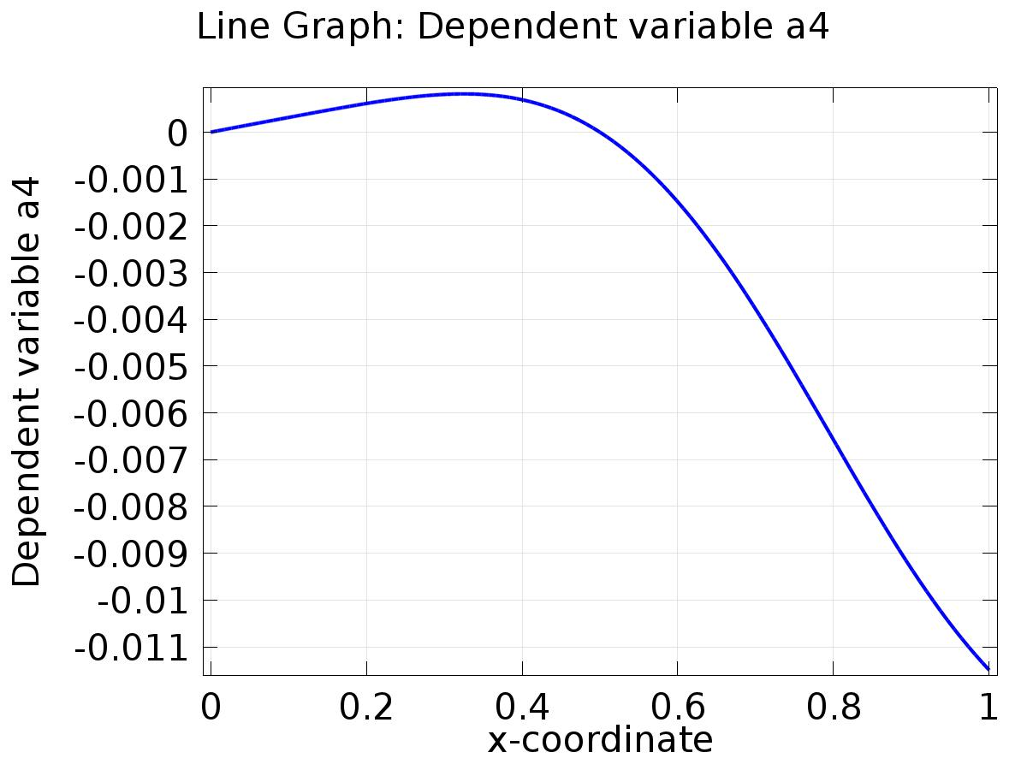

Line Graph: Dependent variable a4

* + 1. 1D Plot Group 7

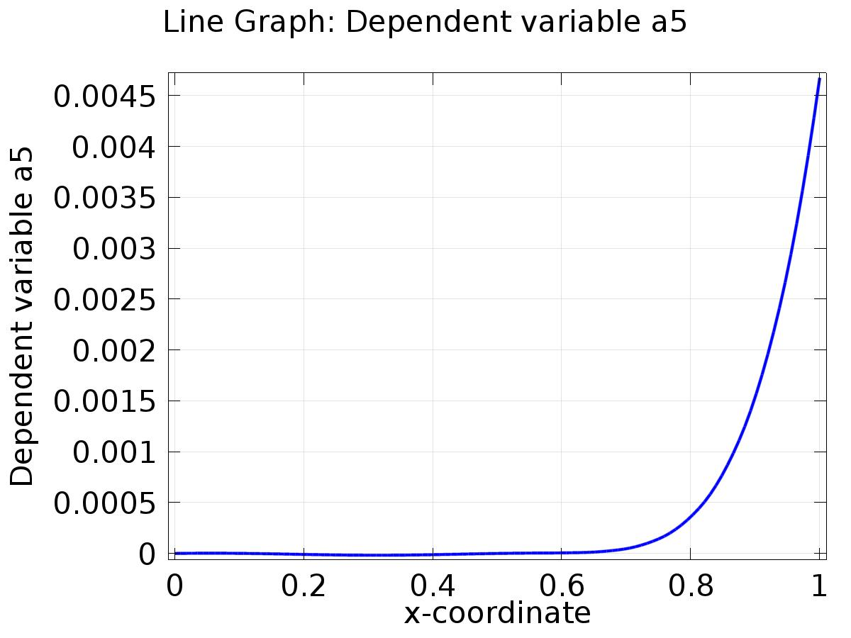

Line Graph: Dependent variable a5

* + 1. 1D Plot Group 8

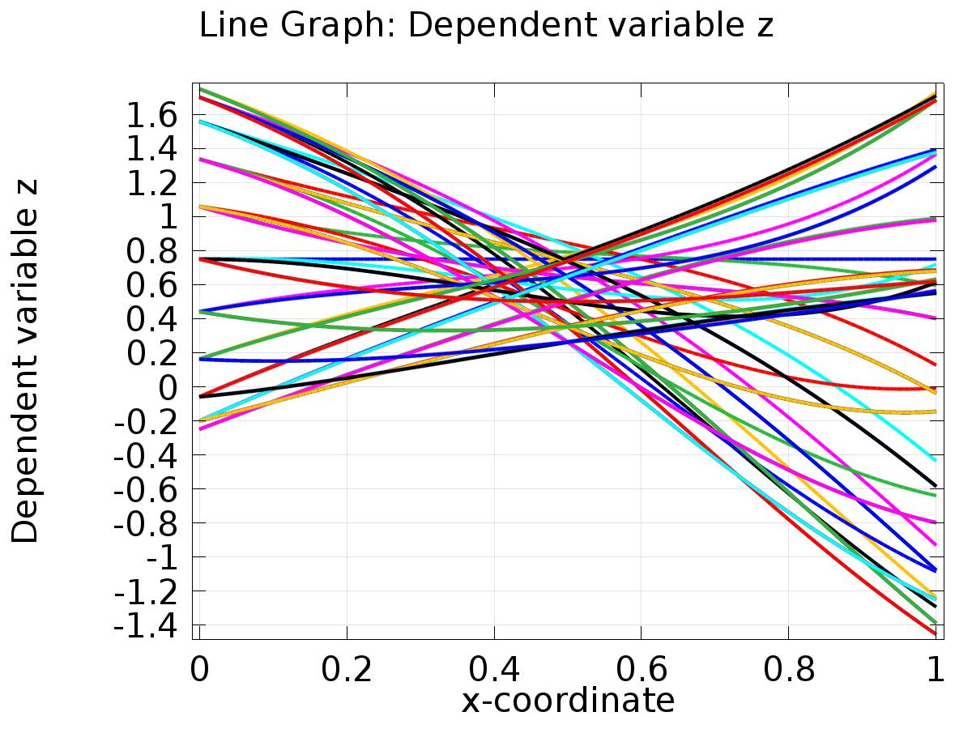

Line Graph: Dependent variable z

* + 1. 1D Plot Group 9

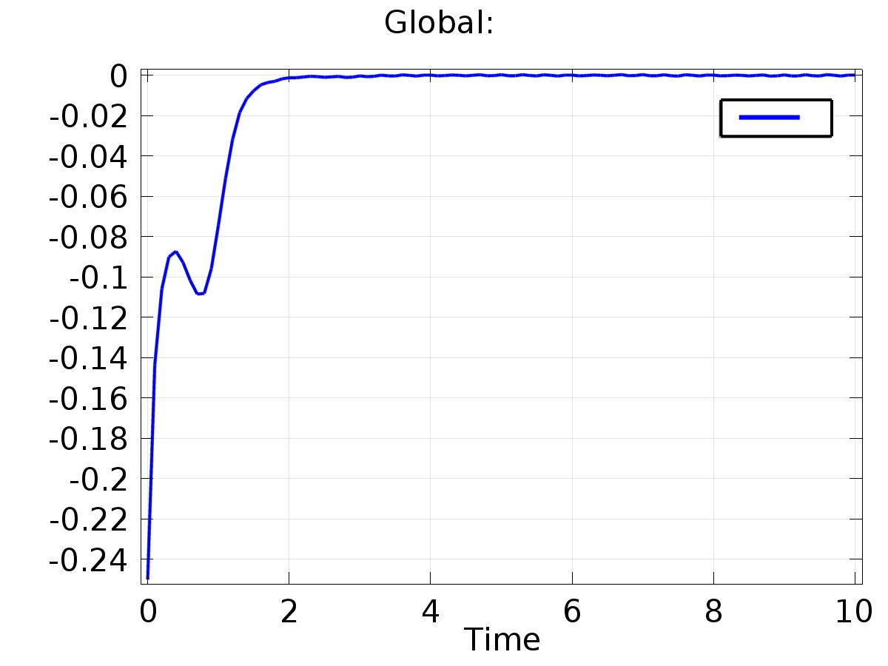

Global:

* + 1. 1D Plot Group 10

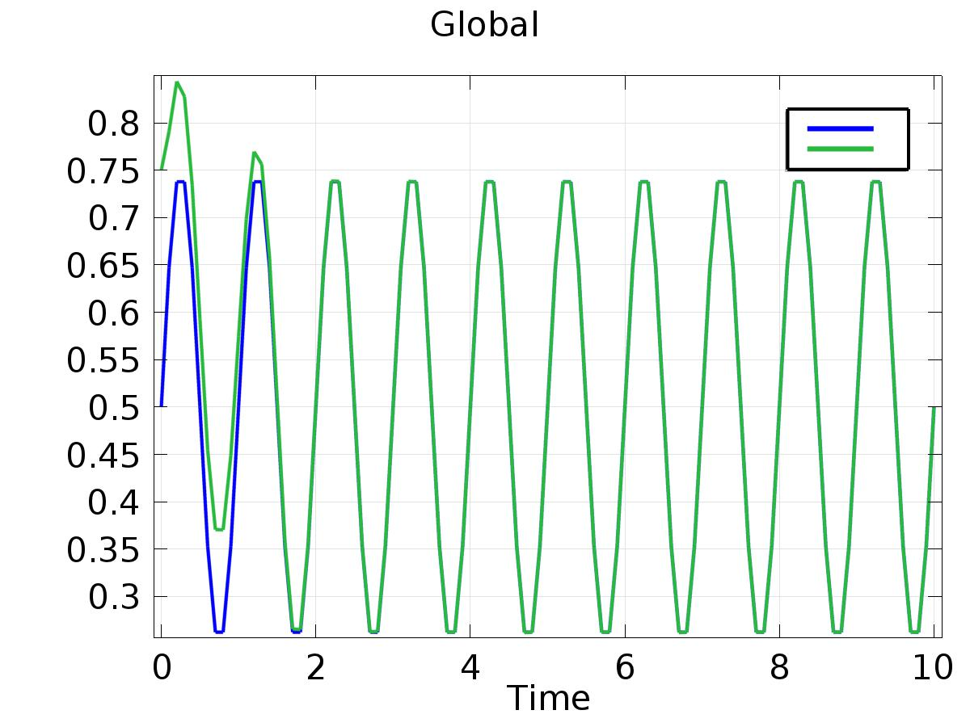

Global