[](http://www.comsol.com/)

Ch4 Ex4 6

|  |  |
| --- | --- |
| Date | Jun 15, 2014 10:22:21 AM |

Contents

1. Global

1.1. Definitions

2. Component 1

2.1. Definitions

2.2. Geometry 1

2.3. Zero Dynamics

2.4. Closed Loop System

2.5. Mesh 1

3. Study 1

3.1. Time Dependent

3.2. Solver Configurations

4. Results

4.1. Data Sets

4.2. Derived Values

4.3. Tables

4.4. Plot Groups

1. Global

|  |  |
| --- | --- |
| Date | May 12, 2014 8:09:38 AM |

Global settings

|  |  |
| --- | --- |
| Name | Ch4 Ex4 6.mph |
| Path | /Users/gilliam/Desktop/collect_15/research_15/geo_reg_mono_eugenio/Mono_1_15/Comsol_EX_GitHub/Chapter4/Example4.6/Ch4_Ex4_6.mph |
| Program | COMSOL 4.4 (Build: 150) |

Used products

|  |
| --- |
| COMSOL Multiphysics |

* 1. Definitions
     1. Parameters 1

Parameters

| **Name** | **Expression** | **Value** | **Description** |
| --- | --- | --- | --- |
| L | 1 | 1.0000 |  |
| k0 | 1 | 1.0000 |  |
| k1 | 2 | 2.0000 |  |
| c | 1 | 1.0000 |  |

1. Component 1

Component settings

|  |  |
| --- | --- |
| Unit system | None |

* 1. Definitions
     1. Variables

#### Variables 1

Selection

|  |  |
| --- | --- |
| Geometric entity level | Entire model |

| **Name** | **Expression** | **Description** |
| --- | --- | --- |
| yr0 | sin(t) |  |
| yr1 | sin(2*t) |  |
| e0 | yr0 - C0(z) |  |
| e1 | yr1 - C1(z) |  |

* + 1. Component Couplings

#### Integration 1

|  |  |
| --- | --- |
| Coupling type | Integration |
| Operator name | C0 |

Source selection

|  |  |
| --- | --- |
| Geometric entity level | Boundary |
| Selection | Boundary 1 |

#### Integration 2

|  |  |
| --- | --- |
| Coupling type | Integration |
| Operator name | C1 |

Source selection

|  |  |
| --- | --- |
| Geometric entity level | Boundary |
| Selection | Boundary 2 |

* 1. Geometry 1

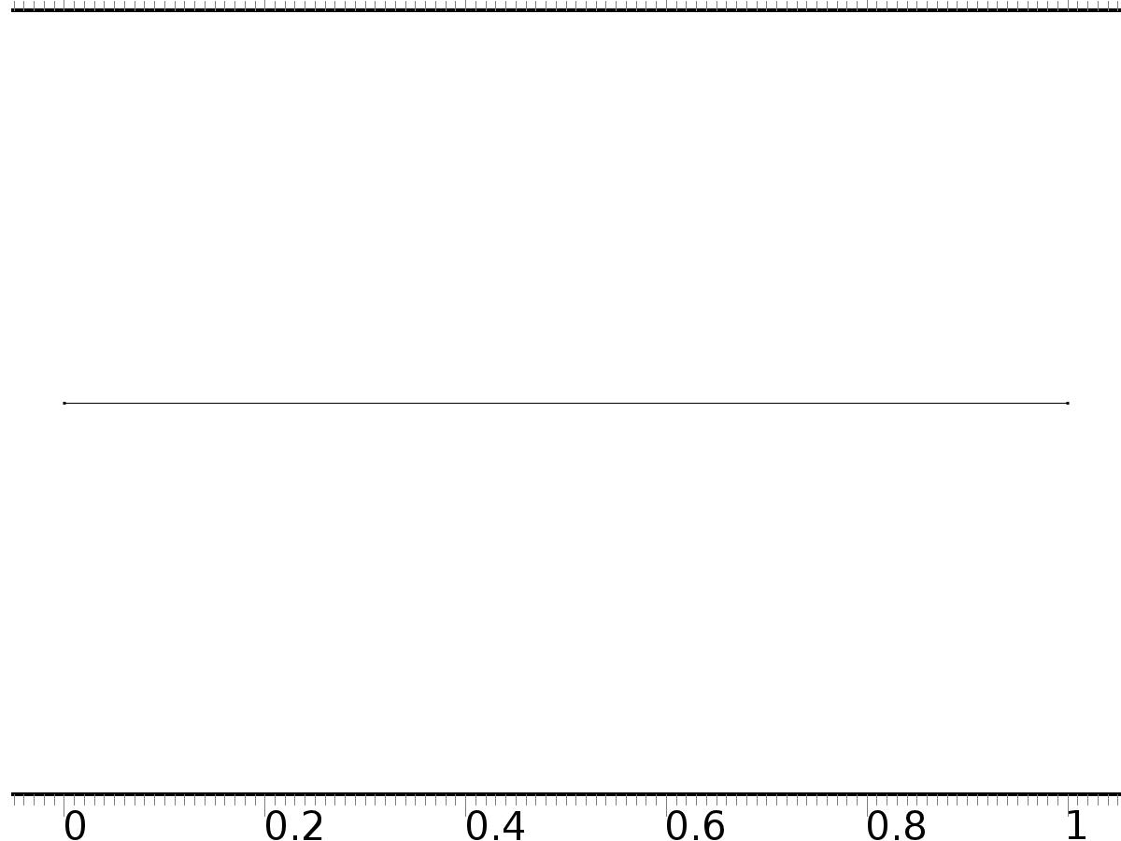

Geometry 1

Units

|  |  |
| --- | --- |
| Length unit | m |
| Angular unit | deg |

Geometry statistics

| **Description** | **Value** |
| --- | --- |
| Space dimension | 1 |
| Number of domains | 1 |
| Number of boundaries | 2 |

* + 1. Interval 1 (i1)

Interval

| **Description** | **Value** |
| --- | --- |
| Number of intervals | One |
| Left endpoint | 0 |
| Right endpoint | L |

* 1. Zero Dynamics

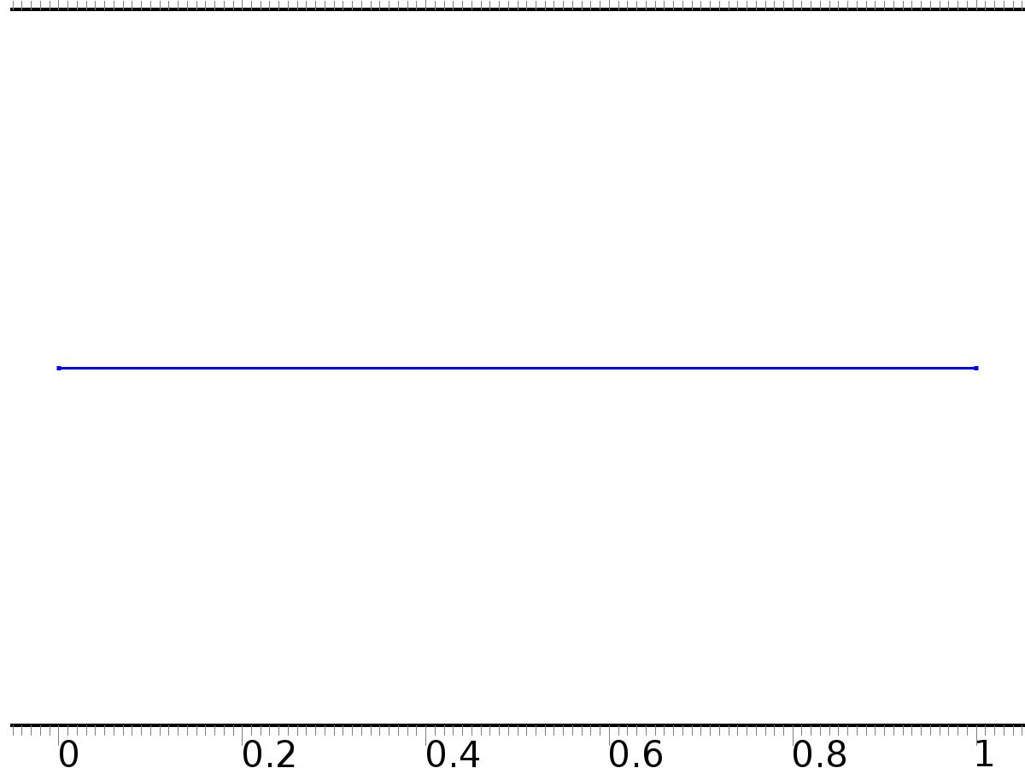

Zero Dynamics

Selection

|  |  |
| --- | --- |
| Geometric entity level | Domain |
| Selection | Domain 1 |

Settings

| **Description** | **Value** |
| --- | --- |
| Shape function type | Lagrange |
| Element order | Quadratic |
| Compute boundary fluxes | On |
| Apply smoothing to boundary fluxes | On |
| Value type when using splitting of complex variables | Complex |
| Dependent variable quantity | Dimensionless (1) |
| Source term quantity | None |
| Unit | m^ - 2 |

Used products

|  |
| --- |
| COMSOL Multiphysics |

Variables

| **Name** | **Expression** | **Unit** | **Description** | **Selection** |
| --- | --- | --- | --- | --- |
| PI.nx | nx |  | Normal vector, x component | Boundaries 1–2 |
| PI.ny | root.ny |  | Normal vector, y component | Boundaries 1–2 |
| PI.nz | root.nz |  | Normal vector, z component | Boundaries 1–2 |
| PI.nxmesh | root.nxmesh |  | Normal vector (mesh), x component | Boundaries 1–2 |
| PI.nymesh | root.nymesh |  | Normal vector (mesh), y component | Boundaries 1–2 |
| PI.nzmesh | root.nzmesh |  | Normal vector (mesh), z component | Boundaries 1–2 |

* + 1. Coefficient Form PDE 1



Coefficient Form PDE 1

Selection

|  |  |
| --- | --- |
| Geometric entity level | Domain |
| Selection | Domain 1 |

Equations

Settings

| **Description** | **Value** |
| --- | --- |
| Diffusion coefficient | c |
| Absorption coefficient | 0 |
| Source term | 0 |
| Mass coefficient | 0 |
| Damping or mass coefficient | 1 |
| Conservative flux convection coefficient | 0 |
| Convection coefficient | PI |
| Conservative flux source | 0 |

#### Variables

| **Name** | **Expression** | **Unit** | **Description** | **Selection** |
| --- | --- | --- | --- | --- |
| domflux.PIx | -c*d(PI,x) |  | Domain flux, x component | Domain 1 |

#### Shape functions

| **Name** | **Shape function** | **Unit** | **Description** | **Shape frame** | **Selection** |
| --- | --- | --- | --- | --- | --- |
| PI | Lagrange (Quadratic) |  | Dependent variable PI | Material | Domain 1 |

* + 1. Zero Flux 1



Zero Flux 1

Selection

|  |  |
| --- | --- |
| Geometric entity level | Boundary |
| Selection | No boundaries |

Equations

* + 1. Initial Values



Initial Values

Selection

|  |  |
| --- | --- |
| Geometric entity level | Domain |
| Selection | Domain 1 |

Settings

| **Description** | **Value** |
| --- | --- |
| Initial value for PI | 0 |
| Initial time derivative of PI | 0 |

* + 1. PI(0)=yr0

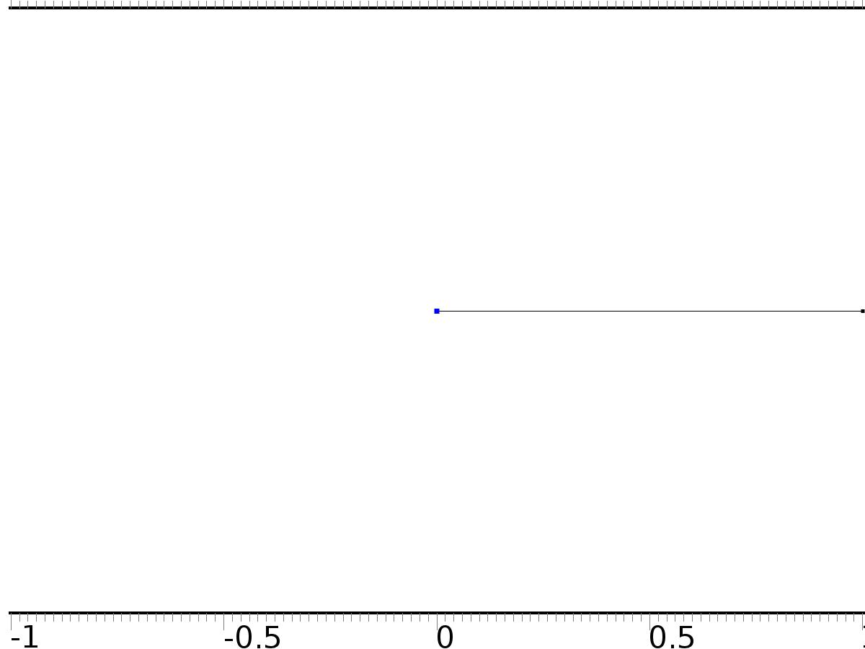

PI(0)=yr0

Selection

|  |  |
| --- | --- |
| Geometric entity level | Boundary |
| Selection | Boundary 1 |

Equations

Settings

| **Description** | **Value** |
| --- | --- |
| Value on boundary | yr0 |
| Prescribed value of PI | On |
| Apply reaction terms on | Individual dependent variables |
| Use weak constraints | Off |
| Constraint method | Elemental |

#### Shape functions

| **Constraint** | **Constraint force** | **Shape function** | **Selection** |
| --- | --- | --- | --- |
| yr0-PI | -test(PI) | Lagrange (Quadratic) | Boundary 1 |

* + 1. PI(L)=yr1

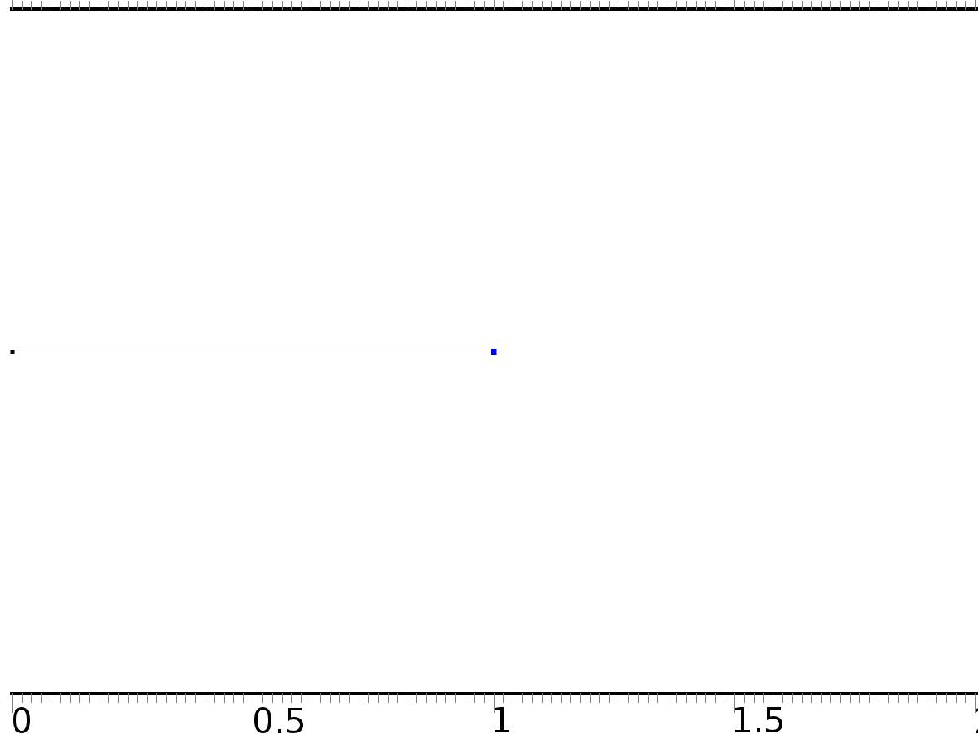

PI(L)=yr1

Selection

|  |  |
| --- | --- |
| Geometric entity level | Boundary |
| Selection | Boundary 2 |

Equations

Settings

| **Description** | **Value** |
| --- | --- |
| Value on boundary | yr1 |
| Prescribed value of PI | On |
| Apply reaction terms on | Individual dependent variables |
| Use weak constraints | Off |
| Constraint method | Elemental |

#### Shape functions

| **Constraint** | **Constraint force** | **Shape function** | **Selection** |
| --- | --- | --- | --- |
| yr1-PI | -test(PI) | Lagrange (Quadratic) | Boundary 2 |

* 1. Closed Loop System



Closed Loop System

Selection

|  |  |
| --- | --- |
| Geometric entity level | Domain |
| Selection | Domain 1 |

Settings

| **Description** | **Value** |
| --- | --- |
| Shape function type | Lagrange |
| Element order | Quadratic |
| Compute boundary fluxes | On |
| Apply smoothing to boundary fluxes | On |
| Value type when using splitting of complex variables | Complex |
| Dependent variable quantity | Dimensionless (1) |
| Source term quantity | None |
| Unit | m^ - 2 |

Used products

|  |
| --- |
| COMSOL Multiphysics |

Variables

| **Name** | **Expression** | **Unit** | **Description** | **Selection** |
| --- | --- | --- | --- | --- |
| z.nx | nx |  | Normal vector, x component | Boundaries 1–2 |
| z.ny | root.ny |  | Normal vector, y component | Boundaries 1–2 |
| z.nz | root.nz |  | Normal vector, z component | Boundaries 1–2 |
| z.nxmesh | root.nxmesh |  | Normal vector (mesh), x component | Boundaries 1–2 |
| z.nymesh | root.nymesh |  | Normal vector (mesh), y component | Boundaries 1–2 |
| z.nzmesh | root.nzmesh |  | Normal vector (mesh), z component | Boundaries 1–2 |

* + 1. Coefficient Form PDE 1



Coefficient Form PDE 1

Selection

|  |  |
| --- | --- |
| Geometric entity level | Domain |
| Selection | Domain 1 |

Equations

Settings

| **Description** | **Value** |
| --- | --- |
| Diffusion coefficient | c |
| Absorption coefficient | 0 |
| Source term | 0 |
| Mass coefficient | 0 |
| Damping or mass coefficient | 1 |
| Conservative flux convection coefficient | 0 |
| Convection coefficient | z |
| Conservative flux source | 0 |

#### Variables

| **Name** | **Expression** | **Unit** | **Description** | **Selection** |
| --- | --- | --- | --- | --- |
| domflux.zx | -c*d(z,x) |  | Domain flux, x component | Domain 1 |

#### Shape functions

| **Name** | **Shape function** | **Unit** | **Description** | **Shape frame** | **Selection** |
| --- | --- | --- | --- | --- | --- |
| z | Lagrange (Quadratic) |  | Dependent variable z | Material | Domain 1 |

* + 1. Zero Flux 1



Zero Flux 1

Selection

|  |  |
| --- | --- |
| Geometric entity level | Boundary |
| Selection | No boundaries |

Equations

* + 1. Initial Values



Initial Values

Selection

|  |  |
| --- | --- |
| Geometric entity level | Domain |
| Selection | Domain 1 |

Settings

| **Description** | **Value** |
| --- | --- |
| Initial value for z | cos(pi*x) |
| Initial time derivative of z | 0 |

* + 1. Bin0*u0



Bin0*u0

Selection

|  |  |
| --- | --- |
| Geometric entity level | Boundary |
| Selection | Boundary 1 |

Equations

Settings

| **Description** | **Value** |
| --- | --- |
| Boundary flux/source | -c*PIx + k0*yr0 |
| Boundary absorption/impedance term | k0 |

#### Variables

| **Name** | **Expression** | **Unit** | **Description** | **Selection** |
| --- | --- | --- | --- | --- |
| z.g_z | -c*PIx+k0*yr0-k0*z |  | Boundary flux/source | Boundary 1 |

* + 1. Bin1*u1



Bin1*u1

Selection

|  |  |
| --- | --- |
| Geometric entity level | Boundary |
| Selection | Boundary 2 |

Equations

Settings

| **Description** | **Value** |
| --- | --- |
| Boundary flux/source | c*PIx + k1*yr1 |
| Boundary absorption/impedance term | k1 |

#### Variables

| **Name** | **Expression** | **Unit** | **Description** | **Selection** |
| --- | --- | --- | --- | --- |
| z.g_z | c*PIx+k1*yr1-k1*z |  | Boundary flux/source | Boundary 2 |

* 1. Mesh 1

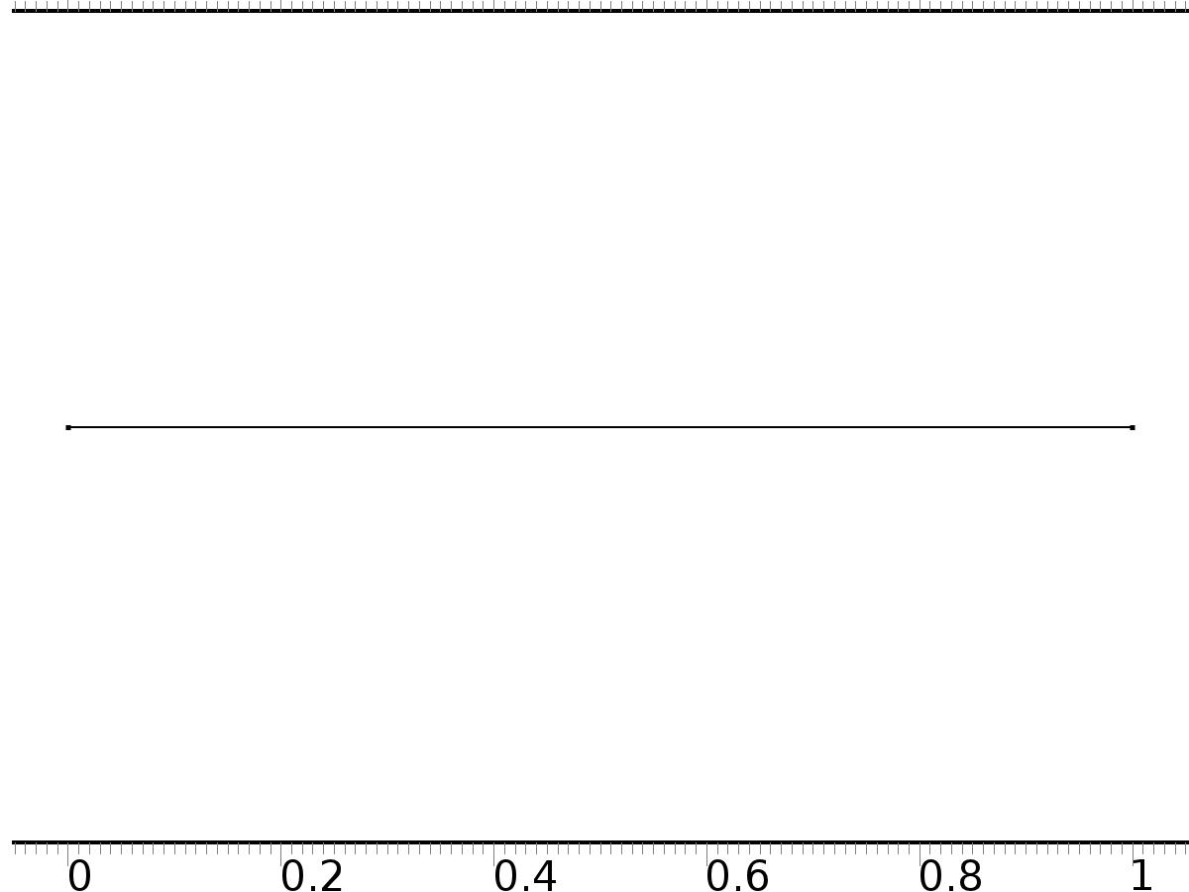

Mesh 1

* + 1. Size (size)

Settings

| **Description** | **Value** |
| --- | --- |
| Maximum element size | 0.02 |
| Minimum element size | 7.5E-5 |
| Curvature factor | 0.25 |
| Maximum element growth rate | 1.2 |
| Predefined size | Extra fine |

* + 1. Edge 1 (edg1)

Selection

|  |  |
| --- | --- |
| Geometric entity level | Remaining |

1. Study 1
   1. Time Dependent

Study settings

| **Description** | **Value** |
| --- | --- |
| Include geometric nonlinearity | Off |

| **Times** | **Unit** |
| --- | --- |
| range(0,0.025,10) | s |

Physics and variables selection

| **Physics interface** | **Discretization** |
| --- | --- |
| Zero Dynamics (c) | physics |
| Closed Loop System (c2) | physics |

Mesh selection

| **Geometry** | **Mesh** |
| --- | --- |
| Geometry 1 (geom1) | mesh1 |

* 1. Solver Configurations
     1. Solver 1

#### Compile Equations: Time Dependent (st1)

Study and step

| **Description** | **Value** |
| --- | --- |
| Use study | Study 1 |
| Use study step | Time Dependent |

#### Dependent Variables 1 (v1)

General

| **Description** | **Value** |
| --- | --- |
| Defined by study step | Time Dependent |
| Constant |  |

Initial values of variables solved for

| **Description** | **Value** |
| --- | --- |
| Solution | Zero |

Values of variables not solved for

| **Description** | **Value** |
| --- | --- |
| Solution | Zero |

##### Dependent variable PI (comp1.PI) (comp1_PI)

General

| **Description** | **Value** |
| --- | --- |
| Field components | comp1.PI |

##### Dependent variable z (comp1.z) (comp1_z)

General

| **Description** | **Value** |
| --- | --- |
| Field components | comp1.z |

#### Time-Dependent Solver 1 (t1)

General

| **Description** | **Value** |
| --- | --- |
| Defined by study step | Time Dependent |
| Time | {0, 0.025, 0.05, 0.07500000000000001, 0.1, 0.125, 0.15000000000000002, 0.17500000000000002, 0.2, 0.225, 0.25, 0.275, 0.30000000000000004, 0.325, 0.35000000000000003, 0.375, 0.4, 0.42500000000000004, 0.45, 0.47500000000000003, 0.5, 0.525, 0.55, 0.5750000000000001, 0.6000000000000001, 0.625, 0.65, 0.675, 0.7000000000000001, 0.7250000000000001, 0.75, 0.775, 0.8, 0.8250000000000001, 0.8500000000000001, 0.875, 0.9, 0.925, 0.9500000000000001, 0.9750000000000001, 1, 1.0250000000000001, 1.05, 1.075, 1.1, 1.125, 1.1500000000000001, 1.175, 1.2000000000000002, 1.225, 1.25, 1.2750000000000001, 1.3, 1.3250000000000002, 1.35, 1.375, 1.4000000000000001, 1.425, 1.4500000000000002, 1.475, 1.5, 1.5250000000000001, 1.55, 1.5750000000000002, 1.6, 1.625, 1.6500000000000001, 1.675, 1.7000000000000002, 1.725, 1.75, 1.7750000000000001, 1.8, 1.8250000000000002, 1.85, 1.875, 1.9000000000000001, 1.925, 1.9500000000000002, 1.975, 2, 2.025, 2.0500000000000003, 2.075, 2.1, 2.125, 2.15, 2.1750000000000003, 2.2, 2.225, 2.25, 2.275, 2.3000000000000003, 2.325, 2.35, 2.375, 2.4000000000000004, 2.4250000000000003, 2.45, 2.475, 2.5, 2.5250000000000004, 2.5500000000000003, 2.575, 2.6, 2.625, 2.6500000000000004, 2.6750000000000003, 2.7, 2.725, 2.75, 2.7750000000000004, 2.8000000000000003, 2.825, 2.85, 2.875, 2.9000000000000004, 2.9250000000000003, 2.95, 2.975, 3, 3.0250000000000004, 3.0500000000000003, 3.075, 3.1, 3.125, 3.1500000000000004, 3.1750000000000003, 3.2, 3.225, 3.25, 3.2750000000000004, 3.3000000000000003, 3.325, 3.35, 3.375, 3.4000000000000004, 3.4250000000000003, 3.45, 3.475, 3.5, 3.5250000000000004, 3.5500000000000003, 3.575, 3.6, 3.625, 3.6500000000000004, 3.6750000000000003, 3.7, 3.725, 3.75, 3.7750000000000004, 3.8000000000000003, 3.825, 3.85, 3.875, 3.9000000000000004, 3.9250000000000003, 3.95, 3.975, 4, 4.025, 4.05, 4.075, 4.1000000000000005, 4.125, 4.15, 4.175, 4.2, 4.2250000000000005, 4.25, 4.275, 4.3, 4.325, 4.3500000000000005, 4.375, 4.4, 4.425, 4.45, 4.4750000000000005, 4.5, 4.525, 4.55, 4.575, 4.6000000000000005, 4.625, 4.65, 4.675, 4.7, 4.7250000000000005, 4.75, 4.775, 4.800000000000001, 4.825, 4.8500000000000005, 4.875, 4.9, 4.925000000000001, 4.95, 4.9750000000000005, 5, 5.025, 5.050000000000001, 5.075, 5.1000000000000005, 5.125, 5.15, 5.175000000000001, 5.2, 5.2250000000000005, 5.25, 5.275, 5.300000000000001, 5.325, 5.3500000000000005, 5.375, 5.4, 5.425000000000001, 5.45, 5.4750000000000005, 5.5, 5.525, 5.550000000000001, 5.575, 5.6000000000000005, 5.625, 5.65, 5.675000000000001, 5.7, 5.7250000000000005, 5.75, 5.775, 5.800000000000001, 5.825, 5.8500000000000005, 5.875, 5.9, 5.925000000000001, 5.95, 5.9750000000000005, 6, 6.025, 6.050000000000001, 6.075, 6.1000000000000005, 6.125, 6.15, 6.175000000000001, 6.2, 6.2250000000000005, 6.25, 6.275, 6.300000000000001, 6.325, 6.3500000000000005, 6.375, 6.4, 6.425000000000001, 6.45, 6.4750000000000005, 6.5, 6.525, 6.550000000000001, 6.575, 6.6000000000000005, 6.625, 6.65, 6.675000000000001, 6.7, 6.7250000000000005, 6.75, 6.775, 6.800000000000001, 6.825, 6.8500000000000005, 6.875, 6.9, 6.925000000000001, 6.95, 6.9750000000000005, 7, 7.025, 7.050000000000001, 7.075, 7.1000000000000005, 7.125, 7.15, 7.175000000000001, 7.2, 7.2250000000000005, 7.25, 7.275, 7.300000000000001, 7.325, 7.3500000000000005, 7.375, 7.4, 7.425000000000001, 7.45, 7.4750000000000005, 7.5, 7.525, 7.550000000000001, 7.575, 7.6000000000000005, 7.625, 7.65, 7.675000000000001, 7.7, 7.7250000000000005, 7.75, 7.775, 7.800000000000001, 7.825, 7.8500000000000005, 7.875, 7.9, 7.925000000000001, 7.95, 7.9750000000000005, 8, 8.025, 8.05, 8.075000000000001, 8.1, 8.125, 8.15, 8.175, 8.200000000000001, 8.225, 8.25, 8.275, 8.3, 8.325000000000001, 8.35, 8.375, 8.4, 8.425, 8.450000000000001, 8.475, 8.5, 8.525, 8.55, 8.575000000000001, 8.6, 8.625, 8.65, 8.675, 8.700000000000001, 8.725, 8.75, 8.775, 8.8, 8.825000000000001, 8.85, 8.875, 8.9, 8.925, 8.950000000000001, 8.975, 9, 9.025, 9.05, 9.075000000000001, 9.1, 9.125, 9.15, 9.175, 9.200000000000001, 9.225, 9.25, 9.275, 9.3, 9.325000000000001, 9.35, 9.375, 9.4, 9.425, 9.450000000000001, 9.475, 9.5, 9.525, 9.55, 9.575000000000001, 9.600000000000001, 9.625, 9.65, 9.675, 9.700000000000001, 9.725000000000001, 9.75, 9.775, 9.8, 9.825000000000001, 9.850000000000001, 9.875, 9.9, 9.925, 9.950000000000001, 9.975000000000001, 10} |
| Relative tolerance | 0.0001 |

Absolute tolerance

| **Description** | **Value** |
| --- | --- |
| Tolerance | 0.000010 |

Time stepping

| **Description** | **Value** |
| --- | --- |
| Initial step | 0.0010 |

Advanced

| **Description** | **Value** |
| --- | --- |
| Fraction of initial step for Backward Euler | 0.0010 |

Log

| **Description** | **Value** |
| --- | --- |
| Constant |  |

##### Fully Coupled 1 (fc1)

General

| **Description** | **Value** |
| --- | --- |
| Linear solver | Direct |

1. Results
   1. Data Sets
      1. Solution 1

Solution

| **Description** | **Value** |
| --- | --- |
| Solution | Solver 1 |
| Component | Save Point Geometry 1 |

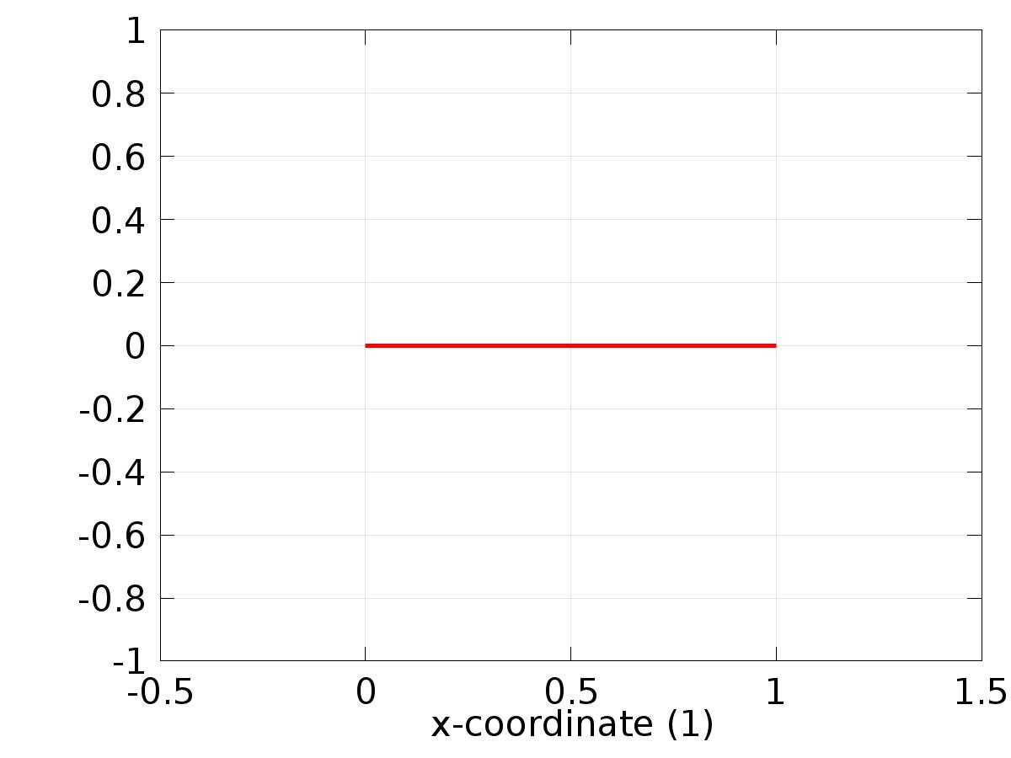

Data set: Solution 1

* 1. Derived Values
     1. Global Evaluation 1

Data

| **Description** | **Value** |
| --- | --- |
| Data set | Solution 1 |

Expression

| **Description** | **Value** |
| --- | --- |
| Expression | e1 |

* 1. Tables
     1. Table 1

Global Evaluation 1 (C0(z))

Table 1

| **Time (s)** | **C0(z)** | **yr0** | **e0** | **C1(z)** | **yr1** | **e1** |
| --- | --- | --- | --- | --- | --- | --- |
| 0.0000 | 0.99538 | 0.0000 | -0.99538 | -0.99099 | 0.0000 | 0.99099 |
| 0.025000 | 0.68233 | 0.024997 | -0.65733 | -0.49938 | 0.049979 | 0.54936 |
| 0.050000 | 0.52560 | 0.049979 | -0.47562 | -0.26222 | 0.099833 | 0.36206 |
| 0.075000 | 0.42167 | 0.074930 | -0.34674 | -0.089286 | 0.14944 | 0.23872 |
| 0.10000 | 0.35474 | 0.099833 | -0.25490 | 0.044252 | 0.19867 | 0.15442 |
| 0.12500 | 0.31464 | 0.12467 | -0.18996 | 0.15083 | 0.24740 | 0.096571 |
| 0.15000 | 0.29365 | 0.14944 | -0.14421 | 0.23849 | 0.29552 | 0.057028 |
| 0.17500 | 0.28605 | 0.17411 | -0.11194 | 0.31271 | 0.34290 | 0.030189 |
| 0.20000 | 0.28768 | 0.19867 | -0.089012 | 0.37733 | 0.38942 | 0.012090 |
| 0.22500 | 0.29573 | 0.22311 | -0.072621 | 0.43488 | 0.43497 | 9.0367E-5 |
| 0.25000 | 0.30816 | 0.24740 | -0.060752 | 0.48714 | 0.47943 | -0.0077186 |
| 0.27500 | 0.32354 | 0.27155 | -0.051993 | 0.53536 | 0.52269 | -0.012675 |
| 0.30000 | 0.34091 | 0.29552 | -0.045390 | 0.58033 | 0.56464 | -0.015685 |
| 0.32500 | 0.35961 | 0.31931 | -0.040303 | 0.62255 | 0.60519 | -0.017367 |
| 0.35000 | 0.37918 | 0.34290 | -0.036282 | 0.66237 | 0.64422 | -0.018154 |
| 0.37500 | 0.39929 | 0.36627 | -0.033017 | 0.69999 | 0.68164 | -0.018347 |
| 0.40000 | 0.41971 | 0.38942 | -0.030295 | 0.73551 | 0.71736 | -0.018150 |
| 0.42500 | 0.44029 | 0.41232 | -0.027973 | 0.76898 | 0.75128 | -0.017702 |
| 0.45000 | 0.46092 | 0.43497 | -0.025954 | 0.80042 | 0.78333 | -0.017096 |
| 0.47500 | 0.48150 | 0.45734 | -0.024158 | 0.82982 | 0.81342 | -0.016405 |
| 0.50000 | 0.50197 | 0.47943 | -0.022544 | 0.85714 | 0.84147 | -0.015668 |
| 0.52500 | 0.52229 | 0.50121 | -0.021074 | 0.88234 | 0.86742 | -0.014917 |
| 0.55000 | 0.54240 | 0.52269 | -0.019717 | 0.90538 | 0.89121 | -0.014175 |
| 0.57500 | 0.56230 | 0.54383 | -0.018462 | 0.92622 | 0.91276 | -0.013452 |
| 0.60000 | 0.58194 | 0.56464 | -0.017299 | 0.94479 | 0.93204 | -0.012751 |
| 0.62500 | 0.60132 | 0.58510 | -0.016218 | 0.96106 | 0.94898 | -0.012076 |
| 0.65000 | 0.62040 | 0.60519 | -0.015212 | 0.97499 | 0.96356 | -0.011429 |
| 0.67500 | 0.63917 | 0.62490 | -0.014269 | 0.98654 | 0.97572 | -0.010817 |
| 0.70000 | 0.65761 | 0.64422 | -0.013389 | 0.99569 | 0.98545 | -0.010236 |
| 0.72500 | 0.67571 | 0.66314 | -0.012577 | 1.0024 | 0.99271 | -0.0096753 |
| 0.75000 | 0.69346 | 0.68164 | -0.011824 | 1.0066 | 0.99749 | -0.0091400 |
| 0.77500 | 0.71082 | 0.69972 | -0.011106 | 1.0084 | 0.99978 | -0.0086470 |
| 0.80000 | 0.72778 | 0.71736 | -0.010423 | 1.0078 | 0.99957 | -0.0081914 |
| 0.82500 | 0.74434 | 0.73455 | -0.0097905 | 1.0046 | 0.99687 | -0.0077568 |
| 0.85000 | 0.76048 | 0.75128 | -0.0092030 | 0.99901 | 0.99166 | -0.0073433 |
| 0.87500 | 0.77620 | 0.76754 | -0.0086528 | 0.99094 | 0.98399 | -0.0069553 |
| 0.90000 | 0.79147 | 0.78333 | -0.0081418 | 0.98044 | 0.97385 | -0.0065898 |
| 0.92500 | 0.80629 | 0.79862 | -0.0076704 | 0.96752 | 0.96128 | -0.0062410 |
| 0.95000 | 0.82065 | 0.81342 | -0.0072346 | 0.95220 | 0.94630 | -0.0059038 |
| 0.97500 | 0.83453 | 0.82770 | -0.0068256 | 0.93455 | 0.92896 | -0.0055942 |
| 1.0000 | 0.84791 | 0.84147 | -0.0064421 | 0.91460 | 0.90930 | -0.0052993 |
| 1.0250 | 0.86080 | 0.85471 | -0.0060860 | 0.89239 | 0.88736 | -0.0050263 |
| 1.0500 | 0.87318 | 0.86742 | -0.0057533 | 0.86797 | 0.86321 | -0.0047643 |
| 1.0750 | 0.88503 | 0.87959 | -0.0054410 | 0.84142 | 0.83690 | -0.0045259 |
| 1.1000 | 0.89635 | 0.89121 | -0.0051469 | 0.81279 | 0.80850 | -0.0042981 |
| 1.1250 | 0.90714 | 0.90227 | -0.0048731 | 0.78216 | 0.77807 | -0.0040896 |
| 1.1500 | 0.91738 | 0.91276 | -0.0046169 | 0.74959 | 0.74571 | -0.0038871 |
| 1.1750 | 0.92707 | 0.92269 | -0.0043775 | 0.71517 | 0.71147 | -0.0037003 |
| 1.2000 | 0.93619 | 0.93204 | -0.0041532 | 0.67899 | 0.67546 | -0.0035249 |
| 1.2250 | 0.94475 | 0.94081 | -0.0039435 | 0.64112 | 0.63776 | -0.0033599 |
| 1.2500 | 0.95273 | 0.94898 | -0.0037473 | 0.60168 | 0.59847 | -0.0032054 |
| 1.2750 | 0.96013 | 0.95657 | -0.0035636 | 0.56074 | 0.55768 | -0.0030593 |
| 1.3000 | 0.96695 | 0.96356 | -0.0033918 | 0.51842 | 0.51550 | -0.0029215 |
| 1.3250 | 0.97318 | 0.96994 | -0.0032313 | 0.47482 | 0.47203 | -0.0027916 |
| 1.3500 | 0.97880 | 0.97572 | -0.0030816 | 0.43005 | 0.42738 | -0.0026704 |
| 1.3750 | 0.98383 | 0.98089 | -0.0029416 | 0.38422 | 0.38166 | -0.0025547 |
| 1.4000 | 0.98826 | 0.98545 | -0.0028105 | 0.33743 | 0.33499 | -0.0024446 |
| 1.4250 | 0.99208 | 0.98939 | -0.0026883 | 0.28982 | 0.28748 | -0.0023407 |
| 1.4500 | 0.99529 | 0.99271 | -0.0025745 | 0.24149 | 0.23925 | -0.0022445 |
| 1.4750 | 0.99788 | 0.99542 | -0.0024684 | 0.19258 | 0.19042 | -0.0021531 |
| 1.5000 | 0.99986 | 0.99749 | -0.0023694 | 0.14319 | 0.14112 | -0.0020664 |
| 1.5250 | 1.0012 | 0.99895 | -0.0022769 | 0.093449 | 0.091465 | -0.0019846 |
| 1.5500 | 1.0020 | 0.99978 | -0.0021897 | 0.043486 | 0.041581 | -0.0019052 |
| 1.5750 | 1.0021 | 0.99999 | -0.0021082 | -0.0065772 | -0.0084072 | -0.0018300 |
| 1.6000 | 1.0016 | 0.99957 | -0.0020317 | -0.056615 | -0.058374 | -0.0017587 |
| 1.6250 | 1.0005 | 0.99853 | -0.0019600 | -0.10650 | -0.10820 | -0.0016906 |
| 1.6500 | 0.99876 | 0.99687 | -0.0018925 | -0.15612 | -0.15775 | -0.0016259 |
| 1.6750 | 0.99640 | 0.99458 | -0.0018291 | -0.20534 | -0.20690 | -0.0015641 |
| 1.7000 | 0.99343 | 0.99166 | -0.0017695 | -0.25404 | -0.25554 | -0.0015056 |
| 1.7250 | 0.98985 | 0.98813 | -0.0017134 | -0.30209 | -0.30354 | -0.0014498 |
| 1.7500 | 0.98565 | 0.98399 | -0.0016607 | -0.34939 | -0.35078 | -0.0013967 |
| 1.7750 | 0.98083 | 0.97922 | -0.0016109 | -0.39580 | -0.39715 | -0.0013461 |
| 1.8000 | 0.97541 | 0.97385 | -0.0015641 | -0.44122 | -0.44252 | -0.0012978 |
| 1.8250 | 0.96938 | 0.96786 | -0.0015197 | -0.48553 | -0.48679 | -0.0012533 |
| 1.8500 | 0.96275 | 0.96128 | -0.0014781 | -0.52863 | -0.52984 | -0.0012096 |
| 1.8750 | 0.95552 | 0.95409 | -0.0014387 | -0.57039 | -0.57156 | -0.0011682 |
| 1.9000 | 0.94770 | 0.94630 | -0.0014014 | -0.61073 | -0.61186 | -0.0011284 |
| 1.9250 | 0.93929 | 0.93792 | -0.0013661 | -0.64953 | -0.65063 | -0.0010908 |
| 1.9500 | 0.93029 | 0.92896 | -0.0013327 | -0.68671 | -0.68777 | -0.0010546 |
| 1.9750 | 0.92072 | 0.91942 | -0.0013009 | -0.72217 | -0.72319 | -0.0010202 |
| 2.0000 | 0.91057 | 0.90930 | -0.0012706 | -0.75582 | -0.75680 | -9.8723E-4 |
| 2.0250 | 0.89985 | 0.89861 | -0.0012416 | -0.78757 | -0.78853 | -9.5610E-4 |
| 2.0500 | 0.88858 | 0.88736 | -0.0012139 | -0.81735 | -0.81828 | -9.2599E-4 |
| 2.0750 | 0.87675 | 0.87556 | -0.0011875 | -0.84509 | -0.84598 | -8.9744E-4 |
| 2.1000 | 0.86437 | 0.86321 | -0.0011621 | -0.87071 | -0.87158 | -8.6982E-4 |
| 2.1250 | 0.85146 | 0.85032 | -0.0011377 | -0.89415 | -0.89499 | -8.4364E-4 |
| 2.1500 | 0.83801 | 0.83690 | -0.0011143 | -0.91535 | -0.91617 | -8.1824E-4 |
| 2.1750 | 0.82405 | 0.82295 | -0.0010916 | -0.93426 | -0.93505 | -7.9411E-4 |
| 2.2000 | 0.80957 | 0.80850 | -0.0010696 | -0.95083 | -0.95160 | -7.7067E-4 |
| 2.2250 | 0.79458 | 0.79353 | -0.0010483 | -0.96502 | -0.96577 | -7.4834E-4 |
| 2.2500 | 0.77910 | 0.77807 | -0.0010275 | -0.97680 | -0.97753 | -7.2661E-4 |
| 2.2750 | 0.76313 | 0.76213 | -0.0010072 | -0.98614 | -0.98684 | -7.0583E-4 |
| 2.3000 | 0.74669 | 0.74571 | -9.8730E-4 | -0.99301 | -0.99369 | -6.8565E-4 |
| 2.3250 | 0.72978 | 0.72882 | -9.6772E-4 | -0.99739 | -0.99805 | -6.6607E-4 |
| 2.3500 | 0.71242 | 0.71147 | -9.4840E-4 | -0.99928 | -0.99992 | -6.4715E-4 |
| 2.3750 | 0.69461 | 0.69369 | -9.2924E-4 | -0.99866 | -0.99929 | -6.2876E-4 |
| 2.4000 | 0.67637 | 0.67546 | -9.1021E-4 | -0.99555 | -0.99616 | -6.1096E-4 |
| 2.4250 | 0.65771 | 0.65682 | -8.9128E-4 | -0.98995 | -0.99055 | -5.9364E-4 |
| 2.4500 | 0.63864 | 0.63776 | -8.7239E-4 | -0.98188 | -0.98245 | -5.7683E-4 |
| 2.4750 | 0.61917 | 0.61831 | -8.5351E-4 | -0.97134 | -0.97190 | -5.6040E-4 |
| 2.5000 | 0.59931 | 0.59847 | -8.3460E-4 | -0.95838 | -0.95892 | -5.4428E-4 |
| 2.5250 | 0.57907 | 0.57826 | -8.1562E-4 | -0.94302 | -0.94355 | -5.2826E-4 |
| 2.5500 | 0.55848 | 0.55768 | -7.9656E-4 | -0.92530 | -0.92581 | -5.1247E-4 |
| 2.5750 | 0.53754 | 0.53676 | -7.7738E-4 | -0.90527 | -0.90577 | -4.9692E-4 |
| 2.6000 | 0.51626 | 0.51550 | -7.5807E-4 | -0.88297 | -0.88345 | -4.8160E-4 |
| 2.6250 | 0.49466 | 0.49392 | -7.3860E-4 | -0.85847 | -0.85893 | -4.6646E-4 |
| 2.6500 | 0.47275 | 0.47203 | -7.1897E-4 | -0.83182 | -0.83227 | -4.5160E-4 |
| 2.6750 | 0.45054 | 0.44985 | -6.9918E-4 | -0.80308 | -0.80352 | -4.3712E-4 |
| 2.7000 | 0.42806 | 0.42738 | -6.7925E-4 | -0.77234 | -0.77276 | -4.2285E-4 |
| 2.7250 | 0.40531 | 0.40465 | -6.5925E-4 | -0.73967 | -0.74008 | -4.0849E-4 |
| 2.7500 | 0.38230 | 0.38166 | -6.3917E-4 | -0.70515 | -0.70554 | -3.9409E-4 |
| 2.7750 | 0.35906 | 0.35844 | -6.1900E-4 | -0.66886 | -0.66924 | -3.7998E-4 |
| 2.8000 | 0.33559 | 0.33499 | -5.9875E-4 | -0.63090 | -0.63127 | -3.6604E-4 |
| 2.8250 | 0.31191 | 0.31133 | -5.7846E-4 | -0.59136 | -0.59172 | -3.5206E-4 |
| 2.8500 | 0.28804 | 0.28748 | -5.5819E-4 | -0.55035 | -0.55069 | -3.3807E-4 |
| 2.8750 | 0.26398 | 0.26345 | -5.3804E-4 | -0.50795 | -0.50828 | -3.2418E-4 |
| 2.9000 | 0.23977 | 0.23925 | -5.1807E-4 | -0.46429 | -0.46460 | -3.1036E-4 |
| 2.9250 | 0.21540 | 0.21490 | -4.9831E-4 | -0.41947 | -0.41976 | -2.9665E-4 |
| 2.9500 | 0.19090 | 0.19042 | -4.7877E-4 | -0.37359 | -0.37388 | -2.8312E-4 |
| 2.9750 | 0.16628 | 0.16582 | -4.5939E-4 | -0.32678 | -0.32705 | -2.6993E-4 |
| 3.0000 | 0.14156 | 0.14112 | -4.4018E-4 | -0.27916 | -0.27942 | -2.5709E-4 |
| 3.0250 | 0.11675 | 0.11633 | -4.2125E-4 | -0.23083 | -0.23108 | -2.4428E-4 |
| 3.0500 | 0.091867 | 0.091465 | -4.0264E-4 | -0.18193 | -0.18216 | -2.3136E-4 |
| 3.0750 | 0.066928 | 0.066543 | -3.8434E-4 | -0.13257 | -0.13279 | -2.1859E-4 |
| 3.1000 | 0.041947 | 0.041581 | -3.6642E-4 | -0.082883 | -0.083089 | -2.0605E-4 |
| 3.1250 | 0.016941 | 0.016592 | -3.4898E-4 | -0.032985 | -0.033179 | -1.9372E-4 |
| 3.1500 | -0.0080751 | -0.0084072 | -3.3211E-4 | 0.016995 | 0.016814 | -1.8117E-4 |
| 3.1750 | -0.033085 | -0.033401 | -3.1578E-4 | 0.066934 | 0.066765 | -1.6930E-4 |
| 3.2000 | -0.058074 | -0.058374 | -3.0006E-4 | 0.11671 | 0.11655 | -1.5725E-4 |
| 3.2250 | -0.083026 | -0.083311 | -2.8488E-4 | 0.16619 | 0.16604 | -1.4586E-4 |
| 3.2500 | -0.10792 | -0.10820 | -2.7027E-4 | 0.21525 | 0.21512 | -1.3442E-4 |
| 3.2750 | -0.13276 | -0.13301 | -2.5623E-4 | 0.26378 | 0.26366 | -1.2349E-4 |
| 3.3000 | -0.15750 | -0.15775 | -2.4281E-4 | 0.31165 | 0.31154 | -1.1270E-4 |
| 3.3250 | -0.18215 | -0.18238 | -2.3013E-4 | 0.35875 | 0.35864 | -1.0232E-4 |
| 3.3500 | -0.20668 | -0.20690 | -2.1806E-4 | 0.40494 | 0.40485 | -9.2265E-5 |
| 3.3750 | -0.23109 | -0.23129 | -2.0645E-4 | 0.45013 | 0.45004 | -8.2284E-5 |
| 3.4000 | -0.25535 | -0.25554 | -1.9568E-4 | 0.49419 | 0.49411 | -7.3009E-5 |
| 3.4250 | -0.27944 | -0.27963 | -1.8602E-4 | 0.53701 | 0.53695 | -6.4087E-5 |
| 3.4500 | -0.30337 | -0.30354 | -1.7635E-4 | 0.57850 | 0.57844 | -5.5462E-5 |
| 3.4750 | -0.32710 | -0.32726 | -1.6630E-4 | 0.61853 | 0.61849 | -4.6315E-5 |
| 3.5000 | -0.35063 | -0.35078 | -1.5652E-4 | 0.65702 | 0.65699 | -3.7630E-5 |
| 3.5250 | -0.37394 | -0.37408 | -1.4723E-4 | 0.69387 | 0.69384 | -2.9083E-5 |
| 3.5500 | -0.39701 | -0.39715 | -1.3959E-4 | 0.72899 | 0.72897 | -2.1902E-5 |
| 3.5750 | -0.41983 | -0.41997 | -1.3403E-4 | 0.76229 | 0.76227 | -1.6090E-5 |
| 3.6000 | -0.44239 | -0.44252 | -1.3015E-4 | 0.79368 | 0.79367 | -1.1659E-5 |
| 3.6250 | -0.46467 | -0.46480 | -1.2753E-4 | 0.82309 | 0.82308 | -8.1969E-6 |
| 3.6500 | -0.48666 | -0.48679 | -1.2492E-4 | 0.85044 | 0.85044 | -4.7608E-6 |
| 3.6750 | -0.50835 | -0.50847 | -1.2274E-4 | 0.87567 | 0.87567 | -1.8801E-6 |
| 3.7000 | -0.52972 | -0.52984 | -1.2108E-4 | 0.89871 | 0.89871 | 5.9374E-7 |
| 3.7250 | -0.55075 | -0.55087 | -1.1810E-4 | 0.91950 | 0.91950 | 3.6725E-6 |
| 3.7500 | -0.57145 | -0.57156 | -1.1297E-4 | 0.93799 | 0.93800 | 8.3208E-6 |
| 3.7750 | -0.59179 | -0.59189 | -1.0682E-4 | 0.95414 | 0.95415 | 1.3320E-5 |
| 3.8000 | -0.61176 | -0.61186 | -1.0018E-4 | 0.96790 | 0.96792 | 1.8519E-5 |
| 3.8250 | -0.63134 | -0.63144 | -9.5829E-5 | 0.97925 | 0.97927 | 2.1558E-5 |
| 3.8500 | -0.65053 | -0.65063 | -9.4075E-5 | 0.98815 | 0.98817 | 2.2394E-5 |
| 3.8750 | -0.66931 | -0.66940 | -9.1125E-5 | 0.99457 | 0.99460 | 2.3866E-5 |
| 3.9000 | -0.68768 | -0.68777 | -8.7103E-5 | 0.99852 | 0.99854 | 2.5971E-5 |
| 3.9250 | -0.70562 | -0.70570 | -8.2035E-5 | 0.99996 | 0.99999 | 2.8638E-5 |
| 3.9500 | -0.72311 | -0.72319 | -7.6498E-5 | 0.99891 | 0.99894 | 3.1385E-5 |
| 3.9750 | -0.74015 | -0.74023 | -7.1901E-5 | 0.99536 | 0.99539 | 3.3069E-5 |
| 4.0000 | -0.75673 | -0.75680 | -6.8946E-5 | 0.98933 | 0.98936 | 3.3158E-5 |
| 4.0250 | -0.77284 | -0.77291 | -6.8731E-5 | 0.98082 | 0.98085 | 3.0793E-5 |
| 4.0500 | -0.78846 | -0.78853 | -7.0190E-5 | 0.96986 | 0.96989 | 2.6895E-5 |
| 4.0750 | -0.80358 | -0.80365 | -7.2042E-5 | 0.95648 | 0.95651 | 2.2498E-5 |
| 4.1000 | -0.81820 | -0.81828 | -7.4218E-5 | 0.94071 | 0.94073 | 1.7699E-5 |
| 4.1250 | -0.83232 | -0.83239 | -7.5455E-5 | 0.92259 | 0.92260 | 1.3478E-5 |
| 4.1500 | -0.84591 | -0.84598 | -7.6111E-5 | 0.90216 | 0.90217 | 9.5791E-6 |
| 4.1750 | -0.85897 | -0.85905 | -7.6260E-5 | 0.87948 | 0.87948 | 5.9125E-6 |
| 4.2000 | -0.87150 | -0.87158 | -7.6185E-5 | 0.85460 | 0.85460 | 2.2997E-6 |
| 4.2250 | -0.88348 | -0.88356 | -7.6268E-5 | 0.82758 | 0.82758 | -1.5440E-6 |
| 4.2500 | -0.89491 | -0.89499 | -7.6477E-5 | 0.79849 | 0.79849 | -5.5441E-6 |
| 4.2750 | -0.90578 | -0.90586 | -7.6901E-5 | 0.76741 | 0.76740 | -9.7173E-6 |
| 4.3000 | -0.91609 | -0.91617 | -7.7201E-5 | 0.73441 | 0.73440 | -1.3780E-5 |
| 4.3250 | -0.92582 | -0.92590 | -7.7741E-5 | 0.69958 | 0.69956 | -1.7931E-5 |
| 4.3500 | -0.93497 | -0.93505 | -7.8569E-5 | 0.66299 | 0.66297 | -2.2219E-5 |
| 4.3750 | -0.94354 | -0.94362 | -8.0044E-5 | 0.62475 | 0.62472 | -2.7009E-5 |
| 4.4000 | -0.95152 | -0.95160 | -8.2075E-5 | 0.58495 | 0.58492 | -3.2231E-5 |
| 4.4250 | -0.95890 | -0.95899 | -8.3244E-5 | 0.54368 | 0.54365 | -3.6447E-5 |
| 4.4500 | -0.96569 | -0.96577 | -8.3406E-5 | 0.50106 | 0.50102 | -3.9779E-5 |
| 4.4750 | -0.97187 | -0.97196 | -8.1768E-5 | 0.45718 | 0.45714 | -4.1754E-5 |
| 4.5000 | -0.97745 | -0.97753 | -8.0493E-5 | 0.41216 | 0.41212 | -4.3581E-5 |
| 4.5250 | -0.98241 | -0.98249 | -7.9046E-5 | 0.36611 | 0.36607 | -4.5158E-5 |
| 4.5500 | -0.98677 | -0.98684 | -7.8114E-5 | 0.31915 | 0.31910 | -4.7245E-5 |
| 4.5750 | -0.99050 | -0.99058 | -7.6532E-5 | 0.27138 | 0.27133 | -4.8506E-5 |
| 4.6000 | -0.99362 | -0.99369 | -7.3946E-5 | 0.22294 | 0.22289 | -4.8627E-5 |
| 4.6250 | -0.99611 | -0.99618 | -7.0442E-5 | 0.17394 | 0.17389 | -4.7926E-5 |
| 4.6500 | -0.99799 | -0.99805 | -6.6242E-5 | 0.12450 | 0.12445 | -4.6567E-5 |
| 4.6750 | -0.99924 | -0.99930 | -6.2333E-5 | 0.074753 | 0.074708 | -4.5116E-5 |
| 4.7000 | -0.99986 | -0.99992 | -5.8703E-5 | 0.024819 | 0.024775 | -4.3882E-5 |
| 4.7250 | -0.99986 | -0.99992 | -5.5732E-5 | -0.025176 | -0.025219 | -4.3348E-5 |
| 4.7500 | -0.99924 | -0.99929 | -5.2282E-5 | -0.075109 | -0.075151 | -4.1988E-5 |
| 4.7750 | -0.99799 | -0.99804 | -4.8690E-5 | -0.12485 | -0.12490 | -4.0352E-5 |
| 4.8000 | -0.99612 | -0.99616 | -4.4641E-5 | -0.17429 | -0.17433 | -3.8197E-5 |
| 4.8250 | -0.99363 | -0.99367 | -4.0740E-5 | -0.22329 | -0.22332 | -3.6064E-5 |
| 4.8500 | -0.99051 | -0.99055 | -3.7020E-5 | -0.27173 | -0.27176 | -3.4046E-5 |
| 4.8750 | -0.98677 | -0.98681 | -3.3425E-5 | -0.31949 | -0.31952 | -3.2191E-5 |
| 4.9000 | -0.98242 | -0.98245 | -2.9885E-5 | -0.36645 | -0.36648 | -3.0422E-5 |
| 4.9250 | -0.97746 | -0.97748 | -2.6183E-5 | -0.41249 | -0.41252 | -2.8413E-5 |
| 4.9500 | -0.97188 | -0.97190 | -2.2323E-5 | -0.45751 | -0.45754 | -2.6164E-5 |
| 4.9750 | -0.96570 | -0.96572 | -1.8232E-5 | -0.50138 | -0.50141 | -2.3539E-5 |
| 5.0000 | -0.95891 | -0.95892 | -1.4211E-5 | -0.54400 | -0.54402 | -2.1135E-5 |
| 5.0250 | -0.95152 | -0.95153 | -1.0191E-5 | -0.58526 | -0.58528 | -1.8683E-5 |
| 5.0500 | -0.94354 | -0.94355 | -6.2665E-6 | -0.62505 | -0.62507 | -1.6143E-5 |
| 5.0750 | -0.93497 | -0.93497 | -2.3347E-6 | -0.66329 | -0.66330 | -1.3738E-5 |
| 5.1000 | -0.92582 | -0.92581 | 1.5478E-6 | -0.69986 | -0.69987 | -1.1406E-5 |
| 5.1250 | -0.91608 | -0.91608 | 5.3280E-6 | -0.73469 | -0.73470 | -8.9921E-6 |
| 5.1500 | -0.90578 | -0.90577 | 8.9705E-6 | -0.76768 | -0.76769 | -6.6534E-6 |
| 5.1750 | -0.89490 | -0.89489 | 1.2442E-5 | -0.79875 | -0.79875 | -4.6484E-6 |
| 5.2000 | -0.88347 | -0.88345 | 1.5718E-5 | -0.82782 | -0.82783 | -2.6225E-6 |
| 5.2250 | -0.87149 | -0.87147 | 1.8779E-5 | -0.85483 | -0.85483 | -4.4556E-7 |
| 5.2500 | -0.85896 | -0.85893 | 2.1600E-5 | -0.87970 | -0.87970 | 1.1531E-6 |
| 5.2750 | -0.84589 | -0.84587 | 2.4181E-5 | -0.90237 | -0.90236 | 2.6951E-6 |
| 5.3000 | -0.83229 | -0.83227 | 2.6532E-5 | -0.92278 | -0.92278 | 4.5282E-6 |
| 5.3250 | -0.81818 | -0.81815 | 2.8602E-5 | -0.94089 | -0.94088 | 5.7500E-6 |
| 5.3500 | -0.80355 | -0.80352 | 3.0405E-5 | -0.95664 | -0.95664 | 6.7328E-6 |
| 5.3750 | -0.78842 | -0.78839 | 3.1951E-5 | -0.97001 | -0.97000 | 7.8379E-6 |
| 5.4000 | -0.77280 | -0.77276 | 3.3234E-5 | -0.98095 | -0.98094 | 8.8019E-6 |
| 5.4250 | -0.75669 | -0.75666 | 3.4247E-5 | -0.98943 | -0.98942 | 9.3629E-6 |
| 5.4500 | -0.74011 | -0.74008 | 3.5008E-5 | -0.99545 | -0.99544 | 1.0154E-5 |
| 5.4750 | -0.72307 | -0.72303 | 3.5521E-5 | -0.99897 | -0.99896 | 1.1346E-5 |
| 5.5000 | -0.70558 | -0.70554 | 3.5759E-5 | -1.0000 | -0.99999 | 1.1789E-5 |
| 5.5250 | -0.68764 | -0.68760 | 3.5733E-5 | -0.99853 | -0.99852 | 1.2247E-5 |
| 5.5500 | -0.66928 | -0.66924 | 3.5441E-5 | -0.99457 | -0.99455 | 1.3110E-5 |
| 5.5750 | -0.65049 | -0.65046 | 3.4914E-5 | -0.98811 | -0.98810 | 1.3229E-5 |
| 5.6000 | -0.63130 | -0.63127 | 3.4159E-5 | -0.97919 | -0.97918 | 1.3174E-5 |
| 5.6250 | -0.61172 | -0.61168 | 3.3199E-5 | -0.96782 | -0.96781 | 1.3312E-5 |
| 5.6500 | -0.59175 | -0.59172 | 3.2048E-5 | -0.95403 | -0.95402 | 1.3328E-5 |
| 5.6750 | -0.57141 | -0.57138 | 3.0727E-5 | -0.93786 | -0.93785 | 1.3129E-5 |
| 5.7000 | -0.55071 | -0.55069 | 2.9274E-5 | -0.91934 | -0.91933 | 1.3489E-5 |
| 5.7250 | -0.52968 | -0.52965 | 2.7707E-5 | -0.89853 | -0.89851 | 1.4488E-5 |
| 5.7500 | -0.50831 | -0.50828 | 2.5980E-5 | -0.87547 | -0.87545 | 1.4508E-5 |
| 5.7750 | -0.48662 | -0.48659 | 2.4120E-5 | -0.85022 | -0.85020 | 1.4336E-5 |
| 5.8000 | -0.46462 | -0.46460 | 2.2121E-5 | -0.82284 | -0.82283 | 1.4092E-5 |
| 5.8250 | -0.44234 | -0.44232 | 2.0081E-5 | -0.79341 | -0.79340 | 1.3450E-5 |
| 5.8500 | -0.41978 | -0.41976 | 1.8007E-5 | -0.76200 | -0.76198 | 1.2902E-5 |
| 5.8750 | -0.39696 | -0.39694 | 1.5948E-5 | -0.72868 | -0.72866 | 1.3059E-5 |
| 5.9000 | -0.37389 | -0.37388 | 1.3892E-5 | -0.69354 | -0.69353 | 1.3258E-5 |
| 5.9250 | -0.35059 | -0.35058 | 1.1843E-5 | -0.65667 | -0.65665 | 1.3332E-5 |
| 5.9500 | -0.32706 | -0.32705 | 9.8339E-6 | -0.61815 | -0.61814 | 1.4038E-5 |
| 5.9750 | -0.30334 | -0.30333 | 7.8747E-6 | -0.57809 | -0.57808 | 1.5215E-5 |
| 6.0000 | -0.27942 | -0.27942 | 5.9615E-6 | -0.53659 | -0.53657 | 1.5406E-5 |
| 6.0250 | -0.25533 | -0.25533 | 4.0959E-6 | -0.49374 | -0.49373 | 1.4959E-5 |
| 6.0500 | -0.23108 | -0.23108 | 2.2717E-6 | -0.44966 | -0.44965 | 1.3655E-5 |
| 6.0750 | -0.20669 | -0.20668 | 5.3595E-7 | -0.40446 | -0.40444 | 1.2873E-5 |
| 6.1000 | -0.18216 | -0.18216 | -1.1169E-6 | -0.35824 | -0.35823 | 1.2923E-5 |
| 6.1250 | -0.15752 | -0.15753 | -2.6712E-6 | -0.31113 | -0.31112 | 1.5027E-5 |
| 6.1500 | -0.13279 | -0.13279 | -4.1251E-6 | -0.26325 | -0.26323 | 1.6997E-5 |
| 6.1750 | -0.10797 | -0.10797 | -5.4670E-6 | -0.21470 | -0.21469 | 1.7939E-5 |
| 6.2000 | -0.083083 | -0.083089 | -6.6774E-6 | -0.16562 | -0.16560 | 1.7834E-5 |
| 6.2250 | -0.058145 | -0.058152 | -7.7533E-6 | -0.11613 | -0.11611 | 1.6898E-5 |
| 6.2500 | -0.033171 | -0.033179 | -8.7134E-6 | -0.066339 | -0.066322 | 1.6926E-5 |
| 6.2750 | -0.0081757 | -0.0081852 | -9.5489E-6 | -0.016388 | -0.016370 | 1.7811E-5 |
| 6.3000 | 0.016824 | 0.016814 | -1.0261E-5 | 0.033603 | 0.033623 | 2.0291E-5 |
| 6.3250 | 0.041813 | 0.041803 | -1.0794E-5 | 0.083510 | 0.083532 | 2.1442E-5 |
| 6.3500 | 0.066776 | 0.066765 | -1.1146E-5 | 0.13321 | 0.13323 | 2.2049E-5 |
| 6.3750 | 0.091697 | 0.091686 | -1.1345E-5 | 0.18258 | 0.18260 | 2.2148E-5 |
| 6.4000 | 0.11656 | 0.11655 | -1.1444E-5 | 0.23149 | 0.23151 | 2.1931E-5 |
| 6.4250 | 0.14135 | 0.14134 | -1.1480E-5 | 0.27982 | 0.27984 | 2.1268E-5 |
| 6.4500 | 0.16605 | 0.16604 | -1.1549E-5 | 0.32745 | 0.32747 | 2.1138E-5 |
| 6.4750 | 0.19065 | 0.19064 | -1.1763E-5 | 0.37427 | 0.37429 | 2.2236E-5 |
| 6.5000 | 0.21513 | 0.21512 | -1.2100E-5 | 0.42014 | 0.42017 | 2.3811E-5 |
| 6.5250 | 0.23948 | 0.23946 | -1.2490E-5 | 0.46497 | 0.46500 | 2.4492E-5 |
| 6.5500 | 0.26367 | 0.26366 | -1.2934E-5 | 0.50864 | 0.50866 | 2.3655E-5 |
| 6.5750 | 0.28770 | 0.28769 | -1.3658E-5 | 0.55103 | 0.55106 | 2.2878E-5 |
| 6.6000 | 0.31156 | 0.31154 | -1.4709E-5 | 0.59205 | 0.59207 | 2.1662E-5 |
| 6.6250 | 0.33521 | 0.33520 | -1.5718E-5 | 0.63159 | 0.63161 | 2.0149E-5 |
| 6.6500 | 0.35866 | 0.35864 | -1.6212E-5 | 0.66955 | 0.66957 | 1.8727E-5 |
| 6.6750 | 0.38188 | 0.38187 | -1.5893E-5 | 0.70584 | 0.70585 | 1.7963E-5 |
| 6.7000 | 0.40487 | 0.40485 | -1.5232E-5 | 0.74036 | 0.74038 | 1.8051E-5 |
| 6.7250 | 0.42759 | 0.42758 | -1.4093E-5 | 0.77303 | 0.77305 | 1.9558E-5 |
| 6.7500 | 0.45006 | 0.45004 | -1.2815E-5 | 0.80376 | 0.80378 | 2.1253E-5 |
| 6.7750 | 0.47224 | 0.47223 | -1.1970E-5 | 0.83249 | 0.83251 | 2.1607E-5 |
| 6.8000 | 0.49413 | 0.49411 | -1.1649E-5 | 0.85914 | 0.85916 | 2.0164E-5 |
| 6.8250 | 0.51570 | 0.51569 | -9.6934E-6 | 0.88364 | 0.88366 | 2.1383E-5 |
| 6.8500 | 0.53695 | 0.53695 | -5.0436E-6 | 0.90593 | 0.90595 | 2.6561E-5 |
| 6.8750 | 0.55787 | 0.55787 | 1.0095E-6 | 0.92595 | 0.92598 | 3.2237E-5 |
| 6.9000 | 0.57843 | 0.57844 | 8.4887E-6 | 0.94366 | 0.94370 | 3.7199E-5 |
| 6.9250 | 0.59863 | 0.59865 | 1.6822E-5 | 0.95901 | 0.95905 | 4.0606E-5 |
| 6.9500 | 0.61846 | 0.61849 | 2.4315E-5 | 0.97196 | 0.97201 | 4.3950E-5 |
| 6.9750 | 0.63791 | 0.63794 | 2.8624E-5 | 0.98249 | 0.98254 | 4.5490E-5 |
| 7.0000 | 0.65695 | 0.65699 | 3.2746E-5 | 0.99056 | 0.99061 | 4.4979E-5 |
| 7.0250 | 0.67559 | 0.67563 | 3.6973E-5 | 0.99616 | 0.99620 | 4.1947E-5 |
| 7.0500 | 0.69380 | 0.69384 | 4.0581E-5 | 0.99927 | 0.99931 | 3.6685E-5 |
| 7.0750 | 0.71159 | 0.71163 | 3.8763E-5 | 0.99989 | 0.99992 | 3.0716E-5 |
| 7.1000 | 0.72894 | 0.72897 | 2.9747E-5 | 0.99800 | 0.99803 | 2.5378E-5 |
| 7.1250 | 0.74583 | 0.74585 | 1.9406E-5 | 0.99362 | 0.99364 | 1.8778E-5 |
| 7.1500 | 0.76226 | 0.76227 | 8.5567E-6 | 0.98676 | 0.98677 | 1.1159E-5 |
| 7.1750 | 0.77821 | 0.77821 | -1.6541E-6 | 0.97743 | 0.97744 | 2.7309E-6 |
| 7.2000 | 0.79368 | 0.79367 | -1.2712E-5 | 0.96566 | 0.96566 | -5.1782E-6 |
| 7.2250 | 0.80865 | 0.80863 | -2.2543E-5 | 0.95148 | 0.95147 | -1.2855E-5 |
| 7.2500 | 0.82311 | 0.82308 | -2.8218E-5 | 0.93492 | 0.93490 | -2.0586E-5 |
| 7.2750 | 0.83705 | 0.83702 | -2.8110E-5 | 0.91602 | 0.91599 | -2.8629E-5 |
| 7.3000 | 0.85046 | 0.85044 | -2.5062E-5 | 0.89483 | 0.89479 | -3.6194E-5 |
| 7.3250 | 0.86335 | 0.86332 | -2.7078E-5 | 0.87140 | 0.87136 | -4.1410E-5 |
| 7.3500 | 0.87571 | 0.87567 | -4.0057E-5 | 0.84579 | 0.84575 | -4.3575E-5 |
| 7.3750 | 0.88752 | 0.88746 | -5.6259E-5 | 0.81807 | 0.81802 | -4.6894E-5 |
| 7.4000 | 0.89879 | 0.89871 | -7.9044E-5 | 0.78831 | 0.78825 | -5.3116E-5 |
| 7.4250 | 0.90949 | 0.90939 | -1.0152E-4 | 0.75657 | 0.75651 | -6.1259E-5 |
| 7.4500 | 0.91962 | 0.91950 | -1.1463E-4 | 0.72295 | 0.72288 | -7.0039E-5 |
| 7.4750 | 0.92916 | 0.92904 | -1.1362E-4 | 0.68752 | 0.68744 | -8.1081E-5 |
| 7.5000 | 0.93812 | 0.93800 | -1.1708E-4 | 0.65038 | 0.65029 | -8.9780E-5 |
| 7.5250 | 0.94649 | 0.94637 | -1.2289E-4 | 0.61160 | 0.61151 | -9.6272E-5 |
| 7.5500 | 0.95428 | 0.95415 | -1.2393E-4 | 0.57130 | 0.57120 | -1.0106E-4 |
| 7.5750 | 0.96145 | 0.96134 | -1.1400E-4 | 0.52956 | 0.52946 | -1.0524E-4 |
| 7.6000 | 0.96801 | 0.96792 | -9.5010E-5 | 0.48651 | 0.48640 | -1.0901E-4 |
| 7.6250 | 0.97398 | 0.97390 | -8.3517E-5 | 0.44223 | 0.44212 | -1.0790E-4 |
| 7.6500 | 0.97935 | 0.97927 | -8.2488E-5 | 0.39684 | 0.39674 | -1.0336E-4 |
| 7.6750 | 0.98411 | 0.98403 | -8.1246E-5 | 0.35046 | 0.35037 | -9.7095E-5 |
| 7.7000 | 0.98824 | 0.98817 | -7.3895E-5 | 0.30321 | 0.30312 | -9.1693E-5 |
| 7.7250 | 0.99175 | 0.99169 | -6.1466E-5 | 0.25520 | 0.25511 | -8.8251E-5 |
| 7.7500 | 0.99465 | 0.99460 | -5.5207E-5 | 0.20655 | 0.20647 | -8.0425E-5 |
| 7.7750 | 0.99694 | 0.99688 | -5.4060E-5 | 0.15738 | 0.15731 | -7.0722E-5 |
| 7.8000 | 0.99860 | 0.99854 | -5.3972E-5 | 0.10782 | 0.10775 | -6.1532E-5 |
| 7.8250 | 0.99963 | 0.99958 | -5.4260E-5 | 0.057986 | 0.057931 | -5.5647E-5 |
| 7.8500 | 1.0000 | 0.99999 | -5.3768E-5 | 0.0080164 | 0.0079632 | -5.3179E-5 |
| 7.8750 | 0.99983 | 0.99978 | -4.9004E-5 | -0.041978 | -0.042024 | -4.6263E-5 |
| 7.9000 | 0.99898 | 0.99894 | -3.6893E-5 | -0.091870 | -0.091907 | -3.6582E-5 |
| 7.9250 | 0.99751 | 0.99748 | -2.8874E-5 | -0.14153 | -0.14156 | -2.7985E-5 |
| 7.9500 | 0.99542 | 0.99539 | -2.3321E-5 | -0.19084 | -0.19086 | -2.0719E-5 |
| 7.9750 | 0.99271 | 0.99269 | -1.9486E-5 | -0.23967 | -0.23968 | -1.4290E-5 |
| 8.0000 | 0.98937 | 0.98936 | -1.6418E-5 | -0.28790 | -0.28790 | -7.1727E-6 |
| 8.0250 | 0.98543 | 0.98541 | -1.3907E-5 | -0.33540 | -0.33541 | -2.1205E-6 |
| 8.0500 | 0.98086 | 0.98085 | -1.1827E-5 | -0.38208 | -0.38207 | 5.1876E-6 |
| 8.0750 | 0.97568 | 0.97567 | -8.8178E-6 | -0.42779 | -0.42778 | 8.9941E-6 |
| 8.1000 | 0.96990 | 0.96989 | -6.6152E-6 | -0.47244 | -0.47242 | 1.6577E-5 |
| 8.1250 | 0.96350 | 0.96350 | -3.6583E-6 | -0.51590 | -0.51588 | 2.0715E-5 |
| 8.1500 | 0.95651 | 0.95651 | -8.6548E-7 | -0.55808 | -0.55805 | 2.6602E-5 |
| 8.1750 | 0.94891 | 0.94891 | 2.0463E-6 | -0.59886 | -0.59883 | 3.1364E-5 |
| 8.2000 | 0.94073 | 0.94073 | 5.1070E-6 | -0.63814 | -0.63811 | 3.4996E-5 |
| 8.2250 | 0.93195 | 0.93196 | 7.8072E-6 | -0.67583 | -0.67579 | 4.0473E-5 |
| 8.2500 | 0.92259 | 0.92260 | 1.0926E-5 | -0.71183 | -0.71179 | 4.0486E-5 |
| 8.2750 | 0.91266 | 0.91267 | 1.3614E-5 | -0.74604 | -0.74600 | 4.3952E-5 |
| 8.3000 | 0.90216 | 0.90217 | 1.6216E-5 | -0.77840 | -0.77835 | 4.6462E-5 |
| 8.3250 | 0.89109 | 0.89111 | 1.8731E-5 | -0.80881 | -0.80876 | 4.9333E-5 |
| 8.3500 | 0.87946 | 0.87948 | 2.1160E-5 | -0.83719 | -0.83714 | 5.1432E-5 |
| 8.3750 | 0.86729 | 0.86731 | 2.3470E-5 | -0.86349 | -0.86343 | 5.3588E-5 |
| 8.4000 | 0.85457 | 0.85460 | 2.5628E-5 | -0.88762 | -0.88757 | 5.5248E-5 |
| 8.4250 | 0.84132 | 0.84135 | 2.7624E-5 | -0.90954 | -0.90948 | 5.6594E-5 |
| 8.4500 | 0.82755 | 0.82758 | 2.9446E-5 | -0.92918 | -0.92912 | 5.7906E-5 |
| 8.4750 | 0.81326 | 0.81329 | 3.1075E-5 | -0.94650 | -0.94644 | 5.8771E-5 |
| 8.5000 | 0.79845 | 0.79849 | 3.2557E-5 | -0.96146 | -0.96140 | 5.9638E-5 |
| 8.5250 | 0.78316 | 0.78319 | 3.3857E-5 | -0.97401 | -0.97395 | 5.9908E-5 |
| 8.5500 | 0.76737 | 0.76740 | 3.4879E-5 | -0.98413 | -0.98407 | 6.0267E-5 |
| 8.5750 | 0.75110 | 0.75113 | 3.5544E-5 | -0.99178 | -0.99172 | 6.0119E-5 |
| 8.6000 | 0.73436 | 0.73440 | 3.5949E-5 | -0.99696 | -0.99690 | 5.9879E-5 |
| 8.6250 | 0.71717 | 0.71720 | 3.6109E-5 | -0.99965 | -0.99959 | 5.9488E-5 |
| 8.6500 | 0.69952 | 0.69956 | 3.6027E-5 | -0.99983 | -0.99977 | 5.8920E-5 |
| 8.6750 | 0.68144 | 0.68148 | 3.5720E-5 | -0.99752 | -0.99746 | 5.8227E-5 |
| 8.7000 | 0.66293 | 0.66297 | 3.5226E-5 | -0.99272 | -0.99266 | 5.7476E-5 |
| 8.7250 | 0.64401 | 0.64405 | 3.4543E-5 | -0.98543 | -0.98537 | 5.6610E-5 |
| 8.7500 | 0.62469 | 0.62472 | 3.3675E-5 | -0.97568 | -0.97563 | 5.5746E-5 |
| 8.7750 | 0.60498 | 0.60501 | 3.2606E-5 | -0.96349 | -0.96344 | 5.4728E-5 |
| 8.8000 | 0.58489 | 0.58492 | 3.1298E-5 | -0.94890 | -0.94884 | 5.3661E-5 |
| 8.8250 | 0.56443 | 0.56446 | 2.9819E-5 | -0.93193 | -0.93188 | 5.2472E-5 |
| 8.8500 | 0.54362 | 0.54365 | 2.8185E-5 | -0.91263 | -0.91258 | 5.1310E-5 |
| 8.8750 | 0.52247 | 0.52250 | 2.6356E-5 | -0.89106 | -0.89101 | 5.0025E-5 |
| 8.9000 | 0.50100 | 0.50102 | 2.4311E-5 | -0.86725 | -0.86720 | 4.8653E-5 |
| 8.9250 | 0.47921 | 0.47923 | 2.2076E-5 | -0.84128 | -0.84123 | 4.7208E-5 |
| 8.9500 | 0.45712 | 0.45714 | 1.9709E-5 | -0.81320 | -0.81316 | 4.5713E-5 |
| 8.9750 | 0.43475 | 0.43477 | 1.7251E-5 | -0.78310 | -0.78305 | 4.4275E-5 |
| 9.0000 | 0.41210 | 0.41212 | 1.4773E-5 | -0.75103 | -0.75099 | 4.2859E-5 |
| 9.0250 | 0.38920 | 0.38921 | 1.2361E-5 | -0.71709 | -0.71705 | 4.1649E-5 |
| 9.0500 | 0.36606 | 0.36607 | 9.9597E-6 | -0.68135 | -0.68131 | 4.0461E-5 |
| 9.0750 | 0.34268 | 0.34269 | 7.5715E-6 | -0.64392 | -0.64388 | 3.9400E-5 |
| 9.1000 | 0.31909 | 0.31910 | 5.2759E-6 | -0.60487 | -0.60483 | 3.8418E-5 |
| 9.1250 | 0.29531 | 0.29531 | 3.0666E-6 | -0.56431 | -0.56428 | 3.7591E-5 |
| 9.1500 | 0.27133 | 0.27133 | 9.3517E-7 | -0.52235 | -0.52231 | 3.6862E-5 |
| 9.1750 | 0.24719 | 0.24719 | -1.1381E-6 | -0.47907 | -0.47904 | 3.6215E-5 |
| 9.2000 | 0.22289 | 0.22289 | -3.1633E-6 | -0.43460 | -0.43457 | 3.5662E-5 |
| 9.2250 | 0.19846 | 0.19845 | -5.1395E-6 | -0.38904 | -0.38901 | 3.5143E-5 |
| 9.2500 | 0.17390 | 0.17389 | -7.0782E-6 | -0.34252 | -0.34248 | 3.4708E-5 |
| 9.2750 | 0.14923 | 0.14922 | -8.9655E-6 | -0.29513 | -0.29510 | 3.4330E-5 |
| 9.3000 | 0.12447 | 0.12445 | -1.0785E-5 | -0.24701 | -0.24697 | 3.4114E-5 |
| 9.3250 | 0.099625 | 0.099612 | -1.2516E-5 | -0.19827 | -0.19823 | 3.4002E-5 |
| 9.3500 | 0.074722 | 0.074708 | -1.4117E-5 | -0.14903 | -0.14900 | 3.4108E-5 |
| 9.3750 | 0.049773 | 0.049757 | -1.5693E-5 | -0.099426 | -0.099392 | 3.4278E-5 |
| 9.4000 | 0.024793 | 0.024775 | -1.7358E-5 | -0.049570 | -0.049536 | 3.4401E-5 |
| 9.4250 | -2.0294E-4 | -2.2204E-4 | -1.9100E-5 | 4.0958E-4 | 4.4408E-4 | 3.4501E-5 |
| 9.4500 | -0.025199 | -0.025219 | -2.0812E-5 | 0.050388 | 0.050423 | 3.4719E-5 |
| 9.4750 | -0.050178 | -0.050201 | -2.2483E-5 | 0.10024 | 0.10028 | 3.5087E-5 |
| 9.5000 | -0.075127 | -0.075151 | -2.4128E-5 | 0.14984 | 0.14988 | 3.5552E-5 |
| 9.5250 | -0.10003 | -0.10005 | -2.5670E-5 | 0.19907 | 0.19910 | 3.6212E-5 |
| 9.5500 | -0.12487 | -0.12490 | -2.7113E-5 | 0.24780 | 0.24783 | 3.7046E-5 |
| 9.5750 | -0.14963 | -0.14966 | -2.8436E-5 | 0.29591 | 0.29594 | 3.8057E-5 |
| 9.6000 | -0.17430 | -0.17433 | -2.9690E-5 | 0.34328 | 0.34331 | 3.9194E-5 |
| 9.6250 | -0.19886 | -0.19889 | -3.0935E-5 | 0.38979 | 0.38983 | 4.0365E-5 |
| 9.6500 | -0.22329 | -0.22332 | -3.2165E-5 | 0.43532 | 0.43537 | 4.1595E-5 |
| 9.6750 | -0.24759 | -0.24762 | -3.3429E-5 | 0.47977 | 0.47982 | 4.2812E-5 |
| 9.7000 | -0.27173 | -0.27176 | -3.4724E-5 | 0.52302 | 0.52307 | 4.4035E-5 |
| 9.7250 | -0.29570 | -0.29573 | -3.6038E-5 | 0.56496 | 0.56501 | 4.5248E-5 |
| 9.7500 | -0.31948 | -0.31952 | -3.7385E-5 | 0.60549 | 0.60554 | 4.6449E-5 |
| 9.7750 | -0.34307 | -0.34311 | -3.8738E-5 | 0.64451 | 0.64456 | 4.7614E-5 |
| 9.8000 | -0.36644 | -0.36648 | -4.0106E-5 | 0.68191 | 0.68196 | 4.8751E-5 |
| 9.8250 | -0.38958 | -0.38962 | -4.1483E-5 | 0.71762 | 0.71767 | 4.9801E-5 |
| 9.8500 | -0.41248 | -0.41252 | -4.2856E-5 | 0.75152 | 0.75157 | 5.0831E-5 |
| 9.8750 | -0.43512 | -0.43517 | -4.4226E-5 | 0.78355 | 0.78360 | 5.1785E-5 |
| 9.9000 | -0.45749 | -0.45754 | -4.5595E-5 | 0.81362 | 0.81367 | 5.2569E-5 |
| 9.9250 | -0.47957 | -0.47962 | -4.6967E-5 | 0.84166 | 0.84171 | 5.3088E-5 |
| 9.9500 | -0.50136 | -0.50141 | -4.8351E-5 | 0.86759 | 0.86764 | 5.3671E-5 |
| 9.9750 | -0.52283 | -0.52288 | -4.9760E-5 | 0.89135 | 0.89141 | 5.4000E-5 |
| 10.000 | -0.54397 | -0.54402 | -5.1214E-5 | 0.91289 | 0.91295 | 5.3791E-5 |

* 1. Plot Groups
     1. 1D Plot Group 1

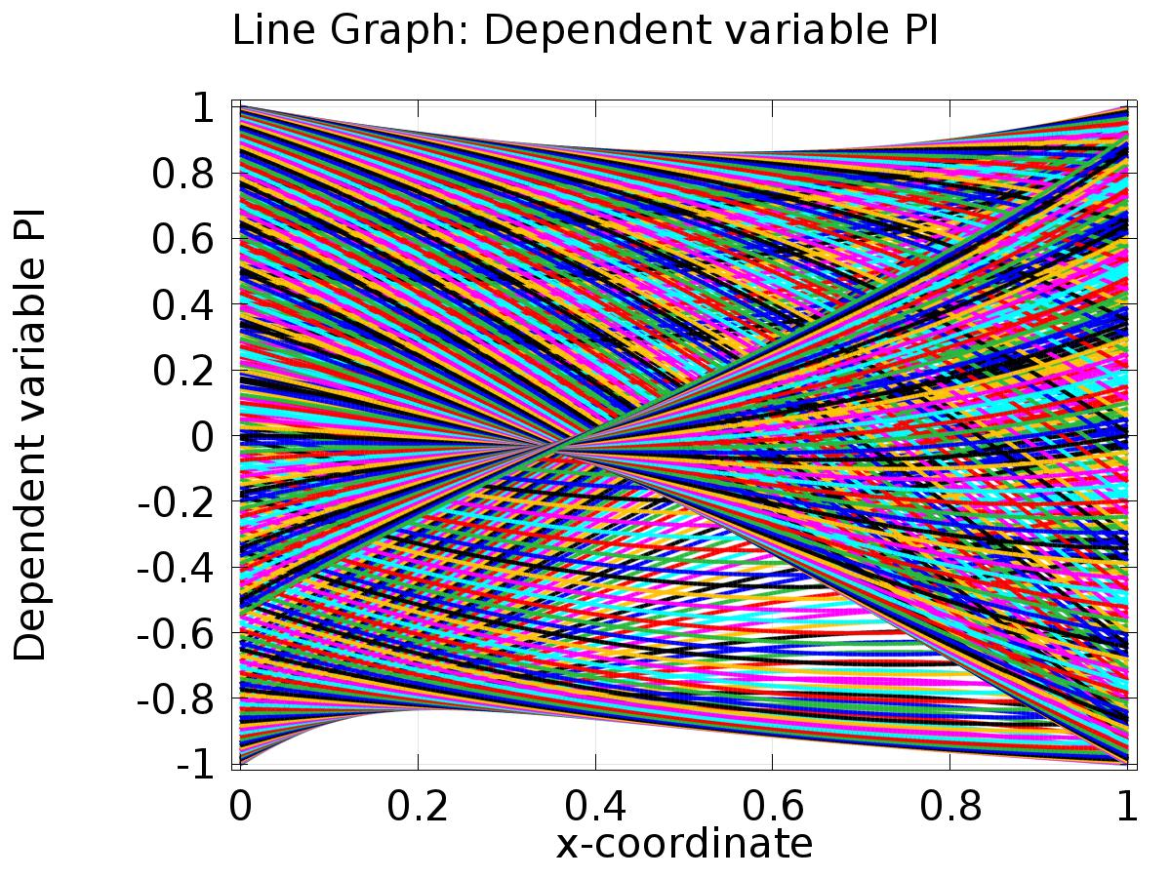

Line Graph: Dependent variable PI

* + 1. 1D Plot Group 2

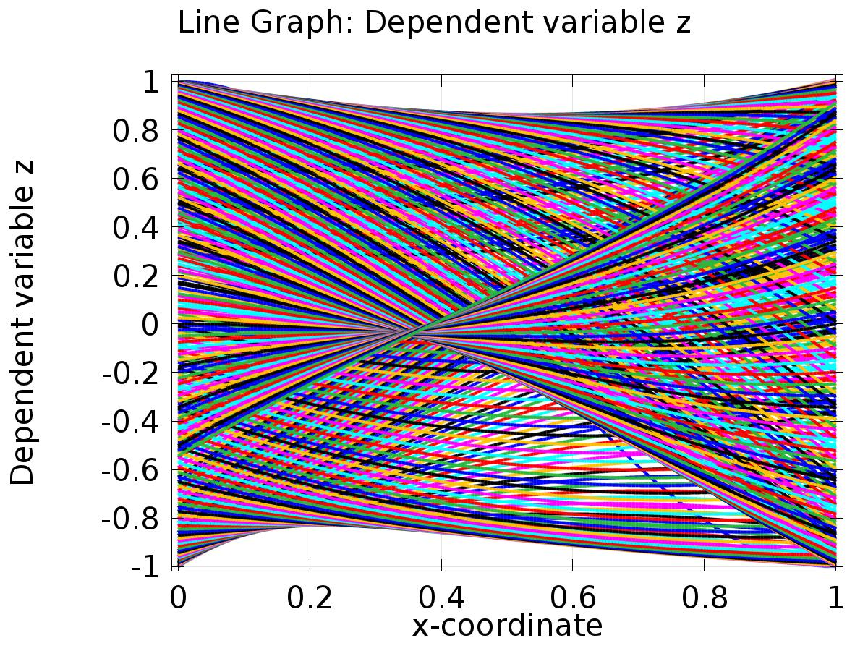

Line Graph: Dependent variable z

* + 1. 1D Plot Group 3

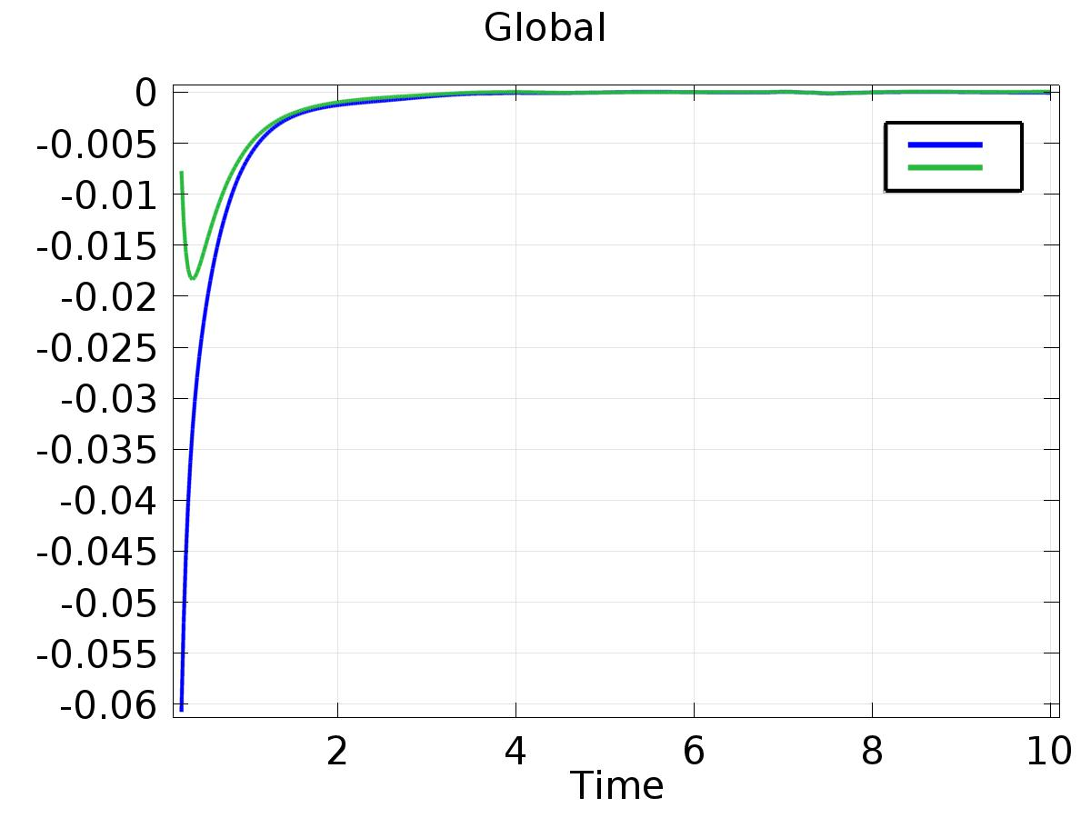

Global

* + 1. 1D Plot Group 4

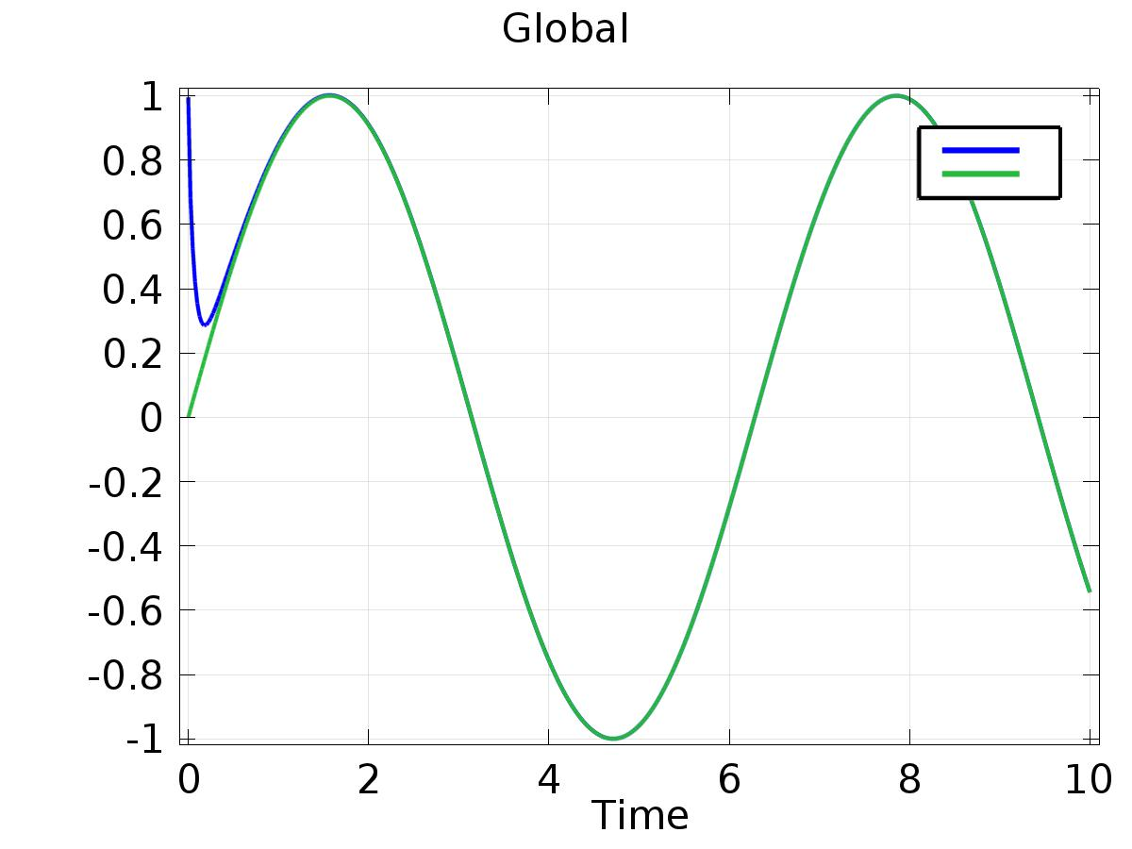

Global

* + 1. 1D Plot Group 5

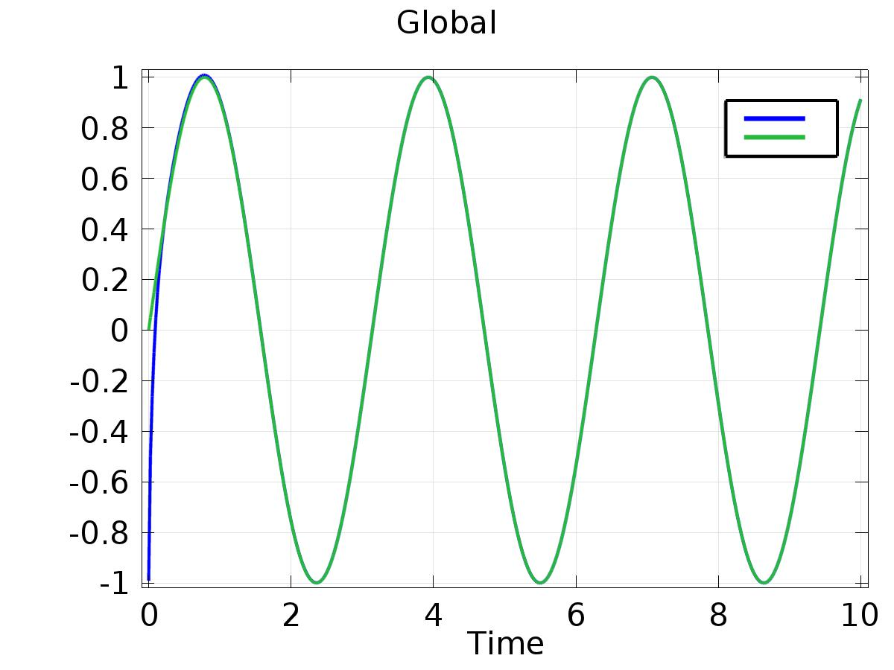

Global