[](http://www.comsol.com/)

Ch4 Ex4 7

|  |  |
| --- | --- |
| Date | Jun 15, 2014 2:35:26 PM |

Contents

1. Global

1.1. Definitions

2. Component 1

2.1. Definitions

2.2. Geometry 1

2.3. Zero Dynamics

2.4. Closed Loop System

2.5. Mesh 1

3. Study 1

3.1. Time Dependent

3.2. Solver Configurations

4. Results

4.1. Data Sets

4.2. Derived Values

4.3. Tables

4.4. Plot Groups

1. Global

|  |  |
| --- | --- |
| Date | May 12, 2014 8:09:38 AM |

Global settings

|  |  |
| --- | --- |
| Name | Ch4 Ex4 7.mph |
| Path | /Users/gilliam/Desktop/collect_15/research_15/geo_reg_mono_eugenio/Mono_1_15/Comsol_EX_GitHub/Chapter4/Example4.7/Ch4_Ex4_7.mph |
| Program | COMSOL 4.4 (Build: 150) |

Used products

|  |
| --- |
| COMSOL Multiphysics |

* 1. Definitions
     1. Parameters 1

Parameters

| **Name** | **Expression** | **Value** | **Description** |
| --- | --- | --- | --- |
| L | 1 | 1.0000 |  |
| k0 | 1 | 1.0000 |  |
| k1 | 1 | 1.0000 |  |
| nu | 1/2 | 0.50000 |  |

1. Component 1

Component settings

|  |  |
| --- | --- |
| Unit system | None |

* 1. Definitions
     1. Variables

#### Variables 1

Selection

|  |  |
| --- | --- |
| Geometric entity level | Entire model |

| **Name** | **Expression** | **Description** |
| --- | --- | --- |
| yr0 | -1 |  |
| yr1 | 1 |  |
| e0 | yr0 - C0(z) |  |
| e1 | yr1 - C1(z) |  |

* + 1. Component Couplings

#### Integration 1

|  |  |
| --- | --- |
| Coupling type | Integration |
| Operator name | C0 |

Source selection

|  |  |
| --- | --- |
| Geometric entity level | Boundary |
| Selection | Boundary 1 |

#### Integration 2

|  |  |
| --- | --- |
| Coupling type | Integration |
| Operator name | C1 |

Source selection

|  |  |
| --- | --- |
| Geometric entity level | Boundary |
| Selection | Boundary 2 |

* 1. Geometry 1

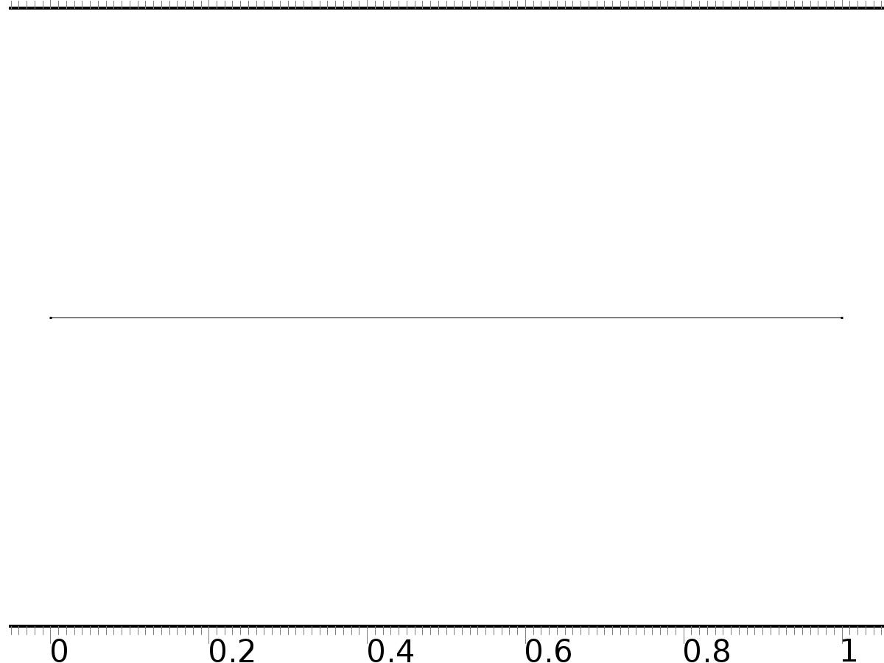

Geometry 1

Units

|  |  |
| --- | --- |
| Length unit | m |
| Angular unit | deg |

Geometry statistics

| **Description** | **Value** |
| --- | --- |
| Space dimension | 1 |
| Number of domains | 1 |
| Number of boundaries | 2 |

* + 1. Interval 1 (i1)

Interval

| **Description** | **Value** |
| --- | --- |
| Number of intervals | One |
| Left endpoint | 0 |
| Right endpoint | L |

* 1. Zero Dynamics

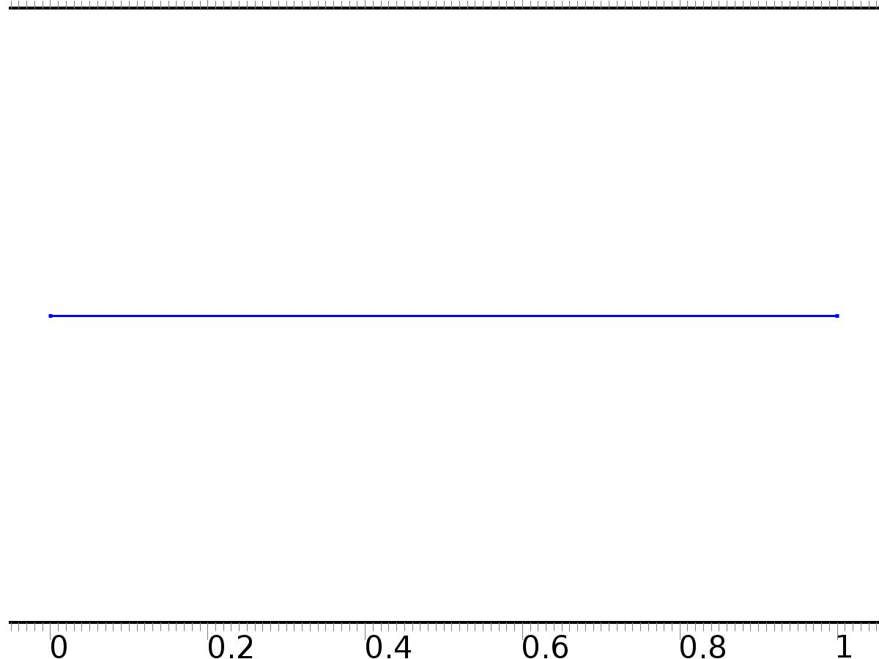

Zero Dynamics

Selection

|  |  |
| --- | --- |
| Geometric entity level | Domain |
| Selection | Domain 1 |

Settings

| **Description** | **Value** |
| --- | --- |
| Shape function type | Lagrange |
| Element order | Quadratic |
| Compute boundary fluxes | On |
| Apply smoothing to boundary fluxes | On |
| Value type when using splitting of complex variables | Complex |
| Dependent variable quantity | Dimensionless (1) |
| Source term quantity | None |
| Unit | m^ - 2 |

Used products

|  |
| --- |
| COMSOL Multiphysics |

Variables

| **Name** | **Expression** | **Unit** | **Description** | **Selection** |
| --- | --- | --- | --- | --- |
| xi.nx | nx |  | Normal vector, x component | Boundaries 1–2 |
| xi.ny | root.ny |  | Normal vector, y component | Boundaries 1–2 |
| xi.nz | root.nz |  | Normal vector, z component | Boundaries 1–2 |
| xi.nxmesh | root.nxmesh |  | Normal vector (mesh), x component | Boundaries 1–2 |
| xi.nymesh | root.nymesh |  | Normal vector (mesh), y component | Boundaries 1–2 |
| xi.nzmesh | root.nzmesh |  | Normal vector (mesh), z component | Boundaries 1–2 |

* + 1. Coefficient Form PDE 1



Coefficient Form PDE 1

Selection

|  |  |
| --- | --- |
| Geometric entity level | Domain |
| Selection | Domain 1 |

Equations

Settings

| **Description** | **Value** |
| --- | --- |
| Diffusion coefficient | {{-nu, 1}, {-1, 0}} |
| Absorption coefficient | {{0, 0}, {0, 1}} |
| Source term | {0, 0} |
| Mass coefficient | {{0, 0}, {0, 0}} |
| Damping or mass coefficient | {{0, 0}, {0, 0}} |
| Conservative flux convection coefficient | {{0, 0}, {0, 0}} |
| Convection coefficient | {{xi, 0}, {0, 0}} |
| Conservative flux source | {0, 0} |

#### Variables

| **Name** | **Expression** | **Unit** | **Description** | **Selection** |
| --- | --- | --- | --- | --- |
| domflux.xix | nu*d(xi,x)+d(Dxi,x) |  | Domain flux, x component | Domain 1 |
| domflux.Dxix | -d(xi,x) |  | Domain flux, x component | Domain 1 |

#### Shape functions

| **Name** | **Shape function** | **Unit** | **Description** | **Shape frame** | **Selection** |
| --- | --- | --- | --- | --- | --- |
| xi | Lagrange (Quadratic) |  | Dependent variable xi | Material | Domain 1 |
| Dxi | Lagrange (Quadratic) |  | Dependent variable Dxi | Material | Domain 1 |

* + 1. Zero Flux 1



Zero Flux 1

Selection

|  |  |
| --- | --- |
| Geometric entity level | Boundary |
| Selection | No boundaries |

Equations

* + 1. Initial Values



Initial Values

Selection

|  |  |
| --- | --- |
| Geometric entity level | Domain |
| Selection | Domain 1 |

Settings

| **Description** | **Value** |
| --- | --- |
| Initial value for xi | 0 |
| Initial time derivative of xi | 0 |
| Initial value for Dxi | 0 |
| Initial time derivative of Dxi | 0 |

* + 1. PI(0)=yr0

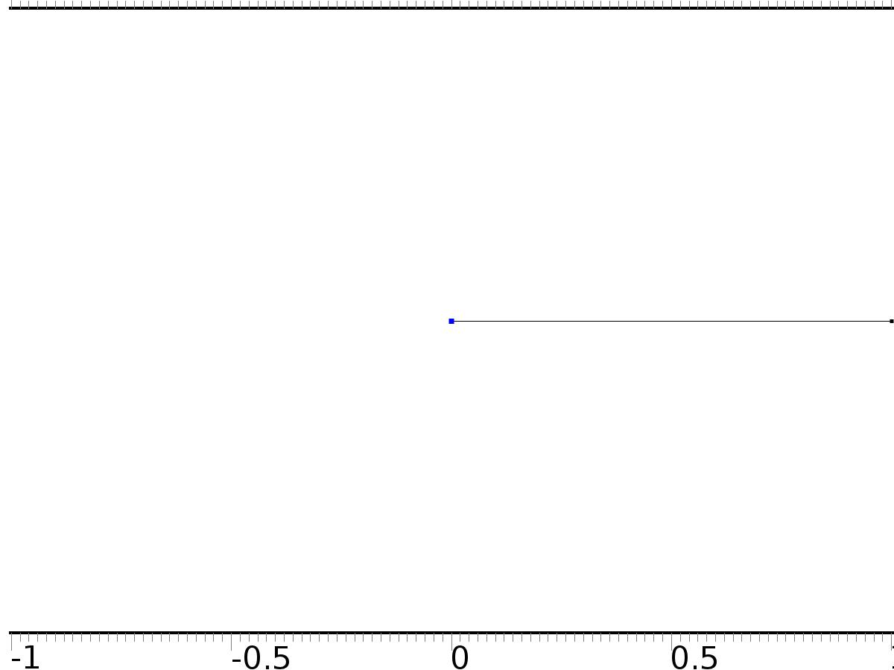

PI(0)=yr0

Selection

|  |  |
| --- | --- |
| Geometric entity level | Boundary |
| Selection | Boundary 1 |

Equations

Settings

| **Description** | **Value** |
| --- | --- |
| Value on boundary | {yr0, 0} |
| Prescribed value of xi | On |
| Prescribed value of Dxi | Off |
| Apply reaction terms on | Individual dependent variables |
| Use weak constraints | Off |
| Constraint method | Elemental |

#### Shape functions

| **Constraint** | **Constraint force** | **Shape function** | **Selection** |
| --- | --- | --- | --- |
| yr0-xi | -test(xi) | Lagrange (Quadratic) | Boundary 1 |

* + 1. PI(L)=yr1

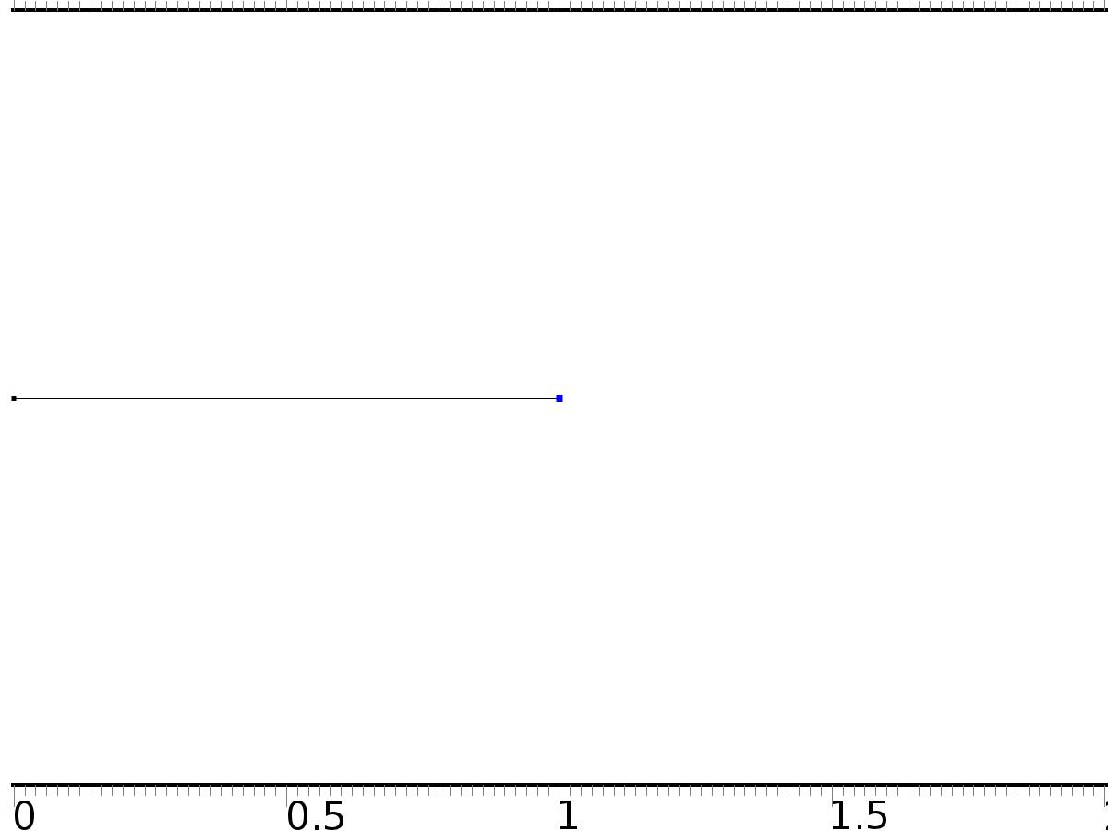

PI(L)=yr1

Selection

|  |  |
| --- | --- |
| Geometric entity level | Boundary |
| Selection | Boundary 2 |

Equations

Settings

| **Description** | **Value** |
| --- | --- |
| Value on boundary | {yr1, 0} |
| Prescribed value of xi | On |
| Prescribed value of Dxi | Off |
| Apply reaction terms on | Individual dependent variables |
| Use weak constraints | Off |
| Constraint method | Elemental |

#### Shape functions

| **Constraint** | **Constraint force** | **Shape function** | **Selection** |
| --- | --- | --- | --- |
| yr1-xi | -test(xi) | Lagrange (Quadratic) | Boundary 2 |

* 1. Closed Loop System



Closed Loop System

Selection

|  |  |
| --- | --- |
| Geometric entity level | Domain |
| Selection | Domain 1 |

Settings

| **Description** | **Value** |
| --- | --- |
| Shape function type | Lagrange |
| Element order | Quadratic |
| Compute boundary fluxes | On |
| Apply smoothing to boundary fluxes | On |
| Value type when using splitting of complex variables | Complex |
| Dependent variable quantity | Dimensionless (1) |
| Source term quantity | None |
| Unit | m^ - 2 |

Used products

|  |
| --- |
| COMSOL Multiphysics |

Variables

| **Name** | **Expression** | **Unit** | **Description** | **Selection** |
| --- | --- | --- | --- | --- |
| z.nx | nx |  | Normal vector, x component | Boundaries 1–2 |
| z.ny | root.ny |  | Normal vector, y component | Boundaries 1–2 |
| z.nz | root.nz |  | Normal vector, z component | Boundaries 1–2 |
| z.nxmesh | root.nxmesh |  | Normal vector (mesh), x component | Boundaries 1–2 |
| z.nymesh | root.nymesh |  | Normal vector (mesh), y component | Boundaries 1–2 |
| z.nzmesh | root.nzmesh |  | Normal vector (mesh), z component | Boundaries 1–2 |

* + 1. Coefficient Form PDE 1



Coefficient Form PDE 1

Selection

|  |  |
| --- | --- |
| Geometric entity level | Domain |
| Selection | Domain 1 |

Equations

Settings

| **Description** | **Value** |
| --- | --- |
| Diffusion coefficient | {{-nu, 1}, {-1, 0}} |
| Absorption coefficient | {{0, 0}, {0, 1}} |
| Source term | {0, 1} |
| Mass coefficient | {{0, 0}, {0, 0}} |
| Damping or mass coefficient | {{1, 0}, {0, 0}} |
| Conservative flux convection coefficient | {{0, 0}, {0, 0}} |
| Convection coefficient | {{z, 0}, {0, 0}} |
| Conservative flux source | {0, 0} |

#### Variables

| **Name** | **Expression** | **Unit** | **Description** | **Selection** |
| --- | --- | --- | --- | --- |
| domflux.zx | nu*d(z,x)+d(Dz,x) |  | Domain flux, x component | Domain 1 |
| domflux.Dzx | -d(z,x) |  | Domain flux, x component | Domain 1 |

#### Shape functions

| **Name** | **Shape function** | **Unit** | **Description** | **Shape frame** | **Selection** |
| --- | --- | --- | --- | --- | --- |
| z | Lagrange (Quadratic) |  | Dependent variable z | Material | Domain 1 |
| Dz | Lagrange (Quadratic) |  | Dependent variable Dz | Material | Domain 1 |

* + 1. Zero Flux 1



Zero Flux 1

Selection

|  |  |
| --- | --- |
| Geometric entity level | Boundary |
| Selection | No boundaries |

Equations

* + 1. Initial Values



Initial Values

Selection

|  |  |
| --- | --- |
| Geometric entity level | Domain |
| Selection | Domain 1 |

Settings

| **Description** | **Value** |
| --- | --- |
| Initial value for z | x - x^2 |
| Initial time derivative of z | 0 |
| Initial value for Dz | 0 |
| Initial time derivative of Dz | 0 |

* + 1. Bin0*u0



Bin0*u0

Selection

|  |  |
| --- | --- |
| Geometric entity level | Boundary |
| Selection | Boundary 1 |

Equations

Settings

| **Description** | **Value** |
| --- | --- |
| Boundary flux/source | {nu*zx + Dxix + k0*yr0, 0} |
| Boundary absorption/impedance term | {{k0, 0}, {0, 0}} |

#### Variables

| **Name** | **Expression** | **Unit** | **Description** | **Selection** |
| --- | --- | --- | --- | --- |
| z.g_z | nu*zx+Dxix+k0*yr0-k0*z |  | Boundary flux/source | Boundary 1 |
| z.g_Dz | 0 |  | Boundary flux/source | Boundary 1 |

* + 1. Bin1*u1



Bin1*u1

Selection

|  |  |
| --- | --- |
| Geometric entity level | Boundary |
| Selection | Boundary 2 |

Equations

Settings

| **Description** | **Value** |
| --- | --- |
| Boundary flux/source | {-nu*zx - Dxix + k1*yr1, 0} |
| Boundary absorption/impedance term | {{k1, 0}, {0, 0}} |

#### Variables

| **Name** | **Expression** | **Unit** | **Description** | **Selection** |
| --- | --- | --- | --- | --- |
| z.g_z | -nu*zx-Dxix+k1*yr1-k1*z |  | Boundary flux/source | Boundary 2 |
| z.g_Dz | 0 |  | Boundary flux/source | Boundary 2 |

* 1. Mesh 1

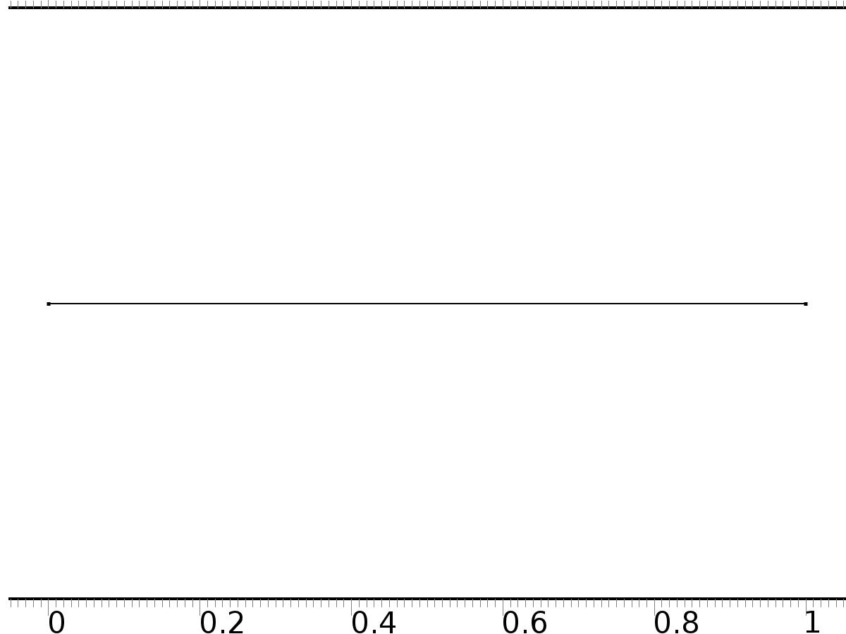

Mesh 1

* + 1. Size (size)

Settings

| **Description** | **Value** |
| --- | --- |
| Maximum element size | 0.02 |
| Minimum element size | 7.5E-5 |
| Curvature factor | 0.25 |
| Maximum element growth rate | 1.2 |
| Predefined size | Extra fine |

* + 1. Edge 1 (edg1)

Selection

|  |  |
| --- | --- |
| Geometric entity level | Remaining |

1. Study 1
   1. Time Dependent

Study settings

| **Description** | **Value** |
| --- | --- |
| Include geometric nonlinearity | Off |

| **Times** | **Unit** |
| --- | --- |
| range(0,0.025,10) | s |

Physics and variables selection

| **Physics interface** | **Discretization** |
| --- | --- |
| Zero Dynamics (c) | physics |
| Closed Loop System (c2) | physics |

Mesh selection

| **Geometry** | **Mesh** |
| --- | --- |
| Geometry 1 (geom1) | mesh1 |

* 1. Solver Configurations
     1. Solver 1

#### Compile Equations: Time Dependent (st1)

Study and step

| **Description** | **Value** |
| --- | --- |
| Use study | Study 1 |
| Use study step | Time Dependent |

#### Dependent Variables 1 (v1)

General

| **Description** | **Value** |
| --- | --- |
| Defined by study step | Time Dependent |
| Constant |  |

Initial values of variables solved for

| **Description** | **Value** |
| --- | --- |
| Solution | Zero |

Values of variables not solved for

| **Description** | **Value** |
| --- | --- |
| Solution | Zero |

##### Dependent variable xi (comp1.xi) (comp1_xi)

General

| **Description** | **Value** |
| --- | --- |
| Field components | comp1.xi |
| Field name | comp1_PI |

##### Dependent variable z (comp1.z) (comp1_z)

General

| **Description** | **Value** |
| --- | --- |
| Field components | comp1.z |

##### Dependent variable Dxi (comp1.Dxi) (comp1_Dxi)

General

| **Description** | **Value** |
| --- | --- |
| Field components | comp1.Dxi |
| Field name | comp1_PI2 |

##### Dependent variable Dz (comp1.Dz) (comp1_Dz)

General

| **Description** | **Value** |
| --- | --- |
| Field components | comp1.Dz |
| Field name | comp1_z2 |

#### Time-Dependent Solver 1 (t1)

General

| **Description** | **Value** |
| --- | --- |
| Defined by study step | Time Dependent |
| Time | {0, 0.025, 0.05, 0.07500000000000001, 0.1, 0.125, 0.15000000000000002, 0.17500000000000002, 0.2, 0.225, 0.25, 0.275, 0.30000000000000004, 0.325, 0.35000000000000003, 0.375, 0.4, 0.42500000000000004, 0.45, 0.47500000000000003, 0.5, 0.525, 0.55, 0.5750000000000001, 0.6000000000000001, 0.625, 0.65, 0.675, 0.7000000000000001, 0.7250000000000001, 0.75, 0.775, 0.8, 0.8250000000000001, 0.8500000000000001, 0.875, 0.9, 0.925, 0.9500000000000001, 0.9750000000000001, 1, 1.0250000000000001, 1.05, 1.075, 1.1, 1.125, 1.1500000000000001, 1.175, 1.2000000000000002, 1.225, 1.25, 1.2750000000000001, 1.3, 1.3250000000000002, 1.35, 1.375, 1.4000000000000001, 1.425, 1.4500000000000002, 1.475, 1.5, 1.5250000000000001, 1.55, 1.5750000000000002, 1.6, 1.625, 1.6500000000000001, 1.675, 1.7000000000000002, 1.725, 1.75, 1.7750000000000001, 1.8, 1.8250000000000002, 1.85, 1.875, 1.9000000000000001, 1.925, 1.9500000000000002, 1.975, 2, 2.025, 2.0500000000000003, 2.075, 2.1, 2.125, 2.15, 2.1750000000000003, 2.2, 2.225, 2.25, 2.275, 2.3000000000000003, 2.325, 2.35, 2.375, 2.4000000000000004, 2.4250000000000003, 2.45, 2.475, 2.5, 2.5250000000000004, 2.5500000000000003, 2.575, 2.6, 2.625, 2.6500000000000004, 2.6750000000000003, 2.7, 2.725, 2.75, 2.7750000000000004, 2.8000000000000003, 2.825, 2.85, 2.875, 2.9000000000000004, 2.9250000000000003, 2.95, 2.975, 3, 3.0250000000000004, 3.0500000000000003, 3.075, 3.1, 3.125, 3.1500000000000004, 3.1750000000000003, 3.2, 3.225, 3.25, 3.2750000000000004, 3.3000000000000003, 3.325, 3.35, 3.375, 3.4000000000000004, 3.4250000000000003, 3.45, 3.475, 3.5, 3.5250000000000004, 3.5500000000000003, 3.575, 3.6, 3.625, 3.6500000000000004, 3.6750000000000003, 3.7, 3.725, 3.75, 3.7750000000000004, 3.8000000000000003, 3.825, 3.85, 3.875, 3.9000000000000004, 3.9250000000000003, 3.95, 3.975, 4, 4.025, 4.05, 4.075, 4.1000000000000005, 4.125, 4.15, 4.175, 4.2, 4.2250000000000005, 4.25, 4.275, 4.3, 4.325, 4.3500000000000005, 4.375, 4.4, 4.425, 4.45, 4.4750000000000005, 4.5, 4.525, 4.55, 4.575, 4.6000000000000005, 4.625, 4.65, 4.675, 4.7, 4.7250000000000005, 4.75, 4.775, 4.800000000000001, 4.825, 4.8500000000000005, 4.875, 4.9, 4.925000000000001, 4.95, 4.9750000000000005, 5, 5.025, 5.050000000000001, 5.075, 5.1000000000000005, 5.125, 5.15, 5.175000000000001, 5.2, 5.2250000000000005, 5.25, 5.275, 5.300000000000001, 5.325, 5.3500000000000005, 5.375, 5.4, 5.425000000000001, 5.45, 5.4750000000000005, 5.5, 5.525, 5.550000000000001, 5.575, 5.6000000000000005, 5.625, 5.65, 5.675000000000001, 5.7, 5.7250000000000005, 5.75, 5.775, 5.800000000000001, 5.825, 5.8500000000000005, 5.875, 5.9, 5.925000000000001, 5.95, 5.9750000000000005, 6, 6.025, 6.050000000000001, 6.075, 6.1000000000000005, 6.125, 6.15, 6.175000000000001, 6.2, 6.2250000000000005, 6.25, 6.275, 6.300000000000001, 6.325, 6.3500000000000005, 6.375, 6.4, 6.425000000000001, 6.45, 6.4750000000000005, 6.5, 6.525, 6.550000000000001, 6.575, 6.6000000000000005, 6.625, 6.65, 6.675000000000001, 6.7, 6.7250000000000005, 6.75, 6.775, 6.800000000000001, 6.825, 6.8500000000000005, 6.875, 6.9, 6.925000000000001, 6.95, 6.9750000000000005, 7, 7.025, 7.050000000000001, 7.075, 7.1000000000000005, 7.125, 7.15, 7.175000000000001, 7.2, 7.2250000000000005, 7.25, 7.275, 7.300000000000001, 7.325, 7.3500000000000005, 7.375, 7.4, 7.425000000000001, 7.45, 7.4750000000000005, 7.5, 7.525, 7.550000000000001, 7.575, 7.6000000000000005, 7.625, 7.65, 7.675000000000001, 7.7, 7.7250000000000005, 7.75, 7.775, 7.800000000000001, 7.825, 7.8500000000000005, 7.875, 7.9, 7.925000000000001, 7.95, 7.9750000000000005, 8, 8.025, 8.05, 8.075000000000001, 8.1, 8.125, 8.15, 8.175, 8.200000000000001, 8.225, 8.25, 8.275, 8.3, 8.325000000000001, 8.35, 8.375, 8.4, 8.425, 8.450000000000001, 8.475, 8.5, 8.525, 8.55, 8.575000000000001, 8.6, 8.625, 8.65, 8.675, 8.700000000000001, 8.725, 8.75, 8.775, 8.8, 8.825000000000001, 8.85, 8.875, 8.9, 8.925, 8.950000000000001, 8.975, 9, 9.025, 9.05, 9.075000000000001, 9.1, 9.125, 9.15, 9.175, 9.200000000000001, 9.225, 9.25, 9.275, 9.3, 9.325000000000001, 9.35, 9.375, 9.4, 9.425, 9.450000000000001, 9.475, 9.5, 9.525, 9.55, 9.575000000000001, 9.600000000000001, 9.625, 9.65, 9.675, 9.700000000000001, 9.725000000000001, 9.75, 9.775, 9.8, 9.825000000000001, 9.850000000000001, 9.875, 9.9, 9.925, 9.950000000000001, 9.975000000000001, 10} |
| Relative tolerance | 0.0001 |

Absolute tolerance

| **Description** | **Value** |
| --- | --- |
| Tolerance | 0.000010 |

Time stepping

| **Description** | **Value** |
| --- | --- |
| Initial step | 0.0010 |

Advanced

| **Description** | **Value** |
| --- | --- |
| Fraction of initial step for Backward Euler | 0.0010 |

Log

| **Description** | **Value** |
| --- | --- |
| Constant |  |

##### Fully Coupled 1 (fc1)

General

| **Description** | **Value** |
| --- | --- |
| Linear solver | Direct |

1. Results
   1. Data Sets
      1. Solution 1

Solution

| **Description** | **Value** |
| --- | --- |
| Solution | Solver 1 |
| Component | Save Point Geometry 1 |

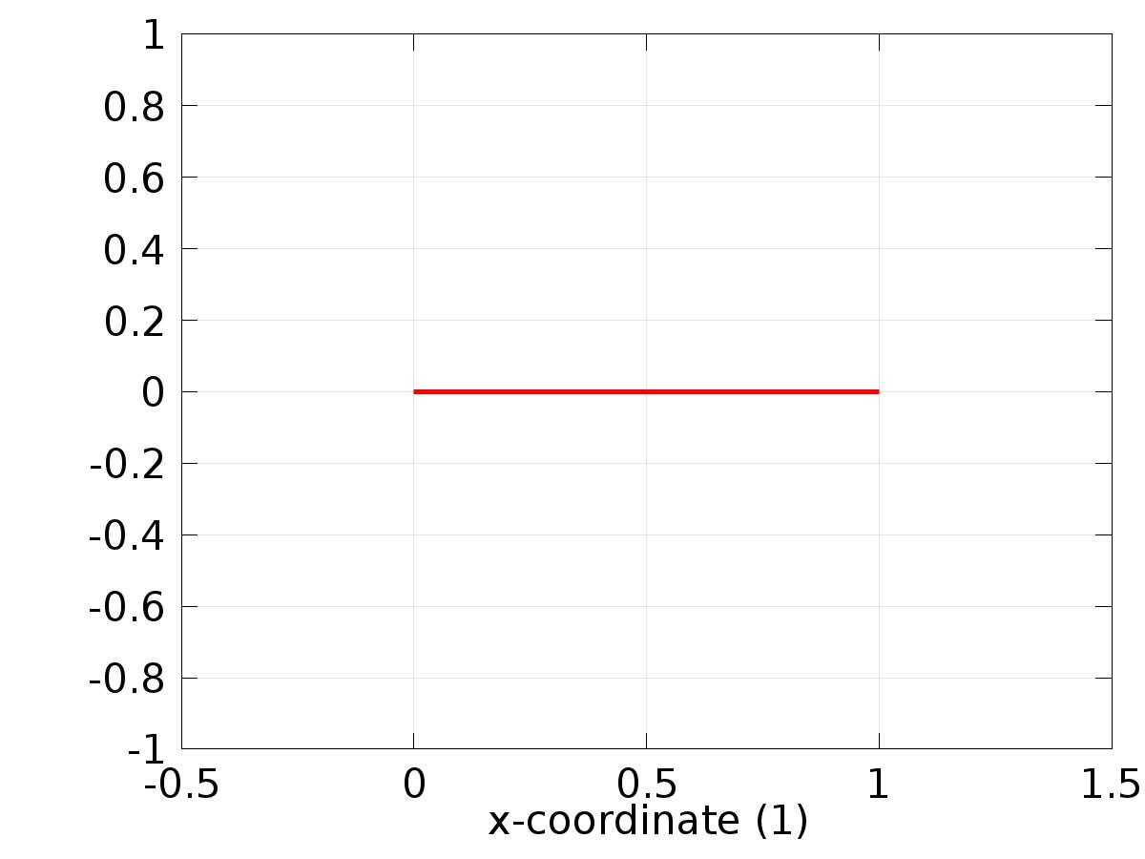

Data set: Solution 1

* 1. Derived Values
     1. Global Evaluation 1

Data

| **Description** | **Value** |
| --- | --- |
| Data set | Solution 1 |

Expression

| **Description** | **Value** |
| --- | --- |
| Expression | e1 |

* 1. Tables
     1. Table 1

Global Evaluation 1 (C0(z))

Table 1

| **Time (s)** | **C0(z)** | **C1(z)** | **yr0** | **yr1** | **e0** | **e1** |
| --- | --- | --- | --- | --- | --- | --- |
| 0.0000 | 0.044321 | 0.054947 | -1.0000 | 1.0000 | -1.0443 | 0.94505 |
| 0.025000 | -0.76318 | 1.0700 | -1.0000 | 1.0000 | -0.23682 | -0.070025 |
| 0.050000 | -0.85383 | 1.1320 | -1.0000 | 1.0000 | -0.14617 | -0.13199 |
| 0.075000 | -0.87349 | 1.1253 | -1.0000 | 1.0000 | -0.12651 | -0.12525 |
| 0.10000 | -0.88603 | 1.1139 | -1.0000 | 1.0000 | -0.11397 | -0.11388 |
| 0.12500 | -0.89689 | 1.1031 | -1.0000 | 1.0000 | -0.10311 | -0.10310 |
| 0.15000 | -0.90669 | 1.0933 | -1.0000 | 1.0000 | -0.093309 | -0.093319 |
| 0.17500 | -0.91556 | 1.0845 | -1.0000 | 1.0000 | -0.084437 | -0.084466 |
| 0.20000 | -0.92358 | 1.0764 | -1.0000 | 1.0000 | -0.076415 | -0.076449 |
| 0.22500 | -0.93084 | 1.0692 | -1.0000 | 1.0000 | -0.069159 | -0.069192 |
| 0.25000 | -0.93741 | 1.0626 | -1.0000 | 1.0000 | -0.062591 | -0.062624 |
| 0.27500 | -0.94335 | 1.0567 | -1.0000 | 1.0000 | -0.056647 | -0.056679 |
| 0.30000 | -0.94873 | 1.0513 | -1.0000 | 1.0000 | -0.051267 | -0.051300 |
| 0.32500 | -0.95360 | 1.0464 | -1.0000 | 1.0000 | -0.046397 | -0.046430 |
| 0.35000 | -0.95801 | 1.0420 | -1.0000 | 1.0000 | -0.041989 | -0.042022 |
| 0.37500 | -0.96200 | 1.0380 | -1.0000 | 1.0000 | -0.037997 | -0.038030 |
| 0.40000 | -0.96562 | 1.0344 | -1.0000 | 1.0000 | -0.034384 | -0.034417 |
| 0.42500 | -0.96888 | 1.0311 | -1.0000 | 1.0000 | -0.031116 | -0.031148 |
| 0.45000 | -0.97184 | 1.0282 | -1.0000 | 1.0000 | -0.028156 | -0.028188 |
| 0.47500 | -0.97452 | 1.0255 | -1.0000 | 1.0000 | -0.025479 | -0.025511 |
| 0.50000 | -0.97694 | 1.0231 | -1.0000 | 1.0000 | -0.023055 | -0.023087 |
| 0.52500 | -0.97914 | 1.0209 | -1.0000 | 1.0000 | -0.020862 | -0.020894 |
| 0.55000 | -0.98112 | 1.0189 | -1.0000 | 1.0000 | -0.018878 | -0.018910 |
| 0.57500 | -0.98292 | 1.0171 | -1.0000 | 1.0000 | -0.017082 | -0.017114 |
| 0.60000 | -0.98454 | 1.0155 | -1.0000 | 1.0000 | -0.015457 | -0.015489 |
| 0.62500 | -0.98601 | 1.0140 | -1.0000 | 1.0000 | -0.013987 | -0.014018 |
| 0.65000 | -0.98734 | 1.0127 | -1.0000 | 1.0000 | -0.012656 | -0.012688 |
| 0.67500 | -0.98855 | 1.0115 | -1.0000 | 1.0000 | -0.011452 | -0.011484 |
| 0.70000 | -0.98964 | 1.0104 | -1.0000 | 1.0000 | -0.010362 | -0.010394 |
| 0.72500 | -0.99062 | 1.0094 | -1.0000 | 1.0000 | -0.0093769 | -0.0094087 |
| 0.75000 | -0.99151 | 1.0085 | -1.0000 | 1.0000 | -0.0084852 | -0.0085171 |
| 0.77500 | -0.99232 | 1.0077 | -1.0000 | 1.0000 | -0.0076783 | -0.0077103 |
| 0.80000 | -0.99305 | 1.0070 | -1.0000 | 1.0000 | -0.0069479 | -0.0069799 |
| 0.82500 | -0.99371 | 1.0063 | -1.0000 | 1.0000 | -0.0062872 | -0.0063191 |
| 0.85000 | -0.99431 | 1.0057 | -1.0000 | 1.0000 | -0.0056900 | -0.0057219 |
| 0.87500 | -0.99485 | 1.0052 | -1.0000 | 1.0000 | -0.0051501 | -0.0051819 |
| 0.90000 | -0.99534 | 1.0047 | -1.0000 | 1.0000 | -0.0046617 | -0.0046936 |
| 0.92500 | -0.99578 | 1.0043 | -1.0000 | 1.0000 | -0.0042199 | -0.0042518 |
| 0.95000 | -0.99618 | 1.0039 | -1.0000 | 1.0000 | -0.0038208 | -0.0038527 |
| 0.97500 | -0.99654 | 1.0035 | -1.0000 | 1.0000 | -0.0034597 | -0.0034916 |
| 1.0000 | -0.99687 | 1.0032 | -1.0000 | 1.0000 | -0.0031326 | -0.0031645 |
| 1.0250 | -0.99716 | 1.0029 | -1.0000 | 1.0000 | -0.0028354 | -0.0028673 |
| 1.0500 | -0.99743 | 1.0026 | -1.0000 | 1.0000 | -0.0025667 | -0.0025986 |
| 1.0750 | -0.99768 | 1.0024 | -1.0000 | 1.0000 | -0.0023240 | -0.0023558 |
| 1.1000 | -0.99790 | 1.0021 | -1.0000 | 1.0000 | -0.0021039 | -0.0021357 |
| 1.1250 | -0.99810 | 1.0019 | -1.0000 | 1.0000 | -0.0019041 | -0.0019359 |
| 1.1500 | -0.99828 | 1.0018 | -1.0000 | 1.0000 | -0.0017227 | -0.0017545 |
| 1.1750 | -0.99844 | 1.0016 | -1.0000 | 1.0000 | -0.0015588 | -0.0015906 |
| 1.2000 | -0.99859 | 1.0014 | -1.0000 | 1.0000 | -0.0014103 | -0.0014421 |
| 1.2250 | -0.99872 | 1.0013 | -1.0000 | 1.0000 | -0.0012756 | -0.0013074 |
| 1.2500 | -0.99885 | 1.0012 | -1.0000 | 1.0000 | -0.0011532 | -0.0011851 |
| 1.2750 | -0.99896 | 1.0011 | -1.0000 | 1.0000 | -0.0010427 | -0.0010745 |
| 1.3000 | -0.99906 | 1.0010 | -1.0000 | 1.0000 | -9.4262E-4 | -9.7449E-4 |
| 1.3250 | -0.99915 | 1.0009 | -1.0000 | 1.0000 | -8.5203E-4 | -8.8390E-4 |
| 1.3500 | -0.99923 | 1.0008 | -1.0000 | 1.0000 | -7.6991E-4 | -8.0178E-4 |
| 1.3750 | -0.99930 | 1.0007 | -1.0000 | 1.0000 | -6.9555E-4 | -7.2741E-4 |
| 1.4000 | -0.99937 | 1.0007 | -1.0000 | 1.0000 | -6.2854E-4 | -6.6039E-4 |
| 1.4250 | -0.99943 | 1.0006 | -1.0000 | 1.0000 | -5.6793E-4 | -5.9976E-4 |
| 1.4500 | -0.99949 | 1.0005 | -1.0000 | 1.0000 | -5.1298E-4 | -5.4482E-4 |
| 1.4750 | -0.99954 | 1.0005 | -1.0000 | 1.0000 | -4.6298E-4 | -4.9482E-4 |
| 1.5000 | -0.99958 | 1.0004 | -1.0000 | 1.0000 | -4.1807E-4 | -4.4991E-4 |
| 1.5250 | -0.99962 | 1.0004 | -1.0000 | 1.0000 | -3.7745E-4 | -4.0929E-4 |
| 1.5500 | -0.99966 | 1.0004 | -1.0000 | 1.0000 | -3.4061E-4 | -3.7246E-4 |
| 1.5750 | -0.99969 | 1.0003 | -1.0000 | 1.0000 | -3.0708E-4 | -3.3893E-4 |
| 1.6000 | -0.99972 | 1.0003 | -1.0000 | 1.0000 | -2.7665E-4 | -3.0851E-4 |
| 1.6250 | -0.99975 | 1.0003 | -1.0000 | 1.0000 | -2.4921E-4 | -2.8106E-4 |
| 1.6500 | -0.99978 | 1.0003 | -1.0000 | 1.0000 | -2.2430E-4 | -2.5616E-4 |
| 1.6750 | -0.99980 | 1.0002 | -1.0000 | 1.0000 | -2.0167E-4 | -2.3353E-4 |
| 1.7000 | -0.99982 | 1.0002 | -1.0000 | 1.0000 | -1.8108E-4 | -2.1293E-4 |
| 1.7250 | -0.99984 | 1.0002 | -1.0000 | 1.0000 | -1.6245E-4 | -1.9430E-4 |
| 1.7500 | -0.99985 | 1.0002 | -1.0000 | 1.0000 | -1.4555E-4 | -1.7740E-4 |
| 1.7750 | -0.99987 | 1.0002 | -1.0000 | 1.0000 | -1.3024E-4 | -1.6209E-4 |
| 1.8000 | -0.99988 | 1.0001 | -1.0000 | 1.0000 | -1.1636E-4 | -1.4821E-4 |
| 1.8250 | -0.99990 | 1.0001 | -1.0000 | 1.0000 | -1.0381E-4 | -1.3566E-4 |
| 1.8500 | -0.99991 | 1.0001 | -1.0000 | 1.0000 | -9.2488E-5 | -1.2434E-4 |
| 1.8750 | -0.99992 | 1.0001 | -1.0000 | 1.0000 | -8.2285E-5 | -1.1413E-4 |
| 1.9000 | -0.99993 | 1.0001 | -1.0000 | 1.0000 | -7.3104E-5 | -1.0495E-4 |
| 1.9250 | -0.99994 | 1.0001 | -1.0000 | 1.0000 | -6.4852E-5 | -9.6695E-5 |
| 1.9500 | -0.99994 | 1.0001 | -1.0000 | 1.0000 | -5.7435E-5 | -8.9277E-5 |
| 1.9750 | -0.99995 | 1.0001 | -1.0000 | 1.0000 | -5.0757E-5 | -8.2598E-5 |
| 2.0000 | -0.99996 | 1.0001 | -1.0000 | 1.0000 | -4.4715E-5 | -7.6555E-5 |
| 2.0250 | -0.99996 | 1.0001 | -1.0000 | 1.0000 | -3.9198E-5 | -7.1037E-5 |
| 2.0500 | -0.99997 | 1.0001 | -1.0000 | 1.0000 | -3.4483E-5 | -6.6322E-5 |
| 2.0750 | -0.99997 | 1.0001 | -1.0000 | 1.0000 | -3.0431E-5 | -6.2270E-5 |
| 2.1000 | -0.99997 | 1.0001 | -1.0000 | 1.0000 | -2.6892E-5 | -5.8732E-5 |
| 2.1250 | -0.99998 | 1.0001 | -1.0000 | 1.0000 | -2.3802E-5 | -5.5643E-5 |
| 2.1500 | -0.99998 | 1.0001 | -1.0000 | 1.0000 | -2.1092E-5 | -5.2934E-5 |
| 2.1750 | -0.99998 | 1.0001 | -1.0000 | 1.0000 | -1.8684E-5 | -5.0529E-5 |
| 2.2000 | -0.99998 | 1.0000 | -1.0000 | 1.0000 | -1.6493E-5 | -4.8340E-5 |
| 2.2250 | -0.99999 | 1.0000 | -1.0000 | 1.0000 | -1.4422E-5 | -4.6271E-5 |
| 2.2500 | -0.99999 | 1.0000 | -1.0000 | 1.0000 | -1.2361E-5 | -4.4212E-5 |
| 2.2750 | -0.99999 | 1.0000 | -1.0000 | 1.0000 | -1.0958E-5 | -4.2811E-5 |
| 2.3000 | -0.99999 | 1.0000 | -1.0000 | 1.0000 | -9.8150E-6 | -4.1671E-5 |
| 2.3250 | -0.99999 | 1.0000 | -1.0000 | 1.0000 | -8.8137E-6 | -4.0672E-5 |
| 2.3500 | -0.99999 | 1.0000 | -1.0000 | 1.0000 | -7.9046E-6 | -3.9765E-5 |
| 2.3750 | -0.99999 | 1.0000 | -1.0000 | 1.0000 | -7.0341E-6 | -3.8896E-5 |
| 2.4000 | -0.99999 | 1.0000 | -1.0000 | 1.0000 | -6.1428E-6 | -3.8005E-5 |
| 2.4250 | -0.99999 | 1.0000 | -1.0000 | 1.0000 | -5.1654E-6 | -3.7027E-5 |
| 2.4500 | -1.00000 | 1.0000 | -1.0000 | 1.0000 | -4.0293E-6 | -3.5888E-5 |
| 2.4750 | -1.00000 | 1.0000 | -1.0000 | 1.0000 | -2.6632E-6 | -3.4517E-5 |
| 2.5000 | -1.00000 | 1.0000 | -1.0000 | 1.0000 | -1.7895E-6 | -3.3643E-5 |
| 2.5250 | -1.00000 | 1.0000 | -1.0000 | 1.0000 | -9.0296E-7 | -3.2756E-5 |
| 2.5500 | -1.0000 | 1.0000 | -1.0000 | 1.0000 | 2.7723E-9 | -3.1850E-5 |
| 2.5750 | -1.0000 | 1.0000 | -1.0000 | 1.0000 | 9.3152E-7 | -3.0920E-5 |
| 2.6000 | -1.0000 | 1.0000 | -1.0000 | 1.0000 | 1.8845E-6 | -2.9967E-5 |
| 2.6250 | -1.0000 | 1.0000 | -1.0000 | 1.0000 | 2.8603E-6 | -2.8991E-5 |
| 2.6500 | -1.0000 | 1.0000 | -1.0000 | 1.0000 | 3.8549E-6 | -2.7996E-5 |
| 2.6750 | -1.0000 | 1.0000 | -1.0000 | 1.0000 | 4.8617E-6 | -2.6989E-5 |
| 2.7000 | -1.0000 | 1.0000 | -1.0000 | 1.0000 | 5.8740E-6 | -2.5977E-5 |
| 2.7250 | -1.0000 | 1.0000 | -1.0000 | 1.0000 | 6.8978E-6 | -2.4953E-5 |
| 2.7500 | -1.0000 | 1.0000 | -1.0000 | 1.0000 | 7.9073E-6 | -2.3943E-5 |
| 2.7750 | -1.0000 | 1.0000 | -1.0000 | 1.0000 | 8.8870E-6 | -2.2963E-5 |
| 2.8000 | -1.0000 | 1.0000 | -1.0000 | 1.0000 | 9.8188E-6 | -2.2032E-5 |
| 2.8250 | -1.0000 | 1.0000 | -1.0000 | 1.0000 | 1.0682E-5 | -2.1168E-5 |
| 2.8500 | -1.0000 | 1.0000 | -1.0000 | 1.0000 | 1.1454E-5 | -2.0396E-5 |
| 2.8750 | -1.0000 | 1.0000 | -1.0000 | 1.0000 | 1.2109E-5 | -1.9741E-5 |
| 2.9000 | -1.0000 | 1.0000 | -1.0000 | 1.0000 | 1.2620E-5 | -1.9231E-5 |
| 2.9250 | -1.0000 | 1.0000 | -1.0000 | 1.0000 | 1.3060E-5 | -1.8792E-5 |
| 2.9500 | -1.0000 | 1.0000 | -1.0000 | 1.0000 | 1.3704E-5 | -1.8148E-5 |
| 2.9750 | -1.0000 | 1.0000 | -1.0000 | 1.0000 | 1.4308E-5 | -1.7544E-5 |
| 3.0000 | -1.0000 | 1.0000 | -1.0000 | 1.0000 | 1.4869E-5 | -1.6983E-5 |
| 3.0250 | -1.0000 | 1.0000 | -1.0000 | 1.0000 | 1.5386E-5 | -1.6466E-5 |
| 3.0500 | -1.0000 | 1.0000 | -1.0000 | 1.0000 | 1.5856E-5 | -1.5996E-5 |
| 3.0750 | -1.0000 | 1.0000 | -1.0000 | 1.0000 | 1.6277E-5 | -1.5575E-5 |
| 3.1000 | -1.0000 | 1.0000 | -1.0000 | 1.0000 | 1.6646E-5 | -1.5206E-5 |
| 3.1250 | -1.0000 | 1.0000 | -1.0000 | 1.0000 | 1.6961E-5 | -1.4892E-5 |
| 3.1500 | -1.0000 | 1.0000 | -1.0000 | 1.0000 | 1.7219E-5 | -1.4633E-5 |
| 3.1750 | -1.0000 | 1.0000 | -1.0000 | 1.0000 | 1.7418E-5 | -1.4434E-5 |
| 3.2000 | -1.0000 | 1.0000 | -1.0000 | 1.0000 | 1.7556E-5 | -1.4296E-5 |
| 3.2250 | -1.0000 | 1.0000 | -1.0000 | 1.0000 | 1.7631E-5 | -1.4221E-5 |
| 3.2500 | -1.0000 | 1.0000 | -1.0000 | 1.0000 | 1.7639E-5 | -1.4213E-5 |
| 3.2750 | -1.0000 | 1.0000 | -1.0000 | 1.0000 | 1.7580E-5 | -1.4272E-5 |
| 3.3000 | -1.0000 | 1.0000 | -1.0000 | 1.0000 | 1.7449E-5 | -1.4402E-5 |
| 3.3250 | -1.0000 | 1.0000 | -1.0000 | 1.0000 | 1.7365E-5 | -1.4486E-5 |
| 3.3500 | -1.0000 | 1.0000 | -1.0000 | 1.0000 | 1.7554E-5 | -1.4297E-5 |
| 3.3750 | -1.0000 | 1.0000 | -1.0000 | 1.0000 | 1.7733E-5 | -1.4118E-5 |
| 3.4000 | -1.0000 | 1.0000 | -1.0000 | 1.0000 | 1.7902E-5 | -1.3950E-5 |
| 3.4250 | -1.0000 | 1.0000 | -1.0000 | 1.0000 | 1.8061E-5 | -1.3791E-5 |
| 3.4500 | -1.0000 | 1.0000 | -1.0000 | 1.0000 | 1.8209E-5 | -1.3642E-5 |
| 3.4750 | -1.0000 | 1.0000 | -1.0000 | 1.0000 | 1.8348E-5 | -1.3503E-5 |
| 3.5000 | -1.0000 | 1.0000 | -1.0000 | 1.0000 | 1.8477E-5 | -1.3375E-5 |
| 3.5250 | -1.0000 | 1.0000 | -1.0000 | 1.0000 | 1.8595E-5 | -1.3256E-5 |
| 3.5500 | -1.0000 | 1.0000 | -1.0000 | 1.0000 | 1.8704E-5 | -1.3148E-5 |
| 3.5750 | -1.0000 | 1.0000 | -1.0000 | 1.0000 | 1.8802E-5 | -1.3049E-5 |
| 3.6000 | -1.0000 | 1.0000 | -1.0000 | 1.0000 | 1.8891E-5 | -1.2961E-5 |
| 3.6250 | -1.0000 | 1.0000 | -1.0000 | 1.0000 | 1.8969E-5 | -1.2882E-5 |
| 3.6500 | -1.0000 | 1.0000 | -1.0000 | 1.0000 | 1.9038E-5 | -1.2814E-5 |
| 3.6750 | -1.0000 | 1.0000 | -1.0000 | 1.0000 | 1.9096E-5 | -1.2755E-5 |
| 3.7000 | -1.0000 | 1.0000 | -1.0000 | 1.0000 | 1.9144E-5 | -1.2707E-5 |
| 3.7250 | -1.0000 | 1.0000 | -1.0000 | 1.0000 | 1.9182E-5 | -1.2669E-5 |
| 3.7500 | -1.0000 | 1.0000 | -1.0000 | 1.0000 | 1.9211E-5 | -1.2641E-5 |
| 3.7750 | -1.0000 | 1.0000 | -1.0000 | 1.0000 | 1.9229E-5 | -1.2622E-5 |
| 3.8000 | -1.0000 | 1.0000 | -1.0000 | 1.0000 | 1.9237E-5 | -1.2614E-5 |
| 3.8250 | -1.0000 | 1.0000 | -1.0000 | 1.0000 | 1.9235E-5 | -1.2616E-5 |
| 3.8500 | -1.0000 | 1.0000 | -1.0000 | 1.0000 | 1.9223E-5 | -1.2628E-5 |
| 3.8750 | -1.0000 | 1.0000 | -1.0000 | 1.0000 | 1.9201E-5 | -1.2650E-5 |
| 3.9000 | -1.0000 | 1.0000 | -1.0000 | 1.0000 | 1.9169E-5 | -1.2682E-5 |
| 3.9250 | -1.0000 | 1.0000 | -1.0000 | 1.0000 | 1.9127E-5 | -1.2724E-5 |
| 3.9500 | -1.0000 | 1.0000 | -1.0000 | 1.0000 | 1.9075E-5 | -1.2776E-5 |
| 3.9750 | -1.0000 | 1.0000 | -1.0000 | 1.0000 | 1.9013E-5 | -1.2838E-5 |
| 4.0000 | -1.0000 | 1.0000 | -1.0000 | 1.0000 | 1.8941E-5 | -1.2910E-5 |
| 4.0250 | -1.0000 | 1.0000 | -1.0000 | 1.0000 | 1.8859E-5 | -1.2993E-5 |
| 4.0500 | -1.0000 | 1.0000 | -1.0000 | 1.0000 | 1.8767E-5 | -1.3085E-5 |
| 4.0750 | -1.0000 | 1.0000 | -1.0000 | 1.0000 | 1.8664E-5 | -1.3187E-5 |
| 4.1000 | -1.0000 | 1.0000 | -1.0000 | 1.0000 | 1.8552E-5 | -1.3299E-5 |
| 4.1250 | -1.0000 | 1.0000 | -1.0000 | 1.0000 | 1.8454E-5 | -1.3397E-5 |
| 4.1500 | -1.0000 | 1.0000 | -1.0000 | 1.0000 | 1.8403E-5 | -1.3448E-5 |
| 4.1750 | -1.0000 | 1.0000 | -1.0000 | 1.0000 | 1.8352E-5 | -1.3499E-5 |
| 4.2000 | -1.0000 | 1.0000 | -1.0000 | 1.0000 | 1.8301E-5 | -1.3550E-5 |
| 4.2250 | -1.0000 | 1.0000 | -1.0000 | 1.0000 | 1.8251E-5 | -1.3601E-5 |
| 4.2500 | -1.0000 | 1.0000 | -1.0000 | 1.0000 | 1.8200E-5 | -1.3652E-5 |
| 4.2750 | -1.0000 | 1.0000 | -1.0000 | 1.0000 | 1.8149E-5 | -1.3703E-5 |
| 4.3000 | -1.0000 | 1.0000 | -1.0000 | 1.0000 | 1.8098E-5 | -1.3754E-5 |
| 4.3250 | -1.0000 | 1.0000 | -1.0000 | 1.0000 | 1.8047E-5 | -1.3804E-5 |
| 4.3500 | -1.0000 | 1.0000 | -1.0000 | 1.0000 | 1.7996E-5 | -1.3855E-5 |
| 4.3750 | -1.0000 | 1.0000 | -1.0000 | 1.0000 | 1.7945E-5 | -1.3906E-5 |
| 4.4000 | -1.0000 | 1.0000 | -1.0000 | 1.0000 | 1.7894E-5 | -1.3957E-5 |
| 4.4250 | -1.0000 | 1.0000 | -1.0000 | 1.0000 | 1.7844E-5 | -1.4008E-5 |
| 4.4500 | -1.0000 | 1.0000 | -1.0000 | 1.0000 | 1.7793E-5 | -1.4059E-5 |
| 4.4750 | -1.0000 | 1.0000 | -1.0000 | 1.0000 | 1.7742E-5 | -1.4110E-5 |
| 4.5000 | -1.0000 | 1.0000 | -1.0000 | 1.0000 | 1.7691E-5 | -1.4161E-5 |
| 4.5250 | -1.0000 | 1.0000 | -1.0000 | 1.0000 | 1.7640E-5 | -1.4211E-5 |
| 4.5500 | -1.0000 | 1.0000 | -1.0000 | 1.0000 | 1.7589E-5 | -1.4262E-5 |
| 4.5750 | -1.0000 | 1.0000 | -1.0000 | 1.0000 | 1.7538E-5 | -1.4313E-5 |
| 4.6000 | -1.0000 | 1.0000 | -1.0000 | 1.0000 | 1.7487E-5 | -1.4364E-5 |
| 4.6250 | -1.0000 | 1.0000 | -1.0000 | 1.0000 | 1.7437E-5 | -1.4415E-5 |
| 4.6500 | -1.0000 | 1.0000 | -1.0000 | 1.0000 | 1.7386E-5 | -1.4466E-5 |
| 4.6750 | -1.0000 | 1.0000 | -1.0000 | 1.0000 | 1.7335E-5 | -1.4517E-5 |
| 4.7000 | -1.0000 | 1.0000 | -1.0000 | 1.0000 | 1.7284E-5 | -1.4568E-5 |
| 4.7250 | -1.0000 | 1.0000 | -1.0000 | 1.0000 | 1.7233E-5 | -1.4618E-5 |
| 4.7500 | -1.0000 | 1.0000 | -1.0000 | 1.0000 | 1.7182E-5 | -1.4669E-5 |
| 4.7750 | -1.0000 | 1.0000 | -1.0000 | 1.0000 | 1.7131E-5 | -1.4720E-5 |
| 4.8000 | -1.0000 | 1.0000 | -1.0000 | 1.0000 | 1.7080E-5 | -1.4771E-5 |
| 4.8250 | -1.0000 | 1.0000 | -1.0000 | 1.0000 | 1.7030E-5 | -1.4822E-5 |
| 4.8500 | -1.0000 | 1.0000 | -1.0000 | 1.0000 | 1.6979E-5 | -1.4873E-5 |
| 4.8750 | -1.0000 | 1.0000 | -1.0000 | 1.0000 | 1.6928E-5 | -1.4924E-5 |
| 4.9000 | -1.0000 | 1.0000 | -1.0000 | 1.0000 | 1.6877E-5 | -1.4975E-5 |
| 4.9250 | -1.0000 | 1.0000 | -1.0000 | 1.0000 | 1.6826E-5 | -1.5025E-5 |
| 4.9500 | -1.0000 | 1.0000 | -1.0000 | 1.0000 | 1.6775E-5 | -1.5076E-5 |
| 4.9750 | -1.0000 | 1.0000 | -1.0000 | 1.0000 | 1.6724E-5 | -1.5127E-5 |
| 5.0000 | -1.0000 | 1.0000 | -1.0000 | 1.0000 | 1.6673E-5 | -1.5178E-5 |
| 5.0250 | -1.0000 | 1.0000 | -1.0000 | 1.0000 | 1.6623E-5 | -1.5229E-5 |
| 5.0500 | -1.0000 | 1.0000 | -1.0000 | 1.0000 | 1.6572E-5 | -1.5280E-5 |
| 5.0750 | -1.0000 | 1.0000 | -1.0000 | 1.0000 | 1.6521E-5 | -1.5331E-5 |
| 5.1000 | -1.0000 | 1.0000 | -1.0000 | 1.0000 | 1.6470E-5 | -1.5382E-5 |
| 5.1250 | -1.0000 | 1.0000 | -1.0000 | 1.0000 | 1.6432E-5 | -1.5419E-5 |
| 5.1500 | -1.0000 | 1.0000 | -1.0000 | 1.0000 | 1.6422E-5 | -1.5429E-5 |
| 5.1750 | -1.0000 | 1.0000 | -1.0000 | 1.0000 | 1.6412E-5 | -1.5440E-5 |
| 5.2000 | -1.0000 | 1.0000 | -1.0000 | 1.0000 | 1.6402E-5 | -1.5450E-5 |
| 5.2250 | -1.0000 | 1.0000 | -1.0000 | 1.0000 | 1.6391E-5 | -1.5460E-5 |
| 5.2500 | -1.0000 | 1.0000 | -1.0000 | 1.0000 | 1.6381E-5 | -1.5470E-5 |
| 5.2750 | -1.0000 | 1.0000 | -1.0000 | 1.0000 | 1.6371E-5 | -1.5480E-5 |
| 5.3000 | -1.0000 | 1.0000 | -1.0000 | 1.0000 | 1.6361E-5 | -1.5491E-5 |
| 5.3250 | -1.0000 | 1.0000 | -1.0000 | 1.0000 | 1.6351E-5 | -1.5501E-5 |
| 5.3500 | -1.0000 | 1.0000 | -1.0000 | 1.0000 | 1.6340E-5 | -1.5511E-5 |
| 5.3750 | -1.0000 | 1.0000 | -1.0000 | 1.0000 | 1.6330E-5 | -1.5521E-5 |
| 5.4000 | -1.0000 | 1.0000 | -1.0000 | 1.0000 | 1.6320E-5 | -1.5531E-5 |
| 5.4250 | -1.0000 | 1.0000 | -1.0000 | 1.0000 | 1.6310E-5 | -1.5542E-5 |
| 5.4500 | -1.0000 | 1.0000 | -1.0000 | 1.0000 | 1.6300E-5 | -1.5552E-5 |
| 5.4750 | -1.0000 | 1.0000 | -1.0000 | 1.0000 | 1.6290E-5 | -1.5562E-5 |
| 5.5000 | -1.0000 | 1.0000 | -1.0000 | 1.0000 | 1.6279E-5 | -1.5572E-5 |
| 5.5250 | -1.0000 | 1.0000 | -1.0000 | 1.0000 | 1.6269E-5 | -1.5582E-5 |
| 5.5500 | -1.0000 | 1.0000 | -1.0000 | 1.0000 | 1.6259E-5 | -1.5593E-5 |
| 5.5750 | -1.0000 | 1.0000 | -1.0000 | 1.0000 | 1.6249E-5 | -1.5603E-5 |
| 5.6000 | -1.0000 | 1.0000 | -1.0000 | 1.0000 | 1.6239E-5 | -1.5613E-5 |
| 5.6250 | -1.0000 | 1.0000 | -1.0000 | 1.0000 | 1.6228E-5 | -1.5623E-5 |
| 5.6500 | -1.0000 | 1.0000 | -1.0000 | 1.0000 | 1.6218E-5 | -1.5633E-5 |
| 5.6750 | -1.0000 | 1.0000 | -1.0000 | 1.0000 | 1.6208E-5 | -1.5643E-5 |
| 5.7000 | -1.0000 | 1.0000 | -1.0000 | 1.0000 | 1.6198E-5 | -1.5654E-5 |
| 5.7250 | -1.0000 | 1.0000 | -1.0000 | 1.0000 | 1.6188E-5 | -1.5664E-5 |
| 5.7500 | -1.0000 | 1.0000 | -1.0000 | 1.0000 | 1.6177E-5 | -1.5674E-5 |
| 5.7750 | -1.0000 | 1.0000 | -1.0000 | 1.0000 | 1.6167E-5 | -1.5684E-5 |
| 5.8000 | -1.0000 | 1.0000 | -1.0000 | 1.0000 | 1.6157E-5 | -1.5694E-5 |
| 5.8250 | -1.0000 | 1.0000 | -1.0000 | 1.0000 | 1.6147E-5 | -1.5705E-5 |
| 5.8500 | -1.0000 | 1.0000 | -1.0000 | 1.0000 | 1.6137E-5 | -1.5715E-5 |
| 5.8750 | -1.0000 | 1.0000 | -1.0000 | 1.0000 | 1.6126E-5 | -1.5725E-5 |
| 5.9000 | -1.0000 | 1.0000 | -1.0000 | 1.0000 | 1.6116E-5 | -1.5735E-5 |
| 5.9250 | -1.0000 | 1.0000 | -1.0000 | 1.0000 | 1.6106E-5 | -1.5745E-5 |
| 5.9500 | -1.0000 | 1.0000 | -1.0000 | 1.0000 | 1.6096E-5 | -1.5756E-5 |
| 5.9750 | -1.0000 | 1.0000 | -1.0000 | 1.0000 | 1.6086E-5 | -1.5766E-5 |
| 6.0000 | -1.0000 | 1.0000 | -1.0000 | 1.0000 | 1.6076E-5 | -1.5776E-5 |
| 6.0250 | -1.0000 | 1.0000 | -1.0000 | 1.0000 | 1.6065E-5 | -1.5786E-5 |
| 6.0500 | -1.0000 | 1.0000 | -1.0000 | 1.0000 | 1.6055E-5 | -1.5796E-5 |
| 6.0750 | -1.0000 | 1.0000 | -1.0000 | 1.0000 | 1.6045E-5 | -1.5807E-5 |
| 6.1000 | -1.0000 | 1.0000 | -1.0000 | 1.0000 | 1.6035E-5 | -1.5817E-5 |
| 6.1250 | -1.0000 | 1.0000 | -1.0000 | 1.0000 | 1.6027E-5 | -1.5824E-5 |
| 6.1500 | -1.0000 | 1.0000 | -1.0000 | 1.0000 | 1.6025E-5 | -1.5826E-5 |
| 6.1750 | -1.0000 | 1.0000 | -1.0000 | 1.0000 | 1.6023E-5 | -1.5828E-5 |
| 6.2000 | -1.0000 | 1.0000 | -1.0000 | 1.0000 | 1.6021E-5 | -1.5830E-5 |
| 6.2250 | -1.0000 | 1.0000 | -1.0000 | 1.0000 | 1.6019E-5 | -1.5832E-5 |
| 6.2500 | -1.0000 | 1.0000 | -1.0000 | 1.0000 | 1.6017E-5 | -1.5834E-5 |
| 6.2750 | -1.0000 | 1.0000 | -1.0000 | 1.0000 | 1.6015E-5 | -1.5837E-5 |
| 6.3000 | -1.0000 | 1.0000 | -1.0000 | 1.0000 | 1.6013E-5 | -1.5839E-5 |
| 6.3250 | -1.0000 | 1.0000 | -1.0000 | 1.0000 | 1.6011E-5 | -1.5841E-5 |
| 6.3500 | -1.0000 | 1.0000 | -1.0000 | 1.0000 | 1.6009E-5 | -1.5843E-5 |
| 6.3750 | -1.0000 | 1.0000 | -1.0000 | 1.0000 | 1.6007E-5 | -1.5845E-5 |
| 6.4000 | -1.0000 | 1.0000 | -1.0000 | 1.0000 | 1.6005E-5 | -1.5847E-5 |
| 6.4250 | -1.0000 | 1.0000 | -1.0000 | 1.0000 | 1.6003E-5 | -1.5849E-5 |
| 6.4500 | -1.0000 | 1.0000 | -1.0000 | 1.0000 | 1.6001E-5 | -1.5851E-5 |
| 6.4750 | -1.0000 | 1.0000 | -1.0000 | 1.0000 | 1.5999E-5 | -1.5853E-5 |
| 6.5000 | -1.0000 | 1.0000 | -1.0000 | 1.0000 | 1.5997E-5 | -1.5855E-5 |
| 6.5250 | -1.0000 | 1.0000 | -1.0000 | 1.0000 | 1.5995E-5 | -1.5857E-5 |
| 6.5500 | -1.0000 | 1.0000 | -1.0000 | 1.0000 | 1.5992E-5 | -1.5859E-5 |
| 6.5750 | -1.0000 | 1.0000 | -1.0000 | 1.0000 | 1.5990E-5 | -1.5861E-5 |
| 6.6000 | -1.0000 | 1.0000 | -1.0000 | 1.0000 | 1.5988E-5 | -1.5863E-5 |
| 6.6250 | -1.0000 | 1.0000 | -1.0000 | 1.0000 | 1.5986E-5 | -1.5865E-5 |
| 6.6500 | -1.0000 | 1.0000 | -1.0000 | 1.0000 | 1.5984E-5 | -1.5867E-5 |
| 6.6750 | -1.0000 | 1.0000 | -1.0000 | 1.0000 | 1.5982E-5 | -1.5869E-5 |
| 6.7000 | -1.0000 | 1.0000 | -1.0000 | 1.0000 | 1.5980E-5 | -1.5871E-5 |
| 6.7250 | -1.0000 | 1.0000 | -1.0000 | 1.0000 | 1.5978E-5 | -1.5873E-5 |
| 6.7500 | -1.0000 | 1.0000 | -1.0000 | 1.0000 | 1.5976E-5 | -1.5875E-5 |
| 6.7750 | -1.0000 | 1.0000 | -1.0000 | 1.0000 | 1.5974E-5 | -1.5877E-5 |
| 6.8000 | -1.0000 | 1.0000 | -1.0000 | 1.0000 | 1.5972E-5 | -1.5879E-5 |
| 6.8250 | -1.0000 | 1.0000 | -1.0000 | 1.0000 | 1.5970E-5 | -1.5881E-5 |
| 6.8500 | -1.0000 | 1.0000 | -1.0000 | 1.0000 | 1.5968E-5 | -1.5883E-5 |
| 6.8750 | -1.0000 | 1.0000 | -1.0000 | 1.0000 | 1.5966E-5 | -1.5886E-5 |
| 6.9000 | -1.0000 | 1.0000 | -1.0000 | 1.0000 | 1.5964E-5 | -1.5888E-5 |
| 6.9250 | -1.0000 | 1.0000 | -1.0000 | 1.0000 | 1.5962E-5 | -1.5890E-5 |
| 6.9500 | -1.0000 | 1.0000 | -1.0000 | 1.0000 | 1.5960E-5 | -1.5892E-5 |
| 6.9750 | -1.0000 | 1.0000 | -1.0000 | 1.0000 | 1.5958E-5 | -1.5894E-5 |
| 7.0000 | -1.0000 | 1.0000 | -1.0000 | 1.0000 | 1.5956E-5 | -1.5896E-5 |
| 7.0250 | -1.0000 | 1.0000 | -1.0000 | 1.0000 | 1.5954E-5 | -1.5898E-5 |
| 7.0500 | -1.0000 | 1.0000 | -1.0000 | 1.0000 | 1.5952E-5 | -1.5900E-5 |
| 7.0750 | -1.0000 | 1.0000 | -1.0000 | 1.0000 | 1.5950E-5 | -1.5902E-5 |
| 7.1000 | -1.0000 | 1.0000 | -1.0000 | 1.0000 | 1.5948E-5 | -1.5904E-5 |
| 7.1250 | -1.0000 | 1.0000 | -1.0000 | 1.0000 | 1.5946E-5 | -1.5905E-5 |
| 7.1500 | -1.0000 | 1.0000 | -1.0000 | 1.0000 | 1.5946E-5 | -1.5906E-5 |
| 7.1750 | -1.0000 | 1.0000 | -1.0000 | 1.0000 | 1.5945E-5 | -1.5906E-5 |
| 7.2000 | -1.0000 | 1.0000 | -1.0000 | 1.0000 | 1.5945E-5 | -1.5907E-5 |
| 7.2250 | -1.0000 | 1.0000 | -1.0000 | 1.0000 | 1.5944E-5 | -1.5907E-5 |
| 7.2500 | -1.0000 | 1.0000 | -1.0000 | 1.0000 | 1.5944E-5 | -1.5907E-5 |
| 7.2750 | -1.0000 | 1.0000 | -1.0000 | 1.0000 | 1.5944E-5 | -1.5908E-5 |
| 7.3000 | -1.0000 | 1.0000 | -1.0000 | 1.0000 | 1.5943E-5 | -1.5908E-5 |
| 7.3250 | -1.0000 | 1.0000 | -1.0000 | 1.0000 | 1.5943E-5 | -1.5909E-5 |
| 7.3500 | -1.0000 | 1.0000 | -1.0000 | 1.0000 | 1.5942E-5 | -1.5909E-5 |
| 7.3750 | -1.0000 | 1.0000 | -1.0000 | 1.0000 | 1.5942E-5 | -1.5910E-5 |
| 7.4000 | -1.0000 | 1.0000 | -1.0000 | 1.0000 | 1.5942E-5 | -1.5910E-5 |
| 7.4250 | -1.0000 | 1.0000 | -1.0000 | 1.0000 | 1.5941E-5 | -1.5910E-5 |
| 7.4500 | -1.0000 | 1.0000 | -1.0000 | 1.0000 | 1.5941E-5 | -1.5911E-5 |
| 7.4750 | -1.0000 | 1.0000 | -1.0000 | 1.0000 | 1.5940E-5 | -1.5911E-5 |
| 7.5000 | -1.0000 | 1.0000 | -1.0000 | 1.0000 | 1.5940E-5 | -1.5912E-5 |
| 7.5250 | -1.0000 | 1.0000 | -1.0000 | 1.0000 | 1.5940E-5 | -1.5912E-5 |
| 7.5500 | -1.0000 | 1.0000 | -1.0000 | 1.0000 | 1.5939E-5 | -1.5912E-5 |
| 7.5750 | -1.0000 | 1.0000 | -1.0000 | 1.0000 | 1.5939E-5 | -1.5913E-5 |
| 7.6000 | -1.0000 | 1.0000 | -1.0000 | 1.0000 | 1.5938E-5 | -1.5913E-5 |
| 7.6250 | -1.0000 | 1.0000 | -1.0000 | 1.0000 | 1.5938E-5 | -1.5914E-5 |
| 7.6500 | -1.0000 | 1.0000 | -1.0000 | 1.0000 | 1.5937E-5 | -1.5914E-5 |
| 7.6750 | -1.0000 | 1.0000 | -1.0000 | 1.0000 | 1.5937E-5 | -1.5914E-5 |
| 7.7000 | -1.0000 | 1.0000 | -1.0000 | 1.0000 | 1.5937E-5 | -1.5915E-5 |
| 7.7250 | -1.0000 | 1.0000 | -1.0000 | 1.0000 | 1.5936E-5 | -1.5915E-5 |
| 7.7500 | -1.0000 | 1.0000 | -1.0000 | 1.0000 | 1.5936E-5 | -1.5916E-5 |
| 7.7750 | -1.0000 | 1.0000 | -1.0000 | 1.0000 | 1.5935E-5 | -1.5916E-5 |
| 7.8000 | -1.0000 | 1.0000 | -1.0000 | 1.0000 | 1.5935E-5 | -1.5916E-5 |
| 7.8250 | -1.0000 | 1.0000 | -1.0000 | 1.0000 | 1.5935E-5 | -1.5917E-5 |
| 7.8500 | -1.0000 | 1.0000 | -1.0000 | 1.0000 | 1.5934E-5 | -1.5917E-5 |
| 7.8750 | -1.0000 | 1.0000 | -1.0000 | 1.0000 | 1.5934E-5 | -1.5918E-5 |
| 7.9000 | -1.0000 | 1.0000 | -1.0000 | 1.0000 | 1.5933E-5 | -1.5918E-5 |
| 7.9250 | -1.0000 | 1.0000 | -1.0000 | 1.0000 | 1.5933E-5 | -1.5919E-5 |
| 7.9500 | -1.0000 | 1.0000 | -1.0000 | 1.0000 | 1.5933E-5 | -1.5919E-5 |
| 7.9750 | -1.0000 | 1.0000 | -1.0000 | 1.0000 | 1.5932E-5 | -1.5919E-5 |
| 8.0000 | -1.0000 | 1.0000 | -1.0000 | 1.0000 | 1.5932E-5 | -1.5920E-5 |
| 8.0250 | -1.0000 | 1.0000 | -1.0000 | 1.0000 | 1.5931E-5 | -1.5920E-5 |
| 8.0500 | -1.0000 | 1.0000 | -1.0000 | 1.0000 | 1.5931E-5 | -1.5921E-5 |
| 8.0750 | -1.0000 | 1.0000 | -1.0000 | 1.0000 | 1.5931E-5 | -1.5921E-5 |
| 8.1000 | -1.0000 | 1.0000 | -1.0000 | 1.0000 | 1.5930E-5 | -1.5921E-5 |
| 8.1250 | -1.0000 | 1.0000 | -1.0000 | 1.0000 | 1.5930E-5 | -1.5922E-5 |
| 8.1500 | -1.0000 | 1.0000 | -1.0000 | 1.0000 | 1.5930E-5 | -1.5922E-5 |
| 8.1750 | -1.0000 | 1.0000 | -1.0000 | 1.0000 | 1.5930E-5 | -1.5922E-5 |
| 8.2000 | -1.0000 | 1.0000 | -1.0000 | 1.0000 | 1.5930E-5 | -1.5922E-5 |
| 8.2250 | -1.0000 | 1.0000 | -1.0000 | 1.0000 | 1.5929E-5 | -1.5922E-5 |
| 8.2500 | -1.0000 | 1.0000 | -1.0000 | 1.0000 | 1.5929E-5 | -1.5922E-5 |
| 8.2750 | -1.0000 | 1.0000 | -1.0000 | 1.0000 | 1.5929E-5 | -1.5922E-5 |
| 8.3000 | -1.0000 | 1.0000 | -1.0000 | 1.0000 | 1.5929E-5 | -1.5922E-5 |
| 8.3250 | -1.0000 | 1.0000 | -1.0000 | 1.0000 | 1.5929E-5 | -1.5922E-5 |
| 8.3500 | -1.0000 | 1.0000 | -1.0000 | 1.0000 | 1.5929E-5 | -1.5922E-5 |
| 8.3750 | -1.0000 | 1.0000 | -1.0000 | 1.0000 | 1.5929E-5 | -1.5922E-5 |
| 8.4000 | -1.0000 | 1.0000 | -1.0000 | 1.0000 | 1.5929E-5 | -1.5923E-5 |
| 8.4250 | -1.0000 | 1.0000 | -1.0000 | 1.0000 | 1.5929E-5 | -1.5923E-5 |
| 8.4500 | -1.0000 | 1.0000 | -1.0000 | 1.0000 | 1.5929E-5 | -1.5923E-5 |
| 8.4750 | -1.0000 | 1.0000 | -1.0000 | 1.0000 | 1.5929E-5 | -1.5923E-5 |
| 8.5000 | -1.0000 | 1.0000 | -1.0000 | 1.0000 | 1.5929E-5 | -1.5923E-5 |
| 8.5250 | -1.0000 | 1.0000 | -1.0000 | 1.0000 | 1.5929E-5 | -1.5923E-5 |
| 8.5500 | -1.0000 | 1.0000 | -1.0000 | 1.0000 | 1.5928E-5 | -1.5923E-5 |
| 8.5750 | -1.0000 | 1.0000 | -1.0000 | 1.0000 | 1.5928E-5 | -1.5923E-5 |
| 8.6000 | -1.0000 | 1.0000 | -1.0000 | 1.0000 | 1.5928E-5 | -1.5923E-5 |
| 8.6250 | -1.0000 | 1.0000 | -1.0000 | 1.0000 | 1.5928E-5 | -1.5923E-5 |
| 8.6500 | -1.0000 | 1.0000 | -1.0000 | 1.0000 | 1.5928E-5 | -1.5923E-5 |
| 8.6750 | -1.0000 | 1.0000 | -1.0000 | 1.0000 | 1.5928E-5 | -1.5923E-5 |
| 8.7000 | -1.0000 | 1.0000 | -1.0000 | 1.0000 | 1.5928E-5 | -1.5924E-5 |
| 8.7250 | -1.0000 | 1.0000 | -1.0000 | 1.0000 | 1.5928E-5 | -1.5924E-5 |
| 8.7500 | -1.0000 | 1.0000 | -1.0000 | 1.0000 | 1.5928E-5 | -1.5924E-5 |
| 8.7750 | -1.0000 | 1.0000 | -1.0000 | 1.0000 | 1.5928E-5 | -1.5924E-5 |
| 8.8000 | -1.0000 | 1.0000 | -1.0000 | 1.0000 | 1.5928E-5 | -1.5924E-5 |
| 8.8250 | -1.0000 | 1.0000 | -1.0000 | 1.0000 | 1.5928E-5 | -1.5924E-5 |
| 8.8500 | -1.0000 | 1.0000 | -1.0000 | 1.0000 | 1.5927E-5 | -1.5924E-5 |
| 8.8750 | -1.0000 | 1.0000 | -1.0000 | 1.0000 | 1.5927E-5 | -1.5924E-5 |
| 8.9000 | -1.0000 | 1.0000 | -1.0000 | 1.0000 | 1.5927E-5 | -1.5924E-5 |
| 8.9250 | -1.0000 | 1.0000 | -1.0000 | 1.0000 | 1.5927E-5 | -1.5924E-5 |
| 8.9500 | -1.0000 | 1.0000 | -1.0000 | 1.0000 | 1.5927E-5 | -1.5924E-5 |
| 8.9750 | -1.0000 | 1.0000 | -1.0000 | 1.0000 | 1.5927E-5 | -1.5924E-5 |
| 9.0000 | -1.0000 | 1.0000 | -1.0000 | 1.0000 | 1.5927E-5 | -1.5925E-5 |
| 9.0250 | -1.0000 | 1.0000 | -1.0000 | 1.0000 | 1.5927E-5 | -1.5925E-5 |
| 9.0500 | -1.0000 | 1.0000 | -1.0000 | 1.0000 | 1.5927E-5 | -1.5925E-5 |
| 9.0750 | -1.0000 | 1.0000 | -1.0000 | 1.0000 | 1.5927E-5 | -1.5925E-5 |
| 9.1000 | -1.0000 | 1.0000 | -1.0000 | 1.0000 | 1.5927E-5 | -1.5925E-5 |
| 9.1250 | -1.0000 | 1.0000 | -1.0000 | 1.0000 | 1.5927E-5 | -1.5925E-5 |
| 9.1500 | -1.0000 | 1.0000 | -1.0000 | 1.0000 | 1.5927E-5 | -1.5925E-5 |
| 9.1750 | -1.0000 | 1.0000 | -1.0000 | 1.0000 | 1.5927E-5 | -1.5925E-5 |
| 9.2000 | -1.0000 | 1.0000 | -1.0000 | 1.0000 | 1.5927E-5 | -1.5925E-5 |
| 9.2250 | -1.0000 | 1.0000 | -1.0000 | 1.0000 | 1.5926E-5 | -1.5925E-5 |
| 9.2500 | -1.0000 | 1.0000 | -1.0000 | 1.0000 | 1.5926E-5 | -1.5925E-5 |
| 9.2750 | -1.0000 | 1.0000 | -1.0000 | 1.0000 | 1.5926E-5 | -1.5925E-5 |
| 9.3000 | -1.0000 | 1.0000 | -1.0000 | 1.0000 | 1.5926E-5 | -1.5925E-5 |
| 9.3250 | -1.0000 | 1.0000 | -1.0000 | 1.0000 | 1.5926E-5 | -1.5925E-5 |
| 9.3500 | -1.0000 | 1.0000 | -1.0000 | 1.0000 | 1.5926E-5 | -1.5925E-5 |
| 9.3750 | -1.0000 | 1.0000 | -1.0000 | 1.0000 | 1.5926E-5 | -1.5925E-5 |
| 9.4000 | -1.0000 | 1.0000 | -1.0000 | 1.0000 | 1.5926E-5 | -1.5925E-5 |
| 9.4250 | -1.0000 | 1.0000 | -1.0000 | 1.0000 | 1.5926E-5 | -1.5925E-5 |
| 9.4500 | -1.0000 | 1.0000 | -1.0000 | 1.0000 | 1.5926E-5 | -1.5925E-5 |
| 9.4750 | -1.0000 | 1.0000 | -1.0000 | 1.0000 | 1.5926E-5 | -1.5925E-5 |
| 9.5000 | -1.0000 | 1.0000 | -1.0000 | 1.0000 | 1.5926E-5 | -1.5925E-5 |
| 9.5250 | -1.0000 | 1.0000 | -1.0000 | 1.0000 | 1.5926E-5 | -1.5925E-5 |
| 9.5500 | -1.0000 | 1.0000 | -1.0000 | 1.0000 | 1.5926E-5 | -1.5925E-5 |
| 9.5750 | -1.0000 | 1.0000 | -1.0000 | 1.0000 | 1.5926E-5 | -1.5925E-5 |
| 9.6000 | -1.0000 | 1.0000 | -1.0000 | 1.0000 | 1.5926E-5 | -1.5925E-5 |
| 9.6250 | -1.0000 | 1.0000 | -1.0000 | 1.0000 | 1.5926E-5 | -1.5925E-5 |
| 9.6500 | -1.0000 | 1.0000 | -1.0000 | 1.0000 | 1.5926E-5 | -1.5925E-5 |
| 9.6750 | -1.0000 | 1.0000 | -1.0000 | 1.0000 | 1.5926E-5 | -1.5925E-5 |
| 9.7000 | -1.0000 | 1.0000 | -1.0000 | 1.0000 | 1.5926E-5 | -1.5925E-5 |
| 9.7250 | -1.0000 | 1.0000 | -1.0000 | 1.0000 | 1.5926E-5 | -1.5925E-5 |
| 9.7500 | -1.0000 | 1.0000 | -1.0000 | 1.0000 | 1.5926E-5 | -1.5925E-5 |
| 9.7750 | -1.0000 | 1.0000 | -1.0000 | 1.0000 | 1.5926E-5 | -1.5925E-5 |
| 9.8000 | -1.0000 | 1.0000 | -1.0000 | 1.0000 | 1.5926E-5 | -1.5925E-5 |
| 9.8250 | -1.0000 | 1.0000 | -1.0000 | 1.0000 | 1.5926E-5 | -1.5925E-5 |
| 9.8500 | -1.0000 | 1.0000 | -1.0000 | 1.0000 | 1.5926E-5 | -1.5925E-5 |
| 9.8750 | -1.0000 | 1.0000 | -1.0000 | 1.0000 | 1.5926E-5 | -1.5925E-5 |
| 9.9000 | -1.0000 | 1.0000 | -1.0000 | 1.0000 | 1.5926E-5 | -1.5925E-5 |
| 9.9250 | -1.0000 | 1.0000 | -1.0000 | 1.0000 | 1.5926E-5 | -1.5925E-5 |
| 9.9500 | -1.0000 | 1.0000 | -1.0000 | 1.0000 | 1.5926E-5 | -1.5925E-5 |
| 9.9750 | -1.0000 | 1.0000 | -1.0000 | 1.0000 | 1.5926E-5 | -1.5925E-5 |
| 10.000 | -1.0000 | 1.0000 | -1.0000 | 1.0000 | 1.5926E-5 | -1.5925E-5 |

* 1. Plot Groups
     1. 1D Plot Group 1

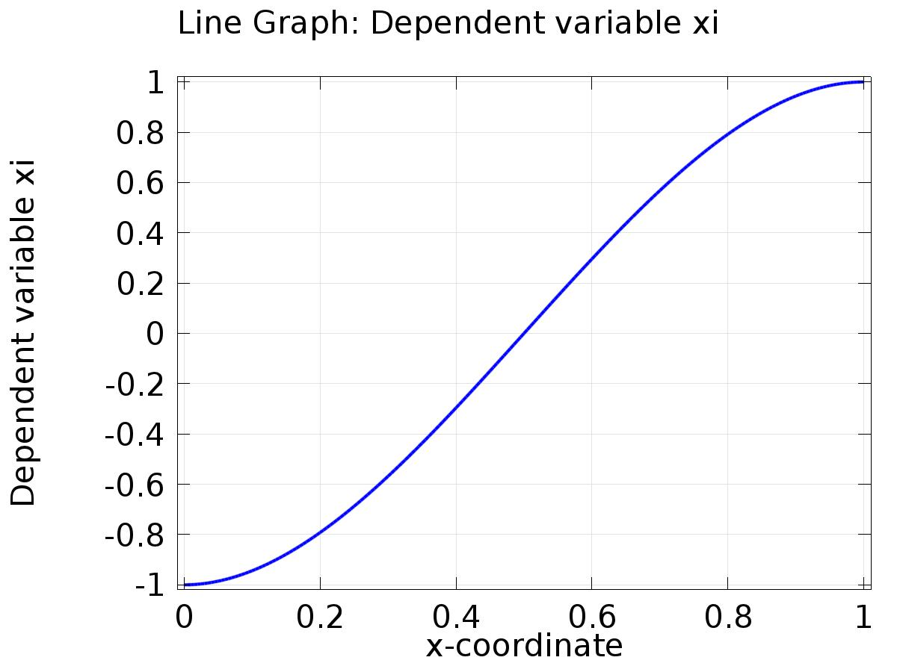

Line Graph: Dependent variable xi

* + 1. 1D Plot Group 2

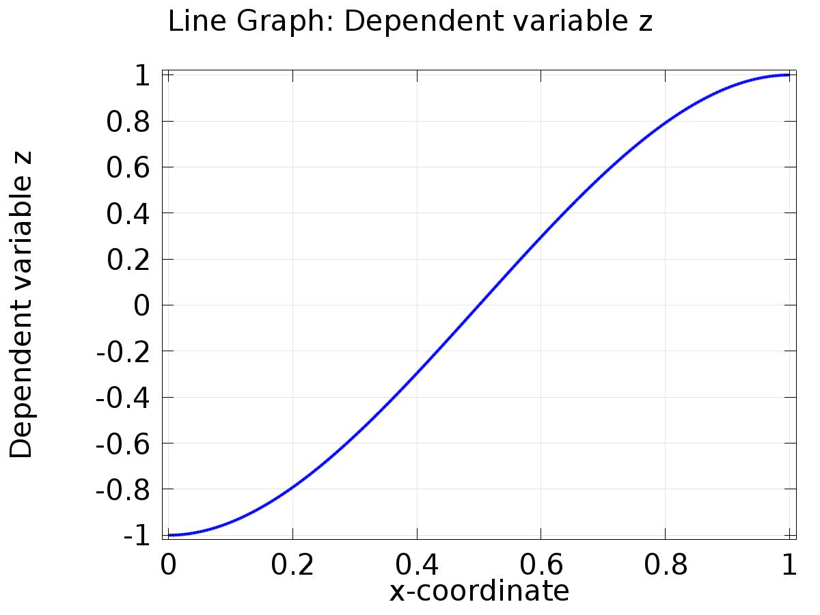

Line Graph: Dependent variable z

* + 1. 1D Plot Group 3

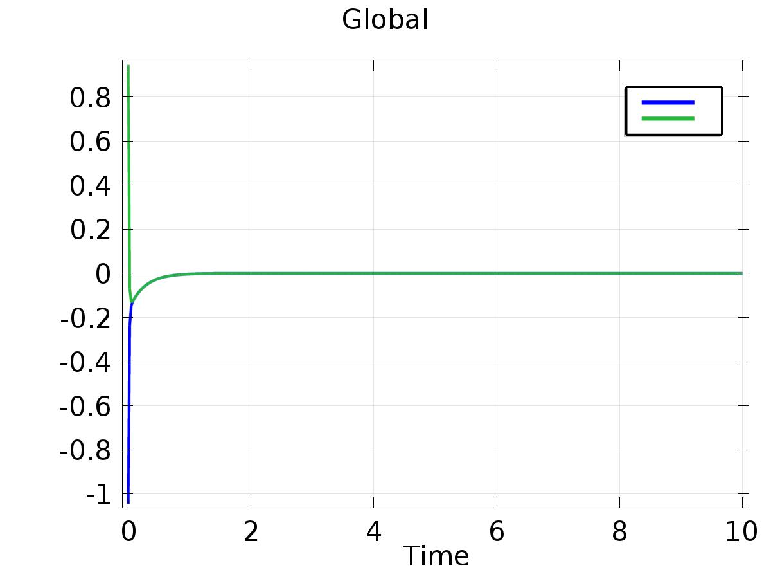

Global

* + 1. 1D Plot Group 4

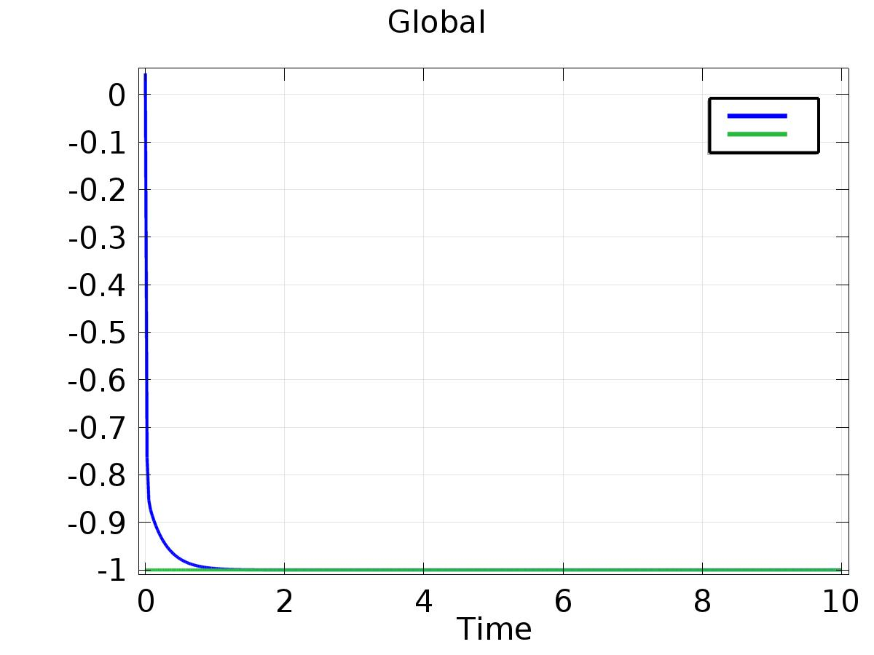

Global

* + 1. 1D Plot Group 5

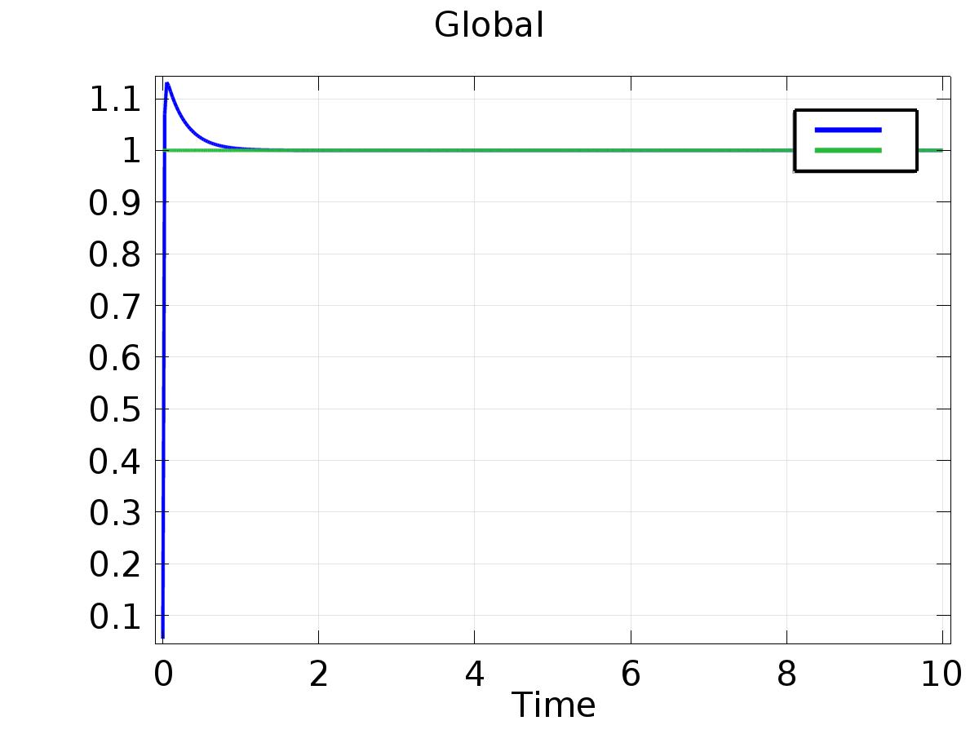

Global