[](http://www.comsol.com/)

Ch4 Ex4 8

|  |  |
| --- | --- |
| Date | Jun 15, 2014 2:40:14 PM |

Contents

1. Global

1.1. Definitions

2. Component 1

2.1. Definitions

2.2. Geometry 1

2.3. Zero Dynamics

2.4. Closed Loop System

2.5. Mesh 1

3. Study 1

3.1. Time Dependent

3.2. Solver Configurations

4. Results

4.1. Data Sets

4.2. Derived Values

4.3. Tables

4.4. Plot Groups

1. Global

|  |  |
| --- | --- |
| Date | May 12, 2014 8:09:38 AM |

Global settings

|  |  |
| --- | --- |
| Name | Ch4 Ex4 8.mph |
| Path | /Users/gilliam/Desktop/collect_15/research_15/geo_reg_mono_eugenio/Mono_1_15/Comsol_EX_GitHub/Chapter4/Example4.8/Ch4_Ex4_8.mph |
| Program | COMSOL 4.4 (Build: 150) |

Used products

|  |
| --- |
| COMSOL Multiphysics |

* 1. Definitions
     1. Parameters 1

Parameters

| **Name** | **Expression** | **Value** | **Description** |
| --- | --- | --- | --- |
| L | 1 | 1.0000 |  |
| k0 | 1 | 1.0000 |  |
| k1 | 1 | 1.0000 |  |
| nu | 1/2 | 0.50000 |  |

1. Component 1

Component settings

|  |  |
| --- | --- |
| Unit system | None |

* 1. Definitions
     1. Variables

#### Variables 1

Selection

|  |  |
| --- | --- |
| Geometric entity level | Entire model |

| **Name** | **Expression** | **Description** |
| --- | --- | --- |
| yr0 | sin(2*t) |  |
| yr1 | 2*sin(t) |  |
| e0 | yr0 - C0(z) |  |
| e1 | yr1 - C1(z) |  |

* + 1. Component Couplings

#### Integration 1

|  |  |
| --- | --- |
| Coupling type | Integration |
| Operator name | C0 |

Source selection

|  |  |
| --- | --- |
| Geometric entity level | Boundary |
| Selection | Boundary 1 |

#### Integration 2

|  |  |
| --- | --- |
| Coupling type | Integration |
| Operator name | C1 |

Source selection

|  |  |
| --- | --- |
| Geometric entity level | Boundary |
| Selection | Boundary 2 |

* 1. Geometry 1

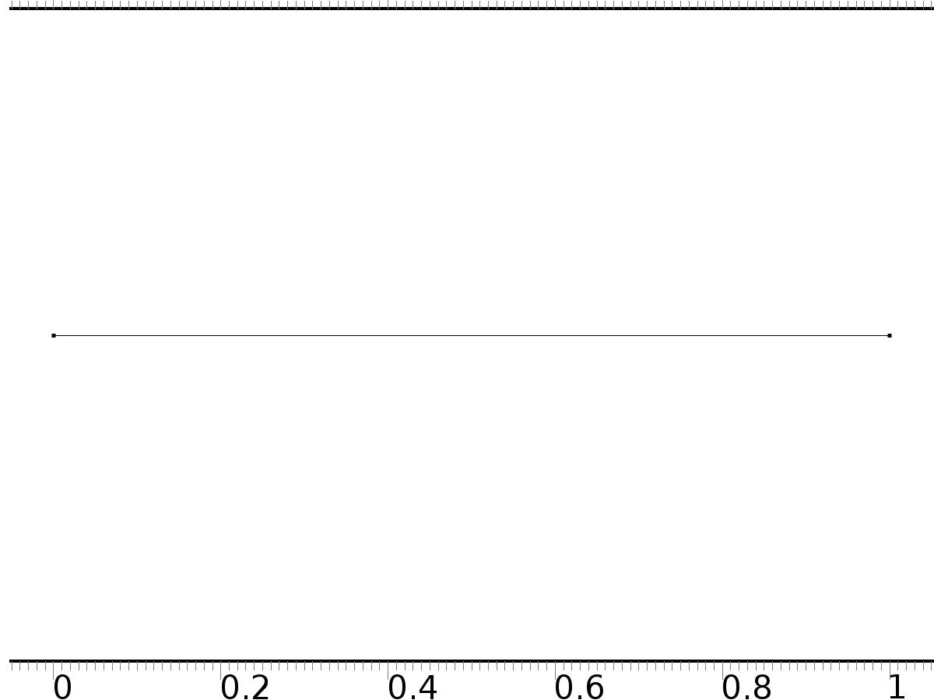

Geometry 1

Units

|  |  |
| --- | --- |
| Length unit | m |
| Angular unit | deg |

Geometry statistics

| **Description** | **Value** |
| --- | --- |
| Space dimension | 1 |
| Number of domains | 1 |
| Number of boundaries | 2 |

* + 1. Interval 1 (i1)

Interval

| **Description** | **Value** |
| --- | --- |
| Number of intervals | One |
| Left endpoint | 0 |
| Right endpoint | L |

* 1. Zero Dynamics

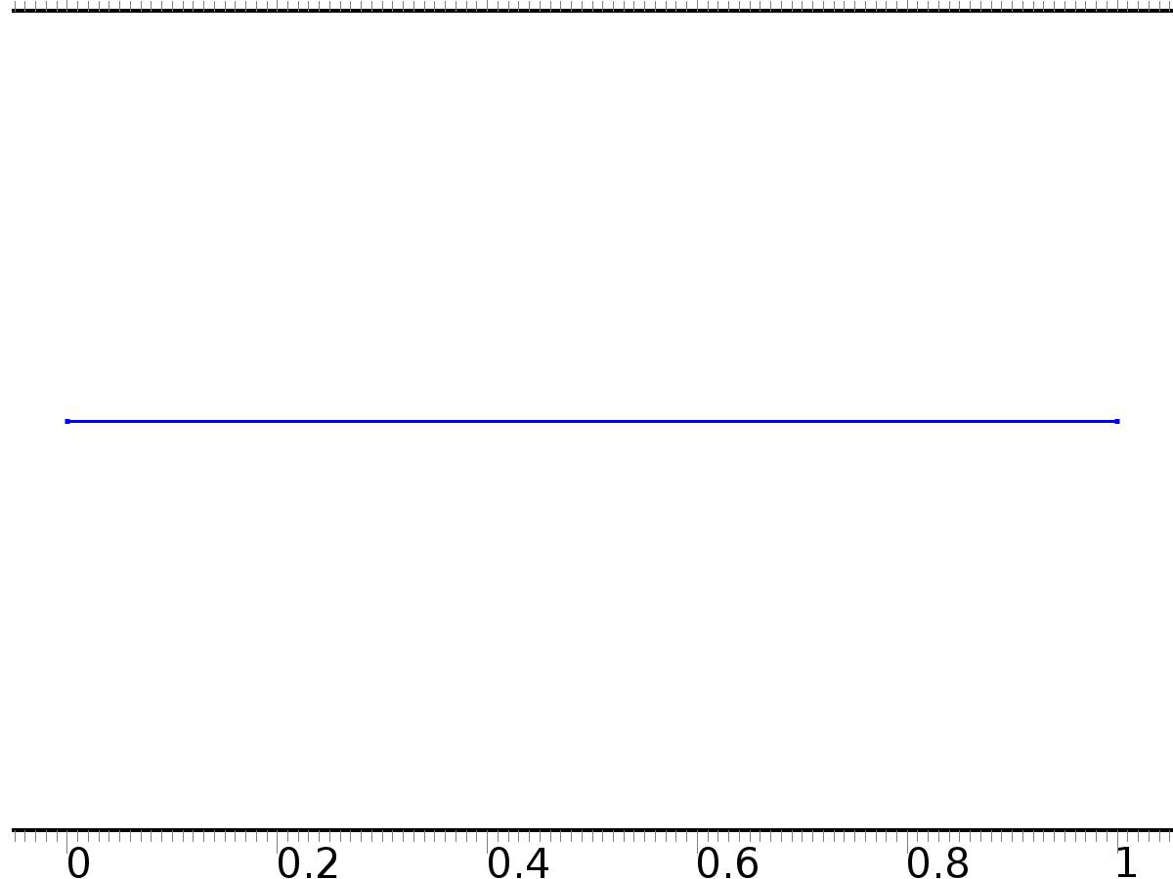

Zero Dynamics

Selection

|  |  |
| --- | --- |
| Geometric entity level | Domain |
| Selection | Domain 1 |

Settings

| **Description** | **Value** |
| --- | --- |
| Shape function type | Lagrange |
| Element order | Quadratic |
| Compute boundary fluxes | On |
| Apply smoothing to boundary fluxes | On |
| Value type when using splitting of complex variables | Complex |
| Dependent variable quantity | Dimensionless (1) |
| Source term quantity | None |
| Unit | m^ - 2 |

Used products

|  |
| --- |
| COMSOL Multiphysics |

Variables

| **Name** | **Expression** | **Unit** | **Description** | **Selection** |
| --- | --- | --- | --- | --- |
| xi.nx | nx |  | Normal vector, x component | Boundaries 1–2 |
| xi.ny | root.ny |  | Normal vector, y component | Boundaries 1–2 |
| xi.nz | root.nz |  | Normal vector, z component | Boundaries 1–2 |
| xi.nxmesh | root.nxmesh |  | Normal vector (mesh), x component | Boundaries 1–2 |
| xi.nymesh | root.nymesh |  | Normal vector (mesh), y component | Boundaries 1–2 |
| xi.nzmesh | root.nzmesh |  | Normal vector (mesh), z component | Boundaries 1–2 |

* + 1. Coefficient Form PDE 1



Coefficient Form PDE 1

Selection

|  |  |
| --- | --- |
| Geometric entity level | Domain |
| Selection | Domain 1 |

Equations

Settings

| **Description** | **Value** |
| --- | --- |
| Diffusion coefficient | {{-nu, 1}, {-1, 0}} |
| Absorption coefficient | {{0, 0}, {0, 1}} |
| Source term | {0, 0} |
| Mass coefficient | {{0, 0}, {0, 0}} |
| Damping or mass coefficient | {{1, 0}, {0, 0}} |
| Conservative flux convection coefficient | {{0, 0}, {0, 0}} |
| Convection coefficient | {{xi, 0}, {0, 0}} |
| Conservative flux source | {0, 0} |

#### Variables

| **Name** | **Expression** | **Unit** | **Description** | **Selection** |
| --- | --- | --- | --- | --- |
| domflux.xix | nu*d(xi,x)+d(Dxi,x) |  | Domain flux, x component | Domain 1 |
| domflux.Dxix | -d(xi,x) |  | Domain flux, x component | Domain 1 |

#### Shape functions

| **Name** | **Shape function** | **Unit** | **Description** | **Shape frame** | **Selection** |
| --- | --- | --- | --- | --- | --- |
| xi | Lagrange (Quadratic) |  | Dependent variable xi | Material | Domain 1 |
| Dxi | Lagrange (Quadratic) |  | Dependent variable Dxi | Material | Domain 1 |

* + 1. Zero Flux 1

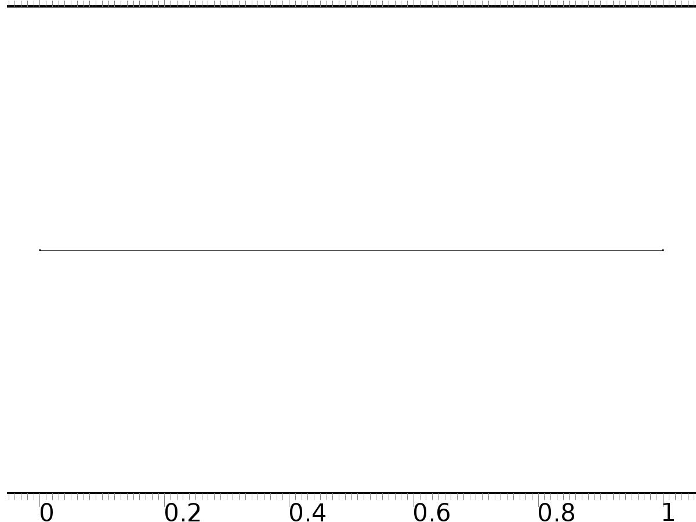

Zero Flux 1

Selection

|  |  |
| --- | --- |
| Geometric entity level | Boundary |
| Selection | No boundaries |

Equations

* + 1. Initial Values



Initial Values

Selection

|  |  |
| --- | --- |
| Geometric entity level | Domain |
| Selection | Domain 1 |

Settings

| **Description** | **Value** |
| --- | --- |
| Initial value for xi | 0 |
| Initial time derivative of xi | 0 |
| Initial value for Dxi | 0 |
| Initial time derivative of Dxi | 0 |

* + 1. PI(0)=yr0

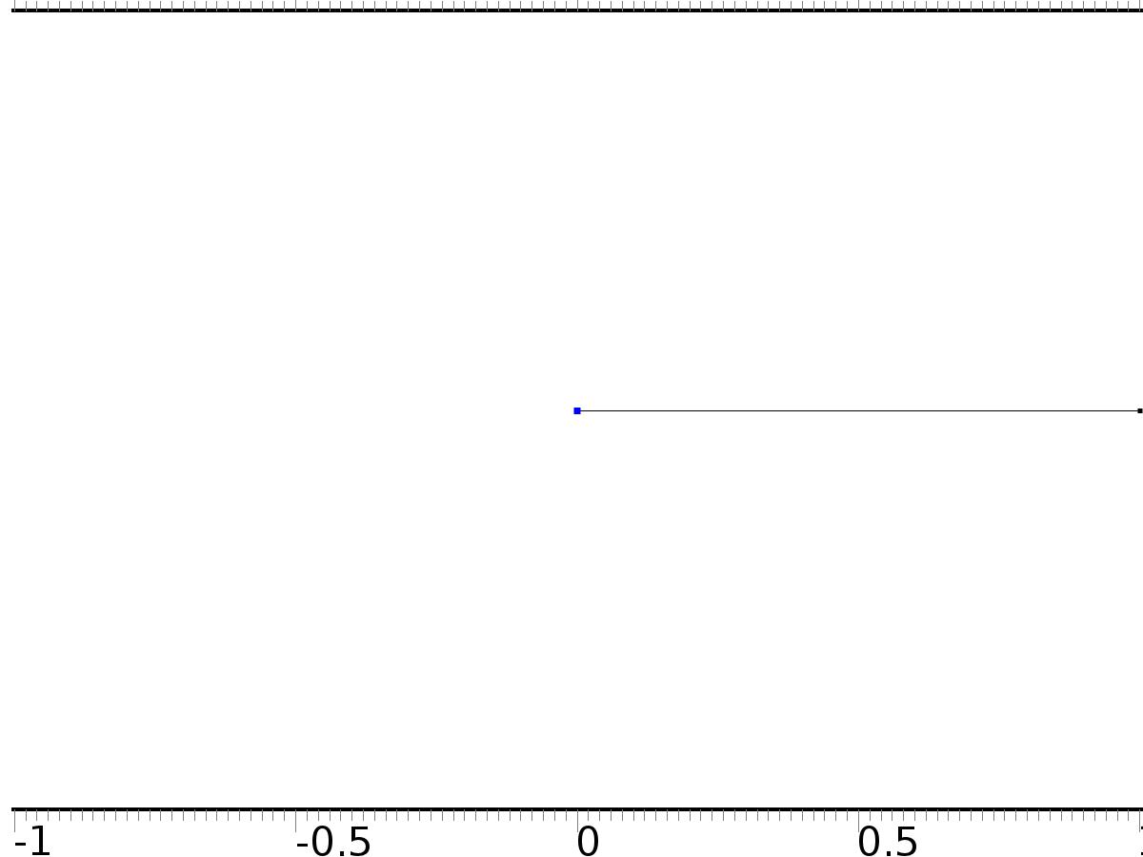

PI(0)=yr0

Selection

|  |  |
| --- | --- |
| Geometric entity level | Boundary |
| Selection | Boundary 1 |

Equations

Settings

| **Description** | **Value** |
| --- | --- |
| Value on boundary | {yr0, 0} |
| Prescribed value of xi | On |
| Prescribed value of Dxi | Off |
| Apply reaction terms on | Individual dependent variables |
| Use weak constraints | Off |
| Constraint method | Elemental |

#### Shape functions

| **Constraint** | **Constraint force** | **Shape function** | **Selection** |
| --- | --- | --- | --- |
| yr0-xi | -test(xi) | Lagrange (Quadratic) | Boundary 1 |

* + 1. PI(L)=yr1

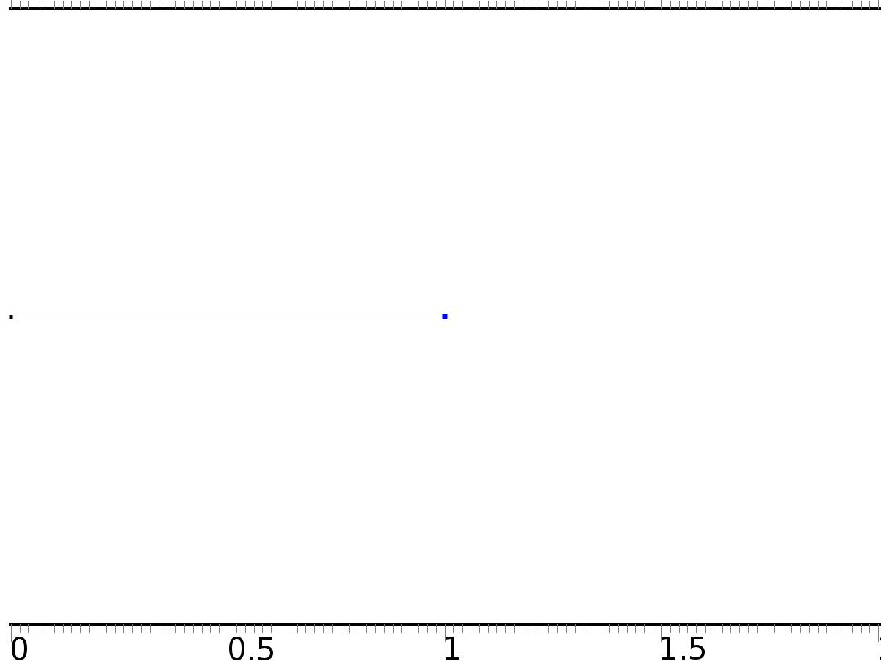

PI(L)=yr1

Selection

|  |  |
| --- | --- |
| Geometric entity level | Boundary |
| Selection | Boundary 2 |

Equations

Settings

| **Description** | **Value** |
| --- | --- |
| Value on boundary | {yr1, 0} |
| Prescribed value of xi | On |
| Prescribed value of Dxi | Off |
| Apply reaction terms on | Individual dependent variables |
| Use weak constraints | Off |
| Constraint method | Elemental |

#### Shape functions

| **Constraint** | **Constraint force** | **Shape function** | **Selection** |
| --- | --- | --- | --- |
| yr1-xi | -test(xi) | Lagrange (Quadratic) | Boundary 2 |

* 1. Closed Loop System



Closed Loop System

Selection

|  |  |
| --- | --- |
| Geometric entity level | Domain |
| Selection | Domain 1 |

Settings

| **Description** | **Value** |
| --- | --- |
| Shape function type | Lagrange |
| Element order | Quadratic |
| Compute boundary fluxes | On |
| Apply smoothing to boundary fluxes | On |
| Value type when using splitting of complex variables | Complex |
| Dependent variable quantity | Dimensionless (1) |
| Source term quantity | None |
| Unit | m^ - 2 |

Used products

|  |
| --- |
| COMSOL Multiphysics |

Variables

| **Name** | **Expression** | **Unit** | **Description** | **Selection** |
| --- | --- | --- | --- | --- |
| z.nx | nx |  | Normal vector, x component | Boundaries 1–2 |
| z.ny | root.ny |  | Normal vector, y component | Boundaries 1–2 |
| z.nz | root.nz |  | Normal vector, z component | Boundaries 1–2 |
| z.nxmesh | root.nxmesh |  | Normal vector (mesh), x component | Boundaries 1–2 |
| z.nymesh | root.nymesh |  | Normal vector (mesh), y component | Boundaries 1–2 |
| z.nzmesh | root.nzmesh |  | Normal vector (mesh), z component | Boundaries 1–2 |

* + 1. Coefficient Form PDE 1



Coefficient Form PDE 1

Selection

|  |  |
| --- | --- |
| Geometric entity level | Domain |
| Selection | Domain 1 |

Equations

Settings

| **Description** | **Value** |
| --- | --- |
| Diffusion coefficient | {{-nu, 1}, {-1, 0}} |
| Absorption coefficient | {{0, 0}, {0, 1}} |
| Source term | {0, 1} |
| Mass coefficient | {{0, 0}, {0, 0}} |
| Damping or mass coefficient | {{1, 0}, {0, 0}} |
| Conservative flux convection coefficient | {{0, 0}, {0, 0}} |
| Convection coefficient | {{z, 0}, {0, 0}} |
| Conservative flux source | {0, 0} |

#### Variables

| **Name** | **Expression** | **Unit** | **Description** | **Selection** |
| --- | --- | --- | --- | --- |
| domflux.zx | nu*d(z,x)+d(Dz,x) |  | Domain flux, x component | Domain 1 |
| domflux.Dzx | -d(z,x) |  | Domain flux, x component | Domain 1 |

#### Shape functions

| **Name** | **Shape function** | **Unit** | **Description** | **Shape frame** | **Selection** |
| --- | --- | --- | --- | --- | --- |
| z | Lagrange (Quadratic) |  | Dependent variable z | Material | Domain 1 |
| Dz | Lagrange (Quadratic) |  | Dependent variable Dz | Material | Domain 1 |

* + 1. Zero Flux 1



Zero Flux 1

Selection

|  |  |
| --- | --- |
| Geometric entity level | Boundary |
| Selection | No boundaries |

Equations

* + 1. Initial Values



Initial Values

Selection

|  |  |
| --- | --- |
| Geometric entity level | Domain |
| Selection | Domain 1 |

Settings

| **Description** | **Value** |
| --- | --- |
| Initial value for z | cos(pi*x) |
| Initial time derivative of z | 0 |
| Initial value for Dz | 0 |
| Initial time derivative of Dz | 0 |

* + 1. Bin0*u0



Bin0*u0

Selection

|  |  |
| --- | --- |
| Geometric entity level | Boundary |
| Selection | Boundary 1 |

Equations

Settings

| **Description** | **Value** |
| --- | --- |
| Boundary flux/source | {nu*zx + Dxix + k0*yr0, 0} |
| Boundary absorption/impedance term | {{k0, 0}, {0, 0}} |

#### Variables

| **Name** | **Expression** | **Unit** | **Description** | **Selection** |
| --- | --- | --- | --- | --- |
| z.g_z | nu*zx+Dxix+k0*yr0-k0*z |  | Boundary flux/source | Boundary 1 |
| z.g_Dz | 0 |  | Boundary flux/source | Boundary 1 |

* + 1. Bin1*u1



Bin1*u1

Selection

|  |  |
| --- | --- |
| Geometric entity level | Boundary |
| Selection | Boundary 2 |

Equations

Settings

| **Description** | **Value** |
| --- | --- |
| Boundary flux/source | {-nu*zx - Dxix + k1*yr1, 0} |
| Boundary absorption/impedance term | {{k1, 0}, {0, 0}} |

#### Variables

| **Name** | **Expression** | **Unit** | **Description** | **Selection** |
| --- | --- | --- | --- | --- |
| z.g_z | -nu*zx-Dxix+k1*yr1-k1*z |  | Boundary flux/source | Boundary 2 |
| z.g_Dz | 0 |  | Boundary flux/source | Boundary 2 |

* 1. Mesh 1

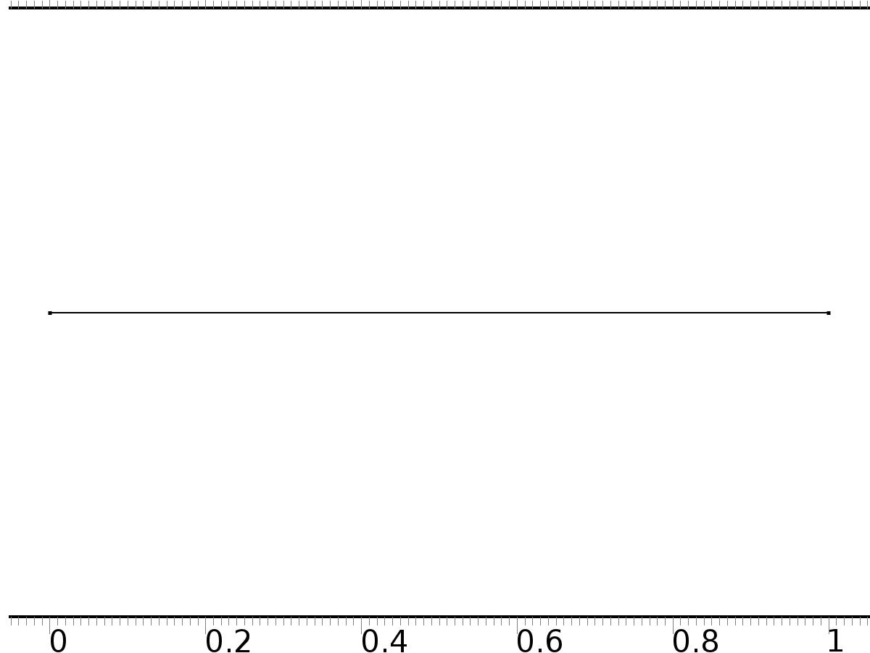

Mesh 1

* + 1. Size (size)

Settings

| **Description** | **Value** |
| --- | --- |
| Maximum element size | 0.02 |
| Minimum element size | 7.5E-5 |
| Curvature factor | 0.25 |
| Maximum element growth rate | 1.2 |
| Predefined size | Extra fine |

* + 1. Edge 1 (edg1)

Selection

|  |  |
| --- | --- |
| Geometric entity level | Remaining |

1. Study 1
   1. Time Dependent

Study settings

| **Description** | **Value** |
| --- | --- |
| Include geometric nonlinearity | Off |

| **Times** | **Unit** |
| --- | --- |
| range(0,0.025,10) | s |

Physics and variables selection

| **Physics interface** | **Discretization** |
| --- | --- |
| Zero Dynamics (c) | physics |
| Closed Loop System (c2) | physics |

Mesh selection

| **Geometry** | **Mesh** |
| --- | --- |
| Geometry 1 (geom1) | mesh1 |

* 1. Solver Configurations
     1. Solver 1

#### Compile Equations: Time Dependent (st1)

Study and step

| **Description** | **Value** |
| --- | --- |
| Use study | Study 1 |
| Use study step | Time Dependent |

#### Dependent Variables 1 (v1)

General

| **Description** | **Value** |
| --- | --- |
| Defined by study step | Time Dependent |
| Constant |  |

Initial values of variables solved for

| **Description** | **Value** |
| --- | --- |
| Solution | Zero |

Values of variables not solved for

| **Description** | **Value** |
| --- | --- |
| Solution | Zero |

##### Dependent variable xi (comp1.xi) (comp1_xi)

General

| **Description** | **Value** |
| --- | --- |
| Field components | comp1.xi |
| Field name | comp1_PI |

##### Dependent variable z (comp1.z) (comp1_z)

General

| **Description** | **Value** |
| --- | --- |
| Field components | comp1.z |

##### Dependent variable Dxi (comp1.Dxi) (comp1_Dxi)

General

| **Description** | **Value** |
| --- | --- |
| Field components | comp1.Dxi |
| Field name | comp1_PI2 |

##### Dependent variable Dz (comp1.Dz) (comp1_Dz)

General

| **Description** | **Value** |
| --- | --- |
| Field components | comp1.Dz |
| Field name | comp1_z2 |

#### Time-Dependent Solver 1 (t1)

General

| **Description** | **Value** |
| --- | --- |
| Defined by study step | Time Dependent |
| Time | {0, 0.025, 0.05, 0.07500000000000001, 0.1, 0.125, 0.15000000000000002, 0.17500000000000002, 0.2, 0.225, 0.25, 0.275, 0.30000000000000004, 0.325, 0.35000000000000003, 0.375, 0.4, 0.42500000000000004, 0.45, 0.47500000000000003, 0.5, 0.525, 0.55, 0.5750000000000001, 0.6000000000000001, 0.625, 0.65, 0.675, 0.7000000000000001, 0.7250000000000001, 0.75, 0.775, 0.8, 0.8250000000000001, 0.8500000000000001, 0.875, 0.9, 0.925, 0.9500000000000001, 0.9750000000000001, 1, 1.0250000000000001, 1.05, 1.075, 1.1, 1.125, 1.1500000000000001, 1.175, 1.2000000000000002, 1.225, 1.25, 1.2750000000000001, 1.3, 1.3250000000000002, 1.35, 1.375, 1.4000000000000001, 1.425, 1.4500000000000002, 1.475, 1.5, 1.5250000000000001, 1.55, 1.5750000000000002, 1.6, 1.625, 1.6500000000000001, 1.675, 1.7000000000000002, 1.725, 1.75, 1.7750000000000001, 1.8, 1.8250000000000002, 1.85, 1.875, 1.9000000000000001, 1.925, 1.9500000000000002, 1.975, 2, 2.025, 2.0500000000000003, 2.075, 2.1, 2.125, 2.15, 2.1750000000000003, 2.2, 2.225, 2.25, 2.275, 2.3000000000000003, 2.325, 2.35, 2.375, 2.4000000000000004, 2.4250000000000003, 2.45, 2.475, 2.5, 2.5250000000000004, 2.5500000000000003, 2.575, 2.6, 2.625, 2.6500000000000004, 2.6750000000000003, 2.7, 2.725, 2.75, 2.7750000000000004, 2.8000000000000003, 2.825, 2.85, 2.875, 2.9000000000000004, 2.9250000000000003, 2.95, 2.975, 3, 3.0250000000000004, 3.0500000000000003, 3.075, 3.1, 3.125, 3.1500000000000004, 3.1750000000000003, 3.2, 3.225, 3.25, 3.2750000000000004, 3.3000000000000003, 3.325, 3.35, 3.375, 3.4000000000000004, 3.4250000000000003, 3.45, 3.475, 3.5, 3.5250000000000004, 3.5500000000000003, 3.575, 3.6, 3.625, 3.6500000000000004, 3.6750000000000003, 3.7, 3.725, 3.75, 3.7750000000000004, 3.8000000000000003, 3.825, 3.85, 3.875, 3.9000000000000004, 3.9250000000000003, 3.95, 3.975, 4, 4.025, 4.05, 4.075, 4.1000000000000005, 4.125, 4.15, 4.175, 4.2, 4.2250000000000005, 4.25, 4.275, 4.3, 4.325, 4.3500000000000005, 4.375, 4.4, 4.425, 4.45, 4.4750000000000005, 4.5, 4.525, 4.55, 4.575, 4.6000000000000005, 4.625, 4.65, 4.675, 4.7, 4.7250000000000005, 4.75, 4.775, 4.800000000000001, 4.825, 4.8500000000000005, 4.875, 4.9, 4.925000000000001, 4.95, 4.9750000000000005, 5, 5.025, 5.050000000000001, 5.075, 5.1000000000000005, 5.125, 5.15, 5.175000000000001, 5.2, 5.2250000000000005, 5.25, 5.275, 5.300000000000001, 5.325, 5.3500000000000005, 5.375, 5.4, 5.425000000000001, 5.45, 5.4750000000000005, 5.5, 5.525, 5.550000000000001, 5.575, 5.6000000000000005, 5.625, 5.65, 5.675000000000001, 5.7, 5.7250000000000005, 5.75, 5.775, 5.800000000000001, 5.825, 5.8500000000000005, 5.875, 5.9, 5.925000000000001, 5.95, 5.9750000000000005, 6, 6.025, 6.050000000000001, 6.075, 6.1000000000000005, 6.125, 6.15, 6.175000000000001, 6.2, 6.2250000000000005, 6.25, 6.275, 6.300000000000001, 6.325, 6.3500000000000005, 6.375, 6.4, 6.425000000000001, 6.45, 6.4750000000000005, 6.5, 6.525, 6.550000000000001, 6.575, 6.6000000000000005, 6.625, 6.65, 6.675000000000001, 6.7, 6.7250000000000005, 6.75, 6.775, 6.800000000000001, 6.825, 6.8500000000000005, 6.875, 6.9, 6.925000000000001, 6.95, 6.9750000000000005, 7, 7.025, 7.050000000000001, 7.075, 7.1000000000000005, 7.125, 7.15, 7.175000000000001, 7.2, 7.2250000000000005, 7.25, 7.275, 7.300000000000001, 7.325, 7.3500000000000005, 7.375, 7.4, 7.425000000000001, 7.45, 7.4750000000000005, 7.5, 7.525, 7.550000000000001, 7.575, 7.6000000000000005, 7.625, 7.65, 7.675000000000001, 7.7, 7.7250000000000005, 7.75, 7.775, 7.800000000000001, 7.825, 7.8500000000000005, 7.875, 7.9, 7.925000000000001, 7.95, 7.9750000000000005, 8, 8.025, 8.05, 8.075000000000001, 8.1, 8.125, 8.15, 8.175, 8.200000000000001, 8.225, 8.25, 8.275, 8.3, 8.325000000000001, 8.35, 8.375, 8.4, 8.425, 8.450000000000001, 8.475, 8.5, 8.525, 8.55, 8.575000000000001, 8.6, 8.625, 8.65, 8.675, 8.700000000000001, 8.725, 8.75, 8.775, 8.8, 8.825000000000001, 8.85, 8.875, 8.9, 8.925, 8.950000000000001, 8.975, 9, 9.025, 9.05, 9.075000000000001, 9.1, 9.125, 9.15, 9.175, 9.200000000000001, 9.225, 9.25, 9.275, 9.3, 9.325000000000001, 9.35, 9.375, 9.4, 9.425, 9.450000000000001, 9.475, 9.5, 9.525, 9.55, 9.575000000000001, 9.600000000000001, 9.625, 9.65, 9.675, 9.700000000000001, 9.725000000000001, 9.75, 9.775, 9.8, 9.825000000000001, 9.850000000000001, 9.875, 9.9, 9.925, 9.950000000000001, 9.975000000000001, 10} |
| Relative tolerance | 0.0001 |

Absolute tolerance

| **Description** | **Value** |
| --- | --- |
| Tolerance | 0.000010 |

Time stepping

| **Description** | **Value** |
| --- | --- |
| Initial step | 0.0010 |

Advanced

| **Description** | **Value** |
| --- | --- |
| Fraction of initial step for Backward Euler | 0.0010 |

Log

| **Description** | **Value** |
| --- | --- |
| Constant |  |

##### Fully Coupled 1 (fc1)

General

| **Description** | **Value** |
| --- | --- |
| Linear solver | Direct |

1. Results
   1. Data Sets
      1. Solution 1

Solution

| **Description** | **Value** |
| --- | --- |
| Solution | Solver 1 |
| Component | Save Point Geometry 1 |

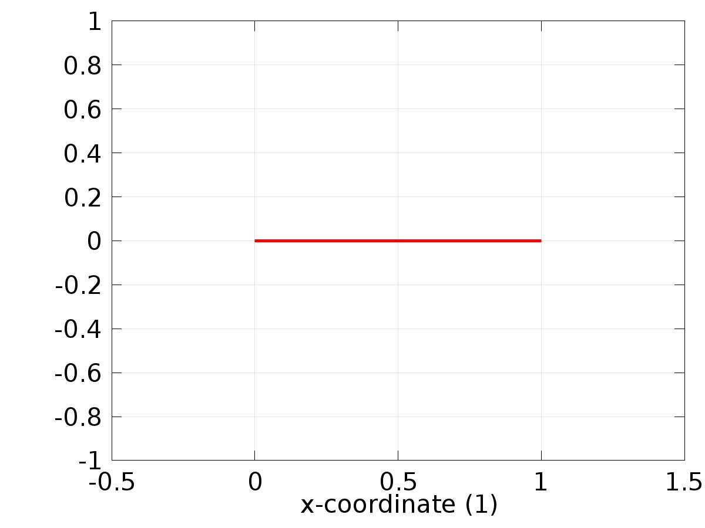

Data set: Solution 1

* 1. Derived Values
     1. Global Evaluation 1

Data

| **Description** | **Value** |
| --- | --- |
| Data set | Solution 1 |

Expression

| **Description** | **Value** |
| --- | --- |
| Expression | e1 |

* 1. Tables
     1. Table 1

Global Evaluation 1 (C0(z))

Table 1

| **Time (s)** | **C0(z)** | **C1(z)** | **yr0** | **yr1** | **e0** | **e1** |
| --- | --- | --- | --- | --- | --- | --- |
| 0.0000 | 0.99794 | -0.99794 | 0.0000 | 0.0000 | -0.99794 | 0.99794 |
| 0.025000 | 0.14083 | -0.040278 | 0.049979 | 0.049995 | -0.090854 | 0.090273 |
| 0.050000 | 0.10835 | 0.092213 | 0.099833 | 0.099958 | -0.0085215 | 0.0077449 |
| 0.075000 | 0.15056 | 0.14952 | 0.14944 | 0.14986 | -0.0011184 | 3.4418E-4 |
| 0.10000 | 0.19911 | 0.19997 | 0.19867 | 0.19967 | -4.3957E-4 | -3.0162E-4 |
| 0.12500 | 0.24776 | 0.24970 | 0.24740 | 0.24935 | -3.5893E-4 | -3.4675E-4 |
| 0.15000 | 0.29585 | 0.29921 | 0.29552 | 0.29888 | -3.3379E-4 | -3.3759E-4 |
| 0.17500 | 0.34322 | 0.34854 | 0.34290 | 0.34822 | -3.1917E-4 | -3.1952E-4 |
| 0.20000 | 0.38972 | 0.39764 | 0.38942 | 0.39734 | -3.0374E-4 | -3.0384E-4 |
| 0.22500 | 0.43525 | 0.44650 | 0.43497 | 0.44621 | -2.8831E-4 | -2.8969E-4 |
| 0.25000 | 0.47970 | 0.49508 | 0.47943 | 0.49481 | -2.7453E-4 | -2.7531E-4 |
| 0.27500 | 0.52295 | 0.54336 | 0.52269 | 0.54309 | -2.6174E-4 | -2.6134E-4 |
| 0.30000 | 0.56489 | 0.59129 | 0.56464 | 0.59104 | -2.4847E-4 | -2.4914E-4 |
| 0.32500 | 0.60542 | 0.63885 | 0.60519 | 0.63862 | -2.3658E-4 | -2.3682E-4 |
| 0.35000 | 0.64444 | 0.68602 | 0.64422 | 0.68580 | -2.2544E-4 | -2.2490E-4 |
| 0.37500 | 0.68185 | 0.73276 | 0.68164 | 0.73255 | -2.1442E-4 | -2.1414E-4 |
| 0.40000 | 0.71756 | 0.77904 | 0.71736 | 0.77884 | -2.0396E-4 | -2.0407E-4 |
| 0.42500 | 0.75147 | 0.82484 | 0.75128 | 0.82464 | -1.9404E-4 | -1.9438E-4 |
| 0.45000 | 0.78351 | 0.87012 | 0.78333 | 0.86993 | -1.8493E-4 | -1.8525E-4 |
| 0.47500 | 0.81359 | 0.91485 | 0.81342 | 0.91468 | -1.7625E-4 | -1.7658E-4 |
| 0.50000 | 0.84164 | 0.95902 | 0.84147 | 0.95885 | -1.6828E-4 | -1.6846E-4 |
| 0.52500 | 0.86758 | 1.0026 | 0.86742 | 1.0024 | -1.6058E-4 | -1.6091E-4 |
| 0.55000 | 0.89136 | 1.0455 | 0.89121 | 1.0454 | -1.5349E-4 | -1.5393E-4 |
| 0.57500 | 0.91291 | 1.0878 | 0.91276 | 1.0877 | -1.4695E-4 | -1.4747E-4 |
| 0.60000 | 0.93218 | 1.1294 | 0.93204 | 1.1293 | -1.4121E-4 | -1.4142E-4 |
| 0.62500 | 0.94912 | 1.1703 | 0.94898 | 1.1702 | -1.3579E-4 | -1.3598E-4 |
| 0.65000 | 0.96369 | 1.2105 | 0.96356 | 1.2104 | -1.3071E-4 | -1.3114E-4 |
| 0.67500 | 0.97585 | 1.2499 | 0.97572 | 1.2498 | -1.2614E-4 | -1.2691E-4 |
| 0.70000 | 0.98557 | 1.2886 | 0.98545 | 1.2884 | -1.2215E-4 | -1.2329E-4 |
| 0.72500 | 0.99283 | 1.3264 | 0.99271 | 1.3263 | -1.1831E-4 | -1.2011E-4 |
| 0.75000 | 0.99761 | 1.3634 | 0.99749 | 1.3633 | -1.1510E-4 | -1.1736E-4 |
| 0.77500 | 0.99990 | 1.3995 | 0.99978 | 1.3994 | -1.1296E-4 | -1.1496E-4 |
| 0.80000 | 0.99968 | 1.4348 | 0.99957 | 1.4347 | -1.1117E-4 | -1.1303E-4 |
| 0.82500 | 0.99697 | 1.4692 | 0.99687 | 1.4691 | -1.0940E-4 | -1.1167E-4 |
| 0.85000 | 0.99177 | 1.5027 | 0.99166 | 1.5026 | -1.0830E-4 | -1.1087E-4 |
| 0.87500 | 0.98409 | 1.5352 | 0.98399 | 1.5351 | -1.0832E-4 | -1.1072E-4 |
| 0.90000 | 0.97396 | 1.5668 | 0.97385 | 1.5667 | -1.0781E-4 | -1.1093E-4 |
| 0.92500 | 0.96138 | 1.5974 | 0.96128 | 1.5972 | -1.0775E-4 | -1.1160E-4 |
| 0.95000 | 0.94641 | 1.6269 | 0.94630 | 1.6268 | -1.0859E-4 | -1.1273E-4 |
| 0.97500 | 0.92907 | 1.6555 | 0.92896 | 1.6554 | -1.1000E-4 | -1.1428E-4 |
| 1.0000 | 0.90941 | 1.6831 | 0.90930 | 1.6829 | -1.1096E-4 | -1.1624E-4 |
| 1.0250 | 0.88747 | 1.7095 | 0.88736 | 1.7094 | -1.1246E-4 | -1.1858E-4 |
| 1.0500 | 0.86332 | 1.7350 | 0.86321 | 1.7348 | -1.1511E-4 | -1.2125E-4 |
| 1.0750 | 0.83702 | 1.7593 | 0.83690 | 1.7592 | -1.1725E-4 | -1.2424E-4 |
| 1.1000 | 0.80862 | 1.7825 | 0.80850 | 1.7824 | -1.1941E-4 | -1.2750E-4 |
| 1.1250 | 0.77820 | 1.8047 | 0.77807 | 1.8045 | -1.2216E-4 | -1.3103E-4 |
| 1.1500 | 0.74583 | 1.8257 | 0.74571 | 1.8255 | -1.2560E-4 | -1.3478E-4 |
| 1.1750 | 0.71160 | 1.8455 | 0.71147 | 1.8454 | -1.2825E-4 | -1.3868E-4 |
| 1.2000 | 0.67559 | 1.8642 | 0.67546 | 1.8641 | -1.3109E-4 | -1.4273E-4 |
| 1.2250 | 0.63790 | 1.8818 | 0.63776 | 1.8816 | -1.3455E-4 | -1.4690E-4 |
| 1.2500 | 0.59861 | 1.8981 | 0.59847 | 1.8980 | -1.3781E-4 | -1.5113E-4 |
| 1.2750 | 0.55782 | 1.9133 | 0.55768 | 1.9131 | -1.4058E-4 | -1.5537E-4 |
| 1.3000 | 0.51564 | 1.9273 | 0.51550 | 1.9271 | -1.4353E-4 | -1.5959E-4 |
| 1.3250 | 0.47218 | 1.9401 | 0.47203 | 1.9399 | -1.4700E-4 | -1.6379E-4 |
| 1.3500 | 0.42753 | 1.9516 | 0.42738 | 1.9514 | -1.4950E-4 | -1.6786E-4 |
| 1.3750 | 0.38181 | 1.9620 | 0.38166 | 1.9618 | -1.5188E-4 | -1.7181E-4 |
| 1.4000 | 0.33514 | 1.9711 | 0.33499 | 1.9709 | -1.5441E-4 | -1.7561E-4 |
| 1.4250 | 0.28763 | 1.9790 | 0.28748 | 1.9788 | -1.5684E-4 | -1.7922E-4 |
| 1.4500 | 0.23941 | 1.9856 | 0.23925 | 1.9854 | -1.5853E-4 | -1.8259E-4 |
| 1.4750 | 0.19058 | 1.9910 | 0.19042 | 1.9908 | -1.6007E-4 | -1.8571E-4 |
| 1.5000 | 0.14128 | 1.9952 | 0.14112 | 1.9950 | -1.6172E-4 | -1.8858E-4 |
| 1.5250 | 0.091627 | 1.9981 | 0.091465 | 1.9979 | -1.6268E-4 | -1.9113E-4 |
| 1.5500 | 0.041744 | 1.9998 | 0.041581 | 1.9996 | -1.6323E-4 | -1.9336E-4 |
| 1.5750 | -0.0082437 | 2.0002 | -0.0084072 | 2.0000 | -1.6359E-4 | -1.9527E-4 |
| 1.6000 | -0.058210 | 1.9993 | -0.058374 | 1.9991 | -1.6379E-4 | -1.9684E-4 |
| 1.6250 | -0.10803 | 1.9973 | -0.10820 | 1.9971 | -1.6336E-4 | -1.9803E-4 |
| 1.6500 | -0.15758 | 1.9939 | -0.15775 | 1.9937 | -1.6260E-4 | -1.9886E-4 |
| 1.6750 | -0.20674 | 1.9894 | -0.20690 | 1.9892 | -1.6162E-4 | -1.9934E-4 |
| 1.7000 | -0.25538 | 1.9835 | -0.25554 | 1.9833 | -1.6027E-4 | -1.9943E-4 |
| 1.7250 | -0.30338 | 1.9765 | -0.30354 | 1.9763 | -1.5852E-4 | -1.9914E-4 |
| 1.7500 | -0.35063 | 1.9682 | -0.35078 | 1.9680 | -1.5646E-4 | -1.9848E-4 |
| 1.7750 | -0.39699 | 1.9586 | -0.39715 | 1.9584 | -1.5407E-4 | -1.9749E-4 |
| 1.8000 | -0.44237 | 1.9479 | -0.44252 | 1.9477 | -1.5145E-4 | -1.9610E-4 |
| 1.8250 | -0.48664 | 1.9359 | -0.48679 | 1.9357 | -1.4855E-4 | -1.9436E-4 |
| 1.8500 | -0.52969 | 1.9227 | -0.52984 | 1.9226 | -1.4528E-4 | -1.9230E-4 |
| 1.8750 | -0.57142 | 1.9084 | -0.57156 | 1.9082 | -1.4177E-4 | -1.8993E-4 |
| 1.9000 | -0.61172 | 1.8928 | -0.61186 | 1.8926 | -1.3822E-4 | -1.8721E-4 |
| 1.9250 | -0.65049 | 1.8760 | -0.65063 | 1.8758 | -1.3439E-4 | -1.8422E-4 |
| 1.9500 | -0.68764 | 1.8581 | -0.68777 | 1.8579 | -1.3007E-4 | -1.8097E-4 |
| 1.9750 | -0.72306 | 1.8390 | -0.72319 | 1.8388 | -1.2599E-4 | -1.7743E-4 |
| 2.0000 | -0.75668 | 1.8188 | -0.75680 | 1.8186 | -1.2183E-4 | -1.7365E-4 |
| 2.0250 | -0.78841 | 1.7974 | -0.78853 | 1.7972 | -1.1734E-4 | -1.6967E-4 |
| 2.0500 | -0.81816 | 1.7749 | -0.81828 | 1.7747 | -1.1253E-4 | -1.6549E-4 |
| 2.0750 | -0.84588 | 1.7513 | -0.84598 | 1.7511 | -1.0821E-4 | -1.6111E-4 |
| 2.1000 | -0.87147 | 1.7266 | -0.87158 | 1.7264 | -1.0375E-4 | -1.5656E-4 |
| 2.1250 | -0.89489 | 1.7008 | -0.89499 | 1.7006 | -9.8805E-5 | -1.5190E-4 |
| 2.1500 | -0.91607 | 1.6739 | -0.91617 | 1.6738 | -9.4166E-5 | -1.4710E-4 |
| 2.1750 | -0.93496 | 1.6461 | -0.93505 | 1.6459 | -8.9873E-5 | -1.4218E-4 |
| 2.2000 | -0.95152 | 1.6171 | -0.95160 | 1.6170 | -8.5368E-5 | -1.3720E-4 |
| 2.2250 | -0.96569 | 1.5872 | -0.96577 | 1.5871 | -8.0348E-5 | -1.3216E-4 |
| 2.2500 | -0.97745 | 1.5563 | -0.97753 | 1.5561 | -7.6297E-5 | -1.2706E-4 |
| 2.2750 | -0.98677 | 1.5244 | -0.98684 | 1.5243 | -7.2284E-5 | -1.2192E-4 |
| 2.3000 | -0.99362 | 1.4915 | -0.99369 | 1.4914 | -6.7872E-5 | -1.1680E-4 |
| 2.3250 | -0.99799 | 1.4577 | -0.99805 | 1.4576 | -6.3556E-5 | -1.1168E-4 |
| 2.3500 | -0.99986 | 1.4231 | -0.99992 | 1.4229 | -6.0031E-5 | -1.0656E-4 |
| 2.3750 | -0.99924 | 1.3875 | -0.99929 | 1.3874 | -5.6428E-5 | -1.0149E-4 |
| 2.4000 | -0.99611 | 1.3510 | -0.99616 | 1.3509 | -5.2134E-5 | -9.6501E-5 |
| 2.4250 | -0.99050 | 1.3137 | -0.99055 | 1.3136 | -4.9014E-5 | -9.1550E-5 |
| 2.4500 | -0.98241 | 1.2756 | -0.98245 | 1.2755 | -4.6113E-5 | -8.6678E-5 |
| 2.4750 | -0.97186 | 1.2367 | -0.97190 | 1.2366 | -4.2934E-5 | -8.1910E-5 |
| 2.5000 | -0.95888 | 1.1970 | -0.95892 | 1.1969 | -3.9520E-5 | -7.7256E-5 |
| 2.5250 | -0.94351 | 1.1566 | -0.94355 | 1.1565 | -3.7201E-5 | -7.2697E-5 |
| 2.5500 | -0.92578 | 1.1154 | -0.92581 | 1.1154 | -3.4905E-5 | -6.8266E-5 |
| 2.5750 | -0.90573 | 1.0736 | -0.90577 | 1.0735 | -3.2052E-5 | -6.3984E-5 |
| 2.6000 | -0.88342 | 1.0311 | -0.88345 | 1.0310 | -2.9844E-5 | -5.9834E-5 |
| 2.6250 | -0.85891 | 0.98790 | -0.85893 | 0.98784 | -2.8209E-5 | -5.5825E-5 |
| 2.6500 | -0.83224 | 0.94411 | -0.83227 | 0.94406 | -2.6399E-5 | -5.1978E-5 |
| 2.6750 | -0.80350 | 0.89974 | -0.80352 | 0.89969 | -2.4063E-5 | -4.8306E-5 |
| 2.7000 | -0.77274 | 0.85480 | -0.77276 | 0.85476 | -2.2896E-5 | -4.4779E-5 |
| 2.7250 | -0.74006 | 0.80934 | -0.74008 | 0.80929 | -2.1795E-5 | -4.1422E-5 |
| 2.7500 | -0.70552 | 0.76336 | -0.70554 | 0.76332 | -2.0283E-5 | -3.8248E-5 |
| 2.7750 | -0.66922 | 0.71691 | -0.66924 | 0.71687 | -1.8894E-5 | -3.5248E-5 |
| 2.8000 | -0.63125 | 0.67001 | -0.63127 | 0.66998 | -1.8229E-5 | -3.2413E-5 |
| 2.8250 | -0.59170 | 0.62269 | -0.59172 | 0.62266 | -1.7458E-5 | -2.9758E-5 |
| 2.8500 | -0.55067 | 0.57498 | -0.55069 | 0.57496 | -1.6030E-5 | -2.7293E-5 |
| 2.8750 | -0.50826 | 0.52692 | -0.50828 | 0.52689 | -1.5583E-5 | -2.4987E-5 |
| 2.9000 | -0.46459 | 0.47852 | -0.46460 | 0.47850 | -1.5201E-5 | -2.2856E-5 |
| 2.9250 | -0.41975 | 0.42983 | -0.41976 | 0.42981 | -1.4539E-5 | -2.0902E-5 |
| 2.9500 | -0.37386 | 0.38086 | -0.37388 | 0.38085 | -1.3652E-5 | -1.9122E-5 |
| 2.9750 | -0.32704 | 0.33166 | -0.32705 | 0.33165 | -1.3406E-5 | -1.7499E-5 |
| 3.0000 | -0.27940 | 0.28226 | -0.27942 | 0.28224 | -1.3086E-5 | -1.6041E-5 |
| 3.0250 | -0.23107 | 0.23267 | -0.23108 | 0.23266 | -1.2346E-5 | -1.4748E-5 |
| 3.0500 | -0.18215 | 0.18294 | -0.18216 | 0.18293 | -1.1894E-5 | -1.3605E-5 |
| 3.0750 | -0.13278 | 0.13310 | -0.13279 | 0.13309 | -1.1627E-5 | -1.2610E-5 |
| 3.1000 | -0.083078 | 0.083173 | -0.083089 | 0.083161 | -1.1192E-5 | -1.1763E-5 |
| 3.1250 | -0.033169 | 0.033195 | -0.033179 | 0.033184 | -1.0452E-5 | -1.1061E-5 |
| 3.1500 | 0.016824 | -0.016804 | 0.016814 | -0.016814 | -1.0073E-5 | -1.0489E-5 |
| 3.1750 | 0.066775 | -0.066792 | 0.066765 | -0.066802 | -9.6331E-6 | -1.0048E-5 |
| 3.2000 | 0.11656 | -0.11674 | 0.11655 | -0.11675 | -8.9995E-6 | -9.7366E-6 |
| 3.2250 | 0.16605 | -0.16661 | 0.16604 | -0.16662 | -8.3152E-6 | -9.5478E-6 |
| 3.2500 | 0.21513 | -0.21638 | 0.21512 | -0.21639 | -7.7176E-6 | -9.4759E-6 |
| 3.2750 | 0.26367 | -0.26601 | 0.26366 | -0.26602 | -7.0527E-6 | -9.5196E-6 |
| 3.3000 | 0.31155 | -0.31548 | 0.31154 | -0.31549 | -6.2830E-6 | -9.6767E-6 |
| 3.3250 | 0.35865 | -0.36475 | 0.35864 | -0.36476 | -5.4996E-6 | -9.9444E-6 |
| 3.3500 | 0.40485 | -0.41379 | 0.40485 | -0.41380 | -4.6814E-6 | -1.0322E-5 |
| 3.3750 | 0.45005 | -0.46258 | 0.45004 | -0.46259 | -3.8849E-6 | -1.0808E-5 |
| 3.4000 | 0.49412 | -0.51107 | 0.49411 | -0.51108 | -3.0869E-6 | -1.1404E-5 |
| 3.4250 | 0.53695 | -0.55925 | 0.53695 | -0.55926 | -2.1450E-6 | -1.2115E-5 |
| 3.4500 | 0.57844 | -0.60707 | 0.57844 | -0.60708 | -1.2538E-6 | -1.2942E-5 |
| 3.4750 | 0.61849 | -0.65452 | 0.61849 | -0.65453 | -6.0287E-7 | -1.3887E-5 |
| 3.5000 | 0.65699 | -0.70155 | 0.65699 | -0.70157 | 2.3097E-7 | -1.4963E-5 |
| 3.5250 | 0.69384 | -0.74815 | 0.69384 | -0.74817 | 1.1116E-6 | -1.6176E-5 |
| 3.5500 | 0.72897 | -0.79428 | 0.72897 | -0.79430 | 1.7479E-6 | -1.7534E-5 |
| 3.5750 | 0.76227 | -0.83991 | 0.76227 | -0.83993 | 2.0063E-6 | -1.9044E-5 |
| 3.6000 | 0.79367 | -0.88502 | 0.79367 | -0.88504 | 2.6440E-6 | -2.0735E-5 |
| 3.6250 | 0.82308 | -0.92957 | 0.82308 | -0.92960 | 3.0679E-6 | -2.2611E-5 |
| 3.6500 | 0.85043 | -0.97355 | 0.85044 | -0.97357 | 2.9235E-6 | -2.4686E-5 |
| 3.6750 | 0.87566 | -1.0169 | 0.87567 | -1.0169 | 2.6660E-6 | -2.6988E-5 |
| 3.7000 | 0.89871 | -1.0596 | 0.89871 | -1.0597 | 2.5471E-6 | -2.9541E-5 |
| 3.7250 | 0.91950 | -1.1017 | 0.91950 | -1.1017 | 1.9374E-6 | -3.2361E-5 |
| 3.7500 | 0.93800 | -1.1431 | 0.93800 | -1.1431 | 3.6271E-7 | -3.5465E-5 |
| 3.7750 | 0.95415 | -1.1838 | 0.95415 | -1.1838 | -7.0801E-7 | -3.8905E-5 |
| 3.8000 | 0.96792 | -1.2237 | 0.96792 | -1.2237 | -2.2138E-6 | -4.2695E-5 |
| 3.8250 | 0.97927 | -1.2628 | 0.97927 | -1.2629 | -4.5962E-6 | -4.6858E-5 |
| 3.8500 | 0.98818 | -1.3012 | 0.98817 | -1.3013 | -7.6853E-6 | -5.1431E-5 |
| 3.8750 | 0.99461 | -1.3388 | 0.99460 | -1.3388 | -1.0577E-5 | -5.6459E-5 |
| 3.9000 | 0.99856 | -1.3755 | 0.99854 | -1.3755 | -1.4219E-5 | -6.1963E-5 |
| 3.9250 | 1.0000 | -1.4113 | 0.99999 | -1.4114 | -1.9222E-5 | -6.7965E-5 |
| 3.9500 | 0.99897 | -1.4463 | 0.99894 | -1.4464 | -2.4213E-5 | -7.4524E-5 |
| 3.9750 | 0.99542 | -1.4804 | 0.99539 | -1.4805 | -2.9658E-5 | -8.1665E-5 |
| 4.0000 | 0.98939 | -1.5135 | 0.98936 | -1.5136 | -3.6229E-5 | -8.9410E-5 |
| 4.0250 | 0.98089 | -1.5457 | 0.98085 | -1.5458 | -4.4153E-5 | -9.7786E-5 |
| 4.0500 | 0.96994 | -1.5769 | 0.96989 | -1.5771 | -5.1892E-5 | -1.0685E-4 |
| 4.0750 | 0.95657 | -1.6072 | 0.95651 | -1.6073 | -6.0586E-5 | -1.1661E-4 |
| 4.1000 | 0.94080 | -1.6364 | 0.94073 | -1.6366 | -7.0807E-5 | -1.2709E-4 |
| 4.1250 | 0.92269 | -1.6646 | 0.92260 | -1.6648 | -8.1719E-5 | -1.3830E-4 |
| 4.1500 | 0.90226 | -1.6918 | 0.90217 | -1.6920 | -9.2970E-5 | -1.5029E-4 |
| 4.1750 | 0.87959 | -1.7179 | 0.87948 | -1.7181 | -1.0543E-4 | -1.6305E-4 |
| 4.2000 | 0.85472 | -1.7430 | 0.85460 | -1.7432 | -1.1965E-4 | -1.7657E-4 |
| 4.2250 | 0.82771 | -1.7669 | 0.82758 | -1.7671 | -1.3370E-4 | -1.9089E-4 |
| 4.2500 | 0.79864 | -1.7898 | 0.79849 | -1.7900 | -1.4872E-4 | -2.0599E-4 |
| 4.2750 | 0.76757 | -1.8115 | 0.76740 | -1.8117 | -1.6514E-4 | -2.2183E-4 |
| 4.3000 | 0.73458 | -1.8321 | 0.73440 | -1.8323 | -1.8266E-4 | -2.3842E-4 |
| 4.3250 | 0.69976 | -1.8515 | 0.69956 | -1.8518 | -2.0027E-4 | -2.5574E-4 |
| 4.3500 | 0.66319 | -1.8698 | 0.66297 | -1.8701 | -2.1887E-4 | -2.7375E-4 |
| 4.3750 | 0.62496 | -1.8870 | 0.62472 | -1.8872 | -2.3896E-4 | -2.9236E-4 |
| 4.4000 | 0.58518 | -1.9029 | 0.58492 | -1.9032 | -2.5908E-4 | -3.1160E-4 |
| 4.4250 | 0.54393 | -1.9176 | 0.54365 | -1.9180 | -2.7967E-4 | -3.3137E-4 |
| 4.4500 | 0.50132 | -1.9312 | 0.50102 | -1.9315 | -3.0114E-4 | -3.5159E-4 |
| 4.4750 | 0.45746 | -1.9435 | 0.45714 | -1.9439 | -3.2352E-4 | -3.7218E-4 |
| 4.5000 | 0.41246 | -1.9547 | 0.41212 | -1.9551 | -3.4557E-4 | -3.9311E-4 |
| 4.5250 | 0.36643 | -1.9646 | 0.36607 | -1.9650 | -3.6799E-4 | -4.1426E-4 |
| 4.5500 | 0.31949 | -1.9733 | 0.31910 | -1.9737 | -3.9104E-4 | -4.3550E-4 |
| 4.5750 | 0.27175 | -1.9807 | 0.27133 | -1.9812 | -4.1402E-4 | -4.5678E-4 |
| 4.6000 | 0.22333 | -1.9869 | 0.22289 | -1.9874 | -4.3664E-4 | -4.7799E-4 |
| 4.6250 | 0.17435 | -1.9919 | 0.17389 | -1.9924 | -4.5926E-4 | -4.9899E-4 |
| 4.6500 | 0.12494 | -1.9956 | 0.12445 | -1.9961 | -4.8200E-4 | -5.1965E-4 |
| 4.6750 | 0.075212 | -1.9981 | 0.074708 | -1.9986 | -5.0385E-4 | -5.3992E-4 |
| 4.7000 | 0.025301 | -1.9993 | 0.024775 | -1.9998 | -5.2520E-4 | -5.5966E-4 |
| 4.7250 | -0.024673 | -1.9993 | -0.025219 | -1.9998 | -5.4607E-4 | -5.7872E-4 |
| 4.7500 | -0.074585 | -1.9980 | -0.075151 | -1.9986 | -5.6625E-4 | -5.9701E-4 |
| 4.7750 | -0.12431 | -1.9955 | -0.12490 | -1.9961 | -5.8532E-4 | -6.1445E-4 |
| 4.8000 | -0.17372 | -1.9917 | -0.17433 | -1.9923 | -6.0344E-4 | -6.3089E-4 |
| 4.8250 | -0.22270 | -1.9867 | -0.22332 | -1.9873 | -6.2057E-4 | -6.4623E-4 |
| 4.8500 | -0.27112 | -1.9804 | -0.27176 | -1.9811 | -6.3642E-4 | -6.6042E-4 |
| 4.8750 | -0.31887 | -1.9729 | -0.31952 | -1.9736 | -6.5095E-4 | -6.7335E-4 |
| 4.9000 | -0.36582 | -1.9642 | -0.36648 | -1.9649 | -6.6410E-4 | -6.8494E-4 |
| 4.9250 | -0.41185 | -1.9543 | -0.41252 | -1.9550 | -6.7581E-4 | -6.9510E-4 |
| 4.9500 | -0.45685 | -1.9431 | -0.45754 | -1.9438 | -6.8607E-4 | -7.0384E-4 |
| 4.9750 | -0.50071 | -1.9307 | -0.50141 | -1.9314 | -6.9475E-4 | -7.1106E-4 |
| 5.0000 | -0.54332 | -1.9171 | -0.54402 | -1.9178 | -7.0170E-4 | -7.1673E-4 |
| 5.0250 | -0.58457 | -1.9023 | -0.58528 | -1.9031 | -7.0714E-4 | -7.2084E-4 |
| 5.0500 | -0.62436 | -1.8864 | -0.62507 | -1.8871 | -7.1105E-4 | -7.2340E-4 |
| 5.0750 | -0.66259 | -1.8692 | -0.66330 | -1.8699 | -7.1323E-4 | -7.2437E-4 |
| 5.1000 | -0.69916 | -1.8509 | -0.69987 | -1.8516 | -7.1350E-4 | -7.2378E-4 |
| 5.1250 | -0.73399 | -1.8314 | -0.73470 | -1.8322 | -7.1263E-4 | -7.2167E-4 |
| 5.1500 | -0.76698 | -1.8108 | -0.76769 | -1.8115 | -7.1016E-4 | -7.1806E-4 |
| 5.1750 | -0.79805 | -1.7891 | -0.79875 | -1.7898 | -7.0588E-4 | -7.1299E-4 |
| 5.2000 | -0.82713 | -1.7662 | -0.82783 | -1.7669 | -7.0011E-4 | -7.0652E-4 |
| 5.2250 | -0.85414 | -1.7422 | -0.85483 | -1.7429 | -6.9336E-4 | -6.9872E-4 |
| 5.2500 | -0.87901 | -1.7172 | -0.87970 | -1.7179 | -6.8513E-4 | -6.8965E-4 |
| 5.2750 | -0.90169 | -1.6911 | -0.90236 | -1.6917 | -6.7508E-4 | -6.7938E-4 |
| 5.3000 | -0.92211 | -1.6639 | -0.92278 | -1.6645 | -6.6453E-4 | -6.6802E-4 |
| 5.3250 | -0.94023 | -1.6356 | -0.94088 | -1.6363 | -6.5299E-4 | -6.5564E-4 |
| 5.3500 | -0.95599 | -1.6064 | -0.95664 | -1.6070 | -6.4012E-4 | -6.4232E-4 |
| 5.3750 | -0.96937 | -1.5761 | -0.97000 | -1.5768 | -6.2600E-4 | -6.2815E-4 |
| 5.4000 | -0.98032 | -1.5449 | -0.98094 | -1.5455 | -6.1187E-4 | -6.1327E-4 |
| 5.4250 | -0.98883 | -1.5127 | -0.98942 | -1.5133 | -5.9693E-4 | -5.9773E-4 |
| 5.4500 | -0.99486 | -1.4796 | -0.99544 | -1.4802 | -5.8075E-4 | -5.8163E-4 |
| 5.4750 | -0.99840 | -1.4455 | -0.99896 | -1.4461 | -5.6445E-4 | -5.6508E-4 |
| 5.5000 | -0.99944 | -1.4105 | -0.99999 | -1.4111 | -5.4816E-4 | -5.4818E-4 |
| 5.5250 | -0.99799 | -1.3747 | -0.99852 | -1.3752 | -5.3124E-4 | -5.3098E-4 |
| 5.5500 | -0.99404 | -1.3380 | -0.99455 | -1.3385 | -5.1339E-4 | -5.1358E-4 |
| 5.5750 | -0.98760 | -1.3004 | -0.98810 | -1.3009 | -4.9644E-4 | -4.9610E-4 |
| 5.6000 | -0.97870 | -1.2621 | -0.97918 | -1.2625 | -4.7937E-4 | -4.7858E-4 |
| 5.6250 | -0.96735 | -1.2229 | -0.96781 | -1.2234 | -4.6173E-4 | -4.6109E-4 |
| 5.6500 | -0.95358 | -1.1830 | -0.95402 | -1.1834 | -4.4414E-4 | -4.4370E-4 |
| 5.6750 | -0.93742 | -1.1423 | -0.93785 | -1.1428 | -4.2741E-4 | -4.2651E-4 |
| 5.7000 | -0.91892 | -1.1010 | -0.91933 | -1.1014 | -4.1065E-4 | -4.0953E-4 |
| 5.7250 | -0.89812 | -1.0589 | -0.89851 | -1.0593 | -3.9325E-4 | -3.9280E-4 |
| 5.7500 | -0.87507 | -1.0162 | -0.87545 | -1.0166 | -3.7721E-4 | -3.7642E-4 |
| 5.7750 | -0.84984 | -0.97282 | -0.85020 | -0.97319 | -3.6156E-4 | -3.6041E-4 |
| 5.8000 | -0.82248 | -0.92886 | -0.82283 | -0.92920 | -3.4585E-4 | -3.4478E-4 |
| 5.8250 | -0.79307 | -0.88431 | -0.79340 | -0.88464 | -3.3015E-4 | -3.2957E-4 |
| 5.8500 | -0.76167 | -0.83921 | -0.76198 | -0.83953 | -3.1577E-4 | -3.1483E-4 |
| 5.8750 | -0.72836 | -0.79359 | -0.72866 | -0.79389 | -3.0171E-4 | -3.0055E-4 |
| 5.9000 | -0.69324 | -0.74747 | -0.69353 | -0.74775 | -2.8745E-4 | -2.8674E-4 |
| 5.9250 | -0.65638 | -0.70088 | -0.65665 | -0.70115 | -2.7410E-4 | -2.7344E-4 |
| 5.9500 | -0.61788 | -0.65385 | -0.61814 | -0.65411 | -2.6160E-4 | -2.6064E-4 |
| 5.9750 | -0.57783 | -0.60641 | -0.57808 | -0.60666 | -2.4931E-4 | -2.4834E-4 |
| 6.0000 | -0.53634 | -0.55859 | -0.53657 | -0.55883 | -2.3693E-4 | -2.3653E-4 |
| 6.0250 | -0.49350 | -0.51043 | -0.49373 | -0.51065 | -2.2589E-4 | -2.2523E-4 |
| 6.0500 | -0.44943 | -0.46194 | -0.44965 | -0.46216 | -2.1527E-4 | -2.1442E-4 |
| 6.0750 | -0.40424 | -0.41317 | -0.40444 | -0.41337 | -2.0471E-4 | -2.0409E-4 |
| 6.1000 | -0.35803 | -0.36413 | -0.35823 | -0.36433 | -1.9459E-4 | -1.9422E-4 |
| 6.1250 | -0.31093 | -0.31487 | -0.31112 | -0.31505 | -1.8534E-4 | -1.8482E-4 |
| 6.1500 | -0.26306 | -0.26541 | -0.26323 | -0.26558 | -1.7634E-4 | -1.7586E-4 |
| 6.1750 | -0.21452 | -0.21578 | -0.21469 | -0.21595 | -1.6753E-4 | -1.6732E-4 |
| 6.2000 | -0.16544 | -0.16602 | -0.16560 | -0.16618 | -1.5950E-4 | -1.5920E-4 |
| 6.2250 | -0.11596 | -0.11615 | -0.11611 | -0.11630 | -1.5179E-4 | -1.5147E-4 |
| 6.2500 | -0.066178 | -0.066214 | -0.066322 | -0.066358 | -1.4421E-4 | -1.4411E-4 |
| 6.2750 | -0.016233 | -0.016233 | -0.016370 | -0.016370 | -1.3725E-4 | -1.3711E-4 |
| 6.3000 | 0.033754 | 0.033758 | 0.033623 | 0.033628 | -1.3061E-4 | -1.3046E-4 |
| 6.3250 | 0.083656 | 0.083729 | 0.083532 | 0.083605 | -1.2416E-4 | -1.2412E-4 |
| 6.3500 | 0.13335 | 0.13365 | 0.13323 | 0.13353 | -1.1810E-4 | -1.1809E-4 |
| 6.3750 | 0.18271 | 0.18348 | 0.18260 | 0.18337 | -1.1237E-4 | -1.1236E-4 |
| 6.4000 | 0.23162 | 0.23321 | 0.23151 | 0.23310 | -1.0687E-4 | -1.0691E-4 |
| 6.4250 | 0.27994 | 0.28278 | 0.27984 | 0.28268 | -1.0163E-4 | -1.0172E-4 |
| 6.4500 | 0.32757 | 0.33218 | 0.32747 | 0.33208 | -9.6661E-5 | -9.6784E-5 |
| 6.4750 | 0.37438 | 0.38137 | 0.37429 | 0.38128 | -9.1951E-5 | -9.2095E-5 |
| 6.5000 | 0.42025 | 0.43033 | 0.42017 | 0.43024 | -8.7485E-5 | -8.7642E-5 |
| 6.5250 | 0.46508 | 0.47901 | 0.46500 | 0.47893 | -8.3192E-5 | -8.3416E-5 |
| 6.5500 | 0.50874 | 0.52740 | 0.50866 | 0.52732 | -7.9159E-5 | -7.9416E-5 |
| 6.5750 | 0.55113 | 0.57546 | 0.55106 | 0.57538 | -7.5442E-5 | -7.5639E-5 |
| 6.6000 | 0.59215 | 0.62315 | 0.59207 | 0.62308 | -7.1782E-5 | -7.2077E-5 |
| 6.6250 | 0.63168 | 0.67046 | 0.63161 | 0.67039 | -6.8373E-5 | -6.8736E-5 |
| 6.6500 | 0.66964 | 0.71735 | 0.66957 | 0.71729 | -6.5379E-5 | -6.5620E-5 |
| 6.6750 | 0.70592 | 0.76380 | 0.70585 | 0.76373 | -6.2380E-5 | -6.2723E-5 |
| 6.7000 | 0.74044 | 0.80976 | 0.74038 | 0.80970 | -5.9598E-5 | -6.0055E-5 |
| 6.7250 | 0.77310 | 0.85522 | 0.77305 | 0.85516 | -5.7251E-5 | -5.7627E-5 |
| 6.7500 | 0.80384 | 0.90014 | 0.80378 | 0.90009 | -5.5057E-5 | -5.5440E-5 |
| 6.7750 | 0.83257 | 0.94451 | 0.83251 | 0.94445 | -5.2950E-5 | -5.3500E-5 |
| 6.8000 | 0.85921 | 0.98828 | 0.85916 | 0.98823 | -5.1278E-5 | -5.1824E-5 |
| 6.8250 | 0.88371 | 1.0314 | 0.88366 | 1.0314 | -4.9973E-5 | -5.0419E-5 |
| 6.8500 | 0.90600 | 1.0739 | 0.90595 | 1.0739 | -4.8620E-5 | -4.9289E-5 |
| 6.8750 | 0.92603 | 1.1158 | 0.92598 | 1.1157 | -4.7689E-5 | -4.8451E-5 |
| 6.9000 | 0.94374 | 1.1569 | 0.94370 | 1.1569 | -4.7346E-5 | -4.7920E-5 |
| 6.9250 | 0.95910 | 1.1973 | 0.95905 | 1.1973 | -4.6837E-5 | -4.7690E-5 |
| 6.9500 | 0.97205 | 1.2370 | 0.97201 | 1.2370 | -4.6723E-5 | -4.7782E-5 |
| 6.9750 | 0.98258 | 1.2759 | 0.98254 | 1.2759 | -4.7388E-5 | -4.8210E-5 |
| 7.0000 | 0.99066 | 1.3140 | 0.99061 | 1.3140 | -4.7799E-5 | -4.8963E-5 |
| 7.0250 | 0.99625 | 1.3513 | 0.99620 | 1.3513 | -4.8568E-5 | -5.0057E-5 |
| 7.0500 | 0.99936 | 1.3877 | 0.99931 | 1.3877 | -5.0047E-5 | -5.1504E-5 |
| 7.0750 | 0.99997 | 1.4233 | 0.99992 | 1.4233 | -5.1627E-5 | -5.3294E-5 |
| 7.1000 | 0.99808 | 1.4580 | 0.99803 | 1.4579 | -5.3310E-5 | -5.5427E-5 |
| 7.1250 | 0.99370 | 1.4918 | 0.99364 | 1.4917 | -5.5602E-5 | -5.7910E-5 |
| 7.1500 | 0.98683 | 1.5246 | 0.98677 | 1.5245 | -5.8296E-5 | -6.0735E-5 |
| 7.1750 | 0.97750 | 1.5565 | 0.97744 | 1.5564 | -6.0867E-5 | -6.3886E-5 |
| 7.2000 | 0.96572 | 1.5874 | 0.96566 | 1.5873 | -6.3928E-5 | -6.7363E-5 |
| 7.2250 | 0.95153 | 1.6173 | 0.95147 | 1.6173 | -6.7600E-5 | -7.1158E-5 |
| 7.2500 | 0.93497 | 1.6462 | 0.93490 | 1.6462 | -7.0966E-5 | -7.5237E-5 |
| 7.2750 | 0.91606 | 1.6741 | 0.91599 | 1.6740 | -7.4687E-5 | -7.9595E-5 |
| 7.3000 | 0.89487 | 1.7010 | 0.89479 | 1.7009 | -7.9123E-5 | -8.4220E-5 |
| 7.3250 | 0.87144 | 1.7267 | 0.87136 | 1.7266 | -8.3119E-5 | -8.9064E-5 |
| 7.3500 | 0.84583 | 1.7514 | 0.84575 | 1.7513 | -8.7326E-5 | -9.4118E-5 |
| 7.3750 | 0.81811 | 1.7750 | 0.81802 | 1.7749 | -9.2090E-5 | -9.9361E-5 |
| 7.4000 | 0.78835 | 1.7975 | 0.78825 | 1.7974 | -9.6645E-5 | -1.0475E-4 |
| 7.4250 | 0.75661 | 1.8189 | 0.75651 | 1.8188 | -1.0110E-4 | -1.1025E-4 |
| 7.4500 | 0.72299 | 1.8391 | 0.72288 | 1.8390 | -1.0589E-4 | -1.1584E-4 |
| 7.4750 | 0.68755 | 1.8582 | 0.68744 | 1.8581 | -1.1071E-4 | -1.2148E-4 |
| 7.5000 | 0.65040 | 1.8761 | 0.65029 | 1.8760 | -1.1515E-4 | -1.2714E-4 |
| 7.5250 | 0.61163 | 1.8929 | 0.61151 | 1.8927 | -1.1970E-4 | -1.3277E-4 |
| 7.5500 | 0.57132 | 1.9084 | 0.57120 | 1.9083 | -1.2439E-4 | -1.3837E-4 |
| 7.5750 | 0.52959 | 1.9228 | 0.52946 | 1.9227 | -1.2852E-4 | -1.4385E-4 |
| 7.6000 | 0.48653 | 1.9360 | 0.48640 | 1.9358 | -1.3258E-4 | -1.4922E-4 |
| 7.6250 | 0.44226 | 1.9480 | 0.44212 | 1.9478 | -1.3678E-4 | -1.5445E-4 |
| 7.6500 | 0.39688 | 1.9587 | 0.39674 | 1.9585 | -1.4031E-4 | -1.5946E-4 |
| 7.6750 | 0.35051 | 1.9682 | 0.35037 | 1.9681 | -1.4363E-4 | -1.6426E-4 |
| 7.7000 | 0.30327 | 1.9765 | 0.30312 | 1.9763 | -1.4695E-4 | -1.6882E-4 |
| 7.7250 | 0.25526 | 1.9836 | 0.25511 | 1.9834 | -1.4972E-4 | -1.7308E-4 |
| 7.7500 | 0.20662 | 1.9894 | 0.20647 | 1.9892 | -1.5209E-4 | -1.7705E-4 |
| 7.7750 | 0.15746 | 1.9939 | 0.15731 | 1.9938 | -1.5429E-4 | -1.8070E-4 |
| 7.8000 | 0.10791 | 1.9973 | 0.10775 | 1.9971 | -1.5612E-4 | -1.8400E-4 |
| 7.8250 | 0.058088 | 1.9993 | 0.057931 | 1.9992 | -1.5742E-4 | -1.8693E-4 |
| 7.8500 | 0.0081216 | 2.0002 | 0.0079632 | 2.0000 | -1.5843E-4 | -1.8949E-4 |
| 7.8750 | -0.041865 | 1.9997 | -0.042024 | 1.9996 | -1.5912E-4 | -1.9166E-4 |
| 7.9000 | -0.091748 | 1.9981 | -0.091907 | 1.9979 | -1.5929E-4 | -1.9343E-4 |
| 7.9250 | -0.14140 | 1.9952 | -0.14156 | 1.9950 | -1.5910E-4 | -1.9480E-4 |
| 7.9500 | -0.19070 | 1.9910 | -0.19086 | 1.9908 | -1.5860E-4 | -1.9577E-4 |
| 7.9750 | -0.23952 | 1.9856 | -0.23968 | 1.9854 | -1.5764E-4 | -1.9632E-4 |
| 8.0000 | -0.28775 | 1.9789 | -0.28790 | 1.9787 | -1.5632E-4 | -1.9647E-4 |
| 8.0250 | -0.33525 | 1.9710 | -0.33541 | 1.9708 | -1.5464E-4 | -1.9623E-4 |
| 8.0500 | -0.38192 | 1.9619 | -0.38207 | 1.9617 | -1.5264E-4 | -1.9559E-4 |
| 8.0750 | -0.42763 | 1.9515 | -0.42778 | 1.9513 | -1.5032E-4 | -1.9455E-4 |
| 8.1000 | -0.47227 | 1.9400 | -0.47242 | 1.9398 | -1.4762E-4 | -1.9316E-4 |
| 8.1250 | -0.51574 | 1.9272 | -0.51588 | 1.9270 | -1.4475E-4 | -1.9139E-4 |
| 8.1500 | -0.55791 | 1.9132 | -0.55805 | 1.9130 | -1.4180E-4 | -1.8925E-4 |
| 8.1750 | -0.59869 | 1.8980 | -0.59883 | 1.8978 | -1.3871E-4 | -1.8677E-4 |
| 8.2000 | -0.63797 | 1.8816 | -0.63811 | 1.8815 | -1.3542E-4 | -1.8397E-4 |
| 8.2250 | -0.67566 | 1.8641 | -0.67579 | 1.8639 | -1.3174E-4 | -1.8089E-4 |
| 8.2500 | -0.71166 | 1.8454 | -0.71179 | 1.8452 | -1.2730E-4 | -1.7759E-4 |
| 8.2750 | -0.74588 | 1.8255 | -0.74600 | 1.8253 | -1.2226E-4 | -1.7407E-4 |
| 8.3000 | -0.77823 | 1.8045 | -0.77835 | 1.8043 | -1.1905E-4 | -1.7017E-4 |
| 8.3250 | -0.80864 | 1.7824 | -0.80876 | 1.7822 | -1.1594E-4 | -1.6604E-4 |
| 8.3500 | -0.83703 | 1.7591 | -0.83714 | 1.7590 | -1.1258E-4 | -1.6172E-4 |
| 8.3750 | -0.86333 | 1.7348 | -0.86343 | 1.7346 | -1.0830E-4 | -1.5728E-4 |
| 8.4000 | -0.88746 | 1.7094 | -0.88757 | 1.7092 | -1.0205E-4 | -1.5280E-4 |
| 8.4250 | -0.90939 | 1.6829 | -0.90948 | 1.6827 | -9.5839E-5 | -1.4819E-4 |
| 8.4500 | -0.92903 | 1.6553 | -0.92912 | 1.6552 | -9.3693E-5 | -1.4326E-4 |
| 8.4750 | -0.94635 | 1.6267 | -0.94644 | 1.6266 | -9.1772E-5 | -1.3824E-4 |
| 8.5000 | -0.96131 | 1.5971 | -0.96140 | 1.5970 | -8.9237E-5 | -1.3317E-4 |
| 8.5250 | -0.97386 | 1.5665 | -0.97395 | 1.5664 | -8.4723E-5 | -1.2813E-4 |
| 8.5500 | -0.98399 | 1.5349 | -0.98407 | 1.5348 | -7.6200E-5 | -1.2321E-4 |
| 8.5750 | -0.99165 | 1.5024 | -0.99172 | 1.5023 | -7.0191E-5 | -1.1819E-4 |
| 8.6000 | -0.99683 | 1.4689 | -0.99690 | 1.4688 | -6.9279E-5 | -1.1299E-4 |
| 8.6250 | -0.99952 | 1.4345 | -0.99959 | 1.4344 | -6.8161E-5 | -1.0782E-4 |
| 8.6500 | -0.99971 | 1.3992 | -0.99977 | 1.3991 | -6.5364E-5 | -1.0273E-4 |
| 8.6750 | -0.99740 | 1.3631 | -0.99746 | 1.3630 | -5.8656E-5 | -9.7817E-5 |
| 8.7000 | -0.99261 | 1.3260 | -0.99266 | 1.3259 | -5.0563E-5 | -9.3010E-5 |
| 8.7250 | -0.98532 | 1.2882 | -0.98537 | 1.2881 | -5.0356E-5 | -8.8062E-5 |
| 8.7500 | -0.97558 | 1.2495 | -0.97563 | 1.2494 | -5.0315E-5 | -8.3204E-5 |
| 8.7750 | -0.96339 | 1.2101 | -0.96344 | 1.2100 | -4.9069E-5 | -7.8484E-5 |
| 8.8000 | -0.94880 | 1.1699 | -0.94884 | 1.1698 | -4.4487E-5 | -7.3968E-5 |
| 8.8250 | -0.93184 | 1.1290 | -0.93188 | 1.1289 | -3.5164E-5 | -6.9700E-5 |
| 8.8500 | -0.91255 | 1.0874 | -0.91258 | 1.0873 | -3.5096E-5 | -6.5335E-5 |
| 8.8750 | -0.89097 | 1.0451 | -0.89101 | 1.0450 | -3.5178E-5 | -6.1109E-5 |
| 8.9000 | -0.86717 | 1.0021 | -0.86720 | 1.0020 | -3.4191E-5 | -5.7051E-5 |
| 8.9250 | -0.84120 | 0.95851 | -0.84123 | 0.95846 | -3.0223E-5 | -5.3209E-5 |
| 8.9500 | -0.81313 | 0.91433 | -0.81316 | 0.91428 | -2.5240E-5 | -4.9549E-5 |
| 8.9750 | -0.78303 | 0.86958 | -0.78305 | 0.86953 | -2.5509E-5 | -4.5949E-5 |
| 9.0000 | -0.75096 | 0.82428 | -0.75099 | 0.82424 | -2.5758E-5 | -4.2522E-5 |
| 9.0250 | -0.71702 | 0.77847 | -0.71705 | 0.77843 | -2.4861E-5 | -3.9294E-5 |
| 9.0500 | -0.68129 | 0.73217 | -0.68131 | 0.73213 | -2.1066E-5 | -3.6303E-5 |
| 9.0750 | -0.64386 | 0.68541 | -0.64388 | 0.68538 | -1.9060E-5 | -3.3451E-5 |
| 9.1000 | -0.60481 | 0.63823 | -0.60483 | 0.63820 | -1.9628E-5 | -3.0722E-5 |
| 9.1250 | -0.56426 | 0.59064 | -0.56428 | 0.59062 | -1.9960E-5 | -2.8169E-5 |
| 9.1500 | -0.52229 | 0.54269 | -0.52231 | 0.54267 | -1.9012E-5 | -2.5807E-5 |
| 9.1750 | -0.47902 | 0.49440 | -0.47904 | 0.49438 | -1.5188E-5 | -2.3659E-5 |
| 9.2000 | -0.43455 | 0.44580 | -0.43457 | 0.44578 | -1.5405E-5 | -2.1624E-5 |
| 9.2250 | -0.38899 | 0.39692 | -0.38901 | 0.39690 | -1.6008E-5 | -1.9757E-5 |
| 9.2500 | -0.34246 | 0.34780 | -0.34248 | 0.34778 | -1.6215E-5 | -1.8071E-5 |
| 9.2750 | -0.29508 | 0.29845 | -0.29510 | 0.29844 | -1.5101E-5 | -1.6584E-5 |
| 9.3000 | -0.24696 | 0.24892 | -0.24697 | 0.24891 | -1.2630E-5 | -1.5292E-5 |
| 9.3250 | -0.19822 | 0.19924 | -0.19823 | 0.19922 | -1.2906E-5 | -1.4103E-5 |
| 9.3500 | -0.14899 | 0.14943 | -0.14900 | 0.14942 | -1.3079E-5 | -1.3071E-5 |
| 9.3750 | -0.099379 | 0.099527 | -0.099392 | 0.099515 | -1.2637E-5 | -1.2197E-5 |
| 9.4000 | -0.049525 | 0.049562 | -0.049536 | 0.049551 | -1.0798E-5 | -1.1487E-5 |
| 9.4250 | 4.5440E-4 | -4.3320E-4 | 4.4408E-4 | -4.4408E-4 | -1.0325E-5 | -1.0876E-5 |
| 9.4500 | 0.050433 | -0.050428 | 0.050423 | -0.050439 | -9.8169E-6 | -1.0389E-5 |
| 9.4750 | 0.10028 | -0.10039 | 0.10028 | -0.10040 | -9.2647E-6 | -1.0023E-5 |
| 9.5000 | 0.14989 | -0.15029 | 0.14988 | -0.15030 | -8.6776E-6 | -9.7820E-6 |
| 9.5250 | 0.19911 | -0.20010 | 0.19910 | -0.20011 | -8.0522E-6 | -9.6627E-6 |
| 9.5500 | 0.24784 | -0.24978 | 0.24783 | -0.24979 | -7.3883E-6 | -9.6636E-6 |
| 9.5750 | 0.29595 | -0.29931 | 0.29594 | -0.29932 | -6.6907E-6 | -9.7787E-6 |
| 9.6000 | 0.34332 | -0.34864 | 0.34331 | -0.34865 | -6.0263E-6 | -1.0002E-5 |
| 9.6250 | 0.38983 | -0.39776 | 0.38983 | -0.39777 | -5.2218E-6 | -1.0340E-5 |
| 9.6500 | 0.43537 | -0.44663 | 0.43537 | -0.44665 | -4.3811E-6 | -1.0789E-5 |
| 9.6750 | 0.47982 | -0.49523 | 0.47982 | -0.49524 | -3.6232E-6 | -1.1340E-5 |
| 9.7000 | 0.52307 | -0.54351 | 0.52307 | -0.54352 | -2.8038E-6 | -1.2008E-5 |
| 9.7250 | 0.56501 | -0.59145 | 0.56501 | -0.59146 | -2.3225E-6 | -1.2767E-5 |
| 9.7500 | 0.60554 | -0.63902 | 0.60554 | -0.63904 | -1.6366E-6 | -1.3661E-5 |
| 9.7750 | 0.64456 | -0.68620 | 0.64456 | -0.68621 | -5.0168E-7 | -1.4713E-5 |
| 9.8000 | 0.68196 | -0.73294 | 0.68196 | -0.73296 | -5.4363E-7 | -1.5820E-5 |
| 9.8250 | 0.71767 | -0.77923 | 0.71767 | -0.77925 | -9.9655E-8 | -1.7111E-5 |
| 9.8500 | 0.75157 | -0.82503 | 0.75157 | -0.82505 | 1.4402E-6 | -1.8643E-5 |
| 9.8750 | 0.78360 | -0.87031 | 0.78360 | -0.87033 | 8.3689E-7 | -2.0190E-5 |
| 9.9000 | 0.81367 | -0.91505 | 0.81367 | -0.91507 | 7.8370E-7 | -2.1973E-5 |
| 9.9250 | 0.84171 | -0.95922 | 0.84171 | -0.95924 | 2.3825E-6 | -2.4098E-5 |
| 9.9500 | 0.86764 | -1.0028 | 0.86764 | -1.0028 | 1.2360E-6 | -2.6233E-5 |
| 9.9750 | 0.89141 | -1.0457 | 0.89141 | -1.0458 | 4.5644E-7 | -2.8658E-5 |
| 10.000 | 0.91294 | -1.0880 | 0.91295 | -1.0880 | 1.4580E-6 | -3.1528E-5 |

* 1. Plot Groups
     1. 1D Plot Group 1

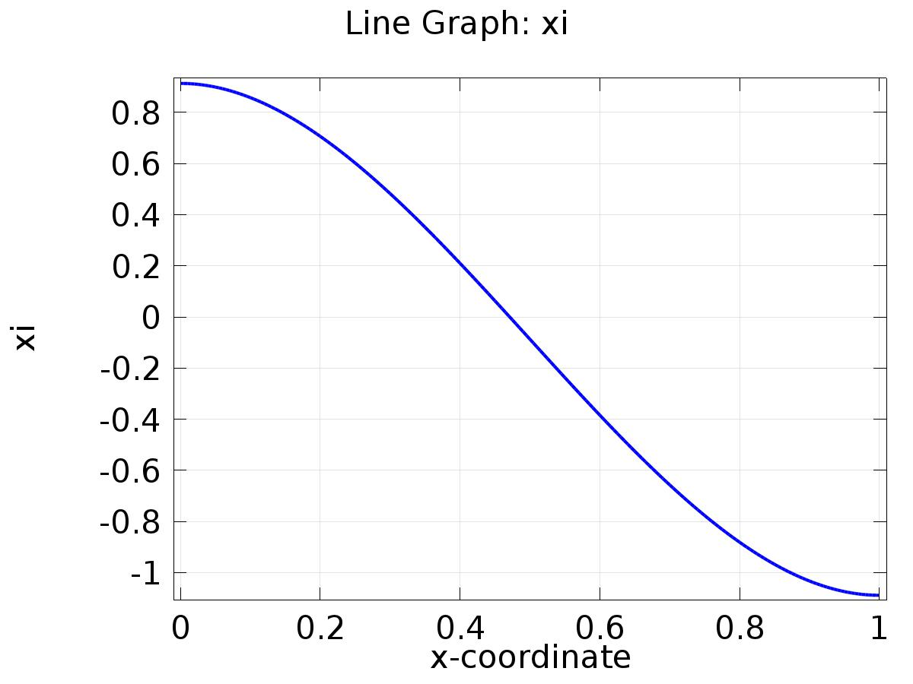

Line Graph: xi

* + 1. 1D Plot Group 2

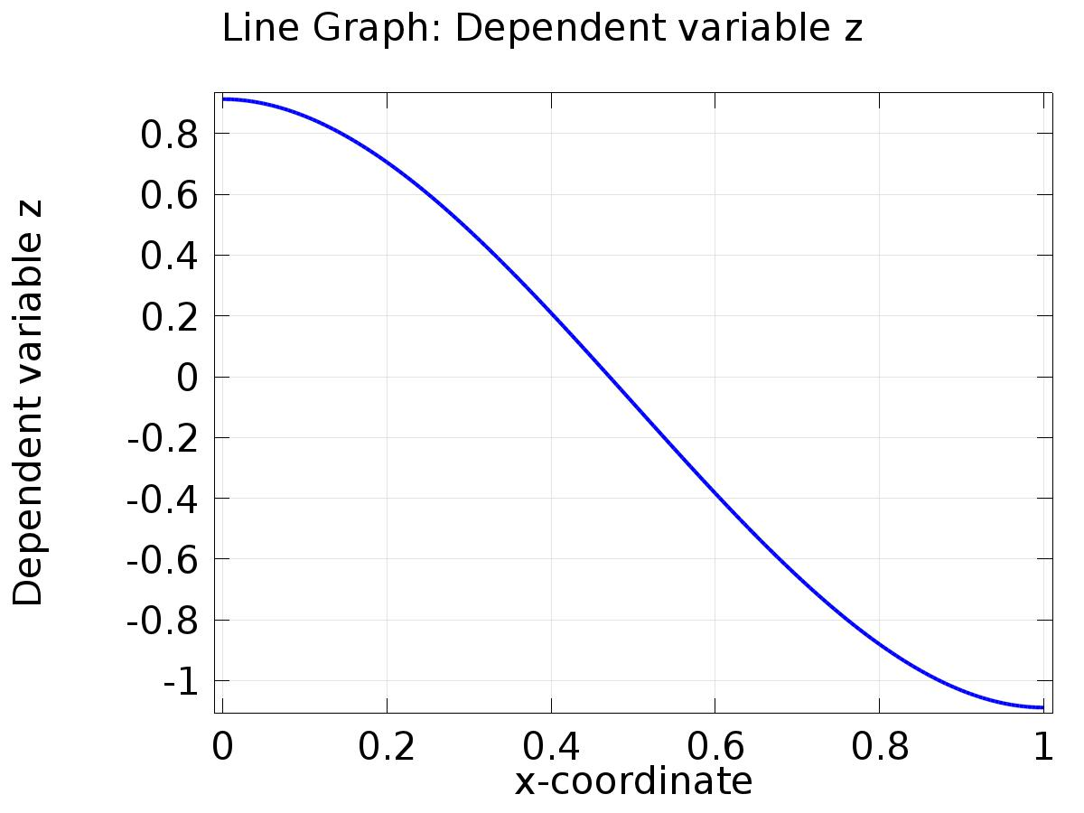

Line Graph: Dependent variable z

* + 1. 1D Plot Group 3

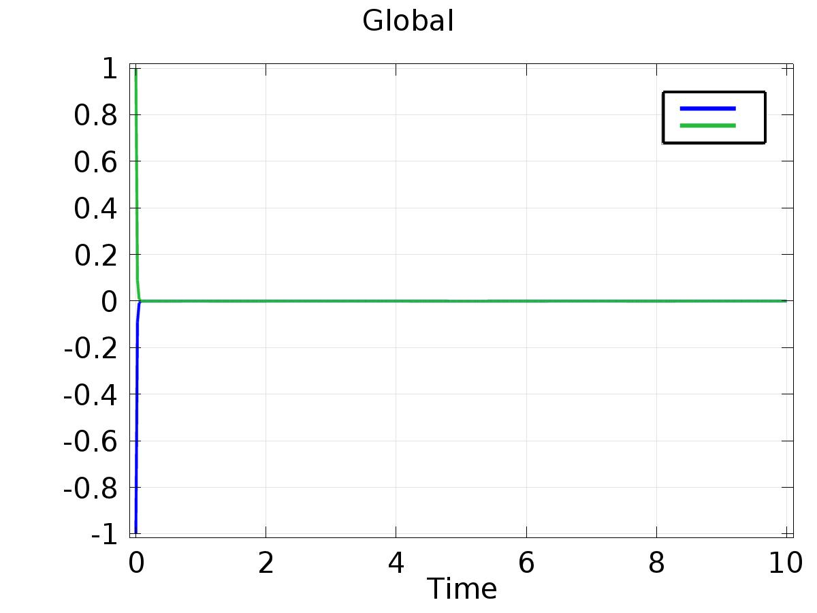

Global

* + 1. 1D Plot Group 4

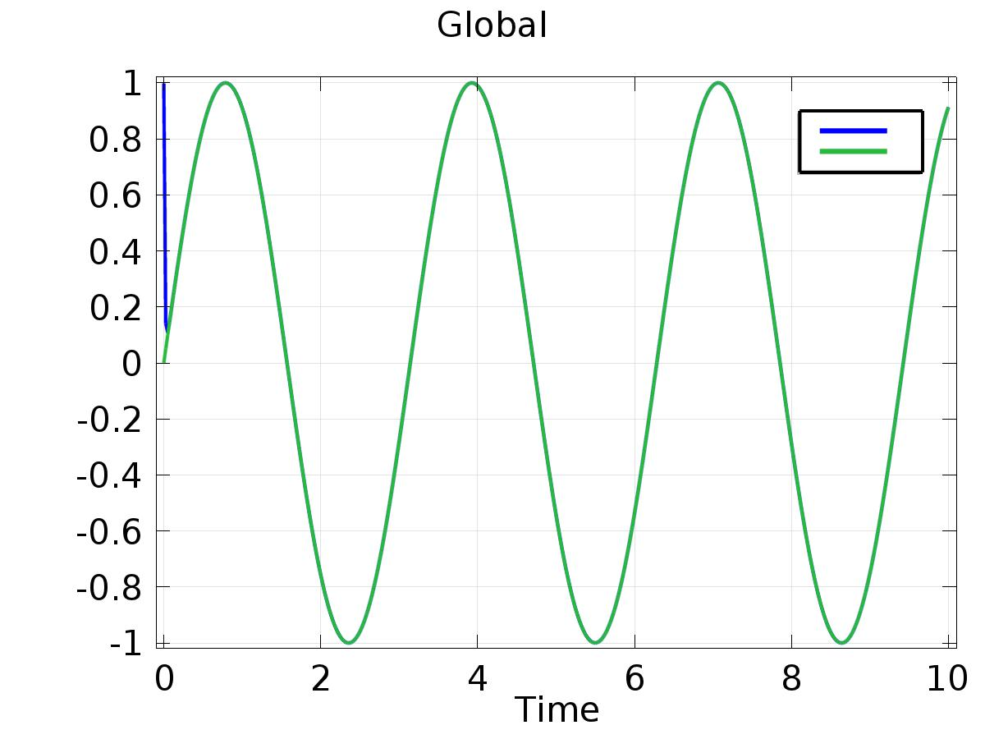

Global

* + 1. 1D Plot Group 5

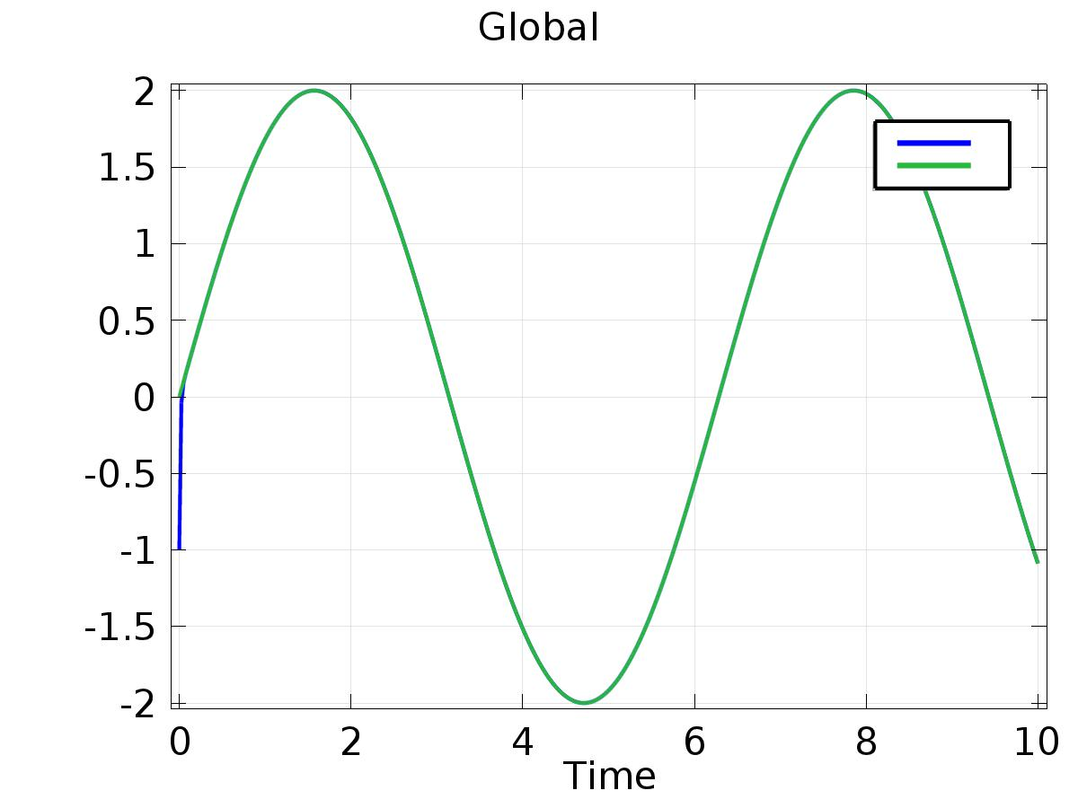

Global