[](http://www.comsol.com/)

Ex5 1 NavierStokesForkChannel

|  |  |
| --- | --- |
| Date | Jul 31, 2014 3:22:36 PM |

Contents

1. Global

1.1. Definitions

2. Model 1

2.1. Definitions

2.2. Geometry 1

2.3. Unit Input

2.4. Set Point

2.5. Set Point Auxiliary

2.6. Closed Loop System

2.7. Mesh 1

3. Study 1

3.1. Stationary

3.2. Solver Configurations

4. Study 2

4.1. Stationary

4.2. Solver Configurations

5. Study 3

5.1. Time Dependent

5.2. Solver Configurations

6. Results

6.1. Data Sets

6.2. Derived Values

6.3. Tables

6.4. Plot Groups

1. Global

|  |  |
| --- | --- |
| Date | Oct 22, 2013 6:54:52 PM |

Global settings

|  |  |
| --- | --- |
| Name | Ex5 1 NavierStokesForkChannel.mph |
| Path | /Users/gilliam/Desktop/collect_15/research_15/geo_reg_mono_eugenio/Mono_1_15/Comsol_EX_GitHub/Chapter5/Chap5Ex1_Forked_channel_Navier-Stokes_flow/Ex5_1_NavierStokesForkChannel.mph |
| Program | COMSOL 4.4 (Build: 150) |

Used products

|  |
| --- |
| COMSOL Multiphysics |

* 1. Definitions
     1. Parameters 1

Parameters

| **Name** | **Expression** | **Value** | **Description** |
| --- | --- | --- | --- |
| D | 0.02[m] | 0.020000 m |  |
| L | 0.1[m] | 0.10000 m |  |
| rho | 1[kg/m^3] | 1.0000 kg/m³ |  |
| mu | 0.0001[Pa*s] | 1.0000E-4 Pa·s |  |
| theta | 30 | 30.000 |  |
| theta_rad | theta*pi/180 | 0.52360 |  |
| x0 | D/2/sin(theta_rad) + D/2*tan(theta_rad/2) | 0.022679 m |  |
| x1 | 0[m] | 0.0000 m |  |
| x2 | 0[m] | 0.0000 m |  |
| y0 | 0[m] | 0.0000 m |  |
| y1 | D/2 | 0.010000 m |  |
| y2 | -y1 | -0.010000 m |  |
| nL | 20 | 20.000 | number of edge partition for L |
| nD | 10 | 10.000 | number of edge partition for D |
| M1 | 0.05 | 0.050000 |  |
| M2 | 25/1000 | 0.025000 |  |
| Bin | 1 [Pa] | 1.0000 Pa |  |
| Bd | 1 [Pa] | 1.0000 Pa |  |
| k | 1 | 1.0000 |  |

1. Model 1

Component settings

|  |  |
| --- | --- |
| Unit system | SI |

* 1. Definitions
     1. Variables

#### Variables 1

Selection

|  |  |
| --- | --- |
| Geometric entity level | Entire model |

| **Name** | **Expression** | **Description** |
| --- | --- | --- |
| G | C(X_u*nx + X_v*ny) |  |
| Yr | M1 |  |
| d | M2 |  |
| U | (M1 - C(Zt_u*nx + Zt_v*ny))/G |  |
| Y | C(u*nx + v*ny) |  |
| e | Yr - Y |  |

* + 1. Probes

#### C(Zb) Probe

|  |  |
| --- | --- |
| Probe type | Global variable probe |

* + 1. Component Couplings

#### Integration 1

|  |  |
| --- | --- |
| Coupling type | Integration |
| Operator name | C1 |

Source selection

|  |  |
| --- | --- |
| Geometric entity level | Boundary |
| Selection | Boundary 11 |

#### Average 1

|  |  |
| --- | --- |
| Coupling type | Average |
| Operator name | C |

Source selection

|  |  |
| --- | --- |
| Geometric entity level | Boundary |
| Selection | Boundary 11 |

* + 1. Coordinate Systems

#### Boundary System 1

|  |  |
| --- | --- |
| Coordinate system type | Boundary system |
| Tag | sys1 |

Coordinate names

| **First (t1)** | **Second (n)** | **Third (to)** |
| --- | --- | --- |
| t1 | n | to |

Settings

| **Description** | **Value** |
| --- | --- |
| Create first tangent direction from | Global Cartesian |

* 1. Geometry 1

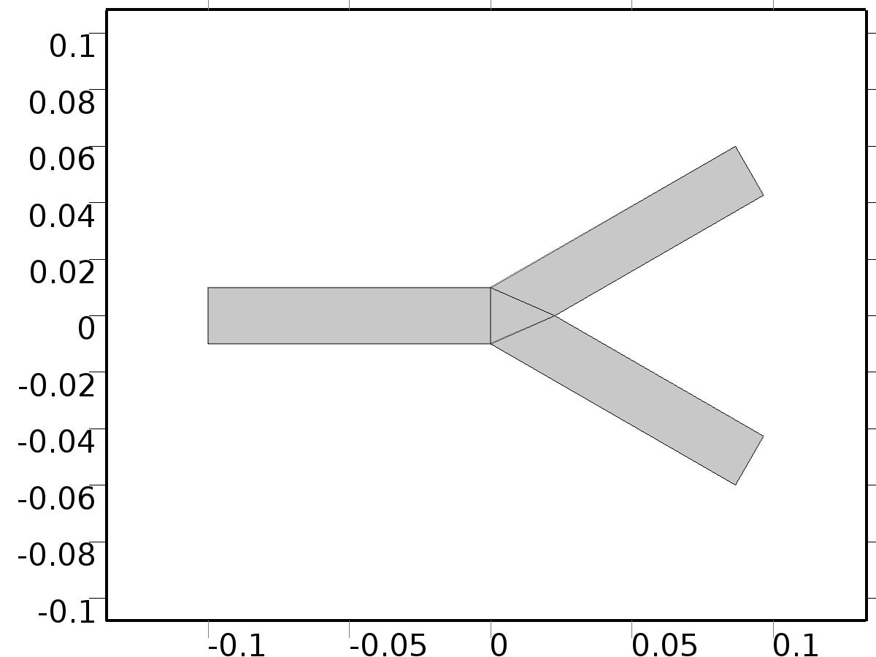

Geometry 1

Units

|  |  |
| --- | --- |
| Length unit | m |
| Angular unit | deg |

Geometry statistics

| **Description** | **Value** |
| --- | --- |
| Space dimension | 2 |
| Number of domains | 4 |
| Number of boundaries | 12 |
| Number of vertices | 9 |

* + 1. Rectangle 1 (r1)

Position

| **Description** | **Value** |
| --- | --- |
| Position | {0, -D/2} |
| Layers |  |

Size

| **Description** | **Value** |
| --- | --- |
| Width | L |
| Height | D |

* + 1. Copy 1 (copy1)

Settings

| **Description** | **Value** |
| --- | --- |
| Keep input objects | On |
| x | -0.1 |
| y | 0 |

* + 1. Copy 2 (copy2)

Settings

| **Description** | **Value** |
| --- | --- |
| Keep input objects | On |
| x | 0 |
| y | 0 |

* + 1. Rotate 1 (rot1)

Settings

| **Description** | **Value** |
| --- | --- |
| Rotation | 30 |
| Point on axis of rotation | {0, 0.01} |

* + 1. Rotate 2 (rot2)

Settings

| **Description** | **Value** |
| --- | --- |
| Rotation | -30 |
| Point on axis of rotation | {0, -0.01} |

* + 1. Union 1 (uni1)

Compose

| **Description** | **Value** |
| --- | --- |
| Keep interior boundaries | Off |

* + 1. Polygon 1 (pol1)

Object type

| **Description** | **Value** |
| --- | --- |
| Type | Solid |

Coordinates

| **Description** | **Value** |
| --- | --- |
| x | {0.02267949192431123, 0, 0} |
| y | {0, 0.01, -0.01} |

* + 1. Union 2 (uni2)

Compose

| **Description** | **Value** |
| --- | --- |
| Keep interior boundaries | Off |

* + 1. Polygon 2 (pol2)

Object type

| **Description** | **Value** |
| --- | --- |
| Type | Closed curve |

Coordinates

| **Description** | **Value** |
| --- | --- |
| x | {0.02267949192431123, 0, 0} |
| y | {0, 0.01, -0.01} |

* 1. Unit Input

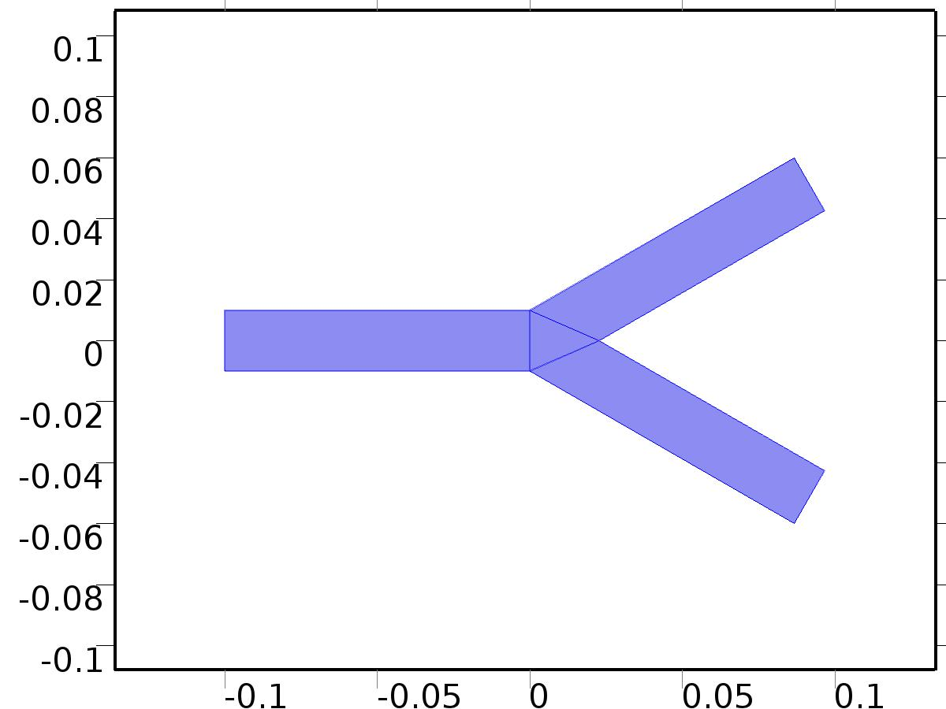

Unit Input

Selection

|  |  |
| --- | --- |
| Geometric entity level | Domain |
| Selection | Domains 1–4 |

Equations









Settings

| **Description** | **Value** |
| --- | --- |
| Discretization of fluids | P2 + P1 |
| Value type when using splitting of complex variables | {Real, Real, Real, Real, Real, Real, Real, Real, Real, Real, Real} |
| Isotropic diffusion | Off |
| Compressibility | Incompressible flow |
| Channel thickness | 1 |
| Turbulence model type | None |
| Reference pressure level | 1[atm] |
| Use pseudo time stepping for stationary equation form | Off |
| Local CFL number | 1.3^min(niterCMP, 9) + if(niterCMP>=25, 9*1.3^min(niterCMP - 25, 9), 0) + if(niterCMP>=45, 90*1.3^min(niterCMP - 45, 9), 0) |
| Streamline diffusion | Off |
| Crosswind diffusion | Off |

Used products

|  |
| --- |
| COMSOL Multiphysics |

Variables

| **Name** | **Expression** | **Unit** | **Description** | **Selection** |
| --- | --- | --- | --- | --- |
| X.dz | 1 | m | Thickness | Domains 1–4 |
| X.pref | 1[atm] | Pa | Reference pressure level | Domains 1–4 |
| X.pA | X_p+X.pref | Pa | Absolute pressure | Domains 1–4 |
| X.nx | nx | 1 | Normal vector, x component | Boundaries 4–5, 7 |
| X.ny | ny | 1 | Normal vector, y component | Boundaries 4–5, 7 |
| X.nz | 0 | 1 | Normal vector, z component | Boundaries 4–5, 7 |
| X.nx | dnx | 1 | Normal vector, x component | Boundaries 1–3, 6, 8–12 |
| X.ny | dny | 1 | Normal vector, y component | Boundaries 1–3, 6, 8–12 |
| X.nz | 0 | 1 | Normal vector, z component | Boundaries 1–3, 6, 8–12 |
| X.nxmesh | root.nxmesh | 1 | Normal vector, x component | Boundaries 4–5, 7 |
| X.nymesh | root.nymesh | 1 | Normal vector, y component | Boundaries 4–5, 7 |
| X.nzmesh | 0 | 1 | Normal vector, z component | Boundaries 4–5, 7 |
| X.nxmesh | root.dnxmesh | 1 | Normal vector, x component | Boundaries 1–3, 6, 8–12 |
| X.nymesh | root.dnymesh | 1 | Normal vector, y component | Boundaries 1–3, 6, 8–12 |
| X.nzmesh | 0 | 1 | Normal vector, z component | Boundaries 1–3, 6, 8–12 |

* + 1. Fluid Properties



Fluid Properties

Selection

|  |  |
| --- | --- |
| Geometric entity level | Domain |
| Selection | Domains 1–4 |

Equations

Settings

| **Description** | **Value** |
| --- | --- |
| Density | User defined |
| Density | rho |
| Dynamic viscosity | User defined |
| Dynamic viscosity | mu |

#### Variables

| **Name** | **Expression** | **Unit** | **Description** | **Selection** |
| --- | --- | --- | --- | --- |
| X.Fx | 0 | N/m^3 | Volume force, x component | Domains 1–4 |
| X.Fy | 0 | N/m^3 | Volume force, y component | Domains 1–4 |
| X.Fz | 0 | N/m^3 | Volume force, z component | Domains 1–4 |
| X.rho | rho | kg/m^3 | Density | Domains 1–4 |
| X.mu | mu | Pa*s | Dynamic viscosity | Domains 1–4 |
| X.sr | sqrt(0.5*(4*X_ux^2+2*(X_uy+X_vx)^2+4*X_vy^2)+eps) | 1/s | Shear rate | Domains 1–4 |
| X.divu | X_ux+X_vy | 1/s | Divergence of velocity field | Domains 1–4 |
| X.U | sqrt(X_u^2+X_v^2) | m/s | Velocity magnitude | Domains 1–4 |
| X.vorticityx | 0 | 1/s | Vorticity field, x component | Domains 1–4 |
| X.vorticityy | 0 | 1/s | Vorticity field, y component | Domains 1–4 |
| X.vorticityz | X_vx-X_uy | 1/s | Vorticity field, z component | Domains 1–4 |
| X.vort_magn | sqrt(X.vorticityx^2+X.vorticityy^2+X.vorticityz^2) | 1/s | Vorticity magnitude | Domains 1–4 |
| X.cellRe | 0.25*X.rho*sqrt(emetric(X_u,X_v)/emetric2)/X.mu | 1 | Cell Reynolds number | Domains 1–4 |
| X.nu | X.mu/X.rho | m^2/s | Kinematic viscosity | Domains 1–4 |
| X.betaT | 0 | 1/Pa | Isothermal compressibility coefficient | Domains 1–4 |
| X.mu_eff | X.mu+X.muT | Pa*s | Dynamic viscosity | Domains 1–4 |
| X.muT | 0 | Pa*s | Turbulent dynamic viscosity | Domains 1–4 |
| X.T_stressx | X.K_stressx-X_p*X.nxmesh | N/m^2 | Total stress, x component | Boundaries 1–12 |
| X.T_stressy | X.K_stressy-X_p*X.nymesh | N/m^2 | Total stress, y component | Boundaries 1–12 |
| X.T_stressz | X.K_stressz-X_p*X.nzmesh | N/m^2 | Total stress, z component | Boundaries 1–12 |
| X.K_stressx | X.mu_eff*(2*X_ux*X.nxmesh+(X_uy+X_vx)*X.nymesh) | N/m^2 | Viscous stress, x component | Boundaries 1–12 |
| X.K_stressy | X.mu_eff*((X_vx+X_uy)*X.nxmesh+2*X_vy*X.nymesh) | N/m^2 | Viscous stress, y component | Boundaries 1–12 |
| X.K_stressz | 0 | N/m^2 | Viscous stress, z component | Boundaries 1–12 |
| X.K_stress_tensorxx | 2*X.mu_eff*X_ux | N/m^2 | Viscous stress tensor, xx component | Domains 1–4 |
| X.K_stress_tensoryx | X.mu_eff*(X_vx+X_uy) | N/m^2 | Viscous stress tensor, yx component | Domains 1–4 |
| X.K_stress_tensorzx | 0 | N/m^2 | Viscous stress tensor, zx component | Domains 1–4 |
| X.K_stress_tensorxy | X.mu_eff*(X_uy+X_vx) | N/m^2 | Viscous stress tensor, xy component | Domains 1–4 |
| X.K_stress_tensoryy | 2*X.mu_eff*X_vy | N/m^2 | Viscous stress tensor, yy component | Domains 1–4 |
| X.K_stress_tensorzy | 0 | N/m^2 | Viscous stress tensor, zy component | Domains 1–4 |
| X.K_stress_tensorxz | 0 | N/m^2 | Viscous stress tensor, xz component | Domains 1–4 |
| X.K_stress_tensoryz | 0 | N/m^2 | Viscous stress tensor, yz component | Domains 1–4 |
| X.K_stress_tensorzz | 0 | N/m^2 | Viscous stress tensor, zz component | Domains 1–4 |
| X.K_stress_tensor_testxx | 2*X.mu_eff*test(X_ux) | N/m^2 | Viscous stress tensor test, xx component | Domains 1–4 |
| X.K_stress_tensor_testyx | X.mu_eff*(test(X_vx)+test(X_uy)) | N/m^2 | Viscous stress tensor test, yx component | Domains 1–4 |
| X.K_stress_tensor_testzx | 0 | N/m^2 | Viscous stress tensor test, zx component | Domains 1–4 |
| X.K_stress_tensor_testxy | X.mu_eff*(test(X_uy)+test(X_vx)) | N/m^2 | Viscous stress tensor test, xy component | Domains 1–4 |
| X.K_stress_tensor_testyy | 2*X.mu_eff*test(X_vy) | N/m^2 | Viscous stress tensor test, yy component | Domains 1–4 |
| X.K_stress_tensor_testzy | 0 | N/m^2 | Viscous stress tensor test, zy component | Domains 1–4 |
| X.K_stress_tensor_testxz | 0 | N/m^2 | Viscous stress tensor test, xz component | Domains 1–4 |
| X.K_stress_tensor_testyz | 0 | N/m^2 | Viscous stress tensor test, yz component | Domains 1–4 |
| X.K_stress_tensor_testzz | 0 | N/m^2 | Viscous stress tensor test, zz component | Domains 1–4 |
| X.upwind_helpx | X_u | m/s | Upwind term, x component | Domains 1–4 |
| X.upwind_helpy | X_v | m/s | Upwind term, y component | Domains 1–4 |
| X.upwind_helpz | 0 | m/s | Upwind term, z component | Domains 1–4 |
| X.tau_vdxx | 2*X.mu*X_ux | Pa | Strain rate, xx component | Domains 1–4 |
| X.tau_vdyx | X.mu*(X_vx+X_uy) | Pa | Strain rate, yx component | Domains 1–4 |
| X.tau_vdzx | 0 | Pa | Strain rate, zx component | Domains 1–4 |
| X.tau_vdxy | X.mu*(X_uy+X_vx) | Pa | Strain rate, xy component | Domains 1–4 |
| X.tau_vdyy | 2*X.mu*X_vy | Pa | Strain rate, yy component | Domains 1–4 |
| X.tau_vdzy | 0 | Pa | Strain rate, zy component | Domains 1–4 |
| X.tau_vdxz | 0 | Pa | Strain rate, xz component | Domains 1–4 |
| X.tau_vdyz | 0 | Pa | Strain rate, yz component | Domains 1–4 |
| X.tau_vdzz | 0 | Pa | Strain rate, zz component | Domains 1–4 |
| X.Qvd | X.tau_vdxx*X_ux+X.tau_vdxy*X_uy+X.tau_vdyx*X_vx+X.tau_vdyy*X_vy | W/m^3 | Viscous dissipation | Domains 1–4 |

#### Shape functions

| **Name** | **Shape function** | **Unit** | **Description** | **Shape frame** | **Selection** |
| --- | --- | --- | --- | --- | --- |
| X_u | Lagrange (Quadratic) | m/s | Velocity field, x component | Material | Domains 1–4 |
| X_v | Lagrange (Quadratic) | m/s | Velocity field, y component | Material | Domains 1–4 |
| X_p | Lagrange (Linear) | Pa | Pressure | Material | Domains 1–4 |

#### Weak expressions

| **Weak expression** | **Integration frame** | **Selection** |
| --- | --- | --- |
| (X_p-X.K_stress_tensorxx)*test(X_ux)-X.K_stress_tensorxy*test(X_uy)-X.K_stress_tensoryx*test(X_vx)+(X_p-X.K_stress_tensoryy)*test(X_vy) | Material | Domains 1–4 |
| X.Fx*test(X_u)+X.Fy*test(X_v) | Material | Domains 1–4 |
| X.rho*(-(X_ux*X_u+X_uy*X_v)*test(X_u)-(X_vx*X_u+X_vy*X_v)*test(X_v)) | Material | Domains 1–4 |
| -X.rho*X.divu*test(X_p) | Material | Domains 1–4 |

* + 1. Wall

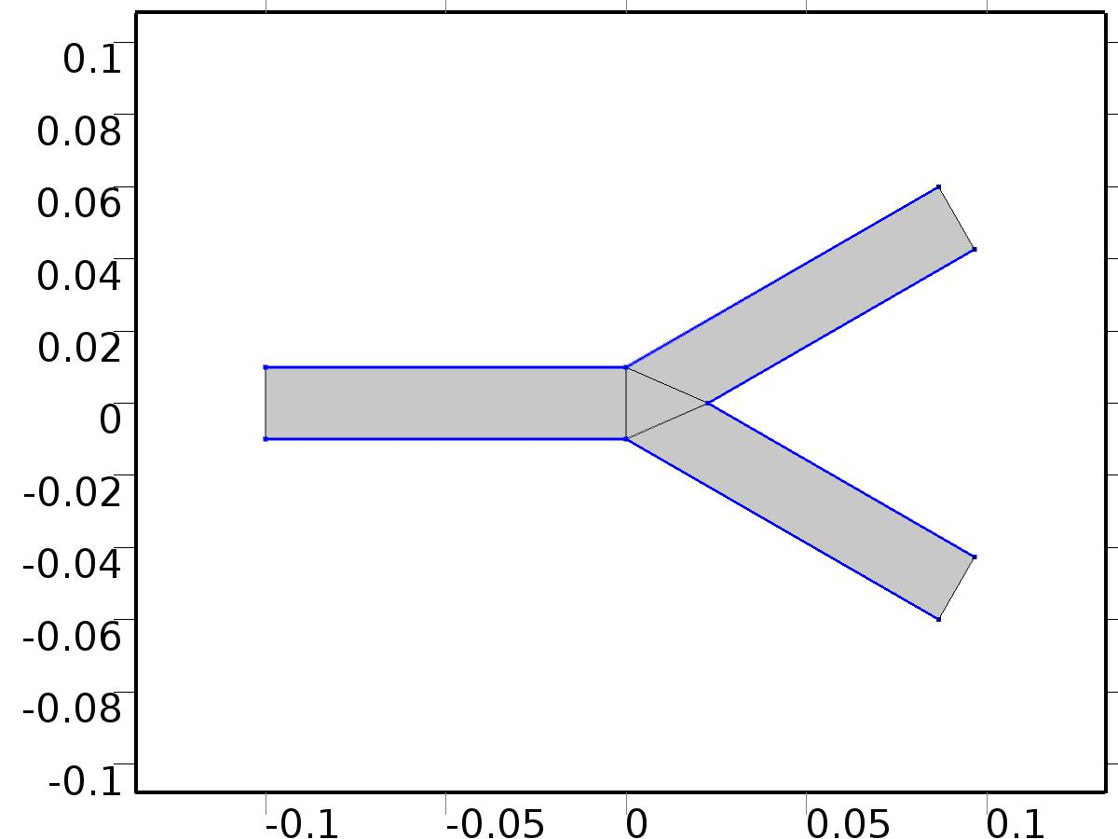

Wall

Selection

|  |  |
| --- | --- |
| Geometric entity level | Boundary |
| Selection | Boundaries 2–3, 6, 8–10 |

Equations

Settings

| **Description** | **Value** |
| --- | --- |
| Boundary condition | No slip |
| Apply reaction terms on | Individual dependent variables |
| Use weak constraints | Off |
| Constraint method | Elemental |

#### Variables

| **Name** | **Expression** | **Unit** | **Description** | **Selection** |
| --- | --- | --- | --- | --- |
| X.ubndx | 0 | m/s | Velocity at boundary, x component | Boundaries 2–3, 6, 8–10 |
| X.ubndy | 0 | m/s | Velocity at boundary, y component | Boundaries 2–3, 6, 8–10 |
| X.ubndz | 0 | m/s | Velocity at boundary, z component | Boundaries 2–3, 6, 8–10 |

#### Shape functions

| **Constraint** | **Constraint force** | **Shape function** | **Selection** |
| --- | --- | --- | --- |
| -X_u+X.ubndx | test(-X_u) | Lagrange (Quadratic) | Boundaries 2–3, 6, 8–10 |
| -X_v+X.ubndy | test(-X_v) | Lagrange (Quadratic) | Boundaries 2–3, 6, 8–10 |
| X.ubndz | 0 |  | Boundaries 2–3, 6, 8–10 |

* + 1. Initial Values



Initial Values

Selection

|  |  |
| --- | --- |
| Geometric entity level | Domain |
| Selection | Domains 1–4 |

Settings

| **Description** | **Value** |
| --- | --- |
| Turbulent kinetic energy | spf.kinit |
| Turbulent dissipation rate | spf.epinit |
| Specific dissipation rate | spf.omInit |
| Reciprocal wall distance | spf.G0 |
| Undamped turbulent kinematic viscosity | spf.nutildeinit |
| Velocity field | {0, 0, 0} |
| Pressure | 0 |

* + 1. Inlet Bd*0

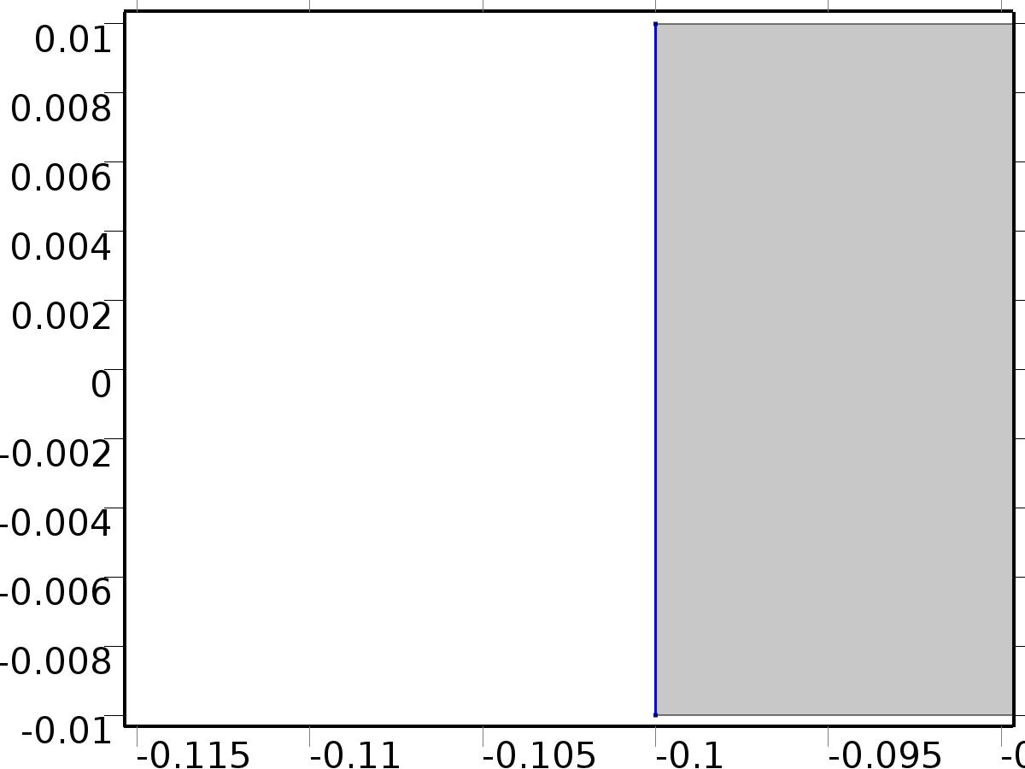

Inlet Bd*0

Selection

|  |  |
| --- | --- |
| Geometric entity level | Boundary |
| Selection | Boundary 1 |

Equations

Settings

| **Description** | **Value** |
| --- | --- |
| Use weak constraints | Off |
| Boundary condition | Normal stress |
| Normal stress | 0 |
| Turbulent intensity | 0.05 |
| Turbulence length scale | 0.01[m] |
| Turbulent kinetic energy | 0.005[m^2/s^2] |
| Turbulent dissipation rate | 0.005[m^2/s^3] |
| Specific dissipation rate | 20[1/s] |
| Undamped turbulent kinematic viscosity | 3*spf.nu |
| Constraint method | Elemental |

#### Variables

| **Name** | **Expression** | **Unit** | **Description** | **Selection** |
| --- | --- | --- | --- | --- |
| X.f0 | 0 | N/m^2 | Normal stress | Boundary 1 |

#### Weak expressions

| **Weak expression** | **Integration frame** | **Selection** |
| --- | --- | --- |
| -X.f0*(test(X_u)*X.nxmesh+test(X_v)*X.nymesh) | Material | Boundary 1 |

* + 1. Outlet Homogeneous

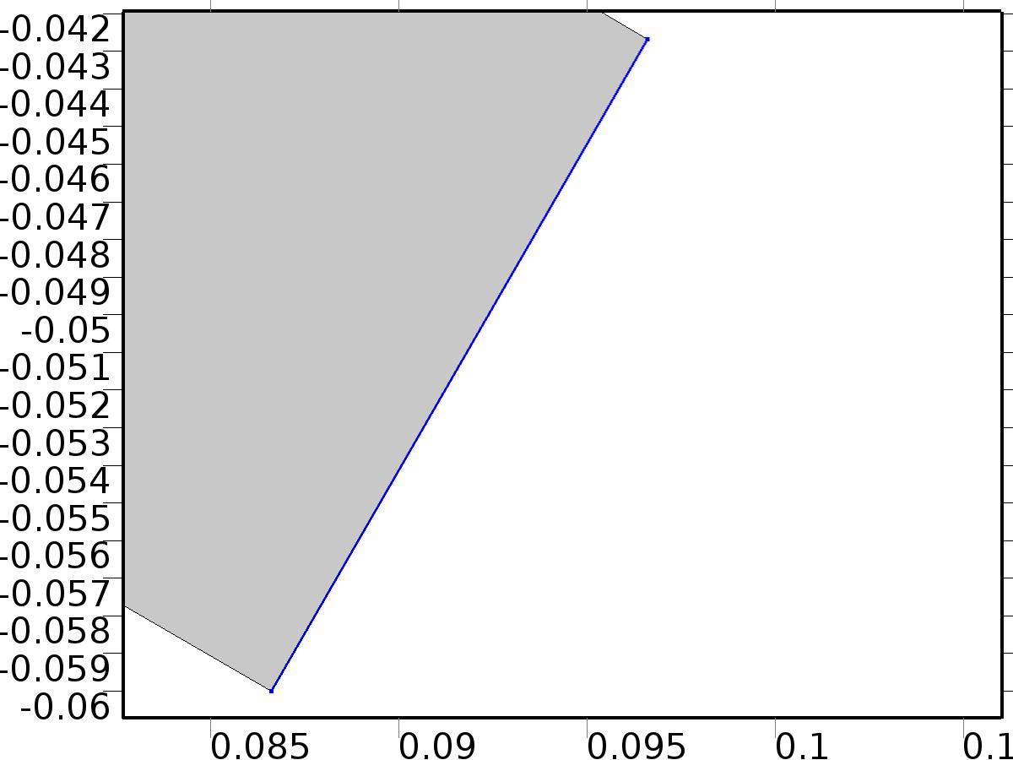

Outlet Homogeneous

Selection

|  |  |
| --- | --- |
| Geometric entity level | Boundary |
| Selection | Boundary 11 |

Equations

Settings

| **Description** | **Value** |
| --- | --- |
| Use weak constraints | Off |
| Boundary condition | Normal stress |
| Normal stress | 0 |
| Constraint method | Elemental |

#### Variables

| **Name** | **Expression** | **Unit** | **Description** | **Selection** |
| --- | --- | --- | --- | --- |
| X.f0 | 0 | N/m^2 | Normal stress | Boundary 11 |

#### Weak expressions

| **Weak expression** | **Integration frame** | **Selection** |
| --- | --- | --- |
| -X.f0*(test(X_u)*X.nxmesh+test(X_v)*X.nymesh) | Material | Boundary 11 |

* + 1. Outlet Bin*1

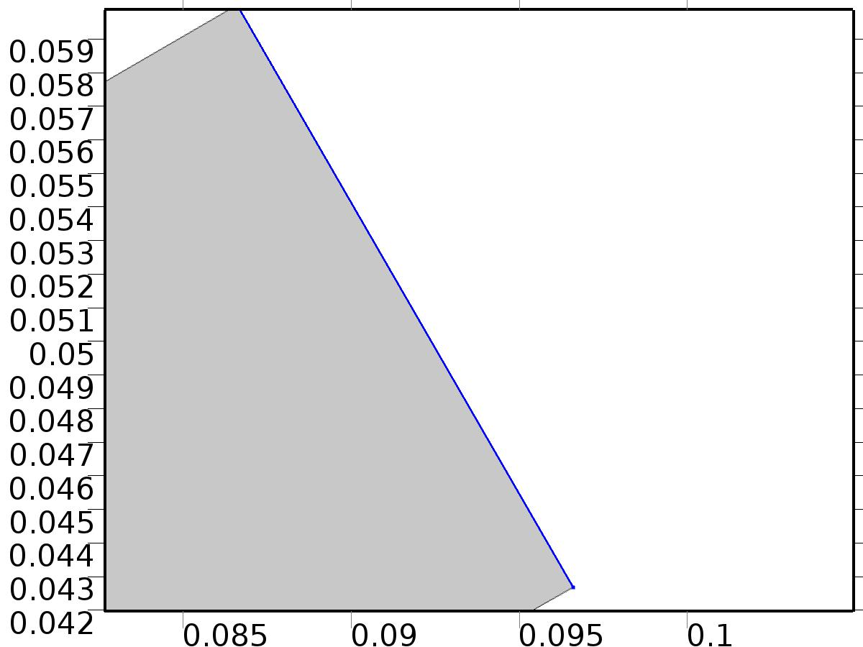

Outlet Bin*1

Selection

|  |  |
| --- | --- |
| Geometric entity level | Boundary |
| Selection | Boundary 12 |

Equations

Settings

| **Description** | **Value** |
| --- | --- |
| Use weak constraints | Off |
| Boundary condition | Normal stress |
| Normal stress | 1 |
| Constraint method | Elemental |

#### Variables

| **Name** | **Expression** | **Unit** | **Description** | **Selection** |
| --- | --- | --- | --- | --- |
| X.f0 | 1 | N/m^2 | Normal stress | Boundary 12 |

#### Weak expressions

| **Weak expression** | **Integration frame** | **Selection** |
| --- | --- | --- |
| -X.f0*(test(X_u)*X.nxmesh+test(X_v)*X.nymesh) | Material | Boundary 12 |

* + 1. Stokes Linearization



Stokes Linearization

Selection

|  |  |
| --- | --- |
| Geometric entity level | Domain |
| Selection | Domains 1–4 |

Equations

#### Variables

| **Name** | **Expression** | **Unit** | **Description** | **Selection** |
| --- | --- | --- | --- | --- |
| X.Fx | rho*(X_u*X_ux+X_v*X_uy) | N/m^3 | Volume force, x component | Domains 1–4 |
| X.Fy | rho*(X_u*X_vx+X_v*X_vy) | N/m^3 | Volume force, y component | Domains 1–4 |
| X.Fz | 0 | N/m^3 | Volume force, z component | Domains 1–4 |

* 1. Set Point



Set Point

Selection

|  |  |
| --- | --- |
| Geometric entity level | Domain |
| Selection | Domains 1–4 |

Equations









Settings

| **Description** | **Value** |
| --- | --- |
| Discretization of fluids | P2 + P1 |
| Value type when using splitting of complex variables | {Real, Real, Real, Real, Real, Real, Real, Real, Real, Real, Real} |
| Isotropic diffusion | Off |
| Compressibility | Incompressible flow |
| Channel thickness | 1 |
| Turbulence model type | None |
| Reference pressure level | 1[atm] |
| Use pseudo time stepping for stationary equation form | Off |
| Local CFL number | 1.3^min(niterCMP, 9) + if(niterCMP>=25, 9*1.3^min(niterCMP - 25, 9), 0) + if(niterCMP>=45, 90*1.3^min(niterCMP - 45, 9), 0) |
| Streamline diffusion | Off |
| Crosswind diffusion | Off |

Used products

|  |
| --- |
| COMSOL Multiphysics |

Variables

| **Name** | **Expression** | **Unit** | **Description** | **Selection** |
| --- | --- | --- | --- | --- |
| Zb.dz | 1 | m | Thickness | Domains 1–4 |
| Zb.pref | 1[atm] | Pa | Reference pressure level | Domains 1–4 |
| Zb.pA | Zb_p+Zb.pref | Pa | Absolute pressure | Domains 1–4 |
| Zb.nx | nx | 1 | Normal vector, x component | Boundaries 4–5, 7 |
| Zb.ny | ny | 1 | Normal vector, y component | Boundaries 4–5, 7 |
| Zb.nz | 0 | 1 | Normal vector, z component | Boundaries 4–5, 7 |
| Zb.nx | dnx | 1 | Normal vector, x component | Boundaries 1–3, 6, 8–12 |
| Zb.ny | dny | 1 | Normal vector, y component | Boundaries 1–3, 6, 8–12 |
| Zb.nz | 0 | 1 | Normal vector, z component | Boundaries 1–3, 6, 8–12 |
| Zb.nxmesh | root.nxmesh | 1 | Normal vector, x component | Boundaries 4–5, 7 |
| Zb.nymesh | root.nymesh | 1 | Normal vector, y component | Boundaries 4–5, 7 |
| Zb.nzmesh | 0 | 1 | Normal vector, z component | Boundaries 4–5, 7 |
| Zb.nxmesh | root.dnxmesh | 1 | Normal vector, x component | Boundaries 1–3, 6, 8–12 |
| Zb.nymesh | root.dnymesh | 1 | Normal vector, y component | Boundaries 1–3, 6, 8–12 |
| Zb.nzmesh | 0 | 1 | Normal vector, z component | Boundaries 1–3, 6, 8–12 |

* + 1. Fluid Properties



Fluid Properties

Selection

|  |  |
| --- | --- |
| Geometric entity level | Domain |
| Selection | Domains 1–4 |

Equations

Settings

| **Description** | **Value** |
| --- | --- |
| Density | User defined |
| Density | rho |
| Dynamic viscosity | User defined |
| Dynamic viscosity | mu |

#### Variables

| **Name** | **Expression** | **Unit** | **Description** | **Selection** |
| --- | --- | --- | --- | --- |
| Zb.rho | rho | kg/m^3 | Density | Domains 1–4 |
| Zb.mu | mu | Pa*s | Dynamic viscosity | Domains 1–4 |
| Zb.sr | sqrt(0.5*(4*Zb_ux^2+2*(Zb_uy+Zb_vx)^2+4*Zb_vy^2)+eps) | 1/s | Shear rate | Domains 1–4 |
| Zb.divu | Zb_ux+Zb_vy | 1/s | Divergence of velocity field | Domains 1–4 |
| Zb.Fx | 0 | N/m^3 | Volume force, x component | Domains 1–4 |
| Zb.Fy | 0 | N/m^3 | Volume force, y component | Domains 1–4 |
| Zb.Fz | 0 | N/m^3 | Volume force, z component | Domains 1–4 |
| Zb.U | sqrt(Zb_u^2+Zb_v^2) | m/s | Velocity magnitude | Domains 1–4 |
| Zb.vorticityx | 0 | 1/s | Vorticity field, x component | Domains 1–4 |
| Zb.vorticityy | 0 | 1/s | Vorticity field, y component | Domains 1–4 |
| Zb.vorticityz | Zb_vx-Zb_uy | 1/s | Vorticity field, z component | Domains 1–4 |
| Zb.vort_magn | sqrt(Zb.vorticityx^2+Zb.vorticityy^2+Zb.vorticityz^2) | 1/s | Vorticity magnitude | Domains 1–4 |
| Zb.cellRe | 0.25*Zb.rho*sqrt(emetric(Zb_u,Zb_v)/emetric2)/Zb.mu | 1 | Cell Reynolds number | Domains 1–4 |
| Zb.nu | Zb.mu/Zb.rho | m^2/s | Kinematic viscosity | Domains 1–4 |
| Zb.betaT | 0 | 1/Pa | Isothermal compressibility coefficient | Domains 1–4 |
| Zb.mu_eff | Zb.mu+Zb.muT | Pa*s | Dynamic viscosity | Domains 1–4 |
| Zb.muT | 0 | Pa*s | Turbulent dynamic viscosity | Domains 1–4 |
| Zb.T_stressx | Zb.K_stressx-Zb_p*Zb.nxmesh | N/m^2 | Total stress, x component | Boundaries 1–12 |
| Zb.T_stressy | Zb.K_stressy-Zb_p*Zb.nymesh | N/m^2 | Total stress, y component | Boundaries 1–12 |
| Zb.T_stressz | Zb.K_stressz-Zb_p*Zb.nzmesh | N/m^2 | Total stress, z component | Boundaries 1–12 |
| Zb.K_stressx | Zb.mu_eff*(2*Zb_ux*Zb.nxmesh+(Zb_uy+Zb_vx)*Zb.nymesh) | N/m^2 | Viscous stress, x component | Boundaries 1–12 |
| Zb.K_stressy | Zb.mu_eff*((Zb_vx+Zb_uy)*Zb.nxmesh+2*Zb_vy*Zb.nymesh) | N/m^2 | Viscous stress, y component | Boundaries 1–12 |
| Zb.K_stressz | 0 | N/m^2 | Viscous stress, z component | Boundaries 1–12 |
| Zb.K_stress_tensorxx | 2*Zb.mu_eff*Zb_ux | N/m^2 | Viscous stress tensor, xx component | Domains 1–4 |
| Zb.K_stress_tensoryx | Zb.mu_eff*(Zb_vx+Zb_uy) | N/m^2 | Viscous stress tensor, yx component | Domains 1–4 |
| Zb.K_stress_tensorzx | 0 | N/m^2 | Viscous stress tensor, zx component | Domains 1–4 |
| Zb.K_stress_tensorxy | Zb.mu_eff*(Zb_uy+Zb_vx) | N/m^2 | Viscous stress tensor, xy component | Domains 1–4 |
| Zb.K_stress_tensoryy | 2*Zb.mu_eff*Zb_vy | N/m^2 | Viscous stress tensor, yy component | Domains 1–4 |
| Zb.K_stress_tensorzy | 0 | N/m^2 | Viscous stress tensor, zy component | Domains 1–4 |
| Zb.K_stress_tensorxz | 0 | N/m^2 | Viscous stress tensor, xz component | Domains 1–4 |
| Zb.K_stress_tensoryz | 0 | N/m^2 | Viscous stress tensor, yz component | Domains 1–4 |
| Zb.K_stress_tensorzz | 0 | N/m^2 | Viscous stress tensor, zz component | Domains 1–4 |
| Zb.K_stress_tensor_testxx | 2*Zb.mu_eff*test(Zb_ux) | N/m^2 | Viscous stress tensor test, xx component | Domains 1–4 |
| Zb.K_stress_tensor_testyx | Zb.mu_eff*(test(Zb_vx)+test(Zb_uy)) | N/m^2 | Viscous stress tensor test, yx component | Domains 1–4 |
| Zb.K_stress_tensor_testzx | 0 | N/m^2 | Viscous stress tensor test, zx component | Domains 1–4 |
| Zb.K_stress_tensor_testxy | Zb.mu_eff*(test(Zb_uy)+test(Zb_vx)) | N/m^2 | Viscous stress tensor test, xy component | Domains 1–4 |
| Zb.K_stress_tensor_testyy | 2*Zb.mu_eff*test(Zb_vy) | N/m^2 | Viscous stress tensor test, yy component | Domains 1–4 |
| Zb.K_stress_tensor_testzy | 0 | N/m^2 | Viscous stress tensor test, zy component | Domains 1–4 |
| Zb.K_stress_tensor_testxz | 0 | N/m^2 | Viscous stress tensor test, xz component | Domains 1–4 |
| Zb.K_stress_tensor_testyz | 0 | N/m^2 | Viscous stress tensor test, yz component | Domains 1–4 |
| Zb.K_stress_tensor_testzz | 0 | N/m^2 | Viscous stress tensor test, zz component | Domains 1–4 |
| Zb.upwind_helpx | Zb_u | m/s | Upwind term, x component | Domains 1–4 |
| Zb.upwind_helpy | Zb_v | m/s | Upwind term, y component | Domains 1–4 |
| Zb.upwind_helpz | 0 | m/s | Upwind term, z component | Domains 1–4 |
| Zb.tau_vdxx | 2*Zb.mu*Zb_ux | Pa | Strain rate, xx component | Domains 1–4 |
| Zb.tau_vdyx | Zb.mu*(Zb_vx+Zb_uy) | Pa | Strain rate, yx component | Domains 1–4 |
| Zb.tau_vdzx | 0 | Pa | Strain rate, zx component | Domains 1–4 |
| Zb.tau_vdxy | Zb.mu*(Zb_uy+Zb_vx) | Pa | Strain rate, xy component | Domains 1–4 |
| Zb.tau_vdyy | 2*Zb.mu*Zb_vy | Pa | Strain rate, yy component | Domains 1–4 |
| Zb.tau_vdzy | 0 | Pa | Strain rate, zy component | Domains 1–4 |
| Zb.tau_vdxz | 0 | Pa | Strain rate, xz component | Domains 1–4 |
| Zb.tau_vdyz | 0 | Pa | Strain rate, yz component | Domains 1–4 |
| Zb.tau_vdzz | 0 | Pa | Strain rate, zz component | Domains 1–4 |
| Zb.Qvd | Zb.tau_vdxx*Zb_ux+Zb.tau_vdxy*Zb_uy+Zb.tau_vdyx*Zb_vx+Zb.tau_vdyy*Zb_vy | W/m^3 | Viscous dissipation | Domains 1–4 |

#### Shape functions

| **Name** | **Shape function** | **Unit** | **Description** | **Shape frame** | **Selection** |
| --- | --- | --- | --- | --- | --- |
| Zb_u | Lagrange (Quadratic) | m/s | Velocity field, x component | Material | Domains 1–4 |
| Zb_v | Lagrange (Quadratic) | m/s | Velocity field, y component | Material | Domains 1–4 |
| Zb_p | Lagrange (Linear) | Pa | Pressure | Material | Domains 1–4 |

#### Weak expressions

| **Weak expression** | **Integration frame** | **Selection** |
| --- | --- | --- |
| (Zb_p-Zb.K_stress_tensorxx)*test(Zb_ux)-Zb.K_stress_tensorxy*test(Zb_uy)-Zb.K_stress_tensoryx*test(Zb_vx)+(Zb_p-Zb.K_stress_tensoryy)*test(Zb_vy) | Material | Domains 1–4 |
| Zb.Fx*test(Zb_u)+Zb.Fy*test(Zb_v) | Material | Domains 1–4 |
| Zb.rho*(-(Zb_ux*Zb_u+Zb_uy*Zb_v)*test(Zb_u)-(Zb_vx*Zb_u+Zb_vy*Zb_v)*test(Zb_v)) | Material | Domains 1–4 |
| -Zb.rho*Zb.divu*test(Zb_p) | Material | Domains 1–4 |

* + 1. Wall



Wall

Selection

|  |  |
| --- | --- |
| Geometric entity level | Boundary |
| Selection | Boundaries 2–3, 6, 8–10 |

Equations

Settings

| **Description** | **Value** |
| --- | --- |
| Boundary condition | No slip |
| Apply reaction terms on | Individual dependent variables |
| Use weak constraints | Off |
| Constraint method | Elemental |

#### Variables

| **Name** | **Expression** | **Unit** | **Description** | **Selection** |
| --- | --- | --- | --- | --- |
| Zb.ubndx | 0 | m/s | Velocity at boundary, x component | Boundaries 2–3, 6, 8–10 |
| Zb.ubndy | 0 | m/s | Velocity at boundary, y component | Boundaries 2–3, 6, 8–10 |
| Zb.ubndz | 0 | m/s | Velocity at boundary, z component | Boundaries 2–3, 6, 8–10 |

#### Shape functions

| **Constraint** | **Constraint force** | **Shape function** | **Selection** |
| --- | --- | --- | --- |
| -Zb_u+Zb.ubndx | test(-Zb_u) | Lagrange (Quadratic) | Boundaries 2–3, 6, 8–10 |
| -Zb_v+Zb.ubndy | test(-Zb_v) | Lagrange (Quadratic) | Boundaries 2–3, 6, 8–10 |
| Zb.ubndz | 0 |  | Boundaries 2–3, 6, 8–10 |

* + 1. Initial Values



Initial Values

Selection

|  |  |
| --- | --- |
| Geometric entity level | Domain |
| Selection | Domains 1–4 |

Settings

| **Description** | **Value** |
| --- | --- |
| Turbulent kinetic energy | spf2.kinit |
| Turbulent dissipation rate | spf2.epinit |
| Specific dissipation rate | spf2.omInit |
| Reciprocal wall distance | spf2.G0 |
| Undamped turbulent kinematic viscosity | spf2.nutildeinit |
| Velocity field | {0, 0, 0} |
| Pressure | 0 |

* + 1. Inlet Bd*d



Inlet Bd*d

Selection

|  |  |
| --- | --- |
| Geometric entity level | Boundary |
| Selection | Boundary 1 |

Equations

Settings

| **Description** | **Value** |
| --- | --- |
| Use weak constraints | Off |
| Boundary condition | Normal stress |
| Normal stress | Bd*d |
| Turbulent intensity | 0.05 |
| Turbulence length scale | 0.01[m] |
| Turbulent kinetic energy | 0.005[m^2/s^2] |
| Turbulent dissipation rate | 0.005[m^2/s^3] |
| Specific dissipation rate | 20[1/s] |
| Undamped turbulent kinematic viscosity | 3*spf2.nu |
| Constraint method | Elemental |

#### Variables

| **Name** | **Expression** | **Unit** | **Description** | **Selection** |
| --- | --- | --- | --- | --- |
| Zb.f0 | Bd*d | N/m^2 | Normal stress | Boundary 1 |

#### Weak expressions

| **Weak expression** | **Integration frame** | **Selection** |
| --- | --- | --- |
| -Zb.f0*(test(Zb_u)*Zb.nxmesh+test(Zb_v)*Zb.nymesh) | Material | Boundary 1 |

* + 1. Outlet Homogeneous



Outlet Homogeneous

Selection

|  |  |
| --- | --- |
| Geometric entity level | Boundary |
| Selection | Boundary 11 |

Equations

Settings

| **Description** | **Value** |
| --- | --- |
| Use weak constraints | Off |
| Boundary condition | Normal stress |
| Normal stress | 0 |
| Constraint method | Elemental |

#### Variables

| **Name** | **Expression** | **Unit** | **Description** | **Selection** |
| --- | --- | --- | --- | --- |
| Zb.f0 | 0 | N/m^2 | Normal stress | Boundary 11 |

#### Weak expressions

| **Weak expression** | **Integration frame** | **Selection** |
| --- | --- | --- |
| -Zb.f0*(test(Zb_u)*Zb.nxmesh+test(Zb_v)*Zb.nymesh) | Material | Boundary 11 |

* + 1. Outlet Bin*U



Outlet Bin*U

Selection

|  |  |
| --- | --- |
| Geometric entity level | Boundary |
| Selection | Boundary 12 |

Equations

Settings

| **Description** | **Value** |
| --- | --- |
| Use weak constraints | Off |
| Boundary condition | Normal stress |
| Normal stress | Bin*U |
| Constraint method | Elemental |

#### Variables

| **Name** | **Expression** | **Unit** | **Description** | **Selection** |
| --- | --- | --- | --- | --- |
| Zb.f0 | Bin*U | N/m^2 | Normal stress | Boundary 12 |

#### Weak expressions

| **Weak expression** | **Integration frame** | **Selection** |
| --- | --- | --- |
| -Zb.f0*(test(Zb_u)*Zb.nxmesh+test(Zb_v)*Zb.nymesh) | Material | Boundary 12 |

* 1. Set Point Auxiliary



Set Point Auxiliary

Selection

|  |  |
| --- | --- |
| Geometric entity level | Domain |
| Selection | Domains 1–4 |

Equations









Settings

| **Description** | **Value** |
| --- | --- |
| Discretization of fluids | P2 + P1 |
| Value type when using splitting of complex variables | {Real, Real, Real, Real, Real, Real, Real, Real, Real, Real, Real} |
| Isotropic diffusion | Off |
| Compressibility | Incompressible flow |
| Channel thickness | 1 |
| Turbulence model type | None |
| Reference pressure level | 1[atm] |
| Use pseudo time stepping for stationary equation form | Off |
| Local CFL number | 1.3^min(niterCMP, 9) + if(niterCMP>=25, 9*1.3^min(niterCMP - 25, 9), 0) + if(niterCMP>=45, 90*1.3^min(niterCMP - 45, 9), 0) |
| Streamline diffusion | Off |
| Crosswind diffusion | Off |

Used products

|  |
| --- |
| COMSOL Multiphysics |

Variables

| **Name** | **Expression** | **Unit** | **Description** | **Selection** |
| --- | --- | --- | --- | --- |
| Zt.dz | 1 | m | Thickness | Domains 1–4 |
| Zt.pref | 1[atm] | Pa | Reference pressure level | Domains 1–4 |
| Zt.pA | Zt_p+Zt.pref | Pa | Absolute pressure | Domains 1–4 |
| Zt.nx | nx | 1 | Normal vector, x component | Boundaries 4–5, 7 |
| Zt.ny | ny | 1 | Normal vector, y component | Boundaries 4–5, 7 |
| Zt.nz | 0 | 1 | Normal vector, z component | Boundaries 4–5, 7 |
| Zt.nx | dnx | 1 | Normal vector, x component | Boundaries 1–3, 6, 8–12 |
| Zt.ny | dny | 1 | Normal vector, y component | Boundaries 1–3, 6, 8–12 |
| Zt.nz | 0 | 1 | Normal vector, z component | Boundaries 1–3, 6, 8–12 |
| Zt.nxmesh | root.nxmesh | 1 | Normal vector, x component | Boundaries 4–5, 7 |
| Zt.nymesh | root.nymesh | 1 | Normal vector, y component | Boundaries 4–5, 7 |
| Zt.nzmesh | 0 | 1 | Normal vector, z component | Boundaries 4–5, 7 |
| Zt.nxmesh | root.dnxmesh | 1 | Normal vector, x component | Boundaries 1–3, 6, 8–12 |
| Zt.nymesh | root.dnymesh | 1 | Normal vector, y component | Boundaries 1–3, 6, 8–12 |
| Zt.nzmesh | 0 | 1 | Normal vector, z component | Boundaries 1–3, 6, 8–12 |

* + 1. Fluid Properties



Fluid Properties

Selection

|  |  |
| --- | --- |
| Geometric entity level | Domain |
| Selection | Domains 1–4 |

Equations

Settings

| **Description** | **Value** |
| --- | --- |
| Density | User defined |
| Density | rho |
| Dynamic viscosity | User defined |
| Dynamic viscosity | mu |

#### Variables

| **Name** | **Expression** | **Unit** | **Description** | **Selection** |
| --- | --- | --- | --- | --- |
| Zt.Fx | 0 | N/m^3 | Volume force, x component | Domains 1–4 |
| Zt.Fy | 0 | N/m^3 | Volume force, y component | Domains 1–4 |
| Zt.Fz | 0 | N/m^3 | Volume force, z component | Domains 1–4 |
| Zt.rho | rho | kg/m^3 | Density | Domains 1–4 |
| Zt.mu | mu | Pa*s | Dynamic viscosity | Domains 1–4 |
| Zt.sr | sqrt(0.5*(4*Zt_ux^2+2*(Zt_uy+Zt_vx)^2+4*Zt_vy^2)+eps) | 1/s | Shear rate | Domains 1–4 |
| Zt.divu | Zt_ux+Zt_vy | 1/s | Divergence of velocity field | Domains 1–4 |
| Zt.U | sqrt(Zt_u^2+Zt_v^2) | m/s | Velocity magnitude | Domains 1–4 |
| Zt.vorticityx | 0 | 1/s | Vorticity field, x component | Domains 1–4 |
| Zt.vorticityy | 0 | 1/s | Vorticity field, y component | Domains 1–4 |
| Zt.vorticityz | Zt_vx-Zt_uy | 1/s | Vorticity field, z component | Domains 1–4 |
| Zt.vort_magn | sqrt(Zt.vorticityx^2+Zt.vorticityy^2+Zt.vorticityz^2) | 1/s | Vorticity magnitude | Domains 1–4 |
| Zt.cellRe | 0.25*Zt.rho*sqrt(emetric(Zt_u,Zt_v)/emetric2)/Zt.mu | 1 | Cell Reynolds number | Domains 1–4 |
| Zt.nu | Zt.mu/Zt.rho | m^2/s | Kinematic viscosity | Domains 1–4 |
| Zt.betaT | 0 | 1/Pa | Isothermal compressibility coefficient | Domains 1–4 |
| Zt.mu_eff | Zt.mu+Zt.muT | Pa*s | Dynamic viscosity | Domains 1–4 |
| Zt.muT | 0 | Pa*s | Turbulent dynamic viscosity | Domains 1–4 |
| Zt.T_stressx | Zt.K_stressx-Zt_p*Zt.nxmesh | N/m^2 | Total stress, x component | Boundaries 1–12 |
| Zt.T_stressy | Zt.K_stressy-Zt_p*Zt.nymesh | N/m^2 | Total stress, y component | Boundaries 1–12 |
| Zt.T_stressz | Zt.K_stressz-Zt_p*Zt.nzmesh | N/m^2 | Total stress, z component | Boundaries 1–12 |
| Zt.K_stressx | Zt.mu_eff*(2*Zt_ux*Zt.nxmesh+(Zt_uy+Zt_vx)*Zt.nymesh) | N/m^2 | Viscous stress, x component | Boundaries 1–12 |
| Zt.K_stressy | Zt.mu_eff*((Zt_vx+Zt_uy)*Zt.nxmesh+2*Zt_vy*Zt.nymesh) | N/m^2 | Viscous stress, y component | Boundaries 1–12 |
| Zt.K_stressz | 0 | N/m^2 | Viscous stress, z component | Boundaries 1–12 |
| Zt.K_stress_tensorxx | 2*Zt.mu_eff*Zt_ux | N/m^2 | Viscous stress tensor, xx component | Domains 1–4 |
| Zt.K_stress_tensoryx | Zt.mu_eff*(Zt_vx+Zt_uy) | N/m^2 | Viscous stress tensor, yx component | Domains 1–4 |
| Zt.K_stress_tensorzx | 0 | N/m^2 | Viscous stress tensor, zx component | Domains 1–4 |
| Zt.K_stress_tensorxy | Zt.mu_eff*(Zt_uy+Zt_vx) | N/m^2 | Viscous stress tensor, xy component | Domains 1–4 |
| Zt.K_stress_tensoryy | 2*Zt.mu_eff*Zt_vy | N/m^2 | Viscous stress tensor, yy component | Domains 1–4 |
| Zt.K_stress_tensorzy | 0 | N/m^2 | Viscous stress tensor, zy component | Domains 1–4 |
| Zt.K_stress_tensorxz | 0 | N/m^2 | Viscous stress tensor, xz component | Domains 1–4 |
| Zt.K_stress_tensoryz | 0 | N/m^2 | Viscous stress tensor, yz component | Domains 1–4 |
| Zt.K_stress_tensorzz | 0 | N/m^2 | Viscous stress tensor, zz component | Domains 1–4 |
| Zt.K_stress_tensor_testxx | 2*Zt.mu_eff*test(Zt_ux) | N/m^2 | Viscous stress tensor test, xx component | Domains 1–4 |
| Zt.K_stress_tensor_testyx | Zt.mu_eff*(test(Zt_vx)+test(Zt_uy)) | N/m^2 | Viscous stress tensor test, yx component | Domains 1–4 |
| Zt.K_stress_tensor_testzx | 0 | N/m^2 | Viscous stress tensor test, zx component | Domains 1–4 |
| Zt.K_stress_tensor_testxy | Zt.mu_eff*(test(Zt_uy)+test(Zt_vx)) | N/m^2 | Viscous stress tensor test, xy component | Domains 1–4 |
| Zt.K_stress_tensor_testyy | 2*Zt.mu_eff*test(Zt_vy) | N/m^2 | Viscous stress tensor test, yy component | Domains 1–4 |
| Zt.K_stress_tensor_testzy | 0 | N/m^2 | Viscous stress tensor test, zy component | Domains 1–4 |
| Zt.K_stress_tensor_testxz | 0 | N/m^2 | Viscous stress tensor test, xz component | Domains 1–4 |
| Zt.K_stress_tensor_testyz | 0 | N/m^2 | Viscous stress tensor test, yz component | Domains 1–4 |
| Zt.K_stress_tensor_testzz | 0 | N/m^2 | Viscous stress tensor test, zz component | Domains 1–4 |
| Zt.upwind_helpx | Zt_u | m/s | Upwind term, x component | Domains 1–4 |
| Zt.upwind_helpy | Zt_v | m/s | Upwind term, y component | Domains 1–4 |
| Zt.upwind_helpz | 0 | m/s | Upwind term, z component | Domains 1–4 |
| Zt.tau_vdxx | 2*Zt.mu*Zt_ux | Pa | Strain rate, xx component | Domains 1–4 |
| Zt.tau_vdyx | Zt.mu*(Zt_vx+Zt_uy) | Pa | Strain rate, yx component | Domains 1–4 |
| Zt.tau_vdzx | 0 | Pa | Strain rate, zx component | Domains 1–4 |
| Zt.tau_vdxy | Zt.mu*(Zt_uy+Zt_vx) | Pa | Strain rate, xy component | Domains 1–4 |
| Zt.tau_vdyy | 2*Zt.mu*Zt_vy | Pa | Strain rate, yy component | Domains 1–4 |
| Zt.tau_vdzy | 0 | Pa | Strain rate, zy component | Domains 1–4 |
| Zt.tau_vdxz | 0 | Pa | Strain rate, xz component | Domains 1–4 |
| Zt.tau_vdyz | 0 | Pa | Strain rate, yz component | Domains 1–4 |
| Zt.tau_vdzz | 0 | Pa | Strain rate, zz component | Domains 1–4 |
| Zt.Qvd | Zt.tau_vdxx*Zt_ux+Zt.tau_vdxy*Zt_uy+Zt.tau_vdyx*Zt_vx+Zt.tau_vdyy*Zt_vy | W/m^3 | Viscous dissipation | Domains 1–4 |

#### Shape functions

| **Name** | **Shape function** | **Unit** | **Description** | **Shape frame** | **Selection** |
| --- | --- | --- | --- | --- | --- |
| Zt_u | Lagrange (Quadratic) | m/s | Velocity field, x component | Material | Domains 1–4 |
| Zt_v | Lagrange (Quadratic) | m/s | Velocity field, y component | Material | Domains 1–4 |
| Zt_p | Lagrange (Linear) | Pa | Pressure | Material | Domains 1–4 |

#### Weak expressions

| **Weak expression** | **Integration frame** | **Selection** |
| --- | --- | --- |
| (Zt_p-Zt.K_stress_tensorxx)*test(Zt_ux)-Zt.K_stress_tensorxy*test(Zt_uy)-Zt.K_stress_tensoryx*test(Zt_vx)+(Zt_p-Zt.K_stress_tensoryy)*test(Zt_vy) | Material | Domains 1–4 |
| Zt.Fx*test(Zt_u)+Zt.Fy*test(Zt_v) | Material | Domains 1–4 |
| Zt.rho*(-(Zt_ux*Zt_u+Zt_uy*Zt_v)*test(Zt_u)-(Zt_vx*Zt_u+Zt_vy*Zt_v)*test(Zt_v)) | Material | Domains 1–4 |
| -Zt.rho*Zt.divu*test(Zt_p) | Material | Domains 1–4 |

* + 1. Wall



Wall

Selection

|  |  |
| --- | --- |
| Geometric entity level | Boundary |
| Selection | Boundaries 2–3, 6, 8–10 |

Equations

Settings

| **Description** | **Value** |
| --- | --- |
| Boundary condition | No slip |
| Apply reaction terms on | Individual dependent variables |
| Use weak constraints | Off |
| Constraint method | Elemental |

#### Variables

| **Name** | **Expression** | **Unit** | **Description** | **Selection** |
| --- | --- | --- | --- | --- |
| Zt.ubndx | 0 | m/s | Velocity at boundary, x component | Boundaries 2–3, 6, 8–10 |
| Zt.ubndy | 0 | m/s | Velocity at boundary, y component | Boundaries 2–3, 6, 8–10 |
| Zt.ubndz | 0 | m/s | Velocity at boundary, z component | Boundaries 2–3, 6, 8–10 |

#### Shape functions

| **Constraint** | **Constraint force** | **Shape function** | **Selection** |
| --- | --- | --- | --- |
| -Zt_u+Zt.ubndx | test(-Zt_u) | Lagrange (Quadratic) | Boundaries 2–3, 6, 8–10 |
| -Zt_v+Zt.ubndy | test(-Zt_v) | Lagrange (Quadratic) | Boundaries 2–3, 6, 8–10 |
| Zt.ubndz | 0 |  | Boundaries 2–3, 6, 8–10 |

* + 1. Initial Values



Initial Values

Selection

|  |  |
| --- | --- |
| Geometric entity level | Domain |
| Selection | Domains 1–4 |

Settings

| **Description** | **Value** |
| --- | --- |
| Turbulent kinetic energy | spf4.kinit |
| Turbulent dissipation rate | spf4.epinit |
| Specific dissipation rate | spf4.omInit |
| Reciprocal wall distance | spf4.G0 |
| Undamped turbulent kinematic viscosity | spf4.nutildeinit |
| Velocity field | {0, 0, 0} |
| Pressure | 0 |

* + 1. Inlet Bd*d



Inlet Bd*d

Selection

|  |  |
| --- | --- |
| Geometric entity level | Boundary |
| Selection | Boundary 1 |

Equations

Settings

| **Description** | **Value** |
| --- | --- |
| Use weak constraints | Off |
| Boundary condition | Normal stress |
| Normal stress | Bd*d |
| Turbulent intensity | 0.05 |
| Turbulence length scale | 0.01[m] |
| Turbulent kinetic energy | 0.005[m^2/s^2] |
| Turbulent dissipation rate | 0.005[m^2/s^3] |
| Specific dissipation rate | 20[1/s] |
| Undamped turbulent kinematic viscosity | 3*spft2.nu |
| Constraint method | Elemental |

#### Variables

| **Name** | **Expression** | **Unit** | **Description** | **Selection** |
| --- | --- | --- | --- | --- |
| Zt.f0 | Bd*d | N/m^2 | Normal stress | Boundary 1 |

#### Weak expressions

| **Weak expression** | **Integration frame** | **Selection** |
| --- | --- | --- |
| -Zt.f0*(test(Zt_u)*Zt.nxmesh+test(Zt_v)*Zt.nymesh) | Material | Boundary 1 |

* + 1. Outlet Homogeneous



Outlet Homogeneous

Selection

|  |  |
| --- | --- |
| Geometric entity level | Boundary |
| Selection | Boundary 11 |

Equations

Settings

| **Description** | **Value** |
| --- | --- |
| Use weak constraints | Off |
| Boundary condition | Normal stress |
| Normal stress | 0 |
| Constraint method | Elemental |

#### Variables

| **Name** | **Expression** | **Unit** | **Description** | **Selection** |
| --- | --- | --- | --- | --- |
| Zt.f0 | 0 | N/m^2 | Normal stress | Boundary 11 |

#### Weak expressions

| **Weak expression** | **Integration frame** | **Selection** |
| --- | --- | --- |
| -Zt.f0*(test(Zt_u)*Zt.nxmesh+test(Zt_v)*Zt.nymesh) | Material | Boundary 11 |

* + 1. Outlet Bin*0



Outlet Bin*0

Selection

|  |  |
| --- | --- |
| Geometric entity level | Boundary |
| Selection | Boundary 12 |

Equations

Settings

| **Description** | **Value** |
| --- | --- |
| Use weak constraints | Off |
| Boundary condition | Normal stress |
| Normal stress | 0 |
| Constraint method | Elemental |

#### Variables

| **Name** | **Expression** | **Unit** | **Description** | **Selection** |
| --- | --- | --- | --- | --- |
| Zt.f0 | 0 | N/m^2 | Normal stress | Boundary 12 |

#### Weak expressions

| **Weak expression** | **Integration frame** | **Selection** |
| --- | --- | --- |
| -Zt.f0*(test(Zt_u)*Zt.nxmesh+test(Zt_v)*Zt.nymesh) | Material | Boundary 12 |

* + 1. Non Linear Term F(Zb)



Non Linear Term F(Zb)

Selection

|  |  |
| --- | --- |
| Geometric entity level | Domain |
| Selection | Domains 1–4 |

Equations

#### Variables

| **Name** | **Expression** | **Unit** | **Description** | **Selection** |
| --- | --- | --- | --- | --- |
| Zt.Fx | rho*(Zt_u*Zt_ux-Zb_u*Zb_ux+Zt_v*Zt_uy-Zb_v*Zb_uy) | N/m^3 | Volume force, x component | Domains 1–4 |
| Zt.Fy | rho*(Zt_u*Zt_vx-Zb_u*Zb_vx+Zt_v*Zt_vy-Zb_v*Zb_vy) | N/m^3 | Volume force, y component | Domains 1–4 |
| Zt.Fz | 0 | N/m^3 | Volume force, z component | Domains 1–4 |

* 1. Closed Loop System



Closed Loop System

Selection

|  |  |
| --- | --- |
| Geometric entity level | Domain |
| Selection | Domains 1–4 |

Equations









Settings

| **Description** | **Value** |
| --- | --- |
| Discretization of fluids | P2 + P1 |
| Value type when using splitting of complex variables | {Real, Real, Real, Real, Real, Real, Real, Real, Real, Real, Real} |
| Isotropic diffusion | Off |
| Compressibility | Incompressible flow |
| Channel thickness | 1 |
| Turbulence model type | None |
| Reference pressure level | 1[atm] |
| Use pseudo time stepping for stationary equation form | Off |
| Local CFL number | 1.3^min(niterCMP, 9) + if(niterCMP>=25, 9*1.3^min(niterCMP - 25, 9), 0) + if(niterCMP>=45, 90*1.3^min(niterCMP - 45, 9), 0) |
| Streamline diffusion | Off |
| Crosswind diffusion | Off |

Used products

|  |
| --- |
| COMSOL Multiphysics |

Variables

| **Name** | **Expression** | **Unit** | **Description** | **Selection** |
| --- | --- | --- | --- | --- |
| Z.dz | 1 | m | Thickness | Domains 1–4 |
| Z.pref | 1[atm] | Pa | Reference pressure level | Domains 1–4 |
| Z.pA | p+Z.pref | Pa | Absolute pressure | Domains 1–4 |
| Z.nx | nx | 1 | Normal vector, x component | Boundaries 4–5, 7 |
| Z.ny | ny | 1 | Normal vector, y component | Boundaries 4–5, 7 |
| Z.nz | 0 | 1 | Normal vector, z component | Boundaries 4–5, 7 |
| Z.nx | dnx | 1 | Normal vector, x component | Boundaries 1–3, 6, 8–12 |
| Z.ny | dny | 1 | Normal vector, y component | Boundaries 1–3, 6, 8–12 |
| Z.nz | 0 | 1 | Normal vector, z component | Boundaries 1–3, 6, 8–12 |
| Z.nxmesh | root.nxmesh | 1 | Normal vector, x component | Boundaries 4–5, 7 |
| Z.nymesh | root.nymesh | 1 | Normal vector, y component | Boundaries 4–5, 7 |
| Z.nzmesh | 0 | 1 | Normal vector, z component | Boundaries 4–5, 7 |
| Z.nxmesh | root.dnxmesh | 1 | Normal vector, x component | Boundaries 1–3, 6, 8–12 |
| Z.nymesh | root.dnymesh | 1 | Normal vector, y component | Boundaries 1–3, 6, 8–12 |
| Z.nzmesh | 0 | 1 | Normal vector, z component | Boundaries 1–3, 6, 8–12 |

* + 1. Fluid Properties



Fluid Properties

Selection

|  |  |
| --- | --- |
| Geometric entity level | Domain |
| Selection | Domains 1–4 |

Equations

Settings

| **Description** | **Value** |
| --- | --- |
| Density | User defined |
| Density | rho |
| Dynamic viscosity | User defined |
| Dynamic viscosity | mu |

#### Variables

| **Name** | **Expression** | **Unit** | **Description** | **Selection** |
| --- | --- | --- | --- | --- |
| Z.rho | rho | kg/m^3 | Density | Domains 1–4 |
| Z.mu | mu | Pa*s | Dynamic viscosity | Domains 1–4 |
| Z.sr | sqrt(0.5*(4*ux^2+2*(uy+vx)^2+4*vy^2)+eps) | 1/s | Shear rate | Domains 1–4 |
| Z.divu | ux+vy | 1/s | Divergence of velocity field | Domains 1–4 |
| Z.Fx | 0 | N/m^3 | Volume force, x component | Domains 1–4 |
| Z.Fy | 0 | N/m^3 | Volume force, y component | Domains 1–4 |
| Z.Fz | 0 | N/m^3 | Volume force, z component | Domains 1–4 |
| Z.U | sqrt(u^2+v^2) | m/s | Velocity magnitude | Domains 1–4 |
| Z.vorticityx | 0 | 1/s | Vorticity field, x component | Domains 1–4 |
| Z.vorticityy | 0 | 1/s | Vorticity field, y component | Domains 1–4 |
| Z.vorticityz | vx-uy | 1/s | Vorticity field, z component | Domains 1–4 |
| Z.vort_magn | sqrt(Z.vorticityx^2+Z.vorticityy^2+Z.vorticityz^2) | 1/s | Vorticity magnitude | Domains 1–4 |
| Z.cellRe | 0.25*Z.rho*sqrt(emetric(u,v)/emetric2)/Z.mu | 1 | Cell Reynolds number | Domains 1–4 |
| Z.nu | Z.mu/Z.rho | m^2/s | Kinematic viscosity | Domains 1–4 |
| Z.betaT | 0 | 1/Pa | Isothermal compressibility coefficient | Domains 1–4 |
| Z.mu_eff | Z.mu+Z.muT | Pa*s | Dynamic viscosity | Domains 1–4 |
| Z.muT | 0 | Pa*s | Turbulent dynamic viscosity | Domains 1–4 |
| Z.T_stressx | Z.K_stressx-p*Z.nxmesh | N/m^2 | Total stress, x component | Boundaries 1–12 |
| Z.T_stressy | Z.K_stressy-p*Z.nymesh | N/m^2 | Total stress, y component | Boundaries 1–12 |
| Z.T_stressz | Z.K_stressz-p*Z.nzmesh | N/m^2 | Total stress, z component | Boundaries 1–12 |
| Z.K_stressx | Z.mu_eff*(2*ux*Z.nxmesh+(uy+vx)*Z.nymesh) | N/m^2 | Viscous stress, x component | Boundaries 1–12 |
| Z.K_stressy | Z.mu_eff*((vx+uy)*Z.nxmesh+2*vy*Z.nymesh) | N/m^2 | Viscous stress, y component | Boundaries 1–12 |
| Z.K_stressz | 0 | N/m^2 | Viscous stress, z component | Boundaries 1–12 |
| Z.K_stress_tensorxx | 2*Z.mu_eff*ux | N/m^2 | Viscous stress tensor, xx component | Domains 1–4 |
| Z.K_stress_tensoryx | Z.mu_eff*(vx+uy) | N/m^2 | Viscous stress tensor, yx component | Domains 1–4 |
| Z.K_stress_tensorzx | 0 | N/m^2 | Viscous stress tensor, zx component | Domains 1–4 |
| Z.K_stress_tensorxy | Z.mu_eff*(uy+vx) | N/m^2 | Viscous stress tensor, xy component | Domains 1–4 |
| Z.K_stress_tensoryy | 2*Z.mu_eff*vy | N/m^2 | Viscous stress tensor, yy component | Domains 1–4 |
| Z.K_stress_tensorzy | 0 | N/m^2 | Viscous stress tensor, zy component | Domains 1–4 |
| Z.K_stress_tensorxz | 0 | N/m^2 | Viscous stress tensor, xz component | Domains 1–4 |
| Z.K_stress_tensoryz | 0 | N/m^2 | Viscous stress tensor, yz component | Domains 1–4 |
| Z.K_stress_tensorzz | 0 | N/m^2 | Viscous stress tensor, zz component | Domains 1–4 |
| Z.K_stress_tensor_testxx | 2*Z.mu_eff*test(ux) | N/m^2 | Viscous stress tensor test, xx component | Domains 1–4 |
| Z.K_stress_tensor_testyx | Z.mu_eff*(test(vx)+test(uy)) | N/m^2 | Viscous stress tensor test, yx component | Domains 1–4 |
| Z.K_stress_tensor_testzx | 0 | N/m^2 | Viscous stress tensor test, zx component | Domains 1–4 |
| Z.K_stress_tensor_testxy | Z.mu_eff*(test(uy)+test(vx)) | N/m^2 | Viscous stress tensor test, xy component | Domains 1–4 |
| Z.K_stress_tensor_testyy | 2*Z.mu_eff*test(vy) | N/m^2 | Viscous stress tensor test, yy component | Domains 1–4 |
| Z.K_stress_tensor_testzy | 0 | N/m^2 | Viscous stress tensor test, zy component | Domains 1–4 |
| Z.K_stress_tensor_testxz | 0 | N/m^2 | Viscous stress tensor test, xz component | Domains 1–4 |
| Z.K_stress_tensor_testyz | 0 | N/m^2 | Viscous stress tensor test, yz component | Domains 1–4 |
| Z.K_stress_tensor_testzz | 0 | N/m^2 | Viscous stress tensor test, zz component | Domains 1–4 |
| Z.upwind_helpx | u | m/s | Upwind term, x component | Domains 1–4 |
| Z.upwind_helpy | v | m/s | Upwind term, y component | Domains 1–4 |
| Z.upwind_helpz | 0 | m/s | Upwind term, z component | Domains 1–4 |
| Z.tau_vdxx | 2*Z.mu*ux | Pa | Strain rate, xx component | Domains 1–4 |
| Z.tau_vdyx | Z.mu*(vx+uy) | Pa | Strain rate, yx component | Domains 1–4 |
| Z.tau_vdzx | 0 | Pa | Strain rate, zx component | Domains 1–4 |
| Z.tau_vdxy | Z.mu*(uy+vx) | Pa | Strain rate, xy component | Domains 1–4 |
| Z.tau_vdyy | 2*Z.mu*vy | Pa | Strain rate, yy component | Domains 1–4 |
| Z.tau_vdzy | 0 | Pa | Strain rate, zy component | Domains 1–4 |
| Z.tau_vdxz | 0 | Pa | Strain rate, xz component | Domains 1–4 |
| Z.tau_vdyz | 0 | Pa | Strain rate, yz component | Domains 1–4 |
| Z.tau_vdzz | 0 | Pa | Strain rate, zz component | Domains 1–4 |
| Z.Qvd | Z.tau_vdxx*ux+Z.tau_vdxy*uy+Z.tau_vdyx*vx+Z.tau_vdyy*vy | W/m^3 | Viscous dissipation | Domains 1–4 |

#### Shape functions

| **Name** | **Shape function** | **Unit** | **Description** | **Shape frame** | **Selection** |
| --- | --- | --- | --- | --- | --- |
| u | Lagrange (Quadratic) | m/s | Velocity field, x component | Material | Domains 1–4 |
| v | Lagrange (Quadratic) | m/s | Velocity field, y component | Material | Domains 1–4 |
| p | Lagrange (Linear) | Pa | Pressure | Material | Domains 1–4 |

#### Weak expressions

| **Weak expression** | **Integration frame** | **Selection** |
| --- | --- | --- |
| (p-Z.K_stress_tensorxx)*test(ux)-Z.K_stress_tensorxy*test(uy)-Z.K_stress_tensoryx*test(vx)+(p-Z.K_stress_tensoryy)*test(vy) | Material | Domains 1–4 |
| Z.Fx*test(u)+Z.Fy*test(v) | Material | Domains 1–4 |
| Z.rho*(-(ux*u+uy*v)*test(u)-(vx*u+vy*v)*test(v)) | Material | Domains 1–4 |
| -Z.rho*Z.divu*test(p) | Material | Domains 1–4 |

* + 1. Wall



Wall

Selection

|  |  |
| --- | --- |
| Geometric entity level | Boundary |
| Selection | Boundaries 2–3, 6, 8–10 |

Equations

Settings

| **Description** | **Value** |
| --- | --- |
| Boundary condition | No slip |
| Apply reaction terms on | Individual dependent variables |
| Use weak constraints | Off |
| Constraint method | Elemental |

#### Variables

| **Name** | **Expression** | **Unit** | **Description** | **Selection** |
| --- | --- | --- | --- | --- |
| Z.ubndx | 0 | m/s | Velocity at boundary, x component | Boundaries 2–3, 6, 8–10 |
| Z.ubndy | 0 | m/s | Velocity at boundary, y component | Boundaries 2–3, 6, 8–10 |
| Z.ubndz | 0 | m/s | Velocity at boundary, z component | Boundaries 2–3, 6, 8–10 |

#### Shape functions

| **Constraint** | **Constraint force** | **Shape function** | **Selection** |
| --- | --- | --- | --- |
| -u+Z.ubndx | test(-u) | Lagrange (Quadratic) | Boundaries 2–3, 6, 8–10 |
| -v+Z.ubndy | test(-v) | Lagrange (Quadratic) | Boundaries 2–3, 6, 8–10 |
| Z.ubndz | 0 |  | Boundaries 2–3, 6, 8–10 |

* + 1. Initial Values



Initial Values

Selection

|  |  |
| --- | --- |
| Geometric entity level | Domain |
| Selection | Domains 1–4 |

Settings

| **Description** | **Value** |
| --- | --- |
| Turbulent kinetic energy | spf4.kinit |
| Turbulent dissipation rate | spf4.epinit |
| Specific dissipation rate | spf4.omInit |
| Reciprocal wall distance | spf4.G0 |
| Undamped turbulent kinematic viscosity | spf4.nutildeinit |
| Velocity field | {0, 0, 0} |
| Pressure | 0 |

* + 1. Inlet Bd*d



Inlet Bd*d

Selection

|  |  |
| --- | --- |
| Geometric entity level | Boundary |
| Selection | Boundary 1 |

Equations

Settings

| **Description** | **Value** |
| --- | --- |
| Use weak constraints | Off |
| Boundary condition | Normal stress |
| Normal stress | Bd*d |
| Turbulent intensity | 0.05 |
| Turbulence length scale | 0.01[m] |
| Turbulent kinetic energy | 0.005[m^2/s^2] |
| Turbulent dissipation rate | 0.005[m^2/s^3] |
| Specific dissipation rate | 20[1/s] |
| Undamped turbulent kinematic viscosity | 3*spf4.nu |
| Constraint method | Elemental |

#### Variables

| **Name** | **Expression** | **Unit** | **Description** | **Selection** |
| --- | --- | --- | --- | --- |
| Z.f0 | Bd*d | N/m^2 | Normal stress | Boundary 1 |

#### Weak expressions

| **Weak expression** | **Integration frame** | **Selection** |
| --- | --- | --- |
| -Z.f0*(test(u)*Z.nxmesh+test(v)*Z.nymesh) | Material | Boundary 1 |

* + 1. Outlet Homogeneous



Outlet Homogeneous

Selection

|  |  |
| --- | --- |
| Geometric entity level | Boundary |
| Selection | Boundary 11 |

Equations

Settings

| **Description** | **Value** |
| --- | --- |
| Use weak constraints | Off |
| Boundary condition | Normal stress |
| Normal stress | 0 |
| Constraint method | Elemental |

#### Variables

| **Name** | **Expression** | **Unit** | **Description** | **Selection** |
| --- | --- | --- | --- | --- |
| Z.f0 | 0 | N/m^2 | Normal stress | Boundary 11 |

#### Weak expressions

| **Weak expression** | **Integration frame** | **Selection** |
| --- | --- | --- |
| -Z.f0*(test(u)*Z.nxmesh+test(v)*Z.nymesh) | Material | Boundary 11 |

* + 1. Outlet Bin*U



Outlet Bin*U

Selection

|  |  |
| --- | --- |
| Geometric entity level | Boundary |
| Selection | Boundary 12 |

Equations

Settings

| **Description** | **Value** |
| --- | --- |
| Use weak constraints | Off |
| Boundary condition | Normal stress |
| Normal stress | Bin*U |
| Constraint method | Elemental |

#### Variables

| **Name** | **Expression** | **Unit** | **Description** | **Selection** |
| --- | --- | --- | --- | --- |
| Z.f0 | Bin*U | N/m^2 | Normal stress | Boundary 12 |

#### Weak expressions

| **Weak expression** | **Integration frame** | **Selection** |
| --- | --- | --- |
| -Z.f0*(test(u)*Z.nxmesh+test(v)*Z.nymesh) | Material | Boundary 12 |

* 1. Mesh 1

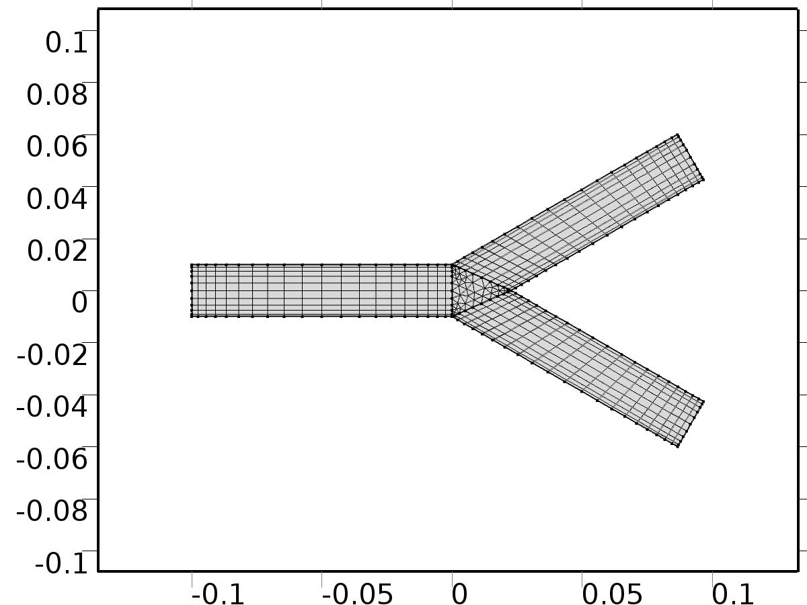

Mesh 1

* + 1. Size (size)

Settings

| **Description** | **Value** |
| --- | --- |
| Maximum element size | 0.0127 |
| Minimum element size | 5.67E-5 |
| Curvature factor | 0.3 |
| Maximum element growth rate | 1.3 |
| Custom element size | Custom |

* + 1. Distribution 1 (dis1)

Selection

|  |  |
| --- | --- |
| Geometric entity level | Boundary |
| Selection | Boundaries 2–3, 6, 8–10 |

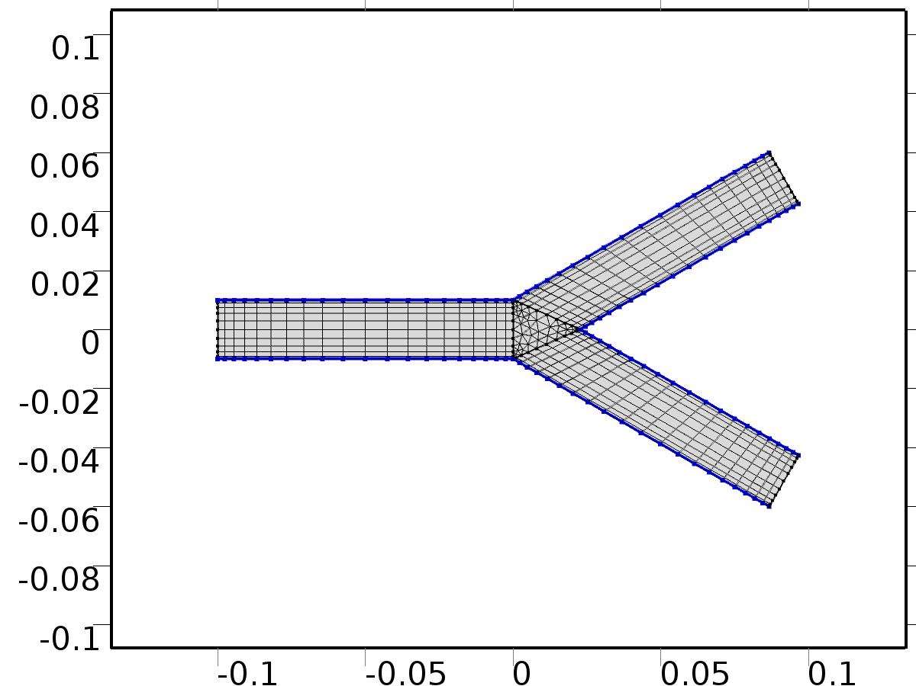

Distribution 1

Settings

| **Description** | **Value** |
| --- | --- |
| Distribution properties | Predefined distribution type |
| Number of elements | nL |
| Element ratio | 3 |
| Symmetric distribution | On |

* + 1. Distribution 2 (dis2)

Selection

|  |  |
| --- | --- |
| Geometric entity level | Boundary |
| Selection | Boundaries 1, 4–5, 7, 11–12 |

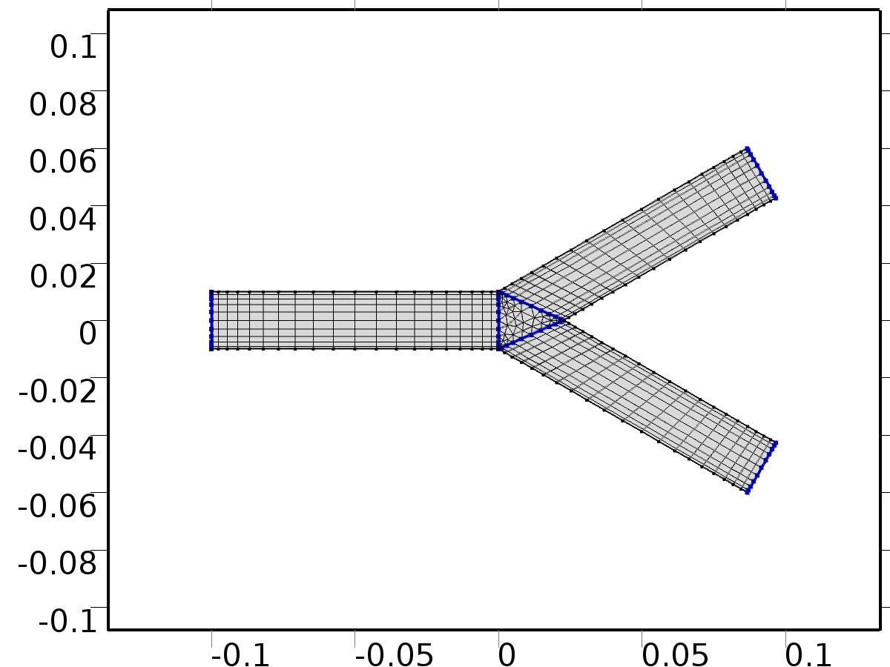

Distribution 2

Settings

| **Description** | **Value** |
| --- | --- |
| Distribution properties | Predefined distribution type |
| Number of elements | nD |
| Element ratio | 3 |
| Symmetric distribution | On |

* + 1. Mapped 1 (map1)

Selection

|  |  |
| --- | --- |
| Geometric entity level | Domain |
| Selection | Domains 1, 3–4 |

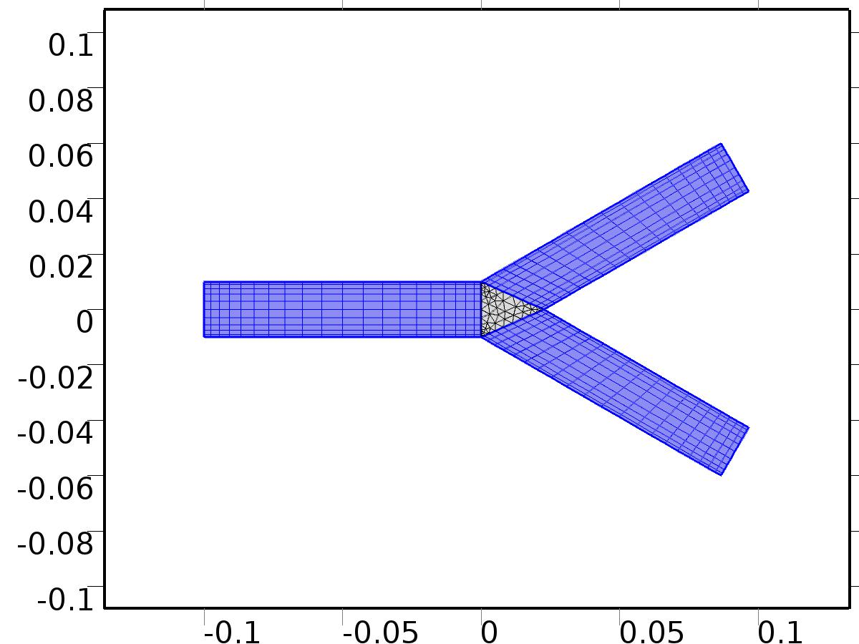

Mapped 1

* + 1. Free Triangular 1 (ftri1)

Selection

|  |  |
| --- | --- |
| Geometric entity level | Remaining |

1. Study 1
   1. Stationary

Study settings

| **Description** | **Value** |
| --- | --- |
| Include geometric nonlinearity | Off |

Physics and variables selection

| **Physics interface** | **Discretization** |
| --- | --- |
| Unit Input (spf) | physics |

Mesh selection

| **Geometry** | **Mesh** |
| --- | --- |
| Geometry 1 (geom1) | mesh1 |

* 1. Solver Configurations
     1. Solver 1

#### Compile Equations: Stationary (st1)

Study and step

| **Description** | **Value** |
| --- | --- |
| Use study | Study 1 |
| Use study step | Stationary |

#### Dependent Variables 1 (v1)

General

| **Description** | **Value** |
| --- | --- |
| Defined by study step | Stationary |
| Constant |  |

Initial values of variables solved for

| **Description** | **Value** |
| --- | --- |
| Solution | Zero |

Values of variables not solved for

| **Description** | **Value** |
| --- | --- |
| Solution | Zero |

##### Velocity field (mod1.X_u) (mod1_X_u)

General

| **Description** | **Value** |
| --- | --- |
| Field components | {mod1.X_u, mod1.X_v} |
| Field name | mod1_u |

##### Pressure (mod1.X_p) (mod1_X_p)

General

| **Description** | **Value** |
| --- | --- |
| Field components | mod1.X_p |
| Field name | mod1_p |

##### Velocity field (mod1.Zb_u) (mod1_Zb_u)

General

| **Description** | **Value** |
| --- | --- |
| Field components | {mod1.Zb_u, mod1.Zb_v} |
| Solve for this field | Off |
| Field name | mod1_u2 |

##### Pressure (mod1.Zb_p) (mod1_Zb_p)

General

| **Description** | **Value** |
| --- | --- |
| Field components | mod1.Zb_p |
| Solve for this field | Off |
| Field name | mod1_p2 |

##### Velocity field (mod1.Zt_u) (mod1_Zt_u)

General

| **Description** | **Value** |
| --- | --- |
| Field components | {mod1.Zt_u, mod1.Zt_v} |
| Solve for this field | Off |
| Field name | mod1_u4 |

##### Pressure (mod1.Zt_p) (mod1_Zt_p)

General

| **Description** | **Value** |
| --- | --- |
| Field components | mod1.Zt_p |
| Solve for this field | Off |
| Field name | mod1_p4 |

##### Velocity field (mod1.u) (mod1_u)

General

| **Description** | **Value** |
| --- | --- |
| Field components | {mod1.u, mod1.v} |
| Solve for this field | Off |

##### Pressure (mod1.p) (mod1_p)

General

| **Description** | **Value** |
| --- | --- |
| Field components | mod1.p |
| Solve for this field | Off |

#### Stationary Solver 1 (s1)

General

| **Description** | **Value** |
| --- | --- |
| Defined by study step | Stationary |
| Relative tolerance | 0.00000010 |

Log

| **Description** | **Value** |
| --- | --- |
| Constant |  |

##### Fully Coupled 1 (fc1)

General

| **Description** | **Value** |
| --- | --- |
| Linear solver | Direct 1 |

Method and termination

| **Description** | **Value** |
| --- | --- |
| Initial damping factor | 0.01 |
| Minimum damping factor | 1.0E-6 |

##### Direct 1 (d1)

General

| **Description** | **Value** |
| --- | --- |
| Solver | PARDISO |

1. Study 2
   1. Stationary

Study settings

| **Description** | **Value** |
| --- | --- |
| Include geometric nonlinearity | Off |

Physics and variables selection

| **Physics interface** | **Discretization** |
| --- | --- |
| Set Point (spf2) | physics |
| Set Point Auxiliary (spf4) | physics |

Mesh selection

| **Geometry** | **Mesh** |
| --- | --- |
| Geometry 1 (geom1) | mesh1 |

* 1. Solver Configurations
     1. Solver 4

#### Compile Equations: Stationary (st1)

Study and step

| **Description** | **Value** |
| --- | --- |
| Use study | Study 2 |
| Use study step | Stationary |

#### Dependent Variables 1 (v1)

General

| **Description** | **Value** |
| --- | --- |
| Defined by study step | Stationary |
| Constant |  |

Initial values of variables solved for

| **Description** | **Value** |
| --- | --- |
| Solution | Zero |

Values of variables not solved for

| **Description** | **Value** |
| --- | --- |
| Method | Solution |
| Solution | Solver 1 |

##### Velocity field (mod1.Zb_u) (mod1_Zb_u)

General

| **Description** | **Value** |
| --- | --- |
| Field components | {mod1.Zb_u, mod1.Zb_v} |
| Field name | mod1_PI1_u |

##### Velocity field (mod1.X_u) (mod1_X_u)

General

| **Description** | **Value** |
| --- | --- |
| Field components | {mod1.X_u, mod1.X_v} |
| Solve for this field | Off |

##### Velocity field (mod1.Zt_u) (mod1_Zt_u)

General

| **Description** | **Value** |
| --- | --- |
| Field components | {mod1.Zt_u, mod1.Zt_v} |
| Field name | mod1_PIt1_u |

##### Pressure (mod1.Zb_p) (mod1_Zb_p)

General

| **Description** | **Value** |
| --- | --- |
| Field components | mod1.Zb_p |
| Field name | mod1_PI1_p |

##### Pressure (mod1.X_p) (mod1_X_p)

General

| **Description** | **Value** |
| --- | --- |
| Field components | mod1.X_p |
| Solve for this field | Off |

##### Pressure (mod1.Zt_p) (mod1_Zt_p)

General

| **Description** | **Value** |
| --- | --- |
| Field components | mod1.Zt_p |
| Field name | mod1_PIt1_p |

##### Velocity field (mod1.u) (mod1_u)

General

| **Description** | **Value** |
| --- | --- |
| Field components | {mod1.u, mod1.v} |
| Solve for this field | Off |

##### Pressure (mod1.p) (mod1_p)

General

| **Description** | **Value** |
| --- | --- |
| Field components | mod1.p |
| Solve for this field | Off |

#### Stationary Solver 1 (s1)

General

| **Description** | **Value** |
| --- | --- |
| Defined by study step | Stationary |
| Relative tolerance | 0.00000010 |

Log

| **Description** | **Value** |
| --- | --- |
| Constant |  |

##### Fully Coupled 1 (fc1)

General

| **Description** | **Value** |
| --- | --- |
| Linear solver | Direct 1 |

Method and termination

| **Description** | **Value** |
| --- | --- |
| Initial damping factor | 0.01 |
| Minimum damping factor | 1.0E-6 |

##### Direct 1 (d1)

General

| **Description** | **Value** |
| --- | --- |
| Solver | PARDISO |

1. Study 3
   1. Time Dependent

Study settings

| **Description** | **Value** |
| --- | --- |
| Include geometric nonlinearity | Off |

| **Times** | **Unit** |
| --- | --- |
| range(0,0.05,5) | s |

Physics and variables selection

| **Physics interface** | **Discretization** |
| --- | --- |
| Closed Loop System (phys1) | physics |

Mesh selection

| **Geometry** | **Mesh** |
| --- | --- |
| Geometry 1 (geom1) | mesh1 |

* 1. Solver Configurations
     1. Solver 3

#### Compile Equations: Time Dependent (st1)

Study and step

| **Description** | **Value** |
| --- | --- |
| Use study | Study 3 |
| Use study step | Time Dependent |

#### Dependent Variables 1 (v1)

General

| **Description** | **Value** |
| --- | --- |
| Defined by study step | Time Dependent |
| Constant |  |

Initial values of variables solved for

| **Description** | **Value** |
| --- | --- |
| Solution | Zero |

Values of variables not solved for

| **Description** | **Value** |
| --- | --- |
| Method | Solution |
| Solution | Solver 4 |

##### Velocity field (mod1.X_u) (mod1_X_u)

General

| **Description** | **Value** |
| --- | --- |
| Field components | {mod1.X_u, mod1.X_v} |
| Solve for this field | Off |
| Field name | mod1_u |

##### Pressure (mod1.X_p) (mod1_X_p)

General

| **Description** | **Value** |
| --- | --- |
| Field components | mod1.X_p |
| Solve for this field | Off |
| Field name | mod1_p |

##### Velocity field (mod1.Zt_u) (mod1_Zt_u)

General

| **Description** | **Value** |
| --- | --- |
| Field components | {mod1.Zt_u, mod1.Zt_v} |
| Solve for this field | Off |
| Field name | mod1_u4 |

##### Velocity field (mod1.Zb_u) (mod1_Zb_u)

General

| **Description** | **Value** |
| --- | --- |
| Field components | {mod1.Zb_u, mod1.Zb_v} |
| Solve for this field | Off |
| Field name | mod1_u2 |

##### Pressure (mod1.Zt_p) (mod1_Zt_p)

General

| **Description** | **Value** |
| --- | --- |
| Field components | mod1.Zt_p |
| Solve for this field | Off |
| Field name | mod1_p4 |

##### Pressure (mod1.Zb_p) (mod1_Zb_p)

General

| **Description** | **Value** |
| --- | --- |
| Field components | mod1.Zb_p |
| Solve for this field | Off |
| Field name | mod1_p2 |

##### Velocity field (mod1.u) (mod1_u)

General

| **Description** | **Value** |
| --- | --- |
| Field components | {mod1.u, mod1.v} |

##### Pressure (mod1.p) (mod1_p)

General

| **Description** | **Value** |
| --- | --- |
| Field components | mod1.p |

#### Time-Dependent Solver 1 (t1)

General

| **Description** | **Value** |
| --- | --- |
| Defined by study step | Time Dependent |
| Time | {0, 0.05, 0.1, 0.15000000000000002, 0.2, 0.25, 0.30000000000000004, 0.35000000000000003, 0.4, 0.45, 0.5, 0.55, 0.6000000000000001, 0.65, 0.7000000000000001, 0.75, 0.8, 0.8500000000000001, 0.9, 0.9500000000000001, 1, 1.05, 1.1, 1.1500000000000001, 1.2000000000000002, 1.25, 1.3, 1.35, 1.4000000000000001, 1.4500000000000002, 1.5, 1.55, 1.6, 1.6500000000000001, 1.7000000000000002, 1.75, 1.8, 1.85, 1.9000000000000001, 1.9500000000000002, 2, 2.0500000000000003, 2.1, 2.15, 2.2, 2.25, 2.3000000000000003, 2.35, 2.4000000000000004, 2.45, 2.5, 2.5500000000000003, 2.6, 2.6500000000000004, 2.7, 2.75, 2.8000000000000003, 2.85, 2.9000000000000004, 2.95, 3, 3.0500000000000003, 3.1, 3.1500000000000004, 3.2, 3.25, 3.3000000000000003, 3.35, 3.4000000000000004, 3.45, 3.5, 3.5500000000000003, 3.6, 3.6500000000000004, 3.7, 3.75, 3.8000000000000003, 3.85, 3.9000000000000004, 3.95, 4, 4.05, 4.1000000000000005, 4.15, 4.2, 4.25, 4.3, 4.3500000000000005, 4.4, 4.45, 4.5, 4.55, 4.6000000000000005, 4.65, 4.7, 4.75, 4.800000000000001, 4.8500000000000005, 4.9, 4.95, 5} |
| Relative tolerance | 0.000001 |

Absolute tolerance

| **Description** | **Value** |
| --- | --- |
| Tolerance | 5.0E-5 |

Time stepping

| **Description** | **Value** |
| --- | --- |
| Initial step | 0.0010 |
| Maximum BDF order | 2 |

Results while solving

| **Description** | **Value** |
| --- | --- |
| Probes | None |

Advanced

| **Description** | **Value** |
| --- | --- |
| Fraction of initial step for Backward Euler | 0.0010 |
| Error estimation | Exclude algebraic |

Log

| **Description** | **Value** |
| --- | --- |
| Constant |  |

##### Fully Coupled 1 (fc1)

General

| **Description** | **Value** |
| --- | --- |
| Linear solver | Direct 1 |

Method and termination

| **Description** | **Value** |
| --- | --- |
| Jacobian update | Once per time step |
| Maximum number of iterations | 6 |

##### Direct 1 (d1)

General

| **Description** | **Value** |
| --- | --- |
| Solver | PARDISO |

1. Results
   1. Data Sets
      1. Solution 1

Solution

| **Description** | **Value** |
| --- | --- |
| Solution | Solver 1 |
| Component | Save Point Geometry 1 |

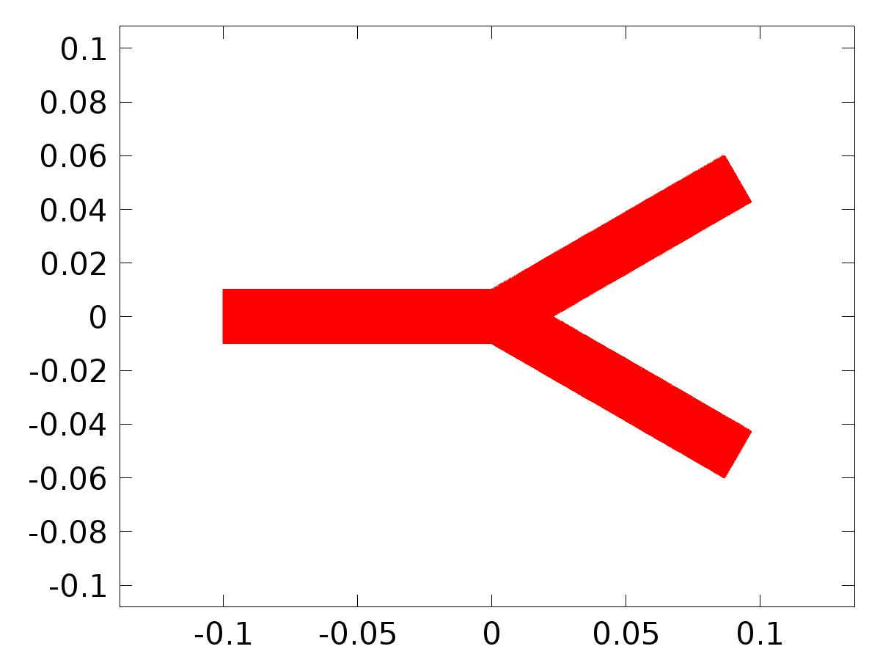

Data set: Solution 1

* + 1. Probe Solution 2

Solution

| **Description** | **Value** |
| --- | --- |
| Solution | Solver 3 |
| Component | Save Point Geometry 1 |



Data set: Probe Solution 2

* + 1. Solution 3

Solution

| **Description** | **Value** |
| --- | --- |
| Solution | Solver 4 |
| Component | Save Point Geometry 1 |



Data set: Solution 3

* + 1. Solution 4

Solution

| **Description** | **Value** |
| --- | --- |
| Solution | Solver 3 |
| Component | Save Point Geometry 1 |



Data set: Solution 4

* 1. Derived Values
     1. C(Zb) Probe

Data

| **Description** | **Value** |
| --- | --- |
| Data set | Probe Solution 2 |

Expression

| **Description** | **Value** |
| --- | --- |
| Expression | gamma*C(Zb_u*nx + Zb_v*ny) |
| Description | gamma*C(Zb_u*nx + Zb_v*ny) |

* + 1. Global Evaluation 2

Data

| **Description** | **Value** |
| --- | --- |
| Data set | Solution 4 |

Expression

| **Description** | **Value** |
| --- | --- |
| Expression | d |

* 1. Tables
     1. Table 1

Global Evaluation 1 (G)

Table 1

| **delta** | **(m^2/s), Global Variable Probe 5** |
| --- | --- |
| 1.0000E-4 | 2.9444E-10 |

* + 1. Probe Table 2

Probe Table 2

| **gamma*C(Zb_u*nx+Zb_v*ny) (1), C(Zb) Probe** |
| --- |
| NaN |

* + 1. Table 3

Global Evaluation 6 (dc(0))

Table 3

| **k** | **dc(0)** | **dc(1)** | **dc(2)** | **dc(3)** |
| --- | --- | --- | --- | --- |
| 0.0000 | 0.0000 | 1.0000 | 0.0000 | 0.0000 |
| 1.0000 | 0.0000 | 1.0000 | 0.0000 | 0.0000 |

* + 1. Table 4

Global Evaluation 5 (Qs(k))

Table 4

| **Qs(k) (m^2/s)** | **Qc(k) (m^2/s)** | **k** |
| --- | --- | --- |
| 0.0000 | 1.0000 | 0.0000 |

* + 1. Probe Table 5
    2. Table 6

Global Evaluation 6 (ds(k))

Table 6

| **k** | **ds(k) (Pa)** | **dc(k) (Pa)** | **alpha(k)** | **Qs(k) (m^2/s)** | **Qc(k) (m^2/s)** |
| --- | --- | --- | --- | --- | --- |
| 0.0000 | 0.0000 | 0.0000 | 0.0000 | 0.0000 | 1.0000 |
| 1.0000 | 0.0000 | 1.0000 | 0.0000 | 0.0000 | 0.0000 |
| 2.0000 | 0.0000 | 0.0000 | 1.0000 | 1.0000 | 0.0000 |
| 3.0000 | 1.0000 | 0.0000 | 1.0000 | 0.0000 | 0.0000 |

* + 1. Table 7

Global Evaluation 7 (Gamma)

Table 7

| **Time** | **Gamma** | **yr** |
| --- | --- | --- |
| 0.0000 | -10.200 | 1.0000 |
| 0.10000 | -11.557 | 1.0998 |
| 0.20000 | -12.798 | 1.1987 |
| 0.30000 | -13.774 | 1.2955 |
| 0.40000 | -14.352 | 1.3894 |
| 0.50000 | -14.416 | 1.4794 |
| 0.60000 | -13.876 | 1.5646 |
| 0.70000 | -12.674 | 1.6442 |
| 0.80000 | -10.782 | 1.7174 |
| 0.90000 | -8.2080 | 1.7833 |
| 1.0000 | -4.9956 | 1.8415 |
| 1.1000 | -1.2218 | 1.8912 |
| 1.2000 | 3.0047 | 1.9320 |
| 1.3000 | 7.5477 | 1.9636 |
| 1.4000 | 12.249 | 1.9854 |
| 1.5000 | 16.932 | 1.9975 |
| 1.6000 | 21.414 | 1.9996 |
| 1.7000 | 25.508 | 1.9917 |
| 1.8000 | 29.033 | 1.9738 |
| 1.9000 | 31.820 | 1.9463 |
| 2.0000 | 33.720 | 1.9093 |
| 2.1000 | 34.612 | 1.8632 |
| 2.2000 | 34.403 | 1.8085 |
| 2.3000 | 33.038 | 1.7457 |
| 2.4000 | 30.500 | 1.6755 |
| 2.5000 | 26.812 | 1.5985 |
| 2.6000 | 22.037 | 1.5155 |
| 2.7000 | 16.274 | 1.4274 |
| 2.8000 | 9.6602 | 1.3350 |
| 2.9000 | 2.3608 | 1.2392 |
| 3.0000 | -5.4329 | 1.1411 |
| 3.1000 | -13.512 | 1.0416 |
| 3.2000 | -21.656 | 0.94163 |
| 3.3000 | -29.641 | 0.84225 |
| 3.4000 | -37.250 | 0.74446 |
| 3.5000 | -44.276 | 0.64922 |
| 3.6000 | -50.531 | 0.55748 |
| 3.7000 | -55.858 | 0.47016 |
| 3.8000 | -60.125 | 0.38814 |
| 3.9000 | -63.242 | 0.31223 |
| 4.0000 | -65.153 | 0.24320 |
| 4.1000 | -65.847 | 0.18172 |
| 4.2000 | -65.349 | 0.12842 |
| 4.3000 | -63.725 | 0.083834 |
| 4.4000 | -61.076 | 0.048398 |
| 4.5000 | -57.535 | 0.022470 |
| 4.6000 | -53.259 | 0.0063090 |
| 4.7000 | -48.425 | 7.6742E-5 |
| 4.8000 | -43.222 | 0.0038354 |
| 4.9000 | -37.844 | 0.017547 |
| 5.0000 | -32.481 | 0.041076 |
| 5.1000 | -27.314 | 0.074185 |
| 5.2000 | -22.505 | 0.11655 |
| 5.3000 | -18.195 | 0.16773 |
| 5.4000 | -14.494 | 0.22724 |
| 5.5000 | -11.481 | 0.29446 |
| 5.6000 | -9.2021 | 0.36873 |
| 5.7000 | -7.6647 | 0.44931 |
| 5.8000 | -6.8428 | 0.53540 |
| 5.9000 | -6.6767 | 0.62612 |
| 6.0000 | -7.0767 | 0.72058 |
| 6.1000 | -7.9278 | 0.81784 |
| 6.2000 | -9.0951 | 0.91691 |
| 6.3000 | -10.430 | 1.0168 |
| 6.4000 | -11.778 | 1.1165 |
| 6.5000 | -12.984 | 1.2151 |
| 6.6000 | -13.903 | 1.3115 |
| 6.7000 | -14.401 | 1.4048 |
| 6.8000 | -14.369 | 1.4941 |
| 6.9000 | -13.722 | 1.5784 |
| 7.0000 | -12.404 | 1.6570 |
| 7.1000 | -10.396 | 1.7290 |
| 7.2000 | -7.7108 | 1.7937 |
| 7.3000 | -4.3977 | 1.8504 |
| 7.4000 | -0.53935 | 1.8987 |
| 7.5000 | 3.7505 | 1.9380 |
| 7.6000 | 8.3317 | 1.9679 |
| 7.7000 | 13.042 | 1.9882 |
| 7.8000 | 17.705 | 1.9985 |
| 7.9000 | 22.135 | 1.9989 |
| 8.0000 | 26.146 | 1.9894 |
| 8.1000 | 29.558 | 1.9699 |
| 8.2000 | 32.205 | 1.9407 |
| 8.3000 | 33.944 | 1.9022 |
| 8.4000 | 34.656 | 1.8546 |
| 8.5000 | 34.255 | 1.7985 |
| 8.6000 | 32.693 | 1.7344 |
| 8.7000 | 29.959 | 1.6630 |
| 8.8000 | 26.083 | 1.5849 |
| 8.9000 | 21.134 | 1.5010 |
| 9.0000 | 15.218 | 1.4121 |
| 9.1000 | 8.4759 | 1.3191 |
| 9.2000 | 1.0794 | 1.2229 |
| 9.3000 | -6.7774 | 1.1245 |
| 9.4000 | -14.883 | 1.0248 |
| 9.5000 | -23.016 | 0.92485 |
| 9.6000 | -30.953 | 0.82567 |
| 9.7000 | -38.477 | 0.72824 |
| 9.8000 | -45.386 | 0.63352 |
| 9.9000 | -51.496 | 0.54246 |
| 10.000 | -56.652 | 0.45598 |
| 10.100 | -60.732 | 0.37493 |
| 10.200 | -63.648 | 0.30013 |
| 10.300 | -65.355 | 0.23231 |
| 10.400 | -65.845 | 0.17217 |
| 10.500 | -65.152 | 0.12030 |
| 10.600 | -63.348 | 0.077225 |
| 10.700 | -60.539 | 0.043365 |
| 10.800 | -56.863 | 0.019064 |
| 10.900 | -52.480 | 0.0045637 |
| 11.000 | -47.570 | 9.7934E-6 |
| 11.100 | -42.324 | 0.0054474 |
| 11.200 | -36.936 | 0.020822 |
| 11.300 | -31.594 | 0.045981 |
| 11.400 | -26.476 | 0.080671 |
| 11.500 | -21.742 | 0.12455 |
| 11.600 | -17.527 | 0.17717 |
| 11.700 | -13.937 | 0.23802 |
| 11.800 | -11.046 | 0.30647 |
| 11.900 | -8.8920 | 0.38186 |
| 12.000 | -7.4777 | 0.46343 |
| 12.100 | -6.7711 | 0.55035 |
| 12.200 | -6.7072 | 0.64177 |
| 12.300 | -7.1918 | 0.73677 |
| 12.400 | -8.1059 | 0.83440 |
| 12.500 | -9.3120 | 0.93368 |
| 12.600 | -10.660 | 1.0336 |
| 12.700 | -11.995 | 1.1332 |
| 12.800 | -13.163 | 1.2315 |
| 12.900 | -14.019 | 1.3275 |
| 13.000 | -14.436 | 1.4202 |
| 13.100 | -14.305 | 1.5087 |
| 13.200 | -13.548 | 1.5921 |
| 13.300 | -12.115 | 1.6696 |
| 13.400 | -9.9910 | 1.7404 |
| 13.500 | -7.1958 | 1.8038 |
| 13.600 | -3.7843 | 1.8592 |
| 13.700 | 0.15531 | 1.9060 |
| 13.800 | 4.5047 | 1.9437 |
| 13.900 | 9.1194 | 1.9720 |
| 14.000 | 13.835 | 1.9906 |
| 14.100 | 18.471 | 1.9993 |
| 14.200 | 22.844 | 1.9980 |
| 14.300 | 26.766 | 1.9868 |
| 14.400 | 30.061 | 1.9657 |
| 14.500 | 32.565 | 1.9349 |
| 14.600 | 34.138 | 1.8948 |
| 14.700 | 34.668 | 1.8457 |
| 14.800 | 34.075 | 1.7883 |
| 14.900 | 32.315 | 1.7229 |
| 15.000 | 29.386 | 1.6503 |
| 15.100 | 25.324 | 1.5712 |
| 15.200 | 20.203 | 1.4864 |
| 15.300 | 14.137 | 1.3967 |
| 15.400 | 7.2729 | 1.3031 |
| 15.500 | -0.21509 | 1.2065 |
| 15.600 | -8.1288 | 1.1078 |
| 15.700 | -16.254 | 1.0080 |
| 15.800 | -24.370 | 0.90809 |
| 15.900 | -32.253 | 0.80914 |
| 16.000 | -39.687 | 0.71210 |
| 16.100 | -46.474 | 0.61793 |
| 16.200 | -52.433 | 0.52758 |
| 16.300 | -57.416 | 0.44195 |
| 16.400 | -61.305 | 0.36189 |
| 16.500 | -64.021 | 0.28821 |
| 16.600 | -65.522 | 0.22165 |
| 16.700 | -65.810 | 0.16286 |
| 16.800 | -64.924 | 0.11243 |
| 16.900 | -62.943 | 0.070876 |
| 17.000 | -59.978 | 0.038603 |
| 17.100 | -56.170 | 0.015935 |
| 17.200 | -51.686 | 0.0030999 |
| 17.300 | -46.706 | 2.2557E-4 |
| 17.400 | -41.423 | 0.0073406 |
| 17.500 | -36.029 | 0.024374 |
| 17.600 | -30.713 | 0.051156 |
| 17.700 | -25.649 | 0.087418 |
| 17.800 | -20.994 | 0.13280 |
| 17.900 | -16.877 | 0.18684 |
| 18.000 | -13.401 | 0.24901 |
| 18.100 | -10.632 | 0.31869 |
| 18.200 | -8.6029 | 0.39517 |
| 18.300 | -7.3108 | 0.47769 |
| 18.400 | -6.7176 | 0.56543 |
| 18.500 | -6.7533 | 0.65752 |
| 18.600 | -7.3190 | 0.75303 |
| 18.700 | -8.2923 | 0.85100 |
| 18.800 | -9.5330 | 0.95046 |
| 18.900 | -10.890 | 1.0504 |
| 19.000 | -12.207 | 1.1499 |
| 19.100 | -13.332 | 1.2478 |
| 19.200 | -14.123 | 1.3433 |
| 19.300 | -14.455 | 1.4354 |
| 19.400 | -14.224 | 1.5231 |
| 19.500 | -13.355 | 1.6055 |
| 19.600 | -11.806 | 1.6820 |
| 19.700 | -9.5669 | 1.7516 |
| 19.800 | -6.6633 | 1.8137 |
| 19.900 | -3.1559 | 1.8676 |
| 20.000 | 0.86162 | 1.9129 |

* + 1. Table 8

Point Evaluation 1 (delta*C(u6*nx+v6*ny))

Table 8

| **Time** | **delta*C(u6*nx+v6*ny) (1), Point: 8** | **yr, Point: 8** | **Gamma, Point: 8** | **d, Point: 8** |
| --- | --- | --- | --- | --- |
| 0.0000 | 0.0016826 | 10.000 | 33.163 | 25.000 |
| 0.10000 | 3.3346 | 10.998 | 34.964 | 27.384 |
| 0.20000 | 6.0104 | 11.987 | 36.642 | 29.673 |
| 0.30000 | 8.2846 | 12.955 | 38.241 | 31.776 |
| 0.40000 | 10.242 | 13.894 | 39.803 | 33.608 |
| 0.50000 | 11.938 | 14.794 | 41.361 | 35.098 |
| 0.60000 | 13.413 | 15.646 | 42.940 | 36.184 |
| 0.70000 | 14.696 | 16.442 | 44.556 | 36.825 |
| 0.80000 | 15.808 | 17.174 | 46.210 | 36.995 |
| 0.90000 | 16.765 | 17.833 | 47.892 | 36.686 |
| 1.0000 | 17.580 | 18.415 | 49.580 | 35.912 |
| 1.1000 | 18.259 | 18.912 | 51.237 | 34.702 |
| 1.2000 | 18.810 | 19.320 | 52.817 | 33.106 |
| 1.3000 | 19.237 | 19.636 | 54.263 | 31.186 |
| 1.4000 | 19.543 | 19.854 | 55.511 | 29.020 |
| 1.5000 | 19.731 | 19.975 | 56.492 | 26.693 |
| 1.6000 | 19.805 | 19.996 | 57.135 | 24.300 |
| 1.7000 | 19.768 | 19.917 | 57.371 | 21.934 |
| 1.8000 | 19.622 | 19.738 | 57.134 | 19.690 |
| 1.9000 | 19.372 | 19.463 | 56.366 | 17.658 |
| 2.0000 | 19.022 | 19.093 | 55.021 | 15.918 |
| 2.1000 | 18.577 | 18.632 | 53.065 | 14.541 |
| 2.2000 | 18.042 | 18.085 | 50.479 | 13.581 |
| 2.3000 | 17.424 | 17.457 | 47.262 | 13.076 |
| 2.4000 | 16.729 | 16.755 | 43.431 | 13.046 |
| 2.5000 | 15.965 | 15.985 | 39.021 | 13.493 |
| 2.6000 | 15.140 | 15.155 | 34.088 | 14.399 |
| 2.7000 | 14.262 | 14.274 | 28.702 | 15.727 |
| 2.8000 | 13.341 | 13.350 | 22.951 | 17.425 |
| 2.9000 | 12.386 | 12.392 | 16.935 | 19.425 |
| 3.0000 | 11.407 | 11.411 | 10.767 | 21.647 |
| 3.1000 | 10.413 | 10.416 | 4.5673 | 24.003 |
| 3.2000 | 9.4141 | 9.4163 | -1.5414 | 26.399 |
| 3.3000 | 8.4210 | 8.4225 | -7.4343 | 28.738 |
| 3.4000 | 7.4436 | 7.4446 | -12.990 | 30.929 |
| 3.5000 | 6.4916 | 6.4922 | -18.095 | 32.884 |
| 3.6000 | 5.5746 | 5.5748 | -22.644 | 34.524 |
| 3.7000 | 4.7016 | 4.7016 | -26.549 | 35.784 |
| 3.8000 | 3.8816 | 3.8814 | -29.734 | 36.615 |
| 3.9000 | 3.1226 | 3.1223 | -32.145 | 36.983 |
| 4.0000 | 2.4323 | 2.4320 | -33.746 | 36.872 |
| 4.1000 | 1.8176 | 1.8172 | -34.521 | 36.289 |
| 4.2000 | 1.2847 | 1.2842 | -34.477 | 35.255 |
| 4.3000 | 0.83887 | 0.83834 | -33.640 | 33.813 |
| 4.4000 | 0.48473 | 0.48398 | -32.055 | 32.019 |
| 4.5000 | 0.22555 | 0.22470 | -29.784 | 29.945 |
| 4.6000 | 0.063931 | 0.063090 | -26.904 | 27.675 |
| 4.7000 | 0.0015085 | 7.6742E-4 | -23.502 | 25.297 |
| 4.8000 | 0.038948 | 0.038354 | -19.676 | 22.908 |
| 4.9000 | 0.17592 | 0.17547 | -15.527 | 20.602 |
| 5.0000 | 0.41105 | 0.41076 | -11.158 | 18.472 |
| 5.1000 | 0.74201 | 0.74185 | -6.6692 | 16.602 |
| 5.2000 | 1.1655 | 1.1655 | -2.1571 | 15.066 |
| 5.3000 | 1.6772 | 1.6773 | 2.2916 | 13.927 |
| 5.4000 | 2.2721 | 2.2724 | 6.6007 | 13.229 |
| 5.5000 | 2.9443 | 2.9446 | 10.707 | 13.000 |
| 5.6000 | 3.6869 | 3.6873 | 14.561 | 13.250 |
| 5.7000 | 4.4926 | 4.4931 | 18.130 | 13.968 |
| 5.8000 | 5.3534 | 5.3540 | 21.396 | 15.126 |
| 5.9000 | 6.2606 | 6.2612 | 24.353 | 16.678 |
| 6.0000 | 7.2051 | 7.2058 | 27.013 | 18.561 |
| 6.1000 | 8.1775 | 8.1784 | 29.398 | 20.701 |
| 6.2000 | 9.1682 | 9.1691 | 31.539 | 23.013 |
| 6.3000 | 10.167 | 10.168 | 33.477 | 25.403 |
| 6.4000 | 11.164 | 11.165 | 35.253 | 27.778 |
| 6.5000 | 12.150 | 12.151 | 36.915 | 30.042 |
| 6.6000 | 13.114 | 13.115 | 38.506 | 32.105 |
| 6.7000 | 14.047 | 14.048 | 40.065 | 33.885 |
| 6.8000 | 14.940 | 14.941 | 41.625 | 35.310 |
| 6.9000 | 15.783 | 15.784 | 43.209 | 36.324 |
| 7.0000 | 16.569 | 16.570 | 44.831 | 36.887 |
| 7.1000 | 17.289 | 17.290 | 46.491 | 36.976 |
| 7.2000 | 17.936 | 17.937 | 48.176 | 36.588 |
| 7.3000 | 18.503 | 18.504 | 49.862 | 35.737 |
| 7.4000 | 18.986 | 18.987 | 51.510 | 34.459 |
| 7.5000 | 19.379 | 19.380 | 53.071 | 32.803 |
| 7.6000 | 19.678 | 19.679 | 54.489 | 30.837 |
| 7.7000 | 19.880 | 19.882 | 55.697 | 28.637 |
| 7.8000 | 19.984 | 19.985 | 56.626 | 26.293 |
| 7.9000 | 19.989 | 19.989 | 57.205 | 23.897 |
| 8.0000 | 19.893 | 19.894 | 57.366 | 21.545 |
| 8.1000 | 19.699 | 19.699 | 57.043 | 19.331 |
| 8.2000 | 19.407 | 19.407 | 56.181 | 17.343 |
| 8.3000 | 19.022 | 19.022 | 54.736 | 15.660 |
| 8.4000 | 18.546 | 18.546 | 52.674 | 14.349 |
| 8.5000 | 17.985 | 17.985 | 49.982 | 13.463 |
| 8.6000 | 17.345 | 17.344 | 46.660 | 13.037 |
| 8.7000 | 16.630 | 16.630 | 42.728 | 13.088 |
| 8.8000 | 15.850 | 15.849 | 38.227 | 13.614 |
| 8.9000 | 15.011 | 15.010 | 33.212 | 14.594 |
| 9.0000 | 14.122 | 14.121 | 27.758 | 15.988 |
| 9.1000 | 13.192 | 13.191 | 21.955 | 17.742 |
| 9.2000 | 12.230 | 12.229 | 15.906 | 19.785 |
| 9.3000 | 11.246 | 11.245 | 9.7239 | 22.036 |
| 9.4000 | 10.249 | 10.248 | 3.5304 | 24.406 |
| 9.5000 | 9.2498 | 9.2485 | -2.5507 | 26.799 |
| 9.6000 | 8.2580 | 8.2567 | -8.3953 | 29.120 |
| 9.7000 | 7.2836 | 7.2824 | -13.883 | 31.277 |
| 9.8000 | 6.3363 | 6.3352 | -18.901 | 33.184 |
| 9.9000 | 5.4257 | 5.4246 | -23.348 | 34.764 |
| 10.000 | 4.5608 | 4.5598 | -27.136 | 35.955 |
| 10.100 | 3.7503 | 3.7493 | -30.195 | 36.710 |
| 10.200 | 3.0022 | 3.0013 | -32.471 | 36.998 |
| 10.300 | 2.3240 | 2.3231 | -33.934 | 36.807 |
| 10.400 | 1.7225 | 1.7217 | -34.570 | 36.146 |
| 10.500 | 1.2038 | 1.2030 | -34.391 | 35.040 |
| 10.600 | 0.77304 | 0.77225 | -33.424 | 33.534 |
| 10.700 | 0.43462 | 0.43365 | -31.719 | 31.688 |
| 10.800 | 0.19166 | 0.19064 | -29.340 | 29.575 |
| 10.900 | 0.046608 | 0.045637 | -26.366 | 27.280 |
| 11.000 | 9.2832E-4 | 9.7934E-5 | -22.886 | 24.894 |
| 11.100 | 0.055132 | 0.054474 | -18.998 | 22.512 |
| 11.200 | 0.20870 | 0.20822 | -14.805 | 20.229 |
| 11.300 | 0.46012 | 0.45981 | -10.409 | 18.137 |
| 11.400 | 0.80688 | 0.80671 | -5.9097 | 16.318 |
| 11.500 | 1.2455 | 1.2455 | -1.4025 | 14.845 |
| 11.600 | 1.7716 | 1.7717 | 3.0278 | 13.777 |
| 11.700 | 2.3800 | 2.3802 | 7.3068 | 13.157 |
| 11.800 | 3.0644 | 3.0647 | 11.374 | 13.009 |
| 11.900 | 3.8182 | 3.8186 | 15.182 | 13.338 |
| 12.000 | 4.6337 | 4.6343 | 18.701 | 14.133 |
| 12.100 | 5.5029 | 5.5035 | 21.914 | 15.361 |
| 12.200 | 6.4170 | 6.4177 | 24.821 | 16.973 |
| 12.300 | 7.3669 | 7.3677 | 27.433 | 18.905 |
| 12.400 | 8.3431 | 8.3440 | 29.774 | 21.080 |
| 12.500 | 9.3358 | 9.3368 | 31.878 | 23.412 |
| 12.600 | 10.335 | 10.336 | 33.785 | 25.806 |
| 12.700 | 11.331 | 11.332 | 35.540 | 28.169 |
| 12.800 | 12.314 | 12.315 | 37.186 | 30.405 |
| 12.900 | 13.274 | 13.275 | 38.769 | 32.426 |
| 13.000 | 14.201 | 14.202 | 40.326 | 34.151 |
| 13.100 | 15.085 | 15.087 | 41.889 | 35.511 |
| 13.200 | 15.920 | 15.921 | 43.479 | 36.451 |
| 13.300 | 16.695 | 16.696 | 45.108 | 36.936 |
| 13.400 | 17.403 | 17.404 | 46.773 | 36.944 |
| 13.500 | 18.037 | 18.038 | 48.461 | 36.477 |
| 13.600 | 18.591 | 18.592 | 50.143 | 35.551 |
| 13.700 | 19.058 | 19.060 | 51.780 | 34.205 |
| 13.800 | 19.435 | 19.437 | 53.321 | 32.493 |
| 13.900 | 19.719 | 19.720 | 54.708 | 30.481 |
| 14.000 | 19.905 | 19.906 | 55.875 | 28.251 |
| 14.100 | 19.992 | 19.993 | 56.750 | 25.891 |
| 14.200 | 19.979 | 19.980 | 57.264 | 23.496 |
| 14.300 | 19.867 | 19.868 | 57.347 | 21.161 |
| 14.400 | 19.656 | 19.657 | 56.937 | 18.979 |
| 14.500 | 19.349 | 19.349 | 55.980 | 17.036 |
| 14.600 | 18.948 | 18.948 | 54.433 | 15.412 |
| 14.700 | 18.458 | 18.457 | 52.266 | 14.169 |
| 14.800 | 17.883 | 17.883 | 49.467 | 13.359 |
| 14.900 | 17.229 | 17.229 | 46.040 | 13.012 |
| 15.000 | 16.504 | 16.503 | 42.010 | 13.144 |
| 15.100 | 15.713 | 15.712 | 37.418 | 13.748 |
| 15.200 | 14.865 | 14.864 | 32.323 | 14.800 |
| 15.300 | 13.969 | 13.967 | 26.804 | 16.260 |
| 15.400 | 13.032 | 13.031 | 20.952 | 18.067 |
| 15.500 | 12.066 | 12.065 | 14.872 | 20.152 |
| 15.600 | 11.079 | 11.078 | 8.6799 | 22.429 |
| 15.700 | 10.081 | 10.080 | 2.4966 | 24.809 |
| 15.800 | 9.0823 | 9.0809 | -3.5534 | 27.196 |
| 15.900 | 8.0927 | 8.0914 | -9.3462 | 29.496 |
| 16.000 | 7.1221 | 7.1210 | -14.763 | 31.617 |
| 16.100 | 6.1804 | 6.1793 | -19.691 | 33.474 |
| 16.200 | 5.2768 | 5.2758 | -24.033 | 34.993 |
| 16.300 | 4.4204 | 4.4195 | -27.703 | 36.114 |
| 16.400 | 3.6198 | 3.6189 | -30.634 | 36.791 |
| 16.500 | 2.8830 | 2.8821 | -32.775 | 36.999 |
| 16.600 | 2.2172 | 2.2165 | -34.099 | 36.728 |
| 16.700 | 1.6293 | 1.6286 | -34.597 | 35.990 |
| 16.800 | 1.1250 | 1.1243 | -34.282 | 34.813 |
| 16.900 | 0.70956 | 0.70876 | -33.188 | 33.245 |
| 17.000 | 0.38692 | 0.38603 | -31.364 | 31.349 |
| 17.100 | 0.16026 | 0.15935 | -28.879 | 29.199 |
| 17.200 | 0.031852 | 0.030999 | -25.813 | 26.882 |
| 17.300 | 0.0029790 | 0.0022557 | -22.258 | 24.490 |
| 17.400 | 0.073970 | 0.073406 | -18.311 | 22.119 |
| 17.500 | 0.24415 | 0.24374 | -14.077 | 19.862 |
| 17.600 | 0.51182 | 0.51156 | -9.6566 | 17.810 |
| 17.700 | 0.87429 | 0.87418 | -5.1500 | 16.044 |
| 17.800 | 1.3280 | 1.3280 | -0.64997 | 14.636 |
| 17.900 | 1.8683 | 1.8684 | 3.7597 | 13.641 |
| 18.000 | 2.4899 | 2.4901 | 8.0070 | 13.099 |
| 18.100 | 3.1865 | 3.1869 | 12.033 | 13.031 |
| 18.200 | 3.9512 | 3.9517 | 15.795 | 13.440 |
| 18.300 | 4.7764 | 4.7769 | 19.263 | 14.310 |
| 18.400 | 5.6537 | 5.6543 | 22.424 | 15.607 |
| 18.500 | 6.5744 | 6.5752 | 25.280 | 17.278 |
| 18.600 | 7.5294 | 7.5303 | 27.845 | 19.256 |
| 18.700 | 8.5091 | 8.5100 | 30.143 | 21.464 |
| 18.800 | 9.5037 | 9.5046 | 32.212 | 23.813 |
| 18.900 | 10.503 | 10.504 | 34.090 | 26.209 |
| 19.000 | 11.498 | 11.499 | 35.823 | 28.556 |
| 19.100 | 12.477 | 12.478 | 37.456 | 30.762 |
| 19.200 | 13.432 | 13.433 | 39.032 | 32.739 |
| 19.300 | 14.352 | 14.354 | 40.588 | 34.407 |
| 19.400 | 15.229 | 15.231 | 42.154 | 35.699 |
| 19.500 | 16.054 | 16.055 | 43.750 | 36.566 |
| 19.600 | 16.818 | 16.820 | 45.385 | 36.971 |
| 19.700 | 17.515 | 17.516 | 47.056 | 36.899 |
| 19.800 | 18.136 | 18.137 | 48.745 | 36.352 |
| 19.900 | 18.675 | 18.676 | 50.422 | 35.353 |
| 20.000 | 19.128 | 19.129 | 52.047 | 33.941 |

* + 1. Table 9

Global Evaluation 2 (Y)

Table 9

| **Time (s)** | **Y (m/s)** | **Yr** | **e (m/s)** | **d** |
| --- | --- | --- | --- | --- |
| 0.0000 | 1.6017E-6 | 0.050000 | 0.049998 | 0.025000 |
| 0.050000 | 0.0066992 | 0.050000 | 0.043301 | 0.025000 |
| 0.10000 | 0.012243 | 0.050000 | 0.037757 | 0.025000 |
| 0.15000 | 0.017038 | 0.050000 | 0.032962 | 0.025000 |
| 0.20000 | 0.021227 | 0.050000 | 0.028773 | 0.025000 |
| 0.25000 | 0.024896 | 0.050000 | 0.025104 | 0.025000 |
| 0.30000 | 0.028113 | 0.050000 | 0.021887 | 0.025000 |
| 0.35000 | 0.030930 | 0.050000 | 0.019070 | 0.025000 |
| 0.40000 | 0.033394 | 0.050000 | 0.016606 | 0.025000 |
| 0.45000 | 0.035547 | 0.050000 | 0.014453 | 0.025000 |
| 0.50000 | 0.037427 | 0.050000 | 0.012573 | 0.025000 |
| 0.55000 | 0.039067 | 0.050000 | 0.010933 | 0.025000 |
| 0.60000 | 0.040496 | 0.050000 | 0.0095036 | 0.025000 |
| 0.65000 | 0.041741 | 0.050000 | 0.0082588 | 0.025000 |
| 0.70000 | 0.042828 | 0.050000 | 0.0071724 | 0.025000 |
| 0.75000 | 0.043773 | 0.050000 | 0.0062272 | 0.025000 |
| 0.80000 | 0.044594 | 0.050000 | 0.0054057 | 0.025000 |
| 0.85000 | 0.045308 | 0.050000 | 0.0046922 | 0.025000 |
| 0.90000 | 0.045928 | 0.050000 | 0.0040718 | 0.025000 |
| 0.95000 | 0.046467 | 0.050000 | 0.0035333 | 0.025000 |
| 1.0000 | 0.046934 | 0.050000 | 0.0030659 | 0.025000 |
| 1.0500 | 0.047340 | 0.050000 | 0.0026601 | 0.025000 |
| 1.1000 | 0.047692 | 0.050000 | 0.0023078 | 0.025000 |
| 1.1500 | 0.047998 | 0.050000 | 0.0020023 | 0.025000 |
| 1.2000 | 0.048263 | 0.050000 | 0.0017372 | 0.025000 |
| 1.2500 | 0.048493 | 0.050000 | 0.0015071 | 0.025000 |
| 1.3000 | 0.048693 | 0.050000 | 0.0013069 | 0.025000 |
| 1.3500 | 0.048868 | 0.050000 | 0.0011324 | 0.025000 |
| 1.4000 | 0.049019 | 0.050000 | 9.8062E-4 | 0.025000 |
| 1.4500 | 0.049150 | 0.050000 | 8.4967E-4 | 0.025000 |
| 1.5000 | 0.049264 | 0.050000 | 7.3636E-4 | 0.025000 |
| 1.5500 | 0.049362 | 0.050000 | 6.3773E-4 | 0.025000 |
| 1.6000 | 0.049448 | 0.050000 | 5.5248E-4 | 0.025000 |
| 1.6500 | 0.049521 | 0.050000 | 4.7883E-4 | 0.025000 |
| 1.7000 | 0.049585 | 0.050000 | 4.1494E-4 | 0.025000 |
| 1.7500 | 0.049641 | 0.050000 | 3.5945E-4 | 0.025000 |
| 1.8000 | 0.049688 | 0.050000 | 3.1156E-4 | 0.025000 |
| 1.8500 | 0.049730 | 0.050000 | 2.7013E-4 | 0.025000 |
| 1.9000 | 0.049766 | 0.050000 | 2.3406E-4 | 0.025000 |
| 1.9500 | 0.049797 | 0.050000 | 2.0289E-4 | 0.025000 |
| 2.0000 | 0.049824 | 0.050000 | 1.7583E-4 | 0.025000 |
| 2.0500 | 0.049848 | 0.050000 | 1.5172E-4 | 0.025000 |
| 2.1000 | 0.049869 | 0.050000 | 1.3090E-4 | 0.025000 |
| 2.1500 | 0.049887 | 0.050000 | 1.1282E-4 | 0.025000 |
| 2.2000 | 0.049903 | 0.050000 | 9.6923E-5 | 0.025000 |
| 2.2500 | 0.049916 | 0.050000 | 8.3628E-5 | 0.025000 |
| 2.3000 | 0.049928 | 0.050000 | 7.1960E-5 | 0.025000 |
| 2.3500 | 0.049938 | 0.050000 | 6.1759E-5 | 0.025000 |
| 2.4000 | 0.049947 | 0.050000 | 5.3345E-5 | 0.025000 |
| 2.4500 | 0.049954 | 0.050000 | 4.5761E-5 | 0.025000 |
| 2.5000 | 0.049961 | 0.050000 | 3.9284E-5 | 0.025000 |
| 2.5500 | 0.049966 | 0.050000 | 3.3959E-5 | 0.025000 |
| 2.6000 | 0.049971 | 0.050000 | 2.9077E-5 | 0.025000 |
| 2.6500 | 0.049975 | 0.050000 | 2.4990E-5 | 0.025000 |
| 2.7000 | 0.049978 | 0.050000 | 2.1580E-5 | 0.025000 |
| 2.7500 | 0.049982 | 0.050000 | 1.8488E-5 | 0.025000 |
| 2.8000 | 0.049984 | 0.050000 | 1.5917E-5 | 0.025000 |
| 2.8500 | 0.049986 | 0.050000 | 1.3667E-5 | 0.025000 |
| 2.9000 | 0.049988 | 0.050000 | 1.1526E-5 | 0.025000 |
| 2.9500 | 0.049990 | 0.050000 | 9.6475E-6 | 0.025000 |
| 3.0000 | 0.049992 | 0.050000 | 8.0321E-6 | 0.025000 |
| 3.0500 | 0.049993 | 0.050000 | 6.6799E-6 | 0.025000 |
| 3.1000 | 0.049994 | 0.050000 | 5.5907E-6 | 0.025000 |
| 3.1500 | 0.049995 | 0.050000 | 4.5110E-6 | 0.025000 |
| 3.2000 | 0.049996 | 0.050000 | 3.5713E-6 | 0.025000 |
| 3.2500 | 0.049997 | 0.050000 | 2.8044E-6 | 0.025000 |
| 3.3000 | 0.049998 | 0.050000 | 2.2103E-6 | 0.025000 |
| 3.3500 | 0.049998 | 0.050000 | 1.7890E-6 | 0.025000 |
| 3.4000 | 0.049999 | 0.050000 | 1.4690E-6 | 0.025000 |
| 3.4500 | 0.049999 | 0.050000 | 1.0613E-6 | 0.025000 |
| 3.5000 | 0.049999 | 0.050000 | 7.3341E-7 | 0.025000 |
| 3.5500 | 0.050000 | 0.050000 | 4.8517E-7 | 0.025000 |
| 3.6000 | 0.050000 | 0.050000 | 3.1662E-7 | 0.025000 |
| 3.6500 | 0.050000 | 0.050000 | 2.2776E-7 | 0.025000 |
| 3.7000 | 0.050000 | 0.050000 | 1.2094E-7 | 0.025000 |
| 3.7500 | 0.050000 | 0.050000 | 3.1729E-9 | 0.025000 |
| 3.8000 | 0.050000 | 0.050000 | -8.2467E-8 | 0.025000 |
| 3.8500 | 0.050000 | 0.050000 | -1.3598E-7 | 0.025000 |
| 3.9000 | 0.050000 | 0.050000 | -1.5737E-7 | 0.025000 |
| 3.9500 | 0.050000 | 0.050000 | -1.5026E-7 | 0.025000 |
| 4.0000 | 0.050000 | 0.050000 | -1.9410E-7 | 0.025000 |
| 4.0500 | 0.050000 | 0.050000 | -2.3167E-7 | 0.025000 |
| 4.1000 | 0.050000 | 0.050000 | -2.6298E-7 | 0.025000 |
| 4.1500 | 0.050000 | 0.050000 | -2.8803E-7 | 0.025000 |
| 4.2000 | 0.050000 | 0.050000 | -3.0680E-7 | 0.025000 |
| 4.2500 | 0.050000 | 0.050000 | -3.1932E-7 | 0.025000 |
| 4.3000 | 0.050000 | 0.050000 | -3.2556E-7 | 0.025000 |
| 4.3500 | 0.050000 | 0.050000 | -3.2555E-7 | 0.025000 |
| 4.4000 | 0.050000 | 0.050000 | -3.1926E-7 | 0.025000 |
| 4.4500 | 0.050000 | 0.050000 | -3.0659E-7 | 0.025000 |
| 4.5000 | 0.050000 | 0.050000 | -2.8854E-7 | 0.025000 |
| 4.5500 | 0.050000 | 0.050000 | -2.7049E-7 | 0.025000 |
| 4.6000 | 0.050000 | 0.050000 | -2.5243E-7 | 0.025000 |
| 4.6500 | 0.050000 | 0.050000 | -2.3438E-7 | 0.025000 |
| 4.7000 | 0.050000 | 0.050000 | -2.1633E-7 | 0.025000 |
| 4.7500 | 0.050000 | 0.050000 | -1.9828E-7 | 0.025000 |
| 4.8000 | 0.050000 | 0.050000 | -1.8023E-7 | 0.025000 |
| 4.8500 | 0.050000 | 0.050000 | -1.6218E-7 | 0.025000 |
| 4.9000 | 0.050000 | 0.050000 | -1.4413E-7 | 0.025000 |
| 4.9500 | 0.050000 | 0.050000 | -1.2660E-7 | 0.025000 |
| 5.0000 | 0.050000 | 0.050000 | -1.1915E-7 | 0.025000 |

* 1. Plot Groups
     1. Probe 1D Plot Group 11

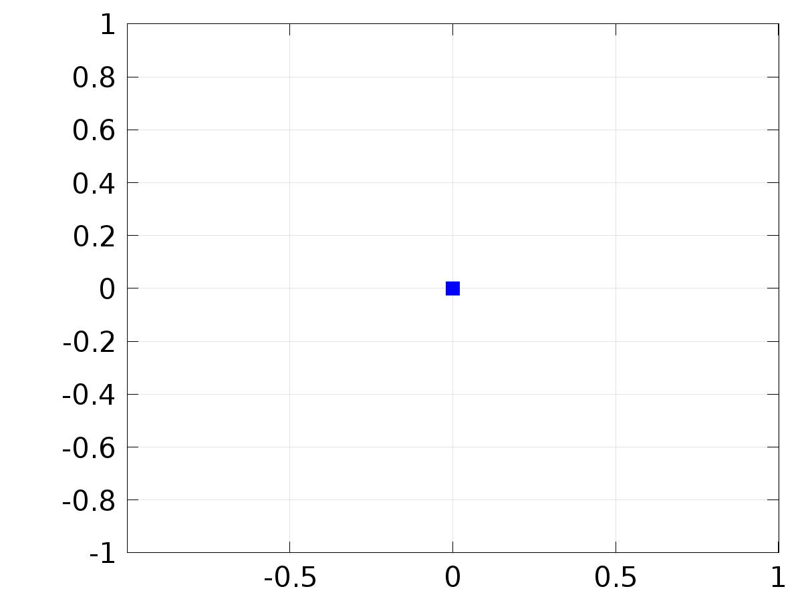

* + 1. Velocity (spf)

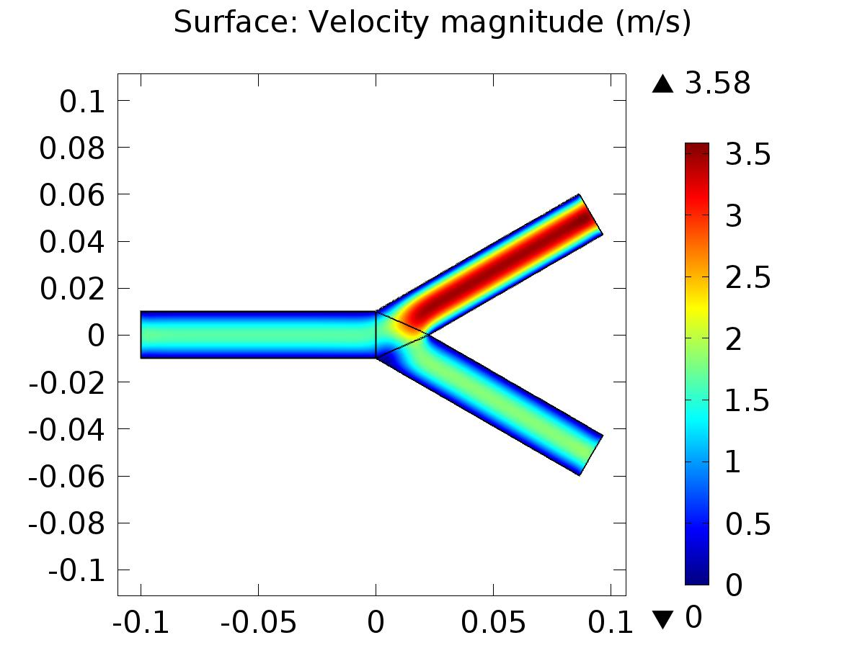

Surface: Velocity magnitude (m/s)

* + 1. Pressure (spf)

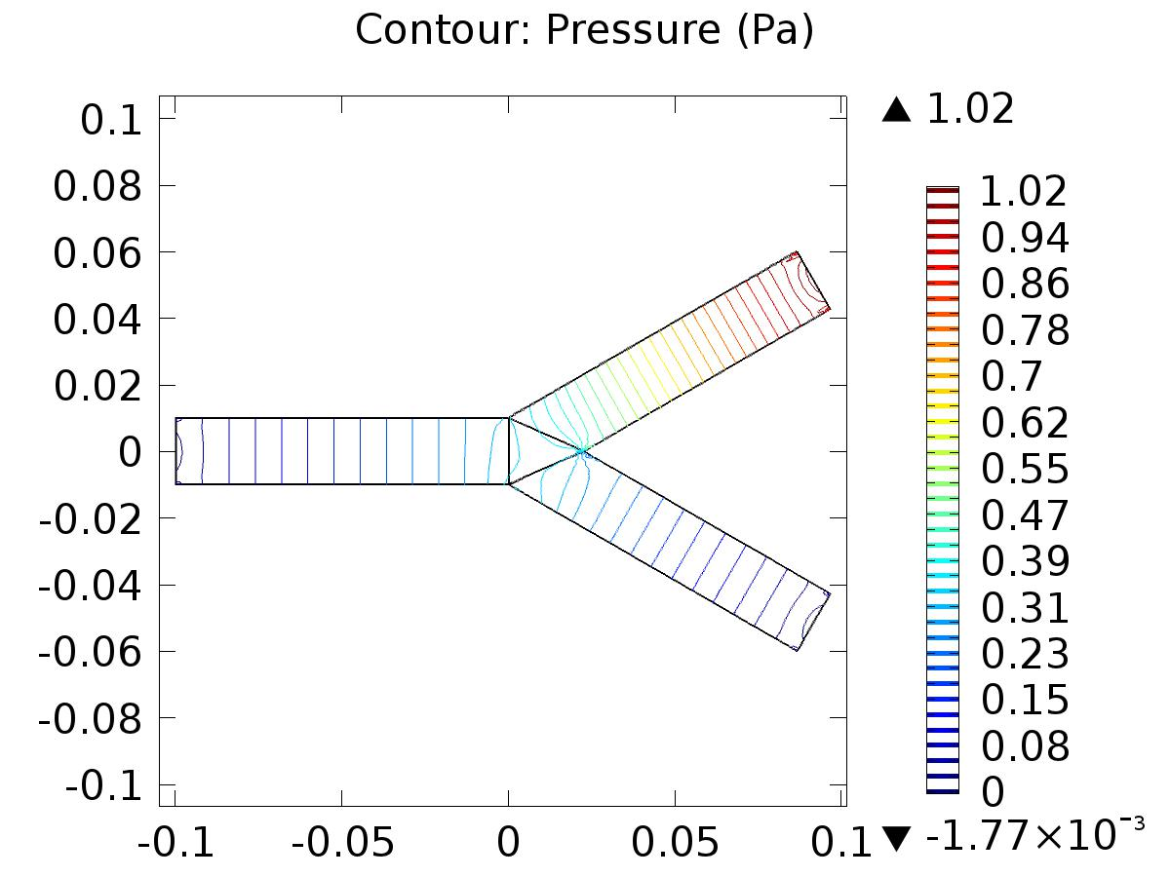

Contour: Pressure (Pa)

* + 1. Velocity (spf2)

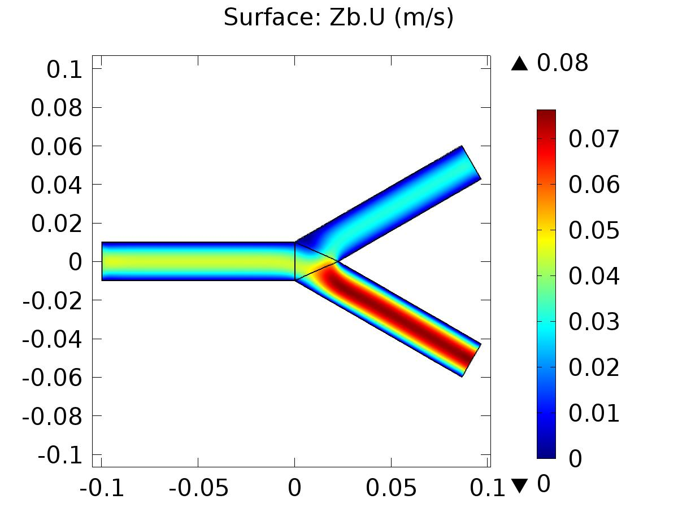

Surface: Zb.U (m/s)

* + 1. Pressure (spf2)

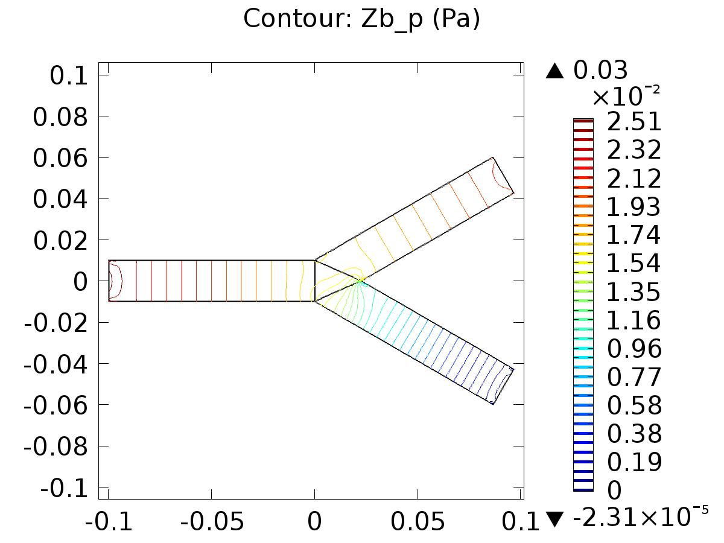

Contour: Zb_p (Pa)

* + 1. Velocity (spf4)

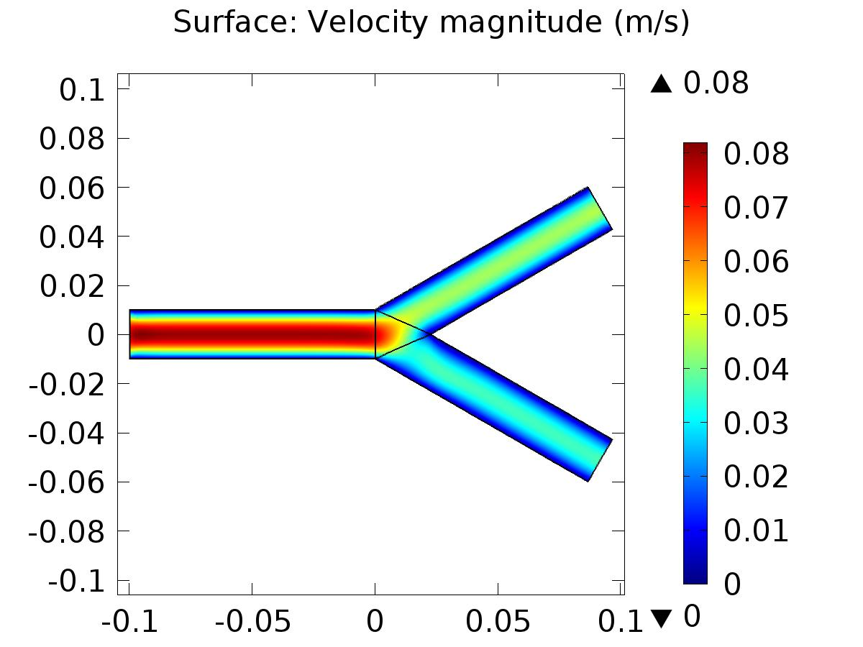

Surface: Velocity magnitude (m/s)

* + 1. Pressure (spf4)

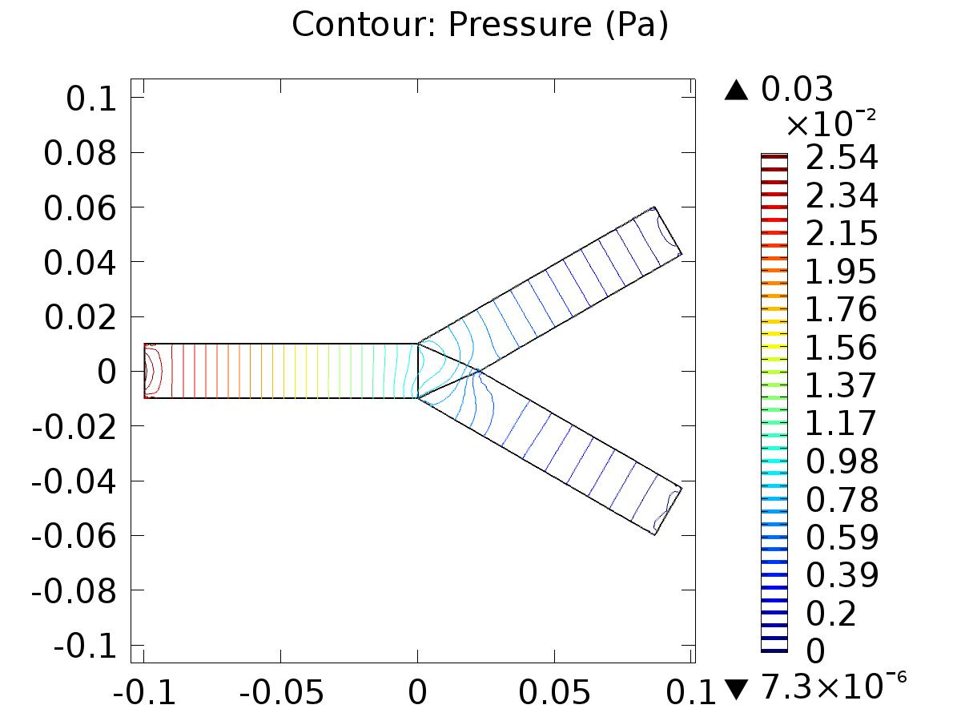

Contour: Pressure (Pa)

* + 1. Velocity (phys1)

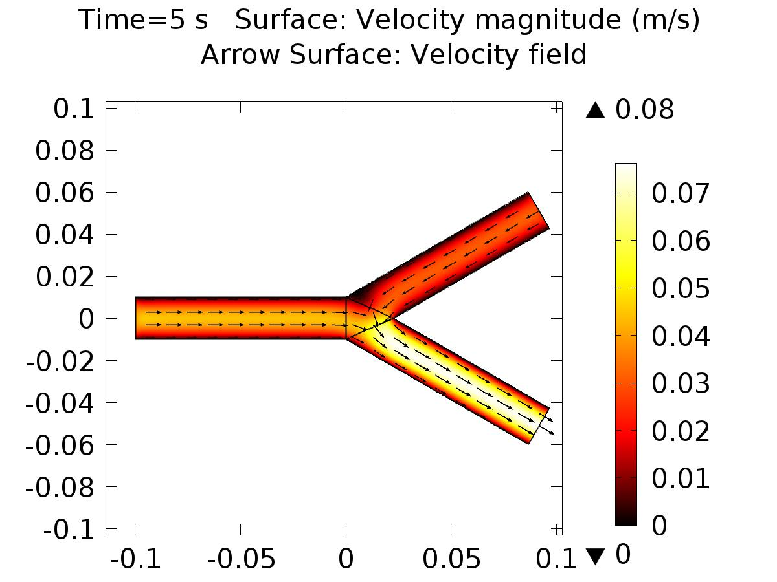

Time=5 s Surface: Velocity magnitude (m/s) Arrow Surface: Velocity field

* + 1. Pressure (phys1)

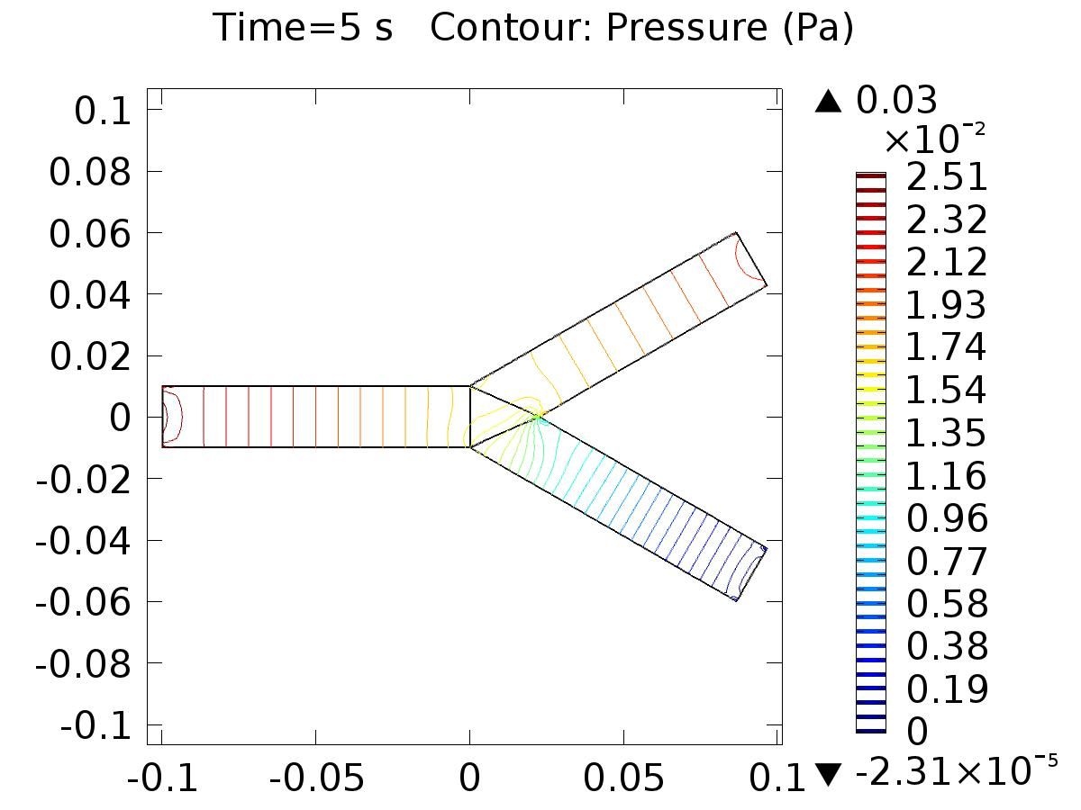

Time=5 s Contour: Pressure (Pa)

* + 1. 1D Plot Group 20

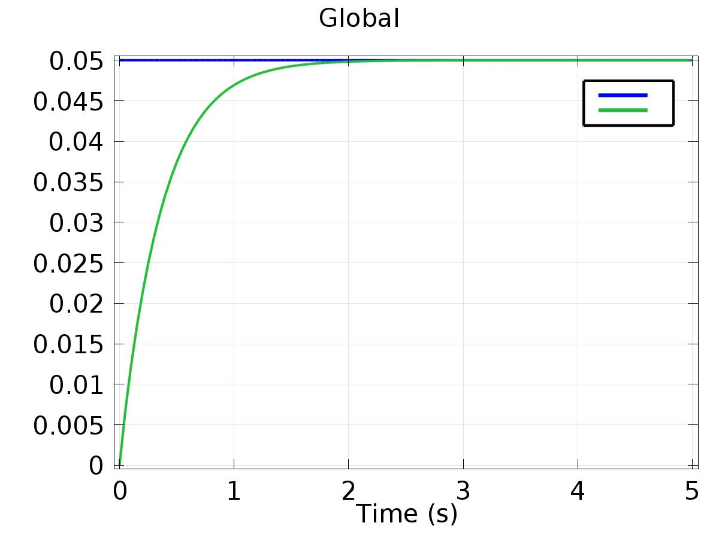

Global

* + 1. 1D Plot Group 21

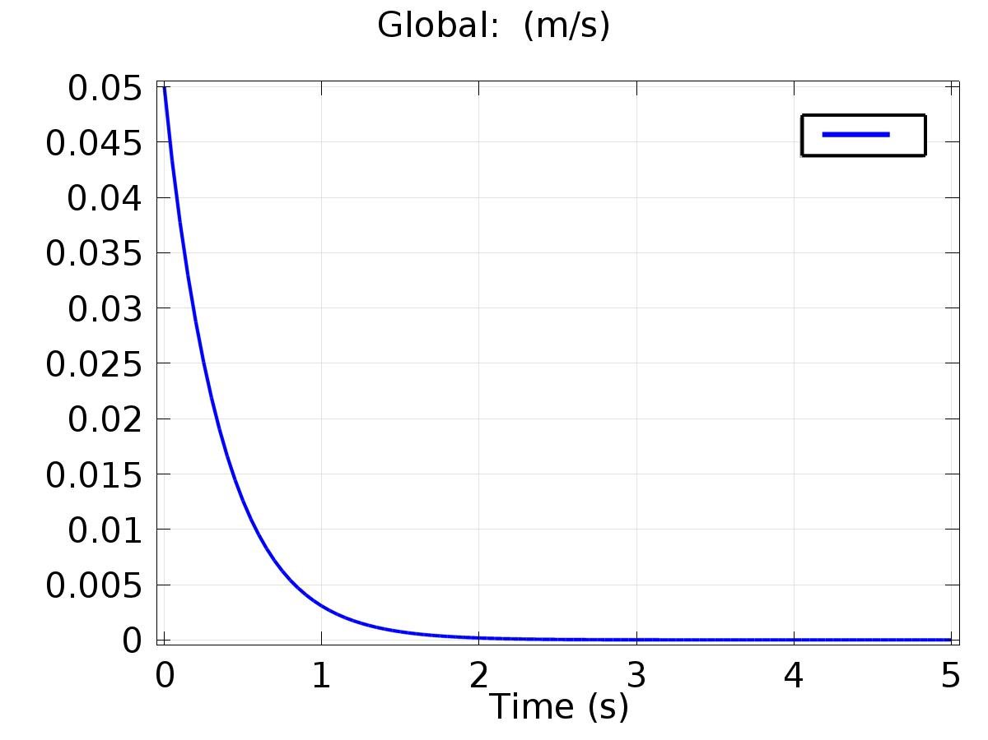

Global: (m/s)