[](http://www.comsol.com/)

Ex5.2.1 NonIsothermal Navies-Stokes Flows temp

|  |  |
| --- | --- |
| Date | Aug 22, 2014 1:44:28 PM |

Contents

1. Global

1.1. Definitions

2. Component 1

2.1. Definitions

2.2. Geometry 1

2.3. Steady Flow

2.4. Unit Input

2.5. Set Point Flow

2.6. Set Point Temperature

2.7. Closed Loop Flow

2.8. Closed Loop Temperature

2.9. Mesh 1

3. Study 1

3.1. Stationary

3.2. Solver Configurations

4. Study 2

4.1. Stationary

4.2. Solver Configurations

5. Study 3

5.1. Time Dependent

5.2. Solver Configurations

6. Results

6.1. Data Sets

6.2. Derived Values

6.3. Tables

6.4. Plot Groups

1. Global

|  |  |
| --- | --- |
| Date | Jul 20, 2014 8:34:26 AM |

Global settings

|  |  |
| --- | --- |
| Name | Ex5.2.1 NonIsothermal Navies-Stokes Flows temp.mph |
| Path | /Users/gilliam/Desktop/collect_15/research_15/geo_reg_mono_eugenio/Mono_1_15/Comsol_EX_GitHub/Chapter5/Chap5Ex2_Non-Isothermal-Navier-Stokes-Flow/Ex5.2.1_setpoint/Ex5.2.1_NonIsothermal_Navies-Stokes_Flows_temp.mph |
| Program | COMSOL 4.4 (Build: 150) |

Used products

|  |
| --- |
| COMSOL Multiphysics |

* 1. Definitions
     1. Parameters 1

Parameters

| **Name** | **Expression** | **Value** | **Description** |
| --- | --- | --- | --- |
| L | 1 | 1.0000 |  |
| H | 0.1 | 0.10000 |  |
| ni | 0.002 | 0.0020000 |  |
| alpha | 0.01 | 0.010000 |  |
| beta | 1 | 1.0000 |  |

1. Component 1

Component settings

|  |  |
| --- | --- |
| Unit system | None |

* 1. Definitions
     1. Variables

#### Variables 1a

Selection

|  |  |
| --- | --- |
| Geometric entity level | Entire model |

| **Name** | **Expression** | **Description** |
| --- | --- | --- |
| G | C(X) |  |
| yr | 0.5 |  |
| d | 1 |  |
| gamma | (yr - C(tT))/G |  |
| e | yr - C(T) |  |

* + 1. Component Couplings

#### Average 1

|  |  |
| --- | --- |
| Coupling type | Average |
| Operator name | C |

Source selection

|  |  |
| --- | --- |
| Geometric entity level | Domain |
| Selection | Domain 9 |

* + 1. Coordinate Systems

#### Boundary System 1

|  |  |
| --- | --- |
| Coordinate system type | Boundary system |
| Tag | sys1 |

Coordinate names

| **First (t1)** | **Second (n)** | **Third (to)** |
| --- | --- | --- |
| t1 | n | to |

Settings

| **Description** | **Value** |
| --- | --- |
| Create first tangent direction from | Global Cartesian |

* 1. Geometry 1

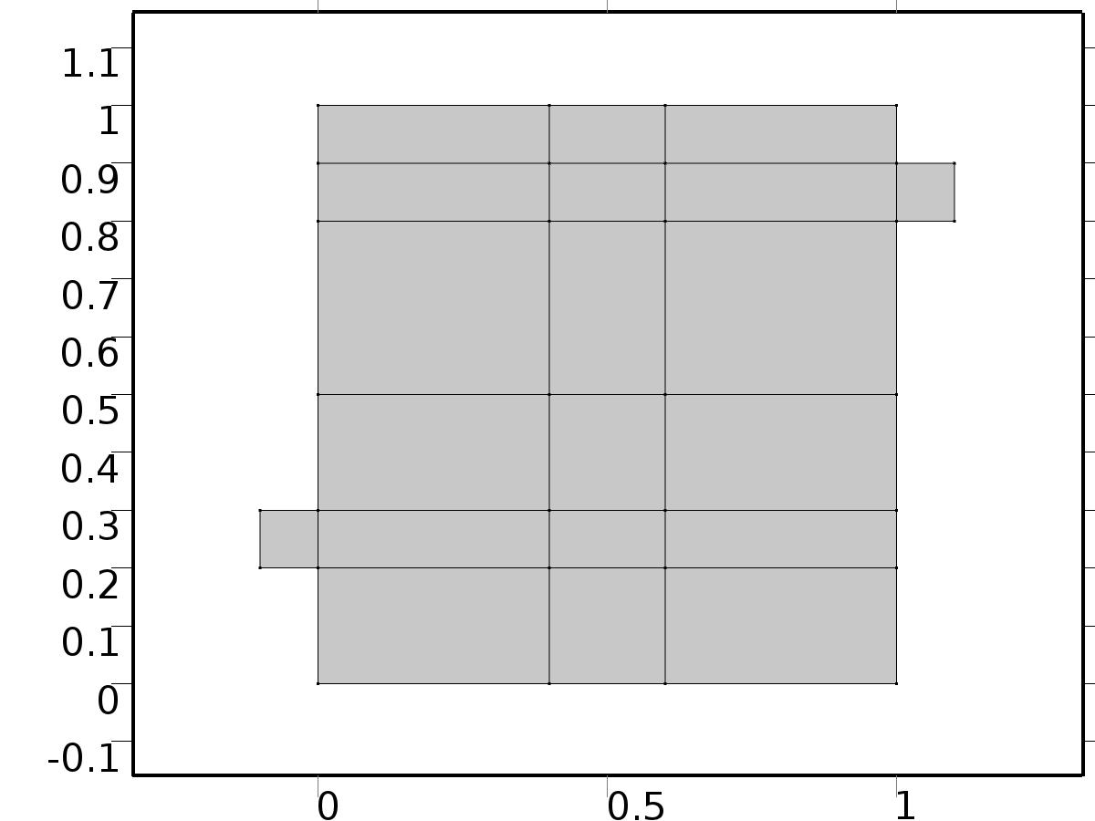

Geometry 1

Units

|  |  |
| --- | --- |
| Length unit | m |
| Angular unit | deg |

Geometry statistics

| **Description** | **Value** |
| --- | --- |
| Space dimension | 2 |
| Number of domains | 20 |
| Number of boundaries | 51 |
| Number of vertices | 32 |

* + 1. Square 1 (sq1)

Position

| **Description** | **Value** |
| --- | --- |
| Position | {0, 0} |
| Layers |  |

Size

| **Description** | **Value** |
| --- | --- |
| Side length | L |

* + 1. Rectangle 1 (r1)

Position

| **Description** | **Value** |
| --- | --- |
| Position | {-H, 2*H} |
| Layers |  |

Size

| **Description** | **Value** |
| --- | --- |
| Width | L + H |
| Height | H |

* + 1. Rectangle 2 (r2)

Position

| **Description** | **Value** |
| --- | --- |
| Position | {0, L - 2*H} |
| Layers |  |

Size

| **Description** | **Value** |
| --- | --- |
| Width | L + H |
| Height | H |

* + 1. Rectangle 3 (r3)

Position

| **Description** | **Value** |
| --- | --- |
| Position | {4*H, 0} |
| Layers |  |

Size

| **Description** | **Value** |
| --- | --- |
| Width | 2*H |
| Height | L |

* + 1. Rectangle 4 (r4)

Position

| **Description** | **Value** |
| --- | --- |
| Position | {0, 3*H} |
| Layers |  |

Size

| **Description** | **Value** |
| --- | --- |
| Width | L |
| Height | 2*H |

* 1. Steady Flow

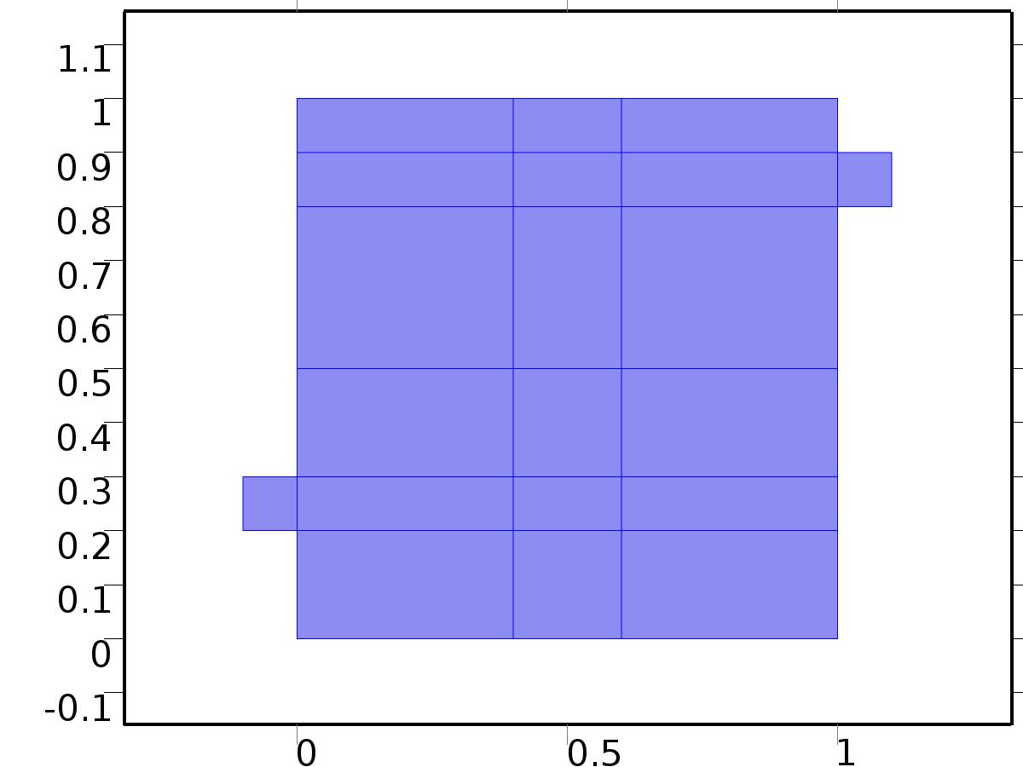

Steady Flow

Selection

|  |  |
| --- | --- |
| Geometric entity level | Domain |
| Selection | Domains 1–20 |

Equations









Settings

| **Description** | **Value** |
| --- | --- |
| Discretization of fluids | P2 + P1 |
| Value type when using splitting of complex variables | {Real, Real, Real, Real, Real, Real, Real, Real, Real, Real, Real} |
| Isotropic diffusion | Off |
| Compressibility | Incompressible flow |
| Channel thickness | 1 |
| Turbulence model type | None |
| Reference pressure level | 1[atm] |
| Use pseudo time stepping for stationary equation form | Off |
| Local CFL number | 1.3^min(niterCMP, 9) + if(niterCMP>=25, 9*1.3^min(niterCMP - 25, 9), 0) + if(niterCMP>=45, 90*1.3^min(niterCMP - 45, 9), 0) |
| Streamline diffusion | Off |
| Crosswind diffusion | Off |

Used products

|  |
| --- |
| COMSOL Multiphysics |

Variables

| **Name** | **Expression** | **Unit** | **Description** | **Selection** |
| --- | --- | --- | --- | --- |
| V.dz | 1 |  | Thickness | Domains 1–20 |
| V.pref | 1[atm] |  | Reference pressure level | Domains 1–20 |
| V.pA | P+V.pref |  | Absolute pressure | Domains 1–20 |
| V.nx | nx |  | Normal vector, x component | Boundaries 6–7, 9, 11, 13, 15, 17, 19–28, 30, 32–41, 47 |
| V.ny | ny |  | Normal vector, y component | Boundaries 6–7, 9, 11, 13, 15, 17, 19–28, 30, 32–41, 47 |
| V.nz | 0 |  | Normal vector, z component | Boundaries 6–7, 9, 11, 13, 15, 17, 19–28, 30, 32–41, 47 |
| V.nx | dnx |  | Normal vector, x component | Boundaries 1–5, 8, 10, 12, 14, 16, 18, 29, 31, 42–46, 48–51 |
| V.ny | dny |  | Normal vector, y component | Boundaries 1–5, 8, 10, 12, 14, 16, 18, 29, 31, 42–46, 48–51 |
| V.nz | 0 |  | Normal vector, z component | Boundaries 1–5, 8, 10, 12, 14, 16, 18, 29, 31, 42–46, 48–51 |
| V.nxmesh | root.nxmesh |  | Normal vector, x component | Boundaries 6–7, 9, 11, 13, 15, 17, 19–28, 30, 32–41, 47 |
| V.nymesh | root.nymesh |  | Normal vector, y component | Boundaries 6–7, 9, 11, 13, 15, 17, 19–28, 30, 32–41, 47 |
| V.nzmesh | 0 |  | Normal vector, z component | Boundaries 6–7, 9, 11, 13, 15, 17, 19–28, 30, 32–41, 47 |
| V.nxmesh | root.dnxmesh |  | Normal vector, x component | Boundaries 1–5, 8, 10, 12, 14, 16, 18, 29, 31, 42–46, 48–51 |
| V.nymesh | root.dnymesh |  | Normal vector, y component | Boundaries 1–5, 8, 10, 12, 14, 16, 18, 29, 31, 42–46, 48–51 |
| V.nzmesh | 0 |  | Normal vector, z component | Boundaries 1–5, 8, 10, 12, 14, 16, 18, 29, 31, 42–46, 48–51 |

* + 1. Fluid Properties



Fluid Properties

Selection

|  |  |
| --- | --- |
| Geometric entity level | Domain |
| Selection | Domains 1–20 |

Equations

Settings

| **Description** | **Value** |
| --- | --- |
| Density | User defined |
| Density | 1 |
| Dynamic viscosity | User defined |
| Dynamic viscosity | ni |

#### Variables

| **Name** | **Expression** | **Unit** | **Description** | **Selection** |
| --- | --- | --- | --- | --- |
| V.rho | 1 |  | Density | Domains 1–20 |
| V.mu | ni |  | Dynamic viscosity | Domains 1–20 |
| V.sr | sqrt(0.5*(4*Ux^2+2*(Uy+Vx)^2+4*Vy^2)+eps) |  | Shear rate | Domains 1–20 |
| V.divu | Ux+Vy |  | Divergence of velocity field | Domains 1–20 |
| V.Fx | 0 |  | Volume force, x component | Domains 1–20 |
| V.Fy | 0 |  | Volume force, y component | Domains 1–20 |
| V.Fz | 0 |  | Volume force, z component | Domains 1–20 |
| V.U | sqrt(U^2+V^2) |  | Velocity magnitude | Domains 1–20 |
| V.vorticityx | 0 |  | Vorticity field, x component | Domains 1–20 |
| V.vorticityy | 0 |  | Vorticity field, y component | Domains 1–20 |
| V.vorticityz | Vx-Uy |  | Vorticity field, z component | Domains 1–20 |
| V.vort_magn | sqrt(V.vorticityx^2+V.vorticityy^2+V.vorticityz^2) |  | Vorticity magnitude | Domains 1–20 |
| V.cellRe | 0.25*V.rho*sqrt(emetric(U,V)/emetric2)/V.mu |  | Cell Reynolds number | Domains 1–20 |
| V.nu | V.mu/V.rho |  | Kinematic viscosity | Domains 1–20 |
| V.betaT | 0 |  | Isothermal compressibility coefficient | Domains 1–20 |
| V.mu_eff | V.mu+V.muT |  | Dynamic viscosity | Domains 1–20 |
| V.muT | 0 |  | Turbulent dynamic viscosity | Domains 1–20 |
| V.T_stressx | V.K_stressx-P*V.nxmesh |  | Total stress, x component | Boundaries 1–51 |
| V.T_stressy | V.K_stressy-P*V.nymesh |  | Total stress, y component | Boundaries 1–51 |
| V.T_stressz | V.K_stressz-P*V.nzmesh |  | Total stress, z component | Boundaries 1–51 |
| V.K_stressx | V.mu_eff*(2*Ux*V.nxmesh+(Uy+Vx)*V.nymesh) |  | Viscous stress, x component | Boundaries 1–51 |
| V.K_stressy | V.mu_eff*((Vx+Uy)*V.nxmesh+2*Vy*V.nymesh) |  | Viscous stress, y component | Boundaries 1–51 |
| V.K_stressz | 0 |  | Viscous stress, z component | Boundaries 1–51 |
| V.K_stress_tensorxx | 2*V.mu_eff*Ux |  | Viscous stress tensor, xx component | Domains 1–20 |
| V.K_stress_tensoryx | V.mu_eff*(Vx+Uy) |  | Viscous stress tensor, yx component | Domains 1–20 |
| V.K_stress_tensorzx | 0 |  | Viscous stress tensor, zx component | Domains 1–20 |
| V.K_stress_tensorxy | V.mu_eff*(Uy+Vx) |  | Viscous stress tensor, xy component | Domains 1–20 |
| V.K_stress_tensoryy | 2*V.mu_eff*Vy |  | Viscous stress tensor, yy component | Domains 1–20 |
| V.K_stress_tensorzy | 0 |  | Viscous stress tensor, zy component | Domains 1–20 |
| V.K_stress_tensorxz | 0 |  | Viscous stress tensor, xz component | Domains 1–20 |
| V.K_stress_tensoryz | 0 |  | Viscous stress tensor, yz component | Domains 1–20 |
| V.K_stress_tensorzz | 0 |  | Viscous stress tensor, zz component | Domains 1–20 |
| V.K_stress_tensor_testxx | 2*V.mu_eff*test(Ux) |  | Viscous stress tensor test, xx component | Domains 1–20 |
| V.K_stress_tensor_testyx | V.mu_eff*(test(Vx)+test(Uy)) |  | Viscous stress tensor test, yx component | Domains 1–20 |
| V.K_stress_tensor_testzx | 0 |  | Viscous stress tensor test, zx component | Domains 1–20 |
| V.K_stress_tensor_testxy | V.mu_eff*(test(Uy)+test(Vx)) |  | Viscous stress tensor test, xy component | Domains 1–20 |
| V.K_stress_tensor_testyy | 2*V.mu_eff*test(Vy) |  | Viscous stress tensor test, yy component | Domains 1–20 |
| V.K_stress_tensor_testzy | 0 |  | Viscous stress tensor test, zy component | Domains 1–20 |
| V.K_stress_tensor_testxz | 0 |  | Viscous stress tensor test, xz component | Domains 1–20 |
| V.K_stress_tensor_testyz | 0 |  | Viscous stress tensor test, yz component | Domains 1–20 |
| V.K_stress_tensor_testzz | 0 |  | Viscous stress tensor test, zz component | Domains 1–20 |
| V.upwind_helpx | U |  | Upwind term, x component | Domains 1–20 |
| V.upwind_helpy | V |  | Upwind term, y component | Domains 1–20 |
| V.upwind_helpz | 0 |  | Upwind term, z component | Domains 1–20 |
| V.tau_vdxx | 2*V.mu*Ux |  | Strain rate, xx component | Domains 1–20 |
| V.tau_vdyx | V.mu*(Vx+Uy) |  | Strain rate, yx component | Domains 1–20 |
| V.tau_vdzx | 0 |  | Strain rate, zx component | Domains 1–20 |
| V.tau_vdxy | V.mu*(Uy+Vx) |  | Strain rate, xy component | Domains 1–20 |
| V.tau_vdyy | 2*V.mu*Vy |  | Strain rate, yy component | Domains 1–20 |
| V.tau_vdzy | 0 |  | Strain rate, zy component | Domains 1–20 |
| V.tau_vdxz | 0 |  | Strain rate, xz component | Domains 1–20 |
| V.tau_vdyz | 0 |  | Strain rate, yz component | Domains 1–20 |
| V.tau_vdzz | 0 |  | Strain rate, zz component | Domains 1–20 |
| V.Qvd | V.tau_vdxx*Ux+V.tau_vdxy*Uy+V.tau_vdyx*Vx+V.tau_vdyy*Vy |  | Viscous dissipation | Domains 1–20 |

#### Shape functions

| **Name** | **Shape function** | **Unit** | **Description** | **Shape frame** | **Selection** |
| --- | --- | --- | --- | --- | --- |
| U | Lagrange (Quadratic) |  | Velocity field, x component | Material | Domains 1–20 |
| V | Lagrange (Quadratic) |  | Velocity field, y component | Material | Domains 1–20 |
| P | Lagrange (Linear) |  | Pressure | Material | Domains 1–20 |

#### Weak expressions

| **Weak expression** | **Integration frame** | **Selection** |
| --- | --- | --- |
| (P-V.K_stress_tensorxx)*test(Ux)-V.K_stress_tensorxy*test(Uy)-V.K_stress_tensoryx*test(Vx)+(P-V.K_stress_tensoryy)*test(Vy) | Material | Domains 1–20 |
| V.Fx*test(U)+V.Fy*test(V) | Material | Domains 1–20 |
| V.rho*(-(Ux*U+Uy*V)*test(U)-(Vx*U+Vy*V)*test(V)) | Material | Domains 1–20 |
| -V.rho*V.divu*test(P) | Material | Domains 1–20 |

* + 1. Wall

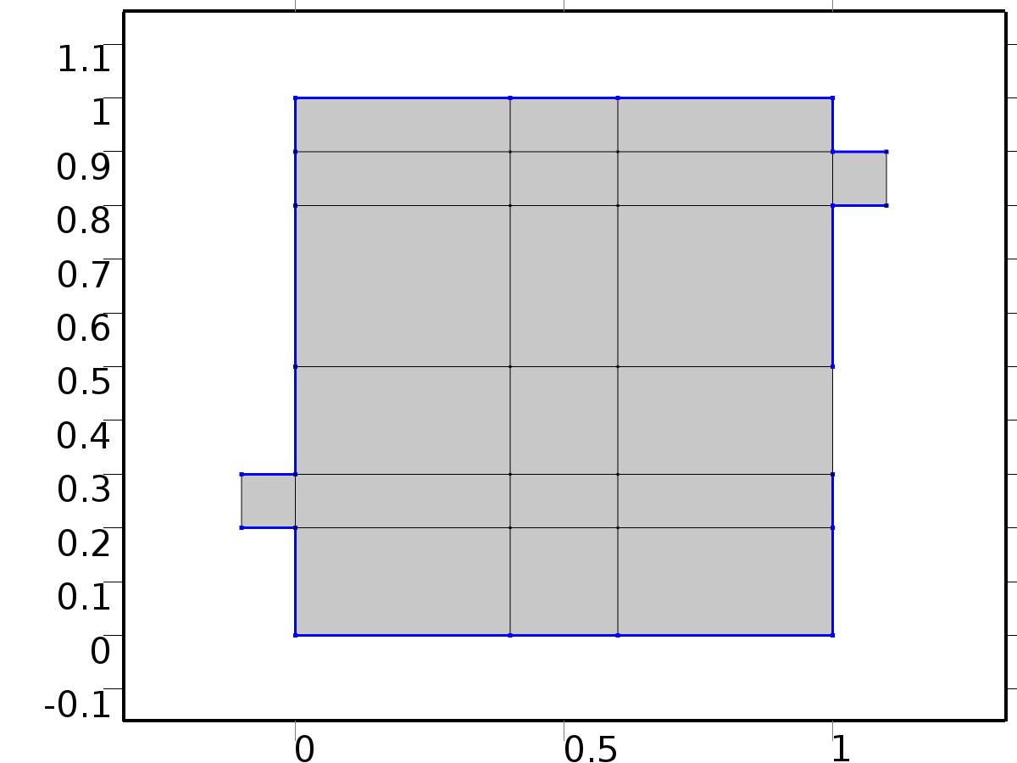

Wall

Selection

|  |  |
| --- | --- |
| Geometric entity level | Boundary |
| Selection | Boundaries 2–5, 8, 10, 12, 14, 16, 18, 29, 31, 42–44, 46, 48–50 |

Equations

Settings

| **Description** | **Value** |
| --- | --- |
| Boundary condition | No slip |
| Apply reaction terms on | Individual dependent variables |
| Use weak constraints | Off |
| Constraint method | Elemental |

#### Variables

| **Name** | **Expression** | **Unit** | **Description** | **Selection** |
| --- | --- | --- | --- | --- |
| V.ubndx | 0 |  | Velocity at boundary, x component | Boundaries 2–5, 8, 10, 12, 14, 16, 18, 29, 31, 42–44, 46, 48–50 |
| V.ubndy | 0 |  | Velocity at boundary, y component | Boundaries 2–5, 8, 10, 12, 14, 16, 18, 29, 31, 42–44, 46, 48–50 |
| V.ubndz | 0 |  | Velocity at boundary, z component | Boundaries 2–5, 8, 10, 12, 14, 16, 18, 29, 31, 42–44, 46, 48–50 |

#### Shape functions

| **Constraint** | **Constraint force** | **Shape function** | **Selection** |
| --- | --- | --- | --- |
| -U+V.ubndx | test(-U) | Lagrange (Quadratic) | Boundaries 2–5, 8, 10, 12, 14, 16, 18, 29, 31, 42–44, 46, 48–50 |
| -V+V.ubndy | test(-V) | Lagrange (Quadratic) | Boundaries 2–5, 8, 10, 12, 14, 16, 18, 29, 31, 42–44, 46, 48–50 |
| V.ubndz | 0 |  | Boundaries 2–5, 8, 10, 12, 14, 16, 18, 29, 31, 42–44, 46, 48–50 |

* + 1. Initial Values



Initial Values

Selection

|  |  |
| --- | --- |
| Geometric entity level | Domain |
| Selection | Domains 1–20 |

Settings

| **Description** | **Value** |
| --- | --- |
| Turbulent kinetic energy | spf.kinit |
| Turbulent dissipation rate | spf.epinit |
| Specific dissipation rate | spf.omInit |
| Reciprocal wall distance | spf.G0 |
| Undamped turbulent kinematic viscosity | spf.nutildeinit |
| Velocity field | {0, 0, 0} |
| Pressure | 0 |

* + 1. Inlet

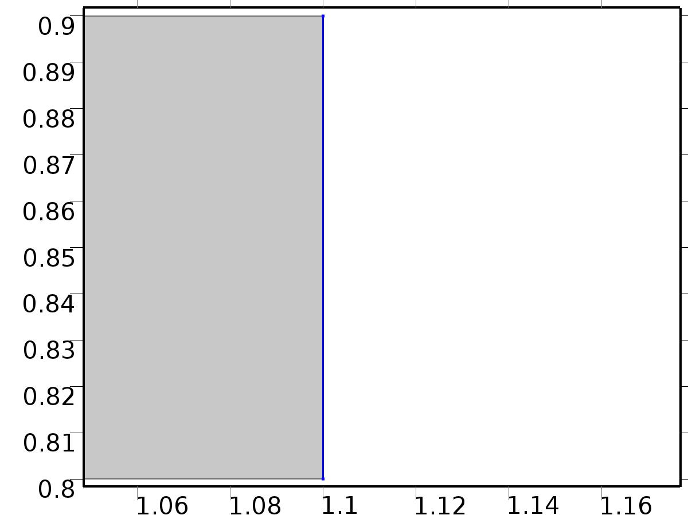

Inlet

Selection

|  |  |
| --- | --- |
| Geometric entity level | Boundary |
| Selection | Boundary 51 |

Equations

Settings

| **Description** | **Value** |
| --- | --- |
| Apply reaction terms on | All physics (symmetric) |
| Use weak constraints | Off |
| Boundary condition | Velocity |
| Velocity field componentwise | Normal inflow velocity |
| Normal inflow velocity | 4*s*(1 - s) |
| Turbulent intensity | 0.05 |
| Turbulence length scale | 0.01[m] |
| Turbulent kinetic energy | 0.005[m^2/s^2] |
| Turbulent dissipation rate | 0.005[m^2/s^3] |
| Specific dissipation rate | 20[1/s] |
| Undamped turbulent kinematic viscosity | 3*spf.nu |
| Constraint method | Elemental |

#### Variables

| **Name** | **Expression** | **Unit** | **Description** | **Selection** |
| --- | --- | --- | --- | --- |
| V.ubndx | -nojac(V.nxmesh)*V.U0in |  | Velocity at boundary, x component | Boundary 51 |
| V.ubndy | -nojac(V.nymesh)*V.U0in |  | Velocity at boundary, y component | Boundary 51 |
| V.ubndz | -nojac(V.nzmesh)*V.U0in |  | Velocity at boundary, z component | Boundary 51 |
| V.U0in | 4*s*(1-s) |  | Normal inflow velocity | Boundary 51 |

#### Shape functions

| **Constraint** | **Constraint force** | **Shape function** | **Selection** |
| --- | --- | --- | --- |
| -U+V.ubndx | test(-U+V.ubndx) | Lagrange (Quadratic) | Boundary 51 |
| -V+V.ubndy | test(-V+V.ubndy) | Lagrange (Quadratic) | Boundary 51 |
| V.ubndz | test(V.ubndz) |  | Boundary 51 |

* + 1. Outflow

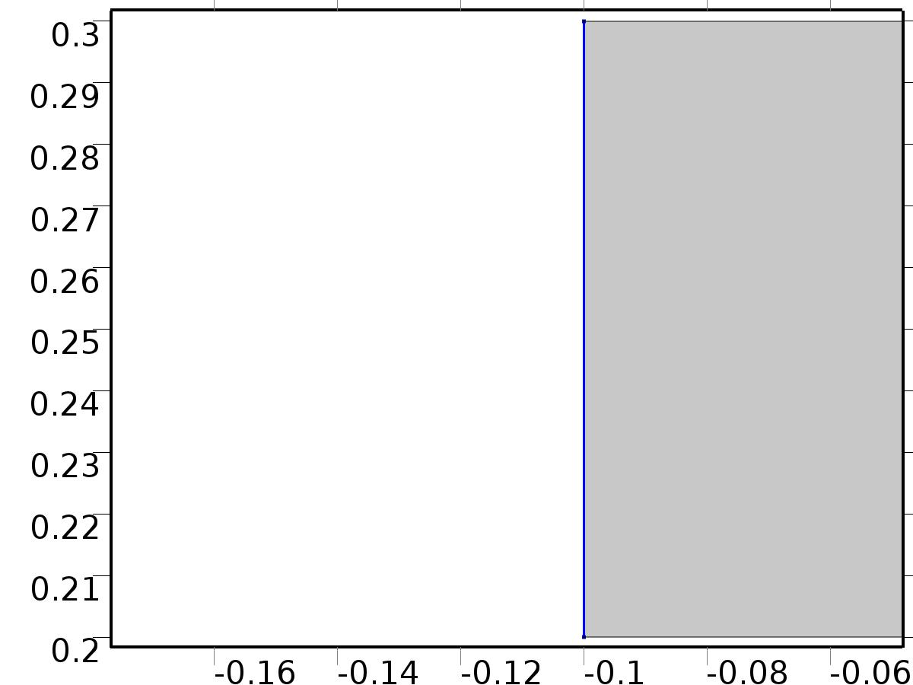

Outflow

Selection

|  |  |
| --- | --- |
| Geometric entity level | Boundary |
| Selection | Boundary 1 |

Equations

Settings

| **Description** | **Value** |
| --- | --- |
| Boundary condition | Normal stress |
| Normal stress | 0 |
| Turbulent intensity | 0.005 |
| Turbulence length scale | 0.1[m] |
| Turbulent kinetic energy | 2.5e-3[m^2/s^2] |
| Turbulent dissipation rate | 1.1e-4[m^2/s^3] |
| Specific dissipation rate | 0.5[1/s] |
| Undamped turbulent kinematic viscosity | 3*spf.nu |

#### Variables

| **Name** | **Expression** | **Unit** | **Description** | **Selection** |
| --- | --- | --- | --- | --- |
| V.f0 | 0 |  | Normal stress | Boundary 1 |

#### Weak expressions

| **Weak expression** | **Integration frame** | **Selection** |
| --- | --- | --- |
| -V.f0*(test(U)*V.nxmesh+test(V)*V.nymesh) | Material | Boundary 1 |

* + 1. Window

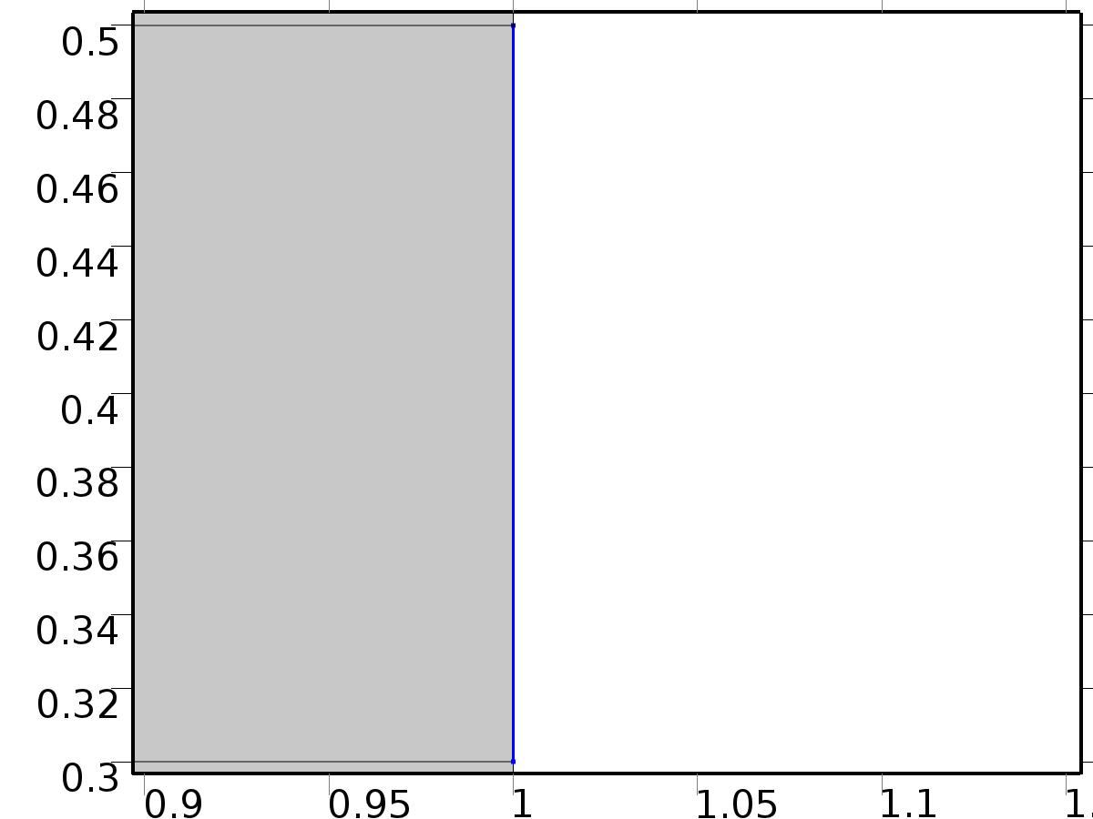

Window

Selection

|  |  |
| --- | --- |
| Geometric entity level | Boundary |
| Selection | Boundary 45 |

Equations

Settings

| **Description** | **Value** |
| --- | --- |
| Boundary condition | No slip |
| Apply reaction terms on | Individual dependent variables |
| Use weak constraints | Off |
| Constraint method | Elemental |

#### Variables

| **Name** | **Expression** | **Unit** | **Description** | **Selection** |
| --- | --- | --- | --- | --- |
| V.ubndx | 0 |  | Velocity at boundary, x component | Boundary 45 |
| V.ubndy | 0 |  | Velocity at boundary, y component | Boundary 45 |
| V.ubndz | 0 |  | Velocity at boundary, z component | Boundary 45 |

#### Shape functions

| **Constraint** | **Constraint force** | **Shape function** | **Selection** |
| --- | --- | --- | --- |
| -U+V.ubndx | test(-U) | Lagrange (Quadratic) | Boundary 45 |
| -V+V.ubndy | test(-V) | Lagrange (Quadratic) | Boundary 45 |
| V.ubndz | 0 |  | Boundary 45 |

* 1. Unit Input



Unit Input

Selection

|  |  |
| --- | --- |
| Geometric entity level | Domain |
| Selection | Domains 1–20 |

Settings

| **Description** | **Value** |
| --- | --- |
| Shape function type | Lagrange |
| Element order | Quadratic |
| Compute boundary fluxes | On |
| Apply smoothing to boundary fluxes | On |
| Value type when using splitting of complex variables | Complex |
| Dependent variable quantity | Dimensionless (1) |
| Source term quantity | None |
| Unit | m^ - 2 |

Used products

|  |
| --- |
| COMSOL Multiphysics |

Variables

| **Name** | **Expression** | **Unit** | **Description** | **Selection** |
| --- | --- | --- | --- | --- |
| X.nx | nx |  | Normal vector, x component | Boundaries 1–51 |
| X.ny | ny |  | Normal vector, y component | Boundaries 1–51 |
| X.nz | root.nz |  | Normal vector, z component | Boundaries 1–51 |
| X.nxmesh | root.nxmesh |  | Normal vector (mesh), x component | Boundaries 1–51 |
| X.nymesh | root.nymesh |  | Normal vector (mesh), y component | Boundaries 1–51 |
| X.nzmesh | root.nzmesh |  | Normal vector (mesh), z component | Boundaries 1–51 |

* + 1. Coefficient Form PDE



Coefficient Form PDE

Selection

|  |  |
| --- | --- |
| Geometric entity level | Domain |
| Selection | Domains 1–20 |

Equations

Settings

| **Description** | **Value** |
| --- | --- |
| Diffusion coefficient | {{alpha, 0}, {0, alpha}} |
| Absorption coefficient | 0 |
| Source term | 0 |
| Mass coefficient | 0 |
| Damping or mass coefficient | 0 |
| Conservative flux convection coefficient | {0, 0} |
| Convection coefficient | {U, V} |
| Conservative flux source | {0, 0} |

#### Variables

| **Name** | **Expression** | **Unit** | **Description** | **Selection** |
| --- | --- | --- | --- | --- |
| domflux.Xx | -alpha*d(X,x) |  | Domain flux, x component | Domains 1–20 |
| domflux.Xy | -alpha*d(X,y) |  | Domain flux, y component | Domains 1–20 |

#### Shape functions

| **Name** | **Shape function** | **Unit** | **Description** | **Shape frame** | **Selection** |
| --- | --- | --- | --- | --- | --- |
| X | Lagrange (Quadratic) |  | Dependent variable X | Material | Domains 1–20 |

* + 1. Insulated Wall



Insulated Wall

Selection

|  |  |
| --- | --- |
| Geometric entity level | Boundary |
| Selection | Boundaries 2–5, 8, 10, 12, 14, 16, 18, 29, 31, 42–44, 46, 48–50 |

Equations

* + 1. Initial Values



Initial Values

Selection

|  |  |
| --- | --- |
| Geometric entity level | Domain |
| Selection | Domains 1–20 |

Settings

| **Description** | **Value** |
| --- | --- |
| Initial value for X | 0 |
| Initial time derivative of X | 0 |

* + 1. Heat Flux Bin*1



Heat Flux Bin*1

Selection

|  |  |
| --- | --- |
| Geometric entity level | Boundary |
| Selection | Boundary 51 |

Equations

Settings

| **Description** | **Value** |
| --- | --- |
| Boundary flux/source | 1 |
| Boundary absorption/impedance term | 0 |

#### Variables

| **Name** | **Expression** | **Unit** | **Description** | **Selection** |
| --- | --- | --- | --- | --- |
| X.g_X | 1 |  | Boundary flux/source | Boundary 51 |

* + 1. Outflow



Outflow

Selection

|  |  |
| --- | --- |
| Geometric entity level | Boundary |
| Selection | Boundary 1 |

Equations

* + 1. Window



Window

Selection

|  |  |
| --- | --- |
| Geometric entity level | Boundary |
| Selection | Boundary 45 |

Equations

Settings

| **Description** | **Value** |
| --- | --- |
| Value on boundary | 0 |
| Prescribed value of X | On |
| Apply reaction terms on | Individual dependent variables |
| Use weak constraints | Off |
| Constraint method | Elemental |

#### Shape functions

| **Constraint** | **Constraint force** | **Shape function** | **Selection** |
| --- | --- | --- | --- |
| -X | -test(X) | Lagrange (Quadratic) | Boundary 45 |

* 1. Set Point Flow



Set Point Flow

Selection

|  |  |
| --- | --- |
| Geometric entity level | Domain |
| Selection | Domains 1–20 |

Equations









Settings

| **Description** | **Value** |
| --- | --- |
| Discretization of fluids | P2 + P1 |
| Value type when using splitting of complex variables | {Real, Real, Real, Real, Real, Real, Real, Real, Real, Real, Real} |
| Isotropic diffusion | Off |
| Compressibility | Incompressible flow |
| Channel thickness | 1 |
| Turbulence model type | None |
| Reference pressure level | 1[atm] |
| Use pseudo time stepping for stationary equation form | Off |
| Local CFL number | 1.3^min(niterCMP, 9) + if(niterCMP>=25, 9*1.3^min(niterCMP - 25, 9), 0) + if(niterCMP>=45, 90*1.3^min(niterCMP - 45, 9), 0) |
| Streamline diffusion | Off |
| Crosswind diffusion | Off |

Used products

|  |
| --- |
| COMSOL Multiphysics |

Variables

| **Name** | **Expression** | **Unit** | **Description** | **Selection** |
| --- | --- | --- | --- | --- |
| bv.dz | 1 |  | Thickness | Domains 1–20 |
| bv.pref | 1[atm] |  | Reference pressure level | Domains 1–20 |
| bv.pA | bp+bv.pref |  | Absolute pressure | Domains 1–20 |
| bv.nx | nx |  | Normal vector, x component | Boundaries 6–7, 9, 11, 13, 15, 17, 19–28, 30, 32–41, 47 |
| bv.ny | ny |  | Normal vector, y component | Boundaries 6–7, 9, 11, 13, 15, 17, 19–28, 30, 32–41, 47 |
| bv.nz | 0 |  | Normal vector, z component | Boundaries 6–7, 9, 11, 13, 15, 17, 19–28, 30, 32–41, 47 |
| bv.nx | dnx |  | Normal vector, x component | Boundaries 1–5, 8, 10, 12, 14, 16, 18, 29, 31, 42–46, 48–51 |
| bv.ny | dny |  | Normal vector, y component | Boundaries 1–5, 8, 10, 12, 14, 16, 18, 29, 31, 42–46, 48–51 |
| bv.nz | 0 |  | Normal vector, z component | Boundaries 1–5, 8, 10, 12, 14, 16, 18, 29, 31, 42–46, 48–51 |
| bv.nxmesh | root.nxmesh |  | Normal vector, x component | Boundaries 6–7, 9, 11, 13, 15, 17, 19–28, 30, 32–41, 47 |
| bv.nymesh | root.nymesh |  | Normal vector, y component | Boundaries 6–7, 9, 11, 13, 15, 17, 19–28, 30, 32–41, 47 |
| bv.nzmesh | 0 |  | Normal vector, z component | Boundaries 6–7, 9, 11, 13, 15, 17, 19–28, 30, 32–41, 47 |
| bv.nxmesh | root.dnxmesh |  | Normal vector, x component | Boundaries 1–5, 8, 10, 12, 14, 16, 18, 29, 31, 42–46, 48–51 |
| bv.nymesh | root.dnymesh |  | Normal vector, y component | Boundaries 1–5, 8, 10, 12, 14, 16, 18, 29, 31, 42–46, 48–51 |
| bv.nzmesh | 0 |  | Normal vector, z component | Boundaries 1–5, 8, 10, 12, 14, 16, 18, 29, 31, 42–46, 48–51 |

* + 1. Fluid Properties



Fluid Properties

Selection

|  |  |
| --- | --- |
| Geometric entity level | Domain |
| Selection | Domains 1–20 |

Equations

Settings

| **Description** | **Value** |
| --- | --- |
| Density | User defined |
| Density | 1 |
| Dynamic viscosity | User defined |
| Dynamic viscosity | ni |

#### Variables

| **Name** | **Expression** | **Unit** | **Description** | **Selection** |
| --- | --- | --- | --- | --- |
| bv.Fx | 0 |  | Volume force, x component | Domains 1–20 |
| bv.Fy | 0 |  | Volume force, y component | Domains 1–20 |
| bv.Fz | 0 |  | Volume force, z component | Domains 1–20 |
| bv.rho | 1 |  | Density | Domains 1–20 |
| bv.mu | ni |  | Dynamic viscosity | Domains 1–20 |
| bv.sr | sqrt(0.5*(4*bux^2+2*(buy+bvx)^2+4*bvy^2)+eps) |  | Shear rate | Domains 1–20 |
| bv.divu | bux+bvy |  | Divergence of velocity field | Domains 1–20 |
| bv.U | sqrt(bu^2+bv^2) |  | Velocity magnitude | Domains 1–20 |
| bv.vorticityx | 0 |  | Vorticity field, x component | Domains 1–20 |
| bv.vorticityy | 0 |  | Vorticity field, y component | Domains 1–20 |
| bv.vorticityz | bvx-buy |  | Vorticity field, z component | Domains 1–20 |
| bv.vort_magn | sqrt(bv.vorticityx^2+bv.vorticityy^2+bv.vorticityz^2) |  | Vorticity magnitude | Domains 1–20 |
| bv.cellRe | 0.25*bv.rho*sqrt(emetric(bu,bv)/emetric2)/bv.mu |  | Cell Reynolds number | Domains 1–20 |
| bv.nu | bv.mu/bv.rho |  | Kinematic viscosity | Domains 1–20 |
| bv.betaT | 0 |  | Isothermal compressibility coefficient | Domains 1–20 |
| bv.mu_eff | bv.mu+bv.muT |  | Dynamic viscosity | Domains 1–20 |
| bv.muT | 0 |  | Turbulent dynamic viscosity | Domains 1–20 |
| bv.T_stressx | bv.K_stressx-bp*bv.nxmesh |  | Total stress, x component | Boundaries 1–51 |
| bv.T_stressy | bv.K_stressy-bp*bv.nymesh |  | Total stress, y component | Boundaries 1–51 |
| bv.T_stressz | bv.K_stressz-bp*bv.nzmesh |  | Total stress, z component | Boundaries 1–51 |
| bv.K_stressx | bv.mu_eff*(2*bux*bv.nxmesh+(buy+bvx)*bv.nymesh) |  | Viscous stress, x component | Boundaries 1–51 |
| bv.K_stressy | bv.mu_eff*((bvx+buy)*bv.nxmesh+2*bvy*bv.nymesh) |  | Viscous stress, y component | Boundaries 1–51 |
| bv.K_stressz | 0 |  | Viscous stress, z component | Boundaries 1–51 |
| bv.K_stress_tensorxx | 2*bv.mu_eff*bux |  | Viscous stress tensor, xx component | Domains 1–20 |
| bv.K_stress_tensoryx | bv.mu_eff*(bvx+buy) |  | Viscous stress tensor, yx component | Domains 1–20 |
| bv.K_stress_tensorzx | 0 |  | Viscous stress tensor, zx component | Domains 1–20 |
| bv.K_stress_tensorxy | bv.mu_eff*(buy+bvx) |  | Viscous stress tensor, xy component | Domains 1–20 |
| bv.K_stress_tensoryy | 2*bv.mu_eff*bvy |  | Viscous stress tensor, yy component | Domains 1–20 |
| bv.K_stress_tensorzy | 0 |  | Viscous stress tensor, zy component | Domains 1–20 |
| bv.K_stress_tensorxz | 0 |  | Viscous stress tensor, xz component | Domains 1–20 |
| bv.K_stress_tensoryz | 0 |  | Viscous stress tensor, yz component | Domains 1–20 |
| bv.K_stress_tensorzz | 0 |  | Viscous stress tensor, zz component | Domains 1–20 |
| bv.K_stress_tensor_testxx | 2*bv.mu_eff*test(bux) |  | Viscous stress tensor test, xx component | Domains 1–20 |
| bv.K_stress_tensor_testyx | bv.mu_eff*(test(bvx)+test(buy)) |  | Viscous stress tensor test, yx component | Domains 1–20 |
| bv.K_stress_tensor_testzx | 0 |  | Viscous stress tensor test, zx component | Domains 1–20 |
| bv.K_stress_tensor_testxy | bv.mu_eff*(test(buy)+test(bvx)) |  | Viscous stress tensor test, xy component | Domains 1–20 |
| bv.K_stress_tensor_testyy | 2*bv.mu_eff*test(bvy) |  | Viscous stress tensor test, yy component | Domains 1–20 |
| bv.K_stress_tensor_testzy | 0 |  | Viscous stress tensor test, zy component | Domains 1–20 |
| bv.K_stress_tensor_testxz | 0 |  | Viscous stress tensor test, xz component | Domains 1–20 |
| bv.K_stress_tensor_testyz | 0 |  | Viscous stress tensor test, yz component | Domains 1–20 |
| bv.K_stress_tensor_testzz | 0 |  | Viscous stress tensor test, zz component | Domains 1–20 |
| bv.upwind_helpx | bu |  | Upwind term, x component | Domains 1–20 |
| bv.upwind_helpy | bv |  | Upwind term, y component | Domains 1–20 |
| bv.upwind_helpz | 0 |  | Upwind term, z component | Domains 1–20 |
| bv.tau_vdxx | 2*bv.mu*bux |  | Strain rate, xx component | Domains 1–20 |
| bv.tau_vdyx | bv.mu*(bvx+buy) |  | Strain rate, yx component | Domains 1–20 |
| bv.tau_vdzx | 0 |  | Strain rate, zx component | Domains 1–20 |
| bv.tau_vdxy | bv.mu*(buy+bvx) |  | Strain rate, xy component | Domains 1–20 |
| bv.tau_vdyy | 2*bv.mu*bvy |  | Strain rate, yy component | Domains 1–20 |
| bv.tau_vdzy | 0 |  | Strain rate, zy component | Domains 1–20 |
| bv.tau_vdxz | 0 |  | Strain rate, xz component | Domains 1–20 |
| bv.tau_vdyz | 0 |  | Strain rate, yz component | Domains 1–20 |
| bv.tau_vdzz | 0 |  | Strain rate, zz component | Domains 1–20 |
| bv.Qvd | bv.tau_vdxx*bux+bv.tau_vdxy*buy+bv.tau_vdyx*bvx+bv.tau_vdyy*bvy |  | Viscous dissipation | Domains 1–20 |

#### Shape functions

| **Name** | **Shape function** | **Unit** | **Description** | **Shape frame** | **Selection** |
| --- | --- | --- | --- | --- | --- |
| bu | Lagrange (Quadratic) |  | Velocity field, x component | Material | Domains 1–20 |
| bv | Lagrange (Quadratic) |  | Velocity field, y component | Material | Domains 1–20 |
| bp | Lagrange (Linear) |  | Pressure | Material | Domains 1–20 |

#### Weak expressions

| **Weak expression** | **Integration frame** | **Selection** |
| --- | --- | --- |
| (bp-bv.K_stress_tensorxx)*test(bux)-bv.K_stress_tensorxy*test(buy)-bv.K_stress_tensoryx*test(bvx)+(bp-bv.K_stress_tensoryy)*test(bvy) | Material | Domains 1–20 |
| bv.Fx*test(bu)+bv.Fy*test(bv) | Material | Domains 1–20 |
| bv.rho*(-(bux*bu+buy*bv)*test(bu)-(bvx*bu+bvy*bv)*test(bv)) | Material | Domains 1–20 |
| -bv.rho*bv.divu*test(bp) | Material | Domains 1–20 |

* + 1. Wall



Wall

Selection

|  |  |
| --- | --- |
| Geometric entity level | Boundary |
| Selection | Boundaries 2–5, 8, 10, 12, 14, 16, 18, 29, 31, 42–44, 46, 48–50 |

Equations

Settings

| **Description** | **Value** |
| --- | --- |
| Boundary condition | No slip |
| Apply reaction terms on | Individual dependent variables |
| Use weak constraints | Off |
| Constraint method | Elemental |

#### Variables

| **Name** | **Expression** | **Unit** | **Description** | **Selection** |
| --- | --- | --- | --- | --- |
| bv.ubndx | 0 |  | Velocity at boundary, x component | Boundaries 2–5, 8, 10, 12, 14, 16, 18, 29, 31, 42–44, 46, 48–50 |
| bv.ubndy | 0 |  | Velocity at boundary, y component | Boundaries 2–5, 8, 10, 12, 14, 16, 18, 29, 31, 42–44, 46, 48–50 |
| bv.ubndz | 0 |  | Velocity at boundary, z component | Boundaries 2–5, 8, 10, 12, 14, 16, 18, 29, 31, 42–44, 46, 48–50 |

#### Shape functions

| **Constraint** | **Constraint force** | **Shape function** | **Selection** |
| --- | --- | --- | --- |
| -bu+bv.ubndx | test(-bu) | Lagrange (Quadratic) | Boundaries 2–5, 8, 10, 12, 14, 16, 18, 29, 31, 42–44, 46, 48–50 |
| -bv+bv.ubndy | test(-bv) | Lagrange (Quadratic) | Boundaries 2–5, 8, 10, 12, 14, 16, 18, 29, 31, 42–44, 46, 48–50 |
| bv.ubndz | 0 |  | Boundaries 2–5, 8, 10, 12, 14, 16, 18, 29, 31, 42–44, 46, 48–50 |

* + 1. Initial Values



Initial Values

Selection

|  |  |
| --- | --- |
| Geometric entity level | Domain |
| Selection | Domains 1–20 |

Settings

| **Description** | **Value** |
| --- | --- |
| Turbulent kinetic energy | spf.kinit |
| Turbulent dissipation rate | spf.epinit |
| Specific dissipation rate | spf.omInit |
| Reciprocal wall distance | spf.G0 |
| Undamped turbulent kinematic viscosity | spf.nutildeinit |
| Velocity field | {U, V, 0} |
| Pressure | P |

* + 1. Inlet



Inlet

Selection

|  |  |
| --- | --- |
| Geometric entity level | Boundary |
| Selection | Boundary 51 |

Equations

Settings

| **Description** | **Value** |
| --- | --- |
| Apply reaction terms on | All physics (symmetric) |
| Use weak constraints | Off |
| Boundary condition | Velocity |
| Velocity field componentwise | Normal inflow velocity |
| Normal inflow velocity | 4*s*(1 - s) |
| Turbulent intensity | 0.05 |
| Turbulence length scale | 0.01[m] |
| Turbulent kinetic energy | 0.005[m^2/s^2] |
| Turbulent dissipation rate | 0.005[m^2/s^3] |
| Specific dissipation rate | 20[1/s] |
| Undamped turbulent kinematic viscosity | 3*vb.nu |
| Constraint method | Elemental |

#### Variables

| **Name** | **Expression** | **Unit** | **Description** | **Selection** |
| --- | --- | --- | --- | --- |
| bv.ubndx | -nojac(bv.nxmesh)*bv.U0in |  | Velocity at boundary, x component | Boundary 51 |
| bv.ubndy | -nojac(bv.nymesh)*bv.U0in |  | Velocity at boundary, y component | Boundary 51 |
| bv.ubndz | -nojac(bv.nzmesh)*bv.U0in |  | Velocity at boundary, z component | Boundary 51 |
| bv.U0in | 4*s*(1-s) |  | Normal inflow velocity | Boundary 51 |

#### Shape functions

| **Constraint** | **Constraint force** | **Shape function** | **Selection** |
| --- | --- | --- | --- |
| -bu+bv.ubndx | test(-bu+bv.ubndx) | Lagrange (Quadratic) | Boundary 51 |
| -bv+bv.ubndy | test(-bv+bv.ubndy) | Lagrange (Quadratic) | Boundary 51 |
| bv.ubndz | test(bv.ubndz) |  | Boundary 51 |

* + 1. Outflow



Outflow

Selection

|  |  |
| --- | --- |
| Geometric entity level | Boundary |
| Selection | Boundary 1 |

Equations

Settings

| **Description** | **Value** |
| --- | --- |
| Boundary condition | Normal stress |
| Normal stress | 0 |
| Turbulent intensity | 0.005 |
| Turbulence length scale | 0.1[m] |
| Turbulent kinetic energy | 2.5e-3[m^2/s^2] |
| Turbulent dissipation rate | 1.1e-4[m^2/s^3] |
| Specific dissipation rate | 0.5[1/s] |
| Undamped turbulent kinematic viscosity | 3*vb.nu |

#### Variables

| **Name** | **Expression** | **Unit** | **Description** | **Selection** |
| --- | --- | --- | --- | --- |
| bv.f0 | 0 |  | Normal stress | Boundary 1 |

#### Weak expressions

| **Weak expression** | **Integration frame** | **Selection** |
| --- | --- | --- |
| -bv.f0*(test(bu)*bv.nxmesh+test(bv)*bv.nymesh) | Material | Boundary 1 |

* + 1. Window



Window

Selection

|  |  |
| --- | --- |
| Geometric entity level | Boundary |
| Selection | Boundary 45 |

Equations

Settings

| **Description** | **Value** |
| --- | --- |
| Boundary condition | No slip |
| Apply reaction terms on | Individual dependent variables |
| Use weak constraints | Off |
| Constraint method | Elemental |

#### Variables

| **Name** | **Expression** | **Unit** | **Description** | **Selection** |
| --- | --- | --- | --- | --- |
| bv.ubndx | 0 |  | Velocity at boundary, x component | Boundary 45 |
| bv.ubndy | 0 |  | Velocity at boundary, y component | Boundary 45 |
| bv.ubndz | 0 |  | Velocity at boundary, z component | Boundary 45 |

#### Shape functions

| **Constraint** | **Constraint force** | **Shape function** | **Selection** |
| --- | --- | --- | --- |
| -bu+bv.ubndx | test(-bu) | Lagrange (Quadratic) | Boundary 45 |
| -bv+bv.ubndy | test(-bv) | Lagrange (Quadratic) | Boundary 45 |
| bv.ubndz | 0 |  | Boundary 45 |

* + 1. Buoyancy Force



Buoyancy Force

Selection

|  |  |
| --- | --- |
| Geometric entity level | Domain |
| Selection | Domains 1–20 |

Equations

#### Variables

| **Name** | **Expression** | **Unit** | **Description** | **Selection** |
| --- | --- | --- | --- | --- |
| bv.Fx | 0 |  | Volume force, x component | Domains 1–20 |
| bv.Fy | beta*bT |  | Volume force, y component | Domains 1–20 |
| bv.Fz | 0 |  | Volume force, z component | Domains 1–20 |

* 1. Set Point Temperature



Set Point Temperature

Selection

|  |  |
| --- | --- |
| Geometric entity level | Domain |
| Selection | Domains 1–20 |

Settings

| **Description** | **Value** |
| --- | --- |
| Shape function type | Lagrange |
| Element order | Quadratic |
| Compute boundary fluxes | On |
| Apply smoothing to boundary fluxes | On |
| Value type when using splitting of complex variables | Complex |
| Dependent variable quantity | Dimensionless (1) |
| Source term quantity | None |
| Unit | m^ - 2 |

Used products

|  |
| --- |
| COMSOL Multiphysics |

Variables

| **Name** | **Expression** | **Unit** | **Description** | **Selection** |
| --- | --- | --- | --- | --- |
| Z.nx | nx |  | Normal vector, x component | Boundaries 1–51 |
| Z.ny | ny |  | Normal vector, y component | Boundaries 1–51 |
| Z.nz | root.nz |  | Normal vector, z component | Boundaries 1–51 |
| Z.nxmesh | root.nxmesh |  | Normal vector (mesh), x component | Boundaries 1–51 |
| Z.nymesh | root.nymesh |  | Normal vector (mesh), y component | Boundaries 1–51 |
| Z.nzmesh | root.nzmesh |  | Normal vector (mesh), z component | Boundaries 1–51 |

* + 1. Coefficient Form PDE



Coefficient Form PDE

Selection

|  |  |
| --- | --- |
| Geometric entity level | Domain |
| Selection | Domains 1–20 |

Equations

Settings

| **Description** | **Value** |
| --- | --- |
| Diffusion coefficient | {{{{alpha, 0}, {0, alpha}}, {{0, 0}, {0, 0}}}, {{{0, 0}, {0, 0}}, {{alpha, 0}, {0, alpha}}}} |
| Absorption coefficient | {{0, 0}, {0, 0}} |
| Source term | {0, 0} |
| Mass coefficient | {{0, 0}, {0, 0}} |
| Damping or mass coefficient | {{0, 0}, {0, 0}} |
| Conservative flux convection coefficient | {{{0, 0}, {0, 0}}, {{0, 0}, {0, 0}}} |
| Convection coefficient | {{{bu, bv}, {bu - U, bv - V}}, {{0, 0}, {U, V}}} |
| Conservative flux source | {{0, 0}, {0, 0}} |

#### Variables

| **Name** | **Expression** | **Unit** | **Description** | **Selection** |
| --- | --- | --- | --- | --- |
| domflux.bTx | -alpha*d(bT,x) |  | Domain flux, x component | Domains 1–20 |
| domflux.bTy | -alpha*d(bT,y) |  | Domain flux, y component | Domains 1–20 |
| domflux.tTx | -alpha*d(tT,x) |  | Domain flux, x component | Domains 1–20 |
| domflux.tTy | -alpha*d(tT,y) |  | Domain flux, y component | Domains 1–20 |

#### Shape functions

| **Name** | **Shape function** | **Unit** | **Description** | **Shape frame** | **Selection** |
| --- | --- | --- | --- | --- | --- |
| bT | Lagrange (Quadratic) |  | Dependent variable bT | Material | Domains 1–20 |
| tT | Lagrange (Quadratic) |  | Dependent variable tT | Material | Domains 1–20 |

* + 1. Insulated Wall



Insulated Wall

Selection

|  |  |
| --- | --- |
| Geometric entity level | Boundary |
| Selection | Boundaries 2–5, 8, 10, 12, 14, 16, 18, 29, 31, 42–44, 46, 48–50 |

Equations

* + 1. Initial Values



Initial Values

Selection

|  |  |
| --- | --- |
| Geometric entity level | Domain |
| Selection | Domains 1–20 |

Settings

| **Description** | **Value** |
| --- | --- |
| Initial value for bT | 0 |
| Initial time derivative of bT | 0 |
| Initial value for tT | 0 |
| Initial time derivative of tT | 0 |

* + 1. Heat Flux Bin*gamma



Heat Flux Bin*gamma

Selection

|  |  |
| --- | --- |
| Geometric entity level | Boundary |
| Selection | Boundary 51 |

Equations

Settings

| **Description** | **Value** |
| --- | --- |
| Boundary flux/source | {gamma, 0} |
| Boundary absorption/impedance term | {{0, 0}, {0, 0}} |

#### Variables

| **Name** | **Expression** | **Unit** | **Description** | **Selection** |
| --- | --- | --- | --- | --- |
| Z.g_bT | gamma |  | Boundary flux/source | Boundary 51 |
| Z.g_tT | 0 |  | Boundary flux/source | Boundary 51 |

* + 1. Outflow



Outflow

Selection

|  |  |
| --- | --- |
| Geometric entity level | Boundary |
| Selection | Boundary 1 |

Equations

* + 1. Window



Window

Selection

|  |  |
| --- | --- |
| Geometric entity level | Boundary |
| Selection | Boundary 45 |

Equations

Settings

| **Description** | **Value** |
| --- | --- |
| Value on boundary | {d, d} |
| Prescribed value of bT | On |
| Prescribed value of tT | On |
| Apply reaction terms on | Individual dependent variables |
| Use weak constraints | Off |
| Constraint method | Elemental |

#### Shape functions

| **Constraint** | **Constraint force** | **Shape function** | **Selection** |
| --- | --- | --- | --- |
| d-bT | -test(bT) | Lagrange (Quadratic) | Boundary 45 |
| d-tT | -test(tT) | Lagrange (Quadratic) | Boundary 45 |

* 1. Closed Loop Flow



Closed Loop Flow

Selection

|  |  |
| --- | --- |
| Geometric entity level | Domain |
| Selection | Domains 1–20 |

Equations









Settings

| **Description** | **Value** |
| --- | --- |
| Discretization of fluids | P2 + P1 |
| Value type when using splitting of complex variables | {Real, Real, Real, Real, Real, Real, Real, Real, Real, Real, Real} |
| Isotropic diffusion | Off |
| Compressibility | Incompressible flow |
| Channel thickness | 1 |
| Turbulence model type | None |
| Reference pressure level | 1[atm] |
| Use pseudo time stepping for stationary equation form | Off |
| Local CFL number | 1.3^min(niterCMP, 9) + if(niterCMP>=25, 9*1.3^min(niterCMP - 25, 9), 0) + if(niterCMP>=45, 90*1.3^min(niterCMP - 45, 9), 0) |
| Streamline diffusion | Off |
| Crosswind diffusion | Off |

Used products

|  |
| --- |
| COMSOL Multiphysics |

Variables

| **Name** | **Expression** | **Unit** | **Description** | **Selection** |
| --- | --- | --- | --- | --- |
| v.dz | 1 |  | Thickness | Domains 1–20 |
| v.pref | 1[atm] |  | Reference pressure level | Domains 1–20 |
| v.pA | p+v.pref |  | Absolute pressure | Domains 1–20 |
| v.nx | nx |  | Normal vector, x component | Boundaries 6–7, 9, 11, 13, 15, 17, 19–28, 30, 32–41, 47 |
| v.ny | ny |  | Normal vector, y component | Boundaries 6–7, 9, 11, 13, 15, 17, 19–28, 30, 32–41, 47 |
| v.nz | 0 |  | Normal vector, z component | Boundaries 6–7, 9, 11, 13, 15, 17, 19–28, 30, 32–41, 47 |
| v.nx | dnx |  | Normal vector, x component | Boundaries 1–5, 8, 10, 12, 14, 16, 18, 29, 31, 42–46, 48–51 |
| v.ny | dny |  | Normal vector, y component | Boundaries 1–5, 8, 10, 12, 14, 16, 18, 29, 31, 42–46, 48–51 |
| v.nz | 0 |  | Normal vector, z component | Boundaries 1–5, 8, 10, 12, 14, 16, 18, 29, 31, 42–46, 48–51 |
| v.nxmesh | root.nxmesh |  | Normal vector, x component | Boundaries 6–7, 9, 11, 13, 15, 17, 19–28, 30, 32–41, 47 |
| v.nymesh | root.nymesh |  | Normal vector, y component | Boundaries 6–7, 9, 11, 13, 15, 17, 19–28, 30, 32–41, 47 |
| v.nzmesh | 0 |  | Normal vector, z component | Boundaries 6–7, 9, 11, 13, 15, 17, 19–28, 30, 32–41, 47 |
| v.nxmesh | root.dnxmesh |  | Normal vector, x component | Boundaries 1–5, 8, 10, 12, 14, 16, 18, 29, 31, 42–46, 48–51 |
| v.nymesh | root.dnymesh |  | Normal vector, y component | Boundaries 1–5, 8, 10, 12, 14, 16, 18, 29, 31, 42–46, 48–51 |
| v.nzmesh | 0 |  | Normal vector, z component | Boundaries 1–5, 8, 10, 12, 14, 16, 18, 29, 31, 42–46, 48–51 |

* + 1. Fluid Properties



Fluid Properties

Selection

|  |  |
| --- | --- |
| Geometric entity level | Domain |
| Selection | Domains 1–20 |

Equations

Settings

| **Description** | **Value** |
| --- | --- |
| Density | User defined |
| Density | 1 |
| Dynamic viscosity | User defined |
| Dynamic viscosity | ni |

#### Variables

| **Name** | **Expression** | **Unit** | **Description** | **Selection** |
| --- | --- | --- | --- | --- |
| v.Fx | 0 |  | Volume force, x component | Domains 1–20 |
| v.Fy | 0 |  | Volume force, y component | Domains 1–20 |
| v.Fz | 0 |  | Volume force, z component | Domains 1–20 |
| v.rho | 1 |  | Density | Domains 1–20 |
| v.mu | ni |  | Dynamic viscosity | Domains 1–20 |
| v.sr | sqrt(0.5*(4*ux^2+2*(uy+vx)^2+4*vy^2)+eps) |  | Shear rate | Domains 1–20 |
| v.divu | ux+vy |  | Divergence of velocity field | Domains 1–20 |
| v.U | sqrt(u^2+v^2) |  | Velocity magnitude | Domains 1–20 |
| v.vorticityx | 0 |  | Vorticity field, x component | Domains 1–20 |
| v.vorticityy | 0 |  | Vorticity field, y component | Domains 1–20 |
| v.vorticityz | vx-uy |  | Vorticity field, z component | Domains 1–20 |
| v.vort_magn | sqrt(v.vorticityx^2+v.vorticityy^2+v.vorticityz^2) |  | Vorticity magnitude | Domains 1–20 |
| v.cellRe | 0.25*v.rho*sqrt(emetric(u,v)/emetric2)/v.mu |  | Cell Reynolds number | Domains 1–20 |
| v.nu | v.mu/v.rho |  | Kinematic viscosity | Domains 1–20 |
| v.betaT | 0 |  | Isothermal compressibility coefficient | Domains 1–20 |
| v.mu_eff | v.mu+v.muT |  | Dynamic viscosity | Domains 1–20 |
| v.muT | 0 |  | Turbulent dynamic viscosity | Domains 1–20 |
| v.T_stressx | v.K_stressx-p*v.nxmesh |  | Total stress, x component | Boundaries 1–51 |
| v.T_stressy | v.K_stressy-p*v.nymesh |  | Total stress, y component | Boundaries 1–51 |
| v.T_stressz | v.K_stressz-p*v.nzmesh |  | Total stress, z component | Boundaries 1–51 |
| v.K_stressx | v.mu_eff*(2*ux*v.nxmesh+(uy+vx)*v.nymesh) |  | Viscous stress, x component | Boundaries 1–51 |
| v.K_stressy | v.mu_eff*((vx+uy)*v.nxmesh+2*vy*v.nymesh) |  | Viscous stress, y component | Boundaries 1–51 |
| v.K_stressz | 0 |  | Viscous stress, z component | Boundaries 1–51 |
| v.K_stress_tensorxx | 2*v.mu_eff*ux |  | Viscous stress tensor, xx component | Domains 1–20 |
| v.K_stress_tensoryx | v.mu_eff*(vx+uy) |  | Viscous stress tensor, yx component | Domains 1–20 |
| v.K_stress_tensorzx | 0 |  | Viscous stress tensor, zx component | Domains 1–20 |
| v.K_stress_tensorxy | v.mu_eff*(uy+vx) |  | Viscous stress tensor, xy component | Domains 1–20 |
| v.K_stress_tensoryy | 2*v.mu_eff*vy |  | Viscous stress tensor, yy component | Domains 1–20 |
| v.K_stress_tensorzy | 0 |  | Viscous stress tensor, zy component | Domains 1–20 |
| v.K_stress_tensorxz | 0 |  | Viscous stress tensor, xz component | Domains 1–20 |
| v.K_stress_tensoryz | 0 |  | Viscous stress tensor, yz component | Domains 1–20 |
| v.K_stress_tensorzz | 0 |  | Viscous stress tensor, zz component | Domains 1–20 |
| v.K_stress_tensor_testxx | 2*v.mu_eff*test(ux) |  | Viscous stress tensor test, xx component | Domains 1–20 |
| v.K_stress_tensor_testyx | v.mu_eff*(test(vx)+test(uy)) |  | Viscous stress tensor test, yx component | Domains 1–20 |
| v.K_stress_tensor_testzx | 0 |  | Viscous stress tensor test, zx component | Domains 1–20 |
| v.K_stress_tensor_testxy | v.mu_eff*(test(uy)+test(vx)) |  | Viscous stress tensor test, xy component | Domains 1–20 |
| v.K_stress_tensor_testyy | 2*v.mu_eff*test(vy) |  | Viscous stress tensor test, yy component | Domains 1–20 |
| v.K_stress_tensor_testzy | 0 |  | Viscous stress tensor test, zy component | Domains 1–20 |
| v.K_stress_tensor_testxz | 0 |  | Viscous stress tensor test, xz component | Domains 1–20 |
| v.K_stress_tensor_testyz | 0 |  | Viscous stress tensor test, yz component | Domains 1–20 |
| v.K_stress_tensor_testzz | 0 |  | Viscous stress tensor test, zz component | Domains 1–20 |
| v.upwind_helpx | u |  | Upwind term, x component | Domains 1–20 |
| v.upwind_helpy | v |  | Upwind term, y component | Domains 1–20 |
| v.upwind_helpz | 0 |  | Upwind term, z component | Domains 1–20 |
| v.tau_vdxx | 2*v.mu*ux |  | Strain rate, xx component | Domains 1–20 |
| v.tau_vdyx | v.mu*(vx+uy) |  | Strain rate, yx component | Domains 1–20 |
| v.tau_vdzx | 0 |  | Strain rate, zx component | Domains 1–20 |
| v.tau_vdxy | v.mu*(uy+vx) |  | Strain rate, xy component | Domains 1–20 |
| v.tau_vdyy | 2*v.mu*vy |  | Strain rate, yy component | Domains 1–20 |
| v.tau_vdzy | 0 |  | Strain rate, zy component | Domains 1–20 |
| v.tau_vdxz | 0 |  | Strain rate, xz component | Domains 1–20 |
| v.tau_vdyz | 0 |  | Strain rate, yz component | Domains 1–20 |
| v.tau_vdzz | 0 |  | Strain rate, zz component | Domains 1–20 |
| v.Qvd | v.tau_vdxx*ux+v.tau_vdxy*uy+v.tau_vdyx*vx+v.tau_vdyy*vy |  | Viscous dissipation | Domains 1–20 |

#### Shape functions

| **Name** | **Shape function** | **Unit** | **Description** | **Shape frame** | **Selection** |
| --- | --- | --- | --- | --- | --- |
| u | Lagrange (Quadratic) |  | Velocity field, x component | Material | Domains 1–20 |
| v | Lagrange (Quadratic) |  | Velocity field, y component | Material | Domains 1–20 |
| p | Lagrange (Linear) |  | Pressure | Material | Domains 1–20 |

#### Weak expressions

| **Weak expression** | **Integration frame** | **Selection** |
| --- | --- | --- |
| (p-v.K_stress_tensorxx)*test(ux)-v.K_stress_tensorxy*test(uy)-v.K_stress_tensoryx*test(vx)+(p-v.K_stress_tensoryy)*test(vy) | Material | Domains 1–20 |
| v.Fx*test(u)+v.Fy*test(v) | Material | Domains 1–20 |
| v.rho*(-(ux*u+uy*v)*test(u)-(vx*u+vy*v)*test(v)) | Material | Domains 1–20 |
| -v.rho*v.divu*test(p) | Material | Domains 1–20 |

* + 1. Wall



Wall

Selection

|  |  |
| --- | --- |
| Geometric entity level | Boundary |
| Selection | Boundaries 2–5, 8, 10, 12, 14, 16, 18, 29, 31, 42–44, 46, 48–50 |

Equations

Settings

| **Description** | **Value** |
| --- | --- |
| Boundary condition | No slip |
| Apply reaction terms on | Individual dependent variables |
| Use weak constraints | Off |
| Constraint method | Elemental |

#### Variables

| **Name** | **Expression** | **Unit** | **Description** | **Selection** |
| --- | --- | --- | --- | --- |
| v.ubndx | 0 |  | Velocity at boundary, x component | Boundaries 2–5, 8, 10, 12, 14, 16, 18, 29, 31, 42–44, 46, 48–50 |
| v.ubndy | 0 |  | Velocity at boundary, y component | Boundaries 2–5, 8, 10, 12, 14, 16, 18, 29, 31, 42–44, 46, 48–50 |
| v.ubndz | 0 |  | Velocity at boundary, z component | Boundaries 2–5, 8, 10, 12, 14, 16, 18, 29, 31, 42–44, 46, 48–50 |

#### Shape functions

| **Constraint** | **Constraint force** | **Shape function** | **Selection** |
| --- | --- | --- | --- |
| -u+v.ubndx | test(-u) | Lagrange (Quadratic) | Boundaries 2–5, 8, 10, 12, 14, 16, 18, 29, 31, 42–44, 46, 48–50 |
| -v+v.ubndy | test(-v) | Lagrange (Quadratic) | Boundaries 2–5, 8, 10, 12, 14, 16, 18, 29, 31, 42–44, 46, 48–50 |
| v.ubndz | 0 |  | Boundaries 2–5, 8, 10, 12, 14, 16, 18, 29, 31, 42–44, 46, 48–50 |

* + 1. Initial Values



Initial Values

Selection

|  |  |
| --- | --- |
| Geometric entity level | Domain |
| Selection | Domains 1–20 |

Settings

| **Description** | **Value** |
| --- | --- |
| Velocity field | {0, 0, 0} |
| Pressure | 0 |
| Turbulent kinetic energy | spf.kinit |
| Turbulent dissipation rate | spf.epinit |
| Specific dissipation rate | spf.omInit |
| Reciprocal wall distance | spf.G0 |
| Undamped turbulent kinematic viscosity | spf.nutildeinit |

* + 1. Inlet



Inlet

Selection

|  |  |
| --- | --- |
| Geometric entity level | Boundary |
| Selection | Boundary 51 |

Equations

Settings

| **Description** | **Value** |
| --- | --- |
| Apply reaction terms on | All physics (symmetric) |
| Use weak constraints | Off |
| Boundary condition | Velocity |
| Velocity field componentwise | Normal inflow velocity |
| Normal inflow velocity | 4*s*(1 - s) |
| Turbulent intensity | 0.05 |
| Turbulence length scale | 0.01[m] |
| Turbulent kinetic energy | 0.005[m^2/s^2] |
| Turbulent dissipation rate | 0.005[m^2/s^3] |
| Specific dissipation rate | 20[1/s] |
| Constraint method | Elemental |

#### Variables

| **Name** | **Expression** | **Unit** | **Description** | **Selection** |
| --- | --- | --- | --- | --- |
| v.ubndx | -nojac(v.nxmesh)*v.U0in |  | Velocity at boundary, x component | Boundary 51 |
| v.ubndy | -nojac(v.nymesh)*v.U0in |  | Velocity at boundary, y component | Boundary 51 |
| v.ubndz | -nojac(v.nzmesh)*v.U0in |  | Velocity at boundary, z component | Boundary 51 |
| v.U0in | 4*s*(1-s) |  | Normal inflow velocity | Boundary 51 |

#### Shape functions

| **Constraint** | **Constraint force** | **Shape function** | **Selection** |
| --- | --- | --- | --- |
| -u+v.ubndx | test(-u+v.ubndx) | Lagrange (Quadratic) | Boundary 51 |
| -v+v.ubndy | test(-v+v.ubndy) | Lagrange (Quadratic) | Boundary 51 |
| v.ubndz | test(v.ubndz) |  | Boundary 51 |

* + 1. Outflow



Outflow

Selection

|  |  |
| --- | --- |
| Geometric entity level | Boundary |
| Selection | Boundary 1 |

Equations

Settings

| **Description** | **Value** |
| --- | --- |
| Boundary condition | Normal stress |
| Normal stress | 0 |
| Turbulent intensity | 0.005 |
| Turbulence length scale | 0.1[m] |
| Turbulent kinetic energy | 2.5e-3[m^2/s^2] |
| Turbulent dissipation rate | 1.1e-4[m^2/s^3] |
| Specific dissipation rate | 0.5[1/s] |

#### Variables

| **Name** | **Expression** | **Unit** | **Description** | **Selection** |
| --- | --- | --- | --- | --- |
| v.f0 | 0 |  | Normal stress | Boundary 1 |

#### Weak expressions

| **Weak expression** | **Integration frame** | **Selection** |
| --- | --- | --- |
| -v.f0*(test(u)*v.nxmesh+test(v)*v.nymesh) | Material | Boundary 1 |

* + 1. Window



Window

Selection

|  |  |
| --- | --- |
| Geometric entity level | Boundary |
| Selection | Boundary 45 |

Equations

Settings

| **Description** | **Value** |
| --- | --- |
| Boundary condition | No slip |
| Apply reaction terms on | Individual dependent variables |
| Use weak constraints | Off |
| Constraint method | Elemental |

#### Variables

| **Name** | **Expression** | **Unit** | **Description** | **Selection** |
| --- | --- | --- | --- | --- |
| v.ubndx | 0 |  | Velocity at boundary, x component | Boundary 45 |
| v.ubndy | 0 |  | Velocity at boundary, y component | Boundary 45 |
| v.ubndz | 0 |  | Velocity at boundary, z component | Boundary 45 |

#### Shape functions

| **Constraint** | **Constraint force** | **Shape function** | **Selection** |
| --- | --- | --- | --- |
| -u+v.ubndx | test(-u) | Lagrange (Quadratic) | Boundary 45 |
| -v+v.ubndy | test(-v) | Lagrange (Quadratic) | Boundary 45 |
| v.ubndz | 0 |  | Boundary 45 |

* + 1. Buoyancy Force



Buoyancy Force

Selection

|  |  |
| --- | --- |
| Geometric entity level | Domain |
| Selection | Domains 1–20 |

Equations

#### Variables

| **Name** | **Expression** | **Unit** | **Description** | **Selection** |
| --- | --- | --- | --- | --- |
| v.Fx | 0 |  | Volume force, x component | Domains 1–20 |
| v.Fy | beta*T |  | Volume force, y component | Domains 1–20 |
| v.Fz | 0 |  | Volume force, z component | Domains 1–20 |

* 1. Closed Loop Temperature



Closed Loop Temperature

Selection

|  |  |
| --- | --- |
| Geometric entity level | Domain |
| Selection | Domains 1–20 |

Settings

| **Description** | **Value** |
| --- | --- |
| Shape function type | Lagrange |
| Element order | Quadratic |
| Compute boundary fluxes | On |
| Apply smoothing to boundary fluxes | On |
| Value type when using splitting of complex variables | Complex |
| Dependent variable quantity | Dimensionless (1) |
| Source term quantity | None |
| Unit | m^ - 2 |

Used products

|  |
| --- |
| COMSOL Multiphysics |

Variables

| **Name** | **Expression** | **Unit** | **Description** | **Selection** |
| --- | --- | --- | --- | --- |
| T.nx | nx |  | Normal vector, x component | Boundaries 1–51 |
| T.ny | ny |  | Normal vector, y component | Boundaries 1–51 |
| T.nz | root.nz |  | Normal vector, z component | Boundaries 1–51 |
| T.nxmesh | root.nxmesh |  | Normal vector (mesh), x component | Boundaries 1–51 |
| T.nymesh | root.nymesh |  | Normal vector (mesh), y component | Boundaries 1–51 |
| T.nzmesh | root.nzmesh |  | Normal vector (mesh), z component | Boundaries 1–51 |

* + 1. Coefficient Form PDE



Coefficient Form PDE

Selection

|  |  |
| --- | --- |
| Geometric entity level | Domain |
| Selection | Domains 1–20 |

Equations

Settings

| **Description** | **Value** |
| --- | --- |
| Diffusion coefficient | {{alpha, 0}, {0, alpha}} |
| Absorption coefficient | 0 |
| Source term | 0 |
| Mass coefficient | 0 |
| Damping or mass coefficient | 1 |
| Conservative flux convection coefficient | {0, 0} |
| Convection coefficient | {u, v} |
| Conservative flux source | {0, 0} |

#### Variables

| **Name** | **Expression** | **Unit** | **Description** | **Selection** |
| --- | --- | --- | --- | --- |
| domflux.Tx | -alpha*d(T,x) |  | Domain flux, x component | Domains 1–20 |
| domflux.Ty | -alpha*d(T,y) |  | Domain flux, y component | Domains 1–20 |

#### Shape functions

| **Name** | **Shape function** | **Unit** | **Description** | **Shape frame** | **Selection** |
| --- | --- | --- | --- | --- | --- |
| T | Lagrange (Quadratic) |  | Dependent variable T | Material | Domains 1–20 |

* + 1. Insulated Wall



Insulated Wall

Selection

|  |  |
| --- | --- |
| Geometric entity level | Boundary |
| Selection | Boundaries 2–5, 8, 10, 12, 14, 16, 18, 29, 31, 42–44, 46, 48–50 |

Equations

* + 1. Initial Values



Initial Values

Selection

|  |  |
| --- | --- |
| Geometric entity level | Domain |
| Selection | Domains 1–20 |

Settings

| **Description** | **Value** |
| --- | --- |
| Initial value for T | 0 |
| Initial time derivative of T | 0 |

* + 1. Dirichlet control T=bT



Dirichlet control T=bT

Selection

|  |  |
| --- | --- |
| Geometric entity level | Boundary |
| Selection | Boundary 51 |

Equations

Settings

| **Description** | **Value** |
| --- | --- |
| Value on boundary | bT |
| Prescribed value of T | On |
| Apply reaction terms on | Individual dependent variables |
| Use weak constraints | Off |
| Constraint method | Elemental |

#### Shape functions

| **Constraint** | **Constraint force** | **Shape function** | **Selection** |
| --- | --- | --- | --- |
| bT-T | -test(T) | Lagrange (Quadratic) | Boundary 51 |

* + 1. Outflow



Outflow

Selection

|  |  |
| --- | --- |
| Geometric entity level | Boundary |
| Selection | Boundary 1 |

Equations

* + 1. Window



Window

Selection

|  |  |
| --- | --- |
| Geometric entity level | Boundary |
| Selection | Boundary 45 |

Equations

Settings

| **Description** | **Value** |
| --- | --- |
| Value on boundary | d |
| Prescribed value of T | On |
| Apply reaction terms on | Individual dependent variables |
| Use weak constraints | Off |
| Constraint method | Elemental |

#### Shape functions

| **Constraint** | **Constraint force** | **Shape function** | **Selection** |
| --- | --- | --- | --- |
| d-T | -test(T) | Lagrange (Quadratic) | Boundary 45 |

* 1. Mesh 1

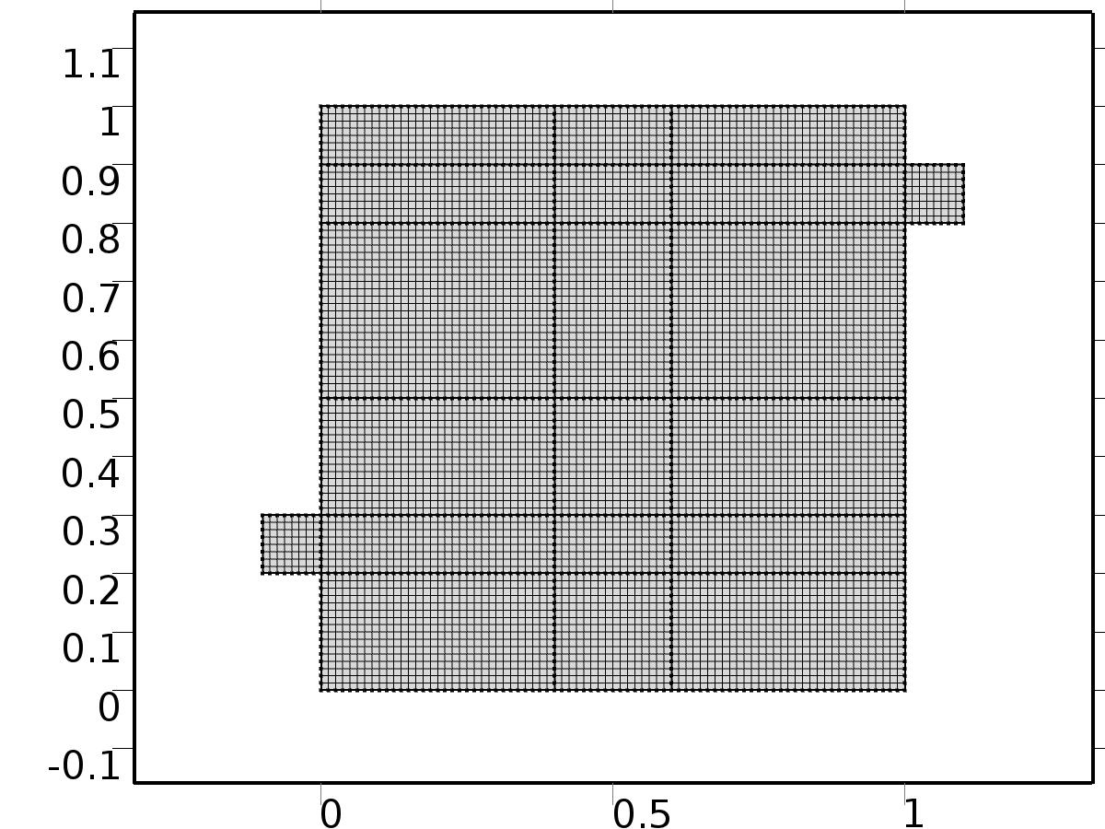

Mesh 1

* + 1. Size (size)

Settings

| **Description** | **Value** |
| --- | --- |
| Maximum element size | 0.0804 |
| Minimum element size | 3.6E-4 |
| Curvature factor | 0.3 |
| Maximum element growth rate | 1.3 |

* + 1. Edge 1 (edg1)

Selection

|  |  |
| --- | --- |
| Geometric entity level | Boundary |
| Selection | Boundaries 1–51 |

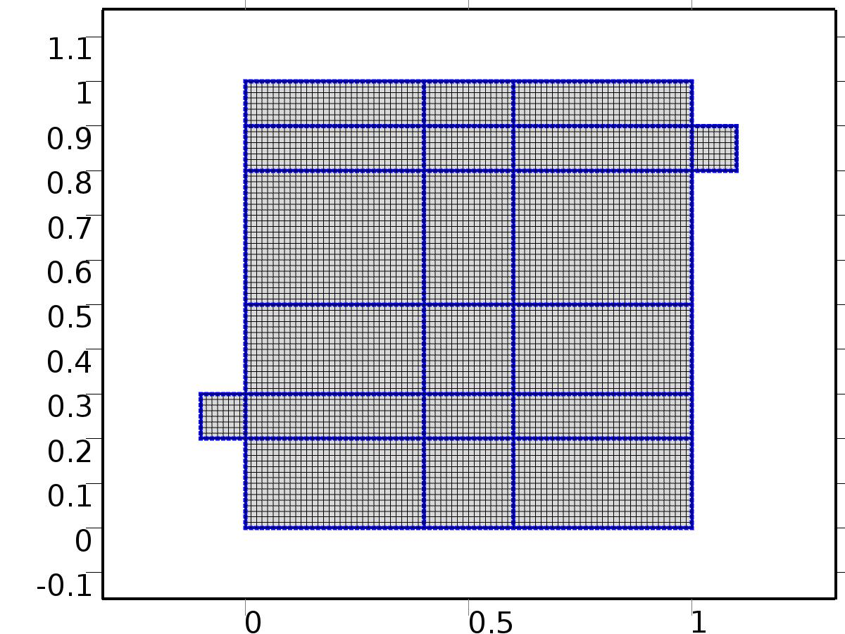

Edge 1

#### Size 1 (size1)

Selection

|  |  |
| --- | --- |
| Geometric entity level | Boundary |
| Selection | Boundaries 1–51 |



Size 1

Settings

| **Description** | **Value** |
| --- | --- |
| Maximum element size | H/8 |
| Minimum element size | H/8 |
| Curvature factor | 0.3 |
| Curvature factor | Off |
| Resolution of narrow regions | Off |
| Maximum element growth rate | 1.3 |
| Maximum element growth rate | Off |
| Custom element size | Custom |

* + 1. Mapped 1 (map1)

Selection

|  |  |
| --- | --- |
| Geometric entity level | Domain |
| Selection | Domains 1–20 |

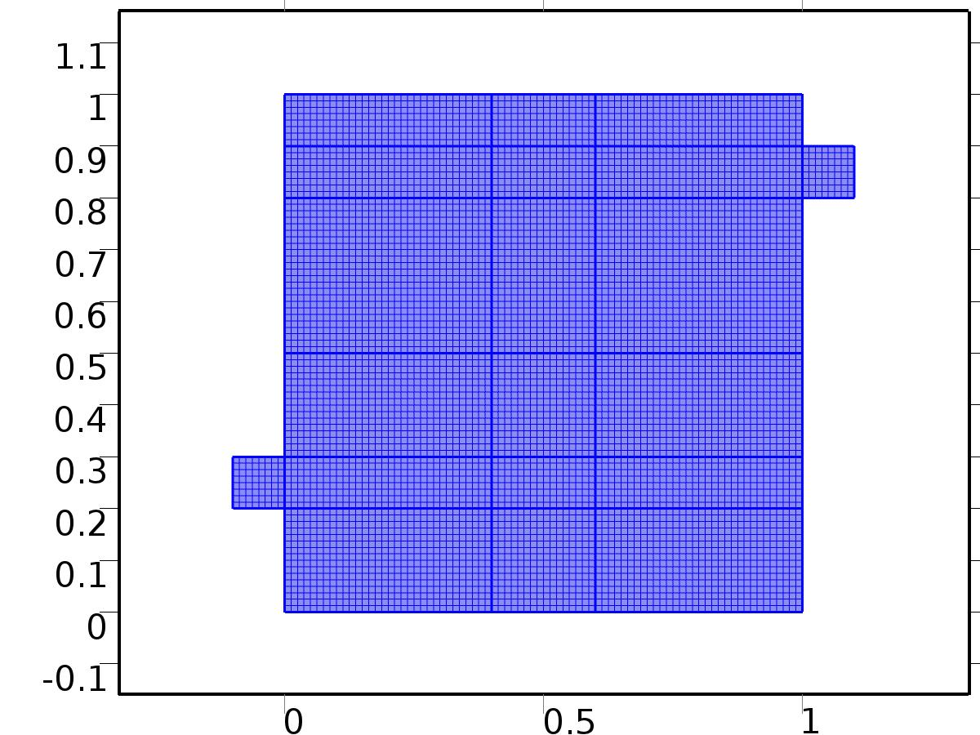

Mapped 1

1. Study 1
   1. Stationary

Study settings

| **Description** | **Value** |
| --- | --- |
| Include geometric nonlinearity | Off |

Physics and variables selection

| **Physics interface** | **Discretization** |
| --- | --- |
| Steady Flow (spf) | physics |
| Unit Input (c) | physics |

Mesh selection

| **Geometry** | **Mesh** |
| --- | --- |
| Geometry 1 (geom1) | mesh1 |

* 1. Solver Configurations
     1. Solver 1

#### Compile Equations: Stationary (st1)

Study and step

| **Description** | **Value** |
| --- | --- |
| Use study | Study 1 |
| Use study step | Stationary |

#### Dependent Variables 1 (v1)

General

| **Description** | **Value** |
| --- | --- |
| Defined by study step | Stationary |
| Constant |  |

Initial values of variables solved for

| **Description** | **Value** |
| --- | --- |
| Solution | Zero |

Values of variables not solved for

| **Description** | **Value** |
| --- | --- |
| Solution | Zero |

##### Dependent variable T (comp1.T) (comp1_T)

General

| **Description** | **Value** |
| --- | --- |
| Field components | comp1.T |
| Solve for this field | Off |

##### Pressure (comp1.bp) (comp1_bp)

General

| **Description** | **Value** |
| --- | --- |
| Field components | comp1.bp |
| Solve for this field | Off |

##### Dependent variable bT (comp1.bT) (comp1_bT)

General

| **Description** | **Value** |
| --- | --- |
| Field components | comp1.bT |
| Solve for this field | Off |

##### Pressure (comp1.P) (comp1_P)

General

| **Description** | **Value** |
| --- | --- |
| Field components | comp1.P |

##### Pressure (comp1.p) (comp1_p)

General

| **Description** | **Value** |
| --- | --- |
| Field components | comp1.p |
| Solve for this field | Off |

##### Velocity field (comp1.bu) (comp1_bu)

General

| **Description** | **Value** |
| --- | --- |
| Field components | {comp1.bu, comp1.bv} |
| Solve for this field | Off |

##### Dependent variable tT (comp1.tT) (comp1_tT)

General

| **Description** | **Value** |
| --- | --- |
| Field components | comp1.tT |
| Solve for this field | Off |

##### Velocity field (comp1.u) (comp1_u)

General

| **Description** | **Value** |
| --- | --- |
| Field components | {comp1.u, comp1.v} |
| Solve for this field | Off |

##### Dependent variable X (comp1.X) (comp1_X)

General

| **Description** | **Value** |
| --- | --- |
| Field components | comp1.X |

##### Velocity field (comp1.U) (comp1_U)

General

| **Description** | **Value** |
| --- | --- |
| Field components | {comp1.U, comp1.V} |

#### Stationary Solver 1 (s1)

General

| **Description** | **Value** |
| --- | --- |
| Defined by study step | Stationary |

Log

| **Description** | **Value** |
| --- | --- |
| Constant |  |

##### Fully Coupled 1 (fc1)

General

| **Description** | **Value** |
| --- | --- |
| Linear solver | Direct 1 |

Method and termination

| **Description** | **Value** |
| --- | --- |
| Initial damping factor | 0.01 |
| Minimum damping factor | 1.0E-6 |

1. Study 2
   1. Stationary

Study settings

| **Description** | **Value** |
| --- | --- |
| Include geometric nonlinearity | Off |

Physics and variables selection

| **Physics interface** | **Discretization** |
| --- | --- |
| Set Point Flow (phys1) | physics |
| Set Point Temperature (phys2) | physics |

Mesh selection

| **Geometry** | **Mesh** |
| --- | --- |
| Geometry 1 (geom1) | mesh1 |

* 1. Solver Configurations
     1. Solver 2

#### Compile Equations: Stationary (st1)

Study and step

| **Description** | **Value** |
| --- | --- |
| Use study | Study 2 |
| Use study step | Stationary |

#### Dependent Variables 1 (v1)

General

| **Description** | **Value** |
| --- | --- |
| Defined by study step | Stationary |
| Constant |  |

Initial values of variables solved for

| **Description** | **Value** |
| --- | --- |
| Solution | Solver 1 |

Values of variables not solved for

| **Description** | **Value** |
| --- | --- |
| Method | Solution |
| Solution | Solver 1 |

##### Dependent variable T (comp1.T) (comp1_T)

General

| **Description** | **Value** |
| --- | --- |
| Field components | comp1.T |
| Solve for this field | Off |

##### Pressure (comp1.bp) (comp1_bp)

General

| **Description** | **Value** |
| --- | --- |
| Field components | comp1.bp |

##### Dependent variable bT (comp1.bT) (comp1_bT)

General

| **Description** | **Value** |
| --- | --- |
| Field components | comp1.bT |

##### Pressure (comp1.P) (comp1_P)

General

| **Description** | **Value** |
| --- | --- |
| Field components | comp1.P |
| Solve for this field | Off |

##### Pressure (comp1.p) (comp1_p)

General

| **Description** | **Value** |
| --- | --- |
| Field components | comp1.p |
| Solve for this field | Off |

##### Velocity field (comp1.bu) (comp1_bu)

General

| **Description** | **Value** |
| --- | --- |
| Field components | {comp1.bu, comp1.bv} |

##### Dependent variable tT (comp1.tT) (comp1_tT)

General

| **Description** | **Value** |
| --- | --- |
| Field components | comp1.tT |

##### Velocity field (comp1.u) (comp1_u)

General

| **Description** | **Value** |
| --- | --- |
| Field components | {comp1.u, comp1.v} |
| Solve for this field | Off |

##### Dependent variable X (comp1.X) (comp1_X)

General

| **Description** | **Value** |
| --- | --- |
| Field components | comp1.X |
| Solve for this field | Off |

##### Velocity field (comp1.U) (comp1_U)

General

| **Description** | **Value** |
| --- | --- |
| Field components | {comp1.U, comp1.V} |
| Solve for this field | Off |

#### Stationary Solver 1 (s1)

General

| **Description** | **Value** |
| --- | --- |
| Defined by study step | Stationary |

Log

| **Description** | **Value** |
| --- | --- |
| Constant |  |

##### Fully Coupled 1 (fc1)

General

| **Description** | **Value** |
| --- | --- |
| Linear solver | Direct 1 |

Method and termination

| **Description** | **Value** |
| --- | --- |
| Initial damping factor | 0.01 |
| Minimum damping factor | 1.0E-6 |

1. Study 3
   1. Time Dependent

Study settings

| **Description** | **Value** |
| --- | --- |
| Include geometric nonlinearity | Off |

| **Times** | **Unit** |
| --- | --- |
| range(0,10,2000) | s |

Physics and variables selection

| **Physics interface** | **Discretization** |
| --- | --- |
| Closed Loop Flow (phys3) | physics |
| Closed Loop Temperature (phys4) | physics |

Mesh selection

| **Geometry** | **Mesh** |
| --- | --- |
| Geometry 1 (geom1) | mesh1 |

* 1. Solver Configurations
     1. Solver 3

#### Compile Equations: Time Dependent (st1)

Study and step

| **Description** | **Value** |
| --- | --- |
| Use study | Study 3 |
| Use study step | Time Dependent |

#### Dependent Variables 1 (v1)

General

| **Description** | **Value** |
| --- | --- |
| Defined by study step | Time Dependent |
| Constant |  |

Initial values of variables solved for

| **Description** | **Value** |
| --- | --- |
| Solution | Zero |

Values of variables not solved for

| **Description** | **Value** |
| --- | --- |
| Method | Solution |
| Solution | Solver 2 |

##### Dependent variable T (comp1.T) (comp1_T)

General

| **Description** | **Value** |
| --- | --- |
| Field components | comp1.T |

##### Pressure (comp1.bp) (comp1_bp)

General

| **Description** | **Value** |
| --- | --- |
| Field components | comp1.bp |
| Solve for this field | Off |

##### Dependent variable bT (comp1.bT) (comp1_bT)

General

| **Description** | **Value** |
| --- | --- |
| Field components | comp1.bT |
| Solve for this field | Off |

##### Pressure (comp1.P) (comp1_P)

General

| **Description** | **Value** |
| --- | --- |
| Field components | comp1.P |
| Solve for this field | Off |

##### Pressure (comp1.p) (comp1_p)

General

| **Description** | **Value** |
| --- | --- |
| Field components | comp1.p |

##### Velocity field (comp1.bu) (comp1_bu)

General

| **Description** | **Value** |
| --- | --- |
| Field components | {comp1.bu, comp1.bv} |
| Solve for this field | Off |

##### Dependent variable tT (comp1.tT) (comp1_tT)

General

| **Description** | **Value** |
| --- | --- |
| Field components | comp1.tT |
| Solve for this field | Off |

##### Velocity field (comp1.u) (comp1_u)

General

| **Description** | **Value** |
| --- | --- |
| Field components | {comp1.u, comp1.v} |

##### Dependent variable X (comp1.X) (comp1_X)

General

| **Description** | **Value** |
| --- | --- |
| Field components | comp1.X |
| Solve for this field | Off |

##### Velocity field (comp1.U) (comp1_U)

General

| **Description** | **Value** |
| --- | --- |
| Field components | {comp1.U, comp1.V} |
| Solve for this field | Off |

#### Time-Dependent Solver 1 (t1)

General

| **Description** | **Value** |
| --- | --- |
| Defined by study step | Time Dependent |
| Time | {0, 10, 20, 30, 40, 50, 60, 70, 80, 90, 100, 110, 120, 130, 140, 150, 160, 170, 180, 190, 200, 210, 220, 230, 240, 250, 260, 270, 280, 290, 300, 310, 320, 330, 340, 350, 360, 370, 380, 390, 400, 410, 420, 430, 440, 450, 460, 470, 480, 490, 500, 510, 520, 530, 540, 550, 560, 570, 580, 590, 600, 610, 620, 630, 640, 650, 660, 670, 680, 690, 700, 710, 720, 730, 740, 750, 760, 770, 780, 790, 800, 810, 820, 830, 840, 850, 860, 870, 880, 890, 900, 910, 920, 930, 940, 950, 960, 970, 980, 990, 1000, 1010, 1020, 1030, 1040, 1050, 1060, 1070, 1080, 1090, 1100, 1110, 1120, 1130, 1140, 1150, 1160, 1170, 1180, 1190, 1200, 1210, 1220, 1230, 1240, 1250, 1260, 1270, 1280, 1290, 1300, 1310, 1320, 1330, 1340, 1350, 1360, 1370, 1380, 1390, 1400, 1410, 1420, 1430, 1440, 1450, 1460, 1470, 1480, 1490, 1500, 1510, 1520, 1530, 1540, 1550, 1560, 1570, 1580, 1590, 1600, 1610, 1620, 1630, 1640, 1650, 1660, 1670, 1680, 1690, 1700, 1710, 1720, 1730, 1740, 1750, 1760, 1770, 1780, 1790, 1800, 1810, 1820, 1830, 1840, 1850, 1860, 1870, 1880, 1890, 1900, 1910, 1920, 1930, 1940, 1950, 1960, 1970, 1980, 1990, 2000} |

Absolute tolerance

| **Description** | **Value** |
| --- | --- |
| Tolerance | 5.0E-4 |

Time stepping

| **Description** | **Value** |
| --- | --- |
| Initial step | 0.0010 |
| Maximum BDF order | 2 |

Advanced

| **Description** | **Value** |
| --- | --- |
| Fraction of initial step for Backward Euler | 0.0010 |

Log

| **Description** | **Value** |
| --- | --- |
| Constant |  |

##### Fully Coupled 1 (fc1)

General

| **Description** | **Value** |
| --- | --- |
| Linear solver | Direct 1 |

Method and termination

| **Description** | **Value** |
| --- | --- |
| Jacobian update | Once per time step |
| Maximum number of iterations | 6 |

1. Results
   1. Data Sets
      1. Solution 1

Solution

| **Description** | **Value** |
| --- | --- |
| Solution | Solver 1 |
| Component | Save Point Geometry 1 |

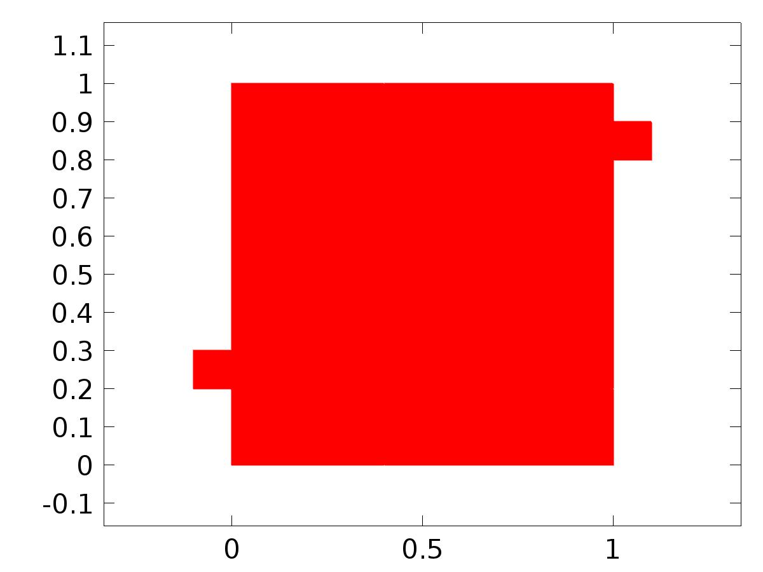

Data set: Solution 1

* + 1. Solution 2

Solution

| **Description** | **Value** |
| --- | --- |
| Solution | Solver 2 |
| Component | Save Point Geometry 1 |



Data set: Solution 2

* + 1. Solution 3

Solution

| **Description** | **Value** |
| --- | --- |
| Solution | Solver 3 |
| Component | Save Point Geometry 1 |



Data set: Solution 3

* 1. Derived Values
     1. Global Evaluation 1

Data

| **Description** | **Value** |
| --- | --- |
| Data set | Solution 2 |

Expression

| **Description** | **Value** |
| --- | --- |
| Expression | C(bT) |
| Description | C(bT) |

* + 1. Global Evaluation 2

Data

| **Description** | **Value** |
| --- | --- |
| Data set | Solution 3 |

Expression

| **Description** | **Value** |
| --- | --- |
| Expression | gamma |

* 1. Tables
     1. Table 1

Global Evaluation 1 (C(bT))

Table 1

| **C(bT)** | **C(bT)** |
| --- | --- |
| 0.50000 | 0.50000 |

* + 1. Table 2

Global Evaluation 1 (C(bT))

Table 2

| **C(bT)** |
| --- |
| 0.50000 |

* + 1. Table 3

Global Evaluation 2 (C(T))

Table 3

| **Time (s)** | **C(T)** | **yr** | **e** | **gamma** |
| --- | --- | --- | --- | --- |
| 0.0000 | 2.9408E-38 | 0.50000 | 0.50000 | -3.4715E-5 |
| 10.000 | 0.27171 | 0.50000 | 0.22829 | -3.4715E-5 |
| 20.000 | 0.40996 | 0.50000 | 0.090036 | -3.4715E-5 |
| 30.000 | 0.46694 | 0.50000 | 0.033056 | -3.4715E-5 |
| 40.000 | 0.48905 | 0.50000 | 0.010948 | -3.4715E-5 |
| 50.000 | 0.49716 | 0.50000 | 0.0028418 | -3.4715E-5 |
| 60.000 | 0.49961 | 0.50000 | 3.8733E-4 | -3.4715E-5 |
| 70.000 | 0.50029 | 0.50000 | -2.8879E-4 | -3.4715E-5 |
| 80.000 | 0.50043 | 0.50000 | -4.3061E-4 | -3.4715E-5 |
| 90.000 | 0.50031 | 0.50000 | -3.1448E-4 | -3.4715E-5 |
| 100.00 | 0.50020 | 0.50000 | -1.9835E-4 | -3.4715E-5 |
| 110.00 | 0.50011 | 0.50000 | -1.1226E-4 | -3.4715E-5 |
| 120.00 | 0.50009 | 0.50000 | -9.4918E-5 | -3.4715E-5 |
| 130.00 | 0.50008 | 0.50000 | -7.7575E-5 | -3.4715E-5 |
| 140.00 | 0.50006 | 0.50000 | -6.0232E-5 | -3.4715E-5 |
| 150.00 | 0.50004 | 0.50000 | -4.2890E-5 | -3.4715E-5 |
| 160.00 | 0.50003 | 0.50000 | -2.5547E-5 | -3.4715E-5 |
| 170.00 | 0.50002 | 0.50000 | -1.6623E-5 | -3.4715E-5 |
| 180.00 | 0.50002 | 0.50000 | -1.5224E-5 | -3.4715E-5 |
| 190.00 | 0.50001 | 0.50000 | -1.3824E-5 | -3.4715E-5 |
| 200.00 | 0.50001 | 0.50000 | -1.2425E-5 | -3.4715E-5 |
| 210.00 | 0.50001 | 0.50000 | -1.1025E-5 | -3.4715E-5 |
| 220.00 | 0.50001 | 0.50000 | -9.6258E-6 | -3.4715E-5 |
| 230.00 | 0.50001 | 0.50000 | -8.2264E-6 | -3.4715E-5 |
| 240.00 | 0.50001 | 0.50000 | -6.8269E-6 | -3.4715E-5 |
| 250.00 | 0.50001 | 0.50000 | -5.4275E-6 | -3.4715E-5 |
| 260.00 | 0.50000 | 0.50000 | -4.0280E-6 | -3.4715E-5 |
| 270.00 | 0.50000 | 0.50000 | -2.6286E-6 | -3.4715E-5 |
| 280.00 | 0.50000 | 0.50000 | -1.2292E-6 | -3.4715E-5 |
| 290.00 | 0.50000 | 0.50000 | -1.1297E-6 | -3.4715E-5 |
| 300.00 | 0.50000 | 0.50000 | -1.0622E-6 | -3.4715E-5 |
| 310.00 | 0.50000 | 0.50000 | -9.9461E-7 | -3.4715E-5 |
| 320.00 | 0.50000 | 0.50000 | -9.2707E-7 | -3.4715E-5 |
| 330.00 | 0.50000 | 0.50000 | -8.5954E-7 | -3.4715E-5 |
| 340.00 | 0.50000 | 0.50000 | -7.9200E-7 | -3.4715E-5 |
| 350.00 | 0.50000 | 0.50000 | -7.2446E-7 | -3.4715E-5 |
| 360.00 | 0.50000 | 0.50000 | -6.5692E-7 | -3.4715E-5 |
| 370.00 | 0.50000 | 0.50000 | -5.8938E-7 | -3.4715E-5 |
| 380.00 | 0.50000 | 0.50000 | -5.2184E-7 | -3.4715E-5 |
| 390.00 | 0.50000 | 0.50000 | -4.5430E-7 | -3.4715E-5 |
| 400.00 | 0.50000 | 0.50000 | -3.8676E-7 | -3.4715E-5 |
| 410.00 | 0.50000 | 0.50000 | -3.1923E-7 | -3.4715E-5 |
| 420.00 | 0.50000 | 0.50000 | -2.5169E-7 | -3.4715E-5 |
| 430.00 | 0.50000 | 0.50000 | -1.8415E-7 | -3.4715E-5 |
| 440.00 | 0.50000 | 0.50000 | -1.1661E-7 | -3.4715E-5 |
| 450.00 | 0.50000 | 0.50000 | -4.9070E-8 | -3.4715E-5 |
| 460.00 | 0.50000 | 0.50000 | 1.8469E-8 | -3.4715E-5 |
| 470.00 | 0.50000 | 0.50000 | 8.6007E-8 | -3.4715E-5 |
| 480.00 | 0.50000 | 0.50000 | 1.5355E-7 | -3.4715E-5 |
| 490.00 | 0.50000 | 0.50000 | 1.5835E-7 | -3.4715E-5 |
| 500.00 | 0.50000 | 0.50000 | 1.6161E-7 | -3.4715E-5 |
| 510.00 | 0.50000 | 0.50000 | 1.6486E-7 | -3.4715E-5 |
| 520.00 | 0.50000 | 0.50000 | 1.6812E-7 | -3.4715E-5 |
| 530.00 | 0.50000 | 0.50000 | 1.7138E-7 | -3.4715E-5 |
| 540.00 | 0.50000 | 0.50000 | 1.7464E-7 | -3.4715E-5 |
| 550.00 | 0.50000 | 0.50000 | 1.7790E-7 | -3.4715E-5 |
| 560.00 | 0.50000 | 0.50000 | 1.8116E-7 | -3.4715E-5 |
| 570.00 | 0.50000 | 0.50000 | 1.8442E-7 | -3.4715E-5 |
| 580.00 | 0.50000 | 0.50000 | 1.8768E-7 | -3.4715E-5 |
| 590.00 | 0.50000 | 0.50000 | 1.9094E-7 | -3.4715E-5 |
| 600.00 | 0.50000 | 0.50000 | 1.9420E-7 | -3.4715E-5 |
| 610.00 | 0.50000 | 0.50000 | 1.9746E-7 | -3.4715E-5 |
| 620.00 | 0.50000 | 0.50000 | 2.0071E-7 | -3.4715E-5 |
| 630.00 | 0.50000 | 0.50000 | 2.0397E-7 | -3.4715E-5 |
| 640.00 | 0.50000 | 0.50000 | 2.0723E-7 | -3.4715E-5 |
| 650.00 | 0.50000 | 0.50000 | 2.1049E-7 | -3.4715E-5 |
| 660.00 | 0.50000 | 0.50000 | 2.1375E-7 | -3.4715E-5 |
| 670.00 | 0.50000 | 0.50000 | 2.1701E-7 | -3.4715E-5 |
| 680.00 | 0.50000 | 0.50000 | 2.2027E-7 | -3.4715E-5 |
| 690.00 | 0.50000 | 0.50000 | 2.2050E-7 | -3.4715E-5 |
| 700.00 | 0.50000 | 0.50000 | 2.2066E-7 | -3.4715E-5 |
| 710.00 | 0.50000 | 0.50000 | 2.2082E-7 | -3.4715E-5 |
| 720.00 | 0.50000 | 0.50000 | 2.2097E-7 | -3.4715E-5 |
| 730.00 | 0.50000 | 0.50000 | 2.2113E-7 | -3.4715E-5 |
| 740.00 | 0.50000 | 0.50000 | 2.2129E-7 | -3.4715E-5 |
| 750.00 | 0.50000 | 0.50000 | 2.2145E-7 | -3.4715E-5 |
| 760.00 | 0.50000 | 0.50000 | 2.2160E-7 | -3.4715E-5 |
| 770.00 | 0.50000 | 0.50000 | 2.2176E-7 | -3.4715E-5 |
| 780.00 | 0.50000 | 0.50000 | 2.2192E-7 | -3.4715E-5 |
| 790.00 | 0.50000 | 0.50000 | 2.2208E-7 | -3.4715E-5 |
| 800.00 | 0.50000 | 0.50000 | 2.2223E-7 | -3.4715E-5 |
| 810.00 | 0.50000 | 0.50000 | 2.2239E-7 | -3.4715E-5 |
| 820.00 | 0.50000 | 0.50000 | 2.2255E-7 | -3.4715E-5 |
| 830.00 | 0.50000 | 0.50000 | 2.2271E-7 | -3.4715E-5 |
| 840.00 | 0.50000 | 0.50000 | 2.2286E-7 | -3.4715E-5 |
| 850.00 | 0.50000 | 0.50000 | 2.2302E-7 | -3.4715E-5 |
| 860.00 | 0.50000 | 0.50000 | 2.2318E-7 | -3.4715E-5 |
| 870.00 | 0.50000 | 0.50000 | 2.2333E-7 | -3.4715E-5 |
| 880.00 | 0.50000 | 0.50000 | 2.2349E-7 | -3.4715E-5 |
| 890.00 | 0.50000 | 0.50000 | 2.2350E-7 | -3.4715E-5 |
| 900.00 | 0.50000 | 0.50000 | 2.2351E-7 | -3.4715E-5 |
| 910.00 | 0.50000 | 0.50000 | 2.2352E-7 | -3.4715E-5 |
| 920.00 | 0.50000 | 0.50000 | 2.2353E-7 | -3.4715E-5 |
| 930.00 | 0.50000 | 0.50000 | 2.2353E-7 | -3.4715E-5 |
| 940.00 | 0.50000 | 0.50000 | 2.2354E-7 | -3.4715E-5 |
| 950.00 | 0.50000 | 0.50000 | 2.2355E-7 | -3.4715E-5 |
| 960.00 | 0.50000 | 0.50000 | 2.2356E-7 | -3.4715E-5 |
| 970.00 | 0.50000 | 0.50000 | 2.2356E-7 | -3.4715E-5 |
| 980.00 | 0.50000 | 0.50000 | 2.2357E-7 | -3.4715E-5 |
| 990.00 | 0.50000 | 0.50000 | 2.2358E-7 | -3.4715E-5 |
| 1000.0 | 0.50000 | 0.50000 | 2.2359E-7 | -3.4715E-5 |
| 1010.0 | 0.50000 | 0.50000 | 2.2359E-7 | -3.4715E-5 |
| 1020.0 | 0.50000 | 0.50000 | 2.2360E-7 | -3.4715E-5 |
| 1030.0 | 0.50000 | 0.50000 | 2.2361E-7 | -3.4715E-5 |
| 1040.0 | 0.50000 | 0.50000 | 2.2362E-7 | -3.4715E-5 |
| 1050.0 | 0.50000 | 0.50000 | 2.2362E-7 | -3.4715E-5 |
| 1060.0 | 0.50000 | 0.50000 | 2.2363E-7 | -3.4715E-5 |
| 1070.0 | 0.50000 | 0.50000 | 2.2364E-7 | -3.4715E-5 |
| 1080.0 | 0.50000 | 0.50000 | 2.2365E-7 | -3.4715E-5 |
| 1090.0 | 0.50000 | 0.50000 | 2.2365E-7 | -3.4715E-5 |
| 1100.0 | 0.50000 | 0.50000 | 2.2365E-7 | -3.4715E-5 |
| 1110.0 | 0.50000 | 0.50000 | 2.2365E-7 | -3.4715E-5 |
| 1120.0 | 0.50000 | 0.50000 | 2.2365E-7 | -3.4715E-5 |
| 1130.0 | 0.50000 | 0.50000 | 2.2365E-7 | -3.4715E-5 |
| 1140.0 | 0.50000 | 0.50000 | 2.2365E-7 | -3.4715E-5 |
| 1150.0 | 0.50000 | 0.50000 | 2.2365E-7 | -3.4715E-5 |
| 1160.0 | 0.50000 | 0.50000 | 2.2365E-7 | -3.4715E-5 |
| 1170.0 | 0.50000 | 0.50000 | 2.2365E-7 | -3.4715E-5 |
| 1180.0 | 0.50000 | 0.50000 | 2.2365E-7 | -3.4715E-5 |
| 1190.0 | 0.50000 | 0.50000 | 2.2365E-7 | -3.4715E-5 |
| 1200.0 | 0.50000 | 0.50000 | 2.2365E-7 | -3.4715E-5 |
| 1210.0 | 0.50000 | 0.50000 | 2.2365E-7 | -3.4715E-5 |
| 1220.0 | 0.50000 | 0.50000 | 2.2365E-7 | -3.4715E-5 |
| 1230.0 | 0.50000 | 0.50000 | 2.2365E-7 | -3.4715E-5 |
| 1240.0 | 0.50000 | 0.50000 | 2.2365E-7 | -3.4715E-5 |
| 1250.0 | 0.50000 | 0.50000 | 2.2365E-7 | -3.4715E-5 |
| 1260.0 | 0.50000 | 0.50000 | 2.2365E-7 | -3.4715E-5 |
| 1270.0 | 0.50000 | 0.50000 | 2.2365E-7 | -3.4715E-5 |
| 1280.0 | 0.50000 | 0.50000 | 2.2366E-7 | -3.4715E-5 |
| 1290.0 | 0.50000 | 0.50000 | 2.2366E-7 | -3.4715E-5 |
| 1300.0 | 0.50000 | 0.50000 | 2.2366E-7 | -3.4715E-5 |
| 1310.0 | 0.50000 | 0.50000 | 2.2366E-7 | -3.4715E-5 |
| 1320.0 | 0.50000 | 0.50000 | 2.2366E-7 | -3.4715E-5 |
| 1330.0 | 0.50000 | 0.50000 | 2.2366E-7 | -3.4715E-5 |
| 1340.0 | 0.50000 | 0.50000 | 2.2366E-7 | -3.4715E-5 |
| 1350.0 | 0.50000 | 0.50000 | 2.2366E-7 | -3.4715E-5 |
| 1360.0 | 0.50000 | 0.50000 | 2.2366E-7 | -3.4715E-5 |
| 1370.0 | 0.50000 | 0.50000 | 2.2366E-7 | -3.4715E-5 |
| 1380.0 | 0.50000 | 0.50000 | 2.2366E-7 | -3.4715E-5 |
| 1390.0 | 0.50000 | 0.50000 | 2.2366E-7 | -3.4715E-5 |
| 1400.0 | 0.50000 | 0.50000 | 2.2366E-7 | -3.4715E-5 |
| 1410.0 | 0.50000 | 0.50000 | 2.2366E-7 | -3.4715E-5 |
| 1420.0 | 0.50000 | 0.50000 | 2.2366E-7 | -3.4715E-5 |
| 1430.0 | 0.50000 | 0.50000 | 2.2366E-7 | -3.4715E-5 |
| 1440.0 | 0.50000 | 0.50000 | 2.2366E-7 | -3.4715E-5 |
| 1450.0 | 0.50000 | 0.50000 | 2.2366E-7 | -3.4715E-5 |
| 1460.0 | 0.50000 | 0.50000 | 2.2366E-7 | -3.4715E-5 |
| 1470.0 | 0.50000 | 0.50000 | 2.2366E-7 | -3.4715E-5 |
| 1480.0 | 0.50000 | 0.50000 | 2.2366E-7 | -3.4715E-5 |
| 1490.0 | 0.50000 | 0.50000 | 2.2366E-7 | -3.4715E-5 |
| 1500.0 | 0.50000 | 0.50000 | 2.2366E-7 | -3.4715E-5 |
| 1510.0 | 0.50000 | 0.50000 | 2.2366E-7 | -3.4715E-5 |
| 1520.0 | 0.50000 | 0.50000 | 2.2366E-7 | -3.4715E-5 |
| 1530.0 | 0.50000 | 0.50000 | 2.2366E-7 | -3.4715E-5 |
| 1540.0 | 0.50000 | 0.50000 | 2.2366E-7 | -3.4715E-5 |
| 1550.0 | 0.50000 | 0.50000 | 2.2366E-7 | -3.4715E-5 |
| 1560.0 | 0.50000 | 0.50000 | 2.2366E-7 | -3.4715E-5 |
| 1570.0 | 0.50000 | 0.50000 | 2.2366E-7 | -3.4715E-5 |
| 1580.0 | 0.50000 | 0.50000 | 2.2366E-7 | -3.4715E-5 |
| 1590.0 | 0.50000 | 0.50000 | 2.2366E-7 | -3.4715E-5 |
| 1600.0 | 0.50000 | 0.50000 | 2.2366E-7 | -3.4715E-5 |
| 1610.0 | 0.50000 | 0.50000 | 2.2366E-7 | -3.4715E-5 |
| 1620.0 | 0.50000 | 0.50000 | 2.2366E-7 | -3.4715E-5 |
| 1630.0 | 0.50000 | 0.50000 | 2.2366E-7 | -3.4715E-5 |
| 1640.0 | 0.50000 | 0.50000 | 2.2366E-7 | -3.4715E-5 |
| 1650.0 | 0.50000 | 0.50000 | 2.2366E-7 | -3.4715E-5 |
| 1660.0 | 0.50000 | 0.50000 | 2.2366E-7 | -3.4715E-5 |
| 1670.0 | 0.50000 | 0.50000 | 2.2366E-7 | -3.4715E-5 |
| 1680.0 | 0.50000 | 0.50000 | 2.2366E-7 | -3.4715E-5 |
| 1690.0 | 0.50000 | 0.50000 | 2.2366E-7 | -3.4715E-5 |
| 1700.0 | 0.50000 | 0.50000 | 2.2366E-7 | -3.4715E-5 |
| 1710.0 | 0.50000 | 0.50000 | 2.2366E-7 | -3.4715E-5 |
| 1720.0 | 0.50000 | 0.50000 | 2.2366E-7 | -3.4715E-5 |
| 1730.0 | 0.50000 | 0.50000 | 2.2366E-7 | -3.4715E-5 |
| 1740.0 | 0.50000 | 0.50000 | 2.2366E-7 | -3.4715E-5 |
| 1750.0 | 0.50000 | 0.50000 | 2.2366E-7 | -3.4715E-5 |
| 1760.0 | 0.50000 | 0.50000 | 2.2366E-7 | -3.4715E-5 |
| 1770.0 | 0.50000 | 0.50000 | 2.2366E-7 | -3.4715E-5 |
| 1780.0 | 0.50000 | 0.50000 | 2.2366E-7 | -3.4715E-5 |
| 1790.0 | 0.50000 | 0.50000 | 2.2366E-7 | -3.4715E-5 |
| 1800.0 | 0.50000 | 0.50000 | 2.2366E-7 | -3.4715E-5 |
| 1810.0 | 0.50000 | 0.50000 | 2.2366E-7 | -3.4715E-5 |
| 1820.0 | 0.50000 | 0.50000 | 2.2366E-7 | -3.4715E-5 |
| 1830.0 | 0.50000 | 0.50000 | 2.2366E-7 | -3.4715E-5 |
| 1840.0 | 0.50000 | 0.50000 | 2.2366E-7 | -3.4715E-5 |
| 1850.0 | 0.50000 | 0.50000 | 2.2366E-7 | -3.4715E-5 |
| 1860.0 | 0.50000 | 0.50000 | 2.2366E-7 | -3.4715E-5 |
| 1870.0 | 0.50000 | 0.50000 | 2.2366E-7 | -3.4715E-5 |
| 1880.0 | 0.50000 | 0.50000 | 2.2366E-7 | -3.4715E-5 |
| 1890.0 | 0.50000 | 0.50000 | 2.2366E-7 | -3.4715E-5 |
| 1900.0 | 0.50000 | 0.50000 | 2.2366E-7 | -3.4715E-5 |
| 1910.0 | 0.50000 | 0.50000 | 2.2366E-7 | -3.4715E-5 |
| 1920.0 | 0.50000 | 0.50000 | 2.2366E-7 | -3.4715E-5 |
| 1930.0 | 0.50000 | 0.50000 | 2.2366E-7 | -3.4715E-5 |
| 1940.0 | 0.50000 | 0.50000 | 2.2366E-7 | -3.4715E-5 |
| 1950.0 | 0.50000 | 0.50000 | 2.2366E-7 | -3.4715E-5 |
| 1960.0 | 0.50000 | 0.50000 | 2.2366E-7 | -3.4715E-5 |
| 1970.0 | 0.50000 | 0.50000 | 2.2366E-7 | -3.4715E-5 |
| 1980.0 | 0.50000 | 0.50000 | 2.2366E-7 | -3.4715E-5 |
| 1990.0 | 0.50000 | 0.50000 | 2.2366E-7 | -3.4715E-5 |
| 2000.0 | 0.50000 | 0.50000 | 2.2366E-7 | -3.4715E-5 |

* 1. Plot Groups
     1. Velocity (spf)

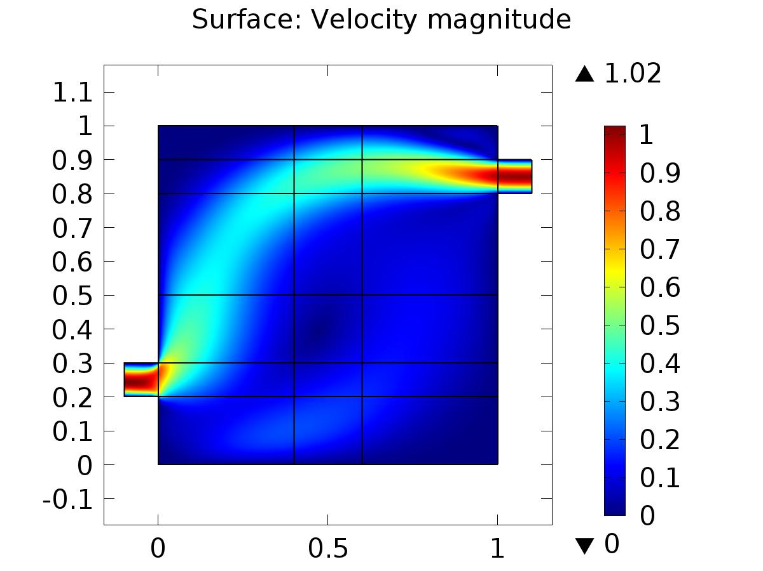

Surface: Velocity magnitude

* + 1. Pressure (spf)

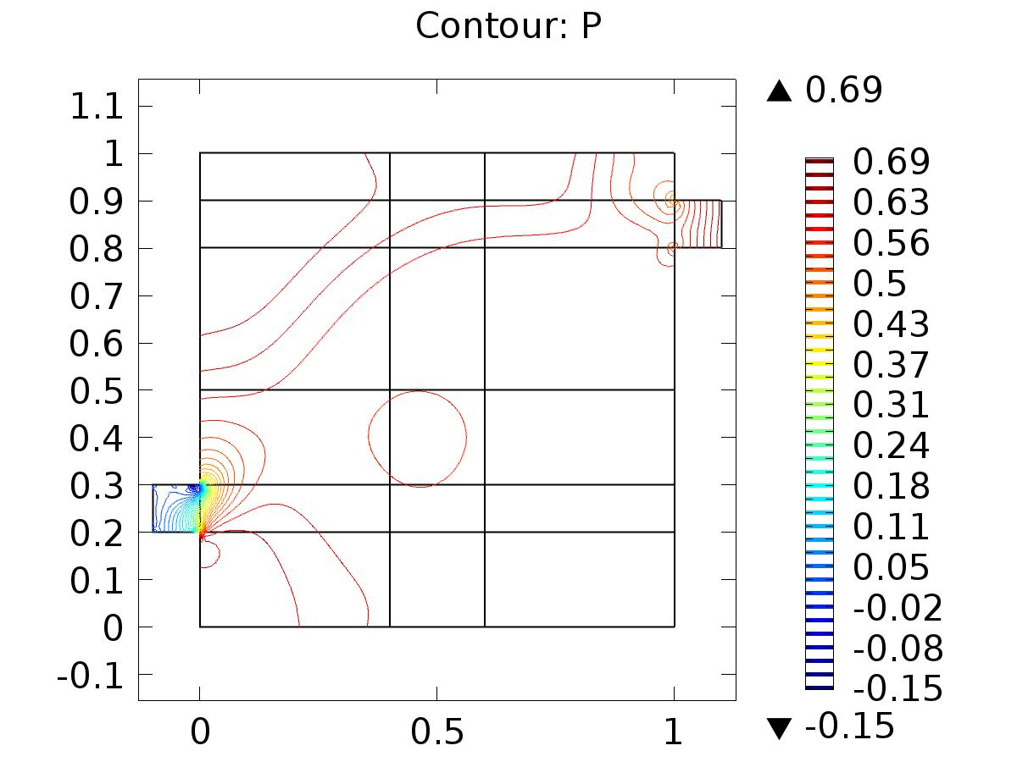

Contour: P

* + 1. 2D Plot Group 3

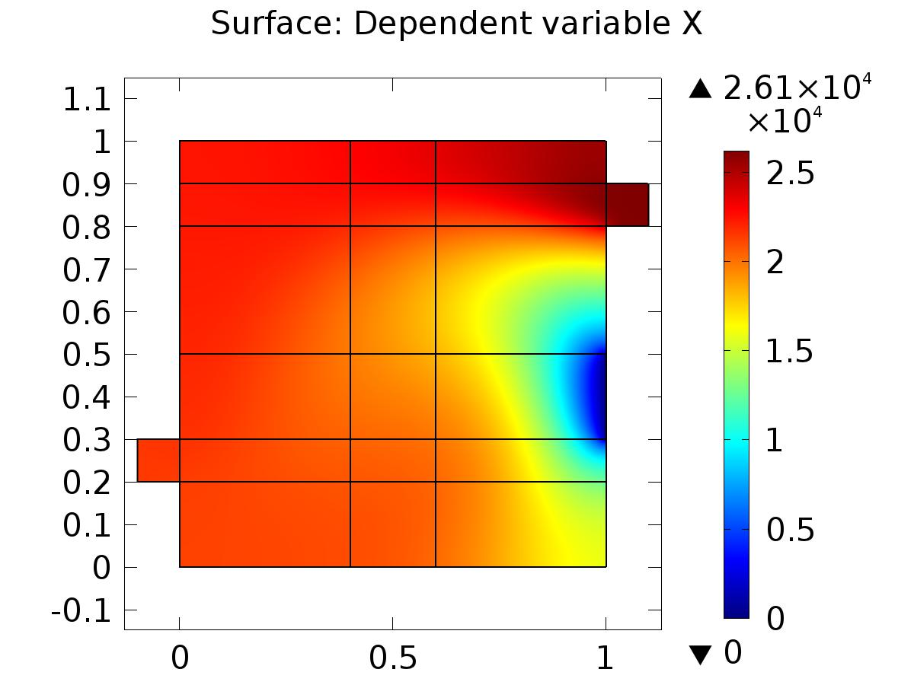

Surface: Dependent variable X

* + 1. Velocity (phys1)

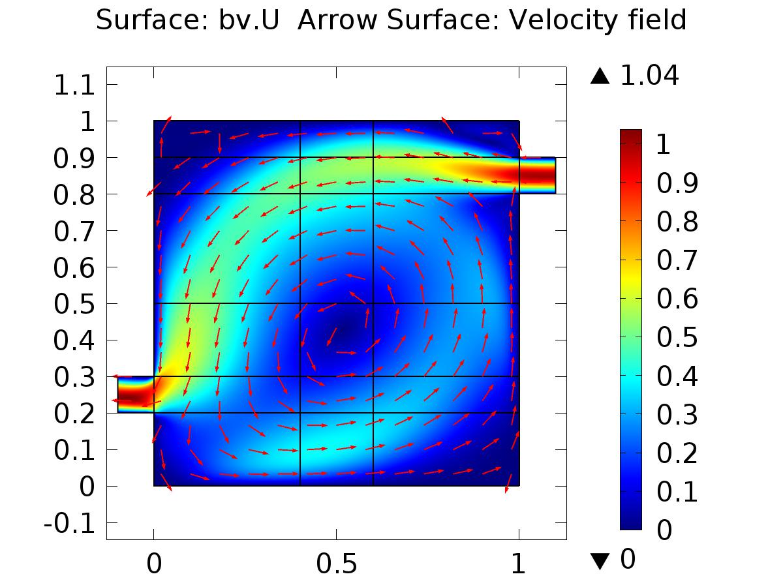

Surface: bv.U Arrow Surface: Velocity field

* + 1. Pressure (phys1)

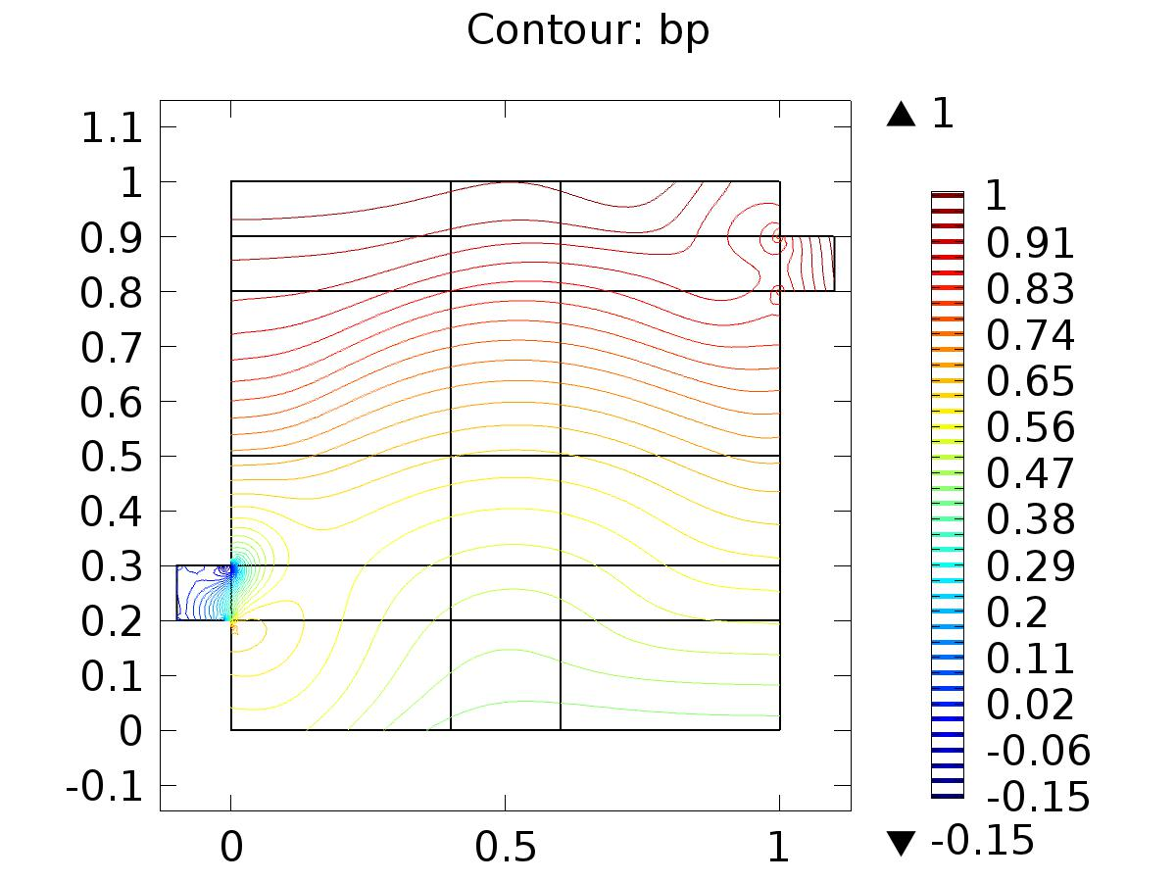

Contour: bp

* + 1. 2D Plot Group 6

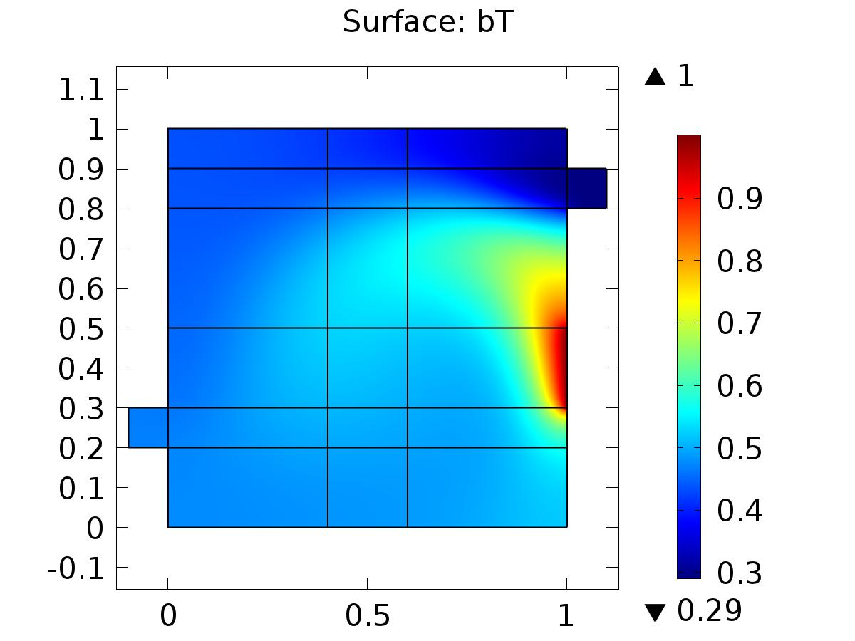

Surface: bT

* + 1. Velocity (phys3)

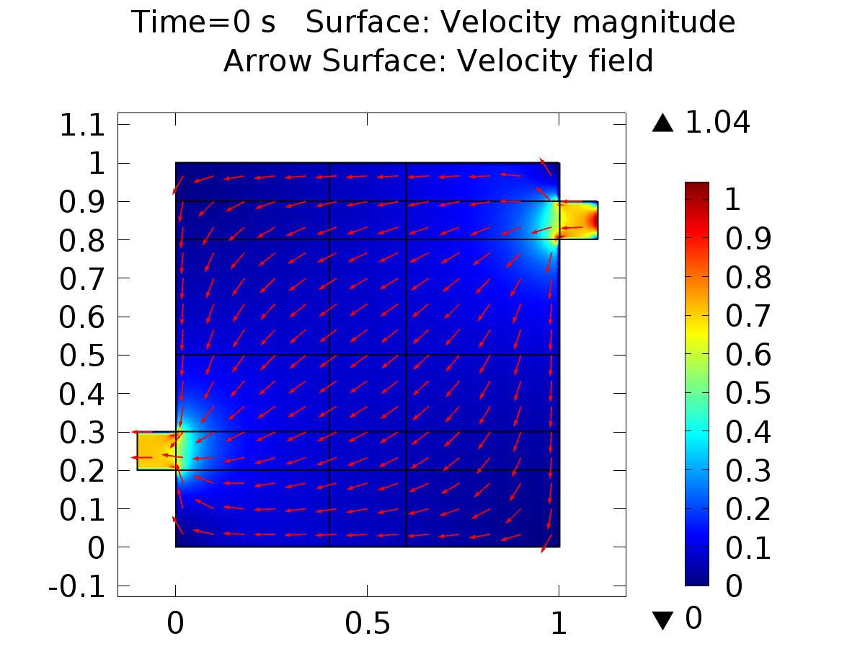

Time=0 s Surface: Velocity magnitude Arrow Surface: Velocity field

* + 1. Pressure (phys3)

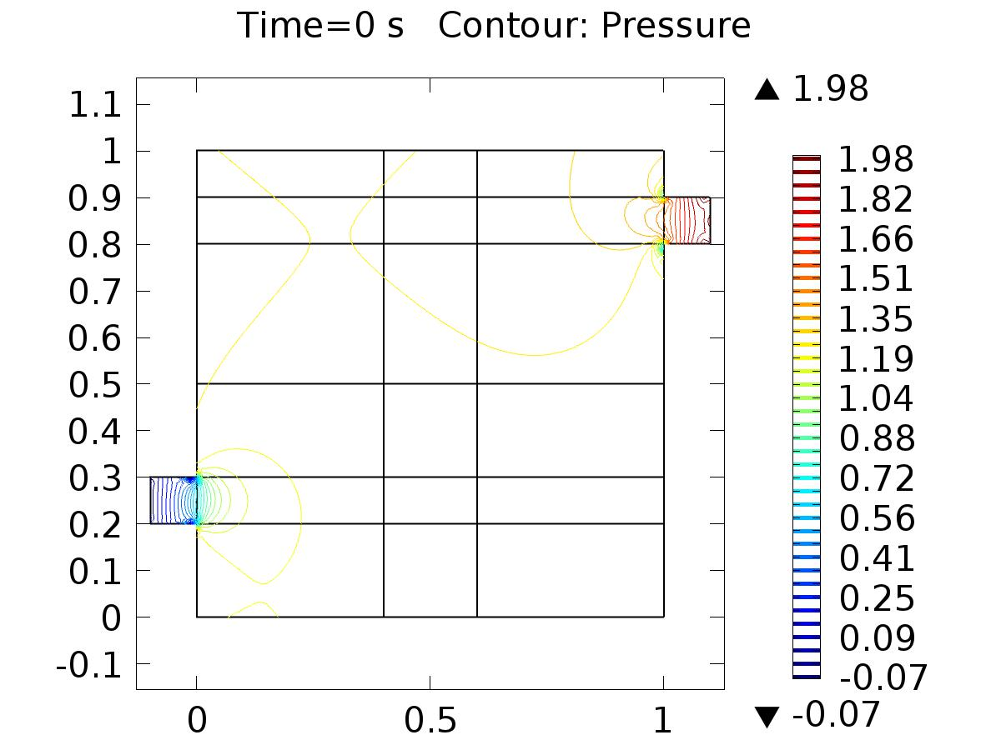

Time=0 s Contour: Pressure

* + 1. 2D Plot Group 9

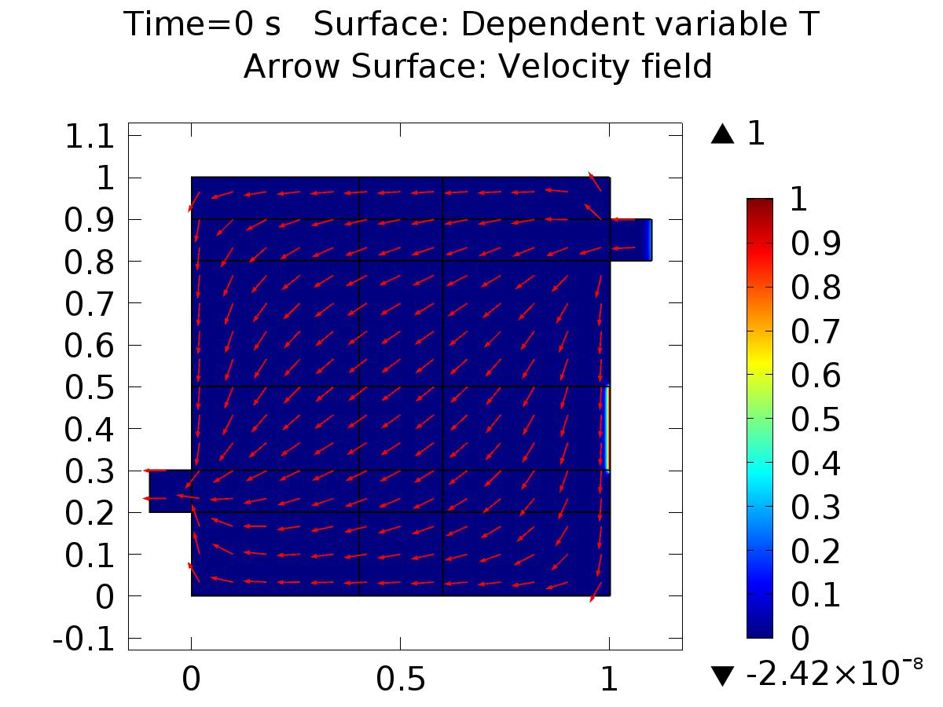

Time=0 s Surface: Dependent variable T Arrow Surface: Velocity field

* + 1. 1D Plot Group 10

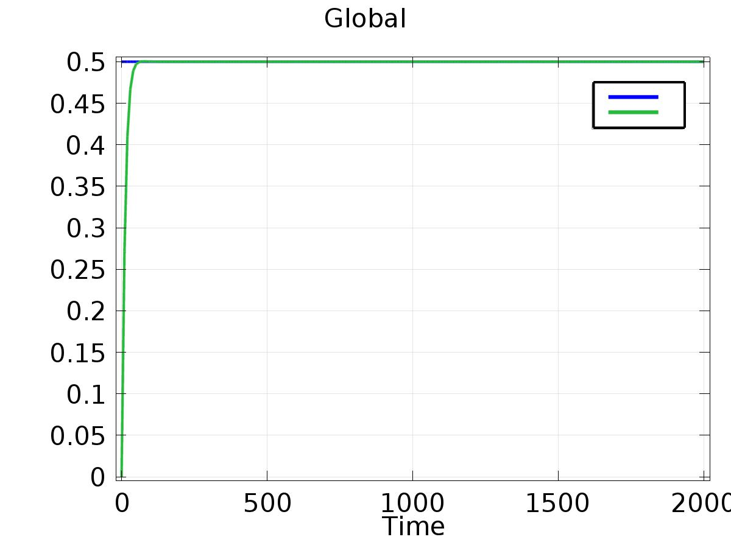

Global

* + 1. 1D Plot Group 11

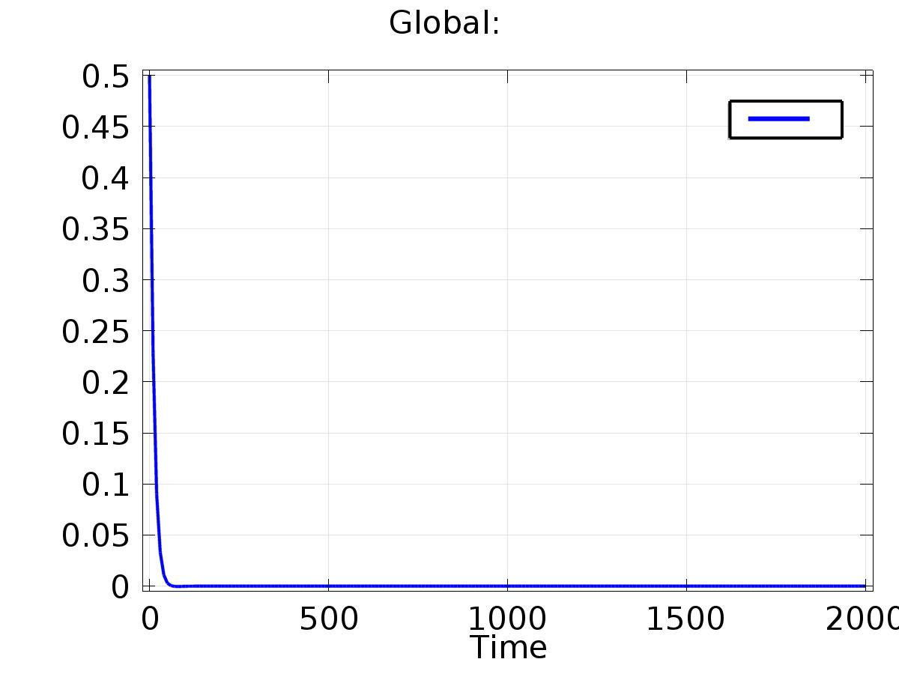

Global: