[](http://www.comsol.com/)

Ex5 2 2 NonIso PW

|  |  |
| --- | --- |
| Date | Aug 7, 2014 10:31:19 AM |

Contents

1. Global

1.1. Definitions

2. Component 1

2.1. Definitions

2.2. Geometry 1

2.3. Steady Flow

2.4. Unit Input

2.5. Set Point Flow

2.6. Set Point Temperature

2.7. Piecewise Constant Flow

2.8. Piecewise Constant Temperature

2.9. Closed Loop Flow

2.10. Closed Loop Temperature

2.11. Mesh 1

3. Study 1

3.1. Stationary

3.2. Solver Configurations

4. Study 2

4.1. Stationary

4.2. Solver Configurations

5. Study 3

5.1. Time Dependent

5.2. Solver Configurations

6. Study 4

6.1. Time Dependent

6.2. Solver Configurations

7. Results

7.1. Data Sets

7.2. Derived Values

7.3. Tables

7.4. Plot Groups

1. Global

|  |  |
| --- | --- |
| Date | Jul 20, 2014 8:34:26 AM |

Global settings

|  |  |
| --- | --- |
| Name | Ex5 2 2 NonIso PW.mph |
| Path | /Users/gilliam/Desktop/collect_15/research_15/geo_reg_mono_eugenio/Mono_1_15/Comsol_EX_GitHub/Chapter5/Chap5Ex2_Non-Isothermal-Navier-Stokes-Flow/Ex5.2.2_pcws_cnstnt/Ex5_2_2_NonIso_PW.mph |
| Program | COMSOL 4.4 (Build: 150) |

Used products

|  |
| --- |
| COMSOL Multiphysics |

* 1. Definitions
     1. Parameters 1

Parameters

| **Name** | **Expression** | **Value** | **Description** |
| --- | --- | --- | --- |
| L | 1 | 1.0000 |  |
| H | 0.1 | 0.10000 |  |
| ni | 0.002 | 0.0020000 |  |
| alpha | 0.01 | 0.010000 |  |
| beta | 1 | 1.0000 |  |
| M1 | 0.25 | 0.25000 |  |
| M2 | 0.5 | 0.50000 |  |
| d1 | 0.75 | 0.75000 |  |
| d2 | 0.5 | 0.50000 |  |
| t1 | 750 | 750.00 |  |
| t2 | 2250 | 2250.0 |  |

1. Component 1

Component settings

|  |  |
| --- | --- |
| Unit system | None |

* 1. Definitions
     1. Variables

#### Variables 1a

Selection

|  |  |
| --- | --- |
| Geometric entity level | Entire model |

| **Name** | **Expression** | **Description** |
| --- | --- | --- |
| G | C(X) |  |
| yr0 | M1 |  |
| d0 | d1 |  |
| gamma0 | (yr0 - C(tZ))/G |  |
| yr | M1 + (M2 - M1)*flc2hs(t - t1, 5) + (M1 - M2)*flc2hs(t - t2, 5) |  |
| d | d1 + (d2 - d1)*flc2hs(t - t1, 5) + (d1 - d2)*flc2hs(t - t2, 5) |  |
| gamma | (yr - C(tT))/G |  |
| e | yr - C(T) |  |

* + 1. Component Couplings

#### Average 1

|  |  |
| --- | --- |
| Coupling type | Average |
| Operator name | C |

Source selection

|  |  |
| --- | --- |
| Geometric entity level | Domain |
| Selection | Domain 9 |

* + 1. Coordinate Systems

#### Boundary System 1

|  |  |
| --- | --- |
| Coordinate system type | Boundary system |
| Tag | sys1 |

Coordinate names

| **First (t1)** | **Second (n)** | **Third (to)** |
| --- | --- | --- |
| t1 | n | to |

Settings

| **Description** | **Value** |
| --- | --- |
| Create first tangent direction from | Global Cartesian |

* 1. Geometry 1

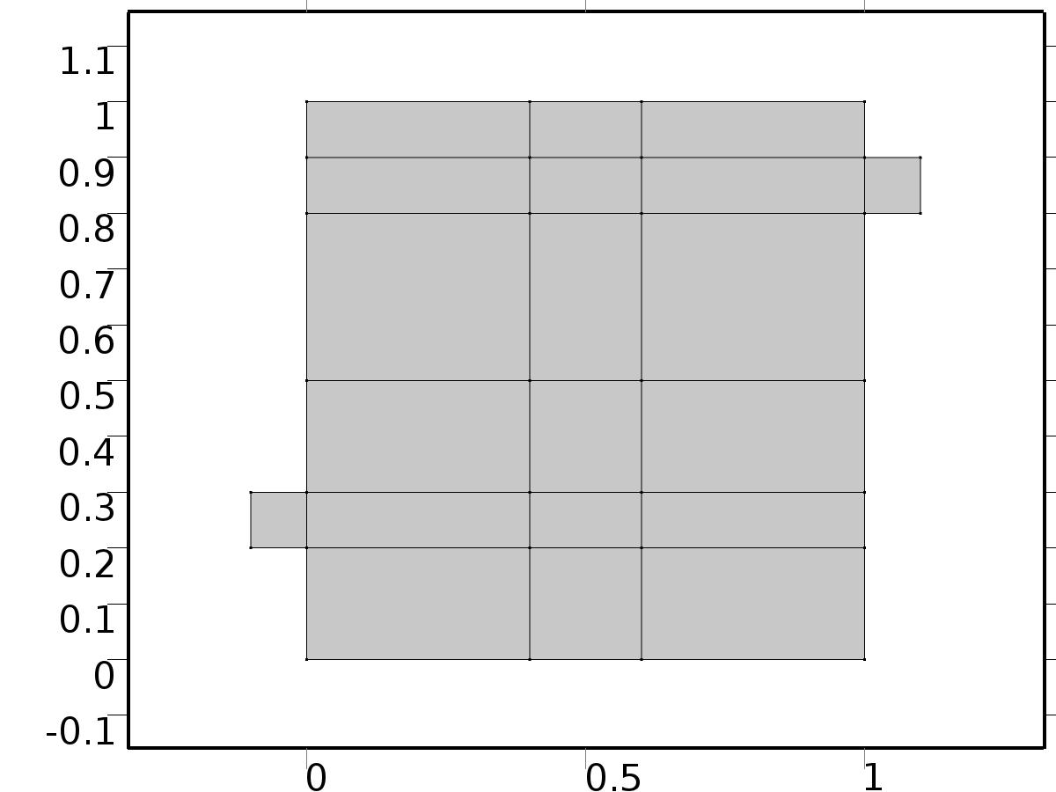

Geometry 1

Units

|  |  |
| --- | --- |
| Length unit | m |
| Angular unit | deg |

Geometry statistics

| **Description** | **Value** |
| --- | --- |
| Space dimension | 2 |
| Number of domains | 20 |
| Number of boundaries | 51 |
| Number of vertices | 32 |

* + 1. Square 1 (sq1)

Position

| **Description** | **Value** |
| --- | --- |
| Position | {0, 0} |
| Layers |  |

Size

| **Description** | **Value** |
| --- | --- |
| Side length | L |

* + 1. Rectangle 1 (r1)

Position

| **Description** | **Value** |
| --- | --- |
| Position | {-H, 2*H} |
| Layers |  |

Size

| **Description** | **Value** |
| --- | --- |
| Width | L + H |
| Height | H |

* + 1. Rectangle 2 (r2)

Position

| **Description** | **Value** |
| --- | --- |
| Position | {0, L - 2*H} |
| Layers |  |

Size

| **Description** | **Value** |
| --- | --- |
| Width | L + H |
| Height | H |

* + 1. Rectangle 3 (r3)

Position

| **Description** | **Value** |
| --- | --- |
| Position | {4*H, 0} |
| Layers |  |

Size

| **Description** | **Value** |
| --- | --- |
| Width | 2*H |
| Height | L |

* + 1. Rectangle 4 (r4)

Position

| **Description** | **Value** |
| --- | --- |
| Position | {0, 3*H} |
| Layers |  |

Size

| **Description** | **Value** |
| --- | --- |
| Width | L |
| Height | 2*H |

* 1. Steady Flow

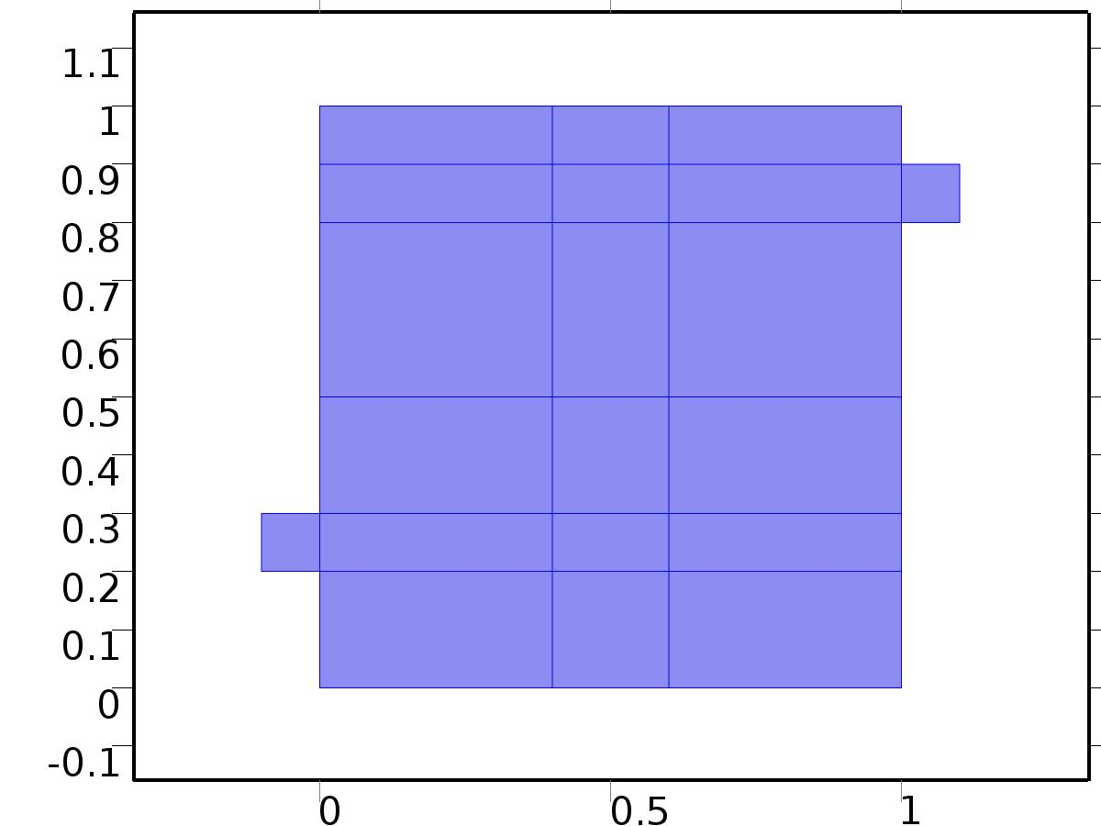

Steady Flow

Selection

|  |  |
| --- | --- |
| Geometric entity level | Domain |
| Selection | Domains 1–20 |

Equations









Settings

| **Description** | **Value** |
| --- | --- |
| Discretization of fluids | P2 + P1 |
| Value type when using splitting of complex variables | {Real, Real, Real, Real, Real, Real, Real, Real, Real, Real, Real} |
| Isotropic diffusion | Off |
| Compressibility | Incompressible flow |
| Channel thickness | 1 |
| Turbulence model type | None |
| Reference pressure level | 1[atm] |
| Use pseudo time stepping for stationary equation form | Off |
| Local CFL number | 1.3^min(niterCMP, 9) + if(niterCMP>=25, 9*1.3^min(niterCMP - 25, 9), 0) + if(niterCMP>=45, 90*1.3^min(niterCMP - 45, 9), 0) |
| Streamline diffusion | Off |
| Crosswind diffusion | Off |

Used products

|  |
| --- |
| COMSOL Multiphysics |

Variables

| **Name** | **Expression** | **Unit** | **Description** | **Selection** |
| --- | --- | --- | --- | --- |
| V.dz | 1 |  | Thickness | Domains 1–20 |
| V.pref | 1[atm] |  | Reference pressure level | Domains 1–20 |
| V.pA | P+V.pref |  | Absolute pressure | Domains 1–20 |
| V.nx | nx |  | Normal vector, x component | Boundaries 6–7, 9, 11, 13, 15, 17, 19–28, 30, 32–41, 47 |
| V.ny | ny |  | Normal vector, y component | Boundaries 6–7, 9, 11, 13, 15, 17, 19–28, 30, 32–41, 47 |
| V.nz | 0 |  | Normal vector, z component | Boundaries 6–7, 9, 11, 13, 15, 17, 19–28, 30, 32–41, 47 |
| V.nx | dnx |  | Normal vector, x component | Boundaries 1–5, 8, 10, 12, 14, 16, 18, 29, 31, 42–46, 48–51 |
| V.ny | dny |  | Normal vector, y component | Boundaries 1–5, 8, 10, 12, 14, 16, 18, 29, 31, 42–46, 48–51 |
| V.nz | 0 |  | Normal vector, z component | Boundaries 1–5, 8, 10, 12, 14, 16, 18, 29, 31, 42–46, 48–51 |
| V.nxmesh | root.nxmesh |  | Normal vector, x component | Boundaries 6–7, 9, 11, 13, 15, 17, 19–28, 30, 32–41, 47 |
| V.nymesh | root.nymesh |  | Normal vector, y component | Boundaries 6–7, 9, 11, 13, 15, 17, 19–28, 30, 32–41, 47 |
| V.nzmesh | 0 |  | Normal vector, z component | Boundaries 6–7, 9, 11, 13, 15, 17, 19–28, 30, 32–41, 47 |
| V.nxmesh | root.dnxmesh |  | Normal vector, x component | Boundaries 1–5, 8, 10, 12, 14, 16, 18, 29, 31, 42–46, 48–51 |
| V.nymesh | root.dnymesh |  | Normal vector, y component | Boundaries 1–5, 8, 10, 12, 14, 16, 18, 29, 31, 42–46, 48–51 |
| V.nzmesh | 0 |  | Normal vector, z component | Boundaries 1–5, 8, 10, 12, 14, 16, 18, 29, 31, 42–46, 48–51 |

* + 1. Fluid Properties



Fluid Properties

Selection

|  |  |
| --- | --- |
| Geometric entity level | Domain |
| Selection | Domains 1–20 |

Equations

Settings

| **Description** | **Value** |
| --- | --- |
| Density | User defined |
| Density | 1 |
| Dynamic viscosity | User defined |
| Dynamic viscosity | ni |

#### Variables

| **Name** | **Expression** | **Unit** | **Description** | **Selection** |
| --- | --- | --- | --- | --- |
| V.rho | 1 |  | Density | Domains 1–20 |
| V.mu | ni |  | Dynamic viscosity | Domains 1–20 |
| V.sr | sqrt(0.5*(4*Ux^2+2*(Uy+Vx)^2+4*Vy^2)+eps) |  | Shear rate | Domains 1–20 |
| V.divu | Ux+Vy |  | Divergence of velocity field | Domains 1–20 |
| V.Fx | 0 |  | Volume force, x component | Domains 1–20 |
| V.Fy | 0 |  | Volume force, y component | Domains 1–20 |
| V.Fz | 0 |  | Volume force, z component | Domains 1–20 |
| V.U | sqrt(U^2+V^2) |  | Velocity magnitude | Domains 1–20 |
| V.vorticityx | 0 |  | Vorticity field, x component | Domains 1–20 |
| V.vorticityy | 0 |  | Vorticity field, y component | Domains 1–20 |
| V.vorticityz | Vx-Uy |  | Vorticity field, z component | Domains 1–20 |
| V.vort_magn | sqrt(V.vorticityx^2+V.vorticityy^2+V.vorticityz^2) |  | Vorticity magnitude | Domains 1–20 |
| V.cellRe | 0.25*V.rho*sqrt(emetric(U,V)/emetric2)/V.mu |  | Cell Reynolds number | Domains 1–20 |
| V.nu | V.mu/V.rho |  | Kinematic viscosity | Domains 1–20 |
| V.betaT | 0 |  | Isothermal compressibility coefficient | Domains 1–20 |
| V.mu_eff | V.mu+V.muT |  | Dynamic viscosity | Domains 1–20 |
| V.muT | 0 |  | Turbulent dynamic viscosity | Domains 1–20 |
| V.T_stressx | V.K_stressx-P*V.nxmesh |  | Total stress, x component | Boundaries 1–51 |
| V.T_stressy | V.K_stressy-P*V.nymesh |  | Total stress, y component | Boundaries 1–51 |
| V.T_stressz | V.K_stressz-P*V.nzmesh |  | Total stress, z component | Boundaries 1–51 |
| V.K_stressx | V.mu_eff*(2*Ux*V.nxmesh+(Uy+Vx)*V.nymesh) |  | Viscous stress, x component | Boundaries 1–51 |
| V.K_stressy | V.mu_eff*((Vx+Uy)*V.nxmesh+2*Vy*V.nymesh) |  | Viscous stress, y component | Boundaries 1–51 |
| V.K_stressz | 0 |  | Viscous stress, z component | Boundaries 1–51 |
| V.K_stress_tensorxx | 2*V.mu_eff*Ux |  | Viscous stress tensor, xx component | Domains 1–20 |
| V.K_stress_tensoryx | V.mu_eff*(Vx+Uy) |  | Viscous stress tensor, yx component | Domains 1–20 |
| V.K_stress_tensorzx | 0 |  | Viscous stress tensor, zx component | Domains 1–20 |
| V.K_stress_tensorxy | V.mu_eff*(Uy+Vx) |  | Viscous stress tensor, xy component | Domains 1–20 |
| V.K_stress_tensoryy | 2*V.mu_eff*Vy |  | Viscous stress tensor, yy component | Domains 1–20 |
| V.K_stress_tensorzy | 0 |  | Viscous stress tensor, zy component | Domains 1–20 |
| V.K_stress_tensorxz | 0 |  | Viscous stress tensor, xz component | Domains 1–20 |
| V.K_stress_tensoryz | 0 |  | Viscous stress tensor, yz component | Domains 1–20 |
| V.K_stress_tensorzz | 0 |  | Viscous stress tensor, zz component | Domains 1–20 |
| V.K_stress_tensor_testxx | 2*V.mu_eff*test(Ux) |  | Viscous stress tensor test, xx component | Domains 1–20 |
| V.K_stress_tensor_testyx | V.mu_eff*(test(Vx)+test(Uy)) |  | Viscous stress tensor test, yx component | Domains 1–20 |
| V.K_stress_tensor_testzx | 0 |  | Viscous stress tensor test, zx component | Domains 1–20 |
| V.K_stress_tensor_testxy | V.mu_eff*(test(Uy)+test(Vx)) |  | Viscous stress tensor test, xy component | Domains 1–20 |
| V.K_stress_tensor_testyy | 2*V.mu_eff*test(Vy) |  | Viscous stress tensor test, yy component | Domains 1–20 |
| V.K_stress_tensor_testzy | 0 |  | Viscous stress tensor test, zy component | Domains 1–20 |
| V.K_stress_tensor_testxz | 0 |  | Viscous stress tensor test, xz component | Domains 1–20 |
| V.K_stress_tensor_testyz | 0 |  | Viscous stress tensor test, yz component | Domains 1–20 |
| V.K_stress_tensor_testzz | 0 |  | Viscous stress tensor test, zz component | Domains 1–20 |
| V.upwind_helpx | U |  | Upwind term, x component | Domains 1–20 |
| V.upwind_helpy | V |  | Upwind term, y component | Domains 1–20 |
| V.upwind_helpz | 0 |  | Upwind term, z component | Domains 1–20 |
| V.tau_vdxx | 2*V.mu*Ux |  | Strain rate, xx component | Domains 1–20 |
| V.tau_vdyx | V.mu*(Vx+Uy) |  | Strain rate, yx component | Domains 1–20 |
| V.tau_vdzx | 0 |  | Strain rate, zx component | Domains 1–20 |
| V.tau_vdxy | V.mu*(Uy+Vx) |  | Strain rate, xy component | Domains 1–20 |
| V.tau_vdyy | 2*V.mu*Vy |  | Strain rate, yy component | Domains 1–20 |
| V.tau_vdzy | 0 |  | Strain rate, zy component | Domains 1–20 |
| V.tau_vdxz | 0 |  | Strain rate, xz component | Domains 1–20 |
| V.tau_vdyz | 0 |  | Strain rate, yz component | Domains 1–20 |
| V.tau_vdzz | 0 |  | Strain rate, zz component | Domains 1–20 |
| V.Qvd | V.tau_vdxx*Ux+V.tau_vdxy*Uy+V.tau_vdyx*Vx+V.tau_vdyy*Vy |  | Viscous dissipation | Domains 1–20 |

#### Shape functions

| **Name** | **Shape function** | **Unit** | **Description** | **Shape frame** | **Selection** |
| --- | --- | --- | --- | --- | --- |
| U | Lagrange (Quadratic) |  | Velocity field, x component | Material | Domains 1–20 |
| V | Lagrange (Quadratic) |  | Velocity field, y component | Material | Domains 1–20 |
| P | Lagrange (Linear) |  | Pressure | Material | Domains 1–20 |

#### Weak expressions

| **Weak expression** | **Integration frame** | **Selection** |
| --- | --- | --- |
| (P-V.K_stress_tensorxx)*test(Ux)-V.K_stress_tensorxy*test(Uy)-V.K_stress_tensoryx*test(Vx)+(P-V.K_stress_tensoryy)*test(Vy) | Material | Domains 1–20 |
| V.Fx*test(U)+V.Fy*test(V) | Material | Domains 1–20 |
| V.rho*(-(Ux*U+Uy*V)*test(U)-(Vx*U+Vy*V)*test(V)) | Material | Domains 1–20 |
| -V.rho*V.divu*test(P) | Material | Domains 1–20 |

* + 1. Wall

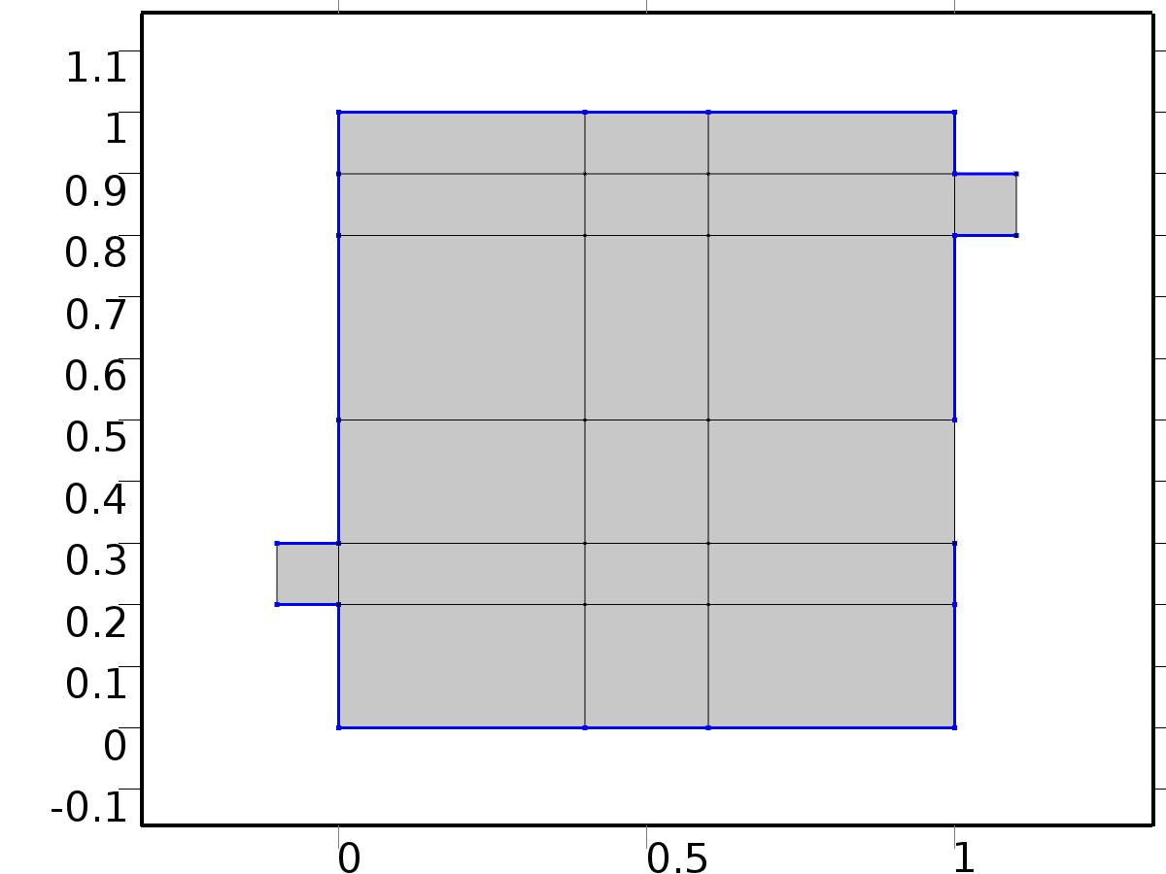

Wall

Selection

|  |  |
| --- | --- |
| Geometric entity level | Boundary |
| Selection | Boundaries 2–5, 8, 10, 12, 14, 16, 18, 29, 31, 42–44, 46, 48–50 |

Equations

Settings

| **Description** | **Value** |
| --- | --- |
| Boundary condition | No slip |
| Apply reaction terms on | Individual dependent variables |
| Use weak constraints | Off |
| Constraint method | Elemental |

#### Variables

| **Name** | **Expression** | **Unit** | **Description** | **Selection** |
| --- | --- | --- | --- | --- |
| V.ubndx | 0 |  | Velocity at boundary, x component | Boundaries 2–5, 8, 10, 12, 14, 16, 18, 29, 31, 42–44, 46, 48–50 |
| V.ubndy | 0 |  | Velocity at boundary, y component | Boundaries 2–5, 8, 10, 12, 14, 16, 18, 29, 31, 42–44, 46, 48–50 |
| V.ubndz | 0 |  | Velocity at boundary, z component | Boundaries 2–5, 8, 10, 12, 14, 16, 18, 29, 31, 42–44, 46, 48–50 |

#### Shape functions

| **Constraint** | **Constraint force** | **Shape function** | **Selection** |
| --- | --- | --- | --- |
| -U+V.ubndx | test(-U) | Lagrange (Quadratic) | Boundaries 2–5, 8, 10, 12, 14, 16, 18, 29, 31, 42–44, 46, 48–50 |
| -V+V.ubndy | test(-V) | Lagrange (Quadratic) | Boundaries 2–5, 8, 10, 12, 14, 16, 18, 29, 31, 42–44, 46, 48–50 |
| V.ubndz | 0 |  | Boundaries 2–5, 8, 10, 12, 14, 16, 18, 29, 31, 42–44, 46, 48–50 |

* + 1. Initial Values



Initial Values

Selection

|  |  |
| --- | --- |
| Geometric entity level | Domain |
| Selection | Domains 1–20 |

Settings

| **Description** | **Value** |
| --- | --- |
| Turbulent kinetic energy | spf.kinit |
| Turbulent dissipation rate | spf.epinit |
| Specific dissipation rate | spf.omInit |
| Reciprocal wall distance | spf.G0 |
| Undamped turbulent kinematic viscosity | spf.nutildeinit |
| Velocity field | {0, 0, 0} |
| Pressure | 0 |

* + 1. Inlet

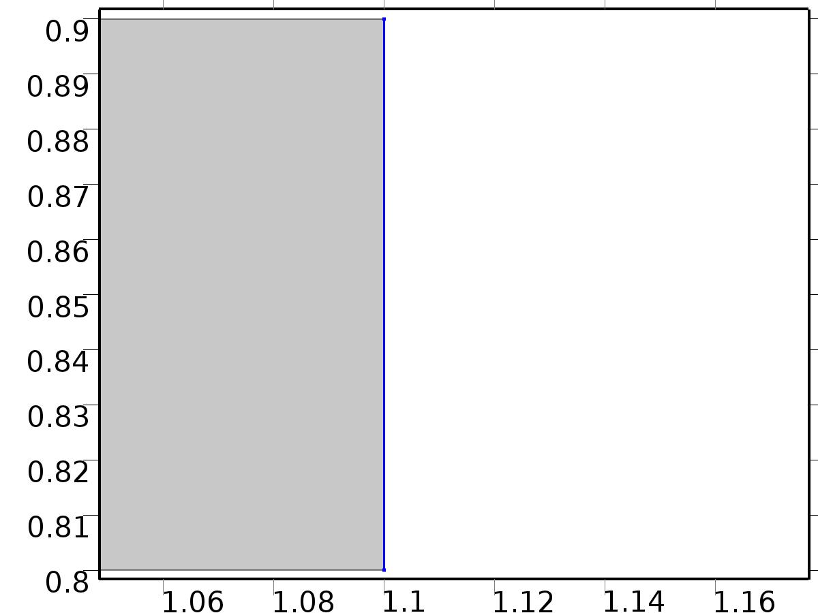

Inlet

Selection

|  |  |
| --- | --- |
| Geometric entity level | Boundary |
| Selection | Boundary 51 |

Equations

Settings

| **Description** | **Value** |
| --- | --- |
| Apply reaction terms on | All physics (symmetric) |
| Use weak constraints | Off |
| Boundary condition | Velocity |
| Velocity field componentwise | Normal inflow velocity |
| Normal inflow velocity | 4*s*(1 - s) |
| Turbulent intensity | 0.05 |
| Turbulence length scale | 0.01[m] |
| Turbulent kinetic energy | 0.005[m^2/s^2] |
| Turbulent dissipation rate | 0.005[m^2/s^3] |
| Specific dissipation rate | 20[1/s] |
| Undamped turbulent kinematic viscosity | 3*spf.nu |
| Constraint method | Elemental |

#### Variables

| **Name** | **Expression** | **Unit** | **Description** | **Selection** |
| --- | --- | --- | --- | --- |
| V.ubndx | -nojac(V.nxmesh)*V.U0in |  | Velocity at boundary, x component | Boundary 51 |
| V.ubndy | -nojac(V.nymesh)*V.U0in |  | Velocity at boundary, y component | Boundary 51 |
| V.ubndz | -nojac(V.nzmesh)*V.U0in |  | Velocity at boundary, z component | Boundary 51 |
| V.U0in | 4*s*(1-s) |  | Normal inflow velocity | Boundary 51 |

#### Shape functions

| **Constraint** | **Constraint force** | **Shape function** | **Selection** |
| --- | --- | --- | --- |
| -U+V.ubndx | test(-U+V.ubndx) | Lagrange (Quadratic) | Boundary 51 |
| -V+V.ubndy | test(-V+V.ubndy) | Lagrange (Quadratic) | Boundary 51 |
| V.ubndz | test(V.ubndz) |  | Boundary 51 |

* + 1. Outflow

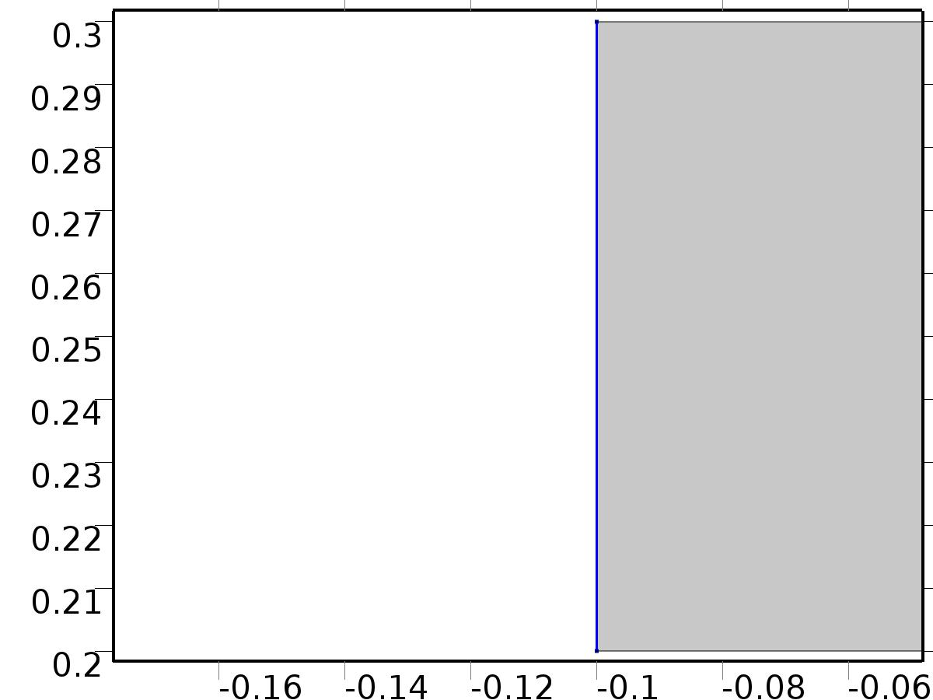

Outflow

Selection

|  |  |
| --- | --- |
| Geometric entity level | Boundary |
| Selection | Boundary 1 |

Equations

Settings

| **Description** | **Value** |
| --- | --- |
| Boundary condition | Normal stress |
| Normal stress | 0 |
| Turbulent intensity | 0.005 |
| Turbulence length scale | 0.1[m] |
| Turbulent kinetic energy | 2.5e-3[m^2/s^2] |
| Turbulent dissipation rate | 1.1e-4[m^2/s^3] |
| Specific dissipation rate | 0.5[1/s] |
| Undamped turbulent kinematic viscosity | 3*spf.nu |

#### Variables

| **Name** | **Expression** | **Unit** | **Description** | **Selection** |
| --- | --- | --- | --- | --- |
| V.f0 | 0 |  | Normal stress | Boundary 1 |

#### Weak expressions

| **Weak expression** | **Integration frame** | **Selection** |
| --- | --- | --- |
| -V.f0*(test(U)*V.nxmesh+test(V)*V.nymesh) | Material | Boundary 1 |

* + 1. Window

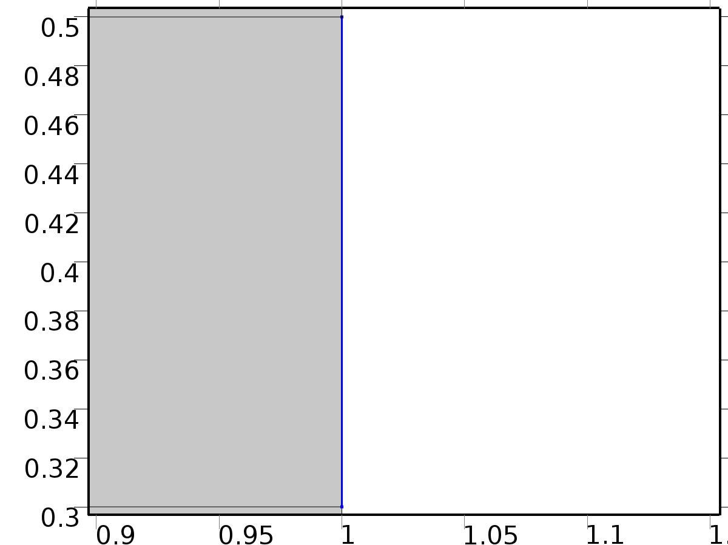

Window

Selection

|  |  |
| --- | --- |
| Geometric entity level | Boundary |
| Selection | Boundary 45 |

Equations

Settings

| **Description** | **Value** |
| --- | --- |
| Boundary condition | No slip |
| Apply reaction terms on | Individual dependent variables |
| Use weak constraints | Off |
| Constraint method | Elemental |

#### Variables

| **Name** | **Expression** | **Unit** | **Description** | **Selection** |
| --- | --- | --- | --- | --- |
| V.ubndx | 0 |  | Velocity at boundary, x component | Boundary 45 |
| V.ubndy | 0 |  | Velocity at boundary, y component | Boundary 45 |
| V.ubndz | 0 |  | Velocity at boundary, z component | Boundary 45 |

#### Shape functions

| **Constraint** | **Constraint force** | **Shape function** | **Selection** |
| --- | --- | --- | --- |
| -U+V.ubndx | test(-U) | Lagrange (Quadratic) | Boundary 45 |
| -V+V.ubndy | test(-V) | Lagrange (Quadratic) | Boundary 45 |
| V.ubndz | 0 |  | Boundary 45 |

* 1. Unit Input



Unit Input

Selection

|  |  |
| --- | --- |
| Geometric entity level | Domain |
| Selection | Domains 1–20 |

Settings

| **Description** | **Value** |
| --- | --- |
| Shape function type | Lagrange |
| Element order | Quadratic |
| Compute boundary fluxes | On |
| Apply smoothing to boundary fluxes | On |
| Value type when using splitting of complex variables | Complex |
| Dependent variable quantity | Dimensionless (1) |
| Source term quantity | None |
| Unit | m^ - 2 |

Used products

|  |
| --- |
| COMSOL Multiphysics |

Variables

| **Name** | **Expression** | **Unit** | **Description** | **Selection** |
| --- | --- | --- | --- | --- |
| X.nx | nx |  | Normal vector, x component | Boundaries 1–51 |
| X.ny | ny |  | Normal vector, y component | Boundaries 1–51 |
| X.nz | root.nz |  | Normal vector, z component | Boundaries 1–51 |
| X.nxmesh | root.nxmesh |  | Normal vector (mesh), x component | Boundaries 1–51 |
| X.nymesh | root.nymesh |  | Normal vector (mesh), y component | Boundaries 1–51 |
| X.nzmesh | root.nzmesh |  | Normal vector (mesh), z component | Boundaries 1–51 |

* + 1. Coefficient Form PDE



Coefficient Form PDE

Selection

|  |  |
| --- | --- |
| Geometric entity level | Domain |
| Selection | Domains 1–20 |

Equations

Settings

| **Description** | **Value** |
| --- | --- |
| Diffusion coefficient | {{alpha, 0}, {0, alpha}} |
| Absorption coefficient | 0 |
| Source term | 0 |
| Mass coefficient | 0 |
| Damping or mass coefficient | 0 |
| Conservative flux convection coefficient | {0, 0} |
| Convection coefficient | {U, V} |
| Conservative flux source | {0, 0} |

#### Variables

| **Name** | **Expression** | **Unit** | **Description** | **Selection** |
| --- | --- | --- | --- | --- |
| domflux.Xx | -alpha*d(X,x) |  | Domain flux, x component | Domains 1–20 |
| domflux.Xy | -alpha*d(X,y) |  | Domain flux, y component | Domains 1–20 |

#### Shape functions

| **Name** | **Shape function** | **Unit** | **Description** | **Shape frame** | **Selection** |
| --- | --- | --- | --- | --- | --- |
| X | Lagrange (Quadratic) |  | Dependent variable X | Material | Domains 1–20 |

* + 1. Insulated Wall



Insulated Wall

Selection

|  |  |
| --- | --- |
| Geometric entity level | Boundary |
| Selection | Boundaries 2–5, 8, 10, 12, 14, 16, 18, 29, 31, 42–44, 46, 48–50 |

Equations

* + 1. Initial Values



Initial Values

Selection

|  |  |
| --- | --- |
| Geometric entity level | Domain |
| Selection | Domains 1–20 |

Settings

| **Description** | **Value** |
| --- | --- |
| Initial value for X | 0 |
| Initial time derivative of X | 0 |

* + 1. Heat Flux Bin*1



Heat Flux Bin*1

Selection

|  |  |
| --- | --- |
| Geometric entity level | Boundary |
| Selection | Boundary 51 |

Equations

Settings

| **Description** | **Value** |
| --- | --- |
| Boundary flux/source | 1 |
| Boundary absorption/impedance term | 0 |

#### Variables

| **Name** | **Expression** | **Unit** | **Description** | **Selection** |
| --- | --- | --- | --- | --- |
| X.g_X | 1 |  | Boundary flux/source | Boundary 51 |

* + 1. Outflow



Outflow

Selection

|  |  |
| --- | --- |
| Geometric entity level | Boundary |
| Selection | Boundary 1 |

Equations

* + 1. Window



Window

Selection

|  |  |
| --- | --- |
| Geometric entity level | Boundary |
| Selection | Boundary 45 |

Equations

Settings

| **Description** | **Value** |
| --- | --- |
| Value on boundary | 0 |
| Prescribed value of X | On |
| Apply reaction terms on | Individual dependent variables |
| Use weak constraints | Off |
| Constraint method | Elemental |

#### Shape functions

| **Constraint** | **Constraint force** | **Shape function** | **Selection** |
| --- | --- | --- | --- |
| -X | -test(X) | Lagrange (Quadratic) | Boundary 45 |

* 1. Set Point Flow



Set Point Flow

Selection

|  |  |
| --- | --- |
| Geometric entity level | Domain |
| Selection | Domains 1–20 |

Equations









Settings

| **Description** | **Value** |
| --- | --- |
| Discretization of fluids | P2 + P1 |
| Value type when using splitting of complex variables | {Real, Real, Real, Real, Real, Real, Real, Real, Real, Real, Real} |
| Isotropic diffusion | Off |
| Compressibility | Incompressible flow |
| Channel thickness | 1 |
| Turbulence model type | None |
| Reference pressure level | 1[atm] |
| Use pseudo time stepping for stationary equation form | Off |
| Local CFL number | 1.3^min(niterCMP, 9) + if(niterCMP>=25, 9*1.3^min(niterCMP - 25, 9), 0) + if(niterCMP>=45, 90*1.3^min(niterCMP - 45, 9), 0) |
| Streamline diffusion | Off |
| Crosswind diffusion | Off |

Used products

|  |
| --- |
| COMSOL Multiphysics |

Variables

| **Name** | **Expression** | **Unit** | **Description** | **Selection** |
| --- | --- | --- | --- | --- |
| bV.dz | 1 |  | Thickness | Domains 1–20 |
| bV.pref | 1[atm] |  | Reference pressure level | Domains 1–20 |
| bV.pA | bP+bV.pref |  | Absolute pressure | Domains 1–20 |
| bV.nx | nx |  | Normal vector, x component | Boundaries 6–7, 9, 11, 13, 15, 17, 19–28, 30, 32–41, 47 |
| bV.ny | ny |  | Normal vector, y component | Boundaries 6–7, 9, 11, 13, 15, 17, 19–28, 30, 32–41, 47 |
| bV.nz | 0 |  | Normal vector, z component | Boundaries 6–7, 9, 11, 13, 15, 17, 19–28, 30, 32–41, 47 |
| bV.nx | dnx |  | Normal vector, x component | Boundaries 1–5, 8, 10, 12, 14, 16, 18, 29, 31, 42–46, 48–51 |
| bV.ny | dny |  | Normal vector, y component | Boundaries 1–5, 8, 10, 12, 14, 16, 18, 29, 31, 42–46, 48–51 |
| bV.nz | 0 |  | Normal vector, z component | Boundaries 1–5, 8, 10, 12, 14, 16, 18, 29, 31, 42–46, 48–51 |
| bV.nxmesh | root.nxmesh |  | Normal vector, x component | Boundaries 6–7, 9, 11, 13, 15, 17, 19–28, 30, 32–41, 47 |
| bV.nymesh | root.nymesh |  | Normal vector, y component | Boundaries 6–7, 9, 11, 13, 15, 17, 19–28, 30, 32–41, 47 |
| bV.nzmesh | 0 |  | Normal vector, z component | Boundaries 6–7, 9, 11, 13, 15, 17, 19–28, 30, 32–41, 47 |
| bV.nxmesh | root.dnxmesh |  | Normal vector, x component | Boundaries 1–5, 8, 10, 12, 14, 16, 18, 29, 31, 42–46, 48–51 |
| bV.nymesh | root.dnymesh |  | Normal vector, y component | Boundaries 1–5, 8, 10, 12, 14, 16, 18, 29, 31, 42–46, 48–51 |
| bV.nzmesh | 0 |  | Normal vector, z component | Boundaries 1–5, 8, 10, 12, 14, 16, 18, 29, 31, 42–46, 48–51 |

* + 1. Fluid Properties



Fluid Properties

Selection

|  |  |
| --- | --- |
| Geometric entity level | Domain |
| Selection | Domains 1–20 |

Equations

Settings

| **Description** | **Value** |
| --- | --- |
| Density | User defined |
| Density | 1 |
| Dynamic viscosity | User defined |
| Dynamic viscosity | ni |

#### Variables

| **Name** | **Expression** | **Unit** | **Description** | **Selection** |
| --- | --- | --- | --- | --- |
| bV.Fx | 0 |  | Volume force, x component | Domains 1–20 |
| bV.Fy | 0 |  | Volume force, y component | Domains 1–20 |
| bV.Fz | 0 |  | Volume force, z component | Domains 1–20 |
| bV.rho | 1 |  | Density | Domains 1–20 |
| bV.mu | ni |  | Dynamic viscosity | Domains 1–20 |
| bV.sr | sqrt(0.5*(4*bUx^2+2*(bUy+bVx)^2+4*bVy^2)+eps) |  | Shear rate | Domains 1–20 |
| bV.divu | bUx+bVy |  | Divergence of velocity field | Domains 1–20 |
| bV.U | sqrt(bU^2+bV^2) |  | Velocity magnitude | Domains 1–20 |
| bV.vorticityx | 0 |  | Vorticity field, x component | Domains 1–20 |
| bV.vorticityy | 0 |  | Vorticity field, y component | Domains 1–20 |
| bV.vorticityz | bVx-bUy |  | Vorticity field, z component | Domains 1–20 |
| bV.vort_magn | sqrt(bV.vorticityx^2+bV.vorticityy^2+bV.vorticityz^2) |  | Vorticity magnitude | Domains 1–20 |
| bV.cellRe | 0.25*bV.rho*sqrt(emetric(bU,bV)/emetric2)/bV.mu |  | Cell Reynolds number | Domains 1–20 |
| bV.nu | bV.mu/bV.rho |  | Kinematic viscosity | Domains 1–20 |
| bV.betaT | 0 |  | Isothermal compressibility coefficient | Domains 1–20 |
| bV.mu_eff | bV.mu+bV.muT |  | Dynamic viscosity | Domains 1–20 |
| bV.muT | 0 |  | Turbulent dynamic viscosity | Domains 1–20 |
| bV.T_stressx | bV.K_stressx-bP*bV.nxmesh |  | Total stress, x component | Boundaries 1–51 |
| bV.T_stressy | bV.K_stressy-bP*bV.nymesh |  | Total stress, y component | Boundaries 1–51 |
| bV.T_stressz | bV.K_stressz-bP*bV.nzmesh |  | Total stress, z component | Boundaries 1–51 |
| bV.K_stressx | bV.mu_eff*(2*bUx*bV.nxmesh+(bUy+bVx)*bV.nymesh) |  | Viscous stress, x component | Boundaries 1–51 |
| bV.K_stressy | bV.mu_eff*((bVx+bUy)*bV.nxmesh+2*bVy*bV.nymesh) |  | Viscous stress, y component | Boundaries 1–51 |
| bV.K_stressz | 0 |  | Viscous stress, z component | Boundaries 1–51 |
| bV.K_stress_tensorxx | 2*bV.mu_eff*bUx |  | Viscous stress tensor, xx component | Domains 1–20 |
| bV.K_stress_tensoryx | bV.mu_eff*(bVx+bUy) |  | Viscous stress tensor, yx component | Domains 1–20 |
| bV.K_stress_tensorzx | 0 |  | Viscous stress tensor, zx component | Domains 1–20 |
| bV.K_stress_tensorxy | bV.mu_eff*(bUy+bVx) |  | Viscous stress tensor, xy component | Domains 1–20 |
| bV.K_stress_tensoryy | 2*bV.mu_eff*bVy |  | Viscous stress tensor, yy component | Domains 1–20 |
| bV.K_stress_tensorzy | 0 |  | Viscous stress tensor, zy component | Domains 1–20 |
| bV.K_stress_tensorxz | 0 |  | Viscous stress tensor, xz component | Domains 1–20 |
| bV.K_stress_tensoryz | 0 |  | Viscous stress tensor, yz component | Domains 1–20 |
| bV.K_stress_tensorzz | 0 |  | Viscous stress tensor, zz component | Domains 1–20 |
| bV.K_stress_tensor_testxx | 2*bV.mu_eff*test(bUx) |  | Viscous stress tensor test, xx component | Domains 1–20 |
| bV.K_stress_tensor_testyx | bV.mu_eff*(test(bVx)+test(bUy)) |  | Viscous stress tensor test, yx component | Domains 1–20 |
| bV.K_stress_tensor_testzx | 0 |  | Viscous stress tensor test, zx component | Domains 1–20 |
| bV.K_stress_tensor_testxy | bV.mu_eff*(test(bUy)+test(bVx)) |  | Viscous stress tensor test, xy component | Domains 1–20 |
| bV.K_stress_tensor_testyy | 2*bV.mu_eff*test(bVy) |  | Viscous stress tensor test, yy component | Domains 1–20 |
| bV.K_stress_tensor_testzy | 0 |  | Viscous stress tensor test, zy component | Domains 1–20 |
| bV.K_stress_tensor_testxz | 0 |  | Viscous stress tensor test, xz component | Domains 1–20 |
| bV.K_stress_tensor_testyz | 0 |  | Viscous stress tensor test, yz component | Domains 1–20 |
| bV.K_stress_tensor_testzz | 0 |  | Viscous stress tensor test, zz component | Domains 1–20 |
| bV.upwind_helpx | bU |  | Upwind term, x component | Domains 1–20 |
| bV.upwind_helpy | bV |  | Upwind term, y component | Domains 1–20 |
| bV.upwind_helpz | 0 |  | Upwind term, z component | Domains 1–20 |
| bV.tau_vdxx | 2*bV.mu*bUx |  | Strain rate, xx component | Domains 1–20 |
| bV.tau_vdyx | bV.mu*(bVx+bUy) |  | Strain rate, yx component | Domains 1–20 |
| bV.tau_vdzx | 0 |  | Strain rate, zx component | Domains 1–20 |
| bV.tau_vdxy | bV.mu*(bUy+bVx) |  | Strain rate, xy component | Domains 1–20 |
| bV.tau_vdyy | 2*bV.mu*bVy |  | Strain rate, yy component | Domains 1–20 |
| bV.tau_vdzy | 0 |  | Strain rate, zy component | Domains 1–20 |
| bV.tau_vdxz | 0 |  | Strain rate, xz component | Domains 1–20 |
| bV.tau_vdyz | 0 |  | Strain rate, yz component | Domains 1–20 |
| bV.tau_vdzz | 0 |  | Strain rate, zz component | Domains 1–20 |
| bV.Qvd | bV.tau_vdxx*bUx+bV.tau_vdxy*bUy+bV.tau_vdyx*bVx+bV.tau_vdyy*bVy |  | Viscous dissipation | Domains 1–20 |

#### Shape functions

| **Name** | **Shape function** | **Unit** | **Description** | **Shape frame** | **Selection** |
| --- | --- | --- | --- | --- | --- |
| bU | Lagrange (Quadratic) |  | Velocity field, x component | Material | Domains 1–20 |
| bV | Lagrange (Quadratic) |  | Velocity field, y component | Material | Domains 1–20 |
| bP | Lagrange (Linear) |  | Pressure | Material | Domains 1–20 |

#### Weak expressions

| **Weak expression** | **Integration frame** | **Selection** |
| --- | --- | --- |
| (bP-bV.K_stress_tensorxx)*test(bUx)-bV.K_stress_tensorxy*test(bUy)-bV.K_stress_tensoryx*test(bVx)+(bP-bV.K_stress_tensoryy)*test(bVy) | Material | Domains 1–20 |
| bV.Fx*test(bU)+bV.Fy*test(bV) | Material | Domains 1–20 |
| bV.rho*(-(bUx*bU+bUy*bV)*test(bU)-(bVx*bU+bVy*bV)*test(bV)) | Material | Domains 1–20 |
| -bV.rho*bV.divu*test(bP) | Material | Domains 1–20 |

* + 1. Wall



Wall

Selection

|  |  |
| --- | --- |
| Geometric entity level | Boundary |
| Selection | Boundaries 2–5, 8, 10, 12, 14, 16, 18, 29, 31, 42–44, 46, 48–50 |

Equations

Settings

| **Description** | **Value** |
| --- | --- |
| Boundary condition | No slip |
| Apply reaction terms on | Individual dependent variables |
| Use weak constraints | Off |
| Constraint method | Elemental |

#### Variables

| **Name** | **Expression** | **Unit** | **Description** | **Selection** |
| --- | --- | --- | --- | --- |
| bV.ubndx | 0 |  | Velocity at boundary, x component | Boundaries 2–5, 8, 10, 12, 14, 16, 18, 29, 31, 42–44, 46, 48–50 |
| bV.ubndy | 0 |  | Velocity at boundary, y component | Boundaries 2–5, 8, 10, 12, 14, 16, 18, 29, 31, 42–44, 46, 48–50 |
| bV.ubndz | 0 |  | Velocity at boundary, z component | Boundaries 2–5, 8, 10, 12, 14, 16, 18, 29, 31, 42–44, 46, 48–50 |

#### Shape functions

| **Constraint** | **Constraint force** | **Shape function** | **Selection** |
| --- | --- | --- | --- |
| -bU+bV.ubndx | test(-bU) | Lagrange (Quadratic) | Boundaries 2–5, 8, 10, 12, 14, 16, 18, 29, 31, 42–44, 46, 48–50 |
| -bV+bV.ubndy | test(-bV) | Lagrange (Quadratic) | Boundaries 2–5, 8, 10, 12, 14, 16, 18, 29, 31, 42–44, 46, 48–50 |
| bV.ubndz | 0 |  | Boundaries 2–5, 8, 10, 12, 14, 16, 18, 29, 31, 42–44, 46, 48–50 |

* + 1. Initial Values



Initial Values

Selection

|  |  |
| --- | --- |
| Geometric entity level | Domain |
| Selection | Domains 1–20 |

Settings

| **Description** | **Value** |
| --- | --- |
| Turbulent kinetic energy | spf.kinit |
| Turbulent dissipation rate | spf.epinit |
| Specific dissipation rate | spf.omInit |
| Reciprocal wall distance | spf.G0 |
| Undamped turbulent kinematic viscosity | spf.nutildeinit |
| Velocity field | {U, V, 0} |
| Pressure | 0 |

* + 1. Inlet



Inlet

Selection

|  |  |
| --- | --- |
| Geometric entity level | Boundary |
| Selection | Boundary 51 |

Equations

Settings

| **Description** | **Value** |
| --- | --- |
| Apply reaction terms on | All physics (symmetric) |
| Use weak constraints | Off |
| Boundary condition | Velocity |
| Velocity field componentwise | Normal inflow velocity |
| Normal inflow velocity | 4*s*(1 - s) |
| Turbulent intensity | 0.05 |
| Turbulence length scale | 0.01[m] |
| Turbulent kinetic energy | 0.005[m^2/s^2] |
| Turbulent dissipation rate | 0.005[m^2/s^3] |
| Specific dissipation rate | 20[1/s] |
| Undamped turbulent kinematic viscosity | 3*vb.nu |
| Constraint method | Elemental |

#### Variables

| **Name** | **Expression** | **Unit** | **Description** | **Selection** |
| --- | --- | --- | --- | --- |
| bV.ubndx | -nojac(bV.nxmesh)*bV.U0in |  | Velocity at boundary, x component | Boundary 51 |
| bV.ubndy | -nojac(bV.nymesh)*bV.U0in |  | Velocity at boundary, y component | Boundary 51 |
| bV.ubndz | -nojac(bV.nzmesh)*bV.U0in |  | Velocity at boundary, z component | Boundary 51 |
| bV.U0in | 4*s*(1-s) |  | Normal inflow velocity | Boundary 51 |

#### Shape functions

| **Constraint** | **Constraint force** | **Shape function** | **Selection** |
| --- | --- | --- | --- |
| -bU+bV.ubndx | test(-bU+bV.ubndx) | Lagrange (Quadratic) | Boundary 51 |
| -bV+bV.ubndy | test(-bV+bV.ubndy) | Lagrange (Quadratic) | Boundary 51 |
| bV.ubndz | test(bV.ubndz) |  | Boundary 51 |

* + 1. Outflow



Outflow

Selection

|  |  |
| --- | --- |
| Geometric entity level | Boundary |
| Selection | Boundary 1 |

Equations

Settings

| **Description** | **Value** |
| --- | --- |
| Boundary condition | Normal stress |
| Normal stress | 0 |
| Turbulent intensity | 0.005 |
| Turbulence length scale | 0.1[m] |
| Turbulent kinetic energy | 2.5e-3[m^2/s^2] |
| Turbulent dissipation rate | 1.1e-4[m^2/s^3] |
| Specific dissipation rate | 0.5[1/s] |
| Undamped turbulent kinematic viscosity | 3*vb.nu |

#### Variables

| **Name** | **Expression** | **Unit** | **Description** | **Selection** |
| --- | --- | --- | --- | --- |
| bV.f0 | 0 |  | Normal stress | Boundary 1 |

#### Weak expressions

| **Weak expression** | **Integration frame** | **Selection** |
| --- | --- | --- |
| -bV.f0*(test(bU)*bV.nxmesh+test(bV)*bV.nymesh) | Material | Boundary 1 |

* + 1. Window



Window

Selection

|  |  |
| --- | --- |
| Geometric entity level | Boundary |
| Selection | Boundary 45 |

Equations

Settings

| **Description** | **Value** |
| --- | --- |
| Boundary condition | No slip |
| Apply reaction terms on | Individual dependent variables |
| Use weak constraints | Off |
| Constraint method | Elemental |

#### Variables

| **Name** | **Expression** | **Unit** | **Description** | **Selection** |
| --- | --- | --- | --- | --- |
| bV.ubndx | 0 |  | Velocity at boundary, x component | Boundary 45 |
| bV.ubndy | 0 |  | Velocity at boundary, y component | Boundary 45 |
| bV.ubndz | 0 |  | Velocity at boundary, z component | Boundary 45 |

#### Shape functions

| **Constraint** | **Constraint force** | **Shape function** | **Selection** |
| --- | --- | --- | --- |
| -bU+bV.ubndx | test(-bU) | Lagrange (Quadratic) | Boundary 45 |
| -bV+bV.ubndy | test(-bV) | Lagrange (Quadratic) | Boundary 45 |
| bV.ubndz | 0 |  | Boundary 45 |

* + 1. Buoyancy Force



Buoyancy Force

Selection

|  |  |
| --- | --- |
| Geometric entity level | Domain |
| Selection | Domains 1–20 |

Equations

#### Variables

| **Name** | **Expression** | **Unit** | **Description** | **Selection** |
| --- | --- | --- | --- | --- |
| bV.Fx | 0 |  | Volume force, x component | Domains 1–20 |
| bV.Fy | beta*bZ |  | Volume force, y component | Domains 1–20 |
| bV.Fz | 0 |  | Volume force, z component | Domains 1–20 |

* 1. Set Point Temperature



Set Point Temperature

Selection

|  |  |
| --- | --- |
| Geometric entity level | Domain |
| Selection | Domains 1–20 |

Settings

| **Description** | **Value** |
| --- | --- |
| Shape function type | Lagrange |
| Element order | Quadratic |
| Compute boundary fluxes | On |
| Apply smoothing to boundary fluxes | On |
| Value type when using splitting of complex variables | Complex |
| Dependent variable quantity | Dimensionless (1) |
| Source term quantity | None |
| Unit | m^ - 2 |

Used products

|  |
| --- |
| COMSOL Multiphysics |

Variables

| **Name** | **Expression** | **Unit** | **Description** | **Selection** |
| --- | --- | --- | --- | --- |
| bZ.nx | nx |  | Normal vector, x component | Boundaries 1–51 |
| bZ.ny | ny |  | Normal vector, y component | Boundaries 1–51 |
| bZ.nz | root.nz |  | Normal vector, z component | Boundaries 1–51 |
| bZ.nxmesh | root.nxmesh |  | Normal vector (mesh), x component | Boundaries 1–51 |
| bZ.nymesh | root.nymesh |  | Normal vector (mesh), y component | Boundaries 1–51 |
| bZ.nzmesh | root.nzmesh |  | Normal vector (mesh), z component | Boundaries 1–51 |

* + 1. Coefficient Form PDE



Coefficient Form PDE

Selection

|  |  |
| --- | --- |
| Geometric entity level | Domain |
| Selection | Domains 1–20 |

Equations

Settings

| **Description** | **Value** |
| --- | --- |
| Diffusion coefficient | {{{{alpha, 0}, {0, alpha}}, {{0, 0}, {0, 0}}}, {{{0, 0}, {0, 0}}, {{alpha, 0}, {0, alpha}}}} |
| Absorption coefficient | {{0, 0}, {0, 0}} |
| Source term | {0, 0} |
| Mass coefficient | {{0, 0}, {0, 0}} |
| Damping or mass coefficient | {{0, 0}, {0, 0}} |
| Conservative flux convection coefficient | {{{0, 0}, {0, 0}}, {{0, 0}, {0, 0}}} |
| Convection coefficient | {{{bU, bV}, {bU - U, bV - V}}, {{0, 0}, {U, V}}} |
| Conservative flux source | {{0, 0}, {0, 0}} |

#### Variables

| **Name** | **Expression** | **Unit** | **Description** | **Selection** |
| --- | --- | --- | --- | --- |
| domflux.bZx | -alpha*d(bZ,x) |  | Domain flux, x component | Domains 1–20 |
| domflux.bZy | -alpha*d(bZ,y) |  | Domain flux, y component | Domains 1–20 |
| domflux.tZx | -alpha*d(tZ,x) |  | Domain flux, x component | Domains 1–20 |
| domflux.tZy | -alpha*d(tZ,y) |  | Domain flux, y component | Domains 1–20 |

#### Shape functions

| **Name** | **Shape function** | **Unit** | **Description** | **Shape frame** | **Selection** |
| --- | --- | --- | --- | --- | --- |
| bZ | Lagrange (Quadratic) |  | Dependent variable bZ | Material | Domains 1–20 |
| tZ | Lagrange (Quadratic) |  | Dependent variable tZ | Material | Domains 1–20 |

* + 1. Insulated Wall



Insulated Wall

Selection

|  |  |
| --- | --- |
| Geometric entity level | Boundary |
| Selection | Boundaries 2–5, 8, 10, 12, 14, 16, 18, 29, 31, 42–44, 46, 48–50 |

Equations

* + 1. Initial Values



Initial Values

Selection

|  |  |
| --- | --- |
| Geometric entity level | Domain |
| Selection | Domains 1–20 |

Settings

| **Description** | **Value** |
| --- | --- |
| Initial value for bZ | 0 |
| Initial time derivative of bZ | 0 |
| Initial value for tZ | 0 |
| Initial time derivative of tZ | 0 |

* + 1. Heat Flux Bin*gamma0



Heat Flux Bin*gamma0

Selection

|  |  |
| --- | --- |
| Geometric entity level | Boundary |
| Selection | Boundary 51 |

Equations

Settings

| **Description** | **Value** |
| --- | --- |
| Boundary flux/source | {gamma0, 0} |
| Boundary absorption/impedance term | {{0, 0}, {0, 0}} |

#### Variables

| **Name** | **Expression** | **Unit** | **Description** | **Selection** |
| --- | --- | --- | --- | --- |
| bZ.g_bZ | gamma0 |  | Boundary flux/source | Boundary 51 |
| bZ.g_tZ | 0 |  | Boundary flux/source | Boundary 51 |

* + 1. Outflow



Outflow

Selection

|  |  |
| --- | --- |
| Geometric entity level | Boundary |
| Selection | Boundary 1 |

Equations

* + 1. Window



Window

Selection

|  |  |
| --- | --- |
| Geometric entity level | Boundary |
| Selection | Boundary 45 |

Equations

Settings

| **Description** | **Value** |
| --- | --- |
| Value on boundary | {d0, d0} |
| Prescribed value of bZ | On |
| Prescribed value of tZ | On |
| Apply reaction terms on | Individual dependent variables |
| Use weak constraints | Off |
| Constraint method | Elemental |

#### Shape functions

| **Constraint** | **Constraint force** | **Shape function** | **Selection** |
| --- | --- | --- | --- |
| d0-bZ | -test(bZ) | Lagrange (Quadratic) | Boundary 45 |
| d0-tZ | -test(tZ) | Lagrange (Quadratic) | Boundary 45 |

* 1. Piecewise Constant Flow



Piecewise Constant Flow

Selection

|  |  |
| --- | --- |
| Geometric entity level | Domain |
| Selection | Domains 1–20 |

Equations









Settings

| **Description** | **Value** |
| --- | --- |
| Discretization of fluids | P2 + P1 |
| Value type when using splitting of complex variables | {Real, Real, Real, Real, Real, Real, Real, Real, Real, Real, Real} |
| Isotropic diffusion | Off |
| Compressibility | Incompressible flow |
| Channel thickness | 1 |
| Turbulence model type | None |
| Reference pressure level | 1[atm] |
| Use pseudo time stepping for stationary equation form | Off |
| Local CFL number | 1.3^min(niterCMP, 9) + if(niterCMP>=25, 9*1.3^min(niterCMP - 25, 9), 0) + if(niterCMP>=45, 90*1.3^min(niterCMP - 45, 9), 0) |
| Streamline diffusion | Off |
| Crosswind diffusion | Off |

Used products

|  |
| --- |
| COMSOL Multiphysics |

Variables

| **Name** | **Expression** | **Unit** | **Description** | **Selection** |
| --- | --- | --- | --- | --- |
| bv.dz | 1 |  | Thickness | Domains 1–20 |
| bv.pref | 1[atm] |  | Reference pressure level | Domains 1–20 |
| bv.pA | bp+bv.pref |  | Absolute pressure | Domains 1–20 |
| bv.nx | nx |  | Normal vector, x component | Boundaries 6–7, 9, 11, 13, 15, 17, 19–28, 30, 32–41, 47 |
| bv.ny | ny |  | Normal vector, y component | Boundaries 6–7, 9, 11, 13, 15, 17, 19–28, 30, 32–41, 47 |
| bv.nz | 0 |  | Normal vector, z component | Boundaries 6–7, 9, 11, 13, 15, 17, 19–28, 30, 32–41, 47 |
| bv.nx | dnx |  | Normal vector, x component | Boundaries 1–5, 8, 10, 12, 14, 16, 18, 29, 31, 42–46, 48–51 |
| bv.ny | dny |  | Normal vector, y component | Boundaries 1–5, 8, 10, 12, 14, 16, 18, 29, 31, 42–46, 48–51 |
| bv.nz | 0 |  | Normal vector, z component | Boundaries 1–5, 8, 10, 12, 14, 16, 18, 29, 31, 42–46, 48–51 |
| bv.nxmesh | root.nxmesh |  | Normal vector, x component | Boundaries 6–7, 9, 11, 13, 15, 17, 19–28, 30, 32–41, 47 |
| bv.nymesh | root.nymesh |  | Normal vector, y component | Boundaries 6–7, 9, 11, 13, 15, 17, 19–28, 30, 32–41, 47 |
| bv.nzmesh | 0 |  | Normal vector, z component | Boundaries 6–7, 9, 11, 13, 15, 17, 19–28, 30, 32–41, 47 |
| bv.nxmesh | root.dnxmesh |  | Normal vector, x component | Boundaries 1–5, 8, 10, 12, 14, 16, 18, 29, 31, 42–46, 48–51 |
| bv.nymesh | root.dnymesh |  | Normal vector, y component | Boundaries 1–5, 8, 10, 12, 14, 16, 18, 29, 31, 42–46, 48–51 |
| bv.nzmesh | 0 |  | Normal vector, z component | Boundaries 1–5, 8, 10, 12, 14, 16, 18, 29, 31, 42–46, 48–51 |

* + 1. Fluid Properties



Fluid Properties

Selection

|  |  |
| --- | --- |
| Geometric entity level | Domain |
| Selection | Domains 1–20 |

Equations

Settings

| **Description** | **Value** |
| --- | --- |
| Density | User defined |
| Density | 1 |
| Dynamic viscosity | User defined |
| Dynamic viscosity | ni |

#### Variables

| **Name** | **Expression** | **Unit** | **Description** | **Selection** |
| --- | --- | --- | --- | --- |
| bv.Fx | 0 |  | Volume force, x component | Domains 1–20 |
| bv.Fy | 0 |  | Volume force, y component | Domains 1–20 |
| bv.Fz | 0 |  | Volume force, z component | Domains 1–20 |
| bv.rho | 1 |  | Density | Domains 1–20 |
| bv.mu | ni |  | Dynamic viscosity | Domains 1–20 |
| bv.sr | sqrt(0.5*(4*bux^2+2*(buy+bvx)^2+4*bvy^2)+eps) |  | Shear rate | Domains 1–20 |
| bv.divu | bux+bvy |  | Divergence of velocity field | Domains 1–20 |
| bv.U | sqrt(bu^2+bv^2) |  | Velocity magnitude | Domains 1–20 |
| bv.vorticityx | 0 |  | Vorticity field, x component | Domains 1–20 |
| bv.vorticityy | 0 |  | Vorticity field, y component | Domains 1–20 |
| bv.vorticityz | bvx-buy |  | Vorticity field, z component | Domains 1–20 |
| bv.vort_magn | sqrt(bv.vorticityx^2+bv.vorticityy^2+bv.vorticityz^2) |  | Vorticity magnitude | Domains 1–20 |
| bv.cellRe | 0.25*bv.rho*sqrt(emetric(bu,bv)/emetric2)/bv.mu |  | Cell Reynolds number | Domains 1–20 |
| bv.nu | bv.mu/bv.rho |  | Kinematic viscosity | Domains 1–20 |
| bv.betaT | 0 |  | Isothermal compressibility coefficient | Domains 1–20 |
| bv.mu_eff | bv.mu+bv.muT |  | Dynamic viscosity | Domains 1–20 |
| bv.muT | 0 |  | Turbulent dynamic viscosity | Domains 1–20 |
| bv.T_stressx | bv.K_stressx-bp*bv.nxmesh |  | Total stress, x component | Boundaries 1–51 |
| bv.T_stressy | bv.K_stressy-bp*bv.nymesh |  | Total stress, y component | Boundaries 1–51 |
| bv.T_stressz | bv.K_stressz-bp*bv.nzmesh |  | Total stress, z component | Boundaries 1–51 |
| bv.K_stressx | bv.mu_eff*(2*bux*bv.nxmesh+(buy+bvx)*bv.nymesh) |  | Viscous stress, x component | Boundaries 1–51 |
| bv.K_stressy | bv.mu_eff*((bvx+buy)*bv.nxmesh+2*bvy*bv.nymesh) |  | Viscous stress, y component | Boundaries 1–51 |
| bv.K_stressz | 0 |  | Viscous stress, z component | Boundaries 1–51 |
| bv.K_stress_tensorxx | 2*bv.mu_eff*bux |  | Viscous stress tensor, xx component | Domains 1–20 |
| bv.K_stress_tensoryx | bv.mu_eff*(bvx+buy) |  | Viscous stress tensor, yx component | Domains 1–20 |
| bv.K_stress_tensorzx | 0 |  | Viscous stress tensor, zx component | Domains 1–20 |
| bv.K_stress_tensorxy | bv.mu_eff*(buy+bvx) |  | Viscous stress tensor, xy component | Domains 1–20 |
| bv.K_stress_tensoryy | 2*bv.mu_eff*bvy |  | Viscous stress tensor, yy component | Domains 1–20 |
| bv.K_stress_tensorzy | 0 |  | Viscous stress tensor, zy component | Domains 1–20 |
| bv.K_stress_tensorxz | 0 |  | Viscous stress tensor, xz component | Domains 1–20 |
| bv.K_stress_tensoryz | 0 |  | Viscous stress tensor, yz component | Domains 1–20 |
| bv.K_stress_tensorzz | 0 |  | Viscous stress tensor, zz component | Domains 1–20 |
| bv.K_stress_tensor_testxx | 2*bv.mu_eff*test(bux) |  | Viscous stress tensor test, xx component | Domains 1–20 |
| bv.K_stress_tensor_testyx | bv.mu_eff*(test(bvx)+test(buy)) |  | Viscous stress tensor test, yx component | Domains 1–20 |
| bv.K_stress_tensor_testzx | 0 |  | Viscous stress tensor test, zx component | Domains 1–20 |
| bv.K_stress_tensor_testxy | bv.mu_eff*(test(buy)+test(bvx)) |  | Viscous stress tensor test, xy component | Domains 1–20 |
| bv.K_stress_tensor_testyy | 2*bv.mu_eff*test(bvy) |  | Viscous stress tensor test, yy component | Domains 1–20 |
| bv.K_stress_tensor_testzy | 0 |  | Viscous stress tensor test, zy component | Domains 1–20 |
| bv.K_stress_tensor_testxz | 0 |  | Viscous stress tensor test, xz component | Domains 1–20 |
| bv.K_stress_tensor_testyz | 0 |  | Viscous stress tensor test, yz component | Domains 1–20 |
| bv.K_stress_tensor_testzz | 0 |  | Viscous stress tensor test, zz component | Domains 1–20 |
| bv.upwind_helpx | bu |  | Upwind term, x component | Domains 1–20 |
| bv.upwind_helpy | bv |  | Upwind term, y component | Domains 1–20 |
| bv.upwind_helpz | 0 |  | Upwind term, z component | Domains 1–20 |
| bv.tau_vdxx | 2*bv.mu*bux |  | Strain rate, xx component | Domains 1–20 |
| bv.tau_vdyx | bv.mu*(bvx+buy) |  | Strain rate, yx component | Domains 1–20 |
| bv.tau_vdzx | 0 |  | Strain rate, zx component | Domains 1–20 |
| bv.tau_vdxy | bv.mu*(buy+bvx) |  | Strain rate, xy component | Domains 1–20 |
| bv.tau_vdyy | 2*bv.mu*bvy |  | Strain rate, yy component | Domains 1–20 |
| bv.tau_vdzy | 0 |  | Strain rate, zy component | Domains 1–20 |
| bv.tau_vdxz | 0 |  | Strain rate, xz component | Domains 1–20 |
| bv.tau_vdyz | 0 |  | Strain rate, yz component | Domains 1–20 |
| bv.tau_vdzz | 0 |  | Strain rate, zz component | Domains 1–20 |
| bv.Qvd | bv.tau_vdxx*bux+bv.tau_vdxy*buy+bv.tau_vdyx*bvx+bv.tau_vdyy*bvy |  | Viscous dissipation | Domains 1–20 |

#### Shape functions

| **Name** | **Shape function** | **Unit** | **Description** | **Shape frame** | **Selection** |
| --- | --- | --- | --- | --- | --- |
| bu | Lagrange (Quadratic) |  | Velocity field, x component | Material | Domains 1–20 |
| bv | Lagrange (Quadratic) |  | Velocity field, y component | Material | Domains 1–20 |
| bp | Lagrange (Linear) |  | Pressure | Material | Domains 1–20 |

#### Weak expressions

| **Weak expression** | **Integration frame** | **Selection** |
| --- | --- | --- |
| (bp-bv.K_stress_tensorxx)*test(bux)-bv.K_stress_tensorxy*test(buy)-bv.K_stress_tensoryx*test(bvx)+(bp-bv.K_stress_tensoryy)*test(bvy) | Material | Domains 1–20 |
| bv.Fx*test(bu)+bv.Fy*test(bv) | Material | Domains 1–20 |
| bv.rho*(-(bux*bu+buy*bv)*test(bu)-(bvx*bu+bvy*bv)*test(bv)) | Material | Domains 1–20 |
| -bv.rho*bv.divu*test(bp) | Material | Domains 1–20 |

* + 1. Wall



Wall

Selection

|  |  |
| --- | --- |
| Geometric entity level | Boundary |
| Selection | Boundaries 2–5, 8, 10, 12, 14, 16, 18, 29, 31, 42–44, 46, 48–50 |

Equations

Settings

| **Description** | **Value** |
| --- | --- |
| Boundary condition | No slip |
| Apply reaction terms on | Individual dependent variables |
| Use weak constraints | Off |
| Constraint method | Elemental |

#### Variables

| **Name** | **Expression** | **Unit** | **Description** | **Selection** |
| --- | --- | --- | --- | --- |
| bv.ubndx | 0 |  | Velocity at boundary, x component | Boundaries 2–5, 8, 10, 12, 14, 16, 18, 29, 31, 42–44, 46, 48–50 |
| bv.ubndy | 0 |  | Velocity at boundary, y component | Boundaries 2–5, 8, 10, 12, 14, 16, 18, 29, 31, 42–44, 46, 48–50 |
| bv.ubndz | 0 |  | Velocity at boundary, z component | Boundaries 2–5, 8, 10, 12, 14, 16, 18, 29, 31, 42–44, 46, 48–50 |

#### Shape functions

| **Constraint** | **Constraint force** | **Shape function** | **Selection** |
| --- | --- | --- | --- |
| -bu+bv.ubndx | test(-bu) | Lagrange (Quadratic) | Boundaries 2–5, 8, 10, 12, 14, 16, 18, 29, 31, 42–44, 46, 48–50 |
| -bv+bv.ubndy | test(-bv) | Lagrange (Quadratic) | Boundaries 2–5, 8, 10, 12, 14, 16, 18, 29, 31, 42–44, 46, 48–50 |
| bv.ubndz | 0 |  | Boundaries 2–5, 8, 10, 12, 14, 16, 18, 29, 31, 42–44, 46, 48–50 |

* + 1. Initial Values



Initial Values

Selection

|  |  |
| --- | --- |
| Geometric entity level | Domain |
| Selection | Domains 1–20 |

Settings

| **Description** | **Value** |
| --- | --- |
| Turbulent kinetic energy | spf.kinit |
| Turbulent dissipation rate | spf.epinit |
| Specific dissipation rate | spf.omInit |
| Reciprocal wall distance | spf.G0 |
| Undamped turbulent kinematic viscosity | spf.nutildeinit |
| Velocity field | {bU, bV, 0} |
| Pressure | 0 |

* + 1. Inlet



Inlet

Selection

|  |  |
| --- | --- |
| Geometric entity level | Boundary |
| Selection | Boundary 51 |

Equations

Settings

| **Description** | **Value** |
| --- | --- |
| Apply reaction terms on | All physics (symmetric) |
| Use weak constraints | Off |
| Boundary condition | Velocity |
| Velocity field componentwise | Normal inflow velocity |
| Normal inflow velocity | 4*s*(1 - s) |
| Turbulent intensity | 0.05 |
| Turbulence length scale | 0.01[m] |
| Turbulent kinetic energy | 0.005[m^2/s^2] |
| Turbulent dissipation rate | 0.005[m^2/s^3] |
| Specific dissipation rate | 20[1/s] |
| Undamped turbulent kinematic viscosity | 3*v.nu |
| Constraint method | Elemental |

#### Variables

| **Name** | **Expression** | **Unit** | **Description** | **Selection** |
| --- | --- | --- | --- | --- |
| bv.ubndx | -nojac(bv.nxmesh)*bv.U0in |  | Velocity at boundary, x component | Boundary 51 |
| bv.ubndy | -nojac(bv.nymesh)*bv.U0in |  | Velocity at boundary, y component | Boundary 51 |
| bv.ubndz | -nojac(bv.nzmesh)*bv.U0in |  | Velocity at boundary, z component | Boundary 51 |
| bv.U0in | 4*s*(1-s) |  | Normal inflow velocity | Boundary 51 |

#### Shape functions

| **Constraint** | **Constraint force** | **Shape function** | **Selection** |
| --- | --- | --- | --- |
| -bu+bv.ubndx | test(-bu+bv.ubndx) | Lagrange (Quadratic) | Boundary 51 |
| -bv+bv.ubndy | test(-bv+bv.ubndy) | Lagrange (Quadratic) | Boundary 51 |
| bv.ubndz | test(bv.ubndz) |  | Boundary 51 |

* + 1. Outflow



Outflow

Selection

|  |  |
| --- | --- |
| Geometric entity level | Boundary |
| Selection | Boundary 1 |

Equations

Settings

| **Description** | **Value** |
| --- | --- |
| Boundary condition | Normal stress |
| Normal stress | 0 |
| Turbulent intensity | 0.005 |
| Turbulence length scale | 0.1[m] |
| Turbulent kinetic energy | 2.5e-3[m^2/s^2] |
| Turbulent dissipation rate | 1.1e-4[m^2/s^3] |
| Specific dissipation rate | 0.5[1/s] |
| Undamped turbulent kinematic viscosity | 3*v.nu |

#### Variables

| **Name** | **Expression** | **Unit** | **Description** | **Selection** |
| --- | --- | --- | --- | --- |
| bv.f0 | 0 |  | Normal stress | Boundary 1 |

#### Weak expressions

| **Weak expression** | **Integration frame** | **Selection** |
| --- | --- | --- |
| -bv.f0*(test(bu)*bv.nxmesh+test(bv)*bv.nymesh) | Material | Boundary 1 |

* + 1. Window



Window

Selection

|  |  |
| --- | --- |
| Geometric entity level | Boundary |
| Selection | Boundary 45 |

Equations

Settings

| **Description** | **Value** |
| --- | --- |
| Boundary condition | No slip |
| Apply reaction terms on | Individual dependent variables |
| Use weak constraints | Off |
| Constraint method | Elemental |

#### Variables

| **Name** | **Expression** | **Unit** | **Description** | **Selection** |
| --- | --- | --- | --- | --- |
| bv.ubndx | 0 |  | Velocity at boundary, x component | Boundary 45 |
| bv.ubndy | 0 |  | Velocity at boundary, y component | Boundary 45 |
| bv.ubndz | 0 |  | Velocity at boundary, z component | Boundary 45 |

#### Shape functions

| **Constraint** | **Constraint force** | **Shape function** | **Selection** |
| --- | --- | --- | --- |
| -bu+bv.ubndx | test(-bu) | Lagrange (Quadratic) | Boundary 45 |
| -bv+bv.ubndy | test(-bv) | Lagrange (Quadratic) | Boundary 45 |
| bv.ubndz | 0 |  | Boundary 45 |

* + 1. Buoyancy Force



Buoyancy Force

Selection

|  |  |
| --- | --- |
| Geometric entity level | Domain |
| Selection | Domains 1–20 |

Equations

#### Variables

| **Name** | **Expression** | **Unit** | **Description** | **Selection** |
| --- | --- | --- | --- | --- |
| bv.Fx | 0 |  | Volume force, x component | Domains 1–20 |
| bv.Fy | beta*bT |  | Volume force, y component | Domains 1–20 |
| bv.Fz | 0 |  | Volume force, z component | Domains 1–20 |

* 1. Piecewise Constant Temperature



Piecewise Constant Temperature

Selection

|  |  |
| --- | --- |
| Geometric entity level | Domain |
| Selection | Domains 1–20 |

Settings

| **Description** | **Value** |
| --- | --- |
| Shape function type | Lagrange |
| Element order | Quadratic |
| Compute boundary fluxes | On |
| Apply smoothing to boundary fluxes | On |
| Value type when using splitting of complex variables | Complex |
| Dependent variable quantity | Dimensionless (1) |
| Source term quantity | None |
| Unit | m^ - 2 |

Used products

|  |
| --- |
| COMSOL Multiphysics |

Variables

| **Name** | **Expression** | **Unit** | **Description** | **Selection** |
| --- | --- | --- | --- | --- |
| bT.nx | nx |  | Normal vector, x component | Boundaries 1–51 |
| bT.ny | ny |  | Normal vector, y component | Boundaries 1–51 |
| bT.nz | root.nz |  | Normal vector, z component | Boundaries 1–51 |
| bT.nxmesh | root.nxmesh |  | Normal vector (mesh), x component | Boundaries 1–51 |
| bT.nymesh | root.nymesh |  | Normal vector (mesh), y component | Boundaries 1–51 |
| bT.nzmesh | root.nzmesh |  | Normal vector (mesh), z component | Boundaries 1–51 |

* + 1. Coefficient Form PDE



Coefficient Form PDE

Selection

|  |  |
| --- | --- |
| Geometric entity level | Domain |
| Selection | Domains 1–20 |

Equations

Settings

| **Description** | **Value** |
| --- | --- |
| Diffusion coefficient | {{{{alpha, 0}, {0, alpha}}, {{0, 0}, {0, 0}}}, {{{0, 0}, {0, 0}}, {{alpha, 0}, {0, alpha}}}} |
| Absorption coefficient | {{0, 0}, {0, 0}} |
| Source term | {0, 0} |
| Mass coefficient | {{0, 0}, {0, 0}} |
| Damping or mass coefficient | {{1, 0.95}, {0, 0}} |
| Conservative flux convection coefficient | {{{0, 0}, {0, 0}}, {{0, 0}, {0, 0}}} |
| Convection coefficient | {{{bu, bv}, {bu - U, bv - V}}, {{0, 0}, {U, V}}} |
| Conservative flux source | {{0, 0}, {0, 0}} |

#### Variables

| **Name** | **Expression** | **Unit** | **Description** | **Selection** |
| --- | --- | --- | --- | --- |
| domflux.bTx | -alpha*d(bT,x) |  | Domain flux, x component | Domains 1–20 |
| domflux.bTy | -alpha*d(bT,y) |  | Domain flux, y component | Domains 1–20 |
| domflux.tTx | -alpha*d(tT,x) |  | Domain flux, x component | Domains 1–20 |
| domflux.tTy | -alpha*d(tT,y) |  | Domain flux, y component | Domains 1–20 |

#### Shape functions

| **Name** | **Shape function** | **Unit** | **Description** | **Shape frame** | **Selection** |
| --- | --- | --- | --- | --- | --- |
| bT | Lagrange (Quadratic) |  | Dependent variable bT | Material | Domains 1–20 |
| tT | Lagrange (Quadratic) |  | Dependent variable tT | Material | Domains 1–20 |

* + 1. Insulated Wall



Insulated Wall

Selection

|  |  |
| --- | --- |
| Geometric entity level | Boundary |
| Selection | Boundaries 2–5, 8, 10, 12, 14, 16, 18, 29, 31, 42–44, 46, 48–50 |

Equations

* + 1. Initial Values



Initial Values

Selection

|  |  |
| --- | --- |
| Geometric entity level | Domain |
| Selection | Domains 1–20 |

Settings

| **Description** | **Value** |
| --- | --- |
| Initial value for bT | bZ |
| Initial time derivative of bT | 0 |
| Initial value for tT | tZ |
| Initial time derivative of tT | 0 |

* + 1. Heat Flux Bin*gamma



Heat Flux Bin*gamma

Selection

|  |  |
| --- | --- |
| Geometric entity level | Boundary |
| Selection | Boundary 51 |

Equations

Settings

| **Description** | **Value** |
| --- | --- |
| Boundary flux/source | {gamma, 0} |
| Boundary absorption/impedance term | {{0, 0}, {0, 0}} |

#### Variables

| **Name** | **Expression** | **Unit** | **Description** | **Selection** |
| --- | --- | --- | --- | --- |
| bT.g_bT | gamma |  | Boundary flux/source | Boundary 51 |
| bT.g_tT | 0 |  | Boundary flux/source | Boundary 51 |

* + 1. Outflow



Outflow

Selection

|  |  |
| --- | --- |
| Geometric entity level | Boundary |
| Selection | Boundary 1 |

Equations

* + 1. Window



Window

Selection

|  |  |
| --- | --- |
| Geometric entity level | Boundary |
| Selection | Boundary 45 |

Equations

Settings

| **Description** | **Value** |
| --- | --- |
| Value on boundary | {d, d} |
| Prescribed value of bT | On |
| Prescribed value of tT | On |
| Apply reaction terms on | Individual dependent variables |
| Use weak constraints | Off |
| Constraint method | Elemental |

#### Shape functions

| **Constraint** | **Constraint force** | **Shape function** | **Selection** |
| --- | --- | --- | --- |
| d-bT | -test(bT) | Lagrange (Quadratic) | Boundary 45 |
| d-tT | -test(tT) | Lagrange (Quadratic) | Boundary 45 |

* 1. Closed Loop Flow



Closed Loop Flow

Selection

|  |  |
| --- | --- |
| Geometric entity level | Domain |
| Selection | Domains 1–20 |

Equations









Settings

| **Description** | **Value** |
| --- | --- |
| Discretization of fluids | P2 + P1 |
| Value type when using splitting of complex variables | {Real, Real, Real, Real, Real, Real, Real, Real, Real, Real, Real} |
| Isotropic diffusion | Off |
| Compressibility | Incompressible flow |
| Channel thickness | 1 |
| Turbulence model type | None |
| Reference pressure level | 1[atm] |
| Use pseudo time stepping for stationary equation form | Off |
| Local CFL number | 1.3^min(niterCMP, 9) + if(niterCMP>=25, 9*1.3^min(niterCMP - 25, 9), 0) + if(niterCMP>=45, 90*1.3^min(niterCMP - 45, 9), 0) |
| Streamline diffusion | Off |
| Crosswind diffusion | Off |

Used products

|  |
| --- |
| COMSOL Multiphysics |

Variables

| **Name** | **Expression** | **Unit** | **Description** | **Selection** |
| --- | --- | --- | --- | --- |
| v.dz | 1 |  | Thickness | Domains 1–20 |
| v.pref | 1[atm] |  | Reference pressure level | Domains 1–20 |
| v.pA | p+v.pref |  | Absolute pressure | Domains 1–20 |
| v.nx | nx |  | Normal vector, x component | Boundaries 6–7, 9, 11, 13, 15, 17, 19–28, 30, 32–41, 47 |
| v.ny | ny |  | Normal vector, y component | Boundaries 6–7, 9, 11, 13, 15, 17, 19–28, 30, 32–41, 47 |
| v.nz | 0 |  | Normal vector, z component | Boundaries 6–7, 9, 11, 13, 15, 17, 19–28, 30, 32–41, 47 |
| v.nx | dnx |  | Normal vector, x component | Boundaries 1–5, 8, 10, 12, 14, 16, 18, 29, 31, 42–46, 48–51 |
| v.ny | dny |  | Normal vector, y component | Boundaries 1–5, 8, 10, 12, 14, 16, 18, 29, 31, 42–46, 48–51 |
| v.nz | 0 |  | Normal vector, z component | Boundaries 1–5, 8, 10, 12, 14, 16, 18, 29, 31, 42–46, 48–51 |
| v.nxmesh | root.nxmesh |  | Normal vector, x component | Boundaries 6–7, 9, 11, 13, 15, 17, 19–28, 30, 32–41, 47 |
| v.nymesh | root.nymesh |  | Normal vector, y component | Boundaries 6–7, 9, 11, 13, 15, 17, 19–28, 30, 32–41, 47 |
| v.nzmesh | 0 |  | Normal vector, z component | Boundaries 6–7, 9, 11, 13, 15, 17, 19–28, 30, 32–41, 47 |
| v.nxmesh | root.dnxmesh |  | Normal vector, x component | Boundaries 1–5, 8, 10, 12, 14, 16, 18, 29, 31, 42–46, 48–51 |
| v.nymesh | root.dnymesh |  | Normal vector, y component | Boundaries 1–5, 8, 10, 12, 14, 16, 18, 29, 31, 42–46, 48–51 |
| v.nzmesh | 0 |  | Normal vector, z component | Boundaries 1–5, 8, 10, 12, 14, 16, 18, 29, 31, 42–46, 48–51 |

* + 1. Fluid Properties



Fluid Properties

Selection

|  |  |
| --- | --- |
| Geometric entity level | Domain |
| Selection | Domains 1–20 |

Equations

Settings

| **Description** | **Value** |
| --- | --- |
| Density | User defined |
| Density | 1 |
| Dynamic viscosity | User defined |
| Dynamic viscosity | ni |

#### Variables

| **Name** | **Expression** | **Unit** | **Description** | **Selection** |
| --- | --- | --- | --- | --- |
| v.Fx | 0 |  | Volume force, x component | Domains 1–20 |
| v.Fy | 0 |  | Volume force, y component | Domains 1–20 |
| v.Fz | 0 |  | Volume force, z component | Domains 1–20 |
| v.rho | 1 |  | Density | Domains 1–20 |
| v.mu | ni |  | Dynamic viscosity | Domains 1–20 |
| v.sr | sqrt(0.5*(4*ux^2+2*(uy+vx)^2+4*vy^2)+eps) |  | Shear rate | Domains 1–20 |
| v.divu | ux+vy |  | Divergence of velocity field | Domains 1–20 |
| v.U | sqrt(u^2+v^2) |  | Velocity magnitude | Domains 1–20 |
| v.vorticityx | 0 |  | Vorticity field, x component | Domains 1–20 |
| v.vorticityy | 0 |  | Vorticity field, y component | Domains 1–20 |
| v.vorticityz | vx-uy |  | Vorticity field, z component | Domains 1–20 |
| v.vort_magn | sqrt(v.vorticityx^2+v.vorticityy^2+v.vorticityz^2) |  | Vorticity magnitude | Domains 1–20 |
| v.cellRe | 0.25*v.rho*sqrt(emetric(u,v)/emetric2)/v.mu |  | Cell Reynolds number | Domains 1–20 |
| v.nu | v.mu/v.rho |  | Kinematic viscosity | Domains 1–20 |
| v.betaT | 0 |  | Isothermal compressibility coefficient | Domains 1–20 |
| v.mu_eff | v.mu+v.muT |  | Dynamic viscosity | Domains 1–20 |
| v.muT | 0 |  | Turbulent dynamic viscosity | Domains 1–20 |
| v.T_stressx | v.K_stressx-p*v.nxmesh |  | Total stress, x component | Boundaries 1–51 |
| v.T_stressy | v.K_stressy-p*v.nymesh |  | Total stress, y component | Boundaries 1–51 |
| v.T_stressz | v.K_stressz-p*v.nzmesh |  | Total stress, z component | Boundaries 1–51 |
| v.K_stressx | v.mu_eff*(2*ux*v.nxmesh+(uy+vx)*v.nymesh) |  | Viscous stress, x component | Boundaries 1–51 |
| v.K_stressy | v.mu_eff*((vx+uy)*v.nxmesh+2*vy*v.nymesh) |  | Viscous stress, y component | Boundaries 1–51 |
| v.K_stressz | 0 |  | Viscous stress, z component | Boundaries 1–51 |
| v.K_stress_tensorxx | 2*v.mu_eff*ux |  | Viscous stress tensor, xx component | Domains 1–20 |
| v.K_stress_tensoryx | v.mu_eff*(vx+uy) |  | Viscous stress tensor, yx component | Domains 1–20 |
| v.K_stress_tensorzx | 0 |  | Viscous stress tensor, zx component | Domains 1–20 |
| v.K_stress_tensorxy | v.mu_eff*(uy+vx) |  | Viscous stress tensor, xy component | Domains 1–20 |
| v.K_stress_tensoryy | 2*v.mu_eff*vy |  | Viscous stress tensor, yy component | Domains 1–20 |
| v.K_stress_tensorzy | 0 |  | Viscous stress tensor, zy component | Domains 1–20 |
| v.K_stress_tensorxz | 0 |  | Viscous stress tensor, xz component | Domains 1–20 |
| v.K_stress_tensoryz | 0 |  | Viscous stress tensor, yz component | Domains 1–20 |
| v.K_stress_tensorzz | 0 |  | Viscous stress tensor, zz component | Domains 1–20 |
| v.K_stress_tensor_testxx | 2*v.mu_eff*test(ux) |  | Viscous stress tensor test, xx component | Domains 1–20 |
| v.K_stress_tensor_testyx | v.mu_eff*(test(vx)+test(uy)) |  | Viscous stress tensor test, yx component | Domains 1–20 |
| v.K_stress_tensor_testzx | 0 |  | Viscous stress tensor test, zx component | Domains 1–20 |
| v.K_stress_tensor_testxy | v.mu_eff*(test(uy)+test(vx)) |  | Viscous stress tensor test, xy component | Domains 1–20 |
| v.K_stress_tensor_testyy | 2*v.mu_eff*test(vy) |  | Viscous stress tensor test, yy component | Domains 1–20 |
| v.K_stress_tensor_testzy | 0 |  | Viscous stress tensor test, zy component | Domains 1–20 |
| v.K_stress_tensor_testxz | 0 |  | Viscous stress tensor test, xz component | Domains 1–20 |
| v.K_stress_tensor_testyz | 0 |  | Viscous stress tensor test, yz component | Domains 1–20 |
| v.K_stress_tensor_testzz | 0 |  | Viscous stress tensor test, zz component | Domains 1–20 |
| v.upwind_helpx | u |  | Upwind term, x component | Domains 1–20 |
| v.upwind_helpy | v |  | Upwind term, y component | Domains 1–20 |
| v.upwind_helpz | 0 |  | Upwind term, z component | Domains 1–20 |
| v.tau_vdxx | 2*v.mu*ux |  | Strain rate, xx component | Domains 1–20 |
| v.tau_vdyx | v.mu*(vx+uy) |  | Strain rate, yx component | Domains 1–20 |
| v.tau_vdzx | 0 |  | Strain rate, zx component | Domains 1–20 |
| v.tau_vdxy | v.mu*(uy+vx) |  | Strain rate, xy component | Domains 1–20 |
| v.tau_vdyy | 2*v.mu*vy |  | Strain rate, yy component | Domains 1–20 |
| v.tau_vdzy | 0 |  | Strain rate, zy component | Domains 1–20 |
| v.tau_vdxz | 0 |  | Strain rate, xz component | Domains 1–20 |
| v.tau_vdyz | 0 |  | Strain rate, yz component | Domains 1–20 |
| v.tau_vdzz | 0 |  | Strain rate, zz component | Domains 1–20 |
| v.Qvd | v.tau_vdxx*ux+v.tau_vdxy*uy+v.tau_vdyx*vx+v.tau_vdyy*vy |  | Viscous dissipation | Domains 1–20 |

#### Shape functions

| **Name** | **Shape function** | **Unit** | **Description** | **Shape frame** | **Selection** |
| --- | --- | --- | --- | --- | --- |
| u | Lagrange (Quadratic) |  | Velocity field, x component | Material | Domains 1–20 |
| v | Lagrange (Quadratic) |  | Velocity field, y component | Material | Domains 1–20 |
| p | Lagrange (Linear) |  | Pressure | Material | Domains 1–20 |

#### Weak expressions

| **Weak expression** | **Integration frame** | **Selection** |
| --- | --- | --- |
| (p-v.K_stress_tensorxx)*test(ux)-v.K_stress_tensorxy*test(uy)-v.K_stress_tensoryx*test(vx)+(p-v.K_stress_tensoryy)*test(vy) | Material | Domains 1–20 |
| v.Fx*test(u)+v.Fy*test(v) | Material | Domains 1–20 |
| v.rho*(-(ux*u+uy*v)*test(u)-(vx*u+vy*v)*test(v)) | Material | Domains 1–20 |
| -v.rho*v.divu*test(p) | Material | Domains 1–20 |

* + 1. Wall



Wall

Selection

|  |  |
| --- | --- |
| Geometric entity level | Boundary |
| Selection | Boundaries 2–5, 8, 10, 12, 14, 16, 18, 29, 31, 42–44, 46, 48–50 |

Equations

Settings

| **Description** | **Value** |
| --- | --- |
| Boundary condition | No slip |
| Apply reaction terms on | Individual dependent variables |
| Use weak constraints | Off |
| Constraint method | Elemental |

#### Variables

| **Name** | **Expression** | **Unit** | **Description** | **Selection** |
| --- | --- | --- | --- | --- |
| v.ubndx | 0 |  | Velocity at boundary, x component | Boundaries 2–5, 8, 10, 12, 14, 16, 18, 29, 31, 42–44, 46, 48–50 |
| v.ubndy | 0 |  | Velocity at boundary, y component | Boundaries 2–5, 8, 10, 12, 14, 16, 18, 29, 31, 42–44, 46, 48–50 |
| v.ubndz | 0 |  | Velocity at boundary, z component | Boundaries 2–5, 8, 10, 12, 14, 16, 18, 29, 31, 42–44, 46, 48–50 |

#### Shape functions

| **Constraint** | **Constraint force** | **Shape function** | **Selection** |
| --- | --- | --- | --- |
| -u+v.ubndx | test(-u) | Lagrange (Quadratic) | Boundaries 2–5, 8, 10, 12, 14, 16, 18, 29, 31, 42–44, 46, 48–50 |
| -v+v.ubndy | test(-v) | Lagrange (Quadratic) | Boundaries 2–5, 8, 10, 12, 14, 16, 18, 29, 31, 42–44, 46, 48–50 |
| v.ubndz | 0 |  | Boundaries 2–5, 8, 10, 12, 14, 16, 18, 29, 31, 42–44, 46, 48–50 |

* + 1. Initial Values



Initial Values

Selection

|  |  |
| --- | --- |
| Geometric entity level | Domain |
| Selection | Domains 1–20 |

Settings

| **Description** | **Value** |
| --- | --- |
| Velocity field | {0, 0, 0} |
| Pressure | 0 |
| Turbulent kinetic energy | spf.kinit |
| Turbulent dissipation rate | spf.epinit |
| Specific dissipation rate | spf.omInit |
| Reciprocal wall distance | spf.G0 |
| Undamped turbulent kinematic viscosity | spf.nutildeinit |

* + 1. Inlet



Inlet

Selection

|  |  |
| --- | --- |
| Geometric entity level | Boundary |
| Selection | Boundary 51 |

Equations

Settings

| **Description** | **Value** |
| --- | --- |
| Apply reaction terms on | All physics (symmetric) |
| Use weak constraints | Off |
| Boundary condition | Velocity |
| Velocity field componentwise | Normal inflow velocity |
| Normal inflow velocity | 4*s*(1 - s) |
| Turbulent intensity | 0.05 |
| Turbulence length scale | 0.01[m] |
| Turbulent kinetic energy | 0.005[m^2/s^2] |
| Turbulent dissipation rate | 0.005[m^2/s^3] |
| Specific dissipation rate | 20[1/s] |
| Constraint method | Elemental |

#### Variables

| **Name** | **Expression** | **Unit** | **Description** | **Selection** |
| --- | --- | --- | --- | --- |
| v.ubndx | -nojac(v.nxmesh)*v.U0in |  | Velocity at boundary, x component | Boundary 51 |
| v.ubndy | -nojac(v.nymesh)*v.U0in |  | Velocity at boundary, y component | Boundary 51 |
| v.ubndz | -nojac(v.nzmesh)*v.U0in |  | Velocity at boundary, z component | Boundary 51 |
| v.U0in | 4*s*(1-s) |  | Normal inflow velocity | Boundary 51 |

#### Shape functions

| **Constraint** | **Constraint force** | **Shape function** | **Selection** |
| --- | --- | --- | --- |
| -u+v.ubndx | test(-u+v.ubndx) | Lagrange (Quadratic) | Boundary 51 |
| -v+v.ubndy | test(-v+v.ubndy) | Lagrange (Quadratic) | Boundary 51 |
| v.ubndz | test(v.ubndz) |  | Boundary 51 |

* + 1. Outflow



Outflow

Selection

|  |  |
| --- | --- |
| Geometric entity level | Boundary |
| Selection | Boundary 1 |

Equations

Settings

| **Description** | **Value** |
| --- | --- |
| Boundary condition | Normal stress |
| Normal stress | 0 |
| Turbulent intensity | 0.005 |
| Turbulence length scale | 0.1[m] |
| Turbulent kinetic energy | 2.5e-3[m^2/s^2] |
| Turbulent dissipation rate | 1.1e-4[m^2/s^3] |
| Specific dissipation rate | 0.5[1/s] |

#### Variables

| **Name** | **Expression** | **Unit** | **Description** | **Selection** |
| --- | --- | --- | --- | --- |
| v.f0 | 0 |  | Normal stress | Boundary 1 |

#### Weak expressions

| **Weak expression** | **Integration frame** | **Selection** |
| --- | --- | --- |
| -v.f0*(test(u)*v.nxmesh+test(v)*v.nymesh) | Material | Boundary 1 |

* + 1. Window



Window

Selection

|  |  |
| --- | --- |
| Geometric entity level | Boundary |
| Selection | Boundary 45 |

Equations

Settings

| **Description** | **Value** |
| --- | --- |
| Boundary condition | No slip |
| Apply reaction terms on | Individual dependent variables |
| Use weak constraints | Off |
| Constraint method | Elemental |

#### Variables

| **Name** | **Expression** | **Unit** | **Description** | **Selection** |
| --- | --- | --- | --- | --- |
| v.ubndx | 0 |  | Velocity at boundary, x component | Boundary 45 |
| v.ubndy | 0 |  | Velocity at boundary, y component | Boundary 45 |
| v.ubndz | 0 |  | Velocity at boundary, z component | Boundary 45 |

#### Shape functions

| **Constraint** | **Constraint force** | **Shape function** | **Selection** |
| --- | --- | --- | --- |
| -u+v.ubndx | test(-u) | Lagrange (Quadratic) | Boundary 45 |
| -v+v.ubndy | test(-v) | Lagrange (Quadratic) | Boundary 45 |
| v.ubndz | 0 |  | Boundary 45 |

* + 1. Buoyancy Force



Buoyancy Force

Selection

|  |  |
| --- | --- |
| Geometric entity level | Domain |
| Selection | Domains 1–20 |

Equations

#### Variables

| **Name** | **Expression** | **Unit** | **Description** | **Selection** |
| --- | --- | --- | --- | --- |
| v.Fx | 0 |  | Volume force, x component | Domains 1–20 |
| v.Fy | beta*T |  | Volume force, y component | Domains 1–20 |
| v.Fz | 0 |  | Volume force, z component | Domains 1–20 |

* 1. Closed Loop Temperature



Closed Loop Temperature

Selection

|  |  |
| --- | --- |
| Geometric entity level | Domain |
| Selection | Domains 1–20 |

Settings

| **Description** | **Value** |
| --- | --- |
| Shape function type | Lagrange |
| Element order | Quadratic |
| Compute boundary fluxes | On |
| Apply smoothing to boundary fluxes | On |
| Value type when using splitting of complex variables | Complex |
| Dependent variable quantity | Dimensionless (1) |
| Source term quantity | None |
| Unit | m^ - 2 |

Used products

|  |
| --- |
| COMSOL Multiphysics |

Variables

| **Name** | **Expression** | **Unit** | **Description** | **Selection** |
| --- | --- | --- | --- | --- |
| T.nx | nx |  | Normal vector, x component | Boundaries 1–51 |
| T.ny | ny |  | Normal vector, y component | Boundaries 1–51 |
| T.nz | root.nz |  | Normal vector, z component | Boundaries 1–51 |
| T.nxmesh | root.nxmesh |  | Normal vector (mesh), x component | Boundaries 1–51 |
| T.nymesh | root.nymesh |  | Normal vector (mesh), y component | Boundaries 1–51 |
| T.nzmesh | root.nzmesh |  | Normal vector (mesh), z component | Boundaries 1–51 |

* + 1. Coefficient Form PDE



Coefficient Form PDE

Selection

|  |  |
| --- | --- |
| Geometric entity level | Domain |
| Selection | Domains 1–20 |

Equations

Settings

| **Description** | **Value** |
| --- | --- |
| Diffusion coefficient | {{alpha, 0}, {0, alpha}} |
| Absorption coefficient | 0 |
| Source term | 0 |
| Mass coefficient | 0 |
| Damping or mass coefficient | 1 |
| Conservative flux convection coefficient | {0, 0} |
| Convection coefficient | {u, v} |
| Conservative flux source | {0, 0} |

#### Variables

| **Name** | **Expression** | **Unit** | **Description** | **Selection** |
| --- | --- | --- | --- | --- |
| domflux.Tx | -alpha*d(T,x) |  | Domain flux, x component | Domains 1–20 |
| domflux.Ty | -alpha*d(T,y) |  | Domain flux, y component | Domains 1–20 |

#### Shape functions

| **Name** | **Shape function** | **Unit** | **Description** | **Shape frame** | **Selection** |
| --- | --- | --- | --- | --- | --- |
| T | Lagrange (Quadratic) |  | Dependent variable T | Material | Domains 1–20 |

* + 1. Insulated Wall



Insulated Wall

Selection

|  |  |
| --- | --- |
| Geometric entity level | Boundary |
| Selection | Boundaries 2–5, 8, 10, 12, 14, 16, 18, 29, 31, 42–44, 46, 48–50 |

Equations

* + 1. Initial Values



Initial Values

Selection

|  |  |
| --- | --- |
| Geometric entity level | Domain |
| Selection | Domains 1–20 |

Settings

| **Description** | **Value** |
| --- | --- |
| Initial value for T | 0 |
| Initial time derivative of T | 0 |

* + 1. Heat Flux Bin*gamma



Heat Flux Bin*gamma

Selection

|  |  |
| --- | --- |
| Geometric entity level | Boundary |
| Selection | Boundary 51 |

Equations

Settings

| **Description** | **Value** |
| --- | --- |
| Boundary flux/source | gamma |
| Boundary absorption/impedance term | 0 |

#### Variables

| **Name** | **Expression** | **Unit** | **Description** | **Selection** |
| --- | --- | --- | --- | --- |
| T.g_T | gamma |  | Boundary flux/source | Boundary 51 |

* + 1. Outflow



Outflow

Selection

|  |  |
| --- | --- |
| Geometric entity level | Boundary |
| Selection | Boundary 1 |

Equations

* + 1. Window



Window

Selection

|  |  |
| --- | --- |
| Geometric entity level | Boundary |
| Selection | Boundary 45 |

Equations

Settings

| **Description** | **Value** |
| --- | --- |
| Value on boundary | d |
| Prescribed value of T | On |
| Apply reaction terms on | Individual dependent variables |
| Use weak constraints | Off |
| Constraint method | Elemental |

#### Shape functions

| **Constraint** | **Constraint force** | **Shape function** | **Selection** |
| --- | --- | --- | --- |
| d-T | -test(T) | Lagrange (Quadratic) | Boundary 45 |

* 1. Mesh 1

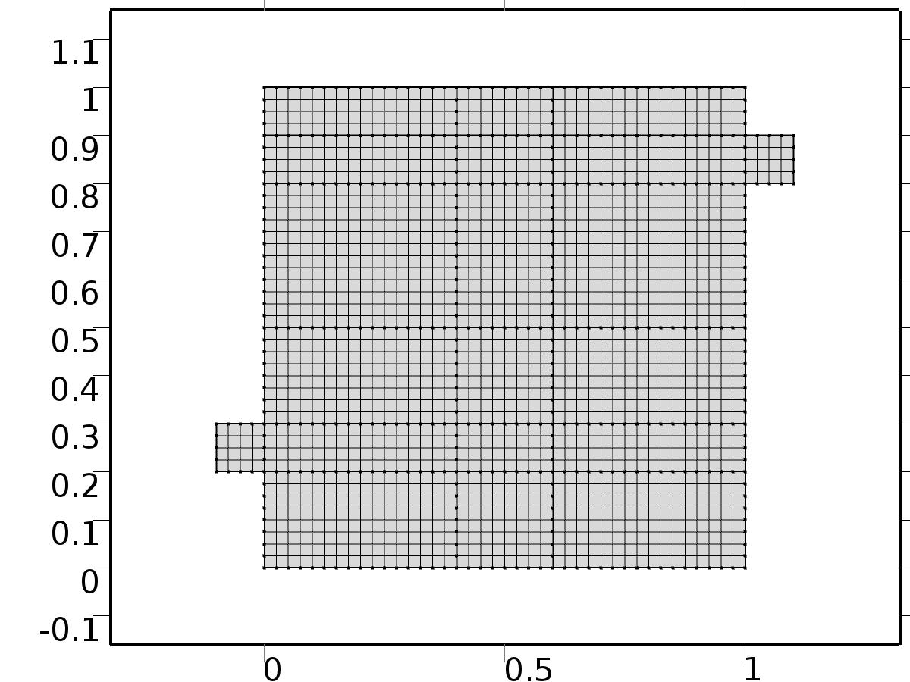

Mesh 1

* + 1. Size (size)

Settings

| **Description** | **Value** |
| --- | --- |
| Maximum element size | 0.0804 |
| Minimum element size | 3.6E-4 |
| Curvature factor | 0.3 |
| Maximum element growth rate | 1.3 |

* + 1. Edge 1 (edg1)

Selection

|  |  |
| --- | --- |
| Geometric entity level | Boundary |
| Selection | Boundaries 1–51 |

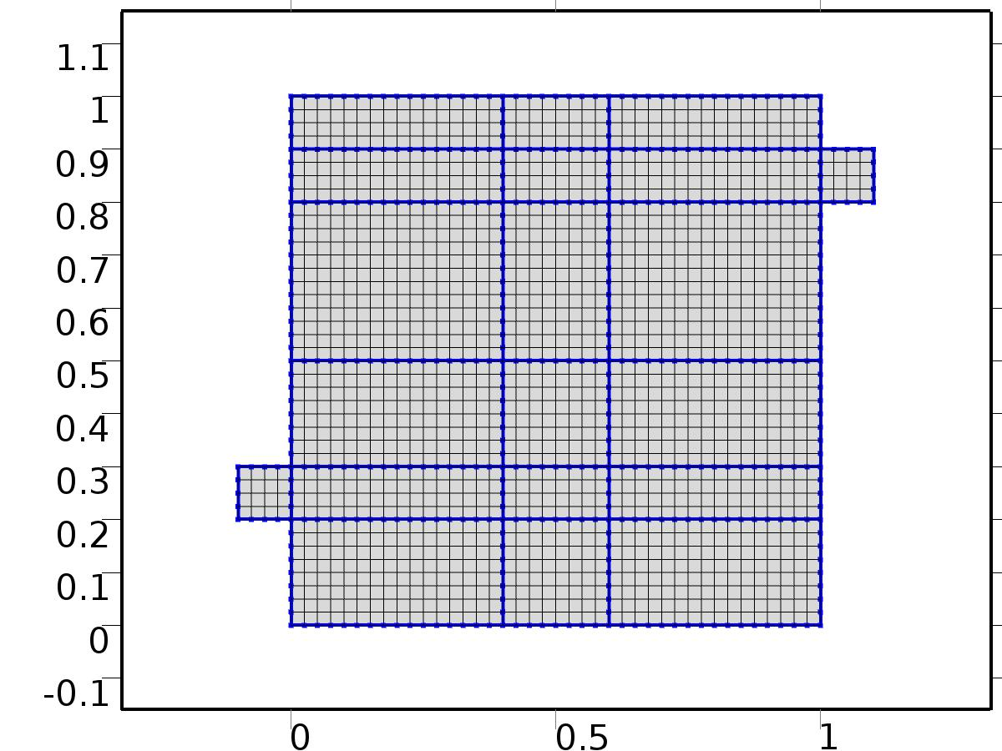

Edge 1

#### Size 1 (size1)

Selection

|  |  |
| --- | --- |
| Geometric entity level | Boundary |
| Selection | Boundaries 1–51 |



Size 1

Settings

| **Description** | **Value** |
| --- | --- |
| Maximum element size | H/4 |
| Minimum element size | H/4 |
| Curvature factor | 0.3 |
| Curvature factor | Off |
| Resolution of narrow regions | Off |
| Maximum element growth rate | 1.3 |
| Maximum element growth rate | Off |
| Custom element size | Custom |

* + 1. Mapped 1 (map1)

Selection

|  |  |
| --- | --- |
| Geometric entity level | Domain |
| Selection | Domains 1–20 |

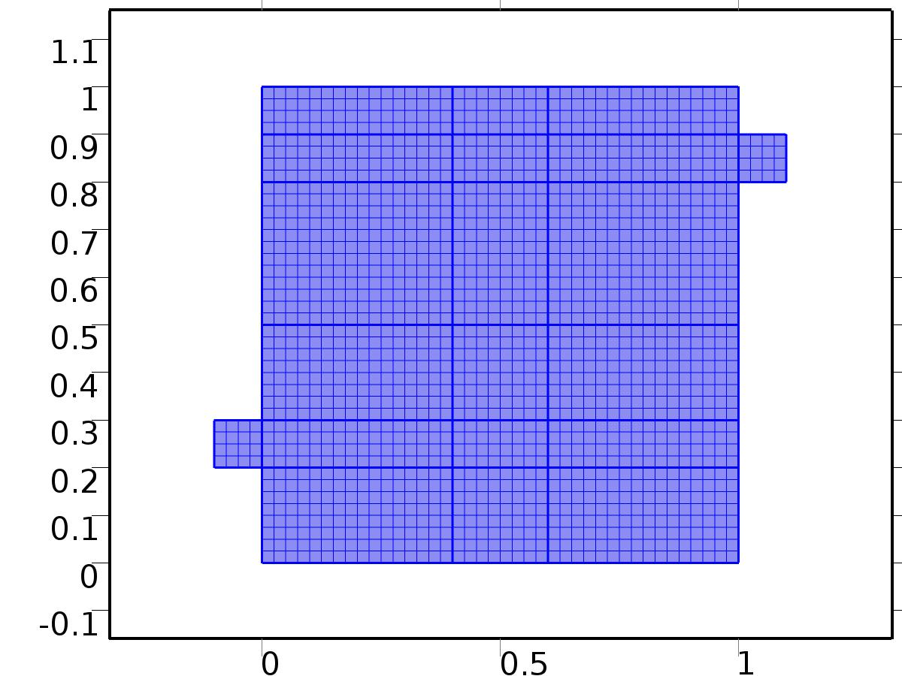

Mapped 1

1. Study 1
   1. Stationary

Study settings

| **Description** | **Value** |
| --- | --- |
| Include geometric nonlinearity | Off |

Physics and variables selection

| **Physics interface** | **Discretization** |
| --- | --- |
| Steady Flow (spf) | physics |
| Unit Input (c) | physics |

Mesh selection

| **Geometry** | **Mesh** |
| --- | --- |
| Geometry 1 (geom1) | mesh1 |

* 1. Solver Configurations
     1. Solver 1

#### Compile Equations: Stationary (st1)

Study and step

| **Description** | **Value** |
| --- | --- |
| Use study | Study 1 |
| Use study step | Stationary |

#### Dependent Variables 1 (v1)

General

| **Description** | **Value** |
| --- | --- |
| Defined by study step | Stationary |
| Constant |  |

Initial values of variables solved for

| **Description** | **Value** |
| --- | --- |
| Solution | Zero |

Values of variables not solved for

| **Description** | **Value** |
| --- | --- |
| Solution | Zero |

##### Dependent variable tZ (comp1.tZ) (comp1_tZ)

General

| **Description** | **Value** |
| --- | --- |
| Field components | comp1.tZ |
| Solve for this field | Off |

##### Pressure (comp1.bP) (comp1_bP)

General

| **Description** | **Value** |
| --- | --- |
| Field components | comp1.bP |
| Solve for this field | Off |

##### Dependent variable T (comp1.T) (comp1_T)

General

| **Description** | **Value** |
| --- | --- |
| Field components | comp1.T |
| Solve for this field | Off |

##### Pressure (comp1.bp) (comp1_bp)

General

| **Description** | **Value** |
| --- | --- |
| Field components | comp1.bp |
| Solve for this field | Off |

##### Dependent variable bT (comp1.bT) (comp1_bT)

General

| **Description** | **Value** |
| --- | --- |
| Field components | comp1.bT |
| Solve for this field | Off |

##### Pressure (comp1.P) (comp1_P)

General

| **Description** | **Value** |
| --- | --- |
| Field components | comp1.P |

##### Pressure (comp1.p) (comp1_p)

General

| **Description** | **Value** |
| --- | --- |
| Field components | comp1.p |
| Solve for this field | Off |

##### Velocity field (comp1.bu) (comp1_bu)

General

| **Description** | **Value** |
| --- | --- |
| Field components | {comp1.bu, comp1.bv} |
| Solve for this field | Off |

##### Dependent variable tT (comp1.tT) (comp1_tT)

General

| **Description** | **Value** |
| --- | --- |
| Field components | comp1.tT |
| Solve for this field | Off |

##### Velocity field (comp1.bV) (comp1_bV)

General

| **Description** | **Value** |
| --- | --- |
| Field components | {comp1.bU, comp1.bV} |
| Solve for this field | Off |

##### Velocity field (comp1.u) (comp1_u)

General

| **Description** | **Value** |
| --- | --- |
| Field components | {comp1.u, comp1.v} |
| Solve for this field | Off |

##### Dependent variable X (comp1.X) (comp1_X)

General

| **Description** | **Value** |
| --- | --- |
| Field components | comp1.X |

##### Velocity field (comp1.U) (comp1_U)

General

| **Description** | **Value** |
| --- | --- |
| Field components | {comp1.U, comp1.V} |

##### Dependent variable bZ (comp1.bZ) (comp1_bZ)

General

| **Description** | **Value** |
| --- | --- |
| Field components | comp1.bZ |
| Solve for this field | Off |

#### Stationary Solver 1 (s1)

General

| **Description** | **Value** |
| --- | --- |
| Defined by study step | Stationary |

Log

| **Description** | **Value** |
| --- | --- |
| Constant |  |

##### Fully Coupled 1 (fc1)

General

| **Description** | **Value** |
| --- | --- |
| Linear solver | Direct 1 |

Method and termination

| **Description** | **Value** |
| --- | --- |
| Initial damping factor | 0.01 |
| Minimum damping factor | 1.0E-6 |

1. Study 2
   1. Stationary

Study settings

| **Description** | **Value** |
| --- | --- |
| Include geometric nonlinearity | Off |

Physics and variables selection

| **Physics interface** | **Discretization** |
| --- | --- |
| Set Point Flow (phys1) | physics |
| Set Point Temperature (phys2) | physics |

Mesh selection

| **Geometry** | **Mesh** |
| --- | --- |
| Geometry 1 (geom1) | mesh1 |

* 1. Solver Configurations
     1. Solver 2

#### Compile Equations: Stationary (st1)

Study and step

| **Description** | **Value** |
| --- | --- |
| Use study | Study 2 |
| Use study step | Stationary |

#### Dependent Variables 1 (v1)

General

| **Description** | **Value** |
| --- | --- |
| Defined by study step | Stationary |
| Constant |  |

Initial values of variables solved for

| **Description** | **Value** |
| --- | --- |
| Solution | Solver 1 |

Values of variables not solved for

| **Description** | **Value** |
| --- | --- |
| Method | Solution |
| Solution | Solver 1 |

##### Dependent variable tZ (comp1.tZ) (comp1_tZ)

General

| **Description** | **Value** |
| --- | --- |
| Field components | comp1.tZ |

##### Pressure (comp1.bP) (comp1_bP)

General

| **Description** | **Value** |
| --- | --- |
| Field components | comp1.bP |

##### Dependent variable T (comp1.T) (comp1_T)

General

| **Description** | **Value** |
| --- | --- |
| Field components | comp1.T |
| Solve for this field | Off |

##### Pressure (comp1.bp) (comp1_bp)

General

| **Description** | **Value** |
| --- | --- |
| Field components | comp1.bp |
| Solve for this field | Off |

##### Dependent variable bT (comp1.bT) (comp1_bT)

General

| **Description** | **Value** |
| --- | --- |
| Field components | comp1.bT |
| Solve for this field | Off |

##### Pressure (comp1.P) (comp1_P)

General

| **Description** | **Value** |
| --- | --- |
| Field components | comp1.P |
| Solve for this field | Off |

##### Pressure (comp1.p) (comp1_p)

General

| **Description** | **Value** |
| --- | --- |
| Field components | comp1.p |
| Solve for this field | Off |

##### Velocity field (comp1.bu) (comp1_bu)

General

| **Description** | **Value** |
| --- | --- |
| Field components | {comp1.bu, comp1.bv} |
| Solve for this field | Off |

##### Dependent variable tT (comp1.tT) (comp1_tT)

General

| **Description** | **Value** |
| --- | --- |
| Field components | comp1.tT |
| Solve for this field | Off |

##### Velocity field (comp1.bV) (comp1_bV)

General

| **Description** | **Value** |
| --- | --- |
| Field components | {comp1.bU, comp1.bV} |

##### Velocity field (comp1.u) (comp1_u)

General

| **Description** | **Value** |
| --- | --- |
| Field components | {comp1.u, comp1.v} |
| Solve for this field | Off |

##### Dependent variable X (comp1.X) (comp1_X)

General

| **Description** | **Value** |
| --- | --- |
| Field components | comp1.X |
| Solve for this field | Off |

##### Velocity field (comp1.U) (comp1_U)

General

| **Description** | **Value** |
| --- | --- |
| Field components | {comp1.U, comp1.V} |
| Solve for this field | Off |

##### Dependent variable bZ (comp1.bZ) (comp1_bZ)

General

| **Description** | **Value** |
| --- | --- |
| Field components | comp1.bZ |

#### Stationary Solver 1 (s1)

General

| **Description** | **Value** |
| --- | --- |
| Defined by study step | Stationary |

Log

| **Description** | **Value** |
| --- | --- |
| Constant |  |

##### Fully Coupled 1 (fc1)

General

| **Description** | **Value** |
| --- | --- |
| Linear solver | Direct 1 |

Method and termination

| **Description** | **Value** |
| --- | --- |
| Initial damping factor | 0.01 |
| Minimum damping factor | 1.0E-6 |

1. Study 3
   1. Time Dependent

Study settings

| **Description** | **Value** |
| --- | --- |
| Include geometric nonlinearity | Off |

| **Times** | **Unit** |
| --- | --- |
| range(0,10,3000) | s |

Physics and variables selection

| **Physics interface** | **Discretization** |
| --- | --- |
| Piecewise Constant Flow (phys3) | physics |
| Piecewise Constant Temperature (phys4) | physics |

Mesh selection

| **Geometry** | **Mesh** |
| --- | --- |
| Geometry 1 (geom1) | mesh1 |

* 1. Solver Configurations
     1. Solver 3

#### Compile Equations: Time Dependent (st1)

Study and step

| **Description** | **Value** |
| --- | --- |
| Use study | Study 3 |
| Use study step | Time Dependent |

#### Dependent Variables 1 (v1)

General

| **Description** | **Value** |
| --- | --- |
| Defined by study step | Time Dependent |
| Constant |  |

Initial values of variables solved for

| **Description** | **Value** |
| --- | --- |
| Solution | Solver 2 |

Values of variables not solved for

| **Description** | **Value** |
| --- | --- |
| Method | Solution |
| Solution | Solver 2 |

##### Dependent variable bT (comp1.bT) (comp1_bT)

General

| **Description** | **Value** |
| --- | --- |
| Field components | comp1.bT |
| Field name | comp1_T |

##### Pressure (comp1.bP) (comp1_bP)

General

| **Description** | **Value** |
| --- | --- |
| Field components | comp1.bP |
| Solve for this field | Off |
| Field name | comp1_bp |

##### Dependent variable bZ (comp1.bZ) (comp1_bZ)

General

| **Description** | **Value** |
| --- | --- |
| Field components | comp1.bZ |
| Solve for this field | Off |
| Field name | comp1_bT |

##### Pressure (comp1.P) (comp1_P)

General

| **Description** | **Value** |
| --- | --- |
| Field components | comp1.P |
| Solve for this field | Off |

##### Pressure (comp1.bp) (comp1_bp)

General

| **Description** | **Value** |
| --- | --- |
| Field components | comp1.bp |
| Field name | comp1_p |

##### Velocity field (comp1.bV) (comp1_bV)

General

| **Description** | **Value** |
| --- | --- |
| Field components | {comp1.bU, comp1.bV} |
| Solve for this field | Off |
| Field name | comp1_bu |

##### Dependent variable tZ (comp1.tZ) (comp1_tZ)

General

| **Description** | **Value** |
| --- | --- |
| Field components | comp1.tZ |
| Solve for this field | Off |
| Field name | comp1_tT |

##### Velocity field (comp1.bu) (comp1_bu)

General

| **Description** | **Value** |
| --- | --- |
| Field components | {comp1.bu, comp1.bv} |
| Field name | comp1_u |

##### Dependent variable X (comp1.X) (comp1_X)

General

| **Description** | **Value** |
| --- | --- |
| Field components | comp1.X |
| Solve for this field | Off |

##### Velocity field (comp1.U) (comp1_U)

General

| **Description** | **Value** |
| --- | --- |
| Field components | {comp1.U, comp1.V} |
| Solve for this field | Off |

##### Dependent variable tT (comp1.tT) (comp1_tT)

General

| **Description** | **Value** |
| --- | --- |
| Field components | comp1.tT |
| Field name | comp1_bT2 |

##### Pressure (comp1.p) (comp1_p)

General

| **Description** | **Value** |
| --- | --- |
| Field components | comp1.p |
| Solve for this field | Off |

##### Velocity field (comp1.u) (comp1_u)

General

| **Description** | **Value** |
| --- | --- |
| Field components | {comp1.u, comp1.v} |
| Solve for this field | Off |

##### Dependent variable T (comp1.T) (comp1_T)

General

| **Description** | **Value** |
| --- | --- |
| Field components | comp1.T |
| Solve for this field | Off |
| Field name | comp1_u2 |

#### Time-Dependent Solver 1 (t1)

General

| **Description** | **Value** |
| --- | --- |
| Defined by study step | Time Dependent |
| Time | {0, 10, 20, 30, 40, 50, 60, 70, 80, 90, 100, 110, 120, 130, 140, 150, 160, 170, 180, 190, 200, 210, 220, 230, 240, 250, 260, 270, 280, 290, 300, 310, 320, 330, 340, 350, 360, 370, 380, 390, 400, 410, 420, 430, 440, 450, 460, 470, 480, 490, 500, 510, 520, 530, 540, 550, 560, 570, 580, 590, 600, 610, 620, 630, 640, 650, 660, 670, 680, 690, 700, 710, 720, 730, 740, 750, 760, 770, 780, 790, 800, 810, 820, 830, 840, 850, 860, 870, 880, 890, 900, 910, 920, 930, 940, 950, 960, 970, 980, 990, 1000, 1010, 1020, 1030, 1040, 1050, 1060, 1070, 1080, 1090, 1100, 1110, 1120, 1130, 1140, 1150, 1160, 1170, 1180, 1190, 1200, 1210, 1220, 1230, 1240, 1250, 1260, 1270, 1280, 1290, 1300, 1310, 1320, 1330, 1340, 1350, 1360, 1370, 1380, 1390, 1400, 1410, 1420, 1430, 1440, 1450, 1460, 1470, 1480, 1490, 1500, 1510, 1520, 1530, 1540, 1550, 1560, 1570, 1580, 1590, 1600, 1610, 1620, 1630, 1640, 1650, 1660, 1670, 1680, 1690, 1700, 1710, 1720, 1730, 1740, 1750, 1760, 1770, 1780, 1790, 1800, 1810, 1820, 1830, 1840, 1850, 1860, 1870, 1880, 1890, 1900, 1910, 1920, 1930, 1940, 1950, 1960, 1970, 1980, 1990, 2000, 2010, 2020, 2030, 2040, 2050, 2060, 2070, 2080, 2090, 2100, 2110, 2120, 2130, 2140, 2150, 2160, 2170, 2180, 2190, 2200, 2210, 2220, 2230, 2240, 2250, 2260, 2270, 2280, 2290, 2300, 2310, 2320, 2330, 2340, 2350, 2360, 2370, 2380, 2390, 2400, 2410, 2420, 2430, 2440, 2450, 2460, 2470, 2480, 2490, 2500, 2510, 2520, 2530, 2540, 2550, 2560, 2570, 2580, 2590, 2600, 2610, 2620, 2630, 2640, 2650, 2660, 2670, 2680, 2690, 2700, 2710, 2720, 2730, 2740, 2750, 2760, 2770, 2780, 2790, 2800, 2810, 2820, 2830, 2840, 2850, 2860, 2870, 2880, 2890, 2900, 2910, 2920, 2930, 2940, 2950, 2960, 2970, 2980, 2990, 3000} |

Absolute tolerance

| **Description** | **Value** |
| --- | --- |
| Tolerance | 5.0E-4 |

Time stepping

| **Description** | **Value** |
| --- | --- |
| Initial step | 0.0010 |

Advanced

| **Description** | **Value** |
| --- | --- |
| Fraction of initial step for Backward Euler | 0.0010 |

Log

| **Description** | **Value** |
| --- | --- |
| Constant |  |

##### Fully Coupled 1 (fc1)

General

| **Description** | **Value** |
| --- | --- |
| Linear solver | Direct 1 |

Method and termination

| **Description** | **Value** |
| --- | --- |
| Jacobian update | Once per time step |
| Maximum number of iterations | 6 |

1. Study 4
   1. Time Dependent

Study settings

| **Description** | **Value** |
| --- | --- |
| Include geometric nonlinearity | Off |

| **Times** | **Unit** |
| --- | --- |
| range(0,10,3000) | s |

Physics and variables selection

| **Physics interface** | **Discretization** |
| --- | --- |
| Closed Loop Flow (phys5) | physics |
| Closed Loop Temperature (phys6) | physics |

Mesh selection

| **Geometry** | **Mesh** |
| --- | --- |
| Geometry 1 (geom1) | mesh1 |

* 1. Solver Configurations
     1. Solver 4

#### Compile Equations: Time Dependent (st1)

Study and step

| **Description** | **Value** |
| --- | --- |
| Use study | Study 4 |
| Use study step | Time Dependent |

#### Dependent Variables 1 (v1)

General

| **Description** | **Value** |
| --- | --- |
| Defined by study step | Time Dependent |
| Constant |  |

Initial values of variables solved for

| **Description** | **Value** |
| --- | --- |
| Solution | Zero |

Values of variables not solved for

| **Description** | **Value** |
| --- | --- |
| Method | Solution |
| Solution | Solver 3 |

##### Dependent variable tZ (comp1.tZ) (comp1_tZ)

General

| **Description** | **Value** |
| --- | --- |
| Field components | comp1.tZ |
| Solve for this field | Off |

##### Pressure (comp1.bP) (comp1_bP)

General

| **Description** | **Value** |
| --- | --- |
| Field components | comp1.bP |
| Solve for this field | Off |

##### Dependent variable T (comp1.T) (comp1_T)

General

| **Description** | **Value** |
| --- | --- |
| Field components | comp1.T |

##### Pressure (comp1.bp) (comp1_bp)

General

| **Description** | **Value** |
| --- | --- |
| Field components | comp1.bp |
| Solve for this field | Off |

##### Dependent variable bT (comp1.bT) (comp1_bT)

General

| **Description** | **Value** |
| --- | --- |
| Field components | comp1.bT |
| Solve for this field | Off |

##### Pressure (comp1.P) (comp1_P)

General

| **Description** | **Value** |
| --- | --- |
| Field components | comp1.P |
| Solve for this field | Off |

##### Pressure (comp1.p) (comp1_p)

General

| **Description** | **Value** |
| --- | --- |
| Field components | comp1.p |

##### Velocity field (comp1.bu) (comp1_bu)

General

| **Description** | **Value** |
| --- | --- |
| Field components | {comp1.bu, comp1.bv} |
| Solve for this field | Off |

##### Dependent variable tT (comp1.tT) (comp1_tT)

General

| **Description** | **Value** |
| --- | --- |
| Field components | comp1.tT |
| Solve for this field | Off |

##### Velocity field (comp1.bV) (comp1_bV)

General

| **Description** | **Value** |
| --- | --- |
| Field components | {comp1.bU, comp1.bV} |
| Solve for this field | Off |

##### Velocity field (comp1.u) (comp1_u)

General

| **Description** | **Value** |
| --- | --- |
| Field components | {comp1.u, comp1.v} |

##### Dependent variable X (comp1.X) (comp1_X)

General

| **Description** | **Value** |
| --- | --- |
| Field components | comp1.X |
| Solve for this field | Off |

##### Velocity field (comp1.U) (comp1_U)

General

| **Description** | **Value** |
| --- | --- |
| Field components | {comp1.U, comp1.V} |
| Solve for this field | Off |

##### Dependent variable bZ (comp1.bZ) (comp1_bZ)

General

| **Description** | **Value** |
| --- | --- |
| Field components | comp1.bZ |
| Solve for this field | Off |

#### Time-Dependent Solver 1 (t1)

General

| **Description** | **Value** |
| --- | --- |
| Defined by study step | Time Dependent |
| Time | {0, 10, 20, 30, 40, 50, 60, 70, 80, 90, 100, 110, 120, 130, 140, 150, 160, 170, 180, 190, 200, 210, 220, 230, 240, 250, 260, 270, 280, 290, 300, 310, 320, 330, 340, 350, 360, 370, 380, 390, 400, 410, 420, 430, 440, 450, 460, 470, 480, 490, 500, 510, 520, 530, 540, 550, 560, 570, 580, 590, 600, 610, 620, 630, 640, 650, 660, 670, 680, 690, 700, 710, 720, 730, 740, 750, 760, 770, 780, 790, 800, 810, 820, 830, 840, 850, 860, 870, 880, 890, 900, 910, 920, 930, 940, 950, 960, 970, 980, 990, 1000, 1010, 1020, 1030, 1040, 1050, 1060, 1070, 1080, 1090, 1100, 1110, 1120, 1130, 1140, 1150, 1160, 1170, 1180, 1190, 1200, 1210, 1220, 1230, 1240, 1250, 1260, 1270, 1280, 1290, 1300, 1310, 1320, 1330, 1340, 1350, 1360, 1370, 1380, 1390, 1400, 1410, 1420, 1430, 1440, 1450, 1460, 1470, 1480, 1490, 1500, 1510, 1520, 1530, 1540, 1550, 1560, 1570, 1580, 1590, 1600, 1610, 1620, 1630, 1640, 1650, 1660, 1670, 1680, 1690, 1700, 1710, 1720, 1730, 1740, 1750, 1760, 1770, 1780, 1790, 1800, 1810, 1820, 1830, 1840, 1850, 1860, 1870, 1880, 1890, 1900, 1910, 1920, 1930, 1940, 1950, 1960, 1970, 1980, 1990, 2000, 2010, 2020, 2030, 2040, 2050, 2060, 2070, 2080, 2090, 2100, 2110, 2120, 2130, 2140, 2150, 2160, 2170, 2180, 2190, 2200, 2210, 2220, 2230, 2240, 2250, 2260, 2270, 2280, 2290, 2300, 2310, 2320, 2330, 2340, 2350, 2360, 2370, 2380, 2390, 2400, 2410, 2420, 2430, 2440, 2450, 2460, 2470, 2480, 2490, 2500, 2510, 2520, 2530, 2540, 2550, 2560, 2570, 2580, 2590, 2600, 2610, 2620, 2630, 2640, 2650, 2660, 2670, 2680, 2690, 2700, 2710, 2720, 2730, 2740, 2750, 2760, 2770, 2780, 2790, 2800, 2810, 2820, 2830, 2840, 2850, 2860, 2870, 2880, 2890, 2900, 2910, 2920, 2930, 2940, 2950, 2960, 2970, 2980, 2990, 3000} |

Absolute tolerance

| **Description** | **Value** |
| --- | --- |
| Tolerance | 5.0E-4 |

Time stepping

| **Description** | **Value** |
| --- | --- |
| Maximum BDF order | 2 |

Advanced

| **Description** | **Value** |
| --- | --- |
| Error estimation | Exclude algebraic |

Log

| **Description** | **Value** |
| --- | --- |
| Constant |  |

##### Fully Coupled 1 (fc1)

General

| **Description** | **Value** |
| --- | --- |
| Linear solver | Direct 1 |

Method and termination

| **Description** | **Value** |
| --- | --- |
| Jacobian update | Once per time step |
| Maximum number of iterations | 6 |

1. Results
   1. Data Sets
      1. Solution 1

Solution

| **Description** | **Value** |
| --- | --- |
| Solution | Solver 1 |
| Component | Save Point Geometry 1 |

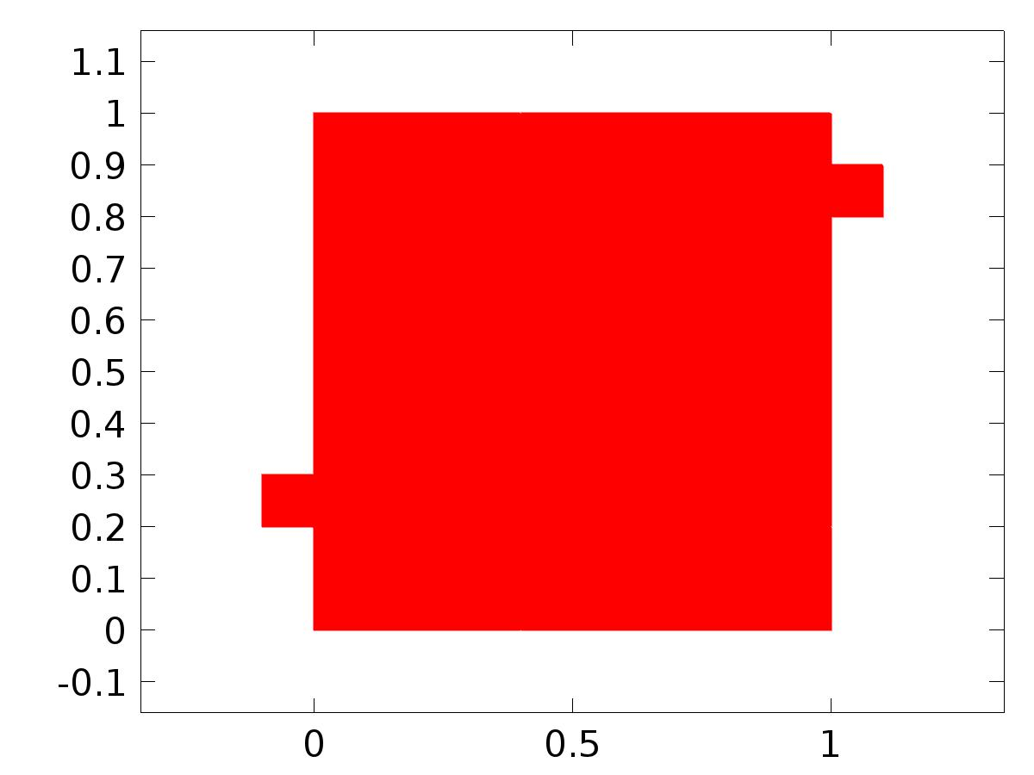

Data set: Solution 1

* + 1. Solution 2

Solution

| **Description** | **Value** |
| --- | --- |
| Solution | Solver 2 |
| Component | Save Point Geometry 1 |



Data set: Solution 2

* + 1. Solution 3

Solution

| **Description** | **Value** |
| --- | --- |
| Solution | Solver 3 |
| Component | Save Point Geometry 1 |



Data set: Solution 3

* + 1. Solution 4

Solution

| **Description** | **Value** |
| --- | --- |
| Solution | Solver 4 |
| Component | Save Point Geometry 1 |



Data set: Solution 4

* 1. Derived Values
     1. Global Evaluation 1

Data

| **Description** | **Value** |
| --- | --- |
| Data set | Solution 2 |

Expression

| **Description** | **Value** |
| --- | --- |
| Expression | C(bT) |
| Description | C(bT) |

* + 1. Global Evaluation 2

Data

| **Description** | **Value** |
| --- | --- |
| Data set | Solution 3 |

Expression

| **Description** | **Value** |
| --- | --- |
| Expression | C(T) |
| Description | C(T) |

* + 1. Global Evaluation 3

Data

| **Description** | **Value** |
| --- | --- |
| Data set | Solution 4 |

Expression

| **Description** | **Value** |
| --- | --- |
| Expression | e |

* 1. Tables
     1. Table 1

Global Evaluation 1 (C(bT))

Table 1

| **C(bT)** | **C(bT)** |
| --- | --- |
| 0.50000 | 0.50000 |

* + 1. Table 2

Global Evaluation 1 (C(bT))

Table 2

| **C(bT)** |
| --- |
| 0.50000 |

* + 1. Table 3

Global Evaluation 2 (C(T))

* + 1. Table 4

Global Evaluation 3 (C(T))

Table 4

| **Time (s)** | **C(T)** | **yr** | **gamma** | **d** | **e** |
| --- | --- | --- | --- | --- | --- |
| 0.0000 | 4.9604E-22 | 0.25000 | -3.6130E-5 | 0.75000 | 0.25000 |
| 10.000 | 0.12105 | 0.25000 | -3.6130E-5 | 0.75000 | 0.12895 |
| 20.000 | 0.18158 | 0.25000 | -3.6130E-5 | 0.75000 | 0.068421 |
| 30.000 | 0.20602 | 0.25000 | -3.6130E-5 | 0.75000 | 0.043979 |
| 40.000 | 0.21600 | 0.25000 | -3.6130E-5 | 0.75000 | 0.034001 |
| 50.000 | 0.22015 | 0.25000 | -3.6130E-5 | 0.75000 | 0.029851 |
| 60.000 | 0.22196 | 0.25000 | -3.6130E-5 | 0.75000 | 0.028043 |
| 70.000 | 0.22315 | 0.25000 | -3.6130E-5 | 0.75000 | 0.026853 |
| 80.000 | 0.22411 | 0.25000 | -3.6130E-5 | 0.75000 | 0.025892 |
| 90.000 | 0.22491 | 0.25000 | -3.6130E-5 | 0.75000 | 0.025086 |
| 100.00 | 0.22572 | 0.25000 | -3.6130E-5 | 0.75000 | 0.024279 |
| 110.00 | 0.22652 | 0.25000 | -3.6130E-5 | 0.75000 | 0.023482 |
| 120.00 | 0.22728 | 0.25000 | -3.6130E-5 | 0.75000 | 0.022717 |
| 130.00 | 0.22805 | 0.25000 | -3.6130E-5 | 0.75000 | 0.021951 |
| 140.00 | 0.22878 | 0.25000 | -3.6130E-5 | 0.75000 | 0.021217 |
| 150.00 | 0.22942 | 0.25000 | -3.6130E-5 | 0.75000 | 0.020579 |
| 160.00 | 0.23006 | 0.25000 | -3.6130E-5 | 0.75000 | 0.019941 |
| 170.00 | 0.23070 | 0.25000 | -3.6130E-5 | 0.75000 | 0.019303 |
| 180.00 | 0.23134 | 0.25000 | -3.6130E-5 | 0.75000 | 0.018664 |
| 190.00 | 0.23197 | 0.25000 | -3.6130E-5 | 0.75000 | 0.018026 |
| 200.00 | 0.23258 | 0.25000 | -3.6130E-5 | 0.75000 | 0.017418 |
| 210.00 | 0.23311 | 0.25000 | -3.6130E-5 | 0.75000 | 0.016893 |
| 220.00 | 0.23363 | 0.25000 | -3.6130E-5 | 0.75000 | 0.016368 |
| 230.00 | 0.23416 | 0.25000 | -3.6130E-5 | 0.75000 | 0.015842 |
| 240.00 | 0.23468 | 0.25000 | -3.6130E-5 | 0.75000 | 0.015317 |
| 250.00 | 0.23521 | 0.25000 | -3.6130E-5 | 0.75000 | 0.014792 |
| 260.00 | 0.23569 | 0.25000 | -3.6130E-5 | 0.75000 | 0.014312 |
| 270.00 | 0.23605 | 0.25000 | -3.6130E-5 | 0.75000 | 0.013946 |
| 280.00 | 0.23642 | 0.25000 | -3.6130E-5 | 0.75000 | 0.013580 |
| 290.00 | 0.23679 | 0.25000 | -3.6130E-5 | 0.75000 | 0.013214 |
| 300.00 | 0.23715 | 0.25000 | -3.6130E-5 | 0.75000 | 0.012849 |
| 310.00 | 0.23752 | 0.25000 | -3.6130E-5 | 0.75000 | 0.012483 |
| 320.00 | 0.23788 | 0.25000 | -3.6130E-5 | 0.75000 | 0.012117 |
| 330.00 | 0.23825 | 0.25000 | -3.6130E-5 | 0.75000 | 0.011751 |
| 340.00 | 0.23861 | 0.25000 | -3.6130E-5 | 0.75000 | 0.011385 |
| 350.00 | 0.23898 | 0.25000 | -3.6130E-5 | 0.75000 | 0.011020 |
| 360.00 | 0.23935 | 0.25000 | -3.6130E-5 | 0.75000 | 0.010654 |
| 370.00 | 0.23971 | 0.25000 | -3.6130E-5 | 0.75000 | 0.010288 |
| 380.00 | 0.24004 | 0.25000 | -3.6130E-5 | 0.75000 | 0.0099574 |
| 390.00 | 0.24030 | 0.25000 | -3.6130E-5 | 0.75000 | 0.0097027 |
| 400.00 | 0.24055 | 0.25000 | -3.6130E-5 | 0.75000 | 0.0094479 |
| 410.00 | 0.24081 | 0.25000 | -3.6130E-5 | 0.75000 | 0.0091932 |
| 420.00 | 0.24106 | 0.25000 | -3.6130E-5 | 0.75000 | 0.0089385 |
| 430.00 | 0.24132 | 0.25000 | -3.6130E-5 | 0.75000 | 0.0086837 |
| 440.00 | 0.24157 | 0.25000 | -3.6130E-5 | 0.75000 | 0.0084290 |
| 450.00 | 0.24183 | 0.25000 | -3.6130E-5 | 0.75000 | 0.0081743 |
| 460.00 | 0.24208 | 0.25000 | -3.6130E-5 | 0.75000 | 0.0079195 |
| 470.00 | 0.24234 | 0.25000 | -3.6130E-5 | 0.75000 | 0.0076648 |
| 480.00 | 0.24259 | 0.25000 | -3.6130E-5 | 0.75000 | 0.0074101 |
| 490.00 | 0.24284 | 0.25000 | -3.6130E-5 | 0.75000 | 0.0071554 |
| 500.00 | 0.24307 | 0.25000 | -3.6130E-5 | 0.75000 | 0.0069275 |
| 510.00 | 0.24325 | 0.25000 | -3.6130E-5 | 0.75000 | 0.0067502 |
| 520.00 | 0.24343 | 0.25000 | -3.6130E-5 | 0.75000 | 0.0065728 |
| 530.00 | 0.24360 | 0.25000 | -3.6130E-5 | 0.75000 | 0.0063954 |
| 540.00 | 0.24378 | 0.25000 | -3.6130E-5 | 0.75000 | 0.0062180 |
| 550.00 | 0.24396 | 0.25000 | -3.6130E-5 | 0.75000 | 0.0060407 |
| 560.00 | 0.24414 | 0.25000 | -3.6130E-5 | 0.75000 | 0.0058633 |
| 570.00 | 0.24431 | 0.25000 | -3.6130E-5 | 0.75000 | 0.0056859 |
| 580.00 | 0.24449 | 0.25000 | -3.6130E-5 | 0.75000 | 0.0055085 |
| 590.00 | 0.24467 | 0.25000 | -3.6130E-5 | 0.75000 | 0.0053312 |
| 600.00 | 0.24485 | 0.25000 | -3.6130E-5 | 0.75000 | 0.0051538 |
| 610.00 | 0.24502 | 0.25000 | -3.6130E-5 | 0.75000 | 0.0049764 |
| 620.00 | 0.24519 | 0.25000 | -3.6130E-5 | 0.75000 | 0.0048066 |
| 630.00 | 0.24535 | 0.25000 | -3.6130E-5 | 0.75000 | 0.0046513 |
| 640.00 | 0.24550 | 0.25000 | -3.6130E-5 | 0.75000 | 0.0044992 |
| 650.00 | 0.24565 | 0.25000 | -3.6130E-5 | 0.75000 | 0.0043503 |
| 660.00 | 0.24580 | 0.25000 | -3.6130E-5 | 0.75000 | 0.0042046 |
| 670.00 | 0.24594 | 0.25000 | -3.6130E-5 | 0.75000 | 0.0040622 |
| 680.00 | 0.24608 | 0.25000 | -3.6130E-5 | 0.75000 | 0.0039229 |
| 690.00 | 0.24621 | 0.25000 | -3.6130E-5 | 0.75000 | 0.0037948 |
| 700.00 | 0.24630 | 0.25000 | -3.6130E-5 | 0.75000 | 0.0036965 |
| 710.00 | 0.24639 | 0.25000 | -3.6130E-5 | 0.75000 | 0.0036095 |
| 720.00 | 0.24647 | 0.25000 | -3.6130E-5 | 0.75000 | 0.0035336 |
| 730.00 | 0.24653 | 0.25000 | -3.6130E-5 | 0.75000 | 0.0034689 |
| 740.00 | 0.24658 | 0.25000 | -3.6130E-5 | 0.75000 | 0.0034155 |
| 750.00 | 0.24515 | 0.37500 | 1.0163E-4 | 0.62500 | 0.12985 |
| 760.00 | 0.23560 | 0.50000 | 2.5367E-4 | 0.50000 | 0.26440 |
| 770.00 | 0.29450 | 0.50000 | 1.9999E-4 | 0.50000 | 0.20550 |
| 780.00 | 0.37773 | 0.50000 | 1.2112E-4 | 0.50000 | 0.12227 |
| 790.00 | 0.44894 | 0.50000 | 5.1654E-5 | 0.50000 | 0.051063 |
| 800.00 | 0.49864 | 0.50000 | 5.0044E-6 | 0.50000 | 0.0013587 |
| 810.00 | 0.52477 | 0.50000 | -1.8332E-5 | 0.50000 | -0.024765 |
| 820.00 | 0.53192 | 0.50000 | -2.3419E-5 | 0.50000 | -0.031915 |
| 830.00 | 0.52755 | 0.50000 | -1.7913E-5 | 0.50000 | -0.027547 |
| 840.00 | 0.51926 | 0.50000 | -9.4523E-6 | 0.50000 | -0.019256 |
| 850.00 | 0.51213 | 0.50000 | -2.7003E-6 | 0.50000 | -0.012134 |
| 860.00 | 0.50775 | 0.50000 | 1.0587E-6 | 0.50000 | -0.0077458 |
| 870.00 | 0.50592 | 0.50000 | 2.3888E-6 | 0.50000 | -0.0059192 |
| 880.00 | 0.50570 | 0.50000 | 2.2147E-6 | 0.50000 | -0.0056998 |
| 890.00 | 0.50618 | 0.50000 | 1.3588E-6 | 0.50000 | -0.0061821 |
| 900.00 | 0.50652 | 0.50000 | 4.4779E-7 | 0.50000 | -0.0065237 |
| 910.00 | 0.50654 | 0.50000 | -2.0279E-7 | 0.50000 | -0.0065446 |
| 920.00 | 0.50641 | 0.50000 | -4.6871E-7 | 0.50000 | -0.0064086 |
| 930.00 | 0.50623 | 0.50000 | -4.2737E-7 | 0.50000 | -0.0062307 |
| 940.00 | 0.50602 | 0.50000 | -2.6298E-7 | 0.50000 | -0.0060176 |
| 950.00 | 0.50584 | 0.50000 | -1.1608E-7 | 0.50000 | -0.0058376 |
| 960.00 | 0.50569 | 0.50000 | -5.7055E-8 | 0.50000 | -0.0056930 |
| 970.00 | 0.50555 | 0.50000 | 1.9720E-9 | 0.50000 | -0.0055484 |
| 980.00 | 0.50540 | 0.50000 | 1.8811E-8 | 0.50000 | -0.0054037 |
| 990.00 | 0.50527 | 0.50000 | 2.6692E-8 | 0.50000 | -0.0052721 |
| 1000.0 | 0.50516 | 0.50000 | 2.9579E-8 | 0.50000 | -0.0051634 |
| 1010.0 | 0.50505 | 0.50000 | 2.5574E-8 | 0.50000 | -0.0050547 |
| 1020.0 | 0.50495 | 0.50000 | 2.1569E-8 | 0.50000 | -0.0049460 |
| 1030.0 | 0.50484 | 0.50000 | 1.7564E-8 | 0.50000 | -0.0048373 |
| 1040.0 | 0.50473 | 0.50000 | 1.3558E-8 | 0.50000 | -0.0047286 |
| 1050.0 | 0.50462 | 0.50000 | 1.1318E-8 | 0.50000 | -0.0046199 |
| 1060.0 | 0.50451 | 0.50000 | 1.0202E-8 | 0.50000 | -0.0045112 |
| 1070.0 | 0.50441 | 0.50000 | 9.0863E-9 | 0.50000 | -0.0044059 |
| 1080.0 | 0.50433 | 0.50000 | 7.9704E-9 | 0.50000 | -0.0043274 |
| 1090.0 | 0.50425 | 0.50000 | 6.8544E-9 | 0.50000 | -0.0042488 |
| 1100.0 | 0.50417 | 0.50000 | 5.7385E-9 | 0.50000 | -0.0041703 |
| 1110.0 | 0.50409 | 0.50000 | 4.6226E-9 | 0.50000 | -0.0040917 |
| 1120.0 | 0.50401 | 0.50000 | 3.5066E-9 | 0.50000 | -0.0040132 |
| 1130.0 | 0.50393 | 0.50000 | 2.3907E-9 | 0.50000 | -0.0039347 |
| 1140.0 | 0.50386 | 0.50000 | 1.2748E-9 | 0.50000 | -0.0038561 |
| 1150.0 | 0.50378 | 0.50000 | 1.2007E-9 | 0.50000 | -0.0037776 |
| 1160.0 | 0.50370 | 0.50000 | 1.1348E-9 | 0.50000 | -0.0036990 |
| 1170.0 | 0.50362 | 0.50000 | 1.0688E-9 | 0.50000 | -0.0036205 |
| 1180.0 | 0.50354 | 0.50000 | 1.0029E-9 | 0.50000 | -0.0035419 |
| 1190.0 | 0.50346 | 0.50000 | 9.3692E-10 | 0.50000 | -0.0034634 |
| 1200.0 | 0.50338 | 0.50000 | 8.7097E-10 | 0.50000 | -0.0033848 |
| 1210.0 | 0.50331 | 0.50000 | 8.0502E-10 | 0.50000 | -0.0033063 |
| 1220.0 | 0.50323 | 0.50000 | 7.3907E-10 | 0.50000 | -0.0032277 |
| 1230.0 | 0.50315 | 0.50000 | 6.7312E-10 | 0.50000 | -0.0031492 |
| 1240.0 | 0.50309 | 0.50000 | 6.0717E-10 | 0.50000 | -0.0030915 |
| 1250.0 | 0.50305 | 0.50000 | 5.4122E-10 | 0.50000 | -0.0030466 |
| 1260.0 | 0.50300 | 0.50000 | 4.7527E-10 | 0.50000 | -0.0030016 |
| 1270.0 | 0.50296 | 0.50000 | 4.0932E-10 | 0.50000 | -0.0029566 |
| 1280.0 | 0.50291 | 0.50000 | 3.4337E-10 | 0.50000 | -0.0029117 |
| 1290.0 | 0.50287 | 0.50000 | 2.7742E-10 | 0.50000 | -0.0028667 |
| 1300.0 | 0.50282 | 0.50000 | 2.1147E-10 | 0.50000 | -0.0028217 |
| 1310.0 | 0.50278 | 0.50000 | 1.4552E-10 | 0.50000 | -0.0027768 |
| 1320.0 | 0.50273 | 0.50000 | 7.9575E-11 | 0.50000 | -0.0027318 |
| 1330.0 | 0.50269 | 0.50000 | 1.3626E-11 | 0.50000 | -0.0026869 |
| 1340.0 | 0.50264 | 0.50000 | -2.5775E-12 | 0.50000 | -0.0026419 |
| 1350.0 | 0.50260 | 0.50000 | -2.6433E-12 | 0.50000 | -0.0025969 |
| 1360.0 | 0.50255 | 0.50000 | -2.7090E-12 | 0.50000 | -0.0025520 |
| 1370.0 | 0.50251 | 0.50000 | -2.7748E-12 | 0.50000 | -0.0025070 |
| 1380.0 | 0.50246 | 0.50000 | -2.8405E-12 | 0.50000 | -0.0024620 |
| 1390.0 | 0.50242 | 0.50000 | -2.9063E-12 | 0.50000 | -0.0024171 |
| 1400.0 | 0.50237 | 0.50000 | -2.9720E-12 | 0.50000 | -0.0023721 |
| 1410.0 | 0.50233 | 0.50000 | -3.0378E-12 | 0.50000 | -0.0023271 |
| 1420.0 | 0.50228 | 0.50000 | -3.1036E-12 | 0.50000 | -0.0022822 |
| 1430.0 | 0.50224 | 0.50000 | -3.1693E-12 | 0.50000 | -0.0022372 |
| 1440.0 | 0.50219 | 0.50000 | -3.2351E-12 | 0.50000 | -0.0021922 |
| 1450.0 | 0.50215 | 0.50000 | -3.3008E-12 | 0.50000 | -0.0021473 |
| 1460.0 | 0.50210 | 0.50000 | -3.3666E-12 | 0.50000 | -0.0021023 |
| 1470.0 | 0.50206 | 0.50000 | -3.4323E-12 | 0.50000 | -0.0020573 |
| 1480.0 | 0.50201 | 0.50000 | -3.4981E-12 | 0.50000 | -0.0020124 |
| 1490.0 | 0.50197 | 0.50000 | -3.5639E-12 | 0.50000 | -0.0019674 |
| 1500.0 | 0.50192 | 0.50000 | -3.6296E-12 | 0.50000 | -0.0019224 |
| 1510.0 | 0.50188 | 0.50000 | -3.6954E-12 | 0.50000 | -0.0018775 |
| 1520.0 | 0.50183 | 0.50000 | -3.7611E-12 | 0.50000 | -0.0018325 |
| 1530.0 | 0.50179 | 0.50000 | -3.8269E-12 | 0.50000 | -0.0017875 |
| 1540.0 | 0.50175 | 0.50000 | -3.8926E-12 | 0.50000 | -0.0017547 |
| 1550.0 | 0.50173 | 0.50000 | -3.9584E-12 | 0.50000 | -0.0017291 |
| 1560.0 | 0.50170 | 0.50000 | -4.0242E-12 | 0.50000 | -0.0017036 |
| 1570.0 | 0.50168 | 0.50000 | -4.0899E-12 | 0.50000 | -0.0016781 |
| 1580.0 | 0.50165 | 0.50000 | -4.1557E-12 | 0.50000 | -0.0016525 |
| 1590.0 | 0.50163 | 0.50000 | -4.2214E-12 | 0.50000 | -0.0016270 |
| 1600.0 | 0.50160 | 0.50000 | -4.2872E-12 | 0.50000 | -0.0016014 |
| 1610.0 | 0.50158 | 0.50000 | -4.3529E-12 | 0.50000 | -0.0015759 |
| 1620.0 | 0.50155 | 0.50000 | -4.4187E-12 | 0.50000 | -0.0015504 |
| 1630.0 | 0.50152 | 0.50000 | -4.4844E-12 | 0.50000 | -0.0015248 |
| 1640.0 | 0.50150 | 0.50000 | -4.3937E-12 | 0.50000 | -0.0014993 |
| 1650.0 | 0.50147 | 0.50000 | -4.2522E-12 | 0.50000 | -0.0014738 |
| 1660.0 | 0.50145 | 0.50000 | -4.1107E-12 | 0.50000 | -0.0014482 |
| 1670.0 | 0.50142 | 0.50000 | -3.9692E-12 | 0.50000 | -0.0014227 |
| 1680.0 | 0.50140 | 0.50000 | -3.8277E-12 | 0.50000 | -0.0013971 |
| 1690.0 | 0.50137 | 0.50000 | -3.6862E-12 | 0.50000 | -0.0013716 |
| 1700.0 | 0.50135 | 0.50000 | -3.5446E-12 | 0.50000 | -0.0013461 |
| 1710.0 | 0.50132 | 0.50000 | -3.4031E-12 | 0.50000 | -0.0013205 |
| 1720.0 | 0.50129 | 0.50000 | -3.2616E-12 | 0.50000 | -0.0012950 |
| 1730.0 | 0.50127 | 0.50000 | -3.1201E-12 | 0.50000 | -0.0012694 |
| 1740.0 | 0.50124 | 0.50000 | -2.9786E-12 | 0.50000 | -0.0012439 |
| 1750.0 | 0.50122 | 0.50000 | -2.8371E-12 | 0.50000 | -0.0012184 |
| 1760.0 | 0.50119 | 0.50000 | -2.6956E-12 | 0.50000 | -0.0011928 |
| 1770.0 | 0.50117 | 0.50000 | -2.5541E-12 | 0.50000 | -0.0011673 |
| 1780.0 | 0.50114 | 0.50000 | -2.4126E-12 | 0.50000 | -0.0011418 |
| 1790.0 | 0.50112 | 0.50000 | -2.2711E-12 | 0.50000 | -0.0011162 |
| 1800.0 | 0.50109 | 0.50000 | -2.1295E-12 | 0.50000 | -0.0010907 |
| 1810.0 | 0.50107 | 0.50000 | -1.9880E-12 | 0.50000 | -0.0010651 |
| 1820.0 | 0.50104 | 0.50000 | -1.8465E-12 | 0.50000 | -0.0010396 |
| 1830.0 | 0.50101 | 0.50000 | -1.7050E-12 | 0.50000 | -0.0010141 |
| 1840.0 | 0.50100 | 0.50000 | -1.5635E-12 | 0.50000 | -9.9541E-4 |
| 1850.0 | 0.50098 | 0.50000 | -1.4220E-12 | 0.50000 | -9.8092E-4 |
| 1860.0 | 0.50097 | 0.50000 | -1.2805E-12 | 0.50000 | -9.6644E-4 |
| 1870.0 | 0.50095 | 0.50000 | -1.1390E-12 | 0.50000 | -9.5195E-4 |
| 1880.0 | 0.50094 | 0.50000 | -9.9747E-13 | 0.50000 | -9.3747E-4 |
| 1890.0 | 0.50092 | 0.50000 | -8.5596E-13 | 0.50000 | -9.2298E-4 |
| 1900.0 | 0.50091 | 0.50000 | -7.1445E-13 | 0.50000 | -9.0850E-4 |
| 1910.0 | 0.50089 | 0.50000 | -5.7294E-13 | 0.50000 | -8.9401E-4 |
| 1920.0 | 0.50088 | 0.50000 | -4.3143E-13 | 0.50000 | -8.7952E-4 |
| 1930.0 | 0.50087 | 0.50000 | -2.8992E-13 | 0.50000 | -8.6504E-4 |
| 1940.0 | 0.50085 | 0.50000 | -2.4895E-13 | 0.50000 | -8.5055E-4 |
| 1950.0 | 0.50084 | 0.50000 | -2.4061E-13 | 0.50000 | -8.3607E-4 |
| 1960.0 | 0.50082 | 0.50000 | -2.3226E-13 | 0.50000 | -8.2158E-4 |
| 1970.0 | 0.50081 | 0.50000 | -2.2391E-13 | 0.50000 | -8.0710E-4 |
| 1980.0 | 0.50079 | 0.50000 | -2.1557E-13 | 0.50000 | -7.9261E-4 |
| 1990.0 | 0.50078 | 0.50000 | -2.0722E-13 | 0.50000 | -7.7813E-4 |
| 2000.0 | 0.50076 | 0.50000 | -1.9888E-13 | 0.50000 | -7.6364E-4 |
| 2010.0 | 0.50075 | 0.50000 | -1.9053E-13 | 0.50000 | -7.4915E-4 |
| 2020.0 | 0.50073 | 0.50000 | -1.8218E-13 | 0.50000 | -7.3467E-4 |
| 2030.0 | 0.50072 | 0.50000 | -1.7384E-13 | 0.50000 | -7.2018E-4 |
| 2040.0 | 0.50071 | 0.50000 | -1.6549E-13 | 0.50000 | -7.0570E-4 |
| 2050.0 | 0.50069 | 0.50000 | -1.5714E-13 | 0.50000 | -6.9121E-4 |
| 2060.0 | 0.50068 | 0.50000 | -1.4880E-13 | 0.50000 | -6.7673E-4 |
| 2070.0 | 0.50066 | 0.50000 | -1.4045E-13 | 0.50000 | -6.6224E-4 |
| 2080.0 | 0.50065 | 0.50000 | -1.3210E-13 | 0.50000 | -6.4776E-4 |
| 2090.0 | 0.50063 | 0.50000 | -1.2376E-13 | 0.50000 | -6.3327E-4 |
| 2100.0 | 0.50062 | 0.50000 | -1.1541E-13 | 0.50000 | -6.1879E-4 |
| 2110.0 | 0.50060 | 0.50000 | -1.0707E-13 | 0.50000 | -6.0430E-4 |
| 2120.0 | 0.50059 | 0.50000 | -9.8719E-14 | 0.50000 | -5.8981E-4 |
| 2130.0 | 0.50058 | 0.50000 | -9.0373E-14 | 0.50000 | -5.7533E-4 |
| 2140.0 | 0.50056 | 0.50000 | -8.2027E-14 | 0.50000 | -5.6228E-4 |
| 2150.0 | 0.50055 | 0.50000 | -7.3680E-14 | 0.50000 | -5.5010E-4 |
| 2160.0 | 0.50054 | 0.50000 | -6.5334E-14 | 0.50000 | -5.3792E-4 |
| 2170.0 | 0.50053 | 0.50000 | -5.6987E-14 | 0.50000 | -5.2574E-4 |
| 2180.0 | 0.50051 | 0.50000 | -4.8641E-14 | 0.50000 | -5.1356E-4 |
| 2190.0 | 0.50050 | 0.50000 | -4.0295E-14 | 0.50000 | -5.0137E-4 |
| 2200.0 | 0.50049 | 0.50000 | -3.1948E-14 | 0.50000 | -4.8919E-4 |
| 2210.0 | 0.50048 | 0.50000 | -2.3602E-14 | 0.50000 | -4.7709E-4 |
| 2220.0 | 0.50047 | 0.50000 | -1.5256E-14 | 0.50000 | -4.6555E-4 |
| 2230.0 | 0.50045 | 0.50000 | -6.9094E-15 | 0.50000 | -4.5402E-4 |
| 2240.0 | 0.50071 | 0.50000 | -4.4006E-16 | 0.50000 | -7.1098E-4 |
| 2250.0 | 0.49975 | 0.37500 | -1.3430E-4 | 0.62500 | -0.12475 |
| 2260.0 | 0.49088 | 0.25000 | -2.7189E-4 | 0.75000 | -0.24088 |
| 2270.0 | 0.43324 | 0.25000 | -2.1781E-4 | 0.75000 | -0.18324 |
| 2280.0 | 0.35945 | 0.25000 | -1.4696E-4 | 0.75000 | -0.10945 |
| 2290.0 | 0.29543 | 0.25000 | -8.7014E-5 | 0.75000 | -0.045432 |
| 2300.0 | 0.25597 | 0.25000 | -4.8284E-5 | 0.75000 | -0.0059660 |
| 2310.0 | 0.23783 | 0.25000 | -2.9592E-5 | 0.75000 | 0.012172 |
| 2320.0 | 0.23281 | 0.25000 | -2.4260E-5 | 0.75000 | 0.017190 |
| 2330.0 | 0.23499 | 0.25000 | -2.5803E-5 | 0.75000 | 0.015006 |
| 2340.0 | 0.23816 | 0.25000 | -2.9523E-5 | 0.75000 | 0.011840 |
| 2350.0 | 0.24089 | 0.25000 | -3.2930E-5 | 0.75000 | 0.0091132 |
| 2360.0 | 0.24272 | 0.25000 | -3.5171E-5 | 0.75000 | 0.0072847 |
| 2370.0 | 0.24364 | 0.25000 | -3.6314E-5 | 0.75000 | 0.0063559 |
| 2380.0 | 0.24400 | 0.25000 | -3.6898E-5 | 0.75000 | 0.0059997 |
| 2390.0 | 0.24425 | 0.25000 | -3.7014E-5 | 0.75000 | 0.0057531 |
| 2400.0 | 0.24433 | 0.25000 | -3.6832E-5 | 0.75000 | 0.0056742 |
| 2410.0 | 0.24442 | 0.25000 | -3.6617E-5 | 0.75000 | 0.0055753 |
| 2420.0 | 0.24455 | 0.25000 | -3.6439E-5 | 0.75000 | 0.0054455 |
| 2430.0 | 0.24468 | 0.25000 | -3.6333E-5 | 0.75000 | 0.0053158 |
| 2440.0 | 0.24481 | 0.25000 | -3.6228E-5 | 0.75000 | 0.0051860 |
| 2450.0 | 0.24495 | 0.25000 | -3.6179E-5 | 0.75000 | 0.0050518 |
| 2460.0 | 0.24509 | 0.25000 | -3.6153E-5 | 0.75000 | 0.0049105 |
| 2470.0 | 0.24523 | 0.25000 | -3.6126E-5 | 0.75000 | 0.0047692 |
| 2480.0 | 0.24537 | 0.25000 | -3.6122E-5 | 0.75000 | 0.0046279 |
| 2490.0 | 0.24551 | 0.25000 | -3.6121E-5 | 0.75000 | 0.0044867 |
| 2500.0 | 0.24565 | 0.25000 | -3.6121E-5 | 0.75000 | 0.0043454 |
| 2510.0 | 0.24580 | 0.25000 | -3.6121E-5 | 0.75000 | 0.0042041 |
| 2520.0 | 0.24594 | 0.25000 | -3.6120E-5 | 0.75000 | 0.0040628 |
| 2530.0 | 0.24606 | 0.25000 | -3.6120E-5 | 0.75000 | 0.0039403 |
| 2540.0 | 0.24615 | 0.25000 | -3.6121E-5 | 0.75000 | 0.0038486 |
| 2550.0 | 0.24624 | 0.25000 | -3.6122E-5 | 0.75000 | 0.0037569 |
| 2560.0 | 0.24633 | 0.25000 | -3.6122E-5 | 0.75000 | 0.0036652 |
| 2570.0 | 0.24643 | 0.25000 | -3.6123E-5 | 0.75000 | 0.0035735 |
| 2580.0 | 0.24652 | 0.25000 | -3.6124E-5 | 0.75000 | 0.0034818 |
| 2590.0 | 0.24661 | 0.25000 | -3.6124E-5 | 0.75000 | 0.0033901 |
| 2600.0 | 0.24670 | 0.25000 | -3.6125E-5 | 0.75000 | 0.0032984 |
| 2610.0 | 0.24679 | 0.25000 | -3.6126E-5 | 0.75000 | 0.0032067 |
| 2620.0 | 0.24688 | 0.25000 | -3.6126E-5 | 0.75000 | 0.0031150 |
| 2630.0 | 0.24698 | 0.25000 | -3.6127E-5 | 0.75000 | 0.0030233 |
| 2640.0 | 0.24707 | 0.25000 | -3.6128E-5 | 0.75000 | 0.0029316 |
| 2650.0 | 0.24716 | 0.25000 | -3.6128E-5 | 0.75000 | 0.0028399 |
| 2660.0 | 0.24725 | 0.25000 | -3.6128E-5 | 0.75000 | 0.0027482 |
| 2670.0 | 0.24734 | 0.25000 | -3.6128E-5 | 0.75000 | 0.0026565 |
| 2680.0 | 0.24744 | 0.25000 | -3.6128E-5 | 0.75000 | 0.0025649 |
| 2690.0 | 0.24751 | 0.25000 | -3.6128E-5 | 0.75000 | 0.0024853 |
| 2700.0 | 0.24757 | 0.25000 | -3.6128E-5 | 0.75000 | 0.0024276 |
| 2710.0 | 0.24763 | 0.25000 | -3.6128E-5 | 0.75000 | 0.0023699 |
| 2720.0 | 0.24769 | 0.25000 | -3.6129E-5 | 0.75000 | 0.0023121 |
| 2730.0 | 0.24775 | 0.25000 | -3.6129E-5 | 0.75000 | 0.0022544 |
| 2740.0 | 0.24780 | 0.25000 | -3.6129E-5 | 0.75000 | 0.0021966 |
| 2750.0 | 0.24786 | 0.25000 | -3.6129E-5 | 0.75000 | 0.0021389 |
| 2760.0 | 0.24792 | 0.25000 | -3.6129E-5 | 0.75000 | 0.0020811 |
| 2770.0 | 0.24798 | 0.25000 | -3.6129E-5 | 0.75000 | 0.0020234 |
| 2780.0 | 0.24803 | 0.25000 | -3.6129E-5 | 0.75000 | 0.0019656 |
| 2790.0 | 0.24809 | 0.25000 | -3.6129E-5 | 0.75000 | 0.0019079 |
| 2800.0 | 0.24815 | 0.25000 | -3.6129E-5 | 0.75000 | 0.0018502 |
| 2810.0 | 0.24821 | 0.25000 | -3.6129E-5 | 0.75000 | 0.0017924 |
| 2820.0 | 0.24827 | 0.25000 | -3.6129E-5 | 0.75000 | 0.0017347 |
| 2830.0 | 0.24832 | 0.25000 | -3.6129E-5 | 0.75000 | 0.0016769 |
| 2840.0 | 0.24838 | 0.25000 | -3.6129E-5 | 0.75000 | 0.0016192 |
| 2850.0 | 0.24843 | 0.25000 | -3.6129E-5 | 0.75000 | 0.0015717 |
| 2860.0 | 0.24846 | 0.25000 | -3.6129E-5 | 0.75000 | 0.0015442 |
| 2870.0 | 0.24848 | 0.25000 | -3.6130E-5 | 0.75000 | 0.0015166 |
| 2880.0 | 0.24851 | 0.25000 | -3.6130E-5 | 0.75000 | 0.0014891 |
| 2890.0 | 0.24854 | 0.25000 | -3.6130E-5 | 0.75000 | 0.0014616 |
| 2900.0 | 0.24857 | 0.25000 | -3.6130E-5 | 0.75000 | 0.0014340 |
| 2910.0 | 0.24859 | 0.25000 | -3.6130E-5 | 0.75000 | 0.0014065 |
| 2920.0 | 0.24862 | 0.25000 | -3.6130E-5 | 0.75000 | 0.0013790 |
| 2930.0 | 0.24865 | 0.25000 | -3.6130E-5 | 0.75000 | 0.0013514 |
| 2940.0 | 0.24868 | 0.25000 | -3.6130E-5 | 0.75000 | 0.0013239 |
| 2950.0 | 0.24870 | 0.25000 | -3.6130E-5 | 0.75000 | 0.0012964 |
| 2960.0 | 0.24873 | 0.25000 | -3.6130E-5 | 0.75000 | 0.0012689 |
| 2970.0 | 0.24876 | 0.25000 | -3.6130E-5 | 0.75000 | 0.0012413 |
| 2980.0 | 0.24879 | 0.25000 | -3.6130E-5 | 0.75000 | 0.0012138 |
| 2990.0 | 0.24881 | 0.25000 | -3.6130E-5 | 0.75000 | 0.0011863 |
| 3000.0 | 0.24884 | 0.25000 | -3.6130E-5 | 0.75000 | 0.0011587 |

* 1. Plot Groups
     1. Velocity (spf)

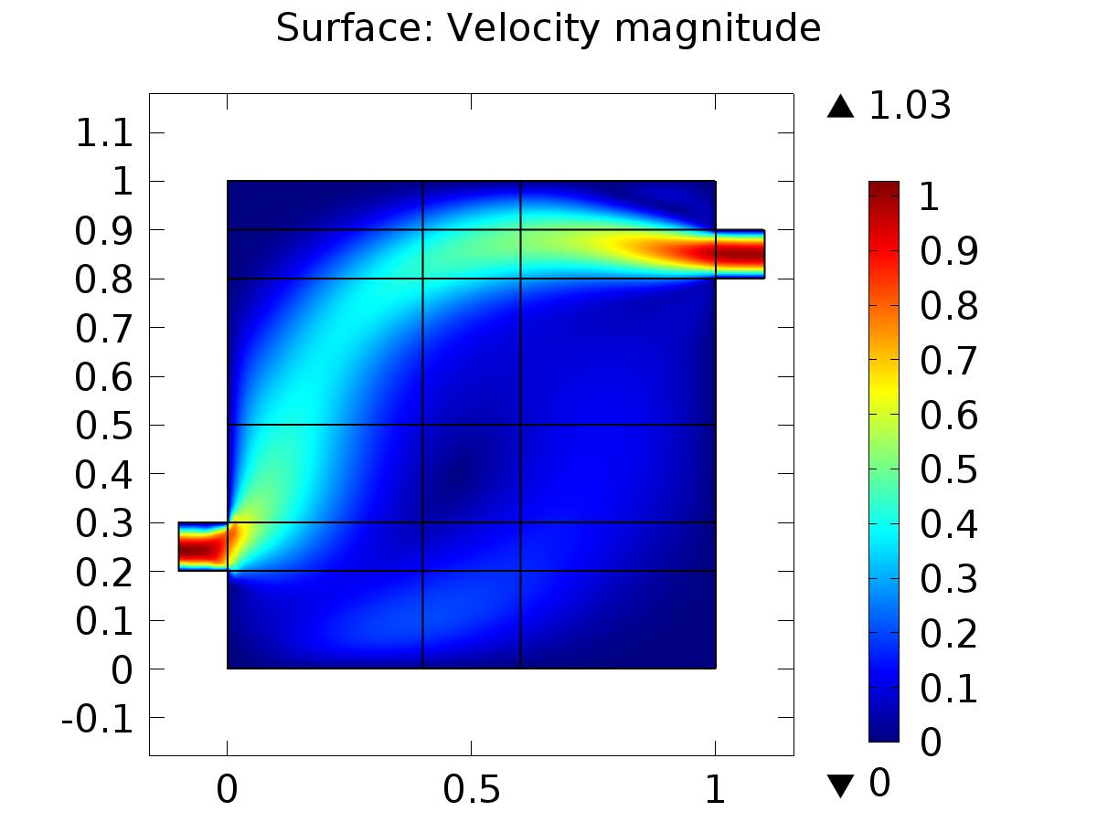

Surface: Velocity magnitude

* + 1. Pressure (spf)

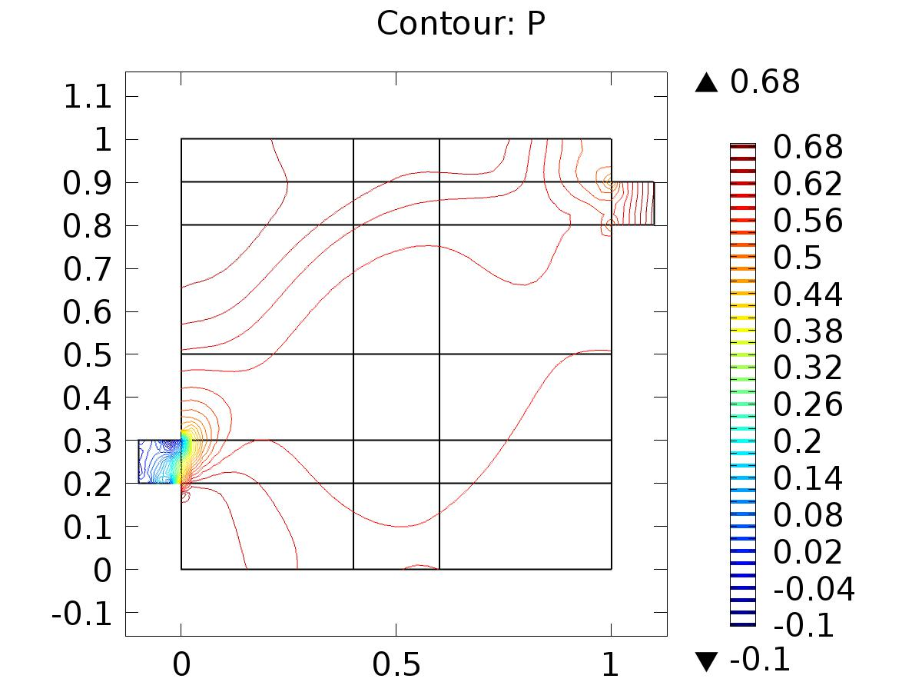

Contour: P

* + 1. 2D Plot Group 3

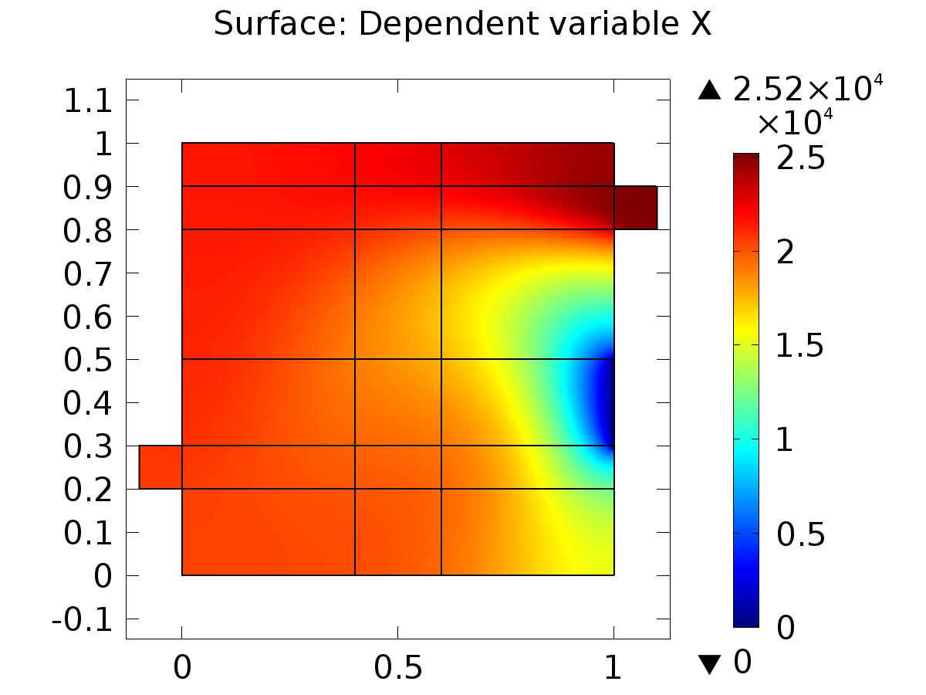

Surface: Dependent variable X

* + 1. Velocity (phys1)

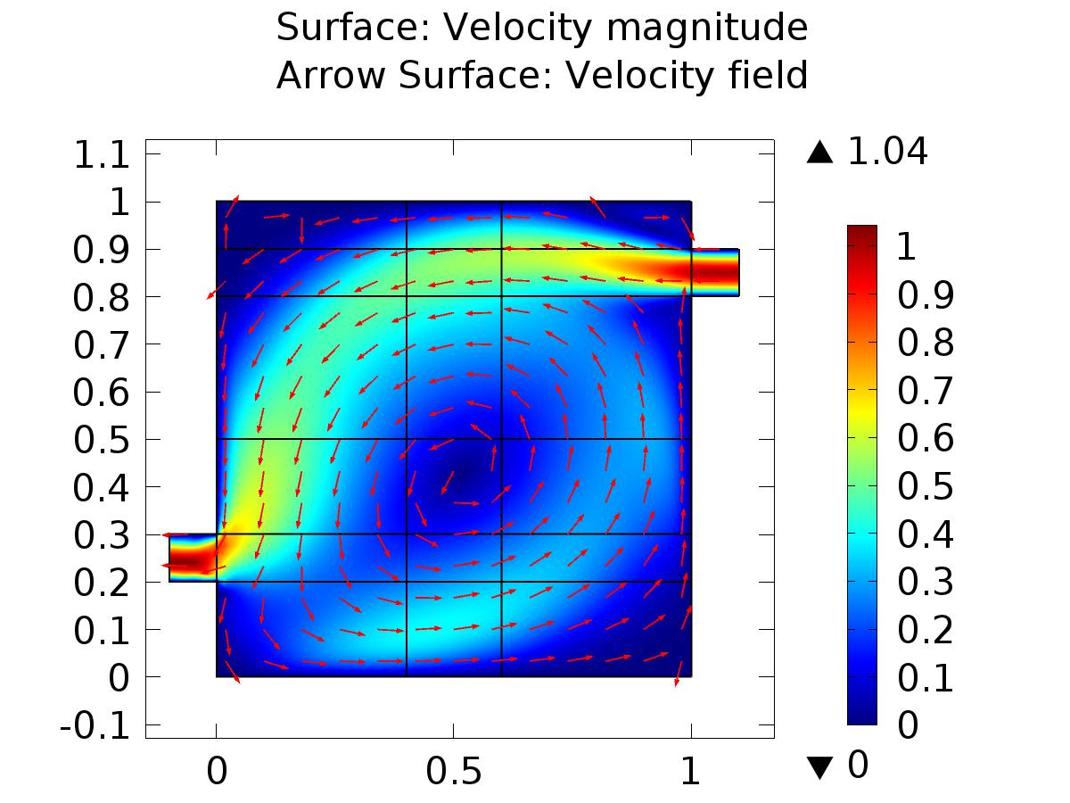

Surface: Velocity magnitude Arrow Surface: Velocity field

* + 1. Pressure (phys1)

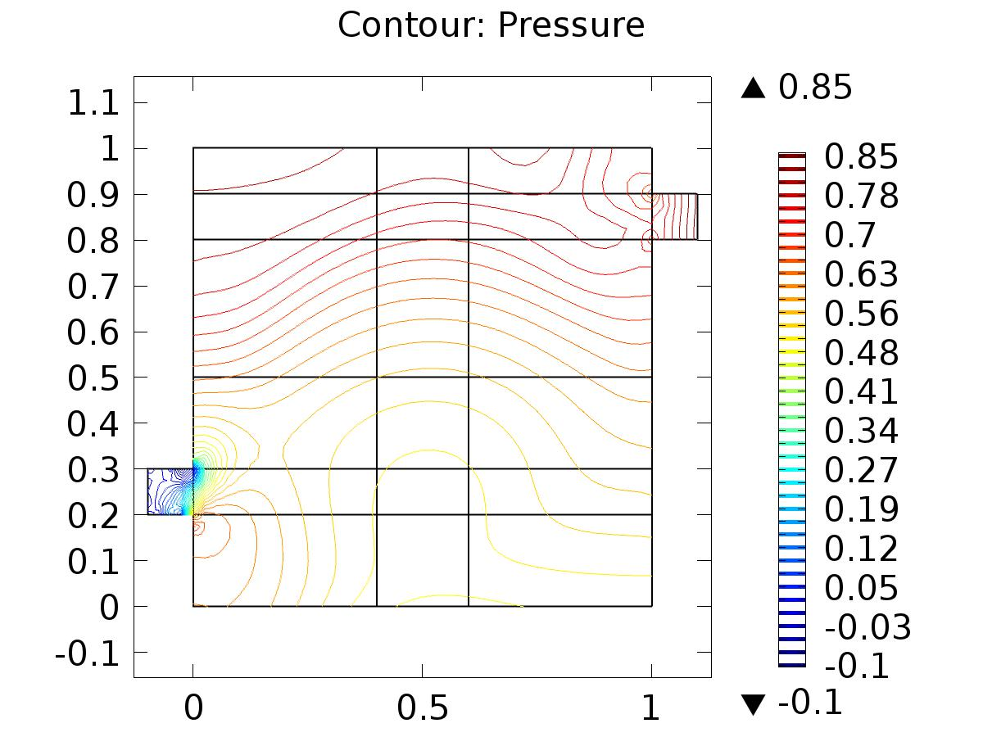

Contour: Pressure

* + 1. 2D Plot Group 6

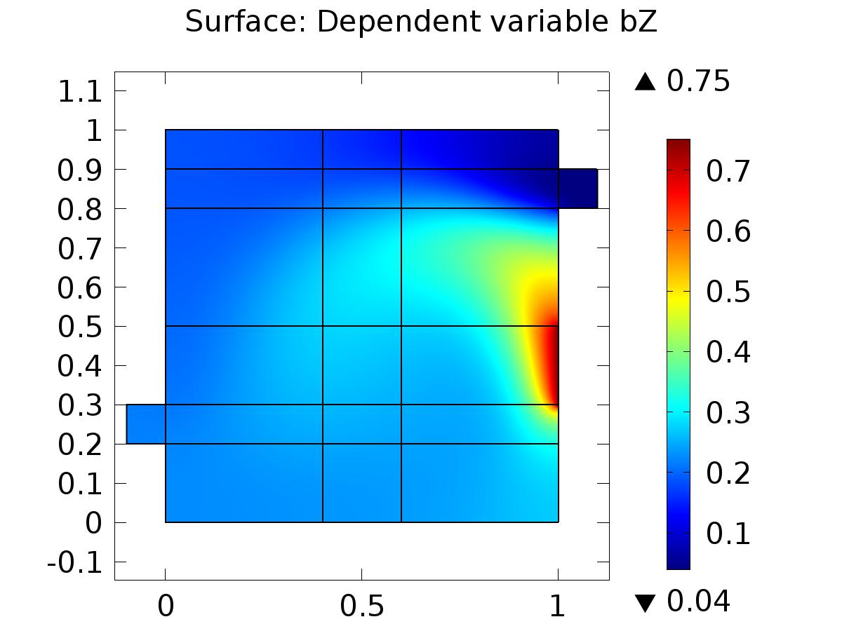

Surface: Dependent variable bZ

* + 1. Velocity (phys3)

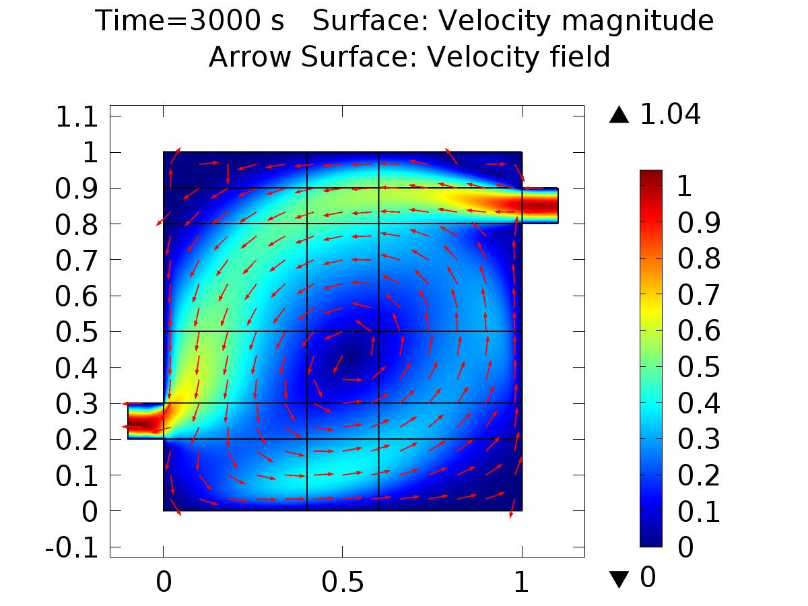

Time=3000 s Surface: Velocity magnitude Arrow Surface: Velocity field

* + 1. Pressure (phys3)

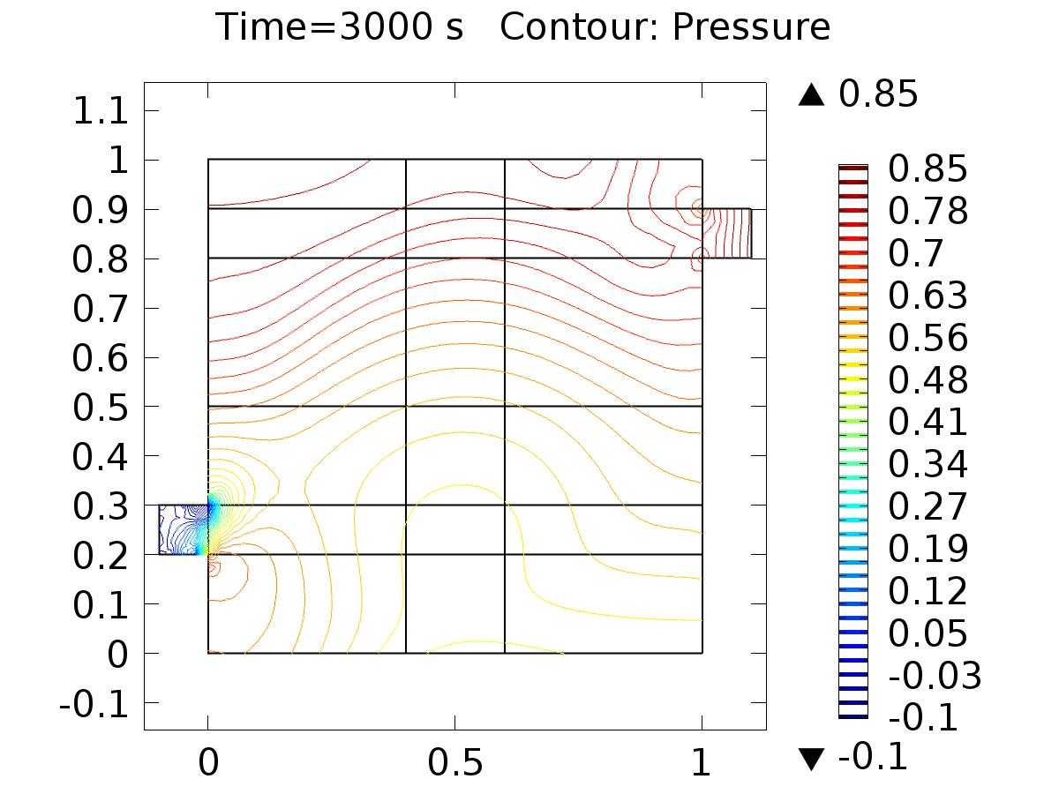

Time=3000 s Contour: Pressure

* + 1. 2D Plot Group 9

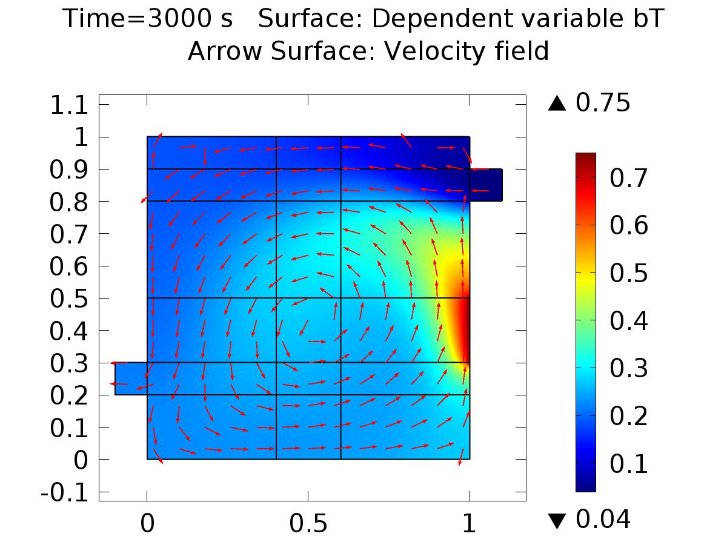

Time=3000 s Surface: Dependent variable bT Arrow Surface: Velocity field

* + 1. Velocity (phys5)

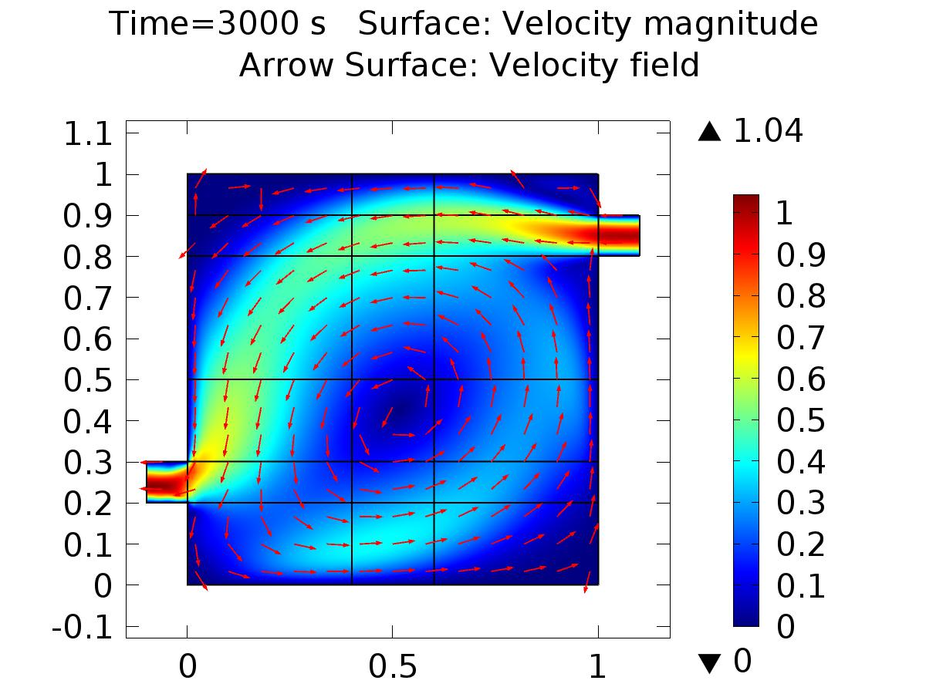

Time=3000 s Surface: Velocity magnitude Arrow Surface: Velocity field

* + 1. Pressure (phys5)

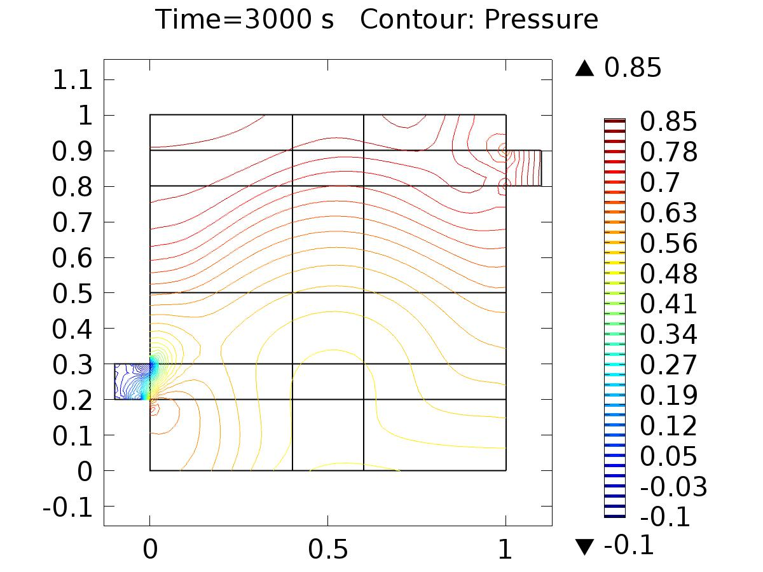

Time=3000 s Contour: Pressure

* + 1. 2D Plot Group 14

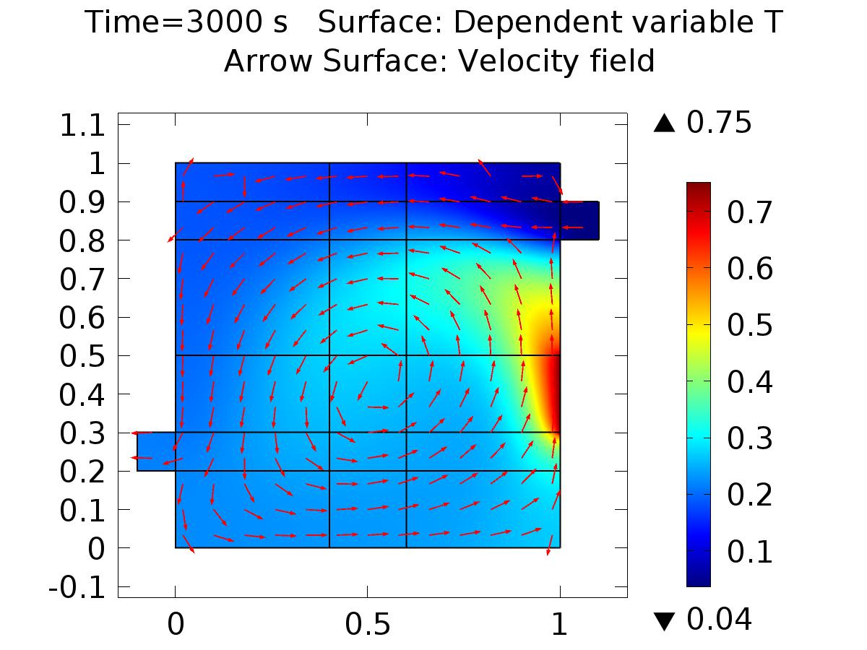

Time=3000 s Surface: Dependent variable T Arrow Surface: Velocity field

* + 1. 1D Plot Group 10

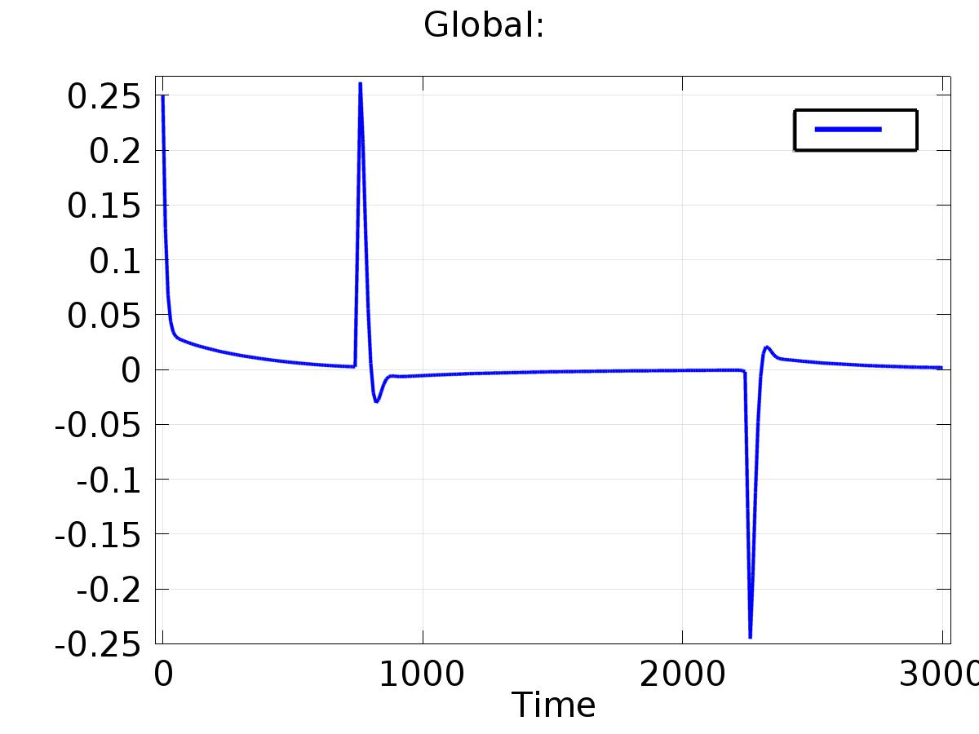

Global:

* + 1. 1D Plot Group 11

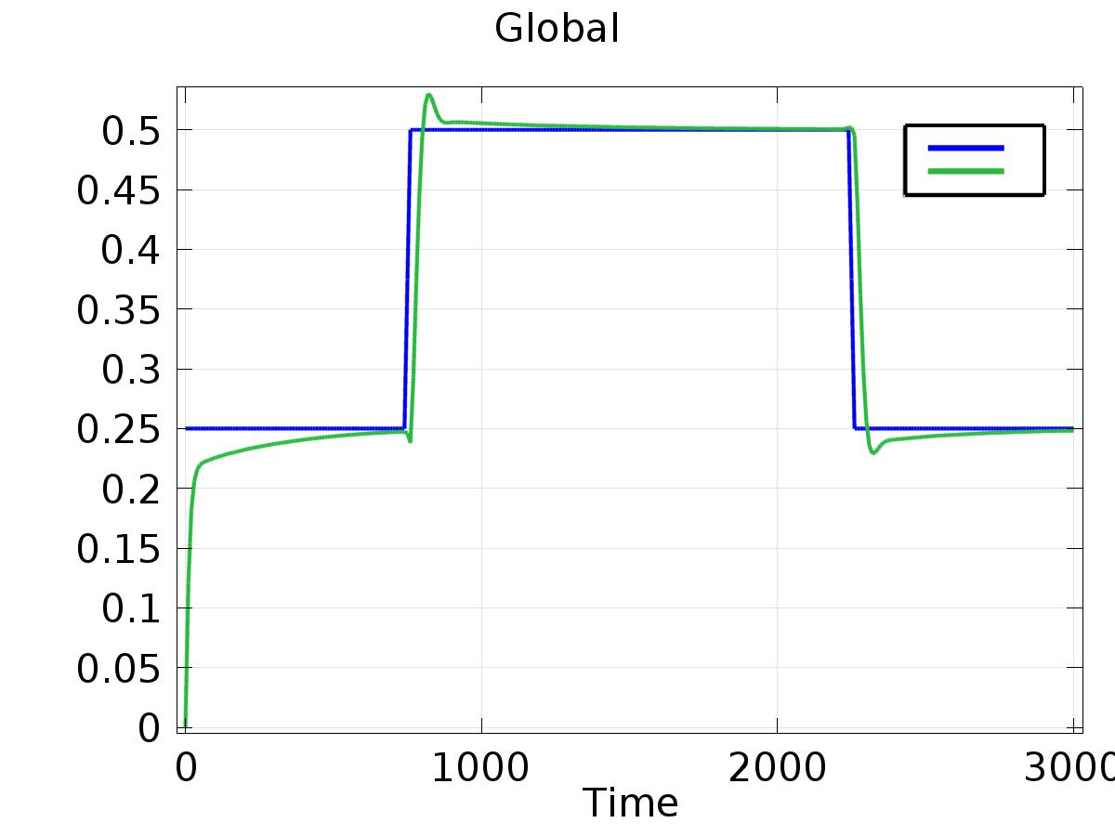

Global