[](http://www.comsol.com/)

Ex5.2.3a NonIsothermal Navies-Stokes Flows

|  |  |
| --- | --- |
| Date | Aug 11, 2014 6:45:36 AM |

Contents

1. Global

1.1. Definitions

2. Component 1

2.1. Definitions

2.2. Geometry 1

2.3. Steady Flow

2.4. Unit Input

2.5. Set Point Flow

2.6. Set Point Temperature

2.7. beta iteration Flow

2.8. beta iteration Temperature 1

2.9. beta iteration Temperature 2

2.10. Closed Loop Flow

2.11. Closed Loop Temperature

2.12. Mesh 1

3. Study 1

3.1. Stationary

3.2. Solver Configurations

4. Study 2

4.1. Stationary

4.2. Solver Configurations

5. Study 3

5.1. Time Dependent

5.2. Solver Configurations

6. Results

6.1. Data Sets

6.2. Derived Values

6.3. Tables

6.4. Plot Groups

1. Global

|  |  |
| --- | --- |
| Date | Jul 20, 2014 8:34:26 AM |

Global settings

|  |  |
| --- | --- |
| Name | Ex5.2.3a NonIsothermal Navies-Stokes Flows.mph |
| Path | /Users/gilliam/Desktop/collect_15/research_15/geo_reg_mono_eugenio/Mono_1_15/Comsol_EX_GitHub/Chapter5/Chap5Ex2_Non-Isothermal-Navier-Stokes-Flow/Ex5.2.3_harmonic/ex_5.2.3_a/Ex5.2.3a_NonIsothermal_Navies-Stokes_Flows.mph |
| Program | COMSOL 4.4 (Build: 150) |

Used products

|  |
| --- |
| COMSOL Multiphysics |

* 1. Definitions
     1. Parameters 1

Parameters

| **Name** | **Expression** | **Value** | **Description** |
| --- | --- | --- | --- |
| L | 1 | 1.0000 |  |
| H | 0.1 | 0.10000 |  |
| ni | 0.002 | 0.0020000 |  |
| alpha | 0.01 | 0.010000 |  |
| beta | 1 | 1.0000 |  |
| M1 | 0.25 | 0.25000 |  |
| M2 | 0.5 | 0.50000 |  |
| d1 | 0.75 | 0.75000 |  |
| d2 | 0.5 | 0.50000 |  |
| t1 | 750 | 750.00 |  |
| t2 | 2250 | 2250.0 |  |

1. Component 1

Component settings

|  |  |
| --- | --- |
| Unit system | None |

* 1. Definitions
     1. Variables

#### Variables 1a

Selection

|  |  |
| --- | --- |
| Geometric entity level | Entire model |

| **Name** | **Expression** | **Description** |
| --- | --- | --- |
| G | C(X) |  |
| yr0 | M1 |  |
| d0 | d1 |  |
| gamma0 | (yr0 - C(tZ))/G |  |
| yr | M1 + (M2 - M1)*sin(t*2*pi/1500) |  |
| d | d1 + (d2 - d1)*sin(t*2*pi/1500) |  |
| gamma1 | (yr - C(tT1))/G |  |
| e1 | yr - C(bT1) |  |
| gamma2 | (e1 - C(tT2))/G |  |
| e2 | e1 - C(bT2) |  |
| gamma3 | (e2 - C(tT3))/G |  |
| e3 | e2 - C(bT3) |  |
| bT | bT1 + bT2 + bT3 |  |
| gamma | gamma1 + gamma2 + gamma3 |  |
| e | yr - C(T) |  |

* + 1. Component Couplings

#### Average 1

|  |  |
| --- | --- |
| Coupling type | Average |
| Operator name | C |

Source selection

|  |  |
| --- | --- |
| Geometric entity level | Domain |
| Selection | Domain 9 |

* + 1. Coordinate Systems

#### Boundary System 1

|  |  |
| --- | --- |
| Coordinate system type | Boundary system |
| Tag | sys1 |

Coordinate names

| **First (t1)** | **Second (n)** | **Third (to)** |
| --- | --- | --- |
| t1 | n | to |

Settings

| **Description** | **Value** |
| --- | --- |
| Create first tangent direction from | Global Cartesian |

* 1. Geometry 1

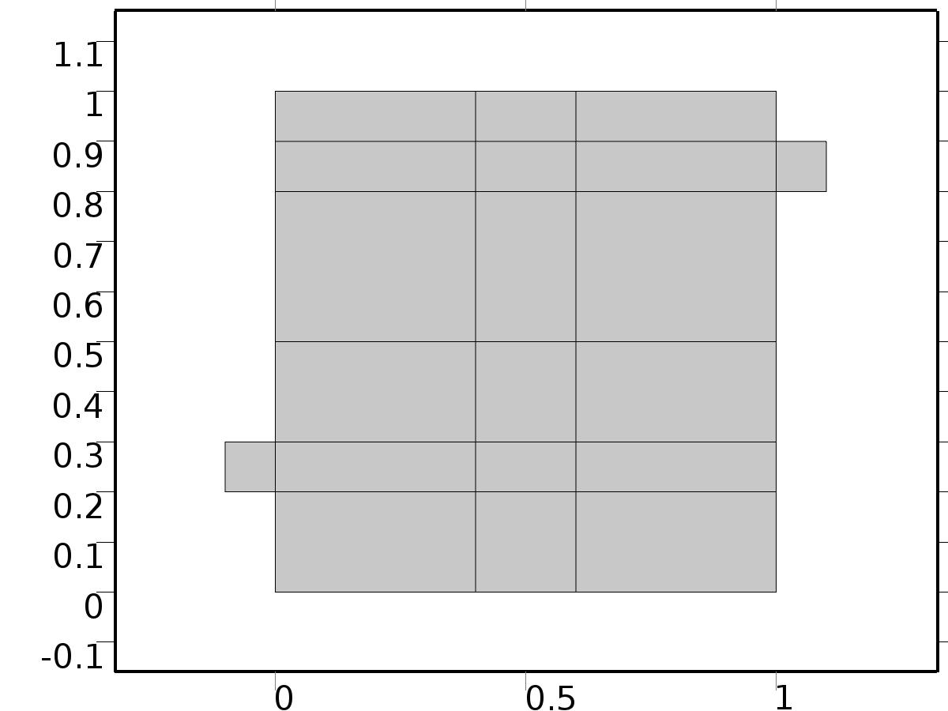

Geometry 1

Units

|  |  |
| --- | --- |
| Length unit | m |
| Angular unit | deg |

Geometry statistics

| **Description** | **Value** |
| --- | --- |
| Space dimension | 2 |
| Number of domains | 20 |
| Number of boundaries | 51 |
| Number of vertices | 32 |

* + 1. Square 1 (sq1)

Position

| **Description** | **Value** |
| --- | --- |
| Position | {0, 0} |
| Layers |  |

Size

| **Description** | **Value** |
| --- | --- |
| Side length | L |

* + 1. Rectangle 1 (r1)

Position

| **Description** | **Value** |
| --- | --- |
| Position | {-H, 2*H} |
| Layers |  |

Size

| **Description** | **Value** |
| --- | --- |
| Width | L + H |
| Height | H |

* + 1. Rectangle 2 (r2)

Position

| **Description** | **Value** |
| --- | --- |
| Position | {0, L - 2*H} |
| Layers |  |

Size

| **Description** | **Value** |
| --- | --- |
| Width | L + H |
| Height | H |

* + 1. Rectangle 3 (r3)

Position

| **Description** | **Value** |
| --- | --- |
| Position | {4*H, 0} |
| Layers |  |

Size

| **Description** | **Value** |
| --- | --- |
| Width | 2*H |
| Height | L |

* + 1. Rectangle 4 (r4)

Position

| **Description** | **Value** |
| --- | --- |
| Position | {0, 3*H} |
| Layers |  |

Size

| **Description** | **Value** |
| --- | --- |
| Width | L |
| Height | 2*H |

* 1. Steady Flow

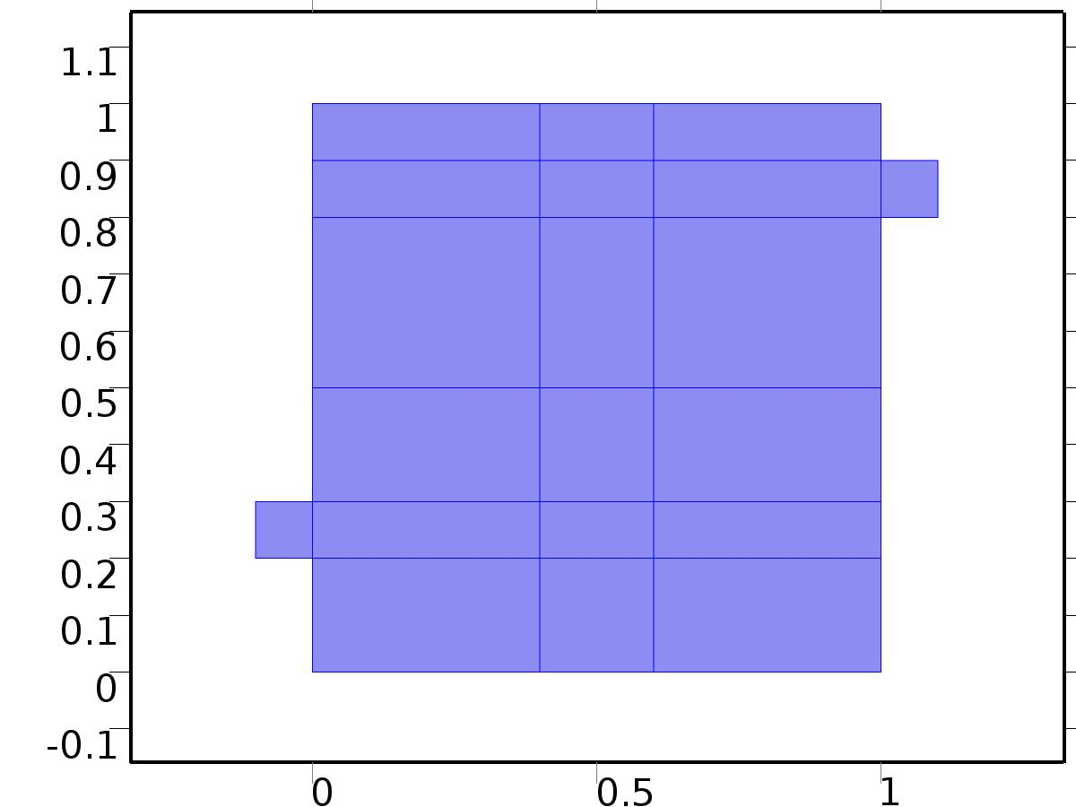

Steady Flow

Selection

|  |  |
| --- | --- |
| Geometric entity level | Domain |
| Selection | Domains 1–20 |

Equations









Settings

| **Description** | **Value** |
| --- | --- |
| Discretization of fluids | P2 + P1 |
| Value type when using splitting of complex variables | {Real, Real, Real, Real, Real, Real, Real, Real, Real, Real, Real} |
| Isotropic diffusion | Off |
| Compressibility | Incompressible flow |
| Channel thickness | 1 |
| Turbulence model type | None |
| Reference pressure level | 1[atm] |
| Use pseudo time stepping for stationary equation form | Off |
| Local CFL number | 1.3^min(niterCMP, 9) + if(niterCMP>=25, 9*1.3^min(niterCMP - 25, 9), 0) + if(niterCMP>=45, 90*1.3^min(niterCMP - 45, 9), 0) |
| Streamline diffusion | Off |
| Crosswind diffusion | Off |

Used products

|  |
| --- |
| COMSOL Multiphysics |

Variables

| **Name** | **Expression** | **Unit** | **Description** | **Selection** |
| --- | --- | --- | --- | --- |
| V.dz | 1 |  | Thickness | Domains 1–20 |
| V.pref | 1[atm] |  | Reference pressure level | Domains 1–20 |
| V.pA | P+V.pref |  | Absolute pressure | Domains 1–20 |
| V.nx | nx |  | Normal vector, x component | Boundaries 6–7, 9, 11, 13, 15, 17, 19–28, 30, 32–41, 47 |
| V.ny | ny |  | Normal vector, y component | Boundaries 6–7, 9, 11, 13, 15, 17, 19–28, 30, 32–41, 47 |
| V.nz | 0 |  | Normal vector, z component | Boundaries 6–7, 9, 11, 13, 15, 17, 19–28, 30, 32–41, 47 |
| V.nx | dnx |  | Normal vector, x component | Boundaries 1–5, 8, 10, 12, 14, 16, 18, 29, 31, 42–46, 48–51 |
| V.ny | dny |  | Normal vector, y component | Boundaries 1–5, 8, 10, 12, 14, 16, 18, 29, 31, 42–46, 48–51 |
| V.nz | 0 |  | Normal vector, z component | Boundaries 1–5, 8, 10, 12, 14, 16, 18, 29, 31, 42–46, 48–51 |
| V.nxmesh | root.nxmesh |  | Normal vector, x component | Boundaries 6–7, 9, 11, 13, 15, 17, 19–28, 30, 32–41, 47 |
| V.nymesh | root.nymesh |  | Normal vector, y component | Boundaries 6–7, 9, 11, 13, 15, 17, 19–28, 30, 32–41, 47 |
| V.nzmesh | 0 |  | Normal vector, z component | Boundaries 6–7, 9, 11, 13, 15, 17, 19–28, 30, 32–41, 47 |
| V.nxmesh | root.dnxmesh |  | Normal vector, x component | Boundaries 1–5, 8, 10, 12, 14, 16, 18, 29, 31, 42–46, 48–51 |
| V.nymesh | root.dnymesh |  | Normal vector, y component | Boundaries 1–5, 8, 10, 12, 14, 16, 18, 29, 31, 42–46, 48–51 |
| V.nzmesh | 0 |  | Normal vector, z component | Boundaries 1–5, 8, 10, 12, 14, 16, 18, 29, 31, 42–46, 48–51 |

* + 1. Fluid Properties



Fluid Properties

Selection

|  |  |
| --- | --- |
| Geometric entity level | Domain |
| Selection | Domains 1–20 |

Equations

Settings

| **Description** | **Value** |
| --- | --- |
| Density | User defined |
| Density | 1 |
| Dynamic viscosity | User defined |
| Dynamic viscosity | ni |

#### Variables

| **Name** | **Expression** | **Unit** | **Description** | **Selection** |
| --- | --- | --- | --- | --- |
| V.rho | 1 |  | Density | Domains 1–20 |
| V.mu | ni |  | Dynamic viscosity | Domains 1–20 |
| V.sr | sqrt(0.5*(4*Ux^2+2*(Uy+Vx)^2+4*Vy^2)+eps) |  | Shear rate | Domains 1–20 |
| V.divu | Ux+Vy |  | Divergence of velocity field | Domains 1–20 |
| V.Fx | 0 |  | Volume force, x component | Domains 1–20 |
| V.Fy | 0 |  | Volume force, y component | Domains 1–20 |
| V.Fz | 0 |  | Volume force, z component | Domains 1–20 |
| V.U | sqrt(U^2+V^2) |  | Velocity magnitude | Domains 1–20 |
| V.vorticityx | 0 |  | Vorticity field, x component | Domains 1–20 |
| V.vorticityy | 0 |  | Vorticity field, y component | Domains 1–20 |
| V.vorticityz | Vx-Uy |  | Vorticity field, z component | Domains 1–20 |
| V.vort_magn | sqrt(V.vorticityx^2+V.vorticityy^2+V.vorticityz^2) |  | Vorticity magnitude | Domains 1–20 |
| V.cellRe | 0.25*V.rho*sqrt(emetric(U,V)/emetric2)/V.mu |  | Cell Reynolds number | Domains 1–20 |
| V.nu | V.mu/V.rho |  | Kinematic viscosity | Domains 1–20 |
| V.betaT | 0 |  | Isothermal compressibility coefficient | Domains 1–20 |
| V.mu_eff | V.mu+V.muT |  | Dynamic viscosity | Domains 1–20 |
| V.muT | 0 |  | Turbulent dynamic viscosity | Domains 1–20 |
| V.T_stressx | V.K_stressx-P*V.nxmesh |  | Total stress, x component | Boundaries 1–51 |
| V.T_stressy | V.K_stressy-P*V.nymesh |  | Total stress, y component | Boundaries 1–51 |
| V.T_stressz | V.K_stressz-P*V.nzmesh |  | Total stress, z component | Boundaries 1–51 |
| V.K_stressx | V.mu_eff*(2*Ux*V.nxmesh+(Uy+Vx)*V.nymesh) |  | Viscous stress, x component | Boundaries 1–51 |
| V.K_stressy | V.mu_eff*((Vx+Uy)*V.nxmesh+2*Vy*V.nymesh) |  | Viscous stress, y component | Boundaries 1–51 |
| V.K_stressz | 0 |  | Viscous stress, z component | Boundaries 1–51 |
| V.K_stress_tensorxx | 2*V.mu_eff*Ux |  | Viscous stress tensor, xx component | Domains 1–20 |
| V.K_stress_tensoryx | V.mu_eff*(Vx+Uy) |  | Viscous stress tensor, yx component | Domains 1–20 |
| V.K_stress_tensorzx | 0 |  | Viscous stress tensor, zx component | Domains 1–20 |
| V.K_stress_tensorxy | V.mu_eff*(Uy+Vx) |  | Viscous stress tensor, xy component | Domains 1–20 |
| V.K_stress_tensoryy | 2*V.mu_eff*Vy |  | Viscous stress tensor, yy component | Domains 1–20 |
| V.K_stress_tensorzy | 0 |  | Viscous stress tensor, zy component | Domains 1–20 |
| V.K_stress_tensorxz | 0 |  | Viscous stress tensor, xz component | Domains 1–20 |
| V.K_stress_tensoryz | 0 |  | Viscous stress tensor, yz component | Domains 1–20 |
| V.K_stress_tensorzz | 0 |  | Viscous stress tensor, zz component | Domains 1–20 |
| V.K_stress_tensor_testxx | 2*V.mu_eff*test(Ux) |  | Viscous stress tensor test, xx component | Domains 1–20 |
| V.K_stress_tensor_testyx | V.mu_eff*(test(Vx)+test(Uy)) |  | Viscous stress tensor test, yx component | Domains 1–20 |
| V.K_stress_tensor_testzx | 0 |  | Viscous stress tensor test, zx component | Domains 1–20 |
| V.K_stress_tensor_testxy | V.mu_eff*(test(Uy)+test(Vx)) |  | Viscous stress tensor test, xy component | Domains 1–20 |
| V.K_stress_tensor_testyy | 2*V.mu_eff*test(Vy) |  | Viscous stress tensor test, yy component | Domains 1–20 |
| V.K_stress_tensor_testzy | 0 |  | Viscous stress tensor test, zy component | Domains 1–20 |
| V.K_stress_tensor_testxz | 0 |  | Viscous stress tensor test, xz component | Domains 1–20 |
| V.K_stress_tensor_testyz | 0 |  | Viscous stress tensor test, yz component | Domains 1–20 |
| V.K_stress_tensor_testzz | 0 |  | Viscous stress tensor test, zz component | Domains 1–20 |
| V.upwind_helpx | U |  | Upwind term, x component | Domains 1–20 |
| V.upwind_helpy | V |  | Upwind term, y component | Domains 1–20 |
| V.upwind_helpz | 0 |  | Upwind term, z component | Domains 1–20 |
| V.tau_vdxx | 2*V.mu*Ux |  | Strain rate, xx component | Domains 1–20 |
| V.tau_vdyx | V.mu*(Vx+Uy) |  | Strain rate, yx component | Domains 1–20 |
| V.tau_vdzx | 0 |  | Strain rate, zx component | Domains 1–20 |
| V.tau_vdxy | V.mu*(Uy+Vx) |  | Strain rate, xy component | Domains 1–20 |
| V.tau_vdyy | 2*V.mu*Vy |  | Strain rate, yy component | Domains 1–20 |
| V.tau_vdzy | 0 |  | Strain rate, zy component | Domains 1–20 |
| V.tau_vdxz | 0 |  | Strain rate, xz component | Domains 1–20 |
| V.tau_vdyz | 0 |  | Strain rate, yz component | Domains 1–20 |
| V.tau_vdzz | 0 |  | Strain rate, zz component | Domains 1–20 |
| V.Qvd | V.tau_vdxx*Ux+V.tau_vdxy*Uy+V.tau_vdyx*Vx+V.tau_vdyy*Vy |  | Viscous dissipation | Domains 1–20 |

#### Shape functions

| **Name** | **Shape function** | **Unit** | **Description** | **Shape frame** | **Selection** |
| --- | --- | --- | --- | --- | --- |
| U | Lagrange (Quadratic) |  | Velocity field, x component | Material | Domains 1–20 |
| V | Lagrange (Quadratic) |  | Velocity field, y component | Material | Domains 1–20 |
| P | Lagrange (Linear) |  | Pressure | Material | Domains 1–20 |

#### Weak expressions

| **Weak expression** | **Integration frame** | **Selection** |
| --- | --- | --- |
| (P-V.K_stress_tensorxx)*test(Ux)-V.K_stress_tensorxy*test(Uy)-V.K_stress_tensoryx*test(Vx)+(P-V.K_stress_tensoryy)*test(Vy) | Material | Domains 1–20 |
| V.Fx*test(U)+V.Fy*test(V) | Material | Domains 1–20 |
| V.rho*(-(Ux*U+Uy*V)*test(U)-(Vx*U+Vy*V)*test(V)) | Material | Domains 1–20 |
| -V.rho*V.divu*test(P) | Material | Domains 1–20 |

* + 1. Wall

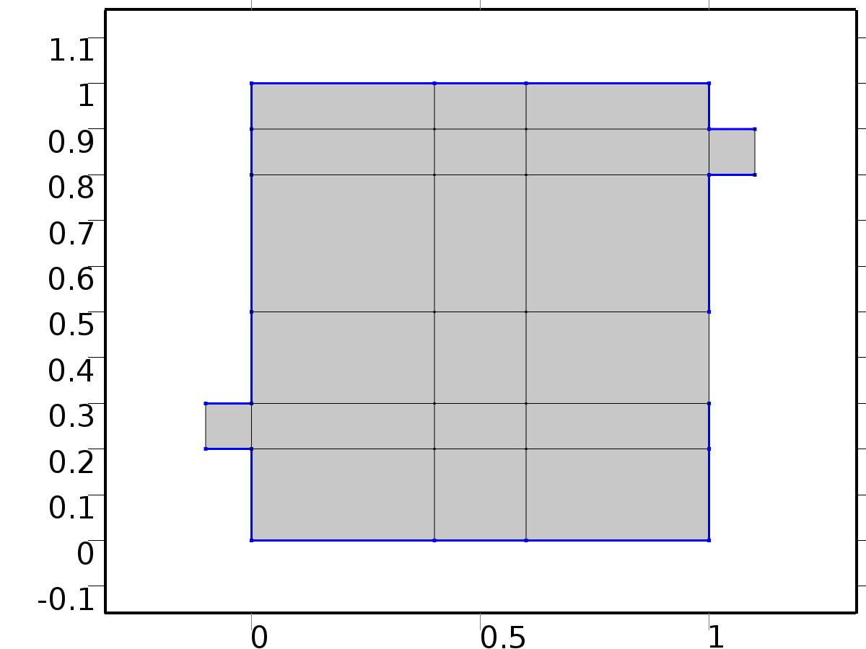

Wall

Selection

|  |  |
| --- | --- |
| Geometric entity level | Boundary |
| Selection | Boundaries 2–5, 8, 10, 12, 14, 16, 18, 29, 31, 42–44, 46, 48–50 |

Equations

Settings

| **Description** | **Value** |
| --- | --- |
| Boundary condition | No slip |
| Apply reaction terms on | Individual dependent variables |
| Use weak constraints | Off |
| Constraint method | Elemental |

#### Variables

| **Name** | **Expression** | **Unit** | **Description** | **Selection** |
| --- | --- | --- | --- | --- |
| V.ubndx | 0 |  | Velocity at boundary, x component | Boundaries 2–5, 8, 10, 12, 14, 16, 18, 29, 31, 42–44, 46, 48–50 |
| V.ubndy | 0 |  | Velocity at boundary, y component | Boundaries 2–5, 8, 10, 12, 14, 16, 18, 29, 31, 42–44, 46, 48–50 |
| V.ubndz | 0 |  | Velocity at boundary, z component | Boundaries 2–5, 8, 10, 12, 14, 16, 18, 29, 31, 42–44, 46, 48–50 |

#### Shape functions

| **Constraint** | **Constraint force** | **Shape function** | **Selection** |
| --- | --- | --- | --- |
| -U+V.ubndx | test(-U) | Lagrange (Quadratic) | Boundaries 2–5, 8, 10, 12, 14, 16, 18, 29, 31, 42–44, 46, 48–50 |
| -V+V.ubndy | test(-V) | Lagrange (Quadratic) | Boundaries 2–5, 8, 10, 12, 14, 16, 18, 29, 31, 42–44, 46, 48–50 |
| V.ubndz | 0 |  | Boundaries 2–5, 8, 10, 12, 14, 16, 18, 29, 31, 42–44, 46, 48–50 |

* + 1. Initial Values



Initial Values

Selection

|  |  |
| --- | --- |
| Geometric entity level | Domain |
| Selection | Domains 1–20 |

Settings

| **Description** | **Value** |
| --- | --- |
| Turbulent kinetic energy | spf.kinit |
| Turbulent dissipation rate | spf.epinit |
| Specific dissipation rate | spf.omInit |
| Reciprocal wall distance | spf.G0 |
| Undamped turbulent kinematic viscosity | spf.nutildeinit |
| Velocity field | {0, 0, 0} |
| Pressure | 0 |

* + 1. Inlet

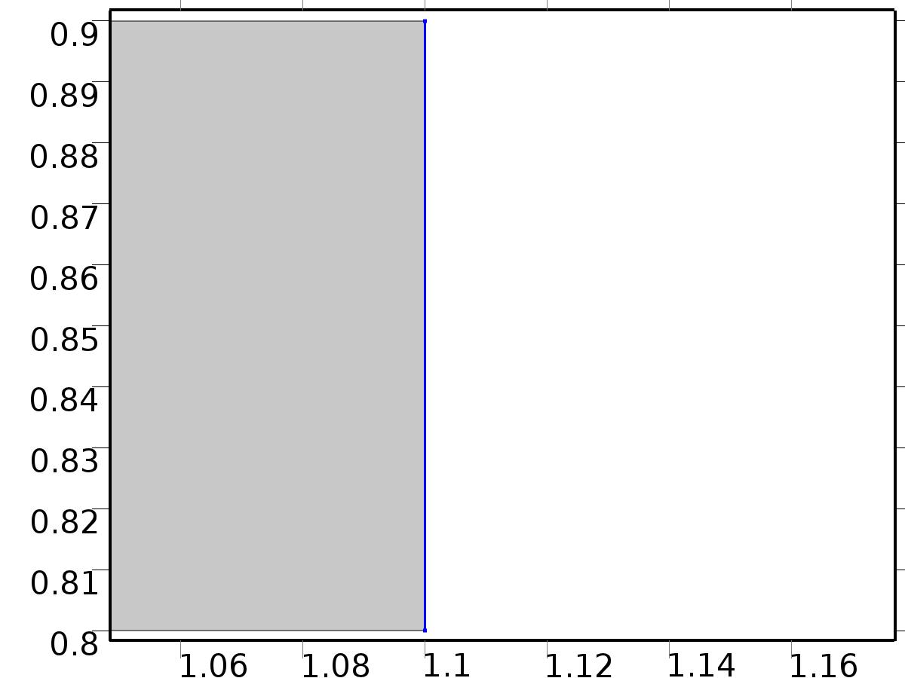

Inlet

Selection

|  |  |
| --- | --- |
| Geometric entity level | Boundary |
| Selection | Boundary 51 |

Equations

Settings

| **Description** | **Value** |
| --- | --- |
| Apply reaction terms on | All physics (symmetric) |
| Use weak constraints | Off |
| Boundary condition | Velocity |
| Velocity field componentwise | Normal inflow velocity |
| Normal inflow velocity | 4*s*(1 - s) |
| Turbulent intensity | 0.05 |
| Turbulence length scale | 0.01[m] |
| Turbulent kinetic energy | 0.005[m^2/s^2] |
| Turbulent dissipation rate | 0.005[m^2/s^3] |
| Specific dissipation rate | 20[1/s] |
| Undamped turbulent kinematic viscosity | 3*spf.nu |
| Constraint method | Elemental |

#### Variables

| **Name** | **Expression** | **Unit** | **Description** | **Selection** |
| --- | --- | --- | --- | --- |
| V.ubndx | -nojac(V.nxmesh)*V.U0in |  | Velocity at boundary, x component | Boundary 51 |
| V.ubndy | -nojac(V.nymesh)*V.U0in |  | Velocity at boundary, y component | Boundary 51 |
| V.ubndz | -nojac(V.nzmesh)*V.U0in |  | Velocity at boundary, z component | Boundary 51 |
| V.U0in | 4*s*(1-s) |  | Normal inflow velocity | Boundary 51 |

#### Shape functions

| **Constraint** | **Constraint force** | **Shape function** | **Selection** |
| --- | --- | --- | --- |
| -U+V.ubndx | test(-U+V.ubndx) | Lagrange (Quadratic) | Boundary 51 |
| -V+V.ubndy | test(-V+V.ubndy) | Lagrange (Quadratic) | Boundary 51 |
| V.ubndz | test(V.ubndz) |  | Boundary 51 |

* + 1. Outflow

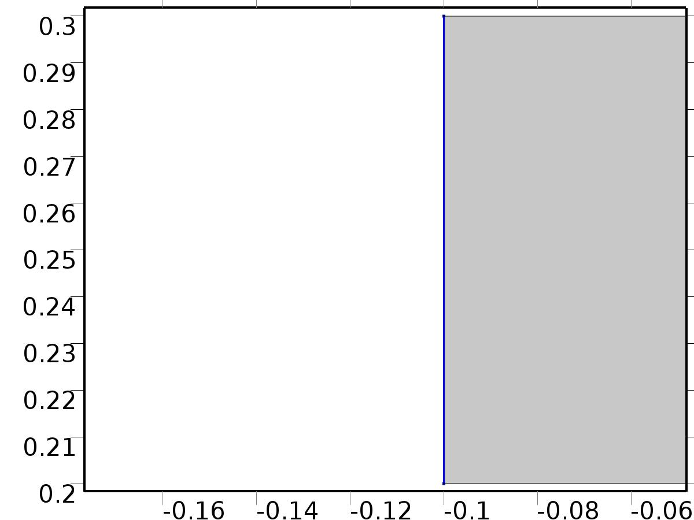

Outflow

Selection

|  |  |
| --- | --- |
| Geometric entity level | Boundary |
| Selection | Boundary 1 |

Equations

Settings

| **Description** | **Value** |
| --- | --- |
| Boundary condition | Normal stress |
| Normal stress | 0 |
| Turbulent intensity | 0.005 |
| Turbulence length scale | 0.1[m] |
| Turbulent kinetic energy | 2.5e-3[m^2/s^2] |
| Turbulent dissipation rate | 1.1e-4[m^2/s^3] |
| Specific dissipation rate | 0.5[1/s] |
| Undamped turbulent kinematic viscosity | 3*spf.nu |

#### Variables

| **Name** | **Expression** | **Unit** | **Description** | **Selection** |
| --- | --- | --- | --- | --- |
| V.f0 | 0 |  | Normal stress | Boundary 1 |

#### Weak expressions

| **Weak expression** | **Integration frame** | **Selection** |
| --- | --- | --- |
| -V.f0*(test(U)*V.nxmesh+test(V)*V.nymesh) | Material | Boundary 1 |

* + 1. Window

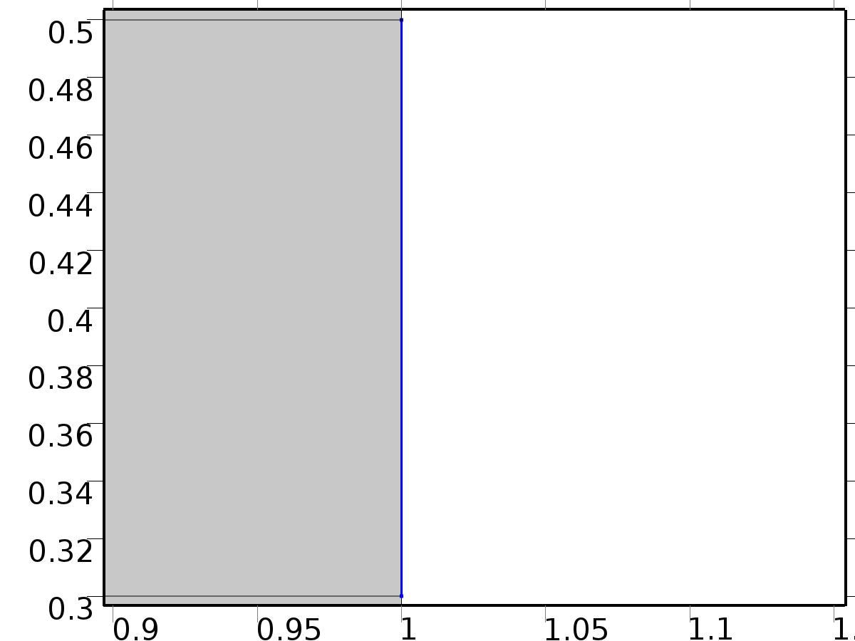

Window

Selection

|  |  |
| --- | --- |
| Geometric entity level | Boundary |
| Selection | Boundary 45 |

Equations

Settings

| **Description** | **Value** |
| --- | --- |
| Boundary condition | No slip |
| Apply reaction terms on | Individual dependent variables |
| Use weak constraints | Off |
| Constraint method | Elemental |

#### Variables

| **Name** | **Expression** | **Unit** | **Description** | **Selection** |
| --- | --- | --- | --- | --- |
| V.ubndx | 0 |  | Velocity at boundary, x component | Boundary 45 |
| V.ubndy | 0 |  | Velocity at boundary, y component | Boundary 45 |
| V.ubndz | 0 |  | Velocity at boundary, z component | Boundary 45 |

#### Shape functions

| **Constraint** | **Constraint force** | **Shape function** | **Selection** |
| --- | --- | --- | --- |
| -U+V.ubndx | test(-U) | Lagrange (Quadratic) | Boundary 45 |
| -V+V.ubndy | test(-V) | Lagrange (Quadratic) | Boundary 45 |
| V.ubndz | 0 |  | Boundary 45 |

* 1. Unit Input



Unit Input

Selection

|  |  |
| --- | --- |
| Geometric entity level | Domain |
| Selection | Domains 1–20 |

Settings

| **Description** | **Value** |
| --- | --- |
| Shape function type | Lagrange |
| Element order | Quadratic |
| Compute boundary fluxes | On |
| Apply smoothing to boundary fluxes | On |
| Value type when using splitting of complex variables | Complex |
| Dependent variable quantity | Dimensionless (1) |
| Source term quantity | None |
| Unit | m^ - 2 |

Used products

|  |
| --- |
| COMSOL Multiphysics |

Variables

| **Name** | **Expression** | **Unit** | **Description** | **Selection** |
| --- | --- | --- | --- | --- |
| X.nx | nx |  | Normal vector, x component | Boundaries 1–51 |
| X.ny | ny |  | Normal vector, y component | Boundaries 1–51 |
| X.nz | root.nz |  | Normal vector, z component | Boundaries 1–51 |
| X.nxmesh | root.nxmesh |  | Normal vector (mesh), x component | Boundaries 1–51 |
| X.nymesh | root.nymesh |  | Normal vector (mesh), y component | Boundaries 1–51 |
| X.nzmesh | root.nzmesh |  | Normal vector (mesh), z component | Boundaries 1–51 |

* + 1. Coefficient Form PDE



Coefficient Form PDE

Selection

|  |  |
| --- | --- |
| Geometric entity level | Domain |
| Selection | Domains 1–20 |

Equations

Settings

| **Description** | **Value** |
| --- | --- |
| Diffusion coefficient | {{alpha, 0}, {0, alpha}} |
| Absorption coefficient | 0 |
| Source term | 0 |
| Mass coefficient | 0 |
| Damping or mass coefficient | 0 |
| Conservative flux convection coefficient | {0, 0} |
| Convection coefficient | {U, V} |
| Conservative flux source | {0, 0} |

#### Variables

| **Name** | **Expression** | **Unit** | **Description** | **Selection** |
| --- | --- | --- | --- | --- |
| domflux.Xx | -alpha*d(X,x) |  | Domain flux, x component | Domains 1–20 |
| domflux.Xy | -alpha*d(X,y) |  | Domain flux, y component | Domains 1–20 |

#### Shape functions

| **Name** | **Shape function** | **Unit** | **Description** | **Shape frame** | **Selection** |
| --- | --- | --- | --- | --- | --- |
| X | Lagrange (Quadratic) |  | Dependent variable X | Material | Domains 1–20 |

* + 1. Insulated Wall



Insulated Wall

Selection

|  |  |
| --- | --- |
| Geometric entity level | Boundary |
| Selection | Boundaries 2–5, 8, 10, 12, 14, 16, 18, 29, 31, 42–44, 46, 48–50 |

Equations

* + 1. Initial Values



Initial Values

Selection

|  |  |
| --- | --- |
| Geometric entity level | Domain |
| Selection | Domains 1–20 |

Settings

| **Description** | **Value** |
| --- | --- |
| Initial value for X | 0 |
| Initial time derivative of X | 0 |

* + 1. Heat Flux Bin*1



Heat Flux Bin*1

Selection

|  |  |
| --- | --- |
| Geometric entity level | Boundary |
| Selection | Boundary 51 |

Equations

Settings

| **Description** | **Value** |
| --- | --- |
| Boundary flux/source | 1 |
| Boundary absorption/impedance term | 0 |

#### Variables

| **Name** | **Expression** | **Unit** | **Description** | **Selection** |
| --- | --- | --- | --- | --- |
| X.g_X | 1 |  | Boundary flux/source | Boundary 51 |

* + 1. Outflow



Outflow

Selection

|  |  |
| --- | --- |
| Geometric entity level | Boundary |
| Selection | Boundary 1 |

Equations

* + 1. Window



Window

Selection

|  |  |
| --- | --- |
| Geometric entity level | Boundary |
| Selection | Boundary 45 |

Equations

Settings

| **Description** | **Value** |
| --- | --- |
| Value on boundary | 0 |
| Prescribed value of X | On |
| Apply reaction terms on | Individual dependent variables |
| Use weak constraints | Off |
| Constraint method | Elemental |

#### Shape functions

| **Constraint** | **Constraint force** | **Shape function** | **Selection** |
| --- | --- | --- | --- |
| -X | -test(X) | Lagrange (Quadratic) | Boundary 45 |

* 1. Set Point Flow



Set Point Flow

Selection

|  |  |
| --- | --- |
| Geometric entity level | Domain |
| Selection | Domains 1–20 |

Equations









Settings

| **Description** | **Value** |
| --- | --- |
| Discretization of fluids | P2 + P1 |
| Value type when using splitting of complex variables | {Real, Real, Real, Real, Real, Real, Real, Real, Real, Real, Real} |
| Isotropic diffusion | Off |
| Compressibility | Incompressible flow |
| Channel thickness | 1 |
| Turbulence model type | None |
| Reference pressure level | 1[atm] |
| Use pseudo time stepping for stationary equation form | Off |
| Local CFL number | 1.3^min(niterCMP, 9) + if(niterCMP>=25, 9*1.3^min(niterCMP - 25, 9), 0) + if(niterCMP>=45, 90*1.3^min(niterCMP - 45, 9), 0) |
| Streamline diffusion | Off |
| Crosswind diffusion | Off |

Used products

|  |
| --- |
| COMSOL Multiphysics |

Variables

| **Name** | **Expression** | **Unit** | **Description** | **Selection** |
| --- | --- | --- | --- | --- |
| bV.dz | 1 |  | Thickness | Domains 1–20 |
| bV.pref | 1[atm] |  | Reference pressure level | Domains 1–20 |
| bV.pA | bP+bV.pref |  | Absolute pressure | Domains 1–20 |
| bV.nx | nx |  | Normal vector, x component | Boundaries 6–7, 9, 11, 13, 15, 17, 19–28, 30, 32–41, 47 |
| bV.ny | ny |  | Normal vector, y component | Boundaries 6–7, 9, 11, 13, 15, 17, 19–28, 30, 32–41, 47 |
| bV.nz | 0 |  | Normal vector, z component | Boundaries 6–7, 9, 11, 13, 15, 17, 19–28, 30, 32–41, 47 |
| bV.nx | dnx |  | Normal vector, x component | Boundaries 1–5, 8, 10, 12, 14, 16, 18, 29, 31, 42–46, 48–51 |
| bV.ny | dny |  | Normal vector, y component | Boundaries 1–5, 8, 10, 12, 14, 16, 18, 29, 31, 42–46, 48–51 |
| bV.nz | 0 |  | Normal vector, z component | Boundaries 1–5, 8, 10, 12, 14, 16, 18, 29, 31, 42–46, 48–51 |
| bV.nxmesh | root.nxmesh |  | Normal vector, x component | Boundaries 6–7, 9, 11, 13, 15, 17, 19–28, 30, 32–41, 47 |
| bV.nymesh | root.nymesh |  | Normal vector, y component | Boundaries 6–7, 9, 11, 13, 15, 17, 19–28, 30, 32–41, 47 |
| bV.nzmesh | 0 |  | Normal vector, z component | Boundaries 6–7, 9, 11, 13, 15, 17, 19–28, 30, 32–41, 47 |
| bV.nxmesh | root.dnxmesh |  | Normal vector, x component | Boundaries 1–5, 8, 10, 12, 14, 16, 18, 29, 31, 42–46, 48–51 |
| bV.nymesh | root.dnymesh |  | Normal vector, y component | Boundaries 1–5, 8, 10, 12, 14, 16, 18, 29, 31, 42–46, 48–51 |
| bV.nzmesh | 0 |  | Normal vector, z component | Boundaries 1–5, 8, 10, 12, 14, 16, 18, 29, 31, 42–46, 48–51 |

* + 1. Fluid Properties



Fluid Properties

Selection

|  |  |
| --- | --- |
| Geometric entity level | Domain |
| Selection | Domains 1–20 |

Equations

Settings

| **Description** | **Value** |
| --- | --- |
| Density | User defined |
| Density | 1 |
| Dynamic viscosity | User defined |
| Dynamic viscosity | ni |

#### Variables

| **Name** | **Expression** | **Unit** | **Description** | **Selection** |
| --- | --- | --- | --- | --- |
| bV.Fx | 0 |  | Volume force, x component | Domains 1–20 |
| bV.Fy | 0 |  | Volume force, y component | Domains 1–20 |
| bV.Fz | 0 |  | Volume force, z component | Domains 1–20 |
| bV.rho | 1 |  | Density | Domains 1–20 |
| bV.mu | ni |  | Dynamic viscosity | Domains 1–20 |
| bV.sr | sqrt(0.5*(4*bUx^2+2*(bUy+bVx)^2+4*bVy^2)+eps) |  | Shear rate | Domains 1–20 |
| bV.divu | bUx+bVy |  | Divergence of velocity field | Domains 1–20 |
| bV.U | sqrt(bU^2+bV^2) |  | Velocity magnitude | Domains 1–20 |
| bV.vorticityx | 0 |  | Vorticity field, x component | Domains 1–20 |
| bV.vorticityy | 0 |  | Vorticity field, y component | Domains 1–20 |
| bV.vorticityz | bVx-bUy |  | Vorticity field, z component | Domains 1–20 |
| bV.vort_magn | sqrt(bV.vorticityx^2+bV.vorticityy^2+bV.vorticityz^2) |  | Vorticity magnitude | Domains 1–20 |
| bV.cellRe | 0.25*bV.rho*sqrt(emetric(bU,bV)/emetric2)/bV.mu |  | Cell Reynolds number | Domains 1–20 |
| bV.nu | bV.mu/bV.rho |  | Kinematic viscosity | Domains 1–20 |
| bV.betaT | 0 |  | Isothermal compressibility coefficient | Domains 1–20 |
| bV.mu_eff | bV.mu+bV.muT |  | Dynamic viscosity | Domains 1–20 |
| bV.muT | 0 |  | Turbulent dynamic viscosity | Domains 1–20 |
| bV.T_stressx | bV.K_stressx-bP*bV.nxmesh |  | Total stress, x component | Boundaries 1–51 |
| bV.T_stressy | bV.K_stressy-bP*bV.nymesh |  | Total stress, y component | Boundaries 1–51 |
| bV.T_stressz | bV.K_stressz-bP*bV.nzmesh |  | Total stress, z component | Boundaries 1–51 |
| bV.K_stressx | bV.mu_eff*(2*bUx*bV.nxmesh+(bUy+bVx)*bV.nymesh) |  | Viscous stress, x component | Boundaries 1–51 |
| bV.K_stressy | bV.mu_eff*((bVx+bUy)*bV.nxmesh+2*bVy*bV.nymesh) |  | Viscous stress, y component | Boundaries 1–51 |
| bV.K_stressz | 0 |  | Viscous stress, z component | Boundaries 1–51 |
| bV.K_stress_tensorxx | 2*bV.mu_eff*bUx |  | Viscous stress tensor, xx component | Domains 1–20 |
| bV.K_stress_tensoryx | bV.mu_eff*(bVx+bUy) |  | Viscous stress tensor, yx component | Domains 1–20 |
| bV.K_stress_tensorzx | 0 |  | Viscous stress tensor, zx component | Domains 1–20 |
| bV.K_stress_tensorxy | bV.mu_eff*(bUy+bVx) |  | Viscous stress tensor, xy component | Domains 1–20 |
| bV.K_stress_tensoryy | 2*bV.mu_eff*bVy |  | Viscous stress tensor, yy component | Domains 1–20 |
| bV.K_stress_tensorzy | 0 |  | Viscous stress tensor, zy component | Domains 1–20 |
| bV.K_stress_tensorxz | 0 |  | Viscous stress tensor, xz component | Domains 1–20 |
| bV.K_stress_tensoryz | 0 |  | Viscous stress tensor, yz component | Domains 1–20 |
| bV.K_stress_tensorzz | 0 |  | Viscous stress tensor, zz component | Domains 1–20 |
| bV.K_stress_tensor_testxx | 2*bV.mu_eff*test(bUx) |  | Viscous stress tensor test, xx component | Domains 1–20 |
| bV.K_stress_tensor_testyx | bV.mu_eff*(test(bVx)+test(bUy)) |  | Viscous stress tensor test, yx component | Domains 1–20 |
| bV.K_stress_tensor_testzx | 0 |  | Viscous stress tensor test, zx component | Domains 1–20 |
| bV.K_stress_tensor_testxy | bV.mu_eff*(test(bUy)+test(bVx)) |  | Viscous stress tensor test, xy component | Domains 1–20 |
| bV.K_stress_tensor_testyy | 2*bV.mu_eff*test(bVy) |  | Viscous stress tensor test, yy component | Domains 1–20 |
| bV.K_stress_tensor_testzy | 0 |  | Viscous stress tensor test, zy component | Domains 1–20 |
| bV.K_stress_tensor_testxz | 0 |  | Viscous stress tensor test, xz component | Domains 1–20 |
| bV.K_stress_tensor_testyz | 0 |  | Viscous stress tensor test, yz component | Domains 1–20 |
| bV.K_stress_tensor_testzz | 0 |  | Viscous stress tensor test, zz component | Domains 1–20 |
| bV.upwind_helpx | bU |  | Upwind term, x component | Domains 1–20 |
| bV.upwind_helpy | bV |  | Upwind term, y component | Domains 1–20 |
| bV.upwind_helpz | 0 |  | Upwind term, z component | Domains 1–20 |
| bV.tau_vdxx | 2*bV.mu*bUx |  | Strain rate, xx component | Domains 1–20 |
| bV.tau_vdyx | bV.mu*(bVx+bUy) |  | Strain rate, yx component | Domains 1–20 |
| bV.tau_vdzx | 0 |  | Strain rate, zx component | Domains 1–20 |
| bV.tau_vdxy | bV.mu*(bUy+bVx) |  | Strain rate, xy component | Domains 1–20 |
| bV.tau_vdyy | 2*bV.mu*bVy |  | Strain rate, yy component | Domains 1–20 |
| bV.tau_vdzy | 0 |  | Strain rate, zy component | Domains 1–20 |
| bV.tau_vdxz | 0 |  | Strain rate, xz component | Domains 1–20 |
| bV.tau_vdyz | 0 |  | Strain rate, yz component | Domains 1–20 |
| bV.tau_vdzz | 0 |  | Strain rate, zz component | Domains 1–20 |
| bV.Qvd | bV.tau_vdxx*bUx+bV.tau_vdxy*bUy+bV.tau_vdyx*bVx+bV.tau_vdyy*bVy |  | Viscous dissipation | Domains 1–20 |

#### Shape functions

| **Name** | **Shape function** | **Unit** | **Description** | **Shape frame** | **Selection** |
| --- | --- | --- | --- | --- | --- |
| bU | Lagrange (Quadratic) |  | Velocity field, x component | Material | Domains 1–20 |
| bV | Lagrange (Quadratic) |  | Velocity field, y component | Material | Domains 1–20 |
| bP | Lagrange (Linear) |  | Pressure | Material | Domains 1–20 |

#### Weak expressions

| **Weak expression** | **Integration frame** | **Selection** |
| --- | --- | --- |
| (bP-bV.K_stress_tensorxx)*test(bUx)-bV.K_stress_tensorxy*test(bUy)-bV.K_stress_tensoryx*test(bVx)+(bP-bV.K_stress_tensoryy)*test(bVy) | Material | Domains 1–20 |
| bV.Fx*test(bU)+bV.Fy*test(bV) | Material | Domains 1–20 |
| bV.rho*(-(bUx*bU+bUy*bV)*test(bU)-(bVx*bU+bVy*bV)*test(bV)) | Material | Domains 1–20 |
| -bV.rho*bV.divu*test(bP) | Material | Domains 1–20 |

* + 1. Wall



Wall

Selection

|  |  |
| --- | --- |
| Geometric entity level | Boundary |
| Selection | Boundaries 2–5, 8, 10, 12, 14, 16, 18, 29, 31, 42–44, 46, 48–50 |

Equations

Settings

| **Description** | **Value** |
| --- | --- |
| Boundary condition | No slip |
| Apply reaction terms on | Individual dependent variables |
| Use weak constraints | Off |
| Constraint method | Elemental |

#### Variables

| **Name** | **Expression** | **Unit** | **Description** | **Selection** |
| --- | --- | --- | --- | --- |
| bV.ubndx | 0 |  | Velocity at boundary, x component | Boundaries 2–5, 8, 10, 12, 14, 16, 18, 29, 31, 42–44, 46, 48–50 |
| bV.ubndy | 0 |  | Velocity at boundary, y component | Boundaries 2–5, 8, 10, 12, 14, 16, 18, 29, 31, 42–44, 46, 48–50 |
| bV.ubndz | 0 |  | Velocity at boundary, z component | Boundaries 2–5, 8, 10, 12, 14, 16, 18, 29, 31, 42–44, 46, 48–50 |

#### Shape functions

| **Constraint** | **Constraint force** | **Shape function** | **Selection** |
| --- | --- | --- | --- |
| -bU+bV.ubndx | test(-bU) | Lagrange (Quadratic) | Boundaries 2–5, 8, 10, 12, 14, 16, 18, 29, 31, 42–44, 46, 48–50 |
| -bV+bV.ubndy | test(-bV) | Lagrange (Quadratic) | Boundaries 2–5, 8, 10, 12, 14, 16, 18, 29, 31, 42–44, 46, 48–50 |
| bV.ubndz | 0 |  | Boundaries 2–5, 8, 10, 12, 14, 16, 18, 29, 31, 42–44, 46, 48–50 |

* + 1. Initial Values



Initial Values

Selection

|  |  |
| --- | --- |
| Geometric entity level | Domain |
| Selection | Domains 1–20 |

Settings

| **Description** | **Value** |
| --- | --- |
| Turbulent kinetic energy | spf.kinit |
| Turbulent dissipation rate | spf.epinit |
| Specific dissipation rate | spf.omInit |
| Reciprocal wall distance | spf.G0 |
| Undamped turbulent kinematic viscosity | spf.nutildeinit |
| Velocity field | {U, V, 0} |
| Pressure | 0 |

* + 1. Inlet



Inlet

Selection

|  |  |
| --- | --- |
| Geometric entity level | Boundary |
| Selection | Boundary 51 |

Equations

Settings

| **Description** | **Value** |
| --- | --- |
| Apply reaction terms on | All physics (symmetric) |
| Use weak constraints | Off |
| Boundary condition | Velocity |
| Velocity field componentwise | Normal inflow velocity |
| Normal inflow velocity | 4*s*(1 - s) |
| Turbulent intensity | 0.05 |
| Turbulence length scale | 0.01[m] |
| Turbulent kinetic energy | 0.005[m^2/s^2] |
| Turbulent dissipation rate | 0.005[m^2/s^3] |
| Specific dissipation rate | 20[1/s] |
| Undamped turbulent kinematic viscosity | 3*vb.nu |
| Constraint method | Elemental |

#### Variables

| **Name** | **Expression** | **Unit** | **Description** | **Selection** |
| --- | --- | --- | --- | --- |
| bV.ubndx | -nojac(bV.nxmesh)*bV.U0in |  | Velocity at boundary, x component | Boundary 51 |
| bV.ubndy | -nojac(bV.nymesh)*bV.U0in |  | Velocity at boundary, y component | Boundary 51 |
| bV.ubndz | -nojac(bV.nzmesh)*bV.U0in |  | Velocity at boundary, z component | Boundary 51 |
| bV.U0in | 4*s*(1-s) |  | Normal inflow velocity | Boundary 51 |

#### Shape functions

| **Constraint** | **Constraint force** | **Shape function** | **Selection** |
| --- | --- | --- | --- |
| -bU+bV.ubndx | test(-bU+bV.ubndx) | Lagrange (Quadratic) | Boundary 51 |
| -bV+bV.ubndy | test(-bV+bV.ubndy) | Lagrange (Quadratic) | Boundary 51 |
| bV.ubndz | test(bV.ubndz) |  | Boundary 51 |

* + 1. Outflow



Outflow

Selection

|  |  |
| --- | --- |
| Geometric entity level | Boundary |
| Selection | Boundary 1 |

Equations

Settings

| **Description** | **Value** |
| --- | --- |
| Boundary condition | Normal stress |
| Normal stress | 0 |
| Turbulent intensity | 0.005 |
| Turbulence length scale | 0.1[m] |
| Turbulent kinetic energy | 2.5e-3[m^2/s^2] |
| Turbulent dissipation rate | 1.1e-4[m^2/s^3] |
| Specific dissipation rate | 0.5[1/s] |
| Undamped turbulent kinematic viscosity | 3*vb.nu |

#### Variables

| **Name** | **Expression** | **Unit** | **Description** | **Selection** |
| --- | --- | --- | --- | --- |
| bV.f0 | 0 |  | Normal stress | Boundary 1 |

#### Weak expressions

| **Weak expression** | **Integration frame** | **Selection** |
| --- | --- | --- |
| -bV.f0*(test(bU)*bV.nxmesh+test(bV)*bV.nymesh) | Material | Boundary 1 |

* + 1. Window



Window

Selection

|  |  |
| --- | --- |
| Geometric entity level | Boundary |
| Selection | Boundary 45 |

Equations

Settings

| **Description** | **Value** |
| --- | --- |
| Boundary condition | No slip |
| Apply reaction terms on | Individual dependent variables |
| Use weak constraints | Off |
| Constraint method | Elemental |

#### Variables

| **Name** | **Expression** | **Unit** | **Description** | **Selection** |
| --- | --- | --- | --- | --- |
| bV.ubndx | 0 |  | Velocity at boundary, x component | Boundary 45 |
| bV.ubndy | 0 |  | Velocity at boundary, y component | Boundary 45 |
| bV.ubndz | 0 |  | Velocity at boundary, z component | Boundary 45 |

#### Shape functions

| **Constraint** | **Constraint force** | **Shape function** | **Selection** |
| --- | --- | --- | --- |
| -bU+bV.ubndx | test(-bU) | Lagrange (Quadratic) | Boundary 45 |
| -bV+bV.ubndy | test(-bV) | Lagrange (Quadratic) | Boundary 45 |
| bV.ubndz | 0 |  | Boundary 45 |

* + 1. Buoyancy Force



Buoyancy Force

Selection

|  |  |
| --- | --- |
| Geometric entity level | Domain |
| Selection | Domains 1–20 |

Equations

#### Variables

| **Name** | **Expression** | **Unit** | **Description** | **Selection** |
| --- | --- | --- | --- | --- |
| bV.Fx | 0 |  | Volume force, x component | Domains 1–20 |
| bV.Fy | beta*bZ |  | Volume force, y component | Domains 1–20 |
| bV.Fz | 0 |  | Volume force, z component | Domains 1–20 |

* 1. Set Point Temperature



Set Point Temperature

Selection

|  |  |
| --- | --- |
| Geometric entity level | Domain |
| Selection | Domains 1–20 |

Settings

| **Description** | **Value** |
| --- | --- |
| Shape function type | Lagrange |
| Element order | Quadratic |
| Compute boundary fluxes | On |
| Apply smoothing to boundary fluxes | On |
| Value type when using splitting of complex variables | Complex |
| Dependent variable quantity | Dimensionless (1) |
| Source term quantity | None |
| Unit | m^ - 2 |

Used products

|  |
| --- |
| COMSOL Multiphysics |

Variables

| **Name** | **Expression** | **Unit** | **Description** | **Selection** |
| --- | --- | --- | --- | --- |
| bZ.nx | nx |  | Normal vector, x component | Boundaries 1–51 |
| bZ.ny | ny |  | Normal vector, y component | Boundaries 1–51 |
| bZ.nz | root.nz |  | Normal vector, z component | Boundaries 1–51 |
| bZ.nxmesh | root.nxmesh |  | Normal vector (mesh), x component | Boundaries 1–51 |
| bZ.nymesh | root.nymesh |  | Normal vector (mesh), y component | Boundaries 1–51 |
| bZ.nzmesh | root.nzmesh |  | Normal vector (mesh), z component | Boundaries 1–51 |

* + 1. Coefficient Form PDE



Coefficient Form PDE

Selection

|  |  |
| --- | --- |
| Geometric entity level | Domain |
| Selection | Domains 1–20 |

Equations

Settings

| **Description** | **Value** |
| --- | --- |
| Diffusion coefficient | {{{{alpha, 0}, {0, alpha}}, {{0, 0}, {0, 0}}}, {{{0, 0}, {0, 0}}, {{alpha, 0}, {0, alpha}}}} |
| Absorption coefficient | {{0, 0}, {0, 0}} |
| Source term | {0, 0} |
| Mass coefficient | {{0, 0}, {0, 0}} |
| Damping or mass coefficient | {{0, 0}, {0, 0}} |
| Conservative flux convection coefficient | {{{0, 0}, {0, 0}}, {{0, 0}, {0, 0}}} |
| Convection coefficient | {{{bU, bV}, {bU - U, bV - V}}, {{0, 0}, {U, V}}} |
| Conservative flux source | {{0, 0}, {0, 0}} |

#### Variables

| **Name** | **Expression** | **Unit** | **Description** | **Selection** |
| --- | --- | --- | --- | --- |
| domflux.bZx | -alpha*d(bZ,x) |  | Domain flux, x component | Domains 1–20 |
| domflux.bZy | -alpha*d(bZ,y) |  | Domain flux, y component | Domains 1–20 |
| domflux.tZx | -alpha*d(tZ,x) |  | Domain flux, x component | Domains 1–20 |
| domflux.tZy | -alpha*d(tZ,y) |  | Domain flux, y component | Domains 1–20 |

#### Shape functions

| **Name** | **Shape function** | **Unit** | **Description** | **Shape frame** | **Selection** |
| --- | --- | --- | --- | --- | --- |
| bZ | Lagrange (Quadratic) |  | Dependent variable bZ | Material | Domains 1–20 |
| tZ | Lagrange (Quadratic) |  | Dependent variable tZ | Material | Domains 1–20 |

* + 1. Insulated Wall



Insulated Wall

Selection

|  |  |
| --- | --- |
| Geometric entity level | Boundary |
| Selection | Boundaries 2–5, 8, 10, 12, 14, 16, 18, 29, 31, 42–44, 46, 48–50 |

Equations

* + 1. Initial Values



Initial Values

Selection

|  |  |
| --- | --- |
| Geometric entity level | Domain |
| Selection | Domains 1–20 |

Settings

| **Description** | **Value** |
| --- | --- |
| Initial value for bZ | 0 |
| Initial time derivative of bZ | 0 |
| Initial value for tZ | 0 |
| Initial time derivative of tZ | 0 |

* + 1. Heat Flux Bin*gamma0



Heat Flux Bin*gamma0

Selection

|  |  |
| --- | --- |
| Geometric entity level | Boundary |
| Selection | Boundary 51 |

Equations

Settings

| **Description** | **Value** |
| --- | --- |
| Boundary flux/source | {gamma0, 0} |
| Boundary absorption/impedance term | {{0, 0}, {0, 0}} |

#### Variables

| **Name** | **Expression** | **Unit** | **Description** | **Selection** |
| --- | --- | --- | --- | --- |
| bZ.g_bZ | gamma0 |  | Boundary flux/source | Boundary 51 |
| bZ.g_tZ | 0 |  | Boundary flux/source | Boundary 51 |

* + 1. Outflow



Outflow

Selection

|  |  |
| --- | --- |
| Geometric entity level | Boundary |
| Selection | Boundary 1 |

Equations

* + 1. Window



Window

Selection

|  |  |
| --- | --- |
| Geometric entity level | Boundary |
| Selection | Boundary 45 |

Equations

Settings

| **Description** | **Value** |
| --- | --- |
| Value on boundary | {d0, d0} |
| Prescribed value of bZ | On |
| Prescribed value of tZ | On |
| Apply reaction terms on | Individual dependent variables |
| Use weak constraints | Off |
| Constraint method | Elemental |

#### Shape functions

| **Constraint** | **Constraint force** | **Shape function** | **Selection** |
| --- | --- | --- | --- |
| d0-bZ | -test(bZ) | Lagrange (Quadratic) | Boundary 45 |
| d0-tZ | -test(tZ) | Lagrange (Quadratic) | Boundary 45 |

* 1. beta iteration Flow



beta iteration Flow

Selection

|  |  |
| --- | --- |
| Geometric entity level | Domain |
| Selection | Domains 1–20 |

Equations









Settings

| **Description** | **Value** |
| --- | --- |
| Discretization of fluids | P2 + P1 |
| Value type when using splitting of complex variables | {Real, Real, Real, Real, Real, Real, Real, Real, Real, Real, Real} |
| Isotropic diffusion | Off |
| Compressibility | Incompressible flow |
| Channel thickness | 1 |
| Turbulence model type | None |
| Reference pressure level | 1[atm] |
| Use pseudo time stepping for stationary equation form | Off |
| Local CFL number | 1.3^min(niterCMP, 9) + if(niterCMP>=25, 9*1.3^min(niterCMP - 25, 9), 0) + if(niterCMP>=45, 90*1.3^min(niterCMP - 45, 9), 0) |
| Streamline diffusion | Off |
| Crosswind diffusion | Off |

Used products

|  |
| --- |
| COMSOL Multiphysics |

Variables

| **Name** | **Expression** | **Unit** | **Description** | **Selection** |
| --- | --- | --- | --- | --- |
| bv.dz | 1 |  | Thickness | Domains 1–20 |
| bv.pref | 1[atm] |  | Reference pressure level | Domains 1–20 |
| bv.pA | bp+bv.pref |  | Absolute pressure | Domains 1–20 |
| bv.nx | nx |  | Normal vector, x component | Boundaries 6–7, 9, 11, 13, 15, 17, 19–28, 30, 32–41, 47 |
| bv.ny | ny |  | Normal vector, y component | Boundaries 6–7, 9, 11, 13, 15, 17, 19–28, 30, 32–41, 47 |
| bv.nz | 0 |  | Normal vector, z component | Boundaries 6–7, 9, 11, 13, 15, 17, 19–28, 30, 32–41, 47 |
| bv.nx | dnx |  | Normal vector, x component | Boundaries 1–5, 8, 10, 12, 14, 16, 18, 29, 31, 42–46, 48–51 |
| bv.ny | dny |  | Normal vector, y component | Boundaries 1–5, 8, 10, 12, 14, 16, 18, 29, 31, 42–46, 48–51 |
| bv.nz | 0 |  | Normal vector, z component | Boundaries 1–5, 8, 10, 12, 14, 16, 18, 29, 31, 42–46, 48–51 |
| bv.nxmesh | root.nxmesh |  | Normal vector, x component | Boundaries 6–7, 9, 11, 13, 15, 17, 19–28, 30, 32–41, 47 |
| bv.nymesh | root.nymesh |  | Normal vector, y component | Boundaries 6–7, 9, 11, 13, 15, 17, 19–28, 30, 32–41, 47 |
| bv.nzmesh | 0 |  | Normal vector, z component | Boundaries 6–7, 9, 11, 13, 15, 17, 19–28, 30, 32–41, 47 |
| bv.nxmesh | root.dnxmesh |  | Normal vector, x component | Boundaries 1–5, 8, 10, 12, 14, 16, 18, 29, 31, 42–46, 48–51 |
| bv.nymesh | root.dnymesh |  | Normal vector, y component | Boundaries 1–5, 8, 10, 12, 14, 16, 18, 29, 31, 42–46, 48–51 |
| bv.nzmesh | 0 |  | Normal vector, z component | Boundaries 1–5, 8, 10, 12, 14, 16, 18, 29, 31, 42–46, 48–51 |

* + 1. Fluid Properties



Fluid Properties

Selection

|  |  |
| --- | --- |
| Geometric entity level | Domain |
| Selection | Domains 1–20 |

Equations

Settings

| **Description** | **Value** |
| --- | --- |
| Density | User defined |
| Density | 1 |
| Dynamic viscosity | User defined |
| Dynamic viscosity | ni |

#### Variables

| **Name** | **Expression** | **Unit** | **Description** | **Selection** |
| --- | --- | --- | --- | --- |
| bv.Fx | 0 |  | Volume force, x component | Domains 1–20 |
| bv.Fy | 0 |  | Volume force, y component | Domains 1–20 |
| bv.Fz | 0 |  | Volume force, z component | Domains 1–20 |
| bv.rho | 1 |  | Density | Domains 1–20 |
| bv.mu | ni |  | Dynamic viscosity | Domains 1–20 |
| bv.sr | sqrt(0.5*(4*bux^2+2*(buy+bvx)^2+4*bvy^2)+eps) |  | Shear rate | Domains 1–20 |
| bv.divu | bux+bvy |  | Divergence of velocity field | Domains 1–20 |
| bv.U | sqrt(bu^2+bv^2) |  | Velocity magnitude | Domains 1–20 |
| bv.vorticityx | 0 |  | Vorticity field, x component | Domains 1–20 |
| bv.vorticityy | 0 |  | Vorticity field, y component | Domains 1–20 |
| bv.vorticityz | bvx-buy |  | Vorticity field, z component | Domains 1–20 |
| bv.vort_magn | sqrt(bv.vorticityx^2+bv.vorticityy^2+bv.vorticityz^2) |  | Vorticity magnitude | Domains 1–20 |
| bv.cellRe | 0.25*bv.rho*sqrt(emetric(bu,bv)/emetric2)/bv.mu |  | Cell Reynolds number | Domains 1–20 |
| bv.nu | bv.mu/bv.rho |  | Kinematic viscosity | Domains 1–20 |
| bv.betaT | 0 |  | Isothermal compressibility coefficient | Domains 1–20 |
| bv.mu_eff | bv.mu+bv.muT |  | Dynamic viscosity | Domains 1–20 |
| bv.muT | 0 |  | Turbulent dynamic viscosity | Domains 1–20 |
| bv.T_stressx | bv.K_stressx-bp*bv.nxmesh |  | Total stress, x component | Boundaries 1–51 |
| bv.T_stressy | bv.K_stressy-bp*bv.nymesh |  | Total stress, y component | Boundaries 1–51 |
| bv.T_stressz | bv.K_stressz-bp*bv.nzmesh |  | Total stress, z component | Boundaries 1–51 |
| bv.K_stressx | bv.mu_eff*(2*bux*bv.nxmesh+(buy+bvx)*bv.nymesh) |  | Viscous stress, x component | Boundaries 1–51 |
| bv.K_stressy | bv.mu_eff*((bvx+buy)*bv.nxmesh+2*bvy*bv.nymesh) |  | Viscous stress, y component | Boundaries 1–51 |
| bv.K_stressz | 0 |  | Viscous stress, z component | Boundaries 1–51 |
| bv.K_stress_tensorxx | 2*bv.mu_eff*bux |  | Viscous stress tensor, xx component | Domains 1–20 |
| bv.K_stress_tensoryx | bv.mu_eff*(bvx+buy) |  | Viscous stress tensor, yx component | Domains 1–20 |
| bv.K_stress_tensorzx | 0 |  | Viscous stress tensor, zx component | Domains 1–20 |
| bv.K_stress_tensorxy | bv.mu_eff*(buy+bvx) |  | Viscous stress tensor, xy component | Domains 1–20 |
| bv.K_stress_tensoryy | 2*bv.mu_eff*bvy |  | Viscous stress tensor, yy component | Domains 1–20 |
| bv.K_stress_tensorzy | 0 |  | Viscous stress tensor, zy component | Domains 1–20 |
| bv.K_stress_tensorxz | 0 |  | Viscous stress tensor, xz component | Domains 1–20 |
| bv.K_stress_tensoryz | 0 |  | Viscous stress tensor, yz component | Domains 1–20 |
| bv.K_stress_tensorzz | 0 |  | Viscous stress tensor, zz component | Domains 1–20 |
| bv.K_stress_tensor_testxx | 2*bv.mu_eff*test(bux) |  | Viscous stress tensor test, xx component | Domains 1–20 |
| bv.K_stress_tensor_testyx | bv.mu_eff*(test(bvx)+test(buy)) |  | Viscous stress tensor test, yx component | Domains 1–20 |
| bv.K_stress_tensor_testzx | 0 |  | Viscous stress tensor test, zx component | Domains 1–20 |
| bv.K_stress_tensor_testxy | bv.mu_eff*(test(buy)+test(bvx)) |  | Viscous stress tensor test, xy component | Domains 1–20 |
| bv.K_stress_tensor_testyy | 2*bv.mu_eff*test(bvy) |  | Viscous stress tensor test, yy component | Domains 1–20 |
| bv.K_stress_tensor_testzy | 0 |  | Viscous stress tensor test, zy component | Domains 1–20 |
| bv.K_stress_tensor_testxz | 0 |  | Viscous stress tensor test, xz component | Domains 1–20 |
| bv.K_stress_tensor_testyz | 0 |  | Viscous stress tensor test, yz component | Domains 1–20 |
| bv.K_stress_tensor_testzz | 0 |  | Viscous stress tensor test, zz component | Domains 1–20 |
| bv.upwind_helpx | bu |  | Upwind term, x component | Domains 1–20 |
| bv.upwind_helpy | bv |  | Upwind term, y component | Domains 1–20 |
| bv.upwind_helpz | 0 |  | Upwind term, z component | Domains 1–20 |
| bv.tau_vdxx | 2*bv.mu*bux |  | Strain rate, xx component | Domains 1–20 |
| bv.tau_vdyx | bv.mu*(bvx+buy) |  | Strain rate, yx component | Domains 1–20 |
| bv.tau_vdzx | 0 |  | Strain rate, zx component | Domains 1–20 |
| bv.tau_vdxy | bv.mu*(buy+bvx) |  | Strain rate, xy component | Domains 1–20 |
| bv.tau_vdyy | 2*bv.mu*bvy |  | Strain rate, yy component | Domains 1–20 |
| bv.tau_vdzy | 0 |  | Strain rate, zy component | Domains 1–20 |
| bv.tau_vdxz | 0 |  | Strain rate, xz component | Domains 1–20 |
| bv.tau_vdyz | 0 |  | Strain rate, yz component | Domains 1–20 |
| bv.tau_vdzz | 0 |  | Strain rate, zz component | Domains 1–20 |
| bv.Qvd | bv.tau_vdxx*bux+bv.tau_vdxy*buy+bv.tau_vdyx*bvx+bv.tau_vdyy*bvy |  | Viscous dissipation | Domains 1–20 |

#### Shape functions

| **Name** | **Shape function** | **Unit** | **Description** | **Shape frame** | **Selection** |
| --- | --- | --- | --- | --- | --- |
| bu | Lagrange (Quadratic) |  | Velocity field, x component | Material | Domains 1–20 |
| bv | Lagrange (Quadratic) |  | Velocity field, y component | Material | Domains 1–20 |
| bp | Lagrange (Linear) |  | Pressure | Material | Domains 1–20 |

#### Weak expressions

| **Weak expression** | **Integration frame** | **Selection** |
| --- | --- | --- |
| (bp-bv.K_stress_tensorxx)*test(bux)-bv.K_stress_tensorxy*test(buy)-bv.K_stress_tensoryx*test(bvx)+(bp-bv.K_stress_tensoryy)*test(bvy) | Material | Domains 1–20 |
| bv.Fx*test(bu)+bv.Fy*test(bv) | Material | Domains 1–20 |
| bv.rho*(-(bux*bu+buy*bv)*test(bu)-(bvx*bu+bvy*bv)*test(bv)) | Material | Domains 1–20 |
| -bv.rho*bv.divu*test(bp) | Material | Domains 1–20 |

* + 1. Wall



Wall

Selection

|  |  |
| --- | --- |
| Geometric entity level | Boundary |
| Selection | Boundaries 2–5, 8, 10, 12, 14, 16, 18, 29, 31, 42–44, 46, 48–50 |

Equations

Settings

| **Description** | **Value** |
| --- | --- |
| Boundary condition | No slip |
| Apply reaction terms on | Individual dependent variables |
| Use weak constraints | Off |
| Constraint method | Elemental |

#### Variables

| **Name** | **Expression** | **Unit** | **Description** | **Selection** |
| --- | --- | --- | --- | --- |
| bv.ubndx | 0 |  | Velocity at boundary, x component | Boundaries 2–5, 8, 10, 12, 14, 16, 18, 29, 31, 42–44, 46, 48–50 |
| bv.ubndy | 0 |  | Velocity at boundary, y component | Boundaries 2–5, 8, 10, 12, 14, 16, 18, 29, 31, 42–44, 46, 48–50 |
| bv.ubndz | 0 |  | Velocity at boundary, z component | Boundaries 2–5, 8, 10, 12, 14, 16, 18, 29, 31, 42–44, 46, 48–50 |

#### Shape functions

| **Constraint** | **Constraint force** | **Shape function** | **Selection** |
| --- | --- | --- | --- |
| -bu+bv.ubndx | test(-bu) | Lagrange (Quadratic) | Boundaries 2–5, 8, 10, 12, 14, 16, 18, 29, 31, 42–44, 46, 48–50 |
| -bv+bv.ubndy | test(-bv) | Lagrange (Quadratic) | Boundaries 2–5, 8, 10, 12, 14, 16, 18, 29, 31, 42–44, 46, 48–50 |
| bv.ubndz | 0 |  | Boundaries 2–5, 8, 10, 12, 14, 16, 18, 29, 31, 42–44, 46, 48–50 |

* + 1. Initial Values



Initial Values

Selection

|  |  |
| --- | --- |
| Geometric entity level | Domain |
| Selection | Domains 1–20 |

Settings

| **Description** | **Value** |
| --- | --- |
| Turbulent kinetic energy | spf.kinit |
| Turbulent dissipation rate | spf.epinit |
| Specific dissipation rate | spf.omInit |
| Reciprocal wall distance | spf.G0 |
| Undamped turbulent kinematic viscosity | spf.nutildeinit |
| Velocity field | {bU, bV, 0} |
| Pressure | 0 |

* + 1. Inlet



Inlet

Selection

|  |  |
| --- | --- |
| Geometric entity level | Boundary |
| Selection | Boundary 51 |

Equations

Settings

| **Description** | **Value** |
| --- | --- |
| Apply reaction terms on | All physics (symmetric) |
| Use weak constraints | Off |
| Boundary condition | Velocity |
| Velocity field componentwise | Normal inflow velocity |
| Normal inflow velocity | 4*s*(1 - s) |
| Turbulent intensity | 0.05 |
| Turbulence length scale | 0.01[m] |
| Turbulent kinetic energy | 0.005[m^2/s^2] |
| Turbulent dissipation rate | 0.005[m^2/s^3] |
| Specific dissipation rate | 20[1/s] |
| Undamped turbulent kinematic viscosity | 3*v.nu |
| Constraint method | Elemental |

#### Variables

| **Name** | **Expression** | **Unit** | **Description** | **Selection** |
| --- | --- | --- | --- | --- |
| bv.ubndx | -nojac(bv.nxmesh)*bv.U0in |  | Velocity at boundary, x component | Boundary 51 |
| bv.ubndy | -nojac(bv.nymesh)*bv.U0in |  | Velocity at boundary, y component | Boundary 51 |
| bv.ubndz | -nojac(bv.nzmesh)*bv.U0in |  | Velocity at boundary, z component | Boundary 51 |
| bv.U0in | 4*s*(1-s) |  | Normal inflow velocity | Boundary 51 |

#### Shape functions

| **Constraint** | **Constraint force** | **Shape function** | **Selection** |
| --- | --- | --- | --- |
| -bu+bv.ubndx | test(-bu+bv.ubndx) | Lagrange (Quadratic) | Boundary 51 |
| -bv+bv.ubndy | test(-bv+bv.ubndy) | Lagrange (Quadratic) | Boundary 51 |
| bv.ubndz | test(bv.ubndz) |  | Boundary 51 |

* + 1. Outflow



Outflow

Selection

|  |  |
| --- | --- |
| Geometric entity level | Boundary |
| Selection | Boundary 1 |

Equations

Settings

| **Description** | **Value** |
| --- | --- |
| Boundary condition | Normal stress |
| Normal stress | 0 |
| Turbulent intensity | 0.005 |
| Turbulence length scale | 0.1[m] |
| Turbulent kinetic energy | 2.5e-3[m^2/s^2] |
| Turbulent dissipation rate | 1.1e-4[m^2/s^3] |
| Specific dissipation rate | 0.5[1/s] |
| Undamped turbulent kinematic viscosity | 3*v.nu |

#### Variables

| **Name** | **Expression** | **Unit** | **Description** | **Selection** |
| --- | --- | --- | --- | --- |
| bv.f0 | 0 |  | Normal stress | Boundary 1 |

#### Weak expressions

| **Weak expression** | **Integration frame** | **Selection** |
| --- | --- | --- |
| -bv.f0*(test(bu)*bv.nxmesh+test(bv)*bv.nymesh) | Material | Boundary 1 |

* + 1. Window



Window

Selection

|  |  |
| --- | --- |
| Geometric entity level | Boundary |
| Selection | Boundary 45 |

Equations

Settings

| **Description** | **Value** |
| --- | --- |
| Boundary condition | No slip |
| Apply reaction terms on | Individual dependent variables |
| Use weak constraints | Off |
| Constraint method | Elemental |

#### Variables

| **Name** | **Expression** | **Unit** | **Description** | **Selection** |
| --- | --- | --- | --- | --- |
| bv.ubndx | 0 |  | Velocity at boundary, x component | Boundary 45 |
| bv.ubndy | 0 |  | Velocity at boundary, y component | Boundary 45 |
| bv.ubndz | 0 |  | Velocity at boundary, z component | Boundary 45 |

#### Shape functions

| **Constraint** | **Constraint force** | **Shape function** | **Selection** |
| --- | --- | --- | --- |
| -bu+bv.ubndx | test(-bu) | Lagrange (Quadratic) | Boundary 45 |
| -bv+bv.ubndy | test(-bv) | Lagrange (Quadratic) | Boundary 45 |
| bv.ubndz | 0 |  | Boundary 45 |

* + 1. Buoyancy Force



Buoyancy Force

Selection

|  |  |
| --- | --- |
| Geometric entity level | Domain |
| Selection | Domains 1–20 |

Equations

#### Variables

| **Name** | **Expression** | **Unit** | **Description** | **Selection** |
| --- | --- | --- | --- | --- |
| bv.Fx | 0 |  | Volume force, x component | Domains 1–20 |
| bv.Fy | beta*bT |  | Volume force, y component | Domains 1–20 |
| bv.Fz | 0 |  | Volume force, z component | Domains 1–20 |

* 1. beta iteration Temperature 1



beta iteration Temperature 1

Selection

|  |  |
| --- | --- |
| Geometric entity level | Domain |
| Selection | Domains 1–20 |

Settings

| **Description** | **Value** |
| --- | --- |
| Shape function type | Lagrange |
| Element order | Quadratic |
| Compute boundary fluxes | On |
| Apply smoothing to boundary fluxes | On |
| Value type when using splitting of complex variables | Complex |
| Dependent variable quantity | Dimensionless (1) |
| Source term quantity | None |
| Unit | m^ - 2 |

Used products

|  |
| --- |
| COMSOL Multiphysics |

Variables

| **Name** | **Expression** | **Unit** | **Description** | **Selection** |
| --- | --- | --- | --- | --- |
| bT1.nx | nx |  | Normal vector, x component | Boundaries 1–51 |
| bT1.ny | ny |  | Normal vector, y component | Boundaries 1–51 |
| bT1.nz | root.nz |  | Normal vector, z component | Boundaries 1–51 |
| bT1.nxmesh | root.nxmesh |  | Normal vector (mesh), x component | Boundaries 1–51 |
| bT1.nymesh | root.nymesh |  | Normal vector (mesh), y component | Boundaries 1–51 |
| bT1.nzmesh | root.nzmesh |  | Normal vector (mesh), z component | Boundaries 1–51 |

* + 1. Coefficient Form PDE



Coefficient Form PDE

Selection

|  |  |
| --- | --- |
| Geometric entity level | Domain |
| Selection | Domains 1–20 |

Equations

Settings

| **Description** | **Value** |
| --- | --- |
| Diffusion coefficient | {{{{alpha, 0}, {0, alpha}}, {{0, 0}, {0, 0}}}, {{{0, 0}, {0, 0}}, {{alpha, 0}, {0, alpha}}}} |
| Absorption coefficient | {{0, 0}, {0, 0}} |
| Source term | {0, 0} |
| Mass coefficient | {{0, 0}, {0, 0}} |
| Damping or mass coefficient | {{1, 0.95}, {0, 0}} |
| Conservative flux convection coefficient | {{{0, 0}, {0, 0}}, {{0, 0}, {0, 0}}} |
| Convection coefficient | {{{bu, bv}, {bu - U, bv - V}}, {{0, 0}, {U, V}}} |
| Conservative flux source | {{0, 0}, {0, 0}} |

#### Variables

| **Name** | **Expression** | **Unit** | **Description** | **Selection** |
| --- | --- | --- | --- | --- |
| domflux.bT1x | -alpha*d(bT1,x) |  | Domain flux, x component | Domains 1–20 |
| domflux.bT1y | -alpha*d(bT1,y) |  | Domain flux, y component | Domains 1–20 |
| domflux.tT1x | -alpha*d(tT1,x) |  | Domain flux, x component | Domains 1–20 |
| domflux.tT1y | -alpha*d(tT1,y) |  | Domain flux, y component | Domains 1–20 |

#### Shape functions

| **Name** | **Shape function** | **Unit** | **Description** | **Shape frame** | **Selection** |
| --- | --- | --- | --- | --- | --- |
| bT1 | Lagrange (Quadratic) |  | Dependent variable bT1 | Material | Domains 1–20 |
| tT1 | Lagrange (Quadratic) |  | Dependent variable tT1 | Material | Domains 1–20 |

* + 1. Insulated Wall



Insulated Wall

Selection

|  |  |
| --- | --- |
| Geometric entity level | Boundary |
| Selection | Boundaries 2–5, 8, 10, 12, 14, 16, 18, 29, 31, 42–44, 46, 48–50 |

Equations

* + 1. Initial Values



Initial Values

Selection

|  |  |
| --- | --- |
| Geometric entity level | Domain |
| Selection | Domains 1–20 |

Settings

| **Description** | **Value** |
| --- | --- |
| Initial value for bT1 | bZ |
| Initial time derivative of bT1 | 0 |
| Initial value for tT1 | tZ |
| Initial time derivative of tT1 | 0 |

* + 1. Heat Flux Bin*gamma1



Heat Flux Bin*gamma1

Selection

|  |  |
| --- | --- |
| Geometric entity level | Boundary |
| Selection | Boundary 51 |

Equations

Settings

| **Description** | **Value** |
| --- | --- |
| Boundary flux/source | {gamma1, 0} |
| Boundary absorption/impedance term | {{0, 0}, {0, 0}} |

#### Variables

| **Name** | **Expression** | **Unit** | **Description** | **Selection** |
| --- | --- | --- | --- | --- |
| bT1.g_bT1 | gamma1 |  | Boundary flux/source | Boundary 51 |
| bT1.g_tT1 | 0 |  | Boundary flux/source | Boundary 51 |

* + 1. Outflow



Outflow

Selection

|  |  |
| --- | --- |
| Geometric entity level | Boundary |
| Selection | Boundary 1 |

Equations

* + 1. Window



Window

Selection

|  |  |
| --- | --- |
| Geometric entity level | Boundary |
| Selection | Boundary 45 |

Equations

Settings

| **Description** | **Value** |
| --- | --- |
| Value on boundary | {d, d} |
| Prescribed value of bT1 | On |
| Prescribed value of tT1 | On |
| Apply reaction terms on | Individual dependent variables |
| Use weak constraints | Off |
| Constraint method | Elemental |

#### Shape functions

| **Constraint** | **Constraint force** | **Shape function** | **Selection** |
| --- | --- | --- | --- |
| d-bT1 | -test(bT1) | Lagrange (Quadratic) | Boundary 45 |
| d-tT1 | -test(tT1) | Lagrange (Quadratic) | Boundary 45 |

* 1. beta iteration Temperature 2



beta iteration Temperature 2

Selection

|  |  |
| --- | --- |
| Geometric entity level | Domain |
| Selection | Domains 1–20 |

Settings

| **Description** | **Value** |
| --- | --- |
| Shape function type | Lagrange |
| Element order | Quadratic |
| Compute boundary fluxes | On |
| Apply smoothing to boundary fluxes | On |
| Value type when using splitting of complex variables | Complex |
| Dependent variable quantity | Dimensionless (1) |
| Source term quantity | None |
| Unit | m^ - 2 |

Used products

|  |
| --- |
| COMSOL Multiphysics |

Variables

| **Name** | **Expression** | **Unit** | **Description** | **Selection** |
| --- | --- | --- | --- | --- |
| bTi.nx | nx |  | Normal vector, x component | Boundaries 1–51 |
| bTi.ny | ny |  | Normal vector, y component | Boundaries 1–51 |
| bTi.nz | root.nz |  | Normal vector, z component | Boundaries 1–51 |
| bTi.nxmesh | root.nxmesh |  | Normal vector (mesh), x component | Boundaries 1–51 |
| bTi.nymesh | root.nymesh |  | Normal vector (mesh), y component | Boundaries 1–51 |
| bTi.nzmesh | root.nzmesh |  | Normal vector (mesh), z component | Boundaries 1–51 |

* + 1. Coefficient Form PDE



Coefficient Form PDE

Selection

|  |  |
| --- | --- |
| Geometric entity level | Domain |
| Selection | Domains 1–20 |

Equations

Settings

| **Description** | **Value** |
| --- | --- |
| Diffusion coefficient | {{{{alpha, 0}, {0, alpha}}, {{0, 0}, {0, 0}}, {{0, 0}, {0, 0}}, {{0, 0}, {0, 0}}}, {{{0, 0}, {0, 0}}, {{alpha, 0}, {0, alpha}}, {{0, 0}, {0, 0}}, {{0, 0}, {0, 0}}}, {{{0, 0}, {0, 0}}, {{0, 0}, {0, 0}}, {{alpha, 0}, {0, alpha}}, {{0, 0}, {0, 0}}}, {{{0, 0}, {0, 0}}, {{0, 0}, {0, 0}}, {{0, 0}, {0, 0}}, {{alpha, 0}, {0, alpha}}}} |
| Absorption coefficient | {{0, 0, 0, 0}, {0, 0, 0, 0}, {0, 0, 0, 0}, {0, 0, 0, 0}} |
| Source term | {0, 0, 0, 0} |
| Mass coefficient | {{0, 0, 0, 0}, {0, 0, 0, 0}, {0, 0, 0, 0}, {0, 0, 0, 0}} |
| Damping or mass coefficient | {{1, 0.95, 0, 0}, {0, 0, 0, 0}, {0, 0, 1, 0.95}, {0, 0, 0, 0}} |
| Conservative flux convection coefficient | {{{0, 0}, {0, 0}, {0, 0}, {0, 0}}, {{0, 0}, {0, 0}, {0, 0}, {0, 0}}, {{0, 0}, {0, 0}, {0, 0}, {0, 0}}, {{0, 0}, {0, 0}, {0, 0}, {0, 0}}} |
| Convection coefficient | {{{bu, bv}, {bu - U, bv - V}, {0, 0}, {0, 0}}, {{0, 0}, {U, V}, {0, 0}, {0, 0}}, {{0, 0}, {0, 0}, {bu, bv}, {bu - U, bv - V}}, {{0, 0}, {0, 0}, {0, 0}, {U, V}}} |
| Conservative flux source | {{0, 0}, {0, 0}, {0, 0}, {0, 0}} |

#### Variables

| **Name** | **Expression** | **Unit** | **Description** | **Selection** |
| --- | --- | --- | --- | --- |
| domflux.bT2x | -alpha*d(bT2,x) |  | Domain flux, x component | Domains 1–20 |
| domflux.bT2y | -alpha*d(bT2,y) |  | Domain flux, y component | Domains 1–20 |
| domflux.tT2x | -alpha*d(tT2,x) |  | Domain flux, x component | Domains 1–20 |
| domflux.tT2y | -alpha*d(tT2,y) |  | Domain flux, y component | Domains 1–20 |
| domflux.bT3x | -alpha*d(bT3,x) |  | Domain flux, x component | Domains 1–20 |
| domflux.bT3y | -alpha*d(bT3,y) |  | Domain flux, y component | Domains 1–20 |
| domflux.tT3x | -alpha*d(tT3,x) |  | Domain flux, x component | Domains 1–20 |
| domflux.tT3y | -alpha*d(tT3,y) |  | Domain flux, y component | Domains 1–20 |

#### Shape functions

| **Name** | **Shape function** | **Unit** | **Description** | **Shape frame** | **Selection** |
| --- | --- | --- | --- | --- | --- |
| bT2 | Lagrange (Quadratic) |  | Dependent variable bT2 | Material | Domains 1–20 |
| tT2 | Lagrange (Quadratic) |  | Dependent variable tT2 | Material | Domains 1–20 |
| bT3 | Lagrange (Quadratic) |  | Dependent variable bT3 | Material | Domains 1–20 |
| tT3 | Lagrange (Quadratic) |  | Dependent variable tT3 | Material | Domains 1–20 |

* + 1. Insulated Wall



Insulated Wall

Selection

|  |  |
| --- | --- |
| Geometric entity level | Boundary |
| Selection | Boundaries 2–5, 8, 10, 12, 14, 16, 18, 29, 31, 42–44, 46, 48–50 |

Equations

* + 1. Initial Values



Initial Values

Selection

|  |  |
| --- | --- |
| Geometric entity level | Domain |
| Selection | Domains 1–20 |

Settings

| **Description** | **Value** |
| --- | --- |
| Initial value for bT2 | 0 |
| Initial time derivative of bT2 | 0 |
| Initial value for tT2 | 0 |
| Initial time derivative of tT2 | 0 |
| Initial value for bT3 | 0 |
| Initial time derivative of bT3 | 0 |
| Initial value for tT3 | 0 |
| Initial time derivative of tT3 | 0 |

* + 1. Heat Flux Bin*gamma2



Heat Flux Bin*gamma2

Selection

|  |  |
| --- | --- |
| Geometric entity level | Boundary |
| Selection | Boundary 51 |

Equations

Settings

| **Description** | **Value** |
| --- | --- |
| Boundary flux/source | {gamma2, 0, gamma3, 0} |
| Boundary absorption/impedance term | {{0, 0, 0, 0}, {0, 0, 0, 0}, {0, 0, 0, 0}, {0, 0, 0, 0}} |

#### Variables

| **Name** | **Expression** | **Unit** | **Description** | **Selection** |
| --- | --- | --- | --- | --- |
| bTi.g_bT2 | gamma2 |  | Boundary flux/source | Boundary 51 |
| bTi.g_tT2 | 0 |  | Boundary flux/source | Boundary 51 |
| bTi.g_bT3 | gamma3 |  | Boundary flux/source | Boundary 51 |
| bTi.g_tT3 | 0 |  | Boundary flux/source | Boundary 51 |

* + 1. Outflow



Outflow

Selection

|  |  |
| --- | --- |
| Geometric entity level | Boundary |
| Selection | Boundary 1 |

Equations

* + 1. Window



Window

Selection

|  |  |
| --- | --- |
| Geometric entity level | Boundary |
| Selection | Boundary 45 |

Equations

Settings

| **Description** | **Value** |
| --- | --- |
| Value on boundary | {0, 0, 0, 0} |
| Prescribed value of bT2 | On |
| Prescribed value of tT2 | On |
| Prescribed value of bT3 | On |
| Prescribed value of tT3 | On |
| Apply reaction terms on | Individual dependent variables |
| Use weak constraints | Off |
| Constraint method | Elemental |

#### Shape functions

| **Constraint** | **Constraint force** | **Shape function** | **Selection** |
| --- | --- | --- | --- |
| -bT2 | -test(bT2) | Lagrange (Quadratic) | Boundary 45 |
| -tT2 | -test(tT2) | Lagrange (Quadratic) | Boundary 45 |
| -bT3 | -test(bT3) | Lagrange (Quadratic) | Boundary 45 |
| -tT3 | -test(tT3) | Lagrange (Quadratic) | Boundary 45 |

* 1. Closed Loop Flow



Closed Loop Flow

Selection

|  |  |
| --- | --- |
| Geometric entity level | Domain |
| Selection | Domains 1–20 |

Equations









Settings

| **Description** | **Value** |
| --- | --- |
| Discretization of fluids | P2 + P1 |
| Value type when using splitting of complex variables | {Real, Real, Real, Real, Real, Real, Real, Real, Real, Real, Real} |
| Isotropic diffusion | Off |
| Compressibility | Incompressible flow |
| Channel thickness | 1 |
| Turbulence model type | None |
| Reference pressure level | 1[atm] |
| Use pseudo time stepping for stationary equation form | Off |
| Local CFL number | 1.3^min(niterCMP, 9) + if(niterCMP>=25, 9*1.3^min(niterCMP - 25, 9), 0) + if(niterCMP>=45, 90*1.3^min(niterCMP - 45, 9), 0) |
| Streamline diffusion | Off |
| Crosswind diffusion | Off |

Used products

|  |
| --- |
| COMSOL Multiphysics |

Variables

| **Name** | **Expression** | **Unit** | **Description** | **Selection** |
| --- | --- | --- | --- | --- |
| v.dz | 1 |  | Thickness | Domains 1–20 |
| v.pref | 1[atm] |  | Reference pressure level | Domains 1–20 |
| v.pA | p+v.pref |  | Absolute pressure | Domains 1–20 |
| v.nx | nx |  | Normal vector, x component | Boundaries 6–7, 9, 11, 13, 15, 17, 19–28, 30, 32–41, 47 |
| v.ny | ny |  | Normal vector, y component | Boundaries 6–7, 9, 11, 13, 15, 17, 19–28, 30, 32–41, 47 |
| v.nz | 0 |  | Normal vector, z component | Boundaries 6–7, 9, 11, 13, 15, 17, 19–28, 30, 32–41, 47 |
| v.nx | dnx |  | Normal vector, x component | Boundaries 1–5, 8, 10, 12, 14, 16, 18, 29, 31, 42–46, 48–51 |
| v.ny | dny |  | Normal vector, y component | Boundaries 1–5, 8, 10, 12, 14, 16, 18, 29, 31, 42–46, 48–51 |
| v.nz | 0 |  | Normal vector, z component | Boundaries 1–5, 8, 10, 12, 14, 16, 18, 29, 31, 42–46, 48–51 |
| v.nxmesh | root.nxmesh |  | Normal vector, x component | Boundaries 6–7, 9, 11, 13, 15, 17, 19–28, 30, 32–41, 47 |
| v.nymesh | root.nymesh |  | Normal vector, y component | Boundaries 6–7, 9, 11, 13, 15, 17, 19–28, 30, 32–41, 47 |
| v.nzmesh | 0 |  | Normal vector, z component | Boundaries 6–7, 9, 11, 13, 15, 17, 19–28, 30, 32–41, 47 |
| v.nxmesh | root.dnxmesh |  | Normal vector, x component | Boundaries 1–5, 8, 10, 12, 14, 16, 18, 29, 31, 42–46, 48–51 |
| v.nymesh | root.dnymesh |  | Normal vector, y component | Boundaries 1–5, 8, 10, 12, 14, 16, 18, 29, 31, 42–46, 48–51 |
| v.nzmesh | 0 |  | Normal vector, z component | Boundaries 1–5, 8, 10, 12, 14, 16, 18, 29, 31, 42–46, 48–51 |

* + 1. Fluid Properties



Fluid Properties

Selection

|  |  |
| --- | --- |
| Geometric entity level | Domain |
| Selection | Domains 1–20 |

Equations

Settings

| **Description** | **Value** |
| --- | --- |
| Density | User defined |
| Density | 1 |
| Dynamic viscosity | User defined |
| Dynamic viscosity | ni |

#### Variables

| **Name** | **Expression** | **Unit** | **Description** | **Selection** |
| --- | --- | --- | --- | --- |
| v.Fx | 0 |  | Volume force, x component | Domains 1–20 |
| v.Fy | 0 |  | Volume force, y component | Domains 1–20 |
| v.Fz | 0 |  | Volume force, z component | Domains 1–20 |
| v.rho | 1 |  | Density | Domains 1–20 |
| v.mu | ni |  | Dynamic viscosity | Domains 1–20 |
| v.sr | sqrt(0.5*(4*ux^2+2*(uy+vx)^2+4*vy^2)+eps) |  | Shear rate | Domains 1–20 |
| v.divu | ux+vy |  | Divergence of velocity field | Domains 1–20 |
| v.U | sqrt(u^2+v^2) |  | Velocity magnitude | Domains 1–20 |
| v.vorticityx | 0 |  | Vorticity field, x component | Domains 1–20 |
| v.vorticityy | 0 |  | Vorticity field, y component | Domains 1–20 |
| v.vorticityz | vx-uy |  | Vorticity field, z component | Domains 1–20 |
| v.vort_magn | sqrt(v.vorticityx^2+v.vorticityy^2+v.vorticityz^2) |  | Vorticity magnitude | Domains 1–20 |
| v.cellRe | 0.25*v.rho*sqrt(emetric(u,v)/emetric2)/v.mu |  | Cell Reynolds number | Domains 1–20 |
| v.nu | v.mu/v.rho |  | Kinematic viscosity | Domains 1–20 |
| v.betaT | 0 |  | Isothermal compressibility coefficient | Domains 1–20 |
| v.mu_eff | v.mu+v.muT |  | Dynamic viscosity | Domains 1–20 |
| v.muT | 0 |  | Turbulent dynamic viscosity | Domains 1–20 |
| v.T_stressx | v.K_stressx-p*v.nxmesh |  | Total stress, x component | Boundaries 1–51 |
| v.T_stressy | v.K_stressy-p*v.nymesh |  | Total stress, y component | Boundaries 1–51 |
| v.T_stressz | v.K_stressz-p*v.nzmesh |  | Total stress, z component | Boundaries 1–51 |
| v.K_stressx | v.mu_eff*(2*ux*v.nxmesh+(uy+vx)*v.nymesh) |  | Viscous stress, x component | Boundaries 1–51 |
| v.K_stressy | v.mu_eff*((vx+uy)*v.nxmesh+2*vy*v.nymesh) |  | Viscous stress, y component | Boundaries 1–51 |
| v.K_stressz | 0 |  | Viscous stress, z component | Boundaries 1–51 |
| v.K_stress_tensorxx | 2*v.mu_eff*ux |  | Viscous stress tensor, xx component | Domains 1–20 |
| v.K_stress_tensoryx | v.mu_eff*(vx+uy) |  | Viscous stress tensor, yx component | Domains 1–20 |
| v.K_stress_tensorzx | 0 |  | Viscous stress tensor, zx component | Domains 1–20 |
| v.K_stress_tensorxy | v.mu_eff*(uy+vx) |  | Viscous stress tensor, xy component | Domains 1–20 |
| v.K_stress_tensoryy | 2*v.mu_eff*vy |  | Viscous stress tensor, yy component | Domains 1–20 |
| v.K_stress_tensorzy | 0 |  | Viscous stress tensor, zy component | Domains 1–20 |
| v.K_stress_tensorxz | 0 |  | Viscous stress tensor, xz component | Domains 1–20 |
| v.K_stress_tensoryz | 0 |  | Viscous stress tensor, yz component | Domains 1–20 |
| v.K_stress_tensorzz | 0 |  | Viscous stress tensor, zz component | Domains 1–20 |
| v.K_stress_tensor_testxx | 2*v.mu_eff*test(ux) |  | Viscous stress tensor test, xx component | Domains 1–20 |
| v.K_stress_tensor_testyx | v.mu_eff*(test(vx)+test(uy)) |  | Viscous stress tensor test, yx component | Domains 1–20 |
| v.K_stress_tensor_testzx | 0 |  | Viscous stress tensor test, zx component | Domains 1–20 |
| v.K_stress_tensor_testxy | v.mu_eff*(test(uy)+test(vx)) |  | Viscous stress tensor test, xy component | Domains 1–20 |
| v.K_stress_tensor_testyy | 2*v.mu_eff*test(vy) |  | Viscous stress tensor test, yy component | Domains 1–20 |
| v.K_stress_tensor_testzy | 0 |  | Viscous stress tensor test, zy component | Domains 1–20 |
| v.K_stress_tensor_testxz | 0 |  | Viscous stress tensor test, xz component | Domains 1–20 |
| v.K_stress_tensor_testyz | 0 |  | Viscous stress tensor test, yz component | Domains 1–20 |
| v.K_stress_tensor_testzz | 0 |  | Viscous stress tensor test, zz component | Domains 1–20 |
| v.upwind_helpx | u |  | Upwind term, x component | Domains 1–20 |
| v.upwind_helpy | v |  | Upwind term, y component | Domains 1–20 |
| v.upwind_helpz | 0 |  | Upwind term, z component | Domains 1–20 |
| v.tau_vdxx | 2*v.mu*ux |  | Strain rate, xx component | Domains 1–20 |
| v.tau_vdyx | v.mu*(vx+uy) |  | Strain rate, yx component | Domains 1–20 |
| v.tau_vdzx | 0 |  | Strain rate, zx component | Domains 1–20 |
| v.tau_vdxy | v.mu*(uy+vx) |  | Strain rate, xy component | Domains 1–20 |
| v.tau_vdyy | 2*v.mu*vy |  | Strain rate, yy component | Domains 1–20 |
| v.tau_vdzy | 0 |  | Strain rate, zy component | Domains 1–20 |
| v.tau_vdxz | 0 |  | Strain rate, xz component | Domains 1–20 |
| v.tau_vdyz | 0 |  | Strain rate, yz component | Domains 1–20 |
| v.tau_vdzz | 0 |  | Strain rate, zz component | Domains 1–20 |
| v.Qvd | v.tau_vdxx*ux+v.tau_vdxy*uy+v.tau_vdyx*vx+v.tau_vdyy*vy |  | Viscous dissipation | Domains 1–20 |

#### Shape functions

| **Name** | **Shape function** | **Unit** | **Description** | **Shape frame** | **Selection** |
| --- | --- | --- | --- | --- | --- |
| u | Lagrange (Quadratic) |  | Velocity field, x component | Material | Domains 1–20 |
| v | Lagrange (Quadratic) |  | Velocity field, y component | Material | Domains 1–20 |
| p | Lagrange (Linear) |  | Pressure | Material | Domains 1–20 |

#### Weak expressions

| **Weak expression** | **Integration frame** | **Selection** |
| --- | --- | --- |
| (p-v.K_stress_tensorxx)*test(ux)-v.K_stress_tensorxy*test(uy)-v.K_stress_tensoryx*test(vx)+(p-v.K_stress_tensoryy)*test(vy) | Material | Domains 1–20 |
| v.Fx*test(u)+v.Fy*test(v) | Material | Domains 1–20 |
| v.rho*(-(ux*u+uy*v)*test(u)-(vx*u+vy*v)*test(v)) | Material | Domains 1–20 |
| -v.rho*v.divu*test(p) | Material | Domains 1–20 |

* + 1. Wall



Wall

Selection

|  |  |
| --- | --- |
| Geometric entity level | Boundary |
| Selection | Boundaries 2–5, 8, 10, 12, 14, 16, 18, 29, 31, 42–44, 46, 48–50 |

Equations

Settings

| **Description** | **Value** |
| --- | --- |
| Boundary condition | No slip |
| Apply reaction terms on | Individual dependent variables |
| Use weak constraints | Off |
| Constraint method | Elemental |

#### Variables

| **Name** | **Expression** | **Unit** | **Description** | **Selection** |
| --- | --- | --- | --- | --- |
| v.ubndx | 0 |  | Velocity at boundary, x component | Boundaries 2–5, 8, 10, 12, 14, 16, 18, 29, 31, 42–44, 46, 48–50 |
| v.ubndy | 0 |  | Velocity at boundary, y component | Boundaries 2–5, 8, 10, 12, 14, 16, 18, 29, 31, 42–44, 46, 48–50 |
| v.ubndz | 0 |  | Velocity at boundary, z component | Boundaries 2–5, 8, 10, 12, 14, 16, 18, 29, 31, 42–44, 46, 48–50 |

#### Shape functions

| **Constraint** | **Constraint force** | **Shape function** | **Selection** |
| --- | --- | --- | --- |
| -u+v.ubndx | test(-u) | Lagrange (Quadratic) | Boundaries 2–5, 8, 10, 12, 14, 16, 18, 29, 31, 42–44, 46, 48–50 |
| -v+v.ubndy | test(-v) | Lagrange (Quadratic) | Boundaries 2–5, 8, 10, 12, 14, 16, 18, 29, 31, 42–44, 46, 48–50 |
| v.ubndz | 0 |  | Boundaries 2–5, 8, 10, 12, 14, 16, 18, 29, 31, 42–44, 46, 48–50 |

* + 1. Initial Values



Initial Values

Selection

|  |  |
| --- | --- |
| Geometric entity level | Domain |
| Selection | Domains 1–20 |

Settings

| **Description** | **Value** |
| --- | --- |
| Velocity field | {0, 0, 0} |
| Pressure | 0 |
| Turbulent kinetic energy | spf.kinit |
| Turbulent dissipation rate | spf.epinit |
| Specific dissipation rate | spf.omInit |
| Reciprocal wall distance | spf.G0 |
| Undamped turbulent kinematic viscosity | spf.nutildeinit |

* + 1. Inlet



Inlet

Selection

|  |  |
| --- | --- |
| Geometric entity level | Boundary |
| Selection | Boundary 51 |

Equations

Settings

| **Description** | **Value** |
| --- | --- |
| Apply reaction terms on | All physics (symmetric) |
| Use weak constraints | Off |
| Boundary condition | Velocity |
| Velocity field componentwise | Normal inflow velocity |
| Normal inflow velocity | 4*s*(1 - s) |
| Turbulent intensity | 0.05 |
| Turbulence length scale | 0.01[m] |
| Turbulent kinetic energy | 0.005[m^2/s^2] |
| Turbulent dissipation rate | 0.005[m^2/s^3] |
| Specific dissipation rate | 20[1/s] |
| Constraint method | Elemental |

#### Variables

| **Name** | **Expression** | **Unit** | **Description** | **Selection** |
| --- | --- | --- | --- | --- |
| v.ubndx | -nojac(v.nxmesh)*v.U0in |  | Velocity at boundary, x component | Boundary 51 |
| v.ubndy | -nojac(v.nymesh)*v.U0in |  | Velocity at boundary, y component | Boundary 51 |
| v.ubndz | -nojac(v.nzmesh)*v.U0in |  | Velocity at boundary, z component | Boundary 51 |
| v.U0in | 4*s*(1-s) |  | Normal inflow velocity | Boundary 51 |

#### Shape functions

| **Constraint** | **Constraint force** | **Shape function** | **Selection** |
| --- | --- | --- | --- |
| -u+v.ubndx | test(-u+v.ubndx) | Lagrange (Quadratic) | Boundary 51 |
| -v+v.ubndy | test(-v+v.ubndy) | Lagrange (Quadratic) | Boundary 51 |
| v.ubndz | test(v.ubndz) |  | Boundary 51 |

* + 1. Outflow



Outflow

Selection

|  |  |
| --- | --- |
| Geometric entity level | Boundary |
| Selection | Boundary 1 |

Equations

Settings

| **Description** | **Value** |
| --- | --- |
| Boundary condition | Normal stress |
| Normal stress | 0 |
| Turbulent intensity | 0.005 |
| Turbulence length scale | 0.1[m] |
| Turbulent kinetic energy | 2.5e-3[m^2/s^2] |
| Turbulent dissipation rate | 1.1e-4[m^2/s^3] |
| Specific dissipation rate | 0.5[1/s] |

#### Variables

| **Name** | **Expression** | **Unit** | **Description** | **Selection** |
| --- | --- | --- | --- | --- |
| v.f0 | 0 |  | Normal stress | Boundary 1 |

#### Weak expressions

| **Weak expression** | **Integration frame** | **Selection** |
| --- | --- | --- |
| -v.f0*(test(u)*v.nxmesh+test(v)*v.nymesh) | Material | Boundary 1 |

* + 1. Window



Window

Selection

|  |  |
| --- | --- |
| Geometric entity level | Boundary |
| Selection | Boundary 45 |

Equations

Settings

| **Description** | **Value** |
| --- | --- |
| Boundary condition | No slip |
| Apply reaction terms on | Individual dependent variables |
| Use weak constraints | Off |
| Constraint method | Elemental |

#### Variables

| **Name** | **Expression** | **Unit** | **Description** | **Selection** |
| --- | --- | --- | --- | --- |
| v.ubndx | 0 |  | Velocity at boundary, x component | Boundary 45 |
| v.ubndy | 0 |  | Velocity at boundary, y component | Boundary 45 |
| v.ubndz | 0 |  | Velocity at boundary, z component | Boundary 45 |

#### Shape functions

| **Constraint** | **Constraint force** | **Shape function** | **Selection** |
| --- | --- | --- | --- |
| -u+v.ubndx | test(-u) | Lagrange (Quadratic) | Boundary 45 |
| -v+v.ubndy | test(-v) | Lagrange (Quadratic) | Boundary 45 |
| v.ubndz | 0 |  | Boundary 45 |

* + 1. Buoyancy Force



Buoyancy Force

Selection

|  |  |
| --- | --- |
| Geometric entity level | Domain |
| Selection | Domains 1–20 |

Equations

#### Variables

| **Name** | **Expression** | **Unit** | **Description** | **Selection** |
| --- | --- | --- | --- | --- |
| v.Fx | 0 |  | Volume force, x component | Domains 1–20 |
| v.Fy | beta*T |  | Volume force, y component | Domains 1–20 |
| v.Fz | 0 |  | Volume force, z component | Domains 1–20 |

* 1. Closed Loop Temperature



Closed Loop Temperature

Selection

|  |  |
| --- | --- |
| Geometric entity level | Domain |
| Selection | Domains 1–20 |

Settings

| **Description** | **Value** |
| --- | --- |
| Shape function type | Lagrange |
| Element order | Quadratic |
| Compute boundary fluxes | On |
| Apply smoothing to boundary fluxes | On |
| Value type when using splitting of complex variables | Complex |
| Dependent variable quantity | Dimensionless (1) |
| Source term quantity | None |
| Unit | m^ - 2 |

Used products

|  |
| --- |
| COMSOL Multiphysics |

Variables

| **Name** | **Expression** | **Unit** | **Description** | **Selection** |
| --- | --- | --- | --- | --- |
| T.nx | nx |  | Normal vector, x component | Boundaries 1–51 |
| T.ny | ny |  | Normal vector, y component | Boundaries 1–51 |
| T.nz | root.nz |  | Normal vector, z component | Boundaries 1–51 |
| T.nxmesh | root.nxmesh |  | Normal vector (mesh), x component | Boundaries 1–51 |
| T.nymesh | root.nymesh |  | Normal vector (mesh), y component | Boundaries 1–51 |
| T.nzmesh | root.nzmesh |  | Normal vector (mesh), z component | Boundaries 1–51 |

* + 1. Coefficient Form PDE



Coefficient Form PDE

Selection

|  |  |
| --- | --- |
| Geometric entity level | Domain |
| Selection | Domains 1–20 |

Equations

Settings

| **Description** | **Value** |
| --- | --- |
| Diffusion coefficient | {{alpha, 0}, {0, alpha}} |
| Absorption coefficient | 0 |
| Source term | 0 |
| Mass coefficient | 0 |
| Damping or mass coefficient | 1 |
| Conservative flux convection coefficient | {0, 0} |
| Convection coefficient | {u, v} |
| Conservative flux source | {0, 0} |

#### Variables

| **Name** | **Expression** | **Unit** | **Description** | **Selection** |
| --- | --- | --- | --- | --- |
| domflux.Tx | -alpha*d(T,x) |  | Domain flux, x component | Domains 1–20 |
| domflux.Ty | -alpha*d(T,y) |  | Domain flux, y component | Domains 1–20 |

#### Shape functions

| **Name** | **Shape function** | **Unit** | **Description** | **Shape frame** | **Selection** |
| --- | --- | --- | --- | --- | --- |
| T | Lagrange (Quadratic) |  | Dependent variable T | Material | Domains 1–20 |

* + 1. Insulated Wall



Insulated Wall

Selection

|  |  |
| --- | --- |
| Geometric entity level | Boundary |
| Selection | Boundaries 2–5, 8, 10, 12, 14, 16, 18, 29, 31, 42–44, 46, 48–50 |

Equations

* + 1. Initial Values



Initial Values

Selection

|  |  |
| --- | --- |
| Geometric entity level | Domain |
| Selection | Domains 1–20 |

Settings

| **Description** | **Value** |
| --- | --- |
| Initial value for T | 0 |
| Initial time derivative of T | 0 |

* + 1. Heat Flux Bin*gamma



Heat Flux Bin*gamma

Selection

|  |  |
| --- | --- |
| Geometric entity level | Boundary |
| Selection | Boundary 51 |

Equations

Settings

| **Description** | **Value** |
| --- | --- |
| Boundary flux/source | gamma |
| Boundary absorption/impedance term | 0 |

#### Variables

| **Name** | **Expression** | **Unit** | **Description** | **Selection** |
| --- | --- | --- | --- | --- |
| T.g_T | gamma |  | Boundary flux/source | Boundary 51 |

* + 1. Outflow



Outflow

Selection

|  |  |
| --- | --- |
| Geometric entity level | Boundary |
| Selection | Boundary 1 |

Equations

* + 1. Window



Window

Selection

|  |  |
| --- | --- |
| Geometric entity level | Boundary |
| Selection | Boundary 45 |

Equations

Settings

| **Description** | **Value** |
| --- | --- |
| Value on boundary | d |
| Prescribed value of T | On |
| Apply reaction terms on | Individual dependent variables |
| Use weak constraints | Off |
| Constraint method | Elemental |

#### Shape functions

| **Constraint** | **Constraint force** | **Shape function** | **Selection** |
| --- | --- | --- | --- |
| d-T | -test(T) | Lagrange (Quadratic) | Boundary 45 |

* 1. Mesh 1

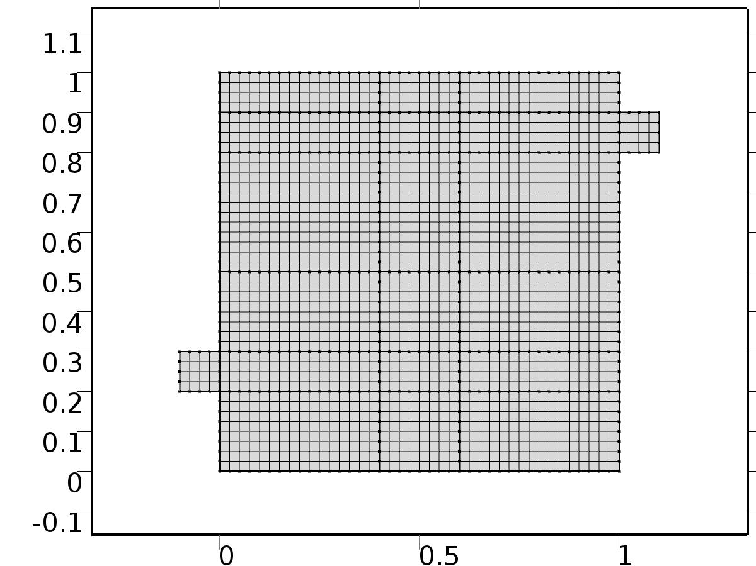

Mesh 1

* + 1. Size (size)

Settings

| **Description** | **Value** |
| --- | --- |
| Maximum element size | 0.0804 |
| Minimum element size | 3.6E-4 |
| Curvature factor | 0.3 |
| Maximum element growth rate | 1.3 |

* + 1. Edge 1 (edg1)

Selection

|  |  |
| --- | --- |
| Geometric entity level | Boundary |
| Selection | Boundaries 1–51 |

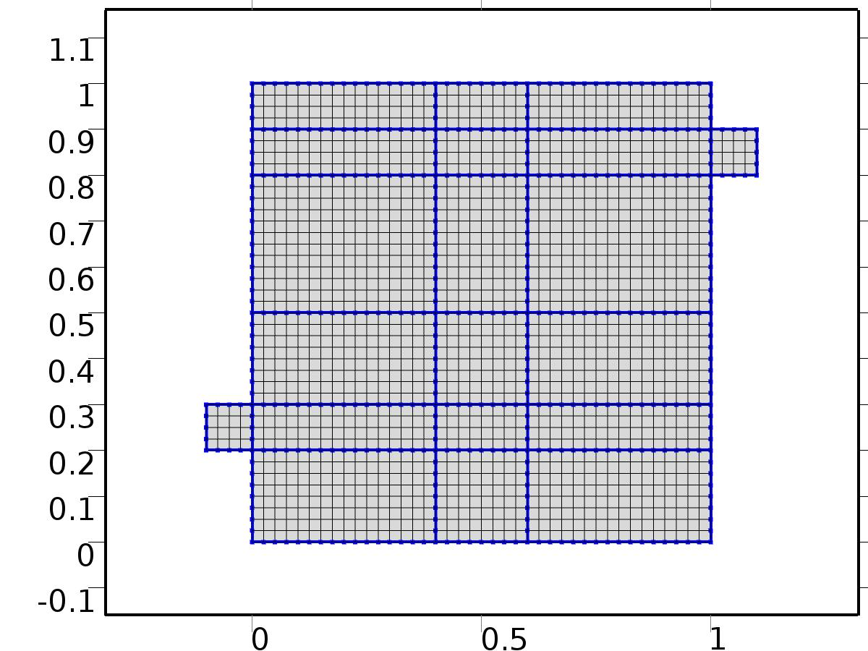

Edge 1

#### Size 1 (size1)

Selection

|  |  |
| --- | --- |
| Geometric entity level | Boundary |
| Selection | Boundaries 1–51 |



Size 1

Settings

| **Description** | **Value** |
| --- | --- |
| Maximum element size | H/4 |
| Minimum element size | H/4 |
| Curvature factor | 0.3 |
| Curvature factor | Off |
| Resolution of narrow regions | Off |
| Maximum element growth rate | 1.3 |
| Maximum element growth rate | Off |
| Custom element size | Custom |

* + 1. Mapped 1 (map1)

Selection

|  |  |
| --- | --- |
| Geometric entity level | Domain |
| Selection | Domains 1–20 |

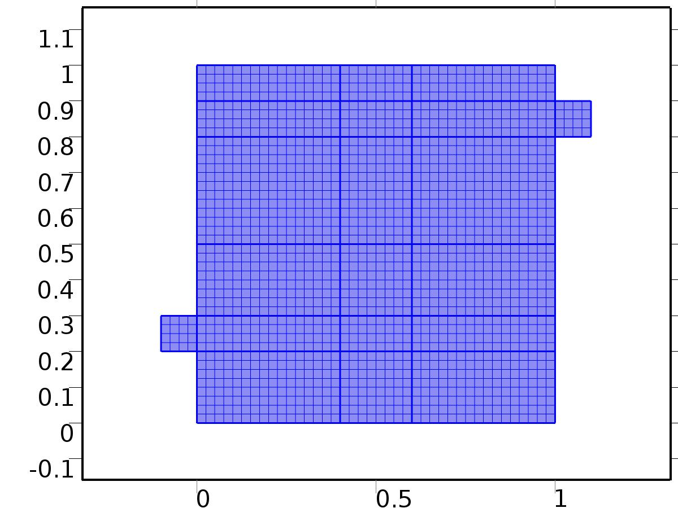

Mapped 1

1. Study 1
   1. Stationary

Study settings

| **Description** | **Value** |
| --- | --- |
| Include geometric nonlinearity | Off |

Physics and variables selection

| **Physics interface** | **Discretization** |
| --- | --- |
| Steady Flow (spf) | physics |
| Unit Input (c) | physics |

Mesh selection

| **Geometry** | **Mesh** |
| --- | --- |
| Geometry 1 (geom1) | mesh1 |

* 1. Solver Configurations
     1. Solver 1

#### Compile Equations: Stationary (st1)

Study and step

| **Description** | **Value** |
| --- | --- |
| Use study | Study 1 |
| Use study step | Stationary |

#### Dependent Variables 1 (v1)

General

| **Description** | **Value** |
| --- | --- |
| Defined by study step | Stationary |
| Constant |  |

Initial values of variables solved for

| **Description** | **Value** |
| --- | --- |
| Solution | Zero |

Values of variables not solved for

| **Description** | **Value** |
| --- | --- |
| Solution | Zero |

##### Pressure (comp1.bP) (comp1_bP)

General

| **Description** | **Value** |
| --- | --- |
| Field components | comp1.bP |
| Solve for this field | Off |

##### Pressure (comp1.bp) (comp1_bp)

General

| **Description** | **Value** |
| --- | --- |
| Field components | comp1.bp |
| Solve for this field | Off |

##### Dependent variable tT3 (comp1.tT3) (comp1_tT3)

General

| **Description** | **Value** |
| --- | --- |
| Field components | comp1.tT3 |
| Solve for this field | Off |

##### Dependent variable tT2 (comp1.tT2) (comp1_tT2)

General

| **Description** | **Value** |
| --- | --- |
| Field components | comp1.tT2 |
| Solve for this field | Off |

##### Dependent variable tT1 (comp1.tT1) (comp1_tT1)

General

| **Description** | **Value** |
| --- | --- |
| Field components | comp1.tT1 |
| Solve for this field | Off |

##### Dependent variable tZ (comp1.tZ) (comp1_tZ)

General

| **Description** | **Value** |
| --- | --- |
| Field components | comp1.tZ |
| Solve for this field | Off |

##### Dependent variable T (comp1.T) (comp1_T)

General

| **Description** | **Value** |
| --- | --- |
| Field components | comp1.T |
| Solve for this field | Off |

##### Dependent variable bT3 (comp1.bT3) (comp1_bT3)

General

| **Description** | **Value** |
| --- | --- |
| Field components | comp1.bT3 |
| Solve for this field | Off |

##### Dependent variable bT2 (comp1.bT2) (comp1_bT2)

General

| **Description** | **Value** |
| --- | --- |
| Field components | comp1.bT2 |
| Solve for this field | Off |

##### Pressure (comp1.P) (comp1_P)

General

| **Description** | **Value** |
| --- | --- |
| Field components | comp1.P |

##### Dependent variable bT1 (comp1.bT1) (comp1_bT1)

General

| **Description** | **Value** |
| --- | --- |
| Field components | comp1.bT1 |
| Solve for this field | Off |

##### Pressure (comp1.p) (comp1_p)

General

| **Description** | **Value** |
| --- | --- |
| Field components | comp1.p |
| Solve for this field | Off |

##### Velocity field (comp1.bu) (comp1_bu)

General

| **Description** | **Value** |
| --- | --- |
| Field components | {comp1.bu, comp1.bv} |
| Solve for this field | Off |

##### Velocity field (comp1.bV) (comp1_bV)

General

| **Description** | **Value** |
| --- | --- |
| Field components | {comp1.bU, comp1.bV} |
| Solve for this field | Off |

##### Velocity field (comp1.u) (comp1_u)

General

| **Description** | **Value** |
| --- | --- |
| Field components | {comp1.u, comp1.v} |
| Solve for this field | Off |

##### Dependent variable X (comp1.X) (comp1_X)

General

| **Description** | **Value** |
| --- | --- |
| Field components | comp1.X |

##### Velocity field (comp1.U) (comp1_U)

General

| **Description** | **Value** |
| --- | --- |
| Field components | {comp1.U, comp1.V} |

##### Dependent variable bZ (comp1.bZ) (comp1_bZ)

General

| **Description** | **Value** |
| --- | --- |
| Field components | comp1.bZ |
| Solve for this field | Off |

#### Stationary Solver 1 (s1)

General

| **Description** | **Value** |
| --- | --- |
| Defined by study step | Stationary |

Log

| **Description** | **Value** |
| --- | --- |
| Constant |  |

##### Fully Coupled 1 (fc1)

General

| **Description** | **Value** |
| --- | --- |
| Linear solver | Direct 1 |

Method and termination

| **Description** | **Value** |
| --- | --- |
| Initial damping factor | 0.01 |
| Minimum damping factor | 1.0E-6 |

1. Study 2
   1. Stationary

Study settings

| **Description** | **Value** |
| --- | --- |
| Include geometric nonlinearity | Off |

Physics and variables selection

| **Physics interface** | **Discretization** |
| --- | --- |
| Set Point Flow (phys1) | physics |
| Set Point Temperature (phys2) | physics |

Mesh selection

| **Geometry** | **Mesh** |
| --- | --- |
| Geometry 1 (geom1) | mesh1 |

* 1. Solver Configurations
     1. Solver 2

#### Compile Equations: Stationary (st1)

Study and step

| **Description** | **Value** |
| --- | --- |
| Use study | Study 2 |
| Use study step | Stationary |

#### Dependent Variables 1 (v1)

General

| **Description** | **Value** |
| --- | --- |
| Defined by study step | Stationary |
| Constant |  |

Initial values of variables solved for

| **Description** | **Value** |
| --- | --- |
| Solution | Solver 1 |

Values of variables not solved for

| **Description** | **Value** |
| --- | --- |
| Method | Solution |
| Solution | Solver 1 |

##### Pressure (comp1.bP) (comp1_bP)

General

| **Description** | **Value** |
| --- | --- |
| Field components | comp1.bP |

##### Pressure (comp1.bp) (comp1_bp)

General

| **Description** | **Value** |
| --- | --- |
| Field components | comp1.bp |
| Solve for this field | Off |

##### Dependent variable tT3 (comp1.tT3) (comp1_tT3)

General

| **Description** | **Value** |
| --- | --- |
| Field components | comp1.tT3 |
| Solve for this field | Off |

##### Dependent variable tT2 (comp1.tT2) (comp1_tT2)

General

| **Description** | **Value** |
| --- | --- |
| Field components | comp1.tT2 |
| Solve for this field | Off |

##### Dependent variable tT1 (comp1.tT1) (comp1_tT1)

General

| **Description** | **Value** |
| --- | --- |
| Field components | comp1.tT1 |
| Solve for this field | Off |

##### Dependent variable tZ (comp1.tZ) (comp1_tZ)

General

| **Description** | **Value** |
| --- | --- |
| Field components | comp1.tZ |

##### Dependent variable T (comp1.T) (comp1_T)

General

| **Description** | **Value** |
| --- | --- |
| Field components | comp1.T |
| Solve for this field | Off |

##### Dependent variable bT3 (comp1.bT3) (comp1_bT3)

General

| **Description** | **Value** |
| --- | --- |
| Field components | comp1.bT3 |
| Solve for this field | Off |

##### Dependent variable bT2 (comp1.bT2) (comp1_bT2)

General

| **Description** | **Value** |
| --- | --- |
| Field components | comp1.bT2 |
| Solve for this field | Off |

##### Pressure (comp1.P) (comp1_P)

General

| **Description** | **Value** |
| --- | --- |
| Field components | comp1.P |
| Solve for this field | Off |

##### Dependent variable bT1 (comp1.bT1) (comp1_bT1)

General

| **Description** | **Value** |
| --- | --- |
| Field components | comp1.bT1 |
| Solve for this field | Off |

##### Pressure (comp1.p) (comp1_p)

General

| **Description** | **Value** |
| --- | --- |
| Field components | comp1.p |
| Solve for this field | Off |

##### Velocity field (comp1.bu) (comp1_bu)

General

| **Description** | **Value** |
| --- | --- |
| Field components | {comp1.bu, comp1.bv} |
| Solve for this field | Off |

##### Velocity field (comp1.bV) (comp1_bV)

General

| **Description** | **Value** |
| --- | --- |
| Field components | {comp1.bU, comp1.bV} |

##### Velocity field (comp1.u) (comp1_u)

General

| **Description** | **Value** |
| --- | --- |
| Field components | {comp1.u, comp1.v} |
| Solve for this field | Off |

##### Dependent variable X (comp1.X) (comp1_X)

General

| **Description** | **Value** |
| --- | --- |
| Field components | comp1.X |
| Solve for this field | Off |

##### Velocity field (comp1.U) (comp1_U)

General

| **Description** | **Value** |
| --- | --- |
| Field components | {comp1.U, comp1.V} |
| Solve for this field | Off |

##### Dependent variable bZ (comp1.bZ) (comp1_bZ)

General

| **Description** | **Value** |
| --- | --- |
| Field components | comp1.bZ |

#### Stationary Solver 1 (s1)

General

| **Description** | **Value** |
| --- | --- |
| Defined by study step | Stationary |

Log

| **Description** | **Value** |
| --- | --- |
| Constant |  |

##### Fully Coupled 1 (fc1)

General

| **Description** | **Value** |
| --- | --- |
| Linear solver | Direct 1 |

Method and termination

| **Description** | **Value** |
| --- | --- |
| Initial damping factor | 0.01 |
| Minimum damping factor | 1.0E-6 |

1. Study 3
   1. Time Dependent

Study settings

| **Description** | **Value** |
| --- | --- |
| Include geometric nonlinearity | Off |

| **Times** | **Unit** |
| --- | --- |
| range(0,10,3000) | s |

Physics and variables selection

| **Physics interface** | **Discretization** |
| --- | --- |
| beta iteration Flow (phys3) | physics |
| beta iteration Temperature 1 (phys4) | physics |
| beta iteration Temperature 2 (phys7) | physics |
| Closed Loop Flow (phys5) | physics |
| Closed Loop Temperature (phys6) | physics |

Mesh selection

| **Geometry** | **Mesh** |
| --- | --- |
| Geometry 1 (geom1) | mesh1 |

* 1. Solver Configurations
     1. Solver 3

#### Compile Equations: Time Dependent (st1)

Study and step

| **Description** | **Value** |
| --- | --- |
| Use study | Study 3 |
| Use study step | Time Dependent |

#### Dependent Variables 1 (v1)

General

| **Description** | **Value** |
| --- | --- |
| Defined by study step | Time Dependent |
| Constant |  |

Initial values of variables solved for

| **Description** | **Value** |
| --- | --- |
| Solution | Solver 2 |

Values of variables not solved for

| **Description** | **Value** |
| --- | --- |
| Method | Solution |
| Solution | Solver 2 |

##### Dependent variable bT1 (comp1.bT1) (comp1_bT1)

General

| **Description** | **Value** |
| --- | --- |
| Field components | comp1.bT1 |
| Field name | comp1_T |

##### Pressure (comp1.bP) (comp1_bP)

General

| **Description** | **Value** |
| --- | --- |
| Field components | comp1.bP |
| Solve for this field | Off |
| Field name | comp1_bp |

##### Dependent variable bZ (comp1.bZ) (comp1_bZ)

General

| **Description** | **Value** |
| --- | --- |
| Field components | comp1.bZ |
| Solve for this field | Off |
| Field name | comp1_bT |

##### Pressure (comp1.P) (comp1_P)

General

| **Description** | **Value** |
| --- | --- |
| Field components | comp1.P |
| Solve for this field | Off |

##### Pressure (comp1.bp) (comp1_bp)

General

| **Description** | **Value** |
| --- | --- |
| Field components | comp1.bp |
| Field name | comp1_p |

##### Velocity field (comp1.bV) (comp1_bV)

General

| **Description** | **Value** |
| --- | --- |
| Field components | {comp1.bU, comp1.bV} |
| Solve for this field | Off |
| Field name | comp1_bu |

##### Dependent variable tZ (comp1.tZ) (comp1_tZ)

General

| **Description** | **Value** |
| --- | --- |
| Field components | comp1.tZ |
| Solve for this field | Off |
| Field name | comp1_tT |

##### Velocity field (comp1.bu) (comp1_bu)

General

| **Description** | **Value** |
| --- | --- |
| Field components | {comp1.bu, comp1.bv} |
| Field name | comp1_u |

##### Dependent variable X (comp1.X) (comp1_X)

General

| **Description** | **Value** |
| --- | --- |
| Field components | comp1.X |
| Solve for this field | Off |

##### Velocity field (comp1.U) (comp1_U)

General

| **Description** | **Value** |
| --- | --- |
| Field components | {comp1.U, comp1.V} |
| Solve for this field | Off |

##### Dependent variable tT1 (comp1.tT1) (comp1_tT1)

General

| **Description** | **Value** |
| --- | --- |
| Field components | comp1.tT1 |
| Field name | comp1_bT2 |

##### Pressure (comp1.p) (comp1_p)

General

| **Description** | **Value** |
| --- | --- |
| Field components | comp1.p |

##### Velocity field (comp1.u) (comp1_u)

General

| **Description** | **Value** |
| --- | --- |
| Field components | {comp1.u, comp1.v} |

##### Dependent variable T (comp1.T) (comp1_T)

General

| **Description** | **Value** |
| --- | --- |
| Field components | comp1.T |
| Field name | comp1_u2 |

##### Dependent variable bT2 (comp1.bT2) (comp1_bT2)

General

| **Description** | **Value** |
| --- | --- |
| Field components | comp1.bT2 |
| Field name | comp1_u2 |

##### Dependent variable tT2 (comp1.tT2) (comp1_tT2)

General

| **Description** | **Value** |
| --- | --- |
| Field components | comp1.tT2 |
| Field name | comp1_bT22 |

##### Dependent variable tT3 (comp1.tT3) (comp1_tT3)

General

| **Description** | **Value** |
| --- | --- |
| Field components | comp1.tT3 |
| Field name | comp1_bT24 |

##### Dependent variable bT3 (comp1.bT3) (comp1_bT3)

General

| **Description** | **Value** |
| --- | --- |
| Field components | comp1.bT3 |
| Field name | comp1_bT23 |

#### Time-Dependent Solver 1 (t1)

General

| **Description** | **Value** |
| --- | --- |
| Defined by study step | Time Dependent |
| Time | {0, 10, 20, 30, 40, 50, 60, 70, 80, 90, 100, 110, 120, 130, 140, 150, 160, 170, 180, 190, 200, 210, 220, 230, 240, 250, 260, 270, 280, 290, 300, 310, 320, 330, 340, 350, 360, 370, 380, 390, 400, 410, 420, 430, 440, 450, 460, 470, 480, 490, 500, 510, 520, 530, 540, 550, 560, 570, 580, 590, 600, 610, 620, 630, 640, 650, 660, 670, 680, 690, 700, 710, 720, 730, 740, 750, 760, 770, 780, 790, 800, 810, 820, 830, 840, 850, 860, 870, 880, 890, 900, 910, 920, 930, 940, 950, 960, 970, 980, 990, 1000, 1010, 1020, 1030, 1040, 1050, 1060, 1070, 1080, 1090, 1100, 1110, 1120, 1130, 1140, 1150, 1160, 1170, 1180, 1190, 1200, 1210, 1220, 1230, 1240, 1250, 1260, 1270, 1280, 1290, 1300, 1310, 1320, 1330, 1340, 1350, 1360, 1370, 1380, 1390, 1400, 1410, 1420, 1430, 1440, 1450, 1460, 1470, 1480, 1490, 1500, 1510, 1520, 1530, 1540, 1550, 1560, 1570, 1580, 1590, 1600, 1610, 1620, 1630, 1640, 1650, 1660, 1670, 1680, 1690, 1700, 1710, 1720, 1730, 1740, 1750, 1760, 1770, 1780, 1790, 1800, 1810, 1820, 1830, 1840, 1850, 1860, 1870, 1880, 1890, 1900, 1910, 1920, 1930, 1940, 1950, 1960, 1970, 1980, 1990, 2000, 2010, 2020, 2030, 2040, 2050, 2060, 2070, 2080, 2090, 2100, 2110, 2120, 2130, 2140, 2150, 2160, 2170, 2180, 2190, 2200, 2210, 2220, 2230, 2240, 2250, 2260, 2270, 2280, 2290, 2300, 2310, 2320, 2330, 2340, 2350, 2360, 2370, 2380, 2390, 2400, 2410, 2420, 2430, 2440, 2450, 2460, 2470, 2480, 2490, 2500, 2510, 2520, 2530, 2540, 2550, 2560, 2570, 2580, 2590, 2600, 2610, 2620, 2630, 2640, 2650, 2660, 2670, 2680, 2690, 2700, 2710, 2720, 2730, 2740, 2750, 2760, 2770, 2780, 2790, 2800, 2810, 2820, 2830, 2840, 2850, 2860, 2870, 2880, 2890, 2900, 2910, 2920, 2930, 2940, 2950, 2960, 2970, 2980, 2990, 3000} |

Absolute tolerance

| **Description** | **Value** |
| --- | --- |
| Tolerance | 5.0E-4 |

Time stepping

| **Description** | **Value** |
| --- | --- |
| Initial step | 0.0010 |

Advanced

| **Description** | **Value** |
| --- | --- |
| Fraction of initial step for Backward Euler | 0.0010 |

Log

| **Description** | **Value** |
| --- | --- |
| Constant |  |

##### Fully Coupled 1 (fc1)

General

| **Description** | **Value** |
| --- | --- |
| Linear solver | Direct 1 |

Method and termination

| **Description** | **Value** |
| --- | --- |
| Jacobian update | Once per time step |
| Maximum number of iterations | 6 |

1. Results
   1. Data Sets
      1. Solution 1

Solution

| **Description** | **Value** |
| --- | --- |
| Solution | Solver 1 |
| Component | Save Point Geometry 1 |

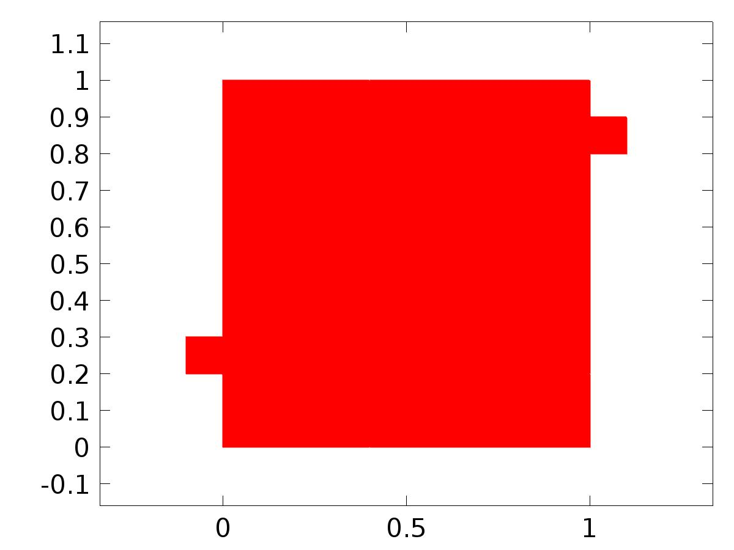

Data set: Solution 1

* + 1. Solution 2

Solution

| **Description** | **Value** |
| --- | --- |
| Solution | Solver 2 |
| Component | Save Point Geometry 1 |



Data set: Solution 2

* + 1. Solution 3

Solution

| **Description** | **Value** |
| --- | --- |
| Solution | Solver 3 |
| Component | Save Point Geometry 1 |



Data set: Solution 3

* 1. Derived Values
     1. Global Evaluation 1

Data

| **Description** | **Value** |
| --- | --- |
| Data set | Solution 2 |

Expression

| **Description** | **Value** |
| --- | --- |
| Expression | C(bT) |
| Description | C(bT) |

* + 1. Global Evaluation 2

Data

| **Description** | **Value** |
| --- | --- |
| Data set | Solution 3 |

Expression

| **Description** | **Value** |
| --- | --- |
| Expression | C(T) |
| Description | C(T) |

* + 1. Global Evaluation 3

Data

| **Description** | **Value** |
| --- | --- |
| Data set | Solution 3 |

Expression

| **Description** | **Value** |
| --- | --- |
| Expression | e |

* 1. Tables
     1. Table 1

Global Evaluation 1 (C(bT))

Table 1

| **C(bT)** | **C(bT)** |
| --- | --- |
| 0.50000 | 0.50000 |

* + 1. Table 2

Global Evaluation 1 (C(bT))

Table 2

| **C(bT)** |
| --- |
| 0.50000 |

* + 1. Table 3

Global Evaluation 2 (C(T))

Table 3

| **Time (s)** | **C(T)** |
| --- | --- |
| 2000.0 | 0.49987 |

* + 1. Table 4

Global Evaluation 3 (C(T))

Table 4

| **Time (s)** | **C(T)** | **yr** | **C(bT1)** | **C(bT1+bT2)** | **C(bT1+bT2+bT3)** | **d** | **gamma** | **e1** | **e2** | **e3** | **e** |
| --- | --- | --- | --- | --- | --- | --- | --- | --- | --- | --- | --- |
| 0.0000 | 4.9604E-22 | 0.25000 | 0.25000 | 0.25000 | 0.25000 | 0.75000 | -3.6129E-5 | 9.1821E-8 | 9.1821E-8 | 9.1821E-8 | 0.25000 |
| 10.000 | 0.12101 | 0.26047 | 0.24949 | 0.24979 | 0.25008 | 0.73953 | -2.5473E-6 | 0.010975 | 0.010682 | 0.010389 | 0.13946 |
| 20.000 | 0.18650 | 0.27092 | 0.24949 | 0.25249 | 0.25539 | 0.72908 | 2.2649E-5 | 0.021433 | 0.018434 | 0.015529 | 0.084417 |
| 30.000 | 0.22457 | 0.28133 | 0.25224 | 0.26117 | 0.26922 | 0.71867 | 3.0819E-5 | 0.029094 | 0.020166 | 0.012113 | 0.056765 |
| 40.000 | 0.25324 | 0.29169 | 0.25818 | 0.27499 | 0.28852 | 0.70831 | 2.5132E-5 | 0.033509 | 0.016707 | 0.0031692 | 0.038449 |
| 50.000 | 0.27701 | 0.30198 | 0.26687 | 0.29159 | 0.30853 | 0.69802 | 1.2842E-5 | 0.035107 | 0.010393 | -0.0065527 | 0.024972 |
| 60.000 | 0.29572 | 0.31217 | 0.27747 | 0.30843 | 0.32523 | 0.68783 | 1.1269E-6 | 0.034702 | 0.0037440 | -0.013055 | 0.016457 |
| 70.000 | 0.30877 | 0.32226 | 0.28904 | 0.32369 | 0.33694 | 0.67774 | -5.6371E-6 | 0.033217 | -0.0014302 | -0.014677 | 0.013485 |
| 80.000 | 0.31719 | 0.33222 | 0.30078 | 0.33659 | 0.34430 | 0.66778 | -6.4800E-6 | 0.031435 | -0.0043687 | -0.012087 | 0.015028 |
| 90.000 | 0.32313 | 0.34203 | 0.31217 | 0.34728 | 0.34935 | 0.65797 | -2.9753E-6 | 0.029858 | -0.0052456 | -0.0073165 | 0.018898 |
| 100.00 | 0.32870 | 0.35168 | 0.32300 | 0.35640 | 0.35408 | 0.64832 | 2.5008E-6 | 0.028684 | -0.0047117 | -0.0023933 | 0.022988 |
| 110.00 | 0.33526 | 0.36116 | 0.33326 | 0.36469 | 0.35986 | 0.63884 | 7.8335E-6 | 0.027894 | -0.0035300 | 0.0012981 | 0.025894 |
| 120.00 | 0.34339 | 0.37044 | 0.34309 | 0.37277 | 0.36725 | 0.62956 | 1.1687E-5 | 0.027344 | -0.0023347 | 0.0031925 | 0.027049 |
| 130.00 | 0.35291 | 0.37951 | 0.35264 | 0.38101 | 0.37607 | 0.62049 | 1.3635E-5 | 0.026868 | -0.0014999 | 0.0034347 | 0.026593 |
| 140.00 | 0.36327 | 0.38835 | 0.36202 | 0.38949 | 0.38577 | 0.61165 | 1.3932E-5 | 0.026330 | -0.0011459 | 0.0025762 | 0.025075 |
| 150.00 | 0.37379 | 0.39695 | 0.37129 | 0.39815 | 0.39566 | 0.60305 | 1.3190E-5 | 0.025653 | -0.0012080 | 0.0012828 | 0.023156 |
| 160.00 | 0.38392 | 0.40529 | 0.38047 | 0.40681 | 0.40520 | 0.59471 | 1.2066E-5 | 0.024820 | -0.0015234 | 8.8739E-5 | 0.021366 |
| 170.00 | 0.39336 | 0.41336 | 0.38950 | 0.41527 | 0.41407 | 0.58664 | 1.1043E-5 | 0.023860 | -0.0019180 | -7.1517E-4 | 0.019991 |
| 180.00 | 0.40202 | 0.42114 | 0.39833 | 0.42340 | 0.42218 | 0.57886 | 1.0370E-5 | 0.022812 | -0.0022672 | -0.0010443 | 0.019114 |
| 190.00 | 0.40996 | 0.42862 | 0.40690 | 0.43112 | 0.42959 | 0.57138 | 1.0092E-5 | 0.021717 | -0.0025020 | -9.7035E-4 | 0.018661 |
| 200.00 | 0.41732 | 0.43579 | 0.41518 | 0.43840 | 0.43645 | 0.56421 | 1.0096E-5 | 0.020608 | -0.0026094 | -6.6304E-4 | 0.018462 |
| 210.00 | 0.42429 | 0.44263 | 0.42313 | 0.44525 | 0.44293 | 0.55737 | 1.0197E-5 | 0.019502 | -0.0026190 | -3.0090E-4 | 0.018337 |
| 220.00 | 0.43097 | 0.44913 | 0.43073 | 0.45171 | 0.44914 | 0.55087 | 1.0233E-5 | 0.018401 | -0.0025767 | -6.8465E-6 | 0.018163 |
| 230.00 | 0.43740 | 0.45529 | 0.43799 | 0.45781 | 0.45512 | 0.54471 | 1.0106E-5 | 0.017298 | -0.0025223 | 1.6505E-4 | 0.017887 |
| 240.00 | 0.44358 | 0.46108 | 0.44489 | 0.46356 | 0.46087 | 0.53892 | 9.7835E-6 | 0.016189 | -0.0024805 | 2.1594E-4 | 0.017507 |
| 250.00 | 0.44945 | 0.46651 | 0.45144 | 0.46897 | 0.46633 | 0.53349 | 9.2857E-6 | 0.015068 | -0.0024607 | 1.8117E-4 | 0.017059 |
| 260.00 | 0.45496 | 0.47155 | 0.45762 | 0.47401 | 0.47144 | 0.52845 | 8.6608E-6 | 0.013933 | -0.0024600 | 1.0895E-4 | 0.016589 |
| 270.00 | 0.46007 | 0.47621 | 0.46342 | 0.47867 | 0.47617 | 0.52379 | 7.9640E-6 | 0.012787 | -0.0024674 | 4.1352E-5 | 0.016136 |
| 280.00 | 0.46474 | 0.48047 | 0.46883 | 0.48294 | 0.48046 | 0.51953 | 7.2339E-6 | 0.011635 | -0.0024725 | 1.3313E-6 | 0.015725 |
| 290.00 | 0.46896 | 0.48432 | 0.47384 | 0.48679 | 0.48433 | 0.51568 | 6.4911E-6 | 0.010482 | -0.0024675 | -5.4059E-6 | 0.015356 |
| 300.00 | 0.47274 | 0.48776 | 0.47843 | 0.49021 | 0.48775 | 0.51224 | 5.7366E-6 | 0.0093333 | -0.0024497 | 1.2940E-5 | 0.015021 |
| 310.00 | 0.47608 | 0.49079 | 0.48260 | 0.49321 | 0.49075 | 0.50921 | 4.9591E-6 | 0.0081920 | -0.0024211 | 4.2008E-5 | 0.014706 |
| 320.00 | 0.47900 | 0.49339 | 0.48633 | 0.49578 | 0.49333 | 0.50661 | 4.1465E-6 | 0.0070598 | -0.0023855 | 6.9689E-5 | 0.014395 |
| 330.00 | 0.48149 | 0.49557 | 0.48963 | 0.49792 | 0.49548 | 0.50443 | 3.2883E-6 | 0.0059373 | -0.0023472 | 8.7779E-5 | 0.014082 |
| 340.00 | 0.48356 | 0.49732 | 0.49249 | 0.49963 | 0.49723 | 0.50268 | 2.3786E-6 | 0.0048245 | -0.0023100 | 9.3007E-5 | 0.013760 |
| 350.00 | 0.48520 | 0.49863 | 0.49491 | 0.50091 | 0.49854 | 0.50137 | 1.4168E-6 | 0.0037207 | -0.0022762 | 8.6601E-5 | 0.013432 |
| 360.00 | 0.48641 | 0.49951 | 0.49688 | 0.50175 | 0.49943 | 0.50049 | 4.0557E-7 | 0.0026251 | -0.0022472 | 7.2783E-5 | 0.013100 |
| 370.00 | 0.48718 | 0.49995 | 0.49841 | 0.50217 | 0.49989 | 0.50005 | -6.5000E-7 | 0.0015369 | -0.0022231 | 5.7218E-5 | 0.012769 |
| 380.00 | 0.48750 | 0.49995 | 0.49949 | 0.50215 | 0.49990 | 0.50005 | -1.7452E-6 | 4.5547E-4 | -0.0022029 | 4.3927E-5 | 0.012443 |
| 390.00 | 0.48738 | 0.49951 | 0.50013 | 0.50169 | 0.49947 | 0.50049 | -2.8780E-6 | -6.1967E-4 | -0.0021856 | 3.4487E-5 | 0.012122 |
| 400.00 | 0.48683 | 0.49863 | 0.50032 | 0.50080 | 0.49860 | 0.50137 | -4.0498E-6 | -0.0016890 | -0.0021709 | 2.7939E-5 | 0.011805 |
| 410.00 | 0.48583 | 0.49732 | 0.50007 | 0.49948 | 0.49730 | 0.50268 | -5.2644E-6 | -0.0027534 | -0.0021590 | 2.2307E-5 | 0.011489 |
| 420.00 | 0.48440 | 0.49557 | 0.49939 | 0.49772 | 0.49556 | 0.50443 | -6.5264E-6 | -0.0038138 | -0.0021507 | 1.5517E-5 | 0.011172 |
| 430.00 | 0.48254 | 0.49339 | 0.49827 | 0.49554 | 0.49339 | 0.50661 | -7.8408E-6 | -0.0048717 | -0.0021470 | 6.4161E-6 | 0.010851 |
| 440.00 | 0.48026 | 0.49079 | 0.49672 | 0.49294 | 0.49080 | 0.50921 | -9.2113E-6 | -0.0059289 | -0.0021487 | -4.9627E-6 | 0.010528 |
| 450.00 | 0.47756 | 0.48776 | 0.49475 | 0.48992 | 0.48778 | 0.51224 | -1.0641E-5 | -0.0069870 | -0.0021562 | -1.7764E-5 | 0.010203 |
| 460.00 | 0.47444 | 0.48432 | 0.49237 | 0.48649 | 0.48435 | 0.51568 | -1.2131E-5 | -0.0080476 | -0.0021693 | -3.0998E-5 | 0.0098779 |
| 470.00 | 0.47091 | 0.48047 | 0.48958 | 0.48265 | 0.48051 | 0.51953 | -1.3684E-5 | -0.0091119 | -0.0021874 | -4.3705E-5 | 0.0095543 |
| 480.00 | 0.46697 | 0.47621 | 0.48639 | 0.47842 | 0.47626 | 0.52379 | -1.5298E-5 | -0.010181 | -0.0022095 | -5.4791E-5 | 0.0092343 |
| 490.00 | 0.46263 | 0.47155 | 0.48280 | 0.47379 | 0.47161 | 0.52845 | -1.6973E-5 | -0.011254 | -0.0022342 | -6.3158E-5 | 0.0089202 |
| 500.00 | 0.45789 | 0.46651 | 0.47884 | 0.46877 | 0.46657 | 0.53349 | -1.8707E-5 | -0.012331 | -0.0022595 | -6.7753E-5 | 0.0086138 |
| 510.00 | 0.45276 | 0.46108 | 0.47449 | 0.46337 | 0.46115 | 0.53892 | -2.0495E-5 | -0.013409 | -0.0022831 | -6.7725E-5 | 0.0083171 |
| 520.00 | 0.44726 | 0.45529 | 0.46978 | 0.45759 | 0.45535 | 0.54471 | -2.2333E-5 | -0.014488 | -0.0023033 | -6.3003E-5 | 0.0080309 |
| 530.00 | 0.44138 | 0.44913 | 0.46470 | 0.45145 | 0.44919 | 0.55087 | -2.4217E-5 | -0.015564 | -0.0023181 | -5.3847E-5 | 0.0077555 |
| 540.00 | 0.43514 | 0.44263 | 0.45926 | 0.44495 | 0.44267 | 0.55737 | -2.6145E-5 | -0.016633 | -0.0023265 | -4.1360E-5 | 0.0074905 |
| 550.00 | 0.42855 | 0.43579 | 0.45348 | 0.43811 | 0.43581 | 0.56421 | -2.8113E-5 | -0.017693 | -0.0023277 | -2.6534E-5 | 0.0072351 |
| 560.00 | 0.42163 | 0.42862 | 0.44736 | 0.43094 | 0.42863 | 0.57138 | -3.0118E-5 | -0.018740 | -0.0023214 | -1.0641E-5 | 0.0069884 |
| 570.00 | 0.41439 | 0.42114 | 0.44091 | 0.42344 | 0.42113 | 0.57886 | -3.2157E-5 | -0.019771 | -0.0023073 | 5.7325E-6 | 0.0067499 |
| 580.00 | 0.40684 | 0.41336 | 0.43414 | 0.41564 | 0.41333 | 0.58664 | -3.4225E-5 | -0.020782 | -0.0022856 | 2.2207E-5 | 0.0065194 |
| 590.00 | 0.39898 | 0.40529 | 0.42705 | 0.40754 | 0.40524 | 0.59471 | -3.6296E-5 | -0.021761 | -0.0022483 | 4.6246E-5 | 0.0063044 |
| 600.00 | 0.39084 | 0.39695 | 0.41965 | 0.39914 | 0.39687 | 0.60305 | -3.8363E-5 | -0.022704 | -0.0021947 | 7.6781E-5 | 0.0061038 |
| 610.00 | 0.38244 | 0.38835 | 0.41196 | 0.39048 | 0.38825 | 0.61165 | -4.0446E-5 | -0.023611 | -0.0021339 | 1.0235E-4 | 0.0059060 |
| 620.00 | 0.37380 | 0.37951 | 0.40400 | 0.38158 | 0.37939 | 0.62049 | -4.2562E-5 | -0.024488 | -0.0020739 | 1.1546E-4 | 0.0057033 |
| 630.00 | 0.36494 | 0.37044 | 0.39578 | 0.37246 | 0.37032 | 0.62956 | -4.4717E-5 | -0.025338 | -0.0020187 | 1.1597E-4 | 0.0054954 |
| 640.00 | 0.35587 | 0.36116 | 0.38732 | 0.36313 | 0.36105 | 0.63884 | -4.6900E-5 | -0.026160 | -0.0019666 | 1.1047E-4 | 0.0052886 |
| 650.00 | 0.34659 | 0.35168 | 0.37863 | 0.35359 | 0.35157 | 0.64832 | -4.9087E-5 | -0.026946 | -0.0019090 | 1.1054E-4 | 0.0050943 |
| 660.00 | 0.33711 | 0.34203 | 0.36972 | 0.34387 | 0.34191 | 0.65797 | -5.1252E-5 | -0.027691 | -0.0018398 | 1.2238E-4 | 0.0049186 |
| 670.00 | 0.32745 | 0.33222 | 0.36060 | 0.33397 | 0.33207 | 0.66778 | -5.3380E-5 | -0.028386 | -0.0017546 | 1.4716E-4 | 0.0047625 |
| 680.00 | 0.31764 | 0.32226 | 0.35128 | 0.32391 | 0.32208 | 0.67774 | -5.5464E-5 | -0.029024 | -0.0016529 | 1.8019E-4 | 0.0046212 |
| 690.00 | 0.30768 | 0.31217 | 0.34176 | 0.31370 | 0.31195 | 0.68783 | -5.7492E-5 | -0.029583 | -0.0015277 | 2.2206E-4 | 0.0044959 |
| 700.00 | 0.29762 | 0.30198 | 0.33206 | 0.30338 | 0.30173 | 0.69802 | -5.9468E-5 | -0.030082 | -0.0014005 | 2.5011E-4 | 0.0043629 |
| 710.00 | 0.28750 | 0.29169 | 0.32227 | 0.29301 | 0.29146 | 0.70831 | -6.1570E-5 | -0.030581 | -0.0013134 | 2.3101E-4 | 0.0041873 |
| 720.00 | 0.27731 | 0.28133 | 0.31236 | 0.28256 | 0.28112 | 0.71867 | -6.3650E-5 | -0.031027 | -0.0012235 | 2.1490E-4 | 0.0040208 |
| 730.00 | 0.26706 | 0.27092 | 0.30236 | 0.27205 | 0.27072 | 0.72908 | -6.5705E-5 | -0.031436 | -0.0011340 | 2.0235E-4 | 0.0038626 |
| 740.00 | 0.25674 | 0.26047 | 0.29225 | 0.26149 | 0.26026 | 0.73953 | -6.7680E-5 | -0.031781 | -0.0010250 | 2.1351E-4 | 0.0037337 |
| 750.00 | 0.24638 | 0.25000 | 0.28206 | 0.25090 | 0.24976 | 0.75000 | -6.9574E-5 | -0.032061 | -9.0003E-4 | 2.3867E-4 | 0.0036240 |
| 760.00 | 0.23601 | 0.23953 | 0.27177 | 0.24029 | 0.23927 | 0.76047 | -7.1356E-5 | -0.032236 | -7.6044E-4 | 2.6503E-4 | 0.0035231 |
| 770.00 | 0.22566 | 0.22908 | 0.26146 | 0.22970 | 0.22879 | 0.77092 | -7.3124E-5 | -0.032379 | -6.1924E-4 | 2.8836E-4 | 0.0034215 |
| 780.00 | 0.21536 | 0.21867 | 0.25113 | 0.21915 | 0.21837 | 0.78133 | -7.4858E-5 | -0.032468 | -4.8691E-4 | 2.9483E-4 | 0.0033081 |
| 790.00 | 0.20511 | 0.20831 | 0.24081 | 0.20866 | 0.20801 | 0.79169 | -7.6544E-5 | -0.032500 | -3.5439E-4 | 2.9712E-4 | 0.0031948 |
| 800.00 | 0.19493 | 0.19802 | 0.23049 | 0.19824 | 0.19772 | 0.80198 | -7.8172E-5 | -0.032471 | -2.1499E-4 | 3.0391E-4 | 0.0030900 |
| 810.00 | 0.18484 | 0.18783 | 0.22021 | 0.18791 | 0.18752 | 0.81217 | -7.9718E-5 | -0.032384 | -7.9539E-5 | 3.0475E-4 | 0.0029838 |
| 820.00 | 0.17485 | 0.17774 | 0.20997 | 0.17767 | 0.17742 | 0.82226 | -8.1188E-5 | -0.032228 | 7.0610E-5 | 3.1821E-4 | 0.0028937 |
| 830.00 | 0.16497 | 0.16778 | 0.19979 | 0.16756 | 0.16745 | 0.83222 | -8.2561E-5 | -0.032007 | 2.2612E-4 | 3.3363E-4 | 0.0028093 |
| 840.00 | 0.15523 | 0.15797 | 0.18969 | 0.15758 | 0.15761 | 0.84203 | -8.3828E-5 | -0.031716 | 3.9204E-4 | 3.5505E-4 | 0.0027345 |
| 850.00 | 0.14564 | 0.14832 | 0.17966 | 0.14774 | 0.14792 | 0.85168 | -8.4956E-5 | -0.031346 | 5.8063E-4 | 3.9239E-4 | 0.0026788 |
| 860.00 | 0.13623 | 0.13884 | 0.16975 | 0.13808 | 0.13843 | 0.86116 | -8.6012E-5 | -0.030908 | 7.6446E-4 | 4.1412E-4 | 0.0026110 |
| 870.00 | 0.12704 | 0.12956 | 0.15997 | 0.12863 | 0.12915 | 0.87044 | -8.7014E-5 | -0.030408 | 9.3462E-4 | 4.1213E-4 | 0.0025229 |
| 880.00 | 0.11808 | 0.12049 | 0.15034 | 0.11940 | 0.12010 | 0.87951 | -8.7960E-5 | -0.029851 | 0.0010891 | 3.9022E-4 | 0.0024181 |
| 890.00 | 0.10935 | 0.11165 | 0.14089 | 0.11042 | 0.11129 | 0.88835 | -8.8839E-5 | -0.029239 | 0.0012300 | 3.5838E-4 | 0.0023067 |
| 900.00 | 0.10086 | 0.10305 | 0.13163 | 0.10169 | 0.10273 | 0.89695 | -8.9636E-5 | -0.028574 | 0.0013615 | 3.2650E-4 | 0.0021983 |
| 910.00 | 0.092612 | 0.094713 | 0.12257 | 0.093224 | 0.094410 | 0.90529 | -9.0334E-5 | -0.027856 | 0.0014887 | 3.0306E-4 | 0.0021012 |
| 920.00 | 0.084626 | 0.086645 | 0.11373 | 0.085029 | 0.086353 | 0.91336 | -9.0922E-5 | -0.027084 | 0.0016156 | 2.9138E-4 | 0.0020188 |
| 930.00 | 0.076914 | 0.078863 | 0.10512 | 0.077119 | 0.078573 | 0.92114 | -9.1396E-5 | -0.026259 | 0.0017441 | 2.9002E-4 | 0.0019495 |
| 940.00 | 0.069493 | 0.071382 | 0.096762 | 0.069508 | 0.071087 | 0.92862 | -9.1757E-5 | -0.025380 | 0.0018741 | 2.9470E-4 | 0.0018888 |
| 950.00 | 0.062383 | 0.064214 | 0.088664 | 0.062210 | 0.063914 | 0.93579 | -9.2011E-5 | -0.024450 | 0.0020039 | 2.9982E-4 | 0.0018312 |
| 960.00 | 0.055600 | 0.057372 | 0.080840 | 0.055240 | 0.057071 | 0.94263 | -9.2162E-5 | -0.023469 | 0.0021313 | 3.0090E-4 | 0.0017719 |
| 970.00 | 0.049158 | 0.050868 | 0.073307 | 0.048613 | 0.050571 | 0.94913 | -9.2215E-5 | -0.022440 | 0.0022544 | 2.9626E-4 | 0.0017093 |
| 980.00 | 0.043068 | 0.044713 | 0.066078 | 0.042341 | 0.044426 | 0.95529 | -9.2167E-5 | -0.021365 | 0.0023720 | 2.8681E-4 | 0.0016442 |
| 990.00 | 0.037340 | 0.038918 | 0.059165 | 0.036434 | 0.038644 | 0.96108 | -9.2020E-5 | -0.020247 | 0.0024837 | 2.7420E-4 | 0.0015781 |
| 1000.0 | 0.031982 | 0.033494 | 0.052582 | 0.030904 | 0.033234 | 0.96651 | -9.1771E-5 | -0.019088 | 0.0025894 | 2.5937E-4 | 0.0015120 |
| 1010.0 | 0.027002 | 0.028449 | 0.046339 | 0.025759 | 0.028205 | 0.97155 | -9.1418E-5 | -0.017890 | 0.0026897 | 2.4429E-4 | 0.0014476 |
| 1020.0 | 0.022407 | 0.023793 | 0.040449 | 0.021008 | 0.023562 | 0.97621 | -9.0960E-5 | -0.016655 | 0.0027852 | 2.3076E-4 | 0.0013867 |
| 1030.0 | 0.018205 | 0.019534 | 0.034921 | 0.016659 | 0.019315 | 0.98047 | -9.0395E-5 | -0.015386 | 0.0028751 | 2.1871E-4 | 0.0013292 |
| 1040.0 | 0.014406 | 0.015680 | 0.029765 | 0.012720 | 0.015473 | 0.98432 | -8.9729E-5 | -0.014085 | 0.0029597 | 2.0668E-4 | 0.0012735 |
| 1050.0 | 0.011018 | 0.012236 | 0.024993 | 0.0091993 | 0.012043 | 0.98776 | -8.8963E-5 | -0.012757 | 0.0030366 | 1.9316E-4 | 0.0012180 |
| 1060.0 | 0.0080523 | 0.0092094 | 0.020624 | 0.0061095 | 0.0090369 | 0.99079 | -8.8115E-5 | -0.011415 | 0.0030998 | 1.7249E-4 | 0.0011570 |
| 1070.0 | 0.0055046 | 0.0066053 | 0.016651 | 0.0034457 | 0.0064505 | 0.99339 | -8.7176E-5 | -0.010045 | 0.0031596 | 1.5479E-4 | 0.0011006 |
| 1080.0 | 0.0033806 | 0.0044282 | 0.013083 | 0.0012133 | 0.0042893 | 0.99557 | -8.6136E-5 | -0.0086545 | 0.0032149 | 1.3887E-4 | 0.0010476 |
| 1090.0 | 0.0016836 | 0.0026819 | 0.0099252 | -5.8435E-4 | 0.0025566 | 0.99732 | -8.4990E-5 | -0.0072433 | 0.0032663 | 1.2528E-4 | 9.9829E-4 |
| 1100.0 | 4.1471E-4 | 0.0013695 | 0.0071792 | -0.0019465 | 0.0012535 | 0.99863 | -8.3743E-5 | -0.0058097 | 0.0033160 | 1.1601E-4 | 9.5482E-4 |
| 1110.0 | -4.1779E-4 | 4.9332E-4 | 0.0048562 | -0.0028657 | 3.8818E-4 | 0.99951 | -8.2401E-5 | -0.0043629 | 0.0033590 | 1.0514E-4 | 9.1111E-4 |
| 1120.0 | -8.1391E-4 | 5.4829E-5 | 0.0029572 | -0.0033416 | -3.9431E-5 | 0.99995 | -8.0969E-5 | -0.0029024 | 0.0033965 | 9.4260E-5 | 8.6873E-4 |
| 1130.0 | -7.6881E-4 | 5.4829E-5 | 0.0014902 | -0.0033698 | -2.4566E-5 | 0.99995 | -7.9458E-5 | -0.0014353 | 0.0034246 | 7.9395E-5 | 8.2364E-4 |
| 1140.0 | -2.8384E-4 | 4.9332E-4 | 4.5695E-4 | -0.0029507 | 4.3140E-4 | 0.99951 | -7.7870E-5 | 3.6370E-5 | 0.0034440 | 6.1917E-5 | 7.7716E-4 |
| 1150.0 | 6.4144E-4 | 0.0013695 | -1.3967E-4 | -0.0020836 | 0.0013289 | 0.99863 | -7.6209E-5 | 0.0015092 | 0.0034531 | 4.0655E-5 | 7.2808E-4 |
| 1160.0 | 0.0020024 | 0.0026819 | -2.9585E-4 | -7.7141E-4 | 0.0026631 | 0.99732 | -7.4480E-5 | 0.0029778 | 0.0034533 | 1.8835E-5 | 6.7955E-4 |
| 1170.0 | 0.0037980 | 0.0044282 | -1.2681E-5 | 9.8469E-4 | 0.0044331 | 0.99557 | -7.2684E-5 | 0.0044409 | 0.0034435 | -4.8817E-6 | 6.3022E-4 |
| 1180.0 | 0.0060221 | 0.0066053 | 7.1067E-4 | 0.0031795 | 0.0066326 | 0.99339 | -7.0823E-5 | 0.0058946 | 0.0034257 | -2.7317E-5 | 5.8321E-4 |
| 1190.0 | 0.0086883 | 0.0092094 | 0.0018883 | 0.0058272 | 0.0092753 | 0.99079 | -6.8946E-5 | 0.0073211 | 0.0033822 | -6.5906E-5 | 5.2110E-4 |
| 1200.0 | 0.011768 | 0.012236 | 0.0035046 | 0.0089023 | 0.012333 | 0.98776 | -6.7007E-5 | 0.0087312 | 0.0033336 | -9.6631E-5 | 4.6782E-4 |
| 1210.0 | 0.015245 | 0.015680 | 0.0055483 | 0.012388 | 0.015788 | 0.98432 | -6.4974E-5 | 0.010131 | 0.0032911 | -1.0811E-4 | 4.3468E-4 |
| 1220.0 | 0.019123 | 0.019534 | 0.0080196 | 0.016285 | 0.019645 | 0.98047 | -6.2872E-5 | 0.011515 | 0.0032487 | -1.1097E-4 | 4.1105E-4 |
| 1230.0 | 0.023406 | 0.023793 | 0.010916 | 0.020591 | 0.023908 | 0.97621 | -6.0720E-5 | 0.012877 | 0.0032019 | -1.1436E-4 | 3.8773E-4 |
| 1240.0 | 0.028090 | 0.028449 | 0.014236 | 0.025303 | 0.028573 | 0.97155 | -5.8536E-5 | 0.014213 | 0.0031463 | -1.2407E-4 | 3.5891E-4 |
| 1250.0 | 0.033171 | 0.033494 | 0.017976 | 0.030415 | 0.033636 | 0.96651 | -5.6332E-5 | 0.015517 | 0.0030789 | -1.4228E-4 | 3.2237E-4 |
| 1260.0 | 0.038637 | 0.038918 | 0.022132 | 0.035918 | 0.039084 | 0.96108 | -5.4110E-5 | 0.016786 | 0.0030002 | -1.6569E-4 | 2.8139E-4 |
| 1270.0 | 0.044472 | 0.044713 | 0.026696 | 0.041800 | 0.044902 | 0.95529 | -5.1865E-5 | 0.018016 | 0.0029124 | -1.8954E-4 | 2.4070E-4 |
| 1280.0 | 0.050659 | 0.050868 | 0.031655 | 0.048045 | 0.051074 | 0.94913 | -4.9591E-5 | 0.019213 | 0.0028230 | -2.0601E-4 | 2.0809E-4 |
| 1290.0 | 0.057189 | 0.057372 | 0.036999 | 0.054640 | 0.057588 | 0.94263 | -4.7284E-5 | 0.020373 | 0.0027318 | -2.1619E-4 | 1.8241E-4 |
| 1300.0 | 0.064052 | 0.064214 | 0.042718 | 0.061575 | 0.064436 | 0.93579 | -4.4949E-5 | 0.021496 | 0.0026392 | -2.2195E-4 | 1.6180E-4 |
| 1310.0 | 0.071238 | 0.071382 | 0.048800 | 0.068837 | 0.071608 | 0.92862 | -4.2597E-5 | 0.022581 | 0.0025448 | -2.2609E-4 | 1.4342E-4 |
| 1320.0 | 0.078739 | 0.078863 | 0.055237 | 0.076417 | 0.079095 | 0.92114 | -4.0240E-5 | 0.023626 | 0.0024464 | -2.3172E-4 | 1.2412E-4 |
| 1330.0 | 0.086546 | 0.086645 | 0.062022 | 0.084306 | 0.086889 | 0.91336 | -3.7893E-5 | 0.024622 | 0.0023384 | -2.4419E-4 | 9.8555E-5 |
| 1340.0 | 0.094644 | 0.094713 | 0.069145 | 0.092492 | 0.094974 | 0.90529 | -3.5564E-5 | 0.025568 | 0.0022215 | -2.6118E-4 | 6.9001E-5 |
| 1350.0 | 0.10302 | 0.10305 | 0.076594 | 0.10096 | 0.10333 | 0.89695 | -3.3258E-5 | 0.026460 | 0.0020958 | -2.8057E-4 | 3.7572E-5 |
| 1360.0 | 0.11165 | 0.11165 | 0.084360 | 0.10969 | 0.11195 | 0.88835 | -3.0977E-5 | 0.027292 | 0.0019612 | -3.0101E-4 | 5.5981E-6 |
| 1370.0 | 0.12051 | 0.12049 | 0.092422 | 0.11867 | 0.12081 | 0.87951 | -2.8716E-5 | 0.028072 | 0.0018267 | -3.1352E-4 | -1.7967E-5 |
| 1380.0 | 0.12960 | 0.12956 | 0.10077 | 0.12788 | 0.12989 | 0.87044 | -2.6479E-5 | 0.028787 | 0.0016855 | -3.2538E-4 | -4.0402E-5 |
| 1390.0 | 0.13889 | 0.13884 | 0.10939 | 0.13729 | 0.13917 | 0.86116 | -2.4260E-5 | 0.029452 | 0.0015496 | -3.2691E-4 | -5.2074E-5 |
| 1400.0 | 0.14838 | 0.14832 | 0.11826 | 0.14691 | 0.14865 | 0.85168 | -2.2062E-5 | 0.030052 | 0.0014087 | -3.3077E-4 | -6.5630E-5 |
| 1410.0 | 0.15804 | 0.15797 | 0.12736 | 0.15669 | 0.15829 | 0.84203 | -1.9882E-5 | 0.030612 | 0.0012797 | -3.2246E-4 | -6.6640E-5 |
| 1420.0 | 0.16785 | 0.16778 | 0.13666 | 0.16663 | 0.16809 | 0.83222 | -1.7727E-5 | 0.031125 | 0.0011554 | -3.1093E-4 | -6.4065E-5 |
| 1430.0 | 0.17781 | 0.17774 | 0.14616 | 0.17672 | 0.17805 | 0.82226 | -1.5622E-5 | 0.031580 | 0.0010255 | -3.0689E-4 | -6.8602E-5 |
| 1440.0 | 0.18791 | 0.18783 | 0.15586 | 0.18694 | 0.18814 | 0.81217 | -1.3588E-5 | 0.031971 | 8.8635E-4 | -3.1264E-4 | -8.2584E-5 |
| 1450.0 | 0.19814 | 0.19802 | 0.16576 | 0.19730 | 0.19836 | 0.80198 | -1.1679E-5 | 0.032259 | 7.2273E-4 | -3.3754E-4 | -1.1527E-4 |
| 1460.0 | 0.20843 | 0.20831 | 0.17579 | 0.20773 | 0.20865 | 0.79169 | -9.7725E-6 | 0.032518 | 5.8026E-4 | -3.3798E-4 | -1.2324E-4 |
| 1470.0 | 0.21880 | 0.21867 | 0.18595 | 0.21823 | 0.21900 | 0.78133 | -7.9160E-6 | 0.032716 | 4.3614E-4 | -3.3765E-4 | -1.3012E-4 |
| 1480.0 | 0.22922 | 0.22908 | 0.19625 | 0.22879 | 0.22942 | 0.77092 | -6.1483E-6 | 0.032826 | 2.8847E-4 | -3.4032E-4 | -1.3960E-4 |
| 1490.0 | 0.23966 | 0.23953 | 0.20663 | 0.23937 | 0.23986 | 0.76047 | -4.4248E-6 | 0.032905 | 1.5680E-4 | -3.2763E-4 | -1.3349E-4 |
| 1500.0 | 0.25013 | 0.25000 | 0.21708 | 0.24997 | 0.25032 | 0.75000 | -2.7627E-6 | 0.032918 | 2.5508E-5 | -3.1699E-4 | -1.2913E-4 |
| 1510.0 | 0.26059 | 0.26047 | 0.22760 | 0.26057 | 0.26077 | 0.73953 | -1.1808E-6 | 0.032874 | -1.0052E-4 | -3.0372E-4 | -1.2184E-4 |
| 1520.0 | 0.27104 | 0.27092 | 0.23814 | 0.27115 | 0.27122 | 0.72908 | 3.3528E-7 | 0.032780 | -2.3053E-4 | -2.9583E-4 | -1.1975E-4 |
| 1530.0 | 0.28146 | 0.28133 | 0.24871 | 0.28170 | 0.28163 | 0.71867 | 1.7627E-6 | 0.032621 | -3.6832E-4 | -2.9697E-4 | -1.2644E-4 |
| 1540.0 | 0.29188 | 0.29169 | 0.25931 | 0.29225 | 0.29205 | 0.70831 | 2.9775E-6 | 0.032379 | -5.6238E-4 | -3.5310E-4 | -1.8802E-4 |
| 1550.0 | 0.30225 | 0.30198 | 0.26994 | 0.30277 | 0.30241 | 0.69802 | 3.9855E-6 | 0.032035 | -7.9232E-4 | -4.3266E-4 | -2.7282E-4 |
| 1560.0 | 0.31250 | 0.31217 | 0.28056 | 0.31319 | 0.31265 | 0.68783 | 4.9154E-6 | 0.031611 | -0.0010159 | -4.8097E-4 | -3.2614E-4 |
| 1570.0 | 0.32258 | 0.32226 | 0.29113 | 0.32346 | 0.32273 | 0.67774 | 5.8361E-6 | 0.031123 | -0.0012060 | -4.7067E-4 | -3.2064E-4 |
| 1580.0 | 0.33248 | 0.33222 | 0.30163 | 0.33357 | 0.33262 | 0.66778 | 6.7609E-6 | 0.030586 | -0.0013541 | -4.0744E-4 | -2.6201E-4 |
| 1590.0 | 0.34221 | 0.34203 | 0.31203 | 0.34350 | 0.34235 | 0.65797 | 7.6563E-6 | 0.030003 | -0.0014685 | -3.2077E-4 | -1.7975E-4 |
| 1600.0 | 0.35179 | 0.35168 | 0.32231 | 0.35325 | 0.35193 | 0.64832 | 8.4761E-6 | 0.029375 | -0.0015633 | -2.4238E-4 | -1.0557E-4 |
| 1610.0 | 0.36122 | 0.36116 | 0.33246 | 0.36281 | 0.36135 | 0.63884 | 9.1834E-6 | 0.028702 | -0.0016523 | -1.9201E-4 | -5.9234E-5 |
| 1620.0 | 0.37048 | 0.37044 | 0.34246 | 0.37218 | 0.37061 | 0.62956 | 9.7647E-6 | 0.027980 | -0.0017431 | -1.7117E-4 | -4.2258E-5 |
| 1630.0 | 0.37955 | 0.37951 | 0.35230 | 0.38134 | 0.37968 | 0.62049 | 1.0223E-5 | 0.027209 | -0.0018376 | -1.7099E-4 | -4.5769E-5 |
| 1640.0 | 0.38841 | 0.38835 | 0.36196 | 0.39028 | 0.38853 | 0.61165 | 1.0568E-5 | 0.026390 | -0.0019351 | -1.8140E-4 | -5.9706E-5 |
| 1650.0 | 0.39702 | 0.39695 | 0.37142 | 0.39898 | 0.39714 | 0.60305 | 1.0812E-5 | 0.025525 | -0.0020321 | -1.9111E-4 | -7.2788E-5 |
| 1660.0 | 0.40536 | 0.40529 | 0.38067 | 0.40741 | 0.40548 | 0.59471 | 1.0971E-5 | 0.024615 | -0.0021243 | -1.9232E-4 | -7.7220E-5 |
| 1670.0 | 0.41342 | 0.41336 | 0.38969 | 0.41556 | 0.41354 | 0.58664 | 1.1052E-5 | 0.023665 | -0.0022080 | -1.8160E-4 | -6.9589E-5 |
| 1680.0 | 0.42119 | 0.42114 | 0.39846 | 0.42342 | 0.42130 | 0.57886 | 1.1062E-5 | 0.022679 | -0.0022806 | -1.5987E-4 | -5.0810E-5 |
| 1690.0 | 0.42864 | 0.42862 | 0.40696 | 0.43096 | 0.42875 | 0.57138 | 1.1000E-5 | 0.021661 | -0.0023418 | -1.3084E-4 | -2.4604E-5 |
| 1700.0 | 0.43578 | 0.43579 | 0.41517 | 0.43818 | 0.43589 | 0.56421 | 1.0861E-5 | 0.020614 | -0.0023926 | -1.0069E-4 | 2.8370E-6 |
| 1710.0 | 0.44260 | 0.44263 | 0.42309 | 0.44506 | 0.44270 | 0.55737 | 1.0646E-5 | 0.019542 | -0.0024331 | -7.3425E-5 | 2.7510E-5 |
| 1720.0 | 0.44908 | 0.44913 | 0.43068 | 0.45160 | 0.44918 | 0.55087 | 1.0355E-5 | 0.018448 | -0.0024650 | -5.0124E-5 | 4.8327E-5 |
| 1730.0 | 0.45522 | 0.45529 | 0.43795 | 0.45777 | 0.45532 | 0.54471 | 9.9921E-6 | 0.017338 | -0.0024871 | -3.0282E-5 | 6.5784E-5 |
| 1740.0 | 0.46100 | 0.46108 | 0.44487 | 0.46358 | 0.46110 | 0.53892 | 9.5656E-6 | 0.016213 | -0.0025017 | -1.3745E-5 | 8.0030E-5 |
| 1750.0 | 0.46641 | 0.46651 | 0.45143 | 0.46901 | 0.46650 | 0.53349 | 9.0737E-6 | 0.015079 | -0.0025083 | 1.5113E-6 | 9.3078E-5 |
| 1760.0 | 0.47145 | 0.47155 | 0.45762 | 0.47406 | 0.47154 | 0.52845 | 8.5150E-6 | 0.013932 | -0.0025107 | 1.2518E-5 | 1.0196E-4 |
| 1770.0 | 0.47609 | 0.47621 | 0.46342 | 0.47870 | 0.47617 | 0.52379 | 7.9260E-6 | 0.012788 | -0.0024969 | 3.2199E-5 | 1.1959E-4 |
| 1780.0 | 0.48032 | 0.48047 | 0.46881 | 0.48293 | 0.48040 | 0.51953 | 7.3179E-6 | 0.011655 | -0.0024657 | 6.0802E-5 | 1.4620E-4 |
| 1790.0 | 0.48415 | 0.48432 | 0.47379 | 0.48675 | 0.48424 | 0.51568 | 6.6659E-6 | 0.010529 | -0.0024269 | 8.5204E-5 | 1.6867E-4 |
| 1800.0 | 0.48759 | 0.48776 | 0.47836 | 0.49016 | 0.48767 | 0.51224 | 5.9435E-6 | 0.0094064 | -0.0023925 | 9.3215E-5 | 1.7480E-4 |
| 1810.0 | 0.49063 | 0.49079 | 0.48251 | 0.49316 | 0.49071 | 0.50921 | 5.1362E-6 | 0.0082793 | -0.0023698 | 8.1656E-5 | 1.6140E-4 |
| 1820.0 | 0.49326 | 0.49339 | 0.48625 | 0.49575 | 0.49334 | 0.50661 | 4.2499E-6 | 0.0071466 | -0.0023586 | 5.7601E-5 | 1.3554E-4 |
| 1830.0 | 0.49546 | 0.49557 | 0.48956 | 0.49792 | 0.49554 | 0.50443 | 3.3077E-6 | 0.0060118 | -0.0023518 | 3.4352E-5 | 1.1052E-4 |
| 1840.0 | 0.49722 | 0.49732 | 0.49244 | 0.49966 | 0.49729 | 0.50268 | 2.3380E-6 | 0.0048811 | -0.0023407 | 2.3898E-5 | 9.8321E-5 |
| 1850.0 | 0.49852 | 0.49863 | 0.49487 | 0.50095 | 0.49860 | 0.50137 | 1.3669E-6 | 0.0037634 | -0.0023166 | 3.3173E-5 | 1.0587E-4 |
| 1860.0 | 0.49938 | 0.49951 | 0.49684 | 0.50178 | 0.49945 | 0.50049 | 4.0310E-7 | 0.0026661 | -0.0022761 | 5.9354E-5 | 1.3035E-4 |
| 1870.0 | 0.49979 | 0.49995 | 0.49836 | 0.50217 | 0.49986 | 0.50005 | -5.7367E-7 | 0.0015892 | -0.0022263 | 8.7524E-5 | 1.5682E-4 |
| 1880.0 | 0.49978 | 0.49995 | 0.49942 | 0.50213 | 0.49984 | 0.50005 | -1.6011E-6 | 5.2555E-4 | -0.0021807 | 1.0018E-4 | 1.6780E-4 |
| 1890.0 | 0.49936 | 0.49951 | 0.50004 | 0.50166 | 0.49942 | 0.50049 | -2.7157E-6 | -5.3786E-4 | -0.0021541 | 8.5053E-5 | 1.5100E-4 |
| 1900.0 | 0.49852 | 0.49863 | 0.50024 | 0.50078 | 0.49859 | 0.50137 | -3.9316E-6 | -0.0016093 | -0.0021512 | 4.5409E-5 | 1.0970E-4 |
| 1910.0 | 0.49726 | 0.49732 | 0.50001 | 0.49949 | 0.49732 | 0.50268 | -5.2401E-6 | -0.0026929 | -0.0021690 | -5.7342E-6 | 5.6887E-5 |
| 1920.0 | 0.49554 | 0.49557 | 0.49934 | 0.49775 | 0.49561 | 0.50443 | -6.5620E-6 | -0.0037706 | -0.0021813 | -3.3653E-5 | 2.7298E-5 |
| 1930.0 | 0.49336 | 0.49339 | 0.49823 | 0.49557 | 0.49342 | 0.50661 | -7.8701E-6 | -0.0048359 | -0.0021779 | -2.9002E-5 | 3.0271E-5 |
| 1940.0 | 0.49075 | 0.49079 | 0.49669 | 0.49296 | 0.49080 | 0.50921 | -9.2090E-6 | -0.0058962 | -0.0021705 | -1.3904E-5 | 4.3680E-5 |
| 1950.0 | 0.48772 | 0.48776 | 0.49472 | 0.48993 | 0.48777 | 0.51224 | -1.0615E-5 | -0.0069578 | -0.0021694 | -7.1831E-6 | 4.8705E-5 |
| 1960.0 | 0.48428 | 0.48432 | 0.49234 | 0.48650 | 0.48433 | 0.51568 | -1.2090E-5 | -0.0080203 | -0.0021751 | -1.1010E-5 | 4.3181E-5 |
| 1970.0 | 0.48043 | 0.48047 | 0.48955 | 0.48265 | 0.48049 | 0.51953 | -1.3628E-5 | -0.0090820 | -0.0021847 | -1.9885E-5 | 3.2610E-5 |
| 1980.0 | 0.47619 | 0.47621 | 0.48635 | 0.47840 | 0.47624 | 0.52379 | -1.5227E-5 | -0.010144 | -0.0021982 | -3.0947E-5 | 1.9862E-5 |
| 1990.0 | 0.47154 | 0.47155 | 0.48276 | 0.47377 | 0.47159 | 0.52845 | -1.6889E-5 | -0.011209 | -0.0022154 | -4.2102E-5 | 7.0360E-6 |
| 2000.0 | 0.46651 | 0.46651 | 0.47878 | 0.46874 | 0.46656 | 0.53349 | -1.8614E-5 | -0.012276 | -0.0022361 | -5.2244E-5 | -4.7568E-6 |
| 2010.0 | 0.46110 | 0.46108 | 0.47443 | 0.46334 | 0.46114 | 0.53892 | -2.0401E-5 | -0.013346 | -0.0022593 | -6.0207E-5 | -1.4343E-5 |
| 2020.0 | 0.45531 | 0.45529 | 0.46971 | 0.45757 | 0.45535 | 0.54471 | -2.2243E-5 | -0.014419 | -0.0022824 | -6.4117E-5 | -1.9846E-5 |
| 2030.0 | 0.44915 | 0.44913 | 0.46462 | 0.45143 | 0.44919 | 0.55087 | -2.4136E-5 | -0.015490 | -0.0023023 | -6.2316E-5 | -1.9602E-5 |
| 2040.0 | 0.44264 | 0.44263 | 0.45919 | 0.44495 | 0.44268 | 0.55737 | -2.6075E-5 | -0.016559 | -0.0023180 | -5.5922E-5 | -1.4727E-5 |
| 2050.0 | 0.43579 | 0.43579 | 0.45341 | 0.43811 | 0.43583 | 0.56421 | -2.8055E-5 | -0.017620 | -0.0023261 | -4.3978E-5 | -4.2625E-6 |
| 2060.0 | 0.42861 | 0.42862 | 0.44729 | 0.43095 | 0.42865 | 0.57138 | -3.0072E-5 | -0.018671 | -0.0023271 | -2.9022E-5 | 9.2569E-6 |
| 2070.0 | 0.42111 | 0.42114 | 0.44085 | 0.42346 | 0.42115 | 0.57886 | -3.2125E-5 | -0.019710 | -0.0023204 | -1.2343E-5 | 2.4541E-5 |
| 2080.0 | 0.41331 | 0.41336 | 0.43409 | 0.41566 | 0.41335 | 0.58664 | -3.4211E-5 | -0.020731 | -0.0023059 | 5.0290E-6 | 4.0560E-5 |
| 2090.0 | 0.40523 | 0.40529 | 0.42702 | 0.40757 | 0.40526 | 0.59471 | -3.6324E-5 | -0.021733 | -0.0022827 | 2.3376E-5 | 5.7598E-5 |
| 2100.0 | 0.39687 | 0.39695 | 0.41965 | 0.39919 | 0.39690 | 0.60305 | -3.8441E-5 | -0.022704 | -0.0022451 | 4.7958E-5 | 8.0913E-5 |
| 2110.0 | 0.38823 | 0.38835 | 0.41198 | 0.39053 | 0.38826 | 0.61165 | -4.0529E-5 | -0.023631 | -0.0021834 | 8.6133E-5 | 1.1787E-4 |
| 2120.0 | 0.37935 | 0.37951 | 0.40402 | 0.38161 | 0.37938 | 0.62049 | -4.2603E-5 | -0.024509 | -0.0021044 | 1.2663E-4 | 1.5719E-4 |
| 2130.0 | 0.37025 | 0.37044 | 0.39578 | 0.37246 | 0.37028 | 0.62956 | -4.4687E-5 | -0.025345 | -0.0020201 | 1.5557E-4 | 1.8498E-4 |
| 2140.0 | 0.36098 | 0.36116 | 0.38733 | 0.36312 | 0.36101 | 0.63884 | -4.6867E-5 | -0.026168 | -0.0019607 | 1.4696E-4 | 1.7527E-4 |
| 2150.0 | 0.35153 | 0.35168 | 0.37865 | 0.35360 | 0.35156 | 0.64832 | -4.9102E-5 | -0.026967 | -0.0019135 | 1.2230E-4 | 1.4955E-4 |
| 2160.0 | 0.34188 | 0.34203 | 0.36974 | 0.34387 | 0.34190 | 0.65797 | -5.1263E-5 | -0.027709 | -0.0018399 | 1.2898E-4 | 1.5520E-4 |
| 2170.0 | 0.33204 | 0.33222 | 0.36061 | 0.33396 | 0.33206 | 0.66778 | -5.3375E-5 | -0.028396 | -0.0017468 | 1.5579E-4 | 1.8102E-4 |
| 2180.0 | 0.32204 | 0.32226 | 0.35128 | 0.32390 | 0.32207 | 0.67774 | -5.5443E-5 | -0.029023 | -0.0016378 | 1.9120E-4 | 2.1548E-4 |
| 2190.0 | 0.31191 | 0.31217 | 0.34173 | 0.31368 | 0.31194 | 0.68783 | -5.7432E-5 | -0.029561 | -0.0015028 | 2.3655E-4 | 2.5992E-4 |
| 2200.0 | 0.30172 | 0.30198 | 0.33208 | 0.30339 | 0.30175 | 0.69802 | -5.9506E-5 | -0.030100 | -0.0014076 | 2.3259E-4 | 2.5507E-4 |
| 2210.0 | 0.29146 | 0.29169 | 0.32229 | 0.29302 | 0.29148 | 0.70831 | -6.1617E-5 | -0.030600 | -0.0013233 | 2.1316E-4 | 2.3478E-4 |
| 2220.0 | 0.28111 | 0.28133 | 0.31238 | 0.28256 | 0.28113 | 0.71867 | -6.3686E-5 | -0.031047 | -0.0012307 | 2.0488E-4 | 2.2568E-4 |
| 2230.0 | 0.27069 | 0.27092 | 0.30236 | 0.27205 | 0.27071 | 0.72908 | -6.5702E-5 | -0.031444 | -0.0011290 | 2.0871E-4 | 2.2872E-4 |
| 2240.0 | 0.26023 | 0.26047 | 0.29225 | 0.26149 | 0.26025 | 0.73953 | -6.7665E-5 | -0.031784 | -0.0010161 | 2.2377E-4 | 2.4301E-4 |
| 2250.0 | 0.24973 | 0.25000 | 0.28204 | 0.25088 | 0.24975 | 0.75000 | -6.9524E-5 | -0.032040 | -8.8289E-4 | 2.5240E-4 | 2.7091E-4 |
| 2260.0 | 0.23924 | 0.23953 | 0.27177 | 0.24028 | 0.23926 | 0.76047 | -7.1333E-5 | -0.032234 | -7.4732E-4 | 2.7408E-4 | 2.9188E-4 |
| 2270.0 | 0.22878 | 0.22908 | 0.26146 | 0.22970 | 0.22879 | 0.77092 | -7.3114E-5 | -0.032377 | -6.1453E-4 | 2.8568E-4 | 3.0281E-4 |
| 2280.0 | 0.21836 | 0.21867 | 0.25113 | 0.21915 | 0.21838 | 0.78133 | -7.4860E-5 | -0.032466 | -4.8352E-4 | 2.9058E-4 | 3.0705E-4 |
| 2290.0 | 0.20800 | 0.20831 | 0.24081 | 0.20866 | 0.20802 | 0.79169 | -7.6554E-5 | -0.032498 | -3.5371E-4 | 2.9163E-4 | 3.0747E-4 |
| 2300.0 | 0.19772 | 0.19802 | 0.23049 | 0.19825 | 0.19773 | 0.80198 | -7.8181E-5 | -0.032472 | -2.2507E-4 | 2.9015E-4 | 3.0538E-4 |
| 2310.0 | 0.18752 | 0.18783 | 0.22021 | 0.18792 | 0.18753 | 0.81217 | -7.9734E-5 | -0.032385 | -8.8978E-5 | 2.9477E-4 | 3.0942E-4 |
| 2320.0 | 0.17742 | 0.17774 | 0.20997 | 0.17768 | 0.17743 | 0.82226 | -8.1199E-5 | -0.032231 | 6.1458E-5 | 3.1148E-4 | 3.2556E-4 |
| 2330.0 | 0.16744 | 0.16778 | 0.19980 | 0.16757 | 0.16746 | 0.83222 | -8.2579E-5 | -0.032014 | 2.1328E-4 | 3.2543E-4 | 3.3896E-4 |
| 2340.0 | 0.15759 | 0.15797 | 0.18968 | 0.15757 | 0.15760 | 0.84203 | -8.3813E-5 | -0.031715 | 3.9617E-4 | 3.6550E-4 | 3.7850E-4 |
| 2350.0 | 0.14790 | 0.14832 | 0.17966 | 0.14773 | 0.14791 | 0.85168 | -8.4935E-5 | -0.031343 | 5.8785E-4 | 4.0456E-4 | 4.1706E-4 |
| 2360.0 | 0.13841 | 0.13884 | 0.16975 | 0.13807 | 0.13842 | 0.86116 | -8.5995E-5 | -0.030904 | 7.7055E-4 | 4.2168E-4 | 4.3369E-4 |
| 2370.0 | 0.12914 | 0.12956 | 0.15997 | 0.12862 | 0.12915 | 0.87044 | -8.7005E-5 | -0.030405 | 9.3833E-4 | 4.1374E-4 | 4.2528E-4 |
| 2380.0 | 0.12010 | 0.12049 | 0.15034 | 0.11940 | 0.12011 | 0.87951 | -8.7961E-5 | -0.029849 | 0.0010896 | 3.8657E-4 | 3.9765E-4 |
| 2390.0 | 0.11129 | 0.11165 | 0.14089 | 0.11042 | 0.11130 | 0.88835 | -8.8847E-5 | -0.029239 | 0.0012277 | 3.5205E-4 | 3.6270E-4 |
| 2400.0 | 0.10272 | 0.10305 | 0.13163 | 0.10170 | 0.10273 | 0.89695 | -8.9645E-5 | -0.028574 | 0.0013584 | 3.2105E-4 | 3.3128E-4 |
| 2410.0 | 0.094403 | 0.094713 | 0.12257 | 0.093227 | 0.094413 | 0.90529 | -9.0340E-5 | -0.027857 | 0.0014860 | 3.0026E-4 | 3.1009E-4 |
| 2420.0 | 0.086344 | 0.086645 | 0.11373 | 0.085031 | 0.086353 | 0.91336 | -9.0925E-5 | -0.027085 | 0.0016139 | 2.9143E-4 | 3.0087E-4 |
| 2430.0 | 0.078562 | 0.078863 | 0.10512 | 0.077120 | 0.078571 | 0.92114 | -9.1396E-5 | -0.026260 | 0.0017435 | 2.9196E-4 | 3.0103E-4 |
| 2440.0 | 0.071076 | 0.071382 | 0.096763 | 0.069508 | 0.071085 | 0.92862 | -9.1756E-5 | -0.025381 | 0.0018740 | 2.9711E-4 | 3.0583E-4 |
| 2450.0 | 0.063903 | 0.064214 | 0.088664 | 0.062210 | 0.063912 | 0.93579 | -9.2009E-5 | -0.024450 | 0.0020043 | 3.0204E-4 | 3.1041E-4 |
| 2460.0 | 0.057061 | 0.057372 | 0.080840 | 0.055240 | 0.057069 | 0.94263 | -9.2160E-5 | -0.023469 | 0.0021319 | 3.0262E-4 | 3.1066E-4 |
| 2470.0 | 0.050562 | 0.050868 | 0.073307 | 0.048613 | 0.050570 | 0.94913 | -9.2213E-5 | -0.022440 | 0.0022550 | 2.9737E-4 | 3.0509E-4 |
| 2480.0 | 0.044418 | 0.044713 | 0.066078 | 0.042340 | 0.044425 | 0.95529 | -9.2166E-5 | -0.021365 | 0.0023724 | 2.8722E-4 | 2.9464E-4 |
| 2490.0 | 0.038637 | 0.038918 | 0.059165 | 0.036434 | 0.038644 | 0.96108 | -9.2019E-5 | -0.020247 | 0.0024841 | 2.7429E-4 | 2.8142E-4 |
| 2500.0 | 0.033226 | 0.033494 | 0.052581 | 0.030903 | 0.033233 | 0.96651 | -9.1768E-5 | -0.019087 | 0.0025908 | 2.6035E-4 | 2.6720E-4 |
| 2510.0 | 0.028196 | 0.028449 | 0.046338 | 0.025757 | 0.028203 | 0.97155 | -9.1412E-5 | -0.017889 | 0.0026921 | 2.4657E-4 | 2.5314E-4 |
| 2520.0 | 0.023554 | 0.023793 | 0.040447 | 0.021005 | 0.023560 | 0.97621 | -9.0953E-5 | -0.016653 | 0.0027878 | 2.3283E-4 | 2.3915E-4 |
| 2530.0 | 0.019310 | 0.019534 | 0.034920 | 0.016658 | 0.019316 | 0.98047 | -9.0392E-5 | -0.015386 | 0.0028759 | 2.1819E-4 | 2.2426E-4 |
| 2540.0 | 0.015476 | 0.015680 | 0.029777 | 0.012728 | 0.015482 | 0.98432 | -8.9745E-5 | -0.014098 | 0.0029513 | 1.9769E-4 | 2.0352E-4 |
| 2550.0 | 0.012048 | 0.012236 | 0.025011 | 0.0092105 | 0.012053 | 0.98776 | -8.9004E-5 | -0.012775 | 0.0030253 | 1.8274E-4 | 1.8834E-4 |
| 2560.0 | 0.0090386 | 0.0092094 | 0.020642 | 0.0061187 | 0.0090440 | 0.99079 | -8.8153E-5 | -0.011432 | 0.0030907 | 1.6536E-4 | 1.7074E-4 |
| 2570.0 | 0.0064443 | 0.0066053 | 0.016662 | 0.0034479 | 0.0064495 | 0.99339 | -8.7197E-5 | -0.010057 | 0.0031574 | 1.5581E-4 | 1.6098E-4 |
| 2580.0 | 0.0042789 | 0.0044282 | 0.013091 | 0.0012112 | 0.0042839 | 0.99557 | -8.6138E-5 | -0.0086626 | 0.0032170 | 1.4430E-4 | 1.4927E-4 |
| 2590.0 | 0.0025396 | 0.0026819 | 0.0099236 | -5.9400E-4 | 0.0025444 | 0.99732 | -8.4975E-5 | -0.0072417 | 0.0032759 | 1.3754E-4 | 1.4231E-4 |
| 2600.0 | 0.0012393 | 0.0013695 | 0.0071775 | -0.0019556 | 0.0012439 | 0.99863 | -8.3722E-5 | -0.0058080 | 0.0033252 | 1.2560E-4 | 1.3018E-4 |
| 2610.0 | 3.7527E-4 | 4.9332E-4 | 0.0048498 | -0.0028761 | 3.7967E-4 | 0.99951 | -8.2378E-5 | -0.0043565 | 0.0033694 | 1.1365E-4 | 1.1805E-4 |
| 2620.0 | -4.6362E-5 | 5.4829E-5 | 0.0029523 | -0.0033485 | -4.2129E-5 | 0.99995 | -8.0954E-5 | -0.0028974 | 0.0034034 | 9.6958E-5 | 1.0119E-4 |
| 2630.0 | -2.7449E-5 | 5.4829E-5 | 0.0014846 | -0.0033743 | -2.3381E-5 | 0.99995 | -7.9449E-5 | -0.0014298 | 0.0034291 | 7.8210E-5 | 8.2278E-5 |
| 2640.0 | 4.3248E-4 | 4.9332E-4 | 4.5302E-4 | -0.0029517 | 4.3639E-4 | 0.99951 | -7.7869E-5 | 4.0298E-5 | 0.0034450 | 5.6928E-5 | 6.0837E-5 |
| 2650.0 | 0.0013308 | 0.0013695 | -1.4153E-4 | -0.0020828 | 0.0013346 | 0.99863 | -7.6214E-5 | 0.0015111 | 0.0034524 | 3.4946E-5 | 3.8704E-5 |
| 2660.0 | 0.0026661 | 0.0026819 | -2.9695E-4 | -7.6848E-4 | 0.0026697 | 0.99732 | -7.4487E-5 | 0.0029789 | 0.0034504 | 1.2190E-5 | 1.5801E-5 |
| 2670.0 | 0.0044352 | 0.0044282 | -1.3005E-5 | 9.8853E-4 | 0.0044387 | 0.99557 | -7.2693E-5 | 0.0044412 | 0.0034397 | -1.0511E-5 | -7.0399E-6 |
| 2680.0 | 0.0066353 | 0.0066053 | 7.1129E-4 | 0.0031858 | 0.0066386 | 0.99339 | -7.0834E-5 | 0.0058940 | 0.0034195 | -3.3352E-5 | -3.0015E-5 |
| 2690.0 | 0.0092605 | 0.0092094 | 0.0018743 | 0.0058173 | 0.0092637 | 0.99079 | -6.8913E-5 | 0.0073351 | 0.0033920 | -5.4363E-5 | -5.1155E-5 |
| 2700.0 | 0.012307 | 0.012236 | 0.0034756 | 0.0088794 | 0.012310 | 0.98776 | -6.6933E-5 | 0.0087603 | 0.0033564 | -7.4268E-5 | -7.1183E-5 |
| 2710.0 | 0.015768 | 0.015680 | 0.0055113 | 0.012365 | 0.015771 | 0.98432 | -6.4898E-5 | 0.010168 | 0.0033147 | -9.1810E-5 | -8.8844E-5 |
| 2720.0 | 0.019639 | 0.019534 | 0.0079793 | 0.016268 | 0.019642 | 0.98047 | -6.2810E-5 | 0.011555 | 0.0032662 | -1.0788E-4 | -1.0503E-4 |
| 2730.0 | 0.023913 | 0.023793 | 0.010875 | 0.020582 | 0.023916 | 0.97621 | -6.0676E-5 | 0.012918 | 0.0032115 | -1.2269E-4 | -1.1995E-4 |
| 2740.0 | 0.028583 | 0.028449 | 0.014193 | 0.025298 | 0.028586 | 0.97155 | -5.8499E-5 | 0.014256 | 0.0031514 | -1.3643E-4 | -1.3379E-4 |
| 2750.0 | 0.033640 | 0.033494 | 0.017926 | 0.030408 | 0.033643 | 0.96651 | -5.6281E-5 | 0.015567 | 0.0030859 | -1.4928E-4 | -1.4674E-4 |
| 2760.0 | 0.039078 | 0.038918 | 0.022069 | 0.035903 | 0.039080 | 0.96108 | -5.4028E-5 | 0.016849 | 0.0030147 | -1.6203E-4 | -1.5959E-4 |
| 2770.0 | 0.044886 | 0.044713 | 0.026615 | 0.041775 | 0.044888 | 0.95529 | -5.1749E-5 | 0.018097 | 0.0029373 | -1.7523E-4 | -1.7288E-4 |
| 2780.0 | 0.051055 | 0.050868 | 0.031557 | 0.048015 | 0.051058 | 0.94913 | -4.9448E-5 | 0.019310 | 0.0028529 | -1.9002E-4 | -1.8776E-4 |
| 2790.0 | 0.057575 | 0.057372 | 0.036887 | 0.054610 | 0.057577 | 0.94263 | -4.7131E-5 | 0.020485 | 0.0027617 | -2.0551E-4 | -2.0334E-4 |
| 2800.0 | 0.064434 | 0.064214 | 0.042596 | 0.061551 | 0.064436 | 0.93579 | -4.4805E-5 | 0.021618 | 0.0026631 | -2.2231E-4 | -2.2021E-4 |
| 2810.0 | 0.071619 | 0.071382 | 0.048674 | 0.068824 | 0.071621 | 0.92862 | -4.2472E-5 | 0.022708 | 0.0025582 | -2.3876E-4 | -2.3675E-4 |
| 2820.0 | 0.079116 | 0.078863 | 0.055112 | 0.076416 | 0.079118 | 0.92114 | -4.0136E-5 | 0.023752 | 0.0024471 | -2.5460E-4 | -2.5266E-4 |
| 2830.0 | 0.086912 | 0.086645 | 0.061897 | 0.084314 | 0.086914 | 0.91336 | -3.7802E-5 | 0.024748 | 0.0023306 | -2.6894E-4 | -2.6707E-4 |
| 2840.0 | 0.094993 | 0.094713 | 0.069018 | 0.092504 | 0.094994 | 0.90529 | -3.5473E-5 | 0.025695 | 0.0022095 | -2.8140E-4 | -2.7960E-4 |
| 2850.0 | 0.10334 | 0.10305 | 0.076463 | 0.10097 | 0.10335 | 0.89695 | -3.3154E-5 | 0.026591 | 0.0020840 | -2.9213E-4 | -2.9039E-4 |
| 2860.0 | 0.11195 | 0.11165 | 0.084218 | 0.10970 | 0.11195 | 0.88835 | -3.0850E-5 | 0.027434 | 0.0019549 | -3.0111E-4 | -2.9944E-4 |
| 2870.0 | 0.12080 | 0.12049 | 0.092268 | 0.11867 | 0.12080 | 0.87951 | -2.8564E-5 | 0.028225 | 0.0018248 | -3.0659E-4 | -3.0498E-4 |
| 2880.0 | 0.12986 | 0.12956 | 0.10059 | 0.12786 | 0.12987 | 0.87044 | -2.6282E-5 | 0.028970 | 0.0017005 | -3.0377E-4 | -3.0221E-4 |
| 2890.0 | 0.13914 | 0.13884 | 0.10918 | 0.13727 | 0.13915 | 0.86116 | -2.4024E-5 | 0.029656 | 0.0015695 | -3.0499E-4 | -3.0349E-4 |
| 2900.0 | 0.14862 | 0.14832 | 0.11803 | 0.14688 | 0.14862 | 0.85168 | -2.1811E-5 | 0.030285 | 0.0014343 | -3.0868E-4 | -3.0724E-4 |
| 2910.0 | 0.15833 | 0.15797 | 0.12717 | 0.15672 | 0.15833 | 0.84203 | -1.9765E-5 | 0.030796 | 0.0012484 | -3.5798E-4 | -3.5659E-4 |
| 2920.0 | 0.16817 | 0.16778 | 0.13654 | 0.16671 | 0.16817 | 0.83222 | -1.7760E-5 | 0.031246 | 0.0010699 | -3.8832E-4 | -3.8698E-4 |
| 2930.0 | 0.17812 | 0.17774 | 0.14607 | 0.17681 | 0.17812 | 0.82226 | -1.5695E-5 | 0.031673 | 9.2736E-4 | -3.7435E-4 | -3.7306E-4 |
| 2940.0 | 0.18817 | 0.18783 | 0.15577 | 0.18703 | 0.18817 | 0.81217 | -1.3621E-5 | 0.032054 | 7.9916E-4 | -3.4423E-4 | -3.4298E-4 |
| 2950.0 | 0.19836 | 0.19802 | 0.16568 | 0.19737 | 0.19836 | 0.80198 | -1.1676E-5 | 0.032343 | 6.5204E-4 | -3.3749E-4 | -3.3629E-4 |
| 2960.0 | 0.20864 | 0.20831 | 0.17575 | 0.20780 | 0.20864 | 0.79169 | -9.8113E-6 | 0.032556 | 5.0427E-4 | -3.3594E-4 | -3.3477E-4 |
| 2970.0 | 0.21899 | 0.21867 | 0.18594 | 0.21830 | 0.21899 | 0.78133 | -7.9648E-6 | 0.032727 | 3.7145E-4 | -3.2302E-4 | -3.2190E-4 |
| 2980.0 | 0.22939 | 0.22908 | 0.19623 | 0.22884 | 0.22939 | 0.77092 | -6.1599E-6 | 0.032849 | 2.4503E-4 | -3.0844E-4 | -3.0735E-4 |
| 2990.0 | 0.23983 | 0.23953 | 0.20661 | 0.23941 | 0.23983 | 0.76047 | -4.4231E-6 | 0.032917 | 1.1933E-4 | -2.9774E-4 | -2.9668E-4 |
| 3000.0 | 0.25029 | 0.25000 | 0.21706 | 0.25001 | 0.25029 | 0.75000 | -2.7592E-6 | 0.032938 | -1.0130E-5 | -2.9353E-4 | -2.9250E-4 |

* 1. Plot Groups
     1. Velocity (spf)

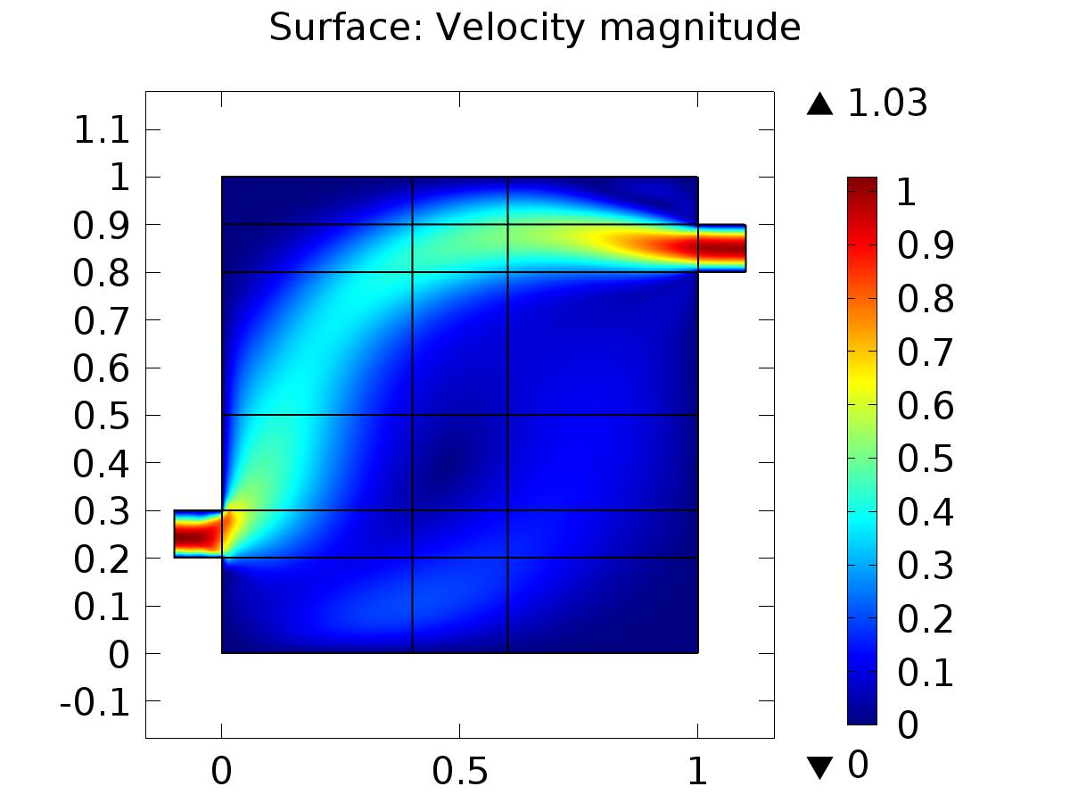

Surface: Velocity magnitude

* + 1. Pressure (spf)

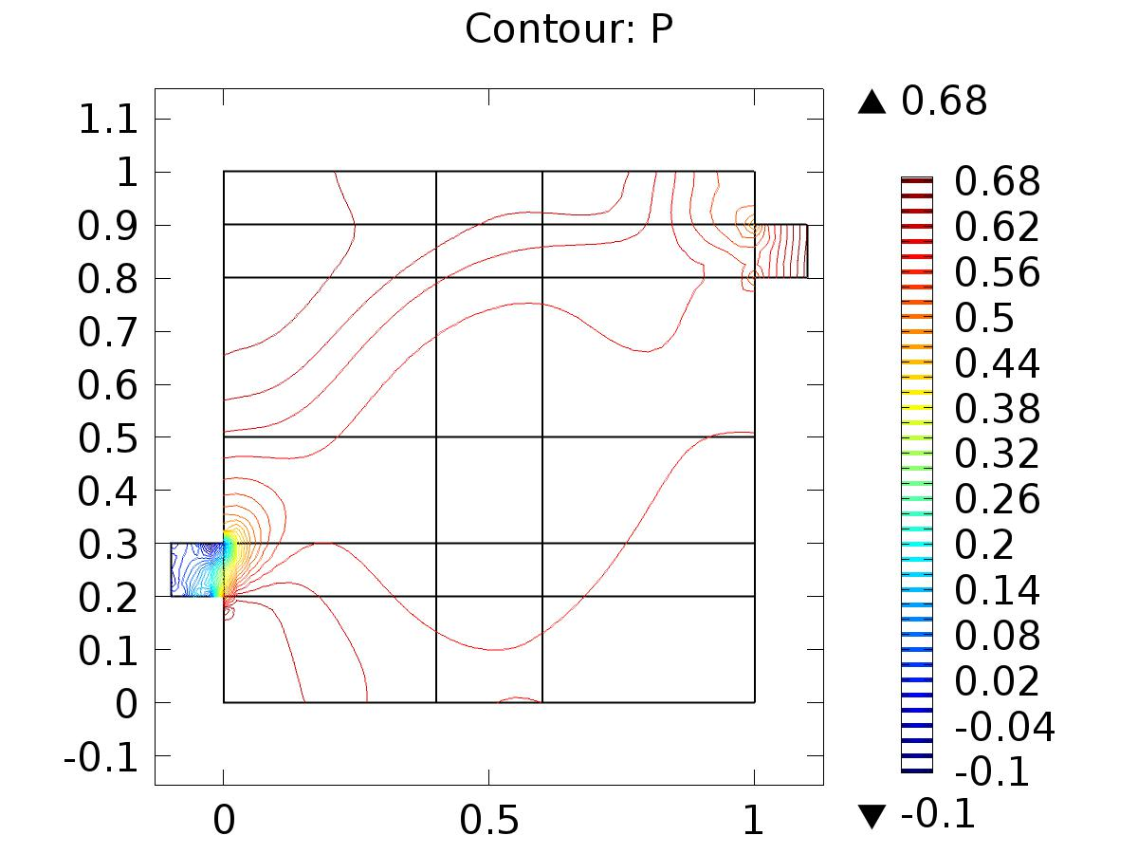

Contour: P

* + 1. 2D Plot Group 3

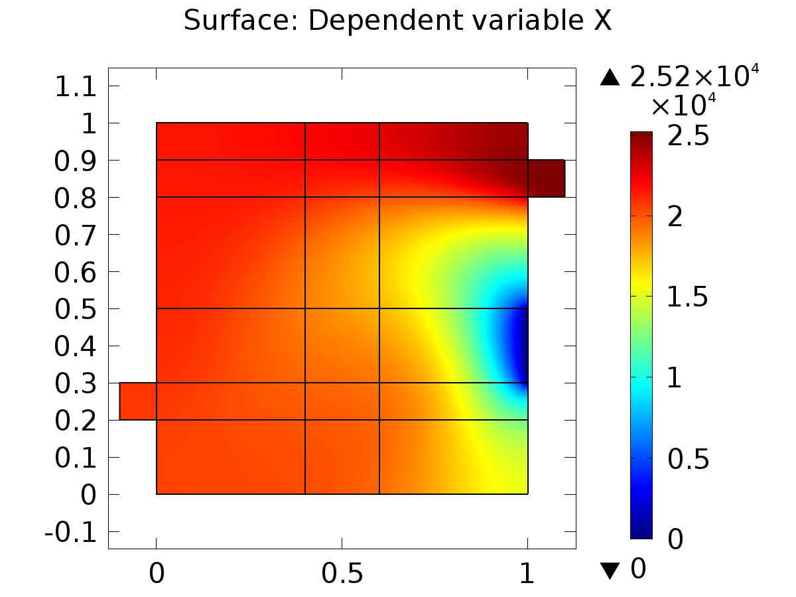

Surface: Dependent variable X

* + 1. Velocity (phys1)

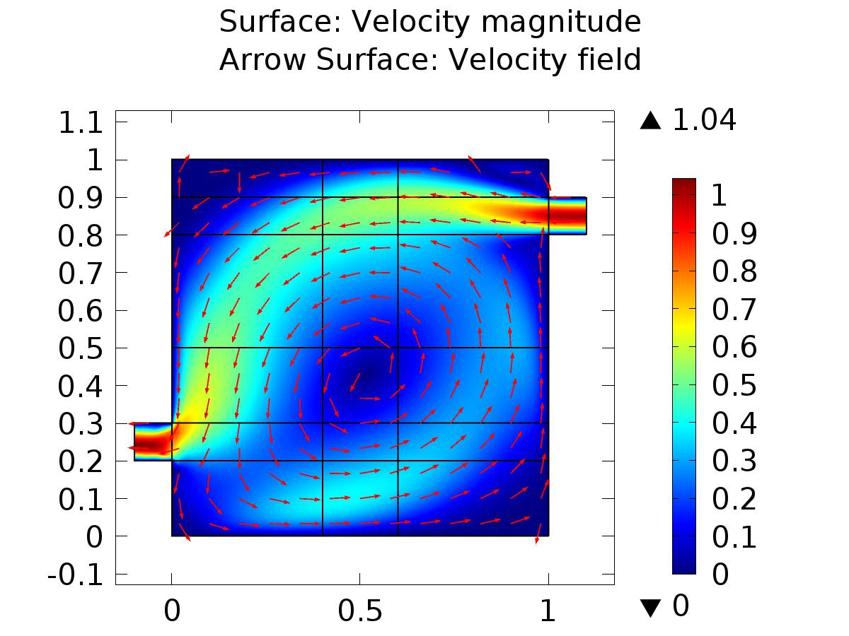

Surface: Velocity magnitude Arrow Surface: Velocity field

* + 1. Pressure (phys1)

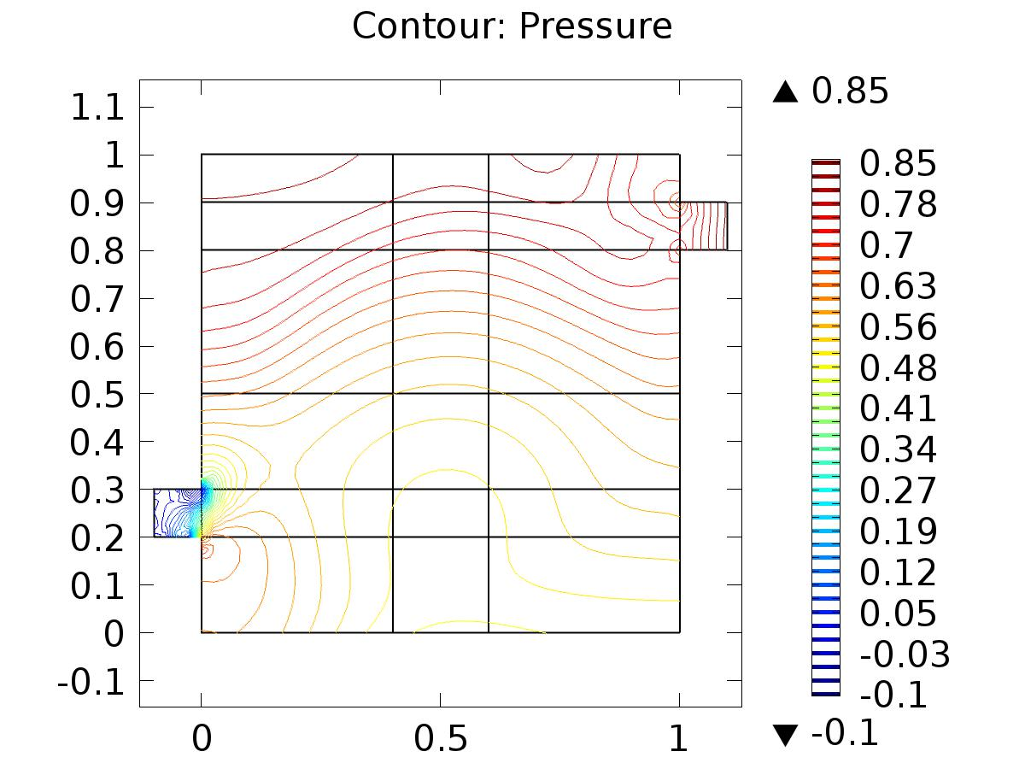

Contour: Pressure

* + 1. 2D Plot Group 6

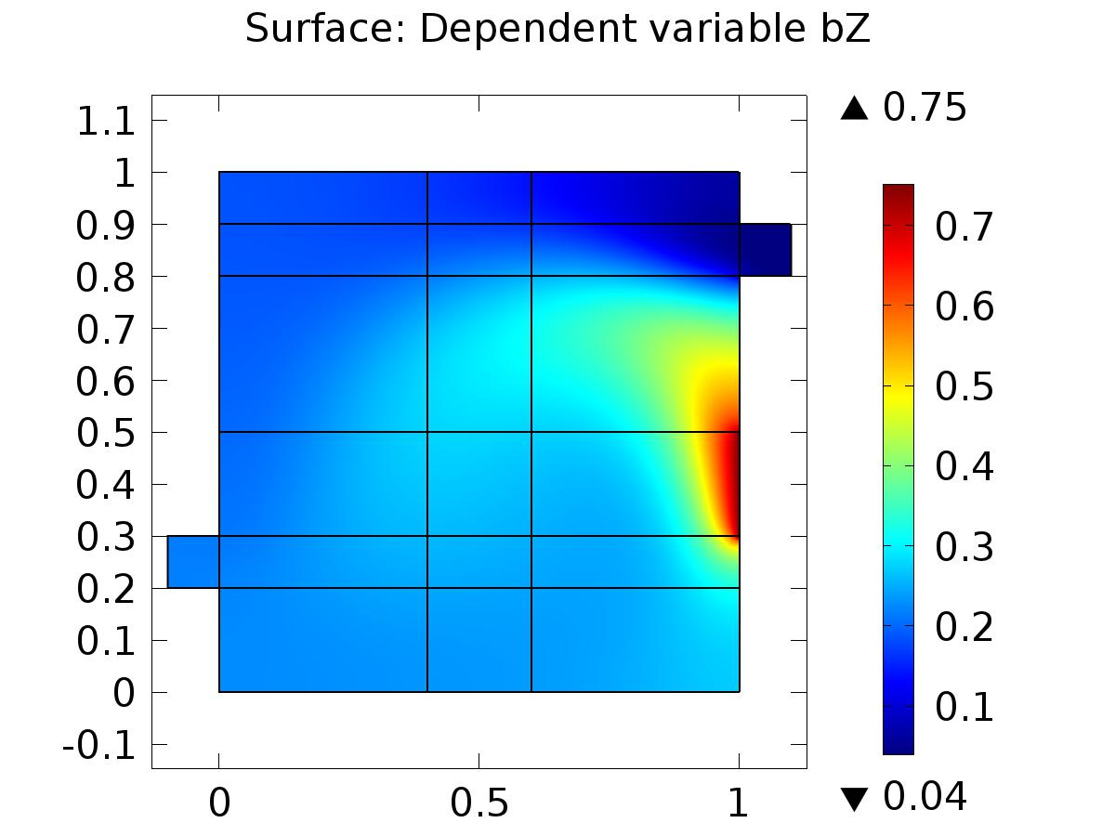

Surface: Dependent variable bZ

* + 1. Velocity (phys3)

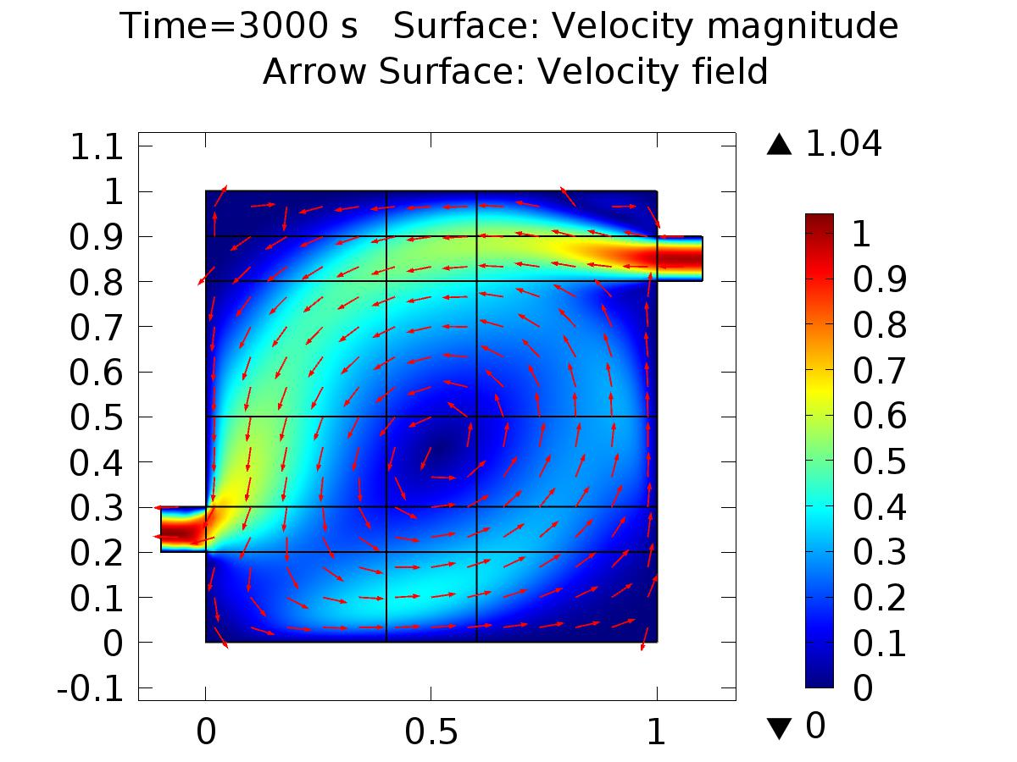

Time=3000 s Surface: Velocity magnitude Arrow Surface: Velocity field

* + 1. Pressure (phys3)

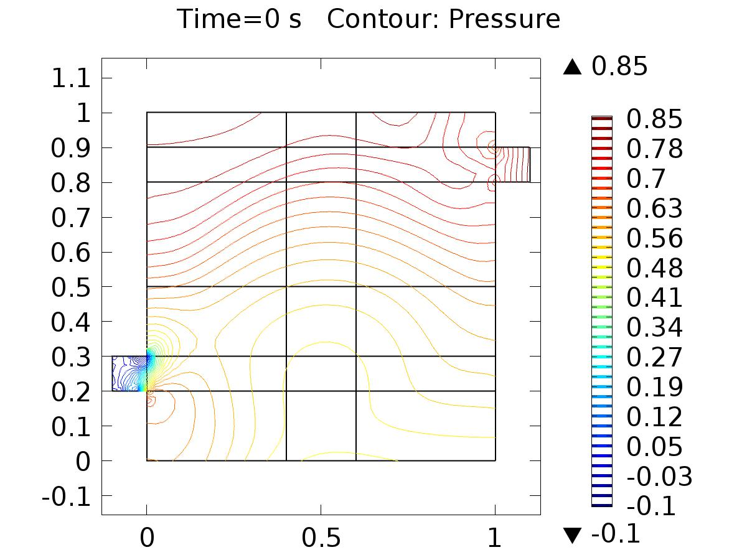

Time=0 s Contour: Pressure

* + 1. 2D Plot Group 9

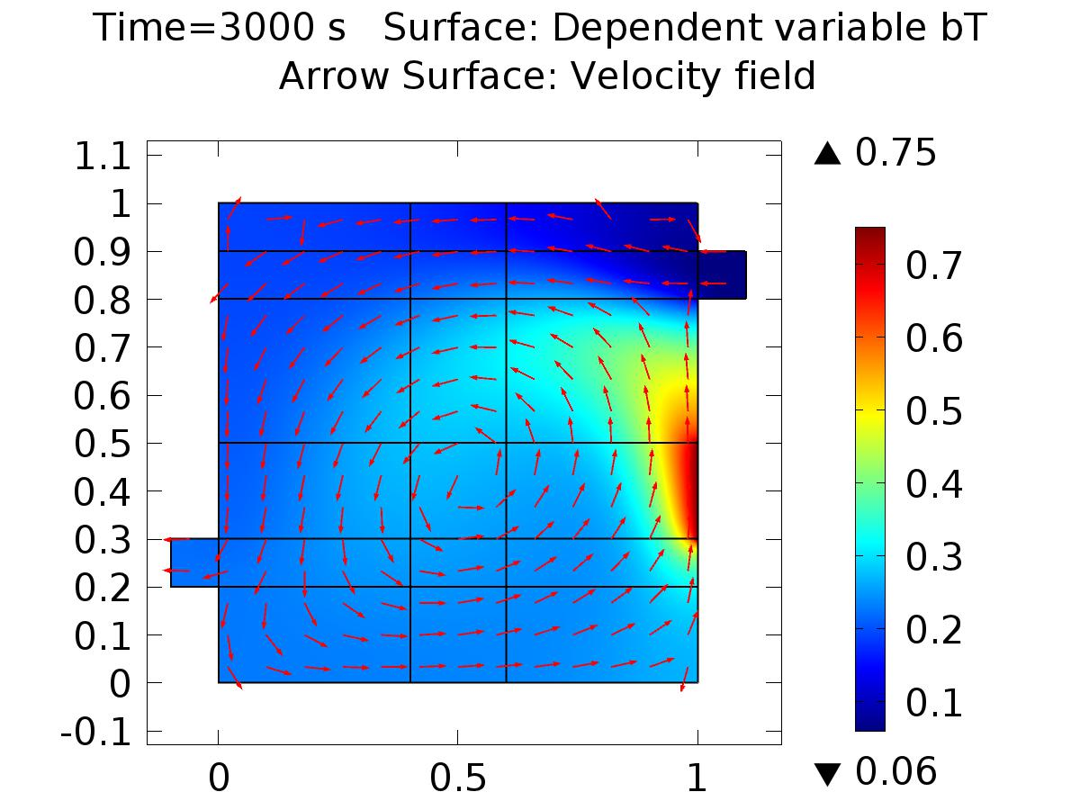

Time=3000 s Surface: Dependent variable bT Arrow Surface: Velocity field

* + 1. 1D Plot Group 10

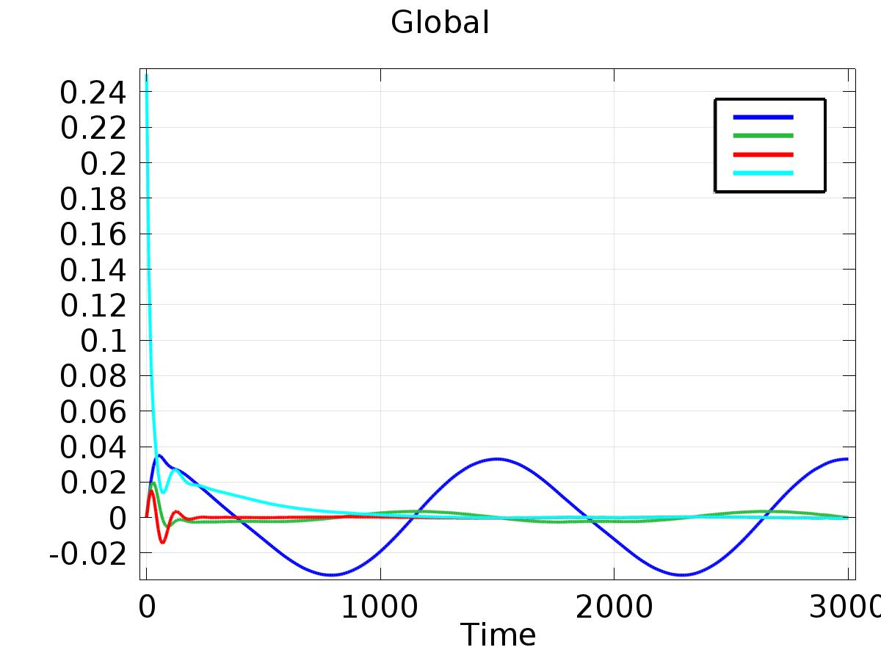

Global

* + 1. 1D Plot Group 11

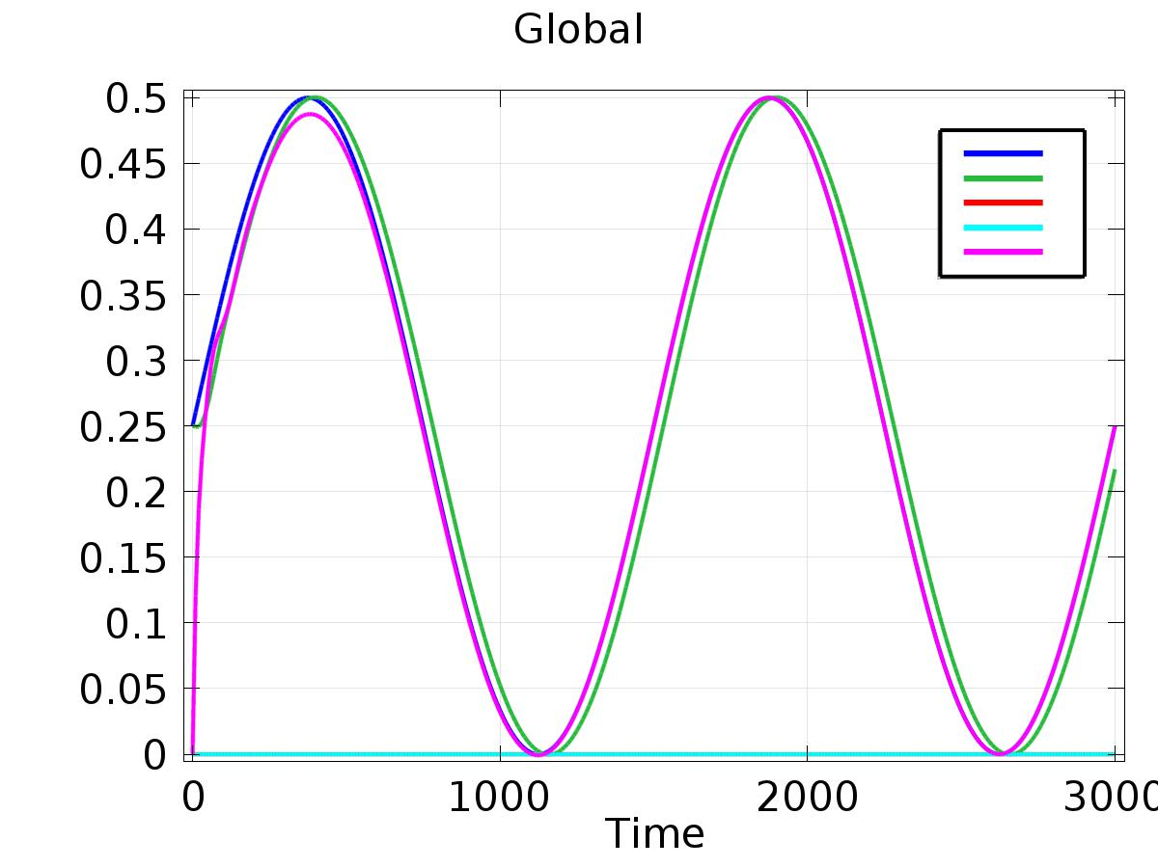

Global

* + 1. 1D Plot Group 12

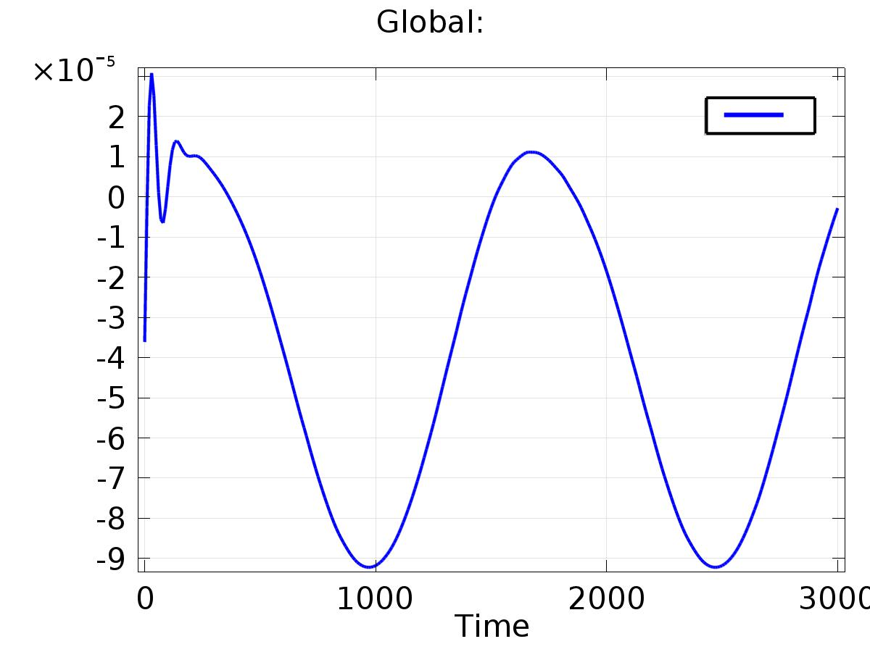

Global: