[](http://www.comsol.com/)

Ex5.2.3b NonIsothermal Navies-Stokes Flows

|  |  |
| --- | --- |
| Date | Aug 11, 2014 7:45:30 AM |

Contents

1. Global

1.1. Definitions

2. Component 1

2.1. Definitions

2.2. Geometry 1

2.3. Steady Flow

2.4. Unit Input

2.5. Set Point Flow

2.6. Set Point Temperature

2.7. Piecewise Constant Flow

2.8. beta iteration 1

2.9. beta iteration 2

2.10. Closed Loop Flow

2.11. Closed Loop Temperature

2.12. Mesh 1

3. Study 1

3.1. Stationary

3.2. Solver Configurations

4. Study 2

4.1. Stationary

4.2. Solver Configurations

5. Study 3

5.1. Time Dependent

5.2. Solver Configurations

6. Results

6.1. Data Sets

6.2. Derived Values

6.3. Tables

6.4. Plot Groups

1. Global

|  |  |
| --- | --- |
| Date | Jul 20, 2014 8:34:26 AM |

Global settings

|  |  |
| --- | --- |
| Name | Ex5.2.3b NonIsothermal Navies-Stokes Flows.mph |
| Path | /Users/gilliam/Desktop/collect_15/research_15/geo_reg_mono_eugenio/Mono_1_15/Comsol_EX_GitHub/Chapter5/Chap5Ex2_Non-Isothermal-Navier-Stokes-Flow/Ex5.2.3_harmonic/ex_5.2.3_b/Ex5.2.3b_NonIsothermal_Navies-Stokes_Flows.mph |
| Program | COMSOL 4.4 (Build: 150) |

Used products

|  |
| --- |
| COMSOL Multiphysics |

* 1. Definitions
     1. Parameters 1

Parameters

| **Name** | **Expression** | **Value** | **Description** |
| --- | --- | --- | --- |
| L | 1 | 1.0000 |  |
| H | 0.1 | 0.10000 |  |
| ni | 0.002 | 0.0020000 |  |
| alpha | 0.01 | 0.010000 |  |
| beta | 1 | 1.0000 |  |
| M1 | 0.25 | 0.25000 |  |
| M2 | 0.5 | 0.50000 |  |
| d1 | 0.75 | 0.75000 |  |
| d2 | 0.5 | 0.50000 |  |
| t1 | 750 | 750.00 |  |
| t2 | 2250 | 2250.0 |  |

1. Component 1

Component settings

|  |  |
| --- | --- |
| Unit system | None |

* 1. Definitions
     1. Variables

#### Variables 1a

Selection

|  |  |
| --- | --- |
| Geometric entity level | Entire model |

| **Name** | **Expression** | **Description** |
| --- | --- | --- |
| G | C(X) |  |
| yr0 | M1 |  |
| d0 | d1 |  |
| gamma0 | (yr0 - C(tZ))/G |  |
| yr | M1 + (M2 - M1)*flc2hs(t - t1, 5) + (M1 - M2)*flc2hs(t - t2, 5) |  |
| d | d1 + (d2 - d1)*sin(t*2*pi/1500) |  |
| gamma1 | (yr - C(tT1))/G |  |
| e1 | yr - C(bT1) |  |
| gamma2 | (e1 - C(tT2))/G |  |
| bT | bT1 + bT2 |  |
| e2 | yr - C(bT) |  |
| gamma | gamma1 + gamma2 |  |
| e | yr - C(T) |  |

* + 1. Component Couplings

#### Average 1

|  |  |
| --- | --- |
| Coupling type | Average |
| Operator name | C |

Source selection

|  |  |
| --- | --- |
| Geometric entity level | Domain |
| Selection | Domain 9 |

* + 1. Coordinate Systems

#### Boundary System 1

|  |  |
| --- | --- |
| Coordinate system type | Boundary system |
| Tag | sys1 |

Coordinate names

| **First (t1)** | **Second (n)** | **Third (to)** |
| --- | --- | --- |
| t1 | n | to |

Settings

| **Description** | **Value** |
| --- | --- |
| Create first tangent direction from | Global Cartesian |

* 1. Geometry 1

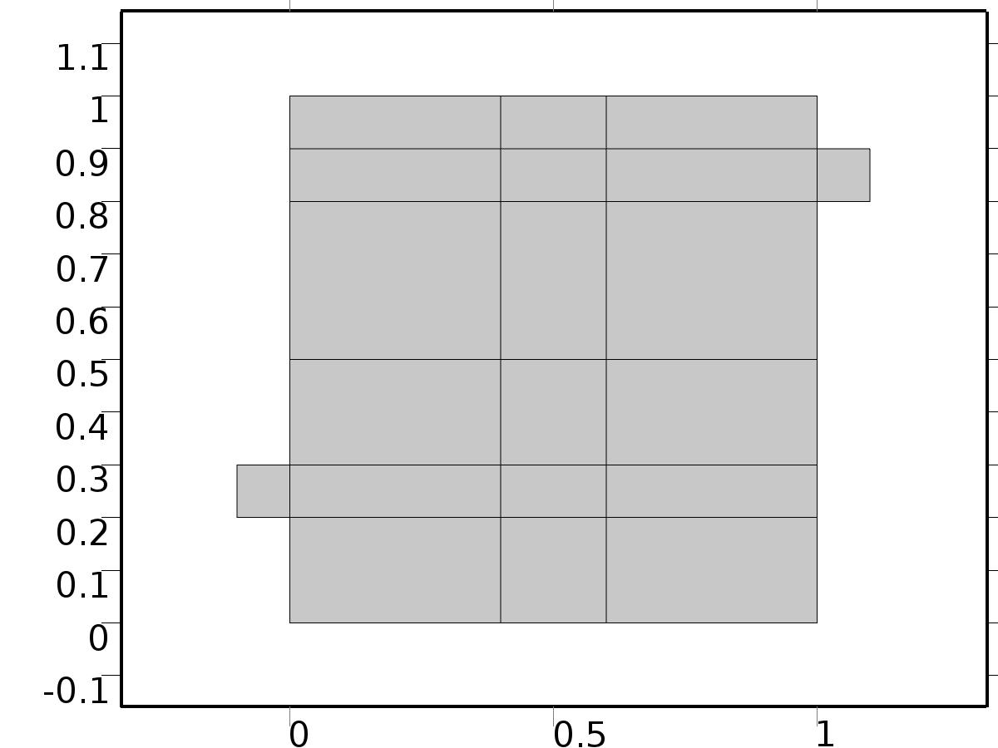

Geometry 1

Units

|  |  |
| --- | --- |
| Length unit | m |
| Angular unit | deg |

Geometry statistics

| **Description** | **Value** |
| --- | --- |
| Space dimension | 2 |
| Number of domains | 20 |
| Number of boundaries | 51 |
| Number of vertices | 32 |

* + 1. Square 1 (sq1)

Position

| **Description** | **Value** |
| --- | --- |
| Position | {0, 0} |
| Layers |  |

Size

| **Description** | **Value** |
| --- | --- |
| Side length | L |

* + 1. Rectangle 1 (r1)

Position

| **Description** | **Value** |
| --- | --- |
| Position | {-H, 2*H} |
| Layers |  |

Size

| **Description** | **Value** |
| --- | --- |
| Width | L + H |
| Height | H |

* + 1. Rectangle 2 (r2)

Position

| **Description** | **Value** |
| --- | --- |
| Position | {0, L - 2*H} |
| Layers |  |

Size

| **Description** | **Value** |
| --- | --- |
| Width | L + H |
| Height | H |

* + 1. Rectangle 3 (r3)

Position

| **Description** | **Value** |
| --- | --- |
| Position | {4*H, 0} |
| Layers |  |

Size

| **Description** | **Value** |
| --- | --- |
| Width | 2*H |
| Height | L |

* + 1. Rectangle 4 (r4)

Position

| **Description** | **Value** |
| --- | --- |
| Position | {0, 3*H} |
| Layers |  |

Size

| **Description** | **Value** |
| --- | --- |
| Width | L |
| Height | 2*H |

* 1. Steady Flow

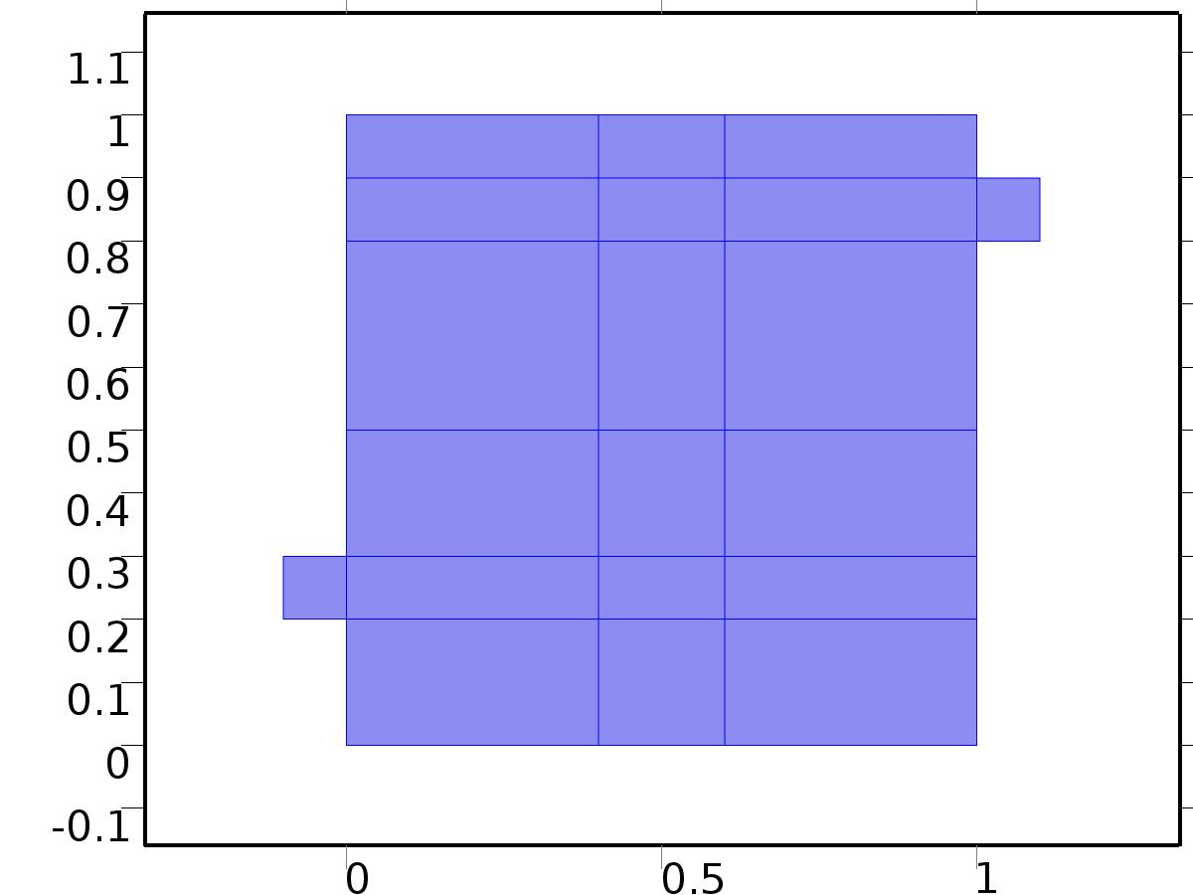

Steady Flow

Selection

|  |  |
| --- | --- |
| Geometric entity level | Domain |
| Selection | Domains 1–20 |

Equations









Settings

| **Description** | **Value** |
| --- | --- |
| Discretization of fluids | P2 + P1 |
| Value type when using splitting of complex variables | {Real, Real, Real, Real, Real, Real, Real, Real, Real, Real, Real} |
| Isotropic diffusion | Off |
| Compressibility | Incompressible flow |
| Channel thickness | 1 |
| Turbulence model type | None |
| Reference pressure level | 1[atm] |
| Use pseudo time stepping for stationary equation form | Off |
| Local CFL number | 1.3^min(niterCMP, 9) + if(niterCMP>=25, 9*1.3^min(niterCMP - 25, 9), 0) + if(niterCMP>=45, 90*1.3^min(niterCMP - 45, 9), 0) |
| Streamline diffusion | Off |
| Crosswind diffusion | Off |

Used products

|  |
| --- |
| COMSOL Multiphysics |

Variables

| **Name** | **Expression** | **Unit** | **Description** | **Selection** |
| --- | --- | --- | --- | --- |
| V.dz | 1 |  | Thickness | Domains 1–20 |
| V.pref | 1[atm] |  | Reference pressure level | Domains 1–20 |
| V.pA | P+V.pref |  | Absolute pressure | Domains 1–20 |
| V.nx | nx |  | Normal vector, x component | Boundaries 6–7, 9, 11, 13, 15, 17, 19–28, 30, 32–41, 47 |
| V.ny | ny |  | Normal vector, y component | Boundaries 6–7, 9, 11, 13, 15, 17, 19–28, 30, 32–41, 47 |
| V.nz | 0 |  | Normal vector, z component | Boundaries 6–7, 9, 11, 13, 15, 17, 19–28, 30, 32–41, 47 |
| V.nx | dnx |  | Normal vector, x component | Boundaries 1–5, 8, 10, 12, 14, 16, 18, 29, 31, 42–46, 48–51 |
| V.ny | dny |  | Normal vector, y component | Boundaries 1–5, 8, 10, 12, 14, 16, 18, 29, 31, 42–46, 48–51 |
| V.nz | 0 |  | Normal vector, z component | Boundaries 1–5, 8, 10, 12, 14, 16, 18, 29, 31, 42–46, 48–51 |
| V.nxmesh | root.nxmesh |  | Normal vector, x component | Boundaries 6–7, 9, 11, 13, 15, 17, 19–28, 30, 32–41, 47 |
| V.nymesh | root.nymesh |  | Normal vector, y component | Boundaries 6–7, 9, 11, 13, 15, 17, 19–28, 30, 32–41, 47 |
| V.nzmesh | 0 |  | Normal vector, z component | Boundaries 6–7, 9, 11, 13, 15, 17, 19–28, 30, 32–41, 47 |
| V.nxmesh | root.dnxmesh |  | Normal vector, x component | Boundaries 1–5, 8, 10, 12, 14, 16, 18, 29, 31, 42–46, 48–51 |
| V.nymesh | root.dnymesh |  | Normal vector, y component | Boundaries 1–5, 8, 10, 12, 14, 16, 18, 29, 31, 42–46, 48–51 |
| V.nzmesh | 0 |  | Normal vector, z component | Boundaries 1–5, 8, 10, 12, 14, 16, 18, 29, 31, 42–46, 48–51 |

* + 1. Fluid Properties



Fluid Properties

Selection

|  |  |
| --- | --- |
| Geometric entity level | Domain |
| Selection | Domains 1–20 |

Equations

Settings

| **Description** | **Value** |
| --- | --- |
| Density | User defined |
| Density | 1 |
| Dynamic viscosity | User defined |
| Dynamic viscosity | ni |

#### Variables

| **Name** | **Expression** | **Unit** | **Description** | **Selection** |
| --- | --- | --- | --- | --- |
| V.rho | 1 |  | Density | Domains 1–20 |
| V.mu | ni |  | Dynamic viscosity | Domains 1–20 |
| V.sr | sqrt(0.5*(4*Ux^2+2*(Uy+Vx)^2+4*Vy^2)+eps) |  | Shear rate | Domains 1–20 |
| V.divu | Ux+Vy |  | Divergence of velocity field | Domains 1–20 |
| V.Fx | 0 |  | Volume force, x component | Domains 1–20 |
| V.Fy | 0 |  | Volume force, y component | Domains 1–20 |
| V.Fz | 0 |  | Volume force, z component | Domains 1–20 |
| V.U | sqrt(U^2+V^2) |  | Velocity magnitude | Domains 1–20 |
| V.vorticityx | 0 |  | Vorticity field, x component | Domains 1–20 |
| V.vorticityy | 0 |  | Vorticity field, y component | Domains 1–20 |
| V.vorticityz | Vx-Uy |  | Vorticity field, z component | Domains 1–20 |
| V.vort_magn | sqrt(V.vorticityx^2+V.vorticityy^2+V.vorticityz^2) |  | Vorticity magnitude | Domains 1–20 |
| V.cellRe | 0.25*V.rho*sqrt(emetric(U,V)/emetric2)/V.mu |  | Cell Reynolds number | Domains 1–20 |
| V.nu | V.mu/V.rho |  | Kinematic viscosity | Domains 1–20 |
| V.betaT | 0 |  | Isothermal compressibility coefficient | Domains 1–20 |
| V.mu_eff | V.mu+V.muT |  | Dynamic viscosity | Domains 1–20 |
| V.muT | 0 |  | Turbulent dynamic viscosity | Domains 1–20 |
| V.T_stressx | V.K_stressx-P*V.nxmesh |  | Total stress, x component | Boundaries 1–51 |
| V.T_stressy | V.K_stressy-P*V.nymesh |  | Total stress, y component | Boundaries 1–51 |
| V.T_stressz | V.K_stressz-P*V.nzmesh |  | Total stress, z component | Boundaries 1–51 |
| V.K_stressx | V.mu_eff*(2*Ux*V.nxmesh+(Uy+Vx)*V.nymesh) |  | Viscous stress, x component | Boundaries 1–51 |
| V.K_stressy | V.mu_eff*((Vx+Uy)*V.nxmesh+2*Vy*V.nymesh) |  | Viscous stress, y component | Boundaries 1–51 |
| V.K_stressz | 0 |  | Viscous stress, z component | Boundaries 1–51 |
| V.K_stress_tensorxx | 2*V.mu_eff*Ux |  | Viscous stress tensor, xx component | Domains 1–20 |
| V.K_stress_tensoryx | V.mu_eff*(Vx+Uy) |  | Viscous stress tensor, yx component | Domains 1–20 |
| V.K_stress_tensorzx | 0 |  | Viscous stress tensor, zx component | Domains 1–20 |
| V.K_stress_tensorxy | V.mu_eff*(Uy+Vx) |  | Viscous stress tensor, xy component | Domains 1–20 |
| V.K_stress_tensoryy | 2*V.mu_eff*Vy |  | Viscous stress tensor, yy component | Domains 1–20 |
| V.K_stress_tensorzy | 0 |  | Viscous stress tensor, zy component | Domains 1–20 |
| V.K_stress_tensorxz | 0 |  | Viscous stress tensor, xz component | Domains 1–20 |
| V.K_stress_tensoryz | 0 |  | Viscous stress tensor, yz component | Domains 1–20 |
| V.K_stress_tensorzz | 0 |  | Viscous stress tensor, zz component | Domains 1–20 |
| V.K_stress_tensor_testxx | 2*V.mu_eff*test(Ux) |  | Viscous stress tensor test, xx component | Domains 1–20 |
| V.K_stress_tensor_testyx | V.mu_eff*(test(Vx)+test(Uy)) |  | Viscous stress tensor test, yx component | Domains 1–20 |
| V.K_stress_tensor_testzx | 0 |  | Viscous stress tensor test, zx component | Domains 1–20 |
| V.K_stress_tensor_testxy | V.mu_eff*(test(Uy)+test(Vx)) |  | Viscous stress tensor test, xy component | Domains 1–20 |
| V.K_stress_tensor_testyy | 2*V.mu_eff*test(Vy) |  | Viscous stress tensor test, yy component | Domains 1–20 |
| V.K_stress_tensor_testzy | 0 |  | Viscous stress tensor test, zy component | Domains 1–20 |
| V.K_stress_tensor_testxz | 0 |  | Viscous stress tensor test, xz component | Domains 1–20 |
| V.K_stress_tensor_testyz | 0 |  | Viscous stress tensor test, yz component | Domains 1–20 |
| V.K_stress_tensor_testzz | 0 |  | Viscous stress tensor test, zz component | Domains 1–20 |
| V.upwind_helpx | U |  | Upwind term, x component | Domains 1–20 |
| V.upwind_helpy | V |  | Upwind term, y component | Domains 1–20 |
| V.upwind_helpz | 0 |  | Upwind term, z component | Domains 1–20 |
| V.tau_vdxx | 2*V.mu*Ux |  | Strain rate, xx component | Domains 1–20 |
| V.tau_vdyx | V.mu*(Vx+Uy) |  | Strain rate, yx component | Domains 1–20 |
| V.tau_vdzx | 0 |  | Strain rate, zx component | Domains 1–20 |
| V.tau_vdxy | V.mu*(Uy+Vx) |  | Strain rate, xy component | Domains 1–20 |
| V.tau_vdyy | 2*V.mu*Vy |  | Strain rate, yy component | Domains 1–20 |
| V.tau_vdzy | 0 |  | Strain rate, zy component | Domains 1–20 |
| V.tau_vdxz | 0 |  | Strain rate, xz component | Domains 1–20 |
| V.tau_vdyz | 0 |  | Strain rate, yz component | Domains 1–20 |
| V.tau_vdzz | 0 |  | Strain rate, zz component | Domains 1–20 |
| V.Qvd | V.tau_vdxx*Ux+V.tau_vdxy*Uy+V.tau_vdyx*Vx+V.tau_vdyy*Vy |  | Viscous dissipation | Domains 1–20 |

#### Shape functions

| **Name** | **Shape function** | **Unit** | **Description** | **Shape frame** | **Selection** |
| --- | --- | --- | --- | --- | --- |
| U | Lagrange (Quadratic) |  | Velocity field, x component | Material | Domains 1–20 |
| V | Lagrange (Quadratic) |  | Velocity field, y component | Material | Domains 1–20 |
| P | Lagrange (Linear) |  | Pressure | Material | Domains 1–20 |

#### Weak expressions

| **Weak expression** | **Integration frame** | **Selection** |
| --- | --- | --- |
| (P-V.K_stress_tensorxx)*test(Ux)-V.K_stress_tensorxy*test(Uy)-V.K_stress_tensoryx*test(Vx)+(P-V.K_stress_tensoryy)*test(Vy) | Material | Domains 1–20 |
| V.Fx*test(U)+V.Fy*test(V) | Material | Domains 1–20 |
| V.rho*(-(Ux*U+Uy*V)*test(U)-(Vx*U+Vy*V)*test(V)) | Material | Domains 1–20 |
| -V.rho*V.divu*test(P) | Material | Domains 1–20 |

* + 1. Wall

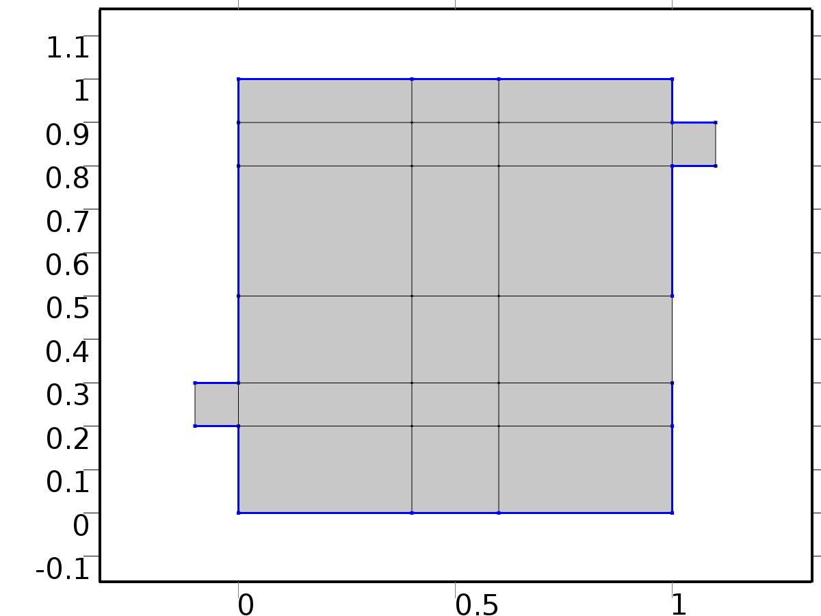

Wall

Selection

|  |  |
| --- | --- |
| Geometric entity level | Boundary |
| Selection | Boundaries 2–5, 8, 10, 12, 14, 16, 18, 29, 31, 42–44, 46, 48–50 |

Equations

Settings

| **Description** | **Value** |
| --- | --- |
| Boundary condition | No slip |
| Apply reaction terms on | Individual dependent variables |
| Use weak constraints | Off |
| Constraint method | Elemental |

#### Variables

| **Name** | **Expression** | **Unit** | **Description** | **Selection** |
| --- | --- | --- | --- | --- |
| V.ubndx | 0 |  | Velocity at boundary, x component | Boundaries 2–5, 8, 10, 12, 14, 16, 18, 29, 31, 42–44, 46, 48–50 |
| V.ubndy | 0 |  | Velocity at boundary, y component | Boundaries 2–5, 8, 10, 12, 14, 16, 18, 29, 31, 42–44, 46, 48–50 |
| V.ubndz | 0 |  | Velocity at boundary, z component | Boundaries 2–5, 8, 10, 12, 14, 16, 18, 29, 31, 42–44, 46, 48–50 |

#### Shape functions

| **Constraint** | **Constraint force** | **Shape function** | **Selection** |
| --- | --- | --- | --- |
| -U+V.ubndx | test(-U) | Lagrange (Quadratic) | Boundaries 2–5, 8, 10, 12, 14, 16, 18, 29, 31, 42–44, 46, 48–50 |
| -V+V.ubndy | test(-V) | Lagrange (Quadratic) | Boundaries 2–5, 8, 10, 12, 14, 16, 18, 29, 31, 42–44, 46, 48–50 |
| V.ubndz | 0 |  | Boundaries 2–5, 8, 10, 12, 14, 16, 18, 29, 31, 42–44, 46, 48–50 |

* + 1. Initial Values



Initial Values

Selection

|  |  |
| --- | --- |
| Geometric entity level | Domain |
| Selection | Domains 1–20 |

Settings

| **Description** | **Value** |
| --- | --- |
| Turbulent kinetic energy | spf.kinit |
| Turbulent dissipation rate | spf.epinit |
| Specific dissipation rate | spf.omInit |
| Reciprocal wall distance | spf.G0 |
| Undamped turbulent kinematic viscosity | spf.nutildeinit |
| Velocity field | {0, 0, 0} |
| Pressure | 0 |

* + 1. Inlet

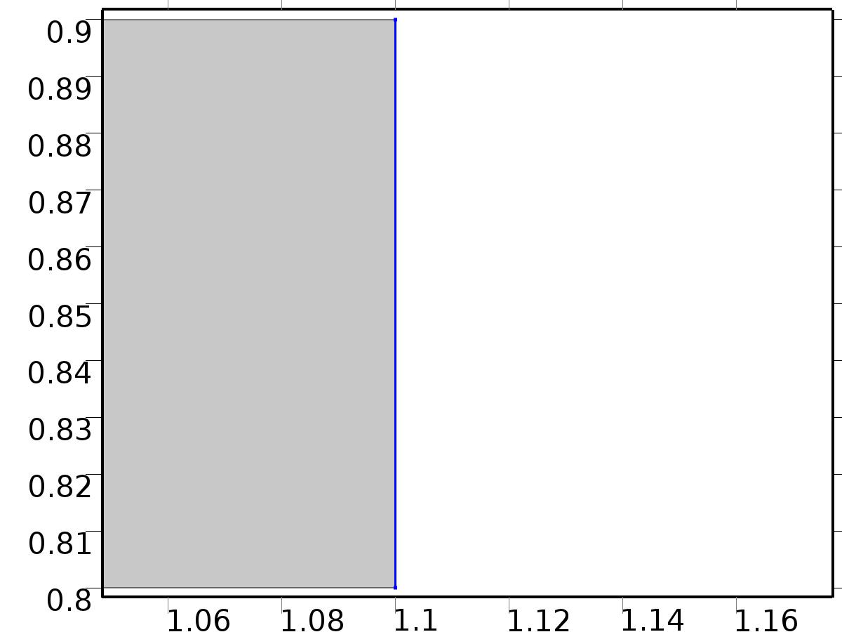

Inlet

Selection

|  |  |
| --- | --- |
| Geometric entity level | Boundary |
| Selection | Boundary 51 |

Equations

Settings

| **Description** | **Value** |
| --- | --- |
| Apply reaction terms on | All physics (symmetric) |
| Use weak constraints | Off |
| Boundary condition | Velocity |
| Velocity field componentwise | Normal inflow velocity |
| Normal inflow velocity | 4*s*(1 - s) |
| Turbulent intensity | 0.05 |
| Turbulence length scale | 0.01[m] |
| Turbulent kinetic energy | 0.005[m^2/s^2] |
| Turbulent dissipation rate | 0.005[m^2/s^3] |
| Specific dissipation rate | 20[1/s] |
| Undamped turbulent kinematic viscosity | 3*spf.nu |
| Constraint method | Elemental |

#### Variables

| **Name** | **Expression** | **Unit** | **Description** | **Selection** |
| --- | --- | --- | --- | --- |
| V.ubndx | -nojac(V.nxmesh)*V.U0in |  | Velocity at boundary, x component | Boundary 51 |
| V.ubndy | -nojac(V.nymesh)*V.U0in |  | Velocity at boundary, y component | Boundary 51 |
| V.ubndz | -nojac(V.nzmesh)*V.U0in |  | Velocity at boundary, z component | Boundary 51 |
| V.U0in | 4*s*(1-s) |  | Normal inflow velocity | Boundary 51 |

#### Shape functions

| **Constraint** | **Constraint force** | **Shape function** | **Selection** |
| --- | --- | --- | --- |
| -U+V.ubndx | test(-U+V.ubndx) | Lagrange (Quadratic) | Boundary 51 |
| -V+V.ubndy | test(-V+V.ubndy) | Lagrange (Quadratic) | Boundary 51 |
| V.ubndz | test(V.ubndz) |  | Boundary 51 |

* + 1. Outflow

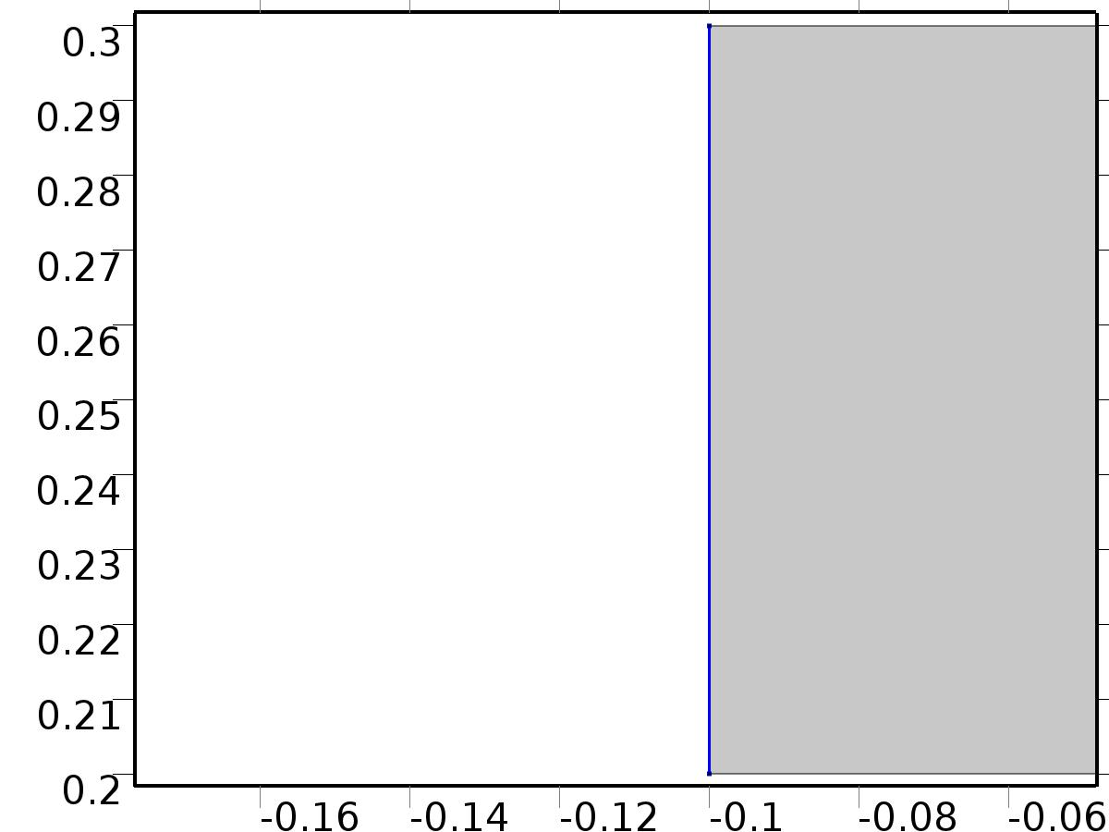

Outflow

Selection

|  |  |
| --- | --- |
| Geometric entity level | Boundary |
| Selection | Boundary 1 |

Equations

Settings

| **Description** | **Value** |
| --- | --- |
| Boundary condition | Normal stress |
| Normal stress | 0 |
| Turbulent intensity | 0.005 |
| Turbulence length scale | 0.1[m] |
| Turbulent kinetic energy | 2.5e-3[m^2/s^2] |
| Turbulent dissipation rate | 1.1e-4[m^2/s^3] |
| Specific dissipation rate | 0.5[1/s] |
| Undamped turbulent kinematic viscosity | 3*spf.nu |

#### Variables

| **Name** | **Expression** | **Unit** | **Description** | **Selection** |
| --- | --- | --- | --- | --- |
| V.f0 | 0 |  | Normal stress | Boundary 1 |

#### Weak expressions

| **Weak expression** | **Integration frame** | **Selection** |
| --- | --- | --- |
| -V.f0*(test(U)*V.nxmesh+test(V)*V.nymesh) | Material | Boundary 1 |

* + 1. Window

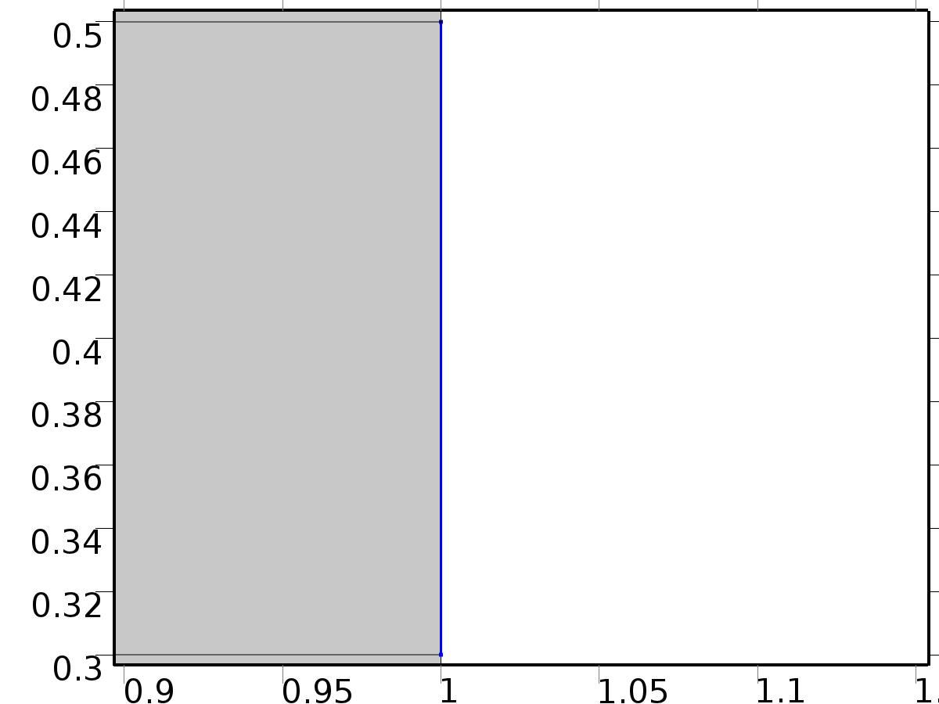

Window

Selection

|  |  |
| --- | --- |
| Geometric entity level | Boundary |
| Selection | Boundary 45 |

Equations

Settings

| **Description** | **Value** |
| --- | --- |
| Boundary condition | No slip |
| Apply reaction terms on | Individual dependent variables |
| Use weak constraints | Off |
| Constraint method | Elemental |

#### Variables

| **Name** | **Expression** | **Unit** | **Description** | **Selection** |
| --- | --- | --- | --- | --- |
| V.ubndx | 0 |  | Velocity at boundary, x component | Boundary 45 |
| V.ubndy | 0 |  | Velocity at boundary, y component | Boundary 45 |
| V.ubndz | 0 |  | Velocity at boundary, z component | Boundary 45 |

#### Shape functions

| **Constraint** | **Constraint force** | **Shape function** | **Selection** |
| --- | --- | --- | --- |
| -U+V.ubndx | test(-U) | Lagrange (Quadratic) | Boundary 45 |
| -V+V.ubndy | test(-V) | Lagrange (Quadratic) | Boundary 45 |
| V.ubndz | 0 |  | Boundary 45 |

* 1. Unit Input



Unit Input

Selection

|  |  |
| --- | --- |
| Geometric entity level | Domain |
| Selection | Domains 1–20 |

Settings

| **Description** | **Value** |
| --- | --- |
| Shape function type | Lagrange |
| Element order | Quadratic |
| Compute boundary fluxes | On |
| Apply smoothing to boundary fluxes | On |
| Value type when using splitting of complex variables | Complex |
| Dependent variable quantity | Dimensionless (1) |
| Source term quantity | None |
| Unit | m^ - 2 |

Used products

|  |
| --- |
| COMSOL Multiphysics |

Variables

| **Name** | **Expression** | **Unit** | **Description** | **Selection** |
| --- | --- | --- | --- | --- |
| X.nx | nx |  | Normal vector, x component | Boundaries 1–51 |
| X.ny | ny |  | Normal vector, y component | Boundaries 1–51 |
| X.nz | root.nz |  | Normal vector, z component | Boundaries 1–51 |
| X.nxmesh | root.nxmesh |  | Normal vector (mesh), x component | Boundaries 1–51 |
| X.nymesh | root.nymesh |  | Normal vector (mesh), y component | Boundaries 1–51 |
| X.nzmesh | root.nzmesh |  | Normal vector (mesh), z component | Boundaries 1–51 |

* + 1. Coefficient Form PDE



Coefficient Form PDE

Selection

|  |  |
| --- | --- |
| Geometric entity level | Domain |
| Selection | Domains 1–20 |

Equations

Settings

| **Description** | **Value** |
| --- | --- |
| Diffusion coefficient | {{alpha, 0}, {0, alpha}} |
| Absorption coefficient | 0 |
| Source term | 0 |
| Mass coefficient | 0 |
| Damping or mass coefficient | 0 |
| Conservative flux convection coefficient | {0, 0} |
| Convection coefficient | {U, V} |
| Conservative flux source | {0, 0} |

#### Variables

| **Name** | **Expression** | **Unit** | **Description** | **Selection** |
| --- | --- | --- | --- | --- |
| domflux.Xx | -alpha*d(X,x) |  | Domain flux, x component | Domains 1–20 |
| domflux.Xy | -alpha*d(X,y) |  | Domain flux, y component | Domains 1–20 |

#### Shape functions

| **Name** | **Shape function** | **Unit** | **Description** | **Shape frame** | **Selection** |
| --- | --- | --- | --- | --- | --- |
| X | Lagrange (Quadratic) |  | Dependent variable X | Material | Domains 1–20 |

* + 1. Insulated Wall



Insulated Wall

Selection

|  |  |
| --- | --- |
| Geometric entity level | Boundary |
| Selection | Boundaries 2–5, 8, 10, 12, 14, 16, 18, 29, 31, 42–44, 46, 48–50 |

Equations

* + 1. Initial Values



Initial Values

Selection

|  |  |
| --- | --- |
| Geometric entity level | Domain |
| Selection | Domains 1–20 |

Settings

| **Description** | **Value** |
| --- | --- |
| Initial value for X | 0 |
| Initial time derivative of X | 0 |

* + 1. Heat Flux Bin*1



Heat Flux Bin*1

Selection

|  |  |
| --- | --- |
| Geometric entity level | Boundary |
| Selection | Boundary 51 |

Equations

Settings

| **Description** | **Value** |
| --- | --- |
| Boundary flux/source | 1 |
| Boundary absorption/impedance term | 0 |

#### Variables

| **Name** | **Expression** | **Unit** | **Description** | **Selection** |
| --- | --- | --- | --- | --- |
| X.g_X | 1 |  | Boundary flux/source | Boundary 51 |

* + 1. Outflow



Outflow

Selection

|  |  |
| --- | --- |
| Geometric entity level | Boundary |
| Selection | Boundary 1 |

Equations

* + 1. Window



Window

Selection

|  |  |
| --- | --- |
| Geometric entity level | Boundary |
| Selection | Boundary 45 |

Equations

Settings

| **Description** | **Value** |
| --- | --- |
| Value on boundary | 0 |
| Prescribed value of X | On |
| Apply reaction terms on | Individual dependent variables |
| Use weak constraints | Off |
| Constraint method | Elemental |

#### Shape functions

| **Constraint** | **Constraint force** | **Shape function** | **Selection** |
| --- | --- | --- | --- |
| -X | -test(X) | Lagrange (Quadratic) | Boundary 45 |

* 1. Set Point Flow



Set Point Flow

Selection

|  |  |
| --- | --- |
| Geometric entity level | Domain |
| Selection | Domains 1–20 |

Equations









Settings

| **Description** | **Value** |
| --- | --- |
| Discretization of fluids | P2 + P1 |
| Value type when using splitting of complex variables | {Real, Real, Real, Real, Real, Real, Real, Real, Real, Real, Real} |
| Isotropic diffusion | Off |
| Compressibility | Incompressible flow |
| Channel thickness | 1 |
| Turbulence model type | None |
| Reference pressure level | 1[atm] |
| Use pseudo time stepping for stationary equation form | Off |
| Local CFL number | 1.3^min(niterCMP, 9) + if(niterCMP>=25, 9*1.3^min(niterCMP - 25, 9), 0) + if(niterCMP>=45, 90*1.3^min(niterCMP - 45, 9), 0) |
| Streamline diffusion | Off |
| Crosswind diffusion | Off |

Used products

|  |
| --- |
| COMSOL Multiphysics |

Variables

| **Name** | **Expression** | **Unit** | **Description** | **Selection** |
| --- | --- | --- | --- | --- |
| bV.dz | 1 |  | Thickness | Domains 1–20 |
| bV.pref | 1[atm] |  | Reference pressure level | Domains 1–20 |
| bV.pA | bP+bV.pref |  | Absolute pressure | Domains 1–20 |
| bV.nx | nx |  | Normal vector, x component | Boundaries 6–7, 9, 11, 13, 15, 17, 19–28, 30, 32–41, 47 |
| bV.ny | ny |  | Normal vector, y component | Boundaries 6–7, 9, 11, 13, 15, 17, 19–28, 30, 32–41, 47 |
| bV.nz | 0 |  | Normal vector, z component | Boundaries 6–7, 9, 11, 13, 15, 17, 19–28, 30, 32–41, 47 |
| bV.nx | dnx |  | Normal vector, x component | Boundaries 1–5, 8, 10, 12, 14, 16, 18, 29, 31, 42–46, 48–51 |
| bV.ny | dny |  | Normal vector, y component | Boundaries 1–5, 8, 10, 12, 14, 16, 18, 29, 31, 42–46, 48–51 |
| bV.nz | 0 |  | Normal vector, z component | Boundaries 1–5, 8, 10, 12, 14, 16, 18, 29, 31, 42–46, 48–51 |
| bV.nxmesh | root.nxmesh |  | Normal vector, x component | Boundaries 6–7, 9, 11, 13, 15, 17, 19–28, 30, 32–41, 47 |
| bV.nymesh | root.nymesh |  | Normal vector, y component | Boundaries 6–7, 9, 11, 13, 15, 17, 19–28, 30, 32–41, 47 |
| bV.nzmesh | 0 |  | Normal vector, z component | Boundaries 6–7, 9, 11, 13, 15, 17, 19–28, 30, 32–41, 47 |
| bV.nxmesh | root.dnxmesh |  | Normal vector, x component | Boundaries 1–5, 8, 10, 12, 14, 16, 18, 29, 31, 42–46, 48–51 |
| bV.nymesh | root.dnymesh |  | Normal vector, y component | Boundaries 1–5, 8, 10, 12, 14, 16, 18, 29, 31, 42–46, 48–51 |
| bV.nzmesh | 0 |  | Normal vector, z component | Boundaries 1–5, 8, 10, 12, 14, 16, 18, 29, 31, 42–46, 48–51 |

* + 1. Fluid Properties



Fluid Properties

Selection

|  |  |
| --- | --- |
| Geometric entity level | Domain |
| Selection | Domains 1–20 |

Equations

Settings

| **Description** | **Value** |
| --- | --- |
| Density | User defined |
| Density | 1 |
| Dynamic viscosity | User defined |
| Dynamic viscosity | ni |

#### Variables

| **Name** | **Expression** | **Unit** | **Description** | **Selection** |
| --- | --- | --- | --- | --- |
| bV.Fx | 0 |  | Volume force, x component | Domains 1–20 |
| bV.Fy | 0 |  | Volume force, y component | Domains 1–20 |
| bV.Fz | 0 |  | Volume force, z component | Domains 1–20 |
| bV.rho | 1 |  | Density | Domains 1–20 |
| bV.mu | ni |  | Dynamic viscosity | Domains 1–20 |
| bV.sr | sqrt(0.5*(4*bUx^2+2*(bUy+bVx)^2+4*bVy^2)+eps) |  | Shear rate | Domains 1–20 |
| bV.divu | bUx+bVy |  | Divergence of velocity field | Domains 1–20 |
| bV.U | sqrt(bU^2+bV^2) |  | Velocity magnitude | Domains 1–20 |
| bV.vorticityx | 0 |  | Vorticity field, x component | Domains 1–20 |
| bV.vorticityy | 0 |  | Vorticity field, y component | Domains 1–20 |
| bV.vorticityz | bVx-bUy |  | Vorticity field, z component | Domains 1–20 |
| bV.vort_magn | sqrt(bV.vorticityx^2+bV.vorticityy^2+bV.vorticityz^2) |  | Vorticity magnitude | Domains 1–20 |
| bV.cellRe | 0.25*bV.rho*sqrt(emetric(bU,bV)/emetric2)/bV.mu |  | Cell Reynolds number | Domains 1–20 |
| bV.nu | bV.mu/bV.rho |  | Kinematic viscosity | Domains 1–20 |
| bV.betaT | 0 |  | Isothermal compressibility coefficient | Domains 1–20 |
| bV.mu_eff | bV.mu+bV.muT |  | Dynamic viscosity | Domains 1–20 |
| bV.muT | 0 |  | Turbulent dynamic viscosity | Domains 1–20 |
| bV.T_stressx | bV.K_stressx-bP*bV.nxmesh |  | Total stress, x component | Boundaries 1–51 |
| bV.T_stressy | bV.K_stressy-bP*bV.nymesh |  | Total stress, y component | Boundaries 1–51 |
| bV.T_stressz | bV.K_stressz-bP*bV.nzmesh |  | Total stress, z component | Boundaries 1–51 |
| bV.K_stressx | bV.mu_eff*(2*bUx*bV.nxmesh+(bUy+bVx)*bV.nymesh) |  | Viscous stress, x component | Boundaries 1–51 |
| bV.K_stressy | bV.mu_eff*((bVx+bUy)*bV.nxmesh+2*bVy*bV.nymesh) |  | Viscous stress, y component | Boundaries 1–51 |
| bV.K_stressz | 0 |  | Viscous stress, z component | Boundaries 1–51 |
| bV.K_stress_tensorxx | 2*bV.mu_eff*bUx |  | Viscous stress tensor, xx component | Domains 1–20 |
| bV.K_stress_tensoryx | bV.mu_eff*(bVx+bUy) |  | Viscous stress tensor, yx component | Domains 1–20 |
| bV.K_stress_tensorzx | 0 |  | Viscous stress tensor, zx component | Domains 1–20 |
| bV.K_stress_tensorxy | bV.mu_eff*(bUy+bVx) |  | Viscous stress tensor, xy component | Domains 1–20 |
| bV.K_stress_tensoryy | 2*bV.mu_eff*bVy |  | Viscous stress tensor, yy component | Domains 1–20 |
| bV.K_stress_tensorzy | 0 |  | Viscous stress tensor, zy component | Domains 1–20 |
| bV.K_stress_tensorxz | 0 |  | Viscous stress tensor, xz component | Domains 1–20 |
| bV.K_stress_tensoryz | 0 |  | Viscous stress tensor, yz component | Domains 1–20 |
| bV.K_stress_tensorzz | 0 |  | Viscous stress tensor, zz component | Domains 1–20 |
| bV.K_stress_tensor_testxx | 2*bV.mu_eff*test(bUx) |  | Viscous stress tensor test, xx component | Domains 1–20 |
| bV.K_stress_tensor_testyx | bV.mu_eff*(test(bVx)+test(bUy)) |  | Viscous stress tensor test, yx component | Domains 1–20 |
| bV.K_stress_tensor_testzx | 0 |  | Viscous stress tensor test, zx component | Domains 1–20 |
| bV.K_stress_tensor_testxy | bV.mu_eff*(test(bUy)+test(bVx)) |  | Viscous stress tensor test, xy component | Domains 1–20 |
| bV.K_stress_tensor_testyy | 2*bV.mu_eff*test(bVy) |  | Viscous stress tensor test, yy component | Domains 1–20 |
| bV.K_stress_tensor_testzy | 0 |  | Viscous stress tensor test, zy component | Domains 1–20 |
| bV.K_stress_tensor_testxz | 0 |  | Viscous stress tensor test, xz component | Domains 1–20 |
| bV.K_stress_tensor_testyz | 0 |  | Viscous stress tensor test, yz component | Domains 1–20 |
| bV.K_stress_tensor_testzz | 0 |  | Viscous stress tensor test, zz component | Domains 1–20 |
| bV.upwind_helpx | bU |  | Upwind term, x component | Domains 1–20 |
| bV.upwind_helpy | bV |  | Upwind term, y component | Domains 1–20 |
| bV.upwind_helpz | 0 |  | Upwind term, z component | Domains 1–20 |
| bV.tau_vdxx | 2*bV.mu*bUx |  | Strain rate, xx component | Domains 1–20 |
| bV.tau_vdyx | bV.mu*(bVx+bUy) |  | Strain rate, yx component | Domains 1–20 |
| bV.tau_vdzx | 0 |  | Strain rate, zx component | Domains 1–20 |
| bV.tau_vdxy | bV.mu*(bUy+bVx) |  | Strain rate, xy component | Domains 1–20 |
| bV.tau_vdyy | 2*bV.mu*bVy |  | Strain rate, yy component | Domains 1–20 |
| bV.tau_vdzy | 0 |  | Strain rate, zy component | Domains 1–20 |
| bV.tau_vdxz | 0 |  | Strain rate, xz component | Domains 1–20 |
| bV.tau_vdyz | 0 |  | Strain rate, yz component | Domains 1–20 |
| bV.tau_vdzz | 0 |  | Strain rate, zz component | Domains 1–20 |
| bV.Qvd | bV.tau_vdxx*bUx+bV.tau_vdxy*bUy+bV.tau_vdyx*bVx+bV.tau_vdyy*bVy |  | Viscous dissipation | Domains 1–20 |

#### Shape functions

| **Name** | **Shape function** | **Unit** | **Description** | **Shape frame** | **Selection** |
| --- | --- | --- | --- | --- | --- |
| bU | Lagrange (Quadratic) |  | Velocity field, x component | Material | Domains 1–20 |
| bV | Lagrange (Quadratic) |  | Velocity field, y component | Material | Domains 1–20 |
| bP | Lagrange (Linear) |  | Pressure | Material | Domains 1–20 |

#### Weak expressions

| **Weak expression** | **Integration frame** | **Selection** |
| --- | --- | --- |
| (bP-bV.K_stress_tensorxx)*test(bUx)-bV.K_stress_tensorxy*test(bUy)-bV.K_stress_tensoryx*test(bVx)+(bP-bV.K_stress_tensoryy)*test(bVy) | Material | Domains 1–20 |
| bV.Fx*test(bU)+bV.Fy*test(bV) | Material | Domains 1–20 |
| bV.rho*(-(bUx*bU+bUy*bV)*test(bU)-(bVx*bU+bVy*bV)*test(bV)) | Material | Domains 1–20 |
| -bV.rho*bV.divu*test(bP) | Material | Domains 1–20 |

* + 1. Wall



Wall

Selection

|  |  |
| --- | --- |
| Geometric entity level | Boundary |
| Selection | Boundaries 2–5, 8, 10, 12, 14, 16, 18, 29, 31, 42–44, 46, 48–50 |

Equations

Settings

| **Description** | **Value** |
| --- | --- |
| Boundary condition | No slip |
| Apply reaction terms on | Individual dependent variables |
| Use weak constraints | Off |
| Constraint method | Elemental |

#### Variables

| **Name** | **Expression** | **Unit** | **Description** | **Selection** |
| --- | --- | --- | --- | --- |
| bV.ubndx | 0 |  | Velocity at boundary, x component | Boundaries 2–5, 8, 10, 12, 14, 16, 18, 29, 31, 42–44, 46, 48–50 |
| bV.ubndy | 0 |  | Velocity at boundary, y component | Boundaries 2–5, 8, 10, 12, 14, 16, 18, 29, 31, 42–44, 46, 48–50 |
| bV.ubndz | 0 |  | Velocity at boundary, z component | Boundaries 2–5, 8, 10, 12, 14, 16, 18, 29, 31, 42–44, 46, 48–50 |

#### Shape functions

| **Constraint** | **Constraint force** | **Shape function** | **Selection** |
| --- | --- | --- | --- |
| -bU+bV.ubndx | test(-bU) | Lagrange (Quadratic) | Boundaries 2–5, 8, 10, 12, 14, 16, 18, 29, 31, 42–44, 46, 48–50 |
| -bV+bV.ubndy | test(-bV) | Lagrange (Quadratic) | Boundaries 2–5, 8, 10, 12, 14, 16, 18, 29, 31, 42–44, 46, 48–50 |
| bV.ubndz | 0 |  | Boundaries 2–5, 8, 10, 12, 14, 16, 18, 29, 31, 42–44, 46, 48–50 |

* + 1. Initial Values



Initial Values

Selection

|  |  |
| --- | --- |
| Geometric entity level | Domain |
| Selection | Domains 1–20 |

Settings

| **Description** | **Value** |
| --- | --- |
| Turbulent kinetic energy | spf.kinit |
| Turbulent dissipation rate | spf.epinit |
| Specific dissipation rate | spf.omInit |
| Reciprocal wall distance | spf.G0 |
| Undamped turbulent kinematic viscosity | spf.nutildeinit |
| Velocity field | {U, V, 0} |
| Pressure | 0 |

* + 1. Inlet



Inlet

Selection

|  |  |
| --- | --- |
| Geometric entity level | Boundary |
| Selection | Boundary 51 |

Equations

Settings

| **Description** | **Value** |
| --- | --- |
| Apply reaction terms on | All physics (symmetric) |
| Use weak constraints | Off |
| Boundary condition | Velocity |
| Velocity field componentwise | Normal inflow velocity |
| Normal inflow velocity | 4*s*(1 - s) |
| Turbulent intensity | 0.05 |
| Turbulence length scale | 0.01[m] |
| Turbulent kinetic energy | 0.005[m^2/s^2] |
| Turbulent dissipation rate | 0.005[m^2/s^3] |
| Specific dissipation rate | 20[1/s] |
| Undamped turbulent kinematic viscosity | 3*vb.nu |
| Constraint method | Elemental |

#### Variables

| **Name** | **Expression** | **Unit** | **Description** | **Selection** |
| --- | --- | --- | --- | --- |
| bV.ubndx | -nojac(bV.nxmesh)*bV.U0in |  | Velocity at boundary, x component | Boundary 51 |
| bV.ubndy | -nojac(bV.nymesh)*bV.U0in |  | Velocity at boundary, y component | Boundary 51 |
| bV.ubndz | -nojac(bV.nzmesh)*bV.U0in |  | Velocity at boundary, z component | Boundary 51 |
| bV.U0in | 4*s*(1-s) |  | Normal inflow velocity | Boundary 51 |

#### Shape functions

| **Constraint** | **Constraint force** | **Shape function** | **Selection** |
| --- | --- | --- | --- |
| -bU+bV.ubndx | test(-bU+bV.ubndx) | Lagrange (Quadratic) | Boundary 51 |
| -bV+bV.ubndy | test(-bV+bV.ubndy) | Lagrange (Quadratic) | Boundary 51 |
| bV.ubndz | test(bV.ubndz) |  | Boundary 51 |

* + 1. Outflow



Outflow

Selection

|  |  |
| --- | --- |
| Geometric entity level | Boundary |
| Selection | Boundary 1 |

Equations

Settings

| **Description** | **Value** |
| --- | --- |
| Boundary condition | Normal stress |
| Normal stress | 0 |
| Turbulent intensity | 0.005 |
| Turbulence length scale | 0.1[m] |
| Turbulent kinetic energy | 2.5e-3[m^2/s^2] |
| Turbulent dissipation rate | 1.1e-4[m^2/s^3] |
| Specific dissipation rate | 0.5[1/s] |
| Undamped turbulent kinematic viscosity | 3*vb.nu |

#### Variables

| **Name** | **Expression** | **Unit** | **Description** | **Selection** |
| --- | --- | --- | --- | --- |
| bV.f0 | 0 |  | Normal stress | Boundary 1 |

#### Weak expressions

| **Weak expression** | **Integration frame** | **Selection** |
| --- | --- | --- |
| -bV.f0*(test(bU)*bV.nxmesh+test(bV)*bV.nymesh) | Material | Boundary 1 |

* + 1. Window



Window

Selection

|  |  |
| --- | --- |
| Geometric entity level | Boundary |
| Selection | Boundary 45 |

Equations

Settings

| **Description** | **Value** |
| --- | --- |
| Boundary condition | No slip |
| Apply reaction terms on | Individual dependent variables |
| Use weak constraints | Off |
| Constraint method | Elemental |

#### Variables

| **Name** | **Expression** | **Unit** | **Description** | **Selection** |
| --- | --- | --- | --- | --- |
| bV.ubndx | 0 |  | Velocity at boundary, x component | Boundary 45 |
| bV.ubndy | 0 |  | Velocity at boundary, y component | Boundary 45 |
| bV.ubndz | 0 |  | Velocity at boundary, z component | Boundary 45 |

#### Shape functions

| **Constraint** | **Constraint force** | **Shape function** | **Selection** |
| --- | --- | --- | --- |
| -bU+bV.ubndx | test(-bU) | Lagrange (Quadratic) | Boundary 45 |
| -bV+bV.ubndy | test(-bV) | Lagrange (Quadratic) | Boundary 45 |
| bV.ubndz | 0 |  | Boundary 45 |

* + 1. Buoyancy Force



Buoyancy Force

Selection

|  |  |
| --- | --- |
| Geometric entity level | Domain |
| Selection | Domains 1–20 |

Equations

#### Variables

| **Name** | **Expression** | **Unit** | **Description** | **Selection** |
| --- | --- | --- | --- | --- |
| bV.Fx | 0 |  | Volume force, x component | Domains 1–20 |
| bV.Fy | beta*bZ |  | Volume force, y component | Domains 1–20 |
| bV.Fz | 0 |  | Volume force, z component | Domains 1–20 |

* 1. Set Point Temperature



Set Point Temperature

Selection

|  |  |
| --- | --- |
| Geometric entity level | Domain |
| Selection | Domains 1–20 |

Settings

| **Description** | **Value** |
| --- | --- |
| Shape function type | Lagrange |
| Element order | Quadratic |
| Compute boundary fluxes | On |
| Apply smoothing to boundary fluxes | On |
| Value type when using splitting of complex variables | Complex |
| Dependent variable quantity | Dimensionless (1) |
| Source term quantity | None |
| Unit | m^ - 2 |

Used products

|  |
| --- |
| COMSOL Multiphysics |

Variables

| **Name** | **Expression** | **Unit** | **Description** | **Selection** |
| --- | --- | --- | --- | --- |
| bZ.nx | nx |  | Normal vector, x component | Boundaries 1–51 |
| bZ.ny | ny |  | Normal vector, y component | Boundaries 1–51 |
| bZ.nz | root.nz |  | Normal vector, z component | Boundaries 1–51 |
| bZ.nxmesh | root.nxmesh |  | Normal vector (mesh), x component | Boundaries 1–51 |
| bZ.nymesh | root.nymesh |  | Normal vector (mesh), y component | Boundaries 1–51 |
| bZ.nzmesh | root.nzmesh |  | Normal vector (mesh), z component | Boundaries 1–51 |

* + 1. Coefficient Form PDE



Coefficient Form PDE

Selection

|  |  |
| --- | --- |
| Geometric entity level | Domain |
| Selection | Domains 1–20 |

Equations

Settings

| **Description** | **Value** |
| --- | --- |
| Diffusion coefficient | {{{{alpha, 0}, {0, alpha}}, {{0, 0}, {0, 0}}}, {{{0, 0}, {0, 0}}, {{alpha, 0}, {0, alpha}}}} |
| Absorption coefficient | {{0, 0}, {0, 0}} |
| Source term | {0, 0} |
| Mass coefficient | {{0, 0}, {0, 0}} |
| Damping or mass coefficient | {{0, 0}, {0, 0}} |
| Conservative flux convection coefficient | {{{0, 0}, {0, 0}}, {{0, 0}, {0, 0}}} |
| Convection coefficient | {{{bU, bV}, {bU - U, bV - V}}, {{0, 0}, {U, V}}} |
| Conservative flux source | {{0, 0}, {0, 0}} |

#### Variables

| **Name** | **Expression** | **Unit** | **Description** | **Selection** |
| --- | --- | --- | --- | --- |
| domflux.bZx | -alpha*d(bZ,x) |  | Domain flux, x component | Domains 1–20 |
| domflux.bZy | -alpha*d(bZ,y) |  | Domain flux, y component | Domains 1–20 |
| domflux.tZx | -alpha*d(tZ,x) |  | Domain flux, x component | Domains 1–20 |
| domflux.tZy | -alpha*d(tZ,y) |  | Domain flux, y component | Domains 1–20 |

#### Shape functions

| **Name** | **Shape function** | **Unit** | **Description** | **Shape frame** | **Selection** |
| --- | --- | --- | --- | --- | --- |
| bZ | Lagrange (Quadratic) |  | Dependent variable bZ | Material | Domains 1–20 |
| tZ | Lagrange (Quadratic) |  | Dependent variable tZ | Material | Domains 1–20 |

* + 1. Insulated Wall



Insulated Wall

Selection

|  |  |
| --- | --- |
| Geometric entity level | Boundary |
| Selection | Boundaries 2–5, 8, 10, 12, 14, 16, 18, 29, 31, 42–44, 46, 48–50 |

Equations

* + 1. Initial Values



Initial Values

Selection

|  |  |
| --- | --- |
| Geometric entity level | Domain |
| Selection | Domains 1–20 |

Settings

| **Description** | **Value** |
| --- | --- |
| Initial value for bZ | 0 |
| Initial time derivative of bZ | 0 |
| Initial value for tZ | 0 |
| Initial time derivative of tZ | 0 |

* + 1. Heat Flux Bin*gamma0



Heat Flux Bin*gamma0

Selection

|  |  |
| --- | --- |
| Geometric entity level | Boundary |
| Selection | Boundary 51 |

Equations

Settings

| **Description** | **Value** |
| --- | --- |
| Boundary flux/source | {gamma0, 0} |
| Boundary absorption/impedance term | {{0, 0}, {0, 0}} |

#### Variables

| **Name** | **Expression** | **Unit** | **Description** | **Selection** |
| --- | --- | --- | --- | --- |
| bZ.g_bZ | gamma0 |  | Boundary flux/source | Boundary 51 |
| bZ.g_tZ | 0 |  | Boundary flux/source | Boundary 51 |

* + 1. Outflow



Outflow

Selection

|  |  |
| --- | --- |
| Geometric entity level | Boundary |
| Selection | Boundary 1 |

Equations

* + 1. Window



Window

Selection

|  |  |
| --- | --- |
| Geometric entity level | Boundary |
| Selection | Boundary 45 |

Equations

Settings

| **Description** | **Value** |
| --- | --- |
| Value on boundary | {d0, d0} |
| Prescribed value of bZ | On |
| Prescribed value of tZ | On |
| Apply reaction terms on | Individual dependent variables |
| Use weak constraints | Off |
| Constraint method | Elemental |

#### Shape functions

| **Constraint** | **Constraint force** | **Shape function** | **Selection** |
| --- | --- | --- | --- |
| d0-bZ | -test(bZ) | Lagrange (Quadratic) | Boundary 45 |
| d0-tZ | -test(tZ) | Lagrange (Quadratic) | Boundary 45 |

* 1. Piecewise Constant Flow



Piecewise Constant Flow

Selection

|  |  |
| --- | --- |
| Geometric entity level | Domain |
| Selection | Domains 1–20 |

Equations









Settings

| **Description** | **Value** |
| --- | --- |
| Discretization of fluids | P2 + P1 |
| Value type when using splitting of complex variables | {Real, Real, Real, Real, Real, Real, Real, Real, Real, Real, Real} |
| Isotropic diffusion | Off |
| Compressibility | Incompressible flow |
| Channel thickness | 1 |
| Turbulence model type | None |
| Reference pressure level | 1[atm] |
| Use pseudo time stepping for stationary equation form | Off |
| Local CFL number | 1.3^min(niterCMP, 9) + if(niterCMP>=25, 9*1.3^min(niterCMP - 25, 9), 0) + if(niterCMP>=45, 90*1.3^min(niterCMP - 45, 9), 0) |
| Streamline diffusion | Off |
| Crosswind diffusion | Off |

Used products

|  |
| --- |
| COMSOL Multiphysics |

Variables

| **Name** | **Expression** | **Unit** | **Description** | **Selection** |
| --- | --- | --- | --- | --- |
| bv.dz | 1 |  | Thickness | Domains 1–20 |
| bv.pref | 1[atm] |  | Reference pressure level | Domains 1–20 |
| bv.pA | bp+bv.pref |  | Absolute pressure | Domains 1–20 |
| bv.nx | nx |  | Normal vector, x component | Boundaries 6–7, 9, 11, 13, 15, 17, 19–28, 30, 32–41, 47 |
| bv.ny | ny |  | Normal vector, y component | Boundaries 6–7, 9, 11, 13, 15, 17, 19–28, 30, 32–41, 47 |
| bv.nz | 0 |  | Normal vector, z component | Boundaries 6–7, 9, 11, 13, 15, 17, 19–28, 30, 32–41, 47 |
| bv.nx | dnx |  | Normal vector, x component | Boundaries 1–5, 8, 10, 12, 14, 16, 18, 29, 31, 42–46, 48–51 |
| bv.ny | dny |  | Normal vector, y component | Boundaries 1–5, 8, 10, 12, 14, 16, 18, 29, 31, 42–46, 48–51 |
| bv.nz | 0 |  | Normal vector, z component | Boundaries 1–5, 8, 10, 12, 14, 16, 18, 29, 31, 42–46, 48–51 |
| bv.nxmesh | root.nxmesh |  | Normal vector, x component | Boundaries 6–7, 9, 11, 13, 15, 17, 19–28, 30, 32–41, 47 |
| bv.nymesh | root.nymesh |  | Normal vector, y component | Boundaries 6–7, 9, 11, 13, 15, 17, 19–28, 30, 32–41, 47 |
| bv.nzmesh | 0 |  | Normal vector, z component | Boundaries 6–7, 9, 11, 13, 15, 17, 19–28, 30, 32–41, 47 |
| bv.nxmesh | root.dnxmesh |  | Normal vector, x component | Boundaries 1–5, 8, 10, 12, 14, 16, 18, 29, 31, 42–46, 48–51 |
| bv.nymesh | root.dnymesh |  | Normal vector, y component | Boundaries 1–5, 8, 10, 12, 14, 16, 18, 29, 31, 42–46, 48–51 |
| bv.nzmesh | 0 |  | Normal vector, z component | Boundaries 1–5, 8, 10, 12, 14, 16, 18, 29, 31, 42–46, 48–51 |

* + 1. Fluid Properties



Fluid Properties

Selection

|  |  |
| --- | --- |
| Geometric entity level | Domain |
| Selection | Domains 1–20 |

Equations

Settings

| **Description** | **Value** |
| --- | --- |
| Density | User defined |
| Density | 1 |
| Dynamic viscosity | User defined |
| Dynamic viscosity | ni |

#### Variables

| **Name** | **Expression** | **Unit** | **Description** | **Selection** |
| --- | --- | --- | --- | --- |
| bv.Fx | 0 |  | Volume force, x component | Domains 1–20 |
| bv.Fy | 0 |  | Volume force, y component | Domains 1–20 |
| bv.Fz | 0 |  | Volume force, z component | Domains 1–20 |
| bv.rho | 1 |  | Density | Domains 1–20 |
| bv.mu | ni |  | Dynamic viscosity | Domains 1–20 |
| bv.sr | sqrt(0.5*(4*bux^2+2*(buy+bvx)^2+4*bvy^2)+eps) |  | Shear rate | Domains 1–20 |
| bv.divu | bux+bvy |  | Divergence of velocity field | Domains 1–20 |
| bv.U | sqrt(bu^2+bv^2) |  | Velocity magnitude | Domains 1–20 |
| bv.vorticityx | 0 |  | Vorticity field, x component | Domains 1–20 |
| bv.vorticityy | 0 |  | Vorticity field, y component | Domains 1–20 |
| bv.vorticityz | bvx-buy |  | Vorticity field, z component | Domains 1–20 |
| bv.vort_magn | sqrt(bv.vorticityx^2+bv.vorticityy^2+bv.vorticityz^2) |  | Vorticity magnitude | Domains 1–20 |
| bv.cellRe | 0.25*bv.rho*sqrt(emetric(bu,bv)/emetric2)/bv.mu |  | Cell Reynolds number | Domains 1–20 |
| bv.nu | bv.mu/bv.rho |  | Kinematic viscosity | Domains 1–20 |
| bv.betaT | 0 |  | Isothermal compressibility coefficient | Domains 1–20 |
| bv.mu_eff | bv.mu+bv.muT |  | Dynamic viscosity | Domains 1–20 |
| bv.muT | 0 |  | Turbulent dynamic viscosity | Domains 1–20 |
| bv.T_stressx | bv.K_stressx-bp*bv.nxmesh |  | Total stress, x component | Boundaries 1–51 |
| bv.T_stressy | bv.K_stressy-bp*bv.nymesh |  | Total stress, y component | Boundaries 1–51 |
| bv.T_stressz | bv.K_stressz-bp*bv.nzmesh |  | Total stress, z component | Boundaries 1–51 |
| bv.K_stressx | bv.mu_eff*(2*bux*bv.nxmesh+(buy+bvx)*bv.nymesh) |  | Viscous stress, x component | Boundaries 1–51 |
| bv.K_stressy | bv.mu_eff*((bvx+buy)*bv.nxmesh+2*bvy*bv.nymesh) |  | Viscous stress, y component | Boundaries 1–51 |
| bv.K_stressz | 0 |  | Viscous stress, z component | Boundaries 1–51 |
| bv.K_stress_tensorxx | 2*bv.mu_eff*bux |  | Viscous stress tensor, xx component | Domains 1–20 |
| bv.K_stress_tensoryx | bv.mu_eff*(bvx+buy) |  | Viscous stress tensor, yx component | Domains 1–20 |
| bv.K_stress_tensorzx | 0 |  | Viscous stress tensor, zx component | Domains 1–20 |
| bv.K_stress_tensorxy | bv.mu_eff*(buy+bvx) |  | Viscous stress tensor, xy component | Domains 1–20 |
| bv.K_stress_tensoryy | 2*bv.mu_eff*bvy |  | Viscous stress tensor, yy component | Domains 1–20 |
| bv.K_stress_tensorzy | 0 |  | Viscous stress tensor, zy component | Domains 1–20 |
| bv.K_stress_tensorxz | 0 |  | Viscous stress tensor, xz component | Domains 1–20 |
| bv.K_stress_tensoryz | 0 |  | Viscous stress tensor, yz component | Domains 1–20 |
| bv.K_stress_tensorzz | 0 |  | Viscous stress tensor, zz component | Domains 1–20 |
| bv.K_stress_tensor_testxx | 2*bv.mu_eff*test(bux) |  | Viscous stress tensor test, xx component | Domains 1–20 |
| bv.K_stress_tensor_testyx | bv.mu_eff*(test(bvx)+test(buy)) |  | Viscous stress tensor test, yx component | Domains 1–20 |
| bv.K_stress_tensor_testzx | 0 |  | Viscous stress tensor test, zx component | Domains 1–20 |
| bv.K_stress_tensor_testxy | bv.mu_eff*(test(buy)+test(bvx)) |  | Viscous stress tensor test, xy component | Domains 1–20 |
| bv.K_stress_tensor_testyy | 2*bv.mu_eff*test(bvy) |  | Viscous stress tensor test, yy component | Domains 1–20 |
| bv.K_stress_tensor_testzy | 0 |  | Viscous stress tensor test, zy component | Domains 1–20 |
| bv.K_stress_tensor_testxz | 0 |  | Viscous stress tensor test, xz component | Domains 1–20 |
| bv.K_stress_tensor_testyz | 0 |  | Viscous stress tensor test, yz component | Domains 1–20 |
| bv.K_stress_tensor_testzz | 0 |  | Viscous stress tensor test, zz component | Domains 1–20 |
| bv.upwind_helpx | bu |  | Upwind term, x component | Domains 1–20 |
| bv.upwind_helpy | bv |  | Upwind term, y component | Domains 1–20 |
| bv.upwind_helpz | 0 |  | Upwind term, z component | Domains 1–20 |
| bv.tau_vdxx | 2*bv.mu*bux |  | Strain rate, xx component | Domains 1–20 |
| bv.tau_vdyx | bv.mu*(bvx+buy) |  | Strain rate, yx component | Domains 1–20 |
| bv.tau_vdzx | 0 |  | Strain rate, zx component | Domains 1–20 |
| bv.tau_vdxy | bv.mu*(buy+bvx) |  | Strain rate, xy component | Domains 1–20 |
| bv.tau_vdyy | 2*bv.mu*bvy |  | Strain rate, yy component | Domains 1–20 |
| bv.tau_vdzy | 0 |  | Strain rate, zy component | Domains 1–20 |
| bv.tau_vdxz | 0 |  | Strain rate, xz component | Domains 1–20 |
| bv.tau_vdyz | 0 |  | Strain rate, yz component | Domains 1–20 |
| bv.tau_vdzz | 0 |  | Strain rate, zz component | Domains 1–20 |
| bv.Qvd | bv.tau_vdxx*bux+bv.tau_vdxy*buy+bv.tau_vdyx*bvx+bv.tau_vdyy*bvy |  | Viscous dissipation | Domains 1–20 |

#### Shape functions

| **Name** | **Shape function** | **Unit** | **Description** | **Shape frame** | **Selection** |
| --- | --- | --- | --- | --- | --- |
| bu | Lagrange (Quadratic) |  | Velocity field, x component | Material | Domains 1–20 |
| bv | Lagrange (Quadratic) |  | Velocity field, y component | Material | Domains 1–20 |
| bp | Lagrange (Linear) |  | Pressure | Material | Domains 1–20 |

#### Weak expressions

| **Weak expression** | **Integration frame** | **Selection** |
| --- | --- | --- |
| (bp-bv.K_stress_tensorxx)*test(bux)-bv.K_stress_tensorxy*test(buy)-bv.K_stress_tensoryx*test(bvx)+(bp-bv.K_stress_tensoryy)*test(bvy) | Material | Domains 1–20 |
| bv.Fx*test(bu)+bv.Fy*test(bv) | Material | Domains 1–20 |
| bv.rho*(-(bux*bu+buy*bv)*test(bu)-(bvx*bu+bvy*bv)*test(bv)) | Material | Domains 1–20 |
| -bv.rho*bv.divu*test(bp) | Material | Domains 1–20 |

* + 1. Wall



Wall

Selection

|  |  |
| --- | --- |
| Geometric entity level | Boundary |
| Selection | Boundaries 2–5, 8, 10, 12, 14, 16, 18, 29, 31, 42–44, 46, 48–50 |

Equations

Settings

| **Description** | **Value** |
| --- | --- |
| Boundary condition | No slip |
| Apply reaction terms on | Individual dependent variables |
| Use weak constraints | Off |
| Constraint method | Elemental |

#### Variables

| **Name** | **Expression** | **Unit** | **Description** | **Selection** |
| --- | --- | --- | --- | --- |
| bv.ubndx | 0 |  | Velocity at boundary, x component | Boundaries 2–5, 8, 10, 12, 14, 16, 18, 29, 31, 42–44, 46, 48–50 |
| bv.ubndy | 0 |  | Velocity at boundary, y component | Boundaries 2–5, 8, 10, 12, 14, 16, 18, 29, 31, 42–44, 46, 48–50 |
| bv.ubndz | 0 |  | Velocity at boundary, z component | Boundaries 2–5, 8, 10, 12, 14, 16, 18, 29, 31, 42–44, 46, 48–50 |

#### Shape functions

| **Constraint** | **Constraint force** | **Shape function** | **Selection** |
| --- | --- | --- | --- |
| -bu+bv.ubndx | test(-bu) | Lagrange (Quadratic) | Boundaries 2–5, 8, 10, 12, 14, 16, 18, 29, 31, 42–44, 46, 48–50 |
| -bv+bv.ubndy | test(-bv) | Lagrange (Quadratic) | Boundaries 2–5, 8, 10, 12, 14, 16, 18, 29, 31, 42–44, 46, 48–50 |
| bv.ubndz | 0 |  | Boundaries 2–5, 8, 10, 12, 14, 16, 18, 29, 31, 42–44, 46, 48–50 |

* + 1. Initial Values



Initial Values

Selection

|  |  |
| --- | --- |
| Geometric entity level | Domain |
| Selection | Domains 1–20 |

Settings

| **Description** | **Value** |
| --- | --- |
| Turbulent kinetic energy | spf.kinit |
| Turbulent dissipation rate | spf.epinit |
| Specific dissipation rate | spf.omInit |
| Reciprocal wall distance | spf.G0 |
| Undamped turbulent kinematic viscosity | spf.nutildeinit |
| Velocity field | {bU, bV, 0} |
| Pressure | 0 |

* + 1. Inlet



Inlet

Selection

|  |  |
| --- | --- |
| Geometric entity level | Boundary |
| Selection | Boundary 51 |

Equations

Settings

| **Description** | **Value** |
| --- | --- |
| Apply reaction terms on | All physics (symmetric) |
| Use weak constraints | Off |
| Boundary condition | Velocity |
| Velocity field componentwise | Normal inflow velocity |
| Normal inflow velocity | 4*s*(1 - s) |
| Turbulent intensity | 0.05 |
| Turbulence length scale | 0.01[m] |
| Turbulent kinetic energy | 0.005[m^2/s^2] |
| Turbulent dissipation rate | 0.005[m^2/s^3] |
| Specific dissipation rate | 20[1/s] |
| Undamped turbulent kinematic viscosity | 3*v.nu |
| Constraint method | Elemental |

#### Variables

| **Name** | **Expression** | **Unit** | **Description** | **Selection** |
| --- | --- | --- | --- | --- |
| bv.ubndx | -nojac(bv.nxmesh)*bv.U0in |  | Velocity at boundary, x component | Boundary 51 |
| bv.ubndy | -nojac(bv.nymesh)*bv.U0in |  | Velocity at boundary, y component | Boundary 51 |
| bv.ubndz | -nojac(bv.nzmesh)*bv.U0in |  | Velocity at boundary, z component | Boundary 51 |
| bv.U0in | 4*s*(1-s) |  | Normal inflow velocity | Boundary 51 |

#### Shape functions

| **Constraint** | **Constraint force** | **Shape function** | **Selection** |
| --- | --- | --- | --- |
| -bu+bv.ubndx | test(-bu+bv.ubndx) | Lagrange (Quadratic) | Boundary 51 |
| -bv+bv.ubndy | test(-bv+bv.ubndy) | Lagrange (Quadratic) | Boundary 51 |
| bv.ubndz | test(bv.ubndz) |  | Boundary 51 |

* + 1. Outflow



Outflow

Selection

|  |  |
| --- | --- |
| Geometric entity level | Boundary |
| Selection | Boundary 1 |

Equations

Settings

| **Description** | **Value** |
| --- | --- |
| Boundary condition | Normal stress |
| Normal stress | 0 |
| Turbulent intensity | 0.005 |
| Turbulence length scale | 0.1[m] |
| Turbulent kinetic energy | 2.5e-3[m^2/s^2] |
| Turbulent dissipation rate | 1.1e-4[m^2/s^3] |
| Specific dissipation rate | 0.5[1/s] |
| Undamped turbulent kinematic viscosity | 3*v.nu |

#### Variables

| **Name** | **Expression** | **Unit** | **Description** | **Selection** |
| --- | --- | --- | --- | --- |
| bv.f0 | 0 |  | Normal stress | Boundary 1 |

#### Weak expressions

| **Weak expression** | **Integration frame** | **Selection** |
| --- | --- | --- |
| -bv.f0*(test(bu)*bv.nxmesh+test(bv)*bv.nymesh) | Material | Boundary 1 |

* + 1. Window



Window

Selection

|  |  |
| --- | --- |
| Geometric entity level | Boundary |
| Selection | Boundary 45 |

Equations

Settings

| **Description** | **Value** |
| --- | --- |
| Boundary condition | No slip |
| Apply reaction terms on | Individual dependent variables |
| Use weak constraints | Off |
| Constraint method | Elemental |

#### Variables

| **Name** | **Expression** | **Unit** | **Description** | **Selection** |
| --- | --- | --- | --- | --- |
| bv.ubndx | 0 |  | Velocity at boundary, x component | Boundary 45 |
| bv.ubndy | 0 |  | Velocity at boundary, y component | Boundary 45 |
| bv.ubndz | 0 |  | Velocity at boundary, z component | Boundary 45 |

#### Shape functions

| **Constraint** | **Constraint force** | **Shape function** | **Selection** |
| --- | --- | --- | --- |
| -bu+bv.ubndx | test(-bu) | Lagrange (Quadratic) | Boundary 45 |
| -bv+bv.ubndy | test(-bv) | Lagrange (Quadratic) | Boundary 45 |
| bv.ubndz | 0 |  | Boundary 45 |

* + 1. Buoyancy Force



Buoyancy Force

Selection

|  |  |
| --- | --- |
| Geometric entity level | Domain |
| Selection | Domains 1–20 |

Equations

#### Variables

| **Name** | **Expression** | **Unit** | **Description** | **Selection** |
| --- | --- | --- | --- | --- |
| bv.Fx | 0 |  | Volume force, x component | Domains 1–20 |
| bv.Fy | beta*bT |  | Volume force, y component | Domains 1–20 |
| bv.Fz | 0 |  | Volume force, z component | Domains 1–20 |

* 1. beta iteration 1



beta iteration 1

Selection

|  |  |
| --- | --- |
| Geometric entity level | Domain |
| Selection | Domains 1–20 |

Settings

| **Description** | **Value** |
| --- | --- |
| Shape function type | Lagrange |
| Element order | Quadratic |
| Compute boundary fluxes | On |
| Apply smoothing to boundary fluxes | On |
| Value type when using splitting of complex variables | Complex |
| Dependent variable quantity | Dimensionless (1) |
| Source term quantity | None |
| Unit | m^ - 2 |

Used products

|  |
| --- |
| COMSOL Multiphysics |

Variables

| **Name** | **Expression** | **Unit** | **Description** | **Selection** |
| --- | --- | --- | --- | --- |
| bT1.nx | nx |  | Normal vector, x component | Boundaries 1–51 |
| bT1.ny | ny |  | Normal vector, y component | Boundaries 1–51 |
| bT1.nz | root.nz |  | Normal vector, z component | Boundaries 1–51 |
| bT1.nxmesh | root.nxmesh |  | Normal vector (mesh), x component | Boundaries 1–51 |
| bT1.nymesh | root.nymesh |  | Normal vector (mesh), y component | Boundaries 1–51 |
| bT1.nzmesh | root.nzmesh |  | Normal vector (mesh), z component | Boundaries 1–51 |

* + 1. Coefficient Form PDE



Coefficient Form PDE

Selection

|  |  |
| --- | --- |
| Geometric entity level | Domain |
| Selection | Domains 1–20 |

Equations

Settings

| **Description** | **Value** |
| --- | --- |
| Diffusion coefficient | {{{{alpha, 0}, {0, alpha}}, {{0, 0}, {0, 0}}}, {{{0, 0}, {0, 0}}, {{alpha, 0}, {0, alpha}}}} |
| Absorption coefficient | {{0, 0}, {0, 0}} |
| Source term | {0, 0} |
| Mass coefficient | {{0, 0}, {0, 0}} |
| Damping or mass coefficient | {{1, 0.95}, {0, 0}} |
| Conservative flux convection coefficient | {{{0, 0}, {0, 0}}, {{0, 0}, {0, 0}}} |
| Convection coefficient | {{{bu, bv}, {bu - U, bv - V}}, {{0, 0}, {U, V}}} |
| Conservative flux source | {{0, 0}, {0, 0}} |

#### Variables

| **Name** | **Expression** | **Unit** | **Description** | **Selection** |
| --- | --- | --- | --- | --- |
| domflux.bT1x | -alpha*d(bT1,x) |  | Domain flux, x component | Domains 1–20 |
| domflux.bT1y | -alpha*d(bT1,y) |  | Domain flux, y component | Domains 1–20 |
| domflux.tT1x | -alpha*d(tT1,x) |  | Domain flux, x component | Domains 1–20 |
| domflux.tT1y | -alpha*d(tT1,y) |  | Domain flux, y component | Domains 1–20 |

#### Shape functions

| **Name** | **Shape function** | **Unit** | **Description** | **Shape frame** | **Selection** |
| --- | --- | --- | --- | --- | --- |
| bT1 | Lagrange (Quadratic) |  | Dependent variable bT1 | Material | Domains 1–20 |
| tT1 | Lagrange (Quadratic) |  | Dependent variable tT1 | Material | Domains 1–20 |

* + 1. Insulated Wall



Insulated Wall

Selection

|  |  |
| --- | --- |
| Geometric entity level | Boundary |
| Selection | Boundaries 2–5, 8, 10, 12, 14, 16, 18, 29, 31, 42–44, 46, 48–50 |

Equations

* + 1. Initial Values



Initial Values

Selection

|  |  |
| --- | --- |
| Geometric entity level | Domain |
| Selection | Domains 1–20 |

Settings

| **Description** | **Value** |
| --- | --- |
| Initial value for bT1 | bZ |
| Initial time derivative of bT1 | 0 |
| Initial value for tT1 | tZ |
| Initial time derivative of tT1 | 0 |

* + 1. Heat Flux Bin*gamma1



Heat Flux Bin*gamma1

Selection

|  |  |
| --- | --- |
| Geometric entity level | Boundary |
| Selection | Boundary 51 |

Equations

Settings

| **Description** | **Value** |
| --- | --- |
| Boundary flux/source | {gamma1, 0} |
| Boundary absorption/impedance term | {{0, 0}, {0, 0}} |

#### Variables

| **Name** | **Expression** | **Unit** | **Description** | **Selection** |
| --- | --- | --- | --- | --- |
| bT1.g_bT1 | gamma1 |  | Boundary flux/source | Boundary 51 |
| bT1.g_tT1 | 0 |  | Boundary flux/source | Boundary 51 |

* + 1. Outflow



Outflow

Selection

|  |  |
| --- | --- |
| Geometric entity level | Boundary |
| Selection | Boundary 1 |

Equations

* + 1. Window



Window

Selection

|  |  |
| --- | --- |
| Geometric entity level | Boundary |
| Selection | Boundary 45 |

Equations

Settings

| **Description** | **Value** |
| --- | --- |
| Value on boundary | {d, d} |
| Prescribed value of bT1 | On |
| Prescribed value of tT1 | On |
| Apply reaction terms on | Individual dependent variables |
| Use weak constraints | Off |
| Constraint method | Elemental |

#### Shape functions

| **Constraint** | **Constraint force** | **Shape function** | **Selection** |
| --- | --- | --- | --- |
| d-bT1 | -test(bT1) | Lagrange (Quadratic) | Boundary 45 |
| d-tT1 | -test(tT1) | Lagrange (Quadratic) | Boundary 45 |

* 1. beta iteration 2



beta iteration 2

Selection

|  |  |
| --- | --- |
| Geometric entity level | Domain |
| Selection | Domains 1–20 |

Settings

| **Description** | **Value** |
| --- | --- |
| Shape function type | Lagrange |
| Element order | Quadratic |
| Compute boundary fluxes | On |
| Apply smoothing to boundary fluxes | On |
| Value type when using splitting of complex variables | Complex |
| Dependent variable quantity | Dimensionless (1) |
| Source term quantity | None |
| Unit | m^ - 2 |

Used products

|  |
| --- |
| COMSOL Multiphysics |

Variables

| **Name** | **Expression** | **Unit** | **Description** | **Selection** |
| --- | --- | --- | --- | --- |
| bT2.nx | nx |  | Normal vector, x component | Boundaries 1–51 |
| bT2.ny | ny |  | Normal vector, y component | Boundaries 1–51 |
| bT2.nz | root.nz |  | Normal vector, z component | Boundaries 1–51 |
| bT2.nxmesh | root.nxmesh |  | Normal vector (mesh), x component | Boundaries 1–51 |
| bT2.nymesh | root.nymesh |  | Normal vector (mesh), y component | Boundaries 1–51 |
| bT2.nzmesh | root.nzmesh |  | Normal vector (mesh), z component | Boundaries 1–51 |

* + 1. Coefficient Form PDE



Coefficient Form PDE

Selection

|  |  |
| --- | --- |
| Geometric entity level | Domain |
| Selection | Domains 1–20 |

Equations

Settings

| **Description** | **Value** |
| --- | --- |
| Diffusion coefficient | {{{{alpha, 0}, {0, alpha}}, {{0, 0}, {0, 0}}}, {{{0, 0}, {0, 0}}, {{alpha, 0}, {0, alpha}}}} |
| Absorption coefficient | {{0, 0}, {0, 0}} |
| Source term | {0, 0} |
| Mass coefficient | {{0, 0}, {0, 0}} |
| Damping or mass coefficient | {{1, 0.95}, {0, 0}} |
| Conservative flux convection coefficient | {{{0, 0}, {0, 0}}, {{0, 0}, {0, 0}}} |
| Convection coefficient | {{{bu, bv}, {bu - U, bv - V}}, {{0, 0}, {U, V}}} |
| Conservative flux source | {{0, 0}, {0, 0}} |

#### Variables

| **Name** | **Expression** | **Unit** | **Description** | **Selection** |
| --- | --- | --- | --- | --- |
| domflux.bT2x | -alpha*d(bT2,x) |  | Domain flux, x component | Domains 1–20 |
| domflux.bT2y | -alpha*d(bT2,y) |  | Domain flux, y component | Domains 1–20 |
| domflux.tT2x | -alpha*d(tT2,x) |  | Domain flux, x component | Domains 1–20 |
| domflux.tT2y | -alpha*d(tT2,y) |  | Domain flux, y component | Domains 1–20 |

#### Shape functions

| **Name** | **Shape function** | **Unit** | **Description** | **Shape frame** | **Selection** |
| --- | --- | --- | --- | --- | --- |
| bT2 | Lagrange (Quadratic) |  | Dependent variable bT2 | Material | Domains 1–20 |
| tT2 | Lagrange (Quadratic) |  | Dependent variable tT2 | Material | Domains 1–20 |

* + 1. Insulated Wall



Insulated Wall

Selection

|  |  |
| --- | --- |
| Geometric entity level | Boundary |
| Selection | Boundaries 2–5, 8, 10, 12, 14, 16, 18, 29, 31, 42–44, 46, 48–50 |

Equations

* + 1. Initial Values



Initial Values

Selection

|  |  |
| --- | --- |
| Geometric entity level | Domain |
| Selection | Domains 1–20 |

Settings

| **Description** | **Value** |
| --- | --- |
| Initial value for bT2 | 0 |
| Initial time derivative of bT2 | 0 |
| Initial value for tT2 | 0 |
| Initial time derivative of tT2 | 0 |

* + 1. Heat Flux Bin*gamma2



Heat Flux Bin*gamma2

Selection

|  |  |
| --- | --- |
| Geometric entity level | Boundary |
| Selection | Boundary 51 |

Equations

Settings

| **Description** | **Value** |
| --- | --- |
| Boundary flux/source | {gamma2, 0} |
| Boundary absorption/impedance term | {{0, 0}, {0, 0}} |

#### Variables

| **Name** | **Expression** | **Unit** | **Description** | **Selection** |
| --- | --- | --- | --- | --- |
| bT2.g_bT2 | gamma2 |  | Boundary flux/source | Boundary 51 |
| bT2.g_tT2 | 0 |  | Boundary flux/source | Boundary 51 |

* + 1. Outflow



Outflow

Selection

|  |  |
| --- | --- |
| Geometric entity level | Boundary |
| Selection | Boundary 1 |

Equations

* + 1. Window



Window

Selection

|  |  |
| --- | --- |
| Geometric entity level | Boundary |
| Selection | Boundary 45 |

Equations

Settings

| **Description** | **Value** |
| --- | --- |
| Value on boundary | {0, 0} |
| Prescribed value of bT2 | On |
| Prescribed value of tT2 | On |
| Apply reaction terms on | Individual dependent variables |
| Use weak constraints | Off |
| Constraint method | Elemental |

#### Shape functions

| **Constraint** | **Constraint force** | **Shape function** | **Selection** |
| --- | --- | --- | --- |
| -bT2 | -test(bT2) | Lagrange (Quadratic) | Boundary 45 |
| -tT2 | -test(tT2) | Lagrange (Quadratic) | Boundary 45 |

* 1. Closed Loop Flow



Closed Loop Flow

Selection

|  |  |
| --- | --- |
| Geometric entity level | Domain |
| Selection | Domains 1–20 |

Equations









Settings

| **Description** | **Value** |
| --- | --- |
| Discretization of fluids | P2 + P1 |
| Value type when using splitting of complex variables | {Real, Real, Real, Real, Real, Real, Real, Real, Real, Real, Real} |
| Isotropic diffusion | Off |
| Compressibility | Incompressible flow |
| Channel thickness | 1 |
| Turbulence model type | None |
| Reference pressure level | 1[atm] |
| Use pseudo time stepping for stationary equation form | Off |
| Local CFL number | 1.3^min(niterCMP, 9) + if(niterCMP>=25, 9*1.3^min(niterCMP - 25, 9), 0) + if(niterCMP>=45, 90*1.3^min(niterCMP - 45, 9), 0) |
| Streamline diffusion | Off |
| Crosswind diffusion | Off |

Used products

|  |
| --- |
| COMSOL Multiphysics |

Variables

| **Name** | **Expression** | **Unit** | **Description** | **Selection** |
| --- | --- | --- | --- | --- |
| v.dz | 1 |  | Thickness | Domains 1–20 |
| v.pref | 1[atm] |  | Reference pressure level | Domains 1–20 |
| v.pA | p+v.pref |  | Absolute pressure | Domains 1–20 |
| v.nx | nx |  | Normal vector, x component | Boundaries 6–7, 9, 11, 13, 15, 17, 19–28, 30, 32–41, 47 |
| v.ny | ny |  | Normal vector, y component | Boundaries 6–7, 9, 11, 13, 15, 17, 19–28, 30, 32–41, 47 |
| v.nz | 0 |  | Normal vector, z component | Boundaries 6–7, 9, 11, 13, 15, 17, 19–28, 30, 32–41, 47 |
| v.nx | dnx |  | Normal vector, x component | Boundaries 1–5, 8, 10, 12, 14, 16, 18, 29, 31, 42–46, 48–51 |
| v.ny | dny |  | Normal vector, y component | Boundaries 1–5, 8, 10, 12, 14, 16, 18, 29, 31, 42–46, 48–51 |
| v.nz | 0 |  | Normal vector, z component | Boundaries 1–5, 8, 10, 12, 14, 16, 18, 29, 31, 42–46, 48–51 |
| v.nxmesh | root.nxmesh |  | Normal vector, x component | Boundaries 6–7, 9, 11, 13, 15, 17, 19–28, 30, 32–41, 47 |
| v.nymesh | root.nymesh |  | Normal vector, y component | Boundaries 6–7, 9, 11, 13, 15, 17, 19–28, 30, 32–41, 47 |
| v.nzmesh | 0 |  | Normal vector, z component | Boundaries 6–7, 9, 11, 13, 15, 17, 19–28, 30, 32–41, 47 |
| v.nxmesh | root.dnxmesh |  | Normal vector, x component | Boundaries 1–5, 8, 10, 12, 14, 16, 18, 29, 31, 42–46, 48–51 |
| v.nymesh | root.dnymesh |  | Normal vector, y component | Boundaries 1–5, 8, 10, 12, 14, 16, 18, 29, 31, 42–46, 48–51 |
| v.nzmesh | 0 |  | Normal vector, z component | Boundaries 1–5, 8, 10, 12, 14, 16, 18, 29, 31, 42–46, 48–51 |

* + 1. Fluid Properties



Fluid Properties

Selection

|  |  |
| --- | --- |
| Geometric entity level | Domain |
| Selection | Domains 1–20 |

Equations

Settings

| **Description** | **Value** |
| --- | --- |
| Density | User defined |
| Density | 1 |
| Dynamic viscosity | User defined |
| Dynamic viscosity | ni |

#### Variables

| **Name** | **Expression** | **Unit** | **Description** | **Selection** |
| --- | --- | --- | --- | --- |
| v.Fx | 0 |  | Volume force, x component | Domains 1–20 |
| v.Fy | 0 |  | Volume force, y component | Domains 1–20 |
| v.Fz | 0 |  | Volume force, z component | Domains 1–20 |
| v.rho | 1 |  | Density | Domains 1–20 |
| v.mu | ni |  | Dynamic viscosity | Domains 1–20 |
| v.sr | sqrt(0.5*(4*ux^2+2*(uy+vx)^2+4*vy^2)+eps) |  | Shear rate | Domains 1–20 |
| v.divu | ux+vy |  | Divergence of velocity field | Domains 1–20 |
| v.U | sqrt(u^2+v^2) |  | Velocity magnitude | Domains 1–20 |
| v.vorticityx | 0 |  | Vorticity field, x component | Domains 1–20 |
| v.vorticityy | 0 |  | Vorticity field, y component | Domains 1–20 |
| v.vorticityz | vx-uy |  | Vorticity field, z component | Domains 1–20 |
| v.vort_magn | sqrt(v.vorticityx^2+v.vorticityy^2+v.vorticityz^2) |  | Vorticity magnitude | Domains 1–20 |
| v.cellRe | 0.25*v.rho*sqrt(emetric(u,v)/emetric2)/v.mu |  | Cell Reynolds number | Domains 1–20 |
| v.nu | v.mu/v.rho |  | Kinematic viscosity | Domains 1–20 |
| v.betaT | 0 |  | Isothermal compressibility coefficient | Domains 1–20 |
| v.mu_eff | v.mu+v.muT |  | Dynamic viscosity | Domains 1–20 |
| v.muT | 0 |  | Turbulent dynamic viscosity | Domains 1–20 |
| v.T_stressx | v.K_stressx-p*v.nxmesh |  | Total stress, x component | Boundaries 1–51 |
| v.T_stressy | v.K_stressy-p*v.nymesh |  | Total stress, y component | Boundaries 1–51 |
| v.T_stressz | v.K_stressz-p*v.nzmesh |  | Total stress, z component | Boundaries 1–51 |
| v.K_stressx | v.mu_eff*(2*ux*v.nxmesh+(uy+vx)*v.nymesh) |  | Viscous stress, x component | Boundaries 1–51 |
| v.K_stressy | v.mu_eff*((vx+uy)*v.nxmesh+2*vy*v.nymesh) |  | Viscous stress, y component | Boundaries 1–51 |
| v.K_stressz | 0 |  | Viscous stress, z component | Boundaries 1–51 |
| v.K_stress_tensorxx | 2*v.mu_eff*ux |  | Viscous stress tensor, xx component | Domains 1–20 |
| v.K_stress_tensoryx | v.mu_eff*(vx+uy) |  | Viscous stress tensor, yx component | Domains 1–20 |
| v.K_stress_tensorzx | 0 |  | Viscous stress tensor, zx component | Domains 1–20 |
| v.K_stress_tensorxy | v.mu_eff*(uy+vx) |  | Viscous stress tensor, xy component | Domains 1–20 |
| v.K_stress_tensoryy | 2*v.mu_eff*vy |  | Viscous stress tensor, yy component | Domains 1–20 |
| v.K_stress_tensorzy | 0 |  | Viscous stress tensor, zy component | Domains 1–20 |
| v.K_stress_tensorxz | 0 |  | Viscous stress tensor, xz component | Domains 1–20 |
| v.K_stress_tensoryz | 0 |  | Viscous stress tensor, yz component | Domains 1–20 |
| v.K_stress_tensorzz | 0 |  | Viscous stress tensor, zz component | Domains 1–20 |
| v.K_stress_tensor_testxx | 2*v.mu_eff*test(ux) |  | Viscous stress tensor test, xx component | Domains 1–20 |
| v.K_stress_tensor_testyx | v.mu_eff*(test(vx)+test(uy)) |  | Viscous stress tensor test, yx component | Domains 1–20 |
| v.K_stress_tensor_testzx | 0 |  | Viscous stress tensor test, zx component | Domains 1–20 |
| v.K_stress_tensor_testxy | v.mu_eff*(test(uy)+test(vx)) |  | Viscous stress tensor test, xy component | Domains 1–20 |
| v.K_stress_tensor_testyy | 2*v.mu_eff*test(vy) |  | Viscous stress tensor test, yy component | Domains 1–20 |
| v.K_stress_tensor_testzy | 0 |  | Viscous stress tensor test, zy component | Domains 1–20 |
| v.K_stress_tensor_testxz | 0 |  | Viscous stress tensor test, xz component | Domains 1–20 |
| v.K_stress_tensor_testyz | 0 |  | Viscous stress tensor test, yz component | Domains 1–20 |
| v.K_stress_tensor_testzz | 0 |  | Viscous stress tensor test, zz component | Domains 1–20 |
| v.upwind_helpx | u |  | Upwind term, x component | Domains 1–20 |
| v.upwind_helpy | v |  | Upwind term, y component | Domains 1–20 |
| v.upwind_helpz | 0 |  | Upwind term, z component | Domains 1–20 |
| v.tau_vdxx | 2*v.mu*ux |  | Strain rate, xx component | Domains 1–20 |
| v.tau_vdyx | v.mu*(vx+uy) |  | Strain rate, yx component | Domains 1–20 |
| v.tau_vdzx | 0 |  | Strain rate, zx component | Domains 1–20 |
| v.tau_vdxy | v.mu*(uy+vx) |  | Strain rate, xy component | Domains 1–20 |
| v.tau_vdyy | 2*v.mu*vy |  | Strain rate, yy component | Domains 1–20 |
| v.tau_vdzy | 0 |  | Strain rate, zy component | Domains 1–20 |
| v.tau_vdxz | 0 |  | Strain rate, xz component | Domains 1–20 |
| v.tau_vdyz | 0 |  | Strain rate, yz component | Domains 1–20 |
| v.tau_vdzz | 0 |  | Strain rate, zz component | Domains 1–20 |
| v.Qvd | v.tau_vdxx*ux+v.tau_vdxy*uy+v.tau_vdyx*vx+v.tau_vdyy*vy |  | Viscous dissipation | Domains 1–20 |

#### Shape functions

| **Name** | **Shape function** | **Unit** | **Description** | **Shape frame** | **Selection** |
| --- | --- | --- | --- | --- | --- |
| u | Lagrange (Quadratic) |  | Velocity field, x component | Material | Domains 1–20 |
| v | Lagrange (Quadratic) |  | Velocity field, y component | Material | Domains 1–20 |
| p | Lagrange (Linear) |  | Pressure | Material | Domains 1–20 |

#### Weak expressions

| **Weak expression** | **Integration frame** | **Selection** |
| --- | --- | --- |
| (p-v.K_stress_tensorxx)*test(ux)-v.K_stress_tensorxy*test(uy)-v.K_stress_tensoryx*test(vx)+(p-v.K_stress_tensoryy)*test(vy) | Material | Domains 1–20 |
| v.Fx*test(u)+v.Fy*test(v) | Material | Domains 1–20 |
| v.rho*(-(ux*u+uy*v)*test(u)-(vx*u+vy*v)*test(v)) | Material | Domains 1–20 |
| -v.rho*v.divu*test(p) | Material | Domains 1–20 |

* + 1. Wall



Wall

Selection

|  |  |
| --- | --- |
| Geometric entity level | Boundary |
| Selection | Boundaries 2–5, 8, 10, 12, 14, 16, 18, 29, 31, 42–44, 46, 48–50 |

Equations

Settings

| **Description** | **Value** |
| --- | --- |
| Boundary condition | No slip |
| Apply reaction terms on | Individual dependent variables |
| Use weak constraints | Off |
| Constraint method | Elemental |

#### Variables

| **Name** | **Expression** | **Unit** | **Description** | **Selection** |
| --- | --- | --- | --- | --- |
| v.ubndx | 0 |  | Velocity at boundary, x component | Boundaries 2–5, 8, 10, 12, 14, 16, 18, 29, 31, 42–44, 46, 48–50 |
| v.ubndy | 0 |  | Velocity at boundary, y component | Boundaries 2–5, 8, 10, 12, 14, 16, 18, 29, 31, 42–44, 46, 48–50 |
| v.ubndz | 0 |  | Velocity at boundary, z component | Boundaries 2–5, 8, 10, 12, 14, 16, 18, 29, 31, 42–44, 46, 48–50 |

#### Shape functions

| **Constraint** | **Constraint force** | **Shape function** | **Selection** |
| --- | --- | --- | --- |
| -u+v.ubndx | test(-u) | Lagrange (Quadratic) | Boundaries 2–5, 8, 10, 12, 14, 16, 18, 29, 31, 42–44, 46, 48–50 |
| -v+v.ubndy | test(-v) | Lagrange (Quadratic) | Boundaries 2–5, 8, 10, 12, 14, 16, 18, 29, 31, 42–44, 46, 48–50 |
| v.ubndz | 0 |  | Boundaries 2–5, 8, 10, 12, 14, 16, 18, 29, 31, 42–44, 46, 48–50 |

* + 1. Initial Values



Initial Values

Selection

|  |  |
| --- | --- |
| Geometric entity level | Domain |
| Selection | Domains 1–20 |

Settings

| **Description** | **Value** |
| --- | --- |
| Velocity field | {0, 0, 0} |
| Pressure | 0 |
| Turbulent kinetic energy | spf.kinit |
| Turbulent dissipation rate | spf.epinit |
| Specific dissipation rate | spf.omInit |
| Reciprocal wall distance | spf.G0 |
| Undamped turbulent kinematic viscosity | spf.nutildeinit |

* + 1. Inlet



Inlet

Selection

|  |  |
| --- | --- |
| Geometric entity level | Boundary |
| Selection | Boundary 51 |

Equations

Settings

| **Description** | **Value** |
| --- | --- |
| Apply reaction terms on | All physics (symmetric) |
| Use weak constraints | Off |
| Boundary condition | Velocity |
| Velocity field componentwise | Normal inflow velocity |
| Normal inflow velocity | 4*s*(1 - s) |
| Turbulent intensity | 0.05 |
| Turbulence length scale | 0.01[m] |
| Turbulent kinetic energy | 0.005[m^2/s^2] |
| Turbulent dissipation rate | 0.005[m^2/s^3] |
| Specific dissipation rate | 20[1/s] |
| Constraint method | Elemental |

#### Variables

| **Name** | **Expression** | **Unit** | **Description** | **Selection** |
| --- | --- | --- | --- | --- |
| v.ubndx | -nojac(v.nxmesh)*v.U0in |  | Velocity at boundary, x component | Boundary 51 |
| v.ubndy | -nojac(v.nymesh)*v.U0in |  | Velocity at boundary, y component | Boundary 51 |
| v.ubndz | -nojac(v.nzmesh)*v.U0in |  | Velocity at boundary, z component | Boundary 51 |
| v.U0in | 4*s*(1-s) |  | Normal inflow velocity | Boundary 51 |

#### Shape functions

| **Constraint** | **Constraint force** | **Shape function** | **Selection** |
| --- | --- | --- | --- |
| -u+v.ubndx | test(-u+v.ubndx) | Lagrange (Quadratic) | Boundary 51 |
| -v+v.ubndy | test(-v+v.ubndy) | Lagrange (Quadratic) | Boundary 51 |
| v.ubndz | test(v.ubndz) |  | Boundary 51 |

* + 1. Outflow



Outflow

Selection

|  |  |
| --- | --- |
| Geometric entity level | Boundary |
| Selection | Boundary 1 |

Equations

Settings

| **Description** | **Value** |
| --- | --- |
| Boundary condition | Normal stress |
| Normal stress | 0 |
| Turbulent intensity | 0.005 |
| Turbulence length scale | 0.1[m] |
| Turbulent kinetic energy | 2.5e-3[m^2/s^2] |
| Turbulent dissipation rate | 1.1e-4[m^2/s^3] |
| Specific dissipation rate | 0.5[1/s] |

#### Variables

| **Name** | **Expression** | **Unit** | **Description** | **Selection** |
| --- | --- | --- | --- | --- |
| v.f0 | 0 |  | Normal stress | Boundary 1 |

#### Weak expressions

| **Weak expression** | **Integration frame** | **Selection** |
| --- | --- | --- |
| -v.f0*(test(u)*v.nxmesh+test(v)*v.nymesh) | Material | Boundary 1 |

* + 1. Window



Window

Selection

|  |  |
| --- | --- |
| Geometric entity level | Boundary |
| Selection | Boundary 45 |

Equations

Settings

| **Description** | **Value** |
| --- | --- |
| Boundary condition | No slip |
| Apply reaction terms on | Individual dependent variables |
| Use weak constraints | Off |
| Constraint method | Elemental |

#### Variables

| **Name** | **Expression** | **Unit** | **Description** | **Selection** |
| --- | --- | --- | --- | --- |
| v.ubndx | 0 |  | Velocity at boundary, x component | Boundary 45 |
| v.ubndy | 0 |  | Velocity at boundary, y component | Boundary 45 |
| v.ubndz | 0 |  | Velocity at boundary, z component | Boundary 45 |

#### Shape functions

| **Constraint** | **Constraint force** | **Shape function** | **Selection** |
| --- | --- | --- | --- |
| -u+v.ubndx | test(-u) | Lagrange (Quadratic) | Boundary 45 |
| -v+v.ubndy | test(-v) | Lagrange (Quadratic) | Boundary 45 |
| v.ubndz | 0 |  | Boundary 45 |

* + 1. Buoyancy Force



Buoyancy Force

Selection

|  |  |
| --- | --- |
| Geometric entity level | Domain |
| Selection | Domains 1–20 |

Equations

#### Variables

| **Name** | **Expression** | **Unit** | **Description** | **Selection** |
| --- | --- | --- | --- | --- |
| v.Fx | 0 |  | Volume force, x component | Domains 1–20 |
| v.Fy | beta*T |  | Volume force, y component | Domains 1–20 |
| v.Fz | 0 |  | Volume force, z component | Domains 1–20 |

* 1. Closed Loop Temperature



Closed Loop Temperature

Selection

|  |  |
| --- | --- |
| Geometric entity level | Domain |
| Selection | Domains 1–20 |

Settings

| **Description** | **Value** |
| --- | --- |
| Shape function type | Lagrange |
| Element order | Quadratic |
| Compute boundary fluxes | On |
| Apply smoothing to boundary fluxes | On |
| Value type when using splitting of complex variables | Complex |
| Dependent variable quantity | Dimensionless (1) |
| Source term quantity | None |
| Unit | m^ - 2 |

Used products

|  |
| --- |
| COMSOL Multiphysics |

Variables

| **Name** | **Expression** | **Unit** | **Description** | **Selection** |
| --- | --- | --- | --- | --- |
| T.nx | nx |  | Normal vector, x component | Boundaries 1–51 |
| T.ny | ny |  | Normal vector, y component | Boundaries 1–51 |
| T.nz | root.nz |  | Normal vector, z component | Boundaries 1–51 |
| T.nxmesh | root.nxmesh |  | Normal vector (mesh), x component | Boundaries 1–51 |
| T.nymesh | root.nymesh |  | Normal vector (mesh), y component | Boundaries 1–51 |
| T.nzmesh | root.nzmesh |  | Normal vector (mesh), z component | Boundaries 1–51 |

* + 1. Coefficient Form PDE



Coefficient Form PDE

Selection

|  |  |
| --- | --- |
| Geometric entity level | Domain |
| Selection | Domains 1–20 |

Equations

Settings

| **Description** | **Value** |
| --- | --- |
| Diffusion coefficient | {{alpha, 0}, {0, alpha}} |
| Absorption coefficient | 0 |
| Source term | 0 |
| Mass coefficient | 0 |
| Damping or mass coefficient | 1 |
| Conservative flux convection coefficient | {0, 0} |
| Convection coefficient | {u, v} |
| Conservative flux source | {0, 0} |

#### Variables

| **Name** | **Expression** | **Unit** | **Description** | **Selection** |
| --- | --- | --- | --- | --- |
| domflux.Tx | -alpha*d(T,x) |  | Domain flux, x component | Domains 1–20 |
| domflux.Ty | -alpha*d(T,y) |  | Domain flux, y component | Domains 1–20 |

#### Shape functions

| **Name** | **Shape function** | **Unit** | **Description** | **Shape frame** | **Selection** |
| --- | --- | --- | --- | --- | --- |
| T | Lagrange (Quadratic) |  | Dependent variable T | Material | Domains 1–20 |

* + 1. Insulated Wall



Insulated Wall

Selection

|  |  |
| --- | --- |
| Geometric entity level | Boundary |
| Selection | Boundaries 2–5, 8, 10, 12, 14, 16, 18, 29, 31, 42–44, 46, 48–50 |

Equations

* + 1. Initial Values



Initial Values

Selection

|  |  |
| --- | --- |
| Geometric entity level | Domain |
| Selection | Domains 1–20 |

Settings

| **Description** | **Value** |
| --- | --- |
| Initial value for T | 0 |
| Initial time derivative of T | 0 |

* + 1. Heat Flux Bin*gamma



Heat Flux Bin*gamma

Selection

|  |  |
| --- | --- |
| Geometric entity level | Boundary |
| Selection | Boundary 51 |

Equations

Settings

| **Description** | **Value** |
| --- | --- |
| Boundary flux/source | gamma |
| Boundary absorption/impedance term | 0 |

#### Variables

| **Name** | **Expression** | **Unit** | **Description** | **Selection** |
| --- | --- | --- | --- | --- |
| T.g_T | gamma |  | Boundary flux/source | Boundary 51 |

* + 1. Outflow



Outflow

Selection

|  |  |
| --- | --- |
| Geometric entity level | Boundary |
| Selection | Boundary 1 |

Equations

* + 1. Window



Window

Selection

|  |  |
| --- | --- |
| Geometric entity level | Boundary |
| Selection | Boundary 45 |

Equations

Settings

| **Description** | **Value** |
| --- | --- |
| Value on boundary | d |
| Prescribed value of T | On |
| Apply reaction terms on | Individual dependent variables |
| Use weak constraints | Off |
| Constraint method | Elemental |

#### Shape functions

| **Constraint** | **Constraint force** | **Shape function** | **Selection** |
| --- | --- | --- | --- |
| d-T | -test(T) | Lagrange (Quadratic) | Boundary 45 |

* 1. Mesh 1

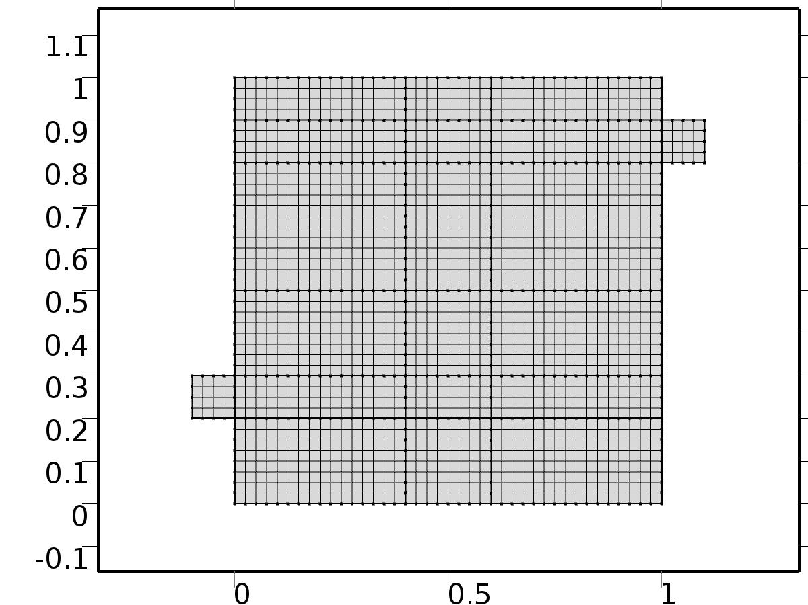

Mesh 1

* + 1. Size (size)

Settings

| **Description** | **Value** |
| --- | --- |
| Maximum element size | 0.0804 |
| Minimum element size | 3.6E-4 |
| Curvature factor | 0.3 |
| Maximum element growth rate | 1.3 |

* + 1. Edge 1 (edg1)

Selection

|  |  |
| --- | --- |
| Geometric entity level | Boundary |
| Selection | Boundaries 1–51 |

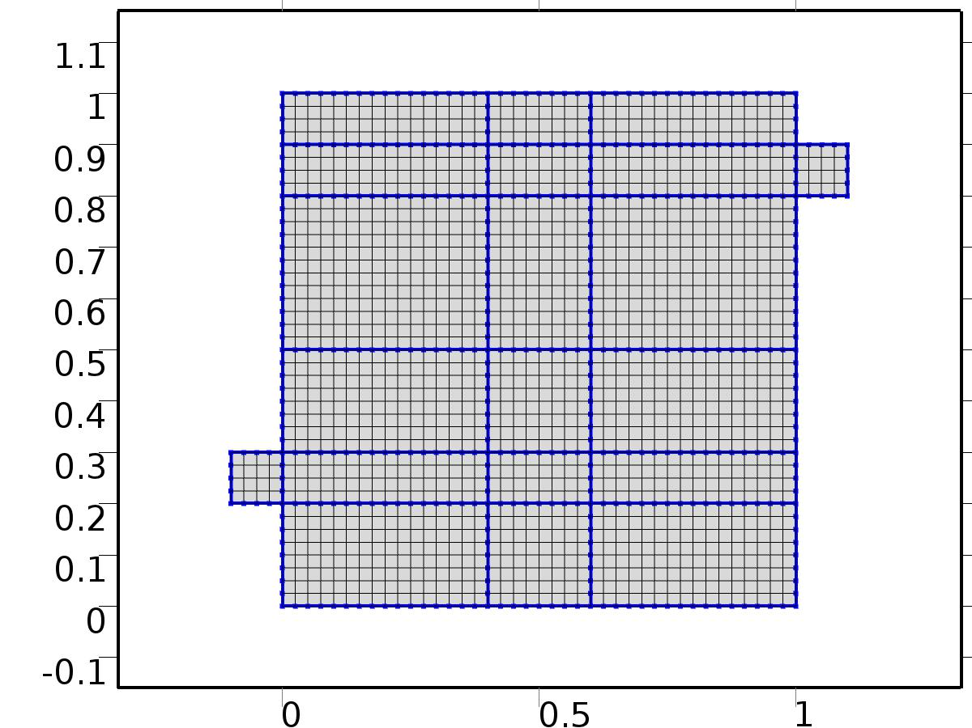

Edge 1

#### Size 1 (size1)

Selection

|  |  |
| --- | --- |
| Geometric entity level | Boundary |
| Selection | Boundaries 1–51 |



Size 1

Settings

| **Description** | **Value** |
| --- | --- |
| Maximum element size | H/4 |
| Minimum element size | H/4 |
| Curvature factor | 0.3 |
| Curvature factor | Off |
| Resolution of narrow regions | Off |
| Maximum element growth rate | 1.3 |
| Maximum element growth rate | Off |
| Custom element size | Custom |

* + 1. Mapped 1 (map1)

Selection

|  |  |
| --- | --- |
| Geometric entity level | Domain |
| Selection | Domains 1–20 |

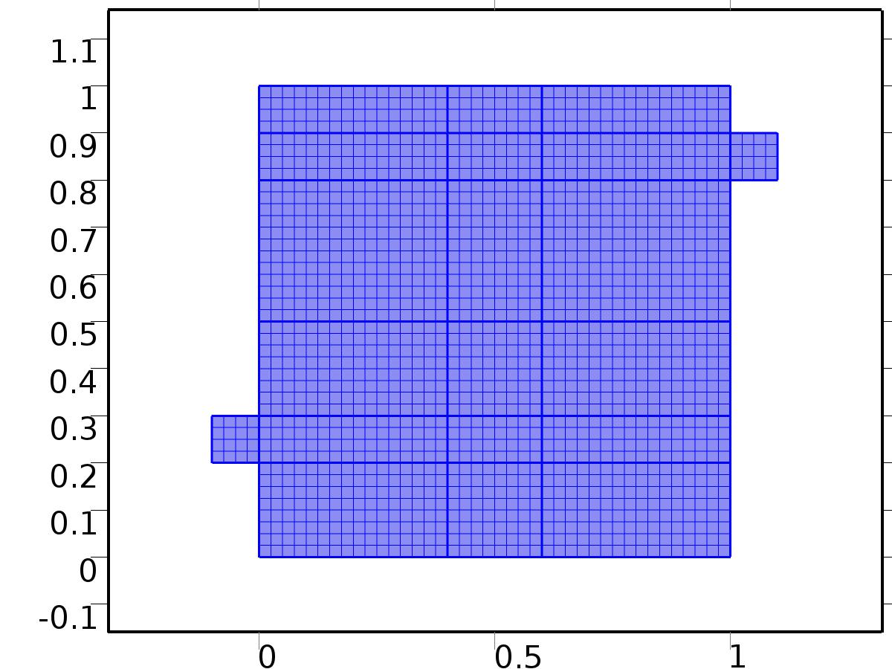

Mapped 1

1. Study 1
   1. Stationary

Study settings

| **Description** | **Value** |
| --- | --- |
| Include geometric nonlinearity | Off |

Physics and variables selection

| **Physics interface** | **Discretization** |
| --- | --- |
| Steady Flow (spf) | physics |
| Unit Input (c) | physics |

Mesh selection

| **Geometry** | **Mesh** |
| --- | --- |
| Geometry 1 (geom1) | mesh1 |

* 1. Solver Configurations
     1. Solver 1

#### Compile Equations: Stationary (st1)

Study and step

| **Description** | **Value** |
| --- | --- |
| Use study | Study 1 |
| Use study step | Stationary |

#### Dependent Variables 1 (v1)

General

| **Description** | **Value** |
| --- | --- |
| Defined by study step | Stationary |
| Constant |  |

Initial values of variables solved for

| **Description** | **Value** |
| --- | --- |
| Solution | Zero |

Values of variables not solved for

| **Description** | **Value** |
| --- | --- |
| Solution | Zero |

##### Dependent variable tZ (comp1.tZ) (comp1_tZ)

General

| **Description** | **Value** |
| --- | --- |
| Field components | comp1.tZ |
| Solve for this field | Off |

##### Pressure (comp1.bP) (comp1_bP)

General

| **Description** | **Value** |
| --- | --- |
| Field components | comp1.bP |
| Solve for this field | Off |

##### Dependent variable bT1 (comp1.bT1) (comp1_bT1)

General

| **Description** | **Value** |
| --- | --- |
| Field components | comp1.bT1 |
| Solve for this field | Off |
| Field name | comp1_T |

##### Pressure (comp1.P) (comp1_P)

General

| **Description** | **Value** |
| --- | --- |
| Field components | comp1.P |

##### Pressure (comp1.bp) (comp1_bp)

General

| **Description** | **Value** |
| --- | --- |
| Field components | comp1.bp |
| Solve for this field | Off |
| Field name | comp1_p |

##### Velocity field (comp1.bV) (comp1_bV)

General

| **Description** | **Value** |
| --- | --- |
| Field components | {comp1.bU, comp1.bV} |
| Solve for this field | Off |

##### Velocity field (comp1.bu) (comp1_bu)

General

| **Description** | **Value** |
| --- | --- |
| Field components | {comp1.bu, comp1.bv} |
| Solve for this field | Off |
| Field name | comp1_u |

##### Dependent variable X (comp1.X) (comp1_X)

General

| **Description** | **Value** |
| --- | --- |
| Field components | comp1.X |

##### Velocity field (comp1.U) (comp1_U)

General

| **Description** | **Value** |
| --- | --- |
| Field components | {comp1.U, comp1.V} |

##### Dependent variable bZ (comp1.bZ) (comp1_bZ)

General

| **Description** | **Value** |
| --- | --- |
| Field components | comp1.bZ |
| Solve for this field | Off |

##### Dependent variable tT1 (comp1.tT1) (comp1_tT1)

General

| **Description** | **Value** |
| --- | --- |
| Field components | comp1.tT1 |
| Solve for this field | Off |
| Field name | comp1_bT2 |

##### Pressure (comp1.p) (comp1_p)

General

| **Description** | **Value** |
| --- | --- |
| Field components | comp1.p |
| Solve for this field | Off |

##### Velocity field (comp1.u) (comp1_u)

General

| **Description** | **Value** |
| --- | --- |
| Field components | {comp1.u, comp1.v} |
| Solve for this field | Off |

##### Dependent variable T (comp1.T) (comp1_T)

General

| **Description** | **Value** |
| --- | --- |
| Field components | comp1.T |
| Solve for this field | Off |
| Field name | comp1_u2 |

##### Dependent variable bT2 (comp1.bT2) (comp1_bT2)

General

| **Description** | **Value** |
| --- | --- |
| Field components | comp1.bT2 |
| Solve for this field | Off |
| Field name | comp1_u2 |

##### Dependent variable tT2 (comp1.tT2) (comp1_tT2)

General

| **Description** | **Value** |
| --- | --- |
| Field components | comp1.tT2 |
| Solve for this field | Off |
| Field name | comp1_bT22 |

#### Stationary Solver 1 (s1)

General

| **Description** | **Value** |
| --- | --- |
| Defined by study step | Stationary |
| Relative tolerance | 0.0010 |

Log

| **Description** | **Value** |
| --- | --- |
| Constant |  |

##### Fully Coupled 1 (fc1)

General

| **Description** | **Value** |
| --- | --- |
| Linear solver | Direct 1 |

Method and termination

| **Description** | **Value** |
| --- | --- |
| Initial damping factor | 0.01 |
| Minimum damping factor | 1.0E-6 |

1. Study 2
   1. Stationary

Study settings

| **Description** | **Value** |
| --- | --- |
| Include geometric nonlinearity | Off |

Physics and variables selection

| **Physics interface** | **Discretization** |
| --- | --- |
| Set Point Flow (phys1) | physics |
| Set Point Temperature (phys2) | physics |

Mesh selection

| **Geometry** | **Mesh** |
| --- | --- |
| Geometry 1 (geom1) | mesh1 |

* 1. Solver Configurations
     1. Solver 2

#### Compile Equations: Stationary (st1)

Study and step

| **Description** | **Value** |
| --- | --- |
| Use study | Study 2 |
| Use study step | Stationary |

#### Dependent Variables 1 (v1)

General

| **Description** | **Value** |
| --- | --- |
| Defined by study step | Stationary |
| Constant |  |

Initial values of variables solved for

| **Description** | **Value** |
| --- | --- |
| Solution | Solver 1 |

Values of variables not solved for

| **Description** | **Value** |
| --- | --- |
| Method | Solution |
| Solution | Solver 1 |

##### Dependent variable tZ (comp1.tZ) (comp1_tZ)

General

| **Description** | **Value** |
| --- | --- |
| Field components | comp1.tZ |

##### Pressure (comp1.bP) (comp1_bP)

General

| **Description** | **Value** |
| --- | --- |
| Field components | comp1.bP |

##### Dependent variable bT1 (comp1.bT1) (comp1_bT1)

General

| **Description** | **Value** |
| --- | --- |
| Field components | comp1.bT1 |
| Solve for this field | Off |
| Field name | comp1_T |

##### Pressure (comp1.P) (comp1_P)

General

| **Description** | **Value** |
| --- | --- |
| Field components | comp1.P |
| Solve for this field | Off |

##### Pressure (comp1.bp) (comp1_bp)

General

| **Description** | **Value** |
| --- | --- |
| Field components | comp1.bp |
| Solve for this field | Off |
| Field name | comp1_p |

##### Velocity field (comp1.bV) (comp1_bV)

General

| **Description** | **Value** |
| --- | --- |
| Field components | {comp1.bU, comp1.bV} |

##### Velocity field (comp1.bu) (comp1_bu)

General

| **Description** | **Value** |
| --- | --- |
| Field components | {comp1.bu, comp1.bv} |
| Solve for this field | Off |
| Field name | comp1_u |

##### Dependent variable X (comp1.X) (comp1_X)

General

| **Description** | **Value** |
| --- | --- |
| Field components | comp1.X |
| Solve for this field | Off |

##### Velocity field (comp1.U) (comp1_U)

General

| **Description** | **Value** |
| --- | --- |
| Field components | {comp1.U, comp1.V} |
| Solve for this field | Off |

##### Dependent variable bZ (comp1.bZ) (comp1_bZ)

General

| **Description** | **Value** |
| --- | --- |
| Field components | comp1.bZ |

##### Dependent variable tT1 (comp1.tT1) (comp1_tT1)

General

| **Description** | **Value** |
| --- | --- |
| Field components | comp1.tT1 |
| Solve for this field | Off |
| Field name | comp1_bT2 |

##### Pressure (comp1.p) (comp1_p)

General

| **Description** | **Value** |
| --- | --- |
| Field components | comp1.p |
| Solve for this field | Off |

##### Velocity field (comp1.u) (comp1_u)

General

| **Description** | **Value** |
| --- | --- |
| Field components | {comp1.u, comp1.v} |
| Solve for this field | Off |

##### Dependent variable T (comp1.T) (comp1_T)

General

| **Description** | **Value** |
| --- | --- |
| Field components | comp1.T |
| Solve for this field | Off |
| Field name | comp1_u2 |

##### Dependent variable bT2 (comp1.bT2) (comp1_bT2)

General

| **Description** | **Value** |
| --- | --- |
| Field components | comp1.bT2 |
| Solve for this field | Off |
| Field name | comp1_u2 |

##### Dependent variable tT2 (comp1.tT2) (comp1_tT2)

General

| **Description** | **Value** |
| --- | --- |
| Field components | comp1.tT2 |
| Solve for this field | Off |
| Field name | comp1_bT22 |

#### Stationary Solver 1 (s1)

General

| **Description** | **Value** |
| --- | --- |
| Defined by study step | Stationary |
| Relative tolerance | 0.0010 |

Log

| **Description** | **Value** |
| --- | --- |
| Constant |  |

##### Fully Coupled 1 (fc1)

General

| **Description** | **Value** |
| --- | --- |
| Linear solver | Direct 1 |

1. Study 3
   1. Time Dependent

Study settings

| **Description** | **Value** |
| --- | --- |
| Include geometric nonlinearity | Off |

| **Times** | **Unit** |
| --- | --- |
| range(0,10,3000) | s |

Physics and variables selection

| **Physics interface** | **Discretization** |
| --- | --- |
| Piecewise Constant Flow (phys3) | physics |
| beta iteration 1 (phys4) | physics |
| beta iteration 2 (phys7) | physics |
| Closed Loop Flow (phys5) | physics |
| Closed Loop Temperature (phys6) | physics |

Mesh selection

| **Geometry** | **Mesh** |
| --- | --- |
| Geometry 1 (geom1) | mesh1 |

* 1. Solver Configurations
     1. Solver 3

#### Compile Equations: Time Dependent (st1)

Study and step

| **Description** | **Value** |
| --- | --- |
| Use study | Study 3 |
| Use study step | Time Dependent |

#### Dependent Variables 1 (v1)

General

| **Description** | **Value** |
| --- | --- |
| Defined by study step | Time Dependent |
| Constant |  |

Initial values of variables solved for

| **Description** | **Value** |
| --- | --- |
| Solution | Solver 2 |

Values of variables not solved for

| **Description** | **Value** |
| --- | --- |
| Method | Solution |
| Solution | Solver 2 |

##### Dependent variable bT1 (comp1.bT1) (comp1_bT1)

General

| **Description** | **Value** |
| --- | --- |
| Field components | comp1.bT1 |
| Field name | comp1_T |

##### Pressure (comp1.bP) (comp1_bP)

General

| **Description** | **Value** |
| --- | --- |
| Field components | comp1.bP |
| Solve for this field | Off |
| Field name | comp1_bp |

##### Dependent variable bZ (comp1.bZ) (comp1_bZ)

General

| **Description** | **Value** |
| --- | --- |
| Field components | comp1.bZ |
| Solve for this field | Off |
| Field name | comp1_bT |

##### Pressure (comp1.P) (comp1_P)

General

| **Description** | **Value** |
| --- | --- |
| Field components | comp1.P |
| Solve for this field | Off |

##### Pressure (comp1.bp) (comp1_bp)

General

| **Description** | **Value** |
| --- | --- |
| Field components | comp1.bp |
| Field name | comp1_p |

##### Velocity field (comp1.bV) (comp1_bV)

General

| **Description** | **Value** |
| --- | --- |
| Field components | {comp1.bU, comp1.bV} |
| Solve for this field | Off |
| Field name | comp1_bu |

##### Dependent variable tZ (comp1.tZ) (comp1_tZ)

General

| **Description** | **Value** |
| --- | --- |
| Field components | comp1.tZ |
| Solve for this field | Off |
| Field name | comp1_tT |

##### Velocity field (comp1.bu) (comp1_bu)

General

| **Description** | **Value** |
| --- | --- |
| Field components | {comp1.bu, comp1.bv} |
| Field name | comp1_u |

##### Dependent variable X (comp1.X) (comp1_X)

General

| **Description** | **Value** |
| --- | --- |
| Field components | comp1.X |
| Solve for this field | Off |

##### Velocity field (comp1.U) (comp1_U)

General

| **Description** | **Value** |
| --- | --- |
| Field components | {comp1.U, comp1.V} |
| Solve for this field | Off |

##### Dependent variable tT1 (comp1.tT1) (comp1_tT1)

General

| **Description** | **Value** |
| --- | --- |
| Field components | comp1.tT1 |
| Field name | comp1_bT2 |

##### Pressure (comp1.p) (comp1_p)

General

| **Description** | **Value** |
| --- | --- |
| Field components | comp1.p |

##### Velocity field (comp1.u) (comp1_u)

General

| **Description** | **Value** |
| --- | --- |
| Field components | {comp1.u, comp1.v} |

##### Dependent variable T (comp1.T) (comp1_T)

General

| **Description** | **Value** |
| --- | --- |
| Field components | comp1.T |
| Field name | comp1_u2 |

##### Dependent variable bT2 (comp1.bT2) (comp1_bT2)

General

| **Description** | **Value** |
| --- | --- |
| Field components | comp1.bT2 |
| Field name | comp1_u2 |

##### Dependent variable tT2 (comp1.tT2) (comp1_tT2)

General

| **Description** | **Value** |
| --- | --- |
| Field components | comp1.tT2 |
| Field name | comp1_bT22 |

#### Time-Dependent Solver 1 (t1)

General

| **Description** | **Value** |
| --- | --- |
| Defined by study step | Time Dependent |
| Time | {0, 10, 20, 30, 40, 50, 60, 70, 80, 90, 100, 110, 120, 130, 140, 150, 160, 170, 180, 190, 200, 210, 220, 230, 240, 250, 260, 270, 280, 290, 300, 310, 320, 330, 340, 350, 360, 370, 380, 390, 400, 410, 420, 430, 440, 450, 460, 470, 480, 490, 500, 510, 520, 530, 540, 550, 560, 570, 580, 590, 600, 610, 620, 630, 640, 650, 660, 670, 680, 690, 700, 710, 720, 730, 740, 750, 760, 770, 780, 790, 800, 810, 820, 830, 840, 850, 860, 870, 880, 890, 900, 910, 920, 930, 940, 950, 960, 970, 980, 990, 1000, 1010, 1020, 1030, 1040, 1050, 1060, 1070, 1080, 1090, 1100, 1110, 1120, 1130, 1140, 1150, 1160, 1170, 1180, 1190, 1200, 1210, 1220, 1230, 1240, 1250, 1260, 1270, 1280, 1290, 1300, 1310, 1320, 1330, 1340, 1350, 1360, 1370, 1380, 1390, 1400, 1410, 1420, 1430, 1440, 1450, 1460, 1470, 1480, 1490, 1500, 1510, 1520, 1530, 1540, 1550, 1560, 1570, 1580, 1590, 1600, 1610, 1620, 1630, 1640, 1650, 1660, 1670, 1680, 1690, 1700, 1710, 1720, 1730, 1740, 1750, 1760, 1770, 1780, 1790, 1800, 1810, 1820, 1830, 1840, 1850, 1860, 1870, 1880, 1890, 1900, 1910, 1920, 1930, 1940, 1950, 1960, 1970, 1980, 1990, 2000, 2010, 2020, 2030, 2040, 2050, 2060, 2070, 2080, 2090, 2100, 2110, 2120, 2130, 2140, 2150, 2160, 2170, 2180, 2190, 2200, 2210, 2220, 2230, 2240, 2250, 2260, 2270, 2280, 2290, 2300, 2310, 2320, 2330, 2340, 2350, 2360, 2370, 2380, 2390, 2400, 2410, 2420, 2430, 2440, 2450, 2460, 2470, 2480, 2490, 2500, 2510, 2520, 2530, 2540, 2550, 2560, 2570, 2580, 2590, 2600, 2610, 2620, 2630, 2640, 2650, 2660, 2670, 2680, 2690, 2700, 2710, 2720, 2730, 2740, 2750, 2760, 2770, 2780, 2790, 2800, 2810, 2820, 2830, 2840, 2850, 2860, 2870, 2880, 2890, 2900, 2910, 2920, 2930, 2940, 2950, 2960, 2970, 2980, 2990, 3000} |

Absolute tolerance

| **Description** | **Value** |
| --- | --- |
| Tolerance | 5.0E-4 |

Time stepping

| **Description** | **Value** |
| --- | --- |
| Initial step | 0.0010 |

Advanced

| **Description** | **Value** |
| --- | --- |
| Fraction of initial step for Backward Euler | 0.0010 |

Log

| **Description** | **Value** |
| --- | --- |
| Constant |  |

##### Fully Coupled 1 (fc1)

General

| **Description** | **Value** |
| --- | --- |
| Linear solver | Direct 1 |

Method and termination

| **Description** | **Value** |
| --- | --- |
| Jacobian update | Once per time step |
| Maximum number of iterations | 6 |

1. Results
   1. Data Sets
      1. Solution 1

Solution

| **Description** | **Value** |
| --- | --- |
| Solution | Solver 1 |
| Component | Save Point Geometry 1 |

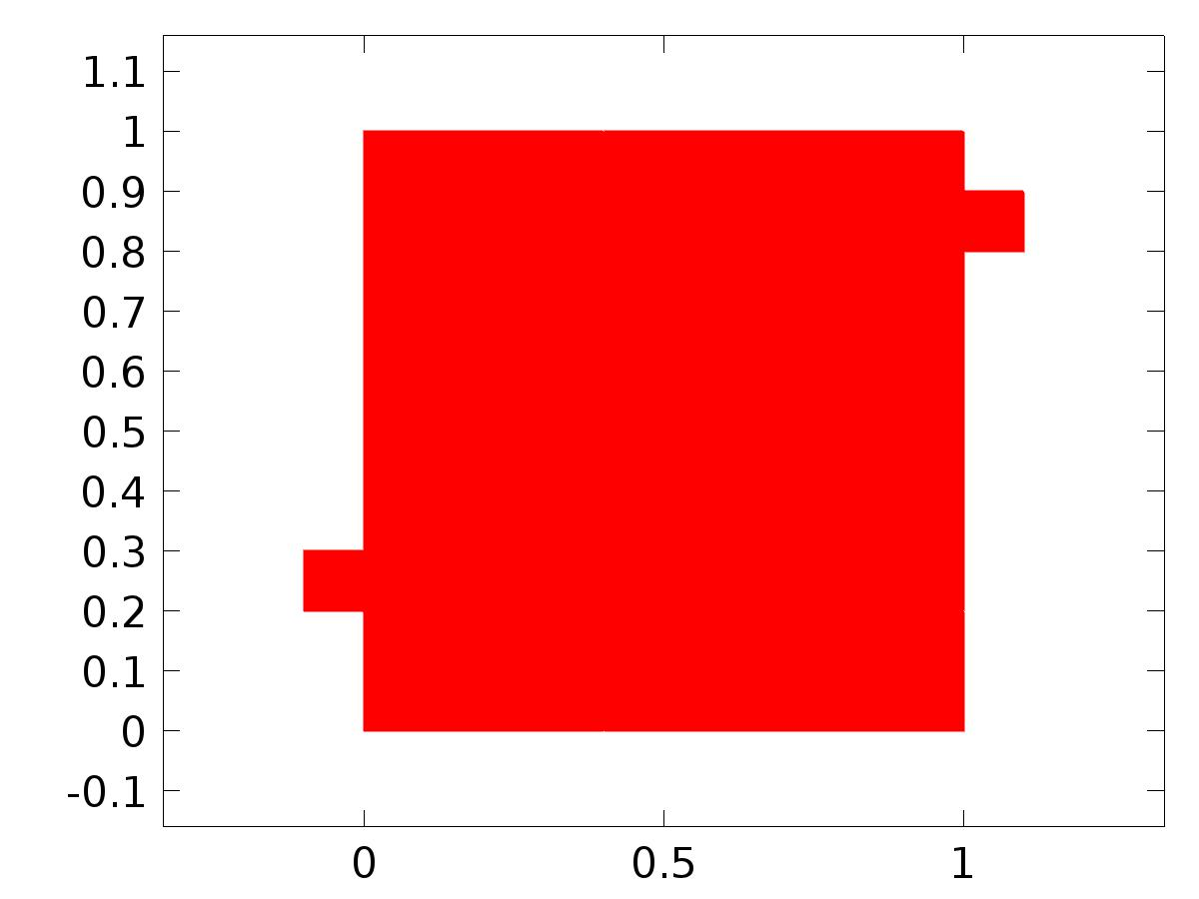

Data set: Solution 1

* + 1. Solution 2

Solution

| **Description** | **Value** |
| --- | --- |
| Solution | Solver 2 |
| Component | Save Point Geometry 1 |



Data set: Solution 2

* + 1. Solution 3

Solution

| **Description** | **Value** |
| --- | --- |
| Solution | Solver 3 |
| Component | Save Point Geometry 1 |



Data set: Solution 3

* 1. Derived Values
     1. Global Evaluation 1

Data

| **Description** | **Value** |
| --- | --- |
| Data set | Solution 2 |

Expression

| **Description** | **Value** |
| --- | --- |
| Expression | C(bT) |
| Description | C(bT) |

* + 1. Global Evaluation 2

Data

| **Description** | **Value** |
| --- | --- |
| Data set | Solution 3 |

Expression

| **Description** | **Value** |
| --- | --- |
| Expression | C(T) |
| Description | C(T) |

* + 1. Global Evaluation 3

Data

| **Description** | **Value** |
| --- | --- |
| Data set | Solution 3 |

Expression

| **Description** | **Value** |
| --- | --- |
| Expression | e |

* 1. Tables
     1. Table 1

Global Evaluation 1 (C(bT))

Table 1

| **C(bT)** | **C(bT)** |
| --- | --- |
| 0.50000 | 0.50000 |

* + 1. Table 2

Global Evaluation 1 (C(bT))

Table 2

| **C(bT)** |
| --- |
| 0.50000 |

* + 1. Table 3

Global Evaluation 2 (C(T))

* + 1. Table 4

Global Evaluation 3 (C(T))

Table 4

| **Time (s)** | **C(T)** | **yr** | **C(bT1)** | **C(bT1+bT2)** | **d** | **gamma** | **e1** | **e2** | **e** |
| --- | --- | --- | --- | --- | --- | --- | --- | --- | --- |
| 0.0000 | 4.9604E-22 | 0.25000 | 0.25000 | 0.25000 | 0.75000 | -3.6130E-5 | 9.1821E-8 | 9.1821E-8 | 0.25000 |
| 10.000 | 0.12003 | 0.25000 | 0.24923 | 0.24924 | 0.73953 | -3.3773E-5 | 7.6561E-4 | 7.6303E-4 | 0.12997 |
| 20.000 | 0.17839 | 0.25000 | 0.24705 | 0.24723 | 0.72908 | -2.8790E-5 | 0.0029534 | 0.0027651 | 0.071611 |
| 30.000 | 0.20120 | 0.25000 | 0.24484 | 0.24580 | 0.71867 | -2.4325E-5 | 0.0051562 | 0.0041966 | 0.048803 |
| 40.000 | 0.21085 | 0.25000 | 0.24322 | 0.24558 | 0.70831 | -2.1586E-5 | 0.0067785 | 0.0044244 | 0.039152 |
| 50.000 | 0.21573 | 0.25000 | 0.24227 | 0.24635 | 0.69802 | -2.0488E-5 | 0.0077288 | 0.0036451 | 0.034267 |
| 60.000 | 0.21893 | 0.25000 | 0.24189 | 0.24767 | 0.68783 | -2.0486E-5 | 0.0081114 | 0.0023314 | 0.031067 |
| 70.000 | 0.22134 | 0.25000 | 0.24191 | 0.24908 | 0.67774 | -2.1001E-5 | 0.0080892 | 9.2322E-4 | 0.028665 |
| 80.000 | 0.22347 | 0.25000 | 0.24216 | 0.25018 | 0.66778 | -2.1478E-5 | 0.0078426 | -1.8215E-4 | 0.026533 |
| 90.000 | 0.22515 | 0.25000 | 0.24247 | 0.25079 | 0.65797 | -2.1573E-5 | 0.0075297 | -7.9117E-4 | 0.024854 |
| 100.00 | 0.22625 | 0.25000 | 0.24277 | 0.25099 | 0.64832 | -2.1289E-5 | 0.0072310 | -9.9465E-4 | 0.023749 |
| 110.00 | 0.22703 | 0.25000 | 0.24303 | 0.25094 | 0.63884 | -2.0736E-5 | 0.0069732 | -9.3765E-4 | 0.022971 |
| 120.00 | 0.22765 | 0.25000 | 0.24324 | 0.25076 | 0.62956 | -2.0042E-5 | 0.0067587 | -7.5890E-4 | 0.022353 |
| 130.00 | 0.22822 | 0.25000 | 0.24342 | 0.25057 | 0.62049 | -1.9321E-5 | 0.0065770 | -5.6560E-4 | 0.021779 |
| 140.00 | 0.22882 | 0.25000 | 0.24359 | 0.25042 | 0.61165 | -1.8651E-5 | 0.0064117 | -4.2193E-4 | 0.021182 |
| 150.00 | 0.22946 | 0.25000 | 0.24375 | 0.25035 | 0.60305 | -1.8072E-5 | 0.0062470 | -3.5226E-4 | 0.020539 |
| 160.00 | 0.23014 | 0.25000 | 0.24393 | 0.25035 | 0.59471 | -1.7586E-5 | 0.0060722 | -3.4540E-4 | 0.019860 |
| 170.00 | 0.23083 | 0.25000 | 0.24412 | 0.25038 | 0.58664 | -1.7176E-5 | 0.0058823 | -3.7692E-4 | 0.019168 |
| 180.00 | 0.23151 | 0.25000 | 0.24432 | 0.25042 | 0.57886 | -1.6818E-5 | 0.0056776 | -4.2105E-4 | 0.018487 |
| 190.00 | 0.23216 | 0.25000 | 0.24454 | 0.25046 | 0.57138 | -1.6491E-5 | 0.0054632 | -4.5855E-4 | 0.017839 |
| 200.00 | 0.23277 | 0.25000 | 0.24475 | 0.25048 | 0.56421 | -1.6173E-5 | 0.0052491 | -4.7911E-4 | 0.017231 |
| 210.00 | 0.23334 | 0.25000 | 0.24497 | 0.25049 | 0.55737 | -1.5879E-5 | 0.0050329 | -4.8874E-4 | 0.016658 |
| 220.00 | 0.23389 | 0.25000 | 0.24518 | 0.25049 | 0.55087 | -1.5602E-5 | 0.0048165 | -4.9215E-4 | 0.016111 |
| 230.00 | 0.23441 | 0.25000 | 0.24540 | 0.25049 | 0.54471 | -1.5360E-5 | 0.0045973 | -4.9440E-4 | 0.015586 |
| 240.00 | 0.23491 | 0.25000 | 0.24562 | 0.25049 | 0.53892 | -1.5142E-5 | 0.0043824 | -4.9076E-4 | 0.015094 |
| 250.00 | 0.23540 | 0.25000 | 0.24584 | 0.25049 | 0.53349 | -1.4943E-5 | 0.0041634 | -4.9011E-4 | 0.014605 |
| 260.00 | 0.23588 | 0.25000 | 0.24607 | 0.25050 | 0.52845 | -1.4814E-5 | 0.0039285 | -5.0093E-4 | 0.014124 |
| 270.00 | 0.23635 | 0.25000 | 0.24632 | 0.25052 | 0.52379 | -1.4729E-5 | 0.0036815 | -5.1838E-4 | 0.013648 |
| 280.00 | 0.23682 | 0.25000 | 0.24658 | 0.25054 | 0.51953 | -1.4691E-5 | 0.0034223 | -5.4102E-4 | 0.013179 |
| 290.00 | 0.23728 | 0.25000 | 0.24685 | 0.25056 | 0.51568 | -1.4696E-5 | 0.0031533 | -5.6344E-4 | 0.012725 |
| 300.00 | 0.23772 | 0.25000 | 0.24713 | 0.25059 | 0.51224 | -1.4744E-5 | 0.0028742 | -5.8700E-4 | 0.012281 |
| 310.00 | 0.23815 | 0.25000 | 0.24741 | 0.25061 | 0.50921 | -1.4830E-5 | 0.0025872 | -6.0863E-4 | 0.011851 |
| 320.00 | 0.23856 | 0.25000 | 0.24770 | 0.25062 | 0.50661 | -1.4947E-5 | 0.0022966 | -6.2415E-4 | 0.011439 |
| 330.00 | 0.23895 | 0.25000 | 0.24799 | 0.25063 | 0.50443 | -1.5088E-5 | 0.0020069 | -6.3130E-4 | 0.011048 |
| 340.00 | 0.23933 | 0.25000 | 0.24828 | 0.25063 | 0.50268 | -1.5253E-5 | 0.0017179 | -6.3363E-4 | 0.010672 |
| 350.00 | 0.23970 | 0.25000 | 0.24858 | 0.25064 | 0.50137 | -1.5464E-5 | 0.0014212 | -6.4023E-4 | 0.010300 |
| 360.00 | 0.24005 | 0.25000 | 0.24887 | 0.25064 | 0.50049 | -1.5704E-5 | 0.0011268 | -6.4117E-4 | 0.0099475 |
| 370.00 | 0.24038 | 0.25000 | 0.24915 | 0.25063 | 0.50005 | -1.5945E-5 | 8.4618E-4 | -6.2886E-4 | 0.0096196 |
| 380.00 | 0.24069 | 0.25000 | 0.24943 | 0.25061 | 0.50005 | -1.6205E-5 | 5.7477E-4 | -6.1157E-4 | 0.0093066 |
| 390.00 | 0.24099 | 0.25000 | 0.24968 | 0.25059 | 0.50049 | -1.6488E-5 | 3.1843E-4 | -5.9112E-4 | 0.0090114 |
| 400.00 | 0.24127 | 0.25000 | 0.24993 | 0.25057 | 0.50137 | -1.6780E-5 | 7.1933E-5 | -5.6833E-4 | 0.0087267 |
| 410.00 | 0.24156 | 0.25000 | 0.25018 | 0.25056 | 0.50268 | -1.7123E-5 | -1.8107E-4 | -5.5671E-4 | 0.0084386 |
| 420.00 | 0.24185 | 0.25000 | 0.25044 | 0.25055 | 0.50443 | -1.7504E-5 | -4.3953E-4 | -5.5389E-4 | 0.0081477 |
| 430.00 | 0.24215 | 0.25000 | 0.25071 | 0.25057 | 0.50661 | -1.7959E-5 | -7.1330E-4 | -5.6635E-4 | 0.0078515 |
| 440.00 | 0.24244 | 0.25000 | 0.25100 | 0.25059 | 0.50921 | -1.8459E-5 | -9.9674E-4 | -5.8504E-4 | 0.0075558 |
| 450.00 | 0.24273 | 0.25000 | 0.25129 | 0.25060 | 0.51224 | -1.8997E-5 | -0.0012862 | -6.0384E-4 | 0.0072679 |
| 460.00 | 0.24301 | 0.25000 | 0.25158 | 0.25062 | 0.51568 | -1.9562E-5 | -0.0015758 | -6.1682E-4 | 0.0069935 |
| 470.00 | 0.24327 | 0.25000 | 0.25186 | 0.25062 | 0.51953 | -2.0148E-5 | -0.0018624 | -6.2230E-4 | 0.0067342 |
| 480.00 | 0.24352 | 0.25000 | 0.25215 | 0.25063 | 0.52379 | -2.0763E-5 | -0.0021495 | -6.2588E-4 | 0.0064830 |
| 490.00 | 0.24376 | 0.25000 | 0.25243 | 0.25062 | 0.52845 | -2.1403E-5 | -0.0024333 | -6.2450E-4 | 0.0062449 |
| 500.00 | 0.24398 | 0.25000 | 0.25271 | 0.25062 | 0.53349 | -2.2060E-5 | -0.0027102 | -6.1728E-4 | 0.0060197 |
| 510.00 | 0.24419 | 0.25000 | 0.25297 | 0.25060 | 0.53892 | -2.2728E-5 | -0.0029705 | -6.0128E-4 | 0.0058128 |
| 520.00 | 0.24438 | 0.25000 | 0.25322 | 0.25058 | 0.54471 | -2.3395E-5 | -0.0032151 | -5.7746E-4 | 0.0056205 |
| 530.00 | 0.24457 | 0.25000 | 0.25346 | 0.25056 | 0.55087 | -2.4099E-5 | -0.0034609 | -5.6103E-4 | 0.0054263 |
| 540.00 | 0.24477 | 0.25000 | 0.25371 | 0.25055 | 0.55737 | -2.4837E-5 | -0.0037079 | -5.5112E-4 | 0.0052308 |
| 550.00 | 0.24496 | 0.25000 | 0.25396 | 0.25055 | 0.56421 | -2.5616E-5 | -0.0039570 | -5.4847E-4 | 0.0050354 |
| 560.00 | 0.24516 | 0.25000 | 0.25421 | 0.25055 | 0.57138 | -2.6426E-5 | -0.0042051 | -5.4747E-4 | 0.0048448 |
| 570.00 | 0.24534 | 0.25000 | 0.25445 | 0.25055 | 0.57886 | -2.7256E-5 | -0.0044514 | -5.4644E-4 | 0.0046591 |
| 580.00 | 0.24552 | 0.25000 | 0.25469 | 0.25054 | 0.58664 | -2.8106E-5 | -0.0046950 | -5.4439E-4 | 0.0044797 |
| 590.00 | 0.24569 | 0.25000 | 0.25493 | 0.25054 | 0.59471 | -2.8981E-5 | -0.0049328 | -5.3970E-4 | 0.0043103 |
| 600.00 | 0.24585 | 0.25000 | 0.25517 | 0.25053 | 0.60305 | -2.9869E-5 | -0.0051654 | -5.3273E-4 | 0.0041480 |
| 610.00 | 0.24601 | 0.25000 | 0.25539 | 0.25052 | 0.61165 | -3.0769E-5 | -0.0053924 | -5.2353E-4 | 0.0039924 |
| 620.00 | 0.24615 | 0.25000 | 0.25561 | 0.25051 | 0.62049 | -3.1684E-5 | -0.0056113 | -5.1169E-4 | 0.0038455 |
| 630.00 | 0.24629 | 0.25000 | 0.25582 | 0.25050 | 0.62956 | -3.2609E-5 | -0.0058186 | -4.9631E-4 | 0.0037082 |
| 640.00 | 0.24642 | 0.25000 | 0.25602 | 0.25048 | 0.63884 | -3.3540E-5 | -0.0060195 | -4.7971E-4 | 0.0035758 |
| 650.00 | 0.24655 | 0.25000 | 0.25621 | 0.25046 | 0.64832 | -3.4483E-5 | -0.0062106 | -4.6214E-4 | 0.0034498 |
| 660.00 | 0.24667 | 0.25000 | 0.25639 | 0.25044 | 0.65797 | -3.5429E-5 | -0.0063863 | -4.4188E-4 | 0.0033328 |
| 670.00 | 0.24678 | 0.25000 | 0.25656 | 0.25042 | 0.66778 | -3.6376E-5 | -0.0065562 | -4.2059E-4 | 0.0032194 |
| 680.00 | 0.24689 | 0.25000 | 0.25671 | 0.25040 | 0.67774 | -3.7334E-5 | -0.0067124 | -4.0029E-4 | 0.0031117 |
| 690.00 | 0.24699 | 0.25000 | 0.25687 | 0.25038 | 0.68783 | -3.8295E-5 | -0.0068654 | -3.8023E-4 | 0.0030053 |
| 700.00 | 0.24708 | 0.25000 | 0.25698 | 0.25036 | 0.69802 | -3.9240E-5 | -0.0069780 | -3.5636E-4 | 0.0029160 |
| 710.00 | 0.24717 | 0.25000 | 0.25709 | 0.25033 | 0.70831 | -4.0184E-5 | -0.0070856 | -3.3203E-4 | 0.0028287 |
| 720.00 | 0.24726 | 0.25000 | 0.25719 | 0.25031 | 0.71867 | -4.1128E-5 | -0.0071932 | -3.0770E-4 | 0.0027414 |
| 730.00 | 0.24735 | 0.25000 | 0.25730 | 0.25028 | 0.72908 | -4.2074E-5 | -0.0073013 | -2.8431E-4 | 0.0026533 |
| 740.00 | 0.24745 | 0.25000 | 0.25742 | 0.25028 | 0.73953 | -4.3067E-5 | -0.0074203 | -2.7909E-4 | 0.0025510 |
| 750.00 | 0.24762 | 0.37500 | 0.25757 | 0.25035 | 0.75000 | 2.1084E-4 | 0.11743 | 0.12465 | 0.12738 |
| 760.00 | 0.29918 | 0.50000 | 0.28230 | 0.30179 | 0.76047 | 3.9321E-4 | 0.21770 | 0.19821 | 0.20082 |
| 770.00 | 0.43196 | 0.50000 | 0.34594 | 0.43450 | 0.77092 | 2.0324E-4 | 0.15406 | 0.065497 | 0.068036 |
| 780.00 | 0.55315 | 0.50000 | 0.41277 | 0.55565 | 0.78133 | 1.8957E-5 | 0.087229 | -0.055649 | -0.053147 |
| 790.00 | 0.61899 | 0.50000 | 0.46763 | 0.62151 | 0.79169 | -1.0112E-4 | 0.032367 | -0.12151 | -0.11899 |
| 800.00 | 0.62423 | 0.50000 | 0.50513 | 0.62670 | 0.80198 | -1.4534E-4 | -0.0051318 | -0.12670 | -0.12423 |
| 810.00 | 0.59210 | 0.50000 | 0.52377 | 0.59446 | 0.81217 | -1.3453E-4 | -0.023766 | -0.094463 | -0.092095 |
| 820.00 | 0.54820 | 0.50000 | 0.52797 | 0.55046 | 0.82226 | -9.7960E-5 | -0.027974 | -0.050457 | -0.048202 |
| 830.00 | 0.51050 | 0.50000 | 0.52436 | 0.51265 | 0.83222 | -5.9355E-5 | -0.024364 | -0.012652 | -0.010498 |
| 840.00 | 0.48679 | 0.50000 | 0.51813 | 0.48885 | 0.84203 | -3.1307E-5 | -0.018132 | 0.011147 | 0.013210 |
| 850.00 | 0.47700 | 0.50000 | 0.51226 | 0.47898 | 0.85168 | -1.6738E-5 | -0.012258 | 0.021022 | 0.023001 |
| 860.00 | 0.47722 | 0.50000 | 0.50801 | 0.47912 | 0.86116 | -1.3253E-5 | -0.0080119 | 0.020878 | 0.022785 |
| 870.00 | 0.48253 | 0.50000 | 0.50557 | 0.48437 | 0.87044 | -1.6416E-5 | -0.0055674 | 0.015631 | 0.017469 |
| 880.00 | 0.48914 | 0.50000 | 0.50459 | 0.49091 | 0.87951 | -2.2303E-5 | -0.0045933 | 0.0090872 | 0.010861 |
| 890.00 | 0.49471 | 0.50000 | 0.50452 | 0.49642 | 0.88835 | -2.8132E-5 | -0.0045227 | 0.0035755 | 0.0052866 |
| 900.00 | 0.49841 | 0.50000 | 0.50490 | 0.50006 | 0.89695 | -3.2642E-5 | -0.0048986 | -6.4192E-5 | 0.0015861 |
| 910.00 | 0.50023 | 0.50000 | 0.50535 | 0.50183 | 0.90529 | -3.5446E-5 | -0.0053543 | -0.0018252 | -2.3361E-4 |
| 920.00 | 0.50065 | 0.50000 | 0.50571 | 0.50219 | 0.91336 | -3.6809E-5 | -0.0057070 | -0.0021885 | -6.5464E-4 |
| 930.00 | 0.50026 | 0.50000 | 0.50588 | 0.50174 | 0.92114 | -3.7195E-5 | -0.0058752 | -0.0017378 | -2.5887E-4 |
| 940.00 | 0.49955 | 0.50000 | 0.50586 | 0.50098 | 0.92862 | -3.7077E-5 | -0.0058584 | -9.7682E-4 | 4.4787E-4 |
| 950.00 | 0.49888 | 0.50000 | 0.50571 | 0.50026 | 0.93579 | -3.6840E-5 | -0.0057124 | -2.5583E-4 | 0.0011174 |
| 960.00 | 0.49840 | 0.50000 | 0.50548 | 0.49972 | 0.94263 | -3.6660E-5 | -0.0054787 | 2.8168E-4 | 0.0016048 |
| 970.00 | 0.49813 | 0.50000 | 0.50521 | 0.49941 | 0.94913 | -3.6634E-5 | -0.0052124 | 5.9185E-4 | 0.0018670 |
| 980.00 | 0.49805 | 0.50000 | 0.50493 | 0.49927 | 0.95529 | -3.6734E-5 | -0.0049332 | 7.2531E-4 | 0.0019541 |
| 990.00 | 0.49808 | 0.50000 | 0.50466 | 0.49926 | 0.96108 | -3.6924E-5 | -0.0046607 | 7.3865E-4 | 0.0019230 |
| 1000.0 | 0.49816 | 0.50000 | 0.50439 | 0.49930 | 0.96651 | -3.7144E-5 | -0.0043941 | 6.9619E-4 | 0.0018376 |
| 1010.0 | 0.49826 | 0.50000 | 0.50413 | 0.49936 | 0.97155 | -3.7351E-5 | -0.0041324 | 6.4027E-4 | 0.0017403 |
| 1020.0 | 0.49834 | 0.50000 | 0.50388 | 0.49940 | 0.97621 | -3.7517E-5 | -0.0038780 | 5.9830E-4 | 0.0016589 |
| 1030.0 | 0.49841 | 0.50000 | 0.50363 | 0.49943 | 0.98047 | -3.7655E-5 | -0.0036341 | 5.6652E-4 | 0.0015893 |
| 1040.0 | 0.49846 | 0.50000 | 0.50339 | 0.49945 | 0.98432 | -3.7745E-5 | -0.0033893 | 5.4916E-4 | 0.0015355 |
| 1050.0 | 0.49850 | 0.50000 | 0.50313 | 0.49945 | 0.98776 | -3.7777E-5 | -0.0031335 | 5.4971E-4 | 0.0015006 |
| 1060.0 | 0.49851 | 0.50000 | 0.50285 | 0.49942 | 0.99079 | -3.7719E-5 | -0.0028520 | 5.7827E-4 | 0.0014949 |
| 1070.0 | 0.49849 | 0.50000 | 0.50254 | 0.49937 | 0.99339 | -3.7575E-5 | -0.0025427 | 6.2918E-4 | 0.0015127 |
| 1080.0 | 0.49846 | 0.50000 | 0.50222 | 0.49932 | 0.99557 | -3.7374E-5 | -0.0022157 | 6.8420E-4 | 0.0015358 |
| 1090.0 | 0.49846 | 0.50000 | 0.50189 | 0.49929 | 0.99732 | -3.7161E-5 | -0.0018909 | 7.1391E-4 | 0.0015352 |
| 1100.0 | 0.49849 | 0.50000 | 0.50158 | 0.49928 | 0.99863 | -3.6953E-5 | -0.0015797 | 7.1684E-4 | 0.0015088 |
| 1110.0 | 0.49853 | 0.50000 | 0.50128 | 0.49929 | 0.99951 | -3.6726E-5 | -0.0012787 | 7.0501E-4 | 0.0014691 |
| 1120.0 | 0.49858 | 0.50000 | 0.50099 | 0.49931 | 0.99995 | -3.6483E-5 | -9.8580E-4 | 6.8750E-4 | 0.0014247 |
| 1130.0 | 0.49861 | 0.50000 | 0.50069 | 0.49933 | 0.99995 | -3.6201E-5 | -6.9350E-4 | 6.7378E-4 | 0.0013850 |
| 1140.0 | 0.49864 | 0.50000 | 0.50039 | 0.49933 | 0.99951 | -3.5859E-5 | -3.9427E-4 | 6.7076E-4 | 0.0013572 |
| 1150.0 | 0.49866 | 0.50000 | 0.50009 | 0.49933 | 0.99863 | -3.5467E-5 | -8.8417E-5 | 6.7474E-4 | 0.0013372 |
| 1160.0 | 0.49867 | 0.50000 | 0.49977 | 0.49931 | 0.99732 | -3.5028E-5 | 2.2803E-4 | 6.8816E-4 | 0.0013273 |
| 1170.0 | 0.49866 | 0.50000 | 0.49943 | 0.49928 | 0.99557 | -3.4508E-5 | 5.6622E-4 | 7.1891E-4 | 0.0013353 |
| 1180.0 | 0.49864 | 0.50000 | 0.49908 | 0.49924 | 0.99339 | -3.3920E-5 | 9.2492E-4 | 7.6095E-4 | 0.0013555 |
| 1190.0 | 0.49863 | 0.50000 | 0.49871 | 0.49920 | 0.99079 | -3.3294E-5 | 0.0012909 | 7.9724E-4 | 0.0013707 |
| 1200.0 | 0.49863 | 0.50000 | 0.49835 | 0.49919 | 0.98776 | -3.2657E-5 | 0.0016505 | 8.1374E-4 | 0.0013670 |
| 1210.0 | 0.49866 | 0.50000 | 0.49800 | 0.49919 | 0.98432 | -3.2022E-5 | 0.0019962 | 8.0693E-4 | 0.0013406 |
| 1220.0 | 0.49870 | 0.50000 | 0.49767 | 0.49922 | 0.98047 | -3.1387E-5 | 0.0023254 | 7.8079E-4 | 0.0012957 |
| 1230.0 | 0.49876 | 0.50000 | 0.49736 | 0.49926 | 0.97621 | -3.0747E-5 | 0.0026387 | 7.4307E-4 | 0.0012399 |
| 1240.0 | 0.49882 | 0.50000 | 0.49706 | 0.49930 | 0.97155 | -3.0093E-5 | 0.0029377 | 7.0060E-4 | 0.0011801 |
| 1250.0 | 0.49888 | 0.50000 | 0.49678 | 0.49934 | 0.96651 | -2.9417E-5 | 0.0032250 | 6.5996E-4 | 0.0011227 |
| 1260.0 | 0.49893 | 0.50000 | 0.49650 | 0.49937 | 0.96108 | -2.8715E-5 | 0.0035030 | 6.2537E-4 | 0.0010720 |
| 1270.0 | 0.49897 | 0.50000 | 0.49623 | 0.49940 | 0.95529 | -2.7984E-5 | 0.0037730 | 5.9843E-4 | 0.0010296 |
| 1280.0 | 0.49901 | 0.50000 | 0.49596 | 0.49942 | 0.94913 | -2.7226E-5 | 0.0040352 | 5.7745E-4 | 9.9376E-4 |
| 1290.0 | 0.49904 | 0.50000 | 0.49571 | 0.49944 | 0.94263 | -2.6443E-5 | 0.0042909 | 5.6200E-4 | 9.6398E-4 |
| 1300.0 | 0.49906 | 0.50000 | 0.49546 | 0.49945 | 0.93579 | -2.5641E-5 | 0.0045391 | 5.4696E-4 | 9.3514E-4 |
| 1310.0 | 0.49909 | 0.50000 | 0.49522 | 0.49947 | 0.92862 | -2.4820E-5 | 0.0047795 | 5.3322E-4 | 9.0813E-4 |
| 1320.0 | 0.49912 | 0.50000 | 0.49499 | 0.49948 | 0.92114 | -2.3991E-5 | 0.0050091 | 5.1522E-4 | 8.7735E-4 |
| 1330.0 | 0.49916 | 0.50000 | 0.49477 | 0.49950 | 0.91336 | -2.3151E-5 | 0.0052288 | 4.9512E-4 | 8.4498E-4 |
| 1340.0 | 0.49919 | 0.50000 | 0.49456 | 0.49953 | 0.90529 | -2.2309E-5 | 0.0054352 | 4.7055E-4 | 8.0858E-4 |
| 1350.0 | 0.49923 | 0.50000 | 0.49437 | 0.49956 | 0.89695 | -2.1461E-5 | 0.0056297 | 4.4244E-4 | 7.6912E-4 |
| 1360.0 | 0.49927 | 0.50000 | 0.49419 | 0.49959 | 0.88835 | -2.0614E-5 | 0.0058097 | 4.1196E-4 | 7.2770E-4 |
| 1370.0 | 0.49932 | 0.50000 | 0.49402 | 0.49962 | 0.87951 | -1.9765E-5 | 0.0059761 | 3.7870E-4 | 6.8393E-4 |
| 1380.0 | 0.49936 | 0.50000 | 0.49387 | 0.49966 | 0.87044 | -1.8918E-5 | 0.0061281 | 3.4460E-4 | 6.3972E-4 |
| 1390.0 | 0.49941 | 0.50000 | 0.49373 | 0.49969 | 0.86116 | -1.8073E-5 | 0.0062658 | 3.0948E-4 | 5.9487E-4 |
| 1400.0 | 0.49945 | 0.50000 | 0.49361 | 0.49973 | 0.85168 | -1.7232E-5 | 0.0063882 | 2.7326E-4 | 5.4932E-4 |
| 1410.0 | 0.49950 | 0.50000 | 0.49351 | 0.49976 | 0.84203 | -1.6398E-5 | 0.0064945 | 2.3611E-4 | 5.0319E-4 |
| 1420.0 | 0.49954 | 0.50000 | 0.49342 | 0.49980 | 0.83222 | -1.5573E-5 | 0.0065849 | 1.9849E-4 | 4.5694E-4 |
| 1430.0 | 0.49959 | 0.50000 | 0.49334 | 0.49984 | 0.82226 | -1.4757E-5 | 0.0066595 | 1.6114E-4 | 4.1129E-4 |
| 1440.0 | 0.49963 | 0.50000 | 0.49328 | 0.49988 | 0.81217 | -1.3950E-5 | 0.0067187 | 1.2454E-4 | 3.6671E-4 |
| 1450.0 | 0.49968 | 0.50000 | 0.49324 | 0.49991 | 0.80198 | -1.3153E-5 | 0.0067636 | 8.9622E-5 | 3.2413E-4 |
| 1460.0 | 0.49972 | 0.50000 | 0.49321 | 0.49994 | 0.79169 | -1.2367E-5 | 0.0067944 | 5.6651E-5 | 2.8378E-4 |
| 1470.0 | 0.49975 | 0.50000 | 0.49319 | 0.49998 | 0.78133 | -1.1592E-5 | 0.0068116 | 2.4990E-5 | 2.4503E-4 |
| 1480.0 | 0.49979 | 0.50000 | 0.49318 | 0.50001 | 0.77092 | -1.0831E-5 | 0.0068154 | -5.0653E-6 | 2.0815E-4 |
| 1490.0 | 0.49983 | 0.50000 | 0.49319 | 0.50004 | 0.76047 | -1.0088E-5 | 0.0068052 | -3.5019E-5 | 1.7164E-4 |
| 1500.0 | 0.49986 | 0.50000 | 0.49322 | 0.50006 | 0.75000 | -9.3621E-6 | 0.0067813 | -6.4958E-5 | 1.3540E-4 |
| 1510.0 | 0.49990 | 0.50000 | 0.49326 | 0.50009 | 0.73953 | -8.6561E-6 | 0.0067444 | -9.4526E-5 | 9.9757E-5 |
| 1520.0 | 0.49994 | 0.50000 | 0.49331 | 0.50012 | 0.72908 | -7.9697E-6 | 0.0066939 | -1.2368E-4 | 6.4778E-5 |
| 1530.0 | 0.49997 | 0.50000 | 0.49337 | 0.50015 | 0.71867 | -7.3043E-6 | 0.0066299 | -1.5038E-4 | 3.2525E-5 |
| 1540.0 | 0.50000 | 0.50000 | 0.49345 | 0.50018 | 0.70831 | -6.6603E-6 | 0.0065540 | -1.7616E-4 | 1.4086E-6 |
| 1550.0 | 0.50003 | 0.50000 | 0.49353 | 0.50020 | 0.69802 | -6.0416E-6 | 0.0064652 | -2.0137E-4 | -2.8911E-5 |
| 1560.0 | 0.50006 | 0.50000 | 0.49363 | 0.50023 | 0.68783 | -5.4455E-6 | 0.0063655 | -2.2623E-4 | -5.8688E-5 |
| 1570.0 | 0.50009 | 0.50000 | 0.49375 | 0.50025 | 0.67774 | -4.8769E-6 | 0.0062534 | -2.5070E-4 | -8.7889E-5 |
| 1580.0 | 0.50012 | 0.50000 | 0.49387 | 0.50027 | 0.66778 | -4.3354E-6 | 0.0061298 | -2.7479E-4 | -1.1651E-4 |
| 1590.0 | 0.50014 | 0.50000 | 0.49400 | 0.50030 | 0.65797 | -3.8204E-6 | 0.0059955 | -2.9837E-4 | -1.4447E-4 |
| 1600.0 | 0.50017 | 0.50000 | 0.49415 | 0.50032 | 0.64832 | -3.3327E-6 | 0.0058507 | -3.2118E-4 | -1.7149E-4 |
| 1610.0 | 0.50020 | 0.50000 | 0.49430 | 0.50034 | 0.63884 | -2.8735E-6 | 0.0056957 | -3.4286E-4 | -1.9721E-4 |
| 1620.0 | 0.50022 | 0.50000 | 0.49447 | 0.50036 | 0.62956 | -2.4441E-6 | 0.0055307 | -3.6300E-4 | -2.2124E-4 |
| 1630.0 | 0.50024 | 0.50000 | 0.49464 | 0.50038 | 0.62049 | -2.0421E-6 | 0.0053573 | -3.8146E-4 | -2.4345E-4 |
| 1640.0 | 0.50026 | 0.50000 | 0.49482 | 0.50040 | 0.61165 | -1.6672E-6 | 0.0051764 | -3.9802E-4 | -2.6361E-4 |
| 1650.0 | 0.50028 | 0.50000 | 0.49501 | 0.50041 | 0.60305 | -1.3195E-6 | 0.0049888 | -4.1251E-4 | -2.8157E-4 |
| 1660.0 | 0.50030 | 0.50000 | 0.49520 | 0.50042 | 0.59471 | -9.9848E-7 | 0.0047953 | -4.2488E-4 | -2.9728E-4 |
| 1670.0 | 0.50031 | 0.50000 | 0.49540 | 0.50044 | 0.58664 | -7.0405E-7 | 0.0045969 | -4.3512E-4 | -3.1075E-4 |
| 1680.0 | 0.50032 | 0.50000 | 0.49561 | 0.50044 | 0.57886 | -4.3586E-7 | 0.0043944 | -4.4332E-4 | -3.2205E-4 |
| 1690.0 | 0.50033 | 0.50000 | 0.49581 | 0.50045 | 0.57138 | -1.9352E-7 | 0.0041887 | -4.4956E-4 | -3.3130E-4 |
| 1700.0 | 0.50034 | 0.50000 | 0.49602 | 0.50045 | 0.56421 | 2.3472E-8 | 0.0039805 | -4.5397E-4 | -3.3860E-4 |
| 1710.0 | 0.50034 | 0.50000 | 0.49623 | 0.50046 | 0.55737 | 2.1575E-7 | 0.0037706 | -4.5665E-4 | -3.4409E-4 |
| 1720.0 | 0.50035 | 0.50000 | 0.49644 | 0.50046 | 0.55087 | 3.8403E-7 | 0.0035597 | -4.5772E-4 | -3.4787E-4 |
| 1730.0 | 0.50035 | 0.50000 | 0.49665 | 0.50046 | 0.54471 | 5.2916E-7 | 0.0033486 | -4.5726E-4 | -3.5004E-4 |
| 1740.0 | 0.50035 | 0.50000 | 0.49686 | 0.50046 | 0.53892 | 6.4728E-7 | 0.0031379 | -4.5508E-4 | -3.5038E-4 |
| 1750.0 | 0.50035 | 0.50000 | 0.49707 | 0.50045 | 0.53349 | 7.4282E-7 | 0.0029286 | -4.5148E-4 | -3.4926E-4 |
| 1760.0 | 0.50035 | 0.50000 | 0.49728 | 0.50045 | 0.52845 | 8.1739E-7 | 0.0027210 | -4.4665E-4 | -3.4682E-4 |
| 1770.0 | 0.50034 | 0.50000 | 0.49748 | 0.50044 | 0.52379 | 8.7211E-7 | 0.0025156 | -4.4073E-4 | -3.4323E-4 |
| 1780.0 | 0.50034 | 0.50000 | 0.49769 | 0.50043 | 0.51953 | 9.0831E-7 | 0.0023125 | -4.3385E-4 | -3.3864E-4 |
| 1790.0 | 0.50033 | 0.50000 | 0.49789 | 0.50043 | 0.51568 | 9.1682E-7 | 0.0021137 | -4.2592E-4 | -3.3291E-4 |
| 1800.0 | 0.50033 | 0.50000 | 0.49808 | 0.50042 | 0.51224 | 9.0767E-7 | 0.0019179 | -4.1762E-4 | -3.2677E-4 |
| 1810.0 | 0.50032 | 0.50000 | 0.49828 | 0.50041 | 0.50921 | 8.8274E-7 | 0.0017247 | -4.0911E-4 | -3.2039E-4 |
| 1820.0 | 0.50031 | 0.50000 | 0.49846 | 0.50040 | 0.50661 | 8.3185E-7 | 0.0015356 | -4.0068E-4 | -3.1403E-4 |
| 1830.0 | 0.50031 | 0.50000 | 0.49865 | 0.50039 | 0.50443 | 7.6069E-7 | 0.0013491 | -3.9286E-4 | -3.0824E-4 |
| 1840.0 | 0.50030 | 0.50000 | 0.49884 | 0.50039 | 0.50268 | 6.7602E-7 | 0.0011641 | -3.8547E-4 | -3.0285E-4 |
| 1850.0 | 0.50030 | 0.50000 | 0.49902 | 0.50038 | 0.50137 | 5.5638E-7 | 9.8159E-4 | -3.7993E-4 | -2.9926E-4 |
| 1860.0 | 0.50030 | 0.50000 | 0.49920 | 0.50038 | 0.50049 | 4.2142E-7 | 7.9974E-4 | -3.7515E-4 | -2.9640E-4 |
| 1870.0 | 0.50029 | 0.50000 | 0.49938 | 0.50037 | 0.50005 | 2.6583E-7 | 6.1880E-4 | -3.7136E-4 | -2.9452E-4 |
| 1880.0 | 0.50030 | 0.50000 | 0.49957 | 0.50037 | 0.50005 | 7.2785E-8 | 4.3009E-4 | -3.7472E-4 | -2.9976E-4 |
| 1890.0 | 0.50031 | 0.50000 | 0.49977 | 0.50039 | 0.50049 | -1.6174E-7 | 2.3276E-4 | -3.8599E-4 | -3.1288E-4 |
| 1900.0 | 0.50033 | 0.50000 | 0.49997 | 0.50040 | 0.50137 | -4.2839E-7 | 2.8685E-5 | -4.0018E-4 | -3.2891E-4 |
| 1910.0 | 0.50035 | 0.50000 | 0.50018 | 0.50042 | 0.50268 | -7.2507E-7 | -1.8096E-4 | -4.1636E-4 | -3.4691E-4 |
| 1920.0 | 0.50036 | 0.50000 | 0.50039 | 0.50042 | 0.50443 | -1.0327E-6 | -3.8720E-4 | -4.2399E-4 | -3.5633E-4 |
| 1930.0 | 0.50036 | 0.50000 | 0.50059 | 0.50042 | 0.50661 | -1.3532E-6 | -5.9021E-4 | -4.2471E-4 | -3.5884E-4 |
| 1940.0 | 0.50035 | 0.50000 | 0.50079 | 0.50042 | 0.50921 | -1.6797E-6 | -7.8569E-4 | -4.1576E-4 | -3.5164E-4 |
| 1950.0 | 0.50034 | 0.50000 | 0.50098 | 0.50040 | 0.51224 | -2.0196E-6 | -9.7521E-4 | -4.0265E-4 | -3.4028E-4 |
| 1960.0 | 0.50033 | 0.50000 | 0.50116 | 0.50039 | 0.51568 | -2.3764E-6 | -0.0011600 | -3.8748E-4 | -3.2682E-4 |
| 1970.0 | 0.50032 | 0.50000 | 0.50134 | 0.50038 | 0.51953 | -2.7598E-6 | -0.0013435 | -3.7630E-4 | -3.1736E-4 |
| 1980.0 | 0.50030 | 0.50000 | 0.50151 | 0.50036 | 0.52379 | -3.1534E-6 | -0.0015098 | -3.6075E-4 | -3.0346E-4 |
| 1990.0 | 0.50029 | 0.50000 | 0.50167 | 0.50035 | 0.52845 | -3.5582E-6 | -0.0016724 | -3.4627E-4 | -2.9064E-4 |
| 2000.0 | 0.50028 | 0.50000 | 0.50184 | 0.50034 | 0.53349 | -3.9984E-6 | -0.0018350 | -3.3886E-4 | -2.8486E-4 |
| 2010.0 | 0.50029 | 0.50000 | 0.50201 | 0.50034 | 0.53892 | -4.4858E-6 | -0.0020077 | -3.4308E-4 | -2.9068E-4 |
| 2020.0 | 0.50031 | 0.50000 | 0.50219 | 0.50036 | 0.54471 | -5.0142E-6 | -0.0021907 | -3.5699E-4 | -3.0618E-4 |
| 2030.0 | 0.50033 | 0.50000 | 0.50239 | 0.50038 | 0.55087 | -5.5969E-6 | -0.0023891 | -3.8163E-4 | -3.3238E-4 |
| 2040.0 | 0.50036 | 0.50000 | 0.50260 | 0.50041 | 0.55737 | -6.2181E-6 | -0.0025983 | -4.0862E-4 | -3.6091E-4 |
| 2050.0 | 0.50039 | 0.50000 | 0.50281 | 0.50043 | 0.56421 | -6.8674E-6 | -0.0028136 | -4.3263E-4 | -3.8641E-4 |
| 2060.0 | 0.50041 | 0.50000 | 0.50303 | 0.50045 | 0.57138 | -7.5420E-6 | -0.0030333 | -4.5172E-4 | -4.0698E-4 |
| 2070.0 | 0.50042 | 0.50000 | 0.50325 | 0.50046 | 0.57886 | -8.2359E-6 | -0.0032542 | -4.6428E-4 | -4.2098E-4 |
| 2080.0 | 0.50043 | 0.50000 | 0.50347 | 0.50047 | 0.58664 | -8.9466E-6 | -0.0034741 | -4.7039E-4 | -4.2850E-4 |
| 2090.0 | 0.50044 | 0.50000 | 0.50370 | 0.50048 | 0.59471 | -9.6882E-6 | -0.0036987 | -4.7800E-4 | -4.3749E-4 |
| 2100.0 | 0.50045 | 0.50000 | 0.50393 | 0.50048 | 0.60305 | -1.0458E-5 | -0.0039258 | -4.8486E-4 | -4.4569E-4 |
| 2110.0 | 0.50044 | 0.50000 | 0.50414 | 0.50048 | 0.61165 | -1.1223E-5 | -0.0041404 | -4.7807E-4 | -4.4020E-4 |
| 2120.0 | 0.50043 | 0.50000 | 0.50434 | 0.50046 | 0.62049 | -1.1992E-5 | -0.0043441 | -4.6373E-4 | -4.2713E-4 |
| 2130.0 | 0.50041 | 0.50000 | 0.50453 | 0.50045 | 0.62956 | -1.2768E-5 | -0.0045332 | -4.4516E-4 | -4.0978E-4 |
| 2140.0 | 0.50039 | 0.50000 | 0.50471 | 0.50042 | 0.63884 | -1.3543E-5 | -0.0047091 | -4.2294E-4 | -3.8874E-4 |
| 2150.0 | 0.50037 | 0.50000 | 0.50488 | 0.50041 | 0.64832 | -1.4343E-5 | -0.0048839 | -4.0687E-4 | -3.7382E-4 |
| 2160.0 | 0.50036 | 0.50000 | 0.50506 | 0.50040 | 0.65797 | -1.5162E-5 | -0.0050579 | -3.9570E-4 | -3.6378E-4 |
| 2170.0 | 0.50036 | 0.50000 | 0.50523 | 0.50039 | 0.66778 | -1.6013E-5 | -0.0052324 | -3.9149E-4 | -3.6065E-4 |
| 2180.0 | 0.50036 | 0.50000 | 0.50540 | 0.50039 | 0.67774 | -1.6874E-5 | -0.0054049 | -3.8803E-4 | -3.5824E-4 |
| 2190.0 | 0.50036 | 0.50000 | 0.50557 | 0.50038 | 0.68783 | -1.7747E-5 | -0.0055734 | -3.8400E-4 | -3.5524E-4 |
| 2200.0 | 0.50035 | 0.50000 | 0.50574 | 0.50038 | 0.69802 | -1.8629E-5 | -0.0057360 | -3.7791E-4 | -3.5013E-4 |
| 2210.0 | 0.50034 | 0.50000 | 0.50589 | 0.50037 | 0.70831 | -1.9514E-5 | -0.0058924 | -3.6902E-4 | -3.4221E-4 |
| 2220.0 | 0.50033 | 0.50000 | 0.50604 | 0.50036 | 0.71867 | -2.0397E-5 | -0.0060395 | -3.5598E-4 | -3.3010E-4 |
| 2230.0 | 0.50031 | 0.50000 | 0.50618 | 0.50034 | 0.72908 | -2.1273E-5 | -0.0061754 | -3.3808E-4 | -3.1310E-4 |
| 2240.0 | 0.50029 | 0.50000 | 0.50630 | 0.50032 | 0.73953 | -2.2141E-5 | -0.0062972 | -3.1541E-4 | -2.9130E-4 |
| 2250.0 | 0.50023 | 0.37500 | 0.50640 | 0.50025 | 0.75000 | -2.7798E-4 | -0.13140 | -0.12525 | -0.12523 |
| 2260.0 | 0.44806 | 0.25000 | 0.48101 | 0.44808 | 0.76047 | -4.5835E-4 | -0.23101 | -0.19808 | -0.19806 |
| 2270.0 | 0.31381 | 0.25000 | 0.41338 | 0.31384 | 0.77092 | -2.6410E-4 | -0.16338 | -0.063836 | -0.063815 |
| 2280.0 | 0.19746 | 0.25000 | 0.34421 | 0.19748 | 0.78133 | -8.5952E-5 | -0.094210 | 0.052518 | 0.052538 |
| 2290.0 | 0.13832 | 0.25000 | 0.29224 | 0.13834 | 0.79169 | 2.1289E-5 | -0.042244 | 0.11166 | 0.11168 |
| 2300.0 | 0.13413 | 0.25000 | 0.26112 | 0.13414 | 0.80198 | 5.6242E-5 | -0.011115 | 0.11586 | 0.11587 |
| 2310.0 | 0.16219 | 0.25000 | 0.24648 | 0.16220 | 0.81217 | 4.4288E-5 | 0.0035227 | 0.087796 | 0.087814 |
| 2320.0 | 0.19950 | 0.25000 | 0.24246 | 0.19952 | 0.82226 | 1.2732E-5 | 0.0075408 | 0.050480 | 0.050497 |
| 2330.0 | 0.23163 | 0.25000 | 0.24421 | 0.23165 | 0.83222 | -1.9966E-5 | 0.0057883 | 0.018349 | 0.018365 |
| 2340.0 | 0.25289 | 0.25000 | 0.24828 | 0.25291 | 0.84203 | -4.4894E-5 | 0.0017164 | -0.0029094 | -0.0028937 |
| 2350.0 | 0.26316 | 0.25000 | 0.25249 | 0.26317 | 0.85168 | -5.9665E-5 | -0.0024919 | -0.013171 | -0.013156 |
| 2360.0 | 0.26518 | 0.25000 | 0.25573 | 0.26520 | 0.86116 | -6.5715E-5 | -0.0057277 | -0.015195 | -0.015180 |
| 2370.0 | 0.26249 | 0.25000 | 0.25769 | 0.26251 | 0.87044 | -6.6036E-5 | -0.0076892 | -0.012506 | -0.012492 |
| 2380.0 | 0.25798 | 0.25000 | 0.25853 | 0.25799 | 0.87951 | -6.3486E-5 | -0.0085307 | -0.0079932 | -0.0079797 |
| 2390.0 | 0.25365 | 0.25000 | 0.25857 | 0.25366 | 0.88835 | -6.0271E-5 | -0.0085724 | -0.0036649 | -0.0036519 |
| 2400.0 | 0.25051 | 0.25000 | 0.25817 | 0.25053 | 0.89695 | -5.7694E-5 | -0.0081727 | -5.2599E-4 | -5.1348E-4 |
| 2410.0 | 0.24872 | 0.25000 | 0.25761 | 0.24874 | 0.90529 | -5.6193E-5 | -0.0076145 | 0.0012636 | 0.0012756 |
| 2420.0 | 0.24803 | 0.25000 | 0.25706 | 0.24804 | 0.91336 | -5.5697E-5 | -0.0070644 | 0.0019610 | 0.0019726 |
| 2430.0 | 0.24805 | 0.25000 | 0.25660 | 0.24806 | 0.92114 | -5.5937E-5 | -0.0065999 | 0.0019389 | 0.0019501 |
| 2440.0 | 0.24842 | 0.25000 | 0.25624 | 0.24843 | 0.92862 | -5.6585E-5 | -0.0062410 | 0.0015672 | 0.0015779 |
| 2450.0 | 0.24887 | 0.25000 | 0.25597 | 0.24888 | 0.93579 | -5.7359E-5 | -0.0059652 | 0.0011238 | 0.0011341 |
| 2460.0 | 0.24923 | 0.25000 | 0.25574 | 0.24924 | 0.94263 | -5.8080E-5 | -0.0057401 | 7.6332E-4 | 7.7324E-4 |
| 2470.0 | 0.24944 | 0.25000 | 0.25553 | 0.24945 | 0.94913 | -5.8659E-5 | -0.0055347 | 5.4574E-4 | 5.5529E-4 |
| 2480.0 | 0.24954 | 0.25000 | 0.25532 | 0.24955 | 0.95529 | -5.9087E-5 | -0.0053231 | 4.5101E-4 | 4.6019E-4 |
| 2490.0 | 0.24955 | 0.25000 | 0.25509 | 0.24956 | 0.96108 | -5.9386E-5 | -0.0050936 | 4.4102E-4 | 4.4985E-4 |
| 2500.0 | 0.24951 | 0.25000 | 0.25484 | 0.24952 | 0.96651 | -5.9587E-5 | -0.0048440 | 4.7839E-4 | 4.8689E-4 |
| 2510.0 | 0.24945 | 0.25000 | 0.25457 | 0.24946 | 0.97155 | -5.9714E-5 | -0.0045749 | 5.3787E-4 | 5.4605E-4 |
| 2520.0 | 0.24939 | 0.25000 | 0.25429 | 0.24940 | 0.97621 | -5.9787E-5 | -0.0042885 | 5.9967E-4 | 6.0753E-4 |
| 2530.0 | 0.24934 | 0.25000 | 0.25399 | 0.24935 | 0.98047 | -5.9818E-5 | -0.0039881 | 6.5222E-4 | 6.5979E-4 |
| 2540.0 | 0.24930 | 0.25000 | 0.25368 | 0.24931 | 0.98432 | -5.9815E-5 | -0.0036770 | 6.9083E-4 | 6.9811E-4 |
| 2550.0 | 0.24928 | 0.25000 | 0.25336 | 0.24928 | 0.98776 | -5.9779E-5 | -0.0033582 | 7.1699E-4 | 7.2399E-4 |
| 2560.0 | 0.24926 | 0.25000 | 0.25303 | 0.24927 | 0.99079 | -5.9707E-5 | -0.0030332 | 7.3403E-4 | 7.4077E-4 |
| 2570.0 | 0.24925 | 0.25000 | 0.25270 | 0.24925 | 0.99339 | -5.9596E-5 | -0.0027031 | 7.4707E-4 | 7.5356E-4 |
| 2580.0 | 0.24923 | 0.25000 | 0.25237 | 0.24924 | 0.99557 | -5.9442E-5 | -0.0023681 | 7.5941E-4 | 7.6565E-4 |
| 2590.0 | 0.24922 | 0.25000 | 0.25203 | 0.24923 | 0.99732 | -5.9244E-5 | -0.0020282 | 7.7089E-4 | 7.7689E-4 |
| 2600.0 | 0.24921 | 0.25000 | 0.25168 | 0.24922 | 0.99863 | -5.9002E-5 | -0.0016842 | 7.8243E-4 | 7.8820E-4 |
| 2610.0 | 0.24920 | 0.25000 | 0.25134 | 0.24921 | 0.99951 | -5.8718E-5 | -0.0013367 | 7.9276E-4 | 7.9832E-4 |
| 2620.0 | 0.24919 | 0.25000 | 0.25099 | 0.24920 | 0.99995 | -5.8395E-5 | -9.8740E-4 | 8.0122E-4 | 8.0657E-4 |
| 2630.0 | 0.24919 | 0.25000 | 0.25064 | 0.24919 | 0.99995 | -5.8030E-5 | -6.3592E-4 | 8.0807E-4 | 8.1322E-4 |
| 2640.0 | 0.24918 | 0.25000 | 0.25028 | 0.24919 | 0.99951 | -5.7625E-5 | -2.8222E-4 | 8.1331E-4 | 8.1827E-4 |
| 2650.0 | 0.24918 | 0.25000 | 0.24993 | 0.24918 | 0.99863 | -5.7181E-5 | 7.1418E-5 | 8.1716E-4 | 8.2192E-4 |
| 2660.0 | 0.24918 | 0.25000 | 0.24957 | 0.24918 | 0.99732 | -5.6698E-5 | 4.2600E-4 | 8.1951E-4 | 8.2409E-4 |
| 2670.0 | 0.24918 | 0.25000 | 0.24922 | 0.24918 | 0.99557 | -5.6176E-5 | 7.8162E-4 | 8.2036E-4 | 8.2477E-4 |
| 2680.0 | 0.24919 | 0.25000 | 0.24888 | 0.24919 | 0.99339 | -5.5639E-5 | 0.0011222 | 8.0631E-4 | 8.1056E-4 |
| 2690.0 | 0.24922 | 0.25000 | 0.24856 | 0.24922 | 0.99079 | -5.5103E-5 | 0.0014422 | 7.7779E-4 | 7.8188E-4 |
| 2700.0 | 0.24924 | 0.25000 | 0.24824 | 0.24925 | 0.98776 | -5.4531E-5 | 0.0017567 | 7.5237E-4 | 7.5631E-4 |
| 2710.0 | 0.24926 | 0.25000 | 0.24793 | 0.24926 | 0.98432 | -5.3912E-5 | 0.0020726 | 7.3671E-4 | 7.4051E-4 |
| 2720.0 | 0.24926 | 0.25000 | 0.24760 | 0.24927 | 0.98047 | -5.3233E-5 | 0.0023991 | 7.3489E-4 | 7.3855E-4 |
| 2730.0 | 0.24925 | 0.25000 | 0.24726 | 0.24925 | 0.97621 | -5.2489E-5 | 0.0027391 | 7.4788E-4 | 7.5140E-4 |
| 2740.0 | 0.24923 | 0.25000 | 0.24692 | 0.24924 | 0.97155 | -5.1700E-5 | 0.0030846 | 7.6400E-4 | 7.6739E-4 |
| 2750.0 | 0.24922 | 0.25000 | 0.24657 | 0.24922 | 0.96651 | -5.0874E-5 | 0.0034325 | 7.8006E-4 | 7.8333E-4 |
| 2760.0 | 0.24921 | 0.25000 | 0.24623 | 0.24922 | 0.96108 | -5.0032E-5 | 0.0037732 | 7.8449E-4 | 7.8763E-4 |
| 2770.0 | 0.24922 | 0.25000 | 0.24590 | 0.24922 | 0.95529 | -4.9181E-5 | 0.0041025 | 7.7654E-4 | 7.7957E-4 |
| 2780.0 | 0.24924 | 0.25000 | 0.24558 | 0.24925 | 0.94913 | -4.8325E-5 | 0.0044180 | 7.5455E-4 | 7.5747E-4 |
| 2790.0 | 0.24927 | 0.25000 | 0.24528 | 0.24928 | 0.94263 | -4.7464E-5 | 0.0047171 | 7.2382E-4 | 7.2663E-4 |
| 2800.0 | 0.24931 | 0.25000 | 0.24500 | 0.24931 | 0.93579 | -4.6596E-5 | 0.0050011 | 6.8527E-4 | 6.8798E-4 |
| 2810.0 | 0.24935 | 0.25000 | 0.24473 | 0.24935 | 0.92862 | -4.5716E-5 | 0.0052706 | 6.4551E-4 | 6.4811E-4 |
| 2820.0 | 0.24939 | 0.25000 | 0.24447 | 0.24940 | 0.92114 | -4.4825E-5 | 0.0055258 | 6.0439E-4 | 6.0690E-4 |
| 2830.0 | 0.24943 | 0.25000 | 0.24423 | 0.24943 | 0.91336 | -4.3921E-5 | 0.0057673 | 5.6556E-4 | 5.6798E-4 |
| 2840.0 | 0.24947 | 0.25000 | 0.24400 | 0.24947 | 0.90529 | -4.3003E-5 | 0.0059958 | 5.2953E-4 | 5.3186E-4 |
| 2850.0 | 0.24950 | 0.25000 | 0.24379 | 0.24950 | 0.89695 | -4.2072E-5 | 0.0062119 | 4.9748E-4 | 4.9973E-4 |
| 2860.0 | 0.24953 | 0.25000 | 0.24358 | 0.24953 | 0.88835 | -4.1129E-5 | 0.0064160 | 4.6803E-4 | 4.7019E-4 |
| 2870.0 | 0.24956 | 0.25000 | 0.24339 | 0.24956 | 0.87951 | -4.0177E-5 | 0.0066084 | 4.4092E-4 | 4.4300E-4 |
| 2880.0 | 0.24958 | 0.25000 | 0.24321 | 0.24959 | 0.87044 | -3.9219E-5 | 0.0067887 | 4.1418E-4 | 4.1619E-4 |
| 2890.0 | 0.24961 | 0.25000 | 0.24304 | 0.24961 | 0.86116 | -3.8258E-5 | 0.0069569 | 3.8685E-4 | 3.8879E-4 |
| 2900.0 | 0.24964 | 0.25000 | 0.24289 | 0.24964 | 0.85168 | -3.7295E-5 | 0.0071129 | 3.5885E-4 | 3.6072E-4 |
| 2910.0 | 0.24967 | 0.25000 | 0.24274 | 0.24967 | 0.84203 | -3.6335E-5 | 0.0072551 | 3.2911E-4 | 3.3092E-4 |
| 2920.0 | 0.24970 | 0.25000 | 0.24262 | 0.24970 | 0.83222 | -3.5377E-5 | 0.0073840 | 2.9833E-4 | 3.0008E-4 |
| 2930.0 | 0.24973 | 0.25000 | 0.24250 | 0.24973 | 0.82226 | -3.4425E-5 | 0.0074998 | 2.6749E-4 | 2.6917E-4 |
| 2940.0 | 0.24976 | 0.25000 | 0.24240 | 0.24976 | 0.81217 | -3.3478E-5 | 0.0076023 | 2.3624E-4 | 2.3786E-4 |
| 2950.0 | 0.24979 | 0.25000 | 0.24231 | 0.24980 | 0.80198 | -3.2535E-5 | 0.0076916 | 2.0457E-4 | 2.0614E-4 |
| 2960.0 | 0.24983 | 0.25000 | 0.24224 | 0.24983 | 0.79169 | -3.1612E-5 | 0.0077635 | 1.7078E-4 | 1.7229E-4 |
| 2970.0 | 0.24986 | 0.25000 | 0.24218 | 0.24986 | 0.78133 | -3.0702E-5 | 0.0078201 | 1.3566E-4 | 1.3712E-4 |
| 2980.0 | 0.24990 | 0.25000 | 0.24214 | 0.24990 | 0.77092 | -2.9804E-5 | 0.0078614 | 9.9291E-5 | 1.0069E-4 |
| 2990.0 | 0.24994 | 0.25000 | 0.24211 | 0.24994 | 0.76047 | -2.8925E-5 | 0.0078866 | 6.2255E-5 | 6.3609E-5 |
| 3000.0 | 0.24997 | 0.25000 | 0.24210 | 0.24998 | 0.75000 | -2.8067E-5 | 0.0078951 | 2.4932E-5 | 2.6240E-5 |

* 1. Plot Groups
     1. Velocity (spf)

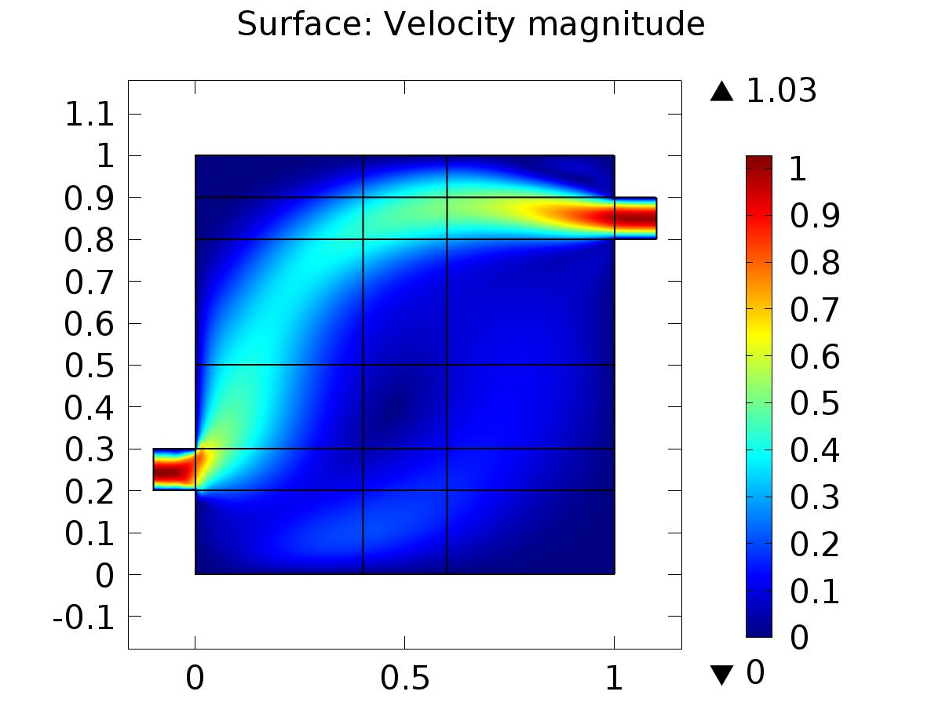

Surface: Velocity magnitude

* + 1. Pressure (spf)

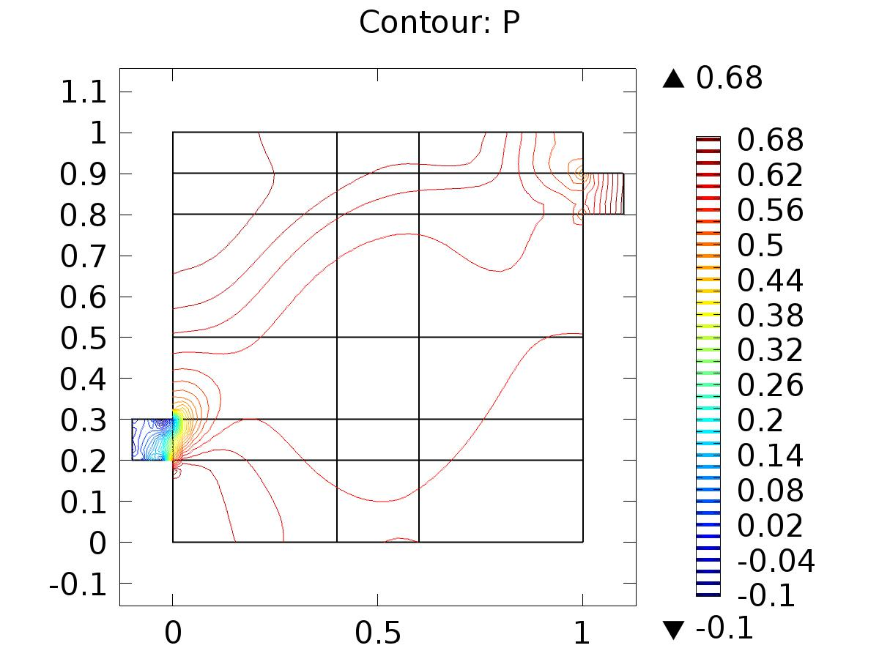

Contour: P

* + 1. 2D Plot Group 3

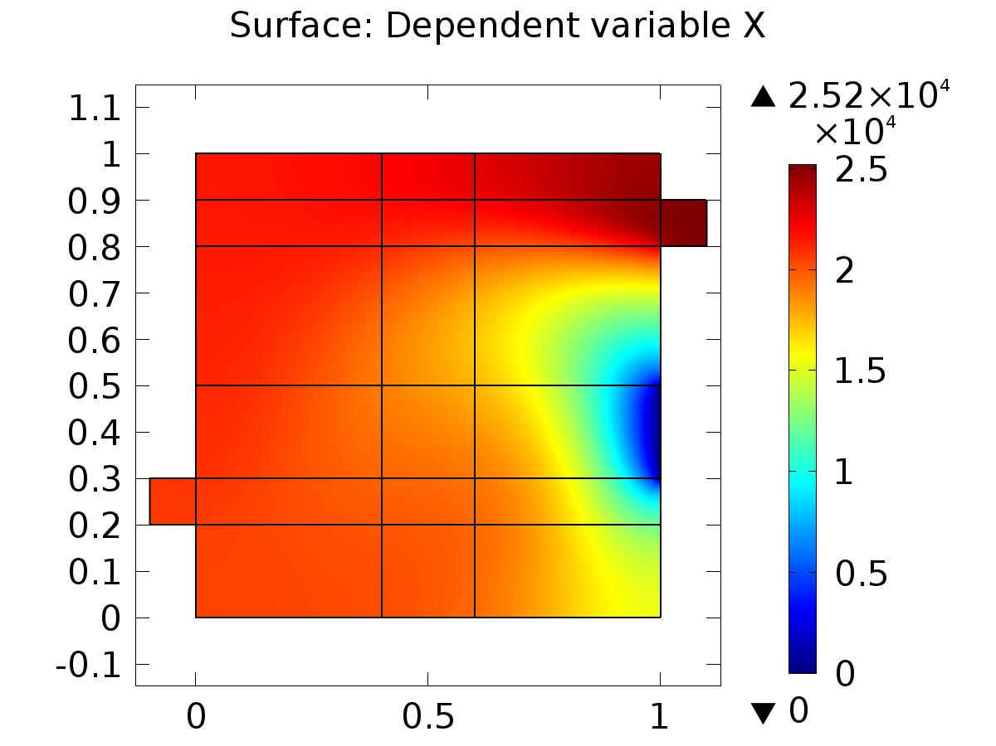

Surface: Dependent variable X

* + 1. Velocity (phys1)

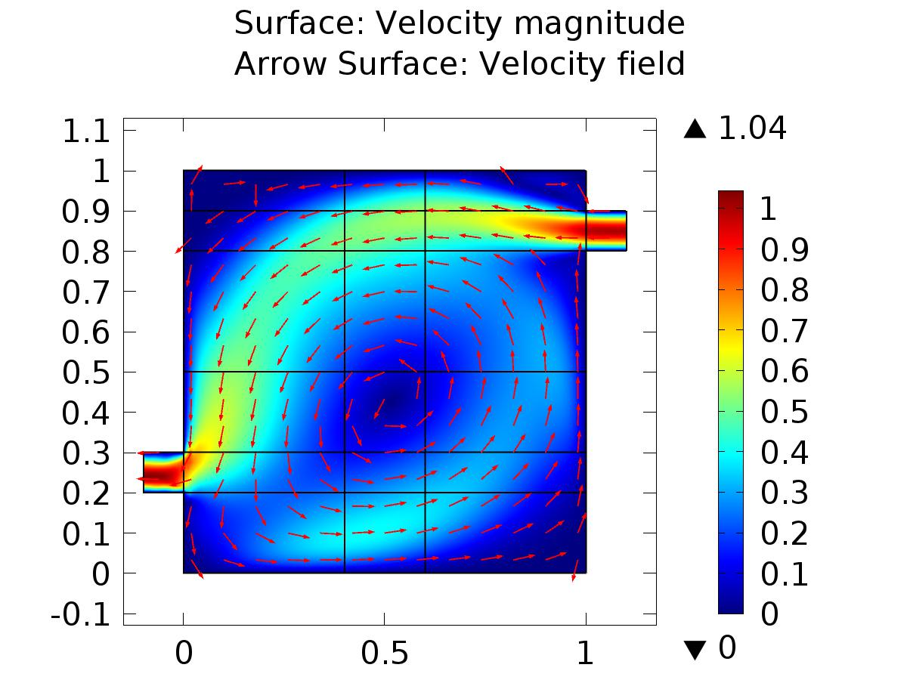

Surface: Velocity magnitude Arrow Surface: Velocity field

* + 1. Pressure (phys1)

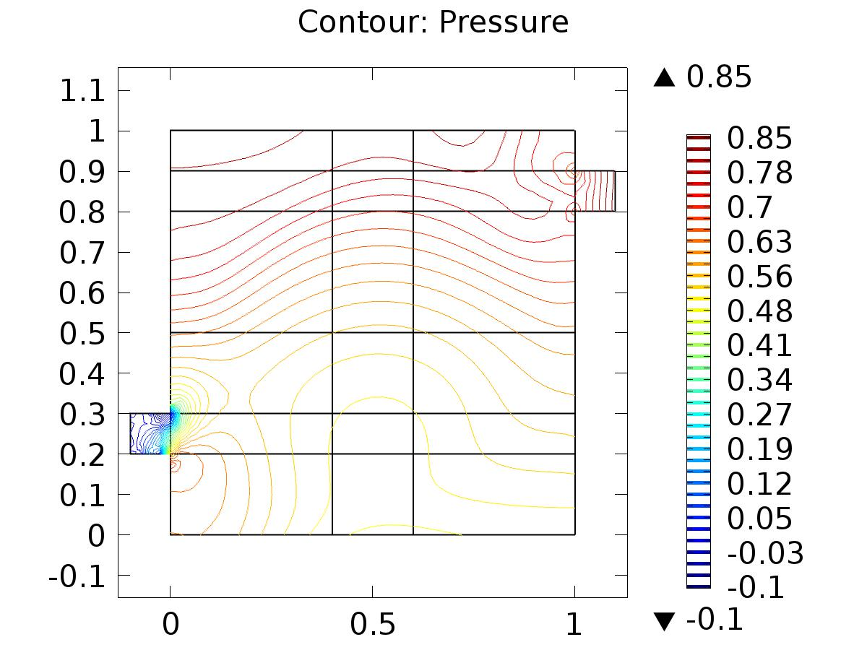

Contour: Pressure

* + 1. 2D Plot Group 6

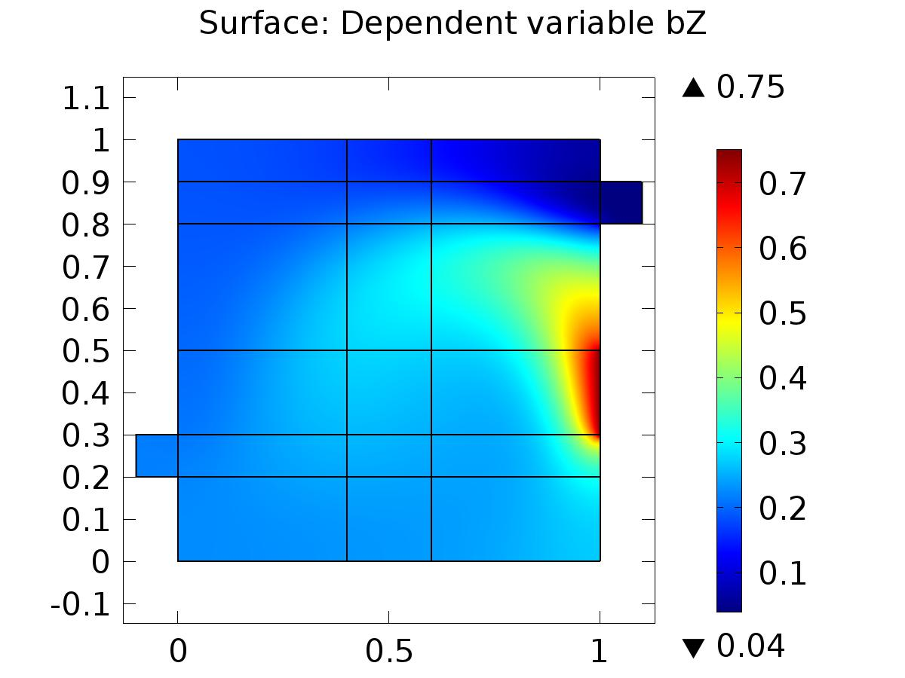

Surface: Dependent variable bZ

* + 1. Velocity (phys3)

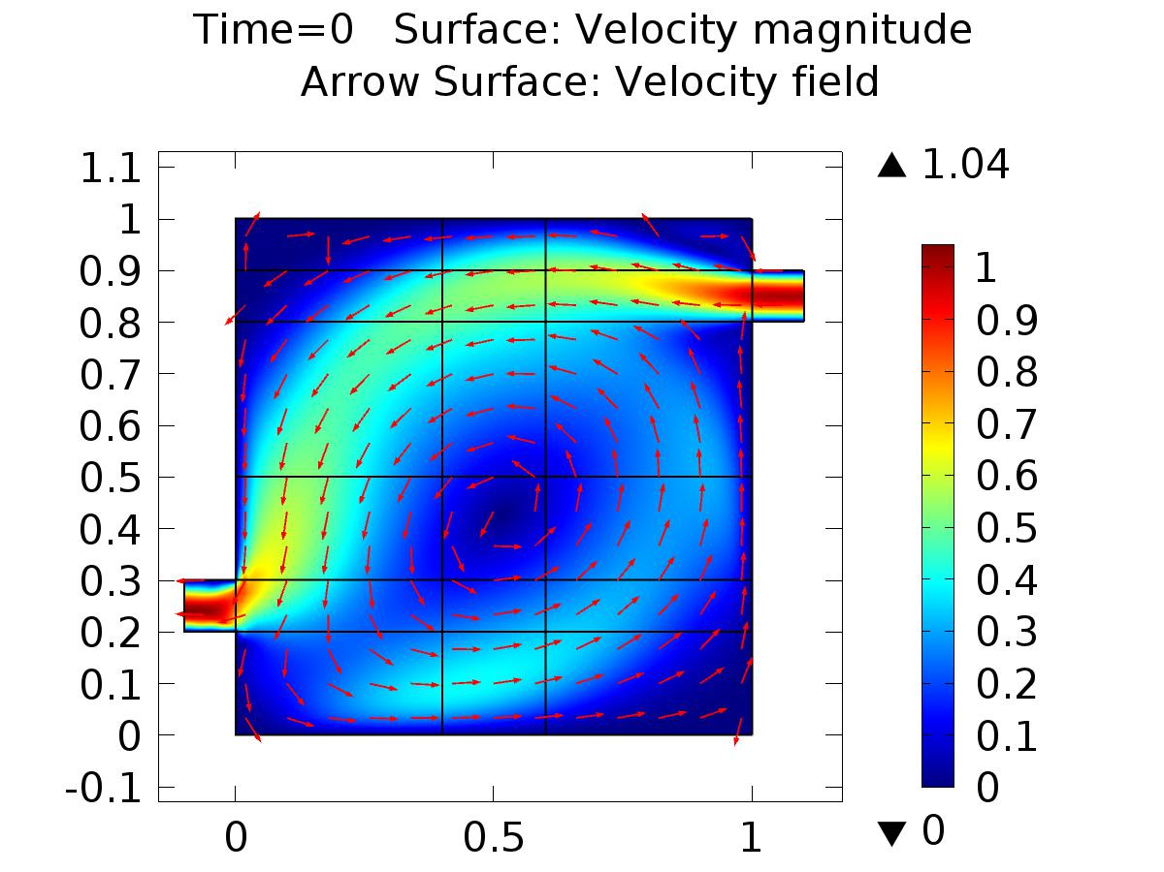

Time=0 Surface: Velocity magnitude Arrow Surface: Velocity field

* + 1. Pressure (phys3)

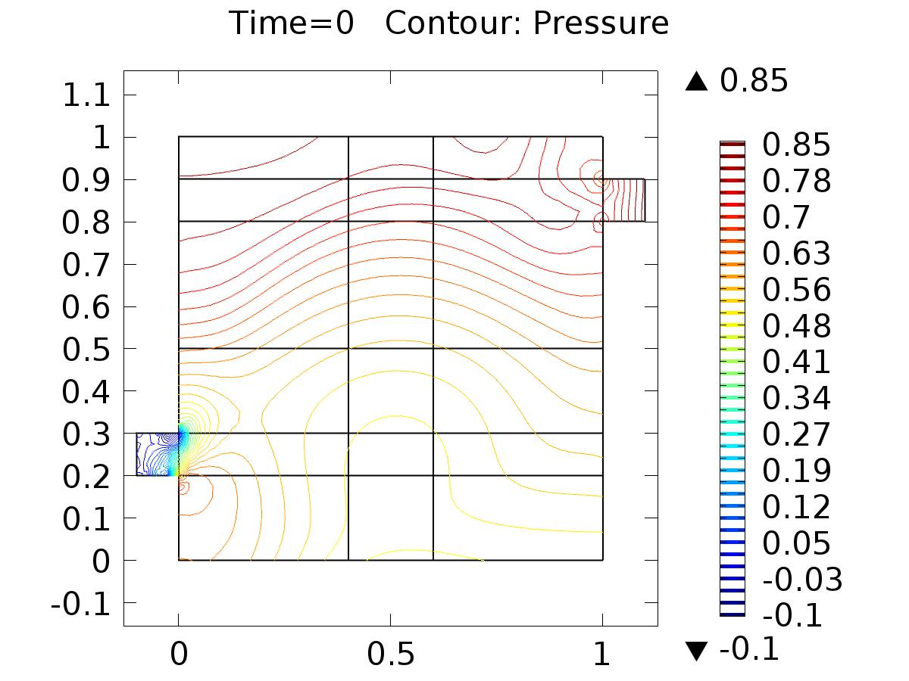

Time=0 Contour: Pressure

* + 1. 2D Plot Group 9

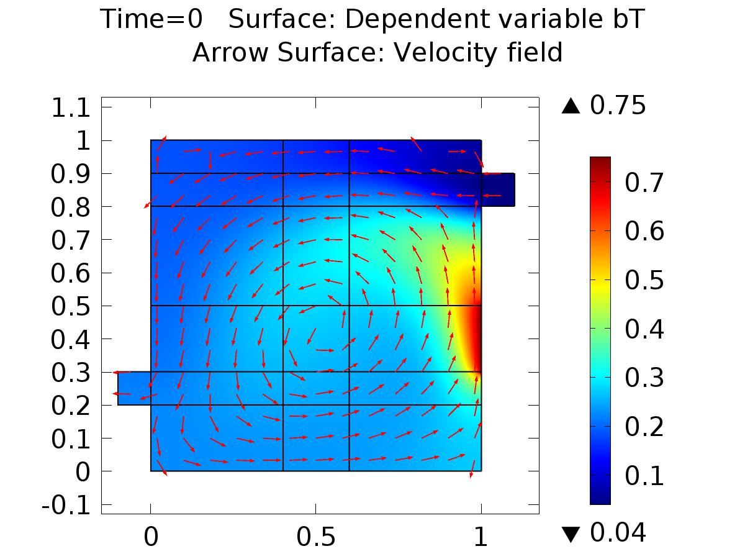

Time=0 Surface: Dependent variable bT Arrow Surface: Velocity field

* + 1. 1D Plot Group 10

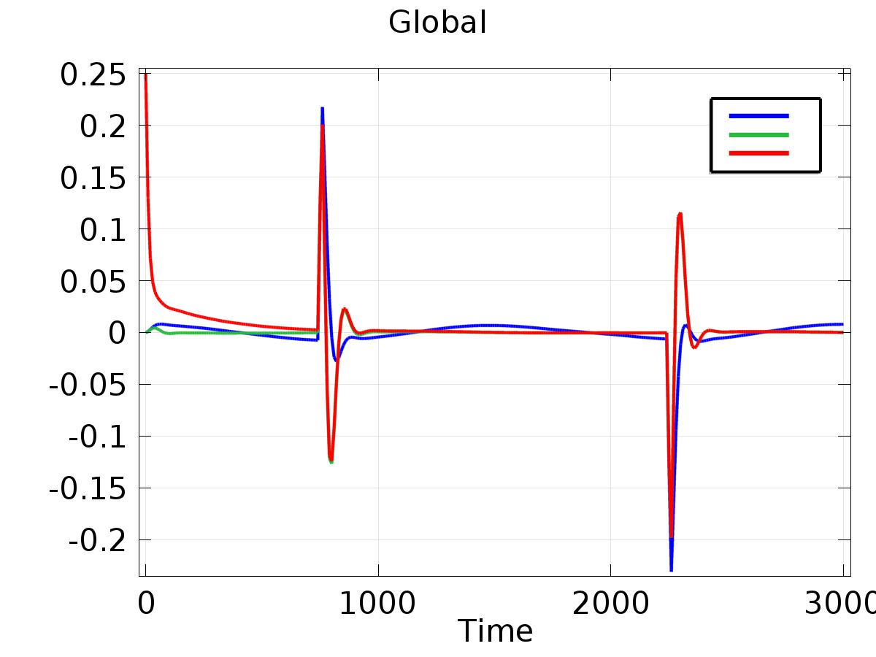

Global

* + 1. 1D Plot Group 11

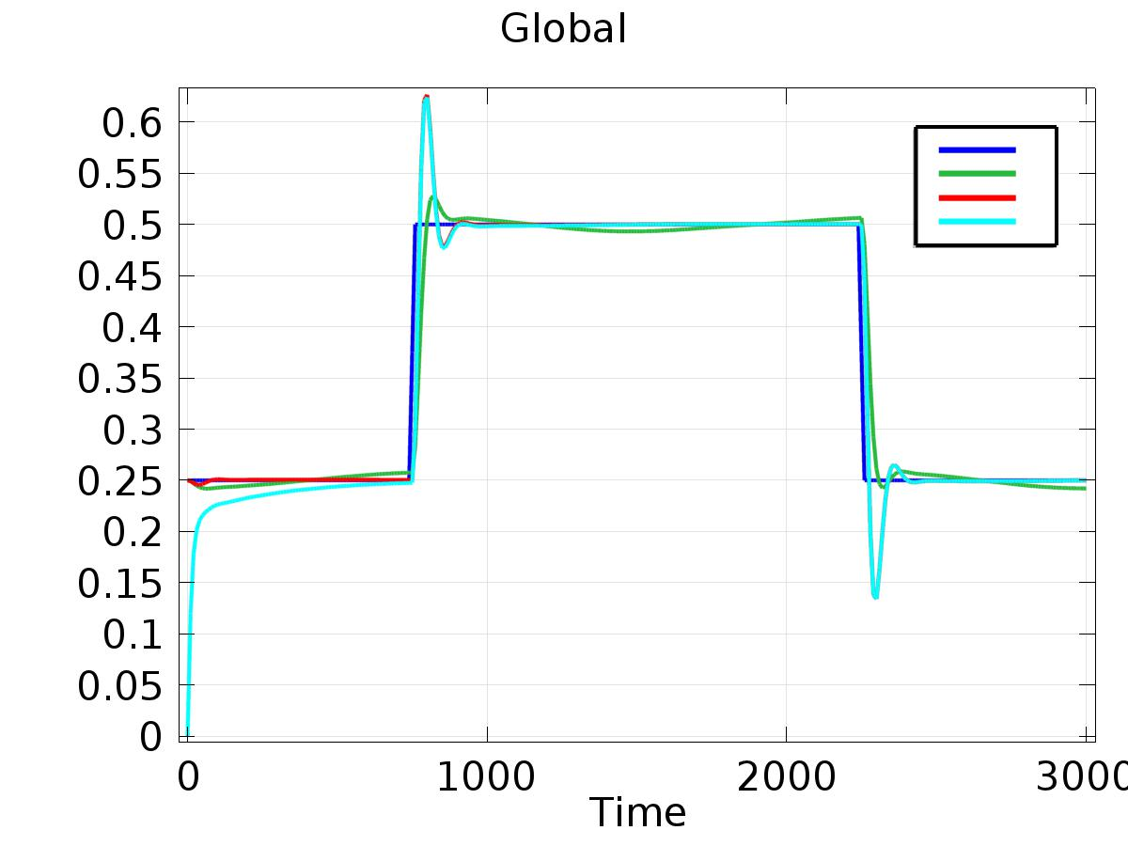

Global