[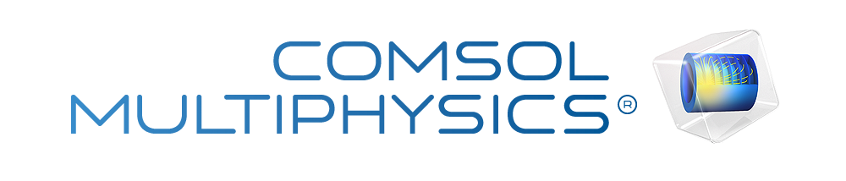](http://www.comsol.com/)

Ex5.3 CI gen signal

|  |  |
| --- | --- |
| Date | Aug 11, 2014 9:14:10 AM |

Contents

1. Global

1.1. Definitions

2. Component 1

2.1. Definitions

2.2. Geometry 1

2.3. Unit Input

2.4. Coefficient Form PDE 3

2.5. Coefficient Form PDE 1

2.6. Coefficient Form PDE 2

2.7. Coefficient Form PDE 5

2.8. Coefficient Form PDE 4

2.9. Mesh 1

3. Study 1

3.1. Stationary

3.2. Solver Configurations

4. Study 2

4.1. Time Dependent

4.2. Solver Configurations

5. Study 3

5.1. Time Dependent

5.2. Solver Configurations

6. Study 4

6.1. Time Dependent

6.2. Solver Configurations

7. Study 5

7.1. Time Dependent

7.2. Solver Configurations

8. Results

8.1. Data Sets

8.2. Derived Values

8.3. Tables

8.4. Plot Groups

1. Global

|  |  |
| --- | --- |
| Date | Jul 21, 2014 4:00:06 PM |

Global settings

|  |  |
| --- | --- |
| Name | Ex5.3 CI gen signal.mph |
| Path | /Users/gilliam/Desktop/collect_15/research_15/geo_reg_mono_eugenio/Mono_1_15/Comsol_EX_GitHub/Chapter5/Chap5Ex3_NLN_2D_CI/Ex5.3_CI_gen_signal.mph |
| Program | COMSOL 4.4 (Build: 150) |

Used products

|  |
| --- |
| COMSOL Multiphysics |

* 1. Definitions
     1. Parameters 1

Parameters

| **Name** | **Expression** | **Value** | **Description** |
| --- | --- | --- | --- |
| L | 1 | 1.0000 |  |
| lambda | 0.4 | 0.40000 |  |
| k | 0.1 | 0.10000 |  |
| beta | 0.5 | 0.50000 |  |
| c | 5 | 5.0000 |  |

1. Component 1

Component settings

|  |  |
| --- | --- |
| Unit system | None |

* 1. Definitions
     1. Variables

#### Variables 1a

Selection

|  |  |
| --- | --- |
| Geometric entity level | Entire model |

| **Name** | **Expression** | **Description** |
| --- | --- | --- |
| G | C(X) |  |
| d0 | 0 |  |
| yr0 | 1 |  |
| gamma0 | (yr0 - C(Zt0))/G |  |
| FZ0 | -lambda*Z0^3 |  |
| d | (1.e-4)*t^2 |  |
| yr | (100 - t)/100*(10 - t)/10*(40 - t)/40*(80 - t)/80 |  |
| gamma1 | (yr - C(Zt1))/G |  |
| FZ1 | -lambda*Z1^3 |  |
| e1 | yr - C(Z1) |  |
| gamma2 | (e1 - C(zt2))/G*(t>5) |  |
| Z2 | Z1 + z2 |  |
| FZ2 | -lambda*Z2^3 |  |
| e2 | yr - C(Z2) |  |
| gamma3 | (e2 - C(zt3))/G*(t>10) |  |
| Z3 | Z2 + z3 |  |
| FZ3 | -lambda*Z3^3 |  |
| e3 | yr - C(Z3) |  |
| gamma | gamma1 + gamma2 + gamma3 |  |
| FZ | -lambda*Z^3 |  |
| e | yr - C(Z) |  |

* + 1. Component Couplings

#### Average 1

|  |  |
| --- | --- |
| Coupling type | Average |
| Operator name | C |

Source selection

|  |  |
| --- | --- |
| Geometric entity level | Boundary |
| Selection | Boundary 4 |

* + 1. Coordinate Systems

#### Boundary System 1

|  |  |
| --- | --- |
| Coordinate system type | Boundary system |
| Tag | sys1 |

Coordinate names

| **First (t1)** | **Second (n)** | **Third (to)** |
| --- | --- | --- |
| t1 | n | to |

Settings

| **Description** | **Value** |
| --- | --- |
| Create first tangent direction from | Global Cartesian |

* 1. Geometry 1

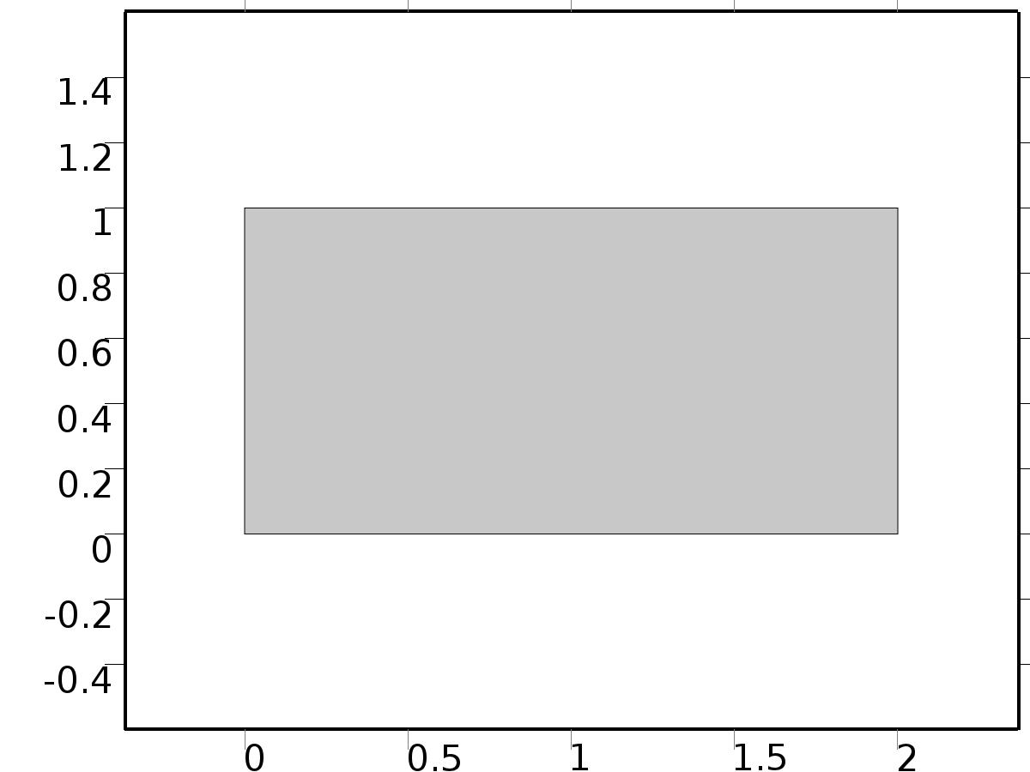

Geometry 1

Units

|  |  |
| --- | --- |
| Length unit | m |
| Angular unit | deg |

Geometry statistics

| **Description** | **Value** |
| --- | --- |
| Space dimension | 2 |
| Number of domains | 1 |
| Number of boundaries | 4 |
| Number of vertices | 4 |

* + 1. Rectangle 1 (r1)

Position

| **Description** | **Value** |
| --- | --- |
| Position | {0, 0} |
| Layers |  |

Size

| **Description** | **Value** |
| --- | --- |
| Width | 2*L |
| Height | L |

* 1. Unit Input

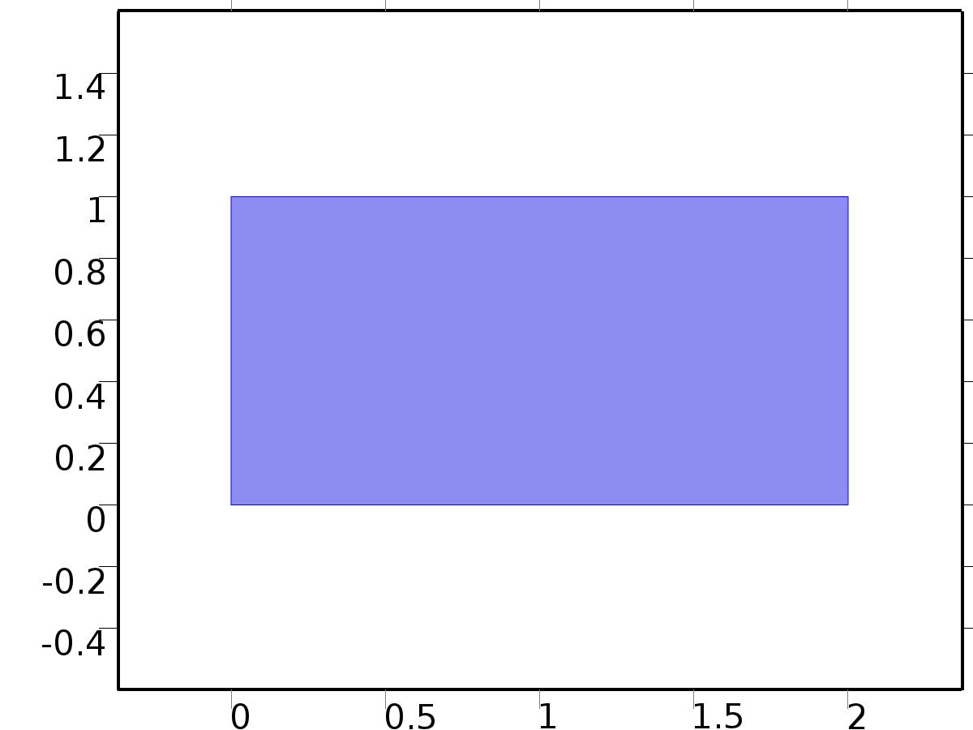

Unit Input

Selection

|  |  |
| --- | --- |
| Geometric entity level | Domain |
| Selection | Domain 1 |

Settings

| **Description** | **Value** |
| --- | --- |
| Shape function type | Lagrange |
| Element order | Quadratic |
| Compute boundary fluxes | On |
| Apply smoothing to boundary fluxes | On |
| Value type when using splitting of complex variables | Complex |
| Dependent variable quantity | Dimensionless (1) |
| Source term quantity | None |
| Unit | m^ - 2 |

Used products

|  |
| --- |
| COMSOL Multiphysics |

Variables

| **Name** | **Expression** | **Unit** | **Description** | **Selection** |
| --- | --- | --- | --- | --- |
| X.nx | dnx |  | Normal vector, x component | Boundaries 1–4 |
| X.ny | dny |  | Normal vector, y component | Boundaries 1–4 |
| X.nz | 0 |  | Normal vector, z component | Boundaries 1–4 |
| X.nxmesh | root.dnxmesh |  | Normal vector (mesh), x component | Boundaries 1–4 |
| X.nymesh | root.dnymesh |  | Normal vector (mesh), y component | Boundaries 1–4 |
| X.nzmesh | 0 |  | Normal vector (mesh), z component | Boundaries 1–4 |

* + 1. Coefficient Form PDE 1



Coefficient Form PDE 1

Selection

|  |  |
| --- | --- |
| Geometric entity level | Domain |
| Selection | Domain 1 |

Equations

Settings

| **Description** | **Value** |
| --- | --- |
| Diffusion coefficient | {{c, 0}, {0, c}} |
| Absorption coefficient | -lambda |
| Source term | 0 |
| Mass coefficient | 0 |
| Damping or mass coefficient | 0 |
| Conservative flux convection coefficient | {0, 0} |
| Convection coefficient | {0, 0} |
| Conservative flux source | {0, 0} |

#### Variables

| **Name** | **Expression** | **Unit** | **Description** | **Selection** |
| --- | --- | --- | --- | --- |
| domflux.Xx | -c*d(X,x) |  | Domain flux, x component | Domain 1 |
| domflux.Xy | -c*d(X,y) |  | Domain flux, y component | Domain 1 |

#### Shape functions

| **Name** | **Shape function** | **Unit** | **Description** | **Shape frame** | **Selection** |
| --- | --- | --- | --- | --- | --- |
| X | Lagrange (Quadratic) |  | Dependent variable X | Material | Domain 1 |

* + 1. Zero Flux 1

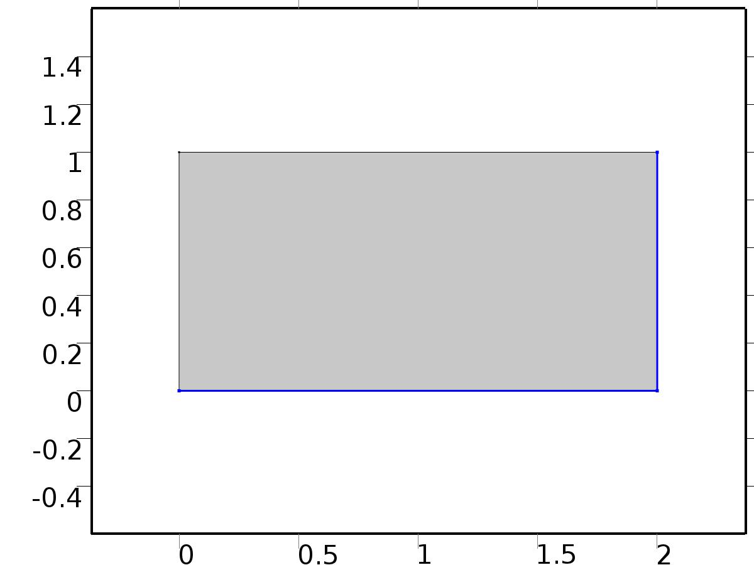

Zero Flux 1

Selection

|  |  |
| --- | --- |
| Geometric entity level | Boundary |
| Selection | Boundaries 2, 4 |

Equations

* + 1. Initial Values 1



Initial Values 1

Selection

|  |  |
| --- | --- |
| Geometric entity level | Domain |
| Selection | Domain 1 |

Settings

| **Description** | **Value** |
| --- | --- |
| Initial value for X | 0 |
| Initial time derivative of X | 0 |

* + 1. Dirichlet Boundary Condition 1

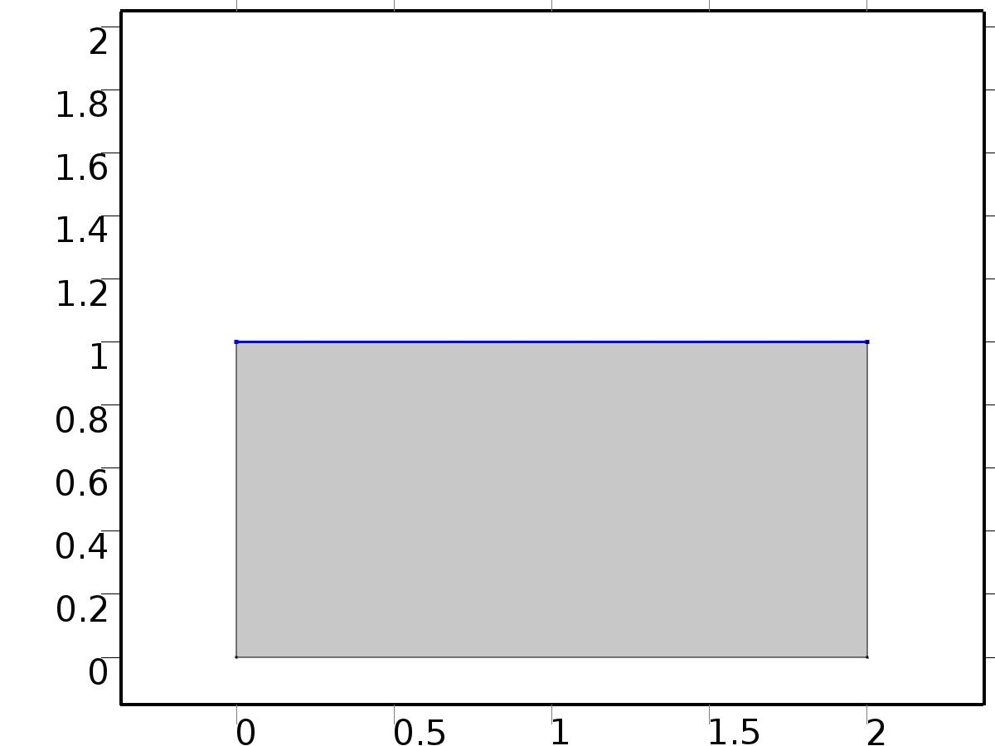

Dirichlet Boundary Condition 1

Selection

|  |  |
| --- | --- |
| Geometric entity level | Boundary |
| Selection | Boundary 3 |

Equations

Settings

| **Description** | **Value** |
| --- | --- |
| Value on boundary | 0 |
| Prescribed value of X | On |
| Apply reaction terms on | Individual dependent variables |
| Use weak constraints | Off |
| Constraint method | Elemental |

#### Shape functions

| **Constraint** | **Constraint force** | **Shape function** | **Selection** |
| --- | --- | --- | --- |
| -X | -test(X) | Lagrange (Quadratic) | Boundary 3 |

* + 1. Flux/Source 1

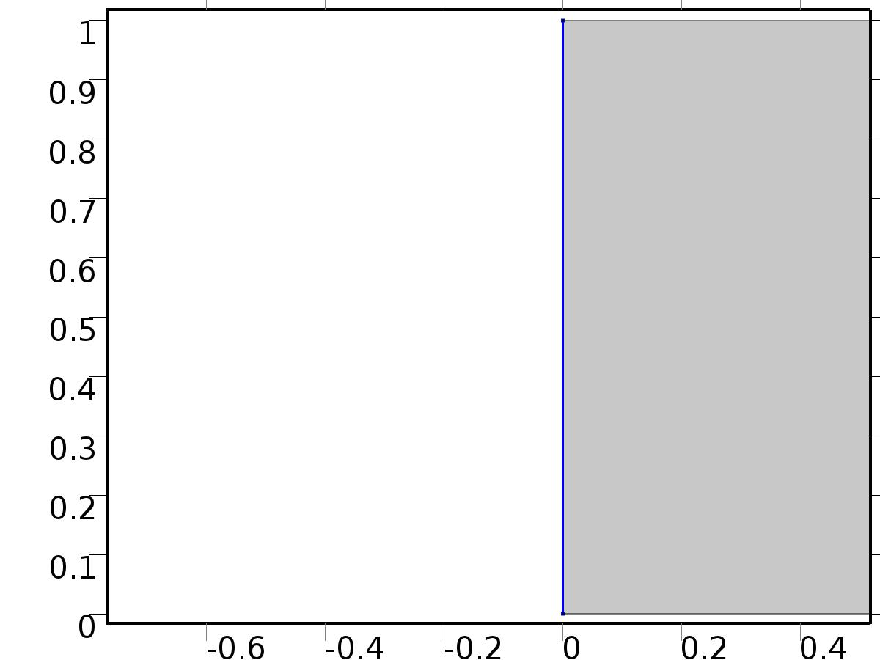

Flux/Source 1

Selection

|  |  |
| --- | --- |
| Geometric entity level | Boundary |
| Selection | Boundary 1 |

Equations

Settings

| **Description** | **Value** |
| --- | --- |
| Boundary flux/source | 1 |
| Boundary absorption/impedance term | k |

#### Variables

| **Name** | **Expression** | **Unit** | **Description** | **Selection** |
| --- | --- | --- | --- | --- |
| X.g_X | 1-k*X |  | Boundary flux/source | Boundary 1 |

* 1. Coefficient Form PDE 3



Coefficient Form PDE 3

Selection

|  |  |
| --- | --- |
| Geometric entity level | Domain |
| Selection | Domain 1 |

Settings

| **Description** | **Value** |
| --- | --- |
| Shape function type | Lagrange |
| Element order | Quadratic |
| Compute boundary fluxes | On |
| Apply smoothing to boundary fluxes | On |
| Value type when using splitting of complex variables | Complex |
| Dependent variable quantity | Dimensionless (1) |
| Source term quantity | None |
| Unit | m^ - 2 |

Used products

|  |
| --- |
| COMSOL Multiphysics |

Variables

| **Name** | **Expression** | **Unit** | **Description** | **Selection** |
| --- | --- | --- | --- | --- |
| Z0.nx | dnx |  | Normal vector, x component | Boundaries 1–4 |
| Z0.ny | dny |  | Normal vector, y component | Boundaries 1–4 |
| Z0.nz | 0 |  | Normal vector, z component | Boundaries 1–4 |
| Z0.nxmesh | root.dnxmesh |  | Normal vector (mesh), x component | Boundaries 1–4 |
| Z0.nymesh | root.dnymesh |  | Normal vector (mesh), y component | Boundaries 1–4 |
| Z0.nzmesh | 0 |  | Normal vector (mesh), z component | Boundaries 1–4 |

* + 1. Coefficient Form PDE 1



Coefficient Form PDE 1

Selection

|  |  |
| --- | --- |
| Geometric entity level | Domain |
| Selection | Domain 1 |

Equations

Settings

| **Description** | **Value** |
| --- | --- |
| Diffusion coefficient | {{{{c, 0}, {0, c}}, {{0, 0}, {0, 0}}}, {{{0, 0}, {0, 0}}, {{c, 0}, {0, c}}}} |
| Absorption coefficient | {{-lambda, 0}, {0, -lambda}} |
| Source term | {FZ0, FZ0} |
| Mass coefficient | {{0, 0}, {0, 0}} |
| Damping or mass coefficient | {{0, 0}, {0, 0}} |
| Conservative flux convection coefficient | {{{0, 0}, {0, 0}}, {{0, 0}, {0, 0}}} |
| Convection coefficient | {{{0, 0}, {0, 0}}, {{0, 0}, {0, 0}}} |
| Conservative flux source | {{0, 0}, {0, 0}} |

#### Variables

| **Name** | **Expression** | **Unit** | **Description** | **Selection** |
| --- | --- | --- | --- | --- |
| domflux.Z0x | -c*d(Z0,x) |  | Domain flux, x component | Domain 1 |
| domflux.Z0y | -c*d(Z0,y) |  | Domain flux, y component | Domain 1 |
| domflux.Zt0x | -c*d(Zt0,x) |  | Domain flux, x component | Domain 1 |
| domflux.Zt0y | -c*d(Zt0,y) |  | Domain flux, y component | Domain 1 |

#### Shape functions

| **Name** | **Shape function** | **Unit** | **Description** | **Shape frame** | **Selection** |
| --- | --- | --- | --- | --- | --- |
| Z0 | Lagrange (Quadratic) |  | Dependent variable Z0 | Material | Domain 1 |
| Zt0 | Lagrange (Quadratic) |  | Dependent variable Zt0 | Material | Domain 1 |

* + 1. Zero Flux 1



Zero Flux 1

Selection

|  |  |
| --- | --- |
| Geometric entity level | Boundary |
| Selection | Boundaries 2, 4 |

Equations

* + 1. Initial Values 1



Initial Values 1

Selection

|  |  |
| --- | --- |
| Geometric entity level | Domain |
| Selection | Domain 1 |

Settings

| **Description** | **Value** |
| --- | --- |
| Initial value for Z0 | 0 |
| Initial time derivative of Z0 | 0 |
| Initial value for Zt0 | 0 |
| Initial time derivative of Zt0 | 0 |

* + 1. Dirichlet Boundary Condition 1



Dirichlet Boundary Condition 1

Selection

|  |  |
| --- | --- |
| Geometric entity level | Boundary |
| Selection | Boundary 3 |

Equations

Settings

| **Description** | **Value** |
| --- | --- |
| Value on boundary | {d0, 0} |
| Prescribed value of Z0 | On |
| Prescribed value of Zt0 | On |
| Apply reaction terms on | Individual dependent variables |
| Use weak constraints | Off |
| Constraint method | Elemental |

#### Shape functions

| **Constraint** | **Constraint force** | **Shape function** | **Selection** |
| --- | --- | --- | --- |
| d0-Z0 | -test(Z0) | Lagrange (Quadratic) | Boundary 3 |
| -Zt0 | -test(Zt0) | Lagrange (Quadratic) | Boundary 3 |

* + 1. Flux/Source 1



Flux/Source 1

Selection

|  |  |
| --- | --- |
| Geometric entity level | Boundary |
| Selection | Boundary 1 |

Equations

Settings

| **Description** | **Value** |
| --- | --- |
| Boundary flux/source | {gamma0, 0} |
| Boundary absorption/impedance term | {{k, 0}, {0, k}} |

#### Variables

| **Name** | **Expression** | **Unit** | **Description** | **Selection** |
| --- | --- | --- | --- | --- |
| Z0.g_Z0 | gamma0-k*Z0 |  | Boundary flux/source | Boundary 1 |
| Z0.g_Zt0 | -k*Zt0 |  | Boundary flux/source | Boundary 1 |

* 1. Coefficient Form PDE 1



Coefficient Form PDE 1

Selection

|  |  |
| --- | --- |
| Geometric entity level | Domain |
| Selection | Domain 1 |

Settings

| **Description** | **Value** |
| --- | --- |
| Shape function type | Lagrange |
| Element order | Quadratic |
| Compute boundary fluxes | On |
| Apply smoothing to boundary fluxes | On |
| Value type when using splitting of complex variables | Complex |
| Dependent variable quantity | Dimensionless (1) |
| Source term quantity | None |
| Unit | m^ - 2 |

Used products

|  |
| --- |
| COMSOL Multiphysics |

Variables

| **Name** | **Expression** | **Unit** | **Description** | **Selection** |
| --- | --- | --- | --- | --- |
| Z1.nx | dnx |  | Normal vector, x component | Boundaries 1–4 |
| Z1.ny | dny |  | Normal vector, y component | Boundaries 1–4 |
| Z1.nz | 0 |  | Normal vector, z component | Boundaries 1–4 |
| Z1.nxmesh | root.dnxmesh |  | Normal vector (mesh), x component | Boundaries 1–4 |
| Z1.nymesh | root.dnymesh |  | Normal vector (mesh), y component | Boundaries 1–4 |
| Z1.nzmesh | 0 |  | Normal vector (mesh), z component | Boundaries 1–4 |

* + 1. Coefficient Form PDE 1



Coefficient Form PDE 1

Selection

|  |  |
| --- | --- |
| Geometric entity level | Domain |
| Selection | Domain 1 |

Equations

Settings

| **Description** | **Value** |
| --- | --- |
| Diffusion coefficient | {{{{c, 0}, {0, c}}, {{0, 0}, {0, 0}}}, {{{0, 0}, {0, 0}}, {{c, 0}, {0, c}}}} |
| Absorption coefficient | {{-lambda, 0}, {0, -lambda}} |
| Source term | {FZ1, FZ1} |
| Mass coefficient | {{0, 0}, {0, 0}} |
| Damping or mass coefficient | {{1, 1 - beta}, {0, 0}} |
| Conservative flux convection coefficient | {{{0, 0}, {0, 0}}, {{0, 0}, {0, 0}}} |
| Convection coefficient | {{{0, 0}, {0, 0}}, {{0, 0}, {0, 0}}} |
| Conservative flux source | {{0, 0}, {0, 0}} |

#### Variables

| **Name** | **Expression** | **Unit** | **Description** | **Selection** |
| --- | --- | --- | --- | --- |
| domflux.Z1x | -c*d(Z1,x) |  | Domain flux, x component | Domain 1 |
| domflux.Z1y | -c*d(Z1,y) |  | Domain flux, y component | Domain 1 |
| domflux.Zt1x | -c*d(Zt1,x) |  | Domain flux, x component | Domain 1 |
| domflux.Zt1y | -c*d(Zt1,y) |  | Domain flux, y component | Domain 1 |

#### Shape functions

| **Name** | **Shape function** | **Unit** | **Description** | **Shape frame** | **Selection** |
| --- | --- | --- | --- | --- | --- |
| Z1 | Lagrange (Quadratic) |  | Dependent variable Z1 | Material | Domain 1 |
| Zt1 | Lagrange (Quadratic) |  | Dependent variable Zt1 | Material | Domain 1 |

* + 1. Zero Flux 1



Zero Flux 1

Selection

|  |  |
| --- | --- |
| Geometric entity level | Boundary |
| Selection | Boundaries 2, 4 |

Equations

* + 1. Initial Values 1



Initial Values 1

Selection

|  |  |
| --- | --- |
| Geometric entity level | Domain |
| Selection | Domain 1 |

Settings

| **Description** | **Value** |
| --- | --- |
| Initial value for Z1 | Z0 |
| Initial time derivative of Z1 | 0 |
| Initial value for Zt1 | Zt0 |
| Initial time derivative of Zt1 | 0 |

* + 1. Dirichlet Boundary Condition 1



Dirichlet Boundary Condition 1

Selection

|  |  |
| --- | --- |
| Geometric entity level | Boundary |
| Selection | Boundary 3 |

Equations

Settings

| **Description** | **Value** |
| --- | --- |
| Value on boundary | {d, d} |
| Prescribed value of Z1 | On |
| Prescribed value of Zt1 | On |
| Apply reaction terms on | Individual dependent variables |
| Use weak constraints | Off |
| Constraint method | Elemental |

#### Shape functions

| **Constraint** | **Constraint force** | **Shape function** | **Selection** |
| --- | --- | --- | --- |
| d-Z1 | -test(Z1) | Lagrange (Quadratic) | Boundary 3 |
| d-Zt1 | -test(Zt1) | Lagrange (Quadratic) | Boundary 3 |

* + 1. Flux/Source 1



Flux/Source 1

Selection

|  |  |
| --- | --- |
| Geometric entity level | Boundary |
| Selection | Boundary 1 |

Equations

Settings

| **Description** | **Value** |
| --- | --- |
| Boundary flux/source | {gamma1, 0} |
| Boundary absorption/impedance term | {{k, 0}, {0, k}} |

#### Variables

| **Name** | **Expression** | **Unit** | **Description** | **Selection** |
| --- | --- | --- | --- | --- |
| Z1.g_Z1 | gamma1-k*Z1 |  | Boundary flux/source | Boundary 1 |
| Z1.g_Zt1 | -k*Zt1 |  | Boundary flux/source | Boundary 1 |

* 1. Coefficient Form PDE 2



Coefficient Form PDE 2

Selection

|  |  |
| --- | --- |
| Geometric entity level | Domain |
| Selection | Domain 1 |

Settings

| **Description** | **Value** |
| --- | --- |
| Shape function type | Lagrange |
| Element order | Quadratic |
| Compute boundary fluxes | On |
| Apply smoothing to boundary fluxes | On |
| Value type when using splitting of complex variables | Complex |
| Dependent variable quantity | Dimensionless (1) |
| Source term quantity | None |
| Unit | m^ - 2 |

Used products

|  |
| --- |
| COMSOL Multiphysics |

Variables

| **Name** | **Expression** | **Unit** | **Description** | **Selection** |
| --- | --- | --- | --- | --- |
| z2.nx | dnx |  | Normal vector, x component | Boundaries 1–4 |
| z2.ny | dny |  | Normal vector, y component | Boundaries 1–4 |
| z2.nz | 0 |  | Normal vector, z component | Boundaries 1–4 |
| z2.nxmesh | root.dnxmesh |  | Normal vector (mesh), x component | Boundaries 1–4 |
| z2.nymesh | root.dnymesh |  | Normal vector (mesh), y component | Boundaries 1–4 |
| z2.nzmesh | 0 |  | Normal vector (mesh), z component | Boundaries 1–4 |

* + 1. Coefficient Form PDE 1



Coefficient Form PDE 1

Selection

|  |  |
| --- | --- |
| Geometric entity level | Domain |
| Selection | Domain 1 |

Equations

Settings

| **Description** | **Value** |
| --- | --- |
| Diffusion coefficient | {{{{c, 0}, {0, c}}, {{0, 0}, {0, 0}}}, {{{0, 0}, {0, 0}}, {{c, 0}, {0, c}}}} |
| Absorption coefficient | {{-lambda, 0}, {0, -lambda}} |
| Source term | {FZ2 - FZ1, FZ2 - FZ1} |
| Mass coefficient | {{0, 0}, {0, 0}} |
| Damping or mass coefficient | {{1, 1 - beta}, {0, 0}} |
| Conservative flux convection coefficient | {{{0, 0}, {0, 0}}, {{0, 0}, {0, 0}}} |
| Convection coefficient | {{{0, 0}, {0, 0}}, {{0, 0}, {0, 0}}} |
| Conservative flux source | {{0, 0}, {0, 0}} |

#### Variables

| **Name** | **Expression** | **Unit** | **Description** | **Selection** |
| --- | --- | --- | --- | --- |
| domflux.z2x | -c*d(z2,x) |  | Domain flux, x component | Domain 1 |
| domflux.z2y | -c*d(z2,y) |  | Domain flux, y component | Domain 1 |
| domflux.zt2x | -c*d(zt2,x) |  | Domain flux, x component | Domain 1 |
| domflux.zt2y | -c*d(zt2,y) |  | Domain flux, y component | Domain 1 |

#### Shape functions

| **Name** | **Shape function** | **Unit** | **Description** | **Shape frame** | **Selection** |
| --- | --- | --- | --- | --- | --- |
| z2 | Lagrange (Quadratic) |  | Dependent variable z2 | Material | Domain 1 |
| zt2 | Lagrange (Quadratic) |  | Dependent variable zt2 | Material | Domain 1 |

* + 1. Zero Flux 1



Zero Flux 1

Selection

|  |  |
| --- | --- |
| Geometric entity level | Boundary |
| Selection | Boundaries 2, 4 |

Equations

* + 1. Initial Values 1



Initial Values 1

Selection

|  |  |
| --- | --- |
| Geometric entity level | Domain |
| Selection | Domain 1 |

Settings

| **Description** | **Value** |
| --- | --- |
| Initial value for z2 | 0 |
| Initial time derivative of z2 | 0 |
| Initial value for zt2 | 0 |
| Initial time derivative of zt2 | 0 |

* + 1. Dirichlet Boundary Condition 1



Dirichlet Boundary Condition 1

Selection

|  |  |
| --- | --- |
| Geometric entity level | Boundary |
| Selection | Boundary 3 |

Equations

Settings

| **Description** | **Value** |
| --- | --- |
| Value on boundary | {0, 0} |
| Prescribed value of z2 | On |
| Prescribed value of zt2 | On |
| Apply reaction terms on | Individual dependent variables |
| Use weak constraints | Off |
| Constraint method | Elemental |

#### Shape functions

| **Constraint** | **Constraint force** | **Shape function** | **Selection** |
| --- | --- | --- | --- |
| -z2 | -test(z2) | Lagrange (Quadratic) | Boundary 3 |
| -zt2 | -test(zt2) | Lagrange (Quadratic) | Boundary 3 |

* + 1. Flux/Source 1



Flux/Source 1

Selection

|  |  |
| --- | --- |
| Geometric entity level | Boundary |
| Selection | Boundary 1 |

Equations

Settings

| **Description** | **Value** |
| --- | --- |
| Boundary flux/source | {gamma2, 0} |
| Boundary absorption/impedance term | {{k, 0}, {0, k}} |

#### Variables

| **Name** | **Expression** | **Unit** | **Description** | **Selection** |
| --- | --- | --- | --- | --- |
| z2.g_z2 | gamma2-k*z2 |  | Boundary flux/source | Boundary 1 |
| z2.g_zt2 | -k*zt2 |  | Boundary flux/source | Boundary 1 |

* 1. Coefficient Form PDE 5



Coefficient Form PDE 5

Selection

|  |  |
| --- | --- |
| Geometric entity level | Domain |
| Selection | Domain 1 |

Settings

| **Description** | **Value** |
| --- | --- |
| Shape function type | Lagrange |
| Element order | Quadratic |
| Compute boundary fluxes | On |
| Apply smoothing to boundary fluxes | On |
| Value type when using splitting of complex variables | Complex |
| Dependent variable quantity | Dimensionless (1) |
| Source term quantity | None |
| Unit | m^ - 2 |

Used products

|  |
| --- |
| COMSOL Multiphysics |

Variables

| **Name** | **Expression** | **Unit** | **Description** | **Selection** |
| --- | --- | --- | --- | --- |
| z3.nx | dnx |  | Normal vector, x component | Boundaries 1–4 |
| z3.ny | dny |  | Normal vector, y component | Boundaries 1–4 |
| z3.nz | 0 |  | Normal vector, z component | Boundaries 1–4 |
| z3.nxmesh | root.dnxmesh |  | Normal vector (mesh), x component | Boundaries 1–4 |
| z3.nymesh | root.dnymesh |  | Normal vector (mesh), y component | Boundaries 1–4 |
| z3.nzmesh | 0 |  | Normal vector (mesh), z component | Boundaries 1–4 |

* + 1. Coefficient Form PDE 1



Coefficient Form PDE 1

Selection

|  |  |
| --- | --- |
| Geometric entity level | Domain |
| Selection | Domain 1 |

Equations

Settings

| **Description** | **Value** |
| --- | --- |
| Diffusion coefficient | {{{{c, 0}, {0, c}}, {{0, 0}, {0, 0}}}, {{{0, 0}, {0, 0}}, {{c, 0}, {0, c}}}} |
| Absorption coefficient | {{-lambda, 0}, {0, -lambda}} |
| Source term | {FZ3 - FZ2, FZ3 - FZ2} |
| Mass coefficient | {{0, 0}, {0, 0}} |
| Damping or mass coefficient | {{1, 1 - beta}, {0, 0}} |
| Conservative flux convection coefficient | {{{0, 0}, {0, 0}}, {{0, 0}, {0, 0}}} |
| Convection coefficient | {{{0, 0}, {0, 0}}, {{0, 0}, {0, 0}}} |
| Conservative flux source | {{0, 0}, {0, 0}} |

#### Variables

| **Name** | **Expression** | **Unit** | **Description** | **Selection** |
| --- | --- | --- | --- | --- |
| domflux.z3x | -c*d(z3,x) |  | Domain flux, x component | Domain 1 |
| domflux.z3y | -c*d(z3,y) |  | Domain flux, y component | Domain 1 |
| domflux.zt3x | -c*d(zt3,x) |  | Domain flux, x component | Domain 1 |
| domflux.zt3y | -c*d(zt3,y) |  | Domain flux, y component | Domain 1 |

#### Shape functions

| **Name** | **Shape function** | **Unit** | **Description** | **Shape frame** | **Selection** |
| --- | --- | --- | --- | --- | --- |
| z3 | Lagrange (Quadratic) |  | Dependent variable z3 | Material | Domain 1 |
| zt3 | Lagrange (Quadratic) |  | Dependent variable zt3 | Material | Domain 1 |

* + 1. Zero Flux 1



Zero Flux 1

Selection

|  |  |
| --- | --- |
| Geometric entity level | Boundary |
| Selection | Boundaries 2, 4 |

Equations

* + 1. Initial Values 1



Initial Values 1

Selection

|  |  |
| --- | --- |
| Geometric entity level | Domain |
| Selection | Domain 1 |

Settings

| **Description** | **Value** |
| --- | --- |
| Initial value for z3 | 0 |
| Initial time derivative of z3 | 0 |
| Initial value for zt3 | 0 |
| Initial time derivative of zt3 | 0 |

* + 1. Dirichlet Boundary Condition 1



Dirichlet Boundary Condition 1

Selection

|  |  |
| --- | --- |
| Geometric entity level | Boundary |
| Selection | Boundary 3 |

Equations

Settings

| **Description** | **Value** |
| --- | --- |
| Value on boundary | {0, 0} |
| Prescribed value of z3 | On |
| Prescribed value of zt3 | On |
| Apply reaction terms on | Individual dependent variables |
| Use weak constraints | Off |
| Constraint method | Elemental |

#### Shape functions

| **Constraint** | **Constraint force** | **Shape function** | **Selection** |
| --- | --- | --- | --- |
| -z3 | -test(z3) | Lagrange (Quadratic) | Boundary 3 |
| -zt3 | -test(zt3) | Lagrange (Quadratic) | Boundary 3 |

* + 1. Flux/Source 1



Flux/Source 1

Selection

|  |  |
| --- | --- |
| Geometric entity level | Boundary |
| Selection | Boundary 1 |

Equations

Settings

| **Description** | **Value** |
| --- | --- |
| Boundary flux/source | {gamma3, 0} |
| Boundary absorption/impedance term | {{k, 0}, {0, k}} |

#### Variables

| **Name** | **Expression** | **Unit** | **Description** | **Selection** |
| --- | --- | --- | --- | --- |
| z3.g_z3 | gamma3-k*z3 |  | Boundary flux/source | Boundary 1 |
| z3.g_zt3 | -k*zt3 |  | Boundary flux/source | Boundary 1 |

* 1. Coefficient Form PDE 4



Coefficient Form PDE 4

Selection

|  |  |
| --- | --- |
| Geometric entity level | Domain |
| Selection | Domain 1 |

Settings

| **Description** | **Value** |
| --- | --- |
| Shape function type | Lagrange |
| Element order | Quadratic |
| Compute boundary fluxes | On |
| Apply smoothing to boundary fluxes | On |
| Value type when using splitting of complex variables | Complex |
| Dependent variable quantity | Dimensionless (1) |
| Source term quantity | None |
| Unit | m^ - 2 |

Used products

|  |
| --- |
| COMSOL Multiphysics |

Variables

| **Name** | **Expression** | **Unit** | **Description** | **Selection** |
| --- | --- | --- | --- | --- |
| Z.nx | dnx |  | Normal vector, x component | Boundaries 1–4 |
| Z.ny | dny |  | Normal vector, y component | Boundaries 1–4 |
| Z.nz | 0 |  | Normal vector, z component | Boundaries 1–4 |
| Z.nxmesh | root.dnxmesh |  | Normal vector (mesh), x component | Boundaries 1–4 |
| Z.nymesh | root.dnymesh |  | Normal vector (mesh), y component | Boundaries 1–4 |
| Z.nzmesh | 0 |  | Normal vector (mesh), z component | Boundaries 1–4 |

* + 1. Coefficient Form PDE 1



Coefficient Form PDE 1

Selection

|  |  |
| --- | --- |
| Geometric entity level | Domain |
| Selection | Domain 1 |

Equations

Settings

| **Description** | **Value** |
| --- | --- |
| Diffusion coefficient | {{c, 0}, {0, c}} |
| Absorption coefficient | -lambda |
| Source term | FZ |
| Mass coefficient | 0 |
| Damping or mass coefficient | 1 |
| Conservative flux convection coefficient | {0, 0} |
| Convection coefficient | {0, 0} |
| Conservative flux source | {0, 0} |

#### Variables

| **Name** | **Expression** | **Unit** | **Description** | **Selection** |
| --- | --- | --- | --- | --- |
| domflux.Zx | -c*d(Z,x) |  | Domain flux, x component | Domain 1 |
| domflux.Zy | -c*d(Z,y) |  | Domain flux, y component | Domain 1 |

#### Shape functions

| **Name** | **Shape function** | **Unit** | **Description** | **Shape frame** | **Selection** |
| --- | --- | --- | --- | --- | --- |
| Z | Lagrange (Quadratic) |  | Dependent variable Z | Material | Domain 1 |

* + 1. Zero Flux 1



Zero Flux 1

Selection

|  |  |
| --- | --- |
| Geometric entity level | Boundary |
| Selection | Boundaries 2, 4 |

Equations

* + 1. Initial Values 1



Initial Values 1

Selection

|  |  |
| --- | --- |
| Geometric entity level | Domain |
| Selection | Domain 1 |

Settings

| **Description** | **Value** |
| --- | --- |
| Initial value for Z | 0 |
| Initial time derivative of Z | 0 |

* + 1. Dirichlet Boundary Condition 1



Dirichlet Boundary Condition 1

Selection

|  |  |
| --- | --- |
| Geometric entity level | Boundary |
| Selection | Boundary 3 |

Equations

Settings

| **Description** | **Value** |
| --- | --- |
| Value on boundary | d |
| Prescribed value of Z | On |
| Apply reaction terms on | Individual dependent variables |
| Use weak constraints | Off |
| Constraint method | Elemental |

#### Shape functions

| **Constraint** | **Constraint force** | **Shape function** | **Selection** |
| --- | --- | --- | --- |
| d-Z | -test(Z) | Lagrange (Quadratic) | Boundary 3 |

* + 1. Flux/Source 1



Flux/Source 1

Selection

|  |  |
| --- | --- |
| Geometric entity level | Boundary |
| Selection | Boundary 1 |

Equations

Settings

| **Description** | **Value** |
| --- | --- |
| Boundary flux/source | gamma |
| Boundary absorption/impedance term | k |

#### Variables

| **Name** | **Expression** | **Unit** | **Description** | **Selection** |
| --- | --- | --- | --- | --- |
| Z.g_Z | gamma-k*Z |  | Boundary flux/source | Boundary 1 |

* 1. Mesh 1

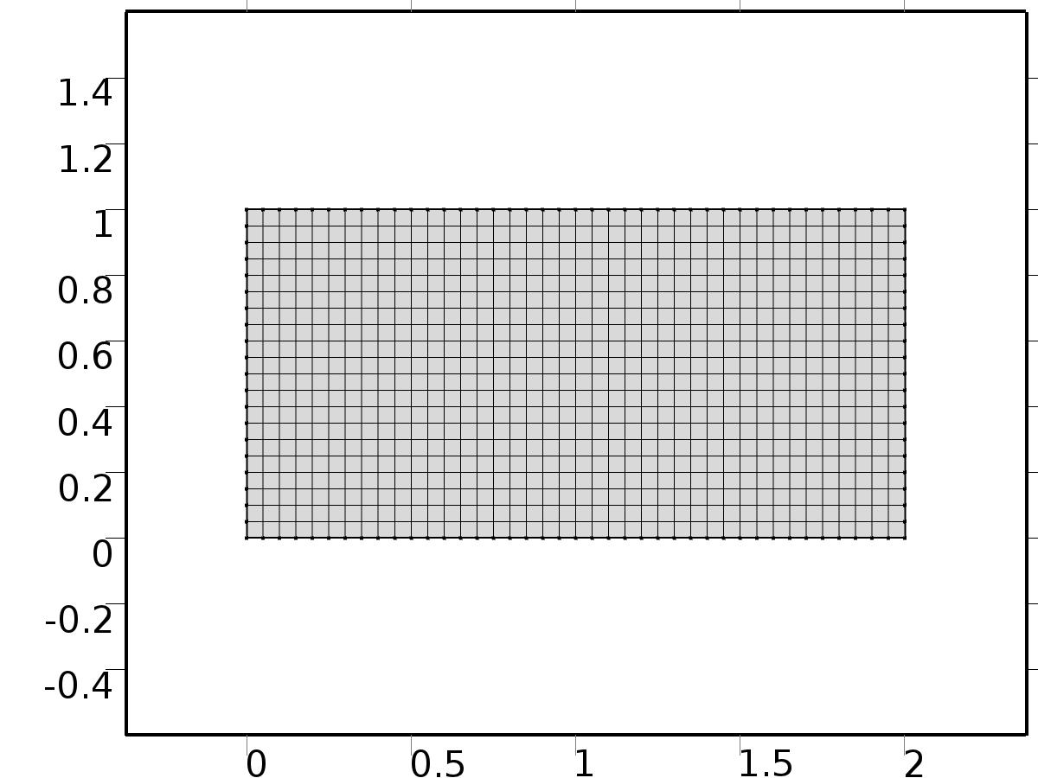

Mesh 1

* + 1. Size (size)

Settings

| **Description** | **Value** |
| --- | --- |
| Maximum element size | 0.134 |
| Minimum element size | 6.0E-4 |
| Curvature factor | 0.3 |
| Maximum element growth rate | 1.3 |

* + 1. Edge 1 (edg1)

Selection

|  |  |
| --- | --- |
| Geometric entity level | Boundary |
| Selection | Boundaries 1–4 |

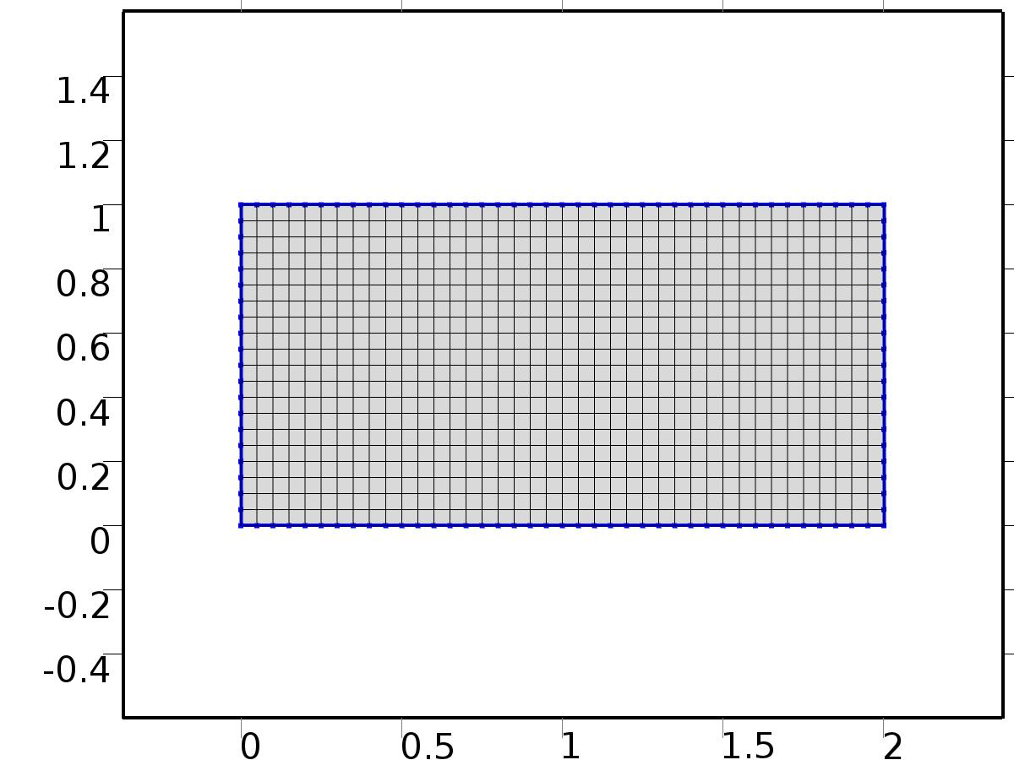

Edge 1

#### Size 1 (size1)

Selection

|  |  |
| --- | --- |
| Geometric entity level | Boundary |
| Selection | Boundaries 1–4 |



Size 1

Settings

| **Description** | **Value** |
| --- | --- |
| Maximum element size | L/20 |
| Minimum element size | L/20 |
| Curvature factor | 0.3 |
| Curvature factor | Off |
| Resolution of narrow regions | Off |
| Maximum element growth rate | 1.3 |
| Maximum element growth rate | Off |
| Custom element size | Custom |

* + 1. Mapped 1 (map1)

Selection

|  |  |
| --- | --- |
| Geometric entity level | Remaining |

1. Study 1
   1. Stationary

Study settings

| **Description** | **Value** |
| --- | --- |
| Include geometric nonlinearity | Off |

Physics and variables selection

| **Physics interface** | **Discretization** |
| --- | --- |
| Unit Input (c) | physics |
| Coefficient Form PDE 3 (phys3) | physics |

Mesh selection

| **Geometry** | **Mesh** |
| --- | --- |
| Geometry 1 (geom1) | mesh1 |

* 1. Solver Configurations
     1. Solver 1

#### Compile Equations: Stationary (st1)

Study and step

| **Description** | **Value** |
| --- | --- |
| Use study | Study 1 |
| Use study step | Stationary |

#### Dependent Variables 1 (v1)

General

| **Description** | **Value** |
| --- | --- |
| Defined by study step | Stationary |
| Constant |  |

Initial values of variables solved for

| **Description** | **Value** |
| --- | --- |
| Method | Solution |
| Solution | Solver 1 |

Values of variables not solved for

| **Description** | **Value** |
| --- | --- |
| Solution | Zero |

##### Dependent variable X (comp1.X) (comp1_X)

General

| **Description** | **Value** |
| --- | --- |
| Field components | comp1.X |

##### Dependent variable Z1 (comp1.Z1) (comp1_Z1)

General

| **Description** | **Value** |
| --- | --- |
| Field components | comp1.Z1 |
| Solve for this field | Off |
| Field name | comp1_u |

##### Dependent variable Zt1 (comp1.Zt1) (comp1_Zt1)

General

| **Description** | **Value** |
| --- | --- |
| Field components | comp1.Zt1 |
| Solve for this field | Off |
| Field name | comp1_z12 |

##### comp1.z2 (comp1_z2)

General

| **Description** | **Value** |
| --- | --- |
| Field components | comp1.z2 |
| Solve for this field | Off |
| Field name | comp1_u |

##### Dependent variable zt2 (comp1.zt2) (comp1_zt2)

General

| **Description** | **Value** |
| --- | --- |
| Field components | comp1.zt2 |
| Solve for this field | Off |
| Field name | comp1_z22 |

##### Dependent variable Z0 (comp1.Z0) (comp1_Z0)

General

| **Description** | **Value** |
| --- | --- |
| Field components | comp1.Z0 |
| Field name | comp1_u |

##### Dependent variable Zt0 (comp1.Zt0) (comp1_Zt0)

General

| **Description** | **Value** |
| --- | --- |
| Field components | comp1.Zt0 |
| Field name | comp1_z02 |

##### Dependent variable Z (comp1.Z) (comp1_Z)

General

| **Description** | **Value** |
| --- | --- |
| Field components | comp1.Z |
| Solve for this field | Off |
| Field name | comp1_u |

##### Dependent variable z3 (comp1.z3) (comp1_z3)

General

| **Description** | **Value** |
| --- | --- |
| Field components | comp1.z3 |
| Solve for this field | Off |
| Field name | comp1_u |

##### Dependent variable zt3 (comp1.zt3) (comp1_zt3)

General

| **Description** | **Value** |
| --- | --- |
| Field components | comp1.zt3 |
| Solve for this field | Off |
| Field name | comp1_z32 |

#### Stationary Solver 1 (s1)

General

| **Description** | **Value** |
| --- | --- |
| Defined by study step | Stationary |
| Relative tolerance | 1.0e-6 |

Log

| **Description** | **Value** |
| --- | --- |
| Constant |  |

##### Fully Coupled 1 (fc1)

General

| **Description** | **Value** |
| --- | --- |
| Linear solver | Direct |

1. Study 2
   1. Time Dependent

Study settings

| **Description** | **Value** |
| --- | --- |
| Include geometric nonlinearity | Off |

| **Times** | **Unit** |
| --- | --- |
| range(0,1,100) | s |

Physics and variables selection

| **Physics interface** | **Discretization** |
| --- | --- |
| Coefficient Form PDE 1 (phys1) | physics |

Mesh selection

| **Geometry** | **Mesh** |
| --- | --- |
| Geometry 1 (geom1) | mesh1 |

* 1. Solver Configurations
     1. Solver 2

#### Compile Equations: Time Dependent (st1)

Study and step

| **Description** | **Value** |
| --- | --- |
| Use study | Study 2 |
| Use study step | Time Dependent |

#### Dependent Variables 1 (v1)

General

| **Description** | **Value** |
| --- | --- |
| Defined by study step | Time Dependent |
| Constant |  |

Initial values of variables solved for

| **Description** | **Value** |
| --- | --- |
| Solution | Solver 1 |

Values of variables not solved for

| **Description** | **Value** |
| --- | --- |
| Method | Solution |
| Solution | Solver 1 |

##### Dependent variable Z1 (comp1.Z1) (comp1_Z1)

General

| **Description** | **Value** |
| --- | --- |
| Field components | comp1.Z1 |
| Field name | comp1_bz1 |

##### Dependent variable X (comp1.X) (comp1_X)

General

| **Description** | **Value** |
| --- | --- |
| Field components | comp1.X |
| Solve for this field | Off |

##### Dependent variable Zt1 (comp1.Zt1) (comp1_Zt1)

General

| **Description** | **Value** |
| --- | --- |
| Field components | comp1.Zt1 |
| Field name | comp1_tz1 |

##### comp1.z2 (comp1_z2)

General

| **Description** | **Value** |
| --- | --- |
| Field components | comp1.z2 |
| Solve for this field | Off |
| Field name | comp1_u |

##### Dependent variable zt2 (comp1.zt2) (comp1_zt2)

General

| **Description** | **Value** |
| --- | --- |
| Field components | comp1.zt2 |
| Solve for this field | Off |
| Field name | comp1_z22 |

##### Dependent variable Z0 (comp1.Z0) (comp1_Z0)

General

| **Description** | **Value** |
| --- | --- |
| Field components | comp1.Z0 |
| Solve for this field | Off |
| Field name | comp1_u |

##### Dependent variable Zt0 (comp1.Zt0) (comp1_Zt0)

General

| **Description** | **Value** |
| --- | --- |
| Field components | comp1.Zt0 |
| Solve for this field | Off |
| Field name | comp1_z02 |

##### Dependent variable Z (comp1.Z) (comp1_Z)

General

| **Description** | **Value** |
| --- | --- |
| Field components | comp1.Z |
| Solve for this field | Off |
| Field name | comp1_u |

##### Dependent variable z3 (comp1.z3) (comp1_z3)

General

| **Description** | **Value** |
| --- | --- |
| Field components | comp1.z3 |
| Solve for this field | Off |
| Field name | comp1_u |

##### Dependent variable zt3 (comp1.zt3) (comp1_zt3)

General

| **Description** | **Value** |
| --- | --- |
| Field components | comp1.zt3 |
| Solve for this field | Off |
| Field name | comp1_z32 |

#### Time-Dependent Solver 1 (t1)

General

| **Description** | **Value** |
| --- | --- |
| Defined by study step | Time Dependent |
| Time | {0, 1, 2, 3, 4, 5, 6, 7, 8, 9, 10, 11, 12, 13, 14, 15, 16, 17, 18, 19, 20, 21, 22, 23, 24, 25, 26, 27, 28, 29, 30, 31, 32, 33, 34, 35, 36, 37, 38, 39, 40, 41, 42, 43, 44, 45, 46, 47, 48, 49, 50, 51, 52, 53, 54, 55, 56, 57, 58, 59, 60, 61, 62, 63, 64, 65, 66, 67, 68, 69, 70, 71, 72, 73, 74, 75, 76, 77, 78, 79, 80, 81, 82, 83, 84, 85, 86, 87, 88, 89, 90, 91, 92, 93, 94, 95, 96, 97, 98, 99, 100} |
| Relative tolerance | 0.000001 |

Absolute tolerance

| **Description** | **Value** |
| --- | --- |
| Tolerance | 0.00000010 |

Time stepping

| **Description** | **Value** |
| --- | --- |
| Steps taken by solver | Intermediate |
| Initial step | 0.0010 |

Advanced

| **Description** | **Value** |
| --- | --- |
| Fraction of initial step for Backward Euler | 0.0010 |

Log

| **Description** | **Value** |
| --- | --- |
| Constant |  |

##### Fully Coupled 1 (fc1)

General

| **Description** | **Value** |
| --- | --- |
| Linear solver | Direct |

1. Study 3
   1. Time Dependent

Study settings

| **Description** | **Value** |
| --- | --- |
| Include geometric nonlinearity | Off |

| **Times** | **Unit** |
| --- | --- |
| range(0,1,100) | s |

Physics and variables selection

| **Physics interface** | **Discretization** |
| --- | --- |
| Coefficient Form PDE 2 (phys2) | physics |

Mesh selection

| **Geometry** | **Mesh** |
| --- | --- |
| Geometry 1 (geom1) | mesh1 |

* 1. Solver Configurations
     1. Solver 3

#### Compile Equations: Time Dependent (st1)

Study and step

| **Description** | **Value** |
| --- | --- |
| Use study | Study 3 |
| Use study step | Time Dependent |

#### Dependent Variables 1 (v1)

General

| **Description** | **Value** |
| --- | --- |
| Defined by study step | Time Dependent |
| Constant |  |

Initial values of variables solved for

| **Description** | **Value** |
| --- | --- |
| Solution | Zero |

Values of variables not solved for

| **Description** | **Value** |
| --- | --- |
| Method | Solution |
| Solution | Solver 2 |

##### Dependent variable zt2 (comp1.zt2) (comp1_zt2)

General

| **Description** | **Value** |
| --- | --- |
| Field components | comp1.zt2 |

##### Dependent variable Z0 (comp1.Z0) (comp1_Z0)

General

| **Description** | **Value** |
| --- | --- |
| Field components | comp1.Z0 |
| Solve for this field | Off |

##### Dependent variable Z1 (comp1.Z1) (comp1_Z1)

General

| **Description** | **Value** |
| --- | --- |
| Field components | comp1.Z1 |
| Solve for this field | Off |

##### Dependent variable Zt0 (comp1.Zt0) (comp1_Zt0)

General

| **Description** | **Value** |
| --- | --- |
| Field components | comp1.Zt0 |
| Solve for this field | Off |

##### Dependent variable Zt1 (comp1.Zt1) (comp1_Zt1)

General

| **Description** | **Value** |
| --- | --- |
| Field components | comp1.Zt1 |
| Solve for this field | Off |

##### Dependent variable Z (comp1.Z) (comp1_Z)

General

| **Description** | **Value** |
| --- | --- |
| Field components | comp1.Z |
| Solve for this field | Off |

##### Dependent variable z2 (comp1.z2) (comp1_z2)

General

| **Description** | **Value** |
| --- | --- |
| Field components | comp1.z2 |

##### Dependent variable X (comp1.X) (comp1_X)

General

| **Description** | **Value** |
| --- | --- |
| Field components | comp1.X |
| Solve for this field | Off |

##### Dependent variable z3 (comp1.z3) (comp1_z3)

General

| **Description** | **Value** |
| --- | --- |
| Field components | comp1.z3 |
| Solve for this field | Off |
| Field name | comp1_u |

##### Dependent variable zt3 (comp1.zt3) (comp1_zt3)

General

| **Description** | **Value** |
| --- | --- |
| Field components | comp1.zt3 |
| Solve for this field | Off |
| Field name | comp1_z32 |

#### Time-Dependent Solver 1 (t1)

General

| **Description** | **Value** |
| --- | --- |
| Defined by study step | Time Dependent |
| Time | {0, 1, 2, 3, 4, 5, 6, 7, 8, 9, 10, 11, 12, 13, 14, 15, 16, 17, 18, 19, 20, 21, 22, 23, 24, 25, 26, 27, 28, 29, 30, 31, 32, 33, 34, 35, 36, 37, 38, 39, 40, 41, 42, 43, 44, 45, 46, 47, 48, 49, 50, 51, 52, 53, 54, 55, 56, 57, 58, 59, 60, 61, 62, 63, 64, 65, 66, 67, 68, 69, 70, 71, 72, 73, 74, 75, 76, 77, 78, 79, 80, 81, 82, 83, 84, 85, 86, 87, 88, 89, 90, 91, 92, 93, 94, 95, 96, 97, 98, 99, 100} |
| Relative tolerance | 0.000001 |

Absolute tolerance

| **Description** | **Value** |
| --- | --- |
| Tolerance | 0.00000010 |

Time stepping

| **Description** | **Value** |
| --- | --- |
| Initial step | 0.0010 |

Advanced

| **Description** | **Value** |
| --- | --- |
| Fraction of initial step for Backward Euler | 0.0010 |

Log

| **Description** | **Value** |
| --- | --- |
| Constant |  |

##### Fully Coupled 1 (fc1)

General

| **Description** | **Value** |
| --- | --- |
| Linear solver | Direct |

1. Study 4
   1. Time Dependent

Study settings

| **Description** | **Value** |
| --- | --- |
| Include geometric nonlinearity | Off |

| **Times** | **Unit** |
| --- | --- |
| range(0,1,100) | s |

Physics and variables selection

| **Physics interface** | **Discretization** |
| --- | --- |
| Coefficient Form PDE 5 (phys5) | physics |

Mesh selection

| **Geometry** | **Mesh** |
| --- | --- |
| Geometry 1 (geom1) | mesh1 |

* 1. Solver Configurations
     1. Solver 4

#### Compile Equations: Time Dependent (st1)

Study and step

| **Description** | **Value** |
| --- | --- |
| Use study | Study 4 |
| Use study step | Time Dependent |

#### Dependent Variables 1 (v1)

General

| **Description** | **Value** |
| --- | --- |
| Defined by study step | Time Dependent |
| Constant |  |

Initial values of variables solved for

| **Description** | **Value** |
| --- | --- |
| Solution | Zero |

Values of variables not solved for

| **Description** | **Value** |
| --- | --- |
| Method | Solution |
| Solution | Solver 3 |

##### Dependent variable zt2 (comp1.zt2) (comp1_zt2)

General

| **Description** | **Value** |
| --- | --- |
| Field components | comp1.zt2 |
| Solve for this field | Off |

##### Dependent variable Z0 (comp1.Z0) (comp1_Z0)

General

| **Description** | **Value** |
| --- | --- |
| Field components | comp1.Z0 |
| Solve for this field | Off |

##### Dependent variable zt3 (comp1.zt3) (comp1_zt3)

General

| **Description** | **Value** |
| --- | --- |
| Field components | comp1.zt3 |

##### Dependent variable Z1 (comp1.Z1) (comp1_Z1)

General

| **Description** | **Value** |
| --- | --- |
| Field components | comp1.Z1 |
| Solve for this field | Off |

##### Dependent variable Zt0 (comp1.Zt0) (comp1_Zt0)

General

| **Description** | **Value** |
| --- | --- |
| Field components | comp1.Zt0 |
| Solve for this field | Off |

##### Dependent variable Zt1 (comp1.Zt1) (comp1_Zt1)

General

| **Description** | **Value** |
| --- | --- |
| Field components | comp1.Zt1 |
| Solve for this field | Off |

##### Dependent variable Z (comp1.Z) (comp1_Z)

General

| **Description** | **Value** |
| --- | --- |
| Field components | comp1.Z |
| Solve for this field | Off |

##### Dependent variable z2 (comp1.z2) (comp1_z2)

General

| **Description** | **Value** |
| --- | --- |
| Field components | comp1.z2 |
| Solve for this field | Off |

##### Dependent variable X (comp1.X) (comp1_X)

General

| **Description** | **Value** |
| --- | --- |
| Field components | comp1.X |
| Solve for this field | Off |

##### Dependent variable z3 (comp1.z3) (comp1_z3)

General

| **Description** | **Value** |
| --- | --- |
| Field components | comp1.z3 |

#### Time-Dependent Solver 1 (t1)

General

| **Description** | **Value** |
| --- | --- |
| Defined by study step | Time Dependent |
| Time | {0, 1, 2, 3, 4, 5, 6, 7, 8, 9, 10, 11, 12, 13, 14, 15, 16, 17, 18, 19, 20, 21, 22, 23, 24, 25, 26, 27, 28, 29, 30, 31, 32, 33, 34, 35, 36, 37, 38, 39, 40, 41, 42, 43, 44, 45, 46, 47, 48, 49, 50, 51, 52, 53, 54, 55, 56, 57, 58, 59, 60, 61, 62, 63, 64, 65, 66, 67, 68, 69, 70, 71, 72, 73, 74, 75, 76, 77, 78, 79, 80, 81, 82, 83, 84, 85, 86, 87, 88, 89, 90, 91, 92, 93, 94, 95, 96, 97, 98, 99, 100} |
| Relative tolerance | 0.000001 |

Absolute tolerance

| **Description** | **Value** |
| --- | --- |
| Tolerance | 0.00000010 |

Time stepping

| **Description** | **Value** |
| --- | --- |
| Initial step | 0.0010 |

Advanced

| **Description** | **Value** |
| --- | --- |
| Fraction of initial step for Backward Euler | 0.0010 |

Log

| **Description** | **Value** |
| --- | --- |
| Constant |  |

##### Fully Coupled 1 (fc1)

General

| **Description** | **Value** |
| --- | --- |
| Linear solver | Direct |

1. Study 5
   1. Time Dependent

Study settings

| **Description** | **Value** |
| --- | --- |
| Include geometric nonlinearity | Off |

| **Times** | **Unit** |
| --- | --- |
| range(0,1,100) | s |

Physics and variables selection

| **Physics interface** | **Discretization** |
| --- | --- |
| Coefficient Form PDE 4 (phys4) | physics |

Mesh selection

| **Geometry** | **Mesh** |
| --- | --- |
| Geometry 1 (geom1) | mesh1 |

* 1. Solver Configurations
     1. Solver 5

#### Compile Equations: Time Dependent (st1)

Study and step

| **Description** | **Value** |
| --- | --- |
| Use study | Study 5 |
| Use study step | Time Dependent |

#### Dependent Variables 1 (v1)

General

| **Description** | **Value** |
| --- | --- |
| Defined by study step | Time Dependent |
| Constant |  |

Initial values of variables solved for

| **Description** | **Value** |
| --- | --- |
| Solution | Zero |

Values of variables not solved for

| **Description** | **Value** |
| --- | --- |
| Method | Solution |
| Solution | Solver 4 |

##### Dependent variable zt2 (comp1.zt2) (comp1_zt2)

General

| **Description** | **Value** |
| --- | --- |
| Field components | comp1.zt2 |
| Solve for this field | Off |

##### Dependent variable Z0 (comp1.Z0) (comp1_Z0)

General

| **Description** | **Value** |
| --- | --- |
| Field components | comp1.Z0 |
| Solve for this field | Off |

##### Dependent variable zt3 (comp1.zt3) (comp1_zt3)

General

| **Description** | **Value** |
| --- | --- |
| Field components | comp1.zt3 |
| Solve for this field | Off |

##### Dependent variable Z1 (comp1.Z1) (comp1_Z1)

General

| **Description** | **Value** |
| --- | --- |
| Field components | comp1.Z1 |
| Solve for this field | Off |

##### Dependent variable Zt0 (comp1.Zt0) (comp1_Zt0)

General

| **Description** | **Value** |
| --- | --- |
| Field components | comp1.Zt0 |
| Solve for this field | Off |

##### Dependent variable Zt1 (comp1.Zt1) (comp1_Zt1)

General

| **Description** | **Value** |
| --- | --- |
| Field components | comp1.Zt1 |
| Solve for this field | Off |

##### Dependent variable Z (comp1.Z) (comp1_Z)

General

| **Description** | **Value** |
| --- | --- |
| Field components | comp1.Z |

##### Dependent variable z2 (comp1.z2) (comp1_z2)

General

| **Description** | **Value** |
| --- | --- |
| Field components | comp1.z2 |
| Solve for this field | Off |

##### Dependent variable X (comp1.X) (comp1_X)

General

| **Description** | **Value** |
| --- | --- |
| Field components | comp1.X |
| Solve for this field | Off |

##### Dependent variable z3 (comp1.z3) (comp1_z3)

General

| **Description** | **Value** |
| --- | --- |
| Field components | comp1.z3 |
| Solve for this field | Off |

#### Time-Dependent Solver 1 (t1)

General

| **Description** | **Value** |
| --- | --- |
| Defined by study step | Time Dependent |
| Time | {0, 1, 2, 3, 4, 5, 6, 7, 8, 9, 10, 11, 12, 13, 14, 15, 16, 17, 18, 19, 20, 21, 22, 23, 24, 25, 26, 27, 28, 29, 30, 31, 32, 33, 34, 35, 36, 37, 38, 39, 40, 41, 42, 43, 44, 45, 46, 47, 48, 49, 50, 51, 52, 53, 54, 55, 56, 57, 58, 59, 60, 61, 62, 63, 64, 65, 66, 67, 68, 69, 70, 71, 72, 73, 74, 75, 76, 77, 78, 79, 80, 81, 82, 83, 84, 85, 86, 87, 88, 89, 90, 91, 92, 93, 94, 95, 96, 97, 98, 99, 100} |
| Relative tolerance | 0.000001 |

Absolute tolerance

| **Description** | **Value** |
| --- | --- |
| Tolerance | 0.00000010 |

Time stepping

| **Description** | **Value** |
| --- | --- |
| Initial step | 0.0010 |

Advanced

| **Description** | **Value** |
| --- | --- |
| Fraction of initial step for Backward Euler | 0.0010 |

Log

| **Description** | **Value** |
| --- | --- |
| Constant |  |

##### Fully Coupled 1 (fc1)

General

| **Description** | **Value** |
| --- | --- |
| Linear solver | Direct |

1. Results
   1. Data Sets
      1. Solution 1

Solution

| **Description** | **Value** |
| --- | --- |
| Solution | Solver 1 |
| Component | Save Point Geometry 1 |

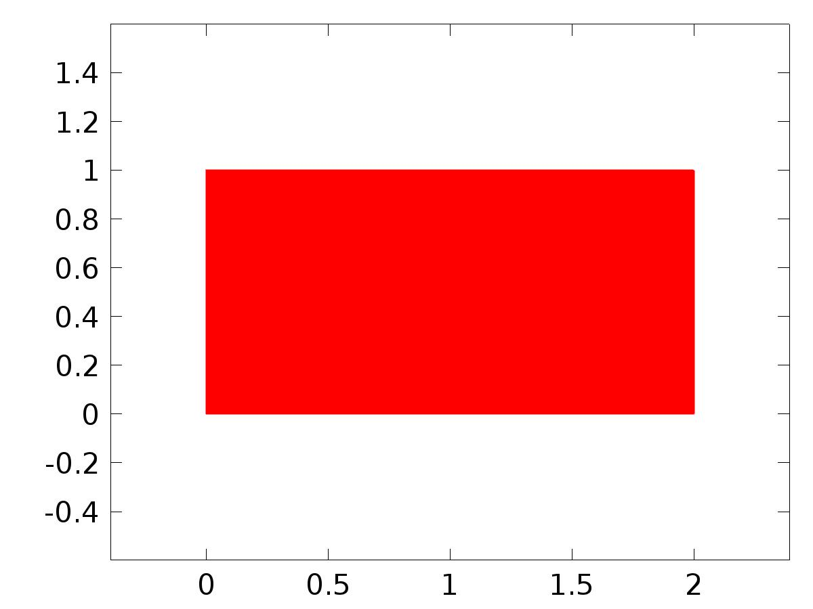

Data set: Solution 1

* + 1. Solution 2

Solution

| **Description** | **Value** |
| --- | --- |
| Solution | Solver 2 |
| Component | Save Point Geometry 1 |



Data set: Solution 2

* + 1. Solution 3

Solution

| **Description** | **Value** |
| --- | --- |
| Solution | Solver 3 |
| Component | Save Point Geometry 1 |



Data set: Solution 3

* + 1. Solution 4

Solution

| **Description** | **Value** |
| --- | --- |
| Solution | Solver 4 |
| Component | Save Point Geometry 1 |



Data set: Solution 4

* + 1. Solution 5

Solution

| **Description** | **Value** |
| --- | --- |
| Solution | Solver 5 |
| Component | Save Point Geometry 1 |



Data set: Solution 5

* 1. Derived Values
     1. Global Evaluation 1

Data

| **Description** | **Value** |
| --- | --- |
| Data set | Solution 5 |

Expression

| **Description** | **Value** |
| --- | --- |
| Expression | gamma |

* 1. Tables
     1. Table 1

Global Evaluation 1 (C(Z))

Table 1

| **Time (s)** | **C(Z)** | **yr** | **C(Z1)** | **C(Z2)** | **C(Z3)** | **e1** | **e2** | **e3** | **e** | **d** | **gamma** |
| --- | --- | --- | --- | --- | --- | --- | --- | --- | --- | --- | --- |
| 0.0000 | 6.0145E-35 | 1.0000 | 1.0000 | 1.0000 | 1.0000 | -1.6054E-13 | -1.6054E-13 | -1.6054E-13 | 1.0000 | 0.0000 | 22439 |
| 1.0000 | 0.90393 | 0.85787 | 0.89234 | 0.89234 | 0.89234 | -0.034471 | -0.034471 | -0.034471 | -0.046065 | 1.0000E-4 | 1633.0 |
| 2.0000 | 0.74104 | 0.72618 | 0.74388 | 0.74388 | 0.74388 | -0.017702 | -0.017702 | -0.017702 | -0.014855 | 4.0000E-4 | 420.13 |
| 3.0000 | 0.61765 | 0.60452 | 0.61791 | 0.61791 | 0.61791 | -0.013391 | -0.013391 | -0.013391 | -0.013133 | 9.0000E-4 | 187.77 |
| 4.0000 | 0.50340 | 0.49248 | 0.50349 | 0.50349 | 0.50349 | -0.011011 | -0.011011 | -0.011011 | -0.010923 | 0.0016000 | 102.11 |
| 5.0000 | 0.39902 | 0.38965 | 0.39906 | 0.39906 | 0.39906 | -0.0094123 | -0.0094123 | -0.0094123 | -0.0093707 | 0.0025000 | 61.160 |
| 6.0000 | 0.29591 | 0.29563 | 0.30385 | 0.29551 | 0.29551 | -0.0082216 | 1.2343E-4 | 1.2343E-4 | -2.7975E-4 | 0.0036000 | 36.579 |
| 7.0000 | 0.20993 | 0.21003 | 0.21731 | 0.20994 | 0.20994 | -0.0072730 | 8.9939E-5 | 8.9939E-5 | 1.0187E-4 | 0.0049000 | 22.516 |
| 8.0000 | 0.13240 | 0.13248 | 0.13896 | 0.13241 | 0.13241 | -0.0064799 | 7.0464E-5 | 7.0464E-5 | 7.7752E-5 | 0.0064000 | 12.463 |
| 9.0000 | 0.062529 | 0.062591 | 0.068383 | 0.062533 | 0.062533 | -0.0057923 | 5.8043E-5 | 5.8043E-5 | 6.2267E-5 | 0.0081000 | 4.5593 |
| 10.000 | -5.2400E-5 | 0.0000 | 0.0051789 | -4.9968E-5 | -4.9968E-5 | -0.0051789 | 4.9968E-5 | 4.9968E-5 | 5.2400E-5 | 0.010000 | -2.1797 |
| 11.000 | -0.055654 | -0.055653 | -0.051033 | -0.055697 | -0.055652 | -0.0046194 | 4.4632E-5 | -3.6104E-7 | 1.0615E-6 | 0.012100 | -8.2879 |
| 12.000 | -0.10472 | -0.10472 | -0.10062 | -0.10476 | -0.10472 | -0.0041004 | 4.1073E-5 | -2.2658E-7 | 6.0859E-7 | 0.014400 | -14.061 |
| 13.000 | -0.14755 | -0.14755 | -0.14393 | -0.14759 | -0.14755 | -0.0036130 | 3.8706E-5 | -1.4214E-7 | 3.6512E-7 | 0.016900 | -19.626 |
| 14.000 | -0.18447 | -0.18447 | -0.18132 | -0.18451 | -0.18447 | -0.0031513 | 3.7071E-5 | -8.7353E-8 | 1.1871E-7 | 0.019600 | -25.013 |
| 15.000 | -0.21582 | -0.21582 | -0.21311 | -0.21586 | -0.21582 | -0.0027117 | 3.5855E-5 | -6.2716E-8 | -2.6590E-7 | 0.022500 | -30.181 |
| 16.000 | -0.24192 | -0.24192 | -0.23963 | -0.24195 | -0.24192 | -0.0022921 | 3.4849E-5 | -5.5400E-8 | 2.7806E-7 | 0.025600 | -35.049 |
| 17.000 | -0.26308 | -0.26308 | -0.26119 | -0.26312 | -0.26308 | -0.0018920 | 3.3847E-5 | -6.2032E-8 | -1.0621E-7 | 0.028900 | -39.511 |
| 18.000 | -0.27962 | -0.27962 | -0.27811 | -0.27965 | -0.27962 | -0.0015112 | 3.2694E-5 | -9.6247E-8 | -5.8143E-8 | 0.032400 | -43.455 |
| 19.000 | -0.29183 | -0.29183 | -0.29068 | -0.29186 | -0.29183 | -0.0011503 | 3.1450E-5 | -1.1486E-7 | 6.3688E-8 | 0.036100 | -46.780 |
| 20.000 | -0.30000 | -0.30000 | -0.29919 | -0.30003 | -0.30000 | -8.1022E-4 | 2.9920E-5 | -1.3524E-7 | -1.7477E-7 | 0.040000 | -49.408 |
| 21.000 | -0.30442 | -0.30442 | -0.30393 | -0.30445 | -0.30442 | -4.9199E-4 | 2.8162E-5 | -1.6307E-7 | -5.3670E-8 | 0.044100 | -51.293 |
| 22.000 | -0.30537 | -0.30537 | -0.30517 | -0.30540 | -0.30537 | -1.9645E-4 | 2.6193E-5 | -1.8567E-7 | -3.1551E-7 | 0.048400 | -52.424 |
| 23.000 | -0.30312 | -0.30312 | -0.30319 | -0.30314 | -0.30312 | 7.5649E-5 | 2.4051E-5 | -2.0238E-7 | -2.1550E-7 | 0.052900 | -52.822 |
| 24.000 | -0.29792 | -0.29792 | -0.29824 | -0.29794 | -0.29792 | 3.2387E-4 | 2.1788E-5 | -2.1355E-7 | 1.8013E-8 | 0.057600 | -52.540 |
| 25.000 | -0.29004 | -0.29004 | -0.29059 | -0.29006 | -0.29004 | 5.4809E-4 | 1.9462E-5 | -2.1860E-7 | 5.3390E-8 | 0.062500 | -51.653 |
| 26.000 | -0.27972 | -0.27972 | -0.28047 | -0.27974 | -0.27972 | 7.4842E-4 | 1.7118E-5 | -2.2103E-7 | 6.5766E-8 | 0.067600 | -50.250 |
| 27.000 | -0.26720 | -0.26720 | -0.26813 | -0.26722 | -0.26720 | 9.2535E-4 | 1.4840E-5 | -2.1246E-7 | -2.4437E-8 | 0.072900 | -48.428 |
| 28.000 | -0.25272 | -0.25272 | -0.25380 | -0.25273 | -0.25272 | 0.0010795 | 1.2634E-5 | -1.9954E-7 | -1.5013E-7 | 0.078400 | -46.283 |
| 29.000 | -0.23650 | -0.23650 | -0.23771 | -0.23651 | -0.23650 | 0.0012117 | 1.0537E-5 | -1.8656E-7 | -1.8234E-7 | 0.084100 | -43.905 |
| 30.000 | -0.21875 | -0.21875 | -0.22007 | -0.21876 | -0.21875 | 0.0013231 | 8.5708E-6 | -1.7293E-7 | 2.5927E-9 | 0.090000 | -41.375 |
| 31.000 | -0.19969 | -0.19969 | -0.20110 | -0.19970 | -0.19969 | 0.0014146 | 6.7454E-6 | -1.5894E-7 | 4.2950E-8 | 0.096100 | -38.764 |
| 32.000 | -0.17952 | -0.17952 | -0.18101 | -0.17953 | -0.17952 | 0.0014874 | 5.0621E-6 | -1.4481E-7 | -1.4957E-7 | 0.10240 | -36.130 |
| 33.000 | -0.15843 | -0.15843 | -0.15998 | -0.15844 | -0.15843 | 0.0015427 | 3.5181E-6 | -1.3164E-7 | -1.2764E-7 | 0.10890 | -33.519 |
| 34.000 | -0.13662 | -0.13662 | -0.13820 | -0.13662 | -0.13662 | 0.0015814 | 2.1057E-6 | -1.1855E-7 | -2.5344E-8 | 0.11560 | -30.967 |
| 35.000 | -0.11426 | -0.11426 | -0.11586 | -0.11426 | -0.11426 | 0.0016047 | 8.1443E-7 | -1.0782E-7 | -1.9366E-7 | 0.12250 | -28.501 |
| 36.000 | -0.091520 | -0.091520 | -0.093133 | -0.091520 | -0.091520 | 0.0016135 | -3.6944E-7 | -9.9062E-8 | -1.1879E-7 | 0.12960 | -26.141 |
| 37.000 | -0.068571 | -0.068572 | -0.070180 | -0.068570 | -0.068571 | 0.0016087 | -1.4546E-6 | -8.8871E-8 | -1.5677E-7 | 0.13690 | -23.898 |
| 38.000 | -0.045570 | -0.045570 | -0.047161 | -0.045568 | -0.045570 | 0.0015912 | -2.4570E-6 | -8.0785E-8 | -3.9928E-8 | 0.14440 | -21.782 |
| 39.000 | -0.022665 | -0.022665 | -0.024227 | -0.022662 | -0.022665 | 0.0015618 | -3.3905E-6 | -7.5988E-8 | 2.4491E-8 | 0.15210 | -19.798 |
| 40.000 | 1.1094E-7 | 0.0000 | -0.0015212 | 4.2551E-6 | 7.0673E-8 | 0.0015212 | -4.2551E-6 | -7.0673E-8 | -1.1094E-7 | 0.16000 | -17.948 |
| 41.000 | 0.022291 | 0.022291 | 0.020821 | 0.022296 | 0.022291 | 0.0014701 | -5.0656E-6 | -6.5506E-8 | -1.4027E-7 | 0.16810 | -16.234 |
| 42.000 | 0.044080 | 0.044080 | 0.042671 | 0.044086 | 0.044080 | 0.0014090 | -5.8292E-6 | -6.0951E-8 | 4.5218E-8 | 0.17640 | -14.657 |
| 43.000 | 0.065247 | 0.065247 | 0.063909 | 0.065254 | 0.065247 | 0.0013386 | -6.5512E-6 | -5.7905E-8 | -9.6131E-8 | 0.18490 | -13.218 |
| 44.000 | 0.085680 | 0.085680 | 0.084421 | 0.085687 | 0.085680 | 0.0012595 | -7.2337E-6 | -5.4714E-8 | -1.4795E-7 | 0.19360 | -11.918 |
| 45.000 | 0.10527 | 0.10527 | 0.10410 | 0.10528 | 0.10527 | 0.0011721 | -7.8785E-6 | -5.1803E-8 | -1.3489E-8 | 0.20250 | -10.760 |
| 46.000 | 0.12393 | 0.12393 | 0.12285 | 0.12394 | 0.12393 | 0.0010771 | -8.4858E-6 | -4.8940E-8 | -9.8052E-8 | 0.21160 | -9.7462 |
| 47.000 | 0.14156 | 0.14156 | 0.14058 | 0.14157 | 0.14156 | 9.7487E-4 | -9.0557E-6 | -4.5993E-8 | -6.0777E-8 | 0.22090 | -8.8793 |
| 48.000 | 0.15808 | 0.15808 | 0.15721 | 0.15809 | 0.15808 | 8.6609E-4 | -9.5854E-6 | -4.2339E-8 | -7.1248E-8 | 0.23040 | -8.1636 |
| 49.000 | 0.17342 | 0.17342 | 0.17266 | 0.17343 | 0.17342 | 7.5129E-4 | -1.0073E-5 | -3.8722E-8 | -3.8845E-8 | 0.24010 | -7.6035 |
| 50.000 | 0.18750 | 0.18750 | 0.18687 | 0.18751 | 0.18750 | 6.3104E-4 | -1.0516E-5 | -3.4794E-8 | -6.3136E-8 | 0.25000 | -7.2035 |
| 51.000 | 0.20027 | 0.20027 | 0.19977 | 0.20028 | 0.20027 | 5.0592E-4 | -1.0910E-5 | -3.0534E-8 | -4.6129E-8 | 0.26010 | -6.9685 |
| 52.000 | 0.21168 | 0.21168 | 0.21130 | 0.21169 | 0.21168 | 3.7657E-4 | -1.1253E-5 | -2.6052E-8 | -5.3531E-8 | 0.27040 | -6.9031 |
| 53.000 | 0.22168 | 0.22168 | 0.22143 | 0.22169 | 0.22168 | 2.4359E-4 | -1.1543E-5 | -2.1371E-8 | -4.2671E-8 | 0.28090 | -7.0116 |
| 54.000 | 0.23023 | 0.23023 | 0.23012 | 0.23024 | 0.23023 | 1.0763E-4 | -1.1777E-5 | -1.6561E-8 | -4.2857E-8 | 0.29160 | -7.2980 |
| 55.000 | 0.23730 | 0.23730 | 0.23734 | 0.23732 | 0.23730 | -3.0656E-5 | -1.1955E-5 | -1.1724E-8 | -3.4308E-8 | 0.30250 | -7.7661 |
| 56.000 | 0.24288 | 0.24288 | 0.24305 | 0.24289 | 0.24288 | -1.7064E-4 | -1.2077E-5 | -6.9635E-9 | -4.2279E-8 | 0.31360 | -8.4194 |
| 57.000 | 0.24694 | 0.24694 | 0.24725 | 0.24695 | 0.24694 | -3.1166E-4 | -1.2145E-5 | -2.4137E-9 | -4.0965E-8 | 0.32490 | -9.2614 |
| 58.000 | 0.24948 | 0.24948 | 0.24993 | 0.24949 | 0.24948 | -4.5312E-4 | -1.2161E-5 | 1.8005E-9 | -3.0944E-8 | 0.33640 | -10.296 |
| 59.000 | 0.25050 | 0.25050 | 0.25109 | 0.25051 | 0.25050 | -5.9438E-4 | -1.2131E-5 | 5.5746E-9 | -4.9101E-8 | 0.34810 | -11.528 |
| 60.000 | 0.25000 | 0.25000 | 0.25073 | 0.25001 | 0.25000 | -7.3489E-4 | -1.2058E-5 | 8.8083E-9 | -4.7606E-8 | 0.36000 | -12.964 |
| 61.000 | 0.24800 | 0.24800 | 0.24888 | 0.24802 | 0.24800 | -8.7410E-4 | -1.1950E-5 | 1.1459E-8 | -8.9762E-8 | 0.37210 | -14.613 |
| 62.000 | 0.24453 | 0.24453 | 0.24554 | 0.24454 | 0.24453 | -0.0010115 | -1.1812E-5 | 1.3414E-8 | -7.5058E-8 | 0.38440 | -16.485 |
| 63.000 | 0.23961 | 0.23961 | 0.24076 | 0.23962 | 0.23961 | -0.0011466 | -1.1653E-5 | 1.4562E-8 | -7.1820E-8 | 0.39690 | -18.597 |
| 64.000 | 0.23328 | 0.23328 | 0.23456 | 0.23329 | 0.23328 | -0.0012791 | -1.1480E-5 | 1.5184E-8 | -2.6505E-8 | 0.40960 | -20.969 |
| 65.000 | 0.22559 | 0.22559 | 0.22699 | 0.22560 | 0.22559 | -0.0014085 | -1.1300E-5 | 1.4828E-8 | -1.4340E-8 | 0.42250 | -23.628 |
| 66.000 | 0.21658 | 0.21658 | 0.21811 | 0.21659 | 0.21658 | -0.0015344 | -1.1122E-5 | 1.4153E-8 | -1.0052E-7 | 0.43560 | -26.608 |
| 67.000 | 0.20632 | 0.20632 | 0.20798 | 0.20633 | 0.20632 | -0.0016567 | -1.0951E-5 | 1.1977E-8 | -3.2423E-8 | 0.44890 | -29.953 |
| 68.000 | 0.19488 | 0.19488 | 0.19666 | 0.19489 | 0.19488 | -0.0017750 | -1.0793E-5 | 1.0905E-8 | -5.9164E-8 | 0.46240 | -33.717 |
| 69.000 | 0.18233 | 0.18233 | 0.18422 | 0.18234 | 0.18233 | -0.0018891 | -1.0655E-5 | 7.9303E-9 | -7.5083E-8 | 0.47610 | -37.967 |
| 70.000 | 0.16875 | 0.16875 | 0.17075 | 0.16876 | 0.16875 | -0.0019988 | -1.0541E-5 | 4.8483E-9 | -8.8869E-8 | 0.49000 | -42.785 |
| 71.000 | 0.15423 | 0.15423 | 0.15634 | 0.15425 | 0.15423 | -0.0021039 | -1.0454E-5 | 1.8621E-9 | -1.1833E-7 | 0.50410 | -48.273 |
| 72.000 | 0.13888 | 0.13888 | 0.14108 | 0.13889 | 0.13888 | -0.0022040 | -1.0395E-5 | -1.5732E-9 | -1.1557E-7 | 0.51840 | -54.552 |
| 73.000 | 0.12279 | 0.12279 | 0.12509 | 0.12280 | 0.12279 | -0.0022991 | -1.0364E-5 | -5.4064E-9 | -4.2168E-8 | 0.53290 | -61.772 |
| 74.000 | 0.10608 | 0.10608 | 0.10847 | 0.10609 | 0.10608 | -0.0023888 | -1.0359E-5 | -9.7103E-9 | -2.8448E-7 | 0.54760 | -70.113 |
| 75.000 | 0.088867 | 0.088867 | 0.091340 | 0.088878 | 0.088867 | -0.0024727 | -1.0377E-5 | -1.3232E-8 | -1.2020E-7 | 0.56250 | -79.794 |
| 76.000 | 0.071280 | 0.071280 | 0.073831 | 0.071290 | 0.071280 | -0.0025506 | -1.0410E-5 | -1.5931E-8 | -1.1490E-7 | 0.57760 | -91.080 |
| 77.000 | 0.053454 | 0.053453 | 0.056075 | 0.053464 | 0.053453 | -0.0026218 | -1.0446E-5 | -1.7920E-8 | -6.8690E-8 | 0.59290 | -104.29 |
| 78.000 | 0.035530 | 0.035530 | 0.038216 | 0.035540 | 0.035530 | -0.0026858 | -1.0471E-5 | -1.8075E-8 | -2.1805E-8 | 0.60840 | -119.83 |
| 79.000 | 0.017660 | 0.017660 | 0.020401 | 0.017670 | 0.017660 | -0.0027418 | -1.0461E-5 | -1.5818E-8 | 9.7893E-8 | 0.62410 | -138.15 |
| 80.000 | 2.3778E-7 | 0.0000 | 0.0027888 | 1.0386E-5 | 1.2360E-8 | -0.0027888 | -1.0386E-5 | -1.2360E-8 | -2.3778E-7 | 0.64000 | -159.84 |
| 81.000 | -0.017284 | -0.017284 | -0.014458 | -0.017274 | -0.017284 | -0.0028256 | -1.0186E-5 | 4.0881E-9 | -2.6306E-7 | 0.65610 | -185.57 |
| 82.000 | -0.034020 | -0.034020 | -0.031169 | -0.034010 | -0.034020 | -0.0028506 | -9.8196E-6 | 2.7533E-8 | 4.9122E-8 | 0.67240 | -216.16 |
| 83.000 | -0.050028 | -0.050028 | -0.047166 | -0.050019 | -0.050028 | -0.0028620 | -9.2009E-6 | 5.7536E-8 | 1.9802E-8 | 0.68890 | -252.56 |
| 84.000 | -0.065120 | -0.065120 | -0.062263 | -0.065112 | -0.065120 | -0.0028572 | -8.1964E-6 | 1.0590E-7 | 1.3997E-7 | 0.70560 | -295.88 |
| 85.000 | -0.079102 | -0.079102 | -0.076268 | -0.079095 | -0.079102 | -0.0028334 | -6.6563E-6 | 1.8623E-7 | 1.6556E-7 | 0.72250 | -347.33 |
| 86.000 | -0.091770 | -0.091770 | -0.088983 | -0.091766 | -0.091770 | -0.0027866 | -4.3646E-6 | 3.0157E-7 | 2.5085E-7 | 0.73960 | -408.18 |
| 87.000 | -0.10292 | -0.10292 | -0.10020 | -0.10291 | -0.10292 | -0.0027125 | -1.0732E-6 | 4.6412E-7 | 6.0861E-7 | 0.75690 | -479.64 |
| 88.000 | -0.11232 | -0.11232 | -0.10971 | -0.11232 | -0.11232 | -0.0026055 | 3.5394E-6 | 6.8768E-7 | 9.9317E-7 | 0.77440 | -562.62 |
| 89.000 | -0.11976 | -0.11976 | -0.11730 | -0.11977 | -0.11976 | -0.0024590 | 9.8401E-6 | 9.8570E-7 | 1.6003E-6 | 0.79210 | -657.41 |
| 90.000 | -0.12500 | -0.12500 | -0.12273 | -0.12502 | -0.12500 | -0.0022659 | 1.8149E-5 | 1.3548E-6 | 1.8758E-6 | 0.81000 | -763.12 |
| 91.000 | -0.12780 | -0.12780 | -0.12578 | -0.12783 | -0.12780 | -0.0020183 | 2.8715E-5 | 1.7793E-6 | 2.0020E-6 | 0.82810 | -877.09 |
| 92.000 | -0.12792 | -0.12792 | -0.12621 | -0.12796 | -0.12792 | -0.0017087 | 4.1495E-5 | 2.1901E-6 | 2.6909E-6 | 0.84640 | -994.17 |
| 93.000 | -0.12510 | -0.12510 | -0.12377 | -0.12515 | -0.12510 | -0.0013309 | 5.6037E-5 | 2.5009E-6 | 2.7915E-6 | 0.86490 | -1106.4 |
| 94.000 | -0.11907 | -0.11907 | -0.11819 | -0.11914 | -0.11907 | -8.8142E-4 | 7.1214E-5 | 2.5453E-6 | 2.7182E-6 | 0.88360 | -1203.0 |
| 95.000 | -0.10957 | -0.10957 | -0.10921 | -0.10966 | -0.10957 | -3.6137E-4 | 8.5334E-5 | 2.2063E-6 | 2.0829E-6 | 0.90250 | -1271.9 |
| 96.000 | -0.096321 | -0.096320 | -0.096542 | -0.096416 | -0.096321 | 2.2215E-4 | 9.6153E-5 | 1.4236E-6 | 1.0895E-6 | 0.92160 | -1302.2 |
| 97.000 | -0.079034 | -0.079034 | -0.079890 | -0.079136 | -0.079034 | 8.5578E-4 | 1.0163E-4 | 2.9182E-7 | -1.8391E-7 | 0.94090 | -1286.7 |
| 98.000 | -0.057419 | -0.057420 | -0.058941 | -0.057520 | -0.057419 | 0.0015207 | 1.0048E-4 | -9.4440E-7 | -1.3011E-6 | 0.96040 | -1225.1 |
| 99.000 | -0.031176 | -0.031178 | -0.033373 | -0.031271 | -0.031176 | 0.0021954 | 9.2887E-5 | -1.9604E-6 | -1.7998E-6 | 0.98010 | -1123.9 |
| 100.00 | -2.2339E-5 | 0.0000 | -0.0028596 | -8.0437E-5 | 2.5208E-6 | 0.0028596 | 8.0437E-5 | -2.5208E-6 | 2.2339E-5 | 1.0000 | -995.25 |

* 1. Plot Groups
     1. 2D Plot Group 1

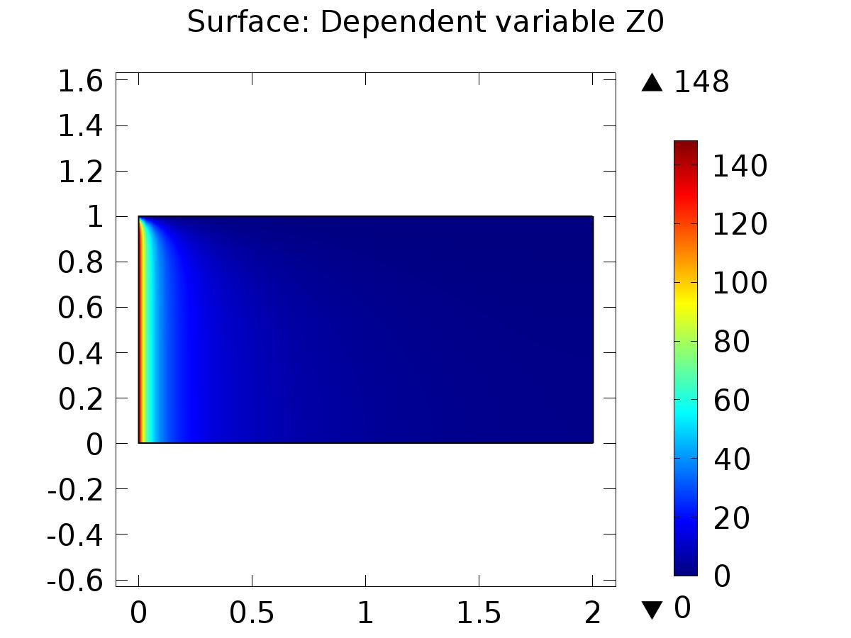

Surface: Dependent variable Z0

* + 1. 2D Plot Group 2

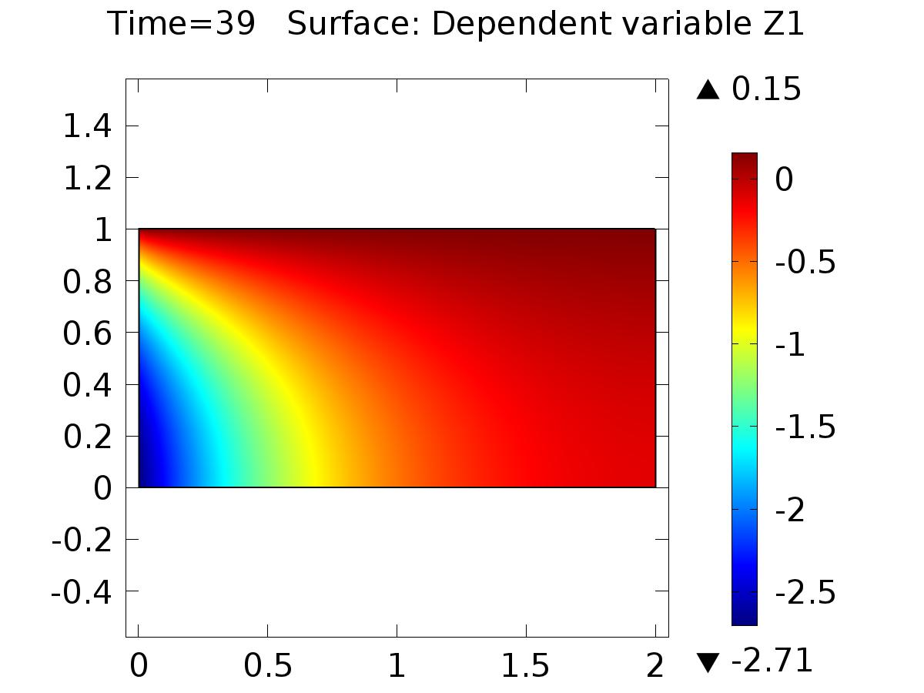

Time=39 Surface: Dependent variable Z1

* + 1. 2D Plot Group 5

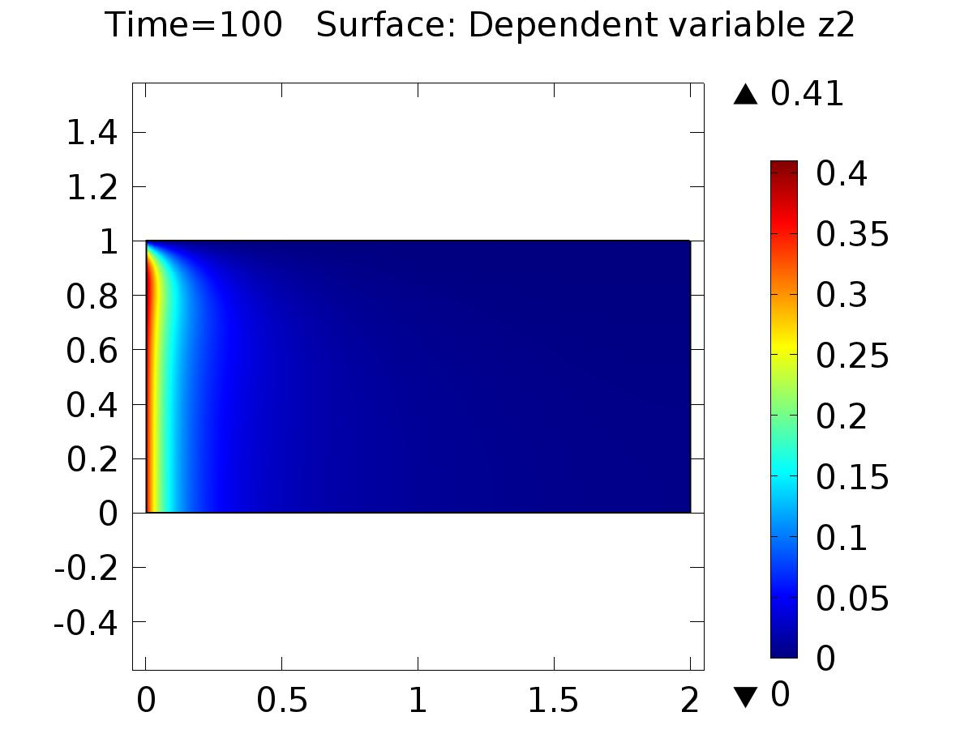

Time=100 Surface: Dependent variable z2

* + 1. 2D Plot Group 8

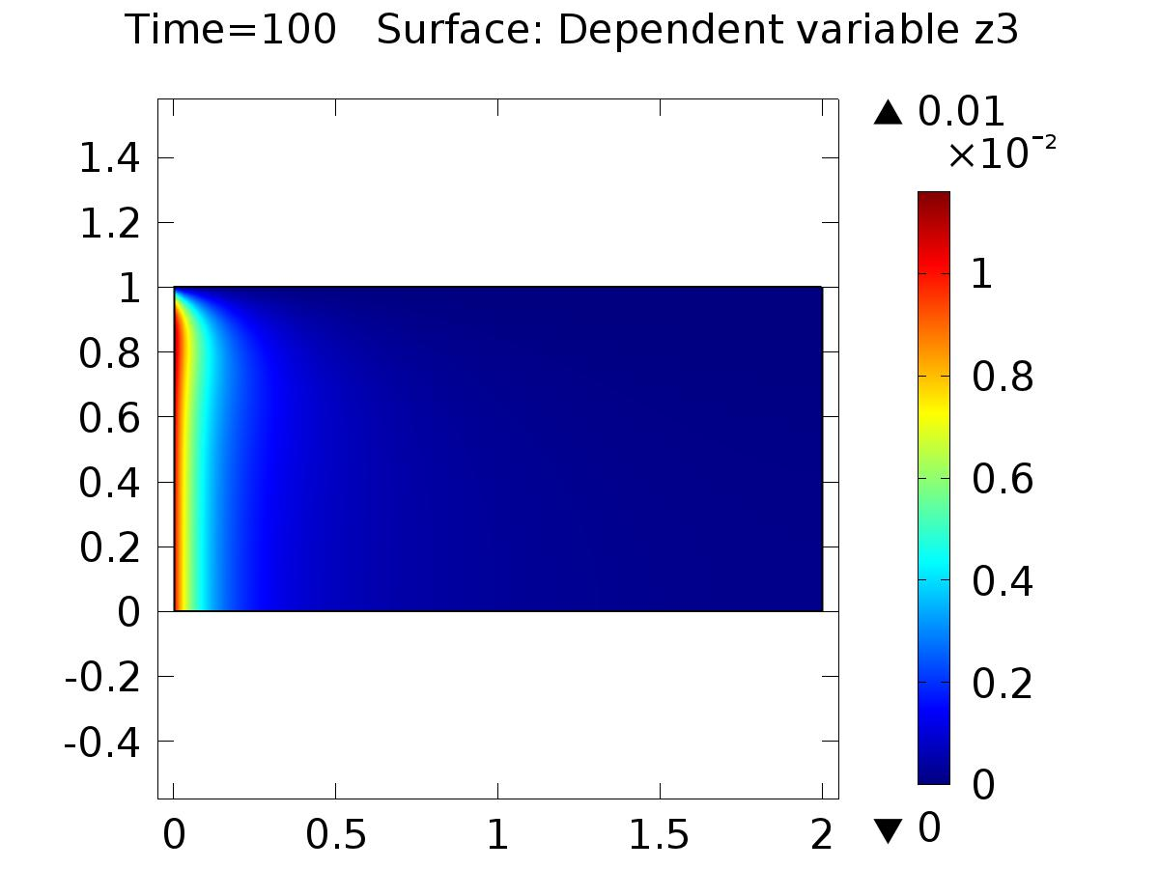

Time=100 Surface: Dependent variable z3

* + 1. 2D Plot Group 9

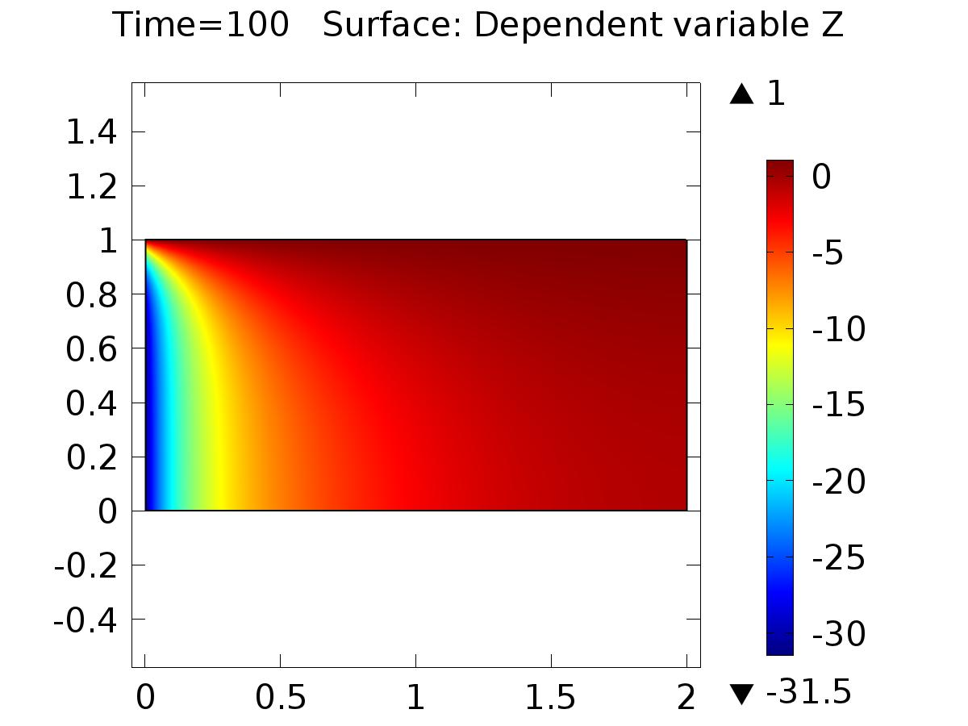

Time=100 Surface: Dependent variable Z

* + 1. 1D Plot Group 3

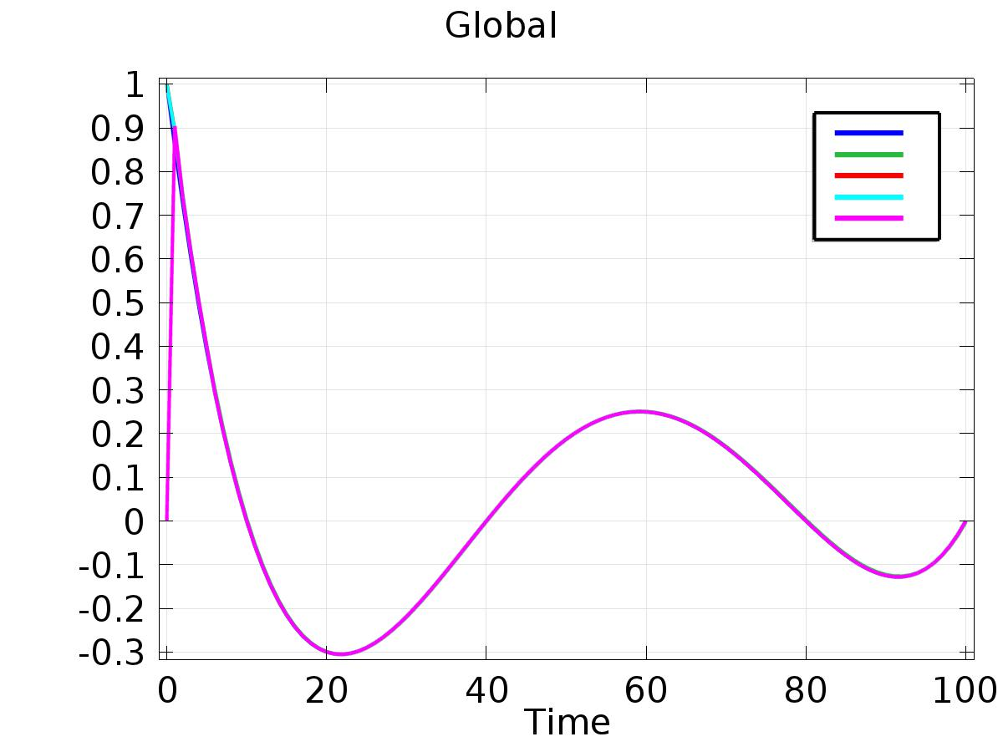

Global

* + 1. 1D Plot Group 7

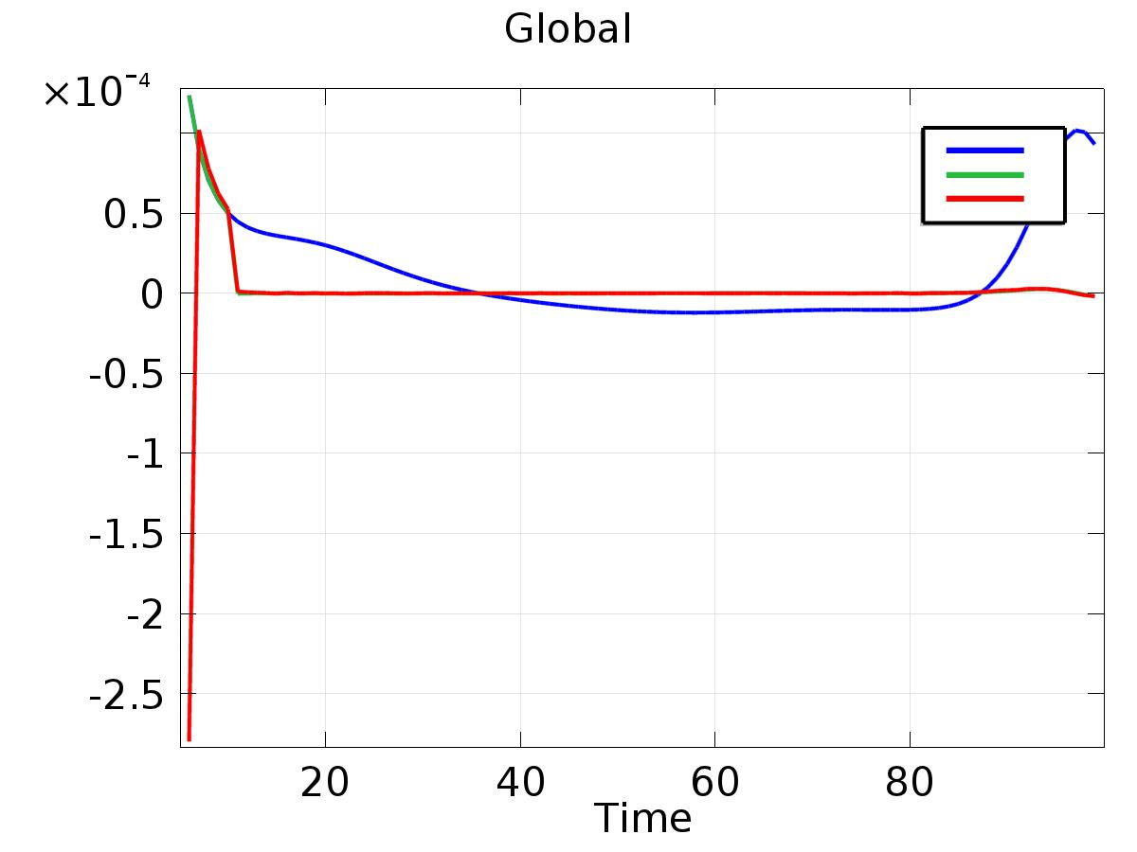

Global

* + 1. 1D Plot Group 10

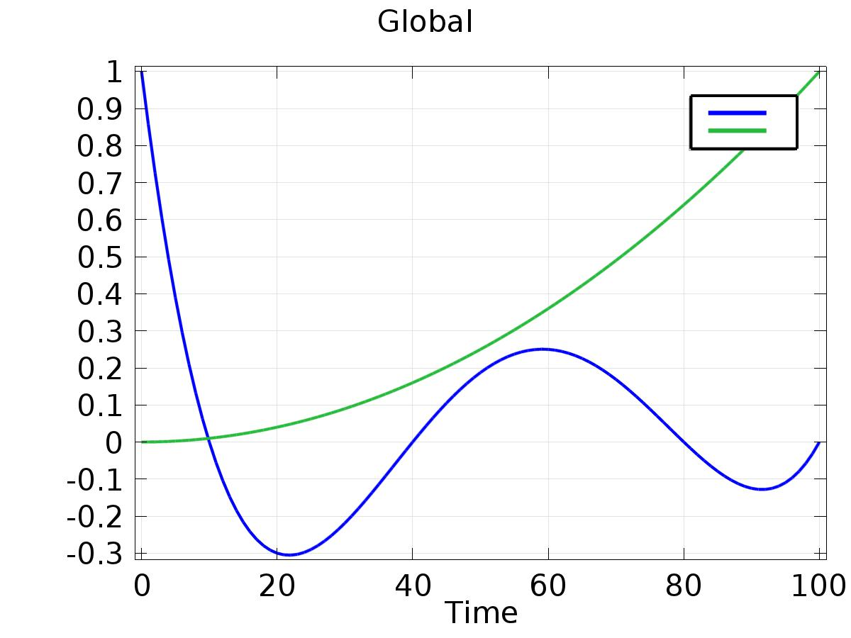

Global