[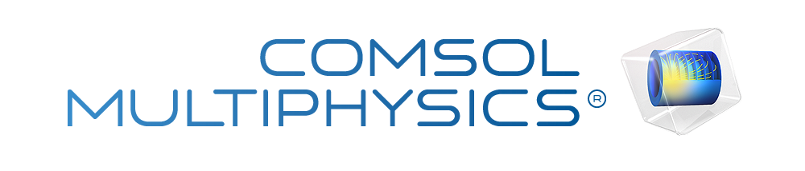](http://www.comsol.com/)

Ex5.4 NL Burg2D N2

|  |  |
| --- | --- |
| Date | Aug 19, 2014 6:05:07 AM |

Contents

1. Global

1.1. Definitions

2. Component 1

2.1. Definitions

2.2. Geometry 1

2.3. Unit Input

2.4. Fourier coefficients 0

2.5. Fourier coefficients 1

2.6. Fourier coefficients 2

2.7. Fourier coefficients 3

2.8. Fourier coefficients 4

2.9. Fourier coefficients 5

2.10. Closed loop system

2.11. Mesh 1

3. Study 1

3.1. Stationary

3.2. Solver Configurations

4. Study 2

4.1. Stationary

4.2. Solver Configurations

5. Study 3

5.1. Time Dependent

5.2. Solver Configurations

6. Results

6.1. Data Sets

6.2. Derived Values

6.3. Tables

6.4. Plot Groups

1. Global

|  |  |
| --- | --- |
| Date | Aug 18, 2014 7:07:34 AM |

Global settings

|  |  |
| --- | --- |
| Name | Ex5.4 NL Burg2D N2.mph |
| Path | /Users/gilliam/Desktop/collect_15/research_15/geo_reg_mono_eugenio/Mono_1_15/Comsol_EX_GitHub/Chapter5/Chap5Ex4_NLFourier_2D_Burg/Ex5.4_NL_Burg2D_N2.mph |
| Program | COMSOL 4.4 (Build: 150) |

Used products

|  |
| --- |
| COMSOL Multiphysics |

* 1. Definitions
     1. Parameters 1

Parameters

| **Name** | **Expression** | **Value** | **Description** |
| --- | --- | --- | --- |
| nu | 1 | 1.0000 |  |
| L | 1 | 1.0000 |  |
| K | 5 | 5.0000 |  |
| alpha | 1 | 1.0000 |  |
| M1 | 0.1 | 0.10000 |  |
| M2 | 0.2 | 0.20000 |  |
| A1 | 0.2 | 0.20000 |  |
| A2 | 0.1 | 0.10000 |  |
| N | 3 | 3.0000 |  |

1. Component 1

Component settings

|  |  |
| --- | --- |
| Unit system | None |

* 1. Definitions
     1. Variables

#### Variables 1

Selection

|  |  |
| --- | --- |
| Geometric entity level | Entire model |

| **Name** | **Expression** | **Description** |
| --- | --- | --- |
| G | C(Xu) |  |
| e | yr - C(u) |  |

#### Variables 2a

Selection

|  |  |
| --- | --- |
| Geometric entity level | Entire model |

| **Name** | **Expression** | **Description** |
| --- | --- | --- |
| f_au0 | -0.5*(au0*au0x + 2.*au1*au1x + 2.*au2*au2x + 2.*au3*au3x + 2.*au4*au4x + 2.*au5*au5x + 2.*bu1*bu1x + 2.*bu2*bu2x + 2.*bu3*bu3x + 2.*bu4*bu4x + 2.*bu5*bu5x + av0*au0y + 2.*av1*au1y + 2.*av2*au2y + 2.*av3*au3y + 2.*av4*au4y + 2.*av5*au5y + 2.*bv1*bu1y + 2.*bv2*bu2y + 2.*bv3*bu3y + 2.*bv4*bu4y + 2.*bv5*bu5y) |  |
| f_av0 | -0.5*(au0*av0x + 2.*au1*av1x + 2.*au2*av2x + 2.*au3*av3x + 2.*au4*av4x + 2.*au5*av5x + 2.*bu1*bv1x + 2.*bu2*bv2x + 2.*bu3*bv3x + 2.*bu4*bv4x + 2.*bu5*bv5x + av0*av0y + 2.*av1*av1y + 2.*av2*av2y + 2.*av3*av3y + 2.*av4*av4y + 2.*av5*av5y + 2.*bv1*bv1y + 2.*bv2*bv2y + 2.*bv3*bv3y + 2.*bv4*bv4y + 2.*bv5*bv5y) |  |
| f_au1 | -0.5*(au0*au1x + au1*au0x + 0.5*au1*au2x + 0.5*au2*au1x + 0.5*au2*au1x + 0.5*au1*au2x + 0.5*au2*au3x + 0.5*au3*au2x + 0.5*au3*au2x + 0.5*au2*au3x + 0.5*au3*au4x + 0.5*au4*au3x + 0.5*au4*au3x + 0.5*au3*au4x + 0.5*au4*au5x + 0.5*au5*au4x + 0.5*au5*au4x + 0.5*au4*au5x + 0.5*bu1*bu2x + 0.5*bu2*bu1x + 0.5*bu2*bu1x + 0.5*bu1*bu2x + 0.5*bu2*bu3x + 0.5*bu3*bu2x + 0.5*bu3*bu2x + 0.5*bu2*bu3x + 0.5*bu3*bu4x + 0.5*bu4*bu3x + 0.5*bu4*bu3x + 0.5*bu3*bu4x + 0.5*bu4*bu5x + 0.5*bu5*bu4x + 0.5*bu5*bu4x + 0.5*bu4*bu5x + av0*au1y + av1*au0y + 0.5*av1*au2y + 0.5*av2*au1y + 0.5*av2*au1y + 0.5*av1*au2y + 0.5*av2*au3y + 0.5*av3*au2y + 0.5*av3*au2y + 0.5*av2*au3y + 0.5*av3*au4y + 0.5*av4*au3y + 0.5*av4*au3y + 0.5*av3*au4y + 0.5*av4*au5y + 0.5*av5*au4y + 0.5*av5*au4y + 0.5*av4*au5y + 0.5*bv1*bu2y + 0.5*bv2*bu1y + 0.5*bv2*bu1y + 0.5*bv1*bu2y + 0.5*bv2*bu3y + 0.5*bv3*bu2y + 0.5*bv3*bu2y + 0.5*bv2*bu3y + 0.5*bv3*bu4y + 0.5*bv4*bu3y + 0.5*bv4*bu3y + 0.5*bv3*bu4y + 0.5*bv4*bu5y + 0.5*bv5*bu4y + 0.5*bv5*bu4y + 0.5*bv4*bu5y)*(N>0) |  |
| f_bu1 | -0.5*(au0*bu1x + bu1*au0x + au1*bu2x + bu2*au1x - au2*bu1x - bu1*au2x + au2*bu3x + bu3*au2x - au3*bu2x - bu2*au3x + au3*bu4x + bu4*au3x - au4*bu3x - bu3*au4x + au4*bu5x + bu5*au4x - au5*bu4x - bu4*au5x + av0*bu1y + bv1*au0y + av1*bu2y + bv2*au1y - av2*bu1y - bv1*au2y + av2*bu3y + bv3*au2y - av3*bu2y - bv2*au3y + av3*bu4y + bv4*au3y - av4*bu3y - bv3*au4y + av4*bu5y + bv5*au4y - av5*bu4y - bv4*au5y)*(N>0) |  |
| f_av1 | -0.5*(au0*av1x + au1*av0x + 0.5*au1*av2x + 0.5*au2*av1x + 0.5*au2*av1x + 0.5*au1*av2x + 0.5*au2*av3x + 0.5*au3*av2x + 0.5*au3*av2x + 0.5*au2*av3x + 0.5*au3*av4x + 0.5*au4*av3x + 0.5*au4*av3x + 0.5*au3*av4x + 0.5*au4*av5x + 0.5*au5*av4x + 0.5*au5*av4x + 0.5*au4*av5x + 0.5*bu1*bv2x + 0.5*bu2*bv1x + 0.5*bu2*bv1x + 0.5*bu1*bv2x + 0.5*bu2*bv3x + 0.5*bu3*bv2x + 0.5*bu3*bv2x + 0.5*bu2*bv3x + 0.5*bu3*bv4x + 0.5*bu4*bv3x + 0.5*bu4*bv3x + 0.5*bu3*bv4x + 0.5*bu4*bv5x + 0.5*bu5*bv4x + 0.5*bu5*bv4x + 0.5*bu4*bv5x + av0*av1y + av1*av0y + 0.5*av1*av2y + 0.5*av2*av1y + 0.5*av2*av1y + 0.5*av1*av2y + 0.5*av2*av3y + 0.5*av3*av2y + 0.5*av3*av2y + 0.5*av2*av3y + 0.5*av3*av4y + 0.5*av4*av3y + 0.5*av4*av3y + 0.5*av3*av4y + 0.5*av4*av5y + 0.5*av5*av4y + 0.5*av5*av4y + 0.5*av4*av5y + 0.5*bv1*bv2y + 0.5*bv2*bv1y + 0.5*bv2*bv1y + 0.5*bv1*bv2y + 0.5*bv2*bv3y + 0.5*bv3*bv2y + 0.5*bv3*bv2y + 0.5*bv2*bv3y + 0.5*bv3*bv4y + 0.5*bv4*bv3y + 0.5*bv4*bv3y + 0.5*bv3*bv4y + 0.5*bv4*bv5y + 0.5*bv5*bv4y + 0.5*bv5*bv4y + 0.5*bv4*bv5y)*(N>0) |  |
| f_bv1 | -0.5*(au0*bv1x + bu1*av0x + au1*bv2x + bu2*av1x - au2*bv1x - bu1*av2x + au2*bv3x + bu3*av2x - au3*bv2x - bu2*av3x + au3*bv4x + bu4*av3x - au4*bv3x - bu3*av4x + au4*bv5x + bu5*av4x - au5*bv4x - bu4*av5x + av0*bv1y + bv1*av0y + av1*bv2y + bv2*av1y - av2*bv1y - bv1*av2y + av2*bv3y + bv3*av2y - av3*bv2y - bv2*av3y + av3*bv4y + bv4*av3y - av4*bv3y - bv3*av4y + av4*bv5y + bv5*av4y - av5*bv4y - bv4*av5y)*(N>0) |  |
| f_au2 | -0.5*(au0*au2x + au2*au0x + 0.5*au1*au1x + 0.5*au1*au1x + 0.5*au1*au3x + 0.5*au3*au1x + 0.5*au2*au4x + 0.5*au4*au2x + 0.5*au3*au1x + 0.5*au1*au3x + 0.5*au3*au5x + 0.5*au5*au3x + 0.5*au4*au2x + 0.5*au2*au4x + 0.5*au5*au3x + 0.5*au3*au5x - 0.5*bu1*bu1x - 0.5*bu1*bu1x + 0.5*bu1*bu3x + 0.5*bu3*bu1x + 0.5*bu2*bu4x + 0.5*bu4*bu2x + 0.5*bu3*bu1x + 0.5*bu1*bu3x + 0.5*bu3*bu5x + 0.5*bu5*bu3x + 0.5*bu4*bu2x + 0.5*bu2*bu4x + 0.5*bu5*bu3x + 0.5*bu3*bu5x + av0*au2y + av2*au0y + 0.5*av1*au1y + 0.5*av1*au1y + 0.5*av1*au3y + 0.5*av3*au1y + 0.5*av2*au4y + 0.5*av4*au2y + 0.5*av3*au1y + 0.5*av1*au3y + 0.5*av3*au5y + 0.5*av5*au3y + 0.5*av4*au2y + 0.5*av2*au4y + 0.5*av5*au3y + 0.5*av3*au5y - 0.5*bv1*bu1y - 0.5*bv1*bu1y + 0.5*bv1*bu3y + 0.5*bv3*bu1y + 0.5*bv2*bu4y + 0.5*bv4*bu2y + 0.5*bv3*bu1y + 0.5*bv1*bu3y + 0.5*bv3*bu5y + 0.5*bv5*bu3y + 0.5*bv4*bu2y + 0.5*bv2*bu4y + 0.5*bv5*bu3y + 0.5*bv3*bu5y)*(N>1) |  |
| f_bu2 | -0.5*(au0*bu2x + bu2*au0x + au1*bu1x + bu1*au1x + au1*bu3x + bu3*au1x + au2*bu4x + bu4*au2x - au3*bu1x - bu1*au3x + au3*bu5x + bu5*au3x - au4*bu2x - bu2*au4x - au5*bu3x - bu3*au5x + av0*bu2y + bv2*au0y + av1*bu1y + bv1*au1y + av1*bu3y + bv3*au1y + av2*bu4y + bv4*au2y - av3*bu1y - bv1*au3y + av3*bu5y + bv5*au3y - av4*bu2y - bv2*au4y - av5*bu3y - bv3*au5y)*(N>1) |  |
| f_av2 | -0.5*(au0*av2x + au2*av0x + 0.5*au1*av1x + 0.5*au1*av1x + 0.5*au1*av3x + 0.5*au3*av1x + 0.5*au2*av4x + 0.5*au4*av2x + 0.5*au3*av1x + 0.5*au1*av3x + 0.5*au3*av5x + 0.5*au5*av3x + 0.5*au4*av2x + 0.5*au2*av4x + 0.5*au5*av3x + 0.5*au3*av5x - 0.5*bu1*bv1x - 0.5*bu1*bv1x + 0.5*bu1*bv3x + 0.5*bu3*bv1x + 0.5*bu2*bv4x + 0.5*bu4*bv2x + 0.5*bu3*bv1x + 0.5*bu1*bv3x + 0.5*bu3*bv5x + 0.5*bu5*bv3x + 0.5*bu4*bv2x + 0.5*bu2*bv4x + 0.5*bu5*bv3x + 0.5*bu3*bv5x + av0*av2y + av2*av0y + 0.5*av1*av1y + 0.5*av1*av1y + 0.5*av1*av3y + 0.5*av3*av1y + 0.5*av2*av4y + 0.5*av4*av2y + 0.5*av3*av1y + 0.5*av1*av3y + 0.5*av3*av5y + 0.5*av5*av3y + 0.5*av4*av2y + 0.5*av2*av4y + 0.5*av5*av3y + 0.5*av3*av5y - 0.5*bv1*bv1y - 0.5*bv1*bv1y + 0.5*bv1*bv3y + 0.5*bv3*bv1y + 0.5*bv2*bv4y + 0.5*bv4*bv2y + 0.5*bv3*bv1y + 0.5*bv1*bv3y + 0.5*bv3*bv5y + 0.5*bv5*bv3y + 0.5*bv4*bv2y + 0.5*bv2*bv4y + 0.5*bv5*bv3y + 0.5*bv3*bv5y)*(N>1) |  |
| f_bv2 | -0.5*(au0*bv2x + bu2*av0x + au1*bv1x + bu1*av1x + au1*bv3x + bu3*av1x + au2*bv4x + bu4*av2x - au3*bv1x - bu1*av3x + au3*bv5x + bu5*av3x - au4*bv2x - bu2*av4x - au5*bv3x - bu3*av5x + av0*bv2y + bv2*av0y + av1*bv1y + bv1*av1y + av1*bv3y + bv3*av1y + av2*bv4y + bv4*av2y - av3*bv1y - bv1*av3y + av3*bv5y + bv5*av3y - av4*bv2y - bv2*av4y - av5*bv3y - bv3*av5y)*(N>1) |  |
| f_au3 | -0.5*(au0*au3x + au3*au0x + 0.5*au1*au2x + 0.5*au2*au1x + 0.5*au1*au4x + 0.5*au4*au1x + 0.5*au2*au1x + 0.5*au1*au2x + 0.5*au2*au5x + 0.5*au5*au2x + 0.5*au4*au1x + 0.5*au1*au4x + 0.5*au5*au2x + 0.5*au2*au5x - 0.5*bu1*bu2x - 0.5*bu2*bu1x + 0.5*bu1*bu4x + 0.5*bu4*bu1x - 0.5*bu2*bu1x - 0.5*bu1*bu2x + 0.5*bu2*bu5x + 0.5*bu5*bu2x + 0.5*bu4*bu1x + 0.5*bu1*bu4x + 0.5*bu5*bu2x + 0.5*bu2*bu5x + av0*au3y + av3*au0y + 0.5*av1*au2y + 0.5*av2*au1y + 0.5*av1*au4y + 0.5*av4*au1y + 0.5*av2*au1y + 0.5*av1*au2y + 0.5*av2*au5y + 0.5*av5*au2y + 0.5*av4*au1y + 0.5*av1*au4y + 0.5*av5*au2y + 0.5*av2*au5y - 0.5*bv1*bu2y - 0.5*bv2*bu1y + 0.5*bv1*bu4y + 0.5*bv4*bu1y - 0.5*bv2*bu1y - 0.5*bv1*bu2y + 0.5*bv2*bu5y + 0.5*bv5*bu2y + 0.5*bv4*bu1y + 0.5*bv1*bu4y + 0.5*bv5*bu2y + 0.5*bv2*bu5y)*(N>2) |  |
| f_bu3 | -0.5*(au0*bu3x + bu3*au0x + au1*bu2x + bu2*au1x + au1*bu4x + bu4*au1x + au2*bu1x + bu1*au2x + au2*bu5x + bu5*au2x - au4*bu1x - bu1*au4x - au5*bu2x - bu2*au5x + av0*bu3y + bv3*au0y + av1*bu2y + bv2*au1y + av1*bu4y + bv4*au1y + av2*bu1y + bv1*au2y + av2*bu5y + bv5*au2y - av4*bu1y - bv1*au4y - av5*bu2y - bv2*au5y)*(N>2) |  |
| f_av3 | -0.5*(au0*av3x + au3*av0x + 0.5*au1*av2x + 0.5*au2*av1x + 0.5*au1*av4x + 0.5*au4*av1x + 0.5*au2*av1x + 0.5*au1*av2x + 0.5*au2*av5x + 0.5*au5*av2x + 0.5*au4*av1x + 0.5*au1*av4x + 0.5*au5*av2x + 0.5*au2*av5x - 0.5*bu1*bv2x - 0.5*bu2*bv1x + 0.5*bu1*bv4x + 0.5*bu4*bv1x - 0.5*bu2*bv1x - 0.5*bu1*bv2x + 0.5*bu2*bv5x + 0.5*bu5*bv2x + 0.5*bu4*bv1x + 0.5*bu1*bv4x + 0.5*bu5*bv2x + 0.5*bu2*bv5x + av0*av3y + av3*av0y + 0.5*av1*av2y + 0.5*av2*av1y + 0.5*av1*av4y + 0.5*av4*av1y + 0.5*av2*av1y + 0.5*av1*av2y + 0.5*av2*av5y + 0.5*av5*av2y + 0.5*av4*av1y + 0.5*av1*av4y + 0.5*av5*av2y + 0.5*av2*av5y - 0.5*bv1*bv2y - 0.5*bv2*bv1y + 0.5*bv1*bv4y + 0.5*bv4*bv1y - 0.5*bv2*bv1y - 0.5*bv1*bv2y + 0.5*bv2*bv5y + 0.5*bv5*bv2y + 0.5*bv4*bv1y + 0.5*bv1*bv4y + 0.5*bv5*bv2y + 0.5*bv2*bv5y)*(N>2) |  |
| f_bv3 | -0.5*(au0*bv3x + bu3*av0x + au1*bv2x + bu2*av1x + au1*bv4x + bu4*av1x + au2*bv1x + bu1*av2x + au2*bv5x + bu5*av2x - au4*bv1x - bu1*av4x - au5*bv2x - bu2*av5x + av0*bv3y + bv3*av0y + av1*bv2y + bv2*av1y + av1*bv4y + bv4*av1y + av2*bv1y + bv1*av2y + av2*bv5y + bv5*av2y - av4*bv1y - bv1*av4y - av5*bv2y - bv2*av5y)*(N>2) |  |
| f_au4 | -0.5*(au0*au4x + au4*au0x + 0.5*au1*au3x + 0.5*au3*au1x + 0.5*au1*au5x + 0.5*au5*au1x + 0.5*au2*au2x + 0.5*au2*au2x + 0.5*au3*au1x + 0.5*au1*au3x + 0.5*au5*au1x + 0.5*au1*au5x - 0.5*bu1*bu3x - 0.5*bu3*bu1x + 0.5*bu1*bu5x + 0.5*bu5*bu1x - 0.5*bu2*bu2x - 0.5*bu2*bu2x - 0.5*bu3*bu1x - 0.5*bu1*bu3x + 0.5*bu5*bu1x + 0.5*bu1*bu5x + av0*au4y + av4*au0y + 0.5*av1*au3y + 0.5*av3*au1y + 0.5*av1*au5y + 0.5*av5*au1y + 0.5*av2*au2y + 0.5*av2*au2y + 0.5*av3*au1y + 0.5*av1*au3y + 0.5*av5*au1y + 0.5*av1*au5y - 0.5*bv1*bu3y - 0.5*bv3*bu1y + 0.5*bv1*bu5y + 0.5*bv5*bu1y - 0.5*bv2*bu2y - 0.5*bv2*bu2y - 0.5*bv3*bu1y - 0.5*bv1*bu3y + 0.5*bv5*bu1y + 0.5*bv1*bu5y)*(N>3) |  |
| f_bu4 | -0.5*(au0*bu4x + bu4*au0x + au1*bu3x + bu3*au1x + au1*bu5x + bu5*au1x + au2*bu2x + bu2*au2x + au3*bu1x + bu1*au3x - au5*bu1x - bu1*au5x + av0*bu4y + bv4*au0y + av1*bu3y + bv3*au1y + av1*bu5y + bv5*au1y + av2*bu2y + bv2*au2y + av3*bu1y + bv1*au3y - av5*bu1y - bv1*au5y)*(N>3) |  |
| f_av4 | -0.5*(au0*av4x + au4*av0x + 0.5*au1*av3x + 0.5*au3*av1x + 0.5*au1*av5x + 0.5*au5*av1x + 0.5*au2*av2x + 0.5*au2*av2x + 0.5*au3*av1x + 0.5*au1*av3x + 0.5*au5*av1x + 0.5*au1*av5x - 0.5*bu1*bv3x - 0.5*bu3*bv1x + 0.5*bu1*bv5x + 0.5*bu5*bv1x - 0.5*bu2*bv2x - 0.5*bu2*bv2x - 0.5*bu3*bv1x - 0.5*bu1*bv3x + 0.5*bu5*bv1x + 0.5*bu1*bv5x + av0*av4y + av4*av0y + 0.5*av1*av3y + 0.5*av3*av1y + 0.5*av1*av5y + 0.5*av5*av1y + 0.5*av2*av2y + 0.5*av2*av2y + 0.5*av3*av1y + 0.5*av1*av3y + 0.5*av5*av1y + 0.5*av1*av5y - 0.5*bv1*bv3y - 0.5*bv3*bv1y + 0.5*bv1*bv5y + 0.5*bv5*bv1y - 0.5*bv2*bv2y - 0.5*bv2*bv2y - 0.5*bv3*bv1y - 0.5*bv1*bv3y + 0.5*bv5*bv1y + 0.5*bv1*bv5y)*(N>3) |  |
| f_bv4 | -0.5*(au0*bv4x + bu4*av0x + au1*bv3x + bu3*av1x + au1*bv5x + bu5*av1x + au2*bv2x + bu2*av2x + au3*bv1x + bu1*av3x - au5*bv1x - bu1*av5x + av0*bv4y + bv4*av0y + av1*bv3y + bv3*av1y + av1*bv5y + bv5*av1y + av2*bv2y + bv2*av2y + av3*bv1y + bv1*av3y - av5*bv1y - bv1*av5y)*(N>3) |  |
| f_au5 | -0.5*(au0*au5x + au5*au0x + 0.5*au1*au4x + 0.5*au4*au1x + 0.5*au2*au3x + 0.5*au3*au2x + 0.5*au3*au2x + 0.5*au2*au3x + 0.5*au4*au1x + 0.5*au1*au4x - 0.5*bu1*bu4x - 0.5*bu4*bu1x - 0.5*bu2*bu3x - 0.5*bu3*bu2x - 0.5*bu3*bu2x - 0.5*bu2*bu3x - 0.5*bu4*bu1x - 0.5*bu1*bu4x + av0*au5y + av5*au0y + 0.5*av1*au4y + 0.5*av4*au1y + 0.5*av2*au3y + 0.5*av3*au2y + 0.5*av3*au2y + 0.5*av2*au3y + 0.5*av4*au1y + 0.5*av1*au4y - 0.5*bv1*bu4y - 0.5*bv4*bu1y - 0.5*bv2*bu3y - 0.5*bv3*bu2y - 0.5*bv3*bu2y - 0.5*bv2*bu3y - 0.5*bv4*bu1y - 0.5*bv1*bu4y)*(N>4) |  |
| f_bu5 | -0.5*(au0*bu5x + bu5*au0x + au1*bu4x + bu4*au1x + au2*bu3x + bu3*au2x + au3*bu2x + bu2*au3x + au4*bu1x + bu1*au4x + av0*bu5y + bv5*au0y + av1*bu4y + bv4*au1y + av2*bu3y + bv3*au2y + av3*bu2y + bv2*au3y + av4*bu1y + bv1*au4y)*(N>4) |  |
| f_av5 | -0.5*(au0*av5x + au5*av0x + 0.5*au1*av4x + 0.5*au4*av1x + 0.5*au2*av3x + 0.5*au3*av2x + 0.5*au3*av2x + 0.5*au2*av3x + 0.5*au4*av1x + 0.5*au1*av4x - 0.5*bu1*bv4x - 0.5*bu4*bv1x - 0.5*bu2*bv3x - 0.5*bu3*bv2x - 0.5*bu3*bv2x - 0.5*bu2*bv3x - 0.5*bu4*bv1x - 0.5*bu1*bv4x + av0*av5y + av5*av0y + 0.5*av1*av4y + 0.5*av4*av1y + 0.5*av2*av3y + 0.5*av3*av2y + 0.5*av3*av2y + 0.5*av2*av3y + 0.5*av4*av1y + 0.5*av1*av4y - 0.5*bv1*bv4y - 0.5*bv4*bv1y - 0.5*bv2*bv3y - 0.5*bv3*bv2y - 0.5*bv3*bv2y - 0.5*bv2*bv3y - 0.5*bv4*bv1y - 0.5*bv1*bv4y)*(N>4) |  |
| f_bv5 | -0.5*(au0*bv5x + bu5*av0x + au1*bv4x + bu4*av1x + au2*bv3x + bu3*av2x + au3*bv2x + bu2*av3x + au4*bv1x + bu1*av4x + av0*bv5y + bv5*av0y + av1*bv4y + bv4*av1y + av2*bv3y + bv3*av2y + av3*bv2y + bv2*av3y + av4*bv1y + bv1*av4y)*(N>4) |  |
| d_a0 | 2*M2 |  |
| d_a1 | 0*(N>0) |  |
| d_b1 | A2*(N>0) |  |
| d_a2 | 0*(N>1) |  |
| d_b2 | 0*(N>1) |  |
| d_a3 | 0*(N>2) |  |
| d_b3 | 0*(N>2) |  |
| d_a4 | 0*(N>3) |  |
| d_b4 | 0*(N>3) |  |
| d_a5 | 0*(N>4) |  |
| d_b5 | 0*(N>4) |  |
| d | M2 + A2*sin(alpha*t) |  |
| Gamma_a0 | (2*M1 - C(atu0))/G |  |
| Gamma_a1 | (0 - C(atu1))/G*(N>0) |  |
| Gamma_b1 | (A1 - C(btu1))/G*(N>0) |  |
| Gamma_a2 | (0 - C(atu2))/G*(N>1) |  |
| Gamma_b2 | (0 - C(btu2))/G*(N>1) |  |
| Gamma_a3 | (0 - C(atu3))/G*(N>2) |  |
| Gamma_b3 | (0 - C(btu3))/G*(N>2) |  |
| Gamma_a4 | (0 - C(atu4))/G*(N>3) |  |
| Gamma_b4 | (0 - C(btu4))/G*(N>3) |  |
| Gamma_a5 | (0 - C(atu5))/G*(N>4) |  |
| Gamma_b5 | (0 - C(btu5))/G*(N>4) |  |
| gamma | 0.5*Gamma_a0 + Gamma_a1*cos(alpha*1*t) + Gamma_b1*sin(alpha*1*t) + Gamma_a2*cos(alpha*2*t) + Gamma_b2*sin(alpha*2*t) + Gamma_a3*cos(alpha*3*t) + Gamma_b3*sin(alpha*3*t) + Gamma_a4*cos(alpha*4*t) + Gamma_b4*sin(alpha*4*t) + Gamma_a5*cos(alpha*5*t) + Gamma_b5*sin(alpha*5*t) |  |
| yr | M1 + A1*sin(alpha*t) |  |

* + 1. Component Couplings

#### Average 1

|  |  |
| --- | --- |
| Coupling type | Average |
| Operator name | C |

Source selection

|  |  |
| --- | --- |
| Geometric entity level | Boundary |
| Selection | Boundary 4 |

* + 1. Coordinate Systems

#### Boundary System 1

|  |  |
| --- | --- |
| Coordinate system type | Boundary system |
| Tag | sys1 |

Coordinate names

| **First (t1)** | **Second (n)** | **Third (to)** |
| --- | --- | --- |
| t1 | n | to |

Settings

| **Description** | **Value** |
| --- | --- |
| Create first tangent direction from | Global Cartesian |

* 1. Geometry 1

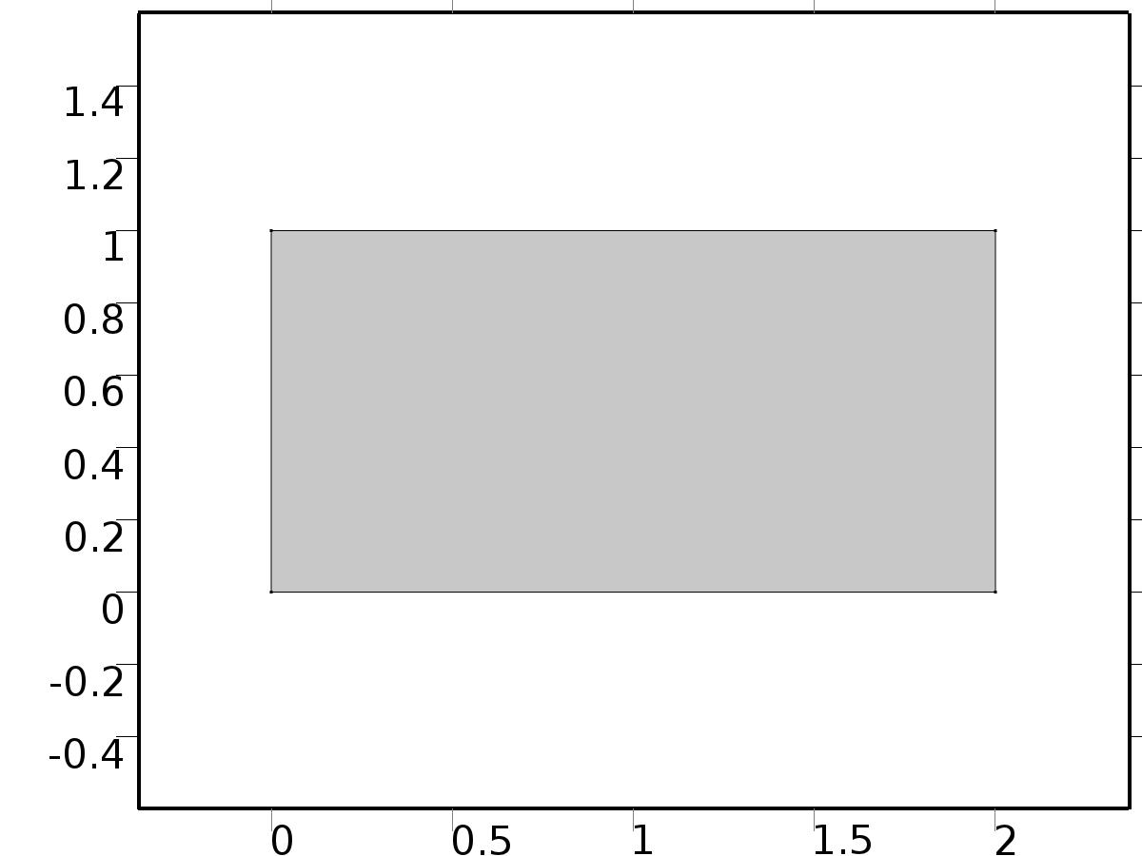

Geometry 1

Units

|  |  |
| --- | --- |
| Length unit | m |
| Angular unit | deg |

Geometry statistics

| **Description** | **Value** |
| --- | --- |
| Space dimension | 2 |
| Number of domains | 1 |
| Number of boundaries | 4 |
| Number of vertices | 4 |

* + 1. Rectangle 1 (r1)

Position

| **Description** | **Value** |
| --- | --- |
| Position | {0, 0} |
| Layers |  |

Size

| **Description** | **Value** |
| --- | --- |
| Width | 2*L |
| Height | L |

* 1. Unit Input

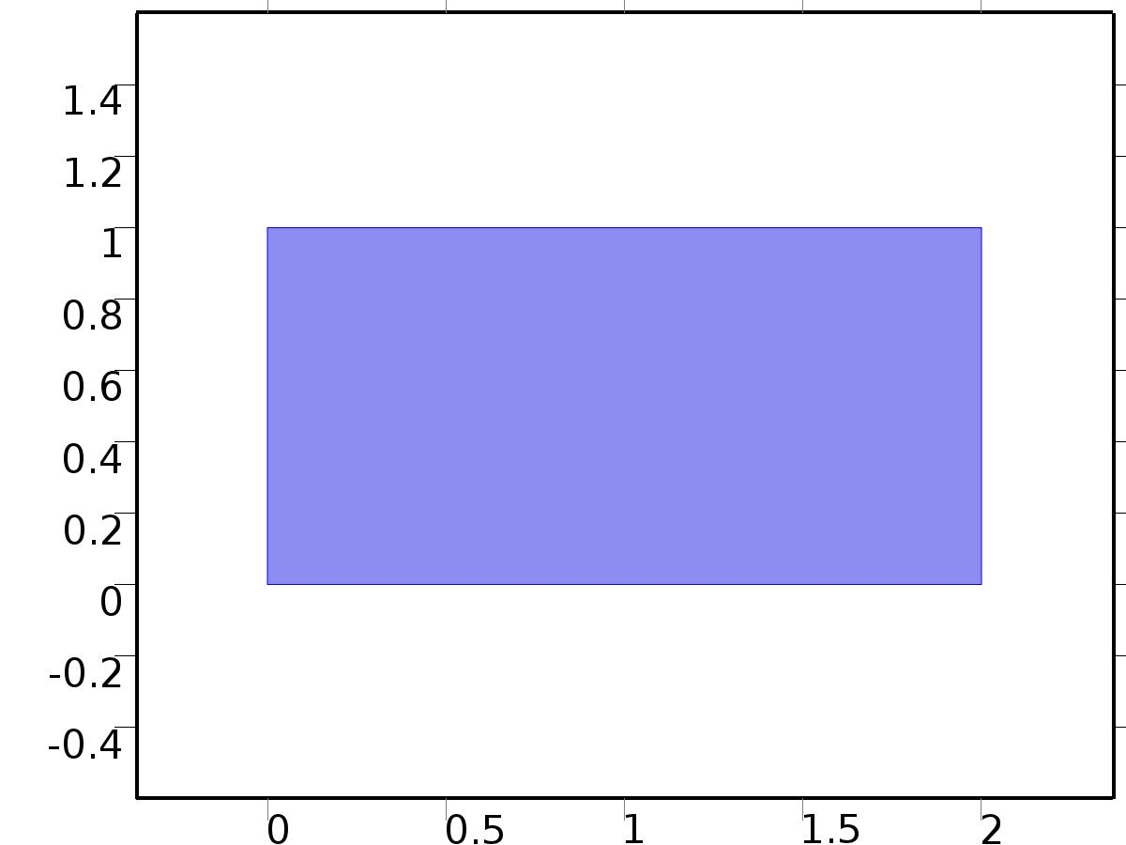

Unit Input

Selection

|  |  |
| --- | --- |
| Geometric entity level | Domain |
| Selection | Domain 1 |

Settings

| **Description** | **Value** |
| --- | --- |
| Shape function type | Lagrange |
| Element order | Quadratic |
| Compute boundary fluxes | On |
| Apply smoothing to boundary fluxes | On |
| Value type when using splitting of complex variables | Complex |
| Dependent variable quantity | Dimensionless (1) |
| Source term quantity | None |
| Unit | m^ - 2 |

Used products

|  |
| --- |
| COMSOL Multiphysics |

Variables

| **Name** | **Expression** | **Unit** | **Description** | **Selection** |
| --- | --- | --- | --- | --- |
| X.nx | dnx |  | Normal vector, x component | Boundaries 1–4 |
| X.ny | dny |  | Normal vector, y component | Boundaries 1–4 |
| X.nz | 0 |  | Normal vector, z component | Boundaries 1–4 |
| X.nxmesh | root.dnxmesh |  | Normal vector (mesh), x component | Boundaries 1–4 |
| X.nymesh | root.dnymesh |  | Normal vector (mesh), y component | Boundaries 1–4 |
| X.nzmesh | 0 |  | Normal vector (mesh), z component | Boundaries 1–4 |

* + 1. Coefficient Form PDE 1



Coefficient Form PDE 1

Selection

|  |  |
| --- | --- |
| Geometric entity level | Domain |
| Selection | Domain 1 |

Equations

Settings

| **Description** | **Value** |
| --- | --- |
| Diffusion coefficient | {{{{nu, 0}, {0, nu}}, {{0, 0}, {0, 0}}}, {{{0, 0}, {0, 0}}, {{nu, 0}, {0, nu}}}} |
| Absorption coefficient | {{0, 0}, {0, 0}} |
| Source term | {0, 0} |
| Mass coefficient | {{0, 0}, {0, 0}} |
| Damping or mass coefficient | {{0, 0}, {0, 0}} |
| Conservative flux convection coefficient | {{{0, 0}, {0, 0}}, {{0, 0}, {0, 0}}} |
| Convection coefficient | {{{0, 0}, {0, 0}}, {{0, 0}, {0, 0}}} |
| Conservative flux source | {{0, 0}, {0, 0}} |

#### Variables

| **Name** | **Expression** | **Unit** | **Description** | **Selection** |
| --- | --- | --- | --- | --- |
| domflux.Xux | -nu*d(Xu,x) |  | Domain flux, x component | Domain 1 |
| domflux.Xuy | -nu*d(Xu,y) |  | Domain flux, y component | Domain 1 |
| domflux.Xvx | -nu*d(Xv,x) |  | Domain flux, x component | Domain 1 |
| domflux.Xvy | -nu*d(Xv,y) |  | Domain flux, y component | Domain 1 |

#### Shape functions

| **Name** | **Shape function** | **Unit** | **Description** | **Shape frame** | **Selection** |
| --- | --- | --- | --- | --- | --- |
| Xu | Lagrange (Quadratic) |  | Dependent variable Xu | Material | Domain 1 |
| Xv | Lagrange (Quadratic) |  | Dependent variable Xv | Material | Domain 1 |

* + 1. Zero Flux 1

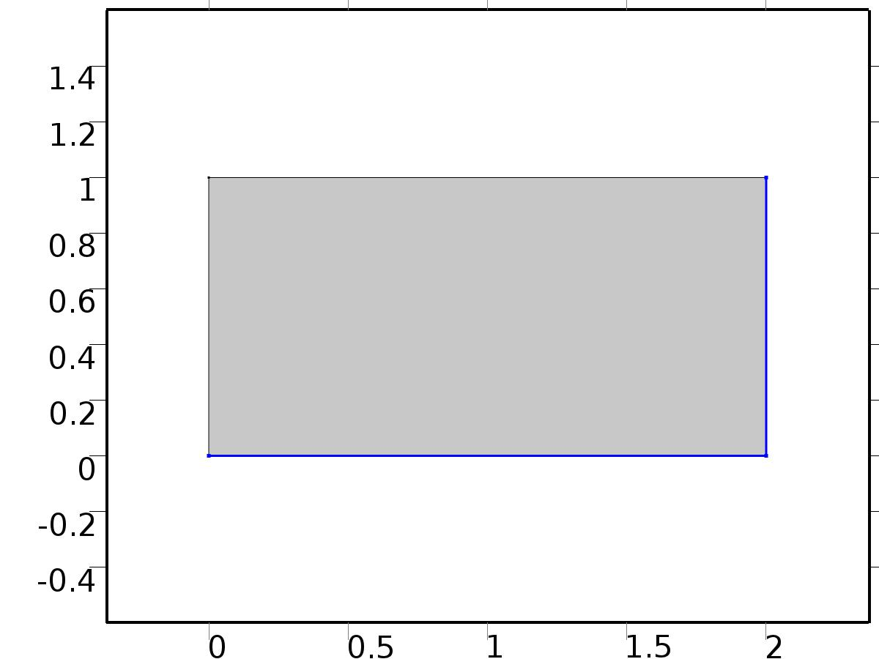

Zero Flux 1

Selection

|  |  |
| --- | --- |
| Geometric entity level | Boundary |
| Selection | Boundaries 2, 4 |

Equations

* + 1. Initial Values 1



Initial Values 1

Selection

|  |  |
| --- | --- |
| Geometric entity level | Domain |
| Selection | Domain 1 |

Settings

| **Description** | **Value** |
| --- | --- |
| Initial value for Xu | 0 |
| Initial value for Xv | 0 |
| Initial time derivative of Xu | 0 |
| Initial time derivative of Xv | 0 |

* + 1. Dirichlet Boundary Condition 1

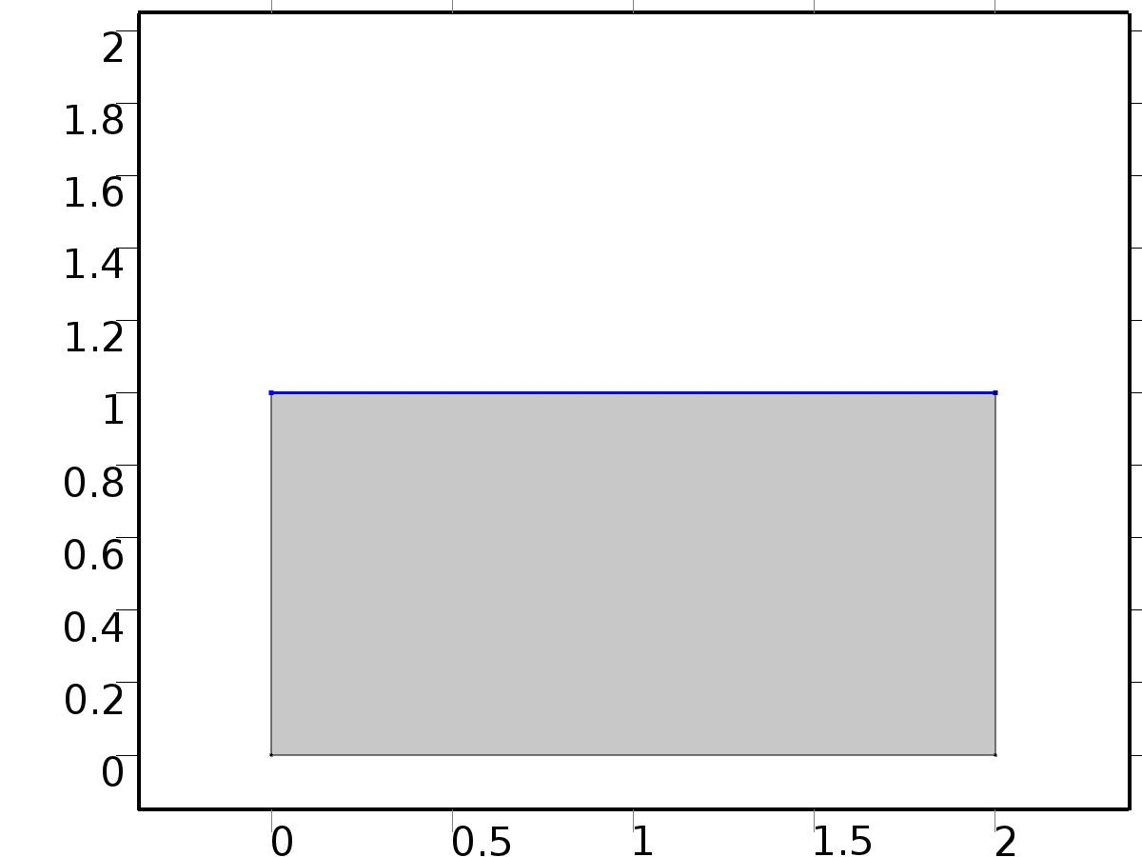

Dirichlet Boundary Condition 1

Selection

|  |  |
| --- | --- |
| Geometric entity level | Boundary |
| Selection | Boundary 3 |

Equations

Settings

| **Description** | **Value** |
| --- | --- |
| Value on boundary | {0, 0} |
| Prescribed value of Xu | On |
| Prescribed value of Xv | On |
| Apply reaction terms on | Individual dependent variables |
| Use weak constraints | Off |
| Constraint method | Elemental |

#### Shape functions

| **Constraint** | **Constraint force** | **Shape function** | **Selection** |
| --- | --- | --- | --- |
| -Xu | -test(Xu) | Lagrange (Quadratic) | Boundary 3 |
| -Xv | -test(Xv) | Lagrange (Quadratic) | Boundary 3 |

* + 1. Flux/Source 1

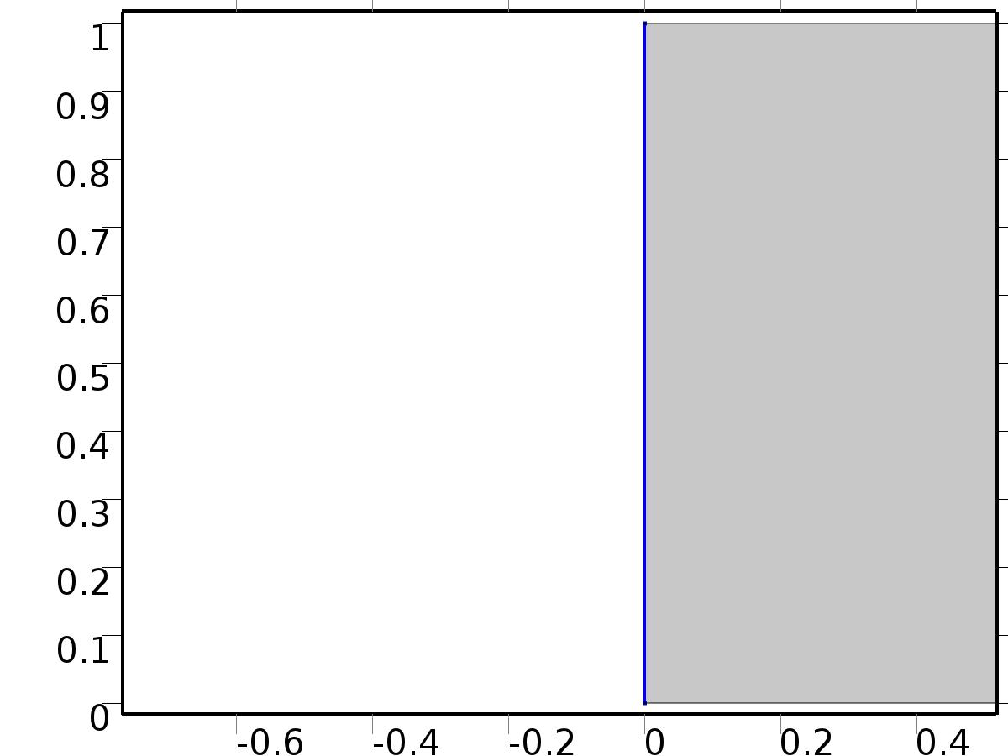

Flux/Source 1

Selection

|  |  |
| --- | --- |
| Geometric entity level | Boundary |
| Selection | Boundary 1 |

Equations

Settings

| **Description** | **Value** |
| --- | --- |
| Boundary flux/source | {1, 0} |
| Boundary absorption/impedance term | {{K, 0}, {0, K}} |

#### Variables

| **Name** | **Expression** | **Unit** | **Description** | **Selection** |
| --- | --- | --- | --- | --- |
| X.g_Xu | 1-K*Xu |  | Boundary flux/source | Boundary 1 |
| X.g_Xv | -K*Xv |  | Boundary flux/source | Boundary 1 |

* 1. Fourier coefficients 0



Fourier coefficients 0

Selection

|  |  |
| --- | --- |
| Geometric entity level | Domain |
| Selection | Domain 1 |

Settings

| **Description** | **Value** |
| --- | --- |
| Shape function type | Lagrange |
| Element order | Quadratic |
| Compute boundary fluxes | On |
| Apply smoothing to boundary fluxes | On |
| Value type when using splitting of complex variables | Complex |
| Dependent variable quantity | Dimensionless (1) |
| Source term quantity | None |
| Unit | m^ - 2 |

Used products

|  |
| --- |
| COMSOL Multiphysics |

Variables

| **Name** | **Expression** | **Unit** | **Description** | **Selection** |
| --- | --- | --- | --- | --- |
| A0.nx | dnx |  | Normal vector, x component | Boundaries 1–4 |
| A0.ny | dny |  | Normal vector, y component | Boundaries 1–4 |
| A0.nz | 0 |  | Normal vector, z component | Boundaries 1–4 |
| A0.nxmesh | root.dnxmesh |  | Normal vector (mesh), x component | Boundaries 1–4 |
| A0.nymesh | root.dnymesh |  | Normal vector (mesh), y component | Boundaries 1–4 |
| A0.nzmesh | 0 |  | Normal vector (mesh), z component | Boundaries 1–4 |

* + 1. Coefficient Form PDE 1



Coefficient Form PDE 1

Selection

|  |  |
| --- | --- |
| Geometric entity level | Domain |
| Selection | Domain 1 |

Equations

Settings

| **Description** | **Value** |
| --- | --- |
| Diffusion coefficient | {{{{nu, 0}, {0, nu}}, {{0, 0}, {0, 0}}, {{0, 0}, {0, 0}}}, {{{0, 0}, {0, 0}}, {{nu, 0}, {0, nu}}, {{0, 0}, {0, 0}}}, {{{0, 0}, {0, 0}}, {{0, 0}, {0, 0}}, {{nu, 0}, {0, nu}}}} |
| Absorption coefficient | {{0, 0, 0}, {0, 0, 0}, {0, 0, 0}} |
| Source term | {f_au0, f_av0, f_au0} |
| Mass coefficient | {{0, 0, 0}, {0, 0, 0}, {0, 0, 0}} |
| Damping or mass coefficient | {{0, 0, 0}, {0, 0, 0}, {0, 0, 0}} |
| Conservative flux convection coefficient | {{{0, 0}, {0, 0}, {0, 0}}, {{0, 0}, {0, 0}, {0, 0}}, {{0, 0}, {0, 0}, {0, 0}}} |
| Convection coefficient | {{{0, 0}, {0, 0}, {0, 0}}, {{0, 0}, {0, 0}, {0, 0}}, {{0, 0}, {0, 0}, {0, 0}}} |
| Conservative flux source | {{0, 0}, {0, 0}, {0, 0}} |

#### Variables

| **Name** | **Expression** | **Unit** | **Description** | **Selection** |
| --- | --- | --- | --- | --- |
| domflux.au0x | -nu*d(au0,x) |  | Domain flux, x component | Domain 1 |
| domflux.au0y | -nu*d(au0,y) |  | Domain flux, y component | Domain 1 |
| domflux.av0x | -nu*d(av0,x) |  | Domain flux, x component | Domain 1 |
| domflux.av0y | -nu*d(av0,y) |  | Domain flux, y component | Domain 1 |
| domflux.atu0x | -nu*d(atu0,x) |  | Domain flux, x component | Domain 1 |
| domflux.atu0y | -nu*d(atu0,y) |  | Domain flux, y component | Domain 1 |

#### Shape functions

| **Name** | **Shape function** | **Unit** | **Description** | **Shape frame** | **Selection** |
| --- | --- | --- | --- | --- | --- |
| au0 | Lagrange (Quadratic) |  | Dependent variable au0 | Material | Domain 1 |
| av0 | Lagrange (Quadratic) |  | Dependent variable av0 | Material | Domain 1 |
| atu0 | Lagrange (Quadratic) |  | Dependent variable atu0 | Material | Domain 1 |

* + 1. Zero Flux 1

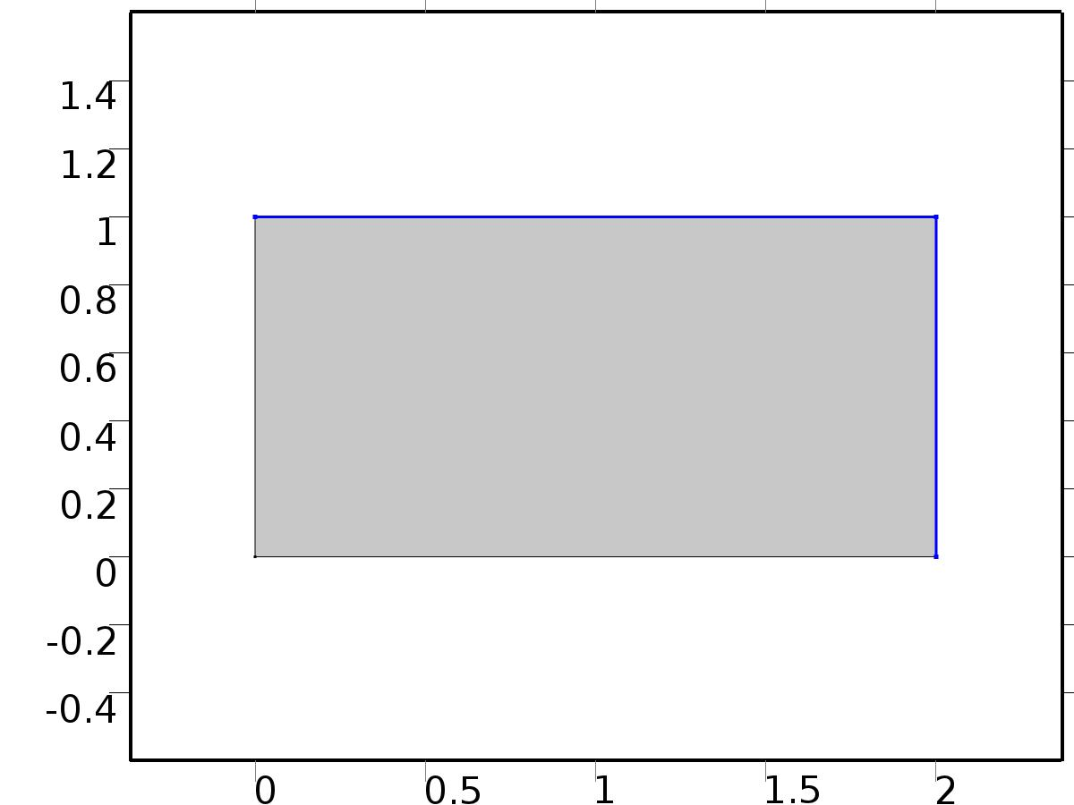

Zero Flux 1

Selection

|  |  |
| --- | --- |
| Geometric entity level | Boundary |
| Selection | Boundaries 3–4 |

Equations

* + 1. Initial Values 1



Initial Values 1

Selection

|  |  |
| --- | --- |
| Geometric entity level | Domain |
| Selection | Domain 1 |

Settings

| **Description** | **Value** |
| --- | --- |
| Initial value for au0 | 0 |
| Initial value for av0 | 0 |
| Initial value for atu0 | 0 |
| Initial time derivative of au0 | 0 |
| Initial time derivative of av0 | 0 |
| Initial time derivative of atu0 | 0 |

* + 1. Dirichlet Boundary Condition 1

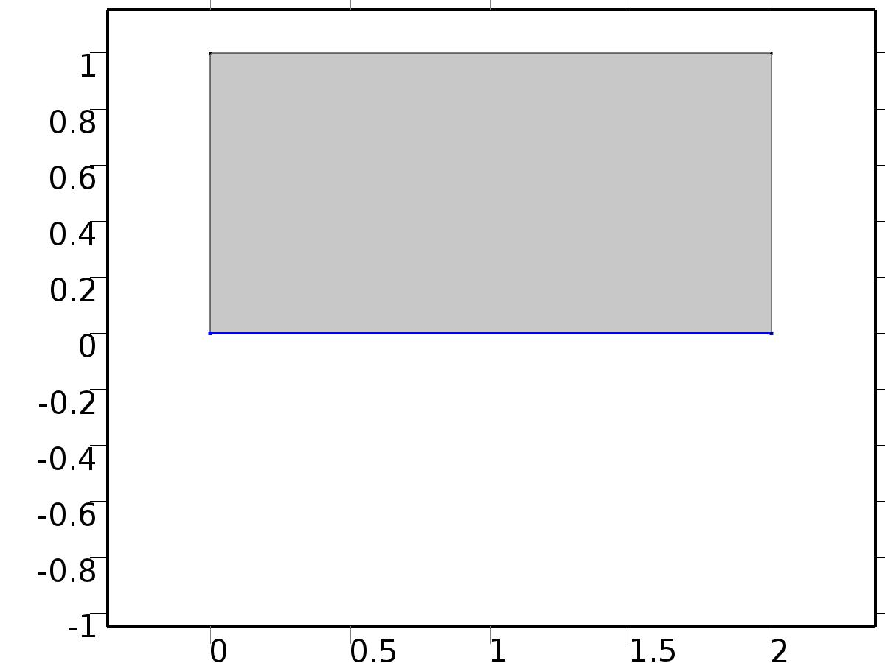

Dirichlet Boundary Condition 1

Selection

|  |  |
| --- | --- |
| Geometric entity level | Boundary |
| Selection | Boundary 2 |

Equations

Settings

| **Description** | **Value** |
| --- | --- |
| Value on boundary | {0, d_a0, 0} |
| Prescribed value of au0 | On |
| Prescribed value of av0 | On |
| Prescribed value of atu0 | On |
| Apply reaction terms on | Individual dependent variables |
| Use weak constraints | Off |
| Constraint method | Elemental |

#### Shape functions

| **Constraint** | **Constraint force** | **Shape function** | **Selection** |
| --- | --- | --- | --- |
| -au0 | -test(au0) | Lagrange (Quadratic) | Boundary 2 |
| d_a0-av0 | -test(av0) | Lagrange (Quadratic) | Boundary 2 |
| -atu0 | -test(atu0) | Lagrange (Quadratic) | Boundary 2 |

* + 1. Flux/Source 1



Flux/Source 1

Selection

|  |  |
| --- | --- |
| Geometric entity level | Boundary |
| Selection | Boundary 1 |

Equations

Settings

| **Description** | **Value** |
| --- | --- |
| Boundary flux/source | {Gamma_a0, 0, 0} |
| Boundary absorption/impedance term | {{K, 0, 0}, {0, K, 0}, {0, 0, K}} |

#### Variables

| **Name** | **Expression** | **Unit** | **Description** | **Selection** |
| --- | --- | --- | --- | --- |
| A0.g_au0 | Gamma_a0-K*au0 |  | Boundary flux/source | Boundary 1 |
| A0.g_av0 | -K*av0 |  | Boundary flux/source | Boundary 1 |
| A0.g_atu0 | -K*atu0 |  | Boundary flux/source | Boundary 1 |

* 1. Fourier coefficients 1



Fourier coefficients 1

Selection

|  |  |
| --- | --- |
| Geometric entity level | Domain |
| Selection | Domain 1 |

Settings

| **Description** | **Value** |
| --- | --- |
| Shape function type | Lagrange |
| Element order | Quadratic |
| Compute boundary fluxes | On |
| Apply smoothing to boundary fluxes | On |
| Value type when using splitting of complex variables | Complex |
| Dependent variable quantity | Dimensionless (1) |
| Source term quantity | None |
| Unit | m^ - 2 |

Used products

|  |
| --- |
| COMSOL Multiphysics |

Variables

| **Name** | **Expression** | **Unit** | **Description** | **Selection** |
| --- | --- | --- | --- | --- |
| A1.nx | dnx |  | Normal vector, x component | Boundaries 1–4 |
| A1.ny | dny |  | Normal vector, y component | Boundaries 1–4 |
| A1.nz | 0 |  | Normal vector, z component | Boundaries 1–4 |
| A1.nxmesh | root.dnxmesh |  | Normal vector (mesh), x component | Boundaries 1–4 |
| A1.nymesh | root.dnymesh |  | Normal vector (mesh), y component | Boundaries 1–4 |
| A1.nzmesh | 0 |  | Normal vector (mesh), z component | Boundaries 1–4 |

* + 1. Coefficient Form PDE 1



Coefficient Form PDE 1

Selection

|  |  |
| --- | --- |
| Geometric entity level | Domain |
| Selection | Domain 1 |

Equations

Settings

| **Description** | **Value** |
| --- | --- |
| Diffusion coefficient | {{{{nu, 0}, {0, nu}}, {{0, 0}, {0, 0}}, {{0, 0}, {0, 0}}, {{0, 0}, {0, 0}}, {{0, 0}, {0, 0}}, {{0, 0}, {0, 0}}}, {{{0, 0}, {0, 0}}, {{nu, 0}, {0, nu}}, {{0, 0}, {0, 0}}, {{0, 0}, {0, 0}}, {{0, 0}, {0, 0}}, {{0, 0}, {0, 0}}}, {{{0, 0}, {0, 0}}, {{0, 0}, {0, 0}}, {{nu, 0}, {0, nu}}, {{0, 0}, {0, 0}}, {{0, 0}, {0, 0}}, {{0, 0}, {0, 0}}}, {{{0, 0}, {0, 0}}, {{0, 0}, {0, 0}}, {{0, 0}, {0, 0}}, {{nu, 0}, {0, nu}}, {{0, 0}, {0, 0}}, {{0, 0}, {0, 0}}}, {{{0, 0}, {0, 0}}, {{0, 0}, {0, 0}}, {{0, 0}, {0, 0}}, {{0, 0}, {0, 0}}, {{nu, 0}, {0, nu}}, {{0, 0}, {0, 0}}}, {{{0, 0}, {0, 0}}, {{0, 0}, {0, 0}}, {{0, 0}, {0, 0}}, {{0, 0}, {0, 0}}, {{0, 0}, {0, 0}}, {{nu, 0}, {0, nu}}}} |
| Absorption coefficient | {{0, -alpha, 0, 0, 0, -alpha}, {alpha, 0, 0, 0, alpha, 0}, {0, 0, 0, -alpha, 0, 0}, {0, 0, alpha, 0, 0, 0}, {0, 0, 0, 0, 0, 0}, {0, 0, 0, 0, 0, 0}} |
| Source term | {f_au1, f_bu1, f_av1, f_bv1, f_au1, f_bu1} |
| Mass coefficient | {{0, 0, 0, 0, 0, 0}, {0, 0, 0, 0, 0, 0}, {0, 0, 0, 0, 0, 0}, {0, 0, 0, 0, 0, 0}, {0, 0, 0, 0, 0, 0}, {0, 0, 0, 0, 0, 0}} |
| Damping or mass coefficient | {{0, 0, 0, 0, 0, 0}, {0, 0, 0, 0, 0, 0}, {0, 0, 0, 0, 0, 0}, {0, 0, 0, 0, 0, 0}, {0, 0, 0, 0, 0, 0}, {0, 0, 0, 0, 0, 0}} |
| Conservative flux convection coefficient | {{{0, 0}, {0, 0}, {0, 0}, {0, 0}, {0, 0}, {0, 0}}, {{0, 0}, {0, 0}, {0, 0}, {0, 0}, {0, 0}, {0, 0}}, {{0, 0}, {0, 0}, {0, 0}, {0, 0}, {0, 0}, {0, 0}}, {{0, 0}, {0, 0}, {0, 0}, {0, 0}, {0, 0}, {0, 0}}, {{0, 0}, {0, 0}, {0, 0}, {0, 0}, {0, 0}, {0, 0}}, {{0, 0}, {0, 0}, {0, 0}, {0, 0}, {0, 0}, {0, 0}}} |
| Convection coefficient | {{{0, 0}, {0, 0}, {0, 0}, {0, 0}, {0, 0}, {0, 0}}, {{0, 0}, {0, 0}, {0, 0}, {0, 0}, {0, 0}, {0, 0}}, {{0, 0}, {0, 0}, {0, 0}, {0, 0}, {0, 0}, {0, 0}}, {{0, 0}, {0, 0}, {0, 0}, {0, 0}, {0, 0}, {0, 0}}, {{0, 0}, {0, 0}, {0, 0}, {0, 0}, {0, 0}, {0, 0}}, {{0, 0}, {0, 0}, {0, 0}, {0, 0}, {0, 0}, {0, 0}}} |
| Conservative flux source | {{0, 0}, {0, 0}, {0, 0}, {0, 0}, {0, 0}, {0, 0}} |

#### Variables

| **Name** | **Expression** | **Unit** | **Description** | **Selection** |
| --- | --- | --- | --- | --- |
| domflux.au1x | -nu*d(au1,x) |  | Domain flux, x component | Domain 1 |
| domflux.au1y | -nu*d(au1,y) |  | Domain flux, y component | Domain 1 |
| domflux.bu1x | -nu*d(bu1,x) |  | Domain flux, x component | Domain 1 |
| domflux.bu1y | -nu*d(bu1,y) |  | Domain flux, y component | Domain 1 |
| domflux.av1x | -nu*d(av1,x) |  | Domain flux, x component | Domain 1 |
| domflux.av1y | -nu*d(av1,y) |  | Domain flux, y component | Domain 1 |
| domflux.bv1x | -nu*d(bv1,x) |  | Domain flux, x component | Domain 1 |
| domflux.bv1y | -nu*d(bv1,y) |  | Domain flux, y component | Domain 1 |
| domflux.atu1x | -nu*d(atu1,x) |  | Domain flux, x component | Domain 1 |
| domflux.atu1y | -nu*d(atu1,y) |  | Domain flux, y component | Domain 1 |
| domflux.btu1x | -nu*d(btu1,x) |  | Domain flux, x component | Domain 1 |
| domflux.btu1y | -nu*d(btu1,y) |  | Domain flux, y component | Domain 1 |

#### Shape functions

| **Name** | **Shape function** | **Unit** | **Description** | **Shape frame** | **Selection** |
| --- | --- | --- | --- | --- | --- |
| au1 | Lagrange (Quadratic) |  | Dependent variable au1 | Material | Domain 1 |
| bu1 | Lagrange (Quadratic) |  | Dependent variable bu1 | Material | Domain 1 |
| av1 | Lagrange (Quadratic) |  | Dependent variable av1 | Material | Domain 1 |
| bv1 | Lagrange (Quadratic) |  | Dependent variable bv1 | Material | Domain 1 |
| atu1 | Lagrange (Quadratic) |  | Dependent variable atu1 | Material | Domain 1 |
| btu1 | Lagrange (Quadratic) |  | Dependent variable btu1 | Material | Domain 1 |

* + 1. Zero Flux 1



Zero Flux 1

Selection

|  |  |
| --- | --- |
| Geometric entity level | Boundary |
| Selection | Boundaries 3–4 |

Equations

* + 1. Initial Values 1



Initial Values 1

Selection

|  |  |
| --- | --- |
| Geometric entity level | Domain |
| Selection | Domain 1 |

Settings

| **Description** | **Value** |
| --- | --- |
| Initial value for au1 | 0 |
| Initial value for bu1 | 0 |
| Initial value for av1 | 0 |
| Initial value for bv1 | 0 |
| Initial value for atu1 | 0 |
| Initial value for btu1 | 0 |
| Initial time derivative of au1 | 0 |
| Initial time derivative of bu1 | 0 |
| Initial time derivative of av1 | 0 |
| Initial time derivative of bv1 | 0 |
| Initial time derivative of atu1 | 0 |
| Initial time derivative of btu1 | 0 |

* + 1. Dirichlet Boundary Condition 1



Dirichlet Boundary Condition 1

Selection

|  |  |
| --- | --- |
| Geometric entity level | Boundary |
| Selection | Boundary 2 |

Equations

Settings

| **Description** | **Value** |
| --- | --- |
| Value on boundary | {0, 0, d_a1, d_b1, 0, 0} |
| Prescribed value of au1 | On |
| Prescribed value of bu1 | On |
| Prescribed value of av1 | On |
| Prescribed value of bv1 | On |
| Prescribed value of atu1 | On |
| Prescribed value of btu1 | On |
| Apply reaction terms on | Individual dependent variables |
| Use weak constraints | Off |
| Constraint method | Elemental |

#### Shape functions

| **Constraint** | **Constraint force** | **Shape function** | **Selection** |
| --- | --- | --- | --- |
| -au1 | -test(au1) | Lagrange (Quadratic) | Boundary 2 |
| -bu1 | -test(bu1) | Lagrange (Quadratic) | Boundary 2 |
| d_a1-av1 | -test(av1) | Lagrange (Quadratic) | Boundary 2 |
| d_b1-bv1 | -test(bv1) | Lagrange (Quadratic) | Boundary 2 |
| -atu1 | -test(atu1) | Lagrange (Quadratic) | Boundary 2 |
| -btu1 | -test(btu1) | Lagrange (Quadratic) | Boundary 2 |

* + 1. Flux/Source 1



Flux/Source 1

Selection

|  |  |
| --- | --- |
| Geometric entity level | Boundary |
| Selection | Boundary 1 |

Equations

Settings

| **Description** | **Value** |
| --- | --- |
| Boundary flux/source | {Gamma_a1, Gamma_b1, 0, 0, 0, 0} |
| Boundary absorption/impedance term | {{K, 0, 0, 0, 0, 0}, {0, K, 0, 0, 0, 0}, {0, 0, K, 0, 0, 0}, {0, 0, 0, K, 0, 0}, {0, 0, 0, 0, K, 0}, {0, 0, 0, 0, 0, K}} |

#### Variables

| **Name** | **Expression** | **Unit** | **Description** | **Selection** |
| --- | --- | --- | --- | --- |
| A1.g_au1 | Gamma_a1-K*au1 |  | Boundary flux/source | Boundary 1 |
| A1.g_bu1 | Gamma_b1-K*bu1 |  | Boundary flux/source | Boundary 1 |
| A1.g_av1 | -K*av1 |  | Boundary flux/source | Boundary 1 |
| A1.g_bv1 | -K*bv1 |  | Boundary flux/source | Boundary 1 |
| A1.g_atu1 | -K*atu1 |  | Boundary flux/source | Boundary 1 |
| A1.g_btu1 | -K*btu1 |  | Boundary flux/source | Boundary 1 |

* 1. Fourier coefficients 2



Fourier coefficients 2

Selection

|  |  |
| --- | --- |
| Geometric entity level | Domain |
| Selection | Domain 1 |

Settings

| **Description** | **Value** |
| --- | --- |
| Shape function type | Lagrange |
| Element order | Quadratic |
| Compute boundary fluxes | On |
| Apply smoothing to boundary fluxes | On |
| Value type when using splitting of complex variables | Complex |
| Dependent variable quantity | Dimensionless (1) |
| Source term quantity | None |
| Unit | m^ - 2 |

Used products

|  |
| --- |
| COMSOL Multiphysics |

Variables

| **Name** | **Expression** | **Unit** | **Description** | **Selection** |
| --- | --- | --- | --- | --- |
| A2.nx | dnx |  | Normal vector, x component | Boundaries 1–4 |
| A2.ny | dny |  | Normal vector, y component | Boundaries 1–4 |
| A2.nz | 0 |  | Normal vector, z component | Boundaries 1–4 |
| A2.nxmesh | root.dnxmesh |  | Normal vector (mesh), x component | Boundaries 1–4 |
| A2.nymesh | root.dnymesh |  | Normal vector (mesh), y component | Boundaries 1–4 |
| A2.nzmesh | 0 |  | Normal vector (mesh), z component | Boundaries 1–4 |

* + 1. Coefficient Form PDE 1



Coefficient Form PDE 1

Selection

|  |  |
| --- | --- |
| Geometric entity level | Domain |
| Selection | Domain 1 |

Equations

Settings

| **Description** | **Value** |
| --- | --- |
| Diffusion coefficient | {{{{nu, 0}, {0, nu}}, {{0, 0}, {0, 0}}, {{0, 0}, {0, 0}}, {{0, 0}, {0, 0}}, {{0, 0}, {0, 0}}, {{0, 0}, {0, 0}}}, {{{0, 0}, {0, 0}}, {{nu, 0}, {0, nu}}, {{0, 0}, {0, 0}}, {{0, 0}, {0, 0}}, {{0, 0}, {0, 0}}, {{0, 0}, {0, 0}}}, {{{0, 0}, {0, 0}}, {{0, 0}, {0, 0}}, {{nu, 0}, {0, nu}}, {{0, 0}, {0, 0}}, {{0, 0}, {0, 0}}, {{0, 0}, {0, 0}}}, {{{0, 0}, {0, 0}}, {{0, 0}, {0, 0}}, {{0, 0}, {0, 0}}, {{nu, 0}, {0, nu}}, {{0, 0}, {0, 0}}, {{0, 0}, {0, 0}}}, {{{0, 0}, {0, 0}}, {{0, 0}, {0, 0}}, {{0, 0}, {0, 0}}, {{0, 0}, {0, 0}}, {{nu, 0}, {0, nu}}, {{0, 0}, {0, 0}}}, {{{0, 0}, {0, 0}}, {{0, 0}, {0, 0}}, {{0, 0}, {0, 0}}, {{0, 0}, {0, 0}}, {{0, 0}, {0, 0}}, {{nu, 0}, {0, nu}}}} |
| Absorption coefficient | {{0, -2*alpha, 0, 0, 0, -2*alpha}, {2*alpha, 0, 0, 0, 2*alpha, 0}, {0, 0, 0, -2*alpha, 0, 0}, {0, 0, 2*alpha, 0, 0, 0}, {0, 0, 0, 0, 0, 0}, {0, 0, 0, 0, 0, 0}} |
| Source term | {f_au2, f_bu2, f_av2, f_bv2, f_au2, f_bu2} |
| Mass coefficient | {{0, 0, 0, 0, 0, 0}, {0, 0, 0, 0, 0, 0}, {0, 0, 0, 0, 0, 0}, {0, 0, 0, 0, 0, 0}, {0, 0, 0, 0, 0, 0}, {0, 0, 0, 0, 0, 0}} |
| Damping or mass coefficient | {{0, 0, 0, 0, 0, 0}, {0, 0, 0, 0, 0, 0}, {0, 0, 0, 0, 0, 0}, {0, 0, 0, 0, 0, 0}, {0, 0, 0, 0, 0, 0}, {0, 0, 0, 0, 0, 0}} |
| Conservative flux convection coefficient | {{{0, 0}, {0, 0}, {0, 0}, {0, 0}, {0, 0}, {0, 0}}, {{0, 0}, {0, 0}, {0, 0}, {0, 0}, {0, 0}, {0, 0}}, {{0, 0}, {0, 0}, {0, 0}, {0, 0}, {0, 0}, {0, 0}}, {{0, 0}, {0, 0}, {0, 0}, {0, 0}, {0, 0}, {0, 0}}, {{0, 0}, {0, 0}, {0, 0}, {0, 0}, {0, 0}, {0, 0}}, {{0, 0}, {0, 0}, {0, 0}, {0, 0}, {0, 0}, {0, 0}}} |
| Convection coefficient | {{{0, 0}, {0, 0}, {0, 0}, {0, 0}, {0, 0}, {0, 0}}, {{0, 0}, {0, 0}, {0, 0}, {0, 0}, {0, 0}, {0, 0}}, {{0, 0}, {0, 0}, {0, 0}, {0, 0}, {0, 0}, {0, 0}}, {{0, 0}, {0, 0}, {0, 0}, {0, 0}, {0, 0}, {0, 0}}, {{0, 0}, {0, 0}, {0, 0}, {0, 0}, {0, 0}, {0, 0}}, {{0, 0}, {0, 0}, {0, 0}, {0, 0}, {0, 0}, {0, 0}}} |
| Conservative flux source | {{0, 0}, {0, 0}, {0, 0}, {0, 0}, {0, 0}, {0, 0}} |

#### Variables

| **Name** | **Expression** | **Unit** | **Description** | **Selection** |
| --- | --- | --- | --- | --- |
| domflux.au2x | -nu*d(au2,x) |  | Domain flux, x component | Domain 1 |
| domflux.au2y | -nu*d(au2,y) |  | Domain flux, y component | Domain 1 |
| domflux.bu2x | -nu*d(bu2,x) |  | Domain flux, x component | Domain 1 |
| domflux.bu2y | -nu*d(bu2,y) |  | Domain flux, y component | Domain 1 |
| domflux.av2x | -nu*d(av2,x) |  | Domain flux, x component | Domain 1 |
| domflux.av2y | -nu*d(av2,y) |  | Domain flux, y component | Domain 1 |
| domflux.bv2x | -nu*d(bv2,x) |  | Domain flux, x component | Domain 1 |
| domflux.bv2y | -nu*d(bv2,y) |  | Domain flux, y component | Domain 1 |
| domflux.atu2x | -nu*d(atu2,x) |  | Domain flux, x component | Domain 1 |
| domflux.atu2y | -nu*d(atu2,y) |  | Domain flux, y component | Domain 1 |
| domflux.btu2x | -nu*d(btu2,x) |  | Domain flux, x component | Domain 1 |
| domflux.btu2y | -nu*d(btu2,y) |  | Domain flux, y component | Domain 1 |

#### Shape functions

| **Name** | **Shape function** | **Unit** | **Description** | **Shape frame** | **Selection** |
| --- | --- | --- | --- | --- | --- |
| au2 | Lagrange (Quadratic) |  | Dependent variable au2 | Material | Domain 1 |
| bu2 | Lagrange (Quadratic) |  | Dependent variable bu2 | Material | Domain 1 |
| av2 | Lagrange (Quadratic) |  | Dependent variable av2 | Material | Domain 1 |
| bv2 | Lagrange (Quadratic) |  | Dependent variable bv2 | Material | Domain 1 |
| atu2 | Lagrange (Quadratic) |  | Dependent variable atu2 | Material | Domain 1 |
| btu2 | Lagrange (Quadratic) |  | Dependent variable btu2 | Material | Domain 1 |

* + 1. Zero Flux 1



Zero Flux 1

Selection

|  |  |
| --- | --- |
| Geometric entity level | Boundary |
| Selection | Boundaries 3–4 |

Equations

* + 1. Initial Values 1



Initial Values 1

Selection

|  |  |
| --- | --- |
| Geometric entity level | Domain |
| Selection | Domain 1 |

Settings

| **Description** | **Value** |
| --- | --- |
| Initial value for au2 | 0 |
| Initial value for bu2 | 0 |
| Initial value for av2 | 0 |
| Initial value for bv2 | 0 |
| Initial value for atu2 | 0 |
| Initial value for btu2 | 0 |
| Initial time derivative of au2 | 0 |
| Initial time derivative of bu2 | 0 |
| Initial time derivative of av2 | 0 |
| Initial time derivative of bv2 | 0 |
| Initial time derivative of atu2 | 0 |
| Initial time derivative of btu2 | 0 |

* + 1. Dirichlet Boundary Condition 1



Dirichlet Boundary Condition 1

Selection

|  |  |
| --- | --- |
| Geometric entity level | Boundary |
| Selection | Boundary 2 |

Equations

Settings

| **Description** | **Value** |
| --- | --- |
| Value on boundary | {0, 0, d_a2, d_b2, 0, 0} |
| Prescribed value of au2 | On |
| Prescribed value of bu2 | On |
| Prescribed value of av2 | On |
| Prescribed value of bv2 | On |
| Prescribed value of atu2 | On |
| Prescribed value of btu2 | On |
| Apply reaction terms on | Individual dependent variables |
| Use weak constraints | Off |
| Constraint method | Elemental |

#### Shape functions

| **Constraint** | **Constraint force** | **Shape function** | **Selection** |
| --- | --- | --- | --- |
| -au2 | -test(au2) | Lagrange (Quadratic) | Boundary 2 |
| -bu2 | -test(bu2) | Lagrange (Quadratic) | Boundary 2 |
| d_a2-av2 | -test(av2) | Lagrange (Quadratic) | Boundary 2 |
| d_b2-bv2 | -test(bv2) | Lagrange (Quadratic) | Boundary 2 |
| -atu2 | -test(atu2) | Lagrange (Quadratic) | Boundary 2 |
| -btu2 | -test(btu2) | Lagrange (Quadratic) | Boundary 2 |

* + 1. Flux/Source 1



Flux/Source 1

Selection

|  |  |
| --- | --- |
| Geometric entity level | Boundary |
| Selection | Boundary 1 |

Equations

Settings

| **Description** | **Value** |
| --- | --- |
| Boundary flux/source | {Gamma_a2, Gamma_b2, 0, 0, 0, 0} |
| Boundary absorption/impedance term | {{K, 0, 0, 0, 0, 0}, {0, K, 0, 0, 0, 0}, {0, 0, K, 0, 0, 0}, {0, 0, 0, K, 0, 0}, {0, 0, 0, 0, K, 0}, {0, 0, 0, 0, 0, K}} |

#### Variables

| **Name** | **Expression** | **Unit** | **Description** | **Selection** |
| --- | --- | --- | --- | --- |
| A2.g_au2 | Gamma_a2-K*au2 |  | Boundary flux/source | Boundary 1 |
| A2.g_bu2 | Gamma_b2-K*bu2 |  | Boundary flux/source | Boundary 1 |
| A2.g_av2 | -K*av2 |  | Boundary flux/source | Boundary 1 |
| A2.g_bv2 | -K*bv2 |  | Boundary flux/source | Boundary 1 |
| A2.g_atu2 | -K*atu2 |  | Boundary flux/source | Boundary 1 |
| A2.g_btu2 | -K*btu2 |  | Boundary flux/source | Boundary 1 |

* 1. Fourier coefficients 3



Fourier coefficients 3

Selection

|  |  |
| --- | --- |
| Geometric entity level | Domain |
| Selection | Domain 1 |

Settings

| **Description** | **Value** |
| --- | --- |
| Shape function type | Lagrange |
| Element order | Quadratic |
| Compute boundary fluxes | On |
| Apply smoothing to boundary fluxes | On |
| Value type when using splitting of complex variables | Complex |
| Dependent variable quantity | Dimensionless (1) |
| Source term quantity | None |
| Unit | m^ - 2 |

Used products

|  |
| --- |
| COMSOL Multiphysics |

Variables

| **Name** | **Expression** | **Unit** | **Description** | **Selection** |
| --- | --- | --- | --- | --- |
| A3.nx | dnx |  | Normal vector, x component | Boundaries 1–4 |
| A3.ny | dny |  | Normal vector, y component | Boundaries 1–4 |
| A3.nz | 0 |  | Normal vector, z component | Boundaries 1–4 |
| A3.nxmesh | root.dnxmesh |  | Normal vector (mesh), x component | Boundaries 1–4 |
| A3.nymesh | root.dnymesh |  | Normal vector (mesh), y component | Boundaries 1–4 |
| A3.nzmesh | 0 |  | Normal vector (mesh), z component | Boundaries 1–4 |

* + 1. Coefficient Form PDE 1



Coefficient Form PDE 1

Selection

|  |  |
| --- | --- |
| Geometric entity level | Domain |
| Selection | Domain 1 |

Equations

Settings

| **Description** | **Value** |
| --- | --- |
| Diffusion coefficient | {{{{nu, 0}, {0, nu}}, {{0, 0}, {0, 0}}, {{0, 0}, {0, 0}}, {{0, 0}, {0, 0}}, {{0, 0}, {0, 0}}, {{0, 0}, {0, 0}}}, {{{0, 0}, {0, 0}}, {{nu, 0}, {0, nu}}, {{0, 0}, {0, 0}}, {{0, 0}, {0, 0}}, {{0, 0}, {0, 0}}, {{0, 0}, {0, 0}}}, {{{0, 0}, {0, 0}}, {{0, 0}, {0, 0}}, {{nu, 0}, {0, nu}}, {{0, 0}, {0, 0}}, {{0, 0}, {0, 0}}, {{0, 0}, {0, 0}}}, {{{0, 0}, {0, 0}}, {{0, 0}, {0, 0}}, {{0, 0}, {0, 0}}, {{nu, 0}, {0, nu}}, {{0, 0}, {0, 0}}, {{0, 0}, {0, 0}}}, {{{0, 0}, {0, 0}}, {{0, 0}, {0, 0}}, {{0, 0}, {0, 0}}, {{0, 0}, {0, 0}}, {{nu, 0}, {0, nu}}, {{0, 0}, {0, 0}}}, {{{0, 0}, {0, 0}}, {{0, 0}, {0, 0}}, {{0, 0}, {0, 0}}, {{0, 0}, {0, 0}}, {{0, 0}, {0, 0}}, {{nu, 0}, {0, nu}}}} |
| Absorption coefficient | {{0, -3*alpha, 0, 0, 0, -3*alpha}, {3*alpha, 0, 0, 0, 3*alpha, 0}, {0, 0, 0, -3*alpha, 0, 0}, {0, 0, 3*alpha, 0, 0, 0}, {0, 0, 0, 0, 0, 0}, {0, 0, 0, 0, 0, 0}} |
| Source term | {f_au3, f_bu3, f_av3, f_bv3, f_au3, f_bu3} |
| Mass coefficient | {{0, 0, 0, 0, 0, 0}, {0, 0, 0, 0, 0, 0}, {0, 0, 0, 0, 0, 0}, {0, 0, 0, 0, 0, 0}, {0, 0, 0, 0, 0, 0}, {0, 0, 0, 0, 0, 0}} |
| Damping or mass coefficient | {{0, 0, 0, 0, 0, 0}, {0, 0, 0, 0, 0, 0}, {0, 0, 0, 0, 0, 0}, {0, 0, 0, 0, 0, 0}, {0, 0, 0, 0, 0, 0}, {0, 0, 0, 0, 0, 0}} |
| Conservative flux convection coefficient | {{{0, 0}, {0, 0}, {0, 0}, {0, 0}, {0, 0}, {0, 0}}, {{0, 0}, {0, 0}, {0, 0}, {0, 0}, {0, 0}, {0, 0}}, {{0, 0}, {0, 0}, {0, 0}, {0, 0}, {0, 0}, {0, 0}}, {{0, 0}, {0, 0}, {0, 0}, {0, 0}, {0, 0}, {0, 0}}, {{0, 0}, {0, 0}, {0, 0}, {0, 0}, {0, 0}, {0, 0}}, {{0, 0}, {0, 0}, {0, 0}, {0, 0}, {0, 0}, {0, 0}}} |
| Convection coefficient | {{{0, 0}, {0, 0}, {0, 0}, {0, 0}, {0, 0}, {0, 0}}, {{0, 0}, {0, 0}, {0, 0}, {0, 0}, {0, 0}, {0, 0}}, {{0, 0}, {0, 0}, {0, 0}, {0, 0}, {0, 0}, {0, 0}}, {{0, 0}, {0, 0}, {0, 0}, {0, 0}, {0, 0}, {0, 0}}, {{0, 0}, {0, 0}, {0, 0}, {0, 0}, {0, 0}, {0, 0}}, {{0, 0}, {0, 0}, {0, 0}, {0, 0}, {0, 0}, {0, 0}}} |
| Conservative flux source | {{0, 0}, {0, 0}, {0, 0}, {0, 0}, {0, 0}, {0, 0}} |

#### Variables

| **Name** | **Expression** | **Unit** | **Description** | **Selection** |
| --- | --- | --- | --- | --- |
| domflux.au3x | -nu*d(au3,x) |  | Domain flux, x component | Domain 1 |
| domflux.au3y | -nu*d(au3,y) |  | Domain flux, y component | Domain 1 |
| domflux.bu3x | -nu*d(bu3,x) |  | Domain flux, x component | Domain 1 |
| domflux.bu3y | -nu*d(bu3,y) |  | Domain flux, y component | Domain 1 |
| domflux.av3x | -nu*d(av3,x) |  | Domain flux, x component | Domain 1 |
| domflux.av3y | -nu*d(av3,y) |  | Domain flux, y component | Domain 1 |
| domflux.bv3x | -nu*d(bv3,x) |  | Domain flux, x component | Domain 1 |
| domflux.bv3y | -nu*d(bv3,y) |  | Domain flux, y component | Domain 1 |
| domflux.atu3x | -nu*d(atu3,x) |  | Domain flux, x component | Domain 1 |
| domflux.atu3y | -nu*d(atu3,y) |  | Domain flux, y component | Domain 1 |
| domflux.btu3x | -nu*d(btu3,x) |  | Domain flux, x component | Domain 1 |
| domflux.btu3y | -nu*d(btu3,y) |  | Domain flux, y component | Domain 1 |

#### Shape functions

| **Name** | **Shape function** | **Unit** | **Description** | **Shape frame** | **Selection** |
| --- | --- | --- | --- | --- | --- |
| au3 | Lagrange (Quadratic) |  | Dependent variable au3 | Material | Domain 1 |
| bu3 | Lagrange (Quadratic) |  | Dependent variable bu3 | Material | Domain 1 |
| av3 | Lagrange (Quadratic) |  | Dependent variable av3 | Material | Domain 1 |
| bv3 | Lagrange (Quadratic) |  | Dependent variable bv3 | Material | Domain 1 |
| atu3 | Lagrange (Quadratic) |  | Dependent variable atu3 | Material | Domain 1 |
| btu3 | Lagrange (Quadratic) |  | Dependent variable btu3 | Material | Domain 1 |

* + 1. Zero Flux 1



Zero Flux 1

Selection

|  |  |
| --- | --- |
| Geometric entity level | Boundary |
| Selection | Boundaries 3–4 |

Equations

* + 1. Initial Values 1



Initial Values 1

Selection

|  |  |
| --- | --- |
| Geometric entity level | Domain |
| Selection | Domain 1 |

Settings

| **Description** | **Value** |
| --- | --- |
| Initial value for au3 | 0 |
| Initial time derivative of au3 | 0 |
| Initial value for bu3 | 0 |
| Initial time derivative of bu3 | 0 |
| Initial value for av3 | 0 |
| Initial time derivative of av3 | 0 |
| Initial value for bv3 | 0 |
| Initial time derivative of bv3 | 0 |
| Initial value for atu3 | 0 |
| Initial time derivative of atu3 | 0 |
| Initial value for btu3 | 0 |
| Initial time derivative of btu3 | 0 |

* + 1. Dirichlet Boundary Condition 1



Dirichlet Boundary Condition 1

Selection

|  |  |
| --- | --- |
| Geometric entity level | Boundary |
| Selection | Boundary 2 |

Equations

Settings

| **Description** | **Value** |
| --- | --- |
| Value on boundary | {0, 0, d_a3, d_b3, 0, 0} |
| Prescribed value of au3 | On |
| Prescribed value of bu3 | On |
| Prescribed value of av3 | On |
| Prescribed value of bv3 | On |
| Prescribed value of atu3 | On |
| Prescribed value of btu3 | On |
| Apply reaction terms on | Individual dependent variables |
| Use weak constraints | Off |
| Constraint method | Elemental |

#### Shape functions

| **Constraint** | **Constraint force** | **Shape function** | **Selection** |
| --- | --- | --- | --- |
| -au3 | -test(au3) | Lagrange (Quadratic) | Boundary 2 |
| -bu3 | -test(bu3) | Lagrange (Quadratic) | Boundary 2 |
| d_a3-av3 | -test(av3) | Lagrange (Quadratic) | Boundary 2 |
| d_b3-bv3 | -test(bv3) | Lagrange (Quadratic) | Boundary 2 |
| -atu3 | -test(atu3) | Lagrange (Quadratic) | Boundary 2 |
| -btu3 | -test(btu3) | Lagrange (Quadratic) | Boundary 2 |

* + 1. Flux/Source 1



Flux/Source 1

Selection

|  |  |
| --- | --- |
| Geometric entity level | Boundary |
| Selection | Boundary 1 |

Equations

Settings

| **Description** | **Value** |
| --- | --- |
| Boundary flux/source | {Gamma_a3, Gamma_b3, 0, 0, 0, 0} |
| Boundary absorption/impedance term | {{K, 0, 0, 0, 0, 0}, {0, K, 0, 0, 0, 0}, {0, 0, K, 0, 0, 0}, {0, 0, 0, K, 0, 0}, {0, 0, 0, 0, K, 0}, {0, 0, 0, 0, 0, K}} |

#### Variables

| **Name** | **Expression** | **Unit** | **Description** | **Selection** |
| --- | --- | --- | --- | --- |
| A3.g_au3 | Gamma_a3-K*au3 |  | Boundary flux/source | Boundary 1 |
| A3.g_bu3 | Gamma_b3-K*bu3 |  | Boundary flux/source | Boundary 1 |
| A3.g_av3 | -K*av3 |  | Boundary flux/source | Boundary 1 |
| A3.g_bv3 | -K*bv3 |  | Boundary flux/source | Boundary 1 |
| A3.g_atu3 | -K*atu3 |  | Boundary flux/source | Boundary 1 |
| A3.g_btu3 | -K*btu3 |  | Boundary flux/source | Boundary 1 |

* 1. Fourier coefficients 4



Fourier coefficients 4

Selection

|  |  |
| --- | --- |
| Geometric entity level | Domain |
| Selection | Domain 1 |

Settings

| **Description** | **Value** |
| --- | --- |
| Shape function type | Lagrange |
| Element order | Quadratic |
| Compute boundary fluxes | On |
| Apply smoothing to boundary fluxes | On |
| Value type when using splitting of complex variables | Complex |
| Dependent variable quantity | Dimensionless (1) |
| Source term quantity | None |
| Unit | m^ - 2 |

Used products

|  |
| --- |
| COMSOL Multiphysics |

Variables

| **Name** | **Expression** | **Unit** | **Description** | **Selection** |
| --- | --- | --- | --- | --- |
| A4.nx | dnx |  | Normal vector, x component | Boundaries 1–4 |
| A4.ny | dny |  | Normal vector, y component | Boundaries 1–4 |
| A4.nz | 0 |  | Normal vector, z component | Boundaries 1–4 |
| A4.nxmesh | root.dnxmesh |  | Normal vector (mesh), x component | Boundaries 1–4 |
| A4.nymesh | root.dnymesh |  | Normal vector (mesh), y component | Boundaries 1–4 |
| A4.nzmesh | 0 |  | Normal vector (mesh), z component | Boundaries 1–4 |

* + 1. Coefficient Form PDE 1



Coefficient Form PDE 1

Selection

|  |  |
| --- | --- |
| Geometric entity level | Domain |
| Selection | Domain 1 |

Equations

Settings

| **Description** | **Value** |
| --- | --- |
| Diffusion coefficient | {{{{nu, 0}, {0, nu}}, {{0, 0}, {0, 0}}, {{0, 0}, {0, 0}}, {{0, 0}, {0, 0}}, {{0, 0}, {0, 0}}, {{0, 0}, {0, 0}}}, {{{0, 0}, {0, 0}}, {{nu, 0}, {0, nu}}, {{0, 0}, {0, 0}}, {{0, 0}, {0, 0}}, {{0, 0}, {0, 0}}, {{0, 0}, {0, 0}}}, {{{0, 0}, {0, 0}}, {{0, 0}, {0, 0}}, {{nu, 0}, {0, nu}}, {{0, 0}, {0, 0}}, {{0, 0}, {0, 0}}, {{0, 0}, {0, 0}}}, {{{0, 0}, {0, 0}}, {{0, 0}, {0, 0}}, {{0, 0}, {0, 0}}, {{nu, 0}, {0, nu}}, {{0, 0}, {0, 0}}, {{0, 0}, {0, 0}}}, {{{0, 0}, {0, 0}}, {{0, 0}, {0, 0}}, {{0, 0}, {0, 0}}, {{0, 0}, {0, 0}}, {{nu, 0}, {0, nu}}, {{0, 0}, {0, 0}}}, {{{0, 0}, {0, 0}}, {{0, 0}, {0, 0}}, {{0, 0}, {0, 0}}, {{0, 0}, {0, 0}}, {{0, 0}, {0, 0}}, {{nu, 0}, {0, nu}}}} |
| Absorption coefficient | {{0, -4*alpha, 0, 0, 0, -4*alpha}, {4*alpha, 0, 0, 0, 4*alpha, 0}, {0, 0, 0, -4*alpha, 0, 0}, {0, 0, 4*alpha, 0, 0, 0}, {0, 0, 0, 0, 0, 0}, {0, 0, 0, 0, 0, 0}} |
| Source term | {f_au4, f_bu4, f_av4, f_bv4, f_au4, f_bu4} |
| Mass coefficient | {{0, 0, 0, 0, 0, 0}, {0, 0, 0, 0, 0, 0}, {0, 0, 0, 0, 0, 0}, {0, 0, 0, 0, 0, 0}, {0, 0, 0, 0, 0, 0}, {0, 0, 0, 0, 0, 0}} |
| Damping or mass coefficient | {{0, 0, 0, 0, 0, 0}, {0, 0, 0, 0, 0, 0}, {0, 0, 0, 0, 0, 0}, {0, 0, 0, 0, 0, 0}, {0, 0, 0, 0, 0, 0}, {0, 0, 0, 0, 0, 0}} |
| Conservative flux convection coefficient | {{{0, 0}, {0, 0}, {0, 0}, {0, 0}, {0, 0}, {0, 0}}, {{0, 0}, {0, 0}, {0, 0}, {0, 0}, {0, 0}, {0, 0}}, {{0, 0}, {0, 0}, {0, 0}, {0, 0}, {0, 0}, {0, 0}}, {{0, 0}, {0, 0}, {0, 0}, {0, 0}, {0, 0}, {0, 0}}, {{0, 0}, {0, 0}, {0, 0}, {0, 0}, {0, 0}, {0, 0}}, {{0, 0}, {0, 0}, {0, 0}, {0, 0}, {0, 0}, {0, 0}}} |
| Convection coefficient | {{{0, 0}, {0, 0}, {0, 0}, {0, 0}, {0, 0}, {0, 0}}, {{0, 0}, {0, 0}, {0, 0}, {0, 0}, {0, 0}, {0, 0}}, {{0, 0}, {0, 0}, {0, 0}, {0, 0}, {0, 0}, {0, 0}}, {{0, 0}, {0, 0}, {0, 0}, {0, 0}, {0, 0}, {0, 0}}, {{0, 0}, {0, 0}, {0, 0}, {0, 0}, {0, 0}, {0, 0}}, {{0, 0}, {0, 0}, {0, 0}, {0, 0}, {0, 0}, {0, 0}}} |
| Conservative flux source | {{0, 0}, {0, 0}, {0, 0}, {0, 0}, {0, 0}, {0, 0}} |

#### Variables

| **Name** | **Expression** | **Unit** | **Description** | **Selection** |
| --- | --- | --- | --- | --- |
| domflux.au4x | -nu*d(au4,x) |  | Domain flux, x component | Domain 1 |
| domflux.au4y | -nu*d(au4,y) |  | Domain flux, y component | Domain 1 |
| domflux.bu4x | -nu*d(bu4,x) |  | Domain flux, x component | Domain 1 |
| domflux.bu4y | -nu*d(bu4,y) |  | Domain flux, y component | Domain 1 |
| domflux.av4x | -nu*d(av4,x) |  | Domain flux, x component | Domain 1 |
| domflux.av4y | -nu*d(av4,y) |  | Domain flux, y component | Domain 1 |
| domflux.bv4x | -nu*d(bv4,x) |  | Domain flux, x component | Domain 1 |
| domflux.bv4y | -nu*d(bv4,y) |  | Domain flux, y component | Domain 1 |
| domflux.atu4x | -nu*d(atu4,x) |  | Domain flux, x component | Domain 1 |
| domflux.atu4y | -nu*d(atu4,y) |  | Domain flux, y component | Domain 1 |
| domflux.btu4x | -nu*d(btu4,x) |  | Domain flux, x component | Domain 1 |
| domflux.btu4y | -nu*d(btu4,y) |  | Domain flux, y component | Domain 1 |

#### Shape functions

| **Name** | **Shape function** | **Unit** | **Description** | **Shape frame** | **Selection** |
| --- | --- | --- | --- | --- | --- |
| au4 | Lagrange (Quadratic) |  | Dependent variable au4 | Material | Domain 1 |
| bu4 | Lagrange (Quadratic) |  | Dependent variable bu4 | Material | Domain 1 |
| av4 | Lagrange (Quadratic) |  | Dependent variable av4 | Material | Domain 1 |
| bv4 | Lagrange (Quadratic) |  | Dependent variable bv4 | Material | Domain 1 |
| atu4 | Lagrange (Quadratic) |  | Dependent variable atu4 | Material | Domain 1 |
| btu4 | Lagrange (Quadratic) |  | Dependent variable btu4 | Material | Domain 1 |

* + 1. Zero Flux 1



Zero Flux 1

Selection

|  |  |
| --- | --- |
| Geometric entity level | Boundary |
| Selection | Boundaries 3–4 |

Equations

* + 1. Initial Values 1



Initial Values 1

Selection

|  |  |
| --- | --- |
| Geometric entity level | Domain |
| Selection | Domain 1 |

Settings

| **Description** | **Value** |
| --- | --- |
| Initial value for au4 | 0 |
| Initial time derivative of au4 | 0 |
| Initial value for bu4 | 0 |
| Initial time derivative of bu4 | 0 |
| Initial value for av4 | 0 |
| Initial time derivative of av4 | 0 |
| Initial value for bv4 | 0 |
| Initial time derivative of bv4 | 0 |
| Initial value for atu4 | 0 |
| Initial time derivative of atu4 | 0 |
| Initial value for btu4 | 0 |
| Initial time derivative of btu4 | 0 |

* + 1. Dirichlet Boundary Condition 1



Dirichlet Boundary Condition 1

Selection

|  |  |
| --- | --- |
| Geometric entity level | Boundary |
| Selection | Boundary 2 |

Equations

Settings

| **Description** | **Value** |
| --- | --- |
| Value on boundary | {0, 0, d_a4, d_b4, 0, 0} |
| Prescribed value of au4 | On |
| Prescribed value of bu4 | On |
| Prescribed value of av4 | On |
| Prescribed value of bv4 | On |
| Prescribed value of atu4 | On |
| Prescribed value of btu4 | On |
| Apply reaction terms on | Individual dependent variables |
| Use weak constraints | Off |
| Constraint method | Elemental |

#### Shape functions

| **Constraint** | **Constraint force** | **Shape function** | **Selection** |
| --- | --- | --- | --- |
| -au4 | -test(au4) | Lagrange (Quadratic) | Boundary 2 |
| -bu4 | -test(bu4) | Lagrange (Quadratic) | Boundary 2 |
| d_a4-av4 | -test(av4) | Lagrange (Quadratic) | Boundary 2 |
| d_b4-bv4 | -test(bv4) | Lagrange (Quadratic) | Boundary 2 |
| -atu4 | -test(atu4) | Lagrange (Quadratic) | Boundary 2 |
| -btu4 | -test(btu4) | Lagrange (Quadratic) | Boundary 2 |

* + 1. Flux/Source 1



Flux/Source 1

Selection

|  |  |
| --- | --- |
| Geometric entity level | Boundary |
| Selection | Boundary 1 |

Equations

Settings

| **Description** | **Value** |
| --- | --- |
| Boundary flux/source | {Gamma_a4, Gamma_b4, 0, 0, 0, 0} |
| Boundary absorption/impedance term | {{K, 0, 0, 0, 0, 0}, {0, K, 0, 0, 0, 0}, {0, 0, K, 0, 0, 0}, {0, 0, 0, K, 0, 0}, {0, 0, 0, 0, K, 0}, {0, 0, 0, 0, 0, K}} |

#### Variables

| **Name** | **Expression** | **Unit** | **Description** | **Selection** |
| --- | --- | --- | --- | --- |
| A4.g_au4 | Gamma_a4-K*au4 |  | Boundary flux/source | Boundary 1 |
| A4.g_bu4 | Gamma_b4-K*bu4 |  | Boundary flux/source | Boundary 1 |
| A4.g_av4 | -K*av4 |  | Boundary flux/source | Boundary 1 |
| A4.g_bv4 | -K*bv4 |  | Boundary flux/source | Boundary 1 |
| A4.g_atu4 | -K*atu4 |  | Boundary flux/source | Boundary 1 |
| A4.g_btu4 | -K*btu4 |  | Boundary flux/source | Boundary 1 |

* 1. Fourier coefficients 5



Fourier coefficients 5

Selection

|  |  |
| --- | --- |
| Geometric entity level | Domain |
| Selection | Domain 1 |

Settings

| **Description** | **Value** |
| --- | --- |
| Shape function type | Lagrange |
| Element order | Quadratic |
| Compute boundary fluxes | On |
| Apply smoothing to boundary fluxes | On |
| Value type when using splitting of complex variables | Complex |
| Dependent variable quantity | Dimensionless (1) |
| Source term quantity | None |
| Unit | m^ - 2 |

Used products

|  |
| --- |
| COMSOL Multiphysics |

Variables

| **Name** | **Expression** | **Unit** | **Description** | **Selection** |
| --- | --- | --- | --- | --- |
| A5.nx | dnx |  | Normal vector, x component | Boundaries 1–4 |
| A5.ny | dny |  | Normal vector, y component | Boundaries 1–4 |
| A5.nz | 0 |  | Normal vector, z component | Boundaries 1–4 |
| A5.nxmesh | root.dnxmesh |  | Normal vector (mesh), x component | Boundaries 1–4 |
| A5.nymesh | root.dnymesh |  | Normal vector (mesh), y component | Boundaries 1–4 |
| A5.nzmesh | 0 |  | Normal vector (mesh), z component | Boundaries 1–4 |

* + 1. Coefficient Form PDE 1



Coefficient Form PDE 1

Selection

|  |  |
| --- | --- |
| Geometric entity level | Domain |
| Selection | Domain 1 |

Equations

Settings

| **Description** | **Value** |
| --- | --- |
| Diffusion coefficient | {{{{nu, 0}, {0, nu}}, {{0, 0}, {0, 0}}, {{0, 0}, {0, 0}}, {{0, 0}, {0, 0}}, {{0, 0}, {0, 0}}, {{0, 0}, {0, 0}}}, {{{0, 0}, {0, 0}}, {{nu, 0}, {0, nu}}, {{0, 0}, {0, 0}}, {{0, 0}, {0, 0}}, {{0, 0}, {0, 0}}, {{0, 0}, {0, 0}}}, {{{0, 0}, {0, 0}}, {{0, 0}, {0, 0}}, {{nu, 0}, {0, nu}}, {{0, 0}, {0, 0}}, {{0, 0}, {0, 0}}, {{0, 0}, {0, 0}}}, {{{0, 0}, {0, 0}}, {{0, 0}, {0, 0}}, {{0, 0}, {0, 0}}, {{nu, 0}, {0, nu}}, {{0, 0}, {0, 0}}, {{0, 0}, {0, 0}}}, {{{0, 0}, {0, 0}}, {{0, 0}, {0, 0}}, {{0, 0}, {0, 0}}, {{0, 0}, {0, 0}}, {{nu, 0}, {0, nu}}, {{0, 0}, {0, 0}}}, {{{0, 0}, {0, 0}}, {{0, 0}, {0, 0}}, {{0, 0}, {0, 0}}, {{0, 0}, {0, 0}}, {{0, 0}, {0, 0}}, {{nu, 0}, {0, nu}}}} |
| Absorption coefficient | {{0, -5*alpha, 0, 0, 0, -5*alpha}, {5*alpha, 0, 0, 0, 5*alpha, 0}, {0, 0, 0, -5*alpha, 0, 0}, {0, 0, 5*alpha, 0, 0, 0}, {0, 0, 0, 0, 0, 0}, {0, 0, 0, 0, 0, 0}} |
| Source term | {f_au5, f_bu5, f_av5, f_bv5, f_au5, f_bu5} |
| Mass coefficient | {{0, 0, 0, 0, 0, 0}, {0, 0, 0, 0, 0, 0}, {0, 0, 0, 0, 0, 0}, {0, 0, 0, 0, 0, 0}, {0, 0, 0, 0, 0, 0}, {0, 0, 0, 0, 0, 0}} |
| Damping or mass coefficient | {{0, 0, 0, 0, 0, 0}, {0, 0, 0, 0, 0, 0}, {0, 0, 0, 0, 0, 0}, {0, 0, 0, 0, 0, 0}, {0, 0, 0, 0, 0, 0}, {0, 0, 0, 0, 0, 0}} |
| Conservative flux convection coefficient | {{{0, 0}, {0, 0}, {0, 0}, {0, 0}, {0, 0}, {0, 0}}, {{0, 0}, {0, 0}, {0, 0}, {0, 0}, {0, 0}, {0, 0}}, {{0, 0}, {0, 0}, {0, 0}, {0, 0}, {0, 0}, {0, 0}}, {{0, 0}, {0, 0}, {0, 0}, {0, 0}, {0, 0}, {0, 0}}, {{0, 0}, {0, 0}, {0, 0}, {0, 0}, {0, 0}, {0, 0}}, {{0, 0}, {0, 0}, {0, 0}, {0, 0}, {0, 0}, {0, 0}}} |
| Convection coefficient | {{{0, 0}, {0, 0}, {0, 0}, {0, 0}, {0, 0}, {0, 0}}, {{0, 0}, {0, 0}, {0, 0}, {0, 0}, {0, 0}, {0, 0}}, {{0, 0}, {0, 0}, {0, 0}, {0, 0}, {0, 0}, {0, 0}}, {{0, 0}, {0, 0}, {0, 0}, {0, 0}, {0, 0}, {0, 0}}, {{0, 0}, {0, 0}, {0, 0}, {0, 0}, {0, 0}, {0, 0}}, {{0, 0}, {0, 0}, {0, 0}, {0, 0}, {0, 0}, {0, 0}}} |
| Conservative flux source | {{0, 0}, {0, 0}, {0, 0}, {0, 0}, {0, 0}, {0, 0}} |

#### Variables

| **Name** | **Expression** | **Unit** | **Description** | **Selection** |
| --- | --- | --- | --- | --- |
| domflux.au5x | -nu*d(au5,x) |  | Domain flux, x component | Domain 1 |
| domflux.au5y | -nu*d(au5,y) |  | Domain flux, y component | Domain 1 |
| domflux.bu5x | -nu*d(bu5,x) |  | Domain flux, x component | Domain 1 |
| domflux.bu5y | -nu*d(bu5,y) |  | Domain flux, y component | Domain 1 |
| domflux.av5x | -nu*d(av5,x) |  | Domain flux, x component | Domain 1 |
| domflux.av5y | -nu*d(av5,y) |  | Domain flux, y component | Domain 1 |
| domflux.bv5x | -nu*d(bv5,x) |  | Domain flux, x component | Domain 1 |
| domflux.bv5y | -nu*d(bv5,y) |  | Domain flux, y component | Domain 1 |
| domflux.atu5x | -nu*d(atu5,x) |  | Domain flux, x component | Domain 1 |
| domflux.atu5y | -nu*d(atu5,y) |  | Domain flux, y component | Domain 1 |
| domflux.btu5x | -nu*d(btu5,x) |  | Domain flux, x component | Domain 1 |
| domflux.btu5y | -nu*d(btu5,y) |  | Domain flux, y component | Domain 1 |

#### Shape functions

| **Name** | **Shape function** | **Unit** | **Description** | **Shape frame** | **Selection** |
| --- | --- | --- | --- | --- | --- |
| au5 | Lagrange (Quadratic) |  | Dependent variable au5 | Material | Domain 1 |
| bu5 | Lagrange (Quadratic) |  | Dependent variable bu5 | Material | Domain 1 |
| av5 | Lagrange (Quadratic) |  | Dependent variable av5 | Material | Domain 1 |
| bv5 | Lagrange (Quadratic) |  | Dependent variable bv5 | Material | Domain 1 |
| atu5 | Lagrange (Quadratic) |  | Dependent variable atu5 | Material | Domain 1 |
| btu5 | Lagrange (Quadratic) |  | Dependent variable btu5 | Material | Domain 1 |

* + 1. Zero Flux 1



Zero Flux 1

Selection

|  |  |
| --- | --- |
| Geometric entity level | Boundary |
| Selection | Boundaries 3–4 |

Equations

* + 1. Initial Values 1



Initial Values 1

Selection

|  |  |
| --- | --- |
| Geometric entity level | Domain |
| Selection | Domain 1 |

Settings

| **Description** | **Value** |
| --- | --- |
| Initial value for au5 | 0 |
| Initial time derivative of au5 | 0 |
| Initial value for bu5 | 0 |
| Initial time derivative of bu5 | 0 |
| Initial value for av5 | 0 |
| Initial time derivative of av5 | 0 |
| Initial value for bv5 | 0 |
| Initial time derivative of bv5 | 0 |
| Initial value for atu5 | 0 |
| Initial time derivative of atu5 | 0 |
| Initial value for btu5 | 0 |
| Initial time derivative of btu5 | 0 |

* + 1. Dirichlet Boundary Condition 1



Dirichlet Boundary Condition 1

Selection

|  |  |
| --- | --- |
| Geometric entity level | Boundary |
| Selection | Boundary 2 |

Equations

Settings

| **Description** | **Value** |
| --- | --- |
| Value on boundary | {0, 0, d_a5, d_b5, 0, 0} |
| Prescribed value of au5 | On |
| Prescribed value of bu5 | On |
| Prescribed value of av5 | On |
| Prescribed value of bv5 | On |
| Prescribed value of atu5 | On |
| Prescribed value of btu5 | On |
| Apply reaction terms on | Individual dependent variables |
| Use weak constraints | Off |
| Constraint method | Elemental |

#### Shape functions

| **Constraint** | **Constraint force** | **Shape function** | **Selection** |
| --- | --- | --- | --- |
| -au5 | -test(au5) | Lagrange (Quadratic) | Boundary 2 |
| -bu5 | -test(bu5) | Lagrange (Quadratic) | Boundary 2 |
| d_a5-av5 | -test(av5) | Lagrange (Quadratic) | Boundary 2 |
| d_b5-bv5 | -test(bv5) | Lagrange (Quadratic) | Boundary 2 |
| -atu5 | -test(atu5) | Lagrange (Quadratic) | Boundary 2 |
| -btu5 | -test(btu5) | Lagrange (Quadratic) | Boundary 2 |

* + 1. Flux/Source 1



Flux/Source 1

Selection

|  |  |
| --- | --- |
| Geometric entity level | Boundary |
| Selection | Boundary 1 |

Equations

Settings

| **Description** | **Value** |
| --- | --- |
| Boundary flux/source | {Gamma_a5, Gamma_b5, 0, 0, 0, 0} |
| Boundary absorption/impedance term | {{K, 0, 0, 0, 0, 0}, {0, K, 0, 0, 0, 0}, {0, 0, K, 0, 0, 0}, {0, 0, 0, K, 0, 0}, {0, 0, 0, 0, K, 0}, {0, 0, 0, 0, 0, K}} |

#### Variables

| **Name** | **Expression** | **Unit** | **Description** | **Selection** |
| --- | --- | --- | --- | --- |
| A5.g_au5 | Gamma_a5-K*au5 |  | Boundary flux/source | Boundary 1 |
| A5.g_bu5 | Gamma_b5-K*bu5 |  | Boundary flux/source | Boundary 1 |
| A5.g_av5 | -K*av5 |  | Boundary flux/source | Boundary 1 |
| A5.g_bv5 | -K*bv5 |  | Boundary flux/source | Boundary 1 |
| A5.g_atu5 | -K*atu5 |  | Boundary flux/source | Boundary 1 |
| A5.g_btu5 | -K*btu5 |  | Boundary flux/source | Boundary 1 |

* 1. Closed loop system



Closed loop system

Selection

|  |  |
| --- | --- |
| Geometric entity level | Domain |
| Selection | Domain 1 |

Settings

| **Description** | **Value** |
| --- | --- |
| Shape function type | Lagrange |
| Element order | Quadratic |
| Compute boundary fluxes | On |
| Apply smoothing to boundary fluxes | On |
| Value type when using splitting of complex variables | Complex |
| Dependent variable quantity | Dimensionless (1) |
| Source term quantity | None |
| Unit | m^ - 2 |

Used products

|  |
| --- |
| COMSOL Multiphysics |

Variables

| **Name** | **Expression** | **Unit** | **Description** | **Selection** |
| --- | --- | --- | --- | --- |
| cls.nx | dnx |  | Normal vector, x component | Boundaries 1–4 |
| cls.ny | dny |  | Normal vector, y component | Boundaries 1–4 |
| cls.nz | 0 |  | Normal vector, z component | Boundaries 1–4 |
| cls.nxmesh | root.dnxmesh |  | Normal vector (mesh), x component | Boundaries 1–4 |
| cls.nymesh | root.dnymesh |  | Normal vector (mesh), y component | Boundaries 1–4 |
| cls.nzmesh | 0 |  | Normal vector (mesh), z component | Boundaries 1–4 |

* + 1. Coefficient Form PDE 1



Coefficient Form PDE 1

Selection

|  |  |
| --- | --- |
| Geometric entity level | Domain |
| Selection | Domain 1 |

Equations

Settings

| **Description** | **Value** |
| --- | --- |
| Diffusion coefficient | {{{{nu, 0}, {0, nu}}, {{0, 0}, {0, 0}}}, {{{0, 0}, {0, 0}}, {{nu, 0}, {0, nu}}}} |
| Absorption coefficient | {{0, 0}, {0, 0}} |
| Source term | {0, 0} |
| Mass coefficient | {{0, 0}, {0, 0}} |
| Damping or mass coefficient | {{1, 0}, {0, 1}} |
| Conservative flux convection coefficient | {{{0, 0}, {0, 0}}, {{0, 0}, {0, 0}}} |
| Convection coefficient | {{{u, v}, {0, 0}}, {{0, 0}, {u, v}}} |
| Conservative flux source | {{0, 0}, {0, 0}} |

#### Variables

| **Name** | **Expression** | **Unit** | **Description** | **Selection** |
| --- | --- | --- | --- | --- |
| domflux.ux | -nu*d(u,x) |  | Domain flux, x component | Domain 1 |
| domflux.uy | -nu*d(u,y) |  | Domain flux, y component | Domain 1 |
| domflux.vx | -nu*d(v,x) |  | Domain flux, x component | Domain 1 |
| domflux.vy | -nu*d(v,y) |  | Domain flux, y component | Domain 1 |

#### Shape functions

| **Name** | **Shape function** | **Unit** | **Description** | **Shape frame** | **Selection** |
| --- | --- | --- | --- | --- | --- |
| u | Lagrange (Quadratic) |  | Dependent variable u | Material | Domain 1 |
| v | Lagrange (Quadratic) |  | Dependent variable v | Material | Domain 1 |

* + 1. Zero Flux 1



Zero Flux 1

Selection

|  |  |
| --- | --- |
| Geometric entity level | Boundary |
| Selection | Boundaries 3–4 |

Equations

* + 1. Initial Values 1



Initial Values 1

Selection

|  |  |
| --- | --- |
| Geometric entity level | Domain |
| Selection | Domain 1 |

Settings

| **Description** | **Value** |
| --- | --- |
| Initial value for u | 0 |
| Initial time derivative of u | 0 |
| Initial value for v | 0 |
| Initial time derivative of v | 0 |

* + 1. Dirichlet Boundary Condition 1



Dirichlet Boundary Condition 1

Selection

|  |  |
| --- | --- |
| Geometric entity level | Boundary |
| Selection | Boundary 2 |

Equations

Settings

| **Description** | **Value** |
| --- | --- |
| Value on boundary | {0, d} |
| Prescribed value of u | On |
| Prescribed value of v | On |
| Apply reaction terms on | Individual dependent variables |
| Use weak constraints | Off |
| Constraint method | Elemental |

#### Shape functions

| **Constraint** | **Constraint force** | **Shape function** | **Selection** |
| --- | --- | --- | --- |
| -u | -test(u) | Lagrange (Quadratic) | Boundary 2 |
| d-v | -test(v) | Lagrange (Quadratic) | Boundary 2 |

* + 1. Flux/Source 1



Flux/Source 1

Selection

|  |  |
| --- | --- |
| Geometric entity level | Boundary |
| Selection | Boundary 1 |

Equations

Settings

| **Description** | **Value** |
| --- | --- |
| Boundary flux/source | {gamma, 0} |
| Boundary absorption/impedance term | {{K, 0}, {0, K}} |

#### Variables

| **Name** | **Expression** | **Unit** | **Description** | **Selection** |
| --- | --- | --- | --- | --- |
| cls.g_u | gamma-K*u |  | Boundary flux/source | Boundary 1 |
| cls.g_v | -K*v |  | Boundary flux/source | Boundary 1 |

* 1. Mesh 1

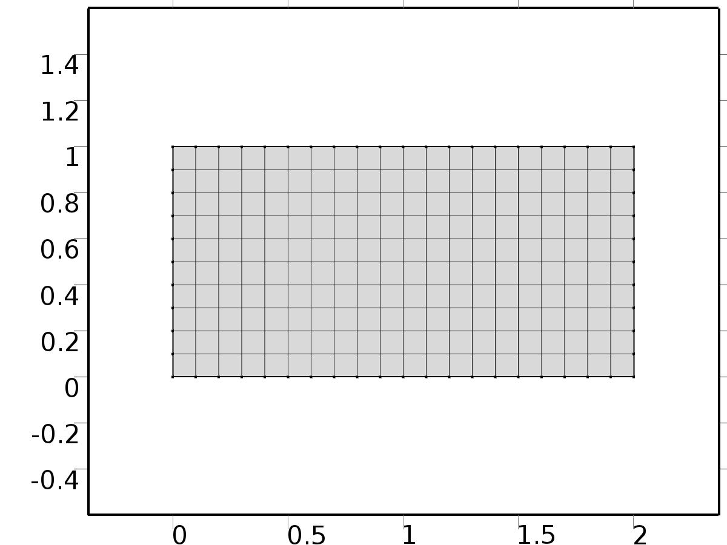

Mesh 1

* + 1. Size (size)

Settings

| **Description** | **Value** |
| --- | --- |
| Maximum element size | 0.134 |
| Minimum element size | 6.0E-4 |
| Curvature factor | 0.3 |
| Maximum element growth rate | 1.3 |

* + 1. Mapped 1 (map1)

Selection

|  |  |
| --- | --- |
| Geometric entity level | Domain |
| Selection | Domain 1 |

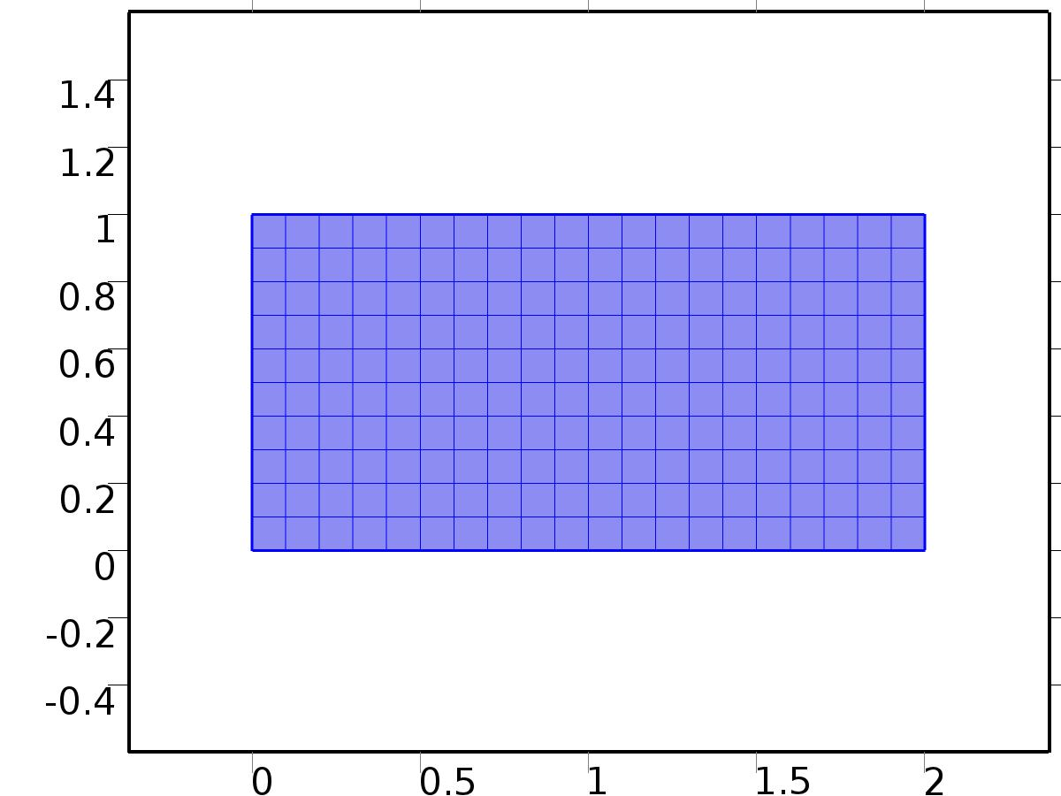

Mapped 1

#### Size 1 (size1)

Selection

|  |  |
| --- | --- |
| Geometric entity level | Domain |
| Selection | Domain 1 |



Size 1

Settings

| **Description** | **Value** |
| --- | --- |
| Maximum element size | L/10 |
| Minimum element size | L/10 |
| Curvature factor | 0.3 |
| Curvature factor | Off |
| Resolution of narrow regions | Off |
| Maximum element growth rate | 1.3 |
| Maximum element growth rate | Off |
| Custom element size | Custom |

1. Study 1
   1. Stationary

Study settings

| **Description** | **Value** |
| --- | --- |
| Include geometric nonlinearity | Off |

Physics and variables selection

| **Physics interface** | **Discretization** |
| --- | --- |
| Unit Input (c) | physics |

Mesh selection

| **Geometry** | **Mesh** |
| --- | --- |
| Geometry 1 (geom1) | mesh1 |

* 1. Solver Configurations
     1. Solver 1

#### Compile Equations: Stationary (st1)

Study and step

| **Description** | **Value** |
| --- | --- |
| Use study | Study 1 |
| Use study step | Stationary |

#### Dependent Variables 1 (v1)

General

| **Description** | **Value** |
| --- | --- |
| Defined by study step | Stationary |
| Constant |  |

Initial values of variables solved for

| **Description** | **Value** |
| --- | --- |
| Solution | Zero |

Values of variables not solved for

| **Description** | **Value** |
| --- | --- |
| Solution | Zero |

##### Dependent variable av0 (comp1.av0) (comp1_av0)

General

| **Description** | **Value** |
| --- | --- |
| Field components | comp1.av0 |
| Solve for this field | Off |

##### Dependent variable av1 (comp1.av1) (comp1_av1)

General

| **Description** | **Value** |
| --- | --- |
| Field components | comp1.av1 |
| Solve for this field | Off |

##### Dependent variable atu0 (comp1.atu0) (comp1_atu0)

General

| **Description** | **Value** |
| --- | --- |
| Field components | comp1.atu0 |
| Solve for this field | Off |

##### Dependent variable au3 (comp1.au3) (comp1_au3)

General

| **Description** | **Value** |
| --- | --- |
| Field components | comp1.au3 |
| Solve for this field | Off |

##### Dependent variable au2 (comp1.au2) (comp1_au2)

General

| **Description** | **Value** |
| --- | --- |
| Field components | comp1.au2 |
| Solve for this field | Off |

##### Dependent variable au1 (comp1.au1) (comp1_au1)

General

| **Description** | **Value** |
| --- | --- |
| Field components | comp1.au1 |
| Solve for this field | Off |

##### Dependent variable atu3 (comp1.atu3) (comp1_atu3)

General

| **Description** | **Value** |
| --- | --- |
| Field components | comp1.atu3 |
| Solve for this field | Off |

##### Dependent variable atu1 (comp1.atu1) (comp1_atu1)

General

| **Description** | **Value** |
| --- | --- |
| Field components | comp1.atu1 |
| Solve for this field | Off |

##### Dependent variable atu2 (comp1.atu2) (comp1_atu2)

General

| **Description** | **Value** |
| --- | --- |
| Field components | comp1.atu2 |
| Solve for this field | Off |

##### Dependent variable btu1 (comp1.btu1) (comp1_btu1)

General

| **Description** | **Value** |
| --- | --- |
| Field components | comp1.btu1 |
| Solve for this field | Off |

##### Dependent variable bu3 (comp1.bu3) (comp1_bu3)

General

| **Description** | **Value** |
| --- | --- |
| Field components | comp1.bu3 |
| Solve for this field | Off |

##### Dependent variable bu2 (comp1.bu2) (comp1_bu2)

General

| **Description** | **Value** |
| --- | --- |
| Field components | comp1.bu2 |
| Solve for this field | Off |

##### Dependent variable btu3 (comp1.btu3) (comp1_btu3)

General

| **Description** | **Value** |
| --- | --- |
| Field components | comp1.btu3 |
| Solve for this field | Off |

##### Dependent variable bu1 (comp1.bu1) (comp1_bu1)

General

| **Description** | **Value** |
| --- | --- |
| Field components | comp1.bu1 |
| Solve for this field | Off |

##### Dependent variable btu2 (comp1.btu2) (comp1_btu2)

General

| **Description** | **Value** |
| --- | --- |
| Field components | comp1.btu2 |
| Solve for this field | Off |

##### Dependent variable Xv (comp1.Xv) (comp1_Xv)

General

| **Description** | **Value** |
| --- | --- |
| Field components | comp1.Xv |

##### Dependent variable Xu (comp1.Xu) (comp1_Xu)

General

| **Description** | **Value** |
| --- | --- |
| Field components | comp1.Xu |

##### Dependent variable au0 (comp1.au0) (comp1_au0)

General

| **Description** | **Value** |
| --- | --- |
| Field components | comp1.au0 |
| Solve for this field | Off |

##### Dependent variable av3 (comp1.av3) (comp1_av3)

General

| **Description** | **Value** |
| --- | --- |
| Field components | comp1.av3 |
| Solve for this field | Off |

##### Dependent variable av2 (comp1.av2) (comp1_av2)

General

| **Description** | **Value** |
| --- | --- |
| Field components | comp1.av2 |
| Solve for this field | Off |

##### Dependent variable u (comp1.u) (comp1_u)

General

| **Description** | **Value** |
| --- | --- |
| Field components | comp1.u |
| Solve for this field | Off |

##### Dependent variable bv2 (comp1.bv2) (comp1_bv2)

General

| **Description** | **Value** |
| --- | --- |
| Field components | comp1.bv2 |
| Solve for this field | Off |

##### Dependent variable v (comp1.v) (comp1_v)

General

| **Description** | **Value** |
| --- | --- |
| Field components | comp1.v |
| Solve for this field | Off |

##### Dependent variable bv1 (comp1.bv1) (comp1_bv1)

General

| **Description** | **Value** |
| --- | --- |
| Field components | comp1.bv1 |
| Solve for this field | Off |

##### Dependent variable bv3 (comp1.bv3) (comp1_bv3)

General

| **Description** | **Value** |
| --- | --- |
| Field components | comp1.bv3 |
| Solve for this field | Off |

##### Dependent variable au4 (comp1.au4) (comp1_au4)

General

| **Description** | **Value** |
| --- | --- |
| Field components | comp1.au4 |
| Solve for this field | Off |
| Field name | comp1_u2 |

##### Dependent variable au5 (comp1.au5) (comp1_au5)

General

| **Description** | **Value** |
| --- | --- |
| Field components | comp1.au5 |
| Solve for this field | Off |
| Field name | comp1_u3 |

##### Dependent variable btu4 (comp1.btu4) (comp1_btu4)

General

| **Description** | **Value** |
| --- | --- |
| Field components | comp1.btu4 |
| Solve for this field | Off |
| Field name | comp1_ab46 |

##### Dependent variable av4 (comp1.av4) (comp1_av4)

General

| **Description** | **Value** |
| --- | --- |
| Field components | comp1.av4 |
| Solve for this field | Off |
| Field name | comp1_ab43 |

##### Dependent variable bu4 (comp1.bu4) (comp1_bu4)

General

| **Description** | **Value** |
| --- | --- |
| Field components | comp1.bu4 |
| Solve for this field | Off |
| Field name | comp1_ab42 |

##### Dependent variable atu4 (comp1.atu4) (comp1_atu4)

General

| **Description** | **Value** |
| --- | --- |
| Field components | comp1.atu4 |
| Solve for this field | Off |
| Field name | comp1_ab45 |

##### Dependent variable bv4 (comp1.bv4) (comp1_bv4)

General

| **Description** | **Value** |
| --- | --- |
| Field components | comp1.bv4 |
| Solve for this field | Off |
| Field name | comp1_ab44 |

##### Dependent variable av5 (comp1.av5) (comp1_av5)

General

| **Description** | **Value** |
| --- | --- |
| Field components | comp1.av5 |
| Solve for this field | Off |
| Field name | comp1_u33 |

##### Dependent variable bv5 (comp1.bv5) (comp1_bv5)

General

| **Description** | **Value** |
| --- | --- |
| Field components | comp1.bv5 |
| Solve for this field | Off |
| Field name | comp1_u34 |

##### Dependent variable atu5 (comp1.atu5) (comp1_atu5)

General

| **Description** | **Value** |
| --- | --- |
| Field components | comp1.atu5 |
| Solve for this field | Off |
| Field name | comp1_u35 |

##### Dependent variable btu5 (comp1.btu5) (comp1_btu5)

General

| **Description** | **Value** |
| --- | --- |
| Field components | comp1.btu5 |
| Solve for this field | Off |
| Field name | comp1_u36 |

##### Dependent variable bu5 (comp1.bu5) (comp1_bu5)

General

| **Description** | **Value** |
| --- | --- |
| Field components | comp1.bu5 |
| Solve for this field | Off |
| Field name | comp1_u32 |

#### Stationary Solver 1 (s1)

General

| **Description** | **Value** |
| --- | --- |
| Defined by study step | Stationary |
| Relative tolerance | 0.000010 |

Log

| **Description** | **Value** |
| --- | --- |
| Constant |  |

##### Fully Coupled 1 (fc1)

General

| **Description** | **Value** |
| --- | --- |
| Linear solver | Direct |

1. Study 2
   1. Stationary

Study settings

| **Description** | **Value** |
| --- | --- |
| Include geometric nonlinearity | Off |

Physics and variables selection

| **Physics interface** | **Discretization** |
| --- | --- |
| Fourier coefficients 0 (c2) | physics |
| Fourier coefficients 1 (c3) | physics |
| Fourier coefficients 2 (c4) | physics |
| Fourier coefficients 3 (phys1) | physics |
| Fourier coefficients 4 (phys2) | physics |
| Fourier coefficients 5 (phys3) | physics |

Mesh selection

| **Geometry** | **Mesh** |
| --- | --- |
| Geometry 1 (geom1) | mesh1 |

* 1. Solver Configurations
     1. Solver 2

#### Compile Equations: Stationary (st1)

Study and step

| **Description** | **Value** |
| --- | --- |
| Use study | Study 2 |
| Use study step | Stationary |

#### Dependent Variables 1 (v1)

General

| **Description** | **Value** |
| --- | --- |
| Defined by study step | Stationary |
| Constant |  |

Initial values of variables solved for

| **Description** | **Value** |
| --- | --- |
| Solution | Zero |

Values of variables not solved for

| **Description** | **Value** |
| --- | --- |
| Method | Solution |
| Solution | Solver 1 |

##### Dependent variable av0 (comp1.av0) (comp1_av0)

General

| **Description** | **Value** |
| --- | --- |
| Field components | comp1.av0 |

##### Dependent variable av1 (comp1.av1) (comp1_av1)

General

| **Description** | **Value** |
| --- | --- |
| Field components | comp1.av1 |

##### Dependent variable atu0 (comp1.atu0) (comp1_atu0)

General

| **Description** | **Value** |
| --- | --- |
| Field components | comp1.atu0 |

##### Dependent variable au3 (comp1.au3) (comp1_au3)

General

| **Description** | **Value** |
| --- | --- |
| Field components | comp1.au3 |

##### Dependent variable au2 (comp1.au2) (comp1_au2)

General

| **Description** | **Value** |
| --- | --- |
| Field components | comp1.au2 |

##### Dependent variable au1 (comp1.au1) (comp1_au1)

General

| **Description** | **Value** |
| --- | --- |
| Field components | comp1.au1 |

##### Dependent variable atu3 (comp1.atu3) (comp1_atu3)

General

| **Description** | **Value** |
| --- | --- |
| Field components | comp1.atu3 |

##### Dependent variable atu1 (comp1.atu1) (comp1_atu1)

General

| **Description** | **Value** |
| --- | --- |
| Field components | comp1.atu1 |

##### Dependent variable atu2 (comp1.atu2) (comp1_atu2)

General

| **Description** | **Value** |
| --- | --- |
| Field components | comp1.atu2 |

##### Dependent variable btu1 (comp1.btu1) (comp1_btu1)

General

| **Description** | **Value** |
| --- | --- |
| Field components | comp1.btu1 |

##### Dependent variable bu3 (comp1.bu3) (comp1_bu3)

General

| **Description** | **Value** |
| --- | --- |
| Field components | comp1.bu3 |

##### Dependent variable bu2 (comp1.bu2) (comp1_bu2)

General

| **Description** | **Value** |
| --- | --- |
| Field components | comp1.bu2 |

##### Dependent variable btu3 (comp1.btu3) (comp1_btu3)

General

| **Description** | **Value** |
| --- | --- |
| Field components | comp1.btu3 |

##### Dependent variable bu1 (comp1.bu1) (comp1_bu1)

General

| **Description** | **Value** |
| --- | --- |
| Field components | comp1.bu1 |

##### Dependent variable btu2 (comp1.btu2) (comp1_btu2)

General

| **Description** | **Value** |
| --- | --- |
| Field components | comp1.btu2 |

##### Dependent variable Xv (comp1.Xv) (comp1_Xv)

General

| **Description** | **Value** |
| --- | --- |
| Field components | comp1.Xv |
| Solve for this field | Off |

##### Dependent variable Xu (comp1.Xu) (comp1_Xu)

General

| **Description** | **Value** |
| --- | --- |
| Field components | comp1.Xu |
| Solve for this field | Off |

##### Dependent variable au0 (comp1.au0) (comp1_au0)

General

| **Description** | **Value** |
| --- | --- |
| Field components | comp1.au0 |

##### Dependent variable av3 (comp1.av3) (comp1_av3)

General

| **Description** | **Value** |
| --- | --- |
| Field components | comp1.av3 |

##### Dependent variable av2 (comp1.av2) (comp1_av2)

General

| **Description** | **Value** |
| --- | --- |
| Field components | comp1.av2 |

##### Dependent variable u (comp1.u) (comp1_u)

General

| **Description** | **Value** |
| --- | --- |
| Field components | comp1.u |
| Solve for this field | Off |

##### Dependent variable bv2 (comp1.bv2) (comp1_bv2)

General

| **Description** | **Value** |
| --- | --- |
| Field components | comp1.bv2 |

##### Dependent variable v (comp1.v) (comp1_v)

General

| **Description** | **Value** |
| --- | --- |
| Field components | comp1.v |
| Solve for this field | Off |

##### Dependent variable bv1 (comp1.bv1) (comp1_bv1)

General

| **Description** | **Value** |
| --- | --- |
| Field components | comp1.bv1 |

##### Dependent variable bv3 (comp1.bv3) (comp1_bv3)

General

| **Description** | **Value** |
| --- | --- |
| Field components | comp1.bv3 |

##### Dependent variable au4 (comp1.au4) (comp1_au4)

General

| **Description** | **Value** |
| --- | --- |
| Field components | comp1.au4 |
| Field name | comp1_u2 |

##### Dependent variable au5 (comp1.au5) (comp1_au5)

General

| **Description** | **Value** |
| --- | --- |
| Field components | comp1.au5 |
| Field name | comp1_u3 |

##### Dependent variable btu4 (comp1.btu4) (comp1_btu4)

General

| **Description** | **Value** |
| --- | --- |
| Field components | comp1.btu4 |
| Field name | comp1_ab46 |

##### Dependent variable av4 (comp1.av4) (comp1_av4)

General

| **Description** | **Value** |
| --- | --- |
| Field components | comp1.av4 |
| Field name | comp1_ab43 |

##### Dependent variable bu4 (comp1.bu4) (comp1_bu4)

General

| **Description** | **Value** |
| --- | --- |
| Field components | comp1.bu4 |
| Field name | comp1_ab42 |

##### Dependent variable atu4 (comp1.atu4) (comp1_atu4)

General

| **Description** | **Value** |
| --- | --- |
| Field components | comp1.atu4 |
| Field name | comp1_ab45 |

##### Dependent variable bv4 (comp1.bv4) (comp1_bv4)

General

| **Description** | **Value** |
| --- | --- |
| Field components | comp1.bv4 |
| Field name | comp1_ab44 |

##### Dependent variable av5 (comp1.av5) (comp1_av5)

General

| **Description** | **Value** |
| --- | --- |
| Field components | comp1.av5 |
| Field name | comp1_u33 |

##### Dependent variable bv5 (comp1.bv5) (comp1_bv5)

General

| **Description** | **Value** |
| --- | --- |
| Field components | comp1.bv5 |
| Field name | comp1_u34 |

##### Dependent variable atu5 (comp1.atu5) (comp1_atu5)

General

| **Description** | **Value** |
| --- | --- |
| Field components | comp1.atu5 |
| Field name | comp1_u35 |

##### Dependent variable btu5 (comp1.btu5) (comp1_btu5)

General

| **Description** | **Value** |
| --- | --- |
| Field components | comp1.btu5 |
| Field name | comp1_u36 |

##### Dependent variable bu5 (comp1.bu5) (comp1_bu5)

General

| **Description** | **Value** |
| --- | --- |
| Field components | comp1.bu5 |
| Field name | comp1_u32 |

#### Stationary Solver 1 (s1)

General

| **Description** | **Value** |
| --- | --- |
| Defined by study step | Stationary |
| Relative tolerance | 0.000010 |

Log

| **Description** | **Value** |
| --- | --- |
| Constant |  |

##### Fully Coupled 1 (fc1)

General

| **Description** | **Value** |
| --- | --- |
| Linear solver | Direct |

1. Study 3
   1. Time Dependent

Study settings

| **Description** | **Value** |
| --- | --- |
| Include geometric nonlinearity | Off |

| **Times** | **Unit** |
| --- | --- |
| range(0,0.1,20) | s |

Physics and variables selection

| **Physics interface** | **Discretization** |
| --- | --- |
| Closed loop system (c5) | physics |

Mesh selection

| **Geometry** | **Mesh** |
| --- | --- |
| Geometry 1 (geom1) | mesh1 |

* 1. Solver Configurations
     1. Solver 3

#### Compile Equations: Time Dependent (st1)

Study and step

| **Description** | **Value** |
| --- | --- |
| Use study | Study 3 |
| Use study step | Time Dependent |

#### Dependent Variables 1 (v1)

General

| **Description** | **Value** |
| --- | --- |
| Defined by study step | Time Dependent |
| Constant |  |

Initial values of variables solved for

| **Description** | **Value** |
| --- | --- |
| Solution | Zero |

Values of variables not solved for

| **Description** | **Value** |
| --- | --- |
| Method | Solution |
| Solution | Solver 2 |

##### Dependent variable Xv (comp1.Xv) (comp1_Xv)

General

| **Description** | **Value** |
| --- | --- |
| Field components | comp1.Xv |
| Solve for this field | Off |

##### Dependent variable Xu (comp1.Xu) (comp1_Xu)

General

| **Description** | **Value** |
| --- | --- |
| Field components | comp1.Xu |
| Solve for this field | Off |

##### Dependent variable au0 (comp1.au0) (comp1_au0)

General

| **Description** | **Value** |
| --- | --- |
| Field components | comp1.au0 |
| Solve for this field | Off |

##### Dependent variable av0 (comp1.av0) (comp1_av0)

General

| **Description** | **Value** |
| --- | --- |
| Field components | comp1.av0 |
| Solve for this field | Off |

##### Dependent variable av1 (comp1.av1) (comp1_av1)

General

| **Description** | **Value** |
| --- | --- |
| Field components | comp1.av1 |
| Solve for this field | Off |

##### Dependent variable av2 (comp1.av2) (comp1_av2)

General

| **Description** | **Value** |
| --- | --- |
| Field components | comp1.av2 |
| Solve for this field | Off |

##### Dependent variable atu0 (comp1.atu0) (comp1_atu0)

General

| **Description** | **Value** |
| --- | --- |
| Field components | comp1.atu0 |
| Solve for this field | Off |

##### Dependent variable au2 (comp1.au2) (comp1_au2)

General

| **Description** | **Value** |
| --- | --- |
| Field components | comp1.au2 |
| Solve for this field | Off |

##### Dependent variable au1 (comp1.au1) (comp1_au1)

General

| **Description** | **Value** |
| --- | --- |
| Field components | comp1.au1 |
| Solve for this field | Off |

##### Dependent variable atu1 (comp1.atu1) (comp1_atu1)

General

| **Description** | **Value** |
| --- | --- |
| Field components | comp1.atu1 |
| Solve for this field | Off |

##### Dependent variable atu2 (comp1.atu2) (comp1_atu2)

General

| **Description** | **Value** |
| --- | --- |
| Field components | comp1.atu2 |
| Solve for this field | Off |

##### Dependent variable btu1 (comp1.btu1) (comp1_btu1)

General

| **Description** | **Value** |
| --- | --- |
| Field components | comp1.btu1 |
| Solve for this field | Off |

##### Dependent variable u (comp1.u) (comp1_u)

General

| **Description** | **Value** |
| --- | --- |
| Field components | comp1.u |

##### Dependent variable bv2 (comp1.bv2) (comp1_bv2)

General

| **Description** | **Value** |
| --- | --- |
| Field components | comp1.bv2 |
| Solve for this field | Off |

##### Dependent variable v (comp1.v) (comp1_v)

General

| **Description** | **Value** |
| --- | --- |
| Field components | comp1.v |

##### Dependent variable bu2 (comp1.bu2) (comp1_bu2)

General

| **Description** | **Value** |
| --- | --- |
| Field components | comp1.bu2 |
| Solve for this field | Off |

##### Dependent variable bv1 (comp1.bv1) (comp1_bv1)

General

| **Description** | **Value** |
| --- | --- |
| Field components | comp1.bv1 |
| Solve for this field | Off |

##### Dependent variable bu1 (comp1.bu1) (comp1_bu1)

General

| **Description** | **Value** |
| --- | --- |
| Field components | comp1.bu1 |
| Solve for this field | Off |

##### Dependent variable btu2 (comp1.btu2) (comp1_btu2)

General

| **Description** | **Value** |
| --- | --- |
| Field components | comp1.btu2 |
| Solve for this field | Off |

##### Dependent variable au3 (comp1.au3) (comp1_au3)

General

| **Description** | **Value** |
| --- | --- |
| Field components | comp1.au3 |
| Solve for this field | Off |
| Field name | comp1_u2 |

##### Dependent variable bv3 (comp1.bv3) (comp1_bv3)

General

| **Description** | **Value** |
| --- | --- |
| Field components | comp1.bv3 |
| Solve for this field | Off |
| Field name | comp1_ab34 |

##### Dependent variable av3 (comp1.av3) (comp1_av3)

General

| **Description** | **Value** |
| --- | --- |
| Field components | comp1.av3 |
| Solve for this field | Off |
| Field name | comp1_ab33 |

##### Dependent variable bu3 (comp1.bu3) (comp1_bu3)

General

| **Description** | **Value** |
| --- | --- |
| Field components | comp1.bu3 |
| Solve for this field | Off |
| Field name | comp1_ab32 |

##### Dependent variable atu3 (comp1.atu3) (comp1_atu3)

General

| **Description** | **Value** |
| --- | --- |
| Field components | comp1.atu3 |
| Solve for this field | Off |
| Field name | comp1_ab35 |

##### Dependent variable btu3 (comp1.btu3) (comp1_btu3)

General

| **Description** | **Value** |
| --- | --- |
| Field components | comp1.btu3 |
| Solve for this field | Off |
| Field name | comp1_ab36 |

##### Dependent variable au4 (comp1.au4) (comp1_au4)

General

| **Description** | **Value** |
| --- | --- |
| Field components | comp1.au4 |
| Solve for this field | Off |
| Field name | comp1_u2 |

##### Dependent variable au5 (comp1.au5) (comp1_au5)

General

| **Description** | **Value** |
| --- | --- |
| Field components | comp1.au5 |
| Solve for this field | Off |
| Field name | comp1_u3 |

##### Dependent variable btu4 (comp1.btu4) (comp1_btu4)

General

| **Description** | **Value** |
| --- | --- |
| Field components | comp1.btu4 |
| Solve for this field | Off |
| Field name | comp1_ab46 |

##### Dependent variable av4 (comp1.av4) (comp1_av4)

General

| **Description** | **Value** |
| --- | --- |
| Field components | comp1.av4 |
| Solve for this field | Off |
| Field name | comp1_ab43 |

##### Dependent variable bu4 (comp1.bu4) (comp1_bu4)

General

| **Description** | **Value** |
| --- | --- |
| Field components | comp1.bu4 |
| Solve for this field | Off |
| Field name | comp1_ab42 |

##### Dependent variable atu4 (comp1.atu4) (comp1_atu4)

General

| **Description** | **Value** |
| --- | --- |
| Field components | comp1.atu4 |
| Solve for this field | Off |
| Field name | comp1_ab45 |

##### Dependent variable bv4 (comp1.bv4) (comp1_bv4)

General

| **Description** | **Value** |
| --- | --- |
| Field components | comp1.bv4 |
| Solve for this field | Off |
| Field name | comp1_ab44 |

##### Dependent variable av5 (comp1.av5) (comp1_av5)

General

| **Description** | **Value** |
| --- | --- |
| Field components | comp1.av5 |
| Solve for this field | Off |
| Field name | comp1_u33 |

##### Dependent variable bv5 (comp1.bv5) (comp1_bv5)

General

| **Description** | **Value** |
| --- | --- |
| Field components | comp1.bv5 |
| Solve for this field | Off |
| Field name | comp1_u34 |

##### Dependent variable atu5 (comp1.atu5) (comp1_atu5)

General

| **Description** | **Value** |
| --- | --- |
| Field components | comp1.atu5 |
| Solve for this field | Off |
| Field name | comp1_u35 |

##### Dependent variable btu5 (comp1.btu5) (comp1_btu5)

General

| **Description** | **Value** |
| --- | --- |
| Field components | comp1.btu5 |
| Solve for this field | Off |
| Field name | comp1_u36 |

##### Dependent variable bu5 (comp1.bu5) (comp1_bu5)

General

| **Description** | **Value** |
| --- | --- |
| Field components | comp1.bu5 |
| Solve for this field | Off |
| Field name | comp1_u32 |

#### Time-Dependent Solver 1 (t1)

General

| **Description** | **Value** |
| --- | --- |
| Defined by study step | Time Dependent |
| Time | {0, 0.1, 0.2, 0.30000000000000004, 0.4, 0.5, 0.6000000000000001, 0.7000000000000001, 0.8, 0.9, 1, 1.1, 1.2000000000000002, 1.3, 1.4000000000000001, 1.5, 1.6, 1.7000000000000002, 1.8, 1.9000000000000001, 2, 2.1, 2.2, 2.3000000000000003, 2.4000000000000004, 2.5, 2.6, 2.7, 2.8000000000000003, 2.9000000000000004, 3, 3.1, 3.2, 3.3000000000000003, 3.4000000000000004, 3.5, 3.6, 3.7, 3.8000000000000003, 3.9000000000000004, 4, 4.1000000000000005, 4.2, 4.3, 4.4, 4.5, 4.6000000000000005, 4.7, 4.800000000000001, 4.9, 5, 5.1000000000000005, 5.2, 5.300000000000001, 5.4, 5.5, 5.6000000000000005, 5.7, 5.800000000000001, 5.9, 6, 6.1000000000000005, 6.2, 6.300000000000001, 6.4, 6.5, 6.6000000000000005, 6.7, 6.800000000000001, 6.9, 7, 7.1000000000000005, 7.2, 7.300000000000001, 7.4, 7.5, 7.6000000000000005, 7.7, 7.800000000000001, 7.9, 8, 8.1, 8.200000000000001, 8.3, 8.4, 8.5, 8.6, 8.700000000000001, 8.8, 8.9, 9, 9.1, 9.200000000000001, 9.3, 9.4, 9.5, 9.600000000000001, 9.700000000000001, 9.8, 9.9, 10, 10.100000000000001, 10.200000000000001, 10.3, 10.4, 10.5, 10.600000000000001, 10.700000000000001, 10.8, 10.9, 11, 11.100000000000001, 11.200000000000001, 11.3, 11.4, 11.5, 11.600000000000001, 11.700000000000001, 11.8, 11.9, 12, 12.100000000000001, 12.200000000000001, 12.3, 12.4, 12.5, 12.600000000000001, 12.700000000000001, 12.8, 12.9, 13, 13.100000000000001, 13.200000000000001, 13.3, 13.4, 13.5, 13.600000000000001, 13.700000000000001, 13.8, 13.9, 14, 14.100000000000001, 14.200000000000001, 14.3, 14.4, 14.5, 14.600000000000001, 14.700000000000001, 14.8, 14.9, 15, 15.100000000000001, 15.200000000000001, 15.3, 15.4, 15.5, 15.600000000000001, 15.700000000000001, 15.8, 15.9, 16, 16.1, 16.2, 16.3, 16.400000000000002, 16.5, 16.6, 16.7, 16.8, 16.900000000000002, 17, 17.1, 17.2, 17.3, 17.400000000000002, 17.5, 17.6, 17.7, 17.8, 17.900000000000002, 18, 18.1, 18.2, 18.3, 18.400000000000002, 18.5, 18.6, 18.7, 18.8, 18.900000000000002, 19, 19.1, 19.200000000000003, 19.3, 19.400000000000002, 19.5, 19.6, 19.700000000000003, 19.8, 19.900000000000002, 20} |
| Relative tolerance | 0.0001 |

Absolute tolerance

| **Description** | **Value** |
| --- | --- |
| Tolerance | 0.000010 |

Time stepping

| **Description** | **Value** |
| --- | --- |
| Initial step | 0.0010 |

Advanced

| **Description** | **Value** |
| --- | --- |
| Fraction of initial step for Backward Euler | 0.0010 |

Log

| **Description** | **Value** |
| --- | --- |
| Constant |  |

##### Fully Coupled 1 (fc1)

General

| **Description** | **Value** |
| --- | --- |
| Linear solver | Direct |

1. Results
   1. Data Sets
      1. Solution 1

Solution

| **Description** | **Value** |
| --- | --- |
| Solution | Solver 1 |
| Component | Save Point Geometry 1 |

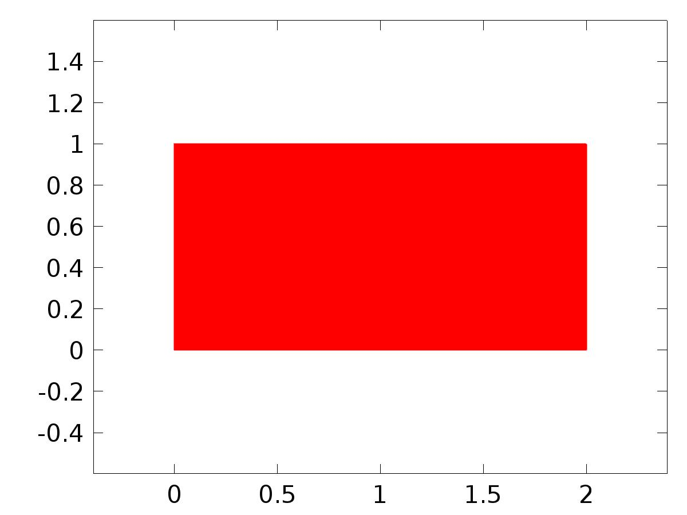

Data set: Solution 1

* + 1. Solution 2

Solution

| **Description** | **Value** |
| --- | --- |
| Solution | Solver 2 |
| Component | Save Point Geometry 1 |



Data set: Solution 2

* + 1. Solution 3

Solution

| **Description** | **Value** |
| --- | --- |
| Solution | Solver 3 |
| Component | Save Point Geometry 1 |



Data set: Solution 3

* 1. Derived Values
     1. Global Evaluation 1

Data

| **Description** | **Value** |
| --- | --- |
| Data set | Solution 3 |

Expression

| **Description** | **Value** |
| --- | --- |
| Expression | e |

* 1. Tables
     1. Table 1

Global Evaluation 1 (G)

Table 1

| **Time (s)** | **C(u)** | **yr** | **gamma** | **e** |
| --- | --- | --- | --- | --- |
| 0.0000 | -2.0873E-19 | 0.10000 | 12.966 | 0.10000 |
| 0.10000 | 9.0897E-6 | 0.11997 | 13.451 | 0.11996 |
| 0.20000 | 0.0023845 | 0.13973 | 13.928 | 0.13735 |
| 0.30000 | 0.016411 | 0.15910 | 14.397 | 0.14269 |
| 0.40000 | 0.043532 | 0.17788 | 14.847 | 0.13435 |
| 0.50000 | 0.077877 | 0.19589 | 15.264 | 0.11801 |
| 0.60000 | 0.11392 | 0.21293 | 15.632 | 0.099010 |
| 0.70000 | 0.14841 | 0.22884 | 15.930 | 0.080430 |
| 0.80000 | 0.17989 | 0.24347 | 16.142 | 0.063583 |
| 0.90000 | 0.20784 | 0.25667 | 16.255 | 0.048821 |
| 1.0000 | 0.23220 | 0.26829 | 16.261 | 0.036094 |
| 1.1000 | 0.25297 | 0.27824 | 16.158 | 0.025273 |
| 1.2000 | 0.27013 | 0.28641 | 15.951 | 0.016282 |
| 1.3000 | 0.28359 | 0.29271 | 15.652 | 0.0091183 |
| 1.4000 | 0.29328 | 0.29709 | 15.274 | 0.0038143 |
| 1.5000 | 0.29914 | 0.29950 | 14.835 | 3.5921E-4 |
| 1.6000 | 0.30127 | 0.29991 | 14.351 | -0.0013533 |
| 1.7000 | 0.29989 | 0.29833 | 13.837 | -0.0015541 |
| 1.8000 | 0.29537 | 0.29477 | 13.300 | -5.9687E-4 |
| 1.9000 | 0.28818 | 0.28926 | 12.743 | 0.0010759 |
| 2.0000 | 0.27886 | 0.28186 | 12.160 | 0.0030016 |
| 2.1000 | 0.26789 | 0.27264 | 11.536 | 0.0047535 |
| 2.2000 | 0.25571 | 0.26170 | 10.849 | 0.0059854 |
| 2.3000 | 0.24268 | 0.24914 | 10.071 | 0.0064660 |
| 2.4000 | 0.22899 | 0.23509 | 9.1705 | 0.0061069 |
| 2.5000 | 0.21472 | 0.21969 | 8.1151 | 0.0049705 |
| 2.6000 | 0.19985 | 0.20310 | 6.8763 | 0.0032485 |
| 2.7000 | 0.18425 | 0.18548 | 5.4325 | 0.0012212 |
| 2.8000 | 0.16779 | 0.16700 | 3.7720 | -7.9240E-4 |
| 2.9000 | 0.15034 | 0.14785 | 1.8966 | -0.0024869 |
| 3.0000 | 0.13185 | 0.12822 | -0.17701 | -0.0036243 |
| 3.1000 | 0.11239 | 0.10832 | -2.4158 | -0.0040786 |
| 3.2000 | 0.092181 | 0.088325 | -4.7711 | -0.0038563 |
| 3.3000 | 0.071528 | 0.068451 | -7.1798 | -0.0030773 |
| 3.4000 | 0.050825 | 0.048892 | -9.5677 | -0.0019328 |
| 3.5000 | 0.030492 | 0.029843 | -11.853 | -6.4875E-4 |
| 3.6000 | 0.010944 | 0.011496 | -13.949 | 5.5238E-4 |
| 3.7000 | -0.0074542 | -0.0059672 | -15.775 | 0.0014870 |
| 3.8000 | -0.024415 | -0.022372 | -17.254 | 0.0020434 |
| 3.9000 | -0.039745 | -0.037553 | -18.321 | 0.0021915 |
| 4.0000 | -0.053316 | -0.051360 | -18.930 | 0.0019555 |
| 4.1000 | -0.065067 | -0.063655 | -19.052 | 0.0014117 |
| 4.2000 | -0.075003 | -0.074315 | -18.680 | 6.8779E-4 |
| 4.3000 | -0.083139 | -0.083233 | -17.829 | -9.4532E-5 |
| 4.4000 | -0.089492 | -0.090320 | -16.535 | -8.2812E-4 |
| 4.5000 | -0.094102 | -0.095506 | -14.851 | -0.0014045 |
| 4.6000 | -0.097018 | -0.098738 | -12.849 | -0.0017197 |
| 4.7000 | -0.098251 | -0.099985 | -10.608 | -0.0017335 |
| 4.8000 | -0.097789 | -0.099233 | -8.2132 | -0.0014443 |
| 4.9000 | -0.095607 | -0.096491 | -5.7525 | -8.8345E-4 |
| 5.0000 | -0.091667 | -0.091785 | -3.3075 | -1.1757E-4 |
| 5.1000 | -0.085915 | -0.085163 | -0.95087 | 7.5251E-4 |
| 5.2000 | -0.078288 | -0.076691 | 1.2572 | 0.0015970 |
| 5.3000 | -0.068725 | -0.066453 | 3.2719 | 0.0022719 |
| 5.4000 | -0.057193 | -0.054553 | 5.0649 | 0.0026402 |
| 5.5000 | -0.043700 | -0.041108 | 6.6248 | 0.0025920 |
| 5.6000 | -0.028320 | -0.026253 | 7.9551 | 0.0020671 |
| 5.7000 | -0.011220 | -0.010137 | 9.0727 | 0.0010829 |
| 5.8000 | 0.0073312 | 0.0070796 | 10.004 | -2.5164E-4 |
| 5.9000 | 0.026991 | 0.025225 | 10.783 | -0.0017659 |
| 6.0000 | 0.047335 | 0.044117 | 11.445 | -0.0032185 |
| 6.1000 | 0.067871 | 0.063567 | 12.024 | -0.0043039 |
| 6.2000 | 0.088213 | 0.083382 | 12.551 | -0.0048313 |
| 6.3000 | 0.10802 | 0.10336 | 13.048 | -0.0046527 |
| 6.4000 | 0.12700 | 0.12331 | 13.532 | -0.0036948 |
| 6.5000 | 0.14507 | 0.14302 | 14.008 | -0.0020422 |
| 6.6000 | 0.16228 | 0.16231 | 14.474 | 2.7438E-5 |
| 6.7000 | 0.17873 | 0.18097 | 14.920 | 0.0022441 |
| 6.8000 | 0.19456 | 0.19882 | 15.330 | 0.0042590 |
| 6.9000 | 0.20998 | 0.21569 | 15.687 | 0.0057114 |
| 7.0000 | 0.22505 | 0.23140 | 15.972 | 0.0063443 |
| 7.1000 | 0.23977 | 0.24579 | 16.169 | 0.0060247 |
| 7.2000 | 0.25397 | 0.25873 | 16.264 | 0.0047611 |
| 7.3000 | 0.26737 | 0.27009 | 16.251 | 0.0027123 |
| 7.4000 | 0.27957 | 0.27974 | 16.130 | 1.6799E-4 |
| 7.5000 | 0.29007 | 0.28760 | 15.907 | -0.0024749 |
| 7.6000 | 0.29836 | 0.29358 | 15.593 | -0.0047713 |
| 7.7000 | 0.30400 | 0.29763 | 15.204 | -0.0063625 |
| 7.8000 | 0.30670 | 0.29971 | 14.756 | -0.0069904 |
| 7.9000 | 0.30635 | 0.29979 | 14.267 | -0.0065576 |
| 8.0000 | 0.30304 | 0.29787 | 13.748 | -0.0051708 |
| 8.1000 | 0.29705 | 0.29398 | 13.208 | -0.0030727 |
| 8.2000 | 0.28874 | 0.28815 | 12.648 | -5.9271E-4 |
| 8.3000 | 0.27854 | 0.28043 | 12.059 | 0.0018906 |
| 8.4000 | 0.26692 | 0.27092 | 11.426 | 0.0039982 |
| 8.5000 | 0.25428 | 0.25970 | 10.726 | 0.0054198 |
| 8.6000 | 0.24091 | 0.24688 | 9.9293 | 0.0059712 |
| 8.7000 | 0.22698 | 0.23259 | 9.0047 | 0.0056171 |
| 8.8000 | 0.21252 | 0.21698 | 7.9203 | 0.0044636 |
| 8.9000 | 0.19747 | 0.20020 | 6.6484 | 0.0027336 |
| 9.0000 | 0.18169 | 0.18242 | 5.1686 | 7.2954E-4 |
| 9.1000 | 0.16504 | 0.16382 | 3.4714 | -0.0012196 |
| 9.2000 | 0.14739 | 0.14458 | 1.5611 | -0.0028085 |
| 9.3000 | 0.12871 | 0.12489 | -0.54303 | -0.0038159 |
| 9.4000 | 0.10909 | 0.10496 | -2.8052 | -0.0041398 |
| 9.5000 | 0.088774 | 0.084970 | -5.1743 | -0.0038038 |
| 9.6000 | 0.068070 | 0.065135 | -7.5850 | -0.0029355 |
| 9.7000 | 0.047389 | 0.045648 | -9.9614 | -0.0017407 |
| 9.8000 | 0.027156 | 0.026704 | -12.221 | -4.5139E-4 |
| 9.9000 | 0.0077738 | 0.0084928 | -14.278 | 7.1905E-4 |
| 10.000 | -0.010398 | -0.0088042 | -16.050 | 0.0015941 |
| 10.100 | -0.027097 | -0.025014 | -17.463 | 0.0020833 |
| 10.200 | -0.042140 | -0.039975 | -18.457 | 0.0021646 |
| 10.300 | -0.055409 | -0.053537 | -18.985 | 0.0018716 |
| 10.400 | -0.066855 | -0.065565 | -19.024 | 0.0012901 |
| 10.500 | -0.076481 | -0.075939 | -18.570 | 5.4144E-4 |
| 10.600 | -0.084312 | -0.084555 | -17.641 | -2.4349E-4 |
| 10.700 | -0.090380 | -0.091327 | -16.277 | -9.4747E-4 |
| 10.800 | -0.094717 | -0.096187 | -14.535 | -0.0014701 |
| 10.900 | -0.097353 | -0.099087 | -12.486 | -0.0017344 |
| 11.000 | -0.098300 | -0.099998 | -10.213 | -0.0016978 |
| 11.100 | -0.097553 | -0.098911 | -7.8018 | -0.0013579 |
| 11.200 | -0.095084 | -0.095836 | -5.3382 | -7.5168E-4 |
| 11.300 | -0.090850 | -0.090804 | -2.9032 | 4.5697E-5 |
| 11.400 | -0.084791 | -0.083866 | -0.56778 | 9.2518E-4 |
| 11.500 | -0.076843 | -0.075090 | 1.6104 | 0.0017523 |
| 11.600 | -0.066948 | -0.064566 | 3.5894 | 0.0023825 |
| 11.700 | -0.055080 | -0.052397 | 5.3436 | 0.0026832 |
| 11.800 | -0.041258 | -0.038705 | 6.8642 | 0.0025533 |
| 11.900 | -0.025573 | -0.023627 | 8.1573 | 0.0019459 |
| 12.000 | -0.0082046 | -0.0073146 | 9.2415 | 8.8999E-4 |
| 12.100 | 0.010569 | 0.010071 | 10.145 | -4.9821E-4 |
| 12.200 | 0.030375 | 0.028354 | 10.902 | -0.0020212 |
| 12.300 | 0.050778 | 0.047354 | 11.547 | -0.0034246 |
| 12.400 | 0.071321 | 0.066879 | 12.115 | -0.0044422 |
| 12.500 | 0.091584 | 0.086736 | 12.636 | -0.0048485 |
| 12.600 | 0.11123 | 0.10672 | 13.130 | -0.0045082 |
| 12.700 | 0.13006 | 0.12665 | 13.613 | -0.0034108 |
| 12.800 | 0.14798 | 0.14630 | 14.087 | -0.0016803 |
| 12.900 | 0.16505 | 0.16549 | 14.550 | 4.4106E-4 |
| 13.000 | 0.18140 | 0.18403 | 14.991 | 0.0026305 |
| 13.100 | 0.19720 | 0.20173 | 15.394 | 0.0045370 |
| 13.200 | 0.21258 | 0.21841 | 15.741 | 0.0058380 |
| 13.300 | 0.22762 | 0.23391 | 16.012 | 0.0062937 |
| 13.400 | 0.24229 | 0.24808 | 16.192 | 0.0057901 |
| 13.500 | 0.25639 | 0.26076 | 16.269 | 0.0043646 |
| 13.600 | 0.26962 | 0.27183 | 16.238 | 0.0022076 |
| 13.700 | 0.28155 | 0.28119 | 16.100 | -3.5818E-4 |
| 13.800 | 0.29167 | 0.28874 | 15.860 | -0.0029319 |
| 13.900 | 0.29951 | 0.29440 | 15.533 | -0.0051067 |
| 14.000 | 0.30464 | 0.29812 | 15.132 | -0.0065213 |
| 14.100 | 0.30680 | 0.29986 | 14.676 | -0.0069426 |
| 14.200 | 0.30592 | 0.29961 | 14.181 | -0.0063166 |
| 14.300 | 0.30213 | 0.29735 | 13.658 | -0.0047742 |
| 14.400 | 0.29571 | 0.29313 | 13.115 | -0.0025828 |
| 14.500 | 0.28707 | 0.28698 | 12.551 | -8.9874E-5 |
| 14.600 | 0.27664 | 0.27896 | 11.956 | 0.0023200 |
| 14.700 | 0.26487 | 0.26915 | 11.314 | 0.0042830 |
| 14.800 | 0.25211 | 0.25765 | 10.599 | 0.0055377 |
| 14.900 | 0.23865 | 0.24458 | 9.7837 | 0.0059298 |
| 15.000 | 0.22461 | 0.23006 | 8.8343 | 0.0054432 |
| 15.100 | 0.21005 | 0.21424 | 7.7202 | 0.0041925 |
| 15.200 | 0.19487 | 0.19728 | 6.4145 | 0.0024102 |
| 15.300 | 0.17895 | 0.17935 | 4.8985 | 4.0009E-4 |
| 15.400 | 0.16213 | 0.16062 | 3.1648 | -0.0015023 |
| 15.500 | 0.14430 | 0.14129 | 1.2200 | -0.0030067 |
| 15.600 | 0.12546 | 0.12155 | -0.91356 | -0.0039106 |
| 15.700 | 0.10572 | 0.10159 | -3.1977 | -0.0041269 |
| 15.800 | 0.085312 | 0.081619 | -5.5786 | -0.0036933 |
| 15.900 | 0.064582 | 0.061828 | -7.9892 | -0.0027541 |
| 16.000 | 0.043943 | 0.042419 | -10.352 | -0.0015238 |
| 16.100 | 0.023823 | 0.023586 | -12.583 | -2.3751E-4 |
| 16.200 | 0.0046226 | 0.0055156 | -14.598 | 8.9302E-4 |
| 16.300 | -0.013322 | -0.011610 | -16.315 | 0.0017112 |
| 16.400 | -0.029753 | -0.027621 | -17.661 | 0.0021320 |
| 16.500 | -0.044501 | -0.042357 | -18.579 | 0.0021437 |
| 16.600 | -0.057467 | -0.055670 | -19.026 | 0.0017968 |
| 16.700 | -0.068611 | -0.067428 | -18.982 | 0.0011822 |
| 16.800 | -0.077933 | -0.077513 | -18.446 | 4.1933E-4 |
| 16.900 | -0.085461 | -0.085825 | -17.441 | -3.6401E-4 |
| 17.000 | -0.091232 | -0.092279 | -16.009 | -0.0010476 |
| 17.100 | -0.095281 | -0.096813 | -14.210 | -0.0015321 |
| 17.200 | -0.097633 | -0.099380 | -12.118 | -0.0017473 |
| 17.300 | -0.098294 | -0.099955 | -9.8150 | -0.0016608 |
| 17.400 | -0.097256 | -0.098532 | -7.3889 | -0.0012761 |
| 17.500 | -0.094491 | -0.095125 | -4.9247 | -6.3462E-4 |
| 17.600 | -0.089952 | -0.089769 | -2.5018 | 1.8304E-4 |
| 17.700 | -0.083579 | -0.082516 | -0.18917 | 0.0010622 |
| 17.800 | -0.075307 | -0.073440 | 1.9580 | 0.0018664 |
| 17.900 | -0.065083 | -0.062631 | 3.9005 | 0.0024519 |
| 18.000 | -0.052886 | -0.050197 | 5.6156 | 0.0026885 |
| 18.100 | -0.038744 | -0.036263 | 7.0972 | 0.0024812 |
| 18.200 | -0.022766 | -0.020967 | 8.3535 | 0.0017996 |
| 18.300 | -0.0051440 | -0.0044617 | 9.4052 | 6.8230E-4 |
| 18.400 | 0.013831 | 0.013087 | 10.282 | -7.4364E-4 |
| 18.500 | 0.033776 | 0.031504 | 11.017 | -0.0022721 |
| 18.600 | 0.054243 | 0.050605 | 11.647 | -0.0036374 |
| 18.700 | 0.074766 | 0.070200 | 12.206 | -0.0045659 |
| 18.800 | 0.094933 | 0.090093 | 12.720 | -0.0048398 |
| 18.900 | 0.11444 | 0.11008 | 13.212 | -0.0043585 |
| 19.000 | 0.13313 | 0.12998 | 13.693 | -0.0031550 |
| 19.100 | 0.15093 | 0.14957 | 14.166 | -0.0013641 |
| 19.200 | 0.16787 | 0.16866 | 14.627 | 7.8853E-4 |
| 19.300 | 0.18411 | 0.18707 | 15.062 | 0.0029632 |
| 19.400 | 0.19984 | 0.20461 | 15.457 | 0.0047699 |
| 19.500 | 0.21517 | 0.22111 | 15.792 | 0.0059394 |
| 19.600 | 0.23010 | 0.23639 | 16.049 | 0.0062925 |
| 19.700 | 0.24468 | 0.25031 | 16.212 | 0.0056341 |
| 19.800 | 0.25872 | 0.26273 | 16.272 | 0.0040190 |
| 19.900 | 0.27173 | 0.27353 | 16.222 | 0.0018038 |
| 20.000 | 0.28333 | 0.28259 | 16.066 | -7.3869E-4 |

* 1. Plot Groups
     1. 2D Plot Group 1

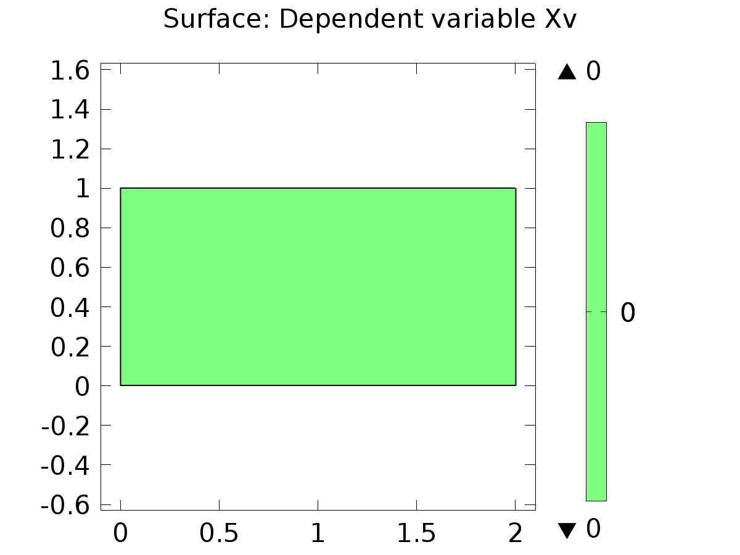

Surface: Dependent variable Xv

* + 1. 2D Plot Group 2

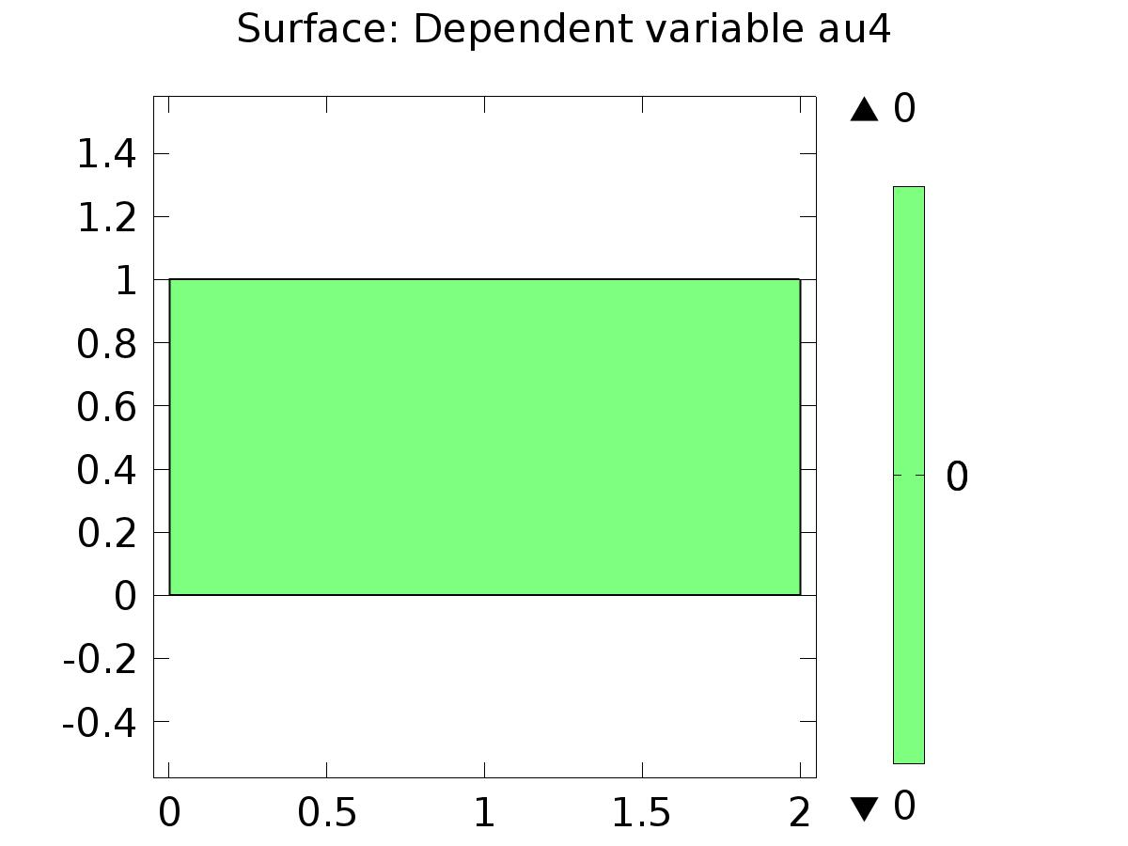

Surface: Dependent variable au4

* + 1. 2D Plot Group 3

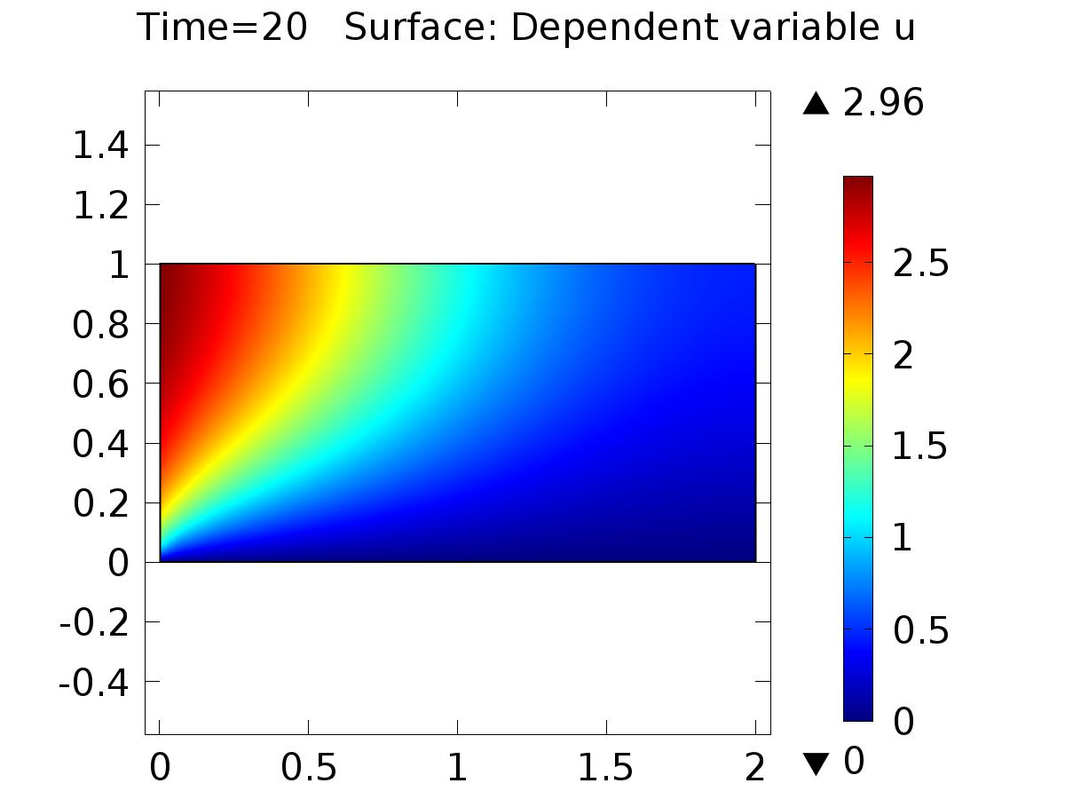

Time=20 Surface: Dependent variable u

* + 1. 1D Plot Group 4

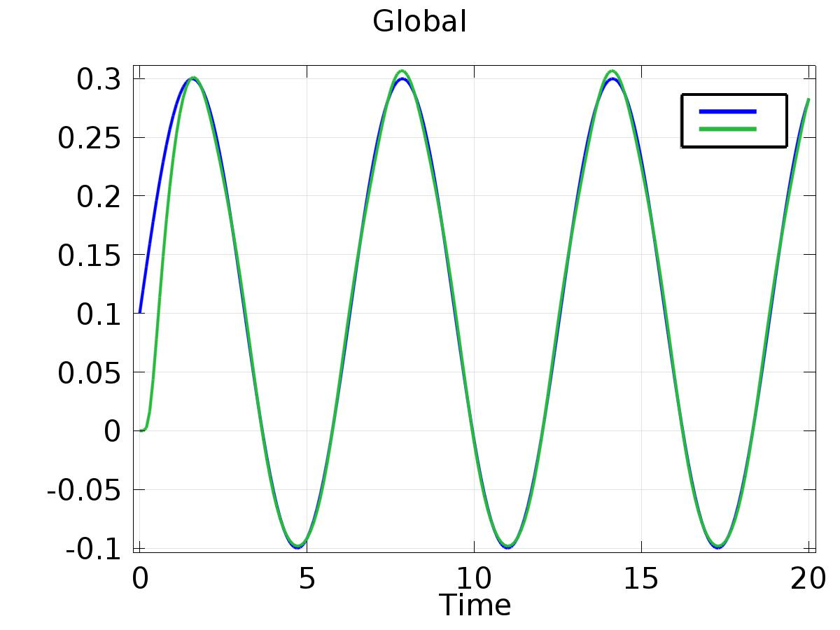

Global

* + 1. 1D Plot Group 5

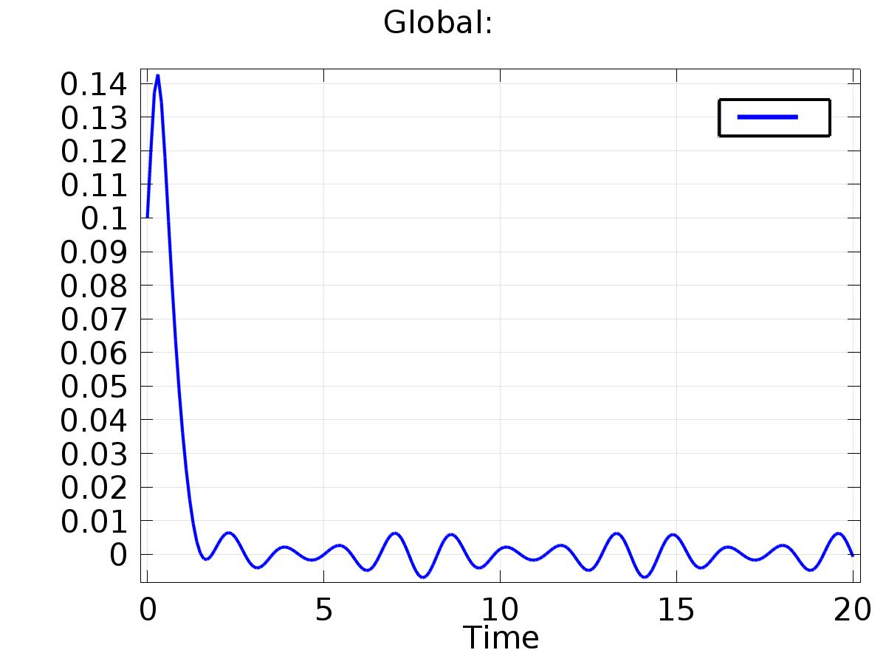

Global: