[](http://www.comsol.com/)

NavierStokes FSA1

|  |  |
| --- | --- |
| Date | Aug 21, 2014 8:06:14 AM |

Contents

1. Global

1.1. Definitions

2. Component 1

2.1. Definitions

2.2. Geometry 1

2.3. Laminar Flow

2.4. Laminar Flow 1

2.5. Laminar Flow 2

2.6. Laminar Flow 3

2.7. Laminar Flow 4

2.8. Laminar Flow 5

2.9. Laminar Flow 6

2.10. Closed loop system

2.11. Mesh 1

3. Study 1

3.1. Stationary

3.2. Solver Configurations

4. Study 2

4.1. Stationary

4.2. Solver Configurations

5. Study 3

5.1. Time Dependent

5.2. Solver Configurations

6. Results

6.1. Data Sets

6.2. Derived Values

6.3. Tables

6.4. Plot Groups

1. Global

|  |  |
| --- | --- |
| Date | Aug 20, 2014 11:31:47 AM |

Global settings

|  |  |
| --- | --- |
| Name | NavierStokes FSA1.mph |
| Path | /Users/gilliam/Desktop/collect_15/research_15/geo_reg_mono_eugenio/Mono_1_15/Comsol_EX_GitHub/Chapter5/Chap5Ex5_NS_Fourier_beta/Chap5Ex5_NvrStks_NnLnrFrSrs/NavierStokes_FSA1.mph |
| Program | COMSOL 4.4 (Build: 150) |

Used products

|  |
| --- |
| COMSOL Multiphysics |

* 1. Definitions
     1. Parameters 1

Parameters

| **Name** | **Expression** | **Value** | **Description** |
| --- | --- | --- | --- |
| D | 0.1 | 0.10000 |  |
| L | 1 | 1.0000 |  |
| nu | 0.005 | 0.0050000 |  |
| A1 | 0.1 | 0.10000 |  |
| M1 | 0.1 | 0.10000 |  |
| alpha | 1 | 1.0000 |  |
| N | 1 | 1.0000 |  |

1. Component 1

Component settings

|  |  |
| --- | --- |
| Unit system | None |

* 1. Definitions
     1. Variables

#### Variables 1a

Selection

|  |  |
| --- | --- |
| Geometric entity level | Entire model |

| **Name** | **Expression** | **Description** |
| --- | --- | --- |
| G | C(U) |  |
| e | yr - C(u) |  |

#### Variables 2

Selection

|  |  |
| --- | --- |
| Geometric entity level | Entire model |

| **Name** | **Expression** | **Description** |
| --- | --- | --- |
| f_au0 | au0*au0x + av0*au0y - 0.5*(au0*au0x + 2.*au1*au1x + 2.*bu1*bu1x + av0*au0y + 2.*av1*au1y + 2.*bv1*bu1y) |  |
| f_atu0 | atu0*atu0x + atv0*atu0y - 0.5*(au0*au0x + 2.*au1*au1x + 2.*bu1*bu1x + av0*au0y + 2.*av1*au1y + 2.*bv1*bu1y) |  |
| f_av0 | au0*av0x + av0*av0y - 0.5*(au0*av0x + 2.*au1*av1x + 2.*bu1*bv1x + av0*av0y + 2.*av1*av1y + 2.*bv1*bv1y) |  |
| f_atv0 | atu0*atv0x + atv0*atv0y - 0.5*(au0*av0x + 2.*au1*av1x + 2.*bu1*bv1x + av0*av0y + 2.*av1*av1y + 2.*bv1*bv1y) |  |
| f_au1 | au1*au1x + av1*au1y - 1*alpha*bu1 - 0.5*(au0*au1x + au1*au0x + av0*au1y + av1*au0y)*(N>0) |  |
| f_atu1 | atu1*atu1x + atv1*atu1y - 1*alpha*bu1 - 0.5*(au0*au1x + au1*au0x + av0*au1y + av1*au0y)*(N>0) |  |
| f_av1 | au1*av1x + av1*av1y - 1*alpha*bv1 - 0.5*(au0*av1x + au1*av0x + av0*av1y + av1*av0y)*(N>0) |  |
| f_atv1 | atu1*atv1x + atv1*atv1y - 1*alpha*bv1 - 0.5*(au0*av1x + au1*av0x + av0*av1y + av1*av0y)*(N>0) |  |
| f_bu1 | bu1*bu1x + bv1*bu1y + 1*alpha*au1 - 0.5*(au0*bu1x + bu1*au0x + av0*bu1y + bv1*au0y)*(N>0) |  |
| f_btu1 | btu1*btu1x + btv1*btu1y + 1*alpha*au1 - 0.5*(au0*bu1x + bu1*au0x + av0*bu1y + bv1*au0y)*(N>0) |  |
| f_bv1 | bu1*bv1x + bv1*bv1y + 1*alpha*av1 - 0.5*(au0*bv1x + bu1*av0x + av0*bv1y + bv1*av0y)*(N>0) |  |
| f_btv1 | btu1*btv1x + btv1*btv1y + 1*alpha*av1 - 0.5*(au0*bv1x + bu1*av0x + av0*bv1y + bv1*av0y)*(N>0) |  |
| Gamma_a0 | (2*M1 - C(atu0))/G |  |
| Gamma_a1 | (0 - C(atu1))/G*(N>0) |  |
| Gamma_b1 | (A1 - C(btu1))/G*(N>0) |  |
| gamma | 0.5*Gamma_a0 + Gamma_a1*cos(alpha*1*t) + Gamma_b1*sin(alpha*1*t) |  |
| yr | M1 + A1*sin(alpha*t) |  |

* + 1. Component Couplings

#### Integration 1

|  |  |
| --- | --- |
| Coupling type | Integration |
| Operator name | C |

Source selection

|  |  |
| --- | --- |
| Geometric entity level | Boundary |
| Selection | Boundaries 9–10 |

* + 1. Coordinate Systems

#### Boundary System 1

|  |  |
| --- | --- |
| Coordinate system type | Boundary system |
| Tag | sys1 |

Coordinate names

| **First (t1)** | **Second (n)** | **Third (to)** |
| --- | --- | --- |
| t1 | n | to |

Settings

| **Description** | **Value** |
| --- | --- |
| Create first tangent direction from | Global Cartesian |

* 1. Geometry 1

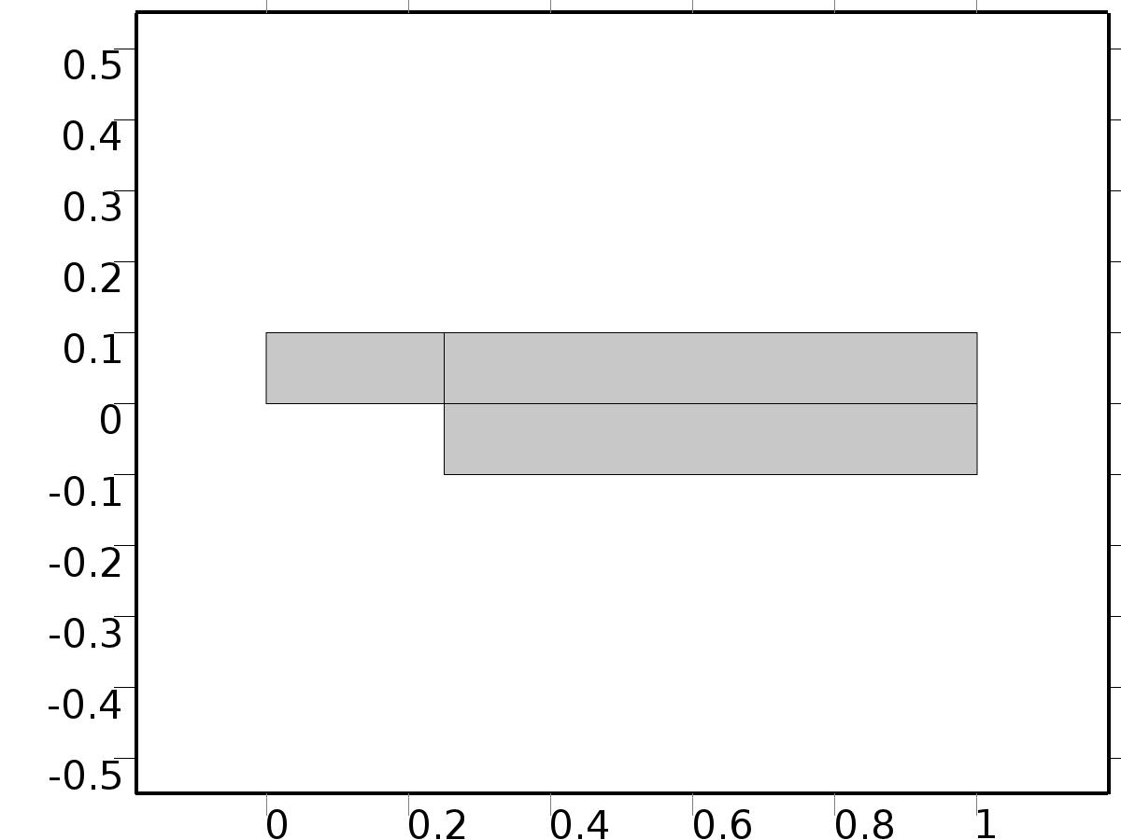

Geometry 1

Units

|  |  |
| --- | --- |
| Length unit | m |
| Angular unit | deg |

Geometry statistics

| **Description** | **Value** |
| --- | --- |
| Space dimension | 2 |
| Number of domains | 3 |
| Number of boundaries | 10 |
| Number of vertices | 8 |

* + 1. Rectangle 1 (r1)

Position

| **Description** | **Value** |
| --- | --- |
| Position | {0, 0} |
| Layers |  |

Size

| **Description** | **Value** |
| --- | --- |
| Width | L |
| Height | D |

* + 1. Rectangle 2 (r2)

Position

| **Description** | **Value** |
| --- | --- |
| Position | {L/4, -D} |
| Layers |  |

Size

| **Description** | **Value** |
| --- | --- |
| Width | L*3/4 |
| Height | 2*D |

* 1. Laminar Flow

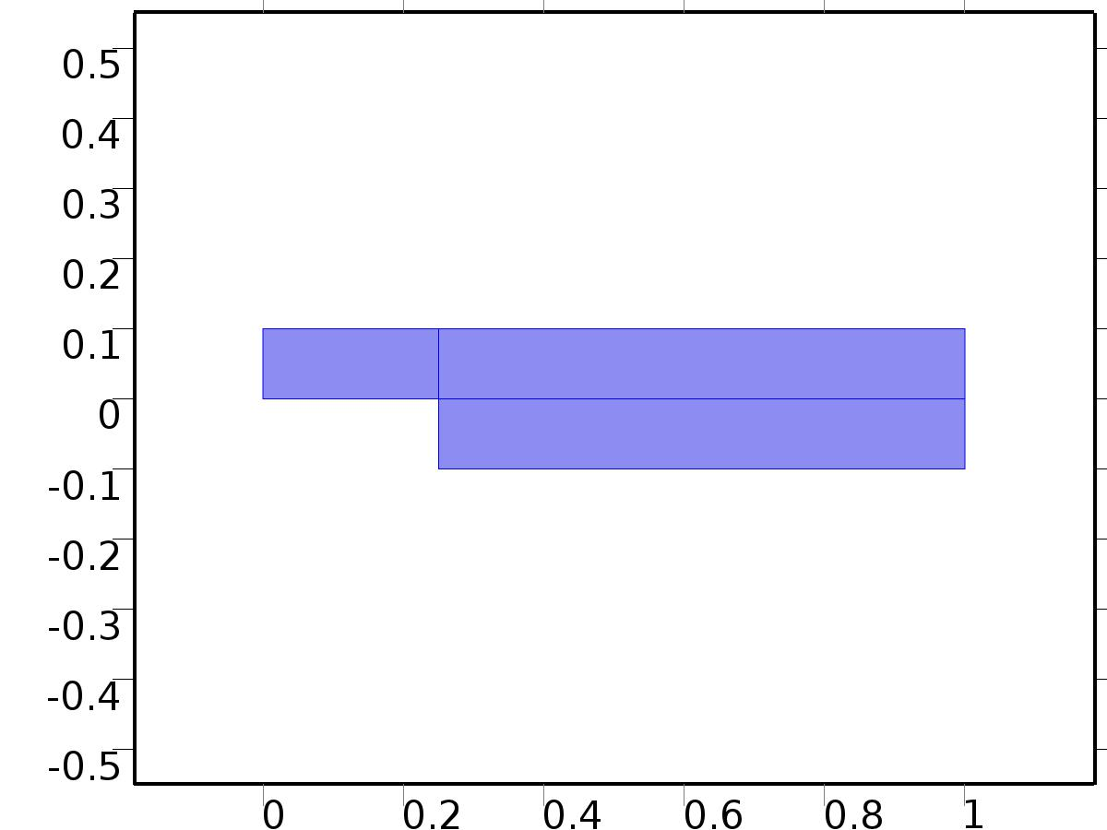

Laminar Flow

Selection

|  |  |
| --- | --- |
| Geometric entity level | Domain |
| Selection | Domains 1–3 |

Equations









Settings

| **Description** | **Value** |
| --- | --- |
| Discretization of fluids | P2 + P1 |
| Value type when using splitting of complex variables | {Real, Real, Real, Real, Real, Real, Real, Real, Real, Real, Real} |
| Isotropic diffusion | Off |
| Compressibility | Incompressible flow |
| Channel thickness | 1 |
| Turbulence model type | None |
| Reference pressure level | 1[atm] |
| Use pseudo time stepping for stationary equation form | Off |
| Local CFL number | 1.3^min(niterCMP, 9) + if(niterCMP>=25, 9*1.3^min(niterCMP - 25, 9), 0) + if(niterCMP>=45, 90*1.3^min(niterCMP - 45, 9), 0) |
| Streamline diffusion | Off |
| Crosswind diffusion | Off |

Used products

|  |
| --- |
| COMSOL Multiphysics |

Variables

| **Name** | **Expression** | **Unit** | **Description** | **Selection** |
| --- | --- | --- | --- | --- |
| X.dz | 1 |  | Thickness | Domains 1–3 |
| X.pref | 1[atm] |  | Reference pressure level | Domains 1–3 |
| X.pA | P+X.pref |  | Absolute pressure | Domains 1–3 |
| X.nx | nx |  | Normal vector, x component | Boundaries 6–7 |
| X.ny | ny |  | Normal vector, y component | Boundaries 6–7 |
| X.nz | 0 |  | Normal vector, z component | Boundaries 6–7 |
| X.nx | dnx |  | Normal vector, x component | Boundaries 1–5, 8–10 |
| X.ny | dny |  | Normal vector, y component | Boundaries 1–5, 8–10 |
| X.nz | 0 |  | Normal vector, z component | Boundaries 1–5, 8–10 |
| X.nxmesh | root.nxmesh |  | Normal vector, x component | Boundaries 6–7 |
| X.nymesh | root.nymesh |  | Normal vector, y component | Boundaries 6–7 |
| X.nzmesh | 0 |  | Normal vector, z component | Boundaries 6–7 |
| X.nxmesh | root.dnxmesh |  | Normal vector, x component | Boundaries 1–5, 8–10 |
| X.nymesh | root.dnymesh |  | Normal vector, y component | Boundaries 1–5, 8–10 |
| X.nzmesh | 0 |  | Normal vector, z component | Boundaries 1–5, 8–10 |

* + 1. Fluid Properties 1



Fluid Properties 1

Selection

|  |  |
| --- | --- |
| Geometric entity level | Domain |
| Selection | Domains 1–3 |

Equations

Settings

| **Description** | **Value** |
| --- | --- |
| Density | User defined |
| Density | 1 |
| Dynamic viscosity | User defined |
| Dynamic viscosity | nu |

#### Variables

| **Name** | **Expression** | **Unit** | **Description** | **Selection** |
| --- | --- | --- | --- | --- |
| X.Fx | 0 |  | Volume force, x component | Domains 1–3 |
| X.Fy | 0 |  | Volume force, y component | Domains 1–3 |
| X.Fz | 0 |  | Volume force, z component | Domains 1–3 |
| X.rho | 1 |  | Density | Domains 1–3 |
| X.mu | nu |  | Dynamic viscosity | Domains 1–3 |
| X.sr | sqrt(0.5*(4*Ux^2+2*(Uy+Vx)^2+4*Vy^2)+eps) |  | Shear rate | Domains 1–3 |
| X.divu | Ux+Vy |  | Divergence of velocity field | Domains 1–3 |
| X.U | sqrt(U^2+V^2) |  | Velocity magnitude | Domains 1–3 |
| X.vorticityx | 0 |  | Vorticity field, x component | Domains 1–3 |
| X.vorticityy | 0 |  | Vorticity field, y component | Domains 1–3 |
| X.vorticityz | Vx-Uy |  | Vorticity field, z component | Domains 1–3 |
| X.vort_magn | sqrt(X.vorticityx^2+X.vorticityy^2+X.vorticityz^2) |  | Vorticity magnitude | Domains 1–3 |
| X.cellRe | 0.25*X.rho*sqrt(emetric(U,V)/emetric2)/X.mu |  | Cell Reynolds number | Domains 1–3 |
| X.nu | X.mu/X.rho |  | Kinematic viscosity | Domains 1–3 |
| X.betaT | 0 |  | Isothermal compressibility coefficient | Domains 1–3 |
| X.mu_eff | X.mu+X.muT |  | Dynamic viscosity | Domains 1–3 |
| X.muT | 0 |  | Turbulent dynamic viscosity | Domains 1–3 |
| X.T_stressx | X.K_stressx-P*X.nxmesh |  | Total stress, x component | Boundaries 1–10 |
| X.T_stressy | X.K_stressy-P*X.nymesh |  | Total stress, y component | Boundaries 1–10 |
| X.T_stressz | X.K_stressz-P*X.nzmesh |  | Total stress, z component | Boundaries 1–10 |
| X.K_stressx | X.mu_eff*(2*Ux*X.nxmesh+(Uy+Vx)*X.nymesh) |  | Viscous stress, x component | Boundaries 1–10 |
| X.K_stressy | X.mu_eff*((Vx+Uy)*X.nxmesh+2*Vy*X.nymesh) |  | Viscous stress, y component | Boundaries 1–10 |
| X.K_stressz | 0 |  | Viscous stress, z component | Boundaries 1–10 |
| X.K_stress_tensorxx | 2*X.mu_eff*Ux |  | Viscous stress tensor, xx component | Domains 1–3 |
| X.K_stress_tensoryx | X.mu_eff*(Vx+Uy) |  | Viscous stress tensor, yx component | Domains 1–3 |
| X.K_stress_tensorzx | 0 |  | Viscous stress tensor, zx component | Domains 1–3 |
| X.K_stress_tensorxy | X.mu_eff*(Uy+Vx) |  | Viscous stress tensor, xy component | Domains 1–3 |
| X.K_stress_tensoryy | 2*X.mu_eff*Vy |  | Viscous stress tensor, yy component | Domains 1–3 |
| X.K_stress_tensorzy | 0 |  | Viscous stress tensor, zy component | Domains 1–3 |
| X.K_stress_tensorxz | 0 |  | Viscous stress tensor, xz component | Domains 1–3 |
| X.K_stress_tensoryz | 0 |  | Viscous stress tensor, yz component | Domains 1–3 |
| X.K_stress_tensorzz | 0 |  | Viscous stress tensor, zz component | Domains 1–3 |
| X.K_stress_tensor_testxx | 2*X.mu_eff*test(Ux) |  | Viscous stress tensor test, xx component | Domains 1–3 |
| X.K_stress_tensor_testyx | X.mu_eff*(test(Vx)+test(Uy)) |  | Viscous stress tensor test, yx component | Domains 1–3 |
| X.K_stress_tensor_testzx | 0 |  | Viscous stress tensor test, zx component | Domains 1–3 |
| X.K_stress_tensor_testxy | X.mu_eff*(test(Uy)+test(Vx)) |  | Viscous stress tensor test, xy component | Domains 1–3 |
| X.K_stress_tensor_testyy | 2*X.mu_eff*test(Vy) |  | Viscous stress tensor test, yy component | Domains 1–3 |
| X.K_stress_tensor_testzy | 0 |  | Viscous stress tensor test, zy component | Domains 1–3 |
| X.K_stress_tensor_testxz | 0 |  | Viscous stress tensor test, xz component | Domains 1–3 |
| X.K_stress_tensor_testyz | 0 |  | Viscous stress tensor test, yz component | Domains 1–3 |
| X.K_stress_tensor_testzz | 0 |  | Viscous stress tensor test, zz component | Domains 1–3 |
| X.upwind_helpx | U |  | Upwind term, x component | Domains 1–3 |
| X.upwind_helpy | V |  | Upwind term, y component | Domains 1–3 |
| X.upwind_helpz | 0 |  | Upwind term, z component | Domains 1–3 |
| X.tau_vdxx | 2*X.mu*Ux |  | Strain rate, xx component | Domains 1–3 |
| X.tau_vdyx | X.mu*(Vx+Uy) |  | Strain rate, yx component | Domains 1–3 |
| X.tau_vdzx | 0 |  | Strain rate, zx component | Domains 1–3 |
| X.tau_vdxy | X.mu*(Uy+Vx) |  | Strain rate, xy component | Domains 1–3 |
| X.tau_vdyy | 2*X.mu*Vy |  | Strain rate, yy component | Domains 1–3 |
| X.tau_vdzy | 0 |  | Strain rate, zy component | Domains 1–3 |
| X.tau_vdxz | 0 |  | Strain rate, xz component | Domains 1–3 |
| X.tau_vdyz | 0 |  | Strain rate, yz component | Domains 1–3 |
| X.tau_vdzz | 0 |  | Strain rate, zz component | Domains 1–3 |
| X.Qvd | X.tau_vdxx*Ux+X.tau_vdxy*Uy+X.tau_vdyx*Vx+X.tau_vdyy*Vy |  | Viscous dissipation | Domains 1–3 |

#### Shape functions

| **Name** | **Shape function** | **Unit** | **Description** | **Shape frame** | **Selection** |
| --- | --- | --- | --- | --- | --- |
| U | Lagrange (Quadratic) |  | Velocity field, x component | Material | Domains 1–3 |
| V | Lagrange (Quadratic) |  | Velocity field, y component | Material | Domains 1–3 |
| P | Lagrange (Linear) |  | Pressure | Material | Domains 1–3 |

#### Weak expressions

| **Weak expression** | **Integration frame** | **Selection** |
| --- | --- | --- |
| (P-X.K_stress_tensorxx)*test(Ux)-X.K_stress_tensorxy*test(Uy)-X.K_stress_tensoryx*test(Vx)+(P-X.K_stress_tensoryy)*test(Vy) | Material | Domains 1–3 |
| X.Fx*test(U)+X.Fy*test(V) | Material | Domains 1–3 |
| X.rho*(-(Ux*U+Uy*V)*test(U)-(Vx*U+Vy*V)*test(V)) | Material | Domains 1–3 |
| -X.rho*X.divu*test(P) | Material | Domains 1–3 |

* + 1. Wall 1

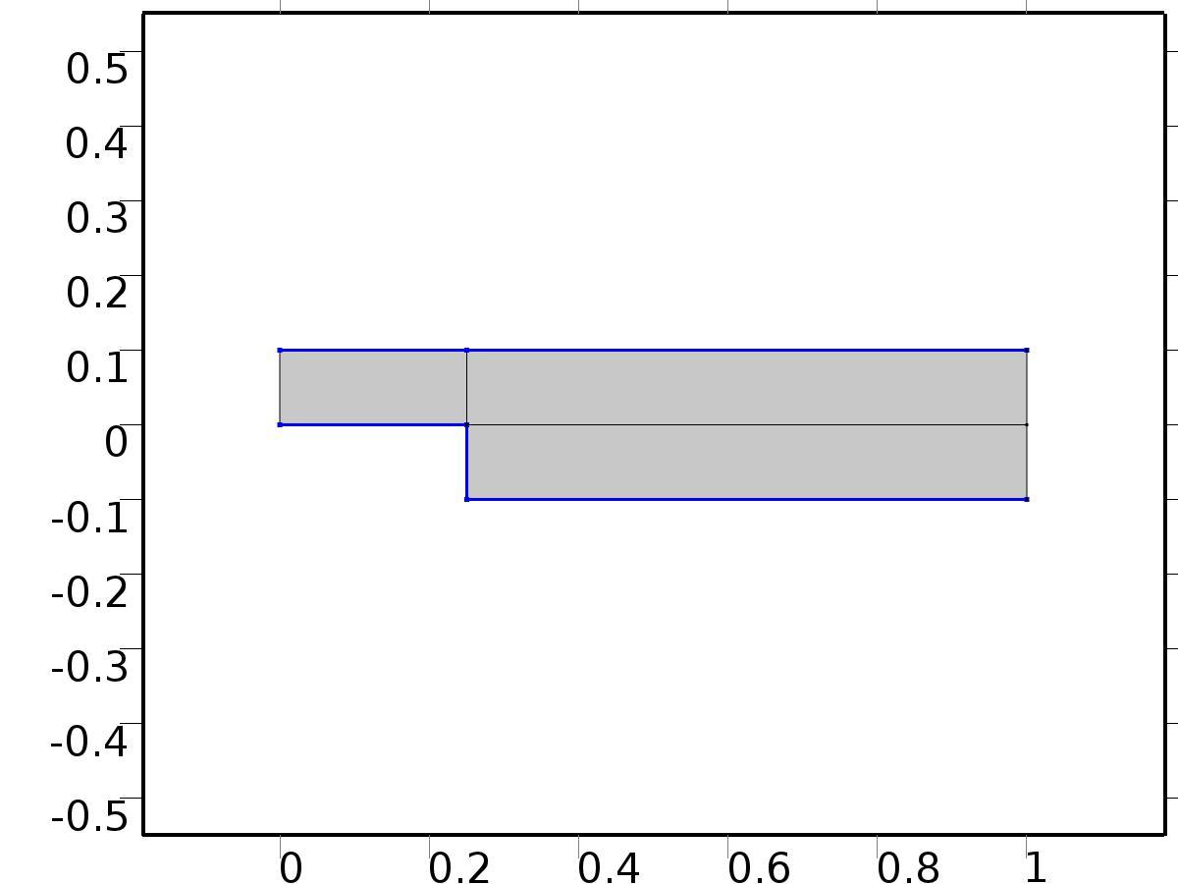

Wall 1

Selection

|  |  |
| --- | --- |
| Geometric entity level | Boundary |
| Selection | Boundaries 2–5, 8 |

Equations

Settings

| **Description** | **Value** |
| --- | --- |
| Boundary condition | No slip |
| Apply reaction terms on | Individual dependent variables |
| Use weak constraints | Off |
| Constraint method | Elemental |

#### Variables

| **Name** | **Expression** | **Unit** | **Description** | **Selection** |
| --- | --- | --- | --- | --- |
| X.ubndx | 0 |  | Velocity at boundary, x component | Boundaries 2–5, 8 |
| X.ubndy | 0 |  | Velocity at boundary, y component | Boundaries 2–5, 8 |
| X.ubndz | 0 |  | Velocity at boundary, z component | Boundaries 2–5, 8 |

#### Shape functions

| **Constraint** | **Constraint force** | **Shape function** | **Selection** |
| --- | --- | --- | --- |
| -U+X.ubndx | test(-U) | Lagrange (Quadratic) | Boundaries 2–5, 8 |
| -V+X.ubndy | test(-V) | Lagrange (Quadratic) | Boundaries 2–5, 8 |
| X.ubndz | 0 |  | Boundaries 2–5, 8 |

* + 1. Initial Values 1



Initial Values 1

Selection

|  |  |
| --- | --- |
| Geometric entity level | Domain |
| Selection | Domains 1–3 |

Settings

| **Description** | **Value** |
| --- | --- |
| Turbulent kinetic energy | spf.kinit |
| Turbulent dissipation rate | spf.epinit |
| Specific dissipation rate | spf.omInit |
| Reciprocal wall distance | spf.G0 |
| Undamped turbulent kinematic viscosity | spf.nutildeinit |
| Velocity field | {0, 0, 0} |
| Pressure | 0 |

* + 1. Inflow Bin=1

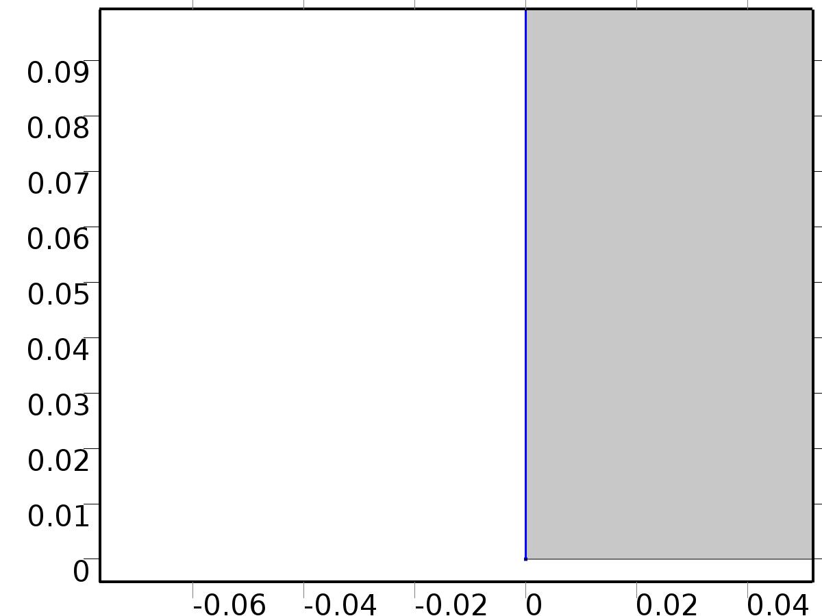

Inflow Bin=1

Selection

|  |  |
| --- | --- |
| Geometric entity level | Boundary |
| Selection | Boundary 1 |

Equations

Settings

| **Description** | **Value** |
| --- | --- |
| Boundary condition | Normal stress |
| Normal stress | 1 |
| Turbulent intensity | 0.005 |
| Turbulence length scale | 0.1[m] |
| Turbulent kinetic energy | 2.5e-3[m^2/s^2] |
| Turbulent dissipation rate | 1.1e-4[m^2/s^3] |
| Specific dissipation rate | 0.5[1/s] |
| Undamped turbulent kinematic viscosity | 3*spf.nu |

#### Variables

| **Name** | **Expression** | **Unit** | **Description** | **Selection** |
| --- | --- | --- | --- | --- |
| X.f0 | 1 |  | Normal stress | Boundary 1 |

#### Weak expressions

| **Weak expression** | **Integration frame** | **Selection** |
| --- | --- | --- |
| -X.f0*(test(U)*X.nxmesh+test(V)*X.nymesh) | Material | Boundary 1 |

* + 1. Outflow

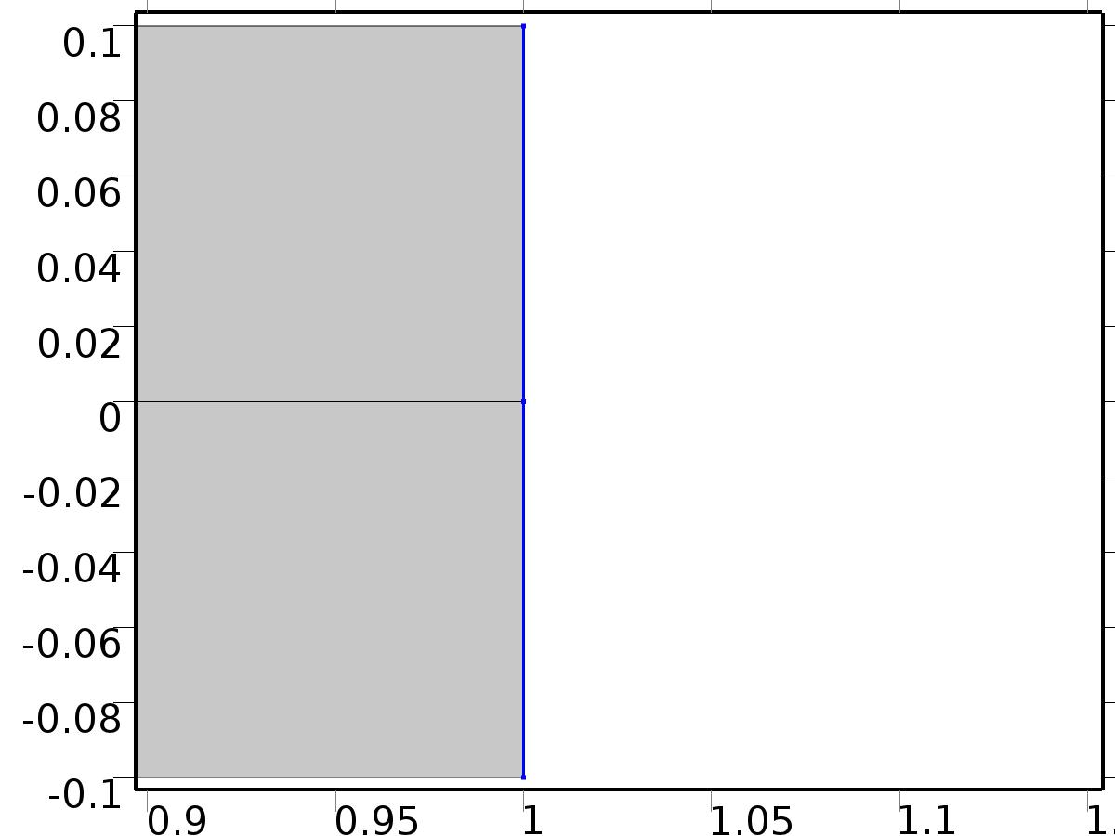

Outflow

Selection

|  |  |
| --- | --- |
| Geometric entity level | Boundary |
| Selection | Boundaries 9–10 |

Equations

Settings

| **Description** | **Value** |
| --- | --- |
| Boundary condition | Normal stress |
| Normal stress | 0 |
| Turbulent intensity | 0.005 |
| Turbulence length scale | 0.1[m] |
| Turbulent kinetic energy | 2.5e-3[m^2/s^2] |
| Turbulent dissipation rate | 1.1e-4[m^2/s^3] |
| Specific dissipation rate | 0.5[1/s] |
| Undamped turbulent kinematic viscosity | 3*spf.nu |

#### Variables

| **Name** | **Expression** | **Unit** | **Description** | **Selection** |
| --- | --- | --- | --- | --- |
| X.f0 | 0 |  | Normal stress | Boundaries 9–10 |

#### Weak expressions

| **Weak expression** | **Integration frame** | **Selection** |
| --- | --- | --- |
| -X.f0*(test(U)*X.nxmesh+test(V)*X.nymesh) | Material | Boundaries 9–10 |

* + 1. Volume Force 1



Volume Force 1

Selection

|  |  |
| --- | --- |
| Geometric entity level | Domain |
| Selection | Domains 1–3 |

Equations

#### Variables

| **Name** | **Expression** | **Unit** | **Description** | **Selection** |
| --- | --- | --- | --- | --- |
| X.Fx | U*Ux+V*Uy |  | Volume force, x component | Domains 1–3 |
| X.Fy | U*Vx+V*Vy |  | Volume force, y component | Domains 1–3 |
| X.Fz | 0 |  | Volume force, z component | Domains 1–3 |

* 1. Laminar Flow 1



Laminar Flow 1

Selection

|  |  |
| --- | --- |
| Geometric entity level | Domain |
| Selection | Domains 1–3 |

Equations









Settings

| **Description** | **Value** |
| --- | --- |
| Discretization of fluids | P2 + P1 |
| Value type when using splitting of complex variables | {Real, Real, Real, Real, Real, Real, Real, Real, Real, Real, Real} |
| Isotropic diffusion | Off |
| Compressibility | Incompressible flow |
| Channel thickness | 1 |
| Turbulence model type | None |
| Reference pressure level | 1[atm] |
| Use pseudo time stepping for stationary equation form | Off |
| Local CFL number | 1.3^min(niterCMP, 9) + if(niterCMP>=25, 9*1.3^min(niterCMP - 25, 9), 0) + if(niterCMP>=45, 90*1.3^min(niterCMP - 45, 9), 0) |
| Streamline diffusion | Off |
| Crosswind diffusion | Off |

Used products

|  |
| --- |
| COMSOL Multiphysics |

Variables

| **Name** | **Expression** | **Unit** | **Description** | **Selection** |
| --- | --- | --- | --- | --- |
| A0.dz | 1 |  | Thickness | Domains 1–3 |
| A0.pref | 1[atm] |  | Reference pressure level | Domains 1–3 |
| A0.pA | ap0+A0.pref |  | Absolute pressure | Domains 1–3 |
| A0.nx | nx |  | Normal vector, x component | Boundaries 6–7 |
| A0.ny | ny |  | Normal vector, y component | Boundaries 6–7 |
| A0.nz | 0 |  | Normal vector, z component | Boundaries 6–7 |
| A0.nx | dnx |  | Normal vector, x component | Boundaries 1–5, 8–10 |
| A0.ny | dny |  | Normal vector, y component | Boundaries 1–5, 8–10 |
| A0.nz | 0 |  | Normal vector, z component | Boundaries 1–5, 8–10 |
| A0.nxmesh | root.nxmesh |  | Normal vector, x component | Boundaries 6–7 |
| A0.nymesh | root.nymesh |  | Normal vector, y component | Boundaries 6–7 |
| A0.nzmesh | 0 |  | Normal vector, z component | Boundaries 6–7 |
| A0.nxmesh | root.dnxmesh |  | Normal vector, x component | Boundaries 1–5, 8–10 |
| A0.nymesh | root.dnymesh |  | Normal vector, y component | Boundaries 1–5, 8–10 |
| A0.nzmesh | 0 |  | Normal vector, z component | Boundaries 1–5, 8–10 |

* + 1. Fluid Properties 1



Fluid Properties 1

Selection

|  |  |
| --- | --- |
| Geometric entity level | Domain |
| Selection | Domains 1–3 |

Equations

Settings

| **Description** | **Value** |
| --- | --- |
| Density | User defined |
| Density | 1 |
| Dynamic viscosity | User defined |
| Dynamic viscosity | nu |

#### Variables

| **Name** | **Expression** | **Unit** | **Description** | **Selection** |
| --- | --- | --- | --- | --- |
| A0.Fx | 0 |  | Volume force, x component | Domains 1–3 |
| A0.Fy | 0 |  | Volume force, y component | Domains 1–3 |
| A0.Fz | 0 |  | Volume force, z component | Domains 1–3 |
| A0.rho | 1 |  | Density | Domains 1–3 |
| A0.mu | nu |  | Dynamic viscosity | Domains 1–3 |
| A0.sr | sqrt(0.5*(4*au0x^2+2*(au0y+av0x)^2+4*av0y^2)+eps) |  | Shear rate | Domains 1–3 |
| A0.divu | au0x+av0y |  | Divergence of velocity field | Domains 1–3 |
| A0.U | sqrt(au0^2+av0^2) |  | Velocity magnitude | Domains 1–3 |
| A0.vorticityx | 0 |  | Vorticity field, x component | Domains 1–3 |
| A0.vorticityy | 0 |  | Vorticity field, y component | Domains 1–3 |
| A0.vorticityz | av0x-au0y |  | Vorticity field, z component | Domains 1–3 |
| A0.vort_magn | sqrt(A0.vorticityx^2+A0.vorticityy^2+A0.vorticityz^2) |  | Vorticity magnitude | Domains 1–3 |
| A0.cellRe | 0.25*A0.rho*sqrt(emetric(au0,av0)/emetric2)/A0.mu |  | Cell Reynolds number | Domains 1–3 |
| A0.nu | A0.mu/A0.rho |  | Kinematic viscosity | Domains 1–3 |
| A0.betaT | 0 |  | Isothermal compressibility coefficient | Domains 1–3 |
| A0.mu_eff | A0.mu+A0.muT |  | Dynamic viscosity | Domains 1–3 |
| A0.muT | 0 |  | Turbulent dynamic viscosity | Domains 1–3 |
| A0.T_stressx | A0.K_stressx-ap0*A0.nxmesh |  | Total stress, x component | Boundaries 1–10 |
| A0.T_stressy | A0.K_stressy-ap0*A0.nymesh |  | Total stress, y component | Boundaries 1–10 |
| A0.T_stressz | A0.K_stressz-ap0*A0.nzmesh |  | Total stress, z component | Boundaries 1–10 |
| A0.K_stressx | A0.mu_eff*(2*au0x*A0.nxmesh+(au0y+av0x)*A0.nymesh) |  | Viscous stress, x component | Boundaries 1–10 |
| A0.K_stressy | A0.mu_eff*((av0x+au0y)*A0.nxmesh+2*av0y*A0.nymesh) |  | Viscous stress, y component | Boundaries 1–10 |
| A0.K_stressz | 0 |  | Viscous stress, z component | Boundaries 1–10 |
| A0.K_stress_tensorxx | 2*A0.mu_eff*au0x |  | Viscous stress tensor, xx component | Domains 1–3 |
| A0.K_stress_tensoryx | A0.mu_eff*(av0x+au0y) |  | Viscous stress tensor, yx component | Domains 1–3 |
| A0.K_stress_tensorzx | 0 |  | Viscous stress tensor, zx component | Domains 1–3 |
| A0.K_stress_tensorxy | A0.mu_eff*(au0y+av0x) |  | Viscous stress tensor, xy component | Domains 1–3 |
| A0.K_stress_tensoryy | 2*A0.mu_eff*av0y |  | Viscous stress tensor, yy component | Domains 1–3 |
| A0.K_stress_tensorzy | 0 |  | Viscous stress tensor, zy component | Domains 1–3 |
| A0.K_stress_tensorxz | 0 |  | Viscous stress tensor, xz component | Domains 1–3 |
| A0.K_stress_tensoryz | 0 |  | Viscous stress tensor, yz component | Domains 1–3 |
| A0.K_stress_tensorzz | 0 |  | Viscous stress tensor, zz component | Domains 1–3 |
| A0.K_stress_tensor_testxx | 2*A0.mu_eff*test(au0x) |  | Viscous stress tensor test, xx component | Domains 1–3 |
| A0.K_stress_tensor_testyx | A0.mu_eff*(test(av0x)+test(au0y)) |  | Viscous stress tensor test, yx component | Domains 1–3 |
| A0.K_stress_tensor_testzx | 0 |  | Viscous stress tensor test, zx component | Domains 1–3 |
| A0.K_stress_tensor_testxy | A0.mu_eff*(test(au0y)+test(av0x)) |  | Viscous stress tensor test, xy component | Domains 1–3 |
| A0.K_stress_tensor_testyy | 2*A0.mu_eff*test(av0y) |  | Viscous stress tensor test, yy component | Domains 1–3 |
| A0.K_stress_tensor_testzy | 0 |  | Viscous stress tensor test, zy component | Domains 1–3 |
| A0.K_stress_tensor_testxz | 0 |  | Viscous stress tensor test, xz component | Domains 1–3 |
| A0.K_stress_tensor_testyz | 0 |  | Viscous stress tensor test, yz component | Domains 1–3 |
| A0.K_stress_tensor_testzz | 0 |  | Viscous stress tensor test, zz component | Domains 1–3 |
| A0.upwind_helpx | au0 |  | Upwind term, x component | Domains 1–3 |
| A0.upwind_helpy | av0 |  | Upwind term, y component | Domains 1–3 |
| A0.upwind_helpz | 0 |  | Upwind term, z component | Domains 1–3 |
| A0.tau_vdxx | 2*A0.mu*au0x |  | Strain rate, xx component | Domains 1–3 |
| A0.tau_vdyx | A0.mu*(av0x+au0y) |  | Strain rate, yx component | Domains 1–3 |
| A0.tau_vdzx | 0 |  | Strain rate, zx component | Domains 1–3 |
| A0.tau_vdxy | A0.mu*(au0y+av0x) |  | Strain rate, xy component | Domains 1–3 |
| A0.tau_vdyy | 2*A0.mu*av0y |  | Strain rate, yy component | Domains 1–3 |
| A0.tau_vdzy | 0 |  | Strain rate, zy component | Domains 1–3 |
| A0.tau_vdxz | 0 |  | Strain rate, xz component | Domains 1–3 |
| A0.tau_vdyz | 0 |  | Strain rate, yz component | Domains 1–3 |
| A0.tau_vdzz | 0 |  | Strain rate, zz component | Domains 1–3 |
| A0.Qvd | A0.tau_vdxx*au0x+A0.tau_vdxy*au0y+A0.tau_vdyx*av0x+A0.tau_vdyy*av0y |  | Viscous dissipation | Domains 1–3 |

#### Shape functions

| **Name** | **Shape function** | **Unit** | **Description** | **Shape frame** | **Selection** |
| --- | --- | --- | --- | --- | --- |
| au0 | Lagrange (Quadratic) |  | Velocity field, x component | Material | Domains 1–3 |
| av0 | Lagrange (Quadratic) |  | Velocity field, y component | Material | Domains 1–3 |
| ap0 | Lagrange (Linear) |  | Pressure | Material | Domains 1–3 |

#### Weak expressions

| **Weak expression** | **Integration frame** | **Selection** |
| --- | --- | --- |
| (ap0-A0.K_stress_tensorxx)*test(au0x)-A0.K_stress_tensorxy*test(au0y)-A0.K_stress_tensoryx*test(av0x)+(ap0-A0.K_stress_tensoryy)*test(av0y) | Material | Domains 1–3 |
| A0.Fx*test(au0)+A0.Fy*test(av0) | Material | Domains 1–3 |
| A0.rho*(-(au0x*au0+au0y*av0)*test(au0)-(av0x*au0+av0y*av0)*test(av0)) | Material | Domains 1–3 |
| -A0.rho*A0.divu*test(ap0) | Material | Domains 1–3 |

* + 1. Wall 1



Wall 1

Selection

|  |  |
| --- | --- |
| Geometric entity level | Boundary |
| Selection | Boundaries 2–5, 8 |

Equations

Settings

| **Description** | **Value** |
| --- | --- |
| Boundary condition | No slip |
| Apply reaction terms on | Individual dependent variables |
| Use weak constraints | Off |
| Constraint method | Elemental |

#### Variables

| **Name** | **Expression** | **Unit** | **Description** | **Selection** |
| --- | --- | --- | --- | --- |
| A0.ubndx | 0 |  | Velocity at boundary, x component | Boundaries 2–5, 8 |
| A0.ubndy | 0 |  | Velocity at boundary, y component | Boundaries 2–5, 8 |
| A0.ubndz | 0 |  | Velocity at boundary, z component | Boundaries 2–5, 8 |

#### Shape functions

| **Constraint** | **Constraint force** | **Shape function** | **Selection** |
| --- | --- | --- | --- |
| -au0+A0.ubndx | test(-au0) | Lagrange (Quadratic) | Boundaries 2–5, 8 |
| -av0+A0.ubndy | test(-av0) | Lagrange (Quadratic) | Boundaries 2–5, 8 |
| A0.ubndz | 0 |  | Boundaries 2–5, 8 |

* + 1. Initial Values 1



Initial Values 1

Selection

|  |  |
| --- | --- |
| Geometric entity level | Domain |
| Selection | Domains 1–3 |

Settings

| **Description** | **Value** |
| --- | --- |
| Turbulent kinetic energy | spf.kinit |
| Turbulent dissipation rate | spf.epinit |
| Specific dissipation rate | spf.omInit |
| Reciprocal wall distance | spf.G0 |
| Undamped turbulent kinematic viscosity | spf.nutildeinit |
| Velocity field | {0, 0, 0} |
| Pressure | 0 |

* + 1. Inflow Bin*Gamma_a0



Inflow Bin*Gamma_a0

Selection

|  |  |
| --- | --- |
| Geometric entity level | Boundary |
| Selection | Boundary 1 |

Equations

Settings

| **Description** | **Value** |
| --- | --- |
| Boundary condition | Normal stress |
| Normal stress | Gamma_a0 |
| Turbulent intensity | 0.005 |
| Turbulence length scale | 0.1[m] |
| Turbulent kinetic energy | 2.5e-3[m^2/s^2] |
| Turbulent dissipation rate | 1.1e-4[m^2/s^3] |
| Specific dissipation rate | 0.5[1/s] |

#### Variables

| **Name** | **Expression** | **Unit** | **Description** | **Selection** |
| --- | --- | --- | --- | --- |
| A0.f0 | Gamma_a0 |  | Normal stress | Boundary 1 |

#### Weak expressions

| **Weak expression** | **Integration frame** | **Selection** |
| --- | --- | --- |
| -A0.f0*(test(au0)*A0.nxmesh+test(av0)*A0.nymesh) | Material | Boundary 1 |

* + 1. Outflow



Outflow

Selection

|  |  |
| --- | --- |
| Geometric entity level | Boundary |
| Selection | Boundaries 9–10 |

Equations

Settings

| **Description** | **Value** |
| --- | --- |
| Boundary condition | Normal stress |
| Normal stress | 0 |
| Turbulent intensity | 0.005 |
| Turbulence length scale | 0.1[m] |
| Turbulent kinetic energy | 2.5e-3[m^2/s^2] |
| Turbulent dissipation rate | 1.1e-4[m^2/s^3] |
| Specific dissipation rate | 0.5[1/s] |

#### Variables

| **Name** | **Expression** | **Unit** | **Description** | **Selection** |
| --- | --- | --- | --- | --- |
| A0.f0 | 0 |  | Normal stress | Boundaries 9–10 |

#### Weak expressions

| **Weak expression** | **Integration frame** | **Selection** |
| --- | --- | --- |
| -A0.f0*(test(au0)*A0.nxmesh+test(av0)*A0.nymesh) | Material | Boundaries 9–10 |

* + 1. Volume Force 1



Volume Force 1

Selection

|  |  |
| --- | --- |
| Geometric entity level | Domain |
| Selection | Domains 1–3 |

Equations

#### Variables

| **Name** | **Expression** | **Unit** | **Description** | **Selection** |
| --- | --- | --- | --- | --- |
| A0.Fx | f_au0 |  | Volume force, x component | Domains 1–3 |
| A0.Fy | f_av0 |  | Volume force, y component | Domains 1–3 |
| A0.Fz | 0 |  | Volume force, z component | Domains 1–3 |

* 1. Laminar Flow 2



Laminar Flow 2

Selection

|  |  |
| --- | --- |
| Geometric entity level | Domain |
| Selection | Domains 1–3 |

Equations









Settings

| **Description** | **Value** |
| --- | --- |
| Discretization of fluids | P2 + P1 |
| Value type when using splitting of complex variables | {Real, Real, Real, Real, Real, Real, Real, Real, Real, Real, Real} |
| Isotropic diffusion | Off |
| Compressibility | Incompressible flow |
| Channel thickness | 1 |
| Turbulence model type | None |
| Reference pressure level | 1[atm] |
| Use pseudo time stepping for stationary equation form | Off |
| Local CFL number | 1.3^min(niterCMP, 9) + if(niterCMP>=25, 9*1.3^min(niterCMP - 25, 9), 0) + if(niterCMP>=45, 90*1.3^min(niterCMP - 45, 9), 0) |
| Streamline diffusion | Off |
| Crosswind diffusion | Off |

Used products

|  |
| --- |
| COMSOL Multiphysics |

Variables

| **Name** | **Expression** | **Unit** | **Description** | **Selection** |
| --- | --- | --- | --- | --- |
| At0.dz | 1 |  | Thickness | Domains 1–3 |
| At0.pref | 1[atm] |  | Reference pressure level | Domains 1–3 |
| At0.pA | atp0+At0.pref |  | Absolute pressure | Domains 1–3 |
| At0.nx | nx |  | Normal vector, x component | Boundaries 6–7 |
| At0.ny | ny |  | Normal vector, y component | Boundaries 6–7 |
| At0.nz | 0 |  | Normal vector, z component | Boundaries 6–7 |
| At0.nx | dnx |  | Normal vector, x component | Boundaries 1–5, 8–10 |
| At0.ny | dny |  | Normal vector, y component | Boundaries 1–5, 8–10 |
| At0.nz | 0 |  | Normal vector, z component | Boundaries 1–5, 8–10 |
| At0.nxmesh | root.nxmesh |  | Normal vector, x component | Boundaries 6–7 |
| At0.nymesh | root.nymesh |  | Normal vector, y component | Boundaries 6–7 |
| At0.nzmesh | 0 |  | Normal vector, z component | Boundaries 6–7 |
| At0.nxmesh | root.dnxmesh |  | Normal vector, x component | Boundaries 1–5, 8–10 |
| At0.nymesh | root.dnymesh |  | Normal vector, y component | Boundaries 1–5, 8–10 |
| At0.nzmesh | 0 |  | Normal vector, z component | Boundaries 1–5, 8–10 |

* + 1. Fluid Properties 1



Fluid Properties 1

Selection

|  |  |
| --- | --- |
| Geometric entity level | Domain |
| Selection | Domains 1–3 |

Equations

Settings

| **Description** | **Value** |
| --- | --- |
| Density | User defined |
| Density | 1 |
| Dynamic viscosity | User defined |
| Dynamic viscosity | nu |

#### Variables

| **Name** | **Expression** | **Unit** | **Description** | **Selection** |
| --- | --- | --- | --- | --- |
| At0.Fx | 0 |  | Volume force, x component | Domains 1–3 |
| At0.Fy | 0 |  | Volume force, y component | Domains 1–3 |
| At0.Fz | 0 |  | Volume force, z component | Domains 1–3 |
| At0.rho | 1 |  | Density | Domains 1–3 |
| At0.mu | nu |  | Dynamic viscosity | Domains 1–3 |
| At0.sr | sqrt(0.5*(4*atu0x^2+2*(atu0y+atv0x)^2+4*atv0y^2)+eps) |  | Shear rate | Domains 1–3 |
| At0.divu | atu0x+atv0y |  | Divergence of velocity field | Domains 1–3 |
| At0.U | sqrt(atu0^2+atv0^2) |  | Velocity magnitude | Domains 1–3 |
| At0.vorticityx | 0 |  | Vorticity field, x component | Domains 1–3 |
| At0.vorticityy | 0 |  | Vorticity field, y component | Domains 1–3 |
| At0.vorticityz | atv0x-atu0y |  | Vorticity field, z component | Domains 1–3 |
| At0.vort_magn | sqrt(At0.vorticityx^2+At0.vorticityy^2+At0.vorticityz^2) |  | Vorticity magnitude | Domains 1–3 |
| At0.cellRe | 0.25*At0.rho*sqrt(emetric(atu0,atv0)/emetric2)/At0.mu |  | Cell Reynolds number | Domains 1–3 |
| At0.nu | At0.mu/At0.rho |  | Kinematic viscosity | Domains 1–3 |
| At0.betaT | 0 |  | Isothermal compressibility coefficient | Domains 1–3 |
| At0.mu_eff | At0.mu+At0.muT |  | Dynamic viscosity | Domains 1–3 |
| At0.muT | 0 |  | Turbulent dynamic viscosity | Domains 1–3 |
| At0.T_stressx | At0.K_stressx-atp0*At0.nxmesh |  | Total stress, x component | Boundaries 1–10 |
| At0.T_stressy | At0.K_stressy-atp0*At0.nymesh |  | Total stress, y component | Boundaries 1–10 |
| At0.T_stressz | At0.K_stressz-atp0*At0.nzmesh |  | Total stress, z component | Boundaries 1–10 |
| At0.K_stressx | At0.mu_eff*(2*atu0x*At0.nxmesh+(atu0y+atv0x)*At0.nymesh) |  | Viscous stress, x component | Boundaries 1–10 |
| At0.K_stressy | At0.mu_eff*((atv0x+atu0y)*At0.nxmesh+2*atv0y*At0.nymesh) |  | Viscous stress, y component | Boundaries 1–10 |
| At0.K_stressz | 0 |  | Viscous stress, z component | Boundaries 1–10 |
| At0.K_stress_tensorxx | 2*At0.mu_eff*atu0x |  | Viscous stress tensor, xx component | Domains 1–3 |
| At0.K_stress_tensoryx | At0.mu_eff*(atv0x+atu0y) |  | Viscous stress tensor, yx component | Domains 1–3 |
| At0.K_stress_tensorzx | 0 |  | Viscous stress tensor, zx component | Domains 1–3 |
| At0.K_stress_tensorxy | At0.mu_eff*(atu0y+atv0x) |  | Viscous stress tensor, xy component | Domains 1–3 |
| At0.K_stress_tensoryy | 2*At0.mu_eff*atv0y |  | Viscous stress tensor, yy component | Domains 1–3 |
| At0.K_stress_tensorzy | 0 |  | Viscous stress tensor, zy component | Domains 1–3 |
| At0.K_stress_tensorxz | 0 |  | Viscous stress tensor, xz component | Domains 1–3 |
| At0.K_stress_tensoryz | 0 |  | Viscous stress tensor, yz component | Domains 1–3 |
| At0.K_stress_tensorzz | 0 |  | Viscous stress tensor, zz component | Domains 1–3 |
| At0.K_stress_tensor_testxx | 2*At0.mu_eff*test(atu0x) |  | Viscous stress tensor test, xx component | Domains 1–3 |
| At0.K_stress_tensor_testyx | At0.mu_eff*(test(atv0x)+test(atu0y)) |  | Viscous stress tensor test, yx component | Domains 1–3 |
| At0.K_stress_tensor_testzx | 0 |  | Viscous stress tensor test, zx component | Domains 1–3 |
| At0.K_stress_tensor_testxy | At0.mu_eff*(test(atu0y)+test(atv0x)) |  | Viscous stress tensor test, xy component | Domains 1–3 |
| At0.K_stress_tensor_testyy | 2*At0.mu_eff*test(atv0y) |  | Viscous stress tensor test, yy component | Domains 1–3 |
| At0.K_stress_tensor_testzy | 0 |  | Viscous stress tensor test, zy component | Domains 1–3 |
| At0.K_stress_tensor_testxz | 0 |  | Viscous stress tensor test, xz component | Domains 1–3 |
| At0.K_stress_tensor_testyz | 0 |  | Viscous stress tensor test, yz component | Domains 1–3 |
| At0.K_stress_tensor_testzz | 0 |  | Viscous stress tensor test, zz component | Domains 1–3 |
| At0.upwind_helpx | atu0 |  | Upwind term, x component | Domains 1–3 |
| At0.upwind_helpy | atv0 |  | Upwind term, y component | Domains 1–3 |
| At0.upwind_helpz | 0 |  | Upwind term, z component | Domains 1–3 |
| At0.tau_vdxx | 2*At0.mu*atu0x |  | Strain rate, xx component | Domains 1–3 |
| At0.tau_vdyx | At0.mu*(atv0x+atu0y) |  | Strain rate, yx component | Domains 1–3 |
| At0.tau_vdzx | 0 |  | Strain rate, zx component | Domains 1–3 |
| At0.tau_vdxy | At0.mu*(atu0y+atv0x) |  | Strain rate, xy component | Domains 1–3 |
| At0.tau_vdyy | 2*At0.mu*atv0y |  | Strain rate, yy component | Domains 1–3 |
| At0.tau_vdzy | 0 |  | Strain rate, zy component | Domains 1–3 |
| At0.tau_vdxz | 0 |  | Strain rate, xz component | Domains 1–3 |
| At0.tau_vdyz | 0 |  | Strain rate, yz component | Domains 1–3 |
| At0.tau_vdzz | 0 |  | Strain rate, zz component | Domains 1–3 |
| At0.Qvd | At0.tau_vdxx*atu0x+At0.tau_vdxy*atu0y+At0.tau_vdyx*atv0x+At0.tau_vdyy*atv0y |  | Viscous dissipation | Domains 1–3 |

#### Shape functions

| **Name** | **Shape function** | **Unit** | **Description** | **Shape frame** | **Selection** |
| --- | --- | --- | --- | --- | --- |
| atu0 | Lagrange (Quadratic) |  | Velocity field, x component | Material | Domains 1–3 |
| atv0 | Lagrange (Quadratic) |  | Velocity field, y component | Material | Domains 1–3 |
| atp0 | Lagrange (Linear) |  | Pressure | Material | Domains 1–3 |

#### Weak expressions

| **Weak expression** | **Integration frame** | **Selection** |
| --- | --- | --- |
| (atp0-At0.K_stress_tensorxx)*test(atu0x)-At0.K_stress_tensorxy*test(atu0y)-At0.K_stress_tensoryx*test(atv0x)+(atp0-At0.K_stress_tensoryy)*test(atv0y) | Material | Domains 1–3 |
| At0.Fx*test(atu0)+At0.Fy*test(atv0) | Material | Domains 1–3 |
| At0.rho*(-(atu0x*atu0+atu0y*atv0)*test(atu0)-(atv0x*atu0+atv0y*atv0)*test(atv0)) | Material | Domains 1–3 |
| -At0.rho*At0.divu*test(atp0) | Material | Domains 1–3 |

* + 1. Wall 1



Wall 1

Selection

|  |  |
| --- | --- |
| Geometric entity level | Boundary |
| Selection | Boundaries 2–5, 8 |

Equations

Settings

| **Description** | **Value** |
| --- | --- |
| Boundary condition | No slip |
| Apply reaction terms on | Individual dependent variables |
| Use weak constraints | Off |
| Constraint method | Elemental |

#### Variables

| **Name** | **Expression** | **Unit** | **Description** | **Selection** |
| --- | --- | --- | --- | --- |
| At0.ubndx | 0 |  | Velocity at boundary, x component | Boundaries 2–5, 8 |
| At0.ubndy | 0 |  | Velocity at boundary, y component | Boundaries 2–5, 8 |
| At0.ubndz | 0 |  | Velocity at boundary, z component | Boundaries 2–5, 8 |

#### Shape functions

| **Constraint** | **Constraint force** | **Shape function** | **Selection** |
| --- | --- | --- | --- |
| -atu0+At0.ubndx | test(-atu0) | Lagrange (Quadratic) | Boundaries 2–5, 8 |
| -atv0+At0.ubndy | test(-atv0) | Lagrange (Quadratic) | Boundaries 2–5, 8 |
| At0.ubndz | 0 |  | Boundaries 2–5, 8 |

* + 1. Initial Values 1



Initial Values 1

Selection

|  |  |
| --- | --- |
| Geometric entity level | Domain |
| Selection | Domains 1–3 |

Settings

| **Description** | **Value** |
| --- | --- |
| Turbulent kinetic energy | spf.kinit |
| Turbulent dissipation rate | spf.epinit |
| Specific dissipation rate | spf.omInit |
| Reciprocal wall distance | spf.G0 |
| Undamped turbulent kinematic viscosity | spf.nutildeinit |
| Velocity field | {0, 0, 0} |
| Pressure | 0 |

* + 1. Inflow



Inflow

Selection

|  |  |
| --- | --- |
| Geometric entity level | Boundary |
| Selection | Boundary 1 |

Equations

Settings

| **Description** | **Value** |
| --- | --- |
| Boundary condition | Normal stress |
| Normal stress | 0 |
| Turbulent intensity | 0.005 |
| Turbulence length scale | 0.1[m] |
| Turbulent kinetic energy | 2.5e-3[m^2/s^2] |
| Turbulent dissipation rate | 1.1e-4[m^2/s^3] |
| Specific dissipation rate | 0.5[1/s] |

#### Variables

| **Name** | **Expression** | **Unit** | **Description** | **Selection** |
| --- | --- | --- | --- | --- |
| At0.f0 | 0 |  | Normal stress | Boundary 1 |

#### Weak expressions

| **Weak expression** | **Integration frame** | **Selection** |
| --- | --- | --- |
| -At0.f0*(test(atu0)*At0.nxmesh+test(atv0)*At0.nymesh) | Material | Boundary 1 |

* + 1. Outflow



Outflow

Selection

|  |  |
| --- | --- |
| Geometric entity level | Boundary |
| Selection | Boundaries 9–10 |

Equations

Settings

| **Description** | **Value** |
| --- | --- |
| Boundary condition | Normal stress |
| Normal stress | 0 |
| Turbulent intensity | 0.005 |
| Turbulence length scale | 0.1[m] |
| Turbulent kinetic energy | 2.5e-3[m^2/s^2] |
| Turbulent dissipation rate | 1.1e-4[m^2/s^3] |
| Specific dissipation rate | 0.5[1/s] |

#### Variables

| **Name** | **Expression** | **Unit** | **Description** | **Selection** |
| --- | --- | --- | --- | --- |
| At0.f0 | 0 |  | Normal stress | Boundaries 9–10 |

#### Weak expressions

| **Weak expression** | **Integration frame** | **Selection** |
| --- | --- | --- |
| -At0.f0*(test(atu0)*At0.nxmesh+test(atv0)*At0.nymesh) | Material | Boundaries 9–10 |

* + 1. Volume Force 1



Volume Force 1

Selection

|  |  |
| --- | --- |
| Geometric entity level | Domain |
| Selection | Domains 1–3 |

Equations

#### Variables

| **Name** | **Expression** | **Unit** | **Description** | **Selection** |
| --- | --- | --- | --- | --- |
| At0.Fx | f_atu0 |  | Volume force, x component | Domains 1–3 |
| At0.Fy | f_atv0 |  | Volume force, y component | Domains 1–3 |
| At0.Fz | 0 |  | Volume force, z component | Domains 1–3 |

* 1. Laminar Flow 3



Laminar Flow 3

Selection

|  |  |
| --- | --- |
| Geometric entity level | Domain |
| Selection | Domains 1–3 |

Equations









Settings

| **Description** | **Value** |
| --- | --- |
| Discretization of fluids | P2 + P1 |
| Value type when using splitting of complex variables | {Real, Real, Real, Real, Real, Real, Real, Real, Real, Real, Real} |
| Isotropic diffusion | Off |
| Compressibility | Incompressible flow |
| Channel thickness | 1 |
| Turbulence model type | None |
| Reference pressure level | 1[atm] |
| Use pseudo time stepping for stationary equation form | Off |
| Local CFL number | 1.3^min(niterCMP, 9) + if(niterCMP>=25, 9*1.3^min(niterCMP - 25, 9), 0) + if(niterCMP>=45, 90*1.3^min(niterCMP - 45, 9), 0) |
| Streamline diffusion | Off |
| Crosswind diffusion | Off |

Used products

|  |
| --- |
| COMSOL Multiphysics |

Variables

| **Name** | **Expression** | **Unit** | **Description** | **Selection** |
| --- | --- | --- | --- | --- |
| A1.dz | 1 |  | Thickness | Domains 1–3 |
| A1.pref | 1[atm] |  | Reference pressure level | Domains 1–3 |
| A1.pA | ap1+A1.pref |  | Absolute pressure | Domains 1–3 |
| A1.nx | nx |  | Normal vector, x component | Boundaries 6–7 |
| A1.ny | ny |  | Normal vector, y component | Boundaries 6–7 |
| A1.nz | 0 |  | Normal vector, z component | Boundaries 6–7 |
| A1.nx | dnx |  | Normal vector, x component | Boundaries 1–5, 8–10 |
| A1.ny | dny |  | Normal vector, y component | Boundaries 1–5, 8–10 |
| A1.nz | 0 |  | Normal vector, z component | Boundaries 1–5, 8–10 |
| A1.nxmesh | root.nxmesh |  | Normal vector, x component | Boundaries 6–7 |
| A1.nymesh | root.nymesh |  | Normal vector, y component | Boundaries 6–7 |
| A1.nzmesh | 0 |  | Normal vector, z component | Boundaries 6–7 |
| A1.nxmesh | root.dnxmesh |  | Normal vector, x component | Boundaries 1–5, 8–10 |
| A1.nymesh | root.dnymesh |  | Normal vector, y component | Boundaries 1–5, 8–10 |
| A1.nzmesh | 0 |  | Normal vector, z component | Boundaries 1–5, 8–10 |

* + 1. Fluid Properties 1



Fluid Properties 1

Selection

|  |  |
| --- | --- |
| Geometric entity level | Domain |
| Selection | Domains 1–3 |

Equations

Settings

| **Description** | **Value** |
| --- | --- |
| Density | User defined |
| Density | 1 |
| Dynamic viscosity | User defined |
| Dynamic viscosity | nu |

#### Variables

| **Name** | **Expression** | **Unit** | **Description** | **Selection** |
| --- | --- | --- | --- | --- |
| A1.Fx | 0 |  | Volume force, x component | Domains 1–3 |
| A1.Fy | 0 |  | Volume force, y component | Domains 1–3 |
| A1.Fz | 0 |  | Volume force, z component | Domains 1–3 |
| A1.rho | 1 |  | Density | Domains 1–3 |
| A1.mu | nu |  | Dynamic viscosity | Domains 1–3 |
| A1.sr | sqrt(0.5*(4*au1x^2+2*(au1y+av1x)^2+4*av1y^2)+eps) |  | Shear rate | Domains 1–3 |
| A1.divu | au1x+av1y |  | Divergence of velocity field | Domains 1–3 |
| A1.U | sqrt(au1^2+av1^2) |  | Velocity magnitude | Domains 1–3 |
| A1.vorticityx | 0 |  | Vorticity field, x component | Domains 1–3 |
| A1.vorticityy | 0 |  | Vorticity field, y component | Domains 1–3 |
| A1.vorticityz | av1x-au1y |  | Vorticity field, z component | Domains 1–3 |
| A1.vort_magn | sqrt(A1.vorticityx^2+A1.vorticityy^2+A1.vorticityz^2) |  | Vorticity magnitude | Domains 1–3 |
| A1.cellRe | 0.25*A1.rho*sqrt(emetric(au1,av1)/emetric2)/A1.mu |  | Cell Reynolds number | Domains 1–3 |
| A1.nu | A1.mu/A1.rho |  | Kinematic viscosity | Domains 1–3 |
| A1.betaT | 0 |  | Isothermal compressibility coefficient | Domains 1–3 |
| A1.mu_eff | A1.mu+A1.muT |  | Dynamic viscosity | Domains 1–3 |
| A1.muT | 0 |  | Turbulent dynamic viscosity | Domains 1–3 |
| A1.T_stressx | A1.K_stressx-ap1*A1.nxmesh |  | Total stress, x component | Boundaries 1–10 |
| A1.T_stressy | A1.K_stressy-ap1*A1.nymesh |  | Total stress, y component | Boundaries 1–10 |
| A1.T_stressz | A1.K_stressz-ap1*A1.nzmesh |  | Total stress, z component | Boundaries 1–10 |
| A1.K_stressx | A1.mu_eff*(2*au1x*A1.nxmesh+(au1y+av1x)*A1.nymesh) |  | Viscous stress, x component | Boundaries 1–10 |
| A1.K_stressy | A1.mu_eff*((av1x+au1y)*A1.nxmesh+2*av1y*A1.nymesh) |  | Viscous stress, y component | Boundaries 1–10 |
| A1.K_stressz | 0 |  | Viscous stress, z component | Boundaries 1–10 |
| A1.K_stress_tensorxx | 2*A1.mu_eff*au1x |  | Viscous stress tensor, xx component | Domains 1–3 |
| A1.K_stress_tensoryx | A1.mu_eff*(av1x+au1y) |  | Viscous stress tensor, yx component | Domains 1–3 |
| A1.K_stress_tensorzx | 0 |  | Viscous stress tensor, zx component | Domains 1–3 |
| A1.K_stress_tensorxy | A1.mu_eff*(au1y+av1x) |  | Viscous stress tensor, xy component | Domains 1–3 |
| A1.K_stress_tensoryy | 2*A1.mu_eff*av1y |  | Viscous stress tensor, yy component | Domains 1–3 |
| A1.K_stress_tensorzy | 0 |  | Viscous stress tensor, zy component | Domains 1–3 |
| A1.K_stress_tensorxz | 0 |  | Viscous stress tensor, xz component | Domains 1–3 |
| A1.K_stress_tensoryz | 0 |  | Viscous stress tensor, yz component | Domains 1–3 |
| A1.K_stress_tensorzz | 0 |  | Viscous stress tensor, zz component | Domains 1–3 |
| A1.K_stress_tensor_testxx | 2*A1.mu_eff*test(au1x) |  | Viscous stress tensor test, xx component | Domains 1–3 |
| A1.K_stress_tensor_testyx | A1.mu_eff*(test(av1x)+test(au1y)) |  | Viscous stress tensor test, yx component | Domains 1–3 |
| A1.K_stress_tensor_testzx | 0 |  | Viscous stress tensor test, zx component | Domains 1–3 |
| A1.K_stress_tensor_testxy | A1.mu_eff*(test(au1y)+test(av1x)) |  | Viscous stress tensor test, xy component | Domains 1–3 |
| A1.K_stress_tensor_testyy | 2*A1.mu_eff*test(av1y) |  | Viscous stress tensor test, yy component | Domains 1–3 |
| A1.K_stress_tensor_testzy | 0 |  | Viscous stress tensor test, zy component | Domains 1–3 |
| A1.K_stress_tensor_testxz | 0 |  | Viscous stress tensor test, xz component | Domains 1–3 |
| A1.K_stress_tensor_testyz | 0 |  | Viscous stress tensor test, yz component | Domains 1–3 |
| A1.K_stress_tensor_testzz | 0 |  | Viscous stress tensor test, zz component | Domains 1–3 |
| A1.upwind_helpx | au1 |  | Upwind term, x component | Domains 1–3 |
| A1.upwind_helpy | av1 |  | Upwind term, y component | Domains 1–3 |
| A1.upwind_helpz | 0 |  | Upwind term, z component | Domains 1–3 |
| A1.tau_vdxx | 2*A1.mu*au1x |  | Strain rate, xx component | Domains 1–3 |
| A1.tau_vdyx | A1.mu*(av1x+au1y) |  | Strain rate, yx component | Domains 1–3 |
| A1.tau_vdzx | 0 |  | Strain rate, zx component | Domains 1–3 |
| A1.tau_vdxy | A1.mu*(au1y+av1x) |  | Strain rate, xy component | Domains 1–3 |
| A1.tau_vdyy | 2*A1.mu*av1y |  | Strain rate, yy component | Domains 1–3 |
| A1.tau_vdzy | 0 |  | Strain rate, zy component | Domains 1–3 |
| A1.tau_vdxz | 0 |  | Strain rate, xz component | Domains 1–3 |
| A1.tau_vdyz | 0 |  | Strain rate, yz component | Domains 1–3 |
| A1.tau_vdzz | 0 |  | Strain rate, zz component | Domains 1–3 |
| A1.Qvd | A1.tau_vdxx*au1x+A1.tau_vdxy*au1y+A1.tau_vdyx*av1x+A1.tau_vdyy*av1y |  | Viscous dissipation | Domains 1–3 |

#### Shape functions

| **Name** | **Shape function** | **Unit** | **Description** | **Shape frame** | **Selection** |
| --- | --- | --- | --- | --- | --- |
| au1 | Lagrange (Quadratic) |  | Velocity field, x component | Material | Domains 1–3 |
| av1 | Lagrange (Quadratic) |  | Velocity field, y component | Material | Domains 1–3 |
| ap1 | Lagrange (Linear) |  | Pressure | Material | Domains 1–3 |

#### Weak expressions

| **Weak expression** | **Integration frame** | **Selection** |
| --- | --- | --- |
| (ap1-A1.K_stress_tensorxx)*test(au1x)-A1.K_stress_tensorxy*test(au1y)-A1.K_stress_tensoryx*test(av1x)+(ap1-A1.K_stress_tensoryy)*test(av1y) | Material | Domains 1–3 |
| A1.Fx*test(au1)+A1.Fy*test(av1) | Material | Domains 1–3 |
| A1.rho*(-(au1x*au1+au1y*av1)*test(au1)-(av1x*au1+av1y*av1)*test(av1)) | Material | Domains 1–3 |
| -A1.rho*A1.divu*test(ap1) | Material | Domains 1–3 |

* + 1. Wall 1



Wall 1

Selection

|  |  |
| --- | --- |
| Geometric entity level | Boundary |
| Selection | Boundaries 2–5, 8 |

Equations

Settings

| **Description** | **Value** |
| --- | --- |
| Boundary condition | No slip |
| Apply reaction terms on | Individual dependent variables |
| Use weak constraints | Off |
| Constraint method | Elemental |

#### Variables

| **Name** | **Expression** | **Unit** | **Description** | **Selection** |
| --- | --- | --- | --- | --- |
| A1.ubndx | 0 |  | Velocity at boundary, x component | Boundaries 2–5, 8 |
| A1.ubndy | 0 |  | Velocity at boundary, y component | Boundaries 2–5, 8 |
| A1.ubndz | 0 |  | Velocity at boundary, z component | Boundaries 2–5, 8 |

#### Shape functions

| **Constraint** | **Constraint force** | **Shape function** | **Selection** |
| --- | --- | --- | --- |
| -au1+A1.ubndx | test(-au1) | Lagrange (Quadratic) | Boundaries 2–5, 8 |
| -av1+A1.ubndy | test(-av1) | Lagrange (Quadratic) | Boundaries 2–5, 8 |
| A1.ubndz | 0 |  | Boundaries 2–5, 8 |

* + 1. Initial Values 1



Initial Values 1

Selection

|  |  |
| --- | --- |
| Geometric entity level | Domain |
| Selection | Domains 1–3 |

Settings

| **Description** | **Value** |
| --- | --- |
| Turbulent kinetic energy | spf.kinit |
| Turbulent dissipation rate | spf.epinit |
| Specific dissipation rate | spf.omInit |
| Reciprocal wall distance | spf.G0 |
| Undamped turbulent kinematic viscosity | spf.nutildeinit |
| Velocity field | {0, 0, 0} |
| Pressure | 0 |

* + 1. Inflow Bin*Gamma_a1



Inflow Bin*Gamma_a1

Selection

|  |  |
| --- | --- |
| Geometric entity level | Boundary |
| Selection | Boundary 1 |

Equations

Settings

| **Description** | **Value** |
| --- | --- |
| Boundary condition | Normal stress |
| Normal stress | Gamma_a1 |
| Turbulent intensity | 0.005 |
| Turbulence length scale | 0.1[m] |
| Turbulent kinetic energy | 2.5e-3[m^2/s^2] |
| Turbulent dissipation rate | 1.1e-4[m^2/s^3] |
| Specific dissipation rate | 0.5[1/s] |

#### Variables

| **Name** | **Expression** | **Unit** | **Description** | **Selection** |
| --- | --- | --- | --- | --- |
| A1.f0 | Gamma_a1 |  | Normal stress | Boundary 1 |

#### Weak expressions

| **Weak expression** | **Integration frame** | **Selection** |
| --- | --- | --- |
| -A1.f0*(test(au1)*A1.nxmesh+test(av1)*A1.nymesh) | Material | Boundary 1 |

* + 1. Outflow



Outflow

Selection

|  |  |
| --- | --- |
| Geometric entity level | Boundary |
| Selection | Boundaries 9–10 |

Equations

Settings

| **Description** | **Value** |
| --- | --- |
| Boundary condition | Normal stress |
| Normal stress | 0 |
| Turbulent intensity | 0.005 |
| Turbulence length scale | 0.1[m] |
| Turbulent kinetic energy | 2.5e-3[m^2/s^2] |
| Turbulent dissipation rate | 1.1e-4[m^2/s^3] |
| Specific dissipation rate | 0.5[1/s] |

#### Variables

| **Name** | **Expression** | **Unit** | **Description** | **Selection** |
| --- | --- | --- | --- | --- |
| A1.f0 | 0 |  | Normal stress | Boundaries 9–10 |

#### Weak expressions

| **Weak expression** | **Integration frame** | **Selection** |
| --- | --- | --- |
| -A1.f0*(test(au1)*A1.nxmesh+test(av1)*A1.nymesh) | Material | Boundaries 9–10 |

* + 1. Volume Force 1



Volume Force 1

Selection

|  |  |
| --- | --- |
| Geometric entity level | Domain |
| Selection | Domains 1–3 |

Equations

#### Variables

| **Name** | **Expression** | **Unit** | **Description** | **Selection** |
| --- | --- | --- | --- | --- |
| A1.Fx | f_au1 |  | Volume force, x component | Domains 1–3 |
| A1.Fy | f_av1 |  | Volume force, y component | Domains 1–3 |
| A1.Fz | 0 |  | Volume force, z component | Domains 1–3 |

* 1. Laminar Flow 4



Laminar Flow 4

Selection

|  |  |
| --- | --- |
| Geometric entity level | Domain |
| Selection | Domains 1–3 |

Equations









Settings

| **Description** | **Value** |
| --- | --- |
| Discretization of fluids | P2 + P1 |
| Value type when using splitting of complex variables | {Real, Real, Real, Real, Real, Real, Real, Real, Real, Real, Real} |
| Isotropic diffusion | Off |
| Compressibility | Incompressible flow |
| Channel thickness | 1 |
| Turbulence model type | None |
| Reference pressure level | 1[atm] |
| Use pseudo time stepping for stationary equation form | Off |
| Local CFL number | 1.3^min(niterCMP, 9) + if(niterCMP>=25, 9*1.3^min(niterCMP - 25, 9), 0) + if(niterCMP>=45, 90*1.3^min(niterCMP - 45, 9), 0) |
| Streamline diffusion | Off |
| Crosswind diffusion | Off |

Used products

|  |
| --- |
| COMSOL Multiphysics |

Variables

| **Name** | **Expression** | **Unit** | **Description** | **Selection** |
| --- | --- | --- | --- | --- |
| At1.dz | 1 |  | Thickness | Domains 1–3 |
| At1.pref | 1[atm] |  | Reference pressure level | Domains 1–3 |
| At1.pA | atp1+At1.pref |  | Absolute pressure | Domains 1–3 |
| At1.nx | nx |  | Normal vector, x component | Boundaries 6–7 |
| At1.ny | ny |  | Normal vector, y component | Boundaries 6–7 |
| At1.nz | 0 |  | Normal vector, z component | Boundaries 6–7 |
| At1.nx | dnx |  | Normal vector, x component | Boundaries 1–5, 8–10 |
| At1.ny | dny |  | Normal vector, y component | Boundaries 1–5, 8–10 |
| At1.nz | 0 |  | Normal vector, z component | Boundaries 1–5, 8–10 |
| At1.nxmesh | root.nxmesh |  | Normal vector, x component | Boundaries 6–7 |
| At1.nymesh | root.nymesh |  | Normal vector, y component | Boundaries 6–7 |
| At1.nzmesh | 0 |  | Normal vector, z component | Boundaries 6–7 |
| At1.nxmesh | root.dnxmesh |  | Normal vector, x component | Boundaries 1–5, 8–10 |
| At1.nymesh | root.dnymesh |  | Normal vector, y component | Boundaries 1–5, 8–10 |
| At1.nzmesh | 0 |  | Normal vector, z component | Boundaries 1–5, 8–10 |

* + 1. Fluid Properties 1



Fluid Properties 1

Selection

|  |  |
| --- | --- |
| Geometric entity level | Domain |
| Selection | Domains 1–3 |

Equations

Settings

| **Description** | **Value** |
| --- | --- |
| Density | User defined |
| Density | 1 |
| Dynamic viscosity | User defined |
| Dynamic viscosity | nu |

#### Variables

| **Name** | **Expression** | **Unit** | **Description** | **Selection** |
| --- | --- | --- | --- | --- |
| At1.Fx | 0 |  | Volume force, x component | Domains 1–3 |
| At1.Fy | 0 |  | Volume force, y component | Domains 1–3 |
| At1.Fz | 0 |  | Volume force, z component | Domains 1–3 |
| At1.rho | 1 |  | Density | Domains 1–3 |
| At1.mu | nu |  | Dynamic viscosity | Domains 1–3 |
| At1.sr | sqrt(0.5*(4*atu1x^2+2*(atu1y+atv1x)^2+4*atv1y^2)+eps) |  | Shear rate | Domains 1–3 |
| At1.divu | atu1x+atv1y |  | Divergence of velocity field | Domains 1–3 |
| At1.U | sqrt(atu1^2+atv1^2) |  | Velocity magnitude | Domains 1–3 |
| At1.vorticityx | 0 |  | Vorticity field, x component | Domains 1–3 |
| At1.vorticityy | 0 |  | Vorticity field, y component | Domains 1–3 |
| At1.vorticityz | atv1x-atu1y |  | Vorticity field, z component | Domains 1–3 |
| At1.vort_magn | sqrt(At1.vorticityx^2+At1.vorticityy^2+At1.vorticityz^2) |  | Vorticity magnitude | Domains 1–3 |
| At1.cellRe | 0.25*At1.rho*sqrt(emetric(atu1,atv1)/emetric2)/At1.mu |  | Cell Reynolds number | Domains 1–3 |
| At1.nu | At1.mu/At1.rho |  | Kinematic viscosity | Domains 1–3 |
| At1.betaT | 0 |  | Isothermal compressibility coefficient | Domains 1–3 |
| At1.mu_eff | At1.mu+At1.muT |  | Dynamic viscosity | Domains 1–3 |
| At1.muT | 0 |  | Turbulent dynamic viscosity | Domains 1–3 |
| At1.T_stressx | At1.K_stressx-atp1*At1.nxmesh |  | Total stress, x component | Boundaries 1–10 |
| At1.T_stressy | At1.K_stressy-atp1*At1.nymesh |  | Total stress, y component | Boundaries 1–10 |
| At1.T_stressz | At1.K_stressz-atp1*At1.nzmesh |  | Total stress, z component | Boundaries 1–10 |
| At1.K_stressx | At1.mu_eff*(2*atu1x*At1.nxmesh+(atu1y+atv1x)*At1.nymesh) |  | Viscous stress, x component | Boundaries 1–10 |
| At1.K_stressy | At1.mu_eff*((atv1x+atu1y)*At1.nxmesh+2*atv1y*At1.nymesh) |  | Viscous stress, y component | Boundaries 1–10 |
| At1.K_stressz | 0 |  | Viscous stress, z component | Boundaries 1–10 |
| At1.K_stress_tensorxx | 2*At1.mu_eff*atu1x |  | Viscous stress tensor, xx component | Domains 1–3 |
| At1.K_stress_tensoryx | At1.mu_eff*(atv1x+atu1y) |  | Viscous stress tensor, yx component | Domains 1–3 |
| At1.K_stress_tensorzx | 0 |  | Viscous stress tensor, zx component | Domains 1–3 |
| At1.K_stress_tensorxy | At1.mu_eff*(atu1y+atv1x) |  | Viscous stress tensor, xy component | Domains 1–3 |
| At1.K_stress_tensoryy | 2*At1.mu_eff*atv1y |  | Viscous stress tensor, yy component | Domains 1–3 |
| At1.K_stress_tensorzy | 0 |  | Viscous stress tensor, zy component | Domains 1–3 |
| At1.K_stress_tensorxz | 0 |  | Viscous stress tensor, xz component | Domains 1–3 |
| At1.K_stress_tensoryz | 0 |  | Viscous stress tensor, yz component | Domains 1–3 |
| At1.K_stress_tensorzz | 0 |  | Viscous stress tensor, zz component | Domains 1–3 |
| At1.K_stress_tensor_testxx | 2*At1.mu_eff*test(atu1x) |  | Viscous stress tensor test, xx component | Domains 1–3 |
| At1.K_stress_tensor_testyx | At1.mu_eff*(test(atv1x)+test(atu1y)) |  | Viscous stress tensor test, yx component | Domains 1–3 |
| At1.K_stress_tensor_testzx | 0 |  | Viscous stress tensor test, zx component | Domains 1–3 |
| At1.K_stress_tensor_testxy | At1.mu_eff*(test(atu1y)+test(atv1x)) |  | Viscous stress tensor test, xy component | Domains 1–3 |
| At1.K_stress_tensor_testyy | 2*At1.mu_eff*test(atv1y) |  | Viscous stress tensor test, yy component | Domains 1–3 |
| At1.K_stress_tensor_testzy | 0 |  | Viscous stress tensor test, zy component | Domains 1–3 |
| At1.K_stress_tensor_testxz | 0 |  | Viscous stress tensor test, xz component | Domains 1–3 |
| At1.K_stress_tensor_testyz | 0 |  | Viscous stress tensor test, yz component | Domains 1–3 |
| At1.K_stress_tensor_testzz | 0 |  | Viscous stress tensor test, zz component | Domains 1–3 |
| At1.upwind_helpx | atu1 |  | Upwind term, x component | Domains 1–3 |
| At1.upwind_helpy | atv1 |  | Upwind term, y component | Domains 1–3 |
| At1.upwind_helpz | 0 |  | Upwind term, z component | Domains 1–3 |
| At1.tau_vdxx | 2*At1.mu*atu1x |  | Strain rate, xx component | Domains 1–3 |
| At1.tau_vdyx | At1.mu*(atv1x+atu1y) |  | Strain rate, yx component | Domains 1–3 |
| At1.tau_vdzx | 0 |  | Strain rate, zx component | Domains 1–3 |
| At1.tau_vdxy | At1.mu*(atu1y+atv1x) |  | Strain rate, xy component | Domains 1–3 |
| At1.tau_vdyy | 2*At1.mu*atv1y |  | Strain rate, yy component | Domains 1–3 |
| At1.tau_vdzy | 0 |  | Strain rate, zy component | Domains 1–3 |
| At1.tau_vdxz | 0 |  | Strain rate, xz component | Domains 1–3 |
| At1.tau_vdyz | 0 |  | Strain rate, yz component | Domains 1–3 |
| At1.tau_vdzz | 0 |  | Strain rate, zz component | Domains 1–3 |
| At1.Qvd | At1.tau_vdxx*atu1x+At1.tau_vdxy*atu1y+At1.tau_vdyx*atv1x+At1.tau_vdyy*atv1y |  | Viscous dissipation | Domains 1–3 |

#### Shape functions

| **Name** | **Shape function** | **Unit** | **Description** | **Shape frame** | **Selection** |
| --- | --- | --- | --- | --- | --- |
| atu1 | Lagrange (Quadratic) |  | Velocity field, x component | Material | Domains 1–3 |
| atv1 | Lagrange (Quadratic) |  | Velocity field, y component | Material | Domains 1–3 |
| atp1 | Lagrange (Linear) |  | Pressure | Material | Domains 1–3 |

#### Weak expressions

| **Weak expression** | **Integration frame** | **Selection** |
| --- | --- | --- |
| (atp1-At1.K_stress_tensorxx)*test(atu1x)-At1.K_stress_tensorxy*test(atu1y)-At1.K_stress_tensoryx*test(atv1x)+(atp1-At1.K_stress_tensoryy)*test(atv1y) | Material | Domains 1–3 |
| At1.Fx*test(atu1)+At1.Fy*test(atv1) | Material | Domains 1–3 |
| At1.rho*(-(atu1x*atu1+atu1y*atv1)*test(atu1)-(atv1x*atu1+atv1y*atv1)*test(atv1)) | Material | Domains 1–3 |
| -At1.rho*At1.divu*test(atp1) | Material | Domains 1–3 |

* + 1. Wall 1



Wall 1

Selection

|  |  |
| --- | --- |
| Geometric entity level | Boundary |
| Selection | Boundaries 2–5, 8 |

Equations

Settings

| **Description** | **Value** |
| --- | --- |
| Boundary condition | No slip |
| Apply reaction terms on | Individual dependent variables |
| Use weak constraints | Off |
| Constraint method | Elemental |

#### Variables

| **Name** | **Expression** | **Unit** | **Description** | **Selection** |
| --- | --- | --- | --- | --- |
| At1.ubndx | 0 |  | Velocity at boundary, x component | Boundaries 2–5, 8 |
| At1.ubndy | 0 |  | Velocity at boundary, y component | Boundaries 2–5, 8 |
| At1.ubndz | 0 |  | Velocity at boundary, z component | Boundaries 2–5, 8 |

#### Shape functions

| **Constraint** | **Constraint force** | **Shape function** | **Selection** |
| --- | --- | --- | --- |
| -atu1+At1.ubndx | test(-atu1) | Lagrange (Quadratic) | Boundaries 2–5, 8 |
| -atv1+At1.ubndy | test(-atv1) | Lagrange (Quadratic) | Boundaries 2–5, 8 |
| At1.ubndz | 0 |  | Boundaries 2–5, 8 |

* + 1. Initial Values 1



Initial Values 1

Selection

|  |  |
| --- | --- |
| Geometric entity level | Domain |
| Selection | Domains 1–3 |

Settings

| **Description** | **Value** |
| --- | --- |
| Turbulent kinetic energy | spf.kinit |
| Turbulent dissipation rate | spf.epinit |
| Specific dissipation rate | spf.omInit |
| Reciprocal wall distance | spf.G0 |
| Undamped turbulent kinematic viscosity | spf.nutildeinit |
| Velocity field | {0, 0, 0} |
| Pressure | 0 |

* + 1. Inflow



Inflow

Selection

|  |  |
| --- | --- |
| Geometric entity level | Boundary |
| Selection | Boundary 1 |

Equations

Settings

| **Description** | **Value** |
| --- | --- |
| Boundary condition | Normal stress |
| Normal stress | 0 |
| Turbulent intensity | 0.005 |
| Turbulence length scale | 0.1[m] |
| Turbulent kinetic energy | 2.5e-3[m^2/s^2] |
| Turbulent dissipation rate | 1.1e-4[m^2/s^3] |
| Specific dissipation rate | 0.5[1/s] |

#### Variables

| **Name** | **Expression** | **Unit** | **Description** | **Selection** |
| --- | --- | --- | --- | --- |
| At1.f0 | 0 |  | Normal stress | Boundary 1 |

#### Weak expressions

| **Weak expression** | **Integration frame** | **Selection** |
| --- | --- | --- |
| -At1.f0*(test(atu1)*At1.nxmesh+test(atv1)*At1.nymesh) | Material | Boundary 1 |

* + 1. Outflow



Outflow

Selection

|  |  |
| --- | --- |
| Geometric entity level | Boundary |
| Selection | Boundaries 9–10 |

Equations

Settings

| **Description** | **Value** |
| --- | --- |
| Boundary condition | Normal stress |
| Normal stress | 0 |
| Turbulent intensity | 0.005 |
| Turbulence length scale | 0.1[m] |
| Turbulent kinetic energy | 2.5e-3[m^2/s^2] |
| Turbulent dissipation rate | 1.1e-4[m^2/s^3] |
| Specific dissipation rate | 0.5[1/s] |

#### Variables

| **Name** | **Expression** | **Unit** | **Description** | **Selection** |
| --- | --- | --- | --- | --- |
| At1.f0 | 0 |  | Normal stress | Boundaries 9–10 |

#### Weak expressions

| **Weak expression** | **Integration frame** | **Selection** |
| --- | --- | --- |
| -At1.f0*(test(atu1)*At1.nxmesh+test(atv1)*At1.nymesh) | Material | Boundaries 9–10 |

* + 1. Volume Force 1



Volume Force 1

Selection

|  |  |
| --- | --- |
| Geometric entity level | Domain |
| Selection | Domains 1–3 |

Equations

#### Variables

| **Name** | **Expression** | **Unit** | **Description** | **Selection** |
| --- | --- | --- | --- | --- |
| At1.Fx | f_atu1 |  | Volume force, x component | Domains 1–3 |
| At1.Fy | f_atv1 |  | Volume force, y component | Domains 1–3 |
| At1.Fz | 0 |  | Volume force, z component | Domains 1–3 |

* 1. Laminar Flow 5



Laminar Flow 5

Selection

|  |  |
| --- | --- |
| Geometric entity level | Domain |
| Selection | Domains 1–3 |

Equations









Settings

| **Description** | **Value** |
| --- | --- |
| Discretization of fluids | P2 + P1 |
| Value type when using splitting of complex variables | {Real, Real, Real, Real, Real, Real, Real, Real, Real, Real, Real} |
| Isotropic diffusion | Off |
| Compressibility | Incompressible flow |
| Channel thickness | 1 |
| Turbulence model type | None |
| Reference pressure level | 1[atm] |
| Use pseudo time stepping for stationary equation form | Off |
| Local CFL number | 1.3^min(niterCMP, 9) + if(niterCMP>=25, 9*1.3^min(niterCMP - 25, 9), 0) + if(niterCMP>=45, 90*1.3^min(niterCMP - 45, 9), 0) |
| Streamline diffusion | Off |
| Crosswind diffusion | Off |

Used products

|  |
| --- |
| COMSOL Multiphysics |

Variables

| **Name** | **Expression** | **Unit** | **Description** | **Selection** |
| --- | --- | --- | --- | --- |
| B1.dz | 1 |  | Thickness | Domains 1–3 |
| B1.pref | 1[atm] |  | Reference pressure level | Domains 1–3 |
| B1.pA | bp1+B1.pref |  | Absolute pressure | Domains 1–3 |
| B1.nx | nx |  | Normal vector, x component | Boundaries 6–7 |
| B1.ny | ny |  | Normal vector, y component | Boundaries 6–7 |
| B1.nz | 0 |  | Normal vector, z component | Boundaries 6–7 |
| B1.nx | dnx |  | Normal vector, x component | Boundaries 1–5, 8–10 |
| B1.ny | dny |  | Normal vector, y component | Boundaries 1–5, 8–10 |
| B1.nz | 0 |  | Normal vector, z component | Boundaries 1–5, 8–10 |
| B1.nxmesh | root.nxmesh |  | Normal vector, x component | Boundaries 6–7 |
| B1.nymesh | root.nymesh |  | Normal vector, y component | Boundaries 6–7 |
| B1.nzmesh | 0 |  | Normal vector, z component | Boundaries 6–7 |
| B1.nxmesh | root.dnxmesh |  | Normal vector, x component | Boundaries 1–5, 8–10 |
| B1.nymesh | root.dnymesh |  | Normal vector, y component | Boundaries 1–5, 8–10 |
| B1.nzmesh | 0 |  | Normal vector, z component | Boundaries 1–5, 8–10 |

* + 1. Fluid Properties 1



Fluid Properties 1

Selection

|  |  |
| --- | --- |
| Geometric entity level | Domain |
| Selection | Domains 1–3 |

Equations

Settings

| **Description** | **Value** |
| --- | --- |
| Density | User defined |
| Density | 1 |
| Dynamic viscosity | User defined |
| Dynamic viscosity | nu |

#### Variables

| **Name** | **Expression** | **Unit** | **Description** | **Selection** |
| --- | --- | --- | --- | --- |
| B1.Fx | 0 |  | Volume force, x component | Domains 1–3 |
| B1.Fy | 0 |  | Volume force, y component | Domains 1–3 |
| B1.Fz | 0 |  | Volume force, z component | Domains 1–3 |
| B1.rho | 1 |  | Density | Domains 1–3 |
| B1.mu | nu |  | Dynamic viscosity | Domains 1–3 |
| B1.sr | sqrt(0.5*(4*bu1x^2+2*(bu1y+bv1x)^2+4*bv1y^2)+eps) |  | Shear rate | Domains 1–3 |
| B1.divu | bu1x+bv1y |  | Divergence of velocity field | Domains 1–3 |
| B1.U | sqrt(bu1^2+bv1^2) |  | Velocity magnitude | Domains 1–3 |
| B1.vorticityx | 0 |  | Vorticity field, x component | Domains 1–3 |
| B1.vorticityy | 0 |  | Vorticity field, y component | Domains 1–3 |
| B1.vorticityz | bv1x-bu1y |  | Vorticity field, z component | Domains 1–3 |
| B1.vort_magn | sqrt(B1.vorticityx^2+B1.vorticityy^2+B1.vorticityz^2) |  | Vorticity magnitude | Domains 1–3 |
| B1.cellRe | 0.25*B1.rho*sqrt(emetric(bu1,bv1)/emetric2)/B1.mu |  | Cell Reynolds number | Domains 1–3 |
| B1.nu | B1.mu/B1.rho |  | Kinematic viscosity | Domains 1–3 |
| B1.betaT | 0 |  | Isothermal compressibility coefficient | Domains 1–3 |
| B1.mu_eff | B1.mu+B1.muT |  | Dynamic viscosity | Domains 1–3 |
| B1.muT | 0 |  | Turbulent dynamic viscosity | Domains 1–3 |
| B1.T_stressx | B1.K_stressx-bp1*B1.nxmesh |  | Total stress, x component | Boundaries 1–10 |
| B1.T_stressy | B1.K_stressy-bp1*B1.nymesh |  | Total stress, y component | Boundaries 1–10 |
| B1.T_stressz | B1.K_stressz-bp1*B1.nzmesh |  | Total stress, z component | Boundaries 1–10 |
| B1.K_stressx | B1.mu_eff*(2*bu1x*B1.nxmesh+(bu1y+bv1x)*B1.nymesh) |  | Viscous stress, x component | Boundaries 1–10 |
| B1.K_stressy | B1.mu_eff*((bv1x+bu1y)*B1.nxmesh+2*bv1y*B1.nymesh) |  | Viscous stress, y component | Boundaries 1–10 |
| B1.K_stressz | 0 |  | Viscous stress, z component | Boundaries 1–10 |
| B1.K_stress_tensorxx | 2*B1.mu_eff*bu1x |  | Viscous stress tensor, xx component | Domains 1–3 |
| B1.K_stress_tensoryx | B1.mu_eff*(bv1x+bu1y) |  | Viscous stress tensor, yx component | Domains 1–3 |
| B1.K_stress_tensorzx | 0 |  | Viscous stress tensor, zx component | Domains 1–3 |
| B1.K_stress_tensorxy | B1.mu_eff*(bu1y+bv1x) |  | Viscous stress tensor, xy component | Domains 1–3 |
| B1.K_stress_tensoryy | 2*B1.mu_eff*bv1y |  | Viscous stress tensor, yy component | Domains 1–3 |
| B1.K_stress_tensorzy | 0 |  | Viscous stress tensor, zy component | Domains 1–3 |
| B1.K_stress_tensorxz | 0 |  | Viscous stress tensor, xz component | Domains 1–3 |
| B1.K_stress_tensoryz | 0 |  | Viscous stress tensor, yz component | Domains 1–3 |
| B1.K_stress_tensorzz | 0 |  | Viscous stress tensor, zz component | Domains 1–3 |
| B1.K_stress_tensor_testxx | 2*B1.mu_eff*test(bu1x) |  | Viscous stress tensor test, xx component | Domains 1–3 |
| B1.K_stress_tensor_testyx | B1.mu_eff*(test(bv1x)+test(bu1y)) |  | Viscous stress tensor test, yx component | Domains 1–3 |
| B1.K_stress_tensor_testzx | 0 |  | Viscous stress tensor test, zx component | Domains 1–3 |
| B1.K_stress_tensor_testxy | B1.mu_eff*(test(bu1y)+test(bv1x)) |  | Viscous stress tensor test, xy component | Domains 1–3 |
| B1.K_stress_tensor_testyy | 2*B1.mu_eff*test(bv1y) |  | Viscous stress tensor test, yy component | Domains 1–3 |
| B1.K_stress_tensor_testzy | 0 |  | Viscous stress tensor test, zy component | Domains 1–3 |
| B1.K_stress_tensor_testxz | 0 |  | Viscous stress tensor test, xz component | Domains 1–3 |
| B1.K_stress_tensor_testyz | 0 |  | Viscous stress tensor test, yz component | Domains 1–3 |
| B1.K_stress_tensor_testzz | 0 |  | Viscous stress tensor test, zz component | Domains 1–3 |
| B1.upwind_helpx | bu1 |  | Upwind term, x component | Domains 1–3 |
| B1.upwind_helpy | bv1 |  | Upwind term, y component | Domains 1–3 |
| B1.upwind_helpz | 0 |  | Upwind term, z component | Domains 1–3 |
| B1.tau_vdxx | 2*B1.mu*bu1x |  | Strain rate, xx component | Domains 1–3 |
| B1.tau_vdyx | B1.mu*(bv1x+bu1y) |  | Strain rate, yx component | Domains 1–3 |
| B1.tau_vdzx | 0 |  | Strain rate, zx component | Domains 1–3 |
| B1.tau_vdxy | B1.mu*(bu1y+bv1x) |  | Strain rate, xy component | Domains 1–3 |
| B1.tau_vdyy | 2*B1.mu*bv1y |  | Strain rate, yy component | Domains 1–3 |
| B1.tau_vdzy | 0 |  | Strain rate, zy component | Domains 1–3 |
| B1.tau_vdxz | 0 |  | Strain rate, xz component | Domains 1–3 |
| B1.tau_vdyz | 0 |  | Strain rate, yz component | Domains 1–3 |
| B1.tau_vdzz | 0 |  | Strain rate, zz component | Domains 1–3 |
| B1.Qvd | B1.tau_vdxx*bu1x+B1.tau_vdxy*bu1y+B1.tau_vdyx*bv1x+B1.tau_vdyy*bv1y |  | Viscous dissipation | Domains 1–3 |

#### Shape functions

| **Name** | **Shape function** | **Unit** | **Description** | **Shape frame** | **Selection** |
| --- | --- | --- | --- | --- | --- |
| bu1 | Lagrange (Quadratic) |  | Velocity field, x component | Material | Domains 1–3 |
| bv1 | Lagrange (Quadratic) |  | Velocity field, y component | Material | Domains 1–3 |
| bp1 | Lagrange (Linear) |  | Pressure | Material | Domains 1–3 |

#### Weak expressions

| **Weak expression** | **Integration frame** | **Selection** |
| --- | --- | --- |
| (bp1-B1.K_stress_tensorxx)*test(bu1x)-B1.K_stress_tensorxy*test(bu1y)-B1.K_stress_tensoryx*test(bv1x)+(bp1-B1.K_stress_tensoryy)*test(bv1y) | Material | Domains 1–3 |
| B1.Fx*test(bu1)+B1.Fy*test(bv1) | Material | Domains 1–3 |
| B1.rho*(-(bu1x*bu1+bu1y*bv1)*test(bu1)-(bv1x*bu1+bv1y*bv1)*test(bv1)) | Material | Domains 1–3 |
| -B1.rho*B1.divu*test(bp1) | Material | Domains 1–3 |

* + 1. Wall 1



Wall 1

Selection

|  |  |
| --- | --- |
| Geometric entity level | Boundary |
| Selection | Boundaries 2–5, 8 |

Equations

Settings

| **Description** | **Value** |
| --- | --- |
| Boundary condition | No slip |
| Apply reaction terms on | Individual dependent variables |
| Use weak constraints | Off |
| Constraint method | Elemental |

#### Variables

| **Name** | **Expression** | **Unit** | **Description** | **Selection** |
| --- | --- | --- | --- | --- |
| B1.ubndx | 0 |  | Velocity at boundary, x component | Boundaries 2–5, 8 |
| B1.ubndy | 0 |  | Velocity at boundary, y component | Boundaries 2–5, 8 |
| B1.ubndz | 0 |  | Velocity at boundary, z component | Boundaries 2–5, 8 |

#### Shape functions

| **Constraint** | **Constraint force** | **Shape function** | **Selection** |
| --- | --- | --- | --- |
| -bu1+B1.ubndx | test(-bu1) | Lagrange (Quadratic) | Boundaries 2–5, 8 |
| -bv1+B1.ubndy | test(-bv1) | Lagrange (Quadratic) | Boundaries 2–5, 8 |
| B1.ubndz | 0 |  | Boundaries 2–5, 8 |

* + 1. Initial Values 1



Initial Values 1

Selection

|  |  |
| --- | --- |
| Geometric entity level | Domain |
| Selection | Domains 1–3 |

Settings

| **Description** | **Value** |
| --- | --- |
| Turbulent kinetic energy | spf.kinit |
| Turbulent dissipation rate | spf.epinit |
| Specific dissipation rate | spf.omInit |
| Reciprocal wall distance | spf.G0 |
| Undamped turbulent kinematic viscosity | spf.nutildeinit |
| Velocity field | {0, 0, 0} |
| Pressure | 0 |

* + 1. Inflow Bin*Gamma_b1



Inflow Bin*Gamma_b1

Selection

|  |  |
| --- | --- |
| Geometric entity level | Boundary |
| Selection | Boundary 1 |

Equations

Settings

| **Description** | **Value** |
| --- | --- |
| Boundary condition | Normal stress |
| Normal stress | Gamma_b1 |
| Turbulent intensity | 0.005 |
| Turbulence length scale | 0.1[m] |
| Turbulent kinetic energy | 2.5e-3[m^2/s^2] |
| Turbulent dissipation rate | 1.1e-4[m^2/s^3] |
| Specific dissipation rate | 0.5[1/s] |

#### Variables

| **Name** | **Expression** | **Unit** | **Description** | **Selection** |
| --- | --- | --- | --- | --- |
| B1.f0 | Gamma_b1 |  | Normal stress | Boundary 1 |

#### Weak expressions

| **Weak expression** | **Integration frame** | **Selection** |
| --- | --- | --- |
| -B1.f0*(test(bu1)*B1.nxmesh+test(bv1)*B1.nymesh) | Material | Boundary 1 |

* + 1. Outflow



Outflow

Selection

|  |  |
| --- | --- |
| Geometric entity level | Boundary |
| Selection | Boundaries 9–10 |

Equations

Settings

| **Description** | **Value** |
| --- | --- |
| Boundary condition | Normal stress |
| Normal stress | 0 |
| Turbulent intensity | 0.005 |
| Turbulence length scale | 0.1[m] |
| Turbulent kinetic energy | 2.5e-3[m^2/s^2] |
| Turbulent dissipation rate | 1.1e-4[m^2/s^3] |
| Specific dissipation rate | 0.5[1/s] |

#### Variables

| **Name** | **Expression** | **Unit** | **Description** | **Selection** |
| --- | --- | --- | --- | --- |
| B1.f0 | 0 |  | Normal stress | Boundaries 9–10 |

#### Weak expressions

| **Weak expression** | **Integration frame** | **Selection** |
| --- | --- | --- |
| -B1.f0*(test(bu1)*B1.nxmesh+test(bv1)*B1.nymesh) | Material | Boundaries 9–10 |

* + 1. Volume Force 1



Volume Force 1

Selection

|  |  |
| --- | --- |
| Geometric entity level | Domain |
| Selection | Domains 1–3 |

Equations

#### Variables

| **Name** | **Expression** | **Unit** | **Description** | **Selection** |
| --- | --- | --- | --- | --- |
| B1.Fx | f_bu1 |  | Volume force, x component | Domains 1–3 |
| B1.Fy | f_bv1 |  | Volume force, y component | Domains 1–3 |
| B1.Fz | 0 |  | Volume force, z component | Domains 1–3 |

* 1. Laminar Flow 6



Laminar Flow 6

Selection

|  |  |
| --- | --- |
| Geometric entity level | Domain |
| Selection | Domains 1–3 |

Equations









Settings

| **Description** | **Value** |
| --- | --- |
| Discretization of fluids | P2 + P1 |
| Value type when using splitting of complex variables | {Real, Real, Real, Real, Real, Real, Real, Real, Real, Real, Real} |
| Isotropic diffusion | Off |
| Compressibility | Incompressible flow |
| Channel thickness | 1 |
| Turbulence model type | None |
| Reference pressure level | 1[atm] |
| Use pseudo time stepping for stationary equation form | Off |
| Local CFL number | 1.3^min(niterCMP, 9) + if(niterCMP>=25, 9*1.3^min(niterCMP - 25, 9), 0) + if(niterCMP>=45, 90*1.3^min(niterCMP - 45, 9), 0) |
| Streamline diffusion | Off |
| Crosswind diffusion | Off |

Used products

|  |
| --- |
| COMSOL Multiphysics |

Variables

| **Name** | **Expression** | **Unit** | **Description** | **Selection** |
| --- | --- | --- | --- | --- |
| Bt1.dz | 1 |  | Thickness | Domains 1–3 |
| Bt1.pref | 1[atm] |  | Reference pressure level | Domains 1–3 |
| Bt1.pA | btp1+Bt1.pref |  | Absolute pressure | Domains 1–3 |
| Bt1.nx | nx |  | Normal vector, x component | Boundaries 6–7 |
| Bt1.ny | ny |  | Normal vector, y component | Boundaries 6–7 |
| Bt1.nz | 0 |  | Normal vector, z component | Boundaries 6–7 |
| Bt1.nx | dnx |  | Normal vector, x component | Boundaries 1–5, 8–10 |
| Bt1.ny | dny |  | Normal vector, y component | Boundaries 1–5, 8–10 |
| Bt1.nz | 0 |  | Normal vector, z component | Boundaries 1–5, 8–10 |
| Bt1.nxmesh | root.nxmesh |  | Normal vector, x component | Boundaries 6–7 |
| Bt1.nymesh | root.nymesh |  | Normal vector, y component | Boundaries 6–7 |
| Bt1.nzmesh | 0 |  | Normal vector, z component | Boundaries 6–7 |
| Bt1.nxmesh | root.dnxmesh |  | Normal vector, x component | Boundaries 1–5, 8–10 |
| Bt1.nymesh | root.dnymesh |  | Normal vector, y component | Boundaries 1–5, 8–10 |
| Bt1.nzmesh | 0 |  | Normal vector, z component | Boundaries 1–5, 8–10 |

* + 1. Fluid Properties 1



Fluid Properties 1

Selection

|  |  |
| --- | --- |
| Geometric entity level | Domain |
| Selection | Domains 1–3 |

Equations

Settings

| **Description** | **Value** |
| --- | --- |
| Density | User defined |
| Density | 1 |
| Dynamic viscosity | User defined |
| Dynamic viscosity | nu |

#### Variables

| **Name** | **Expression** | **Unit** | **Description** | **Selection** |
| --- | --- | --- | --- | --- |
| Bt1.Fx | 0 |  | Volume force, x component | Domains 1–3 |
| Bt1.Fy | 0 |  | Volume force, y component | Domains 1–3 |
| Bt1.Fz | 0 |  | Volume force, z component | Domains 1–3 |
| Bt1.rho | 1 |  | Density | Domains 1–3 |
| Bt1.mu | nu |  | Dynamic viscosity | Domains 1–3 |
| Bt1.sr | sqrt(0.5*(4*btu1x^2+2*(btu1y+btv1x)^2+4*btv1y^2)+eps) |  | Shear rate | Domains 1–3 |
| Bt1.divu | btu1x+btv1y |  | Divergence of velocity field | Domains 1–3 |
| Bt1.U | sqrt(btu1^2+btv1^2) |  | Velocity magnitude | Domains 1–3 |
| Bt1.vorticityx | 0 |  | Vorticity field, x component | Domains 1–3 |
| Bt1.vorticityy | 0 |  | Vorticity field, y component | Domains 1–3 |
| Bt1.vorticityz | btv1x-btu1y |  | Vorticity field, z component | Domains 1–3 |
| Bt1.vort_magn | sqrt(Bt1.vorticityx^2+Bt1.vorticityy^2+Bt1.vorticityz^2) |  | Vorticity magnitude | Domains 1–3 |
| Bt1.cellRe | 0.25*Bt1.rho*sqrt(emetric(btu1,btv1)/emetric2)/Bt1.mu |  | Cell Reynolds number | Domains 1–3 |
| Bt1.nu | Bt1.mu/Bt1.rho |  | Kinematic viscosity | Domains 1–3 |
| Bt1.betaT | 0 |  | Isothermal compressibility coefficient | Domains 1–3 |
| Bt1.mu_eff | Bt1.mu+Bt1.muT |  | Dynamic viscosity | Domains 1–3 |
| Bt1.muT | 0 |  | Turbulent dynamic viscosity | Domains 1–3 |
| Bt1.T_stressx | Bt1.K_stressx-btp1*Bt1.nxmesh |  | Total stress, x component | Boundaries 1–10 |
| Bt1.T_stressy | Bt1.K_stressy-btp1*Bt1.nymesh |  | Total stress, y component | Boundaries 1–10 |
| Bt1.T_stressz | Bt1.K_stressz-btp1*Bt1.nzmesh |  | Total stress, z component | Boundaries 1–10 |
| Bt1.K_stressx | Bt1.mu_eff*(2*btu1x*Bt1.nxmesh+(btu1y+btv1x)*Bt1.nymesh) |  | Viscous stress, x component | Boundaries 1–10 |
| Bt1.K_stressy | Bt1.mu_eff*((btv1x+btu1y)*Bt1.nxmesh+2*btv1y*Bt1.nymesh) |  | Viscous stress, y component | Boundaries 1–10 |
| Bt1.K_stressz | 0 |  | Viscous stress, z component | Boundaries 1–10 |
| Bt1.K_stress_tensorxx | 2*Bt1.mu_eff*btu1x |  | Viscous stress tensor, xx component | Domains 1–3 |
| Bt1.K_stress_tensoryx | Bt1.mu_eff*(btv1x+btu1y) |  | Viscous stress tensor, yx component | Domains 1–3 |
| Bt1.K_stress_tensorzx | 0 |  | Viscous stress tensor, zx component | Domains 1–3 |
| Bt1.K_stress_tensorxy | Bt1.mu_eff*(btu1y+btv1x) |  | Viscous stress tensor, xy component | Domains 1–3 |
| Bt1.K_stress_tensoryy | 2*Bt1.mu_eff*btv1y |  | Viscous stress tensor, yy component | Domains 1–3 |
| Bt1.K_stress_tensorzy | 0 |  | Viscous stress tensor, zy component | Domains 1–3 |
| Bt1.K_stress_tensorxz | 0 |  | Viscous stress tensor, xz component | Domains 1–3 |
| Bt1.K_stress_tensoryz | 0 |  | Viscous stress tensor, yz component | Domains 1–3 |
| Bt1.K_stress_tensorzz | 0 |  | Viscous stress tensor, zz component | Domains 1–3 |
| Bt1.K_stress_tensor_testxx | 2*Bt1.mu_eff*test(btu1x) |  | Viscous stress tensor test, xx component | Domains 1–3 |
| Bt1.K_stress_tensor_testyx | Bt1.mu_eff*(test(btv1x)+test(btu1y)) |  | Viscous stress tensor test, yx component | Domains 1–3 |
| Bt1.K_stress_tensor_testzx | 0 |  | Viscous stress tensor test, zx component | Domains 1–3 |
| Bt1.K_stress_tensor_testxy | Bt1.mu_eff*(test(btu1y)+test(btv1x)) |  | Viscous stress tensor test, xy component | Domains 1–3 |
| Bt1.K_stress_tensor_testyy | 2*Bt1.mu_eff*test(btv1y) |  | Viscous stress tensor test, yy component | Domains 1–3 |
| Bt1.K_stress_tensor_testzy | 0 |  | Viscous stress tensor test, zy component | Domains 1–3 |
| Bt1.K_stress_tensor_testxz | 0 |  | Viscous stress tensor test, xz component | Domains 1–3 |
| Bt1.K_stress_tensor_testyz | 0 |  | Viscous stress tensor test, yz component | Domains 1–3 |
| Bt1.K_stress_tensor_testzz | 0 |  | Viscous stress tensor test, zz component | Domains 1–3 |
| Bt1.upwind_helpx | btu1 |  | Upwind term, x component | Domains 1–3 |
| Bt1.upwind_helpy | btv1 |  | Upwind term, y component | Domains 1–3 |
| Bt1.upwind_helpz | 0 |  | Upwind term, z component | Domains 1–3 |
| Bt1.tau_vdxx | 2*Bt1.mu*btu1x |  | Strain rate, xx component | Domains 1–3 |
| Bt1.tau_vdyx | Bt1.mu*(btv1x+btu1y) |  | Strain rate, yx component | Domains 1–3 |
| Bt1.tau_vdzx | 0 |  | Strain rate, zx component | Domains 1–3 |
| Bt1.tau_vdxy | Bt1.mu*(btu1y+btv1x) |  | Strain rate, xy component | Domains 1–3 |
| Bt1.tau_vdyy | 2*Bt1.mu*btv1y |  | Strain rate, yy component | Domains 1–3 |
| Bt1.tau_vdzy | 0 |  | Strain rate, zy component | Domains 1–3 |
| Bt1.tau_vdxz | 0 |  | Strain rate, xz component | Domains 1–3 |
| Bt1.tau_vdyz | 0 |  | Strain rate, yz component | Domains 1–3 |
| Bt1.tau_vdzz | 0 |  | Strain rate, zz component | Domains 1–3 |
| Bt1.Qvd | Bt1.tau_vdxx*btu1x+Bt1.tau_vdxy*btu1y+Bt1.tau_vdyx*btv1x+Bt1.tau_vdyy*btv1y |  | Viscous dissipation | Domains 1–3 |

#### Shape functions

| **Name** | **Shape function** | **Unit** | **Description** | **Shape frame** | **Selection** |
| --- | --- | --- | --- | --- | --- |
| btu1 | Lagrange (Quadratic) |  | Velocity field, x component | Material | Domains 1–3 |
| btv1 | Lagrange (Quadratic) |  | Velocity field, y component | Material | Domains 1–3 |
| btp1 | Lagrange (Linear) |  | Pressure | Material | Domains 1–3 |

#### Weak expressions

| **Weak expression** | **Integration frame** | **Selection** |
| --- | --- | --- |
| (btp1-Bt1.K_stress_tensorxx)*test(btu1x)-Bt1.K_stress_tensorxy*test(btu1y)-Bt1.K_stress_tensoryx*test(btv1x)+(btp1-Bt1.K_stress_tensoryy)*test(btv1y) | Material | Domains 1–3 |
| Bt1.Fx*test(btu1)+Bt1.Fy*test(btv1) | Material | Domains 1–3 |
| Bt1.rho*(-(btu1x*btu1+btu1y*btv1)*test(btu1)-(btv1x*btu1+btv1y*btv1)*test(btv1)) | Material | Domains 1–3 |
| -Bt1.rho*Bt1.divu*test(btp1) | Material | Domains 1–3 |

* + 1. Wall 1



Wall 1

Selection

|  |  |
| --- | --- |
| Geometric entity level | Boundary |
| Selection | Boundaries 2–5, 8 |

Equations

Settings

| **Description** | **Value** |
| --- | --- |
| Boundary condition | No slip |
| Apply reaction terms on | Individual dependent variables |
| Use weak constraints | Off |
| Constraint method | Elemental |

#### Variables

| **Name** | **Expression** | **Unit** | **Description** | **Selection** |
| --- | --- | --- | --- | --- |
| Bt1.ubndx | 0 |  | Velocity at boundary, x component | Boundaries 2–5, 8 |
| Bt1.ubndy | 0 |  | Velocity at boundary, y component | Boundaries 2–5, 8 |
| Bt1.ubndz | 0 |  | Velocity at boundary, z component | Boundaries 2–5, 8 |

#### Shape functions

| **Constraint** | **Constraint force** | **Shape function** | **Selection** |
| --- | --- | --- | --- |
| -btu1+Bt1.ubndx | test(-btu1) | Lagrange (Quadratic) | Boundaries 2–5, 8 |
| -btv1+Bt1.ubndy | test(-btv1) | Lagrange (Quadratic) | Boundaries 2–5, 8 |
| Bt1.ubndz | 0 |  | Boundaries 2–5, 8 |

* + 1. Initial Values 1



Initial Values 1

Selection

|  |  |
| --- | --- |
| Geometric entity level | Domain |
| Selection | Domains 1–3 |

Settings

| **Description** | **Value** |
| --- | --- |
| Turbulent kinetic energy | spf.kinit |
| Turbulent dissipation rate | spf.epinit |
| Specific dissipation rate | spf.omInit |
| Reciprocal wall distance | spf.G0 |
| Undamped turbulent kinematic viscosity | spf.nutildeinit |
| Velocity field | {0, 0, 0} |
| Pressure | 0 |

* + 1. Inflow



Inflow

Selection

|  |  |
| --- | --- |
| Geometric entity level | Boundary |
| Selection | Boundary 1 |

Equations

Settings

| **Description** | **Value** |
| --- | --- |
| Boundary condition | Normal stress |
| Normal stress | 0 |
| Turbulent intensity | 0.005 |
| Turbulence length scale | 0.1[m] |
| Turbulent kinetic energy | 2.5e-3[m^2/s^2] |
| Turbulent dissipation rate | 1.1e-4[m^2/s^3] |
| Specific dissipation rate | 0.5[1/s] |

#### Variables

| **Name** | **Expression** | **Unit** | **Description** | **Selection** |
| --- | --- | --- | --- | --- |
| Bt1.f0 | 0 |  | Normal stress | Boundary 1 |

#### Weak expressions

| **Weak expression** | **Integration frame** | **Selection** |
| --- | --- | --- |
| -Bt1.f0*(test(btu1)*Bt1.nxmesh+test(btv1)*Bt1.nymesh) | Material | Boundary 1 |

* + 1. Outflow



Outflow

Selection

|  |  |
| --- | --- |
| Geometric entity level | Boundary |
| Selection | Boundaries 9–10 |

Equations

Settings

| **Description** | **Value** |
| --- | --- |
| Boundary condition | Normal stress |
| Normal stress | 0 |
| Turbulent intensity | 0.005 |
| Turbulence length scale | 0.1[m] |
| Turbulent kinetic energy | 2.5e-3[m^2/s^2] |
| Turbulent dissipation rate | 1.1e-4[m^2/s^3] |
| Specific dissipation rate | 0.5[1/s] |

#### Variables

| **Name** | **Expression** | **Unit** | **Description** | **Selection** |
| --- | --- | --- | --- | --- |
| Bt1.f0 | 0 |  | Normal stress | Boundaries 9–10 |

#### Weak expressions

| **Weak expression** | **Integration frame** | **Selection** |
| --- | --- | --- |
| -Bt1.f0*(test(btu1)*Bt1.nxmesh+test(btv1)*Bt1.nymesh) | Material | Boundaries 9–10 |

* + 1. Volume Force 1



Volume Force 1

Selection

|  |  |
| --- | --- |
| Geometric entity level | Domain |
| Selection | Domains 1–3 |

Equations

#### Variables

| **Name** | **Expression** | **Unit** | **Description** | **Selection** |
| --- | --- | --- | --- | --- |
| Bt1.Fx | f_btu1 |  | Volume force, x component | Domains 1–3 |
| Bt1.Fy | f_btv1 |  | Volume force, y component | Domains 1–3 |
| Bt1.Fz | 0 |  | Volume force, z component | Domains 1–3 |

* 1. Closed loop system



Closed loop system

Selection

|  |  |
| --- | --- |
| Geometric entity level | Domain |
| Selection | Domains 1–3 |

Equations









Settings

| **Description** | **Value** |
| --- | --- |
| Discretization of fluids | P2 + P1 |
| Value type when using splitting of complex variables | {Real, Real, Real, Real, Real, Real, Real, Real, Real, Real, Real} |
| Isotropic diffusion | Off |
| Compressibility | Incompressible flow |
| Channel thickness | 1 |
| Turbulence model type | None |
| Reference pressure level | 1[atm] |
| Use pseudo time stepping for stationary equation form | Off |
| Local CFL number | 1.3^min(niterCMP, 9) + if(niterCMP>=25, 9*1.3^min(niterCMP - 25, 9), 0) + if(niterCMP>=45, 90*1.3^min(niterCMP - 45, 9), 0) |
| Streamline diffusion | Off |
| Crosswind diffusion | Off |

Used products

|  |
| --- |
| COMSOL Multiphysics |

Variables

| **Name** | **Expression** | **Unit** | **Description** | **Selection** |
| --- | --- | --- | --- | --- |
| spf.dz | 1 |  | Thickness | Domains 1–3 |
| spf.pref | 1[atm] |  | Reference pressure level | Domains 1–3 |
| spf.pA | p+spf.pref |  | Absolute pressure | Domains 1–3 |
| spf.nx | nx |  | Normal vector, x component | Boundaries 6–7 |
| spf.ny | ny |  | Normal vector, y component | Boundaries 6–7 |
| spf.nz | 0 |  | Normal vector, z component | Boundaries 6–7 |
| spf.nx | dnx |  | Normal vector, x component | Boundaries 1–5, 8–10 |
| spf.ny | dny |  | Normal vector, y component | Boundaries 1–5, 8–10 |
| spf.nz | 0 |  | Normal vector, z component | Boundaries 1–5, 8–10 |
| spf.nxmesh | root.nxmesh |  | Normal vector, x component | Boundaries 6–7 |
| spf.nymesh | root.nymesh |  | Normal vector, y component | Boundaries 6–7 |
| spf.nzmesh | 0 |  | Normal vector, z component | Boundaries 6–7 |
| spf.nxmesh | root.dnxmesh |  | Normal vector, x component | Boundaries 1–5, 8–10 |
| spf.nymesh | root.dnymesh |  | Normal vector, y component | Boundaries 1–5, 8–10 |
| spf.nzmesh | 0 |  | Normal vector, z component | Boundaries 1–5, 8–10 |

* + 1. Fluid Properties 1



Fluid Properties 1

Selection

|  |  |
| --- | --- |
| Geometric entity level | Domain |
| Selection | Domains 1–3 |

Equations

Settings

| **Description** | **Value** |
| --- | --- |
| Density | User defined |
| Density | 1 |
| Dynamic viscosity | User defined |
| Dynamic viscosity | nu |

#### Variables

| **Name** | **Expression** | **Unit** | **Description** | **Selection** |
| --- | --- | --- | --- | --- |
| spf.rho | 1 |  | Density | Domains 1–3 |
| spf.mu | nu |  | Dynamic viscosity | Domains 1–3 |
| spf.sr | sqrt(0.5*(4*ux^2+2*(uy+vx)^2+4*vy^2)+eps) |  | Shear rate | Domains 1–3 |
| spf.divu | ux+vy |  | Divergence of velocity field | Domains 1–3 |
| spf.Fx | 0 |  | Volume force, x component | Domains 1–3 |
| spf.Fy | 0 |  | Volume force, y component | Domains 1–3 |
| spf.Fz | 0 |  | Volume force, z component | Domains 1–3 |
| spf.U | sqrt(u^2+v^2) |  | Velocity magnitude | Domains 1–3 |
| spf.vorticityx | 0 |  | Vorticity field, x component | Domains 1–3 |
| spf.vorticityy | 0 |  | Vorticity field, y component | Domains 1–3 |
| spf.vorticityz | vx-uy |  | Vorticity field, z component | Domains 1–3 |
| spf.vort_magn | sqrt(spf.vorticityx^2+spf.vorticityy^2+spf.vorticityz^2) |  | Vorticity magnitude | Domains 1–3 |
| spf.cellRe | 0.25*spf.rho*sqrt(emetric(u,v)/emetric2)/spf.mu |  | Cell Reynolds number | Domains 1–3 |
| spf.nu | spf.mu/spf.rho |  | Kinematic viscosity | Domains 1–3 |
| spf.betaT | 0 |  | Isothermal compressibility coefficient | Domains 1–3 |
| spf.mu_eff | spf.mu+spf.muT |  | Dynamic viscosity | Domains 1–3 |
| spf.muT | 0 |  | Turbulent dynamic viscosity | Domains 1–3 |
| spf.T_stressx | spf.K_stressx-p*spf.nxmesh |  | Total stress, x component | Boundaries 1–10 |
| spf.T_stressy | spf.K_stressy-p*spf.nymesh |  | Total stress, y component | Boundaries 1–10 |
| spf.T_stressz | spf.K_stressz-p*spf.nzmesh |  | Total stress, z component | Boundaries 1–10 |
| spf.K_stressx | spf.mu_eff*(2*ux*spf.nxmesh+(uy+vx)*spf.nymesh) |  | Viscous stress, x component | Boundaries 1–10 |
| spf.K_stressy | spf.mu_eff*((vx+uy)*spf.nxmesh+2*vy*spf.nymesh) |  | Viscous stress, y component | Boundaries 1–10 |
| spf.K_stressz | 0 |  | Viscous stress, z component | Boundaries 1–10 |
| spf.K_stress_tensorxx | 2*spf.mu_eff*ux |  | Viscous stress tensor, xx component | Domains 1–3 |
| spf.K_stress_tensoryx | spf.mu_eff*(vx+uy) |  | Viscous stress tensor, yx component | Domains 1–3 |
| spf.K_stress_tensorzx | 0 |  | Viscous stress tensor, zx component | Domains 1–3 |
| spf.K_stress_tensorxy | spf.mu_eff*(uy+vx) |  | Viscous stress tensor, xy component | Domains 1–3 |
| spf.K_stress_tensoryy | 2*spf.mu_eff*vy |  | Viscous stress tensor, yy component | Domains 1–3 |
| spf.K_stress_tensorzy | 0 |  | Viscous stress tensor, zy component | Domains 1–3 |
| spf.K_stress_tensorxz | 0 |  | Viscous stress tensor, xz component | Domains 1–3 |
| spf.K_stress_tensoryz | 0 |  | Viscous stress tensor, yz component | Domains 1–3 |
| spf.K_stress_tensorzz | 0 |  | Viscous stress tensor, zz component | Domains 1–3 |
| spf.K_stress_tensor_testxx | 2*spf.mu_eff*test(ux) |  | Viscous stress tensor test, xx component | Domains 1–3 |
| spf.K_stress_tensor_testyx | spf.mu_eff*(test(vx)+test(uy)) |  | Viscous stress tensor test, yx component | Domains 1–3 |
| spf.K_stress_tensor_testzx | 0 |  | Viscous stress tensor test, zx component | Domains 1–3 |
| spf.K_stress_tensor_testxy | spf.mu_eff*(test(uy)+test(vx)) |  | Viscous stress tensor test, xy component | Domains 1–3 |
| spf.K_stress_tensor_testyy | 2*spf.mu_eff*test(vy) |  | Viscous stress tensor test, yy component | Domains 1–3 |
| spf.K_stress_tensor_testzy | 0 |  | Viscous stress tensor test, zy component | Domains 1–3 |
| spf.K_stress_tensor_testxz | 0 |  | Viscous stress tensor test, xz component | Domains 1–3 |
| spf.K_stress_tensor_testyz | 0 |  | Viscous stress tensor test, yz component | Domains 1–3 |
| spf.K_stress_tensor_testzz | 0 |  | Viscous stress tensor test, zz component | Domains 1–3 |
| spf.upwind_helpx | u |  | Upwind term, x component | Domains 1–3 |
| spf.upwind_helpy | v |  | Upwind term, y component | Domains 1–3 |
| spf.upwind_helpz | 0 |  | Upwind term, z component | Domains 1–3 |
| spf.tau_vdxx | 2*spf.mu*ux |  | Strain rate, xx component | Domains 1–3 |
| spf.tau_vdyx | spf.mu*(vx+uy) |  | Strain rate, yx component | Domains 1–3 |
| spf.tau_vdzx | 0 |  | Strain rate, zx component | Domains 1–3 |
| spf.tau_vdxy | spf.mu*(uy+vx) |  | Strain rate, xy component | Domains 1–3 |
| spf.tau_vdyy | 2*spf.mu*vy |  | Strain rate, yy component | Domains 1–3 |
| spf.tau_vdzy | 0 |  | Strain rate, zy component | Domains 1–3 |
| spf.tau_vdxz | 0 |  | Strain rate, xz component | Domains 1–3 |
| spf.tau_vdyz | 0 |  | Strain rate, yz component | Domains 1–3 |
| spf.tau_vdzz | 0 |  | Strain rate, zz component | Domains 1–3 |
| spf.Qvd | spf.tau_vdxx*ux+spf.tau_vdxy*uy+spf.tau_vdyx*vx+spf.tau_vdyy*vy |  | Viscous dissipation | Domains 1–3 |

#### Shape functions

| **Name** | **Shape function** | **Unit** | **Description** | **Shape frame** | **Selection** |
| --- | --- | --- | --- | --- | --- |
| u | Lagrange (Quadratic) |  | Velocity field, x component | Material | Domains 1–3 |
| v | Lagrange (Quadratic) |  | Velocity field, y component | Material | Domains 1–3 |
| p | Lagrange (Linear) |  | Pressure | Material | Domains 1–3 |

#### Weak expressions

| **Weak expression** | **Integration frame** | **Selection** |
| --- | --- | --- |
| (p-spf.K_stress_tensorxx)*test(ux)-spf.K_stress_tensorxy*test(uy)-spf.K_stress_tensoryx*test(vx)+(p-spf.K_stress_tensoryy)*test(vy) | Material | Domains 1–3 |
| spf.Fx*test(u)+spf.Fy*test(v) | Material | Domains 1–3 |
| spf.rho*(-(ux*u+uy*v)*test(u)-(vx*u+vy*v)*test(v)) | Material | Domains 1–3 |
| -spf.rho*spf.divu*test(p) | Material | Domains 1–3 |

* + 1. Wall 1



Wall 1

Selection

|  |  |
| --- | --- |
| Geometric entity level | Boundary |
| Selection | Boundaries 2–5, 8 |

Equations

Settings

| **Description** | **Value** |
| --- | --- |
| Boundary condition | No slip |
| Apply reaction terms on | Individual dependent variables |
| Use weak constraints | Off |
| Constraint method | Elemental |

#### Variables

| **Name** | **Expression** | **Unit** | **Description** | **Selection** |
| --- | --- | --- | --- | --- |
| spf.ubndx | 0 |  | Velocity at boundary, x component | Boundaries 2–5, 8 |
| spf.ubndy | 0 |  | Velocity at boundary, y component | Boundaries 2–5, 8 |
| spf.ubndz | 0 |  | Velocity at boundary, z component | Boundaries 2–5, 8 |

#### Shape functions

| **Constraint** | **Constraint force** | **Shape function** | **Selection** |
| --- | --- | --- | --- |
| -u+spf.ubndx | test(-u) | Lagrange (Quadratic) | Boundaries 2–5, 8 |
| -v+spf.ubndy | test(-v) | Lagrange (Quadratic) | Boundaries 2–5, 8 |
| spf.ubndz | 0 |  | Boundaries 2–5, 8 |

* + 1. Initial Values 1



Initial Values 1

Selection

|  |  |
| --- | --- |
| Geometric entity level | Domain |
| Selection | Domains 1–3 |

Settings

| **Description** | **Value** |
| --- | --- |
| Velocity field | {0, 0, 0} |
| Pressure | 0 |

* + 1. inflow Bin*gamma



inflow Bin*gamma

Selection

|  |  |
| --- | --- |
| Geometric entity level | Boundary |
| Selection | Boundary 1 |

Equations

Settings

| **Description** | **Value** |
| --- | --- |
| Boundary condition | Normal stress |
| Normal stress | gamma |
| Turbulent intensity | 0.005 |
| Turbulence length scale | 0.1[m] |
| Turbulent kinetic energy | 2.5e-3[m^2/s^2] |
| Turbulent dissipation rate | 1.1e-4[m^2/s^3] |
| Specific dissipation rate | 0.5[1/s] |

#### Variables

| **Name** | **Expression** | **Unit** | **Description** | **Selection** |
| --- | --- | --- | --- | --- |
| spf.f0 | gamma |  | Normal stress | Boundary 1 |

#### Weak expressions

| **Weak expression** | **Integration frame** | **Selection** |
| --- | --- | --- |
| -spf.f0*(test(u)*spf.nxmesh+test(v)*spf.nymesh) | Material | Boundary 1 |

* + 1. Outflow



Outflow

Selection

|  |  |
| --- | --- |
| Geometric entity level | Boundary |
| Selection | Boundaries 9–10 |

Equations

Settings

| **Description** | **Value** |
| --- | --- |
| Boundary condition | Normal stress |
| Normal stress | 0 |
| Turbulent intensity | 0.005 |
| Turbulence length scale | 0.1[m] |
| Turbulent kinetic energy | 2.5e-3[m^2/s^2] |
| Turbulent dissipation rate | 1.1e-4[m^2/s^3] |
| Specific dissipation rate | 0.5[1/s] |

#### Variables

| **Name** | **Expression** | **Unit** | **Description** | **Selection** |
| --- | --- | --- | --- | --- |
| spf.f0 | 0 |  | Normal stress | Boundaries 9–10 |

#### Weak expressions

| **Weak expression** | **Integration frame** | **Selection** |
| --- | --- | --- |
| -spf.f0*(test(u)*spf.nxmesh+test(v)*spf.nymesh) | Material | Boundaries 9–10 |

* 1. Mesh 1

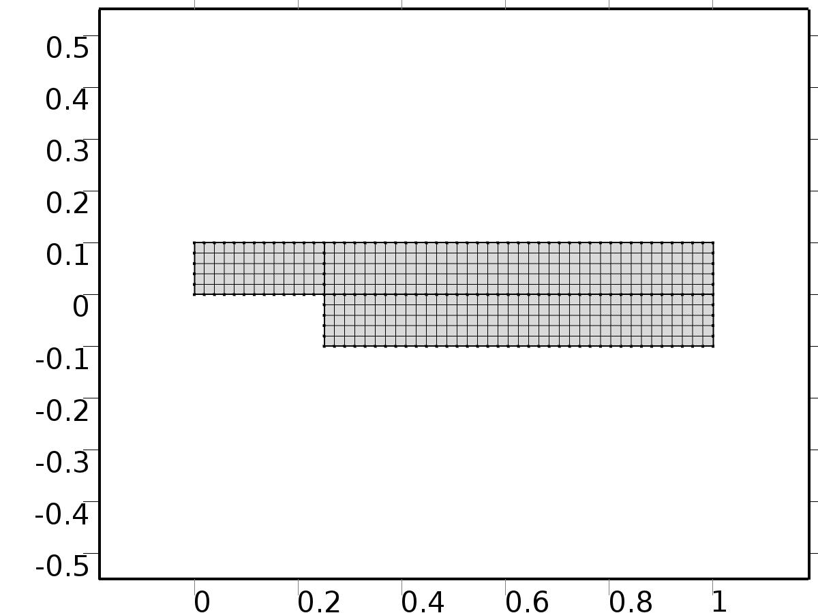

Mesh 1

* + 1. Size (size)

Settings

| **Description** | **Value** |
| --- | --- |
| Maximum element size | 0.067 |
| Minimum element size | 3.0E-4 |
| Curvature factor | 0.3 |
| Maximum element growth rate | 1.3 |

* + 1. Mapped 1 (map1)

Selection

|  |  |
| --- | --- |
| Geometric entity level | Domain |
| Selection | Geometry geom1 |

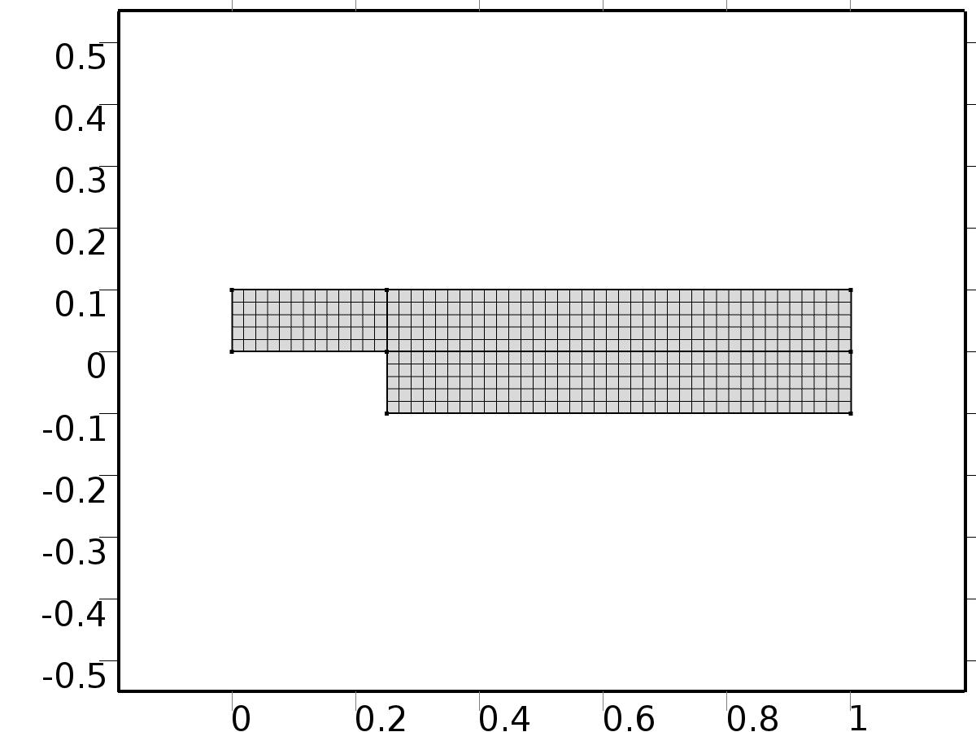

Mapped 1

#### Size 1 (size1)

Selection

|  |  |
| --- | --- |
| Geometric entity level | Domain |
| Selection | Geometry geom1 |



Size 1

Settings

| **Description** | **Value** |
| --- | --- |
| Maximum element size | D/5 |
| Minimum element size | D/5 |
| Curvature factor | 0.3 |
| Curvature factor | Off |
| Resolution of narrow regions | Off |
| Maximum element growth rate | 1.3 |
| Maximum element growth rate | Off |
| Custom element size | Custom |

1. Study 1
   1. Stationary

Study settings

| **Description** | **Value** |
| --- | --- |
| Include geometric nonlinearity | Off |

Physics and variables selection

| **Physics interface** | **Discretization** |
| --- | --- |
| Laminar Flow (spf) | physics |

Mesh selection

| **Geometry** | **Mesh** |
| --- | --- |
| Geometry 1 (geom1) | mesh1 |

* 1. Solver Configurations
     1. Solver 1

#### Compile Equations: Stationary (st1)

Study and step

| **Description** | **Value** |
| --- | --- |
| Use study | Study 1 |
| Use study step | Stationary |

#### Dependent Variables 1 (v1)

General

| **Description** | **Value** |
| --- | --- |
| Defined by study step | Stationary |
| Constant |  |

Initial values of variables solved for

| **Description** | **Value** |
| --- | --- |
| Solution | Zero |

Values of variables not solved for

| **Description** | **Value** |
| --- | --- |
| Solution | Zero |

##### Pressure (comp1.P) (comp1_P)

General

| **Description** | **Value** |
| --- | --- |
| Field components | comp1.P |

##### Velocity field (comp1.U) (comp1_U)

General

| **Description** | **Value** |
| --- | --- |
| Field components | {comp1.U, comp1.V} |

##### Pressure (comp1.ap0) (comp1_ap0)

General

| **Description** | **Value** |
| --- | --- |
| Field components | comp1.ap0 |
| Solve for this field | Off |
| Field name | comp1_p |

##### Velocity field (comp1.au0) (comp1_au0)

General

| **Description** | **Value** |
| --- | --- |
| Field components | {comp1.au0, comp1.av0} |
| Solve for this field | Off |
| Field name | comp1_u |

##### Pressure (comp1.atp0) (comp1_atp0)

General

| **Description** | **Value** |
| --- | --- |
| Field components | comp1.atp0 |
| Solve for this field | Off |
| Field name | comp1_p |

##### Velocity field (comp1.atu0) (comp1_atu0)

General

| **Description** | **Value** |
| --- | --- |
| Field components | {comp1.atu0, comp1.atv0} |
| Solve for this field | Off |
| Field name | comp1_u |

##### Pressure (comp1.ap1) (comp1_ap1)

General

| **Description** | **Value** |
| --- | --- |
| Field components | comp1.ap1 |
| Solve for this field | Off |
| Field name | comp1_p |

##### Velocity field (comp1.au1) (comp1_au1)

General

| **Description** | **Value** |
| --- | --- |
| Field components | {comp1.au1, comp1.av1} |
| Solve for this field | Off |
| Field name | comp1_u |

##### Pressure (comp1.atp1) (comp1_atp1)

General

| **Description** | **Value** |
| --- | --- |
| Field components | comp1.atp1 |
| Solve for this field | Off |
| Field name | comp1_p |

##### Velocity field (comp1.atu1) (comp1_atu1)

General

| **Description** | **Value** |
| --- | --- |
| Field components | {comp1.atu1, comp1.atv1} |
| Solve for this field | Off |
| Field name | comp1_u |

##### Pressure (comp1.bp1) (comp1_bp1)

General

| **Description** | **Value** |
| --- | --- |
| Field components | comp1.bp1 |
| Solve for this field | Off |
| Field name | comp1_p |

##### Velocity field (comp1.bu1) (comp1_bu1)

General

| **Description** | **Value** |
| --- | --- |
| Field components | {comp1.bu1, comp1.bv1} |
| Solve for this field | Off |
| Field name | comp1_u |

##### Pressure (comp1.btp1) (comp1_btp1)

General

| **Description** | **Value** |
| --- | --- |
| Field components | comp1.btp1 |
| Solve for this field | Off |
| Field name | comp1_p |

##### Velocity field (comp1.btu1) (comp1_btu1)

General

| **Description** | **Value** |
| --- | --- |
| Field components | {comp1.btu1, comp1.btv1} |
| Solve for this field | Off |
| Field name | comp1_u |

##### Pressure (comp1.p) (comp1_p)

General

| **Description** | **Value** |
| --- | --- |
| Field components | comp1.p |
| Solve for this field | Off |

##### Velocity field (comp1.u) (comp1_u)

General

| **Description** | **Value** |
| --- | --- |
| Field components | {comp1.u, comp1.v} |
| Solve for this field | Off |

#### Stationary Solver 1 (s1)

General

| **Description** | **Value** |
| --- | --- |
| Defined by study step | Stationary |
| Relative tolerance | 0.000010 |

Log

| **Description** | **Value** |
| --- | --- |
| Constant |  |

##### Fully Coupled 1 (fc1)

General

| **Description** | **Value** |
| --- | --- |
| Linear solver | Direct 1 |

Method and termination

| **Description** | **Value** |
| --- | --- |
| Initial damping factor | 0.01 |
| Minimum damping factor | 1.0E-6 |

##### Direct 1 (d1)

General

| **Description** | **Value** |
| --- | --- |
| Solver | PARDISO |

1. Study 2
   1. Stationary

Study settings

| **Description** | **Value** |
| --- | --- |
| Include geometric nonlinearity | Off |

Physics and variables selection

| **Physics interface** | **Discretization** |
| --- | --- |
| Laminar Flow 1 (phys1) | physics |
| Laminar Flow 2 (phys2) | physics |
| Laminar Flow 3 (phys3) | physics |
| Laminar Flow 4 (spf2) | physics |
| Laminar Flow 5 (phys4) | physics |
| Laminar Flow 6 (phys5) | physics |

Mesh selection

| **Geometry** | **Mesh** |
| --- | --- |
| Geometry 1 (geom1) | mesh1 |

* 1. Solver Configurations
     1. Solver 2

#### Compile Equations: Stationary (st1)

Study and step

| **Description** | **Value** |
| --- | --- |
| Use study | Study 2 |
| Use study step | Stationary |

#### Dependent Variables 1 (v1)

General

| **Description** | **Value** |
| --- | --- |
| Defined by study step | Stationary |
| Constant |  |

Initial values of variables solved for

| **Description** | **Value** |
| --- | --- |
| Solution | Zero |

Values of variables not solved for

| **Description** | **Value** |
| --- | --- |
| Method | Solution |
| Solution | Solver 1 |

##### Pressure (comp1.atp0) (comp1_atp0)

General

| **Description** | **Value** |
| --- | --- |
| Field components | comp1.atp0 |

##### Velocity field (comp1.atu0) (comp1_atu0)

General

| **Description** | **Value** |
| --- | --- |
| Field components | {comp1.atu0, comp1.atv0} |

##### Pressure (comp1.P) (comp1_P)

General

| **Description** | **Value** |
| --- | --- |
| Field components | comp1.P |
| Solve for this field | Off |

##### Pressure (comp1.ap0) (comp1_ap0)

General

| **Description** | **Value** |
| --- | --- |
| Field components | comp1.ap0 |

##### Velocity field (comp1.au0) (comp1_au0)

General

| **Description** | **Value** |
| --- | --- |
| Field components | {comp1.au0, comp1.av0} |

##### Velocity field (comp1.U) (comp1_U)

General

| **Description** | **Value** |
| --- | --- |
| Field components | {comp1.U, comp1.V} |
| Solve for this field | Off |

##### Pressure (comp1.ap1) (comp1_ap1)

General

| **Description** | **Value** |
| --- | --- |
| Field components | comp1.ap1 |
| Field name | comp1_p |

##### Velocity field (comp1.au1) (comp1_au1)

General

| **Description** | **Value** |
| --- | --- |
| Field components | {comp1.au1, comp1.av1} |
| Field name | comp1_u |

##### Pressure (comp1.atp1) (comp1_atp1)

General

| **Description** | **Value** |
| --- | --- |
| Field components | comp1.atp1 |
| Field name | comp1_p |

##### Velocity field (comp1.atu1) (comp1_atu1)

General

| **Description** | **Value** |
| --- | --- |
| Field components | {comp1.atu1, comp1.atv1} |
| Field name | comp1_u |

##### Pressure (comp1.bp1) (comp1_bp1)

General

| **Description** | **Value** |
| --- | --- |
| Field components | comp1.bp1 |
| Field name | comp1_p |

##### Velocity field (comp1.bu1) (comp1_bu1)

General

| **Description** | **Value** |
| --- | --- |
| Field components | {comp1.bu1, comp1.bv1} |
| Field name | comp1_u |

##### Pressure (comp1.btp1) (comp1_btp1)

General

| **Description** | **Value** |
| --- | --- |
| Field components | comp1.btp1 |
| Field name | comp1_p |

##### Velocity field (comp1.btu1) (comp1_btu1)

General

| **Description** | **Value** |
| --- | --- |
| Field components | {comp1.btu1, comp1.btv1} |
| Field name | comp1_u |

##### Pressure (comp1.p) (comp1_p)

General

| **Description** | **Value** |
| --- | --- |
| Field components | comp1.p |
| Solve for this field | Off |

##### Velocity field (comp1.u) (comp1_u)

General

| **Description** | **Value** |
| --- | --- |
| Field components | {comp1.u, comp1.v} |
| Solve for this field | Off |

#### Stationary Solver 1 (s1)

General

| **Description** | **Value** |
| --- | --- |
| Defined by study step | Stationary |
| Relative tolerance | 0.000010 |

Log

| **Description** | **Value** |
| --- | --- |
| Constant |  |

##### Fully Coupled 1 (fc1)

General

| **Description** | **Value** |
| --- | --- |
| Linear solver | Direct 1 |

Method and termination

| **Description** | **Value** |
| --- | --- |
| Initial damping factor | 0.01 |
| Minimum damping factor | 1.0E-6 |

##### Direct 1 (d1)

General

| **Description** | **Value** |
| --- | --- |
| Solver | PARDISO |

1. Study 3
   1. Time Dependent

Study settings

| **Description** | **Value** |
| --- | --- |
| Include geometric nonlinearity | Off |

| **Times** | **Unit** |
| --- | --- |
| range(0,0.1,20) | s |

Physics and variables selection

| **Physics interface** | **Discretization** |
| --- | --- |
| Closed loop system (phys6) | physics |

Mesh selection

| **Geometry** | **Mesh** |
| --- | --- |
| Geometry 1 (geom1) | mesh1 |

* 1. Solver Configurations
     1. Solver 3

#### Compile Equations: Time Dependent (st1)

Study and step

| **Description** | **Value** |
| --- | --- |
| Use study | Study 3 |
| Use study step | Time Dependent |

#### Dependent Variables 1 (v1)

General

| **Description** | **Value** |
| --- | --- |
| Defined by study step | Time Dependent |
| Constant |  |

Initial values of variables solved for

| **Description** | **Value** |
| --- | --- |
| Solution | Zero |

Values of variables not solved for

| **Description** | **Value** |
| --- | --- |
| Method | Solution |
| Solution | Solver 2 |

##### Pressure (comp1.atp0) (comp1_atp0)

General

| **Description** | **Value** |
| --- | --- |
| Field components | comp1.atp0 |
| Solve for this field | Off |

##### Pressure (comp1.atp1) (comp1_atp1)

General

| **Description** | **Value** |
| --- | --- |
| Field components | comp1.atp1 |
| Solve for this field | Off |

##### Velocity field (comp1.au0) (comp1_au0)

General

| **Description** | **Value** |
| --- | --- |
| Field components | {comp1.au0, comp1.av0} |
| Solve for this field | Off |

##### Pressure (comp1.bp1) (comp1_bp1)

General

| **Description** | **Value** |
| --- | --- |
| Field components | comp1.bp1 |
| Solve for this field | Off |

##### Velocity field (comp1.atu0) (comp1_atu0)

General

| **Description** | **Value** |
| --- | --- |
| Field components | {comp1.atu0, comp1.atv0} |
| Solve for this field | Off |

##### Velocity field (comp1.au1) (comp1_au1)

General

| **Description** | **Value** |
| --- | --- |
| Field components | {comp1.au1, comp1.av1} |
| Solve for this field | Off |

##### Pressure (comp1.P) (comp1_P)

General

| **Description** | **Value** |
| --- | --- |
| Field components | comp1.P |
| Solve for this field | Off |

##### Velocity field (comp1.atu1) (comp1_atu1)

General

| **Description** | **Value** |
| --- | --- |
| Field components | {comp1.atu1, comp1.atv1} |
| Solve for this field | Off |

##### Pressure (comp1.p) (comp1_p)

General

| **Description** | **Value** |
| --- | --- |
| Field components | comp1.p |

##### Pressure (comp1.ap0) (comp1_ap0)

General

| **Description** | **Value** |
| --- | --- |
| Field components | comp1.ap0 |
| Solve for this field | Off |

##### Velocity field (comp1.btu1) (comp1_btu1)

General

| **Description** | **Value** |
| --- | --- |
| Field components | {comp1.btu1, comp1.btv1} |
| Solve for this field | Off |

##### Pressure (comp1.ap1) (comp1_ap1)

General

| **Description** | **Value** |
| --- | --- |
| Field components | comp1.ap1 |
| Solve for this field | Off |

##### Velocity field (comp1.u) (comp1_u)

General

| **Description** | **Value** |
| --- | --- |
| Field components | {comp1.u, comp1.v} |

##### Velocity field (comp1.U) (comp1_U)

General

| **Description** | **Value** |
| --- | --- |
| Field components | {comp1.U, comp1.V} |
| Solve for this field | Off |

##### Velocity field (comp1.bu1) (comp1_bu1)

General

| **Description** | **Value** |
| --- | --- |
| Field components | {comp1.bu1, comp1.bv1} |
| Solve for this field | Off |

##### Pressure (comp1.btp1) (comp1_btp1)

General

| **Description** | **Value** |
| --- | --- |
| Field components | comp1.btp1 |
| Solve for this field | Off |

#### Time-Dependent Solver 1 (t1)

General

| **Description** | **Value** |
| --- | --- |
| Defined by study step | Time Dependent |
| Time | {0, 0.1, 0.2, 0.30000000000000004, 0.4, 0.5, 0.6000000000000001, 0.7000000000000001, 0.8, 0.9, 1, 1.1, 1.2000000000000002, 1.3, 1.4000000000000001, 1.5, 1.6, 1.7000000000000002, 1.8, 1.9000000000000001, 2, 2.1, 2.2, 2.3000000000000003, 2.4000000000000004, 2.5, 2.6, 2.7, 2.8000000000000003, 2.9000000000000004, 3, 3.1, 3.2, 3.3000000000000003, 3.4000000000000004, 3.5, 3.6, 3.7, 3.8000000000000003, 3.9000000000000004, 4, 4.1000000000000005, 4.2, 4.3, 4.4, 4.5, 4.6000000000000005, 4.7, 4.800000000000001, 4.9, 5, 5.1000000000000005, 5.2, 5.300000000000001, 5.4, 5.5, 5.6000000000000005, 5.7, 5.800000000000001, 5.9, 6, 6.1000000000000005, 6.2, 6.300000000000001, 6.4, 6.5, 6.6000000000000005, 6.7, 6.800000000000001, 6.9, 7, 7.1000000000000005, 7.2, 7.300000000000001, 7.4, 7.5, 7.6000000000000005, 7.7, 7.800000000000001, 7.9, 8, 8.1, 8.200000000000001, 8.3, 8.4, 8.5, 8.6, 8.700000000000001, 8.8, 8.9, 9, 9.1, 9.200000000000001, 9.3, 9.4, 9.5, 9.600000000000001, 9.700000000000001, 9.8, 9.9, 10, 10.100000000000001, 10.200000000000001, 10.3, 10.4, 10.5, 10.600000000000001, 10.700000000000001, 10.8, 10.9, 11, 11.100000000000001, 11.200000000000001, 11.3, 11.4, 11.5, 11.600000000000001, 11.700000000000001, 11.8, 11.9, 12, 12.100000000000001, 12.200000000000001, 12.3, 12.4, 12.5, 12.600000000000001, 12.700000000000001, 12.8, 12.9, 13, 13.100000000000001, 13.200000000000001, 13.3, 13.4, 13.5, 13.600000000000001, 13.700000000000001, 13.8, 13.9, 14, 14.100000000000001, 14.200000000000001, 14.3, 14.4, 14.5, 14.600000000000001, 14.700000000000001, 14.8, 14.9, 15, 15.100000000000001, 15.200000000000001, 15.3, 15.4, 15.5, 15.600000000000001, 15.700000000000001, 15.8, 15.9, 16, 16.1, 16.2, 16.3, 16.400000000000002, 16.5, 16.6, 16.7, 16.8, 16.900000000000002, 17, 17.1, 17.2, 17.3, 17.400000000000002, 17.5, 17.6, 17.7, 17.8, 17.900000000000002, 18, 18.1, 18.2, 18.3, 18.400000000000002, 18.5, 18.6, 18.7, 18.8, 18.900000000000002, 19, 19.1, 19.200000000000003, 19.3, 19.400000000000002, 19.5, 19.6, 19.700000000000003, 19.8, 19.900000000000002, 20} |
| Relative tolerance | 0.0001 |

Absolute tolerance

| **Description** | **Value** |
| --- | --- |
| Tolerance | 5.0E-4 |

Time stepping

| **Description** | **Value** |
| --- | --- |
| Initial step | 0.0010 |
| Maximum BDF order | 2 |

Advanced

| **Description** | **Value** |
| --- | --- |
| Fraction of initial step for Backward Euler | 0.0010 |
| Error estimation | Exclude algebraic |

Log

| **Description** | **Value** |
| --- | --- |
| Constant |  |

##### Fully Coupled 1 (fc1)

General

| **Description** | **Value** |
| --- | --- |
| Linear solver | Direct 1 |

Method and termination

| **Description** | **Value** |
| --- | --- |
| Jacobian update | Once per time step |
| Maximum number of iterations | 6 |

##### Direct 1 (d1)

General

| **Description** | **Value** |
| --- | --- |
| Solver | PARDISO |

1. Results
   1. Data Sets
      1. Solution 1

Solution

| **Description** | **Value** |
| --- | --- |
| Solution | Solver 1 |
| Component | Save Point Geometry 1 |

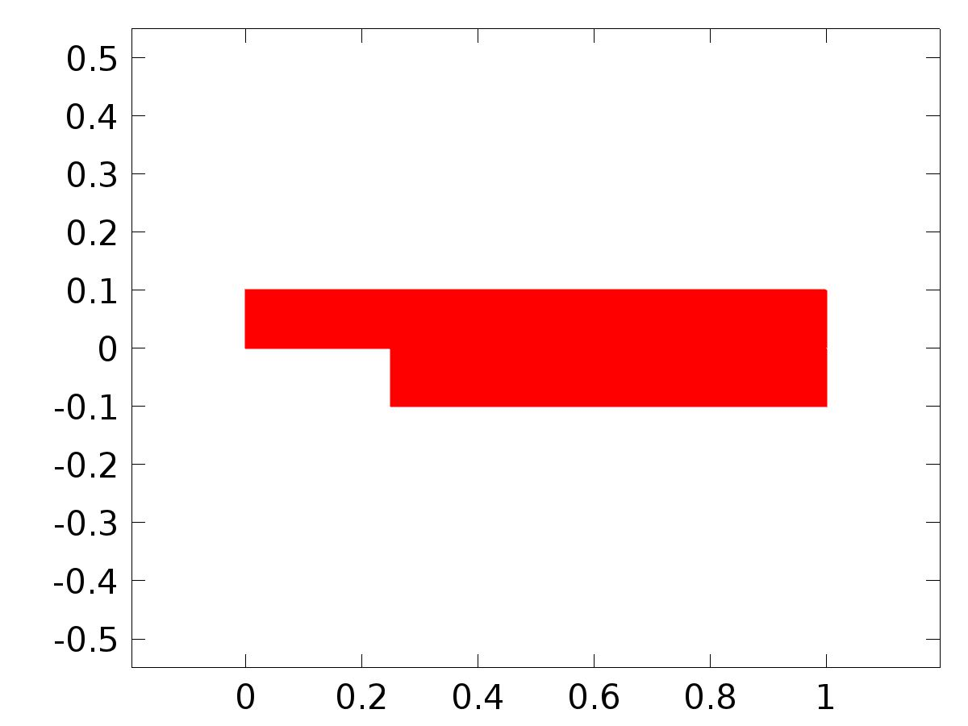

Data set: Solution 1

* + 1. Solution 2

Solution

| **Description** | **Value** |
| --- | --- |
| Solution | Solver 2 |
| Component | Save Point Geometry 1 |



Data set: Solution 2

* + 1. Solution 3

Solution

| **Description** | **Value** |
| --- | --- |
| Solution | Solver 3 |
| Component | Save Point Geometry 1 |



Data set: Solution 3

* 1. Derived Values
     1. Global Evaluation 1

Data

| **Description** | **Value** |
| --- | --- |
| Data set | Solution 2 |

Expression

| **Description** | **Value** |
| --- | --- |
| Expression | C(au2) |
| Description | C(au2) |

* 1. Tables
     1. Table 1

Global Evaluation 1 (C(au0))

Table 1

| **C(au0)** | **C(bu1)** | **C(bu2)** | **C(au2)** |
| --- | --- | --- | --- |
| 0.20000 | 0.050000 | 1.1630E-18 | 2.5902E-18 |

* 1. Plot Groups
     1. Velocity (spf)

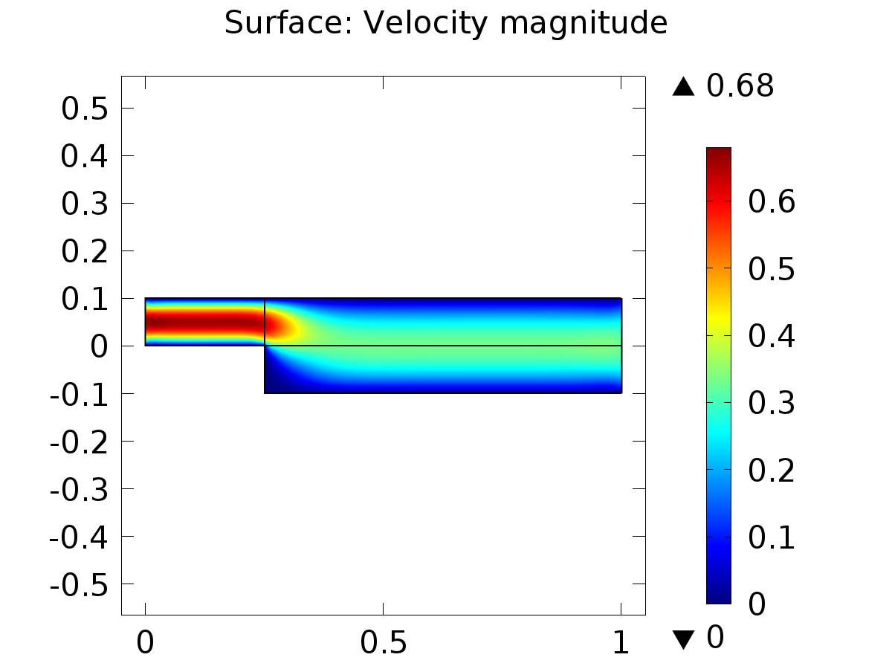

Surface: Velocity magnitude

* + 1. Pressure (spf)

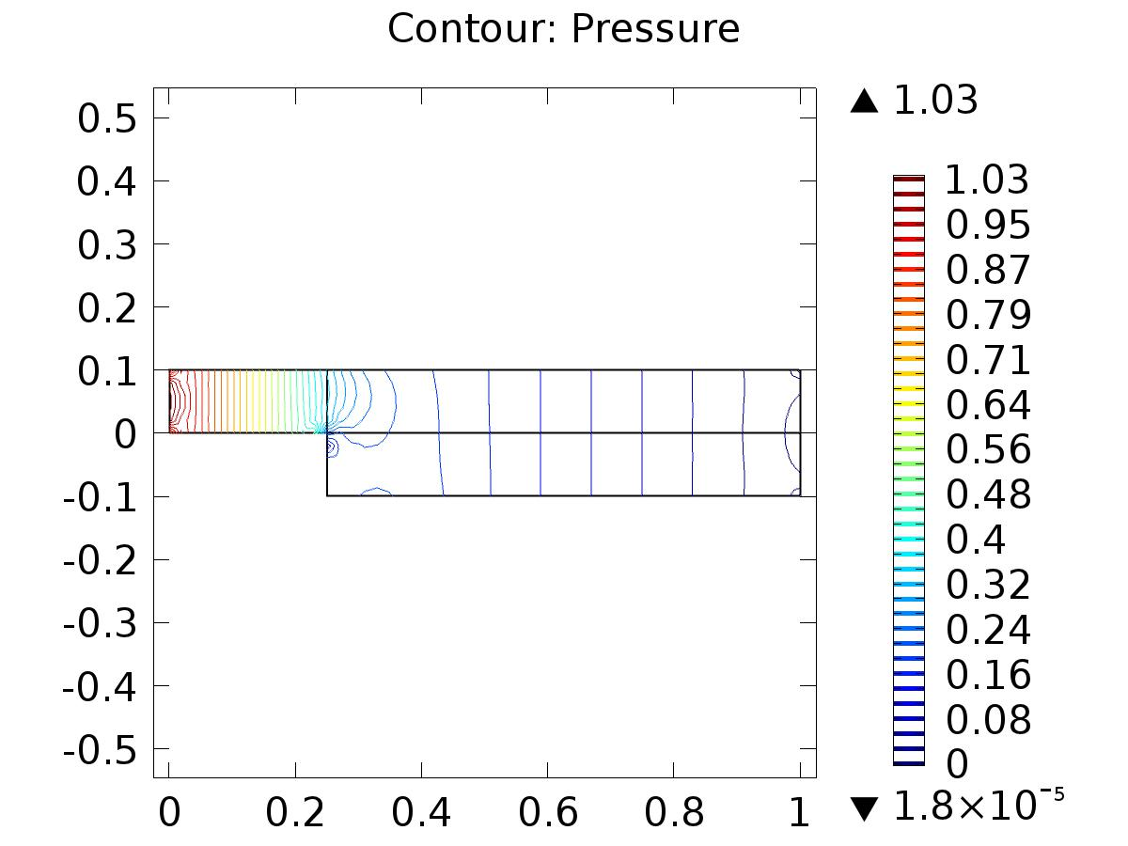

Contour: Pressure

* + 1. Velocity (phys1)

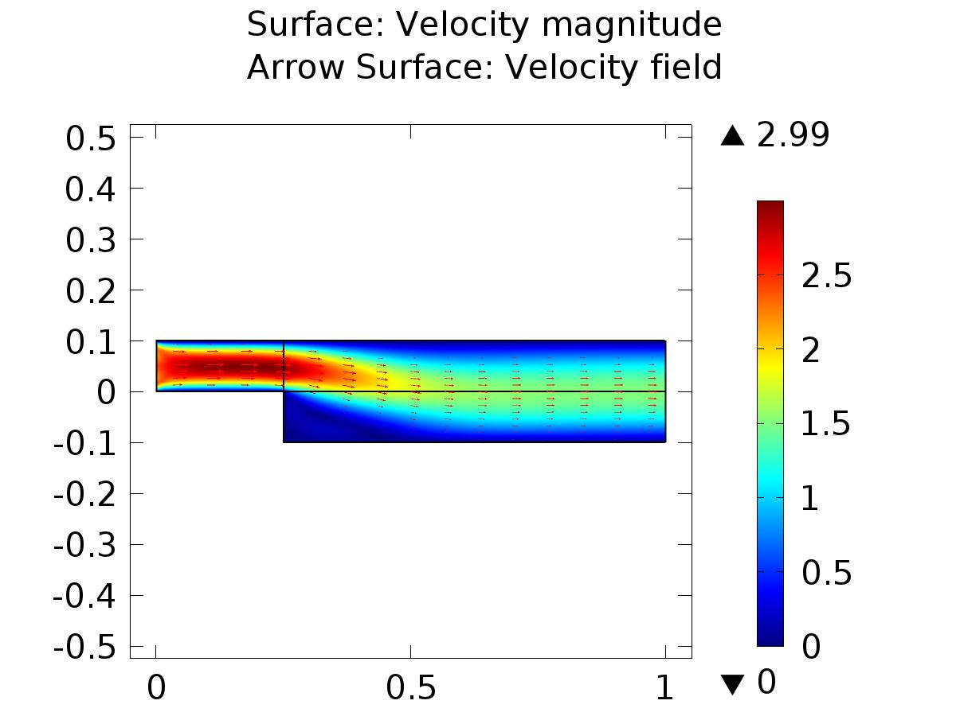

Surface: Velocity magnitude Arrow Surface: Velocity field

* + 1. Pressure (phys1)

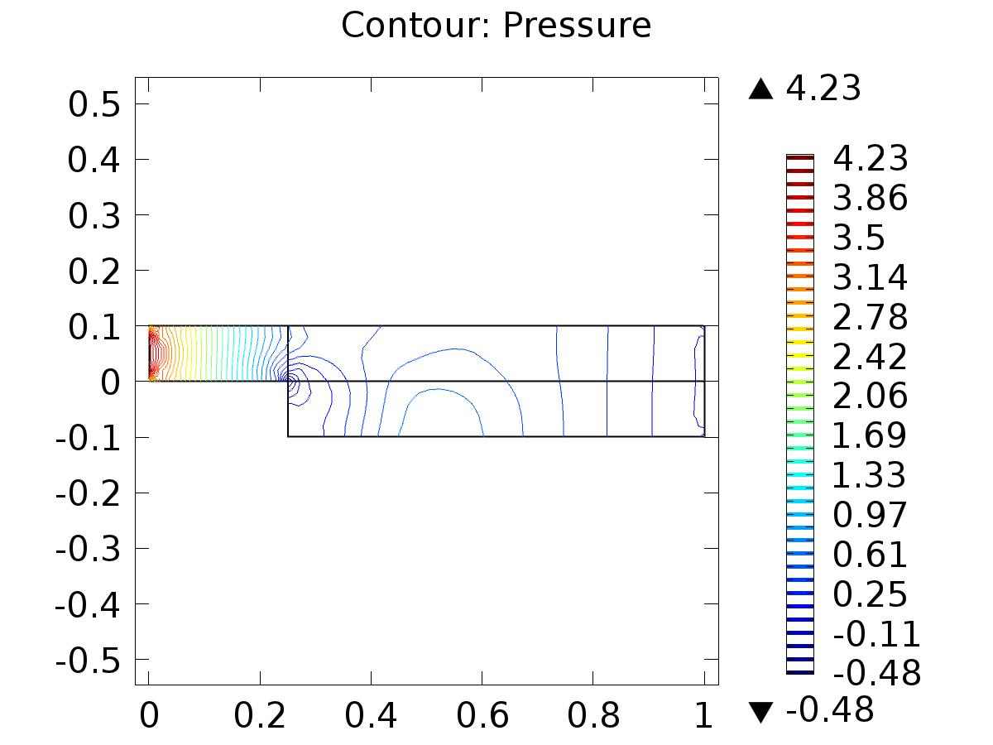

Contour: Pressure

* + 1. Velocity (phys2)

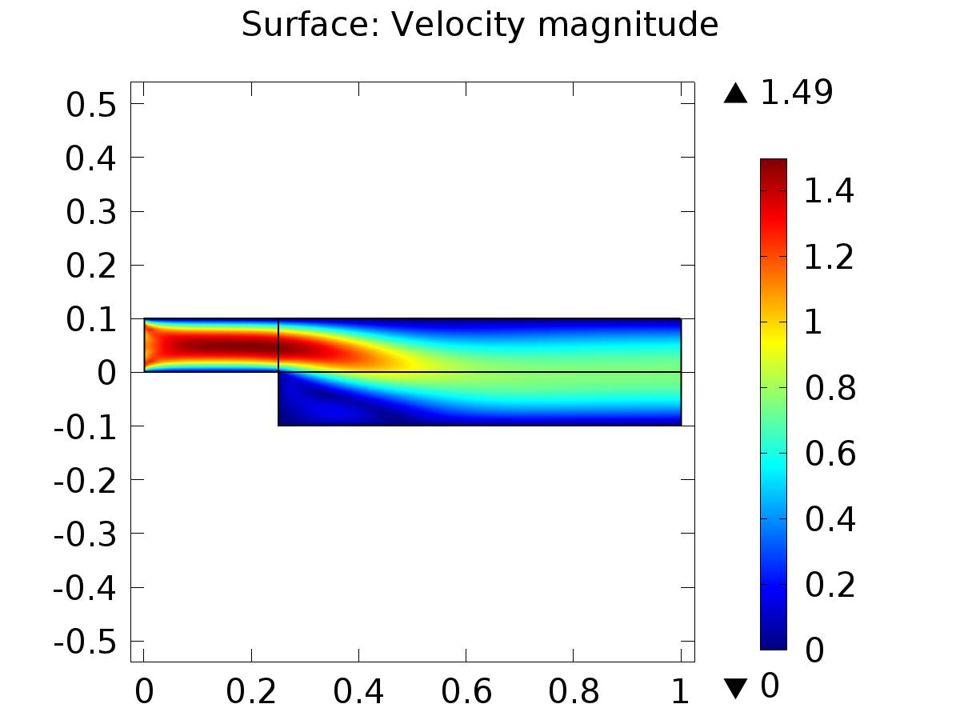

Surface: Velocity magnitude

* + 1. Pressure (phys2)

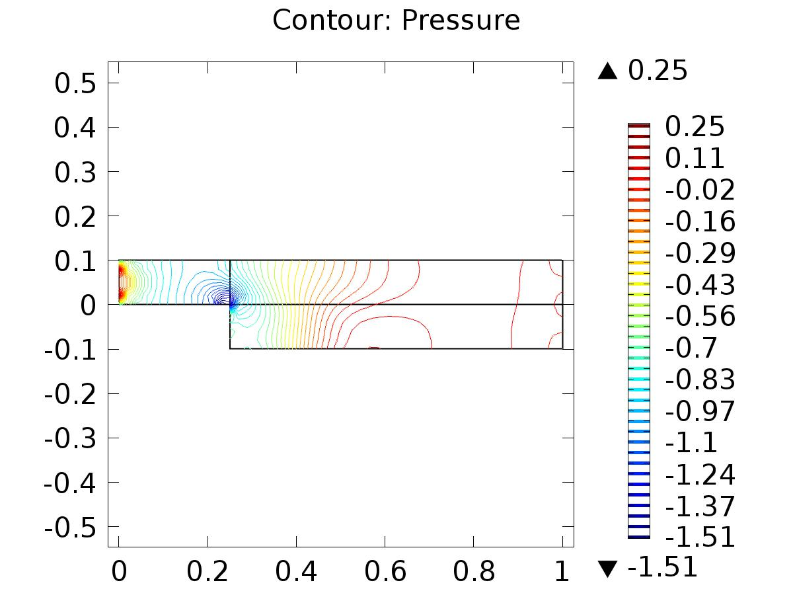

Contour: Pressure

* + 1. Velocity (phys6)

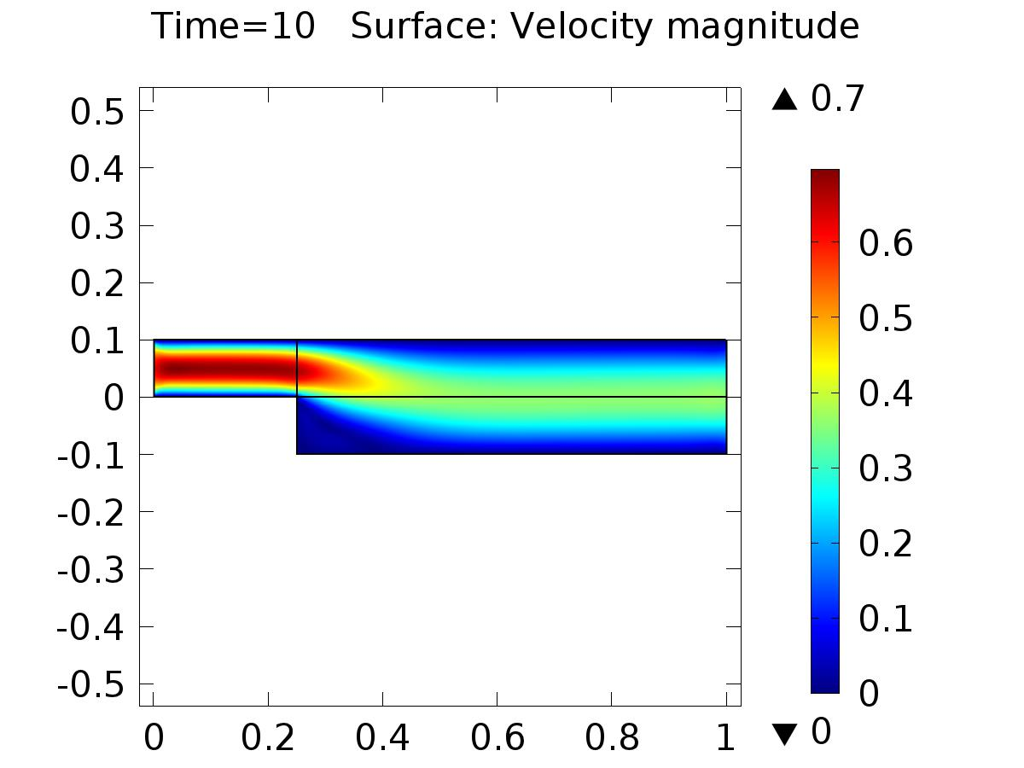

Time=10 Surface: Velocity magnitude

* + 1. Pressure (phys6)

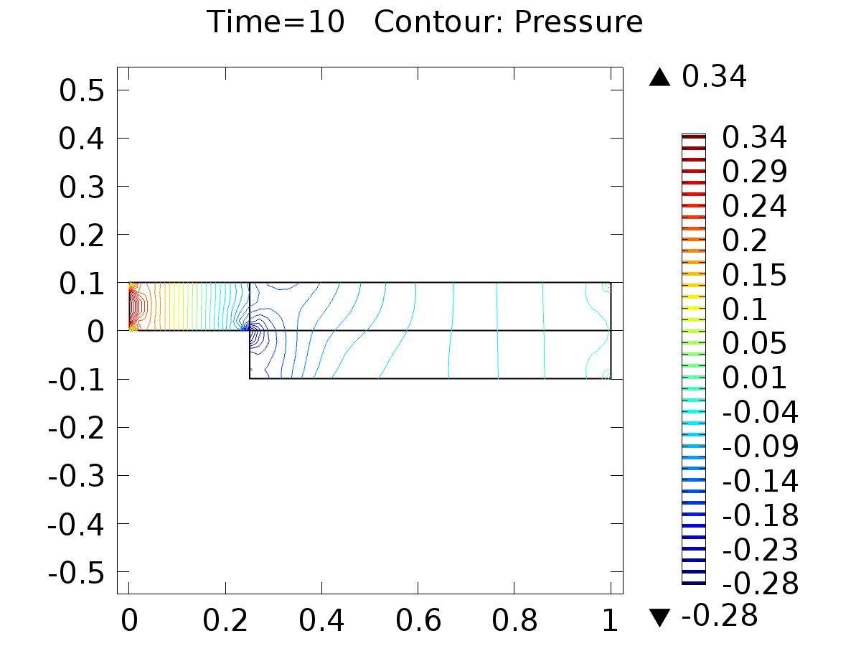

Time=10 Contour: Pressure

* + 1. 1D Plot Group 9

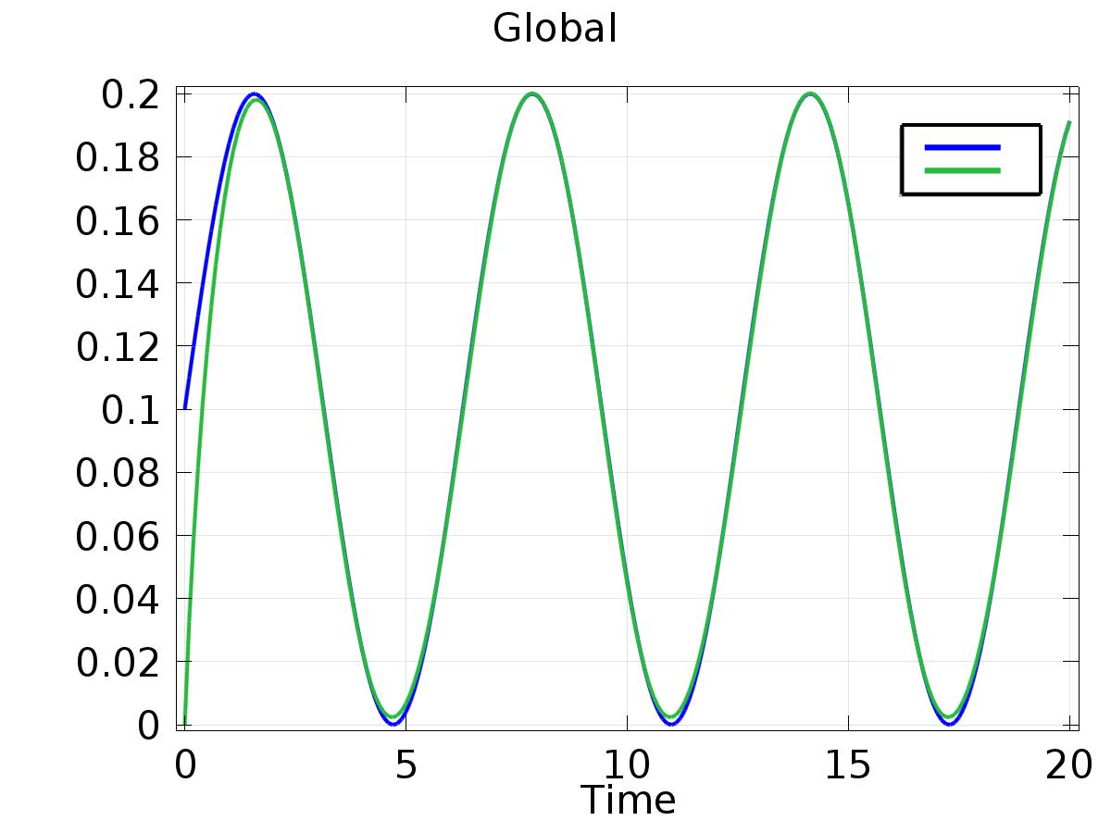

Global

* + 1. 1D Plot Group 10

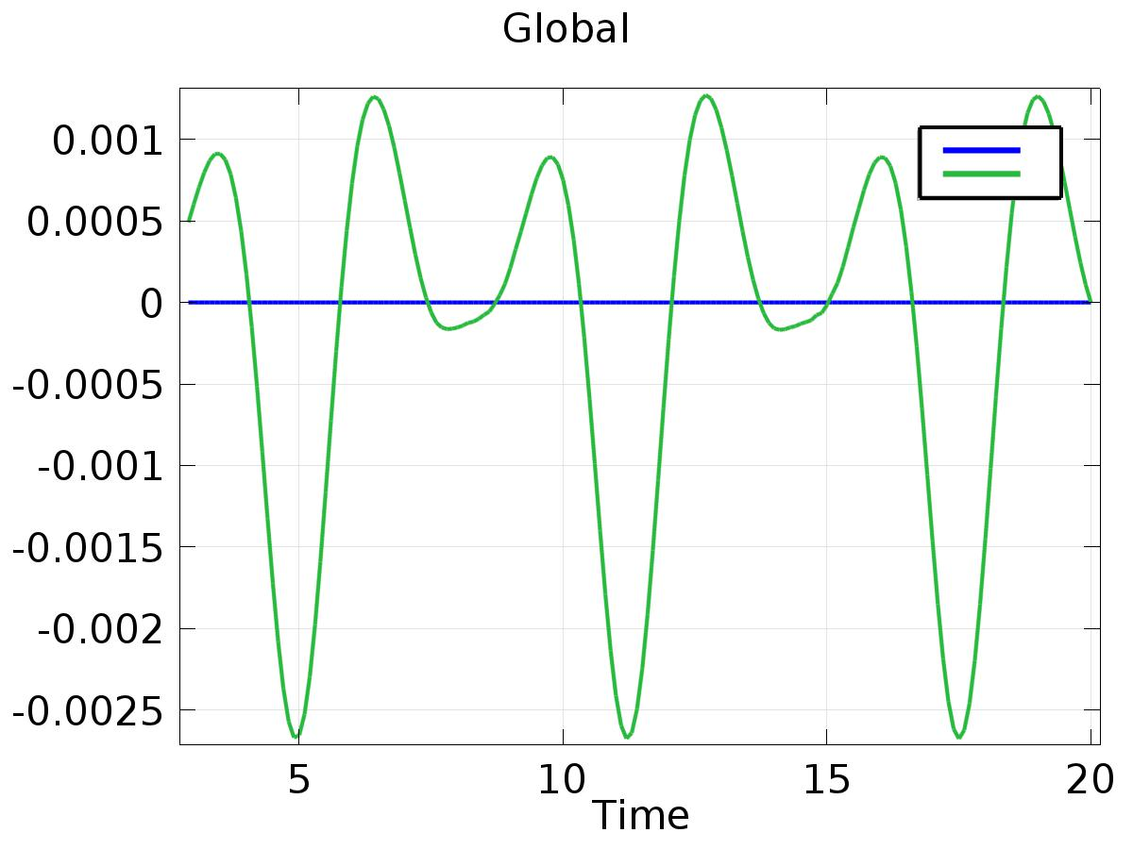

Global