[](http://www.comsol.com/)

NavierStokes FSA3PbetaIt

|  |  |
| --- | --- |
| Date | Aug 26, 2014 6:03:50 AM |

Contents

1. Global

1.1. Definitions

2. Component 1

2.1. Definitions

2.2. Geometry 1

2.3. Laminar Flow

2.4. Laminar Flow 1

2.5. Laminar Flow 2

2.6. Laminar Flow 3

2.7. Laminar Flow 4

2.8. Laminar Flow 5

2.9. Laminar Flow 6

2.10. Laminar Flow 7

2.11. Laminar Flow 8

2.12. Laminar Flow 9

2.13. Laminar Flow 10

2.14. Laminar Flow 11

2.15. Laminar Flow 12

2.16. Laminar Flow 13

2.17. Laminar Flow 14

2.18. Laminar Flow 14a

2.19. Laminar Flow 15

2.20. Laminar Flow 16

2.21. Closed loop system

2.22. Mesh 1

3. Study 1

3.1. Stationary

3.2. Solver Configurations

4. Study 2

4.1. Stationary

4.2. Solver Configurations

5. Study 3

5.1. Time Dependent

5.2. Solver Configurations

6. Results

6.1. Data Sets

6.2. Derived Values

6.3. Tables

6.4. Plot Groups

1. Global

|  |  |
| --- | --- |
| Date | Aug 20, 2014 11:31:47 AM |

Global settings

|  |  |
| --- | --- |
| Name | NavierStokes FSA3PbetaIt.mph |
| Path | /Users/gilliam/Desktop/collect_15/research_15/geo_reg_mono_eugenio/Mono_1_15/Comsol_EX_GitHub/Chapter5/Chap5Ex5_NS_Fourier_beta/NavierStokes_FSA3PbetaIt.mph |
| Program | COMSOL 4.4 (Build: 150) |

Used products

|  |
| --- |
| COMSOL Multiphysics |

* 1. Definitions
     1. Parameters 1

Parameters

| **Name** | **Expression** | **Value** | **Description** |
| --- | --- | --- | --- |
| D | 0.1 | 0.10000 |  |
| L | 1 | 1.0000 |  |
| nu | 0.005 | 0.0050000 |  |
| A1 | 0.1 | 0.10000 |  |
| M1 | 0.1 | 0.10000 |  |
| alpha | 1 | 1.0000 |  |
| N | 3 | 3.0000 |  |

1. Component 1

Component settings

|  |  |
| --- | --- |
| Unit system | None |

* 1. Definitions
     1. Variables

#### Variables 1a

Selection

|  |  |
| --- | --- |
| Geometric entity level | Entire model |

| **Name** | **Expression** | **Description** |
| --- | --- | --- |
| G | C(U) |  |
| e | yr - C(u) |  |

#### Variables 2

Selection

|  |  |
| --- | --- |
| Geometric entity level | Entire model |

| **Name** | **Expression** | **Description** |
| --- | --- | --- |
| f_au0 | au0*au0x + av0*au0y - 0.5*(au0*au0x + 2.*au1*au1x + 2.*au2*au2x + 2.*au3*au3x + 2.*bu1*bu1x + 2.*bu2*bu2x + 2.*bu3*bu3x + av0*au0y + 2.*av1*au1y + 2.*av2*au2y + 2.*av3*au3y + 2.*bv1*bu1y + 2.*bv2*bu2y + 2.*bv3*bu3y) |  |
| f_atu0 | atu0*atu0x + atv0*atu0y - 0.5*(au0*au0x + 2.*au1*au1x + 2.*au2*au2x + 2.*au3*au3x + 2.*bu1*bu1x + 2.*bu2*bu2x + 2.*bu3*bu3x + av0*au0y + 2.*av1*au1y + 2.*av2*au2y + 2.*av3*au3y + 2.*bv1*bu1y + 2.*bv2*bu2y + 2.*bv3*bu3y) |  |
| f_av0 | au0*av0x + av0*av0y - 0.5*(au0*av0x + 2.*au1*av1x + 2.*au2*av2x + 2.*au3*av3x + 2.*bu1*bv1x + 2.*bu2*bv2x + 2.*bu3*bv3x + av0*av0y + 2.*av1*av1y + 2.*av2*av2y + 2.*av3*av3y + 2.*bv1*bv1y + 2.*bv2*bv2y + 2.*bv3*bv3y) |  |
| f_atv0 | atu0*atv0x + atv0*atv0y - 0.5*(au0*av0x + 2.*au1*av1x + 2.*au2*av2x + 2.*au3*av3x + 2.*bu1*bv1x + 2.*bu2*bv2x + 2.*bu3*bv3x + av0*av0y + 2.*av1*av1y + 2.*av2*av2y + 2.*av3*av3y + 2.*bv1*bv1y + 2.*bv2*bv2y + 2.*bv3*bv3y) |  |
| f_au1 | au1*au1x + av1*au1y - 1*alpha*bu1 - 0.5*(au0*au1x + au1*au0x + 0.5*au1*au2x + 0.5*au2*au1x + 0.5*au2*au1x + 0.5*au1*au2x + 0.5*au2*au3x + 0.5*au3*au2x + 0.5*au3*au2x + 0.5*au2*au3x + 0.5*bu1*bu2x + 0.5*bu2*bu1x + 0.5*bu2*bu1x + 0.5*bu1*bu2x + 0.5*bu2*bu3x + 0.5*bu3*bu2x + 0.5*bu3*bu2x + 0.5*bu2*bu3x + av0*au1y + av1*au0y + 0.5*av1*au2y + 0.5*av2*au1y + 0.5*av2*au1y + 0.5*av1*au2y + 0.5*av2*au3y + 0.5*av3*au2y + 0.5*av3*au2y + 0.5*av2*au3y + 0.5*bv1*bu2y + 0.5*bv2*bu1y + 0.5*bv2*bu1y + 0.5*bv1*bu2y + 0.5*bv2*bu3y + 0.5*bv3*bu2y + 0.5*bv3*bu2y + 0.5*bv2*bu3y)*(N>0) |  |
| f_atu1 | atu1*atu1x + atv1*atu1y - 1*alpha*bu1 - 0.5*(au0*au1x + au1*au0x + 0.5*au1*au2x + 0.5*au2*au1x + 0.5*au2*au1x + 0.5*au1*au2x + 0.5*au2*au3x + 0.5*au3*au2x + 0.5*au3*au2x + 0.5*au2*au3x + 0.5*bu1*bu2x + 0.5*bu2*bu1x + 0.5*bu2*bu1x + 0.5*bu1*bu2x + 0.5*bu2*bu3x + 0.5*bu3*bu2x + 0.5*bu3*bu2x + 0.5*bu2*bu3x + av0*au1y + av1*au0y + 0.5*av1*au2y + 0.5*av2*au1y + 0.5*av2*au1y + 0.5*av1*au2y + 0.5*av2*au3y + 0.5*av3*au2y + 0.5*av3*au2y + 0.5*av2*au3y + 0.5*bv1*bu2y + 0.5*bv2*bu1y + 0.5*bv2*bu1y + 0.5*bv1*bu2y + 0.5*bv2*bu3y + 0.5*bv3*bu2y + 0.5*bv3*bu2y + 0.5*bv2*bu3y)*(N>0) |  |
| f_av1 | au1*av1x + av1*av1y - 1*alpha*bv1 - 0.5*(au0*av1x + au1*av0x + 0.5*au1*av2x + 0.5*au2*av1x + 0.5*au2*av1x + 0.5*au1*av2x + 0.5*au2*av3x + 0.5*au3*av2x + 0.5*au3*av2x + 0.5*au2*av3x + 0.5*bu1*bv2x + 0.5*bu2*bv1x + 0.5*bu2*bv1x + 0.5*bu1*bv2x + 0.5*bu2*bv3x + 0.5*bu3*bv2x + 0.5*bu3*bv2x + 0.5*bu2*bv3x + av0*av1y + av1*av0y + 0.5*av1*av2y + 0.5*av2*av1y + 0.5*av2*av1y + 0.5*av1*av2y + 0.5*av2*av3y + 0.5*av3*av2y + 0.5*av3*av2y + 0.5*av2*av3y + 0.5*bv1*bv2y + 0.5*bv2*bv1y + 0.5*bv2*bv1y + 0.5*bv1*bv2y + 0.5*bv2*bv3y + 0.5*bv3*bv2y + 0.5*bv3*bv2y + 0.5*bv2*bv3y)*(N>0) |  |
| f_atv1 | atu1*atv1x + atv1*atv1y - 1*alpha*bv1 - 0.5*(au0*av1x + au1*av0x + 0.5*au1*av2x + 0.5*au2*av1x + 0.5*au2*av1x + 0.5*au1*av2x + 0.5*au2*av3x + 0.5*au3*av2x + 0.5*au3*av2x + 0.5*au2*av3x + 0.5*bu1*bv2x + 0.5*bu2*bv1x + 0.5*bu2*bv1x + 0.5*bu1*bv2x + 0.5*bu2*bv3x + 0.5*bu3*bv2x + 0.5*bu3*bv2x + 0.5*bu2*bv3x + av0*av1y + av1*av0y + 0.5*av1*av2y + 0.5*av2*av1y + 0.5*av2*av1y + 0.5*av1*av2y + 0.5*av2*av3y + 0.5*av3*av2y + 0.5*av3*av2y + 0.5*av2*av3y + 0.5*bv1*bv2y + 0.5*bv2*bv1y + 0.5*bv2*bv1y + 0.5*bv1*bv2y + 0.5*bv2*bv3y + 0.5*bv3*bv2y + 0.5*bv3*bv2y + 0.5*bv2*bv3y)*(N>0) |  |
| f_bu1 | bu1*bu1x + bv1*bu1y + 1*alpha*au1 - 0.5*(au0*bu1x + bu1*au0x + au1*bu2x + bu2*au1x - au2*bu1x - bu1*au2x + au2*bu3x + bu3*au2x - au3*bu2x - bu2*au3x + av0*bu1y + bv1*au0y + av1*bu2y + bv2*au1y - av2*bu1y - bv1*au2y + av2*bu3y + bv3*au2y - av3*bu2y - bv2*au3y)*(N>0) |  |
| f_btu1 | btu1*btu1x + btv1*btu1y + 1*alpha*au1 - 0.5*(au0*bu1x + bu1*au0x + au1*bu2x + bu2*au1x - au2*bu1x - bu1*au2x + au2*bu3x + bu3*au2x - au3*bu2x - bu2*au3x + av0*bu1y + bv1*au0y + av1*bu2y + bv2*au1y - av2*bu1y - bv1*au2y + av2*bu3y + bv3*au2y - av3*bu2y - bv2*au3y)*(N>0) |  |
| f_bv1 | bu1*bv1x + bv1*bv1y + 1*alpha*av1 - 0.5*(au0*bv1x + bu1*av0x + au1*bv2x + bu2*av1x - au2*bv1x - bu1*av2x + au2*bv3x + bu3*av2x - au3*bv2x - bu2*av3x + av0*bv1y + bv1*av0y + av1*bv2y + bv2*av1y - av2*bv1y - bv1*av2y + av2*bv3y + bv3*av2y - av3*bv2y - bv2*av3y)*(N>0) |  |
| f_btv1 | btu1*btv1x + btv1*btv1y + 1*alpha*av1 - 0.5*(au0*bv1x + bu1*av0x + au1*bv2x + bu2*av1x - au2*bv1x - bu1*av2x + au2*bv3x + bu3*av2x - au3*bv2x - bu2*av3x + av0*bv1y + bv1*av0y + av1*bv2y + bv2*av1y - av2*bv1y - bv1*av2y + av2*bv3y + bv3*av2y - av3*bv2y - bv2*av3y)*(N>0) |  |
| f_au2 | au2*au2x + av2*au2y - 2*alpha*bu2 - 0.5*(au0*au2x + au2*au0x + 0.5*au1*au1x + 0.5*au1*au1x + 0.5*au1*au3x + 0.5*au3*au1x + 0.5*au3*au1x + 0.5*au1*au3x - 0.5*bu1*bu1x - 0.5*bu1*bu1x + 0.5*bu1*bu3x + 0.5*bu3*bu1x + 0.5*bu3*bu1x + 0.5*bu1*bu3x + av0*au2y + av2*au0y + 0.5*av1*au1y + 0.5*av1*au1y + 0.5*av1*au3y + 0.5*av3*au1y + 0.5*av3*au1y + 0.5*av1*au3y - 0.5*bv1*bu1y - 0.5*bv1*bu1y + 0.5*bv1*bu3y + 0.5*bv3*bu1y + 0.5*bv3*bu1y + 0.5*bv1*bu3y)*(N>1) |  |
| f_atu2 | atu2*atu2x + atv2*atu2y - 2*alpha*bu2 - 0.5*(au0*au2x + au2*au0x + 0.5*au1*au1x + 0.5*au1*au1x + 0.5*au1*au3x + 0.5*au3*au1x + 0.5*au3*au1x + 0.5*au1*au3x - 0.5*bu1*bu1x - 0.5*bu1*bu1x + 0.5*bu1*bu3x + 0.5*bu3*bu1x + 0.5*bu3*bu1x + 0.5*bu1*bu3x + av0*au2y + av2*au0y + 0.5*av1*au1y + 0.5*av1*au1y + 0.5*av1*au3y + 0.5*av3*au1y + 0.5*av3*au1y + 0.5*av1*au3y - 0.5*bv1*bu1y - 0.5*bv1*bu1y + 0.5*bv1*bu3y + 0.5*bv3*bu1y + 0.5*bv3*bu1y + 0.5*bv1*bu3y)*(N>1) |  |
| f_av2 | au2*av2x + av2*av2y - 2*alpha*bv2 - 0.5*(au0*av2x + au2*av0x + 0.5*au1*av1x + 0.5*au1*av1x + 0.5*au1*av3x + 0.5*au3*av1x + 0.5*au3*av1x + 0.5*au1*av3x - 0.5*bu1*bv1x - 0.5*bu1*bv1x + 0.5*bu1*bv3x + 0.5*bu3*bv1x + 0.5*bu3*bv1x + 0.5*bu1*bv3x + av0*av2y + av2*av0y + 0.5*av1*av1y + 0.5*av1*av1y + 0.5*av1*av3y + 0.5*av3*av1y + 0.5*av3*av1y + 0.5*av1*av3y - 0.5*bv1*bv1y - 0.5*bv1*bv1y + 0.5*bv1*bv3y + 0.5*bv3*bv1y + 0.5*bv3*bv1y + 0.5*bv1*bv3y)*(N>1) |  |
| f_atv2 | atu2*atv2x + atv2*atv2y - 2*alpha*bv2 - 0.5*(au0*av2x + au2*av0x + 0.5*au1*av1x + 0.5*au1*av1x + 0.5*au1*av3x + 0.5*au3*av1x + 0.5*au3*av1x + 0.5*au1*av3x - 0.5*bu1*bv1x - 0.5*bu1*bv1x + 0.5*bu1*bv3x + 0.5*bu3*bv1x + 0.5*bu3*bv1x + 0.5*bu1*bv3x + av0*av2y + av2*av0y + 0.5*av1*av1y + 0.5*av1*av1y + 0.5*av1*av3y + 0.5*av3*av1y + 0.5*av3*av1y + 0.5*av1*av3y - 0.5*bv1*bv1y - 0.5*bv1*bv1y + 0.5*bv1*bv3y + 0.5*bv3*bv1y + 0.5*bv3*bv1y + 0.5*bv1*bv3y)*(N>1) |  |
| f_bu2 | bu2*bu2x + bv2*bu2y + 2*alpha*au2 - 0.5*(au0*bu2x + bu2*au0x + au1*bu1x + bu1*au1x + au1*bu3x + bu3*au1x - au3*bu1x - bu1*au3x + av0*bu2y + bv2*au0y + av1*bu1y + bv1*au1y + av1*bu3y + bv3*au1y - av3*bu1y - bv1*au3y)*(N>1) |  |
| f_btu2 | btu2*btu2x + btv2*btu2y + 2*alpha*au2 - 0.5*(au0*bu2x + bu2*au0x + au1*bu1x + bu1*au1x + au1*bu3x + bu3*au1x - au3*bu1x - bu1*au3x + av0*bu2y + bv2*au0y + av1*bu1y + bv1*au1y + av1*bu3y + bv3*au1y - av3*bu1y - bv1*au3y)*(N>1) |  |
| f_bv2 | bu2*bv2x + bv2*bv2y + 2*alpha*av2 - 0.5*(au0*bv2x + bu2*av0x + au1*bv1x + bu1*av1x + au1*bv3x + bu3*av1x - au3*bv1x - bu1*av3x + av0*bv2y + bv2*av0y + av1*bv1y + bv1*av1y + av1*bv3y + bv3*av1y - av3*bv1y - bv1*av3y)*(N>1) |  |
| f_btv2 | btu2*btv2x + btv2*btv2y + 2*alpha*av2 - 0.5*(au0*bv2x + bu2*av0x + au1*bv1x + bu1*av1x + au1*bv3x + bu3*av1x - au3*bv1x - bu1*av3x + av0*bv2y + bv2*av0y + av1*bv1y + bv1*av1y + av1*bv3y + bv3*av1y - av3*bv1y - bv1*av3y)*(N>1) |  |
| f_au3 | au3*au3x + av3*au3y - 3*alpha*bu3 - 0.5*(au0*au3x + au3*au0x + 0.5*au1*au2x + 0.5*au2*au1x + 0.5*au2*au1x + 0.5*au1*au2x - 0.5*bu1*bu2x - 0.5*bu2*bu1x - 0.5*bu2*bu1x - 0.5*bu1*bu2x + av0*au3y + av3*au0y + 0.5*av1*au2y + 0.5*av2*au1y + 0.5*av2*au1y + 0.5*av1*au2y - 0.5*bv1*bu2y - 0.5*bv2*bu1y - 0.5*bv2*bu1y - 0.5*bv1*bu2y)*(N>2) |  |
| f_atu3 | atu3*atu3x + atv3*atu3y - 3*alpha*bu3 - 0.5*(au0*au3x + au3*au0x + 0.5*au1*au2x + 0.5*au2*au1x + 0.5*au2*au1x + 0.5*au1*au2x - 0.5*bu1*bu2x - 0.5*bu2*bu1x - 0.5*bu2*bu1x - 0.5*bu1*bu2x + av0*au3y + av3*au0y + 0.5*av1*au2y + 0.5*av2*au1y + 0.5*av2*au1y + 0.5*av1*au2y - 0.5*bv1*bu2y - 0.5*bv2*bu1y - 0.5*bv2*bu1y - 0.5*bv1*bu2y)*(N>2) |  |
| f_av3 | au3*av3x + av3*av3y - 3*alpha*bv3 - 0.5*(au0*av3x + au3*av0x + 0.5*au1*av2x + 0.5*au2*av1x + 0.5*au2*av1x + 0.5*au1*av2x - 0.5*bu1*bv2x - 0.5*bu2*bv1x - 0.5*bu2*bv1x - 0.5*bu1*bv2x + av0*av3y + av3*av0y + 0.5*av1*av2y + 0.5*av2*av1y + 0.5*av2*av1y + 0.5*av1*av2y - 0.5*bv1*bv2y - 0.5*bv2*bv1y - 0.5*bv2*bv1y - 0.5*bv1*bv2y)*(N>2) |  |
| f_atv3 | atu3*atv3x + atv3*atv3y - 3*alpha*bv3 - 0.5*(au0*av3x + au3*av0x + 0.5*au1*av2x + 0.5*au2*av1x + 0.5*au2*av1x + 0.5*au1*av2x - 0.5*bu1*bv2x - 0.5*bu2*bv1x - 0.5*bu2*bv1x - 0.5*bu1*bv2x + av0*av3y + av3*av0y + 0.5*av1*av2y + 0.5*av2*av1y + 0.5*av2*av1y + 0.5*av1*av2y - 0.5*bv1*bv2y - 0.5*bv2*bv1y - 0.5*bv2*bv1y - 0.5*bv1*bv2y)*(N>2) |  |
| f_bu3 | bu3*bu3x + bv3*bu3y + 3*alpha*au3 - 0.5*(au0*bu3x + bu3*au0x + au1*bu2x + bu2*au1x + au2*bu1x + bu1*au2x + av0*bu3y + bv3*au0y + av1*bu2y + bv2*au1y + av2*bu1y + bv1*au2y)*(N>2) |  |
| f_btu3 | btu3*btu3x + btv3*btu3y + 3*alpha*au3 - 0.5*(au0*bu3x + bu3*au0x + au1*bu2x + bu2*au1x + au2*bu1x + bu1*au2x + av0*bu3y + bv3*au0y + av1*bu2y + bv2*au1y + av2*bu1y + bv1*au2y)*(N>2) |  |
| f_bv3 | bu3*bv3x + bv3*bv3y + 3*alpha*av3 - 0.5*(au0*bv3x + bu3*av0x + au1*bv2x + bu2*av1x + au2*bv1x + bu1*av2x + av0*bv3y + bv3*av0y + av1*bv2y + bv2*av1y + av2*bv1y + bv1*av2y)*(N>2) |  |
| f_btv3 | btu3*btv3x + btv3*btv3y + 3*alpha*av3 - 0.5*(au0*bv3x + bu3*av0x + au1*bv2x + bu2*av1x + au2*bv1x + bu1*av2x + av0*bv3y + bv3*av0y + av1*bv2y + bv2*av1y + av2*bv1y + bv1*av2y)*(N>2) |  |
| Gamma_a0 | (2*M1 - C(atu0))/G |  |
| Gamma_a1 | (0 - C(atu1))/G*(N>0) |  |
| Gamma_b1 | (A1 - C(btu1))/G*(N>0) |  |
| Gamma_a2 | (0 - C(atu2))/G*(N>1) |  |
| Gamma_b2 | (0 - C(btu2))/G*(N>1) |  |
| Gamma_a3 | (0 - C(atu3))/G*(N>2) |  |
| Gamma_b3 | (0 - C(btu3))/G*(N>2) |  |
| Gamma1 | 0.5*Gamma_a0 + Gamma_a1*cos(alpha*1*t) + Gamma_b1*sin(alpha*1*t) + Gamma_a2*cos(alpha*2*t) + Gamma_b2*sin(alpha*2*t) + Gamma_a3*cos(alpha*3*t) + Gamma_b3*sin(alpha*3*t) |  |
| U10 | 0.5*au0 + au1 + au2 + au3 |  |
| V10 | 0.5*av0 + av1 + av2 + av3 |  |
| P10 | 0.5*ap0 + ap1 + ap2 + ap3 |  |
| FU1 | -U1*U1x - V1*U1y |  |
| FV1 | -U1*V1x - V1*V1y |  |
| U2 | U1 + u2 |  |
| V2 | V1 + v2 |  |
| FU2 | -U2*d(U2, x) - V2*d(U2, y) |  |
| Fu2 | u2*u2x + v2*u2y + FU2 - FU1 |  |
| Fut2 | ut2t - 0.99*u2t + ut2*ut2x + vt2*ut2y + FU2 - FU1 |  |
| FV2 | -U2*d(V2, x) - V2*d(V2, y) |  |
| Fv2 | u2*v2x + v2*v2y + FV2 - FV1 |  |
| Fvt2 | vt2t - 0.99*v2t + ut2*vt2x + vt2*vt2y + FV2 - FV1 |  |
| gamma2 | (yr - C(U1) - C(ut2))/G |  |
| gamma | Gamma1 + gamma2 |  |
| yr | M1 + A1*sin(alpha*t) |  |

* + 1. Component Couplings

#### Integration 1

|  |  |
| --- | --- |
| Coupling type | Integration |
| Operator name | C |

Source selection

|  |  |
| --- | --- |
| Geometric entity level | Boundary |
| Selection | Boundaries 9–10 |

* + 1. Coordinate Systems

#### Boundary System 1

|  |  |
| --- | --- |
| Coordinate system type | Boundary system |
| Tag | sys1 |

Coordinate names

| **First (t1)** | **Second (n)** | **Third (to)** |
| --- | --- | --- |
| t1 | n | to |

Settings

| **Description** | **Value** |
| --- | --- |
| Create first tangent direction from | Global Cartesian |

* 1. Geometry 1

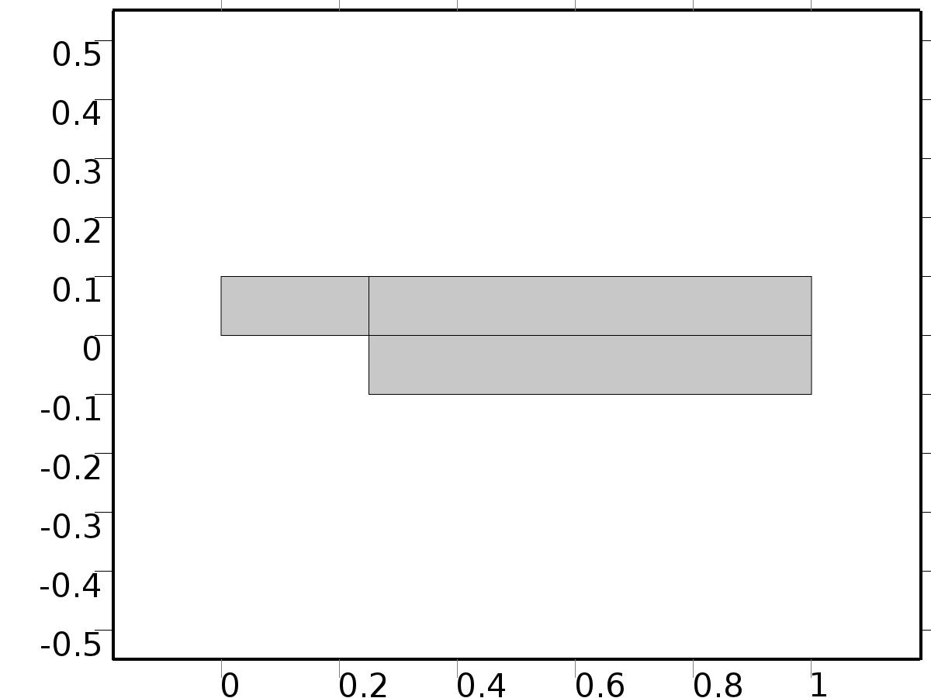

Geometry 1

Units

|  |  |
| --- | --- |
| Length unit | m |
| Angular unit | deg |

Geometry statistics

| **Description** | **Value** |
| --- | --- |
| Space dimension | 2 |
| Number of domains | 3 |
| Number of boundaries | 10 |
| Number of vertices | 8 |

* + 1. Rectangle 1 (r1)

Position

| **Description** | **Value** |
| --- | --- |
| Position | {0, 0} |
| Layers |  |

Size

| **Description** | **Value** |
| --- | --- |
| Width | L |
| Height | D |

* + 1. Rectangle 2 (r2)

Position

| **Description** | **Value** |
| --- | --- |
| Position | {L/4, -D} |
| Layers |  |

Size

| **Description** | **Value** |
| --- | --- |
| Width | L*3/4 |
| Height | 2*D |

* 1. Laminar Flow

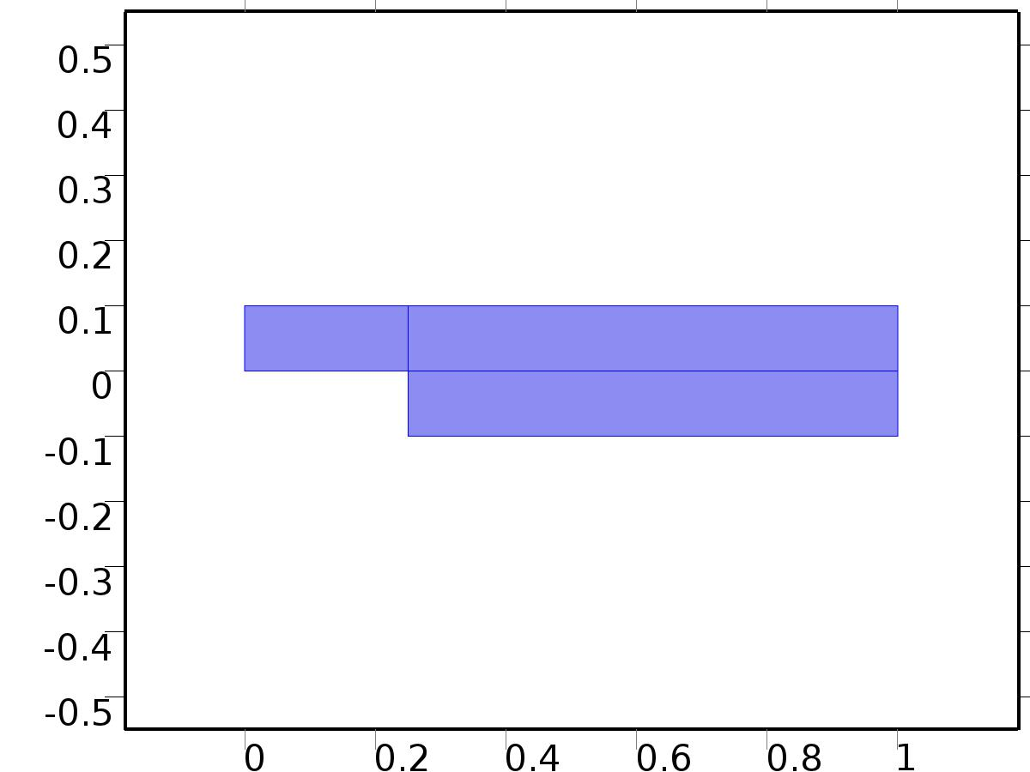

Laminar Flow

Selection

|  |  |
| --- | --- |
| Geometric entity level | Domain |
| Selection | Domains 1–3 |

Equations









Settings

| **Description** | **Value** |
| --- | --- |
| Discretization of fluids | P2 + P1 |
| Value type when using splitting of complex variables | {Real, Real, Real, Real, Real, Real, Real, Real, Real, Real, Real} |
| Isotropic diffusion | Off |
| Compressibility | Incompressible flow |
| Channel thickness | 1 |
| Turbulence model type | None |
| Reference pressure level | 1[atm] |
| Use pseudo time stepping for stationary equation form | Off |
| Local CFL number | 1.3^min(niterCMP, 9) + if(niterCMP>=25, 9*1.3^min(niterCMP - 25, 9), 0) + if(niterCMP>=45, 90*1.3^min(niterCMP - 45, 9), 0) |
| Streamline diffusion | Off |
| Crosswind diffusion | Off |

Used products

|  |
| --- |
| COMSOL Multiphysics |

Variables

| **Name** | **Expression** | **Unit** | **Description** | **Selection** |
| --- | --- | --- | --- | --- |
| X.dz | 1 |  | Thickness | Domains 1–3 |
| X.pref | 1[atm] |  | Reference pressure level | Domains 1–3 |
| X.pA | P+X.pref |  | Absolute pressure | Domains 1–3 |
| X.nx | nx |  | Normal vector, x component | Boundaries 6–7 |
| X.ny | ny |  | Normal vector, y component | Boundaries 6–7 |
| X.nz | 0 |  | Normal vector, z component | Boundaries 6–7 |
| X.nx | dnx |  | Normal vector, x component | Boundaries 1–5, 8–10 |
| X.ny | dny |  | Normal vector, y component | Boundaries 1–5, 8–10 |
| X.nz | 0 |  | Normal vector, z component | Boundaries 1–5, 8–10 |
| X.nxmesh | root.nxmesh |  | Normal vector, x component | Boundaries 6–7 |
| X.nymesh | root.nymesh |  | Normal vector, y component | Boundaries 6–7 |
| X.nzmesh | 0 |  | Normal vector, z component | Boundaries 6–7 |
| X.nxmesh | root.dnxmesh |  | Normal vector, x component | Boundaries 1–5, 8–10 |
| X.nymesh | root.dnymesh |  | Normal vector, y component | Boundaries 1–5, 8–10 |
| X.nzmesh | 0 |  | Normal vector, z component | Boundaries 1–5, 8–10 |

* + 1. Fluid Properties 1



Fluid Properties 1

Selection

|  |  |
| --- | --- |
| Geometric entity level | Domain |
| Selection | Domains 1–3 |

Equations

Settings

| **Description** | **Value** |
| --- | --- |
| Density | User defined |
| Density | 1 |
| Dynamic viscosity | User defined |
| Dynamic viscosity | nu |

#### Variables

| **Name** | **Expression** | **Unit** | **Description** | **Selection** |
| --- | --- | --- | --- | --- |
| X.Fx | 0 |  | Volume force, x component | Domains 1–3 |
| X.Fy | 0 |  | Volume force, y component | Domains 1–3 |
| X.Fz | 0 |  | Volume force, z component | Domains 1–3 |
| X.rho | 1 |  | Density | Domains 1–3 |
| X.mu | nu |  | Dynamic viscosity | Domains 1–3 |
| X.sr | sqrt(0.5*(4*Ux^2+2*(Uy+Vx)^2+4*Vy^2)+eps) |  | Shear rate | Domains 1–3 |
| X.divu | Ux+Vy |  | Divergence of velocity field | Domains 1–3 |
| X.U | sqrt(U^2+V^2) |  | Velocity magnitude | Domains 1–3 |
| X.vorticityx | 0 |  | Vorticity field, x component | Domains 1–3 |
| X.vorticityy | 0 |  | Vorticity field, y component | Domains 1–3 |
| X.vorticityz | Vx-Uy |  | Vorticity field, z component | Domains 1–3 |
| X.vort_magn | sqrt(X.vorticityx^2+X.vorticityy^2+X.vorticityz^2) |  | Vorticity magnitude | Domains 1–3 |
| X.cellRe | 0.25*X.rho*sqrt(emetric(U,V)/emetric2)/X.mu |  | Cell Reynolds number | Domains 1–3 |
| X.nu | X.mu/X.rho |  | Kinematic viscosity | Domains 1–3 |
| X.betaT | 0 |  | Isothermal compressibility coefficient | Domains 1–3 |
| X.mu_eff | X.mu+X.muT |  | Dynamic viscosity | Domains 1–3 |
| X.muT | 0 |  | Turbulent dynamic viscosity | Domains 1–3 |
| X.T_stressx | X.K_stressx-P*X.nxmesh |  | Total stress, x component | Boundaries 1–10 |
| X.T_stressy | X.K_stressy-P*X.nymesh |  | Total stress, y component | Boundaries 1–10 |
| X.T_stressz | X.K_stressz-P*X.nzmesh |  | Total stress, z component | Boundaries 1–10 |
| X.K_stressx | X.mu_eff*(2*Ux*X.nxmesh+(Uy+Vx)*X.nymesh) |  | Viscous stress, x component | Boundaries 1–10 |
| X.K_stressy | X.mu_eff*((Vx+Uy)*X.nxmesh+2*Vy*X.nymesh) |  | Viscous stress, y component | Boundaries 1–10 |
| X.K_stressz | 0 |  | Viscous stress, z component | Boundaries 1–10 |
| X.K_stress_tensorxx | 2*X.mu_eff*Ux |  | Viscous stress tensor, xx component | Domains 1–3 |
| X.K_stress_tensoryx | X.mu_eff*(Vx+Uy) |  | Viscous stress tensor, yx component | Domains 1–3 |
| X.K_stress_tensorzx | 0 |  | Viscous stress tensor, zx component | Domains 1–3 |
| X.K_stress_tensorxy | X.mu_eff*(Uy+Vx) |  | Viscous stress tensor, xy component | Domains 1–3 |
| X.K_stress_tensoryy | 2*X.mu_eff*Vy |  | Viscous stress tensor, yy component | Domains 1–3 |
| X.K_stress_tensorzy | 0 |  | Viscous stress tensor, zy component | Domains 1–3 |
| X.K_stress_tensorxz | 0 |  | Viscous stress tensor, xz component | Domains 1–3 |
| X.K_stress_tensoryz | 0 |  | Viscous stress tensor, yz component | Domains 1–3 |
| X.K_stress_tensorzz | 0 |  | Viscous stress tensor, zz component | Domains 1–3 |
| X.K_stress_tensor_testxx | 2*X.mu_eff*test(Ux) |  | Viscous stress tensor test, xx component | Domains 1–3 |
| X.K_stress_tensor_testyx | X.mu_eff*(test(Vx)+test(Uy)) |  | Viscous stress tensor test, yx component | Domains 1–3 |
| X.K_stress_tensor_testzx | 0 |  | Viscous stress tensor test, zx component | Domains 1–3 |
| X.K_stress_tensor_testxy | X.mu_eff*(test(Uy)+test(Vx)) |  | Viscous stress tensor test, xy component | Domains 1–3 |
| X.K_stress_tensor_testyy | 2*X.mu_eff*test(Vy) |  | Viscous stress tensor test, yy component | Domains 1–3 |
| X.K_stress_tensor_testzy | 0 |  | Viscous stress tensor test, zy component | Domains 1–3 |
| X.K_stress_tensor_testxz | 0 |  | Viscous stress tensor test, xz component | Domains 1–3 |
| X.K_stress_tensor_testyz | 0 |  | Viscous stress tensor test, yz component | Domains 1–3 |
| X.K_stress_tensor_testzz | 0 |  | Viscous stress tensor test, zz component | Domains 1–3 |
| X.upwind_helpx | U |  | Upwind term, x component | Domains 1–3 |
| X.upwind_helpy | V |  | Upwind term, y component | Domains 1–3 |
| X.upwind_helpz | 0 |  | Upwind term, z component | Domains 1–3 |
| X.tau_vdxx | 2*X.mu*Ux |  | Strain rate, xx component | Domains 1–3 |
| X.tau_vdyx | X.mu*(Vx+Uy) |  | Strain rate, yx component | Domains 1–3 |
| X.tau_vdzx | 0 |  | Strain rate, zx component | Domains 1–3 |
| X.tau_vdxy | X.mu*(Uy+Vx) |  | Strain rate, xy component | Domains 1–3 |
| X.tau_vdyy | 2*X.mu*Vy |  | Strain rate, yy component | Domains 1–3 |
| X.tau_vdzy | 0 |  | Strain rate, zy component | Domains 1–3 |
| X.tau_vdxz | 0 |  | Strain rate, xz component | Domains 1–3 |
| X.tau_vdyz | 0 |  | Strain rate, yz component | Domains 1–3 |
| X.tau_vdzz | 0 |  | Strain rate, zz component | Domains 1–3 |
| X.Qvd | X.tau_vdxx*Ux+X.tau_vdxy*Uy+X.tau_vdyx*Vx+X.tau_vdyy*Vy |  | Viscous dissipation | Domains 1–3 |

#### Shape functions

| **Name** | **Shape function** | **Unit** | **Description** | **Shape frame** | **Selection** |
| --- | --- | --- | --- | --- | --- |
| U | Lagrange (Quadratic) |  | Velocity field, x component | Material | Domains 1–3 |
| V | Lagrange (Quadratic) |  | Velocity field, y component | Material | Domains 1–3 |
| P | Lagrange (Linear) |  | Pressure | Material | Domains 1–3 |

#### Weak expressions

| **Weak expression** | **Integration frame** | **Selection** |
| --- | --- | --- |
| (P-X.K_stress_tensorxx)*test(Ux)-X.K_stress_tensorxy*test(Uy)-X.K_stress_tensoryx*test(Vx)+(P-X.K_stress_tensoryy)*test(Vy) | Material | Domains 1–3 |
| X.Fx*test(U)+X.Fy*test(V) | Material | Domains 1–3 |
| X.rho*(-(Ux*U+Uy*V)*test(U)-(Vx*U+Vy*V)*test(V)) | Material | Domains 1–3 |
| -X.rho*X.divu*test(P) | Material | Domains 1–3 |

* + 1. Wall 1

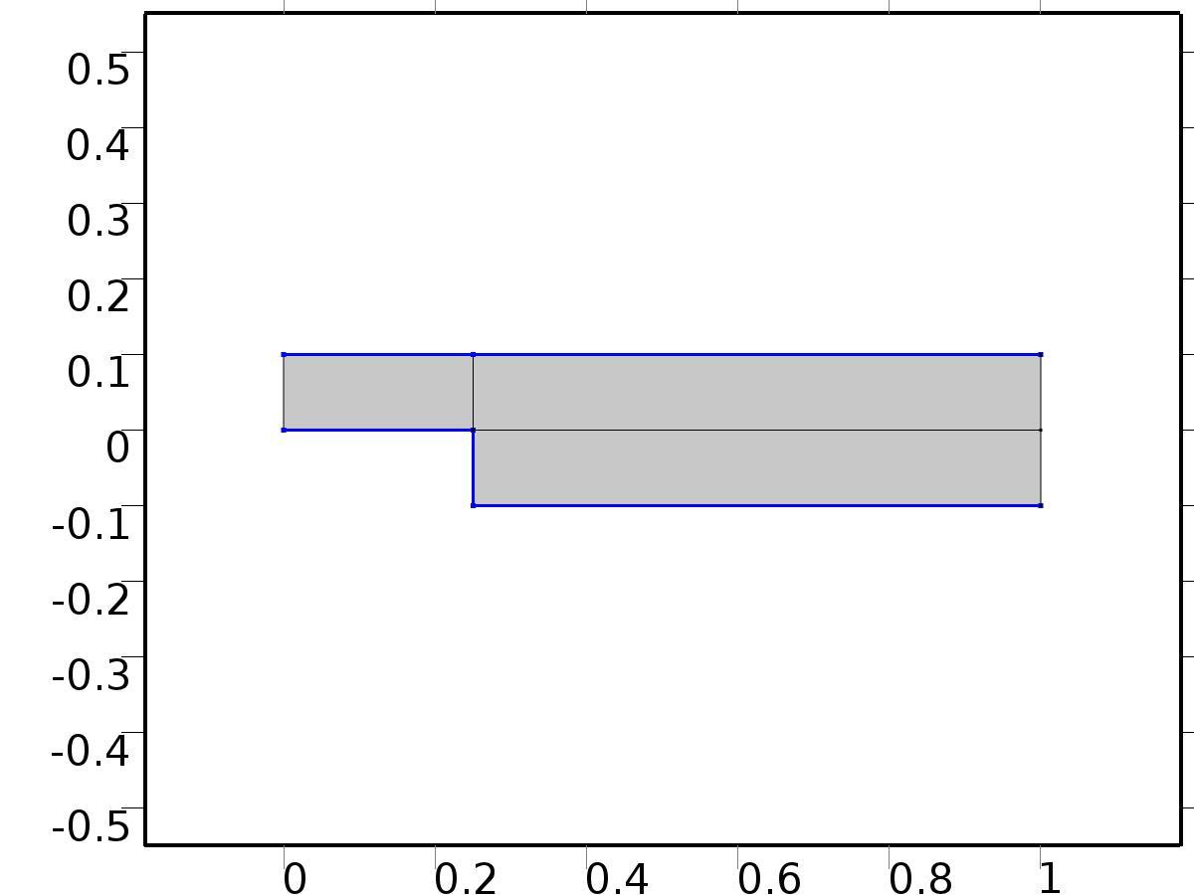

Wall 1

Selection

|  |  |
| --- | --- |
| Geometric entity level | Boundary |
| Selection | Boundaries 2–5, 8 |

Equations

Settings

| **Description** | **Value** |
| --- | --- |
| Boundary condition | No slip |
| Apply reaction terms on | Individual dependent variables |
| Use weak constraints | Off |
| Constraint method | Elemental |

#### Variables

| **Name** | **Expression** | **Unit** | **Description** | **Selection** |
| --- | --- | --- | --- | --- |
| X.ubndx | 0 |  | Velocity at boundary, x component | Boundaries 2–5, 8 |
| X.ubndy | 0 |  | Velocity at boundary, y component | Boundaries 2–5, 8 |
| X.ubndz | 0 |  | Velocity at boundary, z component | Boundaries 2–5, 8 |

#### Shape functions

| **Constraint** | **Constraint force** | **Shape function** | **Selection** |
| --- | --- | --- | --- |
| -U+X.ubndx | test(-U) | Lagrange (Quadratic) | Boundaries 2–5, 8 |
| -V+X.ubndy | test(-V) | Lagrange (Quadratic) | Boundaries 2–5, 8 |
| X.ubndz | 0 |  | Boundaries 2–5, 8 |

* + 1. Initial Values 1



Initial Values 1

Selection

|  |  |
| --- | --- |
| Geometric entity level | Domain |
| Selection | Domains 1–3 |

Settings

| **Description** | **Value** |
| --- | --- |
| Turbulent kinetic energy | spf.kinit |
| Turbulent dissipation rate | spf.epinit |
| Specific dissipation rate | spf.omInit |
| Reciprocal wall distance | spf.G0 |
| Undamped turbulent kinematic viscosity | spf.nutildeinit |
| Velocity field | {0, 0, 0} |
| Pressure | 0 |

* + 1. Inflow Bin=1

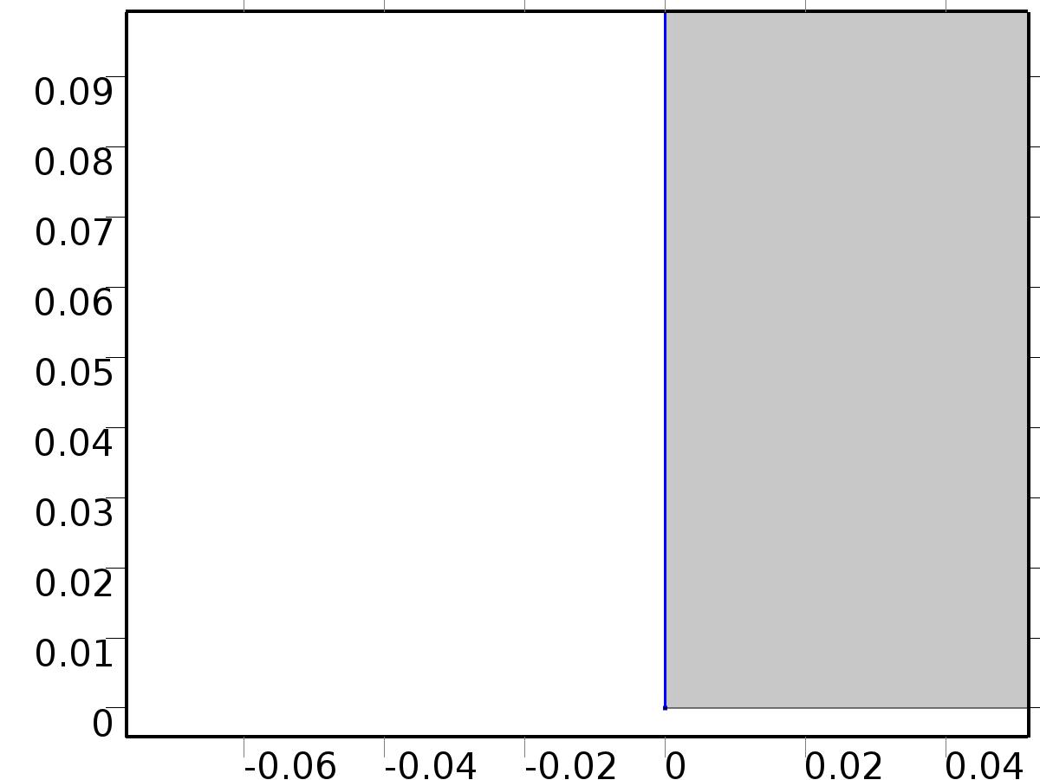

Inflow Bin=1

Selection

|  |  |
| --- | --- |
| Geometric entity level | Boundary |
| Selection | Boundary 1 |

Equations

Settings

| **Description** | **Value** |
| --- | --- |
| Boundary condition | Normal stress |
| Normal stress | 1 |
| Turbulent intensity | 0.005 |
| Turbulence length scale | 0.1[m] |
| Turbulent kinetic energy | 2.5e-3[m^2/s^2] |
| Turbulent dissipation rate | 1.1e-4[m^2/s^3] |
| Specific dissipation rate | 0.5[1/s] |
| Undamped turbulent kinematic viscosity | 3*spf.nu |

#### Variables

| **Name** | **Expression** | **Unit** | **Description** | **Selection** |
| --- | --- | --- | --- | --- |
| X.f0 | 1 |  | Normal stress | Boundary 1 |

#### Weak expressions

| **Weak expression** | **Integration frame** | **Selection** |
| --- | --- | --- |
| -X.f0*(test(U)*X.nxmesh+test(V)*X.nymesh) | Material | Boundary 1 |

* + 1. Outflow

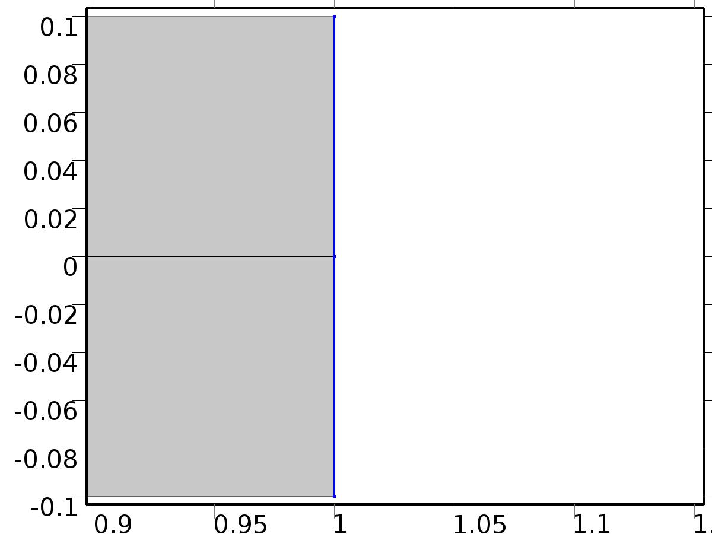

Outflow

Selection

|  |  |
| --- | --- |
| Geometric entity level | Boundary |
| Selection | Boundaries 9–10 |

Equations

Settings

| **Description** | **Value** |
| --- | --- |
| Boundary condition | Normal stress |
| Normal stress | 0 |
| Turbulent intensity | 0.005 |
| Turbulence length scale | 0.1[m] |
| Turbulent kinetic energy | 2.5e-3[m^2/s^2] |
| Turbulent dissipation rate | 1.1e-4[m^2/s^3] |
| Specific dissipation rate | 0.5[1/s] |
| Undamped turbulent kinematic viscosity | 3*spf.nu |

#### Variables

| **Name** | **Expression** | **Unit** | **Description** | **Selection** |
| --- | --- | --- | --- | --- |
| X.f0 | 0 |  | Normal stress | Boundaries 9–10 |

#### Weak expressions

| **Weak expression** | **Integration frame** | **Selection** |
| --- | --- | --- |
| -X.f0*(test(U)*X.nxmesh+test(V)*X.nymesh) | Material | Boundaries 9–10 |

* + 1. Volume Force 1



Volume Force 1

Selection

|  |  |
| --- | --- |
| Geometric entity level | Domain |
| Selection | Domains 1–3 |

Equations

#### Variables

| **Name** | **Expression** | **Unit** | **Description** | **Selection** |
| --- | --- | --- | --- | --- |
| X.Fx | U*Ux+V*Uy |  | Volume force, x component | Domains 1–3 |
| X.Fy | U*Vx+V*Vy |  | Volume force, y component | Domains 1–3 |
| X.Fz | 0 |  | Volume force, z component | Domains 1–3 |

* 1. Laminar Flow 1



Laminar Flow 1

Selection

|  |  |
| --- | --- |
| Geometric entity level | Domain |
| Selection | Domains 1–3 |

Equations









Settings

| **Description** | **Value** |
| --- | --- |
| Discretization of fluids | P2 + P1 |
| Value type when using splitting of complex variables | {Real, Real, Real, Real, Real, Real, Real, Real, Real, Real, Real} |
| Isotropic diffusion | Off |
| Compressibility | Incompressible flow |
| Channel thickness | 1 |
| Turbulence model type | None |
| Reference pressure level | 1[atm] |
| Use pseudo time stepping for stationary equation form | Off |
| Local CFL number | 1.3^min(niterCMP, 9) + if(niterCMP>=25, 9*1.3^min(niterCMP - 25, 9), 0) + if(niterCMP>=45, 90*1.3^min(niterCMP - 45, 9), 0) |
| Streamline diffusion | Off |
| Crosswind diffusion | Off |

Used products

|  |
| --- |
| COMSOL Multiphysics |

Variables

| **Name** | **Expression** | **Unit** | **Description** | **Selection** |
| --- | --- | --- | --- | --- |
| A0.dz | 1 |  | Thickness | Domains 1–3 |
| A0.pref | 1[atm] |  | Reference pressure level | Domains 1–3 |
| A0.pA | ap0+A0.pref |  | Absolute pressure | Domains 1–3 |
| A0.nx | nx |  | Normal vector, x component | Boundaries 6–7 |
| A0.ny | ny |  | Normal vector, y component | Boundaries 6–7 |
| A0.nz | 0 |  | Normal vector, z component | Boundaries 6–7 |
| A0.nx | dnx |  | Normal vector, x component | Boundaries 1–5, 8–10 |
| A0.ny | dny |  | Normal vector, y component | Boundaries 1–5, 8–10 |
| A0.nz | 0 |  | Normal vector, z component | Boundaries 1–5, 8–10 |
| A0.nxmesh | root.nxmesh |  | Normal vector, x component | Boundaries 6–7 |
| A0.nymesh | root.nymesh |  | Normal vector, y component | Boundaries 6–7 |
| A0.nzmesh | 0 |  | Normal vector, z component | Boundaries 6–7 |
| A0.nxmesh | root.dnxmesh |  | Normal vector, x component | Boundaries 1–5, 8–10 |
| A0.nymesh | root.dnymesh |  | Normal vector, y component | Boundaries 1–5, 8–10 |
| A0.nzmesh | 0 |  | Normal vector, z component | Boundaries 1–5, 8–10 |

* + 1. Fluid Properties 1



Fluid Properties 1

Selection

|  |  |
| --- | --- |
| Geometric entity level | Domain |
| Selection | Domains 1–3 |

Equations

Settings

| **Description** | **Value** |
| --- | --- |
| Density | User defined |
| Density | 1 |
| Dynamic viscosity | User defined |
| Dynamic viscosity | nu |

#### Variables

| **Name** | **Expression** | **Unit** | **Description** | **Selection** |
| --- | --- | --- | --- | --- |
| A0.Fx | 0 |  | Volume force, x component | Domains 1–3 |
| A0.Fy | 0 |  | Volume force, y component | Domains 1–3 |
| A0.Fz | 0 |  | Volume force, z component | Domains 1–3 |
| A0.rho | 1 |  | Density | Domains 1–3 |
| A0.mu | nu |  | Dynamic viscosity | Domains 1–3 |
| A0.sr | sqrt(0.5*(4*au0x^2+2*(au0y+av0x)^2+4*av0y^2)+eps) |  | Shear rate | Domains 1–3 |
| A0.divu | au0x+av0y |  | Divergence of velocity field | Domains 1–3 |
| A0.U | sqrt(au0^2+av0^2) |  | Velocity magnitude | Domains 1–3 |
| A0.vorticityx | 0 |  | Vorticity field, x component | Domains 1–3 |
| A0.vorticityy | 0 |  | Vorticity field, y component | Domains 1–3 |
| A0.vorticityz | av0x-au0y |  | Vorticity field, z component | Domains 1–3 |
| A0.vort_magn | sqrt(A0.vorticityx^2+A0.vorticityy^2+A0.vorticityz^2) |  | Vorticity magnitude | Domains 1–3 |
| A0.cellRe | 0.25*A0.rho*sqrt(emetric(au0,av0)/emetric2)/A0.mu |  | Cell Reynolds number | Domains 1–3 |
| A0.nu | A0.mu/A0.rho |  | Kinematic viscosity | Domains 1–3 |
| A0.betaT | 0 |  | Isothermal compressibility coefficient | Domains 1–3 |
| A0.mu_eff | A0.mu+A0.muT |  | Dynamic viscosity | Domains 1–3 |
| A0.muT | 0 |  | Turbulent dynamic viscosity | Domains 1–3 |
| A0.T_stressx | A0.K_stressx-ap0*A0.nxmesh |  | Total stress, x component | Boundaries 1–10 |
| A0.T_stressy | A0.K_stressy-ap0*A0.nymesh |  | Total stress, y component | Boundaries 1–10 |
| A0.T_stressz | A0.K_stressz-ap0*A0.nzmesh |  | Total stress, z component | Boundaries 1–10 |
| A0.K_stressx | A0.mu_eff*(2*au0x*A0.nxmesh+(au0y+av0x)*A0.nymesh) |  | Viscous stress, x component | Boundaries 1–10 |
| A0.K_stressy | A0.mu_eff*((av0x+au0y)*A0.nxmesh+2*av0y*A0.nymesh) |  | Viscous stress, y component | Boundaries 1–10 |
| A0.K_stressz | 0 |  | Viscous stress, z component | Boundaries 1–10 |
| A0.K_stress_tensorxx | 2*A0.mu_eff*au0x |  | Viscous stress tensor, xx component | Domains 1–3 |
| A0.K_stress_tensoryx | A0.mu_eff*(av0x+au0y) |  | Viscous stress tensor, yx component | Domains 1–3 |
| A0.K_stress_tensorzx | 0 |  | Viscous stress tensor, zx component | Domains 1–3 |
| A0.K_stress_tensorxy | A0.mu_eff*(au0y+av0x) |  | Viscous stress tensor, xy component | Domains 1–3 |
| A0.K_stress_tensoryy | 2*A0.mu_eff*av0y |  | Viscous stress tensor, yy component | Domains 1–3 |
| A0.K_stress_tensorzy | 0 |  | Viscous stress tensor, zy component | Domains 1–3 |
| A0.K_stress_tensorxz | 0 |  | Viscous stress tensor, xz component | Domains 1–3 |
| A0.K_stress_tensoryz | 0 |  | Viscous stress tensor, yz component | Domains 1–3 |
| A0.K_stress_tensorzz | 0 |  | Viscous stress tensor, zz component | Domains 1–3 |
| A0.K_stress_tensor_testxx | 2*A0.mu_eff*test(au0x) |  | Viscous stress tensor test, xx component | Domains 1–3 |
| A0.K_stress_tensor_testyx | A0.mu_eff*(test(av0x)+test(au0y)) |  | Viscous stress tensor test, yx component | Domains 1–3 |
| A0.K_stress_tensor_testzx | 0 |  | Viscous stress tensor test, zx component | Domains 1–3 |
| A0.K_stress_tensor_testxy | A0.mu_eff*(test(au0y)+test(av0x)) |  | Viscous stress tensor test, xy component | Domains 1–3 |
| A0.K_stress_tensor_testyy | 2*A0.mu_eff*test(av0y) |  | Viscous stress tensor test, yy component | Domains 1–3 |
| A0.K_stress_tensor_testzy | 0 |  | Viscous stress tensor test, zy component | Domains 1–3 |
| A0.K_stress_tensor_testxz | 0 |  | Viscous stress tensor test, xz component | Domains 1–3 |
| A0.K_stress_tensor_testyz | 0 |  | Viscous stress tensor test, yz component | Domains 1–3 |
| A0.K_stress_tensor_testzz | 0 |  | Viscous stress tensor test, zz component | Domains 1–3 |
| A0.upwind_helpx | au0 |  | Upwind term, x component | Domains 1–3 |
| A0.upwind_helpy | av0 |  | Upwind term, y component | Domains 1–3 |
| A0.upwind_helpz | 0 |  | Upwind term, z component | Domains 1–3 |
| A0.tau_vdxx | 2*A0.mu*au0x |  | Strain rate, xx component | Domains 1–3 |
| A0.tau_vdyx | A0.mu*(av0x+au0y) |  | Strain rate, yx component | Domains 1–3 |
| A0.tau_vdzx | 0 |  | Strain rate, zx component | Domains 1–3 |
| A0.tau_vdxy | A0.mu*(au0y+av0x) |  | Strain rate, xy component | Domains 1–3 |
| A0.tau_vdyy | 2*A0.mu*av0y |  | Strain rate, yy component | Domains 1–3 |
| A0.tau_vdzy | 0 |  | Strain rate, zy component | Domains 1–3 |
| A0.tau_vdxz | 0 |  | Strain rate, xz component | Domains 1–3 |
| A0.tau_vdyz | 0 |  | Strain rate, yz component | Domains 1–3 |
| A0.tau_vdzz | 0 |  | Strain rate, zz component | Domains 1–3 |
| A0.Qvd | A0.tau_vdxx*au0x+A0.tau_vdxy*au0y+A0.tau_vdyx*av0x+A0.tau_vdyy*av0y |  | Viscous dissipation | Domains 1–3 |

#### Shape functions

| **Name** | **Shape function** | **Unit** | **Description** | **Shape frame** | **Selection** |
| --- | --- | --- | --- | --- | --- |
| au0 | Lagrange (Quadratic) |  | Velocity field, x component | Material | Domains 1–3 |
| av0 | Lagrange (Quadratic) |  | Velocity field, y component | Material | Domains 1–3 |
| ap0 | Lagrange (Linear) |  | Pressure | Material | Domains 1–3 |

#### Weak expressions

| **Weak expression** | **Integration frame** | **Selection** |
| --- | --- | --- |
| (ap0-A0.K_stress_tensorxx)*test(au0x)-A0.K_stress_tensorxy*test(au0y)-A0.K_stress_tensoryx*test(av0x)+(ap0-A0.K_stress_tensoryy)*test(av0y) | Material | Domains 1–3 |
| A0.Fx*test(au0)+A0.Fy*test(av0) | Material | Domains 1–3 |
| A0.rho*(-(au0x*au0+au0y*av0)*test(au0)-(av0x*au0+av0y*av0)*test(av0)) | Material | Domains 1–3 |
| -A0.rho*A0.divu*test(ap0) | Material | Domains 1–3 |

* + 1. Wall 1



Wall 1

Selection

|  |  |
| --- | --- |
| Geometric entity level | Boundary |
| Selection | Boundaries 2–5, 8 |

Equations

Settings

| **Description** | **Value** |
| --- | --- |
| Boundary condition | No slip |
| Apply reaction terms on | Individual dependent variables |
| Use weak constraints | Off |
| Constraint method | Elemental |

#### Variables

| **Name** | **Expression** | **Unit** | **Description** | **Selection** |
| --- | --- | --- | --- | --- |
| A0.ubndx | 0 |  | Velocity at boundary, x component | Boundaries 2–5, 8 |
| A0.ubndy | 0 |  | Velocity at boundary, y component | Boundaries 2–5, 8 |
| A0.ubndz | 0 |  | Velocity at boundary, z component | Boundaries 2–5, 8 |

#### Shape functions

| **Constraint** | **Constraint force** | **Shape function** | **Selection** |
| --- | --- | --- | --- |
| -au0+A0.ubndx | test(-au0) | Lagrange (Quadratic) | Boundaries 2–5, 8 |
| -av0+A0.ubndy | test(-av0) | Lagrange (Quadratic) | Boundaries 2–5, 8 |
| A0.ubndz | 0 |  | Boundaries 2–5, 8 |

* + 1. Initial Values 1



Initial Values 1

Selection

|  |  |
| --- | --- |
| Geometric entity level | Domain |
| Selection | Domains 1–3 |

Settings

| **Description** | **Value** |
| --- | --- |
| Turbulent kinetic energy | spf.kinit |
| Turbulent dissipation rate | spf.epinit |
| Specific dissipation rate | spf.omInit |
| Reciprocal wall distance | spf.G0 |
| Undamped turbulent kinematic viscosity | spf.nutildeinit |
| Velocity field | {0, 0, 0} |
| Pressure | 0 |

* + 1. Inflow Bin*Gamma_a0



Inflow Bin*Gamma_a0

Selection

|  |  |
| --- | --- |
| Geometric entity level | Boundary |
| Selection | Boundary 1 |

Equations

Settings

| **Description** | **Value** |
| --- | --- |
| Boundary condition | Normal stress |
| Normal stress | Gamma_a0 |
| Turbulent intensity | 0.005 |
| Turbulence length scale | 0.1[m] |
| Turbulent kinetic energy | 2.5e-3[m^2/s^2] |
| Turbulent dissipation rate | 1.1e-4[m^2/s^3] |
| Specific dissipation rate | 0.5[1/s] |

#### Variables

| **Name** | **Expression** | **Unit** | **Description** | **Selection** |
| --- | --- | --- | --- | --- |
| A0.f0 | Gamma_a0 |  | Normal stress | Boundary 1 |

#### Weak expressions

| **Weak expression** | **Integration frame** | **Selection** |
| --- | --- | --- |
| -A0.f0*(test(au0)*A0.nxmesh+test(av0)*A0.nymesh) | Material | Boundary 1 |

* + 1. Outflow



Outflow

Selection

|  |  |
| --- | --- |
| Geometric entity level | Boundary |
| Selection | Boundaries 9–10 |

Equations

Settings

| **Description** | **Value** |
| --- | --- |
| Boundary condition | Normal stress |
| Normal stress | 0 |
| Turbulent intensity | 0.005 |
| Turbulence length scale | 0.1[m] |
| Turbulent kinetic energy | 2.5e-3[m^2/s^2] |
| Turbulent dissipation rate | 1.1e-4[m^2/s^3] |
| Specific dissipation rate | 0.5[1/s] |

#### Variables

| **Name** | **Expression** | **Unit** | **Description** | **Selection** |
| --- | --- | --- | --- | --- |
| A0.f0 | 0 |  | Normal stress | Boundaries 9–10 |

#### Weak expressions

| **Weak expression** | **Integration frame** | **Selection** |
| --- | --- | --- |
| -A0.f0*(test(au0)*A0.nxmesh+test(av0)*A0.nymesh) | Material | Boundaries 9–10 |

* + 1. Volume Force 1



Volume Force 1

Selection

|  |  |
| --- | --- |
| Geometric entity level | Domain |
| Selection | Domains 1–3 |

Equations

#### Variables

| **Name** | **Expression** | **Unit** | **Description** | **Selection** |
| --- | --- | --- | --- | --- |
| A0.Fx | f_au0 |  | Volume force, x component | Domains 1–3 |
| A0.Fy | f_av0 |  | Volume force, y component | Domains 1–3 |
| A0.Fz | 0 |  | Volume force, z component | Domains 1–3 |

* 1. Laminar Flow 2



Laminar Flow 2

Selection

|  |  |
| --- | --- |
| Geometric entity level | Domain |
| Selection | Domains 1–3 |

Equations









Settings

| **Description** | **Value** |
| --- | --- |
| Discretization of fluids | P2 + P1 |
| Value type when using splitting of complex variables | {Real, Real, Real, Real, Real, Real, Real, Real, Real, Real, Real} |
| Isotropic diffusion | Off |
| Compressibility | Incompressible flow |
| Channel thickness | 1 |
| Turbulence model type | None |
| Reference pressure level | 1[atm] |
| Use pseudo time stepping for stationary equation form | Off |
| Local CFL number | 1.3^min(niterCMP, 9) + if(niterCMP>=25, 9*1.3^min(niterCMP - 25, 9), 0) + if(niterCMP>=45, 90*1.3^min(niterCMP - 45, 9), 0) |
| Streamline diffusion | Off |
| Crosswind diffusion | Off |

Used products

|  |
| --- |
| COMSOL Multiphysics |

Variables

| **Name** | **Expression** | **Unit** | **Description** | **Selection** |
| --- | --- | --- | --- | --- |
| At0.dz | 1 |  | Thickness | Domains 1–3 |
| At0.pref | 1[atm] |  | Reference pressure level | Domains 1–3 |
| At0.pA | atp0+At0.pref |  | Absolute pressure | Domains 1–3 |
| At0.nx | nx |  | Normal vector, x component | Boundaries 6–7 |
| At0.ny | ny |  | Normal vector, y component | Boundaries 6–7 |
| At0.nz | 0 |  | Normal vector, z component | Boundaries 6–7 |
| At0.nx | dnx |  | Normal vector, x component | Boundaries 1–5, 8–10 |
| At0.ny | dny |  | Normal vector, y component | Boundaries 1–5, 8–10 |
| At0.nz | 0 |  | Normal vector, z component | Boundaries 1–5, 8–10 |
| At0.nxmesh | root.nxmesh |  | Normal vector, x component | Boundaries 6–7 |
| At0.nymesh | root.nymesh |  | Normal vector, y component | Boundaries 6–7 |
| At0.nzmesh | 0 |  | Normal vector, z component | Boundaries 6–7 |
| At0.nxmesh | root.dnxmesh |  | Normal vector, x component | Boundaries 1–5, 8–10 |
| At0.nymesh | root.dnymesh |  | Normal vector, y component | Boundaries 1–5, 8–10 |
| At0.nzmesh | 0 |  | Normal vector, z component | Boundaries 1–5, 8–10 |

* + 1. Fluid Properties 1



Fluid Properties 1

Selection

|  |  |
| --- | --- |
| Geometric entity level | Domain |
| Selection | Domains 1–3 |

Equations

Settings

| **Description** | **Value** |
| --- | --- |
| Density | User defined |
| Density | 1 |
| Dynamic viscosity | User defined |
| Dynamic viscosity | nu |

#### Variables

| **Name** | **Expression** | **Unit** | **Description** | **Selection** |
| --- | --- | --- | --- | --- |
| At0.Fx | 0 |  | Volume force, x component | Domains 1–3 |
| At0.Fy | 0 |  | Volume force, y component | Domains 1–3 |
| At0.Fz | 0 |  | Volume force, z component | Domains 1–3 |
| At0.rho | 1 |  | Density | Domains 1–3 |
| At0.mu | nu |  | Dynamic viscosity | Domains 1–3 |
| At0.sr | sqrt(0.5*(4*atu0x^2+2*(atu0y+atv0x)^2+4*atv0y^2)+eps) |  | Shear rate | Domains 1–3 |
| At0.divu | atu0x+atv0y |  | Divergence of velocity field | Domains 1–3 |
| At0.U | sqrt(atu0^2+atv0^2) |  | Velocity magnitude | Domains 1–3 |
| At0.vorticityx | 0 |  | Vorticity field, x component | Domains 1–3 |
| At0.vorticityy | 0 |  | Vorticity field, y component | Domains 1–3 |
| At0.vorticityz | atv0x-atu0y |  | Vorticity field, z component | Domains 1–3 |
| At0.vort_magn | sqrt(At0.vorticityx^2+At0.vorticityy^2+At0.vorticityz^2) |  | Vorticity magnitude | Domains 1–3 |
| At0.cellRe | 0.25*At0.rho*sqrt(emetric(atu0,atv0)/emetric2)/At0.mu |  | Cell Reynolds number | Domains 1–3 |
| At0.nu | At0.mu/At0.rho |  | Kinematic viscosity | Domains 1–3 |
| At0.betaT | 0 |  | Isothermal compressibility coefficient | Domains 1–3 |
| At0.mu_eff | At0.mu+At0.muT |  | Dynamic viscosity | Domains 1–3 |
| At0.muT | 0 |  | Turbulent dynamic viscosity | Domains 1–3 |
| At0.T_stressx | At0.K_stressx-atp0*At0.nxmesh |  | Total stress, x component | Boundaries 1–10 |
| At0.T_stressy | At0.K_stressy-atp0*At0.nymesh |  | Total stress, y component | Boundaries 1–10 |
| At0.T_stressz | At0.K_stressz-atp0*At0.nzmesh |  | Total stress, z component | Boundaries 1–10 |
| At0.K_stressx | At0.mu_eff*(2*atu0x*At0.nxmesh+(atu0y+atv0x)*At0.nymesh) |  | Viscous stress, x component | Boundaries 1–10 |
| At0.K_stressy | At0.mu_eff*((atv0x+atu0y)*At0.nxmesh+2*atv0y*At0.nymesh) |  | Viscous stress, y component | Boundaries 1–10 |
| At0.K_stressz | 0 |  | Viscous stress, z component | Boundaries 1–10 |
| At0.K_stress_tensorxx | 2*At0.mu_eff*atu0x |  | Viscous stress tensor, xx component | Domains 1–3 |
| At0.K_stress_tensoryx | At0.mu_eff*(atv0x+atu0y) |  | Viscous stress tensor, yx component | Domains 1–3 |
| At0.K_stress_tensorzx | 0 |  | Viscous stress tensor, zx component | Domains 1–3 |
| At0.K_stress_tensorxy | At0.mu_eff*(atu0y+atv0x) |  | Viscous stress tensor, xy component | Domains 1–3 |
| At0.K_stress_tensoryy | 2*At0.mu_eff*atv0y |  | Viscous stress tensor, yy component | Domains 1–3 |
| At0.K_stress_tensorzy | 0 |  | Viscous stress tensor, zy component | Domains 1–3 |
| At0.K_stress_tensorxz | 0 |  | Viscous stress tensor, xz component | Domains 1–3 |
| At0.K_stress_tensoryz | 0 |  | Viscous stress tensor, yz component | Domains 1–3 |
| At0.K_stress_tensorzz | 0 |  | Viscous stress tensor, zz component | Domains 1–3 |
| At0.K_stress_tensor_testxx | 2*At0.mu_eff*test(atu0x) |  | Viscous stress tensor test, xx component | Domains 1–3 |
| At0.K_stress_tensor_testyx | At0.mu_eff*(test(atv0x)+test(atu0y)) |  | Viscous stress tensor test, yx component | Domains 1–3 |
| At0.K_stress_tensor_testzx | 0 |  | Viscous stress tensor test, zx component | Domains 1–3 |
| At0.K_stress_tensor_testxy | At0.mu_eff*(test(atu0y)+test(atv0x)) |  | Viscous stress tensor test, xy component | Domains 1–3 |
| At0.K_stress_tensor_testyy | 2*At0.mu_eff*test(atv0y) |  | Viscous stress tensor test, yy component | Domains 1–3 |
| At0.K_stress_tensor_testzy | 0 |  | Viscous stress tensor test, zy component | Domains 1–3 |
| At0.K_stress_tensor_testxz | 0 |  | Viscous stress tensor test, xz component | Domains 1–3 |
| At0.K_stress_tensor_testyz | 0 |  | Viscous stress tensor test, yz component | Domains 1–3 |
| At0.K_stress_tensor_testzz | 0 |  | Viscous stress tensor test, zz component | Domains 1–3 |
| At0.upwind_helpx | atu0 |  | Upwind term, x component | Domains 1–3 |
| At0.upwind_helpy | atv0 |  | Upwind term, y component | Domains 1–3 |
| At0.upwind_helpz | 0 |  | Upwind term, z component | Domains 1–3 |
| At0.tau_vdxx | 2*At0.mu*atu0x |  | Strain rate, xx component | Domains 1–3 |
| At0.tau_vdyx | At0.mu*(atv0x+atu0y) |  | Strain rate, yx component | Domains 1–3 |
| At0.tau_vdzx | 0 |  | Strain rate, zx component | Domains 1–3 |
| At0.tau_vdxy | At0.mu*(atu0y+atv0x) |  | Strain rate, xy component | Domains 1–3 |
| At0.tau_vdyy | 2*At0.mu*atv0y |  | Strain rate, yy component | Domains 1–3 |
| At0.tau_vdzy | 0 |  | Strain rate, zy component | Domains 1–3 |
| At0.tau_vdxz | 0 |  | Strain rate, xz component | Domains 1–3 |
| At0.tau_vdyz | 0 |  | Strain rate, yz component | Domains 1–3 |
| At0.tau_vdzz | 0 |  | Strain rate, zz component | Domains 1–3 |
| At0.Qvd | At0.tau_vdxx*atu0x+At0.tau_vdxy*atu0y+At0.tau_vdyx*atv0x+At0.tau_vdyy*atv0y |  | Viscous dissipation | Domains 1–3 |

#### Shape functions

| **Name** | **Shape function** | **Unit** | **Description** | **Shape frame** | **Selection** |
| --- | --- | --- | --- | --- | --- |
| atu0 | Lagrange (Quadratic) |  | Velocity field, x component | Material | Domains 1–3 |
| atv0 | Lagrange (Quadratic) |  | Velocity field, y component | Material | Domains 1–3 |
| atp0 | Lagrange (Linear) |  | Pressure | Material | Domains 1–3 |

#### Weak expressions

| **Weak expression** | **Integration frame** | **Selection** |
| --- | --- | --- |
| (atp0-At0.K_stress_tensorxx)*test(atu0x)-At0.K_stress_tensorxy*test(atu0y)-At0.K_stress_tensoryx*test(atv0x)+(atp0-At0.K_stress_tensoryy)*test(atv0y) | Material | Domains 1–3 |
| At0.Fx*test(atu0)+At0.Fy*test(atv0) | Material | Domains 1–3 |
| At0.rho*(-(atu0x*atu0+atu0y*atv0)*test(atu0)-(atv0x*atu0+atv0y*atv0)*test(atv0)) | Material | Domains 1–3 |
| -At0.rho*At0.divu*test(atp0) | Material | Domains 1–3 |

* + 1. Wall 1



Wall 1

Selection

|  |  |
| --- | --- |
| Geometric entity level | Boundary |
| Selection | Boundaries 2–5, 8 |

Equations

Settings

| **Description** | **Value** |
| --- | --- |
| Boundary condition | No slip |
| Apply reaction terms on | Individual dependent variables |
| Use weak constraints | Off |
| Constraint method | Elemental |

#### Variables

| **Name** | **Expression** | **Unit** | **Description** | **Selection** |
| --- | --- | --- | --- | --- |
| At0.ubndx | 0 |  | Velocity at boundary, x component | Boundaries 2–5, 8 |
| At0.ubndy | 0 |  | Velocity at boundary, y component | Boundaries 2–5, 8 |
| At0.ubndz | 0 |  | Velocity at boundary, z component | Boundaries 2–5, 8 |

#### Shape functions

| **Constraint** | **Constraint force** | **Shape function** | **Selection** |
| --- | --- | --- | --- |
| -atu0+At0.ubndx | test(-atu0) | Lagrange (Quadratic) | Boundaries 2–5, 8 |
| -atv0+At0.ubndy | test(-atv0) | Lagrange (Quadratic) | Boundaries 2–5, 8 |
| At0.ubndz | 0 |  | Boundaries 2–5, 8 |

* + 1. Initial Values 1



Initial Values 1

Selection

|  |  |
| --- | --- |
| Geometric entity level | Domain |
| Selection | Domains 1–3 |

Settings

| **Description** | **Value** |
| --- | --- |
| Turbulent kinetic energy | spf.kinit |
| Turbulent dissipation rate | spf.epinit |
| Specific dissipation rate | spf.omInit |
| Reciprocal wall distance | spf.G0 |
| Undamped turbulent kinematic viscosity | spf.nutildeinit |
| Velocity field | {0, 0, 0} |
| Pressure | 0 |

* + 1. Inflow



Inflow

Selection

|  |  |
| --- | --- |
| Geometric entity level | Boundary |
| Selection | Boundary 1 |

Equations

Settings

| **Description** | **Value** |
| --- | --- |
| Boundary condition | Normal stress |
| Normal stress | 0 |
| Turbulent intensity | 0.005 |
| Turbulence length scale | 0.1[m] |
| Turbulent kinetic energy | 2.5e-3[m^2/s^2] |
| Turbulent dissipation rate | 1.1e-4[m^2/s^3] |
| Specific dissipation rate | 0.5[1/s] |

#### Variables

| **Name** | **Expression** | **Unit** | **Description** | **Selection** |
| --- | --- | --- | --- | --- |
| At0.f0 | 0 |  | Normal stress | Boundary 1 |

#### Weak expressions

| **Weak expression** | **Integration frame** | **Selection** |
| --- | --- | --- |
| -At0.f0*(test(atu0)*At0.nxmesh+test(atv0)*At0.nymesh) | Material | Boundary 1 |

* + 1. Outflow



Outflow

Selection

|  |  |
| --- | --- |
| Geometric entity level | Boundary |
| Selection | Boundaries 9–10 |

Equations

Settings

| **Description** | **Value** |
| --- | --- |
| Boundary condition | Normal stress |
| Normal stress | 0 |
| Turbulent intensity | 0.005 |
| Turbulence length scale | 0.1[m] |
| Turbulent kinetic energy | 2.5e-3[m^2/s^2] |
| Turbulent dissipation rate | 1.1e-4[m^2/s^3] |
| Specific dissipation rate | 0.5[1/s] |

#### Variables

| **Name** | **Expression** | **Unit** | **Description** | **Selection** |
| --- | --- | --- | --- | --- |
| At0.f0 | 0 |  | Normal stress | Boundaries 9–10 |

#### Weak expressions

| **Weak expression** | **Integration frame** | **Selection** |
| --- | --- | --- |
| -At0.f0*(test(atu0)*At0.nxmesh+test(atv0)*At0.nymesh) | Material | Boundaries 9–10 |

* + 1. Volume Force 1



Volume Force 1

Selection

|  |  |
| --- | --- |
| Geometric entity level | Domain |
| Selection | Domains 1–3 |

Equations

#### Variables

| **Name** | **Expression** | **Unit** | **Description** | **Selection** |
| --- | --- | --- | --- | --- |
| At0.Fx | f_atu0 |  | Volume force, x component | Domains 1–3 |
| At0.Fy | f_atv0 |  | Volume force, y component | Domains 1–3 |
| At0.Fz | 0 |  | Volume force, z component | Domains 1–3 |

* 1. Laminar Flow 3



Laminar Flow 3

Selection

|  |  |
| --- | --- |
| Geometric entity level | Domain |
| Selection | Domains 1–3 |

Equations









Settings

| **Description** | **Value** |
| --- | --- |
| Discretization of fluids | P2 + P1 |
| Value type when using splitting of complex variables | {Real, Real, Real, Real, Real, Real, Real, Real, Real, Real, Real} |
| Isotropic diffusion | Off |
| Compressibility | Incompressible flow |
| Channel thickness | 1 |
| Turbulence model type | None |
| Reference pressure level | 1[atm] |
| Use pseudo time stepping for stationary equation form | Off |
| Local CFL number | 1.3^min(niterCMP, 9) + if(niterCMP>=25, 9*1.3^min(niterCMP - 25, 9), 0) + if(niterCMP>=45, 90*1.3^min(niterCMP - 45, 9), 0) |
| Streamline diffusion | Off |
| Crosswind diffusion | Off |

Used products

|  |
| --- |
| COMSOL Multiphysics |

Variables

| **Name** | **Expression** | **Unit** | **Description** | **Selection** |
| --- | --- | --- | --- | --- |
| A1.dz | 1 |  | Thickness | Domains 1–3 |
| A1.pref | 1[atm] |  | Reference pressure level | Domains 1–3 |
| A1.pA | ap1+A1.pref |  | Absolute pressure | Domains 1–3 |
| A1.nx | nx |  | Normal vector, x component | Boundaries 6–7 |
| A1.ny | ny |  | Normal vector, y component | Boundaries 6–7 |
| A1.nz | 0 |  | Normal vector, z component | Boundaries 6–7 |
| A1.nx | dnx |  | Normal vector, x component | Boundaries 1–5, 8–10 |
| A1.ny | dny |  | Normal vector, y component | Boundaries 1–5, 8–10 |
| A1.nz | 0 |  | Normal vector, z component | Boundaries 1–5, 8–10 |
| A1.nxmesh | root.nxmesh |  | Normal vector, x component | Boundaries 6–7 |
| A1.nymesh | root.nymesh |  | Normal vector, y component | Boundaries 6–7 |
| A1.nzmesh | 0 |  | Normal vector, z component | Boundaries 6–7 |
| A1.nxmesh | root.dnxmesh |  | Normal vector, x component | Boundaries 1–5, 8–10 |
| A1.nymesh | root.dnymesh |  | Normal vector, y component | Boundaries 1–5, 8–10 |
| A1.nzmesh | 0 |  | Normal vector, z component | Boundaries 1–5, 8–10 |

* + 1. Fluid Properties 1



Fluid Properties 1

Selection

|  |  |
| --- | --- |
| Geometric entity level | Domain |
| Selection | Domains 1–3 |

Equations

Settings

| **Description** | **Value** |
| --- | --- |
| Density | User defined |
| Density | 1 |
| Dynamic viscosity | User defined |
| Dynamic viscosity | nu |

#### Variables

| **Name** | **Expression** | **Unit** | **Description** | **Selection** |
| --- | --- | --- | --- | --- |
| A1.Fx | 0 |  | Volume force, x component | Domains 1–3 |
| A1.Fy | 0 |  | Volume force, y component | Domains 1–3 |
| A1.Fz | 0 |  | Volume force, z component | Domains 1–3 |
| A1.rho | 1 |  | Density | Domains 1–3 |
| A1.mu | nu |  | Dynamic viscosity | Domains 1–3 |
| A1.sr | sqrt(0.5*(4*au1x^2+2*(au1y+av1x)^2+4*av1y^2)+eps) |  | Shear rate | Domains 1–3 |
| A1.divu | au1x+av1y |  | Divergence of velocity field | Domains 1–3 |
| A1.U | sqrt(au1^2+av1^2) |  | Velocity magnitude | Domains 1–3 |
| A1.vorticityx | 0 |  | Vorticity field, x component | Domains 1–3 |
| A1.vorticityy | 0 |  | Vorticity field, y component | Domains 1–3 |
| A1.vorticityz | av1x-au1y |  | Vorticity field, z component | Domains 1–3 |
| A1.vort_magn | sqrt(A1.vorticityx^2+A1.vorticityy^2+A1.vorticityz^2) |  | Vorticity magnitude | Domains 1–3 |
| A1.cellRe | 0.25*A1.rho*sqrt(emetric(au1,av1)/emetric2)/A1.mu |  | Cell Reynolds number | Domains 1–3 |
| A1.nu | A1.mu/A1.rho |  | Kinematic viscosity | Domains 1–3 |
| A1.betaT | 0 |  | Isothermal compressibility coefficient | Domains 1–3 |
| A1.mu_eff | A1.mu+A1.muT |  | Dynamic viscosity | Domains 1–3 |
| A1.muT | 0 |  | Turbulent dynamic viscosity | Domains 1–3 |
| A1.T_stressx | A1.K_stressx-ap1*A1.nxmesh |  | Total stress, x component | Boundaries 1–10 |
| A1.T_stressy | A1.K_stressy-ap1*A1.nymesh |  | Total stress, y component | Boundaries 1–10 |
| A1.T_stressz | A1.K_stressz-ap1*A1.nzmesh |  | Total stress, z component | Boundaries 1–10 |
| A1.K_stressx | A1.mu_eff*(2*au1x*A1.nxmesh+(au1y+av1x)*A1.nymesh) |  | Viscous stress, x component | Boundaries 1–10 |
| A1.K_stressy | A1.mu_eff*((av1x+au1y)*A1.nxmesh+2*av1y*A1.nymesh) |  | Viscous stress, y component | Boundaries 1–10 |
| A1.K_stressz | 0 |  | Viscous stress, z component | Boundaries 1–10 |
| A1.K_stress_tensorxx | 2*A1.mu_eff*au1x |  | Viscous stress tensor, xx component | Domains 1–3 |
| A1.K_stress_tensoryx | A1.mu_eff*(av1x+au1y) |  | Viscous stress tensor, yx component | Domains 1–3 |
| A1.K_stress_tensorzx | 0 |  | Viscous stress tensor, zx component | Domains 1–3 |
| A1.K_stress_tensorxy | A1.mu_eff*(au1y+av1x) |  | Viscous stress tensor, xy component | Domains 1–3 |
| A1.K_stress_tensoryy | 2*A1.mu_eff*av1y |  | Viscous stress tensor, yy component | Domains 1–3 |
| A1.K_stress_tensorzy | 0 |  | Viscous stress tensor, zy component | Domains 1–3 |
| A1.K_stress_tensorxz | 0 |  | Viscous stress tensor, xz component | Domains 1–3 |
| A1.K_stress_tensoryz | 0 |  | Viscous stress tensor, yz component | Domains 1–3 |
| A1.K_stress_tensorzz | 0 |  | Viscous stress tensor, zz component | Domains 1–3 |
| A1.K_stress_tensor_testxx | 2*A1.mu_eff*test(au1x) |  | Viscous stress tensor test, xx component | Domains 1–3 |
| A1.K_stress_tensor_testyx | A1.mu_eff*(test(av1x)+test(au1y)) |  | Viscous stress tensor test, yx component | Domains 1–3 |
| A1.K_stress_tensor_testzx | 0 |  | Viscous stress tensor test, zx component | Domains 1–3 |
| A1.K_stress_tensor_testxy | A1.mu_eff*(test(au1y)+test(av1x)) |  | Viscous stress tensor test, xy component | Domains 1–3 |
| A1.K_stress_tensor_testyy | 2*A1.mu_eff*test(av1y) |  | Viscous stress tensor test, yy component | Domains 1–3 |
| A1.K_stress_tensor_testzy | 0 |  | Viscous stress tensor test, zy component | Domains 1–3 |
| A1.K_stress_tensor_testxz | 0 |  | Viscous stress tensor test, xz component | Domains 1–3 |
| A1.K_stress_tensor_testyz | 0 |  | Viscous stress tensor test, yz component | Domains 1–3 |
| A1.K_stress_tensor_testzz | 0 |  | Viscous stress tensor test, zz component | Domains 1–3 |
| A1.upwind_helpx | au1 |  | Upwind term, x component | Domains 1–3 |
| A1.upwind_helpy | av1 |  | Upwind term, y component | Domains 1–3 |
| A1.upwind_helpz | 0 |  | Upwind term, z component | Domains 1–3 |
| A1.tau_vdxx | 2*A1.mu*au1x |  | Strain rate, xx component | Domains 1–3 |
| A1.tau_vdyx | A1.mu*(av1x+au1y) |  | Strain rate, yx component | Domains 1–3 |
| A1.tau_vdzx | 0 |  | Strain rate, zx component | Domains 1–3 |
| A1.tau_vdxy | A1.mu*(au1y+av1x) |  | Strain rate, xy component | Domains 1–3 |
| A1.tau_vdyy | 2*A1.mu*av1y |  | Strain rate, yy component | Domains 1–3 |
| A1.tau_vdzy | 0 |  | Strain rate, zy component | Domains 1–3 |
| A1.tau_vdxz | 0 |  | Strain rate, xz component | Domains 1–3 |
| A1.tau_vdyz | 0 |  | Strain rate, yz component | Domains 1–3 |
| A1.tau_vdzz | 0 |  | Strain rate, zz component | Domains 1–3 |
| A1.Qvd | A1.tau_vdxx*au1x+A1.tau_vdxy*au1y+A1.tau_vdyx*av1x+A1.tau_vdyy*av1y |  | Viscous dissipation | Domains 1–3 |

#### Shape functions

| **Name** | **Shape function** | **Unit** | **Description** | **Shape frame** | **Selection** |
| --- | --- | --- | --- | --- | --- |
| au1 | Lagrange (Quadratic) |  | Velocity field, x component | Material | Domains 1–3 |
| av1 | Lagrange (Quadratic) |  | Velocity field, y component | Material | Domains 1–3 |
| ap1 | Lagrange (Linear) |  | Pressure | Material | Domains 1–3 |

#### Weak expressions

| **Weak expression** | **Integration frame** | **Selection** |
| --- | --- | --- |
| (ap1-A1.K_stress_tensorxx)*test(au1x)-A1.K_stress_tensorxy*test(au1y)-A1.K_stress_tensoryx*test(av1x)+(ap1-A1.K_stress_tensoryy)*test(av1y) | Material | Domains 1–3 |
| A1.Fx*test(au1)+A1.Fy*test(av1) | Material | Domains 1–3 |
| A1.rho*(-(au1x*au1+au1y*av1)*test(au1)-(av1x*au1+av1y*av1)*test(av1)) | Material | Domains 1–3 |
| -A1.rho*A1.divu*test(ap1) | Material | Domains 1–3 |

* + 1. Wall 1



Wall 1

Selection

|  |  |
| --- | --- |
| Geometric entity level | Boundary |
| Selection | Boundaries 2–5, 8 |

Equations

Settings

| **Description** | **Value** |
| --- | --- |
| Boundary condition | No slip |
| Apply reaction terms on | Individual dependent variables |
| Use weak constraints | Off |
| Constraint method | Elemental |

#### Variables

| **Name** | **Expression** | **Unit** | **Description** | **Selection** |
| --- | --- | --- | --- | --- |
| A1.ubndx | 0 |  | Velocity at boundary, x component | Boundaries 2–5, 8 |
| A1.ubndy | 0 |  | Velocity at boundary, y component | Boundaries 2–5, 8 |
| A1.ubndz | 0 |  | Velocity at boundary, z component | Boundaries 2–5, 8 |

#### Shape functions

| **Constraint** | **Constraint force** | **Shape function** | **Selection** |
| --- | --- | --- | --- |
| -au1+A1.ubndx | test(-au1) | Lagrange (Quadratic) | Boundaries 2–5, 8 |
| -av1+A1.ubndy | test(-av1) | Lagrange (Quadratic) | Boundaries 2–5, 8 |
| A1.ubndz | 0 |  | Boundaries 2–5, 8 |

* + 1. Initial Values 1



Initial Values 1

Selection

|  |  |
| --- | --- |
| Geometric entity level | Domain |
| Selection | Domains 1–3 |

Settings

| **Description** | **Value** |
| --- | --- |
| Turbulent kinetic energy | spf.kinit |
| Turbulent dissipation rate | spf.epinit |
| Specific dissipation rate | spf.omInit |
| Reciprocal wall distance | spf.G0 |
| Undamped turbulent kinematic viscosity | spf.nutildeinit |
| Velocity field | {0, 0, 0} |
| Pressure | 0 |

* + 1. Inflow Bin*Gamma_a1



Inflow Bin*Gamma_a1

Selection

|  |  |
| --- | --- |
| Geometric entity level | Boundary |
| Selection | Boundary 1 |

Equations

Settings

| **Description** | **Value** |
| --- | --- |
| Boundary condition | Normal stress |
| Normal stress | Gamma_a1 |
| Turbulent intensity | 0.005 |
| Turbulence length scale | 0.1[m] |
| Turbulent kinetic energy | 2.5e-3[m^2/s^2] |
| Turbulent dissipation rate | 1.1e-4[m^2/s^3] |
| Specific dissipation rate | 0.5[1/s] |

#### Variables

| **Name** | **Expression** | **Unit** | **Description** | **Selection** |
| --- | --- | --- | --- | --- |
| A1.f0 | Gamma_a1 |  | Normal stress | Boundary 1 |

#### Weak expressions

| **Weak expression** | **Integration frame** | **Selection** |
| --- | --- | --- |
| -A1.f0*(test(au1)*A1.nxmesh+test(av1)*A1.nymesh) | Material | Boundary 1 |

* + 1. Outflow



Outflow

Selection

|  |  |
| --- | --- |
| Geometric entity level | Boundary |
| Selection | Boundaries 9–10 |

Equations

Settings

| **Description** | **Value** |
| --- | --- |
| Boundary condition | Normal stress |
| Normal stress | 0 |
| Turbulent intensity | 0.005 |
| Turbulence length scale | 0.1[m] |
| Turbulent kinetic energy | 2.5e-3[m^2/s^2] |
| Turbulent dissipation rate | 1.1e-4[m^2/s^3] |
| Specific dissipation rate | 0.5[1/s] |

#### Variables

| **Name** | **Expression** | **Unit** | **Description** | **Selection** |
| --- | --- | --- | --- | --- |
| A1.f0 | 0 |  | Normal stress | Boundaries 9–10 |

#### Weak expressions

| **Weak expression** | **Integration frame** | **Selection** |
| --- | --- | --- |
| -A1.f0*(test(au1)*A1.nxmesh+test(av1)*A1.nymesh) | Material | Boundaries 9–10 |

* + 1. Volume Force 1



Volume Force 1

Selection

|  |  |
| --- | --- |
| Geometric entity level | Domain |
| Selection | Domains 1–3 |

Equations

#### Variables

| **Name** | **Expression** | **Unit** | **Description** | **Selection** |
| --- | --- | --- | --- | --- |
| A1.Fx | f_au1 |  | Volume force, x component | Domains 1–3 |
| A1.Fy | f_av1 |  | Volume force, y component | Domains 1–3 |
| A1.Fz | 0 |  | Volume force, z component | Domains 1–3 |

* 1. Laminar Flow 4



Laminar Flow 4

Selection

|  |  |
| --- | --- |
| Geometric entity level | Domain |
| Selection | Domains 1–3 |

Equations









Settings

| **Description** | **Value** |
| --- | --- |
| Discretization of fluids | P2 + P1 |
| Value type when using splitting of complex variables | {Real, Real, Real, Real, Real, Real, Real, Real, Real, Real, Real} |
| Isotropic diffusion | Off |
| Compressibility | Incompressible flow |
| Channel thickness | 1 |
| Turbulence model type | None |
| Reference pressure level | 1[atm] |
| Use pseudo time stepping for stationary equation form | Off |
| Local CFL number | 1.3^min(niterCMP, 9) + if(niterCMP>=25, 9*1.3^min(niterCMP - 25, 9), 0) + if(niterCMP>=45, 90*1.3^min(niterCMP - 45, 9), 0) |
| Streamline diffusion | Off |
| Crosswind diffusion | Off |

Used products

|  |
| --- |
| COMSOL Multiphysics |

Variables

| **Name** | **Expression** | **Unit** | **Description** | **Selection** |
| --- | --- | --- | --- | --- |
| At1.dz | 1 |  | Thickness | Domains 1–3 |
| At1.pref | 1[atm] |  | Reference pressure level | Domains 1–3 |
| At1.pA | atp1+At1.pref |  | Absolute pressure | Domains 1–3 |
| At1.nx | nx |  | Normal vector, x component | Boundaries 6–7 |
| At1.ny | ny |  | Normal vector, y component | Boundaries 6–7 |
| At1.nz | 0 |  | Normal vector, z component | Boundaries 6–7 |
| At1.nx | dnx |  | Normal vector, x component | Boundaries 1–5, 8–10 |
| At1.ny | dny |  | Normal vector, y component | Boundaries 1–5, 8–10 |
| At1.nz | 0 |  | Normal vector, z component | Boundaries 1–5, 8–10 |
| At1.nxmesh | root.nxmesh |  | Normal vector, x component | Boundaries 6–7 |
| At1.nymesh | root.nymesh |  | Normal vector, y component | Boundaries 6–7 |
| At1.nzmesh | 0 |  | Normal vector, z component | Boundaries 6–7 |
| At1.nxmesh | root.dnxmesh |  | Normal vector, x component | Boundaries 1–5, 8–10 |
| At1.nymesh | root.dnymesh |  | Normal vector, y component | Boundaries 1–5, 8–10 |
| At1.nzmesh | 0 |  | Normal vector, z component | Boundaries 1–5, 8–10 |

* + 1. Fluid Properties 1



Fluid Properties 1

Selection

|  |  |
| --- | --- |
| Geometric entity level | Domain |
| Selection | Domains 1–3 |

Equations

Settings

| **Description** | **Value** |
| --- | --- |
| Density | User defined |
| Density | 1 |
| Dynamic viscosity | User defined |
| Dynamic viscosity | nu |

#### Variables

| **Name** | **Expression** | **Unit** | **Description** | **Selection** |
| --- | --- | --- | --- | --- |
| At1.Fx | 0 |  | Volume force, x component | Domains 1–3 |
| At1.Fy | 0 |  | Volume force, y component | Domains 1–3 |
| At1.Fz | 0 |  | Volume force, z component | Domains 1–3 |
| At1.rho | 1 |  | Density | Domains 1–3 |
| At1.mu | nu |  | Dynamic viscosity | Domains 1–3 |
| At1.sr | sqrt(0.5*(4*atu1x^2+2*(atu1y+atv1x)^2+4*atv1y^2)+eps) |  | Shear rate | Domains 1–3 |
| At1.divu | atu1x+atv1y |  | Divergence of velocity field | Domains 1–3 |
| At1.U | sqrt(atu1^2+atv1^2) |  | Velocity magnitude | Domains 1–3 |
| At1.vorticityx | 0 |  | Vorticity field, x component | Domains 1–3 |
| At1.vorticityy | 0 |  | Vorticity field, y component | Domains 1–3 |
| At1.vorticityz | atv1x-atu1y |  | Vorticity field, z component | Domains 1–3 |
| At1.vort_magn | sqrt(At1.vorticityx^2+At1.vorticityy^2+At1.vorticityz^2) |  | Vorticity magnitude | Domains 1–3 |
| At1.cellRe | 0.25*At1.rho*sqrt(emetric(atu1,atv1)/emetric2)/At1.mu |  | Cell Reynolds number | Domains 1–3 |
| At1.nu | At1.mu/At1.rho |  | Kinematic viscosity | Domains 1–3 |
| At1.betaT | 0 |  | Isothermal compressibility coefficient | Domains 1–3 |
| At1.mu_eff | At1.mu+At1.muT |  | Dynamic viscosity | Domains 1–3 |
| At1.muT | 0 |  | Turbulent dynamic viscosity | Domains 1–3 |
| At1.T_stressx | At1.K_stressx-atp1*At1.nxmesh |  | Total stress, x component | Boundaries 1–10 |
| At1.T_stressy | At1.K_stressy-atp1*At1.nymesh |  | Total stress, y component | Boundaries 1–10 |
| At1.T_stressz | At1.K_stressz-atp1*At1.nzmesh |  | Total stress, z component | Boundaries 1–10 |
| At1.K_stressx | At1.mu_eff*(2*atu1x*At1.nxmesh+(atu1y+atv1x)*At1.nymesh) |  | Viscous stress, x component | Boundaries 1–10 |
| At1.K_stressy | At1.mu_eff*((atv1x+atu1y)*At1.nxmesh+2*atv1y*At1.nymesh) |  | Viscous stress, y component | Boundaries 1–10 |
| At1.K_stressz | 0 |  | Viscous stress, z component | Boundaries 1–10 |
| At1.K_stress_tensorxx | 2*At1.mu_eff*atu1x |  | Viscous stress tensor, xx component | Domains 1–3 |
| At1.K_stress_tensoryx | At1.mu_eff*(atv1x+atu1y) |  | Viscous stress tensor, yx component | Domains 1–3 |
| At1.K_stress_tensorzx | 0 |  | Viscous stress tensor, zx component | Domains 1–3 |
| At1.K_stress_tensorxy | At1.mu_eff*(atu1y+atv1x) |  | Viscous stress tensor, xy component | Domains 1–3 |
| At1.K_stress_tensoryy | 2*At1.mu_eff*atv1y |  | Viscous stress tensor, yy component | Domains 1–3 |
| At1.K_stress_tensorzy | 0 |  | Viscous stress tensor, zy component | Domains 1–3 |
| At1.K_stress_tensorxz | 0 |  | Viscous stress tensor, xz component | Domains 1–3 |
| At1.K_stress_tensoryz | 0 |  | Viscous stress tensor, yz component | Domains 1–3 |
| At1.K_stress_tensorzz | 0 |  | Viscous stress tensor, zz component | Domains 1–3 |
| At1.K_stress_tensor_testxx | 2*At1.mu_eff*test(atu1x) |  | Viscous stress tensor test, xx component | Domains 1–3 |
| At1.K_stress_tensor_testyx | At1.mu_eff*(test(atv1x)+test(atu1y)) |  | Viscous stress tensor test, yx component | Domains 1–3 |
| At1.K_stress_tensor_testzx | 0 |  | Viscous stress tensor test, zx component | Domains 1–3 |
| At1.K_stress_tensor_testxy | At1.mu_eff*(test(atu1y)+test(atv1x)) |  | Viscous stress tensor test, xy component | Domains 1–3 |
| At1.K_stress_tensor_testyy | 2*At1.mu_eff*test(atv1y) |  | Viscous stress tensor test, yy component | Domains 1–3 |
| At1.K_stress_tensor_testzy | 0 |  | Viscous stress tensor test, zy component | Domains 1–3 |
| At1.K_stress_tensor_testxz | 0 |  | Viscous stress tensor test, xz component | Domains 1–3 |
| At1.K_stress_tensor_testyz | 0 |  | Viscous stress tensor test, yz component | Domains 1–3 |
| At1.K_stress_tensor_testzz | 0 |  | Viscous stress tensor test, zz component | Domains 1–3 |
| At1.upwind_helpx | atu1 |  | Upwind term, x component | Domains 1–3 |
| At1.upwind_helpy | atv1 |  | Upwind term, y component | Domains 1–3 |
| At1.upwind_helpz | 0 |  | Upwind term, z component | Domains 1–3 |
| At1.tau_vdxx | 2*At1.mu*atu1x |  | Strain rate, xx component | Domains 1–3 |
| At1.tau_vdyx | At1.mu*(atv1x+atu1y) |  | Strain rate, yx component | Domains 1–3 |
| At1.tau_vdzx | 0 |  | Strain rate, zx component | Domains 1–3 |
| At1.tau_vdxy | At1.mu*(atu1y+atv1x) |  | Strain rate, xy component | Domains 1–3 |
| At1.tau_vdyy | 2*At1.mu*atv1y |  | Strain rate, yy component | Domains 1–3 |
| At1.tau_vdzy | 0 |  | Strain rate, zy component | Domains 1–3 |
| At1.tau_vdxz | 0 |  | Strain rate, xz component | Domains 1–3 |
| At1.tau_vdyz | 0 |  | Strain rate, yz component | Domains 1–3 |
| At1.tau_vdzz | 0 |  | Strain rate, zz component | Domains 1–3 |
| At1.Qvd | At1.tau_vdxx*atu1x+At1.tau_vdxy*atu1y+At1.tau_vdyx*atv1x+At1.tau_vdyy*atv1y |  | Viscous dissipation | Domains 1–3 |

#### Shape functions

| **Name** | **Shape function** | **Unit** | **Description** | **Shape frame** | **Selection** |
| --- | --- | --- | --- | --- | --- |
| atu1 | Lagrange (Quadratic) |  | Velocity field, x component | Material | Domains 1–3 |
| atv1 | Lagrange (Quadratic) |  | Velocity field, y component | Material | Domains 1–3 |
| atp1 | Lagrange (Linear) |  | Pressure | Material | Domains 1–3 |

#### Weak expressions

| **Weak expression** | **Integration frame** | **Selection** |
| --- | --- | --- |
| (atp1-At1.K_stress_tensorxx)*test(atu1x)-At1.K_stress_tensorxy*test(atu1y)-At1.K_stress_tensoryx*test(atv1x)+(atp1-At1.K_stress_tensoryy)*test(atv1y) | Material | Domains 1–3 |
| At1.Fx*test(atu1)+At1.Fy*test(atv1) | Material | Domains 1–3 |
| At1.rho*(-(atu1x*atu1+atu1y*atv1)*test(atu1)-(atv1x*atu1+atv1y*atv1)*test(atv1)) | Material | Domains 1–3 |
| -At1.rho*At1.divu*test(atp1) | Material | Domains 1–3 |

* + 1. Wall 1



Wall 1

Selection

|  |  |
| --- | --- |
| Geometric entity level | Boundary |
| Selection | Boundaries 2–5, 8 |

Equations

Settings

| **Description** | **Value** |
| --- | --- |
| Boundary condition | No slip |
| Apply reaction terms on | Individual dependent variables |
| Use weak constraints | Off |
| Constraint method | Elemental |

#### Variables

| **Name** | **Expression** | **Unit** | **Description** | **Selection** |
| --- | --- | --- | --- | --- |
| At1.ubndx | 0 |  | Velocity at boundary, x component | Boundaries 2–5, 8 |
| At1.ubndy | 0 |  | Velocity at boundary, y component | Boundaries 2–5, 8 |
| At1.ubndz | 0 |  | Velocity at boundary, z component | Boundaries 2–5, 8 |

#### Shape functions

| **Constraint** | **Constraint force** | **Shape function** | **Selection** |
| --- | --- | --- | --- |
| -atu1+At1.ubndx | test(-atu1) | Lagrange (Quadratic) | Boundaries 2–5, 8 |
| -atv1+At1.ubndy | test(-atv1) | Lagrange (Quadratic) | Boundaries 2–5, 8 |
| At1.ubndz | 0 |  | Boundaries 2–5, 8 |

* + 1. Initial Values 1



Initial Values 1

Selection

|  |  |
| --- | --- |
| Geometric entity level | Domain |
| Selection | Domains 1–3 |

Settings

| **Description** | **Value** |
| --- | --- |
| Turbulent kinetic energy | spf.kinit |
| Turbulent dissipation rate | spf.epinit |
| Specific dissipation rate | spf.omInit |
| Reciprocal wall distance | spf.G0 |
| Undamped turbulent kinematic viscosity | spf.nutildeinit |
| Velocity field | {0, 0, 0} |
| Pressure | 0 |

* + 1. Inflow



Inflow

Selection

|  |  |
| --- | --- |
| Geometric entity level | Boundary |
| Selection | Boundary 1 |

Equations

Settings

| **Description** | **Value** |
| --- | --- |
| Boundary condition | Normal stress |
| Normal stress | 0 |
| Turbulent intensity | 0.005 |
| Turbulence length scale | 0.1[m] |
| Turbulent kinetic energy | 2.5e-3[m^2/s^2] |
| Turbulent dissipation rate | 1.1e-4[m^2/s^3] |
| Specific dissipation rate | 0.5[1/s] |

#### Variables

| **Name** | **Expression** | **Unit** | **Description** | **Selection** |
| --- | --- | --- | --- | --- |
| At1.f0 | 0 |  | Normal stress | Boundary 1 |

#### Weak expressions

| **Weak expression** | **Integration frame** | **Selection** |
| --- | --- | --- |
| -At1.f0*(test(atu1)*At1.nxmesh+test(atv1)*At1.nymesh) | Material | Boundary 1 |

* + 1. Outflow



Outflow

Selection

|  |  |
| --- | --- |
| Geometric entity level | Boundary |
| Selection | Boundaries 9–10 |

Equations

Settings

| **Description** | **Value** |
| --- | --- |
| Boundary condition | Normal stress |
| Normal stress | 0 |
| Turbulent intensity | 0.005 |
| Turbulence length scale | 0.1[m] |
| Turbulent kinetic energy | 2.5e-3[m^2/s^2] |
| Turbulent dissipation rate | 1.1e-4[m^2/s^3] |
| Specific dissipation rate | 0.5[1/s] |

#### Variables

| **Name** | **Expression** | **Unit** | **Description** | **Selection** |
| --- | --- | --- | --- | --- |
| At1.f0 | 0 |  | Normal stress | Boundaries 9–10 |

#### Weak expressions

| **Weak expression** | **Integration frame** | **Selection** |
| --- | --- | --- |
| -At1.f0*(test(atu1)*At1.nxmesh+test(atv1)*At1.nymesh) | Material | Boundaries 9–10 |

* + 1. Volume Force 1



Volume Force 1

Selection

|  |  |
| --- | --- |
| Geometric entity level | Domain |
| Selection | Domains 1–3 |

Equations

#### Variables

| **Name** | **Expression** | **Unit** | **Description** | **Selection** |
| --- | --- | --- | --- | --- |
| At1.Fx | f_atu1 |  | Volume force, x component | Domains 1–3 |
| At1.Fy | f_atv1 |  | Volume force, y component | Domains 1–3 |
| At1.Fz | 0 |  | Volume force, z component | Domains 1–3 |

* 1. Laminar Flow 5



Laminar Flow 5

Selection

|  |  |
| --- | --- |
| Geometric entity level | Domain |
| Selection | Domains 1–3 |

Equations









Settings

| **Description** | **Value** |
| --- | --- |
| Discretization of fluids | P2 + P1 |
| Value type when using splitting of complex variables | {Real, Real, Real, Real, Real, Real, Real, Real, Real, Real, Real} |
| Isotropic diffusion | Off |
| Compressibility | Incompressible flow |
| Channel thickness | 1 |
| Turbulence model type | None |
| Reference pressure level | 1[atm] |
| Use pseudo time stepping for stationary equation form | Off |
| Local CFL number | 1.3^min(niterCMP, 9) + if(niterCMP>=25, 9*1.3^min(niterCMP - 25, 9), 0) + if(niterCMP>=45, 90*1.3^min(niterCMP - 45, 9), 0) |
| Streamline diffusion | Off |
| Crosswind diffusion | Off |

Used products

|  |
| --- |
| COMSOL Multiphysics |

Variables

| **Name** | **Expression** | **Unit** | **Description** | **Selection** |
| --- | --- | --- | --- | --- |
| B1.dz | 1 |  | Thickness | Domains 1–3 |
| B1.pref | 1[atm] |  | Reference pressure level | Domains 1–3 |
| B1.pA | bp1+B1.pref |  | Absolute pressure | Domains 1–3 |
| B1.nx | nx |  | Normal vector, x component | Boundaries 6–7 |
| B1.ny | ny |  | Normal vector, y component | Boundaries 6–7 |
| B1.nz | 0 |  | Normal vector, z component | Boundaries 6–7 |
| B1.nx | dnx |  | Normal vector, x component | Boundaries 1–5, 8–10 |
| B1.ny | dny |  | Normal vector, y component | Boundaries 1–5, 8–10 |
| B1.nz | 0 |  | Normal vector, z component | Boundaries 1–5, 8–10 |
| B1.nxmesh | root.nxmesh |  | Normal vector, x component | Boundaries 6–7 |
| B1.nymesh | root.nymesh |  | Normal vector, y component | Boundaries 6–7 |
| B1.nzmesh | 0 |  | Normal vector, z component | Boundaries 6–7 |
| B1.nxmesh | root.dnxmesh |  | Normal vector, x component | Boundaries 1–5, 8–10 |
| B1.nymesh | root.dnymesh |  | Normal vector, y component | Boundaries 1–5, 8–10 |
| B1.nzmesh | 0 |  | Normal vector, z component | Boundaries 1–5, 8–10 |

* + 1. Fluid Properties 1



Fluid Properties 1

Selection

|  |  |
| --- | --- |
| Geometric entity level | Domain |
| Selection | Domains 1–3 |

Equations

Settings

| **Description** | **Value** |
| --- | --- |
| Density | User defined |
| Density | 1 |
| Dynamic viscosity | User defined |
| Dynamic viscosity | nu |

#### Variables

| **Name** | **Expression** | **Unit** | **Description** | **Selection** |
| --- | --- | --- | --- | --- |
| B1.Fx | 0 |  | Volume force, x component | Domains 1–3 |
| B1.Fy | 0 |  | Volume force, y component | Domains 1–3 |
| B1.Fz | 0 |  | Volume force, z component | Domains 1–3 |
| B1.rho | 1 |  | Density | Domains 1–3 |
| B1.mu | nu |  | Dynamic viscosity | Domains 1–3 |
| B1.sr | sqrt(0.5*(4*bu1x^2+2*(bu1y+bv1x)^2+4*bv1y^2)+eps) |  | Shear rate | Domains 1–3 |
| B1.divu | bu1x+bv1y |  | Divergence of velocity field | Domains 1–3 |
| B1.U | sqrt(bu1^2+bv1^2) |  | Velocity magnitude | Domains 1–3 |
| B1.vorticityx | 0 |  | Vorticity field, x component | Domains 1–3 |
| B1.vorticityy | 0 |  | Vorticity field, y component | Domains 1–3 |
| B1.vorticityz | bv1x-bu1y |  | Vorticity field, z component | Domains 1–3 |
| B1.vort_magn | sqrt(B1.vorticityx^2+B1.vorticityy^2+B1.vorticityz^2) |  | Vorticity magnitude | Domains 1–3 |
| B1.cellRe | 0.25*B1.rho*sqrt(emetric(bu1,bv1)/emetric2)/B1.mu |  | Cell Reynolds number | Domains 1–3 |
| B1.nu | B1.mu/B1.rho |  | Kinematic viscosity | Domains 1–3 |
| B1.betaT | 0 |  | Isothermal compressibility coefficient | Domains 1–3 |
| B1.mu_eff | B1.mu+B1.muT |  | Dynamic viscosity | Domains 1–3 |
| B1.muT | 0 |  | Turbulent dynamic viscosity | Domains 1–3 |
| B1.T_stressx | B1.K_stressx-bp1*B1.nxmesh |  | Total stress, x component | Boundaries 1–10 |
| B1.T_stressy | B1.K_stressy-bp1*B1.nymesh |  | Total stress, y component | Boundaries 1–10 |
| B1.T_stressz | B1.K_stressz-bp1*B1.nzmesh |  | Total stress, z component | Boundaries 1–10 |
| B1.K_stressx | B1.mu_eff*(2*bu1x*B1.nxmesh+(bu1y+bv1x)*B1.nymesh) |  | Viscous stress, x component | Boundaries 1–10 |
| B1.K_stressy | B1.mu_eff*((bv1x+bu1y)*B1.nxmesh+2*bv1y*B1.nymesh) |  | Viscous stress, y component | Boundaries 1–10 |
| B1.K_stressz | 0 |  | Viscous stress, z component | Boundaries 1–10 |
| B1.K_stress_tensorxx | 2*B1.mu_eff*bu1x |  | Viscous stress tensor, xx component | Domains 1–3 |
| B1.K_stress_tensoryx | B1.mu_eff*(bv1x+bu1y) |  | Viscous stress tensor, yx component | Domains 1–3 |
| B1.K_stress_tensorzx | 0 |  | Viscous stress tensor, zx component | Domains 1–3 |
| B1.K_stress_tensorxy | B1.mu_eff*(bu1y+bv1x) |  | Viscous stress tensor, xy component | Domains 1–3 |
| B1.K_stress_tensoryy | 2*B1.mu_eff*bv1y |  | Viscous stress tensor, yy component | Domains 1–3 |
| B1.K_stress_tensorzy | 0 |  | Viscous stress tensor, zy component | Domains 1–3 |
| B1.K_stress_tensorxz | 0 |  | Viscous stress tensor, xz component | Domains 1–3 |
| B1.K_stress_tensoryz | 0 |  | Viscous stress tensor, yz component | Domains 1–3 |
| B1.K_stress_tensorzz | 0 |  | Viscous stress tensor, zz component | Domains 1–3 |
| B1.K_stress_tensor_testxx | 2*B1.mu_eff*test(bu1x) |  | Viscous stress tensor test, xx component | Domains 1–3 |
| B1.K_stress_tensor_testyx | B1.mu_eff*(test(bv1x)+test(bu1y)) |  | Viscous stress tensor test, yx component | Domains 1–3 |
| B1.K_stress_tensor_testzx | 0 |  | Viscous stress tensor test, zx component | Domains 1–3 |
| B1.K_stress_tensor_testxy | B1.mu_eff*(test(bu1y)+test(bv1x)) |  | Viscous stress tensor test, xy component | Domains 1–3 |
| B1.K_stress_tensor_testyy | 2*B1.mu_eff*test(bv1y) |  | Viscous stress tensor test, yy component | Domains 1–3 |
| B1.K_stress_tensor_testzy | 0 |  | Viscous stress tensor test, zy component | Domains 1–3 |
| B1.K_stress_tensor_testxz | 0 |  | Viscous stress tensor test, xz component | Domains 1–3 |
| B1.K_stress_tensor_testyz | 0 |  | Viscous stress tensor test, yz component | Domains 1–3 |
| B1.K_stress_tensor_testzz | 0 |  | Viscous stress tensor test, zz component | Domains 1–3 |
| B1.upwind_helpx | bu1 |  | Upwind term, x component | Domains 1–3 |
| B1.upwind_helpy | bv1 |  | Upwind term, y component | Domains 1–3 |
| B1.upwind_helpz | 0 |  | Upwind term, z component | Domains 1–3 |
| B1.tau_vdxx | 2*B1.mu*bu1x |  | Strain rate, xx component | Domains 1–3 |
| B1.tau_vdyx | B1.mu*(bv1x+bu1y) |  | Strain rate, yx component | Domains 1–3 |
| B1.tau_vdzx | 0 |  | Strain rate, zx component | Domains 1–3 |
| B1.tau_vdxy | B1.mu*(bu1y+bv1x) |  | Strain rate, xy component | Domains 1–3 |
| B1.tau_vdyy | 2*B1.mu*bv1y |  | Strain rate, yy component | Domains 1–3 |
| B1.tau_vdzy | 0 |  | Strain rate, zy component | Domains 1–3 |
| B1.tau_vdxz | 0 |  | Strain rate, xz component | Domains 1–3 |
| B1.tau_vdyz | 0 |  | Strain rate, yz component | Domains 1–3 |
| B1.tau_vdzz | 0 |  | Strain rate, zz component | Domains 1–3 |
| B1.Qvd | B1.tau_vdxx*bu1x+B1.tau_vdxy*bu1y+B1.tau_vdyx*bv1x+B1.tau_vdyy*bv1y |  | Viscous dissipation | Domains 1–3 |

#### Shape functions

| **Name** | **Shape function** | **Unit** | **Description** | **Shape frame** | **Selection** |
| --- | --- | --- | --- | --- | --- |
| bu1 | Lagrange (Quadratic) |  | Velocity field, x component | Material | Domains 1–3 |
| bv1 | Lagrange (Quadratic) |  | Velocity field, y component | Material | Domains 1–3 |
| bp1 | Lagrange (Linear) |  | Pressure | Material | Domains 1–3 |

#### Weak expressions

| **Weak expression** | **Integration frame** | **Selection** |
| --- | --- | --- |
| (bp1-B1.K_stress_tensorxx)*test(bu1x)-B1.K_stress_tensorxy*test(bu1y)-B1.K_stress_tensoryx*test(bv1x)+(bp1-B1.K_stress_tensoryy)*test(bv1y) | Material | Domains 1–3 |
| B1.Fx*test(bu1)+B1.Fy*test(bv1) | Material | Domains 1–3 |
| B1.rho*(-(bu1x*bu1+bu1y*bv1)*test(bu1)-(bv1x*bu1+bv1y*bv1)*test(bv1)) | Material | Domains 1–3 |
| -B1.rho*B1.divu*test(bp1) | Material | Domains 1–3 |

* + 1. Wall 1



Wall 1

Selection

|  |  |
| --- | --- |
| Geometric entity level | Boundary |
| Selection | Boundaries 2–5, 8 |

Equations

Settings

| **Description** | **Value** |
| --- | --- |
| Boundary condition | No slip |
| Apply reaction terms on | Individual dependent variables |
| Use weak constraints | Off |
| Constraint method | Elemental |

#### Variables

| **Name** | **Expression** | **Unit** | **Description** | **Selection** |
| --- | --- | --- | --- | --- |
| B1.ubndx | 0 |  | Velocity at boundary, x component | Boundaries 2–5, 8 |
| B1.ubndy | 0 |  | Velocity at boundary, y component | Boundaries 2–5, 8 |
| B1.ubndz | 0 |  | Velocity at boundary, z component | Boundaries 2–5, 8 |

#### Shape functions

| **Constraint** | **Constraint force** | **Shape function** | **Selection** |
| --- | --- | --- | --- |
| -bu1+B1.ubndx | test(-bu1) | Lagrange (Quadratic) | Boundaries 2–5, 8 |
| -bv1+B1.ubndy | test(-bv1) | Lagrange (Quadratic) | Boundaries 2–5, 8 |
| B1.ubndz | 0 |  | Boundaries 2–5, 8 |

* + 1. Initial Values 1



Initial Values 1

Selection

|  |  |
| --- | --- |
| Geometric entity level | Domain |
| Selection | Domains 1–3 |

Settings

| **Description** | **Value** |
| --- | --- |
| Turbulent kinetic energy | spf.kinit |
| Turbulent dissipation rate | spf.epinit |
| Specific dissipation rate | spf.omInit |
| Reciprocal wall distance | spf.G0 |
| Undamped turbulent kinematic viscosity | spf.nutildeinit |
| Velocity field | {0, 0, 0} |
| Pressure | 0 |

* + 1. Inflow Bin*Gamma_b1



Inflow Bin*Gamma_b1

Selection

|  |  |
| --- | --- |
| Geometric entity level | Boundary |
| Selection | Boundary 1 |

Equations

Settings

| **Description** | **Value** |
| --- | --- |
| Boundary condition | Normal stress |
| Normal stress | Gamma_b1 |
| Turbulent intensity | 0.005 |
| Turbulence length scale | 0.1[m] |
| Turbulent kinetic energy | 2.5e-3[m^2/s^2] |
| Turbulent dissipation rate | 1.1e-4[m^2/s^3] |
| Specific dissipation rate | 0.5[1/s] |

#### Variables

| **Name** | **Expression** | **Unit** | **Description** | **Selection** |
| --- | --- | --- | --- | --- |
| B1.f0 | Gamma_b1 |  | Normal stress | Boundary 1 |

#### Weak expressions

| **Weak expression** | **Integration frame** | **Selection** |
| --- | --- | --- |
| -B1.f0*(test(bu1)*B1.nxmesh+test(bv1)*B1.nymesh) | Material | Boundary 1 |

* + 1. Outflow



Outflow

Selection

|  |  |
| --- | --- |
| Geometric entity level | Boundary |
| Selection | Boundaries 9–10 |

Equations

Settings

| **Description** | **Value** |
| --- | --- |
| Boundary condition | Normal stress |
| Normal stress | 0 |
| Turbulent intensity | 0.005 |
| Turbulence length scale | 0.1[m] |
| Turbulent kinetic energy | 2.5e-3[m^2/s^2] |
| Turbulent dissipation rate | 1.1e-4[m^2/s^3] |
| Specific dissipation rate | 0.5[1/s] |

#### Variables

| **Name** | **Expression** | **Unit** | **Description** | **Selection** |
| --- | --- | --- | --- | --- |
| B1.f0 | 0 |  | Normal stress | Boundaries 9–10 |

#### Weak expressions

| **Weak expression** | **Integration frame** | **Selection** |
| --- | --- | --- |
| -B1.f0*(test(bu1)*B1.nxmesh+test(bv1)*B1.nymesh) | Material | Boundaries 9–10 |

* + 1. Volume Force 1



Volume Force 1

Selection

|  |  |
| --- | --- |
| Geometric entity level | Domain |
| Selection | Domains 1–3 |

Equations

#### Variables

| **Name** | **Expression** | **Unit** | **Description** | **Selection** |
| --- | --- | --- | --- | --- |
| B1.Fx | f_bu1 |  | Volume force, x component | Domains 1–3 |
| B1.Fy | f_bv1 |  | Volume force, y component | Domains 1–3 |
| B1.Fz | 0 |  | Volume force, z component | Domains 1–3 |

* 1. Laminar Flow 6



Laminar Flow 6

Selection

|  |  |
| --- | --- |
| Geometric entity level | Domain |
| Selection | Domains 1–3 |

Equations









Settings

| **Description** | **Value** |
| --- | --- |
| Discretization of fluids | P2 + P1 |
| Value type when using splitting of complex variables | {Real, Real, Real, Real, Real, Real, Real, Real, Real, Real, Real} |
| Isotropic diffusion | Off |
| Compressibility | Incompressible flow |
| Channel thickness | 1 |
| Turbulence model type | None |
| Reference pressure level | 1[atm] |
| Use pseudo time stepping for stationary equation form | Off |
| Local CFL number | 1.3^min(niterCMP, 9) + if(niterCMP>=25, 9*1.3^min(niterCMP - 25, 9), 0) + if(niterCMP>=45, 90*1.3^min(niterCMP - 45, 9), 0) |
| Streamline diffusion | Off |
| Crosswind diffusion | Off |

Used products

|  |
| --- |
| COMSOL Multiphysics |

Variables

| **Name** | **Expression** | **Unit** | **Description** | **Selection** |
| --- | --- | --- | --- | --- |
| Bt1.dz | 1 |  | Thickness | Domains 1–3 |
| Bt1.pref | 1[atm] |  | Reference pressure level | Domains 1–3 |
| Bt1.pA | btp1+Bt1.pref |  | Absolute pressure | Domains 1–3 |
| Bt1.nx | nx |  | Normal vector, x component | Boundaries 6–7 |
| Bt1.ny | ny |  | Normal vector, y component | Boundaries 6–7 |
| Bt1.nz | 0 |  | Normal vector, z component | Boundaries 6–7 |
| Bt1.nx | dnx |  | Normal vector, x component | Boundaries 1–5, 8–10 |
| Bt1.ny | dny |  | Normal vector, y component | Boundaries 1–5, 8–10 |
| Bt1.nz | 0 |  | Normal vector, z component | Boundaries 1–5, 8–10 |
| Bt1.nxmesh | root.nxmesh |  | Normal vector, x component | Boundaries 6–7 |
| Bt1.nymesh | root.nymesh |  | Normal vector, y component | Boundaries 6–7 |
| Bt1.nzmesh | 0 |  | Normal vector, z component | Boundaries 6–7 |
| Bt1.nxmesh | root.dnxmesh |  | Normal vector, x component | Boundaries 1–5, 8–10 |
| Bt1.nymesh | root.dnymesh |  | Normal vector, y component | Boundaries 1–5, 8–10 |
| Bt1.nzmesh | 0 |  | Normal vector, z component | Boundaries 1–5, 8–10 |

* + 1. Fluid Properties 1



Fluid Properties 1

Selection

|  |  |
| --- | --- |
| Geometric entity level | Domain |
| Selection | Domains 1–3 |

Equations

Settings

| **Description** | **Value** |
| --- | --- |
| Density | User defined |
| Density | 1 |
| Dynamic viscosity | User defined |
| Dynamic viscosity | nu |

#### Variables

| **Name** | **Expression** | **Unit** | **Description** | **Selection** |
| --- | --- | --- | --- | --- |
| Bt1.Fx | 0 |  | Volume force, x component | Domains 1–3 |
| Bt1.Fy | 0 |  | Volume force, y component | Domains 1–3 |
| Bt1.Fz | 0 |  | Volume force, z component | Domains 1–3 |
| Bt1.rho | 1 |  | Density | Domains 1–3 |
| Bt1.mu | nu |  | Dynamic viscosity | Domains 1–3 |
| Bt1.sr | sqrt(0.5*(4*btu1x^2+2*(btu1y+btv1x)^2+4*btv1y^2)+eps) |  | Shear rate | Domains 1–3 |
| Bt1.divu | btu1x+btv1y |  | Divergence of velocity field | Domains 1–3 |
| Bt1.U | sqrt(btu1^2+btv1^2) |  | Velocity magnitude | Domains 1–3 |
| Bt1.vorticityx | 0 |  | Vorticity field, x component | Domains 1–3 |
| Bt1.vorticityy | 0 |  | Vorticity field, y component | Domains 1–3 |
| Bt1.vorticityz | btv1x-btu1y |  | Vorticity field, z component | Domains 1–3 |
| Bt1.vort_magn | sqrt(Bt1.vorticityx^2+Bt1.vorticityy^2+Bt1.vorticityz^2) |  | Vorticity magnitude | Domains 1–3 |
| Bt1.cellRe | 0.25*Bt1.rho*sqrt(emetric(btu1,btv1)/emetric2)/Bt1.mu |  | Cell Reynolds number | Domains 1–3 |
| Bt1.nu | Bt1.mu/Bt1.rho |  | Kinematic viscosity | Domains 1–3 |
| Bt1.betaT | 0 |  | Isothermal compressibility coefficient | Domains 1–3 |
| Bt1.mu_eff | Bt1.mu+Bt1.muT |  | Dynamic viscosity | Domains 1–3 |
| Bt1.muT | 0 |  | Turbulent dynamic viscosity | Domains 1–3 |
| Bt1.T_stressx | Bt1.K_stressx-btp1*Bt1.nxmesh |  | Total stress, x component | Boundaries 1–10 |
| Bt1.T_stressy | Bt1.K_stressy-btp1*Bt1.nymesh |  | Total stress, y component | Boundaries 1–10 |
| Bt1.T_stressz | Bt1.K_stressz-btp1*Bt1.nzmesh |  | Total stress, z component | Boundaries 1–10 |
| Bt1.K_stressx | Bt1.mu_eff*(2*btu1x*Bt1.nxmesh+(btu1y+btv1x)*Bt1.nymesh) |  | Viscous stress, x component | Boundaries 1–10 |
| Bt1.K_stressy | Bt1.mu_eff*((btv1x+btu1y)*Bt1.nxmesh+2*btv1y*Bt1.nymesh) |  | Viscous stress, y component | Boundaries 1–10 |
| Bt1.K_stressz | 0 |  | Viscous stress, z component | Boundaries 1–10 |
| Bt1.K_stress_tensorxx | 2*Bt1.mu_eff*btu1x |  | Viscous stress tensor, xx component | Domains 1–3 |
| Bt1.K_stress_tensoryx | Bt1.mu_eff*(btv1x+btu1y) |  | Viscous stress tensor, yx component | Domains 1–3 |
| Bt1.K_stress_tensorzx | 0 |  | Viscous stress tensor, zx component | Domains 1–3 |
| Bt1.K_stress_tensorxy | Bt1.mu_eff*(btu1y+btv1x) |  | Viscous stress tensor, xy component | Domains 1–3 |
| Bt1.K_stress_tensoryy | 2*Bt1.mu_eff*btv1y |  | Viscous stress tensor, yy component | Domains 1–3 |
| Bt1.K_stress_tensorzy | 0 |  | Viscous stress tensor, zy component | Domains 1–3 |
| Bt1.K_stress_tensorxz | 0 |  | Viscous stress tensor, xz component | Domains 1–3 |
| Bt1.K_stress_tensoryz | 0 |  | Viscous stress tensor, yz component | Domains 1–3 |
| Bt1.K_stress_tensorzz | 0 |  | Viscous stress tensor, zz component | Domains 1–3 |
| Bt1.K_stress_tensor_testxx | 2*Bt1.mu_eff*test(btu1x) |  | Viscous stress tensor test, xx component | Domains 1–3 |
| Bt1.K_stress_tensor_testyx | Bt1.mu_eff*(test(btv1x)+test(btu1y)) |  | Viscous stress tensor test, yx component | Domains 1–3 |
| Bt1.K_stress_tensor_testzx | 0 |  | Viscous stress tensor test, zx component | Domains 1–3 |
| Bt1.K_stress_tensor_testxy | Bt1.mu_eff*(test(btu1y)+test(btv1x)) |  | Viscous stress tensor test, xy component | Domains 1–3 |
| Bt1.K_stress_tensor_testyy | 2*Bt1.mu_eff*test(btv1y) |  | Viscous stress tensor test, yy component | Domains 1–3 |
| Bt1.K_stress_tensor_testzy | 0 |  | Viscous stress tensor test, zy component | Domains 1–3 |
| Bt1.K_stress_tensor_testxz | 0 |  | Viscous stress tensor test, xz component | Domains 1–3 |
| Bt1.K_stress_tensor_testyz | 0 |  | Viscous stress tensor test, yz component | Domains 1–3 |
| Bt1.K_stress_tensor_testzz | 0 |  | Viscous stress tensor test, zz component | Domains 1–3 |
| Bt1.upwind_helpx | btu1 |  | Upwind term, x component | Domains 1–3 |
| Bt1.upwind_helpy | btv1 |  | Upwind term, y component | Domains 1–3 |
| Bt1.upwind_helpz | 0 |  | Upwind term, z component | Domains 1–3 |
| Bt1.tau_vdxx | 2*Bt1.mu*btu1x |  | Strain rate, xx component | Domains 1–3 |
| Bt1.tau_vdyx | Bt1.mu*(btv1x+btu1y) |  | Strain rate, yx component | Domains 1–3 |
| Bt1.tau_vdzx | 0 |  | Strain rate, zx component | Domains 1–3 |
| Bt1.tau_vdxy | Bt1.mu*(btu1y+btv1x) |  | Strain rate, xy component | Domains 1–3 |
| Bt1.tau_vdyy | 2*Bt1.mu*btv1y |  | Strain rate, yy component | Domains 1–3 |
| Bt1.tau_vdzy | 0 |  | Strain rate, zy component | Domains 1–3 |
| Bt1.tau_vdxz | 0 |  | Strain rate, xz component | Domains 1–3 |
| Bt1.tau_vdyz | 0 |  | Strain rate, yz component | Domains 1–3 |
| Bt1.tau_vdzz | 0 |  | Strain rate, zz component | Domains 1–3 |
| Bt1.Qvd | Bt1.tau_vdxx*btu1x+Bt1.tau_vdxy*btu1y+Bt1.tau_vdyx*btv1x+Bt1.tau_vdyy*btv1y |  | Viscous dissipation | Domains 1–3 |

#### Shape functions

| **Name** | **Shape function** | **Unit** | **Description** | **Shape frame** | **Selection** |
| --- | --- | --- | --- | --- | --- |
| btu1 | Lagrange (Quadratic) |  | Velocity field, x component | Material | Domains 1–3 |
| btv1 | Lagrange (Quadratic) |  | Velocity field, y component | Material | Domains 1–3 |
| btp1 | Lagrange (Linear) |  | Pressure | Material | Domains 1–3 |

#### Weak expressions

| **Weak expression** | **Integration frame** | **Selection** |
| --- | --- | --- |
| (btp1-Bt1.K_stress_tensorxx)*test(btu1x)-Bt1.K_stress_tensorxy*test(btu1y)-Bt1.K_stress_tensoryx*test(btv1x)+(btp1-Bt1.K_stress_tensoryy)*test(btv1y) | Material | Domains 1–3 |
| Bt1.Fx*test(btu1)+Bt1.Fy*test(btv1) | Material | Domains 1–3 |
| Bt1.rho*(-(btu1x*btu1+btu1y*btv1)*test(btu1)-(btv1x*btu1+btv1y*btv1)*test(btv1)) | Material | Domains 1–3 |
| -Bt1.rho*Bt1.divu*test(btp1) | Material | Domains 1–3 |

* + 1. Wall 1



Wall 1

Selection

|  |  |
| --- | --- |
| Geometric entity level | Boundary |
| Selection | Boundaries 2–5, 8 |

Equations

Settings

| **Description** | **Value** |
| --- | --- |
| Boundary condition | No slip |
| Apply reaction terms on | Individual dependent variables |
| Use weak constraints | Off |
| Constraint method | Elemental |

#### Variables

| **Name** | **Expression** | **Unit** | **Description** | **Selection** |
| --- | --- | --- | --- | --- |
| Bt1.ubndx | 0 |  | Velocity at boundary, x component | Boundaries 2–5, 8 |
| Bt1.ubndy | 0 |  | Velocity at boundary, y component | Boundaries 2–5, 8 |
| Bt1.ubndz | 0 |  | Velocity at boundary, z component | Boundaries 2–5, 8 |

#### Shape functions

| **Constraint** | **Constraint force** | **Shape function** | **Selection** |
| --- | --- | --- | --- |
| -btu1+Bt1.ubndx | test(-btu1) | Lagrange (Quadratic) | Boundaries 2–5, 8 |
| -btv1+Bt1.ubndy | test(-btv1) | Lagrange (Quadratic) | Boundaries 2–5, 8 |
| Bt1.ubndz | 0 |  | Boundaries 2–5, 8 |

* + 1. Initial Values 1



Initial Values 1

Selection

|  |  |
| --- | --- |
| Geometric entity level | Domain |
| Selection | Domains 1–3 |

Settings

| **Description** | **Value** |
| --- | --- |
| Turbulent kinetic energy | spf.kinit |
| Turbulent dissipation rate | spf.epinit |
| Specific dissipation rate | spf.omInit |
| Reciprocal wall distance | spf.G0 |
| Undamped turbulent kinematic viscosity | spf.nutildeinit |
| Velocity field | {0, 0, 0} |
| Pressure | 0 |

* + 1. Inflow



Inflow

Selection

|  |  |
| --- | --- |
| Geometric entity level | Boundary |
| Selection | Boundary 1 |

Equations

Settings

| **Description** | **Value** |
| --- | --- |
| Boundary condition | Normal stress |
| Normal stress | 0 |
| Turbulent intensity | 0.005 |
| Turbulence length scale | 0.1[m] |
| Turbulent kinetic energy | 2.5e-3[m^2/s^2] |
| Turbulent dissipation rate | 1.1e-4[m^2/s^3] |
| Specific dissipation rate | 0.5[1/s] |

#### Variables

| **Name** | **Expression** | **Unit** | **Description** | **Selection** |
| --- | --- | --- | --- | --- |
| Bt1.f0 | 0 |  | Normal stress | Boundary 1 |

#### Weak expressions

| **Weak expression** | **Integration frame** | **Selection** |
| --- | --- | --- |
| -Bt1.f0*(test(btu1)*Bt1.nxmesh+test(btv1)*Bt1.nymesh) | Material | Boundary 1 |

* + 1. Outflow



Outflow

Selection

|  |  |
| --- | --- |
| Geometric entity level | Boundary |
| Selection | Boundaries 9–10 |

Equations

Settings

| **Description** | **Value** |
| --- | --- |
| Boundary condition | Normal stress |
| Normal stress | 0 |
| Turbulent intensity | 0.005 |
| Turbulence length scale | 0.1[m] |
| Turbulent kinetic energy | 2.5e-3[m^2/s^2] |
| Turbulent dissipation rate | 1.1e-4[m^2/s^3] |
| Specific dissipation rate | 0.5[1/s] |

#### Variables

| **Name** | **Expression** | **Unit** | **Description** | **Selection** |
| --- | --- | --- | --- | --- |
| Bt1.f0 | 0 |  | Normal stress | Boundaries 9–10 |

#### Weak expressions

| **Weak expression** | **Integration frame** | **Selection** |
| --- | --- | --- |
| -Bt1.f0*(test(btu1)*Bt1.nxmesh+test(btv1)*Bt1.nymesh) | Material | Boundaries 9–10 |

* + 1. Volume Force 1



Volume Force 1

Selection

|  |  |
| --- | --- |
| Geometric entity level | Domain |
| Selection | Domains 1–3 |

Equations

#### Variables

| **Name** | **Expression** | **Unit** | **Description** | **Selection** |
| --- | --- | --- | --- | --- |
| Bt1.Fx | f_btu1 |  | Volume force, x component | Domains 1–3 |
| Bt1.Fy | f_btv1 |  | Volume force, y component | Domains 1–3 |
| Bt1.Fz | 0 |  | Volume force, z component | Domains 1–3 |

* 1. Laminar Flow 7



Laminar Flow 7

Selection

|  |  |
| --- | --- |
| Geometric entity level | Domain |
| Selection | Domains 1–3 |

Equations









Settings

| **Description** | **Value** |
| --- | --- |
| Discretization of fluids | P2 + P1 |
| Value type when using splitting of complex variables | {Real, Real, Real, Real, Real, Real, Real, Real, Real, Real, Real} |
| Isotropic diffusion | Off |
| Compressibility | Incompressible flow |
| Channel thickness | 1 |
| Turbulence model type | None |
| Reference pressure level | 1[atm] |
| Use pseudo time stepping for stationary equation form | Off |
| Local CFL number | 1.3^min(niterCMP, 9) + if(niterCMP>=25, 9*1.3^min(niterCMP - 25, 9), 0) + if(niterCMP>=45, 90*1.3^min(niterCMP - 45, 9), 0) |
| Streamline diffusion | Off |
| Crosswind diffusion | Off |

Used products

|  |
| --- |
| COMSOL Multiphysics |

Variables

| **Name** | **Expression** | **Unit** | **Description** | **Selection** |
| --- | --- | --- | --- | --- |
| A2.dz | 1 |  | Thickness | Domains 1–3 |
| A2.pref | 1[atm] |  | Reference pressure level | Domains 1–3 |
| A2.pA | ap2+A2.pref |  | Absolute pressure | Domains 1–3 |
| A2.nx | nx |  | Normal vector, x component | Boundaries 6–7 |
| A2.ny | ny |  | Normal vector, y component | Boundaries 6–7 |
| A2.nz | 0 |  | Normal vector, z component | Boundaries 6–7 |
| A2.nx | dnx |  | Normal vector, x component | Boundaries 1–5, 8–10 |
| A2.ny | dny |  | Normal vector, y component | Boundaries 1–5, 8–10 |
| A2.nz | 0 |  | Normal vector, z component | Boundaries 1–5, 8–10 |
| A2.nxmesh | root.nxmesh |  | Normal vector, x component | Boundaries 6–7 |
| A2.nymesh | root.nymesh |  | Normal vector, y component | Boundaries 6–7 |
| A2.nzmesh | 0 |  | Normal vector, z component | Boundaries 6–7 |
| A2.nxmesh | root.dnxmesh |  | Normal vector, x component | Boundaries 1–5, 8–10 |
| A2.nymesh | root.dnymesh |  | Normal vector, y component | Boundaries 1–5, 8–10 |
| A2.nzmesh | 0 |  | Normal vector, z component | Boundaries 1–5, 8–10 |

* + 1. Fluid Properties 1



Fluid Properties 1

Selection

|  |  |
| --- | --- |
| Geometric entity level | Domain |
| Selection | Domains 1–3 |

Equations

Settings

| **Description** | **Value** |
| --- | --- |
| Density | User defined |
| Density | 1 |
| Dynamic viscosity | User defined |
| Dynamic viscosity | nu |

#### Variables

| **Name** | **Expression** | **Unit** | **Description** | **Selection** |
| --- | --- | --- | --- | --- |
| A2.Fx | 0 |  | Volume force, x component | Domains 1–3 |
| A2.Fy | 0 |  | Volume force, y component | Domains 1–3 |
| A2.Fz | 0 |  | Volume force, z component | Domains 1–3 |
| A2.rho | 1 |  | Density | Domains 1–3 |
| A2.mu | nu |  | Dynamic viscosity | Domains 1–3 |
| A2.sr | sqrt(0.5*(4*au2x^2+2*(au2y+av2x)^2+4*av2y^2)+eps) |  | Shear rate | Domains 1–3 |
| A2.divu | au2x+av2y |  | Divergence of velocity field | Domains 1–3 |
| A2.U | sqrt(au2^2+av2^2) |  | Velocity magnitude | Domains 1–3 |
| A2.vorticityx | 0 |  | Vorticity field, x component | Domains 1–3 |
| A2.vorticityy | 0 |  | Vorticity field, y component | Domains 1–3 |
| A2.vorticityz | av2x-au2y |  | Vorticity field, z component | Domains 1–3 |
| A2.vort_magn | sqrt(A2.vorticityx^2+A2.vorticityy^2+A2.vorticityz^2) |  | Vorticity magnitude | Domains 1–3 |
| A2.cellRe | 0.25*A2.rho*sqrt(emetric(au2,av2)/emetric2)/A2.mu |  | Cell Reynolds number | Domains 1–3 |
| A2.nu | A2.mu/A2.rho |  | Kinematic viscosity | Domains 1–3 |
| A2.betaT | 0 |  | Isothermal compressibility coefficient | Domains 1–3 |
| A2.mu_eff | A2.mu+A2.muT |  | Dynamic viscosity | Domains 1–3 |
| A2.muT | 0 |  | Turbulent dynamic viscosity | Domains 1–3 |
| A2.T_stressx | A2.K_stressx-ap2*A2.nxmesh |  | Total stress, x component | Boundaries 1–10 |
| A2.T_stressy | A2.K_stressy-ap2*A2.nymesh |  | Total stress, y component | Boundaries 1–10 |
| A2.T_stressz | A2.K_stressz-ap2*A2.nzmesh |  | Total stress, z component | Boundaries 1–10 |
| A2.K_stressx | A2.mu_eff*(2*au2x*A2.nxmesh+(au2y+av2x)*A2.nymesh) |  | Viscous stress, x component | Boundaries 1–10 |
| A2.K_stressy | A2.mu_eff*((av2x+au2y)*A2.nxmesh+2*av2y*A2.nymesh) |  | Viscous stress, y component | Boundaries 1–10 |
| A2.K_stressz | 0 |  | Viscous stress, z component | Boundaries 1–10 |
| A2.K_stress_tensorxx | 2*A2.mu_eff*au2x |  | Viscous stress tensor, xx component | Domains 1–3 |
| A2.K_stress_tensoryx | A2.mu_eff*(av2x+au2y) |  | Viscous stress tensor, yx component | Domains 1–3 |
| A2.K_stress_tensorzx | 0 |  | Viscous stress tensor, zx component | Domains 1–3 |
| A2.K_stress_tensorxy | A2.mu_eff*(au2y+av2x) |  | Viscous stress tensor, xy component | Domains 1–3 |
| A2.K_stress_tensoryy | 2*A2.mu_eff*av2y |  | Viscous stress tensor, yy component | Domains 1–3 |
| A2.K_stress_tensorzy | 0 |  | Viscous stress tensor, zy component | Domains 1–3 |
| A2.K_stress_tensorxz | 0 |  | Viscous stress tensor, xz component | Domains 1–3 |
| A2.K_stress_tensoryz | 0 |  | Viscous stress tensor, yz component | Domains 1–3 |
| A2.K_stress_tensorzz | 0 |  | Viscous stress tensor, zz component | Domains 1–3 |
| A2.K_stress_tensor_testxx | 2*A2.mu_eff*test(au2x) |  | Viscous stress tensor test, xx component | Domains 1–3 |
| A2.K_stress_tensor_testyx | A2.mu_eff*(test(av2x)+test(au2y)) |  | Viscous stress tensor test, yx component | Domains 1–3 |
| A2.K_stress_tensor_testzx | 0 |  | Viscous stress tensor test, zx component | Domains 1–3 |
| A2.K_stress_tensor_testxy | A2.mu_eff*(test(au2y)+test(av2x)) |  | Viscous stress tensor test, xy component | Domains 1–3 |
| A2.K_stress_tensor_testyy | 2*A2.mu_eff*test(av2y) |  | Viscous stress tensor test, yy component | Domains 1–3 |
| A2.K_stress_tensor_testzy | 0 |  | Viscous stress tensor test, zy component | Domains 1–3 |
| A2.K_stress_tensor_testxz | 0 |  | Viscous stress tensor test, xz component | Domains 1–3 |
| A2.K_stress_tensor_testyz | 0 |  | Viscous stress tensor test, yz component | Domains 1–3 |
| A2.K_stress_tensor_testzz | 0 |  | Viscous stress tensor test, zz component | Domains 1–3 |
| A2.upwind_helpx | au2 |  | Upwind term, x component | Domains 1–3 |
| A2.upwind_helpy | av2 |  | Upwind term, y component | Domains 1–3 |
| A2.upwind_helpz | 0 |  | Upwind term, z component | Domains 1–3 |
| A2.tau_vdxx | 2*A2.mu*au2x |  | Strain rate, xx component | Domains 1–3 |
| A2.tau_vdyx | A2.mu*(av2x+au2y) |  | Strain rate, yx component | Domains 1–3 |
| A2.tau_vdzx | 0 |  | Strain rate, zx component | Domains 1–3 |
| A2.tau_vdxy | A2.mu*(au2y+av2x) |  | Strain rate, xy component | Domains 1–3 |
| A2.tau_vdyy | 2*A2.mu*av2y |  | Strain rate, yy component | Domains 1–3 |
| A2.tau_vdzy | 0 |  | Strain rate, zy component | Domains 1–3 |
| A2.tau_vdxz | 0 |  | Strain rate, xz component | Domains 1–3 |
| A2.tau_vdyz | 0 |  | Strain rate, yz component | Domains 1–3 |
| A2.tau_vdzz | 0 |  | Strain rate, zz component | Domains 1–3 |
| A2.Qvd | A2.tau_vdxx*au2x+A2.tau_vdxy*au2y+A2.tau_vdyx*av2x+A2.tau_vdyy*av2y |  | Viscous dissipation | Domains 1–3 |

#### Shape functions

| **Name** | **Shape function** | **Unit** | **Description** | **Shape frame** | **Selection** |
| --- | --- | --- | --- | --- | --- |
| au2 | Lagrange (Quadratic) |  | Velocity field, x component | Material | Domains 1–3 |
| av2 | Lagrange (Quadratic) |  | Velocity field, y component | Material | Domains 1–3 |
| ap2 | Lagrange (Linear) |  | Pressure | Material | Domains 1–3 |

#### Weak expressions

| **Weak expression** | **Integration frame** | **Selection** |
| --- | --- | --- |
| (ap2-A2.K_stress_tensorxx)*test(au2x)-A2.K_stress_tensorxy*test(au2y)-A2.K_stress_tensoryx*test(av2x)+(ap2-A2.K_stress_tensoryy)*test(av2y) | Material | Domains 1–3 |
| A2.Fx*test(au2)+A2.Fy*test(av2) | Material | Domains 1–3 |
| A2.rho*(-(au2x*au2+au2y*av2)*test(au2)-(av2x*au2+av2y*av2)*test(av2)) | Material | Domains 1–3 |
| -A2.rho*A2.divu*test(ap2) | Material | Domains 1–3 |

* + 1. Wall 1



Wall 1

Selection

|  |  |
| --- | --- |
| Geometric entity level | Boundary |
| Selection | Boundaries 2–5, 8 |

Equations

Settings

| **Description** | **Value** |
| --- | --- |
| Boundary condition | No slip |
| Apply reaction terms on | Individual dependent variables |
| Use weak constraints | Off |
| Constraint method | Elemental |

#### Variables

| **Name** | **Expression** | **Unit** | **Description** | **Selection** |
| --- | --- | --- | --- | --- |
| A2.ubndx | 0 |  | Velocity at boundary, x component | Boundaries 2–5, 8 |
| A2.ubndy | 0 |  | Velocity at boundary, y component | Boundaries 2–5, 8 |
| A2.ubndz | 0 |  | Velocity at boundary, z component | Boundaries 2–5, 8 |

#### Shape functions

| **Constraint** | **Constraint force** | **Shape function** | **Selection** |
| --- | --- | --- | --- |
| -au2+A2.ubndx | test(-au2) | Lagrange (Quadratic) | Boundaries 2–5, 8 |
| -av2+A2.ubndy | test(-av2) | Lagrange (Quadratic) | Boundaries 2–5, 8 |
| A2.ubndz | 0 |  | Boundaries 2–5, 8 |

* + 1. Initial Values 1



Initial Values 1

Selection

|  |  |
| --- | --- |
| Geometric entity level | Domain |
| Selection | Domains 1–3 |

Settings

| **Description** | **Value** |
| --- | --- |
| Turbulent kinetic energy | spf2.kinit |
| Turbulent dissipation rate | spf2.epinit |
| Specific dissipation rate | spf2.omInit |
| Reciprocal wall distance | spf2.G0 |
| Undamped turbulent kinematic viscosity | spf2.nutildeinit |
| Velocity field | {0, 0, 0} |
| Pressure | 0 |

* + 1. Inflow Bin*Gamma_a2



Inflow Bin*Gamma_a2

Selection

|  |  |
| --- | --- |
| Geometric entity level | Boundary |
| Selection | Boundary 1 |

Equations

Settings

| **Description** | **Value** |
| --- | --- |
| Boundary condition | Normal stress |
| Normal stress | Gamma_a2 |
| Turbulent intensity | 0.005 |
| Turbulence length scale | 0.1[m] |
| Turbulent kinetic energy | 2.5e-3[m^2/s^2] |
| Turbulent dissipation rate | 1.1e-4[m^2/s^3] |
| Specific dissipation rate | 0.5[1/s] |

#### Variables

| **Name** | **Expression** | **Unit** | **Description** | **Selection** |
| --- | --- | --- | --- | --- |
| A2.f0 | Gamma_a2 |  | Normal stress | Boundary 1 |

#### Weak expressions

| **Weak expression** | **Integration frame** | **Selection** |
| --- | --- | --- |
| -A2.f0*(test(au2)*A2.nxmesh+test(av2)*A2.nymesh) | Material | Boundary 1 |

* + 1. Outflow



Outflow

Selection

|  |  |
| --- | --- |
| Geometric entity level | Boundary |
| Selection | Boundaries 9–10 |

Equations

Settings

| **Description** | **Value** |
| --- | --- |
| Boundary condition | Normal stress |
| Normal stress | 0 |
| Turbulent intensity | 0.005 |
| Turbulence length scale | 0.1[m] |
| Turbulent kinetic energy | 2.5e-3[m^2/s^2] |
| Turbulent dissipation rate | 1.1e-4[m^2/s^3] |
| Specific dissipation rate | 0.5[1/s] |

#### Variables

| **Name** | **Expression** | **Unit** | **Description** | **Selection** |
| --- | --- | --- | --- | --- |
| A2.f0 | 0 |  | Normal stress | Boundaries 9–10 |

#### Weak expressions

| **Weak expression** | **Integration frame** | **Selection** |
| --- | --- | --- |
| -A2.f0*(test(au2)*A2.nxmesh+test(av2)*A2.nymesh) | Material | Boundaries 9–10 |

* + 1. Volume Force 1



Volume Force 1

Selection

|  |  |
| --- | --- |
| Geometric entity level | Domain |
| Selection | Domains 1–3 |

Equations

#### Variables

| **Name** | **Expression** | **Unit** | **Description** | **Selection** |
| --- | --- | --- | --- | --- |
| A2.Fx | f_au2 |  | Volume force, x component | Domains 1–3 |
| A2.Fy | f_av2 |  | Volume force, y component | Domains 1–3 |
| A2.Fz | 0 |  | Volume force, z component | Domains 1–3 |

* 1. Laminar Flow 8



Laminar Flow 8

Selection

|  |  |
| --- | --- |
| Geometric entity level | Domain |
| Selection | Domains 1–3 |

Equations









Settings

| **Description** | **Value** |
| --- | --- |
| Discretization of fluids | P2 + P1 |
| Value type when using splitting of complex variables | {Real, Real, Real, Real, Real, Real, Real, Real, Real, Real, Real} |
| Isotropic diffusion | Off |
| Compressibility | Incompressible flow |
| Channel thickness | 1 |
| Turbulence model type | None |
| Reference pressure level | 1[atm] |
| Use pseudo time stepping for stationary equation form | Off |
| Local CFL number | 1.3^min(niterCMP, 9) + if(niterCMP>=25, 9*1.3^min(niterCMP - 25, 9), 0) + if(niterCMP>=45, 90*1.3^min(niterCMP - 45, 9), 0) |
| Streamline diffusion | Off |
| Crosswind diffusion | Off |

Used products

|  |
| --- |
| COMSOL Multiphysics |

Variables

| **Name** | **Expression** | **Unit** | **Description** | **Selection** |
| --- | --- | --- | --- | --- |
| At2.dz | 1 |  | Thickness | Domains 1–3 |
| At2.pref | 1[atm] |  | Reference pressure level | Domains 1–3 |
| At2.pA | atp2+At2.pref |  | Absolute pressure | Domains 1–3 |
| At2.nx | nx |  | Normal vector, x component | Boundaries 6–7 |
| At2.ny | ny |  | Normal vector, y component | Boundaries 6–7 |
| At2.nz | 0 |  | Normal vector, z component | Boundaries 6–7 |
| At2.nx | dnx |  | Normal vector, x component | Boundaries 1–5, 8–10 |
| At2.ny | dny |  | Normal vector, y component | Boundaries 1–5, 8–10 |
| At2.nz | 0 |  | Normal vector, z component | Boundaries 1–5, 8–10 |
| At2.nxmesh | root.nxmesh |  | Normal vector, x component | Boundaries 6–7 |
| At2.nymesh | root.nymesh |  | Normal vector, y component | Boundaries 6–7 |
| At2.nzmesh | 0 |  | Normal vector, z component | Boundaries 6–7 |
| At2.nxmesh | root.dnxmesh |  | Normal vector, x component | Boundaries 1–5, 8–10 |
| At2.nymesh | root.dnymesh |  | Normal vector, y component | Boundaries 1–5, 8–10 |
| At2.nzmesh | 0 |  | Normal vector, z component | Boundaries 1–5, 8–10 |

* + 1. Fluid Properties 1



Fluid Properties 1

Selection

|  |  |
| --- | --- |
| Geometric entity level | Domain |
| Selection | Domains 1–3 |

Equations

Settings

| **Description** | **Value** |
| --- | --- |
| Density | User defined |
| Density | 1 |
| Dynamic viscosity | User defined |
| Dynamic viscosity | nu |

#### Variables

| **Name** | **Expression** | **Unit** | **Description** | **Selection** |
| --- | --- | --- | --- | --- |
| At2.Fx | 0 |  | Volume force, x component | Domains 1–3 |
| At2.Fy | 0 |  | Volume force, y component | Domains 1–3 |
| At2.Fz | 0 |  | Volume force, z component | Domains 1–3 |
| At2.rho | 1 |  | Density | Domains 1–3 |
| At2.mu | nu |  | Dynamic viscosity | Domains 1–3 |
| At2.sr | sqrt(0.5*(4*atu2x^2+2*(atu2y+atv2x)^2+4*atv2y^2)+eps) |  | Shear rate | Domains 1–3 |
| At2.divu | atu2x+atv2y |  | Divergence of velocity field | Domains 1–3 |
| At2.U | sqrt(atu2^2+atv2^2) |  | Velocity magnitude | Domains 1–3 |
| At2.vorticityx | 0 |  | Vorticity field, x component | Domains 1–3 |
| At2.vorticityy | 0 |  | Vorticity field, y component | Domains 1–3 |
| At2.vorticityz | atv2x-atu2y |  | Vorticity field, z component | Domains 1–3 |
| At2.vort_magn | sqrt(At2.vorticityx^2+At2.vorticityy^2+At2.vorticityz^2) |  | Vorticity magnitude | Domains 1–3 |
| At2.cellRe | 0.25*At2.rho*sqrt(emetric(atu2,atv2)/emetric2)/At2.mu |  | Cell Reynolds number | Domains 1–3 |
| At2.nu | At2.mu/At2.rho |  | Kinematic viscosity | Domains 1–3 |
| At2.betaT | 0 |  | Isothermal compressibility coefficient | Domains 1–3 |
| At2.mu_eff | At2.mu+At2.muT |  | Dynamic viscosity | Domains 1–3 |
| At2.muT | 0 |  | Turbulent dynamic viscosity | Domains 1–3 |
| At2.T_stressx | At2.K_stressx-atp2*At2.nxmesh |  | Total stress, x component | Boundaries 1–10 |
| At2.T_stressy | At2.K_stressy-atp2*At2.nymesh |  | Total stress, y component | Boundaries 1–10 |
| At2.T_stressz | At2.K_stressz-atp2*At2.nzmesh |  | Total stress, z component | Boundaries 1–10 |
| At2.K_stressx | At2.mu_eff*(2*atu2x*At2.nxmesh+(atu2y+atv2x)*At2.nymesh) |  | Viscous stress, x component | Boundaries 1–10 |
| At2.K_stressy | At2.mu_eff*((atv2x+atu2y)*At2.nxmesh+2*atv2y*At2.nymesh) |  | Viscous stress, y component | Boundaries 1–10 |
| At2.K_stressz | 0 |  | Viscous stress, z component | Boundaries 1–10 |
| At2.K_stress_tensorxx | 2*At2.mu_eff*atu2x |  | Viscous stress tensor, xx component | Domains 1–3 |
| At2.K_stress_tensoryx | At2.mu_eff*(atv2x+atu2y) |  | Viscous stress tensor, yx component | Domains 1–3 |
| At2.K_stress_tensorzx | 0 |  | Viscous stress tensor, zx component | Domains 1–3 |
| At2.K_stress_tensorxy | At2.mu_eff*(atu2y+atv2x) |  | Viscous stress tensor, xy component | Domains 1–3 |
| At2.K_stress_tensoryy | 2*At2.mu_eff*atv2y |  | Viscous stress tensor, yy component | Domains 1–3 |
| At2.K_stress_tensorzy | 0 |  | Viscous stress tensor, zy component | Domains 1–3 |
| At2.K_stress_tensorxz | 0 |  | Viscous stress tensor, xz component | Domains 1–3 |
| At2.K_stress_tensoryz | 0 |  | Viscous stress tensor, yz component | Domains 1–3 |
| At2.K_stress_tensorzz | 0 |  | Viscous stress tensor, zz component | Domains 1–3 |
| At2.K_stress_tensor_testxx | 2*At2.mu_eff*test(atu2x) |  | Viscous stress tensor test, xx component | Domains 1–3 |
| At2.K_stress_tensor_testyx | At2.mu_eff*(test(atv2x)+test(atu2y)) |  | Viscous stress tensor test, yx component | Domains 1–3 |
| At2.K_stress_tensor_testzx | 0 |  | Viscous stress tensor test, zx component | Domains 1–3 |
| At2.K_stress_tensor_testxy | At2.mu_eff*(test(atu2y)+test(atv2x)) |  | Viscous stress tensor test, xy component | Domains 1–3 |
| At2.K_stress_tensor_testyy | 2*At2.mu_eff*test(atv2y) |  | Viscous stress tensor test, yy component | Domains 1–3 |
| At2.K_stress_tensor_testzy | 0 |  | Viscous stress tensor test, zy component | Domains 1–3 |
| At2.K_stress_tensor_testxz | 0 |  | Viscous stress tensor test, xz component | Domains 1–3 |
| At2.K_stress_tensor_testyz | 0 |  | Viscous stress tensor test, yz component | Domains 1–3 |
| At2.K_stress_tensor_testzz | 0 |  | Viscous stress tensor test, zz component | Domains 1–3 |
| At2.upwind_helpx | atu2 |  | Upwind term, x component | Domains 1–3 |
| At2.upwind_helpy | atv2 |  | Upwind term, y component | Domains 1–3 |
| At2.upwind_helpz | 0 |  | Upwind term, z component | Domains 1–3 |
| At2.tau_vdxx | 2*At2.mu*atu2x |  | Strain rate, xx component | Domains 1–3 |
| At2.tau_vdyx | At2.mu*(atv2x+atu2y) |  | Strain rate, yx component | Domains 1–3 |
| At2.tau_vdzx | 0 |  | Strain rate, zx component | Domains 1–3 |
| At2.tau_vdxy | At2.mu*(atu2y+atv2x) |  | Strain rate, xy component | Domains 1–3 |
| At2.tau_vdyy | 2*At2.mu*atv2y |  | Strain rate, yy component | Domains 1–3 |
| At2.tau_vdzy | 0 |  | Strain rate, zy component | Domains 1–3 |
| At2.tau_vdxz | 0 |  | Strain rate, xz component | Domains 1–3 |
| At2.tau_vdyz | 0 |  | Strain rate, yz component | Domains 1–3 |
| At2.tau_vdzz | 0 |  | Strain rate, zz component | Domains 1–3 |
| At2.Qvd | At2.tau_vdxx*atu2x+At2.tau_vdxy*atu2y+At2.tau_vdyx*atv2x+At2.tau_vdyy*atv2y |  | Viscous dissipation | Domains 1–3 |

#### Shape functions

| **Name** | **Shape function** | **Unit** | **Description** | **Shape frame** | **Selection** |
| --- | --- | --- | --- | --- | --- |
| atu2 | Lagrange (Quadratic) |  | Velocity field, x component | Material | Domains 1–3 |
| atv2 | Lagrange (Quadratic) |  | Velocity field, y component | Material | Domains 1–3 |
| atp2 | Lagrange (Linear) |  | Pressure | Material | Domains 1–3 |

#### Weak expressions

| **Weak expression** | **Integration frame** | **Selection** |
| --- | --- | --- |
| (atp2-At2.K_stress_tensorxx)*test(atu2x)-At2.K_stress_tensorxy*test(atu2y)-At2.K_stress_tensoryx*test(atv2x)+(atp2-At2.K_stress_tensoryy)*test(atv2y) | Material | Domains 1–3 |
| At2.Fx*test(atu2)+At2.Fy*test(atv2) | Material | Domains 1–3 |
| At2.rho*(-(atu2x*atu2+atu2y*atv2)*test(atu2)-(atv2x*atu2+atv2y*atv2)*test(atv2)) | Material | Domains 1–3 |
| -At2.rho*At2.divu*test(atp2) | Material | Domains 1–3 |

* + 1. Wall 1



Wall 1

Selection

|  |  |
| --- | --- |
| Geometric entity level | Boundary |
| Selection | Boundaries 2–5, 8 |

Equations

Settings

| **Description** | **Value** |
| --- | --- |
| Boundary condition | No slip |
| Apply reaction terms on | Individual dependent variables |
| Use weak constraints | Off |
| Constraint method | Elemental |

#### Variables

| **Name** | **Expression** | **Unit** | **Description** | **Selection** |
| --- | --- | --- | --- | --- |
| At2.ubndx | 0 |  | Velocity at boundary, x component | Boundaries 2–5, 8 |
| At2.ubndy | 0 |  | Velocity at boundary, y component | Boundaries 2–5, 8 |
| At2.ubndz | 0 |  | Velocity at boundary, z component | Boundaries 2–5, 8 |

#### Shape functions

| **Constraint** | **Constraint force** | **Shape function** | **Selection** |
| --- | --- | --- | --- |
| -atu2+At2.ubndx | test(-atu2) | Lagrange (Quadratic) | Boundaries 2–5, 8 |
| -atv2+At2.ubndy | test(-atv2) | Lagrange (Quadratic) | Boundaries 2–5, 8 |
| At2.ubndz | 0 |  | Boundaries 2–5, 8 |

* + 1. Initial Values 1



Initial Values 1

Selection

|  |  |
| --- | --- |
| Geometric entity level | Domain |
| Selection | Domains 1–3 |

Settings

| **Description** | **Value** |
| --- | --- |
| Turbulent kinetic energy | spf3.kinit |
| Turbulent dissipation rate | spf3.epinit |
| Specific dissipation rate | spf3.omInit |
| Reciprocal wall distance | spf3.G0 |
| Undamped turbulent kinematic viscosity | spf3.nutildeinit |
| Velocity field | {0, 0, 0} |
| Pressure | 0 |

* + 1. Inflow



Inflow

Selection

|  |  |
| --- | --- |
| Geometric entity level | Boundary |
| Selection | Boundary 1 |

Equations

Settings

| **Description** | **Value** |
| --- | --- |
| Boundary condition | Normal stress |
| Normal stress | 0 |
| Turbulent intensity | 0.005 |
| Turbulence length scale | 0.1[m] |
| Turbulent kinetic energy | 2.5e-3[m^2/s^2] |
| Turbulent dissipation rate | 1.1e-4[m^2/s^3] |
| Specific dissipation rate | 0.5[1/s] |

#### Variables

| **Name** | **Expression** | **Unit** | **Description** | **Selection** |
| --- | --- | --- | --- | --- |
| At2.f0 | 0 |  | Normal stress | Boundary 1 |

#### Weak expressions

| **Weak expression** | **Integration frame** | **Selection** |
| --- | --- | --- |
| -At2.f0*(test(atu2)*At2.nxmesh+test(atv2)*At2.nymesh) | Material | Boundary 1 |

* + 1. outflow



outflow

Selection

|  |  |
| --- | --- |
| Geometric entity level | Boundary |
| Selection | Boundaries 9–10 |

Equations

Settings

| **Description** | **Value** |
| --- | --- |
| Boundary condition | Normal stress |
| Normal stress | 0 |
| Turbulent intensity | 0.005 |
| Turbulence length scale | 0.1[m] |
| Turbulent kinetic energy | 2.5e-3[m^2/s^2] |
| Turbulent dissipation rate | 1.1e-4[m^2/s^3] |
| Specific dissipation rate | 0.5[1/s] |

#### Variables

| **Name** | **Expression** | **Unit** | **Description** | **Selection** |
| --- | --- | --- | --- | --- |
| At2.f0 | 0 |  | Normal stress | Boundaries 9–10 |

#### Weak expressions

| **Weak expression** | **Integration frame** | **Selection** |
| --- | --- | --- |
| -At2.f0*(test(atu2)*At2.nxmesh+test(atv2)*At2.nymesh) | Material | Boundaries 9–10 |

* + 1. Volume Force 1



Volume Force 1

Selection

|  |  |
| --- | --- |
| Geometric entity level | Domain |
| Selection | Domains 1–3 |

Equations

#### Variables

| **Name** | **Expression** | **Unit** | **Description** | **Selection** |
| --- | --- | --- | --- | --- |
| At2.Fx | f_atu2 |  | Volume force, x component | Domains 1–3 |
| At2.Fy | f_atv2 |  | Volume force, y component | Domains 1–3 |
| At2.Fz | 0 |  | Volume force, z component | Domains 1–3 |

* 1. Laminar Flow 9



Laminar Flow 9

Selection

|  |  |
| --- | --- |
| Geometric entity level | Domain |
| Selection | Domains 1–3 |

Equations









Settings

| **Description** | **Value** |
| --- | --- |
| Discretization of fluids | P2 + P1 |
| Value type when using splitting of complex variables | {Real, Real, Real, Real, Real, Real, Real, Real, Real, Real, Real} |
| Isotropic diffusion | Off |
| Compressibility | Incompressible flow |
| Channel thickness | 1 |
| Turbulence model type | None |
| Reference pressure level | 1[atm] |
| Use pseudo time stepping for stationary equation form | Off |
| Local CFL number | 1.3^min(niterCMP, 9) + if(niterCMP>=25, 9*1.3^min(niterCMP - 25, 9), 0) + if(niterCMP>=45, 90*1.3^min(niterCMP - 45, 9), 0) |
| Streamline diffusion | Off |
| Crosswind diffusion | Off |

Used products

|  |
| --- |
| COMSOL Multiphysics |

Variables

| **Name** | **Expression** | **Unit** | **Description** | **Selection** |
| --- | --- | --- | --- | --- |
| B2.dz | 1 |  | Thickness | Domains 1–3 |
| B2.pref | 1[atm] |  | Reference pressure level | Domains 1–3 |
| B2.pA | bp2+B2.pref |  | Absolute pressure | Domains 1–3 |
| B2.nx | nx |  | Normal vector, x component | Boundaries 6–7 |
| B2.ny | ny |  | Normal vector, y component | Boundaries 6–7 |
| B2.nz | 0 |  | Normal vector, z component | Boundaries 6–7 |
| B2.nx | dnx |  | Normal vector, x component | Boundaries 1–5, 8–10 |
| B2.ny | dny |  | Normal vector, y component | Boundaries 1–5, 8–10 |
| B2.nz | 0 |  | Normal vector, z component | Boundaries 1–5, 8–10 |
| B2.nxmesh | root.nxmesh |  | Normal vector, x component | Boundaries 6–7 |
| B2.nymesh | root.nymesh |  | Normal vector, y component | Boundaries 6–7 |
| B2.nzmesh | 0 |  | Normal vector, z component | Boundaries 6–7 |
| B2.nxmesh | root.dnxmesh |  | Normal vector, x component | Boundaries 1–5, 8–10 |
| B2.nymesh | root.dnymesh |  | Normal vector, y component | Boundaries 1–5, 8–10 |
| B2.nzmesh | 0 |  | Normal vector, z component | Boundaries 1–5, 8–10 |

* + 1. Fluid Properties 1



Fluid Properties 1

Selection

|  |  |
| --- | --- |
| Geometric entity level | Domain |
| Selection | Domains 1–3 |

Equations

Settings

| **Description** | **Value** |
| --- | --- |
| Density | User defined |
| Density | 1 |
| Dynamic viscosity | User defined |
| Dynamic viscosity | nu |

#### Variables

| **Name** | **Expression** | **Unit** | **Description** | **Selection** |
| --- | --- | --- | --- | --- |
| B2.Fx | 0 |  | Volume force, x component | Domains 1–3 |
| B2.Fy | 0 |  | Volume force, y component | Domains 1–3 |
| B2.Fz | 0 |  | Volume force, z component | Domains 1–3 |
| B2.rho | 1 |  | Density | Domains 1–3 |
| B2.mu | nu |  | Dynamic viscosity | Domains 1–3 |
| B2.sr | sqrt(0.5*(4*bu2x^2+2*(bu2y+bv2x)^2+4*bv2y^2)+eps) |  | Shear rate | Domains 1–3 |
| B2.divu | bu2x+bv2y |  | Divergence of velocity field | Domains 1–3 |
| B2.U | sqrt(bu2^2+bv2^2) |  | Velocity magnitude | Domains 1–3 |
| B2.vorticityx | 0 |  | Vorticity field, x component | Domains 1–3 |
| B2.vorticityy | 0 |  | Vorticity field, y component | Domains 1–3 |
| B2.vorticityz | bv2x-bu2y |  | Vorticity field, z component | Domains 1–3 |
| B2.vort_magn | sqrt(B2.vorticityx^2+B2.vorticityy^2+B2.vorticityz^2) |  | Vorticity magnitude | Domains 1–3 |
| B2.cellRe | 0.25*B2.rho*sqrt(emetric(bu2,bv2)/emetric2)/B2.mu |  | Cell Reynolds number | Domains 1–3 |
| B2.nu | B2.mu/B2.rho |  | Kinematic viscosity | Domains 1–3 |
| B2.betaT | 0 |  | Isothermal compressibility coefficient | Domains 1–3 |
| B2.mu_eff | B2.mu+B2.muT |  | Dynamic viscosity | Domains 1–3 |
| B2.muT | 0 |  | Turbulent dynamic viscosity | Domains 1–3 |
| B2.T_stressx | B2.K_stressx-bp2*B2.nxmesh |  | Total stress, x component | Boundaries 1–10 |
| B2.T_stressy | B2.K_stressy-bp2*B2.nymesh |  | Total stress, y component | Boundaries 1–10 |
| B2.T_stressz | B2.K_stressz-bp2*B2.nzmesh |  | Total stress, z component | Boundaries 1–10 |
| B2.K_stressx | B2.mu_eff*(2*bu2x*B2.nxmesh+(bu2y+bv2x)*B2.nymesh) |  | Viscous stress, x component | Boundaries 1–10 |
| B2.K_stressy | B2.mu_eff*((bv2x+bu2y)*B2.nxmesh+2*bv2y*B2.nymesh) |  | Viscous stress, y component | Boundaries 1–10 |
| B2.K_stressz | 0 |  | Viscous stress, z component | Boundaries 1–10 |
| B2.K_stress_tensorxx | 2*B2.mu_eff*bu2x |  | Viscous stress tensor, xx component | Domains 1–3 |
| B2.K_stress_tensoryx | B2.mu_eff*(bv2x+bu2y) |  | Viscous stress tensor, yx component | Domains 1–3 |
| B2.K_stress_tensorzx | 0 |  | Viscous stress tensor, zx component | Domains 1–3 |
| B2.K_stress_tensorxy | B2.mu_eff*(bu2y+bv2x) |  | Viscous stress tensor, xy component | Domains 1–3 |
| B2.K_stress_tensoryy | 2*B2.mu_eff*bv2y |  | Viscous stress tensor, yy component | Domains 1–3 |
| B2.K_stress_tensorzy | 0 |  | Viscous stress tensor, zy component | Domains 1–3 |
| B2.K_stress_tensorxz | 0 |  | Viscous stress tensor, xz component | Domains 1–3 |
| B2.K_stress_tensoryz | 0 |  | Viscous stress tensor, yz component | Domains 1–3 |
| B2.K_stress_tensorzz | 0 |  | Viscous stress tensor, zz component | Domains 1–3 |
| B2.K_stress_tensor_testxx | 2*B2.mu_eff*test(bu2x) |  | Viscous stress tensor test, xx component | Domains 1–3 |
| B2.K_stress_tensor_testyx | B2.mu_eff*(test(bv2x)+test(bu2y)) |  | Viscous stress tensor test, yx component | Domains 1–3 |
| B2.K_stress_tensor_testzx | 0 |  | Viscous stress tensor test, zx component | Domains 1–3 |
| B2.K_stress_tensor_testxy | B2.mu_eff*(test(bu2y)+test(bv2x)) |  | Viscous stress tensor test, xy component | Domains 1–3 |
| B2.K_stress_tensor_testyy | 2*B2.mu_eff*test(bv2y) |  | Viscous stress tensor test, yy component | Domains 1–3 |
| B2.K_stress_tensor_testzy | 0 |  | Viscous stress tensor test, zy component | Domains 1–3 |
| B2.K_stress_tensor_testxz | 0 |  | Viscous stress tensor test, xz component | Domains 1–3 |
| B2.K_stress_tensor_testyz | 0 |  | Viscous stress tensor test, yz component | Domains 1–3 |
| B2.K_stress_tensor_testzz | 0 |  | Viscous stress tensor test, zz component | Domains 1–3 |
| B2.upwind_helpx | bu2 |  | Upwind term, x component | Domains 1–3 |
| B2.upwind_helpy | bv2 |  | Upwind term, y component | Domains 1–3 |
| B2.upwind_helpz | 0 |  | Upwind term, z component | Domains 1–3 |
| B2.tau_vdxx | 2*B2.mu*bu2x |  | Strain rate, xx component | Domains 1–3 |
| B2.tau_vdyx | B2.mu*(bv2x+bu2y) |  | Strain rate, yx component | Domains 1–3 |
| B2.tau_vdzx | 0 |  | Strain rate, zx component | Domains 1–3 |
| B2.tau_vdxy | B2.mu*(bu2y+bv2x) |  | Strain rate, xy component | Domains 1–3 |
| B2.tau_vdyy | 2*B2.mu*bv2y |  | Strain rate, yy component | Domains 1–3 |
| B2.tau_vdzy | 0 |  | Strain rate, zy component | Domains 1–3 |
| B2.tau_vdxz | 0 |  | Strain rate, xz component | Domains 1–3 |
| B2.tau_vdyz | 0 |  | Strain rate, yz component | Domains 1–3 |
| B2.tau_vdzz | 0 |  | Strain rate, zz component | Domains 1–3 |
| B2.Qvd | B2.tau_vdxx*bu2x+B2.tau_vdxy*bu2y+B2.tau_vdyx*bv2x+B2.tau_vdyy*bv2y |  | Viscous dissipation | Domains 1–3 |

#### Shape functions

| **Name** | **Shape function** | **Unit** | **Description** | **Shape frame** | **Selection** |
| --- | --- | --- | --- | --- | --- |
| bu2 | Lagrange (Quadratic) |  | Velocity field, x component | Material | Domains 1–3 |
| bv2 | Lagrange (Quadratic) |  | Velocity field, y component | Material | Domains 1–3 |
| bp2 | Lagrange (Linear) |  | Pressure | Material | Domains 1–3 |

#### Weak expressions

| **Weak expression** | **Integration frame** | **Selection** |
| --- | --- | --- |
| (bp2-B2.K_stress_tensorxx)*test(bu2x)-B2.K_stress_tensorxy*test(bu2y)-B2.K_stress_tensoryx*test(bv2x)+(bp2-B2.K_stress_tensoryy)*test(bv2y) | Material | Domains 1–3 |
| B2.Fx*test(bu2)+B2.Fy*test(bv2) | Material | Domains 1–3 |
| B2.rho*(-(bu2x*bu2+bu2y*bv2)*test(bu2)-(bv2x*bu2+bv2y*bv2)*test(bv2)) | Material | Domains 1–3 |
| -B2.rho*B2.divu*test(bp2) | Material | Domains 1–3 |

* + 1. Wall 1



Wall 1

Selection

|  |  |
| --- | --- |
| Geometric entity level | Boundary |
| Selection | Boundaries 2–5, 8 |

Equations

Settings

| **Description** | **Value** |
| --- | --- |
| Boundary condition | No slip |
| Apply reaction terms on | Individual dependent variables |
| Use weak constraints | Off |
| Constraint method | Elemental |

#### Variables

| **Name** | **Expression** | **Unit** | **Description** | **Selection** |
| --- | --- | --- | --- | --- |
| B2.ubndx | 0 |  | Velocity at boundary, x component | Boundaries 2–5, 8 |
| B2.ubndy | 0 |  | Velocity at boundary, y component | Boundaries 2–5, 8 |
| B2.ubndz | 0 |  | Velocity at boundary, z component | Boundaries 2–5, 8 |

#### Shape functions

| **Constraint** | **Constraint force** | **Shape function** | **Selection** |
| --- | --- | --- | --- |
| -bu2+B2.ubndx | test(-bu2) | Lagrange (Quadratic) | Boundaries 2–5, 8 |
| -bv2+B2.ubndy | test(-bv2) | Lagrange (Quadratic) | Boundaries 2–5, 8 |
| B2.ubndz | 0 |  | Boundaries 2–5, 8 |

* + 1. Initial Values 1



Initial Values 1

Selection

|  |  |
| --- | --- |
| Geometric entity level | Domain |
| Selection | Domains 1–3 |

Settings

| **Description** | **Value** |
| --- | --- |
| Turbulent kinetic energy | spf4.kinit |
| Turbulent dissipation rate | spf4.epinit |
| Specific dissipation rate | spf4.omInit |
| Reciprocal wall distance | spf4.G0 |
| Undamped turbulent kinematic viscosity | spf4.nutildeinit |
| Velocity field | {0, 0, 0} |
| Pressure | 0 |

* + 1. Inflow Bin*Gamma_b2



Inflow Bin*Gamma_b2

Selection

|  |  |
| --- | --- |
| Geometric entity level | Boundary |
| Selection | Boundary 1 |

Equations

Settings

| **Description** | **Value** |
| --- | --- |
| Boundary condition | Normal stress |
| Normal stress | Gamma_b2 |
| Turbulent intensity | 0.005 |
| Turbulence length scale | 0.1[m] |
| Turbulent kinetic energy | 2.5e-3[m^2/s^2] |
| Turbulent dissipation rate | 1.1e-4[m^2/s^3] |
| Specific dissipation rate | 0.5[1/s] |

#### Variables

| **Name** | **Expression** | **Unit** | **Description** | **Selection** |
| --- | --- | --- | --- | --- |
| B2.f0 | Gamma_b2 |  | Normal stress | Boundary 1 |

#### Weak expressions

| **Weak expression** | **Integration frame** | **Selection** |
| --- | --- | --- |
| -B2.f0*(test(bu2)*B2.nxmesh+test(bv2)*B2.nymesh) | Material | Boundary 1 |

* + 1. Outflow



Outflow

Selection

|  |  |
| --- | --- |
| Geometric entity level | Boundary |
| Selection | Boundaries 9–10 |

Equations

Settings

| **Description** | **Value** |
| --- | --- |
| Boundary condition | Normal stress |
| Normal stress | 0 |
| Turbulent intensity | 0.005 |
| Turbulence length scale | 0.1[m] |
| Turbulent kinetic energy | 2.5e-3[m^2/s^2] |
| Turbulent dissipation rate | 1.1e-4[m^2/s^3] |
| Specific dissipation rate | 0.5[1/s] |

#### Variables

| **Name** | **Expression** | **Unit** | **Description** | **Selection** |
| --- | --- | --- | --- | --- |
| B2.f0 | 0 |  | Normal stress | Boundaries 9–10 |

#### Weak expressions

| **Weak expression** | **Integration frame** | **Selection** |
| --- | --- | --- |
| -B2.f0*(test(bu2)*B2.nxmesh+test(bv2)*B2.nymesh) | Material | Boundaries 9–10 |

* + 1. Volume Force 1



Volume Force 1

Selection

|  |  |
| --- | --- |
| Geometric entity level | Domain |
| Selection | Domains 1–3 |

Equations

#### Variables

| **Name** | **Expression** | **Unit** | **Description** | **Selection** |
| --- | --- | --- | --- | --- |
| B2.Fx | f_bu2 |  | Volume force, x component | Domains 1–3 |
| B2.Fy | f_bv2 |  | Volume force, y component | Domains 1–3 |
| B2.Fz | 0 |  | Volume force, z component | Domains 1–3 |

* 1. Laminar Flow 10



Laminar Flow 10

Selection

|  |  |
| --- | --- |
| Geometric entity level | Domain |
| Selection | Domains 1–3 |

Equations









Settings

| **Description** | **Value** |
| --- | --- |
| Discretization of fluids | P2 + P1 |
| Value type when using splitting of complex variables | {Real, Real, Real, Real, Real, Real, Real, Real, Real, Real, Real} |
| Isotropic diffusion | Off |
| Compressibility | Incompressible flow |
| Channel thickness | 1 |
| Turbulence model type | None |
| Reference pressure level | 1[atm] |
| Use pseudo time stepping for stationary equation form | Off |
| Local CFL number | 1.3^min(niterCMP, 9) + if(niterCMP>=25, 9*1.3^min(niterCMP - 25, 9), 0) + if(niterCMP>=45, 90*1.3^min(niterCMP - 45, 9), 0) |
| Streamline diffusion | Off |
| Crosswind diffusion | Off |

Used products

|  |
| --- |
| COMSOL Multiphysics |

Variables

| **Name** | **Expression** | **Unit** | **Description** | **Selection** |
| --- | --- | --- | --- | --- |
| Bt2.dz | 1 |  | Thickness | Domains 1–3 |
| Bt2.pref | 1[atm] |  | Reference pressure level | Domains 1–3 |
| Bt2.pA | btp2+Bt2.pref |  | Absolute pressure | Domains 1–3 |
| Bt2.nx | nx |  | Normal vector, x component | Boundaries 6–7 |
| Bt2.ny | ny |  | Normal vector, y component | Boundaries 6–7 |
| Bt2.nz | 0 |  | Normal vector, z component | Boundaries 6–7 |
| Bt2.nx | dnx |  | Normal vector, x component | Boundaries 1–5, 8–10 |
| Bt2.ny | dny |  | Normal vector, y component | Boundaries 1–5, 8–10 |
| Bt2.nz | 0 |  | Normal vector, z component | Boundaries 1–5, 8–10 |
| Bt2.nxmesh | root.nxmesh |  | Normal vector, x component | Boundaries 6–7 |
| Bt2.nymesh | root.nymesh |  | Normal vector, y component | Boundaries 6–7 |
| Bt2.nzmesh | 0 |  | Normal vector, z component | Boundaries 6–7 |
| Bt2.nxmesh | root.dnxmesh |  | Normal vector, x component | Boundaries 1–5, 8–10 |
| Bt2.nymesh | root.dnymesh |  | Normal vector, y component | Boundaries 1–5, 8–10 |
| Bt2.nzmesh | 0 |  | Normal vector, z component | Boundaries 1–5, 8–10 |

* + 1. Fluid Properties 1



Fluid Properties 1

Selection

|  |  |
| --- | --- |
| Geometric entity level | Domain |
| Selection | Domains 1–3 |

Equations

Settings

| **Description** | **Value** |
| --- | --- |
| Density | User defined |
| Density | 1 |
| Dynamic viscosity | User defined |
| Dynamic viscosity | nu |

#### Variables

| **Name** | **Expression** | **Unit** | **Description** | **Selection** |
| --- | --- | --- | --- | --- |
| Bt2.Fx | 0 |  | Volume force, x component | Domains 1–3 |
| Bt2.Fy | 0 |  | Volume force, y component | Domains 1–3 |
| Bt2.Fz | 0 |  | Volume force, z component | Domains 1–3 |
| Bt2.rho | 1 |  | Density | Domains 1–3 |
| Bt2.mu | nu |  | Dynamic viscosity | Domains 1–3 |
| Bt2.sr | sqrt(0.5*(4*btu2x^2+2*(btu2y+btv2x)^2+4*btv2y^2)+eps) |  | Shear rate | Domains 1–3 |
| Bt2.divu | btu2x+btv2y |  | Divergence of velocity field | Domains 1–3 |
| Bt2.U | sqrt(btu2^2+btv2^2) |  | Velocity magnitude | Domains 1–3 |
| Bt2.vorticityx | 0 |  | Vorticity field, x component | Domains 1–3 |
| Bt2.vorticityy | 0 |  | Vorticity field, y component | Domains 1–3 |
| Bt2.vorticityz | btv2x-btu2y |  | Vorticity field, z component | Domains 1–3 |
| Bt2.vort_magn | sqrt(Bt2.vorticityx^2+Bt2.vorticityy^2+Bt2.vorticityz^2) |  | Vorticity magnitude | Domains 1–3 |
| Bt2.cellRe | 0.25*Bt2.rho*sqrt(emetric(btu2,btv2)/emetric2)/Bt2.mu |  | Cell Reynolds number | Domains 1–3 |
| Bt2.nu | Bt2.mu/Bt2.rho |  | Kinematic viscosity | Domains 1–3 |
| Bt2.betaT | 0 |  | Isothermal compressibility coefficient | Domains 1–3 |
| Bt2.mu_eff | Bt2.mu+Bt2.muT |  | Dynamic viscosity | Domains 1–3 |
| Bt2.muT | 0 |  | Turbulent dynamic viscosity | Domains 1–3 |
| Bt2.T_stressx | Bt2.K_stressx-btp2*Bt2.nxmesh |  | Total stress, x component | Boundaries 1–10 |
| Bt2.T_stressy | Bt2.K_stressy-btp2*Bt2.nymesh |  | Total stress, y component | Boundaries 1–10 |
| Bt2.T_stressz | Bt2.K_stressz-btp2*Bt2.nzmesh |  | Total stress, z component | Boundaries 1–10 |
| Bt2.K_stressx | Bt2.mu_eff*(2*btu2x*Bt2.nxmesh+(btu2y+btv2x)*Bt2.nymesh) |  | Viscous stress, x component | Boundaries 1–10 |
| Bt2.K_stressy | Bt2.mu_eff*((btv2x+btu2y)*Bt2.nxmesh+2*btv2y*Bt2.nymesh) |  | Viscous stress, y component | Boundaries 1–10 |
| Bt2.K_stressz | 0 |  | Viscous stress, z component | Boundaries 1–10 |
| Bt2.K_stress_tensorxx | 2*Bt2.mu_eff*btu2x |  | Viscous stress tensor, xx component | Domains 1–3 |
| Bt2.K_stress_tensoryx | Bt2.mu_eff*(btv2x+btu2y) |  | Viscous stress tensor, yx component | Domains 1–3 |
| Bt2.K_stress_tensorzx | 0 |  | Viscous stress tensor, zx component | Domains 1–3 |
| Bt2.K_stress_tensorxy | Bt2.mu_eff*(btu2y+btv2x) |  | Viscous stress tensor, xy component | Domains 1–3 |
| Bt2.K_stress_tensoryy | 2*Bt2.mu_eff*btv2y |  | Viscous stress tensor, yy component | Domains 1–3 |
| Bt2.K_stress_tensorzy | 0 |  | Viscous stress tensor, zy component | Domains 1–3 |
| Bt2.K_stress_tensorxz | 0 |  | Viscous stress tensor, xz component | Domains 1–3 |
| Bt2.K_stress_tensoryz | 0 |  | Viscous stress tensor, yz component | Domains 1–3 |
| Bt2.K_stress_tensorzz | 0 |  | Viscous stress tensor, zz component | Domains 1–3 |
| Bt2.K_stress_tensor_testxx | 2*Bt2.mu_eff*test(btu2x) |  | Viscous stress tensor test, xx component | Domains 1–3 |
| Bt2.K_stress_tensor_testyx | Bt2.mu_eff*(test(btv2x)+test(btu2y)) |  | Viscous stress tensor test, yx component | Domains 1–3 |
| Bt2.K_stress_tensor_testzx | 0 |  | Viscous stress tensor test, zx component | Domains 1–3 |
| Bt2.K_stress_tensor_testxy | Bt2.mu_eff*(test(btu2y)+test(btv2x)) |  | Viscous stress tensor test, xy component | Domains 1–3 |
| Bt2.K_stress_tensor_testyy | 2*Bt2.mu_eff*test(btv2y) |  | Viscous stress tensor test, yy component | Domains 1–3 |
| Bt2.K_stress_tensor_testzy | 0 |  | Viscous stress tensor test, zy component | Domains 1–3 |
| Bt2.K_stress_tensor_testxz | 0 |  | Viscous stress tensor test, xz component | Domains 1–3 |
| Bt2.K_stress_tensor_testyz | 0 |  | Viscous stress tensor test, yz component | Domains 1–3 |
| Bt2.K_stress_tensor_testzz | 0 |  | Viscous stress tensor test, zz component | Domains 1–3 |
| Bt2.upwind_helpx | btu2 |  | Upwind term, x component | Domains 1–3 |
| Bt2.upwind_helpy | btv2 |  | Upwind term, y component | Domains 1–3 |
| Bt2.upwind_helpz | 0 |  | Upwind term, z component | Domains 1–3 |
| Bt2.tau_vdxx | 2*Bt2.mu*btu2x |  | Strain rate, xx component | Domains 1–3 |
| Bt2.tau_vdyx | Bt2.mu*(btv2x+btu2y) |  | Strain rate, yx component | Domains 1–3 |
| Bt2.tau_vdzx | 0 |  | Strain rate, zx component | Domains 1–3 |
| Bt2.tau_vdxy | Bt2.mu*(btu2y+btv2x) |  | Strain rate, xy component | Domains 1–3 |
| Bt2.tau_vdyy | 2*Bt2.mu*btv2y |  | Strain rate, yy component | Domains 1–3 |
| Bt2.tau_vdzy | 0 |  | Strain rate, zy component | Domains 1–3 |
| Bt2.tau_vdxz | 0 |  | Strain rate, xz component | Domains 1–3 |
| Bt2.tau_vdyz | 0 |  | Strain rate, yz component | Domains 1–3 |
| Bt2.tau_vdzz | 0 |  | Strain rate, zz component | Domains 1–3 |
| Bt2.Qvd | Bt2.tau_vdxx*btu2x+Bt2.tau_vdxy*btu2y+Bt2.tau_vdyx*btv2x+Bt2.tau_vdyy*btv2y |  | Viscous dissipation | Domains 1–3 |

#### Shape functions

| **Name** | **Shape function** | **Unit** | **Description** | **Shape frame** | **Selection** |
| --- | --- | --- | --- | --- | --- |
| btu2 | Lagrange (Quadratic) |  | Velocity field, x component | Material | Domains 1–3 |
| btv2 | Lagrange (Quadratic) |  | Velocity field, y component | Material | Domains 1–3 |
| btp2 | Lagrange (Linear) |  | Pressure | Material | Domains 1–3 |

#### Weak expressions

| **Weak expression** | **Integration frame** | **Selection** |
| --- | --- | --- |
| (btp2-Bt2.K_stress_tensorxx)*test(btu2x)-Bt2.K_stress_tensorxy*test(btu2y)-Bt2.K_stress_tensoryx*test(btv2x)+(btp2-Bt2.K_stress_tensoryy)*test(btv2y) | Material | Domains 1–3 |
| Bt2.Fx*test(btu2)+Bt2.Fy*test(btv2) | Material | Domains 1–3 |
| Bt2.rho*(-(btu2x*btu2+btu2y*btv2)*test(btu2)-(btv2x*btu2+btv2y*btv2)*test(btv2)) | Material | Domains 1–3 |
| -Bt2.rho*Bt2.divu*test(btp2) | Material | Domains 1–3 |

* + 1. Wall 1



Wall 1

Selection

|  |  |
| --- | --- |
| Geometric entity level | Boundary |
| Selection | Boundaries 2–5, 8 |

Equations

Settings

| **Description** | **Value** |
| --- | --- |
| Boundary condition | No slip |
| Apply reaction terms on | Individual dependent variables |
| Use weak constraints | Off |
| Constraint method | Elemental |

#### Variables

| **Name** | **Expression** | **Unit** | **Description** | **Selection** |
| --- | --- | --- | --- | --- |
| Bt2.ubndx | 0 |  | Velocity at boundary, x component | Boundaries 2–5, 8 |
| Bt2.ubndy | 0 |  | Velocity at boundary, y component | Boundaries 2–5, 8 |
| Bt2.ubndz | 0 |  | Velocity at boundary, z component | Boundaries 2–5, 8 |

#### Shape functions

| **Constraint** | **Constraint force** | **Shape function** | **Selection** |
| --- | --- | --- | --- |
| -btu2+Bt2.ubndx | test(-btu2) | Lagrange (Quadratic) | Boundaries 2–5, 8 |
| -btv2+Bt2.ubndy | test(-btv2) | Lagrange (Quadratic) | Boundaries 2–5, 8 |
| Bt2.ubndz | 0 |  | Boundaries 2–5, 8 |

* + 1. Initial Values 1



Initial Values 1

Selection

|  |  |
| --- | --- |
| Geometric entity level | Domain |
| Selection | Domains 1–3 |

Settings

| **Description** | **Value** |
| --- | --- |
| Turbulent kinetic energy | spf5.kinit |
| Turbulent dissipation rate | spf5.epinit |
| Specific dissipation rate | spf5.omInit |
| Reciprocal wall distance | spf5.G0 |
| Undamped turbulent kinematic viscosity | spf5.nutildeinit |
| Velocity field | {0, 0, 0} |
| Pressure | 0 |

* + 1. Inflow



Inflow

Selection

|  |  |
| --- | --- |
| Geometric entity level | Boundary |
| Selection | Boundary 1 |

Equations

Settings

| **Description** | **Value** |
| --- | --- |
| Boundary condition | Normal stress |
| Normal stress | 0 |
| Turbulent intensity | 0.005 |
| Turbulence length scale | 0.1[m] |
| Turbulent kinetic energy | 2.5e-3[m^2/s^2] |
| Turbulent dissipation rate | 1.1e-4[m^2/s^3] |
| Specific dissipation rate | 0.5[1/s] |

#### Variables

| **Name** | **Expression** | **Unit** | **Description** | **Selection** |
| --- | --- | --- | --- | --- |
| Bt2.f0 | 0 |  | Normal stress | Boundary 1 |

#### Weak expressions

| **Weak expression** | **Integration frame** | **Selection** |
| --- | --- | --- |
| -Bt2.f0*(test(btu2)*Bt2.nxmesh+test(btv2)*Bt2.nymesh) | Material | Boundary 1 |

* + 1. Outflow



Outflow

Selection

|  |  |
| --- | --- |
| Geometric entity level | Boundary |
| Selection | Boundaries 9–10 |

Equations

Settings

| **Description** | **Value** |
| --- | --- |
| Boundary condition | Normal stress |
| Normal stress | 0 |
| Turbulent intensity | 0.005 |
| Turbulence length scale | 0.1[m] |
| Turbulent kinetic energy | 2.5e-3[m^2/s^2] |
| Turbulent dissipation rate | 1.1e-4[m^2/s^3] |
| Specific dissipation rate | 0.5[1/s] |

#### Variables

| **Name** | **Expression** | **Unit** | **Description** | **Selection** |
| --- | --- | --- | --- | --- |
| Bt2.f0 | 0 |  | Normal stress | Boundaries 9–10 |

#### Weak expressions

| **Weak expression** | **Integration frame** | **Selection** |
| --- | --- | --- |
| -Bt2.f0*(test(btu2)*Bt2.nxmesh+test(btv2)*Bt2.nymesh) | Material | Boundaries 9–10 |

* + 1. Volume Force 1



Volume Force 1

Selection

|  |  |
| --- | --- |
| Geometric entity level | Domain |
| Selection | Domains 1–3 |

Equations

#### Variables

| **Name** | **Expression** | **Unit** | **Description** | **Selection** |
| --- | --- | --- | --- | --- |
| Bt2.Fx | f_btu2 |  | Volume force, x component | Domains 1–3 |
| Bt2.Fy | f_btv2 |  | Volume force, y component | Domains 1–3 |
| Bt2.Fz | 0 |  | Volume force, z component | Domains 1–3 |

* 1. Laminar Flow 11



Laminar Flow 11

Selection

|  |  |
| --- | --- |
| Geometric entity level | Domain |
| Selection | Domains 1–3 |

Equations









Settings

| **Description** | **Value** |
| --- | --- |
| Discretization of fluids | P2 + P1 |
| Value type when using splitting of complex variables | {Real, Real, Real, Real, Real, Real, Real, Real, Real, Real, Real} |
| Isotropic diffusion | Off |
| Compressibility | Incompressible flow |
| Channel thickness | 1 |
| Turbulence model type | None |
| Reference pressure level | 1[atm] |
| Use pseudo time stepping for stationary equation form | Off |
| Local CFL number | 1.3^min(niterCMP, 9) + if(niterCMP>=25, 9*1.3^min(niterCMP - 25, 9), 0) + if(niterCMP>=45, 90*1.3^min(niterCMP - 45, 9), 0) |
| Streamline diffusion | Off |
| Crosswind diffusion | Off |

Used products

|  |
| --- |
| COMSOL Multiphysics |

Variables

| **Name** | **Expression** | **Unit** | **Description** | **Selection** |
| --- | --- | --- | --- | --- |
| A3.dz | 1 |  | Thickness | Domains 1–3 |
| A3.pref | 1[atm] |  | Reference pressure level | Domains 1–3 |
| A3.pA | ap3+A3.pref |  | Absolute pressure | Domains 1–3 |
| A3.nx | nx |  | Normal vector, x component | Boundaries 6–7 |
| A3.ny | ny |  | Normal vector, y component | Boundaries 6–7 |
| A3.nz | 0 |  | Normal vector, z component | Boundaries 6–7 |
| A3.nx | dnx |  | Normal vector, x component | Boundaries 1–5, 8–10 |
| A3.ny | dny |  | Normal vector, y component | Boundaries 1–5, 8–10 |
| A3.nz | 0 |  | Normal vector, z component | Boundaries 1–5, 8–10 |
| A3.nxmesh | root.nxmesh |  | Normal vector, x component | Boundaries 6–7 |
| A3.nymesh | root.nymesh |  | Normal vector, y component | Boundaries 6–7 |
| A3.nzmesh | 0 |  | Normal vector, z component | Boundaries 6–7 |
| A3.nxmesh | root.dnxmesh |  | Normal vector, x component | Boundaries 1–5, 8–10 |
| A3.nymesh | root.dnymesh |  | Normal vector, y component | Boundaries 1–5, 8–10 |
| A3.nzmesh | 0 |  | Normal vector, z component | Boundaries 1–5, 8–10 |

* + 1. Fluid Properties 1



Fluid Properties 1

Selection

|  |  |
| --- | --- |
| Geometric entity level | Domain |
| Selection | Domains 1–3 |

Equations

Settings

| **Description** | **Value** |
| --- | --- |
| Density | User defined |
| Density | 1 |
| Dynamic viscosity | User defined |
| Dynamic viscosity | nu |

#### Variables

| **Name** | **Expression** | **Unit** | **Description** | **Selection** |
| --- | --- | --- | --- | --- |
| A3.Fx | 0 |  | Volume force, x component | Domains 1–3 |
| A3.Fy | 0 |  | Volume force, y component | Domains 1–3 |
| A3.Fz | 0 |  | Volume force, z component | Domains 1–3 |
| A3.rho | 1 |  | Density | Domains 1–3 |
| A3.mu | nu |  | Dynamic viscosity | Domains 1–3 |
| A3.sr | sqrt(0.5*(4*au3x^2+2*(au3y+av3x)^2+4*av3y^2)+eps) |  | Shear rate | Domains 1–3 |
| A3.divu | au3x+av3y |  | Divergence of velocity field | Domains 1–3 |
| A3.U | sqrt(au3^2+av3^2) |  | Velocity magnitude | Domains 1–3 |
| A3.vorticityx | 0 |  | Vorticity field, x component | Domains 1–3 |
| A3.vorticityy | 0 |  | Vorticity field, y component | Domains 1–3 |
| A3.vorticityz | av3x-au3y |  | Vorticity field, z component | Domains 1–3 |
| A3.vort_magn | sqrt(A3.vorticityx^2+A3.vorticityy^2+A3.vorticityz^2) |  | Vorticity magnitude | Domains 1–3 |
| A3.cellRe | 0.25*A3.rho*sqrt(emetric(au3,av3)/emetric2)/A3.mu |  | Cell Reynolds number | Domains 1–3 |
| A3.nu | A3.mu/A3.rho |  | Kinematic viscosity | Domains 1–3 |
| A3.betaT | 0 |  | Isothermal compressibility coefficient | Domains 1–3 |
| A3.mu_eff | A3.mu+A3.muT |  | Dynamic viscosity | Domains 1–3 |
| A3.muT | 0 |  | Turbulent dynamic viscosity | Domains 1–3 |
| A3.T_stressx | A3.K_stressx-ap3*A3.nxmesh |  | Total stress, x component | Boundaries 1–10 |
| A3.T_stressy | A3.K_stressy-ap3*A3.nymesh |  | Total stress, y component | Boundaries 1–10 |
| A3.T_stressz | A3.K_stressz-ap3*A3.nzmesh |  | Total stress, z component | Boundaries 1–10 |
| A3.K_stressx | A3.mu_eff*(2*au3x*A3.nxmesh+(au3y+av3x)*A3.nymesh) |  | Viscous stress, x component | Boundaries 1–10 |
| A3.K_stressy | A3.mu_eff*((av3x+au3y)*A3.nxmesh+2*av3y*A3.nymesh) |  | Viscous stress, y component | Boundaries 1–10 |
| A3.K_stressz | 0 |  | Viscous stress, z component | Boundaries 1–10 |
| A3.K_stress_tensorxx | 2*A3.mu_eff*au3x |  | Viscous stress tensor, xx component | Domains 1–3 |
| A3.K_stress_tensoryx | A3.mu_eff*(av3x+au3y) |  | Viscous stress tensor, yx component | Domains 1–3 |
| A3.K_stress_tensorzx | 0 |  | Viscous stress tensor, zx component | Domains 1–3 |
| A3.K_stress_tensorxy | A3.mu_eff*(au3y+av3x) |  | Viscous stress tensor, xy component | Domains 1–3 |
| A3.K_stress_tensoryy | 2*A3.mu_eff*av3y |  | Viscous stress tensor, yy component | Domains 1–3 |
| A3.K_stress_tensorzy | 0 |  | Viscous stress tensor, zy component | Domains 1–3 |
| A3.K_stress_tensorxz | 0 |  | Viscous stress tensor, xz component | Domains 1–3 |
| A3.K_stress_tensoryz | 0 |  | Viscous stress tensor, yz component | Domains 1–3 |
| A3.K_stress_tensorzz | 0 |  | Viscous stress tensor, zz component | Domains 1–3 |
| A3.K_stress_tensor_testxx | 2*A3.mu_eff*test(au3x) |  | Viscous stress tensor test, xx component | Domains 1–3 |
| A3.K_stress_tensor_testyx | A3.mu_eff*(test(av3x)+test(au3y)) |  | Viscous stress tensor test, yx component | Domains 1–3 |
| A3.K_stress_tensor_testzx | 0 |  | Viscous stress tensor test, zx component | Domains 1–3 |
| A3.K_stress_tensor_testxy | A3.mu_eff*(test(au3y)+test(av3x)) |  | Viscous stress tensor test, xy component | Domains 1–3 |
| A3.K_stress_tensor_testyy | 2*A3.mu_eff*test(av3y) |  | Viscous stress tensor test, yy component | Domains 1–3 |
| A3.K_stress_tensor_testzy | 0 |  | Viscous stress tensor test, zy component | Domains 1–3 |
| A3.K_stress_tensor_testxz | 0 |  | Viscous stress tensor test, xz component | Domains 1–3 |
| A3.K_stress_tensor_testyz | 0 |  | Viscous stress tensor test, yz component | Domains 1–3 |
| A3.K_stress_tensor_testzz | 0 |  | Viscous stress tensor test, zz component | Domains 1–3 |
| A3.upwind_helpx | au3 |  | Upwind term, x component | Domains 1–3 |
| A3.upwind_helpy | av3 |  | Upwind term, y component | Domains 1–3 |
| A3.upwind_helpz | 0 |  | Upwind term, z component | Domains 1–3 |
| A3.tau_vdxx | 2*A3.mu*au3x |  | Strain rate, xx component | Domains 1–3 |
| A3.tau_vdyx | A3.mu*(av3x+au3y) |  | Strain rate, yx component | Domains 1–3 |
| A3.tau_vdzx | 0 |  | Strain rate, zx component | Domains 1–3 |
| A3.tau_vdxy | A3.mu*(au3y+av3x) |  | Strain rate, xy component | Domains 1–3 |
| A3.tau_vdyy | 2*A3.mu*av3y |  | Strain rate, yy component | Domains 1–3 |
| A3.tau_vdzy | 0 |  | Strain rate, zy component | Domains 1–3 |
| A3.tau_vdxz | 0 |  | Strain rate, xz component | Domains 1–3 |
| A3.tau_vdyz | 0 |  | Strain rate, yz component | Domains 1–3 |
| A3.tau_vdzz | 0 |  | Strain rate, zz component | Domains 1–3 |
| A3.Qvd | A3.tau_vdxx*au3x+A3.tau_vdxy*au3y+A3.tau_vdyx*av3x+A3.tau_vdyy*av3y |  | Viscous dissipation | Domains 1–3 |

#### Shape functions

| **Name** | **Shape function** | **Unit** | **Description** | **Shape frame** | **Selection** |
| --- | --- | --- | --- | --- | --- |
| au3 | Lagrange (Quadratic) |  | Velocity field, x component | Material | Domains 1–3 |
| av3 | Lagrange (Quadratic) |  | Velocity field, y component | Material | Domains 1–3 |
| ap3 | Lagrange (Linear) |  | Pressure | Material | Domains 1–3 |

#### Weak expressions

| **Weak expression** | **Integration frame** | **Selection** |
| --- | --- | --- |
| (ap3-A3.K_stress_tensorxx)*test(au3x)-A3.K_stress_tensorxy*test(au3y)-A3.K_stress_tensoryx*test(av3x)+(ap3-A3.K_stress_tensoryy)*test(av3y) | Material | Domains 1–3 |
| A3.Fx*test(au3)+A3.Fy*test(av3) | Material | Domains 1–3 |
| A3.rho*(-(au3x*au3+au3y*av3)*test(au3)-(av3x*au3+av3y*av3)*test(av3)) | Material | Domains 1–3 |
| -A3.rho*A3.divu*test(ap3) | Material | Domains 1–3 |

* + 1. Wall 1



Wall 1

Selection

|  |  |
| --- | --- |
| Geometric entity level | Boundary |
| Selection | Boundaries 2–5, 8 |

Equations

Settings

| **Description** | **Value** |
| --- | --- |
| Boundary condition | No slip |
| Apply reaction terms on | Individual dependent variables |
| Use weak constraints | Off |
| Constraint method | Elemental |

#### Variables

| **Name** | **Expression** | **Unit** | **Description** | **Selection** |
| --- | --- | --- | --- | --- |
| A3.ubndx | 0 |  | Velocity at boundary, x component | Boundaries 2–5, 8 |
| A3.ubndy | 0 |  | Velocity at boundary, y component | Boundaries 2–5, 8 |
| A3.ubndz | 0 |  | Velocity at boundary, z component | Boundaries 2–5, 8 |

#### Shape functions

| **Constraint** | **Constraint force** | **Shape function** | **Selection** |
| --- | --- | --- | --- |
| -au3+A3.ubndx | test(-au3) | Lagrange (Quadratic) | Boundaries 2–5, 8 |
| -av3+A3.ubndy | test(-av3) | Lagrange (Quadratic) | Boundaries 2–5, 8 |
| A3.ubndz | 0 |  | Boundaries 2–5, 8 |

* + 1. Initial Values 1



Initial Values 1

Selection

|  |  |
| --- | --- |
| Geometric entity level | Domain |
| Selection | Domains 1–3 |

Settings

| **Description** | **Value** |
| --- | --- |
| Turbulent kinetic energy | spf2.kinit |
| Turbulent dissipation rate | spf2.epinit |
| Specific dissipation rate | spf2.omInit |
| Reciprocal wall distance | spf2.G0 |
| Undamped turbulent kinematic viscosity | spf2.nutildeinit |
| Velocity field | {0, 0, 0} |
| Pressure | 0 |

* + 1. Inflow Bin*Gamma_a3



Inflow Bin*Gamma_a3

Selection

|  |  |
| --- | --- |
| Geometric entity level | Boundary |
| Selection | Boundary 1 |

Equations

Settings

| **Description** | **Value** |
| --- | --- |
| Boundary condition | Normal stress |
| Normal stress | Gamma_a3 |
| Turbulent intensity | 0.005 |
| Turbulence length scale | 0.1[m] |
| Turbulent kinetic energy | 2.5e-3[m^2/s^2] |
| Turbulent dissipation rate | 1.1e-4[m^2/s^3] |
| Specific dissipation rate | 0.5[1/s] |

#### Variables

| **Name** | **Expression** | **Unit** | **Description** | **Selection** |
| --- | --- | --- | --- | --- |
| A3.f0 | Gamma_a3 |  | Normal stress | Boundary 1 |

#### Weak expressions

| **Weak expression** | **Integration frame** | **Selection** |
| --- | --- | --- |
| -A3.f0*(test(au3)*A3.nxmesh+test(av3)*A3.nymesh) | Material | Boundary 1 |

* + 1. Outflow



Outflow

Selection

|  |  |
| --- | --- |
| Geometric entity level | Boundary |
| Selection | Boundaries 9–10 |

Equations

Settings

| **Description** | **Value** |
| --- | --- |
| Boundary condition | Normal stress |
| Normal stress | 0 |
| Turbulent intensity | 0.005 |
| Turbulence length scale | 0.1[m] |
| Turbulent kinetic energy | 2.5e-3[m^2/s^2] |
| Turbulent dissipation rate | 1.1e-4[m^2/s^3] |
| Specific dissipation rate | 0.5[1/s] |

#### Variables

| **Name** | **Expression** | **Unit** | **Description** | **Selection** |
| --- | --- | --- | --- | --- |
| A3.f0 | 0 |  | Normal stress | Boundaries 9–10 |

#### Weak expressions

| **Weak expression** | **Integration frame** | **Selection** |
| --- | --- | --- |
| -A3.f0*(test(au3)*A3.nxmesh+test(av3)*A3.nymesh) | Material | Boundaries 9–10 |

* + 1. Volume Force 1



Volume Force 1

Selection

|  |  |
| --- | --- |
| Geometric entity level | Domain |
| Selection | Domains 1–3 |

Equations

#### Variables

| **Name** | **Expression** | **Unit** | **Description** | **Selection** |
| --- | --- | --- | --- | --- |
| A3.Fx | f_au3 |  | Volume force, x component | Domains 1–3 |
| A3.Fy | f_av3 |  | Volume force, y component | Domains 1–3 |
| A3.Fz | 0 |  | Volume force, z component | Domains 1–3 |

* 1. Laminar Flow 12



Laminar Flow 12

Selection

|  |  |
| --- | --- |
| Geometric entity level | Domain |
| Selection | Domains 1–3 |

Equations









Settings

| **Description** | **Value** |
| --- | --- |
| Discretization of fluids | P2 + P1 |
| Value type when using splitting of complex variables | {Real, Real, Real, Real, Real, Real, Real, Real, Real, Real, Real} |
| Isotropic diffusion | Off |
| Compressibility | Incompressible flow |
| Channel thickness | 1 |
| Turbulence model type | None |
| Reference pressure level | 1[atm] |
| Use pseudo time stepping for stationary equation form | Off |
| Local CFL number | 1.3^min(niterCMP, 9) + if(niterCMP>=25, 9*1.3^min(niterCMP - 25, 9), 0) + if(niterCMP>=45, 90*1.3^min(niterCMP - 45, 9), 0) |
| Streamline diffusion | Off |
| Crosswind diffusion | Off |

Used products

|  |
| --- |
| COMSOL Multiphysics |

Variables

| **Name** | **Expression** | **Unit** | **Description** | **Selection** |
| --- | --- | --- | --- | --- |
| At3.dz | 1 |  | Thickness | Domains 1–3 |
| At3.pref | 1[atm] |  | Reference pressure level | Domains 1–3 |
| At3.pA | atp3+At3.pref |  | Absolute pressure | Domains 1–3 |
| At3.nx | nx |  | Normal vector, x component | Boundaries 6–7 |
| At3.ny | ny |  | Normal vector, y component | Boundaries 6–7 |
| At3.nz | 0 |  | Normal vector, z component | Boundaries 6–7 |
| At3.nx | dnx |  | Normal vector, x component | Boundaries 1–5, 8–10 |
| At3.ny | dny |  | Normal vector, y component | Boundaries 1–5, 8–10 |
| At3.nz | 0 |  | Normal vector, z component | Boundaries 1–5, 8–10 |
| At3.nxmesh | root.nxmesh |  | Normal vector, x component | Boundaries 6–7 |
| At3.nymesh | root.nymesh |  | Normal vector, y component | Boundaries 6–7 |
| At3.nzmesh | 0 |  | Normal vector, z component | Boundaries 6–7 |
| At3.nxmesh | root.dnxmesh |  | Normal vector, x component | Boundaries 1–5, 8–10 |
| At3.nymesh | root.dnymesh |  | Normal vector, y component | Boundaries 1–5, 8–10 |
| At3.nzmesh | 0 |  | Normal vector, z component | Boundaries 1–5, 8–10 |

* + 1. Fluid Properties 1



Fluid Properties 1

Selection

|  |  |
| --- | --- |
| Geometric entity level | Domain |
| Selection | Domains 1–3 |

Equations

Settings

| **Description** | **Value** |
| --- | --- |
| Density | User defined |
| Density | 1 |
| Dynamic viscosity | User defined |
| Dynamic viscosity | nu |

#### Variables

| **Name** | **Expression** | **Unit** | **Description** | **Selection** |
| --- | --- | --- | --- | --- |
| At3.Fx | 0 |  | Volume force, x component | Domains 1–3 |
| At3.Fy | 0 |  | Volume force, y component | Domains 1–3 |
| At3.Fz | 0 |  | Volume force, z component | Domains 1–3 |
| At3.rho | 1 |  | Density | Domains 1–3 |
| At3.mu | nu |  | Dynamic viscosity | Domains 1–3 |
| At3.sr | sqrt(0.5*(4*atu3x^2+2*(atu3y+atv3x)^2+4*atv3y^2)+eps) |  | Shear rate | Domains 1–3 |
| At3.divu | atu3x+atv3y |  | Divergence of velocity field | Domains 1–3 |
| At3.U | sqrt(atu3^2+atv3^2) |  | Velocity magnitude | Domains 1–3 |
| At3.vorticityx | 0 |  | Vorticity field, x component | Domains 1–3 |
| At3.vorticityy | 0 |  | Vorticity field, y component | Domains 1–3 |
| At3.vorticityz | atv3x-atu3y |  | Vorticity field, z component | Domains 1–3 |
| At3.vort_magn | sqrt(At3.vorticityx^2+At3.vorticityy^2+At3.vorticityz^2) |  | Vorticity magnitude | Domains 1–3 |
| At3.cellRe | 0.25*At3.rho*sqrt(emetric(atu3,atv3)/emetric2)/At3.mu |  | Cell Reynolds number | Domains 1–3 |
| At3.nu | At3.mu/At3.rho |  | Kinematic viscosity | Domains 1–3 |
| At3.betaT | 0 |  | Isothermal compressibility coefficient | Domains 1–3 |
| At3.mu_eff | At3.mu+At3.muT |  | Dynamic viscosity | Domains 1–3 |
| At3.muT | 0 |  | Turbulent dynamic viscosity | Domains 1–3 |
| At3.T_stressx | At3.K_stressx-atp3*At3.nxmesh |  | Total stress, x component | Boundaries 1–10 |
| At3.T_stressy | At3.K_stressy-atp3*At3.nymesh |  | Total stress, y component | Boundaries 1–10 |
| At3.T_stressz | At3.K_stressz-atp3*At3.nzmesh |  | Total stress, z component | Boundaries 1–10 |
| At3.K_stressx | At3.mu_eff*(2*atu3x*At3.nxmesh+(atu3y+atv3x)*At3.nymesh) |  | Viscous stress, x component | Boundaries 1–10 |
| At3.K_stressy | At3.mu_eff*((atv3x+atu3y)*At3.nxmesh+2*atv3y*At3.nymesh) |  | Viscous stress, y component | Boundaries 1–10 |
| At3.K_stressz | 0 |  | Viscous stress, z component | Boundaries 1–10 |
| At3.K_stress_tensorxx | 2*At3.mu_eff*atu3x |  | Viscous stress tensor, xx component | Domains 1–3 |
| At3.K_stress_tensoryx | At3.mu_eff*(atv3x+atu3y) |  | Viscous stress tensor, yx component | Domains 1–3 |
| At3.K_stress_tensorzx | 0 |  | Viscous stress tensor, zx component | Domains 1–3 |
| At3.K_stress_tensorxy | At3.mu_eff*(atu3y+atv3x) |  | Viscous stress tensor, xy component | Domains 1–3 |
| At3.K_stress_tensoryy | 2*At3.mu_eff*atv3y |  | Viscous stress tensor, yy component | Domains 1–3 |
| At3.K_stress_tensorzy | 0 |  | Viscous stress tensor, zy component | Domains 1–3 |
| At3.K_stress_tensorxz | 0 |  | Viscous stress tensor, xz component | Domains 1–3 |
| At3.K_stress_tensoryz | 0 |  | Viscous stress tensor, yz component | Domains 1–3 |
| At3.K_stress_tensorzz | 0 |  | Viscous stress tensor, zz component | Domains 1–3 |
| At3.K_stress_tensor_testxx | 2*At3.mu_eff*test(atu3x) |  | Viscous stress tensor test, xx component | Domains 1–3 |
| At3.K_stress_tensor_testyx | At3.mu_eff*(test(atv3x)+test(atu3y)) |  | Viscous stress tensor test, yx component | Domains 1–3 |
| At3.K_stress_tensor_testzx | 0 |  | Viscous stress tensor test, zx component | Domains 1–3 |
| At3.K_stress_tensor_testxy | At3.mu_eff*(test(atu3y)+test(atv3x)) |  | Viscous stress tensor test, xy component | Domains 1–3 |
| At3.K_stress_tensor_testyy | 2*At3.mu_eff*test(atv3y) |  | Viscous stress tensor test, yy component | Domains 1–3 |
| At3.K_stress_tensor_testzy | 0 |  | Viscous stress tensor test, zy component | Domains 1–3 |
| At3.K_stress_tensor_testxz | 0 |  | Viscous stress tensor test, xz component | Domains 1–3 |
| At3.K_stress_tensor_testyz | 0 |  | Viscous stress tensor test, yz component | Domains 1–3 |
| At3.K_stress_tensor_testzz | 0 |  | Viscous stress tensor test, zz component | Domains 1–3 |
| At3.upwind_helpx | atu3 |  | Upwind term, x component | Domains 1–3 |
| At3.upwind_helpy | atv3 |  | Upwind term, y component | Domains 1–3 |
| At3.upwind_helpz | 0 |  | Upwind term, z component | Domains 1–3 |
| At3.tau_vdxx | 2*At3.mu*atu3x |  | Strain rate, xx component | Domains 1–3 |
| At3.tau_vdyx | At3.mu*(atv3x+atu3y) |  | Strain rate, yx component | Domains 1–3 |
| At3.tau_vdzx | 0 |  | Strain rate, zx component | Domains 1–3 |
| At3.tau_vdxy | At3.mu*(atu3y+atv3x) |  | Strain rate, xy component | Domains 1–3 |
| At3.tau_vdyy | 2*At3.mu*atv3y |  | Strain rate, yy component | Domains 1–3 |
| At3.tau_vdzy | 0 |  | Strain rate, zy component | Domains 1–3 |
| At3.tau_vdxz | 0 |  | Strain rate, xz component | Domains 1–3 |
| At3.tau_vdyz | 0 |  | Strain rate, yz component | Domains 1–3 |
| At3.tau_vdzz | 0 |  | Strain rate, zz component | Domains 1–3 |
| At3.Qvd | At3.tau_vdxx*atu3x+At3.tau_vdxy*atu3y+At3.tau_vdyx*atv3x+At3.tau_vdyy*atv3y |  | Viscous dissipation | Domains 1–3 |

#### Shape functions

| **Name** | **Shape function** | **Unit** | **Description** | **Shape frame** | **Selection** |
| --- | --- | --- | --- | --- | --- |
| atu3 | Lagrange (Quadratic) |  | Velocity field, x component | Material | Domains 1–3 |
| atv3 | Lagrange (Quadratic) |  | Velocity field, y component | Material | Domains 1–3 |
| atp3 | Lagrange (Linear) |  | Pressure | Material | Domains 1–3 |

#### Weak expressions

| **Weak expression** | **Integration frame** | **Selection** |
| --- | --- | --- |
| (atp3-At3.K_stress_tensorxx)*test(atu3x)-At3.K_stress_tensorxy*test(atu3y)-At3.K_stress_tensoryx*test(atv3x)+(atp3-At3.K_stress_tensoryy)*test(atv3y) | Material | Domains 1–3 |
| At3.Fx*test(atu3)+At3.Fy*test(atv3) | Material | Domains 1–3 |
| At3.rho*(-(atu3x*atu3+atu3y*atv3)*test(atu3)-(atv3x*atu3+atv3y*atv3)*test(atv3)) | Material | Domains 1–3 |
| -At3.rho*At3.divu*test(atp3) | Material | Domains 1–3 |

* + 1. Wall 1



Wall 1

Selection

|  |  |
| --- | --- |
| Geometric entity level | Boundary |
| Selection | Boundaries 2–5, 8 |

Equations

Settings

| **Description** | **Value** |
| --- | --- |
| Boundary condition | No slip |
| Apply reaction terms on | Individual dependent variables |
| Use weak constraints | Off |
| Constraint method | Elemental |

#### Variables

| **Name** | **Expression** | **Unit** | **Description** | **Selection** |
| --- | --- | --- | --- | --- |
| At3.ubndx | 0 |  | Velocity at boundary, x component | Boundaries 2–5, 8 |
| At3.ubndy | 0 |  | Velocity at boundary, y component | Boundaries 2–5, 8 |
| At3.ubndz | 0 |  | Velocity at boundary, z component | Boundaries 2–5, 8 |

#### Shape functions

| **Constraint** | **Constraint force** | **Shape function** | **Selection** |
| --- | --- | --- | --- |
| -atu3+At3.ubndx | test(-atu3) | Lagrange (Quadratic) | Boundaries 2–5, 8 |
| -atv3+At3.ubndy | test(-atv3) | Lagrange (Quadratic) | Boundaries 2–5, 8 |
| At3.ubndz | 0 |  | Boundaries 2–5, 8 |

* + 1. Initial Values 1



Initial Values 1

Selection

|  |  |
| --- | --- |
| Geometric entity level | Domain |
| Selection | Domains 1–3 |

Settings

| **Description** | **Value** |
| --- | --- |
| Turbulent kinetic energy | spf3.kinit |
| Turbulent dissipation rate | spf3.epinit |
| Specific dissipation rate | spf3.omInit |
| Reciprocal wall distance | spf3.G0 |
| Undamped turbulent kinematic viscosity | spf3.nutildeinit |
| Velocity field | {0, 0, 0} |
| Pressure | 0 |

* + 1. Inflow



Inflow

Selection

|  |  |
| --- | --- |
| Geometric entity level | Boundary |
| Selection | Boundary 1 |

Equations

Settings

| **Description** | **Value** |
| --- | --- |
| Boundary condition | Normal stress |
| Normal stress | 0 |
| Turbulent intensity | 0.005 |
| Turbulence length scale | 0.1[m] |
| Turbulent kinetic energy | 2.5e-3[m^2/s^2] |
| Turbulent dissipation rate | 1.1e-4[m^2/s^3] |
| Specific dissipation rate | 0.5[1/s] |

#### Variables

| **Name** | **Expression** | **Unit** | **Description** | **Selection** |
| --- | --- | --- | --- | --- |
| At3.f0 | 0 |  | Normal stress | Boundary 1 |

#### Weak expressions

| **Weak expression** | **Integration frame** | **Selection** |
| --- | --- | --- |
| -At3.f0*(test(atu3)*At3.nxmesh+test(atv3)*At3.nymesh) | Material | Boundary 1 |

* + 1. Outflow



Outflow

Selection

|  |  |
| --- | --- |
| Geometric entity level | Boundary |
| Selection | Boundaries 9–10 |

Equations

Settings

| **Description** | **Value** |
| --- | --- |
| Boundary condition | Normal stress |
| Normal stress | 0 |
| Turbulent intensity | 0.005 |
| Turbulence length scale | 0.1[m] |
| Turbulent kinetic energy | 2.5e-3[m^2/s^2] |
| Turbulent dissipation rate | 1.1e-4[m^2/s^3] |
| Specific dissipation rate | 0.5[1/s] |

#### Variables

| **Name** | **Expression** | **Unit** | **Description** | **Selection** |
| --- | --- | --- | --- | --- |
| At3.f0 | 0 |  | Normal stress | Boundaries 9–10 |

#### Weak expressions

| **Weak expression** | **Integration frame** | **Selection** |
| --- | --- | --- |
| -At3.f0*(test(atu3)*At3.nxmesh+test(atv3)*At3.nymesh) | Material | Boundaries 9–10 |

* + 1. Volume Force 1



Volume Force 1

Selection

|  |  |
| --- | --- |
| Geometric entity level | Domain |
| Selection | Domains 1–3 |

Equations

#### Variables

| **Name** | **Expression** | **Unit** | **Description** | **Selection** |
| --- | --- | --- | --- | --- |
| At3.Fx | f_atu3 |  | Volume force, x component | Domains 1–3 |
| At3.Fy | f_atv3 |  | Volume force, y component | Domains 1–3 |
| At3.Fz | 0 |  | Volume force, z component | Domains 1–3 |

* 1. Laminar Flow 13



Laminar Flow 13

Selection

|  |  |
| --- | --- |
| Geometric entity level | Domain |
| Selection | Domains 1–3 |

Equations









Settings

| **Description** | **Value** |
| --- | --- |
| Discretization of fluids | P2 + P1 |
| Value type when using splitting of complex variables | {Real, Real, Real, Real, Real, Real, Real, Real, Real, Real, Real} |
| Isotropic diffusion | Off |
| Compressibility | Incompressible flow |
| Channel thickness | 1 |
| Turbulence model type | None |
| Reference pressure level | 1[atm] |
| Use pseudo time stepping for stationary equation form | Off |
| Local CFL number | 1.3^min(niterCMP, 9) + if(niterCMP>=25, 9*1.3^min(niterCMP - 25, 9), 0) + if(niterCMP>=45, 90*1.3^min(niterCMP - 45, 9), 0) |
| Streamline diffusion | Off |
| Crosswind diffusion | Off |

Used products

|  |
| --- |
| COMSOL Multiphysics |

Variables

| **Name** | **Expression** | **Unit** | **Description** | **Selection** |
| --- | --- | --- | --- | --- |
| B3.dz | 1 |  | Thickness | Domains 1–3 |
| B3.pref | 1[atm] |  | Reference pressure level | Domains 1–3 |
| B3.pA | bp3+B3.pref |  | Absolute pressure | Domains 1–3 |
| B3.nx | nx |  | Normal vector, x component | Boundaries 6–7 |
| B3.ny | ny |  | Normal vector, y component | Boundaries 6–7 |
| B3.nz | 0 |  | Normal vector, z component | Boundaries 6–7 |
| B3.nx | dnx |  | Normal vector, x component | Boundaries 1–5, 8–10 |
| B3.ny | dny |  | Normal vector, y component | Boundaries 1–5, 8–10 |
| B3.nz | 0 |  | Normal vector, z component | Boundaries 1–5, 8–10 |
| B3.nxmesh | root.nxmesh |  | Normal vector, x component | Boundaries 6–7 |
| B3.nymesh | root.nymesh |  | Normal vector, y component | Boundaries 6–7 |
| B3.nzmesh | 0 |  | Normal vector, z component | Boundaries 6–7 |
| B3.nxmesh | root.dnxmesh |  | Normal vector, x component | Boundaries 1–5, 8–10 |
| B3.nymesh | root.dnymesh |  | Normal vector, y component | Boundaries 1–5, 8–10 |
| B3.nzmesh | 0 |  | Normal vector, z component | Boundaries 1–5, 8–10 |

* + 1. Fluid Properties 1



Fluid Properties 1

Selection

|  |  |
| --- | --- |
| Geometric entity level | Domain |
| Selection | Domains 1–3 |

Equations

Settings

| **Description** | **Value** |
| --- | --- |
| Density | User defined |
| Density | 1 |
| Dynamic viscosity | User defined |
| Dynamic viscosity | nu |

#### Variables

| **Name** | **Expression** | **Unit** | **Description** | **Selection** |
| --- | --- | --- | --- | --- |
| B3.Fx | 0 |  | Volume force, x component | Domains 1–3 |
| B3.Fy | 0 |  | Volume force, y component | Domains 1–3 |
| B3.Fz | 0 |  | Volume force, z component | Domains 1–3 |
| B3.rho | 1 |  | Density | Domains 1–3 |
| B3.mu | nu |  | Dynamic viscosity | Domains 1–3 |
| B3.sr | sqrt(0.5*(4*bu3x^2+2*(bu3y+bv3x)^2+4*bv3y^2)+eps) |  | Shear rate | Domains 1–3 |
| B3.divu | bu3x+bv3y |  | Divergence of velocity field | Domains 1–3 |
| B3.U | sqrt(bu3^2+bv3^2) |  | Velocity magnitude | Domains 1–3 |
| B3.vorticityx | 0 |  | Vorticity field, x component | Domains 1–3 |
| B3.vorticityy | 0 |  | Vorticity field, y component | Domains 1–3 |
| B3.vorticityz | bv3x-bu3y |  | Vorticity field, z component | Domains 1–3 |
| B3.vort_magn | sqrt(B3.vorticityx^2+B3.vorticityy^2+B3.vorticityz^2) |  | Vorticity magnitude | Domains 1–3 |
| B3.cellRe | 0.25*B3.rho*sqrt(emetric(bu3,bv3)/emetric2)/B3.mu |  | Cell Reynolds number | Domains 1–3 |
| B3.nu | B3.mu/B3.rho |  | Kinematic viscosity | Domains 1–3 |
| B3.betaT | 0 |  | Isothermal compressibility coefficient | Domains 1–3 |
| B3.mu_eff | B3.mu+B3.muT |  | Dynamic viscosity | Domains 1–3 |
| B3.muT | 0 |  | Turbulent dynamic viscosity | Domains 1–3 |
| B3.T_stressx | B3.K_stressx-bp3*B3.nxmesh |  | Total stress, x component | Boundaries 1–10 |
| B3.T_stressy | B3.K_stressy-bp3*B3.nymesh |  | Total stress, y component | Boundaries 1–10 |
| B3.T_stressz | B3.K_stressz-bp3*B3.nzmesh |  | Total stress, z component | Boundaries 1–10 |
| B3.K_stressx | B3.mu_eff*(2*bu3x*B3.nxmesh+(bu3y+bv3x)*B3.nymesh) |  | Viscous stress, x component | Boundaries 1–10 |
| B3.K_stressy | B3.mu_eff*((bv3x+bu3y)*B3.nxmesh+2*bv3y*B3.nymesh) |  | Viscous stress, y component | Boundaries 1–10 |
| B3.K_stressz | 0 |  | Viscous stress, z component | Boundaries 1–10 |
| B3.K_stress_tensorxx | 2*B3.mu_eff*bu3x |  | Viscous stress tensor, xx component | Domains 1–3 |
| B3.K_stress_tensoryx | B3.mu_eff*(bv3x+bu3y) |  | Viscous stress tensor, yx component | Domains 1–3 |
| B3.K_stress_tensorzx | 0 |  | Viscous stress tensor, zx component | Domains 1–3 |
| B3.K_stress_tensorxy | B3.mu_eff*(bu3y+bv3x) |  | Viscous stress tensor, xy component | Domains 1–3 |
| B3.K_stress_tensoryy | 2*B3.mu_eff*bv3y |  | Viscous stress tensor, yy component | Domains 1–3 |
| B3.K_stress_tensorzy | 0 |  | Viscous stress tensor, zy component | Domains 1–3 |
| B3.K_stress_tensorxz | 0 |  | Viscous stress tensor, xz component | Domains 1–3 |
| B3.K_stress_tensoryz | 0 |  | Viscous stress tensor, yz component | Domains 1–3 |
| B3.K_stress_tensorzz | 0 |  | Viscous stress tensor, zz component | Domains 1–3 |
| B3.K_stress_tensor_testxx | 2*B3.mu_eff*test(bu3x) |  | Viscous stress tensor test, xx component | Domains 1–3 |
| B3.K_stress_tensor_testyx | B3.mu_eff*(test(bv3x)+test(bu3y)) |  | Viscous stress tensor test, yx component | Domains 1–3 |
| B3.K_stress_tensor_testzx | 0 |  | Viscous stress tensor test, zx component | Domains 1–3 |
| B3.K_stress_tensor_testxy | B3.mu_eff*(test(bu3y)+test(bv3x)) |  | Viscous stress tensor test, xy component | Domains 1–3 |
| B3.K_stress_tensor_testyy | 2*B3.mu_eff*test(bv3y) |  | Viscous stress tensor test, yy component | Domains 1–3 |
| B3.K_stress_tensor_testzy | 0 |  | Viscous stress tensor test, zy component | Domains 1–3 |
| B3.K_stress_tensor_testxz | 0 |  | Viscous stress tensor test, xz component | Domains 1–3 |
| B3.K_stress_tensor_testyz | 0 |  | Viscous stress tensor test, yz component | Domains 1–3 |
| B3.K_stress_tensor_testzz | 0 |  | Viscous stress tensor test, zz component | Domains 1–3 |
| B3.upwind_helpx | bu3 |  | Upwind term, x component | Domains 1–3 |
| B3.upwind_helpy | bv3 |  | Upwind term, y component | Domains 1–3 |
| B3.upwind_helpz | 0 |  | Upwind term, z component | Domains 1–3 |
| B3.tau_vdxx | 2*B3.mu*bu3x |  | Strain rate, xx component | Domains 1–3 |
| B3.tau_vdyx | B3.mu*(bv3x+bu3y) |  | Strain rate, yx component | Domains 1–3 |
| B3.tau_vdzx | 0 |  | Strain rate, zx component | Domains 1–3 |
| B3.tau_vdxy | B3.mu*(bu3y+bv3x) |  | Strain rate, xy component | Domains 1–3 |
| B3.tau_vdyy | 2*B3.mu*bv3y |  | Strain rate, yy component | Domains 1–3 |
| B3.tau_vdzy | 0 |  | Strain rate, zy component | Domains 1–3 |
| B3.tau_vdxz | 0 |  | Strain rate, xz component | Domains 1–3 |
| B3.tau_vdyz | 0 |  | Strain rate, yz component | Domains 1–3 |
| B3.tau_vdzz | 0 |  | Strain rate, zz component | Domains 1–3 |
| B3.Qvd | B3.tau_vdxx*bu3x+B3.tau_vdxy*bu3y+B3.tau_vdyx*bv3x+B3.tau_vdyy*bv3y |  | Viscous dissipation | Domains 1–3 |

#### Shape functions

| **Name** | **Shape function** | **Unit** | **Description** | **Shape frame** | **Selection** |
| --- | --- | --- | --- | --- | --- |
| bu3 | Lagrange (Quadratic) |  | Velocity field, x component | Material | Domains 1–3 |
| bv3 | Lagrange (Quadratic) |  | Velocity field, y component | Material | Domains 1–3 |
| bp3 | Lagrange (Linear) |  | Pressure | Material | Domains 1–3 |

#### Weak expressions

| **Weak expression** | **Integration frame** | **Selection** |
| --- | --- | --- |
| (bp3-B3.K_stress_tensorxx)*test(bu3x)-B3.K_stress_tensorxy*test(bu3y)-B3.K_stress_tensoryx*test(bv3x)+(bp3-B3.K_stress_tensoryy)*test(bv3y) | Material | Domains 1–3 |
| B3.Fx*test(bu3)+B3.Fy*test(bv3) | Material | Domains 1–3 |
| B3.rho*(-(bu3x*bu3+bu3y*bv3)*test(bu3)-(bv3x*bu3+bv3y*bv3)*test(bv3)) | Material | Domains 1–3 |
| -B3.rho*B3.divu*test(bp3) | Material | Domains 1–3 |

* + 1. Wall 1



Wall 1

Selection

|  |  |
| --- | --- |
| Geometric entity level | Boundary |
| Selection | Boundaries 2–5, 8 |

Equations

Settings

| **Description** | **Value** |
| --- | --- |
| Boundary condition | No slip |
| Apply reaction terms on | Individual dependent variables |
| Use weak constraints | Off |
| Constraint method | Elemental |

#### Variables

| **Name** | **Expression** | **Unit** | **Description** | **Selection** |
| --- | --- | --- | --- | --- |
| B3.ubndx | 0 |  | Velocity at boundary, x component | Boundaries 2–5, 8 |
| B3.ubndy | 0 |  | Velocity at boundary, y component | Boundaries 2–5, 8 |
| B3.ubndz | 0 |  | Velocity at boundary, z component | Boundaries 2–5, 8 |

#### Shape functions

| **Constraint** | **Constraint force** | **Shape function** | **Selection** |
| --- | --- | --- | --- |
| -bu3+B3.ubndx | test(-bu3) | Lagrange (Quadratic) | Boundaries 2–5, 8 |
| -bv3+B3.ubndy | test(-bv3) | Lagrange (Quadratic) | Boundaries 2–5, 8 |
| B3.ubndz | 0 |  | Boundaries 2–5, 8 |

* + 1. Initial Values 1



Initial Values 1

Selection

|  |  |
| --- | --- |
| Geometric entity level | Domain |
| Selection | Domains 1–3 |

Settings

| **Description** | **Value** |
| --- | --- |
| Turbulent kinetic energy | spf4.kinit |
| Turbulent dissipation rate | spf4.epinit |
| Specific dissipation rate | spf4.omInit |
| Reciprocal wall distance | spf4.G0 |
| Undamped turbulent kinematic viscosity | spf4.nutildeinit |
| Velocity field | {0, 0, 0} |
| Pressure | 0 |

* + 1. Inflow Bin*Gamma_b3



Inflow Bin*Gamma_b3

Selection

|  |  |
| --- | --- |
| Geometric entity level | Boundary |
| Selection | Boundary 1 |

Equations

Settings

| **Description** | **Value** |
| --- | --- |
| Boundary condition | Normal stress |
| Normal stress | Gamma_b3 |
| Turbulent intensity | 0.005 |
| Turbulence length scale | 0.1[m] |
| Turbulent kinetic energy | 2.5e-3[m^2/s^2] |
| Turbulent dissipation rate | 1.1e-4[m^2/s^3] |
| Specific dissipation rate | 0.5[1/s] |

#### Variables

| **Name** | **Expression** | **Unit** | **Description** | **Selection** |
| --- | --- | --- | --- | --- |
| B3.f0 | Gamma_b3 |  | Normal stress | Boundary 1 |

#### Weak expressions

| **Weak expression** | **Integration frame** | **Selection** |
| --- | --- | --- |
| -B3.f0*(test(bu3)*B3.nxmesh+test(bv3)*B3.nymesh) | Material | Boundary 1 |

* + 1. outflow



outflow

Selection

|  |  |
| --- | --- |
| Geometric entity level | Boundary |
| Selection | Boundaries 9–10 |

Equations

Settings

| **Description** | **Value** |
| --- | --- |
| Boundary condition | Normal stress |
| Normal stress | 0 |
| Turbulent intensity | 0.005 |
| Turbulence length scale | 0.1[m] |
| Turbulent kinetic energy | 2.5e-3[m^2/s^2] |
| Turbulent dissipation rate | 1.1e-4[m^2/s^3] |
| Specific dissipation rate | 0.5[1/s] |

#### Variables

| **Name** | **Expression** | **Unit** | **Description** | **Selection** |
| --- | --- | --- | --- | --- |
| B3.f0 | 0 |  | Normal stress | Boundaries 9–10 |

#### Weak expressions

| **Weak expression** | **Integration frame** | **Selection** |
| --- | --- | --- |
| -B3.f0*(test(bu3)*B3.nxmesh+test(bv3)*B3.nymesh) | Material | Boundaries 9–10 |

* + 1. Volume Force 1



Volume Force 1

Selection

|  |  |
| --- | --- |
| Geometric entity level | Domain |
| Selection | Domains 1–3 |

Equations

#### Variables

| **Name** | **Expression** | **Unit** | **Description** | **Selection** |
| --- | --- | --- | --- | --- |
| B3.Fx | f_bu3 |  | Volume force, x component | Domains 1–3 |
| B3.Fy | f_bv3 |  | Volume force, y component | Domains 1–3 |
| B3.Fz | 0 |  | Volume force, z component | Domains 1–3 |

* 1. Laminar Flow 14



Laminar Flow 14

Selection

|  |  |
| --- | --- |
| Geometric entity level | Domain |
| Selection | Domains 1–3 |

Equations









Settings

| **Description** | **Value** |
| --- | --- |
| Discretization of fluids | P2 + P1 |
| Value type when using splitting of complex variables | {Real, Real, Real, Real, Real, Real, Real, Real, Real, Real, Real} |
| Isotropic diffusion | Off |
| Compressibility | Incompressible flow |
| Channel thickness | 1 |
| Turbulence model type | None |
| Reference pressure level | 1[atm] |
| Use pseudo time stepping for stationary equation form | Off |
| Local CFL number | 1.3^min(niterCMP, 9) + if(niterCMP>=25, 9*1.3^min(niterCMP - 25, 9), 0) + if(niterCMP>=45, 90*1.3^min(niterCMP - 45, 9), 0) |
| Streamline diffusion | Off |
| Crosswind diffusion | Off |

Used products

|  |
| --- |
| COMSOL Multiphysics |

Variables

| **Name** | **Expression** | **Unit** | **Description** | **Selection** |
| --- | --- | --- | --- | --- |
| Bt3.dz | 1 |  | Thickness | Domains 1–3 |
| Bt3.pref | 1[atm] |  | Reference pressure level | Domains 1–3 |
| Bt3.pA | btp3+Bt3.pref |  | Absolute pressure | Domains 1–3 |
| Bt3.nx | nx |  | Normal vector, x component | Boundaries 6–7 |
| Bt3.ny | ny |  | Normal vector, y component | Boundaries 6–7 |
| Bt3.nz | 0 |  | Normal vector, z component | Boundaries 6–7 |
| Bt3.nx | dnx |  | Normal vector, x component | Boundaries 1–5, 8–10 |
| Bt3.ny | dny |  | Normal vector, y component | Boundaries 1–5, 8–10 |
| Bt3.nz | 0 |  | Normal vector, z component | Boundaries 1–5, 8–10 |
| Bt3.nxmesh | root.nxmesh |  | Normal vector, x component | Boundaries 6–7 |
| Bt3.nymesh | root.nymesh |  | Normal vector, y component | Boundaries 6–7 |
| Bt3.nzmesh | 0 |  | Normal vector, z component | Boundaries 6–7 |
| Bt3.nxmesh | root.dnxmesh |  | Normal vector, x component | Boundaries 1–5, 8–10 |
| Bt3.nymesh | root.dnymesh |  | Normal vector, y component | Boundaries 1–5, 8–10 |
| Bt3.nzmesh | 0 |  | Normal vector, z component | Boundaries 1–5, 8–10 |

* + 1. Fluid Properties 1



Fluid Properties 1

Selection

|  |  |
| --- | --- |
| Geometric entity level | Domain |
| Selection | Domains 1–3 |

Equations

Settings

| **Description** | **Value** |
| --- | --- |
| Density | User defined |
| Density | 1 |
| Dynamic viscosity | User defined |
| Dynamic viscosity | nu |

#### Variables

| **Name** | **Expression** | **Unit** | **Description** | **Selection** |
| --- | --- | --- | --- | --- |
| Bt3.Fx | 0 |  | Volume force, x component | Domains 1–3 |
| Bt3.Fy | 0 |  | Volume force, y component | Domains 1–3 |
| Bt3.Fz | 0 |  | Volume force, z component | Domains 1–3 |
| Bt3.rho | 1 |  | Density | Domains 1–3 |
| Bt3.mu | nu |  | Dynamic viscosity | Domains 1–3 |
| Bt3.sr | sqrt(0.5*(4*btu3x^2+2*(btu3y+btv3x)^2+4*btv3y^2)+eps) |  | Shear rate | Domains 1–3 |
| Bt3.divu | btu3x+btv3y |  | Divergence of velocity field | Domains 1–3 |
| Bt3.U | sqrt(btu3^2+btv3^2) |  | Velocity magnitude | Domains 1–3 |
| Bt3.vorticityx | 0 |  | Vorticity field, x component | Domains 1–3 |
| Bt3.vorticityy | 0 |  | Vorticity field, y component | Domains 1–3 |
| Bt3.vorticityz | btv3x-btu3y |  | Vorticity field, z component | Domains 1–3 |
| Bt3.vort_magn | sqrt(Bt3.vorticityx^2+Bt3.vorticityy^2+Bt3.vorticityz^2) |  | Vorticity magnitude | Domains 1–3 |
| Bt3.cellRe | 0.25*Bt3.rho*sqrt(emetric(btu3,btv3)/emetric2)/Bt3.mu |  | Cell Reynolds number | Domains 1–3 |
| Bt3.nu | Bt3.mu/Bt3.rho |  | Kinematic viscosity | Domains 1–3 |
| Bt3.betaT | 0 |  | Isothermal compressibility coefficient | Domains 1–3 |
| Bt3.mu_eff | Bt3.mu+Bt3.muT |  | Dynamic viscosity | Domains 1–3 |
| Bt3.muT | 0 |  | Turbulent dynamic viscosity | Domains 1–3 |
| Bt3.T_stressx | Bt3.K_stressx-btp3*Bt3.nxmesh |  | Total stress, x component | Boundaries 1–10 |
| Bt3.T_stressy | Bt3.K_stressy-btp3*Bt3.nymesh |  | Total stress, y component | Boundaries 1–10 |
| Bt3.T_stressz | Bt3.K_stressz-btp3*Bt3.nzmesh |  | Total stress, z component | Boundaries 1–10 |
| Bt3.K_stressx | Bt3.mu_eff*(2*btu3x*Bt3.nxmesh+(btu3y+btv3x)*Bt3.nymesh) |  | Viscous stress, x component | Boundaries 1–10 |
| Bt3.K_stressy | Bt3.mu_eff*((btv3x+btu3y)*Bt3.nxmesh+2*btv3y*Bt3.nymesh) |  | Viscous stress, y component | Boundaries 1–10 |
| Bt3.K_stressz | 0 |  | Viscous stress, z component | Boundaries 1–10 |
| Bt3.K_stress_tensorxx | 2*Bt3.mu_eff*btu3x |  | Viscous stress tensor, xx component | Domains 1–3 |
| Bt3.K_stress_tensoryx | Bt3.mu_eff*(btv3x+btu3y) |  | Viscous stress tensor, yx component | Domains 1–3 |
| Bt3.K_stress_tensorzx | 0 |  | Viscous stress tensor, zx component | Domains 1–3 |
| Bt3.K_stress_tensorxy | Bt3.mu_eff*(btu3y+btv3x) |  | Viscous stress tensor, xy component | Domains 1–3 |
| Bt3.K_stress_tensoryy | 2*Bt3.mu_eff*btv3y |  | Viscous stress tensor, yy component | Domains 1–3 |
| Bt3.K_stress_tensorzy | 0 |  | Viscous stress tensor, zy component | Domains 1–3 |
| Bt3.K_stress_tensorxz | 0 |  | Viscous stress tensor, xz component | Domains 1–3 |
| Bt3.K_stress_tensoryz | 0 |  | Viscous stress tensor, yz component | Domains 1–3 |
| Bt3.K_stress_tensorzz | 0 |  | Viscous stress tensor, zz component | Domains 1–3 |
| Bt3.K_stress_tensor_testxx | 2*Bt3.mu_eff*test(btu3x) |  | Viscous stress tensor test, xx component | Domains 1–3 |
| Bt3.K_stress_tensor_testyx | Bt3.mu_eff*(test(btv3x)+test(btu3y)) |  | Viscous stress tensor test, yx component | Domains 1–3 |
| Bt3.K_stress_tensor_testzx | 0 |  | Viscous stress tensor test, zx component | Domains 1–3 |
| Bt3.K_stress_tensor_testxy | Bt3.mu_eff*(test(btu3y)+test(btv3x)) |  | Viscous stress tensor test, xy component | Domains 1–3 |
| Bt3.K_stress_tensor_testyy | 2*Bt3.mu_eff*test(btv3y) |  | Viscous stress tensor test, yy component | Domains 1–3 |
| Bt3.K_stress_tensor_testzy | 0 |  | Viscous stress tensor test, zy component | Domains 1–3 |
| Bt3.K_stress_tensor_testxz | 0 |  | Viscous stress tensor test, xz component | Domains 1–3 |
| Bt3.K_stress_tensor_testyz | 0 |  | Viscous stress tensor test, yz component | Domains 1–3 |
| Bt3.K_stress_tensor_testzz | 0 |  | Viscous stress tensor test, zz component | Domains 1–3 |
| Bt3.upwind_helpx | btu3 |  | Upwind term, x component | Domains 1–3 |
| Bt3.upwind_helpy | btv3 |  | Upwind term, y component | Domains 1–3 |
| Bt3.upwind_helpz | 0 |  | Upwind term, z component | Domains 1–3 |
| Bt3.tau_vdxx | 2*Bt3.mu*btu3x |  | Strain rate, xx component | Domains 1–3 |
| Bt3.tau_vdyx | Bt3.mu*(btv3x+btu3y) |  | Strain rate, yx component | Domains 1–3 |
| Bt3.tau_vdzx | 0 |  | Strain rate, zx component | Domains 1–3 |
| Bt3.tau_vdxy | Bt3.mu*(btu3y+btv3x) |  | Strain rate, xy component | Domains 1–3 |
| Bt3.tau_vdyy | 2*Bt3.mu*btv3y |  | Strain rate, yy component | Domains 1–3 |
| Bt3.tau_vdzy | 0 |  | Strain rate, zy component | Domains 1–3 |
| Bt3.tau_vdxz | 0 |  | Strain rate, xz component | Domains 1–3 |
| Bt3.tau_vdyz | 0 |  | Strain rate, yz component | Domains 1–3 |
| Bt3.tau_vdzz | 0 |  | Strain rate, zz component | Domains 1–3 |
| Bt3.Qvd | Bt3.tau_vdxx*btu3x+Bt3.tau_vdxy*btu3y+Bt3.tau_vdyx*btv3x+Bt3.tau_vdyy*btv3y |  | Viscous dissipation | Domains 1–3 |

#### Shape functions

| **Name** | **Shape function** | **Unit** | **Description** | **Shape frame** | **Selection** |
| --- | --- | --- | --- | --- | --- |
| btu3 | Lagrange (Quadratic) |  | Velocity field, x component | Material | Domains 1–3 |
| btv3 | Lagrange (Quadratic) |  | Velocity field, y component | Material | Domains 1–3 |
| btp3 | Lagrange (Linear) |  | Pressure | Material | Domains 1–3 |

#### Weak expressions

| **Weak expression** | **Integration frame** | **Selection** |
| --- | --- | --- |
| (btp3-Bt3.K_stress_tensorxx)*test(btu3x)-Bt3.K_stress_tensorxy*test(btu3y)-Bt3.K_stress_tensoryx*test(btv3x)+(btp3-Bt3.K_stress_tensoryy)*test(btv3y) | Material | Domains 1–3 |
| Bt3.Fx*test(btu3)+Bt3.Fy*test(btv3) | Material | Domains 1–3 |
| Bt3.rho*(-(btu3x*btu3+btu3y*btv3)*test(btu3)-(btv3x*btu3+btv3y*btv3)*test(btv3)) | Material | Domains 1–3 |
| -Bt3.rho*Bt3.divu*test(btp3) | Material | Domains 1–3 |

* + 1. Wall 1



Wall 1

Selection

|  |  |
| --- | --- |
| Geometric entity level | Boundary |
| Selection | Boundaries 2–5, 8 |

Equations

Settings

| **Description** | **Value** |
| --- | --- |
| Boundary condition | No slip |
| Apply reaction terms on | Individual dependent variables |
| Use weak constraints | Off |
| Constraint method | Elemental |

#### Variables

| **Name** | **Expression** | **Unit** | **Description** | **Selection** |
| --- | --- | --- | --- | --- |
| Bt3.ubndx | 0 |  | Velocity at boundary, x component | Boundaries 2–5, 8 |
| Bt3.ubndy | 0 |  | Velocity at boundary, y component | Boundaries 2–5, 8 |
| Bt3.ubndz | 0 |  | Velocity at boundary, z component | Boundaries 2–5, 8 |

#### Shape functions

| **Constraint** | **Constraint force** | **Shape function** | **Selection** |
| --- | --- | --- | --- |
| -btu3+Bt3.ubndx | test(-btu3) | Lagrange (Quadratic) | Boundaries 2–5, 8 |
| -btv3+Bt3.ubndy | test(-btv3) | Lagrange (Quadratic) | Boundaries 2–5, 8 |
| Bt3.ubndz | 0 |  | Boundaries 2–5, 8 |

* + 1. Initial Values 1



Initial Values 1

Selection

|  |  |
| --- | --- |
| Geometric entity level | Domain |
| Selection | Domains 1–3 |

Settings

| **Description** | **Value** |
| --- | --- |
| Turbulent kinetic energy | spf5.kinit |
| Turbulent dissipation rate | spf5.epinit |
| Specific dissipation rate | spf5.omInit |
| Reciprocal wall distance | spf5.G0 |
| Undamped turbulent kinematic viscosity | spf5.nutildeinit |
| Velocity field | {0, 0, 0} |
| Pressure | 0 |

* + 1. Inflow



Inflow

Selection

|  |  |
| --- | --- |
| Geometric entity level | Boundary |
| Selection | Boundary 1 |

Equations

Settings

| **Description** | **Value** |
| --- | --- |
| Boundary condition | Normal stress |
| Normal stress | 0 |
| Turbulent intensity | 0.005 |
| Turbulence length scale | 0.1[m] |
| Turbulent kinetic energy | 2.5e-3[m^2/s^2] |
| Turbulent dissipation rate | 1.1e-4[m^2/s^3] |
| Specific dissipation rate | 0.5[1/s] |

#### Variables

| **Name** | **Expression** | **Unit** | **Description** | **Selection** |
| --- | --- | --- | --- | --- |
| Bt3.f0 | 0 |  | Normal stress | Boundary 1 |

#### Weak expressions

| **Weak expression** | **Integration frame** | **Selection** |
| --- | --- | --- |
| -Bt3.f0*(test(btu3)*Bt3.nxmesh+test(btv3)*Bt3.nymesh) | Material | Boundary 1 |

* + 1. Outflow



Outflow

Selection

|  |  |
| --- | --- |
| Geometric entity level | Boundary |
| Selection | Boundaries 9–10 |

Equations

Settings

| **Description** | **Value** |
| --- | --- |
| Boundary condition | Normal stress |
| Normal stress | 0 |
| Turbulent intensity | 0.005 |
| Turbulence length scale | 0.1[m] |
| Turbulent kinetic energy | 2.5e-3[m^2/s^2] |
| Turbulent dissipation rate | 1.1e-4[m^2/s^3] |
| Specific dissipation rate | 0.5[1/s] |

#### Variables

| **Name** | **Expression** | **Unit** | **Description** | **Selection** |
| --- | --- | --- | --- | --- |
| Bt3.f0 | 0 |  | Normal stress | Boundaries 9–10 |

#### Weak expressions

| **Weak expression** | **Integration frame** | **Selection** |
| --- | --- | --- |
| -Bt3.f0*(test(btu3)*Bt3.nxmesh+test(btv3)*Bt3.nymesh) | Material | Boundaries 9–10 |

* + 1. Volume Force 1



Volume Force 1

Selection

|  |  |
| --- | --- |
| Geometric entity level | Domain |
| Selection | Domains 1–3 |

Equations

#### Variables

| **Name** | **Expression** | **Unit** | **Description** | **Selection** |
| --- | --- | --- | --- | --- |
| Bt3.Fx | f_btu3 |  | Volume force, x component | Domains 1–3 |
| Bt3.Fy | f_btv3 |  | Volume force, y component | Domains 1–3 |
| Bt3.Fz | 0 |  | Volume force, z component | Domains 1–3 |

* 1. Laminar Flow 14a



Laminar Flow 14a

Selection

|  |  |
| --- | --- |
| Geometric entity level | Domain |
| Selection | Domains 1–3 |

Equations









Settings

| **Description** | **Value** |
| --- | --- |
| Discretization of fluids | P2 + P1 |
| Value type when using splitting of complex variables | {Real, Real, Real, Real, Real, Real, Real, Real, Real, Real, Real} |
| Isotropic diffusion | Off |
| Compressibility | Incompressible flow |
| Channel thickness | 1 |
| Turbulence model type | None |
| Reference pressure level | 1[atm] |
| Use pseudo time stepping for stationary equation form | Off |
| Local CFL number | 1.3^min(niterCMP, 9) + if(niterCMP>=25, 9*1.3^min(niterCMP - 25, 9), 0) + if(niterCMP>=45, 90*1.3^min(niterCMP - 45, 9), 0) |
| Streamline diffusion | Off |
| Crosswind diffusion | Off |

Used products

|  |
| --- |
| COMSOL Multiphysics |

Variables

| **Name** | **Expression** | **Unit** | **Description** | **Selection** |
| --- | --- | --- | --- | --- |
| U1.dz | 1 |  | Thickness | Domains 1–3 |
| U1.pref | 1[atm] |  | Reference pressure level | Domains 1–3 |
| U1.pA | P1+U1.pref |  | Absolute pressure | Domains 1–3 |
| U1.nx | nx |  | Normal vector, x component | Boundaries 6–7 |
| U1.ny | ny |  | Normal vector, y component | Boundaries 6–7 |
| U1.nz | 0 |  | Normal vector, z component | Boundaries 6–7 |
| U1.nx | dnx |  | Normal vector, x component | Boundaries 1–5, 8–10 |
| U1.ny | dny |  | Normal vector, y component | Boundaries 1–5, 8–10 |
| U1.nz | 0 |  | Normal vector, z component | Boundaries 1–5, 8–10 |
| U1.nxmesh | root.nxmesh |  | Normal vector, x component | Boundaries 6–7 |
| U1.nymesh | root.nymesh |  | Normal vector, y component | Boundaries 6–7 |
| U1.nzmesh | 0 |  | Normal vector, z component | Boundaries 6–7 |
| U1.nxmesh | root.dnxmesh |  | Normal vector, x component | Boundaries 1–5, 8–10 |
| U1.nymesh | root.dnymesh |  | Normal vector, y component | Boundaries 1–5, 8–10 |
| U1.nzmesh | 0 |  | Normal vector, z component | Boundaries 1–5, 8–10 |

* + 1. Fluid Properties 1



Fluid Properties 1

Selection

|  |  |
| --- | --- |
| Geometric entity level | Domain |
| Selection | Domains 1–3 |

Equations

Settings

| **Description** | **Value** |
| --- | --- |
| Density | User defined |
| Density | 1 |
| Dynamic viscosity | User defined |
| Dynamic viscosity | nu |

#### Variables

| **Name** | **Expression** | **Unit** | **Description** | **Selection** |
| --- | --- | --- | --- | --- |
| U1.rho | 1 |  | Density | Domains 1–3 |
| U1.mu | nu |  | Dynamic viscosity | Domains 1–3 |
| U1.sr | sqrt(0.5*(4*U1x^2+2*(U1y+V1x)^2+4*V1y^2)+eps) |  | Shear rate | Domains 1–3 |
| U1.divu | U1x+V1y |  | Divergence of velocity field | Domains 1–3 |
| U1.Fx | 0 |  | Volume force, x component | Domains 1–3 |
| U1.Fy | 0 |  | Volume force, y component | Domains 1–3 |
| U1.Fz | 0 |  | Volume force, z component | Domains 1–3 |
| U1.U | sqrt(U1^2+V1^2) |  | Velocity magnitude | Domains 1–3 |
| U1.vorticityx | 0 |  | Vorticity field, x component | Domains 1–3 |
| U1.vorticityy | 0 |  | Vorticity field, y component | Domains 1–3 |
| U1.vorticityz | V1x-U1y |  | Vorticity field, z component | Domains 1–3 |
| U1.vort_magn | sqrt(U1.vorticityx^2+U1.vorticityy^2+U1.vorticityz^2) |  | Vorticity magnitude | Domains 1–3 |
| U1.cellRe | 0.25*U1.rho*sqrt(emetric(U1,V1)/emetric2)/U1.mu |  | Cell Reynolds number | Domains 1–3 |
| U1.nu | U1.mu/U1.rho |  | Kinematic viscosity | Domains 1–3 |
| U1.betaT | 0 |  | Isothermal compressibility coefficient | Domains 1–3 |
| U1.mu_eff | U1.mu+U1.muT |  | Dynamic viscosity | Domains 1–3 |
| U1.muT | 0 |  | Turbulent dynamic viscosity | Domains 1–3 |
| U1.T_stressx | U1.K_stressx-P1*U1.nxmesh |  | Total stress, x component | Boundaries 1–10 |
| U1.T_stressy | U1.K_stressy-P1*U1.nymesh |  | Total stress, y component | Boundaries 1–10 |
| U1.T_stressz | U1.K_stressz-P1*U1.nzmesh |  | Total stress, z component | Boundaries 1–10 |
| U1.K_stressx | U1.mu_eff*(2*U1x*U1.nxmesh+(U1y+V1x)*U1.nymesh) |  | Viscous stress, x component | Boundaries 1–10 |
| U1.K_stressy | U1.mu_eff*((V1x+U1y)*U1.nxmesh+2*V1y*U1.nymesh) |  | Viscous stress, y component | Boundaries 1–10 |
| U1.K_stressz | 0 |  | Viscous stress, z component | Boundaries 1–10 |
| U1.K_stress_tensorxx | 2*U1.mu_eff*U1x |  | Viscous stress tensor, xx component | Domains 1–3 |
| U1.K_stress_tensoryx | U1.mu_eff*(V1x+U1y) |  | Viscous stress tensor, yx component | Domains 1–3 |
| U1.K_stress_tensorzx | 0 |  | Viscous stress tensor, zx component | Domains 1–3 |
| U1.K_stress_tensorxy | U1.mu_eff*(U1y+V1x) |  | Viscous stress tensor, xy component | Domains 1–3 |
| U1.K_stress_tensoryy | 2*U1.mu_eff*V1y |  | Viscous stress tensor, yy component | Domains 1–3 |
| U1.K_stress_tensorzy | 0 |  | Viscous stress tensor, zy component | Domains 1–3 |
| U1.K_stress_tensorxz | 0 |  | Viscous stress tensor, xz component | Domains 1–3 |
| U1.K_stress_tensoryz | 0 |  | Viscous stress tensor, yz component | Domains 1–3 |
| U1.K_stress_tensorzz | 0 |  | Viscous stress tensor, zz component | Domains 1–3 |
| U1.K_stress_tensor_testxx | 2*U1.mu_eff*test(U1x) |  | Viscous stress tensor test, xx component | Domains 1–3 |
| U1.K_stress_tensor_testyx | U1.mu_eff*(test(V1x)+test(U1y)) |  | Viscous stress tensor test, yx component | Domains 1–3 |
| U1.K_stress_tensor_testzx | 0 |  | Viscous stress tensor test, zx component | Domains 1–3 |
| U1.K_stress_tensor_testxy | U1.mu_eff*(test(U1y)+test(V1x)) |  | Viscous stress tensor test, xy component | Domains 1–3 |
| U1.K_stress_tensor_testyy | 2*U1.mu_eff*test(V1y) |  | Viscous stress tensor test, yy component | Domains 1–3 |
| U1.K_stress_tensor_testzy | 0 |  | Viscous stress tensor test, zy component | Domains 1–3 |
| U1.K_stress_tensor_testxz | 0 |  | Viscous stress tensor test, xz component | Domains 1–3 |
| U1.K_stress_tensor_testyz | 0 |  | Viscous stress tensor test, yz component | Domains 1–3 |
| U1.K_stress_tensor_testzz | 0 |  | Viscous stress tensor test, zz component | Domains 1–3 |
| U1.upwind_helpx | U1 |  | Upwind term, x component | Domains 1–3 |
| U1.upwind_helpy | V1 |  | Upwind term, y component | Domains 1–3 |
| U1.upwind_helpz | 0 |  | Upwind term, z component | Domains 1–3 |
| U1.tau_vdxx | 2*U1.mu*U1x |  | Strain rate, xx component | Domains 1–3 |
| U1.tau_vdyx | U1.mu*(V1x+U1y) |  | Strain rate, yx component | Domains 1–3 |
| U1.tau_vdzx | 0 |  | Strain rate, zx component | Domains 1–3 |
| U1.tau_vdxy | U1.mu*(U1y+V1x) |  | Strain rate, xy component | Domains 1–3 |
| U1.tau_vdyy | 2*U1.mu*V1y |  | Strain rate, yy component | Domains 1–3 |
| U1.tau_vdzy | 0 |  | Strain rate, zy component | Domains 1–3 |
| U1.tau_vdxz | 0 |  | Strain rate, xz component | Domains 1–3 |
| U1.tau_vdyz | 0 |  | Strain rate, yz component | Domains 1–3 |
| U1.tau_vdzz | 0 |  | Strain rate, zz component | Domains 1–3 |
| U1.Qvd | U1.tau_vdxx*U1x+U1.tau_vdxy*U1y+U1.tau_vdyx*V1x+U1.tau_vdyy*V1y |  | Viscous dissipation | Domains 1–3 |

#### Shape functions

| **Name** | **Shape function** | **Unit** | **Description** | **Shape frame** | **Selection** |
| --- | --- | --- | --- | --- | --- |
| U1 | Lagrange (Quadratic) |  | Velocity field, x component | Material | Domains 1–3 |
| V1 | Lagrange (Quadratic) |  | Velocity field, y component | Material | Domains 1–3 |
| P1 | Lagrange (Linear) |  | Pressure | Material | Domains 1–3 |

#### Weak expressions

| **Weak expression** | **Integration frame** | **Selection** |
| --- | --- | --- |
| (P1-U1.K_stress_tensorxx)*test(U1x)-U1.K_stress_tensorxy*test(U1y)-U1.K_stress_tensoryx*test(V1x)+(P1-U1.K_stress_tensoryy)*test(V1y) | Material | Domains 1–3 |
| U1.Fx*test(U1)+U1.Fy*test(V1) | Material | Domains 1–3 |
| U1.rho*(-(U1x*U1+U1y*V1)*test(U1)-(V1x*U1+V1y*V1)*test(V1)) | Material | Domains 1–3 |
| -U1.rho*U1.divu*test(P1) | Material | Domains 1–3 |

* + 1. Wall 1



Wall 1

Selection

|  |  |
| --- | --- |
| Geometric entity level | Boundary |
| Selection | Boundaries 2–5, 8 |

Equations

Settings

| **Description** | **Value** |
| --- | --- |
| Boundary condition | No slip |
| Apply reaction terms on | Individual dependent variables |
| Use weak constraints | Off |
| Constraint method | Elemental |

#### Variables

| **Name** | **Expression** | **Unit** | **Description** | **Selection** |
| --- | --- | --- | --- | --- |
| U1.ubndx | 0 |  | Velocity at boundary, x component | Boundaries 2–5, 8 |
| U1.ubndy | 0 |  | Velocity at boundary, y component | Boundaries 2–5, 8 |
| U1.ubndz | 0 |  | Velocity at boundary, z component | Boundaries 2–5, 8 |

#### Shape functions

| **Constraint** | **Constraint force** | **Shape function** | **Selection** |
| --- | --- | --- | --- |
| -U1+U1.ubndx | test(-U1) | Lagrange (Quadratic) | Boundaries 2–5, 8 |
| -V1+U1.ubndy | test(-V1) | Lagrange (Quadratic) | Boundaries 2–5, 8 |
| U1.ubndz | 0 |  | Boundaries 2–5, 8 |

* + 1. Initial Values 1



Initial Values 1

Selection

|  |  |
| --- | --- |
| Geometric entity level | Domain |
| Selection | Domains 1–3 |

Settings

| **Description** | **Value** |
| --- | --- |
| Turbulent kinetic energy | spf2.kinit |
| Turbulent dissipation rate | spf2.epinit |
| Specific dissipation rate | spf2.omInit |
| Reciprocal wall distance | spf2.G0 |
| Undamped turbulent kinematic viscosity | spf2.nutildeinit |
| Velocity field | {U10, V10, 0} |
| Pressure | P10 |

* + 1. Inflow Bin*Gamma1



Inflow Bin*Gamma1

Selection

|  |  |
| --- | --- |
| Geometric entity level | Boundary |
| Selection | Boundary 1 |

Equations

Settings

| **Description** | **Value** |
| --- | --- |
| Boundary condition | Normal stress |
| Normal stress | Gamma1 |
| Turbulent intensity | 0.005 |
| Turbulence length scale | 0.1[m] |
| Turbulent kinetic energy | 2.5e-3[m^2/s^2] |
| Turbulent dissipation rate | 1.1e-4[m^2/s^3] |
| Specific dissipation rate | 0.5[1/s] |
| Undamped turbulent kinematic viscosity | 3*spf2.nu |

#### Variables

| **Name** | **Expression** | **Unit** | **Description** | **Selection** |
| --- | --- | --- | --- | --- |
| U1.f0 | Gamma1 |  | Normal stress | Boundary 1 |

#### Weak expressions

| **Weak expression** | **Integration frame** | **Selection** |
| --- | --- | --- |
| -U1.f0*(test(U1)*U1.nxmesh+test(V1)*U1.nymesh) | Material | Boundary 1 |

* + 1. Outflow



Outflow

Selection

|  |  |
| --- | --- |
| Geometric entity level | Boundary |
| Selection | Boundaries 9–10 |

Equations

Settings

| **Description** | **Value** |
| --- | --- |
| Boundary condition | Normal stress |
| Normal stress | 0 |
| Turbulent intensity | 0.005 |
| Turbulence length scale | 0.1[m] |
| Turbulent kinetic energy | 2.5e-3[m^2/s^2] |
| Turbulent dissipation rate | 1.1e-4[m^2/s^3] |
| Specific dissipation rate | 0.5[1/s] |
| Undamped turbulent kinematic viscosity | 3*spf2.nu |

#### Variables

| **Name** | **Expression** | **Unit** | **Description** | **Selection** |
| --- | --- | --- | --- | --- |
| U1.f0 | 0 |  | Normal stress | Boundaries 9–10 |

#### Weak expressions

| **Weak expression** | **Integration frame** | **Selection** |
| --- | --- | --- |
| -U1.f0*(test(U1)*U1.nxmesh+test(V1)*U1.nymesh) | Material | Boundaries 9–10 |

* 1. Laminar Flow 15



Laminar Flow 15

Selection

|  |  |
| --- | --- |
| Geometric entity level | Domain |
| Selection | Domains 1–3 |

Equations









Settings

| **Description** | **Value** |
| --- | --- |
| Discretization of fluids | P2 + P1 |
| Value type when using splitting of complex variables | {Real, Real, Real, Real, Real, Real, Real, Real, Real, Real, Real} |
| Isotropic diffusion | Off |
| Compressibility | Incompressible flow |
| Channel thickness | 1 |
| Turbulence model type | None |
| Reference pressure level | 1[atm] |
| Use pseudo time stepping for stationary equation form | Off |
| Local CFL number | 1.3^min(niterCMP, 9) + if(niterCMP>=25, 9*1.3^min(niterCMP - 25, 9), 0) + if(niterCMP>=45, 90*1.3^min(niterCMP - 45, 9), 0) |
| Streamline diffusion | Off |
| Crosswind diffusion | Off |

Used products

|  |
| --- |
| COMSOL Multiphysics |

Variables

| **Name** | **Expression** | **Unit** | **Description** | **Selection** |
| --- | --- | --- | --- | --- |
| u2.dz | 1 |  | Thickness | Domains 1–3 |
| u2.pref | 1[atm] |  | Reference pressure level | Domains 1–3 |
| u2.pA | p2+u2.pref |  | Absolute pressure | Domains 1–3 |
| u2.nx | nx |  | Normal vector, x component | Boundaries 6–7 |
| u2.ny | ny |  | Normal vector, y component | Boundaries 6–7 |
| u2.nz | 0 |  | Normal vector, z component | Boundaries 6–7 |
| u2.nx | dnx |  | Normal vector, x component | Boundaries 1–5, 8–10 |
| u2.ny | dny |  | Normal vector, y component | Boundaries 1–5, 8–10 |
| u2.nz | 0 |  | Normal vector, z component | Boundaries 1–5, 8–10 |
| u2.nxmesh | root.nxmesh |  | Normal vector, x component | Boundaries 6–7 |
| u2.nymesh | root.nymesh |  | Normal vector, y component | Boundaries 6–7 |
| u2.nzmesh | 0 |  | Normal vector, z component | Boundaries 6–7 |
| u2.nxmesh | root.dnxmesh |  | Normal vector, x component | Boundaries 1–5, 8–10 |
| u2.nymesh | root.dnymesh |  | Normal vector, y component | Boundaries 1–5, 8–10 |
| u2.nzmesh | 0 |  | Normal vector, z component | Boundaries 1–5, 8–10 |

* + 1. Fluid Properties 1



Fluid Properties 1

Selection

|  |  |
| --- | --- |
| Geometric entity level | Domain |
| Selection | Domains 1–3 |

Equations

Settings

| **Description** | **Value** |
| --- | --- |
| Density | User defined |
| Density | 1 |
| Dynamic viscosity | User defined |
| Dynamic viscosity | nu |

#### Variables

| **Name** | **Expression** | **Unit** | **Description** | **Selection** |
| --- | --- | --- | --- | --- |
| u2.Fx | 0 |  | Volume force, x component | Domains 1–3 |
| u2.Fy | 0 |  | Volume force, y component | Domains 1–3 |
| u2.Fz | 0 |  | Volume force, z component | Domains 1–3 |
| u2.rho | 1 |  | Density | Domains 1–3 |
| u2.mu | nu |  | Dynamic viscosity | Domains 1–3 |
| u2.sr | sqrt(0.5*(4*u2x^2+2*(u2y+v2x)^2+4*v2y^2)+eps) |  | Shear rate | Domains 1–3 |
| u2.divu | u2x+v2y |  | Divergence of velocity field | Domains 1–3 |
| u2.U | sqrt(u2^2+v2^2) |  | Velocity magnitude | Domains 1–3 |
| u2.vorticityx | 0 |  | Vorticity field, x component | Domains 1–3 |
| u2.vorticityy | 0 |  | Vorticity field, y component | Domains 1–3 |
| u2.vorticityz | v2x-u2y |  | Vorticity field, z component | Domains 1–3 |
| u2.vort_magn | sqrt(u2.vorticityx^2+u2.vorticityy^2+u2.vorticityz^2) |  | Vorticity magnitude | Domains 1–3 |
| u2.cellRe | 0.25*u2.rho*sqrt(emetric(u2,v2)/emetric2)/u2.mu |  | Cell Reynolds number | Domains 1–3 |
| u2.nu | u2.mu/u2.rho |  | Kinematic viscosity | Domains 1–3 |
| u2.betaT | 0 |  | Isothermal compressibility coefficient | Domains 1–3 |
| u2.mu_eff | u2.mu+u2.muT |  | Dynamic viscosity | Domains 1–3 |
| u2.muT | 0 |  | Turbulent dynamic viscosity | Domains 1–3 |
| u2.T_stressx | u2.K_stressx-p2*u2.nxmesh |  | Total stress, x component | Boundaries 1–10 |
| u2.T_stressy | u2.K_stressy-p2*u2.nymesh |  | Total stress, y component | Boundaries 1–10 |
| u2.T_stressz | u2.K_stressz-p2*u2.nzmesh |  | Total stress, z component | Boundaries 1–10 |
| u2.K_stressx | u2.mu_eff*(2*u2x*u2.nxmesh+(u2y+v2x)*u2.nymesh) |  | Viscous stress, x component | Boundaries 1–10 |
| u2.K_stressy | u2.mu_eff*((v2x+u2y)*u2.nxmesh+2*v2y*u2.nymesh) |  | Viscous stress, y component | Boundaries 1–10 |
| u2.K_stressz | 0 |  | Viscous stress, z component | Boundaries 1–10 |
| u2.K_stress_tensorxx | 2*u2.mu_eff*u2x |  | Viscous stress tensor, xx component | Domains 1–3 |
| u2.K_stress_tensoryx | u2.mu_eff*(v2x+u2y) |  | Viscous stress tensor, yx component | Domains 1–3 |
| u2.K_stress_tensorzx | 0 |  | Viscous stress tensor, zx component | Domains 1–3 |
| u2.K_stress_tensorxy | u2.mu_eff*(u2y+v2x) |  | Viscous stress tensor, xy component | Domains 1–3 |
| u2.K_stress_tensoryy | 2*u2.mu_eff*v2y |  | Viscous stress tensor, yy component | Domains 1–3 |
| u2.K_stress_tensorzy | 0 |  | Viscous stress tensor, zy component | Domains 1–3 |
| u2.K_stress_tensorxz | 0 |  | Viscous stress tensor, xz component | Domains 1–3 |
| u2.K_stress_tensoryz | 0 |  | Viscous stress tensor, yz component | Domains 1–3 |
| u2.K_stress_tensorzz | 0 |  | Viscous stress tensor, zz component | Domains 1–3 |
| u2.K_stress_tensor_testxx | 2*u2.mu_eff*test(u2x) |  | Viscous stress tensor test, xx component | Domains 1–3 |
| u2.K_stress_tensor_testyx | u2.mu_eff*(test(v2x)+test(u2y)) |  | Viscous stress tensor test, yx component | Domains 1–3 |
| u2.K_stress_tensor_testzx | 0 |  | Viscous stress tensor test, zx component | Domains 1–3 |
| u2.K_stress_tensor_testxy | u2.mu_eff*(test(u2y)+test(v2x)) |  | Viscous stress tensor test, xy component | Domains 1–3 |
| u2.K_stress_tensor_testyy | 2*u2.mu_eff*test(v2y) |  | Viscous stress tensor test, yy component | Domains 1–3 |
| u2.K_stress_tensor_testzy | 0 |  | Viscous stress tensor test, zy component | Domains 1–3 |
| u2.K_stress_tensor_testxz | 0 |  | Viscous stress tensor test, xz component | Domains 1–3 |
| u2.K_stress_tensor_testyz | 0 |  | Viscous stress tensor test, yz component | Domains 1–3 |
| u2.K_stress_tensor_testzz | 0 |  | Viscous stress tensor test, zz component | Domains 1–3 |
| u2.upwind_helpx | u2 |  | Upwind term, x component | Domains 1–3 |
| u2.upwind_helpy | v2 |  | Upwind term, y component | Domains 1–3 |
| u2.upwind_helpz | 0 |  | Upwind term, z component | Domains 1–3 |
| u2.tau_vdxx | 2*u2.mu*u2x |  | Strain rate, xx component | Domains 1–3 |
| u2.tau_vdyx | u2.mu*(v2x+u2y) |  | Strain rate, yx component | Domains 1–3 |
| u2.tau_vdzx | 0 |  | Strain rate, zx component | Domains 1–3 |
| u2.tau_vdxy | u2.mu*(u2y+v2x) |  | Strain rate, xy component | Domains 1–3 |
| u2.tau_vdyy | 2*u2.mu*v2y |  | Strain rate, yy component | Domains 1–3 |
| u2.tau_vdzy | 0 |  | Strain rate, zy component | Domains 1–3 |
| u2.tau_vdxz | 0 |  | Strain rate, xz component | Domains 1–3 |
| u2.tau_vdyz | 0 |  | Strain rate, yz component | Domains 1–3 |
| u2.tau_vdzz | 0 |  | Strain rate, zz component | Domains 1–3 |
| u2.Qvd | u2.tau_vdxx*u2x+u2.tau_vdxy*u2y+u2.tau_vdyx*v2x+u2.tau_vdyy*v2y |  | Viscous dissipation | Domains 1–3 |

#### Shape functions

| **Name** | **Shape function** | **Unit** | **Description** | **Shape frame** | **Selection** |
| --- | --- | --- | --- | --- | --- |
| u2 | Lagrange (Quadratic) |  | Velocity field, x component | Material | Domains 1–3 |
| v2 | Lagrange (Quadratic) |  | Velocity field, y component | Material | Domains 1–3 |
| p2 | Lagrange (Linear) |  | Pressure | Material | Domains 1–3 |

#### Weak expressions

| **Weak expression** | **Integration frame** | **Selection** |
| --- | --- | --- |
| (p2-u2.K_stress_tensorxx)*test(u2x)-u2.K_stress_tensorxy*test(u2y)-u2.K_stress_tensoryx*test(v2x)+(p2-u2.K_stress_tensoryy)*test(v2y) | Material | Domains 1–3 |
| u2.Fx*test(u2)+u2.Fy*test(v2) | Material | Domains 1–3 |
| u2.rho*(-(u2x*u2+u2y*v2)*test(u2)-(v2x*u2+v2y*v2)*test(v2)) | Material | Domains 1–3 |
| -u2.rho*u2.divu*test(p2) | Material | Domains 1–3 |

* + 1. Wall 1



Wall 1

Selection

|  |  |
| --- | --- |
| Geometric entity level | Boundary |
| Selection | Boundaries 2–5, 8 |

Equations

Settings

| **Description** | **Value** |
| --- | --- |
| Boundary condition | No slip |
| Apply reaction terms on | Individual dependent variables |
| Use weak constraints | Off |
| Constraint method | Elemental |

#### Variables

| **Name** | **Expression** | **Unit** | **Description** | **Selection** |
| --- | --- | --- | --- | --- |
| u2.ubndx | 0 |  | Velocity at boundary, x component | Boundaries 2–5, 8 |
| u2.ubndy | 0 |  | Velocity at boundary, y component | Boundaries 2–5, 8 |
| u2.ubndz | 0 |  | Velocity at boundary, z component | Boundaries 2–5, 8 |

#### Shape functions

| **Constraint** | **Constraint force** | **Shape function** | **Selection** |
| --- | --- | --- | --- |
| -u2+u2.ubndx | test(-u2) | Lagrange (Quadratic) | Boundaries 2–5, 8 |
| -v2+u2.ubndy | test(-v2) | Lagrange (Quadratic) | Boundaries 2–5, 8 |
| u2.ubndz | 0 |  | Boundaries 2–5, 8 |

* + 1. Initial Values 1



Initial Values 1

Selection

|  |  |
| --- | --- |
| Geometric entity level | Domain |
| Selection | Domains 1–3 |

Settings

| **Description** | **Value** |
| --- | --- |
| Velocity field | {0, 0, 0} |
| Pressure | 0 |
| Turbulent kinetic energy | spf2.kinit |
| Turbulent dissipation rate | spf2.epinit |
| Specific dissipation rate | spf2.omInit |
| Reciprocal wall distance | spf2.G0 |
| Undamped turbulent kinematic viscosity | spf2.nutildeinit |

* + 1. Inflow Bin*gamma2



Inflow Bin*gamma2

Selection

|  |  |
| --- | --- |
| Geometric entity level | Boundary |
| Selection | Boundary 1 |

Equations

Settings

| **Description** | **Value** |
| --- | --- |
| Boundary condition | Normal stress |
| Normal stress | gamma2 |
| Turbulent intensity | 0.005 |
| Turbulence length scale | 0.1[m] |
| Turbulent kinetic energy | 2.5e-3[m^2/s^2] |
| Turbulent dissipation rate | 1.1e-4[m^2/s^3] |
| Specific dissipation rate | 0.5[1/s] |
| Undamped turbulent kinematic viscosity | 3*Beta2.nu |

#### Variables

| **Name** | **Expression** | **Unit** | **Description** | **Selection** |
| --- | --- | --- | --- | --- |
| u2.f0 | gamma2 |  | Normal stress | Boundary 1 |

#### Weak expressions

| **Weak expression** | **Integration frame** | **Selection** |
| --- | --- | --- |
| -u2.f0*(test(u2)*u2.nxmesh+test(v2)*u2.nymesh) | Material | Boundary 1 |

* + 1. Outflow



Outflow

Selection

|  |  |
| --- | --- |
| Geometric entity level | Boundary |
| Selection | Boundaries 9–10 |

Equations

Settings

| **Description** | **Value** |
| --- | --- |
| Boundary condition | Normal stress |
| Normal stress | 0 |
| Turbulent intensity | 0.005 |
| Turbulence length scale | 0.1[m] |
| Turbulent kinetic energy | 2.5e-3[m^2/s^2] |
| Turbulent dissipation rate | 1.1e-4[m^2/s^3] |
| Specific dissipation rate | 0.5[1/s] |
| Undamped turbulent kinematic viscosity | 3*Beta2.nu |

#### Variables

| **Name** | **Expression** | **Unit** | **Description** | **Selection** |
| --- | --- | --- | --- | --- |
| u2.f0 | 0 |  | Normal stress | Boundaries 9–10 |

#### Weak expressions

| **Weak expression** | **Integration frame** | **Selection** |
| --- | --- | --- |
| -u2.f0*(test(u2)*u2.nxmesh+test(v2)*u2.nymesh) | Material | Boundaries 9–10 |

* + 1. Volume Force 1



Volume Force 1

Selection

|  |  |
| --- | --- |
| Geometric entity level | Domain |
| Selection | Domains 1–3 |

Equations

#### Variables

| **Name** | **Expression** | **Unit** | **Description** | **Selection** |
| --- | --- | --- | --- | --- |
| u2.Fx | Fu2 |  | Volume force, x component | Domains 1–3 |
| u2.Fy | Fv2 |  | Volume force, y component | Domains 1–3 |
| u2.Fz | 0 |  | Volume force, z component | Domains 1–3 |

* 1. Laminar Flow 16



Laminar Flow 16

Selection

|  |  |
| --- | --- |
| Geometric entity level | Domain |
| Selection | Domains 1–3 |

Equations









Settings

| **Description** | **Value** |
| --- | --- |
| Discretization of fluids | P2 + P1 |
| Value type when using splitting of complex variables | {Real, Real, Real, Real, Real, Real, Real, Real, Real, Real, Real} |
| Isotropic diffusion | Off |
| Compressibility | Incompressible flow |
| Channel thickness | 1 |
| Turbulence model type | None |
| Reference pressure level | 1[atm] |
| Use pseudo time stepping for stationary equation form | Off |
| Local CFL number | 1.3^min(niterCMP, 9) + if(niterCMP>=25, 9*1.3^min(niterCMP - 25, 9), 0) + if(niterCMP>=45, 90*1.3^min(niterCMP - 45, 9), 0) |
| Streamline diffusion | Off |
| Crosswind diffusion | Off |

Used products

|  |
| --- |
| COMSOL Multiphysics |

Variables

| **Name** | **Expression** | **Unit** | **Description** | **Selection** |
| --- | --- | --- | --- | --- |
| ut2.dz | 1 |  | Thickness | Domains 1–3 |
| ut2.pref | 1[atm] |  | Reference pressure level | Domains 1–3 |
| ut2.pA | pt2+ut2.pref |  | Absolute pressure | Domains 1–3 |
| ut2.nx | nx |  | Normal vector, x component | Boundaries 6–7 |
| ut2.ny | ny |  | Normal vector, y component | Boundaries 6–7 |
| ut2.nz | 0 |  | Normal vector, z component | Boundaries 6–7 |
| ut2.nx | dnx |  | Normal vector, x component | Boundaries 1–5, 8–10 |
| ut2.ny | dny |  | Normal vector, y component | Boundaries 1–5, 8–10 |
| ut2.nz | 0 |  | Normal vector, z component | Boundaries 1–5, 8–10 |
| ut2.nxmesh | root.nxmesh |  | Normal vector, x component | Boundaries 6–7 |
| ut2.nymesh | root.nymesh |  | Normal vector, y component | Boundaries 6–7 |
| ut2.nzmesh | 0 |  | Normal vector, z component | Boundaries 6–7 |
| ut2.nxmesh | root.dnxmesh |  | Normal vector, x component | Boundaries 1–5, 8–10 |
| ut2.nymesh | root.dnymesh |  | Normal vector, y component | Boundaries 1–5, 8–10 |
| ut2.nzmesh | 0 |  | Normal vector, z component | Boundaries 1–5, 8–10 |

* + 1. Fluid Properties 1



Fluid Properties 1

Selection

|  |  |
| --- | --- |
| Geometric entity level | Domain |
| Selection | Domains 1–3 |

Equations

Settings

| **Description** | **Value** |
| --- | --- |
| Density | User defined |
| Density | 1 |
| Dynamic viscosity | User defined |
| Dynamic viscosity | nu |

#### Variables

| **Name** | **Expression** | **Unit** | **Description** | **Selection** |
| --- | --- | --- | --- | --- |
| ut2.Fx | 0 |  | Volume force, x component | Domains 1–3 |
| ut2.Fy | 0 |  | Volume force, y component | Domains 1–3 |
| ut2.Fz | 0 |  | Volume force, z component | Domains 1–3 |
| ut2.rho | 1 |  | Density | Domains 1–3 |
| ut2.mu | nu |  | Dynamic viscosity | Domains 1–3 |
| ut2.sr | sqrt(0.5*(4*ut2x^2+2*(ut2y+vt2x)^2+4*vt2y^2)+eps) |  | Shear rate | Domains 1–3 |
| ut2.divu | ut2x+vt2y |  | Divergence of velocity field | Domains 1–3 |
| ut2.U | sqrt(ut2^2+vt2^2) |  | Velocity magnitude | Domains 1–3 |
| ut2.vorticityx | 0 |  | Vorticity field, x component | Domains 1–3 |
| ut2.vorticityy | 0 |  | Vorticity field, y component | Domains 1–3 |
| ut2.vorticityz | vt2x-ut2y |  | Vorticity field, z component | Domains 1–3 |
| ut2.vort_magn | sqrt(ut2.vorticityx^2+ut2.vorticityy^2+ut2.vorticityz^2) |  | Vorticity magnitude | Domains 1–3 |
| ut2.cellRe | 0.25*ut2.rho*sqrt(emetric(ut2,vt2)/emetric2)/ut2.mu |  | Cell Reynolds number | Domains 1–3 |
| ut2.nu | ut2.mu/ut2.rho |  | Kinematic viscosity | Domains 1–3 |
| ut2.betaT | 0 |  | Isothermal compressibility coefficient | Domains 1–3 |
| ut2.mu_eff | ut2.mu+ut2.muT |  | Dynamic viscosity | Domains 1–3 |
| ut2.muT | 0 |  | Turbulent dynamic viscosity | Domains 1–3 |
| ut2.T_stressx | ut2.K_stressx-pt2*ut2.nxmesh |  | Total stress, x component | Boundaries 1–10 |
| ut2.T_stressy | ut2.K_stressy-pt2*ut2.nymesh |  | Total stress, y component | Boundaries 1–10 |
| ut2.T_stressz | ut2.K_stressz-pt2*ut2.nzmesh |  | Total stress, z component | Boundaries 1–10 |
| ut2.K_stressx | ut2.mu_eff*(2*ut2x*ut2.nxmesh+(ut2y+vt2x)*ut2.nymesh) |  | Viscous stress, x component | Boundaries 1–10 |
| ut2.K_stressy | ut2.mu_eff*((vt2x+ut2y)*ut2.nxmesh+2*vt2y*ut2.nymesh) |  | Viscous stress, y component | Boundaries 1–10 |
| ut2.K_stressz | 0 |  | Viscous stress, z component | Boundaries 1–10 |
| ut2.K_stress_tensorxx | 2*ut2.mu_eff*ut2x |  | Viscous stress tensor, xx component | Domains 1–3 |
| ut2.K_stress_tensoryx | ut2.mu_eff*(vt2x+ut2y) |  | Viscous stress tensor, yx component | Domains 1–3 |
| ut2.K_stress_tensorzx | 0 |  | Viscous stress tensor, zx component | Domains 1–3 |
| ut2.K_stress_tensorxy | ut2.mu_eff*(ut2y+vt2x) |  | Viscous stress tensor, xy component | Domains 1–3 |
| ut2.K_stress_tensoryy | 2*ut2.mu_eff*vt2y |  | Viscous stress tensor, yy component | Domains 1–3 |
| ut2.K_stress_tensorzy | 0 |  | Viscous stress tensor, zy component | Domains 1–3 |
| ut2.K_stress_tensorxz | 0 |  | Viscous stress tensor, xz component | Domains 1–3 |
| ut2.K_stress_tensoryz | 0 |  | Viscous stress tensor, yz component | Domains 1–3 |
| ut2.K_stress_tensorzz | 0 |  | Viscous stress tensor, zz component | Domains 1–3 |
| ut2.K_stress_tensor_testxx | 2*ut2.mu_eff*test(ut2x) |  | Viscous stress tensor test, xx component | Domains 1–3 |
| ut2.K_stress_tensor_testyx | ut2.mu_eff*(test(vt2x)+test(ut2y)) |  | Viscous stress tensor test, yx component | Domains 1–3 |
| ut2.K_stress_tensor_testzx | 0 |  | Viscous stress tensor test, zx component | Domains 1–3 |
| ut2.K_stress_tensor_testxy | ut2.mu_eff*(test(ut2y)+test(vt2x)) |  | Viscous stress tensor test, xy component | Domains 1–3 |
| ut2.K_stress_tensor_testyy | 2*ut2.mu_eff*test(vt2y) |  | Viscous stress tensor test, yy component | Domains 1–3 |
| ut2.K_stress_tensor_testzy | 0 |  | Viscous stress tensor test, zy component | Domains 1–3 |
| ut2.K_stress_tensor_testxz | 0 |  | Viscous stress tensor test, xz component | Domains 1–3 |
| ut2.K_stress_tensor_testyz | 0 |  | Viscous stress tensor test, yz component | Domains 1–3 |
| ut2.K_stress_tensor_testzz | 0 |  | Viscous stress tensor test, zz component | Domains 1–3 |
| ut2.upwind_helpx | ut2 |  | Upwind term, x component | Domains 1–3 |
| ut2.upwind_helpy | vt2 |  | Upwind term, y component | Domains 1–3 |
| ut2.upwind_helpz | 0 |  | Upwind term, z component | Domains 1–3 |
| ut2.tau_vdxx | 2*ut2.mu*ut2x |  | Strain rate, xx component | Domains 1–3 |
| ut2.tau_vdyx | ut2.mu*(vt2x+ut2y) |  | Strain rate, yx component | Domains 1–3 |
| ut2.tau_vdzx | 0 |  | Strain rate, zx component | Domains 1–3 |
| ut2.tau_vdxy | ut2.mu*(ut2y+vt2x) |  | Strain rate, xy component | Domains 1–3 |
| ut2.tau_vdyy | 2*ut2.mu*vt2y |  | Strain rate, yy component | Domains 1–3 |
| ut2.tau_vdzy | 0 |  | Strain rate, zy component | Domains 1–3 |
| ut2.tau_vdxz | 0 |  | Strain rate, xz component | Domains 1–3 |
| ut2.tau_vdyz | 0 |  | Strain rate, yz component | Domains 1–3 |
| ut2.tau_vdzz | 0 |  | Strain rate, zz component | Domains 1–3 |
| ut2.Qvd | ut2.tau_vdxx*ut2x+ut2.tau_vdxy*ut2y+ut2.tau_vdyx*vt2x+ut2.tau_vdyy*vt2y |  | Viscous dissipation | Domains 1–3 |

#### Shape functions

| **Name** | **Shape function** | **Unit** | **Description** | **Shape frame** | **Selection** |
| --- | --- | --- | --- | --- | --- |
| ut2 | Lagrange (Quadratic) |  | Velocity field, x component | Material | Domains 1–3 |
| vt2 | Lagrange (Quadratic) |  | Velocity field, y component | Material | Domains 1–3 |
| pt2 | Lagrange (Linear) |  | Pressure | Material | Domains 1–3 |

#### Weak expressions

| **Weak expression** | **Integration frame** | **Selection** |
| --- | --- | --- |
| (pt2-ut2.K_stress_tensorxx)*test(ut2x)-ut2.K_stress_tensorxy*test(ut2y)-ut2.K_stress_tensoryx*test(vt2x)+(pt2-ut2.K_stress_tensoryy)*test(vt2y) | Material | Domains 1–3 |
| ut2.Fx*test(ut2)+ut2.Fy*test(vt2) | Material | Domains 1–3 |
| ut2.rho*(-(ut2x*ut2+ut2y*vt2)*test(ut2)-(vt2x*ut2+vt2y*vt2)*test(vt2)) | Material | Domains 1–3 |
| -ut2.rho*ut2.divu*test(pt2) | Material | Domains 1–3 |

* + 1. Wall 1



Wall 1

Selection

|  |  |
| --- | --- |
| Geometric entity level | Boundary |
| Selection | Boundaries 2–5, 8 |

Equations

Settings

| **Description** | **Value** |
| --- | --- |
| Boundary condition | No slip |
| Apply reaction terms on | Individual dependent variables |
| Use weak constraints | Off |
| Constraint method | Elemental |

#### Variables

| **Name** | **Expression** | **Unit** | **Description** | **Selection** |
| --- | --- | --- | --- | --- |
| ut2.ubndx | 0 |  | Velocity at boundary, x component | Boundaries 2–5, 8 |
| ut2.ubndy | 0 |  | Velocity at boundary, y component | Boundaries 2–5, 8 |
| ut2.ubndz | 0 |  | Velocity at boundary, z component | Boundaries 2–5, 8 |

#### Shape functions

| **Constraint** | **Constraint force** | **Shape function** | **Selection** |
| --- | --- | --- | --- |
| -ut2+ut2.ubndx | test(-ut2) | Lagrange (Quadratic) | Boundaries 2–5, 8 |
| -vt2+ut2.ubndy | test(-vt2) | Lagrange (Quadratic) | Boundaries 2–5, 8 |
| ut2.ubndz | 0 |  | Boundaries 2–5, 8 |

* + 1. Initial Values 1



Initial Values 1

Selection

|  |  |
| --- | --- |
| Geometric entity level | Domain |
| Selection | Domains 1–3 |

Settings

| **Description** | **Value** |
| --- | --- |
| Turbulent kinetic energy | spf3.kinit |
| Turbulent dissipation rate | spf3.epinit |
| Specific dissipation rate | spf3.omInit |
| Reciprocal wall distance | spf3.G0 |
| Undamped turbulent kinematic viscosity | spf3.nutildeinit |
| Velocity field | {0, 0, 0} |
| Pressure | 0 |

* + 1. Inflow



Inflow

Selection

|  |  |
| --- | --- |
| Geometric entity level | Boundary |
| Selection | Boundary 1 |

Equations

Settings

| **Description** | **Value** |
| --- | --- |
| Boundary condition | Normal stress |
| Normal stress | 0 |
| Turbulent intensity | 0.005 |
| Turbulence length scale | 0.1[m] |
| Turbulent kinetic energy | 2.5e-3[m^2/s^2] |
| Turbulent dissipation rate | 1.1e-4[m^2/s^3] |
| Specific dissipation rate | 0.5[1/s] |
| Undamped turbulent kinematic viscosity | 3*Betat2.nu |

#### Variables

| **Name** | **Expression** | **Unit** | **Description** | **Selection** |
| --- | --- | --- | --- | --- |
| ut2.f0 | 0 |  | Normal stress | Boundary 1 |

#### Weak expressions

| **Weak expression** | **Integration frame** | **Selection** |
| --- | --- | --- |
| -ut2.f0*(test(ut2)*ut2.nxmesh+test(vt2)*ut2.nymesh) | Material | Boundary 1 |

* + 1. Outflow



Outflow

Selection

|  |  |
| --- | --- |
| Geometric entity level | Boundary |
| Selection | Boundaries 9–10 |

Equations

Settings

| **Description** | **Value** |
| --- | --- |
| Boundary condition | Normal stress |
| Normal stress | 0 |
| Turbulent intensity | 0.005 |
| Turbulence length scale | 0.1[m] |
| Turbulent kinetic energy | 2.5e-3[m^2/s^2] |
| Turbulent dissipation rate | 1.1e-4[m^2/s^3] |
| Specific dissipation rate | 0.5[1/s] |
| Undamped turbulent kinematic viscosity | 3*Betat2.nu |

#### Variables

| **Name** | **Expression** | **Unit** | **Description** | **Selection** |
| --- | --- | --- | --- | --- |
| ut2.f0 | 0 |  | Normal stress | Boundaries 9–10 |

#### Weak expressions

| **Weak expression** | **Integration frame** | **Selection** |
| --- | --- | --- |
| -ut2.f0*(test(ut2)*ut2.nxmesh+test(vt2)*ut2.nymesh) | Material | Boundaries 9–10 |

* + 1. Volume Force 1



Volume Force 1

Selection

|  |  |
| --- | --- |
| Geometric entity level | Domain |
| Selection | Domains 1–3 |

Equations

#### Variables

| **Name** | **Expression** | **Unit** | **Description** | **Selection** |
| --- | --- | --- | --- | --- |
| ut2.Fx | Fut2 |  | Volume force, x component | Domains 1–3 |
| ut2.Fy | Fvt2 |  | Volume force, y component | Domains 1–3 |
| ut2.Fz | 0 |  | Volume force, z component | Domains 1–3 |

* 1. Closed loop system



Closed loop system

Selection

|  |  |
| --- | --- |
| Geometric entity level | Domain |
| Selection | Domains 1–3 |

Equations









Settings

| **Description** | **Value** |
| --- | --- |
| Discretization of fluids | P2 + P1 |
| Value type when using splitting of complex variables | {Real, Real, Real, Real, Real, Real, Real, Real, Real, Real, Real} |
| Isotropic diffusion | Off |
| Compressibility | Incompressible flow |
| Channel thickness | 1 |
| Turbulence model type | None |
| Reference pressure level | 1[atm] |
| Use pseudo time stepping for stationary equation form | Off |
| Local CFL number | 1.3^min(niterCMP, 9) + if(niterCMP>=25, 9*1.3^min(niterCMP - 25, 9), 0) + if(niterCMP>=45, 90*1.3^min(niterCMP - 45, 9), 0) |
| Streamline diffusion | Off |
| Crosswind diffusion | Off |

Used products

|  |
| --- |
| COMSOL Multiphysics |

Variables

| **Name** | **Expression** | **Unit** | **Description** | **Selection** |
| --- | --- | --- | --- | --- |
| spf.dz | 1 |  | Thickness | Domains 1–3 |
| spf.pref | 1[atm] |  | Reference pressure level | Domains 1–3 |
| spf.pA | p+spf.pref |  | Absolute pressure | Domains 1–3 |
| spf.nx | nx |  | Normal vector, x component | Boundaries 6–7 |
| spf.ny | ny |  | Normal vector, y component | Boundaries 6–7 |
| spf.nz | 0 |  | Normal vector, z component | Boundaries 6–7 |
| spf.nx | dnx |  | Normal vector, x component | Boundaries 1–5, 8–10 |
| spf.ny | dny |  | Normal vector, y component | Boundaries 1–5, 8–10 |
| spf.nz | 0 |  | Normal vector, z component | Boundaries 1–5, 8–10 |
| spf.nxmesh | root.nxmesh |  | Normal vector, x component | Boundaries 6–7 |
| spf.nymesh | root.nymesh |  | Normal vector, y component | Boundaries 6–7 |
| spf.nzmesh | 0 |  | Normal vector, z component | Boundaries 6–7 |
| spf.nxmesh | root.dnxmesh |  | Normal vector, x component | Boundaries 1–5, 8–10 |
| spf.nymesh | root.dnymesh |  | Normal vector, y component | Boundaries 1–5, 8–10 |
| spf.nzmesh | 0 |  | Normal vector, z component | Boundaries 1–5, 8–10 |

* + 1. Fluid Properties 1



Fluid Properties 1

Selection

|  |  |
| --- | --- |
| Geometric entity level | Domain |
| Selection | Domains 1–3 |

Equations

Settings

| **Description** | **Value** |
| --- | --- |
| Density | User defined |
| Density | 1 |
| Dynamic viscosity | User defined |
| Dynamic viscosity | nu |

#### Variables

| **Name** | **Expression** | **Unit** | **Description** | **Selection** |
| --- | --- | --- | --- | --- |
| spf.rho | 1 |  | Density | Domains 1–3 |
| spf.mu | nu |  | Dynamic viscosity | Domains 1–3 |
| spf.sr | sqrt(0.5*(4*ux^2+2*(uy+vx)^2+4*vy^2)+eps) |  | Shear rate | Domains 1–3 |
| spf.divu | ux+vy |  | Divergence of velocity field | Domains 1–3 |
| spf.Fx | 0 |  | Volume force, x component | Domains 1–3 |
| spf.Fy | 0 |  | Volume force, y component | Domains 1–3 |
| spf.Fz | 0 |  | Volume force, z component | Domains 1–3 |
| spf.U | sqrt(u^2+v^2) |  | Velocity magnitude | Domains 1–3 |
| spf.vorticityx | 0 |  | Vorticity field, x component | Domains 1–3 |
| spf.vorticityy | 0 |  | Vorticity field, y component | Domains 1–3 |
| spf.vorticityz | vx-uy |  | Vorticity field, z component | Domains 1–3 |
| spf.vort_magn | sqrt(spf.vorticityx^2+spf.vorticityy^2+spf.vorticityz^2) |  | Vorticity magnitude | Domains 1–3 |
| spf.cellRe | 0.25*spf.rho*sqrt(emetric(u,v)/emetric2)/spf.mu |  | Cell Reynolds number | Domains 1–3 |
| spf.nu | spf.mu/spf.rho |  | Kinematic viscosity | Domains 1–3 |
| spf.betaT | 0 |  | Isothermal compressibility coefficient | Domains 1–3 |
| spf.mu_eff | spf.mu+spf.muT |  | Dynamic viscosity | Domains 1–3 |
| spf.muT | 0 |  | Turbulent dynamic viscosity | Domains 1–3 |
| spf.T_stressx | spf.K_stressx-p*spf.nxmesh |  | Total stress, x component | Boundaries 1–10 |
| spf.T_stressy | spf.K_stressy-p*spf.nymesh |  | Total stress, y component | Boundaries 1–10 |
| spf.T_stressz | spf.K_stressz-p*spf.nzmesh |  | Total stress, z component | Boundaries 1–10 |
| spf.K_stressx | spf.mu_eff*(2*ux*spf.nxmesh+(uy+vx)*spf.nymesh) |  | Viscous stress, x component | Boundaries 1–10 |
| spf.K_stressy | spf.mu_eff*((vx+uy)*spf.nxmesh+2*vy*spf.nymesh) |  | Viscous stress, y component | Boundaries 1–10 |
| spf.K_stressz | 0 |  | Viscous stress, z component | Boundaries 1–10 |
| spf.K_stress_tensorxx | 2*spf.mu_eff*ux |  | Viscous stress tensor, xx component | Domains 1–3 |
| spf.K_stress_tensoryx | spf.mu_eff*(vx+uy) |  | Viscous stress tensor, yx component | Domains 1–3 |
| spf.K_stress_tensorzx | 0 |  | Viscous stress tensor, zx component | Domains 1–3 |
| spf.K_stress_tensorxy | spf.mu_eff*(uy+vx) |  | Viscous stress tensor, xy component | Domains 1–3 |
| spf.K_stress_tensoryy | 2*spf.mu_eff*vy |  | Viscous stress tensor, yy component | Domains 1–3 |
| spf.K_stress_tensorzy | 0 |  | Viscous stress tensor, zy component | Domains 1–3 |
| spf.K_stress_tensorxz | 0 |  | Viscous stress tensor, xz component | Domains 1–3 |
| spf.K_stress_tensoryz | 0 |  | Viscous stress tensor, yz component | Domains 1–3 |
| spf.K_stress_tensorzz | 0 |  | Viscous stress tensor, zz component | Domains 1–3 |
| spf.K_stress_tensor_testxx | 2*spf.mu_eff*test(ux) |  | Viscous stress tensor test, xx component | Domains 1–3 |
| spf.K_stress_tensor_testyx | spf.mu_eff*(test(vx)+test(uy)) |  | Viscous stress tensor test, yx component | Domains 1–3 |
| spf.K_stress_tensor_testzx | 0 |  | Viscous stress tensor test, zx component | Domains 1–3 |
| spf.K_stress_tensor_testxy | spf.mu_eff*(test(uy)+test(vx)) |  | Viscous stress tensor test, xy component | Domains 1–3 |
| spf.K_stress_tensor_testyy | 2*spf.mu_eff*test(vy) |  | Viscous stress tensor test, yy component | Domains 1–3 |
| spf.K_stress_tensor_testzy | 0 |  | Viscous stress tensor test, zy component | Domains 1–3 |
| spf.K_stress_tensor_testxz | 0 |  | Viscous stress tensor test, xz component | Domains 1–3 |
| spf.K_stress_tensor_testyz | 0 |  | Viscous stress tensor test, yz component | Domains 1–3 |
| spf.K_stress_tensor_testzz | 0 |  | Viscous stress tensor test, zz component | Domains 1–3 |
| spf.upwind_helpx | u |  | Upwind term, x component | Domains 1–3 |
| spf.upwind_helpy | v |  | Upwind term, y component | Domains 1–3 |
| spf.upwind_helpz | 0 |  | Upwind term, z component | Domains 1–3 |
| spf.tau_vdxx | 2*spf.mu*ux |  | Strain rate, xx component | Domains 1–3 |
| spf.tau_vdyx | spf.mu*(vx+uy) |  | Strain rate, yx component | Domains 1–3 |
| spf.tau_vdzx | 0 |  | Strain rate, zx component | Domains 1–3 |
| spf.tau_vdxy | spf.mu*(uy+vx) |  | Strain rate, xy component | Domains 1–3 |
| spf.tau_vdyy | 2*spf.mu*vy |  | Strain rate, yy component | Domains 1–3 |
| spf.tau_vdzy | 0 |  | Strain rate, zy component | Domains 1–3 |
| spf.tau_vdxz | 0 |  | Strain rate, xz component | Domains 1–3 |
| spf.tau_vdyz | 0 |  | Strain rate, yz component | Domains 1–3 |
| spf.tau_vdzz | 0 |  | Strain rate, zz component | Domains 1–3 |
| spf.Qvd | spf.tau_vdxx*ux+spf.tau_vdxy*uy+spf.tau_vdyx*vx+spf.tau_vdyy*vy |  | Viscous dissipation | Domains 1–3 |

#### Shape functions

| **Name** | **Shape function** | **Unit** | **Description** | **Shape frame** | **Selection** |
| --- | --- | --- | --- | --- | --- |
| u | Lagrange (Quadratic) |  | Velocity field, x component | Material | Domains 1–3 |
| v | Lagrange (Quadratic) |  | Velocity field, y component | Material | Domains 1–3 |
| p | Lagrange (Linear) |  | Pressure | Material | Domains 1–3 |

#### Weak expressions

| **Weak expression** | **Integration frame** | **Selection** |
| --- | --- | --- |
| (p-spf.K_stress_tensorxx)*test(ux)-spf.K_stress_tensorxy*test(uy)-spf.K_stress_tensoryx*test(vx)+(p-spf.K_stress_tensoryy)*test(vy) | Material | Domains 1–3 |
| spf.Fx*test(u)+spf.Fy*test(v) | Material | Domains 1–3 |
| spf.rho*(-(ux*u+uy*v)*test(u)-(vx*u+vy*v)*test(v)) | Material | Domains 1–3 |
| -spf.rho*spf.divu*test(p) | Material | Domains 1–3 |

* + 1. Wall 1



Wall 1

Selection

|  |  |
| --- | --- |
| Geometric entity level | Boundary |
| Selection | Boundaries 2–5, 8 |

Equations

Settings

| **Description** | **Value** |
| --- | --- |
| Boundary condition | No slip |
| Apply reaction terms on | Individual dependent variables |
| Use weak constraints | Off |
| Constraint method | Elemental |

#### Variables

| **Name** | **Expression** | **Unit** | **Description** | **Selection** |
| --- | --- | --- | --- | --- |
| spf.ubndx | 0 |  | Velocity at boundary, x component | Boundaries 2–5, 8 |
| spf.ubndy | 0 |  | Velocity at boundary, y component | Boundaries 2–5, 8 |
| spf.ubndz | 0 |  | Velocity at boundary, z component | Boundaries 2–5, 8 |

#### Shape functions

| **Constraint** | **Constraint force** | **Shape function** | **Selection** |
| --- | --- | --- | --- |
| -u+spf.ubndx | test(-u) | Lagrange (Quadratic) | Boundaries 2–5, 8 |
| -v+spf.ubndy | test(-v) | Lagrange (Quadratic) | Boundaries 2–5, 8 |
| spf.ubndz | 0 |  | Boundaries 2–5, 8 |

* + 1. Initial Values 1



Initial Values 1

Selection

|  |  |
| --- | --- |
| Geometric entity level | Domain |
| Selection | Domains 1–3 |

Settings

| **Description** | **Value** |
| --- | --- |
| Velocity field | {0, 0, 0} |
| Pressure | 0 |

* + 1. inflow Bin*gamma



inflow Bin*gamma

Selection

|  |  |
| --- | --- |
| Geometric entity level | Boundary |
| Selection | Boundary 1 |

Equations

Settings

| **Description** | **Value** |
| --- | --- |
| Boundary condition | Normal stress |
| Normal stress | gamma |
| Turbulent intensity | 0.005 |
| Turbulence length scale | 0.1[m] |
| Turbulent kinetic energy | 2.5e-3[m^2/s^2] |
| Turbulent dissipation rate | 1.1e-4[m^2/s^3] |
| Specific dissipation rate | 0.5[1/s] |

#### Variables

| **Name** | **Expression** | **Unit** | **Description** | **Selection** |
| --- | --- | --- | --- | --- |
| spf.f0 | gamma |  | Normal stress | Boundary 1 |

#### Weak expressions

| **Weak expression** | **Integration frame** | **Selection** |
| --- | --- | --- |
| -spf.f0*(test(u)*spf.nxmesh+test(v)*spf.nymesh) | Material | Boundary 1 |

* + 1. Outflow



Outflow

Selection

|  |  |
| --- | --- |
| Geometric entity level | Boundary |
| Selection | Boundaries 9–10 |

Equations

Settings

| **Description** | **Value** |
| --- | --- |
| Boundary condition | Normal stress |
| Normal stress | 0 |
| Turbulent intensity | 0.005 |
| Turbulence length scale | 0.1[m] |
| Turbulent kinetic energy | 2.5e-3[m^2/s^2] |
| Turbulent dissipation rate | 1.1e-4[m^2/s^3] |
| Specific dissipation rate | 0.5[1/s] |

#### Variables

| **Name** | **Expression** | **Unit** | **Description** | **Selection** |
| --- | --- | --- | --- | --- |
| spf.f0 | 0 |  | Normal stress | Boundaries 9–10 |

#### Weak expressions

| **Weak expression** | **Integration frame** | **Selection** |
| --- | --- | --- |
| -spf.f0*(test(u)*spf.nxmesh+test(v)*spf.nymesh) | Material | Boundaries 9–10 |

* 1. Mesh 1

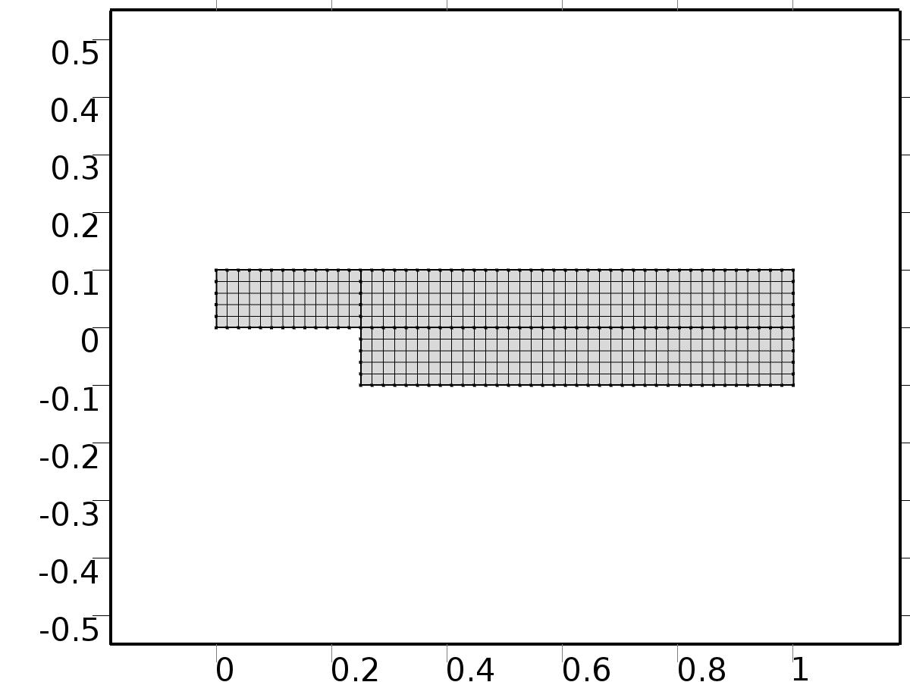

Mesh 1

* + 1. Size (size)

Settings

| **Description** | **Value** |
| --- | --- |
| Maximum element size | 0.067 |
| Minimum element size | 3.0E-4 |
| Curvature factor | 0.3 |
| Maximum element growth rate | 1.3 |

* + 1. Mapped 1 (map1)

Selection

|  |  |
| --- | --- |
| Geometric entity level | Domain |
| Selection | Geometry geom1 |

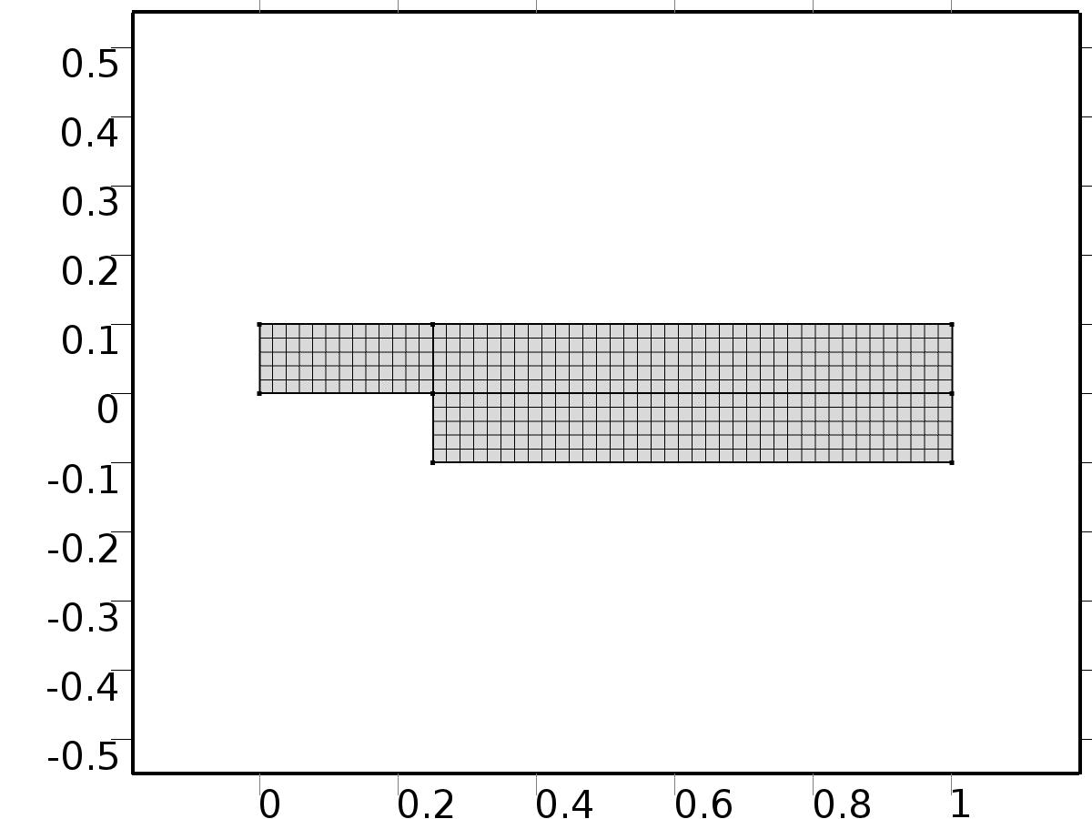

Mapped 1

#### Size 1 (size1)

Selection

|  |  |
| --- | --- |
| Geometric entity level | Domain |
| Selection | Geometry geom1 |



Size 1

Settings

| **Description** | **Value** |
| --- | --- |
| Maximum element size | D/5 |
| Minimum element size | D/5 |
| Curvature factor | 0.3 |
| Curvature factor | Off |
| Resolution of narrow regions | Off |
| Maximum element growth rate | 1.3 |
| Maximum element growth rate | Off |
| Custom element size | Custom |

1. Study 1
   1. Stationary

Study settings

| **Description** | **Value** |
| --- | --- |
| Include geometric nonlinearity | Off |

Physics and variables selection

| **Physics interface** | **Discretization** |
| --- | --- |
| Laminar Flow (spf) | physics |

Mesh selection

| **Geometry** | **Mesh** |
| --- | --- |
| Geometry 1 (geom1) | mesh1 |

* 1. Solver Configurations
     1. Solver 1

#### Compile Equations: Stationary (st1)

Study and step

| **Description** | **Value** |
| --- | --- |
| Use study | Study 1 |
| Use study step | Stationary |

#### Dependent Variables 1 (v1)

General

| **Description** | **Value** |
| --- | --- |
| Defined by study step | Stationary |
| Constant |  |

Initial values of variables solved for

| **Description** | **Value** |
| --- | --- |
| Solution | Zero |

Values of variables not solved for

| **Description** | **Value** |
| --- | --- |
| Solution | Zero |

##### Pressure (comp1.P) (comp1_P)

General

| **Description** | **Value** |
| --- | --- |
| Field components | comp1.P |

##### Velocity field (comp1.U) (comp1_U)

General

| **Description** | **Value** |
| --- | --- |
| Field components | {comp1.U, comp1.V} |

##### Pressure (comp1.ap0) (comp1_ap0)

General

| **Description** | **Value** |
| --- | --- |
| Field components | comp1.ap0 |
| Solve for this field | Off |
| Field name | comp1_p |

##### Velocity field (comp1.au0) (comp1_au0)

General

| **Description** | **Value** |
| --- | --- |
| Field components | {comp1.au0, comp1.av0} |
| Solve for this field | Off |
| Field name | comp1_u |

##### Pressure (comp1.atp0) (comp1_atp0)

General

| **Description** | **Value** |
| --- | --- |
| Field components | comp1.atp0 |
| Solve for this field | Off |
| Field name | comp1_p |

##### Velocity field (comp1.atu0) (comp1_atu0)

General

| **Description** | **Value** |
| --- | --- |
| Field components | {comp1.atu0, comp1.atv0} |
| Solve for this field | Off |
| Field name | comp1_u |

##### Pressure (comp1.ap1) (comp1_ap1)

General

| **Description** | **Value** |
| --- | --- |
| Field components | comp1.ap1 |
| Solve for this field | Off |
| Field name | comp1_p |

##### Velocity field (comp1.au1) (comp1_au1)

General

| **Description** | **Value** |
| --- | --- |
| Field components | {comp1.au1, comp1.av1} |
| Solve for this field | Off |
| Field name | comp1_u |

##### Pressure (comp1.atp1) (comp1_atp1)

General

| **Description** | **Value** |
| --- | --- |
| Field components | comp1.atp1 |
| Solve for this field | Off |
| Field name | comp1_p |

##### Velocity field (comp1.atu1) (comp1_atu1)

General

| **Description** | **Value** |
| --- | --- |
| Field components | {comp1.atu1, comp1.atv1} |
| Solve for this field | Off |
| Field name | comp1_u |

##### Pressure (comp1.bp1) (comp1_bp1)

General

| **Description** | **Value** |
| --- | --- |
| Field components | comp1.bp1 |
| Solve for this field | Off |
| Field name | comp1_p |

##### Velocity field (comp1.bu1) (comp1_bu1)

General

| **Description** | **Value** |
| --- | --- |
| Field components | {comp1.bu1, comp1.bv1} |
| Solve for this field | Off |
| Field name | comp1_u |

##### Pressure (comp1.btp1) (comp1_btp1)

General

| **Description** | **Value** |
| --- | --- |
| Field components | comp1.btp1 |
| Solve for this field | Off |
| Field name | comp1_p |

##### Velocity field (comp1.btu1) (comp1_btu1)

General

| **Description** | **Value** |
| --- | --- |
| Field components | {comp1.btu1, comp1.btv1} |
| Solve for this field | Off |
| Field name | comp1_u |

##### Pressure (comp1.p) (comp1_p)

General

| **Description** | **Value** |
| --- | --- |
| Field components | comp1.p |
| Solve for this field | Off |

##### Velocity field (comp1.u) (comp1_u)

General

| **Description** | **Value** |
| --- | --- |
| Field components | {comp1.u, comp1.v} |
| Solve for this field | Off |

##### Pressure (comp1.ap2) (comp1_ap2)

General

| **Description** | **Value** |
| --- | --- |
| Field components | comp1.ap2 |
| Solve for this field | Off |
| Field name | comp1_p2 |

##### Velocity field (comp1.au2) (comp1_au2)

General

| **Description** | **Value** |
| --- | --- |
| Field components | {comp1.au2, comp1.av2} |
| Solve for this field | Off |
| Field name | comp1_u2 |

##### Velocity field (comp1.atu2) (comp1_atu2)

General

| **Description** | **Value** |
| --- | --- |
| Field components | {comp1.atu2, comp1.atv2} |
| Solve for this field | Off |
| Field name | comp1_u3 |

##### Pressure (comp1.atp2) (comp1_atp2)

General

| **Description** | **Value** |
| --- | --- |
| Field components | comp1.atp2 |
| Solve for this field | Off |
| Field name | comp1_p3 |

##### Velocity field (comp1.bu2) (comp1_bu2)

General

| **Description** | **Value** |
| --- | --- |
| Field components | {comp1.bu2, comp1.bv2} |
| Solve for this field | Off |
| Field name | comp1_u4 |

##### Pressure (comp1.bp2) (comp1_bp2)

General

| **Description** | **Value** |
| --- | --- |
| Field components | comp1.bp2 |
| Solve for this field | Off |
| Field name | comp1_p4 |

##### Velocity field (comp1.btu2) (comp1_btu2)

General

| **Description** | **Value** |
| --- | --- |
| Field components | {comp1.btu2, comp1.btv2} |
| Solve for this field | Off |
| Field name | comp1_u5 |

##### Pressure (comp1.btp2) (comp1_btp2)

General

| **Description** | **Value** |
| --- | --- |
| Field components | comp1.btp2 |
| Solve for this field | Off |
| Field name | comp1_p5 |

##### Pressure (comp1.ap3) (comp1_ap3)

General

| **Description** | **Value** |
| --- | --- |
| Field components | comp1.ap3 |
| Solve for this field | Off |
| Field name | comp1_p2 |

##### Velocity field (comp1.au3) (comp1_au3)

General

| **Description** | **Value** |
| --- | --- |
| Field components | {comp1.au3, comp1.av3} |
| Solve for this field | Off |
| Field name | comp1_u2 |

##### Velocity field (comp1.atu3) (comp1_atu3)

General

| **Description** | **Value** |
| --- | --- |
| Field components | {comp1.atu3, comp1.atv3} |
| Solve for this field | Off |
| Field name | comp1_u3 |

##### Pressure (comp1.atp3) (comp1_atp3)

General

| **Description** | **Value** |
| --- | --- |
| Field components | comp1.atp3 |
| Solve for this field | Off |
| Field name | comp1_p3 |

##### Velocity field (comp1.bu3) (comp1_bu3)

General

| **Description** | **Value** |
| --- | --- |
| Field components | {comp1.bu3, comp1.bv3} |
| Solve for this field | Off |
| Field name | comp1_u4 |

##### Pressure (comp1.bp3) (comp1_bp3)

General

| **Description** | **Value** |
| --- | --- |
| Field components | comp1.bp3 |
| Solve for this field | Off |
| Field name | comp1_p4 |

##### Velocity field (comp1.btu3) (comp1_btu3)

General

| **Description** | **Value** |
| --- | --- |
| Field components | {comp1.btu3, comp1.btv3} |
| Solve for this field | Off |
| Field name | comp1_u5 |

##### Pressure (comp1.btp3) (comp1_btp3)

General

| **Description** | **Value** |
| --- | --- |
| Field components | comp1.btp3 |
| Solve for this field | Off |
| Field name | comp1_p5 |

##### Pressure (comp1.p2) (comp1_p2)

General

| **Description** | **Value** |
| --- | --- |
| Field components | comp1.p2 |
| Solve for this field | Off |

##### Velocity field (comp1.u2) (comp1_u2)

General

| **Description** | **Value** |
| --- | --- |
| Field components | {comp1.u2, comp1.v2} |
| Solve for this field | Off |

##### Velocity field (comp1.ut2) (comp1_ut2)

General

| **Description** | **Value** |
| --- | --- |
| Field components | {comp1.ut2, comp1.vt2} |
| Solve for this field | Off |
| Field name | comp1_u3 |

##### Pressure (comp1.pt2) (comp1_pt2)

General

| **Description** | **Value** |
| --- | --- |
| Field components | comp1.pt2 |
| Solve for this field | Off |
| Field name | comp1_p3 |

##### Velocity field (comp1.U1) (comp1_U1)

General

| **Description** | **Value** |
| --- | --- |
| Field components | {comp1.U1, comp1.V1} |
| Solve for this field | Off |
| Field name | comp1_u3 |

##### Pressure (comp1.P1) (comp1_P1)

General

| **Description** | **Value** |
| --- | --- |
| Field components | comp1.P1 |
| Solve for this field | Off |
| Field name | comp1_p3 |

#### Stationary Solver 1 (s1)

General

| **Description** | **Value** |
| --- | --- |
| Defined by study step | Stationary |
| Relative tolerance | 0.000010 |

Log

| **Description** | **Value** |
| --- | --- |
| Constant |  |

##### Fully Coupled 1 (fc1)

General

| **Description** | **Value** |
| --- | --- |
| Linear solver | Direct 1 |

Method and termination

| **Description** | **Value** |
| --- | --- |
| Initial damping factor | 0.01 |
| Minimum damping factor | 1.0E-6 |

##### Direct 1 (d1)

General

| **Description** | **Value** |
| --- | --- |
| Solver | PARDISO |

1. Study 2
   1. Stationary

Study settings

| **Description** | **Value** |
| --- | --- |
| Include geometric nonlinearity | Off |

Physics and variables selection

| **Physics interface** | **Discretization** |
| --- | --- |
| Laminar Flow 1 (phys1) | physics |
| Laminar Flow 2 (phys2) | physics |
| Laminar Flow 3 (phys3) | physics |
| Laminar Flow 4 (spf2) | physics |
| Laminar Flow 5 (phys4) | physics |
| Laminar Flow 6 (phys5) | physics |
| Laminar Flow 7 (phys7) | physics |
| Laminar Flow 8 (spf3) | physics |
| Laminar Flow 9 (spf4) | physics |
| Laminar Flow 10 (spf5) | physics |
| Laminar Flow 11 (phys8) | physics |
| Laminar Flow 12 (phys9) | physics |
| Laminar Flow 13 (phys10) | physics |
| Laminar Flow 14 (phys11) | physics |

Mesh selection

| **Geometry** | **Mesh** |
| --- | --- |
| Geometry 1 (geom1) | mesh1 |

* 1. Solver Configurations
     1. Solver 2

#### Compile Equations: Stationary (st1)

Study and step

| **Description** | **Value** |
| --- | --- |
| Use study | Study 2 |
| Use study step | Stationary |

#### Dependent Variables 1 (v1)

General

| **Description** | **Value** |
| --- | --- |
| Defined by study step | Stationary |
| Constant |  |

Initial values of variables solved for

| **Description** | **Value** |
| --- | --- |
| Solution | Zero |

Values of variables not solved for

| **Description** | **Value** |
| --- | --- |
| Method | Solution |
| Solution | Solver 1 |

##### Pressure (comp1.atp0) (comp1_atp0)

General

| **Description** | **Value** |
| --- | --- |
| Field components | comp1.atp0 |

##### Velocity field (comp1.atu0) (comp1_atu0)

General

| **Description** | **Value** |
| --- | --- |
| Field components | {comp1.atu0, comp1.atv0} |

##### Pressure (comp1.P) (comp1_P)

General

| **Description** | **Value** |
| --- | --- |
| Field components | comp1.P |
| Solve for this field | Off |

##### Pressure (comp1.ap0) (comp1_ap0)

General

| **Description** | **Value** |
| --- | --- |
| Field components | comp1.ap0 |

##### Velocity field (comp1.au0) (comp1_au0)

General

| **Description** | **Value** |
| --- | --- |
| Field components | {comp1.au0, comp1.av0} |

##### Velocity field (comp1.U) (comp1_U)

General

| **Description** | **Value** |
| --- | --- |
| Field components | {comp1.U, comp1.V} |
| Solve for this field | Off |

##### Pressure (comp1.ap1) (comp1_ap1)

General

| **Description** | **Value** |
| --- | --- |
| Field components | comp1.ap1 |
| Field name | comp1_p |

##### Velocity field (comp1.au1) (comp1_au1)

General

| **Description** | **Value** |
| --- | --- |
| Field components | {comp1.au1, comp1.av1} |
| Field name | comp1_u |

##### Pressure (comp1.atp1) (comp1_atp1)

General

| **Description** | **Value** |
| --- | --- |
| Field components | comp1.atp1 |
| Field name | comp1_p |

##### Velocity field (comp1.atu1) (comp1_atu1)

General

| **Description** | **Value** |
| --- | --- |
| Field components | {comp1.atu1, comp1.atv1} |
| Field name | comp1_u |

##### Pressure (comp1.bp1) (comp1_bp1)

General

| **Description** | **Value** |
| --- | --- |
| Field components | comp1.bp1 |
| Field name | comp1_p |

##### Velocity field (comp1.bu1) (comp1_bu1)

General

| **Description** | **Value** |
| --- | --- |
| Field components | {comp1.bu1, comp1.bv1} |
| Field name | comp1_u |

##### Pressure (comp1.btp1) (comp1_btp1)

General

| **Description** | **Value** |
| --- | --- |
| Field components | comp1.btp1 |
| Field name | comp1_p |

##### Velocity field (comp1.btu1) (comp1_btu1)

General

| **Description** | **Value** |
| --- | --- |
| Field components | {comp1.btu1, comp1.btv1} |
| Field name | comp1_u |

##### Pressure (comp1.p) (comp1_p)

General

| **Description** | **Value** |
| --- | --- |
| Field components | comp1.p |
| Solve for this field | Off |

##### Velocity field (comp1.u) (comp1_u)

General

| **Description** | **Value** |
| --- | --- |
| Field components | {comp1.u, comp1.v} |
| Solve for this field | Off |

##### Pressure (comp1.ap2) (comp1_ap2)

General

| **Description** | **Value** |
| --- | --- |
| Field components | comp1.ap2 |
| Field name | comp1_p2 |

##### Velocity field (comp1.au2) (comp1_au2)

General

| **Description** | **Value** |
| --- | --- |
| Field components | {comp1.au2, comp1.av2} |
| Field name | comp1_u2 |

##### Velocity field (comp1.atu2) (comp1_atu2)

General

| **Description** | **Value** |
| --- | --- |
| Field components | {comp1.atu2, comp1.atv2} |
| Field name | comp1_u3 |

##### Pressure (comp1.atp2) (comp1_atp2)

General

| **Description** | **Value** |
| --- | --- |
| Field components | comp1.atp2 |
| Field name | comp1_p3 |

##### Velocity field (comp1.bu2) (comp1_bu2)

General

| **Description** | **Value** |
| --- | --- |
| Field components | {comp1.bu2, comp1.bv2} |
| Field name | comp1_u4 |

##### Pressure (comp1.bp2) (comp1_bp2)

General

| **Description** | **Value** |
| --- | --- |
| Field components | comp1.bp2 |
| Field name | comp1_p4 |

##### Velocity field (comp1.btu2) (comp1_btu2)

General

| **Description** | **Value** |
| --- | --- |
| Field components | {comp1.btu2, comp1.btv2} |
| Field name | comp1_u5 |

##### Pressure (comp1.btp2) (comp1_btp2)

General

| **Description** | **Value** |
| --- | --- |
| Field components | comp1.btp2 |
| Field name | comp1_p5 |

##### Pressure (comp1.ap3) (comp1_ap3)

General

| **Description** | **Value** |
| --- | --- |
| Field components | comp1.ap3 |
| Field name | comp1_p2 |

##### Velocity field (comp1.au3) (comp1_au3)

General

| **Description** | **Value** |
| --- | --- |
| Field components | {comp1.au3, comp1.av3} |
| Field name | comp1_u2 |

##### Velocity field (comp1.atu3) (comp1_atu3)

General

| **Description** | **Value** |
| --- | --- |
| Field components | {comp1.atu3, comp1.atv3} |
| Field name | comp1_u3 |

##### Pressure (comp1.atp3) (comp1_atp3)

General

| **Description** | **Value** |
| --- | --- |
| Field components | comp1.atp3 |
| Field name | comp1_p3 |

##### Velocity field (comp1.bu3) (comp1_bu3)

General

| **Description** | **Value** |
| --- | --- |
| Field components | {comp1.bu3, comp1.bv3} |
| Field name | comp1_u4 |

##### Pressure (comp1.bp3) (comp1_bp3)

General

| **Description** | **Value** |
| --- | --- |
| Field components | comp1.bp3 |
| Field name | comp1_p4 |

##### Velocity field (comp1.btu3) (comp1_btu3)

General

| **Description** | **Value** |
| --- | --- |
| Field components | {comp1.btu3, comp1.btv3} |
| Field name | comp1_u5 |

##### Pressure (comp1.btp3) (comp1_btp3)

General

| **Description** | **Value** |
| --- | --- |
| Field components | comp1.btp3 |
| Field name | comp1_p5 |

##### Pressure (comp1.p2) (comp1_p2)

General

| **Description** | **Value** |
| --- | --- |
| Field components | comp1.p2 |
| Solve for this field | Off |

##### Velocity field (comp1.u2) (comp1_u2)

General

| **Description** | **Value** |
| --- | --- |
| Field components | {comp1.u2, comp1.v2} |
| Solve for this field | Off |

##### Velocity field (comp1.ut2) (comp1_ut2)

General

| **Description** | **Value** |
| --- | --- |
| Field components | {comp1.ut2, comp1.vt2} |
| Solve for this field | Off |
| Field name | comp1_u3 |

##### Pressure (comp1.pt2) (comp1_pt2)

General

| **Description** | **Value** |
| --- | --- |
| Field components | comp1.pt2 |
| Solve for this field | Off |
| Field name | comp1_p3 |

##### Velocity field (comp1.U1) (comp1_U1)

General

| **Description** | **Value** |
| --- | --- |
| Field components | {comp1.U1, comp1.V1} |
| Solve for this field | Off |
| Field name | comp1_u3 |

##### Pressure (comp1.P1) (comp1_P1)

General

| **Description** | **Value** |
| --- | --- |
| Field components | comp1.P1 |
| Solve for this field | Off |
| Field name | comp1_p3 |

#### Stationary Solver 1 (s1)

General

| **Description** | **Value** |
| --- | --- |
| Defined by study step | Stationary |
| Relative tolerance | 0.000010 |

Log

| **Description** | **Value** |
| --- | --- |
| Constant |  |

##### Fully Coupled 1 (fc1)

General

| **Description** | **Value** |
| --- | --- |
| Linear solver | Direct 1 |

Method and termination

| **Description** | **Value** |
| --- | --- |
| Initial damping factor | 0.01 |
| Minimum damping factor | 1.0E-6 |

##### Direct 1 (d1)

General

| **Description** | **Value** |
| --- | --- |
| Solver | PARDISO |

1. Study 3
   1. Time Dependent

Study settings

| **Description** | **Value** |
| --- | --- |
| Include geometric nonlinearity | Off |

| **Times** | **Unit** |
| --- | --- |
| range(0,0.1,20) | s |

Physics and variables selection

| **Physics interface** | **Discretization** |
| --- | --- |
| Laminar Flow 14a (phys14) | physics |
| Laminar Flow 15 (phys12) | physics |
| Laminar Flow 16 (phys13) | physics |
| Closed loop system (phys6) | physics |

Mesh selection

| **Geometry** | **Mesh** |
| --- | --- |
| Geometry 1 (geom1) | mesh1 |

* 1. Solver Configurations
     1. Solver 3

#### Compile Equations: Time Dependent (st1)

Study and step

| **Description** | **Value** |
| --- | --- |
| Use study | Study 3 |
| Use study step | Time Dependent |

#### Dependent Variables 1 (v1)

General

| **Description** | **Value** |
| --- | --- |
| Defined by study step | Time Dependent |
| Constant |  |

Initial values of variables solved for

| **Description** | **Value** |
| --- | --- |
| Solution | Solver 2 |

Values of variables not solved for

| **Description** | **Value** |
| --- | --- |
| Method | Solution |
| Solution | Solver 2 |

##### Pressure (comp1.atp0) (comp1_atp0)

General

| **Description** | **Value** |
| --- | --- |
| Field components | comp1.atp0 |
| Solve for this field | Off |

##### Pressure (comp1.atp1) (comp1_atp1)

General

| **Description** | **Value** |
| --- | --- |
| Field components | comp1.atp1 |
| Solve for this field | Off |

##### Velocity field (comp1.au0) (comp1_au0)

General

| **Description** | **Value** |
| --- | --- |
| Field components | {comp1.au0, comp1.av0} |
| Solve for this field | Off |

##### Pressure (comp1.bp1) (comp1_bp1)

General

| **Description** | **Value** |
| --- | --- |
| Field components | comp1.bp1 |
| Solve for this field | Off |

##### Velocity field (comp1.atu0) (comp1_atu0)

General

| **Description** | **Value** |
| --- | --- |
| Field components | {comp1.atu0, comp1.atv0} |
| Solve for this field | Off |

##### Velocity field (comp1.au1) (comp1_au1)

General

| **Description** | **Value** |
| --- | --- |
| Field components | {comp1.au1, comp1.av1} |
| Solve for this field | Off |

##### Pressure (comp1.P) (comp1_P)

General

| **Description** | **Value** |
| --- | --- |
| Field components | comp1.P |
| Solve for this field | Off |

##### Velocity field (comp1.atu1) (comp1_atu1)

General

| **Description** | **Value** |
| --- | --- |
| Field components | {comp1.atu1, comp1.atv1} |
| Solve for this field | Off |

##### Pressure (comp1.p) (comp1_p)

General

| **Description** | **Value** |
| --- | --- |
| Field components | comp1.p |

##### Pressure (comp1.ap0) (comp1_ap0)

General

| **Description** | **Value** |
| --- | --- |
| Field components | comp1.ap0 |
| Solve for this field | Off |

##### Velocity field (comp1.btu1) (comp1_btu1)

General

| **Description** | **Value** |
| --- | --- |
| Field components | {comp1.btu1, comp1.btv1} |
| Solve for this field | Off |

##### Pressure (comp1.ap1) (comp1_ap1)

General

| **Description** | **Value** |
| --- | --- |
| Field components | comp1.ap1 |
| Solve for this field | Off |

##### Velocity field (comp1.u) (comp1_u)

General

| **Description** | **Value** |
| --- | --- |
| Field components | {comp1.u, comp1.v} |

##### Velocity field (comp1.U) (comp1_U)

General

| **Description** | **Value** |
| --- | --- |
| Field components | {comp1.U, comp1.V} |
| Solve for this field | Off |

##### Velocity field (comp1.bu1) (comp1_bu1)

General

| **Description** | **Value** |
| --- | --- |
| Field components | {comp1.bu1, comp1.bv1} |
| Solve for this field | Off |

##### Pressure (comp1.btp1) (comp1_btp1)

General

| **Description** | **Value** |
| --- | --- |
| Field components | comp1.btp1 |
| Solve for this field | Off |

##### Pressure (comp1.ap2) (comp1_ap2)

General

| **Description** | **Value** |
| --- | --- |
| Field components | comp1.ap2 |
| Solve for this field | Off |
| Field name | comp1_p2 |

##### Velocity field (comp1.au2) (comp1_au2)

General

| **Description** | **Value** |
| --- | --- |
| Field components | {comp1.au2, comp1.av2} |
| Solve for this field | Off |
| Field name | comp1_u2 |

##### Velocity field (comp1.atu2) (comp1_atu2)

General

| **Description** | **Value** |
| --- | --- |
| Field components | {comp1.atu2, comp1.atv2} |
| Solve for this field | Off |
| Field name | comp1_u3 |

##### Pressure (comp1.atp2) (comp1_atp2)

General

| **Description** | **Value** |
| --- | --- |
| Field components | comp1.atp2 |
| Solve for this field | Off |
| Field name | comp1_p3 |

##### Velocity field (comp1.bu2) (comp1_bu2)

General

| **Description** | **Value** |
| --- | --- |
| Field components | {comp1.bu2, comp1.bv2} |
| Solve for this field | Off |
| Field name | comp1_u4 |

##### Pressure (comp1.bp2) (comp1_bp2)

General

| **Description** | **Value** |
| --- | --- |
| Field components | comp1.bp2 |
| Solve for this field | Off |
| Field name | comp1_p4 |

##### Velocity field (comp1.btu2) (comp1_btu2)

General

| **Description** | **Value** |
| --- | --- |
| Field components | {comp1.btu2, comp1.btv2} |
| Solve for this field | Off |
| Field name | comp1_u5 |

##### Pressure (comp1.btp2) (comp1_btp2)

General

| **Description** | **Value** |
| --- | --- |
| Field components | comp1.btp2 |
| Solve for this field | Off |
| Field name | comp1_p5 |

##### Pressure (comp1.ap3) (comp1_ap3)

General

| **Description** | **Value** |
| --- | --- |
| Field components | comp1.ap3 |
| Solve for this field | Off |
| Field name | comp1_p2 |

##### Velocity field (comp1.au3) (comp1_au3)

General

| **Description** | **Value** |
| --- | --- |
| Field components | {comp1.au3, comp1.av3} |
| Solve for this field | Off |
| Field name | comp1_u2 |

##### Velocity field (comp1.atu3) (comp1_atu3)

General

| **Description** | **Value** |
| --- | --- |
| Field components | {comp1.atu3, comp1.atv3} |
| Solve for this field | Off |
| Field name | comp1_u3 |

##### Pressure (comp1.atp3) (comp1_atp3)

General

| **Description** | **Value** |
| --- | --- |
| Field components | comp1.atp3 |
| Solve for this field | Off |
| Field name | comp1_p3 |

##### Velocity field (comp1.bu3) (comp1_bu3)

General

| **Description** | **Value** |
| --- | --- |
| Field components | {comp1.bu3, comp1.bv3} |
| Solve for this field | Off |
| Field name | comp1_u4 |

##### Pressure (comp1.bp3) (comp1_bp3)

General

| **Description** | **Value** |
| --- | --- |
| Field components | comp1.bp3 |
| Solve for this field | Off |
| Field name | comp1_p4 |

##### Velocity field (comp1.btu3) (comp1_btu3)

General

| **Description** | **Value** |
| --- | --- |
| Field components | {comp1.btu3, comp1.btv3} |
| Solve for this field | Off |
| Field name | comp1_u5 |

##### Pressure (comp1.btp3) (comp1_btp3)

General

| **Description** | **Value** |
| --- | --- |
| Field components | comp1.btp3 |
| Solve for this field | Off |
| Field name | comp1_p5 |

##### Pressure (comp1.p2) (comp1_p2)

General

| **Description** | **Value** |
| --- | --- |
| Field components | comp1.p2 |

##### Velocity field (comp1.u2) (comp1_u2)

General

| **Description** | **Value** |
| --- | --- |
| Field components | {comp1.u2, comp1.v2} |

##### Velocity field (comp1.ut2) (comp1_ut2)

General

| **Description** | **Value** |
| --- | --- |
| Field components | {comp1.ut2, comp1.vt2} |
| Field name | comp1_u3 |

##### Pressure (comp1.pt2) (comp1_pt2)

General

| **Description** | **Value** |
| --- | --- |
| Field components | comp1.pt2 |
| Field name | comp1_p3 |

##### Velocity field (comp1.U1) (comp1_U1)

General

| **Description** | **Value** |
| --- | --- |
| Field components | {comp1.U1, comp1.V1} |
| Field name | comp1_u3 |

##### Pressure (comp1.P1) (comp1_P1)

General

| **Description** | **Value** |
| --- | --- |
| Field components | comp1.P1 |
| Field name | comp1_p3 |

#### Time-Dependent Solver 1 (t1)

General

| **Description** | **Value** |
| --- | --- |
| Defined by study step | Time Dependent |
| Time | {0, 0.1, 0.2, 0.30000000000000004, 0.4, 0.5, 0.6000000000000001, 0.7000000000000001, 0.8, 0.9, 1, 1.1, 1.2000000000000002, 1.3, 1.4000000000000001, 1.5, 1.6, 1.7000000000000002, 1.8, 1.9000000000000001, 2, 2.1, 2.2, 2.3000000000000003, 2.4000000000000004, 2.5, 2.6, 2.7, 2.8000000000000003, 2.9000000000000004, 3, 3.1, 3.2, 3.3000000000000003, 3.4000000000000004, 3.5, 3.6, 3.7, 3.8000000000000003, 3.9000000000000004, 4, 4.1000000000000005, 4.2, 4.3, 4.4, 4.5, 4.6000000000000005, 4.7, 4.800000000000001, 4.9, 5, 5.1000000000000005, 5.2, 5.300000000000001, 5.4, 5.5, 5.6000000000000005, 5.7, 5.800000000000001, 5.9, 6, 6.1000000000000005, 6.2, 6.300000000000001, 6.4, 6.5, 6.6000000000000005, 6.7, 6.800000000000001, 6.9, 7, 7.1000000000000005, 7.2, 7.300000000000001, 7.4, 7.5, 7.6000000000000005, 7.7, 7.800000000000001, 7.9, 8, 8.1, 8.200000000000001, 8.3, 8.4, 8.5, 8.6, 8.700000000000001, 8.8, 8.9, 9, 9.1, 9.200000000000001, 9.3, 9.4, 9.5, 9.600000000000001, 9.700000000000001, 9.8, 9.9, 10, 10.100000000000001, 10.200000000000001, 10.3, 10.4, 10.5, 10.600000000000001, 10.700000000000001, 10.8, 10.9, 11, 11.100000000000001, 11.200000000000001, 11.3, 11.4, 11.5, 11.600000000000001, 11.700000000000001, 11.8, 11.9, 12, 12.100000000000001, 12.200000000000001, 12.3, 12.4, 12.5, 12.600000000000001, 12.700000000000001, 12.8, 12.9, 13, 13.100000000000001, 13.200000000000001, 13.3, 13.4, 13.5, 13.600000000000001, 13.700000000000001, 13.8, 13.9, 14, 14.100000000000001, 14.200000000000001, 14.3, 14.4, 14.5, 14.600000000000001, 14.700000000000001, 14.8, 14.9, 15, 15.100000000000001, 15.200000000000001, 15.3, 15.4, 15.5, 15.600000000000001, 15.700000000000001, 15.8, 15.9, 16, 16.1, 16.2, 16.3, 16.400000000000002, 16.5, 16.6, 16.7, 16.8, 16.900000000000002, 17, 17.1, 17.2, 17.3, 17.400000000000002, 17.5, 17.6, 17.7, 17.8, 17.900000000000002, 18, 18.1, 18.2, 18.3, 18.400000000000002, 18.5, 18.6, 18.7, 18.8, 18.900000000000002, 19, 19.1, 19.200000000000003, 19.3, 19.400000000000002, 19.5, 19.6, 19.700000000000003, 19.8, 19.900000000000002, 20} |
| Relative tolerance | 0.0001 |

Absolute tolerance

| **Description** | **Value** |
| --- | --- |
| Tolerance | 5.0E-4 |

Time stepping

| **Description** | **Value** |
| --- | --- |
| Initial step | 0.0010 |

Advanced

| **Description** | **Value** |
| --- | --- |
| Fraction of initial step for Backward Euler | 0.0010 |
| Error estimation | Exclude algebraic |

Log

| **Description** | **Value** |
| --- | --- |
| Constant |  |

##### Fully Coupled 1 (fc1)

General

| **Description** | **Value** |
| --- | --- |
| Linear solver | Direct 1 |

Method and termination

| **Description** | **Value** |
| --- | --- |
| Jacobian update | Once per time step |
| Maximum number of iterations | 6 |

##### Direct 1 (d1)

General

| **Description** | **Value** |
| --- | --- |
| Solver | PARDISO |

1. Results
   1. Data Sets
      1. Solution 1

Solution

| **Description** | **Value** |
| --- | --- |
| Solution | Solver 1 |
| Component | Save Point Geometry 1 |

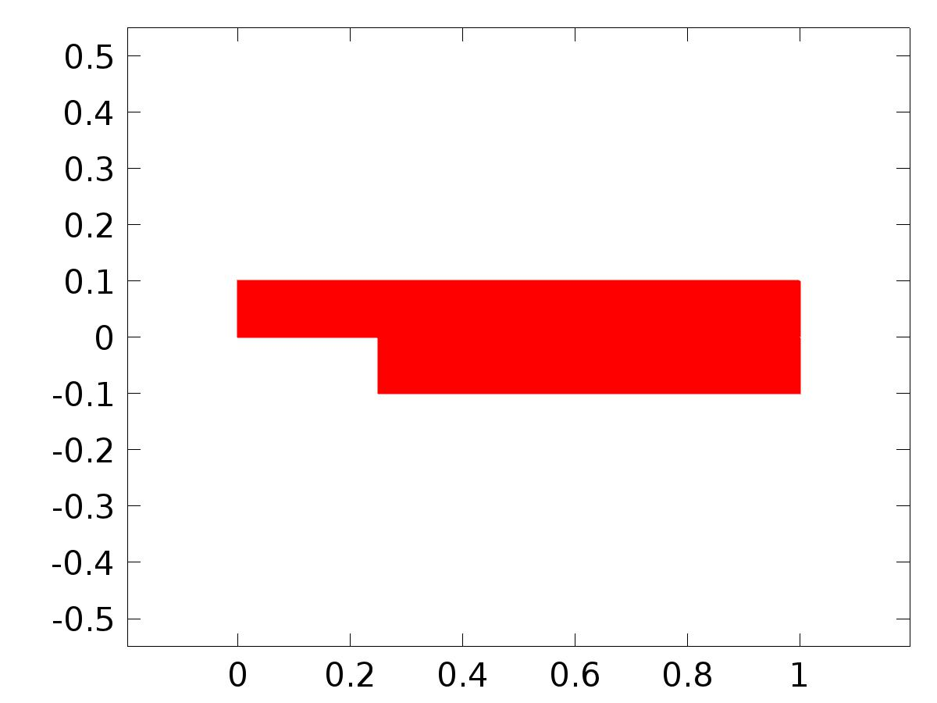

Data set: Solution 1

* + 1. Solution 2

Solution

| **Description** | **Value** |
| --- | --- |
| Solution | Solver 2 |
| Component | Save Point Geometry 1 |



Data set: Solution 2

* + 1. Solution 3

Solution

| **Description** | **Value** |
| --- | --- |
| Solution | Solver 3 |
| Component | Save Point Geometry 1 |



Data set: Solution 3

* 1. Derived Values
     1. Global Evaluation 1

Data

| **Description** | **Value** |
| --- | --- |
| Data set | Solution 3 |

Expression

| **Description** | **Value** |
| --- | --- |
| Expression | gamma |

* 1. Tables
     1. Table 1

Global Evaluation 1 (C(au0))

Table 1

| **Time (s)** | **C(u)** | **C(U1)** | **yr** | **C(U2)** | **gamma** |
| --- | --- | --- | --- | --- | --- |
| 0.0000 | 1.6386E-5 | 0.10000 | 0.10000 | 0.10000 | 2.7552 |
| 0.10000 | 0.032991 | 0.11002 | 0.10998 | 0.10998 | 2.9433 |
| 0.20000 | 0.059461 | 0.11990 | 0.11987 | 0.11987 | 3.1152 |
| 0.30000 | 0.081960 | 0.12958 | 0.12955 | 0.12955 | 3.2751 |
| 0.40000 | 0.10138 | 0.13895 | 0.13894 | 0.13894 | 3.4220 |
| 0.50000 | 0.11828 | 0.14793 | 0.14794 | 0.14794 | 3.5546 |
| 0.60000 | 0.13303 | 0.15643 | 0.15646 | 0.15646 | 3.6718 |
| 0.70000 | 0.14591 | 0.16437 | 0.16442 | 0.16442 | 3.7725 |
| 0.80000 | 0.15712 | 0.17168 | 0.17174 | 0.17174 | 3.8558 |
| 0.90000 | 0.16680 | 0.17828 | 0.17833 | 0.17833 | 3.9211 |
| 1.0000 | 0.17506 | 0.18411 | 0.18415 | 0.18415 | 3.9677 |
| 1.1000 | 0.18197 | 0.18909 | 0.18912 | 0.18912 | 3.9951 |
| 1.2000 | 0.18759 | 0.19319 | 0.19320 | 0.19320 | 4.0027 |
| 1.3000 | 0.19194 | 0.19636 | 0.19636 | 0.19636 | 3.9903 |
| 1.4000 | 0.19509 | 0.19857 | 0.19854 | 0.19855 | 3.9582 |
| 1.5000 | 0.19704 | 0.19978 | 0.19975 | 0.19975 | 3.9062 |
| 1.6000 | 0.19784 | 0.19999 | 0.19996 | 0.19996 | 3.8345 |
| 1.7000 | 0.19752 | 0.19920 | 0.19917 | 0.19917 | 3.7439 |
| 1.8000 | 0.19609 | 0.19742 | 0.19738 | 0.19738 | 3.6353 |
| 1.9000 | 0.19362 | 0.19466 | 0.19463 | 0.19463 | 3.5099 |
| 2.0000 | 0.19014 | 0.19095 | 0.19093 | 0.19093 | 3.3691 |
| 2.1000 | 0.18570 | 0.18633 | 0.18632 | 0.18632 | 3.2144 |
| 2.2000 | 0.18036 | 0.18085 | 0.18085 | 0.18085 | 3.0478 |
| 2.3000 | 0.17419 | 0.17456 | 0.17457 | 0.17457 | 2.8705 |
| 2.4000 | 0.16725 | 0.16753 | 0.16755 | 0.16755 | 2.6848 |
| 2.5000 | 0.15961 | 0.15982 | 0.15985 | 0.15985 | 2.4924 |
| 2.6000 | 0.15136 | 0.15151 | 0.15155 | 0.15155 | 2.2951 |
| 2.7000 | 0.14259 | 0.14270 | 0.14274 | 0.14274 | 2.0948 |
| 2.8000 | 0.13338 | 0.13346 | 0.13350 | 0.13350 | 1.8932 |
| 2.9000 | 0.12384 | 0.12390 | 0.12392 | 0.12393 | 1.6922 |
| 3.0000 | 0.11404 | 0.11411 | 0.11411 | 0.11411 | 1.4936 |
| 3.1000 | 0.10410 | 0.10418 | 0.10416 | 0.10416 | 1.2992 |
| 3.2000 | 0.094119 | 0.094208 | 0.094163 | 0.094163 | 1.1108 |
| 3.3000 | 0.084192 | 0.084294 | 0.084225 | 0.084226 | 0.93003 |
| 3.4000 | 0.074419 | 0.074529 | 0.074446 | 0.074446 | 0.75867 |
| 3.5000 | 0.064900 | 0.065007 | 0.064922 | 0.064922 | 0.59828 |
| 3.6000 | 0.055731 | 0.055820 | 0.055748 | 0.055747 | 0.45034 |
| 3.7000 | 0.047002 | 0.047059 | 0.047016 | 0.047015 | 0.31623 |
| 3.8000 | 0.038802 | 0.038814 | 0.038814 | 0.038813 | 0.19719 |
| 3.9000 | 0.031214 | 0.031173 | 0.031223 | 0.031222 | 0.094367 |
| 4.0000 | 0.024312 | 0.024221 | 0.024320 | 0.024318 | 0.0088575 |
| 4.1000 | 0.018167 | 0.018037 | 0.018172 | 0.018171 | -0.058226 |
| 4.2000 | 0.012839 | 0.012690 | 0.012842 | 0.012842 | -0.10574 |
| 4.3000 | 0.0083813 | 0.0082388 | 0.0083834 | 0.0083840 | -0.13251 |
| 4.4000 | 0.0048391 | 0.0047273 | 0.0048398 | 0.0048412 | -0.13749 |
| 4.5000 | 0.0022474 | 0.0021864 | 0.0022470 | 0.0022490 | -0.11980 |
| 4.6000 | 6.3192E-4 | 6.3298E-4 | 6.3090E-4 | 6.3311E-4 | -0.078928 |
| 4.7000 | 8.8292E-6 | 7.2395E-5 | 7.6742E-6 | 9.7254E-6 | -0.014774 |
| 4.8000 | 3.8440E-4 | 5.0001E-4 | 3.8354E-4 | 3.8508E-4 | 0.072232 |
| 4.9000 | 0.0017550 | 0.0019031 | 0.0017547 | 0.0017555 | 0.18112 |
| 5.0000 | 0.0041070 | 0.0042626 | 0.0041076 | 0.0041074 | 0.31037 |
| 5.1000 | 0.0074172 | 0.0075538 | 0.0074185 | 0.0074175 | 0.45800 |
| 5.2000 | 0.011653 | 0.011747 | 0.011655 | 0.011653 | 0.62163 |
| 5.3000 | 0.016771 | 0.016808 | 0.016773 | 0.016771 | 0.79864 |
| 5.4000 | 0.022721 | 0.022696 | 0.022724 | 0.022721 | 0.98633 |
| 5.5000 | 0.029444 | 0.029364 | 0.029446 | 0.029444 | 1.1821 |
| 5.6000 | 0.036872 | 0.036754 | 0.036873 | 0.036872 | 1.3835 |
| 5.7000 | 0.044931 | 0.044798 | 0.044931 | 0.044931 | 1.5885 |
| 5.8000 | 0.053540 | 0.053417 | 0.053540 | 0.053540 | 1.7952 |
| 5.9000 | 0.062614 | 0.062520 | 0.062612 | 0.062614 | 2.0018 |
| 6.0000 | 0.072060 | 0.072008 | 0.072058 | 0.072060 | 2.2066 |
| 6.1000 | 0.081785 | 0.081778 | 0.081784 | 0.081785 | 2.4078 |
| 6.2000 | 0.091692 | 0.091724 | 0.091691 | 0.091692 | 2.6038 |
| 6.3000 | 0.10168 | 0.10174 | 0.10168 | 0.10168 | 2.7928 |
| 6.4000 | 0.11166 | 0.11172 | 0.11165 | 0.11166 | 2.9730 |
| 6.5000 | 0.12151 | 0.12158 | 0.12151 | 0.12151 | 3.1428 |
| 6.6000 | 0.13115 | 0.13120 | 0.13115 | 0.13115 | 3.3007 |
| 6.7000 | 0.14048 | 0.14051 | 0.14048 | 0.14048 | 3.4454 |
| 6.8000 | 0.14941 | 0.14941 | 0.14941 | 0.14941 | 3.5755 |
| 6.9000 | 0.15784 | 0.15782 | 0.15784 | 0.15784 | 3.6899 |
| 7.0000 | 0.16570 | 0.16566 | 0.16570 | 0.16570 | 3.7877 |
| 7.1000 | 0.17290 | 0.17285 | 0.17290 | 0.17290 | 3.8681 |
| 7.2000 | 0.17937 | 0.17932 | 0.17937 | 0.17937 | 3.9303 |
| 7.3000 | 0.18504 | 0.18501 | 0.18504 | 0.18504 | 3.9737 |
| 7.4000 | 0.18987 | 0.18985 | 0.18987 | 0.18987 | 3.9978 |
| 7.5000 | 0.19380 | 0.19379 | 0.19380 | 0.19380 | 4.0022 |
| 7.6000 | 0.19679 | 0.19680 | 0.19679 | 0.19679 | 3.9866 |
| 7.7000 | 0.19882 | 0.19884 | 0.19882 | 0.19882 | 3.9511 |
| 7.8000 | 0.19985 | 0.19988 | 0.19985 | 0.19985 | 3.8956 |
| 7.9000 | 0.19989 | 0.19992 | 0.19989 | 0.19989 | 3.8207 |
| 8.0000 | 0.19894 | 0.19896 | 0.19894 | 0.19894 | 3.7271 |
| 8.1000 | 0.19699 | 0.19701 | 0.19699 | 0.19699 | 3.6156 |
| 8.2000 | 0.19407 | 0.19409 | 0.19407 | 0.19407 | 3.4875 |
| 8.3000 | 0.19022 | 0.19023 | 0.19022 | 0.19022 | 3.3442 |
| 8.4000 | 0.18546 | 0.18546 | 0.18546 | 0.18546 | 3.1874 |
| 8.5000 | 0.17985 | 0.17984 | 0.17985 | 0.17985 | 3.0187 |
| 8.6000 | 0.17344 | 0.17342 | 0.17344 | 0.17344 | 2.8399 |
| 8.7000 | 0.16630 | 0.16627 | 0.16630 | 0.16630 | 2.6529 |
| 8.8000 | 0.15849 | 0.15846 | 0.15849 | 0.15849 | 2.4596 |
| 8.9000 | 0.15010 | 0.15006 | 0.15010 | 0.15010 | 2.2616 |
| 9.0000 | 0.14121 | 0.14117 | 0.14121 | 0.14121 | 2.0609 |
| 9.1000 | 0.13191 | 0.13187 | 0.13191 | 0.13191 | 1.8593 |
| 9.2000 | 0.12229 | 0.12227 | 0.12229 | 0.12229 | 1.6586 |
| 9.3000 | 0.11245 | 0.11244 | 0.11245 | 0.11245 | 1.4606 |
| 9.4000 | 0.10248 | 0.10250 | 0.10248 | 0.10248 | 1.2671 |
| 9.5000 | 0.092486 | 0.092533 | 0.092485 | 0.092486 | 1.0798 |
| 9.6000 | 0.082568 | 0.082638 | 0.082567 | 0.082568 | 0.90053 |
| 9.7000 | 0.072824 | 0.072907 | 0.072824 | 0.072824 | 0.73090 |
| 9.8000 | 0.063352 | 0.063435 | 0.063352 | 0.063352 | 0.57249 |
| 9.9000 | 0.054246 | 0.054314 | 0.054246 | 0.054246 | 0.42679 |
| 10.000 | 0.045597 | 0.045634 | 0.045598 | 0.045597 | 0.29513 |
| 10.100 | 0.037491 | 0.037484 | 0.037493 | 0.037491 | 0.17874 |
| 10.200 | 0.030011 | 0.029954 | 0.030013 | 0.030011 | 0.078748 |
| 10.300 | 0.023230 | 0.023126 | 0.023231 | 0.023230 | -0.0037424 |
| 10.400 | 0.017216 | 0.017078 | 0.017217 | 0.017216 | -0.067616 |
| 10.500 | 0.012030 | 0.011878 | 0.012030 | 0.012030 | -0.11172 |
| 10.600 | 0.0077232 | 0.0075815 | 0.0077225 | 0.0077232 | -0.13490 |
| 10.700 | 0.0043380 | 0.0042315 | 0.0043365 | 0.0043380 | -0.13612 |
| 10.800 | 0.0019084 | 0.0018558 | 0.0019064 | 0.0019084 | -0.11456 |
| 10.900 | 4.5858E-4 | 4.6926E-4 | 4.5637E-4 | 4.5858E-4 | -0.069764 |
| 11.000 | 2.9681E-6 | 7.5412E-5 | 9.7934E-7 | 2.9681E-6 | -0.0017223 |
| 11.100 | 5.4617E-4 | 6.6815E-4 | 5.4474E-4 | 5.4617E-4 | 0.089045 |
| 11.200 | 0.0020828 | 0.0022336 | 0.0020822 | 0.0020828 | 0.20147 |
| 11.300 | 0.0045978 | 0.0047516 | 0.0045981 | 0.0045978 | 0.33397 |
| 11.400 | 0.0080660 | 0.0081966 | 0.0080671 | 0.0080660 | 0.48446 |
| 11.500 | 0.012453 | 0.012538 | 0.012455 | 0.012453 | 0.65053 |
| 11.600 | 0.017715 | 0.017742 | 0.017717 | 0.017715 | 0.82952 |
| 11.700 | 0.023800 | 0.023764 | 0.023802 | 0.023800 | 1.0187 |
| 11.800 | 0.030646 | 0.030558 | 0.030647 | 0.030646 | 1.2156 |
| 11.900 | 0.038185 | 0.038063 | 0.038186 | 0.038185 | 1.4178 |
| 12.000 | 0.046343 | 0.046210 | 0.046343 | 0.046343 | 1.6232 |
| 12.100 | 0.055036 | 0.054916 | 0.055035 | 0.055036 | 1.8300 |
| 12.200 | 0.064178 | 0.064091 | 0.064177 | 0.064178 | 2.0364 |
| 12.300 | 0.073678 | 0.073634 | 0.073677 | 0.073678 | 2.2407 |
| 12.400 | 0.083441 | 0.083441 | 0.083440 | 0.083441 | 2.4412 |
| 12.500 | 0.093369 | 0.093406 | 0.093368 | 0.093369 | 2.6361 |
| 12.600 | 0.10336 | 0.10342 | 0.10336 | 0.10336 | 2.8237 |
| 12.700 | 0.11332 | 0.11339 | 0.11332 | 0.11332 | 3.0023 |
| 12.800 | 0.12315 | 0.12321 | 0.12315 | 0.12315 | 3.1702 |
| 12.900 | 0.13275 | 0.13279 | 0.13275 | 0.13275 | 3.3260 |
| 13.000 | 0.14202 | 0.14204 | 0.14202 | 0.14202 | 3.4683 |
| 13.100 | 0.15087 | 0.15086 | 0.15087 | 0.15087 | 3.5958 |
| 13.200 | 0.15921 | 0.15918 | 0.15921 | 0.15921 | 3.7075 |
| 13.300 | 0.16696 | 0.16691 | 0.16696 | 0.16696 | 3.8025 |
| 13.400 | 0.17404 | 0.17399 | 0.17404 | 0.17404 | 3.8799 |
| 13.500 | 0.18038 | 0.18033 | 0.18038 | 0.18038 | 3.9389 |
| 13.600 | 0.18592 | 0.18588 | 0.18592 | 0.18592 | 3.9791 |
| 13.700 | 0.19060 | 0.19058 | 0.19060 | 0.19060 | 3.9999 |
| 13.800 | 0.19437 | 0.19437 | 0.19437 | 0.19437 | 4.0009 |
| 13.900 | 0.19720 | 0.19721 | 0.19720 | 0.19720 | 3.9820 |
| 14.000 | 0.19906 | 0.19908 | 0.19906 | 0.19906 | 3.9431 |
| 14.100 | 0.19993 | 0.19996 | 0.19993 | 0.19993 | 3.8844 |
| 14.200 | 0.19980 | 0.19983 | 0.19980 | 0.19980 | 3.8063 |
| 14.300 | 0.19868 | 0.19870 | 0.19868 | 0.19868 | 3.7095 |
| 14.400 | 0.19657 | 0.19659 | 0.19657 | 0.19657 | 3.5951 |
| 14.500 | 0.19349 | 0.19351 | 0.19349 | 0.19349 | 3.4644 |
| 14.600 | 0.18948 | 0.18949 | 0.18948 | 0.18948 | 3.3187 |
| 14.700 | 0.18457 | 0.18458 | 0.18457 | 0.18457 | 3.1598 |
| 14.800 | 0.17882 | 0.17882 | 0.17883 | 0.17882 | 2.9893 |
| 14.900 | 0.17229 | 0.17227 | 0.17229 | 0.17229 | 2.8090 |
| 15.000 | 0.16503 | 0.16500 | 0.16503 | 0.16503 | 2.6208 |
| 15.100 | 0.15712 | 0.15708 | 0.15712 | 0.15712 | 2.4266 |
| 15.200 | 0.14864 | 0.14860 | 0.14864 | 0.14864 | 2.2280 |
| 15.300 | 0.13967 | 0.13963 | 0.13967 | 0.13967 | 2.0271 |
| 15.400 | 0.13031 | 0.13028 | 0.13031 | 0.13031 | 1.8255 |
| 15.500 | 0.12065 | 0.12063 | 0.12065 | 0.12065 | 1.6251 |
| 15.600 | 0.11078 | 0.11078 | 0.11078 | 0.11078 | 1.4277 |
| 15.700 | 0.10080 | 0.10082 | 0.10080 | 0.10080 | 1.2351 |
| 15.800 | 0.090810 | 0.090862 | 0.090809 | 0.090810 | 1.0490 |
| 15.900 | 0.080915 | 0.080988 | 0.080914 | 0.080915 | 0.87128 |
| 16.000 | 0.071210 | 0.071294 | 0.071210 | 0.071210 | 0.70343 |
| 16.100 | 0.061793 | 0.061875 | 0.061793 | 0.061793 | 0.54707 |
| 16.200 | 0.052757 | 0.052821 | 0.052758 | 0.052757 | 0.40363 |
| 16.300 | 0.044193 | 0.044224 | 0.044195 | 0.044193 | 0.27446 |
| 16.400 | 0.036188 | 0.036173 | 0.036189 | 0.036188 | 0.16075 |
| 16.500 | 0.028820 | 0.028754 | 0.028821 | 0.028820 | 0.063624 |
| 16.600 | 0.022163 | 0.022052 | 0.022165 | 0.022163 | -0.015815 |
| 16.700 | 0.016285 | 0.016142 | 0.016286 | 0.016285 | -0.076446 |
| 16.800 | 0.011243 | 0.011091 | 0.011243 | 0.011243 | -0.11711 |
| 16.900 | 0.0070885 | 0.0069511 | 0.0070876 | 0.0070885 | -0.13667 |
| 17.000 | 0.0038619 | 0.0037634 | 0.0038603 | 0.0038619 | -0.13411 |
| 17.100 | 0.0015956 | 0.0015533 | 0.0015935 | 0.0015956 | -0.10866 |
| 17.200 | 3.1219E-4 | 3.3370E-4 | 3.0999E-4 | 3.1219E-4 | -0.059941 |
| 17.300 | 2.4473E-5 | 1.0640E-4 | 2.2557E-5 | 2.4473E-5 | 0.011973 |
| 17.400 | 7.3536E-4 | 8.6384E-4 | 7.3406E-4 | 7.3536E-4 | 0.10647 |
| 17.500 | 0.0024379 | 0.0025910 | 0.0024374 | 0.0024379 | 0.22240 |
| 17.600 | 0.0051151 | 0.0052668 | 0.0051156 | 0.0051151 | 0.35808 |
| 17.700 | 0.0087405 | 0.0088649 | 0.0087418 | 0.0087405 | 0.51137 |
| 17.800 | 0.013278 | 0.013354 | 0.013280 | 0.013278 | 0.67980 |
| 17.900 | 0.018682 | 0.018698 | 0.018684 | 0.018682 | 0.86070 |
| 18.000 | 0.024899 | 0.024854 | 0.024901 | 0.024899 | 1.0514 |
| 18.100 | 0.031867 | 0.031772 | 0.031869 | 0.031867 | 1.2493 |
| 18.200 | 0.039516 | 0.039390 | 0.039517 | 0.039516 | 1.4522 |
| 18.300 | 0.047769 | 0.047637 | 0.047769 | 0.047769 | 1.6579 |
| 18.400 | 0.056544 | 0.056429 | 0.056543 | 0.056544 | 1.8647 |
| 18.500 | 0.065753 | 0.065673 | 0.065752 | 0.065753 | 2.0709 |
| 18.600 | 0.075304 | 0.075268 | 0.075303 | 0.075304 | 2.2747 |
| 18.700 | 0.085102 | 0.085108 | 0.085100 | 0.085102 | 2.4744 |
| 18.800 | 0.095047 | 0.095089 | 0.095046 | 0.095047 | 2.6682 |
| 18.900 | 0.10504 | 0.10511 | 0.10504 | 0.10504 | 2.8544 |
| 19.000 | 0.11499 | 0.11506 | 0.11499 | 0.11499 | 3.0313 |
| 19.100 | 0.12478 | 0.12484 | 0.12478 | 0.12478 | 3.1973 |
| 19.200 | 0.13433 | 0.13437 | 0.13433 | 0.13433 | 3.3509 |
| 19.300 | 0.14354 | 0.14355 | 0.14354 | 0.14354 | 3.4908 |
| 19.400 | 0.15231 | 0.15230 | 0.15231 | 0.15231 | 3.6157 |
| 19.500 | 0.16055 | 0.16052 | 0.16055 | 0.16055 | 3.7247 |
| 19.600 | 0.16820 | 0.16815 | 0.16820 | 0.16820 | 3.8168 |
| 19.700 | 0.17516 | 0.17511 | 0.17516 | 0.17516 | 3.8911 |
| 19.800 | 0.18137 | 0.18132 | 0.18137 | 0.18137 | 3.9470 |
| 19.900 | 0.18676 | 0.18673 | 0.18676 | 0.18676 | 3.9840 |
| 20.000 | 0.19130 | 0.19128 | 0.19129 | 0.19130 | 4.0015 |

* 1. Plot Groups
     1. Velocity (spf)

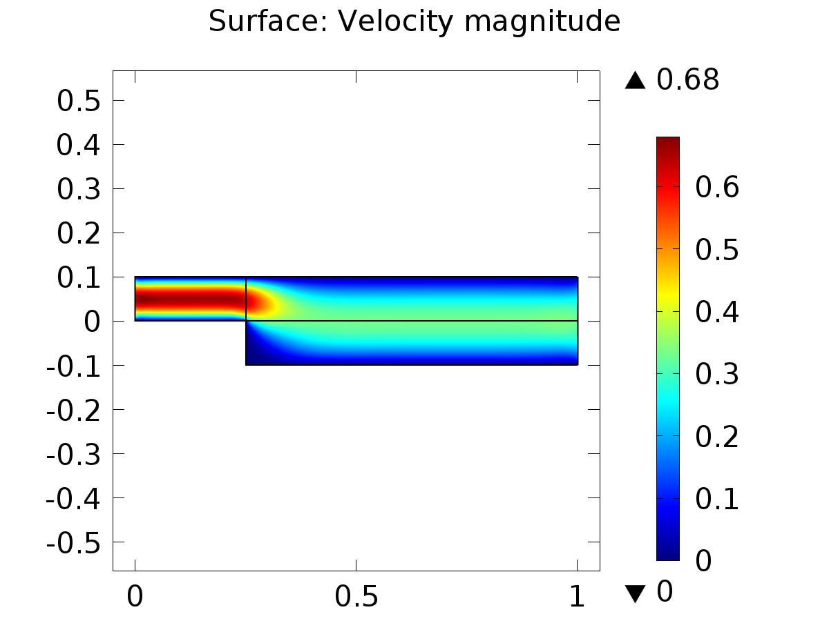

Surface: Velocity magnitude

* + 1. Pressure (spf)

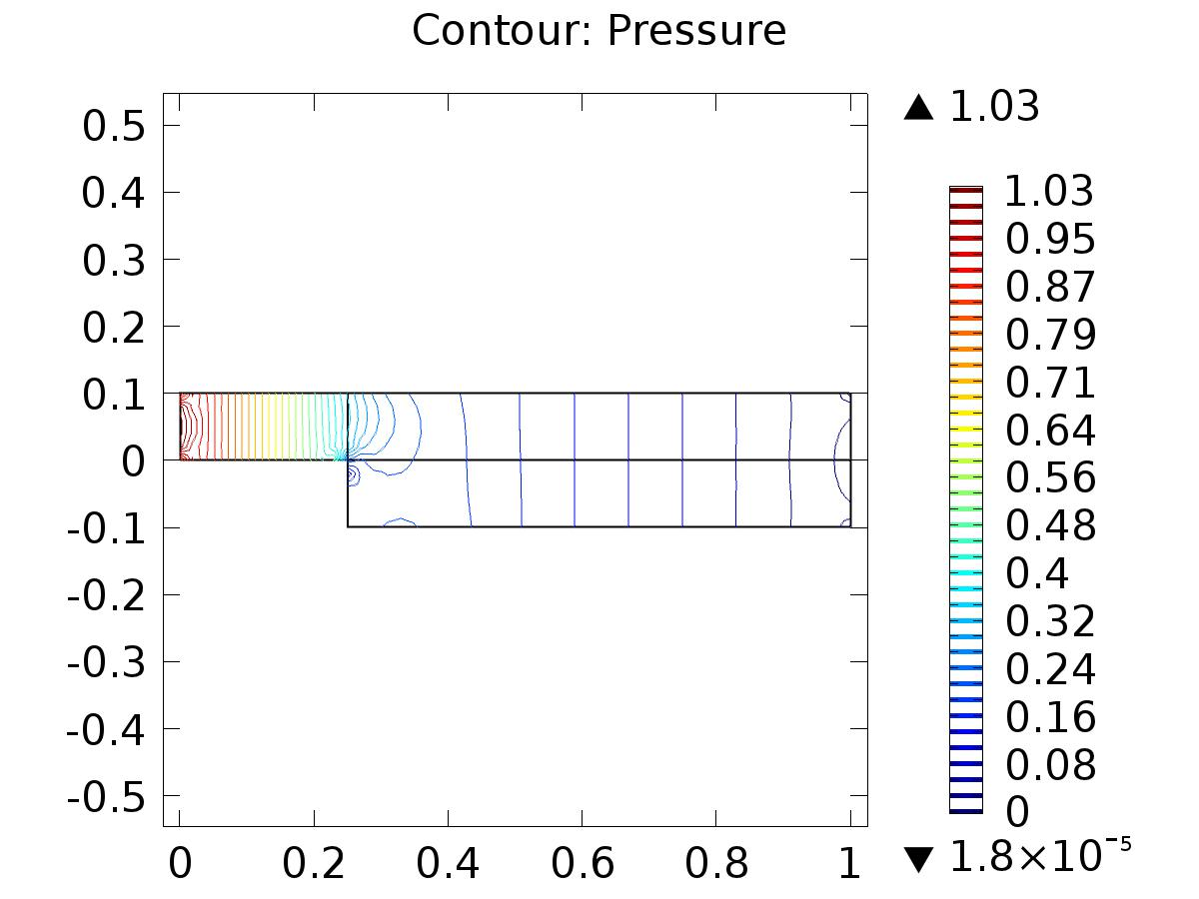

Contour: Pressure

* + 1. Velocity (phys1)

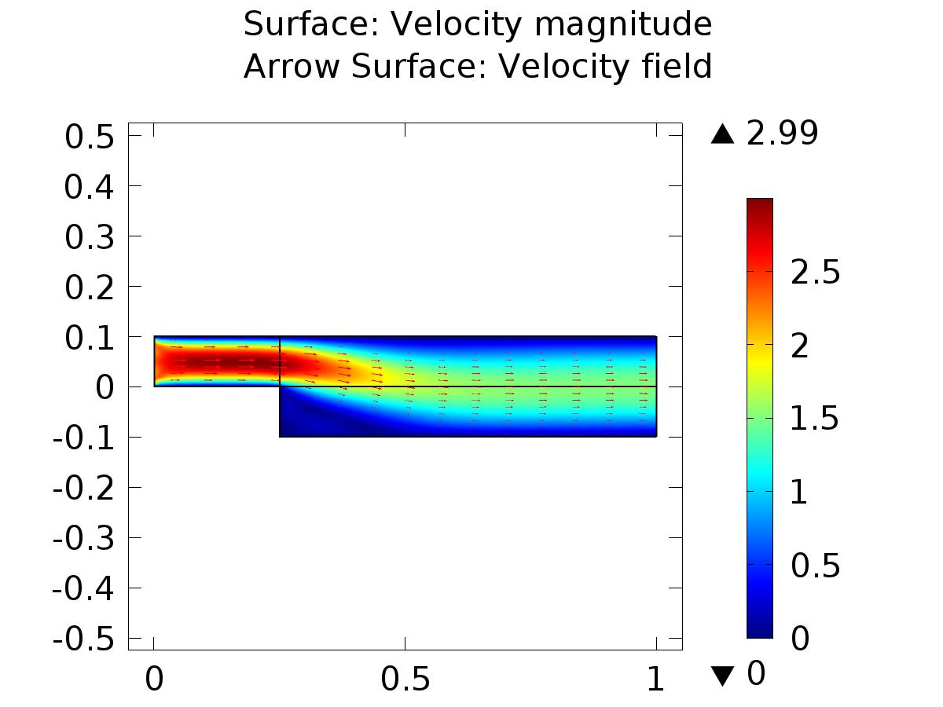

Surface: Velocity magnitude Arrow Surface: Velocity field

* + 1. Pressure (phys1)

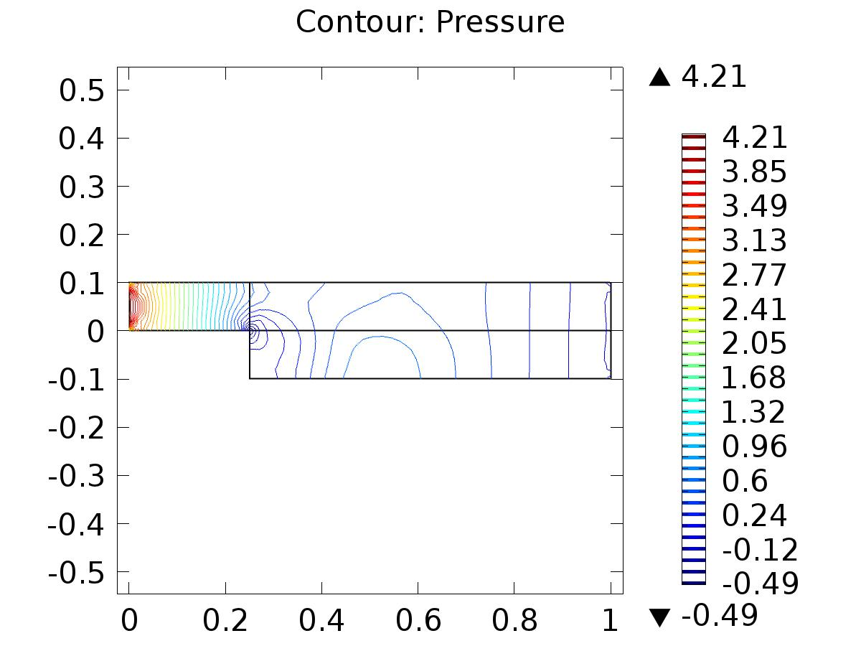

Contour: Pressure

* + 1. Velocity (phys2)

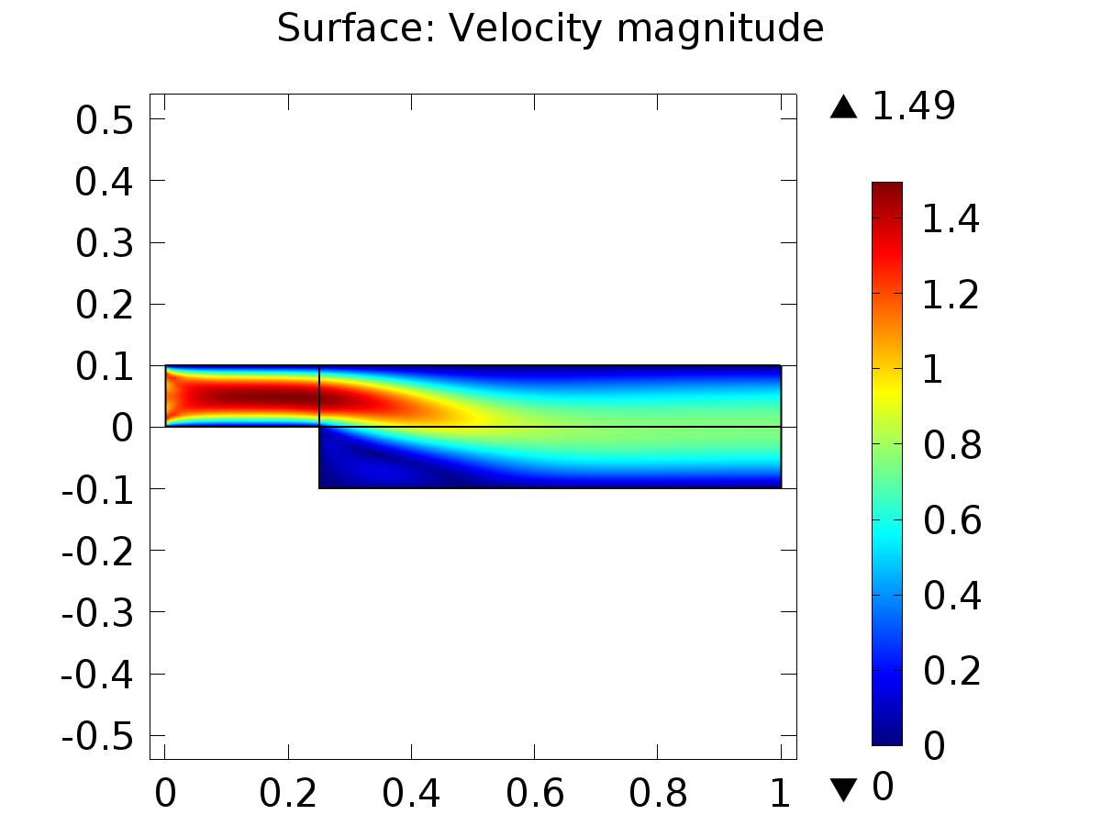

Surface: Velocity magnitude

* + 1. Pressure (phys2)

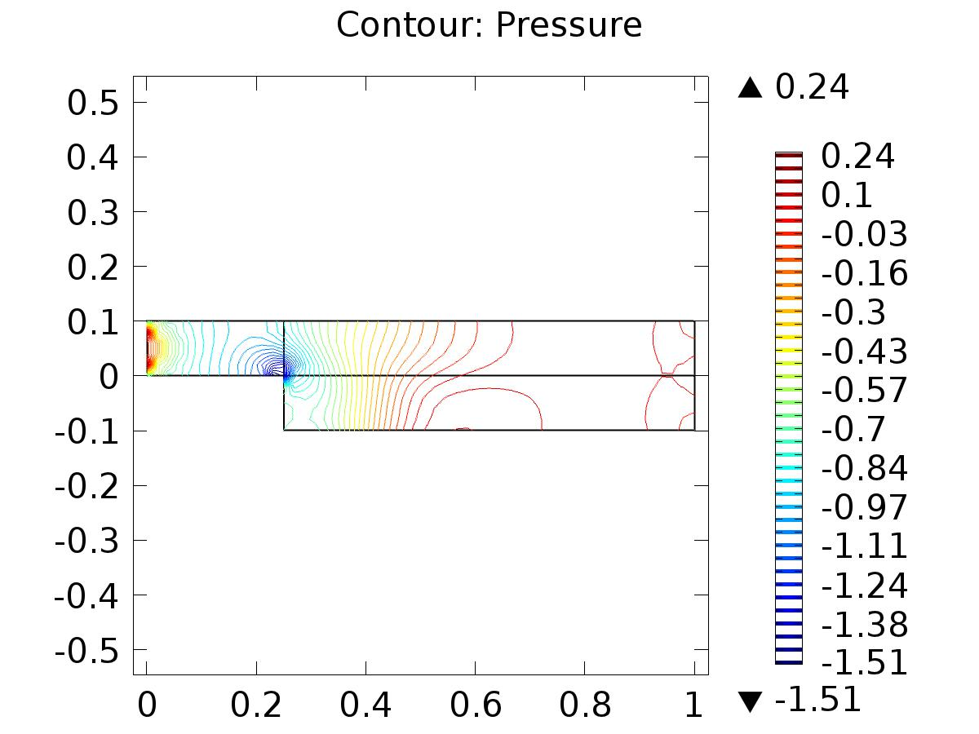

Contour: Pressure

* + 1. Velocity (phys6)

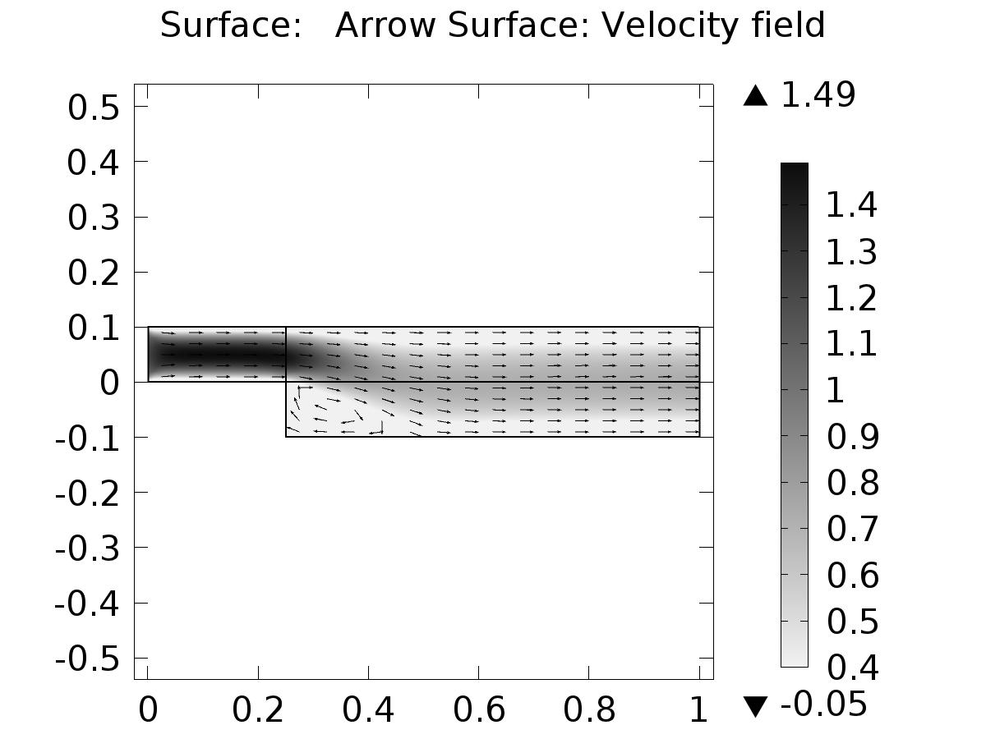

Surface: Arrow Surface: Velocity field

* + 1. Pressure (phys6)

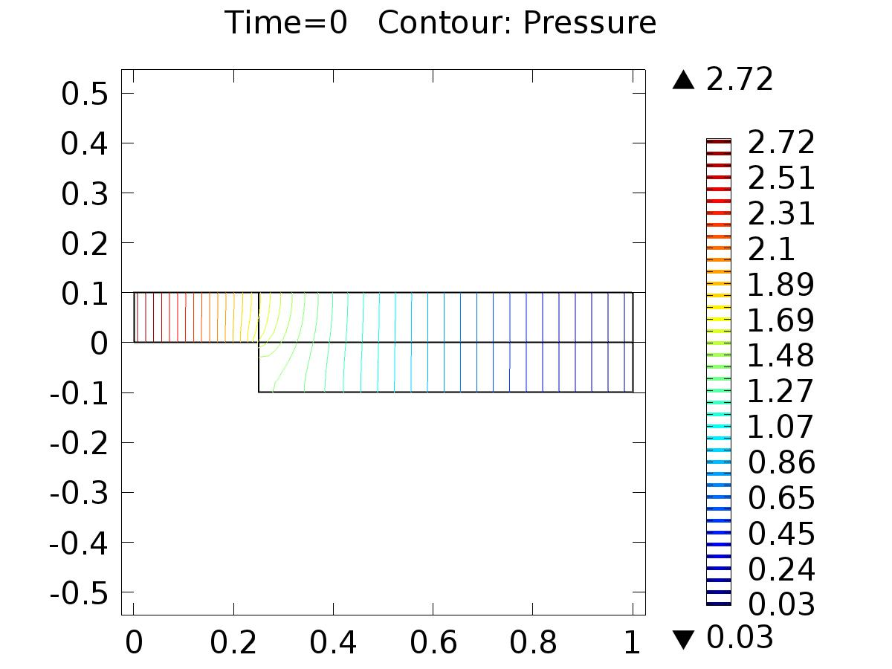

Time=0 Contour: Pressure

* + 1. 1D Plot Group 9

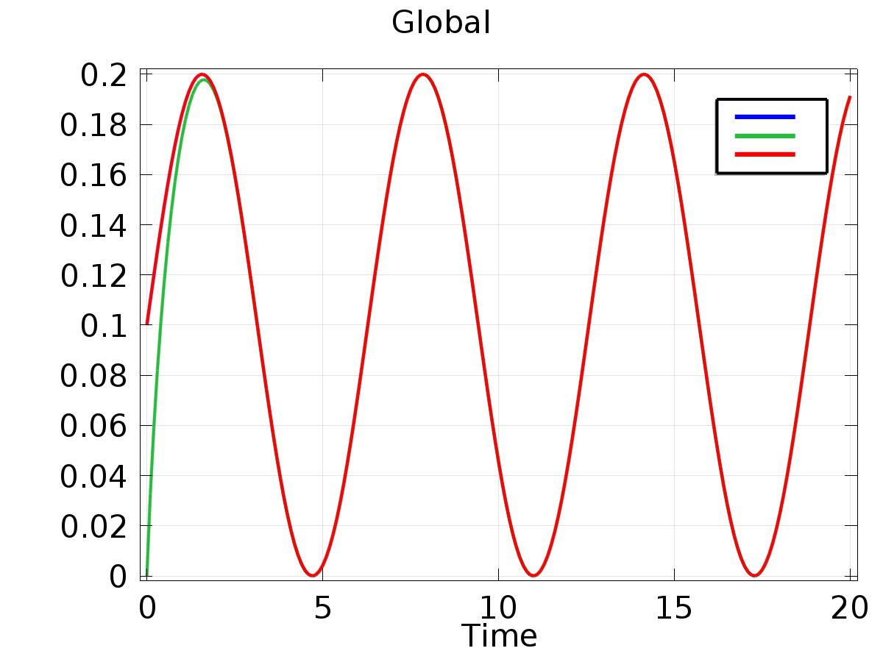

Global

* + 1. 1D Plot Group 10

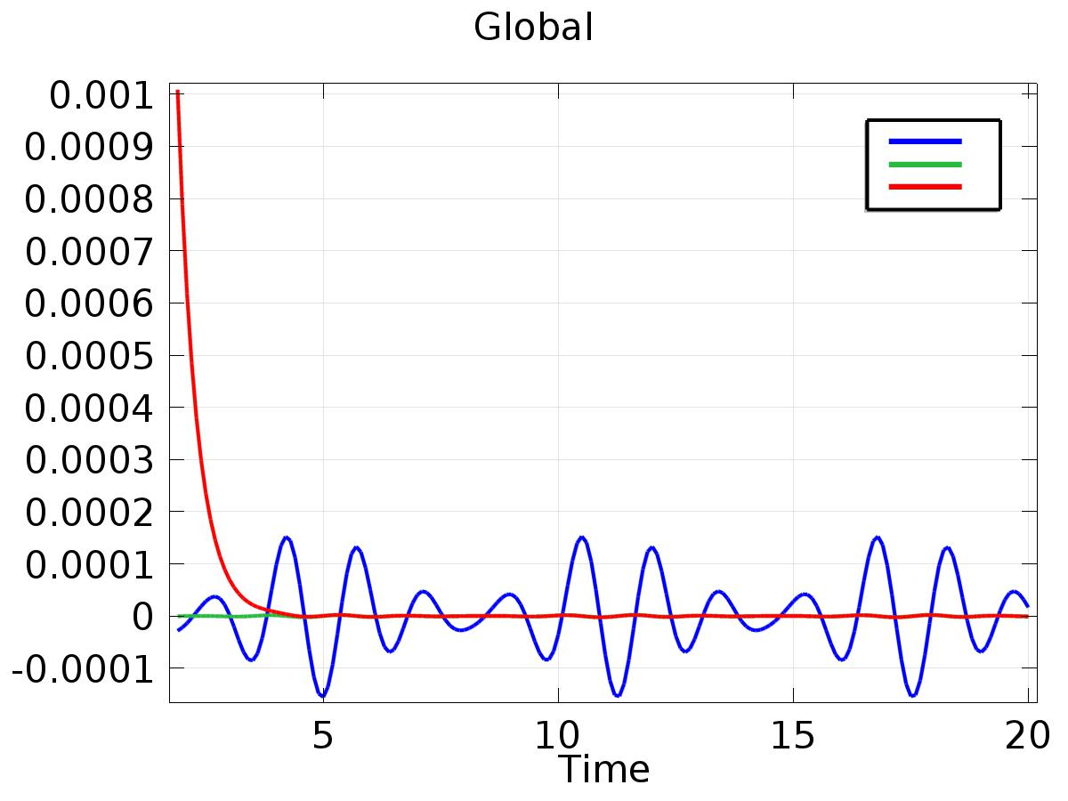

Global

* + 1. Velocity (phys6) 1

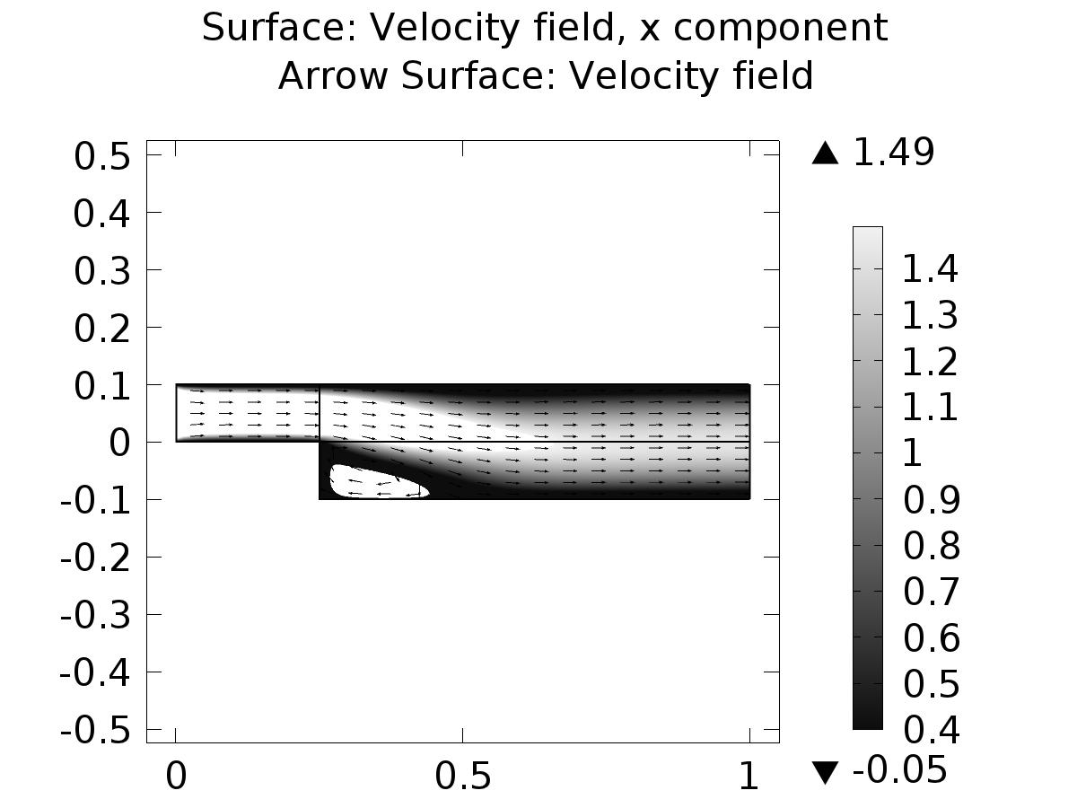

Surface: Velocity field, x component Arrow Surface: Velocity field