[](http://www.comsol.com/)

Ex5 5 1 Non linear beam nu vals

|  |  |
| --- | --- |
| Date | Apr 2, 2015 8:26:17 AM |

Contents

1. Global

1.1. Definitions

2. Component 1

2.1. Definitions

2.2. Geometry 1

2.3. Zero Dynamics

2.4. Closed Loop System

2.5. Mesh 1

3. Study 1

3.1. Time Dependent

3.2. Solver Configurations

4. Results

4.1. Data Sets

4.2. Derived Values

4.3. Tables

4.4. Plot Groups

1. Global

|  |  |
| --- | --- |
| Date | Aug 13, 2014 5:51:10 AM |

Global settings

|  |  |
| --- | --- |
| Name | Ex5 5 1 Non linear beam.mph |
| Path | /Users/gilliam/Desktop/collect_15/research_15/geo_reg_mono_eugenio/Mono_1_15/Comsol_EX_GitHub/Chapter5/Chap5Ex6_ZD/Ex5.5.1_NL_beam/Ex5_5_1_Non_linear_beam.mph |
| Program | COMSOL 5.0 (Build: 276) |

Used products

|  |
| --- |
| COMSOL Multiphysics |

* 1. Definitions
     1. Parameters 1

Parameters

| **Name** | **Expression** | **Value** | **Description** |
| --- | --- | --- | --- |
| L | 5 | 5.0000 |  |
| E | 200*10^9 | 2.0000E11 |  |
| H | 0.1 | 0.10000 |  |
| rho | 6000 | 6000.0 |  |
| A | B*H | 0.0050000 |  |
| I | B*H^3/12 | 4.1667E-6 |  |
| B | 0.05 | 0.050000 |  |
| D1 | E/rho/1000 | 33333 |  |
| D2 | E*I/(rho*A) | 27778 |  |
| beta1 | 0 | 0.0000 |  |
| beta2 | D2 | 27778 |  |

1. Component 1

Component settings

|  |  |
| --- | --- |
| Unit system | None |

* 1. Definitions
     1. Variables

#### Variables 1a

Selection

|  |  |
| --- | --- |
| Geometric entity level | Entire model |

| **Name** | **Expression** | **Description** |
| --- | --- | --- |
| yr1 | 0 |  |
| yr2 | 0.01*sin(4*t) |  |
| e1 | yr1 - C(w) |  |
| e2 | yr2 - C(wx) |  |

* + 1. Component Couplings

#### Integration 1

|  |  |
| --- | --- |
| Coupling type | Integration |
| Operator name | C |

Source selection

|  |  |
| --- | --- |
| Geometric entity level | Boundary |
| Selection | Boundary 2 |

* 1. Geometry 1

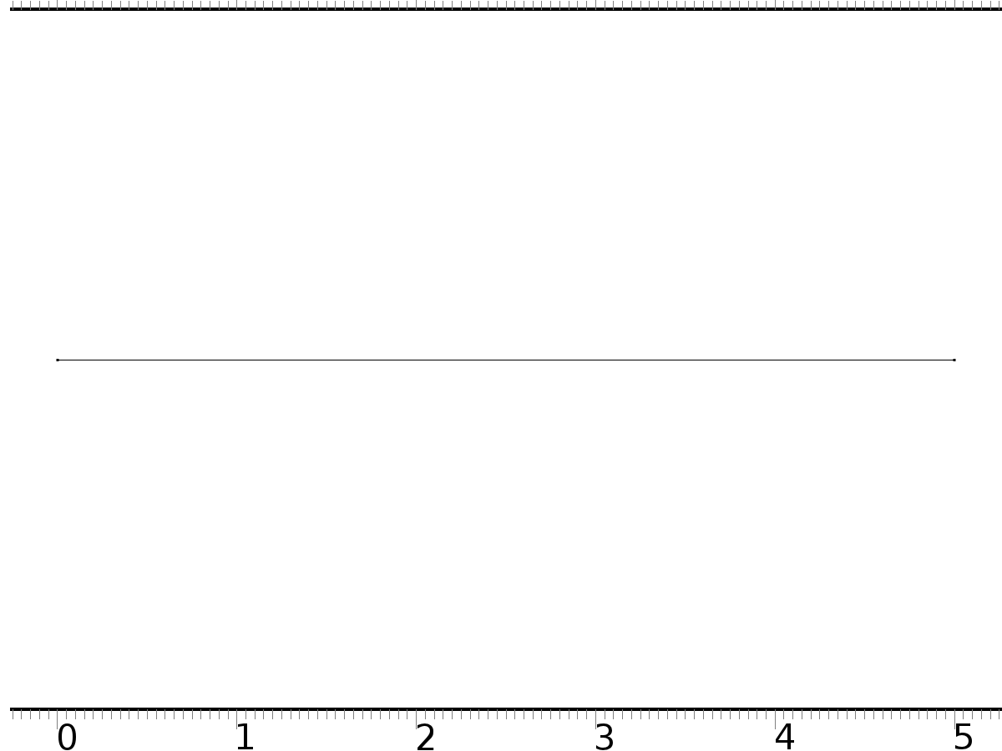

Geometry 1

Units

|  |  |
| --- | --- |
| Length unit | m |
| Angular unit | deg |

Geometry statistics

| **Description** | **Value** |
| --- | --- |
| Space dimension | 1 |
| Number of domains | 1 |
| Number of boundaries | 2 |

* + 1. Interval 1 (i1)

Interval

| **Description** | **Value** |
| --- | --- |
| Number of intervals | One |
| Left endpoint | 0 |
| Right endpoint | L |

* 1. Zero Dynamics

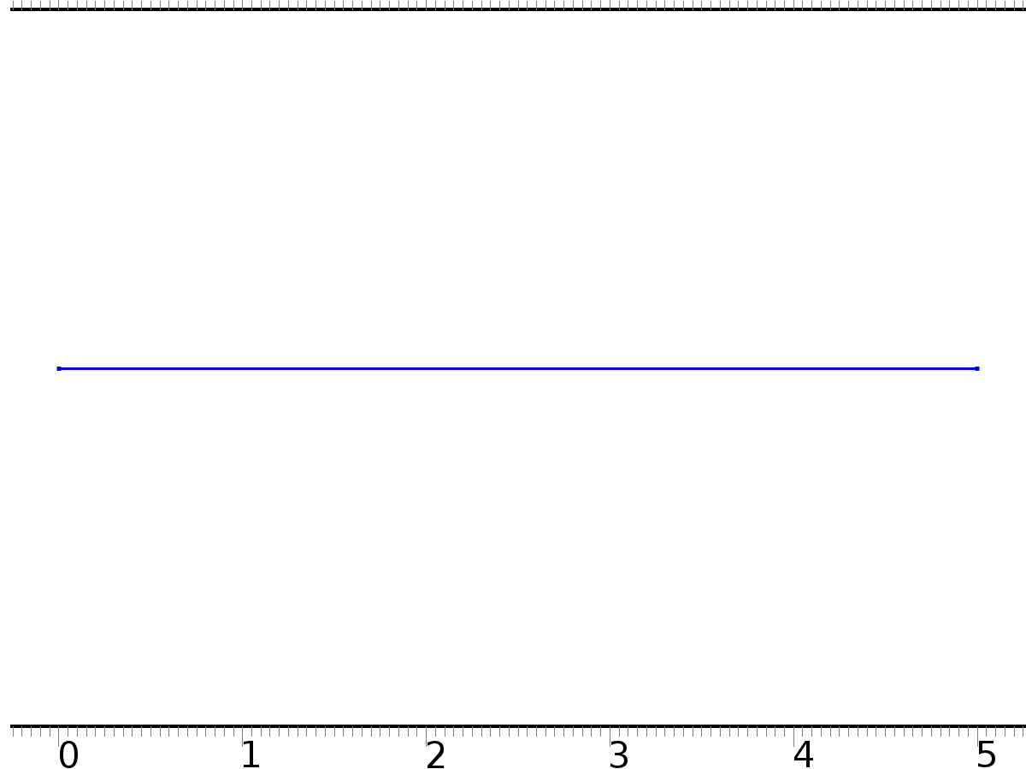

Zero Dynamics

Selection

|  |  |
| --- | --- |
| Geometric entity level | Domain |
| Selection | Domain 1 |

Settings

| **Description** | **Value** |
| --- | --- |
| Shape function type | Lagrange |
| Element order | Quadratic |
| Compute boundary fluxes | On |
| Apply smoothing to boundary fluxes | On |
| Value type when using splitting of complex variables | Complex |
| Dependent variable quantity | Dimensionless (1) |
| Source term quantity | None |
| Unit | m^ - 2 |

Used products

|  |
| --- |
| COMSOL Multiphysics |

Variables

| **Name** | **Expression** | **Unit** | **Description** | **Selection** |
| --- | --- | --- | --- | --- |
| q.nx | nx |  | Normal vector, x component | Boundaries 1–2 |
| q.ny | root.ny |  | Normal vector, y component | Boundaries 1–2 |
| q.nz | root.nz |  | Normal vector, z component | Boundaries 1–2 |
| q.nxmesh | root.nxmesh |  | Normal vector (mesh), x component | Boundaries 1–2 |
| q.nymesh | root.nymesh |  | Normal vector (mesh), y component | Boundaries 1–2 |
| q.nzmesh | root.nzmesh |  | Normal vector (mesh), z component | Boundaries 1–2 |

* + 1. Coefficient Form PDE 1



Coefficient Form PDE 1

Selection

|  |  |
| --- | --- |
| Geometric entity level | Domain |
| Selection | Domain 1 |

Equations







Settings

| **Description** | **Value** |
| --- | --- |
| Diffusion coefficient | {{D1, 0, 0}, {0, 0, 1}, {0, D2, 0}} |
| Absorption coefficient | {{0, 0, 0}, {0, 0, 0}, {0, 0, -1}} |
| Source term | {D1*d(0.5*qx^2, x), D1*d(qx*(px + 1/2*qx^2), x), 0} |
| Mass coefficient | {{1, 0, 0}, {0, 1, 0}, {0, 0, 0}} |
| Damping or mass coefficient | {{0, 0, 0}, {0, beta1, 0}, {0, beta2, 0}} |
| Conservative flux convection coefficient | {{0, 0, 0}, {0, 0, 0}, {0, 0, 0}} |
| Convection coefficient | {{0, 0, 0}, {0, 0, 0}, {0, 0, 0}} |
| Conservative flux source | {0, 0, 0} |

#### Variables

| **Name** | **Expression** | **Unit** | **Description** | **Selection** |
| --- | --- | --- | --- | --- |
| domflux.px | -D1*d(p,x) |  | Domain flux, x component | Domain 1 |
| domflux.qx | -D2*d(Dq,x) |  | Domain flux, x component | Domain 1 |
| domflux.Dqx | -d(q,x) |  | Domain flux, x component | Domain 1 |

#### Shape functions

| **Name** | **Shape function** | **Unit** | **Description** | **Shape frame** | **Selection** |
| --- | --- | --- | --- | --- | --- |
| p | Lagrange (Quadratic) |  | Dependent variable p | Material | Domain 1 |
| q | Lagrange (Quadratic) |  | Dependent variable q | Material | Domain 1 |
| Dq | Lagrange (Quadratic) |  | Dependent variable Dq | Material | Domain 1 |

* + 1. Zero Flux 1



Zero Flux 1

Selection

|  |  |
| --- | --- |
| Geometric entity level | Boundary |
| Selection | No boundaries |

Equations







* + 1. Initial Values 1



Initial Values 1

Selection

|  |  |
| --- | --- |
| Geometric entity level | Domain |
| Selection | Domain 1 |

Settings

| **Description** | **Value** |
| --- | --- |
| Initial value for p | 0 |
| Initial time derivative of p | 0 |
| Initial value for q | 0 |
| Initial time derivative of q | 0 |
| Initial value for Dq | 0 |
| Initial time derivative of Dq | 0 |

* + 1. Dirichlet Boundary Condition 1

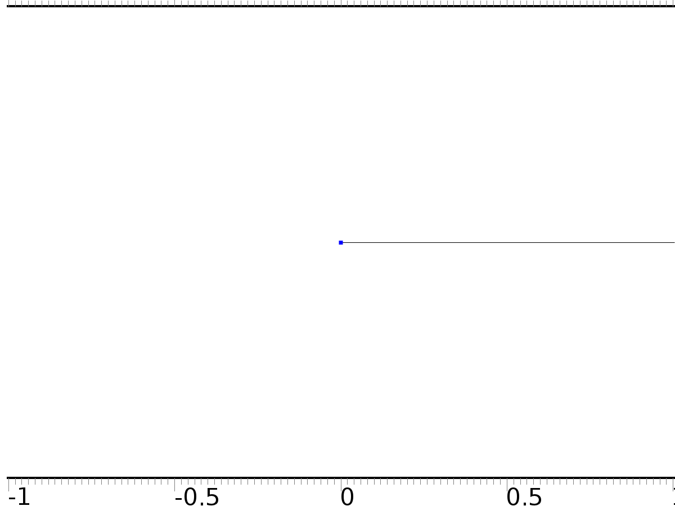

Dirichlet Boundary Condition 1

Selection

|  |  |
| --- | --- |
| Geometric entity level | Boundary |
| Selection | Boundary 1 |

Equations









Settings

| **Description** | **Value** |
| --- | --- |
| Value on boundary | {0, 0, 0} |
| Prescribed value of p | Off |
| Prescribed value of q | On |
| Prescribed value of Dq | On |
| Apply reaction terms on | Individual dependent variables |
| Use weak constraints | Off |
| Constraint method | Elemental |

#### Shape functions

| **Constraint** | **Constraint force** | **Shape function** | **Selection** |
| --- | --- | --- | --- |
| -q | -test(q) | Lagrange (Quadratic) | Boundary 1 |
| -Dq | -test(Dq) | Lagrange (Quadratic) | Boundary 1 |

* + 1. Dirichlet Boundary Condition 2

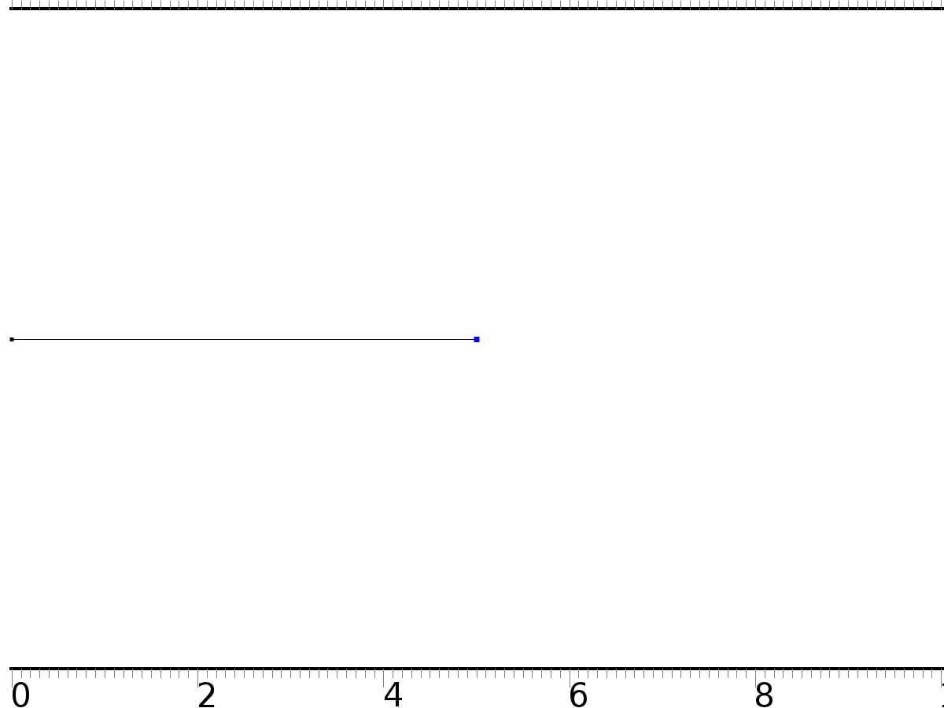

Dirichlet Boundary Condition 2

Selection

|  |  |
| --- | --- |
| Geometric entity level | Boundary |
| Selection | Boundary 2 |

Equations









Settings

| **Description** | **Value** |
| --- | --- |
| Value on boundary | {0, 0, 0} |
| Prescribed value of p | On |
| Prescribed value of q | On |
| Prescribed value of Dq | Off |
| Apply reaction terms on | Individual dependent variables |
| Use weak constraints | Off |
| Constraint method | Elemental |

#### Shape functions

| **Constraint** | **Constraint force** | **Shape function** | **Selection** |
| --- | --- | --- | --- |
| -p | -test(p) | Lagrange (Quadratic) | Boundary 2 |
| -q | -test(q) | Lagrange (Quadratic) | Boundary 2 |

* + 1. Flux/Source 1



Flux/Source 1

Selection

|  |  |
| --- | --- |
| Geometric entity level | Boundary |
| Selection | Boundary 2 |

Equations







Settings

| **Description** | **Value** |
| --- | --- |
| Boundary flux/source | {0, 0, yr2} |
| Boundary absorption/impedance term | {{0, 0, 0}, {0, 0, 0}, {0, 0, 0}} |

#### Variables

| **Name** | **Expression** | **Unit** | **Description** | **Selection** |
| --- | --- | --- | --- | --- |
| q.g_p | 0 |  | Boundary flux/source | Boundary 2 |
| q.g_q | 0 |  | Boundary flux/source | Boundary 2 |
| q.g_Dq | yr2 |  | Boundary flux/source | Boundary 2 |

* 1. Closed Loop System



Closed Loop System

Selection

|  |  |
| --- | --- |
| Geometric entity level | Domain |
| Selection | Domain 1 |

Settings

| **Description** | **Value** |
| --- | --- |
| Shape function type | Lagrange |
| Element order | Quadratic |
| Compute boundary fluxes | On |
| Apply smoothing to boundary fluxes | On |
| Value type when using splitting of complex variables | Complex |
| Dependent variable quantity | Dimensionless (1) |
| Source term quantity | None |
| Unit | m^ - 2 |

Used products

|  |
| --- |
| COMSOL Multiphysics |

Variables

| **Name** | **Expression** | **Unit** | **Description** | **Selection** |
| --- | --- | --- | --- | --- |
| w.nx | nx |  | Normal vector, x component | Boundaries 1–2 |
| w.ny | root.ny |  | Normal vector, y component | Boundaries 1–2 |
| w.nz | root.nz |  | Normal vector, z component | Boundaries 1–2 |
| w.nxmesh | root.nxmesh |  | Normal vector (mesh), x component | Boundaries 1–2 |
| w.nymesh | root.nymesh |  | Normal vector (mesh), y component | Boundaries 1–2 |
| w.nzmesh | root.nzmesh |  | Normal vector (mesh), z component | Boundaries 1–2 |

* + 1. Coefficient Form PDE 1



Coefficient Form PDE 1

Selection

|  |  |
| --- | --- |
| Geometric entity level | Domain |
| Selection | Domain 1 |

Equations







Settings

| **Description** | **Value** |
| --- | --- |
| Diffusion coefficient | {{D1, 0, 0}, {0, 0, 1}, {0, D2, 0}} |
| Absorption coefficient | {{0, 0, 0}, {0, 0, 0}, {0, 0, -1}} |
| Source term | {D1*d(0.5*wx^2, x), D1*d(wx*(ux + 1/2*wx^2), x), 0} |
| Mass coefficient | {{1, 0, 0}, {0, 1, 0}, {0, 0, 0}} |
| Damping or mass coefficient | {{0, 0, 0}, {0, beta1, 0}, {0, beta2, 0}} |
| Conservative flux convection coefficient | {{0, 0, 0}, {0, 0, 0}, {0, 0, 0}} |
| Convection coefficient | {{0, 0, 0}, {0, 0, 0}, {0, 0, 0}} |
| Conservative flux source | {0, 0, 0} |

#### Variables

| **Name** | **Expression** | **Unit** | **Description** | **Selection** |
| --- | --- | --- | --- | --- |
| domflux.ux | -D1*d(u,x) |  | Domain flux, x component | Domain 1 |
| domflux.wx | -D2*d(Dw,x) |  | Domain flux, x component | Domain 1 |
| domflux.Dwx | -d(w,x) |  | Domain flux, x component | Domain 1 |

#### Shape functions

| **Name** | **Shape function** | **Unit** | **Description** | **Shape frame** | **Selection** |
| --- | --- | --- | --- | --- | --- |
| u | Lagrange (Quadratic) |  | Dependent variable u | Material | Domain 1 |
| w | Lagrange (Quadratic) |  | Dependent variable w | Material | Domain 1 |
| Dw | Lagrange (Quadratic) |  | Dependent variable Dw | Material | Domain 1 |

* + 1. Zero Flux 1



Zero Flux 1

Selection

|  |  |
| --- | --- |
| Geometric entity level | Boundary |
| Selection | No boundaries |

Equations







* + 1. Initial Values 1



Initial Values 1

Selection

|  |  |
| --- | --- |
| Geometric entity level | Domain |
| Selection | Domain 1 |

Settings

| **Description** | **Value** |
| --- | --- |
| Initial value for u | 0 |
| Initial time derivative of u | 0 |
| Initial value for w | 0.025*(x^2*(L - x))/L^3 |
| Initial time derivative of w | 0 |
| Initial value for Dw | 0 |
| Initial time derivative of Dw | 0 |

* + 1. Dirichlet Boundary Condition 1



Dirichlet Boundary Condition 1

Selection

|  |  |
| --- | --- |
| Geometric entity level | Boundary |
| Selection | Boundary 1 |

Equations









Settings

| **Description** | **Value** |
| --- | --- |
| Value on boundary | {0, 0, 0} |
| Prescribed value of u | Off |
| Prescribed value of w | On |
| Prescribed value of Dw | On |
| Apply reaction terms on | Individual dependent variables |
| Use weak constraints | Off |
| Constraint method | Elemental |

#### Shape functions

| **Constraint** | **Constraint force** | **Shape function** | **Selection** |
| --- | --- | --- | --- |
| -w | -test(w) | Lagrange (Quadratic) | Boundary 1 |
| -Dw | -test(Dw) | Lagrange (Quadratic) | Boundary 1 |

* + 1. Dirichlet Boundary Condition 2



Dirichlet Boundary Condition 2

Selection

|  |  |
| --- | --- |
| Geometric entity level | Boundary |
| Selection | Boundary 2 |

Equations









Settings

| **Description** | **Value** |
| --- | --- |
| Value on boundary | {0, 0, Dq} |
| Prescribed value of u | On |
| Prescribed value of w | On |
| Prescribed value of Dw | On |
| Apply reaction terms on | Individual dependent variables |
| Use weak constraints | Off |
| Constraint method | Elemental |

#### Shape functions

| **Constraint** | **Constraint force** | **Shape function** | **Selection** |
| --- | --- | --- | --- |
| -u | -test(u) | Lagrange (Quadratic) | Boundary 2 |
| -w | -test(w) | Lagrange (Quadratic) | Boundary 2 |
| Dq-Dw | -test(Dw) | Lagrange (Quadratic) | Boundary 2 |

* + 1. Flux/Source 1



Flux/Source 1

Selection

|  |  |
| --- | --- |
| Geometric entity level | Boundary |
| Selection | Boundary 2 |

Equations







Settings

| **Description** | **Value** |
| --- | --- |
| Boundary flux/source | {0, 0, 0} |
| Boundary absorption/impedance term | {{0, 0, 0}, {0, 0, 0}, {0, 0, 0}} |

#### Variables

| **Name** | **Expression** | **Unit** | **Description** | **Selection** |
| --- | --- | --- | --- | --- |
| w.g_u | 0 |  | Boundary flux/source | Boundary 2 |
| w.g_w | 0 |  | Boundary flux/source | Boundary 2 |
| w.g_Dw | 0 |  | Boundary flux/source | Boundary 2 |

* 1. Mesh 1

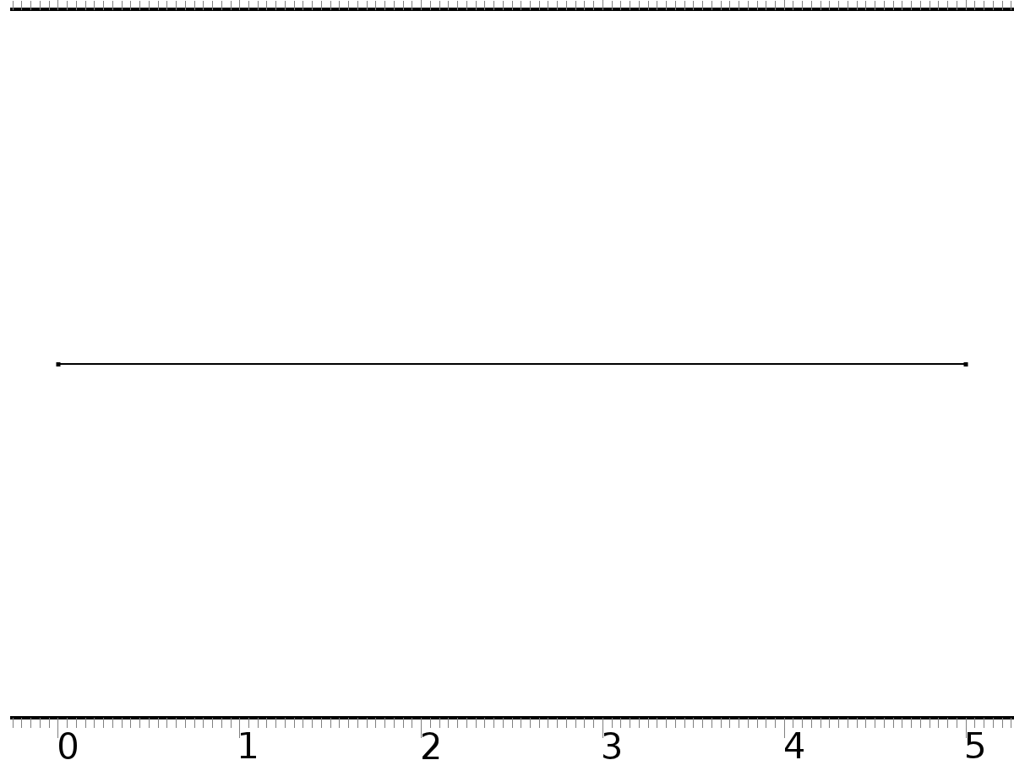

Mesh 1

* + 1. Size (size)

Settings

| **Description** | **Value** |
| --- | --- |
| Maximum element size | 0.1 |
| Minimum element size | 3.75E-4 |
| Curvature factor | 0.25 |
| Maximum element growth rate | 1.2 |
| Predefined size | Extra fine |

* + 1. Distribution 1 (dis1)

Selection

|  |  |
| --- | --- |
| Geometric entity level | Domain |
| Selection | Domain 1 |

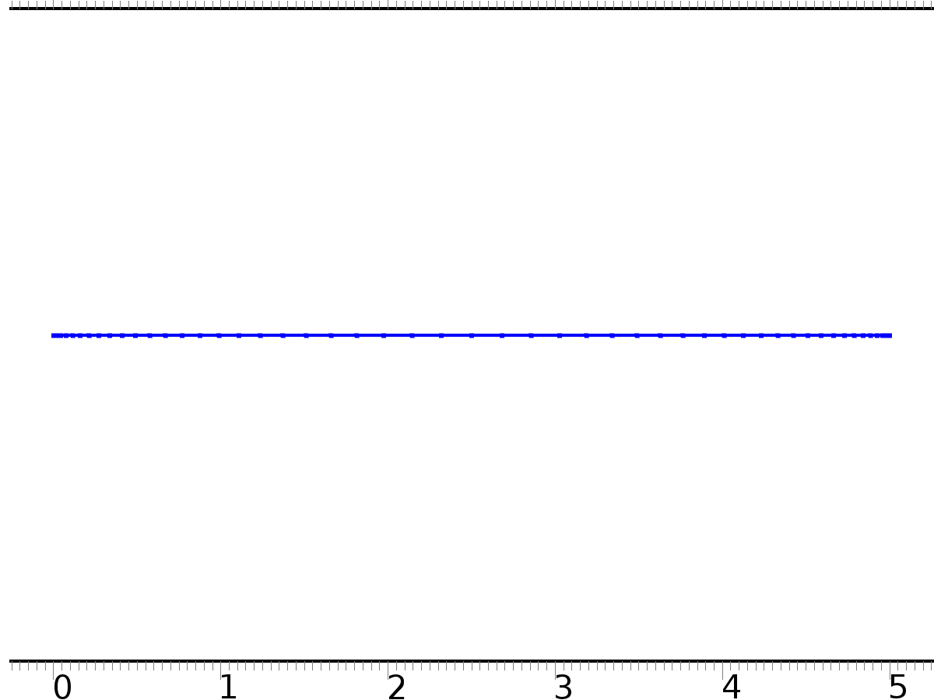

Distribution 1

Settings

| **Description** | **Value** |
| --- | --- |
| Distribution properties | Predefined distribution type |
| Number of elements | 50 |
| Element ratio | 10 |
| Symmetric distribution | On |

* + 1. Edge 1 (edg1)

Selection

|  |  |
| --- | --- |
| Geometric entity level | Domain |
| Selection | Domain 1 |



Edge 1

1. Study 1
   1. Time Dependent

Study settings

| **Description** | **Value** |
| --- | --- |
| Include geometric nonlinearity | Off |

| **Times** | **Unit** |
| --- | --- |
| range(0,0.01,2.5) | s |

Physics and variables selection

| **Physics interface** | **Discretization** |
| --- | --- |
| Zero Dynamics (c) | physics |
| Closed Loop System (c2) | physics |

Mesh selection

| **Geometry** | **Mesh** |
| --- | --- |
| Geometry 1 (geom1) | mesh1 |

* 1. Solver Configurations
     1. Solver 1

#### Compile Equations: Time Dependent (st1)

Study and step

| **Description** | **Value** |
| --- | --- |
| Use study | Study 1 |
| Use study step | Time Dependent |

#### Dependent Variables 1 (v1)

General

| **Description** | **Value** |
| --- | --- |
| Defined by study step | Time Dependent |
| Constant |  |

Initial values of variables solved for

| **Description** | **Value** |
| --- | --- |
| Solution | Zero |

Values of variables not solved for

| **Description** | **Value** |
| --- | --- |
| Solution | Zero |

##### Dependent variable Dq (comp1.Dq) (comp1_Dq)

General

| **Description** | **Value** |
| --- | --- |
| Field components | comp1.Dq |
| Field name | comp1_Dw |

##### Dependent variable p (comp1.p) (comp1_p)

General

| **Description** | **Value** |
| --- | --- |
| Field components | comp1.p |
| Field name | comp1_u |

##### Dependent variable q (comp1.q) (comp1_q)

General

| **Description** | **Value** |
| --- | --- |
| Field components | comp1.q |
| Field name | comp1_w |

##### Dependent variable u (comp1.u) (comp1_u)

General

| **Description** | **Value** |
| --- | --- |
| Field components | comp1.u |
| Field name | comp1_u2 |

##### Dependent variable w (comp1.w) (comp1_w)

General

| **Description** | **Value** |
| --- | --- |
| Field components | comp1.w |
| Field name | comp1_u22 |

##### Dependent variable Dw (comp1.Dw) (comp1_Dw)

General

| **Description** | **Value** |
| --- | --- |
| Field components | comp1.Dw |
| Field name | comp1_u23 |

#### Time-Dependent Solver 1 (t1)

General

| **Description** | **Value** |
| --- | --- |
| Defined by study step | Time Dependent |
| Time | {0, 0.01, 0.02, 0.03, 0.04, 0.05, 0.06, 0.07, 0.08, 0.09, 0.1, 0.11, 0.12, 0.13, 0.14, 0.15, 0.16, 0.17, 0.18, 0.19, 0.2, 0.21, 0.22, 0.23, 0.24, 0.25, 0.26, 0.27, 0.28, 0.29, 0.3, 0.31, 0.32, 0.33, 0.34, 0.35000000000000003, 0.36, 0.37, 0.38, 0.39, 0.4, 0.41000000000000003, 0.42, 0.43, 0.44, 0.45, 0.46, 0.47000000000000003, 0.48, 0.49, 0.5, 0.51, 0.52, 0.53, 0.54, 0.55, 0.56, 0.5700000000000001, 0.58, 0.59, 0.6, 0.61, 0.62, 0.63, 0.64, 0.65, 0.66, 0.67, 0.68, 0.6900000000000001, 0.7000000000000001, 0.71, 0.72, 0.73, 0.74, 0.75, 0.76, 0.77, 0.78, 0.79, 0.8, 0.81, 0.8200000000000001, 0.8300000000000001, 0.84, 0.85, 0.86, 0.87, 0.88, 0.89, 0.9, 0.91, 0.92, 0.93, 0.9400000000000001, 0.9500000000000001, 0.96, 0.97, 0.98, 0.99, 1, 1.01, 1.02, 1.03, 1.04, 1.05, 1.06, 1.07, 1.08, 1.09, 1.1, 1.11, 1.12, 1.1300000000000001, 1.1400000000000001, 1.1500000000000001, 1.16, 1.17, 1.18, 1.19, 1.2, 1.21, 1.22, 1.23, 1.24, 1.25, 1.26, 1.27, 1.28, 1.29, 1.3, 1.31, 1.32, 1.33, 1.34, 1.35, 1.36, 1.37, 1.3800000000000001, 1.3900000000000001, 1.4000000000000001, 1.41, 1.42, 1.43, 1.44, 1.45, 1.46, 1.47, 1.48, 1.49, 1.5, 1.51, 1.52, 1.53, 1.54, 1.55, 1.56, 1.57, 1.58, 1.59, 1.6, 1.61, 1.62, 1.6300000000000001, 1.6400000000000001, 1.6500000000000001, 1.6600000000000001, 1.67, 1.68, 1.69, 1.7, 1.71, 1.72, 1.73, 1.74, 1.75, 1.76, 1.77, 1.78, 1.79, 1.8, 1.81, 1.82, 1.83, 1.84, 1.85, 1.86, 1.87, 1.8800000000000001, 1.8900000000000001, 1.9000000000000001, 1.9100000000000001, 1.92, 1.93, 1.94, 1.95, 1.96, 1.97, 1.98, 1.99, 2, 2.0100000000000002, 2.02, 2.0300000000000002, 2.04, 2.05, 2.06, 2.07, 2.08, 2.09, 2.1, 2.11, 2.12, 2.13, 2.14, 2.15, 2.16, 2.17, 2.18, 2.19, 2.2, 2.21, 2.22, 2.23, 2.24, 2.25, 2.2600000000000002, 2.27, 2.2800000000000002, 2.29, 2.3000000000000003, 2.31, 2.32, 2.33, 2.34, 2.35, 2.36, 2.37, 2.38, 2.39, 2.4, 2.41, 2.42, 2.43, 2.44, 2.45, 2.46, 2.47, 2.48, 2.49, 2.5} |

Absolute tolerance

| **Description** | **Value** |
| --- | --- |
| Tolerance | 0.0010 |

Time stepping

| **Description** | **Value** |
| --- | --- |
| Steps taken by solver | Intermediate |
| Initial step | 0.0010 |

Advanced

| **Description** | **Value** |
| --- | --- |
| Fraction of initial step for Backward Euler | 0.0010 |

Log

| **Description** | **Value** |
| --- | --- |
| Constant |  |

##### Fully Coupled 1 (fc1)

General

| **Description** | **Value** |
| --- | --- |
| Linear solver | Direct |

1. Results
   1. Data Sets
      1. Solution 1

Solution

| **Description** | **Value** |
| --- | --- |
| Solution | Solver 1 |
| Component | Save Point Geometry 1 |

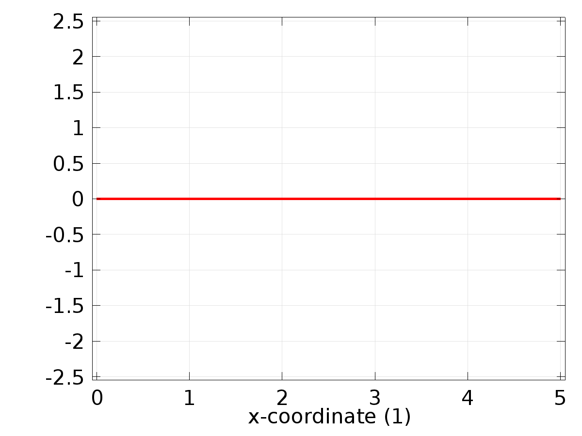

Data set: Solution 1

* 1. Derived Values
     1. Global Evaluation 1

Data

| **Description** | **Value** |
| --- | --- |
| Data set | Solution 1 |

Expression

| **Description** | **Value** |
| --- | --- |
| Expression | C(qx) |
| Description | C(qx) |

* 1. Tables
     1. Table 1

Global Evaluation 1 (C(wx))

Table 1

| **Time (s)** | **C(wx)** | **yr2** | **e2** | **C(qx)** |
| --- | --- | --- | --- | --- |
| 0.0000 | -0.0035857 | 0.0000 | 0.0035857 | 0.0000 |
| 0.010000 | 4.7015E-4 | 3.9989E-4 | -7.0252E-5 | 3.9881E-4 |
| 0.020000 | 8.6694E-4 | 7.9915E-4 | -6.7796E-5 | 7.9805E-4 |
| 0.030000 | 0.0012626 | 0.0011971 | -6.5497E-5 | 0.0011960 |
| 0.040000 | 0.0016565 | 0.0015932 | -6.3336E-5 | 0.0015921 |
| 0.050000 | 0.0020480 | 0.0019867 | -6.1299E-5 | 0.0019856 |
| 0.060000 | 0.0024364 | 0.0023770 | -5.9374E-5 | 0.0023759 |
| 0.070000 | 0.0028211 | 0.0027636 | -5.7550E-5 | 0.0027624 |
| 0.080000 | 0.0032015 | 0.0031457 | -5.5818E-5 | 0.0031446 |
| 0.090000 | 0.0035769 | 0.0035227 | -5.4170E-5 | 0.0035216 |
| 0.10000 | 0.0039468 | 0.0038942 | -5.2601E-5 | 0.0038931 |
| 0.11000 | 0.0043101 | 0.0042594 | -5.0706E-5 | 0.0042579 |
| 0.12000 | 0.0046669 | 0.0046178 | -4.9132E-5 | 0.0046162 |
| 0.13000 | 0.0050170 | 0.0049688 | -4.8241E-5 | 0.0049677 |
| 0.14000 | 0.0053589 | 0.0053119 | -4.6995E-5 | 0.0053108 |
| 0.15000 | 0.0056922 | 0.0056464 | -4.5749E-5 | 0.0056454 |
| 0.16000 | 0.0060165 | 0.0059720 | -4.4542E-5 | 0.0059710 |
| 0.17000 | 0.0063313 | 0.0062879 | -4.3378E-5 | 0.0062870 |
| 0.18000 | 0.0066361 | 0.0065938 | -4.2262E-5 | 0.0065929 |
| 0.19000 | 0.0069304 | 0.0068892 | -4.1190E-5 | 0.0068883 |
| 0.20000 | 0.0072137 | 0.0071736 | -4.0156E-5 | 0.0071727 |
| 0.21000 | 0.0074856 | 0.0074464 | -3.9160E-5 | 0.0074456 |
| 0.22000 | 0.0077456 | 0.0077074 | -3.8200E-5 | 0.0077066 |
| 0.23000 | 0.0079933 | 0.0079560 | -3.7272E-5 | 0.0079552 |
| 0.24000 | 0.0082283 | 0.0081919 | -3.6377E-5 | 0.0081912 |
| 0.25000 | 0.0084502 | 0.0084147 | -3.5513E-5 | 0.0084140 |
| 0.26000 | 0.0086587 | 0.0086240 | -3.4677E-5 | 0.0086234 |
| 0.27000 | 0.0088534 | 0.0088196 | -3.3869E-5 | 0.0088190 |
| 0.28000 | 0.0090341 | 0.0090010 | -3.3087E-5 | 0.0090004 |
| 0.29000 | 0.0092004 | 0.0091680 | -3.2332E-5 | 0.0091675 |
| 0.30000 | 0.0093520 | 0.0093204 | -3.1600E-5 | 0.0093199 |
| 0.31000 | 0.0094887 | 0.0094578 | -3.0890E-5 | 0.0094574 |
| 0.32000 | 0.0096104 | 0.0095802 | -3.0204E-5 | 0.0095797 |
| 0.33000 | 0.0097167 | 0.0096872 | -2.9537E-5 | 0.0096868 |
| 0.34000 | 0.0098075 | 0.0097786 | -2.8891E-5 | 0.0097783 |
| 0.35000 | 0.0098828 | 0.0098545 | -2.8263E-5 | 0.0098542 |
| 0.36000 | 0.0099422 | 0.0099146 | -2.7654E-5 | 0.0099143 |
| 0.37000 | 0.0099859 | 0.0099588 | -2.7064E-5 | 0.0099586 |
| 0.38000 | 0.010014 | 0.0099871 | -2.6489E-5 | 0.0099870 |
| 0.39000 | 0.010025 | 0.0099994 | -2.5932E-5 | 0.0099993 |
| 0.40000 | 0.010021 | 0.0099957 | -2.5389E-5 | 0.0099957 |
| 0.41000 | 0.010001 | 0.0099761 | -2.4862E-5 | 0.0099761 |
| 0.42000 | 0.0099648 | 0.0099404 | -2.4349E-5 | 0.0099405 |
| 0.43000 | 0.0099127 | 0.0098889 | -2.3849E-5 | 0.0098890 |
| 0.44000 | 0.0098449 | 0.0098215 | -2.3363E-5 | 0.0098217 |
| 0.45000 | 0.0097614 | 0.0097385 | -2.2890E-5 | 0.0097387 |
| 0.46000 | 0.0096623 | 0.0096398 | -2.2428E-5 | 0.0096401 |
| 0.47000 | 0.0095477 | 0.0095258 | -2.1978E-5 | 0.0095260 |
| 0.48000 | 0.0094180 | 0.0093965 | -2.1540E-5 | 0.0093968 |
| 0.49000 | 0.0092732 | 0.0092521 | -2.1112E-5 | 0.0092525 |
| 0.50000 | 0.0091137 | 0.0090930 | -2.0695E-5 | 0.0090934 |
| 0.51000 | 0.0089396 | 0.0089193 | -2.0287E-5 | 0.0089197 |
| 0.52000 | 0.0087512 | 0.0087313 | -1.9889E-5 | 0.0087318 |
| 0.53000 | 0.0085489 | 0.0085294 | -1.9500E-5 | 0.0085299 |
| 0.54000 | 0.0083330 | 0.0083138 | -1.9120E-5 | 0.0083144 |
| 0.55000 | 0.0081037 | 0.0080850 | -1.8748E-5 | 0.0080856 |
| 0.56000 | 0.0078615 | 0.0078432 | -1.8385E-5 | 0.0078438 |
| 0.57000 | 0.0076068 | 0.0075888 | -1.8029E-5 | 0.0075895 |
| 0.58000 | 0.0073400 | 0.0073223 | -1.7680E-5 | 0.0073230 |
| 0.59000 | 0.0070614 | 0.0070441 | -1.7339E-5 | 0.0070449 |
| 0.60000 | 0.0067716 | 0.0067546 | -1.7004E-5 | 0.0067554 |
| 0.61000 | 0.0064710 | 0.0064543 | -1.6677E-5 | 0.0064552 |
| 0.62000 | 0.0061601 | 0.0061437 | -1.6355E-5 | 0.0061446 |
| 0.63000 | 0.0058393 | 0.0058233 | -1.6040E-5 | 0.0058242 |
| 0.64000 | 0.0055093 | 0.0054936 | -1.5730E-5 | 0.0054945 |
| 0.65000 | 0.0051704 | 0.0051550 | -1.5426E-5 | 0.0051560 |
| 0.66000 | 0.0048234 | 0.0048082 | -1.5127E-5 | 0.0048092 |
| 0.67000 | 0.0044686 | 0.0044537 | -1.4834E-5 | 0.0044548 |
| 0.68000 | 0.0041067 | 0.0040921 | -1.4545E-5 | 0.0040932 |
| 0.69000 | 0.0037383 | 0.0037240 | -1.4261E-5 | 0.0037250 |
| 0.70000 | 0.0033639 | 0.0033499 | -1.3982E-5 | 0.0033510 |
| 0.71000 | 0.0029841 | 0.0029704 | -1.3707E-5 | 0.0029715 |
| 0.72000 | 0.0025996 | 0.0025862 | -1.3436E-5 | 0.0025873 |
| 0.73000 | 0.0022110 | 0.0021978 | -1.3169E-5 | 0.0021990 |
| 0.74000 | 0.0018189 | 0.0018060 | -1.2906E-5 | 0.0018071 |
| 0.75000 | 0.0014238 | 0.0014112 | -1.2647E-5 | 0.0014123 |
| 0.76000 | 0.0010266 | 0.0010142 | -1.2391E-5 | 0.0010153 |
| 0.77000 | 6.2768E-4 | 6.1554E-4 | -1.2139E-5 | 6.1670E-4 |
| 0.78000 | 2.2780E-4 | 2.1591E-4 | -1.1890E-5 | 2.1708E-4 |
| 0.79000 | -1.7242E-4 | -1.8406E-4 | -1.1644E-5 | -1.8289E-4 |
| 0.80000 | -5.7234E-4 | -5.8374E-4 | -1.1401E-5 | -5.8257E-4 |
| 0.81000 | -9.7133E-4 | -9.8249E-4 | -1.1161E-5 | -9.8131E-4 |
| 0.82000 | -0.0013687 | -0.0013797 | -1.0923E-5 | -0.0013785 |
| 0.83000 | -0.0017639 | -0.0017746 | -1.0689E-5 | -0.0017735 |
| 0.84000 | -0.0021563 | -0.0021668 | -1.0457E-5 | -0.0021656 |
| 0.85000 | -0.0025452 | -0.0025554 | -1.0228E-5 | -0.0025543 |
| 0.86000 | -0.0029300 | -0.0029400 | -1.0001E-5 | -0.0029388 |
| 0.87000 | -0.0033101 | -0.0033199 | -9.7762E-6 | -0.0033187 |
| 0.88000 | -0.0036849 | -0.0036944 | -9.5539E-6 | -0.0036933 |
| 0.89000 | -0.0040537 | -0.0040631 | -9.3338E-6 | -0.0040619 |
| 0.90000 | -0.0044161 | -0.0044252 | -9.1158E-6 | -0.0044241 |
| 0.91000 | -0.0047714 | -0.0047803 | -8.9000E-6 | -0.0047792 |
| 0.92000 | -0.0051190 | -0.0051277 | -8.6863E-6 | -0.0051266 |
| 0.93000 | -0.0054584 | -0.0054669 | -8.4745E-6 | -0.0054659 |
| 0.94000 | -0.0057891 | -0.0057974 | -8.2647E-6 | -0.0057964 |
| 0.95000 | -0.0061105 | -0.0061186 | -8.0572E-6 | -0.0061176 |
| 0.96000 | -0.0064221 | -0.0064300 | -7.8512E-6 | -0.0064290 |
| 0.97000 | -0.0067235 | -0.0067311 | -7.6470E-6 | -0.0067302 |
| 0.98000 | -0.0070140 | -0.0070215 | -7.4440E-6 | -0.0070206 |
| 0.99000 | -0.0072933 | -0.0073006 | -7.2435E-6 | -0.0072997 |
| 1.0000 | -0.0075610 | -0.0075680 | -7.0449E-6 | -0.0075672 |
| 1.0100 | -0.0078165 | -0.0078234 | -6.8483E-6 | -0.0078226 |
| 1.0200 | -0.0080595 | -0.0080662 | -6.6533E-6 | -0.0080654 |
| 1.0300 | -0.0082896 | -0.0082961 | -6.4599E-6 | -0.0082954 |
| 1.0400 | -0.0085065 | -0.0085127 | -6.2684E-6 | -0.0085120 |
| 1.0500 | -0.0087097 | -0.0087158 | -6.0786E-6 | -0.0087151 |
| 1.0600 | -0.0088989 | -0.0089048 | -5.8909E-6 | -0.0089042 |
| 1.0700 | -0.0090740 | -0.0090797 | -5.7043E-6 | -0.0090791 |
| 1.0800 | -0.0092345 | -0.0092400 | -5.5198E-6 | -0.0092394 |
| 1.0900 | -0.0093802 | -0.0093855 | -5.3373E-6 | -0.0093850 |
| 1.1000 | -0.0095109 | -0.0095160 | -5.1567E-6 | -0.0095156 |
| 1.1100 | -0.0096263 | -0.0096313 | -4.9778E-6 | -0.0096309 |
| 1.1200 | -0.0097264 | -0.0097312 | -4.8008E-6 | -0.0097308 |
| 1.1300 | -0.0098109 | -0.0098155 | -4.6257E-6 | -0.0098152 |
| 1.1400 | -0.0098797 | -0.0098841 | -4.4526E-6 | -0.0098838 |
| 1.1500 | -0.0099326 | -0.0099369 | -4.2811E-6 | -0.0099367 |
| 1.1600 | -0.0099697 | -0.0099738 | -4.1120E-6 | -0.0099736 |
| 1.1700 | -0.0099908 | -0.0099948 | -3.9446E-6 | -0.0099946 |
| 1.1800 | -0.0099959 | -0.0099997 | -3.7793E-6 | -0.0099996 |
| 1.1900 | -0.0099851 | -0.0099887 | -3.6161E-6 | -0.0099886 |
| 1.2000 | -0.0099582 | -0.0099616 | -3.4551E-6 | -0.0099616 |
| 1.2100 | -0.0099154 | -0.0099187 | -3.2961E-6 | -0.0099187 |
| 1.2200 | -0.0098567 | -0.0098599 | -3.1393E-6 | -0.0098600 |
| 1.2300 | -0.0097823 | -0.0097853 | -2.9848E-6 | -0.0097854 |
| 1.2400 | -0.0096922 | -0.0096950 | -2.8325E-6 | -0.0096952 |
| 1.2500 | -0.0095866 | -0.0095892 | -2.6825E-6 | -0.0095895 |
| 1.2600 | -0.0094656 | -0.0094681 | -2.5347E-6 | -0.0094684 |
| 1.2700 | -0.0093295 | -0.0093319 | -2.3893E-6 | -0.0093322 |
| 1.2800 | -0.0091785 | -0.0091807 | -2.2464E-6 | -0.0091811 |
| 1.2900 | -0.0090127 | -0.0090148 | -2.1058E-6 | -0.0090152 |
| 1.3000 | -0.0088326 | -0.0088345 | -1.9678E-6 | -0.0088350 |
| 1.3100 | -0.0086383 | -0.0086401 | -1.8322E-6 | -0.0086406 |
| 1.3200 | -0.0084302 | -0.0084319 | -1.6992E-6 | -0.0084324 |
| 1.3300 | -0.0082086 | -0.0082101 | -1.5684E-6 | -0.0082107 |
| 1.3400 | -0.0079738 | -0.0079753 | -1.4411E-6 | -0.0079759 |
| 1.3500 | -0.0077263 | -0.0077276 | -1.3160E-6 | -0.0077283 |
| 1.3600 | -0.0074665 | -0.0074677 | -1.1935E-6 | -0.0074684 |
| 1.3700 | -0.0071946 | -0.0071957 | -1.0735E-6 | -0.0071965 |
| 1.3800 | -0.0069113 | -0.0069123 | -9.5610E-7 | -0.0069130 |
| 1.3900 | -0.0066169 | -0.0066178 | -8.4247E-7 | -0.0066186 |
| 1.4000 | -0.0063119 | -0.0063127 | -7.3110E-7 | -0.0063135 |
| 1.4100 | -0.0059969 | -0.0059975 | -6.2177E-7 | -0.0059983 |
| 1.4200 | -0.0056722 | -0.0056727 | -5.1665E-7 | -0.0056736 |
| 1.4300 | -0.0053384 | -0.0053388 | -4.1305E-7 | -0.0053398 |
| 1.4400 | -0.0049961 | -0.0049964 | -3.2490E-7 | -0.0049974 |
| 1.4500 | -0.0046458 | -0.0046460 | -2.2825E-7 | -0.0046470 |
| 1.4600 | -0.0042881 | -0.0042882 | -1.3417E-7 | -0.0042892 |
| 1.4700 | -0.0039235 | -0.0039235 | -3.3801E-8 | -0.0039245 |
| 1.4800 | -0.0035526 | -0.0035525 | 5.5420E-8 | -0.0035536 |
| 1.4900 | -0.0031760 | -0.0031759 | 1.4104E-7 | -0.0031770 |
| 1.5000 | -0.0027944 | -0.0027942 | 2.2340E-7 | -0.0027952 |
| 1.5100 | -0.0024083 | -0.0024080 | 3.0149E-7 | -0.0024091 |
| 1.5200 | -0.0020183 | -0.0020179 | 3.7777E-7 | -0.0020190 |
| 1.5300 | -0.0016251 | -0.0016246 | 4.5115E-7 | -0.0016258 |
| 1.5400 | -0.0012293 | -0.0012287 | 5.2152E-7 | -0.0012299 |
| 1.5500 | -8.3148E-4 | -8.3089E-4 | 5.8889E-7 | -8.3205E-4 |
| 1.5600 | -4.3237E-4 | -4.3172E-4 | 6.5328E-7 | -4.3288E-4 |
| 1.5700 | -3.2568E-5 | -3.1853E-5 | 7.1468E-7 | -3.3017E-5 |
| 1.5800 | 3.6729E-4 | 3.6806E-4 | 7.7312E-7 | 3.6690E-4 |
| 1.5900 | 7.6656E-4 | 7.6739E-4 | 8.2861E-7 | 7.6622E-4 |
| 1.6000 | 0.0011646 | 0.0011655 | 8.8116E-7 | 0.0011643 |
| 1.6100 | 0.0015608 | 0.0015617 | 9.3080E-7 | 0.0015606 |
| 1.6200 | 0.0019545 | 0.0019555 | 9.7754E-7 | 0.0019543 |
| 1.6300 | 0.0023451 | 0.0023461 | 1.0214E-6 | 0.0023449 |
| 1.6400 | 0.0027319 | 0.0027329 | 1.0625E-6 | 0.0027318 |
| 1.6500 | 0.0031143 | 0.0031154 | 1.1007E-6 | 0.0031143 |
| 1.6600 | 0.0034918 | 0.0034929 | 1.1361E-6 | 0.0034918 |
| 1.6700 | 0.0038637 | 0.0038648 | 1.1688E-6 | 0.0038637 |
| 1.6800 | 0.0042294 | 0.0042306 | 1.1988E-6 | 0.0042295 |
| 1.6900 | 0.0045883 | 0.0045895 | 1.2261E-6 | 0.0045884 |
| 1.7000 | 0.0049399 | 0.0049411 | 1.2508E-6 | 0.0049401 |
| 1.7100 | 0.0052836 | 0.0052848 | 1.2730E-6 | 0.0052838 |
| 1.7200 | 0.0056188 | 0.0056201 | 1.2925E-6 | 0.0056191 |
| 1.7300 | 0.0059451 | 0.0059464 | 1.3097E-6 | 0.0059454 |
| 1.7400 | 0.0062618 | 0.0062631 | 1.3243E-6 | 0.0062622 |
| 1.7500 | 0.0065685 | 0.0065699 | 1.3371E-6 | 0.0065689 |
| 1.7600 | 0.0068647 | 0.0068661 | 1.3467E-6 | 0.0068652 |
| 1.7700 | 0.0071500 | 0.0071513 | 1.3687E-6 | 0.0071504 |
| 1.7800 | 0.0074238 | 0.0074251 | 1.3750E-6 | 0.0074243 |
| 1.7900 | 0.0076857 | 0.0076871 | 1.3788E-6 | 0.0076862 |
| 1.8000 | 0.0079353 | 0.0079367 | 1.3650E-6 | 0.0079359 |
| 1.8100 | 0.0081722 | 0.0081736 | 1.3643E-6 | 0.0081729 |
| 1.8200 | 0.0083961 | 0.0083975 | 1.3611E-6 | 0.0083967 |
| 1.8300 | 0.0086065 | 0.0086079 | 1.3567E-6 | 0.0086072 |
| 1.8400 | 0.0088032 | 0.0088045 | 1.3498E-6 | 0.0088039 |
| 1.8500 | 0.0089857 | 0.0089871 | 1.3417E-6 | 0.0089865 |
| 1.8600 | 0.0091539 | 0.0091553 | 1.3321E-6 | 0.0091547 |
| 1.8700 | 0.0093075 | 0.0093088 | 1.3210E-6 | 0.0093083 |
| 1.8800 | 0.0094461 | 0.0094474 | 1.3083E-6 | 0.0094470 |
| 1.8900 | 0.0095697 | 0.0095710 | 1.2943E-6 | 0.0095705 |
| 1.9000 | 0.0096779 | 0.0096792 | 1.2790E-6 | 0.0096788 |
| 1.9100 | 0.0097707 | 0.0097719 | 1.2624E-6 | 0.0097716 |
| 1.9200 | 0.0098478 | 0.0098490 | 1.2446E-6 | 0.0098487 |
| 1.9300 | 0.0099092 | 0.0099104 | 1.2258E-6 | 0.0099101 |
| 1.9400 | 0.0099547 | 0.0099559 | 1.2060E-6 | 0.0099557 |
| 1.9500 | 0.0099842 | 0.0099854 | 1.1853E-6 | 0.0099853 |
| 1.9600 | 0.0099979 | 0.0099990 | 1.1637E-6 | 0.0099989 |
| 1.9700 | 0.0099955 | 0.0099966 | 1.1414E-6 | 0.0099965 |
| 1.9800 | 0.0099771 | 0.0099782 | 1.1184E-6 | 0.0099782 |
| 1.9900 | 0.0099428 | 0.0099439 | 1.0949E-6 | 0.0099439 |
| 2.0000 | 0.0098925 | 0.0098936 | 1.0708E-6 | 0.0098937 |
| 2.0100 | 0.0098264 | 0.0098275 | 1.0464E-6 | 0.0098276 |
| 2.0200 | 0.0097446 | 0.0097457 | 1.0216E-6 | 0.0097458 |
| 2.0300 | 0.0096473 | 0.0096483 | 9.9659E-7 | 0.0096485 |
| 2.0400 | 0.0095344 | 0.0095354 | 9.7143E-7 | 0.0095357 |
| 2.0500 | 0.0094064 | 0.0094073 | 9.4619E-7 | 0.0094076 |
| 2.0600 | 0.0092632 | 0.0092642 | 9.2095E-7 | 0.0092645 |
| 2.0700 | 0.0091053 | 0.0091062 | 8.9580E-7 | 0.0091066 |
| 2.0800 | 0.0089328 | 0.0089336 | 8.7079E-7 | 0.0089341 |
| 2.0900 | 0.0087460 | 0.0087468 | 8.4603E-7 | 0.0087473 |
| 2.1000 | 0.0085452 | 0.0085460 | 8.2159E-7 | 0.0085465 |
| 2.1100 | 0.0083307 | 0.0083315 | 7.9754E-7 | 0.0083321 |
| 2.1200 | 0.0081029 | 0.0081037 | 7.7397E-7 | 0.0081043 |
| 2.1300 | 0.0078621 | 0.0078629 | 7.5093E-7 | 0.0078635 |
| 2.1400 | 0.0076088 | 0.0076095 | 7.2851E-7 | 0.0076102 |
| 2.1500 | 0.0073433 | 0.0073440 | 7.0678E-7 | 0.0073447 |
| 2.1600 | 0.0070660 | 0.0070667 | 6.8579E-7 | 0.0070674 |
| 2.1700 | 0.0067774 | 0.0067781 | 6.6562E-7 | 0.0067789 |
| 2.1800 | 0.0064780 | 0.0064786 | 6.4632E-7 | 0.0064795 |
| 2.1900 | 0.0061682 | 0.0061688 | 6.2796E-7 | 0.0061697 |
| 2.2000 | 0.0058486 | 0.0058492 | 6.1059E-7 | 0.0058501 |
| 2.2100 | 0.0055195 | 0.0055201 | 5.9426E-7 | 0.0055211 |
| 2.2200 | 0.0051817 | 0.0051823 | 5.7905E-7 | 0.0051832 |
| 2.2300 | 0.0048356 | 0.0048361 | 5.6499E-7 | 0.0048371 |
| 2.2400 | 0.0044817 | 0.0044822 | 5.5214E-7 | 0.0044832 |
| 2.2500 | 0.0041206 | 0.0041212 | 5.4055E-7 | 0.0041222 |
| 2.2600 | 0.0037530 | 0.0037535 | 5.3026E-7 | 0.0037546 |
| 2.2700 | 0.0033794 | 0.0033799 | 5.2131E-7 | 0.0033809 |
| 2.2800 | 0.0030003 | 0.0030008 | 5.1374E-7 | 0.0030019 |
| 2.2900 | 0.0026164 | 0.0026169 | 5.0758E-7 | 0.0026180 |
| 2.3000 | 0.0022284 | 0.0022289 | 5.0286E-7 | 0.0022300 |
| 2.3100 | 0.0018368 | 0.0018373 | 4.9962E-7 | 0.0018384 |
| 2.3200 | 0.0014422 | 0.0014427 | 4.9788E-7 | 0.0014439 |
| 2.3300 | 0.0010454 | 0.0010459 | 4.9766E-7 | 0.0010470 |
| 2.3400 | 6.4683E-4 | 6.4733E-4 | 4.9900E-7 | 6.4848E-4 |
| 2.3500 | 2.4725E-4 | 2.4775E-4 | 5.0190E-7 | 2.4892E-4 |
| 2.3600 | -1.5272E-4 | -1.5221E-4 | 5.0638E-7 | -1.5105E-4 |
| 2.3700 | -5.5245E-4 | -5.5194E-4 | 5.1245E-7 | -5.5077E-4 |
| 2.3800 | -9.5130E-4 | -9.5078E-4 | 5.2012E-7 | -9.4961E-4 |
| 2.3900 | -0.0013486 | -0.0013481 | 5.2940E-7 | -0.0013469 |
| 2.4000 | -0.0017438 | -0.0017433 | 5.4029E-7 | -0.0017421 |
| 2.4100 | -0.0021362 | -0.0021356 | 5.5226E-7 | -0.0021345 |
| 2.4200 | -0.0025252 | -0.0025246 | 5.6685E-7 | -0.0025234 |
| 2.4300 | -0.0029101 | -0.0029095 | 5.8260E-7 | -0.0029084 |
| 2.4400 | -0.0032904 | -0.0032898 | 5.9990E-7 | -0.0032887 |
| 2.4500 | -0.0036654 | -0.0036648 | 6.1877E-7 | -0.0036637 |
| 2.4600 | -0.0040346 | -0.0040339 | 6.3919E-7 | -0.0040328 |
| 2.4700 | -0.0043973 | -0.0043966 | 6.6116E-7 | -0.0043955 |
| 2.4800 | -0.0047530 | -0.0047523 | 6.8465E-7 | -0.0047512 |
| 2.4900 | -0.0051010 | -0.0051003 | 7.0963E-7 | -0.0050993 |
| 2.5000 | -0.0054409 | -0.0054402 | 7.3607E-7 | -0.0054392 |

* 1. Plot Groups
     1. 1D Plot Group 1

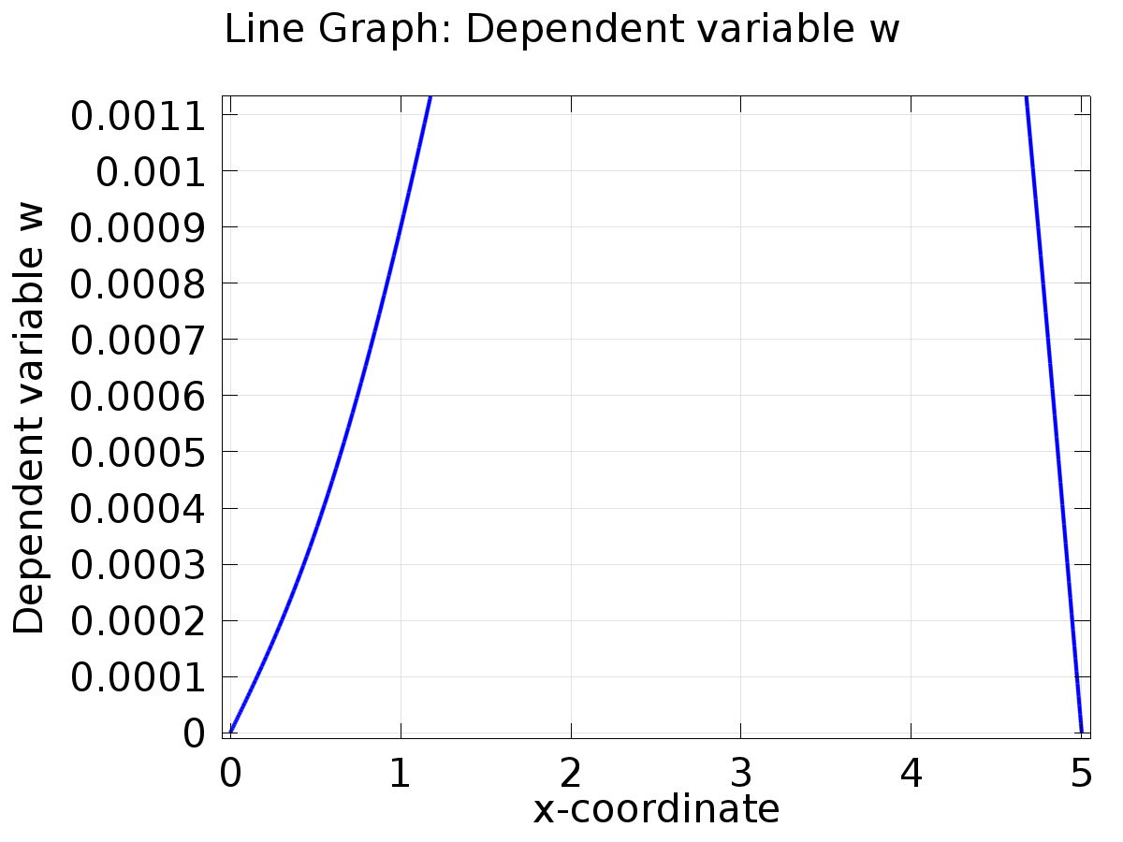

Line Graph: Dependent variable w

* + 1. 1D Plot Group 2

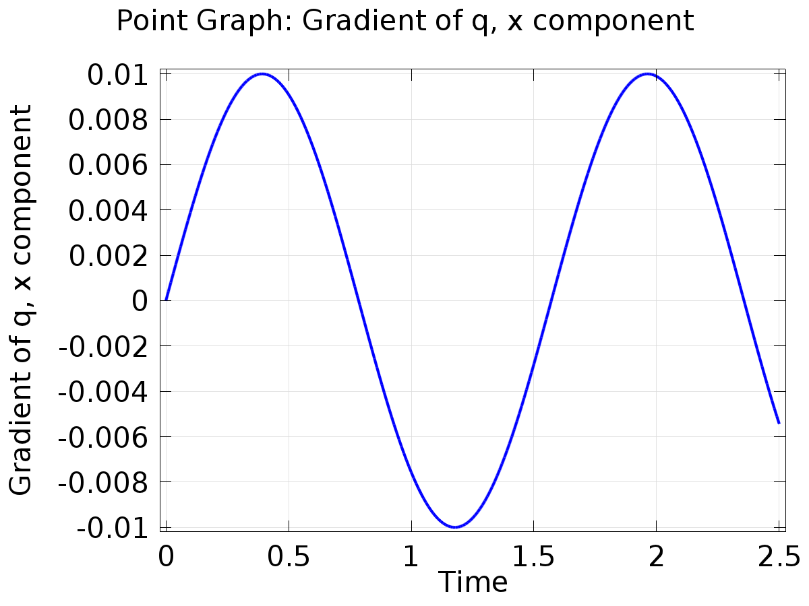

Point Graph: Gradient of q, x component

* + 1. 1D Plot Group 3

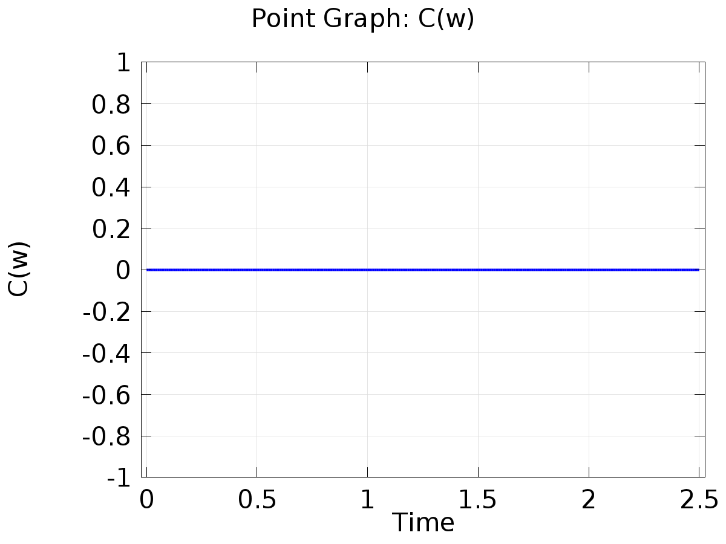

Point Graph: C(w)

* + 1. 1D Plot Group 4

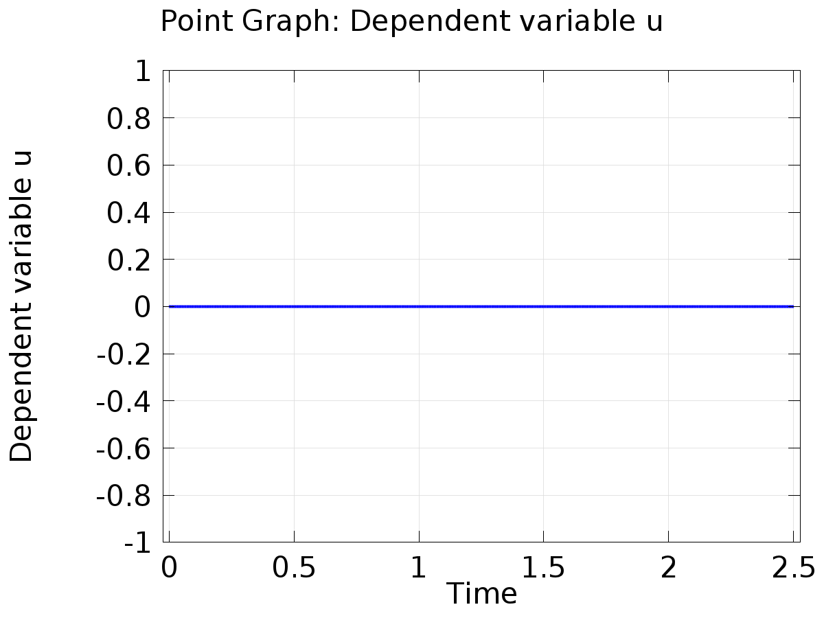

Point Graph: Dependent variable u

* + 1. 1D Plot Group 5

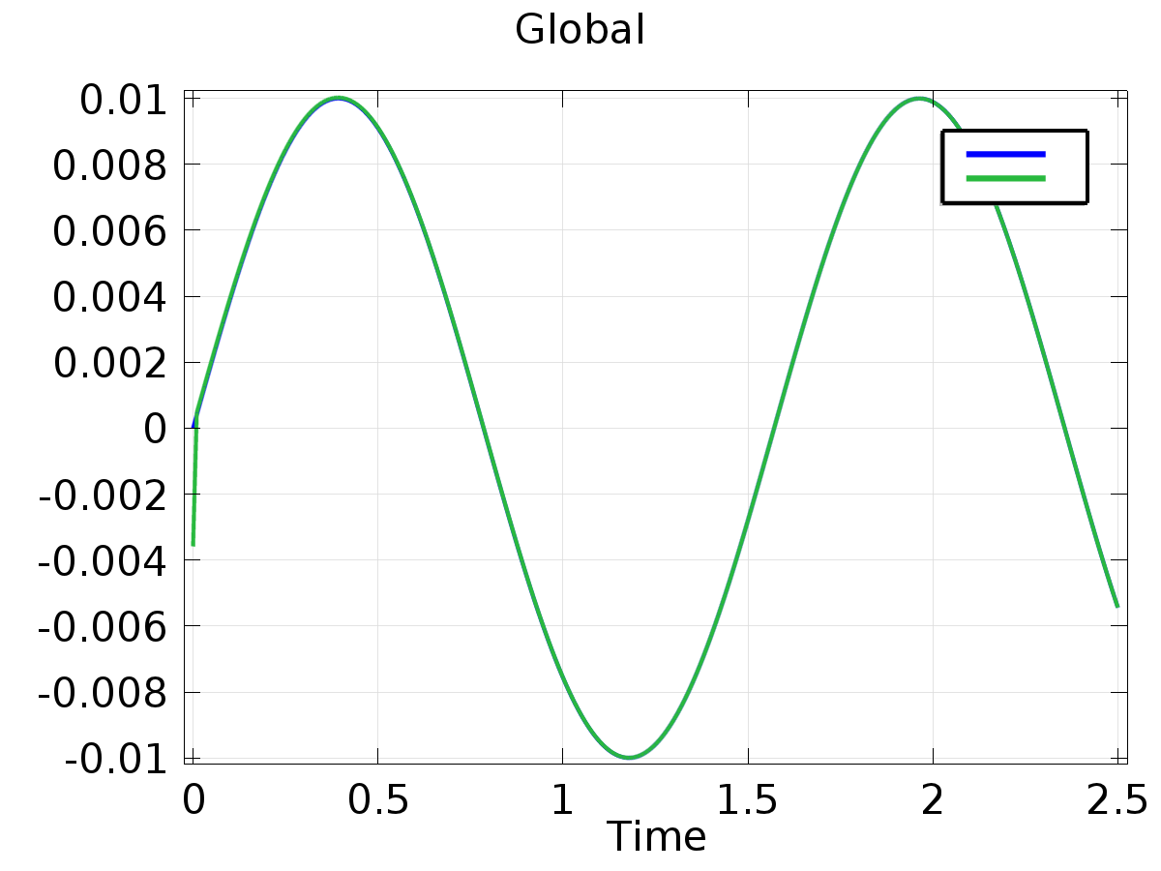

Global

* + 1. 1D Plot Group 6

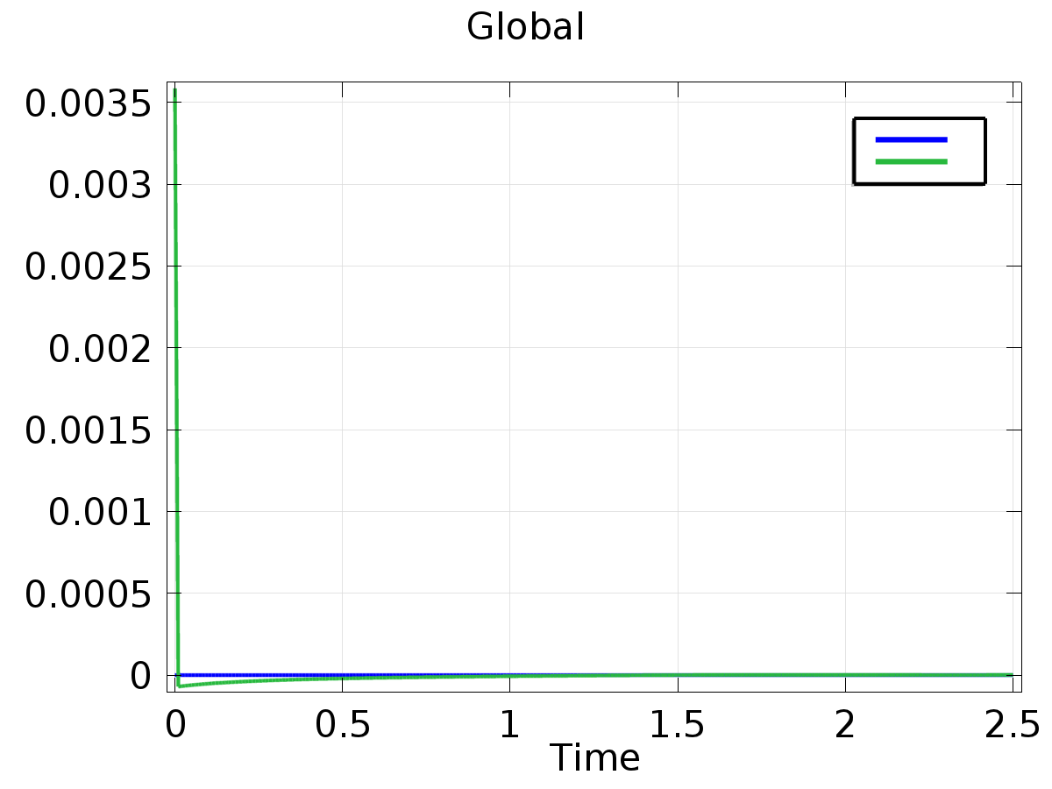

Global