[](http://www.comsol.com/)

Ex5 5 2 Chaffe-Infante zero dynamics

|  |  |
| --- | --- |
| Date | Aug 10, 2014 2:05:05 PM |

Contents

1. Global

1.1. Definitions

2. Component 1

2.1. Definitions

2.2. Geometry 1

2.3. zero dymamics

2.4. Plant

2.5. Mesh 1

3. Study 1

3.1. Time Dependent

3.2. Solver Configurations

4. Results

4.1. Data Sets

4.2. Derived Values

4.3. Tables

4.4. Plot Groups

1. Global

|  |  |
| --- | --- |
| Date | Aug 1, 2014 3:26:36 PM |

Global settings

|  |  |
| --- | --- |
| Name | Ex5 5 2 Chaffe-Infante zero dynamics.mph |
| Path | /Users/gilliam/Desktop/collect_15/research_15/geo_reg_mono_eugenio/Mono_1_15/Comsol_EX_GitHub/Chapter5/Chap5Ex6_ZD/Ex5.5.2_CI_ZD/Ex5_5_2_Chaffe-Infante_zero_dynamics.mph |
| Program | COMSOL 4.4 (Build: 150) |

Used products

|  |
| --- |
| COMSOL Multiphysics |

* 1. Definitions
     1. Parameters 1

Parameters

| **Name** | **Expression** | **Value** | **Description** |
| --- | --- | --- | --- |
| L | 1 | 1.0000 |  |
| lambda | 3 | 3.0000 |  |
| k1 | 1 | 1.0000 |  |
| k2 | 2 | 2.0000 |  |
| k3 | 0.5 | 0.50000 |  |
| k4 | 0.25 | 0.25000 |  |

1. Component 1

Component settings

|  |  |
| --- | --- |
| Unit system | None |

* 1. Definitions
     1. Variables

#### Variables 1

Selection

|  |  |
| --- | --- |
| Geometric entity level | Entire model |

| **Name** | **Expression** | **Description** |
| --- | --- | --- |
| d1 | cos((y - t)*2*pi)*5 |  |
| d2 | cos((x - t)*2*pi)*10 |  |
| yr3 | flc2hs(y - 0.25, 0.05) - flc2hs(y - 0.5, 0.05) |  |
| yr4 | -2*(flc2hs(x - 0.25, 0.05) - flc2hs(x - 0.5, 0.05)) |  |
| e1 | sqrt(C1((yr3 - z)^2)) |  |
| e2 | sqrt(C2((yr4 - z)^2)) |  |

* + 1. Component Couplings

#### Integration 1

|  |  |
| --- | --- |
| Coupling type | Integration |
| Operator name | C1 |

Source selection

|  |  |
| --- | --- |
| Geometric entity level | Boundary |
| Selection | Boundary 4 |

#### Integration 2

|  |  |
| --- | --- |
| Coupling type | Integration |
| Operator name | C2 |

Source selection

|  |  |
| --- | --- |
| Geometric entity level | Boundary |
| Selection | Boundary 3 |

* + 1. Coordinate Systems

#### Boundary System 1

|  |  |
| --- | --- |
| Coordinate system type | Boundary system |
| Tag | sys1 |

Coordinate names

| **First (t1)** | **Second (n)** | **Third (to)** |
| --- | --- | --- |
| t1 | n | to |

Settings

| **Description** | **Value** |
| --- | --- |
| Create first tangent direction from | Global Cartesian |

* 1. Geometry 1

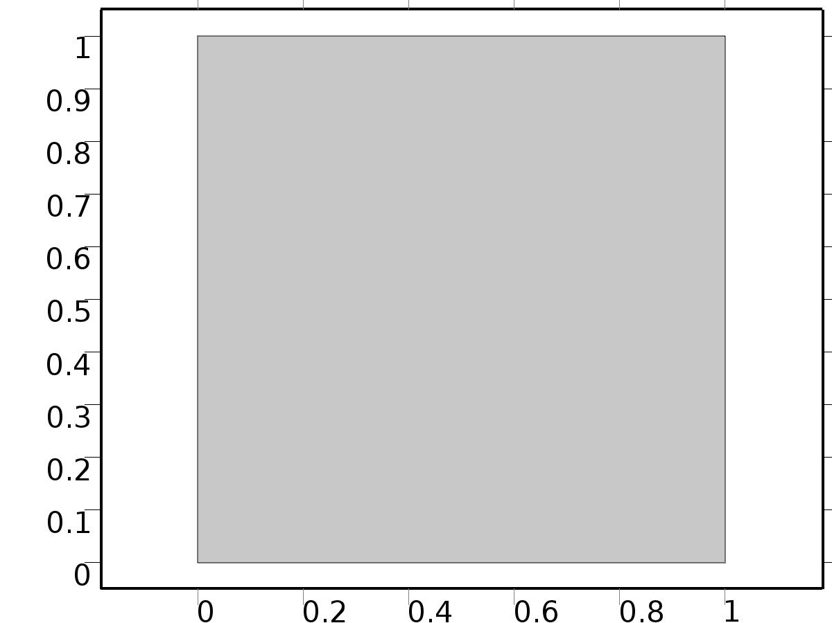

Geometry 1

Units

|  |  |
| --- | --- |
| Length unit | m |
| Angular unit | deg |

Geometry statistics

| **Description** | **Value** |
| --- | --- |
| Space dimension | 2 |
| Number of domains | 1 |
| Number of boundaries | 4 |
| Number of vertices | 4 |

* + 1. Square 1 (sq1)

Position

| **Description** | **Value** |
| --- | --- |
| Position | {0, 0} |
| Layers |  |

Size

| **Description** | **Value** |
| --- | --- |
| Side length | L |

* 1. zero dymamics

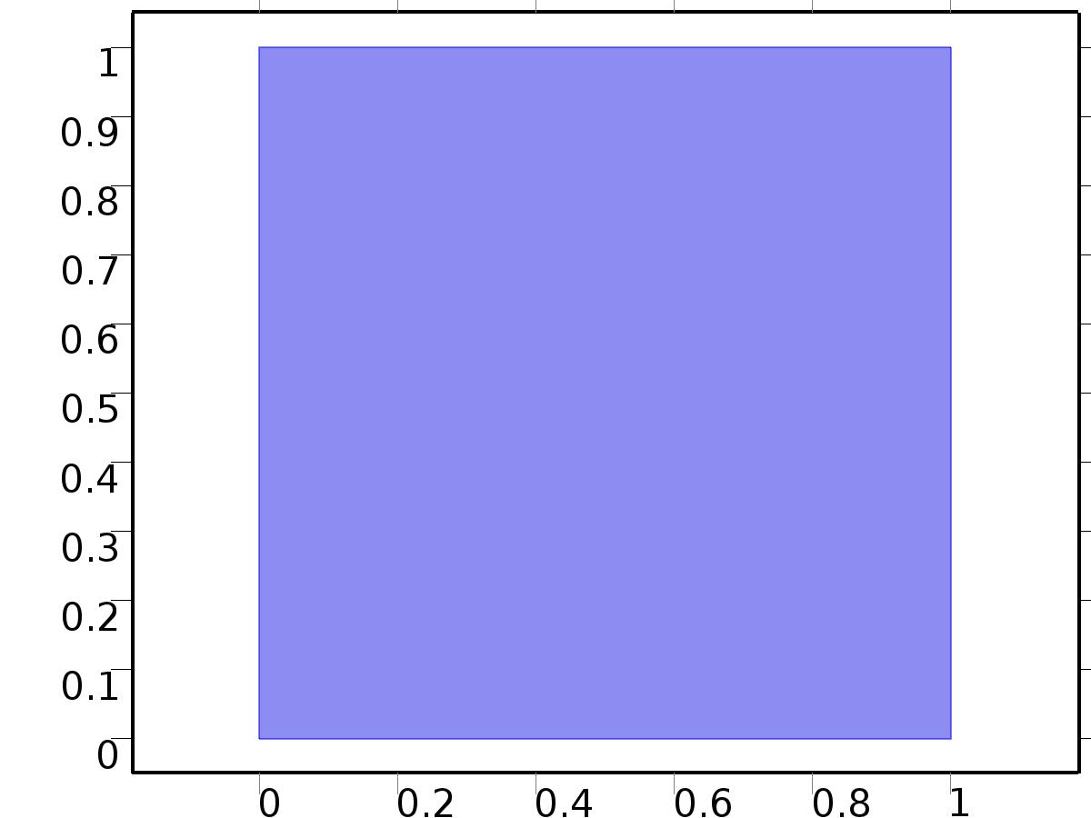

zero dymamics

Selection

|  |  |
| --- | --- |
| Geometric entity level | Domain |
| Selection | Domain 1 |

Settings

| **Description** | **Value** |
| --- | --- |
| Shape function type | Lagrange |
| Element order | Quadratic |
| Compute boundary fluxes | On |
| Apply smoothing to boundary fluxes | On |
| Value type when using splitting of complex variables | Complex |
| Dependent variable quantity | Dimensionless (1) |
| Source term quantity | None |
| Unit | m^ - 2 |

Used products

|  |
| --- |
| COMSOL Multiphysics |

Variables

| **Name** | **Expression** | **Unit** | **Description** | **Selection** |
| --- | --- | --- | --- | --- |
| X.nx | nx |  | Normal vector, x component | Boundaries 1–4 |
| X.ny | ny |  | Normal vector, y component | Boundaries 1–4 |
| X.nz | root.nz |  | Normal vector, z component | Boundaries 1–4 |
| X.nxmesh | root.nxmesh |  | Normal vector (mesh), x component | Boundaries 1–4 |
| X.nymesh | root.nymesh |  | Normal vector (mesh), y component | Boundaries 1–4 |
| X.nzmesh | root.nzmesh |  | Normal vector (mesh), z component | Boundaries 1–4 |

* + 1. Coefficient Form PDE



Coefficient Form PDE

Selection

|  |  |
| --- | --- |
| Geometric entity level | Domain |
| Selection | Domain 1 |

Equations

Settings

| **Description** | **Value** |
| --- | --- |
| Diffusion coefficient | {{1, 0}, {0, 1}} |
| Absorption coefficient | lambda |
| Source term | -lambda*X^3 |
| Mass coefficient | 0 |
| Damping or mass coefficient | 1 |
| Conservative flux convection coefficient | {0, 0} |
| Convection coefficient | {0, 0} |
| Conservative flux source | {0, 0} |

#### Variables

| **Name** | **Expression** | **Unit** | **Description** | **Selection** |
| --- | --- | --- | --- | --- |
| domflux.Xx | -d(X,x) |  | Domain flux, x component | Domain 1 |
| domflux.Xy | -d(X,y) |  | Domain flux, y component | Domain 1 |

#### Shape functions

| **Name** | **Shape function** | **Unit** | **Description** | **Shape frame** | **Selection** |
| --- | --- | --- | --- | --- | --- |
| X | Lagrange (Quadratic) |  | Dependent variable X | Material | Domain 1 |

* + 1. Zero Flux



Zero Flux

Selection

|  |  |
| --- | --- |
| Geometric entity level | Boundary |
| Selection | No boundaries |

Equations

* + 1. Initial Values



Initial Values

Selection

|  |  |
| --- | --- |
| Geometric entity level | Domain |
| Selection | Domain 1 |

Settings

| **Description** | **Value** |
| --- | --- |
| Initial value for X | 0 |
| Initial time derivative of X | 0 |

* + 1. Flux/Source 1

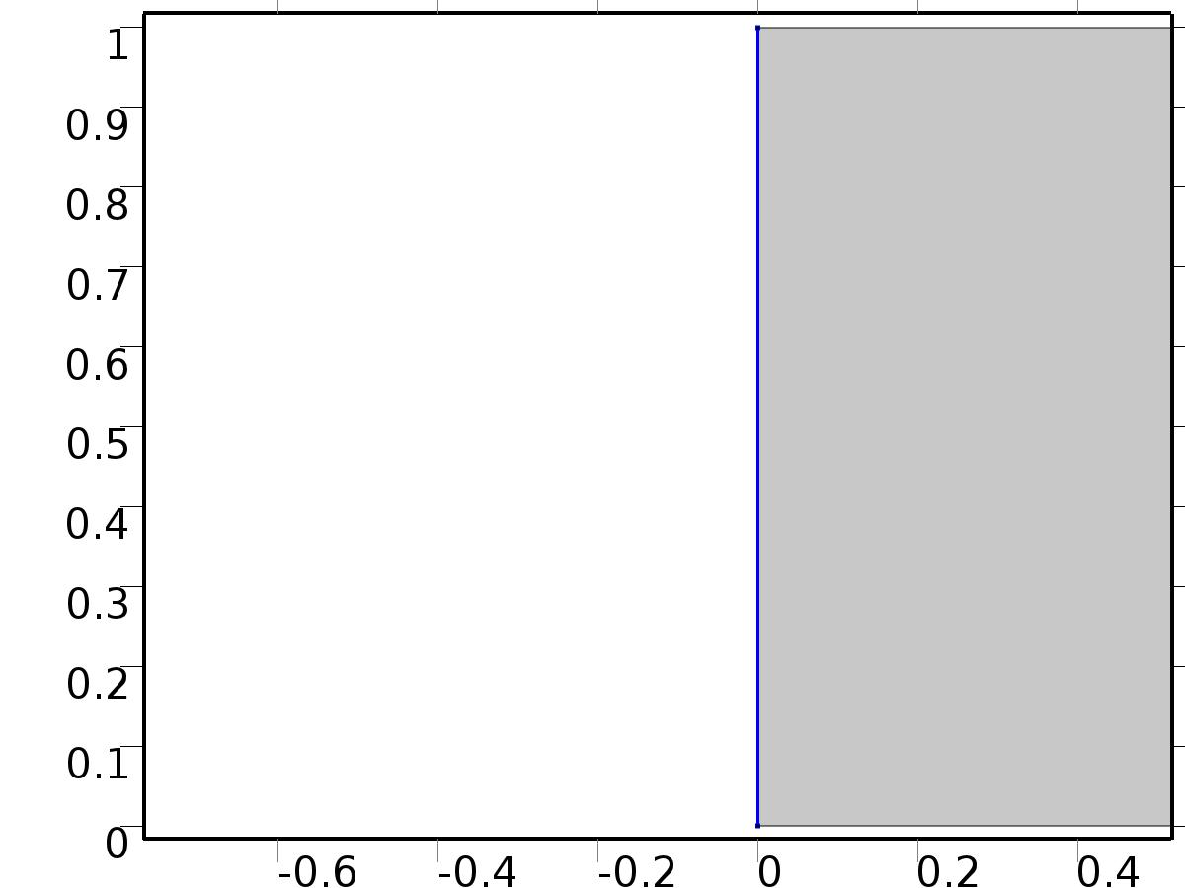

Flux/Source 1

Selection

|  |  |
| --- | --- |
| Geometric entity level | Boundary |
| Selection | Boundary 1 |

Equations

Settings

| **Description** | **Value** |
| --- | --- |
| Boundary flux/source | d1 |
| Boundary absorption/impedance term | k1 |

#### Variables

| **Name** | **Expression** | **Unit** | **Description** | **Selection** |
| --- | --- | --- | --- | --- |
| X.g_X | d1-k1*X |  | Boundary flux/source | Boundary 1 |

* + 1. Flux/Source 2

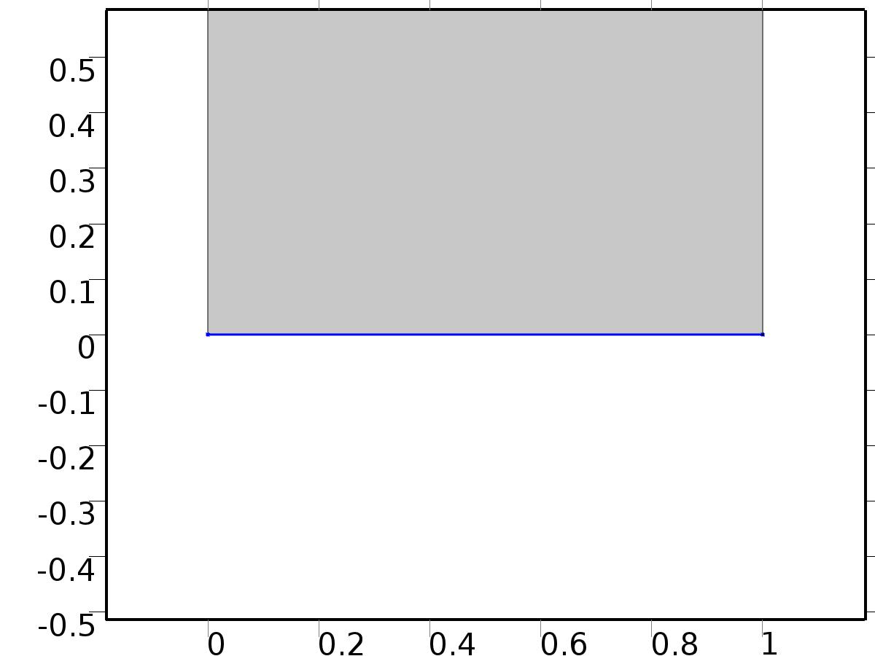

Flux/Source 2

Selection

|  |  |
| --- | --- |
| Geometric entity level | Boundary |
| Selection | Boundary 2 |

Equations

Settings

| **Description** | **Value** |
| --- | --- |
| Boundary flux/source | d2 |
| Boundary absorption/impedance term | k2 |

#### Variables

| **Name** | **Expression** | **Unit** | **Description** | **Selection** |
| --- | --- | --- | --- | --- |
| X.g_X | d2-k2*X |  | Boundary flux/source | Boundary 2 |

* + 1. Constraint 3

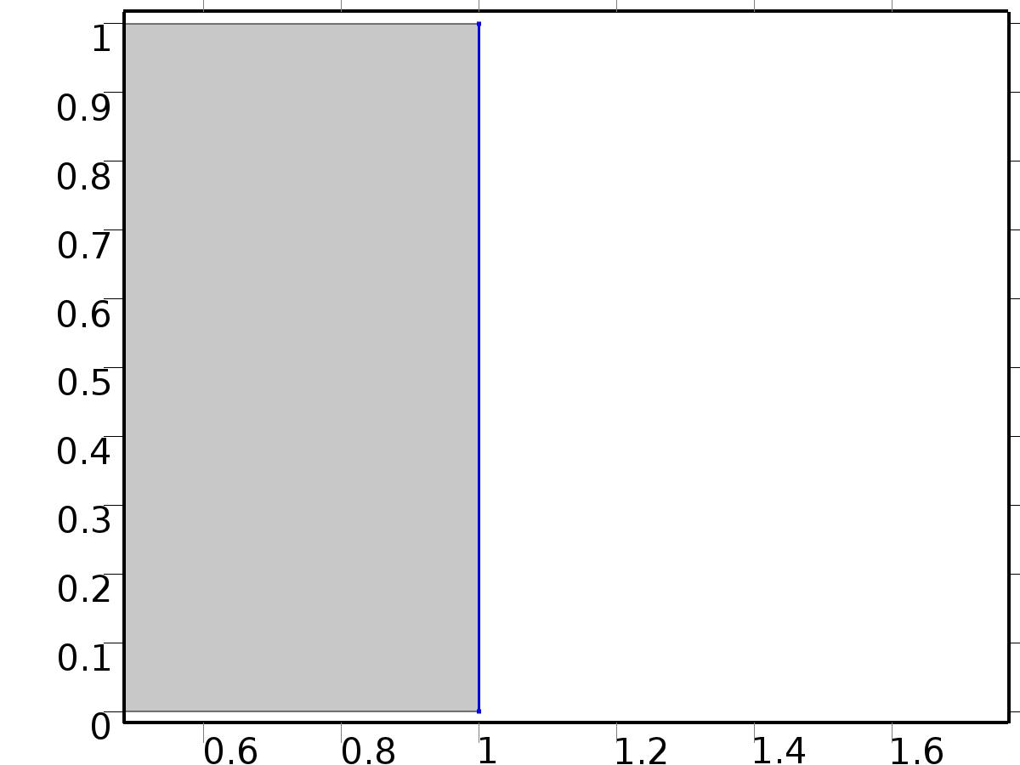

Constraint 3

Selection

|  |  |
| --- | --- |
| Geometric entity level | Boundary |
| Selection | Boundary 4 |

Equations

Settings

| **Description** | **Value** |
| --- | --- |
| Bidirectional constraint, R = 0 | X - yr3 |
| Apply reaction terms on | Individual dependent variables |
| Use weak constraints | On |

#### Variables

| **Name** | **Expression** | **Unit** | **Description** | **Selection** |
| --- | --- | --- | --- | --- |
| X.R_X | X-yr3 |  | Bidirectional constraint, R = 0 | Boundary 4 |

#### Shape functions

| **Name** | **Shape function** | **Unit** | **Description** | **Shape frame** | **Selection** |
| --- | --- | --- | --- | --- | --- |
| X_lm | Lagrange (Quadratic) |  | Lagrange multiplier for dependent variable x | Material | Boundary 4 |

#### Weak expressions

| **Weak expression** | **Integration frame** | **Selection** |
| --- | --- | --- |
| (X-yr3)*test(-X_lm) | Material | Boundary 4 |
| test(X)*X_lm | Material | Boundary 4 |

* + 1. Constraint 4

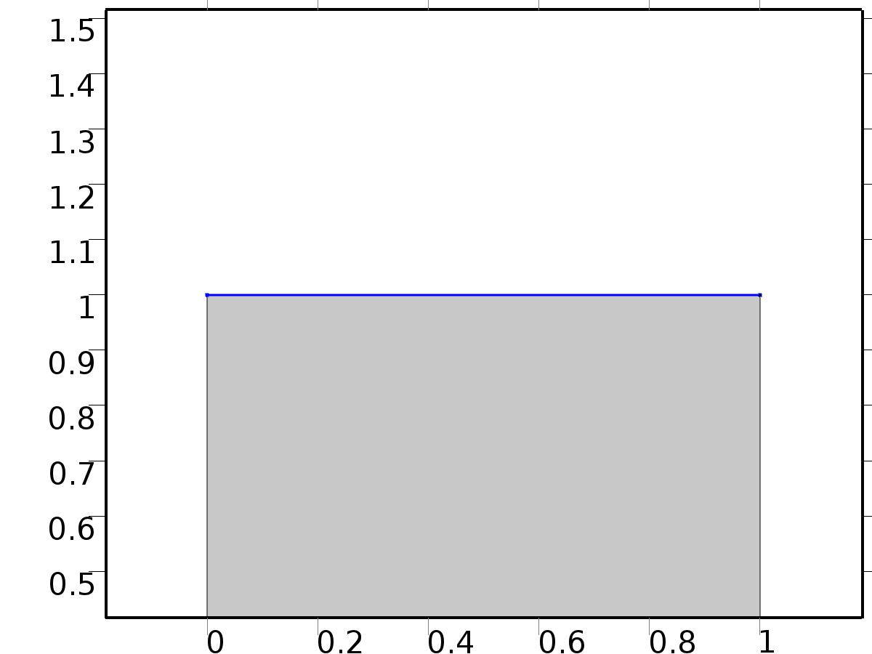

Constraint 4

Selection

|  |  |
| --- | --- |
| Geometric entity level | Boundary |
| Selection | Boundary 3 |

Equations

Settings

| **Description** | **Value** |
| --- | --- |
| Bidirectional constraint, R = 0 | X - yr4 |
| Apply reaction terms on | Individual dependent variables |
| Use weak constraints | On |

#### Variables

| **Name** | **Expression** | **Unit** | **Description** | **Selection** |
| --- | --- | --- | --- | --- |
| X.R_X | X-yr4 |  | Bidirectional constraint, R = 0 | Boundary 3 |

#### Shape functions

| **Name** | **Shape function** | **Unit** | **Description** | **Shape frame** | **Selection** |
| --- | --- | --- | --- | --- | --- |
| X_lm | Lagrange (Quadratic) |  | Lagrange multiplier for dependent variable x | Material | Boundary 3 |

#### Weak expressions

| **Weak expression** | **Integration frame** | **Selection** |
| --- | --- | --- |
| (X-yr4)*test(-X_lm) | Material | Boundary 3 |
| test(X)*X_lm | Material | Boundary 3 |

* 1. Plant



Plant

Selection

|  |  |
| --- | --- |
| Geometric entity level | Domain |
| Selection | Domain 1 |

Settings

| **Description** | **Value** |
| --- | --- |
| Shape function type | Lagrange |
| Element order | Quadratic |
| Compute boundary fluxes | On |
| Apply smoothing to boundary fluxes | On |
| Value type when using splitting of complex variables | Complex |
| Dependent variable quantity | Dimensionless (1) |
| Source term quantity | None |
| Unit | m^ - 2 |

Used products

|  |
| --- |
| COMSOL Multiphysics |

Variables

| **Name** | **Expression** | **Unit** | **Description** | **Selection** |
| --- | --- | --- | --- | --- |
| z.nx | nx |  | Normal vector, x component | Boundaries 1–4 |
| z.ny | ny |  | Normal vector, y component | Boundaries 1–4 |
| z.nz | root.nz |  | Normal vector, z component | Boundaries 1–4 |
| z.nxmesh | root.nxmesh |  | Normal vector (mesh), x component | Boundaries 1–4 |
| z.nymesh | root.nymesh |  | Normal vector (mesh), y component | Boundaries 1–4 |
| z.nzmesh | root.nzmesh |  | Normal vector (mesh), z component | Boundaries 1–4 |

* + 1. Coefficient Form PDE



Coefficient Form PDE

Selection

|  |  |
| --- | --- |
| Geometric entity level | Domain |
| Selection | Domain 1 |

Equations

Settings

| **Description** | **Value** |
| --- | --- |
| Diffusion coefficient | {{1, 0}, {0, 1}} |
| Absorption coefficient | lambda |
| Source term | -lambda*z^3 |
| Mass coefficient | 0 |
| Damping or mass coefficient | 1 |
| Conservative flux convection coefficient | {0, 0} |
| Convection coefficient | {0, 0} |
| Conservative flux source | {0, 0} |

#### Variables

| **Name** | **Expression** | **Unit** | **Description** | **Selection** |
| --- | --- | --- | --- | --- |
| domflux.zx | -d(z,x) |  | Domain flux, x component | Domain 1 |
| domflux.zy | -d(z,y) |  | Domain flux, y component | Domain 1 |

#### Shape functions

| **Name** | **Shape function** | **Unit** | **Description** | **Shape frame** | **Selection** |
| --- | --- | --- | --- | --- | --- |
| z | Lagrange (Quadratic) |  | Dependent variable z | Material | Domain 1 |

* + 1. Zero Flux



Zero Flux

Selection

|  |  |
| --- | --- |
| Geometric entity level | Boundary |
| Selection | No boundaries |

Equations

* + 1. Initial Values



Initial Values

Selection

|  |  |
| --- | --- |
| Geometric entity level | Domain |
| Selection | Domain 1 |

Settings

| **Description** | **Value** |
| --- | --- |
| Initial value for z | 3*cos(x*y*2*pi) |
| Initial time derivative of z | 0 |

* + 1. Flux/Source 1



Flux/Source 1

Selection

|  |  |
| --- | --- |
| Geometric entity level | Boundary |
| Selection | Boundary 1 |

Equations

Settings

| **Description** | **Value** |
| --- | --- |
| Boundary flux/source | d1 |
| Boundary absorption/impedance term | k1 |

#### Variables

| **Name** | **Expression** | **Unit** | **Description** | **Selection** |
| --- | --- | --- | --- | --- |
| z.g_z | d1-k1*z |  | Boundary flux/source | Boundary 1 |

* + 1. Flux/Source 2



Flux/Source 2

Selection

|  |  |
| --- | --- |
| Geometric entity level | Boundary |
| Selection | Boundary 2 |

Equations

Settings

| **Description** | **Value** |
| --- | --- |
| Boundary flux/source | d2 |
| Boundary absorption/impedance term | k2 |

#### Variables

| **Name** | **Expression** | **Unit** | **Description** | **Selection** |
| --- | --- | --- | --- | --- |
| z.g_z | d2-k2*z |  | Boundary flux/source | Boundary 2 |

* + 1. Flux/Source 3



Flux/Source 3

Selection

|  |  |
| --- | --- |
| Geometric entity level | Boundary |
| Selection | Boundary 4 |

Equations

Settings

| **Description** | **Value** |
| --- | --- |
| Boundary flux/source | X_lm + k3*yr3 |
| Boundary absorption/impedance term | k3 |

#### Variables

| **Name** | **Expression** | **Unit** | **Description** | **Selection** |
| --- | --- | --- | --- | --- |
| z.g_z | X_lm+k3*yr3-k3*z |  | Boundary flux/source | Boundary 4 |

* + 1. Flux/Source 4



Flux/Source 4

Selection

|  |  |
| --- | --- |
| Geometric entity level | Boundary |
| Selection | Boundary 3 |

Equations

Settings

| **Description** | **Value** |
| --- | --- |
| Boundary flux/source | X_lm + k4*yr4 |
| Boundary absorption/impedance term | k4 |

#### Variables

| **Name** | **Expression** | **Unit** | **Description** | **Selection** |
| --- | --- | --- | --- | --- |
| z.g_z | X_lm+k4*yr4-k4*z |  | Boundary flux/source | Boundary 3 |

* 1. Mesh 1

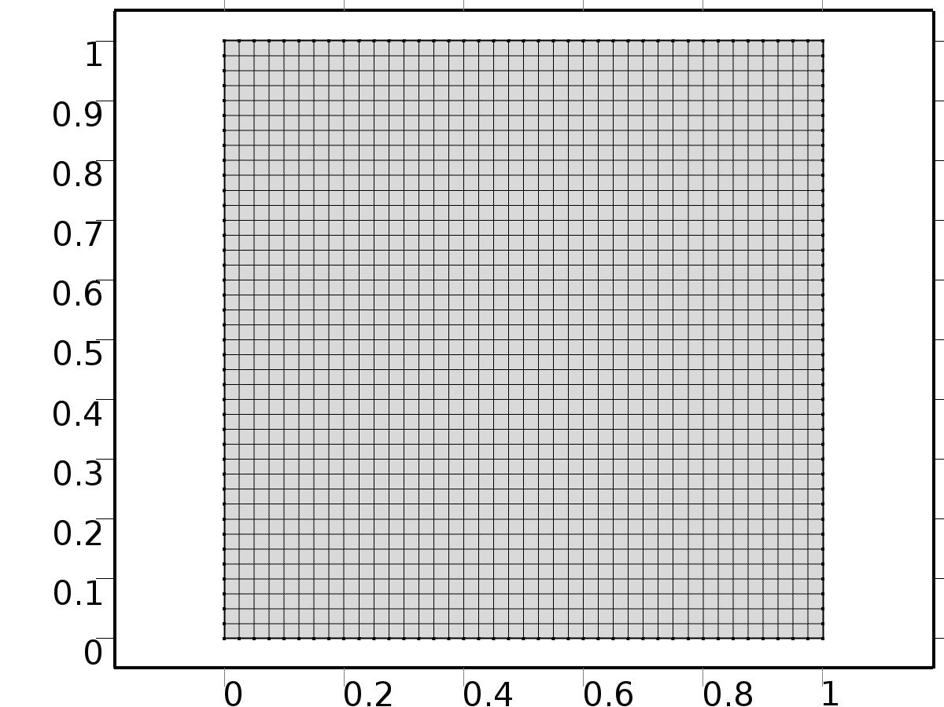

Mesh 1

* + 1. Size (size)

Settings

| **Description** | **Value** |
| --- | --- |
| Maximum element size | L/40 |
| Minimum element size | L/40 |
| Curvature factor | 0.3 |
| Maximum element growth rate | 1.3 |
| Custom element size | Custom |

* + 1. Mapped 1 (map1)

Selection

|  |  |
| --- | --- |
| Geometric entity level | Remaining |

1. Study 1
   1. Time Dependent

Study settings

| **Description** | **Value** |
| --- | --- |
| Include geometric nonlinearity | Off |

| **Times** | **Unit** |
| --- | --- |
| range(0,0.025,2) | s |

Physics and variables selection

| **Physics interface** | **Discretization** |
| --- | --- |
| zero dymamics (c) | physics |
| Plant (c2) | physics |

Mesh selection

| **Geometry** | **Mesh** |
| --- | --- |
| Geometry 1 (geom1) | mesh1 |

* 1. Solver Configurations
     1. Solver 1

#### Compile Equations: Time Dependent (st1)

Study and step

| **Description** | **Value** |
| --- | --- |
| Use study | Study 1 |
| Use study step | Time Dependent |

#### Dependent Variables 1 (v1)

General

| **Description** | **Value** |
| --- | --- |
| Defined by study step | Time Dependent |
| Constant |  |

Initial values of variables solved for

| **Description** | **Value** |
| --- | --- |
| Solution | Zero |

Values of variables not solved for

| **Description** | **Value** |
| --- | --- |
| Solution | Zero |

##### Dependent variable z (comp1.z) (comp1_z)

General

| **Description** | **Value** |
| --- | --- |
| Field components | comp1.z |

##### Dependent variable X (comp1.X) (comp1_X)

General

| **Description** | **Value** |
| --- | --- |
| Field components | comp1.X |

##### Lagrange multiplier for dependent variable x (comp1.X_lm) (comp1_X_lm)

General

| **Description** | **Value** |
| --- | --- |
| Field components | comp1.X_lm |

#### Time-Dependent Solver 1 (t1)

General

| **Description** | **Value** |
| --- | --- |
| Defined by study step | Time Dependent |
| Time | {0, 0.025, 0.05, 0.07500000000000001, 0.1, 0.125, 0.15000000000000002, 0.17500000000000002, 0.2, 0.225, 0.25, 0.275, 0.30000000000000004, 0.325, 0.35000000000000003, 0.375, 0.4, 0.42500000000000004, 0.45, 0.47500000000000003, 0.5, 0.525, 0.55, 0.5750000000000001, 0.6000000000000001, 0.625, 0.65, 0.675, 0.7000000000000001, 0.7250000000000001, 0.75, 0.775, 0.8, 0.8250000000000001, 0.8500000000000001, 0.875, 0.9, 0.925, 0.9500000000000001, 0.9750000000000001, 1, 1.0250000000000001, 1.05, 1.075, 1.1, 1.125, 1.1500000000000001, 1.175, 1.2000000000000002, 1.225, 1.25, 1.2750000000000001, 1.3, 1.3250000000000002, 1.35, 1.375, 1.4000000000000001, 1.425, 1.4500000000000002, 1.475, 1.5, 1.5250000000000001, 1.55, 1.5750000000000002, 1.6, 1.625, 1.6500000000000001, 1.675, 1.7000000000000002, 1.725, 1.75, 1.7750000000000001, 1.8, 1.8250000000000002, 1.85, 1.875, 1.9000000000000001, 1.925, 1.9500000000000002, 1.975, 2} |
| Relative tolerance | 0.0001 |

Absolute tolerance

| **Description** | **Value** |
| --- | --- |
| Tolerance | 0.000010 |

Time stepping

| **Description** | **Value** |
| --- | --- |
| Initial step | 0.0010 |

Advanced

| **Description** | **Value** |
| --- | --- |
| Fraction of initial step for Backward Euler | 0.0010 |

Log

| **Description** | **Value** |
| --- | --- |
| Constant |  |

##### Fully Coupled 1 (fc1)

General

| **Description** | **Value** |
| --- | --- |
| Linear solver | Direct |

1. Results
   1. Data Sets
      1. Solution 1

Solution

| **Description** | **Value** |
| --- | --- |
| Solution | Solver 1 |
| Component | Save Point Geometry 1 |

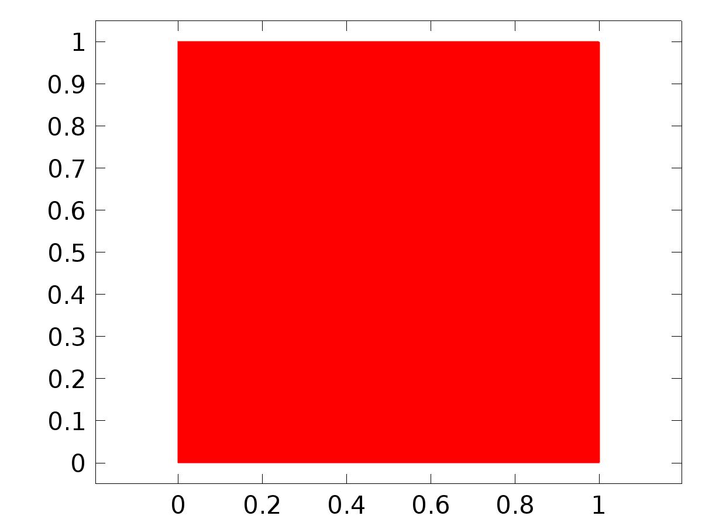

Data set: Solution 1

* 1. Derived Values
     1. Global Evaluation 1

Data

| **Description** | **Value** |
| --- | --- |
| Data set | Solution 1 |

Expression

| **Description** | **Value** |
| --- | --- |
| Expression | e2 |

* 1. Tables
     1. Table 1

Global Evaluation 1 (C1(z))

Table 1

| **Time (s)** | **C1(z)** | **C2(z)** | **e1** | **e2** |
| --- | --- | --- | --- | --- |
| 0.0000 | 0.24636 | -0.50350 | 2.1182 | 2.1187 |
| 0.025000 | -0.084114 | -0.75391 | 0.70119 | 0.71393 |
| 0.050000 | 0.020802 | -0.66530 | 0.44457 | 0.46873 |
| 0.075000 | 0.12533 | -0.57662 | 0.27251 | 0.29830 |
| 0.10000 | 0.19697 | -0.51738 | 0.15865 | 0.18421 |
| 0.12500 | 0.24076 | -0.48342 | 0.090106 | 0.11472 |
| 0.15000 | 0.26534 | -0.46650 | 0.054347 | 0.076203 |
| 0.17500 | 0.27767 | -0.45992 | 0.040240 | 0.056650 |
| 0.20000 | 0.28257 | -0.45917 | 0.036080 | 0.046612 |
| 0.22500 | 0.28317 | -0.46144 | 0.034041 | 0.040338 |
| 0.25000 | 0.28145 | -0.46511 | 0.031653 | 0.035344 |
| 0.27500 | 0.27862 | -0.46923 | 0.028704 | 0.030859 |
| 0.30000 | 0.27536 | -0.47330 | 0.025475 | 0.026735 |
| 0.32500 | 0.27209 | -0.47708 | 0.022242 | 0.022986 |
| 0.35000 | 0.26901 | -0.48047 | 0.019186 | 0.019639 |
| 0.37500 | 0.26623 | -0.48343 | 0.016405 | 0.016701 |
| 0.40000 | 0.26376 | -0.48599 | 0.013937 | 0.014154 |
| 0.42500 | 0.26162 | -0.48818 | 0.011783 | 0.011968 |
| 0.45000 | 0.25978 | -0.49004 | 0.0099267 | 0.010105 |
| 0.47500 | 0.25821 | -0.49161 | 0.0083418 | 0.0085275 |
| 0.50000 | 0.25688 | -0.49294 | 0.0069985 | 0.0071967 |
| 0.52500 | 0.25575 | -0.49406 | 0.0058650 | 0.0060772 |
| 0.55000 | 0.25481 | -0.49500 | 0.0049125 | 0.0051377 |
| 0.57500 | 0.25402 | -0.49580 | 0.0041145 | 0.0043508 |
| 0.60000 | 0.25335 | -0.49647 | 0.0034483 | 0.0036937 |
| 0.62500 | 0.25280 | -0.49703 | 0.0028934 | 0.0031468 |
| 0.65000 | 0.25234 | -0.49751 | 0.0024325 | 0.0026934 |
| 0.67500 | 0.25195 | -0.49791 | 0.0020502 | 0.0023195 |
| 0.70000 | 0.25163 | -0.49825 | 0.0017342 | 0.0020137 |
| 0.72500 | 0.25136 | -0.49853 | 0.0014739 | 0.0017659 |
| 0.75000 | 0.25114 | -0.49877 | 0.0012605 | 0.0015679 |
| 0.77500 | 0.25095 | -0.49897 | 0.0010867 | 0.0014119 |
| 0.80000 | 0.25080 | -0.49914 | 9.4628E-4 | 0.0012911 |
| 0.82500 | 0.25067 | -0.49929 | 8.3401E-4 | 0.0011993 |
| 0.85000 | 0.25056 | -0.49941 | 7.4538E-4 | 0.0011308 |
| 0.87500 | 0.25047 | -0.49951 | 6.7642E-4 | 0.0010806 |
| 0.90000 | 0.25039 | -0.49959 | 6.2361E-4 | 0.0010443 |
| 0.92500 | 0.25033 | -0.49966 | 5.8379E-4 | 0.0010184 |
| 0.95000 | 0.25027 | -0.49972 | 5.5424E-4 | 0.0010002 |
| 0.97500 | 0.25023 | -0.49977 | 5.3263E-4 | 9.8747E-4 |
| 1.0000 | 0.25019 | -0.49981 | 5.1702E-4 | 9.7867E-4 |
| 1.0250 | 0.25016 | -0.49984 | 5.0588E-4 | 9.7261E-4 |
| 1.0500 | 0.25013 | -0.49987 | 4.9798E-4 | 9.6845E-4 |
| 1.0750 | 0.25011 | -0.49989 | 4.9242E-4 | 9.6560E-4 |
| 1.1000 | 0.25009 | -0.49991 | 4.8853E-4 | 9.6366E-4 |
| 1.1250 | 0.25008 | -0.49993 | 4.8583E-4 | 9.6233E-4 |
| 1.1500 | 0.25006 | -0.49994 | 4.8395E-4 | 9.6142E-4 |
| 1.1750 | 0.25005 | -0.49995 | 4.8264E-4 | 9.6079E-4 |
| 1.2000 | 0.25004 | -0.49996 | 4.8174E-4 | 9.6037E-4 |
| 1.2250 | 0.25004 | -0.49997 | 4.8111E-4 | 9.6007E-4 |
| 1.2500 | 0.25003 | -0.49997 | 4.8068E-4 | 9.5987E-4 |
| 1.2750 | 0.25003 | -0.49998 | 4.8038E-4 | 9.5973E-4 |
| 1.3000 | 0.25002 | -0.49998 | 4.8018E-4 | 9.5963E-4 |
| 1.3250 | 0.25002 | -0.49998 | 4.8003E-4 | 9.5957E-4 |
| 1.3500 | 0.25001 | -0.49999 | 4.7993E-4 | 9.5952E-4 |
| 1.3750 | 0.25001 | -0.49999 | 4.7986E-4 | 9.5949E-4 |
| 1.4000 | 0.25001 | -0.49999 | 4.7981E-4 | 9.5946E-4 |
| 1.4250 | 0.25001 | -0.49999 | 4.7978E-4 | 9.5945E-4 |
| 1.4500 | 0.25001 | -0.49999 | 4.7976E-4 | 9.5944E-4 |
| 1.4750 | 0.25001 | -0.49999 | 4.7974E-4 | 9.5943E-4 |
| 1.5000 | 0.25000 | -0.50000 | 4.7973E-4 | 9.5942E-4 |
| 1.5250 | 0.25000 | -0.50000 | 4.7972E-4 | 9.5942E-4 |
| 1.5500 | 0.25000 | -0.50000 | 4.7972E-4 | 9.5942E-4 |
| 1.5750 | 0.25000 | -0.50000 | 4.7971E-4 | 9.5942E-4 |
| 1.6000 | 0.25000 | -0.50000 | 4.7971E-4 | 9.5941E-4 |
| 1.6250 | 0.25000 | -0.50000 | 4.7971E-4 | 9.5941E-4 |
| 1.6500 | 0.25000 | -0.50000 | 4.7971E-4 | 9.5941E-4 |
| 1.6750 | 0.25000 | -0.50000 | 4.7971E-4 | 9.5941E-4 |
| 1.7000 | 0.25000 | -0.50000 | 4.7971E-4 | 9.5941E-4 |
| 1.7250 | 0.25000 | -0.50000 | 4.7971E-4 | 9.5941E-4 |
| 1.7500 | 0.25000 | -0.50000 | 4.7971E-4 | 9.5941E-4 |
| 1.7750 | 0.25000 | -0.50000 | 4.7971E-4 | 9.5941E-4 |
| 1.8000 | 0.25000 | -0.50000 | 4.7971E-4 | 9.5941E-4 |
| 1.8250 | 0.25000 | -0.50000 | 4.7971E-4 | 9.5941E-4 |
| 1.8500 | 0.25000 | -0.50000 | 4.7971E-4 | 9.5941E-4 |
| 1.8750 | 0.25000 | -0.50000 | 4.7971E-4 | 9.5941E-4 |
| 1.9000 | 0.25000 | -0.50000 | 4.7971E-4 | 9.5941E-4 |
| 1.9250 | 0.25000 | -0.50000 | 4.7971E-4 | 9.5941E-4 |
| 1.9500 | 0.25000 | -0.50000 | 4.7971E-4 | 9.5941E-4 |
| 1.9750 | 0.25000 | -0.50000 | 4.7971E-4 | 9.5941E-4 |
| 2.0000 | 0.25000 | -0.50000 | 4.7971E-4 | 9.5941E-4 |

* 1. Plot Groups
     1. 2D Plot Group 1

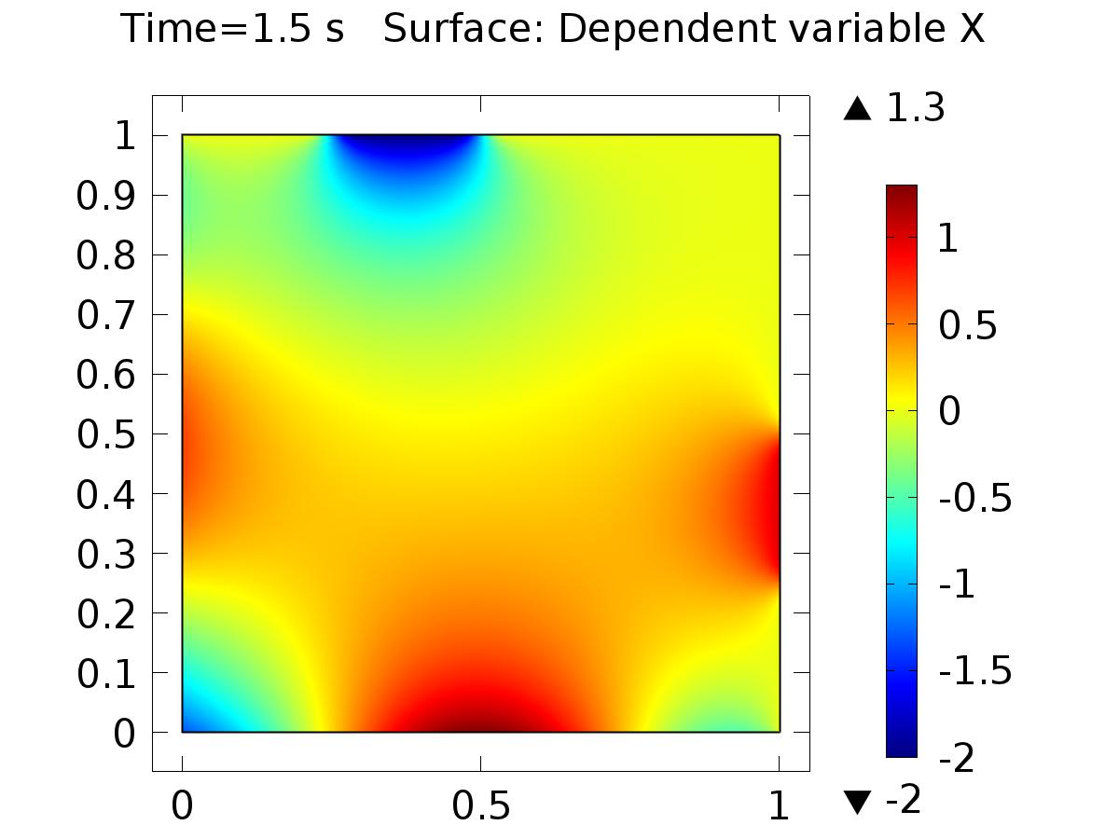

Time=1.5 s Surface: Dependent variable X

* + 1. 2D Plot Group 2

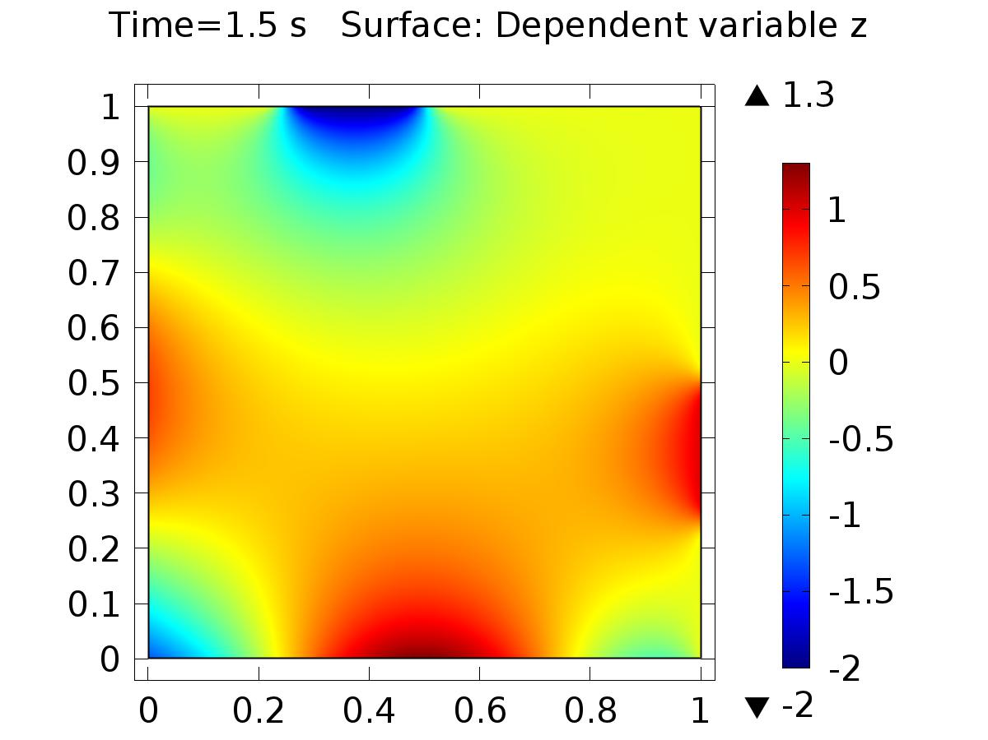

Time=1.5 s Surface: Dependent variable z

* + 1. 1D Plot Group 3

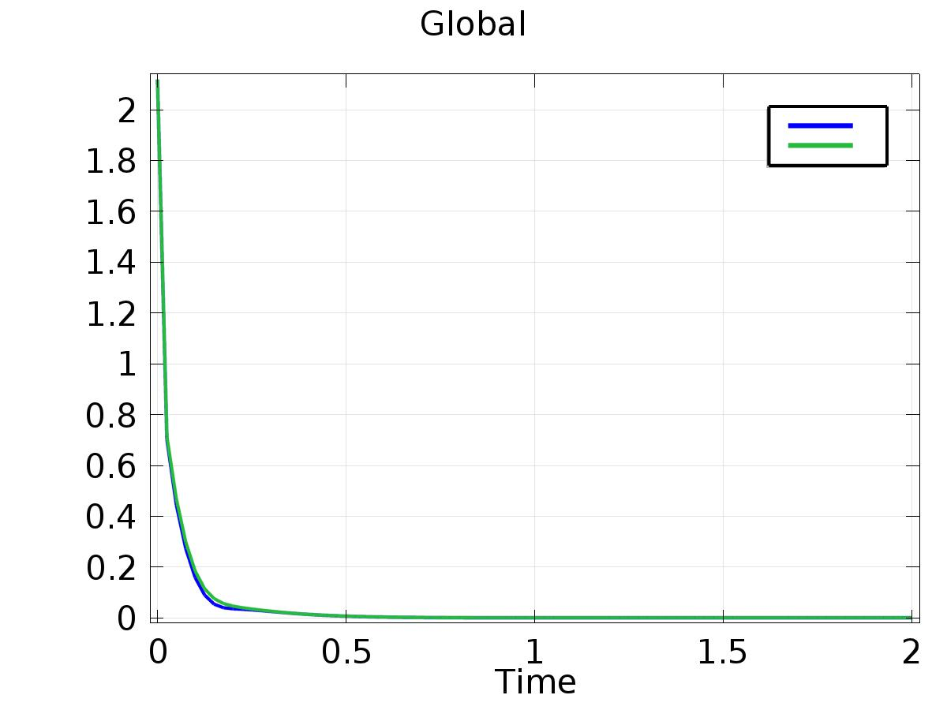

Global