[](http://www.comsol.com/)

Ex5 2 3 Burger zero dynamics

|  |  |
| --- | --- |
| Date | Aug 9, 2014 6:42:33 AM |

Contents

1. Global

1.1. Definitions

2. Component 1

2.1. Definitions

2.2. Geometry 1

2.3. zero dymamics

2.4. Plant

2.5. Mesh 1

3. Study 1

3.1. Time Dependent

3.2. Solver Configurations

4. Results

4.1. Data Sets

4.2. Derived Values

4.3. Tables

4.4. Plot Groups

1. Global

|  |  |
| --- | --- |
| Date | Aug 1, 2014 3:26:36 PM |

Global settings

|  |  |
| --- | --- |
| Name | Ex5 2 3 Burger zero dynamics.mph |
| Path | /Users/gilliam/Desktop/collect_15/research_15/geo_reg_mono_eugenio/Mono_1_15/Comsol_EX_GitHub/Chapter5/Chap5Ex6_ZD/Ex5.5.3_Burg_ZD/Ex5_2_3_Burger_zero_dynamics.mph |
| Program | COMSOL 4.4 (Build: 150) |

Used products

|  |
| --- |
| COMSOL Multiphysics |

* 1. Definitions
     1. Parameters 1

Parameters

| **Name** | **Expression** | **Value** | **Description** |
| --- | --- | --- | --- |
| L | 1 | 1.0000 |  |
| lambda | 3 | 3.0000 |  |
| k1 | 1 | 1.0000 |  |
| k2 | 2 | 2.0000 |  |
| k3 | 0.5 | 0.50000 |  |
| k4 | 0.25 | 0.25000 |  |

1. Component 1

Component settings

|  |  |
| --- | --- |
| Unit system | None |

* 1. Definitions
     1. Variables

#### Variables 1

Selection

|  |  |
| --- | --- |
| Geometric entity level | Entire model |

| **Name** | **Expression** | **Description** |
| --- | --- | --- |
| d11 | cos((y - t)*2*pi)*5 |  |
| d12 | cos((y - t)*2*pi)*5 |  |
| d21 | cos((x - t)*2*pi)*10 |  |
| d22 | cos((x - t)*2*pi)*10 |  |
| yr31 | flc2hs(y - 0.25, 0.05) - flc2hs(y - 0.5, 0.05) |  |
| yr32 | -flc2hs(y - 0.25, 0.05) + flc2hs(y - 0.5, 0.05) |  |
| yr41 | 2*(flc2hs(x - 0.25, 0.05) - flc2hs(x - 0.5, 0.05)) |  |
| yr42 | -2*(flc2hs(x - 0.25, 0.05) - flc2hs(x - 0.5, 0.05)) |  |
| e11 | sqrt(C1((yr31 - z1)^2)) |  |
| e12 | sqrt(C1((yr32 - z2)^2)) |  |
| e21 | sqrt(C2((yr41 - z1)^2)) |  |
| e22 | sqrt(C2((yr42 - z2)^2)) |  |

* + 1. Component Couplings

#### Integration 1

|  |  |
| --- | --- |
| Coupling type | Integration |
| Operator name | C1 |

Source selection

|  |  |
| --- | --- |
| Geometric entity level | Boundary |
| Selection | Boundary 4 |

#### Integration 2

|  |  |
| --- | --- |
| Coupling type | Integration |
| Operator name | C2 |

Source selection

|  |  |
| --- | --- |
| Geometric entity level | Boundary |
| Selection | Boundary 3 |

* + 1. Coordinate Systems

#### Boundary System 1

|  |  |
| --- | --- |
| Coordinate system type | Boundary system |
| Tag | sys1 |

Coordinate names

| **First (t1)** | **Second (n)** | **Third (to)** |
| --- | --- | --- |
| t1 | n | to |

Settings

| **Description** | **Value** |
| --- | --- |
| Create first tangent direction from | Global Cartesian |

* 1. Geometry 1

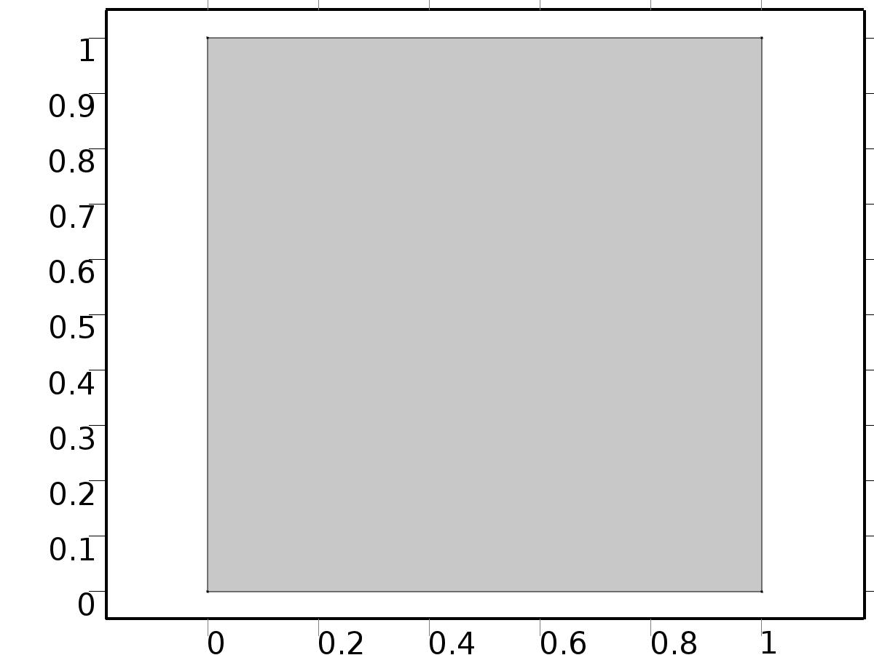

Geometry 1

Units

|  |  |
| --- | --- |
| Length unit | m |
| Angular unit | deg |

Geometry statistics

| **Description** | **Value** |
| --- | --- |
| Space dimension | 2 |
| Number of domains | 1 |
| Number of boundaries | 4 |
| Number of vertices | 4 |

* + 1. Square 1 (sq1)

Position

| **Description** | **Value** |
| --- | --- |
| Position | {0, 0} |
| Layers |  |

Size

| **Description** | **Value** |
| --- | --- |
| Side length | L |

* 1. zero dymamics

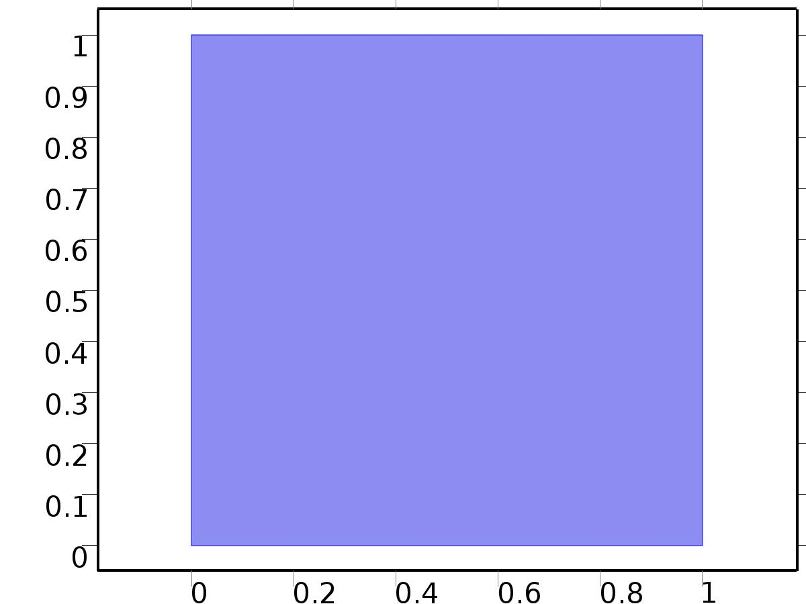

zero dymamics

Selection

|  |  |
| --- | --- |
| Geometric entity level | Domain |
| Selection | Domain 1 |

Settings

| **Description** | **Value** |
| --- | --- |
| Shape function type | Lagrange |
| Element order | Quadratic |
| Compute boundary fluxes | On |
| Apply smoothing to boundary fluxes | On |
| Value type when using splitting of complex variables | Complex |
| Dependent variable quantity | Dimensionless (1) |
| Source term quantity | None |
| Unit | m^ - 2 |

Used products

|  |
| --- |
| COMSOL Multiphysics |

Variables

| **Name** | **Expression** | **Unit** | **Description** | **Selection** |
| --- | --- | --- | --- | --- |
| X.nx | nx |  | Normal vector, x component | Boundaries 1–4 |
| X.ny | ny |  | Normal vector, y component | Boundaries 1–4 |
| X.nz | root.nz |  | Normal vector, z component | Boundaries 1–4 |
| X.nxmesh | root.nxmesh |  | Normal vector (mesh), x component | Boundaries 1–4 |
| X.nymesh | root.nymesh |  | Normal vector (mesh), y component | Boundaries 1–4 |
| X.nzmesh | root.nzmesh |  | Normal vector (mesh), z component | Boundaries 1–4 |

* + 1. Coefficient Form PDE



Coefficient Form PDE

Selection

|  |  |
| --- | --- |
| Geometric entity level | Domain |
| Selection | Domain 1 |

Equations

Settings

| **Description** | **Value** |
| --- | --- |
| Diffusion coefficient | {{{{1, 0}, {0, 1}}, {{0, 0}, {0, 0}}}, {{{0, 0}, {0, 0}}, {{1, 0}, {0, 1}}}} |
| Absorption coefficient | {{0, 0}, {0, 0}} |
| Source term | {0, 0} |
| Mass coefficient | {{0, 0}, {0, 0}} |
| Damping or mass coefficient | {{1, 0}, {0, 1}} |
| Conservative flux convection coefficient | {{{0, 0}, {0, 0}}, {{0, 0}, {0, 0}}} |
| Convection coefficient | {{{X1, X2}, {0, 0}}, {{0, 0}, {X1, X2}}} |
| Conservative flux source | {{0, 0}, {0, 0}} |

#### Variables

| **Name** | **Expression** | **Unit** | **Description** | **Selection** |
| --- | --- | --- | --- | --- |
| domflux.X1x | -d(X1,x) |  | Domain flux, x component | Domain 1 |
| domflux.X1y | -d(X1,y) |  | Domain flux, y component | Domain 1 |
| domflux.X2x | -d(X2,x) |  | Domain flux, x component | Domain 1 |
| domflux.X2y | -d(X2,y) |  | Domain flux, y component | Domain 1 |

#### Shape functions

| **Name** | **Shape function** | **Unit** | **Description** | **Shape frame** | **Selection** |
| --- | --- | --- | --- | --- | --- |
| X1 | Lagrange (Quadratic) |  | Dependent variable X1 | Material | Domain 1 |
| X2 | Lagrange (Quadratic) |  | Dependent variable X2 | Material | Domain 1 |

* + 1. Zero Flux

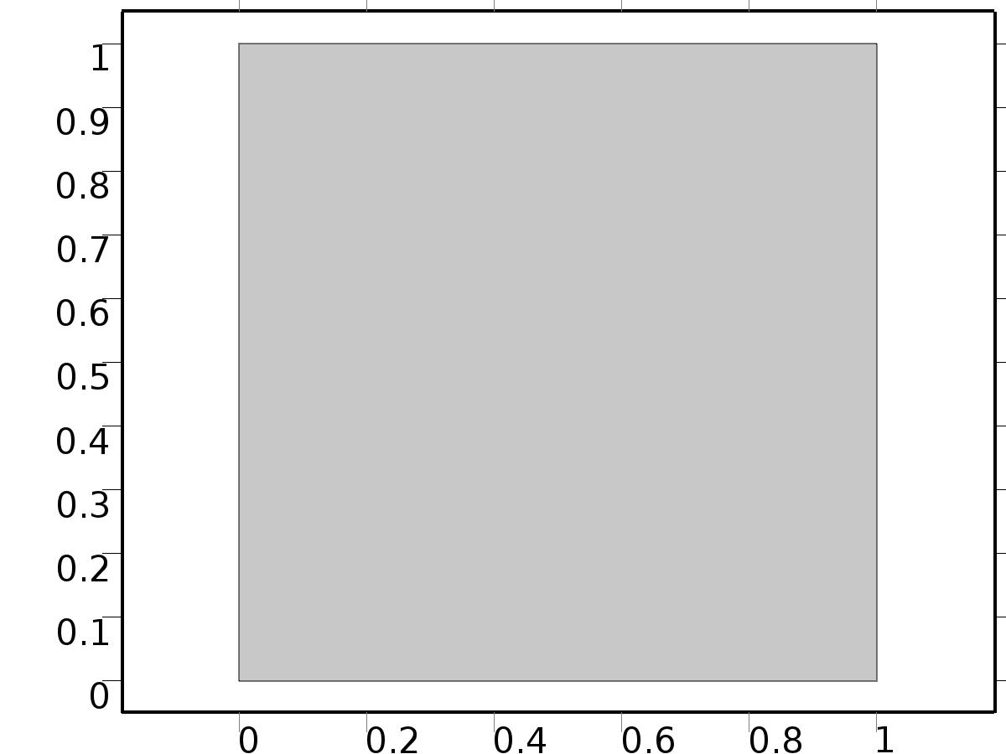

Zero Flux

Selection

|  |  |
| --- | --- |
| Geometric entity level | Boundary |
| Selection | No boundaries |

Equations

* + 1. Initial Values



Initial Values

Selection

|  |  |
| --- | --- |
| Geometric entity level | Domain |
| Selection | Domain 1 |

Settings

| **Description** | **Value** |
| --- | --- |
| Initial value for X2 | 0 |
| Initial time derivative of X2 | 0 |
| Initial value for X1 | 0 |
| Initial time derivative of X1 | 0 |

* + 1. Flux/Source 1

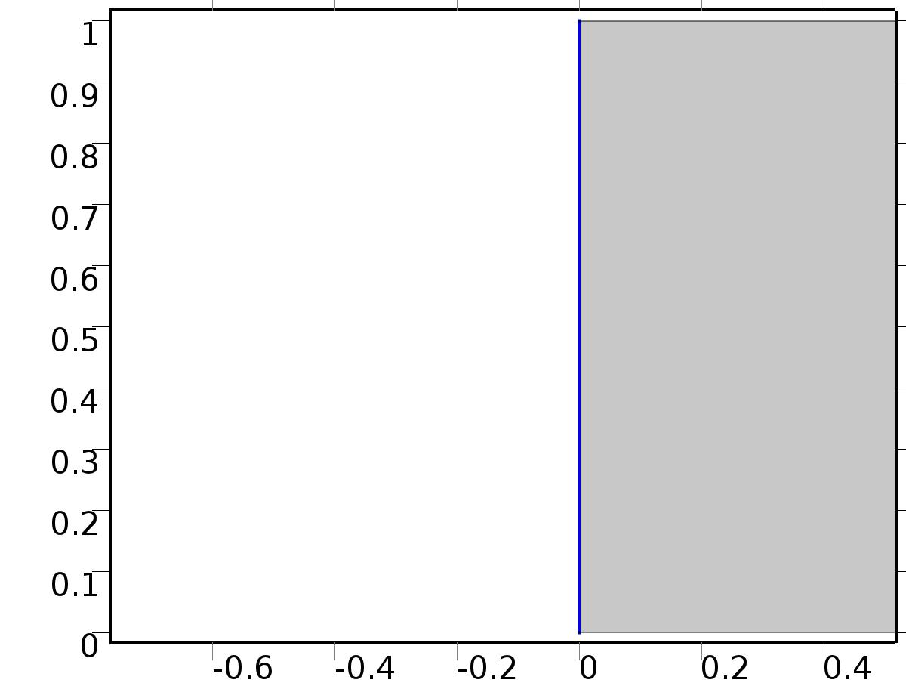

Flux/Source 1

Selection

|  |  |
| --- | --- |
| Geometric entity level | Boundary |
| Selection | Boundary 1 |

Equations

Settings

| **Description** | **Value** |
| --- | --- |
| Boundary flux/source | {d11, d12} |
| Boundary absorption/impedance term | {{k1, 0}, {0, k1}} |

#### Variables

| **Name** | **Expression** | **Unit** | **Description** | **Selection** |
| --- | --- | --- | --- | --- |
| X.g_X1 | d11-k1*X1 |  | Boundary flux/source | Boundary 1 |
| X.g_X2 | d12-k1*X2 |  | Boundary flux/source | Boundary 1 |

* + 1. Flux/Source 2

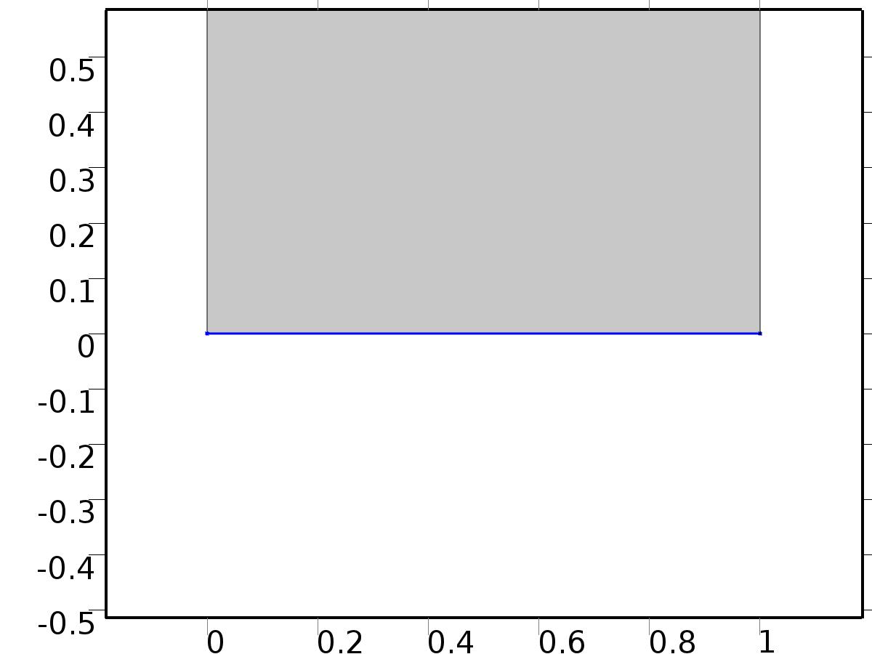

Flux/Source 2

Selection

|  |  |
| --- | --- |
| Geometric entity level | Boundary |
| Selection | Boundary 2 |

Equations

Settings

| **Description** | **Value** |
| --- | --- |
| Boundary flux/source | {d21, d22} |
| Boundary absorption/impedance term | {{k2, 0}, {0, k2}} |

#### Variables

| **Name** | **Expression** | **Unit** | **Description** | **Selection** |
| --- | --- | --- | --- | --- |
| X.g_X1 | d21-k2*X1 |  | Boundary flux/source | Boundary 2 |
| X.g_X2 | d22-k2*X2 |  | Boundary flux/source | Boundary 2 |

* + 1. Constraint 3

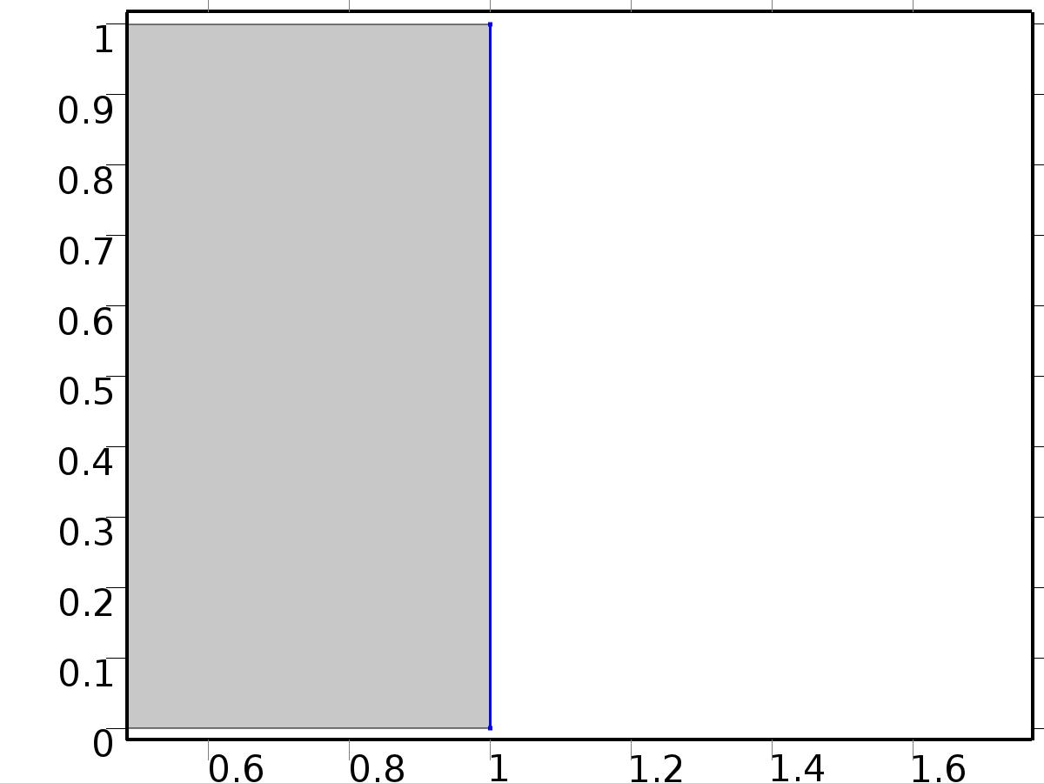

Constraint 3

Selection

|  |  |
| --- | --- |
| Geometric entity level | Boundary |
| Selection | Boundary 4 |

Equations

Settings

| **Description** | **Value** |
| --- | --- |
| Bidirectional constraint, R = 0 | {X1 - yr31, X2 - yr32} |
| Apply reaction terms on | Individual dependent variables |
| Use weak constraints | On |

#### Variables

| **Name** | **Expression** | **Unit** | **Description** | **Selection** |
| --- | --- | --- | --- | --- |
| X.R_X1 | X1-yr31 |  | Bidirectional constraint, R = 0 | Boundary 4 |
| X.R_X2 | X2-yr32 |  | Bidirectional constraint, R = 0 | Boundary 4 |

#### Shape functions

| **Name** | **Shape function** | **Unit** | **Description** | **Shape frame** | **Selection** |
| --- | --- | --- | --- | --- | --- |
| X1_lm | Lagrange (Quadratic) |  | Lagrange multiplier for dependent variable x1 | Material | Boundary 4 |
| X2_lm | Lagrange (Quadratic) |  | Lagrange multiplier for dependent variable x2 | Material | Boundary 4 |

#### Weak expressions

| **Weak expression** | **Integration frame** | **Selection** |
| --- | --- | --- |
| (X1-yr31)*test(-X1_lm) | Material | Boundary 4 |
| test(X1)*X1_lm | Material | Boundary 4 |
| (X2-yr32)*test(-X2_lm) | Material | Boundary 4 |
| test(X2)*X2_lm | Material | Boundary 4 |

* + 1. Constraint 4

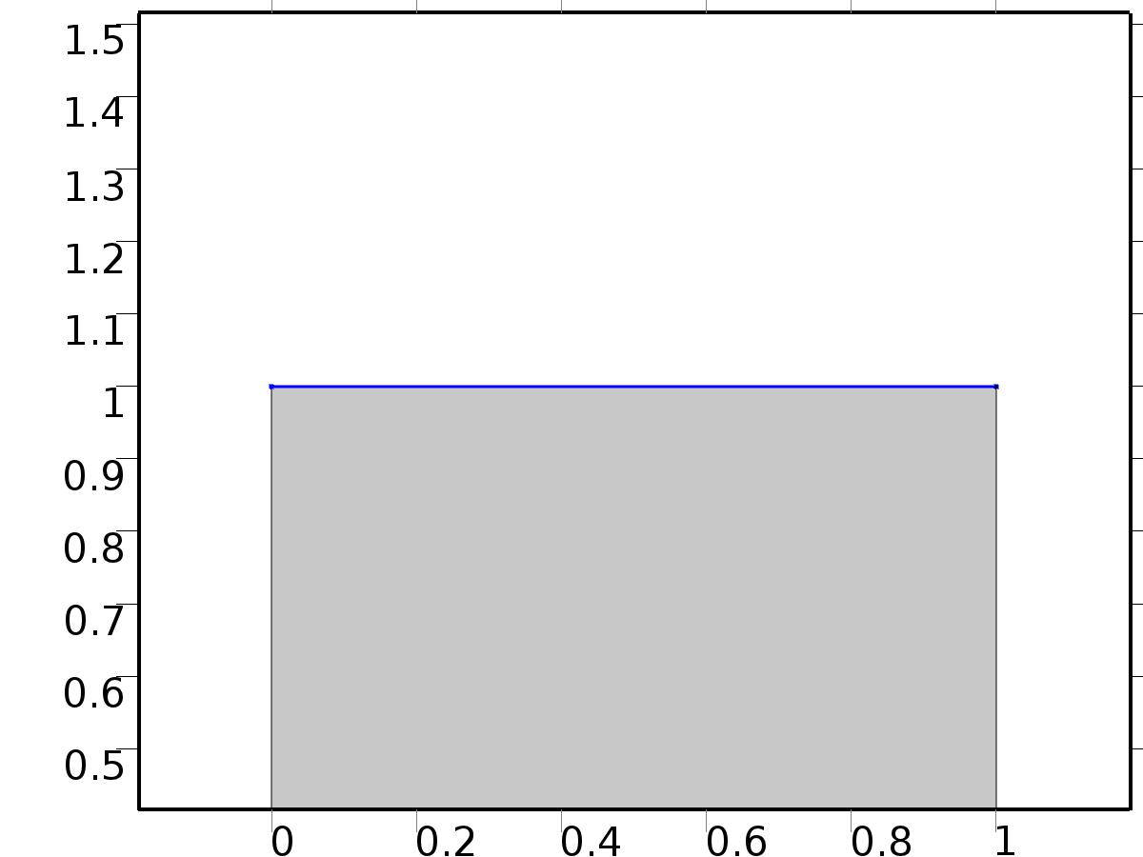

Constraint 4

Selection

|  |  |
| --- | --- |
| Geometric entity level | Boundary |
| Selection | Boundary 3 |

Equations

Settings

| **Description** | **Value** |
| --- | --- |
| Bidirectional constraint, R = 0 | {X1 - yr41, X2 - yr42} |
| Apply reaction terms on | Individual dependent variables |
| Use weak constraints | On |

#### Variables

| **Name** | **Expression** | **Unit** | **Description** | **Selection** |
| --- | --- | --- | --- | --- |
| X.R_X1 | X1-yr41 |  | Bidirectional constraint, R = 0 | Boundary 3 |
| X.R_X2 | X2-yr42 |  | Bidirectional constraint, R = 0 | Boundary 3 |

#### Shape functions

| **Name** | **Shape function** | **Unit** | **Description** | **Shape frame** | **Selection** |
| --- | --- | --- | --- | --- | --- |
| X1_lm | Lagrange (Quadratic) |  | Lagrange multiplier for dependent variable x1 | Material | Boundary 3 |
| X2_lm | Lagrange (Quadratic) |  | Lagrange multiplier for dependent variable x2 | Material | Boundary 3 |

#### Weak expressions

| **Weak expression** | **Integration frame** | **Selection** |
| --- | --- | --- |
| (X1-yr41)*test(-X1_lm) | Material | Boundary 3 |
| test(X1)*X1_lm | Material | Boundary 3 |
| (X2-yr42)*test(-X2_lm) | Material | Boundary 3 |
| test(X2)*X2_lm | Material | Boundary 3 |

* 1. Plant



Plant

Selection

|  |  |
| --- | --- |
| Geometric entity level | Domain |
| Selection | Domain 1 |

Settings

| **Description** | **Value** |
| --- | --- |
| Shape function type | Lagrange |
| Element order | Quadratic |
| Compute boundary fluxes | On |
| Apply smoothing to boundary fluxes | On |
| Value type when using splitting of complex variables | Complex |
| Dependent variable quantity | Dimensionless (1) |
| Source term quantity | None |
| Unit | m^ - 2 |

Used products

|  |
| --- |
| COMSOL Multiphysics |

Variables

| **Name** | **Expression** | **Unit** | **Description** | **Selection** |
| --- | --- | --- | --- | --- |
| z.nx | nx |  | Normal vector, x component | Boundaries 1–4 |
| z.ny | ny |  | Normal vector, y component | Boundaries 1–4 |
| z.nz | root.nz |  | Normal vector, z component | Boundaries 1–4 |
| z.nxmesh | root.nxmesh |  | Normal vector (mesh), x component | Boundaries 1–4 |
| z.nymesh | root.nymesh |  | Normal vector (mesh), y component | Boundaries 1–4 |
| z.nzmesh | root.nzmesh |  | Normal vector (mesh), z component | Boundaries 1–4 |

* + 1. Coefficient Form PDE



Coefficient Form PDE

Selection

|  |  |
| --- | --- |
| Geometric entity level | Domain |
| Selection | Domain 1 |

Equations

Settings

| **Description** | **Value** |
| --- | --- |
| Diffusion coefficient | {{{{1, 0}, {0, 1}}, {{0, 0}, {0, 0}}}, {{{0, 0}, {0, 0}}, {{1, 0}, {0, 1}}}} |
| Absorption coefficient | {{0, 0}, {0, 0}} |
| Source term | {0, 0} |
| Mass coefficient | {{0, 0}, {0, 0}} |
| Damping or mass coefficient | {{1, 0}, {0, 1}} |
| Conservative flux convection coefficient | {{{0, 0}, {0, 0}}, {{0, 0}, {0, 0}}} |
| Convection coefficient | {{{z1, z2}, {0, 0}}, {{0, 0}, {z1, z2}}} |
| Conservative flux source | {{0, 0}, {0, 0}} |

#### Variables

| **Name** | **Expression** | **Unit** | **Description** | **Selection** |
| --- | --- | --- | --- | --- |
| domflux.z1x | -d(z1,x) |  | Domain flux, x component | Domain 1 |
| domflux.z1y | -d(z1,y) |  | Domain flux, y component | Domain 1 |
| domflux.z2x | -d(z2,x) |  | Domain flux, x component | Domain 1 |
| domflux.z2y | -d(z2,y) |  | Domain flux, y component | Domain 1 |

#### Shape functions

| **Name** | **Shape function** | **Unit** | **Description** | **Shape frame** | **Selection** |
| --- | --- | --- | --- | --- | --- |
| z1 | Lagrange (Quadratic) |  | Dependent variable z1 | Material | Domain 1 |
| z2 | Lagrange (Quadratic) |  | Dependent variable z2 | Material | Domain 1 |

* + 1. Zero Flux



Zero Flux

Selection

|  |  |
| --- | --- |
| Geometric entity level | Boundary |
| Selection | No boundaries |

Equations

* + 1. Initial Values



Initial Values

Selection

|  |  |
| --- | --- |
| Geometric entity level | Domain |
| Selection | Domain 1 |

Settings

| **Description** | **Value** |
| --- | --- |
| Initial value for z2 | 3*sin(x*y*2*pi) |
| Initial time derivative of z2 | 0 |
| Initial value for z1 | 3*cos(x*y*2*pi) |
| Initial time derivative of z1 | 0 |

* + 1. Flux/Source 1



Flux/Source 1

Selection

|  |  |
| --- | --- |
| Geometric entity level | Boundary |
| Selection | Boundary 1 |

Equations

Settings

| **Description** | **Value** |
| --- | --- |
| Boundary flux/source | {d11, d12} |
| Boundary absorption/impedance term | {{k1, 0}, {0, k1}} |

#### Variables

| **Name** | **Expression** | **Unit** | **Description** | **Selection** |
| --- | --- | --- | --- | --- |
| z.g_z1 | d11-k1*z1 |  | Boundary flux/source | Boundary 1 |
| z.g_z2 | d12-k1*z2 |  | Boundary flux/source | Boundary 1 |

* + 1. Flux/Source 2



Flux/Source 2

Selection

|  |  |
| --- | --- |
| Geometric entity level | Boundary |
| Selection | Boundary 2 |

Equations

Settings

| **Description** | **Value** |
| --- | --- |
| Boundary flux/source | {d21, d22} |
| Boundary absorption/impedance term | {{k2, 0}, {0, k2}} |

#### Variables

| **Name** | **Expression** | **Unit** | **Description** | **Selection** |
| --- | --- | --- | --- | --- |
| z.g_z1 | d21-k2*z1 |  | Boundary flux/source | Boundary 2 |
| z.g_z2 | d22-k2*z2 |  | Boundary flux/source | Boundary 2 |

* + 1. Flux/Source 3



Flux/Source 3

Selection

|  |  |
| --- | --- |
| Geometric entity level | Boundary |
| Selection | Boundary 4 |

Equations

Settings

| **Description** | **Value** |
| --- | --- |
| Boundary flux/source | {X1_lm + k3*yr31, X2_lm + k3*yr32} |
| Boundary absorption/impedance term | {{k3, 0}, {0, k3}} |

#### Variables

| **Name** | **Expression** | **Unit** | **Description** | **Selection** |
| --- | --- | --- | --- | --- |
| z.g_z1 | X1_lm+k3*yr31-k3*z1 |  | Boundary flux/source | Boundary 4 |
| z.g_z2 | X2_lm+k3*yr32-k3*z2 |  | Boundary flux/source | Boundary 4 |

* + 1. Flux/Source 4



Flux/Source 4

Selection

|  |  |
| --- | --- |
| Geometric entity level | Boundary |
| Selection | Boundary 3 |

Equations

Settings

| **Description** | **Value** |
| --- | --- |
| Boundary flux/source | {X1_lm + k4*yr41, X2_lm + k4*yr42} |
| Boundary absorption/impedance term | {{k4, 0}, {0, k4}} |

#### Variables

| **Name** | **Expression** | **Unit** | **Description** | **Selection** |
| --- | --- | --- | --- | --- |
| z.g_z1 | X1_lm+k4*yr41-k4*z1 |  | Boundary flux/source | Boundary 3 |
| z.g_z2 | X2_lm+k4*yr42-k4*z2 |  | Boundary flux/source | Boundary 3 |

* 1. Mesh 1

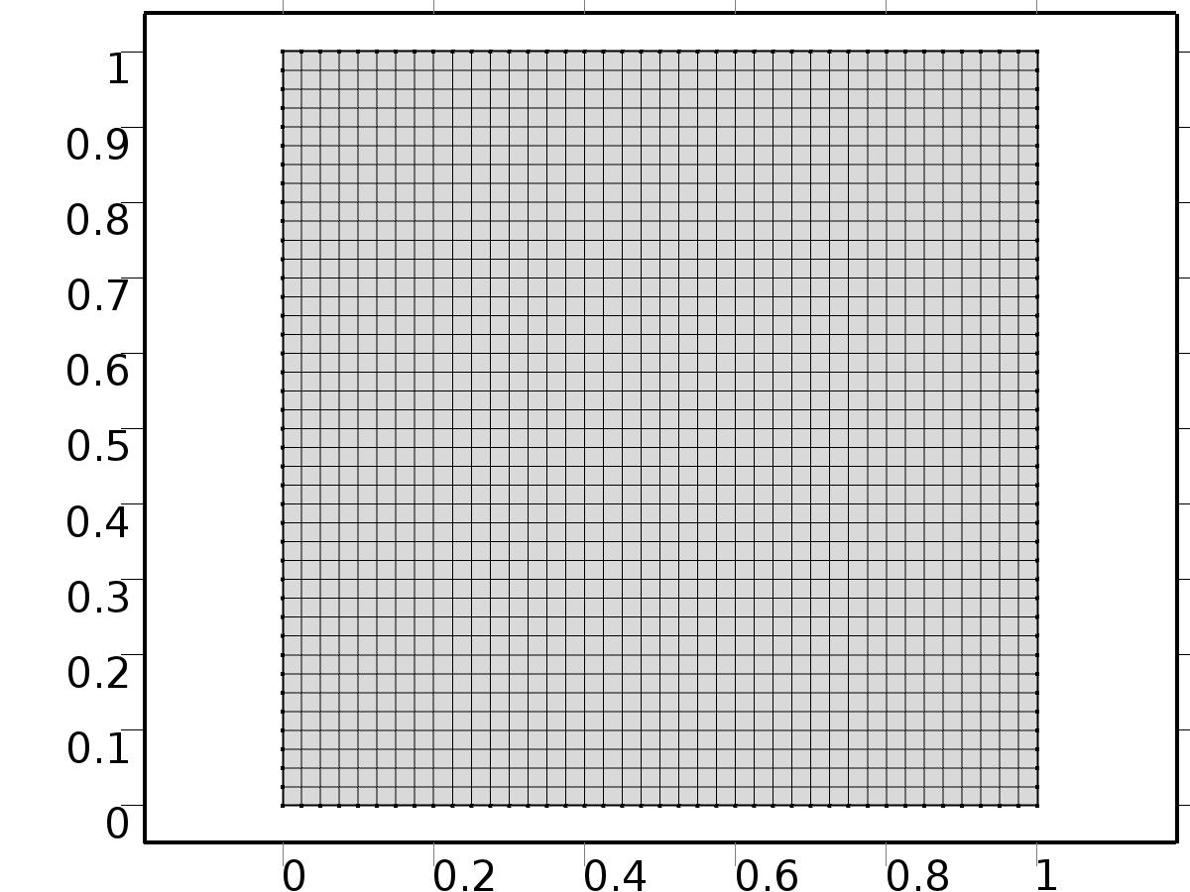

Mesh 1

* + 1. Size (size)

Settings

| **Description** | **Value** |
| --- | --- |
| Maximum element size | L/40 |
| Minimum element size | L/40 |
| Curvature factor | 0.3 |
| Maximum element growth rate | 1.3 |
| Custom element size | Custom |

* + 1. Mapped 1 (map1)

Selection

|  |  |
| --- | --- |
| Geometric entity level | Remaining |

1. Study 1
   1. Time Dependent

Study settings

| **Description** | **Value** |
| --- | --- |
| Include geometric nonlinearity | Off |

| **Times** | **Unit** |
| --- | --- |
| range(0,0.025,4) | s |

Physics and variables selection

| **Physics interface** | **Discretization** |
| --- | --- |
| zero dymamics (c) | physics |
| Plant (c2) | physics |

Mesh selection

| **Geometry** | **Mesh** |
| --- | --- |
| Geometry 1 (geom1) | mesh1 |

* 1. Solver Configurations
     1. Solver 1

#### Compile Equations: Time Dependent (st1)

Study and step

| **Description** | **Value** |
| --- | --- |
| Use study | Study 1 |
| Use study step | Time Dependent |

#### Dependent Variables 1 (v1)

General

| **Description** | **Value** |
| --- | --- |
| Defined by study step | Time Dependent |
| Constant |  |

Initial values of variables solved for

| **Description** | **Value** |
| --- | --- |
| Solution | Zero |

Values of variables not solved for

| **Description** | **Value** |
| --- | --- |
| Solution | Zero |

##### Dependent variable z1 (comp1.z1) (comp1_z1)

General

| **Description** | **Value** |
| --- | --- |
| Field components | comp1.z1 |
| Field name | comp1_z |

##### Dependent variable X1 (comp1.X1) (comp1_X1)

General

| **Description** | **Value** |
| --- | --- |
| Field components | comp1.X1 |
| Field name | comp1_X |

##### Dependent variable X2 (comp1.X2) (comp1_X2)

General

| **Description** | **Value** |
| --- | --- |
| Field components | comp1.X2 |

##### Lagrange multiplier for dependent variable x2 (comp1.X2_lm) (comp1_X2_lm)

General

| **Description** | **Value** |
| --- | --- |
| Field components | comp1.X2_lm |

##### Lagrange multiplier for dependent variable x1 (comp1.X1_lm) (comp1_X1_lm)

General

| **Description** | **Value** |
| --- | --- |
| Field components | comp1.X1_lm |

##### Dependent variable z2 (comp1.z2) (comp1_z2)

General

| **Description** | **Value** |
| --- | --- |
| Field components | comp1.z2 |

#### Time-Dependent Solver 1 (t1)

General

| **Description** | **Value** |
| --- | --- |
| Defined by study step | Time Dependent |
| Time | {0, 0.025, 0.05, 0.07500000000000001, 0.1, 0.125, 0.15000000000000002, 0.17500000000000002, 0.2, 0.225, 0.25, 0.275, 0.30000000000000004, 0.325, 0.35000000000000003, 0.375, 0.4, 0.42500000000000004, 0.45, 0.47500000000000003, 0.5, 0.525, 0.55, 0.5750000000000001, 0.6000000000000001, 0.625, 0.65, 0.675, 0.7000000000000001, 0.7250000000000001, 0.75, 0.775, 0.8, 0.8250000000000001, 0.8500000000000001, 0.875, 0.9, 0.925, 0.9500000000000001, 0.9750000000000001, 1, 1.0250000000000001, 1.05, 1.075, 1.1, 1.125, 1.1500000000000001, 1.175, 1.2000000000000002, 1.225, 1.25, 1.2750000000000001, 1.3, 1.3250000000000002, 1.35, 1.375, 1.4000000000000001, 1.425, 1.4500000000000002, 1.475, 1.5, 1.5250000000000001, 1.55, 1.5750000000000002, 1.6, 1.625, 1.6500000000000001, 1.675, 1.7000000000000002, 1.725, 1.75, 1.7750000000000001, 1.8, 1.8250000000000002, 1.85, 1.875, 1.9000000000000001, 1.925, 1.9500000000000002, 1.975, 2, 2.025, 2.0500000000000003, 2.075, 2.1, 2.125, 2.15, 2.1750000000000003, 2.2, 2.225, 2.25, 2.275, 2.3000000000000003, 2.325, 2.35, 2.375, 2.4000000000000004, 2.4250000000000003, 2.45, 2.475, 2.5, 2.5250000000000004, 2.5500000000000003, 2.575, 2.6, 2.625, 2.6500000000000004, 2.6750000000000003, 2.7, 2.725, 2.75, 2.7750000000000004, 2.8000000000000003, 2.825, 2.85, 2.875, 2.9000000000000004, 2.9250000000000003, 2.95, 2.975, 3, 3.0250000000000004, 3.0500000000000003, 3.075, 3.1, 3.125, 3.1500000000000004, 3.1750000000000003, 3.2, 3.225, 3.25, 3.2750000000000004, 3.3000000000000003, 3.325, 3.35, 3.375, 3.4000000000000004, 3.4250000000000003, 3.45, 3.475, 3.5, 3.5250000000000004, 3.5500000000000003, 3.575, 3.6, 3.625, 3.6500000000000004, 3.6750000000000003, 3.7, 3.725, 3.75, 3.7750000000000004, 3.8000000000000003, 3.825, 3.85, 3.875, 3.9000000000000004, 3.9250000000000003, 3.95, 3.975, 4} |
| Relative tolerance | 0.0001 |

Absolute tolerance

| **Description** | **Value** |
| --- | --- |
| Tolerance | 0.000010 |

Time stepping

| **Description** | **Value** |
| --- | --- |
| Initial step | 0.0010 |

Advanced

| **Description** | **Value** |
| --- | --- |
| Fraction of initial step for Backward Euler | 0.0010 |

Log

| **Description** | **Value** |
| --- | --- |
| Constant |  |

##### Fully Coupled 1 (fc1)

General

| **Description** | **Value** |
| --- | --- |
| Linear solver | Direct |

1. Results
   1. Data Sets
      1. Solution 1

Solution

| **Description** | **Value** |
| --- | --- |
| Solution | Solver 1 |
| Component | Save Point Geometry 1 |

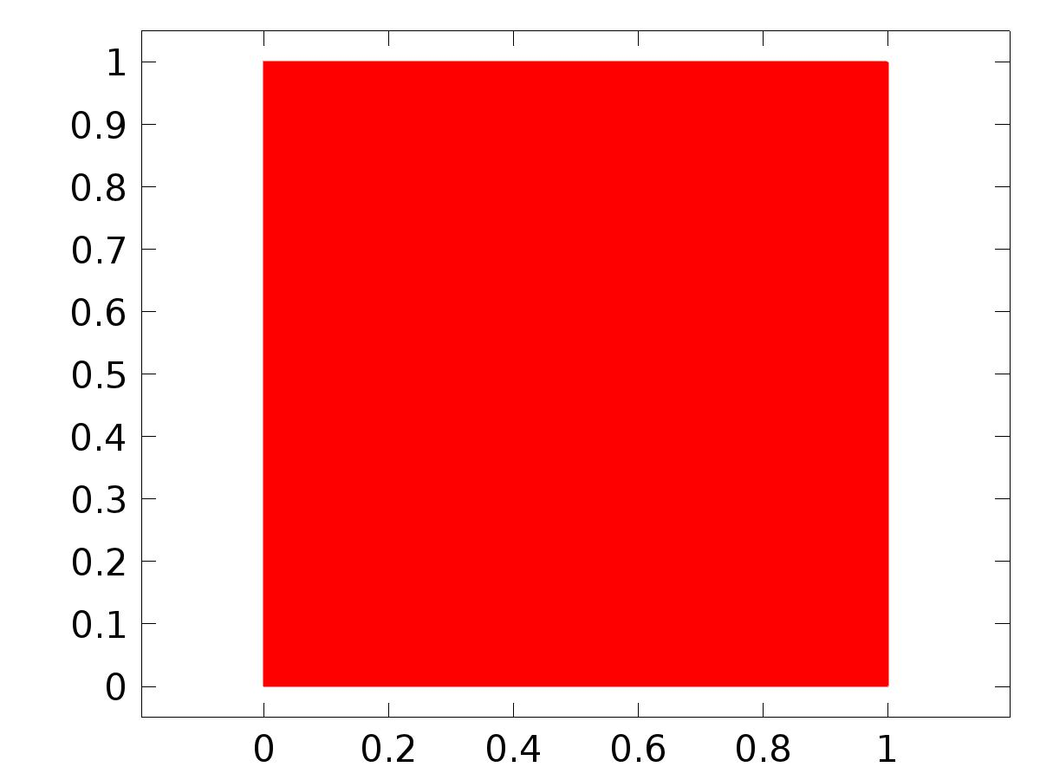

Data set: Solution 1

* 1. Derived Values
     1. Global Evaluation 1

Data

| **Description** | **Value** |
| --- | --- |
| Data set | Solution 1 |

Expression

| **Description** | **Value** |
| --- | --- |
| Expression | e22 |

* 1. Tables
     1. Table 1

Global Evaluation 1 (C1(z))

Table 1

| **Time (s)** | **C1(z1)** | **C1(z2)** | **C2(z1)** | **C2(z2)** | **e11** | **e12** | **e21** | **e22** |
| --- | --- | --- | --- | --- | --- | --- | --- | --- |
| 0.0000 | 0.24420 | -0.25043 | 0.49259 | -0.49897 | 2.1153 | 2.1202 | 2.1178 | 2.1228 |
| 0.025000 | 0.080177 | 0.021735 | 0.18455 | -0.13399 | 0.81957 | 1.2255 | 0.97275 | 1.3486 |
| 0.050000 | 0.15868 | 0.18828 | 0.30864 | 0.085635 | 0.58088 | 0.79563 | 0.66437 | 0.97747 |
| 0.075000 | 0.26379 | 0.27111 | 0.46214 | 0.19444 | 0.40560 | 0.62615 | 0.44632 | 0.83709 |
| 0.10000 | 0.35713 | 0.30669 | 0.58696 | 0.23671 | 0.28506 | 0.58174 | 0.30454 | 0.78972 |
| 0.12500 | 0.42597 | 0.31670 | 0.67290 | 0.24280 | 0.23707 | 0.57202 | 0.24879 | 0.76467 |
| 0.15000 | 0.47124 | 0.31267 | 0.72650 | 0.23023 | 0.23767 | 0.56480 | 0.24783 | 0.74090 |
| 0.17500 | 0.49821 | 0.30099 | 0.75717 | 0.20878 | 0.25200 | 0.55357 | 0.26193 | 0.71514 |
| 0.20000 | 0.51230 | 0.28537 | 0.77281 | 0.18380 | 0.26409 | 0.53879 | 0.27385 | 0.68836 |
| 0.22500 | 0.51789 | 0.26803 | 0.77907 | 0.15820 | 0.27066 | 0.52203 | 0.28027 | 0.66192 |
| 0.25000 | 0.51814 | 0.25030 | 0.77975 | 0.13341 | 0.27240 | 0.50461 | 0.28199 | 0.63670 |
| 0.27500 | 0.51520 | 0.23289 | 0.77721 | 0.11006 | 0.27076 | 0.48733 | 0.28046 | 0.61310 |
| 0.30000 | 0.51044 | 0.21616 | 0.77288 | 0.088273 | 0.26695 | 0.47061 | 0.27687 | 0.59115 |
| 0.32500 | 0.50471 | 0.20021 | 0.76755 | 0.067916 | 0.26184 | 0.45462 | 0.27201 | 0.57067 |
| 0.35000 | 0.49846 | 0.18499 | 0.76161 | 0.048715 | 0.25595 | 0.43932 | 0.26634 | 0.55137 |
| 0.37500 | 0.49194 | 0.17039 | 0.75523 | 0.030355 | 0.24958 | 0.42461 | 0.26008 | 0.53291 |
| 0.40000 | 0.48523 | 0.15627 | 0.74844 | 0.012535 | 0.24286 | 0.41037 | 0.25330 | 0.51498 |
| 0.42500 | 0.47837 | 0.14250 | 0.74124 | -0.0049902 | 0.23586 | 0.39645 | 0.24605 | 0.49735 |
| 0.45000 | 0.47133 | 0.12897 | 0.73360 | -0.022407 | 0.22857 | 0.38274 | 0.23832 | 0.47982 |
| 0.47500 | 0.46411 | 0.11560 | 0.72553 | -0.039828 | 0.22103 | 0.36918 | 0.23013 | 0.46228 |
| 0.50000 | 0.45670 | 0.10235 | 0.71704 | -0.057318 | 0.21322 | 0.35570 | 0.22149 | 0.44467 |
| 0.52500 | 0.44909 | 0.089172 | 0.70815 | -0.074890 | 0.20517 | 0.34229 | 0.21245 | 0.42697 |
| 0.55000 | 0.44129 | 0.076062 | 0.69891 | -0.092533 | 0.19688 | 0.32892 | 0.20305 | 0.40921 |
| 0.57500 | 0.43329 | 0.063012 | 0.68937 | -0.11021 | 0.18839 | 0.31562 | 0.19334 | 0.39141 |
| 0.60000 | 0.42512 | 0.050018 | 0.67959 | -0.12789 | 0.17973 | 0.30237 | 0.18339 | 0.37362 |
| 0.62500 | 0.41678 | 0.037085 | 0.66962 | -0.14550 | 0.17091 | 0.28918 | 0.17327 | 0.35589 |
| 0.65000 | 0.40829 | 0.024213 | 0.65952 | -0.16301 | 0.16197 | 0.27608 | 0.16302 | 0.33828 |
| 0.67500 | 0.39967 | 0.011407 | 0.64934 | -0.18035 | 0.15293 | 0.26305 | 0.15272 | 0.32083 |
| 0.70000 | 0.39094 | -0.0013242 | 0.63914 | -0.19749 | 0.14382 | 0.25013 | 0.14241 | 0.30360 |
| 0.72500 | 0.38212 | -0.013967 | 0.62898 | -0.21436 | 0.13468 | 0.23731 | 0.13216 | 0.28664 |
| 0.75000 | 0.37325 | -0.026501 | 0.61891 | -0.23091 | 0.12552 | 0.22463 | 0.12203 | 0.27000 |
| 0.77500 | 0.36436 | -0.038897 | 0.60900 | -0.24709 | 0.11641 | 0.21211 | 0.11206 | 0.25374 |
| 0.80000 | 0.35552 | -0.051118 | 0.59929 | -0.26285 | 0.10737 | 0.19979 | 0.10232 | 0.23790 |
| 0.82500 | 0.34678 | -0.063116 | 0.58986 | -0.27813 | 0.098472 | 0.18771 | 0.092878 | 0.22256 |
| 0.85000 | 0.33819 | -0.074839 | 0.58076 | -0.29287 | 0.089767 | 0.17593 | 0.083782 | 0.20777 |
| 0.87500 | 0.32983 | -0.086229 | 0.57205 | -0.30700 | 0.081318 | 0.16449 | 0.075091 | 0.19358 |
| 0.90000 | 0.32177 | -0.097228 | 0.56380 | -0.32049 | 0.073186 | 0.15345 | 0.066858 | 0.18004 |
| 0.92500 | 0.31406 | -0.10778 | 0.55604 | -0.33329 | 0.065433 | 0.14288 | 0.059130 | 0.16721 |
| 0.95000 | 0.30677 | -0.11782 | 0.54882 | -0.34534 | 0.058115 | 0.13282 | 0.051946 | 0.15513 |
| 0.97500 | 0.29995 | -0.12732 | 0.54218 | -0.35662 | 0.051278 | 0.12331 | 0.045336 | 0.14382 |
| 1.0000 | 0.29365 | -0.13623 | 0.53614 | -0.36712 | 0.044958 | 0.11438 | 0.039320 | 0.13331 |
| 1.0250 | 0.28788 | -0.14454 | 0.53071 | -0.37681 | 0.039182 | 0.10607 | 0.033908 | 0.12360 |
| 1.0500 | 0.28267 | -0.15223 | 0.52590 | -0.38570 | 0.033965 | 0.098368 | 0.029098 | 0.11469 |
| 1.0750 | 0.27802 | -0.15930 | 0.52171 | -0.39381 | 0.029311 | 0.091289 | 0.024880 | 0.10657 |
| 1.1000 | 0.27393 | -0.16576 | 0.51810 | -0.40115 | 0.025212 | 0.084816 | 0.021229 | 0.099217 |
| 1.1250 | 0.27038 | -0.17164 | 0.51507 | -0.40775 | 0.021652 | 0.078930 | 0.018117 | 0.092600 |
| 1.1500 | 0.26735 | -0.17695 | 0.51257 | -0.41365 | 0.018610 | 0.073609 | 0.015510 | 0.086682 |
| 1.1750 | 0.26481 | -0.18172 | 0.51059 | -0.41891 | 0.016058 | 0.068822 | 0.013363 | 0.081418 |
| 1.2000 | 0.26273 | -0.18600 | 0.50906 | -0.42356 | 0.013957 | 0.064528 | 0.011632 | 0.076754 |
| 1.2250 | 0.26107 | -0.18983 | 0.50794 | -0.42767 | 0.012266 | 0.060688 | 0.010271 | 0.072634 |
| 1.2500 | 0.25979 | -0.19324 | 0.50719 | -0.43129 | 0.010946 | 0.057262 | 0.0092411 | 0.068999 |
| 1.2750 | 0.25884 | -0.19629 | 0.50673 | -0.43450 | 0.0099477 | 0.054204 | 0.0085037 | 0.065785 |
| 1.3000 | 0.25817 | -0.19901 | 0.50653 | -0.43735 | 0.0092273 | 0.051473 | 0.0080230 | 0.062926 |
| 1.3250 | 0.25774 | -0.20146 | 0.50651 | -0.43992 | 0.0087340 | 0.049018 | 0.0077573 | 0.060354 |
| 1.3500 | 0.25749 | -0.20367 | 0.50663 | -0.44226 | 0.0084223 | 0.046799 | 0.0076625 | 0.058010 |
| 1.3750 | 0.25738 | -0.20568 | 0.50682 | -0.44442 | 0.0082465 | 0.044772 | 0.0076885 | 0.055835 |
| 1.4000 | 0.25738 | -0.20753 | 0.50706 | -0.44646 | 0.0081751 | 0.042910 | 0.0077953 | 0.053791 |
| 1.4250 | 0.25744 | -0.20925 | 0.50730 | -0.44841 | 0.0081707 | 0.041181 | 0.0079366 | 0.051833 |
| 1.4500 | 0.25753 | -0.21086 | 0.50751 | -0.45031 | 0.0082003 | 0.039555 | 0.0080734 | 0.049926 |
| 1.4750 | 0.25763 | -0.21238 | 0.50766 | -0.45217 | 0.0082403 | 0.038013 | 0.0081804 | 0.048053 |
| 1.5000 | 0.25772 | -0.21383 | 0.50776 | -0.45402 | 0.0082717 | 0.036538 | 0.0082391 | 0.046199 |
| 1.5250 | 0.25779 | -0.21523 | 0.50778 | -0.45585 | 0.0082779 | 0.035116 | 0.0082355 | 0.044354 |
| 1.5500 | 0.25782 | -0.21659 | 0.50773 | -0.45768 | 0.0082479 | 0.033736 | 0.0081630 | 0.042512 |
| 1.5750 | 0.25779 | -0.21791 | 0.50760 | -0.45951 | 0.0081734 | 0.032388 | 0.0080204 | 0.040675 |
| 1.6000 | 0.25772 | -0.21920 | 0.50740 | -0.46132 | 0.0080534 | 0.031069 | 0.0078125 | 0.038848 |
| 1.6250 | 0.25760 | -0.22047 | 0.50713 | -0.46313 | 0.0078856 | 0.029774 | 0.0075428 | 0.037032 |
| 1.6500 | 0.25742 | -0.22172 | 0.50680 | -0.46492 | 0.0076676 | 0.028497 | 0.0072151 | 0.035230 |
| 1.6750 | 0.25719 | -0.22296 | 0.50641 | -0.46669 | 0.0073998 | 0.027235 | 0.0068374 | 0.033448 |
| 1.7000 | 0.25691 | -0.22419 | 0.50598 | -0.46844 | 0.0070853 | 0.025986 | 0.0064182 | 0.031691 |
| 1.7250 | 0.25657 | -0.22540 | 0.50552 | -0.47016 | 0.0067272 | 0.024749 | 0.0059666 | 0.029965 |
| 1.7500 | 0.25620 | -0.22661 | 0.50502 | -0.47184 | 0.0063291 | 0.023524 | 0.0054897 | 0.028273 |
| 1.7750 | 0.25578 | -0.22781 | 0.50450 | -0.47349 | 0.0058946 | 0.022311 | 0.0049957 | 0.026619 |
| 1.8000 | 0.25532 | -0.22900 | 0.50396 | -0.47509 | 0.0054301 | 0.021112 | 0.0044963 | 0.025013 |
| 1.8250 | 0.25484 | -0.23017 | 0.50343 | -0.47664 | 0.0049429 | 0.019930 | 0.0040017 | 0.023458 |
| 1.8500 | 0.25434 | -0.23132 | 0.50289 | -0.47813 | 0.0044413 | 0.018770 | 0.0035226 | 0.021960 |
| 1.8750 | 0.25384 | -0.23245 | 0.50237 | -0.47957 | 0.0039337 | 0.017638 | 0.0030699 | 0.020523 |
| 1.9000 | 0.25333 | -0.23355 | 0.50187 | -0.48094 | 0.0034294 | 0.016538 | 0.0026558 | 0.019153 |
| 1.9250 | 0.25283 | -0.23460 | 0.50139 | -0.48223 | 0.0029372 | 0.015477 | 0.0022924 | 0.017855 |
| 1.9500 | 0.25235 | -0.23562 | 0.50095 | -0.48346 | 0.0024664 | 0.014460 | 0.0019924 | 0.016631 |
| 1.9750 | 0.25189 | -0.23658 | 0.50054 | -0.48460 | 0.0020259 | 0.013493 | 0.0017661 | 0.015487 |
| 2.0000 | 0.25147 | -0.23750 | 0.50018 | -0.48567 | 0.0016242 | 0.012580 | 0.0016185 | 0.014420 |
| 2.0250 | 0.25107 | -0.23836 | 0.49986 | -0.48666 | 0.0012691 | 0.011720 | 0.0015426 | 0.013433 |
| 2.0500 | 0.25072 | -0.23916 | 0.49959 | -0.48756 | 9.7393E-4 | 0.010918 | 0.0015219 | 0.012527 |
| 2.0750 | 0.25041 | -0.23990 | 0.49936 | -0.48839 | 7.5496E-4 | 0.010176 | 0.0015356 | 0.011699 |
| 2.1000 | 0.25015 | -0.24058 | 0.49918 | -0.48915 | 6.2819E-4 | 0.0094926 | 0.0015634 | 0.010945 |
| 2.1250 | 0.24993 | -0.24121 | 0.49905 | -0.48983 | 5.9609E-4 | 0.0088639 | 0.0015909 | 0.010261 |
| 2.1500 | 0.24974 | -0.24179 | 0.49895 | -0.49045 | 6.3079E-4 | 0.0082853 | 0.0016085 | 0.0096443 |
| 2.1750 | 0.24960 | -0.24232 | 0.49890 | -0.49100 | 6.9051E-4 | 0.0077573 | 0.0016109 | 0.0090898 |
| 2.2000 | 0.24950 | -0.24280 | 0.49888 | -0.49150 | 7.4492E-4 | 0.0072810 | 0.0015932 | 0.0085957 |
| 2.2250 | 0.24943 | -0.24323 | 0.49890 | -0.49194 | 7.8412E-4 | 0.0068514 | 0.0015555 | 0.0081577 |
| 2.2500 | 0.24939 | -0.24362 | 0.49894 | -0.49233 | 8.1033E-4 | 0.0064566 | 0.0015060 | 0.0077627 |
| 2.2750 | 0.24937 | -0.24398 | 0.49901 | -0.49269 | 8.1835E-4 | 0.0060974 | 0.0014463 | 0.0074066 |
| 2.3000 | 0.24938 | -0.24431 | 0.49908 | -0.49302 | 8.0764E-4 | 0.0057691 | 0.0013833 | 0.0070777 |
| 2.3250 | 0.24942 | -0.24460 | 0.49918 | -0.49332 | 7.7561E-4 | 0.0054781 | 0.0013126 | 0.0067820 |
| 2.3500 | 0.24947 | -0.24486 | 0.49928 | -0.49359 | 7.3427E-4 | 0.0052142 | 0.0012407 | 0.0065138 |
| 2.3750 | 0.24954 | -0.24510 | 0.49940 | -0.49383 | 6.8937E-4 | 0.0049758 | 0.0011713 | 0.0062700 |
| 2.4000 | 0.24960 | -0.24533 | 0.49950 | -0.49407 | 6.4840E-4 | 0.0047481 | 0.0011154 | 0.0060330 |
| 2.4250 | 0.24967 | -0.24554 | 0.49960 | -0.49430 | 6.0595E-4 | 0.0045365 | 0.0010710 | 0.0058029 |
| 2.4500 | 0.24975 | -0.24574 | 0.49969 | -0.49453 | 5.6723E-4 | 0.0043413 | 0.0010368 | 0.0055799 |
| 2.4750 | 0.24983 | -0.24591 | 0.49978 | -0.49474 | 5.3381E-4 | 0.0041654 | 0.0010107 | 0.0053683 |
| 2.5000 | 0.24990 | -0.24608 | 0.49986 | -0.49495 | 5.1389E-4 | 0.0039983 | 9.9482E-4 | 0.0051587 |
| 2.5250 | 0.24996 | -0.24624 | 0.49992 | -0.49517 | 5.0356E-4 | 0.0038355 | 9.8669E-4 | 0.0049467 |
| 2.5500 | 0.25002 | -0.24640 | 0.49997 | -0.49539 | 5.0015E-4 | 0.0036753 | 9.8323E-4 | 0.0047330 |
| 2.5750 | 0.25006 | -0.24655 | 0.50000 | -0.49560 | 5.0076E-4 | 0.0035201 | 9.8164E-4 | 0.0045223 |
| 2.6000 | 0.25010 | -0.24670 | 0.50003 | -0.49581 | 5.0412E-4 | 0.0033714 | 9.8083E-4 | 0.0043174 |
| 2.6250 | 0.25014 | -0.24684 | 0.50005 | -0.49601 | 5.0949E-4 | 0.0032305 | 9.8060E-4 | 0.0041189 |
| 2.6500 | 0.25016 | -0.24697 | 0.50005 | -0.49621 | 5.1491E-4 | 0.0030939 | 9.8047E-4 | 0.0039231 |
| 2.6750 | 0.25018 | -0.24710 | 0.50005 | -0.49641 | 5.1894E-4 | 0.0029603 | 9.8006E-4 | 0.0037302 |
| 2.7000 | 0.25019 | -0.24723 | 0.50004 | -0.49660 | 5.2034E-4 | 0.0028280 | 9.7903E-4 | 0.0035411 |
| 2.7250 | 0.25019 | -0.24736 | 0.50003 | -0.49679 | 5.1928E-4 | 0.0026977 | 9.7775E-4 | 0.0033576 |
| 2.7500 | 0.25018 | -0.24749 | 0.50001 | -0.49698 | 5.1622E-4 | 0.0025699 | 9.7655E-4 | 0.0031808 |
| 2.7750 | 0.25017 | -0.24762 | 0.49999 | -0.49716 | 5.1143E-4 | 0.0024445 | 9.7576E-4 | 0.0030107 |
| 2.8000 | 0.25015 | -0.24774 | 0.49996 | -0.49733 | 5.0528E-4 | 0.0023211 | 9.7564E-4 | 0.0028469 |
| 2.8250 | 0.25013 | -0.24786 | 0.49993 | -0.49750 | 4.9848E-4 | 0.0021997 | 9.7638E-4 | 0.0026898 |
| 2.8500 | 0.25010 | -0.24799 | 0.49990 | -0.49766 | 4.9188E-4 | 0.0020810 | 9.7794E-4 | 0.0025403 |
| 2.8750 | 0.25008 | -0.24810 | 0.49987 | -0.49781 | 4.8635E-4 | 0.0019657 | 9.8034E-4 | 0.0023994 |
| 2.9000 | 0.25004 | -0.24822 | 0.49985 | -0.49795 | 4.8243E-4 | 0.0018545 | 9.8346E-4 | 0.0022673 |
| 2.9250 | 0.25001 | -0.24833 | 0.49982 | -0.49809 | 4.8047E-4 | 0.0017479 | 9.8692E-4 | 0.0021451 |
| 2.9500 | 0.24998 | -0.24843 | 0.49979 | -0.49822 | 4.8052E-4 | 0.0016459 | 9.9061E-4 | 0.0020317 |
| 2.9750 | 0.24995 | -0.24854 | 0.49977 | -0.49834 | 4.8252E-4 | 0.0015484 | 9.9459E-4 | 0.0019259 |
| 3.0000 | 0.24992 | -0.24863 | 0.49975 | -0.49845 | 4.8603E-4 | 0.0014571 | 9.9834E-4 | 0.0018291 |
| 3.0250 | 0.24990 | -0.24872 | 0.49974 | -0.49855 | 4.9027E-4 | 0.0013731 | 0.0010011 | 0.0017426 |
| 3.0500 | 0.24988 | -0.24880 | 0.49973 | -0.49865 | 4.9522E-4 | 0.0012944 | 0.0010030 | 0.0016651 |
| 3.0750 | 0.24986 | -0.24889 | 0.49972 | -0.49873 | 5.0107E-4 | 0.0012193 | 0.0010048 | 0.0015941 |
| 3.1000 | 0.24984 | -0.24896 | 0.49971 | -0.49881 | 5.0657E-4 | 0.0011502 | 0.0010057 | 0.0015307 |
| 3.1250 | 0.24983 | -0.24903 | 0.49971 | -0.49889 | 5.1029E-4 | 0.0010889 | 0.0010050 | 0.0014751 |
| 3.1500 | 0.24982 | -0.24909 | 0.49972 | -0.49895 | 5.1270E-4 | 0.0010343 | 0.0010034 | 0.0014261 |
| 3.1750 | 0.24981 | -0.24915 | 0.49972 | -0.49901 | 5.1584E-4 | 9.8161E-4 | 0.0010024 | 0.0013805 |
| 3.2000 | 0.24980 | -0.24921 | 0.49972 | -0.49907 | 5.1828E-4 | 9.3362E-4 | 0.0010011 | 0.0013396 |
| 3.2250 | 0.24980 | -0.24926 | 0.49973 | -0.49912 | 5.1973E-4 | 8.8981E-4 | 9.9916E-4 | 0.0013033 |
| 3.2500 | 0.24980 | -0.24930 | 0.49974 | -0.49917 | 5.1842E-4 | 8.5301E-4 | 9.9517E-4 | 0.0012742 |
| 3.2750 | 0.24981 | -0.24934 | 0.49976 | -0.49920 | 5.1582E-4 | 8.2053E-4 | 9.9048E-4 | 0.0012495 |
| 3.3000 | 0.24982 | -0.24937 | 0.49978 | -0.49924 | 5.1138E-4 | 7.9331E-4 | 9.8497E-4 | 0.0012295 |
| 3.3250 | 0.24984 | -0.24941 | 0.49981 | -0.49926 | 5.0622E-4 | 7.6938E-4 | 9.7983E-4 | 0.0012114 |
| 3.3500 | 0.24985 | -0.24944 | 0.49982 | -0.49929 | 5.0233E-4 | 7.4583E-4 | 9.7610E-4 | 0.0011928 |
| 3.3750 | 0.24986 | -0.24946 | 0.49984 | -0.49932 | 4.9916E-4 | 7.2361E-4 | 9.7303E-4 | 0.0011753 |
| 3.4000 | 0.24987 | -0.24950 | 0.49985 | -0.49936 | 4.9707E-4 | 7.0151E-4 | 9.7099E-4 | 0.0011576 |
| 3.4250 | 0.24988 | -0.24952 | 0.49986 | -0.49939 | 4.9542E-4 | 6.8067E-4 | 9.6963E-4 | 0.0011404 |
| 3.4500 | 0.24989 | -0.24954 | 0.49988 | -0.49941 | 4.9204E-4 | 6.6653E-4 | 9.6724E-4 | 0.0011288 |
| 3.4750 | 0.24991 | -0.24956 | 0.49990 | -0.49943 | 4.8837E-4 | 6.5560E-4 | 9.6482E-4 | 0.0011189 |
| 3.5000 | 0.24992 | -0.24958 | 0.49991 | -0.49946 | 4.8665E-4 | 6.4074E-4 | 9.6392E-4 | 0.0011043 |
| 3.5250 | 0.24993 | -0.24960 | 0.49992 | -0.49948 | 4.8552E-4 | 6.2655E-4 | 9.6335E-4 | 0.0010909 |
| 3.5500 | 0.24994 | -0.24962 | 0.49993 | -0.49950 | 4.8407E-4 | 6.1602E-4 | 9.6247E-4 | 0.0010809 |
| 3.5750 | 0.24995 | -0.24963 | 0.49994 | -0.49953 | 4.8286E-4 | 6.0581E-4 | 9.6186E-4 | 0.0010703 |
| 3.6000 | 0.24995 | -0.24965 | 0.49994 | -0.49955 | 4.8217E-4 | 5.9486E-4 | 9.6162E-4 | 0.0010586 |
| 3.6250 | 0.24996 | -0.24967 | 0.49995 | -0.49957 | 4.8141E-4 | 5.8701E-4 | 9.6112E-4 | 0.0010507 |
| 3.6500 | 0.24997 | -0.24968 | 0.49996 | -0.49959 | 4.8068E-4 | 5.8114E-4 | 9.6058E-4 | 0.0010445 |
| 3.6750 | 0.24998 | -0.24969 | 0.49996 | -0.49961 | 4.8037E-4 | 5.7295E-4 | 9.6047E-4 | 0.0010357 |
| 3.7000 | 0.24998 | -0.24970 | 0.49996 | -0.49963 | 4.8011E-4 | 5.6573E-4 | 9.6035E-4 | 0.0010280 |
| 3.7250 | 0.24999 | -0.24971 | 0.49997 | -0.49965 | 4.7988E-4 | 5.6046E-4 | 9.6012E-4 | 0.0010224 |
| 3.7500 | 0.24999 | -0.24973 | 0.49997 | -0.49967 | 4.7985E-4 | 5.5273E-4 | 9.6017E-4 | 0.0010147 |
| 3.7750 | 0.24999 | -0.24975 | 0.49996 | -0.49970 | 4.7992E-4 | 5.4392E-4 | 9.6038E-4 | 0.0010064 |
| 3.8000 | 0.24999 | -0.24976 | 0.49996 | -0.49971 | 4.7988E-4 | 5.3848E-4 | 9.6031E-4 | 0.0010017 |
| 3.8250 | 0.24999 | -0.24977 | 0.49996 | -0.49973 | 4.7987E-4 | 5.3318E-4 | 9.6027E-4 | 9.9721E-4 |
| 3.8500 | 0.24998 | -0.24979 | 0.49996 | -0.49975 | 4.8000E-4 | 5.2604E-4 | 9.6047E-4 | 9.9122E-4 |
| 3.8750 | 0.24998 | -0.24980 | 0.49996 | -0.49977 | 4.8007E-4 | 5.2081E-4 | 9.6052E-4 | 9.8714E-4 |
| 3.9000 | 0.24998 | -0.24981 | 0.49996 | -0.49978 | 4.8005E-4 | 5.1702E-4 | 9.6041E-4 | 9.8440E-4 |
| 3.9250 | 0.24998 | -0.24982 | 0.49996 | -0.49979 | 4.8005E-4 | 5.1330E-4 | 9.6034E-4 | 9.8177E-4 |
| 3.9500 | 0.24998 | -0.24983 | 0.49996 | -0.49981 | 4.8013E-4 | 5.0927E-4 | 9.6038E-4 | 9.7893E-4 |
| 3.9750 | 0.24998 | -0.24984 | 0.49996 | -0.49982 | 4.8023E-4 | 5.0549E-4 | 9.6042E-4 | 9.7636E-4 |
| 4.0000 | 0.24998 | -0.24985 | 0.49996 | -0.49983 | 4.8027E-4 | 5.0260E-4 | 9.6042E-4 | 9.7439E-4 |

* 1. Plot Groups
     1. 2D Plot Group 1

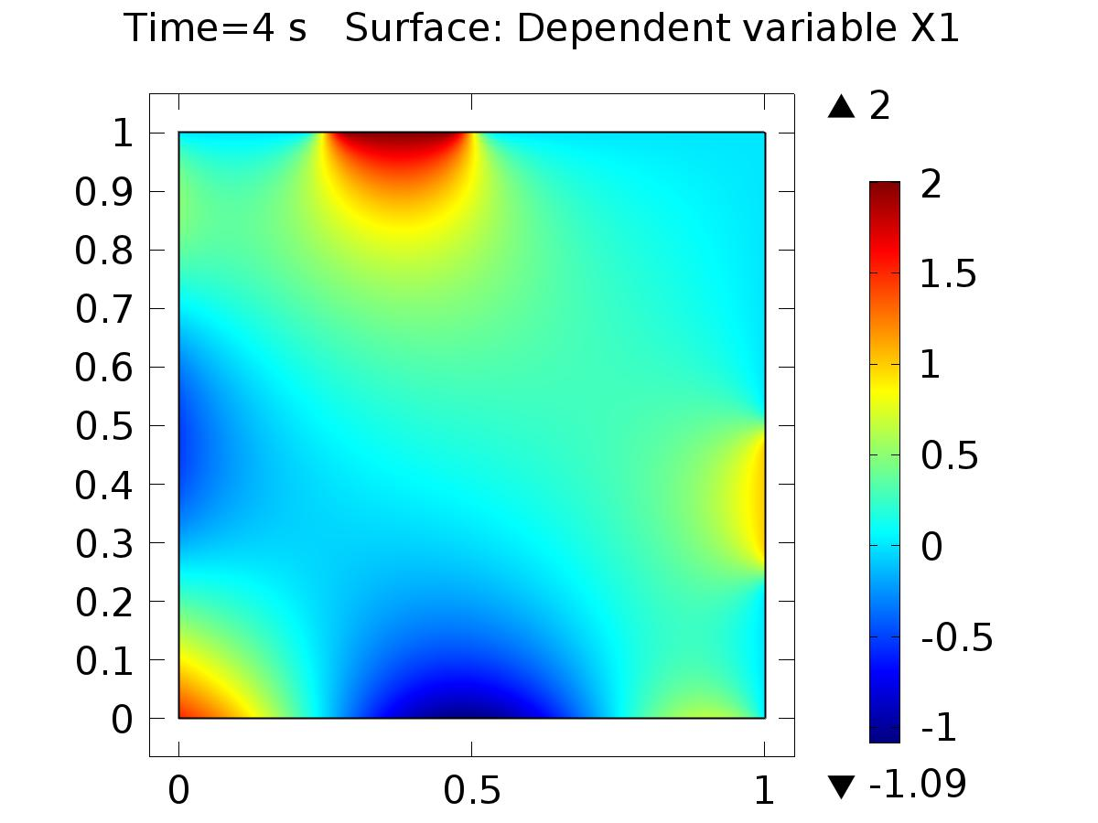

Time=4 s Surface: Dependent variable X1

* + 1. 2D Plot Group 2

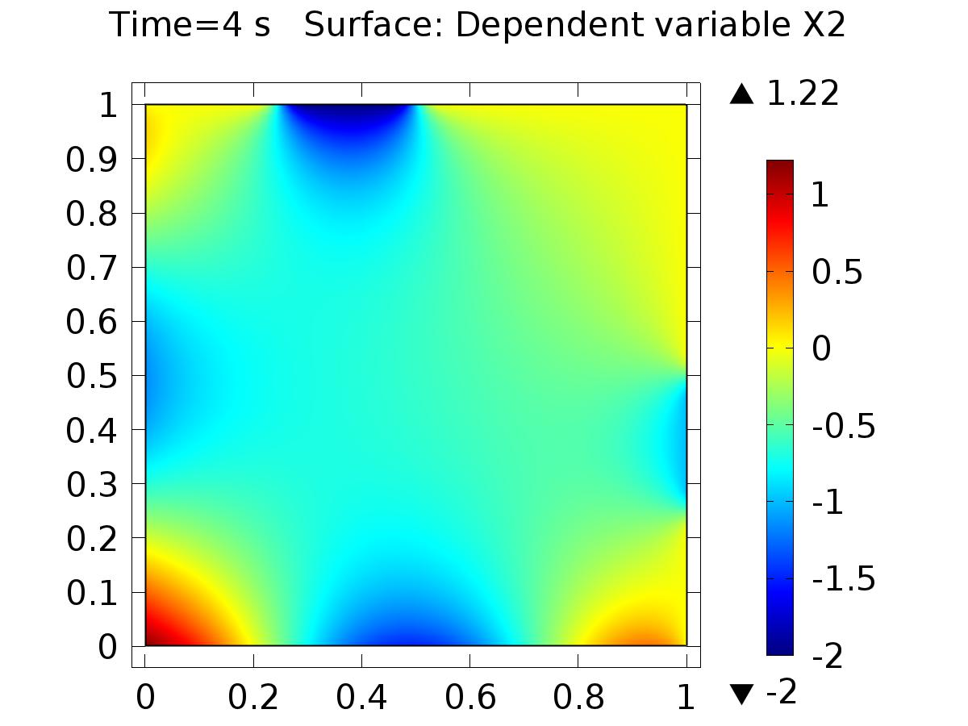

Time=4 s Surface: Dependent variable X2

* + 1. 2D Plot Group 4

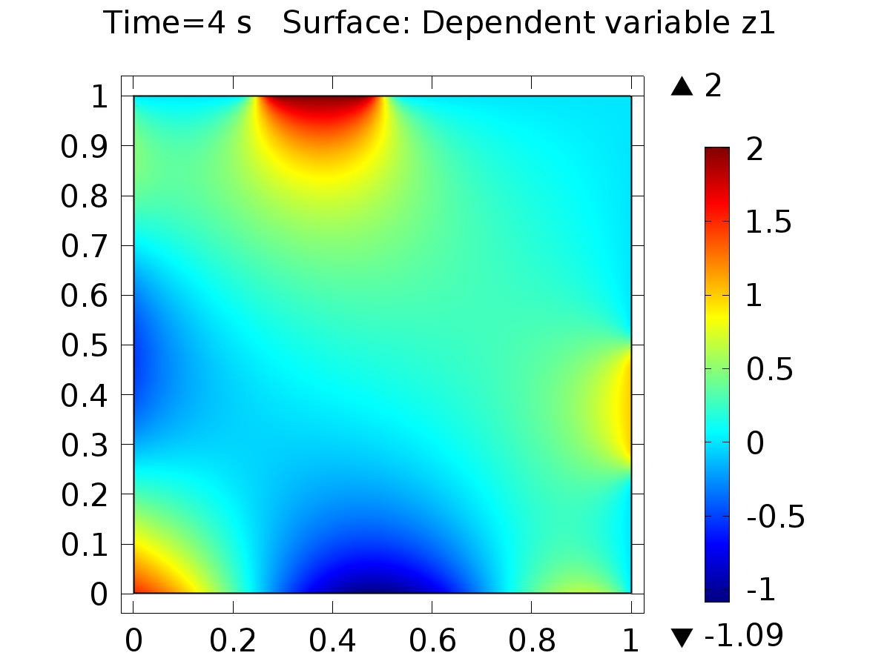

Time=4 s Surface: Dependent variable z1

* + 1. 2D Plot Group 5

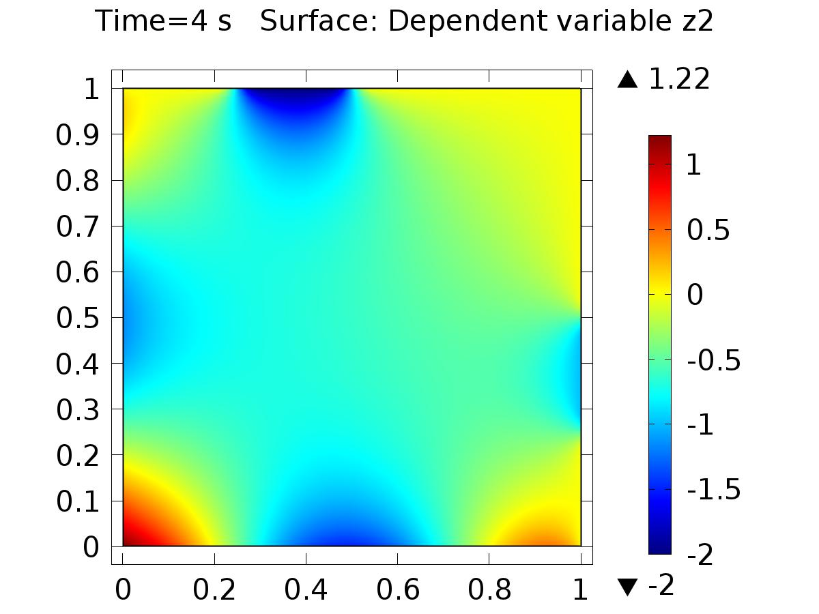

Time=4 s Surface: Dependent variable z2

* + 1. 1D Plot Group 3

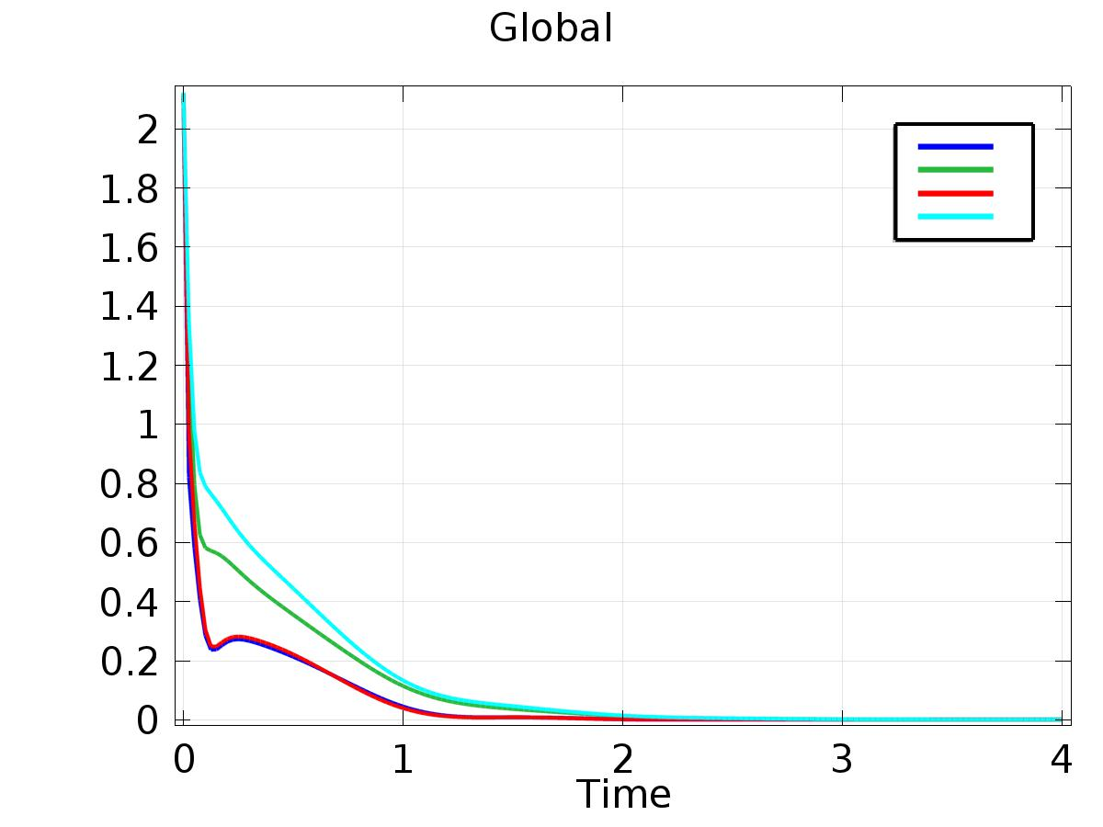

Global