Communication between sketcher and UTU

Format of output to the UTU :
1. Flag for UTU
- ShapeTypeID
- ShapeID
- Point : - x-coordinate
y-coordinate
Line : - pt1 x-coordinate
Pt1 y-coordinate
Pt2 x-coordinate
Pt2 y-coordinate
Circle : - center pt1 x-coordinate
center Pt1 y-coordinate
radius
Arc : - center pt1 x-coordinate
center Pt1 y-coordinate
radius
angle
Image : - pt1 x-coordinate
Pt1 y-coordinate
Pt2 x-coordinate
Pt2 y-coordinate
- -1
- ConstraintTypeID
- ConstraintID
- Number of shapes
- ShapeID
- Subshape of the shape involved in the constraint
- –1
- group tree node ID
- Number of shapes involved
- Shapes ID’s
- Number of children groups
- –1

Format of input from the UTU :

- Number of elements in the array to skip
- Flag
If Flag=-2
- Number of trees
- ClusterID
- Number of shapes
- Shapes ID’s
- Number of Children
- Children cluster ID’s
- –1
if Flag=1
- Number of roots
- Root ID
- Number of shapes
- Shape ID
- Shape Data
If Flag=0
- Number of bifurcation files
- Number of elements whose fin flags are following
- ClusterID
- Fin flag
- Active cluster ID
- Number of Bifurcations
- Number of shapes involved in the bifurcation
- Shape ID
- Shape Data

Examples:

Four points with distance constraints :

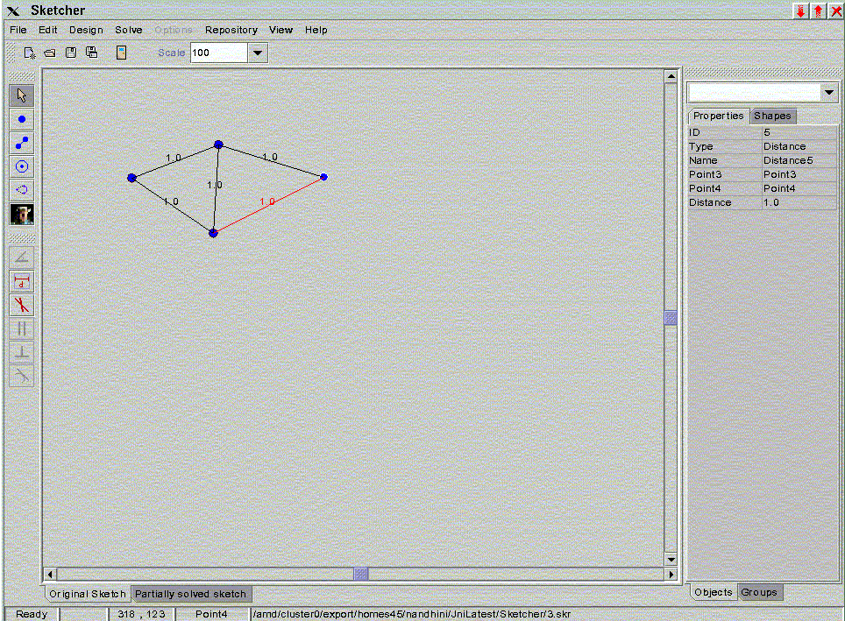
fig.1 . Simple sketch containing 4 points.

Integer array
Sent 0 Flag = 0

Sent 0 Shape Type of point =0
Sent 1 Shape ID =1
Sent 0
Sent 2
Sent 0
Sent 3
Sent 0
Sent 4
Sent -1 End of shapes data
Sent 0 Constraint type ID of distance constraint =0
Sent 1 Constraint ID =1
Sent 2 Number of shapes involved =2
Sent 1 Shape ID of first shape =1
Sent 1 SubShape of first shape involved
Sent 3 Shape ID of second Shape =3
Sent 1 SubShape of second shape involved

Sent 0
Sent 3
Sent 2
Sent 1
Sent 1
Sent 2
Sent 1

Sent 0
Sent 4
Sent 2
Sent 1
Sent 1
Sent 4
Sent 1

Sent 0
Sent 2
Sent 2
Sent 2
Sent 1
Sent 3
Sent 1

Sent 0
Sent 5
Sent 2
Sent 3
Sent 1
Sent 4
Sent 1

Sent -1 End of constraints data
Sent -1 End of groups data

Double array
Sent 200.0 x-coordinate of point 1
Sent 86.0 y-coordinate of point 1

Sent 101.0
Sent 124.0

Sent 194.0
Sent 187.0

Sent 320.0
Sent 123.0

Sent 1.0 Distance 1
Sent 1.0 Distance 2
Sent 1.0 Distance 3
Sent 1.0 Distance 4
Sent 1.0 Distance 5

Received data

Integer array
Received -2 Flag

Dag data
Received 1 Number of roots
Received 10 Cluster ID
Received 4 Number of shapes
Received 1 ShapeID
Received 3 ShapeID
Received 4 ShapeID
Received 2 ShapeID
Received 2 Number of children
Received 4 Child Cluster ID
Received 8 Child Cluster ID
Received 4 Cluster ID
Received 1 Number of shapes
Received 4 ShapeID
Received 0 Number of children
Received 8 Cluster ID
Received 3 Number of shapes
Received 3 ShapeID
Received 2 ShapeID
Received 1 ShapeID
Received 3 Number of children
Received 3 Child Cluster ID
Received 2 Child Cluster ID
Received 1 Child Cluster ID
Received 3 Cluster ID
Received 1 Number of shapes
Received 3 ShapeID
Received 0 Number of children
Received 2 Cluster ID
Received 1 Number of shapes
Received 2 ShapeID
Received 0 Number of children
Received 1 Cluster ID
Received 1 Number of shapes
Received 1 ShapeID
Received 0 Number of children
Received –1

End of dag data

Received 0 Flag

Received 1 Number of roots
Received 6 Number of elements
Received 10 Cluster ID
Received 0 Fin flag
Received 4 Cluster ID
Received 1 Fin flag
Received 8 Cluster ID
Received 0 Fin flag
Received 3 Cluster ID
Received 1 Fin flag
Received 2 Cluster ID
Received 1 Fin flag
Received 1 Cluster ID
Received 1 Fin flag

Received 10 Active cluster
Received 2 Number of bifurcations
Received 4 Number of shapes in each bifurcation
Received 1 Shape ID
Received 2 Shape ID
Received 3 Shape ID
Received 4 Shape ID
Received 1 Shape ID
Received 2 Shape ID
Received 3 Shape ID
Received 4 Shape ID

Double array
first 137.0

first bifurcation

Received 0.0 x-coordinate of point 1
Received 0.0 y-coordinate of point 1
Received -0.8660256862640381 x-coordinate of point 2
Received -0.4999994933605194 y-coordinate of point 2
Received 0.0 x-coordinate of point 3
Received -0.9999989867210388 y-coordinate of point 3
Received 0.8660256862640381 x-coordinate of point 4
Received -0.4999994933605194 y-coordinate of point 4

Second bifurcation

Received 0.0
Received 0.0
Received -0.8660256862640381
Received -0.4999994933605194
Received 0.0
Received -0.9999989867210388
Received 0.8660256862640381
Received -0.4999994933605194

Final output :
read Point1 354 284
point Point1 354 284
read Point2 319 264
point Point2 159 85
read Point3 354 244
point Point3 194 65
read Point4 389 264
point Point4 229 85

Nine points with Distance constraints:

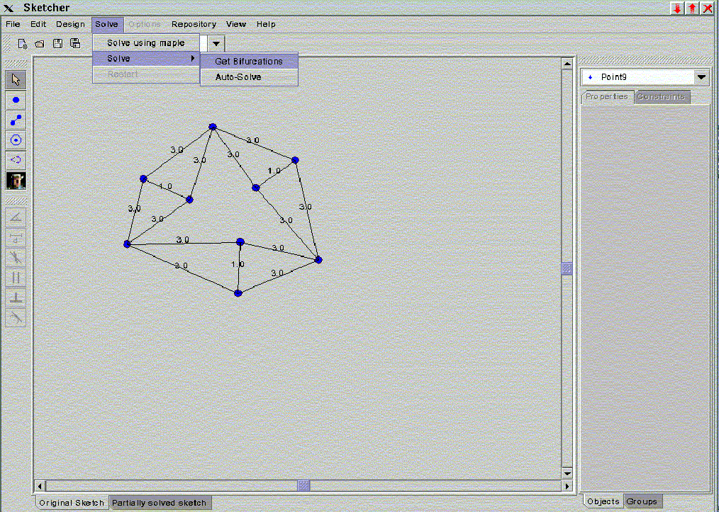
fig. .Solve using get bifurcation mode.

Integer array
Sent 0 Flag = 0
Sent 0
Sent 1
Sent 0
Sent 2
Sent 0
Sent 3
Sent 0
Sent 4
Sent 0
Sent 5
Sent 0
Sent 6
Sent 0
Sent 7
Sent 0
Sent 8
Sent 0
Sent 9
Sent -1 End of shapes data

Sent 0
Sent 4
Sent 2
Sent 1
Sent 1
Sent 9
Sent 1
Sent 0
Sent 7
Sent 2
Sent 1
Sent 1
Sent 3
Sent 1
Sent 0
Sent 8
Sent 2
Sent 2
Sent 1
Sent 1
Sent 1
Sent 0
Sent 9
Sent 2
Sent 2
Sent 1
Sent 4
Sent 1
Sent 0
Sent 6
Sent 2
Sent 3
Sent 1
Sent 2
Sent 1
Sent 0
Sent 10
Sent 2
Sent 4
Sent 1
Sent 3
Sent 1
Sent 0
Sent 11
Sent 2
Sent 4
Sent 1
Sent 5
Sent 1
Sent 0
Sent 12
Sent 2
Sent 4
Sent 1
Sent 6
Sent 1
Sent 0
Sent 13
Sent 2
Sent 5
Sent 1
Sent 6
Sent 1
Sent 0
Sent 15
Sent 2
Sent 6
Sent 1
Sent 7
Sent 1
Sent 0
Sent 14
Sent 2
Sent 7
Sent 1
Sent 5
Sent 1
Sent 0
Sent 2
Sent 2
Sent 8
Sent 1
Sent 7
Sent 1
Sent 0
Sent 3
Sent 2
Sent 8
Sent 1
Sent 1
Sent 1
Sent 0
Sent 5
Sent 2
Sent 8
Sent 1
Sent 9
Sent 1
Sent 0
Sent 1
Sent 2
Sent 9
Sent 1
Sent 7
Sent 1
Sent -1 End of Constraints data

Sent -1 End of Groups data

Double array

Sent 240.0
Sent 93.0
Sent 147.0
Sent 163.0
Sent 209.0
Sent 191.0
Sent 125.0
Sent 251.0
Sent 277.0
Sent 248.0
Sent 274.0
Sent 317.0
Sent 382.0
Sent 272.0
Sent 298.0
Sent 175.0
Sent 351.0
Sent 138.0 Shapes data

Sent 3.0
Sent 3.0
Sent 3.0
Sent 3.0
Sent 1.0
Sent 3.0
Sent 3.0
Sent 3.0
Sent 1.0
Sent 3.0
Sent 3.0
Sent 3.0
Sent 3.0
Sent 1.0
Sent 3.0 Distances

OPEN UTU
FLAG: 0

Received data :

first 1828 Skip index
Received -2 Flag

Dag data

Received 1
Received 22
Received 9
Received 4
Received 1
Received 7
Received 8
Received 9
Received 5
Received 6
Received 2
Received 3
Received 3
Received 21
Received 18
Received 15
Received 21
Received 4
Received 1
Received 8
Received 9
Received 7
Received 2
Received 19
Received 7
Received 19
Received 3
Received 1
Received 9
Received 8
Received 3
Received 9
Received 8
Received 1
Received 9
Received 1
Received 9
Received 0
Received 8
Received 1
Received 8
Received 0
Received 1
Received 1
Received 1
Received 0
Received 7
Received 1
Received 7

End of dag data

Bifurcations in first set of clusters

first 2339 Skip index

Received 0
Received 3
Received 19
Received 22
Received 1
Received 21
Received 0
Received 19
Received 0
Received 9
Received 1
Received 8
Received 1
Received 1
Received 1
Received 7
Received 1
Received 18
Received 0
Received 7
Received 1
Received 16
Received 0
Received 6
Received 1
Received 5
Received 1
Received 4
Received 1
Received 15
Received 0
Received 4
Received 1
Received 13
Received 0
Received 3
Received 1
Received 2
Received 1
Received 1
Received 1
Received 21
Received 2
Received 4
Received 1
Received 7
Received 8
Received 9
Received 1
Received 7

Double array

first 416.0
Received 0.0
Received 0.0
Received 0.0
Received 0.0
Received -0.9860131144523621
Received 2.8333323001861572
Received 0.0
Received 3.0
Received 0.0
Received 0.0
Received -0.9860140681266785
Received 5.833332061767578
Received -0.9860131144523621
Received 2.8333323001861572
Received 0.0
Received 3.0
Received 0.0
Received 0.0
Received 0.0
Received -2.9999990463256836
Received -0.9860134720802307
Received -2.8333332538604736
Received -0.9860113859176636
Received -5.8333330154418945
Received 0.0
Received 0.0
Received 0.0
Received -2.9999990463256836
Received -0.9860134720802307
Received -2.8333332538604736
Received 0.0
Received 0.0
Received 0.0
Received 0.0
Received -0.9860134720802307
Received -2.8333332538604736
Received 0.0
Received -2.9999990463256836
Received -0.9860113859176636
Received -5.8333330154418945
Received 0.0
Received 0.0
Received -0.9860134720802307
Received -2.8333332538604736
Received 0.0
Received -2.9999990463256836
Received 0.0
Received 0.0
Received 0.0
Received 1.0

Bifurcations in second set of clusters
first 2562
Received 0
Received 1
Received 19
Received 22
Received 0
Received 21
Received 0
Received 19
Received 0
Received 9
Received 1
Received 8
Received 1
Received 1
Received 1
Received 7
Received 1
Received 18
Received 0
Received 7
Received 1
Received 16
Received 0
Received 6
Received 1
Received 5
Received 1
Received 4
Received 1
Received 15
Received 0
Received 4
Received 1
Received 13
Received 0
Received 3
Received 1
Received 2
Received 1
Received 1
Received 1
Received 22
Received 2
Received 9
Received 1
Received 2
Received 3
Received 4
Received 5
Received 6

Double array

first 416.0
Received 0.0
Received 0.0
Received -2.5980758666992188
Received 1.5000005960464478
Received -2.946744441986084
Received 0.5627543926239014
Received -5.544821262359619
Received 2.0627527236938477
Received -3.5840892791748047
Received 4.3333306312561035
Received -2.946744680404663
Received 3.5627517700195312
Received -0.9860140681266785
Received 5.833332061767578
Received -0.9860131144523621
Received 2.8333323001861572
Received 0.0
Received 3.0
Received 0.0
Received 0.0
Received 2.598076581954956
Received 1.4999991655349731
Received 1.960731863975525
Received 2.270577907562256
Received 4.558807373046875
Received 3.7705793380737305
Received 1.612062931060791
Received 4.333333969116211
Received 1.9607315063476562
Received 5.270579814910889
Received -0.9860140681266785
Received 5.833332061767578
Received -0.9860131144523621
Received 2.8333323001861572
Received 0.0
Received 3.0
Received 0.0
Received -2.9999990463256836
Received -0.9860113859176636
Received -5.8333330154418945
Received 0.0
Received 0.0
Received -0.9860134720802307
Received -2.8333332538604736
Received 0.0
Received -2.9999990463256836
Received 0.0
Received 0.0
Received 0.0
Received 1.0

Bifurcations in third set of clusters

first 2
Received 1
Received 1
Received 22
Received 9
Received 1
Received 2
Received 3
Received 4
Received 5
Received 6
Received 7
Received 8
Received 9
Received 0
Received 0
Received 4
Received 4
Received 7
Received 8
Received 3
Received 0
Received 1
Received 1
Received -2
Received -2
Received -2
Received -2
Received 1
Received 1
Received 2
Received 0
Received 2
Received 0
Received 0
Received 0
Received 0
Received 0
Received 0
Received 3
Received 8
Received 9
Received 6
Received 0
Received 1
Received 1
Received -2
Received -2
Received -2
Received -2
Received 1

Double array

first 416.0
Received 0.0
Received 0.0
Received -2.5980758666992188
Received 1.5000005960464478
Received -2.946744441986084
Received 0.5627543926239014
Received -5.544821262359619
Received 2.0627527236938477
Received -3.5840892791748047
Received 4.3333306312561035
Received -2.946744680404663
Received 3.5627517700195312
Received -0.9860140681266785
Received 5.833332061767578
Received -0.9860131144523621
Received 2.8333323001861572
Received 0.0
Received 3.0
Received 0.0
Received 0.0
Received 2.598076581954956
Received 1.4999991655349731
Received 1.960731863975525
Received 2.270577907562256
Received 4.558807373046875
Received 3.7705793380737305
Received 1.612062931060791
Received 4.333333969116211
Received 1.9607315063476562
Received 5.270579814910889
Received -0.9860140681266785
Received 5.833332061767578
Received -0.9860131144523621
Received 2.8333323001861572
Received 0.0
Received 3.0
Received 0.0
Received -2.9999990463256836
Received -0.9860113859176636
Received -5.8333330154418945
Received 0.0
Received 0.0
Received -0.9860134720802307
Received -2.8333332538604736
Received 0.0
Received -2.9999990463256836
Received 0.0
Received 0.0
Received 0.0
Received 1.0

Final output
read Point1 354 284
read Point2 250 344
read Point3 236 307
read Point4 132 367
read Point5 211 457
read Point6 236 427
read Point7 315 517
read Point8 315 397
read Point9 354 404

CHANGE CONSTRAINT VALUE:

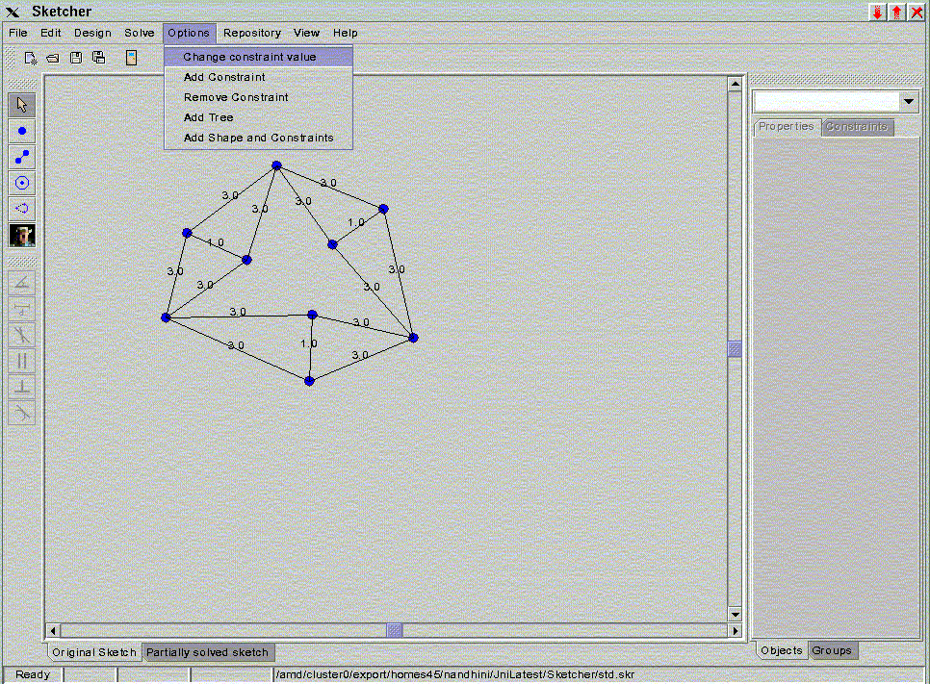
fig 3.1 : To do a change constraint value update

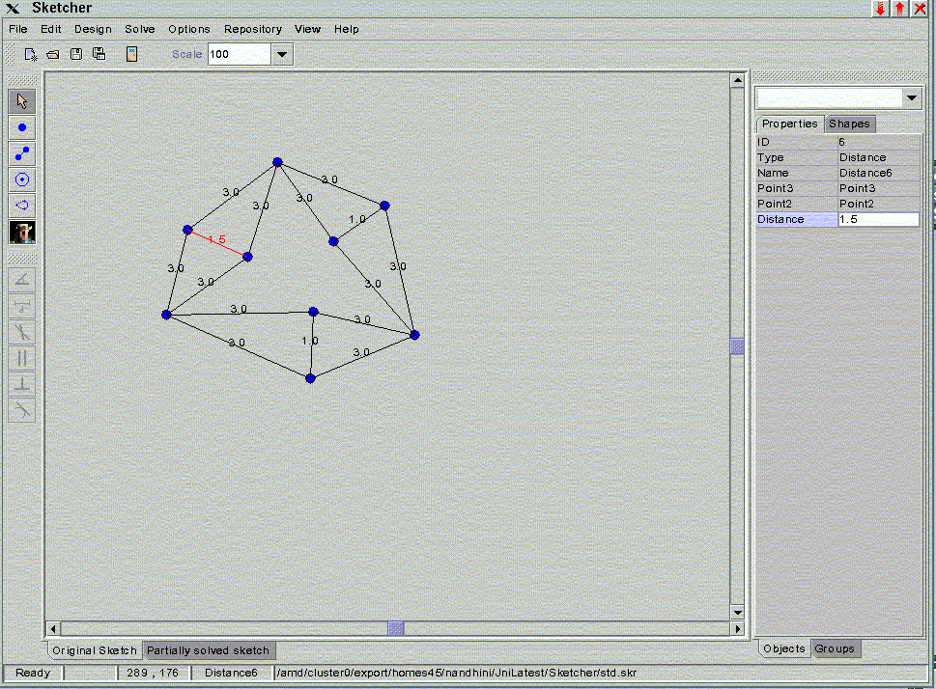
fig 3.2 : After doing a change constraint value update

Integer array
Changed Constraints 9 ID of constraint with a new value

Double array
Changed Constraints 1.5 New constraint value
OPEN UTU
FLAG: 3
ADD CONSTRAINT:

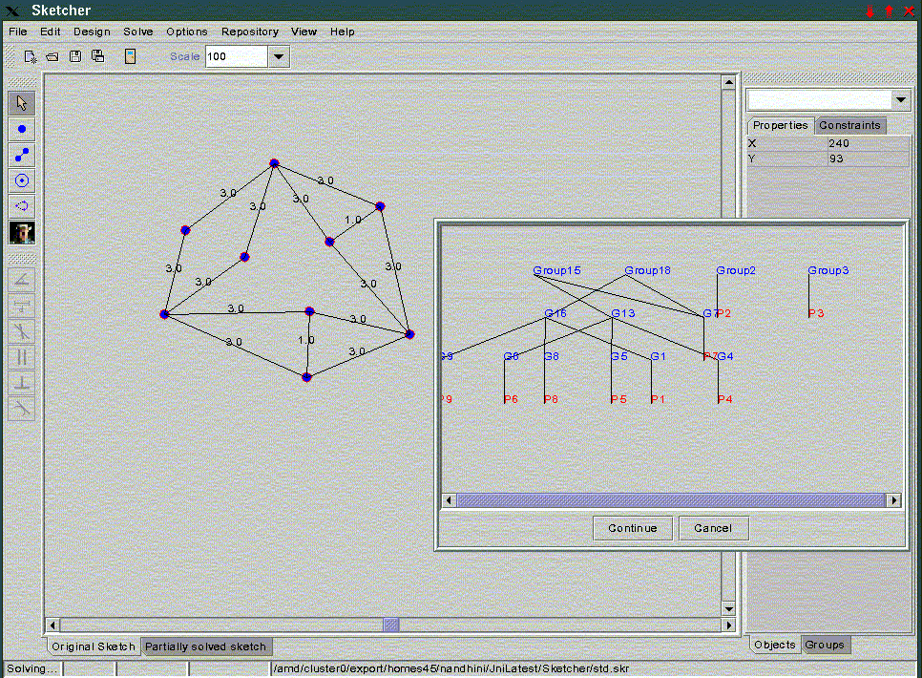
fig 4. Add constraint update example

Integer array
add constraint 0 New Constraint Type ID
add constraint 16 New Constraint ID
add constraint 2 Number of shapes involved
add constraint 3 Shape ID
add constraint 1 SubShape of the shape involved
add constraint 2 Shape ID
add constraint 1 SubShape of the shape involved

Double array
add Constraints 1.0

OPEN UTU
FLAG: 4

REMOVE CONSTRAINT:

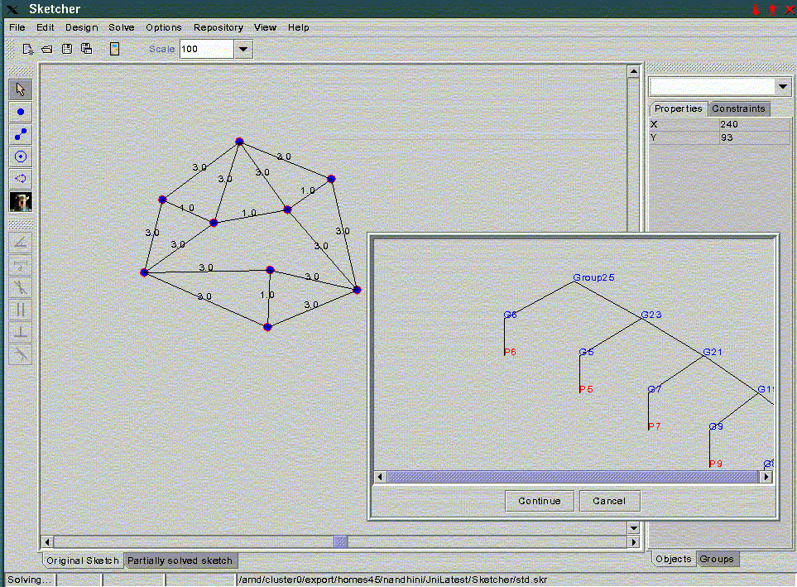
fig 5. Remove Constraint update example

remove Constraints 16 ID of the deleted constraint

OPEN UTU
FLAG: 5

