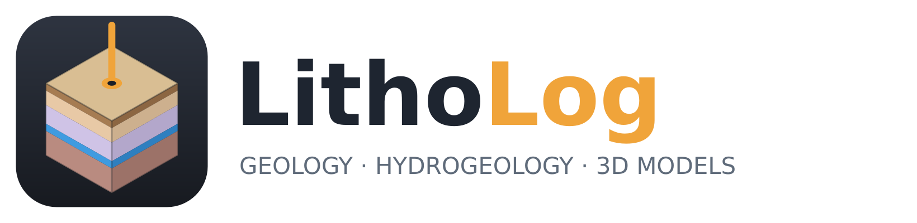
LithoLog Studio
User Manual
Borehole logs · cross-sections · maps · 3D geological models · groundwater analysis
Version 0.1 · September 2026
Open-source software for geology and hydrogeology (MIT licence)

Contents

1 Introduction
LithoLog is free, open-source software for geologists, hydrogeologists and groundwater engineers. It turns borehole data into the outputs a groundwater or geological study needs: strip logs, cross-sections, fence diagrams, contour maps, three-dimensional geological models with volumes, water-table maps, groundwater-storage and recharge estimates, hydrochemical diagrams and fracture analyses. LithoLog Studio is its Windows desktop application; the same engine also runs as a web app in the browser and from the command line.

1.1 What LithoLog Studio does
Table 1. LithoLog Studio at a glance
Area | What you can do
Borehole data | Read an Excel workbook, CSV files or GMS borehole files; check the data for gaps, overlaps and unknown codes; keep a project with all settings.
Logs and sections | Strip logs with lithology patterns, descriptions, well construction, fractures and downhole curves; cross-sections through boreholes with correlated layers and pinch-outs; log sections; 3D fence diagrams.
Maps | Contour maps of ground, top, base, depth and thickness of any unit, water table and depth to water, with inverse distance, kriging or TIN, clipped to the study area; grids for GIS.
3D model | Horizon model that traces every layer between boreholes (like GMS Horizons → Solids) or voxel model; borehole-influence settings with variograms; constraints drawn in Google Earth; DEM as ground surface; volumes by layer and horizon.
Visualisation | Lit 3D solids with textures, borehole tubes, labels, boundary and terrain; tick boxes and properties for every item; standard views; cut plane; dark and light themes; print images at up to 1200 dpi.
Groundwater | Water table from observation wells for each season, fluctuation, saturated volume and storage of every unit, recharge by the water-table-fluctuation method (GEC-2015), 3D models of downhole properties.
Hydrochemistry | Piper, Durov, Stiff, USSL, Wilcox and Gibbs diagrams; water type, ionic balance and irrigation indices.
Structure | Fracture rose diagram, stereonet with pole density, fracture frequency with depth, water strikes.
Quality | Leave-one-out cross-validation of the model with a one-page report, method comparison and volume uncertainty.

1.2 How this manual is organised
Chapters 2 and 3 install the software and explain the window. Chapter 4 describes the input files — read it before preparing your own data. Chapters 5 to 14 follow a typical project from borehole logs to the 3D model, groundwater analysis and validation. Chapter 15 covers the command line and web app, chapter 16 the methods behind the results and their limits, and chapter 17 common questions. The appendices list the built-in lithology codes, patterns and file formats.

1.3 The tutorial data
Every screenshot in this manual was made with the tutorial project that is installed with LithoLog Studio. Open it with Home ▸ Tutorial project and follow along. The tutorial is a synthetic hard-rock site (it is not a real place): 24 boreholes through top soil, weathered gneiss and gneiss with two water-bearing fracture zones, the lower of which pinches out towards the north-east.
Table 2. Tutorial files (folder litholog\data\tutorial inside the installation)
File | Contents
tutorial_boreholes.xlsx | 24 boreholes with lithology, well construction, water level, resistivity log, fractures and legend (UTM zone 43N).
tutorial_boundary.geojson | Study-area polygon in latitude/longitude (16.4 km²).
tutorial_water_levels.csv | 30 observation wells with pre- and post-monsoon depth to water.
tutorial_chemistry.csv | 18 groundwater samples with major ions, EC and pH.
tutorial_constraints.csv | An area where the fracture zones are absent (an interpretation).

2 Installation and first start

2.1 System requirements
Table 3. System requirements
Item | Requirement
Operating system | Windows 10 or 11, 64-bit
Memory | 8 GB RAM (16 GB for very large models or 1000-dpi exports)
Graphics | Any graphics card or integrated graphics with OpenGL 3.2 (all PCs from the last ten years)
Disk | About 1.5 GB for the program
Internet | Only needed to download a DEM (Home ▸ DEM ▸ Download)

2.2 Installing
- Download LithoLogStudio-Windows (a .zip file) from the project's GitHub page (Actions ▸ latest successful “LithoLog Studio (Windows build)” ▸ Artifacts).
- Unzip it. It contains LithoLogStudio-Setup.exe and a portable .zip.
- Run LithoLogStudio-Setup.exe and follow the steps. Windows may show “Windows protected your PC” because the installer is not code-signed; click More info ▸ Run anyway.
- Start LithoLog Studio from the Start menu or the desktop shortcut.
Tip: The portable .zip needs no installation: unzip it anywhere (for example a USB drive) and run LithoLogStudio.exe.

2.3 First start
A splash screen appears while the 3D engine loads, then the main window opens with an empty 3D view (Figure 1). Open the tutorial with Home ▸ Tutorial project: the data are read, checked and a 3D model is built automatically (Figure 2).
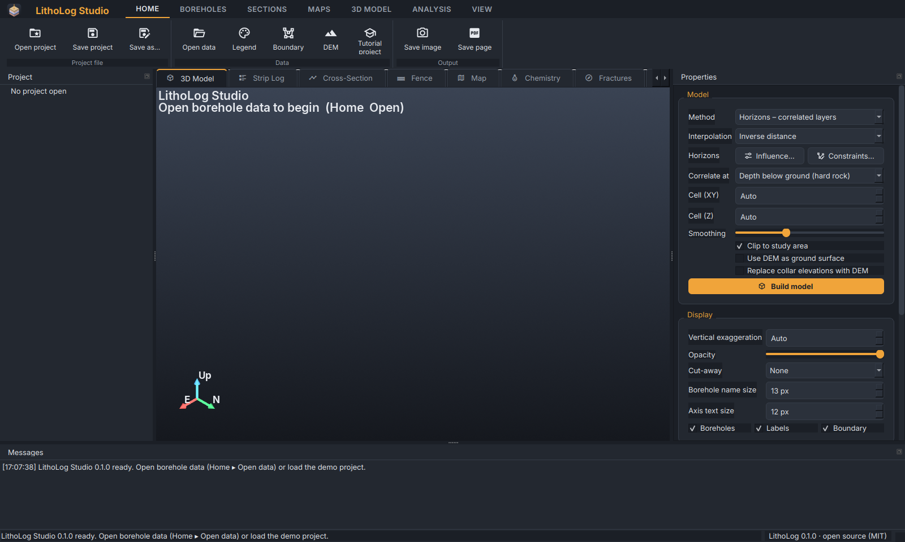
Figure 1. LithoLog Studio when it starts: empty 3D view, ribbon at the top, panels at the sides.
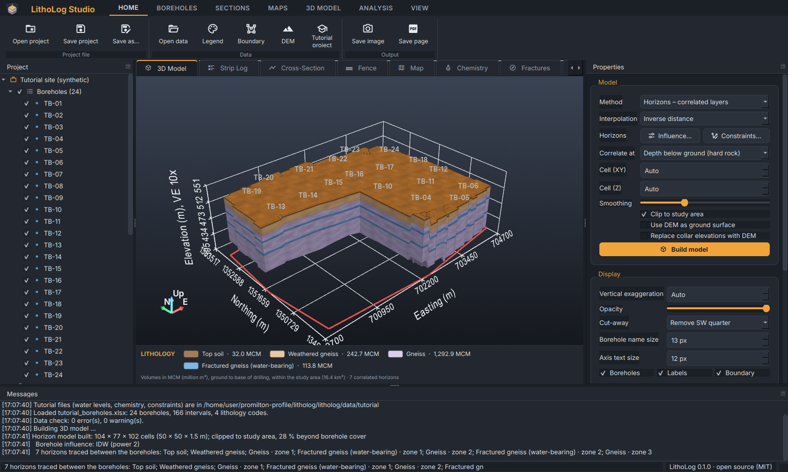
Figure 2. The tutorial project opened: 3D horizon model with the south-west quarter cut away, the Project tree (left), Properties (right), legend bar and Messages (bottom).

3 The LithoLog Studio window
The window has six areas. They can be rearranged: drag a panel by its title bar to another side or float it; double-click a title bar to dock it again.
Table 4. Areas of the window
Area | Purpose
Ribbon (top) | All commands, grouped in tabs: Home, Boreholes, Sections, Maps, 3D Model, Analysis and View.
Project tree (left) | Everything in the project: boreholes, legend, study area, DEM, 3D model units, horizons and 3D scene items, each with tick boxes and a right-click menu.
Documents (centre) | Tabs for the 3D Model, Strip Log, Cross-Section, Fence, Map, Chemistry, Fractures and Validation.
Legend bar | Under the 3D view: colour, name and volume of each layer; click to edit.
Properties (right) | Model settings, display settings, and the volume and storage tables.
Messages (bottom) | A log of everything done, with results and warnings. The status bar repeats the latest message.

3.1 The ribbon
Each ribbon tab groups related commands. Buttons with a coloured frame are switched on (for example the dark theme or the legend bar).
Figure 3. Home: open and save project files, open borehole data, legend, study-area boundary and DEM, the tutorial project, and save images or pages.
Figure 4. Boreholes: strip log of the selected borehole, all logs as one PDF, and the data check.
Figure 5. Sections: new cross-section, and the fence diagram.
Figure 6. Maps: new contour map and export of the grid (.asc).
Figure 7. 3D Model: build, layer properties, borehole influence and constraints, standard views, cut plane, and model exports.
Figure 8. Analysis: aquifer and storage, recharge, property model, stratigraphic model, hydrochemistry, fractures and cross-validation.
Figure 9. View: dark or light theme, 3D background, legend bar, axes grid and terrain, standard views, rendering options and layer properties.

3.2 The Project tree
The tree lists everything in the project. Tick boxes show or hide an item in the 3D view; a group's tick box (for example Boreholes or Horizons) switches all its members. Double-click a borehole to open its strip log, or a layer to open its properties. Right-click any item for more: Layer properties, Strip log, Properties (colour, opacity, line width), Show only this and Show all.
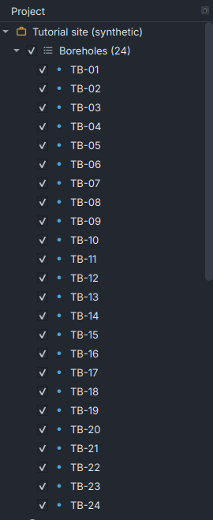
Figure 10. The Project tree: every borehole has a tick box for the 3D view.
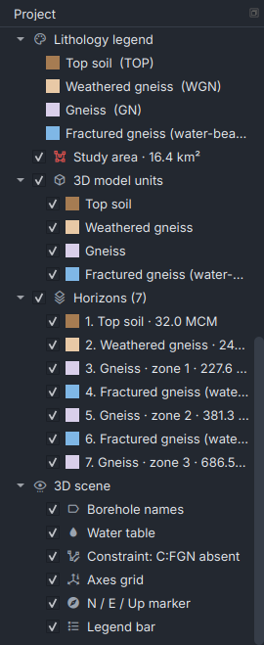
Figure 11. Lower part of the tree: lithology legend, study area, 3D model units, the 11 traced horizons and the 3D scene items (borehole names, water table, constraints, axes grid, N/E/Up marker, legend bar).
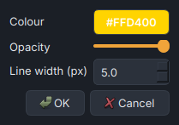
Figure 12. Right-click ▸ Properties on the study area: colour, opacity and line width.

3.3 The Properties panel
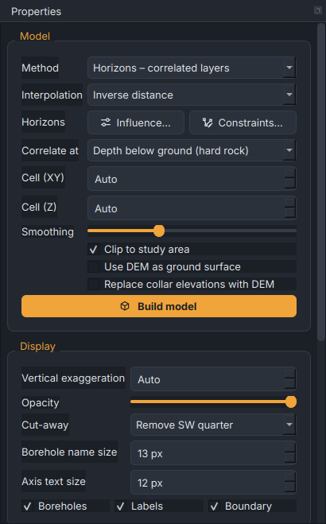
Figure 13. The Properties panel: Model and Display groups (the Volumes & storage tables follow below).
Table 5. Properties panel settings
Setting | Meaning
Method | Horizons – correlated layers (recommended for layered and weathered profiles) or Voxel – indicator interpolation (for irregular bodies and lenses). See chapter 9.
Interpolation | How horizon thickness is interpolated between boreholes: inverse distance, kriging, linear TIN or smooth TIN.
Influence… / Constraints… | Borehole-influence settings with variogram (9.3) and interpretation lines and areas (9.4).
Correlate at | Voxel method only: compare boreholes at equal depth below ground (hard rock) or equal elevation (flat-lying sediments).
Cell (XY), Cell (Z) | Model cell size; Auto chooses about 120 cells across the area.
Smoothing | Voxel method only: smoothing of the solids.
Clip to study area | Limit the model to the boundary polygon.
Use DEM as ground surface | Top of the model follows the DEM (when a DEM is loaded).
Replace collar elevations with DEM | Use DEM elevations for boreholes and wells (see 4.6).
Vertical exaggeration | Stretch of the vertical scale; Auto makes the model about one third as high as wide.
Opacity | Transparency of all solids.
Cut-away | Remove one quarter of the model to see inside.
Borehole name size, Axis text size | Size of the labels and axis numbers in the 3D view (and, proportionally, in exports).
Boreholes, Labels, Boundary | Show borehole tubes, their names and the study-area outline.

3.4 Legend bar and messages
Figure 14. The legend bar under the 3D view: each layer with its colour and volume. Click a layer to edit it; right-click to hide, show or isolate it; double-click the title to rename the legend.
Figure 15. Messages: what was done and the results (here the model build and the traced horizons).

3.5 Themes
View ▸ Dark / Light switches the colour theme; LithoLog remembers your choice. View ▸ 3D background sets the background of the 3D view independently (theme, white, sky or black) — white is useful for reports.
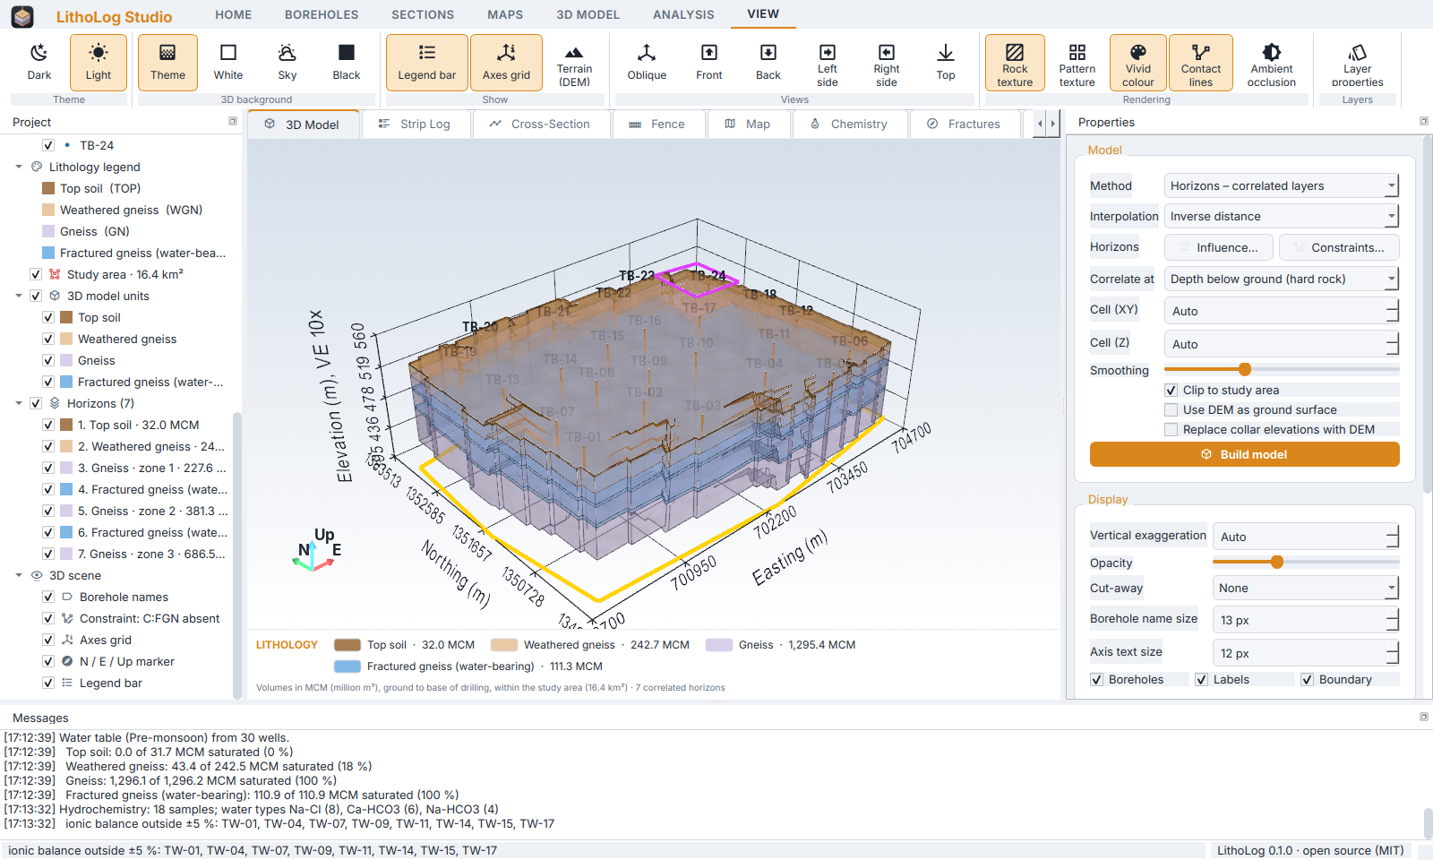
Figure 16. The light theme.

3.6 Keyboard shortcuts and mouse
Table 6. Shortcuts
Action | How
Save project | Ctrl+S
Save project as | Ctrl+Shift+S
Open project | Ctrl+O
Rotate the 3D view | Drag with the left mouse button
Pan | Shift + drag, or drag with the middle button
Zoom | Mouse wheel, or drag with the right button
Spin around the view axis | Ctrl + drag
Zoom a page (logs, sections, maps) | The −, + and Fit buttons above the page; the magnifier of the page toolbar

4 Preparing your data
LithoLog reads plain tables. The easiest start is the Excel template: on the command line run litholog template my_site.xlsx, or copy the tutorial workbook and replace its rows. Column names are recognised flexibly (for example Borehole ID, BH, Well no), units in brackets are ignored, and sheets may be in any order.

4.1 The borehole workbook
Table 7. Sheets of the borehole workbook
Sheet | Columns | Notes
Boreholes | Borehole ID, X (Easting), Y (Northing), Elevation (m amsl), Total depth (m) | One row per borehole. Coordinates in metres (e.g. UTM).
Lithology | Borehole ID, From (m), To (m), Code, Description | Depths below ground; intervals must not overlap or leave gaps.
Construction | Borehole ID, From, To, Element, Diameter (mm), Material | Casing, screen, gravel pack, seal… (optional).
WaterLevels | Borehole ID, Date, Depth to water (m bgl) | Optional; used for water-table maps and the aquifer tools.
Downhole | Borehole ID, Depth (m), Parameter, Value, Unit | Logs such as resistivity, EC, gamma (optional).
Fractures | Borehole ID, Depth, Dip, Dip direction, Aperture, Yield, Remarks | Structural and water-strike data (optional).
Legend | Code, Name, Color, Pattern, Group | Your own lithology codes (optional; see 4.3).

Note: Depths are always metres below ground level (m bgl), measured from the collar. The Total depth is optional; the deepest To is used when it is missing.

4.2 GMS borehole files
Files exported from GMS (columns Name, X, Y, Z, Material, one row per contact, text or Excel) are read directly by Home ▸ Open data. The Z values are converted to depths below the first (collar) elevation and each material ID becomes a lithology code; give names and colours with a legend file. litholog convert file.txt workbook.xlsx turns such a file into a LithoLog workbook that you can then complete with descriptions, construction and water levels.

4.3 Lithology codes, legend and patterns
Each interval has a code. Thirty codes are built in (Appendix A) with names, colours and patterns drawn at a fixed printed size. Use your own codes with a legend table (CSV or Excel, or the Legend sheet): columns Code, Name, Color (hex, e.g. #9FCBEA), Pattern and optionally Group. Patterns can be combined with “+”, for example waves+fractures (Appendix B). Colours and names can also be changed at any time in Layer properties (9.8) and saved as a legend file.

4.4 Coordinates
Borehole coordinates must be in a projected system in metres, such as UTM. Boundaries, DEMs and well files in latitude/longitude are converted automatically to the UTM zone of your boreholes; when LithoLog needs the coordinate system (for example to download a DEM) it proposes one and lets you correct it (e.g. EPSG:32643 for WGS 84 / UTM zone 43N).

4.5 Study-area boundary
Home ▸ Boundary accepts a shapefile (.shp with its .prj, or zipped), a Google Earth KML/KMZ or GeoJSON. Multi-part polygons and holes are supported. Maps and the model are then clipped to the polygon, and volumes are totalled inside it. If a UTM shapefile is in a neighbouring zone, LithoLog detects it and moves it to the zone of the boreholes, and reports what it did in Messages.

4.6 Digital elevation model (DEM)
Home ▸ DEM opens a GeoTIFF, an SRTM tile (.hgt, .hgt.gz or .zip) or an ESRI ASCII grid, in any coordinate system. Download (Copernicus 30 m) fetches the free Copernicus GLO-30 DEM for the project area from the internet and saves it in a folder you choose.
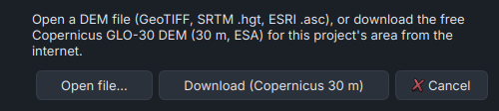
Figure 17. Home ▸ DEM: open a DEM file or download one.
When a DEM is loaded, LithoLog compares the borehole collar and well elevations with it and reports the mean difference in Messages. Tick Use DEM as ground surface so the model top follows the terrain, and Replace collar elevations with DEM to use DEM elevations for boreholes and wells.
Important: A difference that is nearly the same for every borehole (for example +19.5 m ± 1.8 m) usually means the elevations were measured against a different height reference (handheld GPS heights, a local benchmark). Relative results — thickness, gradient, fluctuation, volume — are not affected; absolute “m amsl” values are. Decide which reference to report before replacing elevations.

4.7 Observation-well (water-level) file
A CSV or Excel table with one row per well: a name, coordinates and one column per reading, for example Well, Easting, Northing, Elevation, Pre-monsoon, Post-monsoon. Alternatively one row per reading with a Date and a Depth to water column. Coordinates may be metres or degrees; degrees are recognised even when written under X/Y, in either order. A serial-number column is ignored, village names are used as well IDs, and two wells with the same name are kept apart (“Nanguneri (1)”, “Nanguneri (2)”).

4.8 Water-quality file
One row per sample with Sample, an optional Group, the major ions Ca, Mg, Na, K, HCO3, Cl, SO4 (mg/L, or meq/L when the column name says so), and optionally CO3, NO3, F, EC, TDS, pH. Values such as “<0.5” are read as 0.5.

4.9 Constraints file
Constraints add your interpretation to the boreholes (9.4). In a table: Horizon, Type, X, Y, Value, Feature, where Type is pinchout (a line where the layer thins to zero), absent (an area without the layer) or thickness (a point of known thickness), and rows with the same Feature form one line or polygon. In Google Earth or QGIS draw the line, polygon or point and name it like H4 pinchout, code FGN absent or H7 thickness 6, then save as KML/KMZ or GeoJSON.

4.10 Checking the data
Boreholes ▸ Validate data (also run automatically when data are opened) reports overlapping or missing intervals, depths beyond the total depth, unknown codes, missing coordinates and similar problems in Messages. Fix errors in your workbook and open it again.

5 Working with projects
A project file (.llproj) remembers everything about your work: the data, legend and boundary files, the DEM and constraints, model and display settings, layer colours and visibility, specific yields, view settings and text sizes. It stores the file names relative to its own folder, so a project folder can be copied to another computer.
Table 8. Project commands
Command | What it does
Home ▸ Open data | Start a new project from a borehole workbook, CSV folder or GMS file.
Home ▸ Open project (Ctrl+O) | Open a saved .llproj and rebuild everything as it was.
Home ▸ Save project (Ctrl+S) | Save to the current project file (asks for a name the first time).
Home ▸ Save as… (Ctrl+Shift+S) | Save under a new name.

5.1 Closing with unsaved changes
If you close LithoLog Studio after changing anything since the last save, it asks whether to save. Save writes the project file, Don't save closes without saving, and Cancel returns to your work.
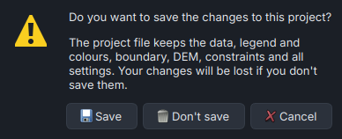
Figure 18. The prompt shown when closing with unsaved changes.

6 Borehole strip logs
Select a borehole in the Project tree and click Boreholes ▸ Strip log, or double-click the borehole. The log opens in the Strip Log tab as a true-proportion page. Boreholes ▸ All logs (PDF) writes every log to one PDF.
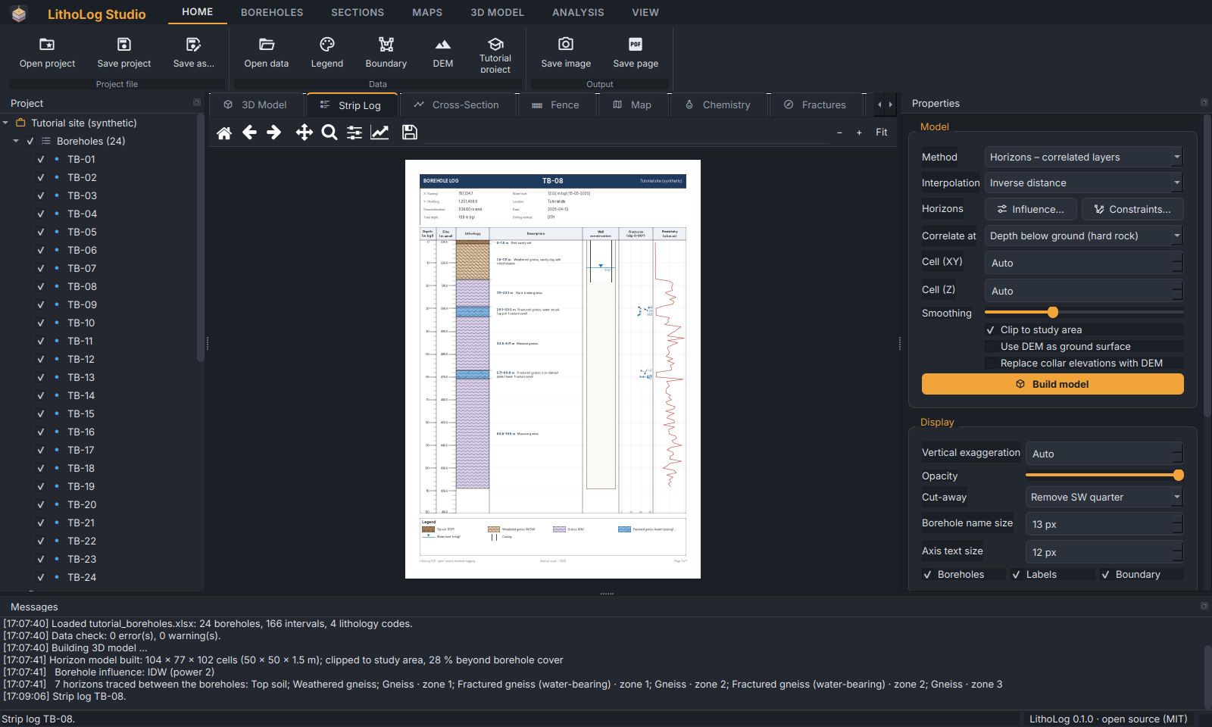
Figure 19. A strip log in the Strip Log tab.
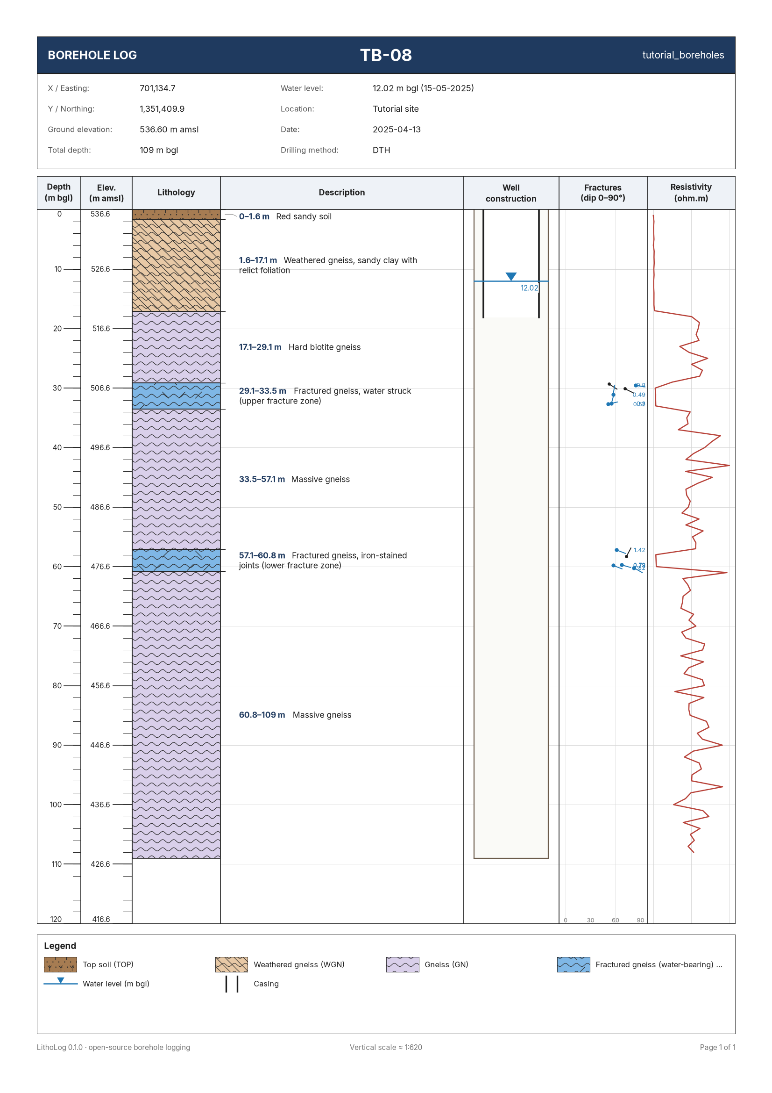
Figure 20. The strip log of TB-08 as printed: depth and elevation scales, lithology column with patterns, descriptions, well construction, fracture tadpoles and the resistivity curve.
Table 9. Tracks of a strip log
Track | Content
Depth / Elevation | Metres below ground and metres above sea level.
Lithology | Colour and pattern of each interval (patterns print at the same size at any scale).
Description | Your description text, wrapped to fit.
Well | Casing, screen, gravel pack and seals (hidden when there are no construction data).
Fractures | Tadpoles: the dot at the depth and dip, the tail pointing in the dip direction; water strikes marked.
Curves | Up to three downhole parameters (e.g. resistivity) on their own scales.

Tip: Long holes are split into pages automatically on the command line with -m 50 (50 m per page). Save the page as PDF or SVG with Home ▸ Save page for editing in a drawing program.

7 Cross-sections and fence diagrams

7.1 Cross-sections
- Click Sections ▸ New section.
- Give the section a name, choose the vertical exaggeration (Fit page is automatic) and how boreholes are hung (by elevation or depth below ground).
- Choose the section style: a geological section, or a log section with strip logs along the line and optionally a curve beside each log.
- Add boreholes to the section with Add ▸ in the order they should appear, then OK.
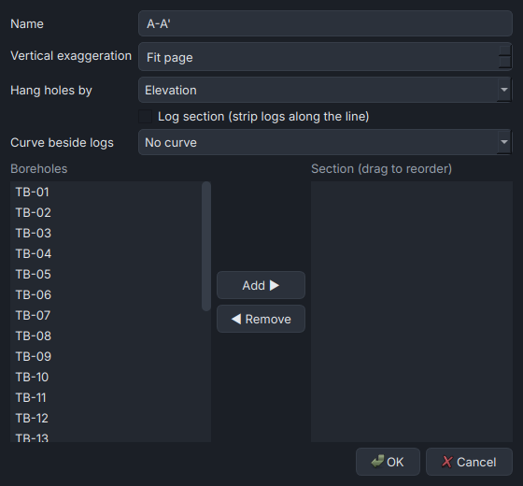
Figure 21. The New section dialog.
LithoLog correlates the layers between neighbouring boreholes by matching their sequences (the same method as the horizon model), draws each layer as a continuous band, and ends layers that are missing in the next hole half-way between the holes (pinch-out).
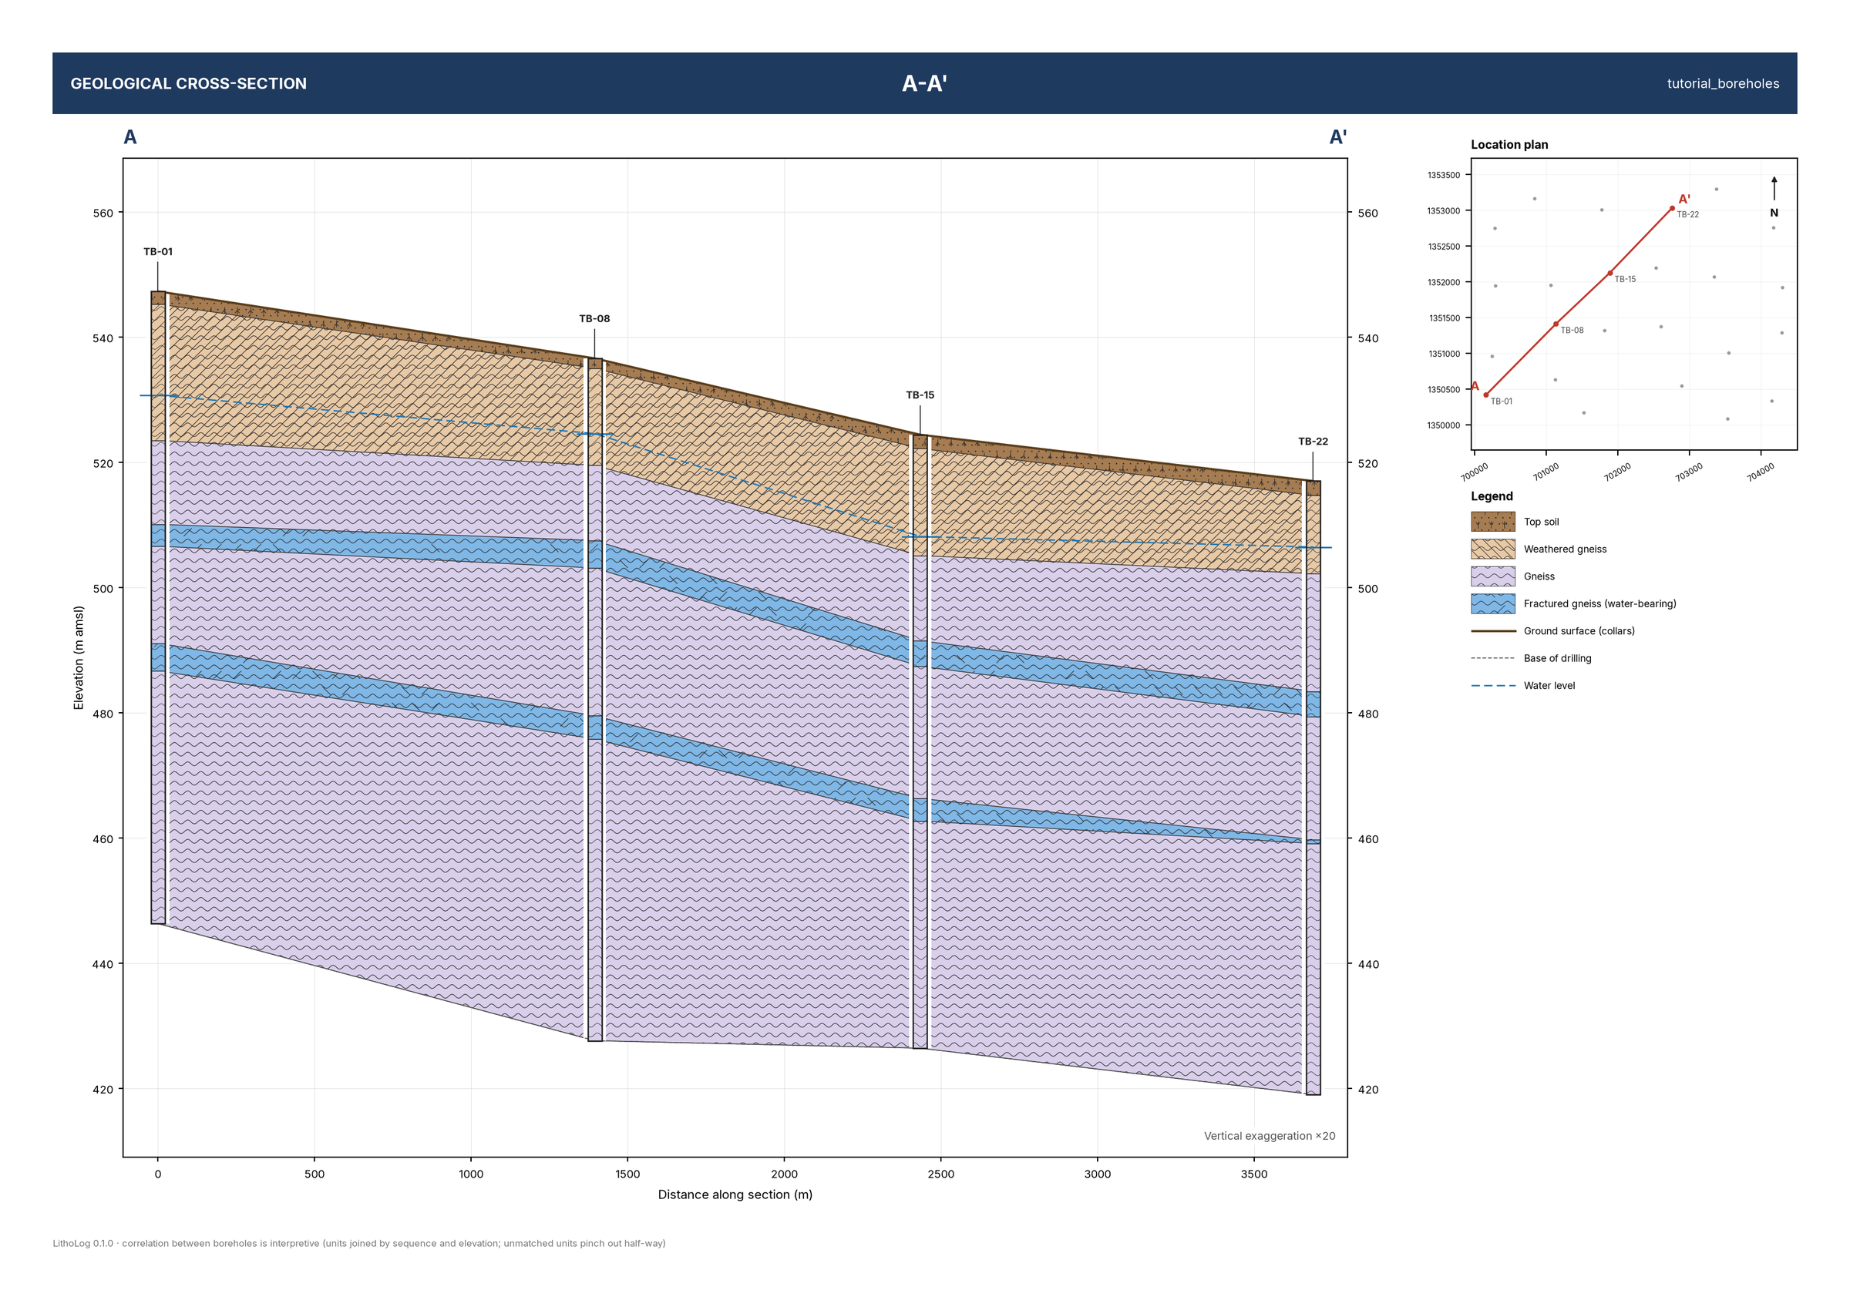
Figure 22. Cross-section A–A' through TB-01, TB-08, TB-15 and TB-22: correlated layers, both fracture zones and pinch-outs.
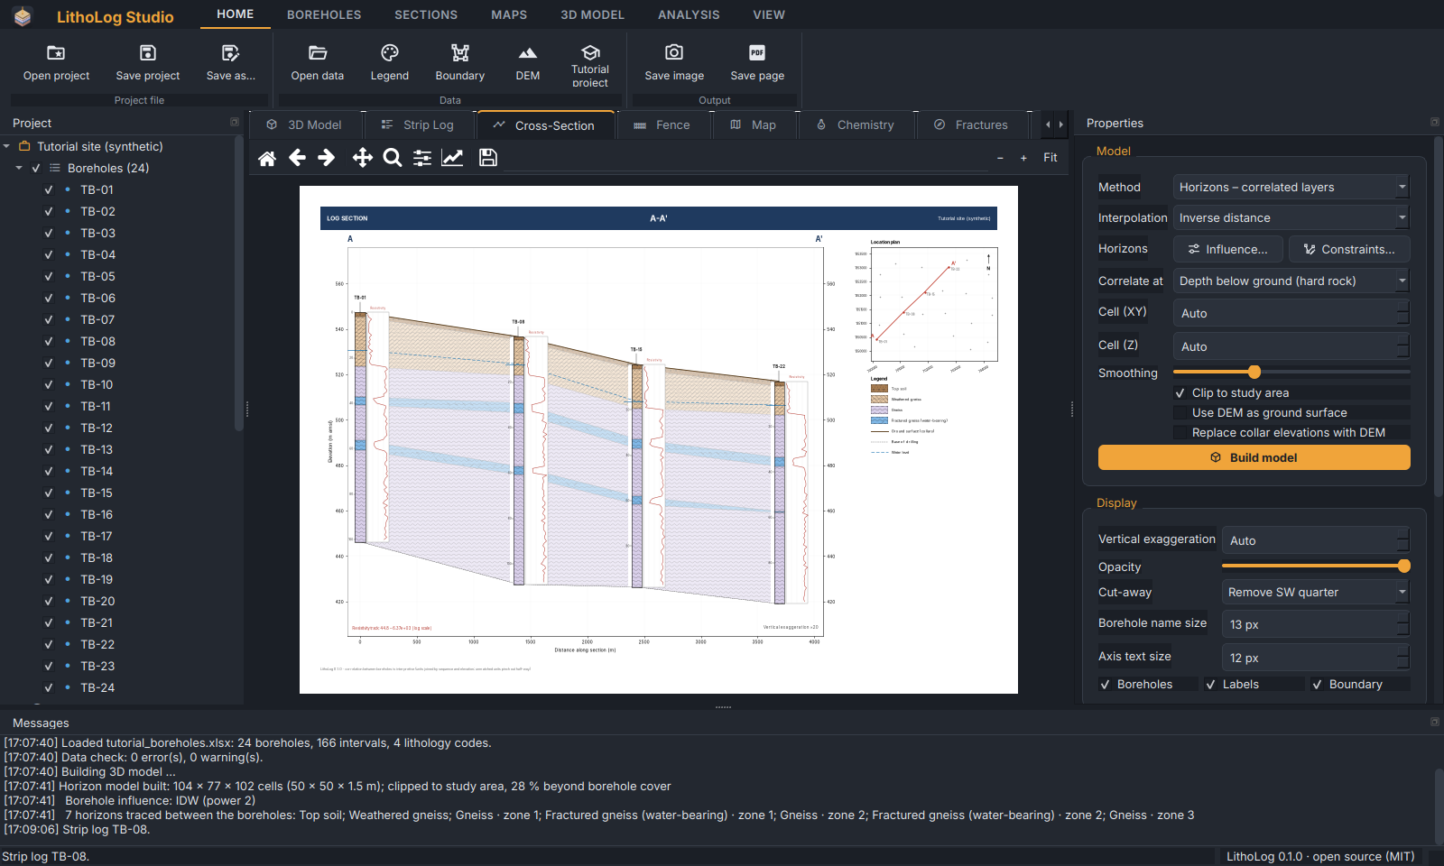
Figure 23. The log-section style: strip logs along the line with the resistivity curve.

7.2 Fence diagrams
Sections ▸ Fence diagram connects the boreholes with a network of panels (minimum spanning tree) and draws them in a 3D perspective, a quick overview of the whole site.
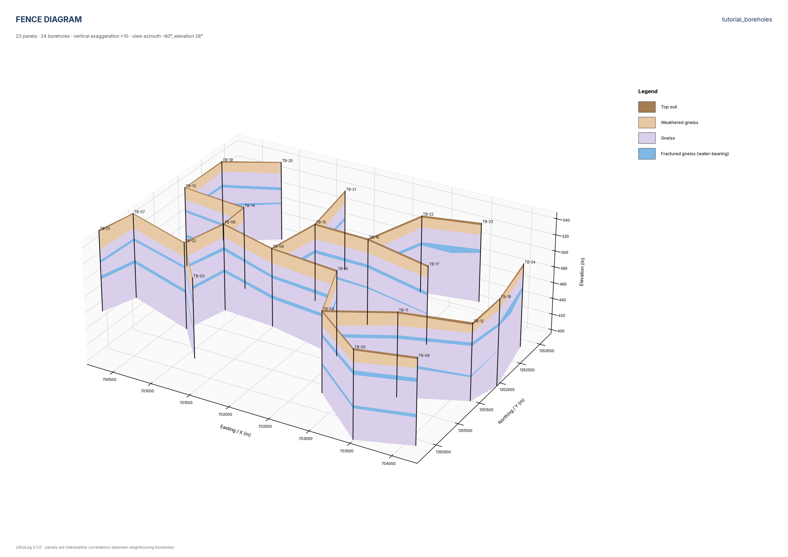
Figure 24. Fence diagram of the tutorial site.

8 Contour maps
- Click Maps ▸ New map.
- Choose what to map and, for unit-related maps, the unit.
- Choose the gridding method and cell size, and whether to clip to the study area, then OK.
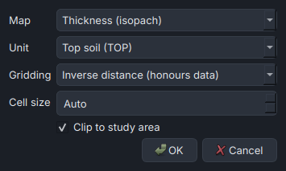
Figure 25. The New map dialog.
Table 10. Map types
Map | Value at each borehole
Ground elevation | Collar elevation (m amsl)
Top / Base of unit | Elevation of the top or base of the chosen unit
Depth to unit | Depth below ground of the unit's top
Thickness (isopach) | Total thickness of the unit; the map also reports its volume
Water-table elevation | Ground minus depth to water, with arrows showing the groundwater flow direction
Depth to water | From the WaterLevels sheet
Drilled depth | Total depth of each borehole

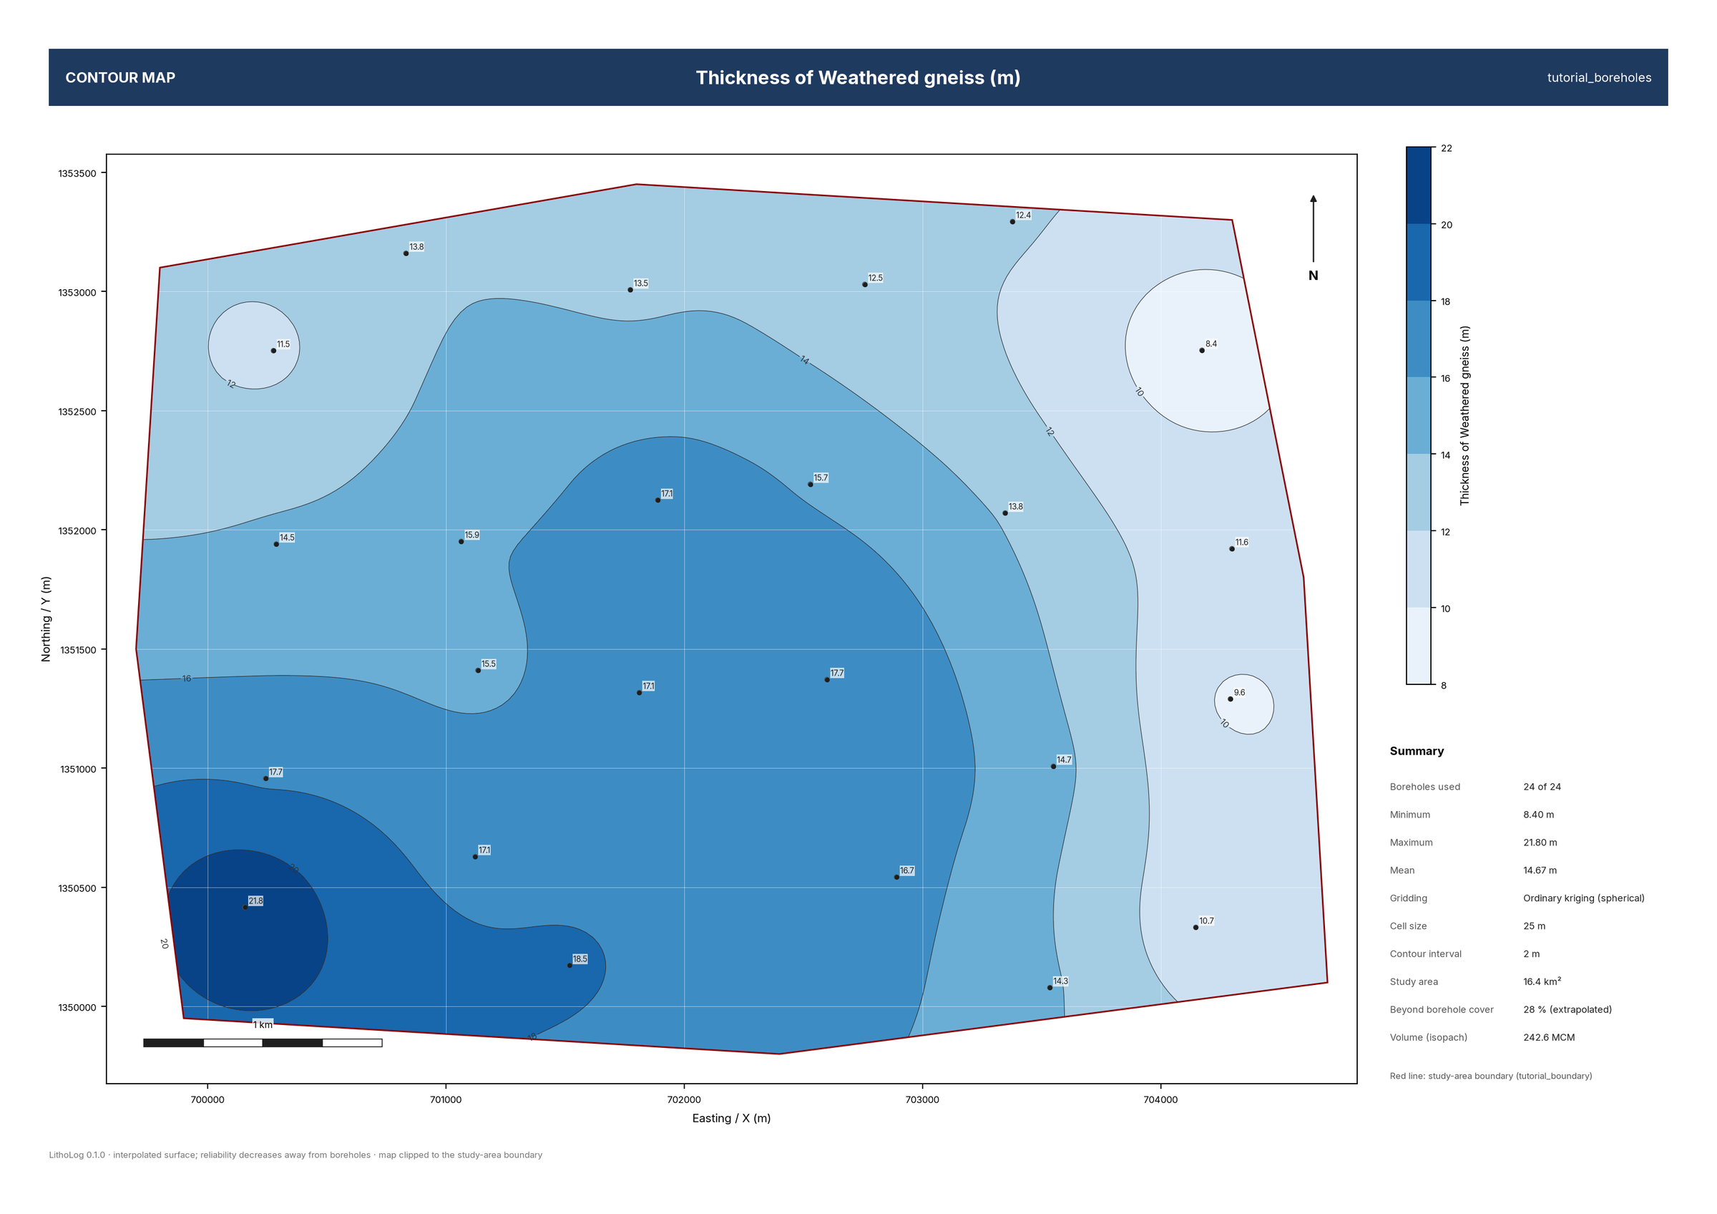
Figure 26. Isopach (thickness) map of the weathered gneiss, kriged and clipped to the study area. The side panel lists the data used, range, method, cell size and the share of the area beyond the boreholes.
Maps ▸ Grid (.asc) saves the grid for QGIS, ArcGIS or Surfer. Gridding methods are explained in 16.2.

9 The 3D geological model
The model is built automatically when data are opened; rebuild it with 3D Model ▸ Build model (or the orange button in Properties) after changing settings.

9.1 Horizon method and voxel method
Table 11. The two modelling methods
 | Horizons – correlated layers | Voxel – indicator interpolation
How it works | Traces every layer from hole to hole, interpolates the thickness of each, and stacks them from the ground down. | Each cell takes the unit most boreholes have at that depth, weighted by distance.
Best for | Layered sequences, weathering profiles, repeated thin layers such as fracture zones. | Irregular bodies and lenses that do not continue between holes.
Thin layers | Stay continuous where the data support it. | Tend to break into isolated patches.
Volumes | Exact from the thickness grids; also per horizon. | From the vote shares, so thin units are not under-counted.

With the horizon method, a unit that occurs more than once in the boreholes becomes several horizons, numbered from the top, for example Fractured gneiss · zone 1 and zone 2. The Messages panel lists them and the Project tree shows each with its volume. If most horizons occur in only one borehole, LithoLog notes that the voxel method may suit the data better.

9.2 Showing and hiding layers and horizons
Untick a unit under 3D model units to hide it (with all its horizons), or untick single horizons under Horizons. Right-click a horizon ▸ Show only this isolates it.
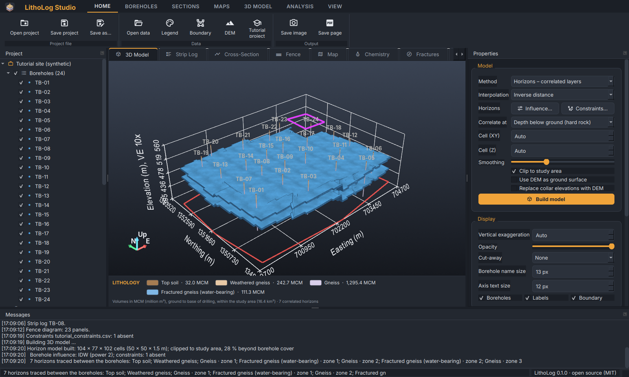
Figure 27. Only the two fracture-zone horizons ticked: both are continuous sheets; the lower one is cut out in the north-east by the constraint.

9.3 Borehole influence
3D Model ▸ Borehole influence (or Influence… in Properties) controls how strongly and how far each borehole influences the interpolated layers — the options GMS calls interpolation settings.
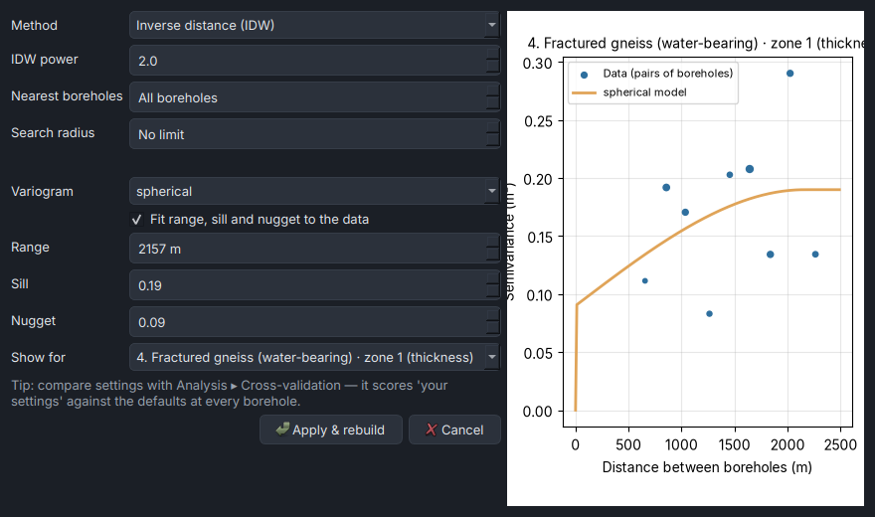
Figure 28. The Borehole influence dialog with the experimental variogram of fracture zone 1 (dots) and the fitted spherical model (line).
Table 12. Borehole-influence settings
Setting | Effect
Method | Inverse distance (IDW), kriging, linear TIN or smooth (Clough-Tocher) TIN.
IDW power | Higher (3–5): each borehole's influence stays local, giving “bull's-eyes”. Lower (1–2): smoother, influence spreads further. Default 2.
Nearest boreholes | Use only the N closest boreholes for each point (All = every borehole).
Search radius | Boreholes farther away have no influence (the nearest one is always used).
Variogram | Kriging model: spherical, exponential or gaussian.
Range, sill, nugget | Fitted automatically to the data, or your own values: the range is the distance over which values are related; the nugget is variation at shorter distances than the borehole spacing.
Show for | Which horizon's variogram to display.

Tip: A large nugget (a big jump of the model curve at zero distance) means that much of the variation happens between boreholes and cannot be predicted from them. Check your choices with Analysis ▸ Cross-validation (chapter 14), which scores “your settings” against the defaults.

9.4 Constraints — adding your interpretation
3D Model ▸ Constraints ▸ Load file… reads pinch-out lines, absent areas and thickness points (format in 4.9). A constraint applies to one horizon (H4 = horizon 4 as numbered in the Project tree) or to all horizons of a unit (code FGN). Constraints are drawn on the model (orange lines, magenta areas, white points) and saved with the project. Remove constraints in the same dialog goes back to the boreholes alone.
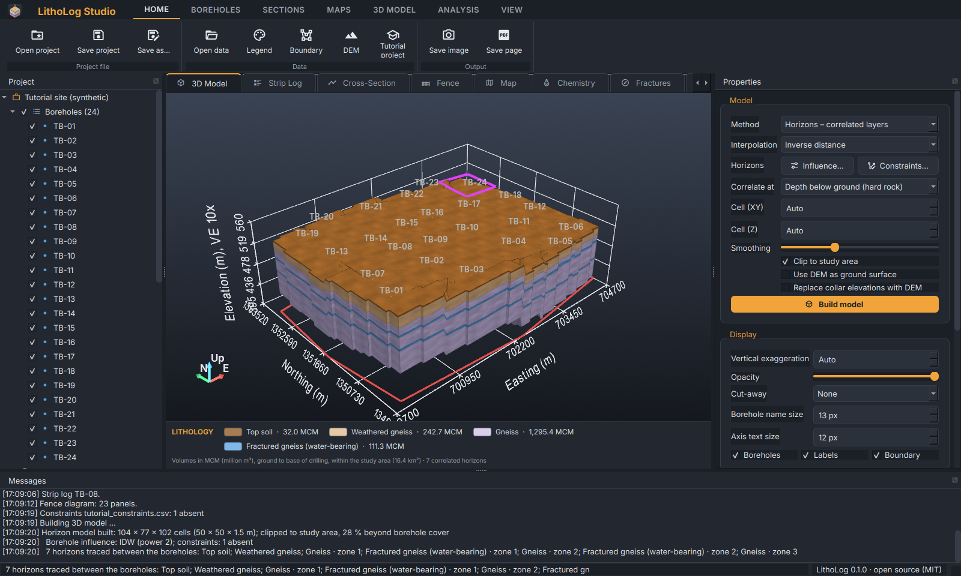
Figure 29. The tutorial constraint (magenta outline, north-east): the fracture zones are absent inside it.
Important: Horizon numbers come from the automatic correlation. After adding or changing boreholes, check the numbering in the Project tree before reusing a constraints file, or use unit codes (code FGN) instead.

9.5 Views and navigation
Rotate, pan and zoom with the mouse (3.6). The standard views are on the 3D Model and View tabs: Oblique (from south-west), Oblique NE, Top (plan), Front (from the south), Back, Left side (from the west) and Right side. Front, side and top views are orthographic (without perspective) so that distances can be read.
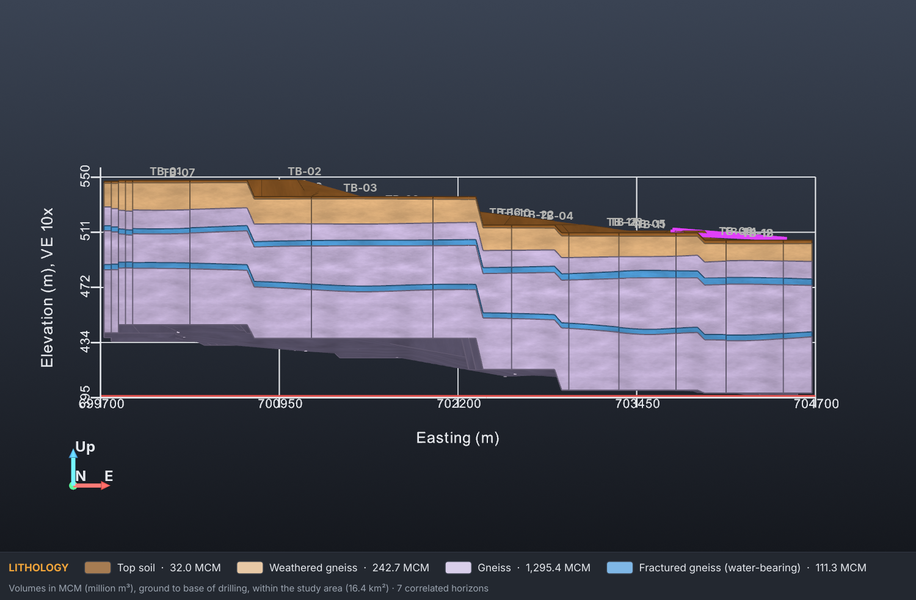
Figure 30. Front view (looking north), exported at 150 dpi: the fracture zones and their depth variation are clear.
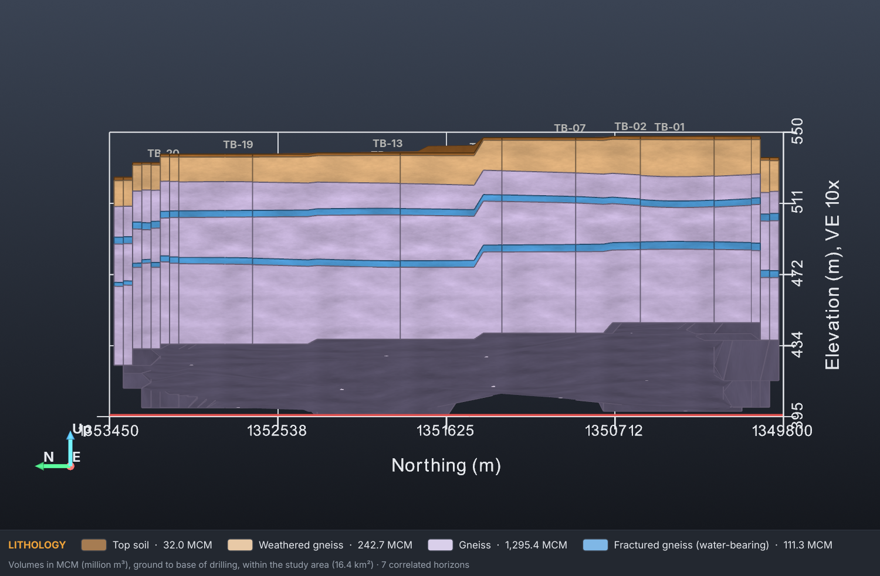
Figure 31. Left-side view (looking east).
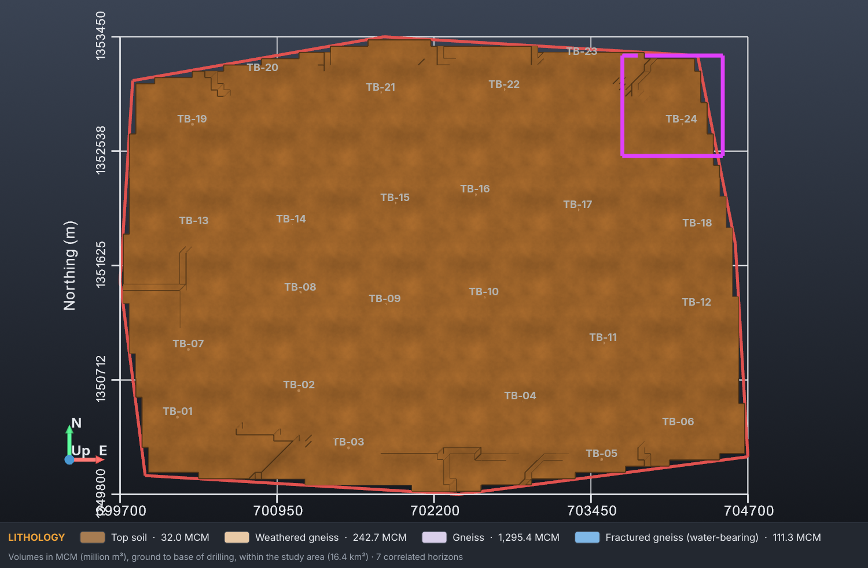
Figure 32. Top view (plan) with the study-area boundary and the constraint area.

9.6 Cut-away and cut plane
Cut-away in Properties removes one quarter of the model. 3D Model ▸ Cut plane adds an amber plane that cuts every solid: drag the plane to move it, drag its arrow to tilt it; click Cut plane again to remove it.
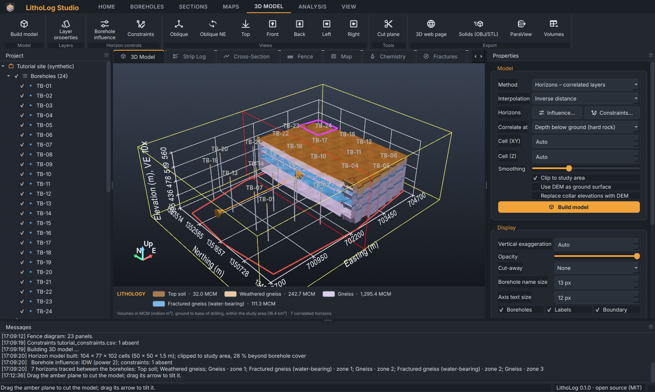
Figure 33. The interactive cut plane.

9.7 Layer properties and the legend bar
3D Model ▸ Layer properties, a click on a layer in the legend bar, or a double-click on a layer in the tree opens Layer properties. Choose a layer on the left, then change its name, colour (colour picker), pattern for logs and sections (with preview), group, 3D opacity and visibility. Apply shows the change at once in the 3D view, logs, sections and maps; Save legend… writes the legend as CSV for other projects, Load legend… reads one.
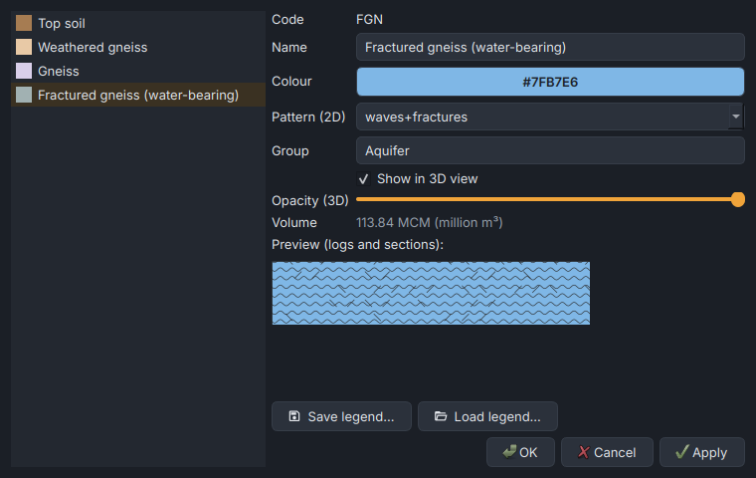
Figure 34. Layer properties: name, colour, pattern with preview, group, opacity and volume.

9.8 3D scene items
Everything drawn in the 3D view has a tick box in the Project tree: each borehole, the borehole names, study area, DEM terrain, water table, constraints, axes grid, N/E/Up marker and the legend bar. Right-click ▸ Properties changes colour, opacity and line width (and the thickness of the borehole tubes). These settings are kept when the model is rebuilt, in exported images and in the project file.

9.9 Rendering options
View ▸ Rendering improves the look of the model: Rock texture (a subtle grain in each layer's colour), Pattern texture (the log pattern on the solids), Vivid colour (livelier versions of pale legend colours), Contact lines (thin dark lines along layer edges) and Ambient occlusion (soft shadows in corners; needs a capable graphics card).
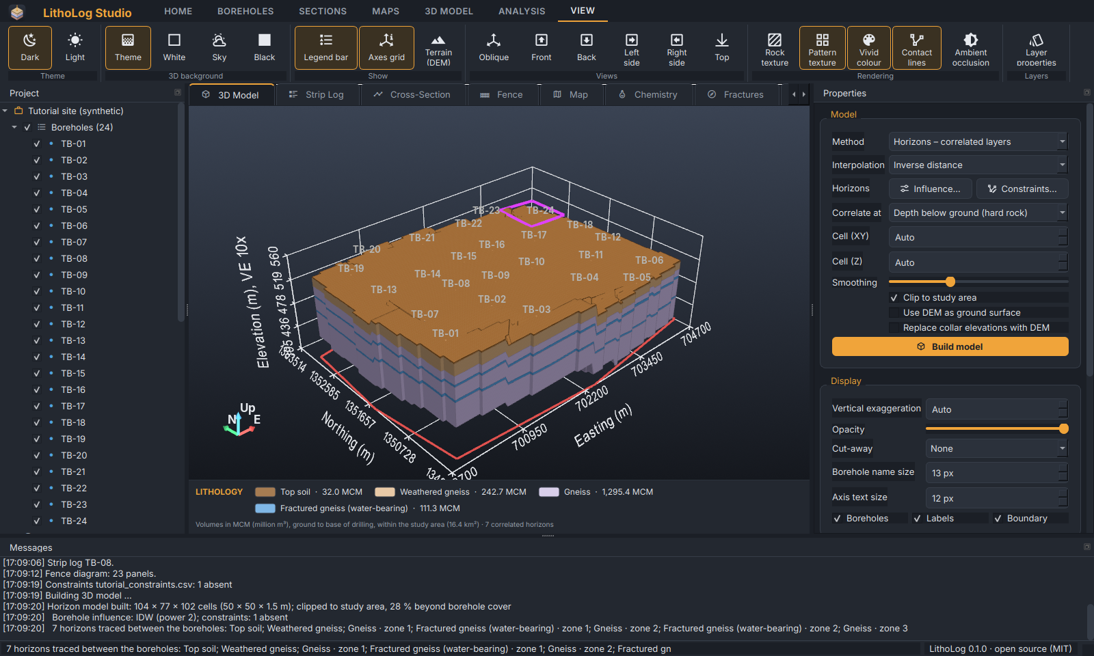
Figure 35. Pattern texture: the lithology patterns of the logs drawn on the solids.

9.10 Volumes and storage
The Volumes & storage table in Properties lists the volume of each unit (MCM = million m³) inside the study area and its share. Type a specific yield for a unit to see its groundwater storage (volume × specific yield). The By horizon tab lists every horizon with the boreholes where it is found, its mean thickness, the share of the area where it exists and its volume.

9.11 Exporting the model
Table 13. Model exports
Export (3D Model tab) | Result
3D web page | An interactive HTML page that opens in any browser (rotate, zoom, hide layers).
Solids (OBJ/STL) | One OBJ, STL and VTP file per unit, in real coordinates, for CAD, 3D printing or other software.
ParaView | The whole model as a VTK file.
Volumes | The volume table as CSV.

10 Images and pages for reports
Home ▸ Save image saves the current document — the 3D view, a log, section, map or diagram — as a print-quality image.
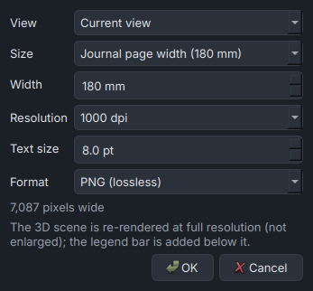
Figure 36. The Save image dialog.
Table 14. Image export options
Option | Meaning
View (3D) | The current view, one standard view, or all standard views at once (one image each).
Size / Width | Printed width: journal column 90 mm, page width 180 mm, A4 or A3, or your own.
Resolution | 300, 600, 1000 (default) or 1200 dpi. 180 mm at 1000 dpi is 7,087 pixels.
Text size | Printed size of labels and axis text in points (1 pt = 1/72 inch); 7–9 pt suits journal figures. Auto keeps the on-screen proportions.
Format | PNG (lossless), TIFF (LZW, for printers and journals) or JPEG. The DPI is written into the file.

For 3D images the scene is drawn again at the full output size, not enlarged from the screen, so lines and text stay sharp; the legend bar is added below. Home ▸ Save page saves logs, sections and maps as PDF or SVG (vector: sharp at any zoom and editable in Inkscape or Illustrator).
Tip: Rendering a 1000-dpi 3D image takes a few seconds on a normal graphics card. If memory is short, choose a smaller width or 600 dpi, or save pages as PDF.

11 Groundwater analysis

11.1 Aquifer and storage
- Click Analysis ▸ Aquifer & storage.
- Choose the observation-well file (4.7), or Cancel to use the WaterLevels sheet of the borehole workbook.
- Choose the reading (season) when the file has several.
- The water table is drawn in the 3D model (the solids become translucent) and as a map with flow arrows; Messages lists the saturated volume of each unit and, where you have typed specific yields, its storage.
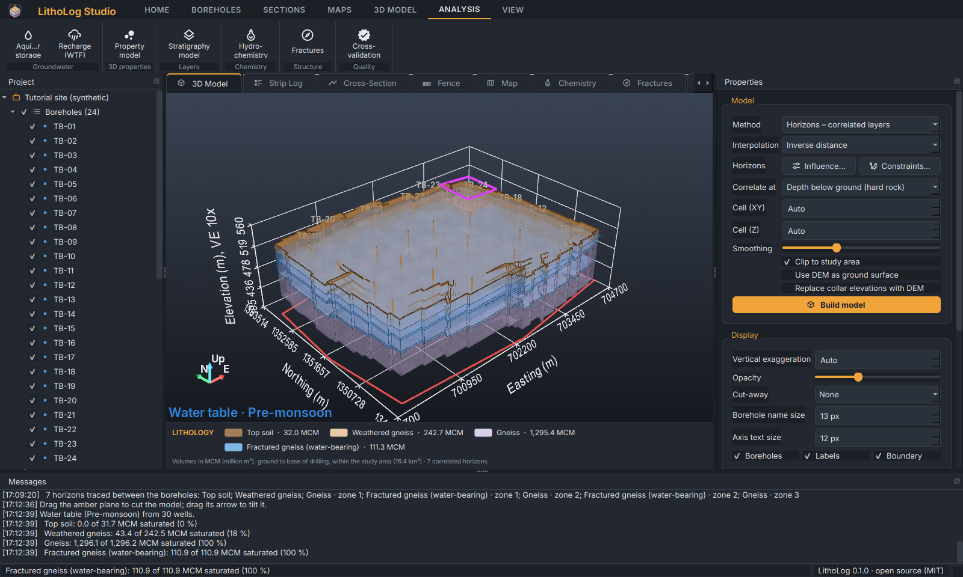
Figure 37. Pre-monsoon water table (blue surface) in the 3D model.
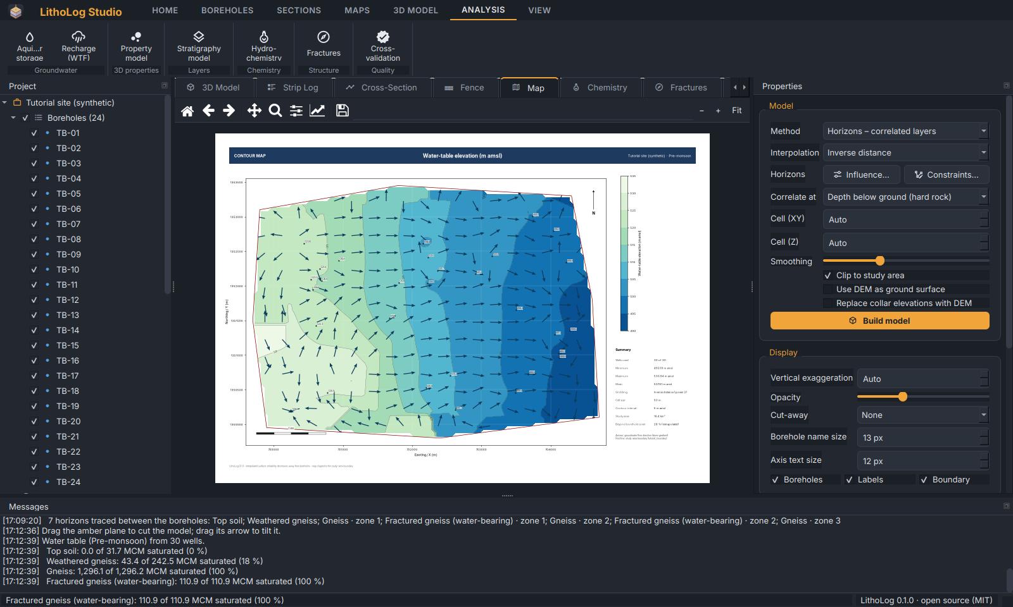
Figure 38. Water-table map with groundwater flow arrows.
By default the depth to water is interpolated between the wells and hung below the ground surface, so the water table follows the topography. The command line also offers contouring of water-table elevations from the wells (--surface elevation).

11.2 Recharge (water-table fluctuation method)
Analysis ▸ Recharge (WTF) estimates recharge between a pre- and a post-season reading, following the water-table-fluctuation method of GEC-2015:
- storage change ΔS = Σ (volume of each unit between the two water tables × its specific yield);
- total recharge = ΔS + gross groundwater draft during the season;
- recharge from rainfall = total recharge − recharge from other sources (tanks, canals, return flow);
- with the rainfall of the season: recharge as a percentage of rainfall, and the rainfall-infiltration-factor (RIF) estimate for comparison.
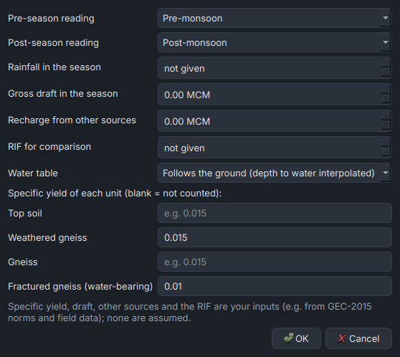
Figure 39. The Recharge dialog: readings, rainfall, draft, other sources, RIF, water-table method and specific yield of each unit.
Important: Specific yield, draft, other sources and the RIF are your inputs (for example from GEC-2015 norms and field data); LithoLog does not assume them. Units without a specific yield are counted as zero and listed in Messages.

11.3 Property model
Analysis ▸ Property model interpolates a downhole parameter (resistivity, EC, yield…) through the model with anisotropic inverse distance (vertical distances are stretched because properties change faster with depth). Choose the parameter and optionally a value range: the voxels within the range are shown with a colour bar, and Messages reports their volume — for example the volume of low-resistivity (fractured, water-bearing) rock.
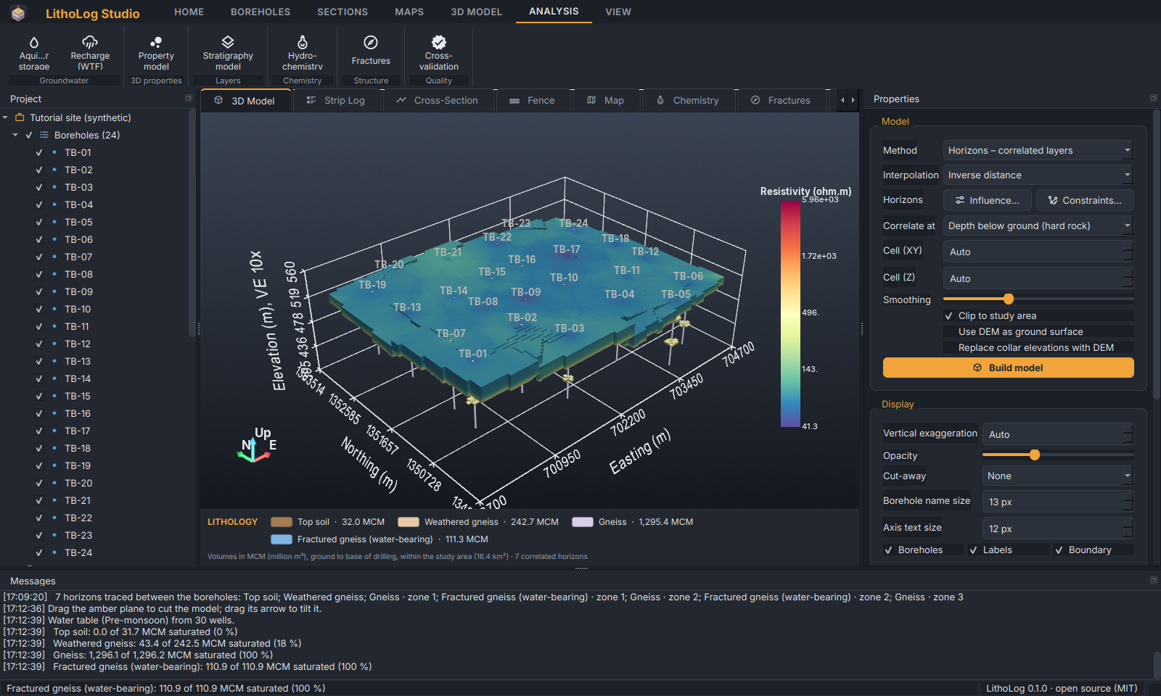
Figure 40. Resistivity model showing only values below 500 Ω·m: the fracture zones and the weathered zone.

11.4 Stratigraphic model
Analysis ▸ Stratigraphy model builds a layer-cake model from formations in a known order (top to bottom): tick the formations and drag them into order. Each formation's top is gridded and forced into order, so surfaces never cross. Use it for sedimentary sequences where each formation occurs once.
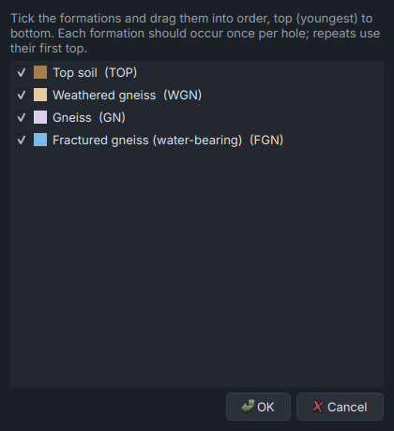
Figure 41. The Stratigraphy model dialog.

12 Hydrochemistry
Analysis ▸ Hydrochemistry reads a water-quality file (4.8), computes the analysis and opens the Chemistry tab with a diagram selector and the results table.
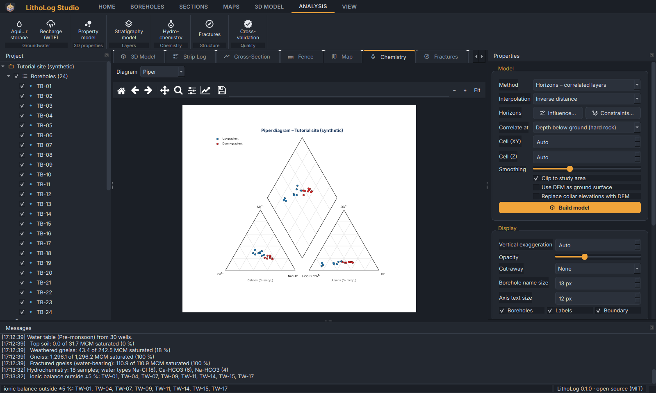
Figure 42. The Chemistry tab with the Piper diagram.
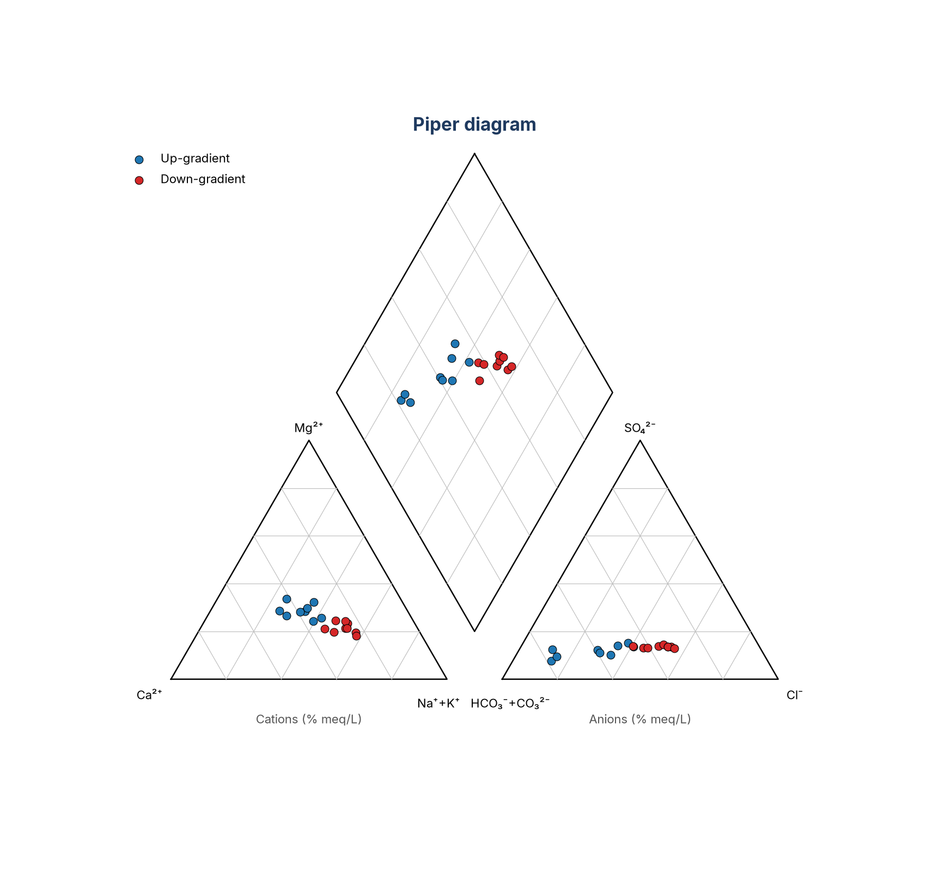
Figure 43. Piper diagram of the 18 tutorial samples by group.
Table 15. Hydrochemical diagrams and indices
Diagram / result | Use
Piper | Water type from the relative major cations and anions.
Durov | Water type with TDS and pH.
Stiff | Shape of each sample's composition, for comparing samples.
USSL (Richards, 1954) | Irrigation classes from salinity (EC) and sodium hazard (SAR).
Wilcox (1955) | Irrigation suitability from %Na and EC.
Gibbs | Controls on chemistry: rainfall, rock weathering or evaporation (indicative).
Results table | Ions in meq/L, ionic balance (flagged outside ±5 %), water type, SAR, %Na, RSC, Kelly's ratio, permeability index, magnesium hazard and irrigation classes.

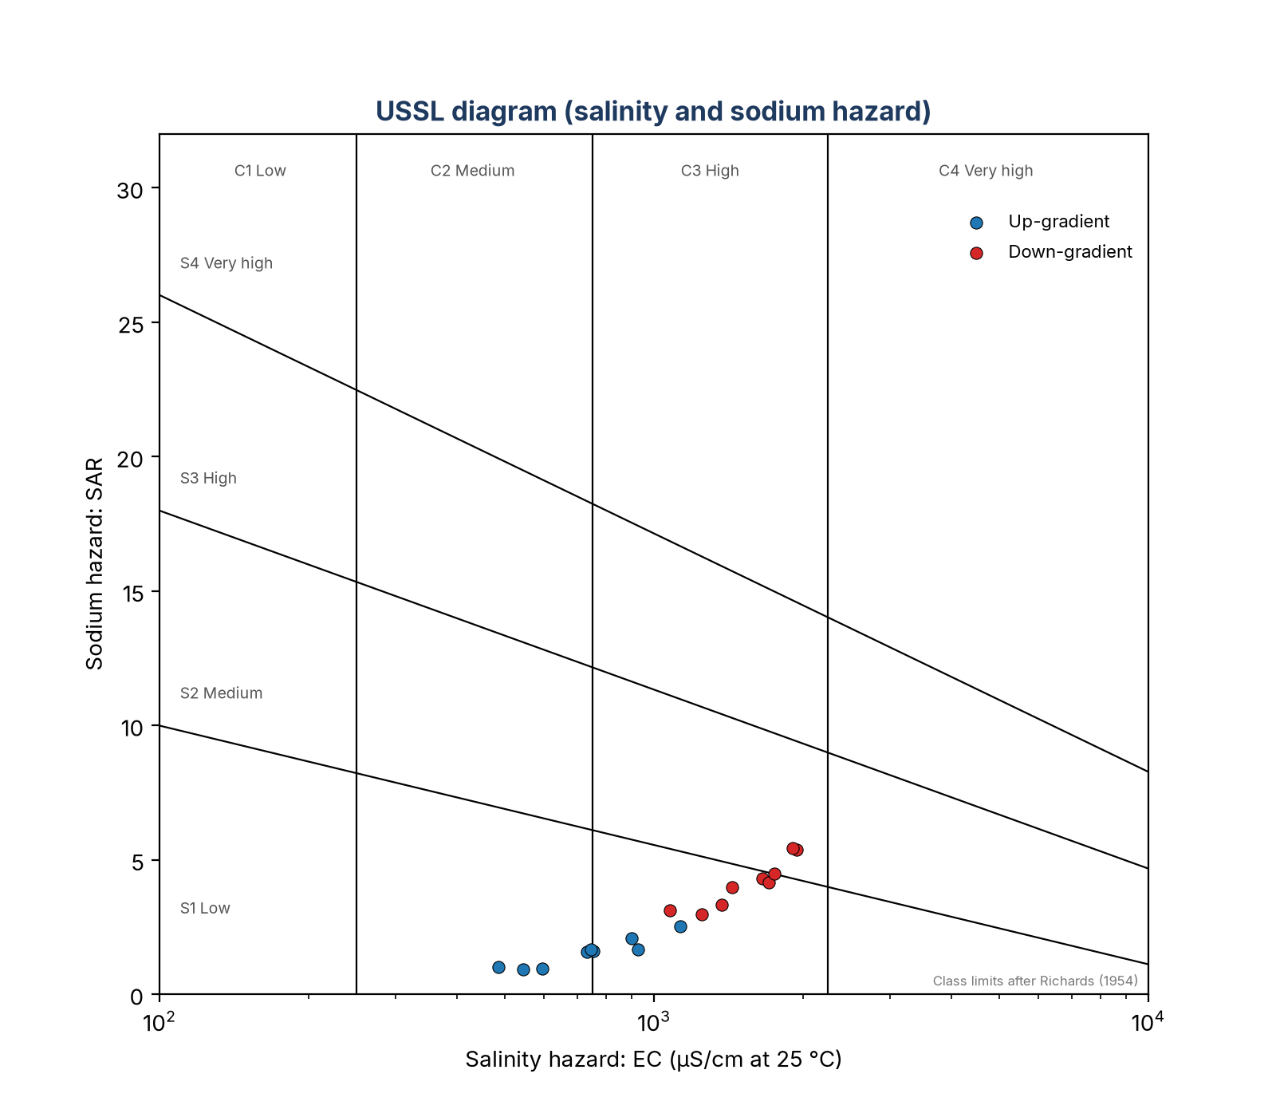
Figure 44. USSL (Richards) diagram.

13 Fracture analysis
Analysis ▸ Fractures uses the Fractures sheet: a strike rose diagram (bidirectional, right-hand rule), an equal-area (Schmidt) lower-hemisphere stereonet with poles, great circles and pole density, and fracture frequency with depth with water strikes marked.
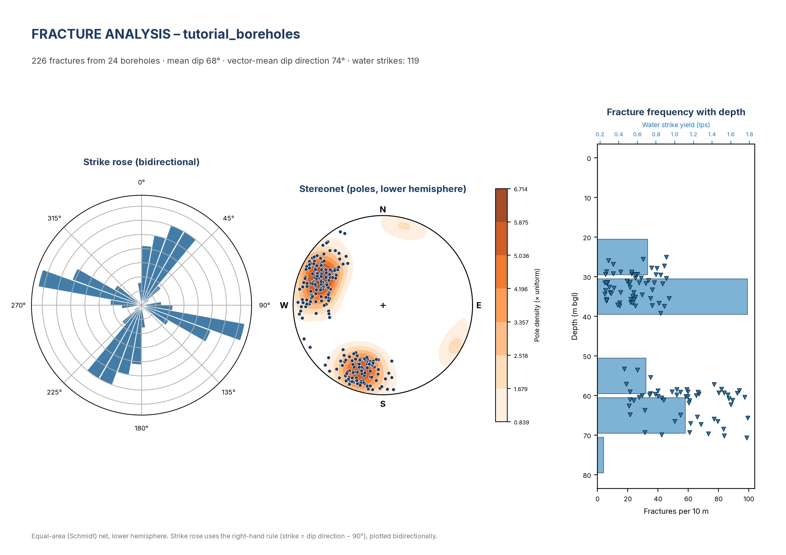
Figure 45. Fracture analysis page of the tutorial site.

14 Model validation (cross-validation)
A 3D model is an estimate between boreholes. Analysis ▸ Cross-validation measures how good that estimate is: each borehole is hidden in turn, its log is predicted from the others, and the prediction is compared with the real log. Choose a folder for the report and the unit to report in detail.
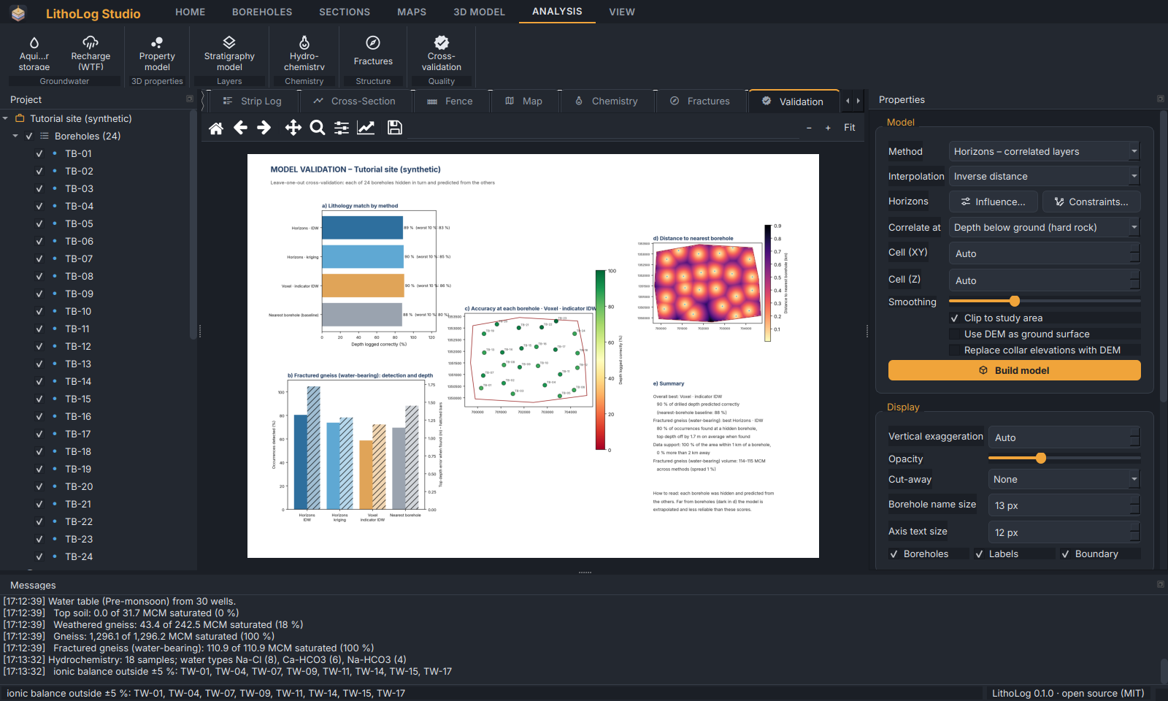
Figure 46. The Validation tab with the one-page report.
Table 16. Cross-validation results
Result | Meaning
Depth logged correctly (%) | Share of the drilled depth where the predicted unit equals the logged unit, as the mean over all boreholes and for the worst 10 %.
Occurrences detected (%) | For the chosen unit: share of its occurrences in the hidden boreholes that the prediction also shows there.
False alarms | Predicted occurrences that the borehole does not have.
Top depth error (m) | Mean difference in the depth of the top, where the occurrence was found.
Nearest-borehole baseline | Simply copying the nearest borehole. A useful model must do better than this.
Accuracy map | The score at each borehole — shows where the model is weak.
Distance to nearest borehole | Data support: far from boreholes the model is extrapolated and cannot be checked.
Volume range | The volume of each unit from every method: a practical uncertainty range to quote in reports.

The report compares the horizon model (inverse distance and kriging), the voxel model, the nearest-borehole baseline and — when you have changed the borehole influence or loaded constraints — your settings. Tables of every borehole and unit are saved as CSV beside the PDF.
Tip: Quote volumes as the range across methods, and describe where the model is supported by boreholes. Thin units that change quickly between holes (such as fracture zones in hard rock) usually score low: geophysics between the boreholes is the way to improve them.

15 Command line and web app
The same engine runs from a command window (after pip install litholog), which is useful for batch work and scripts. Every command has --help.
Table 17. Commands
Command | Purpose
litholog template FILE.xlsx | Write the input workbook to fill in.
litholog validate DATA | Check the data.
litholog convert GMS.txt OUT.xlsx | Convert GMS or CSV input to a workbook.
litholog striplog DATA | Strip logs of all or selected boreholes.
litholog section DATA -b A B C | Cross-section through boreholes (or --line X,Y …).
litholog fence DATA | Fence diagram.
litholog map DATA -a thickness:CODE | Contour maps and grids.
litholog model DATA | 3D model, views, volumes (options: --method, --power, --constraints, --dem …).
litholog aquifer DATA -w WELLS | Water table, fluctuation, storage and recharge.
litholog property DATA -p Resistivity | 3D property model.
litholog strat DATA --order A B C | Stratigraphic model.
litholog chem CHEM.csv | Hydrochemistry diagrams and indices.
litholog fractures DATA | Fracture analysis.
litholog crossval DATA -u CODE | Cross-validation report.
litholog studio / litholog app | Open LithoLog Studio / the browser app.

Examples with the tutorial data:
litholog model tutorial_boreholes.xlsx --boundary tutorial_boundary.geojson --sy WGN=0.015 FGN=0.01
litholog model tutorial_boreholes.xlsx --grid-method kriging --variogram exponential --constraints tutorial_constraints.csv
litholog aquifer tutorial_boreholes.xlsx -w tutorial_water_levels.csv --sy WGN=0.015 FGN=0.01 --rainfall 900 --draft 1.2
litholog crossval tutorial_boreholes.xlsx -u FGN --power 4 -o validation
The web app (litholog app, or a hosted copy) offers strip logs, sections, fence diagrams, maps and the 3D model in a browser: upload the workbook, and optionally a boundary and DEM, and download the results.

16 Methods and limitations

16.1 Correlation of layers
Borehole logs are compared as sequences of units. A sequence-alignment method (as used for DNA sequences) matches units of the same code at similar depths, allowing for units that are missing in one hole. For the horizon model all boreholes are aligned progressively into one master sequence of horizons; horizons of the same unit that never occur together in a hole and can be merged without breaking any hole's order are merged.

16.2 Interpolation
- Inverse distance (IDW): a weighted average of the boreholes, weights 1/distance^power; honours the boreholes exactly.
- Kriging: ordinary kriging with a variogram fitted to the data (or given by you); a statistically best linear estimate.
- Linear TIN / smooth TIN: triangulation between boreholes (the nearest borehole beyond the outer boreholes).
- Horizon thickness is interpolated with zeros where a horizon is absent; a presence indicator decides where the layer exists so layers pinch out between holes rather than spreading thinly everywhere.
- Volumes are integrated from the thickness grids (horizon model) or from the vote shares (voxel model), and agree with isopach volumes.

16.3 What the results can and cannot tell you
- Values at boreholes are data; values between them are estimates, and far from boreholes (see the distance map in the validation report) they are extrapolations.
- Automatic correlation can pair the wrong zones where logs are ambiguous. Review the horizons in the Project tree and add constraints where your geological judgement differs.
- Storage and recharge depend directly on the specific yield and draft you enter.
- Elevations: check boreholes and wells against a DEM (4.6) before reporting absolute levels.
- Hydrochemical classes follow the published diagrams (Richards 1954, Wilcox 1955, Gibbs 1970); the Gibbs diagram is indicative only.

17 Troubleshooting and questions
Table 18. Common problems
Problem | What to do
The boundary does not overlap the boreholes | The boundary and the boreholes are in different coordinate systems. Save the boundary with a .prj file, or use KML/GeoJSON; LithoLog reprojects them to the boreholes' UTM zone.
A thin layer breaks into patches | Use Method: Horizons. If it still breaks, check the horizons in the tree and add constraints.
Bull's-eyes around boreholes | Lower the IDW power, or use kriging (9.3).
Too many horizons, most in one borehole | The layers do not continue between holes; the voxel method may represent the data better.
Collar elevations differ from the DEM by a constant amount | Different height reference; see 4.6.
The 3D view is black or empty | Update the graphics driver. On remote desktops enable hardware graphics, or use the portable version on the local PC.
Exporting a 1000-dpi image fails | Use a smaller width or 600 dpi, or save the page as PDF/SVG.
Windows warns about the installer | The installer is not code-signed; choose More info ▸ Run anyway.
Water-level file reads wrong positions | Coordinates in degrees are recognised automatically; check the Messages note (for example “X was latitude, Y longitude: swapped”).

Appendix A Built-in lithology codes
Table 19. Built-in codes (names, colours and patterns can be changed in Layer properties)
Code | Name | Code | Name
TOP | Topsoil | GRA | Granite (massive)
RSOIL | Red soil | WGN | Weathered gneiss
BCS | Black cotton soil | FGN | Fractured gneiss
FILL | Fill / made ground | GN | Gneiss
CLAY | Clay | SCH | Schist
SCLAY | Sandy clay | PHY | Phyllite
SILT | Silt | QTZ | Quartzite
SAND | Sand | BIF | Banded iron formation
GRAV | Gravel | DOL | Dolerite dyke
KANK | Kankar / calcrete | BAS | Basalt (massive)
LAT | Laterite | VBAS | Vesicular basalt
LITHO | Lithomarge | SST | Sandstone
SAPR | Saprolite / weathered zone | SHL | Shale
WGRA | Weathered granite | LST | Limestone
FGRA | Fractured granite | NOREC | No recovery / not logged

Appendix B Patterns
Pattern names for the legend (combine with “+”): blank, dots, fine_dots, dashes, circles, blobs, hlines, diag, backdiag, fractures, crosses, xmarks, vees, waves, schist, brick, bands, roots.

Appendix C File formats
Table 20. Supported formats
Data | Formats
Boreholes | Excel (.xlsx), CSV folder, GMS text (.txt, .dat, .tsv)
Legend | CSV, Excel
Boundary | Shapefile (.shp + .prj, or zipped), KML, KMZ, GeoJSON
DEM | GeoTIFF, SRTM .hgt / .hgt.gz / .zip, ESRI ASCII (.asc)
Wells, chemistry, constraints | CSV, Excel (constraints also KML/KMZ/GeoJSON)
Project | LithoLog project (.llproj, JSON)
Images and pages | PNG, TIFF, JPEG; PDF, SVG
Grids | ESRI ASCII grid (.asc)
3D | HTML (interactive), OBJ, STL, VTP, VTK (ParaView)
Tables | CSV

Appendix D Licence and credits
LithoLog is open-source software (MIT licence). It uses Python, NumPy, SciPy, pandas, Matplotlib, PyVista/VTK, Qt (PySide6), pyproj/PROJ, scikit-image and Plotly. The user interface uses the Inter typeface (SIL Open Font License) and Material Design icons. The Copernicus GLO-30 DEM is provided by the European Space Agency under the Copernicus licence. The tutorial data are synthetic.

