Rotations & Projectile Motion in 3 Dimensions

PHYS1521

Students: Geordan Krahn & Zack Jones

Instructor: Allan Anderson

Assignment: Application Project Report

Date: 2022 April 9

# Table of Contents

Table of Contents 2

Table of Figures 3

Introduction 4

Rotations in 3 Dimensions 5

Euler Angles and Gimbal Lock 5

Quaternions 5

Projectile Motion is 3 Dimensions 6

Vector Math 6

Applying Vector Math to 3D scenarios 6

Conclusion 7

References 8

# Table of Figures(redo these later)

Figure 1: The Complex Plane 6

# Introduction

Our idea is to create a spherical cannon. We can assume this cannon can freely rotate and we are not concerned with how it floats. For all we know it could be some futuristic technology. In order to actually get the cannon to work, we need to address a few of the components of its functionality. First we need to get the position of our next target. Next we need to determine the required velocity to move the projectile through the air. We can apply an impulse force with these values later on.

The first problem we must address is the problem of Gimbal Lock. This occers when one of the axes become aligned with another axis, locking them into the same rotation. We do not want to have to worry about getting our axes unstuck from this state, so we will need an alternative method of rotation which avoids this issue. I have opted to use Quaternions a they are computationally faster to use than Matrices.

To be clear, quaternions are not an easily understood concept. In fact, despite the similarities with the complex number system, Quaternions too are an exclusing number system. We can think of Complex numbers as 2D numbers, and can describe 2D rotations using complex numbers. Quaternions extend upon the Complex number system by incorporating complex planes into itself. A quaternion can be thought of as a 4D number which performs 4D rotations.

For our cannon, first we calculate the necessary velocities to ensure the projectile hits its target. X and Z axes form the ground plane in 3D, and these axes are where the projectile exhibits uniform motion. The Y axis is where gravity acts on our projectile, and since gravity is a force, we have accelerated motion on this axis.

# Rotations in 3 Dimensions

*NOTE* - Minimum of two sections outlining the details of the topic chosen. The sections must include cited research *NOTE*

## Euler Angles and Gimbal Lock

*NOTE* - Minimum of two fully explained examples showing detailed steps from initial values to final answer *NOTE*

## Quaternions

Quaternions were discovered by Sir William Rowan Hamilton on the 16 October 1843.

To understand quaternions, we should begin with Complex Numbers (Expand on this.)

### Complex Numbers and the Complex Plane

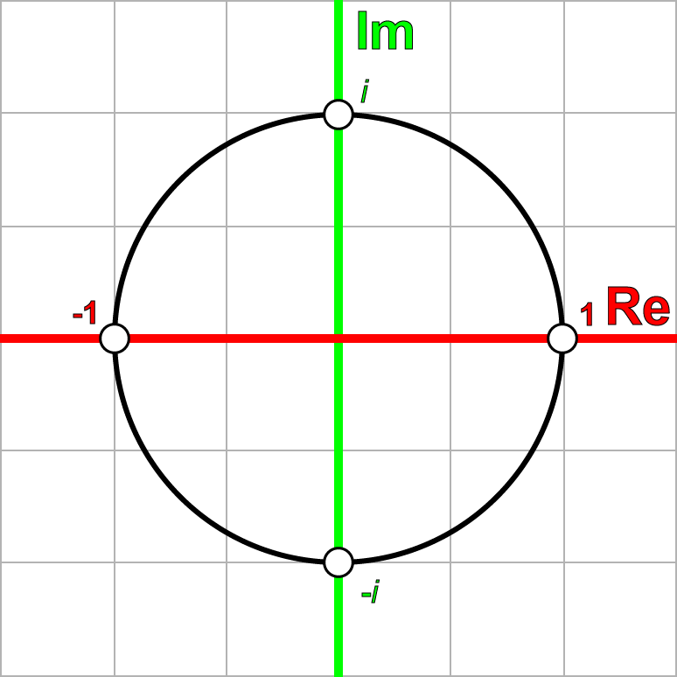

Figure 1: The Complex Plane

### Quaternions are 4D numbers

# Projectile Motion in 3 Dimensions

*NOTE* - Minimum of two sections outlining the details of the topic chosen. The sections must include cited research *NOTE*

## Linear Algebra

## Applying Linear Algebra to 3D scenarios

*NOTE* - Minimum of two fully explained examples showing detailed steps from initial values to final answer *NOTE*

# Conclusion

*NOTE* - Minimum of two, maximum of four, paragraphs outlining the lessons learned during this project. Include how this topic could be included in the content for PHYS1521*NOTE*

# References (Make APA Citations)

*NOTE* - Minimum of three references. The references must exclude You Tube videos, blogs or forum posts. Wikipedia may be used, but there must be two other supported references. References must be cited using either APA or MLA report style both in the body of the report and in a references section (last page of the report) *NOTE*

<https://www.johndcook.com/blog/2012/02/15/dot-cross-and-quaternion-products/>

<https://www.3dgep.com/understanding-quaternions/>

<https://users.ncsa.illinois.edu/kindr/emtc/quaternions/>

<http://www.arielnet.com/presentations/show/adi-ppt-01001/visualizing-orientation-using-quaternions>

<http://www.euclideanspace.com/maths/algebra/realNormedAlgebra/quaternions/>

<https://danceswithcode.net/engineeringnotes/quaternions/quaternions.html>