## Introduction

In this project I analyze several datasets that originate from the Twitter user @dog_rates, also known as WeRateDogs. WeRateDogs is a Twitter account that rates people's dogs with a humorous comment about the dog. These ratings almost always have a denominator of 10. The numerators, though are almost always greater than 10 (e.g. 13/10).

Bases on the three datasets used I will answer questions such as: Is there a relationship between the rating of a tweet and the amount of it's retweets.

I will elaborate on four insights.

## Occurrence of tweets per weekday

In this part, I analyzed how many tweets occur per weekday. The graph shows that the number of tweets are the highest at the beginning of the week and then go continuously down every day. For me this is a surprising insight as I would have expected the Sunday to be the day with the most tweets.

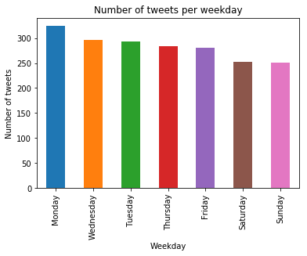

## Relationship between retweets and rating

Here I investigated the relationship between the retweets and the rating numerator.

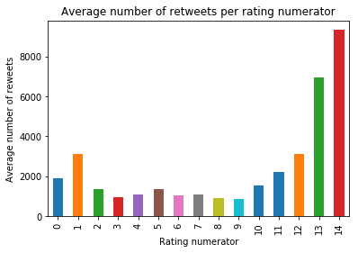

For the numerator rating equal or bigger than 10 there seems to be a positive correlation between the rating and the retweet count. For numerator ratings below 10 there I can derive no clear relationship. Especially tweets with a rating numerator of 1 seem to have a higher amount of retweets.

## Top ten dogs with highest rewet counts

Here I analyzed the top ten dog types with the highest retweet counts. But this is only analyzed for the dogs that have been predicted correctly. The table below shows the ten dog types with the highest retweet counts.

| **Dog type** | | **Retweet count** |
| --- | --- | --- |
| standard_poodle | 6631.857143 | | |
| Afghan_hound | 5976.000000 | | |
| English_springer | 5973.555556 | | |
| Saluki | 5133.750000 | | |
| Great_Pyrenees | 5017.230769 | | |
| Eskimo_dog | 4768.888889 | | |
| French_bulldog | 4683.923077 | | |
| Samoyed | 4623.050000 | | |
| Cardigan | 4540.588235 | | |

## Relationship between dog stage and number of retweets

Here I investigated the relationship between dog stage and number of retweets. The dog stage doggo, puppo is sticking out with many more retweets than the other dog types.

