HSeeker: an algorithm for systematic H-DNA sequence identification

Kimonas Provatas^{1,+}, Guliang Wang^{1,+}, Nikol Chantzi^{1,+}, Archit Patil¹, Imee MA Del Mundo¹, Candace SY Chan¹, Ilias Georgakopoulos-Soares^{1,}*, Karen M Vasquez^{1,}*

¹ Division of Pharmacology and Toxicology, College of Pharmacy, The University of Texas at Austin, Dell Pediatric Research Institute, Austin, TX, USA.
⁺ Co-first authors
*Corresponding authors: ilias@austin.utexas.edu, karen.vasquez@austin.utexas.edu

Abstract
H-DNA is a naturally occurring intramolecular DNA triplex structure formed by Hoogsteen hydrogen bonds at homopurine-homopyrimidine mirror repeats and has functional roles in gene regulation, genome instability, and human disease. The existing H-DNA detection tools capture only a subset of H-DNA sequences, often missing relevant sequence features or failing to assess key aspects of structural stability. To address this gap, we present “HSeeker”, a computational tool that compiles a three-part algorithm to identify and score putative H-DNA-forming sequences. Using a center-outward search algorithm approach, HSeeker evaluates candidate hinge positions and spacer lengths while allowing configurable mirror mismatches and purine-pyrimidine composition thresholds. Overlapping candidates are resolved by one of three user-selectable rules: retaining the longest and most compact motif within each overlapping region, retaining the highest-scoring motif, or reporting every candidate. Finally, an experimentally informed stability scoring model evaluates the candidate motifs using Hoogsteen G-G and A-A bonds, consecutive-pair stacking, and penalties for mismatches and disrupted stacks; the resulting score ranks candidates relative to one another within this scheme and is not a calibrated free energy. The scoring procedure also optimizes motif boundaries by trimming weak terminal positions and reassigning unstable arm positions to the spacer. HSeeker reports genomic coordinates, sequence information, pairing and stacking components, and an overall stability score. On a balanced benchmark of 130 experimentally characterised and designed sequences, HSeeker detected 63 of 65 H-DNA-forming sequences and rejected all 65 non-forming sequences, and its genome-wide predictions were enriched for mirror repeats found single-stranded in cells by permanganate/S1 footprinting. HSeeker is also user-friendly, available as a Python package and as a web application, supporting configurable, high-throughput analysis and exportability of predicted H-DNA motifs. HSeeker provides an accessible and reproducible framework for investigating the distribution and potential stability of H-DNA-forming sequences across genomic datasets.

Keywords: H-DNA, triplex DNA, non-B DNA, mirror repeats, algorithm, genome instability
Key Points
- · HSeeker is a computational tool for the systematic identification and stability scoring of putative H-DNA-forming mirror-repeat sequences in genomic DNA.
- · It combines a center-outward mirror-repeat search, three selectable overlap-resolution rules, and an experimentally informed stability-scoring model that incorporates Hoogsteen G·G and A·A pairing, base stacking, and mismatch penalties.
- · On a balanced benchmark of 130 experimentally characterised and designed sequences, HSeeker achieved higher accuracy than four existing tools, matching triplex on experimentally characterised sequences while rejecting the mirror-disrupted controls that triplex accepted.
- · HSeeker scales efficiently, analysing human chromosome 1 in 16 s and the complete human genome in 3.4 min on 16 cores, and is available as an open-source Python package and a user-friendly web application.
Biographical Note
Ilias Georgakopoulos-Soares studies computational genomics, non-B DNA structures, and cancer genome evolution. Karen M. Vasquez leads research on DNA repair, genome stability, and cancer mechanisms as a principal investigator.
Introduction
H-DNA is an alternative (i.e., non-B) DNA structure that forms at homopurine-homopyrimidine mirror-repeat sequences. H-DNA is formed by the folding back of one of the repeat arms and Hoogsteen hydrogen bonding to the purine-rich strand of the underlying duplex through the major groove, generating a triple-stranded structure, and leaving the complementary strand partially single-stranded ^{1,2}. When a pyrimidine-rich sequence serves as the third strand, it adopts a parallel orientation relative to the purine-rich strand of the underlying duplex, stabilized by canonical Hoogsteen hydrogen bonds. Notably, the formation of this parallel motif typically requires cytosine protonation to generate C+.G-C triads. This pH dependence makes the structure biologically less likely to form under standard intracellular conditions. Conversely, antiparallel H-DNA forms when a purine-rich strand folds back to interact via reverse-Hoogsteen hydrogen bonds with the purine-rich side of the duplex in an antiparallel orientation. The antiparallel conformation maintains stability at neutral physiological pH compared to its parallel counterpart, rendering it a more viable structural motif in vivo.

H-DNA structures can arise from and also modulate essential DNA metabolic processes with important roles in genome function and stability³. For example, H-DNA structures can interfere with replication, transcription, DNA repair^{4–6}, often by acting as an impediment to l polymerases^{3,7,8}. With the exposed single-strand, it can also accumulate more damage and repair errors, resulting in increased mutagenesis^{9–11}. Consistent with this model, naturally occurring H-DNA-forming sequences have been shown to be intrinsically mutagenic in mammalian cells and in mice^{12,13}, and often overlap with human disease-causing mutations^{14–16}, supporting the idea that structure-forming DNA sequences are an endogenous source of genome instability. Thus, H-DNA motifs are considered candidate mutational hotspots, particularly in genomic regions where replication or transcription imposes negative supercoiling, which favors the formation of alternative DNA structures.

One of the best-studied examples of H-DNA-associated instability occurs at the human c-MYC locus^{17–19}. The c-MYC promoter contains sequences capable of adopting a variety of non-B DNA conformations, including H-DNA, and these regions overlap with sites implicated in transcriptional regulation and genetic instability¹⁹. Because c-MYC is a key oncogene whose dysregulation contributes to multiple cancer types, the presence of H-DNA-forming sequences at this locus has provided an exemplary case study for understanding how H-DNA can influence genomic instability and gene regulation associated with cancer. More broadly, H-DNA and related triplex-forming motifs have been linked to chromosomal fragility, rearrangement-prone regions, and disease-associated instability, suggesting that systematic annotation of H-DNA-forming potential could improve our understanding of genome organization, mutational processes, and disease etiology.

Despite this biological relevance, to fully understand the impact of H-DNA on cellular functions, a better understanding of its distribution in genomic sequences is warranted. While we know that potential H-DNA-forming sequences are abundant in mammalian genomes and are possibly enriched in promoters and introns, computational identification and annotation of H-DNA-forming sequences remain less developed than for several other non-B DNA structures. A comprehensive mapping across different genomes is also lacking. Early approaches searched for homopurine-homopyrimidine mirror repeats using relatively simple sequence rules, while later efforts introduced more flexible models. For example, Schroth and Ho proposed sequence-based criteria for identifying potential H-DNA-forming motifs²⁰, and Lexa et al. (2011) subsequently developed a dynamic programming algorithm for detecting triplex-forming sequences that allowed imperfect matches rather than restricting searches to perfect mirror repeats²¹. These advances were important because experimentally validated H-DNA-forming sequences may contain interruptions, mismatches, or variable spacer lengths, features that are missed by overly strict pattern-matching approaches.

Few computational tools are currently available to detect H-DNA-forming sequences; however, these existing resources have important limitations for systematic H-DNA discovery. For example, nBMST provides a general interface for searching multiple classes of non-B DNA motifs, but its mirror-repeat module tolerates no mismatch in mirror symmetry, and the subset it labels as triplex-forming is selected by a purine/pyrimidine count on the reported strand rather than by a purity threshold, so mirror repeats written on the pyrimidine-rich strand are not labelled as triplex-forming ^{22,23}. NeSSie is a C/C++ library and tool for the detection of approximate sequence symmetries, including mirror symmetry and triplex-forming potential, utilizing an optimal global alignment based on the Needleman-Wunsch algorithm²⁴, and allowing gaps, mismatches, or asymmetric loops to be present. Its search returns symmetric or purine-rich k-mers rather than arm-spacer-arm motifs, so a mirror repeat whose two arms flank a non-symmetric spacer is not returned as a single motif. Triplexator²⁵ and 3plex/3plex Web²⁶ were both originally developed for RNA:DNA intramolecular H-DNA and intermolecular Triplex Target Site prediction, which is related but distinctly different from intramolecular H-DNA formation in vivo, and they did not provide a dedicated genome-scale annotation framework for intramolecular H-DNA-forming mirror repeats²⁵. 3plex is the only pipeline that integrates structural rules with thermodynamic modeling. The algorithm first evaluates the canonical rules for parallel and antiparallel Hoogsteen base-pairing, followed by a procedure to evaluate the thermal stability profiles derived from DNA denaturation experiments. It allows calculating an empirical affinity score for a single-stranded DNA or RNA, rather than relying solely on strict sequence patterns²⁶. However, since it was designed to search for intermolecular triplexes, the thermal parameters were derived from single-stranded DNA or RNA, and the existing length and the length of the mirror-symmetric center were not taken into consideration. As a result, there remains a need for dedicated software that can systematically identify naturally occurring intramolecular H-DNA motifs while accounting for biologically relevant sequence features such as mirror symmetry, homopurine-homopyrimidine composition, spacer length, and imperfect triplex-forming potential.

Here, we present “HSeeker”, a computational framework for the systematic identification of anti-parallel H-DNA-forming sequences from genomic DNA. By integrating sequence composition, mirror-repeat architecture, and tolerance for imperfect triplex-forming patterns, HSeeker enables scalable annotation of putative H-DNA-forming loci across genomes. This framework provides a foundation for studying the distribution, evolution, and mutational consequences of H-DNA-forming sequences, and for integrating H-DNA annotations into broader analyses of non-B DNA, genome instability, and disease-associated variation.

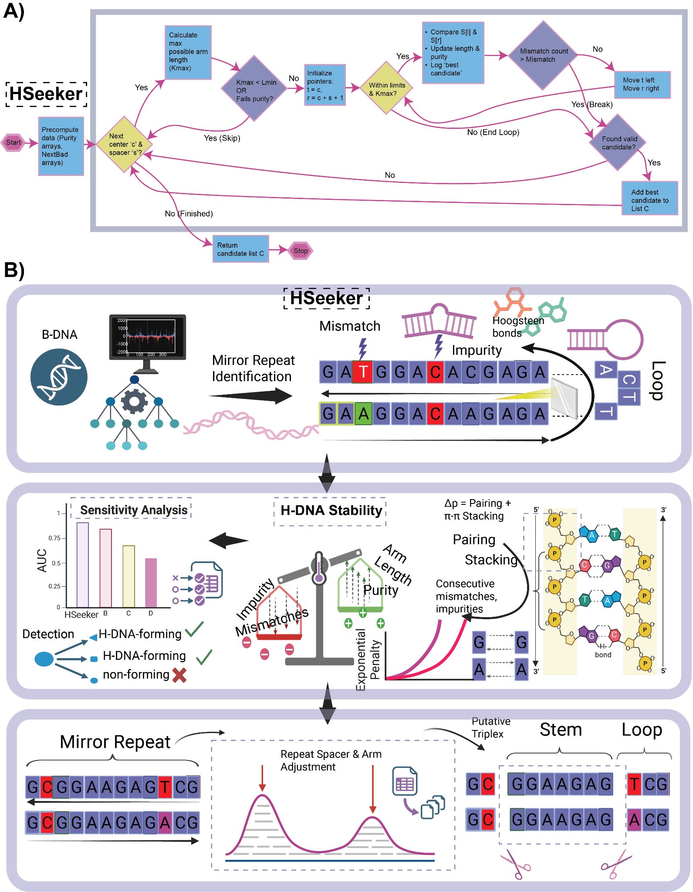
Figure 1: Computational workflow for the identification and scoring of putative H-DNA-forming mirror repeats. A) HSeeker candidate-identification workflow. B) Starting from a sequence input, the pipeline identifies homopurine/homopyrimidine mirror repeats and detects sequence features that may disrupt triplex formation, including mismatches, impurities, and loop-forming segments. Identified candidates are evaluated using an H-DNA thermostability score that integrates sequence composition and structural determinants (e.g., mismatches/impurities, repeat purity, arm length, base pairing, and base stacking) to estimate the propensity of each sequence to form a stable H-DNA/triplex structure. Candidate mirror repeats are further refined by adjustment of repeat spacer and arm boundaries to define the final putative triplex architecture, consisting of a triplex-forming stem and an intervening loop. Together, this framework enables systematic detection and prioritization of sequences with the potential to adopt H-DNA structures.

Methods

H-DNA candidate sequence discovery
HSeeker searches for antiparallel H-DNA that contains reverse Hoogsteen hydrogen bonds (e.g., G·G-C and A·A-T triplets) for their occurrence in neutral physiological conditions (Figure 1). It employs a center-outward heuristic to detect potential H-DNA-forming mirror repeats in genomic sequences, augmented with an exact purity-RMQ prefilter that eliminates center-spacer pairs whose right arm cannot satisfy the composition constraint. After enumeration, matching base pairs at the inner ends of the spacer are absorbed into the arms where the purity criterion permits, so that a motif is reported with its maximal arm representation, and candidates arising from different centre and spacer combinations that normalise to the same arm and spacer partition are reported once. For each potential hinge center  and spacer length , the right-arm start is 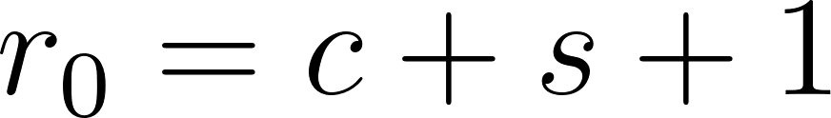. Before performing character-by-character extension, HSeeker computes the maximum reachable arm length , where 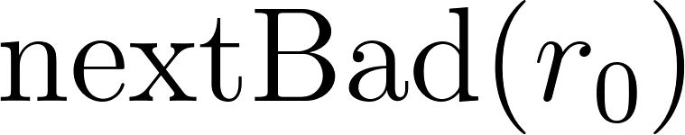 is the first non-ACGT position at or after . It then uses prefix-count arrays 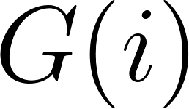 and  for GA-rich and CT-rich right-arm bases and defines and , where 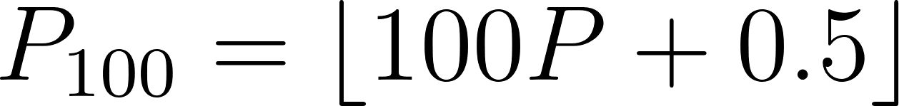 is the integer-scaled purity threshold. A GA-rich right-arm prefix of some length 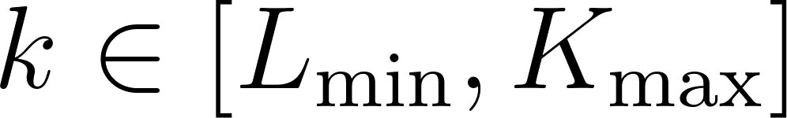 can meet the required purity threshold exactly when 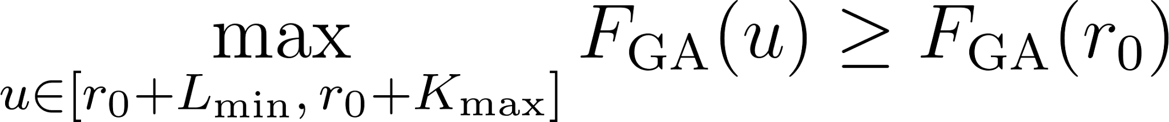, and the CT-rich case is tested analogously using . These two range-maximum queries are a deterministic feasibility check: if neither inequality holds, no extension length for that center-spacer pair can pass the original purity rule, and the pair is skipped without changing output semantics. All remaining pairs are processed by the original center-outward extension logic: the algorithm compares left and right bases, increments the mismatch counter on differences, tracks GA/CT composition from the right arm, evaluates mirror identity and purity using integer-scaled arithmetic, and retains only the longest valid arm for each 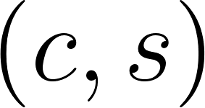 pair. Extension terminates when the mismatch budget is exhausted or a non-ACGT right-arm base is encountered, as described in Algorithm 2. Following the scanning phase, overlapping hits are resolved by a greedy linear sweep over hits sorted by genomic start: the hit with the longest arm survives each overlap group, with ties broken by shorter spacer length. The overlap-removal step is described in Algorithm 3.

Sequence composition filters
Prior to stability scoring, we applied two empirical filters based on experimentally derived criteria for H-DNA formation. First, we filtered out all hits where the mirror repeat arm had an AT-content ≥80% ²⁰, as sequences with very high AT-richness are known to destabilize triplex formation due to geometric incompatibility of Hoogsteen base triplets and reduced stability of A·A-T triads. Second, following stability scoring, we excluded any putative triplex that consisted of a homopolymeric run (poly-A, poly-G, poly-C, or poly-T), as these do not form stable inter-strand triplex interactions despite satisfying homopurine/homopyrimidine requirements. Both rules are fixed and are not fitted during evaluation. They were, however, chosen with knowledge of the H-DNA literature and of the composition of our benchmark, and the benchmark is therefore not an independent test of them: because the single-base homopolymers are reported separately, neither filter changes any benchmark call, so the reported metrics neither depend on the filters nor support them. Evidence bearing on the filters is drawn instead from published single-stranded DNA maps and is presented in the Results.
Stability score
The stability scoring was based on the exact interaction energy changes for each Hoogsteen base pair within a DNA triad provided by Park et al. (2021)²⁷, isolated and calculated by simulating the triplex structures without the constraints of the phosphate backbone. Therein, the interaction energy of a G·G reverse Hoogsteen hydrogen bond in a G·G-C triplet was 7.63 kcal/mol, and that of an A·A reverse Hoogsteen hydrogen bond in an A·A-T triplet was 3.83 kcal/mol. In addition, Park et al. (2021) calculated the interaction energies of different combinations of stacking within the 3rd strand in an H-DNA structure, which ranged from 2.15 to 6.65 kcal/mol. To simplify the searching and scoring, we took an average of 5.0 kcal/mol of stacking energy penalty if a mismatched base exists in a third strand. The combination of these terms is a ranking score, not a free energy: the inputs are drawn from reported interaction energies, but the total has no validated physical units and we do not report it in kcal/mol. Taken together, the HSeeker stability scoring was calculated as follows:

Let  denote an H-DNA-forming sequence, where  is the arm length. The stability  is defined as the total sum of the energy of pairing and stacking interactions of the H-DNA-forming sequence. In particular, we used a greedy algorithm to identify the subsequence of a mirror repeat with the maximum stability, assessed using a prefix and suffix maximization algorithm. The stability is dependent entirely on the mirror repeat arm and not on the spacer length. However, H-DNA is thermodynamically unfavourable with very long spacer lengths; thus, we require that the spacer formed by folding the trimmed arm tails inward does not exceed the length of the selected arm window. In particular, let  denote the spacer length. We require that 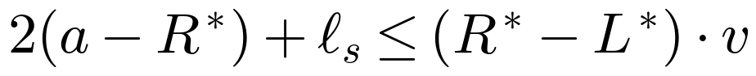.

For each mirror repeat, we consider two types of intramolecular forces: pairing and π-π stacking energies. Again, we assume that only the anti-parallel formation is likely to form, considering neutral pH conditions. Given a purine-dominant sequence, we consider the values in Supplementary Table 2. Given the score table, we can now attempt to extract the subsequence anchored at the spacer with the maximum consecutive score.

Each candidate hit produced by the purity-prefiltered center-outward enumeration and surviving overlap removal is subsequently evaluated for thermodynamic stability. The scorer receives the full motif sequence 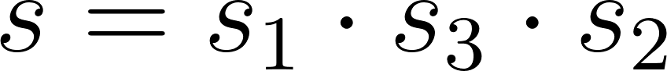, composed of left arm , spacer 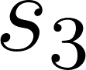, and right arm 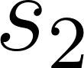, together with the detected arm length . If is CT-rich (i.e., 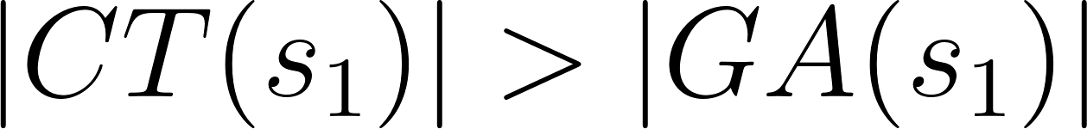), the full sequence is reverse-complemented so that scoring always proceeds on the purine-rich strand. The right arm is then reversed to yield 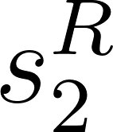, aligning position  of with position of for direct positional Hoogsteen comparison. Non-canonical 5' positions — those where neither 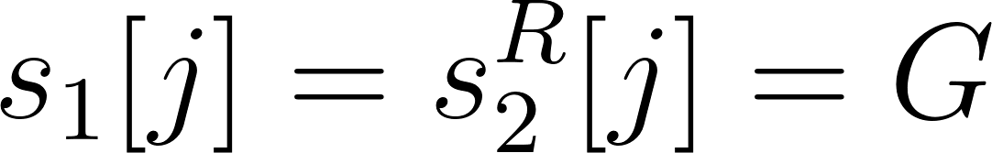 nor 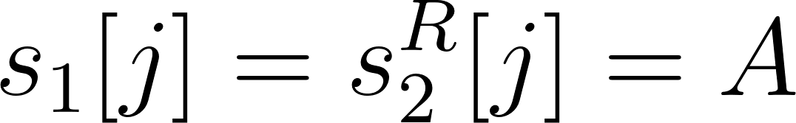 holds — are stripped from both arms before scoring. A per-position pairing score is then assigned as 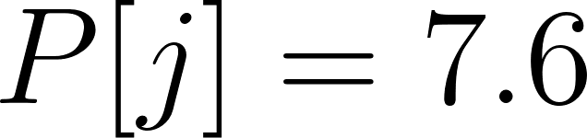 for G--G pairs, 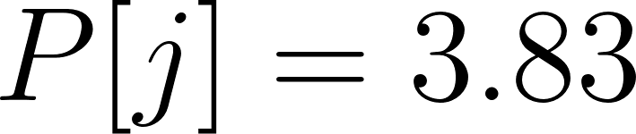 for A--A pairs, and 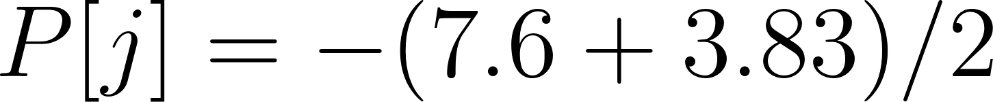 for any mismatch in the body of mirror repeat or impurity, Furthermore, a stacking bonus of 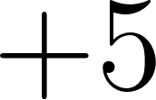 is awarded at each position where the two adjacent positions are both canonical. In particular, we penalized the π-π stacking mismatches or impurities using the formula 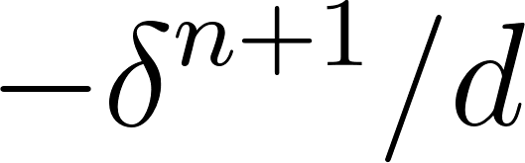, where  counts the length of the immediately preceding non-canonical run. Let 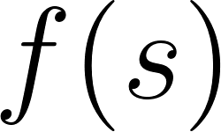 denote the scoring array considering pairing and stacking energies. Since consecutive mismatches or impurities would destabilize the H-DNA structure, we modeled the penalties in π-π stacking as exponential. The putative H-DNA-forming sequence is defined as the subsequence 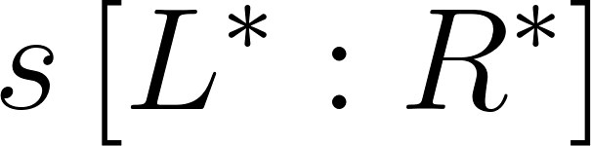 of , such that 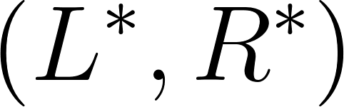 maximizes the stability of , defined as follows:
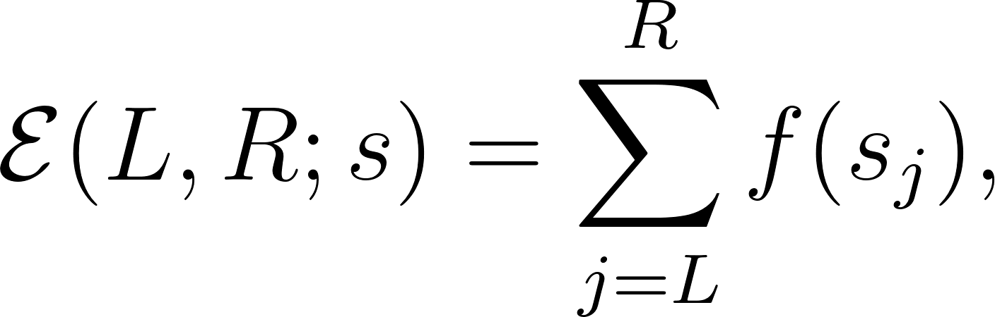
subject to the following constraints:
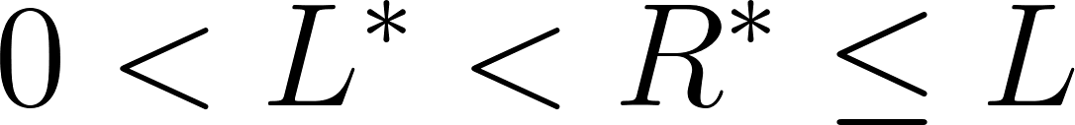, 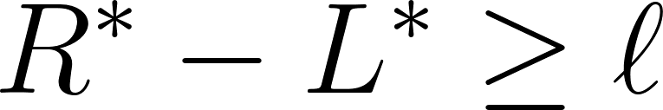,
and

Thus,
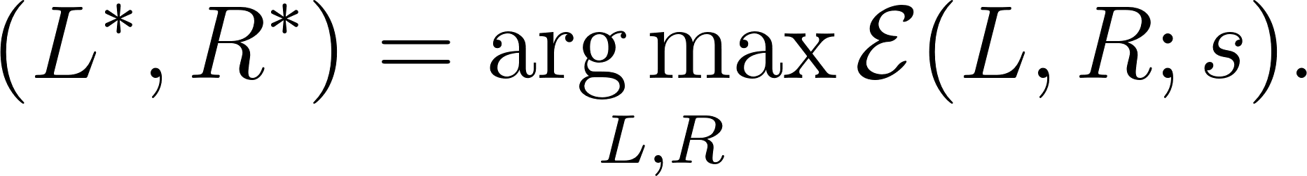
The procedure yields a stacking score, a pairing score, their sum as the total score, clamped at zero so that the reported score is non-negative, and a boundary-optimised putative triplex in 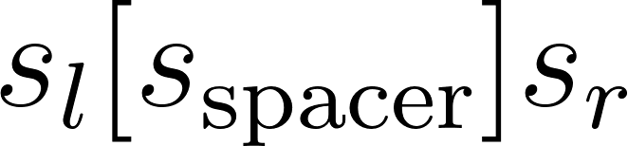 notation. The scoring procedure is described in Algorithm 4.

Detection settings. Unless stated otherwise, all analyses used the default settings: minimum arm length 8 bp, maximum arm length 1,000 bp, maximum spacer 10 bp, purity threshold 0.90, mismatch tolerance 0.10, AT-content threshold 0.80 with homopolymer exclusion enabled, and overlapping candidates resolved by the longest-arm rule. These are the defaults of the Python package, the command-line tool and the web application alike, so that the three interfaces return identical results for identical input, and parameters are given explicitly wherever an analysis departs from these values.
Benchmark dataset. The benchmark contains 130 sequences, 65 reported to form H-DNA and 65 reported or designed not to form it. Seventy are experimental records, 65 forming and five non-forming. Each was traced to its primary publication; records whose annotation derived only from a secondary compilation, and records with no traceable primary source, were removed. Fifty-seven of the retained records are construct-level, meaning the published experiment tested the sequence in the benchmark, and are used for the primary performance figures. The remaining thirteen are class-level, meaning the published experiment tested a closely related construct of the same repeat family, and are reported separately. Two records were excluded on validity grounds: an inosine-substituted oligonucleotide that cannot be represented in A/C/G/T, and a record describing an intermolecular triplex-forming oligonucleotide rather than an intramolecular structure. Because only five experimental non-forming constructs survived curation, we added 60 designed negatives, generated by a documented procedure under a fixed random seed: 22 positives whose mirror symmetry was destroyed by purine-preserving substitutions, 11 dinucleotide-preserving shuffles of positives, 12 random sequences matched to positives in length and GC content, four G-quadruplex-forming sequences, three Z-DNA-forming (CG)n repeats, five random mixed-sequence controls, and three perfect mirror repeats of balanced base composition. Apart from the last group, every designed negative was verified to contain no homopurine mirror repeat satisfying the detection criteria; the three balanced perfect mirrors are included precisely because they do contain such a repeat but are not purine-rich, and they therefore test whether mirror symmetry alone triggers a call. Single-base homopolymers are reported as a separate panel rather than within the benchmark, because the composition filters determine their calls by construction. For each experimental record we recorded the assay used, the DNA context, and the pH, temperature, ionic conditions and supercoiling state under which the structure was assessed, together with the passage in the source supporting those values; values that the source does not report are marked as such. Sixty-four of the 70 experimental records have a reported pH. Because the labels are outcomes under heterogeneous conditions, the pooled performance figures should be read as discrimination of reported sequence labels across assay conditions rather than as propensities under a single common condition (Supplementary Table 1).
Validation designA sequence is called H-DNA-forming when at least one candidate survives detection and filtering; no score threshold is applied. Sensitivity, specificity, positive and negative predictive values are reported with Wilson intervals and the Matthews correlation coefficient with percentile bootstrap intervals. Because many records are closely related variants from the same experimental series, intervals are computed both by resampling records and by resampling whole sequence families, and both are reported. Records were grouped by sequence family and by study from the curated provenance, and designed negatives inherit the group of the record from which they were derived. Parameter selection, where performed, was confined to the training portion of each split, under repeated stratified five-fold cross-validation, leave-one-family-out and leave-one-study-out schemes.
Direct sequence-level validation. We benchmarked HSeeker against four existing tools, triplex, Triplexator, NeSSie and nBMST, running all five independently on the 130 benchmark sequences. HSeeker was run with its default parameters:hseeker -seq benchmark.fna -out hdna_benchmark
Triplex (v1.50.0) ²¹ was run through its R interface (triplex.search) using a minimum score of 15, length bounds of 8–50 bp, and prokaryotic EVD parameters:
triplex.search(fasta, min_score=15, min_len=8, max_len=50, seq_type="prokaryotic")
Triplexator (v1.3.2) ²⁵ was run with a 10 bp minimum length (the tool's lower limit), no maximum length cap, a 15% error rate (matched to HSeeker's mismatch tolerance), and the repeat filter disabled to avoid excluding valid H-DNA motifs:
triplexator -ds <fasta> -l 10 -L -1 -e 15 -fr off -o <out>

Genomic context recovery. We next tested whether embedding a sequence in a genome changes the call made on it. We downloaded the E. coli K-12 genome from NCBI and randomly inserted each of the 130 sequences into it, enforcing a minimum 500 bp spacing between insertions (fixed random seed, seed=42). HSeeker was run on the resulting genome using the same parameters as above. A detected hit was counted as a true match if its overlap with the insertion site exceeded 80% of either the hit length or the insertion length, a threshold chosen to accommodate cases where tools extend hits into flanking sequence or detect only the triplex core within a longer insertion. The criterion is varied from 0.50 to 0.95 as a sensitivity analysis, and the unmodified genome was scanned under the same settings to establish the background locus rate. This experiment measures recovery and the stability of a call across sequence context; it does not test whether H-DNA forms, and we draw no biological conclusion from it.
For both the direct and genomic-context analyses, performance was evaluated using the Matthews correlation coefficient, reported with percentile bootstrap intervals computed over records and over whole sequence families, together with sensitivity, specificity and predictive values reported with Wilson intervals.
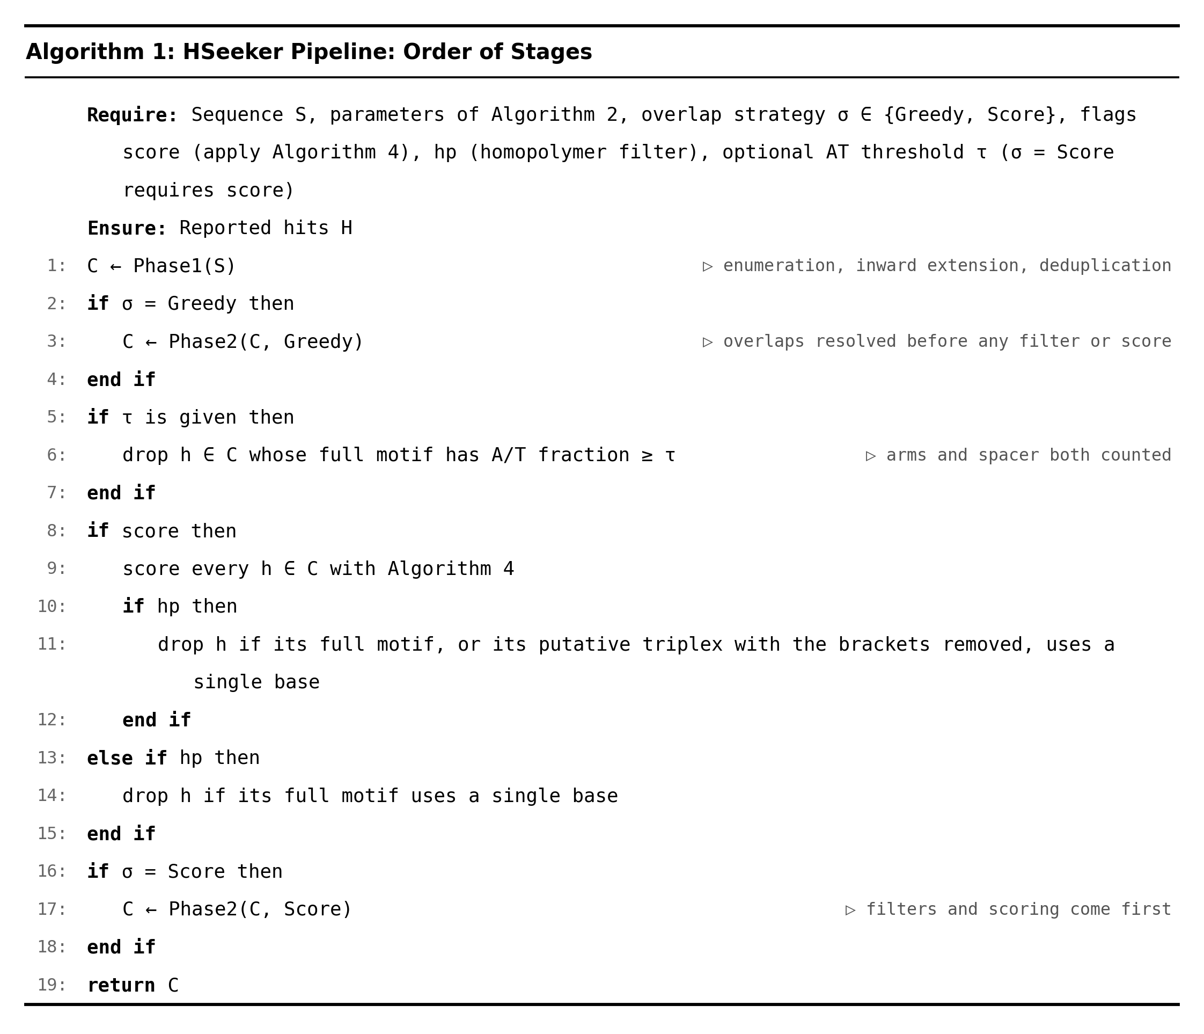
Algorithm 1: HSeeker pipeline, order of stages. Candidate enumeration runs first. If the longest-arm overlap rule is selected, overlaps are resolved before any filter or score is applied; the AT-content filter is applied next, then scoring, then the homopolymer filter, which inspects the scored putative triplex when scoring is enabled. Score-based overlap resolution, if selected, runs last, after filtering and scoring.
Computational benchmarking. Runtime and peak resident set size were measured on a single node of the TACC Lonestar6 cluster with 16 virtual cores of an AMD EPYC 7763 processor, 32 GB of RAM and Rocky Linux 8.10, with no other workload on the node. Each configuration was run three times and wall-clock time and peak memory were recorded externally. Inputs were human chromosome 1 and the hg38 primary assembly, both obtained from the UCSC Genome Browser. Comparators were timed on the same node under the same protocol.
Genome-wide comparison with single-stranded DNA maps. We compared HSeeker's predictions with the permanganate/S1 footprinting data of Kouzine and colleagues, using their published non-B DNA motif calls and single-stranded DNA signal tracks for activated and resting mouse B cells and for human Raji cells, on the genome assemblies used in that work. Both genomes were scanned with HSeeker at its default settings. Recall was computed as the fraction of the motifs they called formed that are overlapped by an HSeeker locus. Selectivity was computed among their own predicted H-DNA motifs, as the odds that a motif is called formed when HSeeker reports it against when HSeeker does not, with the mappability of each motif to 36-nt reads used as a sensitivity analysis. Enrichment of the measured signal was assessed against composition-matched controls. For each HSeeker locus, control windows were drawn on the same chromosome with the same length, the same A/T count and purine/pyrimidine asymmetry within one count, containing no ambiguous base and overlapping no HSeeker locus or predicted H-DNA motif. Two analyses were performed. The first used all loci with controls drawn genome-wide. The second restricted both loci and controls to sequence that 36-nt reads can map to, excluded intervals within 100 bp of a predicted G-quadruplex, Z-DNA, cruciform or stress-induced melting motif and within 2 kb of an annotated transcription start site, and drew ten controls per locus within 50 kb. Enrichment is reported as the ratio of mean signal with a bootstrap interval over loci, together with the probability that a locus exceeds one of its own controls. Two checks accompany each comparison: one control per locus was compared against that locus's remaining controls, and the motifs called formed by the original authors were passed through the identical procedure.
Comparison with existing tools. HSeeker was compared with triplex (v1.50.0), Triplexator (v1.3.2), NeSSie and nBMST on the same 130 records. Each tool was run at its documented defaults; with its geometry matched to HSeeker's where it exposes the corresponding parameters; and with a small parameter grid selected inside training folds only. A record was scored as positive when a tool reported at least one qualifying hit within it, the qualifying hit type being a triplex of any type for triplex, a duplex target site for Triplexator, a triplex-potential motif for NeSSie, and a mirror repeat classified as triplex-forming for nBMST; for NeSSie and nBMST the alternative hit types are reported alongside. Tool versions, command lines and the hit rule for each tool are given in Supplementary Table 3, and the per-record calls in Supplementary Table 4. The settings and the statistical comparison were fixed before the tools were run.
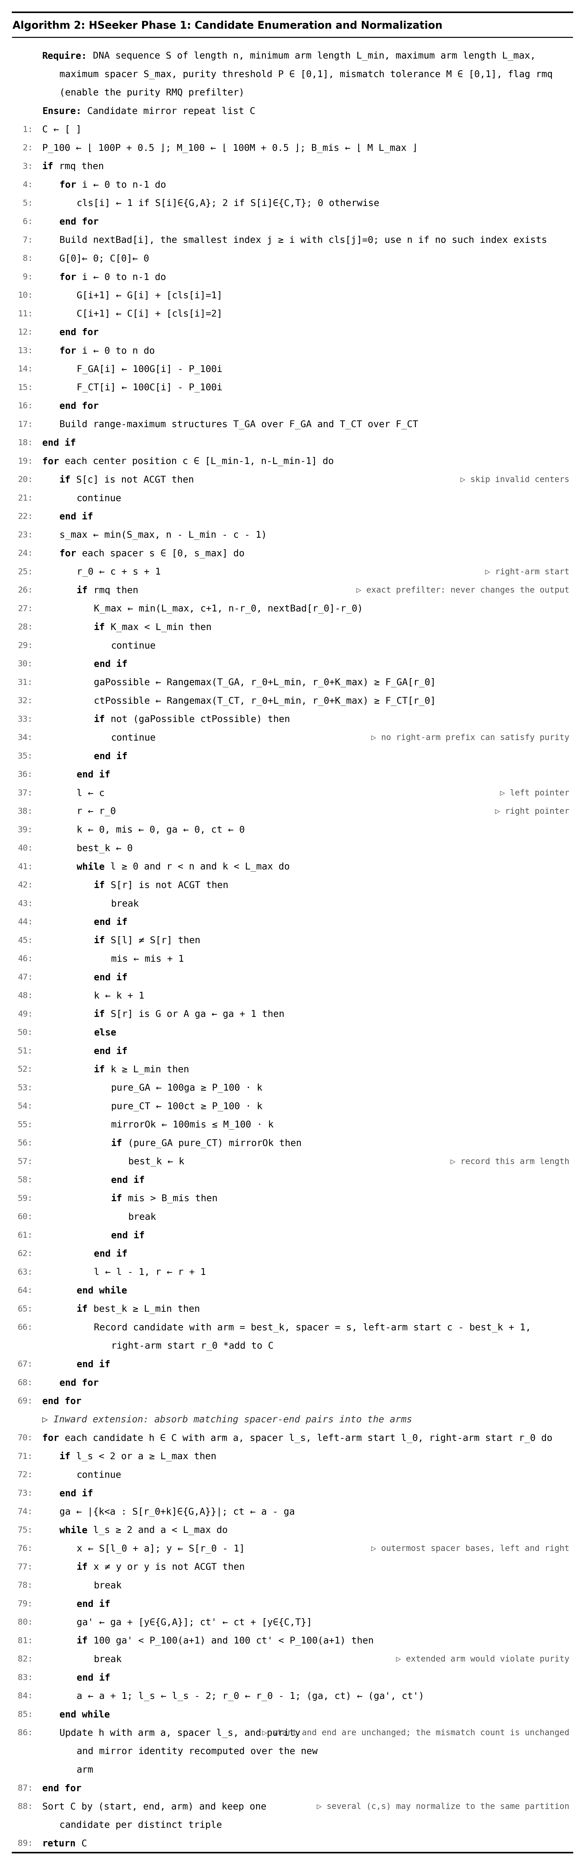
Algorithm 2: Center-outward mirror repeat candidate enumeration with optional purity RMQ prefilter. For each hinge centre and spacer length, HSeeker computes the maximum reachable arm length and, when the prefilter is enabled, discards centre-spacer pairs whose right arm cannot satisfy the composition constraint; the prefilter is exact and does not change the output. Candidates are then extended outward, matching base pairs at the inner ends of the spacer are absorbed into the arms where purity permits, and candidates that normalise to the same start, end and arm length are reported once.
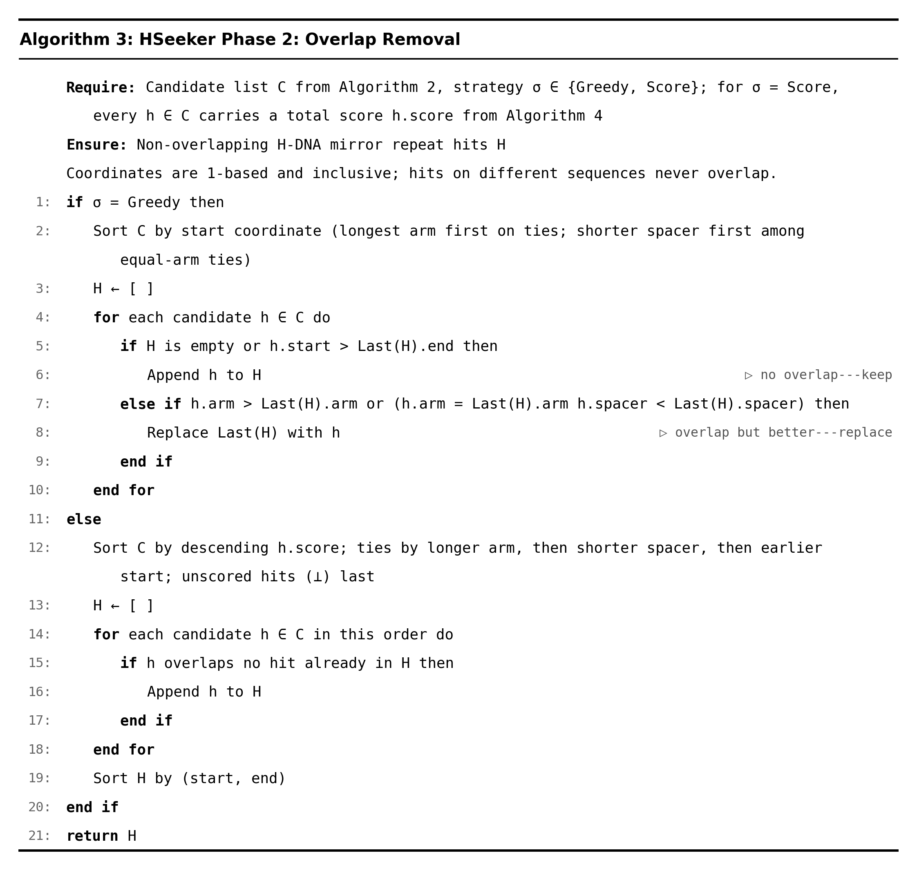
Algorithm 3: Overlap removal. Under the longest-arm rule, hits are sorted by genomic start coordinate and a candidate with a longer arm replaces an overlapping incumbent, with a shorter spacer breaking ties. Under the score-based rule, candidates are considered in descending order of total score and retained when they do not overlap a candidate already retained, with ties resolved by longer arm, then shorter spacer, then earlier coordinate.

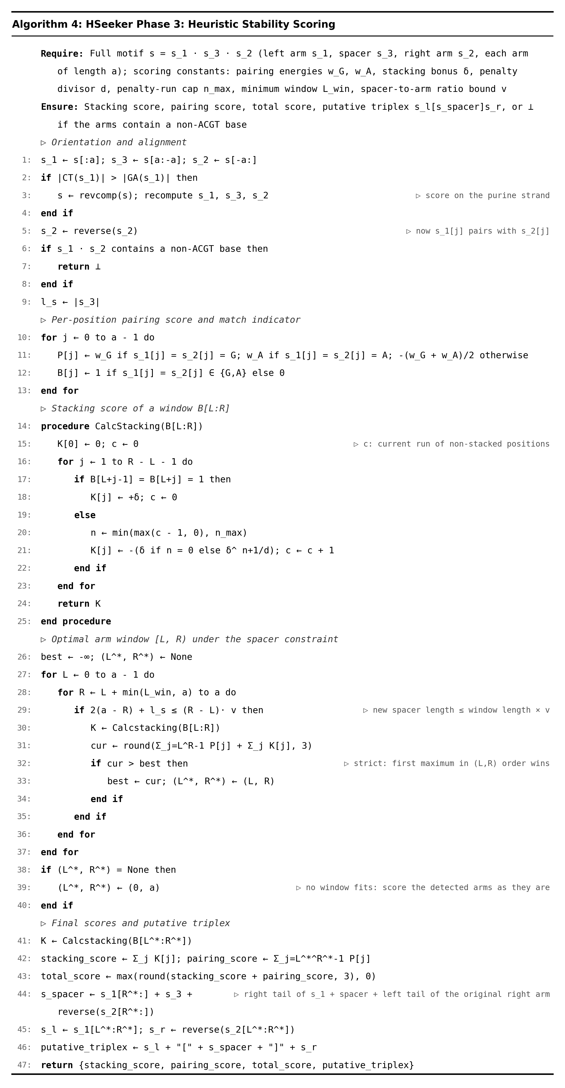
Algorithm 4: Heuristic stability scoring. Each candidate is oriented onto the purine-rich strand, the right arm is reversed for positional comparison, and a per-position pairing score and match indicator are computed. The highest-scoring arm window satisfying the spacer constraint is selected; if no window satisfies it, the detected arms are scored as they stand. The total is the sum of pairing and stacking contributions, clamped at zero.

Results

Computational performance and parallel scalability
To evaluate the computational scalability of HSeeker, we benchmarked the complete analysis pipeline, sequence scanning with the RMQ-based purity prefilter, overlap removal, and stability scoring, on human chromosome 1 (hg38; 248.9 Mbp; FASTA file 252 MB) using a TACC Lonestar6 vm-small virtual machine node. The node provided 16 virtual CPU cores (1 socket, 16 cores per socket, 1 thread per core) of an AMD EPYC 7763 processor operating at 2.45 GHz, with 32 GB of RAM, 256 MB of L3 cache, and running Rocky Linux 8.10 (kernel 4.18.0) with Python 3.11. We varied the number of worker threads from 1 to 16 and recorded wall-clock time and peak resident set size for each configuration, with all other parameters held at their defaults (minimum arm length 8 bp, maximum spacer 10 bp, purity threshold 0.90, mismatch tolerance 0.10, AT-content threshold 0.80 with homopolymer exclusion, RMQ purity prefilter enabled, scoring enabled). All runs produced an identical set of 45,927 non-overlapping putative H-DNA loci, confirming deterministic output across all parallelisation levels. At a single worker, the full pipeline was completed in 173.8 s (approximately 2.9 min). Increasing the thread count to 2, 4, 8, and 16 yielded wall-clock times of 89.6 s, 47.4 s, 26.7 s, and 16.3 s, corresponding to speedups of 1.94-fold, 3.67-fold, 6.51-fold, and 10.65-fold (Figure 2). Parallel efficiency remained above 90% through 4 workers and was 81% at 8 workers and 67% at 16 workers, with the decline at higher thread counts attributable to the post-scan serial phases (cross-chunk overlap removal and stability scoring). Peak memory grew modestly from 1,612 MB at 1 worker to 1,965 MB at 16 workers, consistent with the thread-based design in which additional workers hold more in-flight chunk data within a shared process address space.

For comparison we timed four existing tools on the same chromosome, the same node and the same day. Triplexator, which provides native multi-threading, completed in 45.0 s at 16 threads and reported 275,476 duplex target sites. The triplex package is single-threaded; split into 1 Mbp windows and run as 16 parallel processes it completed in 64.7 s and reported 81,906 hits. nBMST and NeSSie provide no parallel mode and completed in 96.5 s and 295.7 s on one core, reporting 147,222 mirror repeats, of which 33,519 were classified as triplex-forming, and 720,811 motif occurrences respectively. Peak memory was 1,714 MB for Triplexator, 660 MB for each triplex worker process, 866 MB for nBMST and 1,056 MB for NeSSie, against 1,334 MB for HSeeker. The hit counts reported by triplex and Triplexator reproduce our earlier measurements exactly. The comparison should be read with the differences in target class in mind: Triplexator enumerates duplex target sites for a separately supplied third strand and NeSSie enumerates symmetric k-mers, neither of which is the same object as an intramolecular mirror repeat, and the loci counts are correspondingly not comparable.

Rather than extrapolating from chromosome 1, we ran the complete hg38 primary assembly. At 16 workers it completed in 204.5 s, that is 3.4 min, with a peak memory of 2,296 MB, reporting 559,601 non-overlapping H-DNA loci; three independent runs produced identical output. Score-based overlap selection, which defers overlap resolution until after scoring, took 23.9 s on chromosome 1 and reported 47,217 loci.
Complexity analysis
HSeeker processes each input sequence through candidate enumeration, overlap removal, and thermodynamic scoring, with costs governed by the sequence length , maximum spacer , maximum arm length , and minimum arm length . With the purity-RMQ optimization enabled, candidate enumeration first performs a linear preprocessing pass over the sequence to classify bases, build the right-arm invalid-position array , construct GA/CT prefix-count arrays, and derive the transformed purity signals and . Building the range-maximum structures over these signals costs time and memory for the segment-tree implementation. The scanner still considers center positions and spacer lengths per center. For each pair, it computes and , then performs two range-maximum queries to test whether any right-arm prefix length can satisfy the GA-rich or CT-rich purity condition. These feasibility checks cost per pair in the current segment-tree implementation and can skip the center-outward extension entirely when no valid-purity right arm exists. If a pair passes the prefilter, then the original extension loop runs for at most steps, tracking mirror mismatches and retaining the largest valid arm. Thus the Phase 1 cost is , where is the subset of center-spacer pairs that pass the purity prefilter. In the worst case, all pairs may be purity-feasible, so and , which simplifies to for practical settings where . The optimization therefore preserves the original worst-case asymptotic bound but substantially reduces practical work by eliminating inner-loop extensions for purity-impossible pairs. Candidate enumeration produces at most raw candidates, at most one per center-spacer pair; overlap removal sorts them in time and performs a linear sweep in , giving . After overlap removal, surviving hits are pairwise non-overlapping, and since each spans at least bases, the number of scored hits is . Stability scoring applies a constant number of linear passes over each hit's arms and adjusted spacer boundaries, each bounded by , so . The full optimized pipeline is therefore , with worst-case simplification . Thus, purity RMQ does not change the theoretical worst-case class, but it changes the practical cost driver from extending every center-spacer pair to extending only the subset that can possibly satisfy the right-arm purity threshold.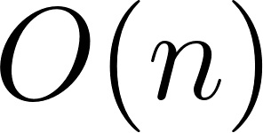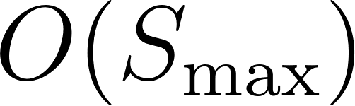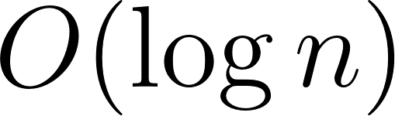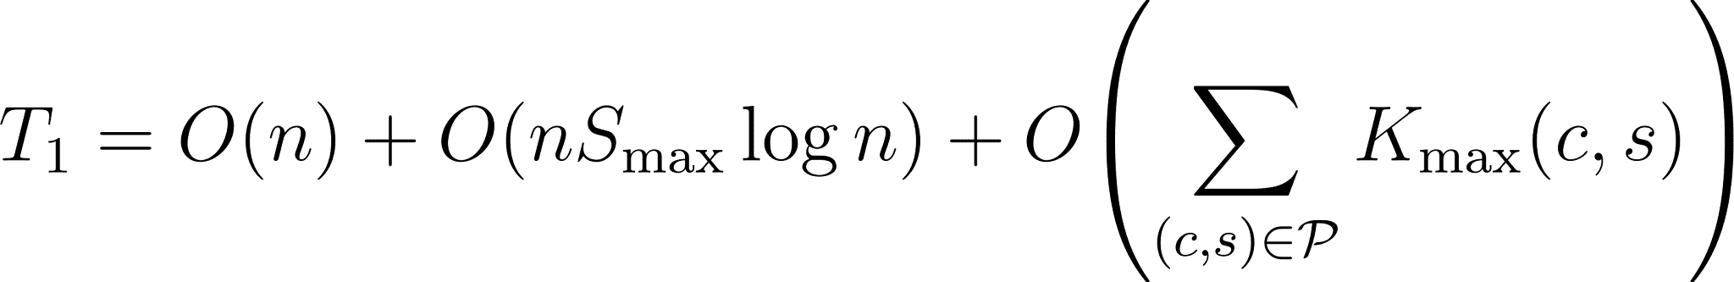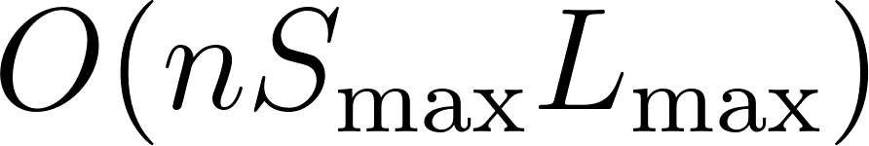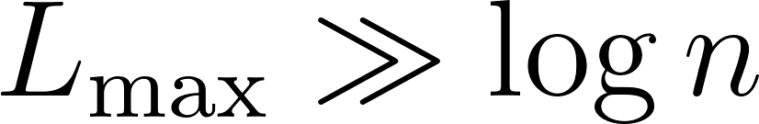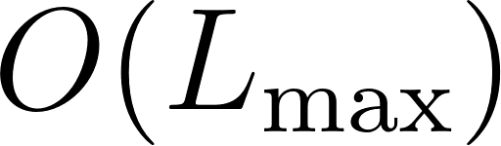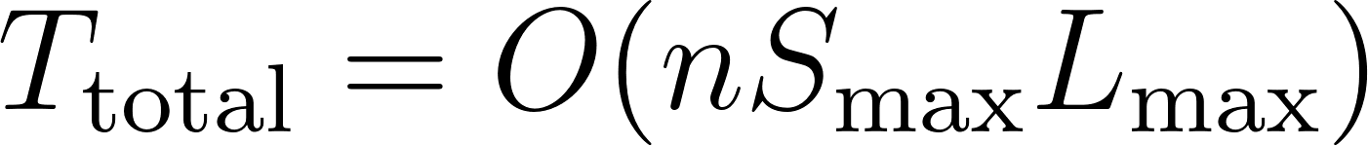

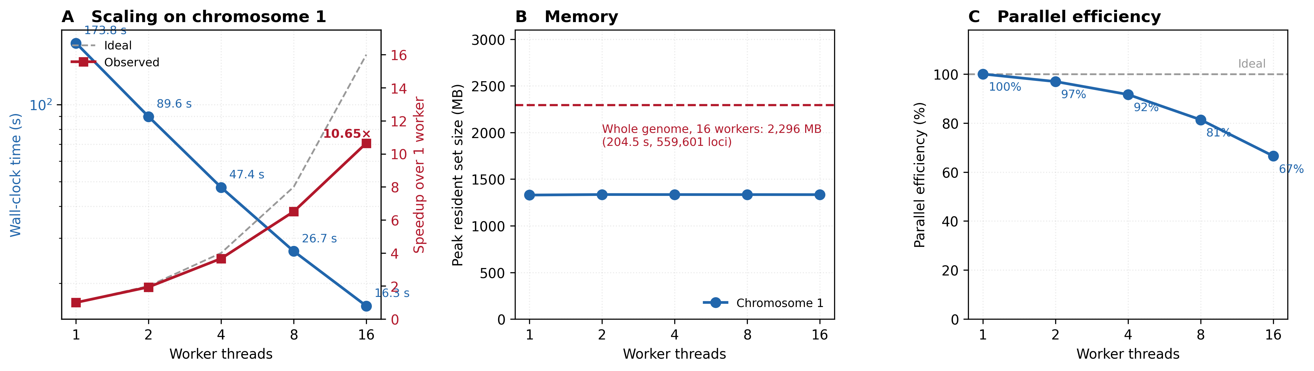
Figure 2: Computational performance of HSeeker. A) Wall-clock time and speedup for the complete pipeline on human chromosome 1 (hg38, 248.9 Mbp) across 1-16 worker threads, mean of three runs; the dashed line is ideal linear speedup. B) Peak resident set size across the same sweep, with the complete hg38 primary assembly shown for reference. C) Parallel efficiency across the same sweep. The comparator tools are not plotted because two of the four provide no parallel mode, so a worker sweep is undefined for them; at 16 cores on the same node and the same day, chromosome 1 took 45.0 s with Triplexator and 64.7 s with triplex run as 16 parallel processes, against 16.3 s for HSeeker, while nBMST and NeSSie took 96.5 s and 295.7 s on one core.

Detection performance on the revised benchmark
HSeeker detected 63 of the 65 H-DNA-forming sequences and rejected all 65 non-forming sequences, corresponding to a sensitivity of 0.969 (95% CI 0.895-0.992), a specificity of 1.000 (0.944-1.000) and a Matthews correlation coefficient of 0.970 (0.925-1.000) (Table 1). The two sequences that were not detected, the c-MYC nuclease-sensitive element construct (ACCCTCCCC)4 and the gamma-globin -228/-189 element, are tandem direct repeats rather than mirror repeats and therefore fall outside the structural model that HSeeker implements. Restricting the evaluation to the 70 experimental records gives a sensitivity of 0.969 (0.895-0.992) and a specificity of 1.000 (0.566-1.000); the width of the latter interval reflects the five experimental non-forming constructs that survived curation, and conclusions about specificity rest largely on the designed negatives. We also asked whether the stability score could improve classification beyond detection. Within each training fold we selected the score threshold maximising Youden's J statistic and applied it only to the held-out records. Out of fold this produced a coefficient of 0.949 (0.937-0.961) under repeated five-fold cross-validation and 0.955 (0.898-1.000) under leave-one-family-out and leave-one-study-out validation, below the 0.970 obtained with no threshold. The threshold removed no false positive, because no non-forming record retains a candidate once the purity requirement is applied, and it discarded forming records whose scores fell below a threshold learned without them. For the same reason the area under the ROC curve on this benchmark, 0.985, restates the detection result rather than adding to it. We therefore report no score threshold: a sequence is called H-DNA-forming when it contains a candidate satisfying the detection criteria, and the stability score is used to rank candidates.
The errors are informative. Mirror-repeat detection alone, before the purity requirement is applied, calls seven of the 65 non-forming sequences: the experimentally non-forming c-MYC control B-33, one G-quadruplex-forming sequence, two Z-DNA-forming (CG)n repeats and all three perfect mirror repeats of balanced composition. The purity requirement removes all seven without losing a forming sequence, which is the clearest demonstration in the benchmark that mirror symmetry alone is not sufficient and that the composition criterion is doing the discriminating work. No designed negative of any class is called at the default settings.
Table 1: Detection performance on the revised benchmark. Values are point estimates with 95% confidence intervals: Wilson intervals for proportions and percentile bootstrap intervals for the Matthews correlation coefficient. The balanced benchmark combines 70 experimental records with 60 designed negatives. Construct-level records are those for which the published experiment tested the exact sequence in the benchmark.
Evaluation set | n | TP | FN | TN | FP | Sensitivity | Specificity | PPV | NPV | MCC
Balanced benchmark | 130 | 63 | 2 | 65 | 0 | 0.969 (0.895-0.992) | 1.000 (0.944-1.000) | 1.000 (0.943-1.000) | 0.970 (0.898-0.992) | 0.970 (0.925-1.000)
Experimental records | 70 | 63 | 2 | 5 | 0 | 0.969 (0.895-0.992) | 1.000 (0.566-1.000) | 1.000 (0.943-1.000) | 0.714 (0.359-0.918) | 0.832 (0.560-1.000)
Construct-level records | 57 | 50 | 2 | 5 | 0 | 0.962 (0.870-0.989) | 1.000 (0.566-1.000) | 1.000 (0.929-1.000) | 0.714 (0.359-0.918) | 0.829 (0.556-1.000)

Family- and study-aware validation. Because many benchmark records are closely related variants from the same experimental series, we grouped records by sequence family and by study and repeated the evaluation holding out one whole group at a time. The 130 records span 52 sequence families and 27 studies, the largest family, the pXY32 substitution series and its derivatives, accounting for 37 of them. Under leave-one-family-out and leave-one-study-out validation the fixed default configuration reached a coefficient of 0.970, against 0.924 when the parameters were tuned within each training fold. Collapsing the benchmark to one representative per family gave 0.862 over 52 records, and to one representative per family and class 0.945 over 74 records. Because the parameters are fixed, a record's call depends only on its own sequence, and group-aware validation does not shift the point estimate; it widens the confidence interval, and both the record-level and the family-level intervals are reported throughout.
Component ablation and parameter robustness. To establish which components of the pipeline account for its behaviour, we evaluated the stages cumulatively, calling a record forming when at least one candidate survives the stage in question. Mirror-repeat detection alone detected 63 of 65 forming records and seven of 65 non-forming records (sensitivity 0.969, specificity 0.892, coefficient 0.864). Adding the purity requirement removed all seven without losing a forming record (specificity 1.000, coefficient 0.970). Adding the AT-content filter, pairing-only scoring, pairing plus stacking, and the complete model with boundary optimisation and homopolymer filtering changed no record-level call. Retaining all candidates, longest-arm selection and score-based selection gave identical record-level calls. Varying one parameter at a time around the defaults: purity 0.80-0.90 gave 0.970, while 0.95 and 1.00 lost nine forming records (0.843); mismatch tolerances of 0 and 0.05 detected 49 of 65 forming records (0.778), 0.10 detected 63 (0.970), and 0.15 and 0.20 detected 64 but added a false positive (0.969); a minimum arm length of 6 added ten false positives (0.839), 7 and 8 gave 0.985 and 0.970, 9 and 10 lost eight forming records (0.884) and 12 lost sixteen (0.778); a maximum spacer of 3 detected 41 forming records (0.679), 5 detected 55 (0.856), and 8 to 15 detected 63 (0.970). Across all 576 combinations with selection confined to training folds, the fixed default configuration performed as well as or better than per-fold tuning under nested cross-validation, leave-one-family-out and leave-one-study-out validation (0.970 against 0.939, 0.924 and 0.924), and tuning did not beat the fixed configuration in any of 200 random splits. A minimum arm length of 8 was selected in 99% of nested folds and in every family and study fold, and a mismatch tolerance of 0.10 in 48 of 52 family folds. Performance therefore does depend on these choices, but the reported results do not rest on a single hand-selected parameterisation. The scorer does not expose an independent mismatch-penalty switch, so we do not claim to have ablated that penalty separately.
Comparison with existing tools. On the balanced benchmark HSeeker reached a coefficient of 0.970 (family-level 95% CI 0.909-1.000), followed by triplex at 0.819 (0.744-0.936), NeSSie at 0.583 (0.421-0.780), nBMST at 0.449 (0.346-0.560) and Triplexator at 0.024 (-0.137-0.249) (Table 1, Supplementary Figure 1). Using paired differences with confidence intervals, the difference was +0.15 (0.03-0.22) against triplex, with 10 records called correctly by HSeeker and none by triplex alone (exact McNemar p = 0.002), +0.39 (0.18-0.55) against NeSSie, +0.52 (0.41-0.62) against nBMST and +0.95 (0.71-1.11) against Triplexator. The advantage over triplex comes from the designed negatives: on the 70 experimental records alone the difference was +0.06 with an interval reaching zero (0.00-0.23), and on that set the two tools are comparable. These differences follow from what each tool searches for. Triplexator enumerates duplex target sites for a separately supplied third strand and does not require a mirror repeat; at the settings used in our original manuscript it detects 64 of 65 forming records but also calls 42 of the 65 negatives, including all 22 mirror-disrupted mutants. NeSSie reports k-mers that are themselves mirror-symmetric rather than arm-spacer-arm motifs; it made no false call but detected none of the 16 pXY32 constructs. nBMST's mirror-repeat module matches HSeeker's geometry, but its triplex classification accepts only mirror repeats with more purines than pyrimidines on the reported strand, so it detected none of the 19 forming records written on the pyrimidine-rich strand, whereas its unclassified mirror-repeat output detected 15 of them. triplex, the only other tool designed for intramolecular triplexes, detected nearly the same forming records as HSeeker but called nine designed negatives forming, seven of them mirror-disrupted mutants. In the homopolymer panel, triplex and NeSSie call four of the five A/T homopolymers forming, and both call poly-(dC)30 forming; Triplexator calls none; nBMST calls poly-A30 only; and HSeeker calls none, which is correct for the five A/T homopolymers and incorrect for poly-(dC)30 (Supplementary Table 5).
Genomic context recovery. Sequences are rarely scanned in isolation, so we asked whether embedding a sequence in a genome changes the call made on it. Inserting the 130 benchmark sequences into the E. coli K-12 genome left HSeeker's calls unchanged for every record: the same 63 forming sequences were detected, no non-forming sequence was called, and the resulting coefficient of 0.970 is identical to the value obtained on the sequences alone (Figure 3A, B). The matching hit covered the whole inserted sequence for the majority of records and at least half of it in every case (Figure 3D). triplex, run on the same modified genome, returned a different call for 44 of the 130 records, in each case a detection present when the sequence was scanned alone and absent once it was embedded, and its coefficient fell from 0.819 to 0.512. Varying the overlap required to match a hit to an insertion from 0.50 to 0.95 changed neither result (Figure 3C). The unmodified genome yielded 83 loci across its 4.64 Mb, or 17.9 per Mb, and the hits in the modified genome are accounted for by those background loci together with the recovered insertions. This experiment measures the stability of a call across sequence context, not whether H-DNA forms. We draw no biological conclusion from it; the comparison with measured single-stranded DNA follows.
Comparison with single-stranded DNA maps. We compared HSeeker's predictions with the permanganate/S1 footprinting data of Kouzine and colleagues. HSeeker loci overlap 79.0% of the H-DNA structures found to be formed in mouse (13,517 of 17,109) and 82.3% in human Raji cells (6,879 of 8,356). Among their predicted H-DNA motifs, those HSeeker calls are formed more often than those it does not: 4.5% against 2.8% in mouse (odds ratio 1.65, 95% CI 1.59-1.71) and 5.7% against 1.7% in human (3.39, 3.20-3.59); restricting to motifs that the 36-nt reads can map to raises these to 1.68-2.07 and 4.16-5.70 (Figure 4A, B). Across all HSeeker loci with genome-wide composition-matched controls, loci in activated mouse B cells carried 14% more single-stranded signal than their controls (ratio of means 1.137, 1.127-1.147; 825,749 loci); in resting B cells the ratio was 0.822 (0.818-0.827) and in human Raji cells 0.977 (0.969-0.984). Restricting loci and controls to mappable sequence more than 100 bp from other predicted non-B motifs and more than 2 kb from annotated transcription start sites, activated mouse B cells carried 25% more signal than their controls (1.254, 1.179-1.332; a locus exceeded one of its own controls with probability 0.514, p = 2 x 10-17), while human Raji cells showed no detectable excess (1.023, 0.988-1.061; p = 0.08). Two built-in checks behaved as required: comparing one control against the remaining controls of the same locus gave no difference (0.500-0.502), and the motifs the authors called formed were enriched 7.4-fold in mouse and 2.1-fold in human under the identical procedure (Figure 4C). The excess increased with mirror-repeat arm length, from no detectable effect at 8-9 nt (1.12, 0.93-1.35) to 1.58 (1.34-1.83) at 12-14 nt and 1.6-1.8 at longer arms (Spearman p = 3 x 10-21), and was absent in resting B cells (0.858, 0.831-0.885), consistent with the activation- and supercoiling-dependent formation the authors report (Figure 4D). Most formed H-DNA that HSeeker does not report are short A/T-rich or single-base motifs excluded by the composition filters; in these data that class is formed at about half the rate of other predicted H-DNA in mouse and a quarter in human, which supports excluding it by default, though it is 17-19% of the formed H-DNA. These results associate HSeeker loci in activated mouse B cells with single-stranded DNA beyond what composition, mappability, local context, the other predicted non-B structures and promoter transcription account for, and the association strengthens with arm length, as H-DNA formation should. We did not observe the same enrichment in human Raji cells. The per-locus effect is modest even in mouse: in a given cell state most HSeeker loci, like most control windows, carry no single-stranded signal, so the loci are candidates rather than sites demonstrated to be structured.
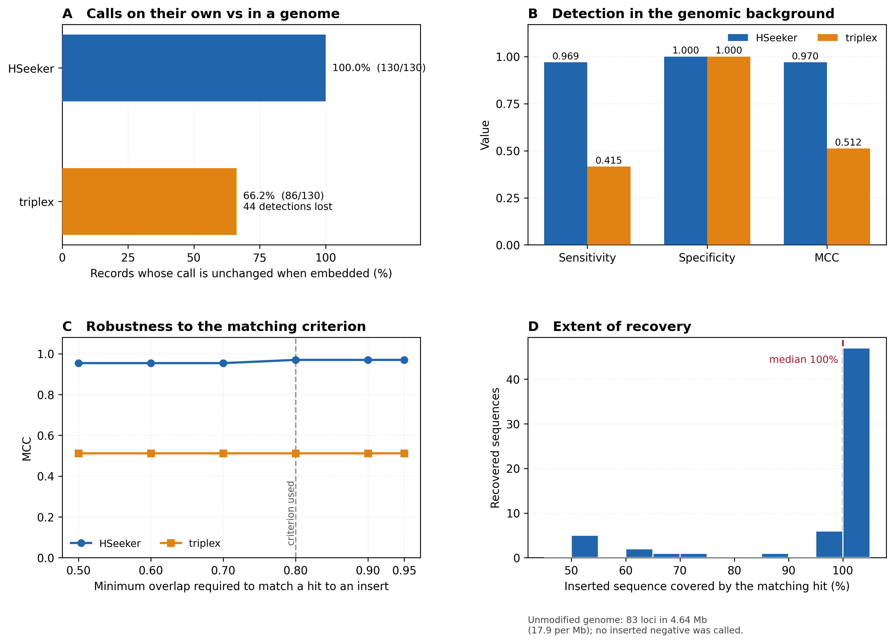
Figure 3: Recovery of benchmark sequences embedded in a genomic background. The 130 benchmark sequences were inserted into the E. coli K-12 MG1655 genome at positions drawn under a fixed random seed, and the modified genome was scanned with HSeeker and with triplex at the settings used throughout. A) Percentage of records for which a tool returns the same call when the sequence is embedded as when it is scanned on its own. B) Detection performance in the genomic background. C) Matthews correlation coefficient as a function of the positional overlap required to match a reported hit to an inserted sequence; the dashed line marks the 0.80 criterion used elsewhere. D) Fraction of each inserted sequence covered by its matching hit, for the sequences HSeeker recovered; the unmodified genome yields 83 loci across 4.64 Mb. This analysis measures recovery and the stability of a call across sequence context; it does not test whether H-DNA forms.
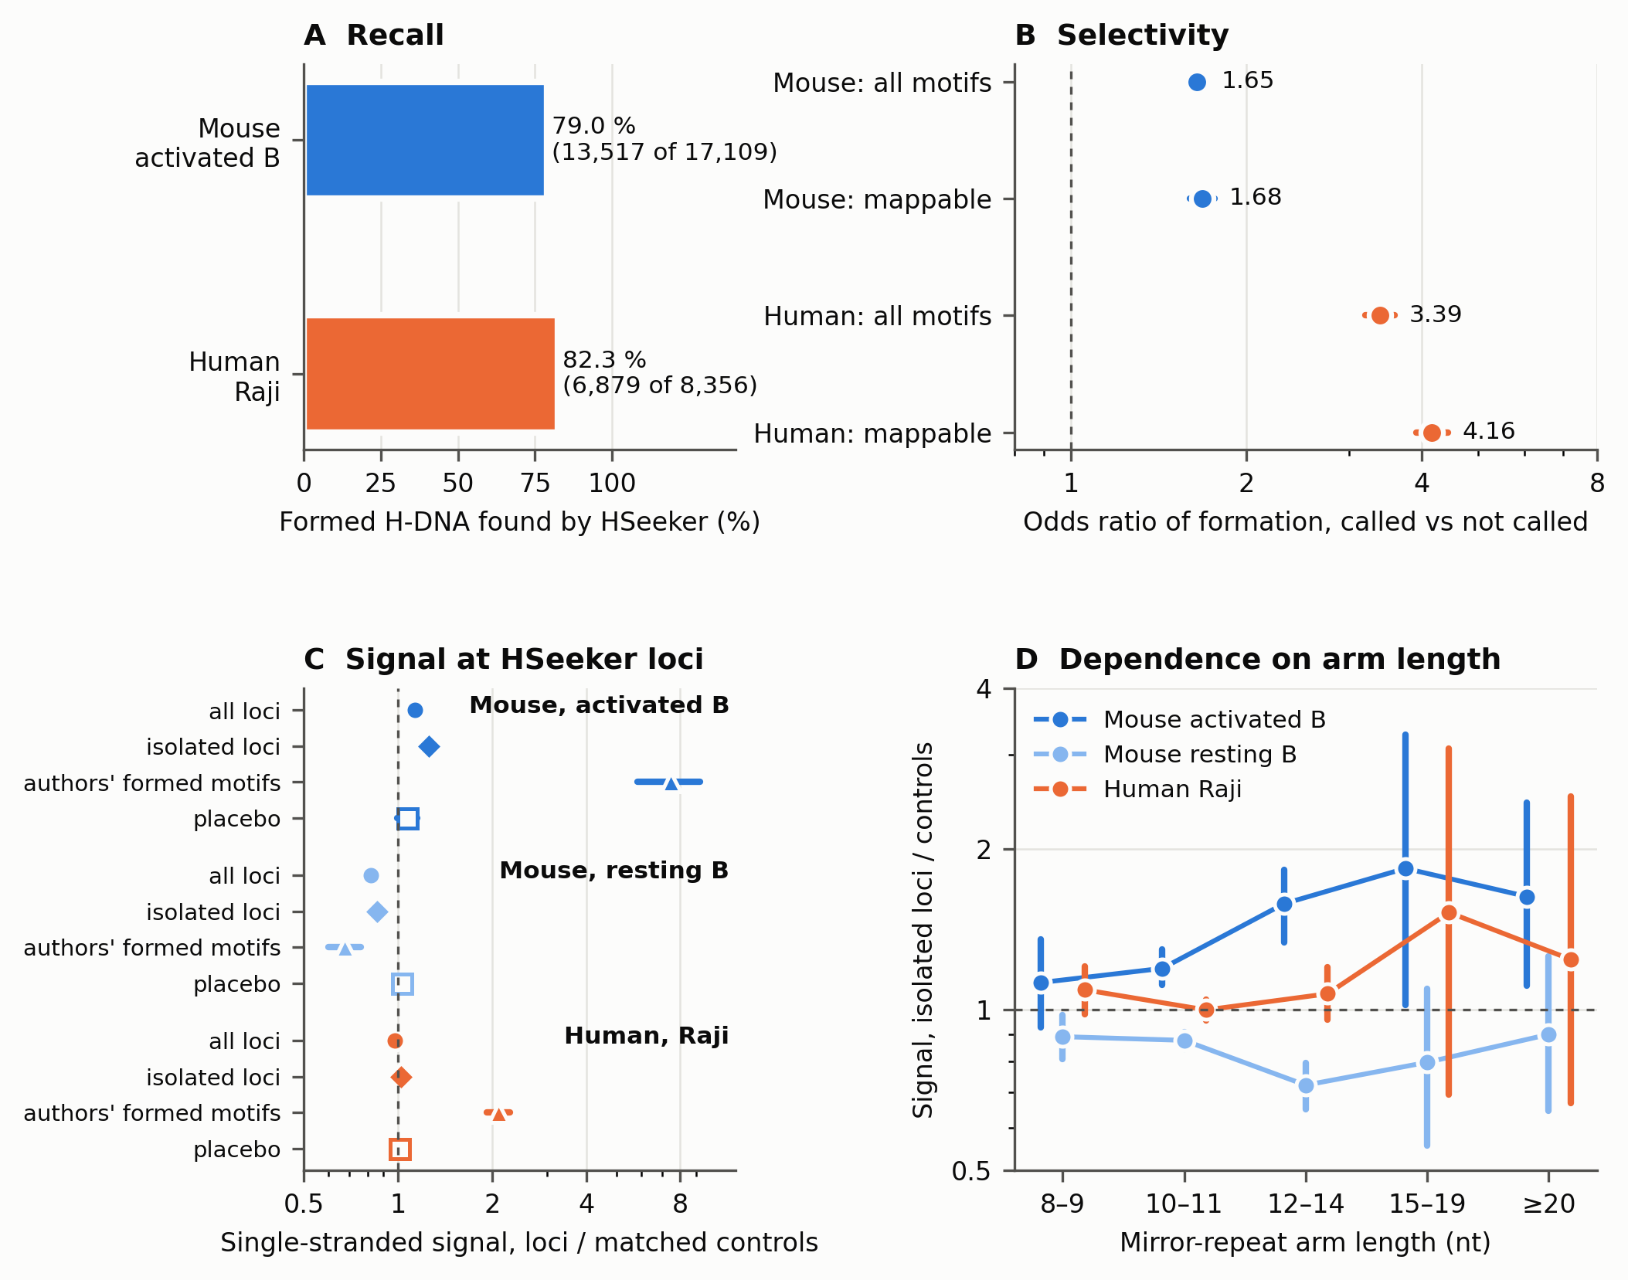
Figure 4: HSeeker predictions compared with single-stranded DNA mapped in cells. HSeeker was run at its default settings on the genome assemblies used by Kouzine and colleagues. A) Recall: the percentage of the H-DNA motifs they found single-stranded that are overlapped by an HSeeker locus, in activated mouse B cells and in human Raji cells. B) Selectivity: the odds ratio that one of their predicted H-DNA motifs is found single-stranded when HSeeker reports it against when it does not, for all analysed motifs and for motifs that 36-nt reads can map to. C) Single-stranded signal at HSeeker loci relative to control windows matched for length, A/T content and purine/pyrimidine asymmetry. All loci uses genome-wide controls; isolated loci restricts loci and controls to mappable sequence more than 100 bp from other predicted non-B motifs and more than 2 kb from annotated transcription start sites, with controls drawn within 50 kb; authors' formed motifs applies the identical procedure to the motifs they called formed; placebo compares one control against the remaining controls of the same locus. D) Isolated loci stratified by mirror-repeat arm length. Points are ratios of mean signal, bars are 95% bootstrap confidence intervals, and the dashed line marks no difference. Scales in B-D are logarithmic.

Command-line interface (CLI) tool and package
HSeeker is freely distributed as an open-source package through PyPI and GitHub and can be used either as a command-line interface tool or as an importable Python library. After installation, users can run HSeeker directly from the terminal to analyze FASTA-formatted input sequences, specify detection parameters, and export putative H-DNA-forming loci for downstream analysis. HSeeker can also be incorporated into custom Python workflows, enabling users to automate analyses, process multiple datasets, or integrate H-DNA detection into larger bioinformatic pipelines. This dual functionality provides flexibility for both standalone use and programmatic applications, supporting users with different levels of computational experience and different analysis needs.

HSeeker web interface
To improve accessibility and facilitate broader use of HSeeker, we developed a single web interface that enables users to identify putative H-DNA-forming sequences without requiring command-line experience. It uses the same scanning library and the same default settings as the command-line tool, so that the two return identical results for identical input. Through the interface, users can submit custom DNA sequences or genomic regions, adjust search parameters, and retrieve annotated putative H-DNA motifs in a user-friendly format. The web platform provides downloadable results for downstream analysis. By lowering technical barriers to H-DNA detection, the HSeeker web interface enables researchers from diverse backgrounds to incorporate non-B DNA annotation into studies of genome organization, gene regulation, genetic instability, disease etiology, and evolution.

The main detection page allows users to either paste FASTA-formatted sequence data into an input box or upload a FASTA file up to 200 MB (Figure 5). The adjustable parameters include minimum and maximum spacer and arm lengths, GA/CT purity threshold in the arms, stability score calculation, and overlap handling. Overlap handling includes either removing overlaps, in which case the sequence with the longest arm is kept, or keeping overlapping H-DNA sequences. Three preset options are also available: i) Strict, ii) Conservative, and iii) Default.

The results page is organized into four tabs that provide complementary views of the putative H-DNA motifs (Figure 5). The Data Table tab reports each candidate site in a sortable and filterable table, including sequence ID, start and end coordinates, arm length, spacer length, total motif length, GA/CT composition, mirror identity, perfect-match status, stability score, and full sequence, with the complete table available for download as a TSV file. The Locus Map tab visualizes the distribution of H-DNA sites across input sequences using sequence-level bar plots, a perfect versus imperfect site summary chart, and a genomic-position locus map in which candidate sites are shown as points scaled or colored by arm length. The Structure tab summarizes motif architecture using arm-length and spacer-length distributions, together with an arm-by-spacer density heatmap that highlights common structural configurations among predicted sites. The Composition tab displays sequence-composition and quality-control plots, including GA versus CT composition profiles, mirror-identity distributions, total stability score distributions, and score-versus-mirror-identity scatter plots, enabling users to assess both compositional purity and predicted structural stability (Figure 5).

Finally, we have included an About page, which provides background information on H-DNA biology, the structural requirements for H-DNA formation, the HSeeker center-outward mirror-repeat extension algorithm, output fields, stability scoring, parameter modes, validation, command-line usage, Python API access, and current limitations. Together, these features make the HSeeker website a user-friendly platform for H-DNA sequence detection, visualization, and interpretation.

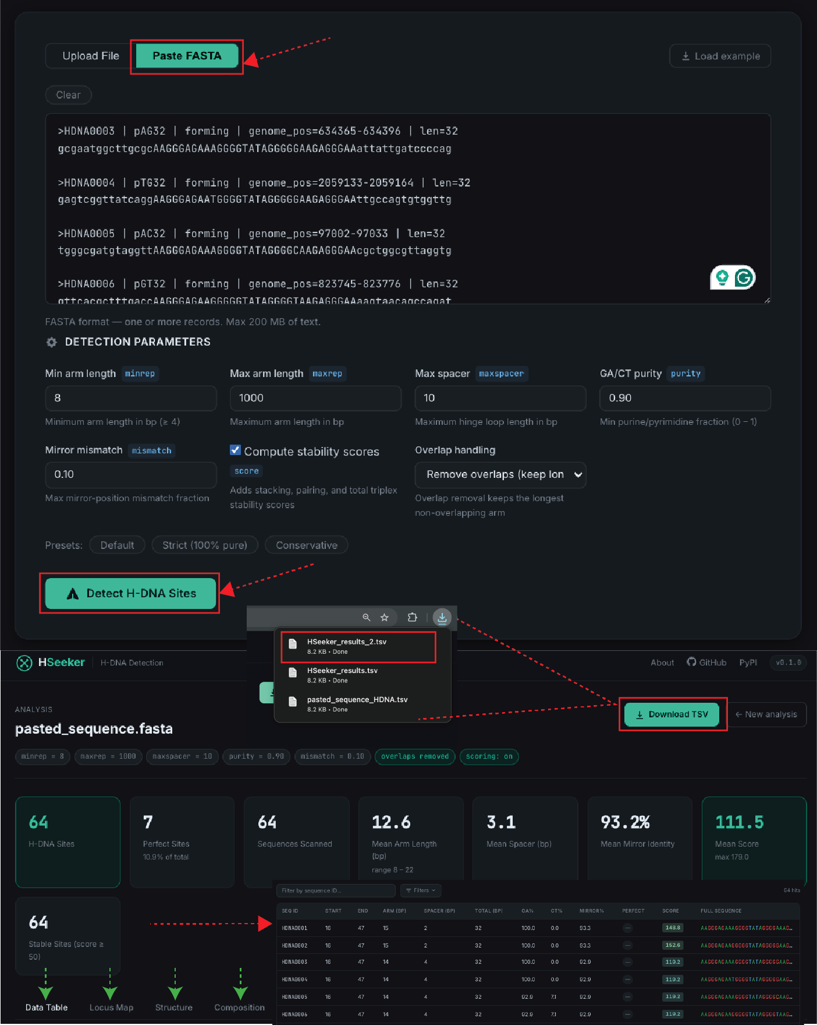

Figure 5: HSeeker web interface. Interface for submitting genomic sequences in FASTA format and configuring job parameters in the HSeeker web app. Detection parameters can be adjusted through the interface, including minimum and maximum arm length, maximum spacer length, GA/CT purity threshold, mirror-mismatch tolerance, stability-score calculation, and overlap handling. After submission, HSeeker reports summary statistics and a full H-DNA sequence table with filtering and dynamic graphs are provided alongside the detection of H-DNA-forming sequences.
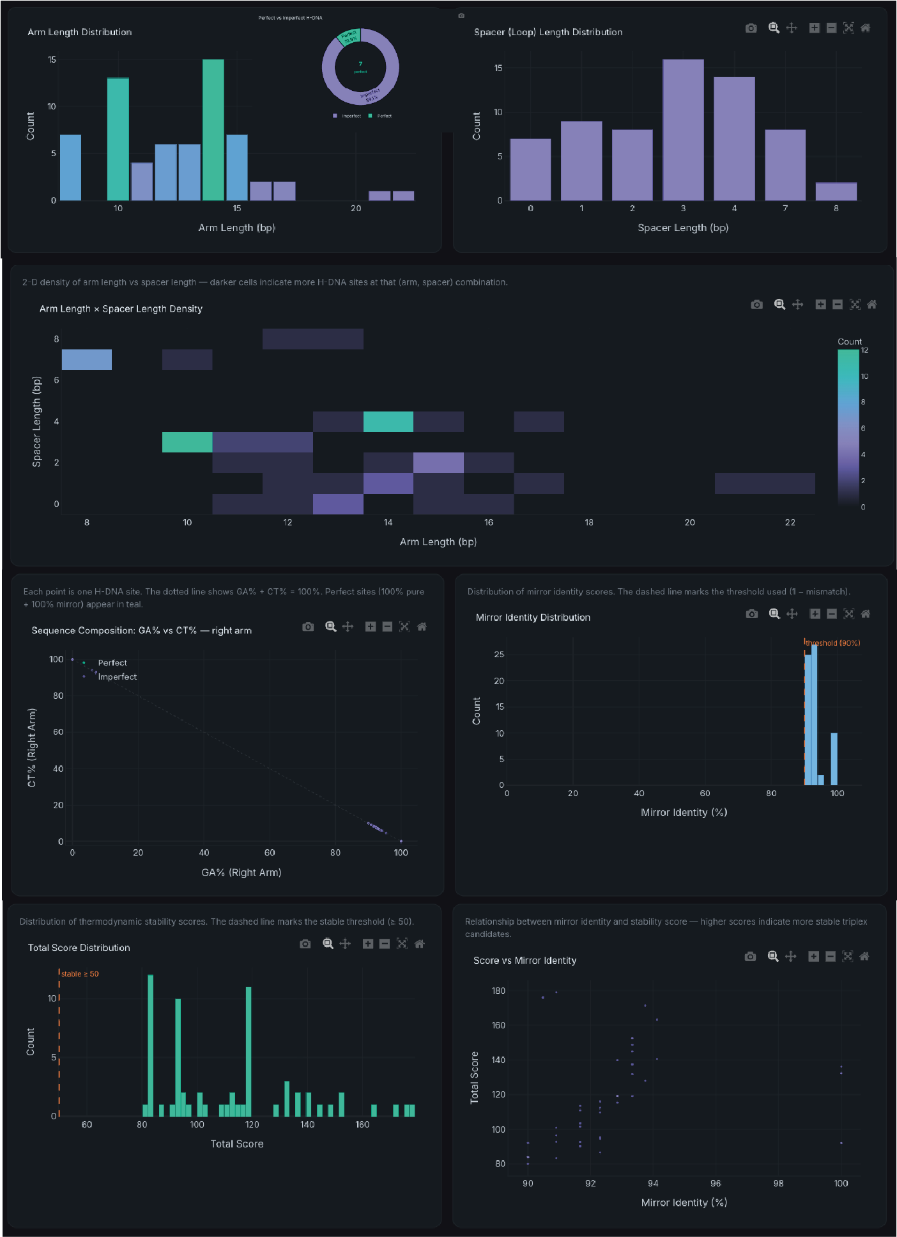
Figure 6: Interactive visualization of predicted H-DNA sequence features in the HSeeker web interface. The interface for H-DNA dynamic graphs enables users to further assess their sequences of interest. An arm-length by spacer-length density heatmap highlights recurrent motif configurations and identifies combinations of arm and spacer lengths that are enriched among the detected candidates. Additional graphs summarize GA-rich and CT-rich arm composition, mirror-identity distributions, total stability-score distributions, and the relationship between stability score and mirror identity.

Discussion
Here, we present a novel software, HSeeker, for the systematic identification of putative H-DNA-forming sequences. HSeeker addresses an important gap in non-B DNA annotation. HSeeker combines a center-outward mirror-repeat search strategy, greedy overlap removal, and stability scoring to move beyond simple mirror-repeat detection. By integrating experimentally supported physical and thermodynamic features of homopurine triplex formation with biologically relevant determinants of H-DNA stability, including homopyrimidine composition, spacer length, mirror mismatches, arm length, Hoogsteen pairing, base stacking, and boundary optimization, HSeeker generates an overall stability score while maintaining high-throughput performance. Thus, HSeeker provides an interpretable and scalable approach for studying H-DNA-forming potential across genomic datasets.

We also performed thorough benchmarking against four existing H-DNA and mirror-repeat detection tools, triplex, Triplexator, NeSSie and nBMST^{21,25}, as well as against experimentally characterized H-DNA-forming and non-forming sequences, demonstrating that HSeeker provides improved detection performance and interpretable stability-based prioritization. The list of positive controls was based on rigorous proof of H-DNA formation, such as structure fine-mapping at a nucleotide level via chemical modifications, tested within a plasmid context (Supplementary Table 1). Another layer of evaluation involved using S1 and P1 nuclease assays, and H-DNA-induced mutagenesis measured in mammalian cells (for the H-DNA-forming sequence from the c-MYC gene)¹². The Stability Scores predicted by HSeeker agreed with these biochemical and genetic findings¹². The stability score ranks candidates in a manner consistent with the biochemical and genetic evidence available for the sequences in our benchmark; it is an experimentally informed heuristic and has not been calibrated against measured thermodynamic quantities.

3plex²⁶ is so far the only other program that has also integrated the biophysical triplex structural features, such as thermal stability information derived from triplex denaturation experiments, into the triplex identification algorithm. But this tool was designed for predicting interactions between single-stranded RNAs and double-stranded DNA regions mediated by intermolecular triple-helix formation, not for intramolecular H-DNA-forming sequences in genomic DNA. Among currently available tools for intramolecular H-DNA, HSeeker is the only one that reports a per-motif stability ranking alongside the detected coordinates, and it achieves high-throughput processing speeds. The center-outward heuristic search algorithm and subsequent greedy overlap removal allow the software to scale linearly with sequence length. HSeeker is optimized for scanning massive inputs with high speed. As demonstrated, it was able to screen the entire human chromosome 1 in approximately 16 seconds, and the complete human genome in 3.4 minutes, using a standard multi-threaded environment. This computational efficiency enables rapid, whole-genome profiling and facilitates broad, cross-species evolutionary comparisons that were previously computationally prohibitive. In addition, HSeeker also provides a user-friendly web interface for easy access, eliminating the technical barriers associated with non-B DNA structural analysis. It allows users to customize the key search parameter, such as the penalty scores for mismatches and the limitations of (Max and Min) spacer and arm lengths between the mirror-symmetric arms, to meet their own project needs.
Limitations. HSeeker has several limitations that bear on how its output should be read. The stability score is an experimentally informed heuristic, not a calculated free energy. It assigns fixed weights to matched G and A positions, a uniform penalty to every other arm pairing, a constant reward to adjacent matched positions and an escalating penalty to runs of disrupted ones, and it then selects the highest-scoring arm window. The underlying interaction and stacking energy parameters are drawn from the ab initio calculations of Park et al., which isolated nucleobase interactions by replacing backbones with hydrogen atoms and left out other factors, such as torsional stress, backbone structural distortions, superhelical stress, pH-dependent protonation, ionic composition, temperature, loop or spacer energetics, or competition with duplex and other non-canonical conformations. It is therefore a relative ranking of candidates within the scheme defined here, and it carries no physical units. We report no score threshold, and a candidate is called on detection alone. The benchmark labels come from assays performed under different conditions, including acidic buffers, Mg2+-containing buffers and negatively supercoiled plasmids. We record those conditions for every record, but a sequence characterised as H-DNA-forming under one set of conditions does not necessarily form the structure under physiological conditions, and the pooled performance figures should be read as discrimination of reported sequence labels across conditions. The composition filters are fixed rules rather than fitted parameters, but they were chosen with knowledge of the H-DNA literature and of the composition of this benchmark, so the benchmark is not an independent test of them. They are not free of cost: the homopolymer filter rejects poly-(dC)-(dG) tracts, which form an Mg2+-dependent triplex28, and the AT-content filter removes a class of motifs that constitutes 17-19% of the H-DNA found to be formed in published single-stranded DNA maps. Finally, HSeeker detects antiparallel, purine-motif H-DNA at mirror repeats. Tandem direct repeats, parallel triplexes requiring cytosine protonation, and intermolecular triplexes are outside its model, and the two forming sequences it misses in our benchmark are direct repeats. Its predictions identify sequences with the potential to adopt H-DNA; they are not evidence that the structure forms at a given locus in vivo.
By systematically mapping these dynamic alternative DNA structures, HSeeker will provide a valuable tool for uncovering the diverse roles of H-DNA in gene regulation and identifying endogenous sources of disease-associated genome instability.
Code availability
The HSeeker package and its Python bindings are released under the GPL license as a multi-platform application and are available at: https://github.com/Georgakopoulos-Soares-lab/HSeeker. A stable version of HSeeker is also found at: https://pypi.org/project/hseeker/. The HSeeker web interface can be found at https://hseeker-production.up.railway.app/.
Data AvailabilityThe benchmark sequences, their provenance and the assay conditions under which each construct was characterised are provided as machine-readable files in the repository and as Supplementary Table 1. Scripts that regenerate every analysis and figure in this work, together with the parameter settings used for each, are provided in the same repository. The human chromosome 1 and hg38 primary assembly sequences used for performance benchmarking were obtained from the UCSC Genome Browser (http://hgdownload.soe.ucsc.edu/downloads.html#human). The E. coli K-12 reference genome used for genomic-context recovery was downloaded from NCBI. The single-stranded DNA maps and non-B DNA motif calls used for the genome-wide comparison are those published by Kouzine and colleagues. Raw benchmark commands, timing output and result files are included in the repository and will be archived in a public repository with a permanent identifier on publication.
Funding
Research reported in this publication was supported by the National Institute of General Medical Sciences [R35GM155468 to I.G.S.] and the National Cancer Institute [R01 CA093729 to K.M.V.].
Conflicts of Interest
The authors declare no competing interests.

Supplementary Figures
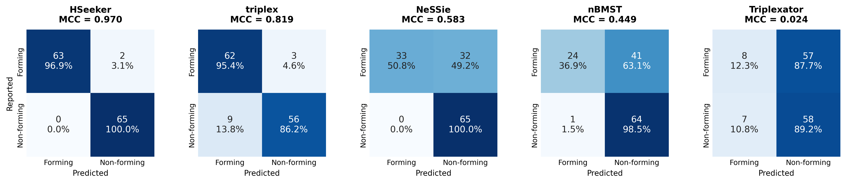
Supplementary Figure 1: Classification of the balanced benchmark by each tool. Confusion matrices for HSeeker and the four comparators on the 130-record benchmark (65 forming, 65 non-forming), each tool at its documented default settings. Cells give the number of records and the percentage of the corresponding reported class. NeSSie is shown for its triplex-potential output and nBMST for the mirror repeats it classifies as triplex-forming.

References
1. Mirkin, S. M. et al. DNA H form requires a homopurine-homopyrimidine mirror repeat. Nature 330, 495–497 (1987).
2. Frank-Kamenetskii, M. D. & Mirkin, S. M. Triplex DNA structures. Annu Rev Biochem 64, 65–95 (1995).
3. Hisey, J. A., Masnovo, C. & Mirkin, S. M. Triplex H-DNA structure: the long and winding road from the discovery to its role in human disease. NAR Mol Med 1, ugae024 (2024).
4. Kouzine, F. et al. Permanganate/S1 Nuclease Footprinting Reveals Non-B DNA Structures with Regulatory Potential across a Mammalian Genome. Cell Syst 4, 344–356.e7 (2017).
5. Jain, A., Wang, G. & Vasquez, K. M. DNA triple helices: biological consequences and therapeutic potential. Biochimie 90, 1117–1130 (2008).
6. Wang, G. & Vasquez, K. M. Impact of alternative DNA structures on DNA damage, DNA repair, and genetic instability. DNA Repair (Amst) 19, 143–151 (2014).
7. Kaushik Tiwari, M., Adaku, N., Peart, N. & Rogers, F. A. Triplex structures induce DNA double strand breaks via replication fork collapse in NER deficient cells. Nucleic Acids Res 44, 7742–7754 (2016).
8. Wang, G. & Vasquez, K. M. Effects of Replication and Transcription on DNA Structure-Related Genetic Instability. Genes (Basel) 8, (2017).
9. Zhao, J., Bacolla, A., Wang, G. & Vasquez, K. M. Non-B DNA structure-induced genetic instability and evolution. Cell Mol Life Sci 67, 43–62 (2010).
10. Wang, G. & Vasquez, K. M. Dynamic alternative DNA structures in biology and disease. Nat Rev Genet 24, 211–234 (2023).
11. Bochalis, E. et al. Non-B DNA structures and their contributions to genetic diversity, aging, and disease. Nucleic Acids Res 54, (2026).
12. Wang, G. & Vasquez, K. M. Naturally occurring H-DNA-forming sequences are mutagenic in mammalian cells. Proc Natl Acad Sci U S A 101, 13448–13453 (2004).
13. Wang, G., Carbajal, S., Vijg, J., DiGiovanni, J. & Vasquez, K. M. DNA structure-induced genomic instability in vivo. J Natl Cancer Inst 100, 1815–1817 (2008).
14. Georgakopoulos-Soares, I. et al. High-throughput characterization of the role of non-B DNA motifs on promoter function. Cell Genom 2, (2022).
15. Bacolla, A., Tainer, J. A., Vasquez, K. M. & Cooper, D. N. Translocation and deletion breakpoints in cancer genomes are associated with potential non-B DNA-forming sequences. Nucleic Acids Res 44, 5673–5688 (2016).
16. Georgakopoulos-Soares, I., Morganella, S., Jain, N., Hemberg, M. & Nik-Zainal, S. Noncanonical secondary structures arising from non-B DNA motifs are determinants of mutagenesis. Genome Res 28, 1264–1271 (2018).
17. Belotserkovskii, B. P. et al. A triplex-forming sequence from the human c-MYC promoter interferes with DNA transcription. J Biol Chem 282, 32433–32441 (2007).
18. Kinniburgh, A. J. A cis-acting transcription element of the c-myc gene can assume an H-DNA conformation. Nucleic Acids Res 17, 7771–7778 (1989).
19. Del Mundo, I. M. A., Zewail-Foote, M., Kerwin, S. M. & Vasquez, K. M. Alternative DNA structure formation in the mutagenic human c-MYC promoter. Nucleic Acids Res 45, 4929–4943 (2017).
20. Schroth, G. P. & Ho, P. S. Occurrence of potential cruciform and H-DNA forming sequences in genomic DNA. Nucleic Acids Res 23, 1977–1983 (1995).
21. Lexa, M., Martínek, T., Burgetová, I., Kopeček, D. & Brázdová, M. A dynamic programming algorithm for identification of triplex-forming sequences. Bioinformatics 27, 2510–2517 (2011).
22. Cer, R. Z. et al. Non-B DB v2.0: a database of predicted non-B DNA-forming motifs and its associated tools. Nucleic Acids Res 41, D94–D100 (2013).
23. Cer, R. Z. et al. Searching for non-B DNA-forming motifs using nBMST (non-B DNA motif search tool). Curr Protoc Hum Genet Chapter 18, Unit 18.7.1–22 (2012).
24. Berselli, M., Lavezzo, E. & Toppo, S. NeSSie: a tool for the identification of approximate DNA sequence symmetries. Bioinformatics 34, 2503–2505 (2018).
25. Buske, F. A., Bauer, D. C., Mattick, J. S. & Bailey, T. L. Triplexator: detecting nucleic acid triple helices in genomic and transcriptomic data. Genome Res 22, 1372–1381 (2012).
26. Masera, M., Cicconetti, C., Ferrero, F., Oliviero, S. & Molineris, I. 3plex Web: An interactive platform for RNA:DNA triplex prediction and analysis. Comput Struct Biotechnol J 27, 3110–3113 (2025).
27. Park, G., Kang, B., Park, S. V., Lee, D. & Oh, S. S. A unified computational view of DNA duplex, triplex, quadruplex and their donor-acceptor interactions. Nucleic Acids Res 49, 4919–4933 (2021).
28.Kohwi, Y. & Kohwi-Shigematsu, T. Magnesium ion-dependent triple-helix structure formed by homopurine-homopyrimidine sequences in supercoiled plasmid DNA. Proc Natl Acad Sci U S A 85, 3781-3785 (1988).

