SID 1835651

Fighter Jet Catalogue

Please make sure JavaScript is enabled otherwise the header, footer and output message via the form will not work.

Synopsis

This website is a catalogue / brochure of currently in service and retired aircraft. It allows you to browse a small selection of fighter jets and get the jets statistics. You can also use the online form to send message to our team. For example, “Can we request the tornado jet to be added to the site?” or “Can you get a hard copy brochure?”.

Bibliography

./ root/html/reference.html

Navigation map

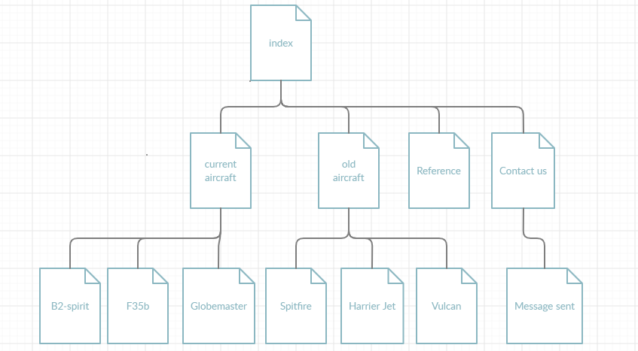

Old Home page design

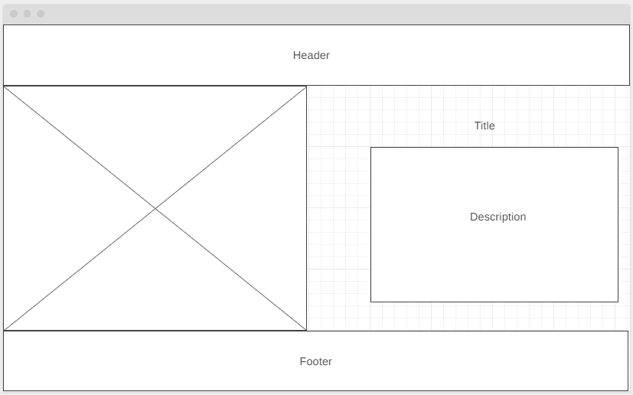

Final design

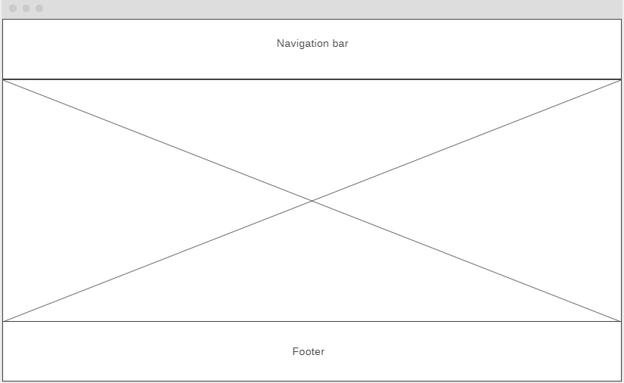

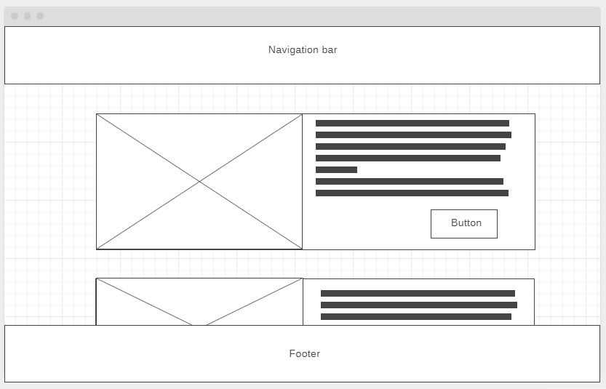

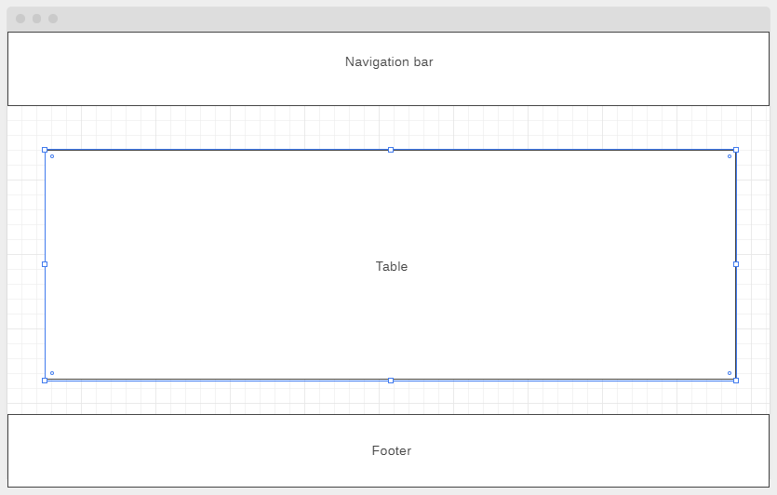

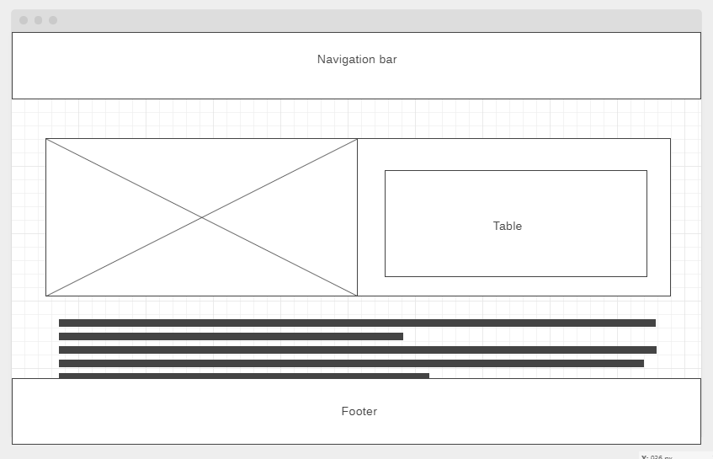

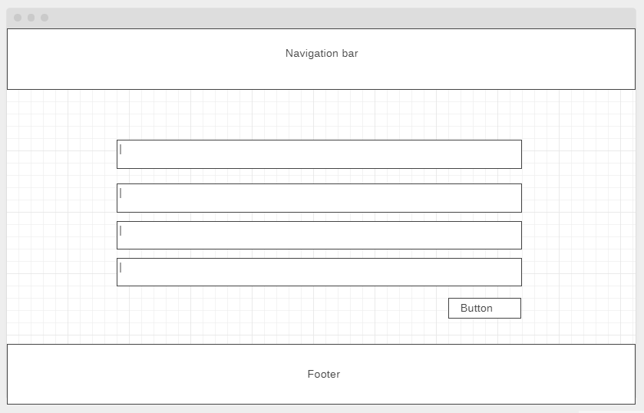

References can be found on the website site.