**1, Login & Registration Page**

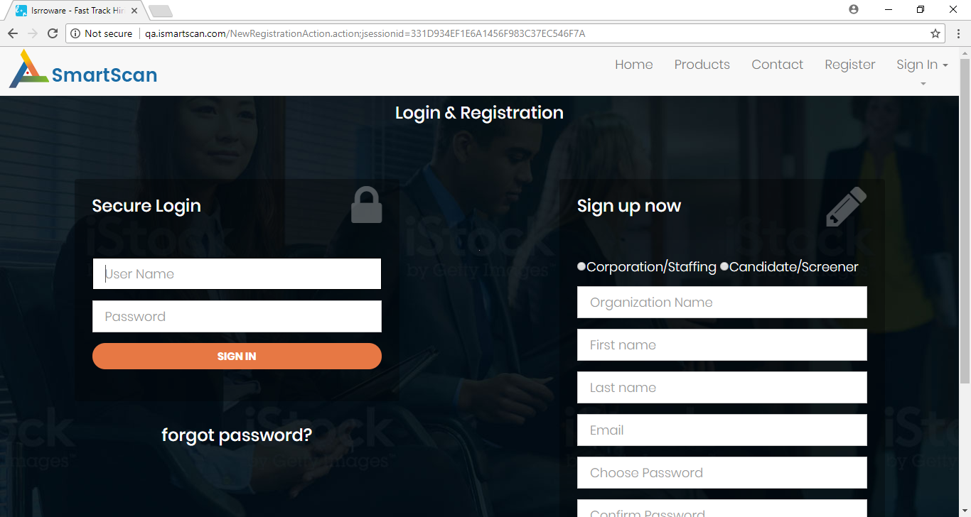

* 1. Move the radio button(Corporation/staffing) up so that text boxes will be aligned according to secure login grid.
  2. Sign in /Sign up buttons are big, resize the buttons.
  3. Sign in /Sign up buttons having unique colors, colors should be organized throughout SmartScan App.
  4. Captions for buttons are in uppercase it should be in lower case except for the first letter.
  5. Email validation is not done.

**2, Sign up Process**

Once email is generated, it would be good to include candidate’s first/last name after “Hello” in the email body.

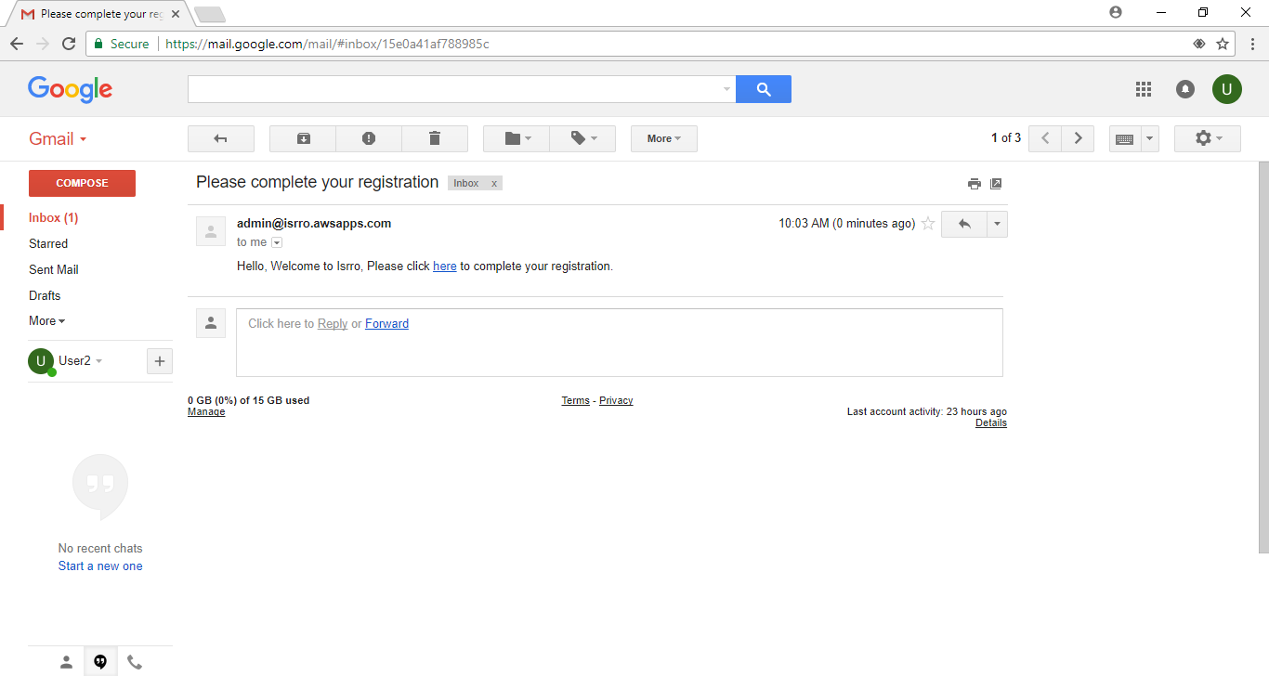

**3, Password Reset Page**

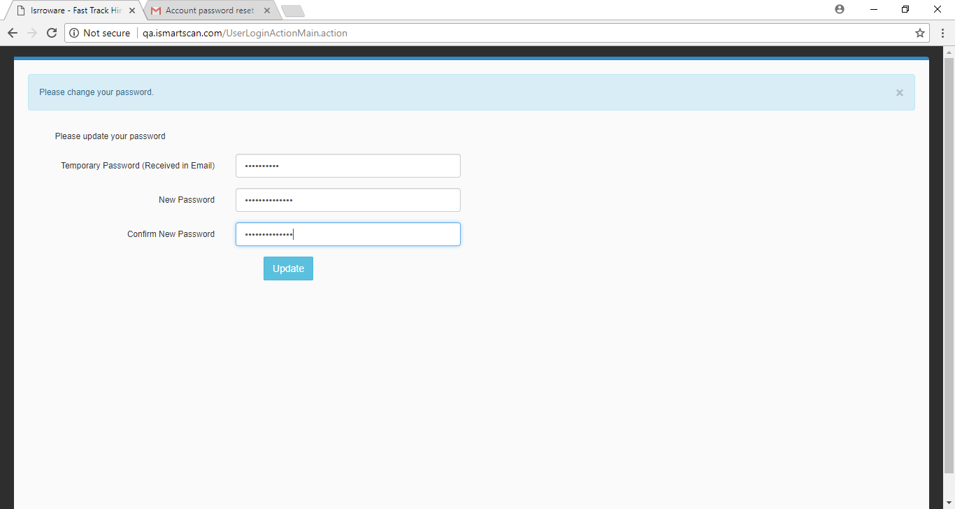

3.1 Position of the “Update button” is not center to the Text Box above.

3.2 After updating the password, no message is displayed like password updated, directly takes you the home screen but email is triggered regarding password change.

4**, Candidate’s Home Screen**

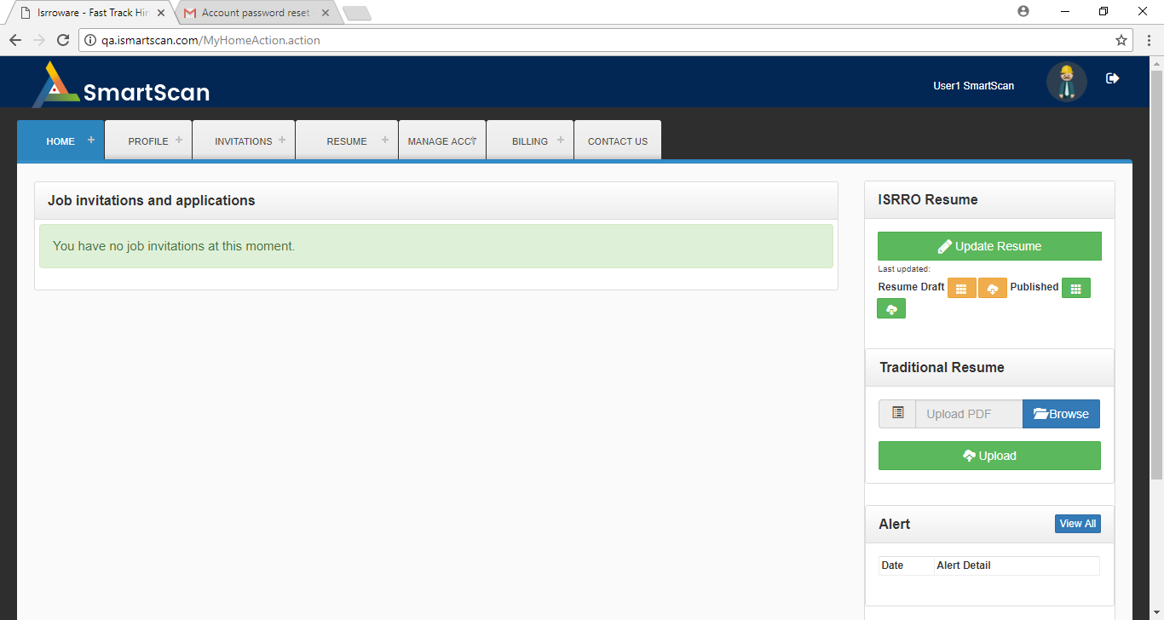

4.1 Menu names should be in upper\lower case.

4.2 Selection of the menu should be highlighted.

5, **Traditional Resume**

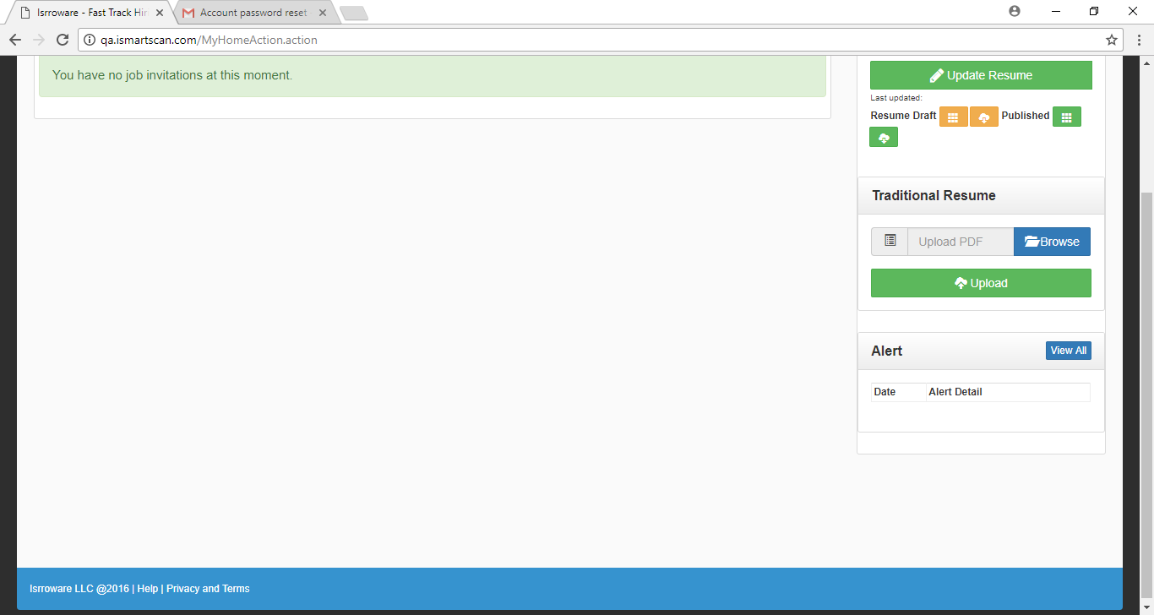

5.1 Upload textbox caption should be changed.

5.2 By default the browse window points to “Adobe Acrobat Document” for the file selection it should be changed.

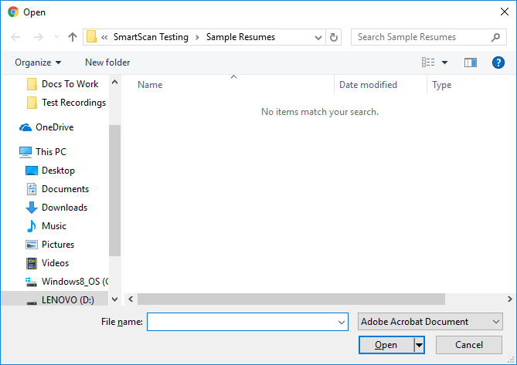

**6, Update Resume Page**

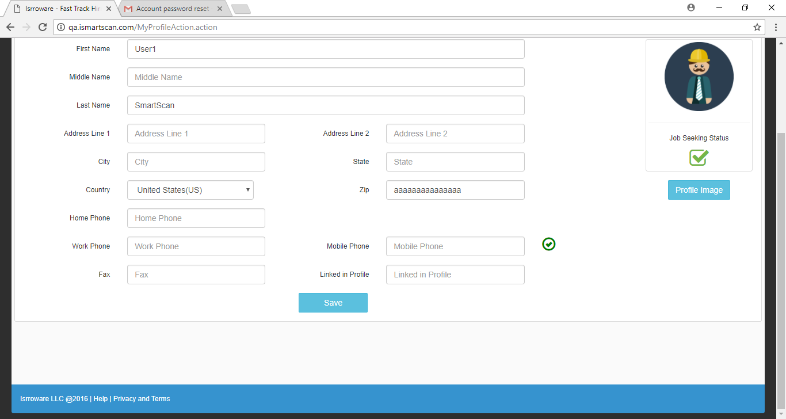

6.1 After the click on “Save” button of “Update Profile” page is not moving or shifting to the earlier screen(Resume Home Page).

6.2 Zip Code validation.

6.3 All Phone number fields accept characters.

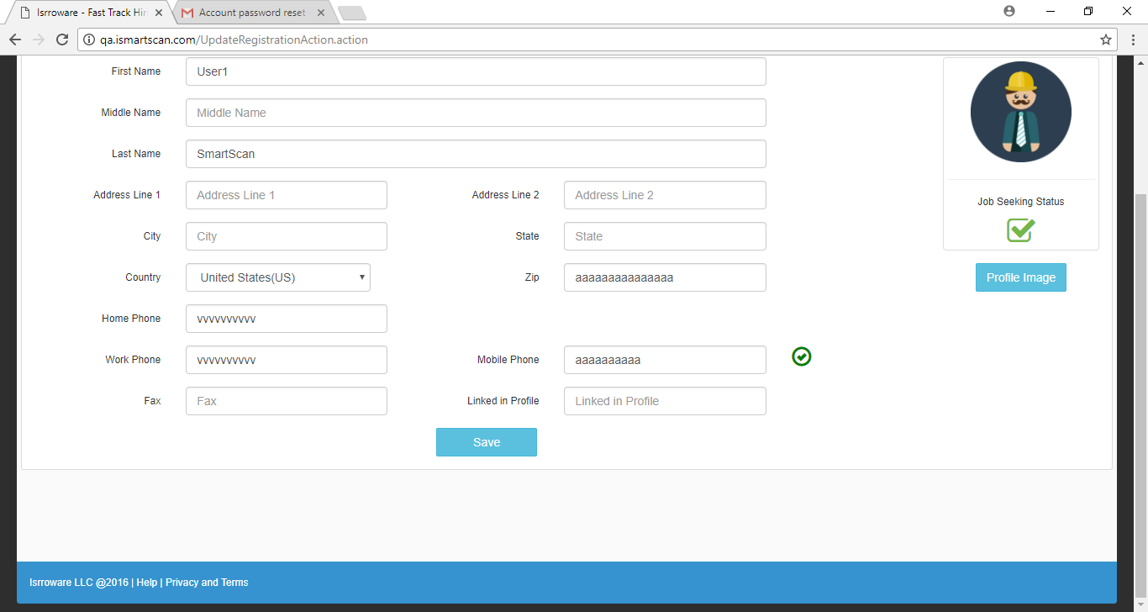

**7, Resume Update Page**

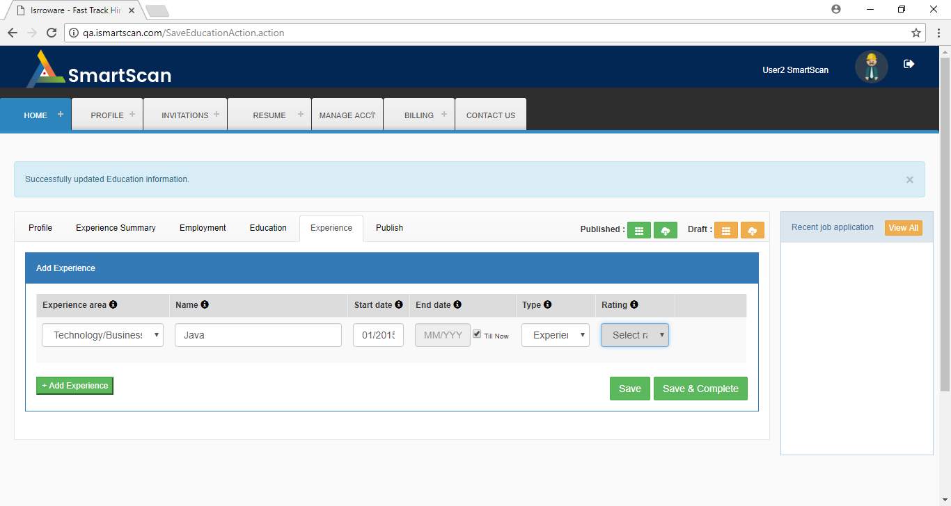

7.1 Type = Experience, “Rating” dropdown selection box should be deactivated.

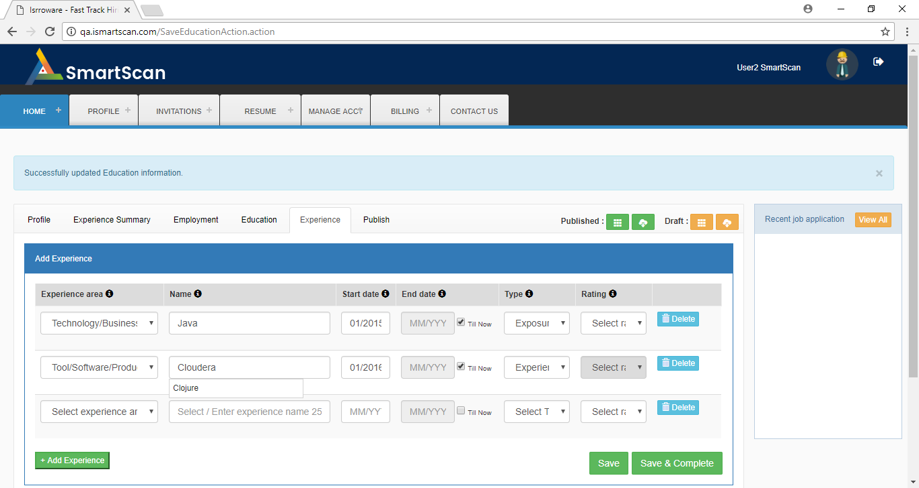

7.2 Content from the drop down menu has not been cleared.

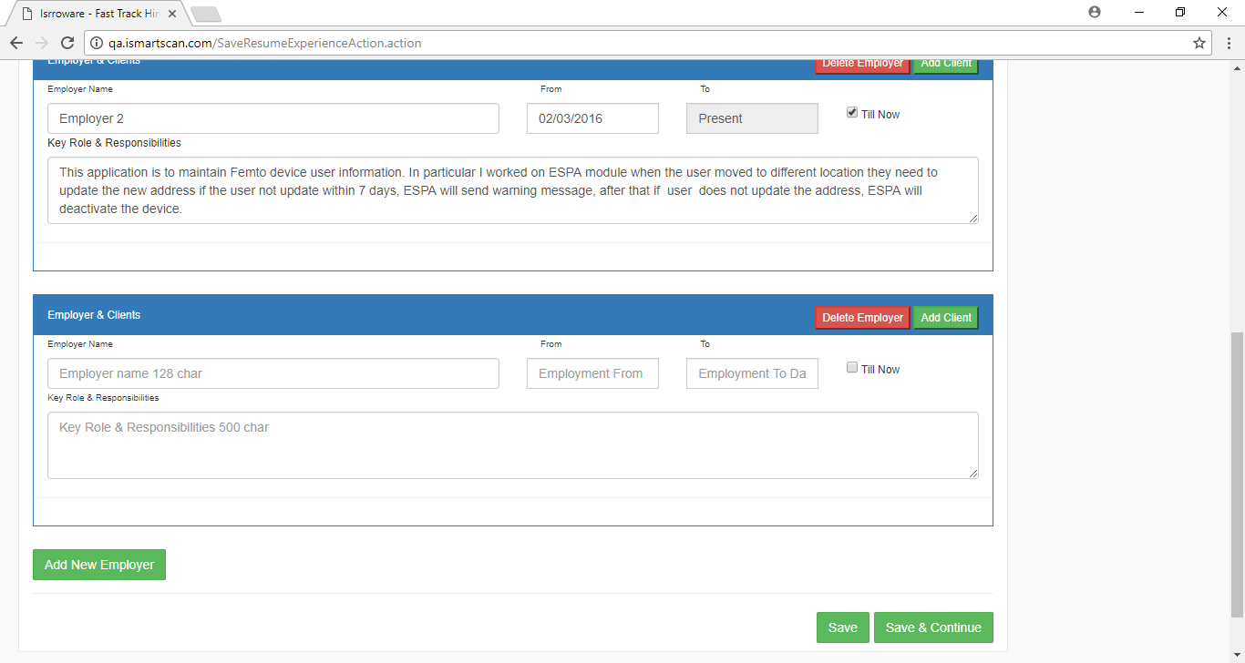

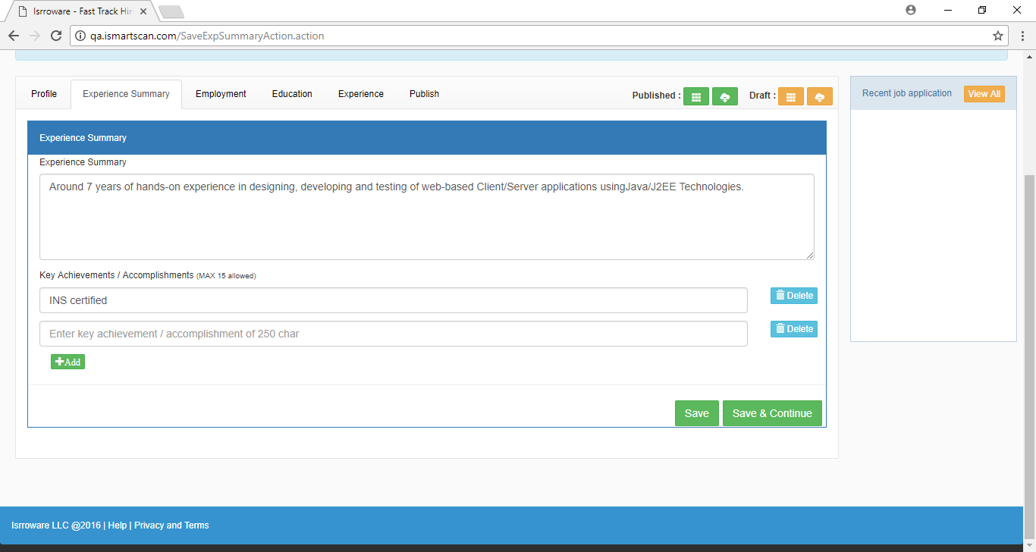

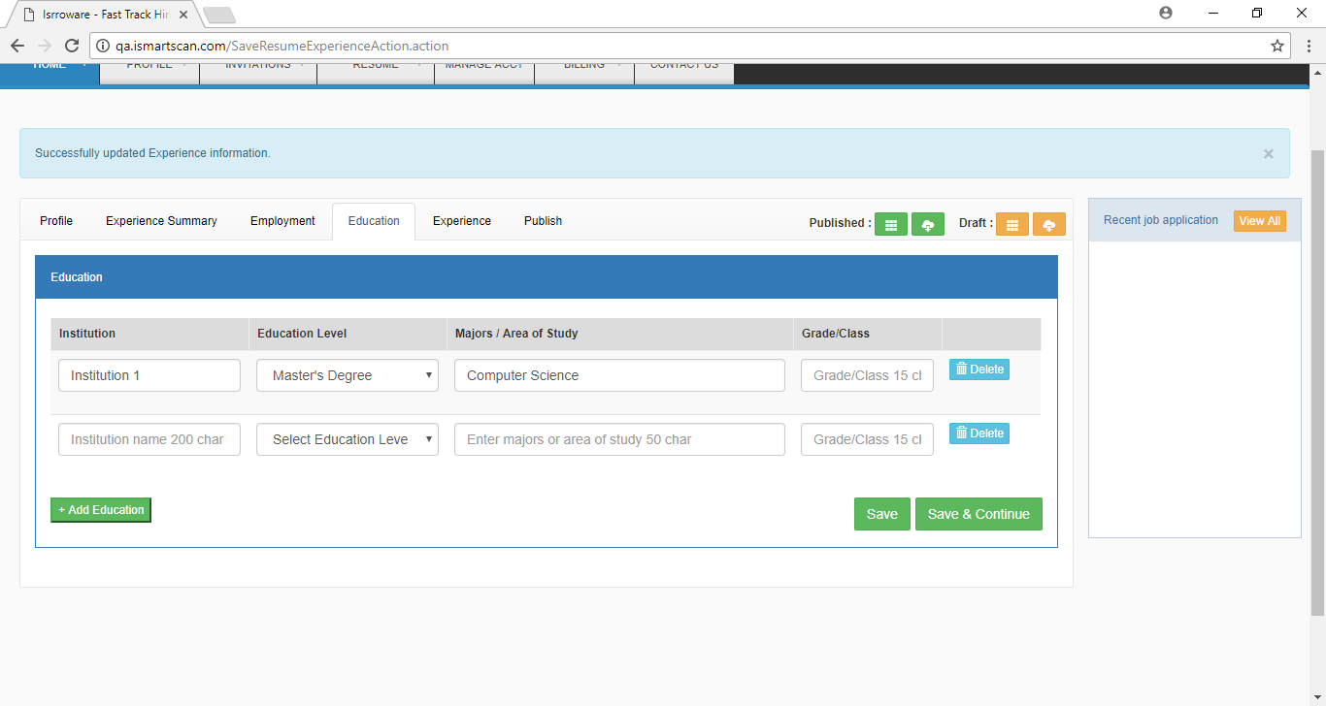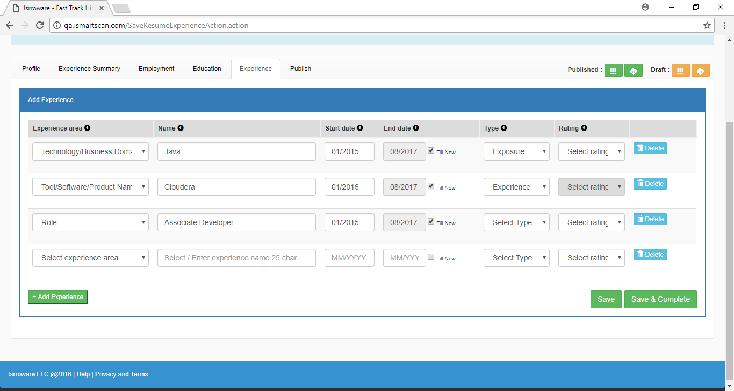

7.3 Experience Summary, Employment, Education, Experience pages have additional row of empty data when we click on “Save” button or if we revisit the pages.

**8, Corporation Screen**

**8.1 Job Creation Page**

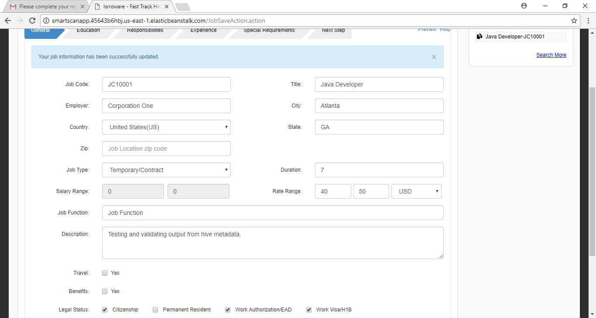

8.1 By default the “Citizenship” checkbox selected.