**Different forms of Prototyping (P1)-**

Concept Prototype. Concept prototype is a prototype that is designed and built within the early stages of a project, they are designed to effectively convey what the developer’s idea of the product should look like. Additionally, it is used to show how the user will interact with the product, how it will function and to give the developers a better idea, if the product they’re producing makes sense and is what the client wants. Finally, it is used to go into more detail about things such as the scope from a business perspective. These types of prototypes again are built to make sure the developers have a clear picture as to what the product is going to turn out like. Finally, Concept prototypes can be built simply on paper or on a computer program.

Horizontal Prototype. These prototypes are prototypes built on the smaller things of the product such as the menus, input boxes, output boxes and the interfaces. These kinds of prototypes only show off things that the user will see while using the product for example the UI. Within this type of prototype developers do not need to specify technical details about the product but it is always a good idea when prototyping something to explain how everything work with the prototype.

Feasibility Prototype. A feasibility prototype is a prototype that irons out things such as the end goal, challenges of the project and tasks; and focuses on finding out whether these objectives are realistically achievable. This type of prototype is essential as it gives the developers an idea, into whether the project will meet the business needs. Finally, the feasibility prototype generally focuses on the technical side of the project and checking to see if all technical assets work properly, work together and to give the developers the peace of mind their project is going in the right direction; because if one or even more technical parts don’t work the project is not going to be able to progress to the next step.

**Different forms of Prototyping software (P2)**

Pigendo is prototyping software application than can be downloaded onto your computer. It supports Windows, Mac and Linux and is a free to use software. The fact that it is a free prototyping software is a huge benefit for developers that are either strapped for cash or would rather put their funds into other side of the project. This software is generally used for creating web prototypes which it is perfect for as it is very intuitive, easy to build within and everything is clearly laid out and labelled so even the newest of developers won’t have a difficult time using it; but not every project will need to have a web prototype built so it may to be the right software to use for every project.

Proto.io is an exceptional prototype tool to use if your company, developer group has some money to splash on a prototype software tool. It is a high-fidelity tool which means you know all the prototypes you produce are going to be highly detailed and very professional. It can create highly detailed and sometimes even interactive prototypes. It is used to create prototypes that can look extremely close to the finished idea you have of your project/product. Unlike Pigendo it is used for more than just web prototypes and can be downloaded onto your computer if it is a Windows or Mac OS X system. Additionally, the fact it can become so close to the finishing product helps you show the client exactly what you have envisioned for this project. The price of the most common subscription is $24 a month which allows you to have 1 user per subscription with an additional 5 projects at any given time and the most expensive subscription allows 10 users with 30 projects open at once.

The last software I am going to speak about is one called Balsamiq. This tool is available on the web or as a downloaded app; it has the ability to make low-fidelity prototypes or web frames. Additionally, it is a very well-equipped application like Pigendo and gives users the options between several templates for several devices, giving you the option to easily create wireframes and prototypes effectively and efficiently for any given project. Unlike Pigendo Balsamiq is not free and comes with a big price tag if you’re doing a solo project but if you’re within a company it may seem an easy price for a perfect prototype. It is $9 a month or you can choose to pay annually for $89.

**End User Categorisations (P3)**

Expert. This name is quite self-explanatory, and it describes the users that have an extremely good grasp on the computing world but more specifically the technical side of your application. Testing with expert users is a lot easier when it comes to testing, as you don’t have to explain much to the user what’s going on and how to use the device/program as they already have a vast amount of knowledge on technology and should be relatively straight forward for them. Additionally, if an expert user is using your application and trying to test it and pop ups or help boxes appear on the screen they may become bored or frustrated which will drive them away from testing your product. Lastly, when it comes to using experts to test or use your product/application, it is essential to include keyboard shortcuts as much as you can, as experts will always use shortcuts to get from one screen to another or to move around an application faster. It is not necessary to add shortcuts to an application but when dealing with an expert for their enjoyment and protocols it is good to add shortcuts to help them help you test your application.

Knowledgeable. Like an expert user a knowledgeable user will have a good understanding about technology and your application but will still need guidance when it comes to the harder tasks involved with your application. It is safe to say you will not need to add many if any shortcuts as knowledgably user have a good understanding but tend not to use many shortcuts. Additionally, they will need some feedback and help when it comes to the more difficult tasks but will be fine when it comes to the simpler tasks. However, it is important to not overwhelm the user with feedback and help as this will make them feel like a novice user as this can drive a lot of knowledgeable users away when they feel undermined.

Novice. As the name states this user will have little to no understanding about your application or the technical world in general. When creating a product that novice users will use it is crucial to include lots of clear feedback and help to make sure the user knows what they should be doing and how to do it. Additionally, when it comes to the feedback try to keep it as simple as possible and especially clear, so the user can understand the language and instructions you are giving them. When it comes to feedback and instructions it is important to make sure they aren’t getting stuck and overwhelmed as this may cause them to leave is they are getting stressed and are not moving forward with the tasks.

Disability. This type of user will have some sort of physical or mental disability and this will need to be taken into consideration when it comes to them using your application. When designing a product, it is important to make sure everyone including disabled people can access and use your product with ease (or at least most people). Some disabilities that may cause the user not to use the product could be a colour-blind defect which would mean you would have to implement a feature that would allow colour blind users to read and see text or certain colours. Additionally, another type of impairment that someone may have which is not classed as a disability but will make them struggle to use the application would be short sited. If all the words and sentences on your application/design are small the user is not going to be able to read any of them, so you need to make sure the words are a good size so that everyone has a good chance of reading them; or give users an option to increase or decrease the size of letters. Finally, depending on the impairment users will need a good amount of feedback, as someone can have an impairment but still be an expert, so depending on the disability it will vary in amounts of feedback. To combat this at the start of the test or session ask the user which category they would put themselves in and then select the type of feedback they will need, such as a lot, some feedback, or none.

**Disabled prototype methods. (P4)**

As mentioned earlier when someone comes under the disability category it will mean they have some sort of impairment which may stop them from using your application in the conventional way or at all. You would need to implement different ways for a user like this to be able to successfully use your prototype. A genius way (depending on what type of prototype you are dealing with) would be a Lego build of the prototype with labels on pieces that tell them what each one is and additionally, you can make a help sheet that would explain what each piece does and where it goes which would be a great way for someone with an impairment to understand what’s going on. With someone’s help of course, just to steer them in the right direction.

Another method that can be used to help/guide disabled users using your prototype would be diagrams. These types of users will love drawing as it engages them and lets their hands draw whatever they want. Building a paper prototype with labels, explanations and then maybe asking them to try recreating the drawing themselves would be an excellent way to engage the user and to help them understand what the application is. (depending on the disability users may need more help than others). Certain users may acquire headaches from staring at a screen for too long so prototypes like these are a great way of stopping these scenarios from occurring. Additionally, these prototypes are extremely cheap for the company saving them money. Finally, at the end of the session you can sit down with the user and give them a questionnaire that ask questions about the prototype to see if they learnt anything or if they have any questions they would like to ask you. Methods like these make people with an impairment feel normal, as they are still testing a prototype and giving user feedback to the developers just like any other tester.

**Tools to create prototypes. (P5)**

Iam going to be presenting my prototypes I did for the API I created. This API was created so anyone could type in a name of any NPC or character from the Halo universe and it would come up with a picture and a description of that character.

The first tool I am going to speak about is Draw.io I used this to make most of my prototypes as it is an easy to use tool with lots of options that help a user create the perfect prototype. Additionally, is it free giving me no cost what so ever all I needed to do was create an account which I could then save and load my prototypes either from my OneDrive, USB or the computer I was on. This is an incredibly Low fidelity prototype that shows the kind of design I am going for when it came to my prototypes.

This was my first prototype (prototype 1) for my API and as you can see I have the name and the faction/race box that contain the basic details about the character; but is not very nice to look at and does not contain anything of use apart from the name and faction of the character.

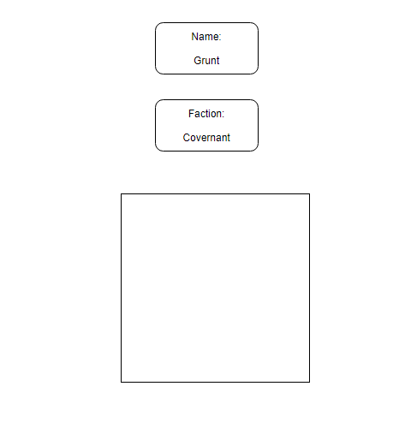

This is prototype 2 I have of my API and it is the point I changed the design of the boxes and added the picture of the character that is being searched. Additionally, it has a brief description about the character below the picture. In the future I would hope to have colour to make the API look more appealing; and I have changed the design of the whole API to make it look better.

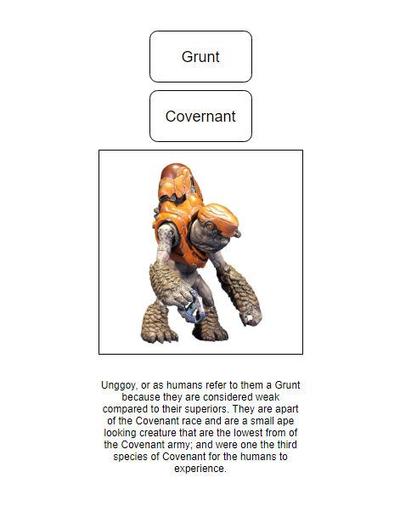

Finally, here we have my High-fidelity prototype (prototype 3) I have added a background to give it a more professional look and have added more text to have it go into more description about the character. Changed the style and have added in general more detail to make my design look presentable. This is how I envision my API to look at the end of my project. Additionally, I used word to add some colour and the style, I chose word as it is an easy tool to use which can hold text, images and has hundreds of design options. Inconclusion, Draw.io and word were perfect for me to use as they’re both free and easy for me to use and create prototypes in.

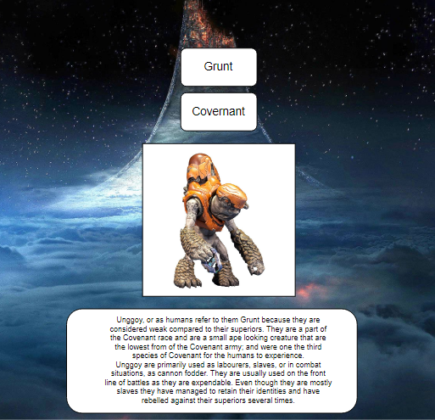

**End user tests and experiments (P6 & P7)**

To test my API I asked 5 friends to test certain parts of my API, I would give them a copy of my API and ask them to complete a task, the first being When searching for someone does it come up with that characters profile? is the information about said character correct? and does the picture of the character load at the same time as the text? These are the tests I gave out to 5 friends and asked them to complete these tests and give me feedback. Here are my results In form of a table.

|  |  |  |  |  |
| --- | --- | --- | --- | --- |
| Name of tester | Test | Expected outcome | Real outcome | Feedback |
| Mark Biswell | When searching for someone does it come up with that character’s profile? | It should show the correct profile for the character you typed in. | It showed Mark the correct profile he searched for | “after searching for Cortana, it showed the profile of Cortana, which is what I wanted” |
| Luke Shead | Is the information about said character correct? | The information displayed on the profile should be correct. | It showed the correct information about the Flood, but the photo was wrong. | “I searched for the Flood and the information was correct, but the picture did not seem to be of the flood, so seems to be bugged” |
| Kieron Haughton | Does the picture of the character load at the same time as the text? | It should show the correct profile for the character you typed in. | It loaded with the text but was slightly delayed | “After searching for the Covenant, the text came up instantly, but the photo was delayed by half a second” |
| Sam Dearing | When searching for someone does it come up with that character’s profile? | The information displayed on the profile should be correct. | Again, it showed the correct profile he searched for | “After searching for Master Chief it popped up with his profile” |
| Joe Williams | Is the information about said character correct? | The information displayed on the profile should be correct. | The information was correct | “ I searched for the marines and it came up with the correct information about the marines” |

**Evaluating and analysing the feedback (P6 & P7)**

I will now evaluate and analyse the feedback I was given by my friends I will look at what I can do to fix this issue or sign off that a certain part of my API is working fine. These tests were all done with prototype 3.

The question/test was When searching for someone does it come up with that character’s profile? After completing this test Mark Biswell said this “after searching for Cortana, it showed the profile of Cortana, which is what I wanted” as well as Sam Dearing saying, “After searching for Master Chief it popped up with his profile”. These feedbacks prove that the searching function and the profile function bring up the correct profile when users search for it. Meaning I do not have to change the search function or profile function.

Now onto the second question Is the information about said character correct? Luke Shead gave me this feedback “I searched for the Flood and the information was correct, but the picture did not seem to be of the flood, so seems to be bugged” as well as Joe Williams saying, “I searched for the marines and it came up with the correct information about the marines”. This tells me the information about the characters are correct but there is a bug where occasionally it will bring up the wrong picture, this means I will have to alter the code for the picture to make sure it brings up the correct image.

The third question/test was Does the picture of the character load at the same time as the text? and Kieron Haughton said this “After searching for the Covenant, the text came up instantly, but the photo was delayed by half a second”. This means I will have to change the code and the image function to make sure they are all popping up at the same time. As the text is all popping up fast at the same time I won’t have to touch the text just change the image, so it pops up in time with the text.

I then decided to go back to prototype 2 and try these tests again to see how much my API had improved. I decided not to create a table but ask them to repeat the tests and give me feedback. Firstly, we have the first test When searching for someone does it come up with that character’s profile? Again, Mark Biswell said this “after searching for Cortana, it showed the profile of Cortana just like the first time” as well as Sam Dearing saying, “After searching for Master Chief it gave me his profile again”. This feedback is saying that the search/profile function was working within prototype 2 as well. This backs up the idea that the search/profile function works.

Secondly, we had the question Is the information about said character correct? and I asked the users to repeat their test a second time and Luke Shead said “I searched for the Flood the information was correct but they was not much of it, and this time the picture was correct” well as Joe Williams again saying “I searched for the marines and it came up with the correct information”. The first test with Luke the image was wrong but the text was right then within the second test the image was correct as well as the text so something must have gone wrong between prototype 2 and 3, which caused the image system to start to glitch out. Backing up what I said on the test on prototype 3 I will need to look closer at the image system and make sure it is working correctly. Again, Joe’s test said the information was correct which further backs up the information function is fine and does not need to be touched right now.

The third question/test was Does the picture of the character load at the same time as the text?, which Kieron said “The text and image have a loading difference of about half a second just like in prototype 3”. SO in both prototypes 2 and 3 the image would load up half a second after the text, I will need to take a look at the code for the image to make sure it is not being stopped or slowed down by anything.