The project was titled 'Macroinvertebrate Image Analyser'. The group members were George Houen (u3324971) and Owen Johnson (u3334568).
The goal of the project was to create a program that could perform EDA (Exploratory Data Analysis and Visualisation) on an image-based dataset of macroinvertebrates, and deploy it as a desktop GUI app.
The system is designed with two pages. The first page allows the user to upload more files to the dataset, giving them the option to select said image’s class. The second page provides the ability to index and perform the EDA on the dataset, with options to select which classes to perform the analysis on.
The program was split into nine main classes. ImageRecord stored image metadata. DatasetIndexer handled image indexing. EDAService handled image analysis. ImageLabel stored image details. DropDown displayed generated charts. MoveFileButton handled image selection while uploading. ClassSelect handled selection of classes for analysis. ScrollFrame handled scrolling of the displayed results. App handled the main interface shell.
The python libraries used were pathlib, dataclasses, pandas, opencv-python, matplotlib, seaborn, tkinter, joblib, typing, pillow, shutil, and threading.
The key features implemented were file uploading, dataset indexing, basic dataset analysis, class distribution analysis, image size distribution analysis, width versus height plotting, width by class plotting, and height by class plotting.
The following screenshots are examples of the system working.
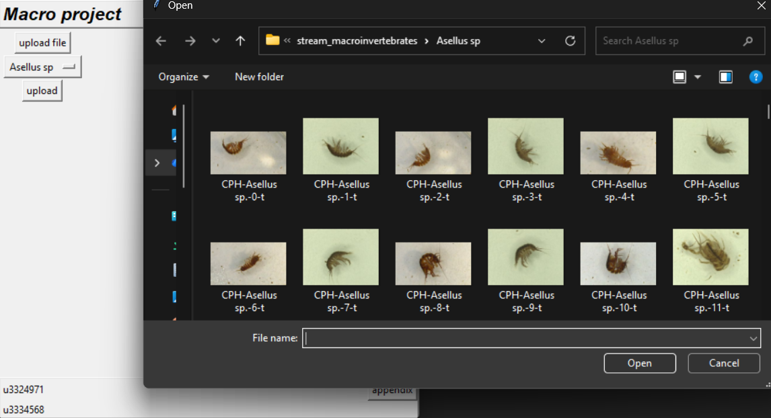
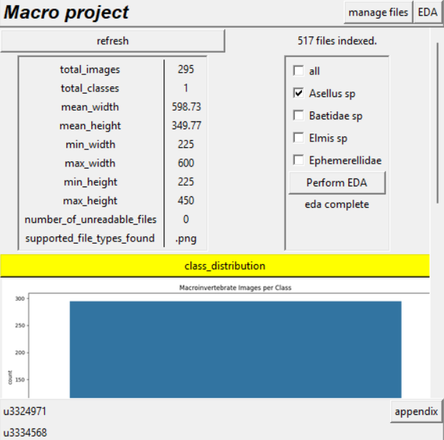
Testing throughout the creation of the system revealed many problems, all of which were solved later down the line.
Some example code by Pranav Gupta was adapted for multiple sections such as in the EDAService class and config.py.

