|  |  |  |  |  |  |
| --- | --- | --- | --- | --- | --- |
| [**Home**](http://222.201.145.168/JudgeOnline/) | [**Web Board**](http://222.201.145.168/JudgeOnline/bbs.php?cid=1130) | [**ProblemSet**](http://222.201.145.168/JudgeOnline/contest.php?cid=1130) | [**Standing**](http://222.201.145.168/JudgeOnline/contestrank.php?cid=1130) | [**Status**](http://222.201.145.168/JudgeOnline/status.php?cid=1130) | [**Statistics**](http://222.201.145.168/JudgeOnline/conteststatistics.php?cid=1130) |



**Problem B: Print Tree**

Time Limit: 1 Sec Memory Limit: 128 MB  
Submit: 100 Solved: 38  
[[Submit](http://222.201.145.168/JudgeOnline/submitpage.php?cid=1130&pid=1&langmask=1021)][[Status](http://222.201.145.168/JudgeOnline/problemstatus.php?id=2017)][[Web Board](http://222.201.145.168/JudgeOnline/bbs.php?pid=2017&cid=1130)]

**Description**

A 2-tree is a tree in which each node either has exactly 2 non-empty children (its left and right child), or is a leaf (has no children). Each leaf is named with an uppercase letter, and each other node is named with a lowercase letter.

We want to print the 2-tree by level. For example, a 2-tree is shown below can be printed as follows:

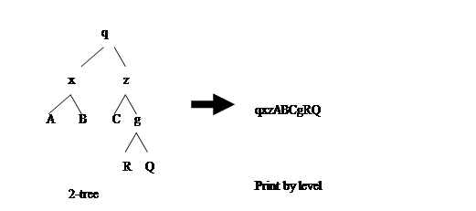

**Input**

The input consists of T test cases. The number of test cases (T) is given in the first line of the input. Each one of the following T lines contains a string representing the preorder traversal sequence of a 2-tree, each character in which is a letter ('A'-'Z','a'-'z').

**Output**

The output consists of T lines. The NO.i line is the result of printing the NO.i 2-tree as input.

**Sample Input**

4

qxABzCgRQ

rAB

bCdEfGH

abmqPDWSE

**Sample Output**

qxzABCgRQ

rAB

bCdEfGH

abEmSqWPD

**HINT**

you can use a queue to help you to print the tree by level:

Use a queue to store the nodes going to be printed in order. The procedure is illustrated as follows:

**Enqueue the root.**

**While(the queue is not empty)**

**{**

**Dequeue(node);**

**Print node**

**If (node has left child)**

**Enqueue the left child**

**If(node has right child)**

**Enqueue the right child  
  
}**

[[Submit](http://222.201.145.168/JudgeOnline/submitpage.php?cid=1130&pid=1&langmask=1021)][[Status](http://222.201.145.168/JudgeOnline/problemstatus.php?id=2017)][[Web Board](http://222.201.145.168/JudgeOnline/bbs.php?pid=2017&cid=1130)]

[한국어](http://222.201.145.168/JudgeOnline/setlang.php?lang=ko) [中文](http://222.201.145.168/JudgeOnline/setlang.php?lang=cn) [فارسی](http://222.201.145.168/JudgeOnline/setlang.php?lang=fa) [English](http://222.201.145.168/JudgeOnline/setlang.php?lang=en) [ไทย](http://222.201.145.168/JudgeOnline/setlang.php?lang=th)   
﻿

当前在线:5今日访问:78昨日访问:1943历史访问:113028

Anything about the Problems, Please Contact Admin:[admin](mailto:root@localhost)   
All Copyright Reserved 2010-2013 [SCUTOJ](http://222.201.145.168/JudgeOnline/) TEAM