POFACETS

Version 4.5 (2/10/23)

# Installation

Copy the zipped file to the desired hard drive and unzip. The programs and directories shown in the figure below should be present.After the MATLAB application is started, the user must change MATLAB’s Current Directory to the directory of POFACETS. Then, POFACETS can be executed by typing *pofacets* at the MATLAB prompt.

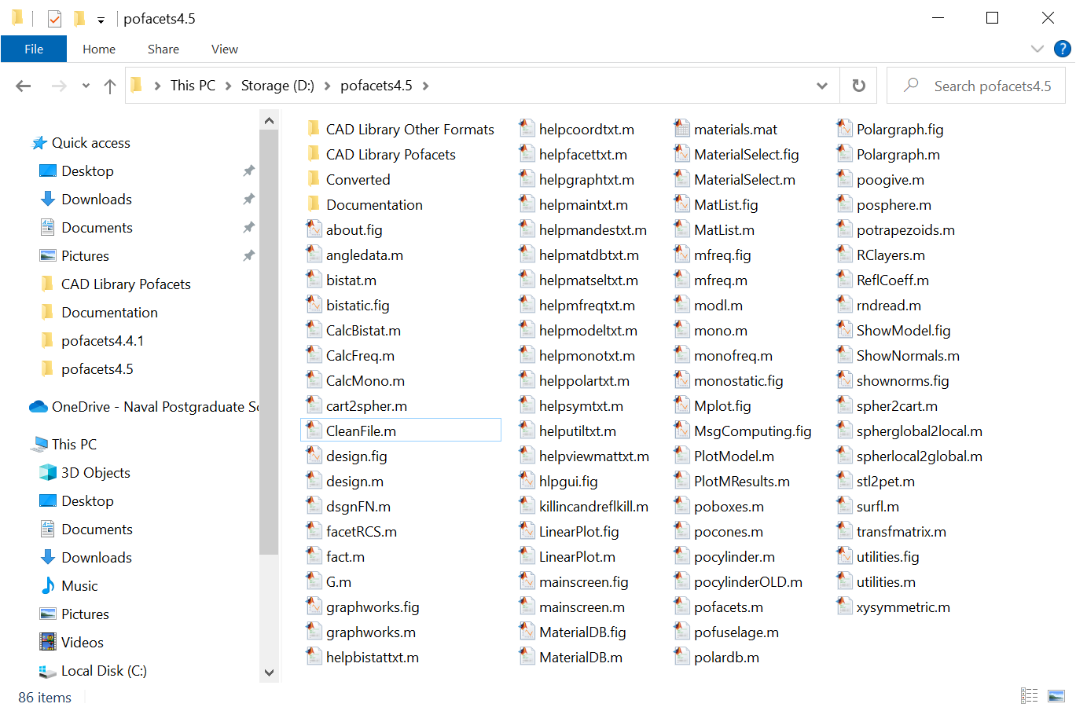

# Introduction

POFACETS is an implementation of the physical optics approximation for predicting the radar cross section (RCS) of complex objects. It utilizes the scientific computational features of MATLAB and its Graphical User Interface (GUI) functions to provide an error-free encoding of input parameters and efficient calculation of RCS. POFACETS provides a convenient tool for a “first cut” at the RCS of complex shapes by representing its constituent parts by triangular facets.

The software calculates the monostatic or bistatic RCS of the object for the parameters specified by the user, and displays plots for the model geometry and its RCS. Note that POFACETS calculations do not include multiple reflections, shadowing, edge diffraction or surface waves. These contributions would have to be taken into account to accurately model a low RCS object.

**Summary of Program Capabilities**

A summary listing of the software capabilities follows:

* Matlab Graphical Users Interface (GUI)
* Library of common geometrical shapes readily available
* Manual Model Design capability (the model triangle nodes are entered manually)
* Graphical Model Design capability (the model is generated from basis geometrical components from the library)
* Scaling, rotation, and translation of a model or its subparts
* Merging of several existing models
* Model import capability from standard CAD packages (STL format), ACADS (facet) and triangle format.
* Bistatic or monostatic RCS calculation versus angle or frequency
* One dimensional RCS cuts or surface contours in direction cosine space
* Polar plots and RCS plots superimposed on model geometry
*  (TM*z*) or  (TE*z*) incident polarizations
* Co- and cross-polarized RCS components are computed
* Circular polarization
* Approximate diffuse RCS component can be computed for rough surfaces
* Approximate effects of an infinite ground can be included
* A user-updateable library of materials is included
* Materials layers can be applied
* Symmetry planes in a model can be defined and exploited to reduce run-time
* Open code architecture allows the user to tailor the code to specific needs
* Help functions and error checking are included for all windows
* Several sample model files are included

**Thank you to all of the users who have contributed to fixes and upgrades of the software over the years. Although it is not possible to acknowledge all contributors, your efforts are appreciated!**

**Major Changes for Version 3.0**

Version 3.0 introduced the GUI interface and featured new options and tools for complex target design. It provided new computational capabilities, including the approximate effects of the ground, the exploitation of symmetry planes in targets, and the effects of materials and coatings.

**Major Changes for Version 3.1**

The major change was the implementation of the wave matrix method for computing the reflection from multilayered materials. The previous version used a transmission line equivalent model, which had some approximations with regard to multiple reflections between layers (this change originally appeared in version 3.0.1). Minor modifications to the import utilities for *facet* files were made to allow more variation in the files that can be read.

**Changes for Version 3.2**

1. CAD import and export was enhanced. STL (stereolithographic, *.stl) capability was added by incorporating freeware from the Matlab Central web page. Raw triangle files can also be read (*.raw).

2. More models have been added to the samples and examples.

3. Some bugs in subroutine facetRCS.m were removed. At some point in the software development the factors “ct2” in the monostatic section and “cti2” in the bistatic section were removed from the current density terms. In the previous versions of POFACETS there are comments on the lines noting this fact. These cosine squared factors should be put back into the second terms in parentheses. The correct expressions follow along with modified comments:

Lines 80-81: (in monostatic section of facetRCS.m)

Jx2 = (-Et2*cp2*para + Ep2*sp2*perp*ct2); % ct2 added

Jy2 = (-Et2*sp2*para - Ep2*cp2*perp*ct2); % ct2 added

Lines 228-229: (in bistatic section of facetRCS.m)

Jx2 = (-Et2*cpi2*para + Ep2*spi2*perp*cti2); % cti2 added

Jy2 = (-Et2*spi2*para - Ep2*cpi2*perp*cti2); % cti2 added

The omission of the factor does not have a significant effect in most cases. It affects the falloff in facet RCS at wide angles from the normal.

**Changes for Version 4.2**

1. A capability to calculate and plot the circularly polarized (CP) RCS was added to the Utilities.

2. The ability to display the surface normals was added to the Utilities. Version 4.1 has the normals scaled by the same factor as the model display (this was not the case for version 4.0).

3. Version 4.2 was thought to have consistent function and file name cases consistencies. However, version 4.2.1 fixed additional case inconsistencies.

**Changes for Version 4.3**

1. Improvements and fixes made in several utilities. The stl import and export functions were improved.

2. A *Quick Range* function added to compute maximum detection range.

3. The *graphworks.m* function modified to attach models with different materials.

4. Some improvements made in the *Clean and Compress* utility.

5. A function *stl2pet.m* is included. The p e t (points, edges, triangles) format is generated by Matlab’s pdetool. This format can be used with S. Makarov’s RWG programs (some minor mods may be required). Reference: S. Makarov, "Antenna and EM Modeling with Matlab" (Wiley, 2002).

**Changes for Version 4.3.1**

The top endcap of the cylinders is pointed inward (down) instead of outward (up). The following change in *pocylinder.m* was made:

1. Change line 104 from “N+i+diff,last,N+i+1+diff,1,Rs];” to “last,N+i+diff,N+i+1+diff,1,Rs];”

2. Change line 110 from “2*N+diff,last,N+2+diff,1,Rs];” to “last,2*N+diff,N+2+diff,1,Rs];”

**Changes for Version 4.3.2**

Minor formatting changes when writing the results for MResults.m (only the real parts of Ethscat and Ephscat were written previously).

**Changes for Version 4.4**

The graphical design functions “Box” and “Trapezoid” were modified so that when a height *H* of zero is entered, a single zero thickness plate is made. Previously, two plates would result – the top and bottom of the box overlapping each other and the 4 sides (with zero area) would be included in the structure. This is still the case if *W* or *L* are set to zero when making the box. To make a thin plate with arbitrary orientation, built a box with *H*=0 and then rotate the plate. The resulting plates are always illuminated.

**Changes for Version 4.4.1**

Minor changes to “CleanFile” and “ShowNormals” utilities. The removal of duplicate nodes in previous versions was not reliable and was removed. The only change this utility makes to the file is to remove facets with zero area. Information on the file is displayed in the command window.

**Changes for Version 4.5**

Some of the GUIs were made almost 20 years ago. Modifications were made to avoid problems introduced by changes in Matlab GUI behavior over the years. Behavior has changed recently due to Matlab’s migration of Guide to the App Designer. Some windows need to be cleared and reset which can lead to slow display and some flashing.

## Software Compatibility

The POFACETS 4.0 version is designed to run under MATLAB version 7.0 (Release 14) or later. The program will not run under MATLAB version 6.1. It appears to run in MATLAB version 6.5, but some warnings will be displayed. Most of the GUIs were generated using MATLAB *guide* command in version 6.5. Some GUIs were updated and saved using MATLAB version 7, so they may not work in MATLAB 6.5. Minor modifications to the GUIs were made for this version and all seems to work up to MATLAB R2022a. In some cases the “help” text does not display. To fix this check the property inspector in the Matlab GUI editor (type “guide” in the command window) to make sure the point size is large enough to be seen.

The case sensitivity has been updated in version 4.2.1 and adhered to as required by Matlab.

## RCS Calculation Methodology and Limitations

The Physical Optics (PO) approximation is one of the most convenient RCS prediction methods for an arbitrary three-dimensional target. The geometrical optics current is used over the illuminated portions of the target surface, while zero current is assumed over the shadowed portions. The current is then used in the radiation integrals to compute the scattered far field from the target. PO is a high-frequency approximation method that gives best results for electrically large bodies  and is most accurate in the specular directions.

One approach to high frequency prediction calculations is to estimate a complex model with an array of simple shapes, such as triangular flat plates. The RCS is obtained by computing the scattered field of the collection of these simple shapes to obtain the total RCS of the target. POFACETS computes the scattering from each triangle as if it is isolated in free space. Multiple reflections, diffraction and surface waves are not included. There is a limited capability to include shadowing, which involves defining which side of a particular triangle is internal to a closed body and, hence, not allowed to be illuminated. Shadows on one part of the object cast by other parts of the object are not included.

**Program Execution, Main Menu and File Directories**

The POFACETS Main Menu displays the three main functions of the program:

* Model Design (Manual or Graphical)
* RCS Calculation (Monostatic or Bistatic) versus frequency or versus angle
* Utilities (conversion from/to previous POFACETS versions, import/export of models from/to commercial CAD programs, material database management)

Each of these selections invokes GUIs that contain all the necessary help files that provide to the user the necessary instructions and information to design a model and compute its RCS.

The POFACETS directory contains all the MATLAB functions, script files, figure files and data files necessary for program execution.

The *Models* subdirectory contains the model files that accompany the program. However, the user can save new model files to any other directory.

The *Results* subdirectory is an empty directory which provides a space for saving RCS computation results. However, the user can save new model files to any other directory.

The *Pics* subdirectory contains the JPG files of the pictures displayed in the Main Menu GUI.

**Import/Export of CAD Files**

The utilities include the capability to import and export the following formats:

1. Facet files (Demaco, *.dem, and ACAD, *.facet)

2. Stereolithographic files(*.stl)

3. Raw triangle files (*.raw)

The most reliable method is *.stl. However, this format does not write/read material properties of facets as currently implemented. All CAD software packages can handle this file format. *MeshLab* (http://meshlab.sourceforge.net/) is a free program that can import all file types and convert them to *.stl.

There is no way to re-mesh a model once it is imported into POFACETS. (Note it is always possible to do this manually by going into “Design Model Manually” and changing nodes and facets, but this approach is not practical for a large target.)

**Tips for RCS Calculations**

Curved Surfaces

The discretization of curved surfaces into triangular facets can create significant errors in the RCS calculations (referred to as *facet noise*, which is a type of quantization error). One approach would be to use a large number of facets to approximate a curved surface. This method yields satisfactory results in the case of singly curved surfaces, such as cylinders, with acceptable side-effects on model size and run-time. However, in the case of doubly curved surfaces, this method leads to large model sizes and long run-times.

When computing the RCS of doubly curved surfaces the user must examine the way that these surfaces were faceted and the effects the facetization could have on the RCS results. For example, it is obvious that the two sphere models shown below would have different RCS behavior, especially when taking  cuts (i.e. finding RCS versus ).

|  |  |
| --- | --- |
|  |  |

Good rules-of-thumb when designing and computing the RCS of doubly curved surfaces involve the following:

* Ensure that the object is electrically large.
* The size of the facet’s edge should be about 2.5 to 4.5 times greater than the wavelength.
* Take  or  cuts that will produce symmetrical results (for example, avoid  cuts for the sphere shown in the right above).
* Keep the “Length of the Taylor Region” at its default value (1e-5). This value yields good results for both small and large facets.

Diffuse Calculations

One measure of the roughness of a surface is the standard deviation  of its variation about the mean value. In addition, the correlation interval  indicates how rapidly the surface changes as one moves along the surface. All triangles are assumed to have the same correlation interval and standard deviation. The roughness should be small in terms of wavelength (). The random deviation of the surface results in diffuse scattering which yields a relatively angle independent term to the RCS. The random surface calculation has not been thoroughly validated.

Generating Zero Thickness Sheets

When surfaces are thin compared to a wavelength it is acceptable to model them as infinitely thin sheets. To make a thin sheet with arbitrary orientation, build a box with *H*=0 and then rotate the plate. The resulting plate are illuminated from both sides. If a box is made with *W* or *L* set to zero then two plates result – the top and bottom of the box overlapping each other and the 4 sides (with zero area) would be included in the structure. The inclusion of zero-area triangles slows the computation and increases data file size. The clean and compress utility can remove zero-angle triangles.

Pattern Spikes

If unexplained pattern spikes occur it is generally due to numerical errors. Try reducing the Taylor Series “Length of Region” parameter. The default is 1e-5 (pattern shown below left for the “helio” model); to eliminate spikes try 1e-7 (below right) as a first step.

 

**POFACETS Data File Structure**

POFACETS uses two types of data files: the model files and the material database file described below.

### 1. Model File Structure

Each model file is comprised of the following data structures.

#### a. Coord

This is a data array that contains the coordinates of the vertices of the model. Each row corresponds to a vertex. The first field in each row represents the *x* coordinate of the vertex, the second field represents *y* and the third represents *z.*

#### b. Facet

This is a data array that contains the definition data for the facets of the model. Each row corresponds to a facet. The first three fields in each row represent the facet’s vertices. The sequence of the vertices defines the normal to the facet according to the right hand rule. The fourth field in each row indicates whether a facet can only be illuminated from its front side (when it contains a 1) or from both its back and front side (when it contains a 0). The fifth field in each row is the surface resistivity of the facet normalized to the impedance of free space (377 ohms).

#### c. Scale

This field stores the scale of the model

#### d. Symplanes

This is a data array that contains the points that form the symmetry planes of the model. If no symmetry planes exist, the array simply holds one row with three fields equal to zero. If symmetry planes exist, each symmetry plane is defined by three points represented by three consecutive rows. Each row contains the coordinates  of each point. The sequence of the points defines the normal to the symmetry plane according to the right hand rule. Up to three symmetry planes (i.e., nine rows) can be stored.

#### e. Comments

This is a cell array that contains the description of the parts of the model to which the facets belong. Each row contains the parts description for one facet.

#### f. Matrl

This is a cell array that contains the material of the facets of the model. Each row of the cell array corresponds to one facet. The first cell of the array contains the description of the type of the material used on the facet. The available options here are: “PEC”, “Composite”, “Composite Layer on PEC”, “Multiple Layers”, and “Multiple Layers on PEC”. The second cell is a one–row vector. For each layer of material used, 5 columns are included in the vector. Thus, if three layers are used, the vector will have 15 columns. In each layer, the first column is the relative electric permittivity, the second column is the loss tangent, the third column is the real part of the relative magnetic permeability, the fourth column is the imaginary part of the relative magnetic permeability, and the fifth column is the thickness of the layer in millimeters.

### 

### 2. Material Database File Structure

The material database file contains a *struct* array called *materials.mat*, which is comprised of the following fields.

#### a. Name

This field holds the name of the material.

#### b. er

This field holds the relative electric permittivity of the material.

#### c. tande

This field holds the loss tangent of the material.

#### d. mpr

This field holds the real part of the relative magnetic permeability of the material.

#### e. m2pr

This field holds the imaginary part of the relative magnetic permeability of the material.

# Disclaimer

*These codes were created for instructional purposes. Basic test geometries have been validated, but there is no guarantee of accuracy in all cases.*

# Reporting of Bugs and Suggestions for Improvement

Program “bugs” and anomalous results can be reported to the authors at the following email addresses:

jenn@nps.navy.mil

jenn@nps.edu

dcjenn@dcjenn.com

# Software Support

There is no support provided for the use or installation of this software.