Week4 Homework

9/20/2021

Question 7.1

Describe a situation or problem from your job, everyday life, current events, etc., for which exponential smoothing would be appropriate. What data would you need? Would you expect the value of alpha (the first smoothing parameter) to be closer to 0 or 1, and why?

1)At my work place I would implement exponential smoothing to inventory movement data between distribution centers and customers because sometimes the data can be sporadic with random sales, but I would still like to observe general seasonal sales results annually. This data could give me some interesting insight into the general patterns of sales my employer has throughout the year, along with any potential cyclical nature the data might hold. I would implement a moderate alpha, such as 0.5 because the structure of the company allows for individual stores to run their own independent sales, along with companywide seasonal sales.

Question 7.2

Using the 20 years of daily high temperature data for Atlanta (July through October) from Question 6.2 (file temps.txt), build and use an exponential smoothing model to help make a judgment of whether the unofficial end of summer has gotten later over the 20 years. (Part of the point of this assignment is for you to think about how you might use exponential smoothing to answer this question. Feel free to combine it with other models if you’d like to. There’s certainly more than one reasonable approach.)

Here we are importing some essential libraries so we can make use of the required packages for this assignment.

library(forecast)

## Registered S3 method overwritten by 'quantmod':  
## method from  
## as.zoo.data.frame zoo

library(tseries)

Lets go ahead and import the data

rm(list = ls())  
temps <- read.table("temps.txt", stringsAsFactors = FALSE, header = TRUE)  
temps

## DAY X1996 X1997 X1998 X1999 X2000 X2001 X2002 X2003 X2004 X2005 X2006  
## 1 1-Jul 98 86 91 84 89 84 90 73 82 91 93  
## 2 2-Jul 97 90 88 82 91 87 90 81 81 89 93  
## 3 3-Jul 97 93 91 87 93 87 87 87 86 86 93  
## 4 4-Jul 90 91 91 88 95 84 89 86 88 86 91  
## 5 5-Jul 89 84 91 90 96 86 93 80 90 89 90  
## 6 6-Jul 93 84 89 91 96 87 93 84 90 82 81  
## 7 7-Jul 93 75 93 82 96 87 89 87 89 76 80  
## 8 8-Jul 91 87 95 86 91 89 89 90 87 88 82  
## 9 9-Jul 93 84 95 87 96 91 90 89 88 89 84  
## 10 10-Jul 93 87 91 87 99 87 91 84 89 78 84  
## 11 11-Jul 90 84 91 82 96 90 84 84 90 83 90  
## 12 12-Jul 91 88 86 77 93 90 77 86 89 86 91  
## 13 13-Jul 93 86 88 73 91 86 82 87 91 84 91  
## 14 14-Jul 93 90 87 81 93 82 88 84 91 87 91  
## 15 15-Jul 82 91 91 81 93 82 91 86 84 84 91  
## 16 16-Jul 91 91 87 86 93 84 93 88 84 85 91  
## 17 17-Jul 96 89 90 82 91 87 93 88 84 89 93  
## 18 18-Jul 95 89 91 87 97 88 93 88 87 90 93  
## 19 19-Jul 96 89 95 88 100 90 93 88 84 89 96  
## 20 20-Jul 99 90 91 90 99 87 91 88 88 89 93  
## 21 21-Jul 91 89 91 90 93 84 95 89 89 90 93  
## 22 22-Jul 95 84 89 91 96 87 91 86 89 91 91  
## 23 23-Jul 91 87 91 93 87 90 89 81 93 91 86  
## 24 24-Jul 93 88 91 93 82 84 87 82 95 90 87  
## 25 25-Jul 84 89 86 91 75 82 84 84 89 92 88  
## 26 26-Jul 84 89 88 93 82 88 86 87 87 94 93  
## 27 27-Jul 82 91 80 93 88 90 89 87 84 92 95  
## 28 28-Jul 79 91 88 93 91 84 91 89 89 90 96  
## 29 29-Jul 90 89 89 93 89 89 91 88 87 83 91  
## 30 30-Jul 91 88 90 97 87 89 88 84 89 78 91  
## 31 31-Jul 87 72 86 99 86 87 90 88 90 84 94  
## 32 1-Aug 86 80 86 96 86 84 93 84 91 82 95  
## 33 2-Aug 90 84 82 93 81 84 91 84 90 86 95  
## 34 3-Aug 84 88 84 88 84 84 91 84 91 88 97  
## 35 4-Aug 91 89 86 89 88 86 91 82 91 91 98  
## 36 5-Aug 93 88 90 91 91 88 93 84 90 88 96  
## 37 6-Aug 88 84 89 93 91 84 97 82 84 86 89  
## 38 7-Aug 91 84 89 93 91 86 87 84 81 80 97  
## 39 8-Aug 84 80 86 93 91 88 87 84 82 82 96  
## 40 9-Aug 90 73 82 91 96 87 86 86 84 85 95  
## 41 10-Aug 89 80 87 90 95 88 88 87 75 83 96  
## 42 11-Aug 88 86 88 96 89 86 89 84 82 87 88  
## 43 12-Aug 86 88 84 98 89 86 91 81 80 88 84  
## 44 13-Aug 84 88 86 97 89 81 91 87 77 86 81  
## 45 14-Aug 86 87 80 98 89 87 89 89 82 90 87  
## 46 15-Aug 89 88 82 93 94 84 88 90 82 92 86  
## 47 16-Aug 90 91 86 93 97 90 90 86 84 89 89  
## 48 17-Aug 91 91 84 96 99 91 91 89 86 90 86  
## 49 18-Aug 91 89 87 98 101 91 93 90 86 90 88  
## 50 19-Aug 90 89 90 98 101 87 91 90 89 89 88  
## 51 20-Aug 89 88 79 89 97 86 93 87 88 92 93  
## 52 21-Aug 90 82 84 91 87 88 93 88 82 94 91  
## 53 22-Aug 91 79 87 91 86 90 91 88 84 93 88  
## 54 23-Aug 91 81 87 90 88 88 95 90 84 87 87  
## 55 24-Aug 91 82 88 80 92 93 93 89 87 85 83  
## 56 25-Aug 84 84 90 82 92 90 91 88 82 84 85  
## 57 26-Aug 88 87 91 89 90 91 88 89 86 84 88  
## 58 27-Aug 84 90 89 88 90 91 84 90 88 86 88  
## 59 28-Aug 86 90 90 90 92 81 82 91 90 86 90  
## 60 29-Aug 88 91 93 91 92 86 82 89 87 85 90  
## 61 30-Aug 84 91 93 91 88 81 78 88 88 85 88  
## 62 31-Aug 82 88 91 84 87 82 77 89 87 85 80  
## 63 1-Sep 80 88 87 88 79 80 84 88 82 85 85  
## 64 2-Sep 73 91 84 91 81 75 84 86 80 88 86  
## 65 3-Sep 87 93 77 84 82 73 89 87 81 87 85  
## 66 4-Sep 84 81 90 93 87 81 95 87 82 85 88  
## 67 5-Sep 87 81 91 96 81 90 93 84 84 81 83  
## 68 6-Sep 89 82 89 96 66 88 91 73 81 81 85  
## 69 7-Sep 89 86 90 91 66 87 88 75 86 83 80  
## 70 8-Sep 89 88 89 91 75 86 87 81 73 85 83  
## 71 9-Sep 91 84 79 77 80 86 91 82 84 86 83  
## 72 10-Sep 84 80 78 87 82 89 95 79 84 84 85  
## 73 11-Sep 86 82 81 87 84 87 95 80 84 84 84  
## 74 12-Sep 88 86 84 87 86 84 90 81 81 86 82  
## 75 13-Sep 78 87 89 86 87 84 75 84 79 88 70  
## 76 14-Sep 79 87 87 87 86 86 78 82 79 88 80  
## 77 15-Sep 86 88 87 89 80 77 91 82 73 91 82  
## 78 16-Sep 82 88 88 81 75 77 88 81 75 88 83  
## 79 17-Sep 82 90 87 81 73 81 86 81 80 86 85  
## 80 18-Sep 78 88 82 82 73 81 81 81 79 88 85  
## 81 19-Sep 79 91 80 79 84 82 80 84 78 90 79  
## 82 20-Sep 79 95 82 68 87 84 86 87 73 90 73  
## 83 21-Sep 78 89 82 79 77 86 84 82 75 90 75  
## 84 22-Sep 81 70 88 72 73 87 77 75 80 86 82  
## 85 23-Sep 84 80 84 75 81 88 82 81 84 87 86  
## 86 24-Sep 84 82 81 78 84 69 73 80 82 88 84  
## 87 25-Sep 87 66 82 81 82 66 69 82 81 85 75  
## 88 26-Sep 84 70 84 82 68 72 75 82 79 77 78  
## 89 27-Sep 79 64 87 78 71 75 75 82 72 86 79  
## 90 28-Sep 75 68 80 80 75 78 79 73 78 85 81  
## 91 29-Sep 72 77 75 77 73 71 73 66 78 85 70  
## 92 30-Sep 64 86 75 71 75 71 79 71 80 82 75  
## 93 1-Oct 66 75 86 73 77 75 82 72 82 83 83  
## 94 2-Oct 72 73 78 75 79 80 84 68 82 85 81  
## 95 3-Oct 84 75 77 84 82 81 84 66 80 83 82  
## 96 4-Oct 70 78 82 71 81 80 82 77 81 85 84  
## 97 5-Oct 66 81 82 73 82 79 87 78 80 81 86  
## 98 6-Oct 64 82 73 71 73 70 86 75 75 72 76  
## 99 7-Oct 60 82 82 73 66 68 80 73 75 72 72  
## 100 8-Oct 78 82 69 73 55 79 71 73 73 73 72  
## 101 9-Oct 70 80 72 72 55 66 66 73 71 70 79  
## 102 10-Oct 72 82 73 72 64 73 70 73 71 77 80  
## 103 11-Oct 69 82 78 73 71 75 78 66 77 82 80  
## 104 12-Oct 69 79 78 70 73 78 84 78 73 74 71  
## 105 13-Oct 73 80 78 64 75 78 79 78 64 77 62  
## 106 14-Oct 79 68 75 75 75 75 68 78 63 78 69  
## 107 15-Oct 81 63 79 73 77 75 57 69 62 79 70  
## 108 16-Oct 80 57 78 77 80 62 66 72 71 76 59  
## 109 17-Oct 82 66 77 80 80 60 64 68 75 75 71  
## 110 18-Oct 66 64 78 71 80 64 68 70 73 81 77  
## 111 19-Oct 63 69 82 66 73 71 71 75 68 83 76  
## 112 20-Oct 68 70 75 60 73 75 73 78 71 83 69  
## 113 21-Oct 79 70 73 64 75 79 71 84 73 80 69  
## 114 22-Oct 81 62 63 73 79 80 64 78 73 67 70  
## 115 23-Oct 69 63 63 57 75 81 59 78 70 70 53  
## 116 24-Oct 73 62 72 59 75 79 68 73 73 56 56  
## 117 25-Oct 73 75 75 64 78 73 60 73 78 54 55  
## 118 26-Oct 75 71 79 69 75 64 68 68 79 61 62  
## 119 27-Oct 75 57 79 75 78 51 69 64 81 63 66  
## 120 28-Oct 81 55 79 73 80 55 75 57 78 62 63  
## 121 29-Oct 82 64 78 72 75 63 75 70 75 64 72  
## 122 30-Oct 82 66 82 75 77 72 68 77 78 69 73  
## 123 31-Oct 81 60 79 75 78 71 60 75 82 70 68  
## X2007 X2008 X2009 X2010 X2011 X2012 X2013 X2014 X2015  
## 1 95 85 95 87 92 105 82 90 85  
## 2 85 87 90 84 94 93 85 93 87  
## 3 82 91 89 83 95 99 76 87 79  
## 4 86 90 91 85 92 98 77 84 85  
## 5 88 88 80 88 90 100 83 86 84  
## 6 87 82 87 89 90 98 83 87 84  
## 7 82 88 86 94 94 93 79 89 90  
## 8 82 90 82 97 94 95 88 90 90  
## 9 89 89 84 96 91 97 88 90 91  
## 10 86 87 84 90 92 95 87 87 93  
## 11 85 89 86 93 95 90 80 85 92  
## 12 87 93 90 90 95 84 87 90 93  
## 13 86 85 84 91 97 90 78 89 92  
## 14 84 88 89 91 90 90 85 90 90  
## 15 81 89 89 94 80 90 86 86 89  
## 16 86 89 90 89 85 92 87 83 88  
## 17 89 88 88 87 87 93 91 86 93  
## 18 89 90 82 83 89 93 87 82 92  
## 19 88 91 80 90 94 91 90 85 91  
## 20 86 94 82 91 91 84 86 76 93  
## 21 86 95 86 94 92 90 87 82 93  
## 22 79 92 84 95 94 95 85 83 92  
## 23 82 87 87 97 92 97 84 88 88  
## 24 87 88 88 94 92 97 86 87 91  
## 25 87 89 90 95 90 98 89 88 90  
## 26 87 87 92 95 94 98 86 89 91  
## 27 90 90 90 93 94 97 82 92 92  
## 28 89 93 89 90 90 97 86 90 94  
## 29 87 92 85 94 93 94 86 82 93  
## 30 92 90 82 95 96 96 90 84 94  
## 31 90 88 85 95 96 88 80 85 93  
## 32 92 89 89 96 91 94 87 81 89  
## 33 92 92 83 84 96 99 89 84 94  
## 34 94 91 90 92 97 94 88 88 94  
## 35 97 91 92 95 85 87 90 90 97  
## 36 96 92 92 93 96 90 88 89 95  
## 37 98 94 89 93 93 86 88 92 88  
## 38 98 90 91 91 93 84 86 95 88  
## 39 100 86 92 93 94 92 83 90 92  
## 40 103 85 93 94 91 88 89 89 93  
## 41 103 85 93 94 95 87 90 86 94  
## 42 100 88 95 95 94 85 90 83 91  
## 43 90 81 86 95 95 88 90 88 90  
## 44 100 81 90 96 95 91 89 84 89  
## 45 99 84 90 89 94 88 83 85 90  
## 46 102 87 90 90 88 85 73 87 90  
## 47 101 86 88 90 90 91 67 88 90  
## 48 101 85 87 91 92 87 66 89 89  
## 49 97 86 88 93 94 87 77 89 88  
## 50 95 90 90 92 96 84 82 86 89  
## 51 96 90 88 93 93 84 84 89 88  
## 52 99 85 88 93 94 88 84 92 89  
## 53 104 82 85 94 98 84 88 93 92  
## 54 98 78 81 93 92 88 90 93 87  
## 55 95 83 86 90 93 86 84 88 89  
## 56 94 78 87 89 95 85 82 84 84  
## 57 92 83 90 90 99 90 82 86 86  
## 58 88 80 83 89 95 90 86 88 85  
## 59 88 86 75 87 95 80 90 91 83  
## 60 89 89 86 84 93 86 92 92 81  
## 61 89 89 79 85 90 80 87 88 74  
## 62 86 88 79 89 92 89 90 89 84  
## 63 84 81 71 90 95 91 90 90 87  
## 64 83 85 78 91 96 89 84 90 90  
## 65 88 83 79 92 95 85 90 92 89  
## 66 91 85 83 84 80 77 89 82 92  
## 67 89 88 83 85 78 85 89 89 87  
## 68 85 87 85 90 75 85 88 91 85  
## 69 86 89 84 91 69 92 88 90 85  
## 70 88 90 87 93 73 88 91 84 84  
## 71 89 88 84 92 81 83 90 84 87  
## 72 89 87 80 94 84 84 89 86 85  
## 73 89 83 75 96 86 83 89 90 86  
## 74 86 87 81 89 87 81 90 92 78  
## 75 85 86 80 86 89 81 87 86 75  
## 76 81 88 82 91 92 83 82 78 77  
## 77 82 79 79 91 86 87 84 80 80  
## 78 76 80 82 89 72 86 89 86 79  
## 79 78 69 73 95 79 83 79 86 83  
## 80 79 82 80 93 77 79 78 85 83  
## 81 82 81 74 92 77 81 84 84 87  
## 82 81 79 81 96 82 79 86 83 89  
## 83 78 75 79 95 86 85 73 87 77  
## 84 86 84 84 92 80 87 82 82 76  
## 85 83 82 83 91 83 81 82 77 81  
## 86 89 78 85 88 82 78 71 78 74  
## 87 87 82 87 93 88 82 67 77 67  
## 88 84 80 85 76 86 86 78 74 71  
## 89 85 77 80 81 84 88 79 78 71  
## 90 85 86 83 76 79 86 77 74 75  
## 91 81 86 72 79 84 84 76 71 77  
## 92 79 86 74 76 78 72 77 84 85  
## 93 80 74 76 79 65 75 82 86 71  
## 94 82 74 75 78 68 72 82 85 66  
## 95 77 80 76 68 75 74 82 78 66  
## 96 80 83 74 67 80 82 85 65 70  
## 97 81 83 62 70 83 82 84 71 73  
## 98 82 82 71 73 81 83 84 78 76  
## 99 83 82 79 81 79 68 74 82 81  
## 100 83 72 80 82 78 63 72 86 82  
## 101 81 75 85 85 72 70 76 86 81  
## 102 81 77 74 86 68 73 80 86 71  
## 103 67 78 77 86 65 75 79 86 73  
## 104 72 77 66 80 73 79 81 85 76  
## 105 74 77 73 80 74 75 82 85 81  
## 106 78 80 66 73 77 77 77 75 78  
## 107 78 81 61 78 80 77 68 69 81  
## 108 76 83 61 76 84 74 74 70 77  
## 109 82 69 51 80 85 75 72 80 70  
## 110 77 67 55 78 80 74 73 76 66  
## 111 76 65 61 82 67 73 63 73 64  
## 112 75 66 68 77 59 71 70 73 71  
## 113 78 72 71 80 63 76 72 77 76  
## 114 72 68 74 78 68 79 69 70 79  
## 115 81 62 72 76 70 78 63 72 81  
## 116 59 54 69 81 73 79 66 74 76  
## 117 61 67 65 76 76 80 56 77 71  
## 118 68 70 65 85 77 80 61 84 67  
## 119 67 59 60 76 79 70 69 84 56  
## 120 70 50 71 74 74 56 64 77 78  
## 121 62 59 75 68 59 56 75 73 70  
## 122 67 65 66 71 61 56 78 68 70  
## 123 71 67 69 75 65 65 74 63 62

Convert the matrix into a list / flattening this traditional data set to fit the needs of a time series model.

b <- unlist(temps[,2:21])  
head(b)

## X19961 X19962 X19963 X19964 X19965 X19966   
## 98 97 97 90 89 93

Now lets take that list and conform it to a vector

temp_vec <- as.vector(b)  
plot(temp_vec, pch = 20)

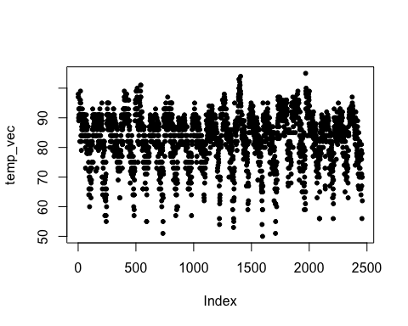

Now lets take that vector and make it into a times series data object, required for time series models.

temps_ts <- ts(b, start=1996, frequency=123)  
head(temps_ts)

## Time Series:  
## Start = c(1996, 1)   
## End = c(1996, 6)   
## Frequency = 123   
## [1] 98 97 97 90 89 93

plot(temps_ts)

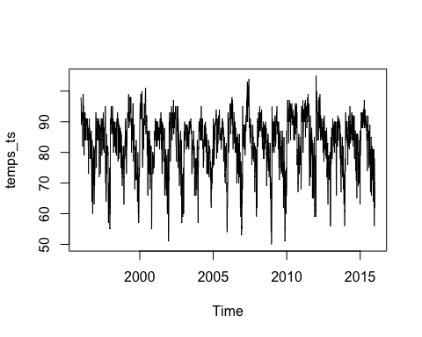

When looking at the bellow graph one can examine interesting aspects such as the evident seasonality of the data set.

plot(decompose(temps_ts))

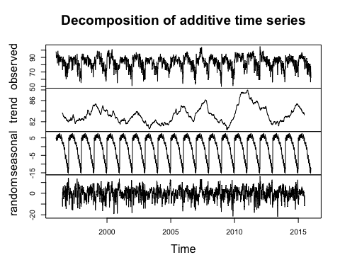

After a few iterations of using random factors I was able to get the SSE down to 76401.62. the alpha is quite high and so is the gamma, probably indicating that there is some white noise in the data long with a steady pattern of seasonality. The additive method seemed to also perform better, besides the obvious year over year seasonal characteristics.

HW1 <- HoltWinters(temps_ts, alpha = 0.7, beta=0.1, gamma = 0.7, seasonal="additive")  
plot(HW1)

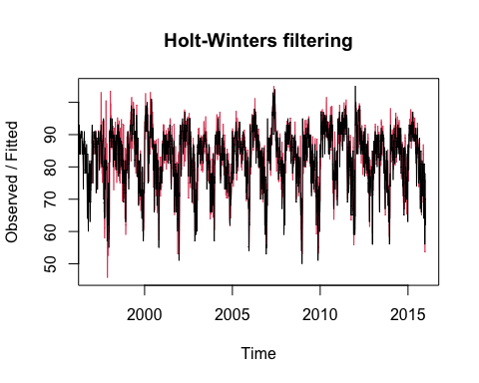

cat("\tSum of Squared Errors:", HW1$SSE)

## Sum of Squared Errors: 76401.62

I set the factors to null so that the Holtwinter package would optimize for the best alpha, beta, and gamma factors, while keeping seasonal factor consistant across both models.

HW2 <- HoltWinters(temps_ts, alpha=NULL, beta=NULL, gamma = NULL, seasonal="additive")  
plot(HW2)

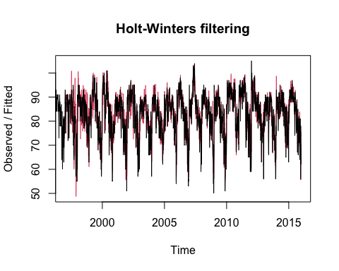 Here we can take a look at the optimized factor results. Something to take note of is how trend factor is 0, which could imply either there was no noisy data within the realm of trend, or there was not much of a trend in the first place to smooth.

cat("\tBase:", HW2$alpha,"\n")

## Base: 0.6610618

cat("\tTrend:",HW2$beta,"\n")

## Trend: 0

cat("\tSeasonal:",HW2$gamma,"\n")

## Seasonal: 0.6248076

cat("\tSum of Squared Errors:", HW2$SSE)

## Sum of Squared Errors: 66244.25

?fitted  
plot(fitted(HW2))

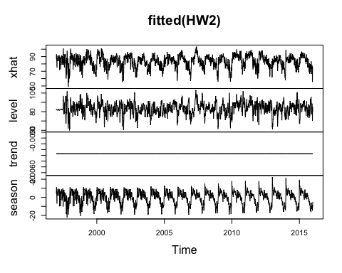 In the above plot the trend row corroborates the idea that there isn’t a trend in the data set to smooth.

plot(HW2, predict(HW2, n.ahead=246))

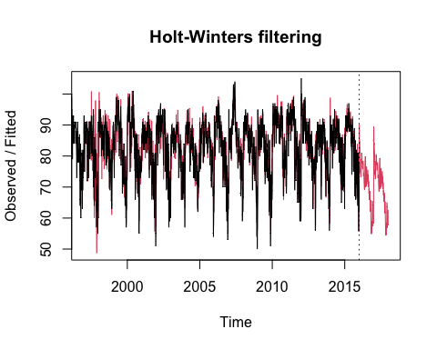 Here is a quick predication plot. As you can see the pattern keeps on projecting forward in the direction of the previous season. This could lead to an obvious larger error variance over further perditions beyond the initial one.